

An-Najah National University
Department of Materials Science and Engineering

Graduation Project 2

Synthesis and characterization of magnesioferrite spinel
Study of grain size change with time & temp.

Prepared by:
Aamer Abo_Jalboush

Supervisor:
Dr.Hamdallah Bearat

Oct2020

Abstract

Magnesioferrite is one member of spinel group. Which has a superior magnetic properties. And stability under high temperatures. In this project, it prepared by thermal diffusion under a temperature of (1000~1100) C. And the particle size can be controlled by changing the temperature for different periods of time. However, to ensure that is possible, two main characterisation techniques are needed. XRD, to proof the magnetic phase formed is magnesioferrite. But for the samples produced only one sample is formed of crystalline magnesioferrite.

Table of Contents

Abstract 2
Introduction 2
Literature review 3
Thermal diffusion 3
High temperature and pressure 3
Precipitation in aqueous solution 4
Sol gel 4
Liquid-feed flame spray pyrolysis 4
Methodology 4
Thermal annealing 4
Dissolution 5
Results& Conclusion 6
Bibliography 7

Introduction

Recently, there are a lot of studies that focus on magnetic oxides synthetic techniques, the main object was the optimization of a reproducible physical properties and short processing times. Research has focused extensively on Spinel ferrites owing to their wide range of practical applications in several major technological fields (electronics, transportation, biology, information technology, etc.)(Dalt, Sousa, & Bergmann, November 08-10).
Spinel ferrites are of great interest due to having diverse chemical and physical properties for various technological applications. Magnesioferrite (MgFe2O4), which has cubic structure of inverse spinel type and is as of magnetic n-type semi conducting material, is a member of spinel ferrite family with the general formula MFe2O4. (Sedat , Svetlana, & Komlev, 2014)
Scientists have been struggling to synthesize ferrite nanoparticles with narrow particle size distribution, homogenously shaped and minimum particles agglomeration to meet the demand of high-technology applications. (Sedat , Svetlana, & Komlev, 2014)It is well known fact that ferrite nanoparticles have superior electric and magnetic properties compared to their micro sized counterparts. (Sedat , Svetlana, & Komlev, 2014) Recently Magnesioferrite nanoparticles have drawn much attention because of having technological applications including semiconductors, low magnetic materials, hyperthermia, anode material for lithium ion batteries and gas sensing. (Sedat , Svetlana, & Komlev, 2014)
Magnesioferrite is a magnetic oxide material with excellent chemical stability. It has been widely used as a high density magnetic recording medium, in electromagnetic wave absorbers, as pigment in ceramics for coloring porcelain, glass and glazes, in control therapy for small liver tumors from magnetic metal particles mildly induce heat energy in an alternating magnetic field (AMF).(Dalt, Sousa, & Bergmann, November 08-10)

In recent years, much effort has been dedicated to the preparation of small ferrite particles using a variety of techniques such as chemical co-precipitation polymerization, microwave hydrothermal processing, high-energy milling, and solid-state reaction, among other methods. However, these methods often require a high calcination temperature of about 1000ºC to form magnesioferrite particles with a single crystalline structure.(Dalt, Sousa, & Bergmann, November 08-10)

Literature review

Nano-sized ferrites display physical and chemical properties which may be quite different from those of their bulk counterparts. Magnesioferrite (MgFe2O4) is one of the most interesting, due to its small magneto crystalline anisotropy, super paramagnetic properties are still present at relatively low temperatures and/or high magnetic fields.( de Biasi, Lúcia Helena, José, Dalber , & João Batista , 2009)
Because of its importance, there’s a lot of work to synthesise magnesioferrite. However, all the work can be classified into three main roots, which is:

Thermal diffusion

Magnesioferrite (MgFe204 spinel) was synthesized in equilibrium with excess MgO using a flux method. Chemical analysis shows that the MgFe204 is stoichiometric, within analytical uncertainty. Samples were annealed at intervals of 50 °C between 450 and 1250 °C and quenched in H20. And this is the method which is used in this project.(H. ST.C., H. , & D. , 1992)

High temperature and pressure

In this work, formation of MgFe2O4 nanoparticles by the decomposition of co-precipitated magnesium and iron hydroxides between 300 and 450 C temperaturesand500atmwater vapour pressure was studied.(Sedat , Svetlana, & Komlev, 2014).
Decomposition mechanism and conditions of co-precipitated hydroxides was investigated by using XRD, FT–IR, SEM–EDS and simultaneous TG–DTA–MS analyses. It was found that magnesium and iron hydroxides were co-precipitated as amorphous layered double hydroxides (LDHs) and formation of MgFe2O4 nanoparticles took place via decomposition of LDHs as spatially separated thermodynamic stable phases under hydro thermal conditions. Crystallite sizes of the MgFe2O4 synthesized were calculated as in the range 45–60 nm. Comparison of thermodynamic calculations and experimental results showed that kinetic hindrances leaded to increase in theoretical formation temperature of MgFe2O4. (Sedat , Svetlana, & Komlev, 2014)

Precipitation in aqueous solution

Sol gel

Nanocrystalline particles of magnesioferrite (MgFe2O4) were prepared by a sol-gel/combustion method using iron nitrate, Fe(NO3)3.9H2O, magnesium nitrate, Mg(NO3)2.6H2O, and citric acid, C6H8O7.H2O, and annealed for 2 hours at 400, 500 and 600 °C. The average particle size, determined by X ray diffraction, was found to depend on the annealing temperature and varied from 〈D〉 = 8.1 to 〈D〉 = 17.8 nm.( de Biasi, Lúcia Helena, José, Dalber , & João Batista , 2009)
By measuring at several temperatures the relative intensity of the Mössbauer spectra due to superparamagnetic particles and to ferrimagnetic particles, we determined the size distribution of the nanoparticles in the samples. It was found to be a log-normal distribution with a most probable diameter that varied from Dm = 6.4 to 17.2 nm and a full width at half-height ΔD in the 5-6 nm range.( de Biasi, Lúcia Helena, José, Dalber , & João Batista , 2009)

Liquid-feed flame spray pyrolysis

LF-FSP has been used to synthesize mixed-metal nanopowders in the (MgO)x(Fe2O3)1-x system from metalloorganic precursors. Iron propionate [Fe(O2CCH2CH3)3] and magnesium acetylacetonate [Mg(C5H7O2)2·2H2O] precursors were dissolved in ethanol, aerosolized with oxygen and combusted at temperatures > 1500 C and then after quenched rapidly.( Kumar, Azurdia, & Laine, 2010)

Methodology
The synthetic process mainly composed of two parts:

Thermal annealing
Materials used: Fe₂O₃, MgO

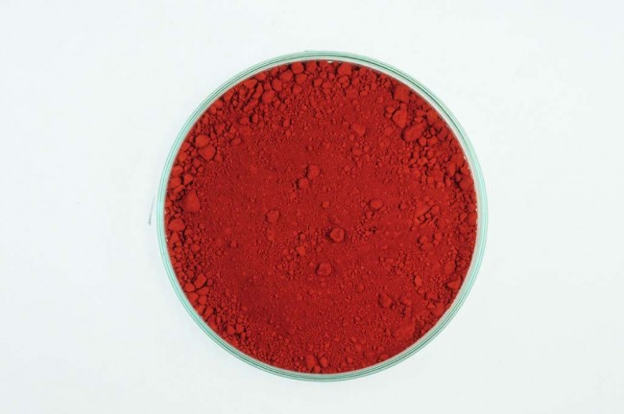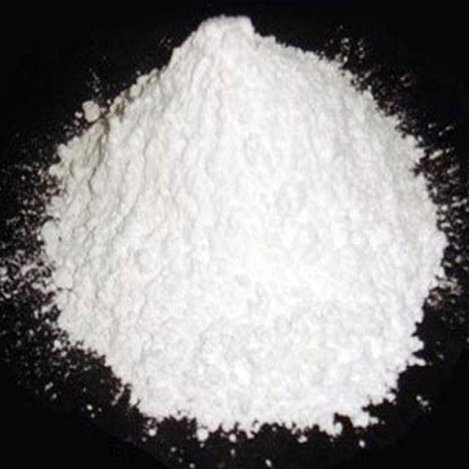
Figure 1: Fe₂O₃ powder & powder of MgO

Procedure
- Samples of defined masses weighted.(2g Fe₂O, .55g MgO)
- Samples mixed before put in the furnace.
- The annealing time was as shown in the table below.
- All the samples got cooled for at least 15minutes.
- Then the samples have been but in a plastic pipes for about two months. 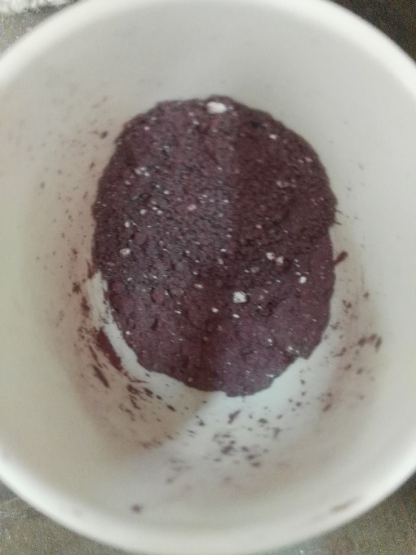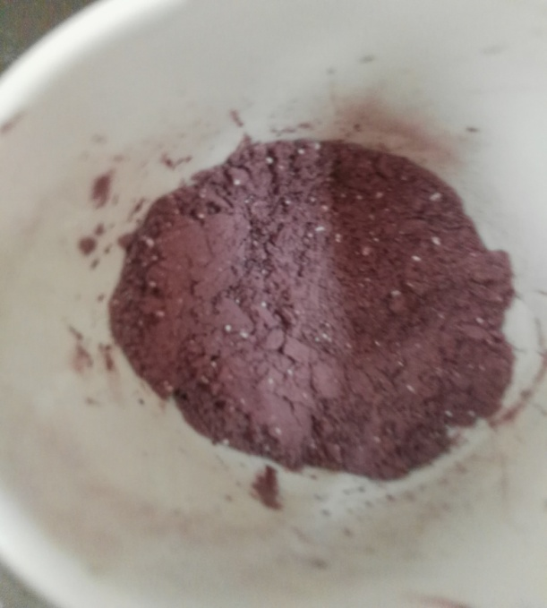
Figure 2; fresh samples

Table 1; diffusion temperature & time
sample# | Temp. | time
1 | 1000 | 10
2 | 1000 | 5
3 | 1100 | 30
4 | 1050 | 30
5 | 1100 | 5
6 | 1050 | 5
7 | 1050 | 10
8 | 1000 | 30
9 | 1100 | 10

Dissolution
Material used is ethanol.
Tools used: tea cup, magnet, aluminium foil, and aluminium coca cola can

Figure 3: simple separation tools

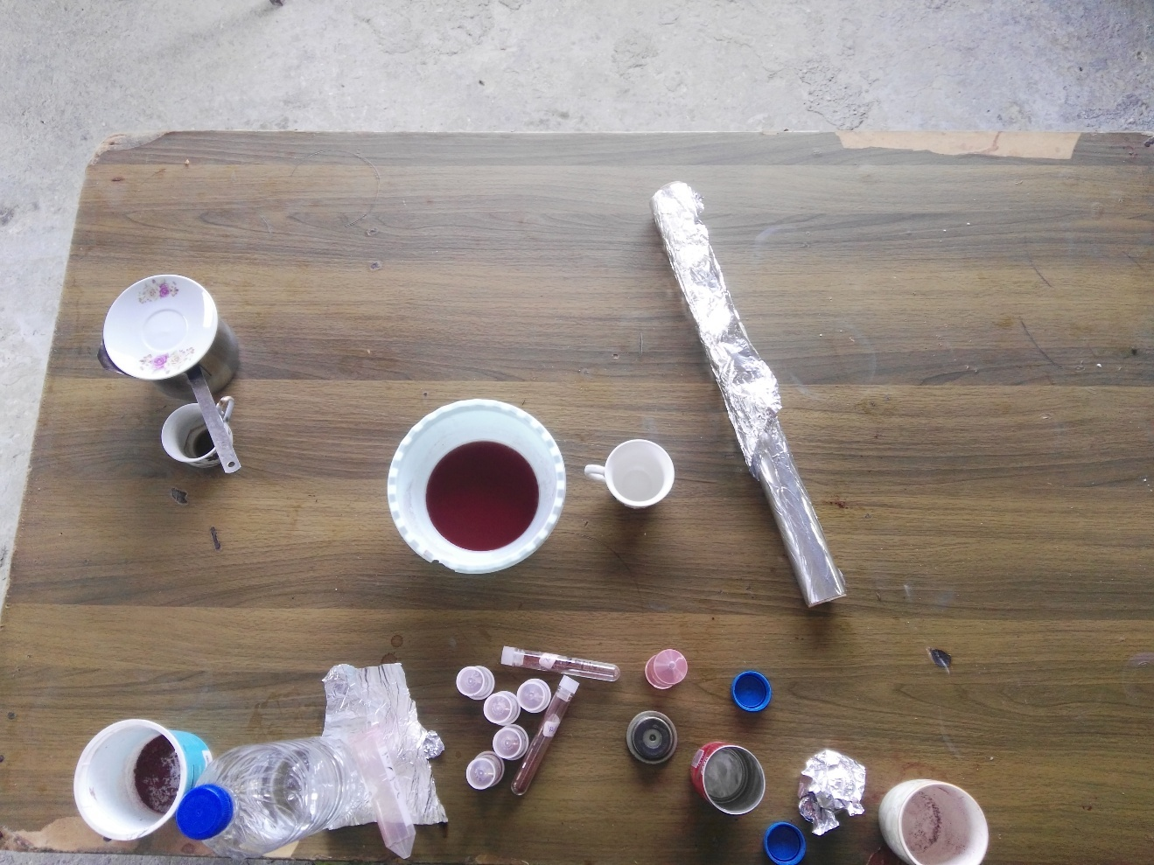
Figure 4; separation tools
Procedure for each sample:
- 70ml of ethanol added to the cup.
- Sample dissolved in ethanol.
- Magnet had put in aluminium can which allows it to coach the magnetic particles, and then they all put in the cup.
- Stirring for 2 min.
- Take the cop from the solution, then withdraw the magnet to drop the magnetic particles on aluminium foil.

Results &Conclusion

Magnetic material appeared in all samples. So, to insure what we have we had to analyze our samples by XRD and that will check what we have.
The results were as shown in the figures below; 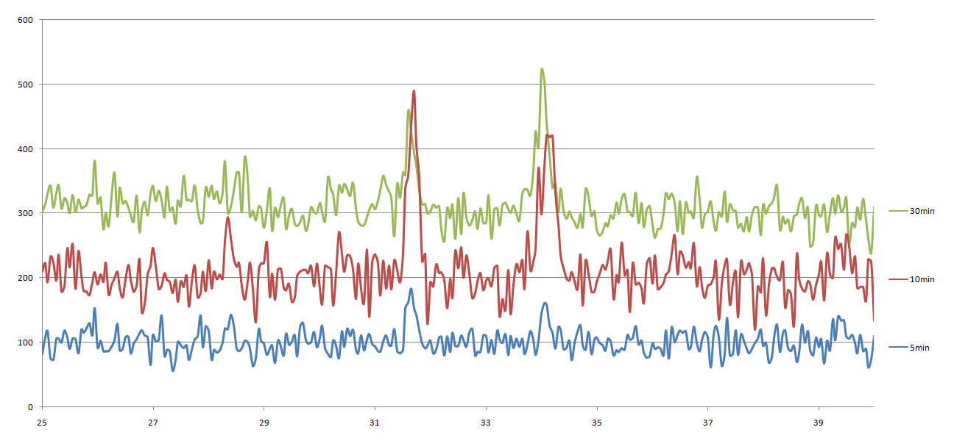
Figure 5: XRD for 1000 samples
For 1000C, we found that there are two main peaks started appearing in 5 minutes, increase in 10 minutes, later it started decrease before 30 minutes. That means, the diffusion starts with the extremely small particles of hematite, which gives a small intensity (undetectable).
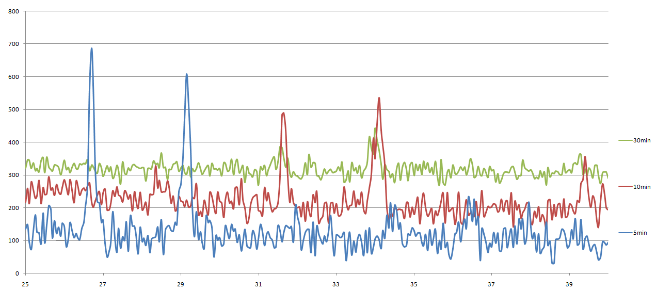
Figure 6; 1050 samples diffraction
At 1050C, it started earlier and reached the top at about 5 minutes. But because of thermal shock, the particles had extremely strained, which leads the beaks to move about 5degrees. The micro strain happened could be because of sudden diffusion of magnesium atoms throw hematite crystal.
The strain decreased throw time, and sharpness too. The crystals started to be smaller and more likely to be amorphous or lower particle size than detectable. It still paramagnetic material but its losing the structure of hematite.

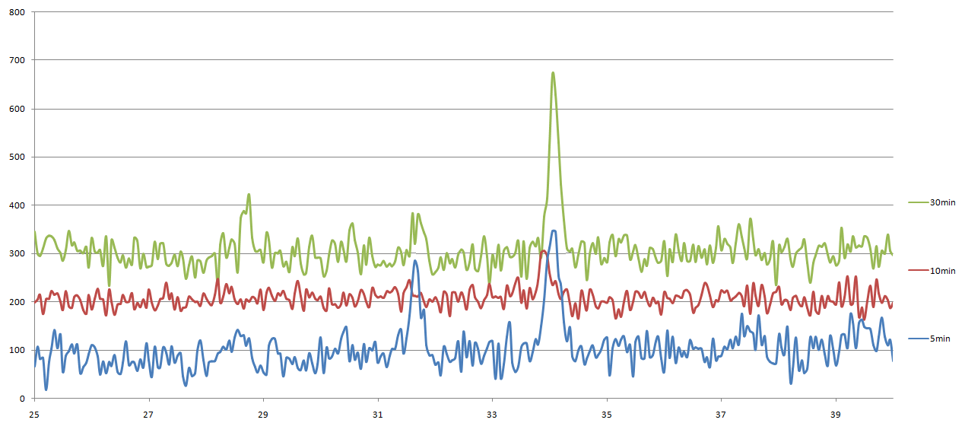
Figure 7;1100 samples results

For 1100C samples, the result for the first 5 minutes approximately has the same shape for 10 minutes at 1050C. And the same happened for the second one with the last one at 1050C. But for the last sample, only one beak appeared, which gives a result that, the crystals appeared is for magnesioferrite, which has a beak at about 30degrees, but with some strain still present.

We have been used Debye-Scherrers formula to obtain the particle size from XRD analyses. The formula is:

$D=\frac{.94*lamda}{β*cosθ}$ debye-scherrers formula Equation 1

And to find the strain approximated value we used the formula;

$ε=\frac{β}{4*tanθ}$ micro- strain formula Equation 2

And the results were as shown in table below;
Table 2; size& strain for samples
temp. | time | beta | theta | Cos theta | D(avg)(nm) | strain
1000 | 5 | 0.00349 | 31.65 | 0.8513 | 48.7 | 0.001415
1000 | 10 | 0.00567 | 31.7 | 0.8508 | 30.0 | 0.002295
1000 | 30 | 0.007417 | 34 | 0.8290 | 23.5 | 0.002749
1050 | 5 | 0.005672 | 26.7 | 0.8934 | 28.6 | 0.002819
1050 | 10 | 0.005672 | 34.1 | 0.8281 | 30.8 | 0.002094
1050 | 30 | 0.0048 | 34 | 0.8290 | 36.4 | 0.001779
1100 | 5 | 0.00698 | 34.05 | 0.8285 | 25.0 | 0.002582
1100 | 10 | 0.004398 | 33.9 | 0.8300 | 39.7 | 0.001636
1100 | 30 | 0.00393 | 34.05 | 0.8285 | 44.5 | 0.001454

For the results of 1000 degrees, the particle size decreases with the increase of strain and beak intensity. Then for 1050 samples, particle size increases with the decrease of strain and intensity. The same for 1100 samples, which indicates that if we got more points on the same temperature it will look like this:

Figure 8; the estemated change in particle size with time at any temperature

In other words, the solid diffusion starts in iron oxide, and breaks its crystals, and then magnesioferrite crystallization starts.
Equations
$D=.94*lamdaβ*cosθ$ debye-scherrers formula Equation 1 9
$ε=β4*tanθ$ micro- strain formula Equation 2 9

Tables
Table 1; diffusion temperature & time 6
Table 2; size& strain for samples 10

Table of figures

Figure 1: Fe₂O₃ powder & powder of MgO 5
Figure 2; fresh samples 5
Figure 3: simple separation tools 6
Figure 4; separation tools 7
Figure 5: XRD for 1000 samples 8
Figure 6; 1050 samples diffraction 8
Figure 7;1100 samples results 9
Figure 8; the estemated change in particle size with time at any temperature 10

Bibliography

de Biasi, R. S., Lúcia Helena, G. C., José, B. d., Dalber , R. S., & João Batista , M. d. (2009). Influence of Annealing on Magnesioferrite Nanoparticles. Materials Research, 225-227.
Kumar, S., Azurdia, J. A., & Laine, R. M. (2010). Synthesis of (MgO)x(Fe2O3)1-x nanoparticles via liquid feed flame spray pyrolysis. Journal of Ceramic Processing Research, 517~522.
Dalt, S. D., Sousa, V. C., & Bergmann, C. P. (November 08-10). Combustion Synthesis and Structural Characterization of. Seventh International Latin American Conference on Powder Technology, (p. 1141). SP, Brazil: Department of Materials Engineering - Federal University of Rio Grande.
H. ST.C., O., H. , A., & D. , V. (1992). The temperature dependence of the cation distribution in magnesioferrite (MgFe204) from. American Mineralogist, 725-740.
Sedat , I., Svetlana, I. G., & Komlev, A. A. (2014, August 24). Synthesis andcharacterizationofMgFe2O4 nanoparticlesprepared. CERAMICSINTERNATIONAL, pp. 1-9.

