

An-Najah National University

Faculty of Engineering & Information Technology
Presented in partial fulfillment of the requirements for Bachelor degree in Computer Engineering
Graduation Project 1

CE Bridge

Student:
"Mohammad Omar" Tanbour (12029362)

Supervisor:
Eng. Khaled Daud

Acknowledgment:

Praise be to God, Lord of the Worlds, who enabled me to complete this research. In it, I mention in particular thanks and gratitude to my family who have supported us at this stage. I would like to express my sincere thanks to An-Najah National University and the administrators and general supervisors. In particular, I owe a lot of gratitude to the Department of Computer Engineering, which has nurtured me over the past years. I would like to thank the virtuous Eng. Khaled Daud, who supervised this project and provided me with every effort through his guidance based on encouragement, advice, and guidance.
I cannot fail to extend our sincere thanks to everyone who contributed to completing the Graduate Project, whether by refining it or revising it. I also extend my sincere thanks to all of my friends and colleagues who provided assistance and assistance during the preparation of this Graduate project.

Disclaimer:
This report was written by the student “Mohammad Omar” Tanbour at the Computer Engineering Department, Faculty of Engineering, An-Najah National University. It has not been altered or corrected, other than editorial corrections, as a result of assessment and it may contain language as well as content errors. The views expressed in it together with any outcomes and recommendations are solely those of the student. An-Najah National University accepts no responsibility or liability for the consequences of this report being used for a purpose other than the purpose for which it was commissioned.

Table of Contents:
Acknowledgment: I
Disclaimer: II
Table of Contents: III
Table of Figures: IV
Abstract: 1
1 Introduction: 1
1.1 Problem Statement 1
1.2 Objectives 2
1.3 Organization of the Report 2
2 Theoretical Background: 3
3 Methodology 4
3.1 Constraints 4
3.1.1 Solo development 4
3.1.2 Data access 4
3.2.2 limited resources 4
3.2.3 Time limitation 4
1.2 Standards and Specifications and Programming Languages 5
1.2.1 Frontend 5
1.2.2 Backend 5
1.2.3 tools 5
3.3 Mobile app features 6
3.3.1 Login 6
3.3.2 Home page 14
3.3.3 Admin dashboard screens 27
3.4 Web pages: 34
4 Results and Discussion 39
4.1 The annunciation and voting ability 39
4.2 Simple Section registration requesting 39
4.3 Partnership obtaining and supervisorship requesting 39
4.4 Management students flow data 39
4.5 Centralizing and gathering students’ data 39
5 Discussion 40
6 Conclusion: 40
6.1 Summary 40
6.2 Recommendations for Improvement 40
6.3 Future Work and Directions 41
Appendix: 41

Table of Figures:
Figure 1: login 7
Figure 2: sign up 8
Figure 3: Verification page 9
Figure 4: Verification Email 9
Figure 5: Verification Message 10
Figure 6: course announcements Figure 7: announcements 15
Figure 8: registration request 16
Figure 9: Profile 17
Figure 10: Partnership Figure 11: partner alone Figure 12: full Partnership 18
Figure 13: search for a partner Figure 14: search for partners Figure 15: partner result search 19
Figure 16: partner requests Figure 17: requests for partnership 20
Figure 18: supervisor request 21
Figure 19: no supervisors Figure 20: supervisors 22
Figure 21: settings Figure 22: dark settings 23
Figure 23: Dark Theme 24
Figure 24: Feedback 27
Figure 25: Admin overview 28
Figure 26: supervisors projects 28
Figure 27: supervision pending 29
Figure 28: supervision details and approvals 29
Figure 29: Course offering 30
Figure 30: offering a course 30
Figure 31: Course Registration 31
Figure 32: course approval 31
Figure 33: no course 32
Figure 34:Announced Courses 32
Figure 35: announced sections 33
Figure 36:no registration 33
Figure 37: registered students 34
Figure 38: log in web 34
Figure 39: announcements web 35
Figure 40: Registration Request web 35
Figure 41: Report or Feedback web 36
Figure 42: Profile web 36
Figure 43: partner page web 37
Figure 44: search for partner web 37
Figure 45: supervisor request web 38
Figure 46: supervisors web 38

Abstract:
As the global situations get more concerned, the demand for innovative mobility and remote solutions for individual students with Registration issues continues to grow. And as the genocide in Gaza extends so it leaves huge blockage and checkpoints in the roadways.

The Computer Engineering Department is responsible for making important announcements and handling administrative tasks for students. These tasks include opening new course sections and enrolling students in graduation projects. To achieve this, the department must collect decentralized data from various supervisors before making final decisions.
My project goal is to simplify and make a way to connect each other to reach and bridge the gap of the purpose formally, the Project have two users, students and admin
Centralize the previous data and gathering it and to enhance managing the flows of the data and monitor it, app announces department ads and allowing students requesting course section opening and request booking a supervisor.
Additionally, the admin has a web dashboard monitors the students’ requests and have statistics info to give him overview about students and supervisors.

Introduction:

Problem Statement
University students register their new courses in every semester going through its whole process, among that process they face some difficulties, challenges and have some concerns.
Like when want to enroll after courses closed, they forced to join long queues in front of registration coordinator office or send series of emails to get the response from them.
On the other hand, the coordinator will overwhelm of much of emails that distract them and delays the process.

Also, for their graduation projects they suffer from several things and consider it a big concern.
First one is the journey of finding and searching for a partner to them and then reserve a supervisor for them lonely and distributed manner and for several semester ahead or maybe years for some of them, on the other hand the coordinator has no data about them as they distributed between the supervisors or even digitalize of them sometimes.

Objectives
The app presence and concepts of (CE Bridge) deal with problems presented and try to provide a feasible solution and elevate the registration process especially
Booking further ahead and make it as fair for all in beginning of semester.
For the student:
- the ability to interact with recommended and announced sections.
- give him the ability to make and request sections operations from the app and easily.
- offer a view of department announcements.
- send a report or feedback.
- make a partnership by from searching or public suggestion or make a popular request.

For the admin (coordinator):
- Show some statistics and figures.
- Manage and list supervisors and its groups for both project requests.
- Offering new sections and announce and officialize them.
- Dealing with sections request.

Organization of the Report
The report's organization aims to give readers a thorough grasp of the CE Bridge. Chapter 2 explores the related Background after that the methodology that specifies the limitations and the procedure and the content and the platform's development process in Chapter 3. In Chapter 4, discussion and results are presented, providing an understanding of the project's results, finally chapter 6 make a recap of it and state recommendations and way to improve the project and the potential and future work.
In Chapter 5, recommendations and conclusions are combined to give a comprehensive summary of the project's journey.

Theoretical Background:

University students register their new courses in every semester going through its whole process, among that process they face some difficulties, challenges and have some concerns.
Like when want to enroll after courses closed, they forced to join long queues in front of registration coordinator office or send series of emails to get the response from them.
On the other hand, the coordinator will overwhelm of much of emails that distract them and delays the process.

Also, for their graduation projects they suffer from several things and consider it a big concern.
First one is the journey of finding and searching for a partner to them and then reserve a supervisor for them lonely and distributed manner and for several semester ahead or maybe years for some of them, on the other hand the coordinator has no data about them as they distributed between the supervisors or even digitalize of them sometimes.

Methodology

Constraints

Solo development
Lack of distributed load on team members as I obliged to make it alone with all its load and effort on my responsibility affects the progress and the organizing of it flow and delay it notably.

Data access
No direct access or API to use obtaining valid authentication or real case date from university database or the Zajel, mock data used instead of it.

limited resources
development process of the project using limited and open-source tools and lacked of and limited financial resources and availability forced me to not reach the advanced and premium tools, framework and services that facilitate and enhance the development process

Time limitation
Project flow process is must be accomplished during a university academic semester regarding all it stages of defining, planning, searching, studying new framework and languages and practicing them, development and finally reporting, which required to be finished entirely and by the end of this term.
The intensive impose on it was the loneliness in the leading, which after losing partner and agreed idea, obligate me to redefining and planning ground up again That led the time be consumed highly also especially in development debugging and testing forced to be focused on the primary features and not letting spatial availability for optional and minor feature to be accomplished or founded.

Standards and Specifications and Programming Languages

Frontend

Flutter
Frontend designed by flutter which is cross platform framework runnable on different machines and to be compatible and applicable on android, IOS and web browsers, built with dart language.
Flutter user-friendly framework and rich with different libraries and content and community usage and support.

Backend

Node.js/Express
JavaScript run time server side which fast and non-blocking execution backend logic, in this project it used with express framework to handle API routing to reach MySQL database schema of the project, depend on RESTful endpoints development.

MySQL
Open-source relational database management system, also providing navigations and dashboard and other administrations features, in this project used to hold the project schema and store all data of the system, was interfaced with node.js backend.

Firebase
Backend-as-a-Service (BaaS) platform from google that provides multiple features like authentication, database, notifications and other cloud services, used it in the project for authentication and providing sign in/up source provider.

tools

Android studio
It’s the top integrated development environment (IDE) for development android applications, developed by google and built on JetBrains’ IntelliJ IDEA
The main ide for developing the frontend with flutter framework and its packages

IntelliJ IDEA
Product of well-know and one of pioneer and leading software IDE compony JetBrains
I used it for the backend mainly for node.js

Flutter emulator
It’s a virtual device emulator for android devices, simulate and run a specific device, used for helping in debugging and development process of the project application.

Postman
Popular API testing tool that allows testing API while development process, by sending request to the server’s side and interface the request in many shapes and list all the details in clear way for developer in user-friendly way.

Visual Studio Code (VS Code)
A Microsoft IDE product stands out of its lightweight and high customization and diversity of supporting many frameworks and programming languages.
Used as full-stack developing while developing process.

Xampp
Open-source local development server environment that provide Apache web server locally and package of MySQL database used for testing and developing backend applications locally without server or internet connection.

GitHub
Cloud-based online website extended for version control and software development Git, that track and effectively store the code version and enable collaborative groups work.

Mobile app features

Login
- Login page: a simple login page with email and password to verify and simple navigation to sign up page

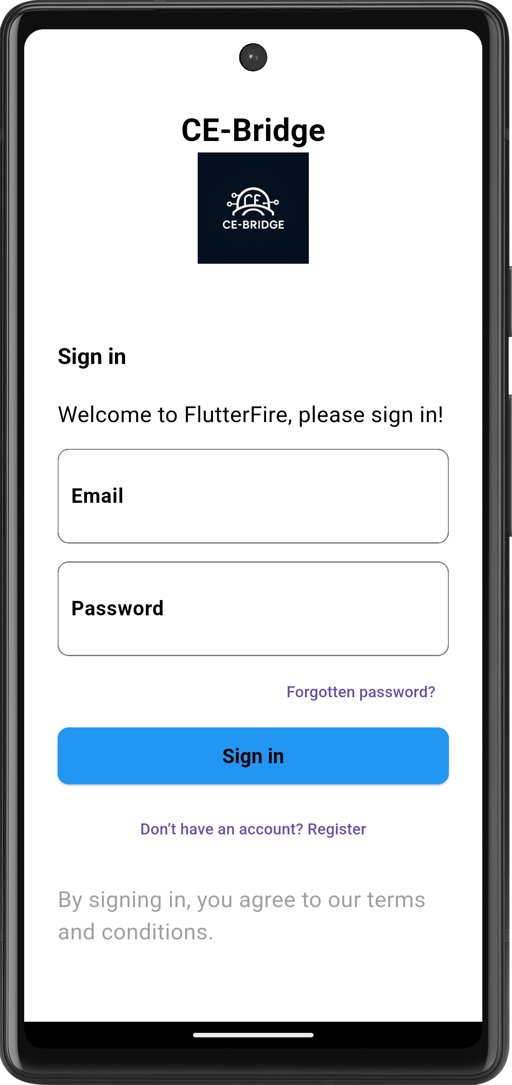
Figure 1: login

- Signup page: user sign up entering their name with the email that belong to the university and enter strong password and choose the role of either student or admin and then their ID number

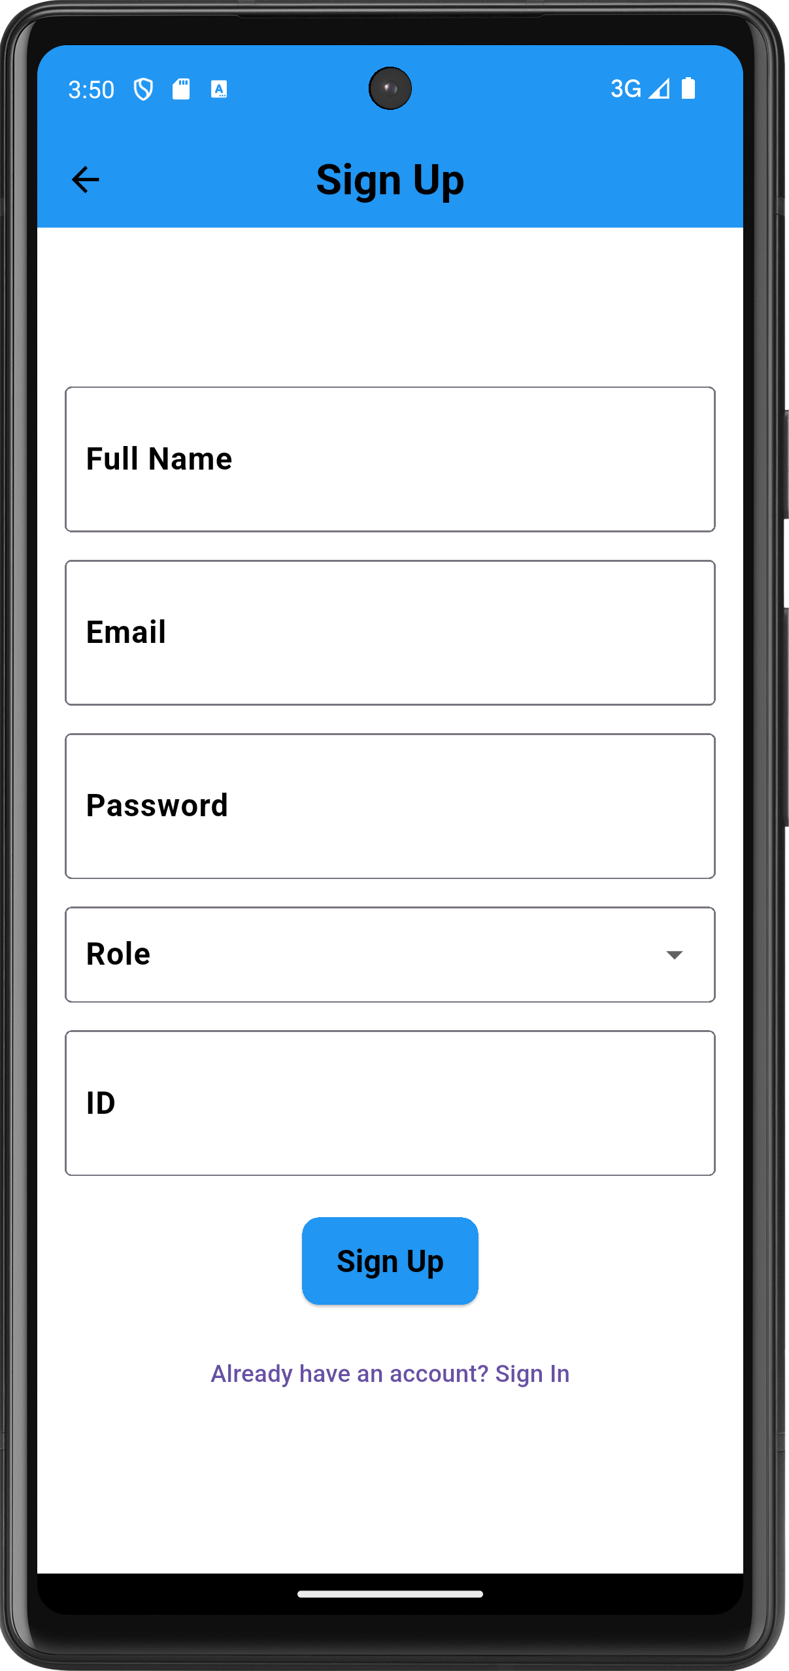
Figure 2: sign up
- Verification page: wait the action from user and verifying to continue by the verification to their email
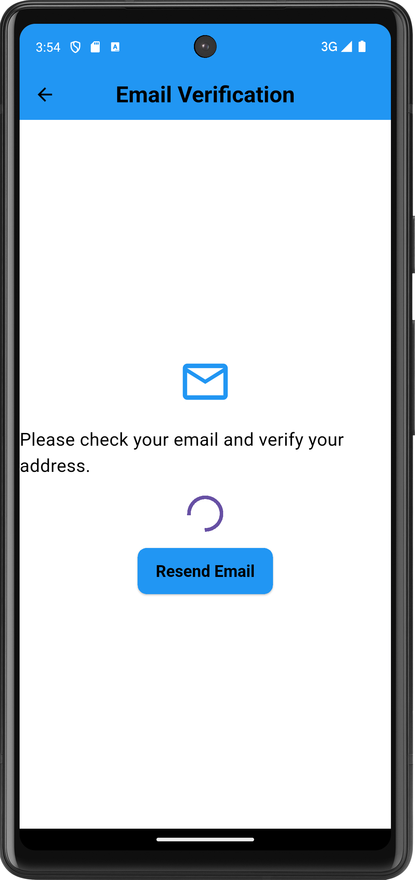
Figure 3: Verification page
- Verification Email:

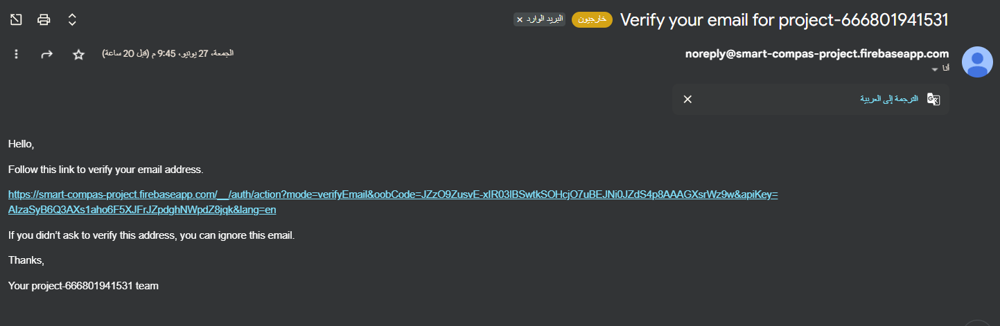
Figure 4: Verification Email
- Verification Message: congratulation your email verified
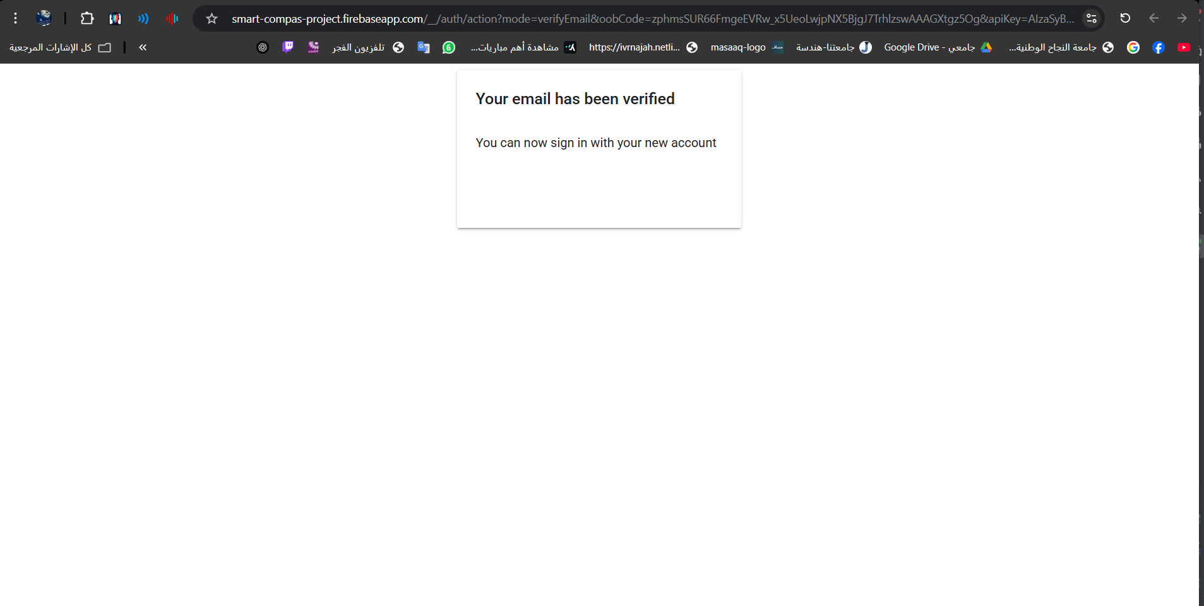
Figure 5: Verification Message

- Forget password: from login page user can choose “forgotten password?”

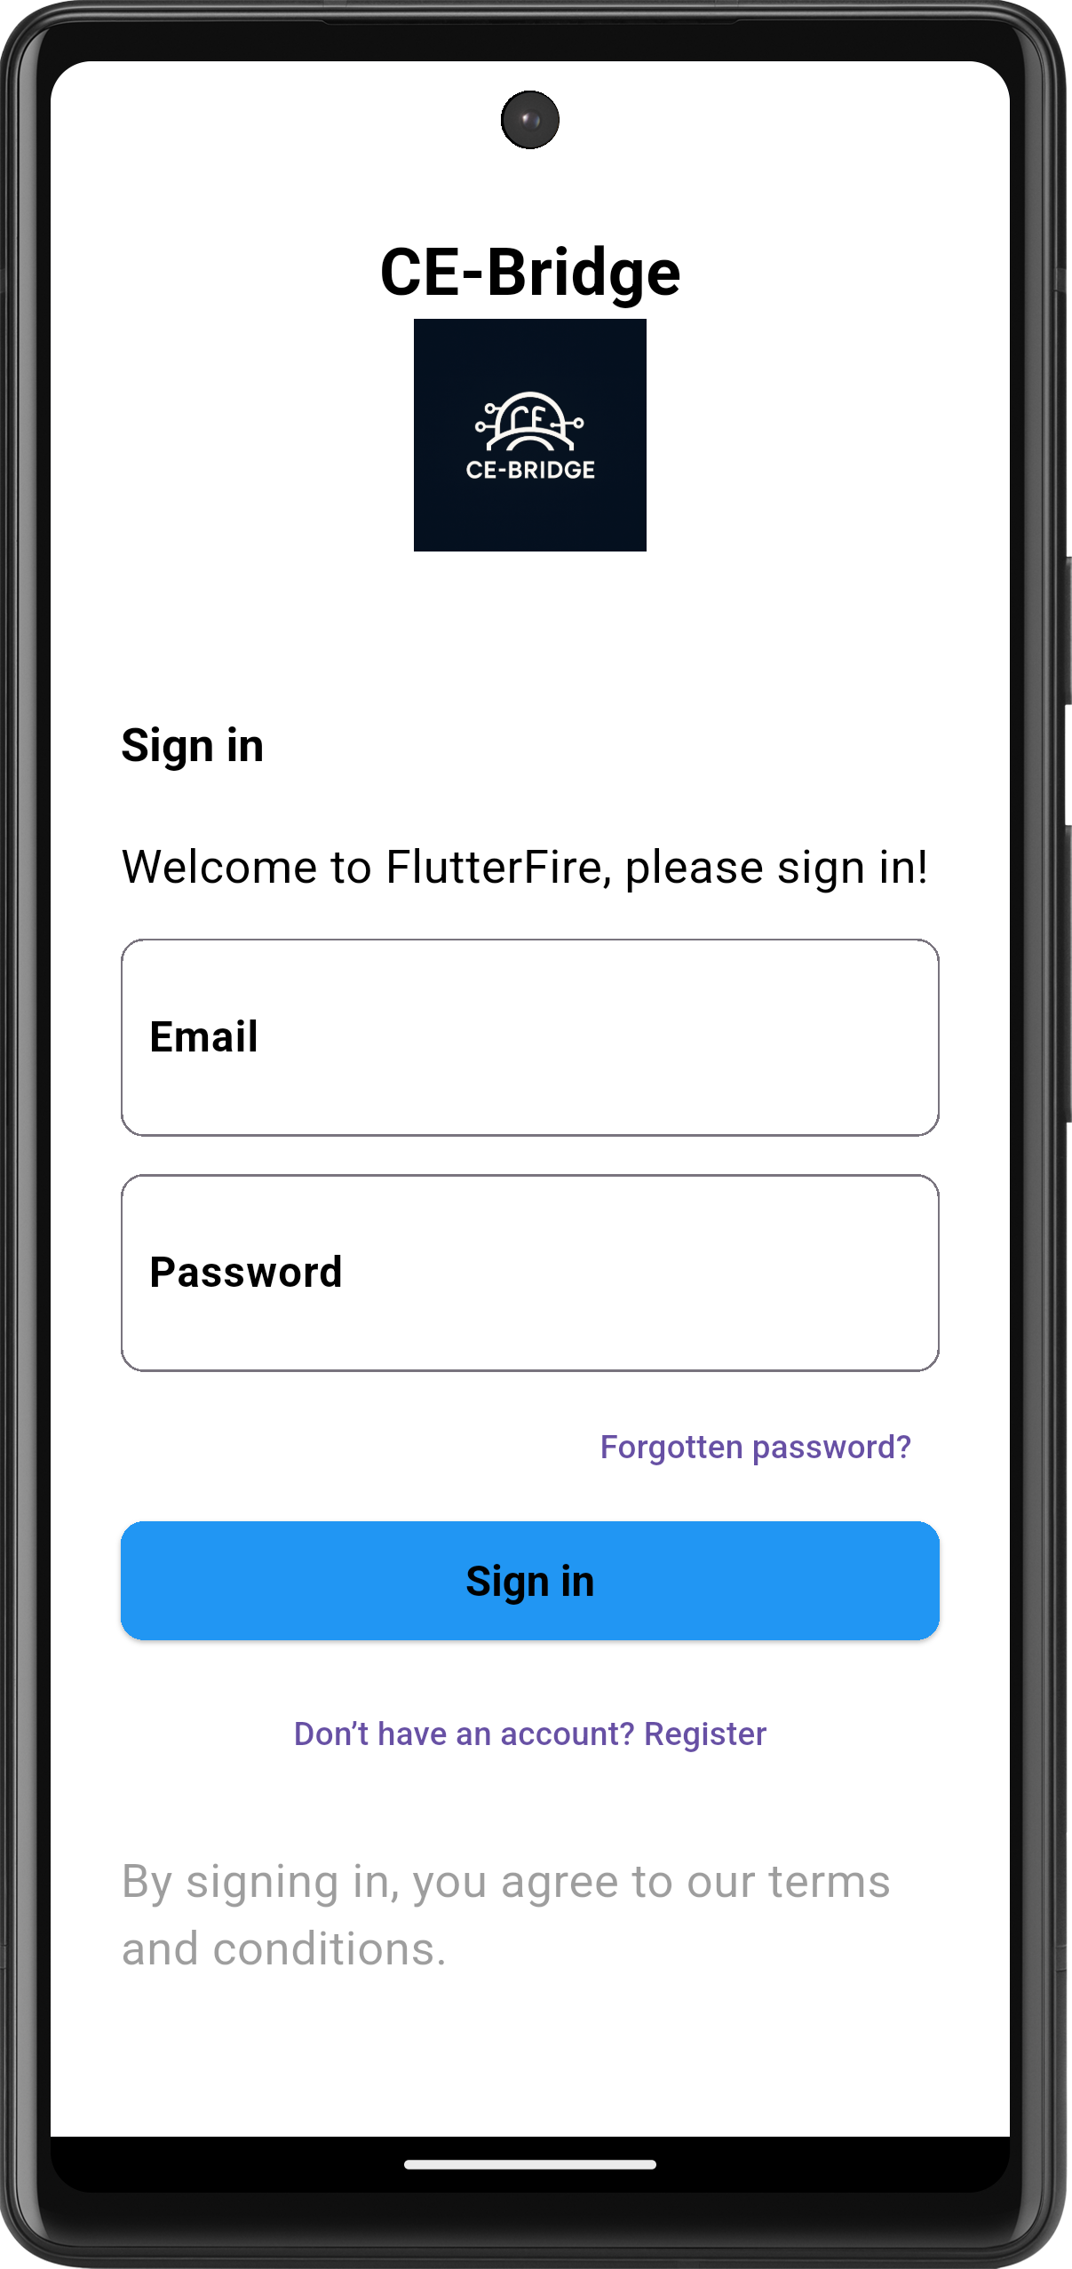
Figure 6: forget option
User enters their email:

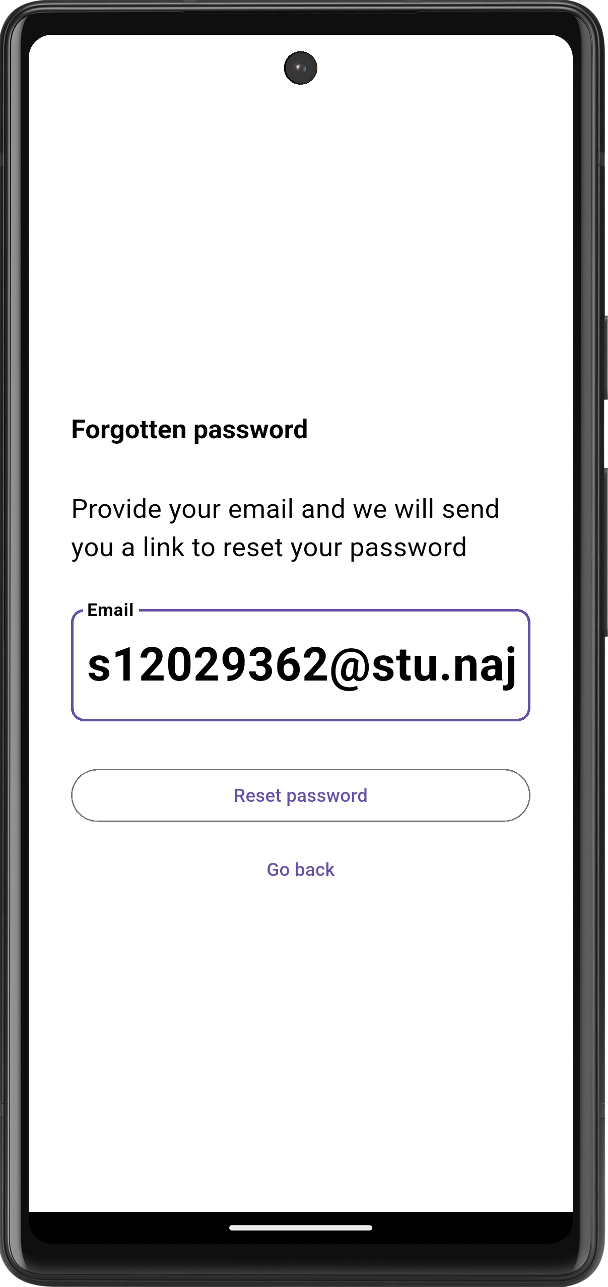
Figure 7: Forget page

Reset email sent to user:
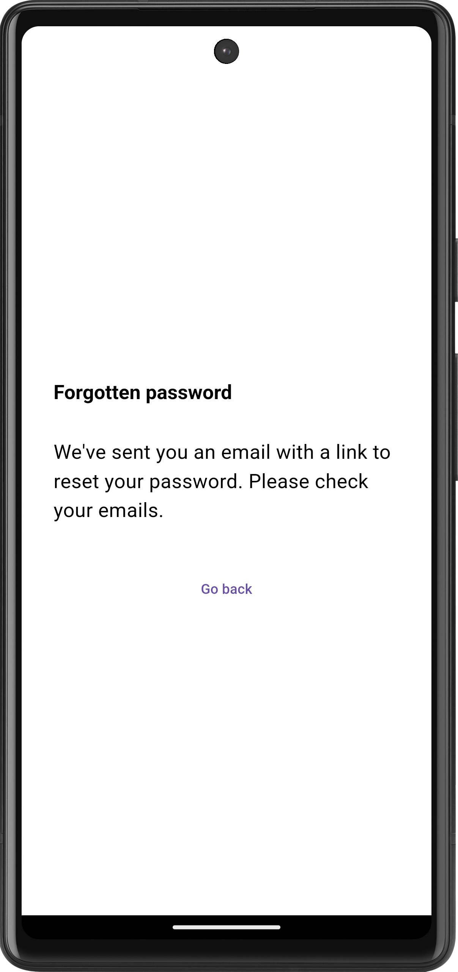
Figure 8: Reset email sent

The reset email received
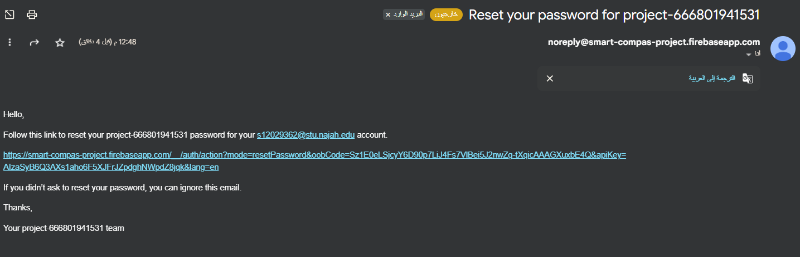
Figure 9: Reset email received
User resets their password
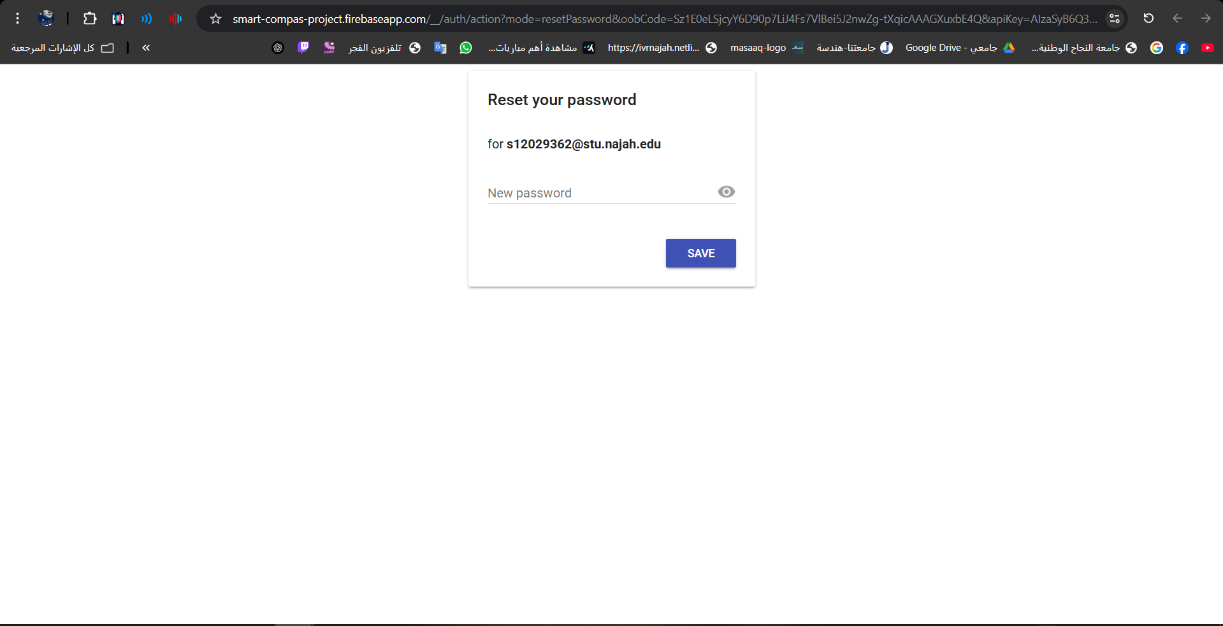
Figure 10: Reset password

Congratulation you can now login!
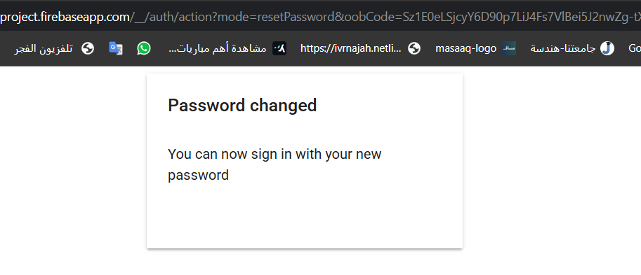
Figure 11: Password changed

Home page

- Announcements tab
Shows the department announcements and section announcements, student can browse announcements and interacts with course ones, either vote on specific section they like or enroll in it and account themselves in it

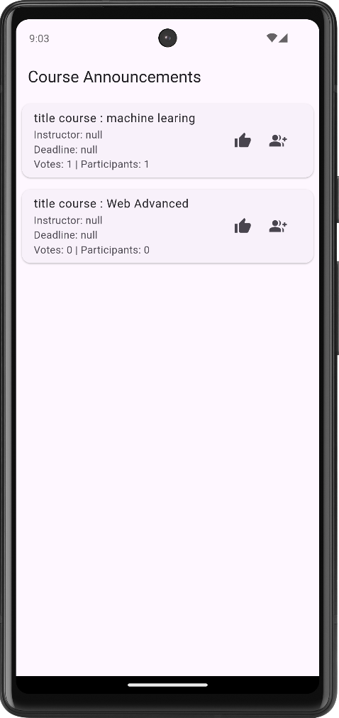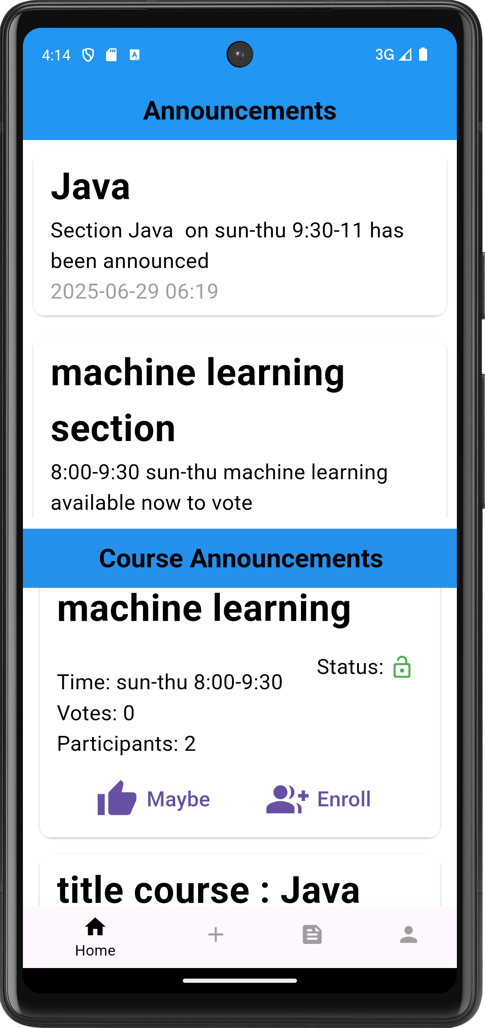
Figure 12: course announcements Figure 13: announcements

- Request action tab
Student can choose a section and either enroll or withdraw and put details or specific reason for that

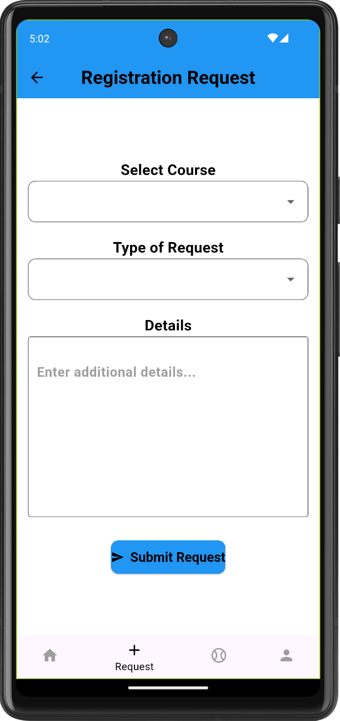
Figure 14: registration request

- Profile: list the name and email of the student and the partnership button and then supervisor and settings and last and not least logout

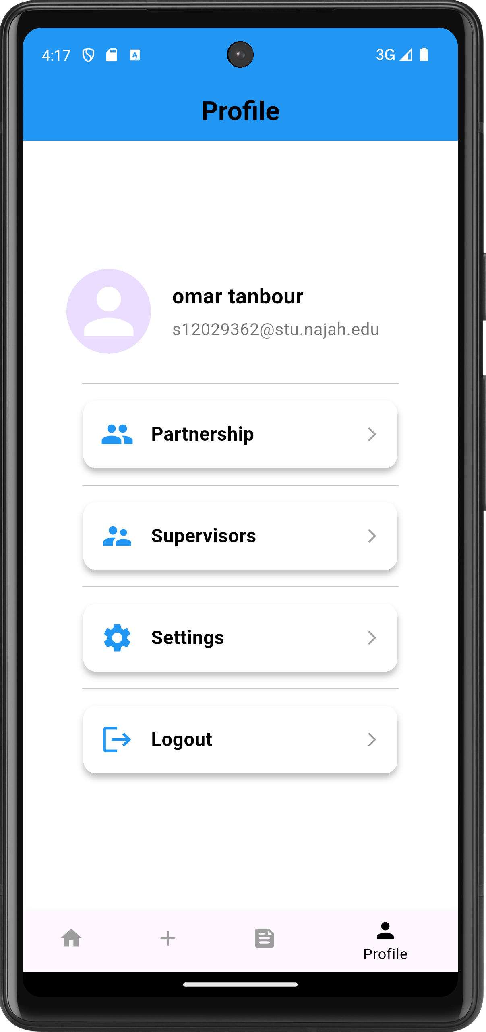
Figure 15: Profile

Partnership
The page where student’s partners list and find them and their info and if there’s a space showed suggestions

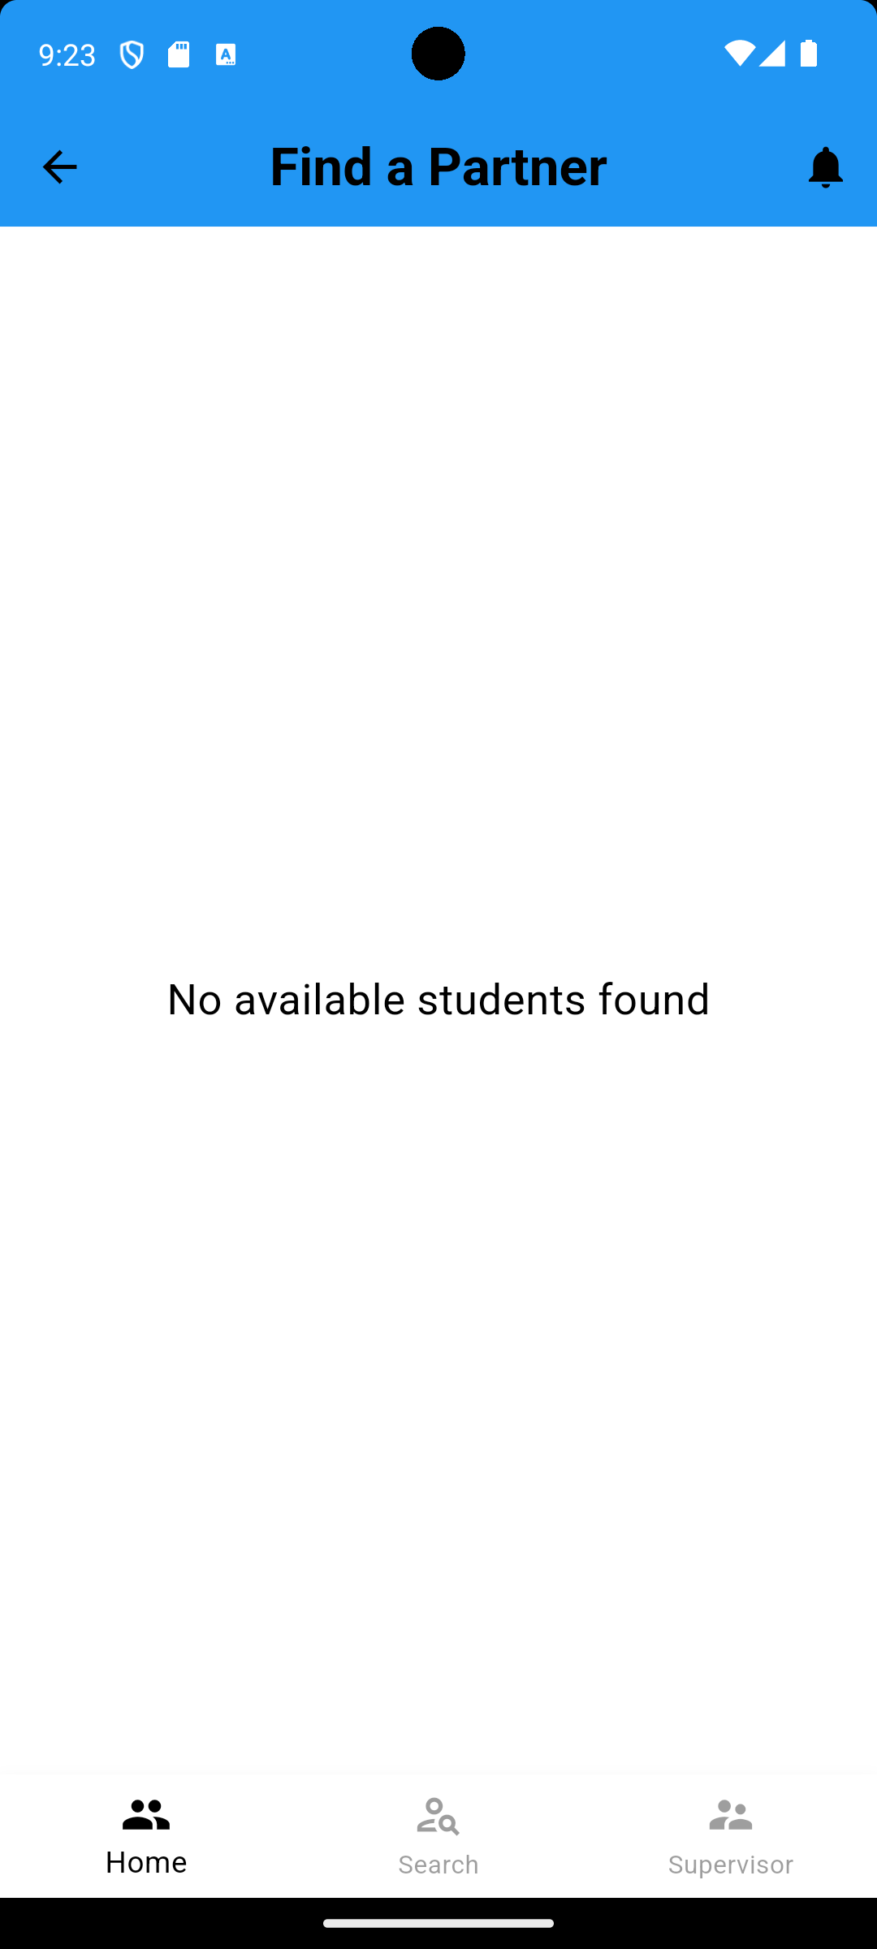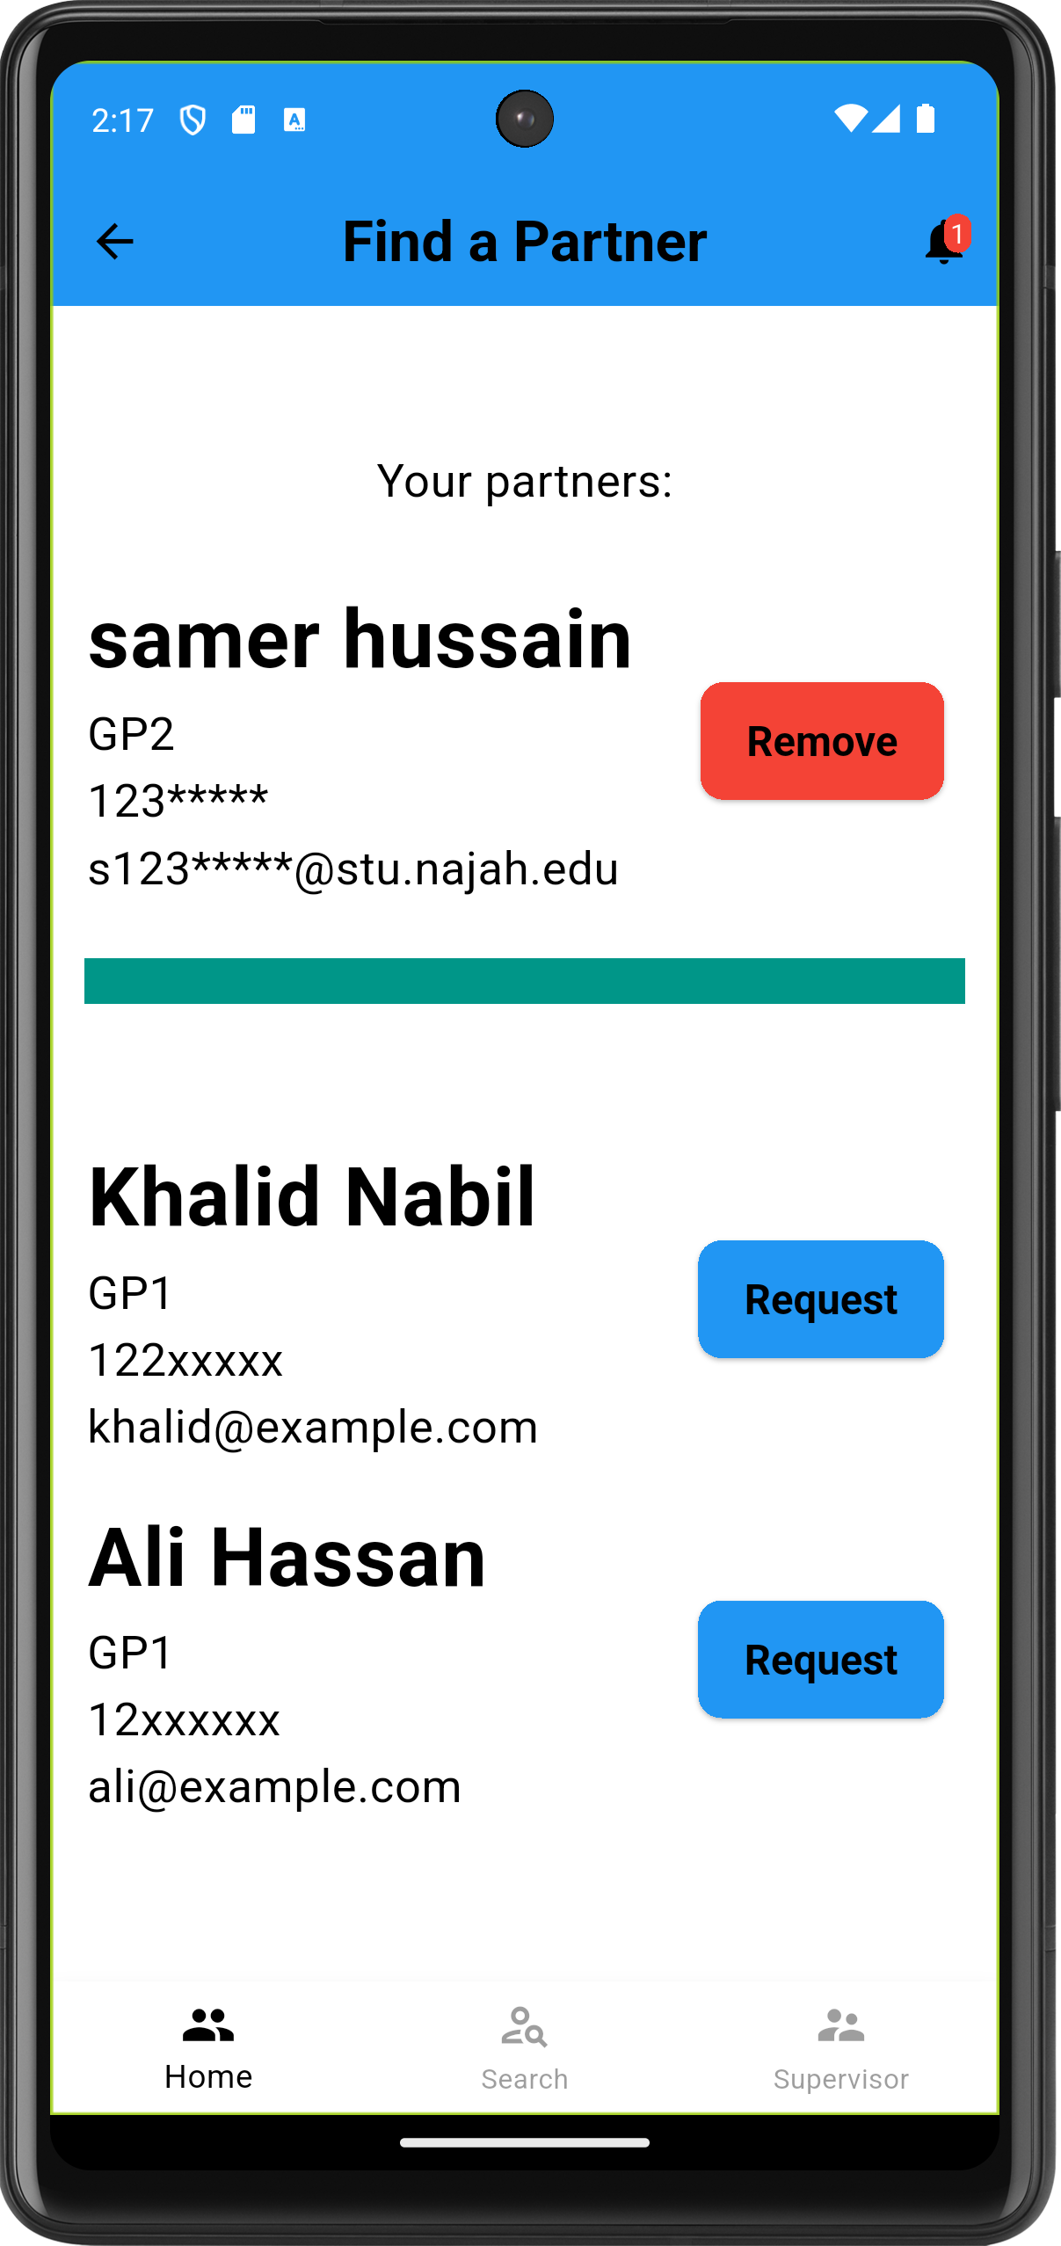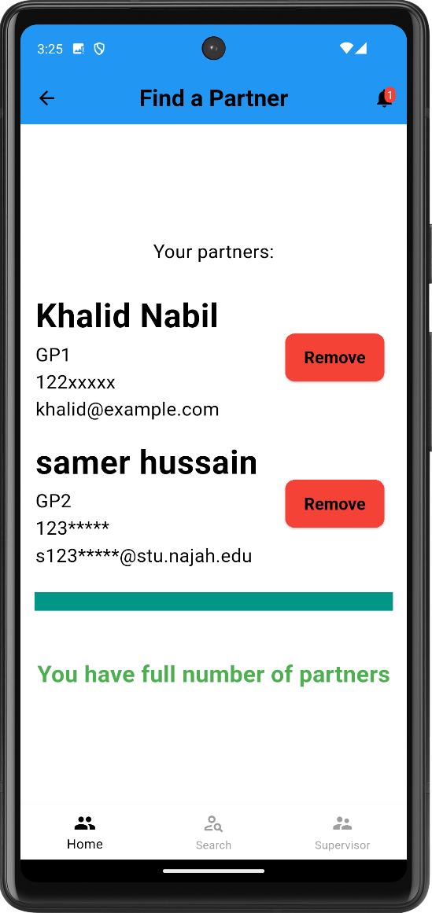
Figure 16: Partnership Figure 17: partner alone Figure 18: full Partnership

- Search for partner
The student can search for a partner with different ways and then to send request to others students and even if this not lead to get one, they can post a public request after choosing a project that show as suggestion to all other students with a space to a partner.

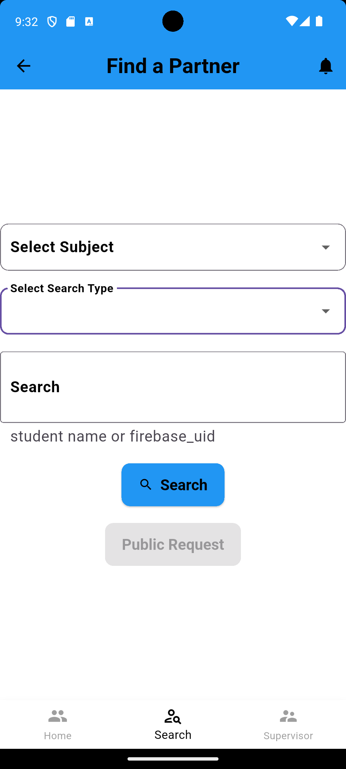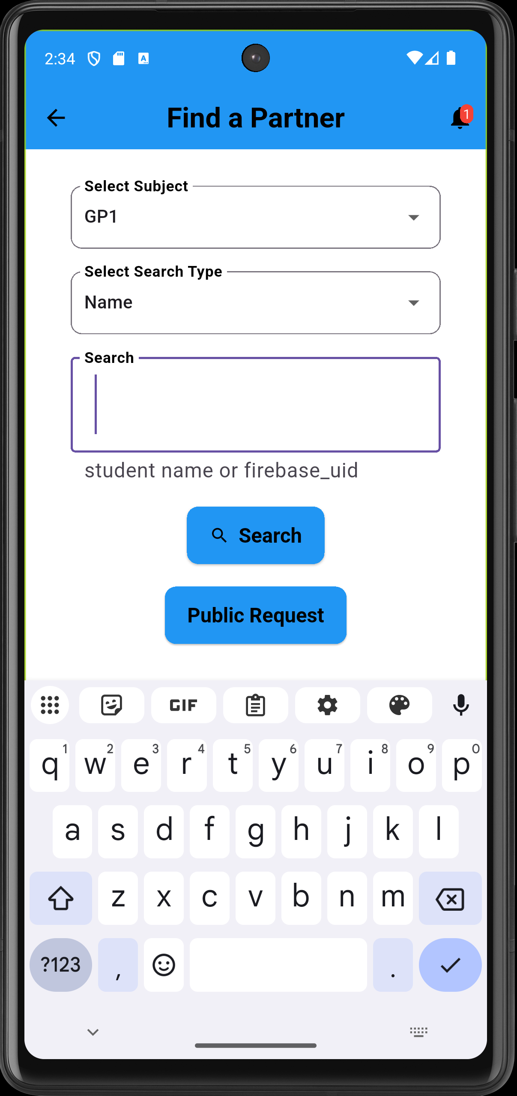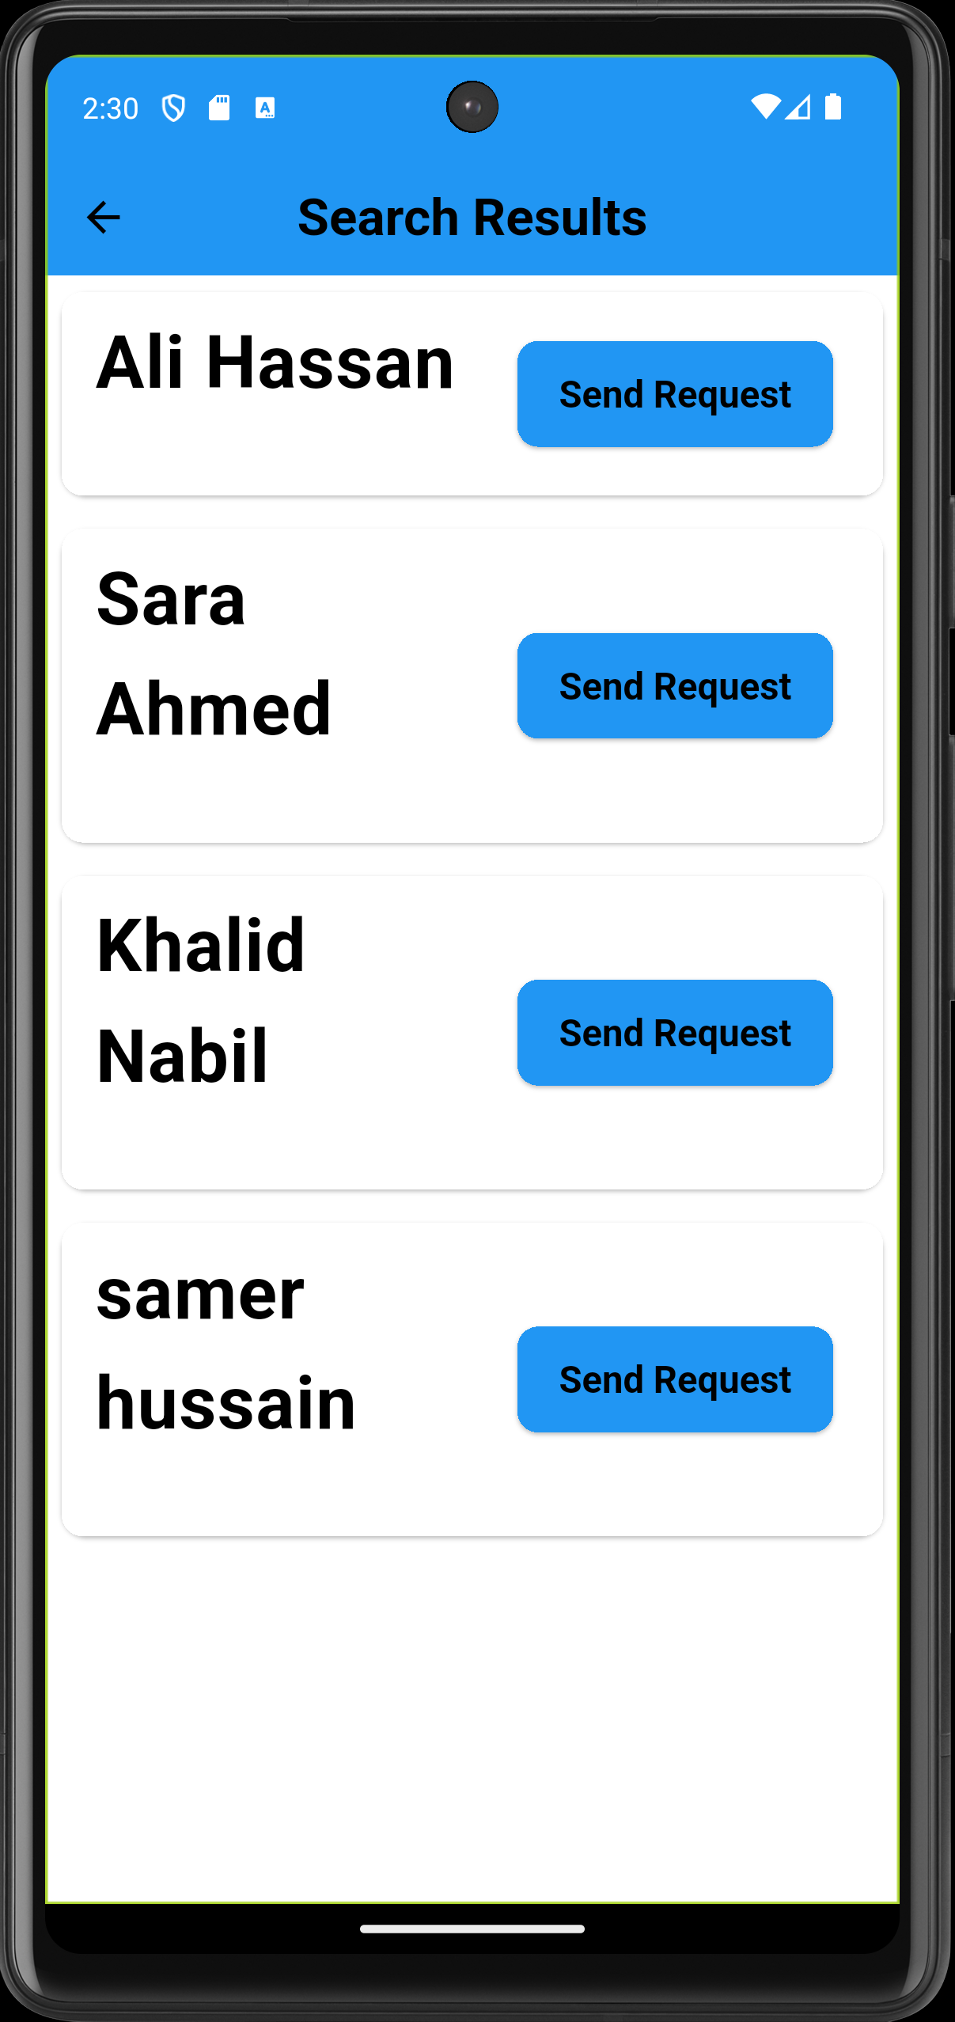
Figure 19: search for a partner Figure 20: search for partners Figure 21: partner result search

- Partnership requests
Incoming partnership requests for the student will reflect and appear as a count on the notification icon on the above right and will be listed in this page if they clicked it.

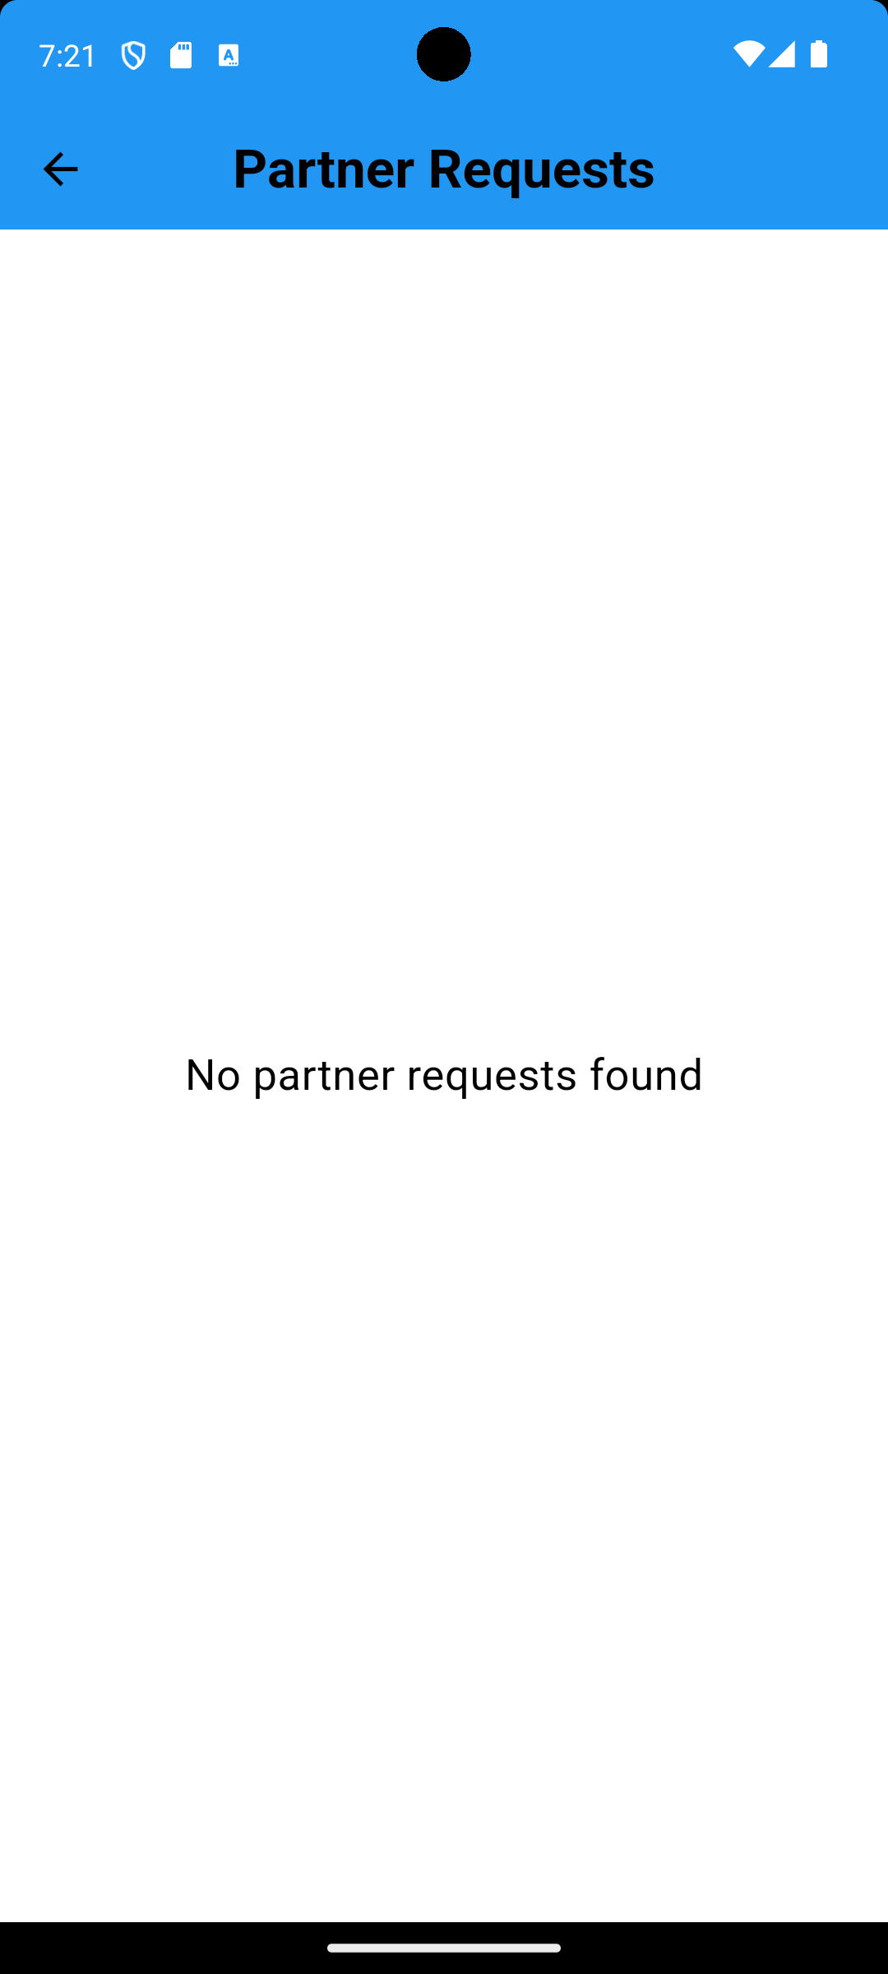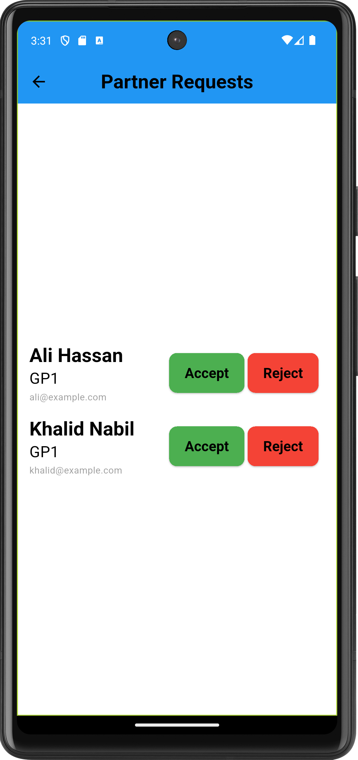
Figure 22: partner requests Figure 23: requests for partnership

- Supervisor request
Student after making a partner can now submit a request to a supervisor they choose

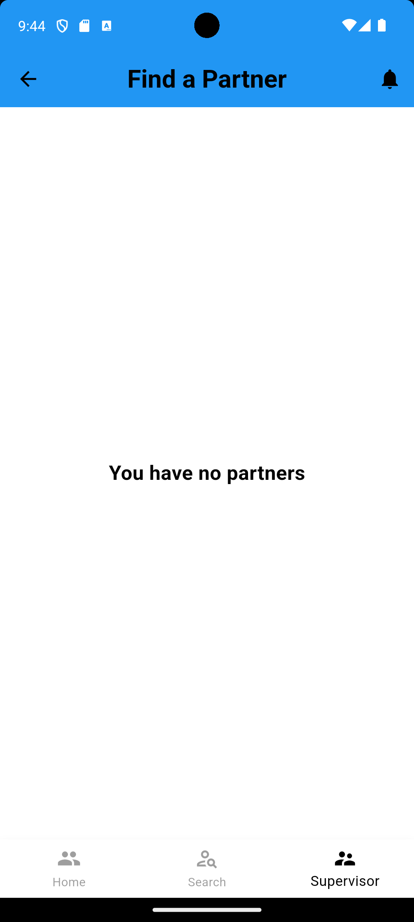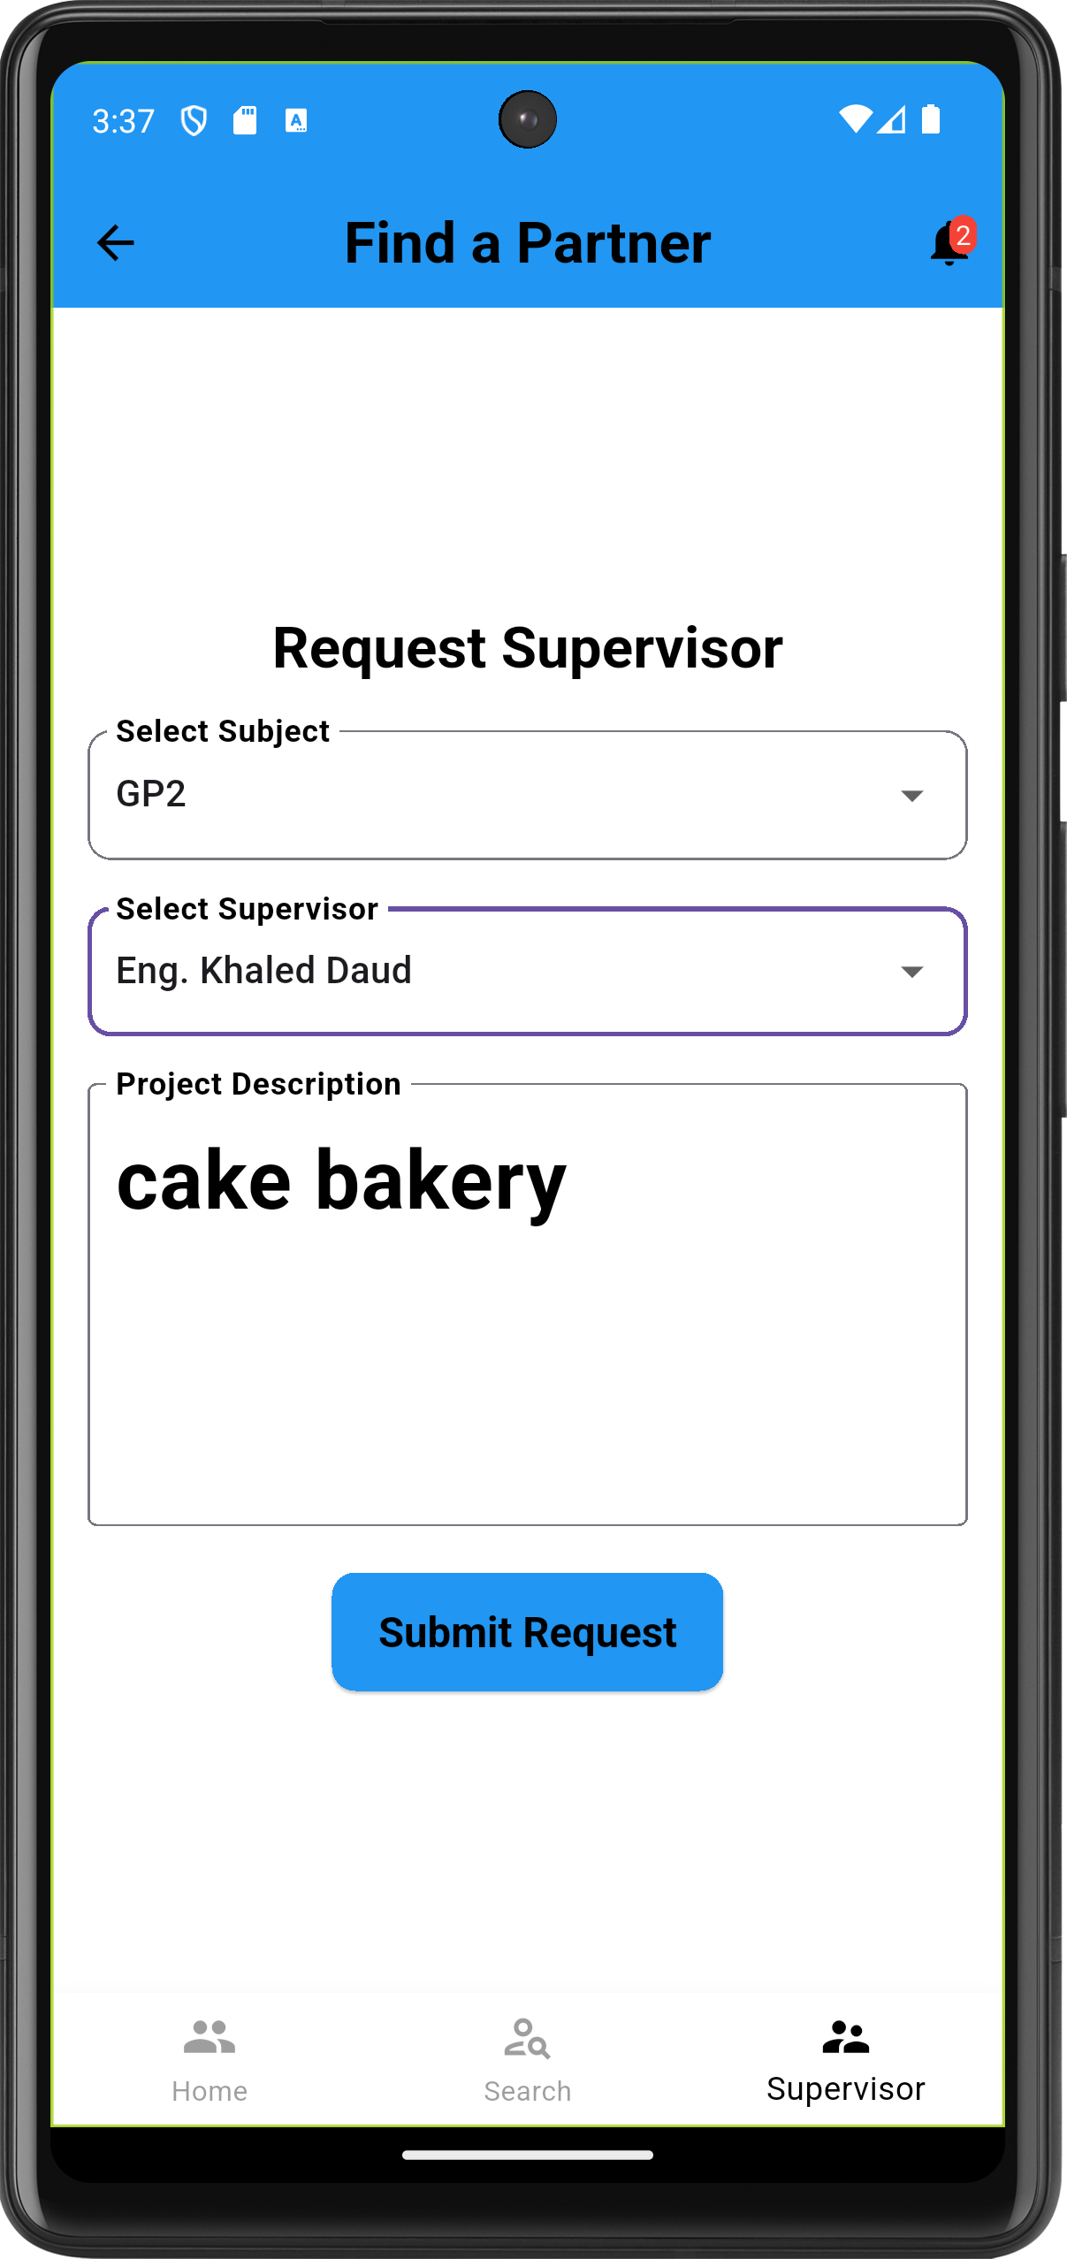
Figure 24: supervisor request

- Supervisors: approved supervisors for the user will list here

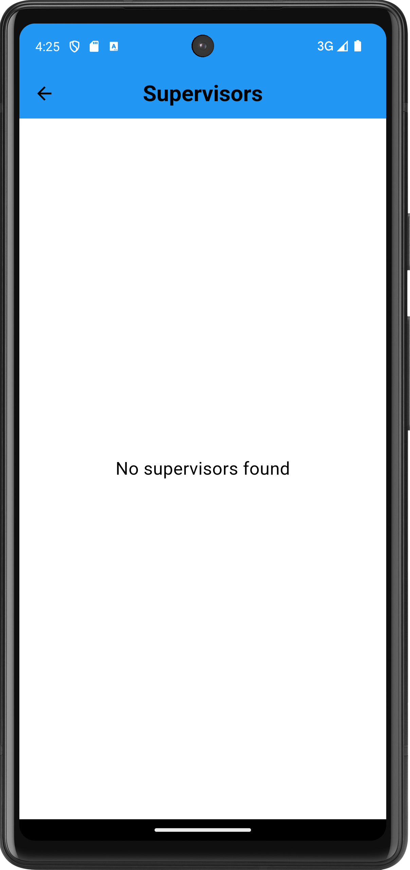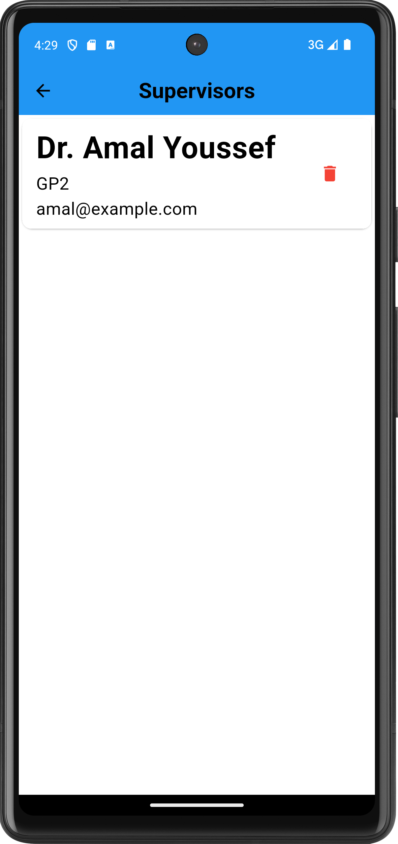
Figure 25: no supervisors Figure 26: supervisors

- Settings: here we can toggle the theme either light or dark mode for the app

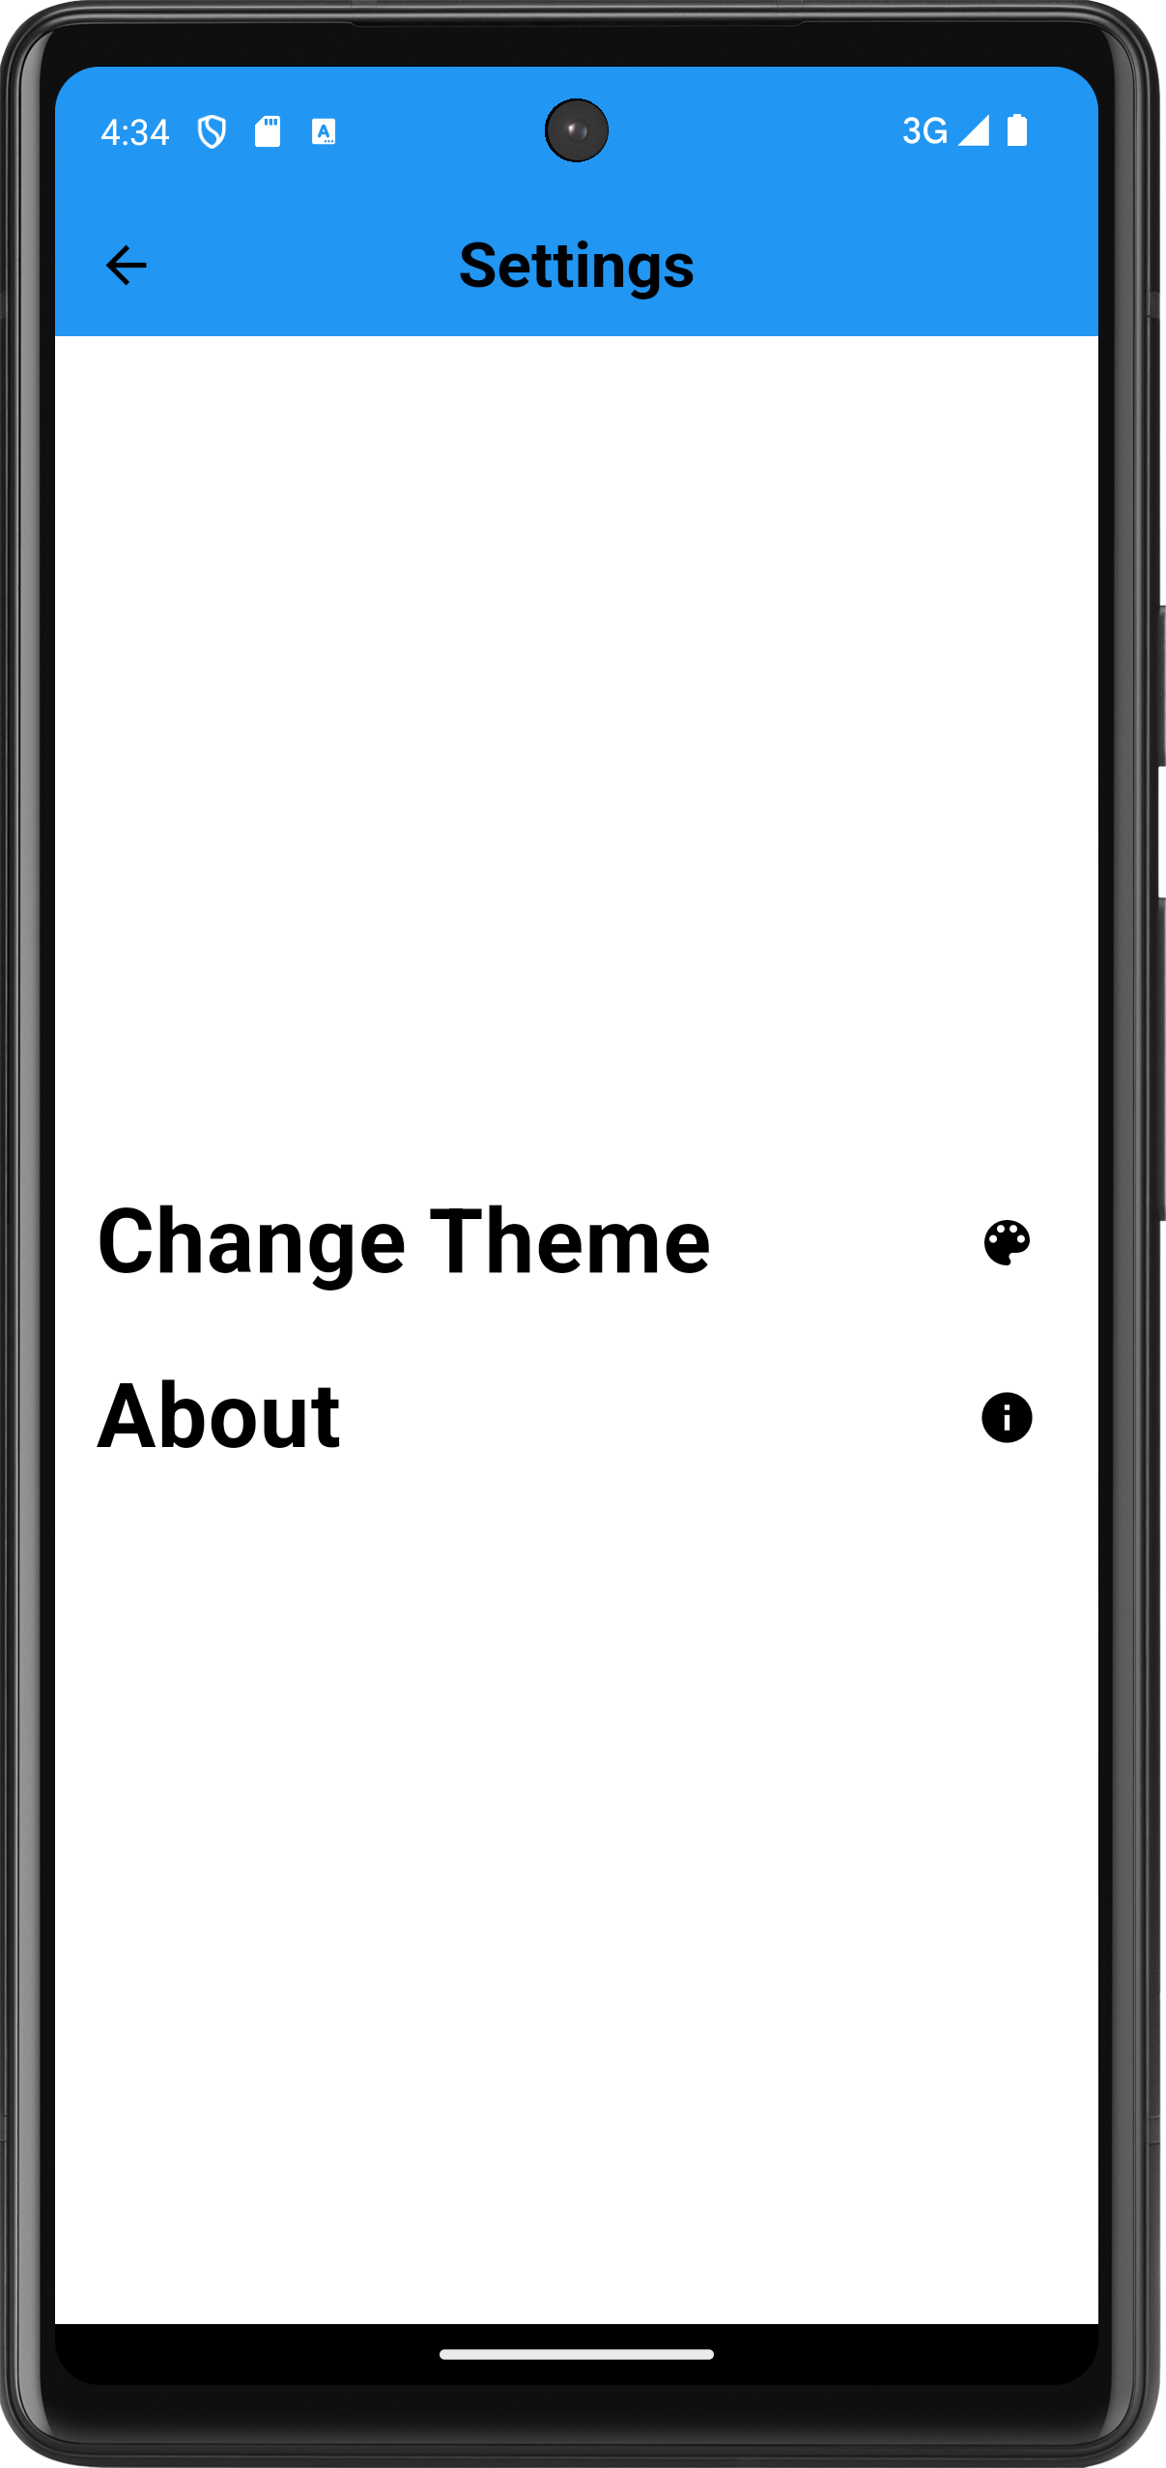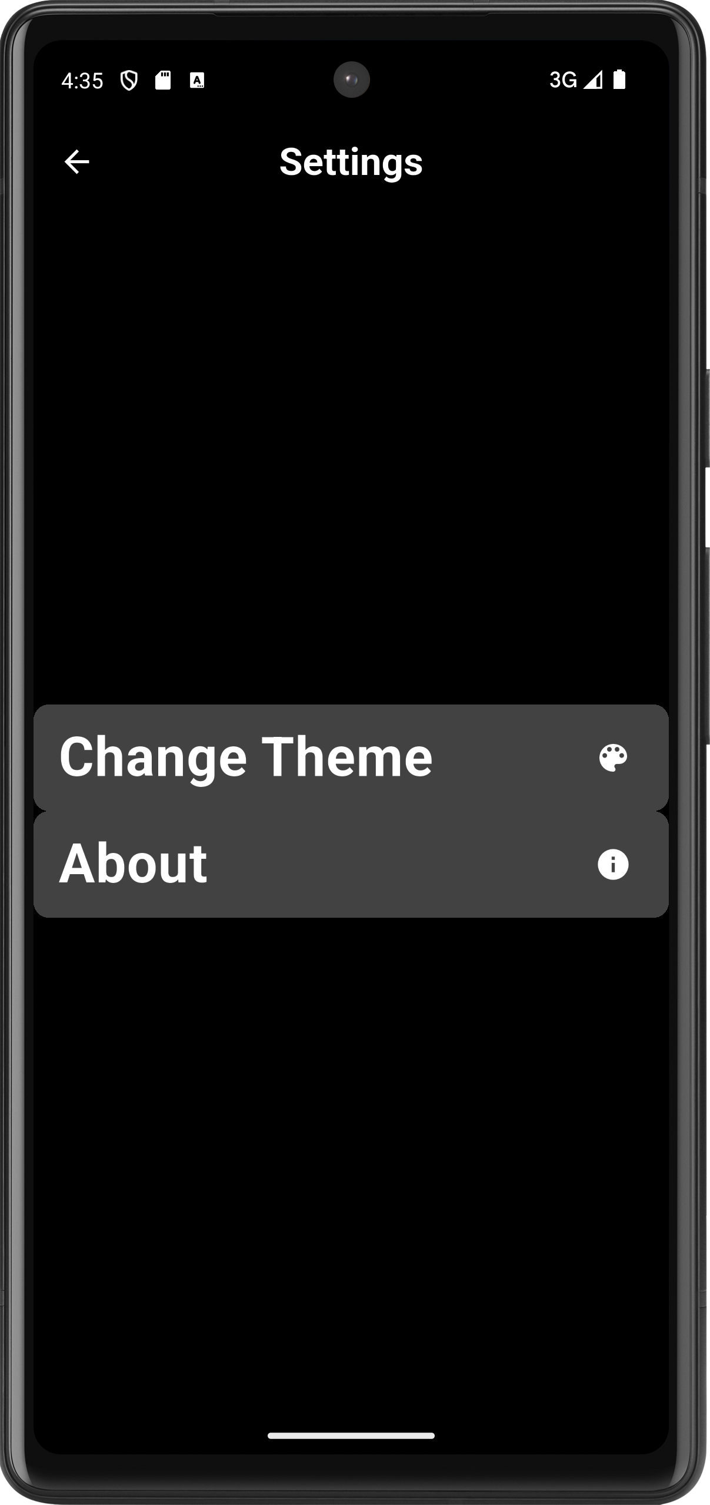
Figure 27: settings Figure 28: dark settings

- Dark Theme
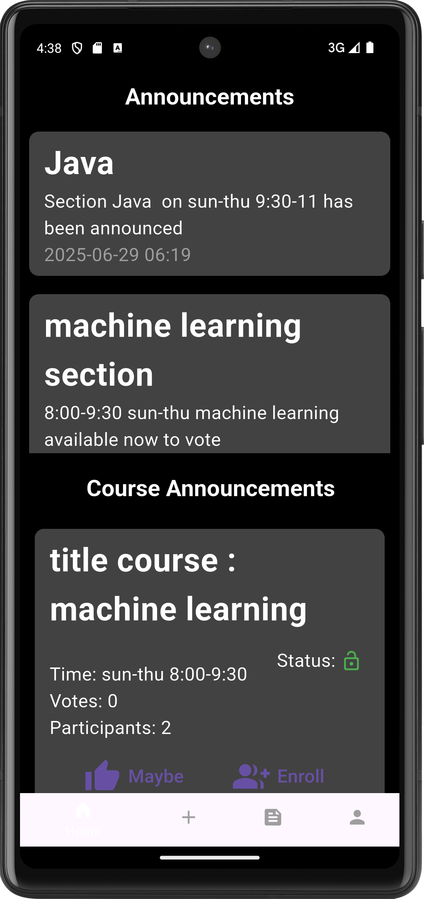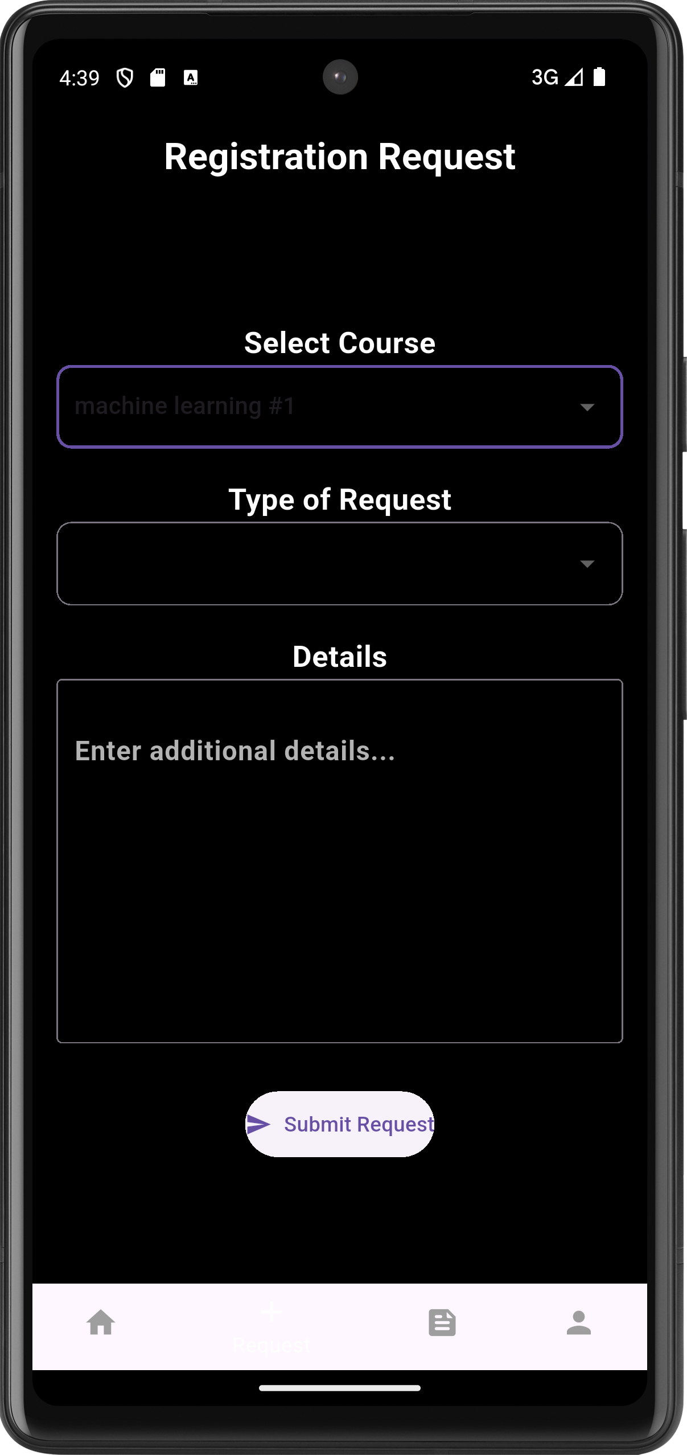
Figure 29: Dark Theme
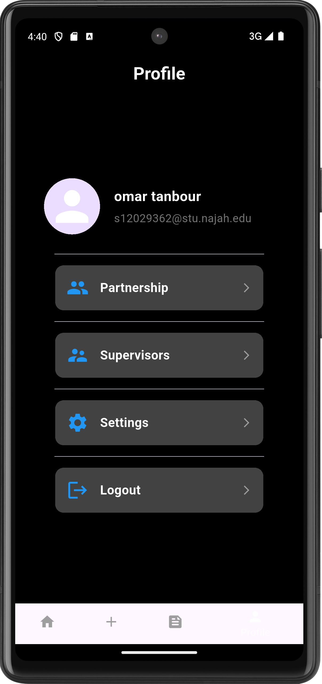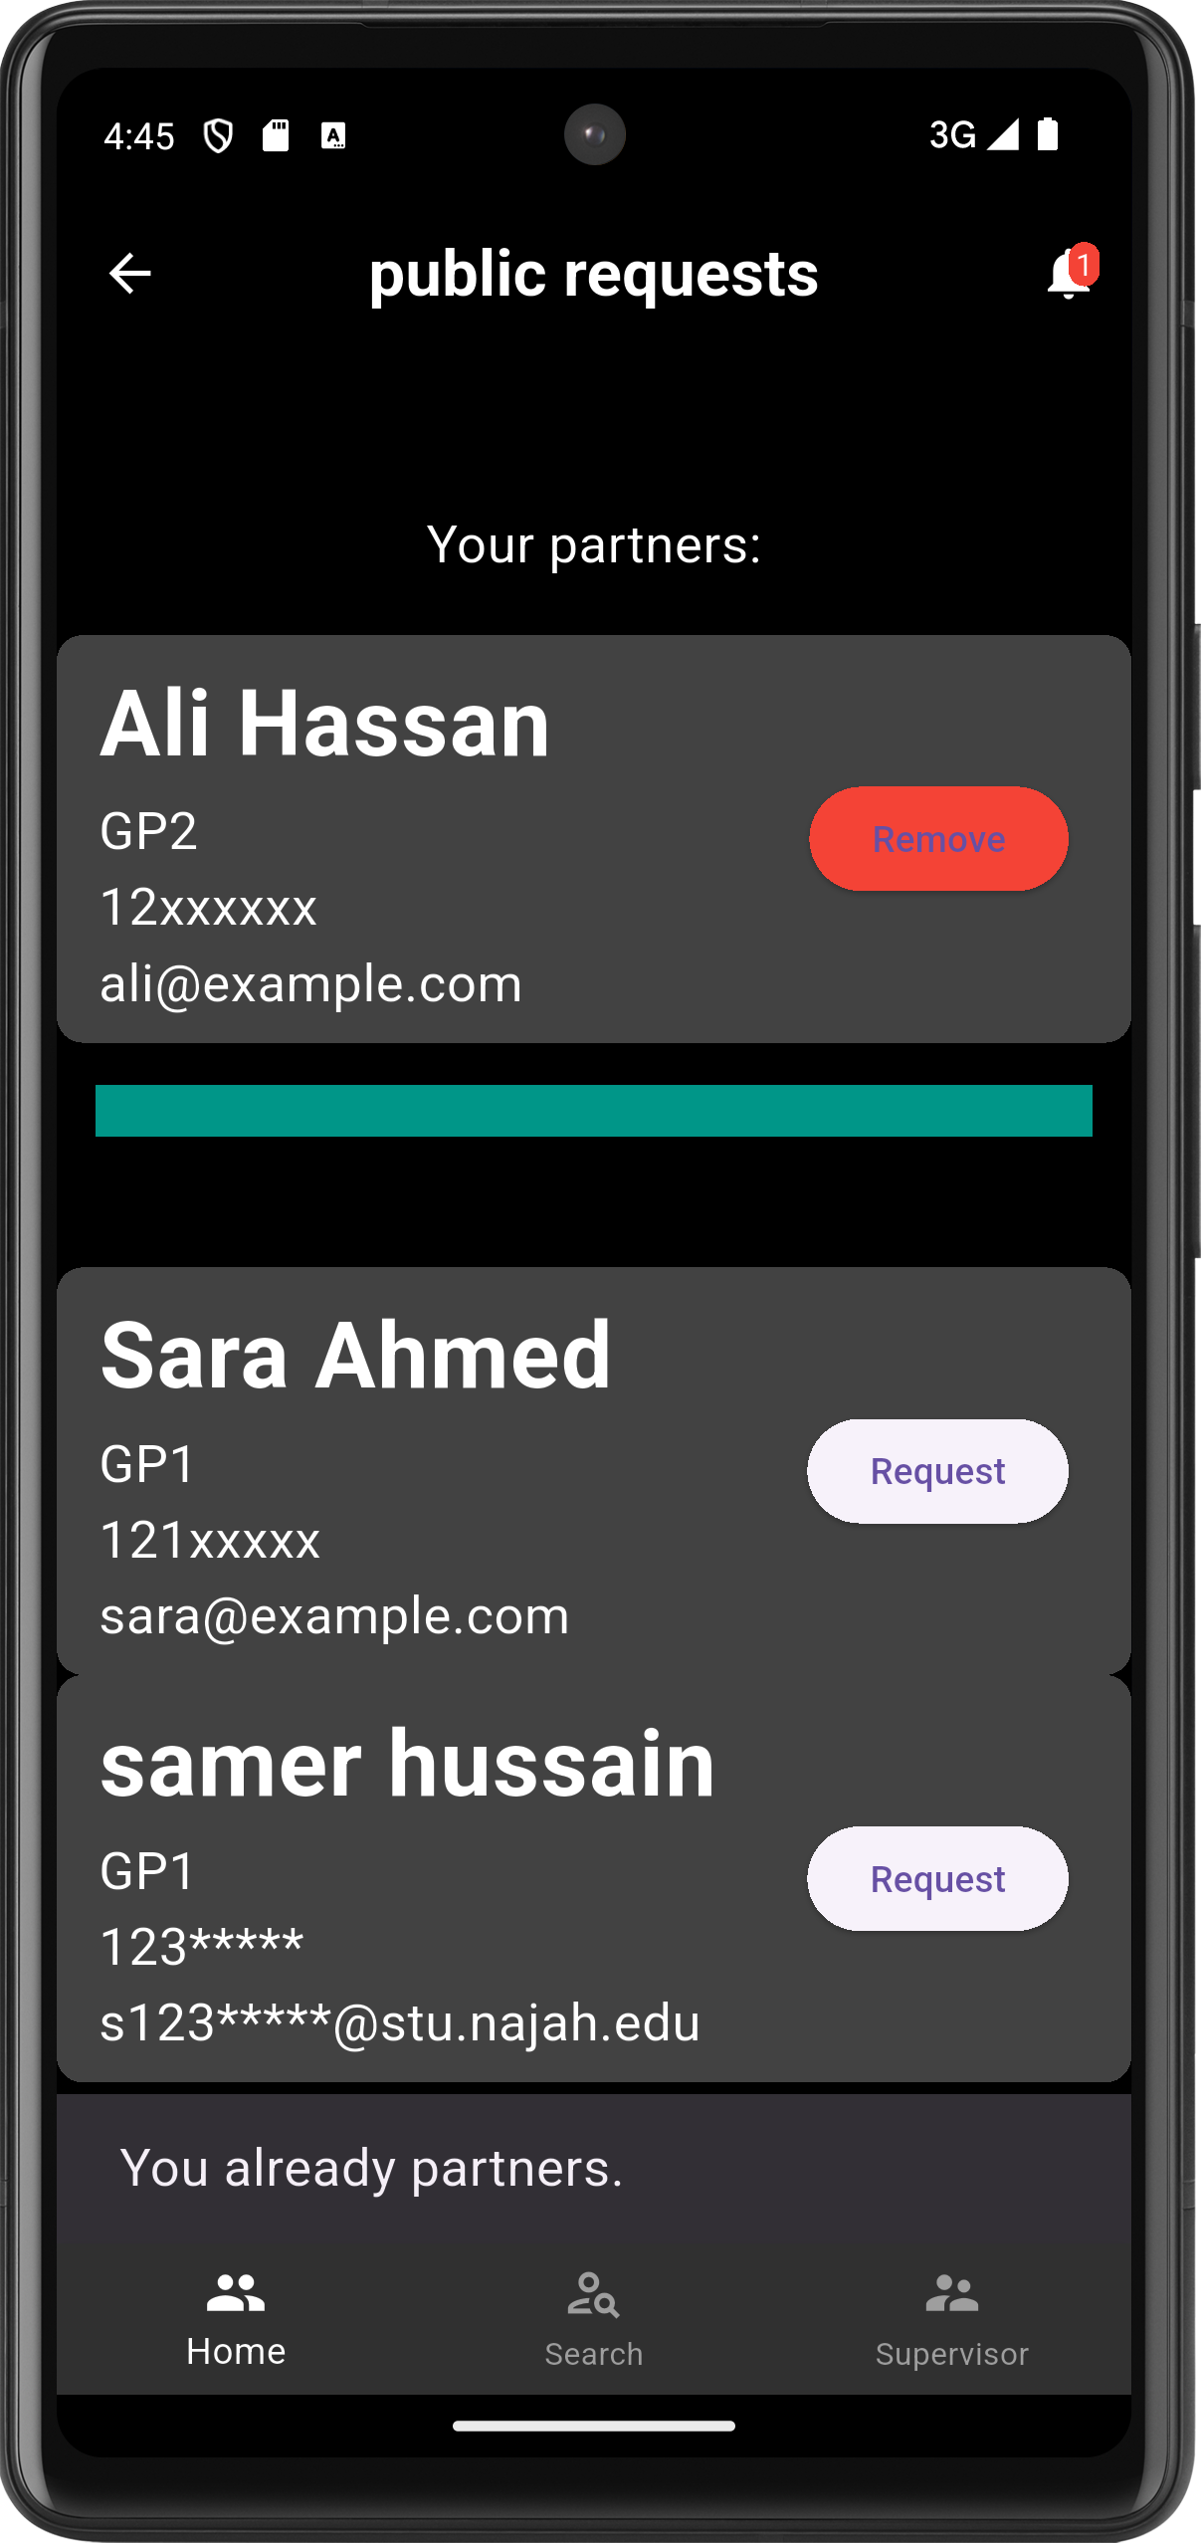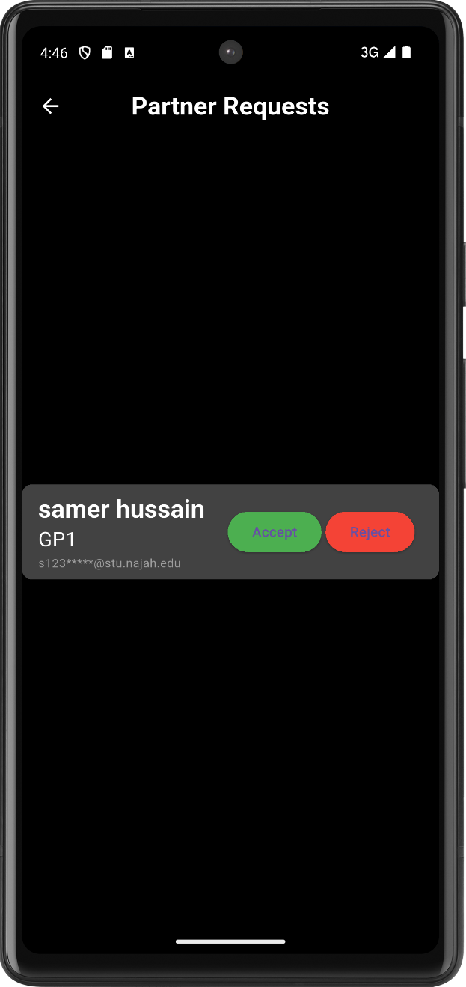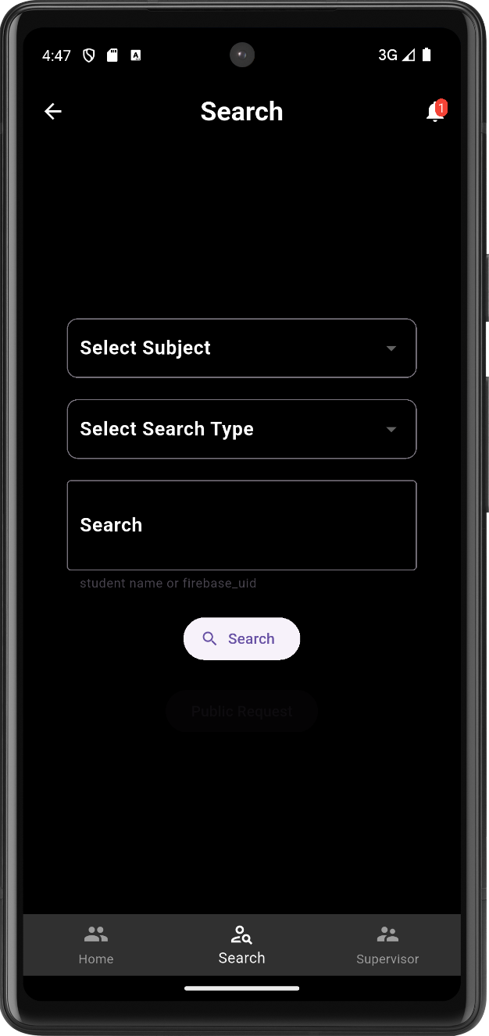

- Feedback
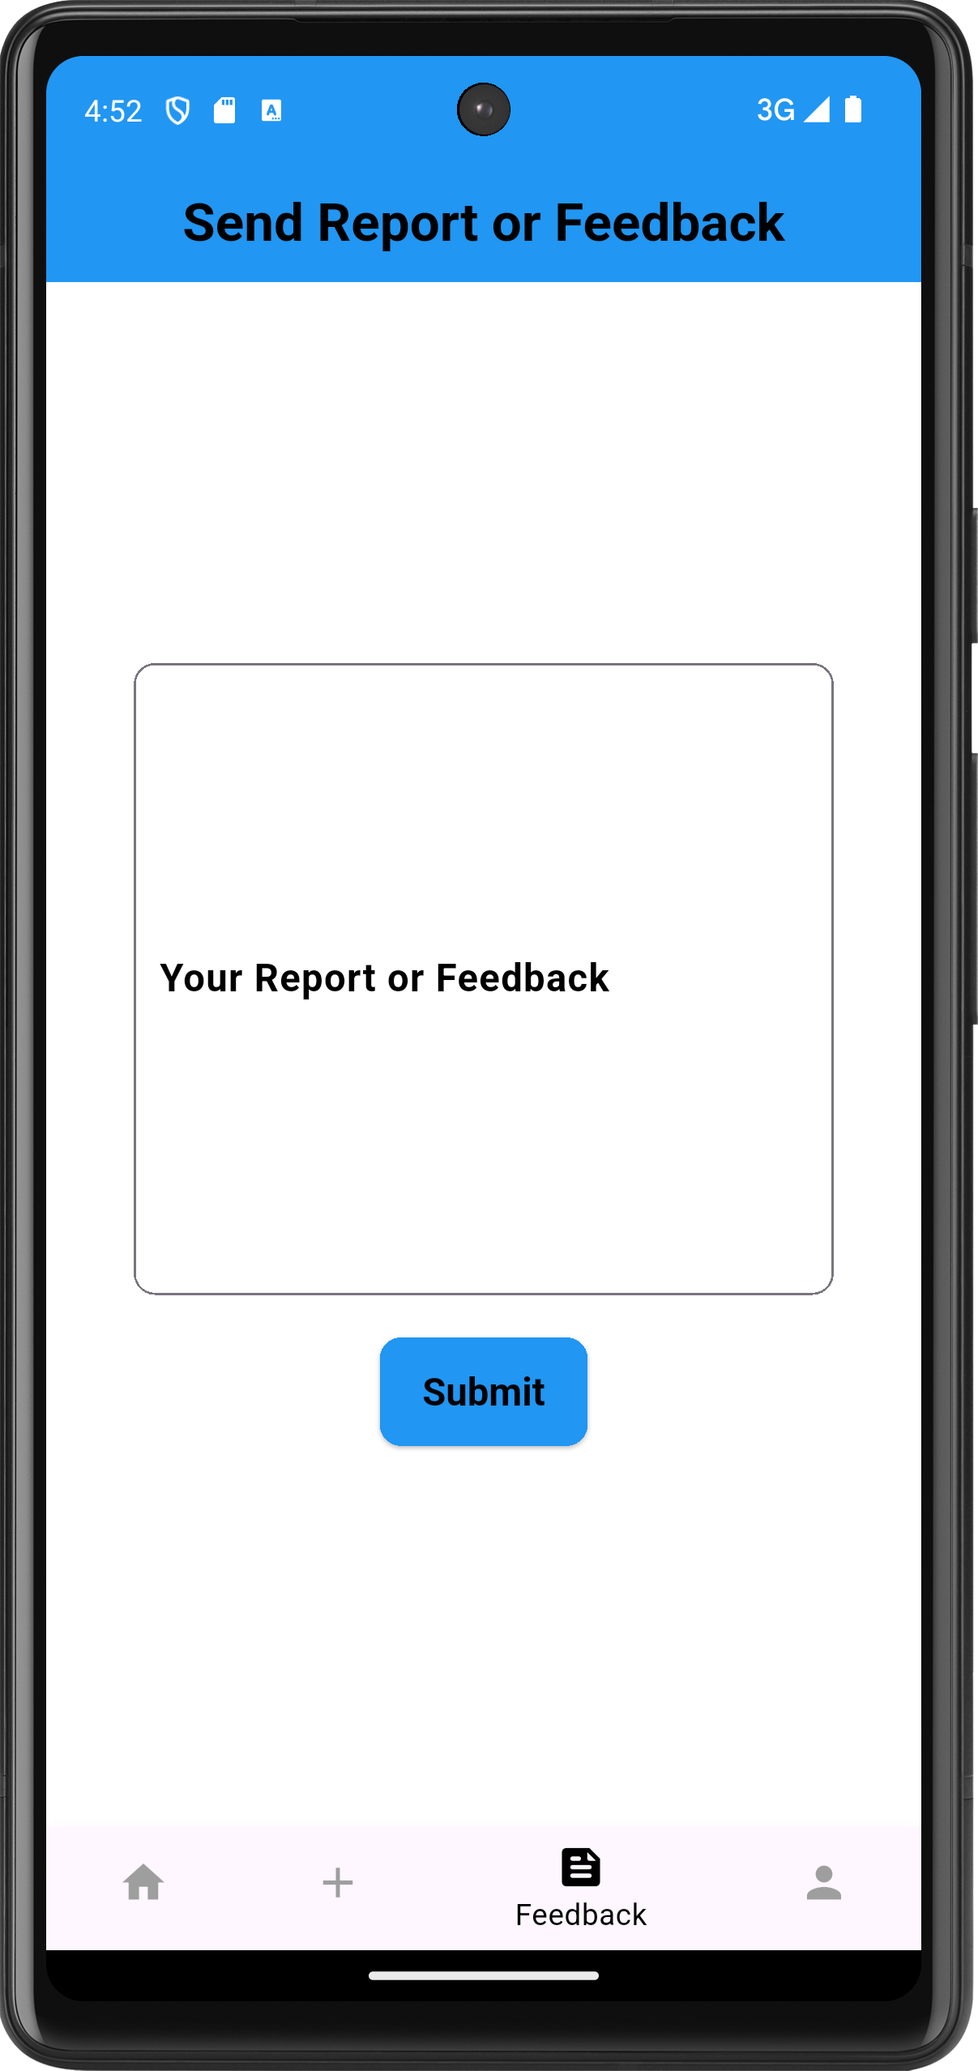
Figure 30: Feedback

Admin dashboard screens

- Overview
Some numbers and figures of the system and its statistics for general data and overview
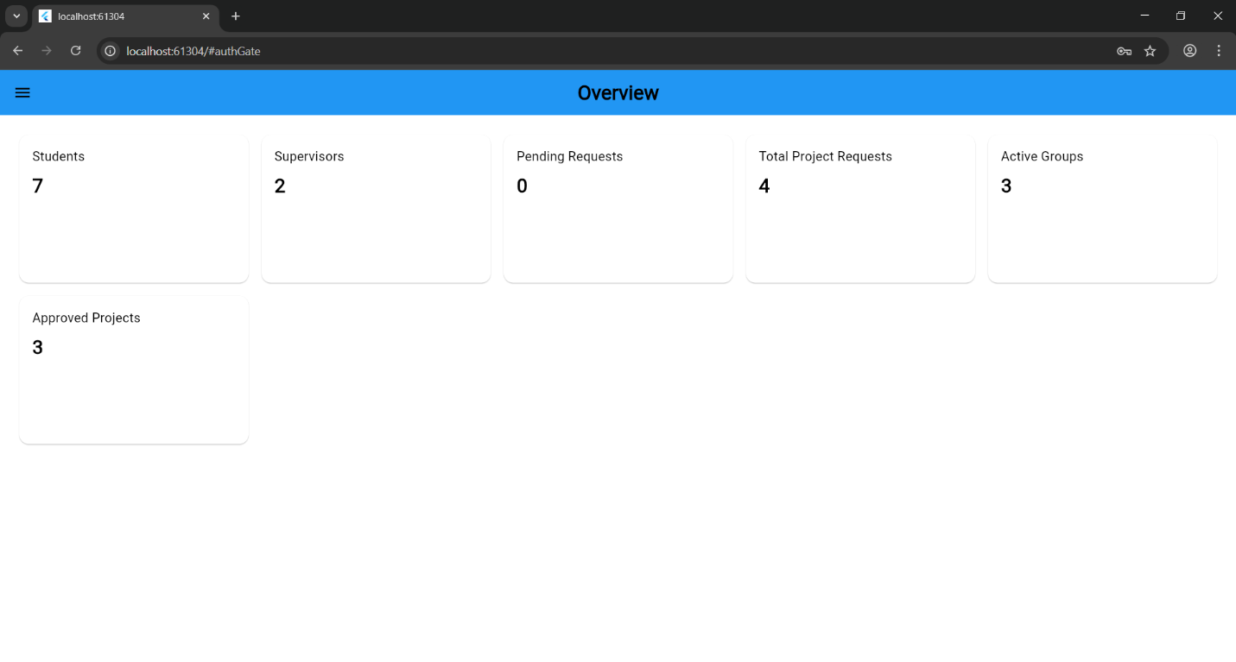
Figure 31: Admin overview

- Supervisor Projects
Here it lists the supervisors and for each there both project subjects
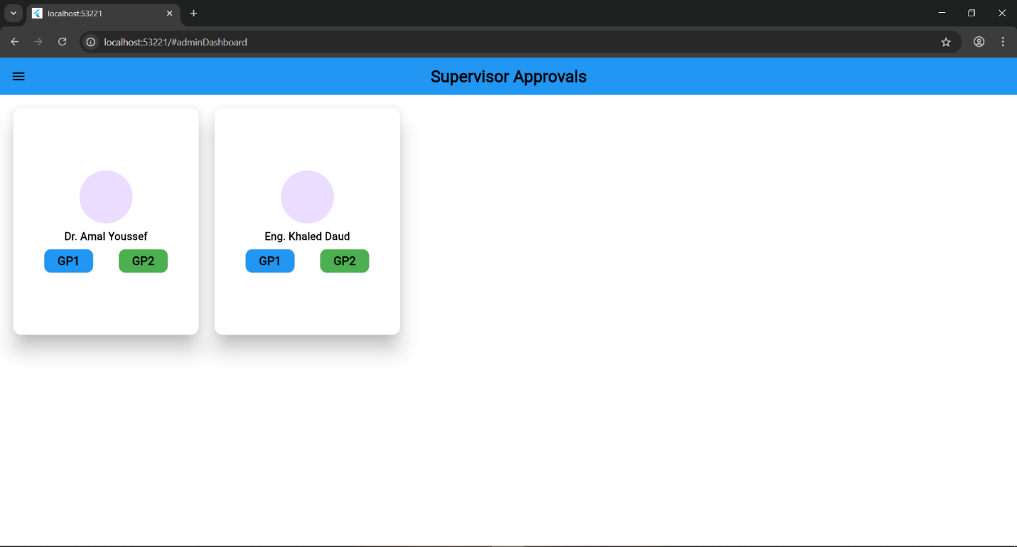
Figure 32: supervisors projects

- Supervision details & approvals
After click on one of project subjects for a supervisor this page appear that shows the approved (if exist) and pending groups with details
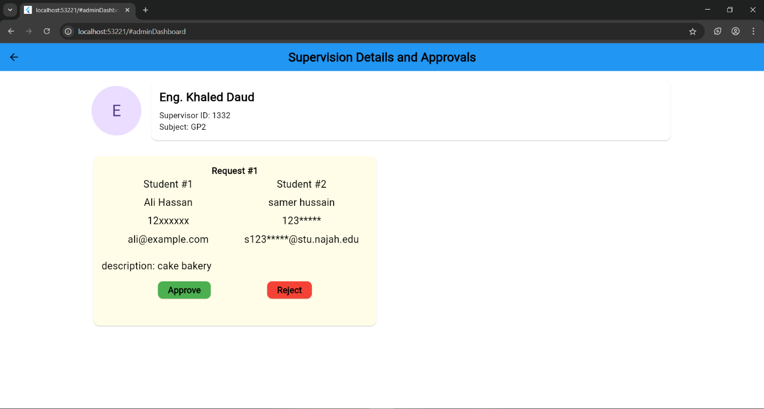
Figure 33: supervision pending
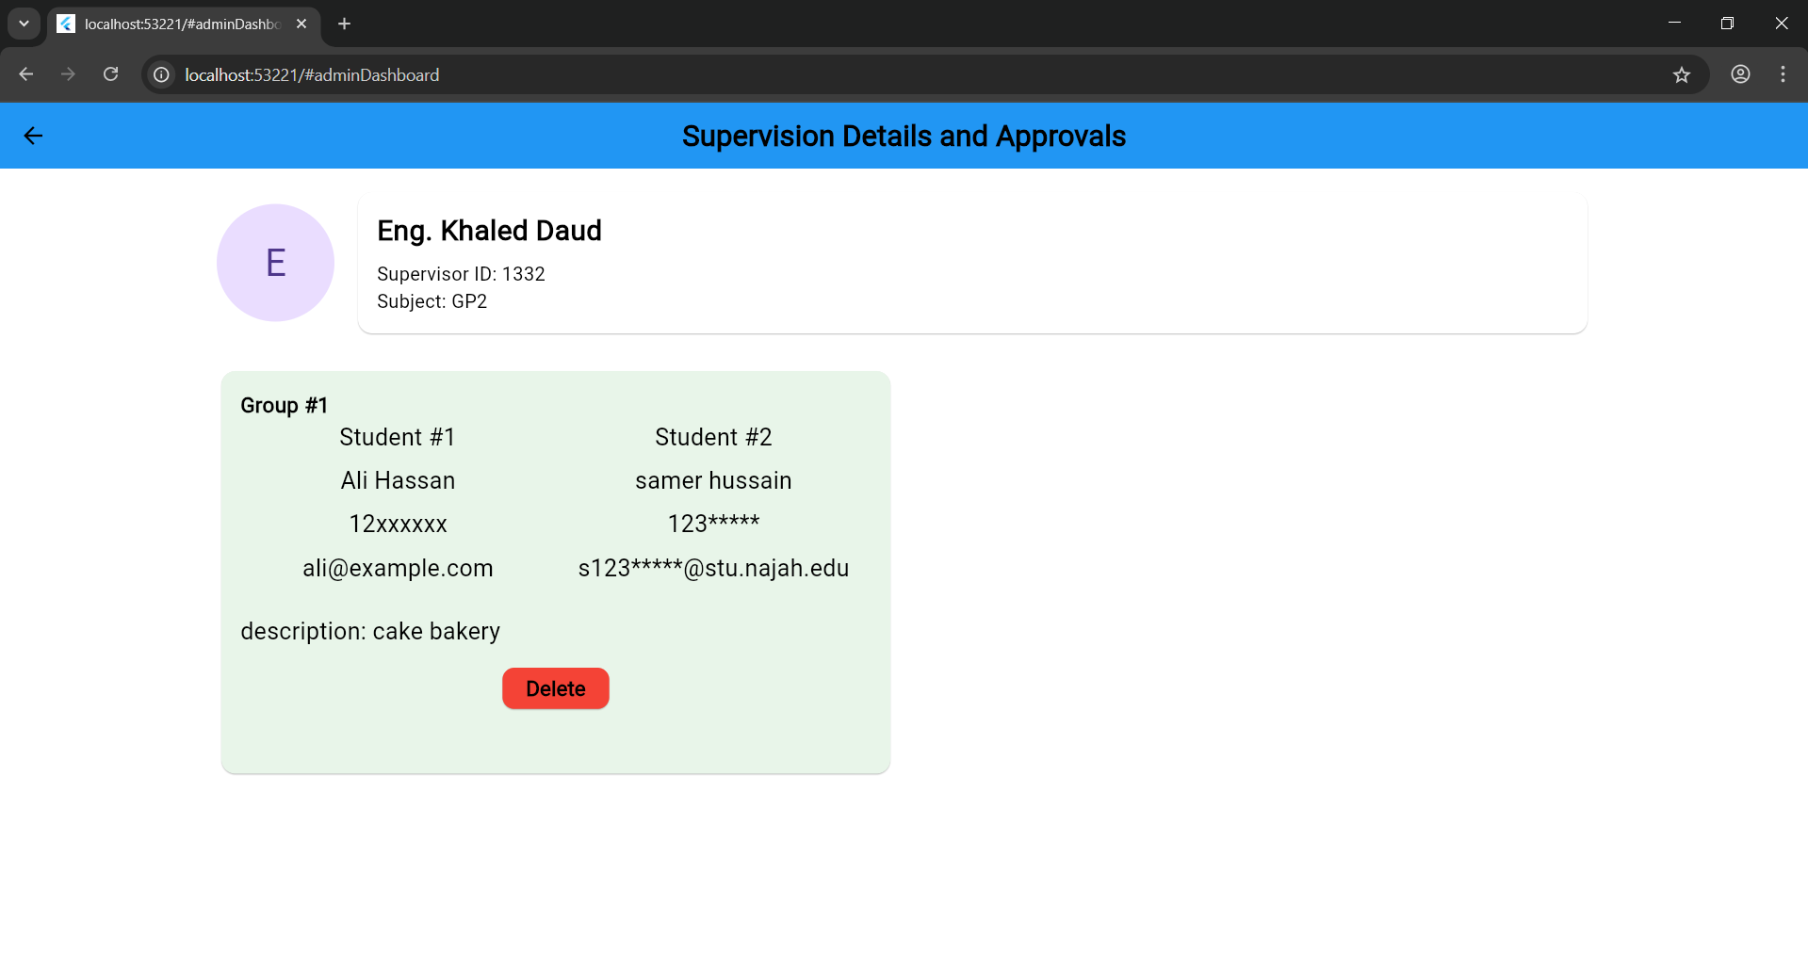
Figure 34: supervision details and approvals

- Course offering
Announced and officialized courses(sections) are made and done here as the admin choose a course and the specify the weekly time and the max participants of this section and after submit it lists below with its current state and with an officialization ability at any time

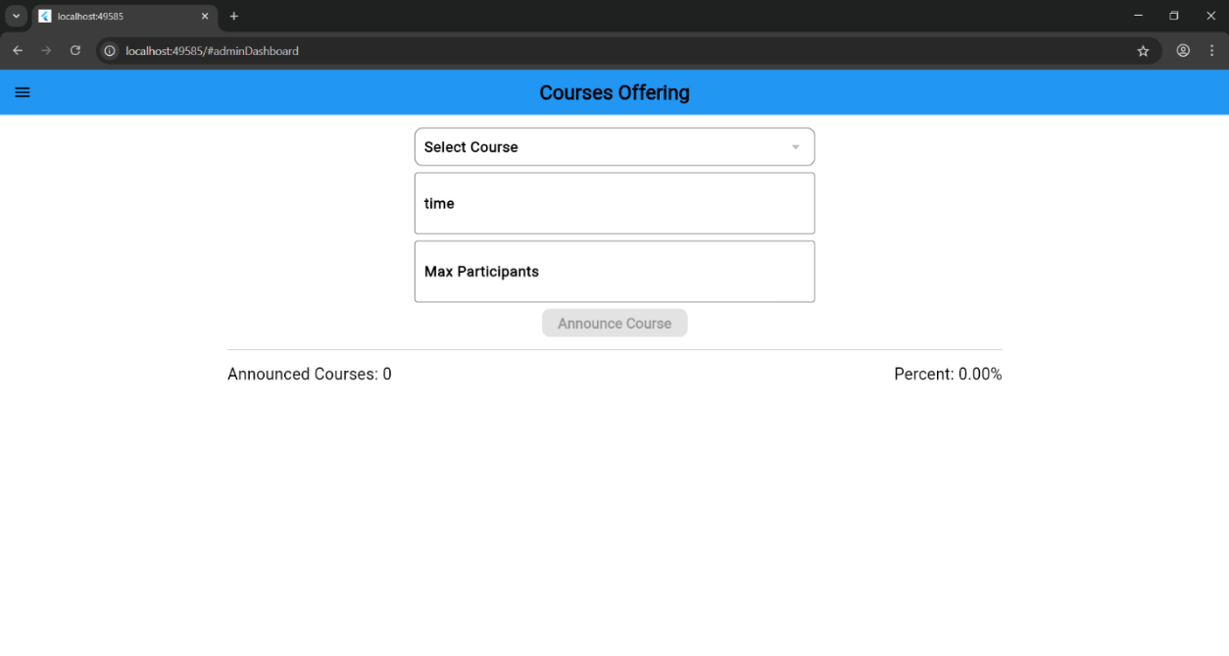
Figure 35: Course offering

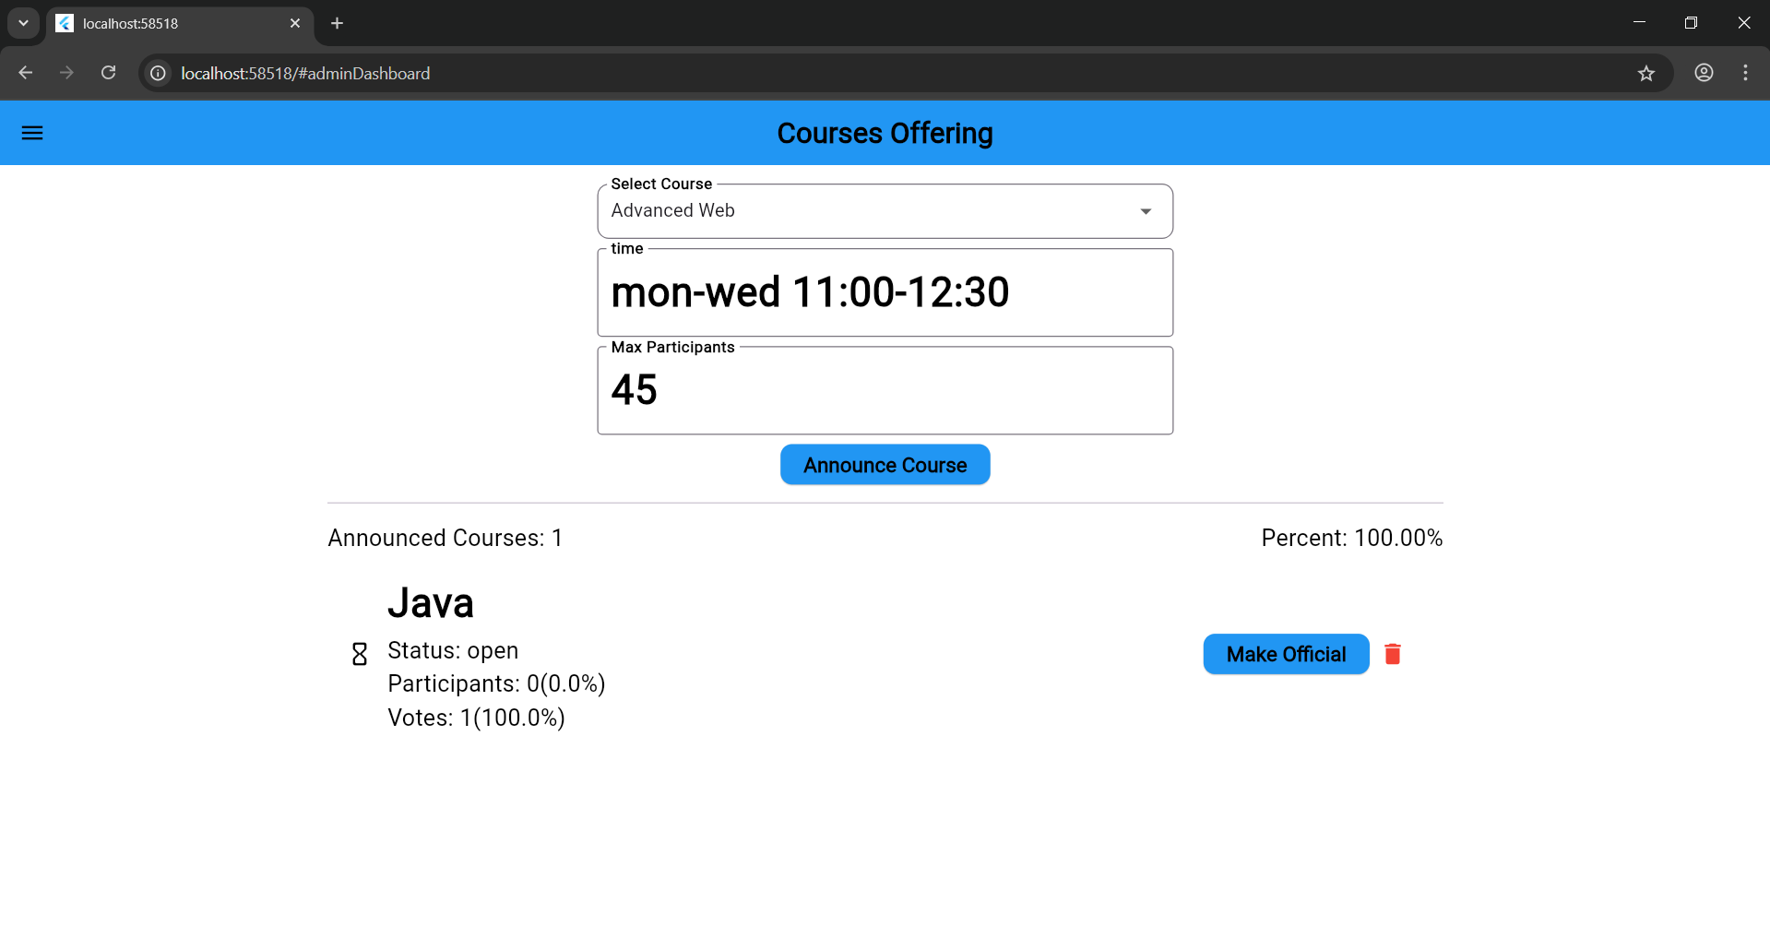
Figure 36: offering a course

- Course Registration
The requests sent by the students will list in this page divided by its type, giving the ability to respond on them with the taken decision
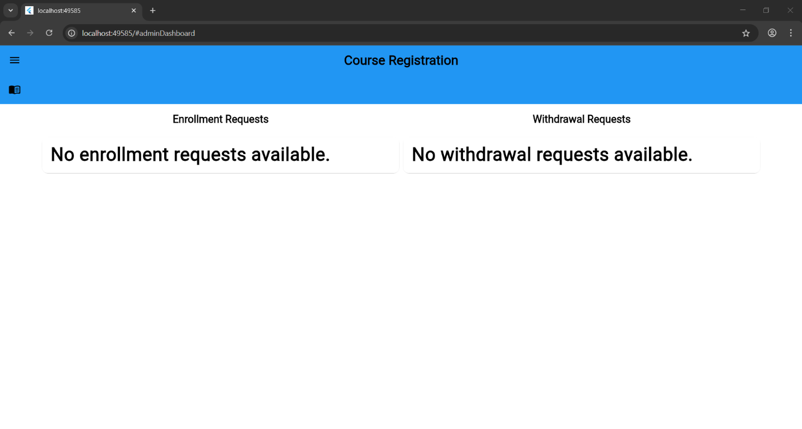
Figure 37: Course Registration
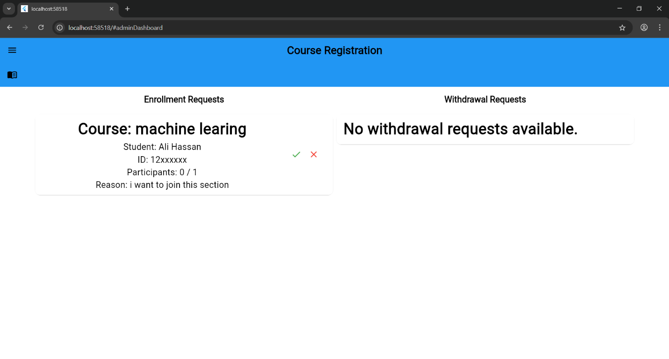
Figure 38: course approval

- Announced Courses
The announced courses(sections) all listing here with its details and current state
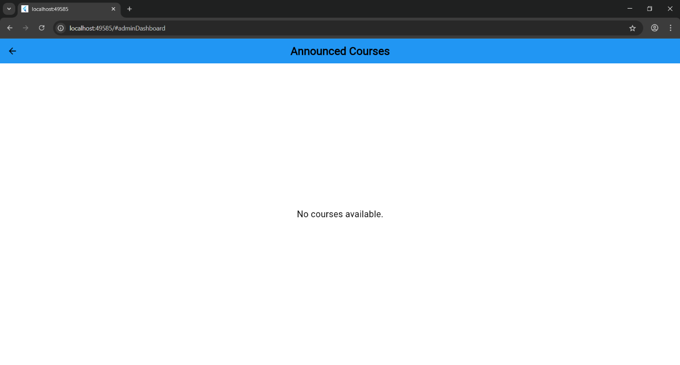
Figure 39: no course

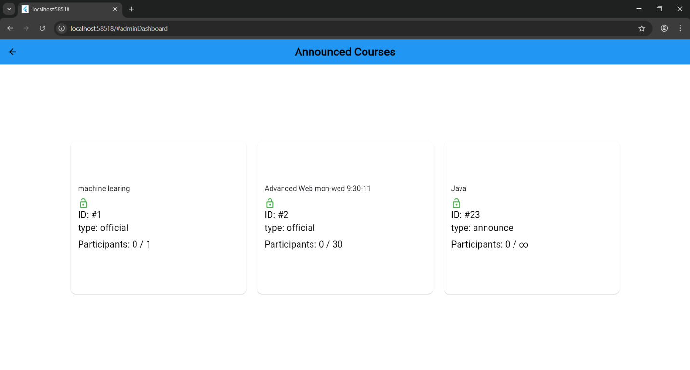
Figure 40:Announced Courses
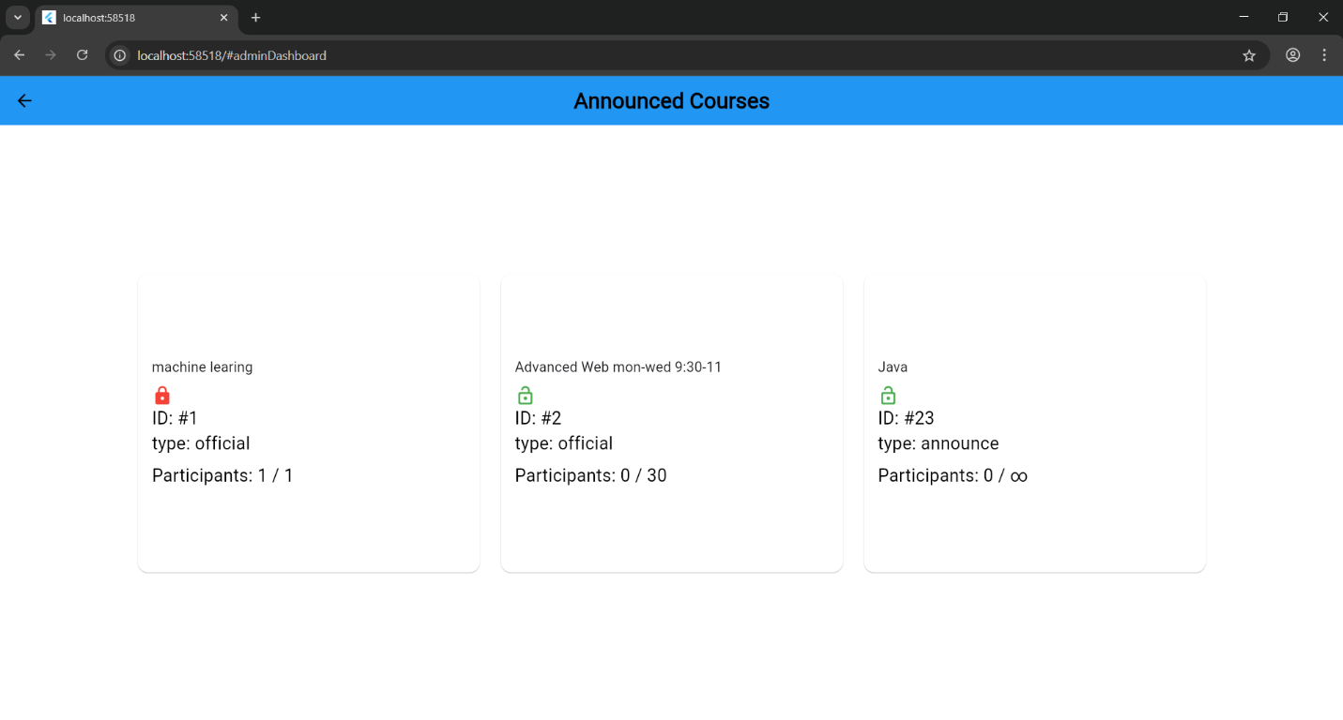
Figure 41: announced sections

- Course Students
After clicking on the specific section its enrolled students appear and list in this page

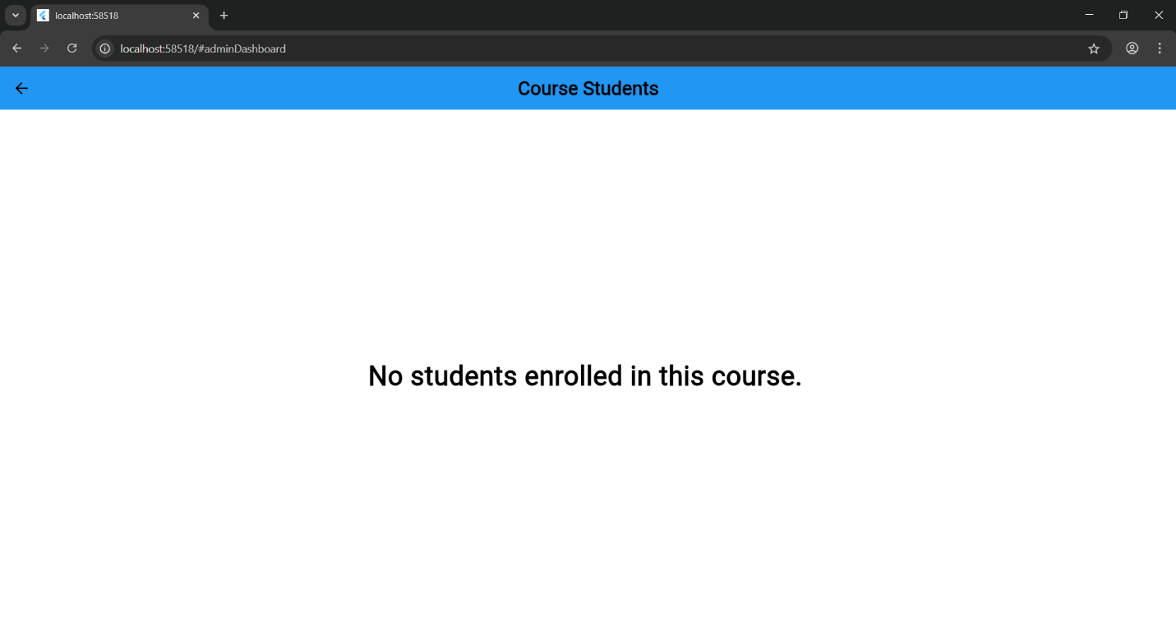
Figure 42:no registration
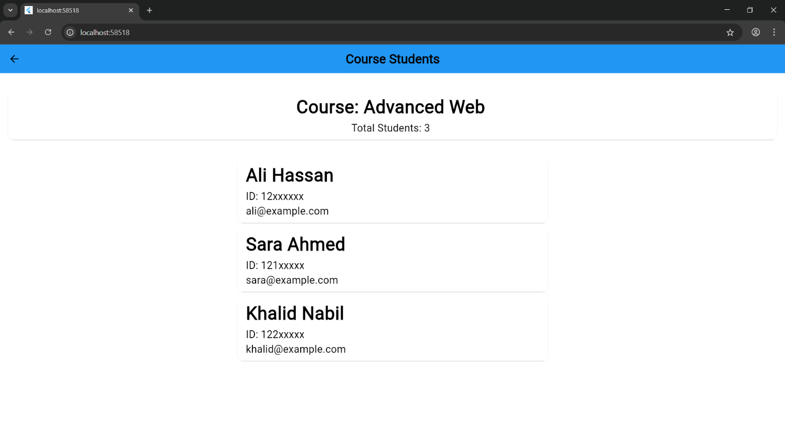
Figure 43: registered students

Web pages:
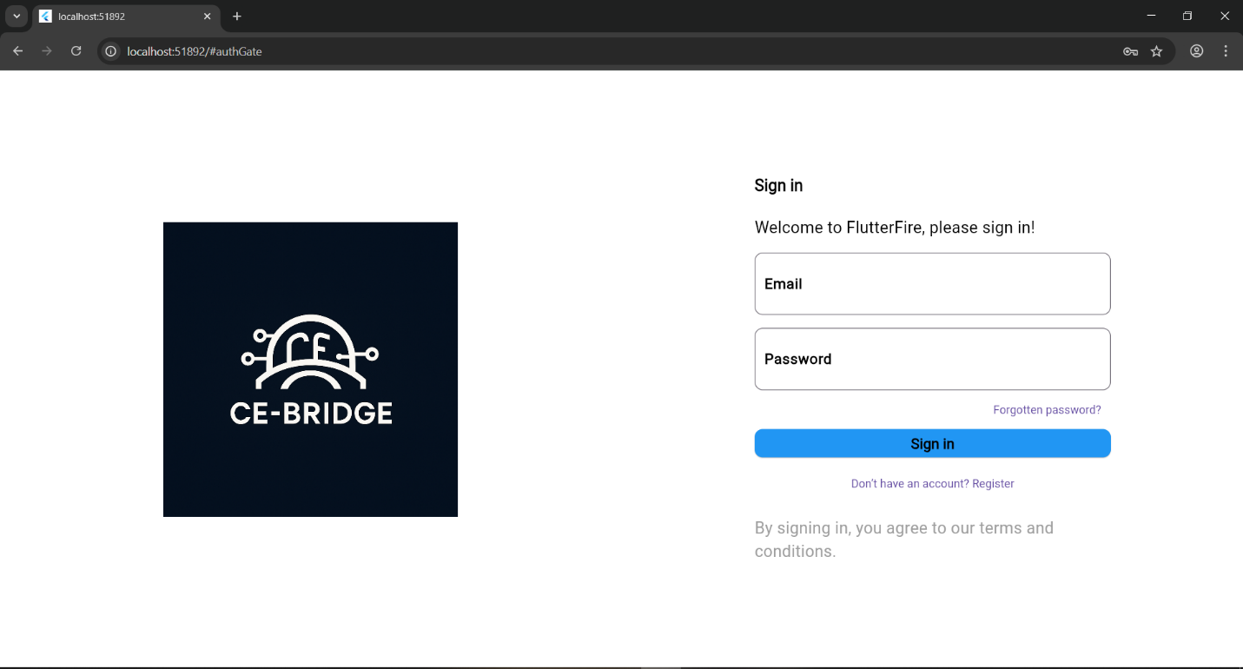
Figure 44: login web
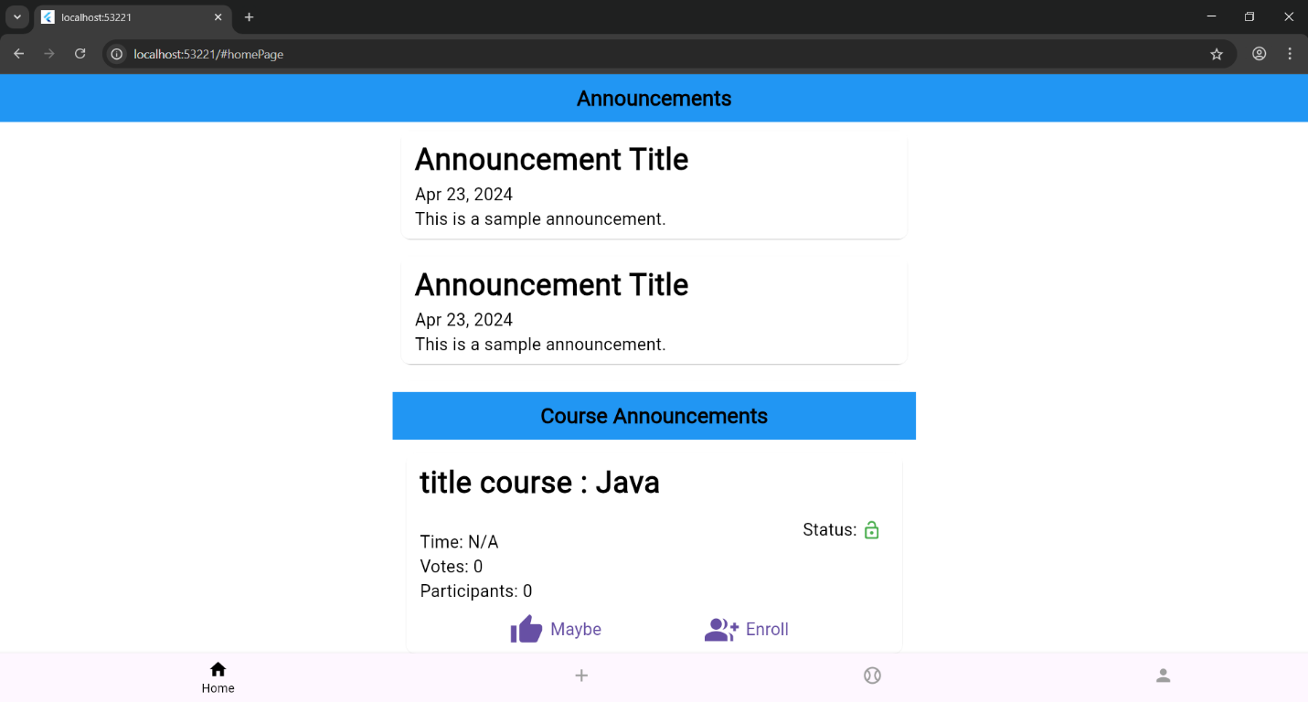
Figure 45: announcements web

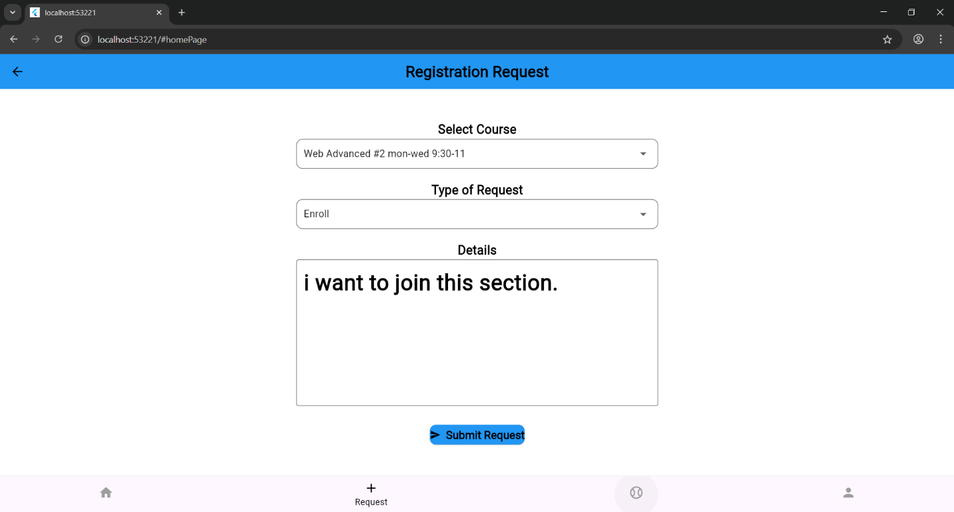
Figure 46: Registration Request web

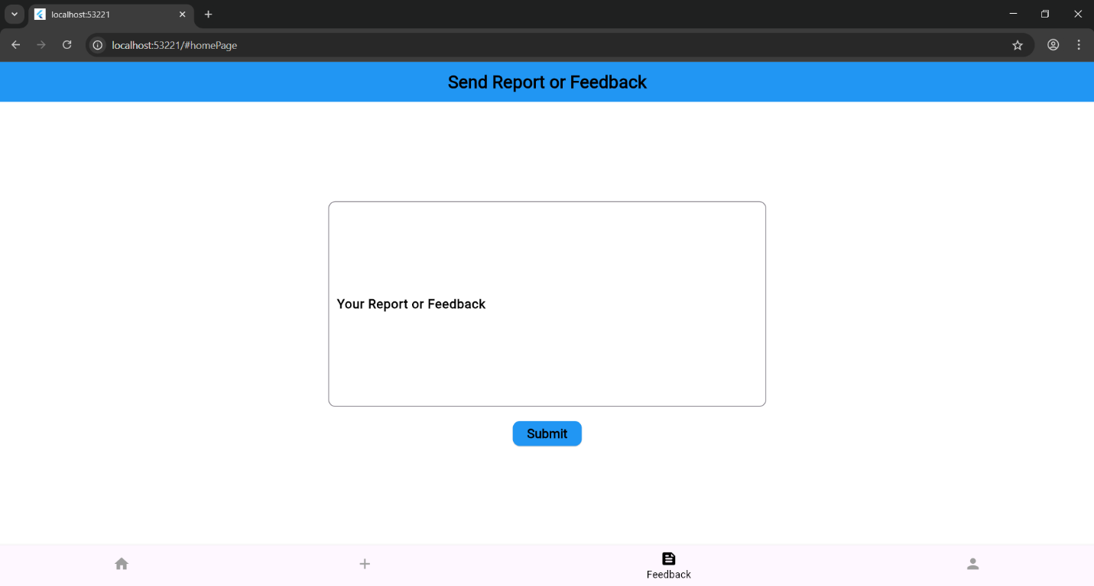
Figure 47: Report or Feedback web
Figure 48: Profile web

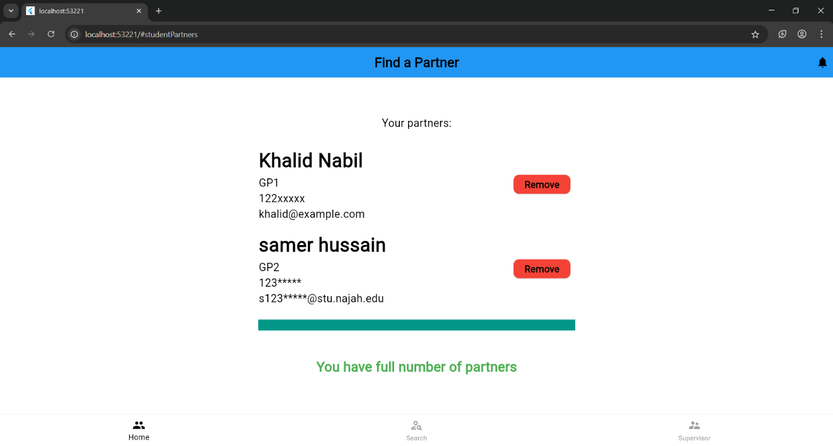
Figure 49: partner page web

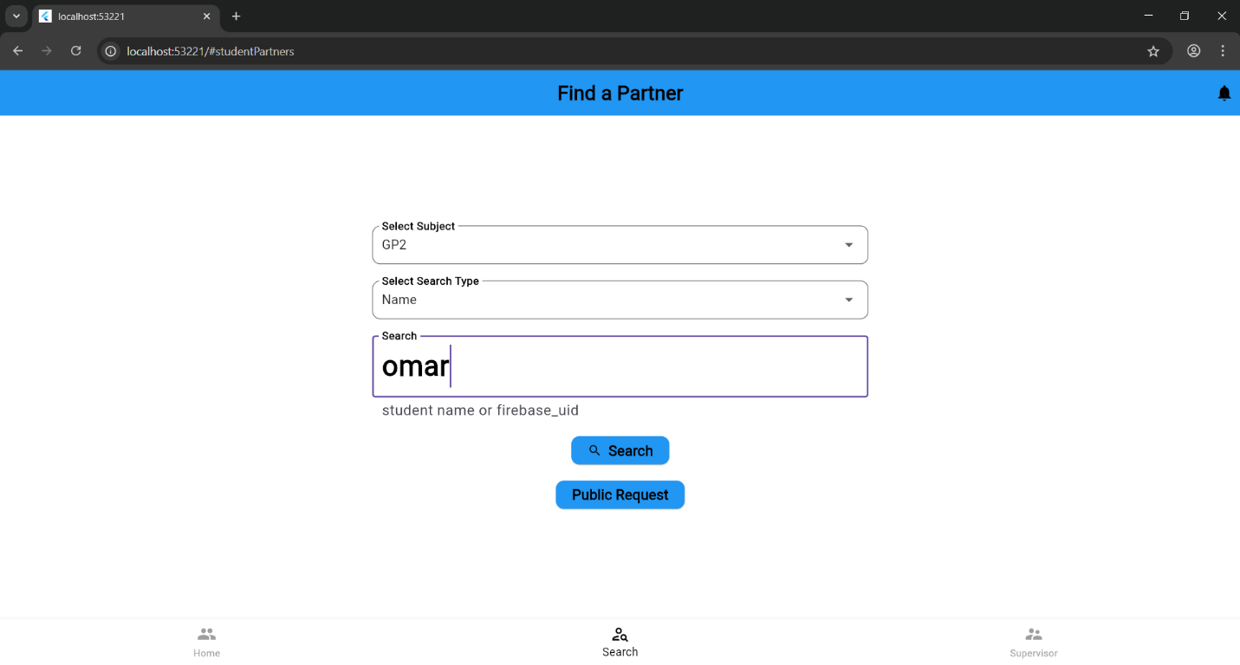
Figure 50: search for partner web

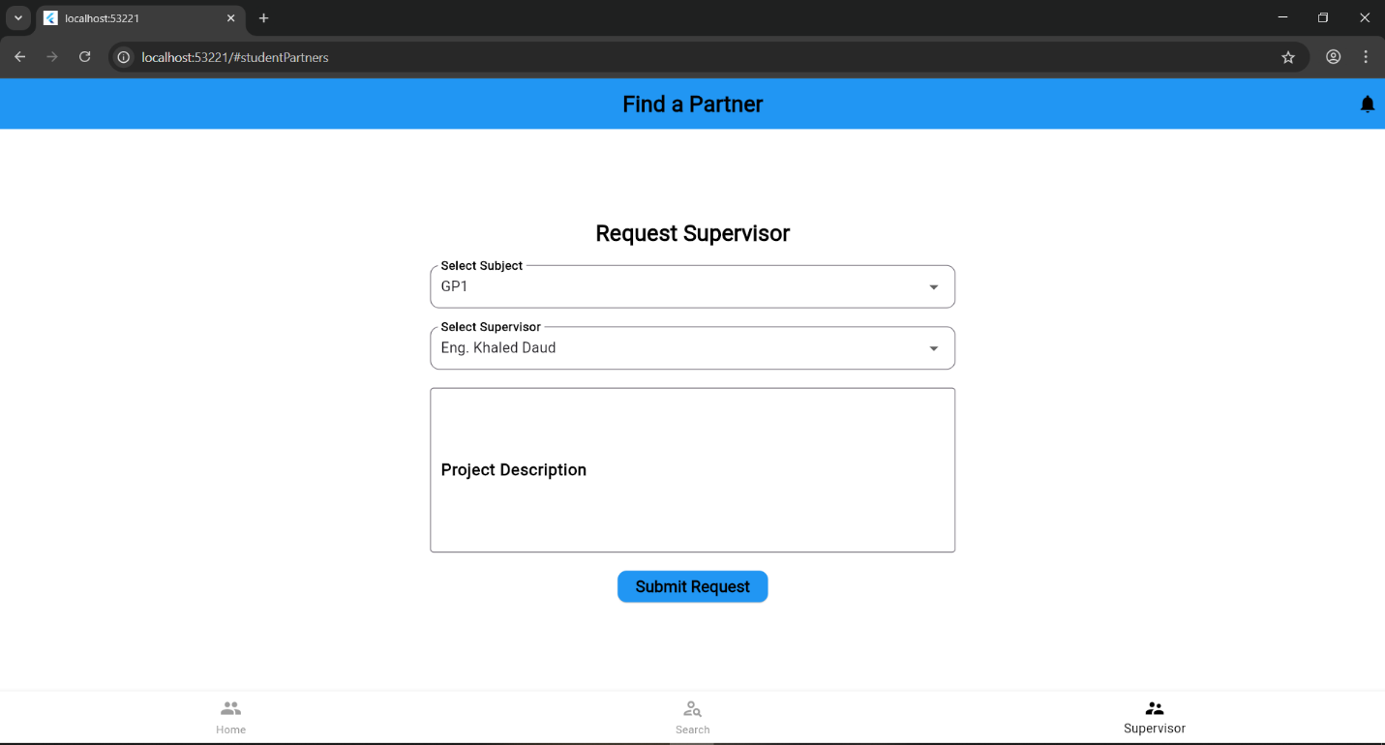
Figure 51: supervisor request web

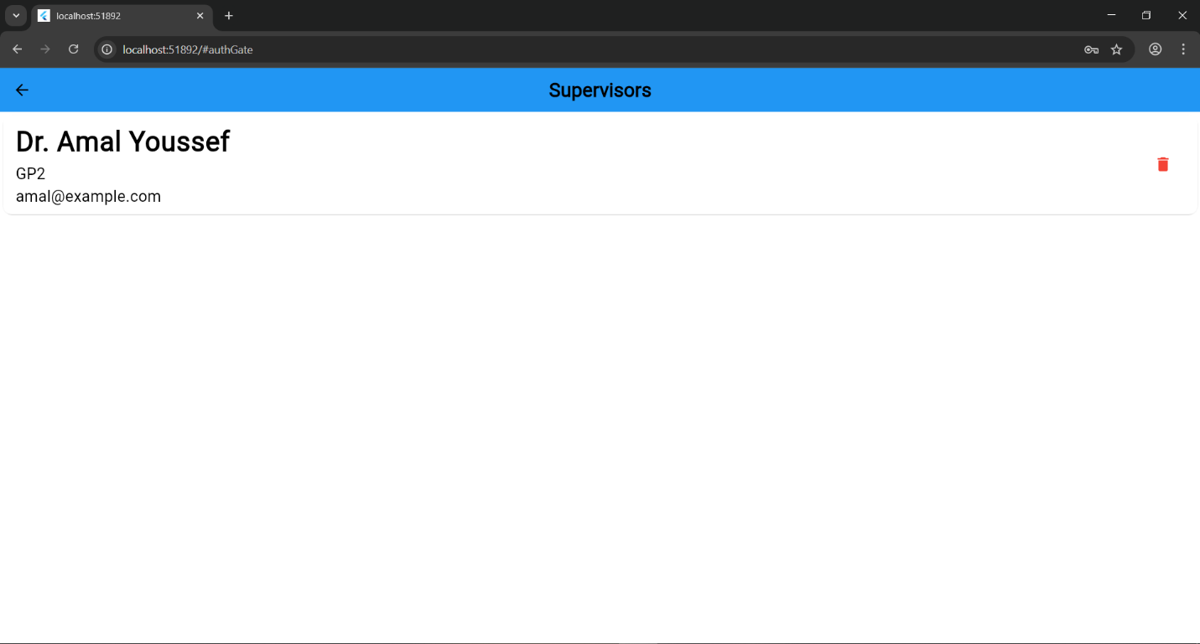
Figure 52: supervisors web

Results and Discussion
The CE Bridge system's development produced positive results in terms of usability, functionality, and user facilitation. The annunciation and voting ability, simple section registration requesting, partnership obtaining and supervisorship requesting, management students flow data and centralizing and gathering students’ data.

The annunciation and voting ability
Department announcement gathered and showed to the student in the app and they browsed them, also voted on the announced sections and contributed either for liking it and showing interest or showing the confirmation and joining it

Simple Section registration requesting
Student chose a specific course section from officialized sections or closed ones, then they specified the type of the registration request(command) and added extra info remotely and easily without suffering from long queuing.

Partnership obtaining and supervisorship requesting
Student has several methods in their hand in their journey of obtaining a partner officially and efficiently, easily and without embarrassing, after that submitted to the chosen supervisors waiting the approval

Management students flow data
Admin admitted or rejected variety students requests after checking them formally, in organized way and systemically and offered sections and took the intentions and officialized them.

Centralizing and gathering students’ data
Admin got all the requests in one place and especially the supervision ones and got the list and the result of them all.

Discussion
CE-Bridge founded to resolve and enhancing the academic and registration of problems and process in Computer Engineering Department.
Officializing voting for new sections in on app replaced other distributed platforms, requesting registration action of students remotely and directly and formally with department official app, for students suffering finding partners and getting embarrassed from that getting rid of this by systematic and official and several ways, finally admin and registration coordinator got the centralize and final version of the supervisor’s associated groups and partners ready with no need of old distributed method and waiting the confirmation or the feedback to come or requested.

Conclusion:

Summary
The project aimed to close the gap between students with registration issues and registration coordinator in engineering department in computer engineering. The system provides systematic structure process for supervisor requests, which was handled before in personally and in distributed way among the supervisors and away from the department and in it head and its centralization, gathering to role-based dashboard, insuring trackability and countability. Also, the ability to manage the flow of registration and organize them officially in one place, which was queuing and being stuck in front of the department head office. Bringing a solution key method to those facing difficulty and lack in finding partner through facilitating it by complete and multiple approaches process effectively and the very important one unashamedly.

Recommendations for Improvement
There are several chances to improve the smart CE bridge system’s overall efficacy. First, need to filtering and adding sort tools in the data flow enhance the equal chances, then supervisor availability status in browsing before submitting warning, and integrating more firebase features and using its Firestore and including photos and variety files. Last but not least, more responsive and suitable UI for all pages across all platforms and devices.

Future Work and Directions
- Tighter integrating with Zajel.
- Improve and extend the schema to deal with different Engineering departments.
- Chat system between students.
- Extend details and reason with file uploading

Appendix:

*For More Videos and Demo use this Link.

