An-Najah National University
Faculty of Engineering
Computer Engineering Department

Graduation Project 1 Documentation

Project Name:

VENUS Compiler & Simulator
For
Single-Cycle Multi-Cycle Pipeline Processor

Done By:
Firas Zahi Shaka’a
Osama Tawfiq Al-Aqel

Supervised By:
Dr. Luai Malhis

☺Abstract
Computer Architecture is one of the most important fields in Computer and IT study which includes the internal infrastructure of the computer such that: processor, memory, IO, cashes, … etc.

The most important component from those, which controls everything in the computer and do processing and computation in the computer, is the processor.

The processor design in the computer architecture history passes through different stages and approaches which are:
- Single-Cycle Approach …
- Multi-Cycle Approach …
- Pipeline Approach …

So, our project, VENUS, is a compiler & Simulator for all those three approaches of processor.

Our application starts with the user from writing his/her MIPS ASM code or C code, compiling, building, optimizing, executing, simulating how it is executed by the processor in real timing and accurate results.

This project is extremely educational one. Here in An-Najah National University especially in computer engineering department students take two courses in Computer Architecture which include MIPS language and the three types of the processor, so the students and instructors will use this project as an applied tool to support those courses.

The project consists of a desktop application with very large number of simulation flashes supported with online website.

☺Project Main Sections
Our project separated into 4 main parts which will be briefly explained with pictures support below.

1-VENUS Compiler
VENUS compiler is a powerful compiler that supports both MIPS ASM code and C code.

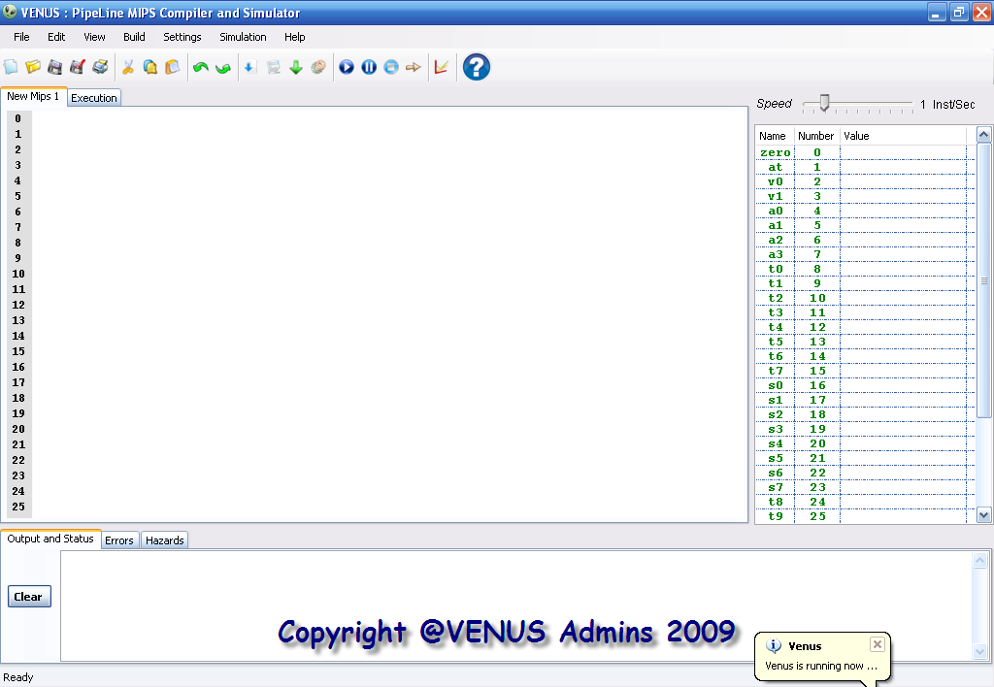

Here the user can write his/her own code, then compile and build it to see if there is errors or hazards in user’s code.
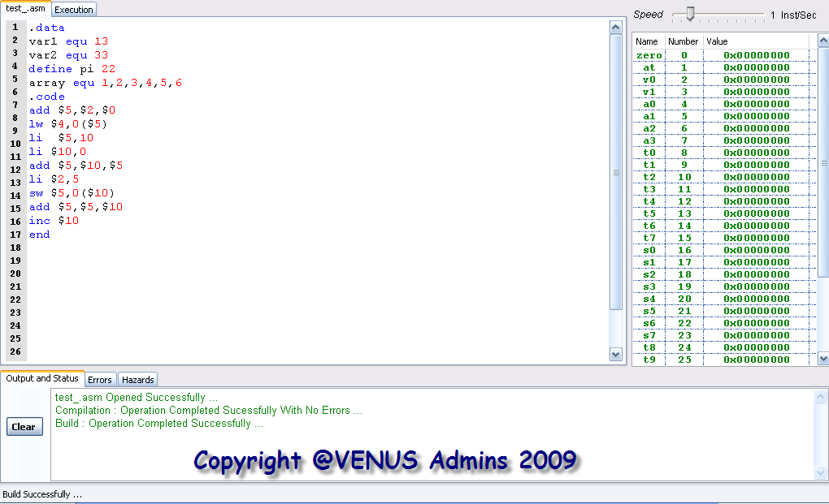

When the user builds his/her code, it is assembled into the core MIPS standard instructions and the data segment will be filled automatically with the values which be reserved by the user in his/her code.
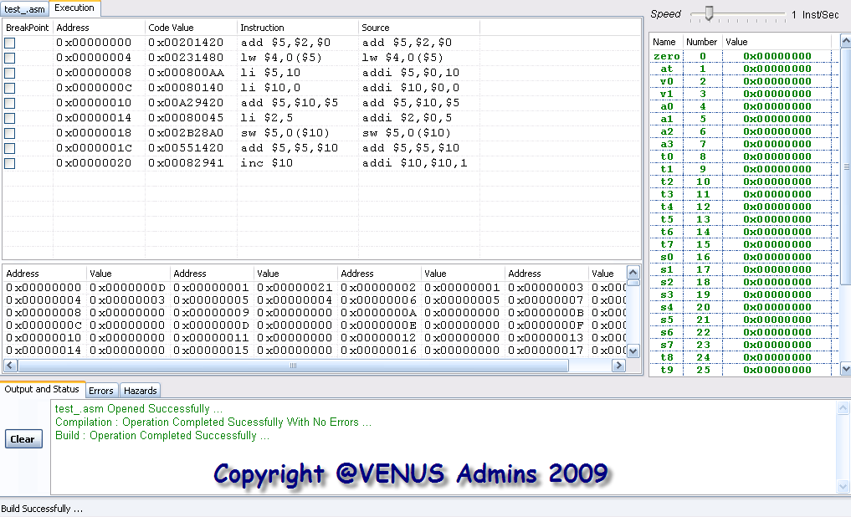

Then the user will execute his/her code, different options available here:
- Execute one shot, all the code will be executed as whole.
- Execute in specific speed specified by the user so that the code will be executed step-step.
- Execute your code manually; user controls the steps of execution.

Execution results are shown on the register file table and the data segment table.

Execution can be stopped, paused, resumed by the user to see results at specific point.

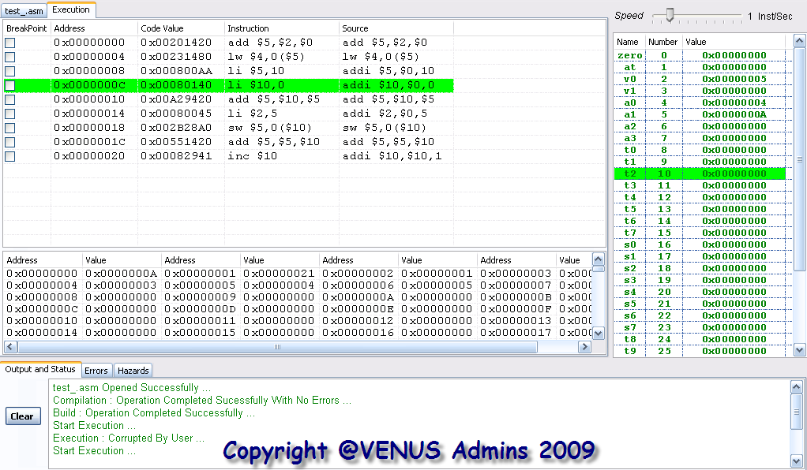

The user can put a breakpoint to see the registers value or data segment at that point, then user can resume execution.

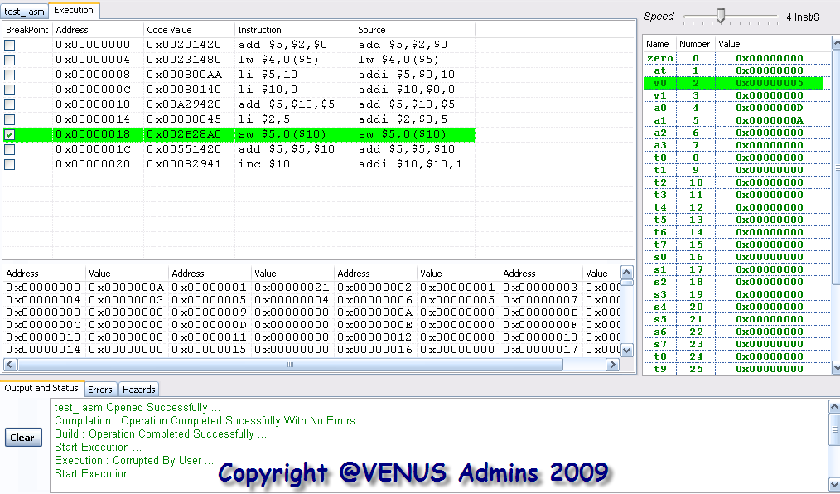

Then the user can see how his/her code is executed in real on the type of processor he wants.

VENUS compiler support several options for simulation, which are:
- Single-Cycle Processor Clock Simulation.
- Single-Cycle Processor Data path Simulation.
- Multi-Cycle Processor Clock Simulation.
- Multi-Cycle Processor Data path Simulation.
- Pipeline Processor Clock Simulation.
- Pipeline Processor Data path Simulation.
- Pipeline Processor Data path Simulation with forwarding unit.
- Pipeline Processor Data path Simulation with hazard detection unit.
- Pipeline Processor Data path Simulation with control signals.
- Full Pipeline Processor Data path Simulation Description.
- Forwarding Unit Simulation.
- Hazard Detection Unit Simulation.

All these flashes are supported in VENUS application, the simulation form looks like:

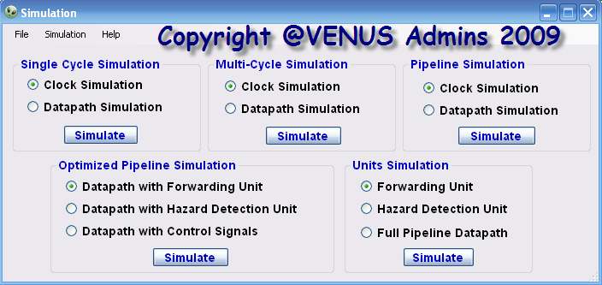

Also, we have a CHM help that learn the user about MIPS language and the three approaches of the processors, also how to use the application.
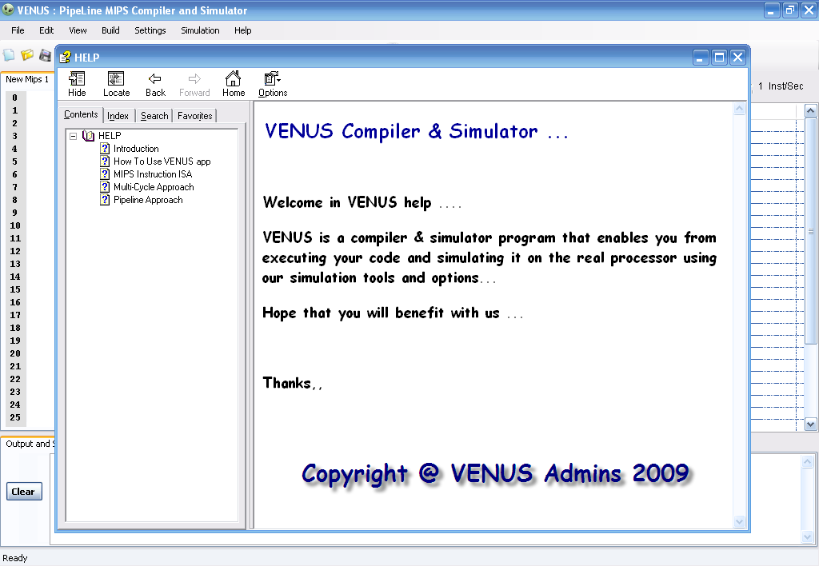
2-VENUS Flash Simulation
Our project contains huge amount of flashes that simulate the execution of the user code on the three approaches of processor which are: Single-Cycle, Multi-Cycle, Pipeline processor.

Several options are available for each simulation with powerful tools and accurate statistics at the end of execution.

** Types of Simulation

- Single-Cycle Clock Simulation

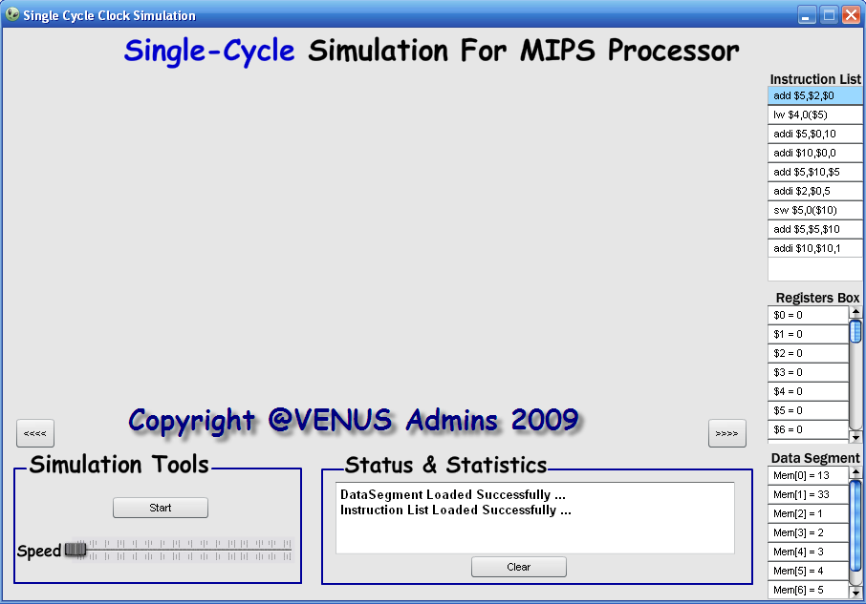

Here, the user code is simulated on the single-cycle processor; this flash shows you how the code is being executed through splitting each instruction into 5 stages which are:
- Fetch Stage.
- Decode Stage.
- Execution Stage.
- Memory Stage.
- Write Back Stage.
Then show the user what happens in each stage in RTL language side by side with the execution results which are showed in the register file and data segment values.
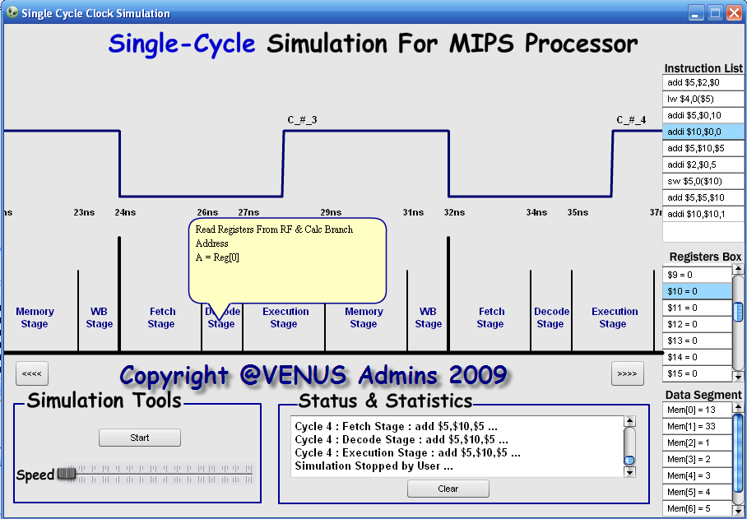

At the end of the execution some statistics are displayed such that number of instructions executed, number of cycles, the time of the execution and the CPI for the execution.
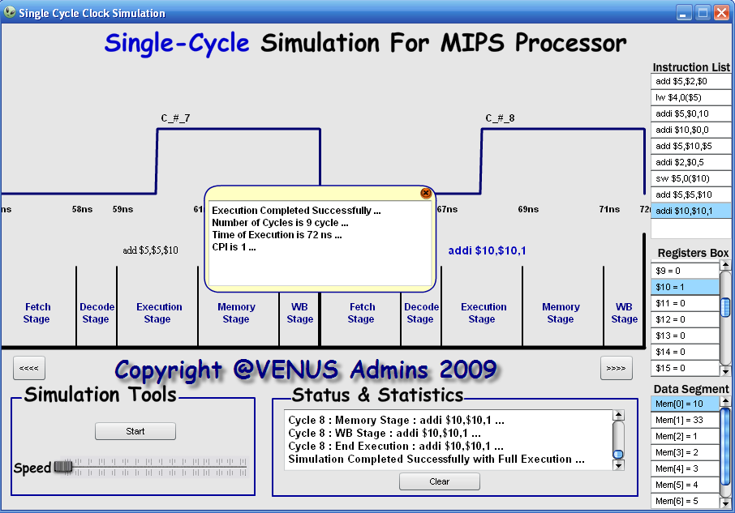
- Single-Cycle Data path Simulation
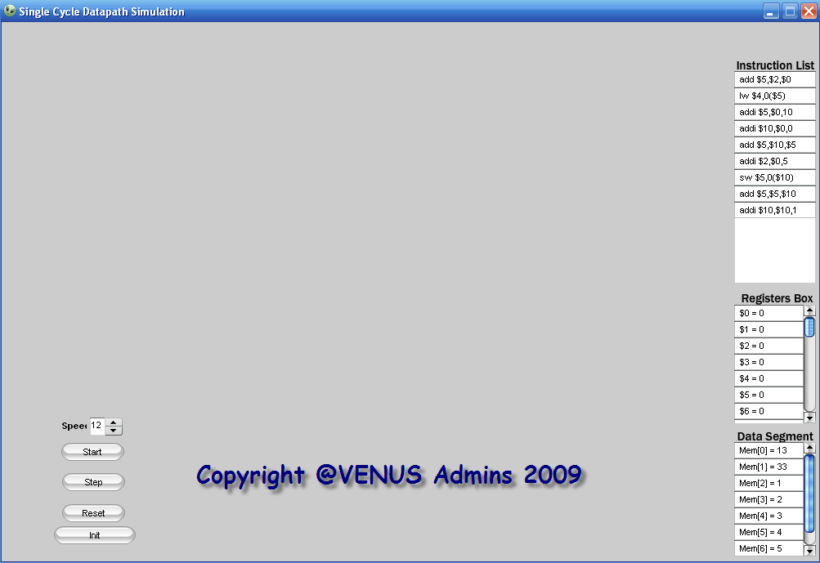

Here, we show the user how his/her code is executed on the hardware of the single-cycle processor through simulating the execution of the instructions on the data path of single-cycle processor.
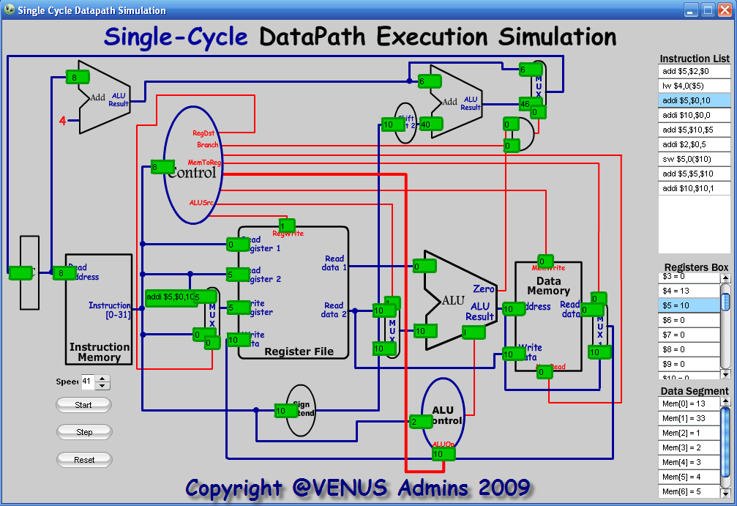
At the end of the execution some statistics are displayed such that number of instructions executed, number of cycles, the time of the execution and the CPI for the execution.
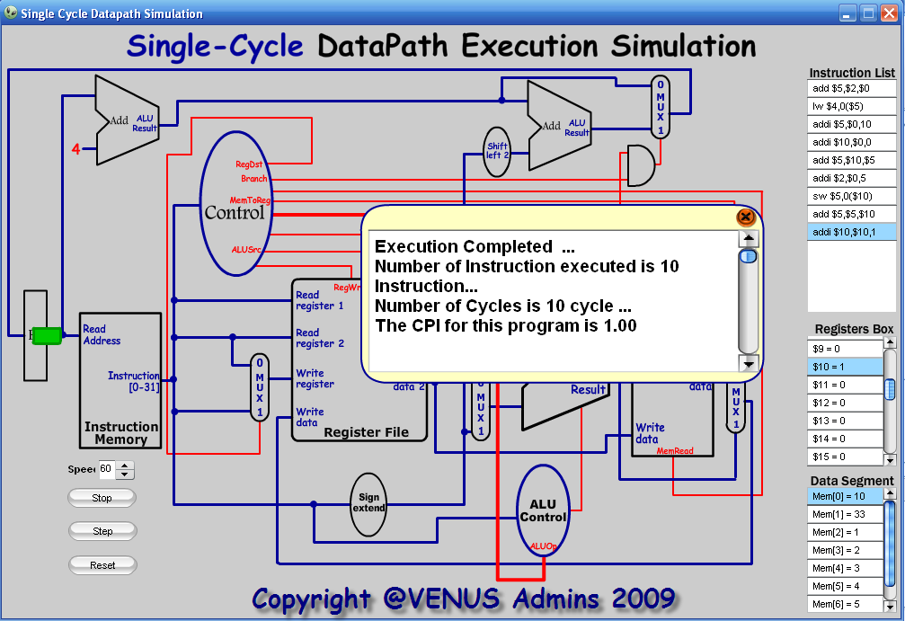

- Multi-Cycle Clock Simulation

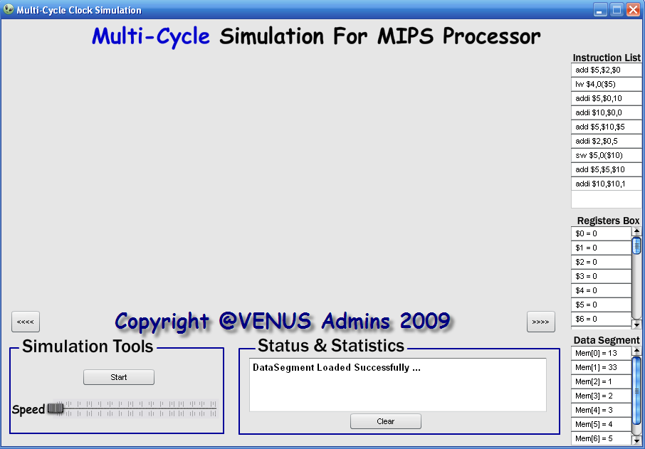
Here, the user code is simulated on the multi-cycle processor; this flash shows you how the code is being executed through splitting each instruction into 5 stages which are:
- Fetch Stage.
- Decode Stage.
- Execution Stage.
- Memory Stage.
- Write Back Stage.

But, here each stage is one cycle, and each instruction takes number of cycles as it needs, may be not all the 5 stages.

Then show the user what happens in each stage in RTL language side by side with the execution results which are showed in the register file and data segment values.

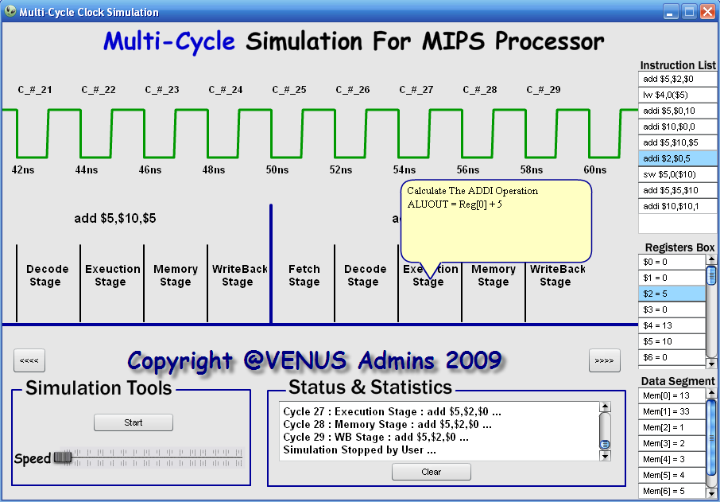

At the end of the execution some statistics are displayed such that number of instructions executed, number of cycles, the time of the execution and the CPI for the execution.
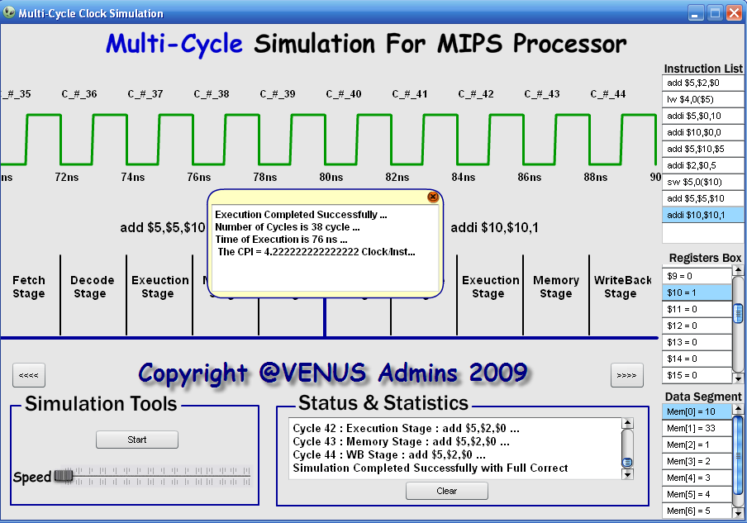

- Multi-Cycle Data path Simulation
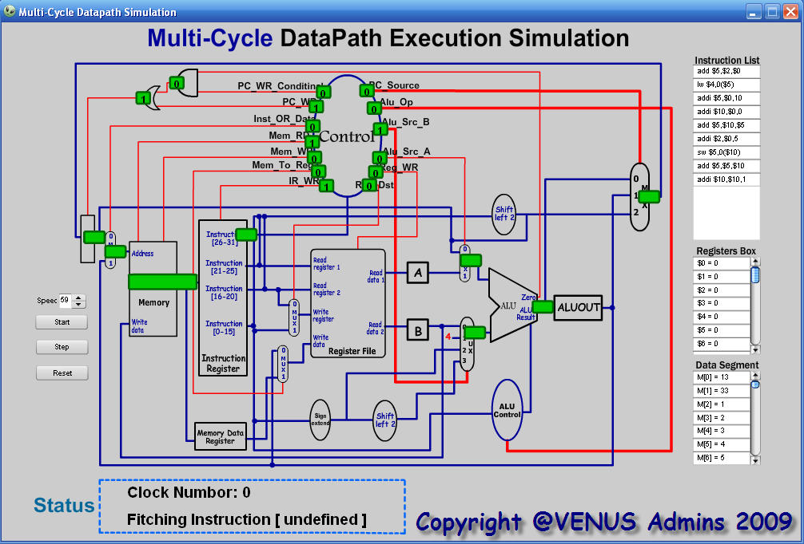
Here, we show the user how his/her code is executed on the hardware of the multi-cycle processor through simulating the execution of the instructions on the data path of multi-cycle processor.
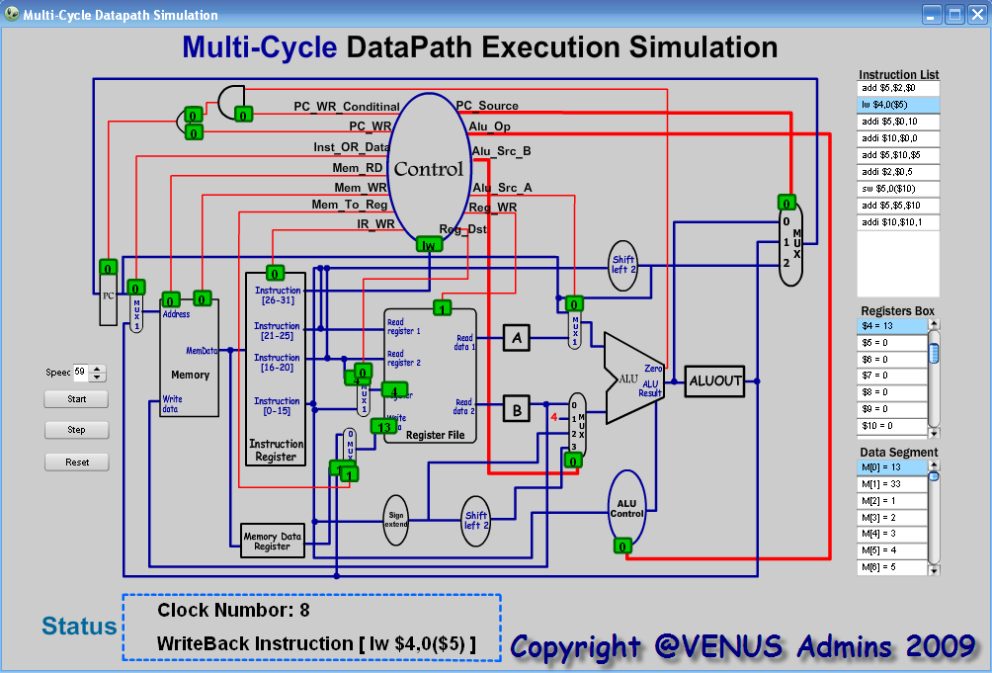

At the end of the execution some statistics are displayed such that number of instructions executed, number of cycles, the time of the execution and the CPI for the execution.
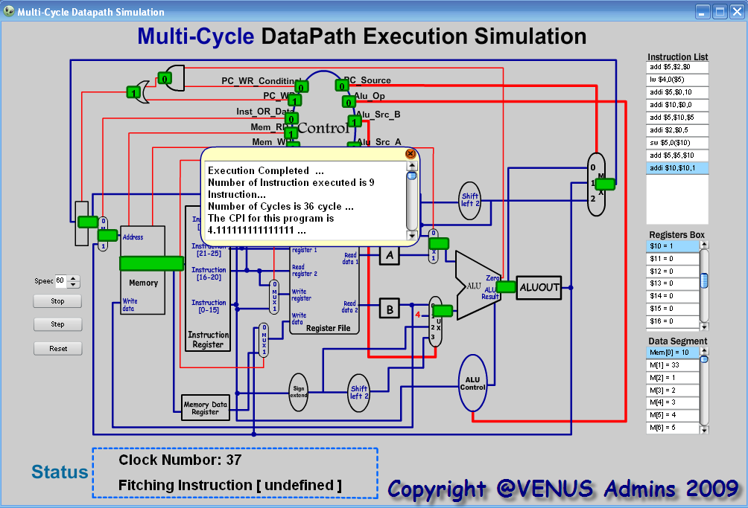
- Pipeline Clock Simulation

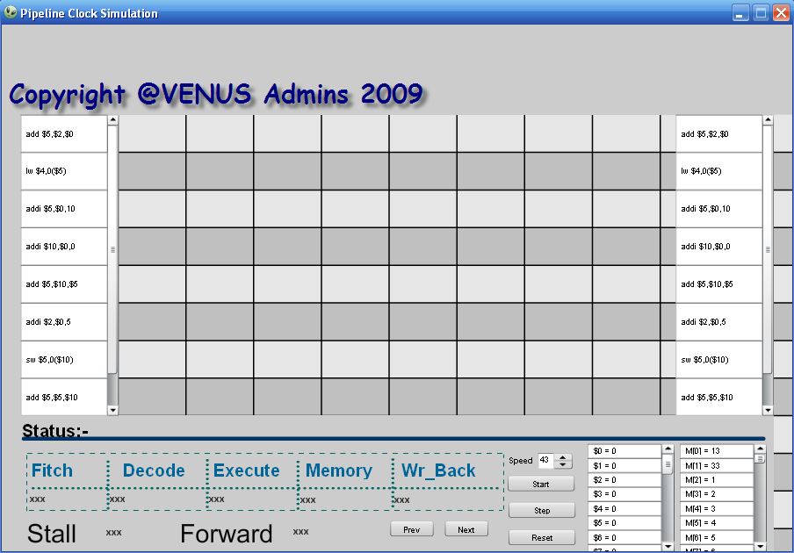

Here, the user code is simulated on the pipeline processor; this flash shows you how the code is being executed through splitting each instruction into 5 stages which are:

- Fetch Stage.
- Decode Stage.
- Execution Stage.
- Memory Stage.
- Write Back Stage.

Also, any forwarding or stall is counted and represented in the flash …
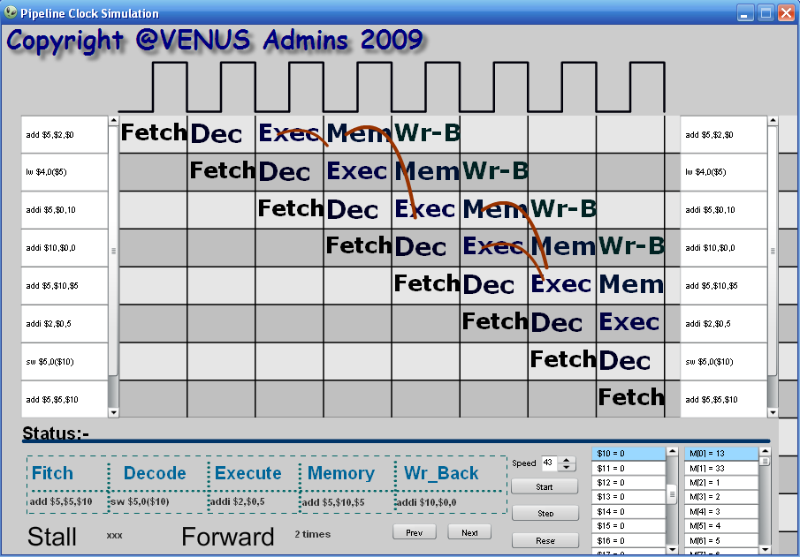

At the end of the execution some statistics are displayed such that number of instructions executed, number of cycles, the time of the execution and the CPI for the execution.
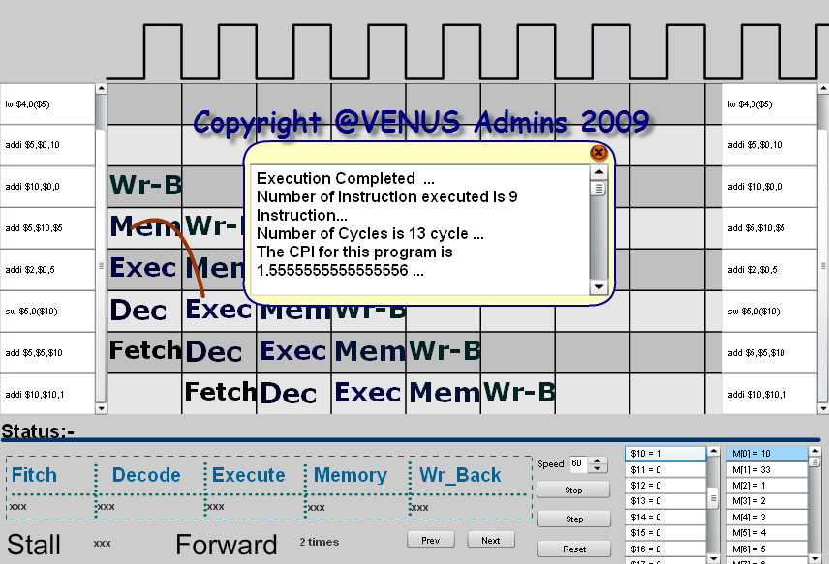
- Pipeline Data path Simulation

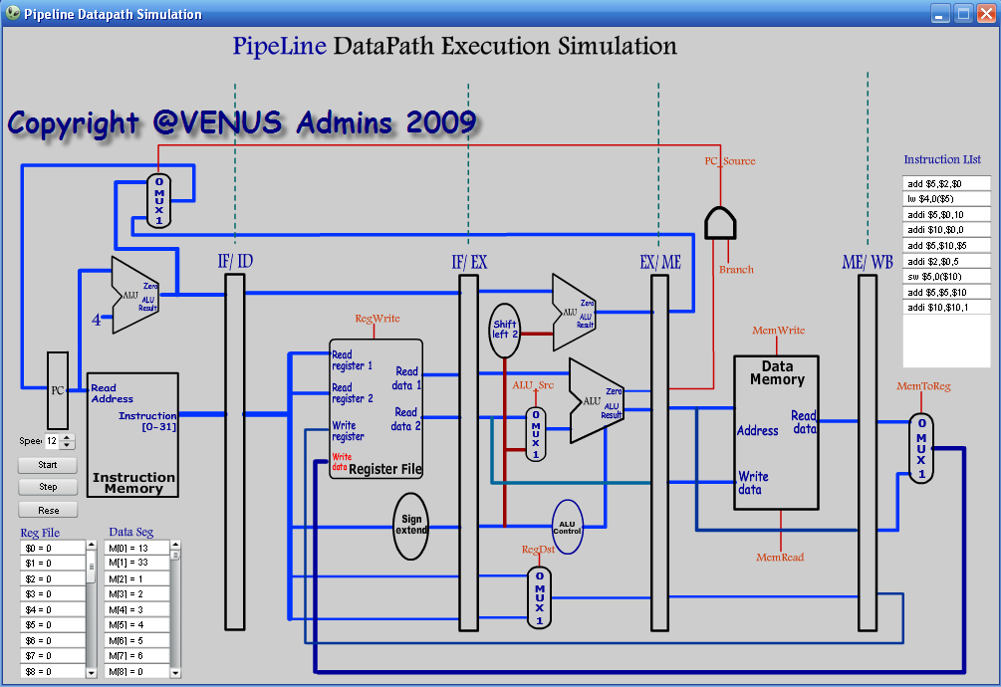

Here, we show the user how his/her code is executed on the hardware of the pipeline processor through simulating the execution of the instructions on the data path of pipeline processor.
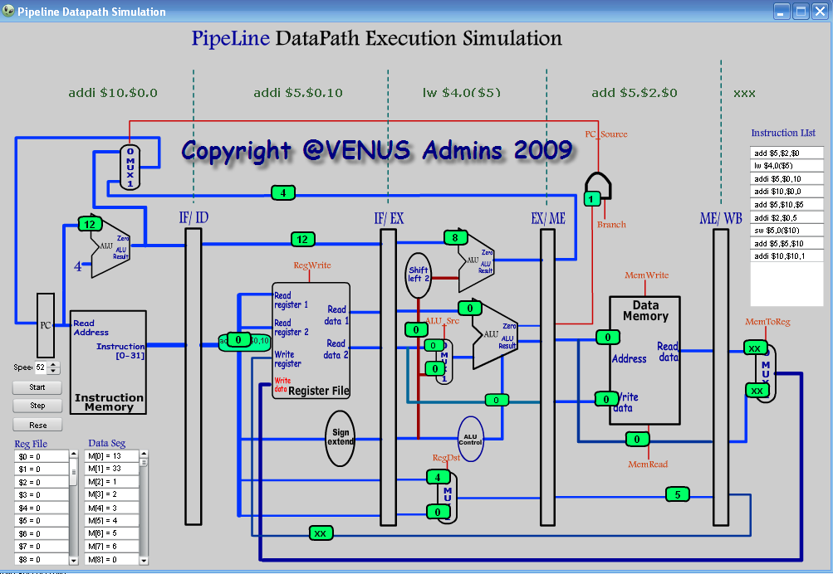
At the end of the execution some statistics are displayed such that number of instructions executed, number of cycles, the time of the execution and the CPI for the execution.
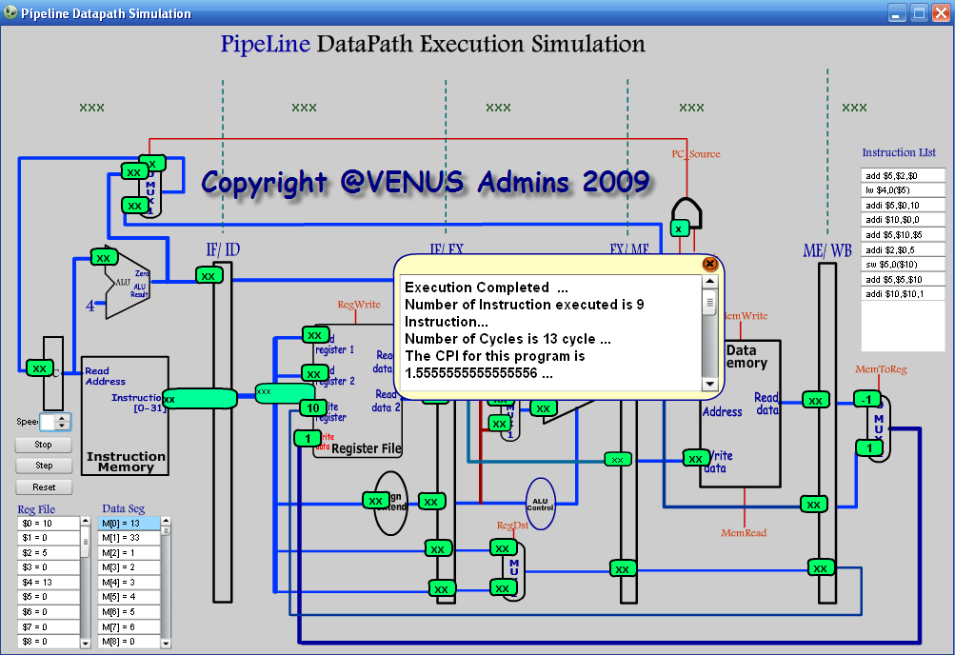

- Pipeline Data path Simulation with Forwarding Unit

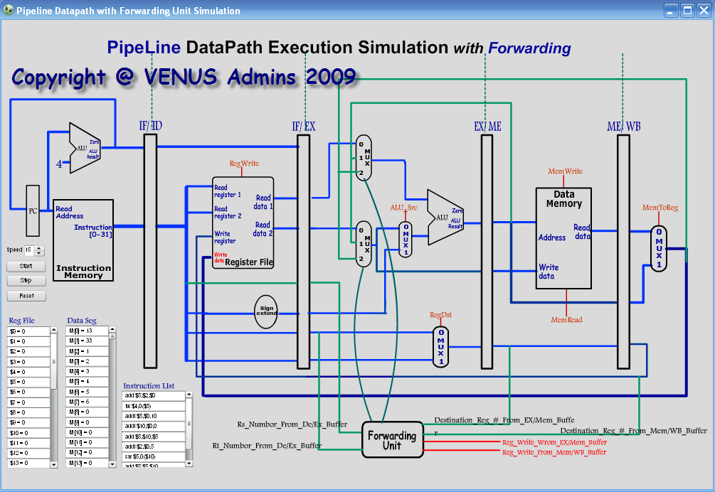
Here, we show the user how his/her code is executed on the hardware of the pipeline processor through simulating the execution of the instructions on the data path of pipeline processor.

This simulation supported with the forwarding unit which solves the data hazards between the instructions in user’s code, when forwarding occurs the unit box will flicker and the values of the registers is forwarded from the pipeline buffers.

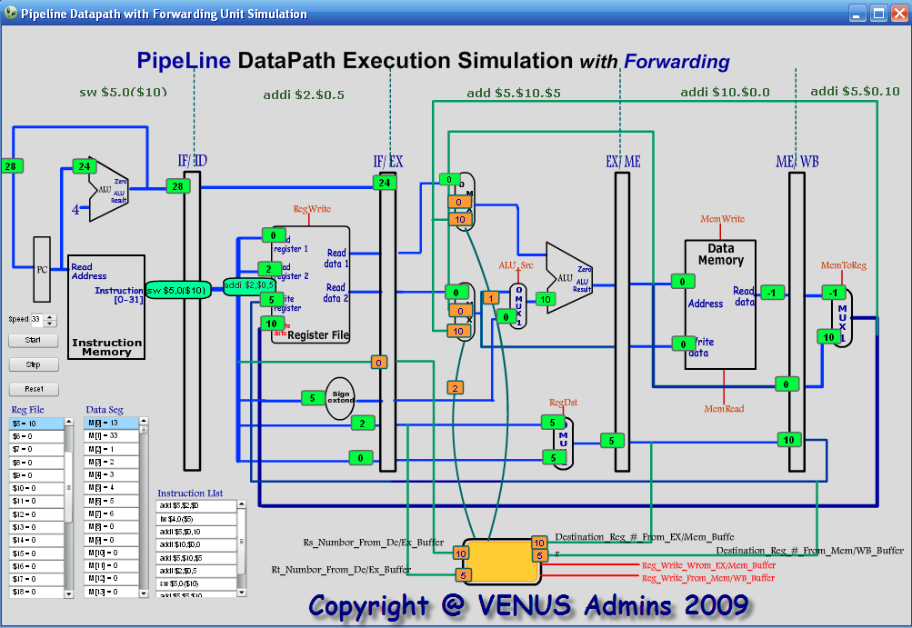

At the end of the execution some statistics are displayed such that number of instructions executed, number of cycles, the time of the execution and the CPI for the execution.
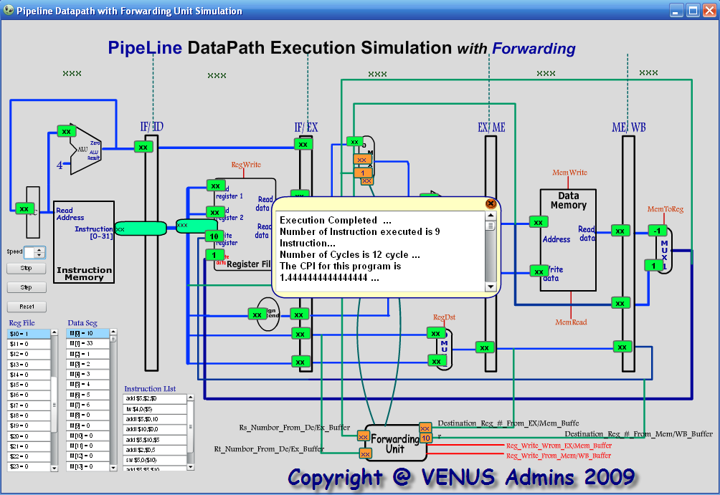

- Pipeline Data path Simulation with Hazard Detection Unit

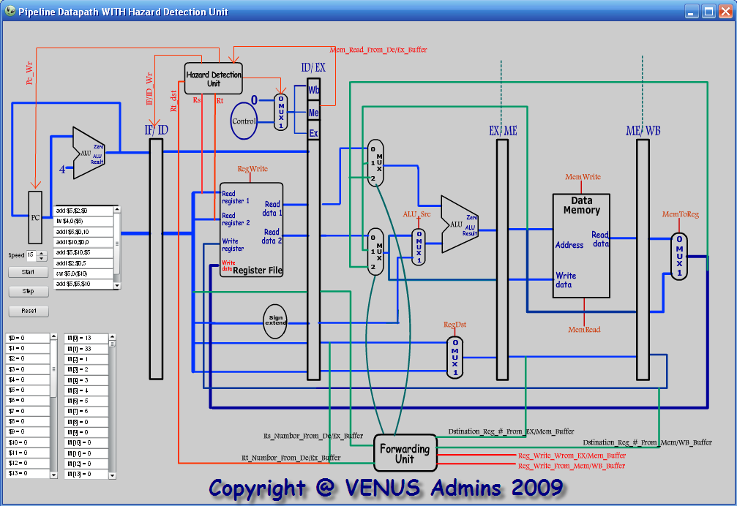

Here, we show the user how his/her code is executed on the hardware of the pipeline processor through simulating the execution of the instructions on the data path of pipeline processor.

This simulation supported with the hazard detection unit which detect the hazard in its types, data or control hazards, in order to be solved by forwarding or stall the whole operation for one stage.

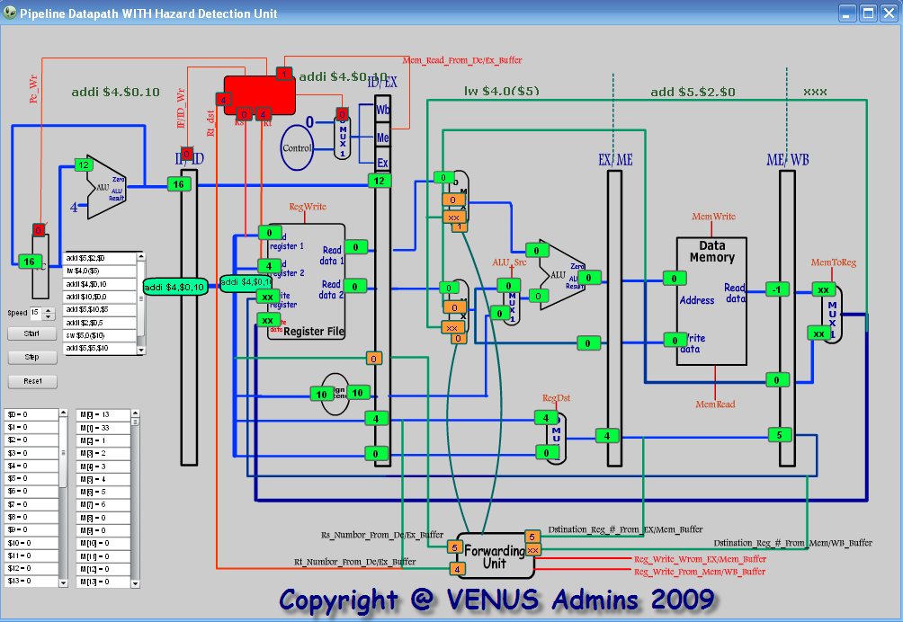

At the end of the execution some statistics are displayed such that number of instructions executed, number of cycles, the time of the execution and the CPI for the execution.

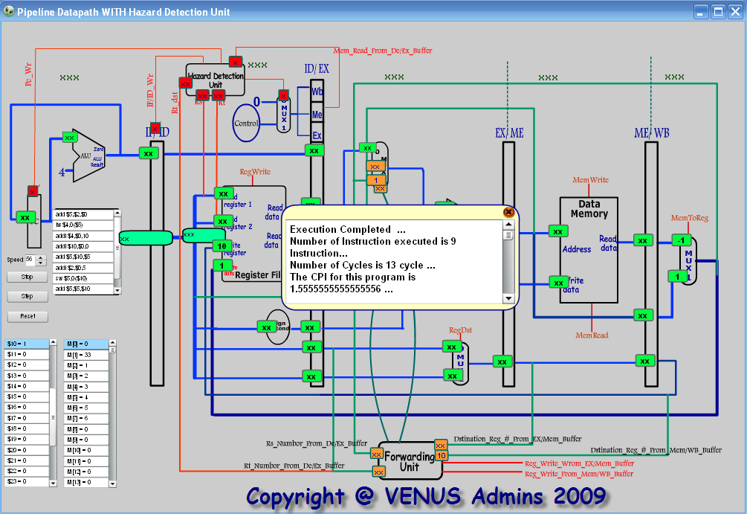

- Pipeline Data path Simulation with Control Signals

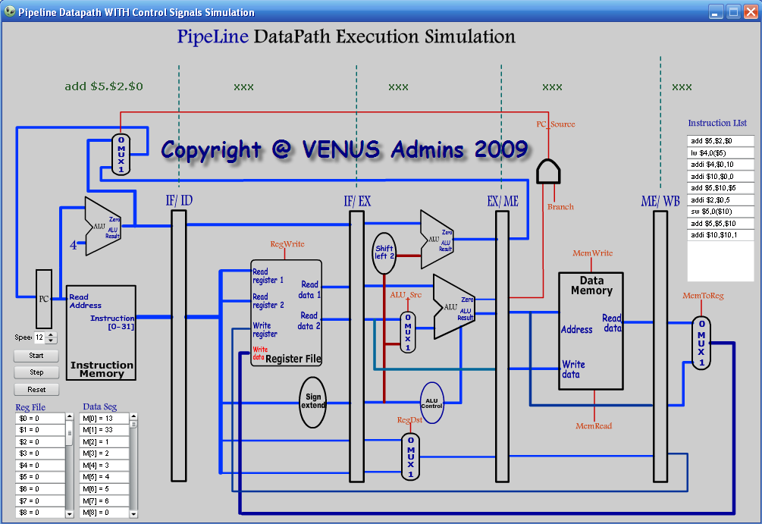

Here, we show the user how his/her code is executed on the hardware of the pipeline processor through simulating the execution of the instructions on the data path of pipeline processor.

This simulation supported with the control signals that control the main components in the data path.

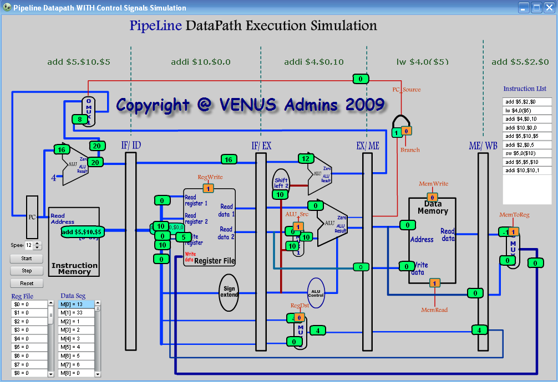

At the end of the execution some statistics are displayed such that number of instructions executed, number of cycles, the time of the execution and the CPI for the execution.
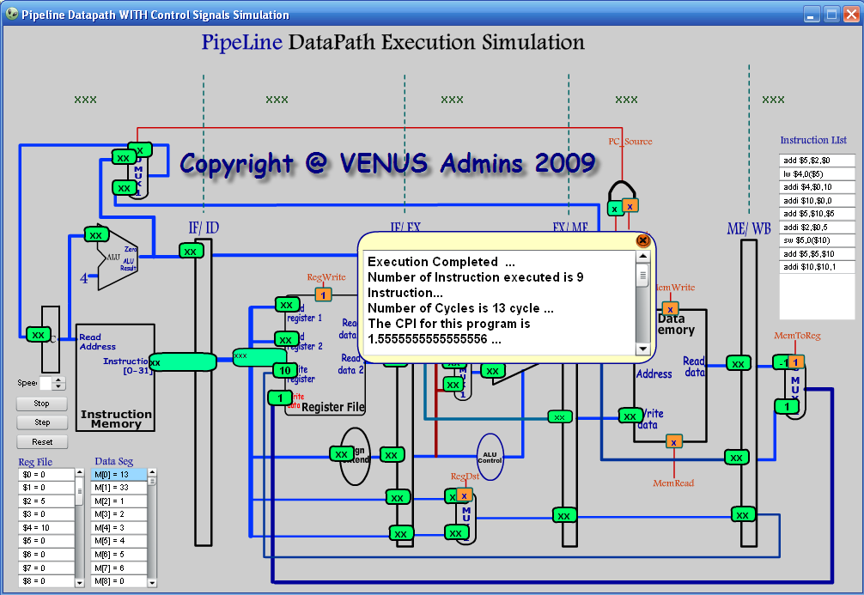

- Full Pipeline Data path Description Simulation
Here, the full pipeline data path is shown with a description for each component in the data path.
You can press on any component to see what it is and how it works …
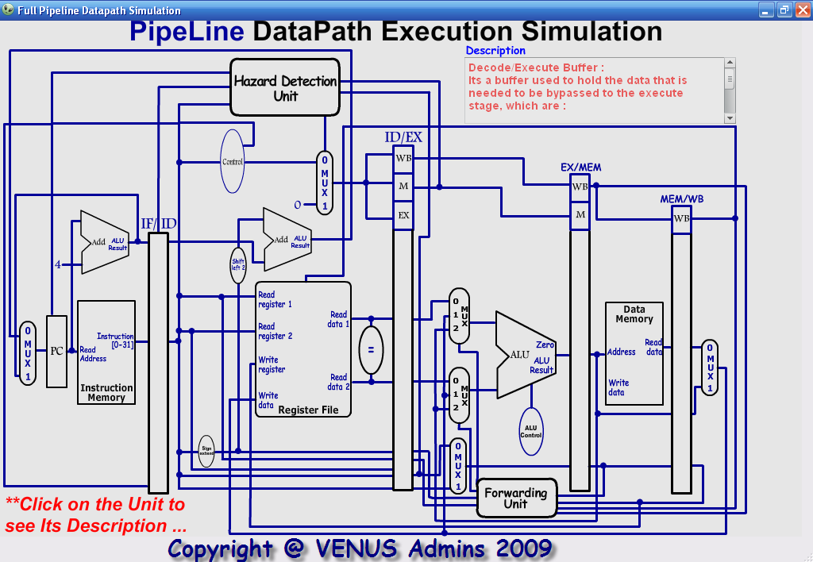
- Forwarding Unit Simulation
The forwarding unit is an optimization unit supported in the pipeline data path in order to solve data hazards and enable the pipeline approach to operate functionally.

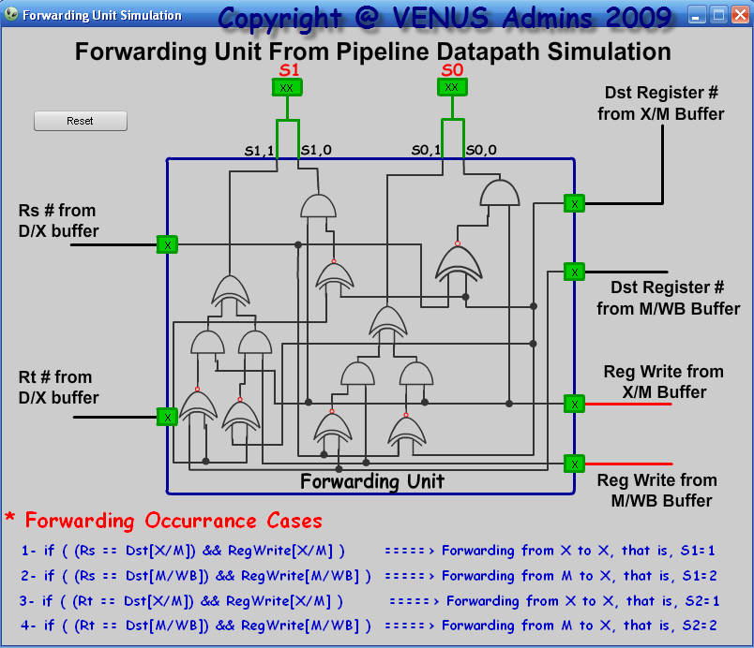

- Hazard Detection Unit Simulation
HDU is an important component in the pipeline data path that detects the hazards in all of its types in order to be solved later with forwarding or stall or reorder the instructions in user’s code.

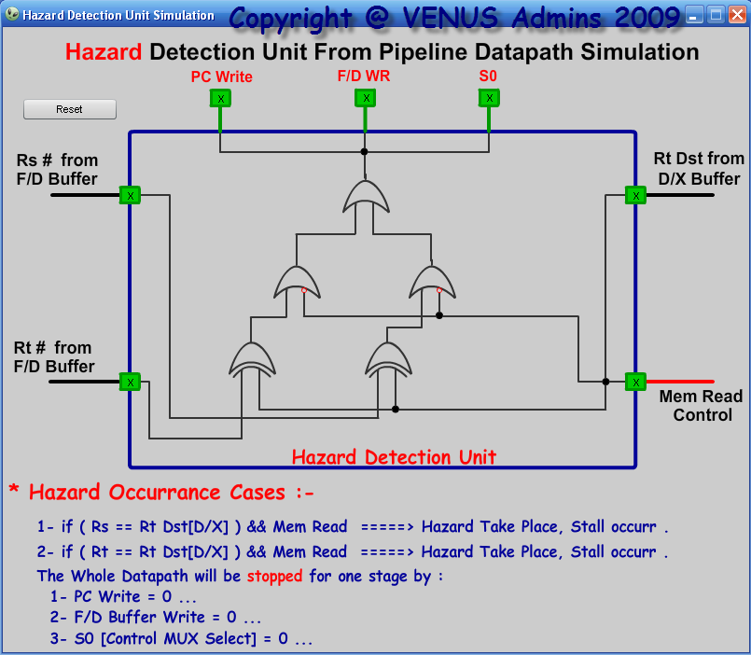

3-VENUS VCompiler
VCompiler is a powerful compiler that uses nearby C language with some specification.

This compiler convert the C code written by the user to an equivalent MIPS ASM code in order to be executed and simulated later.

Features supported in the compiler are:
- Variables declaration …
- String declaration …
- Array declaration …
- IF / else statements and nested if …
- While loop and nested loop …
- Input and output stream …
- Output and Input message boxes …
- Operations : multiply, division, addition, subtraction, and, or, …etc with priority execution.

An example is as follows:
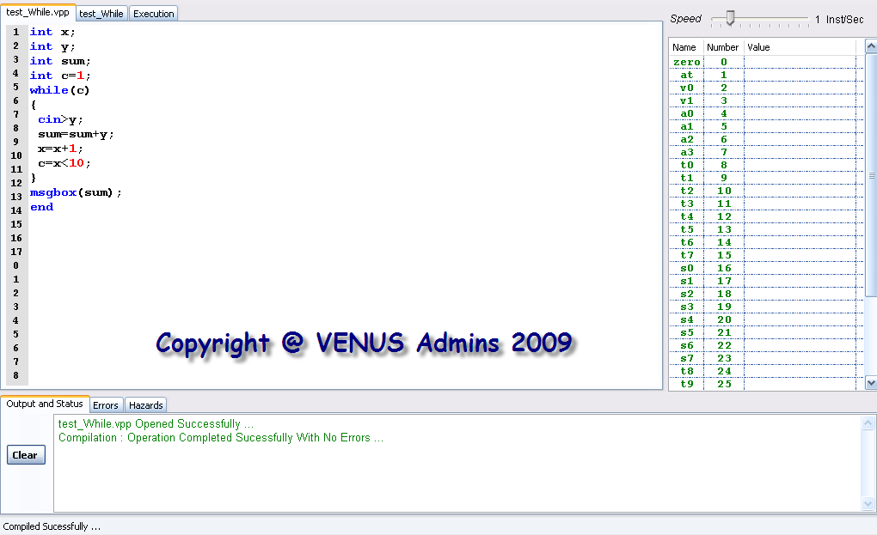

This code takes 10 numbers from the user and calculates the sum of them and output it in a message box to the user.

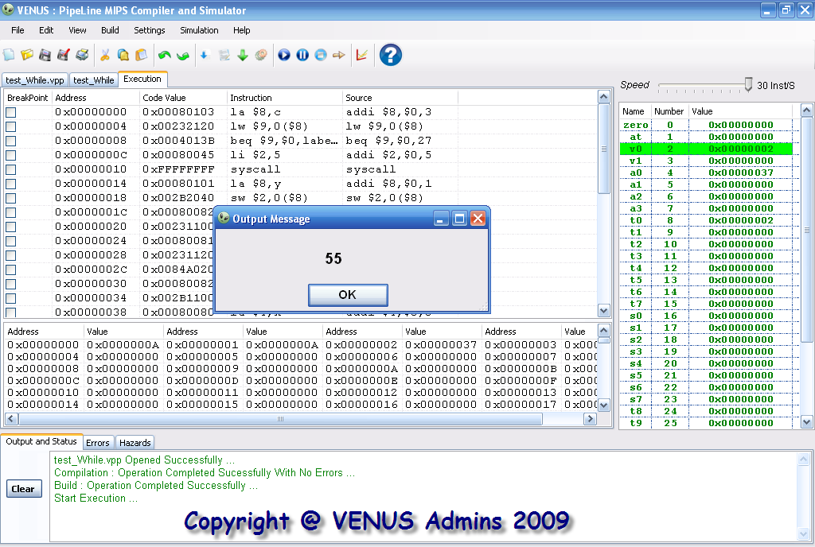

4-VENUS Website
All the features of VENUS application is build in the online website with Ajax technology and full user profile system.
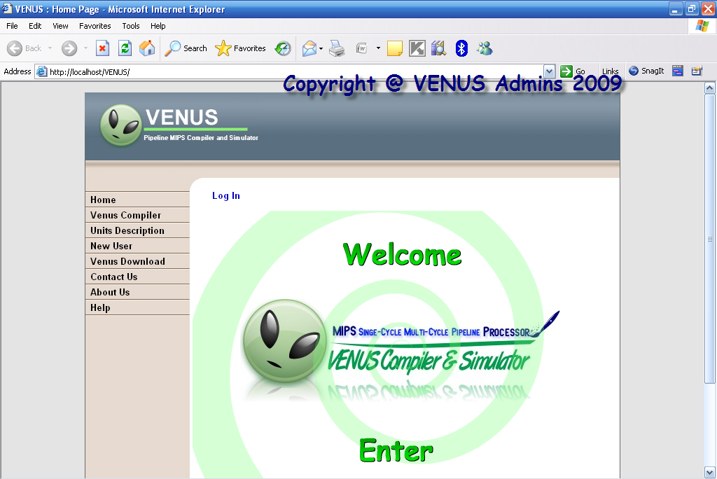
So, first of all the ordinary user can only see a written sample of C code and ASM code and execute them, he/she can’t write its own code only execute and simulate an exists sample.
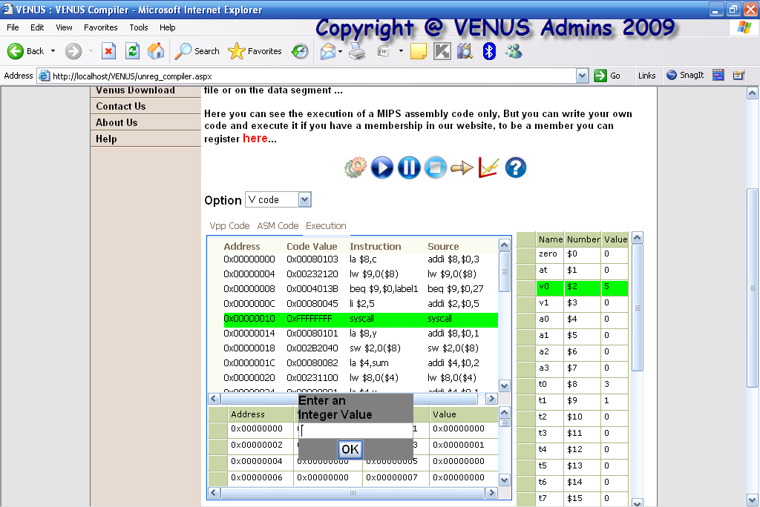
Also unregistered user can simulate an existing sample by all the simulation options we mentioned above.
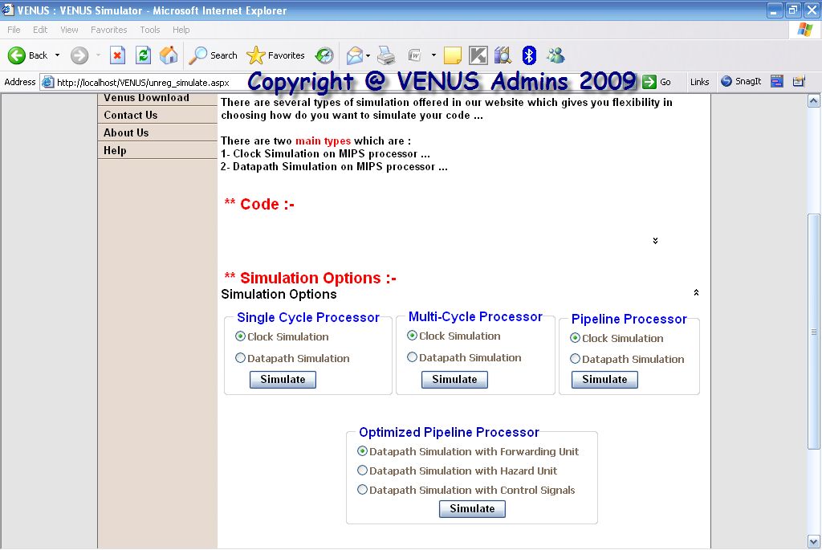

An example of simulation:
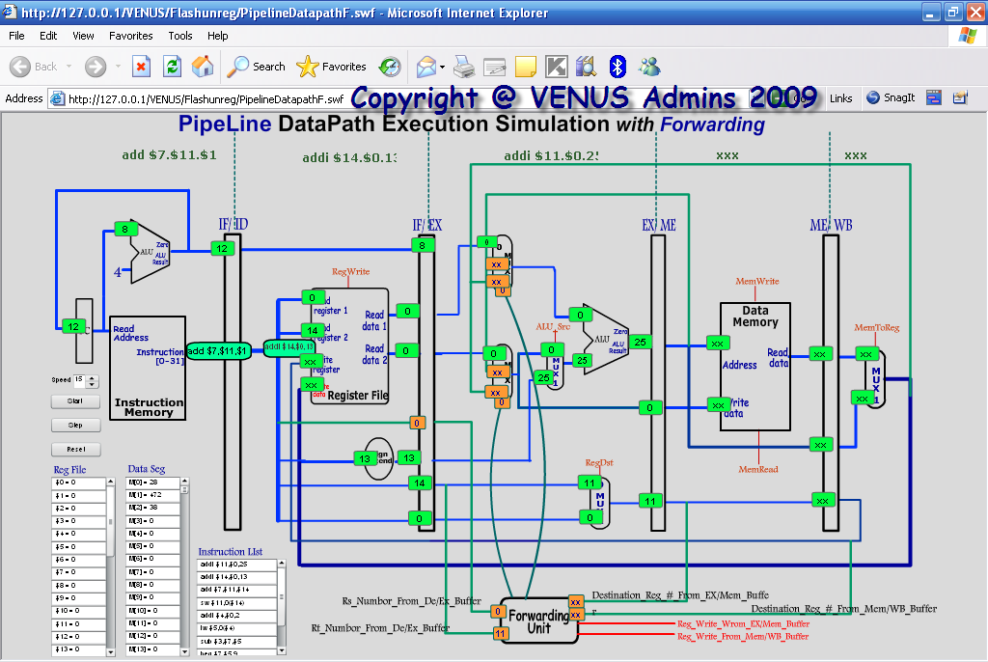
User can register with us free and simple using the new user page:
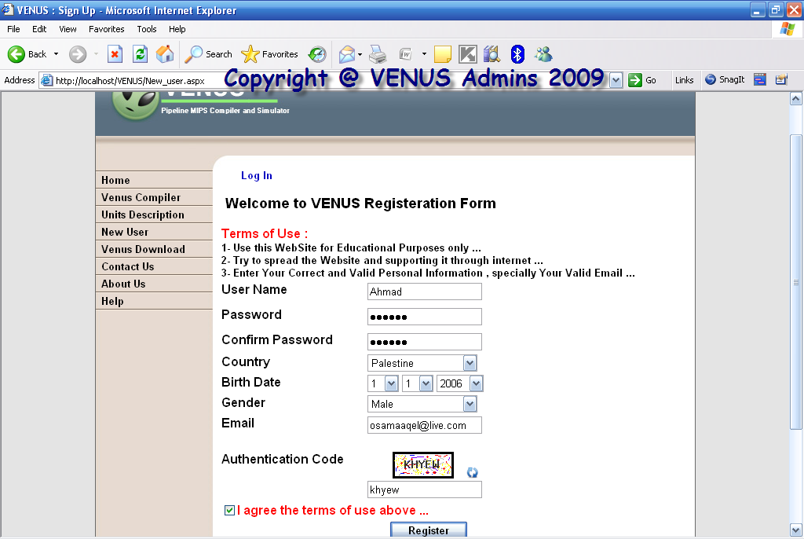

Then the user can login to our website and he will have advanced features in contrast with the unregistered user.
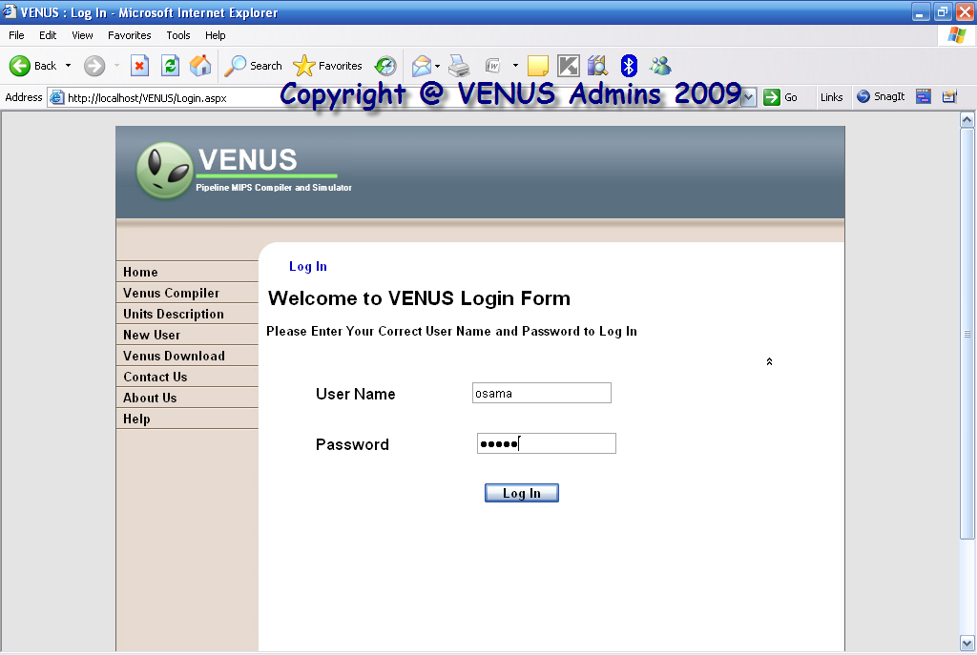
When the user login, the user page will be displayed which contains its personal information and he can modify them and save them.
Also this page contains the history of files that the user compiled and build in previous visit to the website.
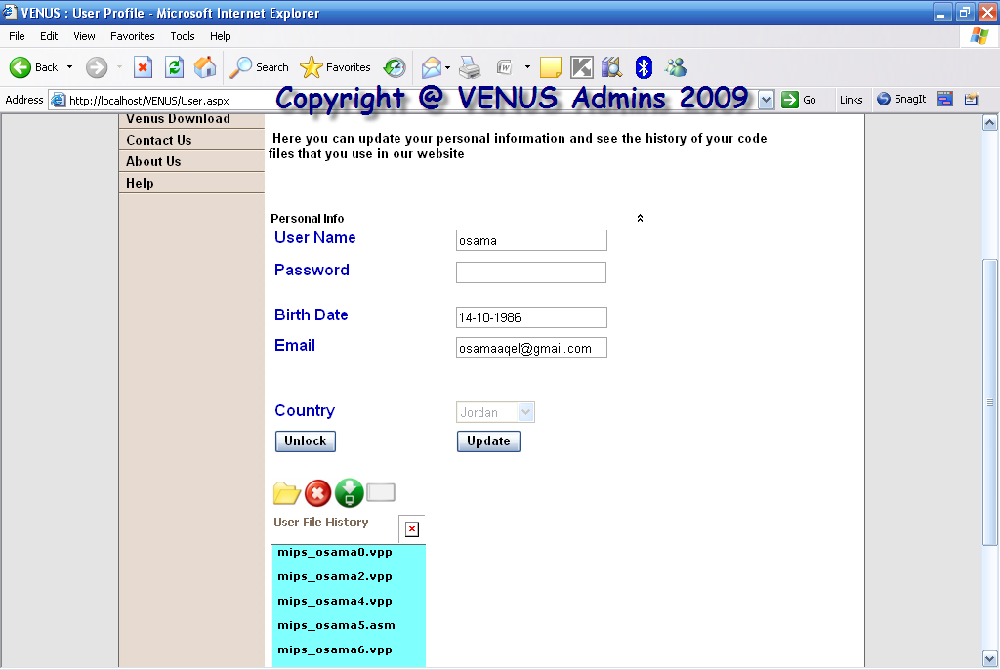
Then the user can enter the VENUS compiler page and write his own code or upload a code from his computer to execute it and simulate it.
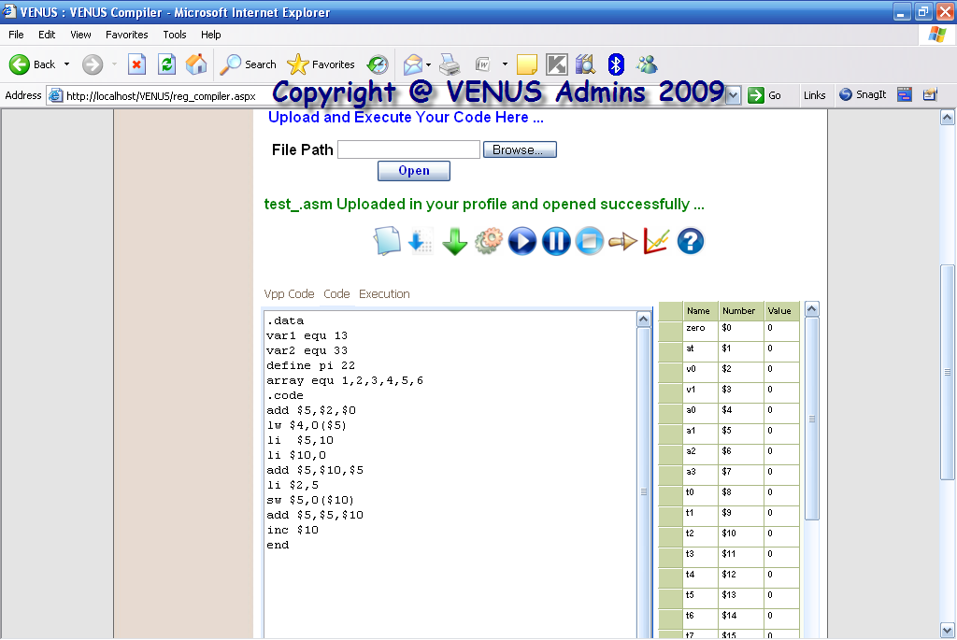
And then he may execute and simulate hi code.
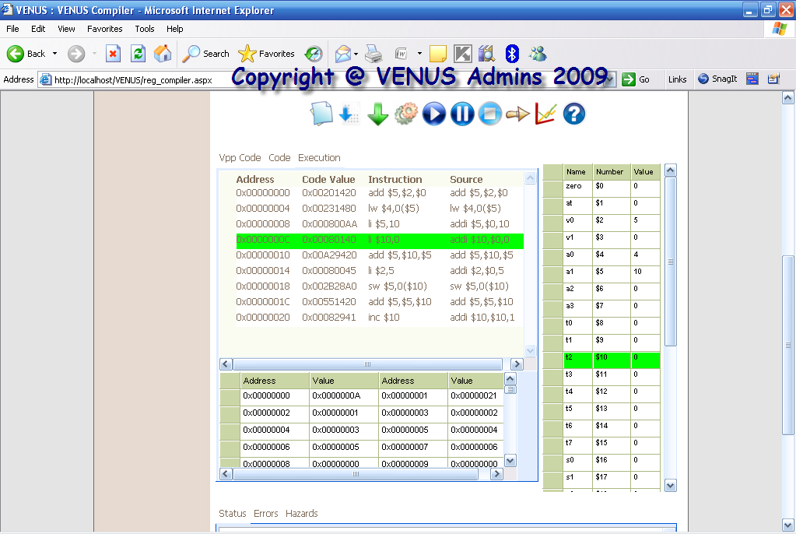

Then simulate its code with all the options available.
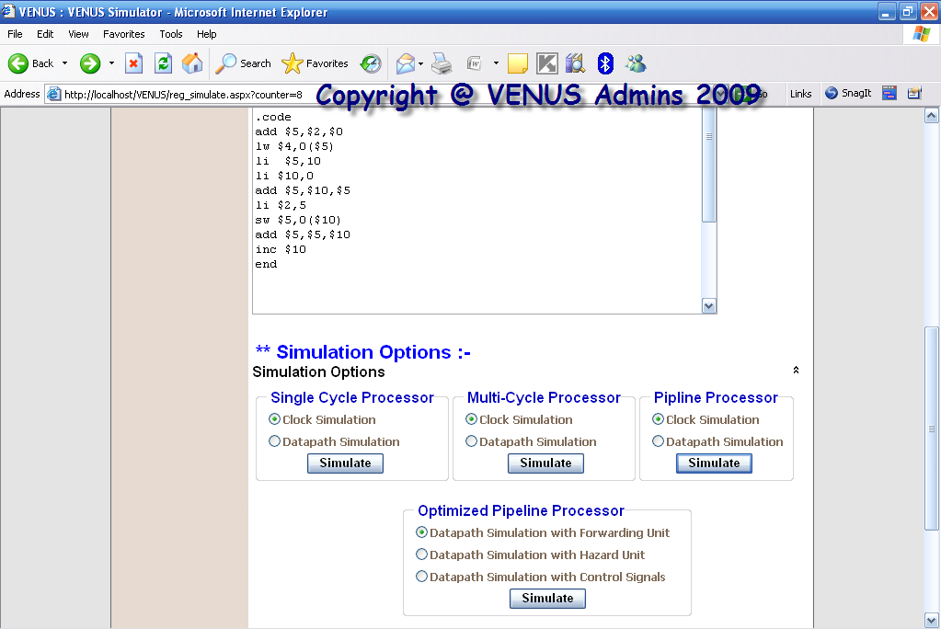

The administrator of the website has its own page in which he can control the users available and their history files.
Ajax search is enabled here.
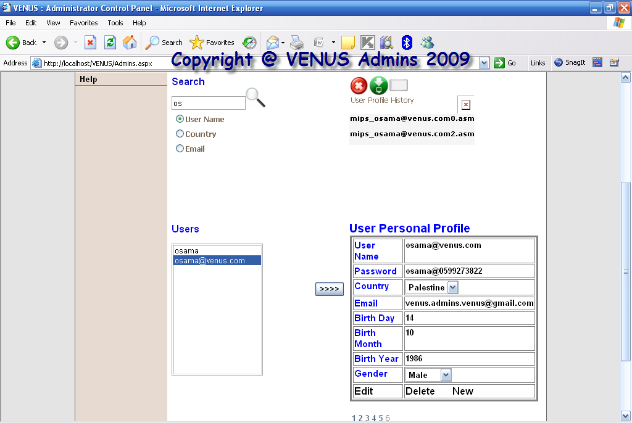
A support page for our VENUS application is available online in the website to download our application and any other versions or updates available.
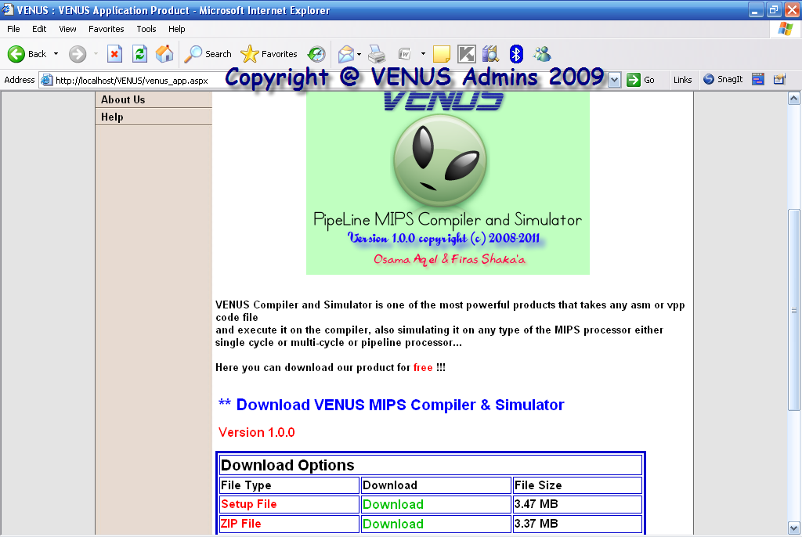
Also the registered user can contact us and give us a feedback, suggestions, complaints, and any help which is sent to the email of the administrator of the website.
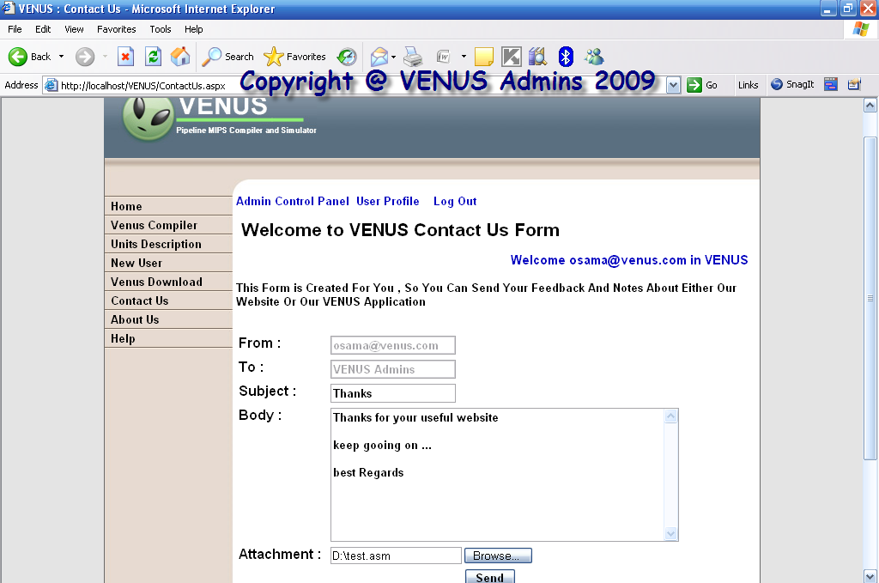
Also, units description is available here, a text description about them and the simulation for them which are:
- Forwarding Unit …
- Hazard Detection Unit …
- Full Pipeline Data path Description Simulation …
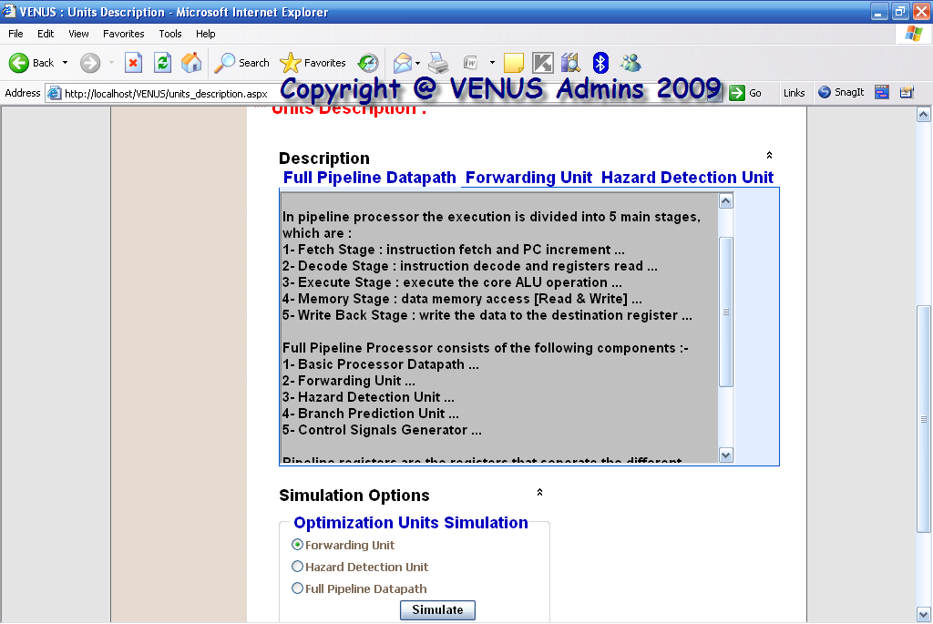

Example of simulation is:
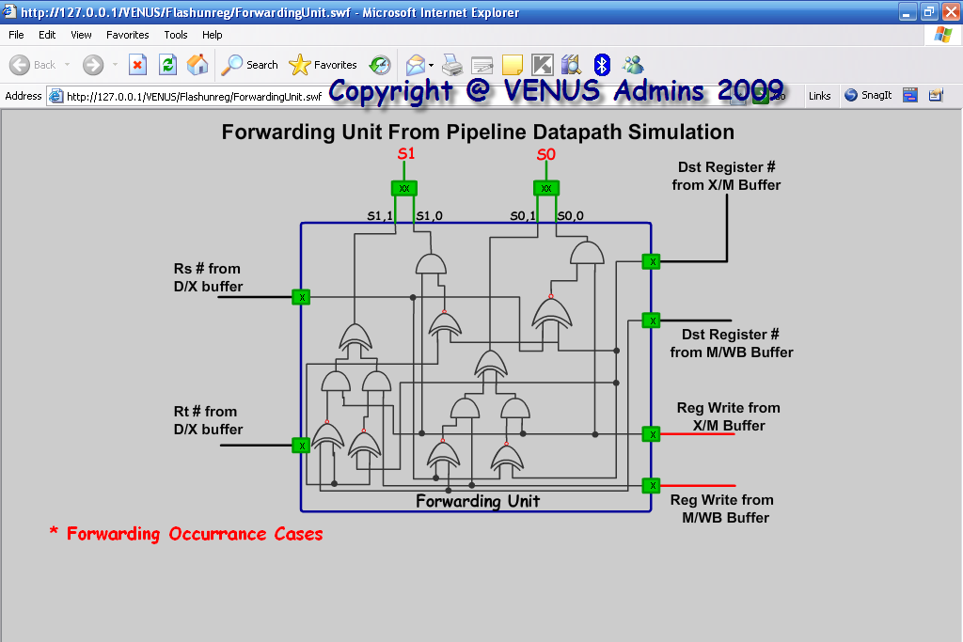

There an About Us page.
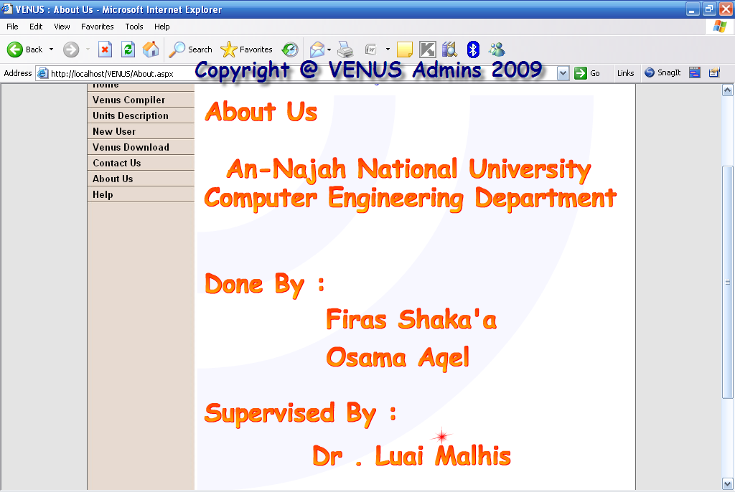

Help online is available either as HTML pages or you can download the CHM help file.
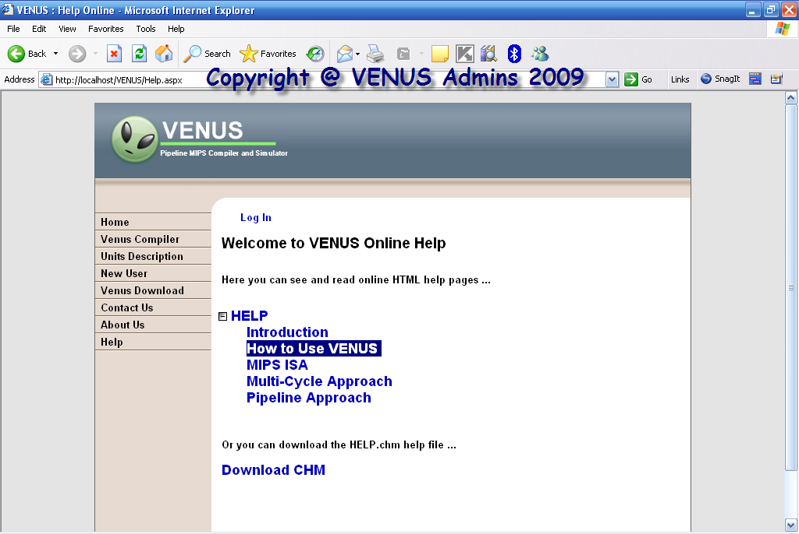

Example of one page in the help is How to use VENUS application:
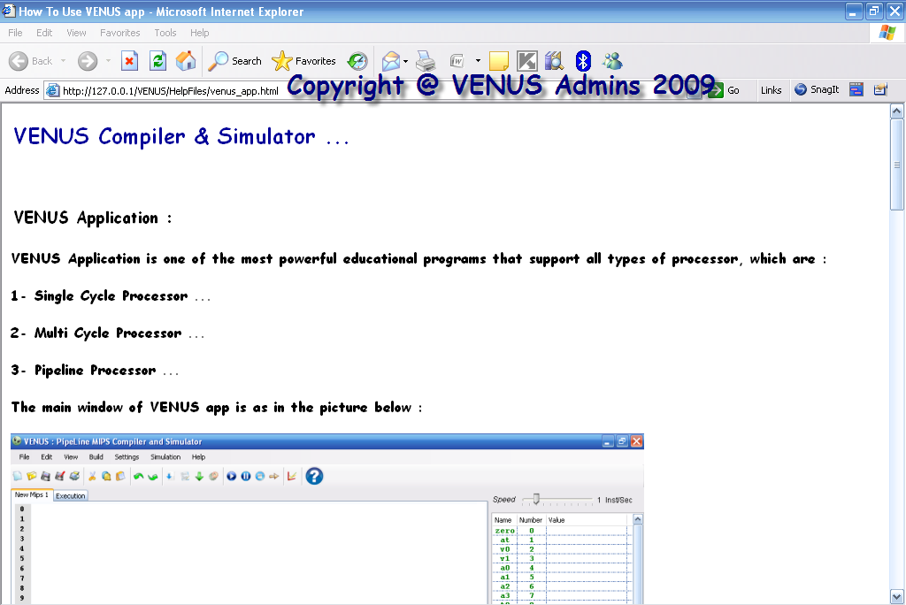
☺Technology Used in the Project
- Visual Studio 2008, C# Language …
- Adobe Flash CS3 – Action Script 3 …
- AsP.NET and JavaScript …

Section | Technology | Line #’s
VENUS Application | C# Programming on VS2008 | 12675
Flash Simulation | Adobe Flash CS3 – AS3 | 13703
VENUS Website | ASP.NET & JavaScript | 3376

☺Last but not Least
Finally, there are future plans for our project which are:
- Writing a paper for the project …
- Upload VENUS website online on the internet …
- Make the interface more beautiful and flexible …

We learn many things in this project such that working with flash, we face many problems but we pass it and we make this project successfully.

Thanks for you all doctors …

Best Regards …

END

