

AN-Najah National University
Factuality of Engineering

Department of Electrical Engineering
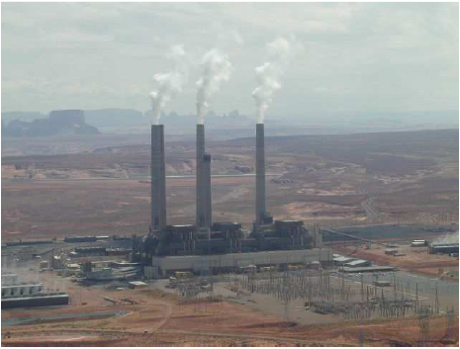
Analysis ,Improvement,Conservation,and Design PV System For Electrical Network of the Beat Ommar Twon

Prepared by :-
Iyad Obaid
Osama Yousef

Presented to :-
Dr. Imad Ibrik

2010

Table of Contents
Page | Content | NO.
 | Acknowledgment
 | Abstract
 | Introduction
 | Electrical network | Chapter 1
 | Electrical supply | 1.1
 | Energy consumption | 1.2
 | The nature of the load | 1.2.1
 | The growth rate of the load | 1.2.2
 | Daily load curve | 1.2.3
 | Element of beat Ommar network | 1.3
 | Distribution transformer | 1.3.1
 | Medium voltage 33kv line | 1.3.2
 | Analysis of the network | Chapter 2
 | ETAP power station | 2.1
 | One line diagram | 2.2
 | Data needed for the load flow analysis | 2.3
 | The real and reactive power | 2.3.1
 | The length and the resistance | 2.3.2
 | Load flow analysis | 2.4
 | The medium voltage | 2.4.1
 | Low tension voltage | 2.4.2
 | Power factor | 2.4.3
 | Load factor | 2.4.4
 | Summary | 2.4.5
 | Load flow analysis for minimum case | 2.5
 | The medium voltage | 2.5.1
 | The low tension voltage | 2.5.2
 | Summary | 2.5.3
 | Problem of the network | 2.6
 | Solution and recommendation | 2.7
 | Electrical network improvement | Chapter 3
 | Power factor improvement | 3.1
 | problem of low power factor | 3.1.1
 | How to improve the power factor | 3.1.2
 | Distribution of the capacitor | 3.1.3
 | The result of maximum case | 3.1.4
 | Power factor after adding capacitor for max case | 3.1.4.1
 | Summary of maximum case after correction | 3.1.4.2
 | The result for minimum case | 3.1.5
 | Power factor after adding the capacitor for min case | 3.1.5.1
 | Summary of min case after correction | 3.1.5.2
 | Comparison between the original and improvement case | 3.1.6
 | Voltage correction | 3.2
 | Economy study | 3.3
 | Energy conservation | Chapter 4
 | Energy conservation for street lighting | 4.1
 | Energy conservation for water pump | 4.2
 | Energy conservation in residential sector | 4.3
 | Replacing the incandescent lamp by the CFL lamp | 4.3.1
 | Energy conservation for refrigerators | 4.3.2
 | Load factor improvement | 4.4
 | Design PV system for electrification of Safa village | Chapter 5
 | Introduction | 5.1
 | The electrical loads of house hold for Safa village | 5.2
 | Design of centralized PV system component for the Safa village | 5.3
 | PV generating sizing | 5.3.1
 | The battery , charge regulator , and inverter | 5.3.2
 | Electrical network map for centralized case | 5.3.3
 | Design decentralized PV system component for Safa village | 5.4
 | PV generating sizing | 5.4.1
 | The battery, charge regulator ,inverter | 5.4.2
 | Economy evaluation of centralized and decentralized PV system for Safa village | 5.5
 | The cost of centralized and decentralized PV system for Safa village | 5.5.1
 | Which project we select centralized or decentralized | 5.5.2
 | Cash flow for centralized PV system | 5.5.2.1
 | Cash flow for decentralized PV system | 5.5.2.2
 | Max overall efficiency for centralized and decentralized PV system | 5.6
 | Building integrated photovoltaic (BIPV) system | 5.7

Acknowledgment

- We would like to take the opportunity to thank people who guided and supported us during this work.

- We are very grateful to our parents whose have always given us their encouragement and support.

- We wish to express our deepest gratitude to our supervisor " Dr. Imad Ibrik " for showing great interest in our work and for the guidance that he has given us.
- Thanks to our doctors especially “Dr.prof.Marwan Mahmud” and “Dr.Maher khammash” Head of Elec.Eng.Dep .

- Thanks to our friends for their encouragement and mental support during this work.

- Our thanks is also directed to everyone gives us information and help in our project, especially the electrical department in BEAT OMMAR.

Abstract

Our project is to make a load flow study and analysis for BEAT OMMAR Electrical Network using ETAP software to improve the power factor and to reduce the electrical losses in the network and so, reducing the penalties in the total tariff for the municipality, increasing the reliability of the network. More over we want to increase the capability of the transformers and the transmission lines.

We made a conservation energy study in order to decrease the consumption and the peak demand. We made that study on all sectors of the network such as houses, street lighting, water pumping .. etc.

we made analysis for three houses on SAFA site, and design of centralized and decentralized PV system component for these houses and we made economic model for selection optimum configuration of PV system (centralized and decentralized ).

To do that we will follow the sequence bellow :

- Analyzing this network by collecting data such as resistance and reactance, length, rated voltages, max power and reactive power on each bus .

- We entered these data to the software ( ETAP) and getting the results .

- We will give recommendations and conclusions.

- The improvements for elements of the network.

- Study the three houses load.

- Design of centralized and decentralized PV system for these houses.

Introduction

The power system in general consists of these parts:

- Generating station: And this part consists of

- Generators in which electric power is produced by 3-phase alternators operating in parallel. And usually electric power is generated at voltages of 12kv to 25kv.
- Sub-station, where the power transformers step up the voltage to between 66kv 1000kv.

- Primary transmission. The electric power at high voltages is transmitted by 3-phase 3-wire over head system to the outskirts of the city. This forms the primary transmission.

- Secondary transmission. The primary transmission line terminates at the receiving station which usually lies at the outskirts of the city. At the receiving station the voltage is reduced to 33kv or 22kv by step-down transformers. From this station, electric power is transmitted at one of these voltages by 3-phase 3-wire overhead system to various sub-stations located at strategic points in the city. This forms the secondary transmission.

- Primary distribution. the secondary transmission line terminates at the sub-station where voltage is reduced from the secondary voltage to the primary distribution voltage usually 11kv ,could be 6.6kv 3-phase 3-wire .the 11kv lines run along the important road sides of the city . And forms the primary distribution.

- Secondary distribution. The electric power form primary distribution line is delivered to distribution sub-stations. These sub-stations are located near the consumers localities and step down the voltage to 400v 3-phase 4-wire for secondary distribution. And this forms secondary distribution.
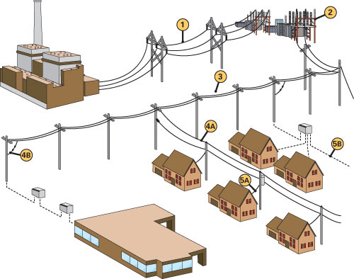

Energy sector in Palestine

Energy sector in Palestine faced sever since the Israeli occupation , financial and management obstacles due to the severe restrictions imposed by the Israeli occupation. as a result of this situation Palestine has not yet a unified power system , the existing network is local low voltage distributions networks connected to Israeli electrical corporation (IEC) , where around 97% of consumed energy were and still supplied by the IEC .

The voltages of the existing distribution networks are :
( 0.4 , 6.6 , 11 , 22 , and 33 KV ) . IEC supplies electricity to the electrified communities by 22 or 33 KV by overhead lines . electricity is purchased from IEC and then distributed to the consumers.

The existing electricity situation is characterized in old fashion over loaded networks , high power losses ( more than 20% ) , low power factor ,poor system reliability , high prices of electricity supplied to the consumer due to high tariff determined by the IEC in addition , many villages depend on diesel generators to provide their own needs of electrical energy .

Due to all factors mentioned above, it becomes very important to design a national independent power system for the west bank of Palestine which will connect all the west bank areas by a reliable network to a national generating plant . the national power system should have the minimum annual cost and provide the consumer with a high quality of electric energy . this power system should also reduced the cost of KWH and be able to provide electricity to any area in the west bank .

Load flow analysis

In power system analysis The Load Flow study is a basic and commonly needed electrical study. The Load Flow study will show the power in KVA or Amperes that is being handled by all of the individual electrical components, e.g. transformers, conductors and panels in the system. This allows a determination of equipment rating margins and reserve capacity loading percentage.

Analysis and study of distribution electrical networks may cover conventional voltage drop analysis, power losses analysis, power factor considerations, capacitors’ placements (correction of power factor).

Prospective goals of the study :-

1. Reduction of power losses
2. Increasing of voltage levels
3. Reducing the penalties by improving the P.F.
4. Increasing the capability of the transformers.
5. Increasing the reliability of the network .

Methods of improvement of operating condition in electrical networks :-

1. Swing bus control
2. Transformer taps
3. Installation of capacitor banks (reactive power compensation)
4. Changing the configuration of distribution network (radial ring)

Power factor improvement

The cosine of angle of Phase displacement between voltage and current in an AC circuit is known as Power Factor. The Reactive component is a measure of the Power Factor.

Under normal operating conditions certain electrical loads (e.g. induction motors, welding equipment, arc furnaces and fluorescent lighting (draw not only active power from the supply (kilowatts, kW) but also reactive power (reactive KVAR). This reactive power is necessary for the equipment to operate correctly but could be interpreted as an undesirable burden on the supply.

Capacitor banks

The important method of improvement power factor is by adding shunt capacitor banks at the buses at both transmission and distribution levels and loads and there are more effective to add them in the low level voltages.

Effect of Low Power Factor

- Higher Apparent Current
- Higher Losses in the Electrical Distribution network
- Low Voltage in the network

Benefits of Improving Power Factor

- Lower Apparent Power.
- Reduces losses in the transmission line .
- Improves voltage drop.
- Reduces load factor on transformers.
- Avoiding the penalties.

Information about Beat Ommar town :

Beat Ommar Palestinian town located in the north of the city of Hebron, the distance between Beat Ommar and the city is about 11 km. Beat Ommar rise 765 meters above sea level and covers an area of land (30129) dunum , Beat Ommar has a population of about 23000 people .

Khirbat Safa is located northwest of the town of Beat Ommar of the town, which suffers from the problem of roads, and electricity.

Surrounding the town of Beat Ommar from all sides of many of the colonies as a colony and the colony of Bat Ayin Gush Etzion.

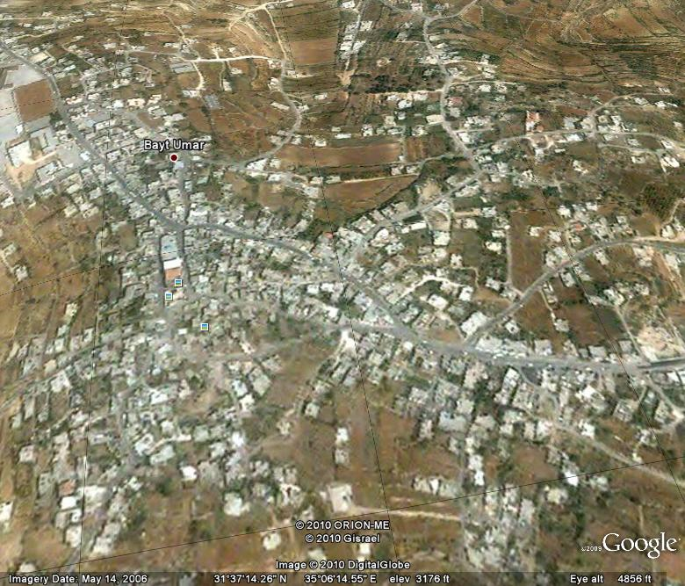

Chapter One

1.1 Electrical Supply

Beat Ommar distribution network is supplied by the IEC ( Israel electrical company ) directly, there is only one connection point at Safa through an overhead lines of 33kv . the main circuit breaker is rated at 129A . the max demand is reached 5.391 MVA.

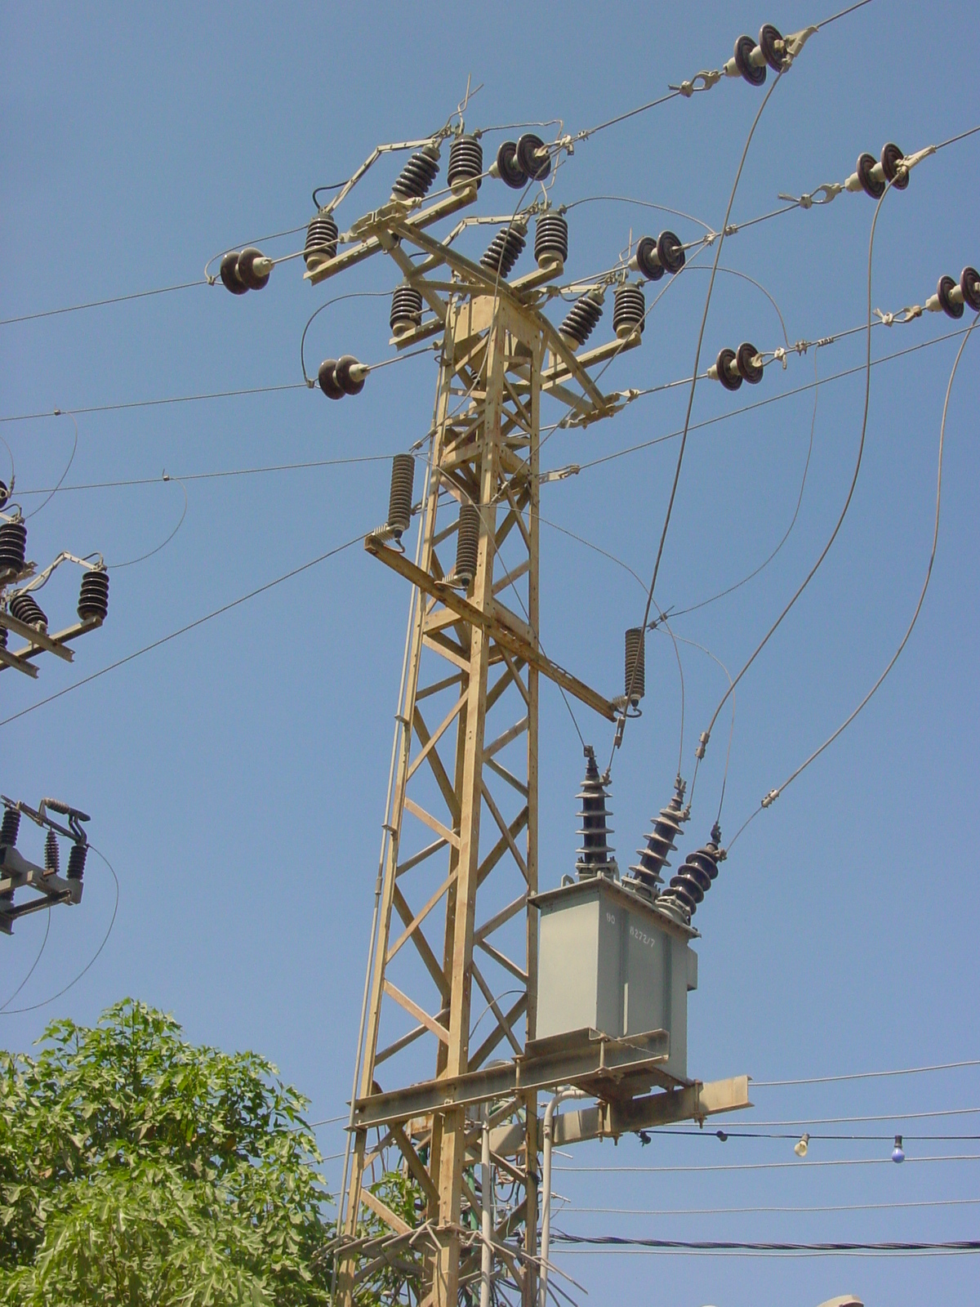

We have the only connection point in the town Safa . The IEC supplies the network with 108A, which is very little value comparing with the needs of the consumers, for example; the maximum demand reach the value of 108A in the summer which exposes the network to the danger and the cutoff of supply. so we have to demand ( purchase) another 60A from the IEC to cover the needs of Beat Ommar from electricity and put the network in the Safe side and increase the reliability of the network.

1.2 Energy Consumption :

In this section we will talk about the consumption of energy in Beat Ommar network.

1.2.1 The Nature Of The Load.

The table bellow shows the consumers classification and their size.

Type of load | Consumption %
Residential | 62%
Industrial | 11%
Commercial | 13%
Water pumps+ light | 14%

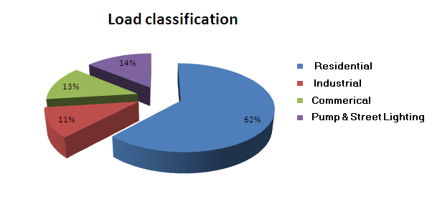

We see that the biggest consumer is the residential sector which achieve about 62 % from the total consumption, also the water pump and street lighting sector has a high percentage from the total consumption. There are many factories in Beat Ommar that consume a big amount of power.

1.2.2 The growth rate of the load

The table below shows the total consumption of energy for 4 years .

Year | Average Monthly consumption  In MWH | Percentage growth  %
2006 | 646 | ---------------
2007 | 717 | 10.99%
2008 | 797 | 11.15%
2009 | 880 | 10.41%

- We notice that the energy purchased from the ICE is changing during the
Years.
- A jump in the power consumption happened in 2008 by nearly 80 MWH.

- And here is the monthly energy consumption in MWH in the last 4 years

 | 2009 |  |  | 2008 |  |  | 2007 |  |  | 2006
month | P  (MWH) |  | month | P  (MWH) |  | month | P  (MWH) |  | month | P  (MWH)
1 | 875.1 |  | 1 | 790.3 |  | 1 | 710.3 |  | 1 | 640.1
2 | 865.9 |  | 2 | 788.7 |  | 2 | 708.3 |  | 2 | 637.9
3 | 861.3 |  | 3 | 781.9 |  | 3 | 703.1 |  | 3 | 630.2
4 | 873.6 |  | 4 | 777.8 |  | 4 | 701.5 |  | 4 | 619.5
5 | 875.2 |  | 5 | 771.9 |  | 5 | 699.6 |  | 5 | 611.1
6 | 869.4 |  | 6 | 762.7 |  | 6 | 697.7 |  | 6 | 607.3
7 | 881.6 |  | 7 | 774.1 |  | 7 | 692.1 |  | 7 | 599.8
8 | 890.6 |  | 8 | 800.1 |  | 8 | 725.5 |  | 8 | 600.2
9 | 880.1 |  | 9 | 797 |  | 9 | 716.3 |  | 9 | 643.3
10 | 882.3 |  | 10 | 793.3 |  | 10 | 709.2 |  | 10 | 660.2
11 | 876.3 |  | 11 | 789 |  | 11 | 701.6 |  | 11 | 629.7
12 | 872.1 |  | 12 | 785.2 |  | 12 | 699.6 |  | 12 | 622.7
TOTAL = | 10560 MWH |  | TOTAL = | 9564 MWH |  | TOTAL = | 8604.8 MWH |  | TOTAL = | 7752 MWH

Note: We note that the peak power is occurs in August and October .

- In graphical mode :

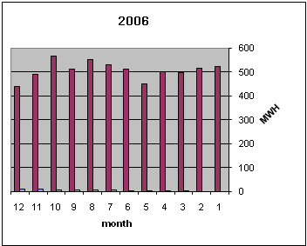
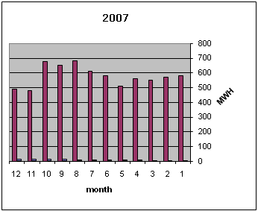
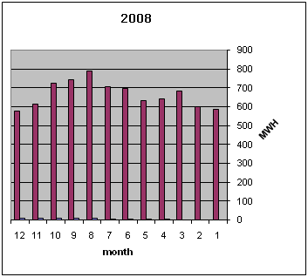
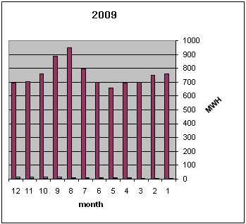

1.2.3 Daily load curve

We take readings to the load changes during the day, the result gives the graph below :

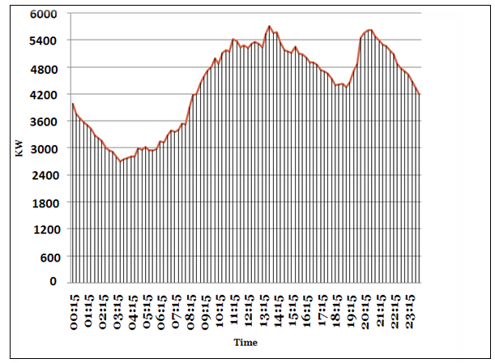

Note : that readings were taken in September 2009

From the above graph we notice the following :

- The maximum power consumed 5.463 MW and occurred at 1:45 pm .
- The peak demand occurs at two intervals :
- { 10:30 am – 03:15 pm }
- { 07:30 pm – 10:00 pm }
- The average demand is about 4.1 MW

  - Elements Of Beat Ommar Network

In this section we will study the elements of the network such as transformers, over head lines and underground cables.

1.3.1 Distribution Transformers:

Beat Ommar network consists of 26 - Δ/Υ - , 33/0.4 KV distribution transformers.
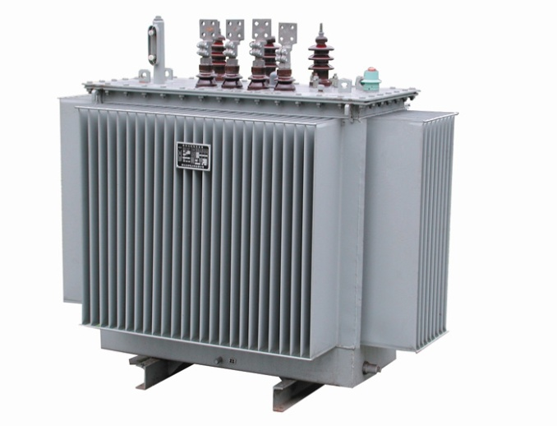

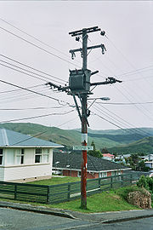

And the table shows the number of each of them and the rated KVA.

Number of Transformers | Transformer Ratings (KVA)
11 | 630
9 | 400
6 | 250

1.3.2 Medium voltage 33kv lines :

- Overhead lines

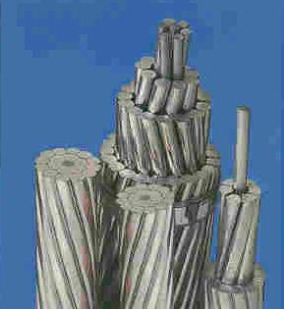

- The conductors used in the network are ACSR (50mm2) , and their
- Resistance R=(0.543/Km)
- and Reactance X= (0.297 /Km) ,

- Underground cables

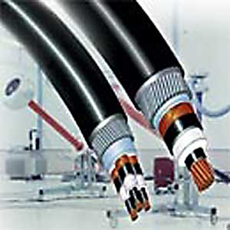

- The Underground cables used in the network are XLPE Cu (120 mm2) and their
- Resistance R= (0.303 /Km) and
- Reactance X= (0.27 /Km)

Chapter Two

Analysis Of The Network

2.1 ETAP power station :-

ETAP PowerStation allows us to work directly with graphical one line diagram.
And it provides us with text reports such as:
- complete report.
- Input data.
- Results .
- Summary reports

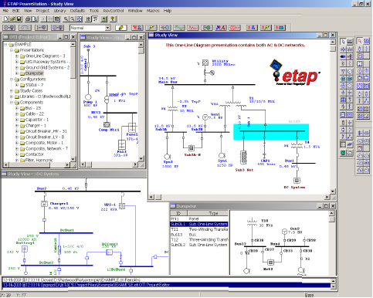

2.2 One line diagram

In order to have the one line diagram, we followed the network diagram from the network plans , and so we get this plan considered as an input to the ETAP program .

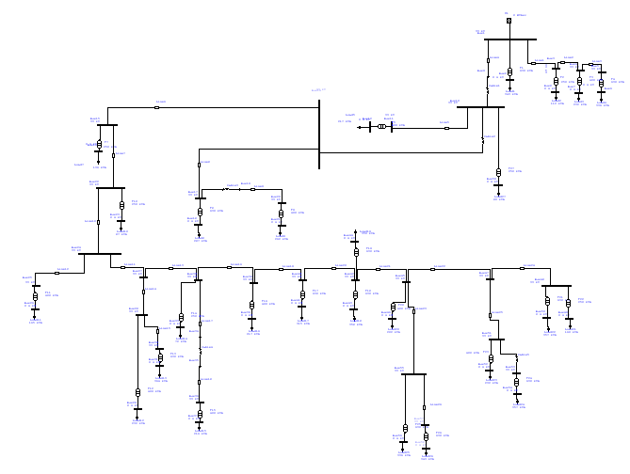

2.3 Data needed for the load flow analysis.

2.3.1 The real and reactive power

( OR apparent power and P.F OR Ampere and P.F ).

And the given table gives the real and reactive power on each bus.

Number of bus | P (kw) | Q (kvar)
1 | 5.463 | 2.896
2 | 0.295 | 0.143
3 | 0.580 | 0.323
4 | 0.483 | 0.271
5 | 0.280 | 0.170
6 | 0.278 | 0.158
7 | 0.201 | 0.092
8 | 0.096 | 0.049
9 | 4.584 | 2.416
10 | 4.583 | 2.415
11 | 0.185 | 0.102
12 | 0.184 | 0.094
14 | 4.327 | 2.276
15 | 3.844 | 2.030
16 | 0.118 | 0.054
17 | 0.477 | 0.243
18 | 0.248 | 0.120
19 | 0.227 | 0.114
20 | 0.277 | 0.114
21 | 0.225 | 0.103
22 | 3.725 | 1.971
23 | 0.076 | 0.037
24 | 3.640 | 1.927
25 | 0.139 | 0.079
26 | 0.138 | 0.075
27 | 3.498 | 1.847
28 | 0.512 | 0.260
29 | 0.196 | 0.095
30 | 0.314 | 0.156
31 | 0.312 | 0.142
32 | 2.985 | 1.585
33 | 0.055 | 0.041
34 | 0.185 | 0.097
35 | 0.185 | 0.097
36 | 0.185 | 0.097
37 | 0.183 | 0.089
38 | 2.743 | 1.445
39 | 0.184 | 0.089
40 | 2.554 | 1.346
41 | 0.267 | 0.129
42 | 2.282 | 1.204
43 | 0.301 | 0.146
44 | 0.291 | 0.149
45 | 1.685 | 0.883
46 | 0.173 | 0.079
47 | 0.934 | 0.495
48 | 0.436 | 0.233
49 | 0.132 | 0.068
50 | 0.300 | 0.145
51 | 0.499 | 0.262
52 | 0.195 | 0.094
53 | 0.302 | 0.159
54 | 0.300 | 0.145
55 | 0.577 | 0.302
56 | 0.283 | 0.137
57 | 0.291 | 0.152
58 | 0.289 | 0.140
59 | 0.070 | 0.034

    - The length and Resistances

- R in (Ω) and X in (Ω) of the lines.

After formatting the one line diagram of the network, and dividing it into buses we formed this table which shows the length of the lines and their resistance and reactance.

Cables and Lines | Length (m) | Resistance (Ω) | Reactance (Ω)
Cable 1 | 110 | 0.0333 | 0.0312
Cable 2 | 105 | 0.3180 | 0.0311
Cable 3 | 100 | 0.3030 | 0.0270
Cable 4 | 100 | 0.3030 | 0.0270
Cable 5 | 100 | 0.3030 | 0.0270
Line 1 | 100 | 0.0543 | 0.0297
Line 2 | 90 | 0.0488 | 0.0267
Line 3 | 100 | 0.0543 | 0.0297
Line 4 | 210 | 0.1140 | 0.0623
Line 5 | 650 | 0.3529 | 0.1930
Line 6 | 610 | 0.3312 | 0.1811
Line 7 | 110 | 0.0597 | 0.0326
Line 8 | 200 | 0.1086 | 0.0594
Line 9 | 320 | 0.1737 | 0.0950
Line 10 | 1000 | 0.5430 | 0.2970
Line 11 | 310 | 0.1683 | 0.0920
Line 12 | 220 | 0.1194 | 0.0653
Line 13 | 190 | 0.1031 | 0.0564
Line 14 | 110 | 0.0597 | 0.0326
Line 15 | 210 | 0.1140 | 0.0623
Line 16 | 310 | 0.1683 | 0.0920
Line 17 | 850 | 0.4615 | 0.2524
Line 18 | 100 | 0.0543 | 0.0297
Line 19 | 900 | 0.4887 | 0.2673
Line 20 | 900 | 0.4887 | 0.2673
Line 21 | 100 | 0.0543 | 0.0297
Line 22 | 220 | 0.1194 | 0.0653
Line 23 | 100 | 0.5430 | 0.0297
Line 24 | 200 | 0.1086 | 0.0594
Line 25 | 120 | 0.0650 | 0.0356
Line 26 | 100 | 0.0543 | 0.0297

.

2.4 load flow analysis for max case

2.4.1 the medium voltages

The actual medium voltages on each transformer is shown in the table below :

Transformer  number | Medium voltage(rated)  kv | Medium voltage(actual)  kv
T1 | 33 | 33
T2 | 33 | 32.99
T3 | 33 | 32.99
T4 | 33 | 32.997
T5 | 33 | 32.97
T6 | 33 | 32.973
T7 | 33 | 32.917
T8 | 33 | 32.965
T9 | 33 | 32.96
T10 | 33 | 32.908
T11 | 33 | 32.83
T12 | 33 | 32.806
T13 | 33 | 32.805
T14 | 33 | 32.795
T15 | 33 | 32.791
T16 | 33 | 32.777
T17 | 33 | 32.728
T18 | 33 | 32.684
T19 | 33 | 32.684
T20 | 33 | 32.68
T21 | 33 | 32.674
T22 | 33 | 32.674
T23 | 33 | 32.675
T24 | 33 | 32.674
T25 | 33 | 32.679
T26 | 33 | 32.679

Note : the colored values refers to the least medium voltages which has more drop of voltages.

2.4.2 The low tension voltages

The actual low voltages on each transformer is shown in the table below :

Transformer  number | Low voltage(rated)  kv | Low voltage(actual)  v
T1 | 0.4 | 391
T2 | 0.4 | 392
T3 | 0.4 | 392
T4 | 0.4 | 39
T5 | 0.4 | 39
T6 | 0.4 | 394
T7 | 0.4 | 39
T8 | 0.4 | 392
T9 | 0.4 | 389
T10 | 0.4 | 393
T11 | 0.4 | 391
T12 | 0.4 | 388
T13 | 0.4 | 388
T14 | 0.4 | 392
T15 | 0.4 | 388
T16 | 0.4 | 388
T17 | 0.4 | 388
T18 | 0.4 | 387
T19 | 0.4 | 387
T20 | 0.4 | 388
T21 | 0.4 | 387
T22 | 0.4 | 385
T23 | 0.4 | 386
T24 | 0.4 | 387
T25 | 0.4 | 387
T26 | 0.4 | 387

Note : the colored values refers to the least low voltages which has more drop of voltages.

2.4.3 Power factor
The table below shows the power factor, real and reactive power on each transformer:

No .of transformer | P (KW) | Q (KVAR) | P.F %
T1 | 295 | 143 | 90
T2 | 96 | 49 | 89
T3 | 201 | 92 | 91
T4 | 278 | 158 | 87
T5 | 184 | 94 | 89
T6 | 70 | 34 | 90
T7 | 118 | 54 | 91
T8 | 248 | 120 | 90
T9 | 225 | 103 | 91
T10 | 76 | 37 | 90
T11 | 138 | 75 | 88
T12 | 196 | 95 | 90
T13 | 312 | 142 | 91
T14 | 55 | 41 | 80
T15 | 183 | 89 | 90
T16 | 184 | 89 | 90
T17 | 267 | 129 | 90
T18 | 301 | 146 | 90
T19 | 391 | 149 | 89
T20 | 173 | 79 | 91
T21 | 300 | 145 | 90
T22 | 132 | 68 | 90
T23 | 195 | 94 | 90
T24 | 300 | 145 | 90
T25 | 283 | 137 | 90
T26 | 289 | 140 | 90

Note : the power factor reach between 0.91 and 0.87 .
This causes more penalties on the total bill

2.4.4 Load factor

The load factor is known as the average power divided by the rated power.

No .of transformer | T. ratings (KVA) | T. load(KVA) | Load factor  %
T1 | 630 | 343 | 54.4
T2 | 250 | 112 | 44.8
T3 | 400 | 232 | 58
T4 | 630 | 336 | 53.3
T5 | 400 | 217 | 54.2
T6 | 250 | 80 | 32
T7 | 250 | 136 | 54.4
T8 | 630 | 287 | 45.5
T9 | 400 | 262 | 65.5
T10 | 250 | 87 | 34.8
T11 | 400 | 165 | 41.2
T12 | 400 | 232 | 58
T13 | 630 | 364 | 57.7
T14 | 250 | 72 | 28.8
T15 | 400 | 216 | 54
T16 | 400 | 217 | 54.2
T17 | 630 | 315 | 50
T18 | 630 | 358 | 56.8
T19 | 630 | 350 | 55.5
T20 | 400 | 202 | 50.5
T21 | 630 | 357 | 56.6
T22 | 250 | 160 | 64
T23 | 400 | 232 | 58
T24 | 630 | 357 | 56.6
T25 | 630 | 336 | 53.3
T26 | 630 | 343 | 54.4

- L.F Somewhere reaches 65.5% , and it drops to 32% in other buses .

- There is no over loaded transformers in the network, but some of the transformers is under loaded .

    - Summery

we have to summarize the results, total generation, demand , loading., percentage of losses, and the total power factor for the maximum case.

MW MVAR MVA % PF
========= ========= ========= ===== =======

SWING BUS: 5.463 2.896 6.183 88.4 Lag

Total Demand: 5.463 2.896 6.183 88.4 Lag
--------- --------- --------- --------------

TOTAL LOAD: 5.391 2.646

APPARENT LOSSES: 0.072 0.249

TOTAL CURRENT : 108 A

- The low power factor is due to the poor power factors at the loads.

2.5 load flow analysis for min case

2.5.1 the medium voltages

The actual medium voltages on each transformer is shown in the table below :

Transformer  number | Medium voltage(rated)  kv | Medium voltage(actual)  kv
T1 | 33 | 33
T2 | 33 | 32.999
T3 | 33 | 32.999
T4 | 33 | 32.999
T5 | 33 | 32.985
T6 | 33 | 32.986
T7 | 33 | 32.958
T8 | 33 | 32.982
T9 | 33 | 32.98
T10 | 33 | 32.953
T11 | 33 | 32.913
T12 | 33 | 32.901
T13 | 33 | 32.901
T14 | 33 | 32.896
T15 | 33 | 32.894
T16 | 33 | 32.887
T17 | 33 | 32.862
T18 | 33 | 32.839
T19 | 33 | 32.839
T20 | 33 | 32.837
T21 | 33 | 32.834
T22 | 33 | 32.834
T23 | 33 | 32.835
T24 | 33 | 32.835
T25 | 33 | 32.837
T26 | 33 | 32.837

.

2.5.2 The low tension voltages

The actual low voltages on each transformer is shown in the table below :

Transformer  number | Low voltage(rated)  kv | Low voltage(actual)  v
T1 | 0.4 | 395
T2 | 0.4 | 395
T3 | 0.4 | 395
T4 | 0.4 | 395
T5 | 0.4 | 395
T6 | 0.4 | 397
T7 | 0.4 | 395
T8 | 0.4 | 396
T9 | 0.4 | 394
T10 | 0.4 | 396
T11 | 0.4 | 395
T12 | 0.4 | 394
T13 | 0.4 | 394
T14 | 0.4 | 396
T15 | 0.4 | 394
T16 | 0.4 | 394
T17 | 0.4 | 394
T18 | 0.4 | 393
T19 | 0.4 | 393
T20 | 0.4 | 394
T21 | 0.4 | 393
T22 | 0.4 | 392
T23 | 0.4 | 393
T24 | 0.4 | 393
T25 | 0.4 | 394
T26 | 0.4 | 393

    - Summery

we have to summarize the results, total generation, demand , loading., percentage of losses, and the total power factor for the maximum case.

MW MVAR MVA % PF
========= ========= ========= ===== =======

SWING BUS: 2.807 1.433 3.151 89.1 Lagging

TOTAL DEMAND: 2.807 1.433 3.151 89.1 Lagging

--------- --------- --------- --------------

TOTAL LOAD: 2.788 1.369

APPARENT LOSSES: 0.019 0.065

TOTAL CURRENT : 55 A

- The min load is equal to 50% of the max load

  - Problems Of The Network

We can summarize the general problems of the network by the following points :

- The consumed power is reached the maximum limit , which causes over load currents .
This result in disconnecting the supply of the town .

- The P.F is less than 0.92 ; this cause penalties and power losses.

- There is a voltage drop and power losses

  - Solutions And Recommendations

- Increasing the supply from the IEC from the main circuit breaker .

- Using capacitor banks to improve the P.F and so, reducing the power losses , and avoiding the penalties.

- Managing the max peak demand by :

1. shift of max demand.
2. using other sources.

- Conservation of energy .

- Increasing the reliability of the system by developing another configurations ( Ring off ) .

- Using PV modules

Chapter Three

Electrical Network Improvements

3.1 Power factor improvement

    - The problem of low power factor

- The low P.F is highly undesirable as it causes an increase in current, resulting in additional losses of active power in all the elements of power system from power station generator down to the utilization devices.

- In addition to the losses the low P.F causes penalties, for example for every 1% P.F below 92% and above 80% costs us 1% of the total bill.

    - How to improve the P.F

Where:
- Qc: the reactive power to be compensated by the capacitor.
- P: the real power of the load.
- Ø old: the actual power angle.
- Ø New: the proposed power angle.

- COMPENSATION AT L.V. IS PROVIDED BY

1- Fixed values of capacitors.
2- Automatic capacitor banks.

- AUTOMATIC COMPENSATION PF.

- A bank of capacitors is divided into a number of sections.

- Each of which is controlled by a contactor.

- A control relay monitors the power factor of the controlled circuit(s) and is arranged to close and open appropriate contactors to maintain a reasonably constant system power factor (within the tolerance imposed by the size of each step of compensation).

For Max Case :

- Qc = Q old – Q new =P [tan cos-¹(PF old) - tan cos-¹(0.92)]
- P = 5.463 MW
- PF old = 88.4%
- PF desired = 92% and above
- Qc ≈ 550 kVAr
- The reactive power needed to reach 92% of P.F equals :

Q_{c} ≈ 550 kVAr

** Which will cause the P.F in the min case to be 95.2% lag.

    - The distribution of capacitors

The following table shows the distribution of the capacitor banks and its effect on the P.F on each transformer.

# of  Transformers | Qc (kvar) | Old P.F% | Max case New P.F% | Min case New P.F%
1 | 30 | 90 | 92.1 | 95.6
2 | 10 | 89 | 91.4 | 94.1
4 | 60 | 87 | 93 | 98
5 | 30 | 89 | 93.1 | 97.7
6 | 10 | 90 | 93.9 | 97.7
8 | 30 | 90 | 92.9 | 96.6
10 | 10 | 90 | 93.5 | 97.2
11 | 25 | 88 | 93 | 97.9
12 | 25 | 90 | 92.7 | 96.7
14 | 20 | 80 | 92.9 | 98
15 | 20 | 90 | 92.3 | 95.9
16 | 20 | 90 | 92.2 | 95.4
17 | 30 | 90 | 92.4 | 96
18 | 30 | 90 | 91.9 | 95.3
19 | 40 | 89 | 91.9 | 96.5
21 | 30 | 90 | 91.9 | 95.3
22 | 20 | 89 | 92.4 | 97
23 | 20 | 90 | 91.9 | 95.5
24 | 30 | 90 | 91.9 | 95.3
25 | 30 | 90 | 92.1 | 95.7
26 | 30 | 90 | 92.1 | 95.6

    - The results for max case

      - Power factor after adding capacitors for max case

# of bus | P  (kw) | Q (kvar) | P.F  %
TR1 | 297 | 144 | 92.1
TR2 | 96 | 49 | 91.4
TR3 | 201 | 92 | 91
TR4 | 282 | 160 | 93
TR5 | 186 | 95 | 93.1
TR6 | 70 | 34 | 93.9
TR7 | 118 | 54 | 89.6
TR8 | 250 | 121 | 92.9
TR9 | 225 | 103 | 89.4
TR10 | 76 | 37 | 93.5
TR11 | 140 | 75 | 93
TR12 | 198 | 96 | 92.7
TR13 | 312 | 142 | 91
TR14 | 56 | 42 | 92.9
TR15 | 183 | 89 | 92.3
TR16 | 185 | 90 | 92.2
TR17 | 269 | 130 | 92.4
TR18 | 303 | 147 | 91.9
TR19 | 294 | 151 | 91.9
TR20 | 173 | 79 | 91
TR21 | 302 | 146 | 91.9
TR22 | 134 | 68 | 92.4
TR23 | 196 | 95 | 91.9
TR24 | 302 | 146 | 91.9
TR25 | 285 | 138 | 92.1
TR26 | 291 | 141 | 92.1

      - Summary of max case after correction

we can summarize the results, total generation, demand , loading., percentage of losses, and the total power factor for the maximum case.

MW Mvar MVA % PF
===== ===== ===== ======

Swing Bus: 5.494 2.374 5.985 91.8 Lagging

Total Demand: 5.494 2.374 5.985 91.8 Lagging
--------- --------- --------- --------------

Total Load: 5.426 2.139

Apparent Losses: 0.068 0.235

Total current 105A. ( Before the capacitors the total current was 108A ).

Saving in the real power P = 4 KW.

Saving in the reactive power Q = 14 Kvar.

    - The results for min case

3.1.5.1 Power factor after adding capacitors for min case

# of bus | P  (kw) | Q (kvar) | P.F  %
TR1 | 152 | 74 | 95.6
TR2 | 58 | 30 | 94.1
TR3 | 103 | 47 | 91
TR4 | 145 | 82 | 98.5
TR5 | 96 | 49 | 97.7
TR6 | 36 | 17 | 97.7
TR7 | 60 | 28 | 91
TR8 | 128 | 62 | 96.6
TR9 | 116 | 53 | 90.2
TR10 | 39 | 19 | 97.2
TR11 | 72 | 39 | 97.9
TR12 | 102 | 49 | 96.7
TR13 | 161 | 73 | 91
TR14 | 29 | 21 | 98
TR15 | 94 | 46 | 95.9
TR16 | 96 | 46 | 95.4
TR17 | 139 | 67 | 96
TR18 | 157 | 76 | 95.3
TR19 | 152 | 78 | 96.5
TR20 | 89 | 41 | 91
TR21 | 157 | 76 | 95.3
TR22 | 69 | 36 | 97
TR23 | 102 | 49 | 95.5
TR24 | 157 | 76 | 95.3
TR25 | 147 | 71 | 95.7
TR26 | 151 | 73 | 95.6

      - Summary of min case after correction

we can summarize the results, total generation, demand , loading., percentage of losses, and the total power factor for the maximum case.

MW Mvar MVA % PF
===== ======= ======= =======

Swing Bus: 2.823 0.896 2.962 95.3 Lagging

Total Demand: 2.823 0.896 2.962 95.3 Lagging
--------- --------- --------- --------------

Total Load: 2.806 0.838

Apparent Losses: 0.017 0.058

Total current 52A. ( Before the capacitors the total current was 55A ).

Saving in the real power P = 2 KW.

Saving in the reactive power Q = 7 Kvar.

    - Comparison between the original and improved cases

Original case After improvement PF

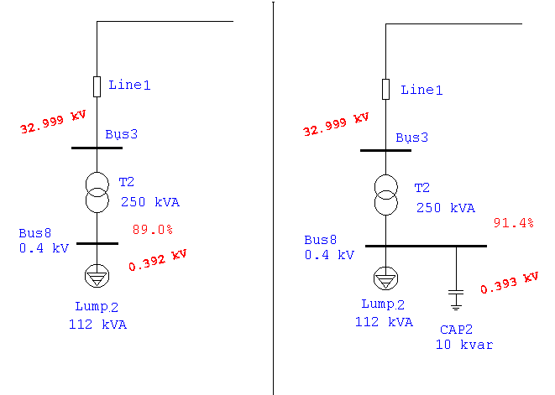

3.2 Voltage correction

The table bellow shows the voltage ranges before and after adding capacitor banks for the two levels of voltage.

# of Transformer | Medium voltage  Kv before | Medium voltage  Kv after | Low voltage  Kv before | Low voltage  Kv after
TR1 | 33 | 33 | 0.391 | 0.392
TR2 | 32.99 | 32.999 | 0.392 | 0.393
TR3 | 32.99 | 32.99 | 0.392 | 0.390
TR4 | 32.997 | 32.997 | 0.39 | 0.393
TR5 | 32.97 | 32.971 | 0.39 | 0.392
TR6 | 32.973 | 32.974 | 0.394 | 0.395
TR7 | 32.917 | 32.92 | 0.39 | 0.390
TR8 | 32.965 | 32.966 | 0.392 | 0.393
TR9 | 32.96 | 32.961 | 0.389 | 0.389
TR10 | 32.908 | 93.912 | 0.393 | 0.394
TR11 | 32.83 | 93.836 | 0.391 | 0.392
TR12 | 32.806 | 32.813 | 0.388 | 0.393
TR13 | 32.805 | 32.812 | 0.388 | 0.388
TR14 | 32.795 | 32.803 | 0.392 | 0.394
TR15 | 32.791 | 32.799 | 0.388 | 0.389
TR16 | 32.777 | 32.785 | 0.388 | 0.390
TR17 | 32.728 | 32.738 | 0.388 | 0.390
TR18 | 32.684 | 32.695 | 0.387 | 0.388
TR19 | 32.684 | 32.695 | 0.387 | 0.388
TR20 | 32.68 | 32.692 | 0.388 | 0.388
TR21 | 32.674 | 32.686 | 0.387 | 0.388
TR22 | 32.674 | 32.686 | 0.385 | 0.387
TR23 | 32.675 | 32.686 | 0.386 | 0.388
TR24 | 32.674 | 32.686 | 0.387 | 0.388
TR25 | 32.679 | 32.691 | 0.387 | 0.389
TR26 | 32.679 | 32.69 | 0.387 | 0.388

  - Economical study

In order to make sure that adding the capacitor banks, we should make an economical study to see if that is feasible .

So we have to know how much saving in power and energy we have, also we have to calculate the simple payback period ( S.P.B.P ) which known as the investment of money through capacitors divided by the total saving in energy through a year.

Simple payback period

0.8≤PF<0.92 penalties is 1% of the total bill for every 0.01 of P.F. < 0.92
0.7≤PF<0.8 penalties is 1.25 % of the total bill for every 0.01 of P.F < 0.8

PF< 0.7 penalties is 1.5% of the total bill for every 0.01 of P.F < 0.7

Average monthly consumption = 880000 kwh

Total bill (NIS/year) = 880000kwh * 12 month * 0.5(NIS/kwh)=5280000 NIS/year

Saving in penalties = (91.8-88.4) * 1% * 5280000 NIS/year

Saving in penalties = 179520 NIS/year

Saving in energy = ∆P * τ* (NIS/kwh)
= (0.072-0.0680)KW *2500h*(0.5)

Saving in energy = 5500 NIS/year

Saving per year = saving in penalties + saving in energy
= 179520 + 5500

Saving per year = 185020 NIS/year

Capital cost = cost of capacitors =Q(KVAR) * (15 JD/KVAR) * 6 NIS
= 550 * 15 *6

Capital cost = 49500 NIS

S.P.B.P = capital cost / (saving per year)
= 49500 / 185020

S.P.B.P = 0.2675 year = 3.21 month = 96 day

Note : since the S.P.B.P less than two years then the project is feasible.

Current in max case

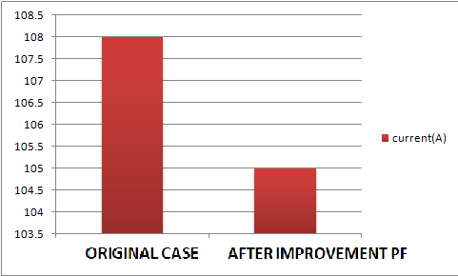

Current in min case

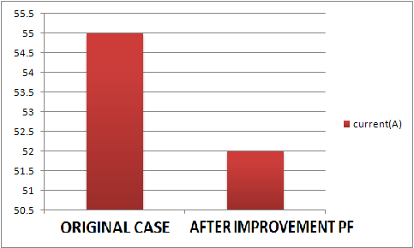

Losses real power (KW) in max case

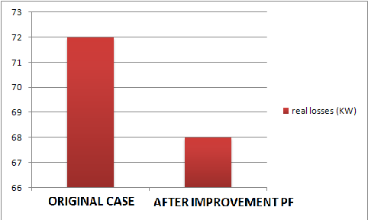

Losses real power(KW) in min case

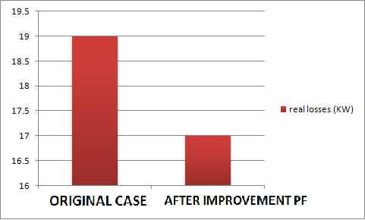

Power factor in max case

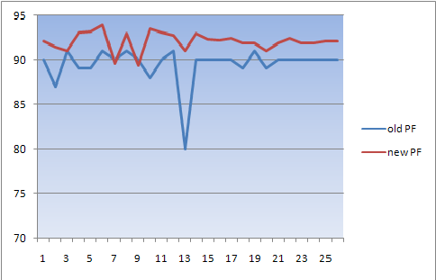

Power factor in min case

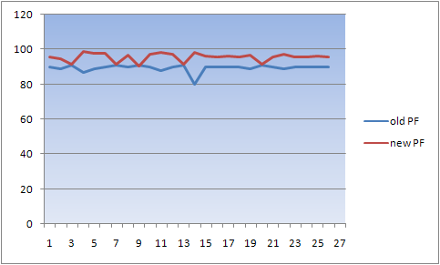

Chapter four

Energy conservation

4.1 Energy conservation in street light

In Beat Ommar town we have a number of street lamps ( about 1100 ) lamps distributed in the streets with rated power of 125 w for 500 lamps, and 70 w for 600 lamps .

We have to conserve energy in this sector by replacing the 125 w lamps by the 70 w lamps .

#of street lamps | Power (W) | After replacement | Saving energy(KWH)/year | Saving in cost NIS/ year
600 | 70 | 70 | 0 | 0
500 | 125 | 70 | 120450 | 66247

- Then we should show the saving in power and energy and money.
- Also the simple payback period to recover the cost is very important .

Calculations :

ΔP=(125-70)=55W, for each lamp.

Working hours per day=12 Hr, and 4380 Hr per year

Saving energy per year = ΔP *#of lamps*hrs per year. =55*500*4380/1000= 120450(Kwh)/year.

Cost of energy =0.55 NIS/Kwh.

Saving in cost=0.55*120450= 66247 NIS./year.

Cost of each lamp=250NIS and for all lamps = 125000 NIS.

S.P.B.P=capital cost/saving per ye =125000NIS/66247(NIS/year).
=1.8year
=1.8*12=22.64 months

Note : since the S.P.B.P less than 5 years then the project is feasible.

4.2 Energy conservation in water pumps

In Beat Ommar we have 9 water pumps, 3 of them are operating by using diesel fuel.

The other 6 motors are working by electricity. We can save energy in this sector by replacing the less efficient ones by another motors of high efficiency as follows :

Existing motors

#of motor | Output power(KW) | Efficiency% | Input power(KW) | ΔP(KW) | Working hours | Working time
4 | 55 | 90 | 61.1 | 6.1 | 18 | 5 am to 11 pm
2 | 75 | 86 | 87.2 | 12.2 | 11 | 5 am to 4 pm

New motors

#of motor | Output power(KW) | Efficiency% | Input power(KW) | ΔP(KW) | Working hours | Working time
4 | 55 | 94.4 | 58.2 | 3.2 | 18 | 5 am to 11 pm
2 | 75 | 94.5 | 79.36 | 4.36 | 11 | 5 am to 4 pm

Economical study
By replacing motors old motors by new motors
The saving in real power

The first group of motors(4 motors)
ΔP=6.1-3.2= 2.9Kw for each
ΔP for 4 motors=2.9*4=11.6kw

The saving in energy of the motors
=11.6*18*365=76212kw per year
Saving in cost of motors
=065*76212=49537.8nis per year

The second group of motors

ΔP=12.2_4.36=7.84kw for each motor

ΔP=7.84*2=15.68kw for 2 motors

The saving in energy of motors

=15.68kw*11hr*365=62955.2 kw per year

The saving in cost of motors

=0.65*62955.2=40920.88nis per year

The cost of 75 hp motor and Efficiency =94.4 is 5000 $

Corresponds to 20000 NIS

The cost of 100hp motor and Efficiency =94.4 is 6000 $

corresponds to 24000 NIS

The total cost of 4 motors (75hp) =80000 NIS

The total cost of 2 motors (100hp) =48000 NIS

The first group of motors (75hp)

S.P.B.P =80000/49537.8=1.61 year =19 month

The second group of motors (100hp)

S.P.B.P =48000/40920.8=1.17 year=14 month

Note: we can Manage the max peak demand by shifting the operating time of the first two motors in group 1 and all the motors in group 2, which works on the peak time. { 7:30 pm to 10:00 pm } From the daily load curve

4.3 Energy conservation in residential sector.

4.3.1 Replacing the incandescent lamps by the CFL lamps.

Note: we have 2400 consumers.

 | Inc.lamp75w | CFL lamp15w
Price(NIS) | 1.5 | 25
Life time (hours) | 1000 | 10000
Cost over life time(NIS) | 10*1.5=15 | 25*1=25
Kwh in 10000 hr | 750 | 150
Energy cost in  10000 hr  (NIS) | 0.65*750=487.5 | 0.65*150=97.5
Total cost(NIS) | 487.5+15=502.5 | 25+97.5=122.5
Saving in 10000 hr | 502.5-122.5=380 (NIS)

- We notice that we can save 380(NIS) by using the CFL lamps during the operating life for one lamp .

Economy study

Each home have about 5 lamps in average, and it work about 5 hours per day

Total lamps = 2400*5=12000 lamps.

Energy consumption per year ( Inc 75 W)
=75* 12000*5*365= 1642500 Kwh/year.

Energy consumption per year ( CFL15 W)
=15*12000*5*365=328500 Kwh/year.

Saving in energy = 1314000Kwh/year.

Saving in cost = 1314000 * 0.65 = 854100 NIS/ year.

Fixed cost/year = (8760/10000)*25*12000 = 262800 NIS

S.P.B.P = 262800 NIS /854100 (NIS/year) = 0.307year
=3.69 months.

S.P.B.P for each consumer

We see that the replacement is feasible and the consumer save 356 NIS per year.

Total lamps = 5 lamps.

Energy consumption per year ( Inc 75 W)

=75*5*365*5= 684.375 Kwh/year.

Energy consumption per year ( CFL15 W)

=15*5*365*5 =136.875Kwh/year.

Saving in energy =548Kwh/year.

Saving in cost = 584* 0.65 = 356.2NIS/ year.

Fixed cost/year = (8760/10000)*25*5 = 109.5NIS

S.P.B.P = 109.5NIS /356.2(NIS/year) = 0.307 year

=3.6months.

4.3.2 Energy conservation in refrigerators:

In this section of energy conservation in the residential sector we aim to replace the old refrigerators which consumes high energy by new refrigerators which consumes less power energy than the old one. And we will make the feasibility study using the simple payback period (S.P.B.P) method.
In beat ommar village 2600 refrigerators at least
1000 of its is old .if we replace it by new type
We notice the following

- The table below shows the old refrigerators and their size and their consumption in Kwh/day .
- And the new refrigerators to be replaced by.

Type of refrigerator | Size in(Ltr) | KWh/day | Cost (NIS) | Type of new one | KWh/day | Cost (NIS)
amcor | 430 | 2.9 | 1200 | LG | 1.2 | 3000

Life cycle for Amcor =5 years

Life Cycle for LG =10years

Annual fixed cost for amcor =1200/5=240 NIS

Annual fixed cost for LG =3000/10=300 NIS

Running cost /year for amcor

=2.9*365*.65=688NIS

Running cost for LG =1.2*365*.65=284NIS

Total cost /year =240+688 =928 NIS for amcor

Total cost /year =300+284 =584 NIS for LG
Saving money /year =928_584=344NIS
Difference in cost =3000_1200=1800NIS
S.P.B.P= 1800/344=5.2 years

4.4 Load factor improvement:

The load factor equal the average power divided by the maximum power, and so it is less than one and the best load factor which is equal to unity, and to do this we have to reduce the maximum demand as possible to be equal the average power.

- From the daily load curve , we see that the average demand is 4.1 MW.

- and the maximum peak demand is 5.463 MW.

- The total load factor = Pav/ Pmax = 72%.

- To improve the load factor and reducing the peak demand we suggest some notes :

- 1. shifting some of loads operating at the max point. The water pumps which operate through the duration of max load should work at another time .

- 2. adding capacitors in the transformers decreases the losses and the apparent power and so the peak demand .

Chapter Five

design of PV system for electrification of Safa Villiage

5.1 Introduction

The main characteristics of using PV system for electrification of
small rural villages are: the fuel is free, technology is mature and almost
worldwide available and it has modularity, low maintenance requirements,
high durability and also they can easily be connected to the utility network.
A rooftop mounted decentralized photovoltaic system is one of the
applications of solar PV systems that has attracted lots of interest among
the people in our region. The generation of electricity by this system is
attractive because :
* Generation is one-site. This results in reduction of transmission and
distribution costs and losses;
* The cost of roofing tiles can be eliminated by using mounted PV systems
instead;
* There is no need for additional land for power generation
The only factor hindering the growth of utilization of PV
decentralized systems is relatively high capital cost.
Another configuration that photovoltaic can have a major
contribution is in centralized generating electricity for people living in
isolated areas. Developing a method based on life cycle cost to select the
optimum configuration (centralized or decentralized ) will help in
increasing the utilization of PV systems

information about Safa village

Safa site is a small village that located north west of the town of Beat Ommar and away from it 4.5 km, which suffers from the problem of roads ,and electricity.

the houses lunch power from diesel generator ( 5KW, engine 9HP , fuel capacity 8 Gallons , run time at 50% load is 18 HR , number of hour operation is 14 HR as 8-12AM , 2-12 PM )

5.2 The electrical loads of household for Safa site

appliance | Power (w) | number | Time (HR) | Energy consumption (W/day)
CFL lamps | 13 | 4 | 5 | 260
TV | 60 | 1 | 5 | 300
Refrigerators | 80 | 1 | 8 | 640
Washing machine | 160 | 1 | 0.25 | 40
Others | 30 | -- | 1 | 30
Total | 343 W / house |  |  | 1270 W/day / house

# of house = 3
Electrical energy consumption = 1270 * 3 = 3.810 Kwh/day
Total required power = (343*3)/D.V = 1029/1.25 = 823.2 W

We use multicrystalline 36 rectangular cell module type (KC 130 GHT – 2)
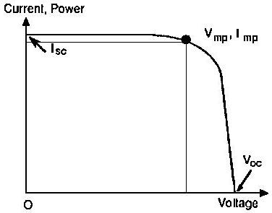
Peak power = 130 W
Vmpp=17.6 V VMPP ≈ 0.8 * Voc
Impp = 7.39 A IMPP ≈ 0.9 * ISC
Vo.c = 21.9v
I s.c = 8.02 A

5.3 Design of centralized PV system components for safa village

5.3.1 PV generating sizing

Ppv=( E/(ηv*ηR*PSH) )*S.F where PSH = 5.4 H in palestine
= 3.810 * 1.15/.9*.92*5.4 = 0.98 KWp
# of necessary PV module = NO.PV = Ppv/Pmpp
= 980/130=2.73 ≈3 PV module
Nominal voltage of PV generator = 48 V
# of module in series = NO.pvs=Vpv/Vmmp
=48/17.6 =2.73≈ 3
# of string = NO.pv/NO.pvs = 7.538/2.73 = 3 string
# of PV generator modulo = 3 * 3 = 9 modulo
The area of array is ( 3 * 1.425)*(3*0.652)=8.36 m²

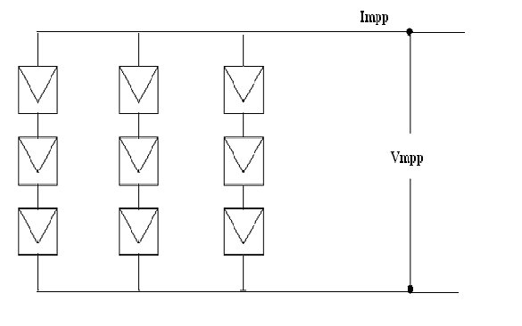

Figure (5.1): The configuration of the centralized PV generator for safa village

Impp = 3 * 7.39 = 22.17 A
Vmpp= 3 * 17.6 = 52.8 V DC
Vo.c = 3 * 21.9 = 65.7 V DC
Is.c = 3 * 8.02 = 24.06 A

The actual maximum power obtained from PV =Vmpp * I mpp
=52.8 * 22.17 =1.170 KWP

5.3.2 the battery , charge regulater , and invertor

The Battery

CAH = E /(Vb*DOD * ηv*ηB )

CAH for two day = 2*3.810/(48*.75*.85*.9)
= 276 .68AH

CWH = CAH * Vb= 276.68 * 48 = 13281 Wh

We use battery 2v/300Ah (sale this battery 63 $ , model No GFM-300G)

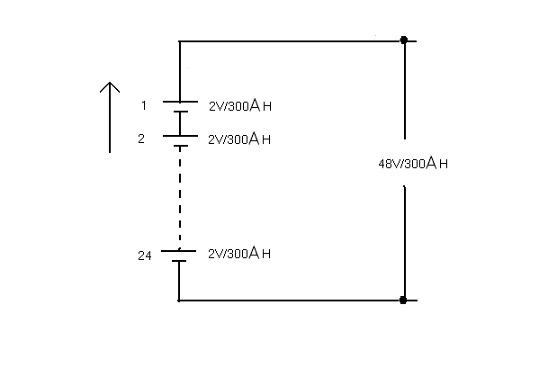

Figure (5.2): The configuration of battery blocks of the PV system for Safa village

Charge Regulator

- Voutput must be equal to Vnominal (PV) = 48*0.875-48*1.2 = (42-57.6)V DC

- The appropriate rated power of CR must be equal Ppv = 1.170KWP ≈1.5KWP

- Change regulator have been selected (30A-48V)

- Efficiency must be not less of 92%

Inverter

- Vinput has to be matched with battery block voltage = VCR output =(42-57.6) V DC

- Voutput 230V AC ± 5% , one phase , 50 HZ

- Power of inverter is Pnominal ≥ 1.278KW ≈ 1.5 KW

- Efficiency must be not less than 90%

5.3.3 Electrical network map for centralized case

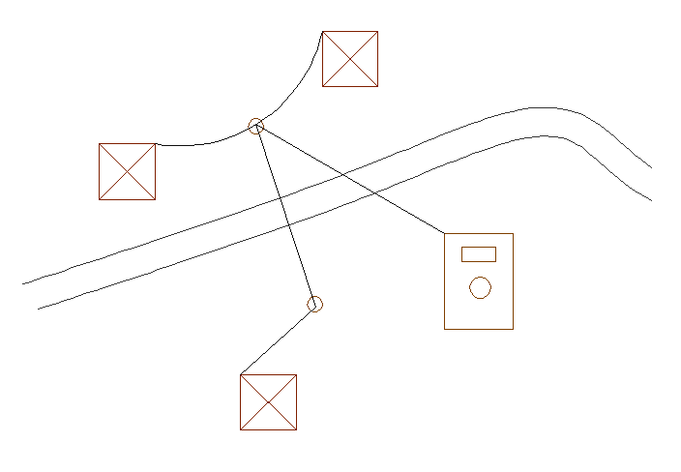

Figure (5.3): Safa electrical network map

5.4 Design of decentralized PV system components for safa village

5.4.1 PV generating sizing

# of house = 3
Energy consumption = 1270 wh/day for each house

Ppv=( E/(ηv*ηR*PSH) )*S.F where PSH = 5.4 H in palestine
= 1270 * 1.15/.9*.92*5.4 = 300 Wp
# of necessary PV module = NO.PV = Ppv/Pmpp
= 300/130 ≈ 2 PV module
Nominal voltage of PV generator = 24 V
# of module in series = NO.pvs=Vpv/Vmmp
=24/17.6 ≈ 2
# of string = NO.pv/NO.pvs = 2/2 = 1 string
# of PV generator modulo = 2 * 1 = 2 modulo
The area of array = 2 * 1.425 * 0.652=1.86 m²

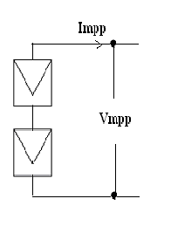
Figure (5.4): The configuration of the decentralized PV generator for safa village

Impp = 1 * 7.39 = 22.17 A

Vmpp= 2 * 17.6 = 35.2 V DC
Vo.c = 2 * 21.9 = 44 V DC
Is.c = 1 * 8.02 = 8.02 A

The actual maximum power obtained from PV =Vmpp * I mpp
=35.2 * 7.39 =260.1WP

5.4.2 the battery , charge regulater , and invertor

The Battery

CAH = E /(Vb*DOD * ηv*ηB )

CAH for two day = 2*1270/(24*.75*.85*.9)
= 92.2 AH

CWH = CAH * Vb= 92.2 * 24 = 4420 Wh

We use battery 12v/100Ah (block battery 12v/100ah)

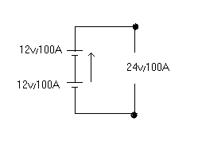

Figure (5.5): The configuration of battery blocks of the PV system for Safa village

Charge regulater

Rated power Ppv=260.1w≈300w
10A-24V

Inverter

Output voltage 230v ± 5% AC
Nominal power Pnominal ≥375w≈400w

5.5 Economic Evaluation of Centralized and Decentralized PV System
for Safa Village as Case Study

5.5.1 The cost of centralized and decentralized PV system for Safa villages

Table (5.6): The costs of the centralized PV system
Component | Quantity | Unit price  $ | Total price  $ | Life time  year
PV-module (KC) | 1170 Wp | 4/Wp | 4680 | 25
Support structure | 2 | 100 | 200 | 25
Batteries (2V/300AH) | 24 | 63 | 1512 | 10
Charge regulator 1.5 KW | 1 | 600/KW | 900 | 12
Inverter 1.5 KW | 1 | 1000/KW | 1500 | 12
C.B & switches | -- | -- | 60 | 12
Others as  * installation  * material  * cost  * poles  * conductors  * civil work  etc | -- | -- | 2780 | --
 |  |  | ∑ 11632 $
O & M = 180 $
S.V = 1200 $

Table (5.7): The costs of the decentralized PV system
Component | Quantity | Unit price  $ | Total price  $ | Life time  year
PV-module (KC) | 260.1 Wp | 4/Wp | 1040.4 | 25
Batteries (12V/100AH) | 2 | --- | 200 | 5
Charge regulator 300 W | 1 | 600/KW | 180 | 12
Inverter 400W | 1 | 1000/KW | 400 | 12
C.B & switches | -- | -- | 18 | 12
Others as  * installation  * material  * cost  * poles  * conductors  * civil work  etc | -- | -- | 900 | --
 |  |  | ∑ 2738.4 $
O & M = 100 $
S.V = 500 $

5.5.2 Which project we select centralized or decentralized ?

In this two case the output is fixed by using present worth method where
Output is fixed select min capital cost.

5.5.2.1 cash flow for centralized PV system

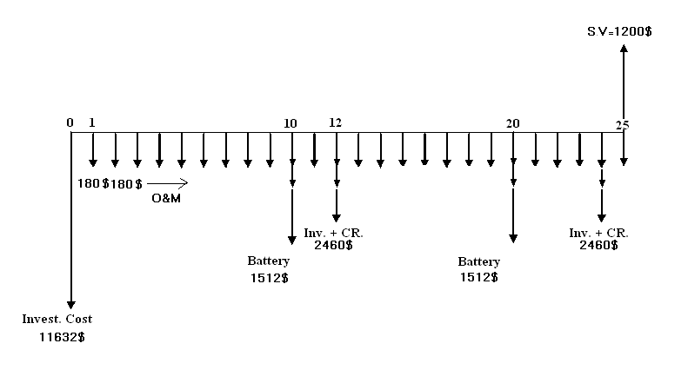

Pc = 11632 +180[P/A,10%,25] +1512[P/F,10%,10]+1512[P/F,10%,20]
+ 2460[P/F,10%,12]+ 2460[P/F,10%,24]-1200[P/F,10%,25]

Pc = 14996 $

5.5.2.2 cash flow for decentralized PV system

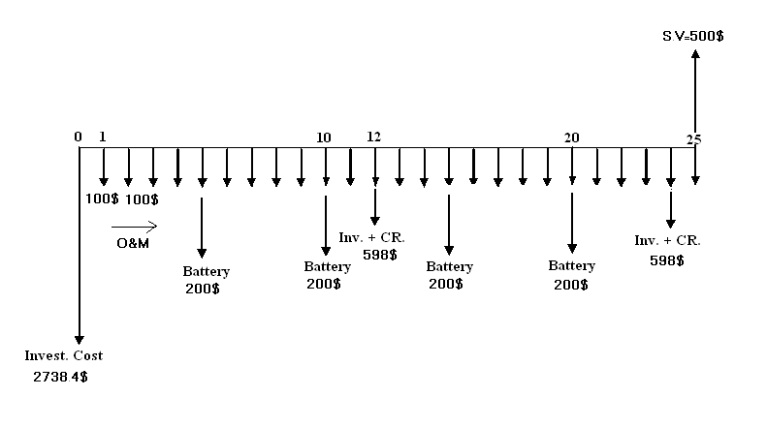

Pc = 3*[ 2738.4 +100[P/A,10%,25] +200[P/F,10%,5]+200[P/F,10%,10]
+ 200[P/F,10%,15]+ 200[P/F,10%,20]+598[P/F,10%,12]
+ 598[P/F,10%,24]-500[P/F,10%,25]]

Pc = 12390 $

Pc decentralized < PC centralized

We select the decentralized project

5.6 Max overall efficiency for centralized and decentralized V system

For case centralized

Effecincy = Pomax/Pimax =[ Vmpp*Impp/G*Apv] * ζCR* ζInv* ζDistribution line

= [52.8*22.17/1000*8.36]*0.92*0.90*0.95

Eff = 11.01%

For case decentralized

Effecincy = Pomax/Pimax =[ Vmpp*Impp/G*Apv] * ζCR* ζInv* ζDistribution line

= [35.2*7.39/1000*1.86]*0.92*0.90*0.95

Eff = 11.38%

We note that ζ decentralized > ζ centralized

5.7 Building Integrated Photovoltaic (BIPV) System
- the PV modules (which might be thin-film or crystalline, transparent, semi-transparent, or opaque);
- a charge controller, to regulate the power into and out of the battery storage bank (in stand-alone systems);
- a power storage system, generally comprised of the utility grid in utility-interactive systems or, a number of batteries in stand-alone systems;
- power conversion equipment including an inverter to convert the PV modules' DC output to AC compatible with the utility grid;
- backup power supplies such as diesel generators (optional-typically employed in stand-alone systems); and
- appropriate support and mounting hardware, wiring, and safety disconnects

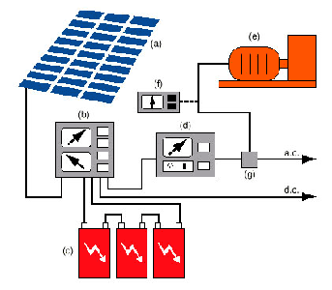

The End

