- Table of content :-
List of Figures 2
List of Symbols 3
Abstract 4
Chapter One Introduction 5
1.1 General Background................. 6
1.2 Statement of The Problem…….... 7
1.3 Objectives and Importance of The Work…….... 7
1.4 Scope of The Work…..... 8
1.5 Significance or importance of the work............ 8
1.6 Organization of the report…...... 8
Chapter Two Constrains, Standards/Codes and earlier 9
2.1 Constraints ………………………………………...……………….……………………………10
2.2 Earlier Coursework....................................................................................................................... 10
Chapter three Literature Review 12
Chapter four Methodology 15
Chapter five The Energy Efficiency software 18
5.1 boiler………………………………………………………………………………...……20
5.1.1Boiler –reduce excess air………………………………………………………………………20
5.1.2 Insulation……………………………………………………………………………………….26
5.1.3 solar water heater………………………………………………………………………………32
5.2 lighting 35
5.2.1 Relamping method ………………………………………………………………………………………………..36
5.2.2 Delamping method ……………………………………………………………………………………………….37
5.3 Motor : 42
5.4 Power factor : 45
Chapter Six Conclusion and Recommendations 49
References: 51

List of Figures
Research methodology | Figure 1
Inputs for the boiler calculations | Figure 2
The efficiency of the boiler | Figure 3
The equations for the boiler calculations | Figure 4
Stack temperature vs the optimal efficiency | Figure 5
Present of fuel saving vs stack temperature | Figure 6
Present of fuel saving vs present of excessair | Figure 7
Flue gas vs efficiency | Figure 8
The inputs for insulation calculations | Figure 9
The equations of insulations | Figure 10
Thickness vs savings | Figure 11
Thickness vs Qnew | Figure 12
The inputs of boiler by swh | Figure 13
The equation of using swh in the boiler | Figure 14
Mass flow rate of water vs the area of the system | Figure 15
Mass flow rate vs cost saving | Figure 16
The inputs of delamping method | Figure 17
The inputs of relamping method | Figure 18
The equations of delamping method | Figure 19
The equations of relamping method | Figure 10
The inputs of motor calculations | Figure 21
The equations of the motor calculations | Figure 22
The equations when we use high efficient motor | Figure 23
The load and efficiency curve | Figure 24
The inputs of power factor calculations | Figure 25
The equations of power factor calculations | Figure 26
Power factor vs fines | Figure 27

List of Symbols
Table (1)
Solar water heater | SWH
Total quality management | TQM
Simple pay Back period | SPBP
Heating and air conditioning | HVAC
National Aeronautics and space administration | NASA
Renewable energy and energy efficiency partnership | REEP
United nation environment programs | UNEP
Global environment facility | GEF
Specific heat | Cp
Different temperature | $$∆T$$
Hours power | Hp
Load factor | L.F
Heat transfer coefficient | U
Thermal resistance | R
Thickness of layer | L
Thermal conductivity | K
Illumination engineering society | IES
High Intensity Discharge lamp | HID
Instant start | IS
Energy Saving | ES
Energy Cost Saving | ECS

Abstract
This project aims to design a software that calculates the energy consumption in industrial and commercial sectors and the corresponding energy savings by applying the energy efficiency measures.
The software performs energy calculations for many systems, including Boiler, lighting, motor and power factor. All energy consuming systems in hospitals and other facilities are studied in details. The energy consumption equations are identified as well as the energy saving models. The economic models are identified as well.
The software estimates the financial viability of each proposed measure. Different economic indicators are estimated. The software is developed using Microsoft excel spreadsheet ,by using the special equations for each system with a simple and detailed information on how to calculate the energy consumption and the energy efficiency and costs of multiple systems.
The software is validated using data from real case studies that dealt with energy management and efficiency.
The software is friendly to users and mostly oriented to energy consuming systems existed in Palestine. The main output of the software is the amount of energy consumption of the system before and after applying the alternative. The amount of energy and money saved are indicated as well. The costs and the bayback period of each alternative are estimated and analyzed in a technical approach.
The software helps the decision makers to use the effective energy efficiency opportunity from different alternatives.

Chapter One

Introduction

General Background
Energy is vital to human beings as we need it in every aspect of our lives. Energy is important for our transportation, manufacturing as well as it improves our standard of lives.
Energy occurs in different forms. Energy neither be "created" nor "destroyed”. It is only converted by us from one form to another so that it is convenient to use. The origin of all forms of energy can be traced back to the solar energy received by the earth, either now or in the past.
If energy productivity is an important opportunity for the nation as a whole, it is a necessary for the individual company. It represents a real chance for creative management to reduce that component of product cost [1].
The efficient and effective use of energy is very important to maximize profits. This rather broad definition covers many operations from services to product and equipment design through product shipment. Waste minimization and disposal also presents many energy management opportunities.
Our main focus is energy management in buildings, manufacturing, and industry. A whole systems viewpoint to energy management is required to ensure that many important activities will be examined and optimized.
Presently, many businesses and industries are adopting a Total Quality Management (TQM) strategy for improving their operations. Any TQM approach should include an energy management component to reduce energy costs.
The primary objective of energy management is to maximize profits or minimize costs. Some desirable sub objectives of energy management programs include [1]:
1. Improving energy efficiency and reducing energy use, thereby reducing costs.
2. Reduce greenhouse gas emissions and improve air quality.
3. Cultivating good communications on energy matters.
4. Developing and maintaining effective monitoring, reporting, and management strategies for wise energy usage.
5. Finding new and better ways to increase returns from energy investments through research and development.
6. Developing interest in and dedication to the energy management program from all employees.
7. Reducing the impacts of curtailments, brownouts, or any interruption in energy supplies.

Statement of The Problem
Palestine suffers from shortage of energy supply which is considered one of the significant problems that hinders progress and development. Palestine has to import all its needs of petroleum products from Israeli market and about 92% of electrical energy from the Israeli Electric Corporation. Indigenous energy resources are quite limited which forced the prices of energy to be relatively high [2].
This project is one of the efforts to reduce energy consumptions by finding out easy and applicable method to estimate energy consumption and savings with the corresponding economical indicators. this method is the software where is a special program to give a special energy consumption and effective alternatives results to reduce this consumption and do many calculation that we need .
The software applied energy conservation that is considered one of the most feasible measures that can reduce the energy consumption and consequently the energy demand [2].

Objectives and Importance of The Work
The main idea of this project is to design a software that estimates the energy consumption and the energy savings obtained by implementing the energy engineer recommendations. The software will be examined using real data. The real data must be obtained by performing energy auditing which is obtained from previous studies and research that it was taken as a reference .The validation of the software results will be examined by performing comparison study among some previous works.
The followings describe the main research motivations:-
- The lack of energy efficiency software suitable for Palestinian facilities and equipment. The software will be designed to help decision makers and energy professionals to evaluate the financial viability of renewable energy, energy efficiency and cogeneration projects in Palestine

- The Low efficiency of most equipment's and processing is lower than expected.
- Scarcity of energy resources: Palestine has to import all its needs of petroleum products and about 95% of electrical energy from Israel.
- High prices of energy: Since most of energy consumed is imported and heavily taxed. About 10% of the family income is paid for electricity bill.
- The High consumption rates of energy which is due to use of inefficient equipment, lack of awareness and knowledge of energy conservation and The High energy demand for energy particularly electricity in order to meet the unusual increment in a lot of sectors.

Scope of The Work
The energy software estimates the energy consumption of each equipment and identify feasible alternatives for reducing energy costs.

Significance or importance of the work
The energy audit examines the ways the energy is currently used in the facility and identifies some alternatives for reducing energy costs [1]. The importance of this project comes from improving energy efficiency and reduces consumption and thereby reduce costs and improve performance. To achieve this, a special software is required to perform energy calculations and propose different solutions to reduce the energy consumptions based on financial and economic indicators.

Organization of the report
In the first chapter the introduction of the project is presented while the second chapter talks about the project constrains, standards/codes and earlier coursework. Chapter three discusses the literature review that contains some reports that are related project. Chapter four presents the mythology of our work. Chapter five illustrates the energy consumptions equations and energy efficiency models that we used to estimate the energy savings in the proposed software. The economic indicators models are presented in this chapter as well, chapter six present the conclusion and recommendations.

Chapter Two

Constrains, Standards/Codes and earlier Coursework

2.1Constraints
In this project the book of administration it was taken as a main reference and taken many equations and numbers from it , and taken many studied and research that done previously as further references.
The specific heat of the water is considered as 4.18 KJ/Kg.C⁰ , and in the motor if the load factor less than 50% the motor is under estimated and if the load factor between 70% to 85% the motor is good and if it more than 85% the motor is over estimated . The temperature that out from the boiler is equal 80 C⁰ , the line voltage is equal 400 volt and the phase voltage is equal 220 volt , the frequency is equal 50 Hz .
The average cost of electricity is considered as: 0.55 NIS/kWh. The cost of electricity is varying related to political situation and demand, but in the last 4 years there is a stability on the cost.

2.2Earlier Coursework
The main studied courses throughout the bachelor degree that facilitates implementation and understanding this project are as following:
- Electrical Machines:
This course gives us good information about the main types of generators and motors used in industries and commercial buildings. The performance of each machine was studied in details.
- Energy management:
It is the key point to know how to save energy and its impact to environment. Reducing the cost of energy and mitigate the environmental impacts are the main objective of energy management.
- Renewable energy systems:
In this course we studied the main renewable energy systems like photovoltaic systems with different types and applications, wind energy systems and solar water heating.
- Environmental impact assessment (EIA):
It is the process in which the anticipated effects on the environment of a proposed development or project are measured. If the likely effects are unacceptable, design measures or other relevant mitigation measures can be taken to reduce or avoid those effects.
- Heating, ventilation and air conditioning (HVAC):
Heating, Ventilating, and Air Conditioning (HVAC) equipment perform heating and/or cooling for residential, commercial or industrial buildings. The HVAC system may also be responsible for providing fresh outdoor air to dilute interior airborne contaminants such as odors from occupants, volatile organic compounds (VOC’s) emitted from interior furnishings, chemicals used for cleaning, etc. A properly designed system will provide a comfortable indoor environment year round when properly maintained.
- Energy efficient building:
Is the practice of increasing the efficiency with which buildings and their sites use and harvest energy, water, and materials, and reducing the impacts of buildings on human health and the environment, through better site planning, design, construction, operation, maintenance, and removal—the complete building life cycle.

Chapter three

Literature Review

This chapter talks about some of the previous studies that have been done about auditing and energy efficiency software.
RETscreenTM software is considered one of the famous tools to help decision makers and energy professionals to evaluate the financial viability of renewable energy, energy efficiency and cogeneration projects around the world [9]. It's an Excel-based clean energy project analysis software tool that helps decision makers quickly and inexpensively determine the technical and financial viability of potential renewable energy, energy efficiency and cogeneration projects.

RETscreenTM models have both new and conventional technologies, allowing for comparisons between technology options. The software can be used to evaluate benefits from both clean energy production from power generation projects and savings through energy efficiency projects, accounting for project costs, emission reductions, and financial risk. RETscreenTM provides access to a global climate database based on ground measurement and NASA satellite data, allowing analysis of projects around the world [3].

In 2015, an energy conservation study was performed for the Arab Women’s Union Hospital, The results shows an energy saving about 14.7% of electrical consumption, conservation measures cost. A 39,592 kWh saving from lighting per year and 80,371 kWh saving in hot water production through using solar system [4].
In a study of energy efficiency for different industries in Palestine Mr. Basel Yaseen trying to establish a beginning step toward the efficient use of energy and energy conservation through conducting energy audits in some high energy consuming industries in Palestine with a potential for energy saving opportunities [5].
The results shows that there is a decent potential for energy saving in the examined industries, they obtained a 277,800 KWh savings in electricity per year and around 66,000 liters of fuel savings per year. On the national level 10 to 20% savings from the total energy consumption in industrial sector could be achieved by implementing some energy conservation measures to the most energy consumption equipment in the facility [5].
An energy management study implemented by Mr. Basel Daas in Palestinian hospitals found that great potential in energy conservation in all energy consumption aspects. In this thesis it was successfully proved that there is a huge potential of energy savings in the Palestinian hospitals sector (10-25%) by implementing some energy conservation measures (no and low cost investment) on the most energy consumption equipment such as boilers, oxygen generation units, air conditioning, lighting systems, solar water heaters and others. It was achieved average total savings of 17% for hospitals, and14%, 43% and 17% for cooling and heating, oxygen generation units, power factor correction and 5% for lighting systems, respectively.[6]

Another study was implemented by Mr. Abd Alhaq Energy Conservation and Load Management Analysis in Nablus Electrical Network. The efficient use of electrical energy, energy conservation and electrical load management are not in a better condition in Palestine or in Nablus electrical network. In this thesis was tried through analyzing and evaluation of the energy consumption situation and by performing energy audits for several energy consuming sectors in Nablus electrical network, to prove that there is a good opportunity to save a considerable amount of consumed electrical energy.

In addition, this study tries to find solutions to decrease the peak electrical demand of Nablus electrical network as the peak demand of the network is nearly equal to the available maximum capacity of the supply so as not to reach a situation that the electrical supply will be cut on consumers. It was showed that there is an opportunity to save a considerable amount of electrical energy if energy conservation measures were implemented in water pumping sector, residential sector and street lighting sector. The total savings in electrical energy in all studied sectors in this thesis is around 14,860,269 kWh/year, associated with an investment cost of 15567303 NIS, and SPBP of less than two years.

The study also showed also that by implementing energy conservation measures and applying applicable load management techniques in the studied sectors, the peak demand of Nablus electrical demand can be decreased by 4.7%, and this percentage can be increased by applying a new electrical tariff structure [7].

Energy audit report for Jacir Palace Intercontinental Hotel was published. The study objective was to obtain an overview of existing building energy consuming systems related to the lighting, boilers, heating ventilating and air conditioning (HVAC), building control, motor loads, and process and office equipment. In order to determine energy consumption for this building, daytime walk-through were performed. Most building characteristics and systems were discussed. Energy savings opportunities for the major systems that consumed energy have been identified. They include boilers, HVAC system, lighting, and no/low cost opportunities, the saving was about 30% [8].

Chapter four

Methodology

In order to ask the research question presented in the introduction the following research methodology is shown in diagram (1)
Literature Review
Theoretical study: Energy opportunities in industrial and commercial sector
Software validation
Software Design
Analysis data and put recommendation

Reporting
Power factor
motor
lighting
boiler
Defining the problem statement
Figure (1): research methodology

For further illustration of the methodology steps:
- Defining the research problem :explained the problem and try to solve it with the software, which was designed.
- Literature review: some of the studies that have been done about auditing and energy software.
- Theoretical study about the energy opportunities in industrial and commercial sector: The data will be collected using auditing. Some data will be gathered by previous auditing studies.
- Design software: We were designed a software by using Microsoft Excel spreadsheet.
- Software validation: by applied case studies to every system to make sure that the program is working well and effective.
- Analyze the data and put recommendation: by analyzed every section and put some recommendation to make the system more efficient.
- Reporting: Final report is written to describe and summarize all research steps and conclusions.

Chapter five

The Energy Efficiency software

The software is implemented using excel sheet platform. The Objective of the software is to identify the types and costs of energy use, Understand how that energy is used—and possibly wasted, identify and analyze alternatives such as improve operational techniques and/or new equipment, Perform an economic analysis on those alternatives to determine which ones are cost-effective. The Software perform special calculations to estimate the amounts of energy consumption and costs using efficiency equations to reduce energy consumptions.
The software is divided into four sections: section one is talked about boiler and some alternatives to reduce the energy consumption , section two is talked about lighting which is one of the largest energy-consuming systems , section three talked about motor and how is used efficiently and the final sector is talked about the power factor correction .
Working Principles of the Proposed Energy Software:
The main systems and their energy efficiency opportunities
- Boilers:
- Reduce Excess air .
- Insulation .
- Solar water heater .

- Lighting system .
- Relamping method .
- Delamping method .

- Motor .
- Rated Capacity of motor .
- Replacement the motor with high efficient motor .

- Power factor correction .

- By using capacitor
Each system is analyzed and discussed separately from the energy conservation opportunity point of view.

5.1 Boiler:

A large fraction of the facility's total energy usage begins in the boiler plant . the cost of boiler fuel is typically the largest energy cost of a facility , or the second largest, for this reason, a relatively small efficiency improvement in the boiler plant may produce greater overall savings than much larger efficiency improvements in individual end users of energy , Also most boiler plants offer significant opportunities for improving efficiency [10].

    - Boiler –reduce excess air :
Excess air is the extra air supplied to the burner beyond the air required for complete combustion . excess air is the supplied to the burner because a boiler firing without sufficient air or "fuel rich" is operating in a potentially dangerous condition . Therefore , excess air is supplied to the burner to provide a safety factor above the actual air required for consumption.

Many inputs were needed to the software for calculation as shown in figure 2:

Figure (2): inputs for boiler calculations

To determine the potential energy savings associated with reducing the amount of excess air of boiler .

The first step were calculated the old and new efficiency of the boiler by using the following graph that it was converted to a table in Excel software to get the required estimations :

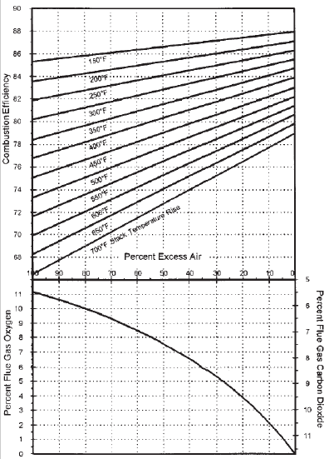

Figure (3) : the efficiency of the boiler

Then the following sequence of steps and equations were followed as shown in figure (4) to get the results:

Figure (4): the equations for boiler calculations

Analysis :
The numbers and equations was implemented in the software then we got these Figures:

Figure (5): stake temperature vs the optimal efficiency

Figure (6): present of fuel savings vs stack temperature

Figure (7) : present of fuel saving vs present of excess air

Figure (8): present of flue gas vs efficiency

Noted when reduce the amount of excess air will increase the efficiency of the boiler and this what we gets when its applied in the software with different values of excess air and fixed value of stack temperature. And When the stack temperature increase the efficiency and percent of fuel saving are decrease .

Case study :

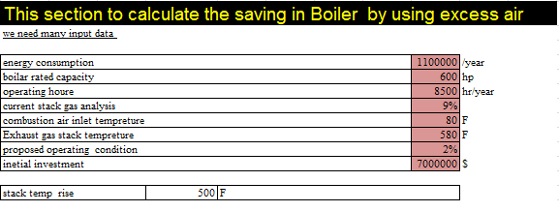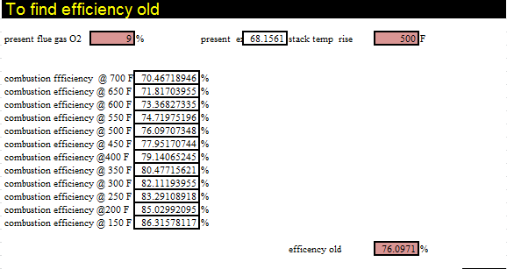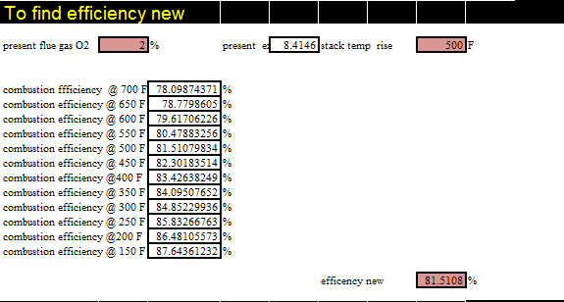

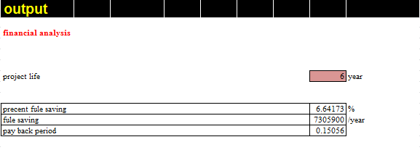

    - Insulation:

Another opportunities to do the saving in energy in the boiler system is the insulation , Hot water boilers and boilers for the production of water vapor under high pressures are considered to be steam boilers. As a generic term, boiler is used to denote steam generators and hot water installations.[11]
Purpose of insulation:
Insulating boilers has the following purposes:
- Reduces heat losses and increases the efficiency of the boiler
- Guarantees protection against contact by minimizing the surface temperature
- Prevents heating of the compartment air in the boiler house, which guarantees an acceptable working.[11]
The boiler has three layer , first layer is the outer layer (aluminum) , the second layer is the insulation and the third layer is cast iron .
And there is many type of insulation to use in the boiler like Rockwool , Astrofoil.
many inputs were needed to the software for calculations as shown in figure (9):

Figure (9): the inputs for insulation calculations

Then the following steps and equations were followed to find the savings as shown in figure (10):

figure(10) : the equations of insulation

Analysis :
The equations were implemented in the software and we got this numbers and curves :

Figure (11):thickness vs saving

Figure (12 ):thickness vs Qnew
From this curves noted that when the thickness of insulation increasing the saving increasing too and the losses decreasing . Also we noted the over all convection losses is decrease because the total thermal resistant increase when added insulation .

Case study :
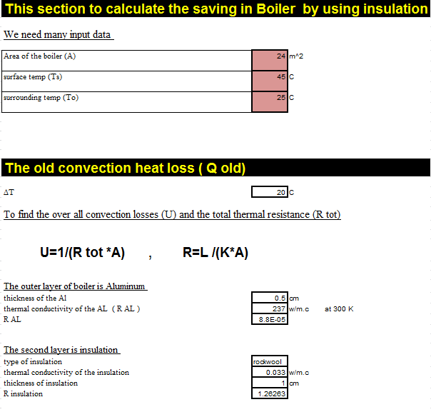
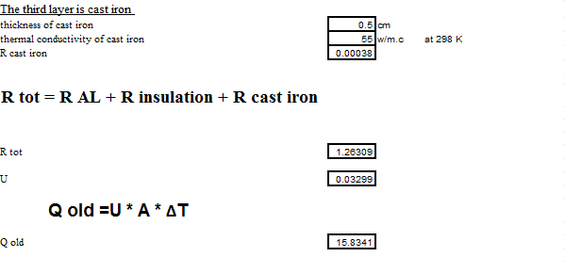
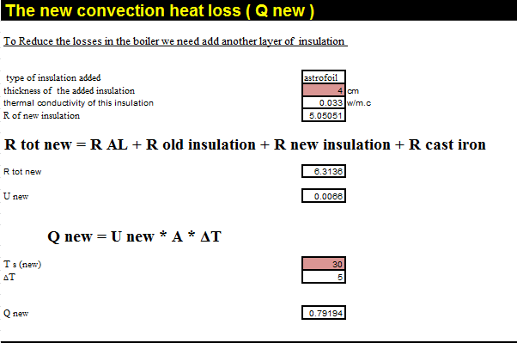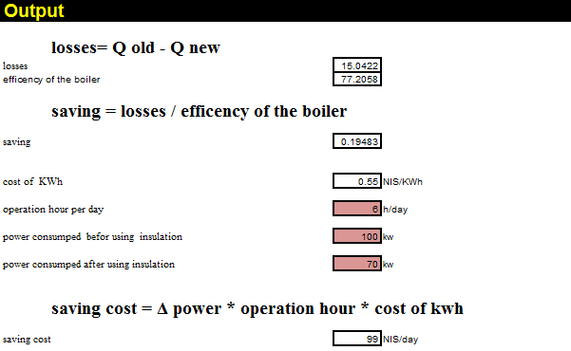

    - solar water heater :
Solar water heating (SWH) is the conversion of sunlight into renewable energy for water heating using a solar thermal collector. Solar water heating systems comprise various technologies that are used worldwide increasingly.
SWH systems are designed to deliver hot water for most of the year. However, in winter there sometimes may not be sufficient solar heat gain to deliver sufficient hot water. In this case a gas or electric booster is used to heat the water.[12]
And we can used this technique in the boiler system to heat the water that inter the boiler to help the boiler that heating the water and make it work more efficient and get saving in energy and cost .
In this system many inputs were needed in the software as shown in figure(13) below:

Figure (13) : the inputs of boiler when using swh

Then the following steps and equations were followed to find the savings and the payback period as shown in figure (14):

Figure (14): the equations when using swh to the boiler

Analysis :

After that the inputs data were put and applied it in the software and then we got these numbers shown in figures below :

Figure (15): mass flow rate of water vs area of the system

Figure (16): mass flow rate vs cost saving

We noted from the curve When the mass flow rate increase we need to increase the size of the system also when increase this mass flow rate the cost of saving will increase .

Case study :

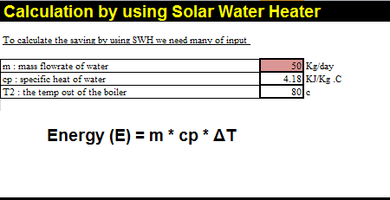
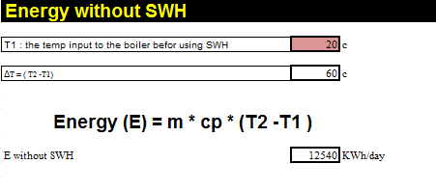
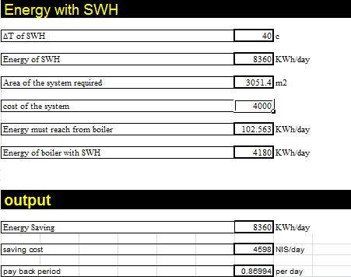

lighting :
The lighting system provides many opportunities for cost-effective energy saving with little or no inconvenience . In many cases , lighting can be improved and operation costs can be reduced at the same time. Lighting improvements are excellent investments in most commercial businesses because lighting accounts for a large part of the energy bill ranging from 30-70% of the total energy cost . Lighting energy use represents only 5-25% of the total energy in industrial facilities, but it is usually cost-effective to address because lighting improvements are often easier to make the many process upgrades .
While there are significant energy-use and power-demand reductions available from lighting retrofits , the minimum lighting level standards of the illuminating engineering society (IES) should be followed to insure worker productivity and safety . Inadequate lighting levels can decrease productivity , and the can also lead to perception of boor indoor air quality .
Used as a starting place for an energy management program , lighting can attract immediate employee attention and participation ,since everyone has ideas about lighting . Lighting is also seen as a barometer of the attitude of top managers toward energy management : if the office of the president of a company is an example of efficient lighting , then employees will see the energy management is taken seriously . A lighting retrofit program can be a win-win proposition for the business owner and the employees as it can improve moral , safety and productivity while reducing life-cycle costs . [1]
The tow strategies Relamping and Delamping were focused in the software .
    - Relamping strategies :

The usual strategy for replacing lamps in many facilities is to wait until a lamp burns out and then replace it (called spot relamping ) . this relamping strategy is not necessarily the best one for a facility to follow because it does not consider such factors as labor cost or lumen depreciation , it is often more economical to replace all of the florescent and HID lamps in a facility at one time ( called group relamping ) . [1]

Advantage of group ralamping :

- Group relamping can:
- Reduce labor costs: Spot relamping can require up to 30 minutes to move furnishings or equipment, set up, replace the lamp, and put equipment away (e.g., ladder, lamps, tools). In group relamping, a fixture can usually be relamped and cleaned in 5 minutes.
- Reduce lamp costs (discounts).
- Allow lamp maintenance to be scheduled.
- Maintain higher and more uniform lighting levels.
- Reduce inventory needs.
- Insure the correct lamp use: provides an opportunity to install the newest energy-efficient lamp.
- Extend ballast life.
- Reduce interruptions in work area.

    - Delamping strategies :
Major saving can be obtained by removing some of the lamps that are producing excessive level of illumination . there is usually one ballast for each tow fluorescent lamps . The ballast for rapid-start lamps will continue to consume some power even when the lamps are removed . Leaving burned-out lamps in instant start (IS) fixture reduces ballast life .[1]

many inputs were needed to the software for calculations as shown in figure (17) and figure (18) :
For Delamping method :

Figure (17): the inputs of delamping method

For Relamping method :

Figure(18): the inputs of relamping method
Then the following steps and equations were followed to find the Saving as shown in figure (19) and figure (20) :
Delamping method :

Figure(19) : the equations of Delamping method

For relamping method :

Figure (20): the equations of relamping method
Analysis :
Note that the lighting after a 70% default life time become more susceptible to damage and the level of lighting decrease so it is advisable to replace it .
When we use any one of this method we obtain saving for energy and cost .

Lighting accounts for a large part of the energy bill, ranging from 30-70% of the total energy cost. Lighting energy use represents only 5-25% of the total energy in industrial facilities .

The minimum lighting level standards of the Illuminating Engineering Society (IES) productive is should be followed to insure worker ty and safety.

Inadequate lighting levels can decrease productivity, and they can also lead to a perception of poor indoor air quality.

Case study :
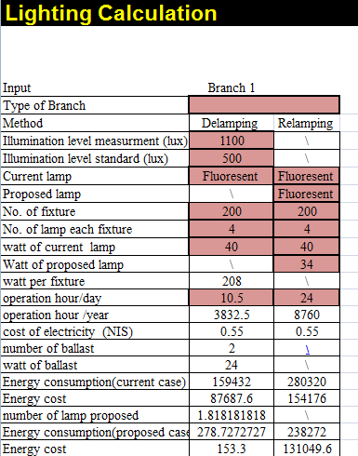

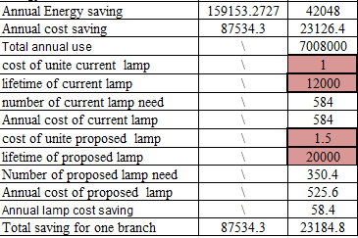

5.3 Motor :
Energy shortage problem becomes more and more serious. People emphasize the electric energy saving in large and medium size drive systems for many years. The evident validity has been got in motor and pump systems. However the energy saving measures for various kinds of small size motor control systems were neglected. Since they are in a huge numbers inside factory auxiliary systems, their electric power consumption can approach to around 1/3 of that of the total motor numbers. [13]
There is many techniques to make the saving in motor and in our software we focused in these tow method : Rated Capacity of motor and Replacement the motor with high efficient motor .
First the motor were checked if it working on the rated capacity or not then decided to replace it to new motor or keep the current motor for that many inputs were needed in the software as shown in figure (21):

Figure (21): the inputs of the motor calculations
Then the following steps and equations were followed to get the outputs as shown in figure (22) :

Figure(22): the equations of motors
And to calculate the saving when replacement the current motor with high efficient motor the following equations were followed in the software as shown in figure (23) :
Figure(23): the equations of when use new high efficient motor
Analysis:

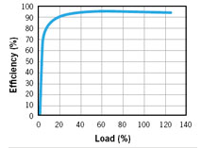
Figure (24):the load and efficiency curve
From figure (9) above we can see that the load increasing with efficiency then the efficiency become steady after 20% and load remains increasing . [15]
And if the motor under/over estimated then replace the motor with new high efficient motor .
Case study :
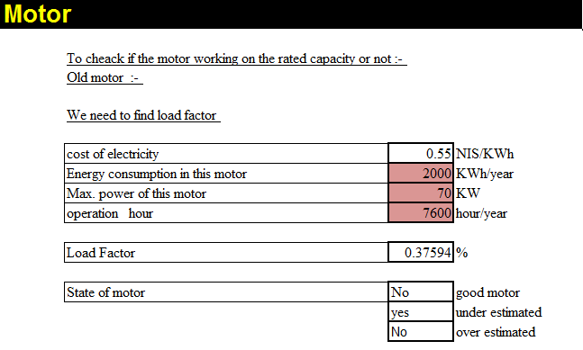
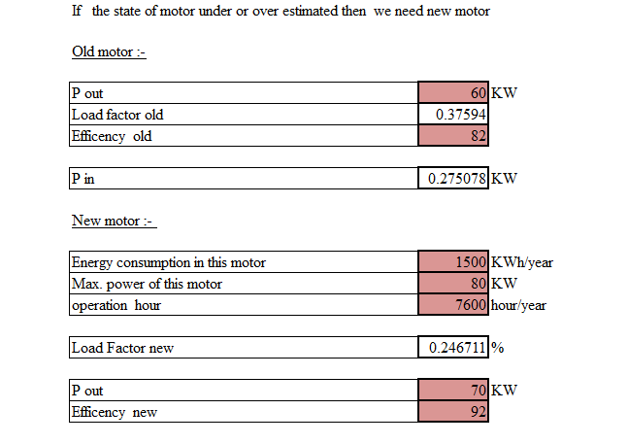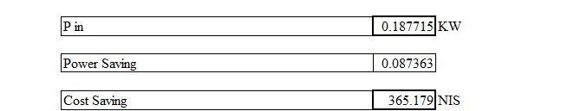

5.4 Power factor :
Power factor is a measure of how effectively you are using electricity at your workplace . low power factor is expensive and inefficient . Many utility companies charge large commercial and industrial customers an additional fee when power factor is less than a certain value which determined by the electric company , 0.92 in Palestine . Low power factor also reduces an electrical system's distribution capacity by increasing current flow and causing voltage drop . [14]
Power factor correction is achieving by the addition of capacitor in parallel with the connected motor or lighting circuit and can be applied at the equipment , distribution board or the origin of the insolation .

There is many techniques to do saving in the power factor one of these is by using capacitor and this what was focused in the software . many inputs were neede as shown in figure (25) below :

figure(25): the inputs of power factor calculations

Then following equations were used to get the results as shown in figure (26) :

figure(26): the equations of power factor calculations

Analysis :
The numbers and the equations were applied in the software then got the curve below (27) :

Figure(27):Power factor vs fines
Noted when the power factor decrease the fines well increase so we should improve the power factor to 0.92 to reduce the fines .The power factor is not allowed decreases about 0.92 Because it would have on the payment of a fine . to improve power factor we use the capacity .
Case study : 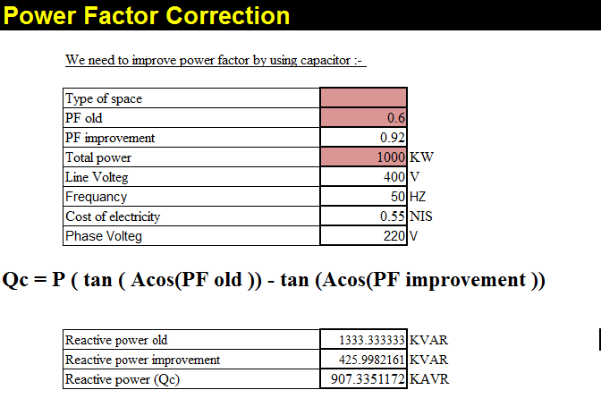
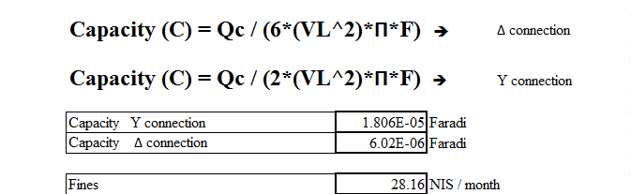

Chapter Six

Conclusion and Recommendations

Many equations and inputs data were used in the software to calculate energy efficiency , costs and payback period for each system . Then put some alternatives to reduce energy consumption , and final calculate the savings in energy .
This method is shortage in Palestine that one of reasons to design it , the software relied on several parameters and equations until we got the desired result and were used simple equations and uncomplicated but effective in the software and then got the desired results .
The Systems were focused on the software which are the more consumptions of energy in Palestine : boiler , lighting , and motor and each system was explained in details and clarify the equations that used and the steps that followed in the previous chapter .
The results were obtained from the software are effective and useful to reduce energy consumption in Palestine .

References:
[1] Barney L and et. al. Guide to Energy Management, Fifth Edition International Version.
[2] Aysar Yasin and et. al (2015). "University Students’ Practices Related to Energy Conservation: A survey-based study”, In proceeding of Fifth International Energy Conference –Palestine (IECP 5), Palestine. January 2015.
[3] http://en.openei.org/wiki/RETScreen_Clean_Energy_Project_Analysis_Software last access 2/12/2016 .

[4] Energy audit report for Arab Women's Union Hospital (Etihad). Palestinian Energy and Natural Sources Authority, 2008.
[5]Yaseen, B. (2008). energy efficiency improvement and cost saving measures in some different industries in palestine. Nablus: An Najah National University.
[6] Daas , B(2008) energy efficiency improvement and cost saving measures in different Palestinian hospitals. palestine. Nablus: An Najah National University.
[7] Alhaq ,A(2010) . Energy Conservation and Load Management
Analysis in Nablus Electrical Network . Nablus : An Najah national university .
[8]Energy Audit Report , Jacir palace intercontinental hotel. Palestinian Energy and Natural Sources Authority, 2008.

[9] L. Blank and A. Tarquin, P. E. Engineering economy, seventh edition, (1989) .
[10]Department of Energy (DOE). (2001a). Office of Industrial Technologies, Energy Efficiency and renewable Energy. Best Practice Program. Information on steam. http://www.oit.doe.god/bestpractices/steam/.
[11] http://www.rockwool-rti.co.uk/products+and+applications/boilers last axes 2/12/2016
[12] https://en.wikipedia.org/wiki/Solar_water_heating last axes 2/12/2016
[13] http://ieeexplore.ieee.org/document/4582586/lastaxess3/12/2016
[14] Imad H.Ibrik' and Marwaan M. Mahmoud. 2002, Energy efficiency improvement and its Techno – Economical Impacts by Rising of Power Factor at Industrial Sector in Palestine . Energy Research Center, An-Najah National University, Nablus, P.O. Box 7, West Bank, Palestine, Israel.
[15] http://powerelectronics.com/motion-systems/motors-efficiency-and-adjustable-speed-driveslastaxis5/12/2016

