Chapter Two

Preliminary Design

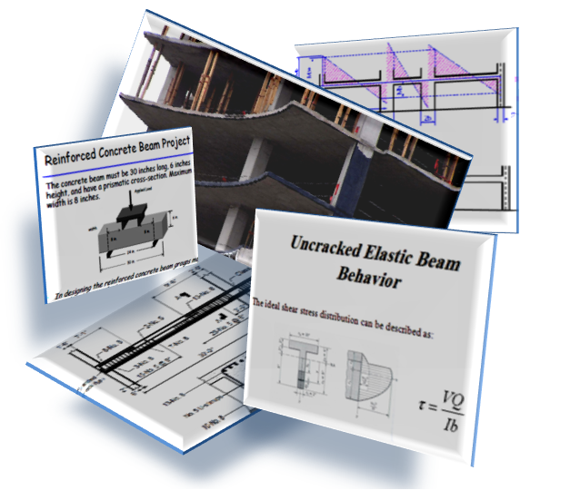

CH.2 Slab & Beam Design:

Slab system and dimensions:

The deflection is the most important factor that controls the slab thickness. According to ACI 318 – 02 code

Table (2.1): Minimum thickness of one way ribbed slab & beam.
Minimum Thickness (h)
Member | One end continuous | Two end continuous | simply supported | Cantilever
Beam or ribbed one way slab | Ln/18.5 | Ln/21 | Ln/16 | Ln/8
Solid one way slab | Ln/24 | Ln/28 | Ln/20 | Ln/10

2.1 Block A:

Design of slab:
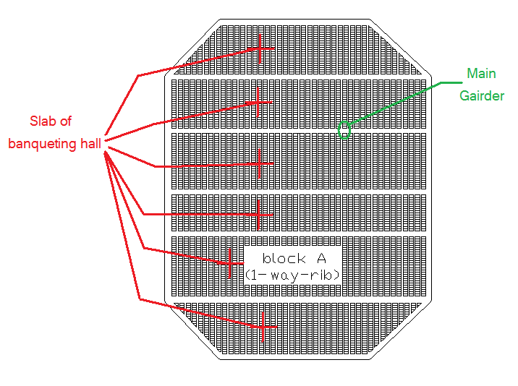
Fig (2-1): Slab for banqueting hall
Thickness of slab:
$t=\frac{L}{18.5}$ One end continuous
=5.5*100/18.5
=30 cm.

Design one way Ribbed slab:

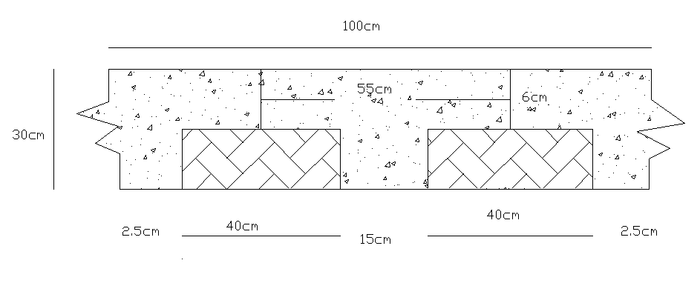
Fig (2-2): Rib slab for banqueting hall

Width of rib=55cm
Load=DL+LL
Dead load/rib =slab weight+ block weight+ own weight+ super imposed
DL= (0.06*2.4*0.55) + (0.4*24*1.4) + (0.24*0.15*2.4) + .55 *0.324 =0.478ton/m
LL=0.55*0.4=0.22 ton/m
𝔀u=1.2DL+1.6LL
𝔀u=1.2*0.487+1.6*0.22=0.926ton/m
b_{E}=40+15=55cm center to center
b_{E}=l/4=6104/4=151cm
b_{E}=16t+bw=16*30+15=495cm
take minimum b_{E}
b_{E}=55cm

𝓜from SAP:
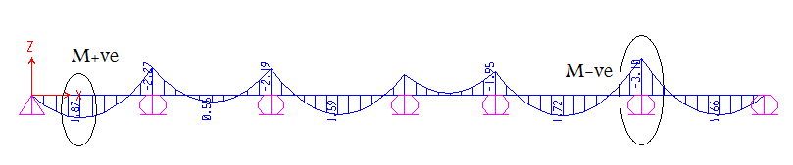
Fig ( 2-3):𝓜 for ribbed slab
𝓜-ve=3.1ton.m
𝓜+ve=1.87ton.m
Assume d=26cm

Design for M-ve
𝓜d_{f}=0.9* b_{E}*a*0.85* 𝒇_{c}΄(d-a/2)
𝓜d_{f}=0.9*.55*.06*.85*240*(.26-(.06/2))/10³
𝓜d_{f}=.9*55*6*.85*240*(26-(6/2))/10³ =13.94ton.m
𝓜d_{f}>𝓜u =3.1 ton
a>ℎ_{f}
b=55 ⟨rectangular section⟩
$$ρ=0.85\frac{f_{c}}{f_{y}}\left(1-\sqrt{\left(1-\frac{{2.35M}_{u}}{{∅bd}^{2}f_{c}}\right)}\right)$$
𝜌 = .85*240/42000(1-(1-((2.35*3.1*10⁵)/(.9*55*26²*240))^{.5}))
𝜌 =0.0023
As = 𝜌*b*d= .oo23*55*26=2.431cm²
*𝜌 _{min}=14.06/ℱy=.0033
*𝜌_{min}=0.8 𝒇_{c}΄/ ℱy
*𝜌 _{min}=.8*(240^{.5})/42000=.003
As_{-ve} = ρ* b_{w}* d=.003*15*26=1.17cm² < As ok
c_{b}=6120d/6120+ℱy=6120*26/6120+4200=15.42cm
a_{b}=.85C_{b}=.85*15.42=13.1cm
T_{b}=C_{b}
.85*240*55*13.1=As _{b}*4200
As _{b}=35cm²
As _{b}>As>As _{min}
35>2.431>1.17
ф12
As=3.29
3ф12
Checks:
1) b_{min} :
b_{min} =2*c + 2*ds + n*d_{b} + (n-1)*S +1.
d_{e}=ℎ-ys.
ys =c+ds+0.5*d_{b}. For one layer
b_{min} = 2*3+2+2*1.4+1*3+1=14.8<15cm
d=ℎ-ys
ys=3+1+.5*1.4=4.7cm
d_{e} =25.3cm
2) DR& ф
ℰt = (d-c/c)*.003
ℰt= (25.3-1.35/1.35)*.003
.05>.004 no Double Rein & ф=0.9 ok
C=a/.85=1.15/.85=1.35
ℎf>a=4200*2*1.54/.85*240*55=1.15cm
3) 𝓜d =0.9*2*1.54*4200*(25.3-(1.15/2))/10⁵
𝓜d =2.88ton.m>2.39ton.m ok
Check shear for rib
𝓥u=1.15*wu*ln/2 = 1.15*0.712*(6.04-0.6)/2=2.23ton
Ø𝓥c=1.1*.075*.53*(240^{0.5}) *15*25.3/10³=2.57ton
𝓥u<Ø𝓥c no shear reinforcement

Design for M+ve
𝓜df=13.94ton>1.87
𝓜df>𝓜u
a<ℎf
𝜌 = .85*240/42000(1-(1-((2.35*1.87*10⁵)/(0.9*55*26²*240))^{.5}))
𝜌 =0.0013
As = 𝜌*b*d= 0.0013*55*26=1.93cm²
𝜌_{min}=14.06/ℱy=.0033
𝜌_{min} =.8*(240^{.5})/42000=.003
As _{min}= 𝜌_{min} * b_{w}*d=.003*15*26=1.17cm²< A_{s} ok
C_{b} = 15.472cm
Asb = 35cm² > as steel yield
2ф12 one layer

Checks:
- bmin = 2*3+2+2*1.2+1*3+1=14.4<15cm
Ys=3+1+.5*1.2=4.8cm
de =30-4.6=25.4cm
2) ℰt = (d-c/c)*.003
ℰt = (25.4-1/1)*.003
.073>.004 no d.r & Ø=0.9 ok
C=a/0.85=0.85/0.85=1.35
ℎ_{f}>a=4200*2*1.13/.85*240*55=0.85cm
3) 𝓜d =0.9*2*1.13*4200*(25.3-(0.85/2))/10⁵
𝓜d =2.13 ton.m>1.87 ton.m ok

Design for main girder
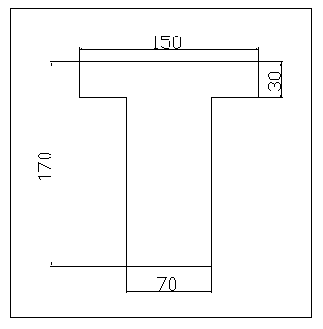 Fig (2-4) Dimension Of main beam

$w_{u}$=1.2DL+1.6LL
DL = slap own weight + weight of the block +imposed load +self weight of rib
=0.06*1*2400+2*0.4*0.24*1.4+0.324+0.2*0.24*2.4=0.852 ton/m²
Imposed load=0.4ton/m²
$w_{u}$=1.2*0.852+1.6*0.4=1.66 ton/m
$w_{u}$ On girder =Wu (2.55+3.02) +1.2own weight.
Own weight=2.95 ton/m.
$w_{U}$=1.66(5.57) +1.2*2. 59=12.35 ton.
ℎ=𝓛/18.5=23.6/18.5=127.6cm ℎ=130cm.
d=120cm
b_{w} =70cm
b_{E} =Ln/4=2360/4=590cm
=16t+b_{w} =16*30+70=550cm
=center to center= (2.55+3.05) =557cm
Take min b_{E}=550cm
Own weight= (0.7*0.9+0.3*1.5)*2.4=2.59
From SAP:
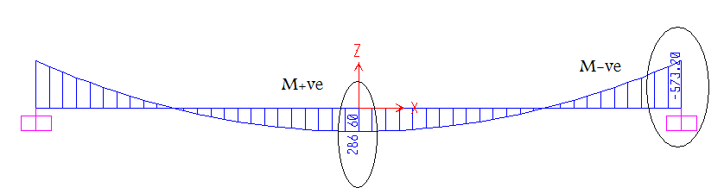
Fig (2-5):𝓜 for gairder

𝓜_{+ve}=$\frac{w_{u}*L_{n}^{2}}{12}$
=12.35*23.6²/12=573.2ton.m
𝓜_{-ve}=$\frac{w_{u}*L_{n}^{2}}{24}$
=12.35*23.6²/24=286.6ton.m

Design for M+ve=573.2ton.m
Assume d=120
b_{w}=70cm
b_{E}=150cm
𝓜_{df}=0.9*150*30*0.85*240(120-30/2)/10⁵
=867.51ton.m
𝓜_{df}>𝓜ua<ℎ_{f}
𝜌 =0.85*240/4200(1-√1-(2.35*573.2*10⁵/0.9*150*120²*240)
𝜌 =0.0076
𝜌_{min}=14.06/ℱ_{y}=0.003
=0.8√𝒇_{c}΄/ ℱ_{y}=0.003
=4/3 𝜌_{calculated}=0.01 𝜌_{min}=0.003
A_{s min}= 𝜌_{min}*b_{w} *d=0.003*70*120=25.2cm²
A_{s}= 𝜌* b_{E}*d=0.0075*150*120=136.8 cm²
A_{s}> A_{s min}ok
Ф28 A_{s}= (23 ф28)
C_{b}=6120*120/ (6120+4200) =71.16
a_{b}=0.85 C_{b}=60.5cm
T_{b}=C_{b} A_{s b}=0.85*240*150*60.5/4200=440.8 cm²
A_{s b}> A_{s} steel yield
Check:-
1) 3 layer (8+8+7) ф stirrup=12mm
b_{min} =2*3+2*1.2+8*2.8+7*3+1=52.8cm<70cmok
Y_{s (one layer)}=6+1.2+0.5*2.8=8.6cm
Y_{s (3 layer)}= Y_{s (one layer)}+(n₂(2.5+d_{b})+n₃(2*2.5+1.5 d_{b})+n₁(0))/# of bars
=8.6+ (8(2.5+2.8) +7(5+1.5*2.8))/23=13.24
d=h- Y_{s} =130-15.24=116.76cm<120cm ……ok
2) DR& ф
ℰ_{t}= ((d-c)/c)*0.003
a=4200*23*6.16/0.85*240*150=19.45cm<30cm ….. ok
c=a/0.85=22.88cm
ℰt=((116.76-22.88)/22.88)*0.003=0.012
ℰ_{t}>0.004
No D.R & Ø=0.9
3) 𝓜_{d}=0.9*4200*23*6.16*(116.76-19.45/2)/10⁵
=573.23ton.m ….ok

Design for -veM=286.6 ton.m
d=120cm
b_{w}=70cm
b_{E}=150cm
𝓜_{df}=867.51ton.m
a<ℎ_{f}
𝜌 =0.85*240/4200(1-√1-(2.35*286.6*10⁵/0.9*150*120²*240)
𝜌=0.0036
A_{s}= 𝜌* b_{E}*d=0.0036*150*120=64.8cm²
𝜌_{min}=0.003
A_{s min}= 𝜌_{min}*b_{w}*d=0.003*70*120=25.2 cm²
A_{s}> A_{s min}ok
Ф11 As= (23 ф28)
Check:-
1) 2 layer (6+5) ф stirrup=12mm
b_{min}=2*3+2*1.2+6*2.8+5*3+1=41.2cm <70cm ok
Y_{s (one layer)} =6+1.2+0.5*2.8=8.6cm
Y_{s (2 layer)} =8.6+ (5(2.5+2.8) +2.8)/11
d=h- Y_{s}=130-11=119cm d=119cm
2) DR& ф
ℰ_{t}= ((d-c)/c)*0.003
a=4200*11*6.16/0.85*240*150=9.3cm
c=a/0.85=9.3/0.85=10.94cm
ℰ_{t}= ((119-10.94)/10.94)*0.003=0.03 >0.004
No D.R & ф=0.9
𝓜_{d} =0.9*4200*11*6.16*(119-9.3/2)/10⁵=292.89ton.m

Shear for Girder:
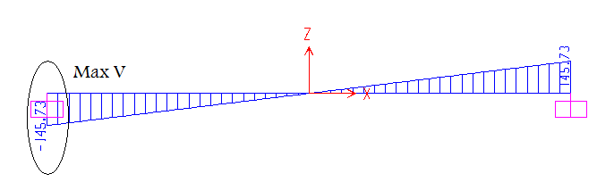
Fig (2-6): Shear for Girder

𝓥_{u}/ ф≤ V_{c}+2.1$√$ 𝒇_{c}΄*b_{w}*d
𝓥_{c}=0.53√ 𝒇_{c}΄* b_{w}*d
𝓥_{u}=$\frac{w_{u}}{2}$ = 12.35*23.6/2=145.73ton
145.73/0.75≤2.63√240*70*120/10³
194.3≤342.25 ok for Dimension
ф Vc=0.75*0.53√240*70*120/10³
=51.73ton
𝓥_{u}> ф 𝓥c need shear reinforcement
𝓥_{u}/ ф=145.73/0.75=194.3=V_{d}
𝓥_{u}(at d=120) 194.3/1180=V_{n}/(1180-120) 𝓥_{u}=174.54
𝓥c=69 ton 𝓥c/2=34.5 ton
𝔁=34.5*1180/194.3=209.5cm
𝓥s=174.54-69=105.54
ф_{stirrup}=10mm Av_{leg}=0.79cm²
S=Av*ℱy*d/Vs
S=2*0.79*4200*120/105.54*10³=7.6cm
S_{min}=8cm S=8cm
For S_{max}S≤ (Av*ℱy/3.5b_{w})=2*0.79*4200/3.5*70*10³=27cm
𝓥s≤√ 𝒇_{c}΄* b_{w}*d
105.54≤√240*70*120*10⁻³
105.54≤130.13 ok
S_{max}≤60cm
≤d/2 120/2 =60cm
≤27.1cm
Take S=25cm
Find the distance
𝓥=𝓥c+Av*$\frac{F_{y}*d}{S}$
=69+2*0.78*120*4200/25*10³
=100.45 ton
𝔁=100.45*1180/194.3=610cm
610-209.5=400.5 cm
(5)(15@8=120cm)(430cm)(17@25=425cm)(8@25=200cm)

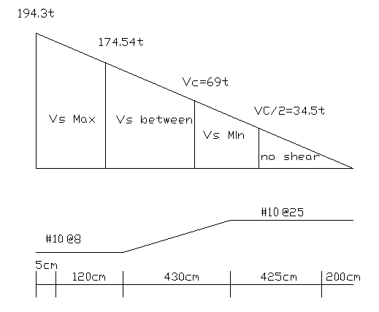
Fig (2-7 ): Shear for Gairder

Slab thickness for waffle slab
Two way waffle slab:
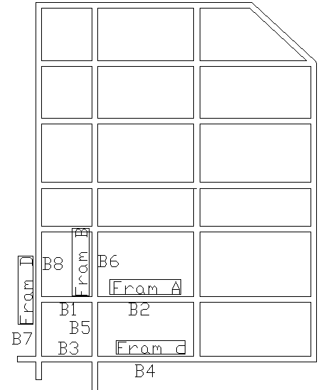
Fig (2-8 ): Two way waffle slab

Assume α>2
H=Ln(0.8+0.2 ℱy/2800)/(36+9β)
=8.75(0.8+0.2*4200/2800)/(36+9*(8.75/6.04)
=19 cm ≊ 20 cm

Check if α > 2:
α=$\frac{I_{b}}{I_{s}}$
Edge beam L-section
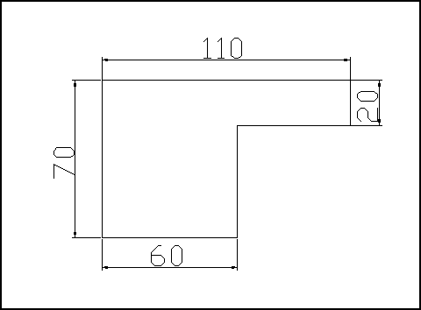
Fig ( 2-9): Edge beam L-section
Assume
b_{w}=60 cm
h=70 cm
h_{f}=20 cm
For L- section
b_{eff}= min of { b_{w}+4 h_{f}} or { b_{w}+(h- h_{f})} b_{eff}=110 cm
Moment of inertia for L-section
I=0.0225 m⁴
Interior beam T-section:
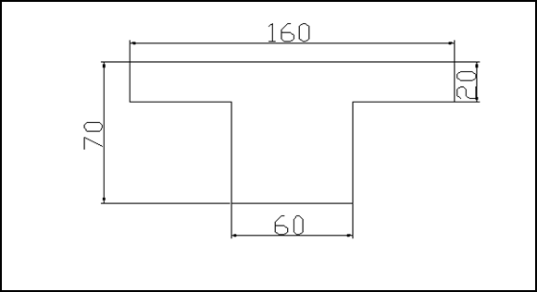
Fig ( 2-10): Interior beam T-section
Assume
b_{w}=60 cm
h=70 cm
h_{f}=20 cm
For T- section
b_{eff}= min of { b_{w}+8 h_{f}} or { b_{w}+2(h- h_{f})} b_{eff}=160 cm
Moment of inertia for T-section
I=0.0263 m⁴
Values of α:
Frame A:
B1-B2
I_{slab}= (1/12) (5.57) (0.2)³=3.713*10⁻³ m⁴
α= 7.08
Frame C:
B3-B4
I_{slab}= (1/12) (4.09) (0.2)³=2.727*10⁻³ m⁴
α= 8.25
Frame B:
B5-B6
I_{slab}= (1/12) (6.775) (0.2)³=4.517*10⁻³ m⁴
α= 5.8
Frame D:
B7-B8
I_{slab}= (1/12) (4.015) (0.2)³=2.677*10⁻³ m⁴
α= 8.4
α _{avg}=(8.4+5.8+8.25+7.08)
=7.38 >2 ok
Dimension of waffle and γ_{equ} and equivalent thickness in sap:
Waffle dimension (60*60*25)
I solid=I waffle
(1/12)(0.2)³(0.75) = (k/12) (0.15) (h)³
5*10⁻⁴ m⁴ ≤ I waffle
K=1+(0.2* b_{eff} / b_{w})
K=1+(0.2*0.75/0.15)
=2
If we take h=33 cm I waffle=8.56*10⁻⁴ m⁴ > 5*10⁻⁴ m⁴ ….. Ok
Banqueting hall
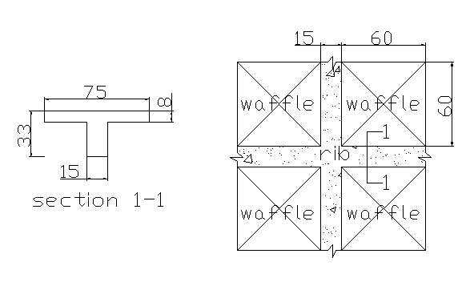
Fig ( 2-11):Waffle slap

I solid=I waffle
(1/12)(h)³(0.75)= 8.56*10⁻⁴
h=24 cm
To find γ_{equ}:
Weight waffle/ m²
= ((0.75*0.75*0.08+0.75*0.15*0.25+0.15*0.25*0.6)*2.4)/0.75²
=0.408t/m²
Weight solid/m²=weight waffle/ m²
γ_{equ}*0.24=0.408
γ_{equ}=1.7 ton/m³

2.2 Block B:

Beams & Slabs thickness:
Beam & slab @ elevation 4m:
One way
Simply supported L/16 =1167.63 =73 cm.
One end continuous L/18.5 =1206.4/18.5 =65.2 cm.
Both ends continuous L/21 =1154/21 =55 cm.
Take h=75 cm. d=70cm & b=d/1.75 b=40 cm.
Two ways:
One end continuous L/18.5 = 868.13/18.5=47 cm.
Both ends continuous L/21 = 807/16=33.8
Take h=60cm. d=55 cm & b=d/1.75 b=35 cm.
One way slabs:
h both end continuous=L/21 =493/21=23.5 cm
h one end continuous =L/18.5 =22.5 cm.
Two way slabs:
h=Ln(0.8+0.2 ℱy/2800)/(36+9β)
=8.75(0.8+0.2*4200/2800)/(36+9*1)
=20 cm.
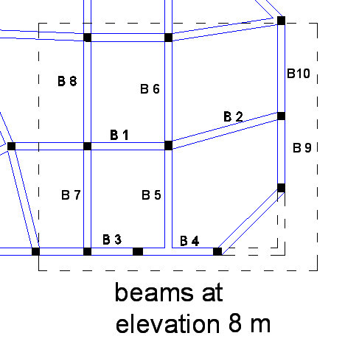
Fig (2-12) Two way ribbed slab
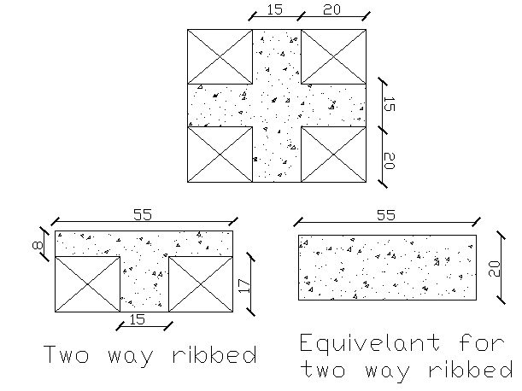
Fig (2-13) Two way ribbed slab

Check if α > 2:
α=I_{b}/I_{s}
I_{b}=(1/12)(0.3)(0.6)³
=6.3*10⁻³
I_{s}
Values of α :
B1-B2
I_{slab}=(1/12)(6.13)(0.2)³=4.09*10⁻³ m⁴
α₁= 7.08
B3-B4
I_{slab}=(1/12)(3.63)(0.2)³=2.42*10⁻³ m⁴
α₂= 2.6
B5-B6
I_{slab}=(1/12)(5.13)(0.2)³=3.42*10⁻³ m⁴
α₄= 5.16
B7-B8
I_{slab}=(1/12)(2.15)(0.2)³=1.43*10⁻³ m⁴
α₃= 4.14
B9-B10
I_{slab}=(1/12)(3)(0.2)³=2*10⁻³ m⁴
α₅= 3.15
α _{avg}=( α₁+ α₂+ α₄+ α₅)/4
=3.11 >2 ok

Calculation for h_{equ} & γ_{equ}:
Take h=25 cm.
One way:
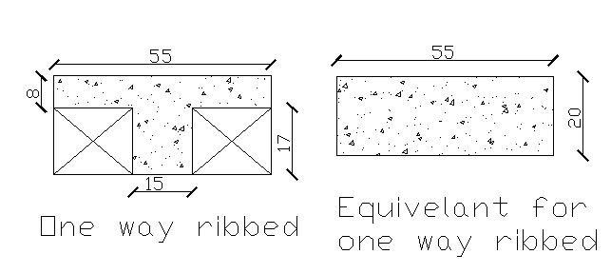
Fig (2-14) One way ribbed slab
I_{solid}=I_{rib}
(1/12)(0.65)(h)³=3.371*10⁻⁴
h_{equ}=0.195 m h_{equ}=20 cm.
Weight/m²=0.4*0.17*1*0.55+0.15*0.17*1*2.4
+0.55*0.08*1*2.4
=0.2047 ton/m²
γ_{equ}* h_{equ} =γ*h
γ_{equ}= (0.2042/0.55)/0.2 =1.9 ton/m³
Two ways:
Weight/m²=0.4*0.17*0.4*1*0.55+0.08*0.55²*2.4+0.15*0.17 *0.55*2.4+0.15*0.17*0.4*2.4=0.1312 ton/m²
γ_{equ}= (0.1312/0.55)/0.2 =2.17 ton/m³

Beam & slab @ elevation 8m:
For beam:
h=60cm.
d=55 cm
b=35 cm.
For slab:
h_{equ}=20cm.
γ_{equ}=2.17 ton/m³
Beam & slab @ elevation 8.5 m:
For beam:
h=80cm.
d=75 cm
b=45 cm.
For slab:
h_{equ}=20cm.
γ_{equ}=1.9 ton/m³
Beam & slab @ elevation 9 m:
For beam:
h=60cm.
d=55 cm
b=35 cm.
For slab:
h_{equ}=20cm.
γ_{equ}=2.17 ton/m³
Beam & slab @ elevation (12,13,16)m:
For beam:
h=60cm.
d=55 cm
b=35 cm.
For slab:
h_{equ}=20cm.
γ_{equ}=2.17 ton/m³

2.3 Block C:
Thickness of slab:
A t=$\frac{L}{28}$ two end cont
=2.18/28= 7. 8cm
t=$\frac{L}{24}$one end cont
=2.18/24=9.1cm
B t=$\frac{L}{20}$ simply supported beam
=1.7/20=8.5 cm
C t=$\frac{L}{28}$ simply supported beam
=2.9/20=14.5cm
D t=$\frac{L}{28}$ two end cont
=5.1/28=18cm
t=$\frac{L}{24}$ one end cont
=6.96/24=29cm
E t=$\frac{L}{28}$ two end cont
=6.1/28=28cm
t=$\frac{L}{28}$ one end cont
=3.6/24=15cm
F t=$\frac{L}{28}$ two end cont
=3.8/28=14cm
t=$\frac{L}{28}$ one end cont
=4.4/24=19cm
Take ℎ slab=30 cm
$W_{u}$=1.2D+1.6L
DL=Super imposed load +Own weight
DL⇒SIL=1*1*.003*2.6+0.02*2.3+0.1*2=0.324 ton/m²
OW=0.3*2.4*1*1=0.72 ton/m²
LL=0.5 ton/m²
$W_{u}$=1.2*(0.324+0.72)+1.6*0.5=2.053 ton/m

Design of slab:
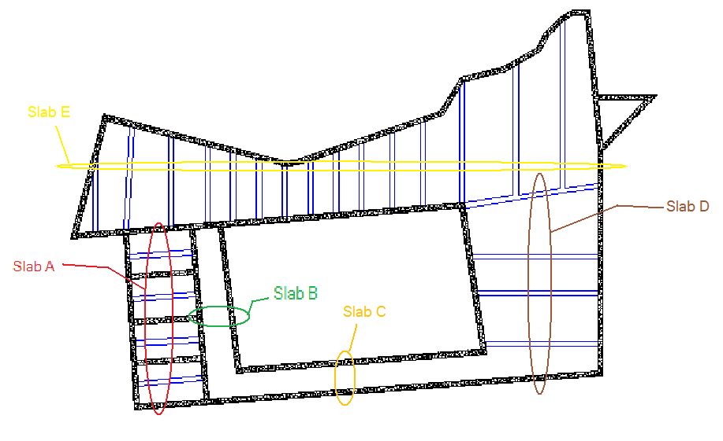
Fig(2-15):Slabs of Block C

Section A:
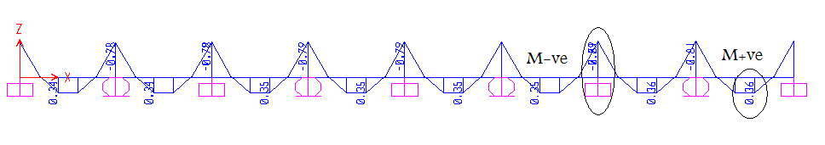
Fig(2-16):𝓜 for slab A

𝓜+ve=0.36 ton.m
𝓜-ve=0.89 ton.m
Design for 𝓜+ve=0.29 ton.m
ℎ=30 cm , c=ℎ-d-0.5*d_{b}, d=ℎ-1.8-0.5*d_{b}
c=4cm ⇒d=30-4=26cm
$$ρ=0.85\frac{f_{c}}{f_{y}}\left(1-\sqrt{\left(1-\frac{{2.35M}_{u}}{{∅bd}^{2}f_{c}}\right)}\right)$$
𝜌=.85*240/4200(1-√ (1-2.35*0.36*10⁵/.9*26²*100*240)
𝜌=0.0001
𝜌min=0.0018*ℎ/d=0.0018*30/26=0.0021
Use 𝜌=𝜌min=0.0021
As=𝜌*b*d=0.0021*100*26=5.46cm²
Ф12 As= (5ф12) S=20 cm
Checks:
- c=ℎ-d-0.5*d_{b}
d=ℎ-1.8-0.5*d_{b}
d=30-1.8-0.5*1.2=27.6 cm
c=30-27.6 -0.5*1.2=1.8 cm
- Spacing between bars
S ⇒ ≥4/3 Max aggregate size
&≤ (45cm or 3ℎ)
S=20cm …ok
Shrinkage & Temperatures:
𝜌_{sh} ⇒ ℱy (2800-3500) ⇒𝜌_{sh}=0.002
⇒ ℱy (4200) ⇒𝜌_{sh}=0.0018
A_{S/Sh}= 𝜌_{sh}*b*ℎ =0.0018*100*30
A_{S/Sh}=5.4 cm²
A_{S/Sh} (5ф12), S=20 cm
Spacing between bars
S ⇒ ≥4/3 Max aggregate size
&≤ (45cm or 5ℎ)
S=20< (45 or 5*30) cm ……. OK.
Design for 𝓜-ve=0.89 ton.m
ℎ=30 cm , c=ℎ-d-0.5*d_{b}, d=ℎ-1.8-0.5*d_{b}
c=4cm ⇒d=30-4=26cm
$$ρ=0.85\frac{f_{c}}{f_{y}}\left(1-\sqrt{\left(1-\frac{{2.35M}_{u}}{{∅bd}^{2}f_{c}}\right)}\right)$$
𝜌=.85*240/4200(1-√ (1-2.35*0.89*10⁵/.9*26²*100*240)
𝜌< 𝜌min
𝜌min=0.0018*ℎ/d=0.0018*30/26=0.0021
Use 𝜌=𝜌min=0.0021
As=𝜌*b*d=0.0021*100*26=5.46cm²
Ф12 As= (5ф12) S=20 cm
Checks:
- d=30-1.8-0.5*1.2=27.6 cm
c=30-27.6 -0.5*1.2=1.8 cm
- Spacing between bars
S ⇒ ≥4/3 Max aggregate size
&≤ (45cm or 3*30cm)
S=20cm OK
Shrinkage & Temperatures:
A_{S/Sh}= 𝜌_{sh}*b*ℎ =0.0018*100*30
A_{S/Sh}=5.4 cm²
A_{S/Sh} (5ф12) , S=20 cm
Spacing between bars
S ⇒ ≥4/3 Max aggregate size
S=20< (45 or 5*30)cm .......ok
Section B
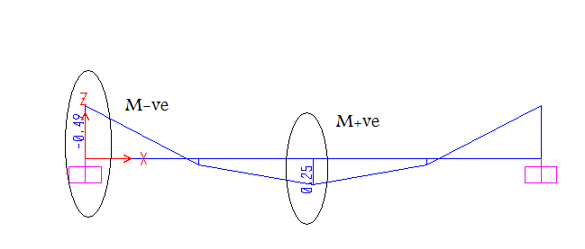
Fig (2-17 ):𝓜 for slab B
𝓜+ve=0.25 ton.m
𝓜-ve=0.494 ton.m
Design for 𝓜+ve=0.25 ton.m
ℎ=30 cm , c=4cm ⇒d=30-4=26cm
𝜌=.85𝒇_{c}/ℱy*(1-√ (1-2.35𝓜u/фbd² 𝒇_{c}))
𝜌=.85*240/4200(1-√ (1-2.35*0.25*10⁵/.9*26²*100*240)
𝜌<𝜌min
𝜌min=0.0018*ℎ/d=0.0018*30/26=0.0021
Use 𝜌=𝜌min=0.0021
As=𝜌*b*d=0.0021*100*26=5.46cm²
Ф12 As= (5ф12) S=20 cm
Checks:
- d=30-1.8-0.5*1.2=27.6 cm
c=30-27.6 -0.5*1.2=1.8 cm
- Spacing between bars
S ⇒ ≥4/3 Max aggregate size & ≤ (45cm or 3ℎ)
S=20cm …..ok
Shrinkage & Temperatures:
A_{S/Sh}= 𝜌_{sh}*b*ℎ =0.0018*100*30
A_{S/Sh}=5.4 cm²
A_{S/Sh} (5ф12), S=20 cm
Spacing between bars
S ⇒ ≥4/3 Max aggregate size
S=20< (45 or 5*30) cm ……….ok
Design for 𝓜-ve=0.494 ton.m
ℎ=30 cm , c=4cm ⇒d=30-4=26cm
$$ρ=0.85\frac{f_{c}}{f_{y}}\left(1-\sqrt{\left(1-\frac{{2.35M}_{u}}{{∅bd}^{2}f_{c}}\right)}\right)$$
𝜌=.85*240/4200(1-√ (1-2.35*0.494*10⁵/.9*26²*100*240)
𝜌< 𝜌min
𝜌min=0.0018*ℎ/d=0.0018*30/26=0.0021
Use 𝜌=𝜌min=0.0021
As=𝜌*b*d=0.0021*100*26=5.46cm²
Ф12 As= (5ф12) S=20 cm
Checks:
- d=30-1.8-0.5*1.2=27.6 cm
c=30-27.6 -0.5*1.2=1.8 cm
- Spacing between bars
S ⇒ ≥4/3 Max aggregate size
&≤ (45cm or 3*30cm)
S=20cm ….ok
Shrinkage & Temperatures:
A_{S/Sh}= 𝜌_{sh}*b*ℎ =0.0018*100*30
A_{S/Sh}=5.4 cm²
A_{S/Sh} (5ф12), S=20 cm
Spacing between bars
S ⇒ ≥4/3 Max aggregate size
S=20< (45 or 5*30) cm OK.
Section C:
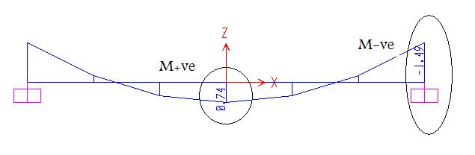
Fig (2-18 ):𝓜 for slab C
𝓜+ve=0.744 ton.m
𝓜-ve=1.49 ton.m
Design for 𝓜+ve=0.744 ton.m
ℎ=30 cm , c=4cm ⇒d=30-4=26cm
$$ρ=0.85\frac{f_{c}}{f_{y}}\left(1-\sqrt{\left(1-\frac{{2.35M}_{u}}{{∅bd}^{2}f_{c}}\right)}\right)$$
𝜌=.85*240/4200(1-√ (1-2.35*0.744*10⁵/.9*26²*100*240)
𝜌<𝜌min
𝜌min=0.0018*ℎ/d=0.0018*30/26=0.0021
Use 𝜌=𝜌min=0.0021
As=𝜌*b*d=0.0021*100*26=5.46cm²
Ф12 As= (5ф12) S=20 cm
Checks:
- d=30-1.8-0.5*1.2=27.6 cm
c=30-27.6 -0.5*1.2=1.8 cm
- Spacing between bars
S ⇒ ≥4/3 Max aggregate size
&≤ (45cm or 3ℎ)
S=20cm ……ok
Shrinkage & Temperatures:
A_{S/Sh}= 𝜌_{sh}*b*ℎ =0.0018*100*30
A_{S/Sh}=5.4 cm²
A_{S/Sh} (5ф12), S=20 cm

Spacing between bars
S ⇒ ≥4/3 Max aggregate size
S=20< (45 or 5*30) cm ……ok
Design for 𝓜-ve=1.49 ton.m
ℎ=30 cm , c=4cm ⇒d=30-4=26cm
$$ρ=0.85\frac{f_{c}}{f_{y}}\left(1-\sqrt{\left(1-\frac{{2.35M}_{u}}{{∅bd}^{2}f_{c}}\right)}\right)$$
𝜌=.85*240/4200(1-√ (1-2.35*1.49*10⁵/.9*26²*100*240)
𝜌< 𝜌min
𝜌min=0.0018*ℎ/d=0.0018*30/26=0.0021
Use 𝜌=𝜌min=0.0021
As=𝜌*b*d=0.0021*100*26=5.46cm²
Ф12 As= (5ф12) S=20 cm
Checks:
- d=30-1.8-0.5*1.2=27.6 cm
c=30-27.6 -0.5*1.2=1.8 cm
- Spacing between bars
S ⇒ ≥4/3 Max aggregate size
&≤ (45cm or 3*30cm)
S=20cm ……ok
Shrinkage & Temperatures:
A_{S/Sh}= 𝜌_{sh}*b*ℎ =0.0018*100*30
A_{S/Sh}=5.4 cm²
A_{S/Sh} (5ф12) , S=20 cm
Spacing between bars
S ⇒ ≥4/3 Max aggregate size
S=20< (45 or 5*30) cm ……ok
Section D:
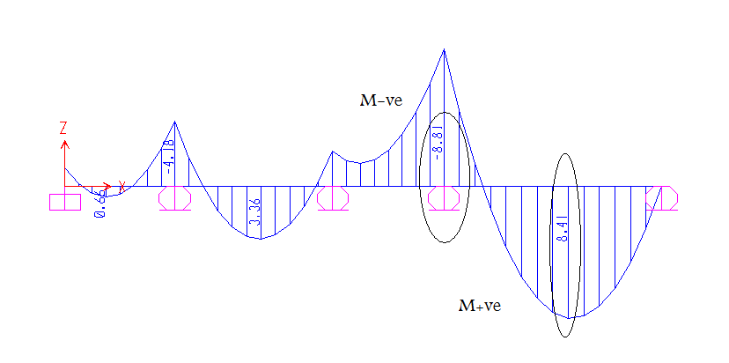
Fig (2-19 ):𝓜 for slab D
𝓜+ve=8.412 ton.m
𝓜-ve=8.808 ton.m
Design for 𝓜+ve=8.412 ton.m
ℎ=30 cm ,c=4cm ⇒d=30-4=26cm
$$ρ=0.85\frac{f_{c}}{f_{y}}\left(1-\sqrt{\left(1-\frac{{2.35M}_{u}}{{∅bd}^{2}f_{c}}\right)}\right)$$
𝜌=.85*240/4200(1-√ (1-2.35*8.412*10⁵/.9*26²*100*240)
𝜌=.0034
𝜌min=0.0018*ℎ/d=0.0018*30/26=0.0021
𝜌> 𝜌_{min} ……ok
As=𝜌*b*d=0.0034*100*26=8.86 cm²
Ф12 As (9ф12), S=11cm
Checks:
- d=30-1.8-0.5*1.2=27.6 cm
c=30-27.6 -0.5*1.2=1.8 cm
- Spacing between bars
S ⇒ ≥4/3 Max aggregate size
&≤ (45cm or 3*30cm)
S=11cm ……ok
Shrinkage & Temperatures:
A_{S/Sh}= 𝜌_{sh}*b*ℎ =0.0018*100*30
A_{S/Sh}=5.4 cm²
A_{S/Sh} (5ф12), S=20 cm
Spacing between bars
S ⇒ ≥4/3 Max aggregate size
S=20< (45 or 5*30) cm ……ok
Design for 𝓜-ve=8.81 ton.m
ℎ=30 cm , c=4cm ⇒d=30-4=26cm
$$ρ=0.85\frac{f_{c}}{f_{y}}\left(1-\sqrt{\left(1-\frac{{2.35M}_{u}}{{∅bd}^{2}f_{c}}\right)}\right)$$
𝜌=.85*240/4200(1-√ (1-2.35*8.81*10⁵/.9*26²*100*240)
𝜌=.0036
𝜌min=0.0018*ℎ/d=0.0018*30/26=0.0021
𝜌> 𝜌min ……ok
As=𝜌*b*d=0.0036*100*26=9.36 cm²
Ф12 As (9ф12), S=11cm
Checks:
- d=30-1.8-0.5*1.2=27.6 cm
c=30-27.6 -0.5*1.2=1.8 cm
- Spacing between bars
S ⇒ ≥4/3 Max aggregate size
&≤ (45cm or 3*30cm)
S=11cm ……ok
Shrinkage & Temperatures:
A_{S/Sh}= 𝜌_{sh}*b*ℎ =0.0018*100*30
A_{S/Sh}=5.4 cm²
A_{S/Sh} (5ф12), S=20 cm
Spacing between bars
S ⇒ ≥4/3 Max aggregate size
S=20< (45 or 5*30) cm ……ok

Section E:
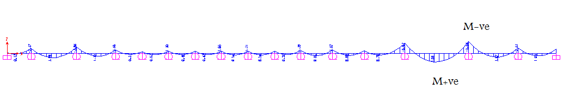
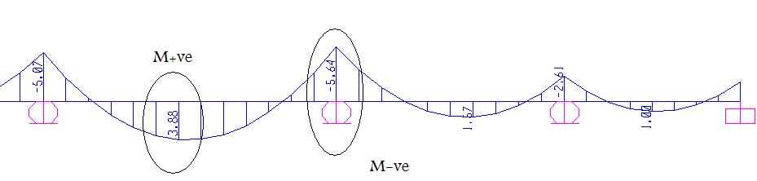
Fig (2-20 ):𝓜 for slab D
𝓜+ve=3.88 ton.m
𝓜-ve=5.64 ton.m
Design for 𝓜+ve=3.88 ton.m
ℎ=30 cm , c=4cm ⇒d=30-4=26cm
$$ρ=0.85\frac{f_{c}}{f_{y}}\left(1-\sqrt{\left(1-\frac{{2.35M}_{u}}{{∅bd}^{2}f_{c}}\right)}\right)$$
𝜌=.85*240/4200(1-√ (1-2.35*3.88*10⁵/.9*26²*100*240)
𝜌<𝜌min
𝜌min=0.0018*ℎ/d=0.0018*30/26=0.0021
Use 𝜌=𝜌min=0.0021
As=𝜌*b*d=0.0021*100*26=5.46cm²
Ф12 As= (5ф12) S=20 cm

Checks:
- d=30-1.8-0.5*1.2=27.6 cm
c=30-27.6 -0.5*1.2=1.8 cm
- Spacing between bars
S ⇒ ≥4/3 Max aggregate size
&≤ (45cm or 3ℎ)
S=20cm ……ok
Shrinkage & Temperatures:
A_{S/Sh}= 𝜌_{sh}*b*ℎ =0.0018*100*30
A_{S/Sh}=5.4 cm²
A_{S/Sh} (5ф12), S=20 cm
Spacing between bars
S ⇒ ≥4/3 Max aggregate size
S=20< (45 or 5*30) cm OK.
Design for 𝓜-ve=5.64 ton.m
ℎ=30 cm , c=4cm d=30-4=26cm
$$ρ=0.85\frac{f_{c}}{f_{y}}\left(1-\sqrt{\left(1-\frac{{2.35M}_{u}}{{∅bd}^{2}f_{c}}\right)}\right)$$
𝜌=.85*240/4200(1-√ (1-2.35*5.64*10⁵/.9*26²*100*240)
𝜌=.0022
𝜌min=0.0018*h/d=0.0018*30/26=0.0021
𝜌> 𝜌min ……ok
As=𝜌*b*d=0.0022*100*26=5.72 cm²
Ф12 As (6ф12), S=16.7cm

Checks:
- d=30-1.8-0.5*1.2=27.6 cm
c=30-27.6 -0.5*1.2=1.8 cm
- Spacing between bars
S ⇒ ≥4/3 Max aggregate size
&≤ (45cm or 3*30cm)
S=11cm ……ok
Shrinkage & Temperatures:
A_{S/Sh}= 𝜌_{sh}*b*ℎ =0.0018*100*30
A_{S/Sh}=5.4 cm²
A_{S/Sh} (5ф12), S=20 cm
Spacing between bars
S ⇒ ≥4/3 Max aggregate size
S=20< (45 or 5*30) cm ……ok

Section F:
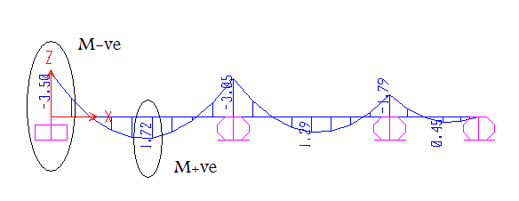
Fig (2-21 ):𝓜 for slab F
𝓜+ve=1.72 ton.m
𝓜-ve=3.5 ton.m
Design for 𝓜+ve=1.72 ton.m
ℎ=30 cm , c=4cm ,d=30-4=26cm
$$ρ=0.85\frac{f_{c}}{f_{y}}\left(1-\sqrt{\left(1-\frac{{2.35M}_{u}}{{∅bd}^{2}f_{c}}\right)}\right)$$
𝜌=.85*240/4200(1-√ (1-2.35*1.72*10⁵/.9*26²*100*240)
𝜌<𝜌min
𝜌min=0.0018* ℎ /d=0.0018*30/26=0.0021
Use 𝜌=𝜌min=0.0021
As=𝜌*b*d=0.0021*100*26=5.46cm²
Ф12 As= (5ф12) S=20 cm
Checks:
- d=30-1.8-0.5*1.2=27.6 cm
c=30-27.6 -0.5*1.2=1.8 cm
- Spacing between bars
$S_{max}$ ≥4/3 Max aggregate size
&≤ (45cm or 3 ℎ)
S=20cm ….ok
Shrinkage & Temperatures:
A_{S/Sh}= 𝜌_{sh}*b*h =0.0018*100*30
A_{S/Sh}=5.4 cm²
A_{S/Sh} (5ф12), S=20 cm
Design for 𝓜-ve=3.5 ton.m
ℎ=30 cm , c=4cm ,d=30-4=26cm
$$ρ=0.85\frac{f_{c}}{f_{y}}\left(1-\sqrt{\left(1-\frac{{2.35M}_{u}}{{∅bd}^{2}f_{c}}\right)}\right)$$
𝜌=.85*240/4200(1-√ (1-2.35*3.5*10⁵/.9*26²*100*240)
𝜌< 𝜌min
𝜌min=0.0018*ℎ/d=0.0018*30/26=0.0021
Use 𝜌=𝜌min=0.0021
As=𝜌*b*d=0.0021*100*26=5.46cm²
Ф12 As= (5ф12) S=20 cm
Checks:
- d=30-1.8-0.5*1.2=27.6 cm
c=30-27.6 -0.5*1.2=1.8 cm
- Spacing between bars
$S_{max}$ ≥4/3 Max aggregate size
&≤ (45cm or 3*30cm)
S=20cm OK
Shrinkage & Temperatures:
A_{S/Sh}= 𝜌_{sh}*b*d =0.0018*100*30
A_{S/Sh}=5.4 cm²
A_{S/Sh} (5ф12), S=20 cm
Spacing between bars
S ⇒ ≥4/3 Max aggregate size
S=20< (45 or 5*30) cm OK.
Shear Reinforcement for slab:
𝓥u<ф𝓥c
No need for Sh.R

Design of Beams

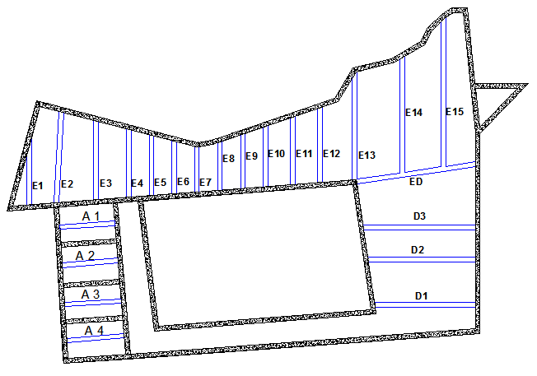
Fig ( 2-22) Beams n Block C

Design beam A
𝔀u=2.053*1.09*2
=4.48 ton/m.
Hand Calculation:
𝓜+ve=𝔀u*𝓛²/24=4.48*6.3²/24=7.41 ton.m
𝓜-ve=𝔀u*𝓛²/12=4.48*6.3²/12=14.82 ton.m

From SAP:
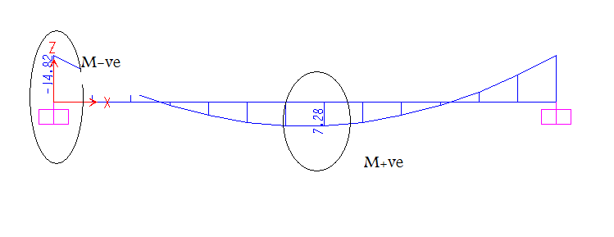
Fig ( 2-23):𝓜 for Beam A

𝓜+ve=7.28 ton.m
(7.41-7.28)/7.41*100%=1.8%<10% OK
𝓜-ve=14.82 ton.m
Design 𝓜-ve=14.82 ton.m
Hidden beam h=30 cm, assume d=26 cm, $ρ$min=.0033
𝝆max=.0184, 𝝆 =.0103
$$ρ=0.85\frac{f_{c}}{f_{y}}\left(1-\sqrt{\left(1-\frac{{2.35M}_{u}}{{∅bd}^{2}f_{c}}\right)}\right)$$
𝝆=.85*240/4200*(1-√ (1-2.35*𝓜u/0.9*b*26²*240))=.0103
b=𝓜u/0.236 ,b=65 cm.
𝝆=.85*240/4200(1-√ (1-2.35*14.82*10⁵/.9*26²*65*240)
𝝆=0.01 𝝆max>𝝆new>𝝆min ok.
As=𝝆*b*d = 0.01*65*26 = 16.9cm².
Ф16 As= (9ф16).
𝝆n=As/ (bd) = 9*2.01/ (65*26) = 0.0107.
Checks:
1) Bmin=2*c + 2*ds + n*d_{b} + (n-1)*S +1.
d_{e}=ℎ-ys.
ys =c+ds+0.5*d_{b}. For one layer
Where: c: cover
ds: Diameter of stirrup. =8mm
n: Number of Bars.
d_{b}: Diameter of Bars. =16mm
S: spacing between two bars. =30mm
de: Effictive depth
ys: Depth to the center of As.
b_{min} =2*3+2*.8+9*1.6+8*3+ 1 =47cm<65cm ⇒OK
ys =3+1+0.5*1.6=4.8 cm
de =30-4.8=25.2cm <26cm ok
2) Double reinforcement & ф
ℰ_{t} = (de-c)/c*0.003≥0.005.
C=a/0.85 a=Fy*As*(β*𝒇c*b)
a=4200*9*2.01/ (0.85*240*65) =5.73cm
C=5.73/0.85=6.75cm.
ℰ_{t} = (25.2-6.75)/6.75*0.003=8.2*10⁻³ >0.004
ф=0.9 & No D.RE
3) 𝓜d = ф*As*ℱy*(de-a/2)
= 0.9*9*2.01*4200*(25.2-5.73/2)*10⁻⁵
𝓜d = 15.27ton.m>14.82ton.m ….OK.

Design for 𝓜+ve=7.41ton.m
𝝆=0.85*240/4200*(1-√ (1-2.35*7.41*10⁵/.9*240*65*26²)).
𝝆 =0.0047 𝝆 max> 𝝆 new> 𝝆 min ok.
As= 𝝆 *b*d = 0.0047*65*26 = 7.943cm².
Ф16 As= (4ф16).
𝝆 n=As/ (bd) = 4*2.01/ (65*26) = 0.00476 OK.
Checks:
1) Bmin=2*c + 2*ds + n*d_{b} + (n-1)*S +1.
de=ℎ-ys.
ys =c+ds+0.5*d_{b}. For one layer
bmin =2*3+2*.8+4*1.6+3*3+ 1 =24cm<65cm ⇒OK
ys =3+1+0.5*1.6=4.8 cm
de =30-4.8=25.2cm <26cm ok
2) Double reinforcement & ф
ℰ_{t} = (de-c)/c*0.003≥0.005.
c=a/0.85, a=Fy*As*(β*𝒇c*b)
a=4200*4*2.01/ (0.85*240*65) =2.55 cm
c =2.55/0.85=3 cm.
ℰ_{t} = (25.2-3)/3*0.003=22*10⁻³ >0.004
ф=0.9 & No D.RE
3) 𝓜d = ф*As*ℱy*(de-a/2)
= 0.9*4*2.01*4200*(25.2-2.55/2)*10⁻⁵
𝓜d = 7.27 ton.m
𝜟= (7.41-7.27)/7.41*100%=1.89 %< 3% OK within the range.

Shear Reinforcement for Beam A:
Ф8 Ds & S min=8 cm
Hand Calculation:
𝓥u=𝔀u*𝓛/2
= 4.48*6.3/2=14.11 ton.
From SAP:
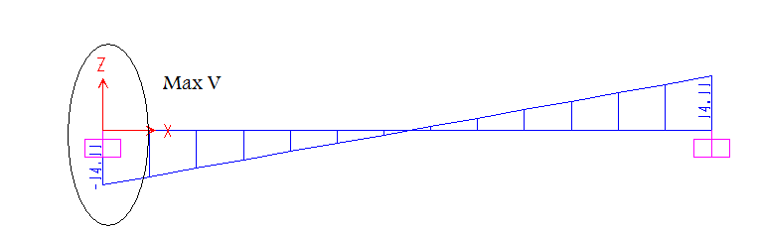
Fig (2-24): Shear diagram for Beam A
𝓥u=14.11 ton.
de=25.2cm, b=65 cm.
𝓥d=𝓥u/ф=14.11/0.75=18.81 ton
𝓥d/315=𝓥n/ (315-de)
18.81/315=𝓥n/ (315-25.2)
𝓥n=17.31 ton
𝓥c=0.53*√𝒇_{c}*bw*de
=0.53*√240*65*25.2*10⁻³=13.45 ton
𝓥u>ф𝓥c need shear reinforcement.
𝓥c/2=13.45/2=6.73 ton
𝔁2/6.73=315/18.81 , 𝔁2=112.7 cm =113 cm
For de=25.2 cm (18.81-17.31) ton
𝓥s=17.31-13.45=3.86 ton
S=Av*ℱy*de/𝓥s=1*4200*25.2*10⁻³/3.86=27.42 cm
𝓥s≤√𝒇c*bw*de
3.86 ton ≤√240*65*25.2*10⁻³ = 25.4 ton OK
S=min of ≤60 cm
≤d/2 =25.2/2=12.6 cm
≤27.4
Take S=12 cm
For S max 𝓥s min
S≤Av*Fy/ (3.5*bw) =1*4200/ (3.5*65) =18.4 cm
Take S max=18 cm.
The point at which we will stop extending S max=18 cm
𝓥s min=𝓥c + Av*ℱy*de/S
=13.45+1*4200*25.2*10⁻³/18=19.33 ton
Use ф8@12 cm.
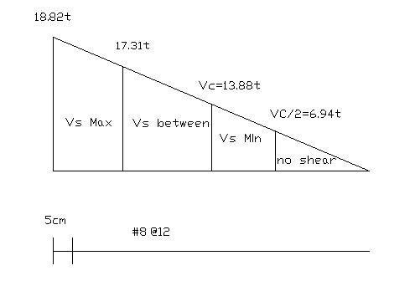
Fig ( 2-25): Shear diagram for Beam A

Check section capacity:
𝓥u/ф≤𝓥c+2.1√𝒇c*bw*de
17.31/0.75≤13.45+2.1√240*65*25.2*10⁻³
18.81 ton ≤ 66.74 ton Section is ……ok

Design of beam F:
From SAP & Hand Calculation
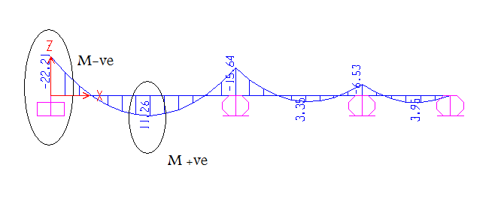
Fig ( 2-26): 𝓜 for Beam F

𝓜-ve = 22.21 ton.m
𝓜 +ve = 11.26 ton.m

Hidden beam h=30 cm, assume d=26 cm, 𝝆min=.0033
𝝆max=.0184, take =.0103
Design For 𝓜-ve = 22.21 ton.m
𝝆=.85𝒇_{c} /Fy*(1-√ (1-2.35𝓜u/фbd² 𝒇_{c}))
𝝆=.85*240/4200*(1-√(1-2.35*𝓜u/0.9*b*26²*240))=.0103
b=𝓜u/0.236 ,b=94.11 cm.
b=100 cm.
𝝆 =.85*240/4200(1-√ (1-2.35*22.21*10⁵/.9*26²*100*240)
𝝆 =.0096 𝝆 max> 𝝆 new> 𝝆 min ok.
As= 𝝆 *b*d = 0.0096*100*26 = 24.96 cm².
Ф22 As= (7ф22).
𝝆 _{n}=As/ (bd) = 7*3.8/ (100*26) = 0.0102
Checks:
1) bmin =2*c + 2*ds + n*d_{b} + (n-1)*S +1.
d_{e}=ℎ-ys.
ys =c+ds+0.5*db. For one layer
b_{min} =2*3+2*.8+7*2.2+6*3+ 1 =42 cm<100cm ⇒…..ok
ys =3+1+0.5*2.2=5.1 cm
de =30-5.1=24.9 cm <26cm …..ok
2) Double reinforcement & ф
ℰ_{t} =(de-c)/c*0.003≥0.005.
c=a/0.85 a=Fy*As*(β*𝒇c*b)
a=4200*7*3.8/(0.85*240*100)=5.48cm
c =5.48/0.85=6.44 cm.
ℰ_{t} = (24.9-6.44)/6.44*0.003=8.6*10⁻³ >0.004
⇒ф=0.9 & No D.RE
3) 𝓜d = ф*As*ℱy*(de-a/2)
= 0.9*7*3.8*4200*(24.9-5.48/2)*10⁻⁵
𝓜d = 22.28 ton.m > 22.21 ton.m …..ok
Design for +ve = 11.26 ton.m
𝝆=0.85*240/4200*(1-√ (1-2.35*11.26*10⁵/.9*240*100*26²)).
𝝆 =0.0046 𝝆 max> 𝝆 new> 𝝆 min ok.
As= 𝝆 *b*d = 0.0046*100*26 = 11.96 cm².
Ф16 As= (6ф16).
𝝆 n=As/ (bd) = 6*2.01/ (100*26) = 0.0046 …..ok
Checks:
1) bmin =2*c + 2*ds + n*d_{b} + (n-1)*S +1.
de=ℎ-ys.
ys =c+ds+0.5*d_{b}. For one layer
bmin =2*3+2*.8+6*1.6+5*3+1 =33.4 cm<100cm …ok
ys =3+1+0.5*1.6=4.8 cm
de =30-4.8=25.2cm <26cm ….ok
2) Double reinforcement & ф
ℰ_{t} = (de-c)/c*0.003≥0.005.
c=a/0.85, a=Fy*As*(β*𝒇c*b)
a=4200*6*2.01/ (0.85*240*100) =2.48 cm
c =2.48/0.85=2.92 cm.
ℰ_{t} = (25.2-2.92)/2.92*0.003=23*10⁻³ >0.004
ф=0.9 & No D.RE

3) 𝓜d = ф*As*ℱy*(de-a/2)
= 0.9*6*2.01*4200*(25.2-2.48/2)*10⁻⁵
𝓜d = 10.92 ton.m
𝜟= (11.26-10.92)/10.92*100%=3 %< 3% …..ok within the range.

Shear Reinforcement for Beam F:
Ф8 Ds & S min=8cm
Hand Calculation:
𝓥u=20.26 ton
From SAP
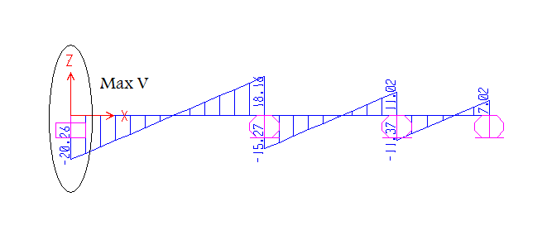
Fig ( 2-27): Shear diagram for Beam F
𝓥u=20.26 ton.
de =24.9cm , b=100 cm.
𝓥d = 𝓥u/ф=20.26/0.75=27 ton.
𝓥d/331=𝓥n/ (331-de)
27/331=𝓥n/ (331-24.9)
𝓥n=25 ton
𝓥c=0.53*√𝒇_{c}*bw*de
=0.53*√240*100*24.9*10⁻³=20.45 ton
𝓥u>ф𝓥c need shear reinforcement.

Check section capacity:
𝓥u/ф≤𝓥c+2.1√𝒇c*bw*de
20.26/0.75≤20.45+2.1√240*100*24.9*10⁻³
27 ton ≤ 101.45 ton Section is OK.
𝓥c/2=20.45/2=6.73 ton
𝔁2/10.2=331/27 ,𝔁2=125 cm
For de=24.9 cm 𝓥 between (27-25) ton
𝓥s=25-20.45=4.6 ton
S = Av*ℱy*de/𝓥s=1*4200*24.9*10⁻³/4.6=22.7 cm.
𝓥s≤√𝓥c*bw*de
4.6 ton ≤√240*100*24.9*10⁻³ = 25.4 ton …..ok
S=min of ≤60 cm
≤d/2 =24.9/2=12.5 cm
≤22.7
Take S=12 cm
For S max 𝓥s min
S≤Av*ℱy/ (3.5*bw) =1*4200/ (3.5*100) =12 cm
Take S max=12 cm.
Use ф8@12 cm.
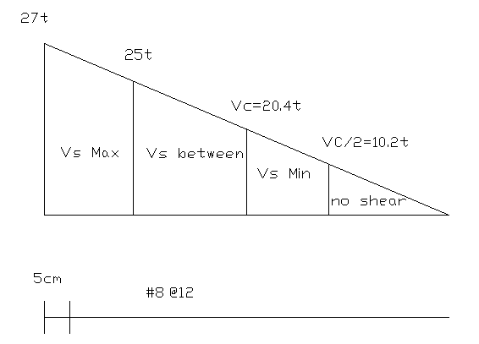
Fig (2-28): Shear diagram for Beam F

Design of beam E:
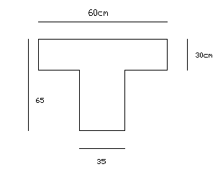
Fig (2-29): Dimension of Beam E

T-Section
𝔀u beam=𝔀u slap +own weight
ℎ=𝓛/16 simply supported
ℎ=10.45/16=65.3cm
ℎ = 𝓛 /18.5=10.7/18.5=58 cm . One way end cont
Take h=65cm
Assume b_{w}= 35cm
be= 𝓛 n/4=10.45/4=261cm
= b_{w} +16t=35+16*30= 515 cm
Center to center = 3/2+6. 76/2=4.88m
Assume
be =60cm
𝔀u beam=2.053*(6.76/2+3/2) +1.2*0.35*0.35*2.4
=10.37 ton/m

From SAP
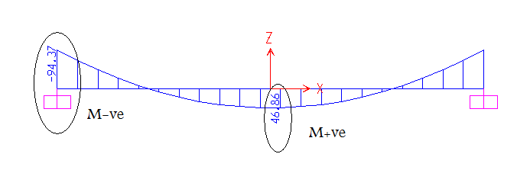
Fig (2-30 ): $M$ for Beam E
Hand Calculation:
𝓜+ve=𝔀u*𝓛n²/12 =10.37*10.45²/12=94.37 ton.m
𝓜-ve= 𝔀u*ln²/24= 47.21 ton.m
Design for 𝓜+ve=94.37 ton.m
𝝆min = .003
𝝆max=.0183
Assume d=58cm, b_{w} =35 cm, be=60 cm
𝓜 _{d}. flange=ф*be*t*β* 𝒇_{c}΄*(d-t/2)
𝓜 _{df}=0.9*60*30*0.85*240*(58-30/2)*10⁻⁵
=142.1 ton.m ,a<hf
𝓜 u< 𝓜 df
𝝆=0.85*240/4200*(1-√ (1-2.35*94.37*10⁵/0.9*240*60*58²)).
𝝆 =0.0145 𝝆 max> 𝝆 new> 𝝆 min ok.
As= 𝝆 *be*d = 0.0145*60*58 = 50.46 cm².
Ф26 As= (10ф26). Two layer (5+5)
As min= 𝝆 min*bw*d=0.003*35*58=6.09 cm²
As>As min …..ok
c_{b} =6120*d*(6120+ ℱ y)
c_{b} =6120*58/ (6120+4200) =34.4 cm
a_{b} =c_{b}*0.85=34.4*0.85=29.24 cm
T_{b}=C_{b} --- A_{sb}=0.85*𝒇c*be*a_{b}/ℱy
A_{sb}=0.85*240*60*29.24/4200=85.21 cm²
A_{sb}>As
Checks:
1) B_{min}=2*c + 2*ds + n*d_{b} + (n-1)*S +1.
de=ℎ-ys.
ys =c+ds+0.5*d_{b}. For one layer
bmin =2*3+2*.8+5*2.6+4*3+ 1 =33.6cm<35cm ⇒OK
ys =3+1 +0.5*2.6=5.3 cm one layer
ys2=ys1+ (2.5+d_{b})*n2/n two layer
de =65-7.85=57.15cm <58 cm ok
2) Double reinforcement & ф
ℰ_{t} = (de-c)/c*0.003≥0.005.
c=a/0.85, a= ℱ y*As*(β* 𝒇_{c}΄*b)
a=4200*10*5.31/(0.85*240*60)=18.22 cm
c=18.22/0.85=21.44 cm
ℰ_{t} = (57.15-21.44)/21.44*0.003=5*10⁻³ >0.004
ф=0.9 & No D.RE

3) 𝓜d = ф*As*ℱy*(de-a/2)
= 0.9*10*5.31*4200*(57.15-18.22/2)*10⁻⁵
𝓜d = 96.42 ton.m >𝓜u=94.37 ton.m

Design for 𝓜-ve=47.2 ton.m
Assume d=58cm, b_{W} =35 cm, be=60 cm
𝓜d.flange=ф*be*t*β*𝒇c*(d-t/2)
𝓜_{df}=0.9*60*30*0.85*240*(58-30/2)*10⁻⁵
=142.1 ton.m , a<hf
𝓜u<𝓜df
𝝆=0.85*240/4200*(1-√ (1-2.35*47.2*10⁵/0.9*240*60*58²)).
𝝆 =0.0066 𝝆 max> 𝝆 new> 𝝆 min …..ok
As= 𝝆 *be*d = 0.0066*60*58 = 23.08 cm².
Ф26 As= (5ф26). One layer
As min= 𝝆 min*b_{w} *d=0.003*35*58=6.09 cm²
As>As min …..ok
c_{b} =6120*d*(6120+ℱy)
=6120*58/ (6120+4200) =34.4 cm
a_{b} =c_{b}*0.85=34.4*0.85=29.24 cm
T_{b}=C_{b} ----A_{sb}=0.85*𝒇c*be*a_{b}/ℱy
A_{sb}=0.85*240*60*29.24/4200=85.21 cm²
A_{sb}>As
Checks:
1) Bmin=2*c + 2*ds + n*d_{b} + (n-1)*S +1.
de=ℎ-ys.
ys =c+ds+0.5*d_{b}. For one layer
bmin =2*3+2*.8+5*2.6+4*3+ 1 =33.6cm<35cm …..ok
ys =3+1+ 0.5*2.6=5.3 cm one layer
de =65-5.3=52.7 cm < 58 cm ok

2) Double reinforcement & ф
ℰ_{t} = (de-c)/c*0.003≥0.005.
c=a/0.85, a=ℱy*As*(β*𝒇c*b)
a=4200*5*5.31/ (0.85*240*60) = 9.11 cm, a<hf …..ok
c=9.11/0.85=10.72 cm
ℰ_{t} = (52.7-10.72)/10.72*0.003=12*10⁻³ >0.004
ф=0.9 & No D.RE

3) 𝓜d = ф*As*ℱy*(de-a/2)
= 0.9*5*5.31*4200*(52.7-9.11/2)*10⁻⁵
𝓜d = 48.32 ton.m >𝓜u=47.2 ton.m

Shear Reinforcement for Beam E:
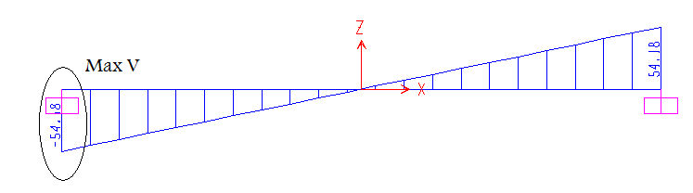
Fig (2-31 ): Shear diagram for Beam E

Ф8 DRs & S min=8cm

Hand Calculation:
𝓥u=𝔀u*𝓛/2=10.37*10.45/2=54.18 ton

From SAP
𝓥u=54.18 ton
d=58cm, be=60 cm, b_{w} =35 cm
𝓥d=𝓥u/ф=54.18/0.75=72.24 ton
𝓥d/523=𝓥n/ (523-58)
72.24/523=𝓥n/ (523-58)
𝓥n=64.23 ton
𝓥c=0.53*√𝒇_{c}*b_{w} *de
=0.53*√240*35*58*10⁻³=16.67 ton
𝓥u>ф𝓥c need shear reinforcement.

Check section capacity:
𝓥u/ф≤𝓥c+2.1√𝓥c*bw *de
54.18/0.75≤16.67+2.1√240*35*58*10⁻³
72.24 ton ≤ 82.71 ton Section is …..ok
𝓥c/2=16.67/2=8.33 ton
𝔁2/8.33=523/72.24 ,𝔁2=60.3 cm
For de=58 cm 𝓥 (64.23 - 16.67) ton
𝓥s=64.23-16.167=47.56 ton
S=Av*ℱy*de/𝓥s=1*4200*58*10⁻³/47.56=5.12 cm
Take S=8 cm.
𝓥s≥√𝒇c*b_{w} *de
47.56 ton ≥√240*35*58*10⁻³ = 31.45 ton …..ok
S=min of ≤30 cm
≤d/4 =58/4=14.5 cm
≤8
Take S=8 cm
For S max 𝓥s min
S≤Av*ℱy/ (3.5*bw) =1*4200/ (3.5*35) =34.3 cm
𝓥s≥√𝓥c*bw* de
47.56 ton ≥√240*35*58*10⁻³ = 31.45 ton …..ok
S=min of ≤30 cm
≤d/4 =58/4=14.5 cm
≤34.3 cm
Take S max=14 cm.
The point at which we will stop extending S max=18 cm
𝓥s min=𝓥c + Av*𝓥y*de/S
=16.67+1*4200*58*10⁻³/14=34.07 ton
𝔁1/34.07=523/72.24 ,𝔁1=246.7 cm
(5cm)(12@8=96cm)(151cm)(14@14=196cm) (3@25=75cm)

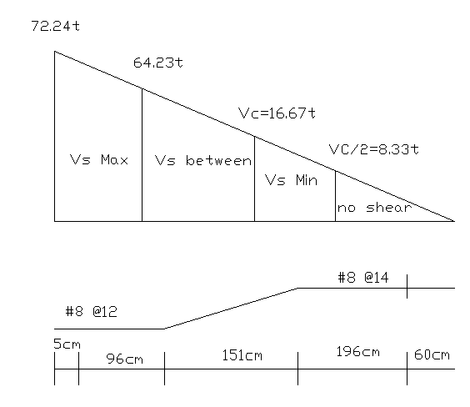
Fig ( 2-32): Shear diagram for Beam E

Design of beam D:
𝓥u=2.053*0.5*6.22
=7.144ton/m
From SAP:
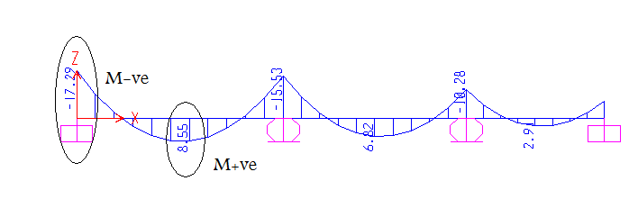
Fig (2-33 ): 𝓜 for Beam D
𝓜+ve=17.29 ton.m
𝓜 -ve =8.55 ton.m
From hand calculation:
𝓜 +ve=𝔀𝓛²/8-(17.27+15.52)/2
= 8.69 ton.m
𝓜 -ve=17.27 ton.m
Design for 𝓜 -ve=17.27 ton.m
Hidden beam=30cm
d=26cm
𝝆_{min}=0.0033
𝝆_{max}=0.75ρ_{b}=0.0184
Assume 𝝆=0.18 𝒇_{c}΄/ℱy
=0.0103
𝝆 _{max}> 𝝆 > 𝝆 _{min} …..ok
𝝆 < 𝝆 _{b} steel yield
1/b= ((1-(ρℱy/0.85 ф 𝒇_{c}΄) ²) (фd² 𝒇_{c}΄/2.35𝓜u)
b=𝓜u/0.236=17.27/0.236=73.2 cm
b=75 cm
𝝆 _{new}=0.85*240/4200(1-√1-(2.35*10⁵*17.27/0.9*75*26²*240))
𝝆 _{new} =0.1
As= 𝝆 *b*d
=0.01*75*26=19.5 cm²
Ф16 As= (10 ф16)
𝝆 =10*2.01/75*26
=0.0103
Checks:
1) For b_{min}
bmin =2*c + 2*ds + n*d_{b} + (n-1)*S +1.
d_{e}=ℎ-ys.
ys =c+ds+0.5*db. For one layer
b_{min} =2*3+2*0.8+10*1.6+9*3+1=51.6cm<75cm …..ok
ys =3+1+0.5*1.6=4.8cm
de =30-4.8=25.2cm <26cm …..ok
2) Double reinforcement & ф
ℰ_{t} = (de-c)/c*0.003≥0.005.
c=a/0.85 a=ℱy*As*(β*𝒇c*b)
a =10*2.01*4200/0.85*240*75=5.52cm
c=a/0.85=6.5cm
ℰ_{t} = ((25.2-6.5)/6.5)*0.003
=8.63*10⁻³
ℰ_{t} >0.005 ф=0.9
ℰ_{t} >0.004No D.R
3) 𝓜d = ф*As*ℱy*(de-a/2)
𝓜d= (0.9*10*2.01*4200/10⁵)(25.2-5.52/2)
=17.05 ton.m
((17.27-17.05)/17.27)*100%=1.27 %< 3% ok
Design for 𝓜+ve=8.69ton.m
Hidden beam=30 cm
d=26cm
b=75cm
𝝆_{min}=0.0033
𝝆_{max}=0.75ρ_{b}=0.0184
𝝆 =0.85*240/4200(1-√1-(2.35*10⁵*8.69/0.9*75*26²*240))
=0.0048
𝝆_{max}>𝝆> 𝝆_{min} …..ok
As=𝝆*b*d
As=0.0048*75*26
=9.36cm²
Ф16 As= (5 ф16)
𝝆 _{new}=5*2.01/75*26=0.0052

Checks:
1) bmin =2*c + 2*ds + n*d_{b} + (n-1)*S +1.
de= ℎ -ys.
ys =c+ds+0.5*d_{b}. For one layer
b_{min} =2*3+2*0.8+5*1.6+4*3+1
=28.6cm <75 cm ok
ys =4.8
de =25.4cm<26cm ok
2) Double reinforcement & ф
ℰ_{t} = (de-c)/c*0.003≥0.005.
c=a/0.85, a=ℱy*As*(β* 𝒇_{c}΄*b)
c= (4200*5*2.01/0.85²*240*75)
=3.25 cm
a=2.76 cm
ℰ_{t} = ((25.2-3.25)/3.25)*0.003
=0.021
ℰ_{t} >0.005 ф=0.9
ℰ_{t} >0.004No D.R
3) 𝓜d = ф*As*ℱy*(d_{e}-a/2)
𝓜d= (0.9*5*2.01*4200/10⁵) (25.2-2.76/2)
=9.08 ton.m > 8.69ton.m …..ok

Shear Reinforcement for Beam D:
Ф8 Ds & S min=8cm

From SAP:
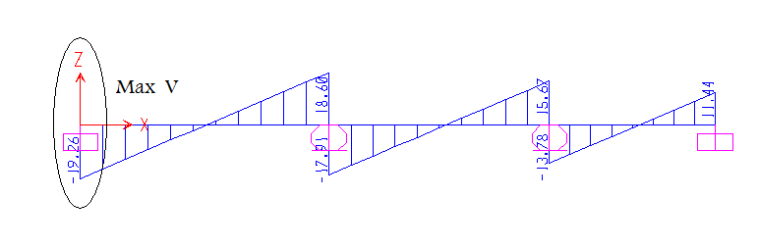
Fig ( 2-34): Shear diagram for Beam D

𝓥u=19.26 ton
𝓥n=𝓥u/0.75
𝓥n=19.26/0.75=25.68 ton
𝓥c=0.53√ 𝒇_{c}΄* b_{w}*d
𝓥c=0.53*√240*75*26/10³
𝓥c=16.01 ton ф 𝓥c=0.75*16.01=12.01 ton
ф 𝓥c<𝓥u need shear reinforcement
𝓥n at d=25.4 cm
25.68/270=𝓥n/ (270-25.4)
𝓥n=23.26
𝓥c=/2=16.01/2=8.015
25.68/270=8.015/𝔁₁
𝔁₁=84.22 cm
𝔁 ₂=270*16.01/25.68
=168.33
Use ф 8mm for stirrup
Av=2*A_{for one leg}
=1 cm²
𝓥s=𝓥n-𝓥c
=23.2616.01=7.25ton
S= (Av*ℱy*d)/ 𝓥s
=1*4200*25.4/7.25*10²=14.7 cm>8cm …..ok
√ 𝒇_{c}΄ *b*d=√240*75*25.4*10⁻³=29.51 ton
𝓥s≤√ 𝒇_{c}΄*b*d
S≤d/2 =25.4/2=12.7cm
S≤60cm
S=14.7cm
Take the smallest S=12 cm
𝓥s _{min}= (left 𝓥c/2)
𝓥s _{min}=3.5b_{w}d
S ≤ Av*ℱy/3.5b_{w}=1*4200/3.5*75=16 mc
S ≤ 60cm
S ≤ d/2=12.7 mc
Take S max=12 cm.
Find the point at which we will stop extending S=12 cm
𝓥s=Av*ℱy*d/S
=1*4200*25.4/12*10³=8.89 ton
𝓥n=𝓥s+𝓥c
=8.89+16.01=24.9 ton
25.68/270=24.9/𝔁₃ 𝔁 ₃=262 cm
(5cm)(16@12 =197cm)(@25 =68cm)

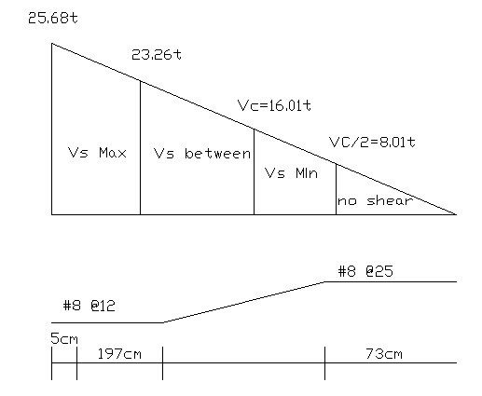
Fig ( 2-35): Shear diagram for Beam D

