Beauty Program

An-NajahNnational University
2011
.
.

Beauty is the standard in professional music notation

بسم الله الرحمن الرحيم

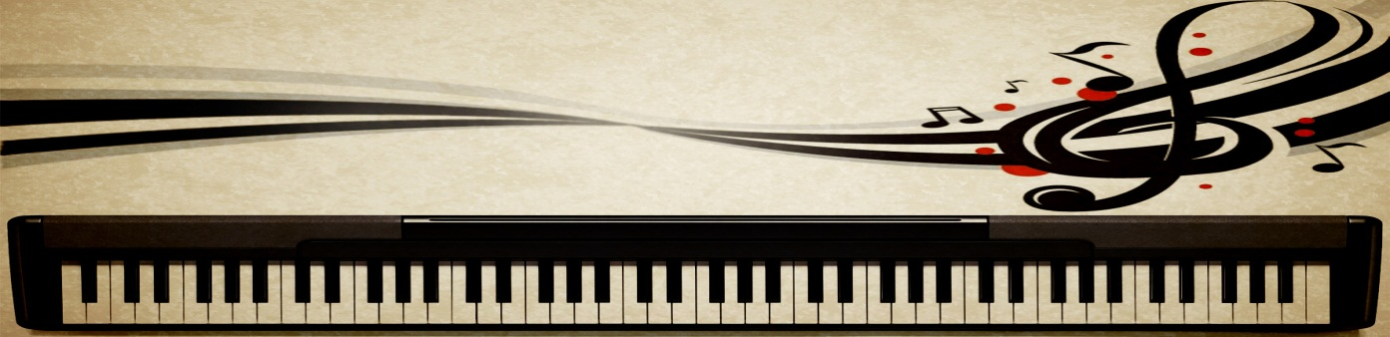

Prepared by :
Ahmad Shawahna
Shadi Awwad

Supervised by:
Dr.luai Malhis

Tusday ,December 22,2011

Contents List:
Acknowledgments …………………………………………………………………………………………………. 5
Abstract …………………………………………………………………………………………………….…………… 6
- Introduction …………………………………………………………………………………………………………… 7
  - Overview ………………………………………………………………………………………………………. 7
  - Existing Problems …………………………………………………………………………………………. 8
  - Related Work ……………………………………………………………………………………………….. 8
  - Motivation For Carrying out the Research ……………………………….…………..………. 8
- Methodology …………………………………………………………………………………………………………. 9
  - Chapter 1: Music Theory Overview……………………..……………………………………..…. 9
  - Chapter 2: Project Components ……………………………….…………………………………… 15
    - Editing Window ……………………………………………………………………………..……. 15
    - Pages …………………………………………………………………………………………………… 15
    - Staff …………………………………………………………………………………………………….. 15
  - Chapter 3: Musical Symbols ………………………………………………………………………….. 17
    - Clef ……………………………………………………………………………………………………… 17
    - BarLine ……………………………………………………………………………………………….. 19
    - Note …………………………………………………………………………………………………… 23
    - Rest ……………………………………………………………………………………………………. 30
    - Time Signature …………………………………………………………………………………… 33
    - Key Signature …………………………………………………………………………………….. 37
  - Chapter 4: Auxiliary Musical Symbols ………………………………………………………….. 42
    - Dot …………………………………………………………………………………………………….. 42
    - Accidentals ………………………………………………………………………………………… 42
    - Lyrics …………………………………………………………………………………………………. 43
    - Tuplet ………………………………………………………………………………………………… 43
    - Tie and Slur ……………………………………………………………………………………….. 44
    - Glissando …………………………………………………………………………………………… 44
    - Specific Musical Symbols …………………………………………………………………… 46
  - Chapter 5: Operation on Musical Symbols ………………………………………………….. 47
    - Delete Symbol …………………………………………………………………………………… 47
    - Delete Measure …………………………………………………………………………………. 48
    - Add Measure …………………………………………………………………………………….. 48
    - Clear Measure……………………………………………………………………………………. 49
  - Chapter 6: Play Musical Symbols …………………………………………………………………. 50
    - Piano Keyboard ………………………………………………………………………………….. 50
    - MIDI Library ……………………………………………………………………………………….. 50
    - Play Note ……………………………………………………………………………………………. 50
  - Chapter 7: Save and Open ……………………………………………………………………………. 53
    - Save Technique …………………………………………………………..……………………... 53
    - Open Technique ………………………………………………………………………………….. 55
- Conclusion ……………………………………………………………………………………………………………… 56

List of Figures:
Figure 1: Staff 9
Figure 2: Note Duration 10
Figure 3: Time Signature 10
Figure 4: Rest Duration 10
Figure 5: Dots and Ties 11
Figure 6: Accidentals 11
Figure 7: C Major Scale 12
Figure 8: Eb Major Scale 12
Figure 9: D Major Scale 12
Figure 10: A Natural Minor Scale 12
Figure 11: C Natural Minor Scale 13
Figure 12: Sharp Key Signature 13
Figure 13: Flat Key Signature 13
Figure 14: Add Page Form 15
Figure 15: Remove Page Form 15
Figure 16: Staff Lines 15
Figure 17: Treble Clef 17
Figure 18: Bass Clef 17
Figure 19: Alto Clef 17
Figure 20: Tenor Clef 17
Figure 21: Mezzo Soprano Clef 17
Figure 22: Add and Update Clef 18
Figure 23: Draw Clef 19
Figure 24: Change the number of BarLine 21
Figure 25: Draw BarLine 22
Figure 26: Leadger Line 23
Figure 27: Add Note 24
Figure 28: Note Parts 24
Figure 29: Draw Note 27
Figure 30:Beam 28
Figure 31: Beam Operation 28
Figure 32: Beam Examples 29
Figure 33: End Beam 29
Figure 34: Beam Calculations 30
Figure 35: Up Direction Of Beam 30
Figure 36: Down Direction Of Beam 30
Figure 37: Rest Types 31
Figure 38: Add Rest 32
Figure 39: Draw Rest 33
Figure 40: Set Time Signature 33
Figure 41: Add and Update Time Signature 35
Figure 42: Insert Time Signature 36
Figure 43: Add and Update Key Signature 39
Figure 44: Draw Key Signature 41
Figure 45: Draw Tuplet 44
Figure 46: Draw Tie, Slur and glissando 45
Figure 47: Add Measure 48
Figure 48: Delete Measure 49
Figure 49: Piano Keyboard 50
Figure 50: Play Notes 52
Figure 51: Save File 54

Acknowledgments

We want to express our gratitude to all the people who have given their heart whelming full support in making this project a magnificent experience.

We also wanted to thank our family who inspired, encouraged and fully supported us for every trial that comes our way and for supported us to doing this project and for giving us not just financial, but morally and spiritually support.

We gratefully acknowledge the excellent support of the staff at music department at Arts Fine Faculty at An-Najah National University in making this project possible. Special thanks go to Dr. Hassan Dradi and Dr. Ammar kadmani , Who taught us the basics of music and how the project should work.

Although any expression of acknowledgment will fail to fully capture the importance of their role, we would still like to thank each of them, and also to say how much we appreciated their contributions and enjoyed our interactions.

To the staff of College of Engineering and Computer Engineering Department, in particular, for their support of science, that made us to get this place of knowledge and for their effort to getting us the graduation year.

A lot thanks go to Head of Computer Department Dr. Luai Malhis , who approved the project , and encouraged us to fly in this project.

We would also like to thank all those that helped the workshops become a reality, and all others who, in various capacities, helped this project come to a successful conclusion.

We whole heartedly thank you for the kindness and patience that you have given us.

Abstract

Beauty is the standard in professional music notation. Its powerful transcribing and editing capabilities help musicians of all levels get their ideas into print. Fast, accurate, and easy to use, Beauty allows you to create beautiful printouts of your scores. Whether you're creating motion picture scores, orchestral arrangements, or teaching music in school and university, Beauty is second to none.

Beauty designed for individuals who fond of music, especially music students at An-Najah National University, where they can write musical notation in eastern and western style together according to the standard rules, played easily and in very beautiful way, knowing that there is no any program that supports writing and playing eastern music.

Introduction:

Overview:

Beauty is the standard in professional music notation. Its powerful transcribing and editing capabilities help musicians of all levels get their ideas into print. Fast, accurate, and easy to use, Beauty allows you to create beautiful printouts of your scores. Whether you're creating motion picture scores, orchestral arrangements, or teaching music in school and university, Beauty is second to none.

Beauty designed for people who fond of music, especially music students at An-Najah National University, where they can write musical notation in east and west style together according to the standard rules, played easily and in very beautiful way, knowing that there is no any program that supports writing and playing eastern music.

Beauty Program designed based on Microsoft visual studio 2010, by using C# programing language, because of its feature and suitability; we have chosen it for working on the project.

Complete Scoring Features, Part Extraction, and MIDI Playback Keep You in Control

Whether you play directly into Beauty or transcribe your MIDI files, you get accurate notation and beautiful printouts every time. You can extract parts, transpose for different instruments, and play your music as you originally conceived it. Beauty graphically displays and plays back dynamic marks, repeats, multiple endings, pedal marks, or any MIDI controller.

Flexible Page Layout

Beauty scores can be fine-tuned with a simple move of the mouse. On-screen palettes let you enter dozens of marks and symbols. Powerful features such as page layout control, TrueType® and PostScript® support, polyphonic part voicing, and editable expressions palettes provide an inexhaustible set of capabilities for presenting your music on paper.

Computer Speed, Professional Results

When you put aside your pencil and staff paper and compose and arrange your music with Beauty, you achieve a new level of professionalism and productivity.

Beauty will become the musician's choice in notation software because it allows you to create and publish everything from simple lead sheets to symphonies in less time and with more control.

Existing Problems:

The programs used in our university does not support writing and playing eastern music, so there was a problem in the Arts Fine Faculty, doctors and students music , with writing and playing this notation, where they are writing the music notation manually on staff paper by pencil, and that was very difficult and makes the way of teaching difficult and disorganized, and students can deviate from the rules of musical because it has no controls on the handwriting , and they cannot play it and listen to the audio output.

In addition, existing programs suffer from a lack of musical symbols used such some kinds of Clef (Mezzo Soprano Clef), so there was a problem for users in dealing with them, through this program We were able to solve these problems and put the solution to the users and made them very comfortable.

  - Related Work :

There are many of the program in the world and used by music colleges , colleges and music schools, which in turn help to practice playing music, but there is no one of them support the Eastern music , but through this project we have integrated the Eastern and Western writing notation in one program without the need for any other program.

  - Motivation For Carrying out the Research :

We wondered before selecting a project idea:
What is the best project can be done and help in the educational process at our university?
So we do field research on the faculties of the university and study the problems in the possession of its faculties and departments, we found that the music department at Arts Fine Faculty has a problem in the lack of programs in support of the educational process, we studied the problem with the head of the department and explained to us the shortcomings in existing programs, and he encourages us to doing this project.
The urgent need for his contribution to the success of the learning tool led us and encouraged us to choose this project.

- Methodology :
  - Chapter 1: Music Theory Overview

    - Staff:
It was in the middle Ages that people first began to think of using lines to represent musical notes. The very first systems used 11 lines. Why eleven? Simple - it was the number needed to fit all the notes the human voice could sing - from the lowest notes of the male bass up to the highest notes of the soprano.
It was soon realized, however, that such a system was impractical - it was too difficult to distinguish one note from another on the huge staff.

Solution to the Staff Crisis:
To solve the problem, the 11-line staff made way for a variety 5-line staffs. Each 5-line staff in itself was capable of holding the entire range of any voice. A system of symbols known as Clefs was used to distinguish which set of five lines was in operation and that is the system we use to this day. Next figure illustrate the staff.
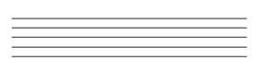
Figure 1: Staff

    - Clefs:
- Clefs assign individual notes to certain lines or spaces.
- Two clefs are normally used: The Treble and Bass clefs.

Next figure illustrate the Clef types:

- Treble Clef (also called the G Clef)
The staff line which the clef wraps around is known as G.

- Bass Clef (also called the F Clef)
The staff line in between the two dots of the clef is F.

- Alto Clef
- Tenor Clef
- Mezzo Soprano Clef

    - Chord:
- A chord is a combination of two or more notes.
- Chords are built off of a single note, called the root.

    - Note duration:
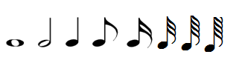
- The length of time that a note is played, which is determined by the type of note.

Figure 2: Note Duration

- The whole note has the longest note duration in modern music.
- The half note has half the duration of a whole note.
- The quarter note is a fourth (or a quarter) of a whole note.
- An eighth note has one flag; therefore, it is half the value of a quarter note.
- A sixteenth note has two flags, halving the value again.
- A 32nd note has three flags, halving the value again.
- A 64th note has four flags, halving the value again.
- A 128th note has five flags, halving the value again.

    - Measures and Time signature :
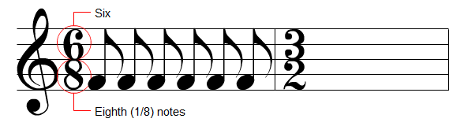
Figure 3: Time Signature

- Vertical black bars called bar lines divide the staff into measures.
- The above staff has been split into two measures.
- Time signatures define the amount and type of notes that each measure contains.

    - Rest duration:
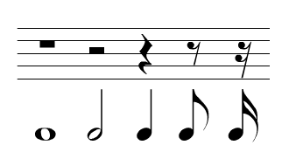
Figure 4: Rest Duration

- Rests are used to show periods of silence in a measure.
- Each type of rest shares a duration with a certain type of note.

    - Dots and Ties:
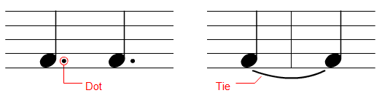

Figure 5: Dots and Ties

- Augmentation dots and tenuto ties are two types of markings used to alter a note's duration.
- A dot increases duration by one half.
- Ties merge multiple notes of the same pitch. They are used to let the duration of a note travel across barriers (such as the measure line).

    - Steps and Accidentals:
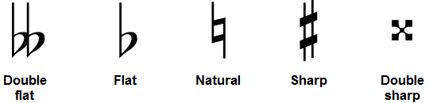
Figure 6: Accidentals

- A half step is the distance from one key on the keyboard to the next adjacent key.
- A whole step is the same distance as two half steps.
- An accidental is a sign used to raise or lower the pitch of a note.
- The flat lowers a note by a half step while the sharp raises a note by a half step.
- The double flat and double sharp alters a note by a whole step.
- The natural cancels out any accidental and returns a note to its original white key.

    - The major scale:
- A scale is a selection of certain notes within an octave.

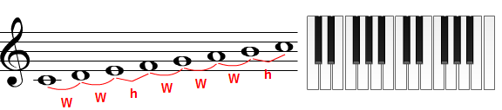
- C Major Scale
Figure 7: C Major Scale

- The C Major Scale is constructed with the above formula. W's represent whole steps and h's represent half steps.

- Eb Major Scale
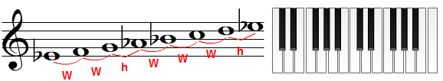
Figure 8: Eb Major Scale

- The Eb Major Scale is constructed with the above formula. W's represent whole steps and h's represent half steps.

- D Major Scale
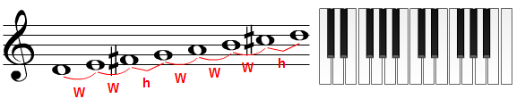
Figure 9: D Major Scale

- The D Major Scale is constructed with the above formula. W's represent whole steps and h's represent half steps.

    - The Minor scales:

- Natural Minor Scale

- A Natural Minor Scale
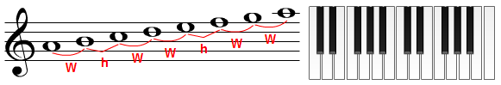
Figure 10: A Natural Minor Scale

The A Natural Minor Scale is constructed with the above formula. W's represent whole steps and h's represent half steps.

- C Natural Minor Scale
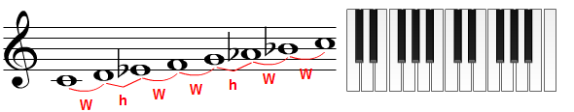
Figure 11: C Natural Minor Scale

The C Natural Minor Scale is constructed with the above formula. W's represent whole steps and h's represent half steps.

- Harmonic Minor Scale
• To convert any natural minor scale into harmonic minor, raise the seventh note by a half step.

- Melodic minor Scale.
• To convert a natural minor scale into melodic minor, raise both the sixth and seventh notes by a half step.

- Most of the time, melodic minor is used only when ascending. When descending, composers prefer to use the natural minor scale.

    - Key signature:
- A key signature is a collection of every accidental found in a scale.
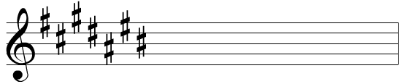
- The sharps are arranged in a special order by using the following saying: "Father Charles Goes Down And Ends Battle".
Figure 12: Sharp Key Signature

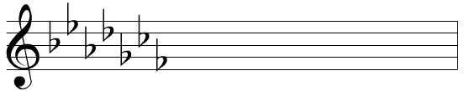
- The flats are arranged in a special order by using the following saying: "Battle Ends And Down Goes Charles' Father".
Figure 13: Flat Key Signature

- In all music's program there are only 30 different key signatures exist (15 for major scales and 15 for minor scales).but in our program we made it very flexible ,where the user can choose one of 30 basic key signatures or make new key signatures as required in very efficient way.

  - Chapter 2: Project Components

    - Editing Window

Editing Window is a panel, which is the main area where the user can make everything as add, delete and update the musical symbols.
Editing Window consist of multiple Pages.

      - Pages:
Page is a container that contains a group of staves, every Page represent musical sheet, and can be grown up as the musician need.
Each of these pages contain affixed number of Parts, each part consist of two staves.

Our project appears active page.

- Page features :
- Add pages.
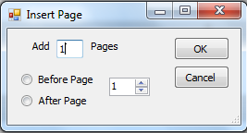

Figure 14: Add Page Form

- Remove Pages
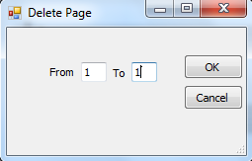

Figure 15: Remove Page Form

      - Staff :
Staff contains array of musical symbol which add to this staff when add or modify element in this array by user.

Figure 16: Staff Lines

Staff includes these main parts:
- Array of musical symbol.
This array contain all musical symbol on this staff that added by the user.

- Draw function.
This function is responsible for drawing the staff lines and all musical symbols on this staff as strings.

- Event on this staff.
A lot of event made to staff, as mouse enter and mouse leave events to change the courser style, and a lot of events that will discos in other section.

  - Chapter 3: Musical Symbols

Musical Symbols are the marks and symbols that are widely used in western and Eastern musical scores, styles, and instruments today.

    - Clefs
Clefs assign individual notes to certain lines or spaces.
Clef has some main properties like: Location, measure ID, Octave and steps.

      - Clef types:

- Treble Clef (also called the G Clef)
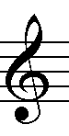

Figure 17: Treble Clef

- The staff line which the clef wraps around is known as G.

- Bass Clef (also called the F Clef)
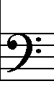

Figure 18: Bass Clef

- The staff line in between the two dots of the clef is F.

- Alto Clef
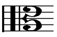

Figure 19: Alto Clef

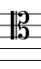
- Tenor Clef

Figure 20: Tenor Clef

- Mezzo Soprano Clef
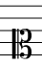

Figure 21: Mezzo Soprano Clef
      - Add and Update Clef
When the user tries to add Clef, the first event will be taken determine what the user try to do, add new Clef or update existing one, this can be done by checking the location of click event, if the user try to update the Clef, check the previous Clef in the staff, if the previous Clef same the new one, then clear the old clef, but if it is different easily update old Clef with new, but if he try to add new chef, first check the previous Clef in the staff, if the previous Clef same the new one, then there is nothing to do, but if it is different, then this Clef will be adding to staff and drawing on its location. Next figure illustrates this process.

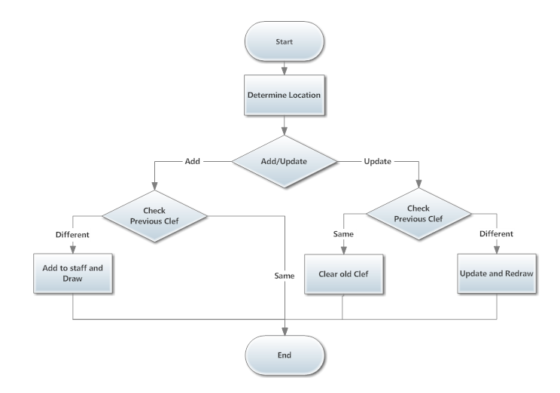
Figure 22: Add and Update Clef

      - Draw Clef
Drawing Clef depend on the clef type, before drawing it the location must be determine, the X position determined by the cursor click location, the Y position determined by the Clef type, after the location determined, the clef will draw in this location as string of the shape of its type. Next figure illustrate this process.

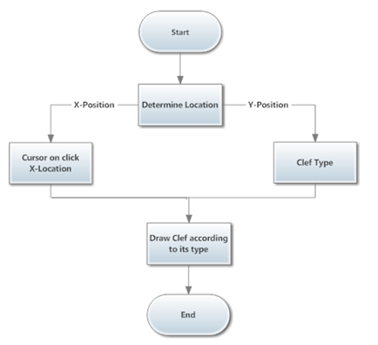

Figure 23: Draw Clef

    - BarLine
Barlines are placed on the musical staff to separate the divisions of time. Time is divided in groups of pulses as defined in the time signature. The space between two bar line is called a measure or bar.
Barline used to divide the musical staff into multiple measures, so the number of Bar Line on staff determines the number of measure on this staff.
The main properties for barline are: Location and Measure ID.

BarLine types:
There are different types of barline that indicate a particular way to perform in time.

- The single line has no purpose other than to divide the musical staff into measures.
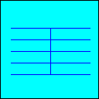

- The double line.
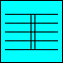

- Repeat bars, that have a pair of dots on the left of the double bar, indicate that the music is to be repeated from a double bar having a pair of dots to its right. If there are no double bars, with a pair of dots on its right, the music is repeated from the beginning.
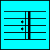

      - change the number of BarLine on part:

This process can be done easily by change the number of measure per system, if the user try to increase the number of measure on determine Part number, then the new BarLines will be drawn on staff according to number of measures on that Part, and surly the width of measure in that Part will reduce, and the offset between the musical symbol on measure in that Part will reduce too, and the musical symbol will shift up from all next Parts to fill these new measure.

If the user try to decrease the number of measure on determine Part number, then existing BarLines will remove from that Part according to number of measures on that Part, and surly the width of measure will increase, and the offset between the musical symbol on measure on that Part will increase too, and the musical symbol will shift down to all next parts to move it. Next figure illustrate this process.

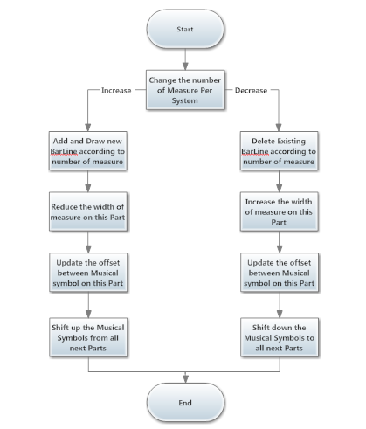
Figure 24: Change the number of BarLine

      - Draw the BarLine:
Drawing BarLine depend on the BarLine type and measure width, before drawing it, the location must be determine, the X position determined by measure number property to bar line and the width of measure on this staff, the Y position determined by the staff width, after the location determined, the bar line will draw in this location as a line of the shape of its type.

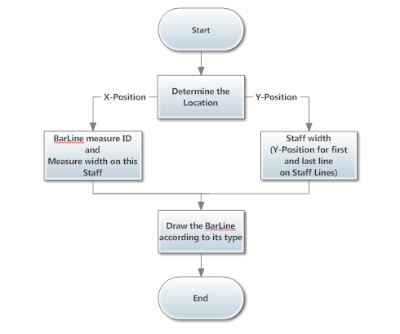
Figure 25: Draw BarLine

    - Note
Note is the symbol that played.
Note symbol has these main properties: Location, Measure ID, duration, step and octave.

      - Note types

- The whole note has the longest note duration in modern music.
- The half note has half the duration of a whole note.
- The quarter note is a fourth (or a quarter) of a whole note.
- An eighth note has one flag; therefore, it is half the value of a quarter note.
- A sixteenth note has two flags, halving the value again.
- A 32nd note has three flags, halving the value again.
- A 64th note has four flags, halving the value again.
- A 128th note has five flags, halving the value again.

      - Add a Note
When the user try to add new note, if the cursor location out of staff lines, the ledger lines will be drawn on that staff to inform user the line name that the note will be added when he click. Picture (1) shows the leger line.
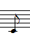

Figure 26: Leadger Line

The location for this note must be determine, the X position determine depending on cursor click location and the offset between the notes and rests in measure, the Y position determine depending on cursor click location and the last Clef before the note location.
Then check if the note is cord or not, if the note is cord then add it to staff and draw according to cord group location, but if not cord then check the time signature rule by checking the type of all notes and rests in this measure and there duration time plus the duration time for the new note and comparing it with the time signature that the measure related to.
If the time signature rule allows this adding, the note will be added to staff, and then check the beam group, to determine if the note will connected by thick line with other notes on that beam group, then draw the note according to its location, but if the time signature rule doesn't allow this adding then nothing will be done. Next figure illustrate this process.
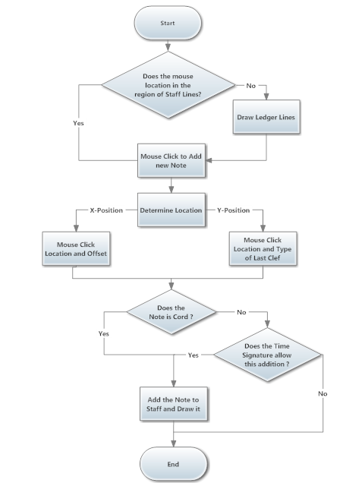
Figure 27: Add Note

      - Drawing a Note
The first thing that must be Known that the Note consist of one or more parts, so that, drawing the note is going through several stages, depends on the type of note and the number of parts that make up.

There are four different parts of a music note. Here they are:
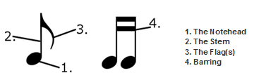
Figure 28: Note Parts

- Note head
The oval shape section of a music note is called the note head. It can either be white (blank) or filled-in. This depends on the note value.
The circular part of a music note can be placed on the lines and spaces of a music staff. Wherever the note head is located tells us what the name of the note is that we need to play or sing.

- Stem
The stem of a note is the straight line or “stick” attached to the note head. It really has no real significance other than helping to identify the value of the note. For example, whole notes do not have a stem while half notes and quarter notes do.
The stems can either point up or down. This depends on how the note heads are placed on the staff following the stem rule. If the note head is located below the third line, the stems go down. If the note head is placed on the third line or above, the stems go up.
The direction of the stem does not have any effect on the rhythmic value of the note. It doesn’t matter if the stem is going up or down, a half note will still receive two counts and a quarter notes will always receive one count.

- Flags
Eighth notes, sixteenth notes, thirty-second notes, and even sixty-fourth notes have a flag attached to the stem when only one note is present. You will only see this if there is only one single note by itself on the page followed by other note values. (This is pretty rare for thirty-second and sixty-fourth notes, but it can happen.)

- Eighth notes = 1 flag
- Sixteenth notes = 2 flags
- 32nd notes = 3 flags
- 64th notes = 4 flags
You could keep going with more flags, but not many people read notes beyond the value of a sixty-fourth note.
Again, these flags do not serve any purpose other than telling us the value of a single note by itself. It does not affect the rhythmic value of the note. You will still treat it the same way.

Barring

You will see notes barred together more often than notes with flags. The bar connects the stems of two or more notes together making it easier to read and count. Visually, it is much easier to read notes grouped together by bars than it is to read them individually with flags.

You will normally see notes barred together in groups of even numbers. For example, you will see 2 notes, 4 notes, 6 notes, or 8 notes all grouped together by barring.

The barring also has another function. It can tell us the value of the note.

Eighth notes = 1 bar
- Sixteenth notes = 2 bars
- 32nd notes = 3 bars
- 64th notes = 4 bars
Drawing Note depend on the Note type, before drawing it the location must be determine, the X position determine depending on cursor click X location and all notes and rests in that measure on that staff, there is function to calculate the offset between the notes and rests on determine measure depending on its type, the Y position determined depending on the last Clef before note X position location and cursor click Y location, after the location determined, the Note will be drawn in multiple steps depend on its type:

  - Draw the Note head on this location as string.

  - Determining if the Stem will be drawn or not by checking the note type, if stem will be drawn, the location will be taken from the Note head location to make them as one part, then draw it as line, the length to stem depend on the beam group and the location for each note in this beam group.

  - Determining if the Flag will be drawn or not by checking the note type and if the note related to beam group or not, if the note doesn't related to beam group the Flag will be drawn, the location will be taken from the Stem location to make them as one part, then draw it as string, the number of flag that will be drawn depend on the note type.

  - Determining if the Barring will be drawn or not by checking the note type and if the note related to beam group or not, if the note related to beam group the Barring will be drawn, the location will be taken from the Stem location to make them as one part, then draw it as line, the number of Barring that will be drawn depend on the note type. Next figure illustrate this process.

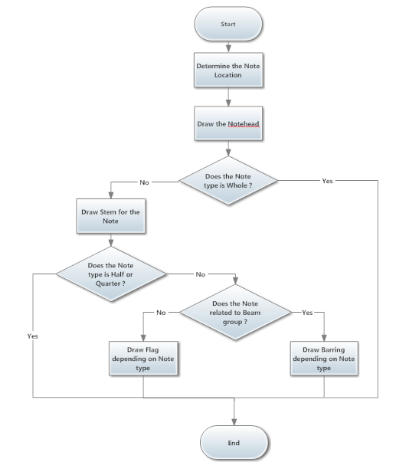

Figure 29: Draw Note

      - Determine Beam
Each note has specific properties related to beam:
- Single
- Start
- Continue
- Backward
- Forward
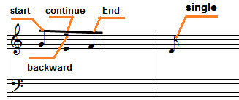
Figure 30:Beam

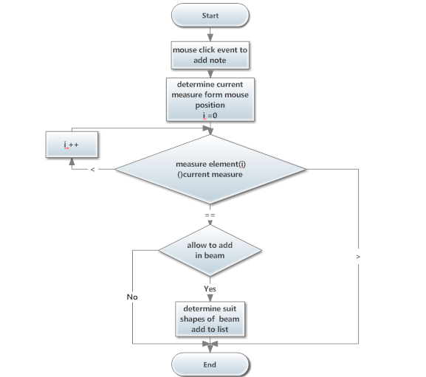
Figure 31: Beam Operation

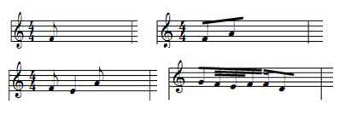
Figure 32: Beam Examples

- Number of note in beam depends on:
- Total duration for previous note.
- Type for each previous note.

- When beam end
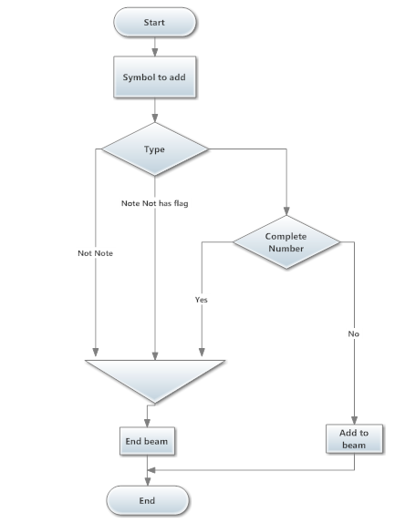
Figure 33: End Beam
Group note in beam must be consecutive. User must select packets in a row, unfortunately, lead to a variable length of legs and the length of the proper stems programmatically. The following image shows all the values ​​that we need to accomplish this:
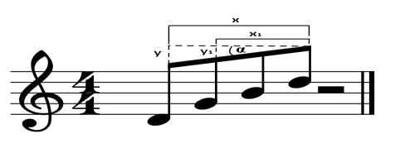
Figure 34: Beam Calculations

- How determine if Direction beams up or down?
In single note above middle line its direction down, but in under middle line its direction up.
Direction to beam depend on direction stronger note which Away the largest distance from the center line.
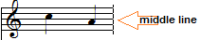
Figure 35: Up Direction Of Beam
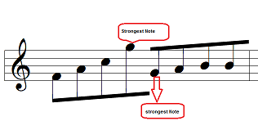
Figure 36: Down Direction Of Beam

    - Rest
A rest is an interval of silence in a piece of music, marked by a sign indicating the length of the pause. Each rest symbol corresponds with a particular note value.

      - Rest types
Figure 37: Rest Types

- The whole rest has the longest note duration in modern music.
- The half rest has half the duration of a whole rest.
- The quarter rest is a fourth (or a quarter) of a whole rest.
- An eighth rest has one flag; therefore, it is half the value of a quarter rest.
- A sixteenth rest has two flags, halving the value again.
- A 32nd rest has three flags, halving the value again.
- A 64th rest has four flags, halving the value again.
- A 128th rest has five flags, halving the value again.

      - Add Rest
When the user try to add new Rest, The location for this Rest must be determine, the X position determine depending on cursor click location and the offset between the notes and rests in measure, the Y position determine depending on cursor click location.
Then check time signature rule by checking the type of all notes and rests in this measure and there duration time plus the duration time for the new rest and comparing it with the time signature that the measure related to.
If the time signature rule allows this adding, the rest will be added to staff, then draw the rest according to its location, but if the time signature rule doesn't allow this adding then nothing will be done. Next figure illustrate this process.

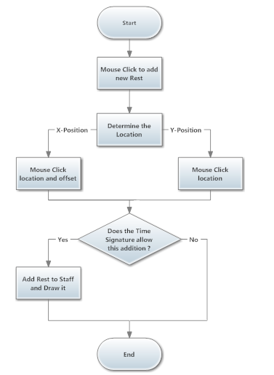
Figure 38: Add Rest

      - Draw Rest
Drawing Rest depend on the Rest type, before drawing it the location must be determine, the X position determine depending on cursor click X location and all notes and rests in that measure on that staff, there is function to calculate the offset between the notes and rests on determine measure depending on its type, the Y position determined depending on the cursor click Y location, after the location determined, the Rest will be drawn.
Next figure illustrate this process.

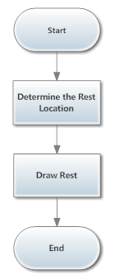

Figure 39: Draw Rest
    - Time Signature
Time signatures define the amount and type of notes that each measure contains.
Time signatures symbol has these main properties: Location, Measure ID, number of Beats and type of Beats.

      - Add and Update Time Signature
When the user try to add new Time Signature or update existing Time Signature, the number of Beats and the type of Beats must be determined, the measure where the user try to do this action must be determined by entering the first and last measure number. The next figure illustrates this process.
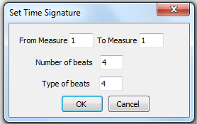
Figure 40: Set Time Signature

Then check if the time duration for all notes and rests in the measure doesn't fail the Time Signature rule, if they fail the rule, the old Time signature doesn't change and nothing will be done, but if they don't fail the rule, then check if there is Time Signature in the measure or not, if there is a Time Signature in the measure first check the previous time signature and compare it with the time signature that will be added, if they are the same, save the old one and remove it from the measure, but if they are different, save the old one and update it with new one.

But if there is no Time Signature in the measure, comparing the time signature that the measure related to with the time signature that will be added, if they are the same, nothing will be done,
But if they are different, add the time signature to this measure and save the old one.
This operation will be done to all determined measure, after the end measure done, the measure after it must be checking, if it has time signature nothing will be done, but if it doesn't has time signature add the time signature that saved previously to this measure.
If the Time Signature added to or deleted from measure, the Notes and Rests in this measure redraw because the offset between them change when add or remove Time Signature.
Next figure illustrate this process.

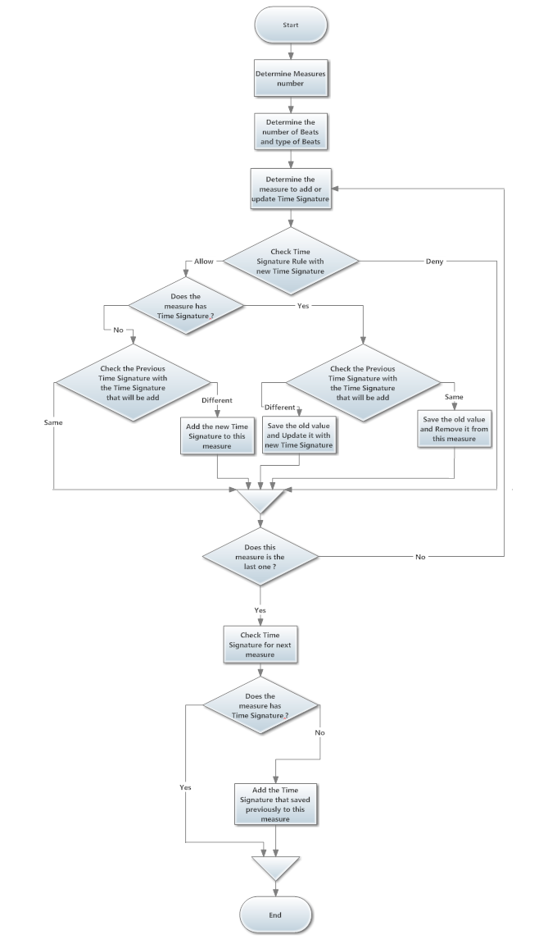

Figure 41: Add and Update Time Signature
      - Draw Time Signature
Drawing Time Signature going through two stages, drawing the number of Beats as string, then drawing the type of Beats as string too, before drawing the location must be determine, where the location for Time Signature must be after the location of Clef and Key Signature if the measure contain Clef and Key Signature, but if the measure doesn't contain Clef and Key Signature the location for Time Signature come after the BarLine directly.
After drawing the Time Signature, the notes and rests must redraw because the offset between them changed. Next figure illustrate this process.
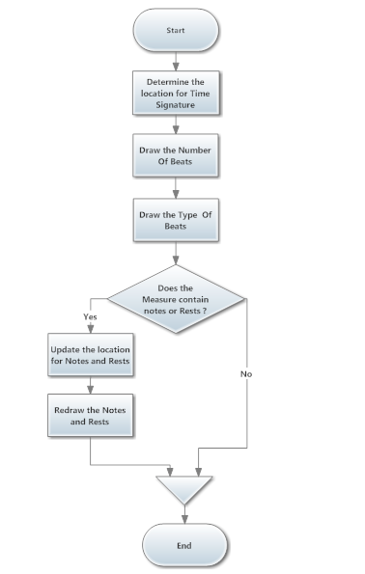
Figure 42: Insert Time Signature

    - Key Signature
Key signatures define the prevailing key of the music that follows, thus avoiding the use of accidentals for many notes. If no key signature appears, the key is assumed to be C major/A minor, but can also signify a neutral key, employing individual accidentals as required for each note. Next figure illustrate the Key Signature.
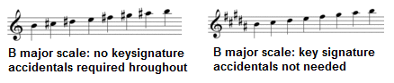

Time signatures symbol has these main properties: Location, Measure ID and fifths.

      - Add and Update Key Signature
When the user try to add new Key Signature or update existing Key Signature, the type of Key Signature must be determined, the type of Key Signature can be selected from the list that contain the famous 15 Key Signature, as figure 0000 shows, or can be made in very beautiful way by selected the accidentals need and draw it on the musical staff, as figure 0000 shows.
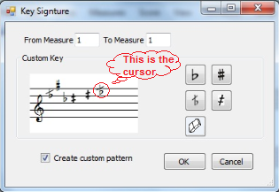
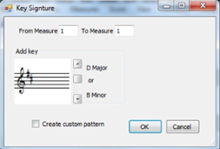

The measure where the user tries to do this action must be determined by entering the first and last measure number. The next figure illustrates this process.
Check if there is Key Signature in the measure or not, if there is a Key Signature in the measure first check the previous Key signature and compare it with the Key signature that will be added, if they are the same, save the old one and remove it from the measure, but if they are different, save the old one and update it with new one.
If there is no Key Signature in the measure, comparing the Key signature that the measure related to with the Key signature that will be added, if they are the same, nothing will be done, but if they are different, add the time signature to this measure and save the old one.
This operation will be done to all determined measure, after the end measure done, the measure after it must be checking, if it has Key signature then nothing will be done, but if it hasn't Key signature, check the Key signature that saved previously, if it's type is A Major/ C Minor, then add Natural Key Signature with the same value of the Key Signature added, but if it's type isn't A Major/ C Minor, then add that Key Signature.
If the Key Signature added to or deleted from measure, the Notes and Rests in this measure redraw because the offset between them change when add or remove key Signature. Next figure illustrate this process.

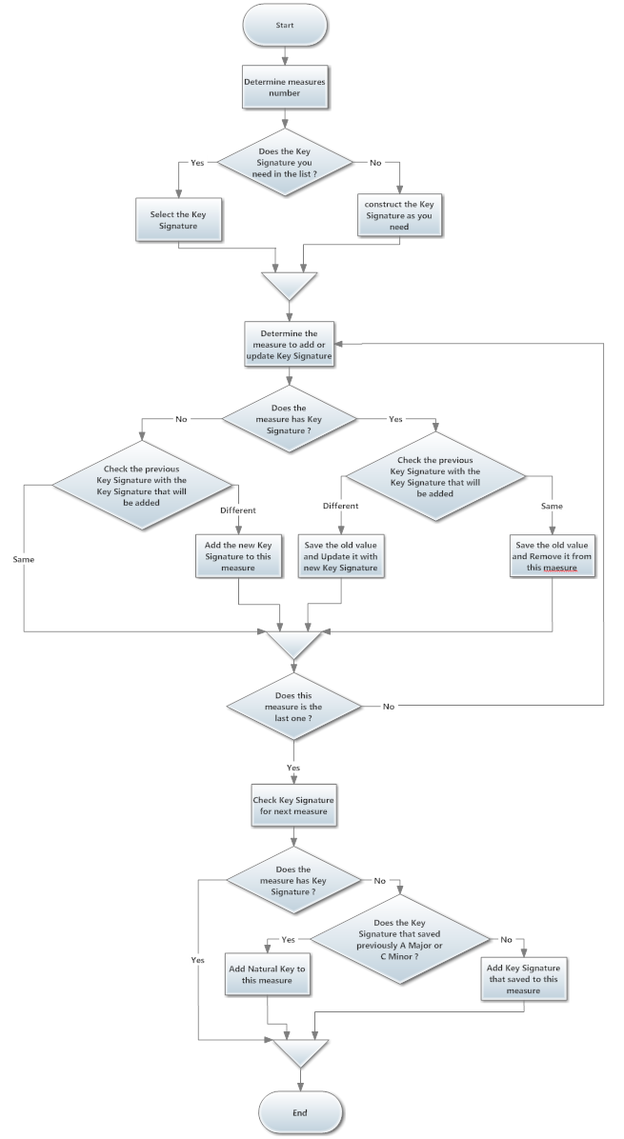
Figure 43: Add and Update Key Signature

      - Draw Key Signature
Drawing Key Signature going through multiple stages depend on the type of Key Signature, there are four type of accidentals: Flat, Half Flat, Sharp and Half Sharp, the Key Signature is combination of these accidentals, so when drawing the Key Signature, we draw each of these accidentals as string in determined location, before drawing the location must be determine, where the location for Key Signature must be after the location of Clef if the measure contain Clef, but if the measure doesn't contain Clef the location for Key Signature comes after the BarLine directly.
After drawing the Key Signature, the notes and rests must redraw because the offset between them changed. Next figure illustrate this process.

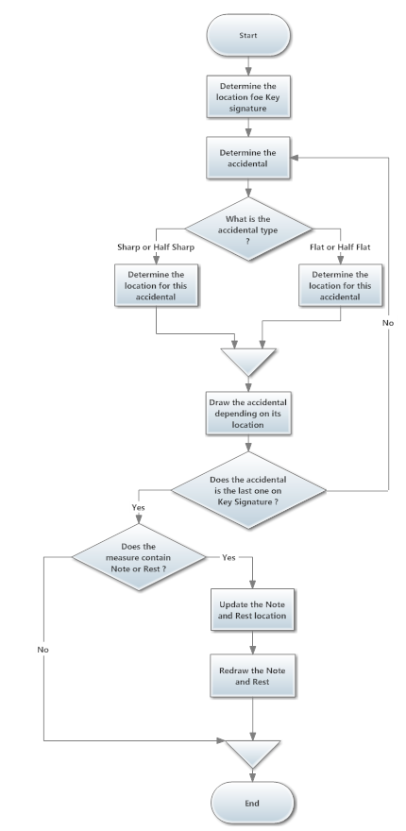
Figure 44: Draw Key Signature

  - Chapter 4: Auxiliary Musical Symbols

These symbols make effect on main musical symbols either in terms of the way of playing or change the frequency.

    - Dot
Dots can be added to the Note or Rest symbol and this effect the duration of Note or Rest.
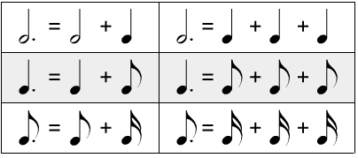

    - Accidental
When add there symbol to Note that will effect on step for this Note.

      - Accidental types

- The flat symbol lowers a Note by a half step.
- The double flat symbol lowers a Note by a three-quarter step.
- The half flat symbol lowers a Note by a quarter steps.
- The sharp symbol lowers a Note by a half step.
- The double sharp symbol lowers a Note by a three-quarter step.
- The half sharp symbol lowers a Note by a quarter steps.
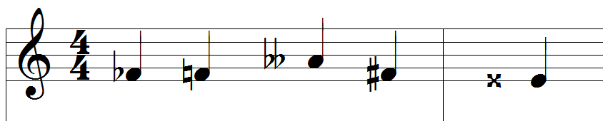

    - Accent ,Staccato and Fermata
These symbols affect when plays Note.

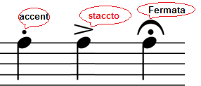

Dots ,Flat , Half Flat , Sharp ,Half Sharp ,Accent , Staccato, and Fermata sign draw in same way ,when dot click event fire search if note or rest on this location and change the symbol properties that according to each type for this symbol and redraw the staff panel.

    - Lyrics
This symbol used to facilitate reading by the musician, and does not affect playing.
When click on some musical symbol popup textbox will appear then write what you want under this note.

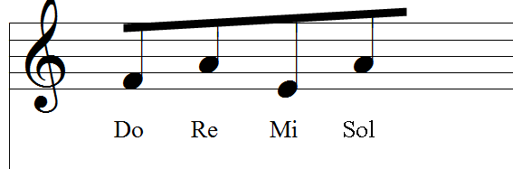

    - Tuplet
Very important in music, use to change the duration time on play note and change number of symbol per measure.
For example 4:2 that allow playing four notes in time require playing two notes.
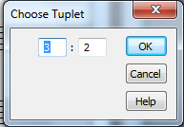
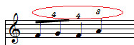

      - Draw Tuplet
When click to draw note or rest symbol check if tuplet active then change number note in same beam and the number of symbol allow to add in measure according the tuplet ratio.

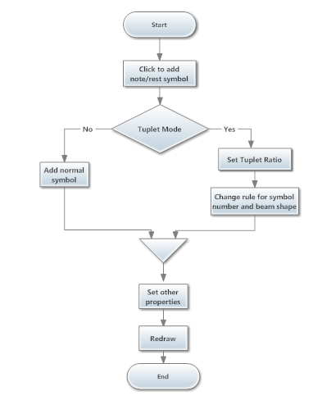
Figure 45: Draw Tuplet

    - Tie and Slur
Tie and slur used to combine duration between two Notes.

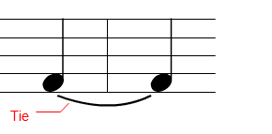

    - Glissando
Has an obvious effect in the play, so moving from one note to other smooth.

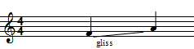

Draw Tie, Slur and glissando
When choose slue cursor and click will record first click location and when click for the second time will specify start and end, then draw arc between them.
If two note in same octave and step Consider Tie if not consider Slur each of them has different way in paly.
Note : when Glissando choose, draw line and gliss word on line.

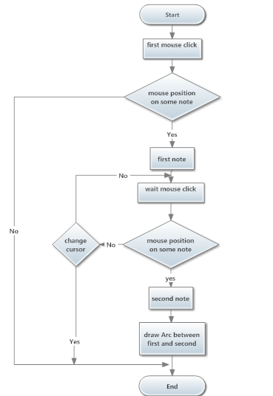
Figure 46: Draw Tie, Slur and glissando

    - Specific Musical symbols
These specific symbols are not directly related to main musical symbols, so these symbols can be added freely and unrestricted on its location.

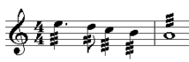
Specific symbols:
- Tremolo.
- Segno.

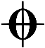
- Coda .

  - Chapter 5: Operation On Musical Symbols

    - Delete Musical symbols
Delete symbol by eraser is very important to modify content and allow deleting any symbol on staff.
Also taking into account the keep correct shape of remainder symbol especially the shape of beam and relocate symbol.

    - Add measure
Add Measure creates new measures anywhere within the score for one Part in the system.
The number of measures must be determined and the location for that measure must be determined and the number of staff that the measure will be added to must be determined too. Next figure illustrates this process.

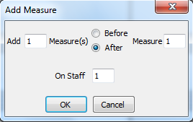

When ok button press, new measures will be added after the last Part location, the number of these measures equal the number of measures that the user need to add.

Then make shift down to musical symbols from the last measure containing musical symbols to next measure and then move to previous measure and made the same thing too, until reach to first measure will be added. Next figure illustrate this process.
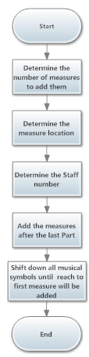
Figure 47: Add Measure

    - Delete measure
Delete Measure removes measures from one Part in a score and all data and information related to those measures.
The number of measures that will be deleted must be determined and the number of staff that the measure will be deleted from must be determined too. Next figure illustrates this process.

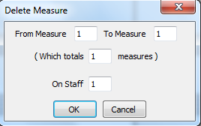

When ok button press, all musical symbols on selected measures will be deleted. Then make shift up to all musical symbols from all next measures to previous measures, when the shift operation end, delete measures from the last Parts. Next figure illustrate this process.

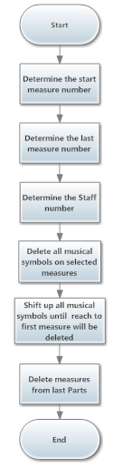
Figure 48: Delete Measure

    - Clear measure
Clear Measure removes all musical symbols from selected measures from one Part.
The number of measures and staff number and Part number must be determined. Next figure illustrates this process.

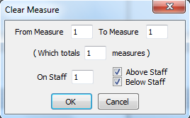

  - Chapter 6: Playing Musical Symbols

    - Piano Keyboard
We have to set up a piano keyboard which used in several tasks:
- To show how note play on keyboard in correct way.
- Use this keyboard to paly note by computer Keyboard and allow press multi button as actual piano keyboard.
- Can play on keyboard by mouse.
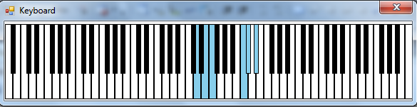

Figure 49: Piano Keyboard

Construction of Piano Keyboard
Each button in keyboard is object and draws this object on panel in specific scale width and height according to location in panel.

Keyboard Events:
Create custom event for each button object on this keyboard, on press make back color blue and redraw when release back to original color.
Each button has own number, when press, the press event send command message to MIDI library that gives us the desired sound .
And when release, the release event fire send command message to MIDI library to stop desired sound.

    - MIDI library
This library gives us the capabilities to hear all the voices of the piano as a real piano.
We can deal with this library through function take parameter to determine the exact tone.
We can hear the tune 16 simultaneously and that because it contains a 16-channel.

    - Play Note
We tried to keep up with playing musical symbols right as much as possible as human, In musical sheet you are reading and playing two lines at the same time and above all, can be more than a score in the same line can be played together, and this so-called chord note.
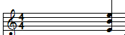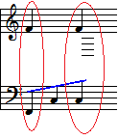

Because of the ability of playing more than one musical Symbol at same time, we use thread to allow more than one score to play at same time.
Looping on each symbol in part(staff0,staff1), if two symbol the same x-position put them in one Node in general array, as you know every symbol has own properties:
- Octave.
- Step.
- Duration Type.
- Tempo which determine period to press.
- Accidentals.
- Other factor was taken when playing musical symbol.
We implement our algorithm to determine which suitable button, the press period, velocity (Volume) and pitch wheel (smooth) for each score.
When press on play button, then looping on all element in array and create threads to all score in each node in array .
Every thread has own data that specify tone number and duration.
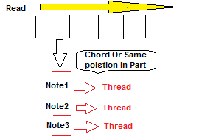

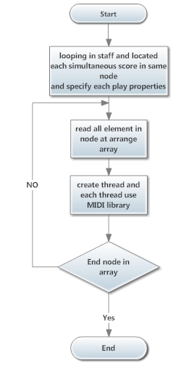
Figure 50: Play Notes

  - Chapter 7: Save and Open

To be a reliable program, the program must save what we have done and allow using them again.

    - Save Technique
In our program use Xml file to save each property for all elements in pages.

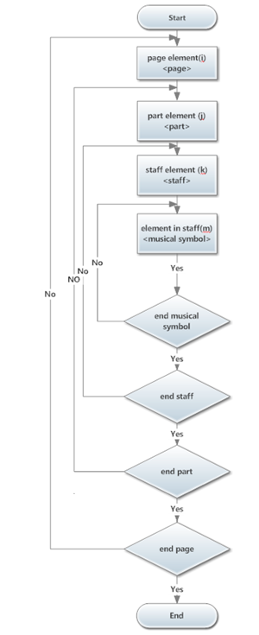
Figure 51: Save File
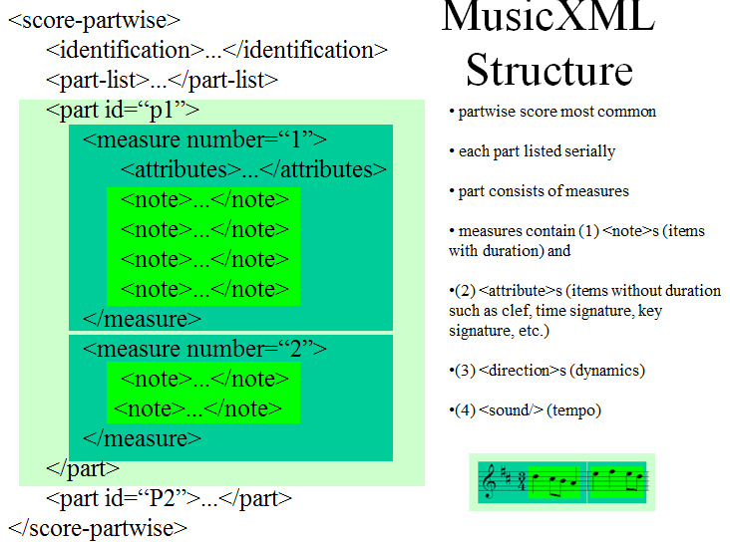

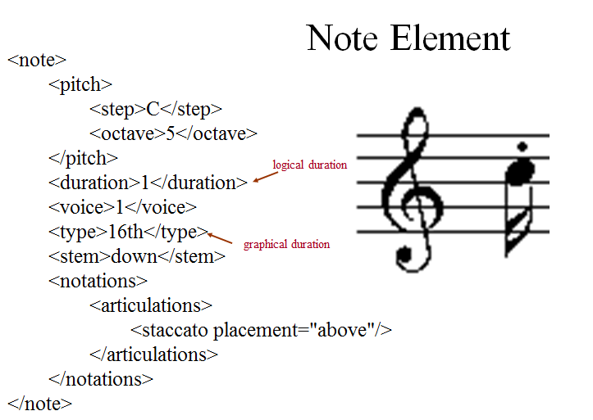

    - Read technique
Read form xml file and create element according properties store in xml tag.
- Conclusion:
In the last of this project we can say that we have a program that can write, and play any eastern or western note in a simple way. We have a very nice user friendly interface, and flexible components.
In the technical side we achieve very good results between sounds and pressed piano keys, we also have an excellent results for the accuracy sound of the note

