An-Najah National University
Chemical Engineering Department

Recycling of Liquid Effluents from HPLC Devices in Pharmaceutical Industry

Prepared by:

Eman Zubidi
Hadi Odeh
Mohammed Zaid Alkeelani
Tasneem Odeh

Supervisor:
Dr. Abdelrahim AbuSafa

A Graduation Project Submitted to Chemical Engineering Department in Partial Fulfillment of the Requirements for Bachelor Degree in Chemical Engineering

December, 2015

الإهداء
للساعات الراحلة، للتحديات الفائزة، للأرواح المكعبة التي سكنت مجتمعات دائرية، للقلوب القلقة، للأحلام التي تحققت ولتلك التي تنتظر، للكادحين خلف لقمة العلم، للباحثين عن شيء في اللاشيء، للمنتظرين على شفا الوصول، لأحلامهم التي حملناها، للثقة المزروعة حيث اليقين، لعيون تمنت، لابتسامات زرعت لتحصد، لدعوات حلقت كثيرا في سماء جوفاء، لكل من أفاد، وأنصف وقال سلام عليكم طبتم ! لأيامنا، لأعمارنا، لشبابنا الذي أفنينا، لنا كي نكون .
الحمد لله الذي بنعمته تتم الصالحات

Table of Contents
Table of Contents i
List of Tables iii
List of Figures iv
Abstract vi
Chapter One 1
Introduction 1
Chapter Two 2
Background and General Situation of Palestinian Pharmaceutical Industry 2
2.1 Pharmaceutical sector in Palestine 2
2.2 Classification of waste streams in pharmaceutical industry 3
2.3 Waste management 4
2.3.1 Source reduction 5
2.3.2 Recycling 5
2.3.3 Disposal 6
2.4 HPLC waste: 7
2.4.1 HPLC Waste Composition 8
Chapter Three 10
HPLC Effluent Recycling Methods 10
3.1 literature review: 10
Chapter Four 13
Liquid Separation Techniques 13
4.1 Crystallization 13
4.1.1Advantages and Disadvantages 13
4.2 Distillation 14
4.3 Special Distillations 16
4.3.1Azeotropic Distillation 16
4.3.2 Extractive Distillation 17
Chapter Five 18
Experimental Work 18
5.1 Materials. 18
5.2 Experiments. 18
5.2.1 Crystallizations 18
5.2.2 Adsorption By Clay. 18
5.2.3 Distillation 19
5.2.4 Extraction. 19
Chapter Six 23
Results And Discussion 23
6.1 Crystallization: 23
6.2 Waste adsorption by clay : 25
6.3Distillation : 25
6.4Extraction : 27
6.4.1 Extraction using kerosene: 28
5.4.2 Extraction using soya-been oil 30
5.4.3 Extraction using fuel from burning tires. 33
5.4.4 Extraction using biodiesel 35
Conclusion 47
Recommendations 48
References 49

List of Tables:
Table (2.1): Pharmaceutical Process Wastes ......................................................................................... 4
Table (2.2): EPA Codes of HPLC Solvents and Universal Treatment Standard ....................................... 8
Table (2.3): Examples of HPLC waste composition................................................................................. 9
Table (5.1): Clay samples....................................................................................................................... 19
Table (5.2); Kerosene, waste samples....................................................................................................20
Table (5.3); Soya bean oil and waste samples....................................................................................... 20
Table (5.4); Fuel oil and waste samples..................................................................................................20
Table (5.5) Methanol/water sample......................................................................................................21
Table(6.1): Temperature vs time............................................................................................................23
Table (6.2): Solubility Of Methanol/Water on Biodiesel........................................................................35
Table (6.3): Solubility Of Acetonitrile/Water on Biodiesel.....................................................................36
Table(6.4) : Solubility Of Acetonitrile/Methanol/Water on Biodiesel....................................................37
Table (6.5) : Temperature effect on Methanol/Water Solubility On Biodiesel......................................38
Table (6.6) : Temperature effect on Acetonitrile/Water Solubility On Biodiesel...................................39
Table (6.7) : Temperature effect on Acetonitrile/Methanol/Water Solubility On Biodiesel..................39
Table (6.8) : Results Of Continues Extraction Of Waste By Biodiesel Using Separating Funnel.............40
Table (6.9): design parameter of the extraction column........................................................................42
Table (6.10) results of extraction column experiments..........................................................................45
Table (6.11) the percentage of waste extracted.....................................................................................45

List of Figures :
Figure(6.1): soln1 before and after crystallization......................................................................................24
Figure(6.2): soln2 before and after crystallization......................................................................................24
Figure(6.3): soln3 before and after crystallization......................................................................................24
Figure (6.4): simple distillation process......................................................................................................26
Figure (6.5) :refractive index for methanol / water mixture......................................................................26
Figure(6.6) Results of refractometer test...................................................................................................27
Figure (6.7)kerosene and water solution...................................................................................................28
Figure(6.8) kerosene and methanol solution.............................................................................................28
Figure (6.9) Kerosene, acetonitrile and water solution..............................................................................29
Figure(6.10) Kerosene , methanol and water solution...............................................................................29
Figure (6.11) Kerosene, methanol, acetonitrile and water solution..........................................................30
Figure (6.12) Three layers obtained from oil, methanol and water solution.............................................31
Figure (6.13) Two layers obtained from oil, acetonitrile and water solution.............................................31
Figure (6.14) Three layers obtained from oil, methanol, acetonitrile and water solution.........................32
Figure (6.15) Methanol and fuel mixture....................................................................................................33
Figure (6.16) Methanol, water and fuel mixture........................................................................................33
Figure (6.17) Methanol, acetonitrile and fuel mixture...............................................................................34
Figure (6.18) Methanol, acetonitrile, water and fuel mixture....................................................................34
Figure (6.19): Solubility Of Methanol/Water on Biodiesel.........................................................................36
Figure (6.20): Solubility Of Acetonitrile/Water on Biodiesel......................................................................34
Figure(6.21): Solubility Of Acetonitrile/Methanol/Water on Biodiesel......................................................38
Figure(6.22) : extraction using separating funnels ....................................................................................41
Figure (6.23): Extraction column design parameters..................................................................................43
Figure(6.24) HPLC waste recycling by using extraction column.................................................................44
Figure(6.25) distillation of used biodiesel...................................................................................................46

Abstract
The main objective of this project is to recycle acetonitrile- methanol -water mixture from the High Pressure Liquid Chromatography (HPLC) waste in the pharmaceutical sector. The recycling process always has economic benefits and helps in protecting the environment.

For this purpose, the literature was reviewed and the most appropriate recycling methods were investigated. Of these methods, biological treatment and degradation, batch extractive distillation, and azeotrope distillation are summarized. Unfortunately, the literature doesn't’ provide enough information, since most of the processes are patented. As a result, other rational techniques were investigated in order to find the most efficient and applicable solution for this problem. These techniques were crystallization, adsorption using clay, distillation, extraction and converting the mixture to a fuel are proposed.

When the crystallization technique was investigated it was found that it is not applicable method to recycle or separate the waste components because of its low freezing points and it was not possible to reach these low temperatures because of the lack of the appropriate equipments, The adsorption of the waste component by using clay was not applicable because the clay adsorb all of the mixture component. The type of distillation was available is simple distillation and it was not an appropriate method because of the creation of azeotropic point. Extraction process was investigated by using different solvents such as; kerosene, soya bean oil, fuel produced from tire oil and biodiesel. it was found that the solubility of waste component by using kerosene, soya bean oil, fuel produced from tire oil was not useful for the main purpose but the extraction by using biodiesel as a solvent was the most appropriate method because acetonitrile and methanol are soluble in biodiesel and the water was not

As a result of using biodiesel as a solvent, a liquid-liquid extraction column was designed with a height of 60 cm. and diameter of 4 cm with a packing material of 1 cm diameter, and the column were operated with different flow rates of waste and biodiesel to find out the most appropriate flow rates of biodiesel and waste to find out the maximum extraction ratio for the waste which was equal to 0.15 mL per second and 2.5 mL per second for waste and biodiesel respectively.

The biodiesel which was used in the extraction process contains methanol and acetonitrile can be distilled to separate the acetonitrile and methanol mixture from the biodiesel in order to reuse the biodiesel for reducing the required amount of biodiesel for the process, also for recovery of the methanol and acetonitrile mixture for using it in future application such as adding it to different types of fuel.

Chapter One

Introduction
In civilized countries, people deal with industry in all parts of their life. This is a result of the great industrial revolutions in the world. Industry is a double edges sword. On one hand, it has raised the level of our life and made it easier. On the other hand, it has polluted the Erath with all types of pollutants.
Nowadays, Palestinian industry is keeping up with the modern industries. A promising one is the pharmaceutical industry. The Palestinian Pharmaceutical sector consists of six major Palestinian local companies with the capability of producing formulations from pharmaceutical raw materials and repackaging of finished dosage forms. In 2010, the local manufacturers covered 59% of the market and 2% of the total jobs. The industry is growing rapidly targeting local as well as international markets.
As most industries, pharmaceutical industries generate a substantial amount of pharmaceutical waste- some hazardous, some non-hazardous- that requires proper disposal. Variety of wastes is generated during processing and quality control testing. One of the most used analytical testing techniques is the High Performance liquid chromatography (HPLC). This technique is known of its hazardous effluents which are mostly liquid mixture. Generally, the effluents consist of mixtures with different fractions of water, methanol and acetonitrile. Such types of waste need special waste management techniques.
The main objective of this project is to find a suitable technique to recycle the liquid effluents from HPLC equipment
Other related objectives can be given as:
- Surveying the general situation of pharmaceutical industry in Palestine.
- Investigate types and amounts of wastes from pharmaceutical industry.
- Reviewing the standards of waste management in pharmaceutical industry.
- Study the most suitable recycling and separating methods for some pharmaceutical wastes.
- Find and test methods for HPLC effluent recycling.

Chapter Two

Background and General Situation of Palestinian Pharmaceutical Industry

2.1 Pharmaceutical sector in Palestine
The pharmaceutical sector in Palestine is unique from other economic sectors in several properties, mainly the characteristics that relate to the areas of the invention and development, and it's targeting the local market and trying to reach the global market. This sector provides the Palestinian domestic market with a variety of products that meet the needs of the people of the drugs. These products are comprehensive and intended for general purposes, which led to the existence of similar production lines, which in turn create a state of competition in this industry interoperability.
There are about 1,118 different type of pharmaceutical products on the local market, and it presents about 45% from the overall products in the local Palestinian market, and there are six main deferent companies that specialized in this area. The proportion contribution of these companies is 2.43% of the total production volume, and annual sales up to approximately $ 40 million, besides it operates 1,100 employees which means 2% of the total jobs. Industry produces about 25% varieties of the market demanded products. The market share for Palestinian products reaches up to 45% of the total consumption. The market of these products is mainly the West Bank 84%, Gaza Strip 7% and Jerusalem 9%. Before the last war on Gaza the sales to Gaza reached up to 30% of the total sales.[1]
Pharmaceutical industry started after the 1967. Prior to that, all pharmaceutical products were imported from foreign companies via importers in Amman, Jordan. This difficult situation led nine pharmacists in the West Bank to establish small laboratories to manufacture simple syrups and anti-diarrhea products in 1969. In 1970 nine small laboratories merged to become three larger companies: Jordan Chemicals in Beit Jala, Palestine Medical Company in Ramallah, and Jerusalem Pharmaceuticals in El-Bireh. After 1970 the pharmaceutical industry started to grow and new companies entered the local market: Balsam Co. in El-Bireh in 1972, and Bir-zeit Co. in Bir-zeit in 1973, Eastern Medical Co. and Gama in 1978, both in Ramallah; and Pharmacare in 1985 in Beitunia, and MASCO in Gaza in 1984.Industry contributes less than 1% of Gross Domestic Product, it is considered one of the highest in worker productivity ($44,000 in 2005). This is represented by a strong industrial association.[1]
Pharmaceutical industry becomes important field on the Palestinian economy, as the role of this industry increased, also there are many problems increased proportionally, like air and water pollution and also the pharmaceutical waste which form main problem with this field of industry, these problems form a real risk for the growth of this industry.
To prevent the continuous growth of the previous problems, solutions have to be found. One of the major problems that prevent the growth of this sector was the large amount of waste that produced from the pharmaceutical industry which generally disposed through Israeli companies for high prices. So the waste streams that produced by the pharmaceutical industry has to be identified and proper disposal techniques should be proposed.

2.2 Classification of waste streams in pharmaceutical industry
Generally, waste could be liquid or solid, both are hazardous. They can be grouped into organic, Re-usable and recyclable waste.
The wastes generated during drugs manufacturing processes mainly resulted from cleaning and sterilizing equipment, chemical spills, rejected products and the processes themselves. During mixing or tabulating operations, dusts can be generated which are recycled back into the formulation process. Though, small amounts of waste dust may be generated. The primary wastewater source is the equipment wash water which may contain inorganic salts, sugars, and syrups and typically has low BOD, COD, and TSS, and mostly neutral PH. Air emissions may result from the use of any volatile solvents in the formulation process. Table 1 lists typical wastes in pharmaceutical industry and their process origins.[2]

Table (2.1) : Pharmaceutical Process Wastes[2].
Waste description | Process origin | Composition
Process liquors | Organic syntheses | Contaminated solvents
Spent fermentation broth | Fermentation processes | Contaminated water
Spent natural product raw materials | Natural product, extraction processes | Leaves, tissues
Spent aqueous solutions | Solvent extraction processes | Contaminated water
Leftover raw material containers | Unloading of materials into process equipment | Sags, drums (fiber, plastic, metal), plastic bottles
Scrubber water from pollution control equipment | Dust or hazardous vapor generating processes | Contaminated water
Volatile organic compounds | Chemical storage tanks, drums | Solvents
Off-spec or out-dated products | Manufacturing operations | Miscellaneous products
Spills | Manufacturing and lab operations | Miscellaneous chemicals
Waste water | Equipment cleaning, extraction residues | Contaminated water
Spent solvents | Solvent extraction or wash practices | Contaminated solvents
Used production materials | Manufacturing operations | Filters, tubing, diatomaceous earth
Used chemical reagents | R & D operations | Miscellaneous chemicals
Natural gas combustion products | Steam boilers | Carbon compounds, oxides of nitrogen and sulfur

These waste streams have to be managed to reduce the amount, or reuse it. So, the general methods of waste management and pharmaceutical waste management has to be identified.

2.3 Waste management
Waste management can relate to many issues like: Generation and Characterization, Minimization and Recycling and reuse. Waste management is approached in three main ways, and each of these depends on the community in question.

2.3.1 Source reduction

Source reduction, often called ‘waste prevention,’ is any change in the design, manufacturing, purchase, or use of materials or products (including packaging) to reduce their amount or toxicity before they become municipal solid waste. Prevention also refers to the reuse of products or materials. Source reduction is the key to solving the world growing solid waste problem. Reducing waste before it is generated is a commonsense way to save financial and natural resources, and it makes good business sense. If the entire country adopted source reduction principles, the strain on our limited natural resources would be dramatically reduced. As many organizations have already realized, source reduction also can cut costs and improve productivity by targeting wasteful processes and products[3].

2.3.2 Recycling
Recycling is the process of collecting and processing materials that would otherwise be thrown away as trash or Pays money to dispose of it and turning them into new products. Recycling can benefit the community and the environment, having a large amount of waste requires suitable recycling knowledge. This involves the collection, sorting, grading and processing of recyclable materials into new materials again. The environmental benefits of source reduction also applied for recycling. Additionally, Recycling process offers several jobs for many people in the community.
Recycling is the process that used to convert the waste materials into new, useful products. This is done to reduce the use of raw materials that would have been used. Recycling also reduce energy and the pollution of air, water and land.
Effective recycling starts with household (or the place where the waste was created). In many countries, the authorities help households with bin bags with labels on them. Households then sort out the waste themselves and place them in the right bags for collection. This makes the work less difficult.
2.3.2.1 Importance and benefits of waste recycling:
There are several benefits for Recycling like:
1 - Recycling helps in protection the environment:
This is because the recyclable waste materials would have been burned or ended up in the landfill. So pollution of the air, land, water and soil will be reduced.
2 - Recycling conserves natural resources:
Recycling more waste means that we do not depend too much on raw (natural) resources, which are already massively depleted.
3 -Recycling saves energy:
Producing products from raw materials requires more energy than producing them from recycled ones. This means law production cost and having more energy.
4 - Recycling creates jobs:
The recycling process needs labor to collect, sort and work in the recycling companies. So it has a great role in creating jobs. Other people also can get jobs in businesses by working with these recycling units. There can be a ripple of jobs in the municipality.

2.3.3 Disposal
This is the toughest part of waste management, it is the part that often poses and brings environmental problems. When waste is not recycled, it may be sent to the landfills, incinerated, combusted to energy or composted. These are all major processes with consequences if they are not done properly, and it’s also involve some serious equipment. This means it is usually funded or operated by the state or government.[4]
In pharmaceutical industry, some of liquid wastes are produced from the high performance liquid chromatography (HPLC), which generally disposed through Israeli companies for high prices.
(HPLC) produces different types of waste, this project specialized in treating the waste stream that contains Acetonitrile, methanol and water.

2.4 HPLC waste:
High Performance Liquid Chromatography (HPLC) is one of the important techniques that used in pharmaceutical industry which is an analytical technique that used to identify and analyze the samples of medicine, this technique is applied by using different types of solvents as mobile phase and stationary phase. The problem with this technique that face the Palestinian pharmaceutical sector is the recycling of the waste that produced from it, which is considered as pharmaceutical waste, the solvents that used as mobile phase is divided into two parts, the first part is water-based solvent, the second one is an organic based, the first one contains water and buffer solution and other impurities. The second solvent is an organic and it's in the liquid phase and consist from one organic solvent or more than one organic solvent also can be mixed with water, many types of organic liquids can be used such as Dioxane, Ethanol, Isopropanol, Tetrahydrofuran, acetonitrile and methanol.
The most important parameter in HPLC is the mobile phase, polarity, retention time, selectivity, elution and back pressure drop, these parameters are important factors for the organic solvent used in HPLC as mobile phase, depends on these factors methanol and acetonitrile are widely used as mobile phase with water, the properties of methanol and acetonitrile make them suitable to be used as mobile phase, acetonitrile is better than methanol, but the price of acetonitrile make it costly for factories, so mixture of methanol and acetonitrile can be used as mobile phase, with optimum fractions of the two solvents this make a better solvent with good price.

2.4.1 HPLC Waste Composition

The solvents generated from the (HPLC) analytical process may consist of the following compounds: water, acetonitrile, methanol, hexane, tetrahydrofuran, ethanol, isopropanol, trifluoroacetic acid, or chloroform.
Table 1 lists the EPA codes of these solvents.
Table 2 lists examples of the targeted solvent wastes for this study.
Table 2.2: EPA Codes of HPLC Solvents and Universal Treatment Standard[5]
EPA Code | HPLC Solvent ingredients | Universal Treatment Standard(UTS) for Non waste water( high TOC)
D001 | Acetone, ACN, EtOH, EtOAc, ether, MeOH, THF, IPA, DMF | CMBST, RORGS, or POLYM
D022 | Chloroform (>6 ppm TCLP) | 6 mg/kg

where : CMBST: consumption , RORGS: recovery of organics, POLYM: polymerization, and TOC : total organic compound.

Table (2..3): Examples of HPLC waste composition[5]
Water content | Solvent content
60-80% | CAN (20-40) with trace of THF, TFA, MeOH, IPA, hexan, EtOAc
60-80% | MeOH(20-40%), with trace of THF, TFA< CAN.
80% | CAN (10%) , MeOH (10%)
35-80% | CAN (20-65%) with trace of THF, MeOH , EtOH , IPA, TFA , DMF.

Where: ACN: acetonitrile, DMF: dimethyl formamide, EtOAc: ethyl acetate, EtOH: ethyl hydroxide, IPA: isoprpanol , MeOH: methanol, THF; tetra hydro furan, and TFA: Tri flouroacetic acid.

The HPLC waste production rate in the pharmaceutical sector in Palestine was found to be 16 liter per month for each device and each company has about 9 HPLC devices, the waste produced from the HPLC contain
-50% water
37.5 % methanol
12.5 % acetonitrile

Chapter Three

HPLC Effluent Recycling Methods
HPLC waste is a major problem in the pharmaceutical industry around the world; many researches were done to recycle the produced waste in order to prevent the environmental pollution and to identify fiscally preferable methods. In this chapter some of the researches will be shown.

3.1 literature review:
Yang [5] has made a preliminary study on the solvents that is generated from the high performance liquid chromatography (HPLC) in order to recycle the HPLC effluent by converting the waste into biodegradable material, the solvents that generated from HPLC is a waste that may consist of the following compounds: water, acetonitrile, methanol, hexane, tetrahydrofuran, ethanol, isopropanol, trifluoroacetic acid, or chloroform. He found that biological treatment has potential to serve as an alternative technology, for the HPLC mixed waste treatment. The results from this preliminary experiments used to design a biological treatment process (using either a sequencing batch reactor(SBR) or a chemostat).In order to convert the waste into biodegradable material. And he had focused on. (A) The degradation of major components (methanol and acetonitrile) as a mixture, (B) The degradation of minor components (trifluoroacetic acid, ethanol, tetrahydrofuran, ieopropanol,etc.), and (C) Confirming the obtained kinetics with a SBR or chemostat.
Guangzhong and others [6], had separated methanol and acetonitrile by batch extractive distillation using aniline as a solvent. Methanol and acetonitrile will form an azeotropic point at 336.74 K with 76.89 mass% methanol. The simulation and the experiment shows how to separate the mixture by batch extractive distillation using aniline as a solvent. So they calculate the (reflux ratio, number of stages, solvent feed stage and the solvent flow rate) and obtain the optimal parameters and configuration of the extractive distillation column with minimal energy requirements. They found that the most appropriate configuration is 30 theoretical stages, the optimal entrainer feeding stage is 8 with a solvent flow rate of 20kg/h and the reflux ratio of 2.0, respectively.
Yumei [7], has showed in his research about isobaric vapor–liquid equilibrium for binary system of methanol and acetonitrile. Isobaric vapor–liquid equilibrium (VLE) data for methanol and acetonitrile system was measured at 101.3 kPa by using equilibrium still. The purities for all the chemicals were checked by a gas chromatograph (GC) equipped with a flame ionization detector. The water content in chemicals was determined.
The results showed that methanol and acetonitrile system can form a minimum temperature azeotrope (there exists azeotrope in the methanol and acetonitrile binary system at 101.3 kPa).
The composition and boiling temperature of the azeotrope obtained were: 0.84 and 63.85 ◦C, respectively.
Romas. C [8], has published a patent about recovery of acetonitrile from waste stream, which contains acetonitrile and methanol, using azeotropic distillation, which is a distillation process involves separating close boiling compounds or azeotropes from each other by carrying out the distillation in a multi-plate rectification column in the presence of an added liquid like hexane which forms an azeotrope with the ACN and methanol. For recovering acetonitrile from a waste stream, the method used for this is feeding a waste mixture comprising methanol and acetonitrile to a distillation tower then adding hexane to the waste mixture to create an admixture and distilling the admixture to recover a bottoms product comprising at least 98 wt. % acetonitrile; removing a column overhead product where it is condensed to form two layers comprising a bottom layer comprising methanol and acetonitrile and a top layer comprising hexane.First portion of the bottom layer is returned to the distillation column and the second portion of the bottom layer is removed from the process, the first and second portions of the bottom layer are varied to control and maintain acetonitrile purity of at least 98 wt. % in the bottoms product.
P. Stepnowski [9], has obtained results during implementation of a recycling methodology for chromatographic solvent waste in the University of Bremen, Germany. The procedures are combined out of three principal areas of activity where the first covers logistics of waste collection, the second is proper recycling techniques and the third biodegradation of post processing residues, the overall procedures where developed for recovery of methanol and acetonitrile, the implemented recycling program is in its initial stage, based on a well organized waste collection system, after preselection, acetonitrile waste is frozen out (−18 °C) for dehydration purposes and further, as methanol waste, introduced into a fully automated batch distillation system, distillation residues are further transferred into a bioreactor Biostat™ B (B. Braun Biotech, Melsungen), the solvent waste was diluted with mineral medium to a concentration, the recycled methanol and acetonitrile is used in high purity solvent applications. Naturally, there is additional not calculable profit of this program, namely educational and behavioral impact on scientists, technicians and most of all students towards the sustainability.

This literature review has showed three separation methods: biological treatment process, batch extractive distillation and azeotropic distillation, some were good for the environment like extractive distillation and azeotropic distillation but costly. The biological treatment was not clear enough and there is no enough details about them. So, more studies and experiments will be done to develop the previous studies or to use new ones like crystallization and converting the product to fuel, which will be discussed later.

Chapter Four

Liquid Separation Techniques

4.1 Crystallization
Crystallization is employed heavily as a separation process in the inorganic chemical industry, particularly where salts are recovered from aqueous media. In production of organic chemicals, crystallization is also used to recover product, to refine intermediate chemicals and to remove undesired salts. The feed to a crystallization system consists of a solution from which solute is crystallized (or precipitated) via one or more of a variety of processes. The solids are normally separated from the crystallizer liquid, washed, and discharged to downstream equipment for additional treatment. High recovery of refined solute is generally the desired design objective, although sometimes the crystalline product is a residue.
The process of forming a solid phase from solution is termed crystallization, and the operation occurs in a vessel called a crystallizer. A crystallizer provides residence time for the process streams to approach equilibrium, possibly a capability of selectively removing fines or coarse product, a mixing or contacting regime to give uniform crystal growth, and may include provision for addition or removal of heat. Crystallization is distinguished from other unit operations in that a solid phase is generated. The solid phase is characterized in part by its inherent shape (habit) and size distribution. The natural habit of the solid phase is important since it influences product purity, yield, and capacity of the crystallizer system.

4.1.1Advantages and Disadvantages
Crystallization offers the following advantages:
1. Pure product (solute) can be recovered in one separation stage. With care in design, product purity greater than 99.0% can be attained in a single stage of crystallization, separation, and washing.
2. A solid phase is formed that is subdivided into discrete particles. Generally, conditions are controlled so that the crystals have the desired physical form for direct packaging and sale.

The major disadvantages of crystallization are:
1. Purification of more than one component is not normally attainable in one stage.
2. The phase behavior of crystallizing systems prohibits full solute recovery in one stage; thus, the use of additional equipment to remove solute completely from the remaining crystallizer solution is necessary.
Since crystallization involves processing and handling of a solid phase, the operation is normally applied when no alternative separation technique is discernible. The choice of crystallization over, say, distillation as the preferred separation technique may hinge on one or more of the following considerations:
1. Solute is heat sensitive and/or a high boiler and decomposes at temperatures required to conduct distillation.
2. Low or nil relative volatility exists between solute and contaminants and/or azeotropes formed between solute and contaminants.
3. Solute (product) is desired in paniculate form. For example, if solute can be purified via distillation then it must be solidified subsequently by flaking or prilling and crystallization may be a more convenient scheme to employ in such cases.
4. Comparative economics favor crystallization. If distillation requires high temperatures and energy usage, crystallization may offer economic incentives.[10]

4.2 Distillation
Distillation is a method of separation based on the difference in composition between a liquid mixture and the vapor formed from it. The composition difference is due to differing effective vapor pressures, or volatilities, of the components of the liquid. When such a difference does not exist, as at an azeotropic point, separation by distillation is not possible. The most elementary form of the method is simple distillation in which the liquid mixture is brought to boiling and the vapor formed is separated and condensed to forma product; if the process is continuous, it is called flash distillation or an equilibrium flash, and if the feed mixture is available as an isolated batch of material, the process is a form of batch distillation and the compositions of the collected vapor and residual liquid are thus time dependent.
The term fractional distillation (which may be contracted to "fractionation") originally was applied to the collection of separate fractions of condensed vapor, each fraction being segregated. Currently, the term is applied to distillation separations in general, where an effort is made to separate an original mixture into several components by means of distillation. When the vapors are enriched by contact with counter flowing liquid reflux, the process often is called rectification. When operated with a continuous feed of liquid mixture and continuous removal of product fractions, the process is continuous distillation. When steam is added to the vapors to reduce the partial pressures of the components to be separated, the term steam distillation is used; if such a process is altered to eliminate the steam, dry distillation ("conventional distillation") results.
Most distillations conducted commercially operate continuously, with a more volatile fraction recovered as distillate and a less volatile fraction remaining as residue or bottoms. If a portion of the distillate is condensed and returned to the process to enrich the vapors, the liquid is called reflux. The apparatus in which the enrichment occurs is usually a vertical, cylindrical vessel called a still or distillation column.
This apparatus normally contains internal devices for effecting vapor-liquid contact; the devices may betrays or packings.
As stated above, a separation by distillation involves differing volatilities of the components to be separated. If the volatility difference is so small that an adequate separation cannot be made, it may be possible to increase the volatility difference by the addition of an extraneous material that can be separated later; this process is known as extractive distillation if the added material is relatively nonvolatile and leaves the column with the residue. If the added material forms an azeotrope with one or more of the components 6T the mixture and in so doing enhances the separability of the original mixture, azeotropic distillation results. In this last-named mode, the extraneous material, or azeotropic agent, may leave the column in the distillate (low-boiling azeotrope) or in the residue (high-boiling azeotrope).
It is clear that the difference in volatility of the various components of a liquid mixture is a key to the successful application of distillation. This difference can be related to the thermodynamic equilibrium that can exist between the liquid and vapor mixtures under conditions that can be associated with the distillation at hand. The phase equilibrium relationships are embodied in the general area of solution thermodynamics and can be measured or, in some cases, predicted from the properties of the pure materials involved. The resulting equilibrium compositions often are referred to as vapor-liquid equilibrium data, shortened to vapor-liquid equilibria and abbreviated simply as VLE. There are occasional instances when a second immiscible liquid phase is involved, with compositions of the three phases at thermodynamic equilibrium known simply as vapor-liquid-liquid equilibria, or VLLE.[10]

4.3 Special Distillations

4.3.1Azeotropic Distillation
Many liquid mixtures exhibit azeotropes at intermediate concentrations such that the liquid and its equilibrium vapor have the same composition. No separation of this concentration is possible by partial vaporization. A binary mixture may have a minimum boiling azeotrope, where the boiling temperature of the azeotrope is less than that of the pure components, or a maximum boiling azeotrope, where the boiling temperature is higher than that of the pure components. About 90% of the known azeotropes are of the minimum variety. The presence of an azeotrope is one indication that a mixture is not ideal, that it has deviations from Raoult's law. Close-boiling mixtures are more likely to exhibit azeotropism than wide-boiling mixtures; when there is more than 30C boiling point difference, it is quite unlikely that an azeotrope will be present. Thus, the combination of close-boiling and nonideality is one that can lead to the presence of an azeotrope. This term usually is applied to cases where an extraneous material, called an entrainer, is added to a mixture to make a distillation separation feasible. In this way, a problem involving a close-boiling mixtures made tractable by the addition of an entrainer that will azeotrope with one of the components to give, in effect, a respectable relative volatility between the nonazeotroping component and the azeotrope (treated as a pseudo component). Typically, the azeotrope has the higher volatility and becomes the distillate product. A difficulty is that the extraneous material must itself be separated from the product and, if valuable, recycled back to the process. This leads to the desirability of employing a heterogeneous azeotrope that through phase separation can provide the entrainer recovery that is needed. Other entrainer separation methods include solvent extraction and distillation under a pressure such that the azeotropic composition is different or that the azeotrope is absent.[10]

4.3.2 Extractive Distillation
As in the case of azeotropic distillation, an extraneous material is added to the mixture in the case of extractive distillation. However, the function of this material, called an extractive agent or simply a solvent, is different. It is designed to enhance the relative volatility of the key components by influencing then on ideality of the mixture. The solvent is normally a high-boiling material and in some cases may form loose chemical bonds with one of the keys, with the result of a suppressed effective vapor pressure. As in the case of azeotropic distillation, there is the problem of separating the solvent from the product, but for extractive distillation the problem is much simpler, since the solvent is normally quite high boiling, beyond the range of azeotrope formation, and simple distillation usually is sufficient to separate the solvent for reuse.[10]

Chapter Five

Experimental Work

5.1 Materials.
The experiment was done by using synthetic waste mixture that was prepared on the laboratory depending on the concentrations that was obtained from the pharmaceutical industry in Palestine which contains 50 % water , 37.5 % methanol, and 12.5 % acetonitrile. This mixture was treated by more than one method, and many materials were used such as kerosene, soya been oil, fuel obtained from tires, clay and biodiesel in order to find appropriate method to recycle the waste mixture.

5.2 Experiments.
Many experiments were done to recycle the waste, which are

5.2.1 Crystallizations

Crystallization is a separation technique used to separate mixtures that are having a wide range of freezing points. First tests were done using different mixtures of (methanol & Water), (Acetonitrile & water) and (Water, Acetonitrile & methanol) to find out the ability of separation the components, this was done by the following procedures:
- Water / methanol solution with 20% methanol was prepared.
- The mixture was put in the refrigerator.
- The mixture temperatures were record with time.
- Results were recorded.
- The previous procedure were repeated for each mixture.

5.2.2 Adsorption By Clay.
Using material that has the ability to adsorb one of the waste components will be a good idea for waste separation.
The material which was used in the adsorption process was the clay, following this procedures:
- The clay samples were grinded.
- The grinded samples of clay were dried.
- Four samples were prepared, each sample contains 1 g of dried clay, and different amounts of waste as shown in table (5.1)
- The results were recorded.

Table (5.1) Clay samples
Sample number | Sample contents of clay (g)
1 | 1g clay- 2mL water -
2 | 1g clay- 1 mL methanol
3 | 1g clay- 1 mL water - 0.5 mL methanol
4 | 1g clay- 1 mL water - 0.5 mL methanol- 0.5 mL acetonitrile

5.2.3 Distillation
Distillation is a separation technique used to separate liquid mixtures depending on its boiling temperature. A mixture with different concentrations of methanol and water was distilled to find out the ability of the simple distillation to separate the mixtures component by the following procedure :
- Solution of 50 % methanol and 50% water was prepared.
- Simple distillation system was built.
- Operate the system by increasing the temperature to 75 C for one hour .
- Refractometer was used for determination the distilled combustion sample.
- Results were recorded..

5.2.4 Extraction.
Solvent extraction is a method used to separate compounds based on their relative solubility's into different immiscible liquids, different solvents were used for extraction such as (kerosene , soybean oil , tire oil fuel , biodiesel )

5.2.4.1 extraction by using kerosene

procedure :
- Five samples of waste and kerosene were prepared as shown in table (5.2)
- The samples were shacked for mixing.
- The change in samples volume was observed.
- The results were recorded.

Table (5.2); Kerosene, waste samples
Sample number | Sample content
1 | Kerosene , water
2 | Kerosene and methanol
3 | Kerosene, acetonitrile, water
4 | Kerosene, methanol, water
5 | Kerosene, methanol, acetonitrile, water

5.2.4.2 Extraction Using Soya been oil.

Procedure :
- Four samples of waste and soya been oil were prepared as shown in table (5.3)
- The samples were shacked for mixing.
- The change in samples was observed.
- The results were recorded.
Table (5.3): Soya been oil and waste samples.
Sample number | Sample content
1 | 30 mL oil, 10 mL methanol, 10 mL water
2 | 30 mL oil, 15 mL acetonitrile, 15 mL water
3 | 30 mL oil, 10 methanol. 10 mL acetonitrile, 10 mL water
4 | 30 mL oil, 10 mL methanol, low amount of SLS surfactant

5.2.4.3 Extraction Using Fuel From Tire Pyrolysis.

Procedure:
- Four samples of waste and fuel were prepared as shown in table (5.4)
- The samples were shacked for mixing.
- The change in samples volume was observed.
- The results were recorded.

Table (5.4) : Fuel oil and waste samples.
Sample number | Sample content
1 | Fuel , methanol
2 | Fuel Methanol Water
3 | Fuel Methanol acetonitrile
4 | Fuel Methanol Acetonitrile water

5.2.4.4 Extraction Using Biodiesel.

Another solvent was used for extraction the waste (methanol-water-acetonitrile), which was the biodiesel, which is a fuel that can be produced by transesterification of methanol and one of different types of oil like, soya been ,frying oil, coconut oil .
Extraction process using biodiesel was done by four stages.
First stage, solubility of each of the waste component in biodiesel was investigated.
Procedure :
- Mixture of methanol and water at different volume fractions were prepared as shown in Table(5.5).
- Mixtures were added to pure biodiesel.
- The solubility of the mixtures in biodiesel was recorded.
- Volume fraction of methanol dissolved in biodiesel and methanol residue in water were calculated and relationship was plotted.
- The same procedure was repeated with the same volume fraction for the acetonitrile and water.
Table (5.5) Methanol/water sample
Sample number | Methanol volume fraction in methanol water solution
1 | 0
2 | 20%
3 | 40%
4 | 50%
5 | 100%

Second stage: The temperature effect on waste solubility in biodiesel.
Procedure:
- Waste samples were prepared in different ratios and then added to biodiesel.
- The samples were mixed will.
- The samples were heated to 50 C.
- The change was observed.
- The results were recorded.
Third stage: Extraction for the waste samples with biodiesel using separating funnels.
Procedure:
- 20 mL waste solution contains (50%Water, 37.5% Methanol, 12.5% acetonitrile) was prepared.
- The waste sample were mixed with 20 mL biodiesel.
- The mixed sample were extracted through separating funnel .
- The aqueous layer (Water +methanol and acetonitrile residue) was separated from the separator funnel and mixed again with other 20 mL of pure biodiesel
- Step four was repeated until all acetonitrile and methanol dissolved in biodiel.
- The amount of biodiesel used was observed.
- The results were recorded.

Fourth stage : Extraction for the waste samples with biodiesel using extraction column.
Procedure
- The parameters of the extraction column(Height, Diameter, Packed material, Diameter ) were assumed to design the column.
- The flow rate of inlet waste was fixed at a minimum value
- The system were operated at different flow rates of biodiesel to get the optimum flow rate.
- The column was operated and the results were recorded.

Chapter Six

Results And Discussion

6.1 Crystallization:
Solutions of (methanol & Water),(Acetonitrile & water) and (Water, Acetonitrile & methanol) were prepared then were cooled by refrigerator to freezing temperature for a cretin time and the temperatures was observed.

When the temperature started to decrease crystals started to appear inside the solution, the change of temperature for the three solutions with time shown in table(6.1).

Table(6.1): Temperature vs time
 | Temperature ⁰C
Time (min) | Soln1 | Soln2 | Soln3
0 | 23.5 | 21.6 | 17
16 | 9.4 | 12.7 | 9.5
34 | 10.2 | 7 | 8.7
49 | 8.8 | 6.9 | 8.4
65 | 5.6 | 5.5 | 7.9
79 | 4.6 | 2 | 4.8
139 | 2.3 | 1 | 3.4
186 | -2.2 | -3.5 | -3.7
Where soln1: Methanol & Water , soln2 :Methanol & Acetonitrile & Water , Soln3: Water, Acetonitrile.

As shown in table (6.1) the lowest temperature could be reached was equal to - 3.7 C.

The change occur on the three solution were shown in the figures below :

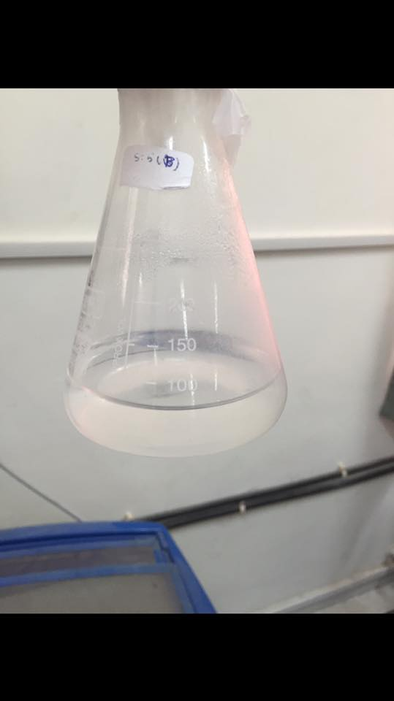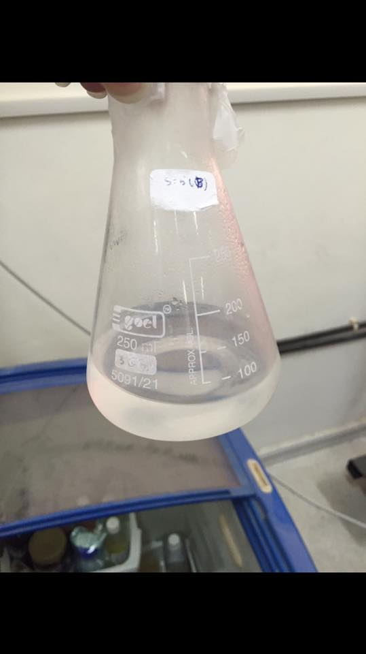
Figure(6.1): soln1 before and after crystallization.
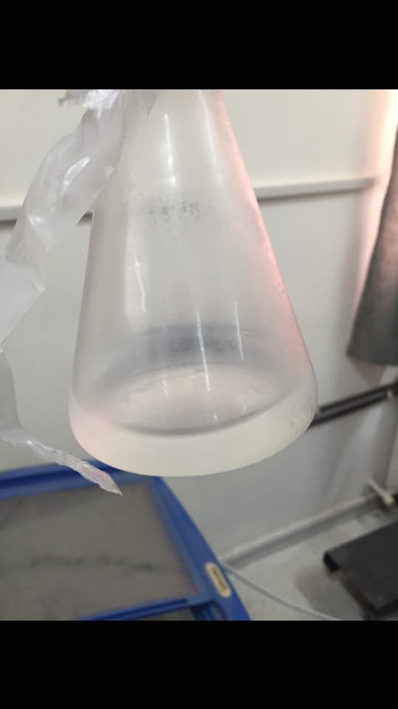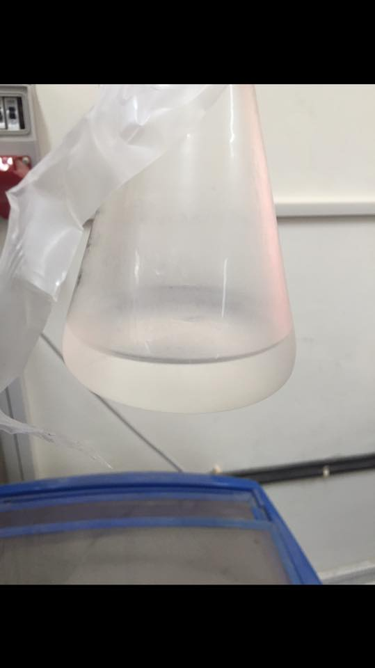
Figure(6.2): soln2 before and after crystallization.
Figure (6.1)and figure (6.2) show that no crystals were formed due to the low freezing point of methanol.
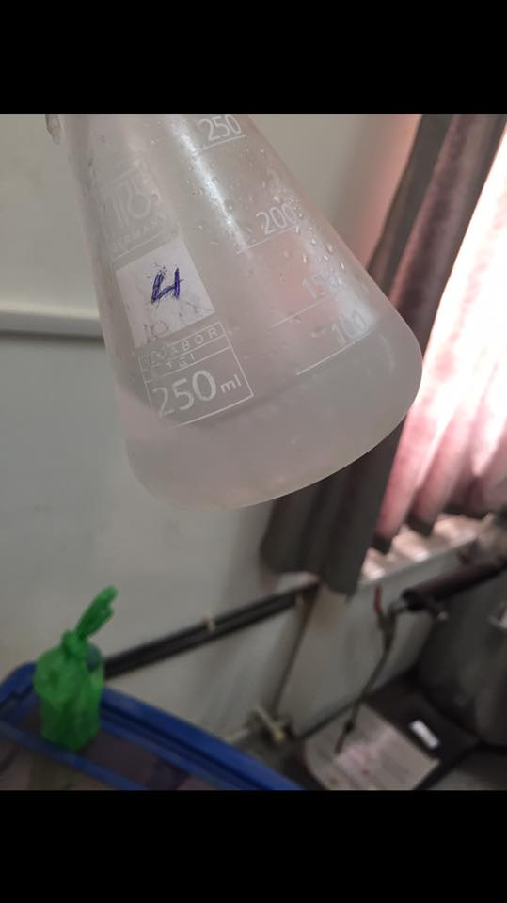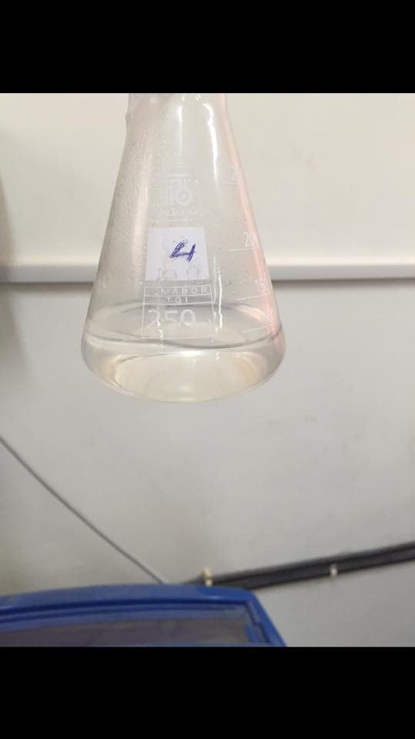
Figure(6.3): Soln3 before and after crystallization.
Figure (6.3) shows that a freezing layer were formed but it was not possible to determine the component.

Different problems were occurred during crystallization , which are :
- Separation between components did not occurs at these temperatures .
- The difficulty of reaching low temperatures ( below 0 ) .
- The difficulty of measuring the temperatures of the solutions .
- The low freezing temperature of Acetonitrile (-51) and methanol (-97.6) .

6.2 Waste adsorption by clay :
Another idea for recycling the waste was using clay to adsorb the waste components .
- First 2mL of water was added to 1gm of clay, the 1gm of clay adsorbed 1.2 mL of water .
- Second 1mL of methanol was added to 1gm of clay, the 1gm of clay adsorbed 0.6mL of methanol.
- Third mixture of 1mL of water and 0.5mL of methanol was added to 1gm of clay, the 1gm of clay was adsorbed 0.8 of the methanol/water mixture .
- Forth mixture of 1 mL water and 0.5 mL methanol and 0.5 mL acetonitrile was added to 1 gm of clay, the 1gm of clay adsorbed 1mL of the mixture .

The problems of using clay :
- The clay adsorbed all the waste components with different amounts.
- The difficulty of determining the amounts of each component that adsorbed by clay .

6.3 Distillation :
A mixture with different concentrations of methanol and water was distilled to find out the ability of the simple distillation to separate the mixtures, it was found that the methanol goes out first by simple distillation and this was confirmed by using refractometer.
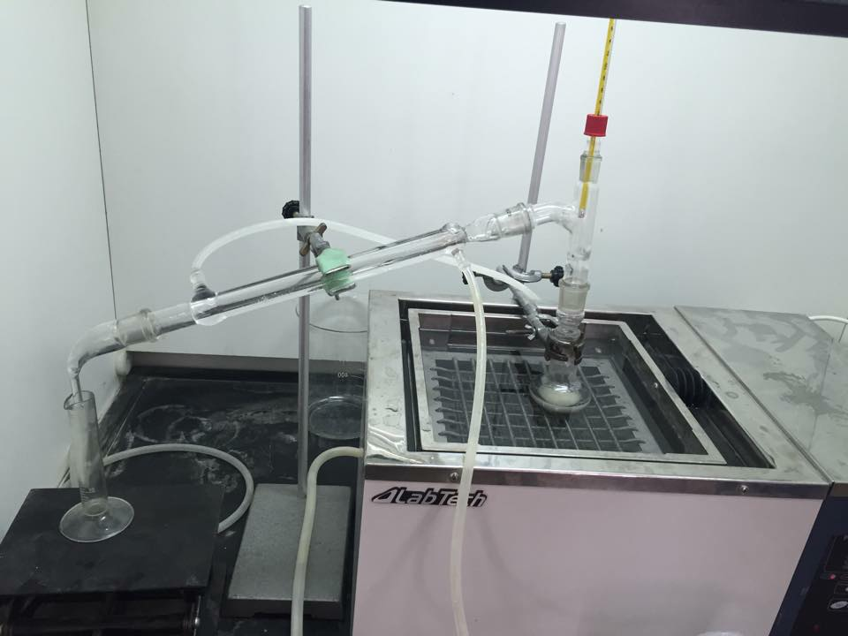
Figure (6.4): simple distillation process.

To determine the concentration of the distilled samples refractometer was used by preparing the calibration solutions of known concentration of methanol and water, then figure (6.5) was drawn.

Figure (6.5) :refractive index for mathanol / water mixture.

The readings of the samples that goes out first from the simple distillation are (1.331 , 1.310 , 1.309 , 1.308 ) and according to figure (6.6). The samples were methanol which its concentration between (90 -100)%.

Figure(6.6) Results of refractometer test

Problems
- It was found that methanol goes out from the distillation is not pure.
- If a mixture contain acetonitrile , methanol and water were distilled an azeotropic point will be created between acetonitrile and methanol . Then this technique is excluded .

6.4 Extraction :
Another suggested solution for the problem was extraction.
Solvent extraction is a method used to separate compounds based on their relative solubility's into different immiscible liquids, different solvents were used for extraction such as (kerosene , soya been oil , tire oil fuel , biodiesel )

6.4.1 Extraction using kerosene:
Kerosene was used to extract solution of (water-methanol-acetonitrile) of different ratios.
.
- Kerosene and water solution separated directly and two layers formed as shown in figure (6.7)

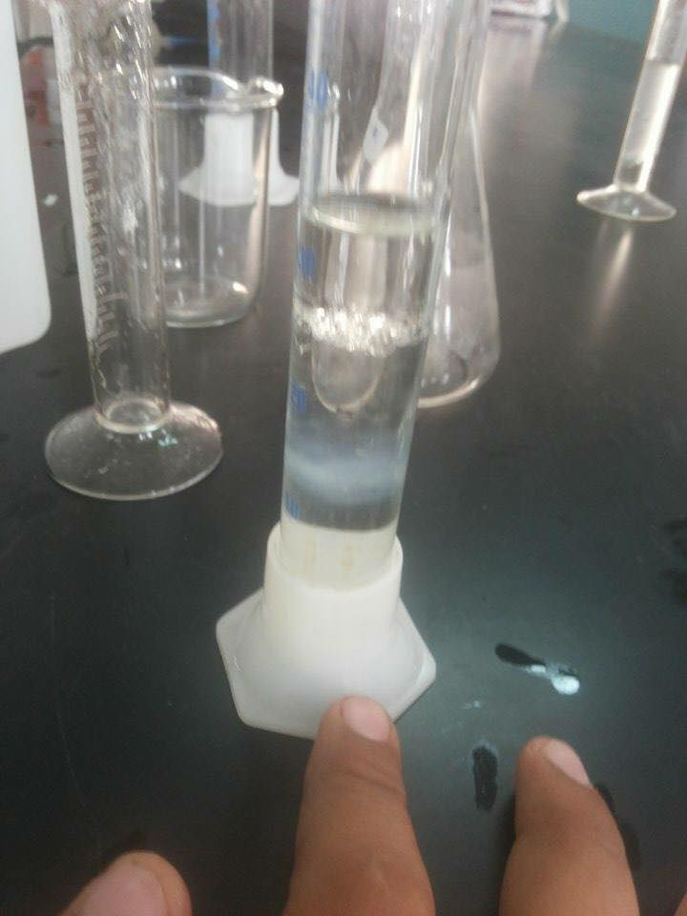

Figure (6.7)kerosene and water solution

- Kerosene and methanol solution separated gradually as shown in figure (6.8) and the methanol does not separated directly.

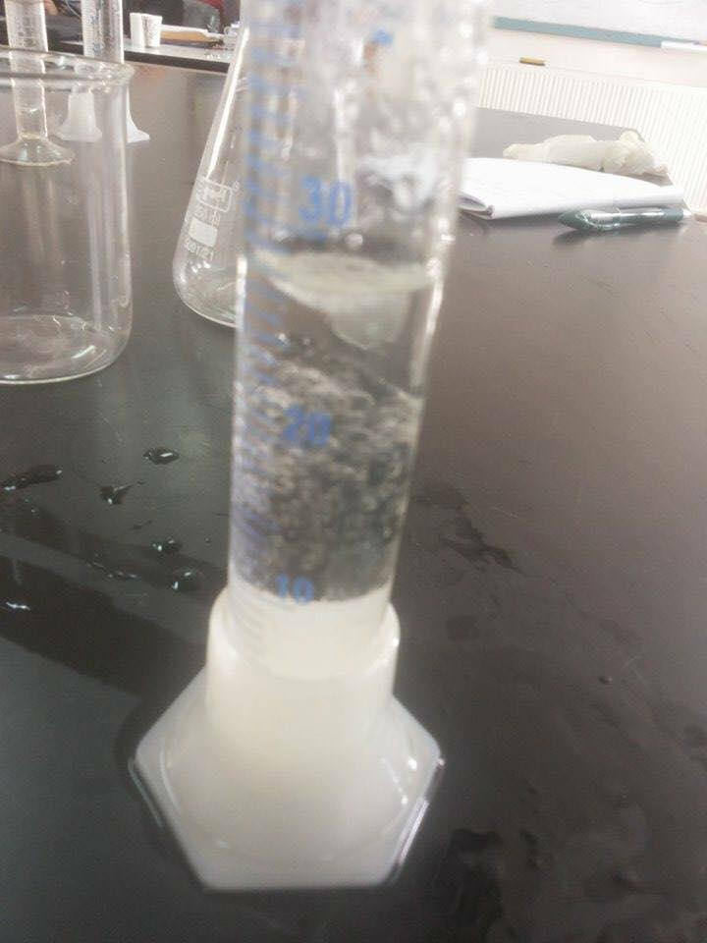
Figure(6.8) kerosene and methanol solution.

- Kerosene, Acetonitrile and water. As shown in figure (6.9) the kerosene was separated from the solution and there was a turbidity in the Acetonitrile –water solution.
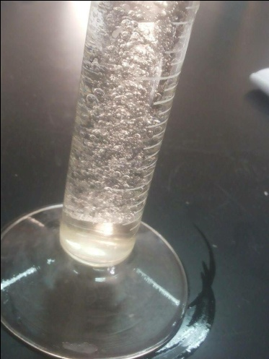
Figure (6.9) Kerosene, acetonitrile and water solution.

- Kerosene, water and methanol. As shown in figure (6.10) kerosene separated from the solution and there was a turbidity in the methanol –water solution.
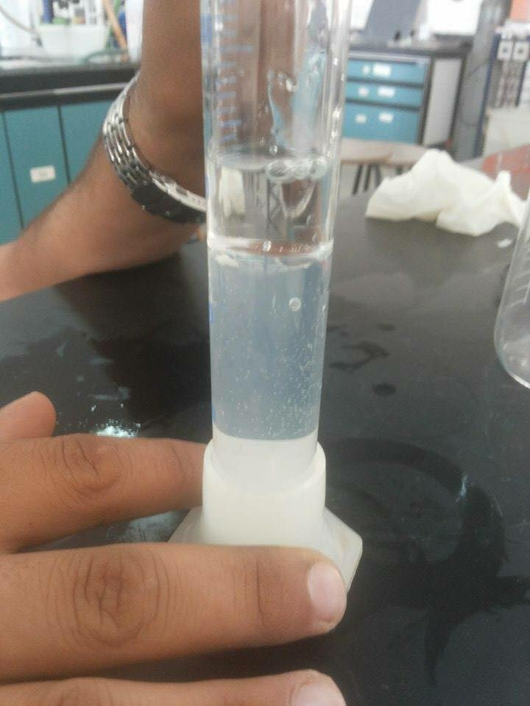
Figure(6.10) Kerosene, methanol and water solution

- Kerosene, methanol, water and Acetonitrile. As shown in figure (6.11) kerosene separated from the solution and there was turbidity in the Acetonitrile –water-methanol solution.
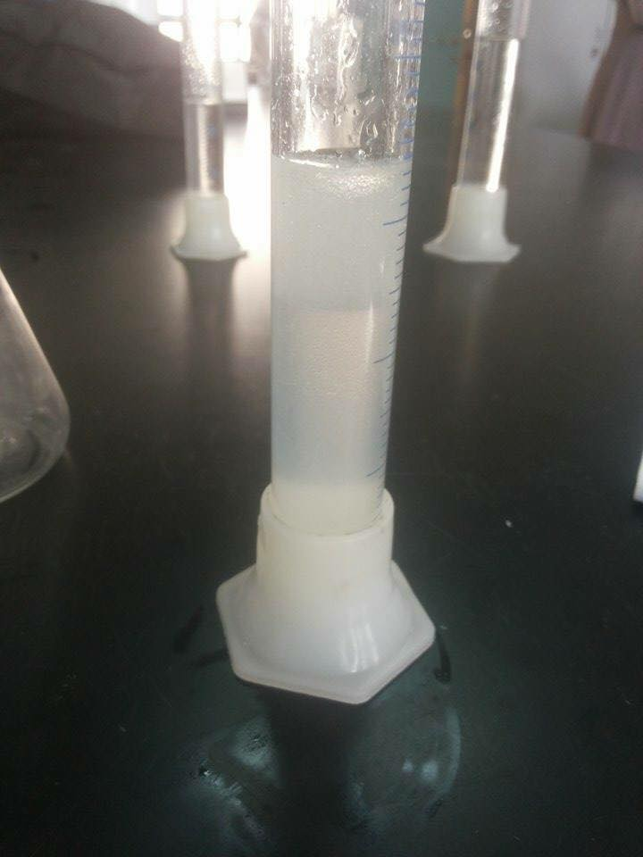
Figure (6.11) Kerosene, methanol, acetonitrile and water solution.

Problems occurred during extraction with kerosene :
-Insolubility of methanol and Acetonitrile in Kerosene.
- The turbidity occurs on the solutions.
- The difficulty in determining the concentrations of the layers.

5.4.2 Extraction using soya been oil

Soya been oil was used to extract water-methanol- Acetonitrile solution by different ratios :
- 30mL Oil with 10mL methanol and 10mL water produced three layers: the middle thin layer was methanol dissolved in oil.
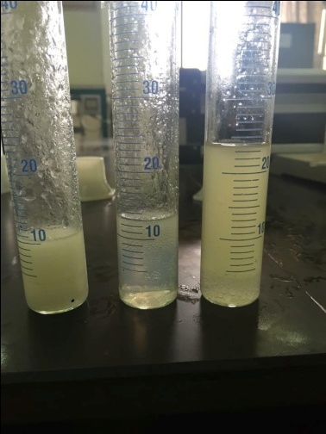
Figure (6.12) Three layers obtained from oil, methanol and water solution.

Figure (6.12) showed the three layers formed. The first one contains methanol and oil, the second layer contains water. the third layer contains oil.

- 30mL Oil with 15mL Acetonitrile and 15 mL water produced two layers.
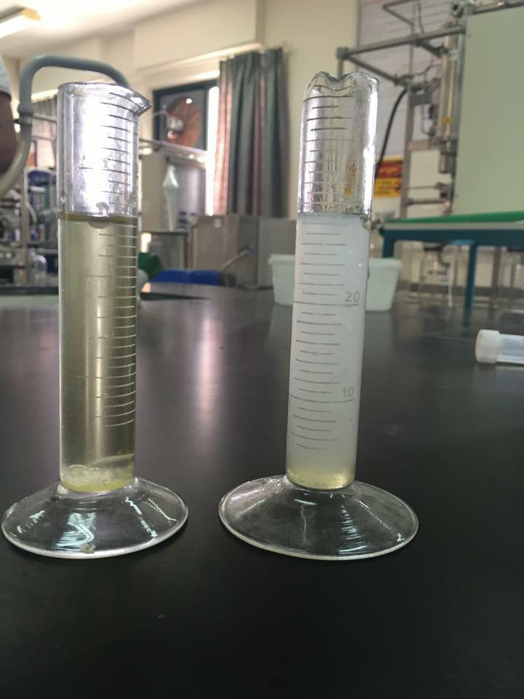
Figure (6.13) Two layers obtained from oil, acetonitrile and water solution.

Figure (6.13) show that acetonitrile and water is completely insoluble in oil.

- 30mL Oil with 5mL methanol,5mL water and 10mL Acetonitrile produced three layers.
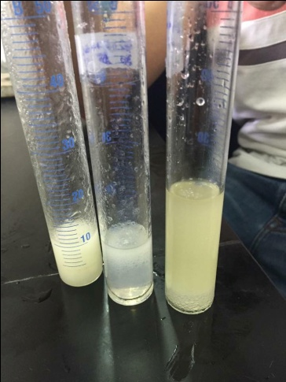
Figure (6.14) Three layers obtained from oil, methanol, acetonitrile and water solution.

As shown in figure (6.14) three layers were obtained and separated, the first one contains oil and methanol, the second one contains methanol, acetonitrile and water, the third one contains oil.

- SLS surfactant was used to increase the solubility.

Problems occurred during extraction with soya been oil:
- Low solubility of methanol on soya been oil .
- Acetonitrile is insoluble in soya been oil
- High amount of SLS surfactant required for the solubility of the solutions.

5.4.3 Extraction using fuel from pyrolysis tires.

A fuel made using pyrolysis tires was tested to find the solubility of the waste components, different mixtures was prepared with different concentrations.
1- Methanol was added to the fuel and it was found that the methanol is completely soluble in fuel, and it made the fuel less viscous as shown in figure (6.15), one layer was formed.

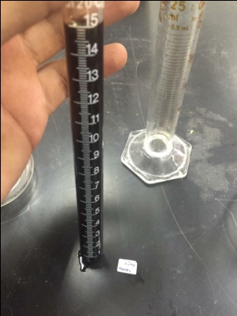
Figure (6.15) Methanol and fuel mixture
2- A mixture of methanol, water and fuel were prepared in different ratios, then separation of water and methanol from the fuel was occurred as shown in figure (6.16), two layers were formed and methanol dissolved in water.
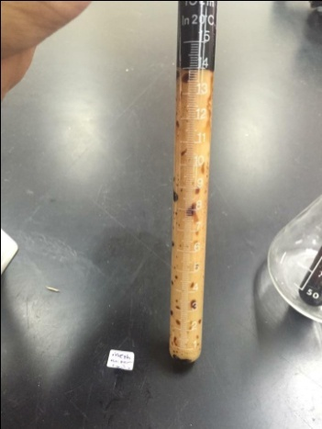
Figure (6.16) Methanol, water and fuel mixture.

3- Methanol and acetonitrile in fuel, the methanol and acetonitrile dissolved in the fuel as shown in figure (6.17), one layer was formed.
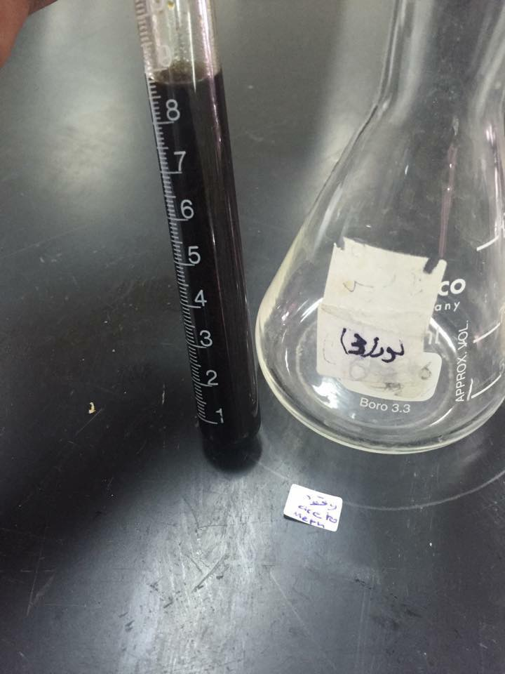
Figure (6.17) Methanol, acetonitrile and fuel mixture

4- Mixture of methanol, acetonitrile, fuel, water was prepared at different ratios, and it was noticed that three layers were formed as shown in figure (6.18).
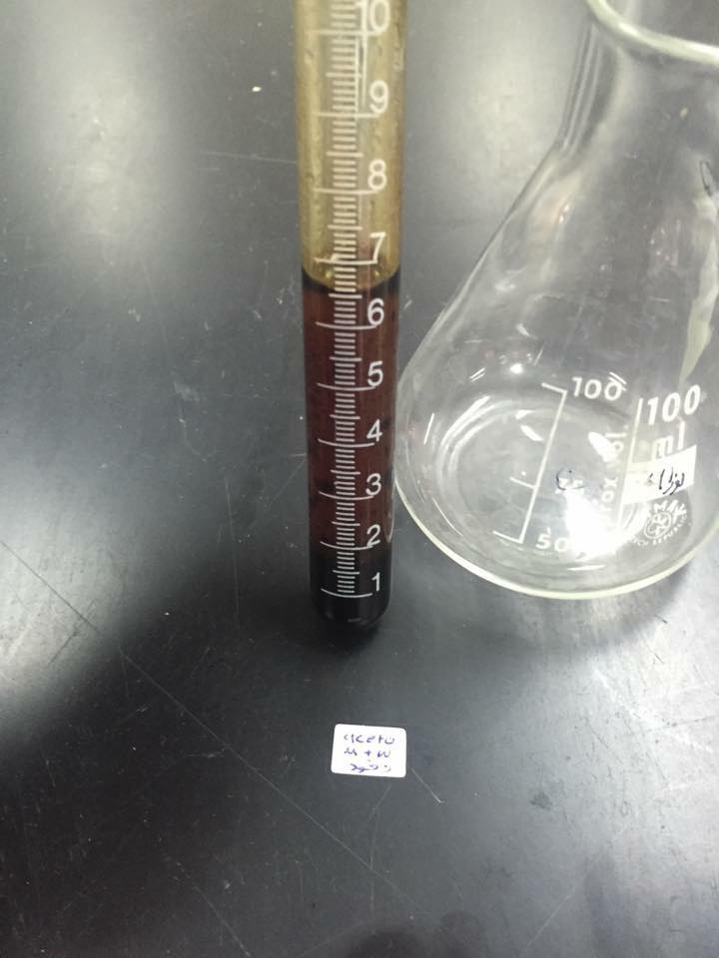
Figure (6.18) Methanol, acetonitrile, water and fuel mixture.

The problems with extraction with fuel :

- The difficulty in determining the composition of each layer.
- No enough information about the fuel.
- Solubility of methanol in water is higher than solubility of methanol in fuel.

5.4.4 Extraction using biodiesel :

Another solvent was used for extraction the waste (methanol - water - acetonitrile) which was biodiesel, which is a fuel that can be produced by transesterification of methanol and one of different types of oil like, soya been, frying oil, coconut oil .
First the solubility of each of the waste component in biodiesel was determined :
For methanol, mixtures of methanol and water with different ratios were prepared, then the solubility of the mixtures in biodiesel was recorded, the experiments were done with 5mL of biodiesel and 5mL of methanol/water mixture for several times . The results are shown in Table (6.2) and Figure (6.19) :
Table (6.2): Solubility Of Methanol/Water on Biodiesel
Methanol residue in aqu VOL % | Methanol dissolved in biodiesel VOL% | %Methanol
0 | 0 | 0
0.167 | 0.038 | 20%
0.288 | 0.06 | 33%
0.348 | 0.074 | 40%
0.444 | 0.09 | 50%
0.75 | 0.167 | 60%
1 | 0.2 | 100%

Figure (6.19): Solubility Of Methanol/Water in Biodiesel
Figure (6.19) shows the relationship between methanol dissolved in biodiesel (v/v%).

For acetonitrile, mixtures of acetonitrile and water at different ratios were prepared, then the solubility of the mixtures in biodiesel was recorded, the experiments were done with 5mL biodiesel and 5mL of acetonitrile/water mixture for several times. The results are shown on Table (6.3) and Figure (6.20).
Table (6.3): Solubility of Acetonitrile/Water in Biodiesel
Acetonitrile residue in aqu solution v% | Acetonitrile dissolved in biodiesel v% | %Acetonitrile
0 | 0 | 0
0.13 | 0.074 | 20%
0.25 | 0.167 | 40%
0.342 | 0.194 | 50%
1 | 0.28 | 100%

Figure (6.20): Solubility of Acetonitrile/Water in Biodiesel.
Figure (6.10) shows the relationship between acetonitrile dissolved in biodiesel (v/v%).

+

For pure water, experiments were done with different ratios of water and biodiesel, and it was found that water is completely insoluble in biodiesel.
For mixtures of methanol/water/acetonitrile with biodiesel at different volume fractions, the results are shown on Table (6.4) and Figure (6.21).

Table(6.4) : Solubility of Acetonitrile/Methanol/Water in Biodiesel.
Waste Residue v% | Waste Dissolved on Bio v% | Waste content
0.5 | 0.167 | 40% meth,20% aceto
0.487 | 0.18 | 30% meth, 30% aceto
0.46 | 0.2 | 20% meth,40%aceto

Figure(6.21): Solubility of Acetonitrile/Methanol/Water in Biodiesel.

According to the results, it was found that methanol and acetonitrile dissolved in biodiesel with acceptable percentage, where acetonitrile has a higher solubility in biodiesel than methanol (the solubility of 100% acetonitrile was 0.28, the solubility of 100% methanol was 0.2), on the other hand, water was insoluble. Also table (6.4) and figure (6.21) shows that increasing of acetonitrile volume fraction (while water fraction is constant ) increase the solubility in biodiesel. Depending on the previous results, biodiesel was expected to be a good solvent for the extraction.

Also the effect of temperature on the solubility was noticed, by increasing the temperature of the mixtures of waste and biodiesel with different compositions to 50Cº, it was not possible to heat to temperature more than 50Cº due to the low boiling point of the waste components.
Table (6.5) : Temperature effect on Methanol/Water Solubility in Biodiesel
After Heating to 50c | After Mixing | Mixture Component
5.2 mL Bio+4.8(meth+H₂O) | 5.2mL Bio+4.8(meth+H₂O) | 5mL Bio +1mL meth+4mL H₂O
5.4mL Bio+4.6(meth+H₂O) | 5.4mL Bio+4.6mL (meth+H₂O) | 5mL Bio +2mL meth+3mL H₂O
6 mL Bio+4mL (meth+H₂O) | 6 mL Bio+4mL(meth+H₂O) | 5mL Bio +3mL meth+2mL H₂O

Table (6.6) : Temperature effect on Acetonitrile/Water Solubility in Biodiesel
After Heating to 50c | After Mixing | Mixture Component
5.5 mL Bio+4.5(aceto +H₂O) | 5.4mL Bio+4.6(aceto +H₂O) | 5mL Bio +1mL aceto+4mL H₂O
6mL Bio+4(aceto +H₂O) | 6mL Bio+4mL(aceto +H₂O) | 5mL Bio +2mL aceto+3mL H₂O
6.3 mL Bio+3.7mL (aceto +H₂O) | 6.3 mL Bio+3.7mL(aceto +H₂O) | 5mL Bio +3mL aceto +2mL H₂O

Table (6.7) : Temperature effect on Acetonitrile/Methanol/Water Solubility in Biodiesel
After Heating to 50c | After Mixing | Mixture Component
6 mL Bio+4mL (meth+ aceto +H₂O) | 6mL Bio+4(meth+ aceto +H₂O) | 5mL Bio +2mL meth+1mL aceto +2mL H₂O
6.3mL Bio+3.7 mL (meth+ aceto +H₂O) | 6.3mL Bio+3.7mL (meth+ aceto +H₂O) | 5mL Bio +1mL meth+2mL aceto +2mL H₂O
6.1 mL Bio+3.9mL (meth+ aceto +H₂O) | 6.1 mL Bio+3.9mL(meth+ aceto +H₂O) | 5mL Bio +1.5mL meth+ 1.5 mL aceto +2mL H₂O

According to the results on tables(6.5,6,7) , there was no change in the solubility of the components on biodiesel, so it was no need to increase the temperature of the solvent .

Depending on the solubility of methanol and acetonitrile in biodiesel, it was used as a solvent for the extraction. Solution of ( 50% water , 37.5% Methanol, 12.5% acetonitrile ) where these compositions are the real compositions of the waste, which were used .
Extraction of 20mL solution using 20 mL biodiesel was used by separating funnel , for a batch process the 20mL biodiesel took about 2 mL from the waste, and this led to use a continuous process by retreating the waste by new amount of biodiesel, more than one experiment was done, and the results are shown in table (6.8).

Table (6.8) : Results of continues extraction of Waste by Biodiesel using separating funnel.
Waste Volume (mL) (Starting with 20mL)
Trial 4 | Trial 3 | Trial 2 | Trial 1 | Biodiesel
17.5 | 18 | 18.5 | 18 | 20mL
16 | 17 | 18 | 16.5 | 20mL
15 | 16 | 16.5 | 15 | 20mL
15 | 15 | 16 | 13.5 | 20mL
14 | 14 | 15 | 12.5 | 20mL
13 | 13 | 14 | 12 | 20mL
12 | 12.5 | 13 | 11 | 20mL
11.5 | 11.5 | 12 | 10.5 | 20mL
11 | 10.5 | 11 | 10 | 20mL
10 | 10 | 10.5 |  | 20mL
 |  | 10 |  | 20mL

As shown in table (6.8), the numbers below each trial represents the amount of aqueous layer after every extraction step.

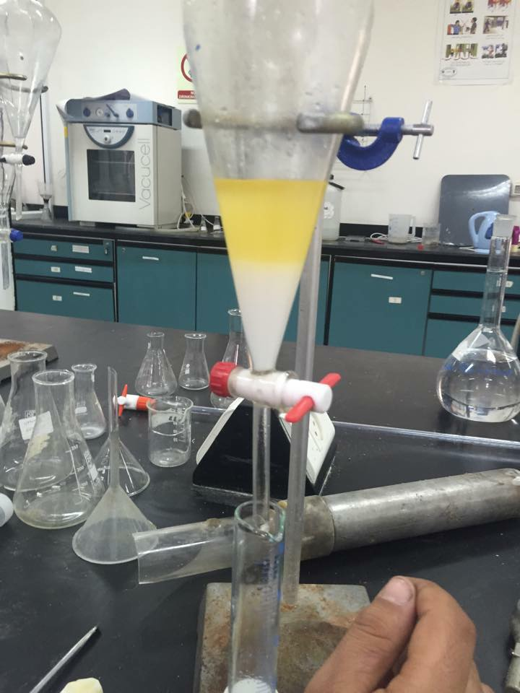 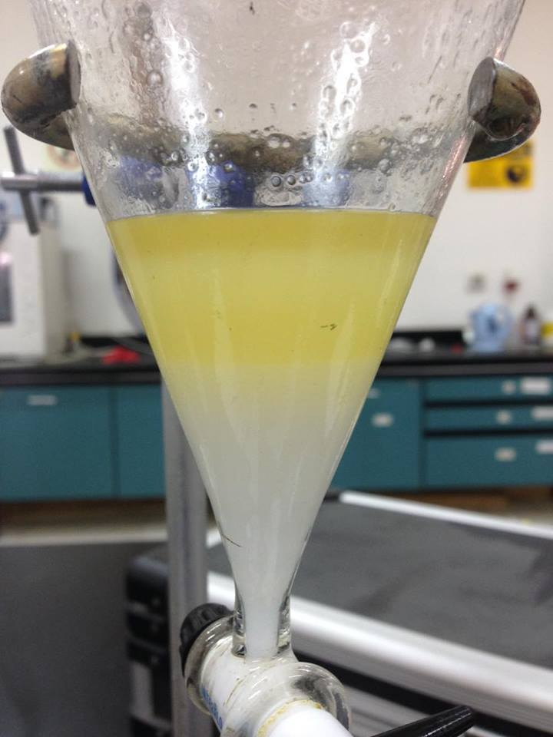d
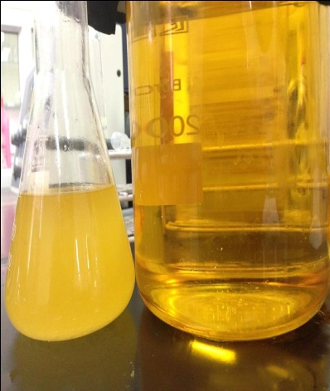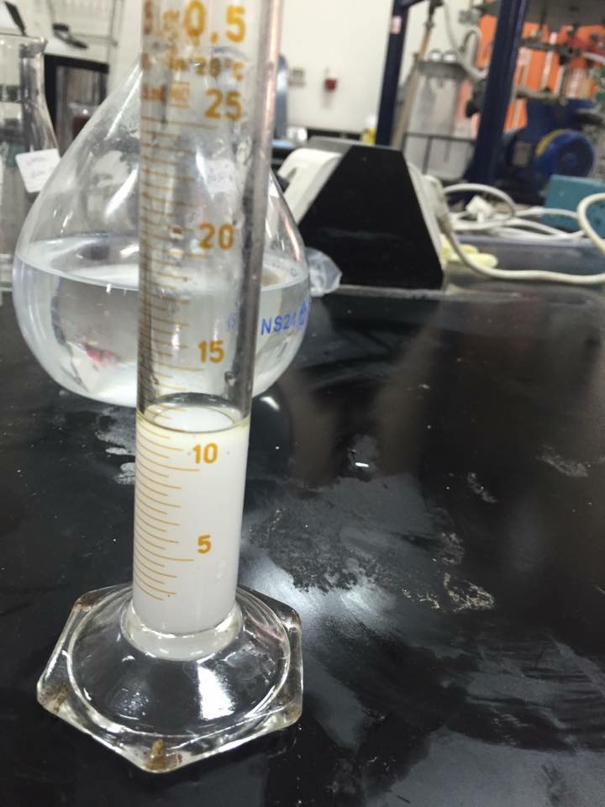
Figure(6.22)(a) and (b): Extraction using biodiesel by separating funnel., (c) samples of pure and used biodiesel, (d) water sample as a heavy phase produced from the extraction process.
According to the results on table (6.8), it was found that 20 mL of waste which contains 10mL water and 7.5 mL methanol and 2.5 mL acetonitrile, required about (180-220 mL ) of pure biodiesel with ratio of 1: (9-11).

After extraction process for the waste and biodiesel using separating funnels, which showed good results as mentioned before, the disadvantages were the need for high amount of biodiesel, and it was difficult to be used for industrial scale, so a continuous process was investigated by designing an extraction packed bed column which is countercurrent flow, in which acetonitrile and methanol was absorbed by biodiesel and goes out from the top of the column and the water separated easily in the bottom of the column.
In order to design a column, the design parameters were investigated. Because of the paucity of information in the literature, fixed parameters (diameter, height, packing diameter) were used to find the relationship between these parameters and the flow rates of biodiesel and waste .

Table (6.9): Design parameters of the extraction column
Parameter | Value
Inside Column diameter (cm) | 4
Column Height (cm) | 50
Packing material type | Raschig ring
Packing Diameter(cm) | 1
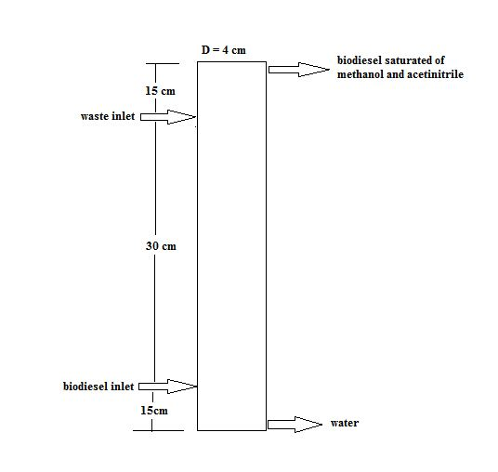
Figure (6.23): Extraction column design parameters

The first experiment was operating the system with flow rate ratios, which were obtained from extraction using separating funnel, the ratio which was obtained to extract 1 mL of waste solution was 10 mL of biodiesel. So 280 mL waste solution was prepared, which contain 50% water, 37.5% methanol and 12.5% acetonitrile in 1 mL per second flow, was extracted with biodiesel with a flow equal to 10 mL per second .

The results show that 100 mL of acetonitrile and methanol was dissolved in biodiesel and 40 mL remained in water.

The problem in this experiment was that there was two variable parameters to be controlled (flow rate of biodiesel , flow rate of waste ), and the suggested solution was to fix the flow rate of the waste solution to a minimum value, and controlling the flow rate of the inlet biodiesel.

The second experiment was operating the system with biodiesel and pure water. The pure water was entered the system with a minimum flow rate which of 0.15 mL per second and the biodiesel was entered in different flow rates, it was found that the optimum flow rate is 4.7 mL per second.

The third experiment was operating the system using 200 mL waste sample and biodiesel, the waste flow rate is 0.15 mL per second, and the flow rate of biodiesel used was equal to the flow in the second experiment which equal to 4.7 mL per second.

The results showed that 50 mL of acetonitrile and methanol was dissolved in biodiesel and the other 50 mL remained in water .

The fourth experiment was operating the system with 200mL waste solution with a flow rate of 0.15 mL per second and the flow rate of biodiesel was 2.5 mL per second. 80 mL of acetonitrile and methanol was dissolved in biodiesel and 20 mL remained in water. Results are shown in table (6.10)

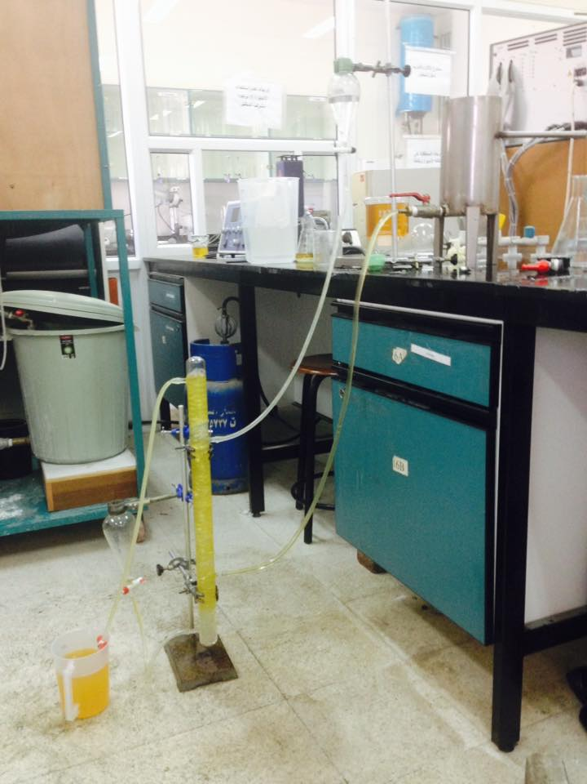
Figure(6.24) HPLC waste recycling using extraction column.
Table (6.10): Results of extraction column experiments.

 | Water flow rate (mL/s) | Waste amount (mL) | Waste flow rate (mL/s) | Biodiesel flow (mL/s) | Biodiesel amount (L) | Methanol, acetonitrile dissolved (mL) | Methanol, acetonitrile remain in water
Exp1 | - | 280 | 1 | 10 | 2.8 | 100 | 40
Exp2 | 0.15 | - | - | 4.7 | - | - | -
Exp3 | - | 200 | 0.15 | 4.7 | 6.2 | 50 | 50
Exp4 | - | 200 | 0.15 | 2.5 | 3.3 | 80 | 20

Table (6.11): The percentage of extracted waste.

 | Biodiesel flow rate | Waste amount | Waste extracted | % of waste extracted
Exp3 | 4.7 | 200 | 50 | 25
Exp4 | 2.5 | 200 | 80 | 40

The flow rate of waste was 0.15 mL per second with different flow rates of biodiesel, table (6.11) shows that when the flow rate of biodiesel decreased the percentage of extracted amount of waste increased. But because of the fixed column parameters, if the flow rate of biodiesel was less than 2.25, the system will not separate the water and the waste from each other and the system will fail.

The problems which were occurred in this system, dissolving all the amount of acetonitrile and methanol that existed in the waste solution in biodiesel, and this was related to many reasons which are :

- The need of larger surface area of the packing material by using smaller diameter packing rings.
- Column parameters (height, diameter): if an extraction column with higher length were used, the contacting time between waste and biodiesel will be longer, as a result biodiesel will take more amount of acetonitrile and methanol.
- Large amount of biodiesel which was needed for each experiment which is not economical, as a result of this the distillation separation technique was applied to separate methanol and acetonitrile from the biodiesel, simple distillation was appropriate for this goal, because of the high range different between methanol, acetonitrile, biodeseil.
- The acetonitrile and methanol mixture will be used in the manufacturing process of biodiesel.

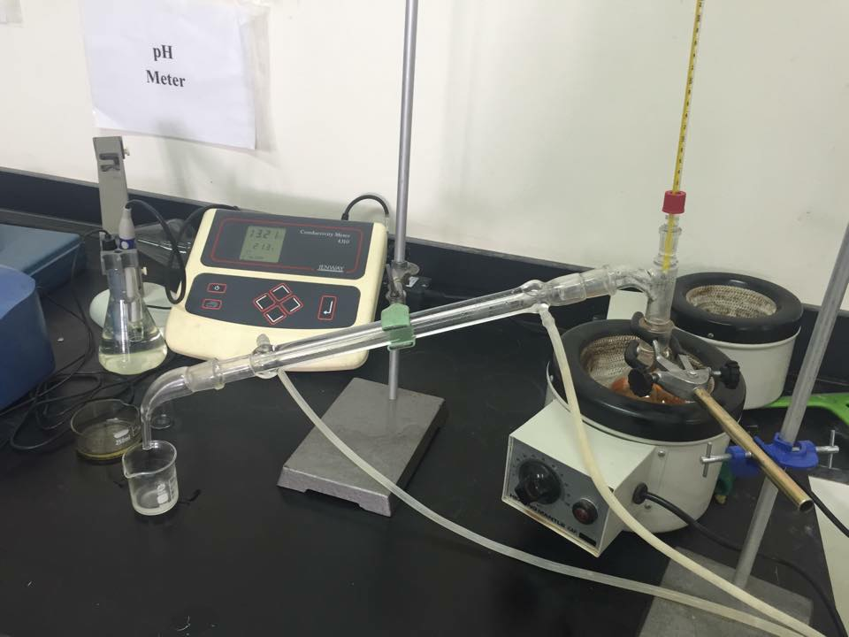
Figure(6.25) distillation of used biodiesel

Conclusion

- The main objective of this project is to find and test methods for HPLC effluent recycling.
- The separation of the waste mixtures, recycle and converting the waste to new product are potential solutions for the problem.

- Biological treatment process, batch extractive distillation and azeotropic distillation, are potential methods which studied in literature for solve the problem but there is no enough information about these techniques, also safety and cost consideration are forming serious challenge for these methods .

- Extractive distillation and crystallization can be efficient methods for solving the problem.
- Extraction method for the waste using biodiesel as a solvent is an efficient method to be used
- Packed extraction column using low diameter packing material is an efficient method for the extraction by biodiesel .
- Distillation of used biodiesel is an efficient method for reusing the biodiesel in extraction process .
- Converting the waste streams to fuel like biodiesel after separating water can be a solution for the problem.

Recommendations

- To test the effect of height of the column.

- To test the column using actual waste samples.

- To test the effect of packing material type.

- To test a special control system for the inlet flow rates

References

[1] The Current Status of Industrial Sectors in Palestine report by Palestinian federation of industries/USAID (2009) .
[2] U.S. Environmental Protection Agency (1991). Guides to Pollution Prevention The Pharmaceutical Industry, EPA 625/7-91/017. Cincinnati, Ohio: Jacobs engineering group. 8 - 9

[3] United States Environmental Protection Agency(1999). Environmental Fact Sheet Source Reduction of Municipal Solid Waste, EPA530-F-99-021.

[4] United States Environmental Protection Agency(2014). Municipal Solid Waste Generation, Recycling, and Disposal in the United States, EPA-530-F-14-001. 9

[5] Li-Yang Chang,(2001). Biological Treatment of aTritiated HPLC Mixed Waste to Meet RCRA Requirements, Orlando, Florida.
.
[6] Guangzhong Li, Yang Yu, Peng Bai,(2012). Batch extractive distillation of mixture methanol-acetonitrile using aniline. polish journal of chemical technology, 14 (3) : 48-53.

[7] Yumei Li, Peng Bai, Qionghong Zhuang (2012). Isobaric vapor–liquid equilibrium for binary system of methanol and acetonitrile. Fluid Phase Equilibria 340 : 42– 45.
[8] Romas Cesas, Napervllle, IL (US) (2012). Recovery of acetontrile from a waste stream, Pub. N0.: US 2012/0073954 A1

[9]P. Stepnowski , K.-H. Blotevogel , P. Ganczarek , U. Fischer , B. Jastorff (2001). Total recycling of chromatographic solvents—applied management of methanol and acetonitrile waste. Resources, Conservation and Recycling, 3 (5): 163–175.

[10] RONALD VV. ROUSSEAU (1987). Hand book of separation process technology. Canada: , john wiley & sons: 229 - 579.

