Dedication
To those who educated, guided, encouraged and did their best to let me be successful and distinguished, my cherished parents.
To those who helped, stand and paid many efforts to make it easy for me to achieve my goals.
To my respected supervisor Dr.Aladdin Masri and Dr. Hanal Abu Zant for his advice, encouragement and guidelines to let this project came to existence.
To all of those we would like to pay our gratitude and thanks.

Doa Zalmout
Asmaa Hanbali

Acknowledgments

We would like to thank almighty God, to reconcile us at each step and for giving us everything to make our work continuous without laziness and foil.
We would like to express our deep gratitude to Dr.Aladdin Masri & Dr. Hanal Abu Zant for thier true guidance, enthusiastic encouragement and useful critiques of this research work. And we would also like to thank all Doctors in computer engineering department at An Najah University, for their advice and assistance in keeping a project on schedule and for their efforts during five years passed.
Finally, we wish to thank our parents for their support and encouragement throughout our study.

Disclaimer statement.

This report was written by Doa Zalmout and Asmaa Hanbali at the computer Engineering Department, Faculty of Engineering, An-Najah National University. It has not been altered or corrected, other than editorial corrections, as a result of assessment and it may contain language as well as content errors. The views expressed in it together with any outcomes and recommendations are solely those of the student(s). An-Najah National University accepts no responsibility or liability for the consequences of this report being used for a purpose other than the purpose for which it was commissioned.

Table of Contents

Dedication 1
Acknowledgments 2
Disclaimer statement. 3
Abstract 6
Chapter 1 : Introduction 7
Chapter 2 : Constraints, Standards/ Codes and Earlier course work. 8
2.1 Constraints. 8
2.2 Standards/Codes. 8
2.3 Earlier coursework. 8
Chapter 3 : Literature Review. 9
Chapter 4 : Methodology. 10
4.1 Parts List 10
4.1.1 Raspberry Pi. 11
4.1.2 Ultrasonic Sensor 13
4.1.3 Stepper Motor 16
4.1.4 DC motor 18
4.1.5 Wheel 19
4.1.5 L298N motor driver 20
4.1.6 Wi-Fi Adapter 21
4.2 Procedures 21
4.2.1 Controlling vehicle side: 21
4.2.2 Distance Measurement: 22
4.2.3 Motors 25
4.2.4 Wireless 27
4.3 Software 28
4.3.1 Raspberry Pi. 28
4.3.2 How GPIO Software Works: 28
4.3.3 Python : 29
Chapter 5 : Results and Analysis. 32
Chapter 6 : Discussion 33
Chapter 7 : Conclusions and Recommendation. 34
References: 35

Table of Figures.
Figure 1 Raspberry Pi 11
Figure 2 Ultrasonic Sensor 14
Figure 3 Timing Diagram 16
Figure 4 Stepper Motor 16
Figure 5 Stepper Frames 17
Figure 6 DC Motors 18
Figure 7 Wheels 19
Figure 8 Motor Driver 20
Figure 9 Tenda 21
Figure 10 MCP3002 circuit 23
Figure 11RasPI GPIO Pins 25
Figure 12Servo Motor 26
Figure 13 Stepper with Driver Board 26
Figure 14 Wi-Fi Configuration 31
Table of Tables.
Table 1 Parts List 10
Table 2 Electric Parameter 15

Abstract

Mapper Robot is designed to collect data of a room which can be visualized as a map later on a computer. The importance of this project is measuring distance by using proximity sensor. The objective of our project is to make a robot capable of mapping an area. For the vehicle we use Raspberry Pi to control the movement of the robot. Mapper Robot is very useful because mapping inside anything in real time is hard.
This project could also help for measuring room sizes and its orientation .Further the project can be applied in difficult areas that are hard for human being to be inside.

: Introduction

Mapping inside anything in real time is very difficult especially for areas that are hard for human being to be inside or previously unknown ones. Even if there is an exiting mapper robot, but all of existing ones are very expensive because of using complex techniques, devices and sensors such as LIDAR,IR..
For these reasons we thought of new way to map surrounding areas avoiding these problems.
The main objective of this project is to make mapping cheaper and simpler than before. In this project you only asked about controlling robot movements until reaching specific position in order to start mapping and collect data.
The importance of this project comes from the importance of safety and security. This project allows you to know many things about areas you can’t reach it. You send the robot and it map what you want. So we have worked day by day during this semester to have this useful project.

: Constraints, Standards/ Codes and Earlier course work.

2.1 Constraints.

Unfortunately our microcontroller device which is raspberry pi is not available in our country. Also not all of electronic IC'S are compatible with it. In addition to this problem many electronic chips in our country don't have good accuracy and if we find a good one it has a high cost. Although we face other hardware challenges for motors after deep work on servo motor to make it mechanically rotate 360 degree that doesn’t work , the servo remains to rotate in 180 degree and because we need 360 degree rotation we decided to convert to stepper motor.
And for Wi-Fi USB adapter we first use TP-link USB, after testing we found that it’s not compatible with Raspberry Pi. Also differences between Raspberry Pi and HC-SR04 Ultrasonic Sensor - 3.3v vs 5v .
All these constraints we will discuss it later in more detail.

2.2 Standards/Codes.

This project is built using Raspberry Pi and Python programming language.

2.3 Earlier coursework.
Microprocessor, Network Security , Network, Wireless .Also microcontroller course help us in using Raspberry Pi, moreover electronic and circuit courses to be able to understand, design and build our circuits also to know how to use lab instruments. Beside that we benefit from online Python courses.

: Literature Review.

As we all know that this project is not the first. There is a another Mapper robot built by Spanish students but they use complex techniques and we do not find another similar projects.

: Methodology.

4.1 Parts List

This table shows the devices we use in our project.
Table 1 Parts List
Part | Quantity
Rspberry Pi | 1
Ultrasonic sensor | 1
Stepper motor | 1
DC motor | 2
ULN2003A Driver board | 1
USB Wireless adapter | 1
L298N motor driver | 1
Resistor | 3
Power source | 1
Car | 1
Wires | Many
Wheel | 2
White board | 1
Battery holder | 1

4.1.1 Raspberry Pi.

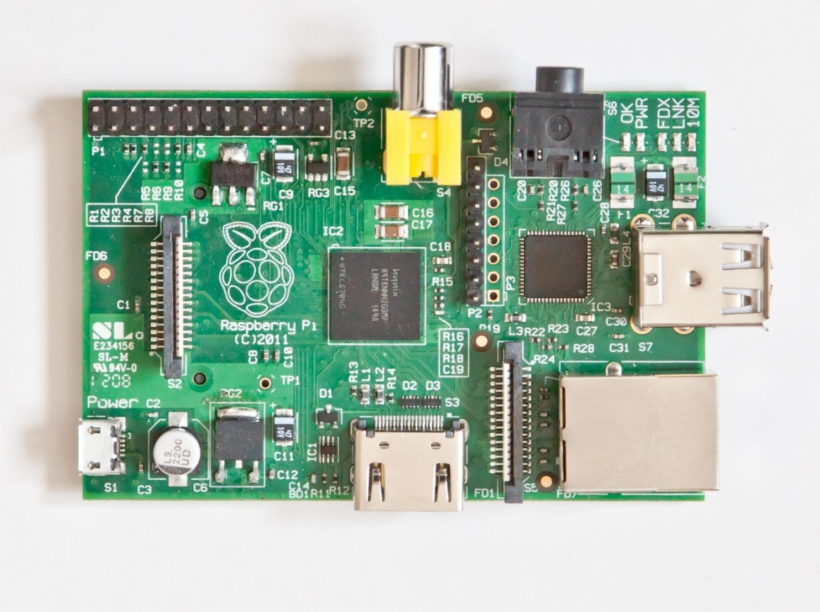
Figure 1 Raspberry Pi
Getting Started with Raspberry Pi , with its low cost and amazing package of functionality, has taken the robotic hobbyist community by Storm.
The Raspberry Pi is a low cost, credit-card sized computer that plugs into a computer monitor or TV, and uses a standard keyboard and mouse. It is a capable little device that enables people to learn how to program in languages like Scratch and Python. It’s capable of doing everything you’d expect a desktop computer to do, from browsing the internet and playing high-definition video, to making spreadsheets, word-processing, and playing games. (1)
It has hardware pins called GPIO pins that allow you to connect all manor of sensors, control boards, and other things. The GPIO pins can then be accessed directly by code.
It is running linux. So we can program for it in C++, Java, python or some other language we already be comfortable with.
Note that many of the ports on it(audio, video, LAN, SD card) are not available on Arduino without additional interface boards or rolling your own.
RasPi technical Features:
Chip: Broadcom BCM2835 SoC full HD multimedia applications processor
CPU: 700 MHz Low Power ARM1176JZ-F Applications Processor
GPU: Dual Core VideoCore IV® Multimedia Co-Processor
Memory: 512MB SDRAM
Ethernet: onboard 10/100 Ethernet RJ45 jack
USB 2.0: Dual USB Connector
Video Output: HDMI (rev 1.3 & 1.4) Composite RCA (PAL and NTSC)
Audio Output: 3.5mm jack, HDMI
Onboard Storage: SD, MMC, SDIO card slot
Operating System: Linux
Dimensions: 8.6cm x 5.4cm x 1.7cm.
Short description of the important RasPi connectors we used ,is as follows:
• GPIO header: GPIO stands for General Purpose Input Output, which has been brought out to pin connectors present on the board. The processor on board (BCM283x, which is the brain of a RasPi) has a facility to provide a speciﬁc functionality during the runtime of our own program. The great thing with this is that we can assign a speciﬁc task to the speciﬁc GPIO in our program, and while program executes, it goes to logic low or high (triggers to off state and on state) accordingly. We can read values from any other peripherals, such as sensors, and compute the received values in our own programs. Apart from reading the values, we can show the result of the program by connecting LEDs . Depending on the decision taken in the code, we can drive a motor connected on GPIO through a motor driver circuit. This feature on RasPi makes a huge difference compared to the normal computing board by giving developers the freedom of crafting the creation.
• Micro USB power: It needs power supply to operate. The device can be powered by a 5V input voltage, and the current ratings solely depend upon what we have hooked up with RasPi. The RasPi module does not have the power on button. Therefore, just plugging the micro USB power adapter will boot the RasPi. The maximum current the Raspberry Pi models A and B can use is 1 ampere.
• SD card slot: The SD card is important because it is where the RasPi keeps its operating system. It is also where we will store our documents, programs, and pictures. It is the secondary and a necessary memory part for the RasPi, the on-board RAM being the primary.
• USB: This is the most common connector, widely used in the modern computers, and hence called the Universal Serial Bus. We used it to connect ﬂash drives, keyboard, Wi-Fi adapter, and mouse to play around with the RasPi.
• Ethernet: This is one of the most important connections we used to have a remote login on RasPi and to provide wired internet connection(used while working on project) .
• HDMI connector: The High-deﬁnition Multimedia Interface (HDMI) is a compact audio/video interface used to transfer uncompressed media data (used while working on project).

4.1.2 Ultrasonic Sensor
Model: HC- SR04
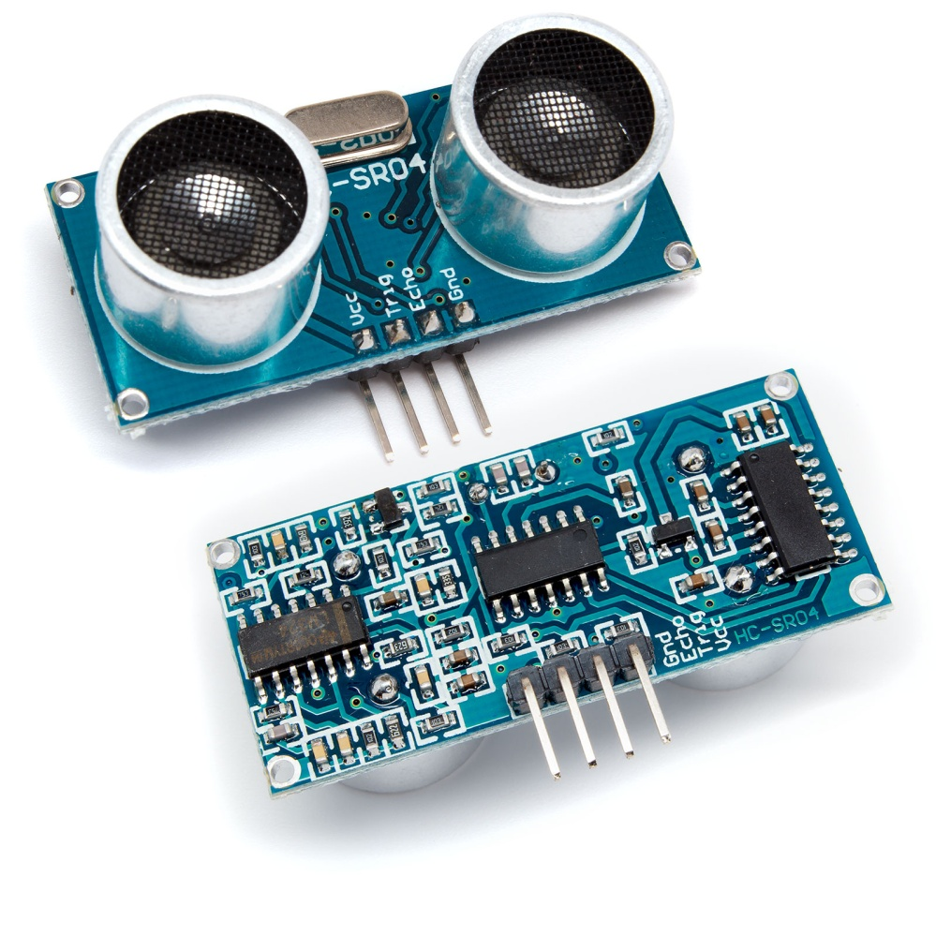
Figure 2 Ultrasonic Sensor
Ultrasonic ranging module HC - SR04 provides 2cm - 400cm non-contact measurement function, the ranging accuracy can reach to 3mm. The modules includes ultrasonic transmitters, receiver and control circuit. The basic principle of work:
(1) Using IO trigger for at least 10us high level signal
(2) The Module automatically sends eight 40 kHz and detect whether there is a pulse signal back.
(3) IF the signal back, through high level , time of high output IO duration is the time from sending ultrasonic to returning. Test distance = (high level time×velocity of sound (340M/S) / 2,
Wire connecting direct as following:
-5V Supply
-Trigger Pulse Input
-Echo Pulse Output
-0V Ground.
Electric Parameter:
Table 2 Electric Parameter
Working Voltage | DC 5 V
Working Current | 15mA
Working Frequency | 40Hz
Max Range | 4m
Min Range | 2cm
Measuring Angle | 15 degree
Trigger Input Signal | 10uS TTL pulse
Echo Output Signal | Input TTL lever signal and the range in proportion
Dimension | 45*20*15mm

The Timing diagram is shown below. We need to supply a short 10uS pulse to the trigger input to start the ranging, and then the module will send out an 8 cycle burst of ultrasound at 40 kHz and raise its echo. The Echo is a distance object that is pulse width and the range in proportion .We can calculate the range through the time interval between sending trigger signal and receiving echo signal. Formula: uS / 58 = centimeters or uS / 148 =inch; or: the range = high level time * velocity (340M/S) / 2; we suggest to use over 60ms measurement cycle, in order to prevent trigger signal to the echo signal. (2)
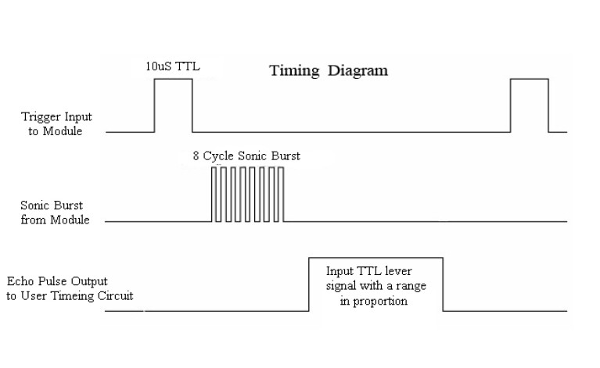
Figure 3 Timing Diagram

4.1.3 Stepper Motor

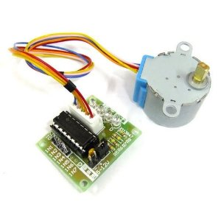
Figure 4 Stepper Motor
A stepper motor (or step motor) is a brushless DC electric motor that divides a full rotation into a number of equal steps. The motor's position can then be commanded to move and hold at one of these steps without any feedback sensor (an open-loop controller), as long as the motor is carefully sized to the application.
Animation of a simplified stepper motor (unipolar):
Frame 1: The top electromagnet (1) is turned on, attracting the nearest teeth of the gear-shaped iron rotor. With the teeth aligned to electromagnet 1, they will be slightly offset from right electromagnet (2).
Frame 2: The top electromagnet (1) is turned off, and the right electromagnet (2) is energized, pulling the teeth into alignment with it. This result in a rotation of 5.6°.
Frame 3: The bottom electromagnet (3) is energized; another 5.6° rotation occurs.
Frame 4: The left electromagnet (4) is energized, rotating again by 5.6°. When the top electromagnet (1) is again enabled, the rotor will have rotated by one tooth position
It will take 2048 steps to make a full rotation. (3)
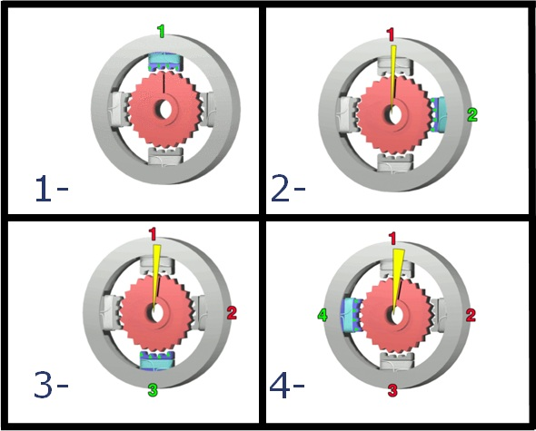
Figure 5 Stepper Frames

4.1.4 DC motor
A DC motor is any of a class of electrical machines that converts direct current electrical power into mechanical power. The most common types rely on the forces produced by magnetic fields. Nearly all types of DC motors have some internal mechanism, either electromechanical or electronic, to periodically change the direction of current flow in part of the motor. Most types produce rotary motion; a linear motor directly produces force and motion in a straight line.
DC motors were the first type widely used, since they could be powered from existing direct-current lighting power distribution systems. A DC motor's speed can be controlled over a wide range, using either a variable supply voltage or by changing the strength of current in its field windings. Small DC motors are used in tools, toys, and appliances. The universal motor can operate on direct current but is a lightweight motor used for portable power tools and appliances. Larger DC motors are used in propulsion of electric vehicles, elevator and hoists, or in drives for steel rolling mills. The advent of power electronics has made replacement of DC motors with AC motors possible in many applications.
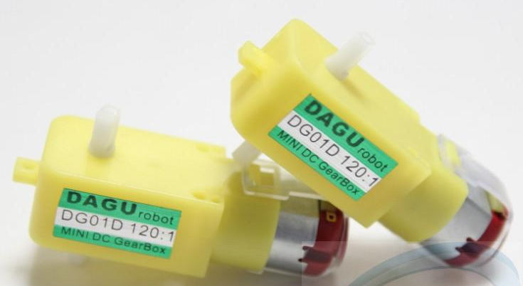
Figure 6 DC Motors
These two Dc motors are enabled to move left, right, forward, backward using H-bridge. Each of which has two lines that are connected with the H-bridge and need 9 volt to work properly. To move forward we have to run both motors in the same direction which forward. To move reverse is similar to forward but in reverse mode. To move either left or right one of the motors should be in the opposite direction of the other.

4.1.5 Wheel
We use two wheels to move robot in many directions. They are connected with dc motor to drive the robot .
Figure 7 Wheels

4.1.5 L298N motor driver
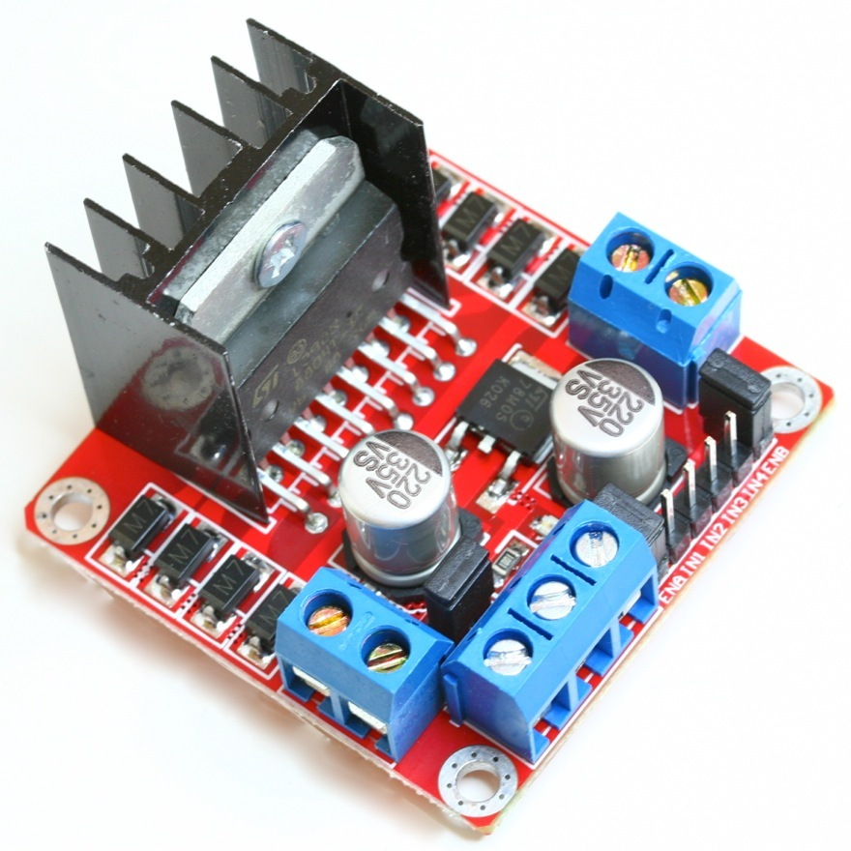
Figure 8 Motor Driver
To control the two DC motors ,first we connected each motor to the A and B connections on the L298N module.
Next, we connected our power supply - the positive to pin 4 on the module and negative/GND to pin 5. And of course we didn't forget to connect Raspberry Pi GND to pin 5 on the module as well to complete the circuit.
Now we will need four digital output pins on our Raspberry Pi to be attached with the driver module. In our project we have two DC motors, so 4 GPIO pins will be connected to pins IN1, IN2, IN3 and IN4 respectively.
The motor direction is controlled by sending a HIGH or LOW signal to the drive for each motor (or channel). For example for motor one, a HIGH to IN1 and a LOW to IN2 will cause it to turn in one direction, and a LOW and HIGH will cause it to turn in the other direction.
However the motors will not turn until a HIGH is set to the enable pin. And they can be turned off with a LOW to the same pin(s).

4.1.6 Wi-Fi Adapter
Tenda W311M is a 802.11n compliant wireless nano USB Adapter that provides up to 4x faster wireless speeds and 3x better wireless reception over 802.11g products while staying backward compatible with 802.11g/b devices. (4)
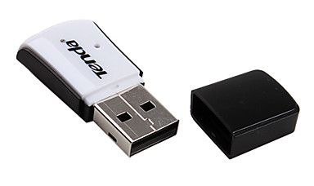
Figure 9 Tenda

4.2 Procedures

4.2.1 Controlling vehicle side:
In our project we used the Raspberry Pi as a microcontroller to control the hardware movements. The code that we installed on it is Python code includes both codes for controlling the movement of the two DC motors, the stepper motor and the ultrasonic sensor code.
We connect the Raspberry with the motor driver, the stepper motor, Ultrasonic sensor and the Wi-Fi adapter.
We control the robot wirelessly from a different computer using python. Our project controls the direction of the robot using the arrow keys and uses the greater keys to edit its speed. Robot can move forward ,backward ,right and left.

4.2.2 Distance Measurement:

The main objective of our project is measuring distance so we need a proximity distance sensor .At the beginning we start working with IR sensor, unfortunately we faced many problems with it. First IR has limited distance measuring range, we test:
-GP2Y0A21YK range: 10 to 80 cm then.
- GP2Y0A02 has longest-range (20 cm to 150 cm) but also not enough.
In addition to limited distance the output type of IR is analog voltage not digital and Raspberry pi doesn’t have a way to read analog inputs also doesn’t include a hardware analog-to-digital converter. It's a digital-only computer!
So we need a way to make the Pi analog-friendly. We do that by wiring up an external analog-digital-converter chip to it. ADC allows us to read an analog voltage signal and convert it to a value usable by Python code.
We try this by connecting MCP3002 chip, a black chip with two rows of four pins acts like a "bridge" between digital and analog. However, this chip doesn’t work .
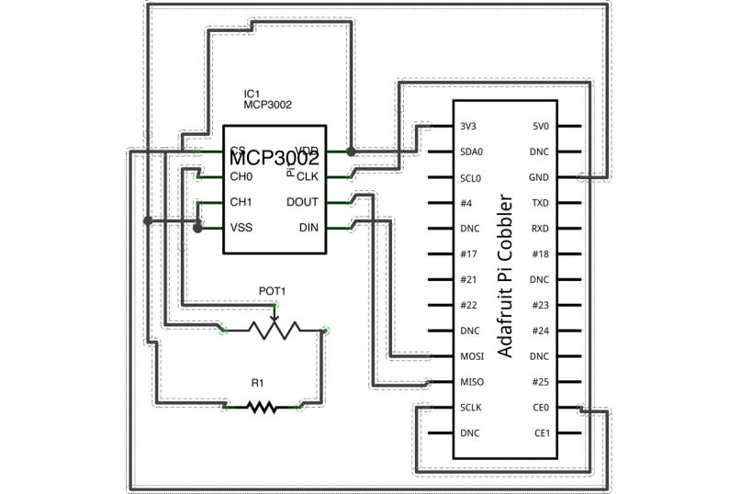
Figure 10 MCP3002 circuit
Again we turned over another IC which is MCP3008. Unfortunately we didn’t find it in our country and its need time to be available.
After all these problems we moved to Ultrasonic sensor. It’s a cheap sensor that can be used to measure the distance between itself and an object in front of it by sending an ultrasonic pulse and listening for its echo. The HC-SR04 can be connected to many things including the Raspberry Pi.
To calculate the distance between sensor and some object ,the pulse which travel distance (D) to the object and travel another distance back to the sensor ,so when we use equation of speed the distance will be (2D)
and the speed of the sound is 340m/s ,so if we follow equation (1) we have distance is equal to 170 multiply by the time
speed = distance /time ..............(1)
340 = 2D/time
D= 170 *time
The sensor output signal (ECHO) on the HC-SR04 is rated at 5V. However, the input pin on the Raspberry Pi GPIO is rated at 3.3V. Sending a 5V signal into that unprotected 3.3V input port could damage GPIO pins, which is something we want to avoid! We’ll need to use a small voltage divider circuit, consisting of two resistors, to lower the sensor output voltage to something our Raspberry Pi can handle.
How do we connect everything?
There are four pins on the HC-SR04 sensor. The pin labeled VCC requires connecting to a 5V pin, the pin labeled "Gnd" requires connecting to a ground pin, and the pins "Trig" and "Echo" need to be each wired to a unique GPIO pin on the Raspberry Pi.
We need to connect 1K resistor between the echo pin and the GPIO pin (to protect the Raspberry Pi from receiving a 5V signal to a 3.3V pin).
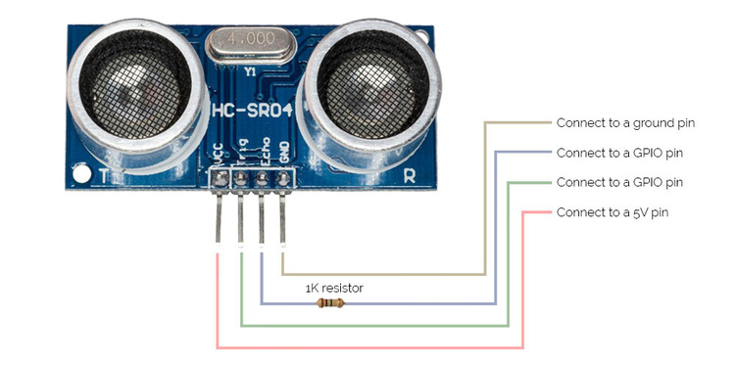
Below is a guide to show where the GPIO pins are on Raspberry Pi:

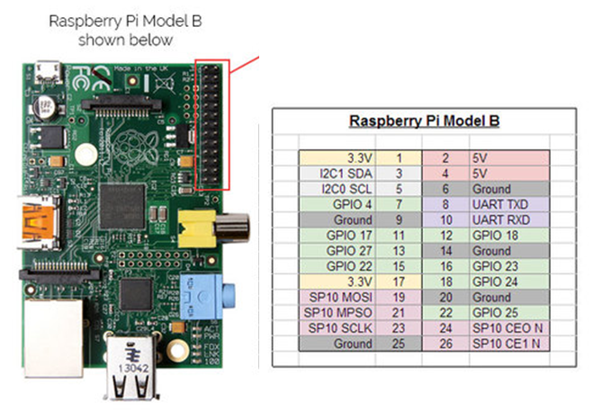
Figure 11RasPI GPIO Pins

Once everything is connected, we're ready to start communicating with the sensor in Python to receive distance readings
In a nutshell, the code sends a command to the sensor. This command tells the sensor to start measuring the distance between itself and whatever is in front of it. To measure distance the sensor sends 8 ultrasonic pulses and listens for the echo. The code measures the time it takes for the echo to be received. The difference between sending the pulse and receiving the echo is used to calculate the distance of objects in front of the sensor. This distance is reported in centimeters.

4.2.3 Motors
Then this sensor fixed above a motor to rotate and collect data about surrounding area. For motor, first we test a servo motor (Tower Pro MG995) by connecting it with raspberry pi without any additional ICs and it works.
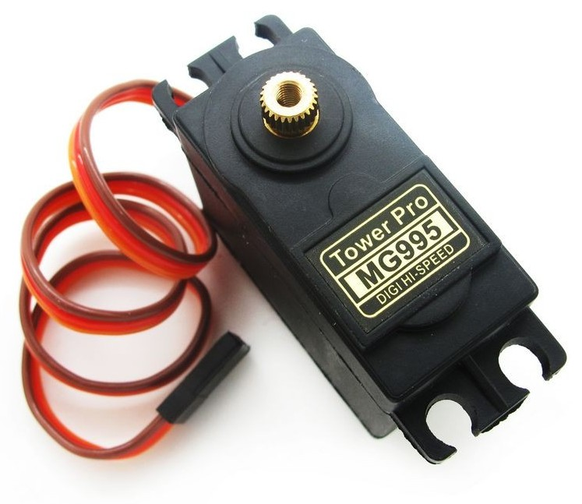
Figure 12Servo Motor
However, we find that this motor do not give us a continuous rotation (360) only half one(180). Again we turned over another motor which is stepper motor in order to have full rotation (360).
This stepper comes with a ULN2003A Driver board, the ULN2003
contains 7 darlington transistors. These boost the current capabilities
of the RPI so that it can supply enough power for the stepper motor.
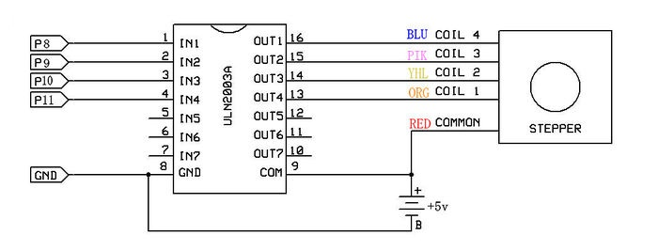
Figure 13 Stepper with Driver Board
The motor is quite low power and suffers less from the surges in current than DC motors and servos (which use DC motors). This will therefore work okay powered from the 5V line of the Raspberry Pi, as long as the Pi is powered from a good supply of at least 1A.
To rotate the stepper motor we provide a sequence of “high” and “low” levels to each of the 4 inputs in sequence. By setting the correct sequence of high and low levels the motor spindle will rotate. The direction can be reversed by reversing the sequence.
Interfacing With RasPi: The motor connects to the controller board with a pre-supplied connector. The controller board has 4+2 pins that need to be connected to the Pi header.

4.2.4 Wireless
Although the Raspberry Pi Model B comes with built-in 100Mbps wired Ethernet, it can also use Wi-Fi via a USB dongle. Simply plugging in a supported USB dongle and after doing a simple bit of configuration it gives Pi access to wireless. Even though this tiny wireless adapter is easy to use and easy to set up.But finding a compatible adapter USB with RasPi is not easy since the only choice was Tenda w311m.
There are two main ways to setup WIFI, both via the GUI (Graphical User Interface) and CMD (Command Line). We use: GUI (Graphical User Interface) we will describe it later.

4.3 Software

4.3.1 Raspberry Pi.
Raspberry pi running linux, so we can program for it in C++, Java, python or some other language we already be comfortable with. But we preferred to program using python to learn new language.
Linux Software Support:
● Kernel-level support: read, write, ioctl /dev/i2c, /dev/spidev, /dev/mem
● Application-level support: sysfs → read, write /sys
● Script-level support: C extension with /dev/mem + import module
First we should choose the required operating system and download it from Raspberry pi website. We choose Raspbian “Wheezy”- Debian based Rspberry Pi distribution/ Operating system.
Then we write the image of the OS on an SD card using the popular and free tool: Win 32 Disk Imager.

4.3.2 How GPIO Software Works:

● Enable or disable a GPIO pin
● Set which signal level is 'active'
● Determine whether it's an input or output
● Write a value to a pin
● Read a value to a pin
● Set the edges that will generate input interrupt
● Wait for an interrupt to occur

4.3.3 Python :

Python code :
● Import module
● Define pin numbering
● Setup up a channel
● Input/Output
● Cleanup

Python Packages:
● RPi.GPIO
● $ sudo apt-get install python-rpi.gpio
● $ curl RPi.GPIO.tar.gz| tar zxvf && sudo python setup.py install
● UART ● $ sudo apt-get install python-pip && sudo pip install pySerial
● PWM ● $ git clone (5)
● I2C ● $ git clone (6)
● SPI ● $ git clone (7)

Python Libraries:
python-smbus
python-gpio : its allows us to easily access and control the GPIO pins while running the Python script
Git-core.

4.3.4 Wi-Fi Configuration:
There are two main ways to setup WIFI( after connecting wireless nano USB adapter) both via the GUI (Graphical User Interface) and CMD (Command Line). We use: GUI (Graphical User Interface)
Before that we must Install and open the free SSH client on PC:
Secure Shell (SSH) is a cryptographic network protocol for secure data communication. It means remote command-line login and remote command execution between two networked computers. Here, we use it for the command-line login and remote command execution between the PC and the RasPi. A one-of-a- kind and free SSH client is PuTTY for Windows. Run PuTTY on Windows PC and then in the Host Name textbox of PuTTY, provide the raspberry IP address .
Launch "WIFI Config" from the desktop, this will launch the GUI application for easily configuring wireless networks
Click "Scan".
Double click our desired network. This will bring up another window containing some more advanced options for connecting to your network. For this example, we are assume we have a simple network setup.
In the "PSK" field, enter wireless password. All keyboard entries here will be converted into *'s for security purposes
Once done, click "Add". This will take you back to the previous scan screen, which you can now close. If everything has been done correctly, the WIFI config application will show you as connected. (8)
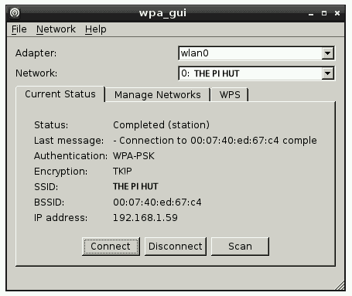
Figure 14 Wi-Fi Configuration

: Results and Analysis.

After very hard work we came out with Mapper Robot project. The project collects data of a room which can be visualized as a map later on a computer.

: Discussion

We expect the project to be usable across wide variety of users . The project is very user friendly and easy to get used to and learn how to use.

: Conclusions and Recommendation.

The importance of the university graduation project as an integrator of vocational and academic education should be recognized. Our case study shows its possible curricular standing that involves the student in a purposeful intensive learning of design and technology.

The project was a proximity distance sensor which is ultrasonic that attached to a vehicle and fixed above stepper motor. This is all controlled by Raspberry Pi microcontroller and computer.
This project was very useful. We learned so much about software and hardware. We also learned the importance of managing our budget and making tradeoff between quality and price. The sensor and motor for example, were surprisingly very expensive. We had to make a lot of research to find elements that would satisfy our budget.

References:

To know about Raspberry Pi:
1. [Online] https://www.raspberrypi.org/.
Ultrasonic Datasheet:
2. [Online] http://www.micropik.com/PDF/HCSR04.pdf.
About stepper motor:
3. [Online] http://en.wikipedia.org/wiki/Stepper_motor.
For Wireless Adapter:
4. [Online] http://www.microcenter.com/product/373032/W311M_150Mbps_Wireless_N_USB_20_Adapter.
Python Packages:
5. [Online] https://github.com/metachris/RPIO.git.
6. [Online] https://bitbucket.org/thinkbowl/i2clibraries.git .
7. [Online] https://github.com/lthiery/SPI-Py .
For setting up WiFi:
8. [Online] http://thepihut.com/blogs/raspberry-pi-tutorials/16018016-how-to-setup-wifi-on-the-raspberry-pi-raspbian.

