

An-Najah National University
Engineering Faculty
Computer Engineering Department

Hardware Graduation Project:
Arabic Sign Language Translator
(ARSL)

Team: Supervisors:
Fatima Daraghmeh. Dr. Luai Malhees
Israa khalifah. Dr. sofyan smarah

-2011-
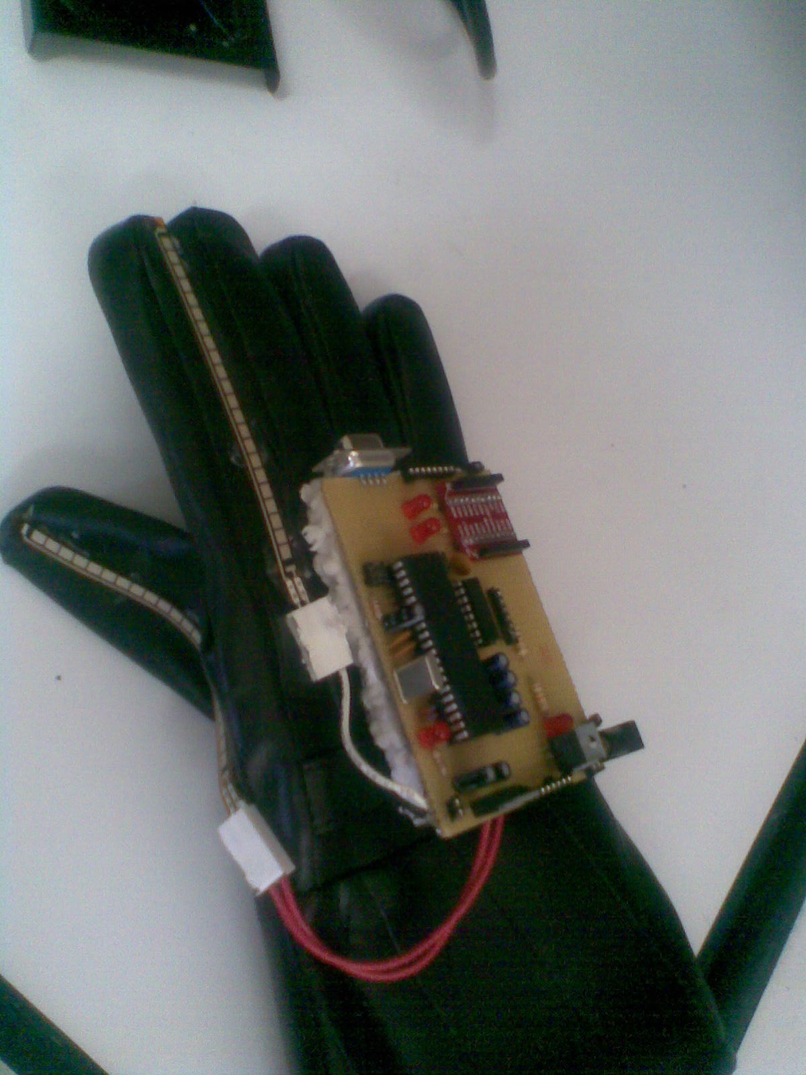
Introduction:
ARSL: Arabic Sign Language Translator.
Understand the language of the deaf and dumb without fatigue.

Using ARSL you can understand what the deaf person said … since our project translate sign language to sound and pictures and text which mean easy to anyone to understand that language.
Our project is a wireless application that allows Deaf persons to communicate with other persons in easy and freely way.

Programming Language used:
- PIC C.
- .Net (C#)

Hardware Component used
- PIC18F4620.
- Accelerometer (MMA7260Q)
- Flex sensors
- X-Bee wireless
Why ARSL:
Since it is attractive project, we found it very necessary to everyone in this life; it is good idea to found the same project in our society.
We study this idea and we love it then we work on it!

Technologies used in our project:
- PIC C
We use pic c to make some calculation and measurement .we use the ADC to take the accelerometer axes and flex values .
then we convert these values to voltage and send it via wireless to the pc to make some calculation .
- C#
We use c# to make some calculation to decide what the deaf person said. We make model depend on decision tree & K-NN.
We gave the character numbers from (1-10) …and the features (A-E) we divide the data to training set and testing sets (1:2).
Then we calculate the (IG ) information gain for all values and take the highest IG which are (A,D) as below :
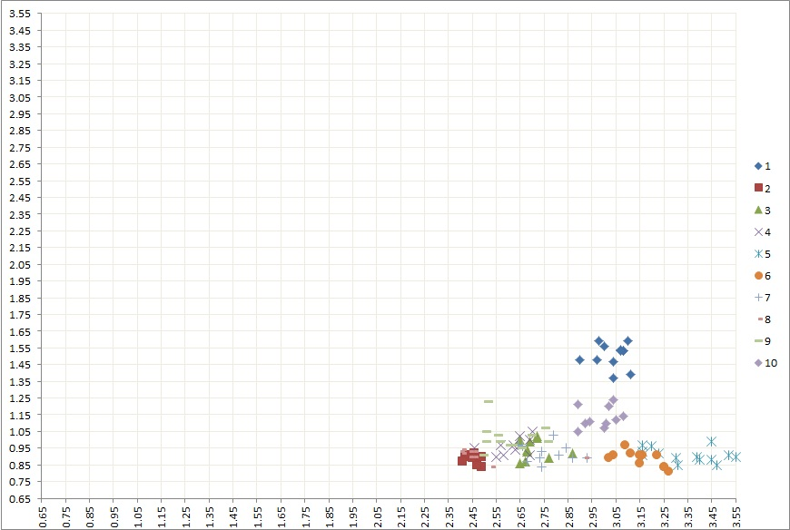

As you see (A,D) Divide the classes into 5 groups as below :-

Then we used K-NN (K=3) to divide the three groups (2,8) and (5,6) and (3,4,7,9).

K-NN: k-nearest neighbor algorithm.

is a method for classifying objects based on closest training examples in the feature space. K-NN is a type of instance-based learning, or lazy learning where the function is only approximated locally and all computation is deferred until classification. The k-nearest neighbor algorithm is amongst the simplest of all machine learning algorithms: an object is classified by a majority vote of its neighbors, with the object being assigned to the class most common amongst its k nearest neighbors (k is a positive integer, typically small). If k = 1, then the object is simply assigned to the class of its nearest neighbor.

It depends on Euclidian Distance =$d\left(p,q\right)= \sqrt{{\left(Ap-Aq\right)}^{2}+…+{\left(Ep-Eq\right)}^{2}}$

KNN Example
Training Data |  |  |  |  |  |  | Distances
A | B | C | D | E | Class |  | a | B | c
1 | 1 | 2 | 1 | 2 | 1 |  | 0.1 | 1 | 1.3
1.5 | 1.3 | 1.9 | 0.9 | 1.8 | 1 |  | 0.538516 | 0.509902 | 0.806226
1.1 | 1.2 | 2.3 | 1.4 | 2.2 | 1 |  | 0.316228 | 0.984886 | 1.264911
1.6 | 1.4 | 2.2 | 2 | 1 | 1 |  | 1.081665 | 1.077033 | 1.220656
3 | 3.1 | 5 | 1 | 2 | 2 |  | 2.002498 | 1 | 0.7
2.8 | 3 | 4.6 | 1.3 | 2.4 | 2 |  | 1.811077 | 0.8544 | 0.583095
3.2 | 3.3 | 5 | 1.1 | 2 | 2 |  | 2.2 | 1.204159 | 0.905539
Testing Data
A | B | C | D | E | Class | Sample | Predicted Class using KNN
1 | 2 | 2 | 1.1 | 2 | ? | a | 1
2 | 2 | 3 | 1 | 1.3 | ? | b | 1
2.3 | 2 | 3 | 1 | 1.3 | ? | c | 2

Then we use (B, C) Features to divide group (2, 8) as below:-

As you see we have outliers values but we can neglected it .
Then we use (B,E) for (5,6) and (3,4,7,9) as below :-

Look:-

The values we used it before it depend on our hardware component which are:-
- Pic18F4620
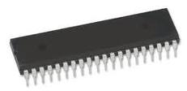

2-accelorometer
±1.5g - 6g Three Axis Low-g Micromachined Accelerometer
The MMA7260Q low cost capacitive micromachined accelerometer features signal conditioning, a 1-pole low pass filter, temperature compensation and g-Select which allows for the selection among 4 sensitivities. Zero-g offset full scale span and filter cut-off are factory set and require no external devices. Includes a Sleep Mode that makes it ideal for handheld battery powered electronics.
Features
. Selectable Sensitivity (1.5g/2g/4g/6g)
. Low Current Consumption: 500 μA
. Sleep Mode: 3 μA
. Low Voltage Operation: 2.2 V . 3.6 V
. 6mm x 6mm x 1.45mm QFN
. High Sensitivity (800 mV/g @1.5 g)
. Fast Turn On Time
. High Sensitivity (1.5 g)
. Integral Signal Conditioning with Low Pass Filter
. Robust Design, High Shocks Survivability
. Pb-Free Terminations
. Environmentally Preferred Package
. Low Cost

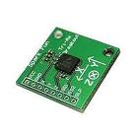

3-Flex sensors :-
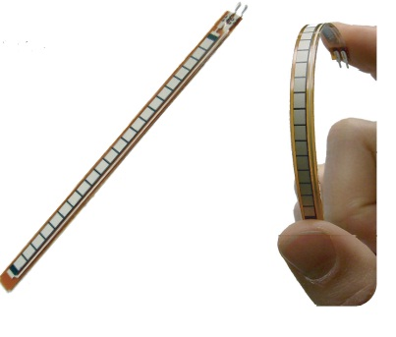

"The impedance buffer in the [Basic Flex Sensor Circuit] (above) is a single sided operational amplifier, used with these sensors because the low bias current of the op amp reduces error due to source impedance of the flex sensor as voltage divider. Suggested op amps are the LM358 or LM324."
"You can also test your flex sensor using the simplest circuit, and skip the op amp."
"Adjustable Buffer - a potentiometer can be added to the circuit to adjust the sensitivity range."
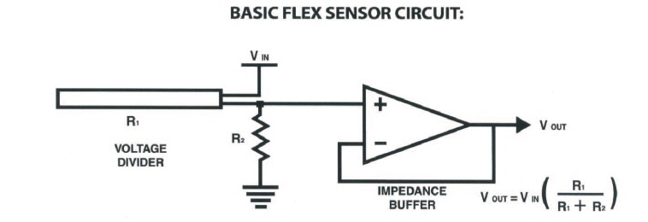

4- X-bee wireless:-
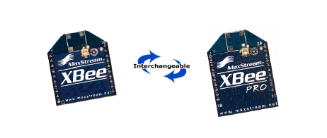
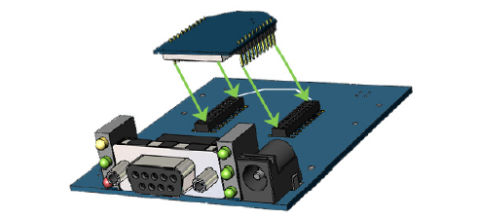

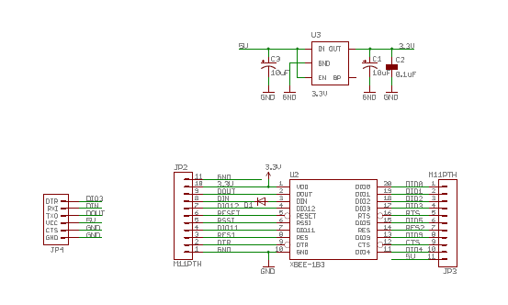

Problems face us:
We face a lot of problems basically in accelerometer, we found a lot of challenges when we test it, we try and try and then we found the result which we need.
in our project we need very exact values which is difficult to obtain it from the accelerometer since it is very sensitive sensor .
Then the flex sensor damaged and we fixed it.
We face big problem in the software of our project which we need it very accurate . Dr. anas help us to obtain this software .

