
Construction A Green Building in Palestine
Graduation Project

December 25, 2017
Laith Sarsour, Moath Yadak, Ansar Dwiekat, Namir Awad
An-Najah National University

An-Najah National University
Faculty of Engineering and Information Technology
Energy Engineering and Environment Department
Construction a Green Building in Palestine
Prepared by:
Laith Sarsour
Moath Yadak
Ansar Dwiekat
Namir Awwad
Supervisor:
Dr. Mohammad Al-Sayed
This project is Submitted in Partial fulfillment of the Requirements for the Bachelor Degree on Energy Engineering and Environment, Faculty of Engineering and Information Technology, An-Najah National University, Nablus – Palestine.

December, 2017

Acknowledgment
Firstly, we would like to express our deepest gratitude to our supervisor, Dr. Mohammad Al-Sayed for his generous advice, kind assistance and patiently guidance. Thank you for all your time and valuable experiences that you have shared with us regarding this study. Without your support, this dissertation could hardly be completed.
Last but not least, sincere gratitude and appreciation is forwarded to our families for care, moral support and understanding during this research work.

Abbreviations
Table 1 Table of Abbreviations
Abbreviation | Definition
LEED | Leadership in Energy and Environmental Design
GBES | Green Building Education Service
USGBC | United States Green Building Council
EPA | Environmental Protection Agency
DOE | Department of Energy
MPRs | Minimum Program Requirements
IPCC | Intergovernmental Panel on Climate Change
LT | Location and Transportation
ND | Neighborhood Development
EPA | Environmental Protection Agency
ITE | Institute of Transportation Engineers
SS | Sustainable Sites
WE | Water Efficiency
ESC | Erosion and Sedimentation Control
SRI | solar reflectance index
EA | Energy and Atmosphere
HVAC | Heating, Ventilation and Air Conditioning
ASHRAE | American Society of Heating, Refrigerating and Air-Conditioning Engineers
HVAC&R | Heating, Ventilation, Air Conditioning and Refrigeration
DHW | Domestic Hot Water
CFC | Chlorofluorocarbon
ODS | Ozone-Depleting Substances
BMS | Building Management System
MR | Materials and Resources
WMP | Waste Management Plan
IEQ | Indoor Environmental Quality
VOC | Volatile Organic Compound
LEED AP | LEED Accredited Professional
RP | Regional Priority

Table of Contents
Acknowledgment i
Abbreviations 1
Table of Contents 2
List of Tables 5
List of Figures 6
List of Appendix 7
Abstract 8
Introduction 10
Objectives of the Project 11
LEED: Leadership in Energy and Environment Design 12
History of LEED 12
LEED Certification Benefits 12
LEED Rating Systems 13
1. Building Design + Construction (BD+C) 13
2. Interior Design + Construction (ID+C) 15
3. Building Operations + Maintenance (O+M) 15
4. Neighborhood Development (ND) 16
LEED Certification 17
Location and Transportation 17
Materials and Resources 19
Water Efficiency 20
Energy and Atmosphere 21
Sustainable Sites 22
Indoor Environmental Quality 27
Multiple Certification for the Same Building 29
LEED Rating System Structure 29
LEED Prerequisites, Credits, and Points 30
Prerequisites 30
Credits 30
Points 31
Minimum Program Requirements 32
Literature Review 34
Defining Green Building 34
Principles and Benefits of Green Building 35
Potential Barriers for Green Building 38
Main Barriers to Green Building in Developed Countries 39
Cultural Barriers 39
Financial Barriers 40
Steering Barriers 41
Barriers to Green Building in Developing Countries 41
Barriers to Green Building in Palestine 42
Case Study: Construction a Shopping Center in Palestine According to LEED Building Design and Construction 43
Introduction 43
Main Project Information 44
Description of the Shopping Center Structural Components 44
Minimum Program Requirements 50
Rating System Selection Guidance 50
Construction Phase LEED Targeted Credit 51
Location and Transportation 51
Sustainable Site 58
Water Efficiency 62
Energy and Atmosphere 67
Materials and Resources 74
Indoor Environmental Quality 78
Innovation 84
Regional Priority 85
Conclusion 87
Appendix A: ENERGY STAR Program Overview 89
Appendix B: Sensitive Land Protection Two Main Options 90
Appendix C: Use Types and Categories 92
Appendix D: Advanced Energy Metering Characteristics 93
Appendix E: ASHRAE Standard 62.1 94
Appendix F: ASHRAE Standard 55 95
Appendix J: Building Flush-Out 97
Appendix H: GROHE Products Data Sheet 98
Appendix I: ANSI/ASHRAE/IESNA Standard 90.1–2010 102
Appendix G: Northern Façade and Roof Top of the Shopping Center 103
Appendix K: Southern Façade of the Shopping Center 103
Appendix L: Eastern Façade of the Shopping Center 104
Appendix M: Site Plan 105
References 106

List of Tables
Table 1 Table of Abbreviations 1
Table 2 Financial Benefits of Green Buildings per ft.² 36
Table 3 The Principles of Green Building 37
Table 4 Glass Material Proprieties 45
Table 5 Exterior Wall Material Properties 46
Table 6 Floor and Ceiling Material Prosperities 47
Table 7 Roof Material Proprieties 48
Table 8 Baseline Water Consumption of Fixtures, Benchmark Water Use for Fixtures, and Potential Percent Savings 65
Table 9 LEED Chicklist 88
Table 10 Use Types and Categories 92

List of Figures
Figure 1 Diagram of Heat Island Effect 26
Figure 3 LEED Certification 31
Figure 4 Surrounding Existing Density within 400-meter Radius of the Shopping Center Boundary 54
Figure 5 Distance between Rafedia Main Street and the Shopping Center Main Entrance 55
Figure 6 Distance between Al-Makhfia Main Street and the Shopping Center Main Entrance 56
Figure 7 Graphic Comfort Zone Method: Acceptable Range of Operative Temperature and Humidity 95
Figure 8 Acceptable Range of Operative Temperature and Air Speeds for the Comfort Zone 96

List of Appendix
Appendix A: ENERGY STAR Program Overview 89
Appendix B: Sensitive Land Protection Two Main Options 90
Appendix C: Use Types and Categories 92
Appendix D: Advanced Energy Metering Characteristics 93
Appendix E: ASHRAE Standard 62.1 94
Appendix F: ASHRAE Standard 55 95
Appendix J: Building Flush-Out 97
Appendix H: GROHE Products Data Sheet 98
Appendix I: ANSI/ASHRAE/IESNA Standard 90.1–2010 102
Appendix G: Northern Façade and Roof Top of the Shopping Center 103
Appendix K: Southern Façade of the Shopping Center 103
Appendix L: Eastern Façade of the Shopping Center 104
Appendix M: Site Plan 105

Abstract
When constructing a green Shopping Center, visitors will be able to experience a Palestinian energy-efficient green building. Striving for a Leadership in Energy and Environmental Design gold rating. A work like this, for sure, will have a great future work with the Palestine Green Building Council to assure that it implements and adheres to green building design guidelines set by LEED.
The Shopping Center’s building will be a model for environmental sustainability on the Palestinian level. This building project can be used as an educational case-study to deliver training workshops to engineers, contractors, university students and other professionals.
The Shopping Center, followed LEED strategies to be a green efficient building that has a less negative impact on the environment and protect the natural resources.
Water and energy consumption in the building will be reduced by using green solutions in design and constructions. The Center building’s orientation is such that it will be able to maintain adequate and comfortable temperatures in both summer and winter months. Green solutions include collecting rainwater from the rooftop of the building in large water containers for reuse. Solar energy will be used to heat water for public use, while wastewater will be refined and reused for irrigating the gardens based on an automatically controlled water system. Moreover, the gardens of the Center will be planted with indigenous plants, which tend not to require large amounts of water.
The Center aims to create a healthy environment that is ideal for both visitors and staff by introducing methods and procedures to reduce the rates of toxic substances that exist in various types of paint, carpets and concrete, which vaporize in certain temperatures and affect breathing and therefore health.
The site will be surrounded with a special fence that prevents the erosion of soil from the construction area, thereby mitigating the environmental impact of the construction process on the adjacent area (silt controlling fence). A washing station for trucks will be created on site to reduce the transmission of dust and mud to the surrounding streets and neighborhoods.
Implementing green building design guidelines in Palestine poses certain challenges. As the global environmental standards are additional requirements for Palestinian contractors and workers who are accustomed old ways of construction and site maintenance. Furthermore, the acute shortage of resources and expertise which will be another challenge to get this work implemented.

Introduction
Green building, or sustainable design, is the practice of increasing the efficiency with which buildings and their sites use energy, water and materials, and of reducing impacts on human health and the environment for the entire lifecycle of a building. Green-building concepts extend beyond the walls of buildings and include site planning, community and land-use planning issues as well.
The growth and development of our communities has a large impact on our natural environment. The manufacturing, design, construction and operation of the buildings in which we live and work are responsible for the consumption of many of our natural resources.
Globally, as reported by Maggie Comstock, former policy analyst at USGBC, buildings account for 40% of energy use, 38% of greenhouse gas emissions, 12% of potable water and 20% of solid waste streams in developed countries (Comstock, 2013). The Intergovernmental Panel on Climate Change (IPCC) has identified buildings as the greatest impact, least costly way to reduce greenhouse gas emissions and address climate change (GBPN, et al., 2014). Beyond emissions reduction and environmental protection, green buildings have extensive co-benefits, including cost-savings, job creation, and improved human health and productivity.
To achieve concrete results in this regard, green building sector, coordinated efforts should be made to employ various means, such as science, technology, economic measures, legislation and administration in an integrated, mutually supportive way.
City planners and architects should raise their awareness of green building, energy efficiency and emissions reduction. At the same time, planning and design institutes should increase their job posts in related areas, such as building technology, building ecology, indoor air quality, water and wastewater engineering, heating, ventilation and air conditioning, and energy management. A mechanism should be set up to allow experts from various disciplines to take part in design and planning. Furthermore, regional energy source planning should be implemented.

Objectives of the Project
The aim of this working project is to construct a green building in Palestine. And seek the potentials and the ability of construction an energy efficient building here in Nablus, Palestine, although of all the difficulties and constrains that this operation is going to face.
According to the USGBC projects’ directory, there is only one LEED Certified building in Palestine. This implies the limited number of LEED projects in Palestine. Accordingly, the overall study objective is to depict the applicability and Implementation of U.S. Green Building Council Rating System (LEED) in Palestine. This study may also contribute to a better understanding of the concept of implementing LEED green building rating system in Palestine.

LEED: Leadership in Energy and Environment Design
LEED, according to (GBES, 2014), stands for Leadership in Energy and Environmental Design. LEED is a leading-edge system for certifying high-performance buildings and sustainable neighborhoods.

History of LEED
LEED was developed by United States of Green Building Council (USGBC), and the LEED Green Building Rating System is the USGBC's primary vehicle for promoting sustainable design and construction. The LEED standard was created through volunteer committees. From 1994 to 2013, LEED grew from one standard for new construction to a comprehensive system of interrelated standards covering all aspects of the development and construction process. LEED also has grown from six volunteers on one committee to more than 200 volunteers on nearly 20 committees and nearly 150 professional staffs.
LEED was created to accomplish a set of clear goals, starting by defining “green building” by establishing a common standard of measurements, promote integrative; whole building design practice, recognize environmental leadership in the building industry, simulate green competition, raise consumer awareness of green building benefits, and transform the building market. Mention that, LEED helps to evaluate a building’s performance throughout the building’s life cycle.

LEED Certification Benefits
LEED certification saves money over the life of the building. One of the benefits of green building is the financial benefits of green building: lower operating costs, increased building value, higher occupancy rates, and higher rents.
Quite simply, LEED certified buildings use key resources more efficiently when compared to conventional buildings which are simply built to code or a strict budget. LEED certified buildings have healthier work and living environments, which contributes to higher productivity and improved employee health and comfort. The USGBC has also compiled a long list of benefits of implementing a LEED strategy which ranges from improving air and water quality to reducing solid waste, benefitting owners, occupiers, and society as a whole.
Some other benefits of LEED certification include:
- State and local government incentives – In general, many government agencies give tax breaks for green buildings.
- LEED facilitates the integrative process from start to finish - LEED encourages design teams to use a holistic approach and to measure progress. Using LEED ensures that your building will have a low impact on its occupants and the environment and a positive economic impact over the lifecycle of the building. Rather than attempting to follow local green building programs that may vary from city to city, or using bits and pieces of different green building approaches.
- Third party validation of achievement - LEED is the mechanism through which project teams certify the performance of their buildings through an independent third party certification. LEED certification has become accepted as the standard that distinguishes a building as green.
- Cost Savings on Utilities - a study conducted by the New Buildings Institute titled `Energy Performance of LEED for New Construction Buildings' (Turner, et al., 2008) analyzed 121 LEED-Certified office buildings in the U.S. and found that they use 24% less energy than similar buildings. Indoor and outdoor water use can also be reduced.
- Increased Value - LEED certified buildings studies are able to charge higher rents for their optimal office environments, making the building itself more valuable for owners and stakeholders.

LEED Rating Systems
LEED is a flexible system, it’s not only applied to different building types (commercial vs. residential), but also beyond the building footprint. Because of this flexibility, there are different versions of LEED depending on the project type.
The LEED rating systems are grouped into four main categories:

Building Design + Construction (BD+C)
The first category, Building Design and Construction, contains 10 LEED rating systems. These rating systems are guidelines for new buildings and old buildings undergoing major renovations. Schools, hospitals, retail, data centers, warehouses, office buildings, and apartment buildings are all examples of buildings that would fall into this category.
- LEED BD+C New Construction - addresses design and construction activities for both new buildings and major renovations of existing buildings. This includes major HVAC improvements, significant building envelope modifications and major interior rehabilitation.
- LEED BD+C Core & Shell - is for projects where the developer controls the design and construction of the entire mechanical, electrical, plumbing, and fire protection system -called the core and shell - but not the design and construction of the tenant fit-out.
- LEED BD+C Schools - is for buildings made up of core and ancillary learning spaces on K-12 school grounds. If can also be used for higher education and non-academic buildings on school campuses.
- LEED BD+C Retail - addresses the unique needs of retailers - from banks, restaurants, apparel, electronics, big box and everything in between.
- LEED BD+C Hospitality - is dedicated to hotels, motels, inns, or other businesses within the service industry that provide transitional or short-term lodging with or without food.
- LEED BD+C Data Centers - is specifically designed and equipped to meet the needs of high density computing equipment such as server racks, used for data storage and processing.
- LEED BD+C Warehouses & Distribution Centers - is for buildings used to store goods, manufactured products, merchandise, raw materials, or personal belongings, like self-storage.
- LEED BD+C Healthcare - is hospitals that operate twenty-four hours a day, seven days a week and provide inpatient medical treatment, including acute and long-term care.
- LEED BD+C Homes and Multifamily Low-rise - is for single-family homes and multi-family residential buildings of 1 to 3 stories. Projects 3 to 5 stories can choose the Homes rating system that corresponds to the ENERGY STAR program (Appendix A) in which they are participating.
- LEED BD+C Multifamily Midrise - is for multi-family residential buildings of 4 to 8 occupiable stories above grade.

Interior Design + Construction (ID+C)
The second category is Interior Design and Construction, which was designed specifically for tenants leasing a portion of a larger building. Interior spaces in commercial buildings, retail, and hospitals would fall into this category. For example, a company leasing commercial office space or for example; a Starbucks in a strip center would pursue this option.
- LEED ID+C Commercial Interiors is for interior spaces dedicated to functions other than retail or hospitality.
- LEED ID+C Retail guides retailers interior spaces used to conduct the retail sale of consumer product goods. Includes both direct customer service areas (showroom) and preparation or storage areas that support customer service.
- LEED ID+C Hospitality is designed for interior spaces dedicated to hotels, motels, inns, or other businesses within the service industry that provide transitional or short-term lodging with or without food.

Building Operations + Maintenance (O+M)
The third category is Building Operations and Maintenance, which can be used by building owners and operators to measure operations and maintenance as well as make minor improvements with no construction. Schools, hospitals, retail, data centers, and warehouses can fall into this category.
- LEED O+M Existing Buildings is specifically projects that do not primarily serve K-12 educational, retail, data centers, warehouses and distribution centers, or hospitality uses.
- LEED O+M Retail guides existing retail spaces, both showrooms, and storage areas.
- LEED O+M Schools is for existing buildings made up of core and ancillary learning spaces on K-12 school grounds. It can also be used for higher education and non-academic buildings on school campuses.
- LEED O+M Hospitality is for existing hotels, motels, inns, or other businesses within the service industry that provide transitional or short-term lodging with or without food.
- LEED O+M Data Center is for existing buildings specifically designed and equipped to meet the needs of high density computing equipment such as server racks, used for data storage and processing.
- LEED O+M Warehouses and Distribution Centers is for existing buildings used to store goods, manufactured products, merchandise, raw materials, or personal belongings (such as self-storage).

Neighborhood Development (ND)
The fourth and final category is LEED for Neighborhood Development, which integrates the principles of smart growth, urbanism, and green building into the first national program for neighborhood design.
LEED ND applies to new land development projects or redevelopment projects containing residential uses, nonresidential uses, or a mix. Projects can be at any stage of the development process, from conceptual planning to construction.
LEED ND Plan certification is available to any neighborhood-scale project if it's currently in any phase of planning and design and up to 75% constructed. USGBC designed this offering to help market developers and fund their projects among prospective tenants, financiers, public officials, etc. by affirming their intended sustainability strategies.
LEED ND Built Project is designed for neighborhood-scale projects that are near completion, or were completed within the last three years.

LEED Certification
In order for a building project to earn LEED Certification, it must meet certain criteria and goals within the following categories:
Location and Transportation
The location of a building is as important as how it is built, it is a crucial component of green building practice. A building can meet the needs of the local community, support active street life, promote healthy lifestyles and contributes in reducing greenhouse gas emissions in a wide range through its location.
When choosing the building location, it is preferable that the project (building) is connected to the community by pedestrian paths and bicycle lanes to let people ride bicycles, or walk to the building, and take public transportation as these practices contribute in reducing the carbon emissions associated with commuting. Mention that when people walk or bike instead of drive, not only helping to reduce air pollution, but also promoting physical activity.
The following sub-sections list and explain some strategies according to the LEED (Blust, et al., 2014),
- Strategies to Address Location:
- Choose redevelopment and infill development. Build on previously developed land and brownfield sites.
- Locate near existing infrastructure. Avoid triggering suburban sprawl and unnecessary materials use by consolidating development along existing roads, power lines, and water supplies.
- Protect habitat. Give preference to locations that do not include sensitive site elements and land types.
- Increase density. Create a smaller footprint and maximize the FAR (floor area ratio) or square footage per acre.
- Increase diversity of uses. Provide the services that are most needed within communities and support a balance of jobs and housing.
- Encourage multiple modes of transportation. Enable occupants to walk, bicycle, and use public transit.
- Strategies to Address Transportation:
- Strategies to Address Transportation in Design and Planning:
- Locate near public transit. Select a project site within easy walking distance of an existing transportation network.
- Limit parking. The lack of parking spaces on the project site will spark interest in alternative transportation options.
- Encourage bicycling. Install secure bike racks and showers for commuters.
- Strategies to Address Transportation in Operations and Maintenance:
- Encourage carpooling. Designate preferred spaces for carpool vehicles in the parking area.
- Promote alternative-fuel vehicles. Provide a convenient refueling station on the site.
- Offer incentives. Develop an alternative commuting incentive program for building occupants.
- Support alternative transportation. Promote alternatives to single occupant car commuting at the building and/or city level.

Materials and Resources
Materials are the foundation of any building. In green buildings specifically, the materials and resources used for buildings should minimize the embodied impacts associated with the entire life-cycle of building materials, reduce the harms associated with materials by using less, finding materials with environmentally preferable attributes, using locally harvested materials, and eliminating wastes.
Strategies for conserving materials:
- Reuse existing buildings and salvaged materials. Selecting resources that have already been harvested and manufactured results in tremendous materials savings.
- Plan for smaller, more compact communities. Reduce the need for new roads and other infrastructure by preventing sprawling land-use patterns.
- Identify local sources of environmentally preferable products. Using local materials not only reduces the environmental harms associated with transportation, it also supports the local economy.
- Specify green materials and equipment. Give preference to rapidly renewable materials, regional materials, salvaged materials, and those with recycled content. Choose vendors who promote source reduction through reusable or minimal packaging of products.
- Design buildings that produce less waste. Use strategies such as designing for dimensional construction materials, prefabrication, or material efficient framing.

Water Efficiency
Reducing water consumption and protecting water quality is the key objective of sustainable building.
In general, sustainable use of water means utilizing limited water resources in a sustainable way to realize more functions and make it more efficient by recycling or harvesting.
Water efficiency helps in protecting our aquifers and the supply of renewable fresh water, reducing the quantity of water needed a buildings and landscaping, reducing municipal water use, and reducing the need of water treatment (GBES, 2014).
The following sub-sections list and explain some strategies according to the LEED (Blust, et al., 2014),
- Strategies for reducing indoor water use:
- Install efficient plumbing fixtures. Install new high-efficiency fixtures, including high-efficiency lavatories, kitchen sinks and showers, dual-flush toilets, waterless urinals, and composting toilets.
- Use non-potable water. Use captured rainwater, graywater, or municipally-provided reclaimed water for flush fixtures. Design and install plumbing systems that can use captured rainwater or graywater in flush fixtures.
- Install sub-meters. Meter indoor water systems and monitor the data to track consumption trends, determine fixture performance, and pinpoint leaks.
- Strategies for reducing outdoor water use:
- Choose locally adapted plants. Landscape with native and adapted plants that require less water. These plantings have the added benefit of providing habitat for native wildlife.
- Use xeriscaping. These drought-tolerant plantings have extremely low water needs. Especially in arid regions.
- Select efficient irrigation technologies. Drip and bubbler systems and weather-based controllers can save water.
- Use non-potable water. Captured rainwater, graywater, or municipal reclaimed water is suitable for irrigation.
- Install sub-meters. Meter the irrigation system to track water consumption and identify leaks.
Energy and Atmosphere
Day by day the importance of energy conservation increases since the global warming and air pollution causes are linked to the increasing in energy demand and fossil fuel burning.
In buildings, the sustainability use of energy means use less energy and support the use of more environmentally friendly energy sources.
Green buildings can reduce demand for energy by capturing natural, incident energy, such as sunlight, wind, and geothermal potential and also it encourages sustainable methods for meeting energy needs to reduce loads.
Furthermore, green buildings promote energy efficiency; using less energy to accomplish the same amount of work.
The following sub-sections list and explain some strategies according to the LEED (Blust, et al., 2014),
- Strategies for reducing energy demand:
- Establish design and energy goals. Set targets and establish performance indicators at the outset of a project and periodically verify their achievement.
- Size the building appropriately. A facility that is larger than necessary to serve its function creates costly and wasteful energy demand.
- Use free energy. Orient the facility to benefit from natural ventilation, solar energy, and daylight.
- Insulate. Design the building envelope to insulate efficiently against heating and cooling losses.
- Strategies for achieving energy efficiency:
- Address the envelope. Use the regionally-appropriate amount of insulation in the walls and roof and install high-performance glazing to minimize unwanted heat gain or loss.
- Install high-performance mechanical systems and appliances.
- Use energy simulation. Computer modeling can identify and prioritize energy efficiency opportunities.
Sustainable Sites
Site sustainability refers to the relation between the building and the environment surrounding it and creating synergies between building and site, it includes many strategies that take under consideration the vital relationships among buildings, ecosystems, and ecosystem services. It focuses on restoring project site elements, integrating the site with local and regional ecosystems, and preserving the biodiversity that natural systems rely on.

The following strategies do benefit the building and larger community:
- Site Assessment
A site assessment assesses site conditions before design to evaluate sustainable options and inform related decisions about site design. A site assessment is part of the integrative process that helps to incorporate the assets of the site and its historical contexts.
In other words, site assessment means to look and examine the site features and take those features into the design considerations and how the site conditions influence the project design.
An assessment reviews the sites’:
- Topography: contour mapping, unique topographic features, slope stability risks.
- Hydrology: flood hazard areas, delineated wetlands, lakes, streams, shorelines, rainwater collection and reuse opportunities.
- Hydrology: flood hazard areas, delineated wetlands, lakes, streams, shorelines, rainwater collection and reuse opportunities.
- Climate: solar exposure, heat island effect potential, seasonal sun angles, prevailing winds, monthly precipitation and temperature ranges.
- Vegetation: primary vegetation types, green field area, significant tree mapping, threatened or endangered species, unique habitat, and invasive plant species.
- Soils: prime farmland, healthy soils.
- Human use: views, adjacent transportation infrastructure, adjacent properties, construction materials with existing recycle or reuse potential.
- Human health effects: proximity of vulnerable populations, adjacent physical activity opportunities, proximity to major sources of air pollution.
- Site Design
The sustainable site design includes strategies for designing and maintaining a sustainable site. The site planning considers both the site and the function of the building to determine the site's ability to support the building while minimizing environmental impacts. The development footprint of the building should be taken into account, it includes the building as it and the areas that will be affected by the project's activity, such as cross roads, parking lots, sidewalks, other hardscapes, and any other type of building like a storage shed, etc. Mention that the building footprint should be minimized and the open spaces should be maximized this is what it called by the site development dense.
Strategies for developing a sustainable site design:
- Minimize hardscape. Substitute pervious surfaces for traditional paving.
- Use native landscaping. Select plants that are native to the area both to reduce water use and to provide habitat for local birds and other species. Incorporate mulch into the landscape to build the soil and naturally suppress weeds.
- Prevent light pollution. Avoid up-lighting, glare, and trespass by using shielded fixtures and strategic lighting design.
- Preserve open space and sensitive areas. Consolidate the development footprint and protect and restore natural vegetation, wetland areas, and bodies of water.
- Protect and restore habitat. Designate areas as protected habitat and open space for the life of the project. Develop a conservation management program to make sure that the natural environment is protected. Consider putting protected areas into a land trust.

- Rainwater Management
The management of water from precipitation is a major step towards a sustainable use of resources. Rainwater management includes planning, design, and operational practices that control rainwater and protect the quality of surface and ground water. It also includes the collection and reuse of water for no potable purposes, such as landscape irrigation, toilet and urinal flushing, and custodial uses.
Strategies for rainwater management:
- Minimize impervious areas. Increase the area of permeable surfaces, such as vegetated roofs, porous pavement, and landscaped areas.
- Control rainwater. Install dry ponds, rain gardens, bioswales, and similar landscape features designed to hold water and slow the rate of runoff.
- Incorporate rainwater management into site design. Use features that serve multiple functions, such as planters that collect rainwater, streets that include bioswales to capture and hold rainwater, and mulch that both builds soil and holds moisture.
- Redirect rainwater. Direct runoff into rain gardens, bioswales, and other landscape features that retain water.
- Harvest rainwater. Collected water can be used as process water, to flush toilets, or to provide irrigation.
- Heat Island Effect
Urban areas are usually warmer than their rural surroundings, a phenomenon known as the “heat island effect”.
Heat islands can affect communities by increasing summertime peak energy demand, air conditioning costs, air pollution and greenhouse gas emissions, heat-related illness and mortality, water quality and wildlife species not adapted to the higher temperature decline.

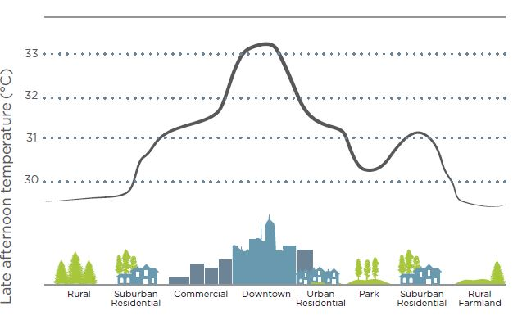
Figure 1 Diagram of Heat Island Effect
Source: (Blust, et al., 2014)
Strategies for Reducing the Heat Island Effect:
- Install reflective roof surfaces. Light-colored roofs absorb less heat.
- Reduce the area of paved surfaces exposed to sunlight. Limit the amount of hardscape, design narrow roads, use light-colored paving, shade hardscape with greenery, and locate parking underground.
- Plant an urban forest or a green roof. Use street trees, shrubs, and landscaping to reduce heat island effects through evapotranspiration and provide shade.

Indoor Environmental Quality
Indoor environmental quality refers to the conditions inside a building, and that includes, air quality, lighting, thermal conditions, acoustics, and their effects on occupants.
Better indoor environmental quality provides better human health, improves quality of life, reduces stress and potential injuries, can enhance the lives of building occupants, increases the resale value of the building, and reduces liability for building owners.
Any strategies, which are used to provide better indoor environmental quality, main aim is providing stimulating and comfortable environments for occupants and minimizing the risk of building-related health problems.
The following sub-sections list and explain some strategies according to the LEED (Blust, et al., 2014),
- Strategies for designing for good indoor air quality:
- Prohibit smoking. Institute a no-smoking policy for the building and around building entrances, operable windows, and air intakes.
- Design for proper ventilation. Consider the number of occupants in each space and the activities they will be engaged in. Make sure that the ventilation system, whether natural or mechanical, is sized appropriately and can provide enough fresh air.
- Protect air that comes into the building. Locate air intakes away from likely exhaust sources, such as idling vehicles or smoking areas. Use air filtration to remove outdoor air contaminants.
- Specify low-emitting materials. Use materials with low VOC emissions.
- Conduct a flush-out. Before occupancy, flush out off-gassed compounds and other contaminants left behind at the end of construction.

- Strategies for improving occupants’ comfort and control:
- Use delighting. Design the building to provide ample access to natural light and views for the occupants. Optimize access to views by using low partitions and vision panels.
- Install operable windows. If possible, provide windows that can be opened to the outside. To save energy, sensors may be included to inform the HVAC system to shut down if a window is open.
- Include appropriate acoustic design. Use soft surfaces and other strategies to ensure that sound levels remain comfortable for the activity level of the space.
- Give occupants lighting control. Provide adjustable lighting controls so that occupants can match lighting levels to their tasks.
Although there are many ways to organize green building projects, this section listed some of the major categories associated with the LEED rating system. Finally, these are the main technologies to follow to create sustainable buildings, these technologies and their strategies are able to be implemented by having good planning and team.
As explained earlier, each of these credit categories contains a series of suggested opportunities to earn the credit. The building project earns points when it properly uses and integrates these opportunities.

Multiple Certification for the Same Building
Projects are not limited to just one rating system. A building could earn LEED BD+C: Core & Shell, then earn LEED ID+C: Commercial Interiors, and finally move on to LEED O+M: Existing Buildings.
A building can earn multiple certifications for the same building. The most common example is once a building has been built and earned a New Construction rating, the project team can start on the Operations & Maintenance certification.
Other examples:
A Core & Shell project can move on to Commercial Interiors, a New Construction project can move on to Commercial Interiors, and Commercial projects can move on to Operations & Maintenance.

LEED Rating System Structure
LEED (GBES, 2014) can be applied to any building at any point in the building's lifecycle. In order to measure if a building has met the definition of a high-performance green building as defined by LEED, every LEED rating system (except LEED for Neighborhood Development) has performance criteria in these major areas:
- Location and Transportation — does the location preserve environmentally sensitive places and take advantage of existing infrastructure, community resources, and public transit.
- Sustainable Sites — is the selected site able to maximize sustainability?
- Water Efficiency — what can you do to save on landscaping water use and interior water use?
- Energy and Atmosphere — how can you save energy, cut energy costs and encourage green energy development and use?
- Materials and Resources — are your building materials sustainable for the environment, and where does the waste go?
- Indoor Environmental Quality — how can you increase the productivity, satisfaction, and health of the occupants?
- Innovation — what can you discover that isn't in the rating system to add even further value to the project?; and
- Regional Priority — Are there regionally important issues such as water conservation in the Southwest?
LEED for Neighborhood Development has different categories than the other rating systems:
- Smart Location and Linkage
- Neighborhood Pattern and Design; and
- Green Infrastructure & Buildings

LEED Prerequisites, Credits, and Points

Prerequisites
LEED (GBES, 2014) certification means healthier, more productive places for us to live, learn, work and play, as well as less stress on the environment, by encouraging energy- and resource-efficient buildings. While project managers can pick and choose the credits they want to pursue, prerequisites set the minimum requirements that all buildings need to meet in order to achieve LEED certification.
Additionally, fulfilling the requirements of prerequisites will not earn points. Prerequisites are fundamental of every LEED Rating System. Prerequisites do not earn the project any points because they are required for the project to be considered.
The term "prerequisite" refers to a mandatory project characteristic, measurement, quality, value or function as identified within the LEED rating system. Prerequisites represent the key criteria that define green building performance. Each project must satisfy all specified prerequisites outlined in the LEED rating system under which it is registered. Failure to meet any prerequisite will render a project ineligible for certification.

Credits
These are what truly the constructed building apart from the rest. You, as a building owner/manager, etc., are free to go for any credit you want within your chosen rating system, as long as it applies to your project type. Certain credits pair well with certain prerequisites or even other credits which amounts to synergistic benefits.
Each sustainable category has a group of credits that defines a particular sustainability goal. The sustainability goal is referred to as the 'intent' of the credit.
The project does not have to achieve all credits. Credits are optional elements. The project only needs to achieve enough credits for the certification level the project is aiming for – certified silver, gold, or platinum. The project is also not required to submit any documentation for credits the project is not attempting.
The phrase “Credit” means a non-mandatory project characteristic, measurement, quality, value or function as identified within a LEED rating system. Credits represent particular facets of sustainable design that contribute to overall green building performance. No single credit is mandatory: credits are selected and pursued at the option of a LEED project team.

Points
The more points, the higher the reward. With LEED, there are many rewards, ranging from healthier spaces to buildings that save money and resources. The number of points a project earns determines the level of LEED certification it receives. There are four levels of certification:
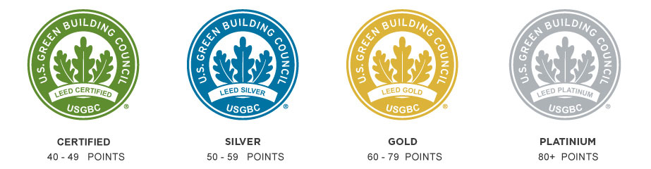
Figure 3 LEED Certification

Minimum Program Requirements
Projects must comply with Minimum Program Requirements (GBES, 2014). MRPs help define what types of buildings the rating system are used to evaluate. The purpose of MPRs are to:
- Provide guidance on what types of projects are eligible for certification
- Protect the integrity of the LEED program; and
- Reduce the number of issues that come from the certification process
All projects must:

Must be in a permanent location on existing land
The LEED rating system is designed to evaluate buildings, spaces, and neighborhoods in the context of their surroundings. A significant portion of LEED requirements are dependent on the project's location, therefore it is important that LEED projects are evaluated as permanent structures. Locating projects on existing land is important to avoid artificial land masses that have the potential to displace and disrupt ecosystems. In other words, the structure can't be a modular home or be moved to another location in the future.

Must use a reasonable LEED boundaries
The LEED rating system is designed to evaluate buildings, spaces, or neighborhoods, and all environmental impacts associated with those projects. Defining a reasonable LEED boundary ensures that project is accurately evaluated.
The project can't exclude some project areas or include extra project areas for the purposes of skewing calculations to achieve more points.

Must comply with project size requirements
The LEED rating system is designed to evaluate buildings, spaces, or neighborhoods of a certain size. The LEED requirements do not accurately assess the performance of projects outside of these size requirements.
All LEED projects must meet the size requirements listed:
- LEED BD+C and LEED O+M Rating Systems: The LEED project must include a minimum of 93 square meters of gross floor area.
- LEED ID+C Rating Systems: The LEED project must include a minimum of 22 square meters of gross floor area.
- LEED Neighborhood Development Rating Systems: The LEED project should contain at least two habitable buildings and be no larger than 1500 acres.
Mention that, projects that do not comply with the MPRs may have their certification revoked.

Literature Review

Defining Green Building
Green building has now become a flagship of sustainable development in this century that takes the responsibility for balancing long-term economic, environmental and social health (Ali, et al., 2008), different countries worldwide take responsibility to implement this concept in the construction industry and several definition can be found of the term “green building”, this terms “Refers to the quality and characteristics of the actual structure created using the principles and methodologies of sustainable construction”. (Kibert, 2016) Defined the green building as “healthy facilities designed and built in a resources-efficient manner, using ecologically based principles”.
Aberrantly, there is no single, widely accepted definition for green building. Green building is also referred to as sustainable design and sustainable construction. Project and construction management practices that seek to:
  - Minimize or eliminate impacts on the environment, natural resources, and nonrenewable energy sources to promote the sustainability of the built environment
  - Enhance the health, wellbeing and productivity of occupants and whole communities
  - Cultivate economic development and financial returns for developers and whole communities; and
  - Apply life cycle approaches to community planning and development.
Also falls under the name of green building field.

Principles and Benefits of Green Building
In the construction industry, awareness of sustainability among building professionals has increased (Bansal, 2005). This can be seen where the green market has been promoted to bring major improvements through developing green buildings or where implementation of an energy rating guideline to assess environmental and energy performance of buildings has become more important. Benefits of adopting this concept in the construction industry include minimizing operating and maintenance costs, minimizing construction wastes, increasing occupant health and satisfaction (Ahn, et al., 2007).
The environmental impact of buildings is often underestimated, while the perceived costs of green buildings are overestimated. According to (Rathod, et al.), a recent survey by the World Business Council for Sustainable Development found that green costs are overestimated by 300 percent, as key players in real estate and construction estimate the additional cost at 17 percent above conventional construction, more than triple the true average cost difference of about 5 percent. As has been stated in Elements of Civil Engineering Book (SAIKIA, et al., 2011), the perceived costs of green buildings are always overestimated, but a simple fact is often unaddressed that every extra financial unit spent to make the features environment-friendly is earned back well within the period of lifetime of the building. Thumb-rule of green building based on numerous studies made on the practical application on this subject, that in its lifetime, every extra rupee spent on making a building green will earn at least 4 rupees during its lifetime.
Green building is interpreted in many different ways, a common opinion is that they bring together a vast array of practice and techniques to reduce and ultimately eliminate the impacts of buildings on human health and the natural environment.

Table 2 Financial Benefits of Green Buildings per ft.²
Category | 20-year Net Present Value
Energy savings | $5.80
Emissions savings | $1.20
Water savings | $0.50
Operations and maintenance savings | $8.50
Productivity and health value | $36.90 to $55.30
Subtotal | $52.90 to $71.30
Average extra cost of building green | -$3.00 to $5.00
Total 20-year net benefit | $49.90 to $66.30

(Vatalisa, et al., 2013) stated that the sustainability components affecting decisions for green building projects in Greece and based in their study on a questionnaire survey of thirty two participants who asked to assess nine sustainability components namely: Life cycle assessment, energy efficiency and renewable energy, water efficiency, environmentally preferable building materials and specifications, waste reduction, toxics reduction, indoor air quality, smart growth and sustainable development and environmentally innovative projects, which affect the decisions for green building projects. The respondent results indicate how participants prioritized the sustainability components ensuring a better quality of life inside buildings based on the principals of “green” buildings economy. Energy efficiency and renewable energy is considered of high priority followed by the reduction of toxic materials, indoor pollution and water saving.
Sustainable development or sustainability is the fundamental principle underlying various efforts to ensure a decent quality of life for future generations. This concept aims to meet the needs of the present without compromising the ability of future generations to meet their needs (Rustom, 2014).
This implies that the environment and the quality of human life are as important as economic performance (Riley, Pexton, & Drilling, 2003, Kibert, 2016 and Ali & Nsairat, 2008). It was agreed that the mainstay of sustainability thinking is to strike a balance between three dimensions: environmental, social, and economic impacts of the design. Finally, (Hussin, et al., 2013) stated the principles of green building i.e. environment, economic and social aspect together as shown in Table 20.
Table 3 The Principles of Green Building
Environment aspect | Increase material efficiency by reducing the material demand of non-renewable goods
Environment aspect | Reduce the material intensity via substitution technologies.
Environment aspect | Enhance material recyclability.
Environment aspect | Reduce and control the use and dispersion of toxic materials.
Environment aspect | Reduce the energy required for transforming goods and supplying services.
Environment aspect | Support the instruments of international conventions and agreements.
Environment aspect | Maximize the sustainable use of biological and renewable resources.
Environment aspect | Consider the impact of planned projects on air, soil, water, flora, and fauna.
Economic aspect | Consider life-cycle costs.
Economic aspect | Internalize external costs.
Economic aspect | Consider alternative financing mechanisms.
Economic aspect | Develop appropriate economic instruments to promote sustainable consumption.
Economic aspect | Consider the economic impact on local structures.
Social Aspect | Enhance a participatory approach by involving stakeholders.
Social Aspect | Promote public participation.
Social Aspect | Promote the development of appropriate institutional frameworks.
Social Aspect | Consider the influence on the existing social framework.
Social Aspect | Assess the impact on health and the quality of life.

Potential Barriers for Green Building
The situation is a more optimistic and positive response to calls for promoting sustainability in construction and design techniques (Morton, 2008). Due to the many benefits associated with sustainable design and construction, public governments and their agencies are increasingly incorporating sustainable design and construction practices into not only new buildings, but also existing buildings constructed (Ahn, et al., 2013). In spite of these benefits, unsustainable design and construction processes as well as constant degradation of the environment for construction purposes still exist in most developing countries, of which Palestine is no exception.
(Murillo-Luna, et al., 2007) identified scarcity of information and lack of clarity on environmental legislation, rigidity of legislation and bureaucratic complexity, limited development of the environmental supply sector, high cost of environmental services/technologies, and difficulties derived from competitive pressure as possible barriers to the adoption of proactive environmental strategies.
(Lam, et al., 2009) Discussed factors hindering successful implementation of green specification in construction. The factors identified are; lack of green technology and techniques, reliability and quality of specification, leadership and responsibility, stakeholder involvement, and guide and benchmarking systems. More recently, there has been growing interest in empirically analyzing the extent to which such barriers hinder development of sustainable construction (Samari, Godrati, Esmaeilifar, Olfat, & Shafiei, 2013; Hoffman & Henn, 2008; Bon & Hutchinson, 2000; and Ayarkwa, Ayirebi-Dansoh, & Amoah, 2010). According to (Häkkinen, et al., 2011) although various steps have been taken by the developed world to fully practice sustainable construction, there exist barriers.
The situation could even be more serious in this part of undeveloped world if there exist barriers to sustainable design and construction in the developed world. In order to endorse and drive the agenda of green construction within the Palestinian construction industry, the barriers that impede these practices must first be identified. The barriers can be grouped into three main categories: cultural, financial, steering barriers (Rustom, 2014).

Main Barriers to Green Building in Developed Countries

Cultural Barriers
The Palestinian construction process has been used over the past decades. As such, it presents itself as a sector which is traditionally very difficult to change especially with respect to construction methods practiced and building materials used. Construction in Palestine favors the use of blocks and reinforced concrete and discourages any other alternative to these building materials. This illustrates a typical resistance to change; a major barrier. This resistance to change results in a lack of demand by clients and stakeholders of construction projects affecting its eventual supply (Rustom, 2014).
In that same vain identified lack of green measure by stakeholder as by far the most commonly recorded barrier and further stated the lack of demand by the client as a commonly recognized barrier. Lack of demand was also cited as the most significant barrier by eighty-four per cent (84%) of respondents as a building project cannot be done along sustainable lines without the owner or developers “full support for sustainable concepts” (Ahn, et al., 2013).
The Toronto Green Development Standard (2006) also acknowledges that public awareness about green building has been an important component that led to high demand. Thus a continual public awareness of sustainable concepts on sustainable construction and its benefits will lead to increased demand, compelling products to be tailored to their needs to be produced.

Financial Barriers
The fear of higher investment costs of green buildings compared to traditional building and the risks of unforeseen costs are often addressed as barriers to green buildings (Häkkinen, et al., 2011). The adoption of green building solutions may be hindered because clients are concerned about the higher risk (Nelms, et al., 2005) based on unfamiliar techniques, the lack of previous experience, additional testing and inspection in construction, a lack of manufacturer and supplier support, and a lack of performance information.
Cost overrun is another hindrance faced by green projects. Green buildings tend to be more complicated because they use newer technologies and materials with less environmental impact. In addition, sustainability certification programs, such as Leadership in Energy and Environmental Design (LEED), have many requirements. Combined with the lack of understanding of the green concept, these characteristics tend to lead to cost overruns, project delays, and productivity losses (Nalewaik, et al., 2010).
The promotion of green building practices in real estate development has developed more and more influence on society. Several factors play into uncertainties about future growth in green building practices. Most environmental impacts remain externalities for construction costs; green products are seen as expensive and technically unreliable by some practitioners; and environmental issues are of varying importance to consumers (Rustom, 2014).
According to (Kats, 2003), the average premium for green buildings is approximately 2%, and the main source of this premium is architectural and engineering design. Although the same report also asserted that the increased upfront costs to support green design result in life cycle savings of 20% of total construction costs, the extra upfront costs for green buildings remain burdensome to industry practitioners.
Another barrier increased indirect cost of green building project that some researchers also argue that green projects have higher injury rates (Rajendran, et al., 2009). The selection of construction equipment for green projects is another new consideration because construction equipment is a major source of diesel exhaust emissions (Ahn, et al., 2013).

Steering Barriers
A major characteristic of the construction industry is the involvement of a large number of individuals ranging from clients to the builder thus an effective steering or strategy will be required to implement green building. The lack thereof or wrongful steering may rather stifle green building whilst on the other hand, steering measures can promote it. Steering barriers include but not limited to the lack of building codes, government policies/support and measurement tools amongst others. The lack of methods is a barrier, but methods as such do not improve the sustainability of built environment. The impact will depend on the implementation of methods (Häkkinen, et al., 2011).

Barriers to Green Building in Developing Countries
There are a number of systemic problems facing developing countries, such as rapid rates of urbanization, deep poverty, social inequity, low skills levels, institutional incapacity, weak governance, an uncertain economic environment and environmental degradation, which by themselves create a challenging environment within which to work.
(Serpell, et al., 2013), stated that the main barriers towards green buildings are the lack of financial incentives, lack of integrated design, and affordability whereas company's tax reduction incentives related to the level of investment effort on green buildings would be a key governmental policy these barriers were found as the result of survey conducted in Chile to discusses the level of awareness and knowledge, barriers and drivers of green building that were found in building and infrastructure construction companies.

Barriers to Green Building in Palestine
There are numerous barriers preventing green construction in Palestine; most of the experts from engineers, contractors, developers and researchers attribute these barriers to the political situation while others think that although instability and insecurity play a major role in preventing sustainable growth but as (Rustom, 2014) stated that there are many other causes such as:
  - Operational factors: failure to effectively manage markets, finance, employees, prices and customer satisfaction.
  - Management skills, technical ability and leadership, decision making ability, motivation and aspiration values of managers.
  - Accepting change.
  - Financial constraints; lack of financial resources.
  - Limited marketing and human resource management expertise; lack of understanding marketing concept and lack of employees training and development.
  - Limited strategic planning; market segmentation, pricing strategies and environment analysis.
  - Limited incentives for innovation.
  - Ineffective information technology, lack of system knowledge.
  - Ignorance of life cycle cost, lack of education and knowledge in sustainable design, and client worries in profitability and pay-back period.
As a result, Palestine is in need to develop green building practices; it needs to improve the environmental and economic performance of new and existing commercial, institutional, and residential buildings.

Case Study: Construction a Shopping Center in Palestine According to LEED Building Design and Construction

Introduction
Green buildings are an integral part of the solution to the environmental challenges facing the planet.
Buildings account for a significant portion of greenhouse gas emissions; according to United Nations Environment Programme (UNEP), in the U.S., buildings are associated with 38% of all emissions of carbon dioxide; globally, the figure is nearly one-third. The problem is anticipated to worsen as developing countries attain higher standards of living. These forces are bringing us to a tipping point, a threshold beyond which Earth cannot rebalance itself without major disruption to the systems that humans and other species rely on for survival.
Buildings have a major role to play in sustainability through their construction, the lifetime of their operation, and patterns of development. As Earth’s population continues to increase, construction and renovation of buildings expand even more rapidly.
The green building portion of the construction market is rapidly expanding. As reported by Harvey Bernstein, the Vice President of Global Thought Leadership & Business Development, it represented 2% of nonresidential construction starts in 2005, 12% in 2008, and 28% to 35% in 2010. The concept of green buildings provides a vision for resource equity between developing and developed nations. As green building practices guide developed nations toward a more responsible use of resources, they enable developing nations to attain essential improvements in quality of life without overtaxing local resources.
Therefore, what we build today and where we build it are profoundly important.

Main Project Information
Plaza Shopping Center will be situated on 3700 meters square area, the land will be consumed by the center store buildings, customer parking spaces, employee parking spaces, truck loading docks. It is located in Nablus city, Al-Makfia district in a land adjacent to populated residential district which generally, will support the center’s activities.
As a part of our commitment to reduce building operations’ environmental impact, and efforts to combat climate change, the Shopping Center design and construction will optimize energy use in the building, including its HVAC and lighting systems; reduce potable water consumption; and take advantage of its location by installing a photovoltaic system.
The first floor will be designed for retail and commercial spaces, while the second floor will include food court spaces and commercial spaces. For the third building, it will be a premium space for a mall sit down restaurant. The underground parking also will have spaces dedicated to administrative offices, electrical and technical rooms.

Description of the Shopping Center Structural Components
The building envelope is the physical separator between the interior and exterior of a building. Typically, components of the envelope are: walls, floors, and roofs.
When designing the building envelope for the Shopping Center, we took under consideration some fundamentals of building materials and heat transfer which will help making the right trade-off decisions.
The Shopping Center northern façade is 70% glazed as this will provide high percent of daylight for the building. The used glass will be double glass with 16 mm air gap, and a U-Value equals to 0.810 W/m²K. Glass specification shown in table 4. (Appendix G)
The southern façade and the eastern façade are glazed with about 15% and 5% respectively, with overhang shading for a horizontal plane structure. (Appendix K)
In summer, to provide shading for the building from the southern side, trees will be planted profusely with an appropriate pattern. Also trees will contribute to lessen the wind speed around the year.
The eastern façade has individual windows with vertical and horizontal shadings, the used glass material is also shown in table 4. (Appendix L)
Table 4 Glass Material Proprieties
Layers Section
Layer Names and Proprieties | 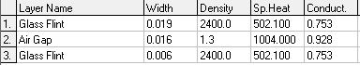
Thermal Proprieties | 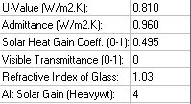

The envelope of a building have several functions. Not only do they define the shape of a house, they also support the floors, walls, and roof. Equally important is their role in separating the building’s interior from the outdoors, and to do this effectively they have to block the weather with systems that insulate, shed water, and repel moisture and air infiltration.
For the Shopping Center, the exterior walls are made of concrete lightweight with thermal insulation (Expanded Polystyrene), this leads to a U-Value equals to 0.18 W/m²k. Table 5 shows detailed data of the wall material.
Table 5 Exterior Wall Material Properties
Layers Section
Layer Names and Proprieties | 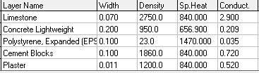
Thermal Proprieties | 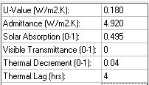

Floor and ceiling material, they are made of lightweight concrete, cement, and sand, this material combination has a U-Value equals to 0.220 W/m²k. Table 6 shows detailed data of floor and ceiling materials.
Roof structure material, will be divided into two categories. The area that includes the restaurant zone is made of white cement tiles with high solar reflectance index that equals to 93. These high SRI tiles are 9 mm thickness with open pores which also helps for heat insulation. All this combination leads to 1.92 W/m²k U-Value. The rest area of the roof is made of untreated white stone with a solar reflectance index of 84.71, and with 0.22 W/m²k U-Value. Table 7 shows detailed data of roof coating material.
Table 6 Floor and Ceiling Material Prosperities
Layers Section
Layer Names and Proprieties | 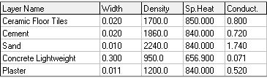
Thermal Proprieties | 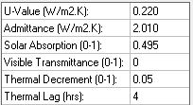

Table 7 Roof Material Proprieties
Layers Section | Restaurant Area  The Rest Area of the Roof
Layer Names and Proprieties | Restaurant Area  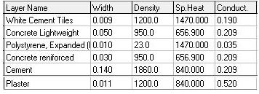  The Rest Area of the Roof  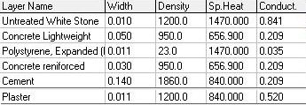
Thermal Proprieties | Restaurant Area  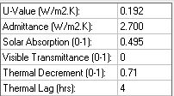  The Rest Area of the Roof  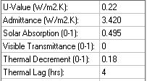
Mention that all the U-Value calculation were made using ECOTECT Software.

Minimum Program Requirements
Minimum program requirements (MPRs) define the types of buildings that LEED was designed to evaluate. Taken together, they serve three goals: to give clear guidance to customers, to reduce complications that occur during the LEED certification process and to protect the integrity of the LEED program.

MPRs 1: Must be in a permanent location on existing land
The intent of this requirement is to locating projects on existing land is important to avoid artificial land masses that have the potential to displace and disrupt ecosystems.
For the Shopping Center, it will be constructed in a permanent location on existing land. The project will be situated in Palestine, Nablus, Al-Makhfia district. Furthermore, the structure of the project will not be modular, it will be stick built and will not be able to move to another location now nor in the future.

MPRs 2: Must use a reasonable LEED boundaries
The intent of this requirement is that the LEED rating system is designed to evaluate buildings, spaces, or neighborhoods, and all environmental impacts associated with those projects. Defining a reasonable LEED boundary ensures that project is accurately evaluated.
The Shopping Center, will be situated on 3700 m² acreage, as this area includes all contiguous land associated with and that supports normal building's operations. In other words, the project will not contain land owned by a party other than the LEED project owner.

MPRs 3: Must comply with project size requirements
The intent of this requirement is that the LEED rating system is designed to evaluate buildings, spaces, or neighborhoods of a certain size. The LEED requirements do not accurately assess the performance of projects outside of these size requirements.
For the Shopping Center, it will include about 2000 meters square of gross floor area.

Rating System Selection Guidance
As the proposed project is about construction a Shopping Center in Palestine, the project aims to get gold LEED certification under the Building Design and Construction rating system. Mention that the chosen rating system based on; construction type which is complete construction, space usage type which is retail; a building dedicated to the sale of goods or commodities directly to consumers who come onto the premise for the purpose of obtaining those goods or commodities. Furthermore, the chosen rating system is appropriate for more than 60% of the whole gross area of the LEED project building.

Construction Phase LEED Targeted Credit

Location and Transportation
The Location and Transportation (LT) category rewards thoughtful decisions about building location, with credits that encourage compact development, alternative transportation, and connection with amenities, such as restaurants and parks. The LT category considers the existing features of the surrounding community and how this infrastructure affects occupants’ behavior and environmental performance.
Well-located buildings take advantage of existing infrastructure-public transit, street networks, pedestrian paths, bicycle networks, services and amenities, and existing utilities, such as electricity, water, gas, and sewage. By recognizing existing patterns of development and land density, project teams can reduce strain on the environment from the material and ecological costs that accompany the creation of new infrastructure and hardscape. In addition, the compact communities promoted by the LT credits encourage robust and realistic alternatives to private automobile use, such as walking, biking, vehicle shares, and public transit. These incremental steps can have significant benefits, according to Urban Land Institute study concluded that improvements in land-use patterns and investments in public transportation infrastructure alone could reduce greenhouse gas emissions from transportation in the U.S. by 9% to 15% by 2050;globally, the transportation sector is responsible for about one quarter of energy-related greenhouse gas emissions.
Therefore, if a building is integrated into the surrounding community, it can offer distinct advantages to owners and building users. For owners, proximity to existing utility lines and street networks avoids the cost of bringing this infrastructure to the project site. For occupants, walkable and bikeable locations can enhance health by encouraging daily physical activity, and proximity to services and amenities can increase happiness and productivity. Locating in a vibrant, livable community makes the building a destination for residents, employees, customers, and visitors, and the building’s occupants will contribute to the area’s economic activity, creating a good model for future development. Reusing previously developed land, cleaning up brownfield sites, and investing in disadvantaged areas conserve undeveloped land and ensure efficient delivery of services and infrastructure.
The Location and Transportation credit category has 8 credits, and no prerequisites.

LT Credit 1: LEED for Neighborhood Development Location
Starting by LEED for Neighborhood Development Location credit. The intent of this credit is to avoid development on inappropriate sites, to reduce vehicles miles or kilometers traveled, and to enhance livability and improve human health by encouraging daily physical activity.
According to LEED BD+C, the requirements of this credit are to locate the project within the boundary of a development certified under LEED for Neighborhood Development, in other words, the project must be located in a site with ND project in order to achieve this credit.
In our case, the chosen area for the proposed project is Al-Makhfia district-Nablus, which doesn’t contain any LEED certified project or plan. Therefore, we won't get any advantage of this credit.

LT Credit 2: Sensitive Land Protection
The intent of this credit is to avoid the development of environmentally sensitive lands and reduce the environmental impact from the location of a building on a site. This credit addresses wetlands, water-bodies, floodplains, and prime farmland.
There are two options for this credit, see (Appendix B). The first one is to develop on previously developed land. The second one is to develop on previously developed land or land that does not meet the criteria for sensitive land. Each option can earn one point.
In our case, the project location was selected based on criteria designed to ensure minimum environmental impact:
- The project location was not a farmland
- The site is not identified as a habitat for any threatened or endangered species
- The site is far from wetlands
- The site is far from any body of water that could support aquatic life (seas, lakes, rivers and tributaries)
- Prior to acquisition, the site was not public parkland
According to LEED BD+C, the project will be qualified to earn one LEED point regard to this credit.

LT Credit 3: High-Priority Site
The intent of this credit is to encourage project location in areas with development constraints and promote the health of the surrounding area.
The project will be located on an urban infill site, as it is a key component of smart growth. Most infill occurs in the cities, in largely developed areas. Thereby, the Shopping Center site had been chosen in Al-Makhfia district, as it will build and foster community, and it will activate neighborhoods, making them more useful and livelier for longer periods of the day and night.
By this the project will be qualified to earn one LEED point.

LT Credit 4: Surrounding Density and Diverse Uses
The intent of this credit is to conserve land and protect farmland and wildlife habitat by encouraging development in areas with existing infrastructure and social benefits. Density promotes walkability, transportation efficiency, reduces vehicle distance traveled, and improves public health by encouraging daily physical activity.
The Shopping Center will be located in Al-Makhfia district, whose surrounding existing density within 400-meter radius of the project boundary is up to 5050 m²/hectare.
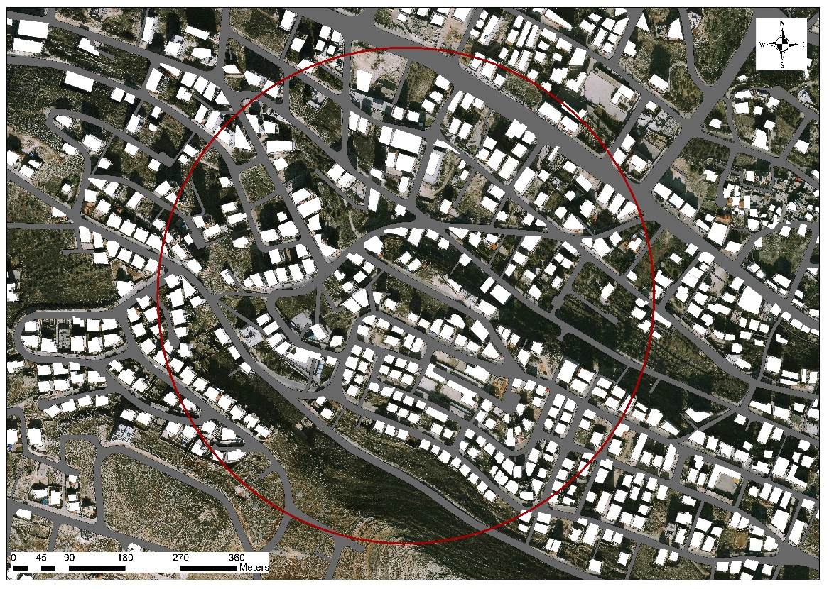
Figure 4 Surrounding Existing Density within 400-meter Radius of the Shopping Center Boundary
Furthermore, the Shopping Center main entrance will be within 800-meter walking of the main entrance of several existing and publicly available diverse uses, examples (listed in Appendix C).
As shown in figure 4, the Shopping main entrance is about 550 meters away from Rafedia Main Street, which is lively street, it implies the focal point for business, especially shops, street stalls, markets, coffee shop, and restaurants.
Also, it will be away for about 450 meters from Al-Makhfia Main Street, which also a lively street has a wide diversity of shops, and markets. See figure 5.
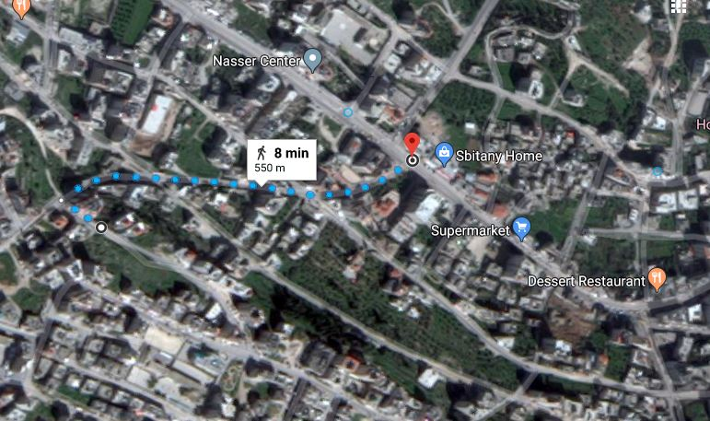
Figure 5 Distance between Rafedia Main Street and the Shopping Center Main Entrance
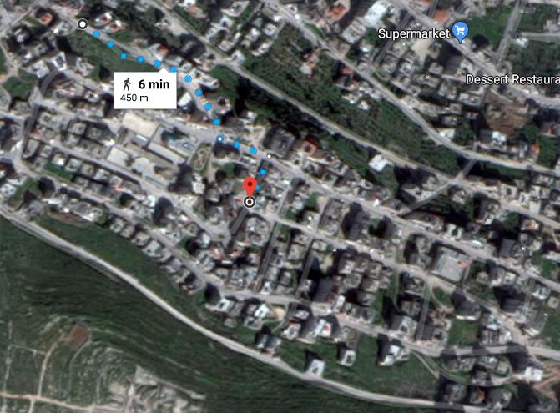
Figure 6 Distance between Al-Makhfia Main Street and the Shopping Center Main Entrance
Thereby, the project will be qualified to earn four LEED points regard to this credit.

LT Credit 5: Access to Quality Transit
The intent of this credit is to encourage development in locations shown to have multimodal transportation choices or otherwise reduced motor vehicle use, thereby reducing greenhouse gas emissions, air pollution, and other environmental and public health harms associated with motor vehicle use.
For the Shopping Center, its site located near “Abdul Rahim Mahmoud” intersection, also near it is near to Al-Makfia Main Street. Thereby, transportation (taxicab/service) will be readily available throughout the day.
The proposed location for the project is about 200 meters away from “Abdul Rahim Mahmoud” intersection and 400 meters away from Al-Makfia Main Street, which both are considered to be areas with average taxi traffic.
By this, the project will be qualified to earn five LEED points.

LT Credit 6: Bicycle Facilities
The intent of this credit is to promote bicycling and transportation efficiency and reduce vehicle distance traveled, and to improve public health by encouraging utilitarian and recreational physical activity.
The main requirement to achieve this credit is to have bicycle network which is, according to (USGBC, 2013), a continuous work consist of any combination of the following:
- Physically designated on-sheet bicycle lanes at least 1.5 meters wide;
- Off-sheet bicycle paths or trails at least 2.5 meters wide for a two-way path and at least 1.5 meters wide for a one-way path; and
- Streets designed for a target speed of 40 kmh.
In our case, Nablus doesn’t have “bicycle network” or even bike lanes. Furthermore, it doesn’t have the ability for retrofitting urban streets to include bike lanes and establish bicycle network. Therefore, we will overlook this credit.

LT Credit 7: Reduced Parking Footprint
The intent of this credit is to minimize the environmental harms associated with parking facilities, including automobile dependence, land consumption, and rainwater runoff. The implication is if there's less parking, people are motivated to walk, get a bus, get a bike, or do something other than drive.
For the Shopping Center, the provided parking capacity will be 40% less than the baseline adapted from the ITE guidance which states; “every shopping center can have number of parking lots ranging from 90 to 100” therefore, the shopping center will be provided with about 36 parking lots.
In addition, the project will be provided by preferred parking for carpools for 5% of total parking spaces after the reduction.
Thereby, the project will be qualified to earn one LEED point.

LT Credit 8: Green Vehicles
The intent of this credit is to reduce pollution by promoting alternatives to conventionally fueled automobiles.
To achieve this credit, the Shopping Center will designate 5% of all parking spaces as preferred parking spaces for green vehicles. Furthermore, alternative fuel stations will be installed. For the project, an electric vehicle supply equipment which provides level 2 charging capacity (up to 240 volt) will be installed in green spaces for solo use plug-in electric vehicles.
Thereby, the project will be qualified to earn one LEED point.

Sustainable Site
The Sustainable Sites (SS) category rewards decisions about the environment surrounding the building, with credits that emphasize the vital relationships among buildings, ecosystems, and ecosystem services. It focuses on restoring project site elements, integrating the site with local and regional ecosystems, and preserving the biodiversity that natural systems rely on.
Earth’s systems depend on biologically diverse forests, wetlands, coral reefs, and other ecosystems, which are often referred to as “natural capital” because they provide regenerative services. A United Nations study indicates that of the ecosystem services that have been assessed worldwide, about 60% are currently degraded or used unsustainably.The results are deforestation, soil erosion, a drop in water table levels, extinction of species, and rivers that no longer run to the sea.
Recent trends like exurban development and sprawl encroach on the remaining natural landscapes and farmlands, fragmenting and replacing them with dispersed hardscapes surrounded by nonnative vegetation. The rainwater runoff from these hardscape areas frequently overloads the capacity of natural infiltration systems, increasing both the quantity and pollution of site runoff. Rainwater runoff carries such pollutants as oil, sediment, chemicals, and lawn fertilizers directly to streams and rivers, where they contribute to eutrophication and harm aquatic ecosystems and species.
Project teams that comply with the prerequisites and credits in the SS category protect sensitive ecosystems by completing an early site assessment and planning the locations of buildings and hardscape areas to avoid harming habitat, open space, and water bodies. They use low-impact development methods that minimize construction pollution, reduce heat island effects and light pollution, and mimic natural water flow patterns to manage rainwater runoff. They also remediate areas on the project site that are already in decline.
The purpose of this category is to adapt practical site design strategies sensitive to plant-life, wildlife, water, and air quality onsite.
The Sustainable Site credit category has 5 credits and one common prerequisite, and one prerequisite specific to Schools and Healthcare, which is not related to our case.

SS Prerequisite 1: Construction Activity Pollution Prevention
The intent of this prerequisite is to reduce pollution from construction activities by controlling soil erosion, waterway sedimentation, and airborne dust.
This prerequisite requires reduction of the pollution resulting from construction activities, as a means of limiting their effect on the surrounding environment. This is going to be achieved through:
- Prevention of soil loss during construction by storm water runoff or wind erosion
- Prevention of waterway sedimentation; and
- Prevention of pollution of the air with dust and other particles
To achieve this purpose, an Erosion and Sedimentation Control (ESC) plan is developed. The plan entails using protective bunds, road watering, establishing a wheel wash area (washing station) at the exits, silt control fence, and gravel bag berms. Periodic inspections are made to ensure best management practice in the site.

SS Credit 1: Site Assessment
The intent of this credit is to assess site conditions before design to evaluate sustainable options and inform related decisions about site design.
Site inventory is the value free data collection step of the design process. The site analysis is the assessment step. The goal of the site inventory and analysis is to create and display information geographically.
Nablus Governorate - Al-Makhfia district, the proposed site, is further characterized by variation in its topography and altitude. It has an elevation varying between 801 m above sea level in the west, and -175 m above sea level toward the west and northwest.
Nablus Governorate’s climate is determined as hot and dry in the summer, with the presence of mild winters. The mean average temperature across the region is 18 ⁰C, with temperatures each annum ranging on average between 15 ⁰C in January and 31 ⁰C in August.
Summers in Nablus Governorate are hot and dry, while the mean quantity of rainfall varies from year to year. The mean annual rainfall is 586 mm, with an average humidity of 59% (ARIJ, 2014).
In general, Nablus governorate is located in the Central Highlighted ecosystem which record the highest number of plant families among the different ecosystems in the West Bank.
Nablus is characterized by its Mediterranean ecosystem, where the temperatures are moderates and rainfall amounts are medium to high. The climate in general tends to be semi-dry to humid east to west and south to north in the governorate. Most of Nablus lands have fertile soil types such as Alluvial and Brown soils, and some beds of Terra Rosa soils.
Collectively, integrating all the geographical conditions onto the building site will safeguard the surrounding environment from harm while ensuring that the project design will be useful and comfortable for building occupants. (Appendix M)
Thereby, the Shopping Center will be qualified to earn one LEED point.

SS Credit 2: Site Development Protect or Restore Habitat
The intent of this credit is to conserve existing natural areas and restore damaged areas to provide habitat and promote biodiversity.
In our case, we will overlook this credit.

SS Credit 3: Open Space
The intent of this credit is to create exterior open space that encourages interaction with environment, social interaction, passive recreation, and physical activities.
For the Shopping Center, total site area (including building footprint) is equal to 3757 meters square, for that there will be 2765 meters square open area (up to 70% of total area) and vegetated area equals to 30% of total area.
By this, the project will be qualified to earn one LEED point.

SS Credit 4: Rainwater Management
The intent of this credit is to reduce runoff volume and improve water quality by replicating the natural hydrology and water balance of the site, based on historical conditions and undeveloped ecosystems in the region.
When the water hits the ground it may go into runoff as gutters, streams, rivers and lakes, or it evaporates or it taken in by plants. Land cover determines what water does once it hits the ground. Trees and vegetation reduce runoff by absorbing water, also leaves catch and increase evaporation.
For the Shopping Center, the imperviousness of the existing site is less than 50% and the completed project will consist of a large extent of landscaping. This will help in reducing the runoff quantity and thus avoiding excessive erosion. To protect the stream channel, a storm water management plan will be developed and implemented including onsite rainwater harvesting and usage.
To limit pollution of natural water flows by managing storm water runoff, at the Shopping Center, storm water will be collected from roof area. Water then will be stored in tanks, treated using sand filtration, and reused for flushing and irrigation.
This treatment method contributes to treating a good percent of the storm water. The rest of the site runoff will be captured through a planting bed from which it will be discharged to a natural valley offsite. The water will be treated by a natural filtration process through the ground.
By this, the project will be qualified to earn three LEED points.

SS Credit 5: Heat Island Reduction
The intent of this credit is to minimize effects on microclimates and human and wildlife habitats by reducing heat islands.
This credit can be achieved through using materials with high solar reflectance that reduce heat absorption. Therefore, for roof surfaces we will use an untreated white stone with a solar reflectance index (SRI) of 84.71 and white cement tiles with SRI equals to 93. These high SRI tiles are 9 mm thickness with 32% open pores which also help for heat insulation.
Furthermore, 100% parking spaces will be underground, which will reduce heat island as the human health may suffer because exposure to ground-level pollution is often worse in places affected by heat islands. Additionally, heat islands increase cooling loads in the summer, necessitating larger, more powerful air-conditioners, in turn increasing cooling costs, producing more greenhouse gases, and generating pollution.
Thereby, the project will be qualified to earn two LEED points.

Water Efficiency
The Water Efficiency (WE) section addresses water holistically, looking at indoor use, outdoor use, specialized uses, and metering. The section is based on an “efficiency first” approach to water conservation. As a result, each prerequisite looks at water efficiency and reductions in potable water use alone. Then, the WE credits additionally recognize the use of non-potable and alternative sources of water.
The conservation and creative reuse of water are important because only 3% of Earth’s water is fresh, and of that, slightly over two-thirds is trapped in glaciers. Typically, most of a building’s water cycles through the building and then flows off-site as wastewater. In developed nations, potable water often comes from a public water supply system far from the building site, and wastewater leaving the site must be piped to a processing plant, after which it is discharged into a distant water body. This pass-through system reduces stream flow in rivers and depletes freshwater aquifers, causing water tables to drop and wells to go dry. In 60% of European cities with more than 100,000 people, groundwater is being used faster than it can be replenished. In addition, the energy required to treat water for drinking, transport it to and from a building, and treat it for disposal represents a significant amount of energy use not captured by a building’s utility meter.
Designers and builders can construct green buildings that use significantly less water than conventional construction by incorporating native landscapes that eliminate the need for irrigation, installing water efficient fixtures, and reusing wastewater for non-potable water needs. LEED’s WE credits encourage project teams to take advantage of every opportunity to significantly reduce total water use.
Water efficiency relates to not only water consumption and potable water but also indirectly to saving energy, water recycling, and feedback mechanisms.
Water Efficiency credit category has 3 prerequisites and 4 credits. Three of the credits build upon the prerequisite requirements and offer points for increased levels of achievement.
As Palestine suffers from water scarcity, it is essential to find innovative solutions and techniques for water saving. The purpose of this category is to promote the efficient use of water for irrigation, sewage conveyance, and sanitary fixtures.

WE Prerequisite 1: Outdoor Water Use Reduction 30%
The intent of this prerequisite is to reduce outdoor water consumption.
To reduce the project’s landscape water requirements by 30% from the site’s peak watering month, some strategies will be implemented. Starting by the landscape design, all the plants that will be grown; will be drought tolerant plants such like; Sage, Rosemary, Emerald Green tree, Windmill Palm Tree, and Olive Tree.
Also the irrigation systems, drip irrigation systems will be installed as they have the potential to save water and nutrients by allowing water to drip slowly to the roots of plants, either from above the soil surface or buried below the surface.
By this, this prerequisite will be fulfilled.

WE Credit 1: Outdoor Water Use Reduction
The intent of this credit is to reduce outdoor water consumption.
To increase the outdoor water reduction up to 50% from the site’s peak watering month, smart irrigation controls will be used instead of standard clock-timer controls, these smart controls automatically result 15% reduction. Furthermore, onsite rainwater harvesting system and onsite-treated grey-water will be used for irrigation as a partial replacement of potable water. This strategy will contribute in reduction in potable water consumption for landscaping by approximately 100%.
Thereby, the project will be qualified to earn two LEED points.

WE Prerequisite 2: Indoor Water Use Reduction 20%
This prerequisite has requirements for building water use, appliance and process water use, and standards for processes. Specifically, it concerns restroom fixtures inside the building, water heating appliances. The prerequisite requires a 20 percent reduction beyond a baseline.
For the Shopping Center, all installed toilets, urinals, private lavatory faucets, and showerheads will be water-efficient products.
In general, buildings consume up to 30% of potable water to cover the need of toilets and urinals that leads to an increase in water consumption and the generation of the corresponding amount of graywater. Therefore, lowering the consumption to the minimum as possible, graywater will be treated and reused onsite for toilet and urinal flushing. Thereby, this will provide substantial benefits for both the water supply subsystem by reducing the demand for fresh clean water as well as the wastewater subsystems by reducing the amount of wastewater required to be conveyed and treated.

WE Credit 2: Indoor Water Use Reduction
Designing efficiency beyond the prerequisite by reducing the water consumption up to 50%.
This will be achieved by using efficient fixtures for public lavatory, privet lavatory and kitchen faucet, and shower heads. Ordinary fixture consumes 70% of potable water, but by using GROHE EcoJoy™ products, savings will reach up to 40% from the total ordinary consumption.
Table 8 Baseline Water Consumption of Fixtures, Benchmark Water Use for Fixtures, and Potential Percent Savings
End Use Area | Baseline (SI) | Benchmark Water Use for Fixtures (SI) | Potential Percent Savings
Public lavatory faucets | 1.90 lpm | 1.14 lpm | 40%
Private lavatory faucets | 8.30 lpm | 4.50 lpm | 46%
Kitchen faucet | 8.30 lpm | 4.50 lpm | 46%
Showerhead | 9.50 lpm | 7.60 lpm | 20%
_{lpm = liters per minute}
Collectivity, reduction in indoor water consumption at the Shopping Center will reach up to 50% in total.
That comes out from the reduction by 30% of water consumption for toilets and urinals, reduction by 46% of potable water consumption for privet lavatory and kitchen faucet, and 20% reduction by using the proposed shower heads, in total 55% reduction will be achieved.
Thereby, the project will be qualified to earn six LEED points.
Mention that, by achieving a reduction percentage higher than 50% in potable water consumption in a context of Palestinian water scarcity, the project will be qualified to achieving one additional point for regional priority credit.

WE Prerequisite 3: Building-Level Water Metering
The intent of this prerequisite is to support water management and identify opportunities for additional water savings by tracking water consumption.
This prerequisite will be fulfilled by installing permanent water meters that measure the total potable water use for the building and associated grounds, also meter data will be compiled into monthly and annual summaries.
Water consumption will be tracked at one-month intervals, and the resulting water consumption data for a five-year period beginning on the date the project accepts LEED certification will be shared with USGBC.

WE Credit 3: Water Metering
The intent of this credit is to support water management and identify opportunities for additional water savings by tracking water consumption.
This credit will be achieved by installing meter water systems serving the irrigated landscape area, and systems serve the indoor fixtures and fittings. Furthermore, a main water meter to measure the total quantity of water entering the building will be installed.
Thereby, the project will be qualified to earn one LEED point.

WE Credit 4: Cooling Tower Water Use
The intent of this credit is to conserve water used for cooling tower makeup while controlling microbes, corrosion, and scale in the condenser water system.
In our case, we will overlook this credit.

Energy and Atmosphere
The Energy and Atmosphere (EA) category approaches energy from a holistic perspective, addressing energy use reduction, energy-efficient design strategies, and renewable energy sources.
Energy efficiency in a green building starts with a focus on design that reduces overall energy needs, such as building orientation and glazing selection, and the choice of climate-appropriate building materials. Strategies such as passive heating and cooling, natural ventilation, and high-efficiency HVAC systems partnered with smart controls further reduce a building’s energy use. The generation of renewable energy on the project site or the purchase of green power allows portions of the remaining energy consumption to be met with non–fossil fuel energy, lowering the demand for traditional sources.
The EA category recognizes that the reduction of fossil fuel use extends far beyond the walls of the building. Projects can contribute to increasing the electricity grid’s efficiency by enrolling in a demand response program.
The purpose of this category is to reduce the amount of energy required for building operations. This can be achieved by use of benign forms of energy and high-efficiency equipment. This category is particularly important in the context of Palestine as Palestinians import most of their energy from Israel and thus pay high costs for energy.
The Energy & Atmosphere credit category has 4 prerequisites and 7 credits, four of these credits build upon the prerequisites.

EA Prerequisite 1: Fundamental Commissioning and Verification
The intent of this prerequisite is to support the design, construction, and eventual operation of a project that meets the owner’s project requirements for energy, water, indoor environmental quality, and durability.
To ensure appropriate commissioning process, the project requirements will be prepared in the conceptual design phase with the help of the LEED consultant and the design team. Moreover, a commissioning plan will be developed and then implemented by the contractor to cover commissioning requirements for HVAC&R, DHW, Lighting controls, and renewable energy systems.

EA Credit 1: Enhanced Commissioning
After project teams complete the commissioning process activities for mechanical, electrical, plumbing, and renewable energy systems, and competing the commissioning process activities for the building’s thermal envelops; a commissioning agent/s with LEED knowledge will be requested to contribute as a third party to help project teams meet the requirements of LEED Certification.
Mention that, to enhance the commissioning process, it must be considered early in the design phase.
Specifically, some of the ways in which commissioning agent/s contribute to the project include;

Option 1: Enhanced Systems Commissioning
Developing a system manual for future operating staff, including training requirements for staff and the building users, and reviewing the building operation within 10 months of completion, taking into account staff and occupants’ feedback. Furthermore, modifying control programs to enhance occupant comfort while reducing energy consumption and increasing operational efficiency, scheduling site visits and tests throughout the construction cycle to ensure on-going efficiency, verifying seasonal testing, developing an on-going commissioning plan, and reviewing design plans to ensure they meet owner’s objectives and LEED Certification requirements.
By following this option, the project will earn three points regard to this credit and the proposed project will be qualified for a further extra point for regional priority credit.

Option 2: Envelope Commissioning
Reviewing contractor submittals, verifying inclusion of systems manual requirements in construction documents, verifying inclusion of operator and occupant training requirements in construction documents, verifying systems manual updates and delivery, verifying operator and occupant training delivery and effectiveness, verifying seasonal testing, reviewing building operations 10 months after substantial completion, and developing an on-going commissioning plan.
By following this option, the project will be qualified to earn two LEED points.

EA Prerequisite 2: Minimum Energy Performance
The intent is to reduce the environmental and economic harms of excessive energy use by achieving a minimum level of energy efficiency for the building and its systems.
The requirements of this prerequisite will be fulfilled by taking the proposed design under a whole-building simulation and demonstrate an improvement of 5% compared with the baseline building performance rating which will be calculated according to according to ANSI/ASHRAE/IESNA Standard 90.1–2010 (Appendix I), Whole-Building Energy Simulation, process loads will include refrigeration equipment, cooking and food preparation, clothes washing, and other major support appliances.

EA Credit 2: Optimize Energy Performance
The intent of this credit is to achieve increasing levels of energy performance beyond the prerequisite standard to reduce environmental and economic harms associated with excessive energy use.
For this credit we are aiming to achieve 24% of energy saving. The energy saving in the project will be calculated using energy modeling software called “eQUEST”. This will be achieved due to using low energy HVAC systems, high performance façade and shading techniques, renewable energy source for heating the domestic water and energy control devices. The project will be qualified to achieving another extra point for regional priority since Palestine is placed in a zone where energy is marked as environmental priority by the USGBC; Palestine imports almost all its electricity needs from Israel which affects the cost of its energy unit.
Thereby the project will be qualified to earn ten LEED points.

EA Prerequisite 3: Building level energy metering
The intent of this prerequisite is to support energy management and identify opportunities for additional energy savings by tracking building-level energy use.
Fulfilling the requirements of this prerequisite by identifying all sources of energy delivered to the building (electricity, natural gas, etc.), and then installing sub-energy meters which can be aggregated to provide building-level data representing total building energy consumption.
Energy consumption will be tracked at one-month intervals, and the resulting energy consumption data and electrical demand data for a five-year period beginning on the date the project accepts LEED certification will be shared with USGBC.

EA Credit 3: Advance Energy Metering
The intent of this credit is to support energy management and identify opportunities for additional energy savings by tracking building-level and system-level energy use.
This credit will be achieved by installing advanced energy metering (Appendix D) for the whole-building energy sources used by the building, and any individual energy end uses that represent 10% or more of the total annual consumption of the building.
These systems include:
- Primary, and Secondary HVAC Systems
- Lighting
- Plug Loads; and
- Elevators
By this, the project will be qualified to earn one LEED point.

EA Prerequisite 4: Fundamental Refrigerant Management
The intent of this prerequisite is to reduce stratospheric ozone depletion, by avoiding the use of products and materials that cause ozone depletion and thus contribute to global warming.
Instead of using CFC-based refrigerants containing Carbone, chlorine and fluorine (chlorofluorocarbon) in the HVAC and firefighting system, the Shopping Center will chose to employ Zero CFC-based refrigerants R410-A and R407-C (in limited quantities). These have a lower overall impact on global warming due to reduced greenhouse gas’ emissions from power plants.

EA Credit 4: Demand Response
The intent of this credit is to increase participation in demand response technologies and programs that make energy generation and distribution systems more efficient, increase grid reliability, and reduce greenhouse gas emissions.
In order to achieve this credit, a building management system will be installed. Building Management System (BMS) is a system which “uses computer-based monitoring to coordinate, organize, and optimize building control subsystems, including lighting, equipment scheduling, alarm reporting, HVAC, and other systems and building components.
BMS may prove useful in assessing energy savings, detecting sources of wasted energy, measuring improvements in energy performance, and monitoring energy data.
By installing a BMS, there will be better chances to, increase functionality by integrating systems onto single platform, control building from one location, control individual rooms based on specific center schedule, manage climate control in key center areas, optimize energy savings, and utilize existing components and systems if possible.
The system will be implemented by specialized company, the system will include all the center floors, and all its mechanical systems. Through it, all the building’s loads will be monitored according to their types and percent, monitoring the main energy meter of the building, the ability to choose a specific system to monitor and control individually, the ability to control HVAC systems and in any of their components, for example, the chiller, through the system it will be able to monitor it using MODBUS. Furthermore, it has the ability to control the air conditioning units individually, the ability to set a schedule for daily, weekly, and monthly operations, control lighting levels using BACnet protocol, observing the daily energy consumption, comparing the daily consumption with the previous day consumption, controlling and monitoring temperature and CO₂ levels, observing faults, if occurred, for any system, controlling and monitoring water systems, for example, the hot water system. Moreover, all the building components, such like, sensors, video surveillance, and access controls, etc. all will be connected to the BMS.
Mainly, for shedding 10% of center estimated peak electricity demand, some measures will be adopted by the shopping center to save and conserve energy.

Lighting
Lighting in the upcoming shopping center, will be designed to save energy.
- Using LED tubes instead of fluorescent tubes.
- During daytime, where possible, it is prudent to switch off lights and use the natural light from the sun.
- Isolation of switch points, Lights in different zones of the area (office, shop, etc.) should have different switching points. This ensures that unoccupied areas remain switched off.
- Use of motion sensors, helps ensure that lights are off whenever a person leaves the area.

Heating Applications and Water Pumping
- Using solar water heating collector system as a main source of hot water, and use electric boilers when necessary.
- Where necessary, consideration should be given to replacing electric appliances like oven with gas ovens. Use of LPG is cheaper than use of electric heating elements.
- Proper sizing of pumps should be considered when designing the pumping system.
- Pump water at night, when other loads have been switched off. This will reduce the demand charges on the electricity bill.
Ventilation and Air Conditioning Systems
- Rooms that are air conditioned, should have air curtains at their entrances. If an air conditioned room has no air curtain, heat flows from the outside into the cooled room, negating the work of the compressor. Air curtains will make short the time taken by the compressor to cool the room to the desired level.
- Shops with many cold rooms or fridges, it is important that they be fully occupied. Partial use of the cooling spaces leads to economic disadvantages.
- Ensure that lighting system in the fridges are LED, if not, they should be replaced.
By this, the project will earn one point regard to this credit.

EA Credit 5: Renewable Energy Production
The intent of this credit is to reduce the environmental and economic harms associated with fossil fuel energy by increasing self-supply of renewable energy.
This will be achieved through installing a PV system to offset building energy costs.
Mention that the project will own the system, and it will be located at the same utility service area.
Furthermore, a modest solar thermal array will be designed to provide a renewable energy source for hot water services, with a backup electrical water heater used to cover any shortfall.
By this, the project will be qualified to earn three LEED points.

EA Credit 6: Enhanced Refrigerant Management
The intent of this credit is to reduce ozone depletion and support early compliance with the Montreal Protocol while minimizing direct contributions to climate change.
To achieve this credit, R410-A and R407-C refrigerants will be used with maximum refrigerant charge value 1.98 and 2.20 respectively, to insure total atmospheric impact less than 100 as a baseline according to LEED.
Thereby, the project will be qualified to earn one LEED point.

EA Credit 7: Green power and Carbon Offsets
The intent of this credit is to encourage the reduction of greenhouse gas emissions through the use of grid-source, renewable energy technologies and carbon mitigation projects.
In our case, we will overlook this credit.

Materials and Resources
The Materials and Resources (MR) credit category focuses on minimizing the embodied energy, and other impacts associated with the extraction, processing, transport, maintenance, and disposal of building materials. Then requirements are designed to support a life-cycle approach improves performance and promotes resource efficiency. Each requirement identifies a specific action that fits into the larger context of a life-cycle approach to embodied impact reduction.
This category encompasses responsible construction and materials selection. It gives priority to select sustainable materials that are recyclable and environment-friendly. This category also encourages waste reduction, namely reducing waste at source and reusing and recycling materials.
The MR credit category has 2 prerequisite and 5 credits.

MR Prerequisite 1: Storage and Collection of Recyclables
The intent of this prerequisite is to reduce the waste that is generated by building occupants and hauled to and disposed of in landfills.
In order to facilitate recycling process, this prerequisite stipulates specifying accessible and segregated areas for storage onsite. The Shopping Center will be equipped with individual bins and a building waste collection area. Bins will be provided at public arrival and congregation areas visible to visitors. Segregated bins for different types of waste are also will be provided at administration offices, and centralized bins will be available for open plan/multi-occupant spaces to encourage waste reduction. Waste will be segregated in types; plastic, metal, paper, cardboard, and glass and will be stored at two accessible storage areas in the site.

MR Prerequisite 2: Construction and Demolition Waste Management Planning
The intent of this prerequisite is to reduce construction and demolition waste disposed of in landfills and incineration facilities by recovering, reusing, and recycling materials.
This prerequisite will be fulfilled by construction a Waste Management Plan (WMP). The plan will include templates to facilitate monitoring and documentation of waste diversion. The waste resulting from construction process will be segregated as follows:
- Scrap steel
- Plastic waste
- Carton and cardboard
- Wood waste
- Concrete waste
- Stone cladding waste
- Gypsum board waste
A storage area for each waste type will be specified at the project site. After collection, segregation and storage processes, different waste types will be assigned to different agents to be diverted, recycled, and reused in other manufacturing and building processes.
The main purpose of WMP is reducing the environmental impact caused by construction operations by dispose of; drilling products, building materials (concrete, iron, etc.), building tools, and packaging materials.
The WMP depends on strategic planning for a comprehensive waste management plan includes essential steps to either creating or enhancing your waste management program:
- Eliminate the generation of waste, as a priority
- Recycle and reuse waste that is created on the job
- Use construction methods that allow for deconstruction; and
- Use products and materials that reduce waste

MR Credit 1: Building Life Cycle Impact Reduction
The intent of this credit is to encourage adaptive reuse and optimize the environmental performance of products and materials.
For the Shopping Center, this credit will be achieved by re-using or salvaging building materials from off site or on site.

Soil and stone:
Soil and stone excavated from sites during site preparation will normally be used locally as fill. Topsoil removed during initial scarifying of the site will be stored nearby and returned to the site to be used while landscaping the new site, reducing the need to purchase topsoil for finish landscaping near project completion.

Asphalt Paving:
Asphalt is a recycled material, asphalt will be grounded up and used under new roadways and parking lots.

Concrete:
Waste concrete will be crushed, screened and used as road-base. Aggregates will be recovered from this process and used in the production of new concrete. This crushing and recycling process can be accomplished utilizing mobile grinding equipment, saving the cost to purchase and transport new aggregate or road-base.

Green mulch:
Vegetation removed during clearing of the site will be ground up on-site and used as landscaping mulch for finish landscaping near project completion.

Wood:
Wood waste generated during site work will be ground up and recycled with green-waste.

Steel:
Mixed salvaged steel will be sold to salvage companies. Also, small pieces and resulting waste will be collected and returned to specialized plants to be melted into dissolved liquid and then remodeled to rods and sheets.
By following the previous strategies the project will be qualified to earn three LEED points.

MR Credit 2: Building Product Disclosure and Optimization - Environmental Product Declarations
The intent of this credit is to encourage the use of products and materials for which life-cycle information is available and that have environmentally, economically, and socially preferable life-cycle impacts. To reward project teams for selecting products from manufacturers who have verified improved environmental life-cycle impacts.
In our case, we will overlook this credit.

MR Credit 3: Building Product Disclosure and Optimization - Sourcing Of Raw Materials
The intent of this credit is to encourage the use of products and materials for which life cycle information is available and that have environmentally, economically, and socially preferable life cycle impacts. To reward project teams for selecting products verified to have been extracted or sourced in a responsible manner.
In our case, we will overlook this credit.

MR Credit 4: Building Product Disclosure and Optimization - Material Ingredients
The intent of this credit is to encourage the use of products and materials for which life-cycle information is available and that have environmentally, economically, and socially preferable life-cycle impacts. To reward project teams for selecting products for which the chemical ingredients in the product are inventoried using an accepted methodology and for selecting products verified to minimize the use and generation of harmful substances. To reward raw material manufacturers who produce products verified to have improved life-cycle impacts.
In our case, we will overlook this credit.

MR Credit 5: Construction and Demolition Waste Management
The intent of this credit is to reduce construction and demolition waste disposed of in landfills and incineration facilities by recovering, reusing, and recycling materials.
This credit can be achieved by reduction of total waste material, in other words, to not generate more than 12.2 kilograms of waste per square meter of the building’s floor area.
In order to not exceed the baseline that mentioned above, project teams will design strategies that will greatly reduce the amount of waste generated on site. Strategies such as prefabrication, and modular construction that will greatly reduce the amount of waste that needs to be managed and diverted from landfills and incinerators.
By achieving this credit the project will be qualified to earn two LEED points.

Indoor Environmental Quality
The Indoor Environmental Quality (IEQ) category rewards decisions made by project teams about indoor air quality and thermal, visual, and acoustic comfort. Green buildings with good indoor environmental quality protect the health and comfort of building occupants. High-quality indoor environments also enhance productivity, decrease absenteeism, improve the building’s value, and reduce liability for building designers and owners. This category addresses the myriad design strategies and environmental factors-air quality, lighting quality, acoustic design, control over one’s surroundings-that influence the way people learn, work, and live.
The category is designed to address environmental concerns related to the quality of indoor environments. Priorities in this category are as follows: improving ventilation, managing air contaminants, specifying less harmful materials, allowing occupants to control their immediate thermal and lighting environment, and providing daylight and external views.
The Indoor Environmental Quality credit category has 2 prerequisites and 9 credits. The credits and prerequisites are:

IEQ Prerequisite 1: Minimum Indoor Air Quality Performance
The intent of this prerequisite is to contribute to the comfort and well-being of building occupants by establishing minimum standards for indoor air quality (IAQ).
This prerequisite stipulates establishment of minimum indoor air quality (IAQ) performance according to ASHRAE standard 62.1 (Appendix E). This enhances indoor air quality in the building, thus contributing to the comfort and well-being of its users.
The Shopping Center project will use mechanical ventilation and conditioning systems. For each ventilation, and heat system, the required outdoor air intake flow will be calculated, and the outdoor air intake flow will be designed to exceed the required (calculated) values.

IEQ Prerequisite 2: Environmental Tobacco Smoke Control
The intent of this prerequisite is to prevent or minimize exposure of building occupants, indoor surfaces, and ventilation air distribution systems to environmental tobacco smoke.
To fulfilling this prerequisite in the Shopping Center, no-smoking policy will be developed, prohibiting smoking within the building. Furthermore, at all building entrances, there will be signs indicated that the building has a no-smoking policy. Mention that, the signs must be posted within 3 meters of all building entrances. Instead, a smoking area will be specified outside the building, where it has no effect on the inside environment. The smoking area will provided with appropriate litter receptacles and signs. Where it will be located 7.5 meters from the main entrance.

IEQ Credit 1: Enhanced Indoor Air Quality Strategies
The intent of this credit is to promote occupants’ comfort, well-being, and productivity by improving indoor air quality.
This credit will be achieved by implementing applicable strategies for the mechanical ventilation systems.
Therefore, permanent entryway systems will be installed, 3 meters long, in the primary direction of travel to capture dirt and particulates entering the building at regularly used exterior entrances. Mention that these systems will be maintained and cleaned all on a weekly basis.
Also, each space with hazardous gases or chemicals will be sufficiently exhausted and each space will be provided by self-closing doors and deck-to-deck partitions.
Furthermore, each ventilation system that supplies outdoor air to occupied spaces will have particle filters with minimum efficiency reporting value of 13, Koch-Model MERV 13, will be used according to ASHRAE Standard 62.1. Mention that all air filtration media after completion of construction and before occupancy will be replaced.
For mechanically ventilated spaces, the minimum performance of ventilation system will be ensured through the provision of ventilation system monitoring. This further promotes building user comfort.
Permanent monitoring systems will be installed at the Shopping Center, including CO₂ sensors and outdoor airflow rate sensors. The CO₂ sensors will be installed in occupied spaces with a design density greater than or equal to 25 people per 93 m², while outdoor airflow rate sensors are used to monitor airflow rate in the flow and return air streams of all of the central air handling units serving the building. Sensors will be connected to the building management system (BMS) and programmed to activate an alarm if the conditions vary by 10% or more from the designed value, according to ASHRAE Standard 62.1.
By this, the project will be qualified to earn two LEED points.

IEQ Credit 2: Low-emitting materials
The intent of this credit is to reduce concentrations of chemical contaminants that can damage air quality, human health, productivity, and the environment and to encourage specification of low-VOC (Volatile Organic Compound) materials in construction documents.
Long-term exposure to VOC materials contributes to health deterioration and sick building syndrome. New buildings tend to produce high levels of VOC in indoor environments due to new materials generating VOC particles. VOC can be produced by furnishings, wall coverings, office equipment, and adhesives and sealants. For the Shopping Center project, materials with no- or low-VOC will be required in specifications and tender documents. All adhesives and sealants inside the weather-proofing system will be supplied to meet the permissible VOC content standards. The materials covered in this credit include:
- Carpet and flooring adhesives
- Drywall and panel adhesives
- Structural glazing adhesives
- Metal, wood, and plastic adhesives; and
- Architectural and specialist sealants
In order to limit or eliminate sources of indoor air contaminants, materials with no- or low-VOC content will be specified and supplied for the Shopping Center project. The products, materials and elements covered for this credit include:
- Architectural paints, coatings and primers
- Anti-corrosion and anti-rust paints
- Clear wood finishes, floor coatings, sealers, and stains
- Indoor carpet Adhesives
- Rubber flooring Adhesive
- Vinyl for flooring; and
- Composite wood and agrifiber products (particleboard, medium density fiberboard (MDF), plywood, wheat board strawboard, panel substrates and door cores). No added formaldehyde resins will be used in the building.
By achieving this credit the project will be qualified to earn three LEED points.

IEQ Credit 3: Construction Indoor Air Quality Management Plan
The intent of this credit is to promote the well-being of construction workers and building occupants by minimizing indoor air quality problems associated with construction and renovation.

Construction IAQ Management Plan (During Construction):
A Construction Indoor Air quality (IAQ) management plan will be developed and implemented specifically for the Shopping Center project. The following actions will also be taken into account in order to limit the absorption of other pollutants by absorbent materials:
- Materials will be handled and stored as recommended by the manufacturer and the safety data sheets; high absorbent materials like duct liner, carpeting, and rock wool insulation, in addition to porous materials like gypsum, will be stored indoors in an appropriate packaging.
- Dense materials like glass, metal framing and ductwork will be covered and kept dry.
- Materials will be cleaned before insulation.
- Large cover sheet will be used to protect the installed materials from rain and moisture; and
- No standing water will be presented at the site and the work area will be kept dry all the time.
By achieving this credit, the project will be qualified to earn one LEED point.

IEQ Credit 4: Indoor Air Quality Assessment
The intent of this credit is to establish better quality indoor air in the building after construction and during occupancy.
This credit aims to reduce indoor air quality problems resulting from the construction process. This is necessary for sustaining the comfort and well-being of all the Shopping Center users. Following construction, and prior to occupancy, and with all interior finishes installed, the contractor will install new filtration media and perform a building flush-out by supplying a total air volume of 397 cubic meter of outdoor air per 0.1 square meter of floor area while maintaining an internal temperature of at least 15.5°C and relative humidity no higher than 60%. Using this method, the air will be cleaned of all contaminants and pollutants and occupants’ health will be protected.
By achieving this credit, the project will be qualified to earn one LEED point.

IEQ Credit 5: Thermal Comfort
The intent of this credit is to promote occupants’ productivity, comfort, and well-being by providing quality thermal comfort.
Thermal conditions inside buildings directly affect people’s satisfaction and performance. Therefore, effective thermal comfort strategies will be adapted.
The purpose of this credit is to provide building users with a high-quality thermal comfort system and allow them to control it effectively. More than 50% of the Shopping Center staff will have access to control and adjustment of the thermal system. Operable windows will be provided at the building and thermostats will be available at all shared and multiple-occupant spaces in order to allow local temperature controlling.
To ensure a comfortable internal environment, the heating, ventilating, air conditioning (HVAC), and building envelope will be designed to meet the requirements of ASHRAE Standard 55 (Thermal Environmental Conditions for Human Occupancy) (Appendix F). The HVAC system will be designed to meet requirements at both partial and full load conditions. Moreover, the personal factors, including operative temperature, air speed and humidity will be considered in the design in order to mitigate the local discomfort effects and thus limit the percentage of dissatisfied people to less than 10%.
By achieving this, the project will be qualified to earn one LEED points.

IEQ Credit 6: Interior Lighting
The intent of this credit is to promote occupants’ productivity, comfort, and well-being by providing high-quality lighting.
The Shopping Center staff will be provided with adjustable and flexible lighting solutions to make their working environment more comfortable and functional, herewith improving their productivity. Around 90% of occupants will have access to adjust the lighting to suit their individual tasks and preferences, with three lighting levels; on, off and midlevel.
Furthermore, switches will be located in the same space as the controlled luminaires; thereby the person operating the controls will have a direct line of sight to the controlled luminaires.
Also, strategies will be implemented to improve lighting quality. For all regularly occupied spaces, light fixtures with a luminance of less than 2100 lm/m² will be used. All light fixtures will have high Color Rendering Index value up to 90%. For 75% of the total connected lighting load, light sources that have a rated life greater than 24,000 hours will be installed, and direct-only overhead lighting will be installed for 25% of the total connected lighting load for all regularly occupied spaces.
By achieving this, the project will be qualified to earn two LEED points.

IEQ Credit 7: Daylight
The intent of this credit is to connect building occupants with the outdoors, reinforce circadian rhythms, and reduce the use of electrical lighting by introducing daylight into the space.
The Shopping Center northern facades will be mostly glazed, each individual space will have windows with the most accurate and suitable glare-control devices, interior window blinds, to ensure and maximize day-lighting. By using such strategies, the project will bring in 300 watt of daylight.
Thereby, the project will be qualified to earn three LEED points.

IEQ Credit 8: Quality Views
The intent of this credit is to give building occupants a connection to the natural outdoor environment by providing quality views.
The Shopping Center occupants’ will have a direct line of pure sight to the outdoor via pure vision glazing. The clarity of the window view will be taken under consideration for view quality. Therefore, windows with transparent, undistorted and neutrally colored glazing at the eye level of persons standing or sitting in a room, will be provided. Windows and any glazed faced will have a high quality view content includes flora and sky views, with no objectives or obstructions. The greened spaces outside the Shopping Center will include a number of key attributes that contribute to a high quality views.
By achieving this, the project will be qualified to earn one LEED points.

IEQ Credit 9: Acoustic Performance
The intent of this credit is to provide workspaces and classrooms that promote occupants’ wellbeing, productivity, and communications through effective acoustic design.
In our case, we will overlook this credit.

Innovation
Sustainable design strategies and measures are constantly evolving and improving. New technologies are continually introduced to the marketplace, and up-to-date scientific research influences building design strategies. The purpose of this LEED category is to recognize projects for innovative building features and sustainable building practices and strategies.
Occasionally, a strategy results in building performance that greatly exceeds what is required in an existing LEED credit. Other strategies may not be addressed by any LEED prerequisite or credit but warrant consideration for their sustainability benefits. In addition, LEED is most effectively implemented as part of a cohesive team, and this category addresses the role of a LEED Accredited Professional in facilitating that process.
The innovation credit category has 2 main credits.

Innovation
The intent of this credit is to encourage projects to achieve exceptional or innovative performance.
The Shopping Center will be qualified for one additional point for exemplary performance within the Innovation in Sustainable Site category, Site Development-Protect or Restore Habitat credit. For the Shopping Center, it will have a green-field area up to 75% of site area.
Thereby, the project will be qualified to earn one LEED point.

LEED Accredit Professional
To encourage the team integration required by a LEED project and to streamline the application and certification process.
A LEED Accredited Professional (LEED AP) with specialty can be a valuable resource in the LEED certification process. Therefore, one of the project team member will be a LEED AP.
By this the project will be qualified to earn one LEED point.

Regional Priority
Because some environmental issues are particular to a locale, LLED has identified distinct environmental priorities within their areas and the credits that address those issues. These Regional Priority credits encourage project teams to focus on their local environmental priorities.
The ultimate goal of RP credits is to enhance the ability of LEED project teams to address critical environmental issues across the country and around the world.
The regional priority credit category has 1 main credit.

Regional Priority
The intent of this credit is to provide an incentive for the achievement of credits that address geographically specific environmental, social equity, and public health priorities.
This category addresses geographically specific environmental priorities. Palestine is located in a zone that suffers from water scarcity: the actual household water use in Palestine is estimated to an average of 50 liter/capita/day because of the limited access to water resources. Further, Palestinians are prevented by political and economic circumstances from generating their own electrical power.
As a result, the Shopping Center project will be qualified to achieve extra points due its location.
- Water reduction (Achieved)
- Enhanced commissioning (Achieved)
- Energy conservation (Achieved)
Thereby, the project will be qualified to earn two LEED points.

Conclusion
There are numerous barriers preventing green construction in Palestine, but in this project we were able to propose an environmentally friendly shopping center matching to LEED criteria in assessment of achieving sustainability for building from several sides, where this project includes sustainable solutions were achieved through the following:
- Reducing energy consumption, and utilizing solar power
- Reducing water consumption, and utilizing rainwater and grey water
- Using recycled material
- Reducing CO₂ emissions; and
- Providing a high quality indoor environment
We were looking to go green with our construction project therefore, we chose LEED certification to prove that we’re environmentally responsible. Since LEED uses a point-scoring system for certification of a construction, our construction project was qualified to earn points according to how well it complies with the requirements of the LEED standard. In particular, evaluation is made in the following eight green design categories:
- Location and Transportation
- Sustainable Site
- Water Efficiency
- Energy and Atmosphere
- Materials and Resources
- Indoor Environmental Quality
- Innovation; and
- Regional Priority
The Shopping Center project has been qualified to earn 75 LEED points. Thereby, by following LEED guidelines, the Shopping Center project is qualified to have LEED GOLD certificate and can be registered as “Green Shopping Center” by USA Green Building Council. Points were classified as shown in table 9.
Table 9 LEED Chicklist
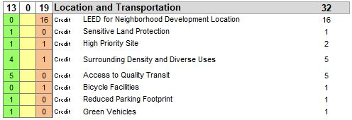
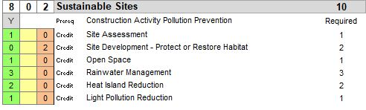
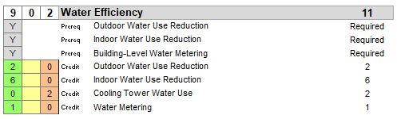
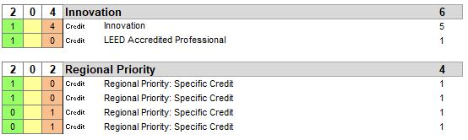
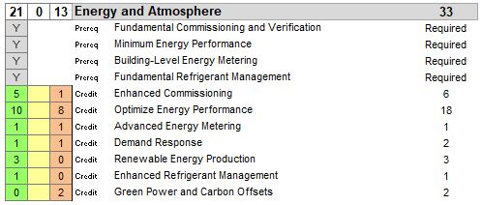
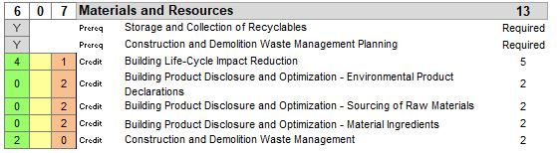
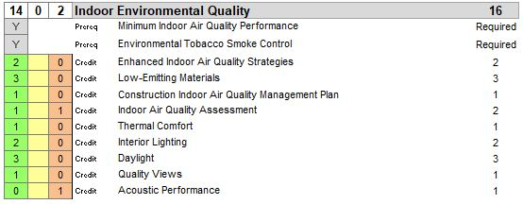

Appendix A: ENERGY STAR Program Overview
ENERGY STAR (Offices) is a joint program of the Environmental Protection Agency (EPA) and the Department of Energy (DOE). Its goal is to help consumers, businesses, and industry save money and protect the environment through the adoption of energy efficient products and practices. The ENERGY STAR label identifies top performing, cost-effective products, homes, and buildings.
A Memorandum of Understanding between EPA and DOE on improving the energy efficiency of products and buildings establishes working arrangements to enhance and expand the various aspects of ENERGY STAR. EPA and DOE are coordinating efforts to expand and enhance the ENERGY STAR products program, the Home Performance with ENERGY STAR program, and the National Building Rating Program, also known as the Commercial Building Energy Asset Score program.
- The ENERGY STAR products program sets specifications, testing procedures, and verification testing requirements for various consumer appliances, electronics, and commercial equipment.
- The Home Performance with ENERGY STAR program combines DOE's research into residential energy use with ENERGY STAR's outreach capabilities to promote energy-efficient home retrofits.
- The Commercial Building Energy Asset Score program is developing a commercial building energy asset rating program to allow building owners, managers, and operators to more accurately assess building energy performance.

Appendix B: Sensitive Land Protection Two Main Options
Option 1: Previously Developed Land
This option requires locating the development footprint on land that has been previously developed. There are some key terms here that are important for this requirement.
The development footprint is the total land area of a project site covered by buildings, streets, parking areas, sidewalks, and other typically impermeable surfaces constructed as part of the project. It's not just the building itself, but the entire sum of all physical development. It's not enough to put the building on a previously developed area and put the parking lot next door in a green-field.
previously developed means, It is land that has been altered by humans, such as paving, construction, and/or land use that would typically have required regulatory permitting to have been initiated (alterations may exist now or in the past). If 100% of the land within your LEED boundary is previously developed, you may build anywhere.
Option 2: Avoid Land meeting Sensitive Criteria
This option applies to undeveloped land, or green-field conditions. The intent is avoiding building on land that meets one of the sensitivity criteria.
Sensitivity criteria means; do not develop on portions of sites that meet any of the following:
Prime Farmland
Do not develop on prime farmland. Which means, lands with soil as prime, unique.
Floodplains
Do not develop on undeveloped floodplains. Floodplain, literary, is an area of land adjacent to a stream or river which stretches from the banks of its channel to the base of the enclosing valley walls and which experiences flooding during periods of high discharge.
Floodplains often contain wetlands and other important ecological areas as part of a total functioning system that impacts directly on the quality of the local environment.
Habitats
Protect habitats for endangered species. There are both endangered plants and animal species. Therefore, while choosing a land for development, we should consider the effect of this development on wildlife, plant or animal species, in order not be a part contributing of loss of natural habitat.
Water Bodies
Do not develop land within 30 meters of a water body such as a stream (including intermittent streams), arroyo, river, canal, lake, estuary, bay, or ocean. It does not include irrigation ditches. This buffer is generous because if human impacts affect the water body, from storm-water runoff, it will quickly end up in the ocean or our drinking water supply.
Wetlands
Do not develop land within 15 meters of any wetlands. Wetlands are areas inundated or saturated by surface or ground water at a frequency and duration sufficient to support a prevalence of vegetation typically adapted for life in saturated soil conditions. This buffer is smaller than water bodies because the primary purpose of a wetland is to filter water of contaminants.
Mention that, development means not just the building. It's also hardscapes, roadways, and sidewalks, which are all parts of the building project.

Appendix C: Use Types and Categories
Table 10 Use Types and Categories
Category | Use type
Food retail | Supermarket
Food retail | Grocery with produce section
Community-serving retail | Convenience store
Community-serving retail | Farmers market
Community-serving retail | Hardware store
Community-serving retail | Pharmacy
Community-serving retail | Other retail
Services | Bank
Services | Family entertainment venue (e.g., theater, sports)
Services | Gym, health club, exercise studio
Services | Hair care
Services | Laundry, dry cleaner
Services | Restaurant, café, diner (excluding those with only drive-thru service)
Civic and community facilities | Adult or senior care (licensed)
Civic and community facilities | Child care (licensed)
Civic and community facilities | Community or recreation center
Civic and community facilities | Cultural arts facility (museum, performing arts)
Civic and community facilities | Education facility (e.g., K—12 school, university, adult education center, vocational school, community college)
Civic and community facilities | Government office that serves public on-site
Civic and community facilities | Medical clinic or office that treats patients
Civic and community facilities | Place of worship
Civic and community facilities | Police or fire station
Civic and community facilities | Post office
Civic and community facilities | Public library
Civic and community facilities | Public park
Civic and community facilities | Social services center
Community anchor uses (BD&C and ID&C only) | Commercial office (100 or more full-time equivalent jobs)
Community anchor uses (BD&C and ID&C only) | Housing (100 or more dwelling units)

Appendix D: Advanced Energy Metering Characteristics
The advanced energy metering must have the following characteristics.
- Meters must be permanently installed, record at intervals of one hour or less, and transmit data to a remote location.
- Electricity meters must record both consumption and demand. Whole-building electricity meters should record the power factor, if appropriate.
- The data collection system must use a local area network, building automation system, wireless network, or comparable communication infrastructure.
- The system must be capable of storing all meter data for at least 36 months.
- The data must be remotely accessible.
- All meters in the system must be capable of reporting hourly, daily, monthly, and annual energy use.

Appendix E: ASHRAE Standard 62.1
IAQ has direct effects on our health as well as the perception of an acceptable indoor environment. ASHRAE Standard 62.1: Ventilation for Acceptable Indoor Air Quality is the most commonly referenced standard to quantify acceptable conditions and appropriate HVAC system design.
The standard is best known for its regulation of the amount of ventilation air delivered to each space by HVAC systems through its ventilation rate procedure approach to system design. However, the standard covers many other aspects of building design that are less well known and understood. The key aspects of building design that it covers are: outdoor air quality, envelope design and construction, HVAC system construction, concept of air classes, the ventilation rate procedure, the IAQ procedure, the natural ventilation procedure, and operations and maintenance.
The purpose of this standard is to specify minimum ventilation rates and other measures intended to provide indoor air quality that is acceptable to human occupants and that minimizes adverse health effects. This standard is intended for regulatory application to new buildings, additions to existing buildings, and those changes to existing buildings that are identified in the body of the standard. Also it is intended to be used to guide the improvement of indoor air quality in existing buildings.

Appendix F: ASHRAE Standard 55
ASHRAE Standard 55 (Thermal Environmental Conditions for Human Occupancy) is a standard that provides minimum requirements for acceptable thermal indoor environments. It establishes the ranges of indoor environmental conditions that are acceptable to achieve thermal comfort for occupants.
The purpose of this standard is to specify the combinations of indoor thermal environmental factors and personal factors that will produce thermal environmental conditions acceptable to a majority of the occupants within the space.
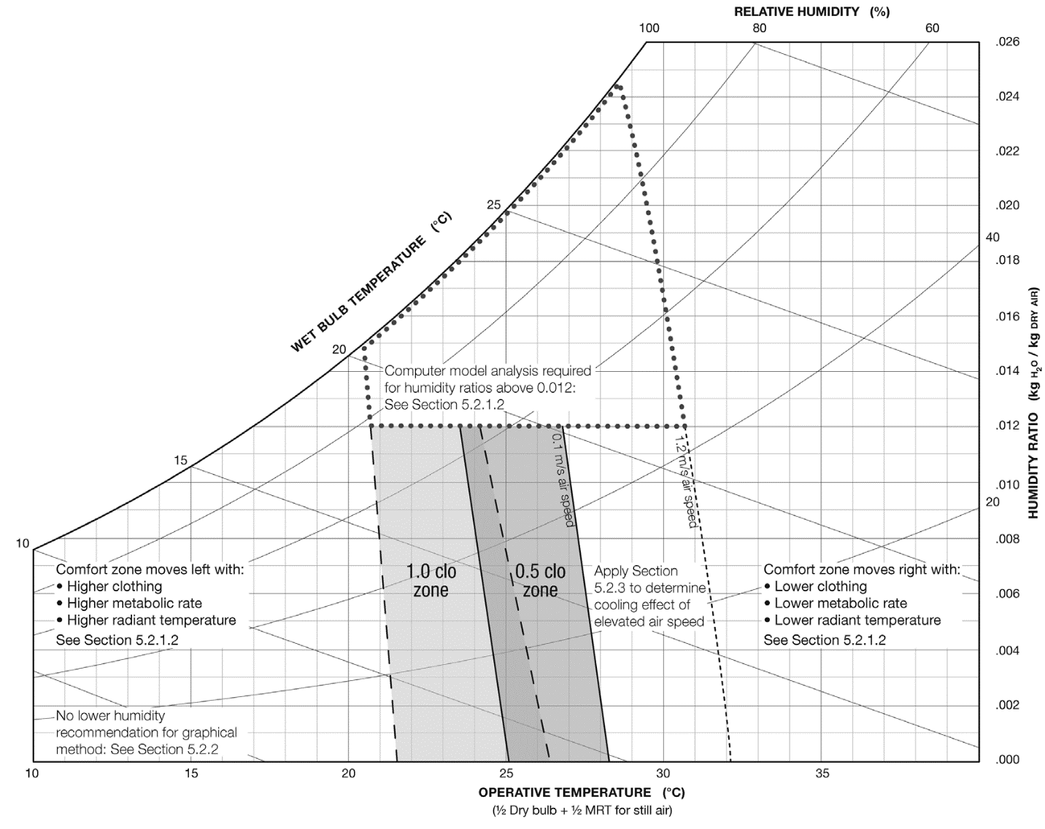
Figure 7 Graphic Comfort Zone Method: Acceptable Range of Operative Temperature and Humidity

Figure 8 Acceptable Range of Operative Temperature and Air Speeds for the Comfort Zone

Appendix J: Building Flush-Out
Flush out or building flush is a process to force air through a building just prior to occupancy to remove some of the pollutants, such as formaldehyde and other volatile organic compounds, that seep from newly installed components, fresh paint, materials, finishes and furnishings. These include flooring and flooring adhesives, paints and finishes, caulks and sealants, and cabinets and work surfaces made from composite lumber products. The flush out process aims to improve indoor air quality by limiting occupants’ exposure to the most intense period of contamination, and minimizing the cross-contamination between materials.
After all interior finishes are installed, the building must be flushed out with outside air for 14 days with either continuous ventilation or aggregate intermittent ventilation equivalent to 14 days.
This is performed prior to occupancy by providing 14,000 cubic feet of outdoor air per square foot of building space. Relative humidity must be maintained at 60% or below and temperature must be maintained at 60 degrees or above.

Appendix H: GROHE Products Data Sheet

Public Lavatory Faucets Data Sheet
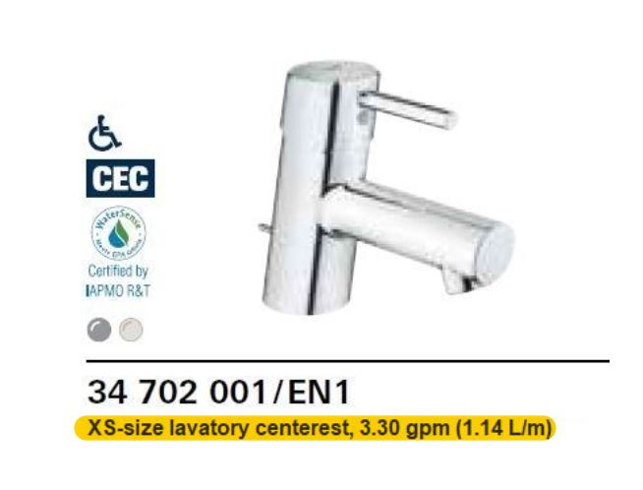

Private Lavatory Faucets Data Sheet
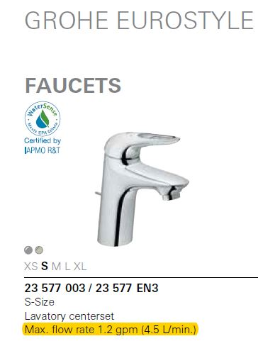

Kitchen Faucet Data Sheet
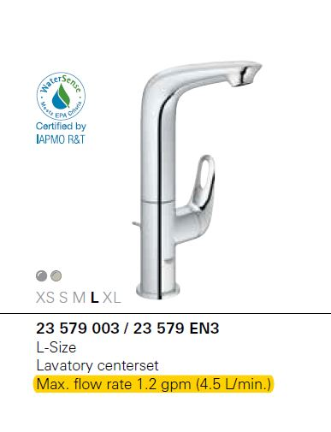

Showerhead Data Sheet
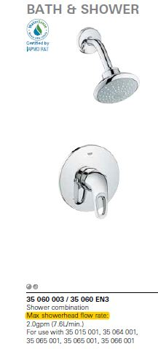

Appendix I: ANSI/ASHRAE/IESNA Standard 90.1–2010
The purpose of ANSI/ASHRAE/IES Standard 90.1-2010, Energy Standard for Buildings except Low-Rise Residential Buildings, is to address minimum requirements for energy efficiency in buildings, including requirements for the building envelope, HVAC systems, service water heating, power, lighting, and other equipment. The scope covers new building construction as well as renovations or additions to existing buildings and systems.

Appendix G: Northern Façade and Roof Top of the Shopping Center
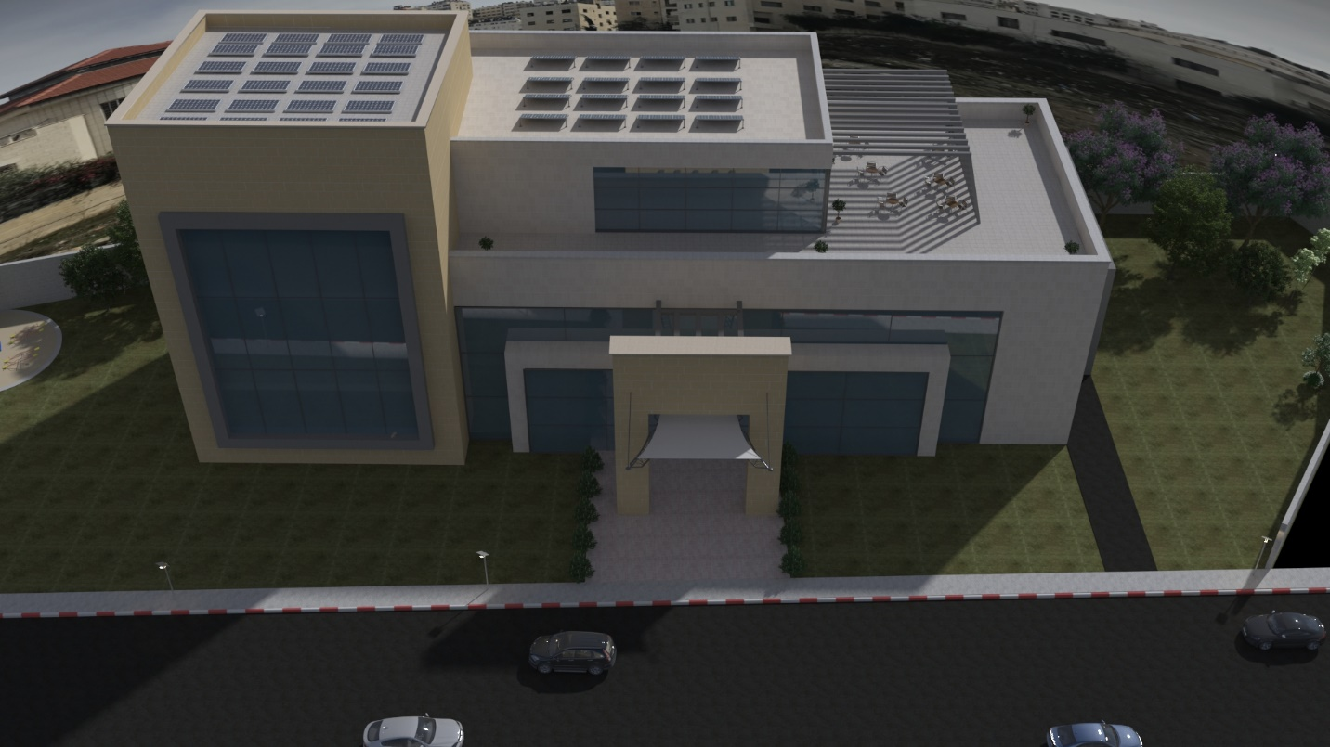

Appendix K: Southern Façade of the Shopping Center
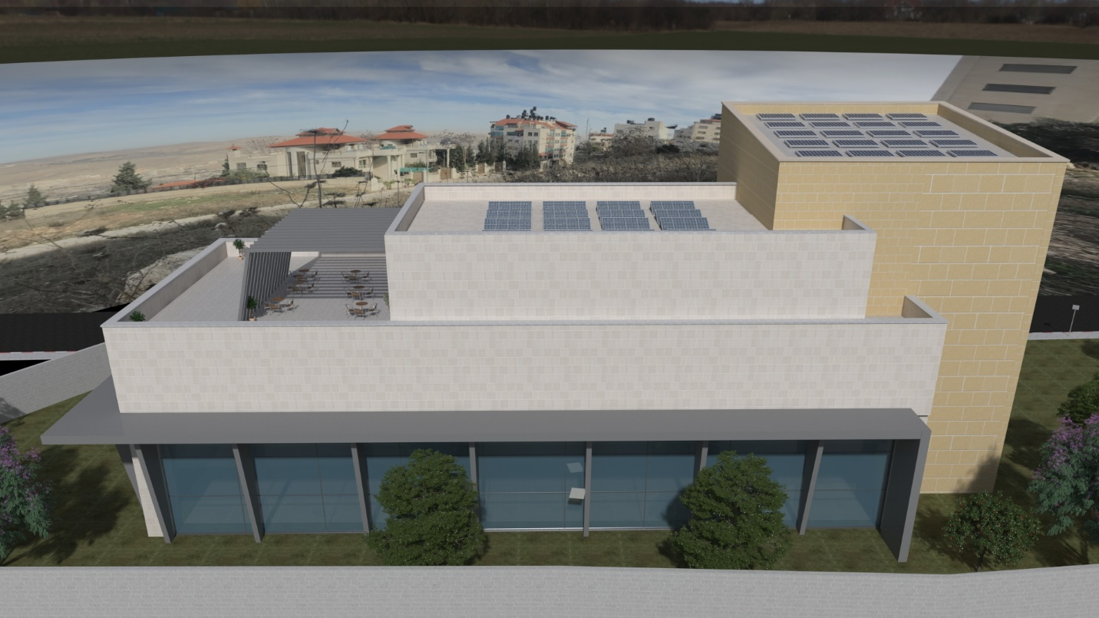

Appendix L: Eastern Façade of the Shopping Center
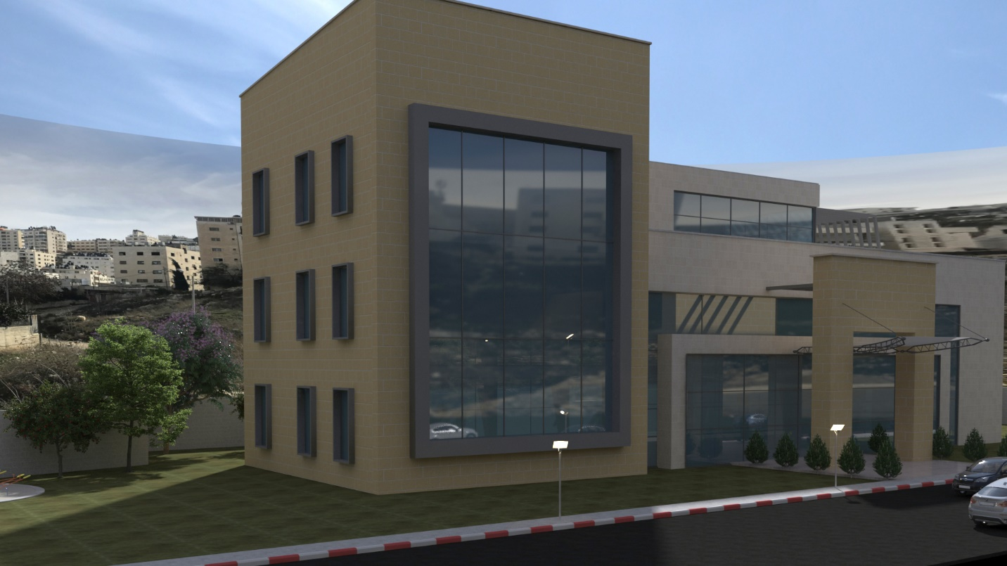

Appendix M: Site Plan
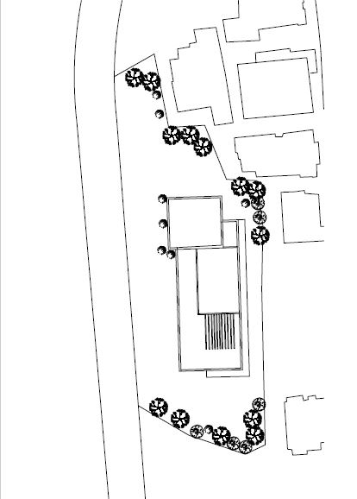

References
[Report] Climate Change: Implications for Buildings [Online] = Climate Change:Implications of Buildings / auth. GBPN [et al.] // http://www.gbpn.org. - 6 12, 2014. - 10 21, 2017. - http://www.gbpn.org/newsroom/report-climate-change-implications-buildings.
Analysing the implementation of sustainable public procurement policies, [Report] / auth. Morton B.. - [s.l.] : 3rd International Seminar on Public Procurement Asuncion, 2008.
Assessing the performance of sustainable technologies for building projects [Journal] / auth. Nelms C., Russel A. D. and Lence B. J // Canadian Journal for Civil Engineering. - 2005. - Vol. 32. - pp. 114-128..
Assessment of Local Excavation Support Systems: A Case Study of Nablus City, Palestine [Journal] / auth. Jardaneh Isam. - Nablus : An Najah National University, 2006. - Vol. 20.
Awareness, actions, drivers and barriers of sustainable construction in Chile [Journal] / auth. Serpell Alfredo, Vera Sergio and Kort Jorge // Technological and Economic Development. - 2013. - 2 : Vol. 19. - pp. 272-288.
Barriers and drivers for sustainable building [Journal] / auth. Häkkinen T. and Belloni K. // Building Research & Information. - 2011. - 3 : Vol. 39. - pp. 239-255.
Costs and benefits of building green [Journal] / auth. Nalewaik Alexia and Venters Valerie // IEEE Engineering Management Review. - 2010. - 2 : Vol. 38. - pp. 77-87.
Developing a green building assessment tool for developing countries – Case of Jordan [Journal] / auth. Ali Hikmat H. and Nsairat Saba F. Al // Building and Environment. - [s.l.] : Elsevier, 2008. - pp. 1053-1064.
Drivers and barriers of sustainable design and construction: The perception of green building experience [Journal] / auth. Ahn Yong Han [et al.] // International Journal Of Sustainable Building Technology And Urban Development. - 2013. - pp. 35-45.
ELEMENTS OF CIVIL ENGINEERING [Book] / auth. SAIKIA MIMI DAS, DAS BHARGAB MOHAN and DAS MADAN MOHAN. - India : Prentice-Hall of India, 2011. - 1 : p. 228.
Energy Performance of LEED for New Construction Buildings [Report] / auth. Turner Cathy and Frankel Mark. - Washington DC : New Buildings Institute, 2008.
EPA [Online] // United states Environmental Protection Agency. - may 26, 2016. - https://www3.epa.gov/climatechange/ghgemissions/gases.html.
Evolving sustainably: A longitudinal study of corporate sustainable development. [Journal] / auth. Bansal Pratima // Strategic Management. - 2005. - 3 : Vol. 26. - pp. 197–218.
Factors affecting the implementation of green specifications in construction [Journal] / auth. Lam Patrick T.I. [et al.] // Environmental Management. - 2009. - pp. 654–661.
Google Maps [Online] / auth. Google-Maps // Google Maps. - http://obeattie.github.io/gmaps-radius/?radiusInput=400&unitSelector=mt&lat=32.222999&lng=35.23&z=16&u=mt&r=400.
Green Building Costs and Financial Benefits: report to California‟s sustainable building task force, developed for the Sustainable Building Task Force. [Report] / auth. Kats Gregory H.. - California, U.S.A : The Massachusetts Technology Collaborative, 2003.
Green Construction: Contractor Experiences Expectations, and Perceptions [Journal] / auth. Ahn Y.H. and Pearce A.R // Green Building. - 2007. - pp. 106-122.
Impact of green building design and construction on worker safety and health. [Journal] / auth. Rajendran Sathyanarayanan, Gambatese John A. and Behm Michael G. // Journal of Construction Engineering and Management. - 2009. - 10 : Vol. 153. - pp. 1058–1066.
Importance of Green Buildings Stressed by Business and Industry at UN Climate Negotiations [Report] / auth. Comstock Maggie. - Washington, D.C., United States : USGBC, 2013.
LEED Green Associate Exam Preperation Study Guide [Book] / auth. GBES. - Lewisville : Green Building Education Service, 2014. - 4 : p. 287.
LEED Reference Guide for Building Design and Construction [Report] / auth. USGBC. - Washington, DC : U.S. Green Building Council, 2013.
LEED v4 BD&C EXAM GUIDE: A Must-Have for the LEED AP BD+C Exam: Study Materials, Sample Questions, Green Building Design and Construction, LEED [Book] / auth. Chen Gang. - California : G architects, 2013. - Vol. 4. - 978-1612650173.
LEED: Green Ascociate Exam Preperation Study Guide [Book] / auth. GBES. - Lewisville : Green Building Education Service, 2014. - Fourth Edition : p. 287.
LEED® Core Concepts Guide: An Introduction to LEED and Green Building [Book] / auth. Blust Karen [et al.]. - Washington, DC : U.S. Green Building Council, 2014. - 3.
Locality Profiles and Needs Assessment in the Nablus Governorate [Report] / auth. ARIJ. - Jerusalem : The Applied Research Institute – Jerusalem (ARIJ), 2014.
Master of Technology - GROHE Ecojoy [Online] / auth. GROHE // GROHE America Website. - GROHE AMERICA. - https://www.homedepot.com/catalog/pdfImages/4c/4ca71b1d-f5f9-4caa-82c1-df899144b7f3.pdf.
Masters of Technology - GROHE EcoJoy [Online] / auth. GROHE // GROHE AMERICA web site. - GROHE AMERICA. - 12 1, 2017. - https://www.grohe.us/en_us/bathroom/masters-of-technology-save-precious-resources/.
Promoting Green Buildings Practices in Palestine [Report] / auth. Rustom Naim H.. - Gaza : The Islamic University of Gaza, 2014.
State and Trends of the Environment 1987–2001 [Report] = Biodiversity / auth. Armenteras Dolors and Finlayson C. Max. - [s.l.] : UN Environment Programme, 1987-2001.
Sustainability components affecting decisions for green building projects', Procedia Economics and Finance [Journal] / auth. Vatalisa K.I. [et al.] // Procedia Economics and Finance. - 2013. - pp. 747 – 756..
SUSTAINABLE BUILDING: AN REVIEW [Journal] / auth. Rathod Shashank and Panchayat Zila. - [s.l.] : International Journal of Advanced Engineering Technology.
Sustainable construction: green building design and delivery [Book] / auth. Kibert Charles J. - [s.l.] : John Wiley & Sons, 2016. - 4.
The Emissions Gap Report 2016 [Report] / auth. UNEP. - Nairobi : United Nations Environment Programme (UNEP), 2016. - 978-92-807-3617-5.
The Evolution of National Water Regimes in Europe: Transitions in Water Rights and Water Policies (Environment & Policy) [Book] / auth. Kuks Stefan and Kissling-Näf Ingrid. - netherlands : kluwer academic, 2005. - 1402024835.
The Green Outlook 2011:Green Trends Driving Growth through 2015 [Report] / auth. Bernstein Harvey M.. - New York, NY : McGraw-Hill Construction, 2010.
The Way Forward in Sustainable Construction: Issues and Challenges [Journal] / auth. Hussin J., Md, Rahman Abdul and Memon // International Journal of Advances in Applied Sciences (IJAAS). - 2013. - 1 : Vol. 2. - pp. 31-42.
Toilets [Report] / auth. EPA / EPA-832-F-06-018. - USA : Environmental Protection Agency, 2013.
Transport, Energy and CO2 [Report] / auth. IEA. - France : International Energy Agency, 2009.
United States Environmental Protection Agency [Online] / auth. EPA // United States Environmental Protection Agency website. - 2012. - 10 24, 2017. - https://www.epa.gov/smartgrowth/smart-growth-and-climate-change.
What Prevents Firms from Advancing in their Environmental Strategy? [Journal] / auth. Murillo-Luna Josefina L., Garcés-Ayerbe Concepción and Rivera-Torres Pilar // International Advances in Economic Research. - 2007. - 1 : Vol. 13. - pp. 35-46.
www.Energy.gov [Online] / auth. Offices Energy Gov.. - U.S Department of Energy. - 10 17, 2017. - https://energy.gov/eere/buildings/energy-star.
قرار مجلس الوزراء رقم (6) لسنة 2011م بنظام الأبنية والتنظيم للهيئات المحلية [Report] / auth. Palestinian-Cabinet. - Ramallah : [s.n.], 2011.

Source: (GBES, 2014)
(GBES, 2014)
Intents express for the prerequisite or credit what the environmental goal is. An example is that LEED has several credits related to carpooling, telecommuting, or locating near mass transit. All these credits are trying to meet the Intent of reducing automobile use.
1 Rupees=0.015$=0.054 NIS
Source: Capital E analysis, www.cap-e.com
Source: Capital E analysis, www.cap-e.com
Source: (UNEP, 2016)
Source: (Bernstein, 2010)
(EPA, 2012)
(IEA, 2009)
Source: (USGBC, 2013)
Sensitive land: the site has pre-project wetlands, water bodies, land within 15 meters of wetlands, or land within 30 meters of water bodies
Source: (USGBC, 2013)
Source: (Google-Maps)
Source: (Google-Maps)
Source: (Google-Maps)
Preferred parking means, parking spaces closest to the main entrance of a building (exclusive of spaces designated for handicapped persons).
Source: (Armenteras, et al., 1987-2001)
Source: (ARIJ, 2014)
Source: (Jardaneh, 2006)
Source: (Chen, 2013)
Source: (Kuks, et al., 2005)
Source: (EPA, 2013)
GROHE EcojayTM: products by GROHE are systematically designed to save water and energy so that precious resources are conserved. These products, equipped with water-saving technologies, offer the perfect water experience without the need to compromise. Reducing water and energy consumption goes hand in hand with convenience and attractive design. Less water. Perfect flow. Source: (GROHE)
See (Appendix H)
MODBUS, is a serial communication protocol is used to connect a supervisory computer with a remote terminal unit.
BACnet, is a data communication protocol for building management and control networks.
The Montreal Protocol, finalized in 1987, is a global agreement to protect the stratospheric ozone layer by phasing out the production and consumption of ozone-depleting substances (ODS).
The Koch Multi-Pleat GREEN 13 is a high efficiency extended surface pleated panel filter, engineered to provide higher initial efficiencies than standard pleated filters. The Green 13 is a sustainable component of green building development. The MERV 13 performance ratings provided by the Multi-Pleat GREEN 13 make the filter an excellent upgrade from disposable filters and ordinary pleated filters in any system in which a higher degree of clean air is required. Mention that, it is available in Palestine.
For further information, see (Appendix J)
Source: (GROHE)
Source: (GROHE)
Source: (GROHE)
Source: (GROHE)

