

An-Najah National University

Faculty of Engineering

Energy and Environmental Engineering Department
Optimal Renewable Energy Electrification Strategy for Masafer Yatta, Palestine, Considering The Technical and Political Aspect.
Graduation Project-2 submitted to:
Department of Energy and Environmental Engineering Faculty of Engineering and Information Technology
An-Najah National University

In partial fulfillment of the requirements for Bachelor degree in Energy
and Environmental Engineering

Supervisor Name: -
Dr. Tamer Khatib

Students Name:
Eman Thouqan and Zaina Ruzzeh
May 12, 2021

DECLARATION

We do hereby declare that the project titled "Optimal renewable energy electrification strategy for Masafer Yatta, Palestine, considering the technical and political aspect" was submitted to the Department of Energy and Environmental Engineering of An-Najah National University in partial fulfillment of the Bachelor degree in Energy and Environmental Engineering. This is our original work and was not submitted elsewhere for the award of any other degree or any other publication. And whenever we have used materials (data, theoretical analysis, and text) from other sources, we have given due credit to them in the text of the report and giving their details in the references.

Acknowledgements

Primarily we would thank first and foremost the Lord God Almighty for His never-ending grace to complete this project with success. Then we would like to gratefully and sincerely thank our supervisor Dr. Tamer Khatib, words can neither qualify nor quantify how helpful your guidance and advice has been, we are forever grateful for your support whose was the basic part to completion of the project.
Then we would like to thank our parents, getting parents like them by our side makes us what we are today and friends who have helped us with their valuable suggestions and guidance has been helpful in various phases.
Thanks, are extended to faculty of Engineering and Information Technology in general and specially for the Department of Energy and Environmental Engineering at An-Najah National University

Table of Contents
DECLARATION 2
Acknowledgements 3
List of figures 5
List of tables 6
Nomenclature 7
Abstract 8
Ch1.Introduction: 9
CH2. Literature Review 11
2.1 Solar and wind Energy potentials in Palestine 11
2.2 Electrification of remote areas 12
2.3 HOMER pro software applications in modeling and simulation hybrid renewable Energy systems. 13
CH3.Masafer Yatta 14
Ch4.Methodology 17
4.1 Electrification Using PV 17
4.2 Electrification Using Wind Turbine 18
4.3 Option of Hybrid System with Diesel Generator 20
Ch5. Results and discussion: 21
5.1 Results for First location 21
5.2 Results for Second Location 24
CH:6 Environmental Impact For Wind Turbine 27
3.4.2 Negative Impacts of Wind Turbine 30
3.4.3 Positive Impact of Wind Turbine. 31
Ch6. Conclusion: 32
Ch6. References 33

List of figures
Figure 1: The two zones of the project in Masafer Yatta 14
Figure 2:Energy consumption per day for zone A 15
Figure 3:Energy consumption per day for zone B 16
Figure 4:Monthly Average Solar Global Horizontal Irradiance 18
Figure 5: Wind speed distribution for Zone A 19
Figure 6: Wind speed distribution for Zone B 19
Figure 8:Annual production of PV for First Location 22
Figure 9: The Change of Batteries capacity with the shortage from PV for First Location 22
Figure 10: Annual production of Wind Turbine for First Location 23
Figure 11: The Change of Batteries capacity with the shortage of wind turbine system for Fist location 23
Figure 12: Annual production of PV for Second Location 24
Figure 13: The Change of Batteries capacity with the shortage from PV for Second Location 25
Figure 14:Annual production of Wind Turbine for Second Location 25
Figure 15:The Change of Batteries capacity with the shortage of wind turbine system for Second location 26

List of tables

Table 1:Families distribution 14
Table 2: Renewable Energy Systems specifications for First Location 22
Table 3:Renewable Energy Systems specifications for Second Location 25
Table 4:Some of Envieimental component that affected by project activites 30

Nomenclature

Area A | Full civilian and security control by the Palestinian Authority
Area B | Palestinian civilian control and joint Israeli-Palestinian security control
Area C | Full Israeli civilian and security control, except for Palestinian civilians
COE | Cost Of Energy
Comet-ME | Community, Energy and Technology in the Middle East.
dB | decibel
DESCOs | Distributed Energy Service Companies
EIA | Environmental Impact Assessment
EWEA | The European Wind Energy Association
HOMER | Hybrid Optimization of Multiple Energy Resources
IEC | Israel Electric Company
LCOE | Levelized Cost Of Energy
LLP | Loss of Load Probability
NGO | Non-Governmental Organization
NPC | Net Present Cost
O&M | Operation and Maintenance
PV | Photovoltaic
RE | Renewable Energy

Abstract

This project proposes two methods of electrification for a rural area which is Masafer Yatta, south of Hebron using an off-grid hybrid system based mainly on renewable energy sources (PV, wind turbine) and diesel generators, to electrify the regions in which the occupation prevents electricity access to it, which considered as Area C, the project is located in two locations in Masafer. The average energy demand in the first site which contains 72 families is 2075 kWh/day. for the second site which contains 30 families, the average energy demand is 1015 kWh/day. The region has good renewable energy potentials, where the average solar radiation there is 5.15 kWh/m2.day and the average wind speed in Masafer Yatta at the first site is 4 m/s and the second site is 5.4 m/s. HOMER software was used to optimize the design of renewable energy in remote areas which requires solar radiation data, wind speed data, electrical demand profile for the two locations proposed. The results showed that the best option for the electrification of Masafer Yatta after studying the region from a political and social point of view is wind turbines with a capacity of 920 for 72 kW families and 300 kW for 30 families with the first diesel generator capacity of 240 kW and 120 kW for the second site. In the end, the effect of wind turbines on the environment was studied.

Ch1.Introduction:
In Palestine, the energy sector situation is highly different compared to other countries in the Middle East due to many reasons: non-availability of natural resources, unstable political conditions, financial crisis, and high-density population. Where The total energy consumption per habitant in Palestine is (0.79 MW h/ inhabitant) and costs more than anywhere else in the Middle East countries. Palestine has good potential for renewable energy, as the average wind speed (m / s) for each of Tubas 4.97, Salfit 4.26, Ramallah 3.09, Hebron 2.90, and Jericho 1.32. Wind energy resource is moderate, therefore; microturbines can be used whereas backup sources instead of diesel generators for PV hybrid systems, which renders the utilization of such hybrid systems more attractive for remote areas. On the other hand, Palestine has a high solar energy potential of around 3000 hours of brightness per year with solar radiation (kWh / m2 / day) for 2013 of 8.27 in Ramallah, 7.51 in Hebron, 6.86 in Salfit, and 6.15 in Tubas. Thus, when Palestine uses renewable energy to produce electricity, Palestine's dependence on neighboring countries for electricity may decrease significantly.[1]
But given the political situation in Palestine, most of the energy consumed comes from the Israel Electric Corporation (IEC). Meanwhile, the Israeli government is controlling the electricity supply to the Palestinians for political reasons. Consequently, this leads to many shortages of electricity, which is why the Palestinians have to invest in renewable energy systems to make up for the shortage. However, according to the Oslo Accords, any development in the field of electricity or energy must take place in cooperation between Palestine and Israel. However, the current political situation precludes any cooperation in this regard. Electricity is generated on the Israeli side near the borders of the West Bank and Gaza Strip. Then energy is transmitted on the Israeli side through major transmission lines of 161 kilovolts. These lines are converted into 33 kV transmission lines or 22 kV transmission lines. In the middle of these transmission lines, a connection point is placed that controls the amount of electricity that flows to the Palestinian side. Capacities are controlled by an entity called the Israeli Civil Administration in the West Bank, and any increase in capabilities takes place on the basis of political coordination. As for the electricity networks, they are either owned by private Palestinian electricity distribution companies (DESCOs) or local councils.[2]
Palestine lands are classified into three areas according to Oslo Agreement: Areas A (full civilian and security control by the Palestinian Authority) Areas B (Palestinian civilian control and joint Israeli-Palestinian security control) Areas C (full Israeli civilian and security control, except for Palestinian civilians). our project is located in Masafer Yatta which is classified under Class C, which is under the control of the occupation, and as part of the occupation’s policy to displace and deport Palestinians from these areas, the occupation establishes Israeli settlements, to increase restrictions imposed on the freedom of movement for residents, to reduce the space available to them. Since the 1980s, the Israeli authorities have designated most of the area's lands, including 14 communities, as closed military zones for training, or so-called “firing 918” zones, so these communities are at risk of forcible displacement, Therefore, the occupation does not allow electricity to reach this area, and there is also no infrastructure for it to extend power lines, so the only solution in this area is renewable energy.[3]
Moreover, some donor countries, represented by the organization Comet Me, provide electricity to some homes through renewable energy projects. Several Bedouin communities have benefited from projects that generate electricity from PV, to provide the population with their simple needs of electricity, especially for manufacturing and cooling dairy products. These projects, in addition to their economic and social benefits, have a political significance in strengthening the resilience of the population.
Through our study of the political, energy situation, and the problems that exist there, the project discussed three scenarios to generate electricity in the region through PV, wind turbines, and diesel generators via HOMER software, which is a global standard for energy modeling tools that analyze solar-plus-storage, microgrids, and other distributed energy projects. The optimization of the system using HOMER is usually done based on the system’s cost and reliability. it’s used to study the feasibility of stand-alone hybrid solar PV, and wind for remote housing electrification. The software is used to find the optimum combination of renewable energy resources for rural housing electrification [4].These scenarios were compared on the basis of the number of kilowatts required, the appropriate storage size, and the cost of the project, taking into consideration the environmental, social, and political impacts.

CH2. Literature Review

2.1 Solar and wind Energy potentials in Palestine
The Palestinians are among the most in need of local alternatives to electricity, as nearly 90% of the electricity needs come directly from Israel. So to limit the impact of Israeli control on this vital sector, and because Palestine receives about 3000 hours of sunlight every year, at a rate of 8.2 hours per day. It's suitable for investing in solar energy on its land-based on this study [5]. However, in [6], the potential energy production was estimated from the installation of photovoltaic (PV) energy systems on the roofs of apartment buildings and it was found that it could increase the electricity production for types of buildings containing 2-4 housing units from the estimated future consumption, as well as buildings containing 4 8- Housing units that produce their electricity consumption in 2030. As for building types of 12-24 housing units, they can produce more than half of their future consumption in 2030.
As for wind energy, this study [1] encouraging to use of small wind turbines to electrify sites located far from the grid and have a high potential of wind speeds. In addition, another feasible application for small wind turbines is to use them for water pump ping, especially for rural areas where diesel generators are used for this purpose. Study [7] showed through a climatic analysis of the wind profile in the State of Palestine, in addition to choosing a typical meteorological year, wind energy intensity, and annual energy production. This climatology is based on a 12-year simulation (2000 2011) using the WRF Numerical Weather Forecast model. For the Gaza region and the West Bank, the highest wind speed was observed during the winter period with wind direction is westerly for both Gaza and the West Bank. In [8] the results also showed that wind energy is outperforming solar energy in the winter months. It also showed that a single wind turbine and a similar PV system could provide sufficient power for 3.7 households.
This study [9] represents an overview on the possibility of using wind energy to fulfil the increasing demand on energy and the lack of supplied energy in the Palestinian territories, by analysing and discussing former studies in this field agree about the possibility of exploiting wind energy, especially in high areas in Hebron in West Bank and Gaza city in Gaza Strip, to solve both the crisis of shortage electricity and the increase demand on energy. The highest wind energy is in Hebron, and the average monthly wind speed is between 3 m/s – 7.5 m/s, and the lowest wind energy is in Jericho, and the wind speed there is less than 2.5 m/s most time. In [10]seems the potential of wind energy seems to be limited to the mountains (elevation of about 1000 m); regions of Nablus, Ramallah, and Hebron where the speed surpasses 5 m/s and the potential about 600 kWh/m2.studies show that the wind regime is suitable for operating a wind turbine for wind power generation in the city of Hebron in West Bank. For example, Al-Ahli Hospital is located in the south-western part of Hebron at ~1000m above sea level on a site of 27500 m2. The average wind speed at 10 m could be as high as 6.2m/s in this region according to detailed data supplied by the Weather Authority. However, for political issues this study [11]is intended to perform wind resource assessment in Palestine/Israel; the study has used two stages of assessment, the primary one based on reference station data on both sides, Israeli and Palestinian. The second stage of wind resource assessment is based on WindPRO software. Moreover, the study recognized the importance of political situation assessment due to the Israeli-Palestinian conflict. Based on the conducted survey, the political situation assessment concluded that international non-governmental organizations seem to be most capable of starting upwind power projects in Palestine/Israel. Furthermore, the study concluded that supportive policies from both the Israeli and Palestinian governments are crucial to promote wind power projects in the region.

2.2 Electrification of remote areas
Remote areas are becoming a topic of increasing international interest as they can provide insights into the transition towards a more sustainable energy future. Being geographically isolated and distant from different services (e.g. energy, health, and education), remote areas have seen their development delayed for decades[12].In Palestine, there is an example of contributing to the rural areas development program, because there are a large number of small remote villages that lack electricity, and the possibility of connecting them to the high voltage network in the near future is very weak due to the financial and political situation. This paper[13] s represented the photovoltaic power system, the diesel generator, and the electric grid. The computer-aided dynamic economic assessment method with five indicators is used to compare the economic effects of these energy systems. The results showed that using PV systems for rural electrification in Palestine is more economically feasible. In this paper [14], another example is in Palestine in remote areas far from the grid, where a hybrid photovoltaic system is used as an effective option to supply it with electricity. The study also found that electrifying small rural communities using the hybrid system is very beneficial and competitive with other types of traditional sources because it reduces operating costs and pollutant emissions. This paper [15] presents an investigation of the feasibility of using micro-turbines as backup sources in hybrid systems in Palestine. One scenario is based on the independent PV system and another scenario is based on the microturbine only.
Another example, in India, a [16] study was conducted on the use of solar, wind, or small hydroelectric power to provide high-quality energy supplies to remote areas. This paper details an analysis of a small-capacity hybrid power system to supply electricity and demand for clean water in rural and remote areas using a small grid hybrid power system consisting of renewable energy (solar photovoltaics and windmill) and battery. This, in turn, will lead to raising people's living standards without access to the electricity grid. There is a disadvantage in using renewable energy alone, which is that it has daily and seasonal patterns, which sometimes leads to not meeting the demand, but to solve this problem, more than one renewable energy system can be combined or generation through diesel generators, which will increase the reliability of the system (power system Hybrid) In[17] the optimal use of renewable energy resources in India has also been determined in the state of Uttara which is rich in the availability of renewable energy resources such as solar energy, small hydropower, biomass, and wind energy, which is an efficient economic option compared to grid expansion for electrifying rural homes away from the grid. By combining technical and economic improvement and energy management to meet the electric power demand.
In the end, [4] Renewable energy becomes a goal to provide adequate electricity demand to end-users in remote areas, and in general, most viable renewable energy systems are off-grid systems such as photovoltaic systems, wind energy systems, and small hydropower systems. Access to electricity in remote areas is limited due to some restrictions, including complex geographic factors, harsh political conditions, and the high costs of transmission lines. Therefore, investments in this regard should be planned wisely to produce energy at a reasonable unit cost (price per kilowatt-hour) and for the renewable energy system to be in the midst of a group in small communities to provide all communities with electricity with minimal energy loss and voltage drop.

2.3 HOMER pro software applications in modeling and simulation hybrid renewable Energy systems.
An advantage of using the Hybrid Renewable Energy Optimization Model (HOMER) is to design and perform a technical-economic analysis to meet the load requirements using the hybrid PV / biomass configuration. This is done by entering the solar radiation data and the biomass potential available on the desired farm. In this study [18], an economic design is proposed to generate electricity for an agricultural farm and residential community centered in a small village in Layyah district of Punjab province in Pakistan using a PV / biomass hybrid power source made through the HOMER software. One of the most important results was to know the cost of energy (COE) and the total net current cost (NPC), and then these results were analyzed in a precise and Broadway to know that the system is technically and economically applicable based on these two costs, the net current cost and the energy cost. The uses of Homer have reached Palestine as well, as this study [10] worked on electrifying a small Palestinian village using a complex hybrid renewable energy system, and the optimal design was based on the HOMER Pro software

CH3.Masafer Yatta
Masafer Yatta is located between 14 and 24 km south of Hebron and away from the capital Jerusalem for about 70 km. It is bordered from the east and south by the Green Line (the lands of 1948), the north and west by Yatta and Al Samu '.
It has an area of about 40,000 dunums, its population is estimated at 1,800 people. They work in agriculture and depend on livestock, especially sheep and goats, as their main source of income. Masafer Yatta is located on a plateau in the east of Yatta, and its height ranges between 518 meters and 805 meters above sea level. it is located at the longitude of 35.31 and the latitude of 30.1, the average temperature reaches 18 degrees Celsius, and the average relative humidity is about 60%.
Masafer Yatta includes 22 Bedouin communities, which are: Jinba, Markaz, Halawa, Khirbat al-Fakhit, Khirbet Maqawrah al-Taban, Khirbet al-Majaz, Khirbet Isfay (al-Fuqa and al-Tahta), al-Munaqasa, Mughair al-Abed, Khallat al-Dabaa, Umm al-Khair, Sada al-Thaalaisp, al-Daqiqah, Shaab al-Butm, Ber alaid, Qawawis, Al Rakiz, Ahariba alnabi, Wadi Ajhaish, Susiya, Wadi Al Rakhim, and Tuba.[3]
The project is placed in two zones in the Masafer as shown in Figure 1 the first zone is placed in the north which contains: Tuba, Mughair al-al-Abed, Isfat al-Fawqa, and Isfat al-Tahta. The second zone is located south of Masafer, which is consisting of Halawa, Markaz, Junab, and Khirbet Bear Al I’d
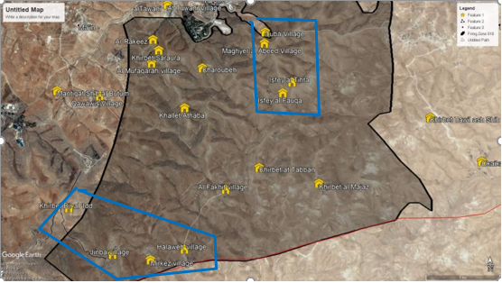
Figure 1: The two zones of the project in Masafer Yatta

Before analyzing the load in the two zones, this is a simple overview of the number of families in each Bedouin community from these two zones.
Table 1:Families distribution
Zone (A) | Number of families
Khirbet Bir al-I’d | 3
Jenba | 40
Al-Markaz | 12
Al-Halawa | 16
Total | 72 families
Zone (B)
Isfay al-Fawqa | 6
Isfay al-Tahta | 6
Tuba | 15
Maghir al-Abid | 3
Total | 30 families

So, this means the number of families that will gain the advantage of the project is about 102 families, with 8 persons as an average number for each of these families, hence the project will be served 896 persons, which means that half of Masafer's population will be covered.
Through the following figures, it shows the daily loads for zones A, B and through these loads, we designed a suitable renewable energy system.
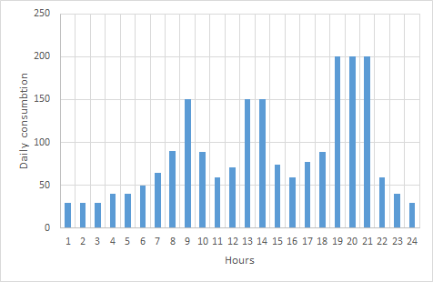
Figure 2:Energy consumption per day for zone A

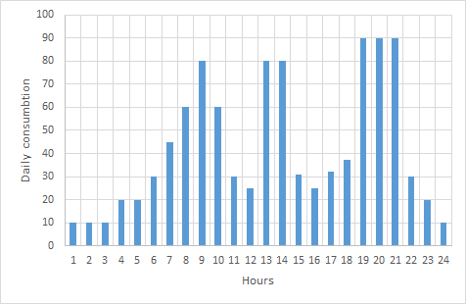
Figure 3:Energy consumption per day for zone B

As for load profiles, the electricity consumption for all households in rural areas, it assumed to be similar in this project. The calculated scaled annual electricity consumption is found (2075) kWh/day for zone A, (1015) kWh/day for zone B.

Ch4.Methodology

We studied Masafer Yatta and the problems that exist. There is a basic problem, which is the problem of access to electricity to all localities in the area, for political reasons that have been mentioned. Some of Masafer Yatta’s electricity comes from donor countries represented by Comet Me, an NGO that provides energy services to these off-grid communities in the Occupied Palestinian Territories, such as the wind turbines in Masafer Yatta. But the electricity supplied by this organization was limited to 400 watts peak per household, which is relatively small, and the turbines were small in size, random and intermittent.
In this project, two scenarios off-grid hybrid systems photovoltaics and wind turbines with the power systems banks of lead-acid batteries are shown to compare them to find out the most appropriate and optimal system. The backup system (diesel generator) was designed to ensure that electricity is not cut off due to climate changes. The suitable scenario will be established to supply electrical requirements to Palestinians in Masafer Yatta, taking into consideration the political, economic, and social conditions.
After determining the optimal location for the installation of the project, the HOMER software is used as a tool to simulate the proposed systems to know the best renewable energy technology and its size, whether it is wind turbines or photovoltaics to generate electricity from them, to cover the demand without restrictions of the peak amount of Watts.

4.1 Electrification Using PV
Palestine is one of the countries rich in solar radiation. Where the number of sunshine hours about 3000 sunshine hours per year and the estimated solar radiation in Hebron is about 7.51 kW h / m2 / day).[1] Moreover, the values of solar radiation in Masafer yatta are very close to Hebron as it is a part of it. The figure below shows the values of solar radiation in Massafer Yatta throughout the year. These values are good for generating electricity from it and using it in the daily needs of the residents of the area, such as milk shakers, washing, lighting, etc. Although PV is a good option for electrifying remote areas that are not connected to the grid but the Israel occupation tries hard to prevent this option because it uses the land of the area that is considered Area C. In Masafer Yatta there are few examples of using PV to meet the needs of some homes.

Figure 4:Monthly Average Solar Global Horizontal Irradiance
In this study, we designed photovoltaic system for Masafer Yatta using HOMER software, where the main data required by the software must be entered, such as solar radiation data, house load. Additionally, the capital, replacement and O&M costs are US$1700/kW, US$1700/kW and US$10/year respectively was also entered as inputs. to choose the most appropriate solution with good specifications like the project size, batteries and net present cost.to compare this solution with other technologies which is Wind Turbines.

4.2 Electrification Using Wind Turbine
The wind energy potential is limited to the mountains with heights about 1000 m above sea level. This would include regions of Hebron where the speed reaches 5 m/s, which is suitable for operating a wind turbine.[1] Therefore, the high potential wind speed in the southern Hebron mountains and being one of the poorest areas in Palestine, as its residents have neither access to water nor electricity, so this encouraged Comet-ME organization to build some small wind turbines with a capacity not exceeding 3 KW in Masafer Yatta. But also not all of these communities are completely covered with electricity, there are still some families that do not have any electricity till now.
After studying and analyzing wind speeds for the two areas in Masafer Yatta for a year to construct wind turbines, it was found that the average wind speed in Zone (A), which includes Khirbet Bir al-I’d, Jenba, al-Markaz and al-Halawa is 4m/s, the maximum wind speed is 18.4 m/s and the minimum wind speed is 0.35 m/s
As for zone (B), which includes Isfay al-Fawqa, Isfay al-Tahta, Tuba, and Maghir al-Abid, the average, maximum, and minimum wind speeds are 5.4 m/s, 20.78 m/s, and 0.35 m/s respectively. The figures below show the distribution of wind speeds during the year.

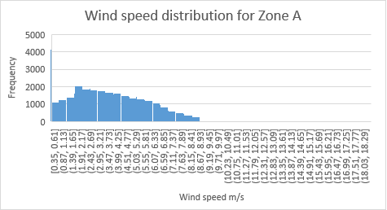
Figure 5: Wind speed distribution for Zone A
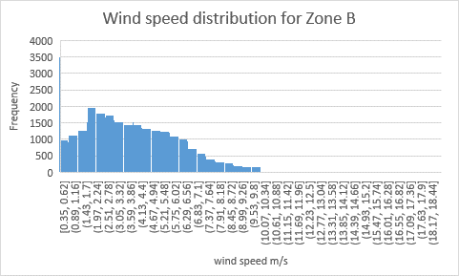
Figure 6: Wind speed distribution for Zone B

By using HOMER software, the main data required by the software must be entered, such as values of wind speed for the two locations and the daily loads. The rated power of the selected wind turbine is 10 kW with capital, replacement and O&M costs are US$12000, US$12000 and US$500/year respectively, to choose the most appropriate wind turbines size, batteries capacity, and net present cost of this wind turbine electrification, then compare this solution with other technologies which is PV

4.3 Option of Hybrid System with Diesel Generator

The option of electrifying remote areas that are not connected to the electricity grid via the diesel generator is a good option. As it meets all the needs of the population without interruption.
In some cases, if the diesel is easily available and its price is low, it can be a great option to generate electricity from it, but in some cases, it is not easily accessible and transported to the communities so, if the diesel generator is the only option we have to generate electricity from it, we need a constant amount of diesel for use it.
in this case, we have a big number of families, therefore, we need a constant presence of diesel in the area, and this is not an easy thing because the region does not have a street infrastructure and the cost of the diesel are not low. In addition, the emissions from generators can be larger than using renewable energy that causes environmental pollution.
Thus, diesel generators can be combined with renewable energy to reduce environmental damage, cost, and transportation difficulty. consequently, in cases where there are Interruptions from renewable energy, it is covered by generators to ensure reliability and security in accessing electricity. so the HOMER's inputs are loads in addition to the capital, replacement, O&M, and fuel costs are US$500/kW, US$500/kW, US$0.03/h, and 1.5 $/L respectively.

Ch5. Results and discussion:

In this project, HOMER software is used to optimize the proposed hybrid renewable energy electrification system for the selected two locations. All of the information such as solar radiation, exact wind speed, and the real load profile are used as inputs for HOMER software. then the software evaluated and calculates the number of kilowatts needed, the size of the project the size and number of batteries. Here, the results that we have reached will be presented through the listed tables and a comparison between options and solutions to find the most appropriate solution from the economic, social, and political point of view in Masafer Yatta.

5.1 Results for First location
Table (2) shows Specifications of the proposed renewable energy systems (PV and wind turbine technology) for the first site which contain is 30 these families for.

Table 2: Renewable Energy Systems specifications for First Location
Renewable Sources | Solar PV | Wind Energy
KW needed | 300 | 300
Battery size (1kWh LA) | 1800 | 1500
Levelized Cost of Energy( $/kWh) | 0.3485 | 0.3132
Net Present Cost-NOC ( $) | 1.53M | 1.37M

From the attached table above it can be seen that the size of the PV system required to cover the demand = 300 kW as the annual production of the system = 485,815 kWh / yr.
The annual production of PV throughout the year is shown in the figure below

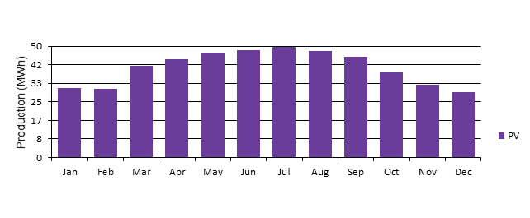
Figure 8:Annual production of PV for First Location
The Generic storage systems capacity is 1,800 kWh where The annual throughput from the batteries 190,158 kWh/yr.

these calculations are done when the shortage from the system is 12%. The figure below shows the Loss of load probability LLP (the shortage with the batteries).
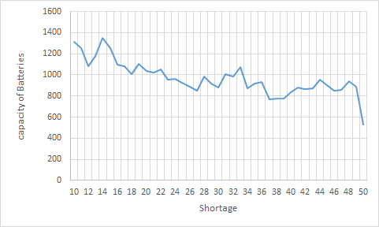
Figure 9: The Change of Batteries capacity with the shortage from PV for First Location

also from the table above it can be seen that the size of the wind turbine system required to cover the demand is the same as to PV size which is 300 kW. where the annual Wind Turbine Total Production is 706,821 kWh / yr.
The annual production from wind turbines throughout the year is shown in the figure below

Figure 10: Annual production of Wind Turbine for First Location
The Generic storage systems capacity is 1500 kWh where The annual throughput from the batteries 141,774 kWh/yr. The net present cost of the system is 1.37 M$ which is less than the NPC of PV The Levelized cost of energy (LCOE) produced by this configuration is 0.3132 $/kWh.
Also, these calculations are done when the shortage from the system is 12%. The figure below shows the Loss of load probability LLP (the shortage with the batteries).
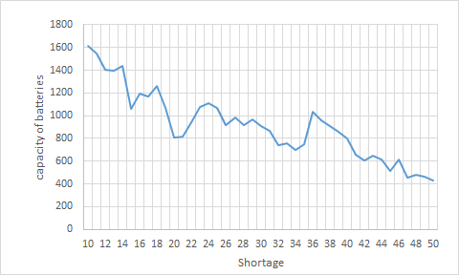
Figure 11: The Change of Batteries capacity with the shortage of wind turbine system for Fist location

To cover the shortage from renewable energy to ensure that the electricity never interrupt and increase reliability, security of the system. diesel generator will be added for first location and it is size =120 KW.

5.2 Results for Second Location
Table (3) shows Specifications of the proposed renewable energy systems (PV and wind turbine technology) for the second site which contain of 72 families.
Table 3:Renewable Energy Systems specifications for Second Location
Renewable Sources | Solar PV | Wind Energy
KW needed | 660 | 920
Battery size (1kWh LA) | 2500 | 3800
Levelized Cost of Energy( $/kWh) | 0.3445 | 0.4387
Net Present Cost-NOC ($) | 2.88M | 3.67M

From table above it can be seen that the size of the PV system required to cover the demand is 660 kW. where the annual PV Production is 1,068,786 kWh / yr.
The annual production from PV throughout the year is shown in the figure below
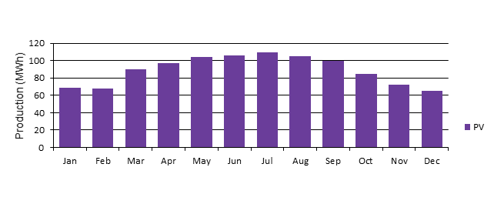
Figure 12: Annual production of PV for Second Location
The Generic storage system's capacity is 2400 kWh where the annual throughput from the batteries 374,694 kWh/yr. The net present cost of the system is 2.88 M$ which includes the capital cost, replacement cost, O&M cost, and salvage cost. The levelized cost of energy (LCOE) produced by this configuration is 0.3445 $/kWh.
All of these calculations done when the shortage from the system is 12%. The figure below shows the Loss of load probability LLP (the shortage with the batteries).

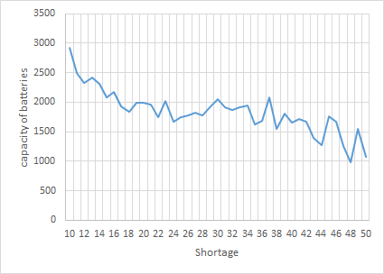
Figure 13: The Change of Batteries capacity with the shortage from PV for Second Location
Also from the table above it can be seen that the size of wind turbines system required to cover the demand is 920 kW. where the annual Wind Turbine Total Production is 1,349,407 kWh / yr.
The annual production from wind turbines throughout the year is shown in the figure below
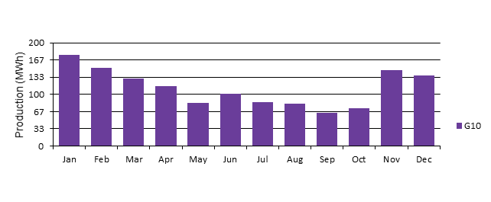
Figure 14:Annual production of Wind Turbine for Second Location
The net present cost of the system is 3.67 M$ which is higher than the NPC of PV. The Levelized cost of energy (LCOE) produced by this configuration is 0.4387 $/kWh.

Also, these calculations are done when the shortage from the system is 12%. The figure below shows the Loss of load probability LLP (the shortage with the batteries).
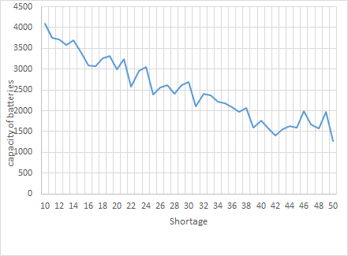
Figure 15:The Change of Batteries capacity with the shortage of wind turbine system for Second location

In addition to renewable energy which covers the demand. Some interruptions may occur in it because of a shortage of renewable energy for many reasons, like weather conditions and so on, to ensure that electricity reaches the population at all times. The diesel generator has been designed with a size of 240 kW.

The results show that in the 30-family community, the wind turbine option is the most appropriate in terms of cost, and it also contains the same number of kilowatts for the pv. Regarding the community of 72 families, from the economical point of view, the pv option was the most appropriate, being cheaper, and therefore economically the best. But in both communities, the option of electrifying the area through wind turbines is considered the most appropriate politically, as it is located in a firing zone and military training for the occupation army, and it is possible that if the pv system is installed, the faults will increase due to the fire. Also, given that area C and The available areas of land are few and restricted by the occupation. This was another reason for choosing wind turbines, as they need much less space than PV. Finally, from the social point of view, there are family and clan problems among the residents of the region, and therefore problems faced regarding the issue of installing PV, including the extension of electrical wiring networks. An example of these problems is the problem of installing the system on the land of one of the clans and extending wires to other clans.

CH:6 Environmental Impact For Wind Turbine
Wind Energy considered of the most sustainable and environmentally-friendly sources of energy. There are advantages to using renewables to generate electricity, including that fossil fuel prices are very expensive and there is growing concerned about climate change and global warming issues. But there can be some environmental downsides depending on the project size and circumstances in which they’re built.
To understand the environmental issues in the project this is an overview of the project land. It is considered almost empty of vegetation, as it is of low agricultural value, where there are only very few crops such as wheat and barley. For animals, there are sheep, goats, and prey birds in these communities.
In terms of archaeological sites, there are a large number of caves dating back to the Romans decades ago, and about 200 Palestinians live in them. However, there is no impact from the wind turbines on these ancient caves.
The following table 4 explains the impact of project activities on some environmental components.

Table 4:Some of Envieimental component that affected by project activites
The Environmental Component | Effect | During the Construction Phase | Operating Phase | After the Operation Phase
Air Quality | Negative | During the period of construction volatilization dust into the air as a result of excavation work and construction for the tower of wind turbine. | Affectless | Affectless
Wildlife (Fauna) | Negative | During this period, wildlife could be affected by construction work because of the dust and noise. | Wind turbines affect birds when they crash into wind turbine blades which leads to kill them. | Habitat loss can accrue over years by leading to wildlife being forced out of the area especially birds.
Land use | Positive | Short term negatively effect, by taking some limited area of land during constructing operation. | Affectless | Wind turbines don’t take up much physical land space. However, wind farms can be set up for dual land use can also serve as pasture land for livestock, cropland for farming. In the end, this project will provide electricity to be used to meet their needs and encourage them not to migrate their land.
Safety of workers | Negative | Like any construction project in the event of non-compliance with public safety requirements, this would negatively affect the health and safety of workers. | If the blades of the turbine are not securely fastened, the blades may foul and harmed the workers with serious injuries, as they are considered as sharp sword. | Affectless
Noise | Negative | Short term negatively effect. During the period of construction, the noise generated by some operations, such as excavations for the tower. | Noise generated by the turbine and rotors negatively affects the environment. | Noise generated by the turbine and rotors negatively affects the environment

Thus, some environmental components in all stages of the project was presented, and accordingly the most important positive and negative impacts was mentioned with some ways to mitigate these negative damage according to global papers, journal articles, reports, books, and web materials about the field of environmental impacts of wind energy.

3.4.2 Negative Impacts of Wind Turbine
Noise pollution
Noise is defined as any unwanted sound. Wind turbines generate two types of noise: mechanical and aerodynamic. The mechanical noise is generated by the turbine's mechanical and electrical parts, while the aerodynamic noise is generated by the interaction of blades with the air. Recently, to reduce the mechanical noise, advanced mechanical design appeared (e.g., proper insulation to prevent mechanical noise from proliferating outside the nacelle or tower, vibration damping), and is no longer considered to be as important as the aerodynamic noise, especially for utility scale wind turbines [19]. The measurement of noise from wind turbines is influenced by the background noise (e.g., traffic on nearby roads and rail tracks). In many cases, it is difficult to measure sound pressure levels from modern wind turbines at wind speeds around 8 m/s or above, because the noise from the wind itself or background sounds may generally mask the turbine noise completely [20]. At lower wind speeds (e.g., 4–6m/s) the noise from a wind turbine is more noticeable, since wind is strong enough to turn the blades but is not itself very noisy. reported that at 5.1 m/s wind speed at 10 m height, the noise from wind turbines was 48.571.6 dB, approximately 9 dB more than the ambient sound [21]. in our project the average wind speed (4-5.4) m/s so it will cause a noise for people who live there.
In our project there are two types of noise, the first one during the construction and installation period and its short-term, and the second one long-term noise during operating the turbines. But to reduce this effect we will distance the project as much as possible from residential areas and use insulators to reduce mechanical noise.
Effect on birds
Although wind power is generally considered environmentally friendly, but there is a danger of wind turbines on birds. bird fatalities range from 8–118 birds per year or 0.02–0.6 collisions per turbine per year[20]. Raptors are found being more susceptible than other species. The European Wind Energy Association (EWEA) reported that raptors showed some of the highest levels of mortality; this is due to their dependence on thermals to gain altitude, to move between locations and to forage. Some of them are long-lived species with low reproductive rates and thus more vulnerable to loss of individuals by collisions. Raptors are most affected (78.2%) during spring, followed by migrant passerines during post-breeding migration (September/October) [21].
The most common types of birds in Masafer Yatta are birds of prey such as eagles of all kinds, owls and swallows. studies show that local birds can quickly learn to avoid obstacles, and thus that wind turbines would not be a serious problem for them [22] . The birds of prey considered as a local bird Therefore, the damage to them will be considered minimal. And we will employ ultrasonic speakers that, when operating, it will avoid birds from flying too close to the blades.

3.4.3 Positive Impact of Wind Turbine.
Carbon dioxide emission
In general, wind energy is free from direct air pollution, because the energy produced by wind turbines does not contain pollutants like other energy sources (such as coal, gas, and petroleum fuels).
Wind power may help reduce air pollution by replacing existing sources of conventional energy. As a result, emissions can be reduced especially carbon dioxide (CO2), nitrogen oxide (NO) and sulfur dioxide (SO2). As these gases are responsible for acid rain and global warming, which causes sea level rise, and weather variability.
Although a very small amount of CO2 emissions was released by wind power during the construction and maintenance phases. However, this amount of carbon dioxide is much less than other fossil fuel-based power plants. The tree can absorb this amount of carbon dioxide from photosynthesis. [23]
Each unit (kWh) of electricity produced by the wind displaces a unit of electricity that could have been produced by the power plant by burning fossil fuels. It is estimated that a 2.5-kilowatt system can save 1-2 tons of carbon dioxide. [24].

Water quality
In a world suffering from increasing water demand, water consumption is a vital matter and a major concern especially for marginalized areas, which do not have water networks and collect water through wells dug such as Masafer Yatta in Hebron. For them, clean water is important, scarce value and they collect it in separate wells. It should be noted that conventional power plants use large quantities of water for the condensation portion of the thermodynamic cycle. For coal power plants, water is also used to treat the fuel. The amount of water used can reach millions of liters per day. But for generating electricity through wind turbines, there will be no need for water, and the project does not have a negative impact on the water in the region, so the water can be preserved and used for their basic purposes and sheep grazing.

Ch6. Conclusion:

It was found in this project that electrifying remote areas that are far from the electric grid using a hybrid wind power system with diesel generators is the most appropriate solution, especially if these areas suffer from political and social problems, as is the case in Masafer Yatta. The size of the wind turbines required for the first and second locations in the Masafer yatta are 300 kW and 992 kW respectively, with the first diesel generator capacity of 120 kW and 240 kW for the second site. finally, and after studying the effect of these turbines on the environment, it was also found that it was environmentally friendly and clean, which confirmed that the choice of wind energy was the best and suited for this area.

Ch6. References
[1] A. Juaidi, F. G. Montoya, I. H. Ibrik, and F. Manzano-Agugliaro, “An overview of renewable energy potential in Palestine,” Renew. Sustain. Energy Rev., vol. 65, pp. 943–960, 2016, doi: https://doi.org/10.1016/j.rser.2016.07.052.
[2] T. Khatib, A. Bazyan, H. Assi, and S. Malhis, “Palestine Energy Policy for Photovoltaic Generation: Current Status and What Should Be Next?,” Sustainability , vol. 13, no. 5. 2021, doi: 10.3390/su13052996.
[3] OCHA, “The Massafer Yatta Case Study.” https://www.ochaopt.org/content/massafer-yatta-case-study-may-2013.
[4] A. Khamis, T. Khatib, N. Amira Haziqah Mohd Yosliza, and A. Nazmin Azmi, “Optimal selection of renewable energy installation site in remote areas using segmentation and regional technique: A case study of Sarawak, Malaysia,” Sustain. Energy Technol. Assessments, vol. 42, p. 100858, 2020, doi: https://doi.org/10.1016/j.seta.2020.100858.
[5] S. Hamada and A. Ghodieh, “Mapping of Solar Energy Potential in the West Bank, Palestine Using Geographic Information Systems,” Pap. Appl. Geogr., pp. 1–14, Jan. 2021, doi: 10.1080/23754931.2020.1870540.
[6] S. Monna, A. Juaidi, R. Abdallah, and M. Itma, “A Comparative Assessment for the Potential Energy Production from PV Installation on Residential Buildings,” Sustainability , vol. 12, no. 24. 2020, doi: 10.3390/su122410344.
[7] A. De Meij et al., “Wind energy resource mapping of Palestine,” Renew. Sustain. Energy Rev., vol. 56, pp. 551–562, 2016, doi: https://doi.org/10.1016/j.rser.2015.11.090.
[8] M. Elnaggar, E. Edwan, and M. Ritter, “Wind Energy Potential of Gaza Using Small Wind Turbines: A Feasibility Study,” Energies, vol. 10, p. 1229, Aug. 2017, doi: 10.3390/en10081229.
[9] H. Albisher and H. Alsamamra, “An Overview of Wind Energy Potentials in Palestine,” J. Energy Nat. Resour., vol. 8, no. 3, p. 98, 2019.
[10] A. Yasin, “Optimum Design of a Stand-alone Hybrid Energy System for a Remote Village in Palestinian Territories,” J. Eng. Res. Technol., vol. 4, 2017.
[11] Y. Odeh, “Wind Power Potential in Palestine/Israel: An investigation study for the potential of wind power in Palestine/Israel, with emphasis on the political obstacles.” 2011.
[12] M. F. G. GALINDO, Universal Electricity Access in Remote Areas. Building a pathway toward universalization in the Brazilian Amazon, 2014.
[13] M. M. Mahmoud and I. H. Ibrik, “Techno-economic feasibility of energy supply of remote villages in Palestine by PV-systems, diesel generators and electric grid,” Renew. Sustain. Energy Rev., vol. 10, no. 2, pp. 128–138, 2006, doi: https://doi.org/10.1016/j.rser.2004.09.001.
[14] M. S. Ismail1, M. Moghavvemi2, and T. M. I. Mahlia, “DESIGN OF A PV/DIESEL STAND ALONE HYBRID SYSTEM FOR A REMOTE COMMUNITY IN PALESTINE,” J. Asian Sci. Res.
[15] M. S. Ismail, M. Moghavvemi, and T. M. I. Mahlia, “Design of an optimized photovoltaic and microturbine hybrid power system for a remote small community: Case study of Palestine,” Energy Convers. Manag., vol. 75, pp. 271–281, 2013, doi: https://doi.org/10.1016/j.enconman.2013.06.019.
[16] R. Nagaraj, “Renewable energy based small hybrid power system for desalination applications in remote locations,” in 2012 IEEE 5th India International Conference on Power Electronics (IICPE), 2012, pp. 1–5, doi: 10.1109/IICPE.2012.6450437.
[17] A. Chauhan and R. P. Saini, “Techno-economic optimization based approach for energy management of a stand-alone integrated renewable energy system for remote areas of India,” Energy, vol. 94, pp. 138–156, 2016, doi: https://doi.org/10.1016/j.energy.2015.10.136.
[18] S. Mukherjee and A. Asthana, “Techno-Economic Feasibility of a Hybrid Power Generation System for Developing Economies †,” pp. 10–13, 2017, doi: 10.3390/proceedings1070693.
[19] J. R. Rousseau, S. M. Colella, S. F. Quinlivan, and M. P. Burger, “Construction of a Wind Turbine Project in the Town of Florida, MA,” Worcester Polytechnic Institute, Florida, 2007. [Online]. Available: https://digital.wpi.edu/show/h702q835n.
[20] B. K. Sovacool, “The avian benefits of wind energy: A 2009 update,” Renew. Energy, vol. 49, pp. 19–24, 2013, doi: https://doi.org/10.1016/j.renene.2012.01.074.
[21] European Wind Energy Association (EWEA) ., “Wind Energy-The Facts. WindFacts project,” 2009.
[22] E. Hau, Wind Turbines: Fundamentals, Technologies, Application, Economics. 2006.
[23] American Wind Energy Association, “AWEA. CO2 emissions. Wind vs. trees,” 2009. [Online]. Available: http://www.awea.org/faq/co2trees.htm.
[24] R. Saidur, N. A. Rahim, M. R. Islam, and K. H. Solangi, “Environmental impact of wind energy,” Renew. Sustain. Energy Rev., vol. 15, no. 5, pp. 2423–2430, 2011, doi: https://doi.org/10.1016/j.rser.2011.02.024.

