

An-Najah National University
Faculty of Engineering and Information Technology
Management information systems

Graduation project

Website sartawi Gym System

Prepared by
Assem assedeh
Ahmad al-akhras

Supervisor
Dr.ahmad shraideh

ABSTRACT:

- Any business that does not have a website is missing out on one of the most powerful marketing tools available to them. The main reason that it is important for businesses to have a website is how people are likely to find you. These days most people will go online and research products and companies before they make a purchase
- For this reason of dependency on online, we develop a website for a gym in which customer can get all information about the gymnasium and he/she can access or enroll at the gym via online

History of the srtawiGym(ABOUT US):
The first sports center in Nablus opened in 1992 under the name of the Olympic Sports Center and was led by the center founded by Captain Adham Sartawi. Then we opened our second center in 1999 under the name of Sports Palace in Rafidia and was the updated version of the Olympic Center. In 2006 we opened the Fitness One Center, which was updated under the name Sartawi C in 2013 at the park Tower building on the 8th floor of Captain Adham Sartawi

Existing System:

An Existing system refers to the system that is being followed till now. The gym is working manually. The current system is time consuming and also it is very costly, because it involves a lot of paperwork. To manually handle the system was very difficult task.

1-Registration method:
Registration is made when the player comes to the GYM only and gives a card that contains information about his name, mobile number, address and quality of the subscription and then handed over to the secretary and the player recognizes the card when he enters the GYM before the game and the payment of the subscription at registration.

2-SHOPPING:
The GYM depends on the traditional way of selling, which is the customer to go to the club and ask the product he wants from the club and then receive the product from the club's place of existence. Payment will be by cash or by installments.

Problem:
- Limited sales on certain areas

- The difficulty of displaying products in the company to customers
- The geographic dimension of the place of the club for the place of sale of the products.

- There is no clear methodology for promoting the company
- Difficulty dealing with the paper system

Proposed System:
The online gym management system is user-friendly application. This automated system makes all functionality easier for both owners and customers. It is very simple in design and to implement. The system requirements are very low. System resources and the system will work in almost all configurations.

General description of the proposed system:

In general, anyone can browse the site and browse the content of the site including products, blog, offers, campaigns and other services and features provided by the site without having to log in. As for the process of adding to the basket, it is possible without logging in as is customary in The policy of e-commerce sites, however, in case of a request to display the basket or purchase requires the process of login.

Home page : The homepage of the site is the first criterion for the acceptance of the site and whether or not the visitor is welcomed must be designed in a manner that attracts the attention of visitors and contains the main things on the site such as ads, offers and social networking links in the club.

Exercises and programs page:
These pages are the most important pages that the player needs because it contains
Things that will help him in his game This page will contain games such as Bodybuilding and other activities and there are sections suitable for the novice and advanced player and all
He has his own training program in which exercises will be developed for each muscle with a video showing the correct way of playing the participant.

There is a calorie calculator:
Through which the participant can know the nature of his
body and what he needs from the system of increasing weight
Or amplification etc. A food program will be developed for each target.

Schedule:
Each of the three programs will be allotted times for each of the three programes, with the name of the coach assigned to each program. This will help the customer to know and subscribe to his favorite playing time.

Traniners:
This page contains the club's trainers as well as the personal information of each coach, his schedule and the game he is responsible for.

SHOP:
One of the most important pages where this system helps significantly, it will facilitate the gym many things suffer from the difficulty of displaying products and after the place of sale for the club and other things.
This page contains all the products in the club and is constantly updated. The visitor can only shop without an account. To buy, you must register an account, sign in, tell the subscriber, add a list of things he wants, specify the quantity and size, and then fill out a form with information about him and his name And then the most important to determine the method of payment, which we will adopt two methods, namely payment on receipt or electronic payment and will ensure the club to ship the product and delivery to the address of the customer and the cost of shipping depends on the quality of the product and quantity.

The products will be divided into three sections: equipment, food supplements and clothing. A brief description of each product will be made, why we use it and how to use it.

Subscription:
The customer will sign up and sign up for it(package) The customer chooses to subscribe from the program he wants
- FREE DAY
- Monthly
- 3 month
- 6 month
- Annualy
- Personal trainer( 1month,3 month,6 month ,annualy)
* The subscription is paid by coming to the GYM or by electronic payment(VISA and MASTER card)
The aim of the project:
Provide the user with a platform easy and stable to get the best services possible for all. The website will be launched first in a format compatible with computers and can be browsing the site through smart phones, and then can be expanded as a smart application suitable for mobile phones Android system and others.

CASE TOOLS :

We developed this site using the WordPress tool that allows users to create websites and manage content by using drag-and-drop tools over the Internet. Users can add functions such as social plugins, e-commerce, online marketing, contact forms, and email marketing.

Specifications:
Functional User Requirements:

VISITOR:
1-display product
2. View product details.
3. Can communicate and chat with customer service.
4. Review of the blog.
5. Review of existing programs and services at the Club
6- Review of subscriptions and details
7 - benefit and display exercises

Can become a member of the site through the registration process.

USER:
1-Login to the site
2 Account Management:
- View requests.
- Show Cart.
3. Sure product purchase process (payment).
4. Add evaluation of products.
5 - Participation in the programs and review details and payment
5. Log off.

administrator:
1. Sign in.
2. Display the Dashboard.
3. Managing members within the site.
4. Product management.
5 - Manage the characteristics and specifications of the product.
6 - Manage orders and shipment of the product.
7. Managing and tracking inventory.
8. Preparation of reports
9. Respond to user messages by chatting
10 - Tracking subscriptions and subscribers and details

Non-functional requirements:
1-Usability: Easy to understand and use, clarity, system design is simple for everyone.
2. Reliability: Follow the customer's request by contacting him by e-mail.
3-Dependability: The system delivers information to both sides at the same time (eg sending an e-mail to the customer about the request and informing the administrator of a new order).
4-Portability: The system is capable of operating on different browsers and platforms.
5. Availability: Availability of the system to the users at any time.
6-Integrity: Each element has its own image / price / specifications, and must be identical on the ground.

TOOLS AND BLUGINS :
- To create the site was used:
Wordpress tool.
2: plugins
• Analytifi: Adds help in preparing details and reports to identify people who visit your site, visitor analytics has everything you need. See where visitors come from, your most popular pages.
• Crisp chat: used for communication and customer service
• Trainer: Used to prepare the trainers page in the gym
• Classes: Used to schedule appointments for the gym
Comment: is the perfect way to interact with customers, add them to your website, and let users instantly ask questions, submit comments, and discuss topics with you and other customers in real time.
Paid membership pro: one of the most important additions to the site and is used to manage everything related to the subscription of the presentation of the details and details and participation in it and get the invoices and the preparation of reports for sessions and participants.
• Woocommerce: an indispensable add-on to e-commerce sites used in our website to create a shop page and display and manage products.
• Profile builder: Used to register and access the site and fill in the form of the customer.

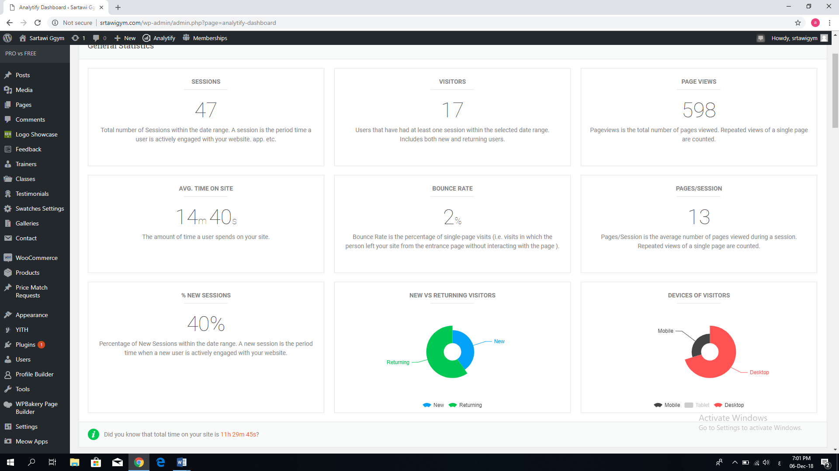

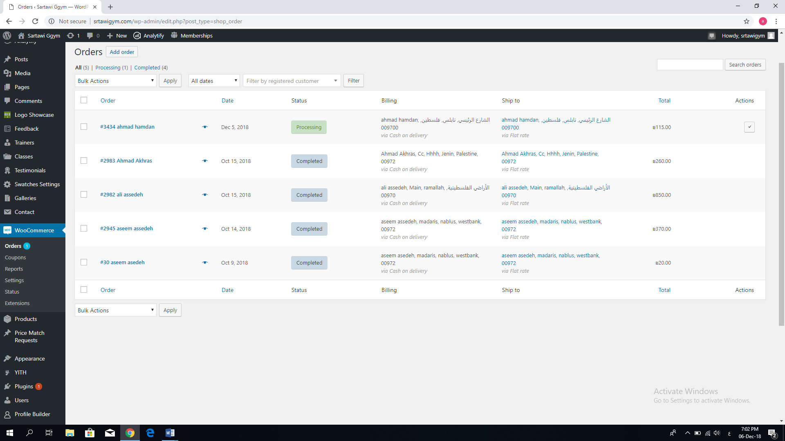

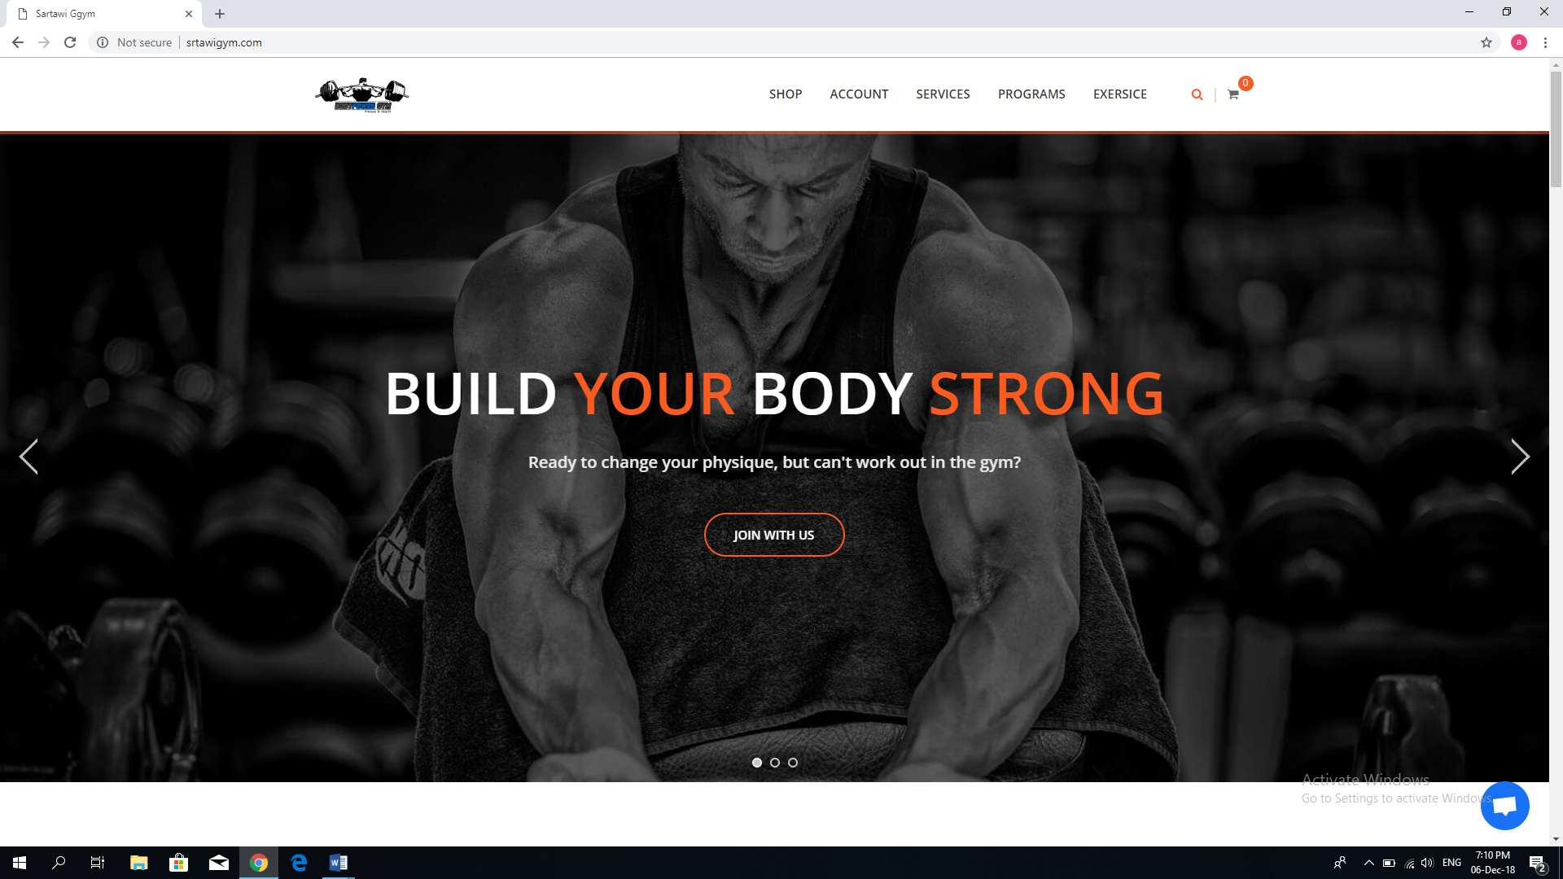

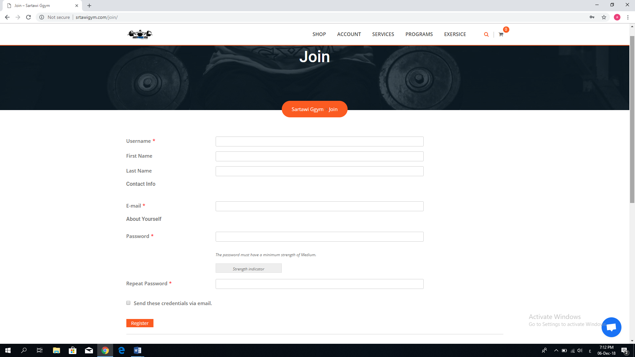

USE CASE DIAGRAM And data flow diagram:
