

An-Najah National University

Faculty of Engineering

Energy and Environmental Engineering Department
Long-term wind energy prediction using three machine learning algorithms.
Graduation Project-2 submitted to:
Department of Energy and Environmental Engineering Faculty of Engineering and Information Technology
An-Najah National University

In partial fulfillment of the requirements for Bachelor degree in Energy
And Environmental Engineering

Supervisor Name: -
Dr. Tamer Khatib

Students Name:
Asma Isead and Reziq Deria
May 22 ,2020

DECLARATION

We do hereby declare that the project titled "Long-term wind energy prediction using three machine learning algorithms" submitted to the department of Energy and Environmental Engineering of An-Najah National University in partial fulfillment of the Bachelor degree in Energy and Environmental Engineering. This is our original work and was not submitted elsewhere for the award of any other degree or any other publication.

Acknowledgements

Primarily we would thank God for being able to complete this project with success. Then we would like to gratefully and sincerely thank Dr. Tamer Khatib, whose valuable guidance has been the ones that helped us patch this project and make it full proof success his suggestions and his instructions has served as the major contributor towards the completion of the project.
Then we would like to thank our parents and friends who have helped us with their valuable suggestions and guidance has been helpful in various phases of the completion of the project.
Thanks, are extended to faculty of Engineering and Information Technology in general and specially for the Department of Energy and Environmental Engineering at An-Najah National University.

Table of Contents

DECLARATION I
Acknowledgements II
List of figures III
List of tables IV
Nomenclature IV
Abstract VI
Introduction: 1
Objectives: 1
Literature review: 2
Machine learning: 5
Cascade-forward neural network: 5
Random forests: 6
Support vector machines: 6
Wind speed 6
Wind speed and installation height 7
Wind distribution 8
Wind energy 9
Methodology 11
Results and discussion 14
Conclusion 16
References 17

List of figures

Figure 1: Wind speed data for five Palestinian cities 7
Figure 2: Weibull probability density function for selected cities 9
Figure 3: 1MW turbine power curve 10
Figure 4: Wind energy forcasting flowchart 12
Figure 5:CFNN prediction results 15
Figure 6: RFs prediction results 15
Figure 7: SVM prediction results 16

List of tables

Table 1: Weibull parameters for selected cities 8
Table 2: 1MW turbine technical specification 11
Table 3: RMSE, MBE, and R² values 14

Nomenclature

$$CFNN$$ | Cascade-forward neural network | $$MAPE$$ | mean absolute percentage error
$$RF$$ | random forest | $$RPE$$ | recursive prediction error
$$ANN$$ | artificial neural network | $$CART$$ | Classification and Regression Tree
$$SVM$$ | support vector machines | $$AI$$ | artificial Intelligent
$BMA$_$EL$ | Bayesian model averaging and Ensemble learning | $$PVGIS$$ | Photovoltaic Geographical Information System
$$ARMA$$ | autoregressive moving average | $$V$$ | Wind Speed
$$MAE$$ | Absolute Average Error | $$V_{0}$$ | measured wind speed
$$ECMWF$$ | European Centre for Medium-Range Weather Forecasts | $$H$$ | hub height
$$PSO$$ | particle swarm optimization | $$a$$ | Constant varies with surface roughness and terrain condition
$$P_{w}$$ | available wind power | $$H_{0}$$ | height where the speed was measured
$P_{a}$ | actual output power | $$P_{r}$$ | turbine rated power
$$P_{turbine}$$ | turbine output power | $C_{p}$ | power coefficient
$$ρ$$ | air density | $$v_{r}$$ | turbine rated speed
$$A$$ | area of the blades | $$v_{co}$$ | turbine cut-out speed
$$MBE$$ | mean bias error | $$RMSE$$ | root mean square error
$$R^{2}$$ | coefficient of determination | $$SS_{tot}$$ | sum of squares of residuals

Abstract

In this research, an approach for predicting wind energy in the long term has been developed based on daily average cubic wind speed and standard deviation. Three machine learning algorithms were used namely, Cascade-forward neural network (CFNN), random forests (RFs), and support vector machines (SVM). The R-Squared values were found to be 0.9996,0.9901, and 0.9991 and RMSE values 41.1659, 68.4101, and 205.10, respectively.

Introduction:

Renewable energy sources have become the focus of the attention of countries and energy companies because of their sustainable and inexhaustible nature, their availability everywhere in the world unlike fossil fuels and minerals, and most importantly, they are not polluting to the environment [1]. Wind energy is the second largest source of renewable energy in the world after hydropower and is one of the fastest growing energy sources [2]. The main advantages of wind energy as an energy source are that it is relatively safe, environmentally friendly, quick to install, scalable (a wind farm can consist of a couple of turbines or hundreds depending on the needs they cover), and it has a low-carbon footprint throughout the lifecycle of the project [3], [4]. However, many challenges are facing the exploitation of wind energy, such as the high initial cost, the impact on wildlife, noise, and visual pollution, some remote areas suitable for wind energy need a high cost to be connected to the electrical network, and the unpredicted amount of energy due to variation in wind speed and weather conditions.
The most significant problem facing wind energy is that the wind does not blow all the time in most sites. Wind speed is variable all the time, it may blow for four days in a row and then sits idle for two days or more [2]. Therefore, wind energy cannot be available all the time like fossil fuels. Because of that, wind speed analysis and forecasting must be done at the location where the wind farm is to be established to ensure that it will be appropriate to produce energy in a feasible manner.

Objectives:

- This research aims to train and test machine learning models to predict wind energy based on daily average cubic wind speed and standard deviation.
- Wind speed data will be used for a specific location to train the machine learning model, and then these models can be used to predict wind energy in different locations to investigate the model accuracy.
- Three machine learning algorithms will be trained to predict wind energy, and then they will be tested to choose the best algorithm to use.

Literature review:

Wind energy forecasting is extremely important to select an appropriate site to install a wind farm capable of producing sufficient and profitable amounts of energy. Wind energy forecasting methods can be divided into two categories depending on the time range, namely short-term forecasting methods and long-term forecasting methods. Short-term methods try to predict wind energy over a short period ranging from an hour to several days, while long-term methods try to predict wind energy over a long period ranging from several days to several years. In the literature, many methods that rely on statistics or machine learning have been used to predict wind energy in both short term and long term.

Numerous researchers have used machine learning to predict short-term wind energy. In [5] Li et al. proposed a new effective method for wind power forecasting based on the support vector machine model. In this method, the optimal parameter for the support vector machine model was optimized using improved dragonfly algorithm. Najeebullah et al.[6] used an approach that utilizes a combination of machine learning techniques for regression and feature selection before using enhanced particle swarm optimization and a hybrid neural network for wind power forecasting using a dataset consists of daily wind speed, relative humidity, temperature, and wind power. Jursa and Rohrig [7] developed a model based on evolutionary optimization algorithms with artificial neural networks and nearest neighbor search. This model was able to predict wind power on hourly basis. Amjady et al. [8] used a hybrid machine learning model consist of radial basis function, backpropagation neural networks, and enhanced particle swarm algorithm for wind power forecasting. This model has achieved good results compared to some other methods. Abhinav et al.[9] proposed a robust and accurate model based on wavelet neural network. This model is applicable to all seasons of the year and requires less historic data compared to other methods in literatures. Similarly, Chitsaz et al. [10] used wavelet neural network trained by improved clonal selection algorithm to optimize the free parameters of the wavelet neural network. Moreover, Du et al. [11] used three-layer feed-forward wavelet neural network for multi-step prediction of wind power time series. This model presents excellent results compared to other methods in literatures. Pousinho et al. [12] proposed a hybrid approach for wind power forecasting in Portugal by combining particle swarm optimization and adaptive-network-based fuzzy inference system. Significant improvements in prediction accuracy can be achieved using this approach, compared to results obtained from five other methods. A very short-term wind forecasting method developed by Potter and Negnevitsky [13] using an adaptive neuro-fuzzy inference system to forecasting a wind time series. This method requires both wind speed and wind direction as input for the adaptive neuro-fuzzy inference system. Lahouar and Ben Hadj Slama [14] used random forests for hour-ahead wind power forecasting in Tunisia. This method is immune to irrelevant inputs and does not require optimization. Wang et al. [15] proposed a hybrid model based on Bayesian model averaging and Ensemble learning (BMA-EL) for daily wind forecasting. This model can forecast wind power under different meteorological conditions, with higher precision and reliability.
On the other hand, statistical models have also been used to predict wind power, and the most important of these models is ARMA model. Chen and Folly [16] successfully used the ARMA model to predict wind energy and wind speed for an hour ahead. This model has less error in wind power and wind speed forecasting compared to artificial neural networks and adaptive neuro-fuzzy inference systems. Erdem and Shi [17] used four approached based on autoregressive moving average (ARMA) to predict wind speed and direction tuple. Results are compared using Absolute Average Error (MAE) as a measure of prediction quality. The component model was found to be better in wind direction prediction than the traditional-linked ARMA model, while the opposite was observed for wind speed prediction. Han et al. [18] proposed two hybrid model based on autoregressive moving average (ARMA) by adopting the non-parametric models. The results of this research show that non-parametric hybrid models are generally better than other models and have more robust performance prediction. Sfetsos in [19] applied Autoregressive integrated moving average (ARIMA) for multi-step forecasting of 10 minutes averaged data and the subsequent averaging to generate mean hourly predictions. This result of this model outperforms the conventional methods that utilize past mean hourly wind speed as model input. Kavasseri and Seetharaman [20] used fractional-ARIMA model for wind power forecasting on day ahead and two day ahead horizons. Model errors computed and compared to the persistence models. The results show a significant improvement in prediction accuracy compared to the persistence method. Dupre et al. [21] used the downscaling model to predict hourly and sub-hourly wind speed at 100 m height using outputs from the European Centre for Medium-Range Weather Forecasts (ECMWF). This model outperforms ANN, ARMA, and persistence models.
In long term wind forecasting using machine learning, Grassi and Vecchio [22] used a two-hidden layer neural network trained by backpropagation learning algorithm on wind data from three different wind farms. Their model was able to predict wind power on monthly basis with a high accuracy. Barbounis and Theocharis [23] suggested using a locally recurrent neural network optimized by recursive prediction error (RPE) algorithm for long term wind power and wind speed forecasting. This suggested model shows a better performance and accuracy compared to atmospheric and time-series forecasting models. Samadianfard et al. [24] used a multilayer perceptron (MLP) optimized by whale optimization algorithm for long term wind speed forecasting in Iran. The research shows that whale optimization algorithm could improve the accuracy of the MLP model. Carolin Mabel and Fernandez [25] developed a model based on artificial neural networks using MATLAB. To predict wind power, this model requires three inputs wind speed, relative humidity, and generation hours. Yan and Ouyang [26] used physical mechanisms and data mining algorithms to create a hybrid model for wind power forecasting based on a monthly basis. Model results show a better performance in terms of accuracy and cost analysis compared to traditional models. Khan et al. [27] used a robust method called cartesian genetic programming to evolve artificial neural network for wind power forecasting. This model can forecast wind power from one hour up to a year. Dumitru and Gligor [28] proposed a model based on feedforward artificial neural network for long term wind power forecasting in South-East part of Europe.
In long term wind forecasting using statistical models, Cadenas and Rivera [29] developed a hybrid model based on Artificial Neural Network (ANN) and Autoregressive Integrated Moving Average (ARIMA) models for wind speed forecasting. This hybrid model shows better accuracy compared to other ANN or ARIMA based models. Kamal and Jafri [30] used the time series model ARMA for wind speed prediction. This model takes into account several features such as autocorrelation, non-Gaussian distribution, and diurnal non-stationarity. Liu et al. [31] proposed two hybrid models called ARIMA-Kalman and ARIMA-ANN for wind speed prediction. Results shows that both models are performing well and can be applied to the non-stationary wind speed. De Alencar and De Mattos Affonso [32] used artificial neural network, Autoregressive Integrated Moving Average (ARIMA), and wavelets hybrid model for wind speed prediction. This model can be used on short-term, medium-term, and long-term wind speed prediction.

Machine learning:

Machine learning is a sub-field of Artificial Intelligence (AI) that has evolved from pattern recognition and is used to explore data structure and fit models that users can understand and use [33]. It answers the question of how to build a computer program using historical data, solve a specific problem, and automatically improve program efficiency through experience [33]. Machine learning is related to the field of mathematical statistics and mathematical optimization. It is divided into multiple methods such as supervised learning, unsupervised learning, semi-supervised learning, and reinforcement learning, each method has specific use cases and its own algorithms.
Supervised learning is a model in which both the required input and output data is provided. Input and output data are categorized to provide the basis for learning to process data in the future. In this research, three supervised learning algorithms will be used, namely, Cascade-forward neural network, random forests, and support vector machines.

Cascade-forward neural network:

Cascaded forward neural network (CFNN) can be described as a “self-organizing” neural networks. The CFNN network generates many hidden layers one after another to learn and evolve from its basic structure to become a multi-layer network. It is called cascade because it includes a connection to the following layers from the input and each previous layer. It consists of three layers, input layer, hidden layer, and output layer.
The network does not change the neuron values in the input layer, but it distributes them on hidden and output layers. A transfer function obtains the final output value by receiving the sum of the neuron output values multiplied by its weight [34].

Random forests:

Random forests is a classification and regression machine learning technique that works by assembling a multitude of decision trees developed by [35]. Random forest algorithm is a mixture of numerous decision trees that are generated from the learning data of the predictor’s samples, these samples are chosen arbitrarily at each node using the bootstrapping technique. The random forests algorithm is based on the CART model approach [36]. However, there are some differences noteworthy. The first difference is that the training data is selected arbitrarily while the best split is computed at each split node of the random forests. All the trees in the random forest reach the maximum by using the “no clipping” step. The input variables can be ranked based on their significance to the output by comparing the effect of each input on the model accuracy. This comparison is based on the out of bag error.

Support vector machines:

Support vector machines (SVMs) are one of the most popular classic machine learning techniques. One of the most important advantages of the SVM technique is that it is non-parametric, and therefore does not adopt any prior knowledge about the primary distribution of data. another advantage is its distribution and resiliency and the fact that it can easily handle large datasets with unknown, complex, and high-dimensional dependency structures [37]. However, the most important feature of the SVMs technique is its robustness. This feature is very significant because it guarantees this technique to remain able to work well even with the presence of outliers or extreme data, regardless of whether these are simple errors in the data or extreme observations, or data comes from an extreme value or heavy-tailed distributions [37].

Wind speed

In this research, wind speed data for five Palestinian cities were used, namely, Nablus Ramallah, Hebron, Jenin, and Jericho. These data were measured at 10m high and were obtained from the PVGIS database. Figure.2 below shows these data.
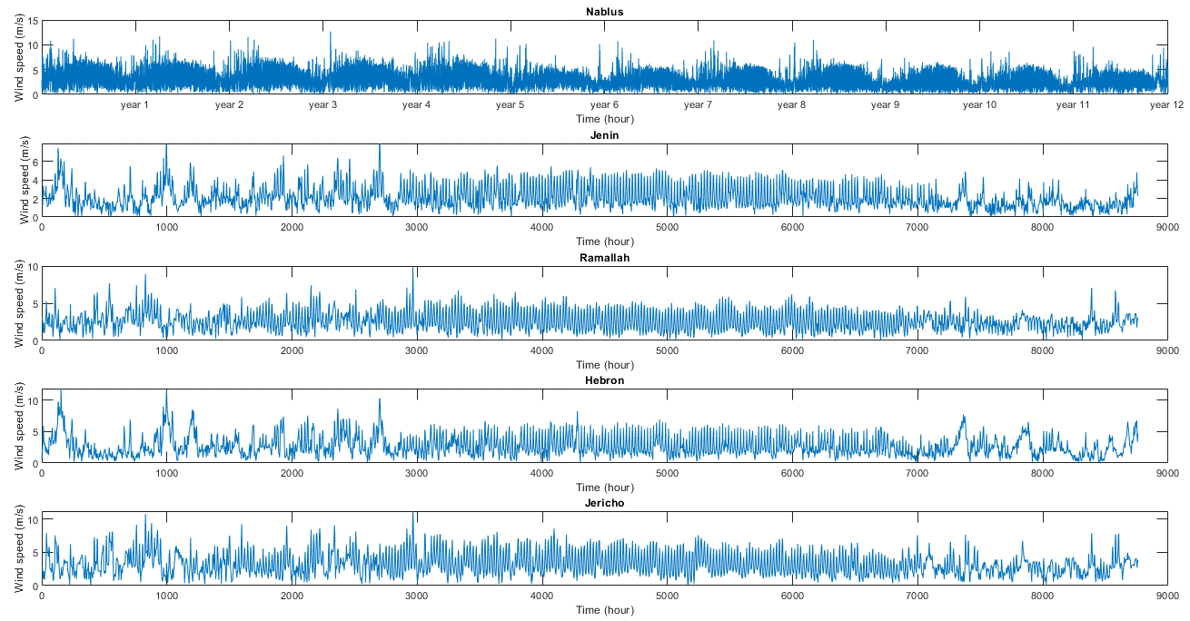
Figure 1: Wind speed data for five Palestinian cities

Wind speed and installation height

The PVGIS wind speed data measured at 10m above ground level, which is lower than the hub height of 50m of the selected turbine. Therefore, the wind speed at the turbine hub height can be estimated by using the power-law equation with the measured data as reference input. Power law equation is given by;
$$\frac{V}{V_{0}}={\frac{H}{H_{0}}}^{a}$$ | (1)

Where $V$ is the wind speed at the hub height, $V_{0}$ is the measured wind speed, $H$ is the hub height, $H_{0}$ is the height where the speed was measured, and $a$ is a constant that varies with surface roughness and terrain condition. This constant ($a$) has a typical value of 0.14 for smooth, level, grass-covered terrain [38].

Wind distribution

The output power of wind turbines depends on the speed of the wind and air density, but they are not the only factors. Wind power also depends on wind speed distribution and wind speed frequency. The two-parameter Weibull distribution is the most used distribution in wind energy studies. It has been found that this distribution is a good fit with the measured wind speed data. The Weibull probability density function is given by Equation.2;
$$f(v)= \frac{k}{c}{\left(\frac{v}{c}\right)}^{k-1}e^{-{\left(\frac{v}{c}\right)}^{k}}$$ | (2)

And the Weibull cumulative distribution function is given by Equation.3;

$$F(v)=1-e^{-{\left(\frac{v}{c}\right)}^{k}}$$ | (3)

Where v is the wind speed, k is Weibull shape parameter, and c is Weibull scale parameter. Weibull parameter are calculated by fitting the wind speed data to Equation.2 by using an iterative procedure to minimize the summation of the absolute difference between Equation.2 and the real data. Table.1 shows Weibull scale parameters and Weibull shape parameters for the selected cities for wind energy forecasting in this research.

Table 1: Weibull parameters for selected cities
City/Parameter | Scale parameter | Shape parameter
Nablus | 2.40 | 1.894
Ramallah | 2.36 | 1.924
Jenin | 2.92 | 2.243
Hebron | 3.08 | 1.827
Jericho | 3.67 | 2.129

Figure.3 shows the Weibull probability density function for these selected cities.

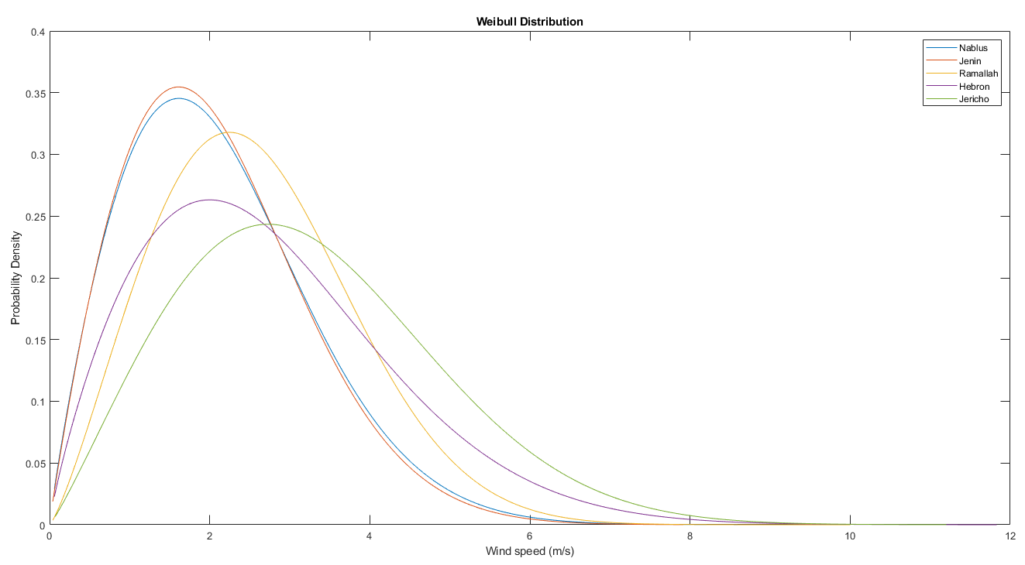
Figure 2: Weibull probability density function for selected cities

Wind energy

Wind energy has been used for thousands of years in many ways such as, windmills, sailing, and wind turbines. Modern large-scale wind turbines are machines used to convert kinetic wind energy into mechanical energy, which is converted into electrical energy using electric generators [39]. Wind energy is a kinetic energy obtained by utilizing the kinetic energy of the flowing air. The available wind kinetic energy is directly proportional to air mass and airflow speed. However, it is easier to use air density instead of air mass to compute available wind energy and actual wind turbine output energy using Equation.4 [38] , Equation.5 [40], respectively.

$$P_{w}=\frac{1}{2}*ρ*A*V^{3}$$ | (4)
$$P_{a}=\frac{1}{2}*ρ*A*V^{3}*C_{p}$$ | (5)

Where $P_{w}$ is the available wind power, $P_{a}$ is the actual output power generated by the wind turbine,$ρ$ is the air density, $A$ is the swept area of the blades of the wind turbine, $V$ is wind speed, and $C_{p}$ is the power coefficient. The power coefficient ($C_{p}$) is an indicator of total wind turbine system efficiency, and it depends on many factors, such as tip angel, blade shape, and the correlation between wind speed and rotor speed. According to Carrillo [41] the maximum theoretical value of the power coefficient (Betz limit) for any turbine is 0.593. However, real turbines can't achieve this value and their maximum value is usually around 0.5.
The output power of a wind turbine is usually represented through its power curve, where there is a relationship between wind speed and turbine output energy, as shown below [41];
$$E_{turbine}=\left\{\begin{matrix}0 v<v_{ci} or v>v_{co} \\ P_{a} { v}_{ci}≤v<v_{r} \\ P_{r} { v}_{ci}≤v<v_{r} \end{matrix}\right.$$ | (6)

Where, $v$ is hourly wind speed, $v_{ci}$ is turbine cut-in speed,$v_{r}$ is turbine rated speed, $v_{co}$ is turbine cut-out speed, $P_{turbine}$ is turbine output power, $P_{r}$ is turbine rated power, and $P_{a}$ is the non-linear relationship between turbine power and wind speed (equation.2).
In this research, a 1 MW turbine will be used for wind power modeling. Figure.3 shows the power curve of this turbine, and the technical specification of this turbine is shown in Table.2.

Figure 3: 1MW turbine power curve
Table 2: 1MW turbine technical specification
Rated power | 1000 kW
Cut-in Wind Speed | 3m/s
Rated Wind Speed | 13m/s
Cut-out Wind Speed | 25m/s
Diameter | 53.4m
Rated Rotational Speed | 19rpm
Length of Blade | 40m
Hub Height | 50m

Methodology

In this research, training and testing datasets were generated using datasets obtained from PVGIS database. Figure.1 shows this dataset which contains hourly wind speed data at 10m height for twelve years for the city of Nablus and one year for Hebron, Ramallah, Jenin, and Jericho. The training dataset for machine learning model was generated based on Nablus hourly wind speed data, where the inputs in the training dataset is the daily average cubic wind speed, and the standard deviation, while the target is the daily wind energy. Similarly, the testing dataset was generated based on other cities hourly wind speed data.
The training process for the machine learning model starts by calculating wind speed at hub height (50m) using Equation.1, hourly energy using Equation.6, daily energy using Equation.7, daily average cubic wind speed using Equation.8, and daily standard deviation using Equation.9. Then daily average cubic wind speed and standard deviation are used to train the models to predict daily wind energy.
$$E\left(i\right)=\sum_{k=1}^{k=24}{P_{a}(k)}$$ | (7)
$$V_{m}\left(i\right)=\frac{1}{24}\sum_{k=1}^{k=24}{V{\left(k\right)}^{3}}$$ | (8)
$${SD}_{m}\left(i\right)=\sqrt{\frac{\sum_{k=1}^{k=24}{{\left(V\left(k\right)-V_{m}\left(i\right)\right)}^{2}}}{24-1}}$$ | (9)

The trained models testing process starts by generating the testing dataset for Hebron, Ramallah, Jenin, and Jericho in the same way training datasets were generated. Figure.4 shows the flowchart of the whole approach used for wind energy forecasting.
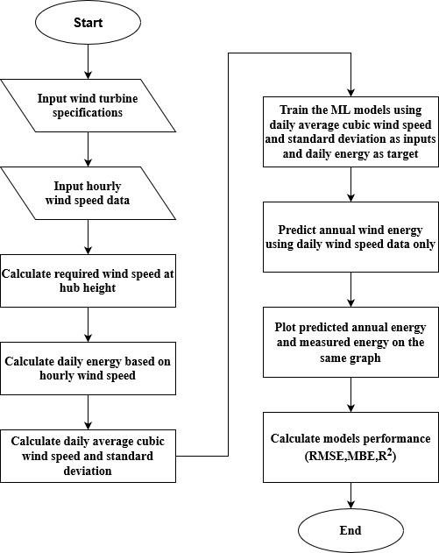
Figure 4: Wind energy forcasting flowchart

The accuracy of the proposed model is evaluated based on the Root Mean Squared Error (RMSE), mean bias error (MBE), and coefficient of determination (R²).
MBE provides information about the long-term performance of the proposed method and it shows the average variance between the predicted values of the energy to the corresponding values of the actual energy. In the current prediction, a positive MBE error represents overestimation of data from datasets and vice versa. MBE can be determined using the equation below,

$$MBE=\frac{1}{n}\sum_{k=1}^{n}{E_{p}(k)-E_{a}(k)}$$ | (10)

Eventually, RMSE is a measure of the variance of the energy values from the model around the values of the actual energy and it provides information on the short-term performance. RMSE is calculated by,

$$RMSE=\sqrt{\frac{1}{n}\sum_{k=1}^{n}{(}E_{p}(k)-E_{a}(k))^{2}}$$ | (11)

Where $E_{p}(k)$ is the predicted energy, $E_{a}(k)$is the actual energy value, and n is the number of data points.
Eventually,$R^{2}$ is coefficient for analyzing how a difference in one or more variables can be explained by a difference in another variable. $R^{2}$ can be calculated by;

$$R^{2}=1-\frac{SS_{res}}{SS_{tot}}$$ | (12)

Where $SS_{res}$ is regression sum of squares and $SS_{tot}$ is the sum of squares of residuals.

Results and discussion

In this research, long term wind energy has been predicted using three machine learning algorithms namely, Cascade-forward neural network (CFNN), random forests (RFs), support vector machines (SVM). MATLAB statistics and machine learning toolbox was used to train and test these models. Nablus wind speed data was used to train the models, then these models was tested on wind speed data of four other cities. Table.3 shows the RMSE, MBE, and R² for the three models.

Table 3: RMSE, MBE, and R² values
 | CFNN |  |  | RFs |  |  | SVM
 | RMSE | MBE | R² | RMSE | MBE | R² | RMSE | MBE | R²
Jenin | 22.71 | 2.66 | 0.9992 | 26.05 | 2.96 | 0.9990 | 32.64 | -11.23 | 0.9985
Hebron | 58.08 | 5.64 | 0.9996 | 341.52 | -34.56 | 0.9913 | 114.65 | 6.60 | 0.9989
Jericho | 31.08 | -3.40 | 0.9997 | 23.71 | -2.42 | 0.9998 | 57.70 | 2.08 | 0.9993
Ramallah | 20.42 | -5.48 | 0.9995 | 47.93 | -2.42 | 0.9971 | 34.32 | -19.09 | 0.9991

According to the results, the Cascade-forward neural network predicted energy throughout the year, with the highest accuracy followed by SVM with slightly lower accuracy, and finally the RFs model. It was noted that the RFs model could not predict high energy because the models were trained at relatively low speeds and this model relies mainly on regression, it cannot predict data outside its range. Figure.5, Figure.6, and Figure.7 shows the predicted energy by CFNN, RFs, and SVM, respectively.

Figure 5:CFNN prediction results
Figure 6: RFs prediction results
Figure 7: SVM prediction results

Conclusion

In this research, an approach was developed to predict wind energy in the long term for any location, as machine learning models were trained on wind energy data in Nablus and these models succeeded in predicting wind energy in several other cities with varying accuracy. The CFNN model was the most accurate model for wind energy forecasting at different locations from the one on which the model was trained. The SVM model results are similar to CFNN model but with less accuracy. RF was not able to predict high wind energy in these different locations but it was able to predict energy ranges similar to the training dataset energy ranges. The accuracy of these models can be increased effectively by increasing training data using different locations data with different wind speed ranges.

References

[1] V. Nelson and K. Starcher, Wind energy : renewable energy and the environment. 2019.
[2] M. Sagrillo, I. Woofenden, and D. D. Chiras, Wind Power Basics. New Society Publishers, Limited, 2010.
[3] G. Nikitas, S. Bhattacharya, N. Vimalan, H. E. Demirci, N. Nikitas, and P. Kumar, “Wind power: A sustainable way to limit climate change,” pp. 333–364, 2019.
[4] J. S. Aber, I. Marzolff, J. B. Ries, and S. E. W. Aber, “Chapter 20 - Wind Energy,” J. S. Aber, I. Marzolff, J. B. Ries, and S. E. W. B. T.-S.-F. A. P. and U. A. S. I. (Second E. Aber, Eds. Academic Press, 2019, pp. 343–347.
[5] L.-L. Li, X. Zhao, M.-L. Tseng, and R. R. Tan, “Short-term wind power forecasting based on support vector machine with improved dragonfly algorithm,” J. Clean. Prod., vol. 242, p. 118447, 2020, doi: https://doi.org/10.1016/j.jclepro.2019.118447.
[6] Najeebullah, A. Zameer, A. Khan, and S. G. Javed, “Machine Learning based short term wind power prediction using a hybrid learning model,” Comput. Electr. Eng., vol. 45, pp. 122–133, 2015, doi: https://doi.org/10.1016/j.compeleceng.2014.07.009.
[7] R. Jursa and K. Rohrig, “Short-term wind power forecasting using evolutionary algorithms for the automated specification of artificial intelligence models,” Int. J. Forecast., vol. 24, no. 4, pp. 694–709, 2008, doi: https://doi.org/10.1016/j.ijforecast.2008.08.007.
[8] N. Amjady, F. Keynia, and H. Zareipour, “Wind Power Prediction by a New Forecast Engine Composed of Modified Hybrid Neural Network and Enhanced Particle Swarm Optimization,” IEEE Trans. Sustain. Energy, vol. 2, no. 3, pp. 265–276, 2011, doi: 10.1109/TSTE.2011.2114680.
[9] R. Abhinav, N. M. Pindoriya, J. Wu, and C. Long, “Short-term wind power forecasting using wavelet-based neural network,” Energy Procedia, vol. 142, pp. 455–460, 2017, doi: https://doi.org/10.1016/j.egypro.2017.12.071.
[10] H. Chitsaz, N. Amjady, and H. Zareipour, “Wind power forecast using wavelet neural network trained by improved Clonal selection algorithm,” Energy Convers. Manag., vol. 89, pp. 588–598, 2015, doi: https://doi.org/10.1016/j.enconman.2014.10.001.
[11] P. Du, J. Wang, W. Yang, and T. Niu, “A novel hybrid model for short-term wind power forecasting,” Appl. Soft Comput., vol. 80, pp. 93–106, 2019, doi: https://doi.org/10.1016/j.asoc.2019.03.035.
[12] H. M. I. Pousinho, V. M. F. Mendes, and J. P. S. Catalão, “A hybrid PSO–ANFIS approach for short-term wind power prediction in Portugal,” Energy Convers. Manag., vol. 52, no. 1, pp. 397–402, 2011, doi: https://doi.org/10.1016/j.enconman.2010.07.015.
[13] C. W. Potter and M. Negnevitsky, “Very short-term wind forecasting for Tasmanian power generation,” IEEE Trans. Power Syst., vol. 21, no. 2, pp. 965–972, 2006, doi: 10.1109/TPWRS.2006.873421.
[14] A. Lahouar and J. Ben Hadj Slama, “Hour-ahead wind power forecast based on random forests,” Renew. Energy, vol. 109, pp. 529–541, 2017, doi: https://doi.org/10.1016/j.renene.2017.03.064.
[15] G. Wang, R. Jia, J. Liu, and H. Zhang, “A hybrid wind power forecasting approach based on Bayesian model averaging and ensemble learning,” Renew. Energy, vol. 145, pp. 2426–2434, 2020, doi: https://doi.org/10.1016/j.renene.2019.07.166.
[16] Q. Chen and K. A. Folly, “Wind Power Forecasting,” IFAC-PapersOnLine, vol. 51, no. 28, pp. 414–419, 2018, doi: https://doi.org/10.1016/j.ifacol.2018.11.738.
[17] E. Erdem and J. Shi, “ARMA based approaches for forecasting the tuple of wind speed and direction,” Appl. Energy, vol. 88, no. 4, pp. 1405–1414, 2011, doi: https://doi.org/10.1016/j.apenergy.2010.10.031.
[18] Q. Han, F. Meng, T. Hu, and F. Chu, “Non-parametric hybrid models for wind speed forecasting,” Energy Convers. Manag., vol. 148, pp. 554–568, 2017, doi: https://doi.org/10.1016/j.enconman.2017.06.021.
[19] A. Sfetsos, “A novel approach for the forecasting of mean hourly wind speed time series,” Renew. Energy, vol. 27, no. 2, pp. 163–174, 2002, doi: https://doi.org/10.1016/S0960-1481(01)00193-8.
[20] R. G. Kavasseri and K. Seetharaman, “Day-ahead wind speed forecasting using f-ARIMA models,” Renew. Energy, vol. 34, no. 5, pp. 1388–1393, 2009, doi: https://doi.org/10.1016/j.renene.2008.09.006.
[21] A. Dupré, P. Drobinski, B. Alonzo, J. Badosa, C. Briard, and R. Plougonven, “Sub-hourly forecasting of wind speed and wind energy,” Renew. Energy, vol. 145, pp. 2373–2379, 2020, doi: https://doi.org/10.1016/j.renene.2019.07.161.
[22] G. Grassi and P. Vecchio, “Wind energy prediction using a two-hidden layer neural network,” Commun. Nonlinear Sci. Numer. Simul., vol. 15, no. 9, pp. 2262–2266, 2010, doi: https://doi.org/10.1016/j.cnsns.2009.10.005.
[23] T. G. Barbounis and J. B. Theocharis, “Locally recurrent neural networks for long-term wind speed and power prediction,” Neurocomputing, vol. 69, no. 4, pp. 466–496, 2006, doi: https://doi.org/10.1016/j.neucom.2005.02.003.
[24] S. Samadianfard et al., “Wind speed prediction using a hybrid model of the multi-layer perceptron and whale optimization algorithm,” Energy Reports, vol. 6, pp. 1147–1159, 2020, doi: https://doi.org/10.1016/j.egyr.2020.05.001.
[25] M. Carolin Mabel and E. Fernandez, “Analysis of wind power generation and prediction using ANN: A case study,” Renew. Energy, vol. 33, no. 5, pp. 986–992, 2008, doi: https://doi.org/10.1016/j.renene.2007.06.013.
[26] J. Yan and T. Ouyang, “Advanced wind power prediction based on data-driven error correction,” Energy Convers. Manag., vol. 180, pp. 302–311, 2019, doi: https://doi.org/10.1016/j.enconman.2018.10.108.
[27] G. M. Khan, J. Ali, and S. A. Mahmud, “Wind power forecasting — An application of machine learning in renewable energy,” in 2014 International Joint Conference on Neural Networks (IJCNN), 2014, pp. 1130–1137, doi: 10.1109/IJCNN.2014.6889771.
[28] C.-D. Dumitru and A. Gligor, “Daily Average Wind Energy Forecasting Using Artificial Neural Networks,” Procedia Eng., vol. 181, pp. 829–836, 2017, doi: https://doi.org/10.1016/j.proeng.2017.02.474.
[29] E. Cadenas and W. Rivera, “Wind speed forecasting in three different regions of Mexico, using a hybrid ARIMA–ANN model,” Renew. Energy, vol. 35, no. 12, pp. 2732–2738, 2010, doi: https://doi.org/10.1016/j.renene.2010.04.022.
[30] L. Kamal and Y. Z. Jafri, “Time series models to simulate and forecast hourly averaged wind speed in Quetta, Pakistan,” Sol. Energy, vol. 61, no. 1, pp. 23–32, 1997, doi: https://doi.org/10.1016/S0038-092X(97)00037-6.
[31] H. Liu, H. Tian, and Y. Li, “Comparison of two new ARIMA-ANN and ARIMA-Kalman hybrid methods for wind speed prediction,” Appl. Energy, vol. 98, pp. 415–424, 2012, doi: https://doi.org/10.1016/j.apenergy.2012.04.001.
[32] D. B. De Alencar, C. De Mattos Affonso, R. C. L. De Oliveira, J. L. M. Rodríguez, J. C. Leite, and J. C. R. Filho, “Different Models for Forecasting Wind Power Generation: Case Study,” Energies, vol. 10, no. 12, 2017, doi: 10.3390/en10121976.
[33] G. Shobha and S. Rangaswamy, “Chapter 8 - Machine Learning,” in Computational Analysis and Understanding of Natural Languages: Principles, Methods and Applications, vol. 38, V. N. Gudivada and C. R. B. T.-H. of S. Rao, Eds. Elsevier, 2018, pp. 197–228.
[34] T. Khatib, A. Mohamed, K. Sopian, and M. Mahmoud, “Assessment of Artificial Neural Networks for Hourly Solar Radiation Prediction,” Int. J. Photoenergy, vol. 2012, Jun. 2012, doi: 10.1155/2012/946890.
[35] L. Breiman, “Random Forests,” Mach. Learn., vol. 45, no. 1, pp. 5–32, 2001, doi: 10.1023/A:1010933404324.
[36] L. Breiman, “Bagging predictors,” Mach. Learn., vol. 24, no. 2, pp. 123–140, 1996, doi: 10.1007/BF00058655.
[37] A. B. T.-H. of S. Van Messem, “Support vector machines: A robust prediction method with applications in bioinformatics,” Elsevier, 2020.
[38] A. R. JHA PH. D., WIND TURBINE TECHNOLOGY. [Place of publication not identified]: CRC Press, 2017.
[39] W. Tong, Wind power generation and wind turbine design. Southampton; Boston: WIT Press, 2010.
[40] Z. O. Olaofe and K. A. Folly, “Wind energy analysis based on turbine and developed site power curves: A case-study of Darling City,” Renew. Energy, vol. 53, pp. 306–318, 2013, doi: https://doi.org/10.1016/j.renene.2012.11.003.
[41] C. Carrillo, A. F. Obando Montaño, J. Cidrás, and E. Díaz-Dorado, “Review of power curve modelling for wind turbines,” Renew. Sustain. Energy Rev., vol. 21, pp. 572–581, 2013, doi: https://doi.org/10.1016/j.rser.2013.01.012.

