

An-Najah National University

Faculty of Engineering & Information Technology

Department of Materials Engineering

Graduation project ΙΙ

Exploring mineral deposits in Palestine for potential
use in manufacturing refractory ceramics

Group members:
Saja Hussein
Noora Khanfa
Hanan Walwil

Supervisors':
Dr. Hamdallah Bearat

الاهداء
الى كل من يتمسك بالامل رغم ان يعيش في فلسطين
ويدرس هندسة المواد!
وبالرغم من الصعوبات والاوجاع التي مررنا بها
وصلت رحلتي الجامعية الى نهايتها بعد تعب ومشقه
ها أنا أختم بحث تخرُّجي بكل همَّة ونشاط
وأمتنُّ لكل من كان له فضل في مسيرتي،
وساعدني ولو باليسير،
الأبوين، والأهل، والأصدقاء، والأساتذة المُبجَّلين..
أُهديكم بحث تخرُّجي

Abstract:

Refractories are materials that retain their strength and integrity at relatively high temperature. They are mainly oxide ceramics based on one or more of oxides like silica (SiO₂), alumina (Al₂O₃), lime (CaO), Magnesia (MgO), zirconia (ZrO₂) or their mixtures such as mullite , wollastonite , etc. Refractory ceramics are important for local manufacturing and construction industries. They are used in these industries for internal lining of melting furnaces and for insulation in many sectors of construction industry.

This project aims to use the raw materials available in Palestine to create an investment project to support the Palestinian economy. The raw materials that we intend to explore and test their suitability are: various clay deposits, flint formations, whether in the veins, layers, or surface, the formation of dolomite in the southeast of the West Bank, and limestone (calcium carbonate) waste from local stone factories, as well as access to raw materials Containing silica.

The project is the second type of refractory brick that does not contain clay and is mainly dependent on silica and calcium carbonate. A silica sample was brought from near Nablus and calcium carbonate was brought from the laboratory and quarries.

During the first semester, a(1:1) ratio was mixed to form a refractory brick of calcium carbonate(CaCO3) and silica(SiO2), but the final result of a refractory brick sample was destroyed, given that the material brought in contained a small proportion of the silica , This was known through later tests on the sample.

During the second semester, we used silica and calcium carbonate in a ratio of (1:1)& (1:2) silica powder and calcium carbonate were formed and the result of calculating at a ratio of (1:1) the rate was $3.7*{10}^{-2}\min^{-1}$⁡. As for silica with calcium carbonate in a ratio of (1:2),the rate was equal to$2.5*{10}^{-1}\min^{-1}$ refractory bricks were obtained from calcium carbonate and silica.

The project goal has been achieved, we got two stones from refractory bricks, but it were weak and fragile , and it need additional materials to achieve both strength and toughness

Table of contact :
Chapter 1: Introduction 1
1.1 Refractory definition: 1
1.2 Refractory properties: 12
1.3 Refractory types: 12
1.4 lecture review: 13
1.5 Problem statement: 17
Chapter 2: Methodology 18
2.1 Materials: 18
2.2 Preparation of powder samples : 19
Chapter 3: Results and Discussion 22
3.1 Characterization results: 22
3.2 Result of firing powder sample 26
3.3 Rate of reaction calculation : 28
Chapter 4: Obstacles and challenges 31
4.1 Obstacles 31
4.2 Challenges: 32
4.3 Sources of errors: 33
4.4 Recommendations: 33
Chapter 5: conclusion 34
Chapter 6 : References 34

List of Figures
Figure 1:Glassmaking 2
Figure 2:Ceramic industries 2
Figure 3: Fireplaces 3
Figure 4: phases diagram for the binary CaO.SiO2 system . 19
Figure 5: powder samples for a 1:1 ratio 20
Figure 6: powder samples for a 1:2 ratio 21
Figure 7: sample brick sample for a ratio 1:1 21
Figure 8:powder sample 22
Figure 9:XRF analyzing for elemental analysis in of powder 23
Figure 10: (1:1) paste sample when placed in the oven 24
Figure 11:XRF analyzing for element ratio of the dough 24
Figure 12:XRD pattern of the samples fired at 1100 25
Figure 13: Relation between % of decomposition CaCo3 and time 29
Figure 14: Relation between % od decomposition CaCo3 and time in table 5 30
Figure 15:Broken samples 31

List of Tables :

Table 1: the ratio of chemical composition in 1:1 powder sample 15
Table 2:the chemical composition ratio of the dough sample 17
Table 3: The result of first experiment with 1:1 powder samples 19
Table 4: result of losing weight at different times for 1:1 powder sample 20
Table 5: result of losing weight at different times for 1:2 powder sample 20

Chapter 1: Introduction

1.1 Refractory definition:
Refractories are heat resistant materials used in almost all processes involving high temperatures and/or corrosive environment. These are typically used to insulate and protect industrial furnaces and vessels due to their excellent resistance to heat, chemical attack and mechanical damage. Any failure of refractory could result in a great loss of production time, equipment, and sometimes the product itself. The various types of refractories also influence the safe operation, energy consumption and product quality; therefore, obtaining refractories best suited to each application is of supreme importance ⁽¹⁾.
Refractories are inorganic, nonmetallic, porous and heterogeneous materials composed of thermally stable mineral aggregates, a binder phase and additives. The principal raw materials used in the production of refractories are: the oxides of silicon, aluminum, magnesium, calcium and zirconium and some non-oxide refractories like carbides, nitrides, borides, silicates and graphite ⁽²⁾.
The main types include fire-clay bricks, constables, ceramic fiber and insulating bricks that are made in varying combinations and shapes for diverse applications. The value of refractories is judged not merely by the cost of material itself, but by the nature of the job and/or its performance in a particular situation. Atmosphere, temperature, and the materials in contact are some of the operating factors that determine the composition of refractory materials. ⁽³⁾.
Refractories are used by the metallurgy industry in the internal linings of furnaces , kilns , reactors , Glassmaking ( Fig 1) , Ceramic kiln (Fig 2), Bricks for fireplaces ( Fig 3) and other vessels for holding and transporting metal and slag .
Figure 1:Glass making
Figure 2:Ceramic kiln
Figure 3: Bricks for fireplace

1.2 Refractory properties:
Important properties of refractories are chemical composition, bulk density It is a measure of the weight of a given volume of the refractory. For many refractories, the bulk density provides a general indication of the product quality , porosity is a measure of the effective open pore space in the refractory into which the molten metal, slag, fluxes, vapors etc can penetrate and thereby contribute to eventual degradation of the structure , apparent specific gravity and strength at atmospheric temperatures. These properties are often among those which are used as ‘control points’ in the manufacturing and quality control process. The chemical composition serves as a basic for classification of refractories and the density, porosity and strength is influenced by many other factors. Among these are type and quality of the raw materials, the size and fit of the particles, moisture content at the time of pressing, pressure at mould, temperature, duration of firing and the rate of cooling. ⁽⁴⁾

1.3 Refractory types:
We can classify the refractories according to the basis of composition as clay-based or none clay-based. Or we can classify as :
- Acidic refractories
They consist of mostly acidic materials like alumina (Al2O3) and silica (SiO2). They are not attacked or affected by acidic materials, but easily affected by basic materials e.g.:-silica, alumina, fire clay refractories, etc.

- Neutral refractories
These are used in areas where slags and atmosphere are either acidic or basic and are chemically stable to both acids and bases. The main raw materials belongs to, but not confined to, R2O3 group, (R) stand for the chemical symbol and O stand for Oxygen . The common examples of these materials are alumina (Al2O3), chromium oxide (Cr2O3) and carbon. ⁽⁵⁾
- Carbon graphite refractories mainly consist of carbon. These refractories are often used in highly reducing environments, and their properties of high refractoriness allow them excellent thermal stability and resistance to slags.

- Chromite refractories are composed of sintered magnesia and chromia. They have constant volume at high temperatures, high refractoriness, and high resistance to slags

- Alumina refractories are composed of ≥ 50% alumina (Al₂O₃).

- Basic refractories
These are used on areas where slags and atmosphere are basic; they are stable to alkaline materials but react with acids. The main raw materials belong to the RO group to which magnesia (MgO) and (CaO ) is a very common examples . Other examples include dolomite and chrome-magnesia .

1.4 literature review:
The manufacturing process of a refractory is quite similar to the formation of basalt, a naturally occurring siliceous rock. Basalt forms from lava that flows out from volcanic eruptions under the natural geological forces of heat and pressure. Refractory production is somewhat a replication of this natural process where, in general, the naturally occurring Refractory Technology (or synthetic) non-metallic mineral oxides (and some non-oxides in special cases) convert to refractory under the conditions of high heat 1200 ℃. and pressure mostly in solid state .
Since very ancient times, the developments in refractory technology follows the similar track of the developments of the ceramic and metal industries. In the early Bronze Age, a kind of pit kiln was used to fire the earthen wares, where green earthen wares were placed in a hole, dug into the ground for firing. the soil around the dug-out portion used to act a heat / fire-resistant material, and the upper limit of such kilns was the decomposition temperature of those soil/clayey materials. Naturally, the cavities for the pit kilns were made in such an area where the soil is relatively more heat resistant, insulating and resistant to any crack formation on heating and breaking. In today’s technical term, the refractories that were used for such firing are nothing but clay refractories , With time, civilization entered the iron age when remarkable improvements in refractories were observed. Iron was produced by reducing iron ore with charcoal in a furnace at a temperature much higher than the pottery making temperatures. The furnace lining had to withstand not only the temperature but also the mechanical action and chemical corrosion of the process and wear of the charge and product materials. Natural stones (mostly silica containing), fire clays, and a mixture of charcoal and clay were the standard materials for furnace lining. Evidence of iron-making furnaces was found in Europe in the fourteenth century. ⁽⁶⁾

The history of glass-making dates back to at least 3,600 BC in Mesopotamia, however some claim they may have been producing copies of glass objects from Egypt. (7) In the modern history, evidence of glass pots, the refractory vessel for glass melting, were found in Salem, Massachusetts, in 1638. Fire bricks were reported to be manufactured in England in the seventeenth century and used to be transported to different countries for glass manufacturing. In the late eighteenth century, fire brick making was started in the United States. ⁽⁸⁾

Again if we look into the history of refractory making, it can be found that silica refractories were reported to be manufactured initially in South Wales, England, way back in 1842 and later in 1899 it was started in the Mount Union region of Pennsylvania in the United States. Magnesite refractories were initially started in Austria, Europe, around 1880 and in 1888 its manufacturing was started in Homestead, Pennsylvania. ⁽⁹⁾

- History :
Red brick is known as one of the oldest types of bricks and the oldest is simple in production with high specifications and excellent quality in construction. where it was the beginning of construction and architecture, where red bricks were used in the past in the construction of several features, including good insulation . Red brick is made of clay, it becomes pottery and bear the pressure of cold and heat and is resistant to heat and fire. These are some of the old features that used red bricks. Red bricks were known for other features compared to modern materials used in modern construction. ⁽¹⁰⁾

- Analysis :
Many researchers studied the composite and the properties of bricks . e.g .
Calvoa et al. ⁽¹¹⁾ Analysis of AMC composite refractory bricks using X-ray diffraction methods, X-ray fluorescence chemical dissociation, energy dispersed X-ray spectroscopy, density and porosity measurements, and mercury porosity measurements for analyzing chemical and physical properties result . Oster mortem studies in the secondary steel industry are an important method for determining factors related to thermal corrosion of alumina - magnesium – carbon.

Abu-Mashaeekh et al. ⁽¹²⁾ Refractory bricks are a high temperature resistant material used in building the furnace, and can be made of silica and calcium carbonate with the addition of the following these materials to aid in the manufacturing process (KCl, NH4Cl and NaCl) produced using waste that impedes the environment. Mentioned in their research that CaO was formed from CaCO3 decomposition, reacted with silica, and added salt, reacted at (800,900, and 1000) ° C, and it was found that the ideal case for using NaCl salt was 900 ° C and a 10% concentration for 3 hours according to a pressure resistance value of 2.372 MPa

- Properties :
Karakus, ^{. (13)} Refractories are ceramic materials that have high thermal shock properties and resistance to slag wear, as well as resistance to crawling at high temperatures. They are used in large quantities in steelmaking furnaces, metal smelting vessels, and glass melting tanks, and they are made from very refractory metal oxides such as lime, niclase, corundum, spi-nel, and zirconia.
- Improvements
Ghasemi-Kahrizsangi et al . ⁽¹⁴⁾ made a study about the effect of Cr2O3 nanoparticles (up to 3 wt.%) on the physical and mechanical properties of MgO–CaO refractory bricks with confirmation on the hydration resistance improvement .The experiments were calculated at pressure= 90MPa and temperature= 1650°C for 5 h .They obtained some improvement in specimens hydration resistance as :(1) decreasing the amount of free CaO and MgO with converted to high hydration resistance phases such as CaCr2O4 and MgCr2O4 phases, (2) promotion of the densification as well as (3) modification of the microstructure
Dehshikh & Ghasemi-Kahrizsangi . ⁽¹⁵⁾obtained many benefits of the MgO-C refractory bricks such as excellent corrosion resistance, high thermal shock resistance, good mechanical strength at high temperature.

But, the low oxidation resistance of these refractory bricks at high temperatures has restricted their application. Hence Dehshikh et al, the impact of Nano-ZrSiO4 addition on microstructure was investigated improvement of MgO-C refractory was obtained .

Ruh & McDOWELL . ⁽¹⁶⁾Heat conductivity measurements were conducted on many types of refractory bricks include high alumina, silica, chrome, magnesium, zircon, and silicon carbide

Rabah & Ewais . ⁽¹⁷⁾Describing the method of preparing the Egyptian Dolomite impregnated multi-layer impregnated refractory bricks. The bricks were prepared from a mixture of calcined dolomite and pitched coal tar. The mixing was done hot and pressed with a strength of 151 MPa. The green bricks were baked for two hours at temperatures of 1000 ° C.

Sengupta . ⁽¹⁸⁾ Provides information about the installation, maintenance and management of refractories in the cement industry. It illustrates how to describe refractory materials and refractory selection for different equipment in a cement plant. It clarifies the thermal composition and explains in detail the chemical and physical factors that affect the performance of refractories and the mechanism of decomposition of refractories, with a special focus on the thermo-chemical and mechanical mechanical aspects.

Serry et al . ⁽¹⁹⁾ They verified four technological samples that represent the sediments of pure and impure dolomite magnesium, recently explored in the Sol Hamid region, Eastern Desert, Egypt for their chemical and mineral composition. XRD, DTA, DTG, TG methods and wet chemical analysis methods were used, and pure magnesite use was used with the addition of MgO and / or Fe2O3-rich materials to produce unmodified MgO-CaO refractories
Xiangchong . ⁽²⁰⁾ The achievements of the Chinese refractory industry in developing advanced high-performance refractory products and that the refractory industry in China continue to focus on further development of high-performance products. With attention to developing high quality raw materials with good affinity and adopting advanced technological equipment. And developing more high-performance refractories with Chinese features based on our raw materials and more basic research work deeply in refractory science and technology.

1.5 Problem statement:

Brick industry is not available in Palestine, so the market depends on products imported from abroad. This means that it is difficult to use bricks in construction projects or use it as a substitute for bricks. Therefore this project aims to exploit the raw materials available in Palestine to produce local stone bricks can be sold at market with suitable prices, which can open a new window for a new investment to improve national economy . This project highlighting problem such as a certain class of project that needs extremely high-temperature furnaces.

Chapter 2: Methodology

2.1 Materials:
- Carbon-based refractories have unique properties such as high thermal conductivity, low thermal expansion, high resistance to thermal shock and chemical inactivity of slag ,so we used calcium carbonate ( Limestone) is a sedimentary rock, which is a white crystalline metal , its chemical formula CaCO3 , it is widely found in nature and is found in the form of rock around the world as it is the main component of limestone, marble, coral, calcite and chalk. In this project, we used lime-stone available in the laboratory .

- Silica (SiO2): The chemical formula (SiO2) is classified as volcanic miniature and is an essential component of sand as it is called industrial silica sand, due to its use in many industries such as glass and building materials, especially concrete and is used to produce minerals, casting molds and melting points 1723 ℃ , So , has physical and chemical specifications that suit industries.( The silica is crystalline quartz)

2.2 Preparation of powder samples :

- Through the phase diagram, we worked at a 1: 1 ratio CaO. SiO2 has 52% SiO2 , the highest melting point for this ratio is 1544 ℃ and the lowest melting point is 1436 and the name is phase Wollestonite , and we also worked on a 1:2 ratio of 2CaO. SiO2 .The Ca2SiO4 is melts at 2140C
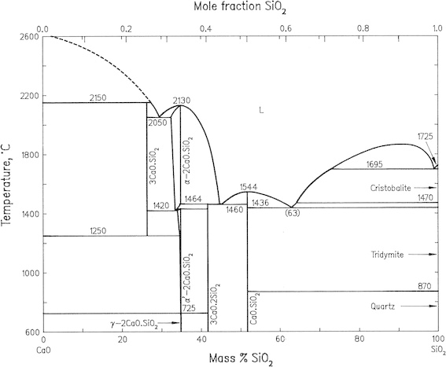
Figure 4 : phases diagram for the binary CaO.SiO2 system .
- 1:1 calcium carbonate sample.
- Mixed a mixture of silica (SiO2) and calcium carbonate (CaCO3)with 1:1 ratio.
- The mixture was divided into 5 equal sample .
- The samples were but in the furnace at 1100°C for different time , ( 5 minute , 10 minute , 20 minute , 30 minute and 60 minute ) (Fig 5 ).
- After that the paste was made by adding water to powder and it was left to dry at room temperature .
- Then was put in furnace at 1100°C for 1 hour , the temperature was gradually raised until it arrived 1100°C and so that we avoid a shock to the sample ( Until you absorb the water gradually and avoid fragmentation)

- 1:2calcium carbonate sample .
- Mixed a mixture of silica (SiO2) and calcium carbonate (CaCO3) with 1:2 ratio.
- The mixture was divided into 5 equal sample .
- The samples were but in the furnace at 1100°C at different time ( 5 minute , 10 minute , 20 minute , 30 minute and 60 minute ) ( Fig 6) .
- After that the paste was made by adding water to powder and it was left to dry at room temperature .
- Then was put in furnace at 1100°C for 1 hour , the temperature was gradually raised until it arrived 1100°C and so that we avoid a shock to the sample .

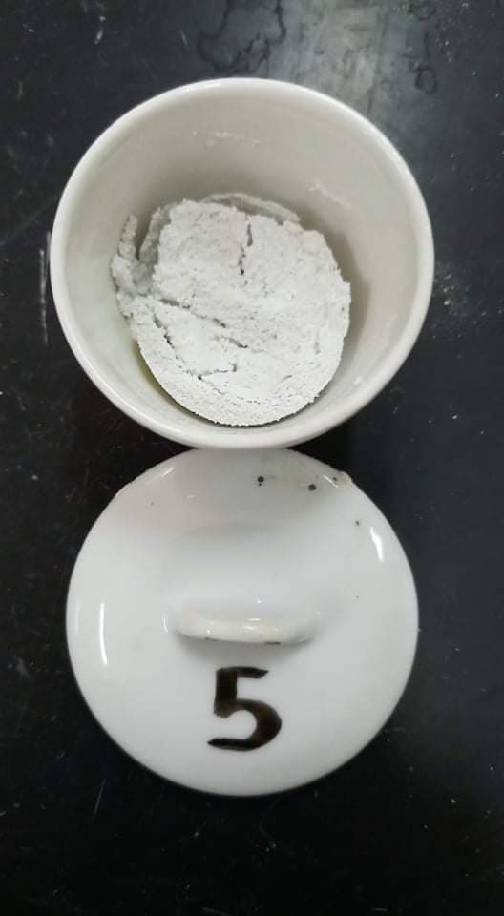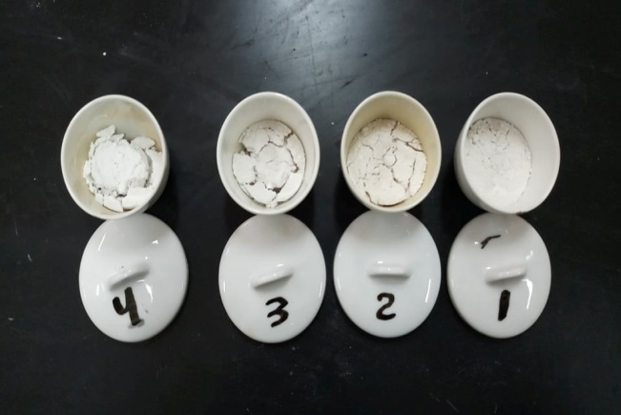
Figure 5: powder samples for a 1:1 ratio
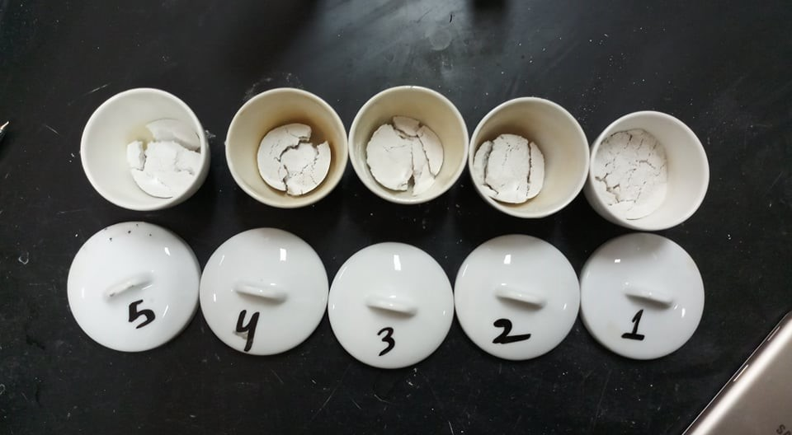
Figure 6: powder samples for a 1:2 ratio

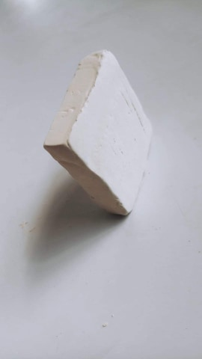
Figure 7: sample Brick sample for a ratio 1:1

Chapter 3: Results and Discussion

3.1 Characterization results:
3.1.1 Powder sample analysis :

- 1:1Powder sample of silica and calcium carbonate at 1100°C and for 1 hour( Fig 9) .
The composition of a 1: 1 sample in (Table 1) and (Fig 8) shows the ratio of the elements to the powder by XRF, and the results showed that this sample contains mainly calcium, which is the highest value.
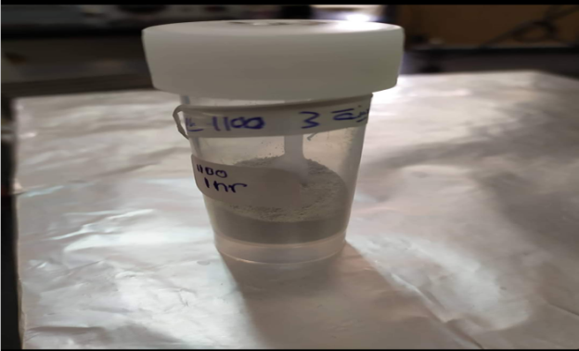
Figure 8:powder sample
Table 1: the ratio of chemical composition in 1:1 powder sample
Stat Error % | Concentration% |  |  | Compound
0.0409 |  | 88.317 |  |  | Calcium ( Ca)
0.0164 |  |  | 9.289 | Silicon ( Si )
0.00336 |  |  | 0.7749 | Iron (Fe)
0.00929 |  |  | 0.7525 | Magnesium ( Mg )
0.00188 | 0.515 |  |  | Potassium (k)
0.00207 | 0.161 |  |  | Aluminum(Al )
0.00040 | 0.0494 |  |  | Sulfur (S)
0.00032 | 0.0486 |  |  | Chlorine( Cl )
0.00016 | 0.046 |  |  | Strontium (Sr)
0.00045 | 0.0379 |  |  | Manganese (Mn)
0.00010 | 0.0091 |  |  | Cobalt ( Co)

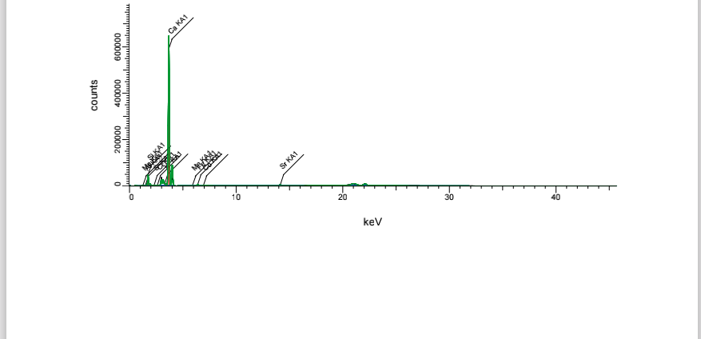
Figure 9 :XRF analyzing for elemental analysis in of powder

3.1.2 . Dough in (Fig 9) sample for a 1: 1 ratio that was cracked when placed in the oven at 1100 ° C .
The results in (Table 2) and (Figure 10) showed that the analysis of the dough sample using XRF is similar to the powder sample in that the calcium ratio, the highest value as in the analysis of the powder sample, the slight difference in this analysis is that the dough sample contains titanium.

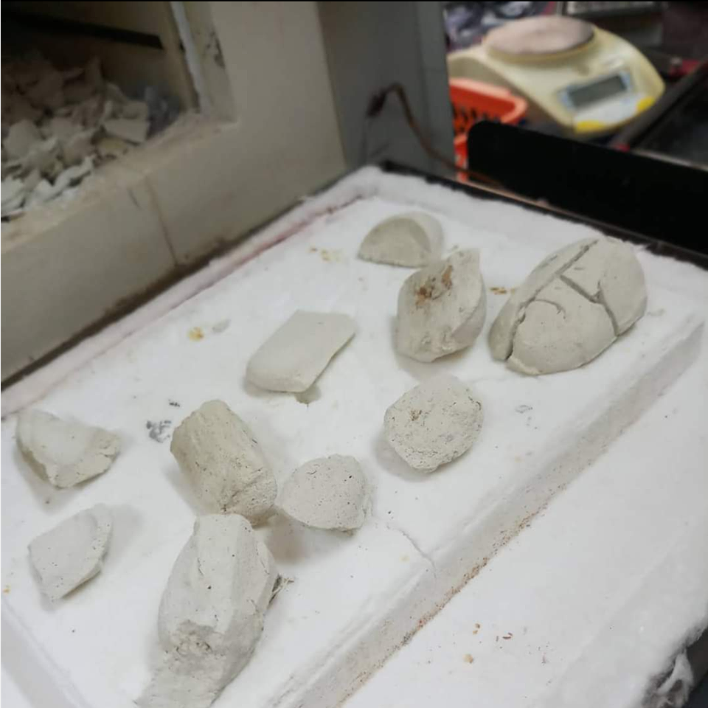
Figure 10: (1:1) paste sample when placed in the oven

Table 2:the chemical composition ratio of the dough sample
Error % Stat | Concentration% | Compound
0.0415 | 88.519 | Calcium ( Ca)
0.0161 | 9. 097 | Silicon ( Si )
0.00371 | 0.8883 | Iron (Fe)
0.00985 | 0.8229 | Magnesium ( Mg )
0.00121 | 0.2956 | Potassium (k)
0.00194 | 0.1518 | Aluminum(Al )
0.00016 | 0.0512 | Strontium (Sr)
0.00032 | 0.0494 | Chlorine( Cl )
0.00068 | 0.0468 | Titanium (Ti)
0.00045 | 0.0393 | Manganese (Mn)
0.00023 | 0.0274 | Sulfur (S)
0.00011 | 0.0114 | Cobalt ( Co)

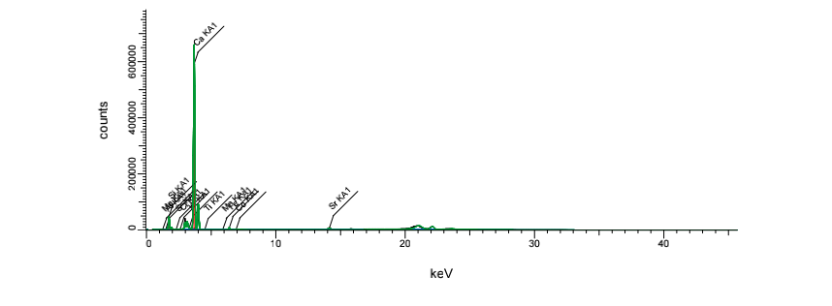
Figure 11:XRF analyzing for element ratio of the dough
Note: The percentage of silica with calcium carbonate together make up> 97% of the samples. This is why Ca> 88% and Si ~ ~ 9% only. This is because most of the sample is will be CaO, of which a small fraction reacts with SiO₂ and the rest will react with H2O from the air and expands causing fracture of the sample.

3.1.3 These are XRD patterns of CaO and quartz (SiO2) that have in samples.( explain the samples showing the phase composition after firing at 1100C ). ( Fig 12 )

Figure 12:XRD pattern of the samples fired at 1100

Note : By comparing these patterns with the standard XRD patterns of lime (CaO from the decomposition of CaCO3) and quartz (from the rock you ground) you can say if there is something else in each of the two samples produced during firing. We should expect Ca2SiO4 and maybe CaSiO3.

3.2 Result of firing powder sample

This table is for the sample powder (1:1) at a different time and its temperature is 1100, which is the results of the first powder experiment .
Table 3: The result of first experiment with 1:1 powder samples
Time (min) | Weight of sample before firing (g) | Weight of sample after firing (g) | Δmass (exp) (g) | Initial mass of CaCO3 (g) | Theoretical loss (g)  (mass of CO2 in CaCO3 ) | Percent mass loss = (Δmass (exp) Initial mass of CaCO3 ) * 100
0 | 4.7 | 4.7 | 0 | 2.94 | 1.29 | 0
5 | 4.7 | 3.45 | 1.25 | 2.94 | 1.29 | 20.77
10 | 4.7 | 3.21 | 1.49 | 2.94 | 1.29 | 24.57
15 | 4.7 | 3.29 | 1.41 | 2.94 | 1.29 | 23.25
20 | 4.7 | 3.29 | 1.41 | 2.94 | 1.29 | 23.25
30 | 4.7 | 3.23 | 1.47 | 2.94 | 1.29 | 22.25
60 | 4.7 | 3.23 | 1.47 | 2.94 | 1.29 | 24.19
90 | 4.7 | 3.42 | 1.28 | 2.94 | 1.29 | 21.08
120 | 4.7 | 3.38 | 1.32 | 2.94 | 1.29 | 21.7
150 | 4.7 | 3.27 | 1.43 | 2.94 | 1.29 | 23.56

Note: This experiment was carried out at the beginning of the season, by finding the relationship between time and mass and it resulted with us that the mass does not increase with increasing time, so the experiment was wrong and there is another reason for a problem in dryers (because silica contains moisture content), and this was known when measuring samples After a time period of about an hour when there was a difference in weight, we repeated the experiment in Table 3 after making sure that the dryers had no problem as shown in Table 4.

Table 4: result of losing weight at different times for 1:1 powder sample
Note : we use crucible with deferent weight , so the weight of samples may increase or decrease as according to crucible weight .
Time (min) |  | Weight of sample before firing (g) | Weight of sample after firing (g) | Δmass (exp) (g) | Initial mass of CaCO3 (g) | Theoretical loss (g)  (mass of CO2 in CaCO3 ) | Percent mass loss = Exp (weight loss / Theoretical loss ) * 100
 | 0 | 5.3 | 5.3 | 0 | 3.31 | 1.46 | 0
 | 5 | 5.3 | 4.29 | 1.01 | 3.31 | 1.46 | 30.5
 | 10 | 5.3 | 3.63 | 1.67 | 3.31 | 1.46 | 50.4
 | 20 | 5.3 | 3.61 | 1.69 | 3.31 | 1.46 | 51
 | 30 | 5.3 | 3.55 | 1.75 | 3.31 | 1.46 | 52.8
 | 60 | 5.3 | 2.73 | 2.57 | 3.31 | 1.46 | ^{77.5}

Note: Through this table, we contented us with 5 samples of powder, and we found the relationship between time and mass in a ratio of 1: 1, that the more time increases, the more gradually the weight loss increases.

Table 5: result of losing weight at different times for 1:2 powder sample
Note : we use crucible with deferent weight , so the weight of samples may increase or decrease as according to crucible weight .

Time (min) | Weight of sample before firing (g) | Weight of sample after firing (g) | Δmass (exp) (g) | Initial mass of CaCO3 (g) | Theoretical loss (g)  (mass of CO2 in CaCO3 ) | Percent mass loss = (Δmass (exp) (g)/ Initial mass of CaCO3 (g)) * 100
0 | 3.6 | 3.6 | 0 | 2.77 | 1.22 | 0.00
5 | 3.6 | 2.8 | 0.8 | 2.77 | 1.22 | 65.64
10 | 3.6 | 2.67 | 0.93 | 2.77 | 1.22 | 76.30
20 | 3.6 | 2.65 | 0.95 | 2.77 | 1.22 | 77.95
30 | 3.6 | 2.62 | 0.98 | 2.77 | 1.22 | 80.41
60 | 3.6 | 2.56 | 1.04 | 2.77 | 1.22 | 85.33

Note: The fourth and fifth tables are results of two samples of the powder (calcium carbonate and silica in a ratio of (1: 1). The first table, which is the first experiment of the sample with a ratio of 1: 1, had a percentage of errors due to external factors mentioned, while the fifth table is the second experiment of the powder sample In a 1:2 ratio, it contains better results than Table 4

3.3 Rate of reaction calculation :

3.3.1 Reaction rate calculation of 1:1 powder sample .
$$CaCO3→CaO+ CO2$$
$$CaO+SiO2 →CaSiO3$$
We made plot between % of decomposition CaCO3 vs. time in munities to find " t half " the time needed for 50% decomposition of CaCO3

Figure 13 : Relation between % of decomposition CaCO3 and Time .

As shown above at figure 13 ; at 27 minute 50% of CaCO3 Decomposed
Rate of reaction = $\frac{1}{t0.5}$ = $\frac{1}{27}$ =$3.7*{10}^{-2}\min^{-1}$

3.3.2 Reaction rate calculation of 1:2 powder sample .
CaCO3→Cao+ Co2
$$CaO+2SiO2 →CaSiO3$$

We made a plot between % of decomposition CaCO3 vs. time in munities to find " t half " the time needed for 50% decomposition of CaCO3

Figure 14 : Relation between % of decomposition CaCO3 and Time in table 5 .
As shown above at figure 14 at 4 minute 50% of CaCO3 Decomposed
$$Rate of reaction=\frac{1}{t0.5}=\frac{1}{4}=2.5*{10}^{-1}\min^{-1}$$

Chapter 4: Obstacles and challenges

4.1 Obstacles
Like any project, we faced some obstacles:

- At first, we had a problem finding different molds from the first molds because the wooden molds that were used in the first project were not good

- We used shaped molds of cardboard, the stone was made of silica and calcium carbonate, and after we put it in the oven at 1100 degrees Celsius after removing it, the minutes were cracked and then the sample crumbled We were unable to do compression test

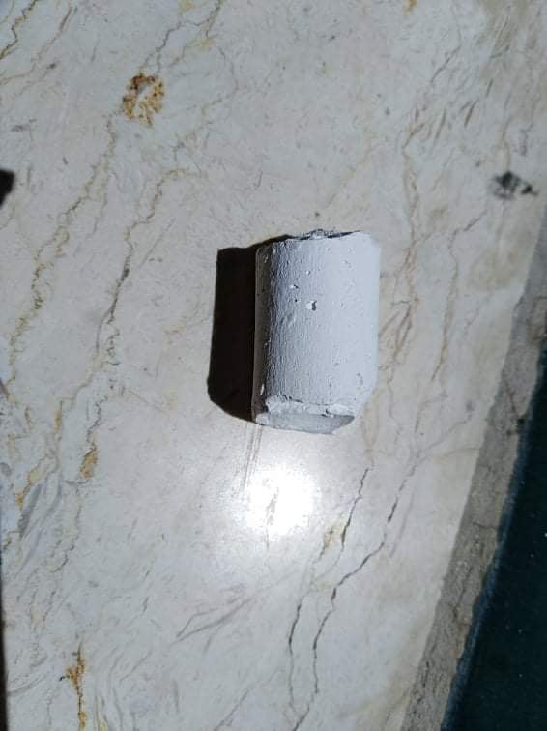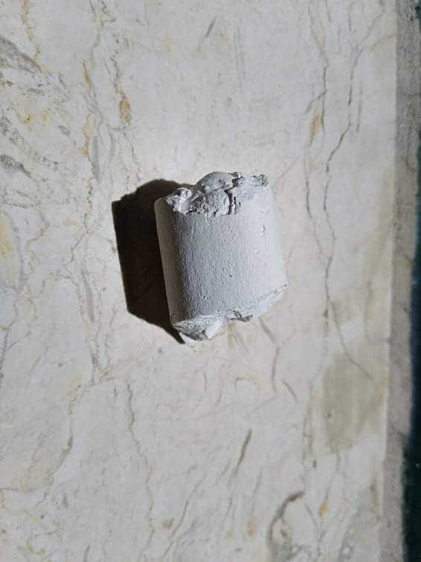
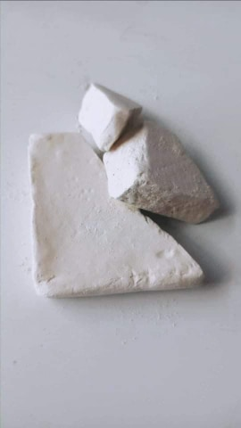
Figure 15:the samples are broken

- We initially faced some problems in making powder samples, and the samples were not correct from the beginning due to inaccurate readings (due to an imbalance in the scale used) and the oven was unclean and contains impurities of various materials.

- We did not have enough time to make other samples of the molds due to circumstances

4.2 Challenges:

- Desiccator (the preservative in which the samples were placed to preserve and prevent the sample from absorbing the amount of CO₂)The silica material inside the preservative contained a percentage of moisture, which caused the sample to absorb co2 . This was identified due to the weight difference of the sample when it was measured for separate periods.

- Balance: because of its many uses, or because it was not calibrated, it caused errors after measurement.

- Furnace: This is due to the use of the furnace for several uses and it contains unwanted materials and impurities, which causes a problem with the sample due to these impurities and materials

- When the release of a sample of calcium silicate at a temperature of 1100 C⁰ for two hours, the first sample that was prepared at the beginning of the separation disintegrated and we were unable to determine the temperature at which the sample disintegrated as the sample was placed in varying temperatures to prevent its explosion but it collapsed with us

- Corona crisis, which caused the delay in preparing samples and the difficulty of preparing the project remotely

4.3 Sources of errors:
- The silica inside the desiccator is moist and thus made samples that contain CaO to react with H₂O and formation CaCO₃ again ,we noted this status when we weighted the samples in the day after the samples are removed from the oven, the reason is that the insulating glass was not insulated as it should.

- Silica and calcium carbonate have low plasticity , so they are poorly bonded and have little water absorption

4.4 Recommendations:
- Using a special scale for this experiment so that it is accurate and the error rate is very small
- Using a specific furnace so that it with only for the experiments of making refract-tory bricks in order to avoid any conterminal in foreign wanted materials or impurities
- Using the glass insulator, making sure that the silica material does not contain any moisture content, and taking into account its preservation
- Prepare special molds to get good samples
- Use calcium carbonate obtained from sawmills
- Calculate the amount of water added to the mixture to prevent excess plasticity and cause cracks
- Using a special crossbills that can withstand high temperatures without causing it to break

Chapter 5: conclusion

In this project, we used silica and calcium carbonate in a ratio of (1: 1)&(2:1) silica powder and calcium carbonate were formed and the result of calculating at a ratio of 1:1 the rate was$3.7*{10}^{-2}\min^{-1}$⁡. As for silica with calcium carbonate in a ratio of (1:2),the rate was equal to$2.5*{10}^{-1}\min^{-1}$ Finally, refractory bricks were obtained from calcium carbonate and silica. Also, many difficulties are overcome Facing a certain class of project that needs extremely high-temperature furnaces.

Chapter 6 : References

- Cardarelli, F. (2008). Rocks and Meteorites. Materials Handbook: A Concise Desktop Reference, 885-925

- Bhatia, A. (2005). Overview of Refractories. Continuing Education and De-velopment, Inc, 9

- Sarkar, R. (2016). Refractory technology: Fundamentals and applications. CRC Press

- Chukwudi, B. C., & Eng, M. (2008). Characterization and evaluation of the refracto-ry properties of Nsu clay deposit in Imo State Nigeria. Pacific Journal of Science and
Technology, 9(2), 487-494.

- "Refractories and Classification of Refractories – ispatguru".https://www.ispatguru.com/refractories-and-classification-of-refractories/ Retrieved 6 March 2020.

- Klein, S., & Hauptmann, A. (1999). Iron Age leaded tin bronzes from Khirbet edh-Dharih, Jordan. Journal of Archaeological Science, 26(8), 1075-1082.

- Ubale, S., & Bansod, S. (2016). To prepare silica soda borate glass from biomass ash and study its optical properties.

- Tse, E. (2016, November). Let's Talk Architecture: An Introduction to Glass Buildings. In Proceedings of the 2016 ACM International Conference on Interactive Surfaces and Spaces (pp. 521-524).

- Sugita, K. (2008). Historical overview of refractory technology in the steel industry. Shinnittetsu Giho, 388, 8.

- Vargas, R., Neggers, J., Canto, R. B., Rodrigues, J. A., & Hild, F. (2019). Analysis of a castable refractory using the wedge splitting test and cohesive zone mod-el. Journal of the European Ceramic Society, 39(13), 3903-3914.

- Calvo, W. A., Pena, P., & Martinez, A. G. T. (2019). Post-mortem analysis of alu-mina-magnesia-carbon refractory bricks used in steelmaking ladles. Ceramics International, 45(1), 185-196.

- Abu-Mashaeekh, S. T., & Zamel, E. H. (2017). Optimizing Limestone De-composition For Lime and Carbon Dioxide Production

- Karakus, M. (2002). Cathodoluminescence (CL) microscopy application to refractories and slags. Journal of Minerals and Materials Characterization and Engineering, 1(01), 11

- Ghasemi-Kahrizsangi, S., Dehsheikh, H. G., & Boroujerdnia, M. (2017). MgO–CaO–Cr2O3 composition as a novel refractory brick: Use of Cr2O3 na-noparticles. Boletín de la Sociedad Española de Cerámica y Vidrio, 56(2), 83-89.

- Dehsheikh, H. G., & Ghasemi-Kahrizsangi, S. (2017). Performance improve-ment of MgO-C refractory bricks by the addition of Nano-ZrSiO4. Materials Chem-istry and Physics, 202, 369-376.

- Ruh, E., & McDOWELL, J. S. (1962). Thermal conductivity of refractory brick. Journal of the American Ceramic Society, 45(4), 189-195.

- Rabah, M., & Ewais, E. M. M. (2009). Multi-impregnating pitch-bonded Egyptian dolomite refractory brick for application in ladle furnaces. Ceramics International, 35(2), 813-819.

- Sengupta, P. (2020). Cement Manufacturing and Process Control. In Refractories for the Cement Industry (pp. 61-76). Springer, Cham.

- Serry, M. A., El-Kholi, M. B., Elmaghraby, M. S., & Telle, R. (2002). Characterization of Egyptian dolomitic magnesite deposits for the refractories industry. Ceramics international, 28(5), 575-583.
.

- Xiangchong, Z. (1994). Trends of Development of High Performance Refractory Products in China's Refractories Industry [J]. Bulletin of the Chinese Ceramic Society, 5.

Appendix

Figure: XRD pattern of the samples fired at 1100
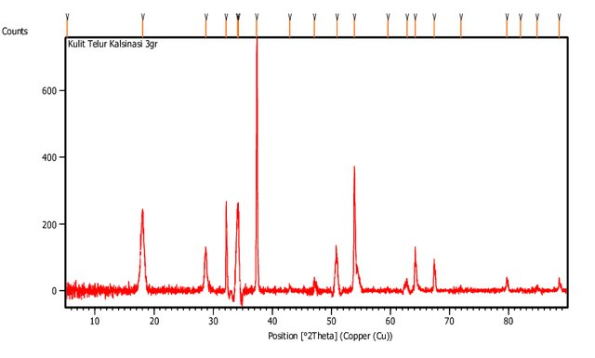
Figure: XRD pattern of lime (CaO)

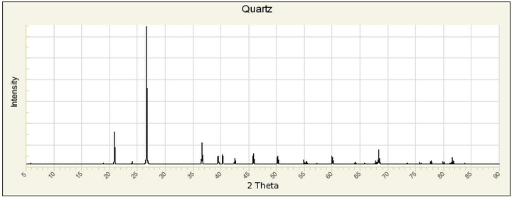
Figure: XRD pattern of quartz (SiO2)

