Project Concept:

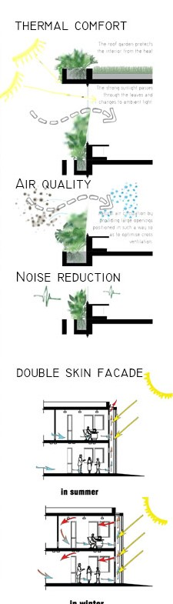
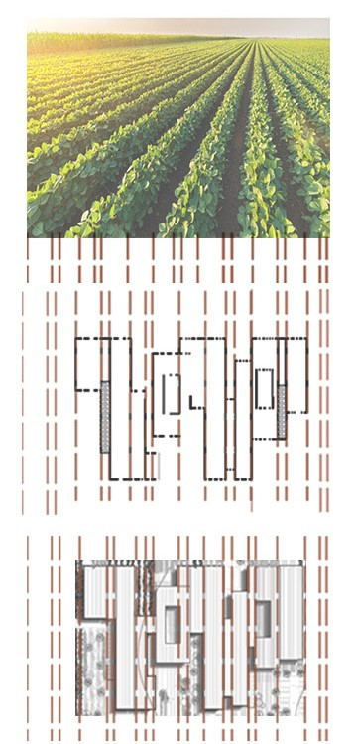
Moving along with the linear shape the agricultural fields make and take from those lines a base for the project to rise. Using a green roof to compensate for the lost green area.
