
Palestine
An-Najah National University
Faculty of Information Technology
Computerized Information Systems
دولــــــــــــــــــة فلســـــــــــــــــطين
جامعة النـجـاح الـوطنـيـة
كليـة تكنولوجيا المعلومات
قسم نظم المعلومات المحوسبة

Automating the plants growth monitoring
By digital image processing

Students:

Zein Banna | 11525033
Dana Younis | 11523848

Supervisor:
Dr. Baker Abdalhaq

Automating the plants growth monitoring by digital image processing

Zein Sami Banna, Dana Ammar Younis

Computer Information Systems Dept.
An-Najah National University

Abstract- Monitoring plants growth is a real challenge in the field of agriculture .The complexity, effort, time and accuracy are critical factors for the tracking efficiency. In traditional context, discovering potential problems are likely to be late, as well for knowing the reasons behind, as a subsequent consequences, a latency in remedy actions. Automatic plants growth monitoring is an efficient method to lower the total effort of tracking and decision making. However, in practice, most plants monitoring methods focus on controlling the environment based on information from sensor devices regardless plants condition. This paper suggests using image processing techniques in extracting plants features i.e. (health, growth rate, condition...etc.) to help tracking plant's progress, care and access important gardening knowledge. The proposed techniques introduce image extraction using color spaces, color intensity, structural difference measure and k-means clustering for accurate plants conditions tracking. The test results from 60 sample of plants tracking show that the proposed methods manifest good level of accuracy and performance.

Index Terms-Features extraction, Image processing, Plants monitoring.

- Introduction

We live in a world where everything can be controlled and operated automatically and agricultural sector is not an exception. Due to the increasing demand in the agricultural industry, plants monitoring is seen as one of the most important task in any farming or agriculture based environment. The need to effectively grow plants and increase them is very important.

In order to do so, it is important to monitor the plants during their growth period. With the evolve of digital image processing techniques [18], there have been a rise in employing them to play an important role in many applicable fields in our life. In this paper, we discuss an important and challenging task in image processing field, which is object tracking, to target the plants monitoring challenges. Object tracking can be defined as the process of extracting some useful sparse set of features to be tracked. As the method suggests we implemented a set of techniques for extracting plants features to access important gardening knowledge.

The proposed techniques discussed in this paper are done in four steps. The first step involves image enhancement .The second step involves extraction of plants region using color spaces. The third step involves feature extraction by applying three methodologies, which they are: color intensity, structural differences measure and k-means cluster and transformed them into nominal values. Finally we applied analysis and interpretation for values to determine the growth rate, florescence and age stage cluster.

The paper is organized as follow: Section. 2 describes the related work, whilst Section 3 demonstrates the proposed methodology used in this project and analysis of their use, while the experiment and the result that applied on the dataset presented in Section 4, in Section 5 concludes the work in this paper and the work in the future.

- Literature Review

Anup Vibhute Assistant Professor, BMIT, Solapur(India) , Application of Image Processing in Agriculture: A Survey intends to focus on the survey of application of image processing in agriculture field such as imaging techniques, weed detection and fruit grading. The analysis of the parameters has proved to be accurate and less time consuming as compared to traditional methods [7].

Esmael Hamuda , National University of Ireland, University Road, Galway, Ireland , A survey of image processing techniques for plant extraction and segmentation in the field, In this review, he presented a comprehensive and critical survey on image-based plant segmentation techniques. In this context, ‘‘segmentation” refers to the process of classifying an image into plant and non-plant pixels. Good performance in this process is crucial for further analysis of the plant such as plant classification (i.e. identifying the plant as either crop or weed), and effective action based on this analysis, e.g. precision application of herbicides in smart agriculture applications. The survey briefly discussed pre-processing of images, before focusing on segmentation. The segmentation stage involves the segmentation of plant against the background (identifying plant from a background of soil and other residues). Three primary plant extraction algorithms, namely, (I) color index-based segmentation, (ii) threshold-based segmentation, (iii) learning-based segmentation are discussed. Based on its prevalence in the literature, this review focuses in particular on color index-based approaches. Therefore, a detailed discussion of the segmentation performance of color index-based approaches is presented, based on studies from the literature conducted in the recent past, particularly from 2008 to 2015. Finally, identify the challenges and some opportunities for future developments in this space. The proposed algorithms in this survey which are Normalized Difference Index (NDI), Excess Green Index (ExG) and Excess Red Index (ExR) are tested and failed with real plants images.[9]

Akshaya Devadiga Prathyakshini and Aravinda C V , NMAM Institute of Technology, Nitte, Karkala, India , Classiﬁcation and Clustering of Infected Leaf Plant Using K-Means Algorithm . The paper suggests image segmentation using k-means clustering method. Cluster showing the disease by highlighting the aﬀected area also one more cluster showing greenness which implies the leaf area is healthier. [2]

J.Praveen Kumar and S.Domnic, Image based leaf segmentation and counting in rosette plants, this paper proposes an efficient method to extract the leaf region and count the number of leaves in digital plant images. The plant image analysis plays a significant role in viable and productive agriculture. It is used to record the plant growth, plant yield, chlorophyll fluorescence, plant width and tallness, leaf area, etc. frequently and accurately. Plant growth is a major character to be analyzed among these plant characters and it directly depends on the number of leaves in the plants. In this paper, a new method is presented for leaf region extraction from plant images and counting the number of leaves. The proposed method has three steps. The first step involves a new statistical based technique for image enhancement. The second step involves in the extraction of leaf region in plant image using a graph based method. The third step involves in counting the number of leaves in the plant image by applying Circular Hough Transform (CHT). The proposed work has been experimented on benchmark datasets of Leaf Segmentation Challenge (LSC). The proposed method achieves the segmentation accuracy of 95.4% and it also achieves the counting accuracy of −0.7 (DiC) and 2.3 (|DiC|) for datasets (A1, A2 and A3), which are better than the state-of-the-art methods.[6]

- Methodology

The proposed graph based model in this paper has been designed to extract the plant area from the given plant image and apply other techniques that are used in feature extraction and analysis. The proposed methodology is shown in Fig1, which consists of four steps: Image enhancement, plant extraction, feature extraction and analysis.
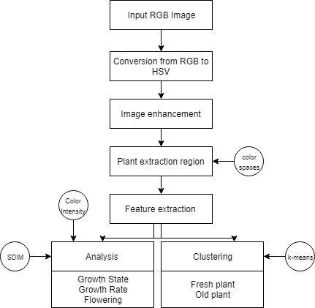

Fig1: Methodology

- Conversion from RGB to HSV color model
In comparing the most common color space model [8][12], RGB (Red Green Blue), which describes a color as a tuple of three components, each component can take a value between 0 and 255, the tuple (0, 0, 0) represents black and (255, 255, 255) represents white. HSV model is also a good choice of color space for extraction by color, HSV stands for Hue, Saturation, and Value (or brightness). By looking to a same image plant visualization in RGB and HSV color space model, we noticed that In HSV space, plant greens are much more localized and visually separable as shown in Fig2.

Fig2: Visualizing Image in models Color Space
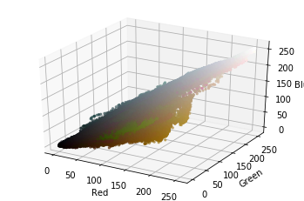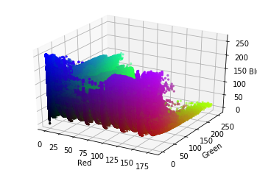
Visualizing Image in RGB Color Space Visualizing Image in HSV Color Space
- Image enhancement
The natural plant images may contain shadows or illumination effect, which depends on the brightness of the image. The presence of shadow or illumination effect affects the performance of plant region identification. The brightness of an image is represented by the V plane of its corresponding HSV image. This effect caused by the changes in brightness can be reduced by pre-processing the V plane of HSV color space. Image enhancement is the technique used to enhance the illumination effect. The illumination of an image is the range of values for brightness in an image. By applying image enhancement technique, the features of an image will be clearly identified. In the proposed work, initially the RGB image of the plant is converted to HSV image. [17][15]

- Plant area extraction using color spaces
The key point that can be leveraged for extraction is picking out plant color range then threshold plant image just based on that range .From experiment we found that the combination of two colors: green and yellow is more realistic and efficient in extracting plant area and gives a best visualization with minimum noise and maximum needed details. Once we got a decent color range, we used cv2.inRange () to try to threshold plant image. .inRange () takes three parameters: the image, the lower range, and the higher range. It returns a binary mask (an ND array of 1s and 0s) the size of the image where value of 1 indicates values within the range, and zero value indicates values outside. To impose the mask on top of the original image, we used cv2.bitwise_and (), which keeps every pixel in the given image if the corresponding value in the mask is 1. Finally, we combined the two masks- green and yellow. Adding the two masks together results in 1 values wherever there is green or yellow, which is exactly what is needed[13][14]. Fig3 shows the extraction of plant area.
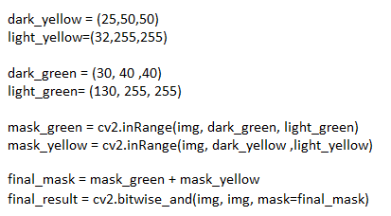
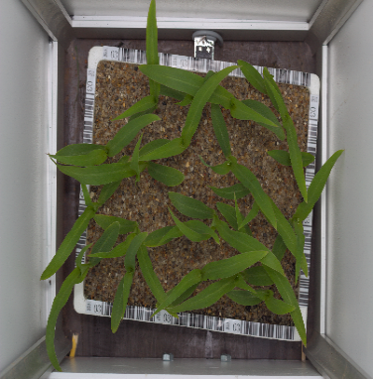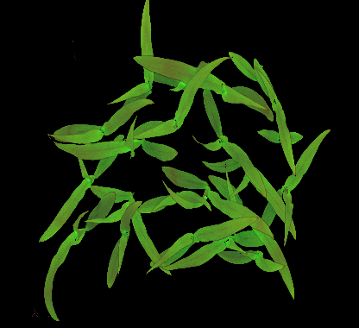
Code used for extraction Original Image Extracted plant area
Fig3: Plant area extraction
The results above are enhanced with the morphological operation: erosion (window of 3 X 3 pixel, iterations=3) and smoothing function: median blurring (aperture=9) for removing noise, Isolating of individual elements, joining disparate elements in an image and finding of intensity bumps or holes in an image.
The basic idea of erosion is just like soil erosion only, it erodes away the boundaries of foreground object (Always try to keep foreground in white). So what it does? The kernel slides through the image (as in 2D convolution). A pixel in the original image (either 1 or 0) will be considered 1 only if all the pixels under the kernel is 1, otherwise it is eroded (made to zero).
So what happens is that, all the pixels near boundary will be discarded depending upon the size of kernel. So the thickness or size of the foreground object decreases or simply white region decreases in the image. It is useful for removing small white noises, detach two connected objects etc.
The function erodes the source image using the specified structuring element that determines the shape of a pixel neighborhood over which the minimum is taken:

The function supports the in-place mode. Erosion can be applied several (iterations) times. In case of multi-channel images, each channel is processed independently.
For the smoothing function it is just that simple[16]the median filter run through each element of the signal (in this case the image) and replace each pixel with the median of its neighboring pixels (located in a square neighborhood around the evaluated pixel).

The same methodology is being applied to extract the plants that contain flowers as following test images:
Red Mask Range: dark red = (140, 150, 0), light red = (190, 255, 255)

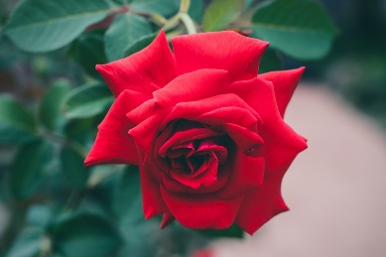

Orange Mask Range: dark orange = (5, 190, 200), light orange = (30, 255, 255)
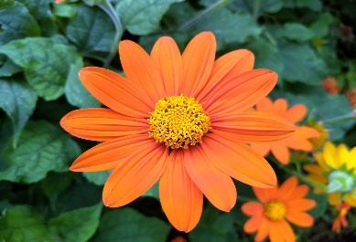
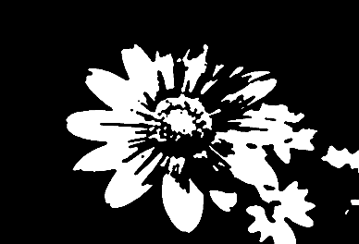

Yellow Mask Range: dark yellow = (15, 0, 0), light yellow = (25,255,255)

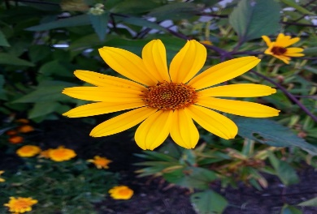

Purple Mask Range: dark purple = (100, 0, 100), light purple = (210, 255, 255)
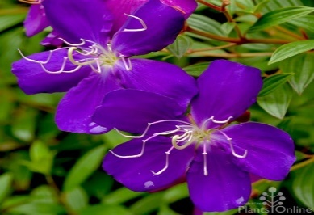
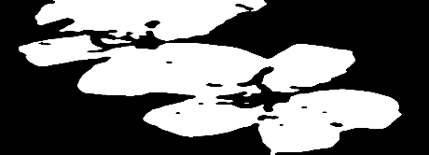

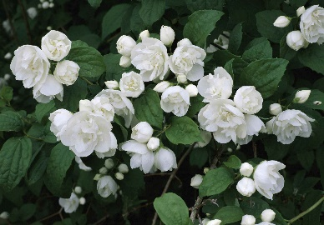
White Mask Range: dark white = (0, 0, 200), light white = (145, 60, 255)
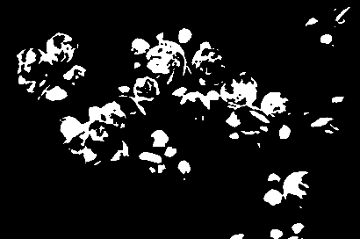

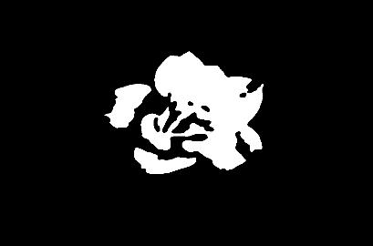
Pink Mask Range: dark pink = (135, 10, 65), light pink = (255,250,250)
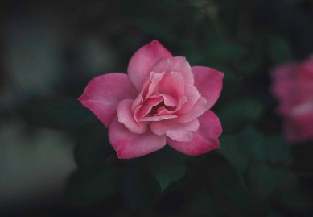

- Color intensity
For threshold step, we used two threshold functions: OTSU and BINARY INVERSE [11]. cv2.threshold () function is used, but pass an extra flag, cv2.THRESH_OTSU. For threshold value, simply pass zero. Then the algorithm will find the optimal threshold value and returns the Thresholded output. As the OTSU result is white for background and black for the object we used BINARY_INV function to swipe between them.
So How Otsu’s Binarization Works? Since we are working with bimodal images, Otsu’s algorithm tries to find a threshold value (t) which minimizes the weighted within-class variance given by the relation:
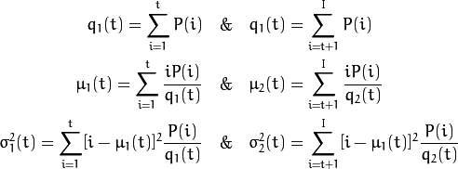
Where:

It actually finds a value of t which lies in between two peaks such that variances to both classes are minimum.
For Threshold Binary Inverted, this thresholding operation can be expressed as:
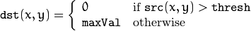

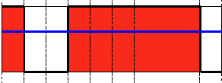
If the intensity of the pixel src(x, y) is higher than thresh, then the new pixel intensity is set to a 0. Otherwise, it is set to MaxVal.

Below the Results of Thresholding step including <the Enhancement> that we will discuss next:
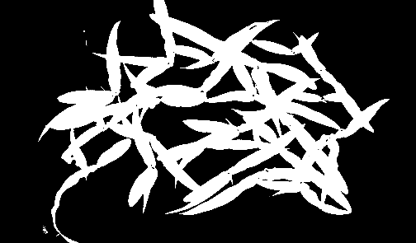
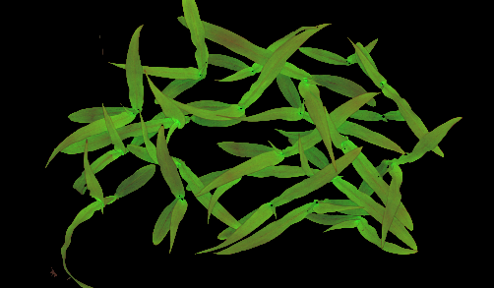

Extracted plant area Thresholded plant area


The results above are enhanced with the morphological operations: closing and opening where opening is just another name of erosion followed by dilation, which is useful in removing noise and closing is the reverse of opening [10]. Figure below illustrates the effect of each function in removing noise.

Closing
Opining

As now we have a binary image containing the plant area, we can now calculate the ratio of area that plant dominates, and use this ratio to compare with the next image that will be taken after period to help in determining the growth state and ratio.
How to calculate this ratio? Simply we find the sum of white pixels in the binary image and divide it on the value of resolution for the image as the code below:
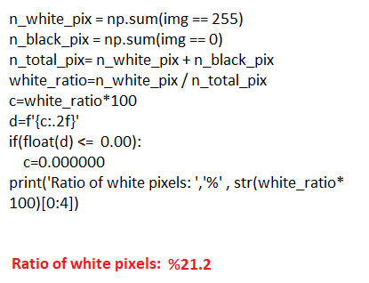
Code for finding plant area ratio Binary plant Image

- SDIM: Structural differences Index Measure
We need a measure that can tell the difference between phases in plants images, for that we used Structural Similarity Index (SSIM) measure to conclude the value of difference [5].

Structural Similarity Index:
Equation 1:
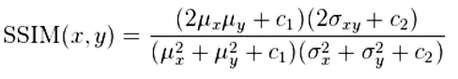
Equation 2:
SDIM = 1 – SSIM(x, y)

The gist is that SSIM attempts to model the perceived change in the structural information of the image, in Equation 1 is used to compare two windows, The parameters to Equation 1 include the (x, y) location of the N x N window in each image, the mean of the pixel intensities in the x and y direction, the variance of intensities in the x and y direction, along with the covariance. The SSIM value can vary between 0 and 1, where 1 indicates perfect similarity. SSIM, while slower, is able to perceive the change in structural information of the image by comparing local regions of the image instead of globally, SSIM will give you better results, but you’ll lose a bit of performance.
The Equation 2 represents the value of differences measure between the given images, by finding the complement of SSIM value. The SDIM value can vary between 0 and 1, where 0 indicates no change in plant growth.

SDIM= %44.25
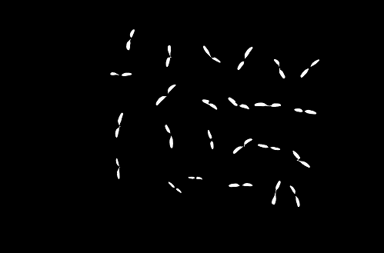
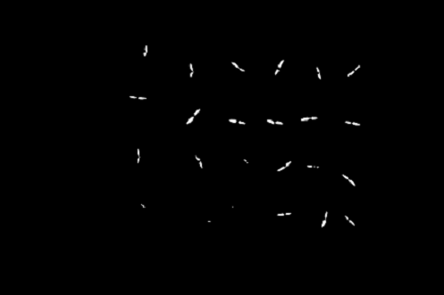
Phase 1 Phase 2

SDIM= %42.66
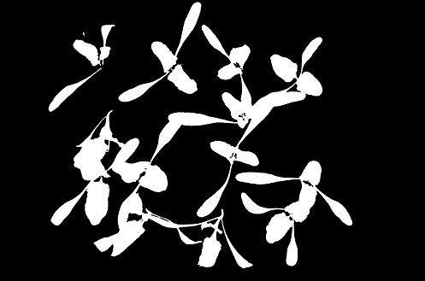
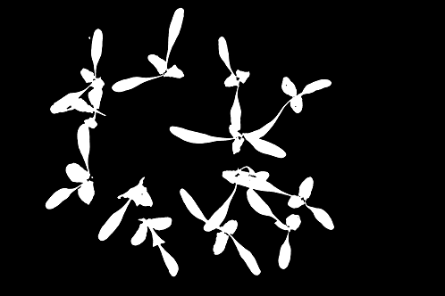

Phase 7 Phase 8

- Analysis after applying color spaces, color intensity & SDIM Methods

Depending on the plant type and color, we apply the masks to extract the plant area as the color spaces method suggests. Color intensity can determine the value of growth rate and also the flowering rate by comparing the given consequent images. The result of compression may either an Increase or decrease or could be no change , so in this case , it’s very important to be sure what exactly happened to that plant , is it really no change in Its growth ? Well, we know can apply the SDIM to know what is going on, the value given by this measure can indicate the growth state and detect if any abnormal action or situation occurred.

- The k-means cluster algorithm
K-Means clustering is a type of unsupervised learning algorithm. The goal of this algorithm is to find groups in the data, with the number of groups represented by the variable K. The algorithm works iteratively to assign each data point to one of K groups based on the features that are provided [3][4].
Segmentation using K-means clustering: This algorithm is used in order to diﬀerentiate the objects based on the K set of clusters. The clustering is made by considering the mean distance in the clusters [1]. The figure below represents the algorithm:
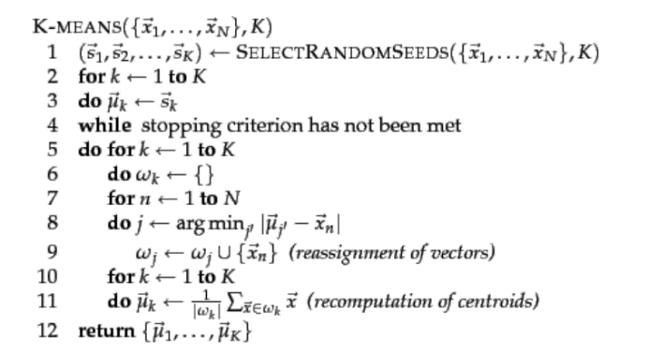
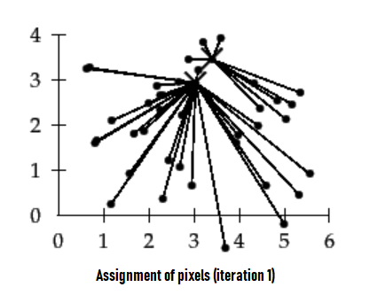

Well, as the algorithm suggests, we can employ it to reach for a very important indicators in plant health and growth. Applying k-means cluster algorithm on image pixels values will help to determine the most dominant color in image, plant health and also can be used to know the percentage of fresh and old plant depending on the type of plant growth.

Depending on the plant color, let’s say green, as the most plants color, the symptoms of the growth are identiﬁed in the image by changing in color of the plants in every stage. Another indicator for the health of the plants, the color is green is identiﬁed as healthy part where as other than green is considered as the disease.

Employing the k-means cluster algorithm to determine the percentage of fresh and old plant can be done in the same way we cluster the colors of image. Clusters of pixels value will contain the pixels that almost share the same hue, saturation and value of brightness and that a strong index that this part of plant region has grown in the same stage of growth. With knowing already the saturation value of the color we can use measures like Euclidean distance to label this cluster as fresh or old, i.e. for the green plants we can say that the light green area is the fresh one and the dark green is the old one as one the value of pixel is close to the tuple (0, 0, 0) it become darker, else, the more farther distance, the more lighter value.

Euclidean distance measure equation:

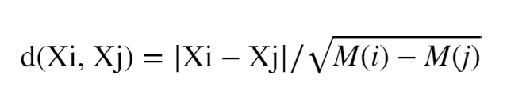

Visualizing Image in HSV Color Space

Applying k-means cluster on plant image will give the following information:

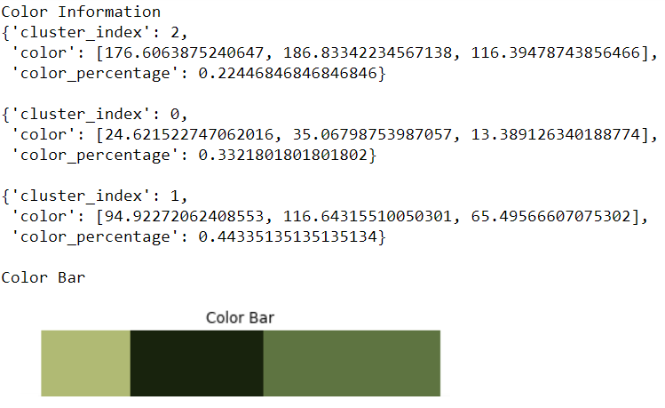
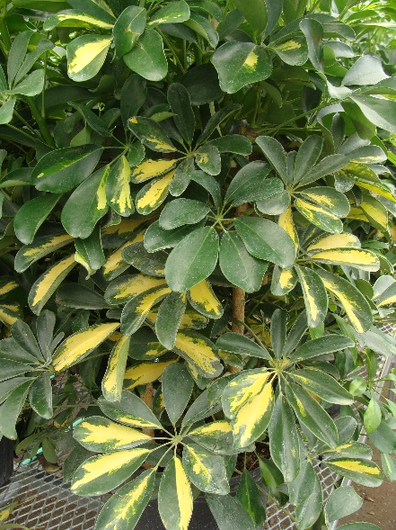

Plant Image Applying k-means cluster

- Experiment:

The proposed methodologies are experimented for 60 images from the same dataset, 12 different plants type, four tracking test for each plant type. The figures show the experimental results on plant image.
Tracking plants growth values:
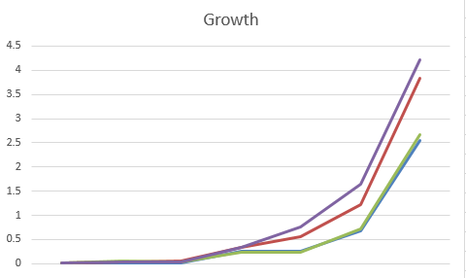
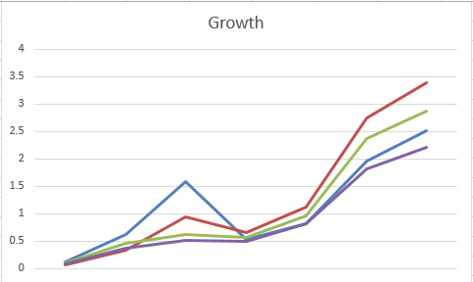
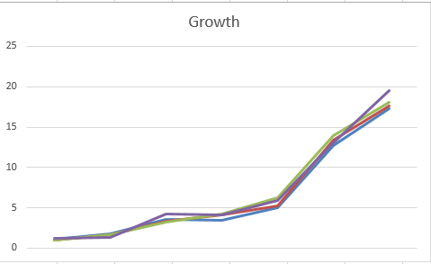

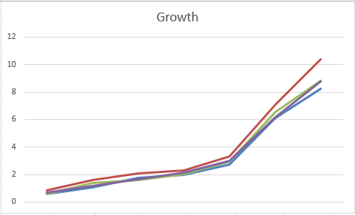
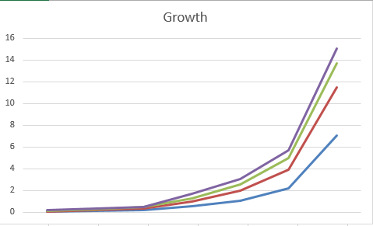
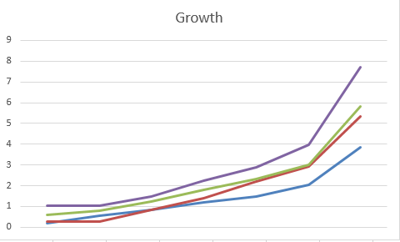
Black Grass Charlock chickweed
Cranes-bill
Cleavers

Fat Hen
Applying Structural differences Index measure to images in the dataset and get the differences:
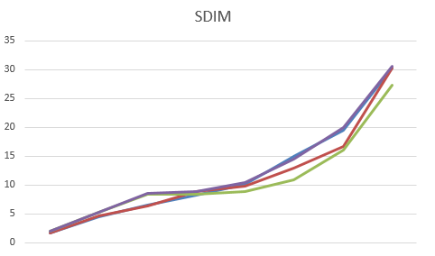
Images/plant | plant1 | plant2 | plant3 | plant4
1-2 | 44.25 | 43.85 | 45.20 | 43.61
2-3 | 43.91 | 44.03 | 43.81 | 44.58
3-4 | 43.27 | 41.81 | 42.56 | 42.88
4-5 | 45.50 | 45.04 | 44.85 | 44.73
5-6 | 45.71 | 46.08 | 45.48 | 44.96
6-7 | 44.28 | 44.13 | 42.04 | 43.66
7-8 | 42.66 | 43.40 | 42.63 | 43.88
8-9 | 40.75 | 40.78 | 41.26 | 40.54

Sugar beet SDIM Values Sugar beet SDIM graph

Applying k-means cluster to images in the dataset and get the information:

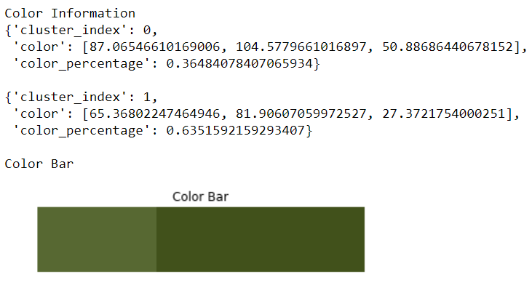
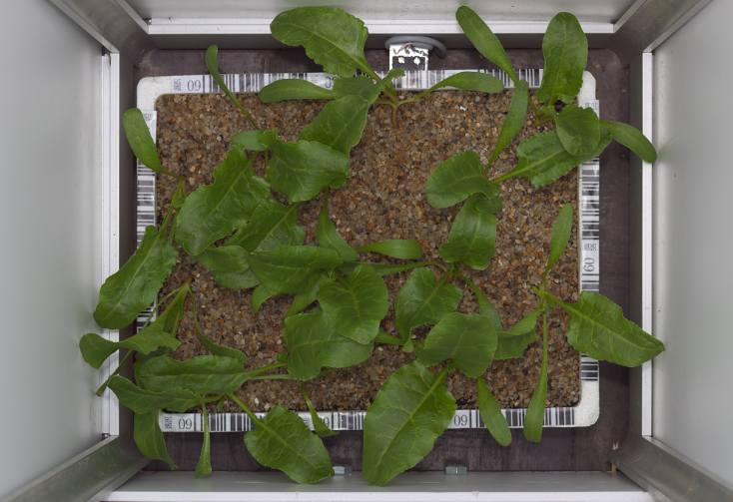

Sugar beet plant image k-means cluster information

For this type of plant the old plant have a darker color saturation value than the fresh one. From the Euclidean distance measure:

Cluster Index=0, Distance is: 145.26, Labeled as: Fresh.
Cluster Index=1, Distance is: 108.29, Labeled as: Old.

For evaluating the performance of techniques we tested them on high resolution images of: 5194 X 3457 pixel and time for processing these images was 2 second and for the low resolution images it retracted to 0.2 second . The Accuracy was better in high resolution images but it was acceptable in low resolution images.
- CONCLUSION

A new methodology with image enhancement technique and graph model for plant growth tracking is proposed. This method relies on the color intensity, color spaces, color distribution, pixel value location and pixel variance, all are employed and integrated in four techniques and measurements which are: color spaces, color intensity, structural differences index measure and k-means cluster algorithm that are being used beside the other enhancement techniques to form a good indicators to tracking plants growth.

Plants growth monitoring methodology can be applied in a controlled environment, with fixed camera that take images every predefined period. The efficiency of the proposed method will be observed with specifying a plant type, features can easily be twined to convey the nature of plant and also other features can be added to be tracked, so this research is like a base stone to other researchers. To increase the usage of this proposed method in plants growth tracking in future, this proposed method will be left as an open source.

For a future work that can be done is to integrate a machine learning techniques to use the plants data to learn a growth model to predict the growth rate, stage and also detect any anomaly in growth.

- References

- https://nlp.stanford.edu/IR-book/html/htmledition/k-means-1.html

- https://www.researchgate.net/publication/324267198_Classification_and_Clustering_of_Infected_Leaf_Plant_Using_K-Means_Algorithm

- https://code.likeagirl.io/finding-dominant-colour-on-an-image-b4e075f98097

- https://www.dataquest.io/blog/tutorial-colors-image-clustering-python/

- https://www.pyimagesearch.com/2014/09/15/python-compare-two-images/

- https://www.sciencedirect.com/science/article/pii/S2214317318301562?fbclid=IwAR0KJMbc0wbuCpqqZ3l8hsbo6W0AoFflUp54Xs5V5bCVBvGujfIgor_k6e0#b0015

- https://www.researchgate.net/publication/253908767_Application_of_Image_Processing_in_Agriculture_A_Survey

- https://www.learnopencv.com/color-spaces-in-opencv-cpp-python/

- https://www.researchgate.net/publication/303398277_A_survey_of_image_processing_techniques_for_plant_extraction_and_segmentation_in_the_field

- https://docs.opencv.org/3.0-beta/doc/py_tutorials/py_imgproc/py_morphological_ops/py_morphological_ops.html
- https://docs.opencv.org/3.0-beta/doc/py_tutorials/py_imgproc/py_thresholding/py_thresholding.html

- https://docs.opencv.org/3.4.3/df/d9d/tutorial_py_colorspaces.html

- https://realpython.com/python-opencv-color-spaces/

- https://www.learnopencv.com/invisibility-cloak-using-color-detection-and-segmentation-with-opencv/

- https://opencv-python-tutroals.readthedocs.io/en/latest/py_tutorials/py_imgproc/py_colorspaces/py_colorspaces.html

- https://opencv-python-tutroals.readthedocs.io/en/latest/py_tutorials/py_imgproc/py_filtering/py_filtering.html

- https://opensource.com/article/19/3/python-image-manipulation-tools

- https://opencv-python-tutroals.readthedocs.io/en/latest/py_tutorials/py_imgproc/py_table_of_contents_imgproc/py_table_of_contents_imgproc.html

