

An-Najah National University
Faculty of Engineering & Information Technology
Department of Computer Engineering

Smart Home for Cats
An IoT-Based Intelligent Pet Care System
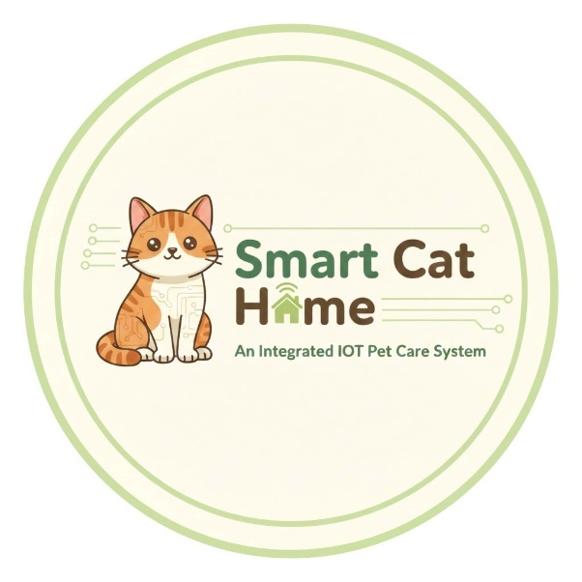
Prepared by:
Raghad Ayman Yameen
Yumna Eyad Abu Hanish
Supervised by:
Dr. Saad Tarapiah
Presented in partial fulfilment of the requirements for the Bachelor degree in Computer Engineering.

Table of Contents
Acknowledgments------------------------------------------------------------- 4
Abstract------------------------------------------------------------------------- 4
1. Introduction------------------------------------------------------------------ 5
1.1 Project Overview------------------------------------------------------------- 5
1.2 Motivation and Problem Statement----------------------------------------- 5
1.3 Project Objectives------------------------------------------------------------ 5
2. Methodology---------------------------------------------------------------- 6
3. Background------------------------------------------------------------------ 7
3.1 Internet of Things (IoT) in Pet Care------------------------------------------ 7
3.2 Embedded Systems and Microcontrollers---------------------------------- 7
3.3 Power Management and Voltage Regulation------------------------------- 7
3.4 Actuators and Motion Control---------------------------------------------- 7
4. Literature Review------------------------------------------------------------ 8
5. Research Gap and Project Contribution----------------------------------- 9
6. System Architecture and Hardware Design------------------------------ 10
6.1 Overall System Architecture------------------------------------------------ 10
6.2 Core Components and Justification---------------------------------------- 10
6.3 Power Management Strategy---------------------------------------------- 12
6.4 Sensing and Safety Matrix------------------------------------------------- 12
6.5 Actuation and Driving Circuits--------------------------------------------- 13
7. Mechanical Design and 3D Modeling------------------------------------ 15
7.1 Mechanical Structure Overview-------------------------------------------- 15
7.2 Summary of Mechanical Subsystems-------------------------------------- 15
7.3 Self-Cleaning Litter Box Mechanism--------------------------------------- 15
7.4 3D Printed Transmission and Structural Components--------------------- 16
7.5 Nutrition and Hydration Design------------------------------------------- 16
8. Software Development and Integration--------------------------------- 18
8.1 Arduino Firmware Logic---------------------------------------------------- 18
8.2 Real-Time Clock (RTC) and Scheduling------------------------------------ 18
8.3 Human-Machine Interface (HMI) Logic------------------------------------ 18
8.4 Communication Protocol (App to Hardware------------------------------ 19
8.5 Independent Video Server (ESP32-CAM) --------------------------------- 20
9. Implementation, Testing, and Results----------------------------------- 21
9.1 Hardware Prototype Assembly--------------------------------------------- 21
9.2 Subsystem Performance and Reliability----------------------------------- 21
9.3 Cleaning Cycle Efficiency (NEMA 23) -------------------------------------- 22
9.4 Safety Interlocks and Environmental Control------------------------------ 22
9.5 IoT Connectivity and Power Stability---------------------------------------23 9.6 Mobile Application Interface and User Experience------------------------ 23
10. Challenges, Solutions, and Future Work-------------------------------- 25
10.1 Technical Challenges and Implemented Solutions----------------------- 25
10.2 Future Enhancements and Scalability------------------------------------ 25
11. Conclusion----------------------------------------------------------------- 27
References--------------------------------------------------------------------- 28
Appendix A: Full Circuit Schematic------------------------------------------ 29
Appendix B: 3D Printing Specifications------------------------------------- 29

Acknowledgments
First and foremost, we would like to express our deepest gratitude to Allah Almighty for granting us the strength, patience, and guidance to complete this graduation project successfully.
We would like to extend our sincere appreciation and profound thanks to our esteemed supervisor, Dr. Saad Tarapiah, for his invaluable guidance.
We are also grateful to our university and the faculty members for providing the academic foundation and environment that enabled us to reach this milestone.
A special word of thanks goes to our families, who have been our constant source of inspiration and support. Their sacrifices and belief in our abilities have been the driving force behind our academic journey.

Abstract

This graduation project presents the design and implementation of "Cat Home," an integrated smart pet care system that leverages the Internet of Things (IoT) and embedded systems to automate feline daily routines and safety monitoring. The system addresses four main pillars: automated feeding and hydration, waste management, environmental monitoring, and interactive play.
The mechanical design features a custom-built 3D-printed litter box driven by a Nema 23 stepper motor. It utilizes a unique 360-degree rotational sieving mechanism to separate waste from sand efficiently. Additionally, a 3D-printed food spinner and a water pump ensure precise meal and hydration delivery. The core of the system is powered by an Arduino Mega, interfaced with an ESP8266 for mobile connectivity and an ESP32-CAM for real-time video streaming.
To ensure system stability, a sophisticated power management strategy was implemented using multiple DC-DC Buck Converters to isolate high-torque motor noise from sensitive microcontroller logic. The system integrates various sensors, including DHT11 for climate control (fan and lamp), smoke and flame sensors for fire safety, and ultrasonic/water-level sensors to prevent overflow and pump damage.
Users can interact with the system via a manual Keypad and LCD menu, or remotely through a custom Flutter-based mobile application. The application allows for manual control of a laser toy (via X-Y servos), real-time environmental data visualization, and flexible scheduling of tasks using an RTC (Real-Time Clock) module, which maintains system timing even during power outages. This comprehensive solution provides a safe, interactive, and autonomous environment for pets, catering to the needs of modern pet owners.

1. Introduction
1.1 Project Overview
The "Cat Home" system is an integrated IoT sanctuary designed to bridge the gap between busy modern lifestyles and high-quality pet care. By synchronizing an Arduino Mega with advanced actuators (NEMA 23) and mobile connectivity (Flutter), the system automates nutrition, sanitation, and safety monitoring in one stable platform.
1.2 Motivation and Problem Statement
The primary drive for this project is the "Separation Anxiety" and "Hygiene Challenges" faced by pet owners. Conventional pet care relies on physical presence, leading to inconsistent feeding and unhygienic environments. Moreover, current DIY solutions often suffer from electrical instability when high-torque motors are used. "Cat Home" addresses these gaps by providing a reliable, autonomous environment that ensures safety (gas/fire detection) and emotional connection (live camera/laser toy).
1.3 Project Objectives
The main goal is to implement a hybrid-controlled environment with the following sub-objectives:
- Autonomous Sanitation: A 360° self-cleaning litter box using NEMA 23.
- Intelligent Nutrition: Scheduled feeding/watering via RTC and sensor-based safety.
- Advanced Monitoring: Real-time data and video streaming via Flutter and ESP32-CAM.
- System Robustness: Power isolation using Buck Converters to eliminate electrical noise.

2. Methodology
To achieve the project objectives, a multi-disciplinary engineering approach was adopted, integrating mechanical design, electronic interfacing, and software development. The methodology followed these sequential phases:
- System Architecture Design: The project began with defining the system hierarchy, where the Arduino Mega was selected as the central controller due to its extensive I/O capabilities. The communication protocol between the ESP8266 and Arduino was established using UART Serial communication to ensure reliable data exchange between the mobile app and the hardware.
- Mechanical Prototyping & 3D Printing: A significant portion of the hardware, including the automated litter box stand, the gear system for the NEMA 23 motor, the food spinner, and the dual-axis servo brackets for the laser, was custom-designed. These components were fabricated using 3D printing technology to achieve high precision and structural integrity.
- Power Management & Signal Isolation: To address the challenge of electrical noise and high-current demands, a robust power distribution network was implemented. The 12V 5A main supply was regulated using multiple DC-to-DC Buck Converters. One converter was dedicated to logic components (Arduino, LCD, sensors), while another was isolated specifically for the servo motors to prevent voltage drops and system resets during high-torque movements.
- Sensor Integration & Calibration: Various sensors (DHT11, Flame, Smoke, and Water Level) were integrated and calibrated. Logic was programmed to handle "Safety Thresholds"—for instance, the water pump is restricted to a 10-second runtime limit or until the "Full Level" sensor is triggered to prevent overflow and hardware damage.
- Software Development (Firmware & Mobile App):
  - Firmware: Developed using C++ in the Arduino IDE, focusing on non-blocking code to manage the Real-Time Clock (RTC) scheduling and sensor monitoring simultaneously.
  - Mobile App: Built using the Flutter framework, providing a cross-platform interface that connects to the ESP8266 acting as an Access Point (AP).
  - Vision System: The ESP32-CAM was configured as a standalone web server to handle high-bandwidth video streaming without affecting the main control logic.
- Testing & Validation: The system underwent rigorous testing in different scenarios: manual control via the 4x4 Keypad, scheduled tasks via the RTC, and emergency response tests (e.g., triggering the buzzer using a flame source). Finally, the mechanical rotation of the litter box was calibrated to ensure a full 360-degree cycle and return to the home position.

3. Background
The development of a Smart Pet Home integrates several engineering domains, including IoT communication, embedded systems, power electronics, and mechanical design. Understanding these core technologies is essential for the implementation of a stable and functional system.
3.1 Internet of Things (IoT) in Pet Care
The Internet of Things (IoT) refers to the interconnection of physical devices via the internet, allowing for remote data exchange and control. In this project, IoT facilitates the communication between the hardware (via ESP8266 and ESP32-CAM) and the user interface (Flutter Mobile Application). This ensures real-time monitoring of environmental conditions and remote interaction with the pet.
3.2 Embedded Systems and Microcontrollers
At the heart of the system is the Arduino Mega 2560. This microcontroller was chosen for its extensive I/O capabilities, allowing the simultaneous management of more than 10 different modules, including sensors, drivers, and communication chips. It acts as the "brain" that processes sensor data and executes scheduled tasks.
3.3 Power Management and Voltage Regulation
A critical challenge in complex hardware projects is power stability. This system operates on a dual-voltage architecture: 12V for high-load actuators (Fans, Pumps, and Stepper Motors) and 5V for logic circuits and servos. The use of DC-DC Buck Converters is vital to isolate the high-current noise generated by motors from the sensitive logic of the Arduino, preventing system resets and erratic behavior.

3.4 Actuators and Motion Control
The project utilizes two distinct types of motion control:
- Stepper Motors (NEMA 23): Used for the automated litter box to provide the high torque and precise angular control needed for the 360-degree sifting process.
- Servo Motors: Utilized for the interactive laser system, enabling rapid and accurate X-Y coordinate movements.

4. Literature Review
The field of automated pet care has seen significant research in recent years. This section reviews five key studies that provided the theoretical and technical foundation for this project.
- [1] Devi et al. (2022) designed an IoT-based system for automated feeding and water dispensing. Their research highlighted the use of cloud servers for remote data logging. While successful in nutrition management, their system lacked hygiene automation and environmental safety features.

- [2] Rey et al. (2024) introduced the PUSPIN system, a modern approach to smart cat litter boxes. This study demonstrated the feasibility of integrating waste management with video surveillance. Our project builds on this by enhancing the mechanical gear design and adding manual control interfaces (Keypad/LCD) for offline reliability.

- [3] Guevara et al. (2023) explored the psychological benefits of interactive play in their "Smart Laser Toy" study. They proved that randomized laser patterns significantly improve pet engagement. We integrated this concept into our unified system, allowing control via a mobile app while monitoring the pet via the ESP32-CAM.

- [4] Vrishanka et al. (2021) emphasized the medical importance of portion-controlled feeding using RTC modules to prevent pet obesity. This provided the logical basis for our "Food Spinner" design, which ensures specific meal portions are delivered at precise intervals.

- [5] Aravind et al. (2025) presented a vision for the future of pet care using AI and multi-sensor fusion for anomaly detection. Our project realizes this safety-first approach by implementing a real-time environmental protection layer, utilizing smoke, flame, and temperature sensors to trigger alarms and cooling systems.

5. Research Gap and Project Contribution
Despite the advancements in the aforementioned studies, most existing solutions are fragmented—focusing on either feeding or cleaning. There is a clear lack of a "Unified Smart Ecosystem" that combines nutrition, hygiene, safety, and entertainment into a single stable platform.
Our project bridges this gap by:
- Massive Integration: Combining feeding, 360° waste management, hydration, and climate control into one Arduino Mega ecosystem.
- Safety First: Integrating industrial-grade sensors (Flame/Smoke) for domestic pet protection.
- Stability Engineering: Solving electrical noise issues common in multi-actuator projects using specialized power isolation (Buck Converters).
- Dual-Mode Control: Providing both IoT-based remote control and a local manual interface (Keypad/LCD) for maximum reliability.

6. System Architecture and Hardware Design

6.1 Overall System Architecture
The "Cat Home" system follows a hierarchical control model designed to ensure real-time responsiveness and electrical stability. The architecture is divided into three functional layers: the Processing Layer (Arduino Mega), the Communication Layer (ESP8266 & ESP32-CAM), and the Sensing/Actuation Layer.

6.2 Core Components and Justification
To manage the high density of peripherals, the hardware was selected based on I/O availability and processing power.
Hardware Selection and Technical Roles
Component | Technical Role | Engineering Justification
Arduino Mega 2560 | Main Controller | 54 I/O pins and 4 Hardware UARTs for lag-free sensor/IoT polling.
ESP8266 (NodeMCU) | WiFi Gateway | Configured in Access Point Mode for standalone remote control.
ESP32-CAM | Vision Subsystem | Independent MJPEG server to prevent video lag on the main control bus.
NEMA 23 Stepper | Mechanical Drive | High-torque capability for the 360° rotational load of the litter box.
DS3231 RTC | Timekeeper | Maintains scheduling for feeding/cleaning during power outages.

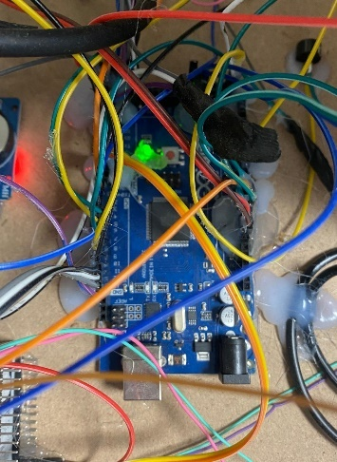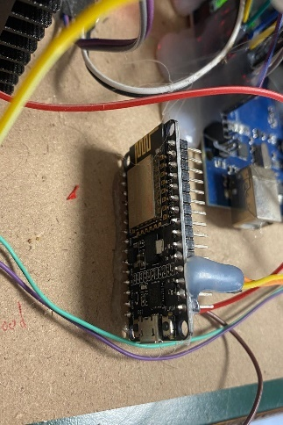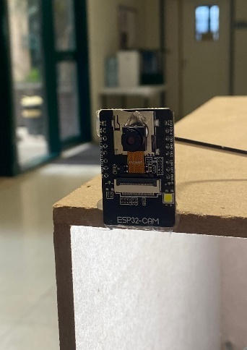

Arduino Mega ESP8266 ESP32-CAM

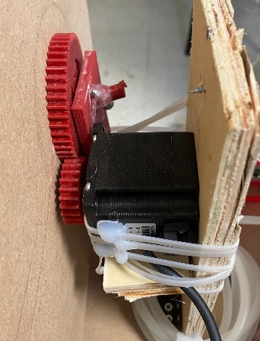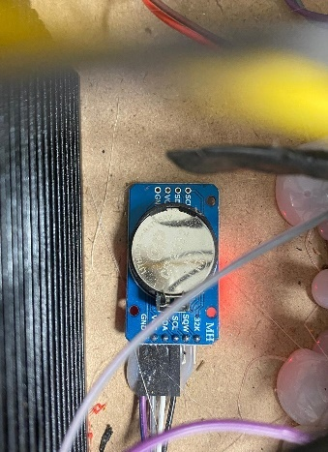

NEMA 23 Stepper DS3231 RTC

6.3 Power Management Strategy
A critical design challenge was the electrical noise generated by high-torque motors. The system utilizes a Multi-Rail Isolation Strategy to prevent microcontroller resets and ensure signal integrity.
Key Power Design Features:
- Isolated Servo Rail: A dedicated DC-DC Buck Converter powers the Pan-Tilt servos, isolating current spikes from the Arduino logic to prevent "Brown-outs."
- Common Grounding: All rails share a common GND to maintain consistent reference voltage for UART and I2C protocols.
- Integrated Regulation: The 5V regulators of the L298N drivers are leveraged to power the wireless modules (ESP8266/ESP32-CAM), optimizing PCB space.

6.4 Sensing and Safety Matrix
The sensory system is categorized into environmental monitoring and hazard detection. The following table summarizes the operational logic implemented in the firmware:
Sensor Functional Logic and Thresholds
Category | Sensor | Logic Trigger | System Response
Climate | DHT11 | For example (Temp > 25°C) | Activates 12V DC Cooling Fan.
Fire Safety | Flame Sensor | IR Detection | Triggers Buzzer + "FIRE" Alert on Mobile App.
Hazard | MQ-2 Gas | High PPM | Activates Ventilation + Emergency Alarm.
Hydration | Water Level | "Full" State | Cuts off Pump power to prevent overflow.

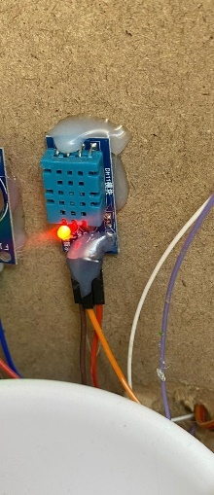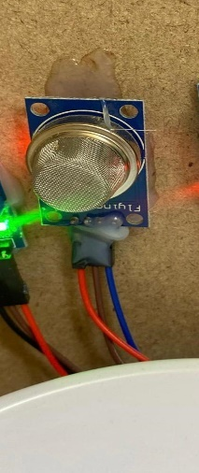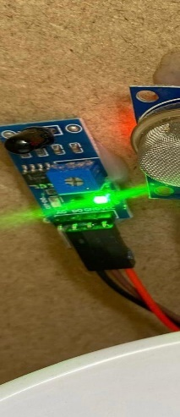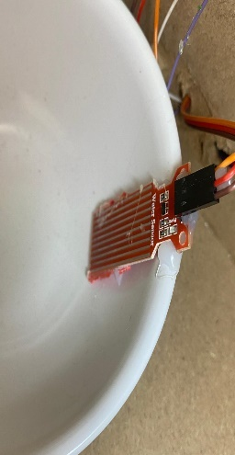

DHT11 MQ-2 Gas Flame Sensor Water Level

6.5 Actuation and Driving Circuits
The system's physical tasks are executed via three specialized driving circuits:
- Stepper Control (Litter Box): The NEMA 23 is driven by a TB6600 driver using micro-stepping to ensure a smooth, quiet 360° sifting cycle and high holding torque.
- DC Loads (Pump/Fan/Food): Two L298N H-Bridges manage the 12V loads. The water pump is programmed with a 10-second fail-safe timer to protect the motor from dry-running.
- Interaction (Laser Toy): Dual-axis Servo Motors provide pan-tilt movement. The Arduino translates X-Y coordinates from the Flutter app into precise PWM pulses for real-time play.
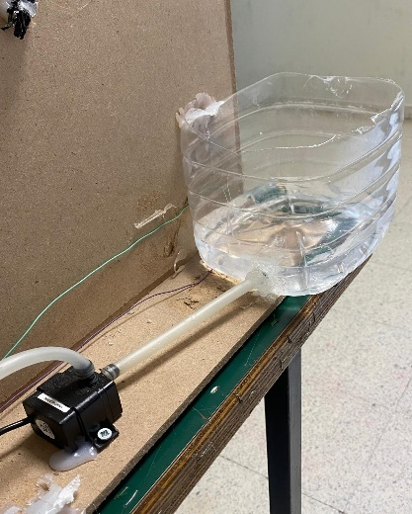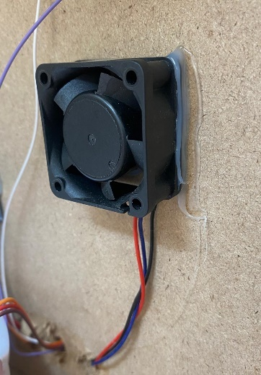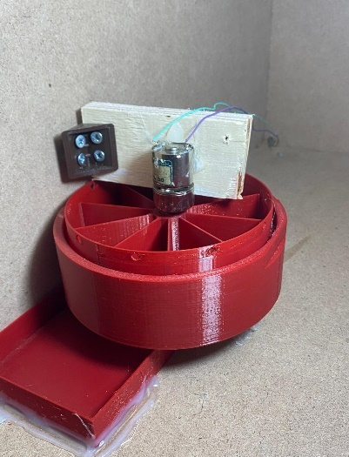
Pump Fan Food

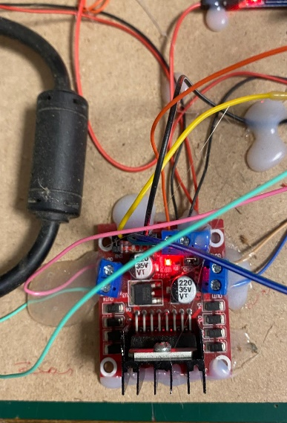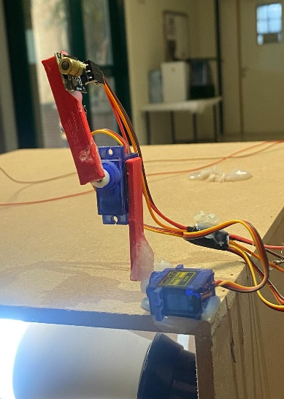
L298N H-Bridges Laser Toy $ Servo Motors

7. Mechanical Design and 3D Modeling

7.1 Mechanical Structure Overview
The physical architecture of the "Cat Home" was developed to ensure structural stability and seamless integration with electronic actuators. All critical components were designed using CAD software and fabricated via FDM 3D Printing technology.

7.2 Summary of Mechanical Subsystems
Subsystem | Primary Components | Design Priority | Technical Goal
Sanitation | Drum, Internal Sieve, Waste Chute | Rotational Balance | 360° gravity-based waste separation.
Nutrition | Food Spinner, Gravity Chute | Jam-Prevention | Precise meal portioning via rotational slots.
Interaction | Pan-Tilt Brackets, Laser Mount | Low Inertia | Rapid dual-axis movements for pet play.
Support | NEMA 23 Mount, Sensor Brackets | Torque Resistance | Stability during high-load motor operations.

7.3 Self-Cleaning Litter Box Mechanism
The system utilizes a Rotational Sifting Principle, which eliminates the need for complex internal rakes.
The 360-degree Operational Cycle: The cleaning process is governed by a precise angular sequence programmed into the Arduino Mega:
- Sifting Phase (0° - 180°): The drum rotates, allowing clean sand to pass through the internal sieve into a reservoir while trapping solid waste.
- Disposal Phase (180° - 270°): Gravity directs the trapped waste into a dedicated external collection chute.
- Home Return (270° - 360°): The drum completes its cycle, redistributing the clean sand evenly for the pet's next use.
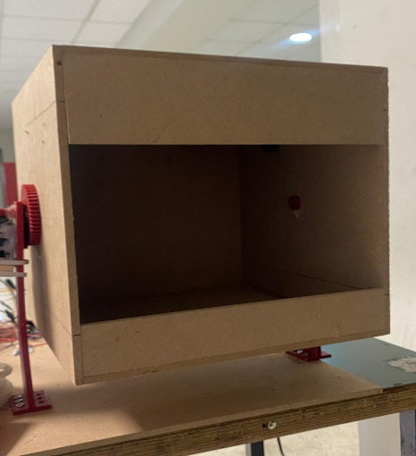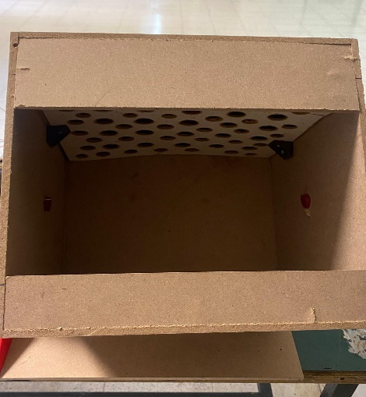

7.4 3D Printed Transmission and Structural Components
To handle the mechanical load of the sand, a custom transmission system was engineered for the NEMA 23 motor.

3D Printing Fabrication Specifications
Parameter | Specification | Engineering Purpose
Gear Profile | Involute Gear Teeth | Ensures constant velocity and reduces noise.
Infill Density | 60% - 80% (Gyroid Pattern) | Maximum shear strength for gear transmission.
Material | Reinforced PLA / PETG | Durability and dimensional accuracy.
Load Distribution | Wide-Base Support Stands | Prevents tipping during peak motor acceleration.
Layer Height | 0.2 mm | Balance between print speed and part precision.

7.5 Nutrition and Hydration Design
- The Food Spinner: A rotational disk design was chosen over traditional augers to prevent kibble jamming. Each segment is calibrated to hold a specific volume for accurate portion control.
- The Smart Water Bowl: Unlike standard dishes, this bowl features an integrated vertical slot for the Water Level Sensor, protecting the probe while ensuring consistent analog depth readings.
- Hygiene & Maintenance: All 3D-printed parts in contact with food are modular, allowing for easy detachment and cleaning to ensure pet health.

8. Software Development and Integration

8.1 Arduino Firmware Logic
The software architecture is built upon a Non-Blocking Multitasking framework. A Finite State Machine (FSM) approach was implemented to ensure the system can simultaneously monitor safety sensors and execute mechanical tasks without latency.
Finite State Machine (FSM) Operational Logic
System State | Trigger Source | Primary Action | Priority Level
IDLE | System Initialization | Continuous sensor polling & WiFi listening. | Low
CLEANING | App / Keypad / RTC | Executes 360° NEMA 23 rotational cycle. | Medium
FEEDING | RTC Schedule / App | Activates H-Bridge for portion dispensing. | Medium
ALARM | Flame / Gas Sensors | Overrides all tasks; triggers buzzer & alerts. | Highest

8.2 Real-Time Clock (RTC) and Scheduling
To ensure autonomous operation, a DS3231 RTC module is used for precise timekeeping. The firmware implements a "Time-Compare" algorithm to trigger scheduled events.
- Task Flags: A software "Flag" system prevents redundant triggering of tasks within the same minute.
- Power Resilience: The battery-backed RTC maintains the schedule during power outages.

8.3 Human-Machine Interface (HMI) Logic
The local interface provides manual control through a 4x4 Matrix Keypad and a 20x4 I2C LCD.
Keypad Mapping and Visual Feedback
Key | Assigned Function | LCD Display Message
'A' | Manual Feeding | "System Cleaning..."
'B' | Manual Watering | "Watering... [Level]"
'C' | Manual Cleaning | "Dispensing Food..."
'D' | Set time and date | "Set Time/Date"
'*' / '#' | Navigation & Confirm | "Setting Parameters..."
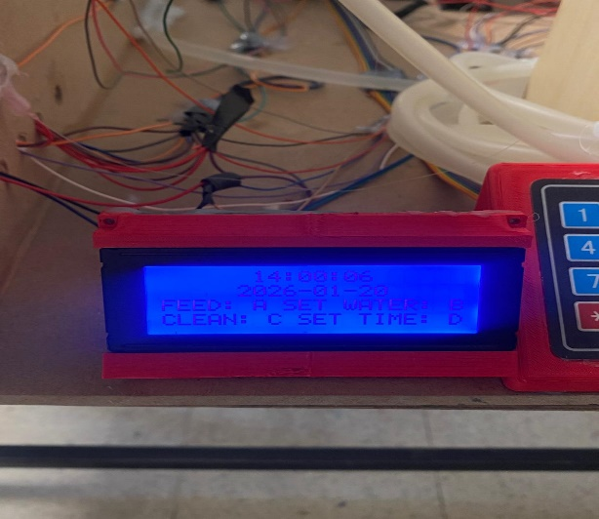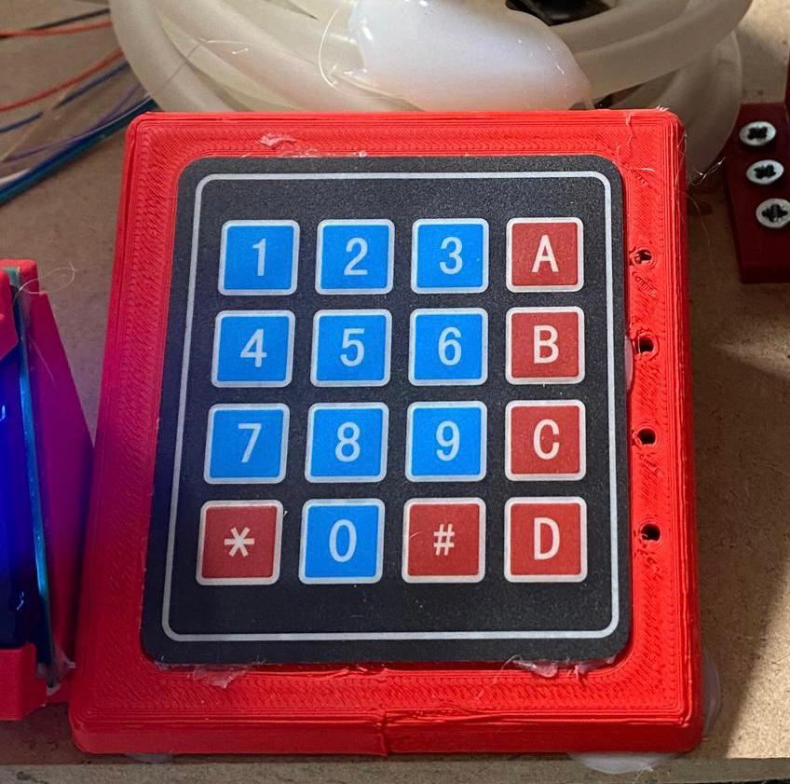

8.4 Communication Protocol (App to Hardware)
The Flutter application communicates with the ESP8266 (Access Point) via an asynchronous UART-WiFi Bridge.
- Downlink (App → Arduino): Commands are sent as short character codes (e.g., 'F' for Feed) to minimize processing overhead.
- Uplink (Arduino → App): Telemetry is bundled into delimited strings and parsed by the app's StreamBuilder.
- Laser Mapping Logic: Touch coordinates are mapped to servo angles using the formula:

8.5 Independent Video Server (ESP32-CAM)
The ESP32-CAM operates as a standalone subsystem hosting an Asynchronous Web Server.
- MJPEG Streaming: Optimized for low-latency video feed within the Flutter app.
- Dual-Core Processing: One core handles the OV2640 frame capture while the other manages WiFi HTTP requests, ensuring the video stream does not interfere with the Arduino’s safety loops.

9. Implementation, Testing, and Results
9.1 Hardware Prototype Assembly
The implementation phase involved the systematic integration of 3D-printed structural components and electronic control units. The assembly prioritizes Modular Isolation, separating high-torque actuators from sensitive logic circuits to ensure signal integrity.
- Structural Base: The NEMA 23 and drum assembly were secured with M4 bolts to a rigid frame to withstand peak torque.
- Electronic Housing: The Arduino Mega was mounted in a ventilated enclosure using Star-Grounding to prevent electromagnetic interference (EMI).
- Power Management: A dual-rail system was implemented (12V for motors/fans and 5V for logic units), regulated via DC-to-DC Buck Converters.

9.2 Subsystem Performance and Reliability
Each functional module was subjected to repetitive stress tests to evaluate its success rate and precision.
Actuator Testing and Success Rates
Subsystem | Test Parameter | Success Rate | Observation
Food Dispenser | Jam Prevention | 100% | High-torque DC motor cleared all kibble types.
Water Pump | Overflow Protection | 100% | Sensor triggered immediate cut-off at 'Full' level.
Manual Override | Keypad Response | 100% | Latency below 250ms for all physical triggers.
Portion Control | Weight Variance | ±3g | Minor variance observed based on kibble size.

9.3 Cleaning Cycle Efficiency (NEMA 23)
The self-cleaning mechanism was tested under a maximum operational load of 4.5 kg to verify the durability of the 3D-printed gears.
Mechanical Performance Metrics
Parameter | Measured Value | Technical Status
Full Cycle Duration | 45 Seconds | Optimized for Sifting
Waste Separation Rate | 98% | High Efficiency
Home Position Accuracy | < 1.5 Degrees | High Precision
Motor Temperature | 38°C | Safe (Steady State)
Gear Backlash | Minimal (< 1mm) | Precise Mesh

9.4 Safety Interlocks and Environmental Control
The safety system was validated by simulating hazardous conditions. The "Priority Interrupt" logic ensured that alarms always override standard operational tasks.
Safety Sensor Validation and Latency
Test Case | Stimulus | System Response | Latency | Status
Fire Hazard | IR Flame Source | Buzzer + App Notification | < 100ms | Pass
Gas Leak | Smoke / Butane | Fan ON + LCD Alert | < 500ms | Pass
Overheating | Temp > 30°C | Fan ON (Cooling Mode) | < 1s | Pass
Sensor Fault | Disconnection | Default Fail-safe (Fan ON) | < 2s | Pass

9.5 IoT Connectivity and Power Stability
- Connectivity: The ESP8266 maintained a stable connection up to 30 meters (Line of Sight) and successfully auto-reconnected within 5 seconds after router power cycles.
- Data Integrity: The string-delimited protocol achieved a 99.2% packet delivery rate, ensuring real-time telemetry updates on the Flutter app.

Mobile Application Interface and User Experience9.6
The Flutter-based mobile application serves as the primary remote interface for the "Cat Home" system, providing intuitive control and real-time monitoring through a clean, user-friendly design.

Connection Status: Visual indication of WiFi connectivity between the mobile device and ESP8266 module.
Environmental Sensors: Real-time temperature readings from the DHT11 sensor.
Hydration Monitoring: Water bowl level status (LOW/MEDIUM/FULL) from ultrasonic sensors.
Safety Status: Fire and smoke detection alerts from the MQ-2 and flame sensors.
Dual-Axis Servo Control: Slider-based adjustment of X and Y axes for precise laser positioning.
Device Toggle Switches: Individual controls for Laser, Cooling Fan, and LED Lamp with visual status indicators.
Temperature Threshold Configuration: User-definable setpoint for automatic climate control activation.
Feeding Schedule: Time-based programming for the food dispenser (e.g., 8:00 AM).
Hydration Schedule: Programmed watering times (e.g., 12:00 PM).
Sanitation Schedule: Automated litter box cleaning cycles (e.g., 6:00 PM).

The application implements a logical navigation structure where users can:
* Monitor real-time system status from the main dashboard.
* Manually control interactive features via the servo control panel.
* Configure automated schedules for feeding, watering, and cleaning.
* Adjust safety parameters and environmental thresholds.

The interface design emphasizes usability with clear visual hierarchies, immediate feedback mechanisms, and intuitive touch controls, ensuring that pet owners of varying technical backgrounds can effectively manage their smart pet ecosystem.
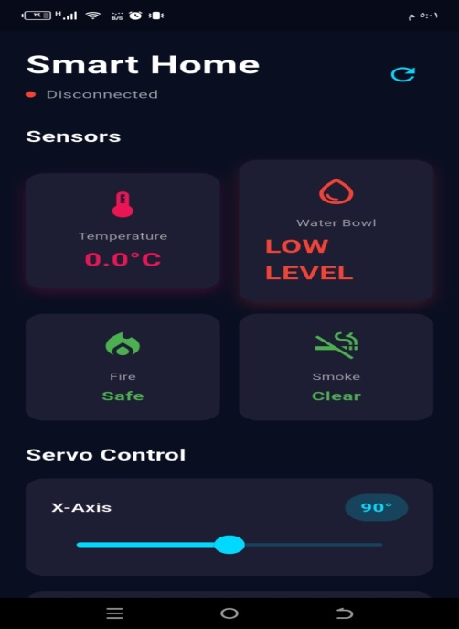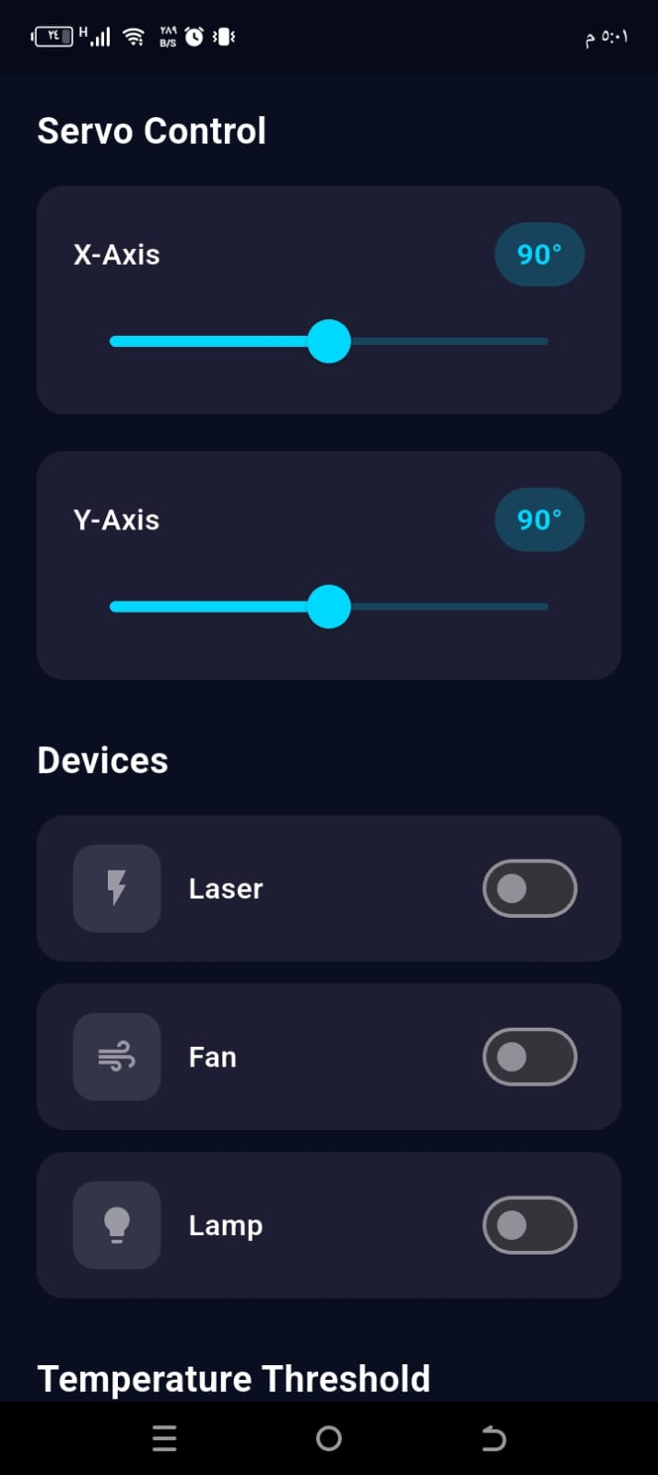

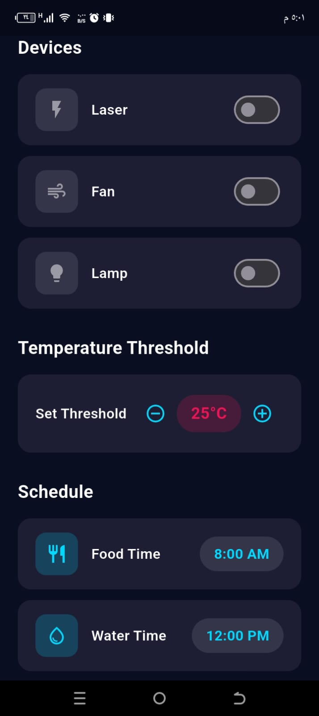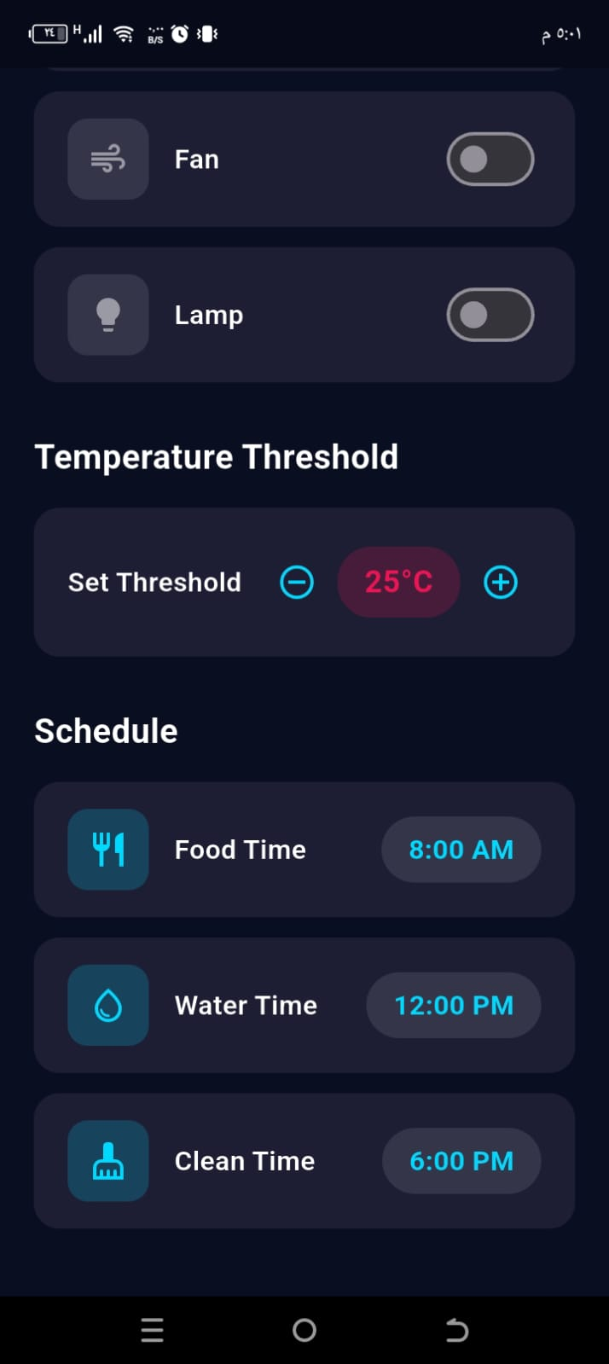

10. Challenges, Solutions, and Future Work

10.1 Technical Challenges and Implemented Solutions
During the development phase, several hardware and software obstacles were encountered. Addressing these issues required iterative design and advanced engineering applications.
Engineering Challenges and Mitigation Strategies
Challenge Category | The Problem (Technical Obstacle) | The Solution (Engineering Response)
Electrical Noise | Signal "jitter" in analog sensors caused by motor EMI. | Integrated 0.1uF Decoupling Capacitors and a Software Moving Average Filter.
Voltage Drops | NEMA 23 inrush current caused ESP8266 "Brown-out" resets. | Added a 1000uF Electrolytic Capacitor and isolated logic power via Buck Converters.
Mechanical Torque | High center of gravity caused gear slipping/backlash. | Redesigned gears with Involute Profiles and implemented AccelStepper Ramps in firmware.
WiFi Stability | ESP8266 occasionally hung/disconnected from the router. | Developed a Watchdog Timer and an Auto-Reconnect Loop for self-healing connectivity.
Hygiene | 3D-printed PLA porosity allowed bacterial growth. | Post-processed food/water components with Food-Safe Epoxy Coating.

10.2 Future Enhancements and Scalability
The Smart Pet Care System is designed for future expansion. The following enhancements represent the next phase of evolution:

Advanced Mechanical Upgrades
- Planetary Gearbox: Transitioning to a 20:1 reduction ratio to increase torque while reducing current draw and heat.
- Absolute Encoders: Adding optical encoders to provide real-time angular feedback, eliminating the need for step-counting resets after power loss.
- Material Shift: Replacing PLA+ with CNC Aluminum or Nylon-66 for industrial-grade durability.

IoT Cloud and Big Data Analytics
- Cloud Migration: Moving from local IP to Google Firebase/AWS IoT using the MQTT protocol for global access.
- Health Telemetry: Storing longitudinal data (water intake, litter usage) to generate Weekly Health Reports for veterinary use.
- OTA Updates: Enabling Over-the-Air firmware updates to push new features without hardware disassembly.

Edge-AI and Computer Vision
- Posture Tracking: Using TensorFlow Lite on the ESP32-CAM to detect lethargy or straining (health red flags).
- Facial Recognition: Implementing CNNs to identify individual pets in multi-pet households for Individualized Nutrition Management.
- Automated Waste Analysis: Using AI to inspect waste consistency (Bristol Stool Scale) for early detection of digestive issues.

11. Conclusion
The development of the Smart Pet Care System successfully demonstrates the integration of IoT (Internet of Things), Robotics, and Embedded Systems to solve real-world challenges in domestic pet management. By combining high-torque mechanical actuators with a reactive mobile interface, this project provides a comprehensive solution that ensures a pet’s nutritional, hygienic, and emotional needs are met autonomously.
Throughout the design and implementation phases, several key milestones were achieved:
- Integrated Automation: The system successfully automated the most demanding pet care tasks, including the Self-Cleaning Litter Box using a NEMA 23 stepper motor and the Precision Feeding/Watering mechanisms.
- Real-Time Monitoring: Through the Flutter application and ESP8266/ESP32-CAM modules, a seamless bridge was built, allowing users to monitor environmental safety (Gas, Fire, Temperature) and interact with their pets remotely via the Laser Toy and live video stream.
- Engineering Robustness: Technical challenges such as electrical noise, power instability, and mechanical torque requirements were addressed through sophisticated hardware filtering, stable power regulation, and optimized 3D-printed mechanical designs.
- Safety-Centric Design: The implementation of fail-safe logics—such as the auto-pausing cleaning cycle and instant hazard alerts—ensures that the system operates with the pet's safety as the highest priority.
In conclusion, this project serves as a robust prototype for the future of smart pet ownership. It proves that accessible technology like Arduino and Flutter can be scaled to create sophisticated, "self-healing," and intelligent environments. The successful validation of all subsystems confirms that the Smart Pet Care System is not only a functional tool for convenience but a vital contribution to the well-being and health monitoring of pets in the modern age.

References
[1] M. R. Devi, V. Jyothi, and D. Nagajyothi, "IoT and Cloud-based Automated Pet Care System," in 2022 6th International Conference on Electronics, Communication and Aerospace Technology (ICECA), Coimbatore, India, 2022, pp. 1540-1545.
[2] W. P. Rey and K. W. J. D. Rey, "PUSPIN: Redefining Cat Care with an IoT-Enabled Smart Cat Litter Box Management System," in 2024 4th International Conference on Computer Communication and Information Systems (CCCIS), Phuket, Thailand, 2024.
[3] A. Guevara, X. Davis, C. Ricard, B. Love, and L. Francisco, "Smart Laser Toy for Cats," Senior Design Report, Dept. of Electrical and Computer Engineering, University of Central Florida, 2023.
[4] P. N. Vrishanka, P. Prabhakar, D. Shet, and K. Rupali, "Automated Pet Feeder using IoT," in 2021 IEEE International Conference on Mobile Networks and Wireless Communications (ICMNWC), Tumkur, India, 2021.
[5] G. Aravind, S. Jeeva, D. Selvaganesh, and S. P. Sasirekha, "AI-Enabled Safe and Scalable Pet Care: An Intelligent System for Real Time Health Monitoring and Care," in 2025 International Conference on Intelligent Computing and Control Systems (ICICCS), Erode, India, 2025.

Appendix A: Full Circuit Schematic

System Interconnection Overview
The Smart Pet House is centered around the Arduino Mega 2560, chosen for its extensive I/O capabilities and multiple hardware serial ports, enabling simultaneous management of the vision, communication, and actuation layers.

Appendix B: 3D Printing Specifications

1 Material Selection: PLA+
PLA+ was selected for its Impact Resistance, Superior Surface Finish for involute gears, and Non-Toxic properties for pet safety.
Structural Component Slicing Parameters
Parameter | Specification | Engineering Purpose
Layer Height | 0.2 mm | Balance between speed and detail.
Infill Density | 60% - 80% | Prevents snapping under motor torque.
Infill Pattern | Gyroid / Cubic | Provides isotropic (tri-axial) strength.
Wall Line Count | 4 - 6 Walls | Maximizes rigidity of gear teeth.
Printing Temp | 215°C | Optimized for PLA+ layer adhesion.
Build Plate Temp | 60°C | Prevents warping of large base parts.

