An-Najah National University
Chemical Engineering Department

Sun-dried/ low temperature clay bricks

Prepared by:
Ahmed Ihbaishe
Do’a Kanaan
Hana’ Hamarshah
Tala’at Hmaidat

Supervisor:
Dr. Hamdallah Bearat

A Graduation Project Submitted to Chemical Engineering Department in Partial Fulfillment of the Requirements for Bachelor Degree in Chemical Engineering

May 4, 2016
Table of contents:

List of figures i
List of Tables ii
Abstract iii
Introduction 1
Over view 1
Objectives 1
Motivation 1
Clay 2
Methodology 8
Results and Discussion 11
6. Lime addition: 24
Conclusion 25
References: 27

List of figures

Figure 1: Poeh museum tower in New Mexico 3
Figure 2: Great mosque of Djenne in Mali 3
Figure 3: X-ray diffraction apparatus 5
Figure 4: Thermogravimetric analysis instrument 6
Figure 5: Compressive strength tester 6
Figure 6: Limestone quarry 7
Figure 7: Cylindrical samples while drying 8
Figure 8: Sample of clay with 4M and 8M of NaOH in steel molds 9
Figure 9: Sample of clay with 30% lime (by weight) 10
Figure 10: Sample of clay with 8M and treat at 600C in plastic mold 10
Figure 11: sample of clay with 8M and treat at 110C in plastic molds. 10
Figure 12: Heating rate of the TGA instrument on the sample 11
Figure 13: Heat flow of the sample on heating 11
Figure 14: Weight loss of the sample on heating 12
Figure 15: X-ray diffraction analysis result 13
Figure 16: The relation between the strength of samples vs. weight of straw added 14
Figure 17: The relation between the strength of the sample vs. weight of ash added 15
Figure 18: Behavior of clay samples for different drying periods with 4M & 8M NaOH addition 16
Figure 19: Behaviour of clay samples for different drying periods with 4M & 8M NaOH addition 17
Figure 20: Behaviour of clay sample for the same drying period with 4M & 8M NaOH addition 18
Figure 21: Strength of clay samples vs. lime ratio of lime added 19
Figure 22: Strength of clay fired at 600C with the addition of lime in different ratios 20
Figure 23: Strength for non fired clay treated with CO2 for 3 h 21
List of Tables
Table 1: Compositional test results 12
Table 2: Data of the pure, straw and sand additives samples 14
Table 3: Results of the ash additive samples 15
Table 4: Results for the samples treated at 45C with the addition of 4 & 8 molar NaOH 16
Table 5: Data of clay samples treated at 110C with 4 and 8 molar NaOH addition 17
Table 6: Data of clay samples treated at 600C with 4 and 8 molar NaOH addition 18
Table 7: data of the lime added to non-fired clay 19
Table 8: Data o the lime added to fired clay at 600C 20
Table 9: Data of non-fired clay treated with CO2 for 3 hrs, with lime used as an additive 21

Abstract

Limestone has been used as a construction material in Palestine for a long time, but the disadvantages in extracting it in addition to other cons have opened the door for alternative materials such as clay to be used. Thus, the main objective of our project is to invent a clay-brick that can be used for building purposes, making it environmentally-friendly and economic (sun-dried for instance).
To implement this objective, literature is reviewed, different activation methods of clay including thermal, chemical and mechanical are studied, and a series of lab tests are conducted in order to make the best clay-brick possible.
33 samples were tested using compressive strength tester. Pure clay has strength of 2.056 Mpa, which is incredibly higher than cement that has a value of 0.011 Mpa. Using sand as an additive increased the strength to reach 3.093, other additives and different mechanisms were used to enhance the clay’s strength.

Introduction

Over view
Clay has been used as building material thousands of years ago, but in spite of the rudimentary methods in construction, these building are still standing. Clay bricks which are used for building can be developed by applying the appropriate knowledge and science in order to make them more efficient. A lot of countries, including Palestine, are returning to use the clay for building purposes because of its characteristics, for instance, there is a current project called Jericho gate (Bawabet-Areha), to build a new quarter with a “no-stone, no-concrete, no-steel” approach, clay is the material of choice (7). This project was inspired from the fact that ancient buildings in Jericho (Neolithic city, currently named Tell Al-Sultan) were made from clay.

Objectives
The main objective of our project is to make clay bricks that are economic and environment-friendly (sun-dried for instance). These bricks can be used for various building purposes. This project shall start in the lab and end in the field through lab research and testing. It consists in different methods of clay activation: thermal, chemical and mechanical, in order to enhance their mechanical properties for construction.

Motivation
Population in Palestine increases steadily, with rising demand for new buildings and facilities, therefore, providing alternative materials for construction such as clay would be beneficial, as it will reduce the consumption of the traditional building material which is limestone, and revive the construction with clay in areas like the Jordan valley and Jericho in particular.

Clay
Clay is a natural material composed of fine grained minerals, which is generally plastic at appropriate water contents and will harden with dried or fired, and it usually contains phyllosilicates. It also may contain other materials that impart plasticity and harden when dried or fired. (1)
It is used in nearly every aspect of our everyday life, from cosmetics, medicines and papers to refining edible oils, fats and hydrocarbon oils, but their major uses are for brick making, porcelain manufacture, ceramics and refractories.
Clay materials are composed of solid, liquid and vapor phases. The solid phases consist of mineral organic phases. These minerals are subdivided into clay and non-clay minerals. Clay minerals refer to hydrous aluminum phyllosilicate minerals that have a particle size below 2µm, and are structured as sheets.
There are two types of layer structure in clay minerals:
- Two layer or 1:1 type structure, in this type, one octahedral sheet is linked with one tetrahedral sheet, such as kaolin and serpentine groups.
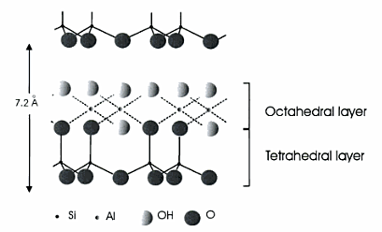
- Three layer or 2:1 type structure, this structure has one octahedral sheet linked to two tetrahedral sheets, such as illite-mica, smectite, vermiculite and chlorite groups.

Figure 1: Crystal structure of kaolinite

While the non-clay minerals include Quartz, Carbonate, Iron sulphides, Sulphates, Halides, Zeolites, Feldspars, Oxides and hydroxides. (2)
Clay fired brick is one of the oldest and most durable construction techniques used by mankind. Many buildings which are built with clay bricks prevailed until the 21st century, which testifies to the strength of this material along centuries of rain storms, snow, high temperatures and human induced deterioration.

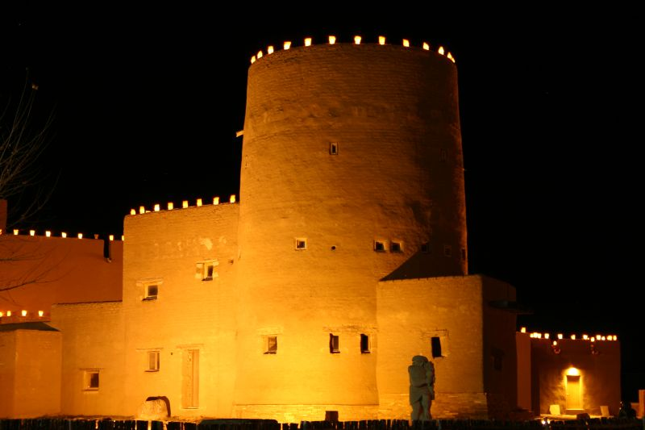
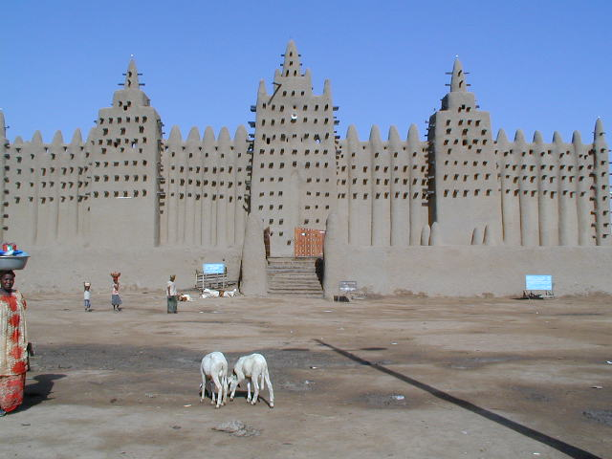

Figure 1: Poeh museum tower in New Mexico
Figure 2: Great mosque of Djenne in Mali

Furthermore, brick could be easily, inexpensively and rapidly handled and produced with a simple manufacturing process which is divided into four stages according to the basic principles followed during thousands of years. Firstly, the extraction and preparation of the raw clay, as soon as the raw material is extracted, it is accumulated and moved to an open air storage area. After storage, clay is further crushed and mixed with water, the resulting mix must be characterized by enough plasticity to facilitate the molding. Finally, hardening of the bricks came in order to acquire additional resistance. After all, bricks were put in a kiln or clamp with temperatures of 1,000ºC. (3)
Clay bricks exhibit a set of properties that are important in the evaluation of strength and durability. These properties are closely related to the quality of the raw clay and directly associated with the conditions of manufacturing.
Physical properties:
- Porosity: can be defined as the ratio between the volume of void spaces (pores and cracks) and the total volume of the specimen, it is an important parameter concerning clay bricks due to its influence on properties such as chemical reactivity, mechanical strength, durability and the general quality of the brick.
- Water Absorption: pores form a large part of the brick’s volume. When the bricks are exposed to rainfall or rising damp, water generally penetrates into the pores. Water absorption then determines the volume of the fluid that can be stored and circulated within the brick, favoring deterioration and reduction of mechanical strength.
- Moisture Expansion: the expansion or shrinkage observed in clay bricks can be partially or totally reversible due to wetting/drying, being not so relevant for old clay bricks. Moisture expansion in clay bricks is influenced by the contents of argillaceous minerals and by the presence of lime nodules.
- Apparent Density: is described as the ratio between the dry brick weight and the volume of the clay brick. It is evident from this description that the higher this value is, the denser the brick is, and obviously, the better its mechanical and durability properties.(3)

Mechanical properties:
Strength, hardness, ductility, toughness and brittleness are examples of the mechanical properties of clay. Several tests are made for determining various mechanical properties of the material. The precise results of these tests are utilized to determine suitability of materials for the field application. (3)

Thermal properties:
- Thermal conductivity: A measure of the clay ability to allow the flow of heat from its warmer surface to its colder surface.
- Thermal diffusivity: A measure of the clay ability to transmit a difference in temperature. (3)
Laboratory tests are complementary. They can provide a closer understanding of the properties and behavior of clay as constructing material. Its advantages can be summarized as follow:
- Control of test conditions can be exercised, and changes in conditions can be simulated.
- High degree of accuracy of measurements is possible.
- Parameter can be obtained within an acceptable timescale.
- Tests can be performed on undisturbed and remolded clay.

These tests can be divided into two categories:
- Classification tests: to establish the type of clay. Two apparatuses can be used for this test, which are the X-ray diffraction apparatus, and the thermogravimetric analysis (TGA) instrument.
- Tests for the assessments of engineering properties. Compressive strength tester is used to determine the compression strength of a sample. (2)

X‐ray diffraction:
X‐ray diffraction has three primary uses in today’s research. At first, it is used to identify individual mineral samples and their corresponding characteristics. Secondly, it allows identification of specific mineral components within mixed clay or soil samples. After that, it provides an insight of unit cell dimensions, which can be defined as the distance between the inner protons and neutrons. The process, as rapid as twenty minutes, gives results that are unambiguous with a low percentage of error. (4)
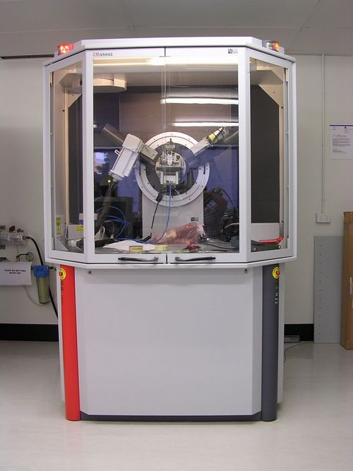

Figure 3: X-ray diffraction apparatus
Compressive strength tester:
The compression test is a mechanical test measuring the maximum amount of compressive load a material can bear before fracturing and deforming. The specimen, usually in the form of a cube or cylinder, is compressed between the platens of a compression-testing machine by a gradually applied load. Materials such as concrete, metals, plastic and ceramics can be subjected to this test. This test is used to calculate the maximum strength, young’s modulus, yield point and the maximum yield. A stress-strain curve is plotted and the strength can be calculated by dividing the maximum load applied over the cross-sectional area.
Thermogravimetric analysis (TGA):
Thermogravimetric (TGA) analysis provides determination of endotherms, exotherms, and weight loss on heating and cooling. Materials analyzed by TGA include polymers, plastics, composites, ceramics and glasses. It uses heat to force reactions and physical changes in materials in an atmosphere of nitrogen, helium, air, other gas, or in vacuum, and records the change in mass of the sample from dehydration, decomposition, and oxidation with time and temperature. Sample weight ranges from 1-150 mg, and he temperature from 25-1000°C. Characteristic thermogravimetric curves are given for specific materials and chemical compounds due to unique sequence from physicochemical reactions occuring over specific temperature ranges and heating rates.



Figure 4: Thermogravimetric analysis instrument
Figure 5: Compressive strength tester

Clay brick has several advantages related to several properties, these are listed as followed:
- Versatile and Aesthetic, it can be used in many applications as walls, roofs, gardens and open spaces.
- Energy-efficient, Excellent insulation and heat storage capacity in clay building materials both help to reduce the energy consumption of buildings.
- Clay brick is characterized as firm and stable resulting in life expectancy as long as 100 years, considering it as durable material.
- Brick-made buildings can be constructed quickly and flexibly which saves both time and money. Weather including wind, heat and frost is not able to damage clay building materials. As a result, it is considered economic.
- The value of buildings which are made of clay building materials is retained or might be increased. Owing to their durability, stability and special living quality. Brick-constructed buildings are in great demand and achieving high resale values. Furthermore, bricks and tiles are easy to be cleaned with less amount of maintenance. (5)

Limestone is extensively used for construction; due to the large abundance of raw material. However, environmental concerns both in damage caused by the extraction, and CO₂ emission, have brought pressure to reduce the consumption by the use of supplementary materials. The disadvantages of limestone can be summarized as follow:
- Five percent of the global emission of carbon dioxide is from limestone.
- Limestone quarrying may permanently disfigure the local environment.
- Quarrying is a heavy industry that creates noise and heavy traffic.
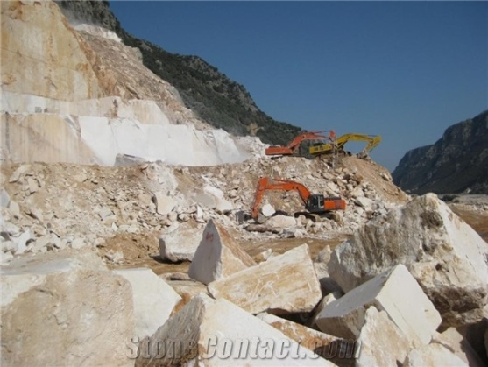
- Quarrying uses up land and destroys habitats.
- Quarries produce unsightly dust and powder. (6)

Figure 6: Limestone quarry

Methodology

A cement sample was prepared to make it the reference to the results of the clay samples. Cement was mixed with water until having sludge, the mixture was inserted into a steel cubic mold having dimensions of 10*10*10 cm and left for a week. The solid cubic was then tested using the concrete compressive strength tester.
Raw clay was collected from Jabaa’-Jenin, it was then prepared by grinding it, in order to achieve a good homogenous phase to avoid cracking. Different procedures were taken for the preparation of samples.
- Straw samples:
Clay was soaked in water for 3-4 days. Different proportions of straw were to be added to clay, 2.7%, 4.4% and 8% of straw were mixed with the wet clay using a mixer, the mixture was then inserted into the cylindrical mold, squeezed and left in the room temperature for about 2 weeks until it got solid. Compressive strength test was then conducted on the samples.

- Sand samples:
Clay was soaked in water for 3-4 days. Different proportions of sand were to be added to clay, 15.3% and 30% of sand were mixed with the wet clay using a mixer, the mixture was then inserted to the cylindrical mold, squeezed and left in the room for about 2 weeks until it got solid. Compressive strength test was then conducted on the samples.
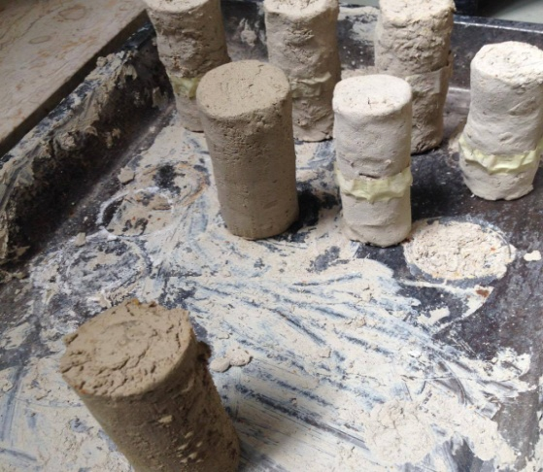

Figure 7: Cylindrical samples while drying
- Ash samples:
Different proportions of ash were to be added to dry clay, 10.3%, 15.9%, 27%, and 33.8% of ash were mixed with dry clay, then, water was added in acceptable ratio and the mixture was homogenizing well, the mixture was then inserted to a 5*5*5 cm square mold made of plastic, and left in the room for about 2 weeks until it got solid. Compressive strength test was then conducted on the samples.

- NaOH samples:
The treatment was done using two molds, steel and plastic molds with dimensions of 5 cm, 5cm and 5cm for both.
Using steel molds:
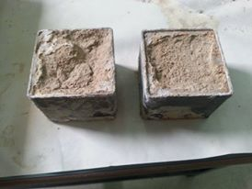
First, the collected samples of clay were treated at different temperatures 45C°, 110C° and 600C°. After heat treatment, the samples were grinded by grinding machine. Then NaOH was prepared in two concentrations, 4M and 8M. The concentration of 4M was prepared using 70 ml of water and 11.2 gm NaOH, while the concentration of 8M was prepared using 80 ml of water and 22.4 gm NaOH. After that, the samples of clay were mixed with NaOH using the mixer. After mixing, the samples were put into molds and compacted by hand in order to avoid cracks. The samples then were left to dry for 5 days and 14 days at room’s temperature. It was difficult to take out the samples from steel molds as they were stuck, so plastics molds were alternatively used.

Figure 8: Sample of clay with 4M and 8M of NaOH in steel molds

Using plastic molds:
After following the same steps as in the case of steel molds, the samples were tested by compressive strength test equipment.

- Lime samples:
The work took two ways, normal clay and fired clay at 600 C° , some samples from each way we treated by CO2 gas . Five samples of normal clay were prepared in different ratio of lime (5%, 10 %, 20%, 30%, and 40 %), meanwhile, an amount of clay was fired at 600C° to prepare other five molds of the same ratios. In fired clay suitable amount of water was mixed with lime before mixing it with clay. All of these samples were dried at room temperature for several days, and then compression test was made by compressive strength tester. To discover the effect of CO2 in lime, samples of normal clay and fired clay of different lime ratios were prepared .While the samples are still wet they were put under CO2 gas, some samples were put for three hours, while others were put for six hours.
All tests were conducted using compressive strength apparatus shown in figure 3. This apparatus applies load on the sample until it reaches failure, then calculates the load and strength based on the initial area of the sample.
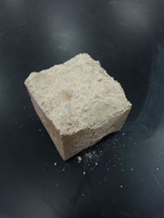
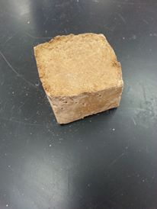
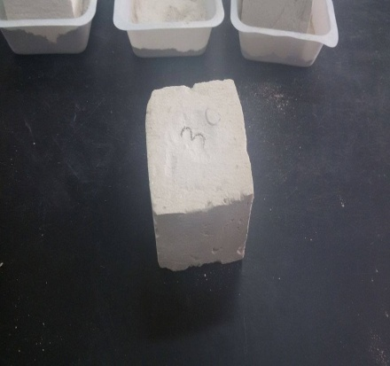

Figure 9: Sample of clay with 30% lime (by weight)
Figure 10: Sample of clay with 8M and treat at 600C in plastic mold
Figure 11: sample of clay with 8M and treat at 110C in plastic molds.

Results and Discussion

A series of laboratory analysis were done on Jabaa’s clay including:
- Thermal analysis:
This test was performed to determine the weight loss of the sample on heating.
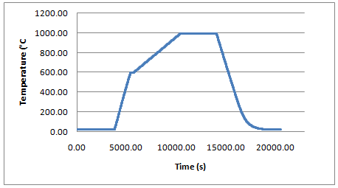
Figure 12: Heating rate of the TGA instrument on the sample

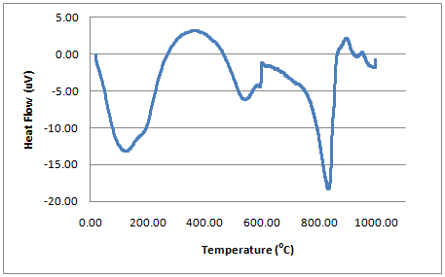
Figure 13: Heat flow of the sample on heating

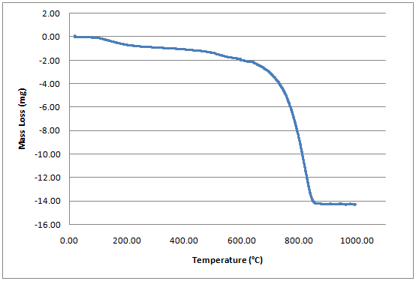

Figure 14: Weight loss of the sample on heating

- Compositional test:
This test aims to determine the elements of the sample and their percentage.

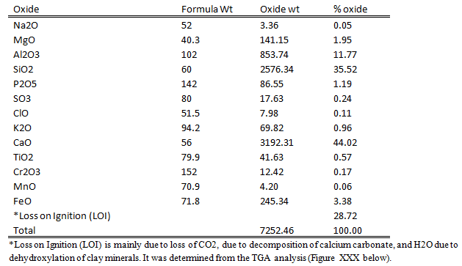
Table 1: Compositional test results

- X-ray diffraction
This test was done to identify the minerals forming the sample.
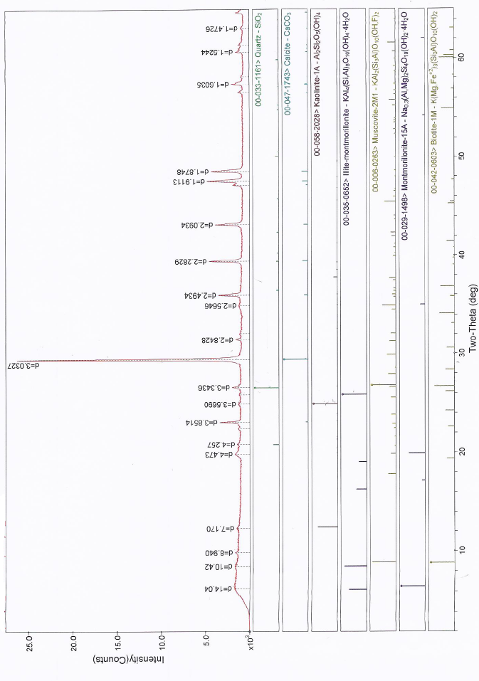
Figure 15: X-ray diffraction analysis result

- Compressive strength:
This test is to determine the compressive strength of the samples. The cement sample was tested, and the compressive strength was 0.011 Mpa. 33 samples were tested in order to determine the best additive and technique to use for making a clay brick that has good mechanical properties (i.e. compressive strength). The results obtained are divided into 4 categories based on the type of additive used and are discussed below.

- Straw and sand addition

Table 2: Data of the pure, straw and sand additives samples
Additive | Sample no. | Weight of  additive (g) | Percent of  Additive(%) | Initial  section (mm²) | Maximum  load (kN) | Strength  (Mpa)
Pure | 1 | 0 | 0 | 1134.115 | 2.352 | 2.056
 | 2 | 4 | 2.7 | 1134.115 | 1.832 | 1.594
straw | 3 | 6 | 4.4 | 1134.115 | 1.545 | 1.291
 | 4 | 10 | 8 | 1134.115 | 1.29 | 1.059
sand | 5 | 21 | 15.3 | 1134.115 | 3.53 | 3.093
 | 6 | 41 | 30 | 1134.115 | 2.49 | 2.174

Figure 16: The relation between the strength of samples vs. weight of straw added
- Ash addition

Table 3: Results of the ash additive samples
Sample no. | Weight of  additive (g) | Percent of  Additive(%) | Initial  section (mm²) | Maximum  load (kN) | Strength  (Mpa)
1 | 14 | 10.3 | 2500 | 1.21 | 0.484
2 | 21 | 15.9 | 2500 | 1.34 | 0.536
3 | 37 | 27 | 2500 | 1.57 | 0.628
4 | 45 | 33.8 | 2500 | 1.42 | 0.568

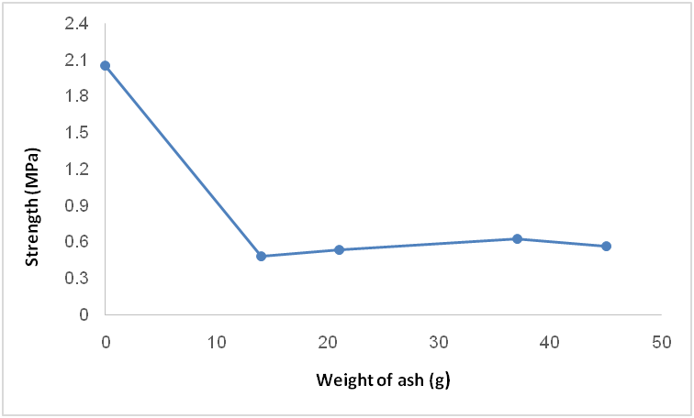
Figure 17: The relation between the strength of the sample vs. weight of ash added

- NaOH addition
- Treated at 45C°

Table 4: Results for the samples treated at 45C with the addition of 4 & 8 molar NaOH

Concentration of  NaOH (M) | Sample  No. | Time of  drying (day) | Initial  section(mm²) | Maximum  load (KN) | Strength  (Mpa)
4 | 1 | 5 | 2500 | 0.143 | 0.057
4 | 2 | 14 | 2500 | 1.046 | 0.385
8 | 3 | 5 | 2500 | 0.18 | 0.068
8 | 4 | 14 | 2500 | 0.195 | 0.072

Figure 18: Behavior of clay samples for different drying periods with 4M & 8M NaOH addition

- Treated at 110C°

Table 5: Data of clay samples treated at 110C with 4 and 8 molar NaOH addition
Concentration of  NaOH (M) | Sample  No. | Time of  drying (day) | Initial  section(mm²) | Maximum  load (kN) | strength  (Mpa)
4 | 1 | 5 | 2500 | 0.912 | 0.335
4 | 2 | 14 | 2500 | 0.346 | 0.124
8 | 3 | 5 | 2500 | 3.822 | 1.197
8 | 4 | 14 | 2500 | 0.384 | 0.153

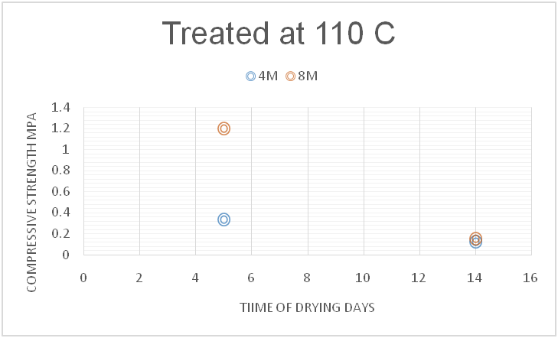
Figure 19: Behaviour of clay samples for different drying periods with 4M & 8M NaOH addition

- Treated at 600C°

Table 6: Data of clay samples treated at 600C with 4 and 8 molar NaOH addition
Concentration of  NaOH (M) | Sample  No. | Time of  drying (day) | Initial  section(mm²) | Maximum  load (kN) | Strength  (Mpa)
4 | 1 | 5 | 2500 | 0.39 | 0.134
8 | 2 | 5 | 2500 | 1.756 | 0.573

Figure 20: Behaviour of clay sample for the same drying period with 4M & 8M NaOH addition

- Lime addition
- Non-fired clay

Table 7: data of the lime added to non-fired clay
Sample No . | Lime ratio (by weight) | Initial section (mm²) | Max. load (kN) | Strength (Mpa)
1 | 5% | 2500 | 0.387 | 0.145
2 | 10% | 2500 | 2.44 | 0.905
3 | 20% | 2500 | 0.328 | 0.128
4 | 30% | 2500 | 0.949 | 0.336
5 | 40% | 2500 | 1.192 | 0.474

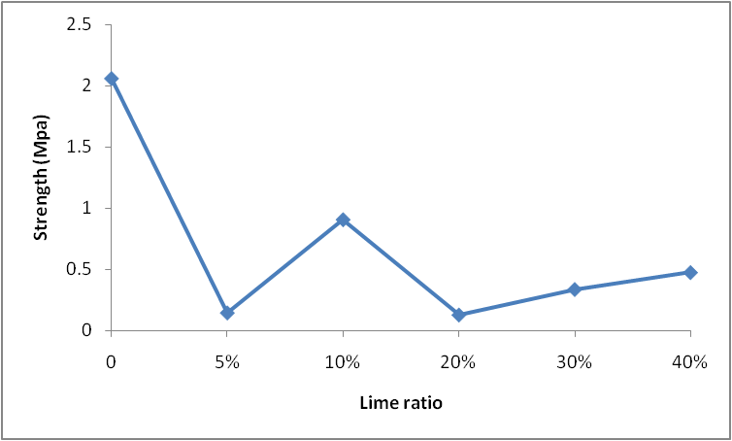
Figure 21: Strength of clay samples vs. lime ratio of lime added

- Fired clay at 600C°

Table 8: Data o the lime added to fired clay at 600C
Sample No | lime ration (by weight) | Initial section (mm²) | Max. load (kN) | Strength (Mpa)
1 | 5% | 2500 | 0.235 | 0.089
2 | 10% | 2500 | 0.447 | 0.169
3 | 20% | 2500 | 0.32 | 0.119
4 | 30% | 2500 | 0.778 | 0.287
5 | 40% | 2500 | 0.657 | 0.252

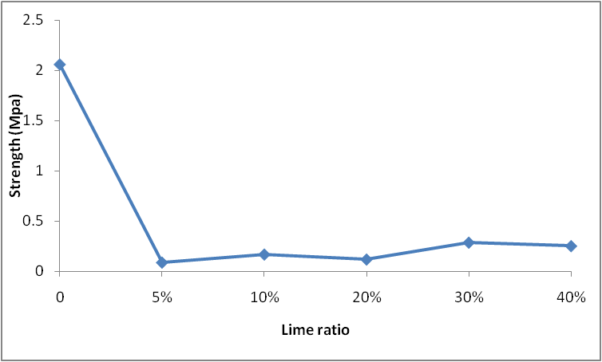
Figure 22: Strength of clay fired at 600C with the addition of lime in different ratios

- Non-fired clay treated with CO₂

Table 9: Data of non-fired clay treated with CO2 for 3 hrs, with lime used as an additive
Sample No. | lime ratio | Initial section | Max . Load (KN) | Strength (Mpa)
1 | 10% | 2500 | 1.752 | 0.697
2 | 30% | 2500 | 1.806 | 0.719
3 | 40% | 2500 | 1.01 | 0.386

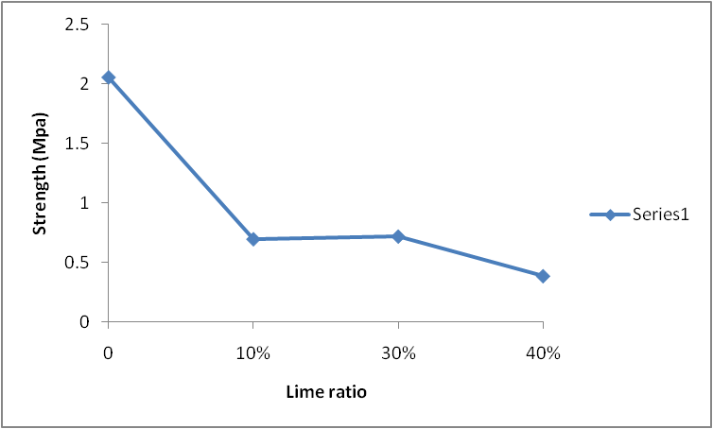
Figure 23: Strength for non fired clay treated with CO2 for 3 h

Discussion

- Pure sundried sample:
No additive was added to this sample, and it was sun-dried. This sample is the reference to the modified ones. The compressive strength test has shown a result of 2.056 Mpa, which makes it incredibly higher than the sun-dried cement sample which had strength of 0.011 Mpa.

- Straw addition:
Straw was used in different proportions, using 2.7%, 4.4% and 8%, these samples were dried at room temperature. The test showed that as increasing the percent of straw mixed with clay, the strength decreases, which is illustrated in figure (). This result was expected because the role of straw is to prevent clay from cracking when it shrinks, as it will ‘open up’ the clay, allowing it to dry more readily and evenly, but using it will adversely affect its strength.

- Sand addition:
Adding sand to clay is known for its role in increasing its compressive strength, but adding it above a certain limit will adversely affect its strength as shown in the results.

- Ash addition:
Ash was used in different proportions, using 10.3%, 15.9%, 27%, and 33.8% these samples were dried at room temperature. The test showed that as increasing the percent of ash mixed with clay, the strength decreases rapidly and sharply, then it increases before it starts to decrease again which is illustrated in figure (8). This result is acceptable logically because in the chemical composition of the ash there are sodium and magnesium and calcium and others basics of salts, that means that a salt was formed which adversely affect the strength. At the same time these ions reacted with the clay minerals to form compounds such as sodium aluminates which has a good effect on the strength, in addition, calcium carbonate was formed in a small amount which also has a good effect on the strength. This explains why the strength increased again.
- NaOH addition:

- Treated at 45C°
Table (1) illustrates the relationship between compressive strength of clay at different concentrations (4M and 8M) considering different periods of drying (5 days and 14 days), the treatment was done at 45 C. The compressive strength of clay increased as the period of drying increased from 5 days to 14 days, this can be seen by comparing both samples 2 and 4, with 1 and 3 respectively. The concentration in the case of treatment at 45 C has an adverse effect on the compressive strength of clay as noticed in the table (1).

- Treated at 110C°
Table (2) illustrates the relationship between compressive strength of clay at different concentrations (4M and 8M) considering different periods of drying (5 days and 14 days), the treatment was done at 110 C. At concentrations of 4M and 8M, the compressive strength decreased as the period of drying increased from 5 days to 14 days. The strength increased significantly when the concentration increased from 4M to 8M resulted in a compressive strength of clay 1.197 Mpa which was the maximum value achieved in the case of NaOH.

- Treated at 600C°
Table (3) illustrates the relationship between compressive strength of clay at different concentrations (4M, 8M) considering 5 days as a period of drying, this was done in the purpose of finding the strength that can be achieved during a short period of time in the case of treatment at 600C. The strength of clay was 0.573 Mpa at a concentration of 8M which is higher than the value at 4M. Moreover, the appearance of these samples, as shown in Figure (4) in methodology, was better than the samples treated at 45C and 110 C.

Lime addition:
- Non-fired clay
Table (7) contains data for compression strength test for five non fired clay samples with lime (CaO) in different ratios. The chemical reaction between clay particles clay and lime can be categorized into two forms of improvement, short term reaction (modification) and long term reaction (stabilizing). In the first reaction the process of ion exchanges makes the clay minerals flocculate and agglomerate leading to the reduction in plasticity, swell and moisture content. The second reaction (pozzolanic reaction) accomplished over a period of time creating cementing products that cause long-term strength gain. The result in table (1) show that the best maximum load and strength is for 10% lime (135g clay and 15 g lime). In the next three samples the max. load increased gradually . We can predict here that all amount of lime in this sample reacted with clay to give this high result, while the reaction in 20% ,30% and 40% samples may didn't complete ,and the amount of lime in 5% lime sample wasn't enough . Here and according to chemical reactions we can predict that the maximum load and strength will increase by the time to have much better results.

- Fired clay at 600C°
Table (8) contains data for five samples of fired clay at 600C° with different ratios of lime (5%,10%,20%,30%,40%) by weight. Firing clay changes the microstructure of the clay and it allows to get rid of all water between the layers, the effect of firing is discussed in the thermal test. The results show that the max. load is doubled in the second sample then it decreases and doubled again in the next two samples ,and decrease again in the fifth one .The maximum strength here was recording in the fourth sample (30% lime ).

- Non-fired clay treated with CO₂
Table (9) contains the results of three samples of non fired clay that were treated with CO₂ gas. The samples got lighter after the treatment, because of the reaction of CO2 with Ca(OH)₂ ,which cause to get rid of water . At room temperature, the reaction of lime with carbon dioxide is very slow, and it was speeded by mixing lime with water. When lime is mixed with water, it forms calcium hydroxide, called slaked lime (CaCO₃). The reaction of calcium hydroxide with carbon dioxide is faster, producing clay that hardens more quickly. Even with the increased reaction speed, it requires many years for the complete reaction to occur. The results here show that the maximum load for first and second samples have close value, then in the third sample the max. load decreases .

Conclusion

- The main objective of the project is to make a clay brick that have good characteristics, and can be used for various building purposes.
- A compression test was conducted by compressive strength testing apparatus.
- Straw addition decreases the strength of clay, but prevents it from cracking when drying.
- Adding sand increases the strength of clay, until exceeding a certain limit, it adversely affects its strength.
- Several compounds are formed after the addition of ash, affecting the strength to increase or decrease, but salts are formed more than other compounds, which will adversely affect the strength of clay, therefore, ash cannot be used as an additive to increase the strength of clay.
- In the case of chemical treatment using NaOH, two concentrations 4M and 8M were considered at different temperatures for two periods of drying 5 days and 14 days. The maximum values of compressive strength were 0.385 Mpa, 1.197 Mpa and 0.573 Mpa at 45 C, 110 C and 600 C respectively. It is also concluded that the relationship between compressive strength and temperature of treatment is not an increasing function as the maximum value was achieved at a temperature of 110C°, which was not the maximum temperature.
- The appearance of the surface of the sample can be an indication of a high compressive strength, just like in the case of the NaOH samples that got stuck in the metal cube mold, which is shown in figure 8. This can be justified because the reaction took place in a closed, non adjustable mold, which will cause the retention of water.
- White color appearing on the samples in figure (8, 9&11) indicates the quick-drying, which is caused by the loss of water, or by the excess amount of NaOH.
- Samples of fired and non fired clay were treated with different ratios of lime ,also some samples were treated with CO₂.
- Results for non fired clay samples show that the best compression relate to 10% sample (15 g lime with 135 g clay )
- Results for fired clay samples show that the best compression relate to 30% sample (45 g lime and 105 clay )
- Results for non fired clay samples that were treated with CO₂ show that the test values for 10% and 30% are close and high with comparison with other tests.
- The best results were recorded for the sample that were treated with CO₂, and for non fired 10% lime sample.

References:

1. GUGGENHEIM, STEPHEN. DEFINITION OF CLAY AND CLAY MINERAL. Chicago : Department of Geological Sciences, University of Illinois at Chicago, 2008.
2. G.M.reeves, l.sims & J.C. Cripps. Clay Materials used in Construction. London : Geological Society, 2006.
3. Francisco M. Fernandes, Paulo B. Lourenço and Fernando Castr. Ancient Clay Bricks. Portugal : Civil Engineering Department Campus de Azurém, 2009.
4. James, Reuben. X-Ray Diffraction. s.l. : Carleton College, 2014.
5. [Online] wienerberger. [Cited: 11 9, 2015.] http://www.clay-wienerberger.com/building-with-clay/advantages.
6. Pallister, Ann Bowen and John. Understanding GCSE Geography. Britain : British library, 2006.
7. Daoud, Ahmad. With Dirt And A Vision, Palestinian Architects Break The Mold. Jarico : npr, 2014.
8. Fathy, Hassan. Architecture for the Poor. Egypt : University of Chicago Press, 2010.
9. C D F ROGERS, GLENDINNING, S, T E J ROFF. Geotechnical Engineering. 2015.
10. Guo Wei, Wang Tao, Yang Nanru. Construction and Building Materials. s.l. : science Direct Jounrals, 2005.
11. Mouhamadou Bassir Diop, Michael W. Grutzeck, Laurent Molez, Applied Clay Science, 2011.

