﷽
An-Najah National University
Faculty of Engineering and Information Technology Computer Engineering Department


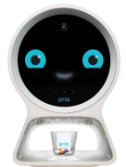
Hardware Graduation Project

Smart Medication Dispenser Robot
Done by: Aya Moeen & Lujain Darawzeh
Supervisor :
Dr. Ashraf Armoush & Dr. Anas Toma

Submitted on :
Jan 2025
Presented in partial fulfillment of the requirements for a Bachelor's degree in
Computer Engineering.

Dedication:
وَآخِرُ دَعْوَاهُمْ أَنِ الْحَمْدُ لِلَّهِ رَبِّ الْعَالَمِينَ

Thank you to Allah, who without His grace made no effort complete or endeavor ended, and it was only with His direction that I was able to conquer these challenges.

To the source of my safety and support in this life, to my beloved father, and to everyone who helped me during my academic career.

To my dear mother, who illuminated my life's path and showed me that life is full of giving.

My gratitude goes out to my brothers and companions of the first step and the step before the last.

On the day that You question me about my youth and how I spent it, O Allah, give me this knowledge as an intercessor so that I can get more knowledge and benefit from it.

Acknowledgment:

Firstly, we thank our supervisor, Dr. Ashraf Armoush & Dr. Anas Toma, for his continuous support and encouragement.
We would like to thank the doctors of the Computer Engineering Department for what they gave us during the educational process.

Table of Contents:

Dedication: 2
Acknowledgment: 3
Table of Contents: 4
Table of figures: 5
Disclaimer: 6
Abstract: 7
Chapter 1: Introduction 8
1.1 Statement of the problem 8
1.2 Objective: 8
1.3 Scope of work: 9
1.4 Importance of the work : 10
1.5 Organization of the report : 11
Chapter 2: Constraints, Standards and earlier course work 12
2.1 Constraints and design limitations: 12
2.2 Standards: 12
2.3 Earlier course work: 13
Chapter 3: Literature Review 14
Chapter 4: Methodology 16
4.1 How it work: 16
4.2 The Mechanism: 17
4.3 UML Diagram: 18
4.4 Component: 19
4.4 Design: 23
4.5 Mobile Application: 26
Chapter 5: Result and Analysis 33
Chapter 6: Conclusions 34
Chapter 7: Future Work 35
Chapter 8: References: 36

Table of figures:

Figure 1: The system 23
Figure 2: Component 23
Figure 3: Robot design 23
Figure 4: Battery and driver 23
Figure 5: power pank 23
Figure 6: ESP 24
Figure 7: Final Design 24
Figure 8: 3D for pill dispenser 24
Figure 9: Pill dispenser and servo 25
Figure 10: DC motor for movement Drawer 25
Figure 11: Final Design 26
Figure 12: Final Design 26
Figure 13: Home Screen 28
Figure 14: Login screen 28
Figure 15: Edit Patient 28
Figure 16: Add Patient 28
Figure 17: Remove Patient 28
Figure 18: Show ALL Medicine 29
Figure 19: Add medicine 29
Figure 20: Edit amount of medicine 29
Figure 21: Add New Time for Distribute medicine. 30
Figure 22: Patient Information 31
Figure 23: Patient Information Vital signs 31
Figure 24: notification 32
Figure 25: notification 32

Disclaimer:

This report was written by Aya Moeen and Lujain Darwazeh at the Computer Engineering Department, Faculty of Engineering, An-Najah National University. It has not been altered or corrected, other than editorial corrections, because of assessment and it may contain language as well as content errors. The views expressed in it together with any outcomes and recommendations are solely those of Aya Moeen and Lujain Darwazeh. An-Najah National University accepts no responsibility or liability for the consequences of this report being used for a purpose other than the purpose for which it was commissioned.

Abstract:

In hospitals, nurses may make mistakes in dispensing medication to patients or distributing it at the wrong time, so we decided to make a robot based on the RTC system and start moving to distribute medicines to patients.
The goal of our project is to support the work of nurses. The robot dispenses the correct medication to each patient independently at specific times, ensuring accurate delivery, adherence to the specified schedules, and avoiding human errors.
Once the robot reads the patient's ID, it enters the database to retrieve the patient's medication schedule. The robot then distributes the medication appropriately to the patient. After collecting the pills on the conveyor, they are transferred to a platform. It also contains an audio alert to inform the patient when the medication is ready to be received.
It also allows monitoring the patient's vital signs such as measuring oxygen level, heart rate, and temperature, and displaying them on an LCD screen. In case of abnormal readings, a notification is sent to the nurse to inform her to take immediate action.

The nurse can refill the medication as the robot will notify the nurse if one of the medications in the tubes runs out, through a notification.

Chapter 1: Introduction

Statement of the problem

In Palestinian hospitals, a significant challenge exists in the timely and accurate administration of medications to patients. Nurses, often overburdened with heavy workloads, may inadvertently administer medications at incorrect times, skip doses, or make errors during the distribution process. These mistakes can lead to severe patient complications, prolonged hospital stays, and increased healthcare costs. There is a pressing need for an automated, reliable, and efficient system to ensure that medications are delivered to the right patient, in the correct dosage, and at the prescribed times.

Objective:

Design an automated medication distribution system to support nurses in hospitals by ensuring accurate and timely delivery of medications to patients. The system aims to:
- Improve adherence to the specified medication time through a mechanism based on RTC and reduce errors that occur when distributing medications by identifying each patient and retrieving the medication schedule from the database.
- Ensure accurate delivery of medications through a carrier and an audio alert to the patient to inform him of the readiness of the medication.
- Monitor the patient's vital signs, such as oxygen level, heart rate, and temperature.
- Notify nurses if vital signs are abnormal or if a pill dispenser needs to be filled.
- Provide a mobile application through which the nurse can determine the hours of distributing medications and can also enter new medicines into the system or enter new patients.

Scope of work:

The project focuses on implementing a system to assist nurses by automating the process of dispensing medication to patients. The project includes:
- Medication dispensing mechanism: Developing a system and using a servo motor to extract the correct medication from the tube containing this medication, and integrating a conveyor system to collect the pills and transport them outside to allow the patient to access the medication.
- Patient identification: Identifying the patient through RFID where each patient has a unique key and developing a database to store patient information and ensure data retrieval and accurate medication dispensing in the correct quantity.
- RTC: Implementing a real-time clock to determine the time of dispensing the medication based on pre-determined times and ensuring adherence to the schedule.
- Alerts: Integrating an audio alert informs patients when the medication is ready.
- Vital signs monitoring: Deploying sensors to monitor Vital signs displaying data on the screen and sending alerts to the nurse in case of abnormal readings.
- Mobile application for control and management: Through the application, the nurse can determine the time of dispensing the medication and determine the medication schedule for patients who can enter new medications or patients and can monitor notifications.

Importance of the work :

Robotic medicine distribution plays an important role in addressing the challenges facing nurses and patients in the hospital, as it ensures the safe, efficient, and reliable distribution of medicines. Here are the reasons why the project is important:
- Reducing errors and improving accuracy: The medicine is distributed at the right time through the RTC, and also identifying each patient through RFID, which reduces errors resulting from manual processes.
- Adherence to medication schedules: By automating the medicine distribution process, the robot eliminates the risk of missing or delaying patient doses, ensuring adherence to the medication schedule. This is very important in critical medical cases that require taking the medicine on time and not postponing the dose.
- Assisting nurses: The system reduces the burden on the nurse by automating tasks prone to human error and repetition, allowing for focus on the patient and improving hospital efficiency.
- Monitoring vital signs: The system monitors patients' vital signs, such as temperature, heart rate, and oxygen level. Any abnormal readings are notified to the nurse for immediate intervention.
- Ease of control and management: Providing a mobile application that enables the nurse to adjust the times of distributing the medicine in the specified quantity for each patient and monitor notifications.
- Professionalism and enhancing efficiency: Reducing human effort, providing an environment for caring, and ensuring patient safety.

Organization of the report :

The arrangement of the report is as follows: In Chapter 2, constraints and standards/rules and We had a detailed discussion of the coursework earlier. A review of the literature is included in the third chapter. Chapter Four, Methodology, will provide an explanation of the resources and techniques at our disposal.
The results we obtained will be discussed in the fifth chapter, results, and analysis. Chapter 6 Discussion will address the findings, highlighting the characteristics and limitations of the work.

Chapter 2: Constraints, Standards and earlier course work

2.1 Constraints and design limitations:

- Drug storage capacity: The size of the pill dispenser and the number of dispensers determine how many pills can be put in the dispenser, which restricts the robot's capacity to handle a lot of drugs.
- Power source: Because a 12-volt (9-amp) battery was utilized, the robot's mobility depends on batteries. This necessitates careful energy management to prevent power outages or battery life degradation.
- Weight and movement: The robot weighs around 20 kg, which slows it down and makes it harder for it to move quickly and carry out the necessary activities.
- Stability of wireless communication: The response and stability of the connection are questioned when using the ESP32 for wireless communication.
- Movement challenges: The robot's effectiveness is limited in these intricate situations due to its impact on hospital layouts, busy areas, and obstacles.

2.2 Standards:

- ISO 13485: These standards outline the specifications for quality control systems used in medical device design and production. For use in hospitals, they make sure the robot satisfies safety and efficacy requirements.
- IEC 60601: This standard guarantees the robot's performance and safety as a medical device, particularly when it comes to patient interaction and vital sign monitoring.
- IEEE 802.11: They guarantee the robot's wireless connectivity (e.g., Wi-Fi) so that it may communicate with the database and mobile application without any problems.

These guidelines are incorporated into the design process to guarantee that the robot satisfies operational and industry standards.

2.3 Earlier coursework:

The information and abilities we gained from prior coursework—particularly in the areas of PIC microcontrollers, the C programming language, and pertinent digital and electronic courses—were crucial to the development of our project.
We gained a thorough understanding of microcontroller architecture, programming ideas, and interface strategies from the PIC microcontroller curriculum. We improved our ability to implement different functionality, write code for microcontrollers, and efficiently operate hardware components.

Chapter 3: Literature Review

In recent years, automated medication dispensing systems become increasingly important in Facing challenges in healthcare, especially in reducing human errors and ensuring the distribution of medicine in suitable time. A study published in the Journal of Pharmaceutical Health Care and Sciences highlights how robotic dispensing systems enhance safety and efficiency by automating the preparation and distribution of medications, which minimizes errors and increases patient adherence (JPHCS, 2022).

Saudi Arabian studies on robotic medication distribution in pharmacy settings revealed that such systems can significantly improve healthcare delivery by streamlining processes and ensuring the accurate delivery of prescribed medications. For example, a study found a 53% reduction in waiting time, a 20% increase in patient satisfaction regarding pharmacy wait times, and a 33% increase in pharmacist productivity with zero dispensing errors (Momattin et al., 2021; Al Nemari & Waterson, 2022). These findings underscore the potential benefits of automation systems in broader healthcare settings, including hospitals and patient-facing services.

There are several similar applications, such as the PillPick system by Swisslog Healthcare, which automates the packaging and dispensing of unit-dose medications, reducing errors and increasing patient safety. It also utilizes robotic arms and automated storage to streamline medication management, minimizing human intervention and enhancing efficiency (Swisslog Healthcare, 2023). Additionally, Parata’s Max system, a separate pharmacy automation solution, focuses on high-speed dispensing and adherence packaging, ensuring accurate medication distribution while improving pharmacy workflow and patient compliance (Parata, 2023).
Our project aims to close this gap by offering an automated drug dispensing solution that is more adaptable and scalable. Our Smart Medication Dispenser provides a comprehensive strategy for enhancing patient safety and healthcare efficiency by including features like RFID-based identification, real-time tracking, and patient vital monitoring.

Chapter 4: Methodology

4.1 How it work:

The purpose of the medication dispensing robot is to automate the precise and timely dispensing of medication:
- The robot is powered by a rechargeable battery, and the system uses RTC to distribute the medication to patients by starting the process at a predetermined time.
- The database contains the patient and medication data, which the robot accesses over a WIFI connection.
- The robot begins dispensing at the designated time, and when it reaches the patient, the patient inputs his unique ID. The robot then opens the appropriate pill dispenser that has the matching medications in the database and retrieves the medication the patient is taking in the necessary quantity from the database.
- A conveyor pulls out the medication when it is ready for the patient to pick it up, and the patient can hear an alarm to let him know when the medication is ready.
- The system measures the patient's heart rate, and oxygen saturation level and shows the results on the LCD screen. The robot notifies the nurse to take immediate action if the readings are abnormal.
- The nurse receives a signal from the system to refill any empty pill dispensers.

4.2 The Mechanism:

- The robot’s pill dispenser is dedicated to a specific type of medication, with the tube being manufactured to maintain the quality of the medication and avoid contamination.
- A rechargeable battery powers the robot, ensuring that all its parts are supplied with electricity.
- To ensure smooth movement through the hospital corridors, the system is equipped with stepper motors.
- Ultrasound is used to identify and avoid obstacles.
- The robot starts delivering the medication based on a specific time using RTC.
- Since each patient’s card is unique and linked to their database file, an RFID reader is used to scan each card to identify the patient.
- The robot identifies the patient and then retrieves the patient’s medication from the database, including the dosage of each medication.
- The tube is opened and closed using a servo motor, which rotates to release the appropriate amount of pills when the system detects the required dosage.
- To facilitate retrieval of the medication to the patient, it is assembled on a conveyor belt and then moved out.
- A technology has been introduced to track the patient’s vital signs.

4.3 UML Diagram:
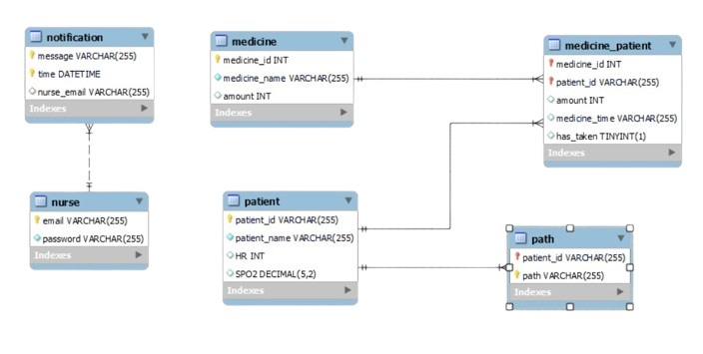

4.4 Component:

Component | Image | Purpose
Arduino Mega | 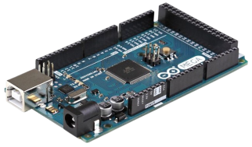 | Main controller board for overall system functionality.
Servo Motor | 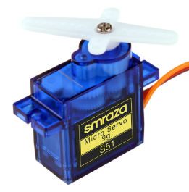 | For control [open/close] pill dispenser.
LDR & Laser | 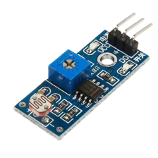  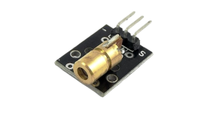 | - It is used to check the pill dispanser if it is empty, to refill it.  - Check the conveyor if it contains medicine to move it out.  - Check if the patient took the medicine or not.
RFID |   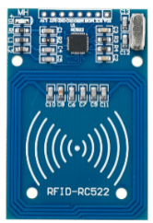 | RFID is used to identify each patient as each patient has his own unique key.
LCD | 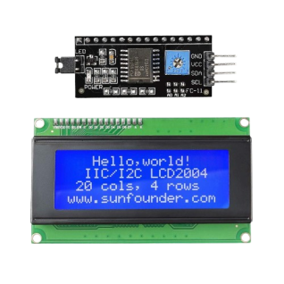 | LCD is used to track some commands and display the results on the screen.
Max30102 | 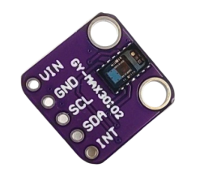 | Used to measure oxygen level and heart rate.
Temperature | 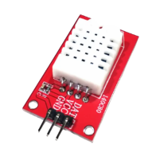 | Used for read the temperature of Room.
RTC | 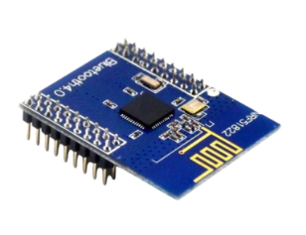  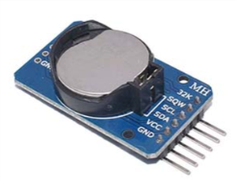 | used to ensure that medication is dispensed at the precise, pre-scheduled times specified in the patient's medication plan.
ESP8266 | 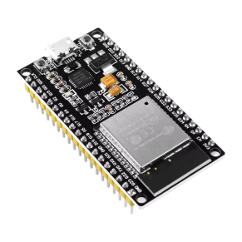 | - It is used to connect via Wi-Fi with the database to store and retrieve data from the database.  - Also another piece is used for the mobile application.
Stepper Motor | 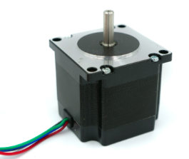 | NEMA 23 stepper motor is used for regular robot movement.
Driver TB6600 | 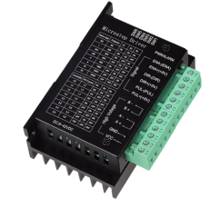 | used to control the stepper motors, enabling precise movements.
Battery 12V |  | primary power source for the system. It provides the necessary energy to operate various components of the robot.
DC Voltage converter | 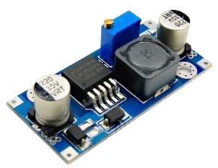 | Provides a regulated 5V output to power several components in the system.
Wheel |  | Wheel for move robot
Wheel Ball metal | 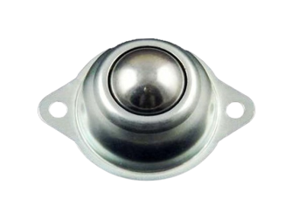 | omnidirectional support for the robot, allowing smooth and stable movement. It acts as a free-rotating caster that supports the robot's weight and enables it to move in any direction without resistance
Keypad | 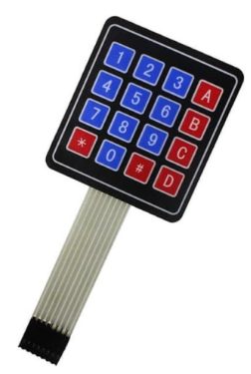 | To enter some values ​​and data.
Ultrasonic | 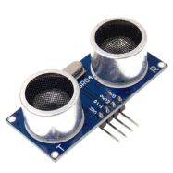 | To discover obstacles and barriers.
IR sensor | 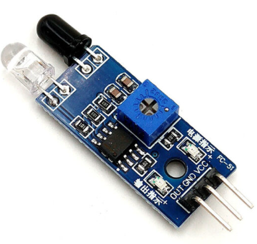 | To track the black line and make the robot move in a specific way.
Dc motor | 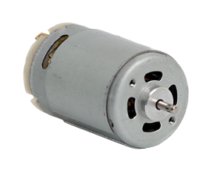 | DC motor used to move the conveyor.
H-Bridge  L298N | 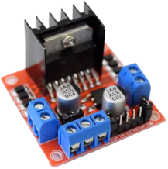 | Used to control the Dc Motor.
Power Pank |  | It is used to supply components that require five volts.
Battery lithium | 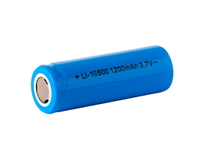 | It is used to supply components that require 3.3 volts.
Wire | 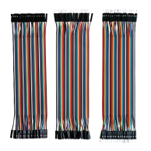 | connections between the various components of the system.
Connector | 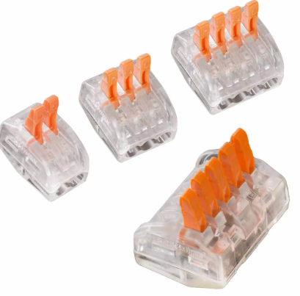 | Wire the junction to the same point as VCC and GND.
Limit switch | 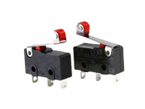 | Used for stop the conveyer.
Buzzer | 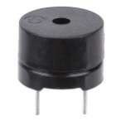 | Used to notify the patient when the medicine is ready.

4.4 Design:

Firstly We design the Robot to move using two wheel ,two Stepper Motor, two Driver TB6600, and one Wheel Ball metal as shown in the figures.

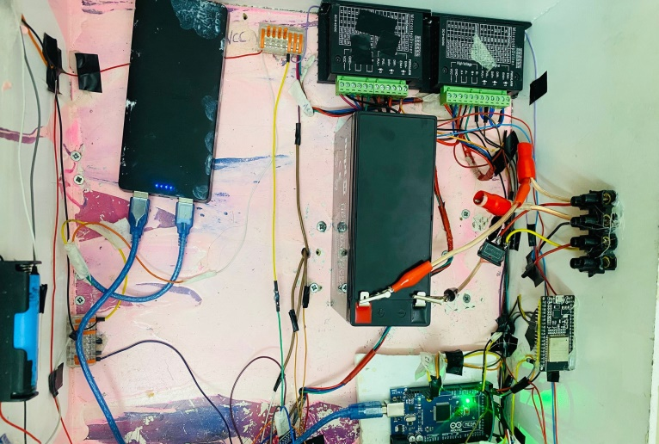
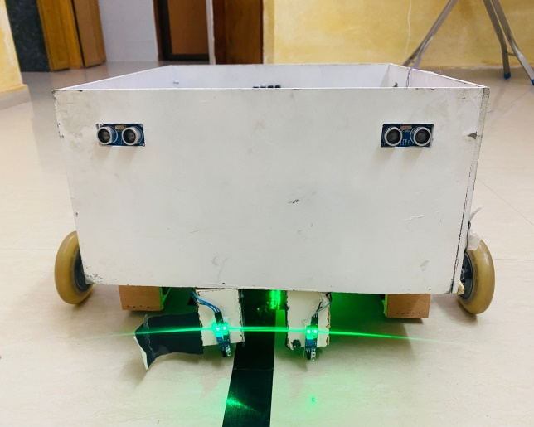
Figure 1: The system
Figure 1: Component
Figure 2: Component
Figure 2: Robot design
Figure 3: Robot design

The movement of our robot relies on four strategically placed Infrared (IR) sensors to achieve smooth and efficient navigation. Additionally, the robot is designed with two ultrasonic sensors that detect objects in its path. If an object is detected, the robot will stop until the obstacle is removed, after which it will continue its movement.
We use a 12V, 9A battery to supply power to the two TB6600 drivers and the H-Bridge. Additionally, a 5V power bank is used to power the Arduino.
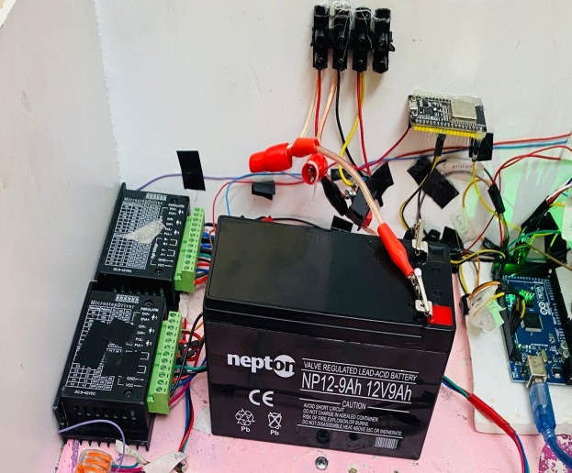
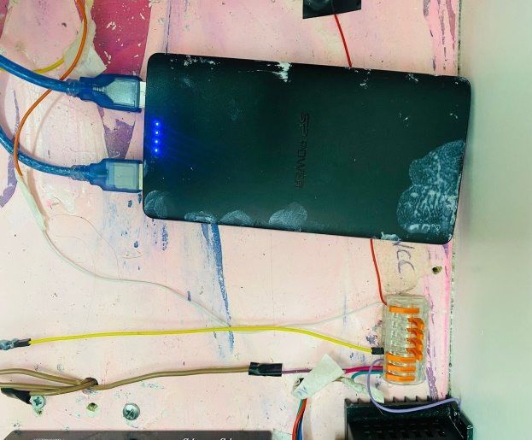
Figure 3: Battery and driver
Figure 4: Battery and driver
Figure 4: power pank
Figure 5: power pank

The robot's movement is controlled by an RTC (Real-Time Clock) component, allowing the nurse to set the exact time for the robot to start moving and distribute medication to the patients.
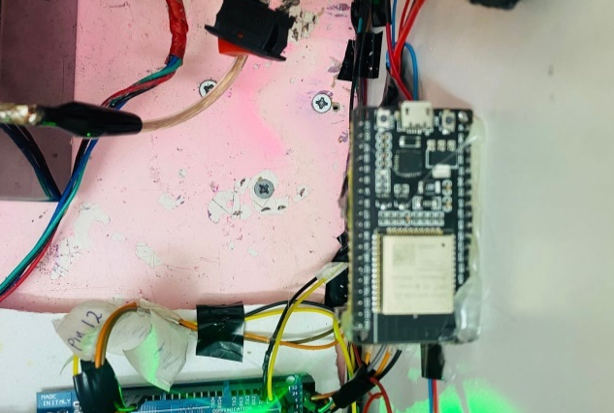
We use an ESP8266 to connect to our App Inventor application. The TX and RX pins of the ESP8266 are connected to the RX and TX pins of the Arduino, respectively.
Figure 5: ESP
Figure 6: ESP

After that, we designed the top to include a pill dispenser, RFID module, LCD, and keypad as shown in the figure .
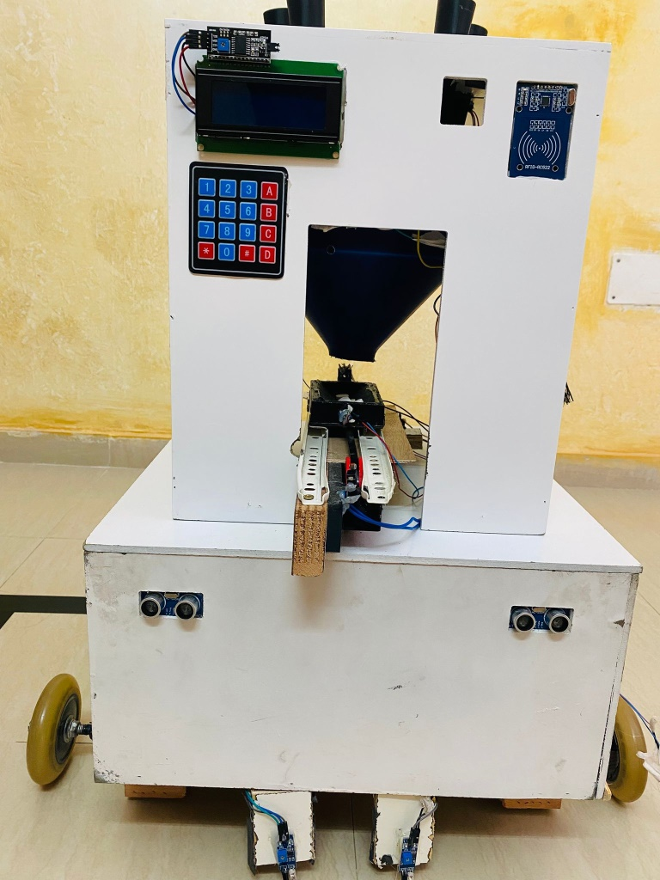
Figure 6: Final Design
Figure 7: Final Design

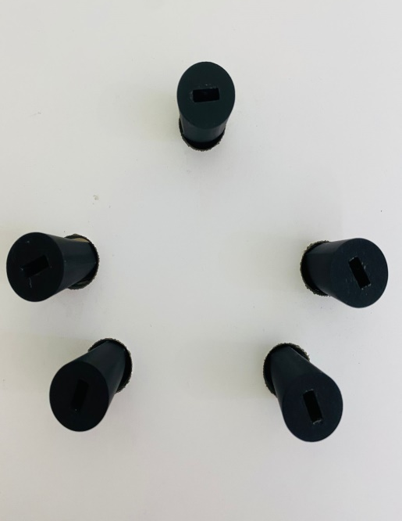
Figure 7: 3D for pill dispenser
Figure 8: 3D for pill dispenser

After the robot reaches the patient's location, the patient must place their key on the RFID scanner. The ESP8266 then communicates with the database to retrieve the patient medicines and the amounts required for each. We designed a 3D-printed system with five pipes, each specific to a specific medicine. Each pipe is equipped with a servo motor that allows the pills to drop into a funnel. The funnel directs the pills into a designated drawer.
The drawer is moved forward using a DC motor controlled by an H-Bridge. This forward movement continues until the drawer hits a limit switch, triggering a buzzer to notify the patient to take their medicines.
The drawer also features an LDR and a laser system. After the patient removes the medicines, the LDR detects the laser beam, which means that the drawer is empty. The drawer then moves in reverse to its original position until it presses a second limit switch, at which point the motor stops.
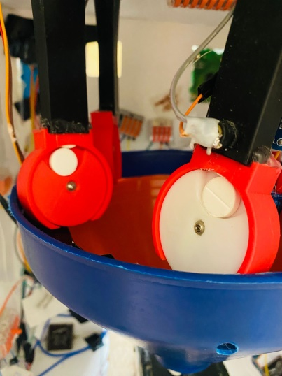
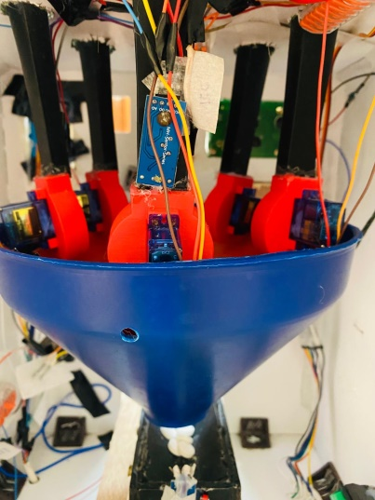
Figure 8: Pill dispenser and servo
Figure 9: Pill dispenser and servo

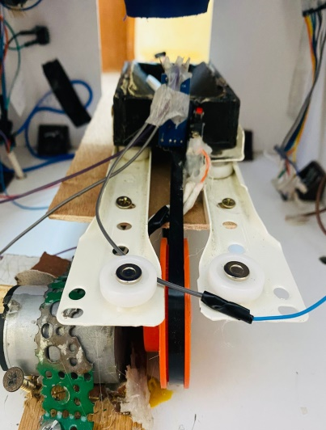
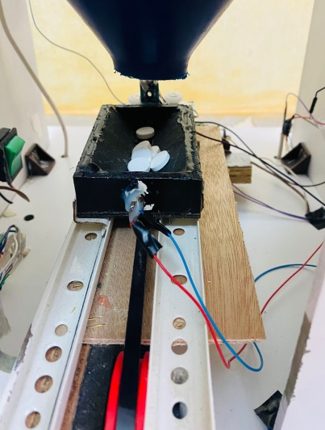
Figure 9: DC motor for movement Drawer
Figure 10: DC motor for movement Drawer

Final Design of robot:
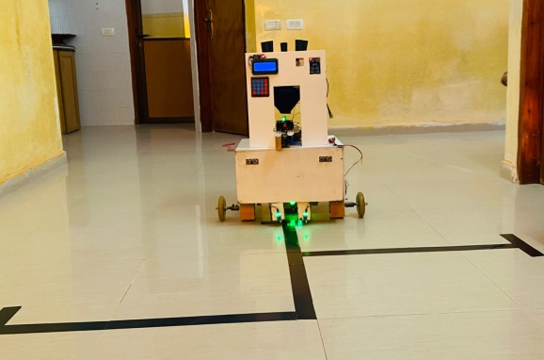
Figure 10: Final Design
Figure 11: Final Design

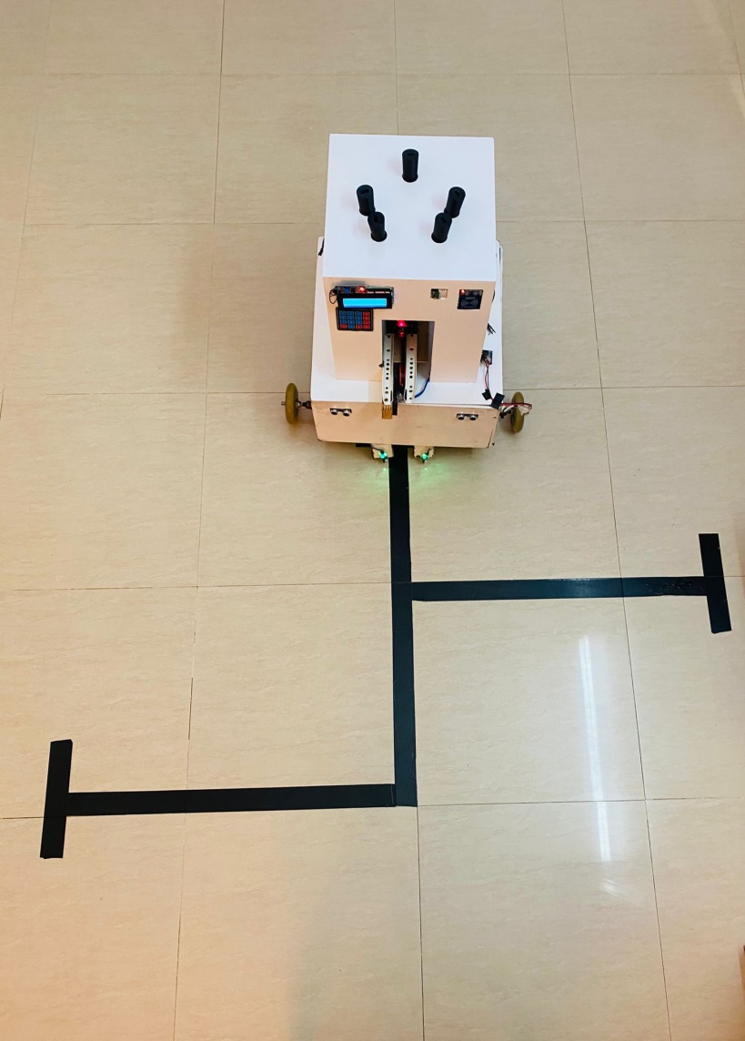
Figure 11: Final Design
Figure 12: Final Design

4.5 Mobile Application:

We developed a mobile application using App Inventor with a user-friendly interface. The application allows nurses to control the system and select appropriate functions and settings.
We used ESP32 to connect to the mobile app using Wi-Fi.
Nurse functions:
- The nurse can add a patient to the system, as there is an interface through which the patient's data can be entered. He can also modify the patient's data or delete him from the system.
- The nurse can add the medicine to the system and modify the amount of medicine in the system.
- The nurse can specify the times for distributing medicines to patients in the system.
- There is an interface to display the patient's data and also display the results of the patient's vital signs. The nurse can also easily refer to the patient's data to know which patients have taken their medicine and which patients have not taken their medicine.

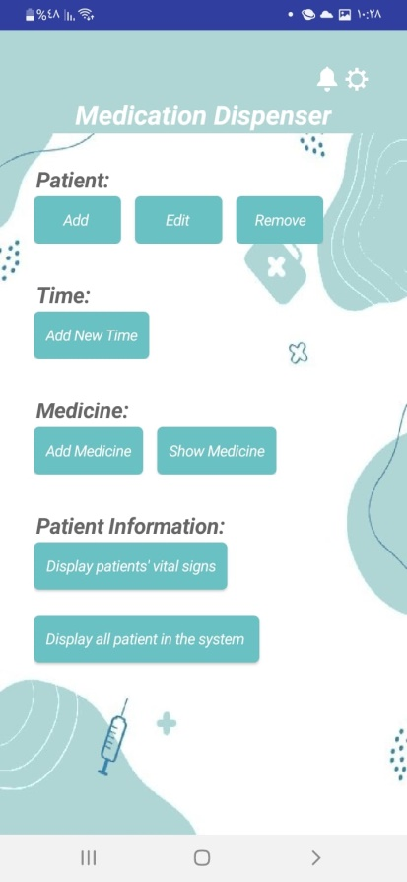
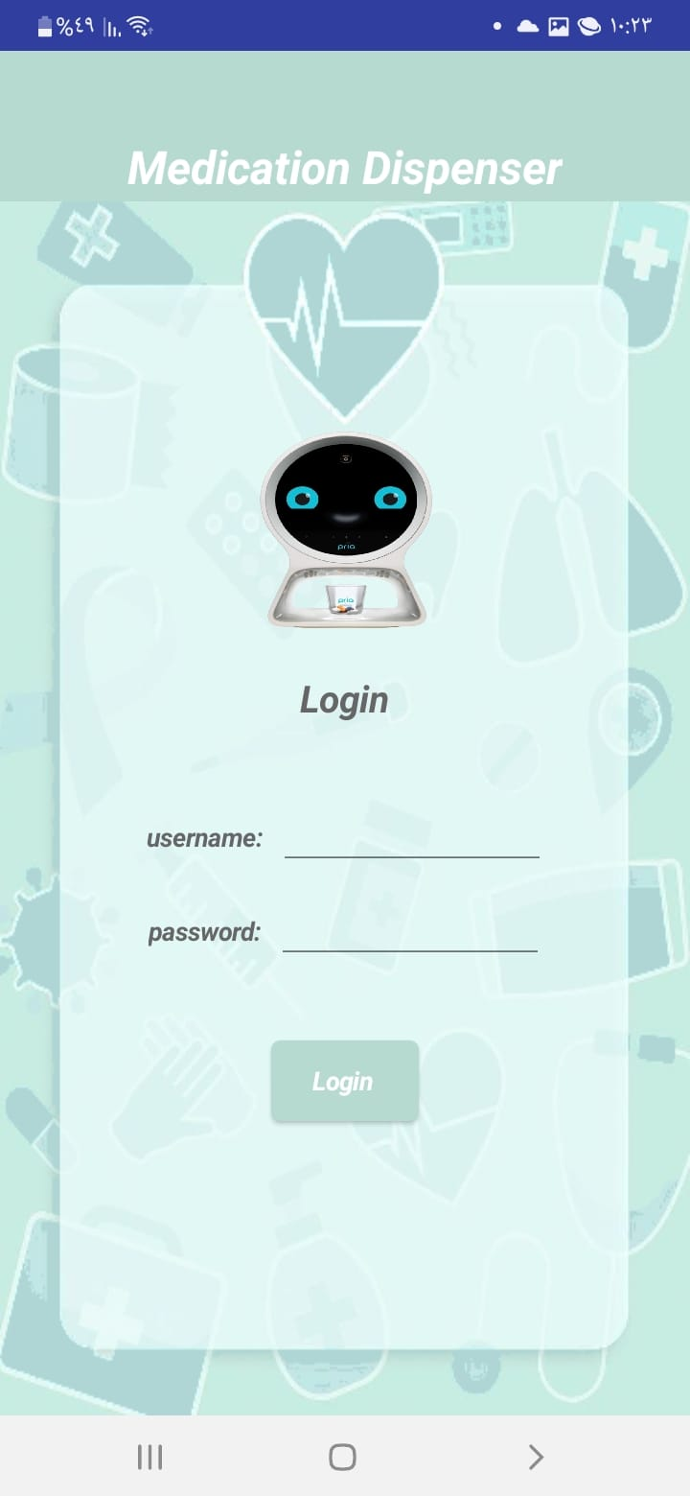
Figure 13: Home Screen
Figure 14: Login screen
- As shown in the figures the login to the system and the home page so that can the nurse navigate to other screens in the application.

- Also as shown in below in the figures the nurse can add patient, edit or remove it from the system.

Figure 13: Home Screen
Figure 12: Login screen
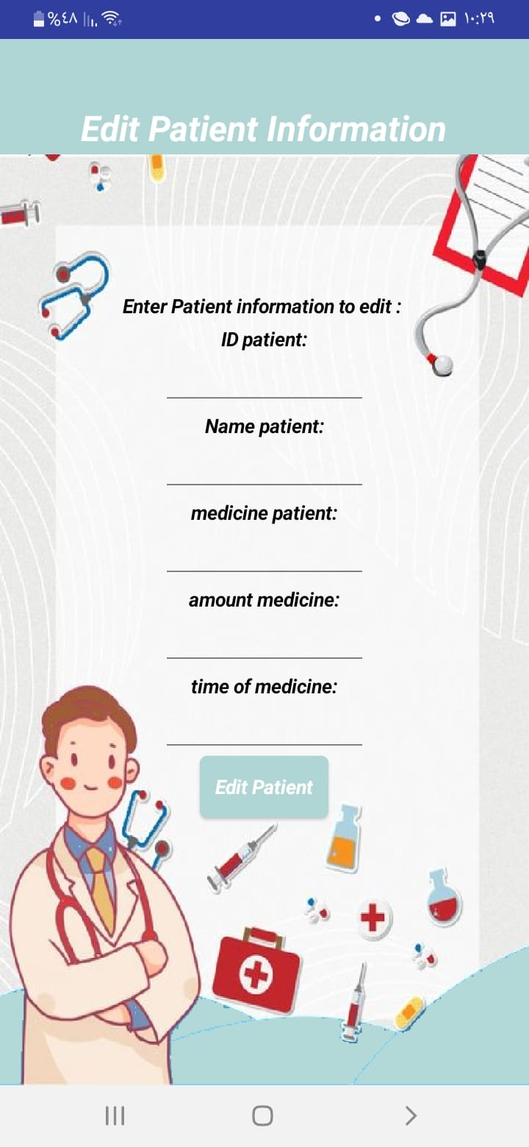
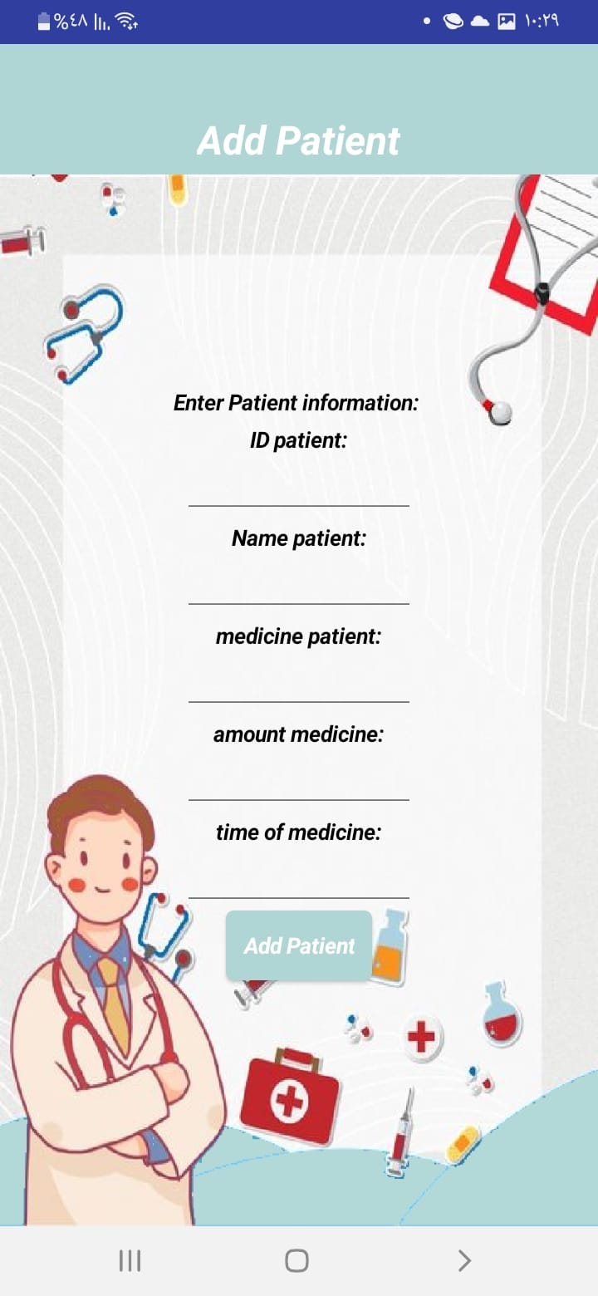
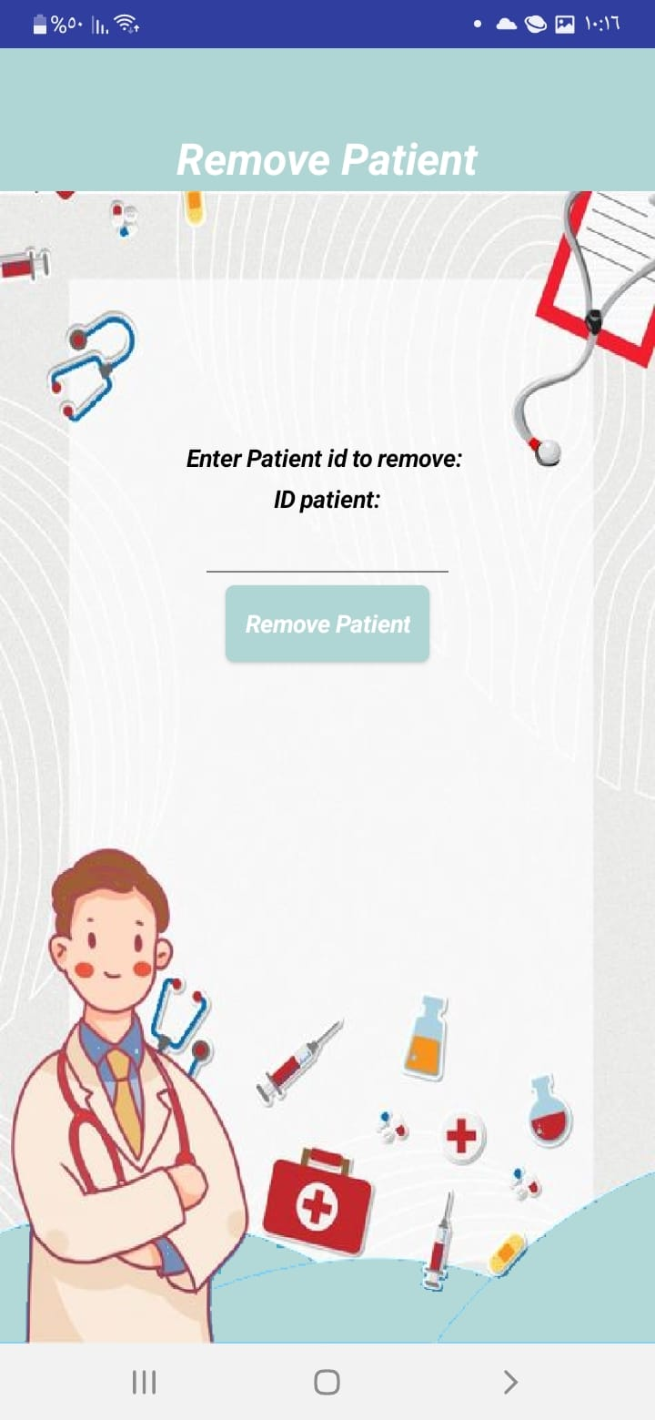
Figure 15: Edit Patient
Figure 16: Add Patient
Figure 17: Remove Patient

Figure 14: Add Patient
Figure 15: Edit Patient
Figure 16: Remove Patient
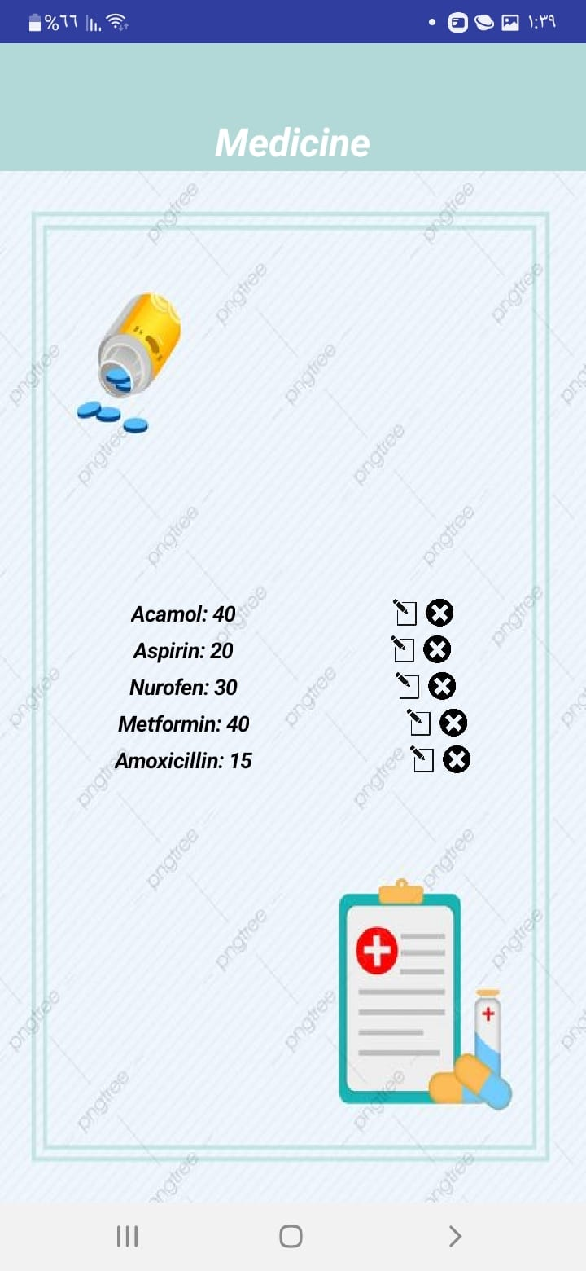
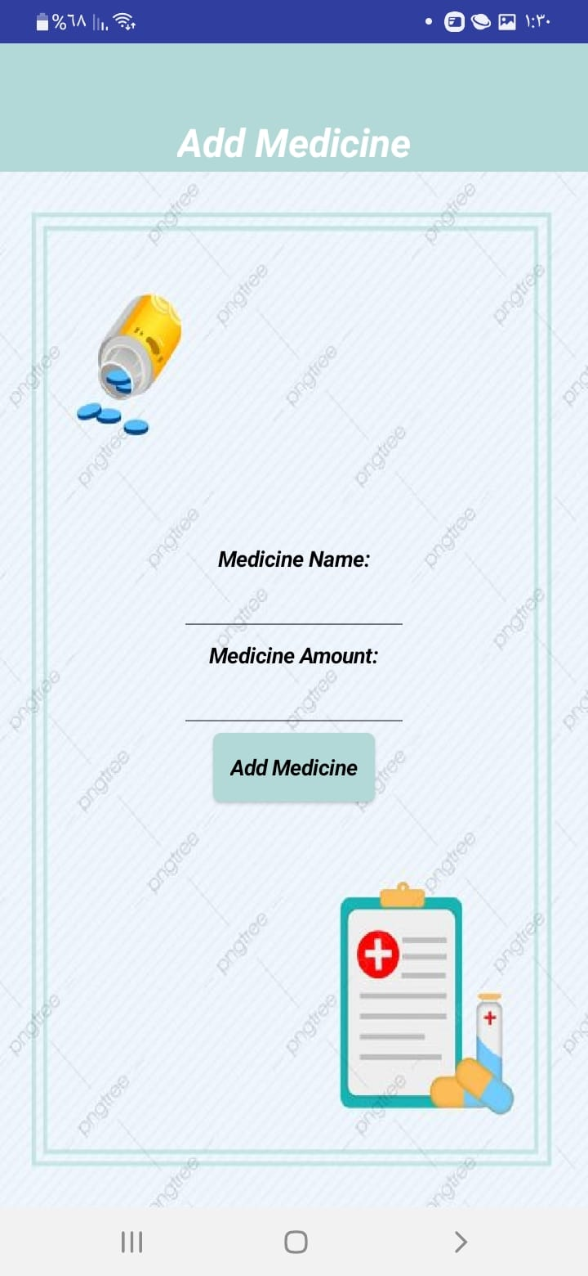
Figure 18: Show ALL Medicine
Figure 18: Show ALL Medicine
Figure 17: Add medicine
Figure 19: Add medicine
- Nurses using this screen can add medicine to the system, change the amount of the medicine, or remove it, Also show all medicine in the system.

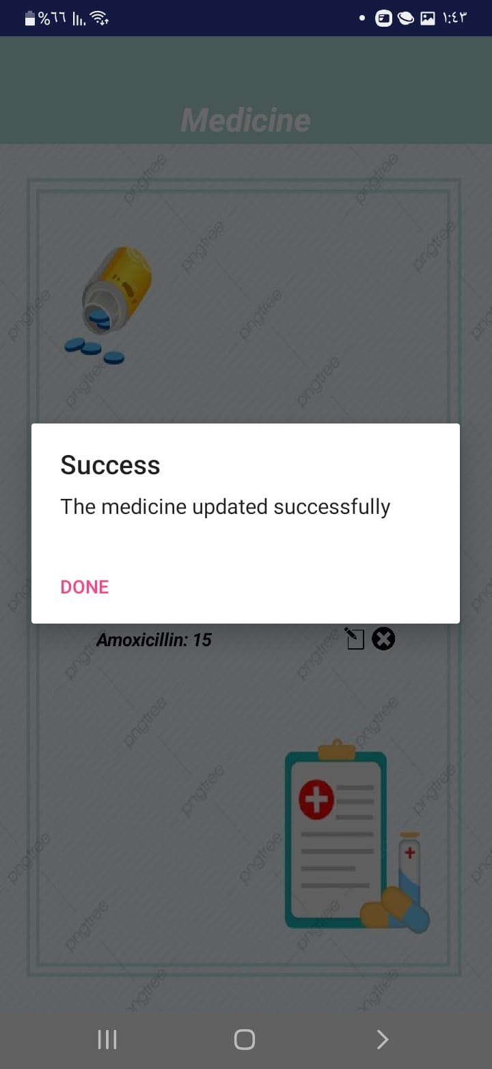
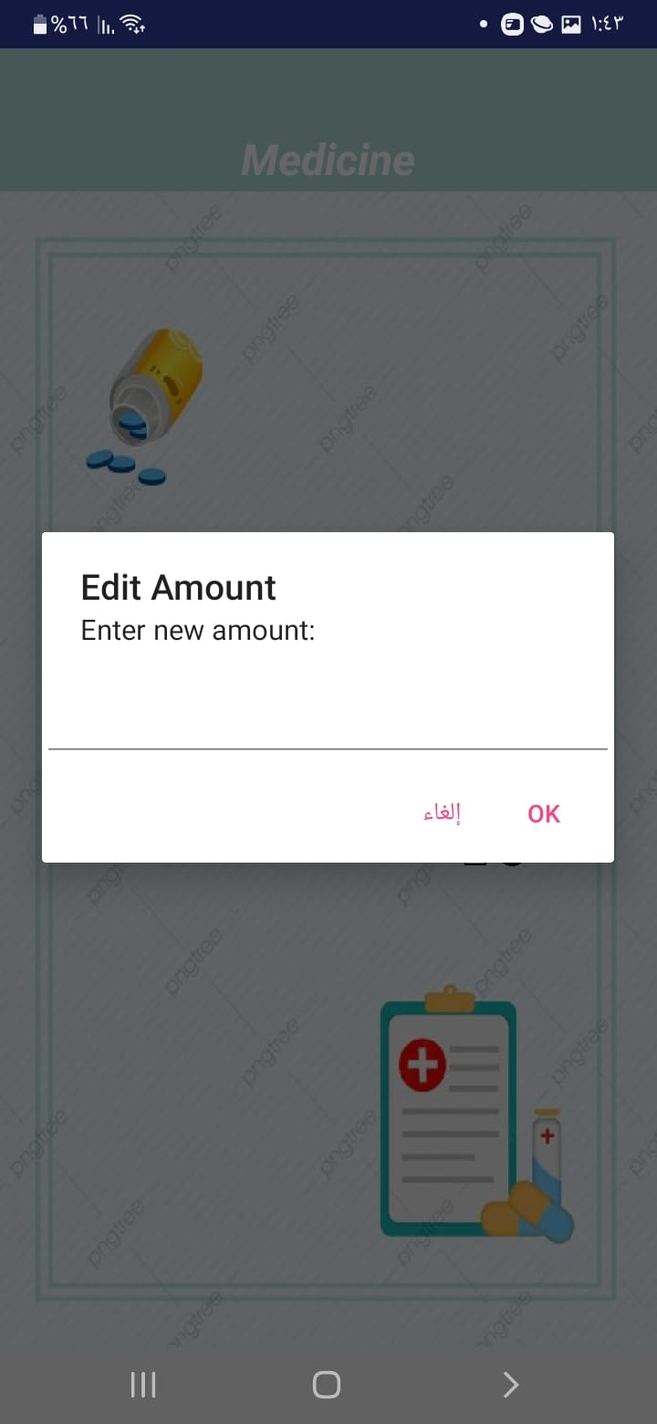
Figure 20: Edit amount of medicine

Figure 19: Edit amount of medicine

- Also, Nurses can change the time of the distribution of medicine as needed from this screen so nurses can put any time needed and can put multiple times to save it in the system to start movement according to the new time.

Before entering the necessary time to begin the drug distribution process, the nurse can select which patients he plans to distribute the medication to. The robot begins moving to deliver the drug to the designated patients at the appropriate time, as determined by the RTC.

- The nurse can choose to distribute the medication to all patients, and it will be distributed based on the data retrieved from the database. Each patient has a medication assigned to him according to his key.

- Or the nurse can choose several patients or one patient where this patient needs this dose of medication because he has appointments other than the appointments of the rest of the patients, so the medication is distributed to him at the specified time.
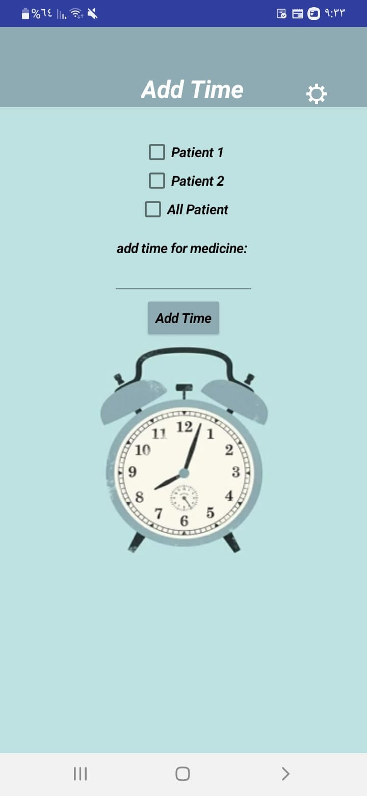
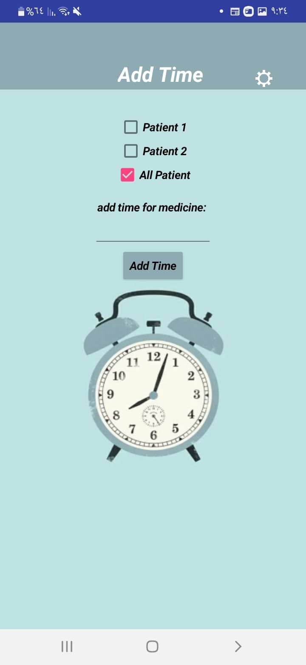

Figure 21: Add New Time for Distribute medicine.
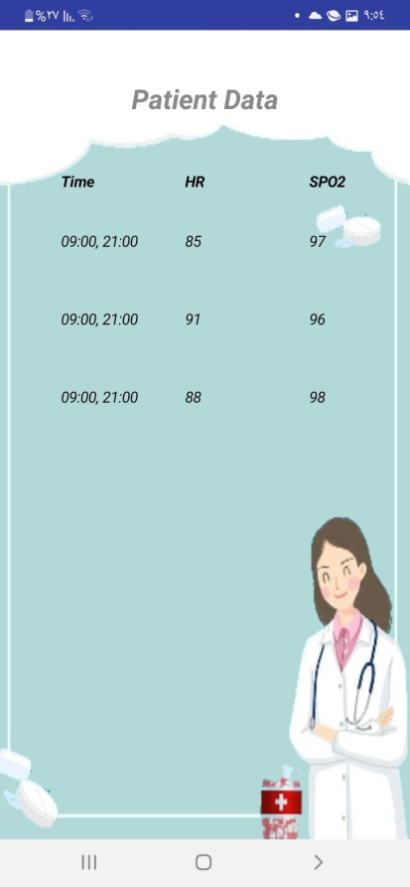
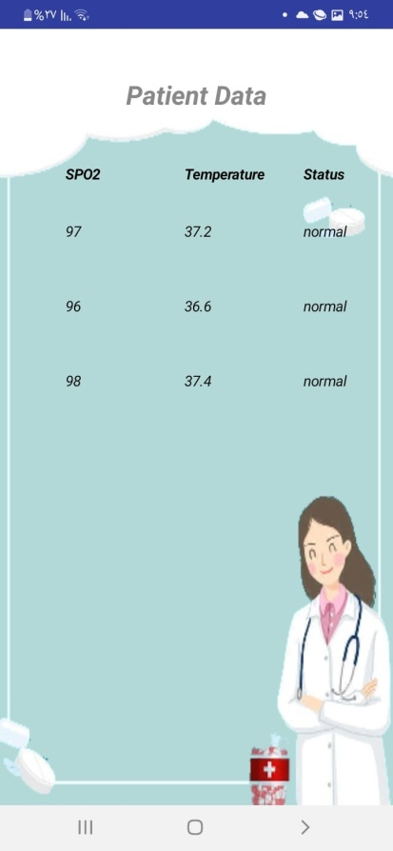
- Nurse can show the patient information :

Figure 22: Patient Information
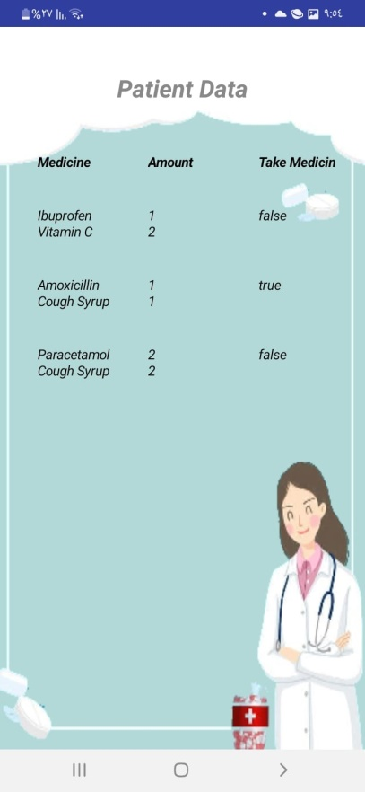
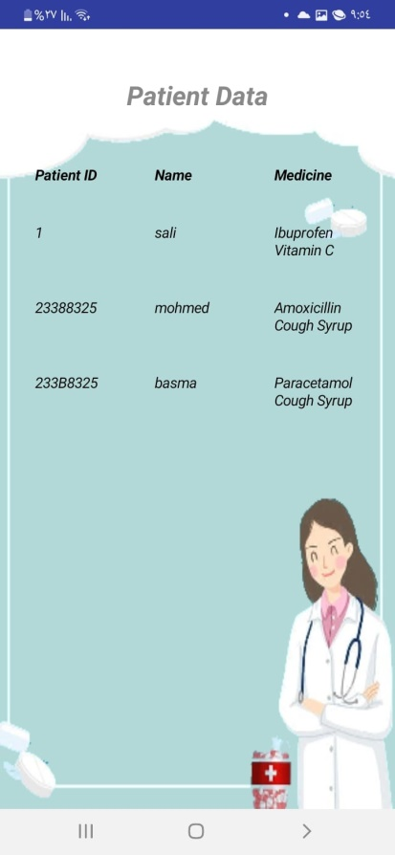
Figure 23: Patient Information Vital signs
Figure 21: Patient Information

- real-time notification system. This system will proactively notify nurses when specific events occur, rather than requiring them to manually check the system.

- When the dispenser medicine was empty then send notification to nurse to refill it again :
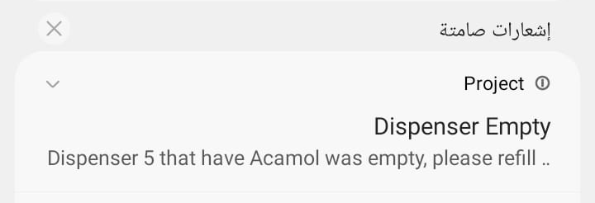
Figure 23: notification
Figure 24: notification

- The technology automatically recognizes the missing dose and promptly alerts the designated nurse when a patient forgets to take their prescription. For the system to distribute medication to other patients, the nurse is instructed to take the unneeded medicines out of the collector. For reporting and tracking purposes, this procedure is recorded in the system, guaranteeing responsibility and effective drug delivery administration.
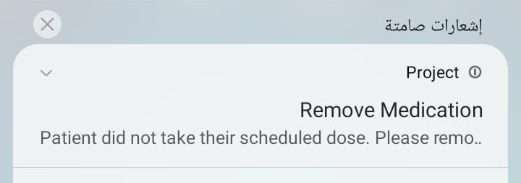
Figure 24: notification
Figure 25: notification
- When the patient has abnormal vital signs, a notification will be sent to the nurse for immediate intervention.

Chapter 5: Result and Analysis

Through tests, the robot was able to use the RTC system to deliver medications to patients on time, ensure adherence to appointments, and reduce human error, proving its effectiveness in assisting nurses and administering medications. Furthermore, patient identification with reliable RFID technology made it possible to dispense the correct medications to each patient based on database data.
The sensors used by the system to track vital signs gave reasonably accurate results that were close to the actual value.
The system testing showed that the robot’s medication dispensing mechanism achieved the necessary accuracy rate by dispensing the necessary medication in the required quantity. Accuracy was also provided by the movement system and tracking the black line through the infrared sensor. However, we noticed that it was difficult to detect the black line in low or strong lighting conditions, which was solved by adjusting the sensor location and creating a cover for it. In addition, the robot was able to operate without interruption because the system’s battery life and reliability exceeded expectations.

Thus, the project achieved its primary goals, which were to empower nurses, reduce errors, and increase the accuracy of medication dispensing.

Chapter 6: Conclusions

The project's objective of lowering human error in medication dispensing and increasing adherence to timely medication dispensing was accomplished by integrating the RTC system and RFID to identify the patient. The robot proved to be dependable in accurately dispensing medications and providing each patient with the prescribed dosage without error, which lessened the workload for nurses and improved patient care.

As a result, the project emphasizes the value of technology in the healthcare industry, how it streamlines workflow, how easy it is to apply in hospitals, and how it offers a scalable and dependable drug management system.

Chapter 7: Future Work

- Motion system: To enhance the robot's movement in congested and complex surroundings, optimize the robot's motion system and apply vision-based algorithms.

- Battery life: Take advantage of an automatic charging station to guarantee extended operating hours.

- Automated tube filling: Install a pharmacy that will automatically restock the tubes when they run out.

- Integration with the hospital system: To improve database efficiency and update patient records, connect the robot to the hospital administration systems.

- Patient touchscreen interface: To give patients a user-friendly interface.

Chapter 8: References:

Kinoshita, S., Yamaguchi, K., & Takahashi, M. (2022). Robotic dispensing systems improve safety and efficiency in medication management. Journal of Pharmaceutical Health Care and Sciences, 8(3), 45–52. https://doi.org/10.1186/s40780-022-00255-w

Momattin, H., Alrashidi, S., Rahal, M., & Hammad, R. (2021). Impact of robotic dispensing machines on patient safety and pharmacy efficiency in Saudi Arabia. Saudi Pharmaceutical Journal, 29(2), 148–154. https://doi.org/10.1016/j.jsps.2020.12.002

Al Nemari, H., & Waterson, P. (2022). Exploring the benefits of automation in pharmacy workflows: A Saudi Arabian perspective. Human Factors in Healthcare, 10(1), 33–40. https://doi.org/10.1016/j.hfh.2022.04.005

Swisslog Healthcare. (2023). PillPick automated packaging and dispensing system: Enhancing medication safety and efficiency. Swisslog Healthcare Reports, 15(2), 45–50. https://www.swisslog-healthcare.com

Parata. (2023). Max system: High-speed dispensing and adherence packaging for improved pharmacy workflows. Parata Technology Overview, 18(1), 22–27. https://www.parata.com

