

Internet over TV Band

Prepared by:
Ahmad Ali, Ma'en Mallah, Rami Haj Mohammad and Orwa Odeh

Submitted to:
Dr.Ahmed Masri

Report Submitted in Partial Fulfillment of the Requirements of Graduation Project 2 (695 90)

Departments of Telecommunication and Electrical Engineering
Faculty of Engineering
An-Najah National University

April 27th, 2013

Dedication
To
My Mother
A strong and gentle soul who taught me to trust in Allah, believe in myself and that anything is possible with hard work. No words would do you just
My Father
For being my role model in hard work, devotion and sacrifice. For all your love and support. You shine my days

My whole family and close friends
Your commitment, encouragement and support have been unwavering.

Acknowledgment
First and last, all thanks to God (Allah) for his support and blessing on us to complete this project.

We deeply thank our project’s supervisor; Dr. Ahmed Masri, who dedicated his time and expert to help us accomplish this project in the best way possible. His support and encouragement were invaluable. We are privileged to have worked under his guidance.

We would like to acknowledge the teaching assistances of the An-najah National University labs, for their assistance in enrolling lab equipment in the project: Eng. Moneer Aghbar and Eng. Nuha Odeh.

We also would like to thank Dr. Falah Hassan and Dr. Yousof Dama for their efforts, help and time they gave us, along with the staff of the Electrical and Communication Engineering Department.

Thank is due to Eng. Amr Kalboneh, Eng. Ahmad saqf Al-heit and Eng. Morad Abu Shamma for their kind cooperation and help.

Finally, we greatly acknowledge and appreciate our parents for their endless guidance, support and encouragement. Without them, nothing would be possible.
Contents
List of Figures 5
Abstract 7
1 Introduction 8
1.1 Definitions 8
1.2 Overview 8
1.3 Frequency usage in Palestine: 9
1.4 Current challenges 11
1.5 Related work 11
1.6 Motivation for Carrying out the project 12
1.7 Main Contribution 12
1.8 Report Organization 12
2 Ethical and legal Argument 13
3 Project Constrains and SWOT Analysis. 14
3.1 Strengths: 15
3.2 Weakness 15
3.3 Opportunities 16
3.4 Threats 16
3.5 Constrains 16
4 Standards 17
5 Methodology 18
5.1 Phases of the project 18
5.2 Real Field Data Measurements and Collection 18
5.2.1 Data collection 18
5.2.1 Data analysis 27
5.2.2 Data discussion 35
5.2.3 Database and Webpage 36
5.3 Software Design 40
5.3.1 Introduction 40
5.3.2 Algorithm to solve the synchronization in cognitive radio 41
5.4 Hardware Design 46
5.4.1 Introduction 46
5.4.2 Oscillator 46
5.4.3 Helical Antennas 50
6 Conclusions and Recommendations 55
6.1 Conclusions 55
6.2 Recommendations 55
7 Bibliography 56
8 Appendixes 57
8.1 Appendix A: synchronization code/main loop 57
8.2 Appendix B: synchronization code/primary_tx 59
8.3 Appendix C: synchronization code/primary_rx 60
8.4 Appendix D: synchronization code/secondary_tx 61

List of Figures
Figure ‎5.1: spectrum analyzer dimensions 20
Figure ‎5.2: Yagi-Uda Antenna 21
Figure ‎5.3: Radiation Pattern of Yaga-Uda Antenna. 21
Figure ‎5.4: west-bank map showing Nablus 22
Figure ‎5.5 :west-bank map showing Qalqilya 23
Figure ‎5.6: Deir al-Htab 24
Figure ‎5.7: Bet Forik 24
Figure ‎5.8: Qusin 25
Figure ‎5.9: Awarta 25
Figure ‎5.10: Beita 26
Figure ‎5.11: Nablus City 26
Figure ‎5.12: Hableh 27
Figure ‎5.13: Al Foundq 27
Figure ‎5.14: Jayyus 28
Figure ‎5.15: Qalqilya City 28
Figure ‎5.16: University spectrum measurement directed North 29
Figure ‎5.17: Al-Amryeh spectrum measurement directed West 30
Figure ‎5.18: Al-dowar spectrum measurement directed South 30
Figure ‎5.19: Al-Toor spectrum measurement directed North 31
Figure ‎5.20: Bet Forik spectrum measurement directed West 31
Figure ‎5.21: Sabstia spectrum measurement directed East 32
Figure ‎5.22: Sama Nablus spectrum measurement directed South 32
Figure ‎5.23: Sarra spectrum measurement directed North 33
Figure ‎5.24: Nablus Spectrum measurement, averaged over all the directions 33
Figure ‎5.25: Jayoos spectrum measurement directed East 34
Figure ‎5.26: Hableh spectrum measurement directed North 34
Figure ‎5.27: Emateen spectrum measurement directed North 35
Figure ‎5.28: Qalqilya Spectrum measurement, averaged over all the directions 35
Figure ‎5.29: signal classification according to bandwidth. From left a) <8MHz b) 8 MHz c) 100 kHz d) unclassified 37
Figure ‎5.30: website homepage 38
Figure ‎5.31: website statistics content 39
Figure ‎5.32: website map content 39
Figure ‎5.33: website Data tables content 40
Figure ‎5.34: spectrum Usage 40
Figure ‎5.35: UML dig ram representing the database 42
Figure ‎5.36: first synchronization Scenario 44
Figure ‎5.37: first synchronization Scenario 44
Figure ‎5.38: synchronization flowchart/main loop 45
Figure ‎5.39: synchronization flowchart/primary_tx 46
Figure ‎5.40: synchronization flowchart/primary_rx 46
Figure ‎5.41: synchronization flowchart/secondary_tx 47
Figure ‎5.42: Feedback oscillator circuit (9) 48
Figure ‎5.43: Two ports oscillator. (9) 49
Figure ‎5.44: Negative resistance and oscillation circuit. 50
Figure ‎5.45: Oscillation Frequency changes due to sweep voltage 51
Figure ‎5.46: Low frequency voltage drop 51
Figure ‎5.47: helical Antenna 52
Figure ‎5.48: First Antenna design 53
Figure ‎5.49: First Anetnna radiation Pattern 54
Figure ‎5.50: First Antenna return loss 54
Figure ‎5.51: Second Antenna design 55
Figure ‎5.52: Second Antenna Radiation Pattern 55
Figure ‎5.53: Second Antenna return loss 56

List of Tables
Table ‎5-1: First Antenna design Parameters 54
Table ‎5-2: second Antenna design Parameters 56

Abstract

The Palestinian rural areas suffer from lack of wired and wireless communications with no internet services provided to such areas. Therefore, we are conducting a two-phase project named "Internet over TV Band". First phase is completed, in the hope to finish the second phase in the near future. Our main objective was to form a reliable database contains real field data measurements to be relayed on in the current phase, and/or any other related projects. In addition, designs of main key hardware blocks, a (1.6-2) GHz oscillator, along with 2 antennas with different directivities are discussed. Moreover, an algorithm to be used over cognitive radio devices was written to solve the synchronization problem between primary and secondary users.

Nablus and Qalqilya provinces were chosen as a targeted area in this research project. It has been divided into regions, according to population and geography, were the measurements took place. Then, data was analyzed by plotting in several places and direction to have a clear picture of the spectrum status and results are shown. As it was expected a free spectrum was observed in most of the low altitude places. Though signals have been detected in the high altitude places, we still can safely say that the spectrum is mostly free.

Recommendations of expanding the database to comprise all of the west-bank to have the full picture of the spectrum were suggested. Moreover, after the viewing results and data specified in this report, we highly recommend moving to the second phase of the project.

Introduction

Definitions
Licensed band: no one can transmit over this band but the authorized one, which is specified by the country regulations. Reusing the band is possible in different geographical areas; as long as no interference exists.

Unlicensed band: anyone can transmit over this band under strict specifications that regulates the transmission power and covering distance, used by WIFI, Bluetooth and several other technologies.

White spaces: frequencies allocated to broadcast services but are not used. (1)

Cognitive radio: A functionality of some wireless communication devices in which either a network or a wireless node can change the devices' transmission and/or reception parameters to communicate efficiently and to avoid interference with licensed users. This alteration of parameters is based on the active monitoring of several factors in the external and internal radio environment, such a radio frequency spectrum, location information, user behavior, network state, etc. (2)

Overview
In 1950s –when the first message was successfully sent between two computers- Not even the most optimistic guy had foreseen how big the Internet will grow and how is it going to be today, With the standing fact that nobody can even foresee its behavior in the near future.

Accessing the Internet has become a life basis, a fundamental resource just like${ O}_{2}$, a man asks about the Wi-Fi password at the first chance. So we can safely say it's getting into all of us, rather we like or not. Amount of Data Stored and Accessed every day is astonishingly enormous.

The Internet is growing rapidly and the handled data volume is exponentially increasing. Moreover, the world is now moving toward centralization of all data storage units and services servers with what is called cloud computing, computers will only display results with no need to have big processors or huge storage volumes since all of this is being done on super servers for all. Thus, the need of a big bitrates to tolerate such communications is arising quickly.

Finally, it is a must to emphasize of who and where we can access such a huge network, not only people living in places where cables are available or where a phone network exists, and not only for those who can afford to establish an internet connection through satellites. However, people living in rural areas or even remote areas should be able to access internet under low cost with sufficient bitrates to what they need. So, somebody will have to provide that.
To provide such services, it is suggested to exploit the white space -unused frequency in the TV band- with the concept of cognitive radio to broadcast in the licensed and unlicensed frequencies. All of this is due to that fact, that these frequencies are poorly exploited in Palestine which is a huge resource to make use of. Besides, they are considered as low frequency carriers, which gives it immunity against attenuation and obstacles and can travel long distances, which makes it suitable for such kind of services.

Frequency usage in Palestine:
It was among the things that have been identified and clarified by holding the Oslo's agreement is to determine what the allowable frequencies used by the Palestinian side. Among the frequencies granted to the Palestinian National Authority are:
1. Cellular Frequencies:
Palestinian cellular communications companies are using the GSM system
Jawwal Company uses a system GSM 900 with the following characteristics:
Uplink: 880-915 MHz
Downlink: 925-960 MHz
Transmission rate = 270kbps
Number of Channels = 175

Wataniya Mobile Company uses both systems, 900 and 1800
The characteristics of the system GSM 1800 is as follows:
Uplink: 1710-1785 MHz
Downlink: 1805-1880 MHz
Transmission rate = 270kbps
Number of Channels = 373

With the continuous development in the world of communications and technology, the two companies are racing to develop their network and provide 3G services, but obstacles and constraints imposed by the Israeli occupation authorities stand without realizing it.

- Radio Frequencies:
Palestinian radio channels broadcast at different frequencies depending on the type of modulation whether AM (Amplitude Modulation) or FM (Frequency Modulation):
The Amplitude Modulated (AM radio) carrier frequencies are in the frequency range 535-1605 kHz. Carrier frequencies of 540 to 1600 kHz are assigned at 10 kHz intervals.

The FM radio band is from 88 to 108 MHz between VHF television Channels 6 and 7. The FM stations are assigned center frequencies at 200 kHz separation starting at 88.1 MHz, for a maximum of 100 stations. These FM stations have a 75 kHz maximum deviation from the center frequency, which leaves 25 kHz upper and lower "gaurd bands" to minimize interaction with the adjacent frequency band.
For example:
Nablus Radio FM 93.5, Voice of Jerusalem - Quds Radio (102.7 FM) Gaza, Radio Bethlehem 2000 (89.6 FM), Quran Radio (96.9 FM)
- Local television frequencies:
A broadcast band is a segment of the radio spectrum used for broadcasting, which contains both VHF and UHF bands for the purposes of terrestrial television broadcast:
- VHF (Very High Frequency): Is the set of radio frequencies that belong to the domain between 174 MHz to 216 MHz.
- UHF (Ultra High Frequency): Is the set of radio frequencies that belong to the domain between 470 MHz to 806 MHz.
As mentioned previously as a result of the Oslo's agreement Accords granted the Palestinian National Authority six channels for the purposes of local broadcast. Moreover, a committee was formed from both sides for licensing purposes. But, since this committee was formed it did not license any terrestrial channel. Due to the inadequacy of the six channels, the Ministry of Communications and Technology grant the Palestinian people, wishing to establish a local TV station, frequencies without returning to the committee and the Israeli occupation.
For example:
Nablus TV (VHF 12), Rowad TV (UHF 33), Gama Tv (UHF 30).

Until relatively recently, all television broadcasting in Palestine employed analogue terrestrial transmission networks, and all household television receivers were analogue-based. To our knowledge, it is expected by the end of 2015, all broadcasters' analogue system will turn to digital system.

Digital technology allows the transmission of more information over a given bandwidth than can be achieved with analogue technology. With ‘standard definition television’ (SDTV), ten digital TV channels can replace one analogue TV channel, and with ‘high definition television’ (HDTV) at least two digital TV channels (with residual capacity for some further SDTV channels) can be substituted. (3)

The objectives of the transition from analogue to digital services are: (3)
- To release spectrum for allocation to new broadcasting or other uses (for example, mobile applications or broadband wireless access).
- To facilitate re-planning of the UHF spectrum band for greater efficiency and to encourage new broadcasting entrants.
- to enable cost and energy savings to be realized by terminating the requirement for simulcast transmission in analogue and digital formats; and
- To enable consumers to determine their long term reception equipment needs, by minimizing confusion about the implications of analogue switch-off.

Current challenges

The key challenges that we are focusing on and trying to find a solution for can be summarized as follows:
- Providing a reliable database that contains real field frequency usage of the TV spectrum in Palestine, containing Nablus and Qalqilya provinces.
- Transmit wirelessly over TV band channels.
- Offering cheap broadband internet services with high bitrates.

Our research project has been divided into several phases. During this current phase we have implemented the web-based database and fill it with extensive real field measurements data from the TV spectrum. Moreover, we have designed and simulated some blocks of the total communication system model.

Related work

From one hand, there is no such relevant work in Palestine; accordingly, our project is considered a pioneering work on the national level. From another hand, several similar projects have been carried out all around the world by famous research centers, such as, Google's project in Africa and Microsoft research center (4).

Back in 2008, Google proposed tapping into unused television broadcasting frequencies called "white spaces" to push Internet access to rural areas in the United States where getting such service was difficult and expensive.

Now Google is proposing a trial white space project in South Africa where the company wants to see if it can use the same idea to bring Internet access to more communities inside the developing nation.

"White spaces are unused channels in the broadcast TV spectrum," wrote Fortune Mgwili-Sibanda, the public policy manager for Google South Africa, in a March 25 post on the Google.org Blog. "They offer the potential to improve Internet connectivity where they are most needed—in the developing world. Today we're announcing the launch of a trial with ten schools in the Cape Town area, which will receive wireless broadband over a white space network."

One advantage of using white space is that its low frequency signals can travel longer distances than other broadcast signals, wrote Mgwili-Sibanda. "The technology is well suited to provide low cost connectivity to rural communities with poor telecommunications infrastructure, and for expanding coverage of wireless broadband in densely populated urban areas."

Motivation for Carrying out the project

The following are our main motivations behind conducting the project:
- The TV band is parley exploited in Palestine.
- Palestinian operators do not support 3G or higher communication schemes.
- The huge growth in internet usage in Palestine demands new solutions for broadband internet services.
- In 2015, the digital TV transition will be completed by the ministry of Telecommunication, which means extra free space in the TV band will be available.

Main Contribution

This project contribution is four folds:
- Developing the real field TV spectrum usage database and provide it as online service for monitored public access and analyze the data.
- Design and simulation of a tunable oscillator which generates a sine frequency in the range of 1.6 to 2 GHz.
- Design helical antennas which covers the targeted spectrum (400-800Mhz) with an enough gain to cover a long distances.
- Implementing and simulation of cognitive radio algorithm to solve the syncronization problem.

Report Organization

This report has been organized as follows, first, there is a quick overview to define the problem and why we turned to the suggested solutions. Afterwards, ethics, SWOT analysis along with project constrains and budget estimation are briefly discussed, followed by the methodology of the project and specific data collection, analysis and discussion. Moreover, implementation a cognitive radio algorithm to solve synchronization problem is introduced. On the other hand, this report contains the design and simulation of hardware components, oscillator and two antennas to be used in the implementation phase. Finally, there are a brief discussion, conclusion and recommendations.

Ethical and legal Argument

We are implementing the cognitive radio technique, which as mentioned earlier senses the spectrum and utilize it, using whitespace, licensed and unlicensed frequencies. Regulations for using such frequencies are not present in Palestine. Because of this we will consider the global regulation and standards supplied by the IEEE association:
- IEEE 802.22™-2011 : Standard for Local and metropolitan area networks - Specific requirements - Part 22: Cognitive Wireless RAN Medium Access Control (MAC) and Physical Layer (PHY) specifications: Policies and procedures for operation in the TV Bands.
- IEEE 802.22.1™-2010 : IEEE Standard for Local and Metropolitan Area Networks - Specific requirements Part 22.1: Standard to Enhance Harmful Interference Protection for Low-Power Licensed Devices Operating in TV Broadcast Bands.
- IEEE 802.22.2™-2012 : IEEE Recommended Practice for Information Technology - Telecommunications and information exchange between systems Wireless Regional Area Networks (WRAN) - Specific requirements - Part 22.2: Installation and Deployment of IEEE 802.22 Systems.
The ministry of communication has some conservation regarding the online database since it is afraid that some people will misuse the information and start broadcasting without the knowledge of the ministry. Moreover, the ministry is poorly equipped to find such illegal transmissions and pursue responsible people.

According to Oslo's agreement a joint commission from both Palestinian and Israeli side is formed to allocate the frequencies and give using licenses but this committee has never gave any license but the one written in the agreement for the "Palestine TV". So the ministry allocate frequencies and sell licenses on its own without getting approval from the committee, the picture is unclear which rises question about is it legitimate or not, and whether allocation such frequencies for Internet would cause problems.

Due to the political situation of Palestine in general and west-bank in Particular, we would like to mention that it was a big risk to take measurements since it is not allowed for people to purchase such devices i.e. spectrum analyzer, and the university was able to purchase one under the restriction that it will be only used for academic purposes and teaching but not actual measurements. Precautions were made to avoid getting arrested; places near settlements and army camps were avoided. Although it's legal to measure spectrum usage but charges like spying can be held against us.

Project Constrains and SWOT Analysis.
- Political and occupational restrictions
- It is difficult to determine the origin and the type of signals we have detected.

- Professional well-trained team.
- The results of this project is a valuable resource for researchers, companies...etc
- The real TV spectrum usage database is the first of its type in Palestine
- Well equipped.
- No competitors in this field.

SWOT Analysis

Opportunities Threats

Strengths
Weaknesses

- Absence of rules and regulations about channels allocation.
- Occupation.

- Existence of free spectrum for utilization.
- The absence of broadband internet services in rural areas.
- Switching to digital TV, this will free up more spectrum to be used.

Strengths:
  - Project was conducted by the well-trained students Ahmad Ali, Ma'en Mallah, Orwa Odeh, and Rami Haj Mohammad; who have solid background in communication, wave propagation, Antennas and measuring devices and electronic circuit design. In addition, the project is supervised by doctors specialized in relevant fields having done researches about cognitive radio and exploiting the white space.
  - To our knowledge, we are the first to establish a reliable database since to the moment this report was conducted none exists. Moreover, the ministry has weak information about spectrum usage since no measuring devices are in its dispose. The present information obtained from the ministry includes only the licensed channels and their power of transmission with no clue of the covering distances. On top of that, the ministry does not have any information about the undesired side loops transmissions or wrong filtration processes that yield larger bandwidth. Therefore, a database construction is essential for users; as it can be used by the public to view the existing channels in each area. It can also be used by broadcasters who desire to choose a suitable frequency. The ministry can also benefit from it to handle licensing, and most importantly it gives a head start for new technologies to be implemented such as cognitive radio.
  - We are supported and equipped with the spectrum analyzer and Yagi Uda antenna supplied by the labs of An-najah National University. That was a great advantage considering it is extremely difficult getting such devices through customs into the west-bank. Moreover, we might need to purchase and import other electronic devices and doing this through university saves time, money and hard work.
  - Even though 3G licensing might be obtained and telecom companies start to provide 3G services in the future, this doesn’t constitute a threat to our project, since the services will be implemented with good reliability, low cost and high data rates exploiting the unused spectrum.

Weakness
  - It's hard to specifically determine the origin of all the signals detected on the spectrum analyzer. Some are identified as TV signals, others could be unknown transmission from the Israeli side and others remain totally unknown.
  - On the phase of system implementation and construction, we expect to face problems importing the equipment and system parts since some known telecom companies have equipment trapped at costumes for more than two years now.
  - Choosing the location of our broadcast points for the cells will be relatively problematic, because of the west-bank geography and the land classifications according to Oslo's agreement, which allows the Palestinians to build on "A" lands only. Which is not the case for lots of the lands

Opportunities
- The TV spectrum is poorly exploited; which leaves lots of unused frequencies that can be utilized.
- The Infrastructure in wired communication of rural areas is poor. Moreover, switching to wireless communication is not yet possible, since 3G technology and services are not yet provided. Therefore the best solution, in our opinion, is exploiting the spectrum of TV band, and providing the internet services using the TV frequencies and cognitive radio technique by exploiting the white space.
- Similar to every country, Palestine has future plans to move to the digital TV; which will provide an extra spectrum for broadcasting when all TV channels are compressed. So, there will be no protection for analog TVs anymore.

Threats
- There are no clear regulations regarding the use of the frequencies. In addition, the ministry does not have authorities to give licenses for spectrum usage due to occupation obstacles. So we might not be able to transmit over empty spectrum for no apparent reason.
- Occupation is the biggest threat to our project, starting from importing equipment, its installation and spectrum usage. There are never ending harassments made by the Israeli side just to make the Palestinian existence harder.

Constrains

  - Imposed by the ministry of communication, the Database can’t be publically accessed, which imposes the use of login methods to monitor the viewing of the Database results.
  - Precise power control and channel access have to be done on the cognitive radio devices, to obtain values below the IEEE standards thresholds of interference.
  - Some hardware components are not available in the Palestinian market and may raise flags while chipping them in. Moreover, some of the mounting and implementation techniques need can’t be done here as well, which require us to manufacture some hardware components, even for testing, outside Palestine.
  - Constrains are imposed over chosen the broadcasting points in which transmission of broadband Internet will occur. These constrains are due to the existence of the Palestinian-Israeli conflict over the Palestinian land with the existence of agreements governing these issues, in addition, the terrain and geography have a considerable impact in the chosen criteria since west-bank is rough area, which makes it harder to estimate channels that wide open areas.

Standards

- All of the Number in this report follows the International standard (SI) unit system.
- For power representation, dBm and watt units were used. The dBm have a reference of 1mw, 1mw=0dBm, this scale is used in radio, microwave and fiber optic networks as a convenient measure of absolute power because of its capability to express both very large and very small values in a short form.
- The power tables in the database were converted to dBm/Mhz where it makes it easier to compare between different signals by having the same quantity to be valued through.
- For coordinates, the decimal format of presentation was used for GPS longitude and latitude obtained for each location.

We are implementing the cognitive radio technique, which as mentioned earlier senses the spectrum and utilize it, using whitespace, licensed and unlicensed frequencies. Regulations for using such frequencies are not present in Palestine. Because of this we will consider the global regulation and standards supplied by the IEEE association:
• IEEE 802.22™-2011: Standard for Local and metropolitan area networks - Specific requirements - Part 22: Cognitive Wireless RAN Medium Access Control (MAC) and Physical Layer (PHY) specifications: Policies and procedures for operation in the TV Bands.
• IEEE 802.22.1™-2010: IEEE Standard for Local and Metropolitan Area Networks - Specific requirements Part 22.1: Standard to Enhance Harmful Interference Protection for Low-Power Licensed Devices Operating in TV Broadcast Bands.
• IEEE 802.22.2™-2012: IEEE Recommended Practice for Information Technology - Telecommunications and information exchange between systems Wireless Regional Area Networks (WRAN) - Specific requirements - Part 22.2: Installation and Deployment of IEEE 802.22 Systems.

Methodology

Phases of the project

This is a several-phase project. The first phase was conducted; in which the Real Field Data Measurements and Collection were done, Hardware Design (Oscillator) was completed, and Design of a helical antenna, and algorithm for cognitive radio devices to solve synchronization problem was implemented and tested in simulation. The next phase will be carried out in which, we will implement a real Digital Video Broadcasting system using the Universal Software Radio Peripheral (USRP) which is an inexpensive hardware platform for software radio, and is commonly used by research labs and universities. Thus, the methodology followed consisted of two parts in this phase, which will be discussed in details.

Real Field Data Measurements and Collection

Data collection

Introduction
Our first outcome of this project is to form a clear picture of the spectrum usage status and whether it can be used for internet providing services or not. Moreover, it is essential to construct a clear database of real field measurements to be used for the upcoming phases and several other important applications. In order to do that, Nablus province were chosen as our targeted area to have real field measurements which will help forming a good picture of the spectrum status and then we expand our measurements to include another area Qalqilya city. To achieve that, points were chosen and measured using devices granted by An-najah National University. Moreover these measurements were analyzed, discussed and stored in a database as outcome of this phase.

Equipment

For this phase of the project we have used spectrum analyzer and a Yagi Uda Antenna with the following specifications.

Handheld Spectrum analyzer

The Handheld Spectrum Analyzers are high-performance spectrum analyzers providing excellent performance and functions perfect for many different applications. It is a compact, lightweight and inexpensive unit. (5)

We have used the handheld spectrum analyzer manufactured by BK precision model number 2650 with the following specification (5):
- Frequency ranges between 50 KHz-3.3GHz.
- Units : dBm,dBV,dBmV,dBμV,dBμV/m,dBμA/m
- Input impedance : 50Ω
- Input VSWR : less than 2.0
- Display Scale : 10dB/div,2dB/div
- Input Damaged level : +23dBm
- Input marker : SMA
- Communication interface : RS-232C
- Baud rate:2400 to 38400 bps
- Display : LCD
- Resolution : 240(V) *320(H)dots
- Battery : works for 120 minutes
- Weight : approx.1.8kg(include battery)
- Dimensions :
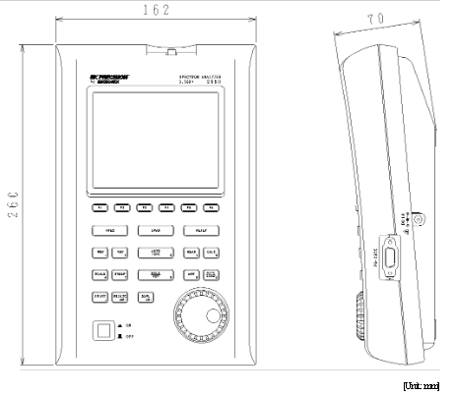

Figure ‎5.1: spectrum analyzer dimensions

Yagi-Uda antenna

The handheld spectrum analyzer has its own antennas but none were suitable to measure the whole targeted spectrum from this project. So, we have used the Yagi-Uda antenna manufactured by lab-volt.
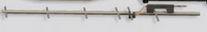
Figure ‎5.2: Yagi-Uda Antenna

Upon contacting lab-volts, as manufacturers of the training set number 8092 which includes the Yaga-Uda antenna we have used, we were able to obtain this information:
- Operational Frequency: 915 MHz
- SWR: < 2
- Gain:9to 10 dBm typically
Moreover, to have a clearer view of the antenna and the directivity we have plotted the radiation pattern for the antenna
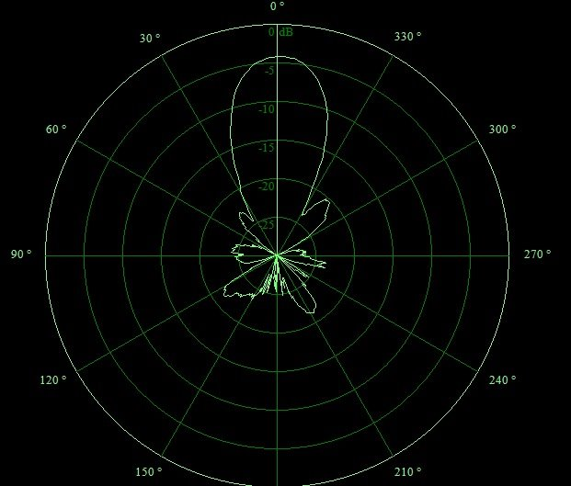
Figure ‎5.3: Radiation Pattern of Yaga-Uda Antenna.

Localization criteria
For our research project we chose the Nablus and Qalqilya provinces as our targeted area. Nablus is considered to be a good example of which we can have a clear picture of the spectrum status in West-Bank. Because, it is the second largest city in the West Bank, as well as the nature of the unique geographical location; it is located between the summits of two mountains, Ebal and Gerizim. In addition to this that, there are many villages of this city from north to south and from east to west constitutes a good source to form a good idea about spectrum status and the extent of coverage of the City.

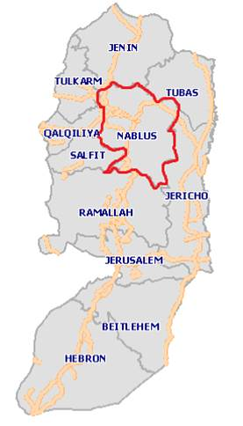
Figure ‎5.4: west-bank map showing Nablus
After we have chosen the Nablus province, we have divided it into two main parts. On one hand, the first part consists of the villages surrounding the city, which were divided into four categories according to location from Nablus city, South, West, North, and East. On the other hand, the other part contains the city itself and within existing neighborhoods.

Moreover, Qalqilya province was chosen in order to strengthen and expand the database, having a more detailed picture about the spectrum. In addition, although the province is a medium sized province but is situated on the border fully with the Israeli side and besieged from all directions, and this helps to identify the larger extent of the impact of the Israeli side on the spectrum status.

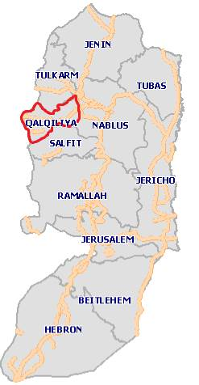
Figure ‎5.5 :west-bank map showing Qalqilya
The same criteria in dividing Nablus were conducted to divide Qalqilya.

Our selection of points of measurement was based on several things:
- The number of measurement points taken in each region was based on the area and population, one point was enough for some regions which were small enough, while in the larger regions we needed two points each, and some needed three.
- The locations of the points in each region were chosen by the personnel taking in consideration :
  - First point should represent the majority of the population. So, points at the center of the villages or the most accommodated areas were chosen. Some big regions needed two points to cover the population.
  - Second point, if chosen, has to be high enough with level difference of the first one, because it's a good candidate to be cell center and it receives more signals with larger power due to the height difference.

For better and cleared view we listed some examples from each region:

- Deir al-Hatab:
The village of Deir al-Hatab is located to the east of the city of Nablus, away from Nablus about 4 km, with a population of about 2500 people.

After considering the nature of the geography of the village we found that taking a single point in the middle will give a good impression of the nature of the frequencies in the village. Moreover, this point took place in the locality of the village and has a height close to the highest point in the village.

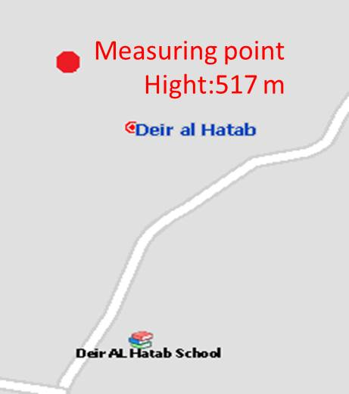

Figure ‎5.6: Deir al-Htab

- Bet Forik
The village of Bet Forik 7 kilometers east of the city of Nablus, with a residential area of ​​18 Km2of , reaching a population of 11740 people in 2013.

Because of the divergent distribution among the population in the village, there is a need to take more than one point of measurement, the first was in the middle of the village where inhabiting the majority of the people of the village and the second was at the highest point in the village, where the views of the various neighborhoods.

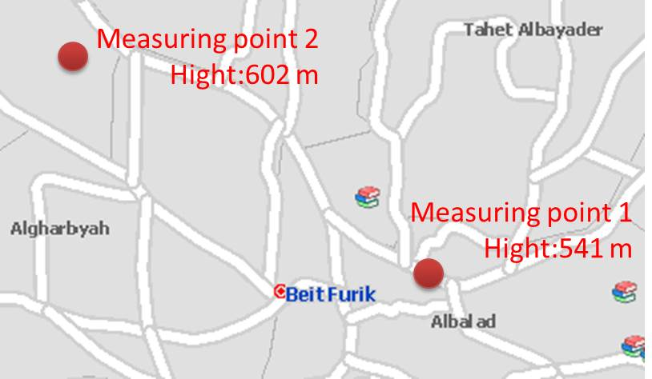
Figure ‎5.7: Bet Forik

- Qusin
Qusin is Located about 8 kilometers west of the city of Nablus, and has an area of ​​18 Km2, and a population of about 1940 people.

Due to the small size of this village, we snapped one measurement point in the highest point in the village, so that was overlooking the locality biggest in the village.
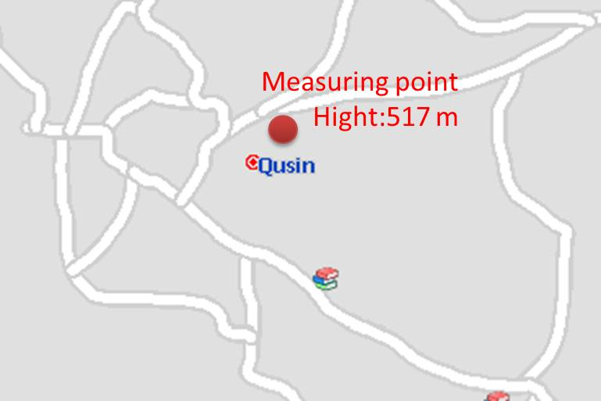
Figure ‎5.8: Qusin

- Awarta
Located about 8 kilometers to the south of the city of Nablus, and has an area of ​​65 Km2, with a population of about 6385 people.

We snapped one point in the middle of the village so that they cover the largest conurbation in the village and at a convenient height.

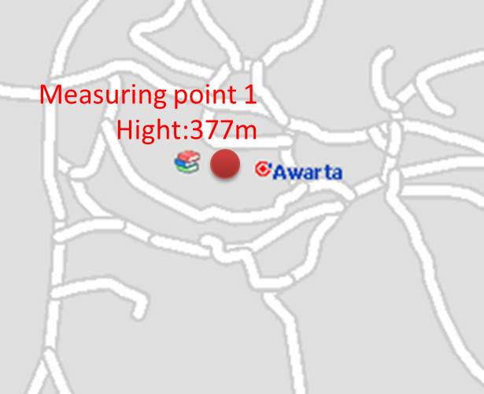
Figure ‎5.9: Awarta

- Beita
Located about 14 kilometers to the south of the city of Nablus, it has an area of ​​84 Km2, with a population of about 10310 people.

Due to the large area of ​​the village and the big difference in height between the center of the village and the highest point, we snapped a measurement point in the middle of the village at the center of locality, and another point at the top of the area to cover most regions.

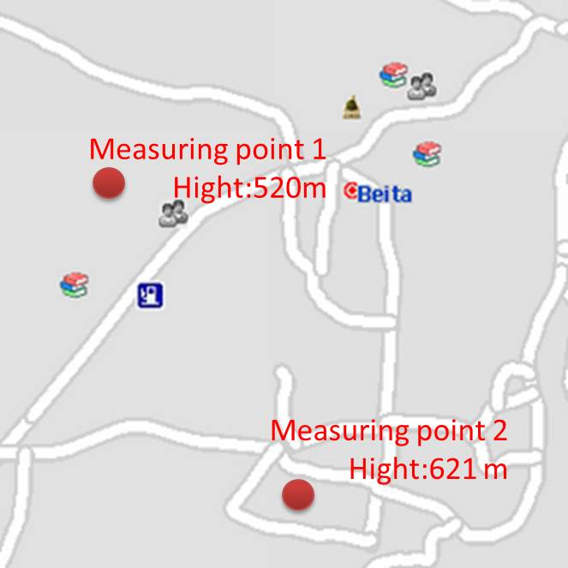
Figure ‎5.10: Beita
- Nablus city
The Strategy did not differ for the city, but with more points to cover the populated areas. 11 points have been taken in the city, in which some were at the summit and others were in the populated. Moreover, when choosing the points we tried to cover as much as residential areas as possible; most of the areas can be viewed from the chose points.
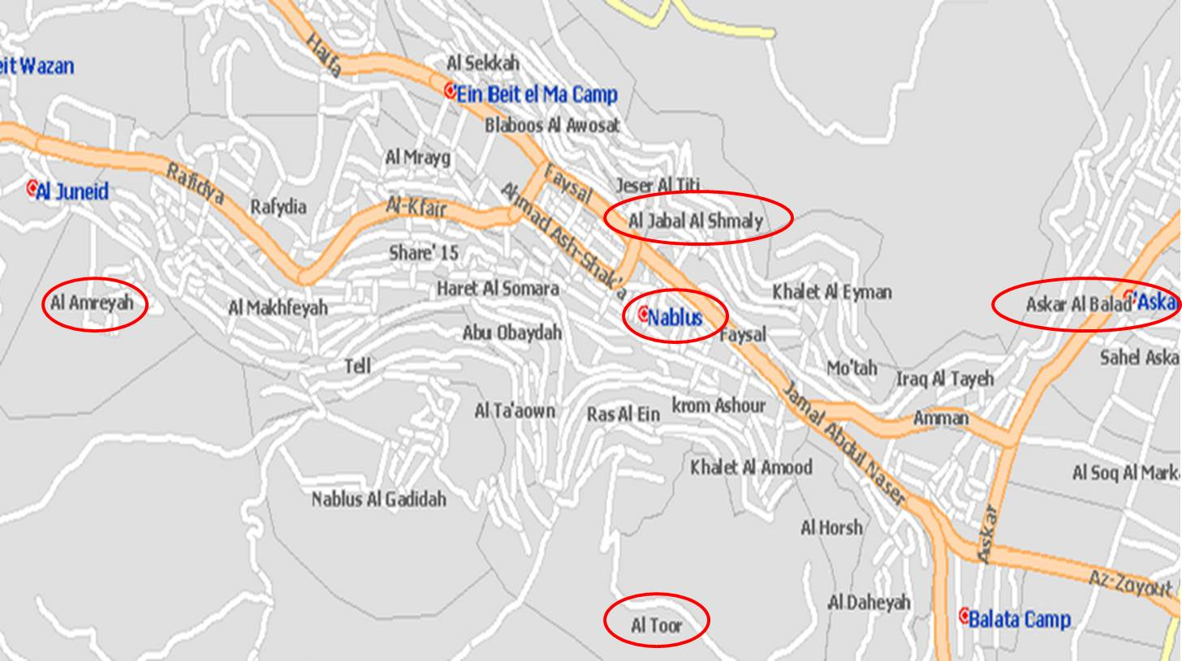
Figure ‎5.11: Nablus City

- Hableh:
Located 3 Km to the south of the city of Qalqilya, has a population of 6,500 people. Hableh is one of the biggest villages in Qalqilya province, thus two different locations were measured, one in the center of village and the other in one of highest point in Hableh.
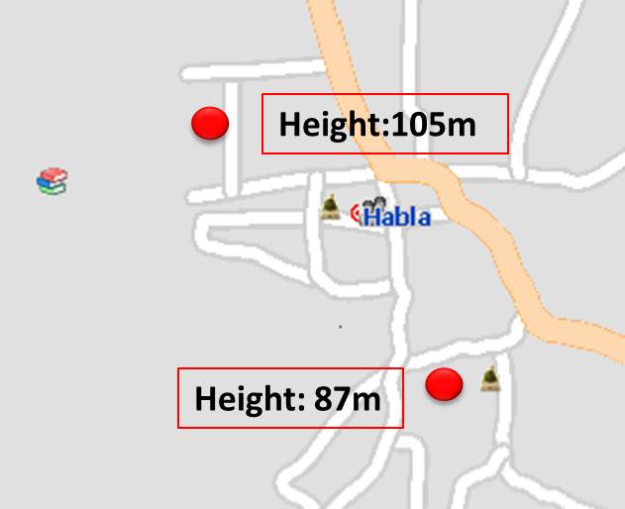
Figure ‎5.12: Hableh
- Al Fondoq:
Is located south-west of Nablus, at a distance of 17 km. It is small village, thus, one point. was chosen.
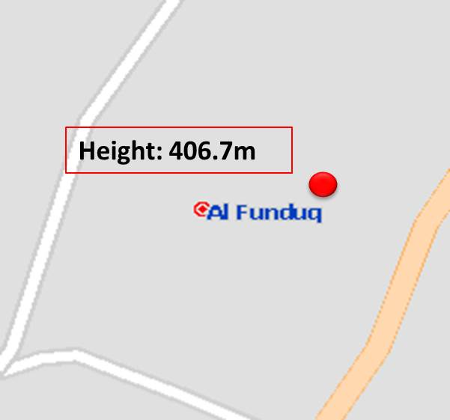
Figure ‎5.13: Al Foundq

- Jayyus:
Located north of Qalqilya, about 12 km and a population of up to 6000. After considering the nature of the geography of the village we found that taking a single point in the middle will give a good impression of the nature of the frequencies in the village.
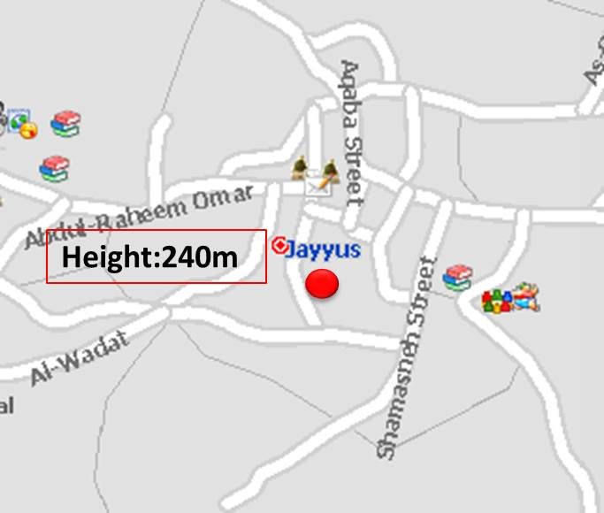
Figure ‎5.14: Jayyus

- Qalqilya :
Qalqilya city located west of the West Bank on the border with Israel. The total population of the city is 59.965 inhabitants.
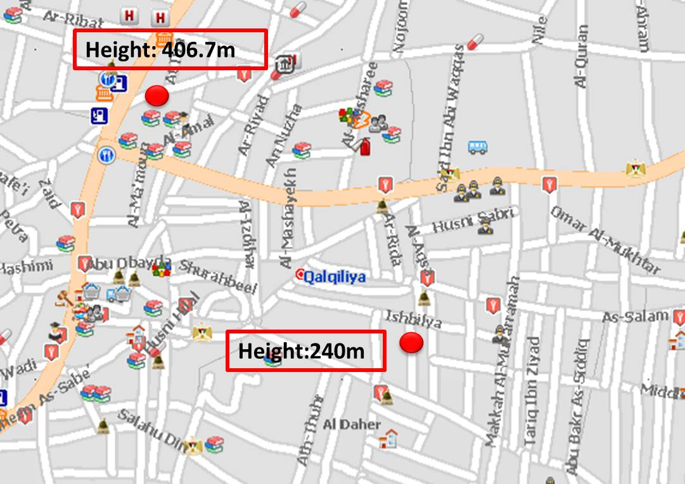
Figure ‎5.15: Qalqilya City

Data analysis

The field measurements was collected in each point as follows
  - We took the measurements for the four directions, North, East, South, and West.
  - Measurements for both vertical and horizontal polarized signals were done.
  - Values of center frequency, bandwidth, and power (in dBm) were recorded for detected signals.

So for analysis purposes conversion from dBm to watt was needed according to the following equation:
$$P\left(w\right)={10}^{P(dBm)/10}$$

Analysis was done by plotting the spectrum in the targeted area (400MHz-800MHz) in several locations, Directions in both horizontal and vertical polarizations to have some comparison. Moreover, for the plot to be clear, normalization to the maximum value was done as follows:
$$P_{i}=\frac{P_{i}}{⁡\max_{i}(p)}$$

Maxi (P): is the maximum value of the desired data to be plotted.

Some location and directions were chosen from the whole set in order to give the reader of this report of a good view of the spectrum status.
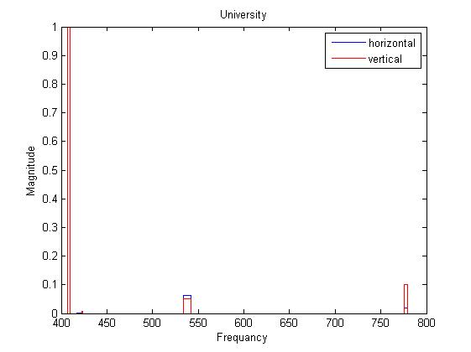
Figure ‎5.16: University spectrum measurement directed North
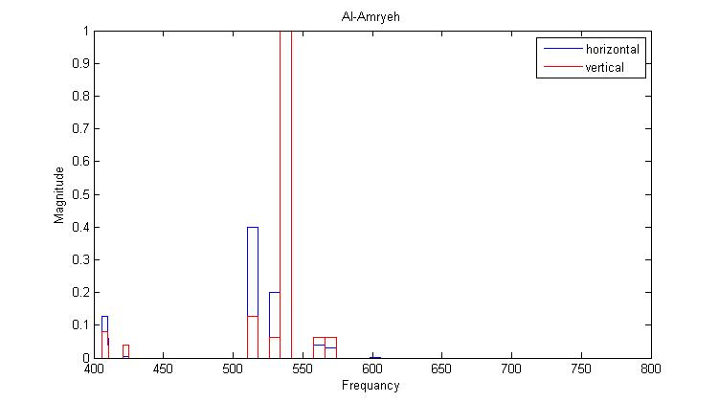
Figure ‎5.17: Al-Amryeh spectrum measurement directed West
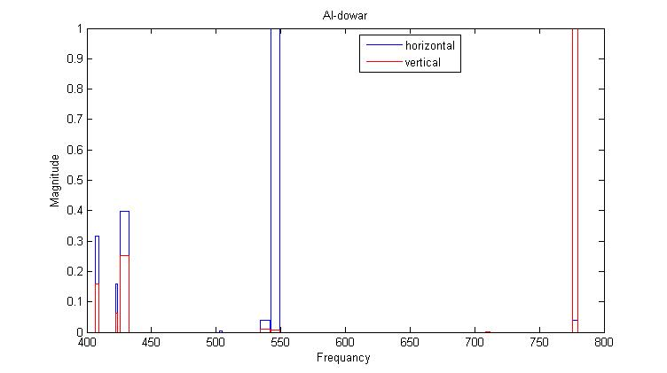
Figure ‎5.18: Al-dowar spectrum measurement directed South
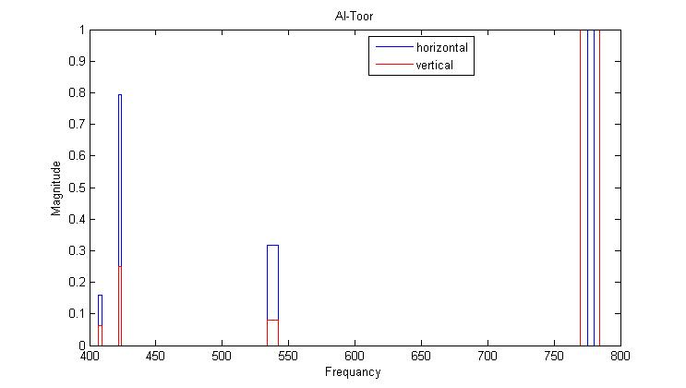
Figure ‎5.19: Al-Toor spectrum measurement directed North
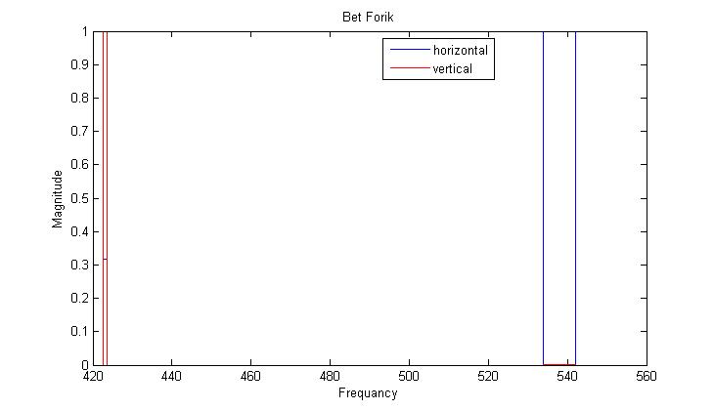
Figure ‎5.20: Bet Forik spectrum measurement directed West
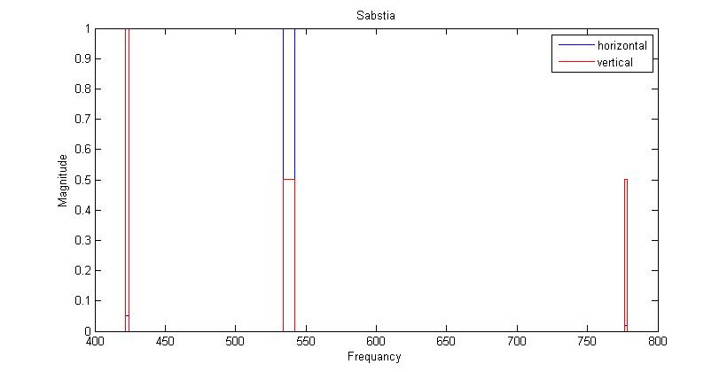
Figure ‎5.21: Sabstia spectrum measurement directed East
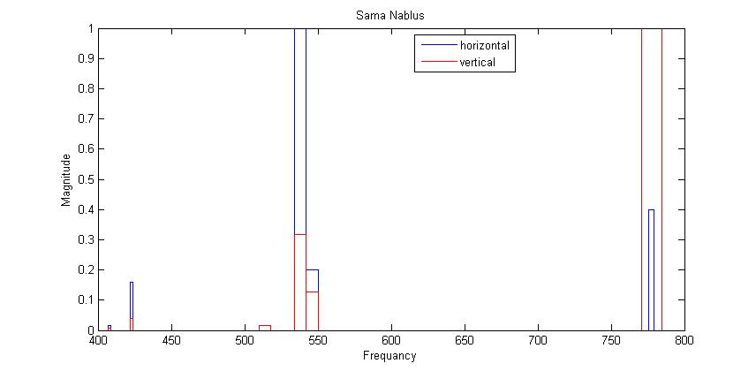
Figure ‎5.22: Sama Nablus spectrum measurement directed South
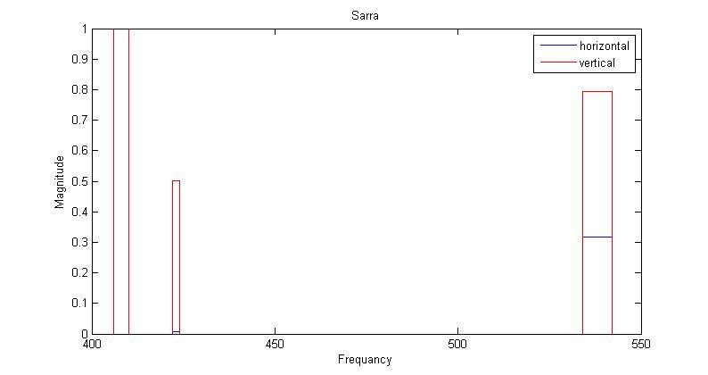
Figure ‎5.23: Sarra spectrum measurement directed North
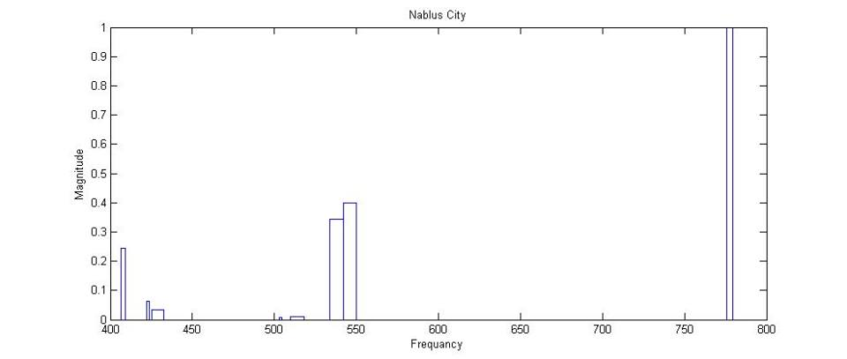
Figure ‎5.24: Nablus Spectrum measurement, averaged over all the directions

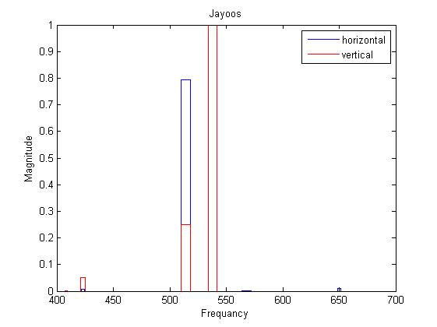
Figure ‎5.25: Jayoos spectrum measurement directed East
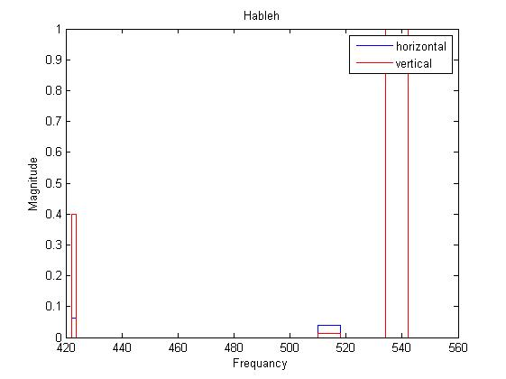
Figure ‎5.26: Hableh spectrum measurement directed North

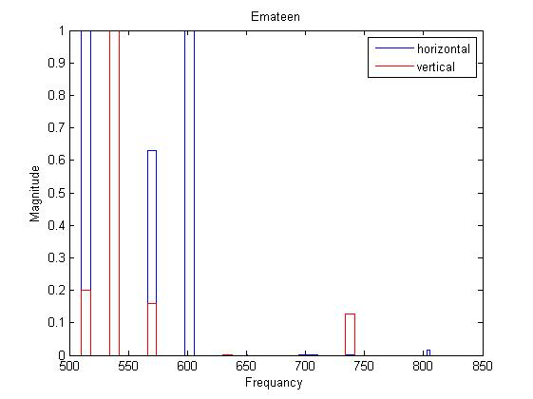

Figure ‎5.27: Emateen spectrum measurement directed North

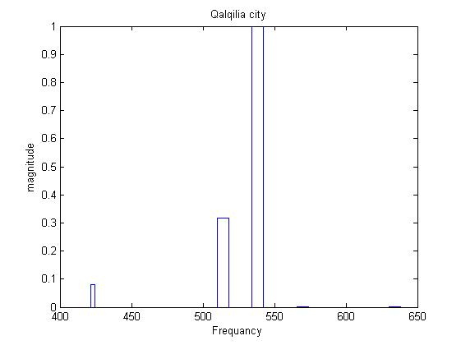

Figure ‎5.28: Qalqilya Spectrum measurement, averaged over all the directions

Data discussion
Upon collecting and analyzing the data, we detected several types of signals. On one hand, telling the origin of the signal and its nature is nearly impossible. But on the other hand, we were able to classify detected signals according to bandwidth into three main categories as shown in Figure ‎5.29.

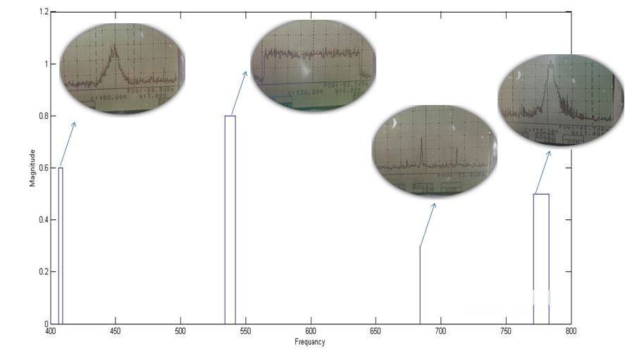
Figure ‎5.29: signal classification according to bandwidth. From left a) <8MHz b) 8 MHz c) 100 kHz d) unclassified

- Less than 8 MHz: the shape of this signal is in the form of a triangle. In addition, its bandwidth changes from location to another according to its power, this is due to the triangle shape of the signal. This signal is unknown but we assumed it broadcast from the Israeli side since its power increases at the borderlines. Moreover, the nature and functionality of the signal is unknown as well.
- 8 MHz: the shape of this signal is in the form of a rectangle, this represents a typical terrestrial analog TV channel. Moreover, the power of this type of signals changes in location and direction measured and they can be coming from a Palestinian or any other surrounding countries channels. The power of such signals falls in the range of (-40 to -90)dBm and they are classified as follows:
  - Up to -70dBm/MHz: excellent.
  - Between -70 and -80 dBm/MHz: acceptable.
  - Above -80dBm/MHz: very weak and negligible.
- 100 KHz: which is marked as X in our study; nothing can be told about the origin, power, nature, or functionality of this signal. On the first hand, this signal could be used by the Israeli army and nothing can be known about it. On the other hand, it could be a signal used by walkie-talkie like devices i.e. Taxis.

Database and Webpage

Introduction

After collecting the data in the deferent regions we offered to make this data available to the public, in a controlled monitored manner; the best way we found was by using a webpage connected to a database. In addition, the design of the webpage was done using Bootstrap templates and function using HTML, PhP and JavaScript languages. The webpage is connected to an SQL based database by using PhP tags.

Webpage layout

The webpage was designed to offer the user an easy simple way of interactivity. Where, we tried to offer all of the functionalities needed. Moreover, the website is a one page website where it does not change the url in the transmissions rather than changing the dynamic content.

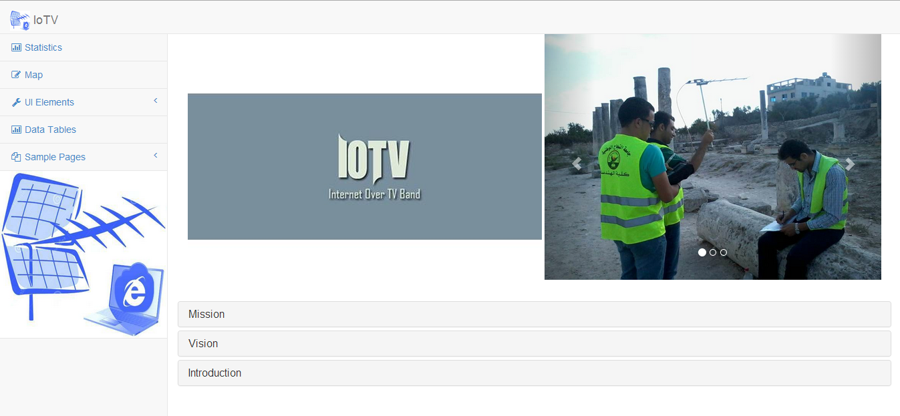
Figure ‎5.30: website homepage

On the left of the page lies the static menu to direct the user in the website, containing Statistics, map, Data tables, contact us, and login. Statistics content shows some statistical figures about the spectrum in the measured areas (see Figure ‎5.31) while map shows a Google map pinned with the measured point which allows access to the control by hovering over the pin (see Figure ‎5.32) or displaying the measured table of power by clicking the pin. In addition, the same table power can be viewed through the Data tables menu with the plotted spectrum in all of the direction at the chosen point (see Figure ‎5.33).

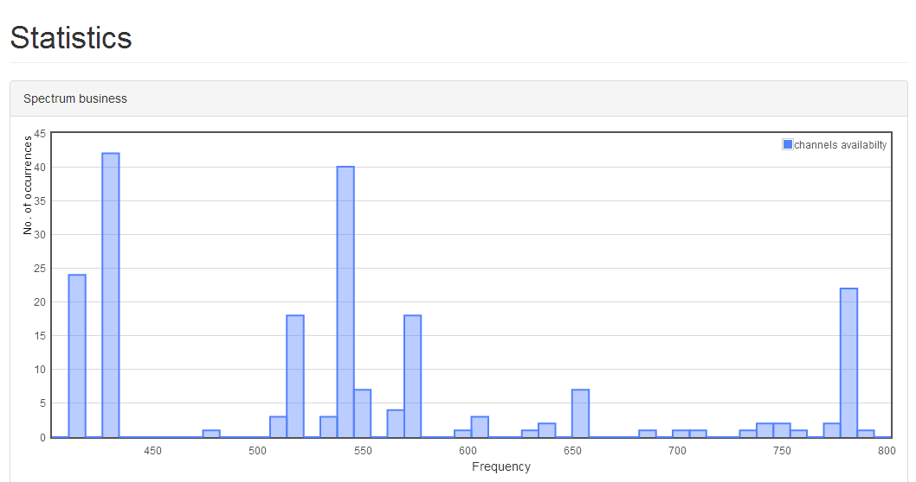
Figure ‎5.31: website statistics content

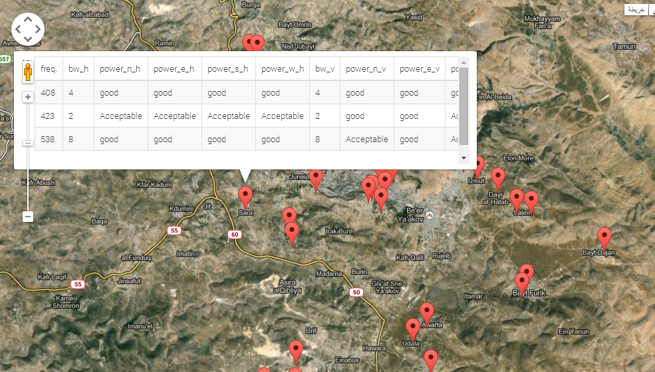
Figure ‎5.32: website map content
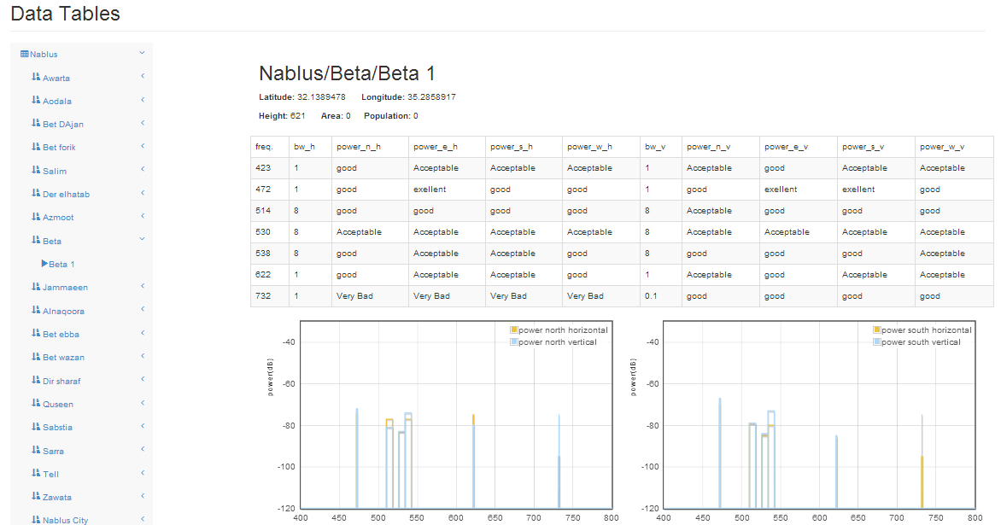
Figure ‎5.33: website Data tables content

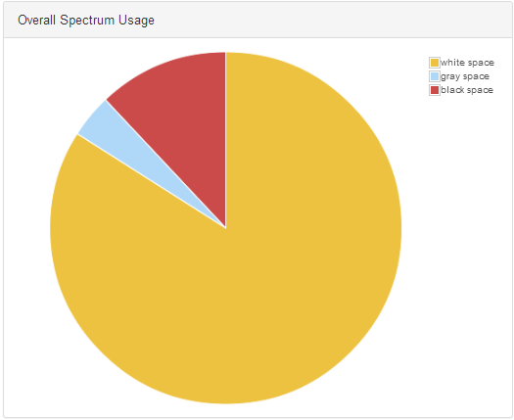
Figure ‎5.34: spectrum Usage

An additional feature would allow the user to plot the measured data in the location he wishes with the direction specifications, plotting whole Nablus spectrum as example. However, monitored controlled access of these data tables and plots is needed, thus, login page is introduced and the login box will pop up while trying to access classified data.

Database design

In the database design some tables where added for obtaining a few redundant data and easy way for linking the data with the locations.

The data was divided between linked tables, the first table was used for authentication the users for who permitted to access the data, since this is to be controlled in association with the ministry of communications.

The second table added is the locations table, which has all the locations and its information, like GPS coordinates (latitude, longitude), the height, the area and the population of the location and a given ID, where the ID is the key of connecting each location with the frequencies in this location that is inserted in the third table.

The third table has all the founded frequencies which named the power table, which has each frequency with its vertical and horizontal power in the four directions (North, South, East, and West), with the power level of -105 dBm/Mhz for undetectable power in any direction. Each frequency was given an ID and it was linked to the location by the location ID.

Moreover, two tables were added to reduce redundancy in the data display rather than storage, which makes it easier to process. The two tables are province where it maps the province to its towns, while the second one is loc where it maps each town to its selected measure points that are specified in the location table.

After collecting the data it was added an excel sheets, where each sheet has the frequencies and the information of a certain location, so while the data was very large and can’t be added to the database by hand a java code was written to take the data from the sheets and write it in MySQL forms for adding it for the database.

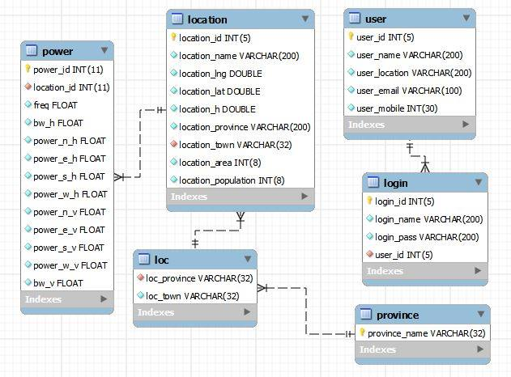
Figure ‎5.35: UML dig ram representing the database

Software Design

Introduction

In cognitive overlay systems, symbol level synchronization between the primary and the secondary transmitters involves estimating the sample functions of the primary received signal at the secondary transmitter to determine symbol transmission interval of the primary transmitter. Based on this knowledge and using some mechanism to determine the primary codeword, the secondary transmitter will be able to design its own codewords accordingly and cooperate with the primary system by aligning the secondary codewords with the primary transmission.

Secondary user has to be synchronized with the primary transmitter. Such synchronization requirement is already achieved for the DVB-T Single Frequency Network (SFN) based overlay cognitive radio in (6). Where, the primary signal is sent via satellite to some major transmitters, which need to apply the corresponding delay to keep the synchronization required by the SFN model. Thus, a potential secondary transmitter might also gain access to the primary signal, keeping time and frequency synchronization with the primary transmitters and, therefore, join the primary network (7). In contrary to our case understudy, no synchronization solution is proposed yet (8), where we are targeting PUs that are utilizing HARQ and OFDM-CP. Accordingly, we propose our distributed MAC protocol which will allow secondary user to achieve a synchronized reception on the primary receiver with the primary signal.

Algorithm to solve the synchronization in cognitive radio

Given the transmission scenarios below and assuming static secondary users with access to the geographical locations then we use the following terminology:

- Stx : Secondary transmitter.
- Ptx: Primary transmitter
- Prx : Primary receiver
- Mp: Primary message.
- Ms: Secondary message.
- TM: Message time.
- Tack : Acknowledgment time
- Tw: The time needed by the primary receiver to send Ack or Nack.
- tm: The time needed by the primary transmitter to send new message.
- Tp12: Propagation delay between primary transmitter and primary receiver.
- Tp13 : Propagation delay between primary transmitter and secondary transmitter
- Tp23 : Propagation delay between primary receiver and secondary transmitter
- Delta T: Time difference between the primary and secondary transmitters due to unsynchronized reception of the ACK/NACK from the primary receiver.

- First Scenario happens when the primary transmitter is closer to the primary receiver than the secondary user. Yielding that Delta to be positive and the secondary user has to correct tm time by -2*Delta, i.e. transmission time advance will occur at the secondary side.

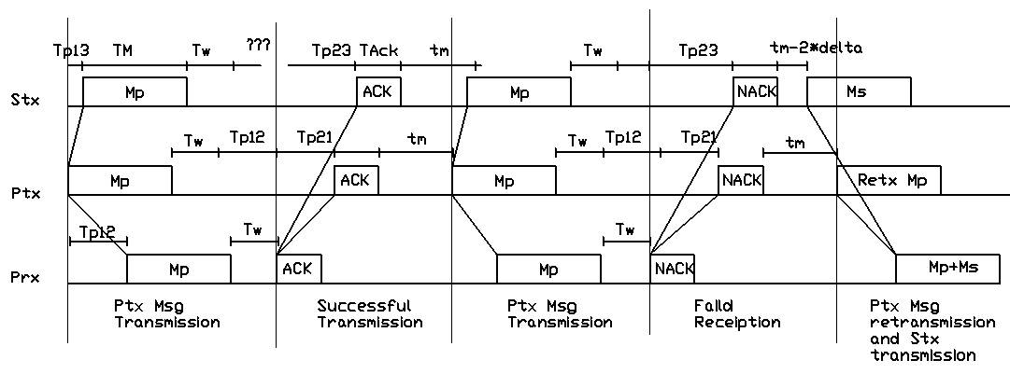
Figure ‎5.36: first synchronization Scenario

- Second Scenario happens when the secondary user is closer to the primary receiver than the primary transmitter. Yielding that Delta to be negative and the secondary user has to correct tm time by -2*Delta, i.e. transmission time delay will occur at the secondary side.

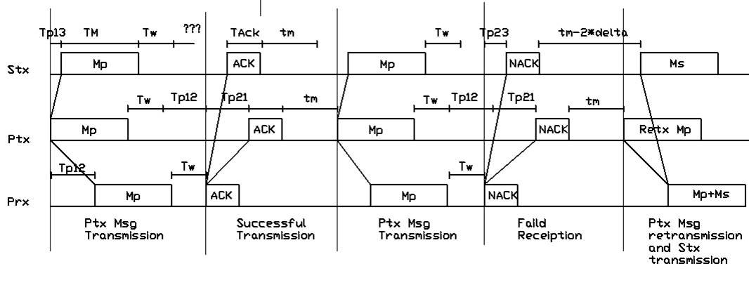
Figure ‎5.37: Second synchronization Scenario

To resolve this issue and enable the occurrence of synchronization between primary and secondary users, we implemented an algorithm indicated by the following flowchart.

- Our algorithm consists of main loop which contains three sub processes as shown.

Figure ‎5.38: synchronization flowchart/main loop

- Each sub process is expanded in details as shown (Figure ‎5.39, Figure ‎5.40 and Figure ‎5.41).
- The codes represented by the flowcharts main loop, primary_tx, primary_rx, and secondary_tx are illustrated at the Appendix A, B, C and D respectively.
- Example is shown illustrating the algorithm results under the first scenario displaying the messages received at the Primary receiver from both primary and secondary transmitters, showing the synchronization of reception of the two messages under Nack condition.

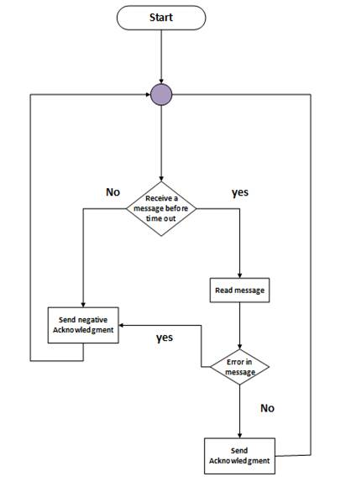
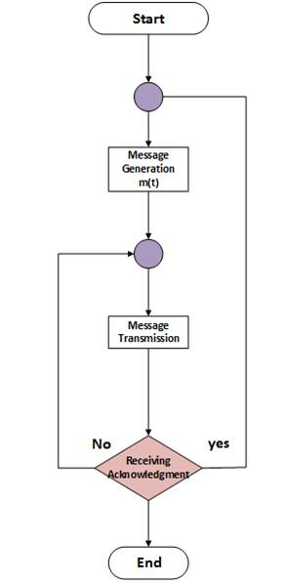

Figure ‎5.39: synchronization flowchart/primary_tx
Figure ‎5.40: synchronization flowchart/primary_rx

Figure ‎5.41: synchronization flowchart/secondary_tx
Example: main (5, 2, 7,1000);
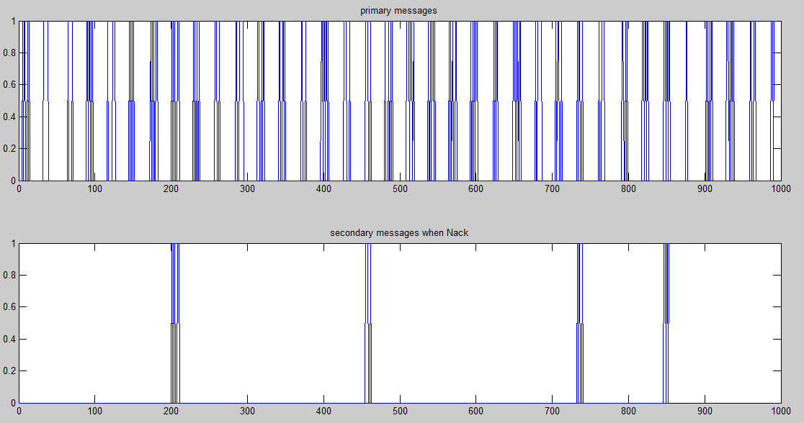

Hardware Design

Introduction

In this section the design of a negative resistance oscillator will be discussed. The purpose of using an oscillator is to use the channels and protocols of WiFi at 2.4 and shift its frequency from 2.4 to the UHF or VHF bands that analyzed in this project, by designing an oscillator with (1.6-2 GHz shifting frequency, multiply it with the original signal using a suitable multiplexer. Then, transmission will occur using antenna o our design.

Two Antennas with different directivities were designed. The first, is responsible of the point to point link where a very directive antenna is be designed, to connect the access points towers together without the need of microwave link , exploiting the targeted spectrum(400-800) Mhz.
While the second, is responsible of broadcasting internet towards users where a less directive antenna is needed introducing a good beam width angle.

Oscillator

Literature review

There are many type of oscillators and many configurations, the basic feedback oscillator shown in the figure is the simplest to understand how to obtain the oscillation conditions.
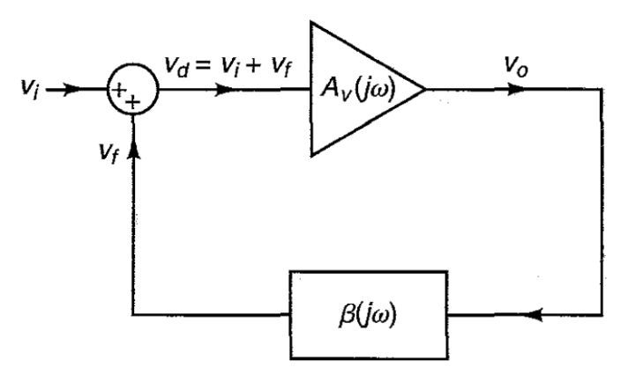
Figure ‎5.42: Feedback oscillator circuit (9)
Where Av(jw) is the forward amplifier or the open loop amplifier, and B(jw) if the feedback network. A negative feedback happens when the feedback signal subtracts from the input signal and from Figure ‎5.42 where it shows that the feedback was added to the input signal. What determines whether the signals was added or subtracted is the closed loop phase shift, for both forward and backward amplifiers if they added a total phase shift of 0 or 360 degrees, this makes a positive feedback: (9)
Vo =Av(jw)*Vd
Vf=B(jw)*V0
And
Vd = Vi+Vf

From the three previous equations we obtain the following equation:
$A_{vf}\left(jw\right)=\frac{A_{v}\left(jw\right)}{1-{B\left(jw\right)A}_{v}\left(jw\right)}$ (9)
From basic control analysis the oscillation occurs when no signal applied and the happens when the denominator goes to zero
$$1-{B\left(jw\right)A}_{v}\left(jw\right)=0$$
This leads for oscillation the loop gain should be unity and applies a phase shift of 0 or 360 degrees.

This simple representation of oscillator is good for understanding the concept but for obtaining a good oscillator and at a high frequency a two port negative oscillators are better to be used.

The general diagram of two ports oscillator is shown in Figure ‎5.43. As mentioned before the s parameters can represent the response of the transistor network, in Figure ‎5.43it appears that any port of the transistor can be used as terminating port and the other as load. (9)

The negative resistance that is tried to be obtained is to cancel the resistor of the oscillation LC port of the network where in this case the signal will not attenuate and keeps oscillating.

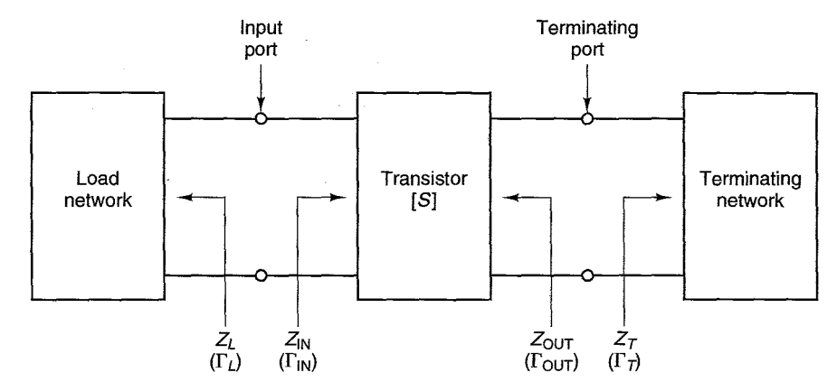
Figure ‎5.43: Two ports oscillator. (9)

For good oscillation the condition of unity loop gain and phase shift conditions should be applied and the values of the resistances should be chosen to make the tow networks to oscillate:
$Γ_{IN}Γ_{L}=1$ (9)

Design and simulation results

In our design we used the method of negative resistance two port bipolar transistor network. Moreover, we have used Advanced Design System (ADS) to design, simulate the circuit and to show the results.

In ADS there are many simulators that are implemented to show the performance of the circuit some of them has been used, from them, the transient simulator, which is used to get the output of the design with respect to the real time working, were the transient response of the design is shown.

At the beginning of the design a suitable oscillator was selected, which has suitable bias conditions and suitable for such a high frequency. The selected transistor was High Performance Isolated Collector silicon Bipolar Transistor HBFP-0450.

In designing the oscillator circuit the bias was obtained to get a negative resistance as desired for oscillation condition as shown in Figure ‎5.44 ‎bellow.

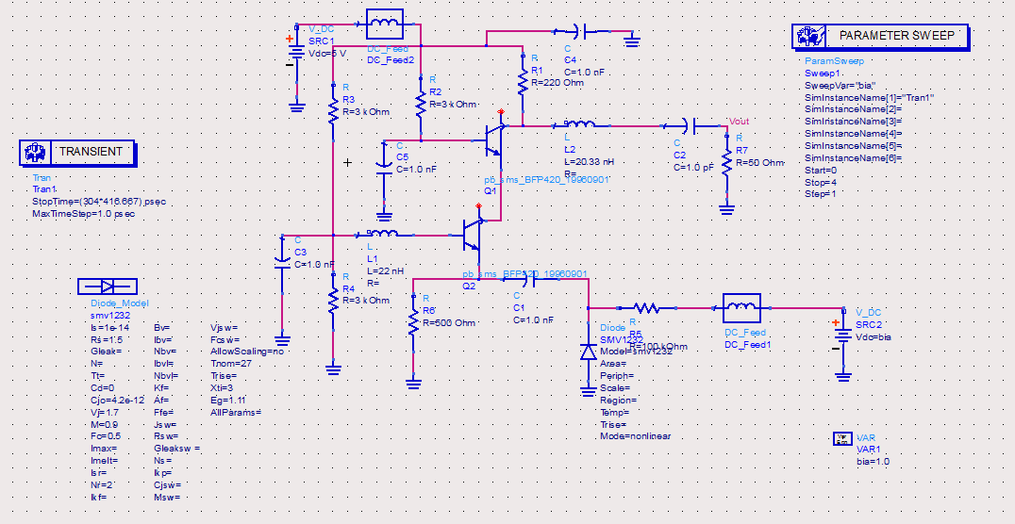
Figure ‎5.44: Negative resistance and oscillation circuit.

The parameter sweep shown in the graph make the simulation to run more than once and change some parameters where in this design changes the bias voltage of the varactor which changes the capacitance so the operating frequency will change as shown in Figure ‎5.45.

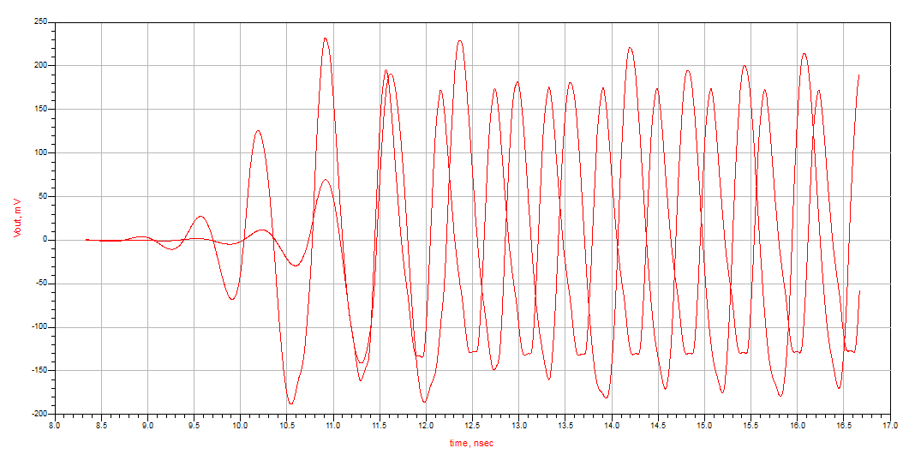
Figure ‎5.45: Oscillation Frequency changes due to sweep voltage
As we can see for two runs with changing the voltage from 0 to 1 we get two resulting frequencies, the design works on the range of 1.4 to 2 GHz with a controlling voltage from 10 to 0 respectively.

One of the problems of the oscillator is the instability when going to lower frequencies where the output voltage drops after some time as shown in Figure ‎5.46, to solve this problem an inductor is used in the output but this inductor can cover a portion of the range of the band so it has to be changed with each frequency, but instead a matching circuit can be used at the output where it should has a high quality factor to cover the range of the frequencies.
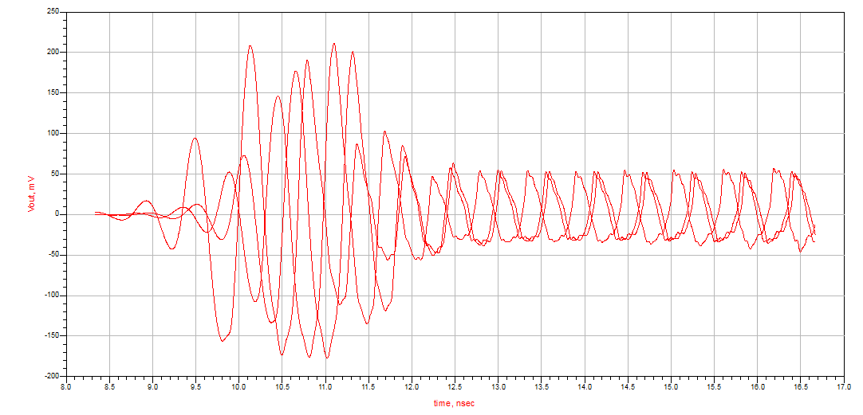
Figure ‎5.46: Low frequency voltage drop

Helical Antennas

Introduction
One of the basic and practical configurations of electromagnetic radiation is a conductor wire wound in the form of screw thread forming a helical antenna as shown in Figure ‎5.47. In the most helical antennas a ground plate is used with different forms. The ground plate should be flat and with a minimum radius of 3*λ/4. In addition, the helix is usually connected to the center conductor of a coaxial transmission line at the feed point with the outer conductor of the line attached to the ground plane. (10)
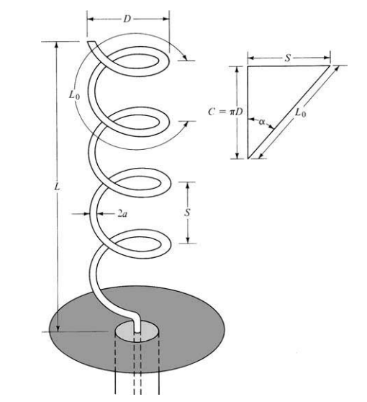
Figure ‎5.47: helical Antenna

Design procedures
To design a helical antenna some assumptions should be started with to get to the desired gain and bandwidth. First the pitch angle α, the helix works for broadband in a certain range of α which is between 11 and 14 degrees, were these numbers are a statistical numbers, the most popular angle is α=13. (10)

After we considered α to be 13, then the circumference was calculated to indicate the operating center frequency by considering the circumference to be one wavelength (C=λ0). And the bandwidth was approximated by the relation 3/4 < C/λ0 < 4/3.

Since we are working on an antenna for the UHF and VHF bands the center frequency was approximated to be at 600 MHz, which leads to ⇒ C=π*15.9 cm , after some trials on Ansoft HFSS the number was changed for the a higher performance on C=π*15 cm.

Now by knowing C and α the spacing between the turns can be calculated by the previous formula by completing the triangle as in the graph above.

After considering the desired gain the following equation was applied to calculate the number of turns in the antenna.
$G=\frac{26000}{{HP}^{2}}= 6.2{(\frac{C}{λ})}^{2}N\frac{S}{λ}$ …. (10)
By this formula it is clear that the gain depends on the operating frequency with a power of 3.
For the polarization of the antenna it depends on the number of turns, where the polarization in elliptical polarization, but it can be enhanced to circular by increasing the number of turns as shown in the following formula.
$\left|AR\right|=\frac{2N+1}{2N}$ … (10)
As the relation shows as the number of turns increases the axial ratio get closer to 1 and closer to a circular polarization, but the number of turns controls the gain of the antenna so, it is not that easy to control the axial ratio.

Simulation results
In this project more than one design was considered to fulfill the needs in the project.

First antenna design
The first design was made for a high gain to cover a very long distances, the antenna chosen gain equals to 15 dB. The next table shows the dimensions of the antenna.
Dimension | Value
Helix diameter | 15 cm
Helix spacing | 11.5 cm
Number of turns | 10.5
Wire diameter | 2.819 cm
Ground X dimension | 35
Ground Y dimension | 34
Table ‎5-1: First Antenna design Parameters
The next figure shows the antenna on HFSS software, the total length of the antenna equals to 120.75 cm.
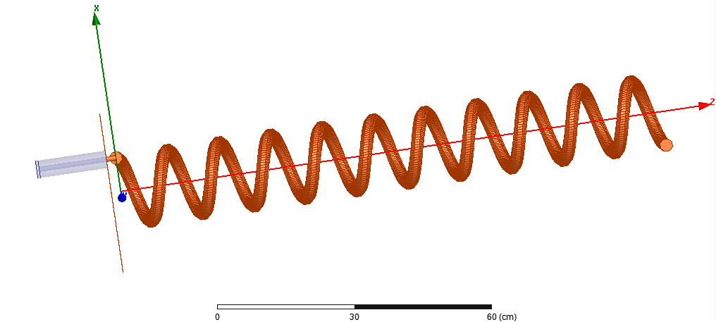
Figure ‎5.48: First Antenna design

The radiation pattern of the antenna as shown in Figure ‎5.49 shows how directive is the antenna with a narrow HPBW, which leads to the mounting of the antenna should be have the line of sight condition.
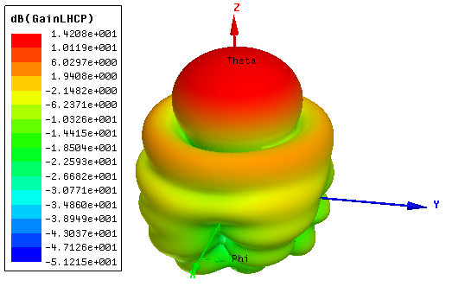
Figure ‎5.49: First Anetnna radiation Pattern
For the return loss of any antenna which can be considered as acceptable when it is under the (-10 dB) this simulation results shows that this antenna can work in the desired band. This is shown in the following graph.
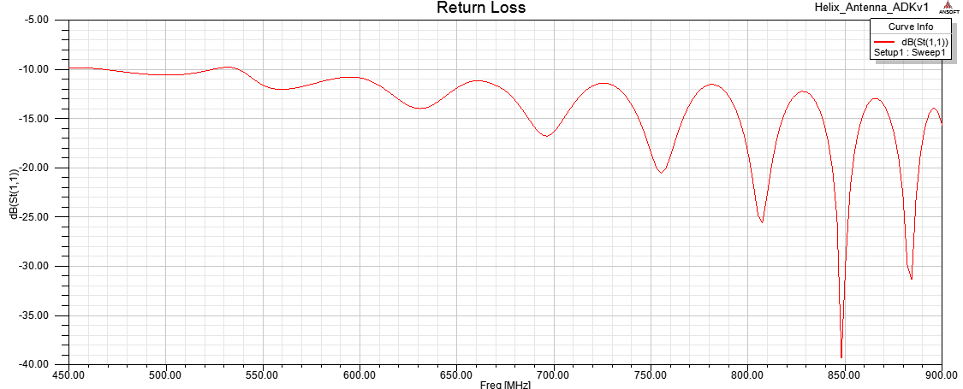
Figure ‎5.50: First Antenna return loss
After considering that such a high gain is not always desirable, a second antenna is designed.

Second antenna design
In the second design the gain is picked to be lower than the first one, were we chose it to be around 7 dB. And the table below shows the dimensions of the antenna.
Dimension | Value
Helix diameter | 16 cm
Helix spacing | 11.08 cm
Number of turns | 1.6
Wire diameter | 2.819 cm
Ground X dimension | 30
Ground Y dimension | 30
Table ‎5-2: second Antenna design Parameters
The next figure shows the antenna on HFSS, where the total length equals to 17.73 cm.
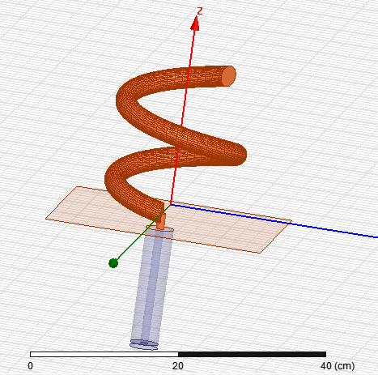
Figure ‎5.51: Second Antenna design
The radiation pattern of the antenna as shown Figure ‎5.52 bellow shows how the antenna is less directive than the first design a wider HPBW, were it has a HPBW of 80 degrees approximately.
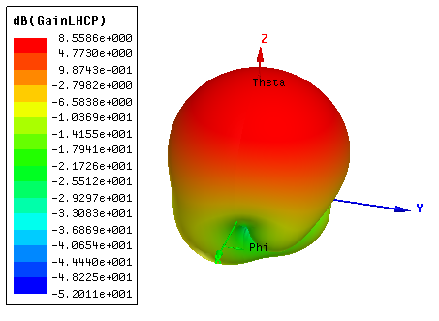
Figure ‎5.52: Second Antenna Radiation Pattern
The return loss for this antenna as the graph below shows, it works better than the first one on the same band where it has less variation.
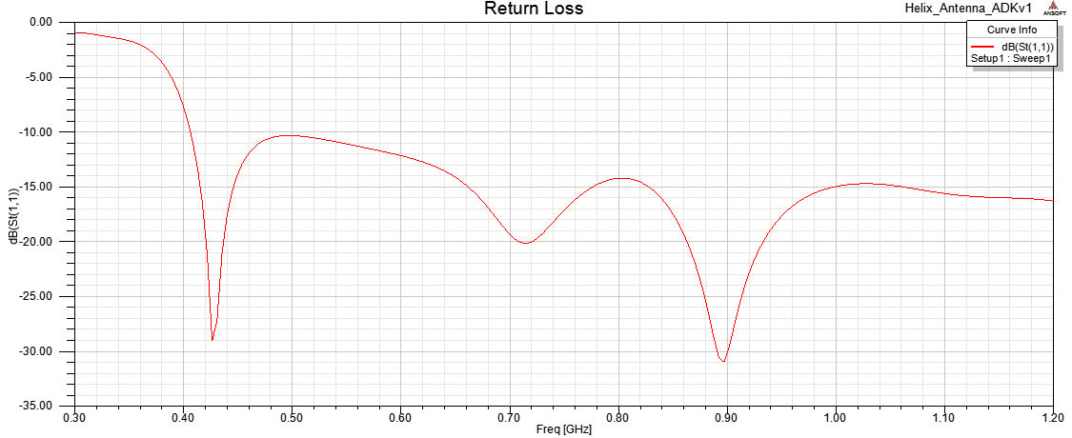
Figure ‎5.53: Second Antenna return loss

Conclusions and Recommendations

Conclusions

The results we obtained from measurements in Nablus and Qalqilya areas, as sample of the west-bank, shows a good picture of the spectrum usage of the targeted range (400MHz-800MHz). Moreover, as it was predicted the results show that most of the spectrum is free and usable with no fear of interference with other broadcasters. In addition, synchronization in cognitive radio environment was successfully achieved by the algorithms written.

We were able to construct a database partially filled of real field data measurements in Nablus and Qalqilya areas and connect it to website. Moreover, we successfully designed and simulated a (1.6-2) GHz oscillator to shift the frequency from 2.4GHz to our targeted spectrum (400-800) MHZ. Finally, two antennas were designed with different directivities to achieve the desired communication, point to point or broadcasting over big area, to work in the targeted spectrum (400-800) MHz.

Recommendations

- We recommend Purchasing more efficient devices i.e. spectrum analyzer that is always present for further work.
- The database should be filled of measurements from the whole west-bank to have the full picture.
- We highly advice Moving to phase two, implementation, of the project.
- Developing and uploading the website online is recommended in order to achieve more interactivity. This also allows input from users.

Bibliography
1. Ray, Bill. How to build a national cellular wireless network for £50m. London : the register, 2011.
2. webopedia. webopedia. [Online] [Cited: November 26, 2013.] http://www.webopedia.com/TERM/C/cognitive_radio.html.
3. New Zealand ministry of economic development. Review of digital conversion policy. http://www.rsm.govt.n. [Online] http://bit.ly/IysV9i.
4. Weiss, Todd R. Google Testing Use of TV Spectrum for Internet Access in South Africa. s.l. : eWeeks, 2013.
5. BKprecision, Datasheet. BK precision. [Online] [Cited: October 20, 2013.] http://www.bkprecision.com/.
6. Cognitive Cellular Systems within the TV Spectrum. Sachs, J. ; Maric, I. ; Goldsmith, A. Singapore : IEEE, 2010. 978-1-4244-5189-0.
7. On the coexistence of primary , secondary transmitters in a broadcast network. A. Rico-Alvarino, C. Mosquera, and F. Gonzalez. Barcelona : CogART '11, 2011.
8. A survey on mac strategies for cognitive radio networks. A. Domenico, E. Strinati, and M. G. Benedetto. s.l. : IEEE , 2010, Vol. Toturials .
9. Gonzalez, Guillermo. Microwave Transistor Amplifier.
10. Balanis, Constantine A. Antenna Theory Analysis and Design. new jersey : john wiley & sons, 2005.
11. Kong, The Chinese University of Hong. The Design of 2.4GHz Bipolar Oscillator by Using the. 2001.

Appendixes

Appendix A: synchronization code/main loop
function main(a,b,c,time)

global tp12; % propagation delay between primary tx and primary rx
global tp13; % propagation delay between primary tx and secondery user
global tp23; % propagation delay between primary rx and secondery user
tp12=a;
tp13=b;
tp23=c;
global tm; % time to wait before sending message
global tw; % time to wait before sending ack
global lm; % length of message
global lack; % length of ack
global count;%success transmision from sec user
global msg;
global s_msg;% secondary msg
msg=[];
s_msg=[];
tm=4;
tw=2;
lm=10;
lack=2;
t=0;
count=0;

global m;
global ack;
global nack;
global M_t;

ack(1)=-inf;
nack(1)=-inf;
m(1)=-inf;
M_t=inf;
global ack_received;
global nack_received;
global msg_received;
global s_msg_received;
global M_r;%counter receiver/prim msg
global secondary_M;%counter receiver/sec msg
global s_m;%msg from sec

ack_received=-inf;
nack_received=-inf;
msg_received=-inf;
s_msg_received=-inf;
M_r=inf;
secondary_M=inf;
s_m(1)=-inf;

global s_ack_received;
global s_nack_received;
global s_M;
global ack_flag;
global delta;
ack_flag=0;

s_ack_received=-inf;
s_nack_received=-inf;
s_M=inf;
delta=-inf;

while(t<time)
primary_tx(t);
primary_rx(t);
secondary(t);
t=t+1;
end

subplot(2,1,1)
plot(msg)
xlim([0 time])
subplot(2,1,2)
plot(s_msg)
xlim([0 time])

end

Appendix B: synchronization code/primary_tx
function primary_tx(t)
global tp12; % propagation delay between primary tx and primary rx
global tp13; % propagation delay between primary tx and secondery user
global tm; % time to wait before sending message
global tw; % time to wait before sending ack
global lm; % length of message
global lack; % length of ack
global m;
global ack;
global nack;
global M_t;

global ack_received;
global nack_received;
%initially
if t==0
M_t=lm; %message counter
m(1)=0;
end

%receiving ack
if ack(1)+tp12==t
ack_received=t;
end
%receiving nack
if nack(1)+tp12==t
nack_received=t;
end

%new message
if t==ack_received+lack+tm %waiting ack length + tm before transmission
M_t=lm;
m=[];
m(1)=t;
end
%retransmission message
if t==nack_received+lack+tm %waiting ack length + tm before transmission
m(1)=t;
end

%messaqge transmission
if M_t>0

m=[m,randint];
M_t=M_t-1;
end

end

Appendix C: synchronization code/primary_rx

function primary_rx(t)
global tp12; % propagation delay between primary tx and primary rx
global tp13; % propagation delay between primary tx and secondery user
global tp23; % propagation delay between primary rx and secondery user
global tm; % time to wait before sending message
global tw; % time to wait before sending ack
global lm; % length of message
global lack; % length of ack
global m;
global ack;
global nack;
global msg_received;
global s_m;
global s_msg_received;
global M_r;
global secondary_M;
global count;
global msg;
global s_msg;
%message received
if m(1)+tp12==t
msg_received=t;
M_r=1;
end
%message read
if M_r<lm+1
x(M_r)=m(M_r+1);
msg(t)=m(M_r+1);%all recieved msg
M_r=M_r+1;
end
%secondary message received
if s_m(1)+tp23==t
s_msg_received=t;
secondary_M=1;
if s_msg_received==msg_received
count=count+1;
end
end
% secondary message read
if secondary_M<lm+1
s_x(secondary_M)=s_m(secondary_M+1);

s_msg(t)=s_m(secondary_M+1);
secondary_M=secondary_M+1;
end
%new ack or nack
if t==msg_received+lm+tw %waiting ack length + tm before transmission
if ceil(rand-.9)==1
nack=[t,zeros(1,lack)];
else
ack=[t,ones(1,lack)];
end
end
end

Appendix D: synchronization code/secondary_tx

function secondary(t)
global tp12; % propagation delay between primary tx and primary rx
global tp13; % propagation delay between primary tx and secondery user
global tp23; % propagation delay between primary rx and secondery user
global tm; % time to wait before sending message
global tw; % time to wait before sending ack
global lm; % length of message
global lack; % length of ack
global m;
global ack;
global nack;
global s_ack_received;
global s_nack_received;
global s_M;
global ack_flag;
global s_m;
global delta
global s_x;
%message received
if m(1)+tp13==t
msg_received=t;
s_M=1;
if ack_flag==1
delta=tm-(msg_received-tp13-s_ack_received-lack);
end
end
%message read
if s_M<lm+1
s_x(s_M)=m(s_M+1);
s_M=s_M+1;
end
%receiving ack
if ack(1)+tp23==t
s_ack_received=t;
ack_flag=1;
end
%receiving nack
if nack(1)+tp23==t
s_nack_received=t;
ack_flag=0;
end
%retransmission message
if tm>=2*delta
if t==s_nack_received+lack+tm-2*delta %waiting ack length + tm before transmission
s_m=[t,s_x];
end
end
end

Appendix E: Data Tables

location Name :Tell 1 | lat.:32.201214 | lon.:35.212954 | height:633 m
polarization : Horizontal |  | Power (dBm)
Frequency | B.W. | North | East | South | West
408 | 4M | -74 | -67 | -77 | -66
423 | 4M | -71 | -74 | -72 | -76
538 | 8M | -73 | -73 | -73 | -73
562 | 8M | -69 | -74 | -74 | -74
570 | 8M | -67 | -75 | -73 | -74
679 | 2.5M | -76 | -75 | -77 | -76
polarization : Vertical |  | Power (dBm)
Frequency | B.W. | North | East | South | West
408 | 4M | -68 | -73 | -65 | -70
423 | 1.5M | -66 | -64 | -65 | -66
538 | 8M | -71 | -68 | -71 | -72
562 | 8M | -68 | -67 | -68 | -70
570 | 8M | -72 | -69 | -67 | -70
649.3 | 2M | -83 | -77 | -80 | -79

