

AN-NAJAH NATIONAL UNIVERSITY

FACULTY OF ENGINEERING
AND INFORMATION TECHNOLOGY

COMPUTER ENGINEERING DEPARTMENT

Software Graduation Project:
Complaint Management System (CMS)

SUBMITTED BY
Hamza Khaleel
Hosny Ishtaya

SUPERVISOR
Dr.Mona Demaidi

Presented in partial fulfillment of the requirements for the Bachelor’s degree in Computer Engineering.

January, 2023

TABLE OF CONTENTS

ACKNOWLEDGEMENTS Dedication
DISCLAIMER
ABSTRACT

Chapter | Contents | Page
1 | INTRODUCTION  - Project Introduction  - Problem Statement  - Objectives  - Scopes  - Expected Result | 1  2  3  3 - 4  4
2 | LITERATURE REVIEW  - Introduction  - Existing System  - Proposed System  - Background Research  - Review Comparison  - Chapter Summary | 5  5  5  6 – 7  7  7

3 | METHODOLOGY  - Introduction  - Project Methodology  - Feasibility Study  - Planning  - Analysis  - Design  - Implementation  - Deployment and Maintenance  - Software and Hardware Requirement  - Chapter Summary | 9  10  10  11  11  12  12  12 – 13  14
4 | MODELLING AND DESIGN  - Introduction  - Use Case Diagram  - Data Flow Diagram  - Context Diagram  - Interfaces  - Summary | 15  15 – 17  17 – 18  19 – 20  21 – 22  23
5 | DISCUSSION AND CONLUSION  - Introduction  - Project Contribution  - Project Constraint  - Future Work | 27  28  28  29

Acknowledgment

To all those who helped in making this project possible, to our beloved An-Najah National University that supported this project to make the country and the community better and to make us the students make a difference.
To our supervisor, Dr.Mona Demaidi who took from his time for us, was supportive, always believed that we could do it.
To all those and many more, who supported us through thick and thin, we give a big “Thank You” straight from our hearts, and we present you this report and project.

Dedication

We would like to thank everyone who supported us those who this work won’t be done without from friends, family, and those people who made it their life’s journey to write articles that help those who are thirsty for knowledge.

DISCLAIMER

This report was written by student(s) at the Computer Engineering Department, Faculty of Engineering, An-Najah National University. It has not been altered or corrected, other than editorial corrections, as a result of the assessment, and it may contain language as well as content errors. The views expressed in it together with any outcomes and recommendations are solely those of the student(s). An-Najah National University accepts no responsibility or liability for the consequences of this report being used for a purpose other than the purpose for which it was commissioned.

ABSTRACT

Complaint Management System offers an online solution to customer problems, saving time and eradicating corruption. The goal of the complaints management system is to make it easier to coordinate, monitor, track, and resolve complaints, as well as to provide the company with an effective tool for identifying and targeting problem areas, monitoring complaints handling performance, and making business improvements. Complaint Management is a management technique that evaluates, analyzes, and responds to customer complaints. Complaints management software is used to record, resolve, and respond to customer complaints, requests, and other feedback.

CHAPTER 1

INTRODUCTION

Project Introduction

To deal with customer-related difficulties, the Consumer Protection Association (CPA) has a number of measures in place. A complaint system is a set of procedures used by businesses to address complaints and resolve disputes. In addition, there is a considerable necessity to collect, investigate, and appreciate the nature of the CPA's conflict resolution and complaint systems. CMS (Complaint Management System) intends to provide an effective software gateway for handling customer needs and complaints for example, purchase broken furniture, microphone issues, projector issues, electrical issues, and other customer related problems. As a result, there is a need for a system that can recognize customer complaints and provide appropriate feedback. This system will be able to address complaints by recording and responding to each one. The study's findings can be used to determine user demands from e-complaints and the handling process for these complaints.

Problem Statement

    - Redundancy of the complaint

Every present complaint will be record by the FIK Department into the logbook, which concludes the information needs such as the student’s name, the date reported and the complaint. There are not providing with the specific database, which facilities the staff to enter the complaint’s detail directly to the database provided.

    - Data loss

By using this previous system, the probability for data loss is very high. If files loss, so the data also will be lost. If this situation happens, so it will bring some problems to get the data. In some cases, some files going to damage after certain period especially for files which open for a few last years

    - Difficulty to view list of Complaint

When the Head of the Faculty wanted to see listing of complaint, the department need to check the complaint first and then prepared the list. Certainly, it will take time and only wasting the time.

Objectives

- Provide a means for customers to submit complaints via the internet.

- Making it simple for customers to file a complaint without using social media.

- Gathering complaint information and methods of settlement.

- Develop a systematic and effective complaint handling strategy using laptops or mobile devices.

Scope

- To design and build a system for recording client complaints.
- To design 2 interface and operation:
  - User
    - Technician
    - User (Customers of CMS)
  - Operating Location and Availability
    - This system operates via internet
    - Since the system is a web-based system, hence it is platform independence, support multiple computer platforms and mobile devices.

  - System Functionality

    - Employee and Admin side (Desktop/web side):
- As an employee you can see all companies, add, delete, update for companies, and he can see all complaints for that company, an he can see who the one who made the complaint so he can verify from him.
- As an admin you can do all the management operation to all entities in the program (add, delete, get, update) for companies, complaints, employees and customers.
- Registration for both admin and employees.
    - User/Customer of CMS (mobile side):

      - User Registration
      - make complaint
      - Upload files necessary.
      - Profile Management
      - Change Password
      - See the ratting status of the companies or stores in neighborhood.

Expected Result

The system can be effectively constructed but must be tested. Making certain that it is user-friendly and includes the necessary options that the user can use to execute the needed actions. For future refinement, the system must fulfill goals such as fast access, optimum resource usage, effective record management, shorter processing time to obtain essential information, user friendliness, portability, and flexibility.

CHAPTER 2

LITERATURE REVIEW

Introduction

The consumer must go to the Customer Protection Association office and make a complaint if there are any problems within business hours. Regardless of the nature or category of the complaint, the complaint must be made by filling out a form. After the issue is settled, the consumer must return to the office to obtain confirmation, making it extremely time consuming for the customer to receive the conclusion of their complaint.
Some of them submit the complaint via social media in a random and unstructured manner, making dealing with it extremely difficult, and this results in the loss of a big percentage of it due to a lack of organization and aggregation.

Existing System

In the existing system the customer must go to Consumer Protection Association for any kind of help. Customer can post their problems but cannot get the details of the problems and some other services. This system doesn’t have much popularity and is not user friendly.

Proposed System

In our system there is an application that can be downloaded on the mobile phone, which contains a form through which the complaint can be submitted easily and quickly, and he can see the classification of the company or store he wants to complain about, or even if he wants to buy from it.
There is also a section for the employees who will deal with these complaints, which can be accessed through the Consumer Protection website

Background Research

In this background study, the customer problem is observed, as well as the nature of the problem and the involvement of the CPA in resolving it. The completed case study was also evaluated. Its goal is to guarantee that the function incorporates all emerging materials into the system. For this assignment, the primary sources of information for the system analysis were reference books, online browsing, an interview, and a conversation with the supervisor.

Internet Surfing

Some ideas were gathered from a comparable method when visiting a website. A survey was done with a comprehensive site of the present Complaint Management System website to acquire system information. Computer magazines and reference books are also excellent sources of information.
The function is studied and compared to the proposed system in order to uncover the system's flaws. Another Association's website was also visited to see whether or not they have a Complaint Management System. According to the findings, no other Association has implemented this type of technology thus far. This leads to the development of the suggested system to assist customers in managing themselves. Electronic journals were read to get up-to-date information on highly particular themes.

Books and References

Books and references are used to gather information for project documentation, such as project methodology. Aside from that, it acts as a guide to better grasp the concept and behavior of the to-be-built-in system. A book on psychology is also examined in order to better comprehend the student's psychological requirements and actions.
.

Informal Interview

The personal interview is often regarded as the most significant and frequently employed fact-finding tool. An informal interview with the Consumer Protection Association (CPA) as the end user was done to collect information and establish system needs. This aids in the discovery of facts, the verification of facts, the clarification of facts, and the solicitation of ideas and possibilities.

Discussion with Supervisor

Discussion with supervisors have been held on occasion in order to obtain assistance and guidance when drafting the report. Supervisors are customers, and their teaching environment teaches them a lot about consumer life. As a result, they are aware of the system requirements that should be met by the system.

Review Comparison

RESEARCH COMPARISON  SYSTEM | METHOD | PLATFORM | FINDING
UNISZA’S E-ADUAN | - Complaint lodge through mobile application | Android OS | - Category for complaint lodge are too broad  - Picture can be included
SOA in E-complaint System | - Each complaint must be lodged to the right department | Any Operating System including Mobile devices browser | - User have to report complaint to each department for different complaint
Complaint Management System  CreativeSoft (Corporate Office) | - Product ID required to lodge a complaint regarding the product and services | Any Operating System including Mobile devices browser | - Communicate with customer via emails  - Used numbers of staffs to manage complaint

  - Chapter summary

This phase will offer information about the study on previous research, present application or system, and online article. This research focuses on the development process and the creation of a new system that will benefit users. The aims that are reached through resource utilization, effective record administration, operation simplifications, reduced processing time and obtaining essential information, user friendliness, portability, and flexibility for future improvement.

CHAPTER 3

METHODOLOGY

Introduction

This chapter will go through the approach that will be utilized to construct the system. As a result, the SDLC, or system development life cycle, that will be employed is an Iterative Waterfall model. The Waterfall approach was chosen to design this Complaint Management System (CMS) since it is based on the flow itself, and there are a few phases that must be repeated throughout the development process. This chapter will go into further depth regarding each step of the project's development, as well as the system requirements.

Project Methodology
Planning

Analysis
Design
Implementation
Testing
Deployment and
Maintenance

The waterfall model is a sequential software development approach in which the development process is viewed as a downhill (waterfall) flow through many phases. A project starts with a feasibility study. As soon as the feasibility study is successfully shown, the requirement analysis and project planning may commence, and so on. Once a phase is completed, there is no going back since the output of one phase's work becomes an input of the following phase, therefore any changes and modifications in the previous phase are not possible and may cause the lead to fail. According to the waterfall model, one should advance to the next step only once the current one has been finished with no errors. The phases of the development waterfall model are so distinct, with no backtracking or overlap between them. The waterfall model, which is a completely sequential process, is still widely used and has now evolved into a software development strategy.

Feasibility Study

This is the section in which we will attempt to determine the user's requirements, how the complaint will be handled, who will be involved in managing the issue, and who will be responsible for informing the user of the complaint's status. It is critical to understand how the complaint will be handled and managed. It is critical to have thorough details on how the prior manual system worked so that we may improve it when using those work flows in the computerized system. All of the information gathered should be organized and analyzed so that the suggested system can satisfy the user's requirements.

Planning

During this planning phase, a remote conversation with the supervisor was held to discuss the title of the Final Year Project. A decision is made to create a system for complaint handling and management known as the "CPA Complaint Management System" (CPA CMS). A handful of discussions were held with the relevant individual at the Consumer Association to discuss the system's requirements in order to acquire a sense of how the system works. A texting chat was also conducted with the supervisor to gain insight into what may be additional value to the system. Prepare the proposal and presentation slides.

Analysis

During this phase, the system's needs are discussed, with an emphasis on what the system should perform and how it will function. we went over the complaint form and all of the flow surrounding complaint making together so that it would be simpler to grasp how the manual style of meeting management is done all this time. After several evaluations and a comparison of the present manual system and the system to be developed, all of the disadvantages and weaknesses are identified, and a way to enhance the system is found. The CPA CMS that is being developed must address all of the shortcomings and improve the functionality of the previous system. As a result, in order to ensure that the system is more effective and achieves an ideal level of satisfaction, it must be user friendly, which means that it is simple to use for all types of system users. The meeting information has been matched with the requirements that have previously been discussed with the supervisor. If the need is changed, the system's procedure will be changed as well.

Design

During this phase, we began designing the Graphical User Interface (GUI), using "React" for the admin and staff sides and "Flutter" for the client side. During this step, the student must design the complete module in the system and locate the appropriate code that is relevant to the required procedure. The design's coding has been researched and reviewed with the supervisor. The designed GUI will be required to demonstrate and discuss with my supervisor so that if the design does not fit the standards, adjustments will be made until it does. The system will be developed using the previously stated code. The programming language used for this project is Spring Boot (JAVA), as well as the database Postgres and the Tomcat server. During this step, the database is also designed. Please go to Chapter 4 of modeling and design, where the database and API’s have been constructed.

Implementation

Following the design of the system's GUI, the implementation phase will perform some testing on all of the system's modules. If there is an issue in the code, it should be discussed with either the supervisor or the partners to find a remedy. The objective of unit and integrated testing for the module is to identify system errors and devise solutions to them. The components will then be integrated and implemented as a whole. Test cases are employed on purpose to test the system and look for errors.

Deployment and Maintenance

During this step, the button and the system's validation procedure must be verified so that if an issue is discovered, it may be fixed and the system updated from the previous one. The maintenance process is vital because if an issue is discovered, it may be repaired, ensuring that all of the system's operations are running properly.

Software and Hardware Requirements

The hardware and software requirements are the most crucial aspect of any project since they determine the project's success. The project cannot be completed without both software and hardware needs. Tools from both hardware and software should be employed to finish the job. The employment of these tools is determined by what is already available or what has been utilized previously. The prerequisites of the CPA CMS are detailed below.

Hardware Requirements

Hardware requirements of this project are:

    - Laptop DELL e-machine

      - This laptop contains disk storage that is used as disk storage for OCS.

      - The laptop specifications are AMD vision, 8GB RAM, 256GB Hard Disk and 14’1 laptop screen.

Software Requirements

Software requirements of this project are:

- React Library

  - This software is used for designing an interface and front-end part.
- Tomcat Server and Postgres

  - This software is used for designing and creates the database of the system.
- IntelliJ

  - This software is used to write the API’s required and to handle request.

- Spring Boot JPA

- This framework work with API’s and databases. And the back-end part.

Chapter Summary

This chapter discusses the approaches used to construct the CPA CMS, with the Iterative Waterfall model phase being the method used. It also discusses the hardware and software requirements for this project, which will aid in the project's success.

CHAPTER 4

MODELLING & DESIGN

Introduction

This chapter covers how the system works, the strategy used to develop this project, and how to design the database that corresponds with the interface. According to the approach described in the previous chapter, the methods are Use Case Diagram, Context Diagram, and Data Flow Diagram (DFD).

Use Case Diagram

This Use Case diagram describes the system flow based on user requirements and the essential processes involved in system functionality. It is just describing the system's fundamental function.

19
Student

Customer Module Technician Module

Login

View Complaint
Details

Manage/Handle Complaint

Update Complaint Status

Update Category

Generate report
Technician

Module Explanation

The graphic shows that there are two types of users involved in this system. As the first user, the client of the CPA organization, must login before going to submit a complaint, and the system will immediately record it and transfer it to the next user, the employee. After completing the complaint form, the client can save it as a reference or attach a file such as a document or a photo as proof. They may afterwards track the status of the complaint, whether it has been settled or is still ongoing.
The second user, an employee or administrator, will have access to all complaints submitted by customers and will be able to write a comment on the issue before handling or resolving it. If a student files a new complaint, the staff will be notified so that they may go and handle it as soon as possible. After the complaint has been handled, the employee can change the status of the complaint, and the complaint will be listed as completed.

Data Flow Diagram

Data flow diagram is a diagram that shows the flow of the data on this system. All the data will be saved on the database with a specific table created. All processes in the data flow diagram are the main process involve in FIK Complaint Management System.

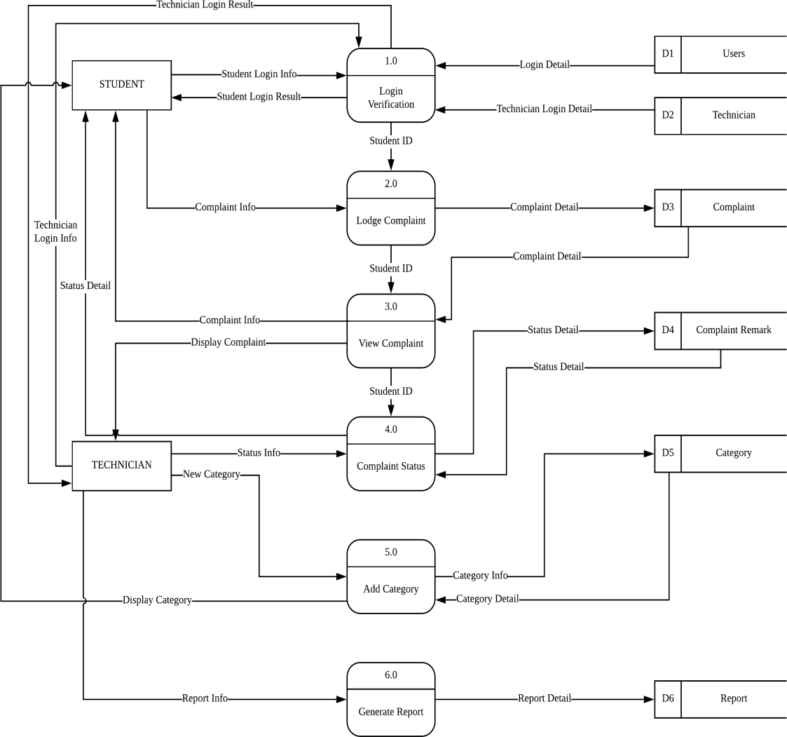

Context Diagram
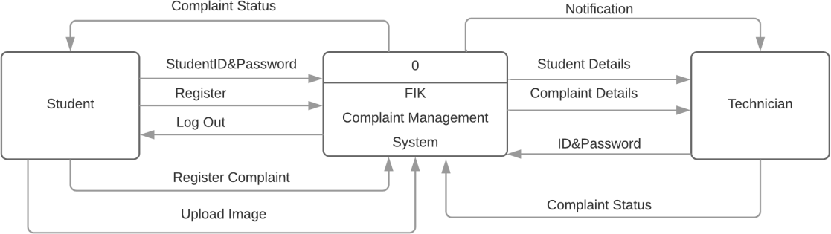

DFD Level 1 Login
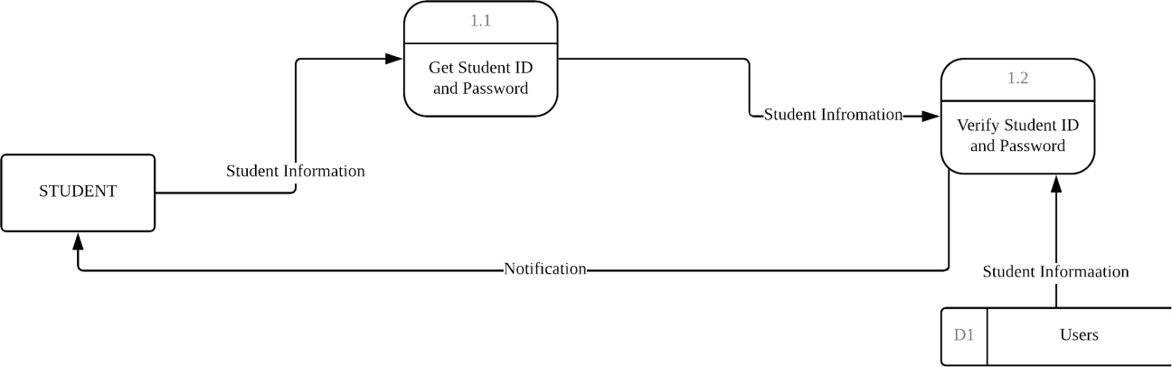

In order for all students to login, each of them should enter their student id and password correctly and must be verified. Then the database will ensure the details are either valid or not. If the process is a success they system will lead the student into their dashboard and if it failed student will get a notification to enter again their student id and password correctly.

DFD Level 1 Lodge Complaint
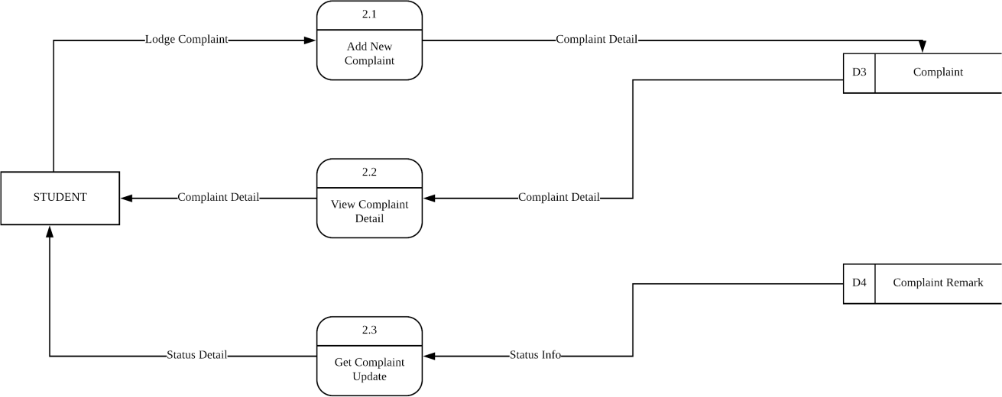

DFD Level 1 View Complaint

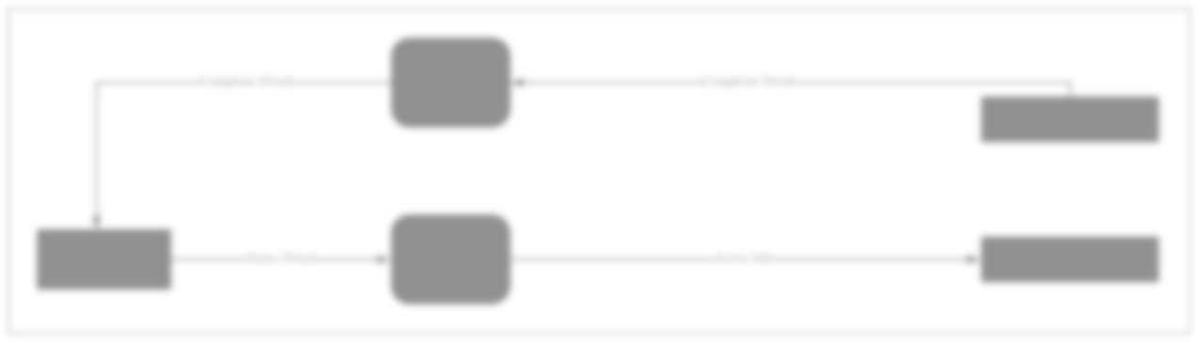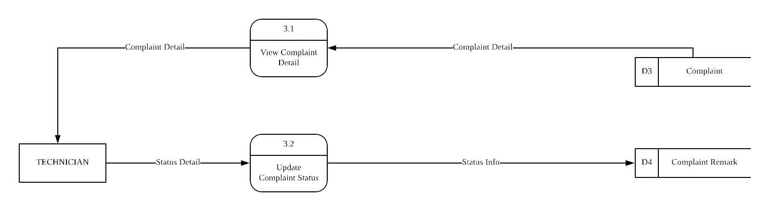

DFD Level 1 Add Category

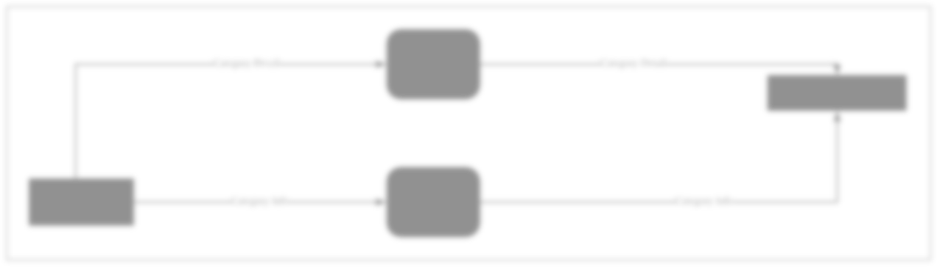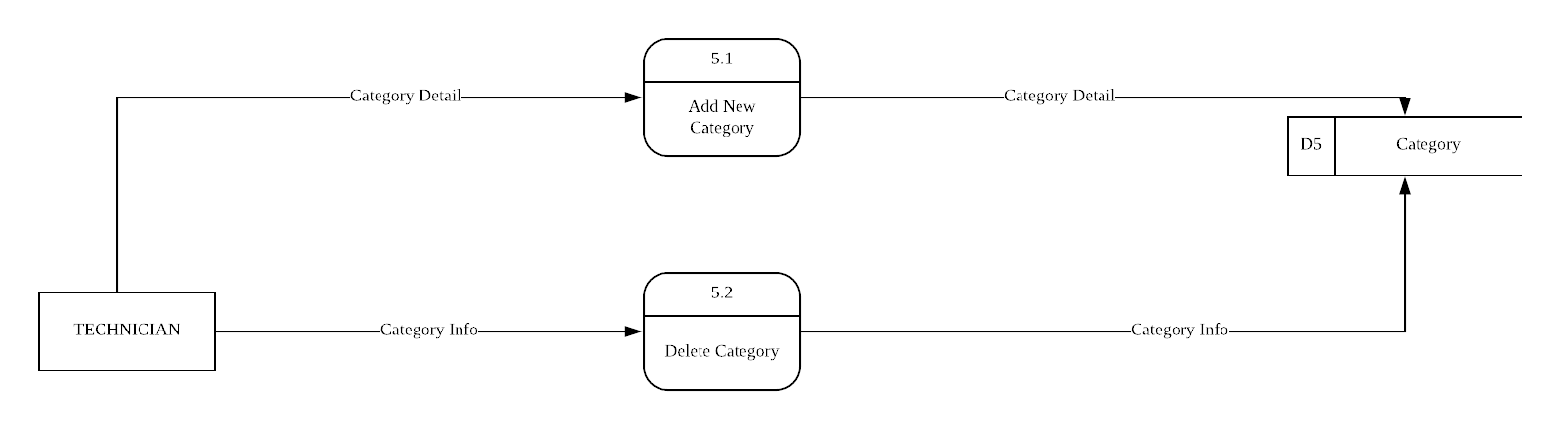

  - Interfaces

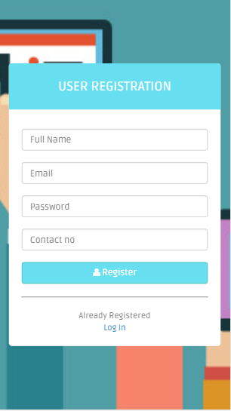
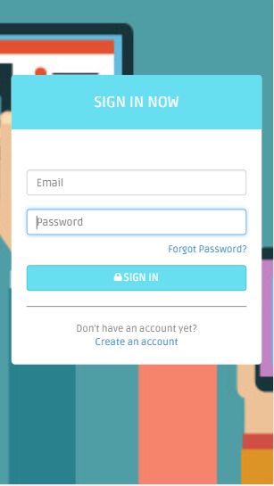
User Register
User Sign In

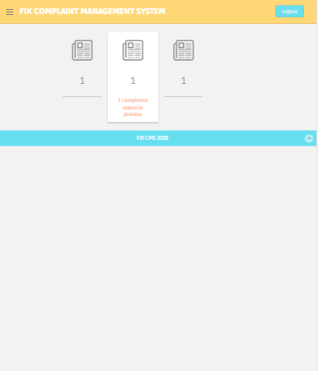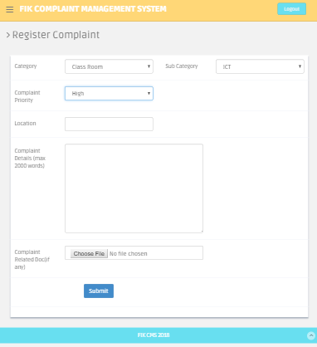
User Dashboard
User Lodge Complaint

4.5 Interfaces

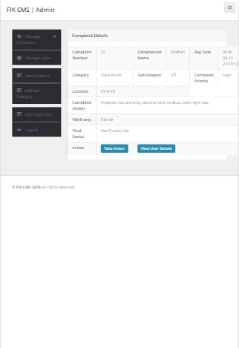

Technician Dashboard
Technician View Complaint

Summary

The approach of the authentication system may be finished in this chapter. The RAD paradigm was utilized for this project to illustrate requirement planning, user design, construction, and cutover. The system requirements are divided into software and hardware requirements for developing the authentication system.

CHAPTER 5

DISCUSSION AND CONCLUSION

Introduction

This chapter discusses project contributions, project constraints and development, future works that can be considered, and finally conclusion.

Project Contribution

This system's offer to the CPA organization is to assist them in managing and addressing consumer complaints more efficiently and methodically. Furthermore, the association may easily keep the complaint information and all the facts about the associations in a logical manner. Without CPA CMS, looking for complaint data will be considerably more difficult, especially if the complaint was filed a few years ago. This system must also be developed in order to avoid missing records and information. As a result, employing CPA CMS will enhance complaint handling for the CPA association.

Project Constraint

Every challenge and limitation encountered while creating this system was solved by completing a supervisor and feasibility study. The majority of the constraints arose during the development phase, especially in the coding area. A lack of resources and data may also have an impact on the development phase. Finally, every student is constrained by the project submission deadline, which requires them to manage their time effectively while producing the project and focused on their academics.

Future Work

Every project has opportunity for improvement in the future, whether produced by the developer alone or by a team for a better product. The future development for this system might be a notion where this system can combine with other systems, including live matter for the consumer. Many suggestions and future improvements may be made to this system, which may pave the way for a more efficient and systematic approach in the future.

REFERENCES

Doyle, M. & Straus D. (1976). How to Handle Complaint Better: The new interaction method. Chicago: Playboy Press.

- Hornby, A. S. (2001). Oxford Fajar. Advanced Learner’s English-English Dictionary. SSelangor Darul Ehsan, Malaysia: Kum-vivar Printing.

- Sridhar, R. P.,Sangareddy, Sanjeev, J., Chen, Y., Kevin, C. P. (2009). Attaining superior complaint resolution. Communication of the ACM; A View of Parallel Computing. 52 (10), October 2009, 122-126. Doi: 10.1145/1562764.1562795

- http://en.wikipedia.org/wiki/Literature_review

- http://www.aberdeen.com/_aberdeen/app/research- agenda/library.aspx

- http://www.dps.state.ia.us/fm/buidling/bcac/index.shtml

- http://www/ontariodirectors.ca/CODE

- https://simplicable.com/new/project-constraint

- https://bizfluent.com/facts-6401656-complaint-management-system

- https://www.hr.msu.edu/policies-procedures/faculty-academic-

APPENDIX

<?php define('DB_SERVER','localhost'); define('DB_USER','root');
define('DB_PASS' ,'');
define('DB_NAME', 'cms');
$con = mysqli_connect(DB_SERVER,DB_USER,DB_PASS,DB_NAME);
// Check connection
if (mysqli_connect_errno())
{
echo "Failed to connect to MySQL: " . mysqli_connect_error();
}
?>

<?php include('includes/config.php'); error_reporting(0); if(isset($_POST['submit']))

{

$fullname=$_POST['fullname'];

$email=$_POST['email'];

$password=md5($_POST['password']);

$confirmpassword=md5($_POST['confirmpassword']);

$contactno=$_POST['contactno'];

$status=1;

$query=mysqli_query($con,"insert into users(fullName,userEmail,password,confirmpassword,contactNo,status) values('$fullname','$email','$password','$confirmpassword','$contactno','$status')");

$msg="Registration successfull. Now You can login !";

}

?>

<?php session_start(); error_reporting(0);
include('includes/config.php'); if(strlen($_SESSION['login'])==0)
{

header('location:index.php');

}

else{

date_default_timezone_set('Asia/Kolkata');// change according timezone

$currentTime = date( 'd-m-Y h:i:s A', time () );

if(isset($_POST['submit']))

{

$fname=$_POST['fullname'];

$contactno=$_POST['contactno'];

$address=$_POST['address'];

$state=$_POST['state'];

$country=$_POST['country'];

$pincode=$_POST['pincode'];

$query=mysqli_query($con,"update users set fullName='$fname',contactNo='$contactno',address='$address',State='$state',country='$country',

pincode='$pincode' where userEmail='".$_SESSION['login']."'"); if($query)
{$successmsg="Profile Successfully !!";} else
{$errormsg="Profile not updated !!";}

}?>

<?php session_start(); error_reporting(0);
include('includes/config.php'); if(strlen($_SESSION['login'])==0)
{

header('location:index.php');

}

else{

if(isset($_POST['submit']))

{

$uid=$_SESSION['id'];

$category=$_POST['category'];

$subcat=$_POST['subcategory'];

$complaintype=$_POST['complaintype'];

$state=$_POST['state'];

$noc=$_POST['noc'];

$complaintdetials=$_POST['complaindetails'];

$compfile=$_FILES["compfile"]["name"];

move_uploaded_file($_FILES["compfile"]["tmp_name"],"complaintdocs/".$_FILES["compfile"]["nam e"]);
$query=mysqli_query($con,"insert into tblcomplaints(userId,category,subcategory,complaintType,state,noc,complaintDetails,complaintFile) values('$uid','$category','$subcat','$complaintype','$state','$noc','$complaintdetials','$compfile')");

// code for show complaint number

$sql=mysqli_query($con,"select complaintNumber from tblcomplaints order by complaintNumber desc limit 1");
while($row=mysqli_fetch_array($sql))

{

$cmpn=$row['complaintNumber'];

}

$complainno=$cmpn;

echo '<script> alert("Your complain has been successfully filled and your complaint no is "+"'.$complainno.'")</script>';

}

?>

function getCat(val) {

//alert('val');

$.ajax({

type: "POST",

url: "getsubcat.php", data:'catid='+val, success: function(data){
$("#subcategory").html(data);

}

});

}

<?php

function fetch_data()

{

$output = '';

$conn = mysqli_connect("localhost", "root", "", "cms");

$sql = "SELECT * FROM tblcomplaints ORDER BY complaintNumber ASC";

$result = mysqli_query($conn, $sql); while($row = mysqli_fetch_array($result))
{

$output .= '<tr>

<td>'.$row["complaintNumber"].'</td>

<td>'.$row["subcategory"].'</td>

<td>'.$row["complaintType"].'</td>

<td>'.$row["noc"].'</td>

<td>'.$row["complaintDetails"].'</td>

<td>'.$row["regDate"].'

<td>'.$row["status"].'</td>

</tr> ';
}

return $output;

}

if(isset($_POST["generate_pdf"]))

{

require_once('tcpdf/tcpdf.php');

$obj_pdf = new TCPDF('P', PDF_UNIT, PDF_PAGE_FORMAT, true, 'UTF-8', false);

$obj_pdf->SetCreator(PDF_CREATOR);

$obj_pdf->SetTitle("");

$obj_pdf->SetHeaderData('', '', PDF_HEADER_TITLE, PDF_HEADER_STRING);

$obj_pdf->setHeaderFont(Array(PDF_FONT_NAME_MAIN, '', PDF_FONT_SIZE_MAIN));

$obj_pdf->setFooterFont(Array(PDF_FONT_NAME_DATA, '', PDF_FONT_SIZE_DATA));

$obj_pdf->SetDefaultMonospacedFont('times');

$obj_pdf->SetFooterMargin(PDF_MARGIN_FOOTER);

$obj_pdf->SetMargins(PDF_MARGIN_LEFT, '10', PDF_MARGIN_RIGHT);

$obj_pdf->setPrintHeader(false);

$obj_pdf->setPrintFooter(true);

$obj_pdf->SetAutoPageBreak(TRUE, 10);

$obj_pdf->SetFont('times', '', 11);

$obj_pdf->AddPage();

$content = '';

$content .= '

<img src="log.jpg" width="50" height="50" align"right" title="Logo of a company" alt="Logo of a company" />

<h4 align="center">List Of Complaint Had Been Reported/Resolved</h4><br />

<table border="1" cellspacing="0" cellpadding="3">

<tr>

<th width="10%">No</th>

<th width="15%">Category</th>

<th width="15%">Priority</th>

<th width="10%">Location</th>

<th width="25%">Details</th>

<th width="15%">Registered</th>

<th width="10%">Status</th>

</tr>

';

$content .= fetch_data();

$content .= '</table>';

$obj_pdf->writeHTML($content);

$obj_pdf->Output('Complaint Report.pdf', 'I');

}

?>

