

An-Najah National University
Faculty of Engineering & Information Technology
Energy and Environmental Engineering

Optimization of residential Solar-Hydrogen Production as Remote Electrification Using HOMER in Nablus City

Supervisor:
Tamer Al-Khatib

Done by:
Rahaf Aloudeh

Presented in partial fulfilment of the requirements for Bachelor degree in Energy and Environment Engineering

May
Winter 2020-2021
Acknowledgement

I gratefully acknowledge the support and guidance that have been dedicated to me from my supervisor Dr. Tamer Al-Khatib, where the completion of this research paper could not have been accomplished without his efforts and encouragement. I sincerely appreciate his assistance and I express my gratitude by acknowledging his contribution in the success of this work.

DISCLAIMER

This report was written by Rahaf Aloudeh at the Energy and Environmental Engineering Department, Faculty of Engineering, An-Najah National University. It has not been altered or corrected, other than editorial corrections, as a result of assessment and it may contain language as well as content errors. The views expressed in it together with any outcomes and recommendations are solely those of the student. An-Najah National University accepts no responsibility or liability for the consequences of this report being used for a purpose other than the purpose for which it was commissioned.

Abstract
The research paper investigates the optimum design of an off-grid PV-FC power system that is set to cover the electric load demand of residence in the city of Nablus, Palestine. The techno-economic performance of the optimum design is tested over number of parameters and specifications and based on real weather data and first-hand load profile of Al Masaken Al Sha’beya area in the city.
The simulation model is designed and studied for optimization results using HOMER Pro Software. The developed simulations are run over the same conditions and parameters for three different models: PV arrays with hydrogen tank, PV arrays with battery storage system and PV arrays with both commentary units of hydrogen and battery storage. The main power of the hybrid system in the three models comes from the PV panels, where the FC and battery system are both considered as backup renewables to cover what shortage caused from different radiation levels.
The optimization software HOMER in the paper proposes the system architecture and the statue que of the power control, and proposes feasible solutions over the three models that covers the load demand. The results demonstrate obvious compatibility of PV-BATT model, where the PV-FC shows better power saving and utilization of renewables.
Keyword: Fuel cell, PV/Hydrogen, Hybrid power system, techno-economy optimization, HOMER.
Table of Contents
1 Introduction 6
1.1 Background 6
1.2 Research objectives 8
1.3 Significance of the research 8
1.4 Research structure 8
2 Literature Review 8
3 Research Methodology 11
3.1 Introduction 11
3.2 System Description 11
3.2.1 Case Study 11
3.2.2 Electric Load Profile 12
3.2.3 Solar Resource and PV Generator Data 13
3.3 System Modeling 14
3.3.1 PV-FC Model 14
3.3.2 PV-BATT Model 14
3.3.3 PV-FC-BATT Model 15
4 Result and Discussion 16
4.1 System architecture: 17
5 Conclusion 21
5.1 Limitations 21
5.2 Recommendation and Future Work 21
6 References 22

List of Figures
Figure 1 Daily Load Profile 12
Figure 2 Seasonal Load Profile 12
Figure 3 Yearly Load Profile 12
Figure 4 Monthly average Global Horizontal Irradiation at site 13
Figure 5 Average Monthly Baseline Data 13
Figure 6 PV-FC off-grid hybrid power system 14
Figure 7 PV-BATT off-grid power system 15
Figure 8 PC-FC-BATT off-grid hybrid power system 15
Figure 9 Cost Summary of the PV/FC hybrid power system 18
Figure 10 Cost Summary of the PV/BATT power system 18
Figure 11 Cost Summary of the PV/FC/BATT hybrid power system 19
Figure 12 Monthly electric production in PV-FC model 19
Figure 14 Monthly Electric Production in PV-FC-BATT model 19
Figure 13 Monthly electric production in PV-BATT model 19

List of Tables
Table 1 Clearness Index and Average Solar Radiation 16
Table 2 Input Data on Component Cost 16
Table 3 Input data on sizing and other parameters 16
Table 4 Optimization results for system architecture of the models 17
Table 5 Optimization results by HOMER for economic parameters 17
Table 6 Annual Energy Production HOMER-based 17
Table 7 Annual Electric Energy Consumption by HOMER 17

Introduction

Background

Small remote villages have always been a concern for any local authority. It is an undeniable fact that electrifying remote areas is economically inconvenient and requires much more than what it would provide, in order to fulfil the electrical demand of the residents (Anyi, Kirke, & Ali, 2010). From a side, supplying remote places with sufficient power by conventional energy resources, as in diesel and gas, is proven inefficient and non-viable, where the fuel is considered expensive with the available capabilities on one hand, and generators of such fuel types are noisy and necessarily need frequent operation maintenance, which are probably forgotten about or neglected due to supplying hardships for rural areas (Chakrabarti & Chakrabarti, 2002). It is also hard to manage and control, considering the limited resources in the area. On the other side, renewable inexhaustible resources, as in solar, wind and bioenergy, unfortunately are not a reliable source of energy yet as they are highly dependent on the characteristics of the area and its suitability for such developments and viability of it to provide power contentiously for the residents of remote areas (Anyi, Kirke, & Ali, 2010).
Although some projects that utilizes the solar energy to power such areas work out, considering the change of weather in the four seasons of the year, the sudden harsh rainfall, humidity and very hot climates in some places, that consequently leads to PV cells dysfunction and unexpected shut off of system, research in the field are working on providing a constant power line to remote areas. However, with the limited electrical needs of some areas, such developments are welcomed, especially when many are left with little to no access at all as a viable alternative (Reiche & Covarrubias, 2000).
In valleys and mountainous areas, the development and installments of projects of renewable energy, as in PV and wind, are not very much viable or manageable, however, they could be playing a part of the main solution for limited access and shortage of power in remote places, and that’s where hydrogen fuel cell was introduced to the field.
The introductory of hydrogen fuel cell goes back to 1932 by the scientist Francis Thomas Bacon, as a result of the previous knowledge demonstrated by William Robert Grove (Williams, 1994). It was then used in NASA space program- Apollo Moon Project back in the sixties (NASA , 2019). And since then, the hydrogen fuel cells has grown fast in popularity to be used in many other applications as a promising option for generation of power with limited resources (Blomen & Mugerwa, 2013). The hydrogen fuel cell consists of a sequence of electrochemical processes that converts the chemical energy stored in the hydrogen element into electrical energy efficiently, in the most environmental-friendly behavioral as a zero-carbon alternative for conventional energy resources (Hoffmann, 2012). In addition to electricity, the combustion that takes place in a hydrogen fuel cells produces heat and water as sub-products that can be utilized as well in other application in HVAC and water pumping heating application (Dodds, et al., 2015).
Furthermore, the hydrogen fuel cell paved its way to the transportation sector as an important power source, offered as an alternative for the conventional ones with the implementation of strict controls on gaseous emissions from vehicles’ engines (Trimm & Önsan, 2011). It then became necessary to search for other sources to fuel the vehicles without the legislation interference once more, where whatever the method chosen for the production of hydrogen is to be adopted to eliminate current vehicle exhaust (Jacobson, Colella, & Golden, 2005). The hardest barrier that prevents hydrogen fuel cells for cars in replacing non-renewable energy sources was the storage difficulty on board (Ross, 2006), which is in fact a challenge for hydrogen cells, considering the design and infrastructure of all vehicles (Chalk & Miller, 2006). This pushed researchers to consider the stationary application of hydrogen fuel cell in power generation, in attempt to lessen the reliance on fossil fuel and stop the escalation to the time where their impacts on planet Earth are irreversible (Wilberforce, Alaswad, Palumbo, Dassisti, & Olabi, 2016), which was highly supported, especially with the arising issue of the necessity of electrifying isolated remote places independently with the absence of other conventional sources of energy.
As an inexhaustible resource of energy, many considered this evolution of technologies with hydrogen fuel cells as a cornerstone of a whole new concept of energy (Hoffmann, 2012). Further enhancements into the technologies of hydrogen fuel cells resulted in innovative combinations with other renewable energy resources as to maximize the benefits of both resources in off-grid hybrid renewable energy systems (Eriksson & Gray, 2017). The hydrogen fuel cell and solar photovoltaic hybrid renewable energy system has been one of the most attractive topic that has been investigated not only for its economic feasibility, but also for its highly-technical mechanism of work and its potential in providing a stable reliable source of power for remote place (Singh, Baredar, & Gupta, 2017), proposing an optimal utilization of the potential of hydrogen fuel cells with storage system powered by solar energy, with the presence of power management unit for coordination purposes between the different sources of energy (Gibson & Kelly, 2010).
Such approaches however, are all well-developed technologies, that if designed correctly, can be used in a large scale for whole villages or even cities. In that case, battery storage systems might be needed; since off-grid power systems are expected to cover the load demand and provide a continuous power source. And although renewables have proven their capabilities, they are still dependent on environmental variables and conditions that are out of human-control, which is why they are incapable of providing this constant power without their complementary sub-units as battery storage and hydrogen tanks (Benbouzid, Mohammad, Amirat, & Elbaset, 2014)
The research paper will investigate the demonstration of a hydrogen fuel cell powered by PV for electrifying a remote village in Nablus, Palestine. The proposed off-grid hybrid power system aims to cover the load demand of residence in village, optimally designed and tested by HOMER Pro Software, utilizing real load demand and site radiation.

Research objectives

The set objectives if this research paper are stated as the following:
- To propose a residential PV-FC hybrid system as a power source.
- To optimize the system operation using HOMER Pro Software
- To evaluate the validation of the system in comparison to other suggestion, including storage units.

Significance of the research

The importance of this research is the proposal of optimum off-grid hybrid power system that meets the electric demand of residence in Palestine in the most economic aspect. It also provides crucial comparisons between three different systems with techno-economic analysis of the final choice for viability, reliability and compatibility. The research is considered an important solution for electrification of rural areas using renewable alternatives of diesel and natural gas generators.

Research structure

The research consists of 5 chapters. The first chapter, which is the introduction, gives a general background that gradually introduce the objective of the paper. The second chapter, which is the literature review, discusses a theoretical background of previous work in the PV-hydrogen electrification system. The third chapter, which is the methodology, provides a thorough detailed model of the hybrid system and three different scenarios of it. The fourth chapter, which is the results, summarizes all data collected with results computed from simulations from HOMER Pro Software. It also discusses and analyzes the results technically and economically. The last chapter concludes the important results of paper, mentions the limitations and provide future recommendation.

Literature Review

The unstoppable increase in the energy demand and the high cost of conventional fossil fuel have made renewable energy sources become more attractive and convenient, especially for remote areas, where transportation and storage high fees are also taken into consideration (Zhang, Maleki, Rosen, & Liu, 2019). With hybridization of different renewable systems introduced to the field as well, and the combination of the many advantages and features of both, the developed system became increasingly technically and economically viable (Ulleberg, Nakken, & Ete, 2010). Hydrogen production by solar energy has attracted a lot of attention by many researchers for its capability of generating power from the produced hydrogen by solar power autonomously, which has been seriously considered as an attractive alternative on many aspects.
HOMER (Hybrid Optimization Model for Electric Renewable) software is one of the greatest developments of the National Renewable Energy Laboratory NRLE that aims to achieve an optimum model based on the combination of all components of power systems, according to the specifications and constraints entered by the user (HOMER Energy, 2021). The sizing options and suggestions provided by the software follow the criteria set by user, whether it was economic or environmental, such as initial cost and cost of energy for the first one, or the CO2 emissions and penalties for pollutants for the latter. The determination of the most suited, feasible solution is based on the set data for each unit, starting from cost per kW of electrical component, through efficiency and ending with O&M costs and timings. In addition, the simulation will go through reliability and sensitivity tests in order to finally come out with the best fit that covers the electric load demand over the lifetime of the project. All possible solutions and scenarios are simulated for the final optimum configuration to be proposed.
Kalinci & Dincer (2015) presented a highly informative techno-economic analysis of hybrid renewable energy system with hydrogen production and storage options for an island. The study aimed to investigate the sustainability of the hydrogen production and the continuity of this energy in serving as an energy storage from an economic perspective by offering options of optimum system capacities for stand-alone application supported with simulation results. Additionally, the effect of different components of a PV/hydrogen energy system were examined for both sustainability and economic reasons using HOMER software for hybrid optimization model and validation of presented systems. Considering the net presented cost, the cost of energy and total annual cost in the economic investigation of the system. As a result, PV array of 300 kW, was found best fit with a wind turbine as well for a fuel cell of 100 kW and an electrolyzer of 200 kW in order to meet the demand by generating hydrogen with size of 400 kg that is expected to supply around 1875 kWh/day of demand. Such a huge system is set to utilize the renewable energy sources available to power the island and meet the demand of the citizens.
In addition, Benbouzid, Mohammad, Amirat, & Elbaset (2014) have conducted a research study using a HOMER-based optimal design for hybrid system of PV/Fuel Cell system without battery storage in order to cover the load demand of the city of Brest in France, which has an average load of 16,000 kWh/day. The research investigated the economic and technical performance of the simulated model given by HOMER, while considering the important techniques of energy management unit for an off-grid hybrid power system. The study offered a sufficient search study for all the components and used on-hand-data for the load profile with the real weather conditions of the city and optimization results proposed a 4200 kW pf PV arrays with 2000 kW FC for a 955,000 kg for hydrogen tank. With an average of 3.39 kWh/m²/day of radiation, a favorable, economic solution for the load is hybridization of power system with FC for stable energy production.
Another study of hybrid power systems utilizing both solar and wind energy, accompanied with battery storage systems and hydrogen tanks was carried by Rohani, Mazlumi, & Kord (2010) targeting remote located areas, using the optimization software HOMER. The proposed model and control strategy of the software gave a feasible solution for stand-alone application of locations for a hybrid system of PV, Wind Energy (WE), FC and battery storage. For an average radiation of 5,45 kWh/m²/day and average wind speed of 4.3 m/s, covering the electric load of 623 kWh/day, HOMER proposed a 200 kW of PV and 4 wind generators for a 50 kg hydrogen storage tank. The optimization aims to achieve a viable solution in terms of economic, reliability, and environmental measures subject to physical and operational constraints/strategies.
Highlighting the importance of simulations and modeling, especially in power systems and project is crucial and informative; as such systems are costly, variable-dependent and done on both micro-scales and large ones, which is why system description and modeling, in addition to energy control and management unit saves much time, money and energy to reach the optimum solution, benefiting from the well-developed software (El-Shatter, Eskandar, & El-Hagry, 2001).
Other studies as Khadem, Billah, Barua & Hossain (2017) and Rezk, Alghassab, & Ziedan (2020) focused on using HOMER-based simulation for irrigation and desalination purposes through PV/FC hybrid power system in Bangladesh and Saudi Arabia, respectively. The replacement of fossil fuels in both approaches moving towards an environmentally effective and reliable system, that is also economically efficient is the peak target of the optimization study.
This research paper will carry on simulation and the results are to be related and discussed with what have been found in previous literature review, where HOMER Pro Software is used for modeling the optimum off-grid PV/FC hybrid system.

Research Methodology

Introduction

The first project covered the theoretical part of the study, which investigated the function of fuel cells and PV systems, while studying the different factors that impact the performance of the system, as in the environmental factors: temperature, humidification, pressure and availability, and the technical aspect from volumetric flowrate, efficiency, storage and transmission.
This project translates the theoretical comprehension into practical approach by suggesting a residential PV-FC hybrid system as a distribution power source, optimized by HOMER Pro Software over three scenarios: PV-FC system, PV-Battery system and PV-FC-Battery system.
The three scenarios are carried on with different components in each while remaining the same residential electric monthly demand, which is set to be 16 kWh/day, with the same benefited solar potential over the area, which is around 4.63 kWh/m²/day. In addition, the result of the carried optimizations on the proposed system are presented and compared for evaluation of a suitable economic hybrid system. Moreover, the analysis carried explain the viability and validity of the optimization in terms of compatibility and coverage.

System Description
The hybrid PV-FC off-grid power system design depends on some important sensitivity variables to optimize the system cost and the component sizes, which is why the space search in HOMER differs in components accordingly, considering the requirements and availability of each one. For that, the system model is design considering the available solar irradiation of the location (Nablus, Palestine), and the electrical load demand of residence.
The hybrid PV-FC system mainly consists of two units: the PV unit, which present the initial source of power given by the chosen PV modules, and the hydrogen unit, which consists of three sections: the hydrogen production section (electrolyzer), hydrogen storage section and the fuel cell section that utilizes the produced hydrogen. The system is designed to be able to perform independently by generating a continuous, reliable and undisturbed source of energy to meet the electrical demands of the families. This system will later be compared to another consisting of battery storage unit without the hydrogen unit once, and then with the unit all together, where the PV is expected to cover the load from sunrise to sunset, and the other units are expected to cover overnight load and winter shortage from PV.

Case Study
The optimization of the PV-FC hybrid power system is for the city of Nablus, Palestine of which the load demand profile is taken from a real residential house. The latitude and longitude for location is of 32°13′29″N 35°18′09″E Al Masaken Al Sha’beya.

Electric Load Profile
Figure-1 illustrates the daily load demand of residence in Nablus city, which is scaled to around 16 kWh/day. Peak is 3 kWh from 3-5 Pm. Peak season occurs between November and January and lowest between May and July.

Figure 1 Daily Load Profile
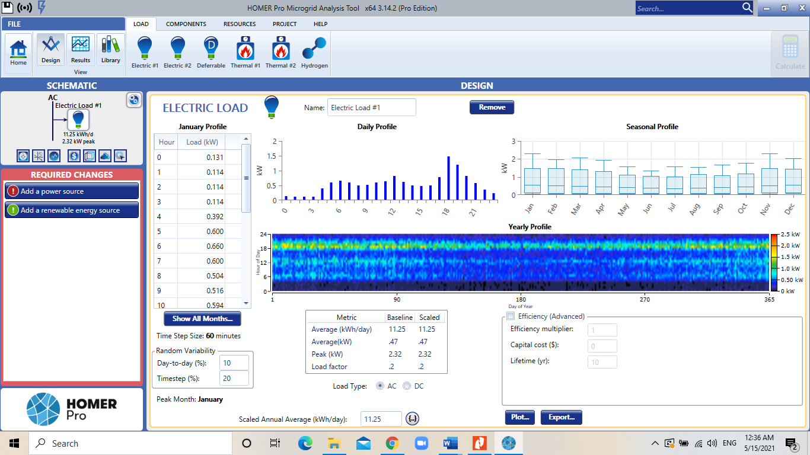
Figure-2 shows the seasonal profile of the load profile for the house. Figure-3 shows the daily average load for a whole year.
Figure 2 Seasonal Load Profile
Figure 3 Yearly Load Profile

Solar Resource and PV Generator Data
For the residence in the city of Nablus, the solar radiation data was deprived from the Global Solar Atlas (GSA), where the average GHI at site is 5.463 kWh/m²/day as shown in Figure-4.
Figure 4 Monthly average Global Horizontal Irradiation at site
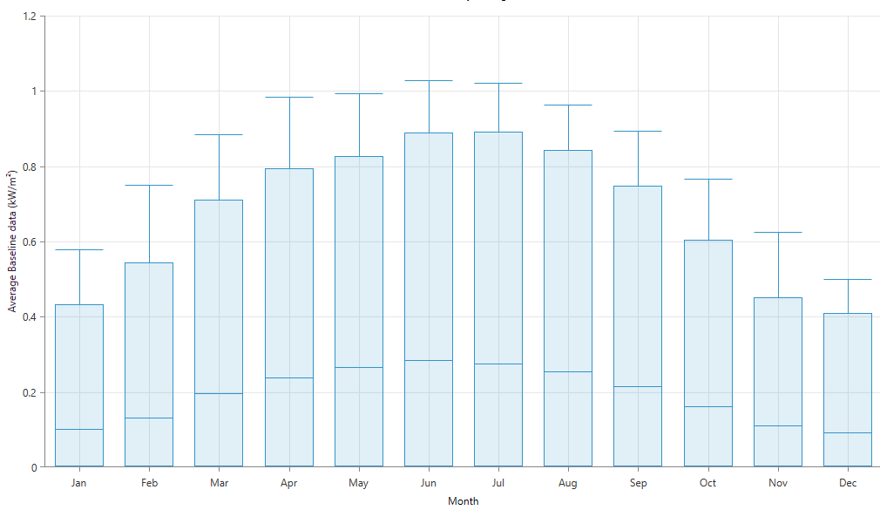
Figure 5 Average Monthly Baseline Data

The PV models have 20% ground reflectance, and with set array azimuth of 0$°$ directed to the south and array slope angle set to 40$°$. The Derating Factor is set at 90% and the lifetime of panels is 20 years. No tracking system is added as the optimization is set to meet residential economic capabilities.

System Modeling

PV-FC Model
The PV-FC model consists of the two main units. Considering Figure-4, a hybrid system consisting of PV modules and FC fed by stored hydrogen is a viable solution to cover the electric demand throughout the day, noting that it’s an off-grid hybrid power system, with hydrogen storage tanks. Figire-6 shows the illustrated PV-FC off-grid power system model given by HOMER.
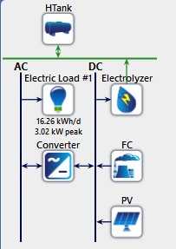
The optimization process mainly tests all the available economic solutions, considering the space search of each possible variable. This includes:
- PV array sizing [kW]
- Fuel Cell sizing [kW]
- Electrolyzer sizing [kW]
- DC/AC converter sizing [kW]
- Hydrogen tank sizing [kg]
The wider the space search of each variable, the better search for a viable suitable solution, of which is compatible with the entered load, that must be fulfilled by the proposed system with a 100% rate.
Figure 6 PV-FC off-grid hybrid power system
Considering the expected excess energy in summer, and the annual capacity shortage in winter, the search space should be sufficient in order to land an optimum solution for the given electrical load. The operational control strategy in PV-FC hybrid power system states by statue que that the PV meets the load demand through sunshine hours, the excess energy is sent to the electrolyzer in order to produce hydrogen and send it to the hydrogen storage tanks. In summer, the excess energy that is not desired by the electrolyzer is then sent to dump load. However, if the PV is not capable of covering the load demand, the FC is then set to generate electricity from the stored hydrogen. HOMER in this case is expected to give the optimum solution where the FC is able to cover the load fully when the PV is not in operation, which is in case of no irradiance. In this case, the model constraint is maximum 5% capacity shortage; as 0% shortage pushes the system to be economically unattractive and not viable.

PV-BATT Model
The PV-BATT model consists of the two main units: The PV arrays and the battery storage system. Considering Figure-4, a hybrid system consisting of the rightful sizing of PV modules, accompanied by sufficient storage system of lead-acid batteries, might also be a viable solution to cover the load demand. Figire-7 shows the illustrated PV-BATT off-grid power system model given by HOMER.
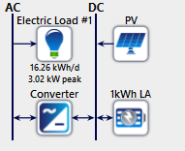
The optimization process mainly tests all the available economic solutions, considering the space search of each possible variable. This includes:
- PV array sizing [kW]
- DC/AC converter sizing [kW]
- Lead-acid battery sizing [kWh]
In the case of an off-grid, it has been set to issue a warning in case the battery autonomy is less than 2 hours. In this PV-BATT model, the battery works for 47 hours by itself. The larger the autonomy of the battery the more expensive it is.
Figure 7 PV-BATT off-grid power system
The narrative of having the battery work by itself for 120 hours, which is 5 days a week requires double the sizing of lead-acid batteries. The optimization results balance between the sufficiency and independency of the power system with the economic viability as well.

PV-FC-BATT Model
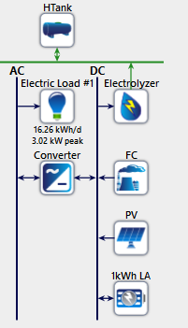
The PV-FC-BATT model consists of three units: The PV arrays, the FC fed by stored hydrogen and the battery storage system. The PV and FC are both expected to work simultaneously to feed the demand with a smaller proposed sizing; since there will be a storage system for the excess power generated. Figire-8 shows the illustrated PV-FC-BATT off-grid power system model given by HOMER. The optimization process mainly tests all the available economic solutions, considering the space search of each possible variable. This includes:
- PV array sizing [kW] and Fuel Cell sizing [kW]
- Electrolyzer sizing [kW]
- DC/AC converter sizing [kW]
- Hydrogen tank sizing [kg]
- Lead-acid battery sizing [kWh]
This model is a crucial one that consist of all electric variables that are studied in the first and second models. The model. However, is sensitive and biased; since working with PV and basic storage system is economically more viable, the suggested models shift towards disposing the fuel cell and electrolyzer or include them with a smaller contribution than the first model. And so, although the fuel cell does indeed play a role in covering the demand, its coverage is between 2-5% of the load demand only. In addition, the excess and shortage capacity issue arise more in this model since it heavily depends on the lead-acid batteries sizing rather than the hydrogen tank, which in this case, the excess electricity is simply wasted outside the batteries and cannot be used for hydrogen production that can be sold later. Further discussion will be given in chapter 4.
Figure 8 PC-FC-BATT off-grid hybrid power system

Result and Discussion
The three different models were simulated and the optimum configuration and sizing of each, considering techno-economic variables, using HOMER Pro software
Table-1 below shows the clearness index and average the solar radiation.
Table 1 Clearness Index and Average Solar Radiation
Month | Clearness index | Average radiation  [kWh/m2/day]
JAN | 0.431 | 2.392
FEB | 0.456 | 3.111
MARCH | 0.546 | 4.672
APRIL | 0.561 | 5.672
MAY | 0.570 | 6.339
JUNE | 0.593 | 6.809
JULY | 0.584 | 6.575
AUGT | 0.579 | 6.050
SEP | 0.568 | 5.141
OCT | 0.526 | 3.848
NOV | 0.453 | 2.637
DEC | 0.427 | 2.200
HOMER input data on component costs are given in Table-2 below.
Table 2 Input Data on Component Cost
Component | Capital Cost | Replacement Cost | O&M Cost
PV [kW] | $500/ kW | $500/ kW | $5/yr
FC [kW] | $22,500/ 5 kW | $22,500/ 5 kW | $0.1/op.hr
AC/DC Converter [kW] | $1000/ 5 kW | $1000/ 5 kW | $20/yr
Electrolyzer [kW] | $400/ kW | $400/ kW | $10/ yr
Hydrogen Tank [kg] | $1400/ kW | $1400/ kW | $10/yr
Lead-Acid Battery [kWh] | $150/ kW | $100/ kW | $10/yr
HOMER input data on component sizing search space and others are given in Table-3 below.
Table 3 Input data on sizing and other parameters
Component | Option on size | Lifetime | information
PV [kW] | 0, 1, 2, 3, 4, 5, 6, 7, 8, 9. | 20 years | Derating factor= 90%
FC [kW] | 0, 1, 2, 3, 4, 5, 0, 1, 2, 3, 4, 5, 6, 7, 8, 9, 10. | 40,000 hours | Minimum load ratio: 0%
AC/DC Converter [kW] | 0, 2, 4, 6, 8, 10 | 15 years | Efficiency= 95%
Electrolyzer [kW] | 0, 2, 4, 6, 8, 10 | 15 years | Efficiency= 85%
Hydrogen Tank [kg] | 0, 5, 10, 15, 20 | 25 years | Relative to tank size= 10%
Lead-Acid Battery [kWh] | 30, 35, 40, 45, 50, 55, 60, 65, 70 | 10 years | Min state of charge=30%

System architecture:
Table-4 below shows the optimization results for the system architecture of the off-grid hybrid power system run by HOMER for the three proposed models
Table 4 Optimization results for system architecture of the models
Component | Sizing (PV-FC) | Sizing (PV-BATT) | Sizing (PV-FC-BATT)
PV [kW] | 9 | 6 | 10
FC [kW] | 2 | - | 1
AC/DC Converter [kW] | 2 | 3 | 5
Electrolyzer [kW] | 2 | - | 10
Hydrogen Tank [kg] | 5 | - | 2
Lead-Acid Battery [kWh] | - | 45 strings | 10 strings
Table-5 demonstrate the economic parameters between the three models run by HOMER
Table 5 Optimization results by HOMER for economic parameters
Parameter | (PV-FC) | (PV-BATT) | (PV-FC-BATT)
Initial Capital Cost [$] | 21,700 | 10,350 | 18,800
Total NPC [$] | 40,921 | 23,697 | 29,010
LCOE [4/kWh] | 0.4425 | 0.2561 | 0.3103
Operating Cost [$/Year] | 1,220 | 847 | 648
Table-6 shows the annual electric energy production of the hybrid power system from each model given by HOMER. Power from model 1 and 3 are given from both the PV and FC, while model 2 is covered solely by the PV arrays.
Table 6 Annual Energy Production HOMER-based
 | PV-FC |  | PV-BATT |  | PV-FC-BATT
Component | Production  [kWh/year] | Fraction  [%] | Production  [kWh/year] | Fraction  [%] | Production  [kWh/year] | Fraction  [%]
PV array | 15,998 | 83.3 | 10, 665 | 100 | 17,775 | 93.1
FC | 3,213 | 16.7 | - | - | 1,318 | 6.9
Total production | 19,210 | 100 | 10,665 | 100 | 19,093 | 100
Table-7 shows the annual electric energy consumption between the primary AC load and the electrolyzer. Only model 1 and 3 have the division since model 2 does not have any.
Table 7 Annual Electric Energy Consumption by HOMER
 | PV-FC |  | PV-BATT |  | PV-FC-BATT
Component | Consumption  [kWh/year] | Fraction  [%] | Consumption  [kWh/year] | Fraction  [%] | Consumption  [kWh/year] | Fraction  [%]
AC primary load | 5,871 | 56.2 | 5,871 | 100 | 5,935 | 61.4
Electrolyzer | 4,584 | 43.8 | - | - | 3,729 | 38.6
Total | 10,455 | 100 | 5,871 | 100 | 9665 | 100

Table-8 shows the annual emissions of each model run by HOMER. Model 2 does not emit any harmful pollutants as it solely works on the solar radiation used by PV arrays
Pollutant | Emission [kg/year]
Pollutant | PV-FC | PV-FC-BATT
CO₂ | -0.985 | -0.808
CO | 0.627 | 0.514
Unburned hydrocarbons | 0.0694 | 0.0569
Particulate matter | 0.0472 | 0.0388
SO₂ | 0 | 0
NO | 5.59 | 4.59

Figure-9, Figure-10 and Figure-11 illustrate the cost summary for the PV-FC model, PV-BATT model and the PV-FC-BATT model, respectively, run by HOMER.
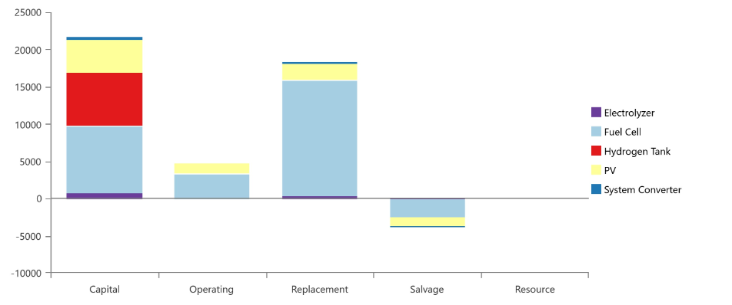
Figure 9 Cost Summary of the PV/FC hybrid power system
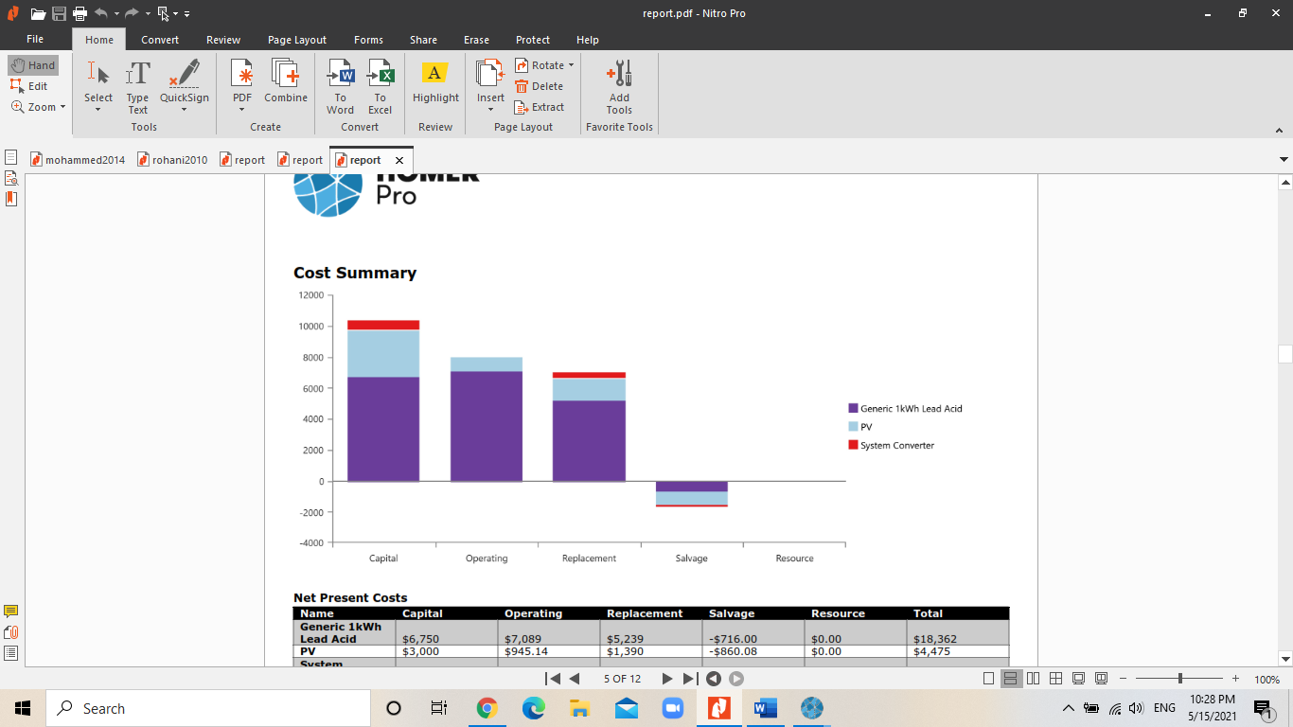
Figure 10 Cost Summary of the PV/BATT power system
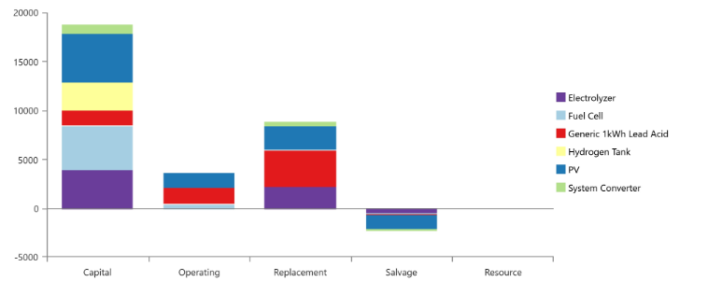
Figure 11 Cost Summary of the PV/FC/BATT hybrid power system
Figure-12, Figure-13 and Figure-14 demonstrate the monthly electric production from both PV and FC in the three models of hybrid power systems run by HOMER.
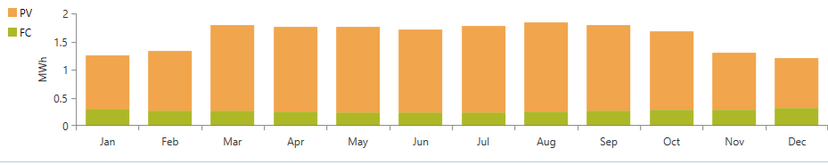
Figure 12 Monthly electric production in PV-FC model
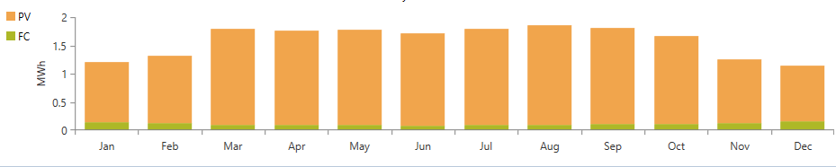
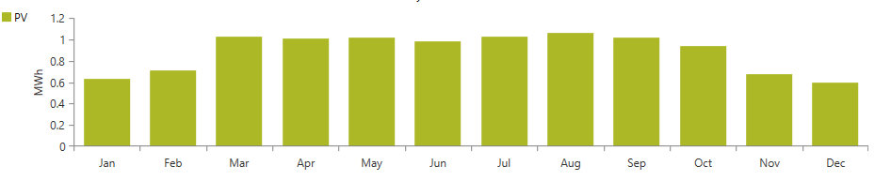
Figure 14 Monthly Electric Production in PV-FC-BATT model
Figure 13 Monthly electric production in PV-BATT model

From Table-4 and Table-5, as expected, it shows that using a simple PV system with battery storage system is the most economically-attractive model; as the cost of FC, electrolyzer and hydrogen tanks weight over the compatibility of the system. The second model covers the electric demand with 6 kW of PV arrays and 45 strings of lead-acid batteries, that are set to work autonomously 2 days/week with shortage of 70 kWh/year, which is almost 0.77 kWh/day. However, the first and third models are also economically competitive, considering the lifetime of the project, the first model proposes a 9 kW of PV arrays; the excess energy is sent to the electrolyzer for the hydrogen production, the stored hydrogen than can be sold if the load is fully covered by the PV and so there is no loss in energy, the model also works with a 5 kg hydrogen tank making up to 96 kg a year for covering the load, considering the specific fuel consumption to be 0.003 kg/ kWh (1/ 33.3 kWh/kg H₂). The fuel cell covers great portion of the load with production of 3213 kWh/year where the AC Primary load is 5871 kWh/year. The electricity wasted on electrolyzer is made up by more stored hydrogen that can be used any other time, on contrary of the first model with battery storage system. The third model on the other hand has the smallest contribution of hydrogen and fuel cell as all with only 6.9% of electric production, which is 1,318. The PV is capable of covering most of the load with 10 kW size, which makes the fuel cell almost extra with 10 strings of batteries. However, economically it is more viable than the second option as it requires less size of the FC: 1 kW, and hydrogen tank of 2 kg only.
The PV-FC model have been set to maximum annual capacity shortage of 2%; since 5% will lead to 250 kWh/ year of shortage, standing for 4.21% of the overall demand, accompanied with 3377 excess electricity, however 0% shortage will not only increase the losses to 4699 kWh/year, it will also increase the capital cost from $38,000 to $55,00, which makes it economically unattractive. The middle-ground solution of 2% will lessen the shortage to 111 kWh/year in winter as in 1.88 of the total load demands, which is 90 days. That means only 1,233 shortage is expected per day, which is made up by the economic saving of the power system. The excess electricity however, is found to be 8774, which is more than double the initial value, which explained why initially, HOMER proposed 6 kW of PV arrays, then switched to 9 kW of PV in order to cover the shortage in winter. In this case, the excess is not waster as it can be used in hydrogen production, which is stored in tanks, of which in can be saved for later consumption or sold for its value. The same capacity shortage has also been set the same for model 2&3. In Model 2, at shortage capacity of 2%, the shortage is 70 kWh/year standing for 1.18 pf the total demand, which is in 90 days of winder equals to less than 0,8 kWh shortage per day. The excess energy however is doubled from its value from 5% shortage, and became 3682, which is in this case all wasted; since the system is only integrated to battery storage that have a set capacity and cannot accept more electricity, which means it is sent to dump load. In this case, increasing the size of batteries will almost double the cost of power system, which holds more value than the dump excess electricity, and so the optimum solution is set for 45 strings of lead-acid batteries only. Last model got excess energy of 8638 for shortage capacity of 2%, in this case, it can be utilized for more hydrogen production rather than being dumped since the system is integrated to a fuel cell and hydrogen tanks, and the shortage is quite insignificant as less than 0.8 kWh/year, which is less than 0.008 kWh/day during winter.

Conclusion
The research paper investigates the performance of hybrid PV-FC off-grid power system for residential purposes in the city of Nablus in order to meet the electric load demand utilizing different renewables. The proposed design has been run by HOMER Pro Software which considered techno-economic variables to test all possible solutions and configuration for an optimum viable solution that is economically attractive, and also provides a continuous power supply from the stand-alone hybrid system.
The HOMER-based optimization study used real data weather of the location and first-hand load profile from a residence in Al Masaken Al Sha’beya in the city of Nablus on different scenarios where the PV arrays are once complemented with hydrogen tanks, and once with battery storage systems and once with both complementary units; in order to show the suitable optimum solution with important economic parameters of LCOE, capital cost and NPC for the power systems in the three models.
The research also provided figures and illustrations of the viability and attractiveness of the three models over the lifetime of the project, which is set to be 25 years, considering specifications of each component as efficiency of converter and electrolyzer, deration of PV and minimum charging and relativity of hydrogen tank and lead-acid batteries.

Limitations
Some limitations have been faced through the research:
- The number of simulations is quite large, considering the space search of each component, the shortage capacity, the specifications and economic parameters, which made it quite impossible to cover all the possible solutions that might have been there.
- Most of the HOMER-based previous research are large scale power systems for whole villages and cities, or for governmental purposes over large areas are desalination and irrigation for the models proposed, and few papers have had the proposed models but as an on-grid systems, which made it somehow difficult to compare and comment on results.

Recommendation and Future Work
For a better optimization of the results, more simulations are to be run by HOMER software where all economic parameters as inflation, cost of fuel, interest rate and temperature effect are to be considered and studied. In addition, more focus is to be dedicated for the shortage capacity and excess electricity issue in order to avoid the loss of power and oversize of power supply, which influences the economic statue of the hybrid power system. Moreover, other renewables as biogas and wind energy should also be proposed to cover the load demand fully, especially for rural remote locations around the country.

References
Anyi, M., Kirke, B., & Ali, S. (2010). Remote community electrification in Sarawak, Malaysia. Journal of Renewable Energy, 35(7), 1609-1613.
Benbouzid, M., Mohammad, O. H., Amirat, Y., & Elbaset, A. A. (2014). Optimal Design of a PV/Fuel Cell Hybrid Power System for the City of Brest in France. First International Conference on Green Energy ICGE, (pp. 119-123). Brest.
Blomen, L. J., & Mugerwa, M. N. (2013). Fuel Cesll Systems . Rome : Springer Science & Business Media.
Chakrabarti, S., & Chakrabarti, S. (2002). Rural electrification programme with solar energy in remote region–a case study in an island. Journal of Energy Policy, 30(1), 33-42.
Chalk, S. G., & Miller, J. F. (2006). Key challenges and recent progress in batteries, fuel cells, and hydrogen storage for clean energy systems. Journal of Power Sources, 159(1), 73-80.
Dodds, P. E., Staffell, L., Hawkes, A. D., Li, F., Grunewald, P., McDowall, W., & Ekins, P. (2015). Hydrogen and fuel cell technologies for heating: A review. Internationa Journal of Hydrogen Energy, 40(5), 2065-2083.
El-Shatter, T. F., Eskandar, M. N., & El-Hagry, M. T. (2001). Hybrid PV/fuel cell system design and simulation. nternational Solar Energy Conference (pp. 267-273). American Society of Mechanical Engineers.
Eriksson, E. L., & Gray, E. A. (2017). Optimization and integration of hybrid renewable energy hydrogen fuel cell energy systems – A critical review. Journal of Applied Energy, 202(15), 348-364.
Gibson, T. L., & Kelly, N. A. (2010). Predicting efficiency of solar powered hydrogen generation using photovoltaic-electrolysis devices. International Journal of Hydrogen Energy, 35(3), 900-911.
Hoffmann, P. (2012). Tomorrow's Energy: Hydrogen, Fuel Cells, and the Prospects for a Cleaner Planet. London: The MIT press.
HOMER Energy. (2021). Retrieved from http://homerenergy.com/
Jacobson, M. Z., Colella, W. G., & Golden, D. M. (2005, June 24). Cleaning the air and improving health with hydrogen fuel-cell vehicles. Science Magazine, 308(5730), pp. 1901-1905. doi:10.1126
Kalinci , Y., & Dincer, I. (2015). Techno-economic analysis of a stand-alone hybrid renewable energy system with hydrogen production and storage options. International Journal of Hydrogen Energy, 40(24), 7652-7664.
Khadem, T., Billah, S., Barua, S., & Hossain, M. (2017). Homer based hydrogen fuel cell system design for irrigation in bangladesh. Homer based hydrogen fuel cell system d4th International Conference on Advances in Electrical Engineering (ICAE) (pp. 445-449). IEEE.
NASA . (2019, May 15). Apollo 11 Mission Overview. Retrieved from NASA Official Web Site: https://www.nasa.gov/mission_pages/apollo/missions/apollo11.html
Reiche, K., & Covarrubias, A. M. (2000). Expanding electricity access to remote areas: off-grid rural electrification in developing countries. Fuel, 1(1.2), 1-4.
Rezq, H., Alghassab, M., & Ziedan, H. (2020). An optimal sizing of stand-alone hybrid PV-fuel cell-battery to desalinate seawater at saudi NEOM city. Proccessors, 8(4), 382-384.
Rohani, A., Mazlumi, K., & Kord, H. (2010). Modeling of a hybrid power system for economic analysis and environmental impact in HOMER. 2010 18th Iranian Conference on Electrical Engineering , (pp. 819-823). Zanjab.
Ross, D. (2006). Hydrogen storage: The major technological barrier to the development of hydrogen fuel cell cars. Vacuum Journal, 80(10), 1084-1089.
Singh, A., Baredar, P., & Gupta, B. (2017). Techno-economic feasibility analysis of hydrogen fuel cell and solar photovoltaic hybrid renewable energy system for academic research building. Energy Conversion and Management Journal, 154(1), 398-414.
Trimm, D. L., & Önsan, I. (2011). ONBOARD FUEL CONVERSION FOR HYDROGEN-FUEL-CELL-DRIVEN VEHICLES. Journal of Catalysis Reviews: Science and Engineering, 43(1-2), 31-84.
Ulleberg, Ø., Nakken, T., & Ete, A. (2010). The wind/hydrogen demonstration system at Utsira in Norway: Evaluation of system performance using operational data and updated hydrogen energy system modeling tools. International Journal of Hydrogen Energy, 35(5), 1841-1852.
Wilberforce, T., Alaswad, A., Palumbo, A., Dassisti, M., & Olabi, A. (2016). Advances in stationary and portable fuel cell applications. International Journal of Hydrogen Energy, 41(37), 16509-16522.
Williams, K. R. (1994). Francis Thomas Bacon, 21 December 1904 - 24 May 1992. Biographical Memoirs aof Fellows of the Royal Society, 1-18.
Zhang, W., Maleki, A., Rosen, M., & Liu, J. (2019). Sizing a stand-alone solar-wind-hydrogen energy system using weather forecasting and a hybrid search optimization algorithm. Journal of Energy Conversion and Management, 180, 609-621.

