

Department of Computer Engineering
College of Engineering
An-Najah National University

GMAP
(Great Map)

Prepared by :
Saif Marwan & Osama Nabulsi

Supervisor Name:
Dr. Loay Malhis , Eng. Haya Sammaneh

Academic Year:
2011 – 2012

Contents List

Abstraction …………………………………………………………. 4
- Introduction …………………………………………………….. 5
  - Overview ……………………………………………………... 5
  - Existing Problems ………………………………………….... 6
  - Related Work ………………………………………………... 6
  - Motivation for Carrying out the Project ……………………6
  - Report Organization …………………………………………7
- Methodology ……………………………………………………. 8
- Results and Discussion …………………………………………. 23
- Conclusions and Recommendations …………………………… 33
  - Conclusions ……………………………………………………33
  - Recommendations …………………………………………….33
- References ……………………………………………………….. 35
- Appendix ………………………………………………………… 36

List of Figures
Fig.1 An-Najah National University – New Campus ………………………………………… 8
Fig.2 Real view for the university by Google Earth ………………………………………….. 9
Fig.3 version of map with using our standard symbols …………………………………….... 19
Fig.4 Flow Chart shows the functionality of Developer Form ………………………………. 22
Fig.5 Developer Form ………………………………………………………………………… 24
Fig.6 Layer Properties in Admin Form ………………………………………………………. 25
Fig.7 Features of Objects, may be Set by Admin ……………………………………………. 26
Fig.8 Admin Form ……………………………………………………………………………. 27
Fig.9 Manager Form ………………………………………………………………………….. 28
Fig.10 Flow Chart shows functionality of manager form ……………………………………. 29
Fig.11 Sample From Google Map in Real User Form ………………………………………... 31
Fig.12 Flow Chart shows routing feature ……………………………………………………...31
Fig.13 Real User Form ……………………………………………………………………….. 32
List of Tables
Table 1 Real pictures for every collages, buildings and public utilities for the university ….. 15
Table 2 symbols and its meaning in map ……………………………………………………… 18
List of Nomenclatures
Symbol Description
GPS Global Positioning System
GIS Geographic Information System
API Application Programming Interface
ESRI Economic and Social Research Institute
Abstract

In these days, urban life evolved and expanded significantly, which increases the need for computerized maps, and consequently the need for efficient and accurate import applications software with wide scope, as this type of tools are necessary for developing applications targeting vast range of industrial sectors, such as mechanical engineering, building, circuit technology, cartography and analytic systems, where it is necessary to work with CAD file formats such as DWG, DXF, PLT (HPGL), CGM and convert this maps into convenient ones to enable end-user to work easily and efficiently.
Computerized maps offer many advantages over traditional maps which waste the user time, not to mention the inefficient and difficulty retrieval of information these maps suffer from. This project comes to facilitate access to computerized maps through a user friendly method which saves time and accuracy.
Our project includes creating easy to use programs to convert the maps into dynamic ones with integrated database in addition to managing the created maps in the way the customer fields requires in addition to embedding the map in other systems such as Web Sites, tracking systems, guiding system, educational systems, etc.
Our project converts the CAD maps of buildings, cities, cables, etc, to software which analyze that maps in a specific standard. It further develops smart CAD-enabled applications using Microsoft Visual Studio.Net software with the ability to instantly read and process data and graphics from CAD drawings and save the result to a file or database.
In this documentation we will give an example illustrating the flexibility of our application by converting An-Najah National University map and integrating it with a multi-touch screen which will be located at the main entrance of the new campus, to be used for guiding issues.

1. Introduction

  - Overview
A geographic information system (GIS), or geographical information system refers to any system that records and analyzes information linked to a geographic location.
It allows users to search for specific queries and draw conclusions from the analysis of the spatial information and data presented by the map.
Technically, a GIS is a system which includes :
- Mapping software and its application to remote sensing , land surveying, aerial photography, mathematics, geography.
- Tools that can be implemented with GIS software.
Modern GIS technologies use digital information, for which various digitized data creation methods are used. The most common method of data creation is digitization, where a hard copy map or survey plan is transferred into a digital medium through the use of a computer-aided design (CAD) program, and geo-referencing capabilities. With the wide availability of ortho-rectified imagery (both from satellite and aerial sources), heads-up digitizing is becoming the main avenue through which geographic data is extracted. Heads-up digitizing involves the tracing of geographic data directly on top of the aerial imagery instead of by the traditional method of tracing the geographic form on a separate digitizing tablet .
This project in general, has several uses . We can use it in telecommunication companies and we just need to re-definition of street to cable and college to cabins of wire, etc. Also, we can use our project in municipalities and we can re-definition of college to fountains of water, etc.
The main objective of this project is to make a sample of electronic map guide for " An-Najah National University ", and we used a simple map for New Campus in our university .

  - Existing Problems
Most of available programs used GPS in their applications to apply maps guide, but in our project we created efficient Great Map without need for GPS and its problems, so any user can simply use it without having any device must support GPS.
Local companies here in Palestine pay a lot of money for special global companies in order to convert their maps to GIS applications to be used in their job, which does not enable it to make GIS as a service for public costumers.
As a result, our application with its features came to provide the same targets and make it available for many public and global companies and sample users.

1.3 Related Work
In fact, there are some companies here in our country use GIS in their business like as PALTEL company that used GIS for its cables and wires networks and Nablus Municipality, which also used GIS for water and sanitation networks in the city.
Although, we think that using GIS for tourist guides in our country are not available in wide .

  - Motivation for Carrying out the Project
This is our first Graduation Project, so we hope to carry out our project in best possible condition, in order to do something express our gratitude to our university and enhance the confidence of our doctors and teachers and make them proud of us.
Also, supervisors always follow up and encourage us, and this is another reason to work on project’s success .
It should be noted that we had training course in PALTEL Company, and we visited GIS department . As a result, we realized that most of companies today used to development of their business by using new technologies and computerized their work, for that we taken in our attention that GIS projects will have wide ranges in the future .

1.5 Report Organization
This document discuss the functionality of our project included the features in each part of it. In addition, we will summarize all the results that we got it in this project.
We will find that in our document, contents for each section as follow :
- Methodology Section : we will describe the methods used to establish facts and ideas for this project.
- Results and Discussion Section : we will turn to discuss the parts of
"Great Map Guide " project, including its four parts (Developer Form, Admin Form, Manager Form and Real User Form).
- Conclusions and Recommendations section : you will find our recommendations and conclusions about this project, and how we can develop this product in order to use it commonly in different working life.

2. Methodology

The steps that were carried out for implementing the project are :
- Collection data and information about An-Najah National University.
- Create standard symbols that represent each building in the university.
- Programs and applications that depend on GIS.
- Programming parts.
Collection data and information about An-Najah National University :
Because we hope that this project can provide assistance and guidance to user, it must contain a lot of data about the target site.
So, we collect many information about An-Najah National University – New Campus and its colleges and public utilities in order to make our project full of details.
We used a sample picture that shows the architectural drawing for An-Najah National University – New Campus.
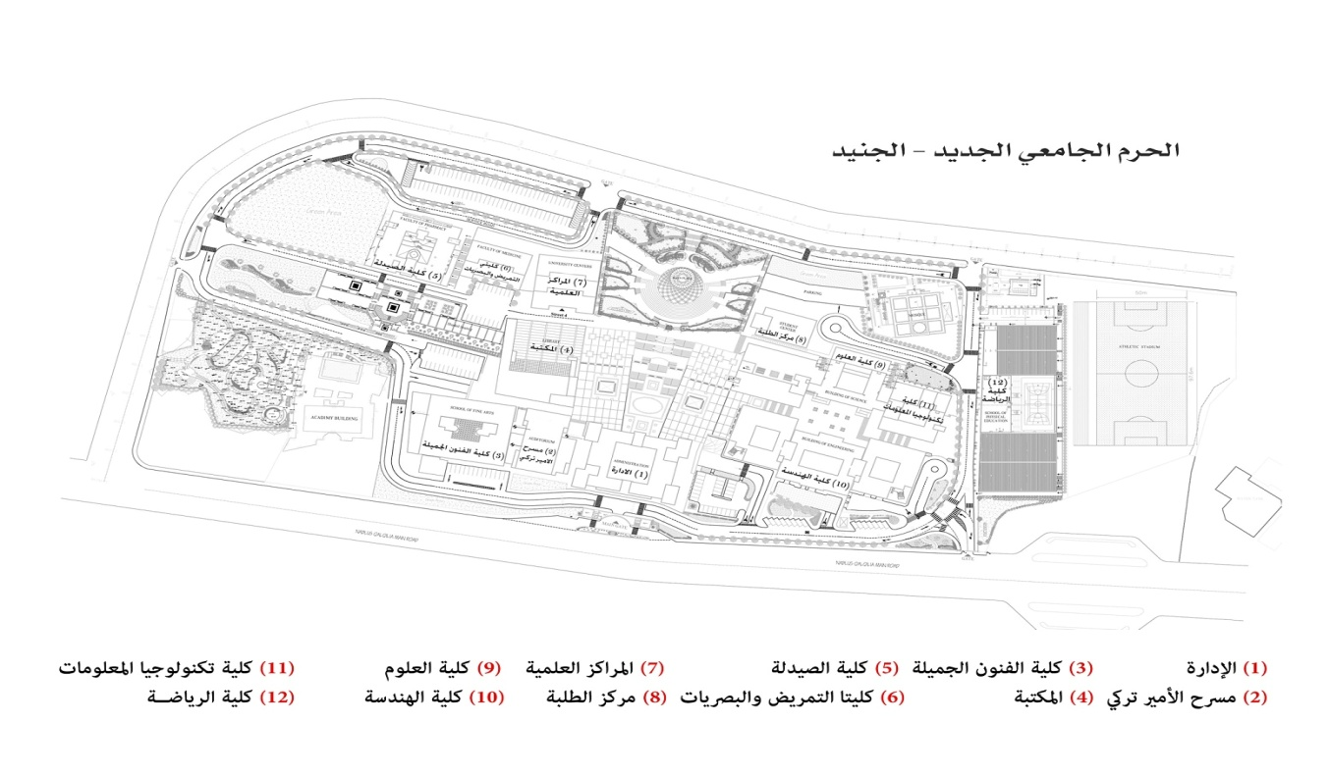
Fig.1 An-Najah National University – New Campus
Also, we support our project with real view in order to connect the destination target with real world.
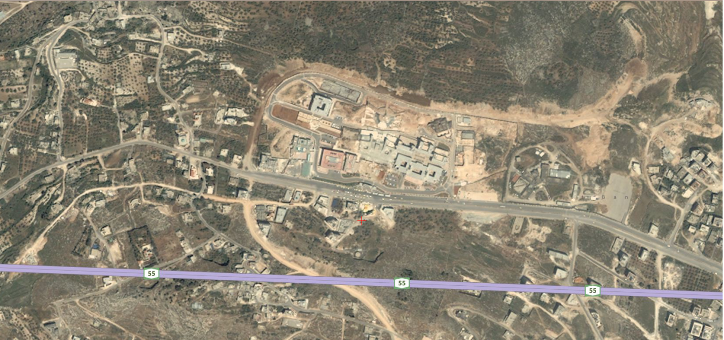
Fig.2 Real view for the university by Google Earth

In addition, we got real pictures for every collages, buildings and public utilities in the university, in order to make the users sure that this is the place that they need, and they will acquainted it, by reach this place.
These real picture will appear in our project when the users need more information about their destination. So, this feature may be provides more help for users in addition to the path that will also appear directly on the map .
The following table shows these pictures and places that connect with it :
Picture | The destination
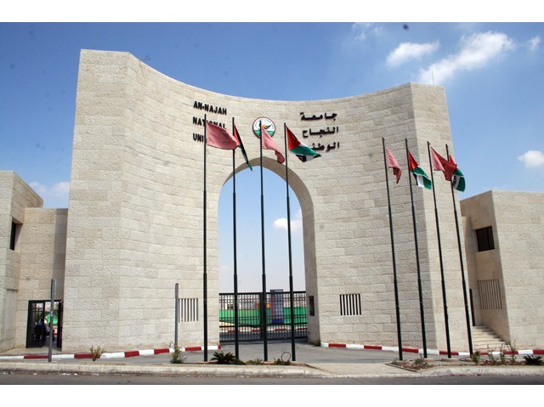 | Start Point
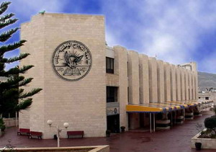 | Administration Building
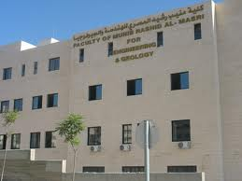 | Faculty of Engineering
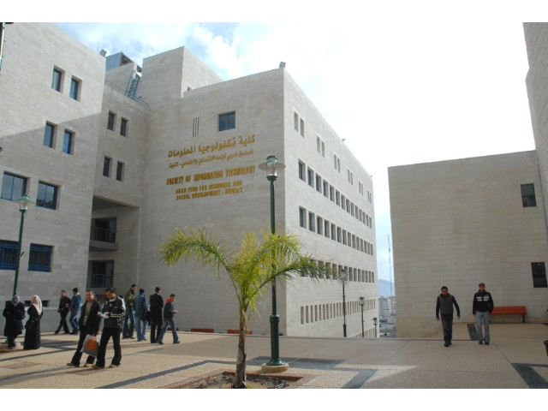 | Faculty of Information Technology
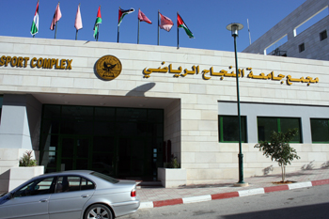 | Faculty of Physical Education
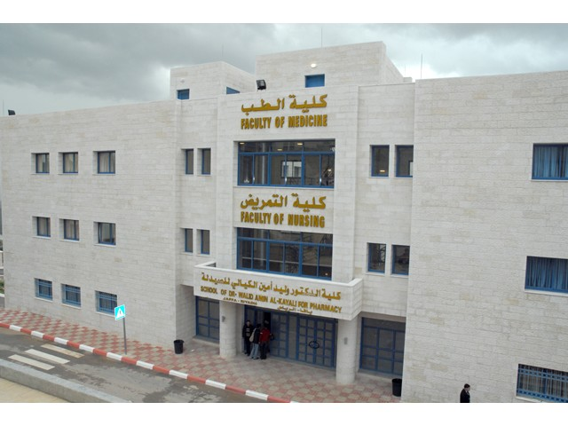 | Faculty of Pharmacy
 | Faculty of Nursing and Optometry
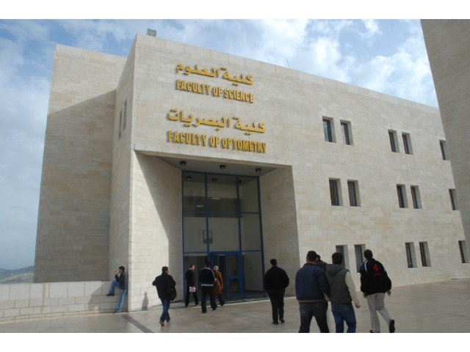 | Faculty of Science
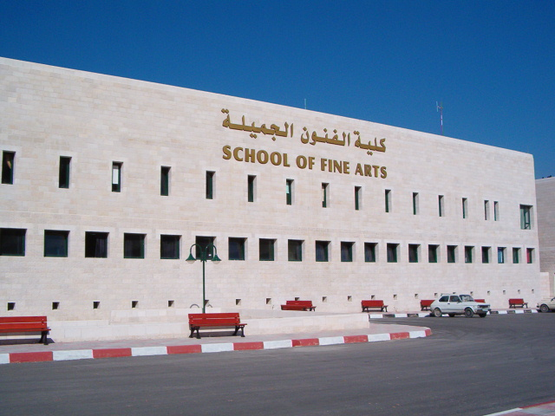 | Faculty of Fine Arts
 | Scientific Centers
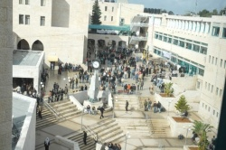 | Student Center
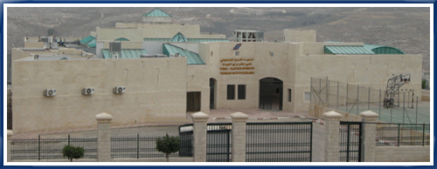 | Korea Institute
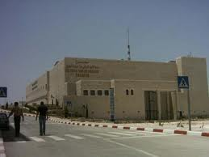 | Theater Prince Turki
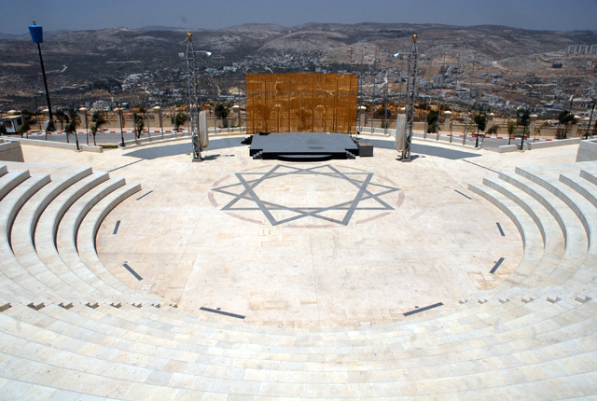 | Stadium Hikmat Al Masri
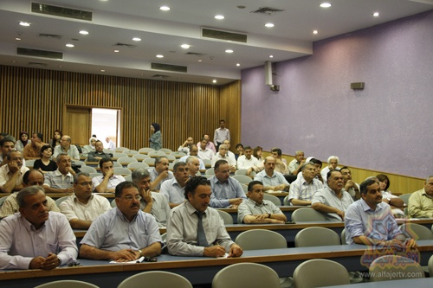 | Science Stadium
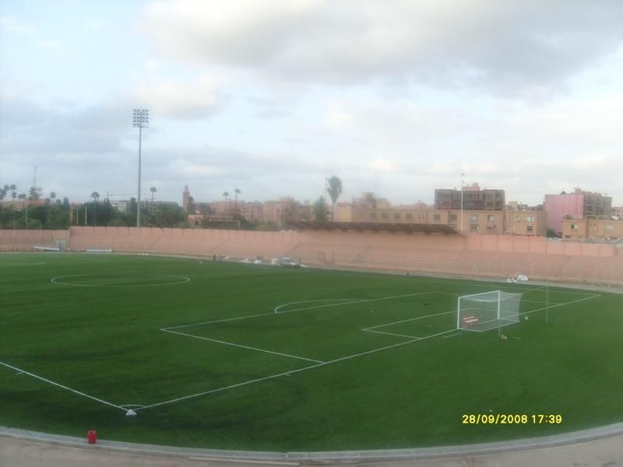 | Football Stadium
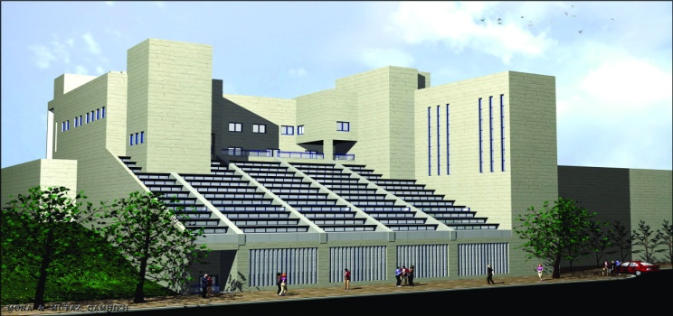 | Library
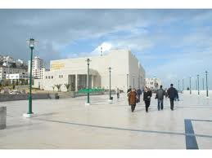 | The main square
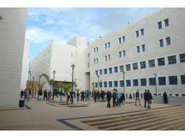 | Square of Engineering
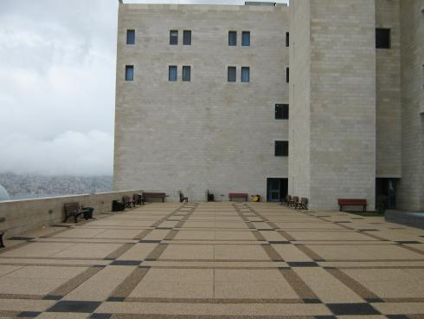 | Square of Science
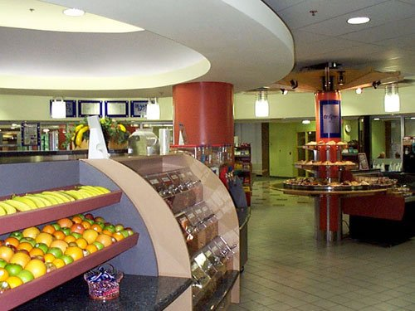 | Main cafeteria
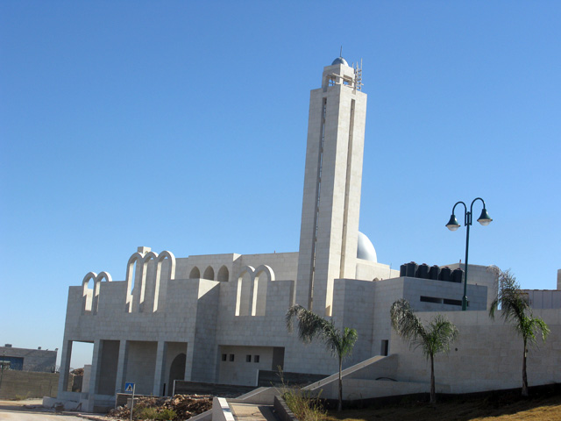 | Mosque Academy
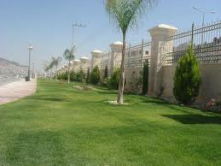 | Garden 1
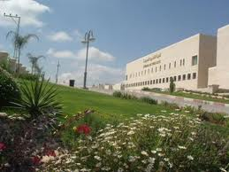 | Garden 2
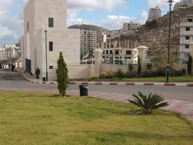 | Garden 3
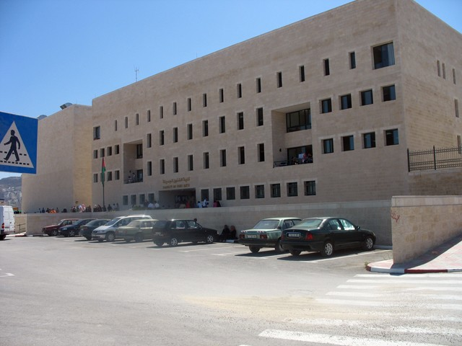 | Parking 1
 | Parking 2
 | Parking 3
 | Parking 4
 | Parking 5

Table 1 Real pictures for every collages, buildings and public utilities for the university

Create standard symbols that represent each building in the university :
We created a standard symbols for every locations in our map in order to make it more user friendly and easy to understand, and to create a protocol between admins, which make the project more suitable to use by another many companies.
The table below, describes these symbols and its meaning in map :
symbol | meaning
 | Administration Building
 | Faculty of Engineering
 | Faculty of Information Technology
 | Faculty of Physical Education
 | Faculty of Pharmacy
 | Faculty of Nursing and Optometry
 | Faculty of Science
 | Faculty of Fine Arts
 | Scientific Centers
 | Student Center
 | Korea Institute
 | Theater Prince Turki
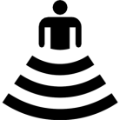 | Stadium Hikmat Al Masri
 | Science Stadium
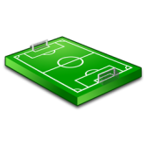 | Football Stadium
 | Library
 | The main square
 | Square of Engineering
 | Square of Science
 | Main cafeteria
 | Mosque Academy
 | Garden 1
 | Garden 2
 | Garden 3
 | Parking 1
 | Parking 2
 | Parking 3
 | Parking 4
 | Parking 5

Table 2 symbols and its meaning in map

So, we put every symbol in front of its place in map to add another feature to our project, that user also may be used to these symbols, in order to guide him to the location.

Finally, we got the following map with using the previous symbols :
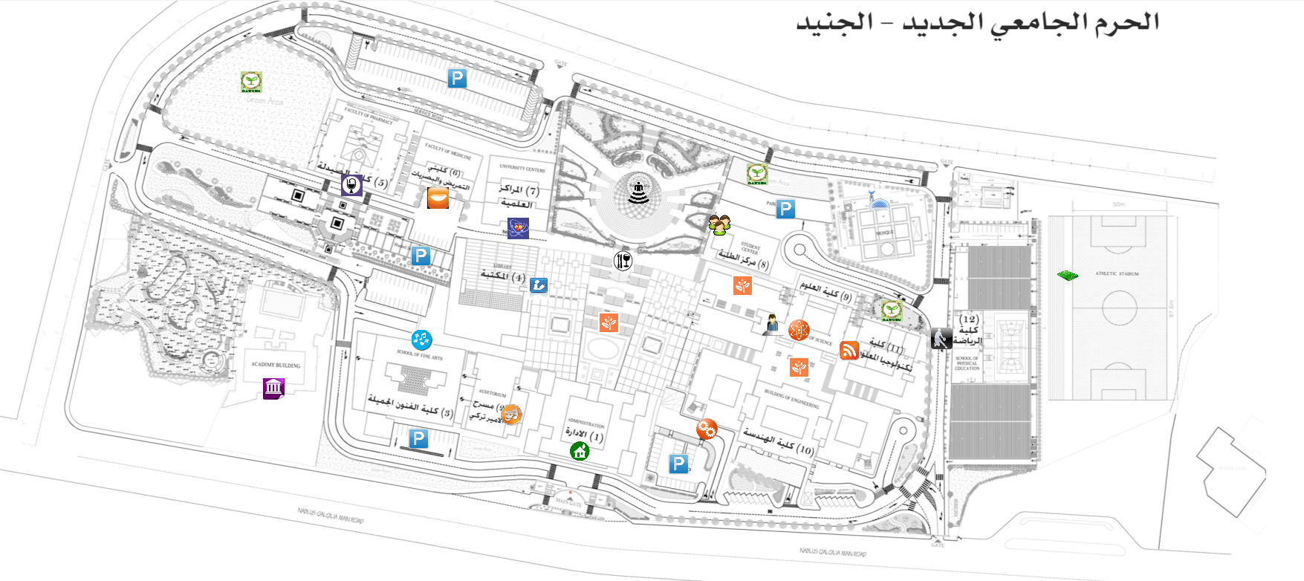
Fig.3 version of map with using standard symbols

Programs and applications that depend on GIS :
We used many programs at the beginning of this project for testing and for learning, and some program we used it to add more features in our project.
These program can be mentioned as follow :
- AutoCAD Program : we used this program in order to analyze our file which is a scheme about company that use this project.
- CAD2Shape Program : this program used to convert DWG file format to SHP file format, which can be used directly in our program.
By the way, we built in our project, internal code by C# that provides automatic converting from DXF file format to Shape file format, which is also supported by our project.
- Google Map (API): we used this application to get real view from real world for company which uses our project. In addition, we added some features in our project, that we connected our project with Google map, and this will provide more help and accuracy for users.
- ESRI technology Shape Files standard: ESRI technology supports users of remote sensing data including scientists and GIS professionals as well as a broad range of commercial and casual users. ESRI is committed to providing technology that fully integrates imagery with other GIS data. This increases both the value of imagery as well as other GIS datasets.

Programming parts:
We built our project by using C# language, so we can get any help from many sources in the internet, and we will mention these resources in references section.
By the way, we took a decision to use C# language in our project because this language has many advantages and features like as :
- C# is a simple, modern, object oriented language derived from C++ and Java.
- It aims to combine the high productivity of Visual Basic and the raw power of C++.
- .NET includes a Common Execution engine and a rich class library.
- It is compiled to an intermediate language (CIL) indepently of the language it was developed or the target architecture and operating system.
- Classes can be defined within classes.
- There are no global functions or variables, everything belongs to a class.
- All the variables are initialized to their default values before being used (this is automatic by default but can be done manually using static constructors).
- In addition to the try...catch construct to handle exceptions, C# has a try...finally construct to guarantee execution of the code in the finally block.
- Enumeration members are placed in their own scope.
- Multiple inheritance is not supported, although a class can implement any number of interfaces. This was a design decision by the language's lead architect to avoid complication and simplify architectural requirements throughout CLI.

Advantages over C++ and java :
- Formalized concept of get-set methods, so the code becomes more legible.
- More clean events management (using delegates).

Advantages over java :
- Usually it is much more efficient than java and runs faster.
- CIL (Common (.NET) Intermediate Language) is a standard language, while java byte codes aren't.
- It has more primitive types (value types), including unsigned numeric types.
- Conditional compilation.

So, we used this language to make interface between AutoCAD program and our application, and also to create interface between developer and admin from one side and the Manager and the user from other side.
It is important to mention that we built in our application four forms, these forms are: Developer Form, Admin Form, Manager Form and Real User Form.
Now, the following part will explain briefly about the functionality of Developer Form, and the main topics that used for this forms.
By the Developer Form, we can get from this form the final map that we will use it in our application.

The following flow chart explains the primary functionality according to this form:
START

Save AutoCAD file as DXF file format

Read Line from DXF file

Is It “EOF”
No
Is It “CIRCLE”
No Yes
Yes
Is It “LINE”
Read
X1, Y1, Radius
No Yes
Is It “VERTEX”
Read
X1,Y1,X2,Y2
No Yes
Is It “ARC”
Draw Circle by Circle Equation
Read X1,Y1
Save the result as SHP file format
Yes
Read Thickness,X1,Y1,X2,Y2,R
Radius
Draw Vertex by this point
Draw Line by start & end points
No
Finish
Draw Arc by these variables

Fig.4 Flow Chart shows the functionality of Developer Form
3. Results and Discussion

By this section, we will discuss briefly about our demo for this project.
In order to make our project easy to use because it has a huge features and a lot of data, we created many forms, each of them has its own operations and functionality.
Now we will start explain every operations and features for each form and the main objective for why we created this form.

Developer Form :
In this form, developer can redraw any map with AutoCAD file format in our project.
We can get this feature by using our code that read DXF file format from this map, and Developer Form can identify on DXF file format then redraw this map again with format that C# language can deal with it.
Also, with Developer Form we can update any map for the company that used this application, by adding any details that company wants to make this map ready to send it to Admin who will add information and naming on this map.
Finally, after editing of map, Developer Form can save this new map with “Save As" command, in order to use it in other forms.

The following figure shows the interface of Developer Form :
View each selected drawn element information
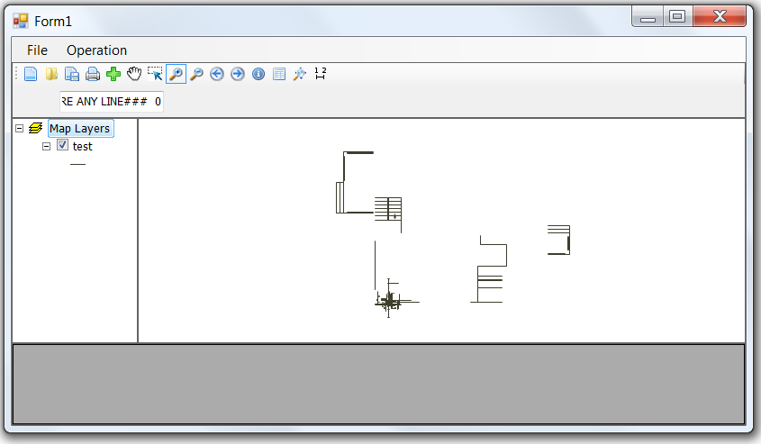
For Calculations
View Attributes table of each layer for editing
Zoom to extended
Fig.5 Developer Form
Admin Form :
There are many operations in this form, these operations are created in main options as follow :
File Menu : Open, Load, Clear, Save as and Exit.
These operations to deal with maps.
Shape File Operation Menu : Point, PolyLine and Polygon.
In this menu we can create a shape file with each type, and can save this update in map.
Map Operations Menu : Default, Information, Measurement, Zoom In, Zoom Out, Zoom To Extent, Pan and Print Map.
These operations in this menu to deal with view of map.
Attribute Table Operation Menu : View attribute table, Add a column in the attribute table, Delete a column in the attribute table, Update attribute table in shape file and Export Attribute table to Excel.
In this menu, there are operations for Add, View, Delete and Update information and attribute about selected objects.
This information includes pictures, data, naming and statistics about this object. Also, in Admin Form there are many features of authority for this Admin in map editing, that is Admin can change object color and change text, naming and value for objects.
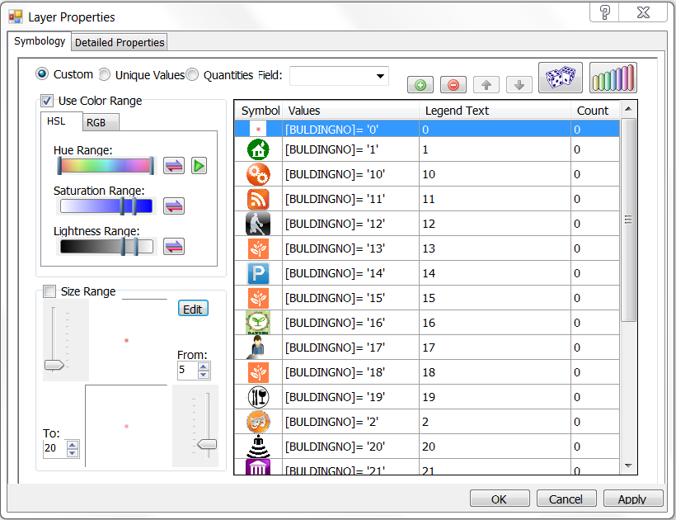
Fig.6 Layer Properties in Admin Form

By the same content, each object in map has its own features that may be change by Admin, like as : Scale Mode, Symbol Type, Style, Color, Width, Angle, Opacity, etc.

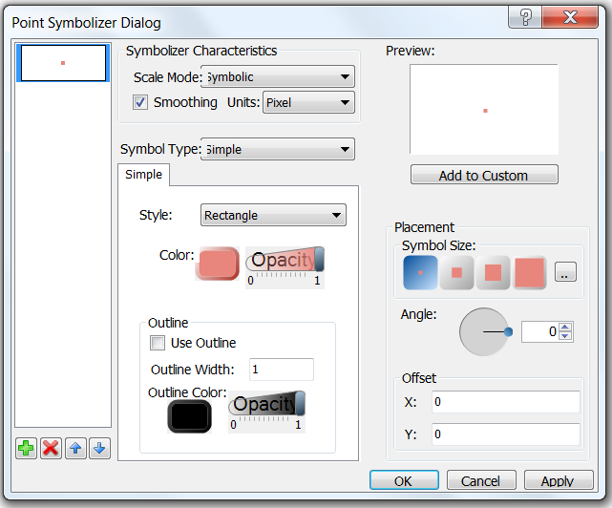
Fig.7 Features of Objects, may be Set by Admin

Finally, the following figure shows the interface of Admin Form :
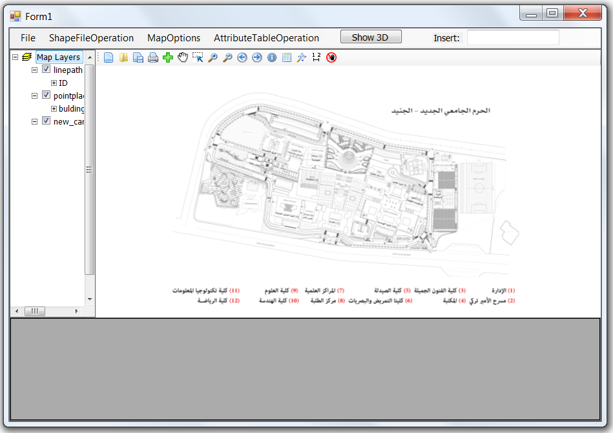
Fig.8 Admin Form
Manager Form :
After the Admin of company update and edit the map in Admin Form (usually for once), this form can be used over and over by application manager.
That because this form contains features connected with users and tourists who daily may use this application.
By this form, manager can update events and advertisements related with company on the Real User Form.
Manager Form connected to the Real User Form by network, and we used server client code to create this connection in order to view every update in this information on the Real User Form directly.
Every event connected with real time clock, so this event will appear to the users before it happen to remember them, and will disappear when its time finished.
Also, any important information or data that the company want to attract the attention of users to it can be easily done by this form.
We created this form as TCP Server and we created a part from Real User Form to be client, which receives from this Server.
The following figure shows the Manager Form:
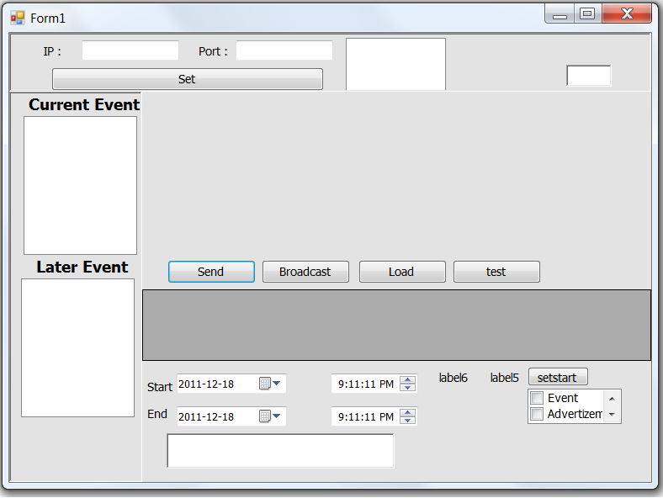
Fig.9 Manager Form

The next flow chart shows responsibility of the manager :
START

Set IP address & Port for Server

Set IP address & Port for Client

Connect with Server

Get connection
Yes No

Choose screen from client list
Set name of event on Server
Set the information and location of event

Set event’s time

Load on real user screen
Finish

Fig.10 Flow Chart shows functionality of manager form
Real User Form :
This form is the interface between our application and the user, and by this form users can get a lot of information and details about company that is visited.
In this form, we made all possible effort in order to make our application user friendly and easy to use. So, this form cuts short of the whole company in a small multi-touch screen that user can through it roaming and mobility across the company.
With Real User Form, there are operations to deal with map like as :
Clear Map, Load Map, Zoom In, Zoom Out, Zoom to Extent and Pan.
Also, user can get information about any object in the map by Info. button, and can measure the path between any two points by Measure button.
The main target for this form is to find the path between start point and any destination that the user wanted to visit it. So, the user can search for this destination and then the path to this destination will appear directly by using Find Path button.
In addition, user can also get any details or information about this target, and this information are supported by real pictures for this target to Making it easier for the user to identify the target when he arrive to it.
We connect this form with Google Map, which provide for the user view from real world for the company that used this application and shows every detail about that company like as : buildings, roads, public utilities, etc.
We provided a routing feature by free Google Maps API which enables us to get real view through http request then we will receive response that contain view from real world and routing from start point to end point which selected by user.
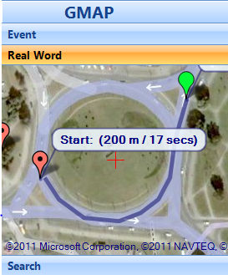
Fig.11 Sample From Google Map in Real User Form
The following flow chart shows functionality of this feature:
START

Connect to internet
Get Google map service using HTTP

Send Latitude and longitude for specific location
Put marks in real map shows in our program

Rout command to get the result

Finish

Fig.12 Flow Chart shows routing feature
In Real User Form, there is a panel for events and important advertisements, from the company to users, will appear in this panel. And as we said previously, this panel connected with real time clock which give our project another feature that these events will appear and disappear according to its time.
By the way, each event is related with special place in the company, this place can easily user finds its path and details about it.
Finally, after the user knowing every detail about his destination, he can get a sample photo for the map showing these details (path, direction, etc) from Real User Form to his mobile by Bluetooth. By this feature, the user can remember any detail from this photo instead of back again to the application.
The following figure shows the final interface of Real User Form :
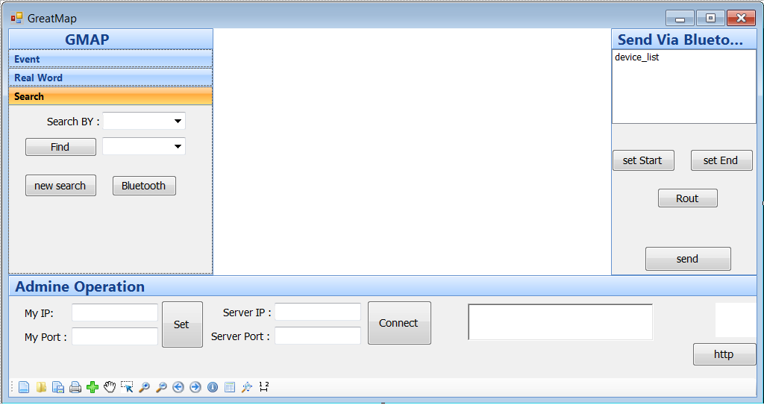
For installation needed
Fig.13 Real User Form

4. Conclusions and Recommendations

4.1 Conclusions
By this project, we created many forms to distribute responsibilities and increase the degree of protection and safety of information and the specifics of the company that uses this project.
So, our program allow for developer to create his own map from any AutoCAD file for company which want to use this application.
On the other hand, admin this company has many options to update the map using many tools in our project, and he can also add naming and information about company that he wanted from the user to know it by using this application.
In Manager Form, the manager of this application can easily update events and advertisements and any messages, that the company want from the user to know them.
Finally, we achieved that the user not only can easily identify and recognize the path of his destination, but also he has other information about this target and he can get a sample photo of the map from this application to his mobile by Bluetooth. Also, there is another feature, that the user can note the latest announcements and news and events about this company.

4.2 Recommendations
It’s great to develop this application by adding more features that make from this project an ideal project can and should used in large malls and huge companies in the giant countries.
Of course this means that we need to build a huge database with a lot of data and details, but in our opinion this will done once then the company or developer that has this project will gain a lot of money because the tourism around the world will never stop, and the tourists need anything to help them in their journey in order to get maximum happiness and make their visit more enjoyable.
We look forward to create 3D showing for the company which used this application, to make a full understand information related with picture and video which provide an ideal guide in huge town or malls, etc.
Another feature we look forward to create it, creating panoramic photo for each object in the map.
This feature will take the user a fast journey around that object, and will show every side (real view) of that object in all directions.
Also, we can support this project with mobile tracking by GPS of user’s mobile, this feature will provide to the user his location exactly, then we can send to the user mobile alert if the user went through wrong paths.

5. References

- http://www.najah.edu/virtualtour
- http://en.wikipedia.org/wiki/Main_Page
- http://www.esri.com
- http://www.mycutepictures.com/tutorials/csharp/2009/04/free-shape-file-shp-viewer
- http://wiki.thinkgeo.com/wiki/Map_Suite_Desktop_Edition
- http://webhelp.esri.com/arcgisdesktop/9.3/index.cfm?TopicName=Text_on_maps
- http://www.codeproject.com/KB/graphics/gismap.aspx
- http://www.codeguru.com/csharp/.net/net_general/graphics/article.php/c11375__1/Creating-an-Interactive-3D-World-in-CNET.htm
- http://www.rockware.com/product/overview.php?id=73

6. Appendix

There is a CD attached to the documentation, so kindly back to this CD and you will find programming code and every material that we used in our project.

