
An-Najah National University
Faculty of Engineering and
Information Technology

جامعة النجاح الوطنية
كلية الهندسة وتكنولوجيا المعلومات

Graduation Project Report

Design a Sewer System of Asira Al Shamaliya

by
Sadi Sawlmeh
Mohammad Abu Hanoud
Hamza Yaseen

Under the direction of: Dr. Hafez Shaheen

Submitted in partial fulfillment of the requirements for Bachelor degree in Civil Engineering

2022-2023

Abstract
Asira Al Shamaliya lacks a wastewater collection and treatment system. It suffers the disposal of the sewage using percolation/cesspits. The pits floods sometimes and pollute the soil, groundwater and causes environmental and social problems.

The project estimates the population and their densities for Asira Al-Shamaliya town up to the planning horizon of 2053, and evaluates the water consumption and the wastewater production. It defines the area to be served and divides it into main catchments according to the exiting situation using the topographical map and site visits. The methodology covered:

- Information and data collection: this includes the nature of the project area, its climate, water resources, water consumption, statistical information, contour mapping, etc.
- Preparing and applying a questionnaire and analyzing it. It covers Water, Sanitation, and Hygiene (WASH) practices among the households in Asira Al Shamaliya.
- Evaluate the current wastewater situation and design a sewage network identifying design standards and requirements. The analysis and design is to use the computer programs; Sewer Cad, Civil 3D and Arc Map 10.8).

The project includes the description of the current water and sanitation situation in Asira Al Shamaliya town. A sewage collection network is to be designed covering most of areas of Asira Al Shamaliya twon.

Although there have previous project and studies covering the wastewater collection for Asira Al Shamaliya, but it has been never implemented. This project has considered the recent and updated information. It also to prepare tender documents and Bill of Quantities.

1. Introduction 6
1.1 Background 6
1.2 Importance of the study 6
1.3 Objectives 7
1.4 Methodology 7
2. Study Area 8
2.1 Location and Area 8
2.2 Topography 8
2.3 Geography and Boundaries 8
2.4 Socio-Economic features 10
2.5 Climate 10
2.5.1 Temperature 10
2.5.2 Relative Humidity 11
2.5.3 Wind 11
2.5.4 Rainfall 12
2.6 Solid Waste Management 12
2.7 The road network 12
3. Population Development 14
3.1 Introduction 14
3.2 Population growth rate for the year 2053 14
3.3 Population Forecast 16
3.4 Future population growth areas 16
3.5 Maximum capacity of number of houses 17
3.6 Geopolitical status in 'Asira Al Shamaliya Town 19
4. Water Situation in Asira Al-Shamaliya 20
4.1 Source of water: 20
4.2 Rainwater Collection Cisterns 20
4.3 Water use 25
4.4 Quantity of Water consumed per day. 26
4.4.1 Average per capita consumption of municipal water 26
4.4.2 Average per capita consumption from a collection well . 26
4.4.3 Total per capita consumption of water 27
4.4.4 Water consumption rate for the industrial area 27
4.5 Strom water flow directions of Asira Al Shamaliya 28
5. Wastewater Collection Network: 30
5.1 General 30
5.2 Definition of wastewater 30
5.3 Problem definition 30
5.4 Network Aim and Goal 30
5.5 Methodology 31
6. Sewage network components 32
6.1 Types of sewers 32
6.2 Sanitary Service Connection 32
6.3 Collection System 32
6.4 Pipe installation 33
6.5 Pipe connections. 33
6.6 Materials of pipe 33
6.7 Manholes 33
6.7.1 definition of manholes 33
6.7.2 The main purpose of a manhole is 33
6.7.3 Type of manhole 34
6.7.4 Materials Used for Manholes Construction 34
6.7.5 The inspecting cambers 35
7. DESIGN CRITIRIA 36
7.1 Sewerage System Design Criteria 36
7.1.1 Wastewater Generation 36
7.1.2 Minimum Pipe Diameter 36
7.1.3 Infiltration Flows 36
7.1.4 Sewage flows 36
7.1.5 Peaking Factor 36
7.1.6 Minimum and Maximum Sewage Flow Velocities 37
7.1.7 Depth of Flow 37
7.1.8 Pipe Gradients 37
7.1.9 Sewer Pipe Materials 37
7.1.10 Roughness Coefficient 38
7.1.11 Pipe Depths 38
7.1.12 Manhole Spacing 38
7.1.13 Manhole Diameter 39
7.1.14 Hydraulic Calculations 39
8. Developing the sewerage network 41
8.1 Introduction: 41
8.2 Object of project 2: 41
8.3 Methodology of building the network: 41
8.4 Assumptions: 42
8.5 calculation 44
8.5.1 Estimation of population: 44
8.5.2 Calculating waste water loading: 44
5. Reference 45

List of Figure

Figure 1: : Location of Asira Al-Shamalya Town 5
Figure 2: contor map of Asira Al Shamalya 8
Figure 3: ‘of Asira Al-Shamalya location and borders 8
Figure 4: Distribution of labor force among main economic activities in of Asira Al-Shamalya 9
Figure 5: road network in of Asira Al-Shamalya 12
Figure 6 : Zoning populations in Table 10 16
Figure 7: Home collection well 20
Figure 8: Distribution of study houses 21
Figure 9: Strom water flow directions 26
Figure 10 : Strom water flow directions of streets Asira Al Shamaliya 27

List of Table
Table 1: Temperature 2012-2021 9
Table 2: Relative Humidity at Asira Al-Shamalya for the years 2012-2021 9
Table 3 :Wind Average Speed for the years 2012-2021 9
Table 4: Rainfall at Nablus Station in mm for the years 2012-2021 10
Table 5: Roads in ‘Asira Al-Shamalya Town 11
Table 6: The population for the Asira town (1922-2023) 12
Table 7: Population growth rate 13
Table 8 : Estimated Number of Population of Asira Al Shamaliys 14
Table 9: The development of housing units in the Asira town 16
Table 10 : Future population growth area 16
Table 11 : the maximum capacity of number houses 17
Table 12: Average per capita consumption of municipal water 24
Table 13: Water consumption rate for the industrial area 25
Table 14 : Maximum and Minimum Design Velocities in Sewers 34
Table 15 : Minimum Sewer Pipeline Gradients 34
Table 16 : Recommended Sewage Pipe Materials 35
Table 17 : Typical Roughness Coefficients for Pipes 35
Table 18 : Manholes Diameters per Depth 36

Introduction

Background
Asira Al Shamaliya Twon, as similar to many localities in the West Bank, Palestine suffers from lack of reliable sanitation and sewer systems. Asira Al Shamaliya is fully unserved by a wastewater collection network. The residents of Asira Al Shamaliya depend on the existing cesspits/percolation tanks for collecting the generated sewage. Among the other related problems is where they empty these pits regularly by vacuum trucks, which empty their loads in the wadis and/or open lands close to the Town. Figure 1 shows the bounders Asira Al Shamaliya town

The existing sanitation and practice is threatening the surrounding environment by polluting the underneath soil and water resources. Additionally, the Asira Al Shamaliya Town lacks a reliable wastewater treatment plant.
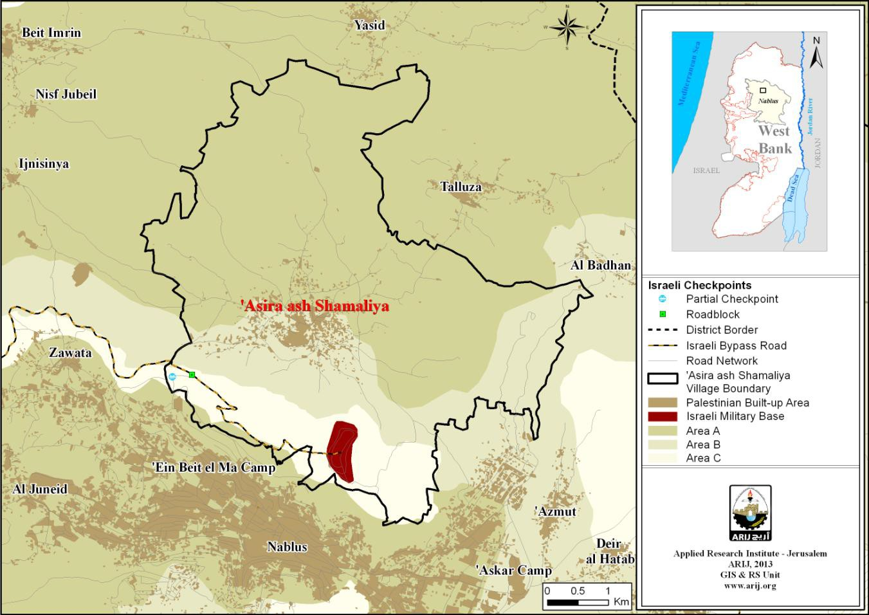
Figure 1: : Location of Asira Al-Shamalya Town

Importance of the study
The following points summarize the importance of the study:

- To study how to dispose of wastewater and evaluate the impacts on health and socio-economic situation
- To design a sewage network for of Asira Al Shamaliya.
- Conceptualize how to deal with the disposal and treatment of the collected wastewater.

Objectives
The objectives of the study are the following
- Estimate the population and their densities for Asira Al Shamaliya area up to the planning horizon of 2053, and evaluate the water consumption and the wastewater production.
- Define the area to be served and divide it into main catchments according to the exiting situation using the topographical map and site visits.
- design a sewage collection system and treatment concept for Asira Al Shamaliya.

Methodology
The following methodology has been applied for preparing this project:
- Information and data collection: this includes the nature of the project area, its climate, water resources, water consumption, statistical information, contour map, etc.
- Preparing and applying a questionnaire and analyzing it. It covers Water, Sanitation, and Hygiene (WASH) practices among the households in Asira Al Shamaliya.
- Evaluate the current wastewater situation and design a sewage network identifying design standards and requirements. The analysis and design is to use the computer programs; Sewer Cad, Civil 3D and Arc Map 10.8).
- State conclusions and recommendations to be used for project design, implementation; that is to be covered in Project II.

Study Area

Location and Area
Asira Al Shamaliya is a Palestinian town in Nablus Governorate, located 3.5km north of Nablus City. The total area of ‘Asira Al Shamaliya town consists of approximately 29000 dunums. This is according to the new boundaries of the local entities which were stipulated by the Palestinian Ministry of local government,

Topography
The features town of Asira Al Shamaliya contains a large number of valleys and mountains. It has several factor including rifting and folding from these valleys and highlands and had managed to increase the intensity and complexity of the topographic features, evidenced by some topographic features such as valleys and Alsagor and Al-hamam.
Asira Al Shamaliya mountains are part of the mountains Asira town of Nablus, which take the trend North East – Southerner west, and lies south of Marj Ibn Amer extending to Jenin city in the North.
Nablus mountain extends also toward Jerusalem mountain in the South. and ending in the mountains south of Jerusalem, with a length of 120 kilometers.
The most important of these mountains in this series, which is part of the territory of the Asira town of Mount Eibal, which constitutes a borderline between Asira Nablus, rises 940 meters above sea level. This mountains to impede the growth direction of the physical city of Nablus. Asira mountains rises up to 654 meters above sea level, Al-abude Mountain, rises 684 meters above sea level and separates Asira Asira town from Ajensenia. Mount Karak in the north-west which separates the Asira town from the Asira town of Yasid.

As for the valleys surrounded Asira some valleys such as the Valley Al-husan and Suade in the north, and Al-subian and Abu-shuwan in West Asira town, and Al-hamam and Alsagor Valley in eastern Asira town, and Wadi Said in the north-east of the Asira town.
The Figure2 is shown the contour map

Geography and Boundaries
It is bordered by Talluza, Al Badhan, and 'Azmut to the east, Nablus city to the south, Zawata, Ijnisinya, and Nisf Jubeil to the west, and Beit Imrin and Yasid to the north .
As in Figure 3, which shows the location and boundaries

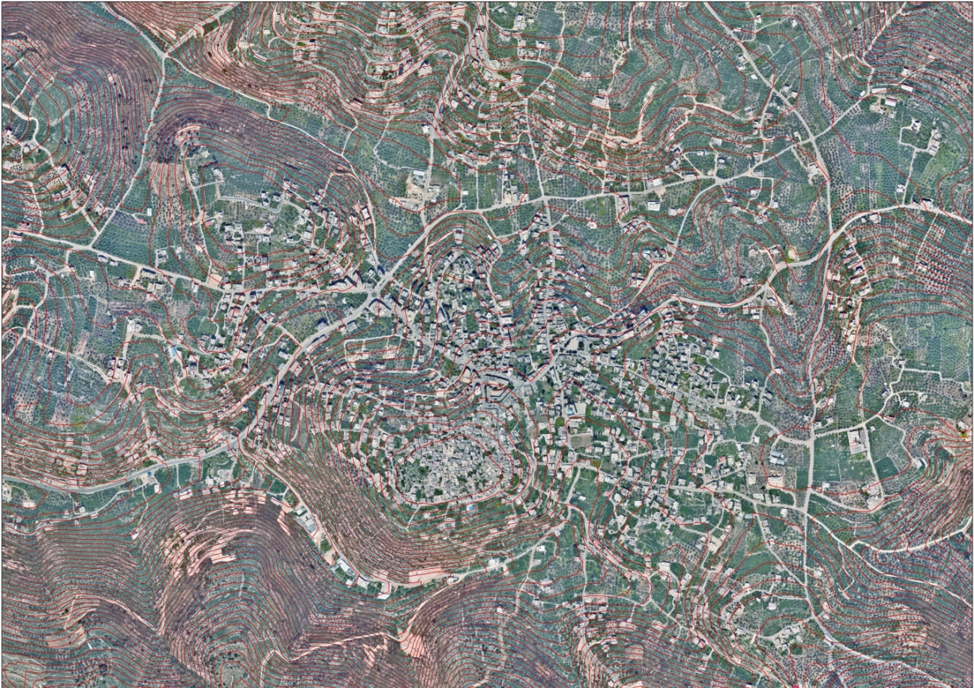
Figure 2:The contour map of Asira Al Shamalya

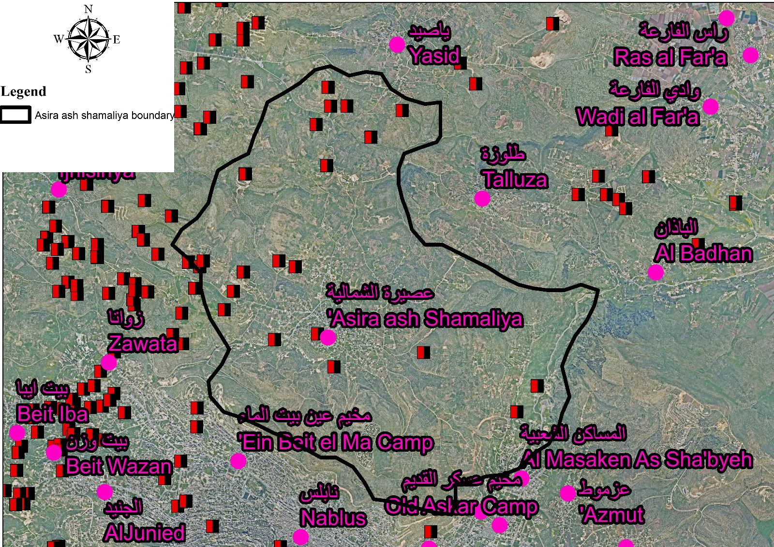
Figure 3: Asira Al-Shamalya location and boundaries

Socio-Economic features
The economy in Asira Al Shamaliya is dependent mainly on the Government or other employees sector, which absorbs 80% of the town’s workforce .
The results of a field survey conducted by the ARIJ for the distribution of labor by economic activity in ‘Asira Al Shamaliya are as follows: (Figure4)

- Government or other employees sector (80%)
- Agriculture sector (15%)
- Israeli labor market (5%)

Figure 4: Distribution of labor force among main economic activities in of Asira Al-Shamalya
Source: Asira Al- Shamaliya Municipal Council, 2022

Climate
Asira Al-Shamalya is located at an altitude of 636m above sea level with a mean annual rainfall of 590mm. The average annual temperature is 16 oC whilst the average annual humidity is approximately 74.2 %

Temperature
Falling temperatures in of Asira Al-Shamalya within temperatures for the Middle East, has been adopted in the study data Meteorological Station Nablus due to the unavailability of Meteorological Station in Asira.

There is a clear difference between the temperatures in winter and summer heat, differences between 16.6 degrees
At the time, which is the month of January when the minimum temperature as the months up to 10.2 degrees, the highest since the month of August is 26.8 degrees.

Table 1: Temperature 2012-2021
2012-2021 | 2012 | 2013 | 2014 | 2015 | 2016 | 2017 | 2018 | 2019 | 2020 | 2021
Lower Average Temperature (ºC) | 13.8 | 14.4 | 14.4 | 14.3 | 14.6 | 14.3 | 15.3 | 14.9 | 16.1 | 16.2
Higher Average Temperature (ºC) | 25.4 | 23.9 | 24.1 | 24 | 24.7 | 24.9 | 25.2 | 24.8 | 24.2 | 24.6

Relative Humidity
The rate relative humidity in the year reached 74.2% and the rate varies from month to month with average relative humidity for the month of July at 52% while the ratio of moisture for the month of January is around 0.76.
The dry eastern winds lead to a decline humidity in a clear and the accompanying rise in temperature.

Table 2: Relative Humidity at Asira Al-Shamalya for the years 2012-2021
Year | 2012 | 2013 | 2014 | 2015 | 2016 | 2017 | 2018 | 2019 | 2020 | 2021
% | 71 | 72 | 73 | 75 | 71 | 73 | 77 | 75 | 80 | 75

Wind
Wind is created by different atmospheric pressure, wind rushed from areas of high air pressure to areas of low pressure air pressure. However, there are clear trends of the winds throughout the year, which is due to wind western focus depressions air over the Mediterranean leading to the windy towards the low pressure center.
The wind hits the region, causing the wind rainfall in the form of successive waves, have affected the region and therefore the Asira town Arctic cold winds caused a decline in temperatures and rain to fall, but for the general rate of wind speed amounted to 5.3 kilometers per hour.
Table 3 :Wind Average Speed for the years 2012-2021
2012-2021 | 2012 | 2013 | 2014 | 2015 | 2016 | 2017 | 2018 | 2019 | 2020 | 2021
Average Speed (km/hr) | 5.9 | 6.1 | 5.4 | 5.2 | 5 | 4.6 | 4.6 | 4.7 | 5.5 | 6.1

Rainfall
It is the main source of water in the study area in the winter, as it feeds the valleys and household collection wells. The rain is used to irrigate large areas of agricultural lands in the northern town of of Asira Al-Shamalya. The period of precipitation in the study area starts from November and peaks between December and March. The variation in the topography of Palestine affects the annual rainfall rate. It ranges from 100 mm in the valley to 650 mm in the higher areas. The average annual precipitation in the town of Asira al-Shamaliya is 589.2 mm.

Table 4: Rainfall at Nablus Station in mm for the years 2012-2021
Years | 2012 | 2013 | 2014 | 2015 | 2016 | 2017 | 2018 | 2019 | 2020 | 2021
Rain Fall in mm | 763.5 | 805.9 | 360.8 | 595.4 | 681.2 | 291 | 873.3 | 779.9 | 849 | 668.8

Solid Waste Management
The ‘of Asira Al-Shamalya Municipal Council is responsible for the collection and disposal of solid waste generated by citizens and establishments in the town. As the process of solid waste management is costly, a monthly fee amounting to 15 NIS/ month per household is charged to the population and facilities served by domestic solid waste collection and transportation services. All of these fees are collected from the citizens (‘Asira Al Shamaliya Municipal Council, 2022).

Most of the population in ‘Asira Al Shamaliya benefits from solid waste services, whereby waste is collected from households, institutions, shops, and public squares in plastic bags and placed in 250 containers (of 1m³ capacity), located at various points in the town. ‘Asira Al Shamaliya Municipal Council collects the solid waste daily and transports it using a waste vehicle to Zahret al Finjan dumping site in Jenin Governorate, 35km from the Asira town, where it is subsequently buried in an environmentally-friendly way (‘Asira Al Shamaliya Municipal Council, 2022).

The daily per capita rate of solid waste production in ‘ Asira Al-Shamalya is 1.05kg. Thus the estimated amount of solid waste produced per day from the Asira Al Shamaliya residents is nearly 10tons, or 3,832.5 tons per year

The road network
The road network is the most important element in the design of the sewage network, because the sewage network follows the road network and also depends mainly on the inclination of the roads.
Table 5 lists the length of the 3 different types of roads in Asira town Figure 5 shows the road network in Asira Al Shamaliya.

Table 5: Roads in ‘Asira Al-Shamalya Town
Status of Internal Roads | Road Length (km)
Status of Internal Roads | Main | Secondary
1. Paved & in good condition | 10 | 12
2. Paved & in poor condition | 6 | 4
3. Unpaved | 12 | 24

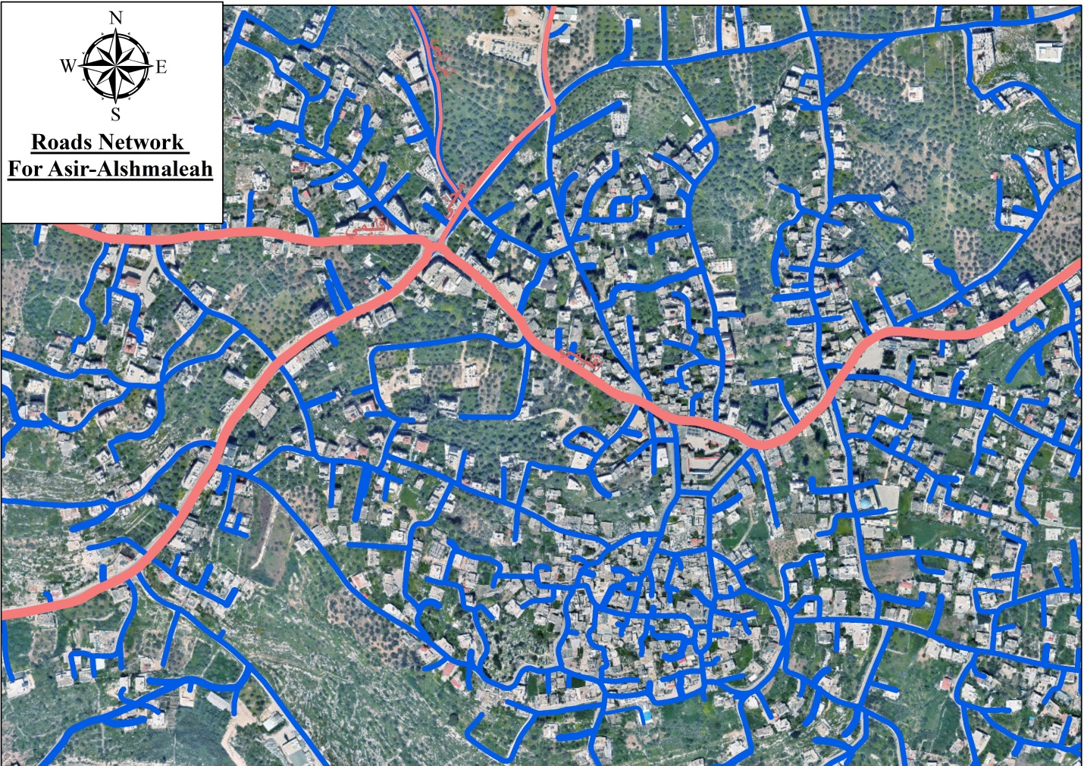
Figure 5: road network in of Asira Al-Shamalya

Population Development

Introduction
When designing a water works project, it is necessary to estimate the amount of water needed by the people who will be served, so it is also important to estimate the number of people and factors affecting the water consumption. This involves determining the design period of the project which is the period for which the water supply scheme is designed. Mostly these periods vary from 20 to 40 years and sometimes even up to 50 years, but 20 to 30 years design is the normal practice.

The design period should not be too long, so the present population of the Asira town is overestimated nor it should be too small, and that just after few years it may require large extension to meet increased demands. This proves the great importance of selecting the suitable design period of the project and estimating the population of the Asira town at the end of the period as accurate as possible.

Choosing a suitable design is generally based on:
- The useful life of component structures and equipment’s.
- The anticipated of population growth and water use by the community and its industries.

According to these criteria, and taking into account all factors in predicting population, the design period for this project is chosen to be 30 years.

Population growth rate for the year 2053
The population growth rate in the middle of the year 2022 in the State of Palestine reached 2.4%, by 2.1% in the West Bank and 2.8% in the Gaza Strip. Depending on the Palestinian Central Bureau of Statistics (PCBS) .

Table 6: The population for the Asira town (1922-2023)
Year | Population | Year | Population
1922 | 1179 | 2000 | 6421
1931 | 1542 | 2007 | 7,441
1945 | 2060 | 2017 | 8737
1961 | 3232 | 2018 | 8906
1967 | 3217 | 2019 | 9078
1975 | 3620 | 2020 | 9254
1987 | 4586 | 2021 | 9432
1992 | 5090 | 2022 | 9613
1997 | 5724 | 2023 | 9795

Applying the following mathematical equation:

Where:
R = annual growth rate of the population.
P1 = population census later.
P0 = population in the previous census.
T = number of years between Census

During the period from 1922 to 1945, the population of Asira increased at an average annual rate of 2.5 percent.
In the aftermath of the events of 1948, there was a sudden increase due to internal migration, which resulted in the 1961 census mentioned in the population of 3,232. Over the next decade the rate of increase slowed to less than 0.0775 percent annually, and according to the 1967 census, the population slowed. The number of Asira is 3217 people.
The reason for the population decrease in 1967 is the migration of the Asira population as a result of the 1967 war.
Table 7: Population growth rate
 |  | R | Census Year
The pre-war in 1967 | 2.66 | 3.03 | 1922-1931
The pre-war in 1967 | 2.66 | 2.09 | 1931-1945
The pre-war in 1967 | 2.66 | 2.85 | 1945-1961
1967 | 0.078 | 0.07 | 1961-1967
Post-war period in 1976 | 2.57 | 1.49 | 1967-1975
Post-war period in 1976 | 2.57 | 1.99 | 1975-1987
Post-war period in 1976 | 2.57 | 2.11 | 1987-1992
Post-war period in 1976 | 2.57 | 2.37 | 1992-1997
Post-war period in 1976 | 2.57 | 3.90 | 1997-2000
Post-war period in 1976 | 2.57 | 3.55 | 2000-2007
2007-2023 | 1.82 | 1.61 | 2007-2017
2007-2023 | 1.82 | 1.93 | 2017-2020
2007-2023 | 1.82 | 1.91 | 2020-2023
 |  | 2.21 | Average values previous

It is noted that the annual growth rate used is 2.21%.

Population Forecast
Estimating population figures for the upcoming years of 2023 and 2053 is calculated based on the following equation.
P_{n} = P₀ (1+r/100)^{n}

Where:
P_{n} = Population after n years
P₀ = Initial population
n= Planning horizon in years
r = Population growth rate

Accordingly, the population figures for the years 2023 until 2053 are presented in Table 3.3 at 10 years periods

Table 8 : Estimated Number of Population of Asira Al Shamaliys
Year | Population
2023 | 9795
2053 | 18873

Scenarios for the future population of Asira Al Shamaliya:

- That the political situation remains as it is and therefore the population in 2053 will be 18873 people
- That there be a political solution, thus assuming that 40% of the population abroad will return to the town
- Asira population outside Palestine = 9000people
- The percentage of the population expected to return to Asira and live there permanently= 40%
- A population outside Asira expected to return= 3600
- On the assumption that the population increase to the families of Palestinian Asira who are outside are the same for them at home = 2.21%.
- Using the previous equation, the number of Asira residents outside Palestine who are expected to return to their country in 2053 = 6939 people.
- Immigration to Palestine and its liberation
- Asira population outside Palestine = 9000people
- The population of Asira in the year 2053 with the number of people immigrating to ASIRA = 36,000
- Using the previous equations to calculate the growth rate, considering the current population to be 9,795 and the future population to be 36,000, the growth rate = 4.7%
- Considerations of the increase in the growth rate as a result of the liberation of the Palestinian lands
- The return of the population to their country of origin
- The return of lands (C) that were under the control of the Israeli occupation to the Palestinians, with an estimated area of ​​4016 dunums, which accommodates approximately 28,915 housing units.
Improved economic, social and health conditions

Future population growth areas
Asira Al Shamaliya was divided into a number of areas and housing units, and here we study each area separately, and the population growth in all areas cannot be considered the same, there are areas where the population increase is very small and because it has become densely populated there is room for more homes and people And there are areas that tend towards population sprawl, which are the areas of available modern services and surrounding public facilities as a result of the population increase at a very high rate. Figure 6 and Table 10 show this.

Figure 6 : Zoning populations in Table 10

Maximum capacity of number of houses
The average number of people per housing unit:
-The current population = 9795 people.
- The current number of housing units = 3200 units.
- Average number of people per housing unit = 3.06= 3 persons per unit.

The political situation remains as it is and consequently the number of housing in 2053 would be as follows: the number of housing = population / number of individuals in single dwelling = 18872/ 3 = 6291 housing unit

Table 9: The development of housing units in the Asira town
The number of housing units | Census Year
805 | 1994
1100 | 2000
1438 | 2007
3200 | 2023

Table 10 shows the difference in population density in the town of Asira, and this shows the difference in the rate of increase for each region.
Table 10 : Future population growth area
No. | Region | Area  (*10³ m²) | The percentage of housing units in each region(%) | Number of housing units | Density (person/Km²) | Percentage increase in the region | The number of housing units in 2053
1- | Al-thhore | 1052 | 2.5 | 80 | 228 | 4 | 259
2- | Wadi cadarah | 1100 | 5.7 | 182 | 496 | 3 | 442
3- | Muscat school | 217 | 3.4 | 109 | 1507 | 4.5 | 408
4- | Al-quserat | 324 | 4.1 | 131 | 1213 | 4.5 | 491
5- | Ejnesenya road | 819 | 10 | 320 | 1173 | 4 | 1083
6- | Wadi al-sabei | 717 | 8 | 256 | 1072 | 2.5 | 536
7- | Sporting Club old | 121 | 3.1 | 99 | 2455 | 1.5 | 155
8- | Asira a school for boys | 174 | 5 | 160 | 2758 | 0.5 | 186
9- | Abu Khalil Mosque | 57 | 5.2 | 166 | 8736 | 0.5 | 193
10- | Carme sewalem | 182 | 7.0 | 225 | 3708 | 1.5 | 284
11- | Center of Asira town | 33 | 3 | 96 | 8727 | 0.5 | 112
12- | Old Asira town | 141 | 10 | 320 | 6808 | 0.5 | 163
13- | Al-masaih | 92 | 3.5 | 112 | 3652 | 2 | 203
14- | Haret Abdul al-Jalil | 73 | 5.5 | 176 | 7232 | 1.3 | 259
15- | Omar ibn Al-Khattab mosque | 58 | 3.3 | 106 | 5483 | 2 | 192
16- | The old police | 51 | 5 | 160 | 9412 | 2 | 250
17- | Haret al-safa | 79 | 4.7 | 151 | 5734 | 2 | 273
18- | Haret Al-mahed | 101 | 8 | 256 | 7604 | 2.3 | 507
19- | Kalet Al-tine | 61 | 4 | 128 | 6295 | 3 | 311
 | Total | 5348 | 100 | 3233 |  |  | 6307

Geopolitical status in 'Asira Al Shamaliya Town
According to the Oslo II Interim Agreement signed on 28th September 1995 by the Palestinian Liberation Organization (PLO) and Israel, 'Asira Al Shamaliya was divided into Areas A, B and C. Approximately 17,956 dunums (62% of the towns total area) were assigned as Area A where the Palestinian National Authority (PNA) holds all responsibility for internal security and public order, while 7,061 dunums (24% of the town total area) were classified as Area B, where the PNA has a complete control over civil matters but Israel continues to have overriding responsibility for security. (Arij,2014)

The rest of the Asira town’s area, constituting of 4,016 dunums (14% of the total area), were classified as Area C, where Israel retains full control over the security and administration of the territory. In Area C, Palestinian building and land management is prohibited unless through the consent or authorization of the Israeli Civil Administration. The majority of 'Asira Al Shamaliya’s population resides in Areas A and B, while most of the land lying within Area C is open space, agricultural land or has been taken for Israeli military bases(Arij,2014)
(See Table 11).
.
Table 11 : the maximum capacity of number houses
Area | Percentage of Total town area % | Area in dunums | Permissible building ratio% | The allowed building area(m²) | average home area  (m²) | the maximum capacity of number houses | The number of floors
Area A | 62 | 17956 | 36% | 6464160 | 200 | 32321 | 4
Area B | 24 | 7061 | 46% | 3248060 | 200 | 16240 | 7
Area C | 14 | 4016 | 0% | 0 | 200 | 0 | 0
Nature Reserve | 0 | 0 | 0% | 0 | 200 | 0 | 0
Total | 100 | 29033 | 82% | 0 |  | 48561

The source of the first 3 columns of (ARIJ website 2014), and I added 5 columns, by collecting information from (Asira Al Shamaliya Municipal Council, 2022).

Water Situation in Asira Al-Shamaliya

Source of water:
Asira Al Shamaliya is provided with water by Nablus Municipality through the public water network established in 1982. 98% of housing units are connected to the network)

The quantity of water supplied to ‘Asira Al Shamaliya town in 2022 was recorded at approximately 328,500 cubic meters/year). Therefore, the estimated rate of water supply per capita is approximately 90 liters/day. However, no ‘Asira Al Shamaliya citizen consumes this amount of water due to water losses, which are estimated at 30% (‘Asira Al Shamaliya Municipal Council, 2022). These losses happen at the main source, major transport lines, in the distribution network, and at the household level. Therefore, the rate of water consumption per capita in ‘Asira Al Shamaliya is 73 liters per day. The average water consumption of ‘Asira Al Shamaliya residents is closed to the minimum quantity of 100 liters per capita per day proposed by the World Health Organization.

The town also has five springs and 1,000 individual household rainwater harvesting cisterns, as well as a public water reservoir with a capacity of 300 cubic meters

Rainwater Collection Cisterns
The process of collecting rainwater from rooftops, before it reaches the ground, is an ancient Palestinian tradition, especially in the Palestinian countryside, where we find collection wells in many homes, regardless of whether or not they are connected to the water networks. The collection well is an additional backup source for irrigation of the home garden, for watering animals, or for drinking.
In light of the current restrictions, collection wells can alleviate, even partially, the drinking and irrigation water crisis, not to mention its contribution to reducing the extent of groundwater depletion. In areas where there are many greenhouses, millions of cubic meters of water can be collected from their roofs annually. The collection well is a free, reliable and renewable water source.
The process of collecting rainwater from the roofs of houses is a guarantee to prevent pollution of that water resulting from its mixing with soil pollutants, in addition to that intercepting the water falling from a high place facilitates the collection process, increases its quantity, and reduces water loss on the ground and inside the soil.

The cement roofs that are widespread in the Palestinian areas are among the best roofs for collecting rainwater, in terms of the amount of water that we can collect from them, out of the total amount of precipitation, and in terms of the possibility of maintaining its cleanliness, and thus the cleanliness of the water, noting that the materials that make up the cement roofs do not interact with water. Which does not affect the taste and smell of water.

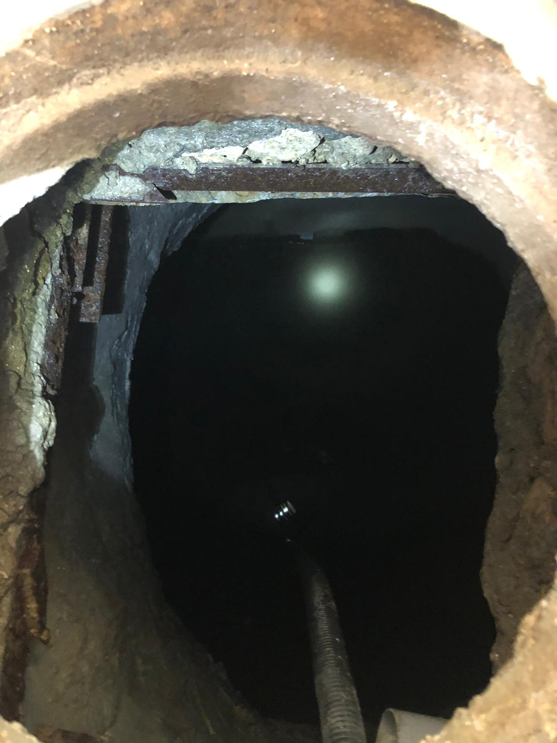
Figure 7: Home collection well
According to a questioner applied on 21 houses distributed within Asira Al-Shamalya town, who has rainwater collection citterns; 21 responsive. Figure 8 Show locations and distribution of homes.

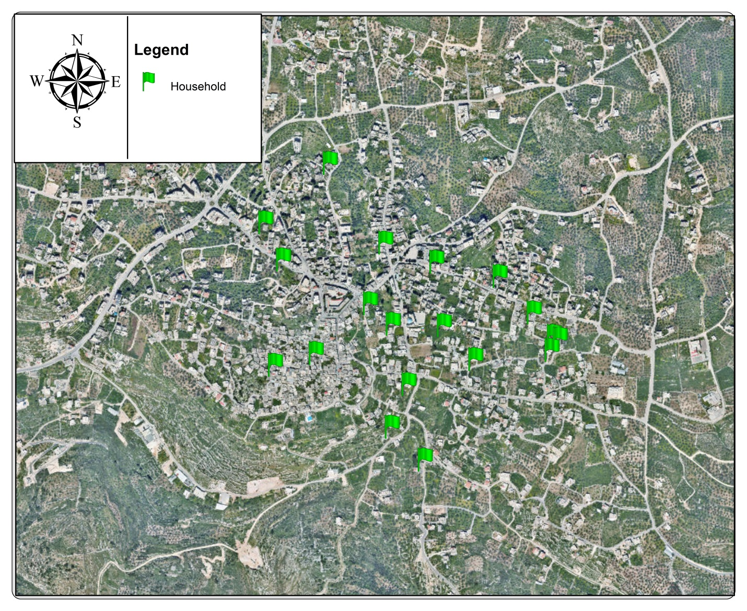
Figure 8: Distribution of study houses

Q 1: Surface area of ​​the house (m2)

The figure expresses an answer to the question, where the vertical axis is the number of people and the horizontal axis shows the answer (surface area)

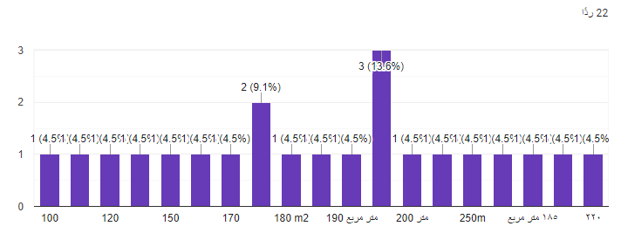

Avg =3909/22 =177.68 = nearly (178m ²)

Q2: collection well size(m ³)
The figure expresses an answer to the question, where the vertical axis is the number of people and the horizontal axis shows the answer (the size of the collecting well)
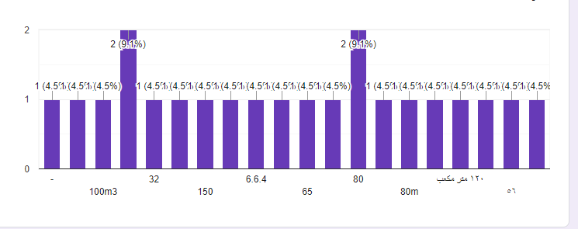

Average = 1553/21 = 74 m³

Q3: Use of well water :
It was found that 86% use the water of the collection well for drinking, and 14% use the water of the collection well for washing, as shown in fig
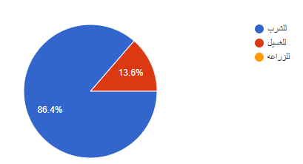

Q4: The location of the collection well from the house (m):

The figure expresses an answer to the question, where the vertical axis is the number of people and the horizontal axis shows the answer (the location of the well from the house)
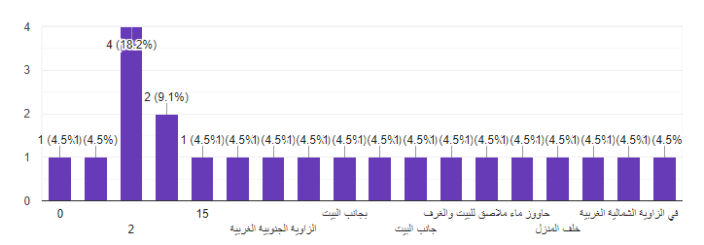

Q5:The location of the cesspit from the house (m)

The figure expresses an answer to the question, where the vertical axis is the number of people and the horizontal axis shows the answer (The location of the cesspit from the house)

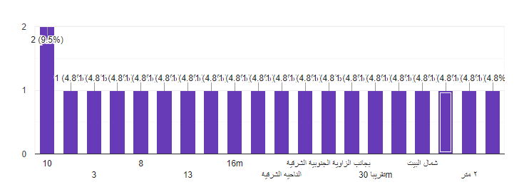

Q6: Distance between collection well and cesspit (m).

The figure expresses an answer to the question, where the vertical axis is the number of people and the horizontal axis shows the answer (distance between collection well and cesspit)

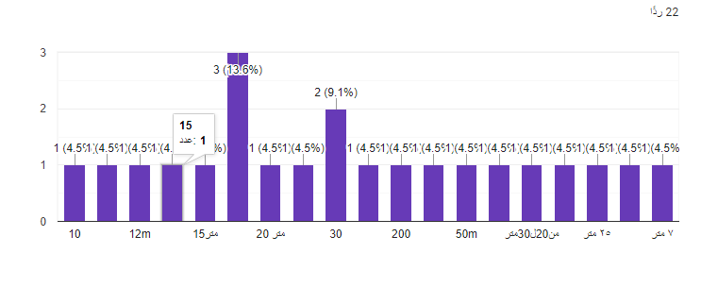
Average =676/22 =31m

4.3 Water use
Municipal water demand is commonly classify according to the nature of the use, the ordinary classification are:-
- Domestic: - water furnished houses, hotels …..Etc, culinary and other purposes. Use varies with economical level of the consumer, the range being 75to 380 L\C\D (Litter per capita par day).
- Commercial and industrial: - water furnished to industrial and commercial establishment such as factors and offices. The importance of this varies depend on wither there are large industries and wither the industries obtain there water from the municipality.
- Public use: - water furnished to public building and use for public services. Protection for which the municipal supplier usual is not bad.
- Loss and waste: - water, which is uncounted for in the sense that it is not assign to specific user.
- Uncounted for water: - is attributed to errors in meter readings, unauthorized connection, and leaks in the distribution system.
- Agricultural: - for farms farmhouses, livestock, dairies, greenhouses, spray irrigation, etc.
A water works distribution system includes pipes, vales, hydrants and appurtenances for conveying water, reservoirs for storage, equalizing and distribution purposes.
The total consumption is the sum of the individual elements listed above

4.4 Quantity of Water consumed per day.

Average per capita consumption of municipal water
The average number of family members in the town = 5 people

Table 12 shows water consumption per capita, as we read the monthly water bills for 20 families from each region of the municipality, where we took the average water consumption in each region, then we took the average water consumption for all regions, and it turned out that the per capita water consumption is approximately 73L/D

Table 12: Average per capita consumption of municipal water
No. | Region | Average monthly water consumption for a family(M3) | Per capita water consumption (L/D)
1- | Carme sewalem | 10.1 | 67.3
2- | Wadi al-sabei | 11.4 | 76
3- | Al-quserat | 10.25 | 68.3
4- | Old Asira town | 8 | 53.3
5- | Haret Al-mahed | 11.2 | 74.4
6- | Haret al-safa | 14.2 | 94.4

Average = 433.7/6 =72.3 L/D

Average per capita consumption from a collection well .
According to the survey, it was found that the average size of the collection well = 74m3
Well water is used throughout the year
The average number of family members in the town = 5people

Average = 74/360 =0.2
Average =0.2/6 =0.041
Average =0.0411*1000 = 41 L/D

Total per capita consumption of water
T= 41 + 73.2= 114.2 L/D

Water consumption rate for the industrial area
Table 13: Water consumption rate for the industrial area
Factories | monthly consumption rate (m ³ ) | daily consumption rate(L/D)
brick factory | 150 | 5000
Olive presses | 500 | 16667
Stone saw | 15 | 500
farmer
Poultry farm | 30 | 1000
Gardens
swimming pool | 65 | 2167
schools
The primary school | 20 | 667
Muscat school | 25 | 834
Jawaher School | 85 | 2834

4.5 Strom water flow directions of Asira Al Shamaliya
Work to determine the direction of the water in' Asira Ash Shamalya , depending on the contour lines and using a program Civil 3D , in order to locate the wastewater treatment plant.
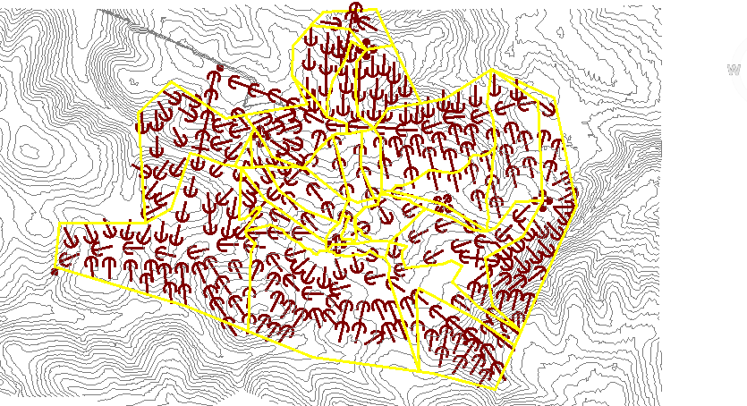
Figure 9: Strom water flow directions

The direction of the flow in the streets of Asira Al Shamaliya is very necessary for the sewage network, which helps us locate the manholes and determine the direction of the wastewater
And that, using the Civil 3D program, and based on the contour lines and aerial photos of the, Asira Al Shamaliya we determined the direction as in the figure 10

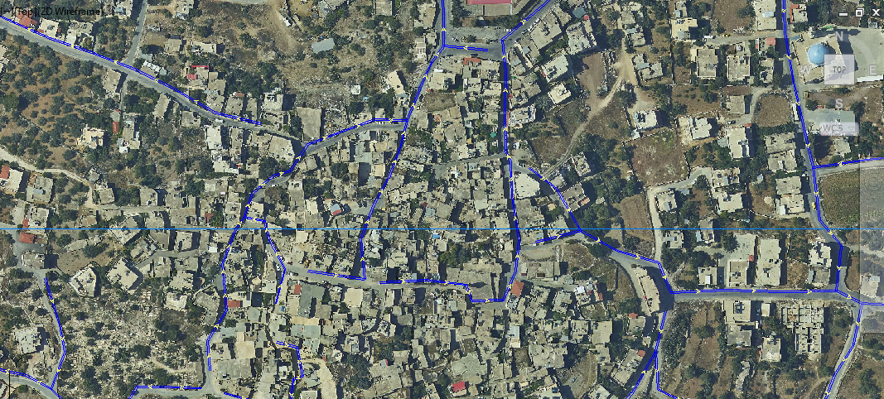
Figure 10 : Strom water flow directions of streets Asira Al Shamaliya

Wastewater Collection Network:

5.1 General
There are two systems in Palestine for the disposal of wastewater, either system are the first disposal of waste water through sewage systems, while the second are the disposal of waste water by cesspit.

5.2 Definition of wastewater
Wastewater is what we flush and what goes "down the drain" it comes from many different sources. Both domestic and industrial .and contains many different compounds. Contrary to what most people believe.
The wastewater is composed primarily of natural organic substances, Which are the byproduct of human , animal and plant processes .
The primary elements in our wastewater include nitrogen phosphorous Ammonia and carbon
The large quantities present in the wastewater could be harmful if they were not removed.

5.3 Problem definition
West Bank has lived many years under occupation, which led to neglect and degradation in all spheres of life, and various obstacles to the growth and evolution of Palestinian towns and Asira town.
Many areas in the West Bank by no sanitary drainage networks and sewage networks found would not conform to specifications.

The accelerated expansion and development of Asira has resulted in increasing the water consumption and consequently in generation large quantities of wastewater from various sources such as residential areas, commercial establishments and different industries. The shortage in the services is the main problem of this areas.

Where citizens in the Asira town of Asira disposing of wastewater through the cesspits in the absence of a sanitary drainage networks, scientific studies have demonstrated the impact of these different cesspits on the environment in general and on groundwater and human health, animal and plant

5.4 Network Aim and Goal
The overall objective of this project is to serve Asira area with sewerage system collection to reduce the problems caused by the free disposal in the area. Some areas in Asira are developed in the future. More specifically the objectives of this study may be classified as follows:

Propose wastewater collection system of Asira and design sample trunk of the proposed sewage collection network.

5.5 Methodology
In order to reduce the detrimental effect on the surrounding environment, the sewage collection system is designed. The following are defined to perform the design:

- Information and data collection from the previous chapters.
- Layout of network depending on contour map, nature of the area, and main streets.
- Calculation (served area, density, total consumption, per capita, and flow).
- Conduct the design using the computer program (Sewer Cad).

Sewage network components
The sewer system consists of a network of pipe and manholes. The system is designed to transport sewage from houses and other buildings to sanitary sewer system.
The sanitary system consists of pipes transport wastewater to the disposal system.

6.1 Types of sewers
- Community Sewers: in general, and except for special reasons, the Department will approve plans for new systems, extensions, or replacement sewers only when designed upon the separate plan, in which rain water from roofs, inflow from streets and other areas, and groundwater from foundation drains is excluded. “Combined” sewers are not permitted unless provisions have been made for directing and treating the overflows.

- House Sewers: house sewers conveying raw wastewater to public sewers should meet all requirements of the State Plumbing Code and the plumbing code of the local authority having jurisdiction, as well as the following:

- They shall be of a plastic, cast iron, concrete, vitrified clay or other material of 1,200 pound crush strength or heavier.

- They shall have a nominal inside diameter of not lees than four inches.

- House sewer joints and connections to public sewer should be watertight and root proof.

- House sewer should be laid on a slope of 1\4 inch per foot and in no case lees than 1\8 inch per foot.

- House sewer shall not be directly con nected to manholes.

- Industrial sewer – any industrial hookups such as restaurants, rendering plants and service stations should have adequate pretreatment facilities for grease and grit collection in order to prevent clogging of collections lines and wear of components in discharge lines.

6.2 Sanitary Service Connection
The sanitary service connection is a pipe that runs from the sanitary main in the street to the residence or buildings. The diameter of the sanitary sewer pipe is usually 8 inch but can be larger for commercial or industrial services.

6.3 Collection System
The Sanitary Sewer Collection System is a complex network of underground pipes, the pipes are made from several different materials. These materials vary depending on the time they were installed.

6.4 Pipe installation
Pipes are installed on slope, allowing wastewater to flow by gravity from a house site to the treatment site. Sized and designed with straight alignment and uniform gradients to maintain self-cleansing velocities.
All items shall be examined before installation and no piece shall be installed which is to be defective. Handling and installation of pipe and fitting shall be in accordance with the manufacture’s instruction referenced standards and as specified herein. Any pipe or fitting showing a crack or which has received a below that may have caused an incident fracture even through no such fracture can be seen, shall be marked as rejected and removed at once from the work. In handling the items, use special devices and methods as required to achieve the results herein.

6.5 Pipe connections.
The invert of the outlet pipe from a manhole will be on line with or below the invert of the inlet pipe, when the outlet pipe from a manhole is larger than the largest inlet pipe the crown if outlet pipe is to be no higher than the lowest inlet pipe crown, where the invert of the inlet pipe would be more than 24 inches above the manhole floor a drop connection will be provided.

6.6 Materials of pipe
Collecting and intercepting sewers are constructed of asbestos cement sewer pipe. Cast-iron pipe, concrete pipe, vitrified clay pipe, brick plastic or PVC, and bituminized fiber pipe.
Care should be exercised in designing the system so that permissible structural Loading Are exceeded for the material selected. Information on pipe loading is readily available from the Clay Products Association, the cast iron pipe manufactures and others.

6.7 Manholes

definition of manholes
Sewer systems are built underground with conduit that carry waste from homes and other buildings to a place of treatment or disposal, A manhole is a unit constructed underground to provide access to the utilities of sewer system.

The main purpose of a manhole is
- To perform inspection, cleaning, and removal of any obstruction present in the sewage line the equipment that clean can cover within length =30 m, so we should be sure that the distance between two manholes lees than 50 m

- The joining of sewers, the change of direction or the alignment of sewers can be performed with the help of manhole.

Type of manhole
In the following, some of types of manholes are explained
- Shallow Manhole
A manhole having a depth of up to 90 cm is termed a shallow manhole. It serves as an inspection chamber at the start of a branch sewer, and the cover is light in weight.
- Normal Manhole
A manhole with a depth of 90-150 cm is categorized as a normal manhole, and it is covered with a heavy cover.
- Deep Manhole
A deep manhole has a depth greater than 150 cm. The size of a deep manhole is also big, according to the size of the facility. It is also facilitated with a permanent ladder.
- Drop Manhole
A drop manhole is a manhole in which a vertical pipe is provided to allow for flow between the branch sewer and the main sewer. It is utilized in areas where the slope is steep or when an inlet pipe’s invert elevation is much higher than the outlet pipe’s invert level.
Gradient differences between two sewer pipes can sometimes be more than 0.5m, which is too big of an elevation difference for unimpeded sewage flow between the branch sewer and main sewer. Drop manholes are used in this scenario as well as when larger sloping gradients are impractical or uneconomical.

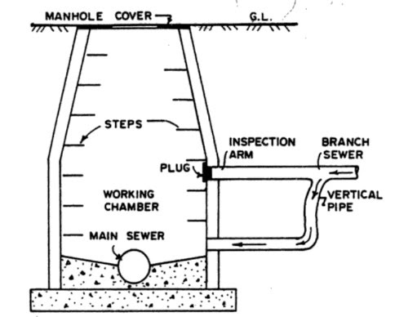
Figure 11 Drop Manhole

Materials Used for Manholes Construction
There’s several materials that can be use in manhole like Plastic and Fiberglass but the most common material is Precast Concrete Manholes.

Construction of manholes by precast concrete is a traditional method. These manhole frames are engineered in the segment in a factory located offsite. This method hence ensures quality and also facilitates quick installation. The manufactured precast manholes are assembled on the site.

The increased durability with a life span of 100 years is one of the reasons for its continued popularity and widespread use.

The inspecting cambers

The inspecting cambers are circular, square, or sometimes rectangular. The minimum dimension is 1.00m to allow workman inside the chambers, although quite an amount of maintenance work can be workman inside the chambers, although quite an amount of maintenance work can be performed from ground level. Manholes covers are circular with a diameter of 0.06m to allow access into the chamber. The cover and frame are made of cast iron. The cover is filled with concrete to avoid ratting. Concrete cover slabs are not recommended, as they are heavy and liable to damage. The chamber is made of brick or concrete (cast in-situ or pr recast): sometimes plastic and asbestos cement are used. Steel lining should be used for situ concrete. The cross –sectional dimensions of an inspection chamber are determined by sewer diameter and the pressure of bend.

DESIGN CRITIRIA
The following sections outline the design criteria adopted for the detailed design of the collection network. The design criteria were based on (PWA)) Planning and Design Guidelines “Dimensioning of Water Supply, Sewer and storm run-off Pipes and “Construction and Installation of Pipes in Water Supply and Sewerage

7.1 Sewerage System Design Criteria
The following sections present the design criteria used for designing the sewerage collection system.

7.1.1 Wastewater Generation
The domestic water consumption for residents of Asira Al Shamaliya varies from one month to another; this depends mainly on the different seasons, , the highest water consumption that was recorded for the village is 95 L/D
In addition, the person in Asira town depends on the water of the collection wells, which estimated per capita consumption from the collection wells is 41L/D
Accordingly, we can consider 136L/D for the purpose of designing the sewage network
Actual amount of wastewater =0.85*18873*0.136 = 2182m³ /d

7.1.2 Minimum Pipe Diameter
According to the Palestinian standards, the minimum pipe diameter for the collection network is Ф 200mm. (8in)

7.1.3 Infiltration Flows
Infiltration flow from the surrounding areas into the wastewater collection network shall be accounted-for in the design calculation. Two values are considered in the hydraulic analysis. The first one is for the dry season with 10% increase and the second one is 20% increase for the wet season. The value of the wet season is used for sizing the pipelines

7.1.4 Sewage flows
Estimation of the sewage maximum flows depends on the population ultimate holding capacity of the project and the adopted design sewage generation rate.

7.1.5 Peaking Factor
In the design analysis of wastewater mains, average flows do not represent the actual flows that the mains shall handle. Wastewater mains should be designed to convey the projected peak flows that might reach as high as 5 times the average daily flows, depending on the population served by the wastewater mains. For purpose of this project, peak factor is based on the Babbitt - Herman formula and it has been

Summarized in below equation:
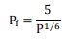
Where:

P_{f} = peak factor which shall be <= 3
P = the forecasted population (in 1,000) and shall be < 80,000

7.1.6 Minimum and Maximum Sewage Flow Velocities
As per PWA standards, flow velocities shall be within the limits presented in Table 14. To ensure self-cleansing, the pipes must be designed to give a minimum flow velocity of 0.75 m/s at full-flow conditions. However, if this velocity cannot be achieved at the branch sewers where there are few house connections, the pipes should be designed to achieve the self-cleansing velocity of 0.7 m/s at the peak flow. Maximum velocity is set to prevent manhole abrasion and to minimize sewer gas generation in the sewer system.

Table 14 : Maximum and Minimum Design Velocities in Sewers
Pipe Description | Minimum (m/s) | Maximum (m/s)  (Partial
Gravity line | 0.7 | 3.0

7.1.7 Depth of Flow
The depth of sewage flow in the pipes at peak rates is to be maintained within the limit of (d/D) < 0.70 or 0.75 where (d) is the flow depth and (D) is the internal pipe diameter. This will ensure aerobic condition of the flow.

7.1.8 Pipe Gradients
Pipe gradients, often the same as the hydraulic gradient, directly influence sewer pipe capacity. In order to achieve the required minimum velocity in sewer lines of 0.7 m/s, pipes should be designed by observing the minimum gradients listed in Table 15

Table 15 : Minimum Sewer Pipeline Gradients
Sewer Diameter | Minimum Slope (%) | Q full (L/s)
200 mm(8in) | 0.60 | 24
250 mm(10in) | 0.40 | 36
315 mm(12in) | 0.30 | 58
400 mm(16in) | 0.25 | 94
*Using Manning Equation at Velocity 0.7 m/s.

Sewer Pipe Materials
The pipe material for sanitary sewer pipes should be selected based on local environmental conditions such as the characteristics of wastes, possibility of septicity, corrosion, soil characteristics, exceptionally heavy external loadings, abrasion, presence in the local market, ease of operation and maintenance practices.

Recommended pipe materials to be used in Palestine for sewer pipes are given in Table 4. Standard specifications and details reflect the use of these materials. Specification of alternate materials shall be justified and approved.

Table 16 : Recommended Sewage Pipe Materials
Category of Use | Size Range | Prepared Material
House Connections | Up to 160 mm (6in) | uPVC
Sewer Mains | 200 mm to 400 mm (8in-16in) | uPVC
Sewer Mains | 450 mm & Greater | Reinforced Concrete (RC)

7.1.10 Roughness Coefficient
According to PWA standards; the roughness coefficient is a measure of the variation and magnitude of protuberances on the interior surface of the pipe. The roughness, therefore, is a function of the pipe material, age and condition. Typical coefficients for the various pipe materials are given in Table 5.

Table 17 : Typical Roughness Coefficients for Pipes
Pipe Material | Manning’s Coefficient, (n)
uPVC | 0.010
RC | 0.014

7.1.11 Pipe Depths
According to PWA standards; the minimum cover for sewer pipes is 0.9 m to the crown of the sewer pipe, 1.0 m is adapted in the design. This is to provide pipe protection from external traffic loads. If circumstances require installation of a pipe with cover less than 1.0 m above the crown, then concrete protection is required. The recommended maximum depth for pipes is approximately 6.0 m for safe and cost- effective design and in this case also reinforced concrete encasement will be applied for this depth and deeper.

7.1.12 Manhole Spacing
Manholes shall be constructed at all changes in grade, size and alignment, as well as all intersections, and at all end of each line and at house connections. The maximum distances between manholes depend on the pipes diameters and maintenance equipment/procedure and shall be as given in Table 6

Table 17: Distances between Manholes

Pipe Diameter (mm) | Maximum Distance between Manholes (m)
200 - 250 | 50
315 - 600 | 70
Drop manholes shall be provided in all cases where the invert of the incoming pipe is
60 cm higher than the invert of the outgoing pipe. Drop manholes shall be constructed with an outside drop. When there is an increase in pipe diameter at a manhole, the crowns of both pipes shall be matched. In all cases, an allowance of 2 cm between inlet and outlet pipes for hydraulic losses shall be provided at manholes.

Manhole in dirt road will be constructed where its finished grade level will be raised
30 cm above adjacent ground level and this raise will be protected by reinforced
Concrete. Wadi manholes shall be reinforced and cast in situ and rising a minimum of
0.6 m above the wadi bed.

7.1.13 Manhole Diameter
Circular manholes with precast reinforced rings and conical sections and cast in situ bases are specified to be used. The inside diameters of the manholes per depth of manhole for pipes diameters less than 500mm are presented in Table 7

Table 18 : Manholes Diameters per Depth
Manhole Depth (m) | Manholes Inside Diameter (m)
Depth ≤2.5 | 1.00
2.5<Depth ≤5 | 1.25
5<Depth ≤8 | 1.50

7.1.14 Hydraulic Calculations
The system will be sized using Sewer CAD software developed by. The modeling software compiler can consider Manning Equation in its computation algorithm as per PWA Standards.
Colebrook-White equation:

Manning Equation:
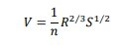

Where:

V = velocity (m/s) n = coefficient of roughness, dimensionless
= hydraulic radius (m)
= slope of the energy grade line (m/)

It should be noted that empirical relationships such as the Manning equation, require that the specified units be used for the variables in order to give the correct result.

Developing the sewerage network

Introduction:
Before starting the design we have to define some terms related to sewage systems such as:

sewer and sewage.
Sewer is a pipe used to transport human waste to the proper disposal place. The system of sewers is called sewerage or sewerage system. Sewage or wastewater is water contains wastes which is discharged by domes residences, commercial properties, industry and agriculture, and transmitted by sewers to the place of disposal.
Manholes are used for making connections, performing maintenance on Underground and buried public utility including sewers and storm drains, and For inspection.

Wastewater transfers by gravity until it reaches the final assembly station or treatment plant. A number of obstacles will appear, as pipeline excavation, limited topography and existing infrastructures. Also, gravity collection systems may not be practical and the sewage must be pumped through a pipeline to the treatment plant. The amount of sewage can be determined by civil engineers, then several studies should be completed in order to clarify details about the network, such as pipe diameters, manhole locations, disposal place and the design of treatment station if it is. After that, treatment should be done to get clean water in order to reuse it in some domains as industry, agriculture and so on.

Object of project 2:
As we mentioned before this project aims mainly to:
Design a wastewater collection network for Asira town using SewerCAD.

Methodology of building the network:
- Determination of the study area where the networks will be designed.
This depends on :
- The location of Asira Al Shamaliya according to Nablus.
- The Ability to establish the network.
- Accessibility.

- Getting data about the study area (Asira Al Shamaliya) :
- Information about water sources of the study area getting from municipality and village council
- Contour map represents the study area.
- AutoCAD maps for study area including (roads, buildings, contour lines).

- Start using SewerCAD software:
- Dealing with data entered correctly.
- The ability to obtain correct results
- Practicing on drawing the network of sewer system.
- Design of Asira Al Shamaliya sewage network using SewerCAD program:
By using AutoCAD and Auto desck land desktop, we changed the format of the contour from (.dwg) to (.dxf), in order to use it in the SewerCAD program as a background and to get the elevation values
steps
- Draw the network this include (manholes, sewers).
- Input data to SewerCAD program. This includes:
- Manholes data, represented by manhole diameter, rim invert and ground elevations, and loading.
- Pipes data, represented by section shape, material, manning coefficient, section size, upstream and downstream elevations.
- Constraints data represented by cover constraints, velocity constraints and slope constraints.
- Outlets data, represented by sump, rim and ground elevations.

Save input and then run
The results included errors and warning messages, so we solved these errors by modifying
the design accordingly.
Get the results : This include:
- Profiles
- Tables of manholes and pipes.
- Plans

Assumptions:
- The sewer system will cover of Asira village
- The sewer path will be with street
- The outfall location
- Location of manholes and waste water load at each manholes
- 6-The flow is partial at percent of 75 of pipe

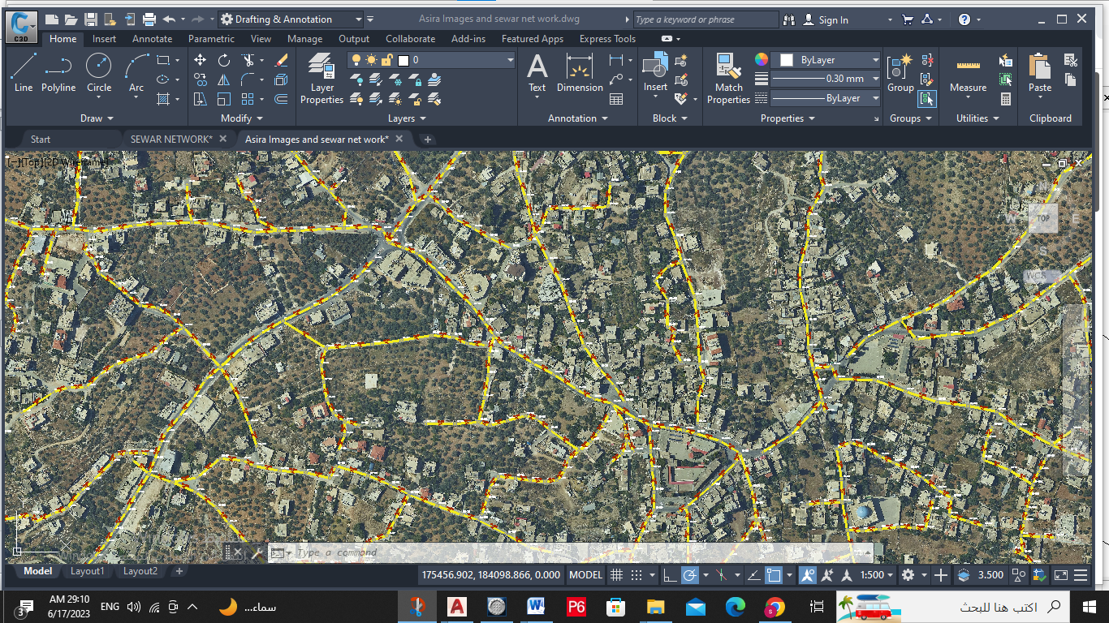

calculation

Estimation of population:

Tack any two years:
Year | 2023 | 2053
Population | 9795 | 25812

P2053= P2023 (1+r/100) n

A population outside Asira expected to return= 3600
On the assumption that the population increase to the families of Palestinian Asira who are outside are the same for them at home = 2.21%.
Using the previous equation, the number of Asira residents outside Palestine who are expected to return to their country in 2053 = 6939 people.

Calculating waste water loading:
=(design period population * Per capita water demand* % of produced waste water to consumed water *( Infiltration rate peaking factor )
design period population=30 years
per capita water demand=136(L/c.d)
% % of produced waste water to consumed water =70
Infiltration rate =20%
=(25812*100*70%*(0.2+5))=12778m3/day

DESIGN OF SEWER NETWORK

layout of sewer network:

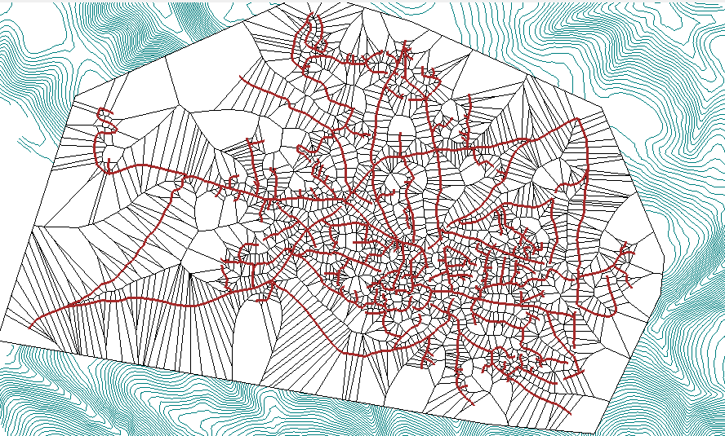

manholes

A) Ground Elevation.
B) Rim Elevation.
C) Sump Elevation.
D) Structure Diameter.
E) Head loss method.
F) Head loss coefficient.
G) Loading

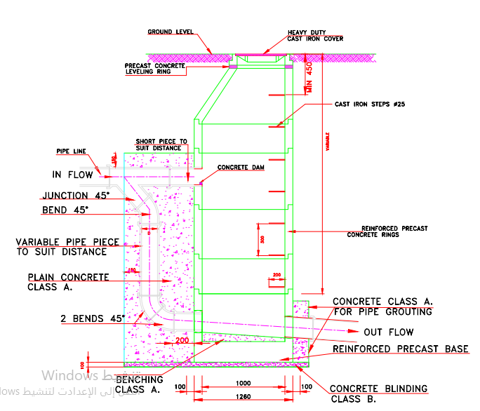

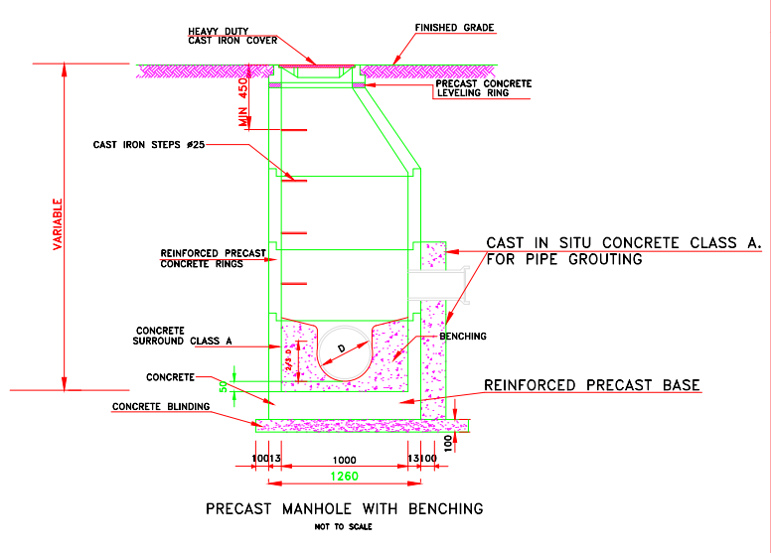

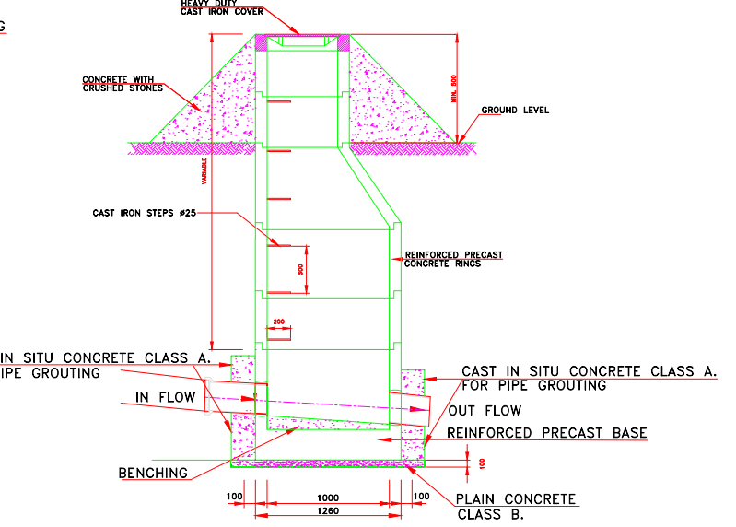

Manhole diameter
Define a 1 m diameter for all manholes , and use circular structure .

The demand for manholes
Each manhole tack a of sanitary load depend ( area * density)
- Where we divided the area on each manhole using the Thiessen polygons method.
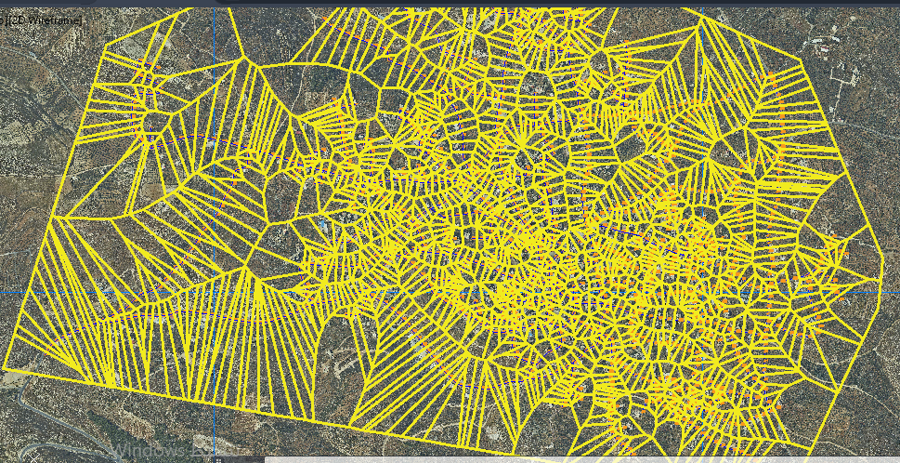

- We calculated the area of each polyline and multiplied it by the population density using the ARC Map program.
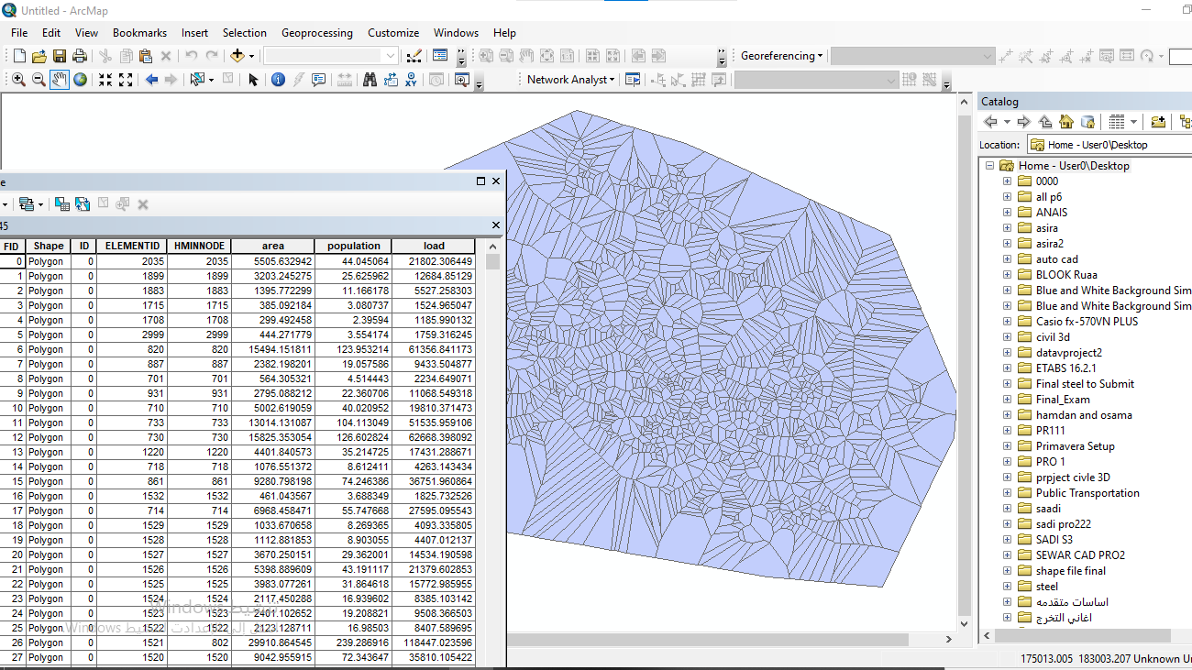

- The per capita consumption of wastewater is 495 L/D
- The demand for manholes = population * 495

condioute.
First define the condioute material is pvc

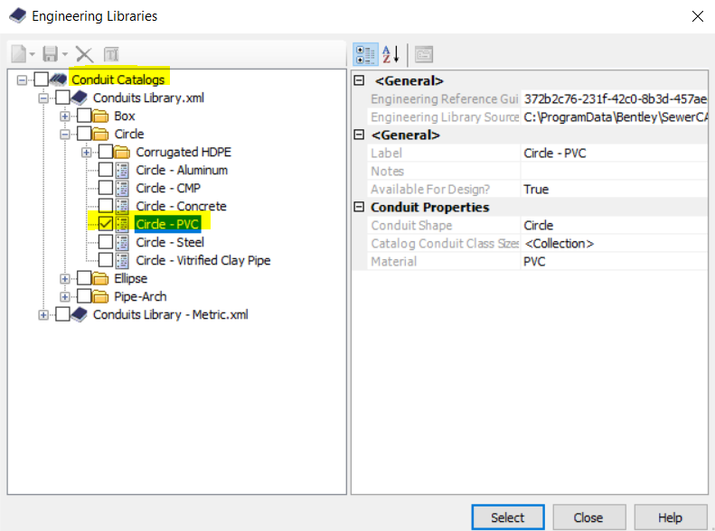

.

Then define the sewer diameter by known the minimum dimeter should be 8 inch or more
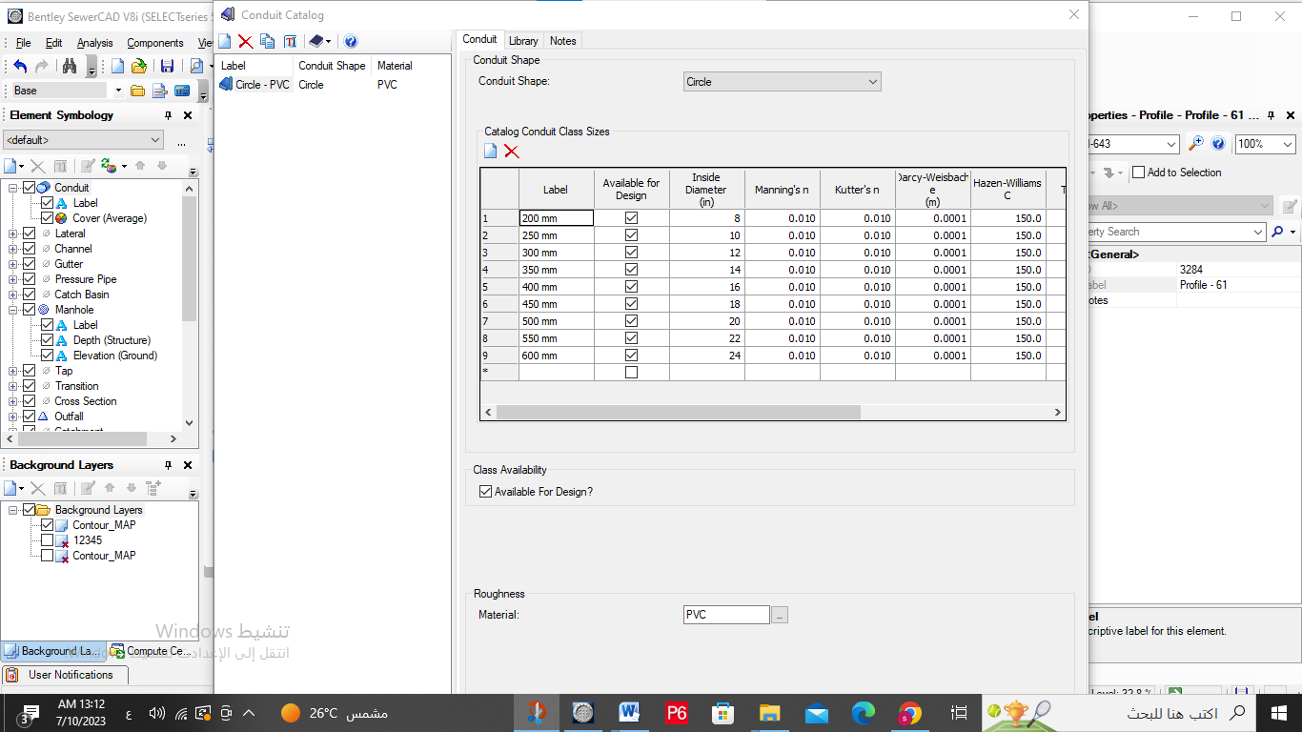

constrains

Then define it in sewer cad:

- Velocity constrain (and par full design )
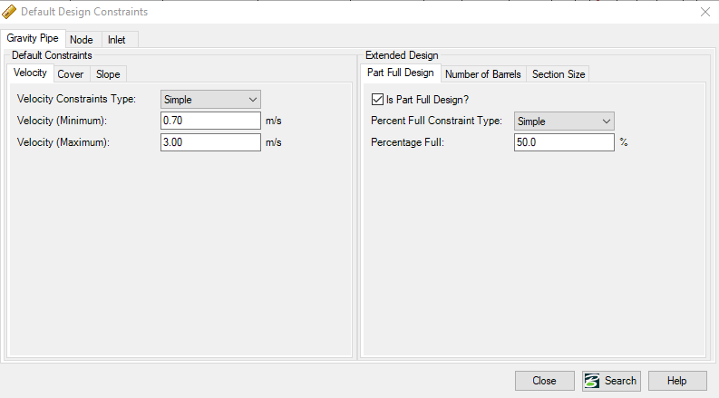

- Cover constrain:
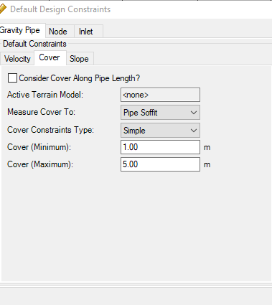
- Slop constrain:
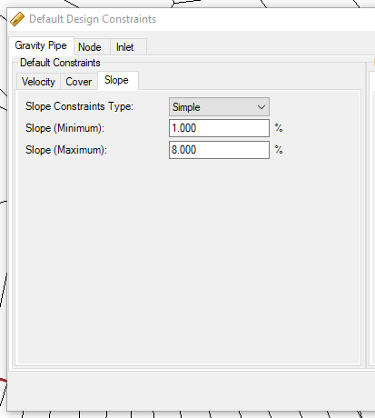

calculation option:

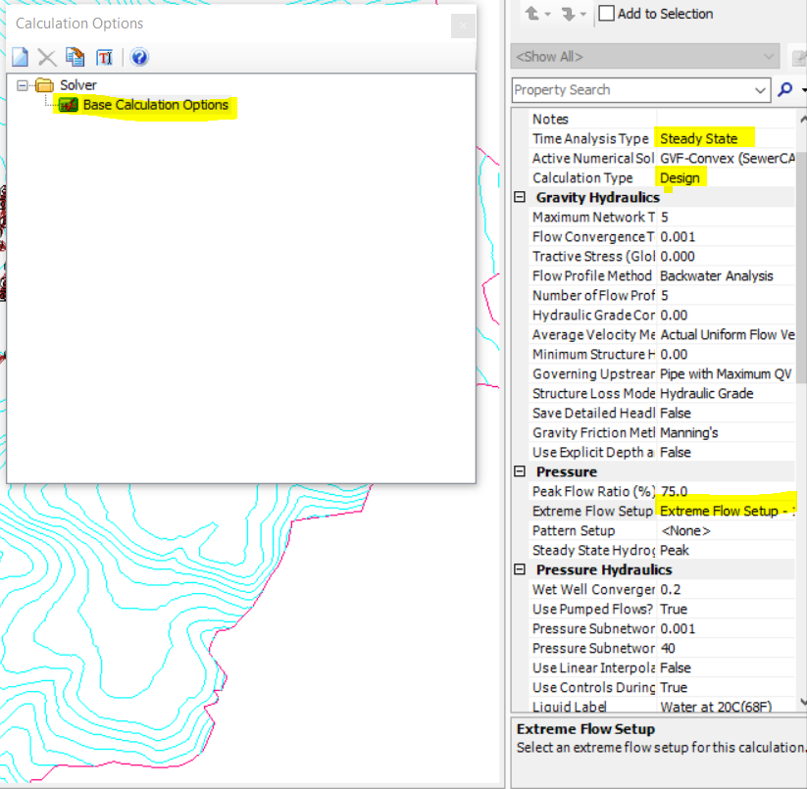

result and conclusion

conduit result:
Desiccation on conduit results:

- length of conduit good should be in range between (20-50)m but with any change in direction of street well need to manhole so the length will increase but in general its good .
- slop: maximum slop =8% and minimum slop = 1% within the design constrain so very good
- section type= circle and catalog class =pvc with 8-inch diameter
- velocity: maximum velocity = 4.84 m/s and minimum velocity =0 m/s which it within so very good

- cover: maximum cover = 23 m and minimum =0.91 m which are not within the constrain cover
- (1 -5m) that we will discuss it latter and found the best recommendation for this problem

Dissection the cover result:
As known the sewer system should be a partial flow with gravity and to be that the out fall should have the lowest elevation but in our case there is zone with elevation less than the outfall so the cover will be high to deliver the waste water to outfall
Outfall elevation = 500 m
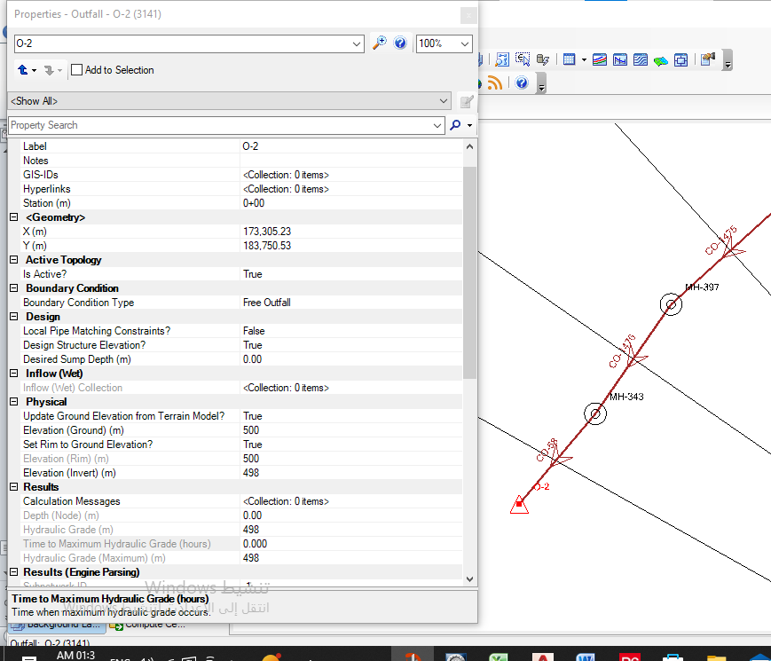

the solution
Suggestion of a pump in CO-673 to pump wastewater to CO-901, which estimates the amount of wastewater to be pumped 1830.82 M³/D
pump

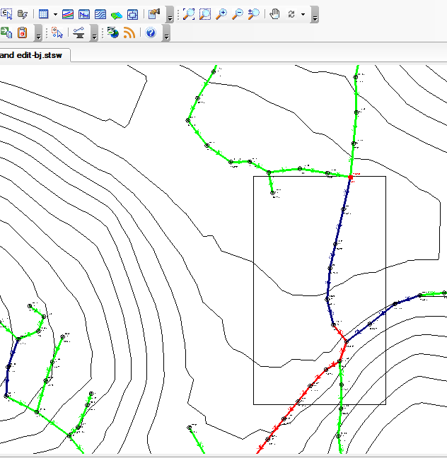

Appendix

Definition of Sewer Cad

Effortless Sewer Design
Ideal for system design and rehabilitation, Sewer CAD will help you invest your capital improvement funds wisely with a wealth of easy-to-use and powerful modeling tools.
Sewer CAD can be used to solve the hydraulics of most any system that consists of gravity flow in partly full pipes. Unlike many gravity flow models, it also does an excellent job with pumps, force mains, and pressure sewers.
Users of Sewer CAD, such as utilities, municipalities, and engineering firms, are primarily involved with design of new sanitary sewer systems or extensions of existing systems. A typical use is design of the sanitary sewer system in a new land development project.
While it can also be used for analysis of existing combined sewer systems or rainfall induced infiltration/inflow in sanitary systems with overflow problems, users working on those problems will generally find sewer GEMS to be a more appropriate product because of the way it handles rainfall hydrology and dynamic flow routing.

Bentley Sewer CAD
"Bentley Sewer CAD version 5.6 is an extremely powerful program for the design and analysis of gravity flow and pressure flow through pipe networks and pumping stations. The program can be run in AutoCAD mode, giving you all the power of AutoCAD’s capabilities, or in Stand-Alone mode utilizing our own graphical interface. Bentley SewerCAD allows you to construct a graphical representation of a pipe network containing information such as pipe data, pump data, loading, and infiltration. You have a choice of conveyance elements including circular pipes, arches, boxes and more.

The gravity network is calculated using the built-in numerical model, which utilizes both the direct step and standard step gradually varied flow methods. Flow calculations are valid for both surcharged and varied flow situations, including hydraulic jumps, backwater, and drawdown curves. You also have the flexibility to mix gravity and pressure components freely, building your systems in parallel or in series as they exist in the field. Pressure elements can be controlled based on system hydraulics, turning pumps on and off due to changes in flows and pressures.

Bentley Sewer CAD’s flexible reporting feature allows you to customize and print the model results in both a report format and as a graphical plot."

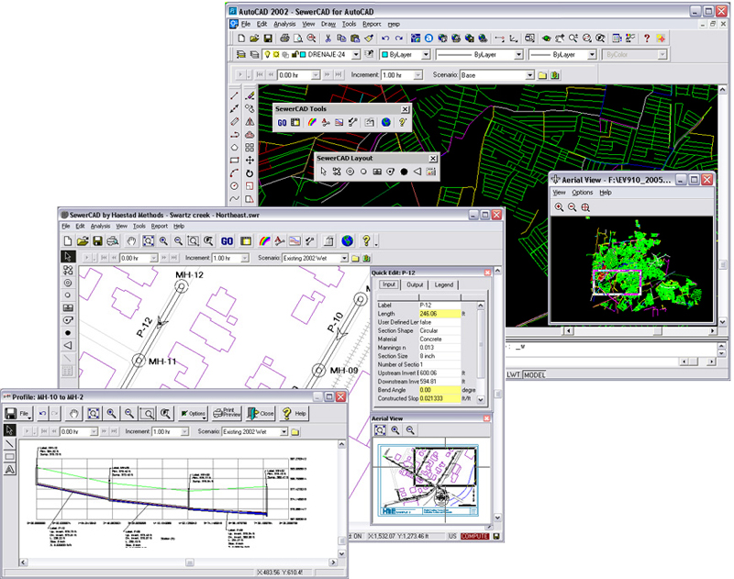

conduit result:
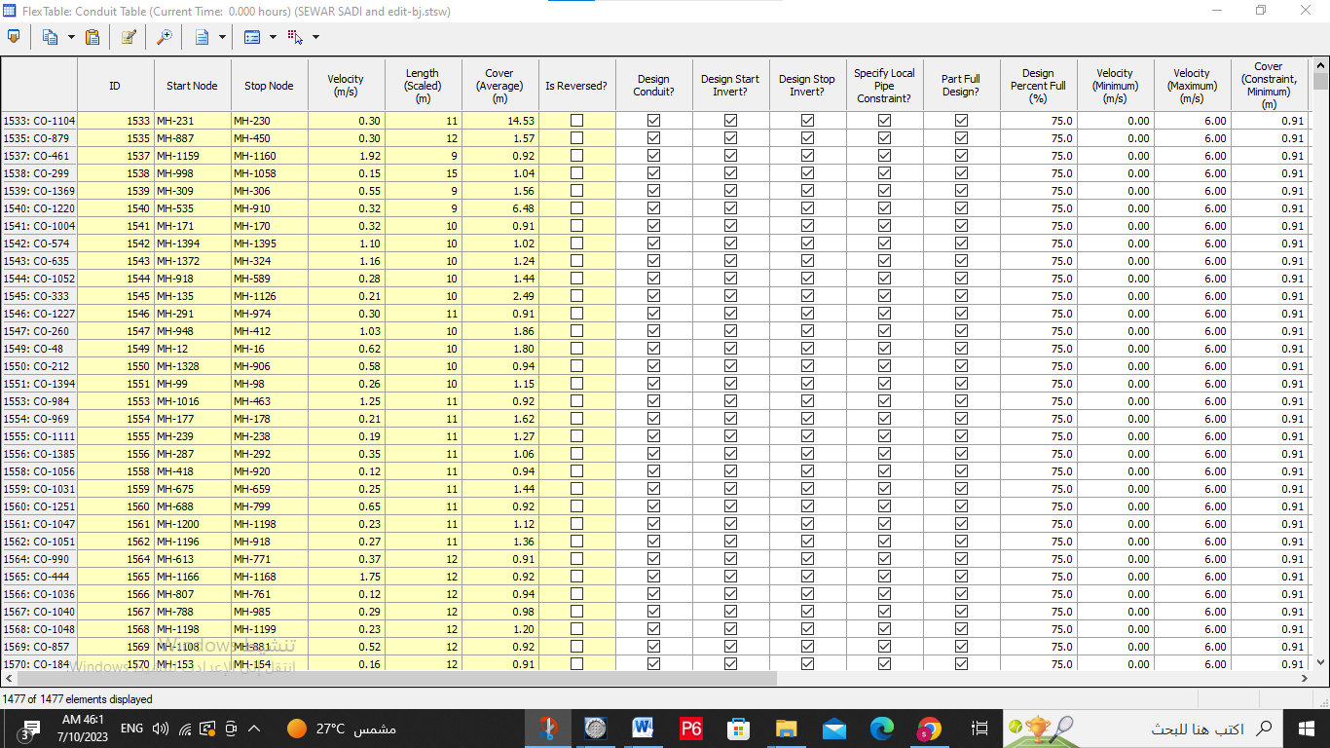
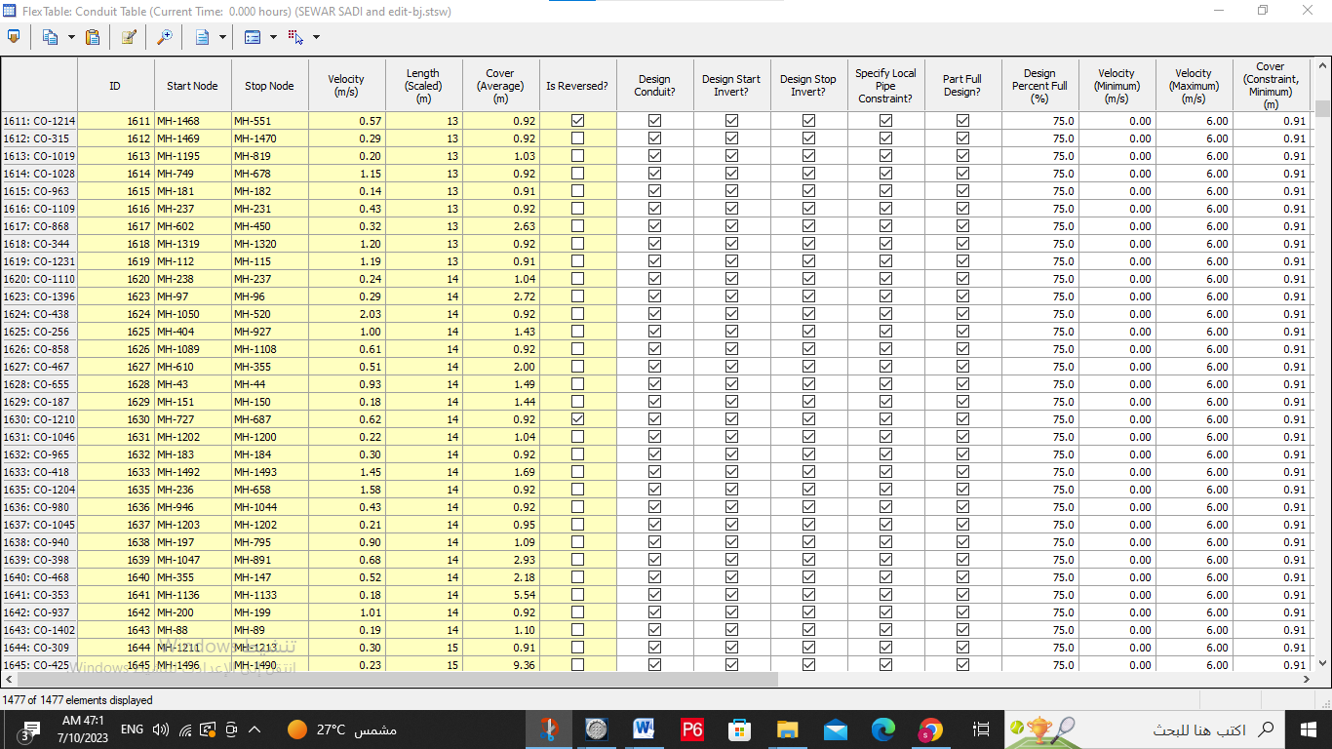

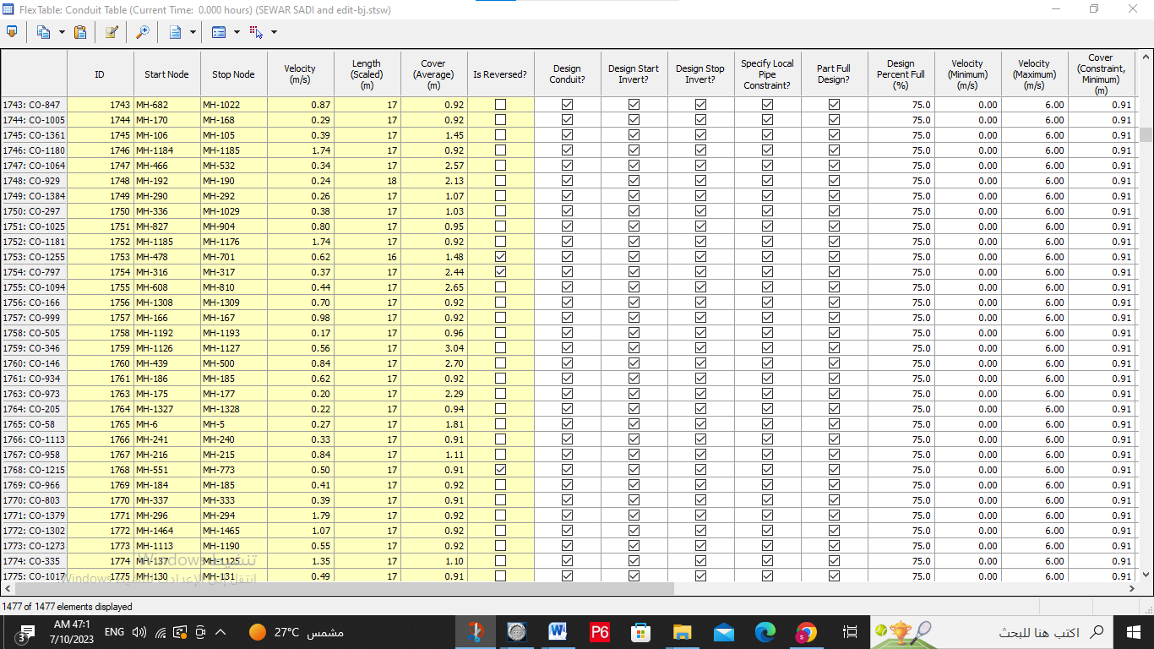

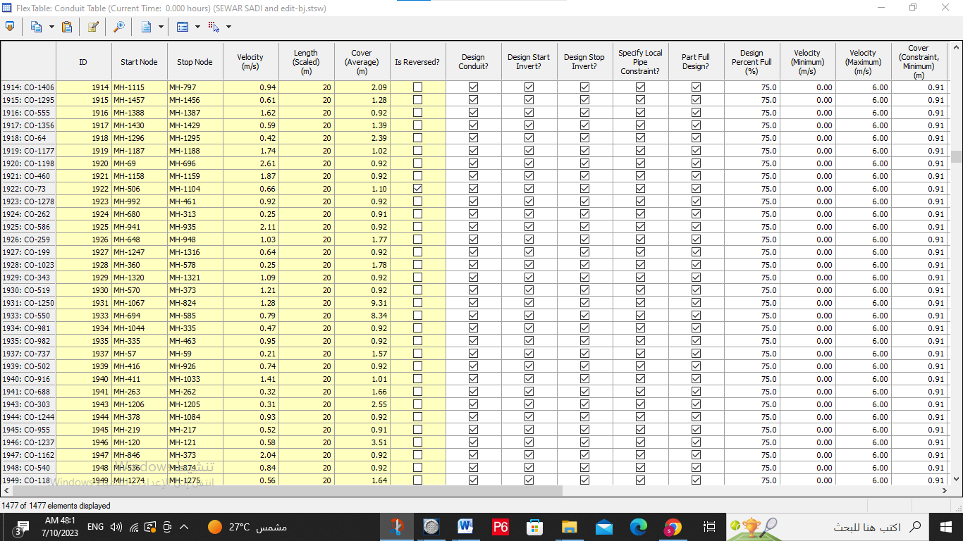
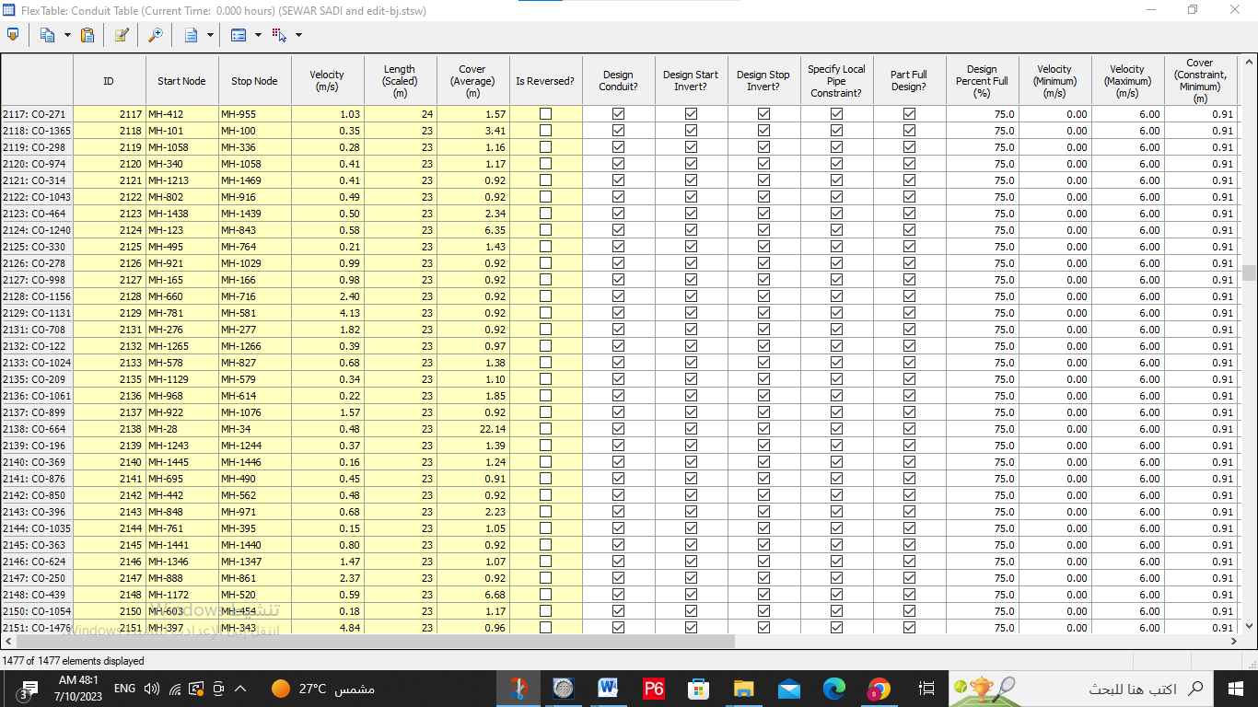

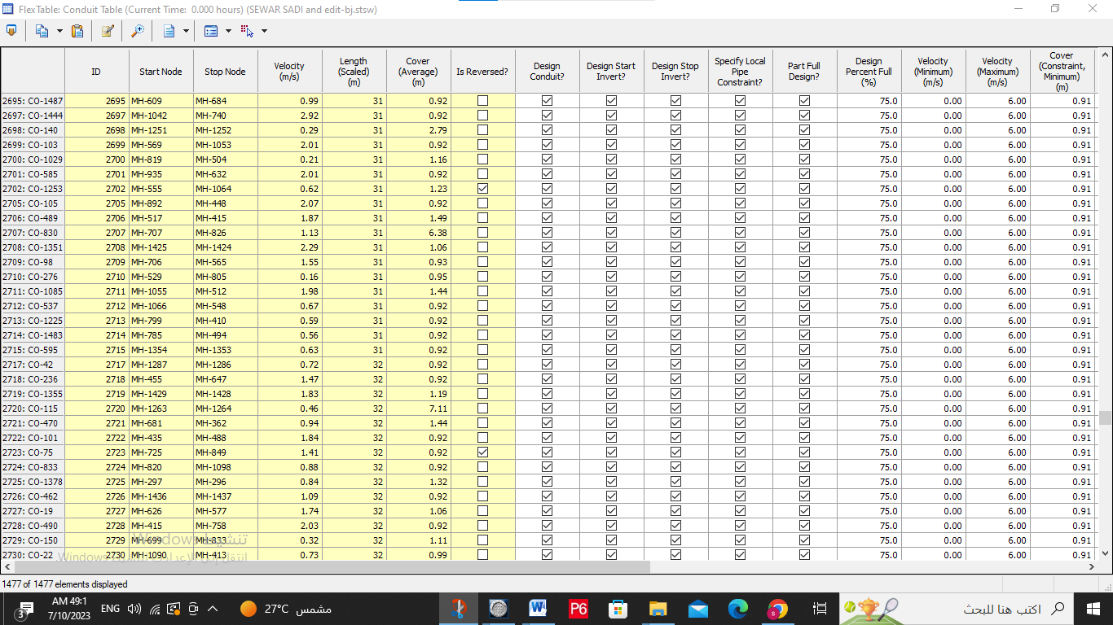
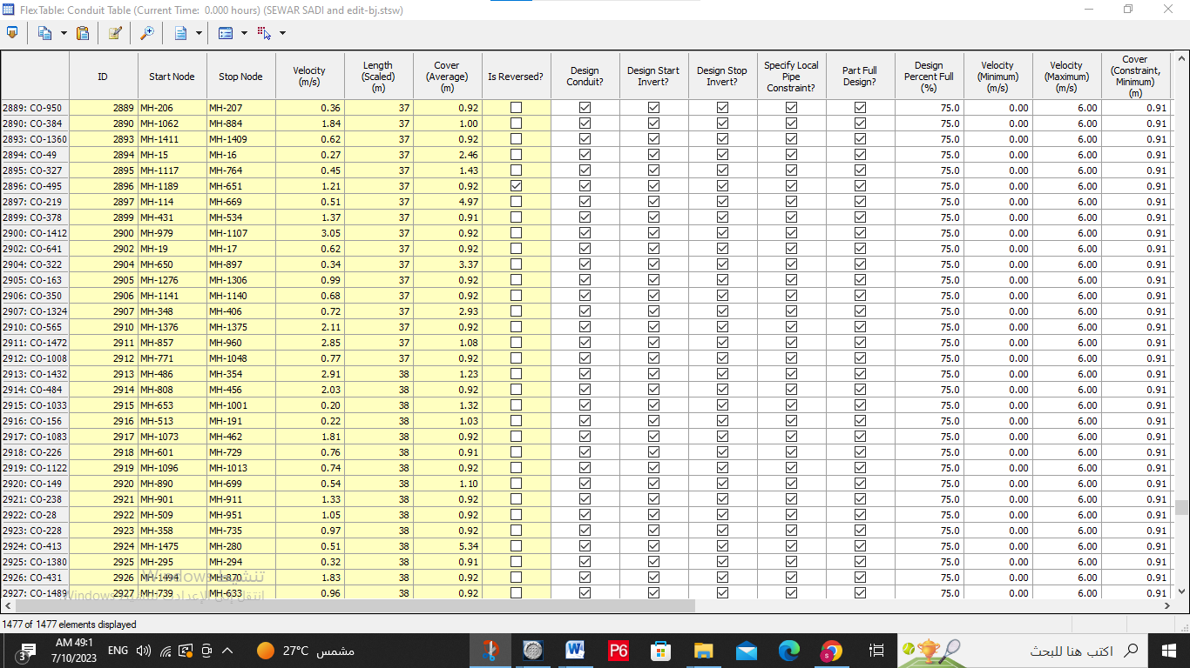

manholes result
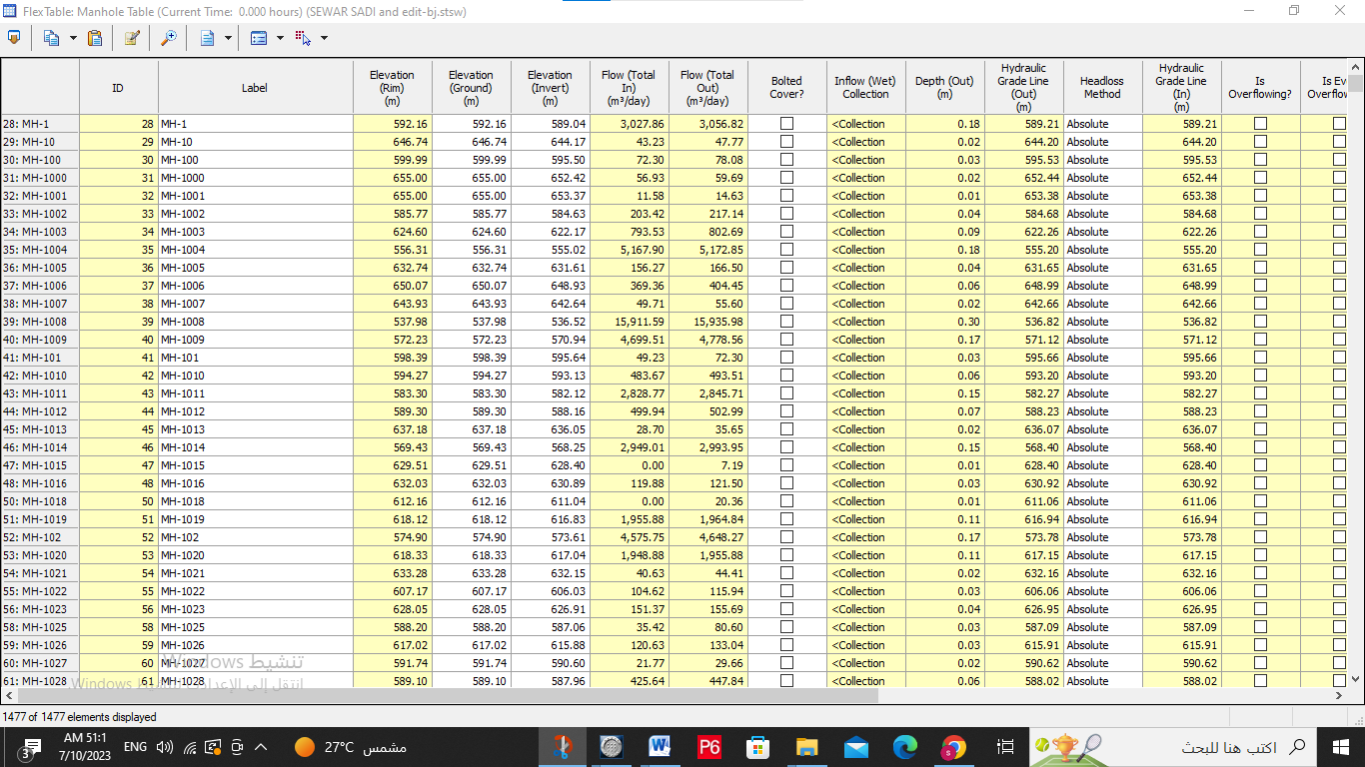
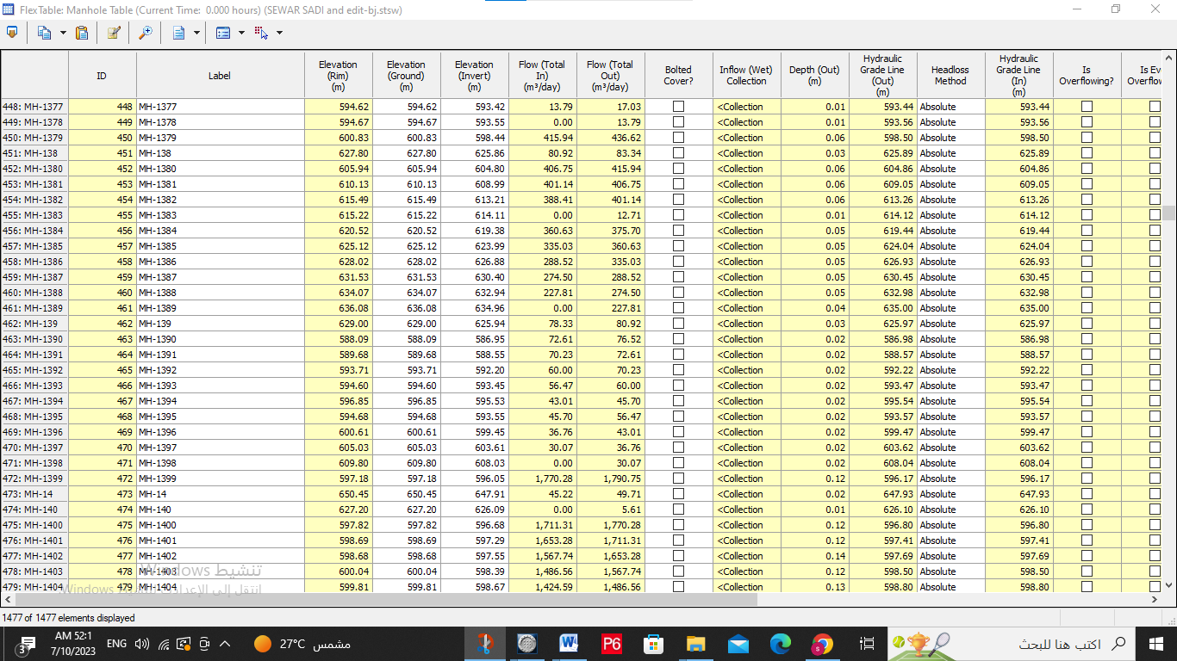
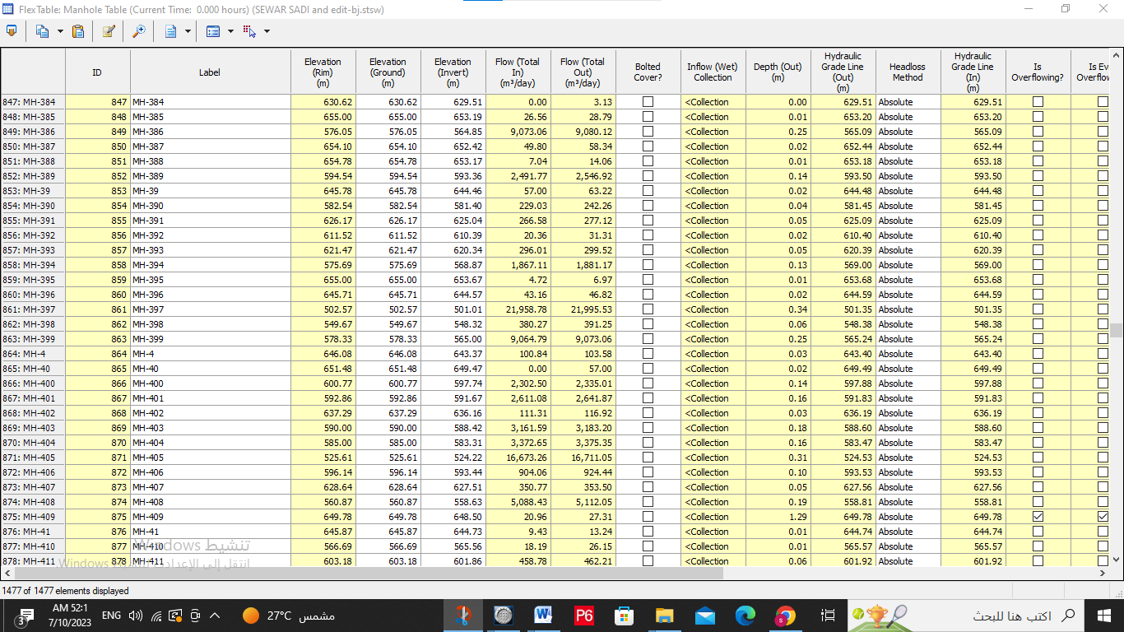
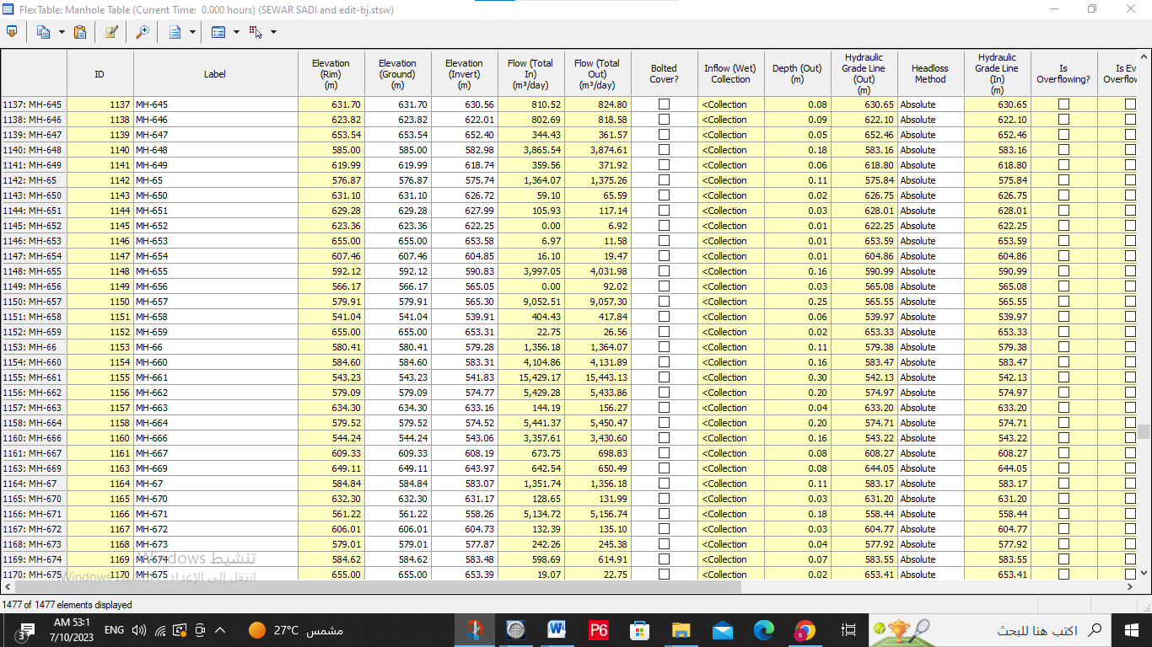
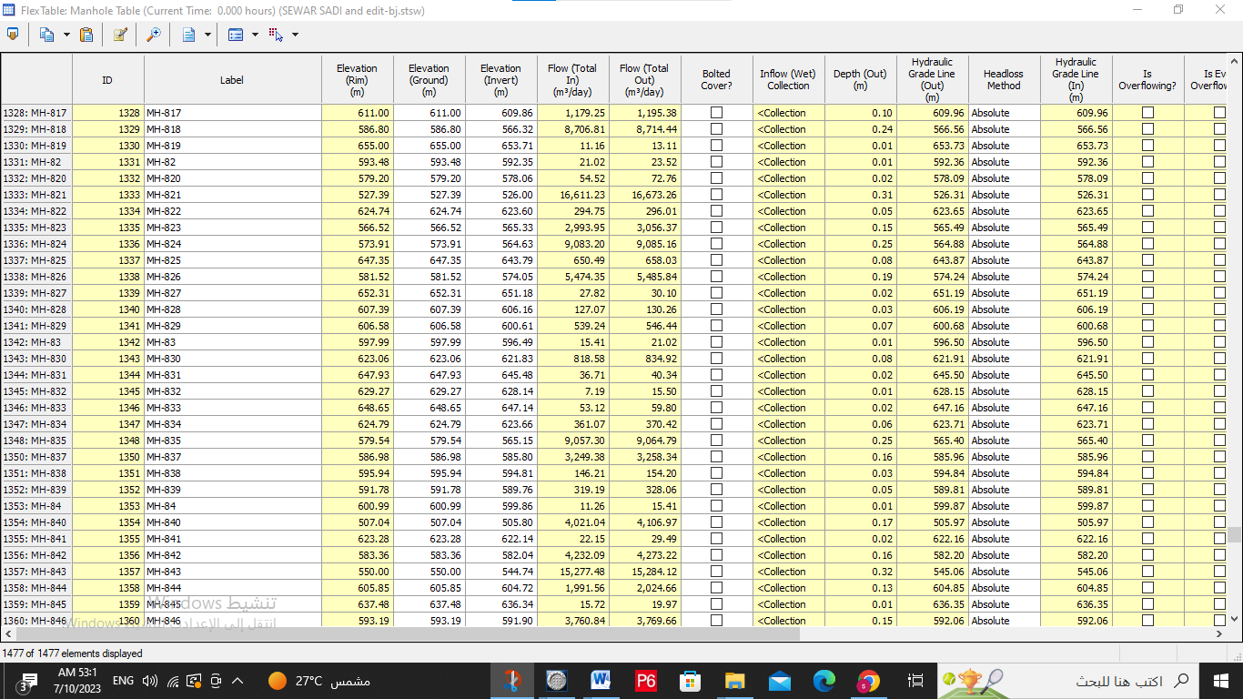
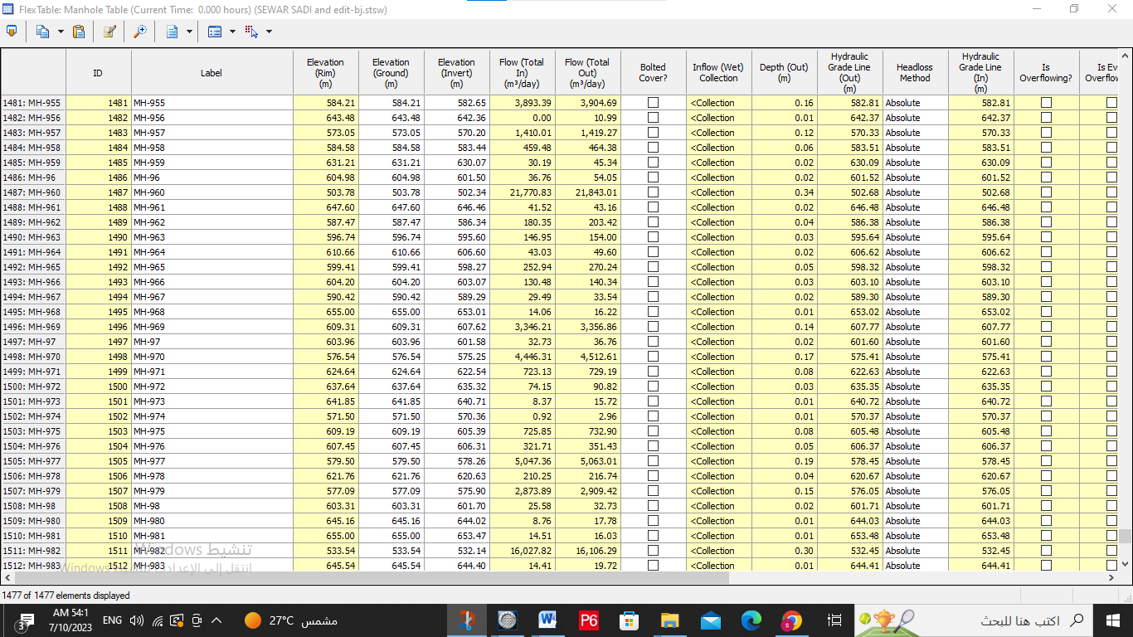

Outfall result
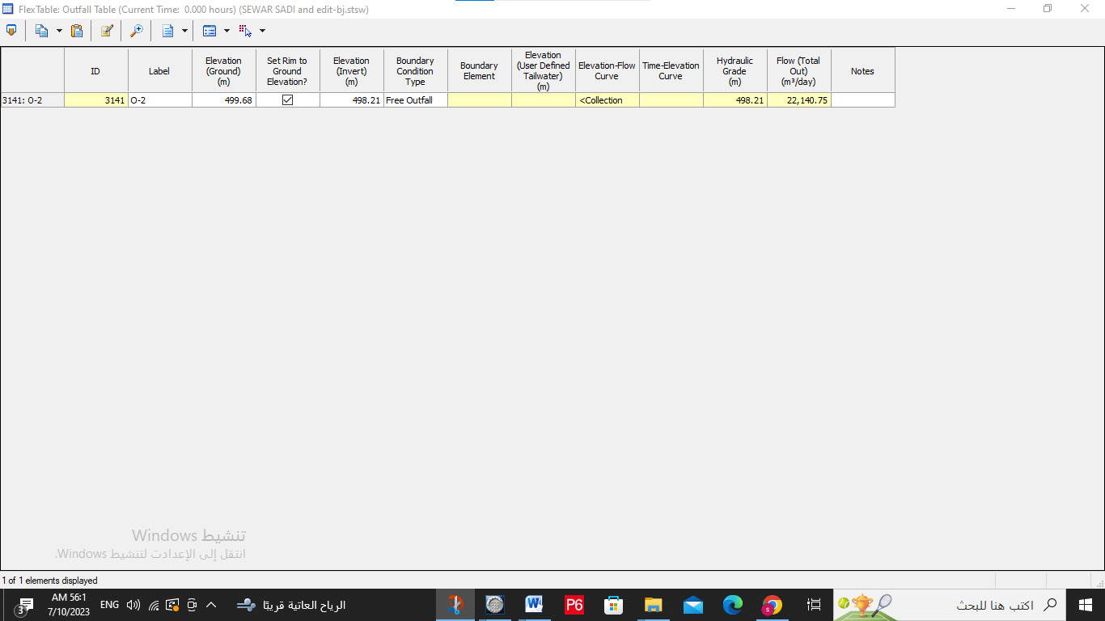

Reference
Arij. (2014). Asira ash Shamaliya Town Profile. Palestine.
Council, A. A. (2022). Design of a Wastewater Collection Network for Asira Al-Shamalya. Asira Al Shamaliya Municipal Council.
PCBS, P. C. (n.d.).
PWA, P. W. (n.d.).
Warren Viessman, J. a. (SEVENTH EDITION). Water Supply and Pollution control. FLORIDA.

