بسم الله الرحمن الرحيم

An-Najah National University
Information Technology Collage
Department of Computer Science

Articles Classification
System
NLP

Students :
Rani halabi
Ahmad Rabayaa
Naeem Awashra
Lecturer :
Dr. Baker Abdalhaq
2018
Table of Contents
CH1:Abstraxt………………………………………………………………………………………………………………………….2
CH2: Introduction ………………………………………………………………………………………………………………………….3
CH3 Requirements:………………………………………………………………………………………………………………………….4
CH3.1: Description ………………………………………………………………………………………………………………………….4
CH3.2: Funcional ………………………………………………………………………………………………………….5
CH3.3:Non-Funcional ……………………………………………………………………………………………………………….7
CH4:Senareio………………………………………………………………………………………………………………………….8
CH5.1:use case………………………………………………………………………………………………………………………….11
CH5.2:Seqiense daigram…………………………………………………………………………………………………………………….12
CH5.3 data flwo………………………………………………………………………………………………………………………….13
CH6.1 :interfaceDesktob ……………………………………………………………………………………………………………….14
CH6.2:interface website………………………………………………………………………………………………………………….17
CH6.3:interface Andrioed……………………………………………………………………………………………………………….20

Abstract:

We have seen recently that websites that are interested in the transfer of news and circulation from other sites have proliferated, and the circulation of these news needs a tool that helps journalists, article writers and data entry users in the sites to categorize those news and articles by certain categories.
The categories we will deal with are sports, economic, social, political and cultural, and a sixth category of news and articles that do not fall within the above.
This tool will be able to fetch articles from sources that support fetching and provided with API to fetch and deal with their services like facebook API and AljazeeraNet API, and store them on the hard drive and then analyze and process them in several stages to ensure that the news or article is ready to upload to the site, and that they are acceptable files.
In order for the files to be accepted, they are subject to a filtering process, so that any articles or news written in a non-standard Arabic language are excluded, as well as the filtered files if they are not related to the news or articles.
The program will be linked to a website, where articles and news will be transferred to it, and the program will have a user interface to facilitate the program.

Introduction:
Since many websites and blogs interesting in searching of news and edit them to put them organized in their websites, and many users needs to collect categorized news and use them in their work, our software has come to help them to do their job easily and fast.
Today organized data articles and news on sport, politics etc
has big attention in press , we decided to help them in their job by doing this software which designed to collect news and articles from many trusted sources and classify them in specified categories in order to upload them on their sites automatically.

Description:
The application gets the news an articles from facebook API or a website that gives news(RC , Aljazeera, etc...).
First step is to determine if the new/article is fusha or not by searching in the database fro its words, if its exists its fusha, if not we make some spell correction by looking fro repeated letters and make repeat one and two times and we looking for them again, if its not exists its a slang new/article, and it calculates the percent yield of the fusha and slang words.
As example: “جيش الاحتلال راحوا يدمروا قرية في نابلس مشان يحتلوها”
This example will take 88.888% fusha and 11.111% slang yields.
Second step is to check the class of the new/article. We look for stop words if they exist or not to eliminate them, then we can use the Farasa framework to lemmatize the words to make them exactly like the words in the training sets , then we use the calculations of Naive bays algorithm to determine what class the new/article belongs to.
For example:”امريكا تعلن السفارة الامريكية في فلسطين “
The results of Naive is:
نسبة الاقتصاد= 5.445922401771808E-20
نسبة السياسة = 6.102477549367376E-20
نسبة الرياضة = 1.0065681732191967E-20
نسبة الثقافة = 4.8344963833600106E-20
نسبة التعليقات = 2.3683307306884144E-20

Functional Requirements:
1-Costumed News fetcher.
The program must bring news from several reliable sources, and these sources are user-defined in advance.
The user must determine the news to be brought accurately, determine its type, whether sports, political or economic, and allocate more content, for example the user wants sports news, which determines that news related to the Spanish league, and then identify a source can be brought news automatically, and it has an API supports data fetching from it.
For example, the program brings sports news about the La Liga from the Koora website.

2-News and articles recognition
The program should be able to categorize news and articles into custom categories, so that it is easy for the user to know which category the article or article belongs to.

3-Texts Filtering
The program should be able to pick news and articles well. It excludes any news in dialectic Arabic languages and any text that is irrelevant with news or articles.

4-Ease using and good look interface

The program has a beautiful interface, easy to use, and customized in its functionality.
5- showing available and supported sites.

The program should provide users with websites that has an API , which supports automated data retrieval feature, which makes it easy to handle the data of those sites.

Functional Requirements for Desktop Application:
1-the program will provide access to presses and admins by a login screen.
2- The program shall let the program user to select the news add them to the website. and other applications and show them by categories.
3- The program will categorize the news from the file filled of by the API.
4-the program will show the important news to the user.
5-the program will give the admin the ability to add, delete and modify presses.
6-the program will categorize the news and give determine if its slang or Standard Arabic.

Non-functional Requirements:

1-Fast and accurate

The program must be fast in its performance during data analysis, and give results in the rating of more than 80% accuracy.

2-Auto-learning
The program must support machine learning, so that it dynamically develops its parameters, and any file entered as an input is added to the training set.

3-Maintenance:
Regular maintenance for system.

Scenario:
The user of the application, through the user interface or through the website, adds the sources of information from which the data will be obtained, for example, the site of Facebook, Twitter or the site of the island.
And then press the fetch button in the program, it brings the information from the IPA to the hard drive on the user's device, and may take the fetch period of time.
As for the classification, the user can categorize a news story individually by inserting a file, filling the news as it is in a text box, or by placing the news in a folder. The program classifies it into political, sports, economic and cultural categories. The above categories go to the classification of marginal news or that do not belong to a category among several categories.
The program will support more diverse categories of news and articles in the next development process, ie, it will be able to assign the classification, for example military-Syria dedicated to a politician, in the later stages, and the Spanish league type of sport.
As for the work of the program behind the scenes, after bringing the news from sources through an API or RSS, from sites that support this feature, the program makes sure that it is really articles or news written in a literal language, the language of writing is the standard Arabic language, then the program will exclude any article or news written in the slang
language, or that a publication has been written on the site or source of news, but a publication is not news, but something else such as a side post talking about tuning settings or publication talking about honor or ceremony of the site or the information Of which.
After that, the program determines the score for each class that shows the extent of belonging to the article or article for this class, and the class that has the highest score, is the right class for the news or article.
For example, if a news item is covered in the political category, it is equal to 85%, and it has a score of 70%. The program chooses the highest score, and the news is classified as political.

Usecase :
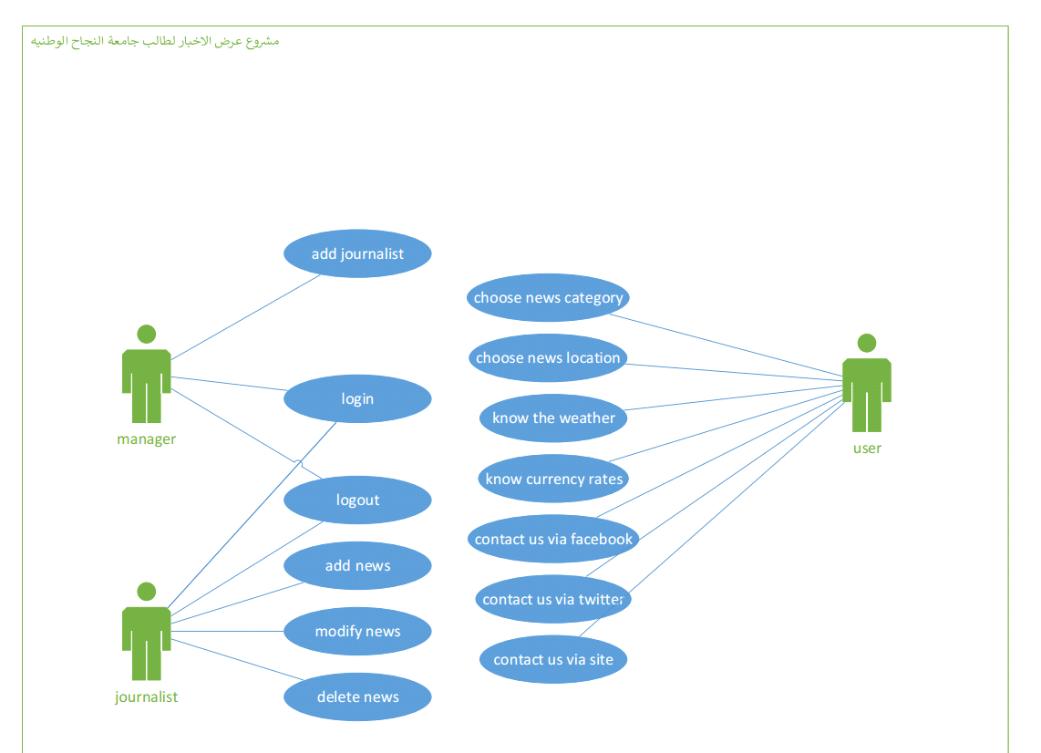
Sequance diagram :
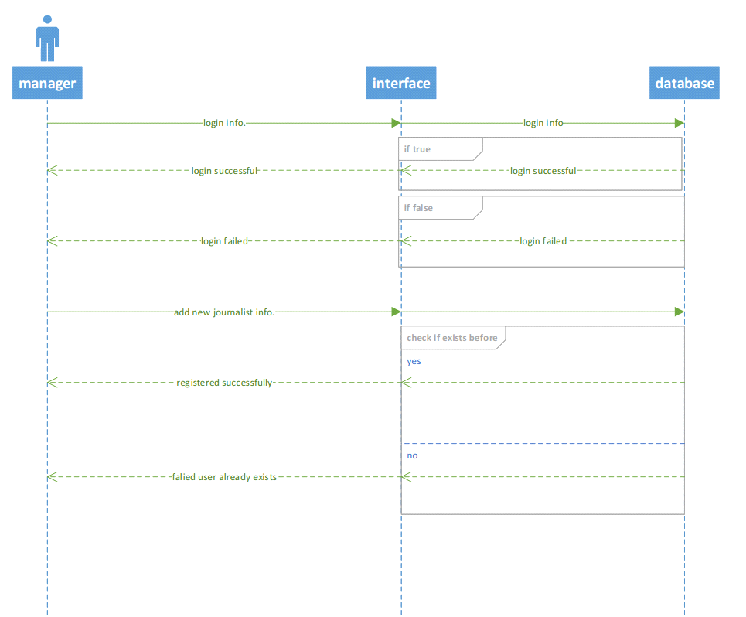
Login , and add new journalist
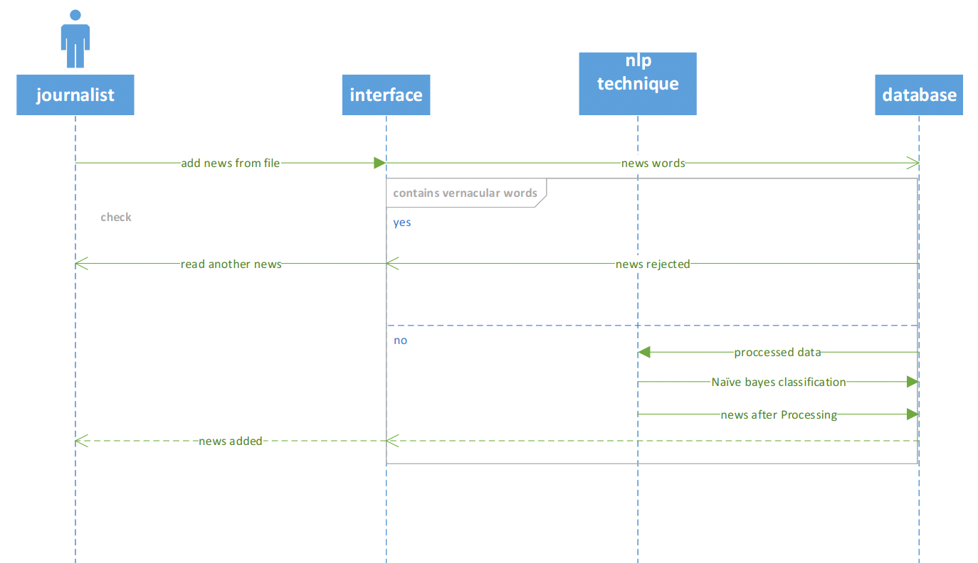
Add new news file(nlp app)
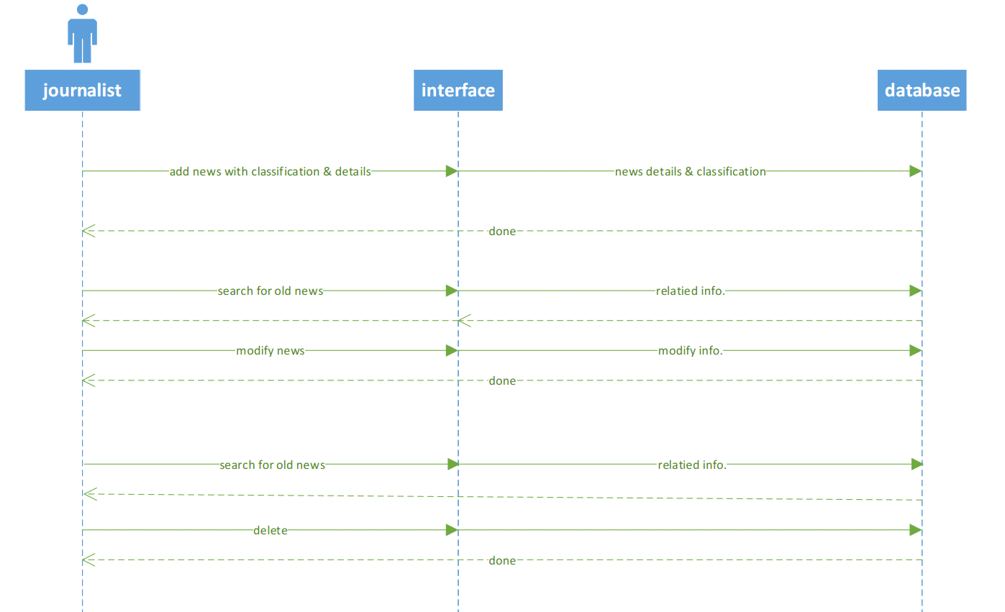
Add , modify , and delete news via website
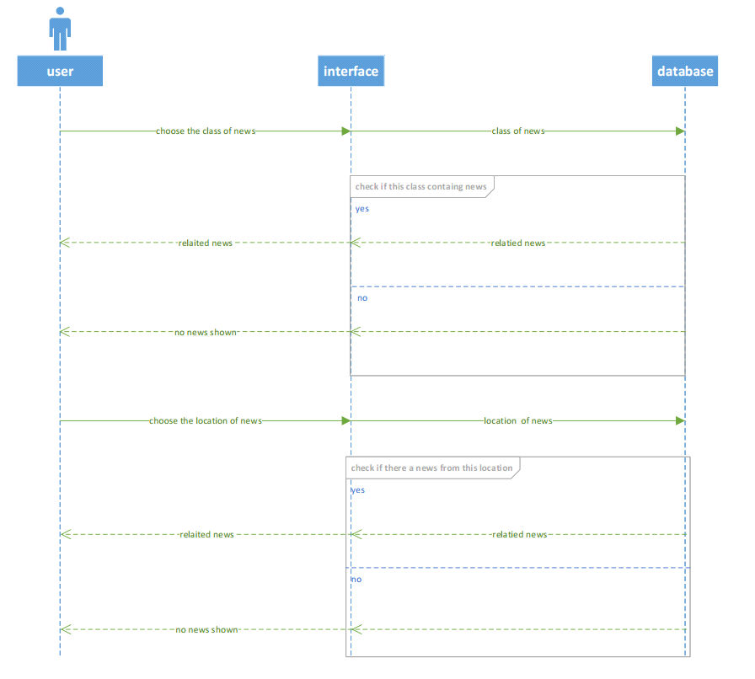
User choose location and the calss of news

Data flow : Context diagram
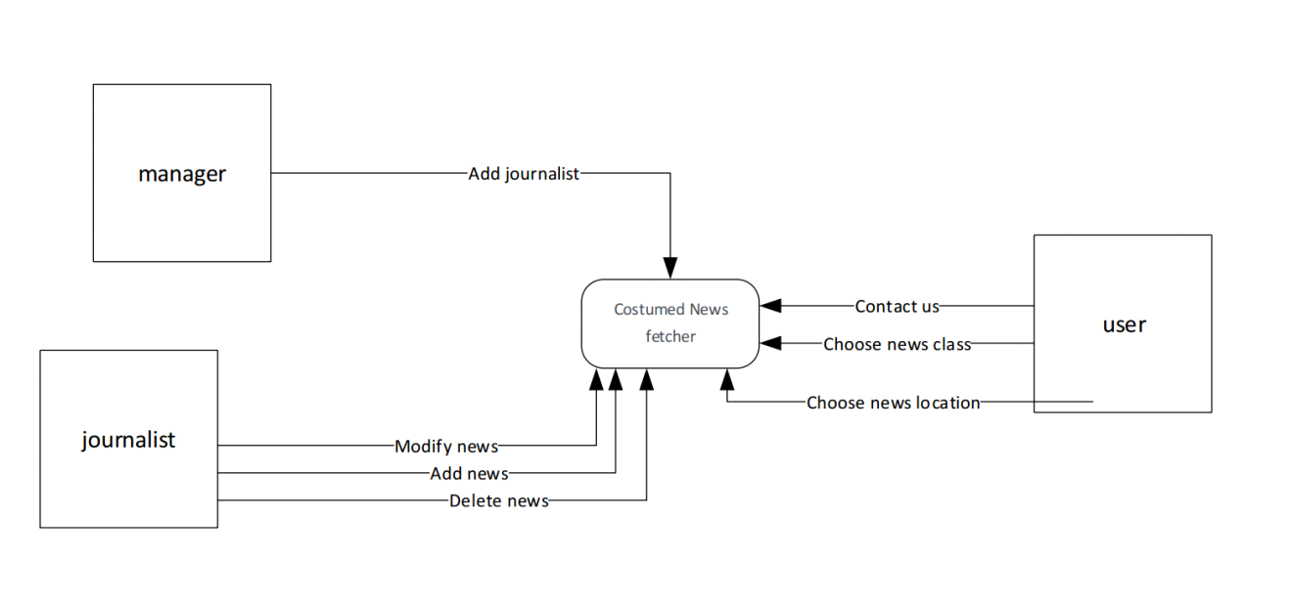

Results and conclusions:

We made a test set consists of 20 news for each type of news and we got these results:

precision للسياسة:45.0%
precision للثقافة:75.0%
precision للرياضة:100.0%
precision للاقتصاد:90.0%
Recall للسياسة=75.0%
Recall للاقتصاد=78.26087%
Recall للرياضة=83.33333%
Recall للثقافة=71.42857%
Accuracy=77.5%
MacroAverage=0.775
MicroAverage=0.775
we found that the economy and politics news are near from each other, and that because there are some news that enter the economy training set and has some words like( ترامب,رئيس, وزراء ) That is in fact belong to politics type and they have entered the Economy training set, so when we classify politics news we got the economy and politics are the most results in it, therefor we need to insert more news to get a better accuracy.

