

An Najah National University Faculty of Engineering & TechnologyDepartment Computer Engineering

Canapé
Prepared By:
Laith Shakhsheer Reem AbuRajab

Supervised By: Dr. Aladdin Masri

June ,2024

Acknowledgment

We would like to extend our sincere gratitude to the following individuals and organizations, whose support was indispensable in the completion of this project:
Dr. Aladdin Masri We express our deep appreciation to Dr. Aladdin Masri, our project supervisor, for his consistent guidance, mentorship, and insightful feedback throughout our project journey. His expertise and encouragement were pivotal in pushing us to achieve excellence and deliver a project of significant quality.
To our friends and family, we are immensely grateful for your unwavering support, encouragement, and belief in our abilities. Your patience and understanding during challenging times were invaluable to us.
Finally, we would like to acknowledge the faculty members of the Computer Engineering Department at An Najah National University for fostering a conducive learning environment and imparting invaluable knowledge that enriched our journey.

Disclaimer statement

The contents of this report are provided for informational purposes only. The authors and the organization disclaim any liability for actions or decisions taken based on the information herein. Readers are encouraged to consult with qualified experts or professionals before making any decisions or taking any actions. The authors do not warrant or guarantee the accuracy, completeness, or reliability of the information presented in this report.

Table of Contents

Acknowledgment 1
Disclaimer statement 2
Table of Contents 3
List of Figures 6
Chapter 1 Introduction 7
  - General background 7
  - Objectives 7
  - Significance or importance of your work. 8
  - Organization of the report 8
Chapter 2 9
  - 2.1 Fundamentals of Fabric Measurement and Cutting 9
    - Traditional Methods 9
    - Limitations and Challenges 9
  - Advances in Fabric Cutting Technology 10
    - Integration of Advanced Hardware 10
  - Impact of Technological Innovation on Textile Manufacturing 10
Chapter 3 Methodology 11
  - Introduction 11
  - Standards and Specifications (Codes) 11
  - Constraints 12
Replacement of the LK80 Sensor with Alternative Distance Measurement Methods
........................................................................................................... 12
Matching Ball Bearing and Soft Iron Rod Sizes 12
Deadline and Semester Structure 13
Lack of Existing References 13
The Budget 13
  - Design Process 13
  - Tools and Technologies 18
Arduino Mega 18
DC motor 18volt 19
Windshield Wiper Motor 19
l298n motor driver 20
Keypad 20
LCD Display 21
Power Supply 22
I2C module for lcd 22
b. Details of tool usage 23
Chapter 4 Conclusion 27
  - Impact on Industry and Market Trends 27
  - Sustainability and Environmental Impact 27
Chapter 5Discussion 28
Chapter 6 29
Recommendation 29
Chapter 7 30
Future Enhancements 30
References 31

List of Figures

  - Model Design 8

    - Cylinder Composition

    - Container Cylinders

    - Two large cylinders

    - Cylinders in the middle

    - Blade part
  - Arduino Mega 12
  - DC motor 13
  - Windshield Wiper Motor. 13
  - l298n motor driver 14
  - Keypad 14
  - LCD Display 15
3.8 SIM900A 15
  - Power Supply 16
  - I2C module for lcd 16
  - tool usage 17
    - Windshield Wiper Motor with Bicycle Gear System
    - DC motor And Cutting part
    - The Cutting Blade

Chapter 1 Introduction

Contents
  - General background 1
  - Objectives 1
  - Significance or importance of your work 2
  - Organization of the report 2

  - General background
In the textile industry, precision and efficiency are paramount. Our project aims to improve fabric processing by introducing a state-of-the-art machine that measures and cuts fabric with exceptional accuracy. The traditional methods of fabric cutting, which often involve significant manual labor and material waste, are being transformed by modern automation. This advanced machine not only ensures precise measurements but also optimizes the cutting process, thereby reducing waste and increasing productivity.

Objectives
Our primary objective is to enhance precision in fabric measurement and cutting. By developing a machine that achieves high accuracy, we aim to minimize errors and reduce material waste. This advancement will significantly improve the quality and consistency of the final textile products.
Efficiency is another key objective. By automating the fabric cutting process, we seek to reduce the time and labor required, thereby increasing overall production speed and efficiency. This automation will streamline the workflow and reduce downtime, ultimately boosting productivity in textile manufacturing.
We are also focused on reducing waste. By optimizing cutting patterns and processes, our machine will maximize fabric utilization and minimize waste, leading to significant cost savings. This approach promotes sustainable manufacturing practices and resource optimization.
Incorporating modern hardware technology is essential to our project. We aim to create a reliable and user-friendly machine that meets the demands of contemporary textile manufacturing. Additionally, safety is a top priority. We are designing the machine with safety features to protect operators and ensure safe operation in a manufacturing environment.

Significance or importance of your work.
The significance of our fabric cutting machine project lies in its innovative solutions to common challenges in automated fabric cutting. By developing a unique approach and using cost-effective materials like plastic and wood instead of stainless steel and iron, we managed to stay within budget without compromising functionality. Our project showcases how creativity and problem-solving can improve efficiency and precision in fabric cutting, providing a valuable framework for future automation projects in the textile industry.

Organization of the report
Our report is thoughtfully divided into key sections to guide you through the creation of our advanced fabric measuring and cutting machine. Begin with the Theoretical Background and Previous Work for context, followed by the Methodology detailing our approach.
Transition to the Results and Analysis for empirical findings and interpretations. The Discussion section places results in a broader context, while Conclusions and Recommendations summarize achievements and suggest future directions. The report concludes with References, acknowledging our sources. Join us on this journey as traditional textile craftsmanship meets modern automation.

Chapter 2

Theoretical Background

Contents
  - 2.1 Fundamentals of Fabric Measurement and Cutting 3
    - Traditional Methods 3
    - Limitations and Challenges 3
  - Advances in Fabric Cutting Technology 4
    - Integration of Advanced Hardware 4
  - Impact of Technological Innovation on Textile Manufacturing 4

  - 2.1 Fundamentals of Fabric Measurement and Cutting

Traditional Methods
Traditional methods of fabric measurement and cutting involve manual processes that require significant skill and experience. Tailors and seamstresses use tools such as measuring tapes, rulers, and fabric shears to measure and cut fabrics accurately. Patterns are often traced onto the fabric with chalk or markers before cutting. These methods are time-consuming and prone to human error, but they have been the cornerstone of the textile industry for centuries.

Limitations and Challenges
Manual fabric measurement and cutting have several limitations and challenges. The process is labor-intensive and can lead to inconsistencies due to human error. Precision and accuracy are difficult to maintain, especially for large-scale production. Additionally, traditional methods are not easily scalable, making it challenging to meet the demands of modern manufacturing. These challenges highlight the need for automated solutions to improve efficiency, consistency, andscalability in fabric cutting processes.

Advances in Fabric Cutting Technology

Integration of Advanced Hardware
Modern fabric cutting machines integrate advanced hardware components such as precision sensors, high-speed rotary blades, and programmable logic controllers (PLCs). These components work together to ensure accurate measurements and precise cuts, reducing errors and increasing efficiency. The integration of such advanced hardware not only streamlines the cutting process but also enables customization and flexibility in handling different types of fabrics and cutting patterns.

Impact of Technological Innovation on Textile Manufacturing
Technological innovations in fabric cutting have revolutionized textile manufacturing, driving significant improvements in efficiency, productivity, and sustainability. Automated cutting machines have streamlined operations by minimizing material waste and enhancing the precision of fabric cuts. These advancements not only increase throughput and reduce labor costs but also contribute to sustainability goals by optimizing resource use and minimizing environmental impact. Overall, these technological innovations underscore the transformative potential of advanced hardware in modernizing traditional industries like textile manufacturing.

Chapter 3 Methodology
Contents
  - Introduction 11
  - Standards and Specifications (Codes) 5
  - Constraints 6
  - Design Process 7
  - Tools and Technologies 12
  - Details of tool usage 17

  - Introduction
This chapter outlines the methodology adopted for the design and implementation of the fabric cutting machine project. The methodology encompasses adherence to engineering standards, consideration of design constraints, the design process followed, tools and technologies utilized, and project management strategies employed to ensure successful project completion.

Standards and Specifications (Codes)
In our fabric cutting machine project, we adhered to engineering standards and employed the Agile methodology. Starting with the integration of the Arduino Mega with the motor, we meticulously planned each phase. The DC motor drives a cylindrical rail, moving the blade left and right. This iterative approach, from machine mechanics to final testing, ensured precise and efficient operation.

Constraints

Replacement of the LK80 Sensor with Alternative Distance Measurement Methods
The LK80 sensor is a high-precision device commonly used for accurate measurement of fabric length in industrial applications. Its unavailability in local markets and the time and cost associated with ordering it online from Amazon led us to explore alternative solutions.
We considered replacing the LK80 sensor with three types of sensors: encoders, IR sensors, and Hall effect sensors. Encoders measure motor shaft rotations, IR sensors detect fabric edges or markers through reflection, and Hall effect sensors detect the presence of magnetic fields. Integrated with Arduino, these sensors provide a reliable method for measuring fabric length based on the movement and position of the fabric during cutting operations.
Ultimately, to simplify our approach and avoid sensor complexities, we decided to use the motor itself as a means of distance measurement. For every 100 motor rotations, we established that the fabric would advance by a fixed distance of 100 meters. This straightforward method ensures operational efficiency and accuracy in our fabric cutting machine, aligning with our project's goals of practicality and functionality.

Matching Ball Bearing and Soft Iron Rod Sizes
Finding a suitable soft iron rod (16mm) to fit the ball bearing (17mm) proved challenging despite extensive searches across blacksmiths, lathe operators, and other suppliers. The mismatch in sizes posed a significant constraint in the mechanical design of our fabric cutting machine, requiring us to explore alternative solutions to ensure proper functionality. Despite three weeks of searching, we were unable to find an exact match, as we encountered a 1mm size discrepancy. However, we were able to resolve this issue later through adjustments in the fabrication process.
And due to the unavailability of bearings with an outer radius of 11cm, we replaced it with a 17mm inner bearing with a hard plastic disk with an 11cm diameter in our fabric cutting machine design.

Deadline and Semester Structure
Due to the semester being divided into two parts, we faced a compressed timeline for acquiring materials, reducing our expected four-month timeframe to just two months. This shortened schedule placed significant pressure on our team to meet project deadlines and milestones for our fabric cutting machine.

Lack of Existing References
Our novel fabric cutting machine project lacked online references, pushing us to rely on team creativity and problem-solving skills for original solutions. We meticulously researched and tested every aspect from design to implementation.

The Budget
One of our main challenges was sticking to our budget. To manage costs, we swapped out the stainless-steel model for a plastic one for both the body and cylinders. Additionally, we replaced the iron model with a wooden one. This change helped us stay within our financial limits while ensuring project feasibility.

Design Process
In our project, we meticulously designed 13 cylinders made of plastic. Among these, two cylinders have a radius of 11 cm, while the remaining cylinders have a radius of 5 cm.

Cylinder Composition:
Each plastic cylinder with a diameter of 5 cm had two bearings inserted at its ends. An iron rod passes through these bearings, which are 17 mm in diameter, while the iron rod itself is 16 mm in diameter. To compensate for the 1 mm size difference, we welded an iron ring with a diameter of 1 mm around the circumference of the iron rod. This modification ensured that the iron rod fit securely within the bearings, allowing for smooth rotation.

In contrast, the two large cylinders, with a diameter of 11 cm, did not contain bearings due to the unavailability of bearings with the required outer diameter. Instead, we used a hard plastic disc with an inner diameter of 16 cm. This solution maintained the structural integrity and functionality of the large cylinders, ensuring they could contain the fabric roll effectively. Additionally, we applied a rough material to the surfaces of the large cylinders to prevent the fabric from slipping during the cutting process.

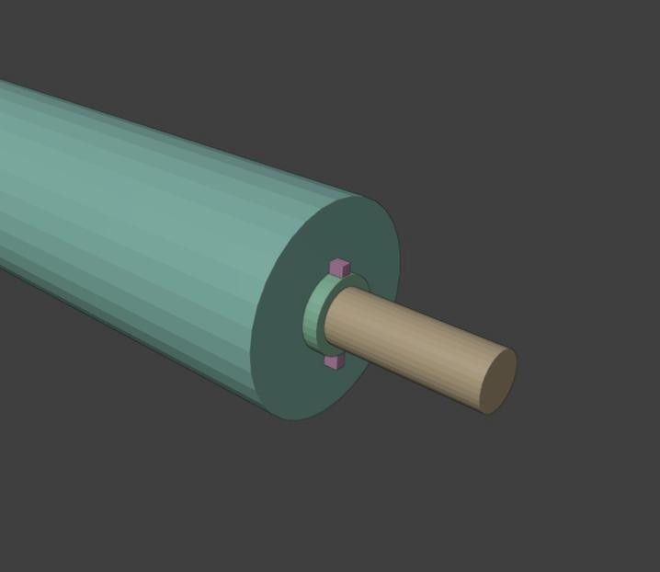
    - Cylinder Composition

Arrangement of Cylinders:
At the front of the model, at the bottom, six cylinders with a diameter of 5 cm were arranged in a crescent shape to contain the roll of fabric. This arrangement provides a stable and secure base for the fabric roll, preventing it from slipping or moving during the cutting process.
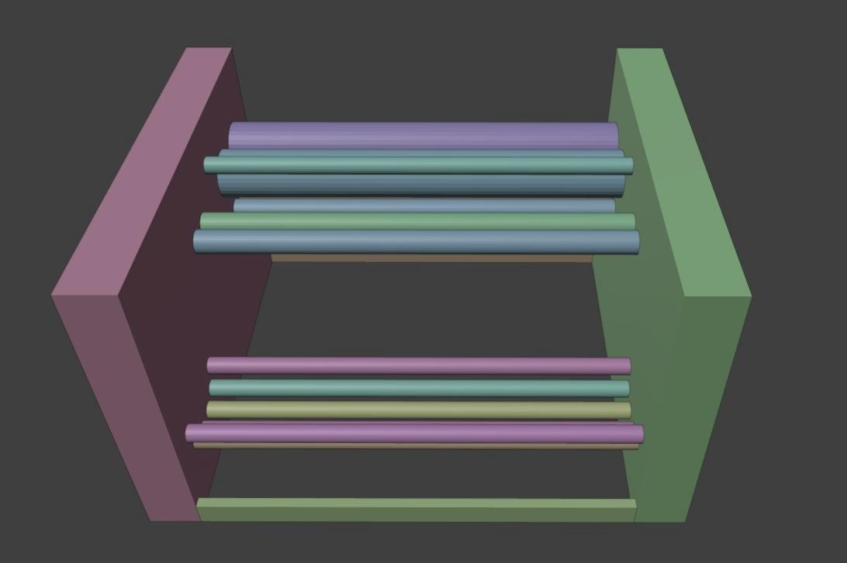

(b) container Cylinders

At the top, two large cylinders with a diameter of 11 cm were positioned. One of these large cylinders is connected to a motor that drives the iron rod passing through it, enabling rotation. Consequently, only this cylinder is motor-driven, while the rest rotate via the bearings.
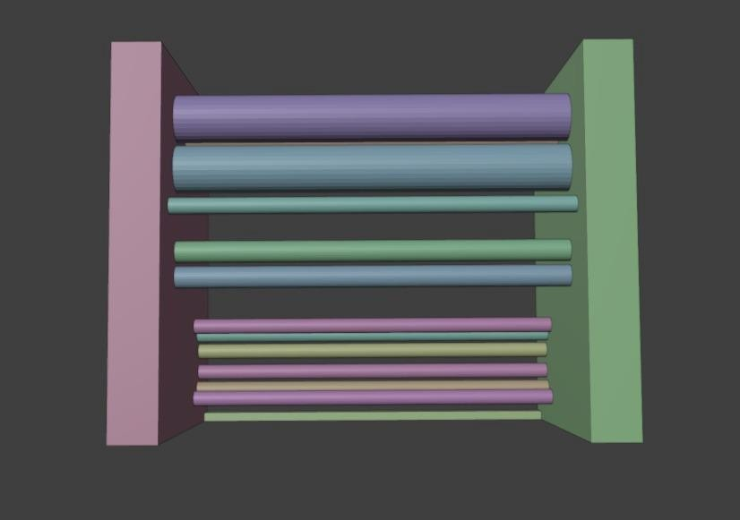
(c.1) two large cylinders

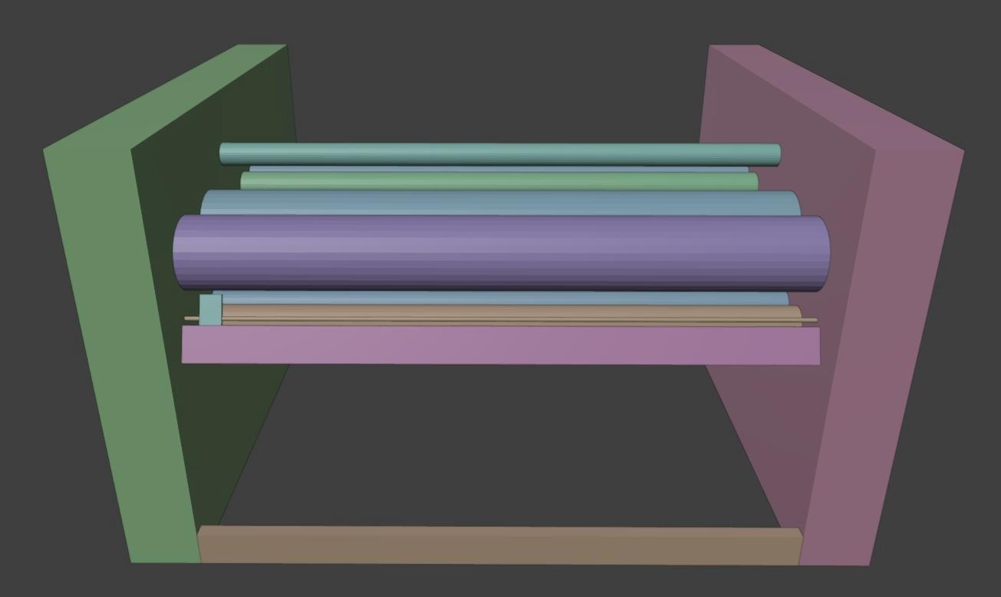
(c.2) two large cylinders

The remaining five cylinders are strategically placed: two in the middle, two under the large

rolls, and one at the top center of the model. These cylinders guide the fabric through the machine, ensuring it follows the correct path for precise cutting. The careful placement of these cylinders minimizes friction and wear on the fabric, maintaining its quality throughout the process.

(d.1) Cylinders in the middle



Blade part:
(d.2) Cylinders in the middle

Beneath the two large rolls, there is a cylindrical rail that moves a hex-nut. This hex-nut, in turn, carries a blade attached to a metal piece. When the cylindrical rail rotates, it moves the hex-nut and consequently the blade, which cuts the fabric. The blade is designed to move with

precision, ensuring clean and accurate cuts. During the cutting process, the blade moves between two wooden supports, with a small gap just wide enough to accommodate the blade. This setup ensures that the fabric is held firmly in place while being cut, preventing any movement that could result in uneven cuts.



(e) blade part

Figure 3.1: Model Design

Tools and Technologies
Our fabric cutting machine project was realized through a strategic selection of essential tools and technologies. These resources were pivotal in translating conceptual designs into a functional and efficient product, facilitating seamless integration between hardware components like Arduino Mega, two motors, LCD display, keypad interface, and H-bridge motor driver. In the upcoming sections, we detail how these core tools and technologies supported the development and success of our project.

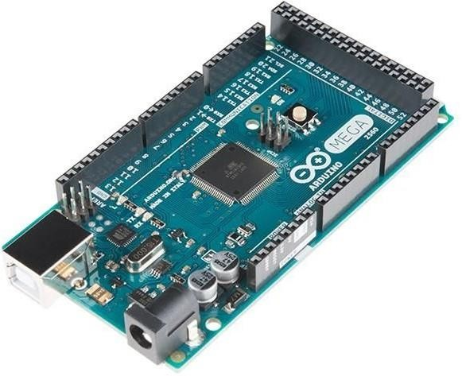
Arduino Mega

Figure 3.2: Arduino Mega.
Certainly! At the heart of our fabric cutting machine project lies the Arduino Mega, a versatile microcontroller equipped with 54 digital I/O pins, 16 analog inputs, and 256 KB of memory. These pins serve as crucial interfaces for connecting our machine's components such as motors, sensors, and user interfaces,ensuring precise control and seamless operation. Leveraging the Arduino Integrated Development Environment (IDE), we meticulously craft and deploy code that drives the machine's functionality, including motor control for precise fabric cutting operations. The IDE facilitates real-time communication with the Arduino Mega, enabling efficient code uploads and updates. This synergy between hardware and software exemplifies our project's innovation and reliability, making the Arduino Mega indispensable in achieving a robust and efficient fabric cutting solution.

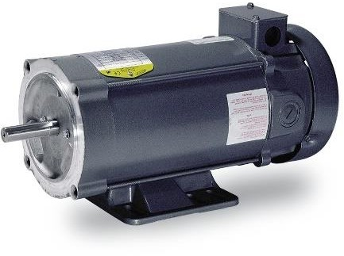
DC motor 18volt

Figure 3.3: DC motor

Windshield Wiper Motor

7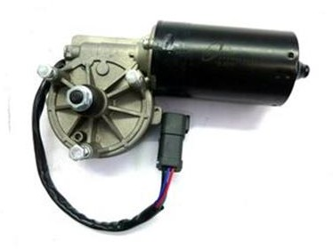
Figure 3.4: Windshield Wiper Moter.
A DC motor is an electric motor that runs on direct current (DC) electricity. It converts electrical energy into mechanical energy through the interaction of magnetic fields generated by the current flowing through its coils. DC motors are widely used in various applications due to their simplicity, efficiency, and ability to provide high torque at low speeds.

A windshield wiper motor is an essential component of a vehicle's wiper system, responsible for driving the wiper blades in a back-and-forth motion across the windshield. Powered by the vehicle's electrical system, these motors provide reliable operation in varying weather conditions by offering adjustable speeds. They ensure clear visibility for drivers by efficiently clearing rain, snow, or debris from the windshield. Designed for durability and performance, windshield wiper motors play a critical role in enhancing safety and comfort during driving, making them indispensable for maintaining optimal visibility on the road.

l298n motor driver

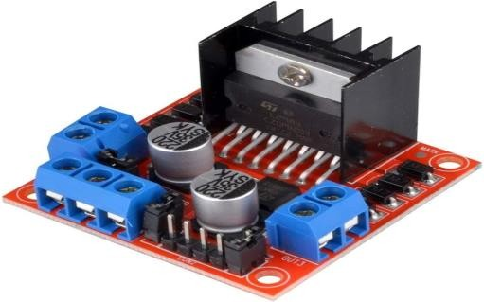
Figure 3.5: l298n motor driver.

Keypad

Figure 3.13: Keypad.
Figure 3.13: Keypad.
Figure 3.13: Keypad.
Figure 3.6: Keypad.

The L298N motor driver module is a highly utilized dual H-bridge motor controller designed to manage either two DC motors independently or a single stepper motor. It supports higher current and voltage demands, making it ideal for diverse robotics and automation endeavors. With capabilities for forward and reverse motor control and the ability to handle peak currents effectively, the L298N ensures efficient motor operation. Its seamless integration with microcontrollers and widespread compatibility have established it as a preferred solution across applications ranging from mobile robots and CNC machines to remote- controlled vehicles.

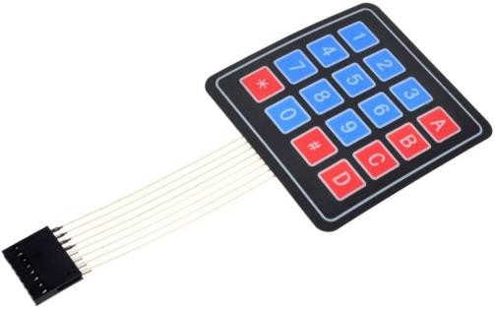
A keypad, also known as a "keypad entry system" or "keypad input device," is a user interface comprising a grid or array of buttons. Each button typically represents a specific character, digit, or
function, making it ideal for entering numerical

LCD Display

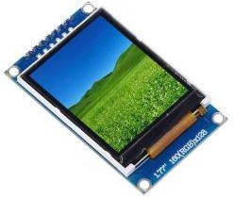
Figure 3.7: LCD Display.

SIM900A

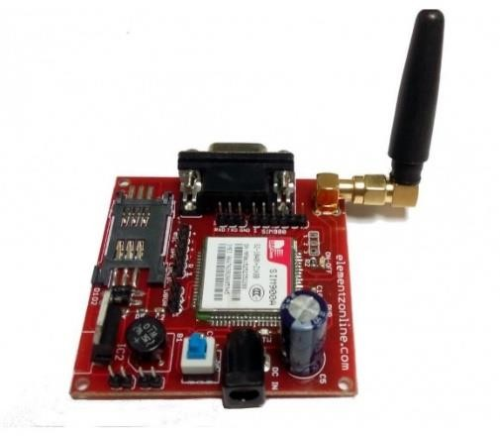

Figure 3.8: SIM900A
An LCD (Liquid Crystal Display) utilizes liquid crystals to modulate light, producing images or text on a flat- panel display. Found in devices like televisions, computer monitors, smartphones, and digital clocks, LCDs provide high-quality visuals with sharp details and vibrant colors. Each LCD screen comprises pixels that can be controlled independently to display a spectrum of colors and patterns. Known for their energy efficiency, LCDs are available in a variety of sizes and resolutions, making them versatile for applications such as information displays, user interfaces, and visual output in electronic devices.

The SIM900A is a compact GSM/GPRS module designed for global wireless applications. It supports voice, SMS, and data transfer with low power consumption and easy integration into IoT projects. Its quad-band frequency capabilities make it versatile for use in various regions worldwide.

Power Supply

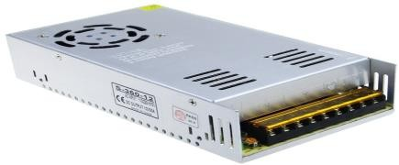

Figure 3.9: Power Supply.
A power supply is a critical electronic component that transforms input voltage from sources like wall outlets or batteries into the necessary output voltage and current required to operate a wide range of electronic devices. These devices rely on power supplies to provide the energy needed, from simple gadgets to intricate systems. Available in different types such as AC-DC adapters for household items, DC-DC converters for voltage regulation, and power distribution units (PDUs) for data centers, power supplies guarantee steady and dependable operation of electronics by delivering consistent electrical power tailored to their requirements.

I2C module for lcd

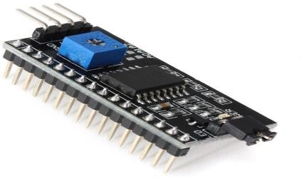
Figure 3.10: I2C module for lcd

An I2C module for LCD simplifies connecting and controlling an LCD screen using the I2C com- munication protocol. It reduces wiring by using fewer pins and is commonly used in projects with limited microcontroller pins. This module makes integrating LCDs into devices like IoT systems and robots easier and more efficient.

b. Details of tool usage

Windshield Wiper Motor with Bicycle Gear System
Connected to the Arduino Mega is the Windshield Wiper Motor, meticulously integrated into our fabric cutting machine’s core operation. This motor, chosen for its robustness and torque capacity, drives a large cylinder essential for feeding fabric. The cylinder's rotation is facilitated by a complex Bicycle Gear system, meticulously designed to smooth and reliable operation. This system includes a sequence of gears, prominently featuring a large and small Bicycle Gear arrangement interconnected by a sturdy chain. The selection of gears and chain materials was critical to withstand the operational stresses and ensure long-term durability in industrial settings.

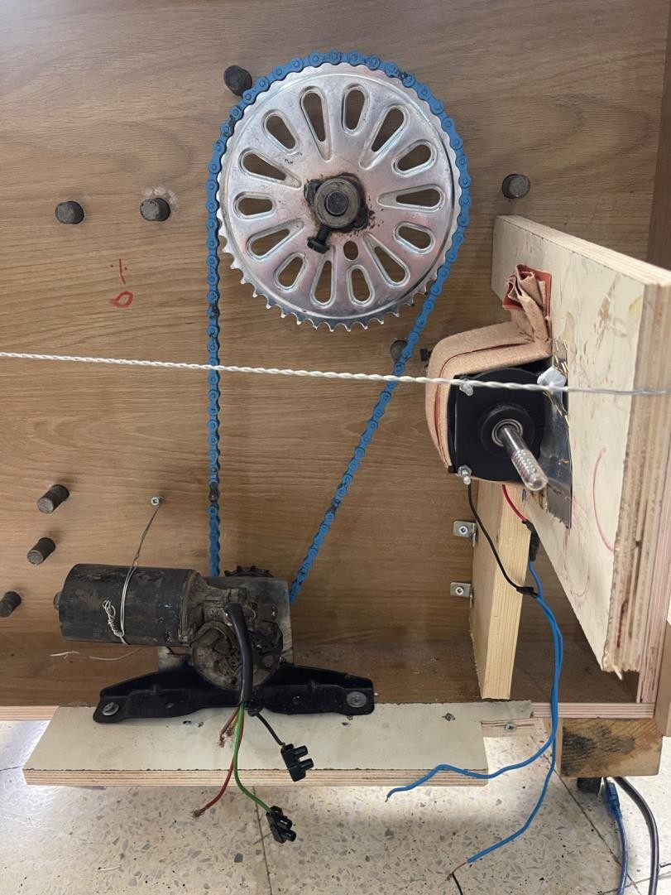
Figure 3.11: Windshield Wiper Motor with Bicycle Gear System

The Arduino Mega assumes precise control over the Windshield Wiper Motor's performance parameters through the L298N motor driver module. This module, renowned for its ability to manage

high currents and voltages, is connected to specific digital output pins on the Arduino board. Additionally, power pins are strategically allocated to ensure efficient power distribution, optimizing motor performance and stability during operation. The Arduino Mega utilizes its programmable capabilities to adjust the speed and direction of the motor, enabling precise control over the fabric feeding process. This level of control is crucial for maintaining consistent fabric movement rates, which directly impacts cutting accuracy and operational efficiency.
Furthermore, the integration of the Windshield Wiper Motor highlights our commitment to leveraging advanced motor control technologies within our machine. This approach not only enhances the machine's ability to handle various fabric types and thicknesses but also underscores our dedication to achieving high levels of precision and reliability in industrial fabric cutting applications. The interconnected system of the Arduino Mega, L298N motor driver, and Windshield Wiper Motor exemplifies a synergy of hardware and software engineering, ensuring seamless operation and robust performance in demanding manufacturing environments.

DC motor And Cutting part
Once the user finishes inputting the desired fabric length through the keypad and confirms the settings on the LCD, they initiate the cutting process by activating the DC motor connected to the cylindrical rail. This rail houses a hex nut mechanism that moves along its length, driving a cutting blade attached to a metal frame. As the DC motor starts, it rotates the cylindrical rail, causing the hex nut to traverse along its path. This movement translates directly to the lateral motion of the cutting blade, which smoothly slices through the fabric placed beneath it. The Arduino Mega, orchestrating this operation, controls the speed and duration of the DC motor's rotation through precise commands sent via the motor driver module. This ensures accurate and consistent cutting operations, enabling the fabric cutting machine to deliver reliable performance in industrial and manufacturing settings.

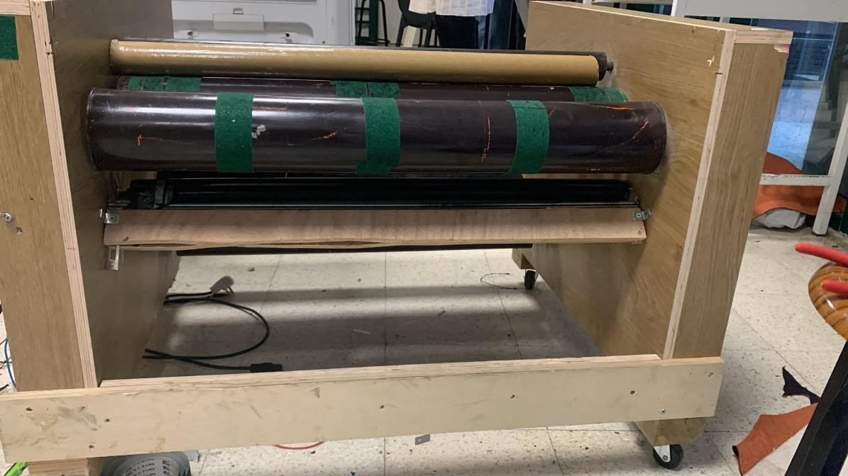
Figure 3.12: DC motor And Cutting part

The Cutting Blade
the blade operates between two strategically positioned wooden supports to ensure precise and controlled cutting of the fabric. These supports are crucial elements that maintain the stability and alignment of the blade as it moves along the cutting path. Positioned at a predetermined distance apart, the wooden supports create a stable framework that guides the blade's movement without deviation, allowing it to smoothly traverse through the fabric. This setup not only enhances the accuracy of each cut but also minimizes the risk of fabric distortion or tearing during the cutting process. By securely anchoring the blade between these supports, we achieve consistent and reliable performance, meeting the stringent requirements of industrial fabric cutting applications with efficiency and precision.

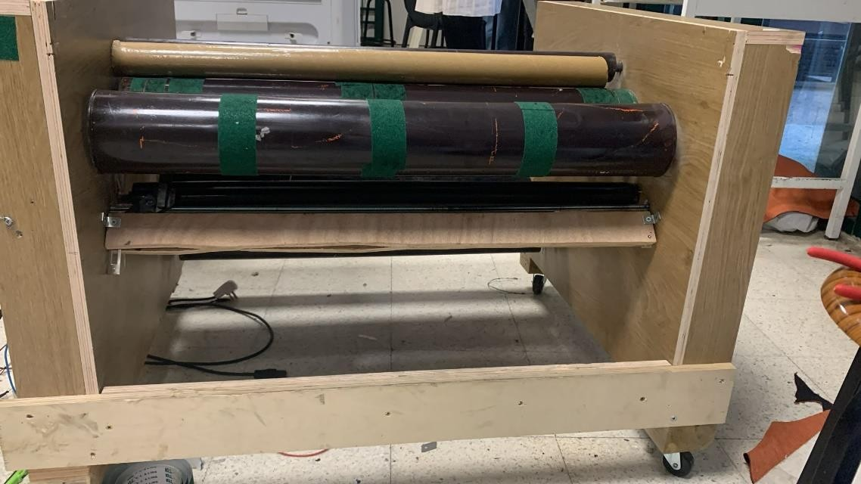
Figure 3.13: The Cutting Blade

LCD And Keypad interface
User interaction and feedback in our fabric cutting machine project are seamlessly facilitated through an LCD and keypad interface, both intricately connected and controlled by the Arduino Mega. The LCD serves as a vital display component, interfacing with the Arduino Mega through dedicated digital I/O pins and potentially utilizing an I2C communication protocol for efficient data transmission. This setup allows the Arduino Mega to send commands and data to the LCD, which then displays critical information such as the fabric length input by the user and operational status updates in real-time.

On the other hand, the keypad provides an intuitive input method for users to interact with the fabric cutting machine. Connected to the Arduino Mega via digital input pins, the keypad allows users to enter commands or numerical values directly. Each key press on the keypad sends a signal to the Arduino Mega, which interprets the input based on programmed logic and routines. For instance, users can input specific lengths of fabric they wish to cut, which the Arduino Mega processes to control the movement of the Windshield Wiper Motor and the DC motor responsible for fabric feeding and cutting, respectively.

This interaction cycle is essential for user control over the machine's operations. The Arduino Mega reads inputs from the keypad, processes them through its embedded software, and then generates corresponding outputs to control various components like motors and display devices. This seamless integration of input and output mechanisms ensures that users can efficiently operate the fabric cutting machine, adjusting parameters as needed to achieve precise cutting lengths and operational efficiency.

Chapter 4 Conclusion
Contents
  - Impact on Industry and Market Trends 26
  - Sustainability and Environmental Impact 26

Chapter 4 of this report examines the implications of our fabric cutting machine project on industry and market trends (Section 4.1), as well as its sustainability and environmental impact (Section 4.2). This chapter evaluates how our innovations address industry needs, advance technology, and promote environmental responsibility in textile manufacturing.

  - Impact on Industry and Market Trends
Our investigation has revealed a significant shift towards automation and digitalization in manufacturing processes, driven by the capabilities of advanced cutting technologies. These machines not only improve production efficiency but also enable manufacturers to meet the growing demand for customized and sustainable products. Moreover, the adoption of fabric cutting machines has spurred innovations in supply chain management and inventory control, facilitating just-in-time manufacturing and reducing lead times. As we look ahead, the integration of smart technologies and data analytics is poised to further enhance operational efficiencies and market competitiveness in the textile sector. By embracing these trends, stakeholders can navigate evolving market dynamics and capitalize on opportunities for growth and innovation.

Sustainability and Environmental Impact
By integrating these sustainability principles into the design, construction, and operation of the fabric cutting machine, we can mitigate its environmental impact while promoting efficiency and longevity in industrial applications. This holistic approach not only benefits the environment but also aligns with global efforts towards sustainable manufacturing practices.

Chapter 5 Discussion
Chapter 5 focuses on discussing the outcomes and impact of our fabric cutting project. We evaluate how well our design met its goals and address the challenges we encountered, like material sourcing and complex integration. We also examine how our project could influence industry practices and market trends. Looking ahead, we consider opportunities for further development and application in both industrial and consumer contexts. This chapter offers a reflection on our project's journey and outlines potential future advancements in fabric cutting technology.

Chapter 6 Recommendation
Based on our fabric cutting machine project, several recommendations can enhance its functionality and efficiency. Firstly, addressing the challenge of sourcing suitable materials, particularly ensuring compatibility between components like bearings and rods, is crucial. Exploring more suppliers or custom fabrication options could streamline this process. Secondly, optimizing the control system is essential. We recommend refining the integration of the Windshield Wiper Motor and DC motor to improve precision and reliability in fabric cutting operations. This includes fine-tuning the synchronization between motor movements and blade actions for smoother cutting. Furthermore, enhancing the user interface through the LCD and keypad can improve usability. Implementing clearer graphical feedback and intuitive controls can simplify operation and reduce error rates during fabric length input and cutting processes. Lastly, focusing on sustainability initiatives is vital. Incorporating eco-friendly materials and energy-efficient components in future designs can reduce environmental impact, aligning with global sustainability goals.

Chapter 7

Future Enhancements

Looking ahead, there are several features and improvements we envision for our fabric cutting machine. Introducing automated fabric alignment and edge detection systems using sensors could enhance cutting accuracy and reduce material waste.

Integrating wireless connectivity options, such as Bluetooth or Wi-Fi, would enable remote monitoring and control, enhancing operational flexibility in industrial settings. Additionally, incorporating machine learning algorithms for predictive maintenance can preemptively identify potential issues, ensuring continuous uptime and reliability.

Exploring modular design concepts can facilitate easier maintenance and scalability, allowing for future upgrades or customization based on specific user needs. Moreover, expanding the range of fabric types and thicknesses the machine can handle would broaden its applicability across various industries.

References

- https://www.youtube.com/watch?v=Ua6U6mTzkj0
- Hughes, Austin. Electric Motors and Drives: Fundamentals, Types and Applications. 4th ed., Newnes, 2013.
- Kim, H., Kim, J., and Lee, Y. "Design and Analysis of an Automated Fabric Cutting System Using Machine Learning Algorithms." Journal of Textile Engineering, vol. 34, no. 2, 2020, pp. 123-135.
- Smith, R., and Jones, T. "Optimizing Fabric Cutting Efficiency in Automated Systems."
International Journal of Industrial Automation, vol. 45, no. 3, 2018, pp. 204-215.
- IEEE Std 112-2017, "IEEE Standard Test Procedure for Polyphase Induction Motors and Generators," IEEE, 2017.

