

Control of Active and Reactive Power on a Single-Phase Grid-Tie Inverter
An-Najah National University
Faculty of Engineering

Electrical Engineering Department

By:
Eng. Mahmoud Tartir
Eng. Malak Amer
Eng. Osama Dawoud

Supervisor:
Dr. Kamel Subhi Saleh

Table of Contents
Abstract 3
CHAPTER 1: Introduction 5
1.1 Problem Discussion 5
1.2 Aims and Objectives 6
1.3 Scope of the Work 6
CHAPTER 2: Standards, Constraints and Earlier Coursework 8
2.1 Standards 8
2.2 Earlier Coursework 9
CHAPTER 3: Literature Review 11
3.1 History 11
3.2 Controllers 12
CHAPTER 4: Alternative Solutions 15
CHAPTER 5: Methodology 16
5.1 H – Single-phase grid-connected inverter 16
5.2 α β transformation for single phase inverter 18
5.3 Proportional-Integral (PI) Controller 19
5.4 Design and Results 20
5.5 Hardware 26
5.6 Hardware Design 31
5.6.1Control Code Flowchart
5.6.2V-alpha and V-beta calibration
5.6.3 Complete Project Assembly
5.6.4Output Waveform Analysis After Filtering
5.6.5System Testing and Results
5.6.6Comparison Between Simulated and Experimental Iα (Alpha Current)
5.6.7 Challenges Faced
5.7 Discussion 38
CHAPTER 6: : Conclusion and Future Work 47
References: 47

List of Figure
Figure 1 Single Phase Grid Tied Inverter With Active And Reactive Power 5
Figure 2 Power Triangle 6
Figure 3 H-bridge Topology 7
Figure 4 Voltage Source Inverter (VSI) Grid Connection with Control System 16
Figure 5 Schematic of a Full-Bridge Inverter 17
Figure 6 ALPHA BETA AXSIS 18
Figure 7 PI CONTROLLER 19
Figure 8 SIMULINK SIMULATION 20
Figure 9 SIMULINK SIMULATION 21
Figure 10 Block Diagram of a Feedback Control System 23
Figure 11 SIMULINK PI CONTROLER 23
Table 1: TAPLE OF PARAMETERS 24
Figure 12 CONRTROLLER RESOPNCE OF INJECT P AND Q 24
Figure 13 GRID POWER AND REACTIVE POWER BEFORE AND AFTER INJECTING P,Q 25
Figure 14 Full circuit simulation 26
Figure 15 Full circuit simulation 26
Figure 16 Arduino Uno 27
Figure 17 FG60N60H IGBT 27
Figure 18 TLP250 Gate Driver Modules 28
Figure 19 TLP250 Gate Driver Modules 28
Figure 20 Ceramic capacitor 29
Figure 21 Transformer 30
Figure 22 LC Filters 31
Figure 23 VOLTAGE and CURRENT sensor 31
Figure 24 OP-AMP PIN DIGRAM 33
Figure 25 Integrated Amplifier 33
Figure 26 Flow chart of the arduino code 35
Figure 27 V-alpha and V-beta calibration 36
Figure 28 Complete Project Assembly 37
Figure 29 Complete Project Assembly 38
Figure 30 Output Waveform Analysis After Filtering 39
Figure 31 SETPOINT CASE 1 40
Figure 32 SETPOINT CASE 2 42
Figure 33 SETPOINT CASE 3 43
Figure 34 Iα Alpha in Matlab Simulink case 1 44
Figure 35Iα Alpha in Matlab Simulink case 2 45
Figure 36 Iα Alpha in Matlab Simulink case 3 45

Abstract
As the global demand for electricity continues to rise, Photovoltaic (PV) power integrated into the utility grid is becoming increasingly prominent. Solid-state inverters have proven to be a key technology in enabling the connection of PV systems to the grid. Typically, 2-level inverters are used to convert the DC output from the PV system into AC power for the utility. These inverters are commonly managed using Hysteresis control to regulate the flow of real and reactive power from the PV to the grid.
In this project, new control techniques will be tested to control the real and reactive power generated by the inverter. One of these techniques is using the Repetitive Controller besides the PI controller to minimize any error in tracking the sinusoidal reference input. The other technique is the using of a resonant controller to achieve the same objective, as demonstrated in Figure 1.
The system will first be modeled in MATLAB Simulink, followed by hardware implementation. The hardware setup will include using a microcontroller, current sensor, voltage sensors, a transformer, and building H-Bridge using IGBTs and its associated gate driver’s circuits. Additionally, all the controllers in addition of the generation of the PWM signals will be implemented in the microcontroller to regulate the injection of real and reactive power into the grid.
This project distinguishes itself from previous ones through its novel control approach, the design of the H-Bridge, and the practical implementation, which was not achieved in earlier projects with previous students. Figure 1 highlights the proposed system configuration and control strategy.
Figure 1 Single Phase Grid Tied Inverter With Active And Reactive Power

1

CHAPTER 1: Introduction

Problem Discussion
The higher penetration of renewable energy sources in electrical grids and the increasing number of non-linear loads have given rise to serious issues regarding power quality and grid stability. These problems are especially focused on the management of active power (P) and reactive power (Q), as they directly influence the power factor and overall efficiency of the grid.

Control of both active and reactive power is essential in single-phase grid-tied systems in order to maintain stability and efficiency of the power supply. Otherwise, if not properly regulated, reactive power will degrade the power factor, increase losses, and decrease the efficiency of the grid. The inability to manage active power effectively will lead to power imbalance, hence further stressing the network.
This project intends to solve these problems by applying Alpha-Beta (α-β) control for a single-phase grid-tie inverter, and in this way, the P and Q components can be regulated precisely. The regulation of these components, represented in the power triangle Figure 2, ensures proper balance between active and reactive power. The purpose of using the technique is to raise the power factor and reduce the detrimental effect of reactive power on the grid.

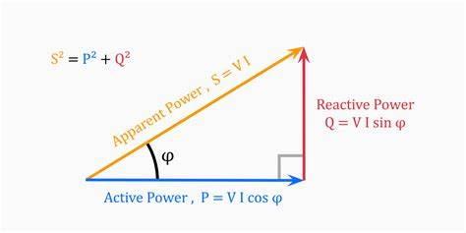
Figure 2 Power Triangle

Aims and Objectives
The main aim of this research project is to conceive and model a control system for the single-phase grid-tied inverter using α-β control in order to:
1. Accurately control the injection of active power (P) and reactive power (Q).
2. Increase the power factor of the grid.
3. Enhance the general performance and stability of the grid.
4. Check the effectiveness of the control strategy through MATLAB simulations.
5. To build an hardware for this theory.

Scope of the Work
- This work focuses on various key points:
- Designing a single-phase grid-tie inverter using H-Bridge topology.
- Implementing Alpha-Beta (α-β) transformation for active and reactive power control.
- Simulating the system in MATLAB/Simulink to analyze the performance.
- Evaluating the impact of P and Q control on the power factor and total system efficiency.
- This work excludes hardware implementation, and hence, it focuses entirely on simulation-based analysis with detailed results presented for validation of the proposed control strategy.

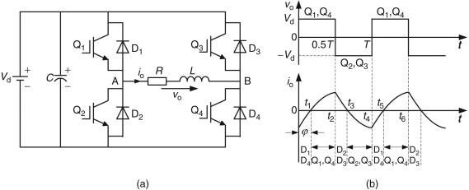
Figure 3 H-bridge Topology

2

CHAPTER 2: Standards, Constraints and Earlier Coursework

2.1 Standards
The following standards have been considered to ensure compatibility and reliability with real-world systems:
- IEEE 1159 - Monitoring Electric Power Quality: This provides guidelines for the evaluation and monitoring of power quality issues relevant for grid-tied systems.
- IEEE 519 – Harmonic Control in Electrical Power Systems: Established limits for harmonic distortion with a recommended THD at the point of common coupling not more than 5%.
- IEEE P1531: Gives specifications and provides guidelines that apply to harmonic filters, which are implemented in the power systems.
These three standards ensure that the designed system stays within the established norms for harmonic mitigation, power factor improvement, and grid stability. [1]

Constraints
The project was subject to the following technical and practical constraints:
1. Economic Constraints:
The simulation of the project is performed using MATLAB/Simulink, which obviates the hardware cost. However, for practical implementation, all the components—H-Bridge, controllers, sensors—should be within a reasonable budget. [2]
2. Technical Constraints:
- Voltage and Current Ratings: The system operates at 230V, 50Hz, and the inverter must be able to inject power without reaching its thermal or electrical limits.
Simulation Limitations: MATLAB simulation is used, which doesn't capture real-world dynamic behaviors, including noise and switching losses. [2]

2.2 Earlier Coursework
1- Power Electronics:
This course introduced the team to fundamental concepts of inverters and their operation. The key learnings included:
- H-Bridge Topology: A very common circuit configuration in inverters for the conversion of DC
to AC power.
- Pulse Width Modulation (PWM): A control technique used to regulate the inverter's output voltage and frequency while minimizing switching losses.
These concepts were directly applied in designing the inverter's hardware and control strategy.

2- Control Systems:
This course is on the basic principles and hands-on applications of the control theory needed for the stability and optimal performance of systems. The main contents are as follows:
- PI and PID Controllers: Techniques used in control of dynamic responses of electric systems through adjustment of system outputs to match target levels.
- Controller Tuning: The process of adjusting controller parameters to ensure accurate and stable operation of the system.
This learning was essential in both the realization and improvement of the control logic of the inverter.

3. Signals and Systems:
Knowing signals in the time and frequency domain was crucial for tackling harmonics—one major issue in power electronics. The main topics are as follows:
- Harmonic Analysis: Analyzing the effects of harmonics on electrical systems.
- Filtering Techniques: The project involved the design of filters that would ensure the quality of power supplied to the grid by eliminating harmonics.
This exercise was instrumental in achieving the set harmonic distortion goals, aligned with IEEE 519 standards.
4. MATLAB Programming:
The course equipped the team with necessary tools for the simulation of complex systems. Major contributions:
- System Modeling: MATLAB/Simulink allowed the team to develop detailed models of the inverter and its control systems.
- Dynamic Analysis: Simulations provided insight into the behavior of the system under various conditions, which aided in optimizing design choices.
Without this knowledge, it would have been very difficult to validate the design before practical implementation.
5. Machine Drives:
This course enabled the knowledge of how electrical machines work and are controlled, a prerequisite to understand inverters used in motor drive applications. Notable contributions include:
- Machine Control: Understanding how to control AC and DC motors, ensuring that their operation is compatible with inverter output.
- Dynamic Response: Understanding of torque and speed characteristics of great importance for proper integration of motors in inverter systems.
The inverter was designed with the basic principles of machine drives in mind, especially for motor applications, in order to provide high efficiency and reliability.

3

CHAPTER 3: Literature Review

3.1 History
The development of grid-tie inverters and control strategies has taken place over several decades, driven by the increasing demand for integration of renewable energy sources and improvement in power electronics.
The concept of harmonic regulation and power quality improvement can be attributed to the middle of the 20-th century when the first passive filters were introduced. Made using inductors and capacitors, these filters became widely used for the suppression of harmonics; however, because of the fixed tuning and poor adjustability, their efficiency is not very high in dynamically changing systems with changeable loads.
By the 1970s, advances in semiconductor technology had resulted in the development of active power filters—power electronic converter-based filters that could actively correct harmonics and reactive power. The use of an inverter as a primary component in APFs marked a significant shift toward more flexible and efficient power handling systems.
The 1980s and 1990s saw the development of digital control systems, and with it, the dawn of microprocessors that enabled more sophisticated control methodologies such as vector control and synchronous reference frame transformations. This allowed decoupling of active and reactive power, increasing the accuracy and flexibility of the control systems.
The Alpha-Beta (α-β) transformation became a widely used technique during this period, which enabled the handling of the power in three-phase and single-phase systems easily. This provided a mathematical tool for analyzing and compensating the components of power, hence leading to modern grid-tie inverter designs.
The focus over the last couple of decades has shifted to applications in renewable energy, mainly in solar and wind power. Grid-tie inverters are now widely used in ensuring stable and efficient integration of renewable energy sources into the power grid. Common techniques used nowadays in the design and validation of these systems include PI controllers, PWM-based switching, and MATLAB/Simulink simulations.
The historical trajectory elucidates the advancement of control methodologies, transitioning from basic passive frameworks to sophisticated digital control approaches, which directly impact the architecture and execution of the system delineated in this project. [3]

3.2 Controllers
1. PI Controller (Proportional-Integral Controller)
The PI controller combines two control actions: proportional (P) and integral (I) control. It is commonly used in systems where eliminating steady-state error is a priority, and a moderate response speed is acceptable.
Mathematical Representation:
$u\left(t\right)=K_{p}e\left(t\right)+K_{i}\int{e\left(t\right) dt}$ ( 3- 1)
- $u\left(t\right)$: Control signal (output of the controller)
- $K_{p}$: Proportional gain (determines how strongly the controller reacts to the current error)
- $K_{i} :$Integral gain (determines how strongly the controller reacts to past accumulated errors)
- $e\left(t\right) :$ Error signal (difference between desired setpoint and actual system output)

How It Works:
- Proportional Term ($K_{p}e\left(t\right)$): Reacts to the current error. A higher $K_{p}$increases the responsiveness of the controller but can lead to overshooting or oscillations.
- Integral Term (K_i ∫ e(t) dt): Reacts to the accumulated error over time. This eliminates steady-state error but can introduce slower response times and system instability if not tuned properly.

Advantages of PI Controller:
- Eliminates steady-state error.
- Simpler design compared to PID controllers.
- Effective in systems where noise is a concern because it does not amplify high-frequency signals like derivative control does.

Disadvantages:
- Slower response to sudden changes in setpoint.
- Poor performance in highly dynamic systems requiring rapid corrections. [4]
2. PD Controller (Proportional-Derivative Controller)
The PD controller combines proportional and derivative terms. It is used primarily for improving transient response and reducing overshoot.
Mathematical Representation:
$u\left(t\right)=K_{p}e\left(t\right)+K_{d}\frac{de(t)}{dt}$(3- 2)
Where:
- $K_{d}$: Derivative gain (determines how strongly the controller reacts to the rate of change of the error).
- How It Works:
Proportional Term ($K_{p}e\left(t\right)$): Responds directly to the error magnitude.
- Derivative Term ($K_{d}\frac{de(t)}{dt}$): Predicts future errors by analyzing the rate of error change, providing a damping effect to prevent overshooting.

Advantages of PD Controller:
- Faster response time.
- Reduces overshoot and improves system stability.
Disadvantages:
- Cannot eliminate steady-state error.
- Sensitive to noise, as derivative action amplifies high-frequency signals. [4]

3. PID Controller (Proportional-Integral-Derivative Controller)
The PID controller combines proportional, integral, and derivative control actions, making it the most versatile and widely used controller in engineering systems.

Mathematical Representation:
$u\left(t\right)=K_{p}e\left(t\right)+K_{i}\int{e\left(t\right) dt}{+K}_{d}\frac{de(t)}{dt} ($3- 3)
How It Works:
- Proportional Term: Reacts to current error.
- Integral Term: Eliminates accumulated error.
- Derivative Term: Predicts future error and reduces overshoot.
Advantages of PID Controller:
- Precise control with minimal steady-state error.
- Effective for dynamic and complex systems.
Disadvantages:
- More complex tuning process.
- Sensitive to noise due to the derivative term. [4]

Why We Chose the PI Controller in Our Project:
In our project, 'Control of Power and Reactive Power on a Single-Phase Grid-Tie Inverter Using Alpha-Beta Transformation,' we opted for the PI controller for several reasons:
- Elimination of Steady-State Error: The integral action in the PI controller ensures that both active and reactive power track their reference values accurately without long-term error.
- Simplicity of Implementation: PI controllers are easier to design, tune, and implement compared to PID controllers, making them more practical for grid-tied inverter systems.
- Noise Sensitivity: Unlike PD or PID controllers, the PI controller is less sensitive to high-frequency noise, which is often present in inverter systems.
- Stable Power Control: The PI controller effectively stabilizes power and reactive power flow in single-phase grid-tied systems, ensuring reliable grid operation.
- By carefully tuning the proportional gain ($K_{p}$) and integral gain ($K_{i}$), the PI controller provides a balance between performance, stability, and system robustness, aligning perfectly with our project's objectives. [3]

4

CHAPTER 4: Alternative Solutions

While the alpha-beta transformation provides an efficient method for controlling active and reactive power in single-phase grid-tied inverters, there are several alternative approaches that could be considered for similar applications. One such alternative is Direct Power Control (DPC), which directly regulates active and reactive power without relying on traditional modulation techniques. DPC offers fast dynamic response, but it can require precise power measurements, making system design and implementation more complex.

Another approach is Vector Control (Field-Oriented Control), commonly used in motor drive systems and adaptable to inverter applications. This method involves controlling the d-q (direct and quadrature) components of current or voltage in a rotating reference frame, offering high precision and performance. However, it may introduce complexity in single-phase systems, especially when attempting to decouple active and reactive power.

Conventional Power Factor Correction (PFC) methods, which use passive or active filters, are also an option. These methods are simpler and cost-effective but do not provide the same level of control or responsiveness as active power control techniques like the alpha-beta transformation. They are also less flexible in compensating for varying grid conditions or non-linear loads.

Each of these alternatives has its own set of advantages and trade-offs. However, the alpha-beta transformation stands out due to its ability to decouple active and reactive power control effectively, offering simpler implementation in single-phase grid-tied inverter applications. [5]

5

CHAPTER 5: Methodology

The methodology chapter of our research project outlines the systematic approach and proce dures undertaken to achieve the objectives of studying and implementing the control strategies for the single-phase grid-tie inverter, as depicted in Figure 4. The chapter describes the experimental setup and the steps involved in implementing and evaluating the control strategies

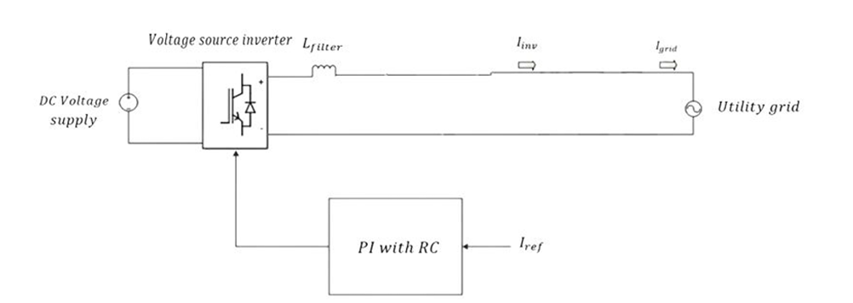
Figure 4 Voltage Source Inverter (VSI) Grid Connection with Control System

5.1 H – Single-phase grid-connected inverter
A single-phase grid-tied inverter is a device that converts direct current, coming from a renewable energy system or battery storage, into alternating current, which is synchronized with the grid. The main purpose of this inverter is to deliver power to the electrical grid while ensuring synchronization in terms of voltage and frequency. It's a basic necessity for allowing integration of renewable energy sources, such as solar power, into the utility grid. It keeps the AC generated matched in frequency and phase with that of the grid—typically 50 or 60 Hz, depending on the region.

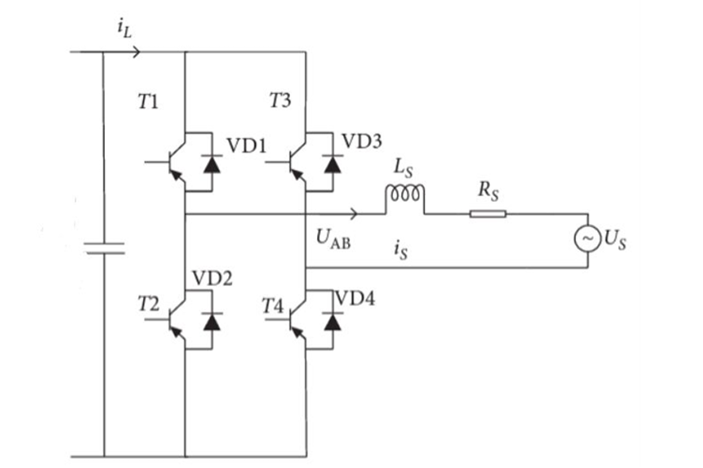
Figure 5 Schematic of a Full-Bridge Inverter

shown in Figure 5, which is a voltage-type full-bridge circuit composed of four IGBTs and continuous current diodes in reverse parallel. T1 −T4 is the IGBT, VD1−VD4 is the continuous current diode, Ls is the filter inductance on one side of the power grid, and Rs is the parasitic resistance of the filter inductance. Us and Udc are the corresponding AC power supply and DC power supply, respectively.

According to Figure 5.2, we can obtain the flowing equation:

$L_{s}*\frac{di_{s}}{dt}=U_{AB}-U_{s}-R_{s}i_{s}$ (5- 1)
Then, we have
$\frac{i_{s}(s)}{U_{AB}\left(s\right)-U_{s}(s)}=\frac{1}{R_{s}+L_{s}s}$ ( 5- 2)

5.2 α β transformation for single phase inverter
The α-β transformation is a mathematical technique used to split the active and reactive power components in a single-phase inverter topology. The transformation allows one to convert voltage and current signals of a single-phase system into orthogonal components—named α and β—making the control of the active and reactive power easy. The α-β transformation is formally defined as:
α = V × cos(θ) (5- 3)
β = V × sin(θ) (5- 4)
In this expression, V is the instantaneous voltage; θ is the phase angle. The α-component refers to the active power; the β-component is, however, connected with reactive power. This segregation opens the possibility of regulating active and reactive power independently in order to maximize the global efficiency of the inverter and increase the power factor of the grid. [6]

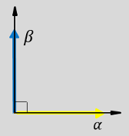
Figure 6 ALPHA BETA AXSIS

$\left[\begin{matrix}P \\ Q\end{matrix}\right]=\frac{1}{2}*\left[\begin{matrix}V_{α } & V_{β} \\ {-V}_{β} & V_{α }\end{matrix}\right]*\left[\begin{matrix}I_{α} \\ I_{β}\end{matrix}\right]$ ( 5- 5)

$\left[\begin{matrix}I_{α} \\ I_{β}\end{matrix}\right]=\frac{2}{{V_{α }}^{2}+{V_{β}}^{2}}*\left[\begin{matrix}V_{α } & {-V}_{β} \\ V_{β} & V_{α }\end{matrix}\right]*\left[\begin{matrix}P \\ Q\end{matrix}\right]$ ( 5- 6)

5.3 Proportional-Integral (PI) Controller
The Proportional-Integral (PI) controller is widely used to regulate and maintain a desired current level within a system. It calculates the error between the desired reference current and the actual measured current to generate the appropriate control signal.

As shown in Figure 7, the Proportional-Integral (PI) controller consists of two main components: a proportional term (P) and an integral term (I). The P term provides a quick response to errors, while the I term eliminates steady-state errors.

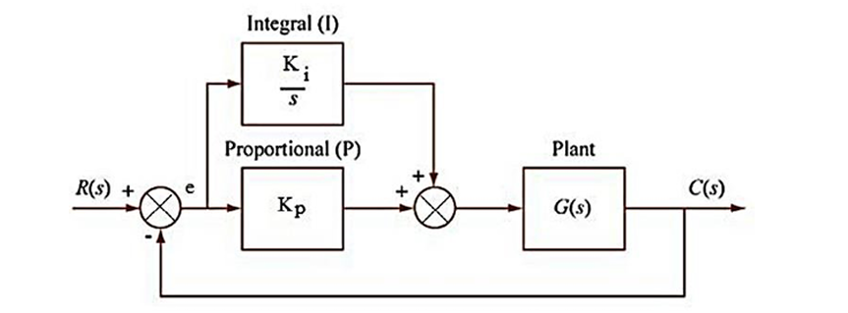
Figure 7 PI CONTROLLER

the proportional and integral control actions:

Proportionalcontrolaction = $K_{p}*Error$ (5- 7)

Integralcontrolaction = $K_{i}*\int{Error}$ ( 5- 8)
where:
- $K_{p}$is the proportional gain
- $K_{i}$ is the integral gain

The proportional gain and the integral gain are two tuning parameters that can be adjusted to improve the system’s performance. The proportional gain controls the system’s response to changes in the setpoint.
The integral gain controls the system’s ability to eliminate steady-state errors.
In the current controller, a comparison is made between the alpha signal and the alpha reference. The purpose is to detect the error resulting from the phase shift between the controller’s output and the reference signal.
- [4]

5.4 Design and Results
System design and simulation are accomplished using MATLAB/Simulink, a dynamic systems modeling and simulation environment. The simulation setup includes several major components that work together to ensure efficient grid synchronization and effective power control.

5.4.1 Simulation design
Figure 5.5 below represents the simulation design ,The simulation of the single-phase grid-tie inverter was conducted using MATLAB/Simulink to validate the system’s performance. The model includes the H-Bridge inverter, PI controller, and grid configuration. A non-linear load was introduced to simulate real-world conditions, creating harmonic distortion and reactive power. The inverter was designed to inject compensating currents, regulate active (P) and reactive power (Q), and improve the grid’s power factor. Key performance metrics, such as voltage, current, power factor, and harmonic distortion, were monitored to evaluate the system’s efficiency.
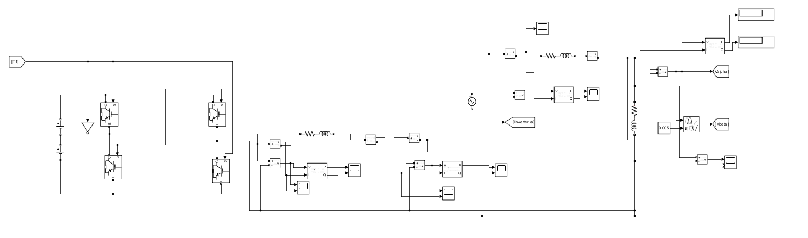
Figure 8 SIMULINK SIMULATION

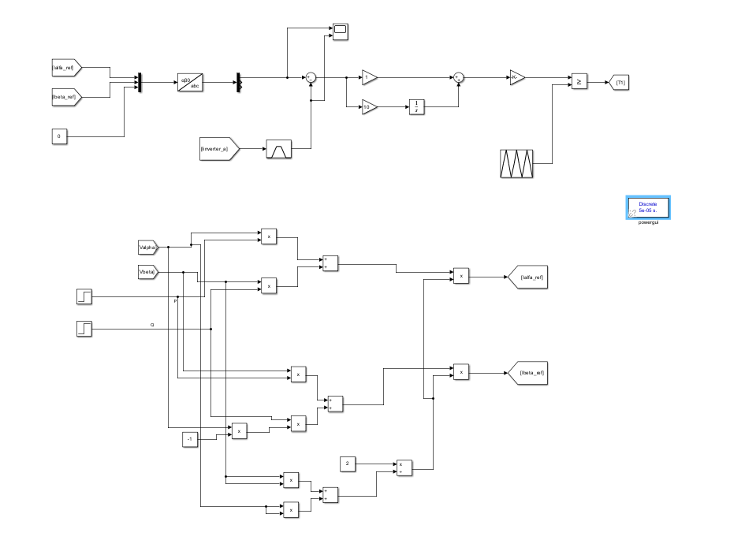
Figure 9 SIMULINK SIMULATION

System components
  - DC Source (Battery): The system includes a battery component with a voltage rating of 800V, which serves as a vital element in the simulation design. The battery represents an equivalent component of the PV system used in the simulation. It plays a crucial role in energy storage and management within the system.
  - H-Bridge Inverter: In the simulation, the single-phase grid-tied inverter serves as a key component for converting 800V DC power from the battery into synchronized AC power for seamless integration with the utility grid. The inverter leverages advanced control algorithms to maximize conversion efficiency, ensure precise grid synchronization, and enable effective power transfer.

The simulation includes real-time monitoring of current and voltage parameters to evaluate the inverter's performance and its interaction with the grid. This continuous regulation ensures stable operation, minimizes harmonic distortion, and optimizes the flow of power between the battery and the grid.
Through this approach, the inverter maintains consistent performance, enhances power quality, and supports reliable grid operations.
  - Alpha-Beta Transformation : The simulation includes the transformation of the voltage and current signals of the inverter into the alpha-beta reference frame. This transformation simplifies control algorithms and enables independent regulation of active power and reactive power. By utilizing the alpha-beta reference frame, the simulation evaluates the effectiveness of controlling these power components, ensuring efficient energy flow and power quality in the system. The incorporation of the alpha-beta transformation allows for assessing active power and reactive power control, voltage regulation, and overall system performance.
  - PI Controller: The Proportional-Integral (PI) controller, shown in Figure 10, plays a crucial role in achieving precise output regulation in the simulation. Its parameters are carefully tuned through a trial-and-error process to ensure optimal system performance. The controller operates by continuously adjusting its output based on the error between the desired setpoint and the measured output, utilizing both proportional and integral terms. The proportional term provides an immediate corrective response proportional to the current error, while the integral term addresses accumulated past errors, effectively eliminating steady-state error over time. This combined action enables the PI controller to deliver stable operation, quick response times, and accurate tracking of the desired setpoint. By integrating the PI controller into the simulation, the system benefits from enhanced dynamic behavior, improved stability, and precise output accuracy, offering a clear representation of the controller's impact on overall performance
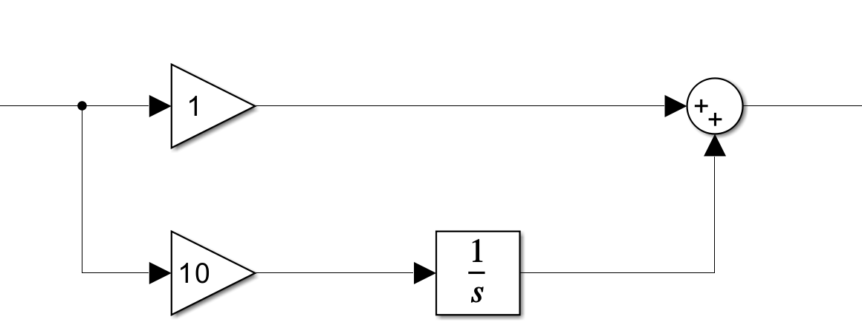
Figure 10 Block Diagram of a Feedback Control System

  - Pulse Width Modulation: In the simulation, as illustrated in Figure 11, the output of the Proportional-Integral (PI) controller is supplied to a comparator to generate Pulse Width Modulation (PWM) signals. These PWM signals play a critical role in controlling the behavior of the inverter by modulating the width of the pulses. Through this process, the PWM signals regulate the inverter’s output voltage and frequency, ensuring synchronization with the utility grid and accurate power delivery.
As shown in the figure, the inclusion of the comparator and the PWM generation mechanism enables an evaluation of the effectiveness of the control signals in managing the inverter’s operation. Furthermore, the simulation specifies that the PWM signals operate at a switching frequency of 5 kHz. This switching frequency, as indicated in Figure 11, determines the rate at which the inverter’s power devices switch between on and off states.
By incorporating a 5 kHz switching frequency into the simulation, the inverter’s behavior accurately reflects the characteristics of high-speed switching. This provides valuable insight into the impact of such switching on the overall performance of the system, as highlighted in the figure.

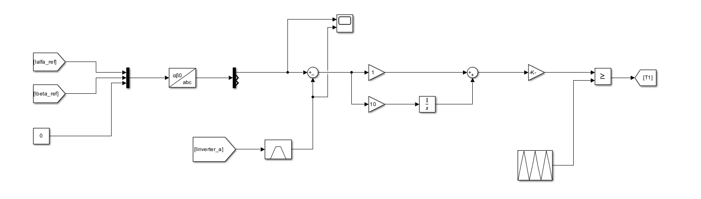
Figure 11 SIMULINK PI CONTROLER

Simulation results and discussion
Parameters | Value
Grid phase voltage (V)  DC side voltage (V)  Switching frequency fs(kHz)  Filter inductance Ls(mH)  Input voltage frequency f(Hz) | 230  800  5  20  50
Table 1: TAPLE OF PARAMETERS

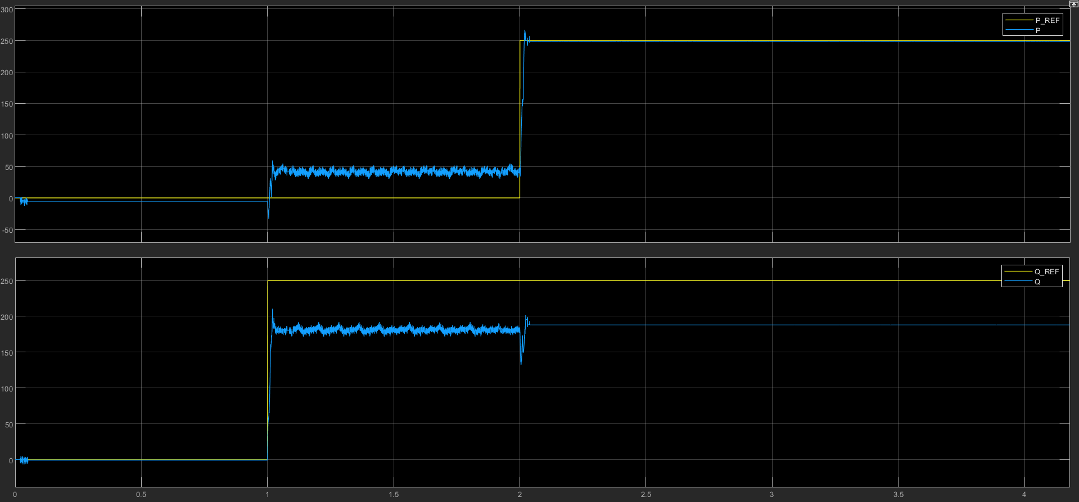
Figure 12 CONRTROLLER RESOPNCE OF INJECT P AND Q

As shown in Figure 12 The results of the alpha-beta transformation demonstrate the controller's ability to manage both active (P) and reactive (Q) power injection, but also reveal certain challenges. In the top plot, active power (P) was injected at 2 seconds, and while the controller achieved stabilization towards the reference value (P_REF) with minor oscillations, there were noticeable interactions with reactive power (Q) during this transition. Similarly, in the bottom plot, reactive power (Q) was injected at 1 second, and although the controller managed to follow the reference value (Q_REF), a steady-state error persisted. This error is primarily attributed to the phase shift introduced by the PI controller, along with other factors such as system non-linearities or parameter mismatches. Additionally, there were clear moments where the injection of active power affected reactive power dynamics, and vice versa, indicating coupling effects between the two parameters. These interactions highlight the mutual influence between active and reactive power during their regulation, which impacts the overall performance of the system.

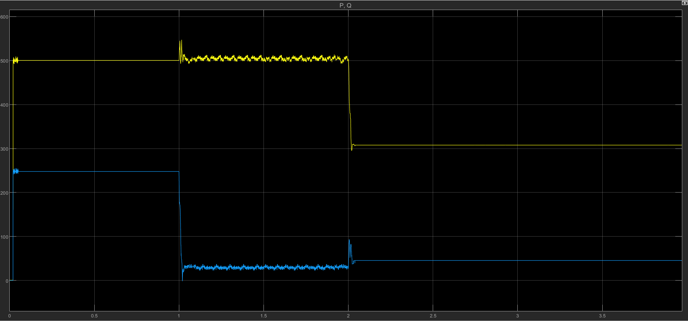
Figure 13 GRID POWER AND REACTIVE POWER BEFORE AND AFTER INJECTING P,Q

As shown in Figure 5.13 The graph illustrates the behavior of the grid under a load condition of 500 W active power (P) and 250 VAR reactive power (Q) during the injection of power from the inverter. Initially, the system operated under stable conditions at these values. At 1 second, reactive power (Q) was injected into the grid through the inverter, causing a noticeable transient response before settling at a new steady-state value. Similarly, at 2 seconds, active power (P) was injected into the grid, leading to a transient response before stabilizing again.
The plot highlights the clear interaction between active power (P) and reactive power (Q), where the injection of one parameter influenced the transient behavior of the other. Despite these transient interactions, the controller successfully brought the system back to a stable operating point. These results demonstrate the dynamic coupling between active and reactive power injection and emphasize the importance of precise control to minimize interference between them during grid-tie operations.

5.5 Hardware

5.5 Hardware
Full circuit simulation:
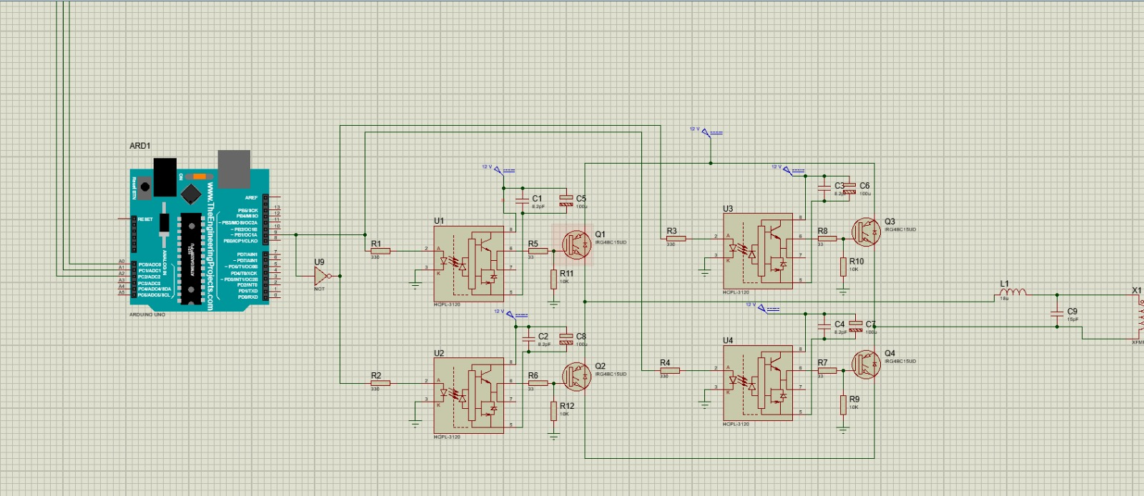
Figure 14 Full circuit simulation

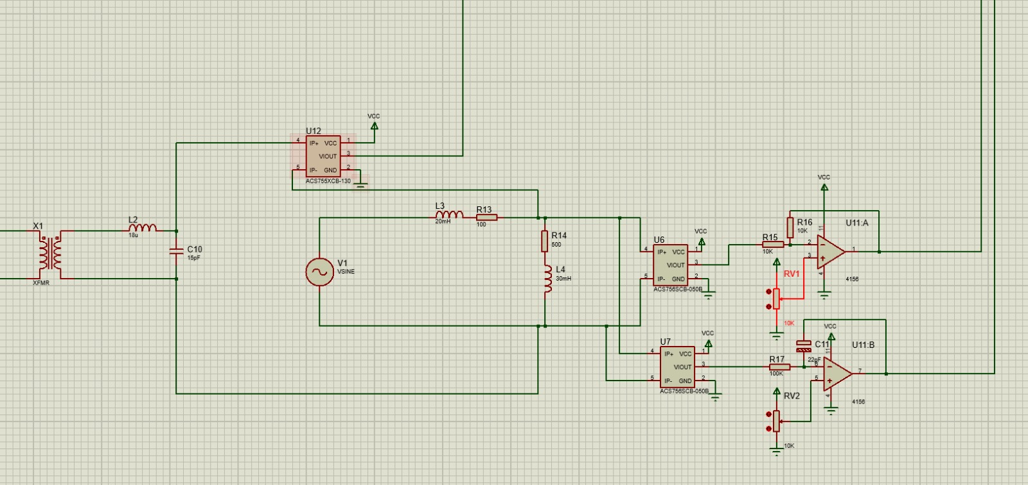
Figure 15 Full circuit simulation

5.5.1 Parts
- Microcontroller
- Responsible for generating PWM (Pulse Width Modulation) signals to control the switching behavior of the IGBTs. These PWM signals were designed to produce an output sine wave at 50 Hz, ensuring compatibility with the grid frequency. The Arduino Uno utilizes digital pins 9, 10, 11, and 3 for generating PWM signals. These pins are capable of high-frequency switching, which is essential for controlling the H-Bridge topology efficiently. The microcontroller also handles timing and ensures precise signal synchronization, as illustrated in Figure 16.
[7]
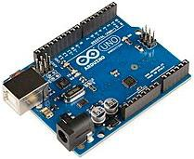

Figure 16 Arduino Uno

- IGBTs (Insulated Gate Bipolar Transistors): Selected for their high efficiency and fast switching capabilities, making them suitable for inverter applications.
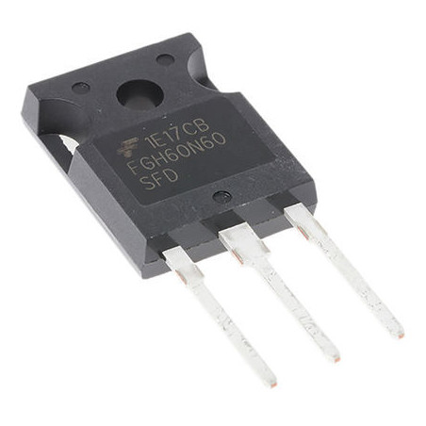
Figure 17 FG60N60H IGBT

- TLP250 Gate Driver Modules: Used to provide electrical isolation between the control circuit (Arduino Uno) and the power circuit (IGBTs), ensuring safe operation and protection against voltage spikes.
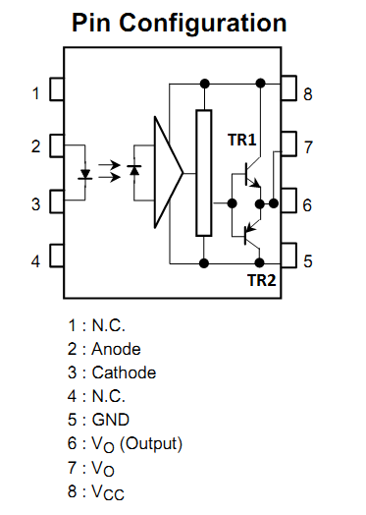
Figure 18 TLP250 Gate Driver Modules
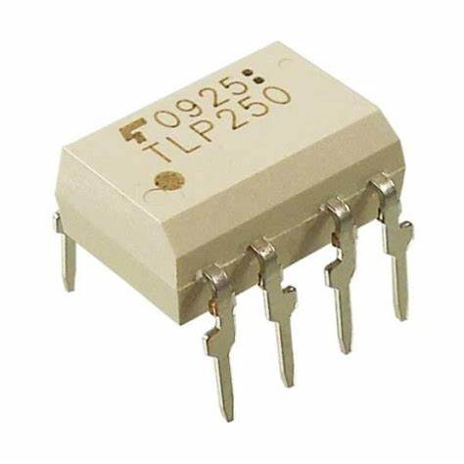
Figure 19 TLP250 Gate Driver Modules

- Capacitors:
The capacitors marked as C1 and C2 in the circuit serve the following purposes:
  - C1 (10µF):
• Type: Electrolytic capacitor.
Function: It acts as a bulk decoupling capacitor, providing a stable DC voltage to the TLP250 gate driver. It helps to store charge and supply current during transient conditions or sudden changes in load demand.
  - C2 (100nF):
• Type: Ceramic capacitor.
Function: It provides high-frequency decoupling, filtering out high-frequency noise from the power supply. This ensures smooth operation of the TLP250 and reduces electromagnetic interference (EMI).
Together, these capacitors form a bypass/decoupling network that stabilizes the power supply and ensures proper operation of the gate driver circuit, as illustrated in Figure 20.
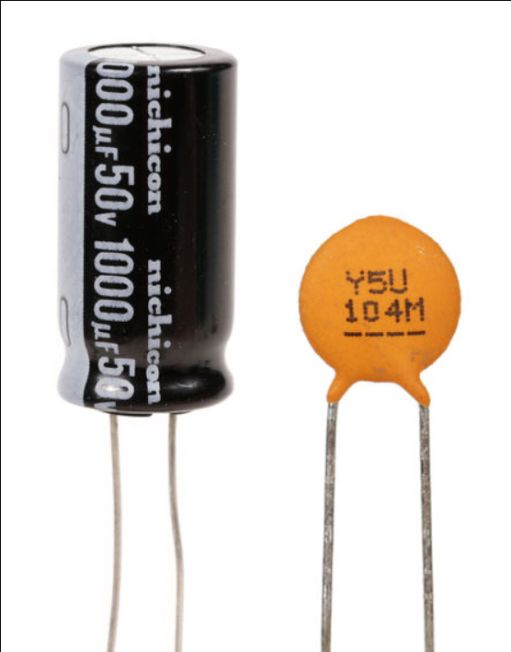
Figure 20 Ceramic capacitor

5)Transformer: At the beginning, we tested several transformers to step up the inverter output voltage to match the 220V AC grid level. Unfortunately, most of the transformers we tried failed to provide the required voltage or experienced significant voltage drops under load. After many trials, we finally succeeded in selecting a specific transformer that delivers a stable 220V output with minimal voltage drop under load.
Below is a Figure 21 of the transformer that met our requirements: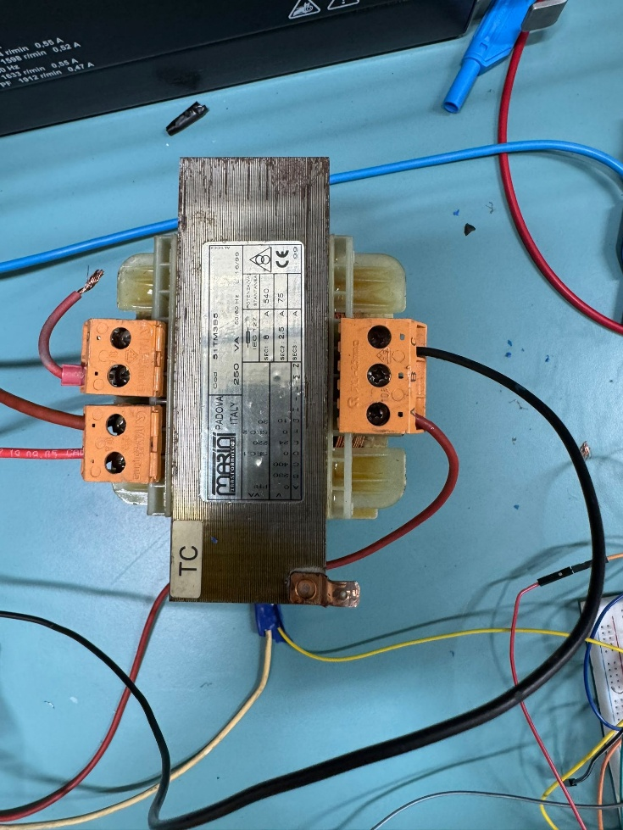
Figure 21 Transformer

6)LC Filters: Used to reduce harmonics and ensure a smooth sinusoidal output waveform, two low-pass filters were employed, provided by the power laboratory at the university. Each filter consisted of an 8 mH inductor and a 1.5 μF capacitor. One low-pass filter was connected on the low-voltage side of the transformer, and the other on the high-voltage side, as shown in Figure 22.

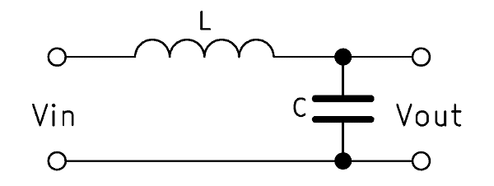
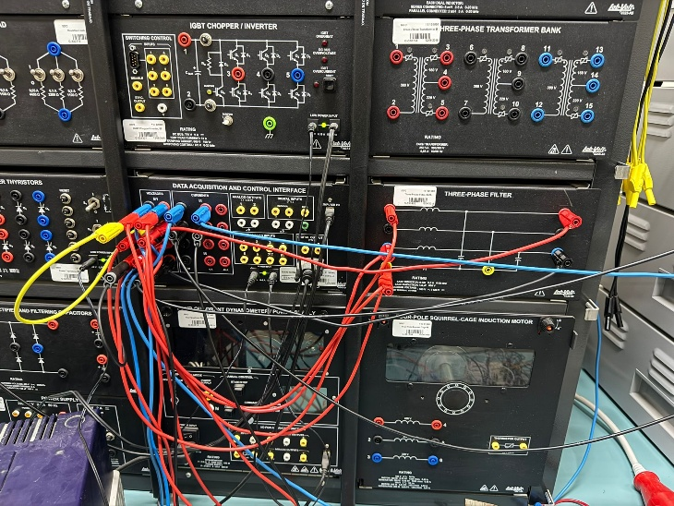
Figure 22 LC Filters

7)VOLTAGE and CURRENT sensor:
In this setup, two voltage sensors and one current sensor were utilized to monitor the system’s performance. The first voltage sensor was connected across the load side, which is directly linked to the grid. The output from this sensor was used to generate the Vα (V alpha) signal. This signal was conditioned using an operational amplifier (op-amp) to shift and scale the voltage within the Arduino's readable range.
The Vβ (V beta) signal was derived by passing Vα through an integrator amplifier, and its output was also fed into the Arduino for further processing.
As for the current sensor, it was of the built-in type and was placed at the transformer’s output. Unlike the voltage sensors, it did not require signal conditioning through an op-amp, as its output was already within a compatible range. The use of op-amps for voltage signals was essential because the Arduino cannot directly measure negative voltages.
This sensing and signal conditioning arrangement is illustrated in Figure 23.

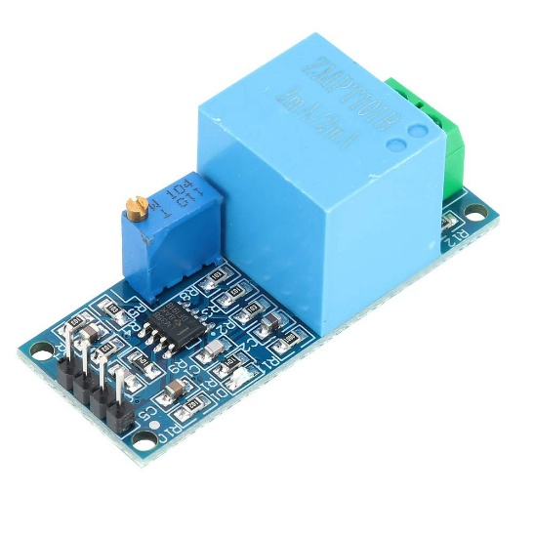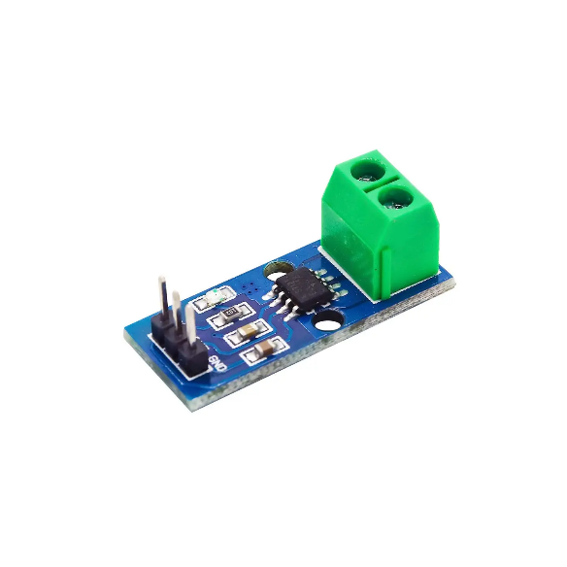
Figure 23 VOLTAGE and CURRENT sensor

8) Operational Amplifiers (Op-Amps):

In our inverter system, operational amplifiers (Op-Amps) played an important role in the signal conditioning stage—especially when dealing with voltage and current sensors. The raw signals coming from sensors like the ZMPT101B (voltage sensor) and ACS-type current sensor are typically in low voltage ranges and may contain noise or offsets that could affect the accuracy of readings.

To ensure reliable performance and accurate feedback to the Arduino microcontroller, we used Op-Amps for the following reasons:

Signal Amplification: The output of some sensors may be too weak for the Arduino’s analog-to-digital converter (ADC) to read accurately. The Op-Amp was used to amplify these small signals to a readable voltage range (typically 0–5V).

Offset Adjustment: Some sensors, particularly current sensors like ACS712, output a mid-point voltage (e.g., 2.5V at zero current). We used Op-Amps to adjust the offset if needed, making it easier to interpret the signal and improve resolution.

Noise Filtering: In environments where switching components like IGBTs operate at high frequencies (e.g., 5 kHz PWM), Op-Amps can also be used in active low-pass filter configurations to reduce high-frequency noise.

Impedance Matching: Op-Amps offer high input impedance and low output impedance, which helps prevent signal loss or distortion when inter

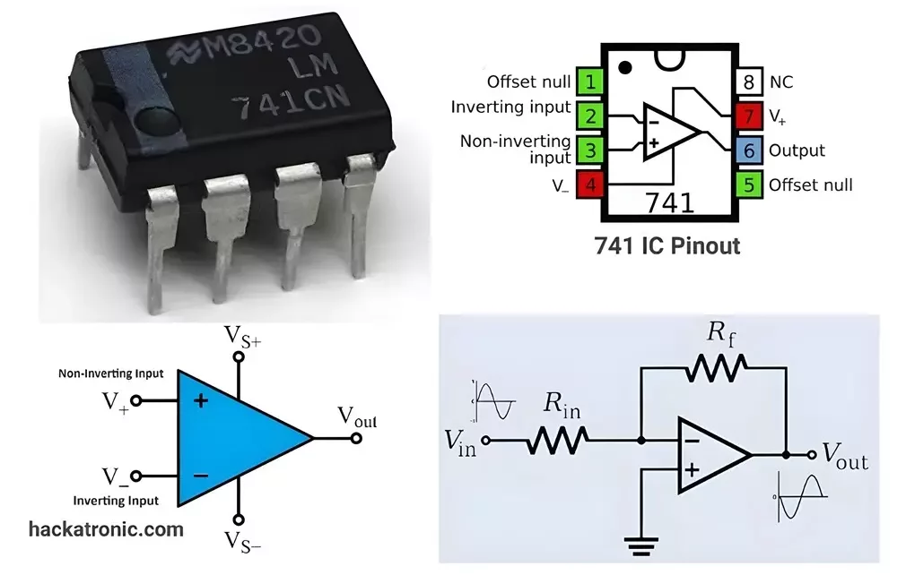
Figure 24 OP-AMP PIN DIGRAM

9) Integrated Amplifier:

In our graduation project, we built a single-phase inverter where the integral amplifier became our secret weapon for smooth voltage control. Since single-phase systems don’t naturally give us the two-axis signals (Vα and Vβ) we needed for space vector modulation, we got creative—we added a 90° phase-shifter to artificially generate the missing quadrature component. The integral amplifier then worked like a precision filter, cleaning up distortions and locking in those perfect Vα/Vβ waveforms. Thanks to this combo, our inverter output stayed stable even under tough load changes, with fewer harmonics and a much cleaner sine wave. It was a game-changer for our design. 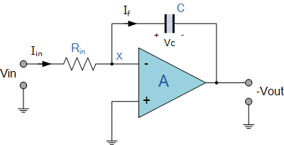
Figure 25 Integrated Amplifier

5.6 Hardware Design
The sampling frequency used is 𝑓_{𝑠} = 10 𝑘𝐻𝑧, and the desired output is 𝑓 = 50 𝐻𝑧;

5.6.1Control Code Flowchart
To better understand the internal operation of the inverter’s control system, the flowchart in Figure 26 illustrates the main logic implemented in the microcontroller. The code is responsible for reading voltage and current signals, applying alpha-beta transformation, computing the error between measured and reference currents, and generating the corresponding PWM signals through the PI controller.

The chart outlines the sequential process, starting from analog signal acquisition and filtering, passing through control computations, and ending with PWM output updates. This structured flow ensures both real-time performance and stable operation of the inverter.
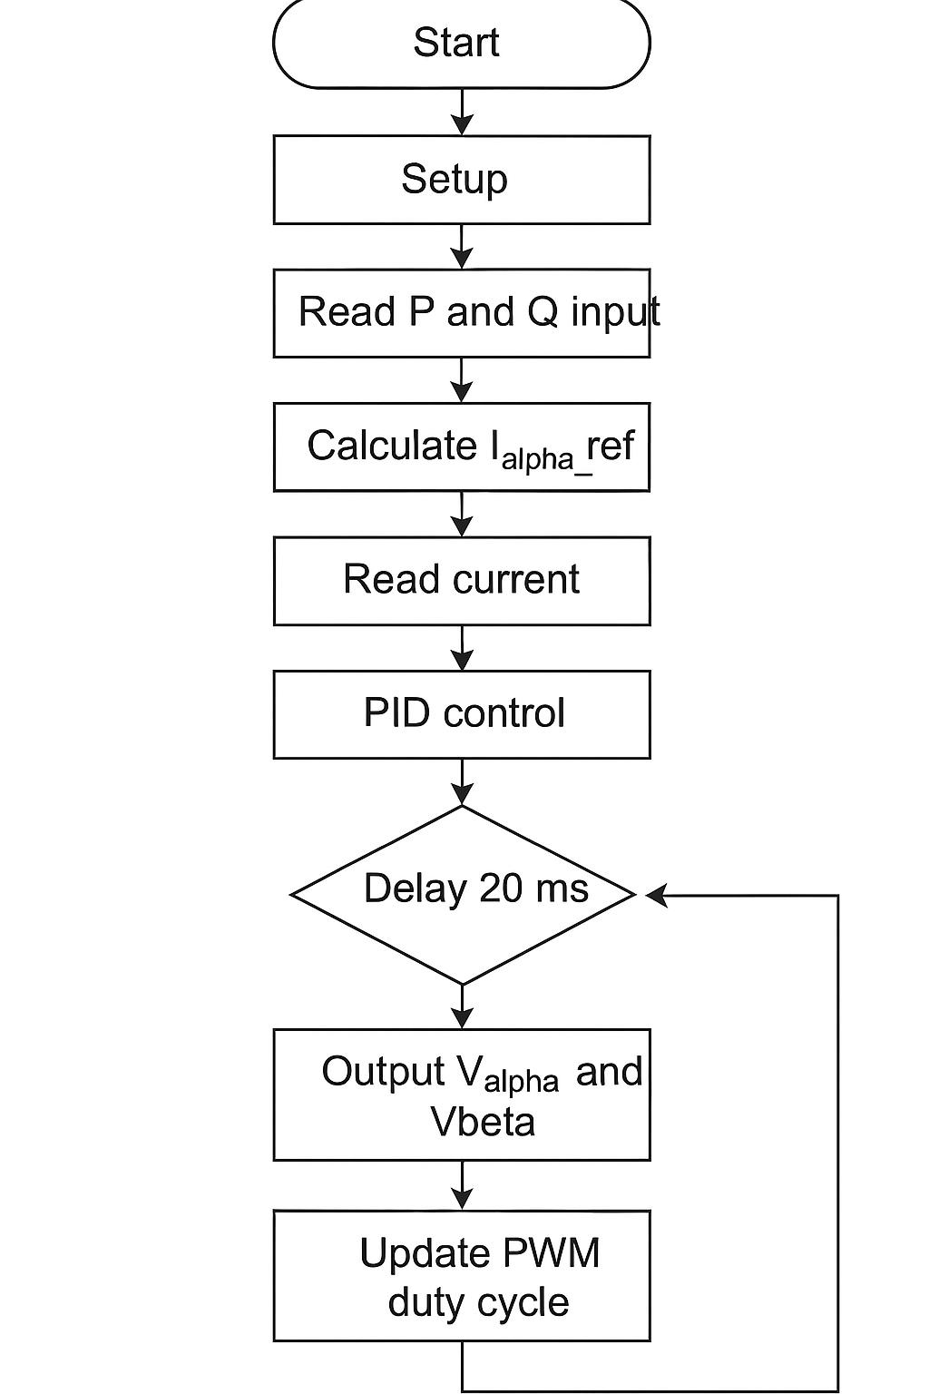
Figure 26 Flow chart of the arduino code

5.6.2V-alpha and V-beta calibration
To ensure accurate readings, both Vα (V alpha) and Vβ (V beta) signals were carefully calibrated prior to their use in the control system. The calibration process, as illustrated in Figure 27, involved comparing the sensor outputs to known reference voltages and adjusting the scaling factors accordingly.
For V alpha, after being processed through the op-amp, the signal was checked to confirm it proportionally reflected the actual grid voltage within the Arduino’s readable range (0–5V). Similarly, the V beta signal—obtained from the integrator amplifier—was verified and fine-tuned to maintain the correct 90-degree phase shift relative to V alpha.
This calibration step was critical to ensure reliable signal representation and accurate control system performance.

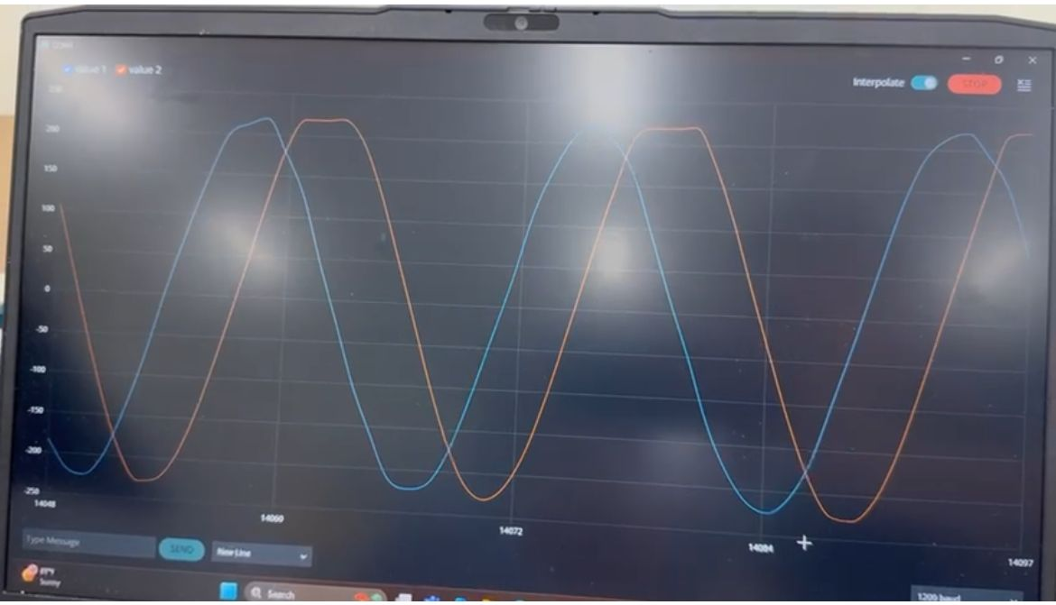
Figure 27 V-alpha and V-beta calibration

5.6.3 Complete Project Assembly:
After preparing all the individual components, the complete system was assembled by interconnecting the H-bridge inverter, the transformer, the low-pass filters, and the load. This integration phase, as shown in Figure 28 and 29, marked a significant milestone in the project. It enabled real-world testing of the entire setup, providing insights into the performance of voltage conversion and filtering under practical operating conditions.

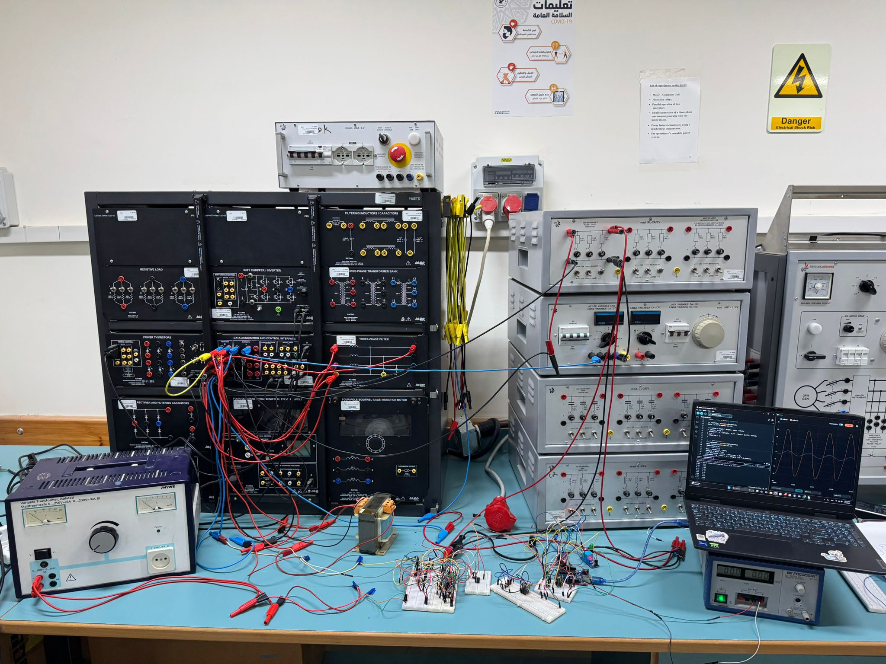
Figure 28 Complete Project Assembly

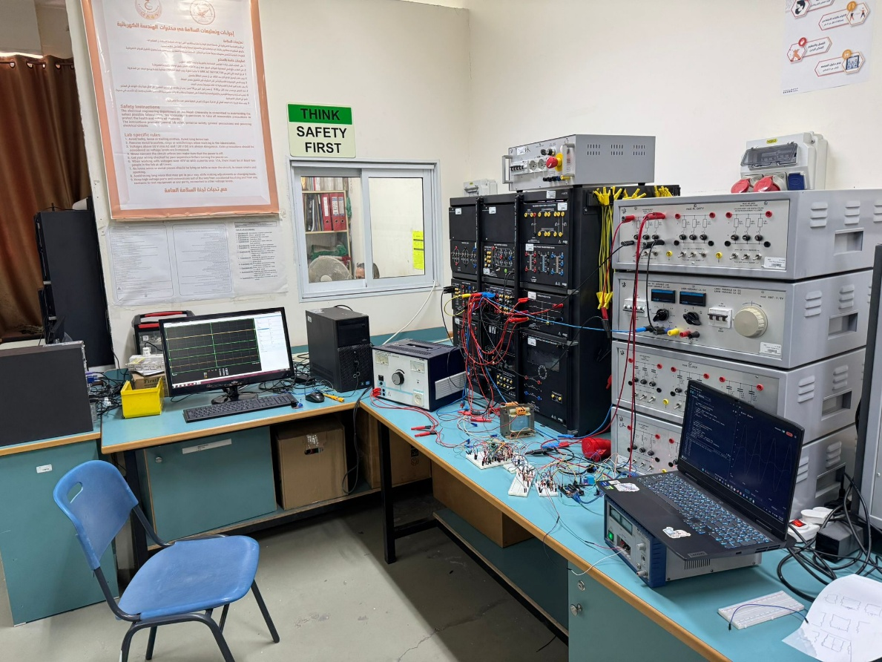
Figure 29 Complete Project Assembly

5.6.4Output Waveform Analysis After Filtering:

After the full implementation of the control system and the addition of LC filtering, we captured the inverter’s output waveform for analysis. As shown in Figure 30 , the resulting signal is impressively clean and smooth—very close to an ideal pure sine wave. There’s barely any sign of harmonic distortion or electrical noise, which highlights how well the filtering and control strategy worked together.

The waveform maintained a steady RMS voltage of around 220V and a frequency of 50Hz, perfectly aligned with standard grid specifications. This confirms that the inverter is not only functioning correctly but also producing high-quality power that’s safe and suitable for grid connection. The clarity and consistency of the waveform strongly demonstrate the effectiveness of the Alpha-Beta transformation and PI controller in shaping the output and maintaining power quality.

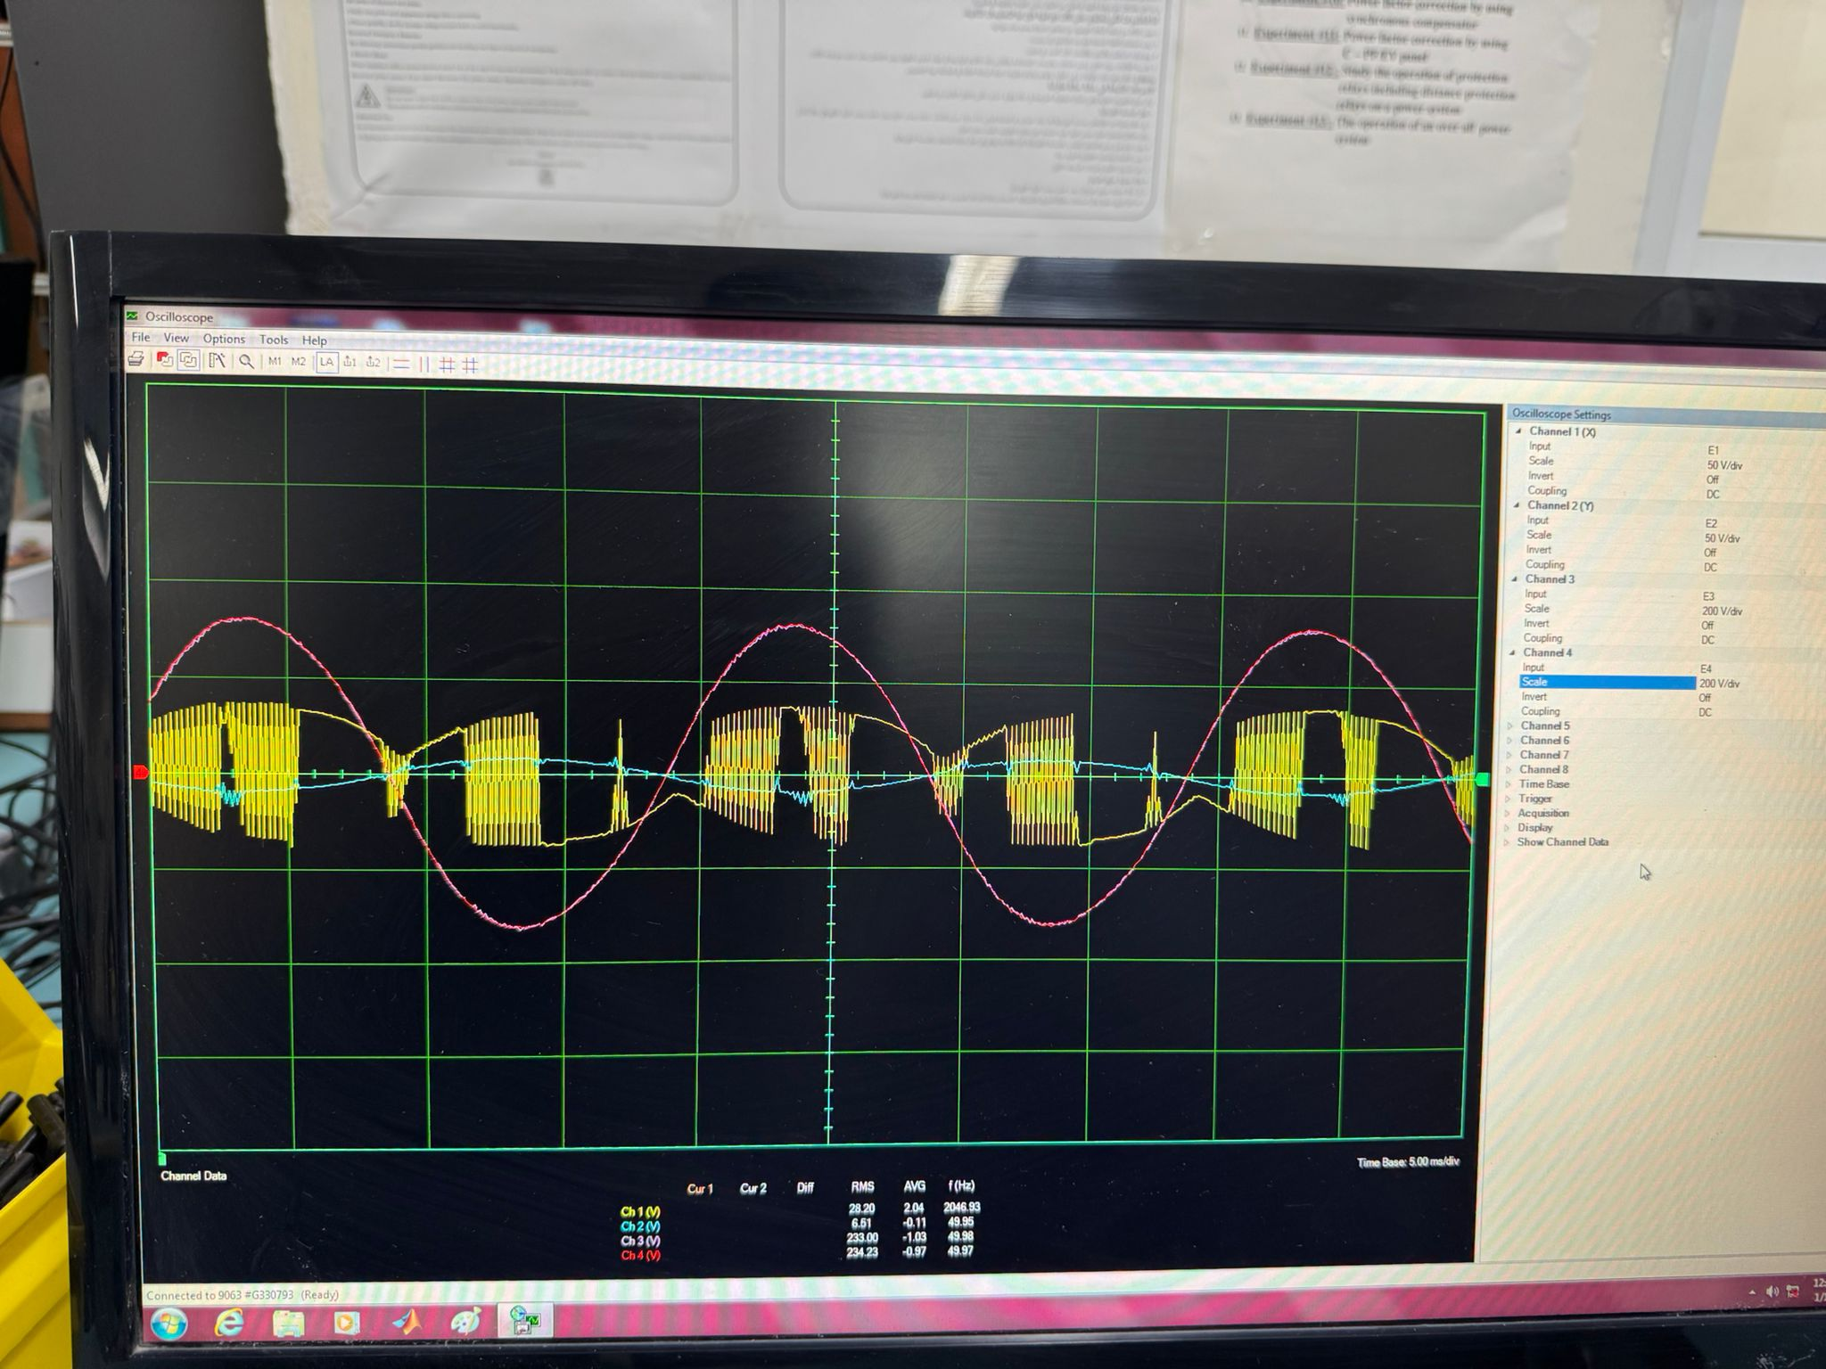
Figure 30 Output Waveform Analysis After Filtering

5.6.5System Testing and Results:

The inverter system underwent a series of practical tests in which various reference values for both real and reactive power were applied. These tests aimed to evaluate how well the system could track and respond to changes in power demand. Using the calibrated voltage and current sensors, the Arduino continuously monitored the output and adjusted the PWM signals in real-time through the PI controller to match the desired setpoints.

Examples of setpoints used:

1-Pref=100 W I-alpha

Qref= 50VAR I-measure

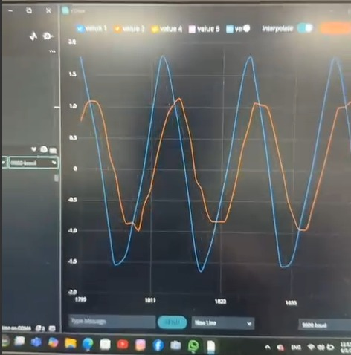
Figure 31 SETPOINT CASE 1

2-Pref=100 w I-alpha

Qref=10VAR I-measure

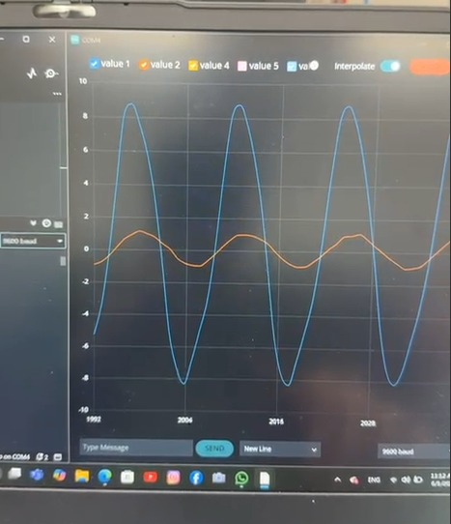
Figure 32 SETPOINT CASE 2

3-Pref=0 w I-alpha

Qref=10VAR I-measure

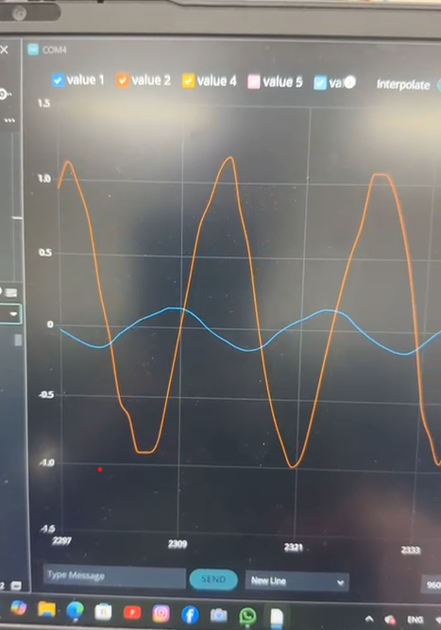
Figure 33 SETPOINT CASE 3

5.6.6Comparison Between Simulated and Experimental Iα (Alpha Current)

To better assess the reliability of our control strategy and evaluate how closely the practical implementation aligns with the theoretical model, a comparison was carried out between the simulated and measured Iα (alpha-axis current). This comparison, illustrated in Figures 34, 35, and 36, was a crucial step in validating the effectiveness of the alpha-beta transformation and PI controller under real-world conditions.
The results demonstrated a strong correlation between the two waveforms. Both exhibited similar shapes and dynamic responses when exposed to the same load and setpoint conditions. While minor discrepancies were observed, they were within acceptable limits and are attributed to factors such as sensor tolerances, electrical noise, or the resolution constraints of the microcontroller.

1-Pref=100 W

Qref= 50VAR

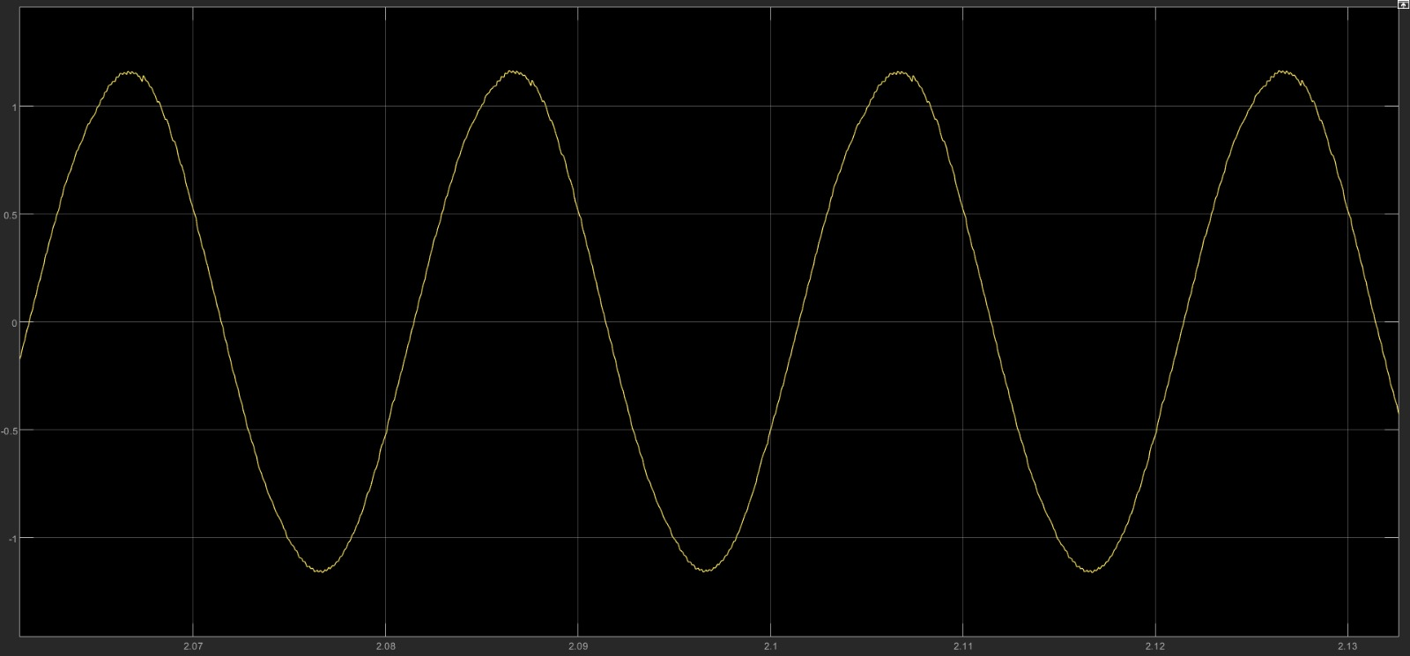
Figure 34 Iα Alpha in Matlab Simulink case 1

a digital oscilloscope. The waveform closely resembles a clean sinusoidal shape, with a few minor distortions likely caused by noise or measurement imperfections. The peak value of Iα is estimated to be approximately ±1.1 A, confirming the system’s ability to generate a stable and well-regulated output in practical conditions.

2-Pref=0 w

Qref=10VAR

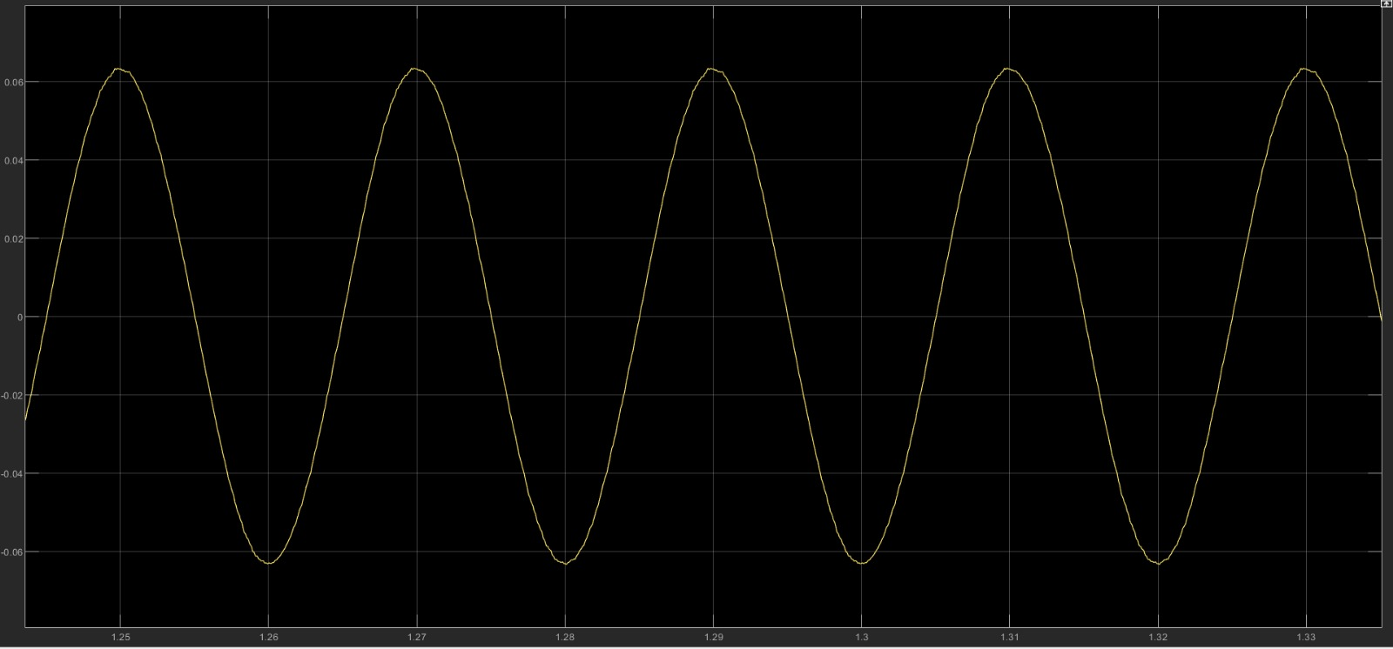
Figure 35Iα Alpha in Matlab Simulink case 2
This figure shows the measured Iα when only reactive power was injected. As expected, the current is very small—around ±0.06 A—indicating that no active power was delivered. This confirms the correct behavior of the system under pure reactive power control.

3-Pref=600w

Qref=50VAR

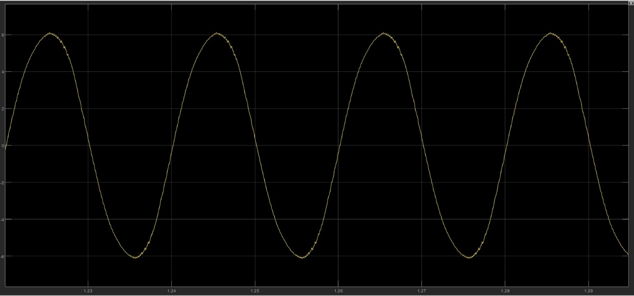
Figure 36 Iα Alpha in Matlab Simulink case 3

This figure presents the measured Iα waveform under high active power injection (600 W) with a small reactive component (50 VAR). The waveform shows a strong sinusoidal shape with a peak current of approximately ±6 A, confirming effective tracking of active power by the control system.

Simulation vs. Experimental Results

The experimental results show a strong agreement with the simulation outcomes obtained from MATLAB/Simulink. The measured Iα waveforms closely match the simulated ones in terms of shape, amplitude, and dynamic response. This confirms that the alpha-beta transformation and PI control strategy implemented in hardware performed as expected and accurately followed the behavior predicted in the simulation environment.

5.6.7 Challenges Faced
• Lack of measurement equipment: We did not have access to a differential probe or PicoScope, which made it difficult to measure high-side voltages in the H-Bridge circuit. This was critical since we were dealing with floating voltages.

• Hardware limitations: We were unable to implement the closed-loop control system because the hardware could not handle operating under high voltage and high current conditions. The system became unstable and potentially unsafe when driven at full power, which forced us to limit the testing to open-loop control only.

• Component availability: Some essential components, such as current sensors and IGBT drivers, were either unavailable or not fully compatible with our design. This required adjustments and slowed down the implementation process.

• Signal measurement challenges: Accurately reading voltage and current values under switching conditions was difficult without proper isolation and filtering, which affected the reliability of our feedback signals.

• Time constraints: The limited time available for hardware testing and debugging made it difficult to iterate and fine-tune the system effectively.

• Learning curve: Understanding and handling high-frequency switching, PWM control, and real-time signal acquisition presented a steep learning curve, especially with limited equipment.

6

CHAPTER 6: : Conclusion and Future Work

In this second phase of our project, we successfully brought our inverter system from simulation to reality. What started as a theoretical model in MATLAB/Simulink is now a fully working hardware setup capable of injecting both real (P) and reactive (Q) power into the grid.

We built the system using carefully selected components: a reliable transformer to boost voltage, calibrated sensors for accurate feedback, and an Arduino running our control logic. Thanks to the use of Alpha-Beta transformation and a PI controller, the system was able to respond accurately to different power demands. Our tests showed that the inverter could deliver clean, stable power, and the output waveform was very close to a pure sine wave—exactly what’s needed for grid compatibility.

Overall, the system performed just as we had hoped: improving power factor, compensating for reactive power, and maintaining voltage and frequency levels in line with grid standards.

Future Work:
While we’re proud of the results, there’s still a lot of room for growth and improvement. Here’s what we see as the next steps:
- Smarter Control: Using more advanced control methods—like Repetitive Control or Model Predictive Control—could help the system react faster and handle disturbances more smoothly.

- Better Hardware: Replacing the Arduino with a faster microcontroller, like the STM32 or ESP32, would give us more processing power and better real-time performance.

- Solar Integration: Connecting the inverter to a real solar panel would turn this into a practical grid-tie PV system and move us closer to clean energy applications.

- Safety Features: Adding anti-islanding protection is important to make sure the inverter shuts down properly if the grid goes offline.

- Three-Phase Support: Expanding the design to a three-phase system would allow it to handle bigger loads and be used in industrial settings.

- Remote Monitoring: Adding Wi-Fi or Bluetooth would let users monitor the inverter remotely and even adjust settings from a phone or computer.
This project gave us valuable hands-on experience and opened the door to many exciting possibilities. We’re confident that with a few upgrades, this system could be used in real-world renewable energy applications.

References

- Fehr, R. Harmonics Made Simple. (2004).
- Ingale, Rajesh. (2014). Harmonic Analysis Using FFT and STFT. International Journal of Signal Processing, Image Processing and Pattern Recognition.
- Hantouli, Naeil. (2018). Design of Active Power Filter with Active and Reactive Power Injection Capabilite, Using Multilevel Inverter and Photovoltaic Arrays. An-Najah National University (Nablus – Palestine).
- Khalid, Saifullah & Dwivedi, Bharti. (2011). Power quality issues, problems, standards & their effects in industry with corrective means. International Journal of Advances in Engineering & Technology.
- Shinde, Chandrakant R. & Ingole, D. T. & Thakre Saurabh. (2018). Review on Power Quality Improvement by Power Filter’s. (India).
- Suárez, Johann & Amaris, Hortensia & Robles, Guillermo. (2010). Current control schemes for three-phase four-wire shunt active power filters: A comparative study. Revista Facultad de Ingeniería Universidad de Antioquia. 206-214.
- Chinta, Narendra. (2011). ONE CYCLE CONTROL OF SHUNT ACTIVE POWER FILTER.

- Singh, Bhim, et al. Power Quality Problems and Mitigation Techniques. John Wiley & Sons Inc, 2015.
- General PLL Description: T. H. Lee, Chap. 15. Gray and Meyer, 10.4 Clock generation: B. Razavi, Design of Analog CMOS Integrated Circuits, Chap. 15, McGraw-Hill, 2001.
- Akademia Baru, Penerbit & Jaffar, Hairol & Azli, Naziha. (2015). Performance Analysis of an Active Power Filter Utilizing Cascaded H-Bridge Multilevel Inverter with Unified Constant- frequency Integration Control. 15-22.
- David (Zhiwei) Gao, Kai Sun, in Electric Renewable Energy Systems, 2016

- Gautam, Samir & Yunqing, Pei & Kafle, Yuba & Kashif, Muhammad & Hasan, Saad. (2014). Evaluation of Fundamental d-q Synchronous Reference Frame Harmonic Detection Method for Single Phase Shunt Active Power Filter. International Journal of Power Electronics and Drive Systems.
- Suul, J. A., Ljokelsoy, K., Midtsund, T., & Undeland, T. (2011). Synchronous Reference Frame Hysteresis Current Control for Grid Converter Applications. IEEE Transactions on Industry Applications.
- Team, The Arduino. “PWM.” Arduino, www.arduino.cc/en/guide/introduction
- Team, The Arduino. “PWM.” Arduino, www.arduino.cc/en/Tutorial/Foundations/PWM.
- Khechiba, Kamel. “Design and Implementation of Microcontroller Based Controller for Direction and Speed of a Robot Using ARDUINO.” Research Gate, May 2016, www.researchgate.net/publication/315337631_Design_and_implementation_of_microcontroller_ based_controller_for_direction_and_speed_of_a_robot_using_ARDUINO.
- Sivaranjith. “Electrical Transformers.” Industrial Automation, PLC Programming, Scada & Pid Control System, 2 Mar. 2018, automationforum.in/t/electrical-transformers/3225.

