Overview of the Project :

The robot snake consists of six segments and a head, with each segment being
powered by an R/C servo.
The segments alternate in orientation so that the first segment moves in a horizontal motion and the next segment moves in a vertical motion.
This sequence repeats itself for all six segments and the head, this gives the snake enough flexibility to move its body in a number of different ways in order to achieve locomotion, in much
the same way as a biological snake.
The robot is controlled by a Microchip PIC 18F4620 microcontroller.
The microcontroller is used to sequence the movement of each of the snake’s body sections via
Servos, and it also monitors an infrared sensor so that the snake will avoid obstacles as it explores.
Or we can use the manual mode to control the snake by wirless joystick through the microcontroller.

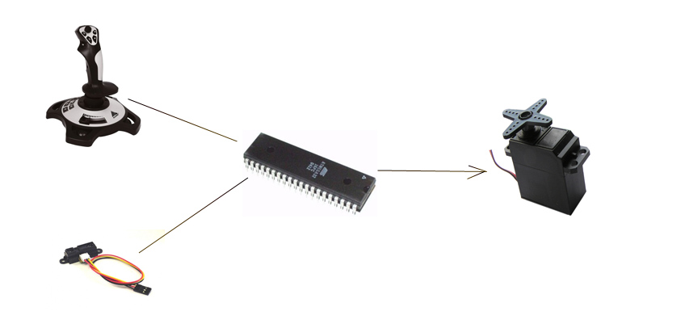

Used Equipment:
DC Servo motor :
A Servo is a small device that has an output shaft. This shaft can be positioned to specific angular positions by sending the servo a coded signal. As long as the coded signal exists on the input line, the servo will maintain the angular position of the shaft. As the coded signal changes, the angular position of the shaft changes. In practice, servos are used in radio controlled airplanes to position control surfaces like the elevators and rudders. They are also used in radio controlled cars, puppets, and of course, robots.
Servos are extremely useful in robotics. The motors are small, as you can see by the picture above, have built in control circuitry, and are extremely powerful for thier size. A standard servo such as the Futaba S-148 has 42 oz/inches of torque, which is pretty strong for its size. It also draws power proportional to the mechanical load. A lightly loaded servo, therefore, doesn't consume much energy.
So, how does a servo work? The servo motor has some control circuits and a potentiometer (a variable resistor, aka pot) that is connected to the output shaft. In the picture above, the pot can be seen on the right side of the circuit board. This pot allows the control circuitry to monitor the current angle of the servo motor. If the shaft is at the correct angle, then the motor shuts off. If the circuit finds that the angle is not correct, it will turn the motor the correct direction until the angle is correct. The output shaft of the servo is capable of travelling somewhere around 180 degrees. Usually, its somewhere in the 210 degree range, but it varies by manufacturer. A normal servo is used to control an angular motion of between 0 and 180 degrees. A normal servo is mechanically not capable of turning any farther due to a mechanical stop built on to the main output gear.
The amount of power applied to the motor is proportional to the distance it needs to travel. So, if the shaft needs to turn a large distance, the motor will run at full speed. If it needs to turn only a small amount, the motor will run at a slower speed. This is called proportional control.
How do you communicate the angle at which the servo should turn? The control wire is used to communicate the angle. The angle is determined by the duration of a pulse that is applied to the control wire. This is called Pulse Coded Modulation. The servo expects to see a pulse every 20 milliseconds (.02 seconds). The length of the pulse will determine how far the motor turns. A 1.5 millisecond pulse, for example, will make the motor turn to the 90 degree position (often called the neutral position). If the pulse is shorter than 1.5 ms, then the motor will turn the shaft to closer to 0 degress. If the pulse is longer than 1.5ms, the shaft turns closer to 180 degress.
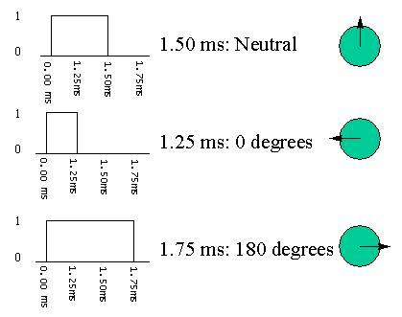

Servo vs. stepper motors:

A servo motor can be either DC or AC, and is usually comprised of the drive section and the resolver/encoder. A servo motor is much smoother in motion than a comparable stepper, and will have a much higher resolution for position control. The servo family is further divided into AC and DC types. An AC servo had the advantage of being able to handle much higher current surges than a DC, as the DC has brushes, which are the limiting factor in this case. Therefore, for our practical considerations, you can get a lot stronger AC servo motor than you could in DC or stepper configuration. Steppers, on the other hand, have economy as an advantage, and can be incorporated into a design to produce very smooth motion also. The trend for manufacturers of “serious” CNC machinery is to use AC servos. “Entry level” machines may have DC servos, or even steppers.

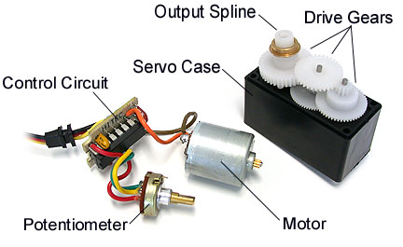

2) aluminum body .
3) IR transmitter & receiver
4) wirless joystick .
5) DC battery (6v & 9v)
6) PIC 18F4620.

  - Used Programs:
    - MPLAB 810
    - PIC C compiler
    - EAGLE 5.1.0

Printed CCT :

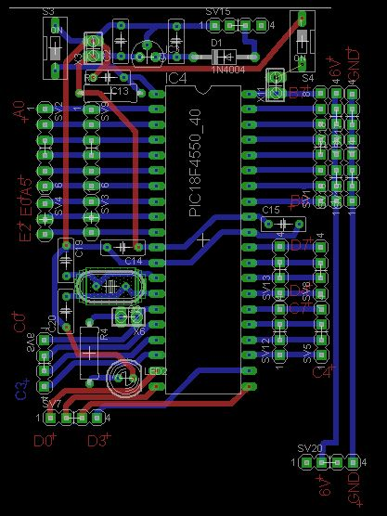

Software :

Servo software :
#define servo_1 PIN_B0
#define servo_2 PIN_B1
#define servo_3 PIN_B5
#define servo_4 PIN_B4
#define servo_5 PIN_B3
#define servo_6 PIN_B2

byte servo1=0;
byte servo2=0;
byte servo3=0;
byte servo4=0;
byte servo5=0 ;
byte servo6=0;
int i;
int j;
int pin;
int busy1=0;
int busy2=0;
int busy3=0;
int busy4=0;
int busy5=0;
int busy6=0;

void out_servo_right(int val, int index,int no)
{

if(no==1)pin=servo_1;
else if(no==2)pin=servo_2;
else if(no==3)pin=servo_3;
else if(no==4)pin=servo_4;
else if(no==5)pin=servo_5;
else if (no==6)pin=servo_6;

output_low(pin);
for(i=0;i<index;i++)
{
output_high(pin);
// 2000 cycles
for(j=0;j<20;j++) { delay_cycles(100); }
output_low(pin);
// delay 18000

for(j=0;j<180;j++) {delay_cycles(100);}
//delay_ms(20);

}

}

void out_servo_mid(int val, int index,int no)
{
if(no==1)pin=servo_1;
else if(no==2)pin=servo_2;
else if(no==3)pin=servo_3;
else if(no==4)pin=servo_4;
else if(no==5)pin=servo_5;
else if (no==6)pin=servo_6;
for(i=0;i<index;i++)

{
output_high(pin);
// 1500 cycles
for(j=0;j<15;j++) { delay_cycles(100); }

output_low(pin);
// delay 18500

for(j=0;j<185;j++) {delay_cycles(100);}

}
}
void out_servo_left(int val, int index,int no)
{
output_low(pin);
if(no==1)pin=servo_1;
else if(no==2)pin=servo_2;
else if(no==3)pin=servo_3;
else if(no==4)pin=servo_4;
else if(no==5)pin=servo_5;
else if (no==6)pin=servo_6;
for(i=0;i<index;i++)
{
output_high(pin);
// 1000 cycles
for(j=0;j<100;j++) { delay_cycles(100); }

output_low(pin);
// delay 19000

for(j=0;j<100;j++) {delay_cycles(100);}
delay_ms(20);

}

}
void out_servo_rr(int val, int index,int no)
{
index=index/2;
if(no==1)pin=servo_1;
else if(no==2)pin=servo_2;
else if(no==3)pin=servo_3;
else if(no==4)pin=servo_4;
else if(no==5)pin=servo_5;
else if (no==6)pin=servo_6;
for(i=0;i<index;i++)
{
output_high(pin);
// 1000 cycles
for(j=0;j<100;j++) { delay_cycles(100); }

output_low(pin);
// delay 19000

for(j=0;j<100;j++) {delay_cycles(100);}

}
}
void out_servo_rl(int val, int index,int no)
{
index=index/2;
if(no==1)pin=servo_1;
else if(no==2)pin=servo_2;
else if(no==3)pin=servo_3;
else if(no==4)pin=servo_4;
else if(no==5)pin=servo_5;
else if (no==6)pin=servo_6;
for(i=0;i<index;i++)
{
output_high(pin);
// 2000 cycles
for(j=0;j<20;j++) { delay_cycles(100); }

output_low(pin);
// delay 18000

for(j=0;j<180;j++) {delay_cycles(100);}

}

Main Problems :

- Reshaping the body
- Controlling the servo motors
- Power supply (using stand alone power)
- Damaging of high cost motor



An_najah National university

Project Name:

Snake Robot

Team members:
Mohammed Jawabri
Anas shayib
Supervisors:
Dr.Haya Samaaneh

