User guideline

It’s a web application that will serve both customer and restaurant,
For customer:
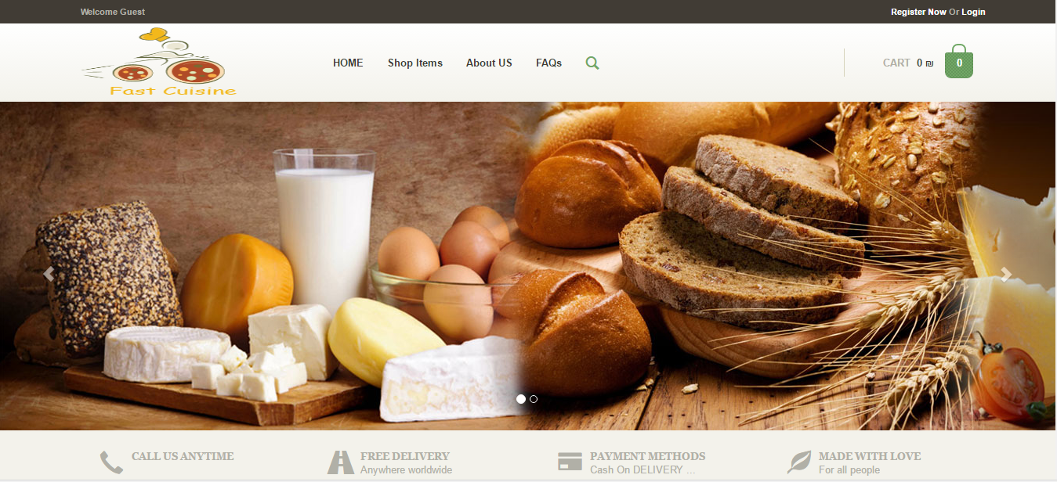
This is the customer interface that interface will appears to the customer at the beginning.

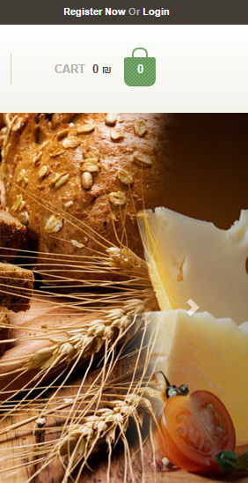

You can register if you are new customer and fill the form below,

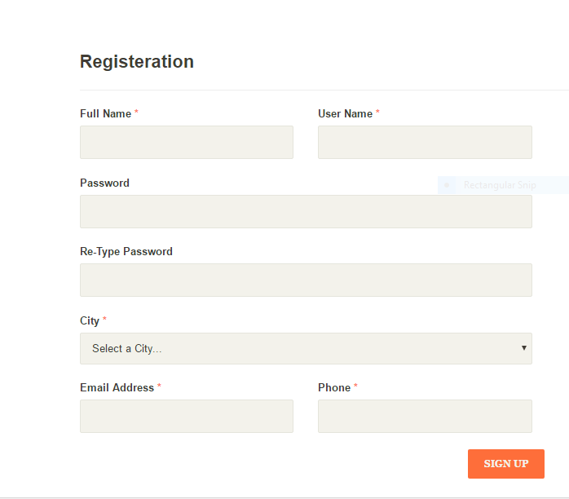

If you have an existing account you can log in directly and fill the form below,
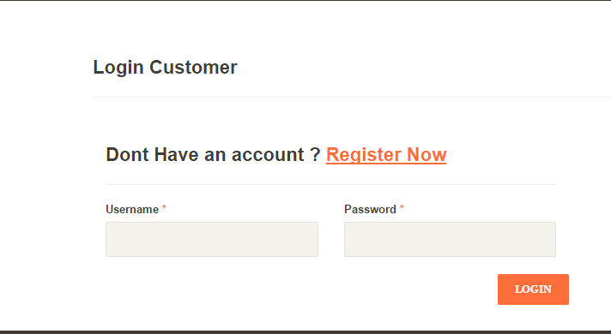

After log in you can browse the website ,additional thing will appears ,
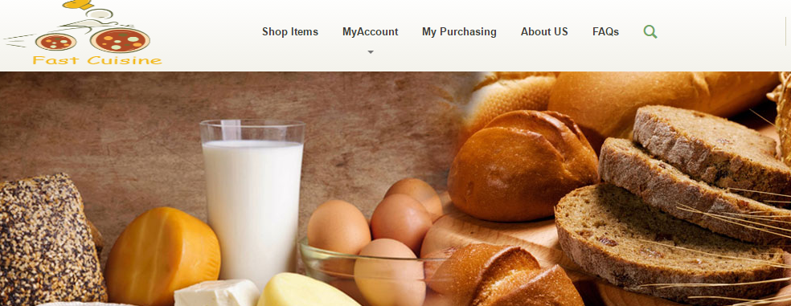
You can browse the site according to different ways, for example according to categorization, location, and hashtags,
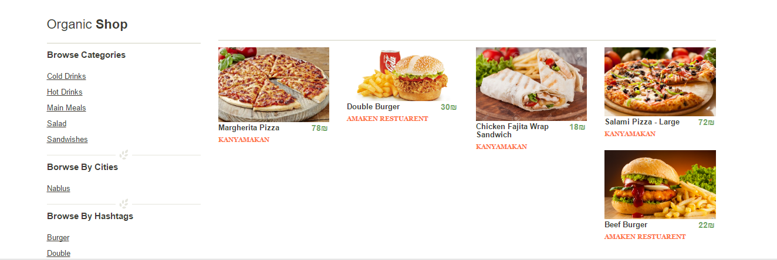
After choosing the meal that you want by click on the meal’s image this screen will appears,
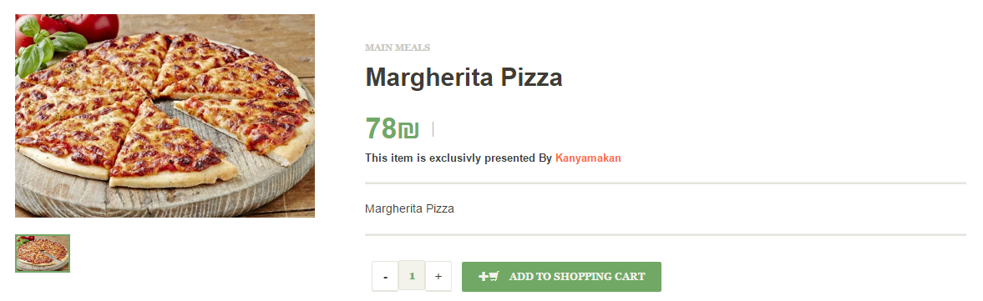
You can see the price, description and from any restaurant this meal, if you want to order it you have to click on add to shopping cart,
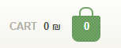
if you want to modify on your order click on the cart, the screen below will appear ,you can modify on the quantity ,cancel the meal and see the total price,
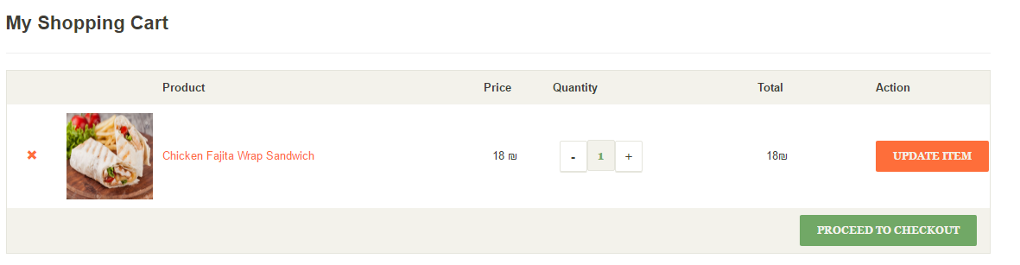
Now you ready to checkout, you have to choose the payment method, and enter your address,
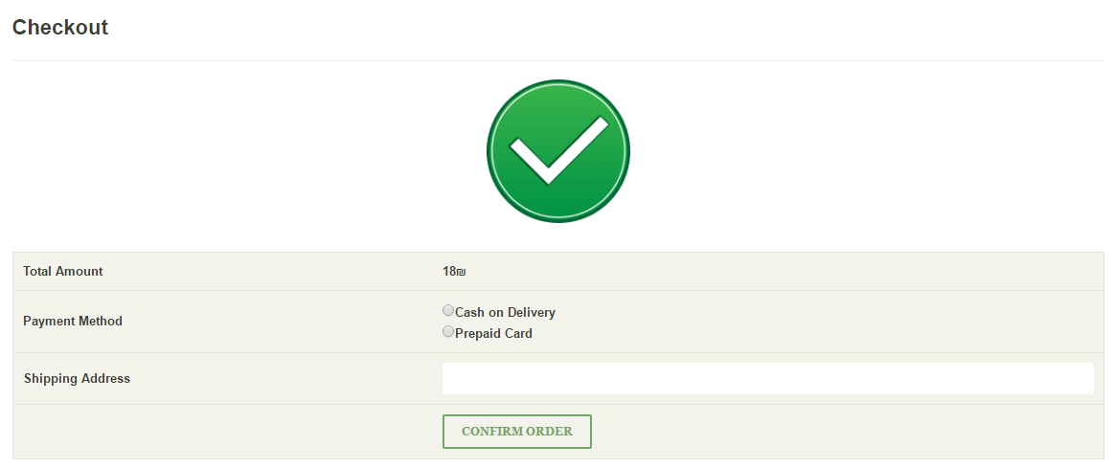
If you choose prepaid card, you have to enter the required information,
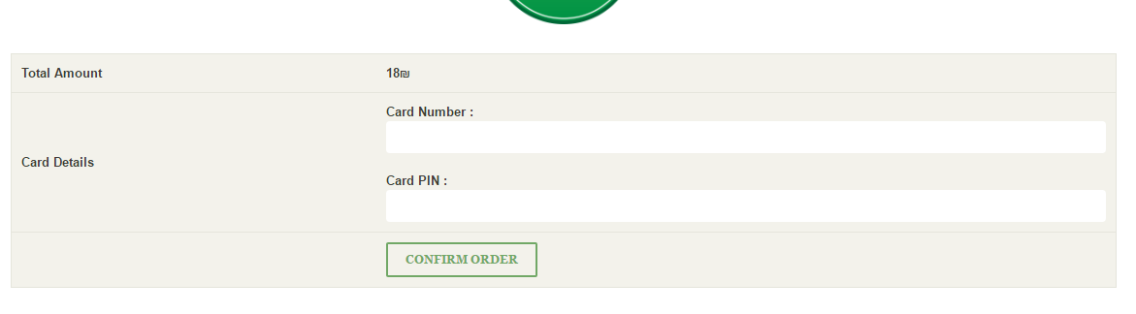

Also you can display your whole orders details ,and track it to see needed time to finish the order, cancel the order if it is still pending ,and see the reason if the order rejected,
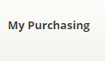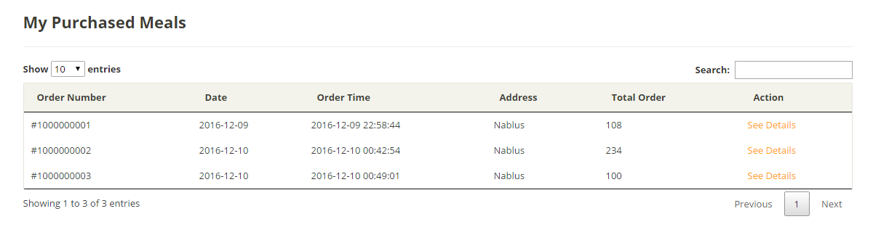
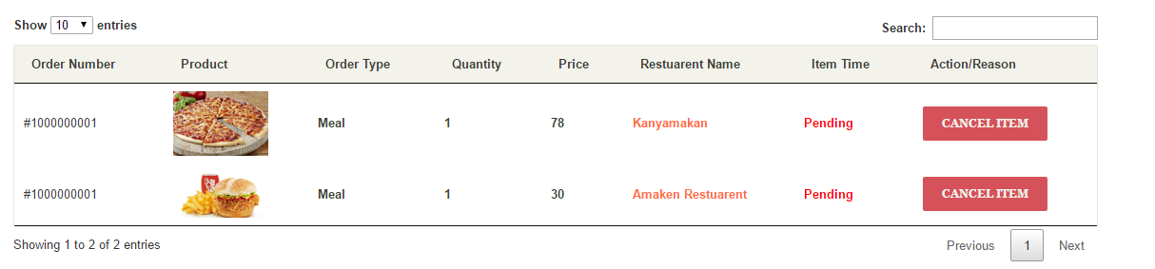

For extra information about the website you can go to about us
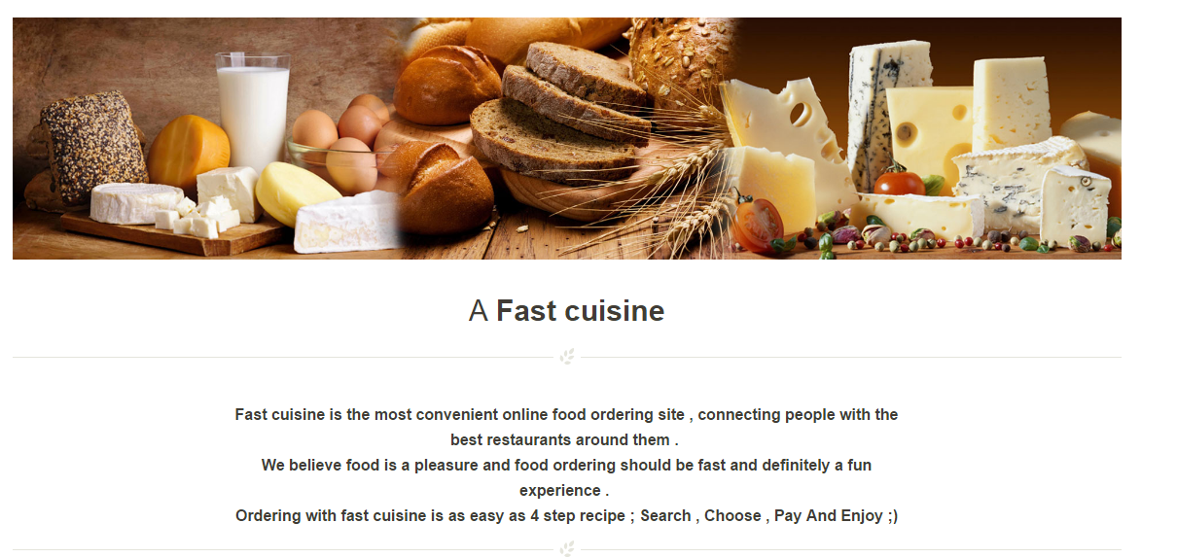

To see the frequent asked question you can go to FAQ
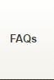
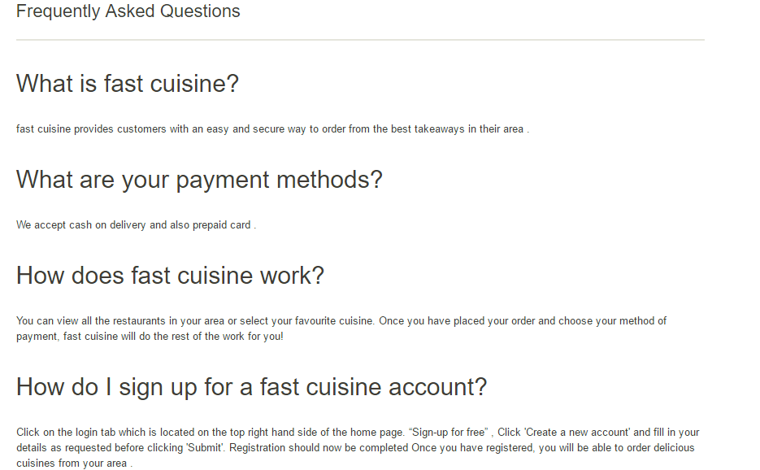
If you want to search about specific thing go to search box,
Enter what you want in the box,
If you want to contact with us click on,
Enter your message and the address,
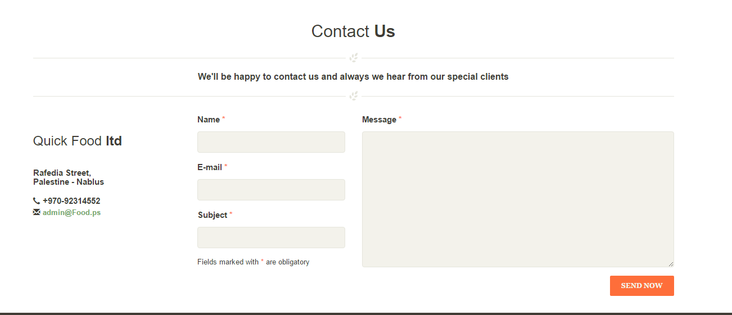

You can easily log out from your account by click on log out

For restaurant:
You have to log in first,
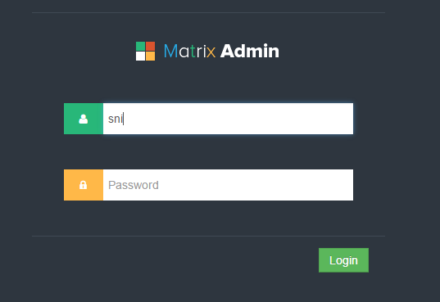

If you want to modify your personal information,
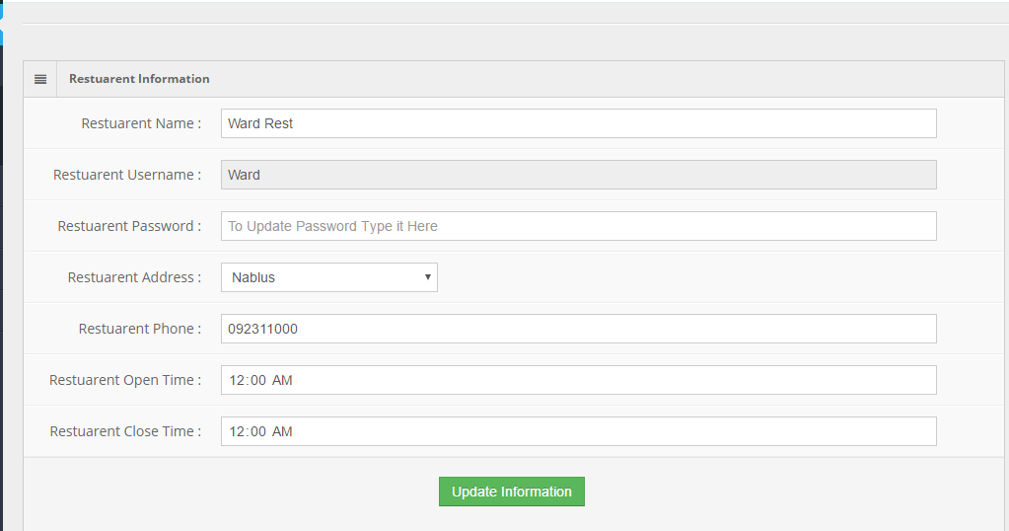

If you want to add or modify your images,
If you want to add new meal,
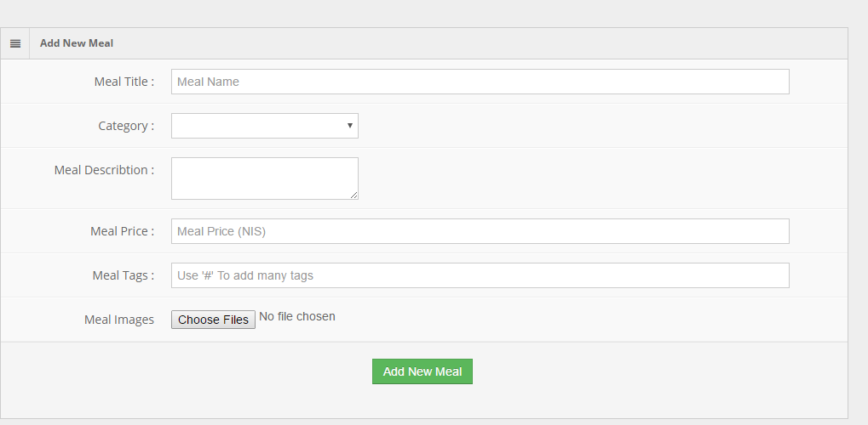
If you want to modify or hide a meal,
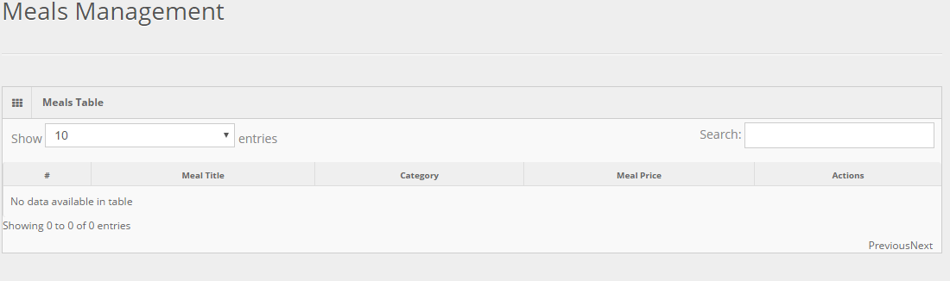

If you want to add offer,
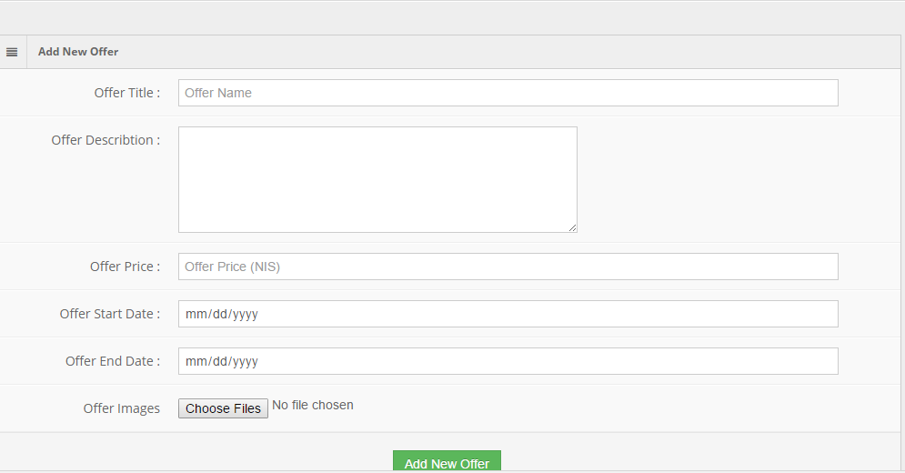

If you want to modify or hide offer,
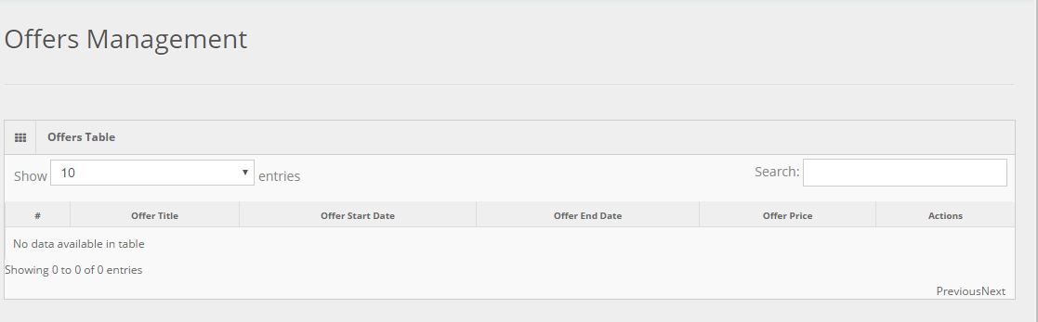
If you want to see your customer request and take an action ,
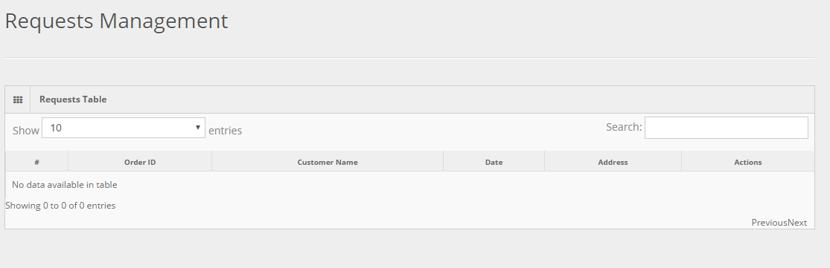

If you want to see your reports (your sellings, offers selling, your customer).
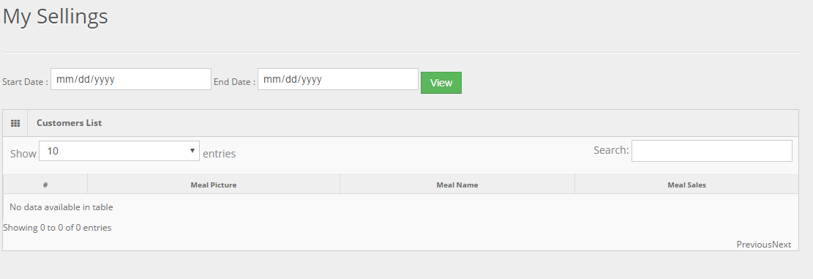
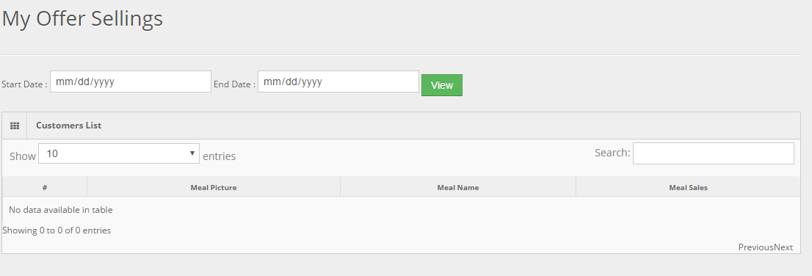

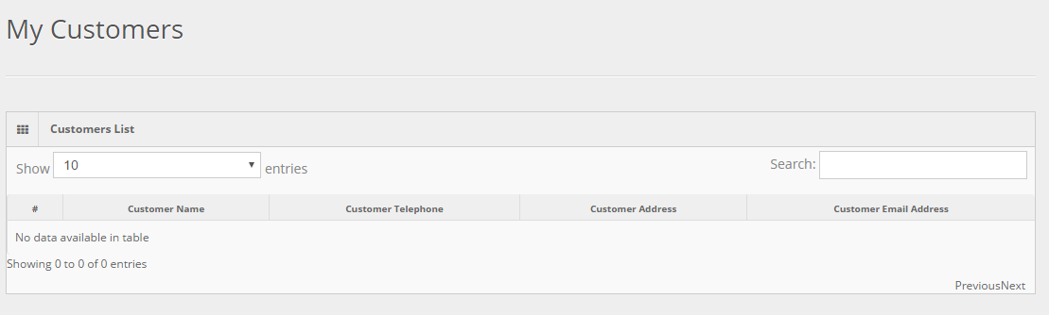

Thanks

