

An-Najah National University

FACULTY OF ENGINEERING AND INFORMATION TECHNOLOGY
Computer Engineering Department

Software Graduation Project

Quick Mart

Students: Supervisor:
Majd Waked Dr. Hanal Abuzant
Abdullah Shwareb

Jan ,23, 2025
Acknowledgment

To our Computer Engineering Department Doctors we say thank you so much for all the great work each of you have done in the computer engineering department Your wisdom, knowledge and dedication have all contributed to our academic journey.
A special thanks to our supervisor Dr. Hanal Abuzant Your dedication to our project, your guidance and constant encouragement have been amazing. Your guidance has not only helped us academic life but also pushed us to be the best in everything we do.
To those who helped us without asking for anything in return we say thank you for being with us all the way. The collaboration, encouragement and shared enthusiasm from all of you have added to the fun and the sense of achievement.
Finally, but not least we thank you all our parents. Their trust, support, encouragement, patience and faith in us have given us the strength and courage to complete our academic journey.
This project is a team work and we are thankful to all who contributed to it. Thank you for being part of our academic and personal life.

Abstract

Quick Mart is a cross platform application which provides an environment for traders and customers, where traders can publish their products and customers buys them.
Quick Mart provides payment methods for easier deal between customers and traders, it also includes a chat system for easier contact between traders and customers.
It also has a filtering system and a smart search system for easier match between desired products and customers.
The project is divided into three parts:
- A Mobile app for customers and traders, the mobile application should be a cross platform for android and ios, and provides the necessary features for a full and easy user journey for both the trader and the customer. It should have a chat system and a payment method, and a real time orders management for both traders and customers.
- A Website for admin to monitor the system, where he can control all the system parts includes the users, the products, orders and sales on the system, and have a full control of it.
- Quick Mart also has a smart system built with matching algorithm using
Machine learning techniques, it makes customers more comfortable while randomly looking for the desired products for easier user experience.

Table of content

Acknowledgment .....................................................................................................................2
Abstract ..................................................................................................................................2
Table of content.................................................................................................................4
Introduction..................................................................................................................................4
motivation.............................................................................................................6
Aim and Objective.......................................................................................................6
Scope of work..............................................................................................................6
Constrains ..........................................................................................................................6
LiteratureReview..........................................................................................................................7
Methodology .......................................................................................................................8
Result.........................................................................................................................................15
Result and descesion.............................................................................................................................15
FutureWork...............................................................................................................................15

Conclusion............................................................................................................................56

Introduction

Motivation

Picture a world where the shopping experience is smooth, intuitive, and as easy as a few taps of a finger on your cell phone. Quick Mart is intended to be that world. Its mission is to break down the barriers that can make online shopping annoying or stressful. Quick Mart is about ease, efficiency and complete satisfaction by connecting traders and customers in a friendly space.

The integrated chat system facilitates effortless communication, ensuring that any queries or concerns are addressed promptly. The secure payment methods instill confidence in every transaction, making the buying and selling process smooth and worry-free. And with a smart matching algorithm powered by machine learning, users are effortlessly guided to the products that best match their needs, making shopping a delightful and personalized experience.

Aims and Objectives

Aims:
- Increase accessibility : Develop an intuitive and person-friendly platform this is accessible to a wide range of users. From tech-savvy individuals to those strange with digital gadgets.
- Build believe: Create a depended on and stable environment by defensive person information to make certain steady transactions.
- Facilitates clean interactions: Facilitates clean communication between traders and customers to improve the buying and selling system.
- Improve user enjoy: Develop functions that meet service provider and client wishes. It makes journeying on the platform fun and efficient.

Objective:
- Cross-platform mobile utility development:
- Create cellular programs which might be well suited with Android and iOS.
- Includes vital features together with a talk device and secure price strategies. And real-time order control
- Comprehensive admin website:
Design a internet site for directors to screen and control each a part of the machine, along with customers, merchandise, orders, and income.
Develop and integrate intelligent matching algorithms the usage of system getting to know techniques.
Make it simpler so as to locate the goods you need by supplying a tailored shopping experience in your clients.
- User engagement and retention:
Various functions are delivered We use it to preserve users engaged, along with personalized recommendations, notifications, and promotions.
Focused on constructing a faithful person base thru exquisite person revel in and customer support.

1.3 Scope of work

Quick Mart is a cross-platform app that connects traders and customers, enabling easy product listings, secure payments, real-time order management, and smart search functionalities. It includes an admin website for system monitoring and control. The app uses machine learning to enhance user experience with personalized recommendations.

Constraints

Lack of knowledge:
choosing the techniques to implement was challenging, because there are carious ways and technologies that can be used to develop either web apps or mobile apps, so we took sometime to decide and search about different techniques, and so we chose Vue JS for the web app, and Dart for our mobile app. We had to be proficient in these technologies and languages, that we didn’t even know how to write a single program on smartphone app or in building websites.

Meeting these challenges required us to lay a strong foundation and comprehend the fundamentals of such technologies. The first blow came when

Additionally, huge software installations needed during development impeded deployment on devices. Besides academic schedules, proper planning is important to ensure enough time is set aside for the project.

Another hurdle is difficulty in searching and selecting suitable training courses, that requires more effort and time in reviewing a program or solution. We decided to consult experts experienced in this field who can provide effective guidance through technical complexities and overcome several obstacles.

So as to ease these problems, therefore, we specifically sought help from professionals, and the supervisor Dr.Hanal Abozant who have vast knowledge about the technologies being applied and try to find ways out of them.

Literature Review
The introduction of e-business has fundamentally changed the way agencies operate. Promote financial growth and change consumer behavior The need for an intuitive and user-friendly structure is paramount. Studies show that an effective e-business structure confers user trust and satisfaction. This is mainly due to safe taxation techniques. Efficient customer support and customized user reporting...
Important elements that influence ecommerce revenue include: A pleasing website design. ease of navigation efficiency of the search and filtering structure. Additionally, better technologies such as machine learning It plays a key role in personalizing the shopping experience by providing intelligent product recommendations.
Key highlights of state-of-the-art e-commerce infrastructure keeping in mind smooth interaction between customers and retailers. Integrating conversation tools In addition to the chat system It is extremely important to maintain the integrity of the system and the consideration of consumers.
The growth of e-commerce continues to be driven by improvements that prioritize individual convenience and enjoyment. This makes systems like Kwik Mart important in the digital market.

- Methodology
4.1 Non-Functional Requirements
• Screen Adaptation:
It is viable to dynamically exchange the interface of the software for distinct sizes of monitors. It has built-in functions that automate the procedure of changing fonts, sizes, and photographs for choicest rendering on diverse gadgets.
• Security:
Chat capability is secured from internal threats and unauthorized outdoor get entry to which guarantees confidentiality and integrity of person interactions.
• Ease-of-Use:
The utility is designed with a person-friendly approach, providing pages geared up with a fixed of icons and hyperlinks for streamlined navigation among extraordinary sections. This design permits customers to effortlessly go back to the preceding web page, enhancing normal user experience.
• Usability:
The software is designed to be self- descriptive and clean in use which permits users without difficulty recognize how it works without requiring professional help or support. The interface is designed for easy comprehension, lowering the studying curve of users working with the device.

Design
Effective design making plans holds substantial importance. Prioritizing simplicity and efficiency, the graphical person interface performs a pivotal function in comprehending the intended capability of the software program. When starting up the design phase for any software, important issues come into play. These involve analyzing similar apps within the app save, formulating a layout that resonates with the furnished services and target audience, and innovating an extraordinary layout that distinguishes this app within its class.

4.2.1 Web User Interface

4.2.1 Registration and Log In
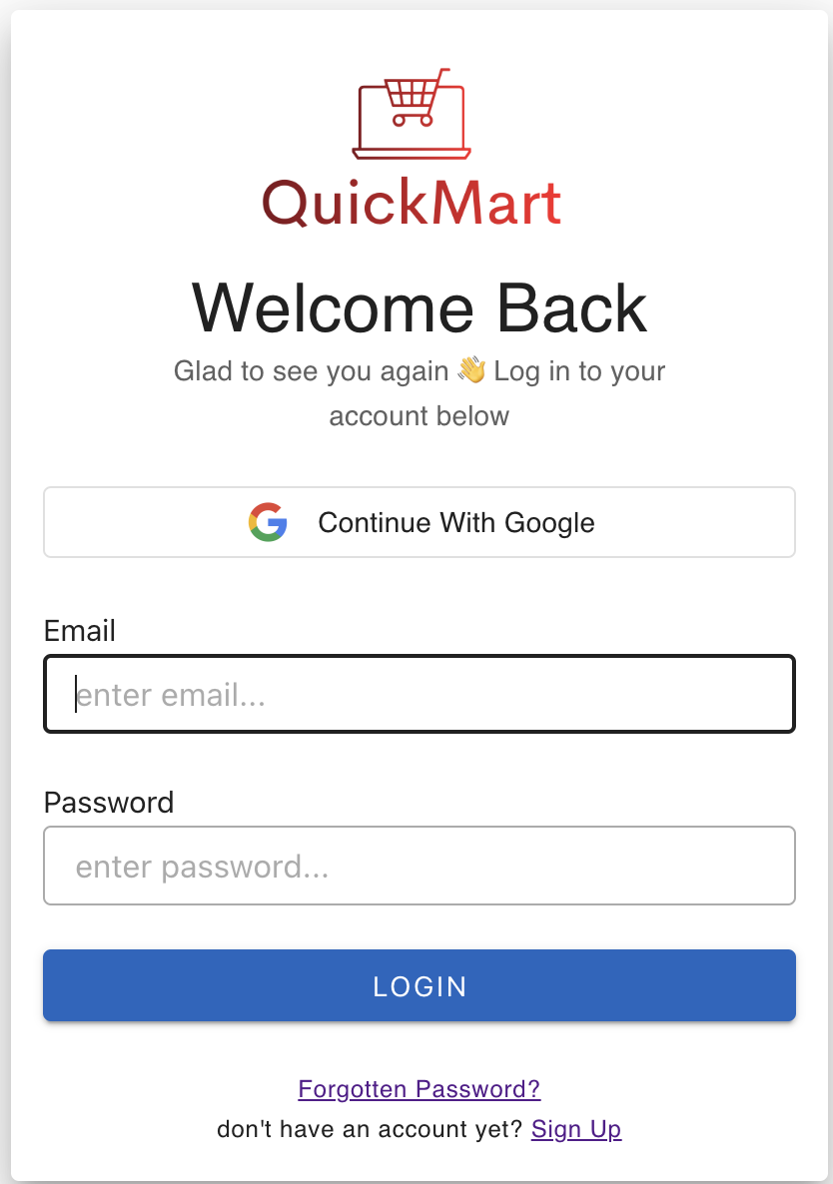
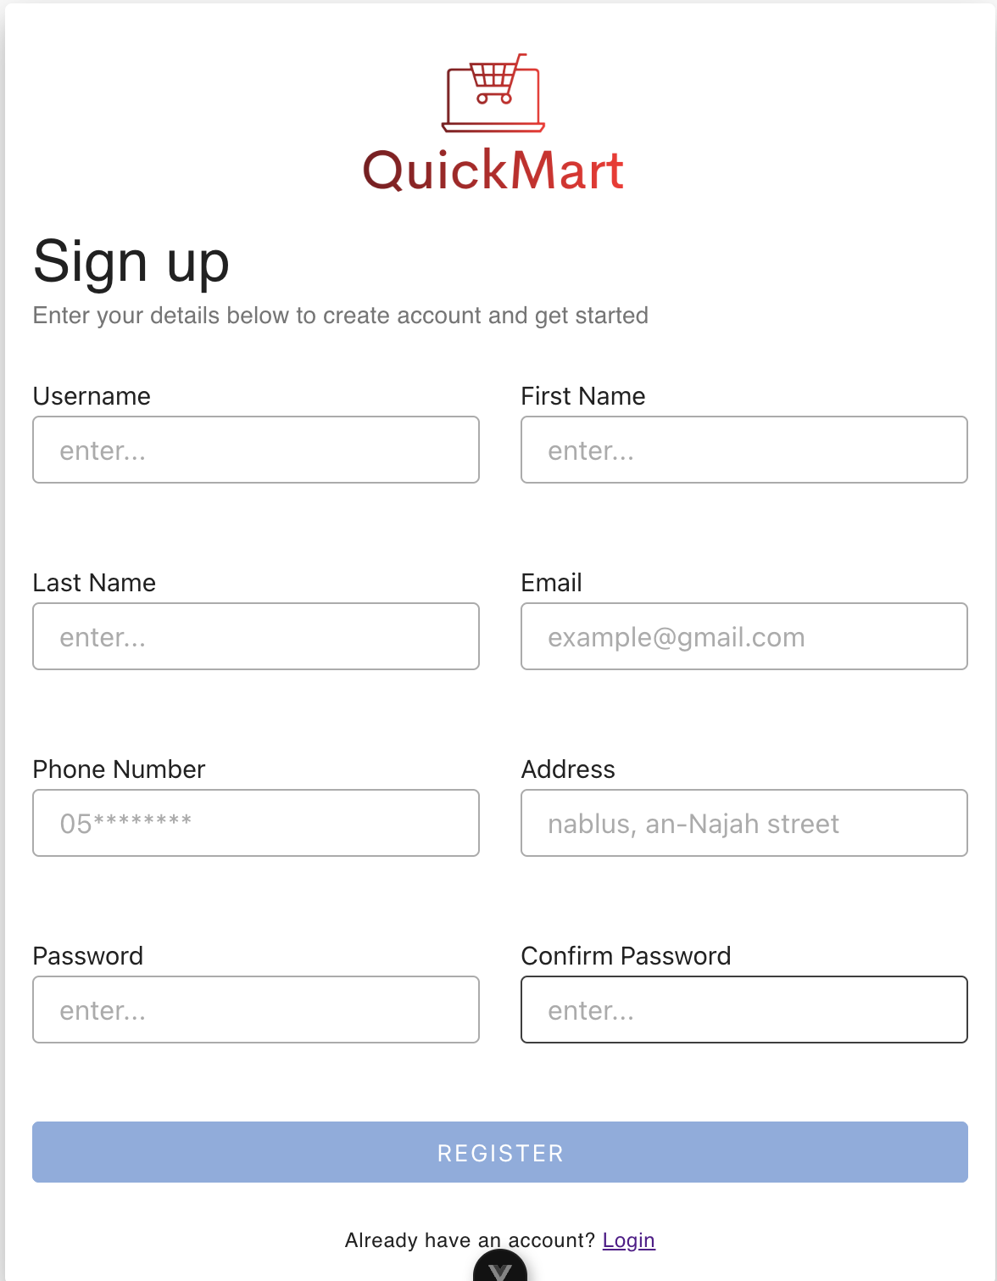
Login Form
Registration Form

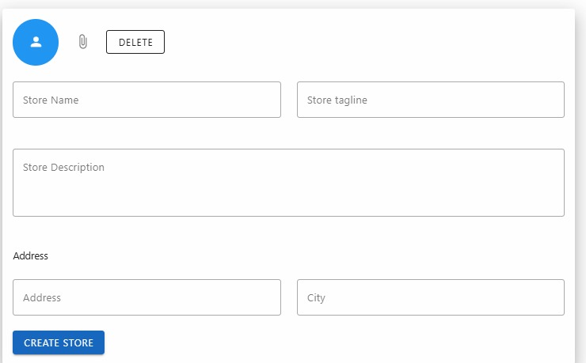

Sign up as Store

Here we have two interfaces for login and the other for registration, where you can register as a merchant and you can register as a user, where you need to enter the email and password to enter and requires both the first name, username, password, address and email ,elch…

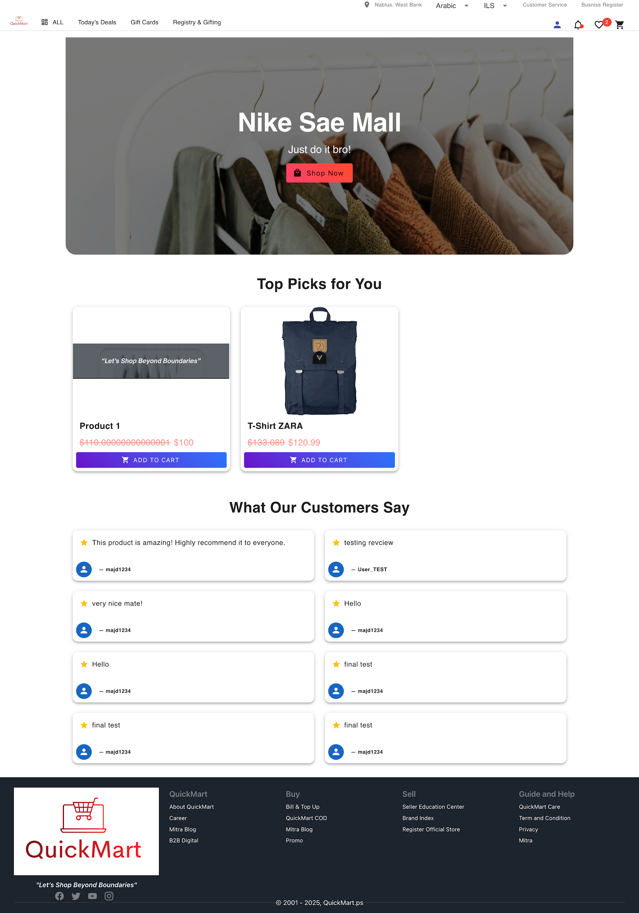
4.2.2 Main Store Pages
Store Profile Page
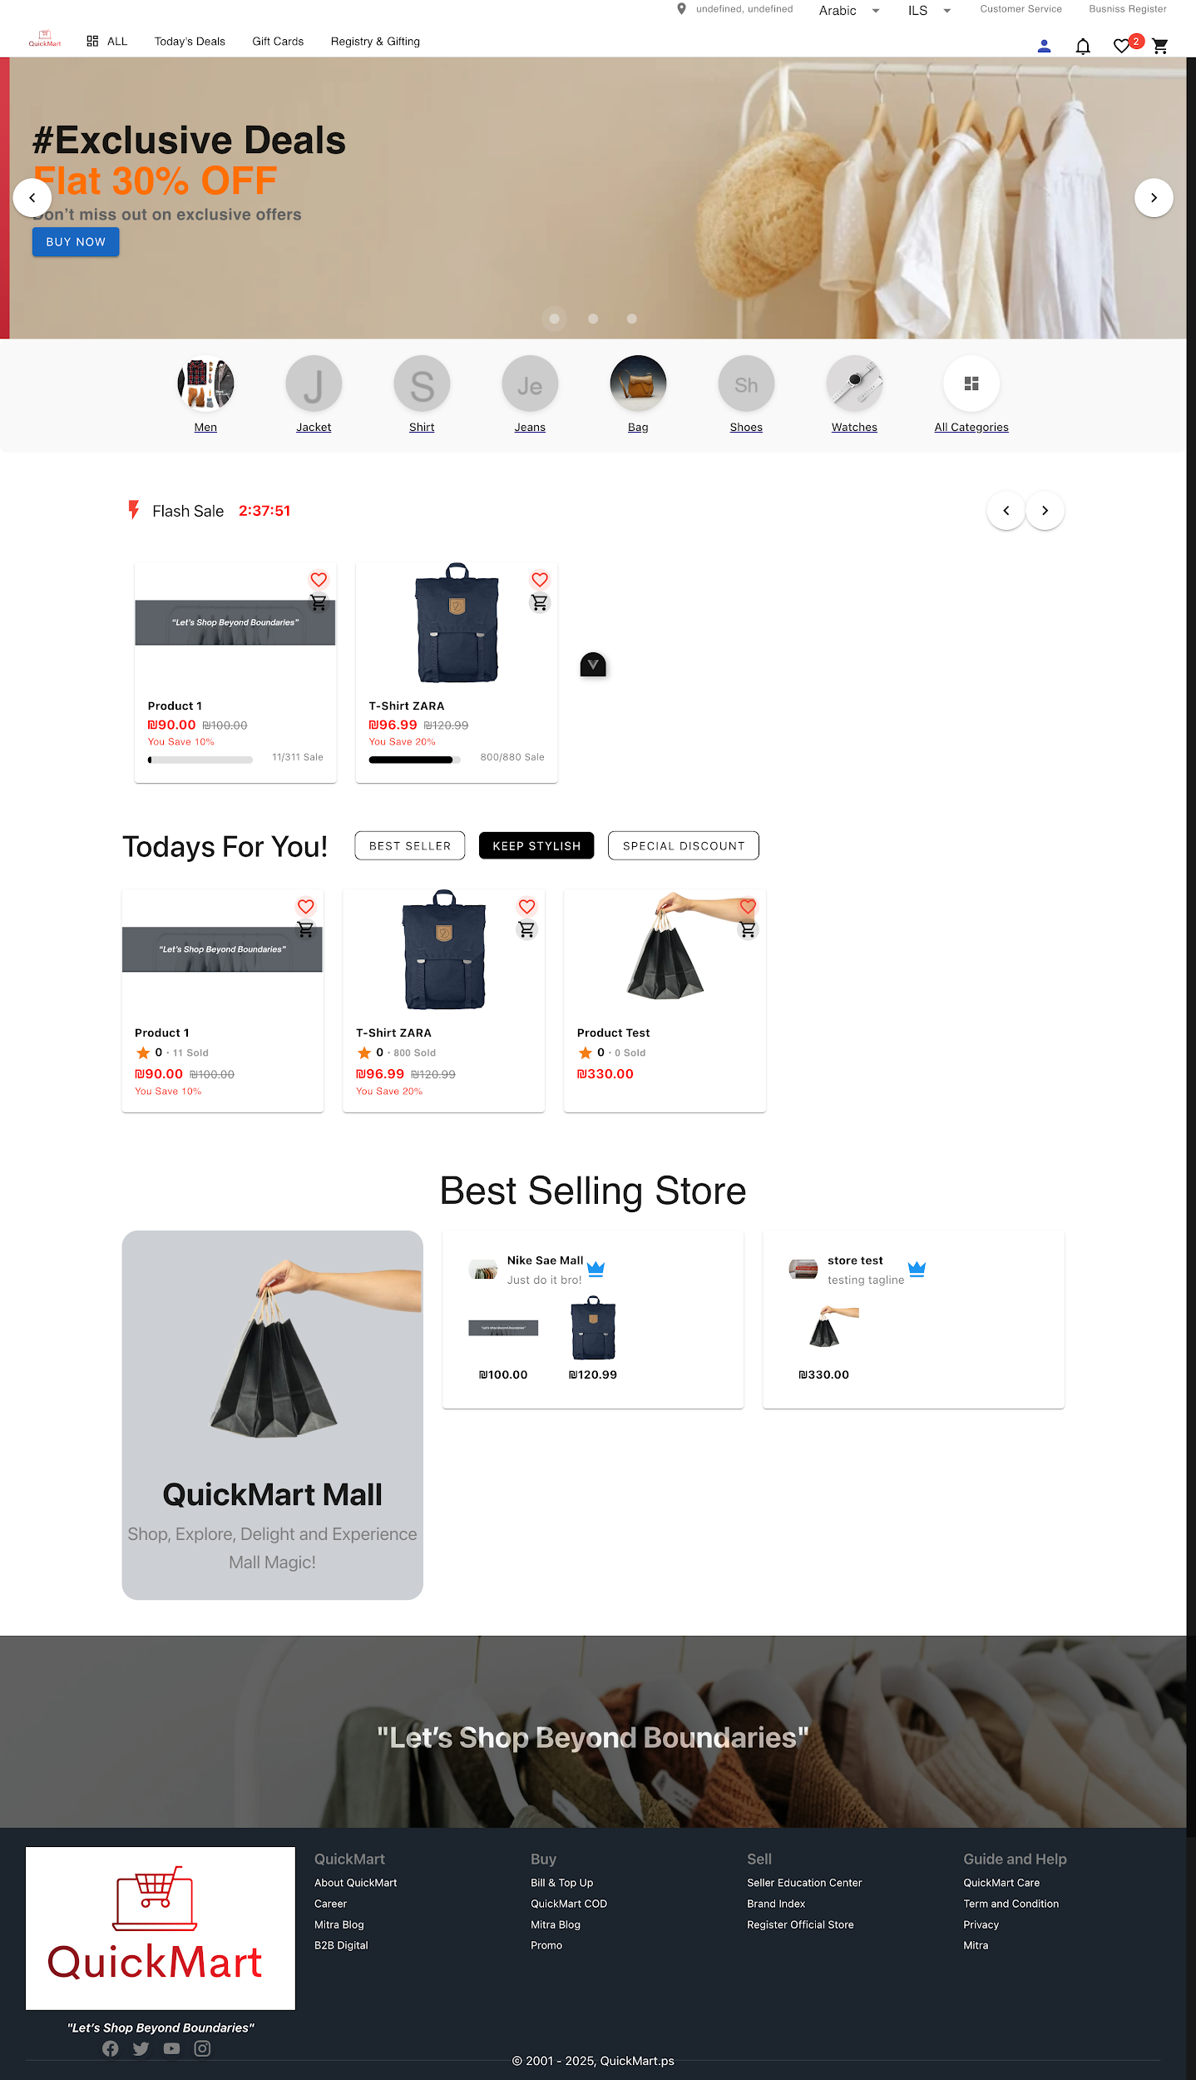
Landing Page

Here at landing page I have an advertising interface where both the store owner or the customer can advertise his goods .
I also have a list in the catalog and I also have a flash sales based on some products
And I also have today for you in which the best-selling, the best-selling and others

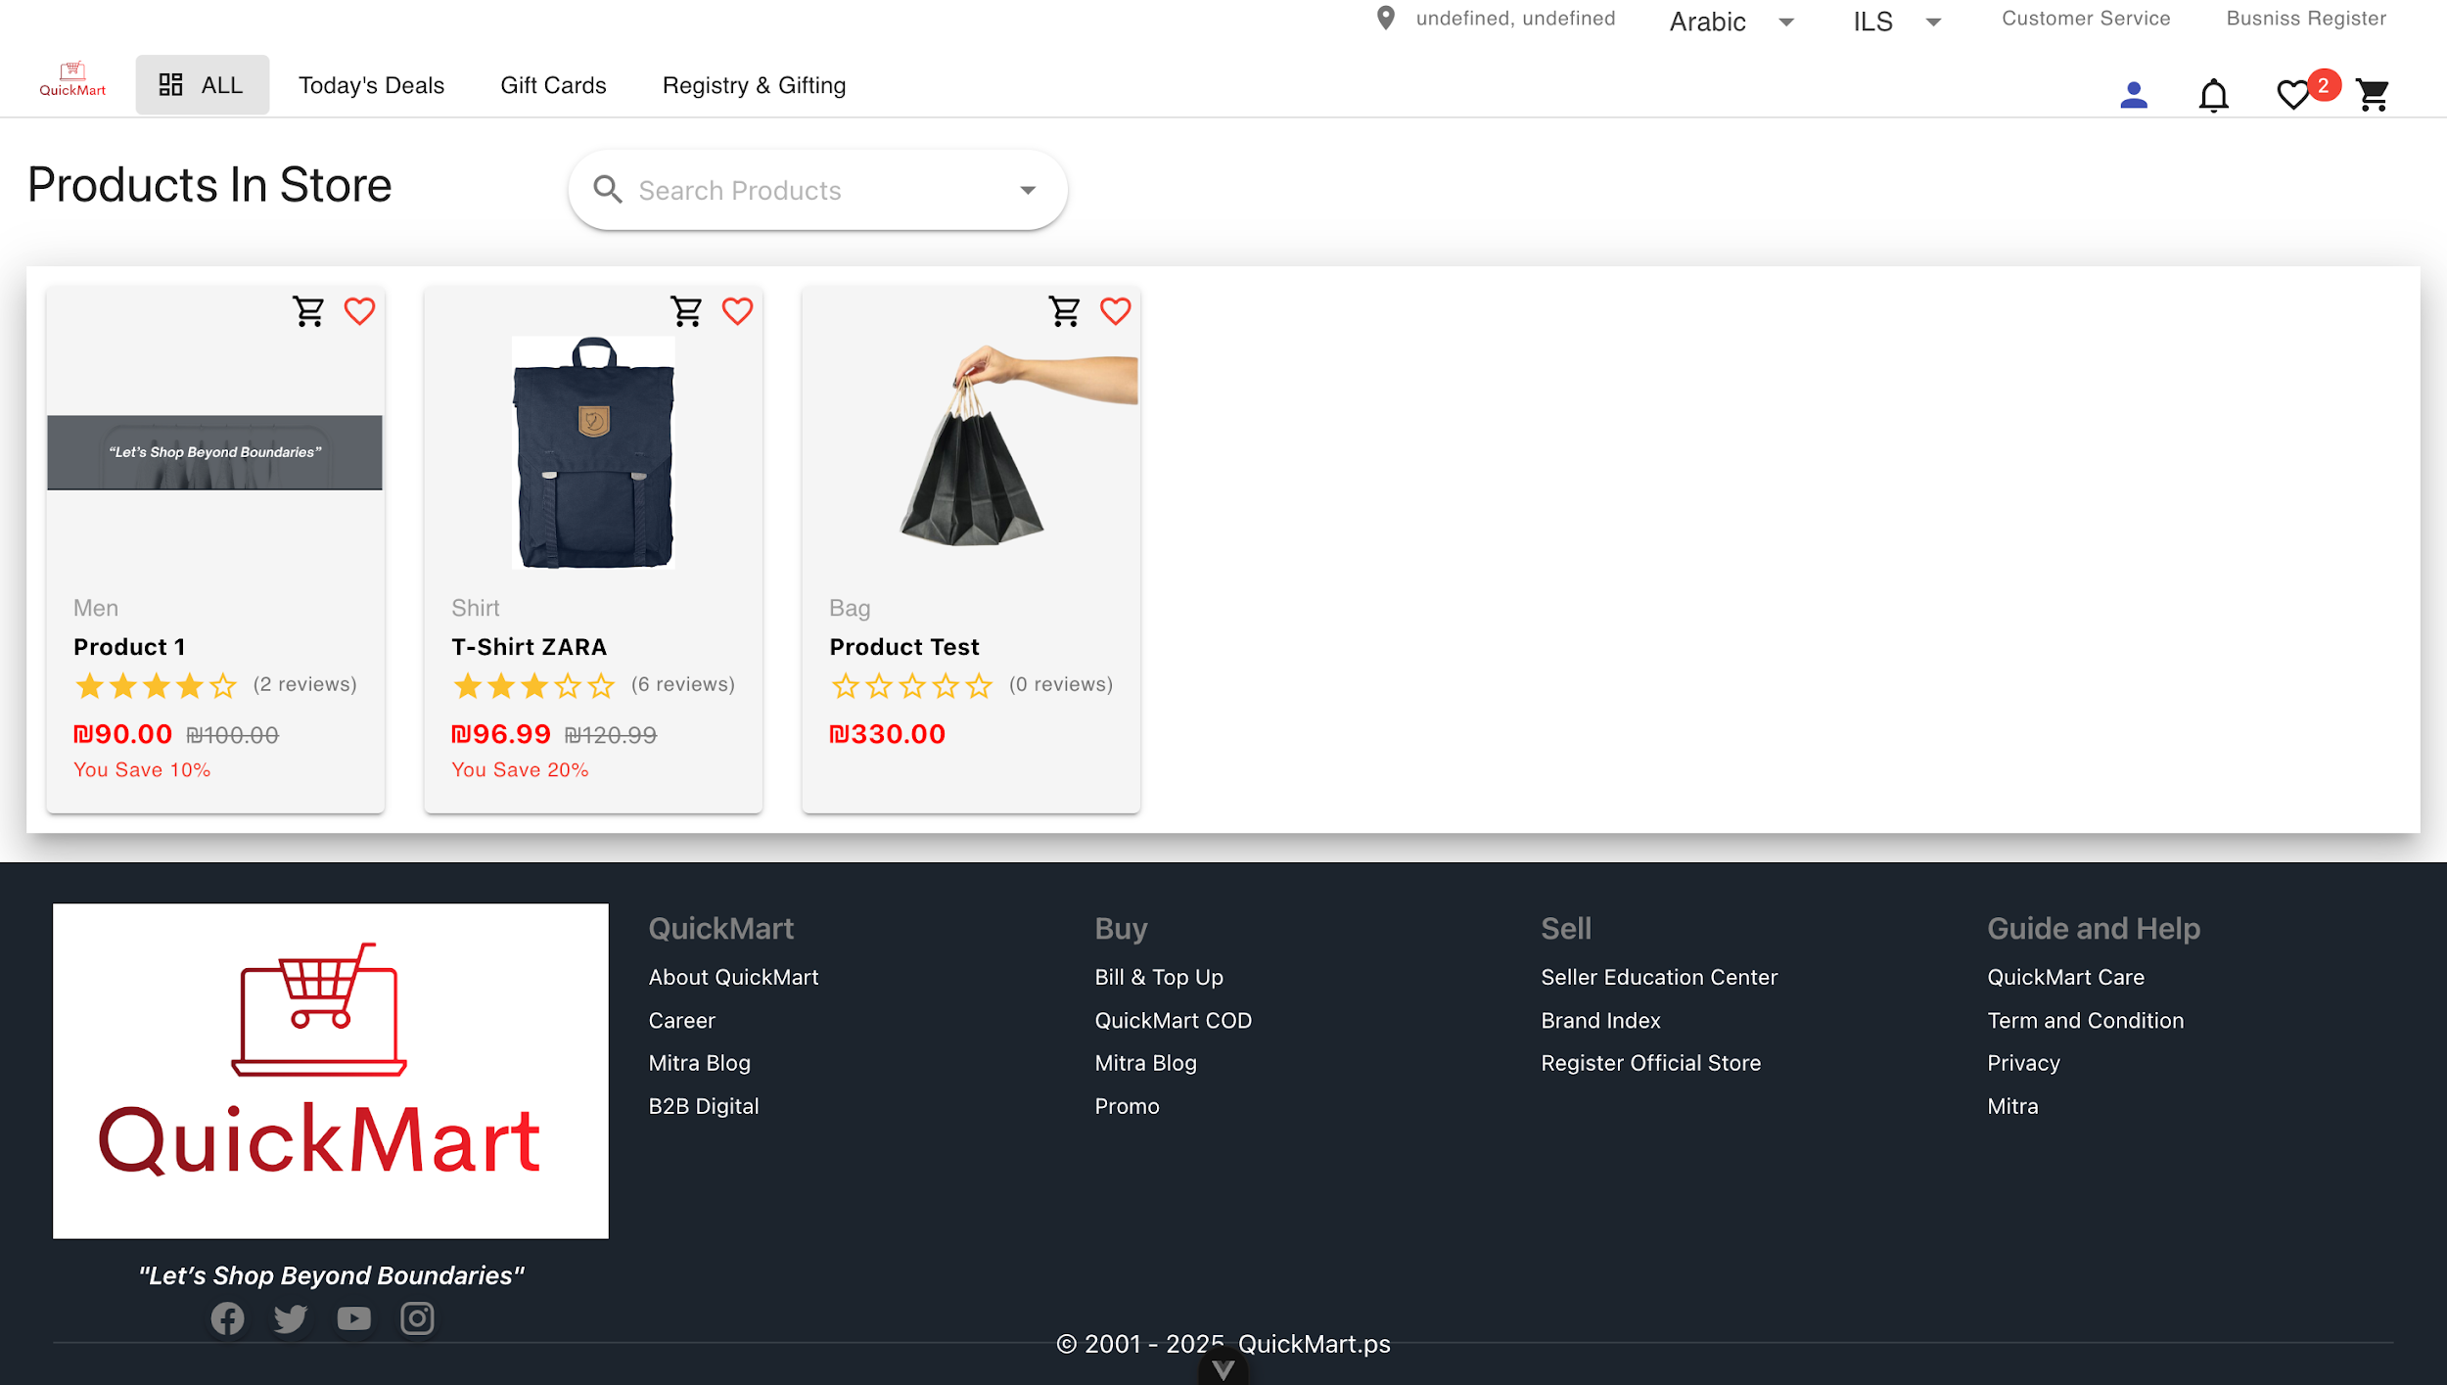
Products Page

I have a product in store here that displays products with their prices, photos, ratings and discounts

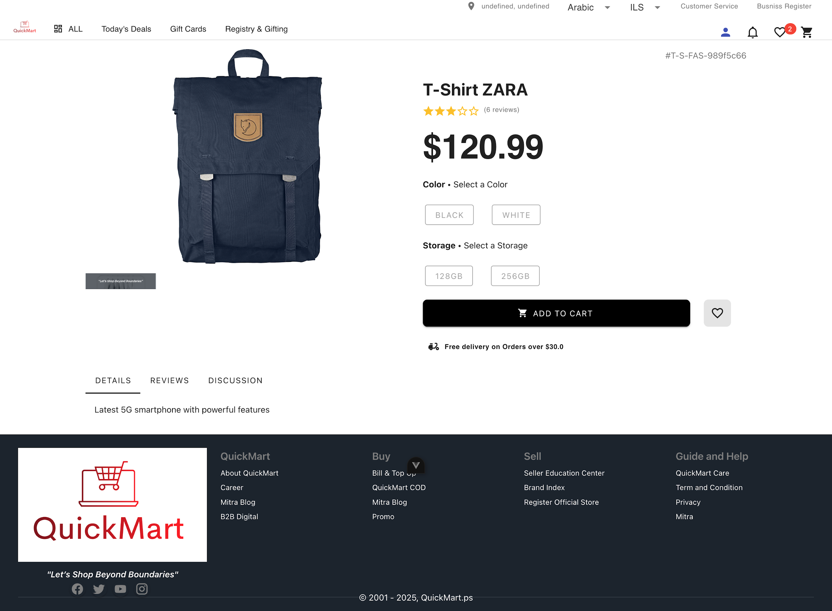
Product Details Page

I have here the product details where the products are displayed with their prices, image, rating, discounts and the possibility of adding them to the card, there is also the available color and size, and there is a list that displays both opinions and evaluation, details and discussion of customers.

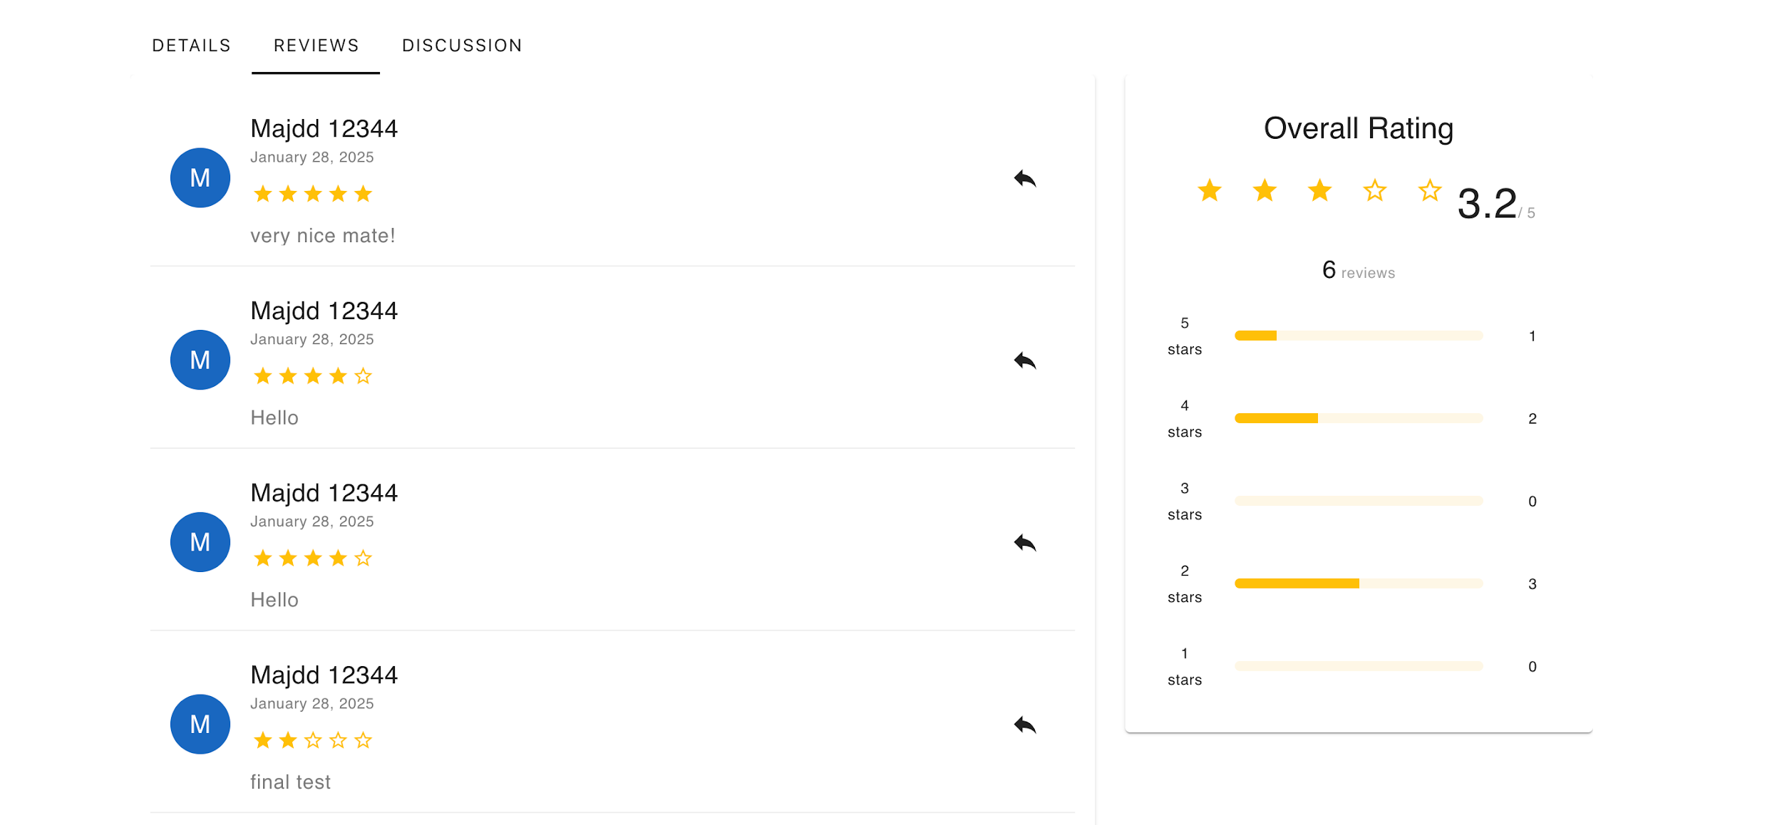

Product Review Section

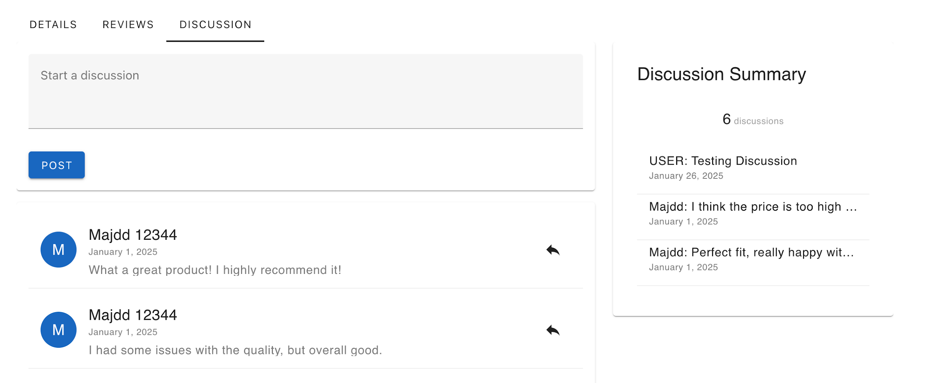

Product Discussion Section

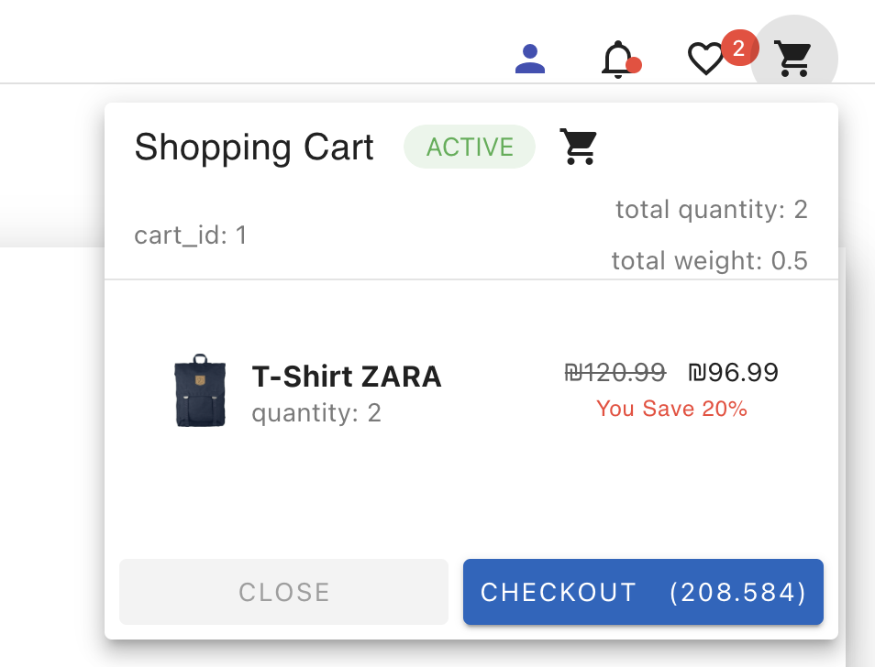

Cart Summery Menu

Here I have a shopping card that contains the ID card and I have the required quantity and I have the price before the discount and after where I can make a check out for the order .

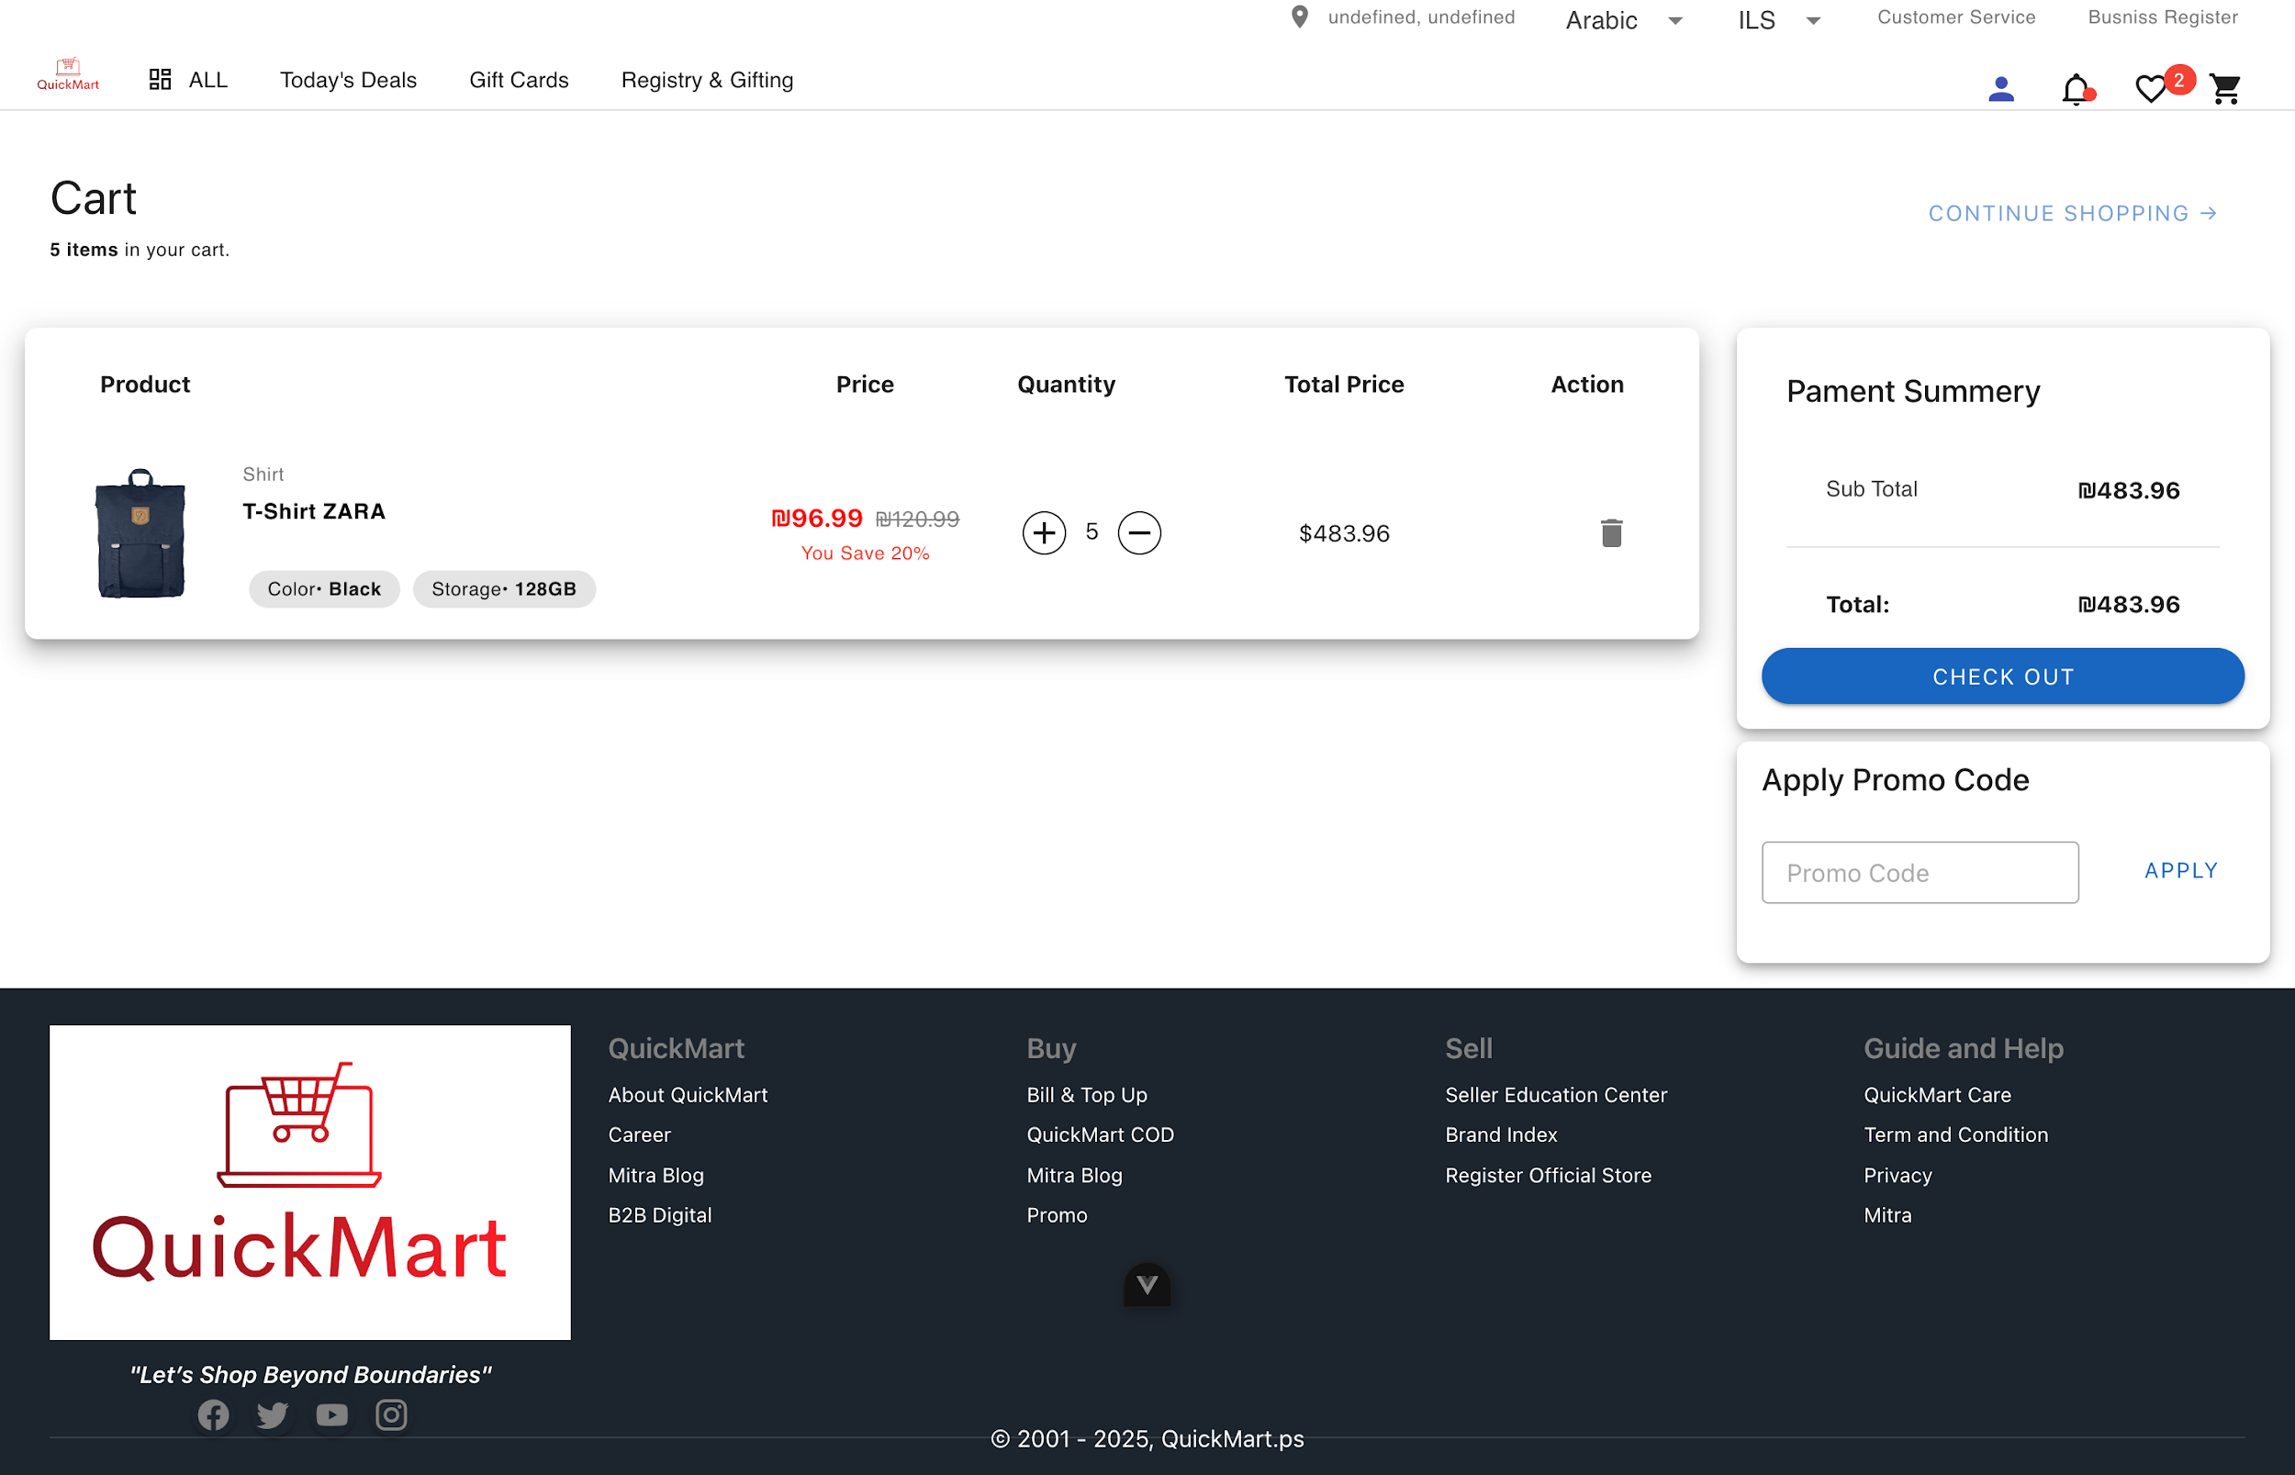
Cart Page

Here I have the product and its details inside the card, where there is the price, quantity and total price, and on the left there is the payment Summery, where I can make a check out and it is found that I can add the discount promo code from the ad.

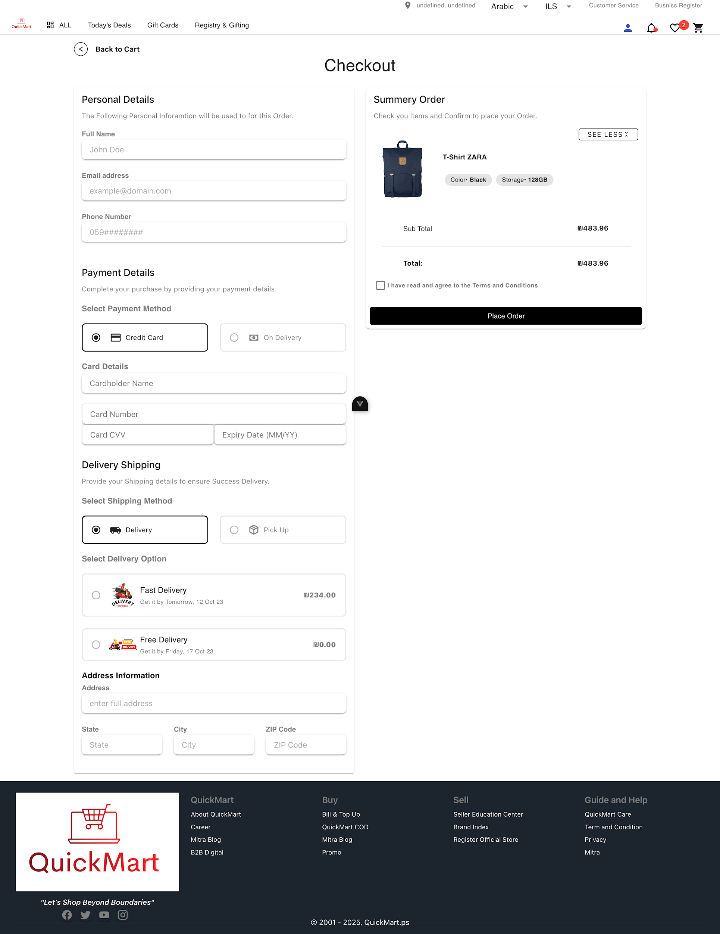
Checkout Page

Here I have the necessary information inside the check out page, first of all, personal information from email, number and full name must be entered

Then the answer is to enter the payment information such as the payment mechanism through the credit card or the accounting of the delivery driver and we have the methods of receipt where we can receive from the store or through the delivery.

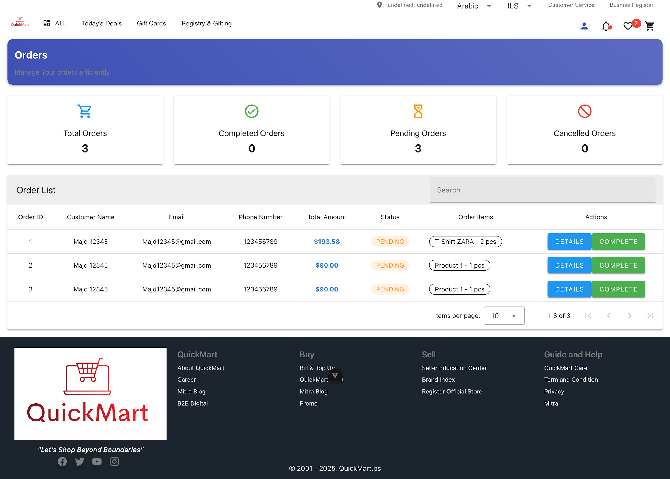
Customer Orders Page

Here we have the total number of orders, the number of completed orders, the number of orders that are on the Pending list and the number of canceled orders, and also there is a table in the list of orders and contains the full information of the orders .

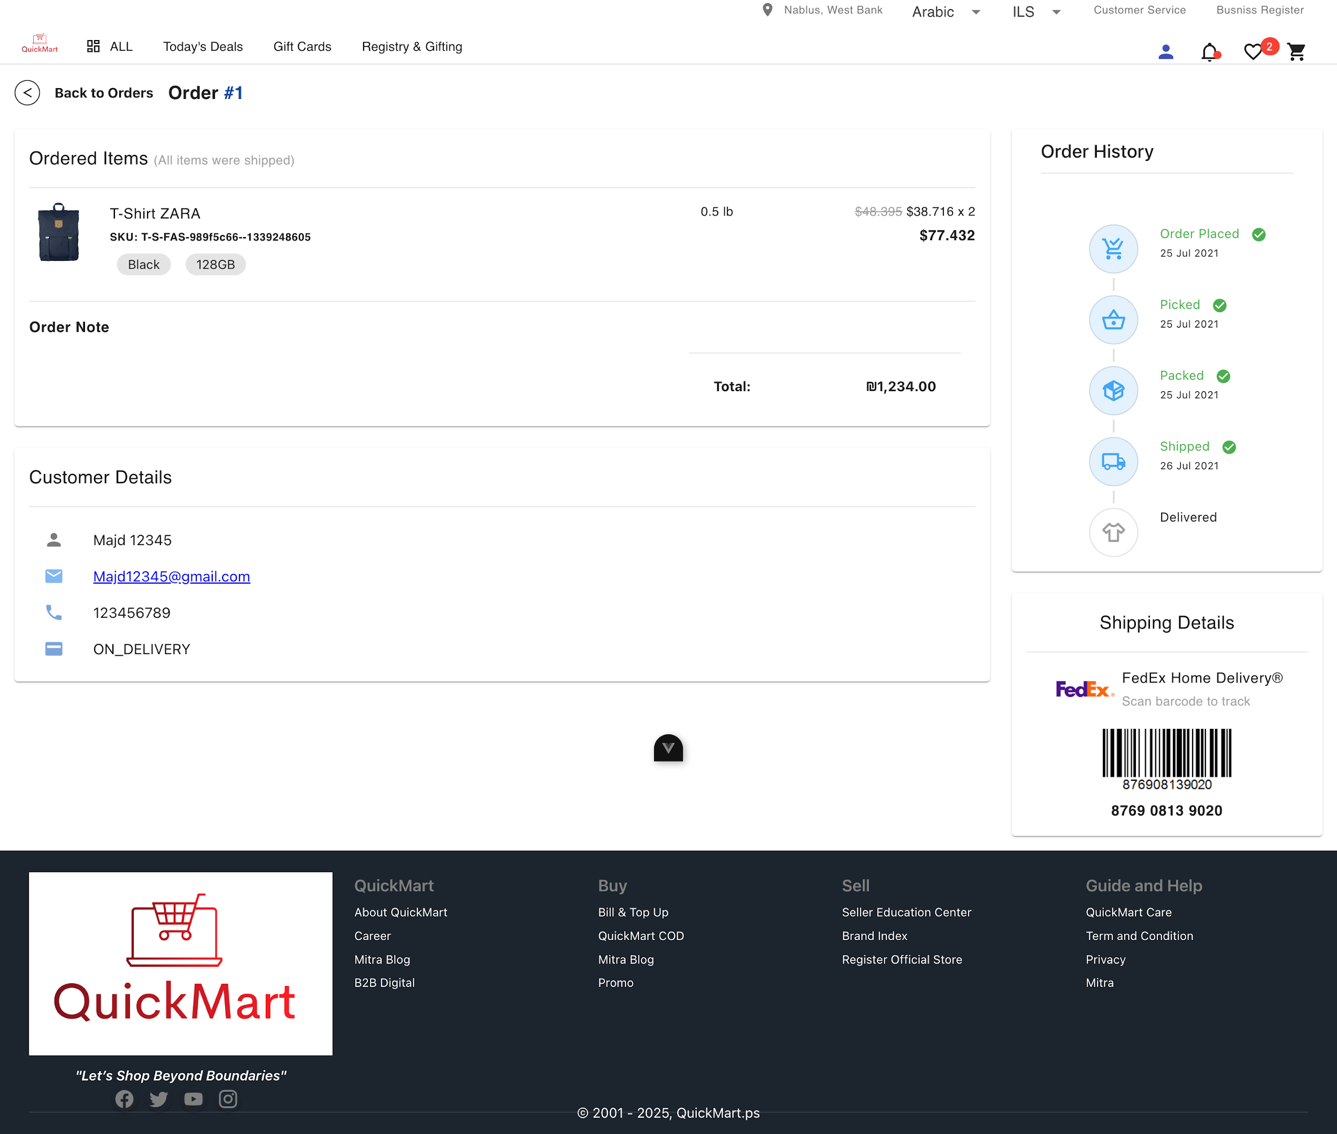
Customer Orders Details Page

Here we have the full order information from the color, size, price and image and there is also the customer information below and there is a history order on the right until the customer arrives .

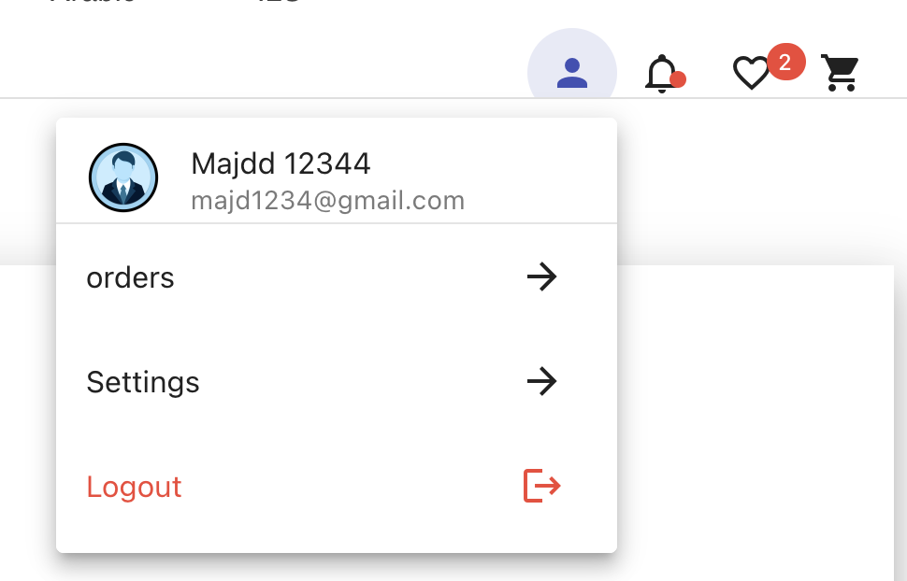

User Menu

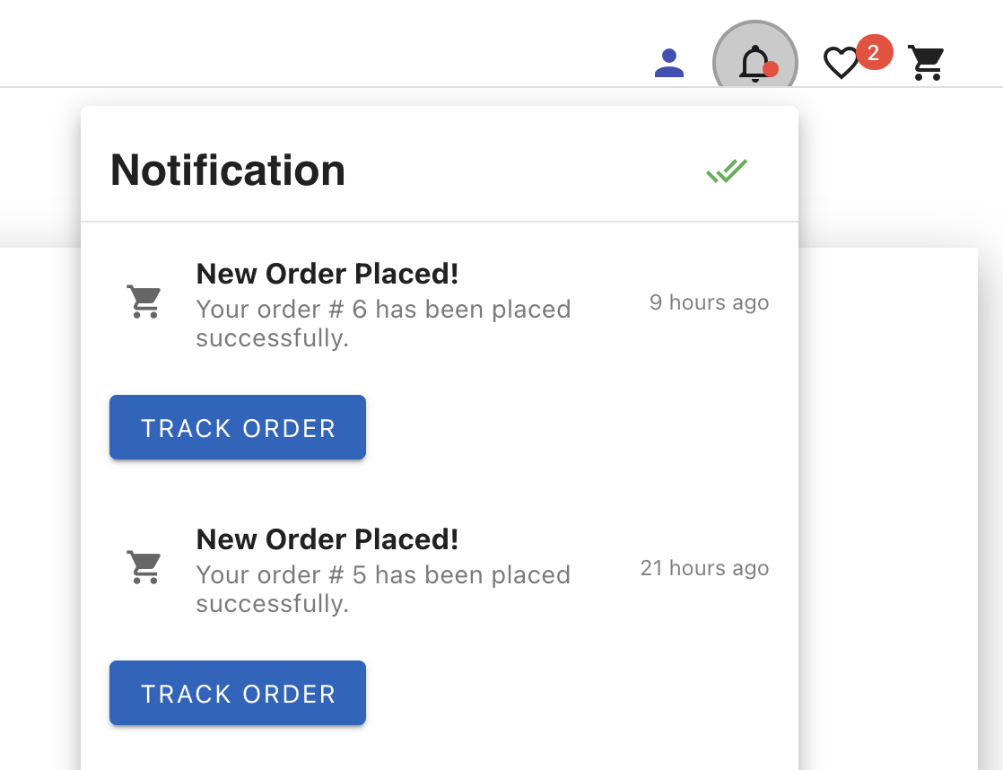

Notification Menu

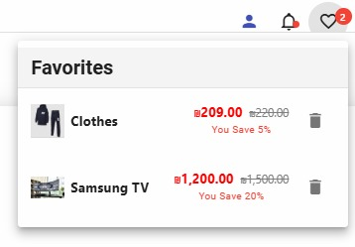
Favorites

Here we have a list of user menu orders , settings ,logout we also have a list of notifications and Favorites .

4.2.3 Vendor Dashboard Pages

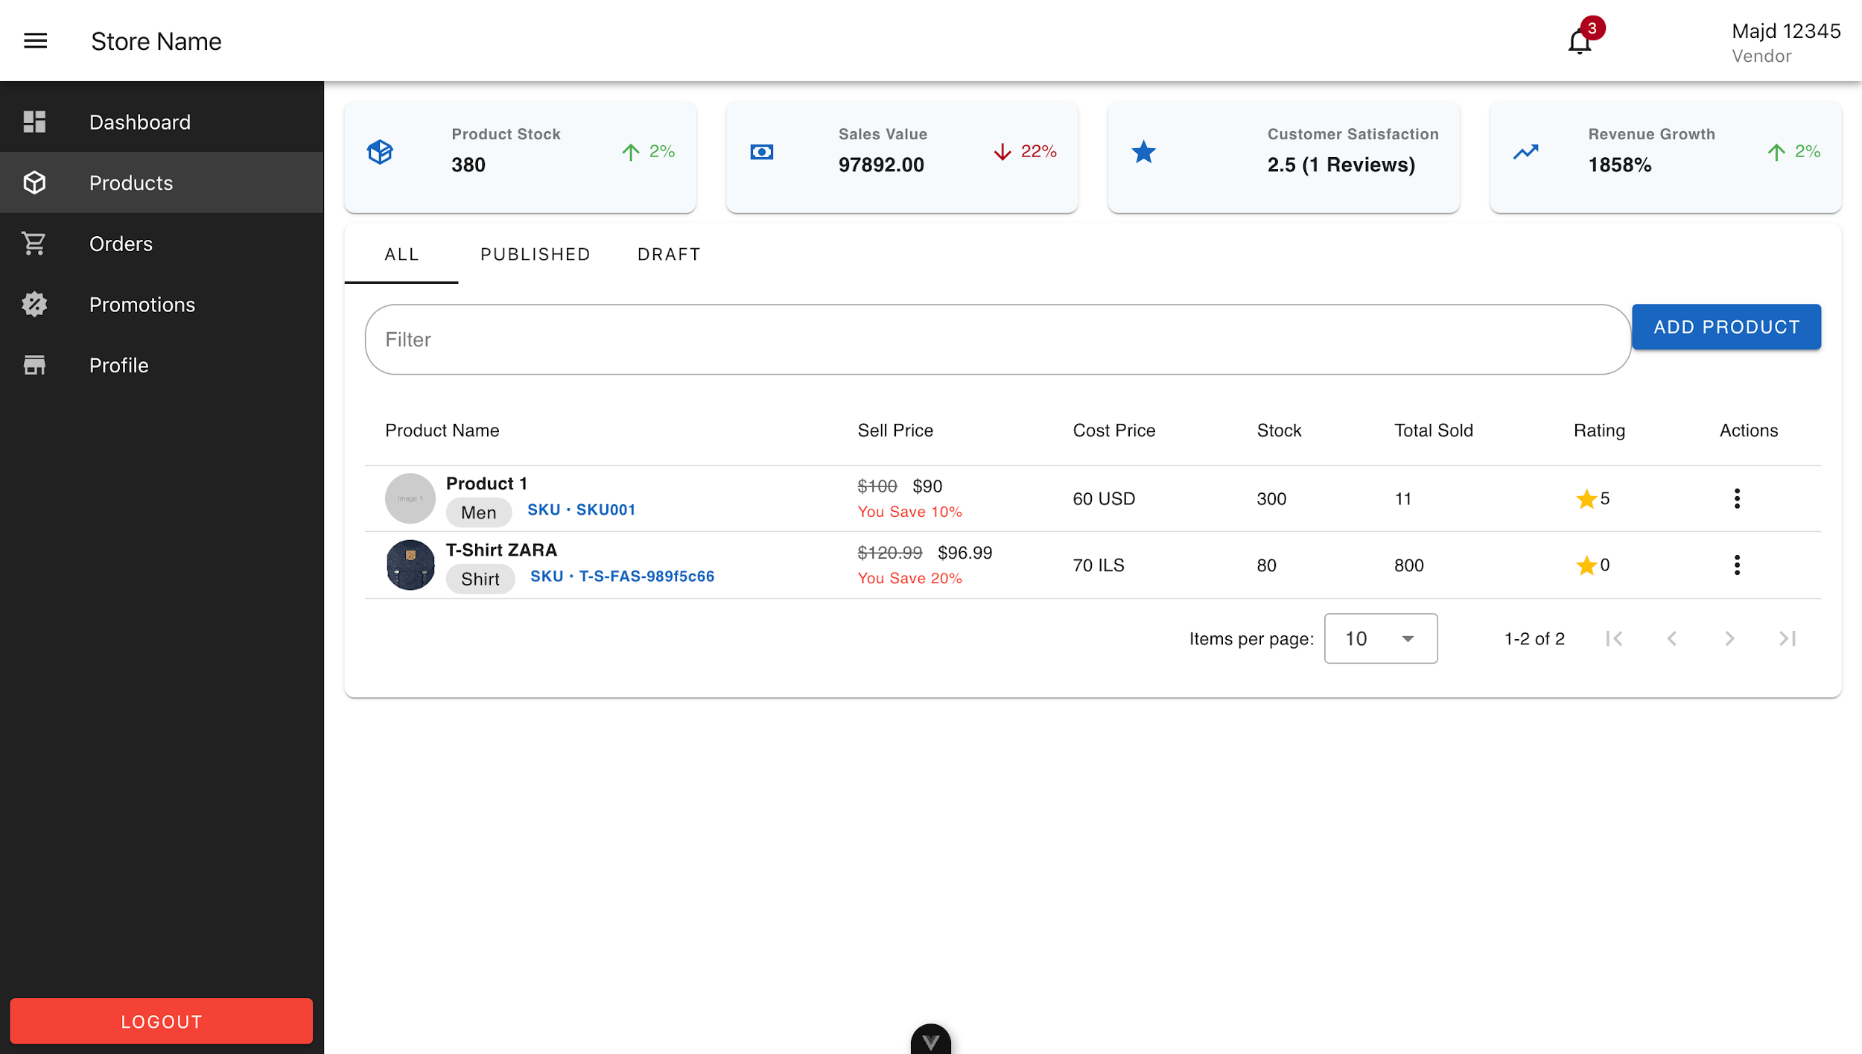

Product Management Page

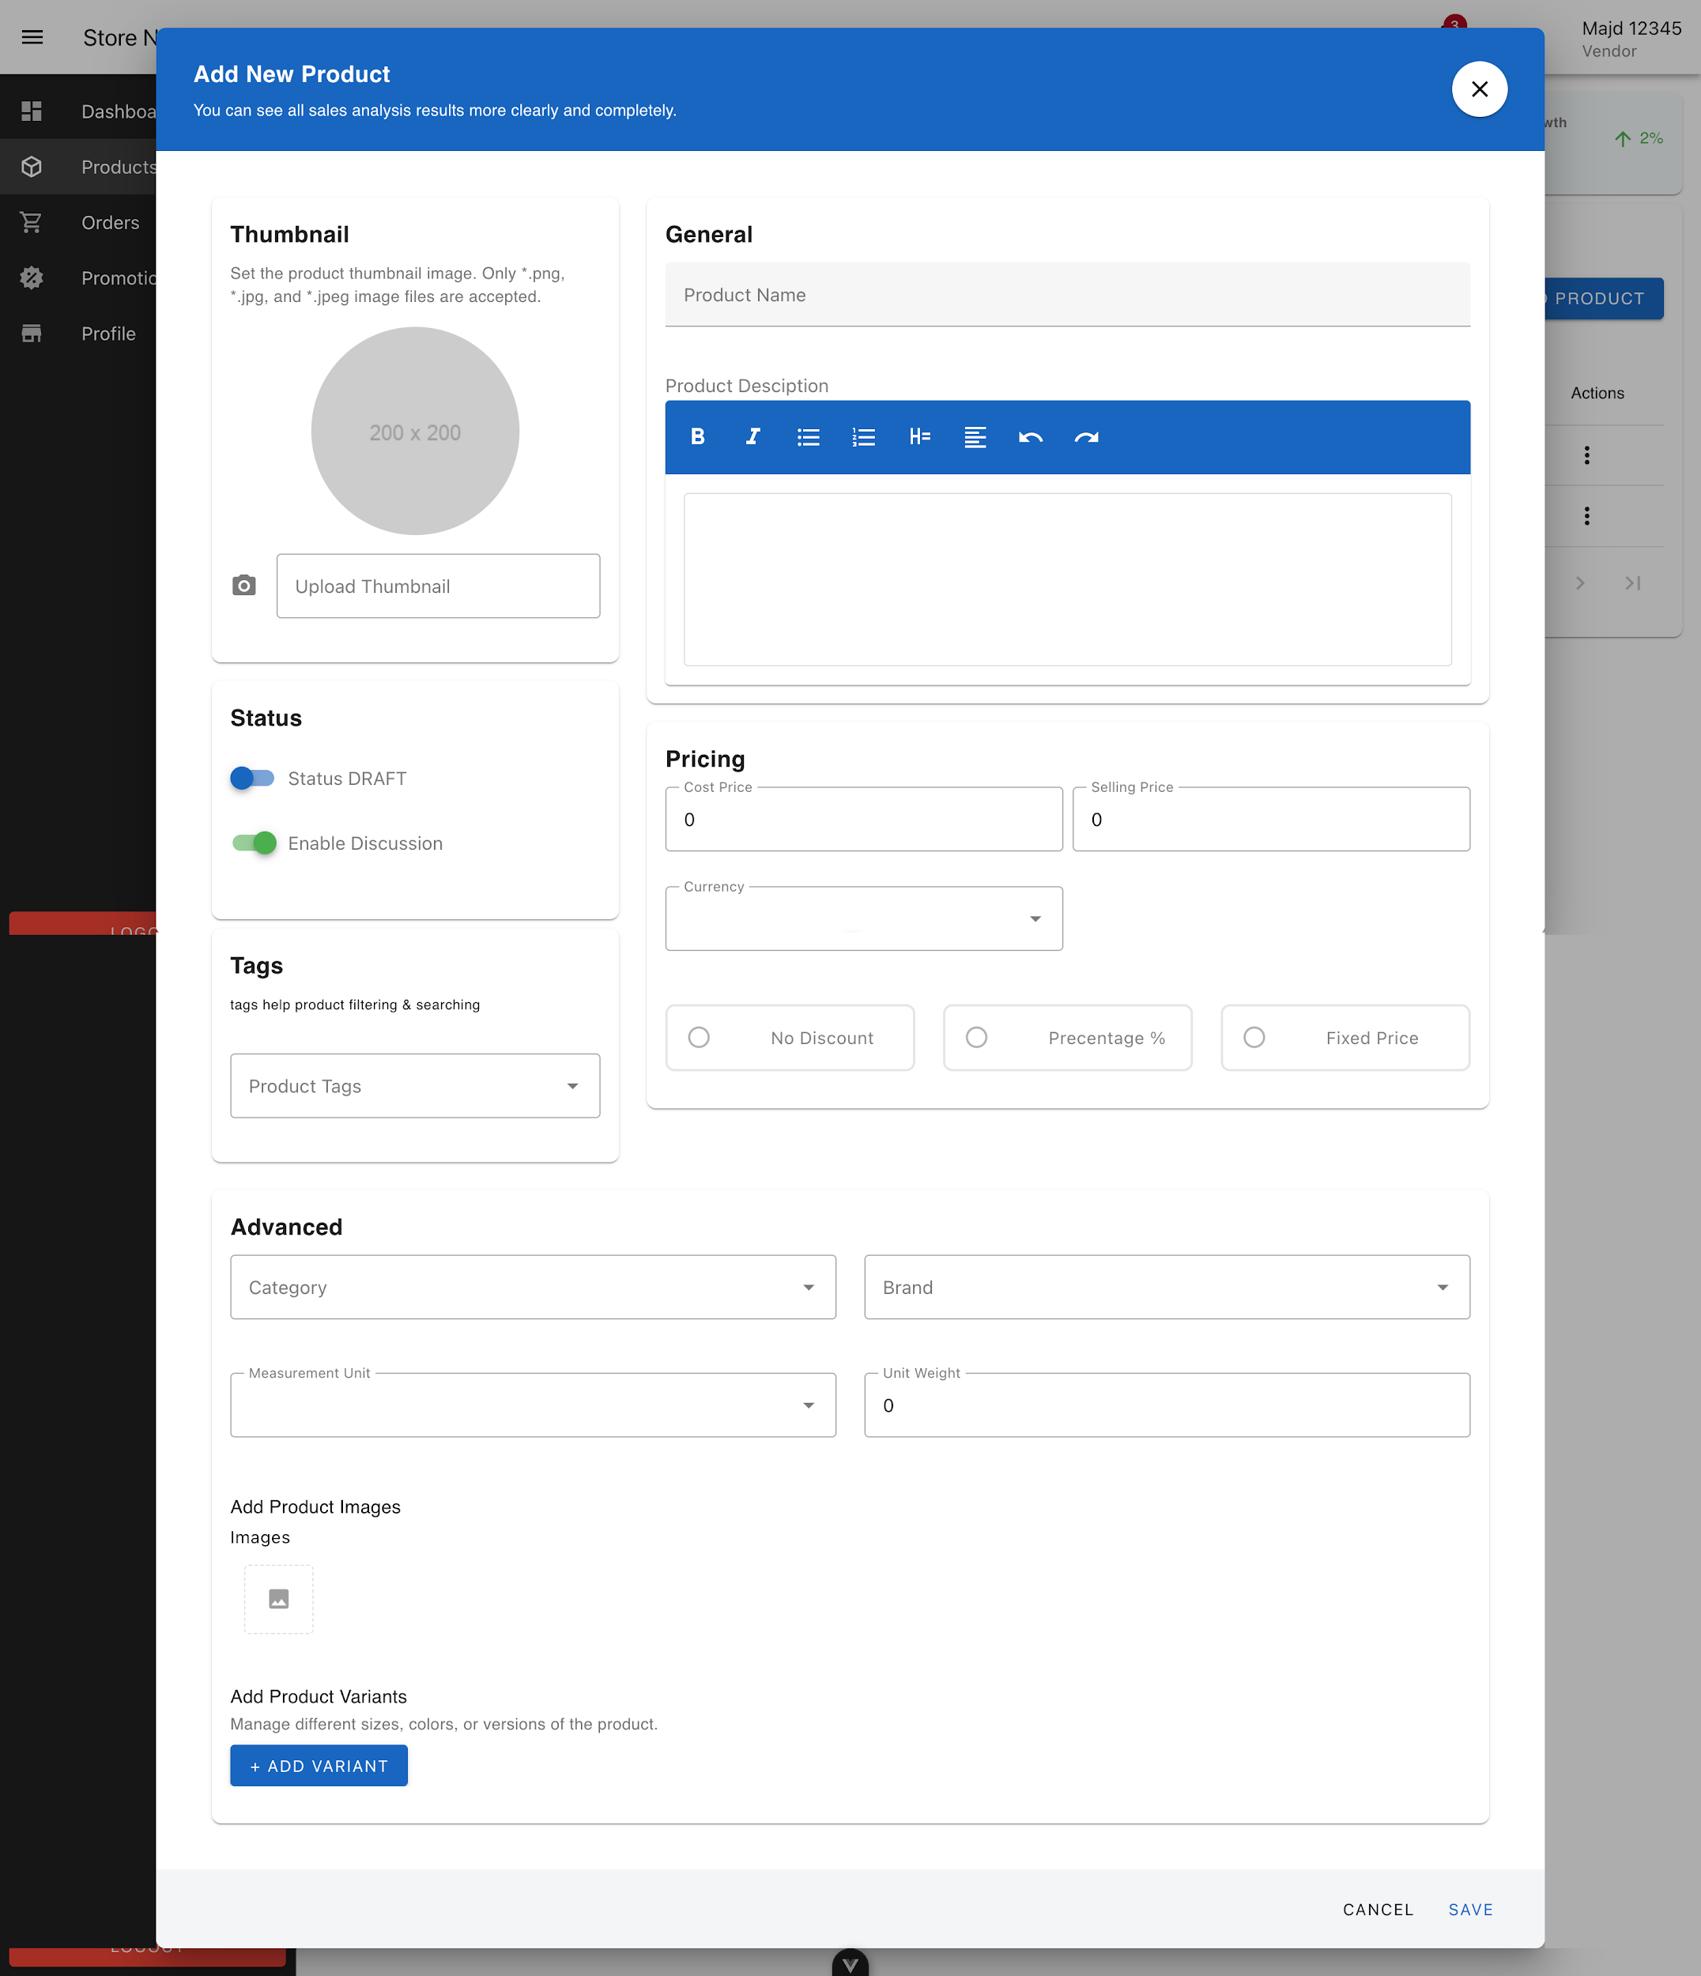

Add Product Form

Here a product is added Where You can add a photo, a description, the price, if it has a discount, the product tag, all the necessary information to display the product and a recipe in the best possible way for the customer.

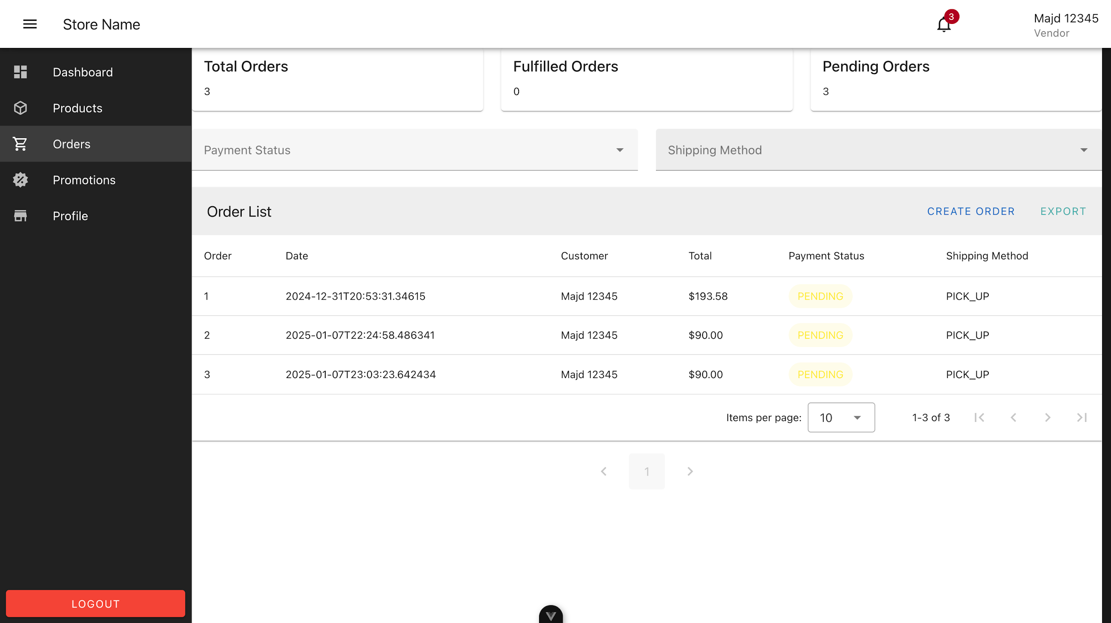

Vendor Order Management Page

Here there is the Order Number, Date and time, customer name, total We have the store settings and the possibility of modifying the name, photo, surname, description and address, and also the account information can be modified from email and password price, payment States, shipping method, and above the total number of orders, the number of Fulfilled orders, and the number of Pending orders .

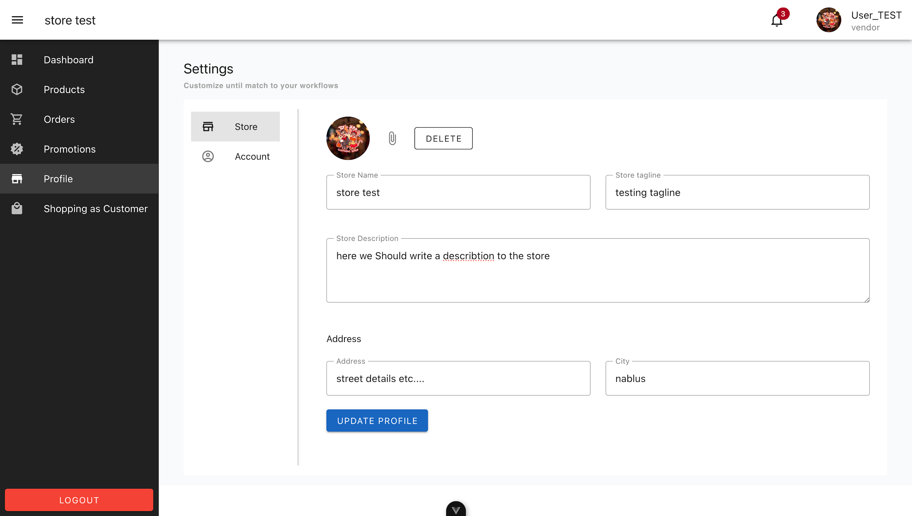

Store Profile Setting Page

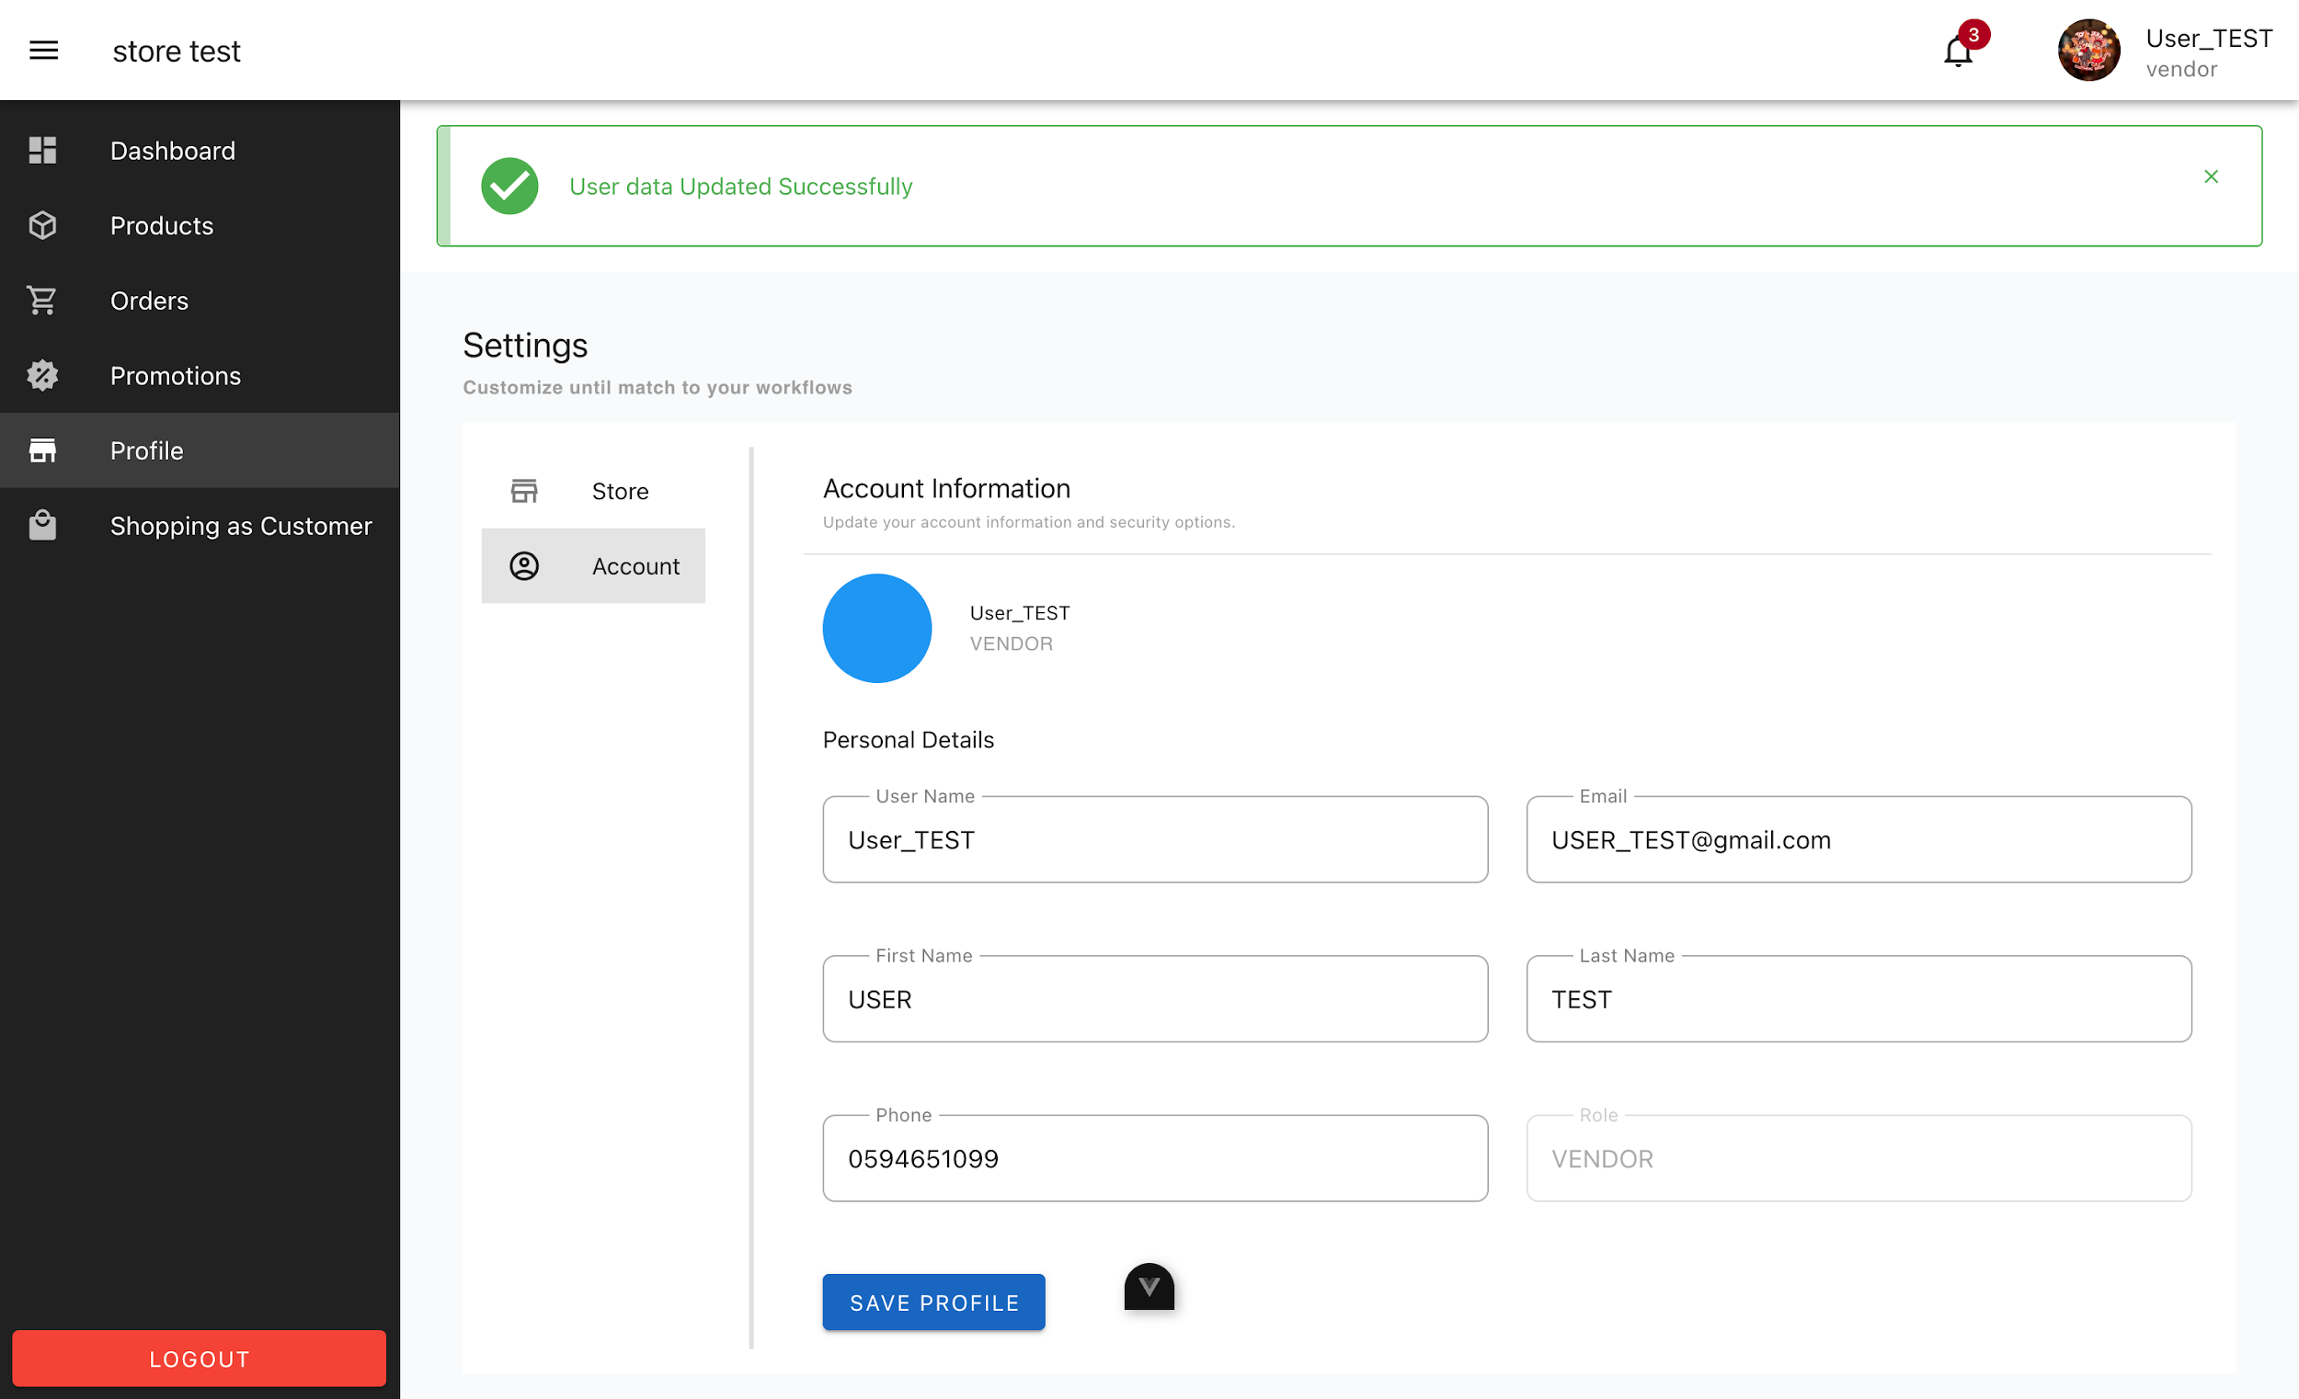

Vendor Profile Setting Page

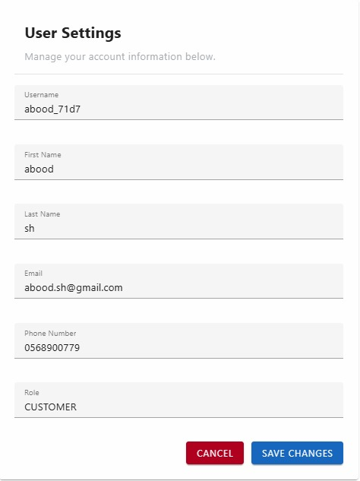
User setting

We have the store settings and the possibility of modifying the name, photo, tag name, description and address, and also the account information can be modified from email and password .

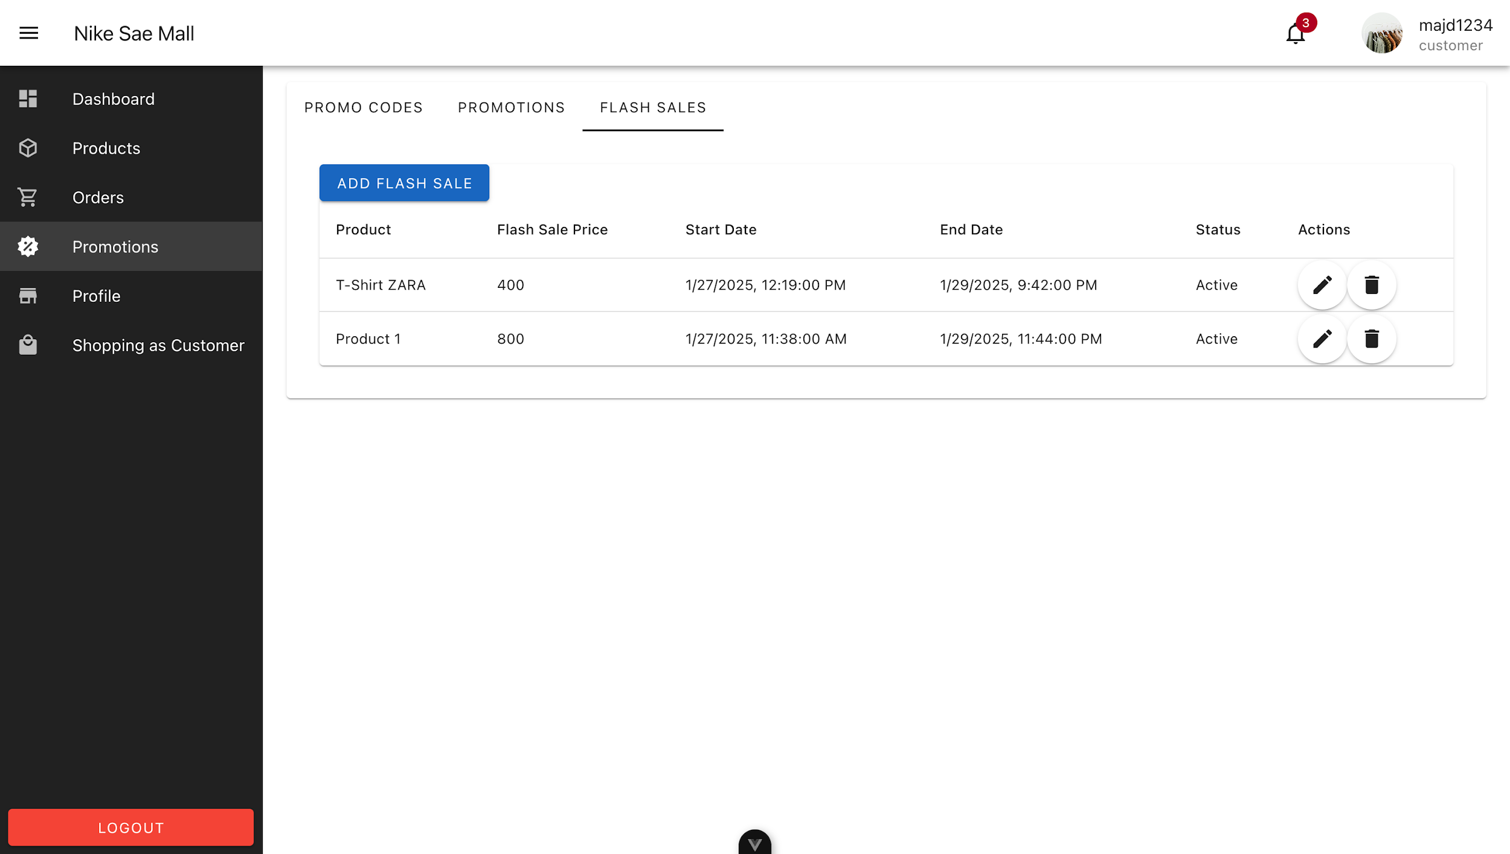

Vendor Flash Sale Management Page

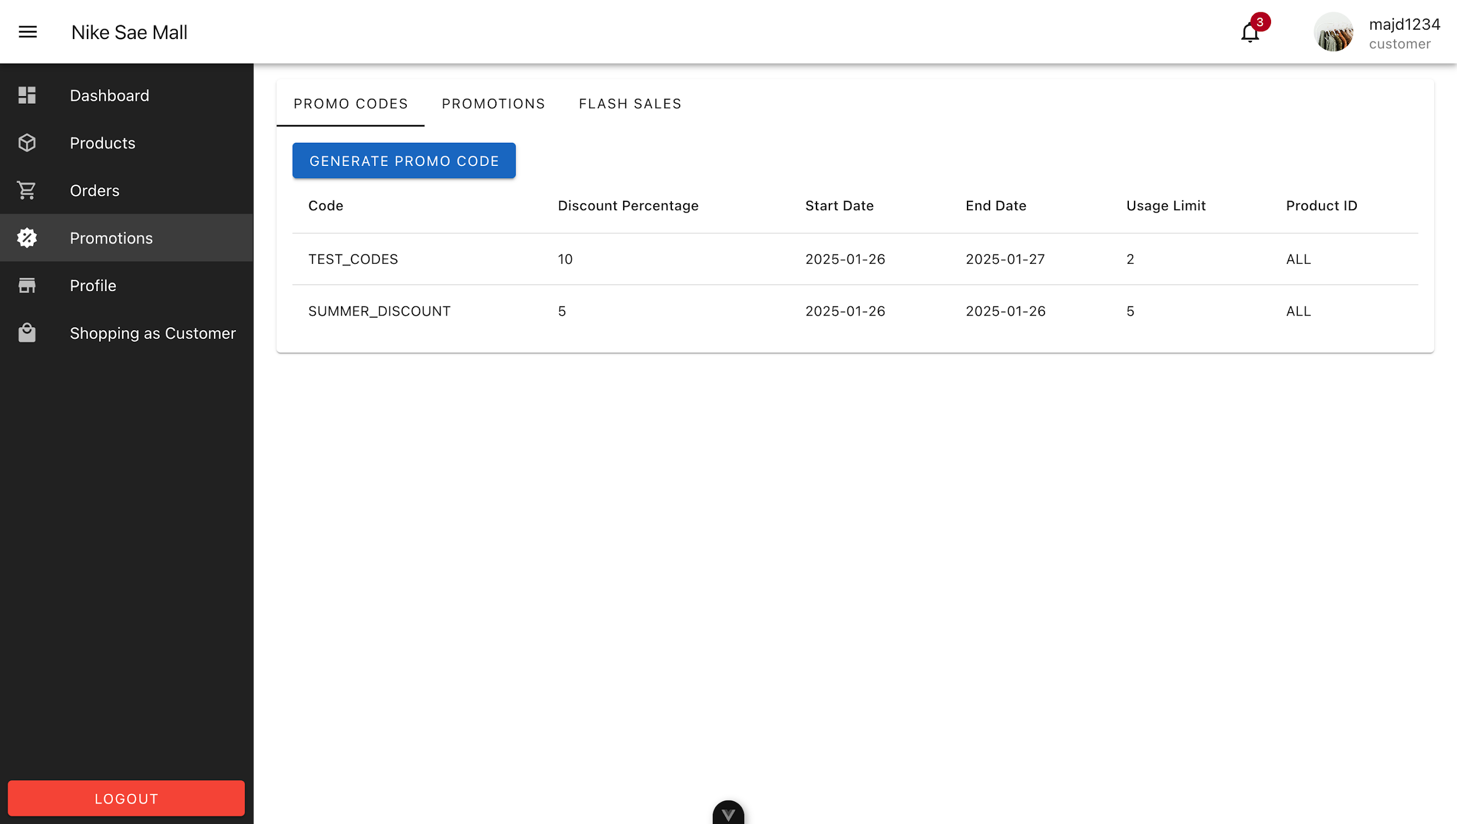

Vendor Promo Code Management Page

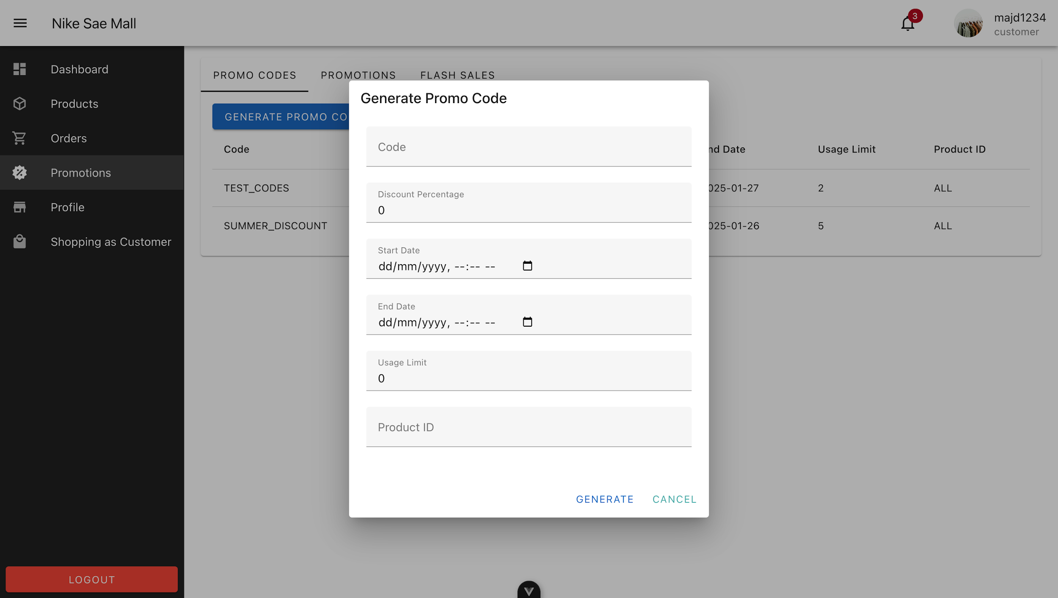

Vendor Promo Code Form

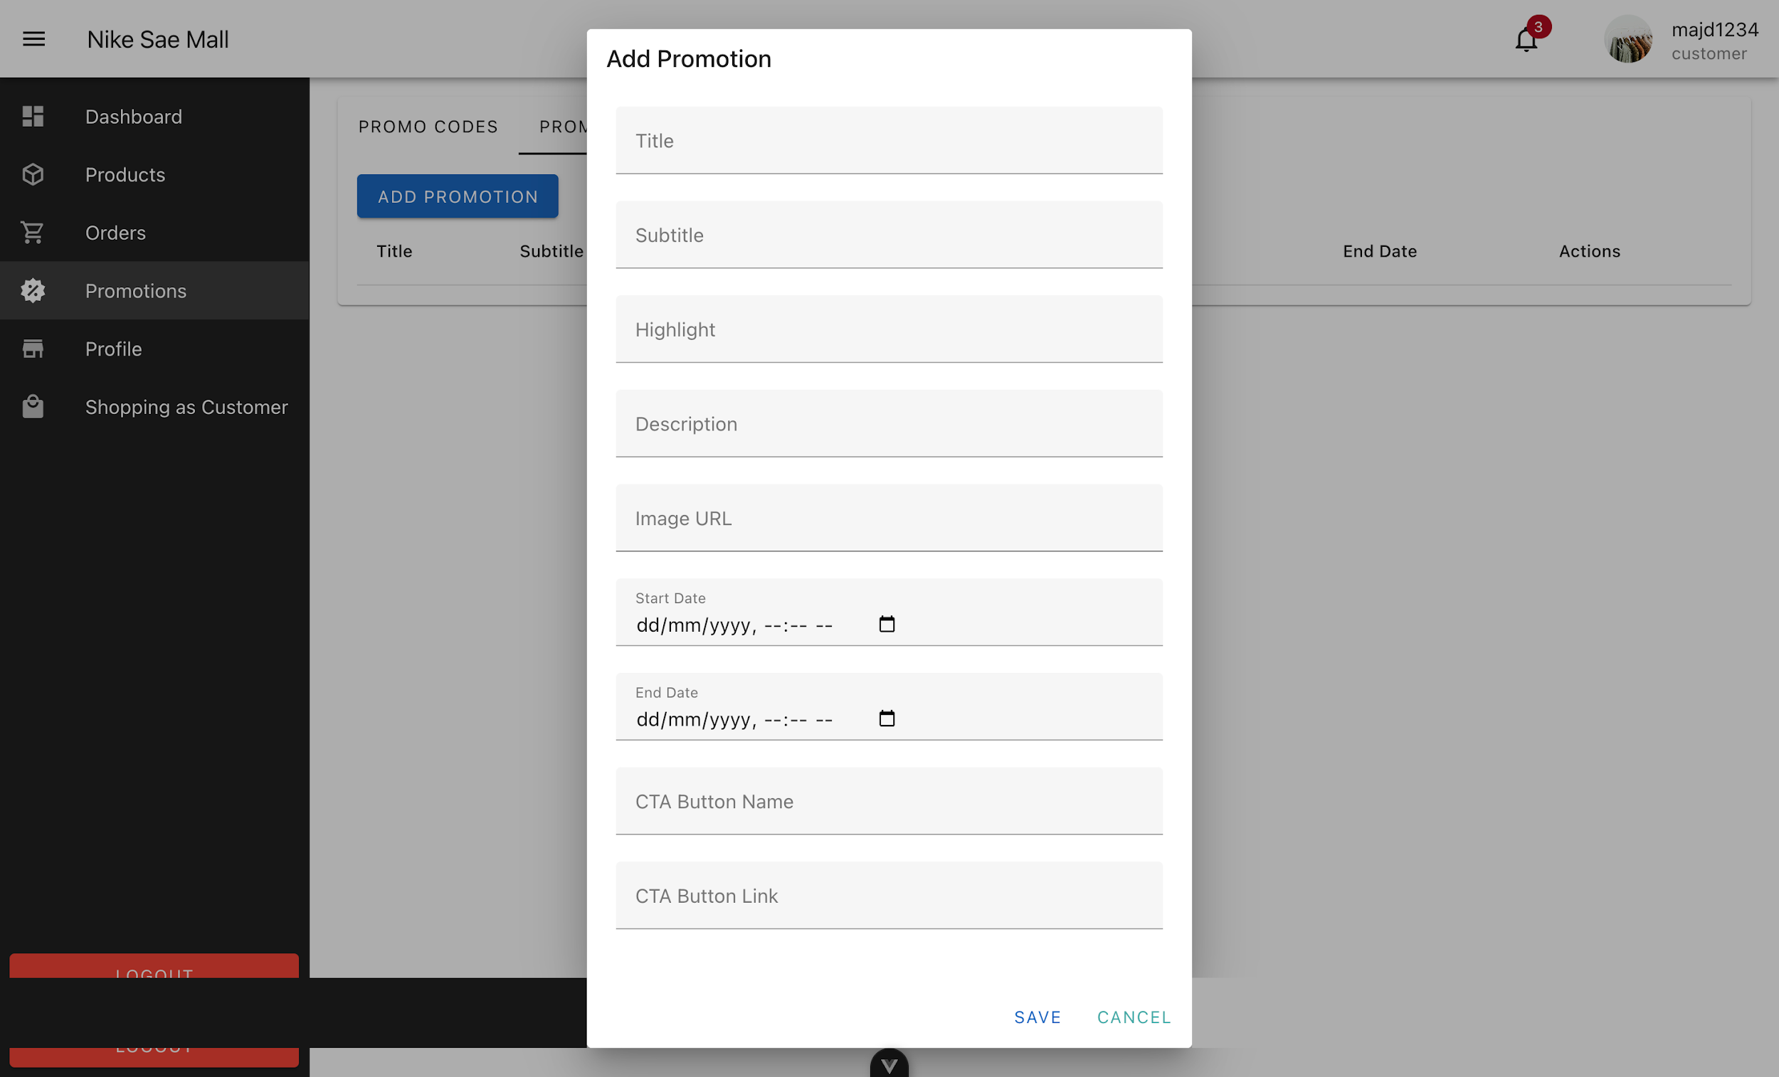

Vendor Add Promotion Form

4.2.4 Admin Dashboard Pages
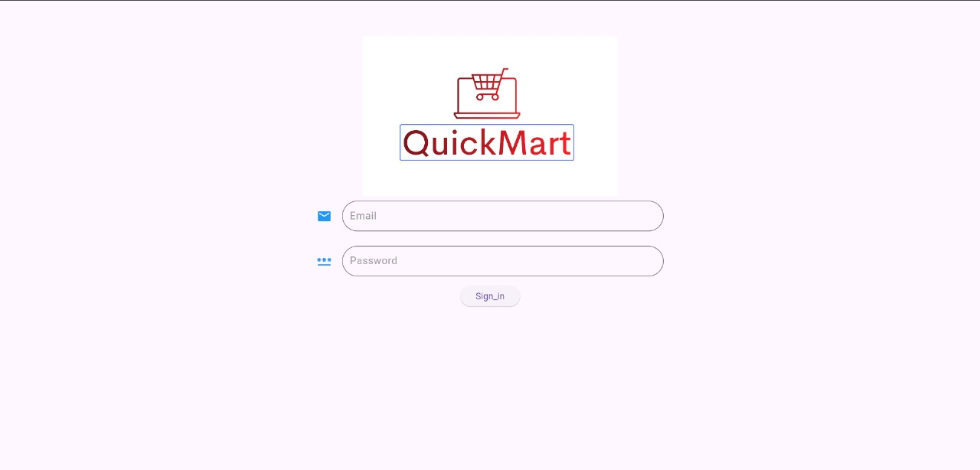

Admin Login Page

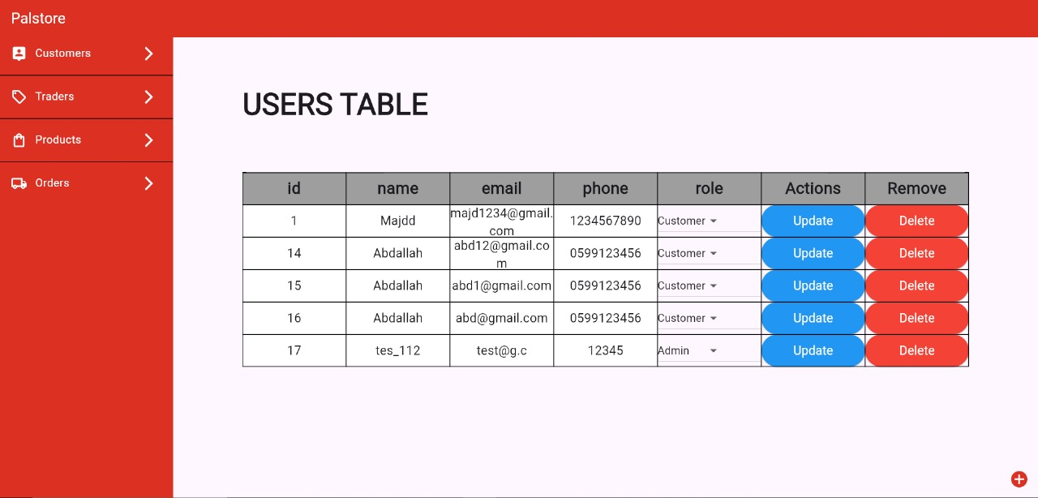

Admin User Manaegment Page

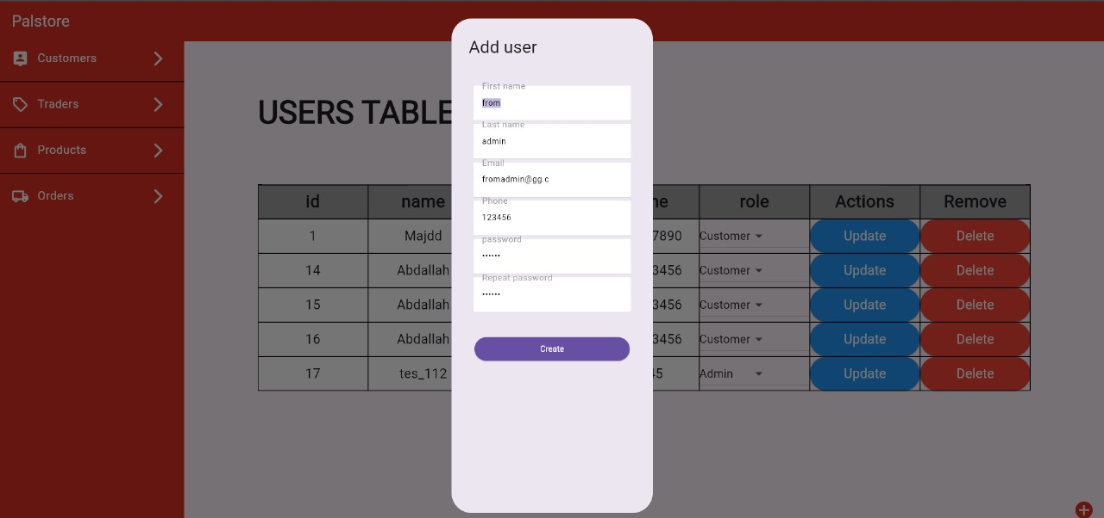

Admin Add User Form

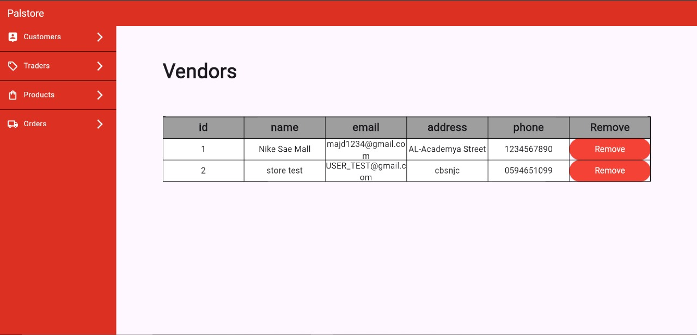

Admin Vendor Managment Page

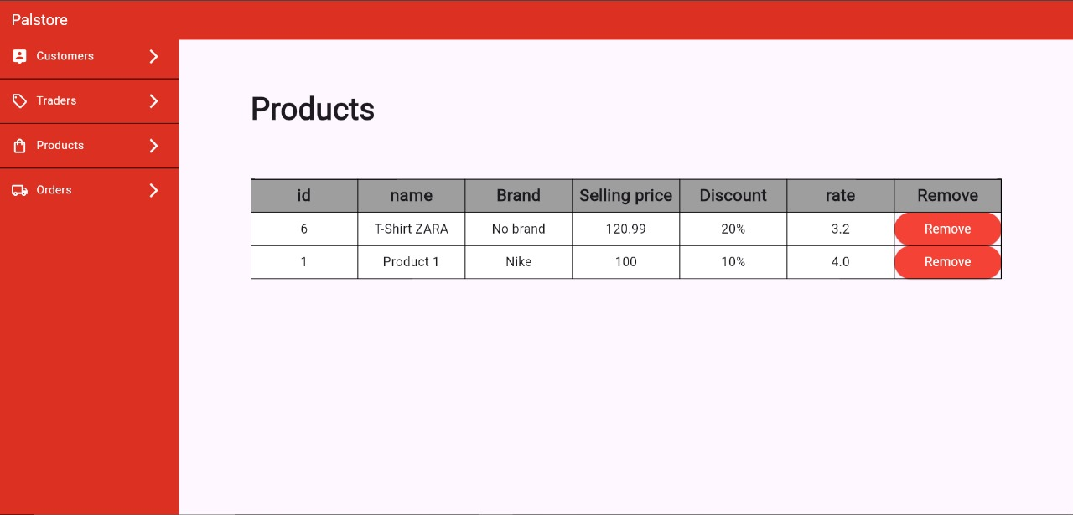

Admin Product Management Page

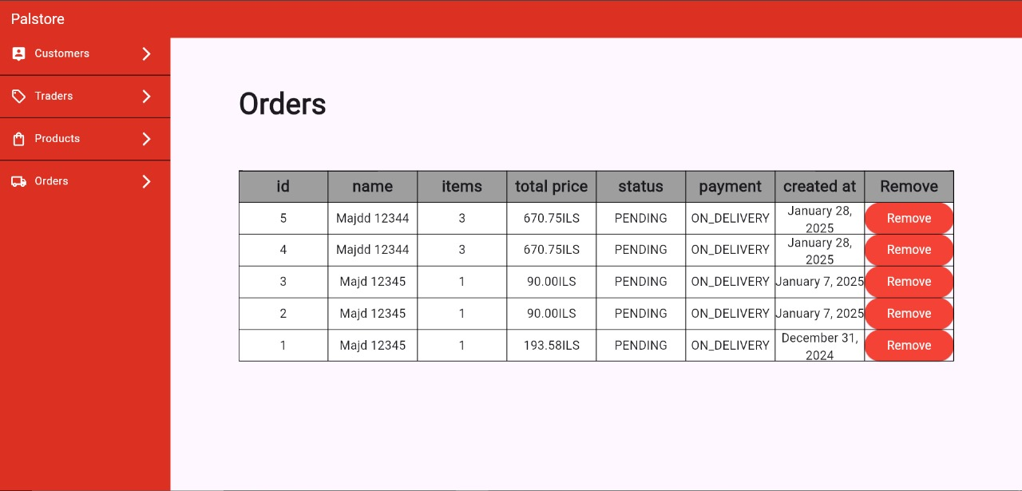

Admin Orders Management Page

4.3 Mobile User Interface

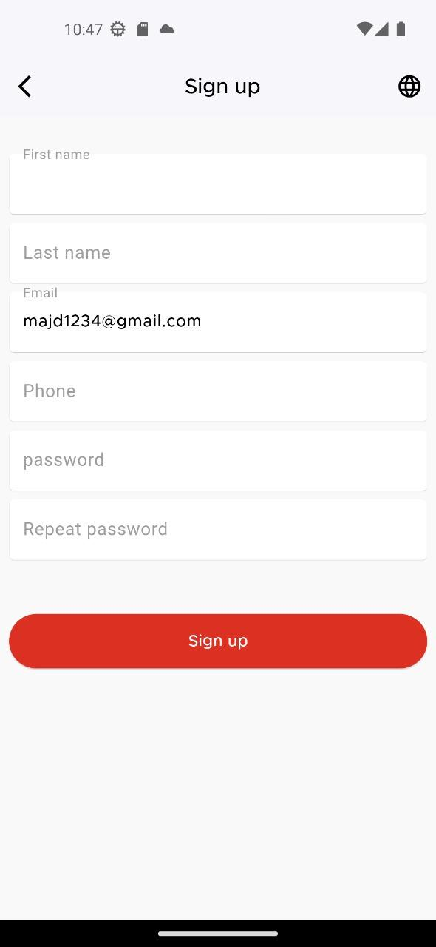

Sign up Page

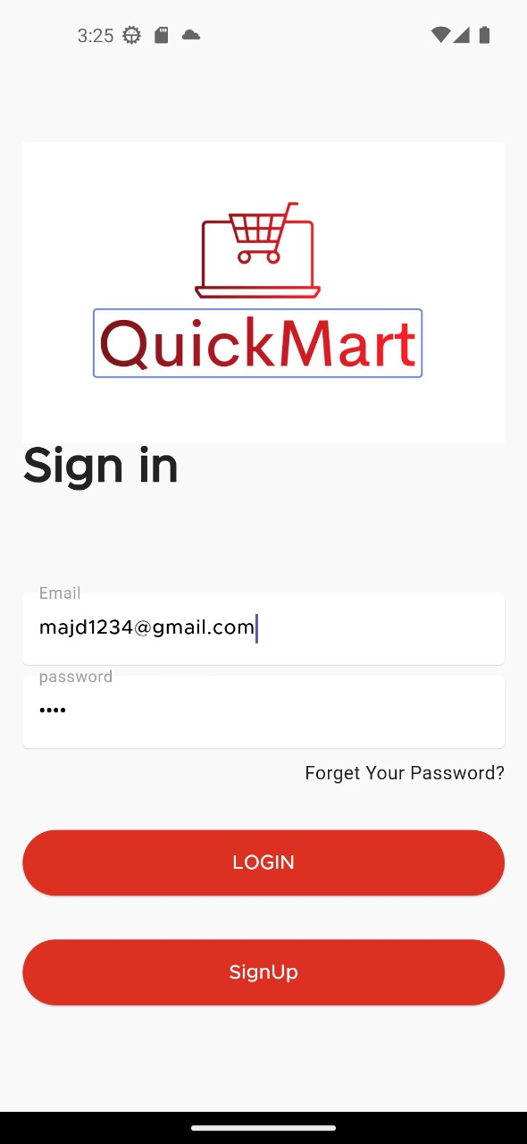
Sign In Page

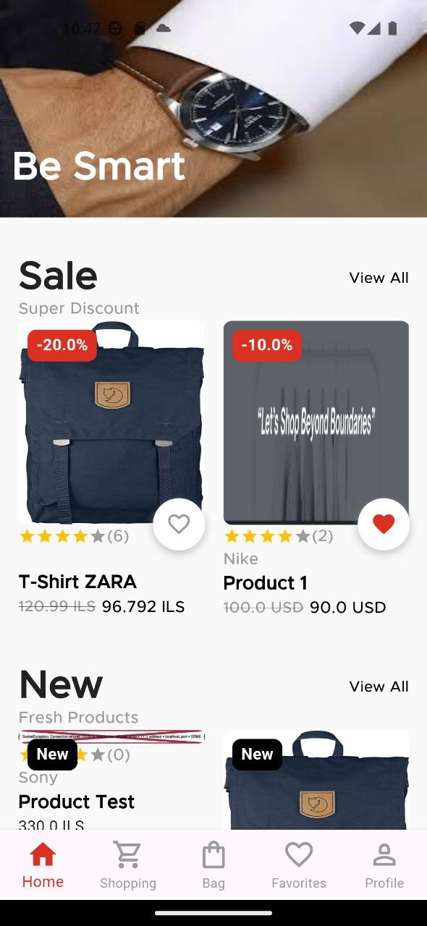

Home Page

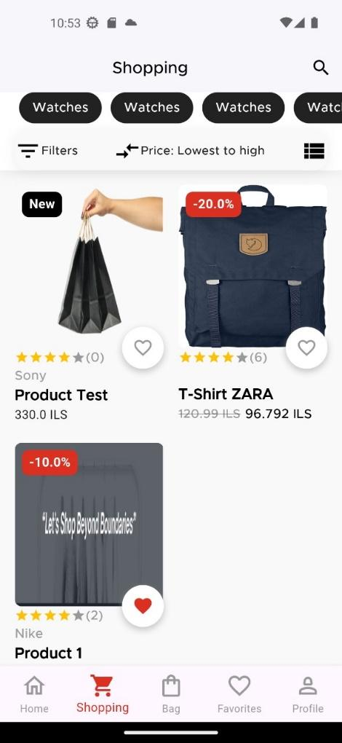
Shopping Page

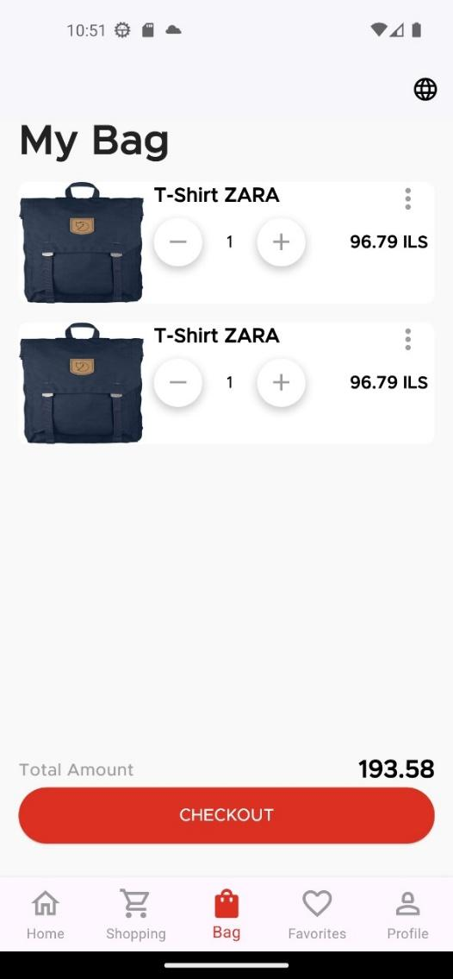
My Bag Page

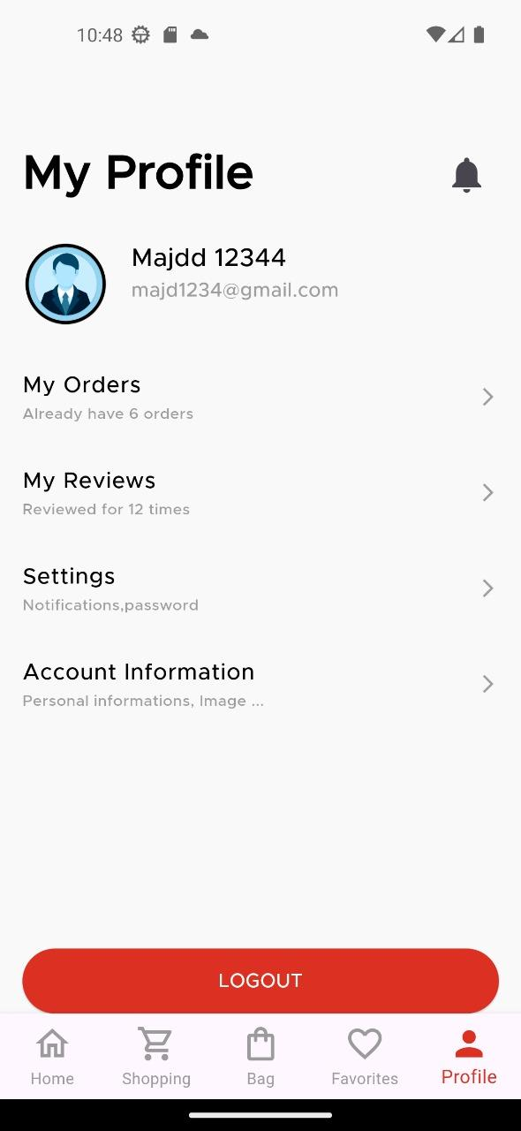
Profile Page

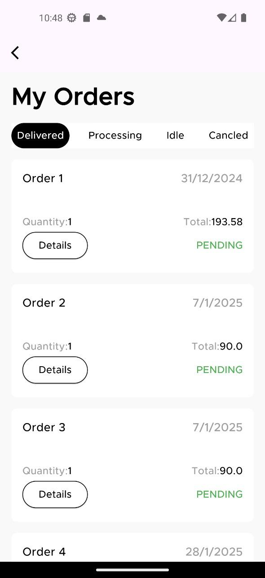

My Orders Page

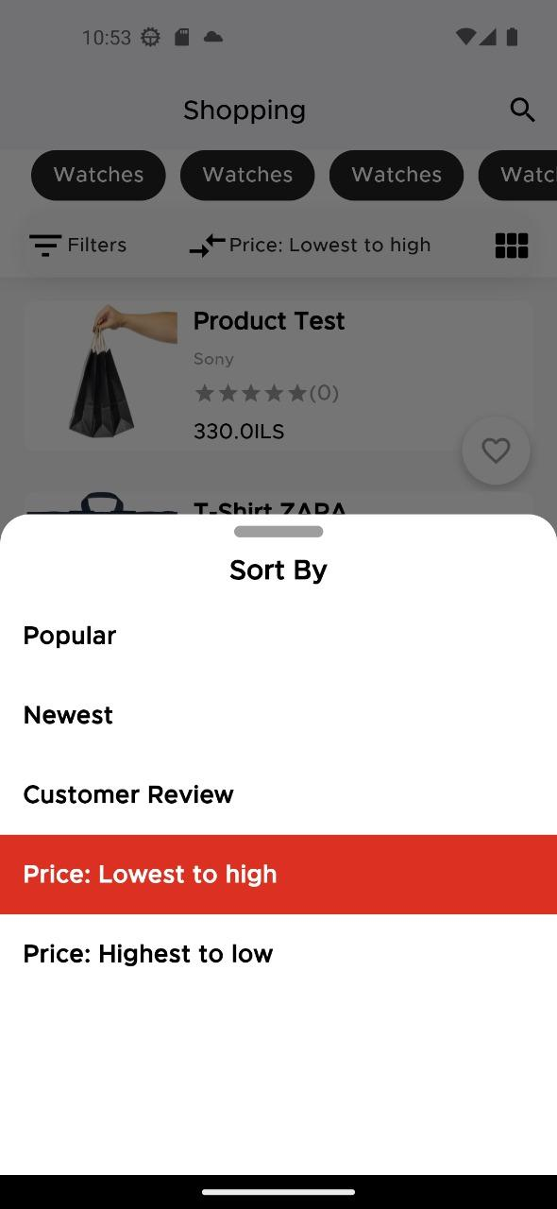
Sort By Page

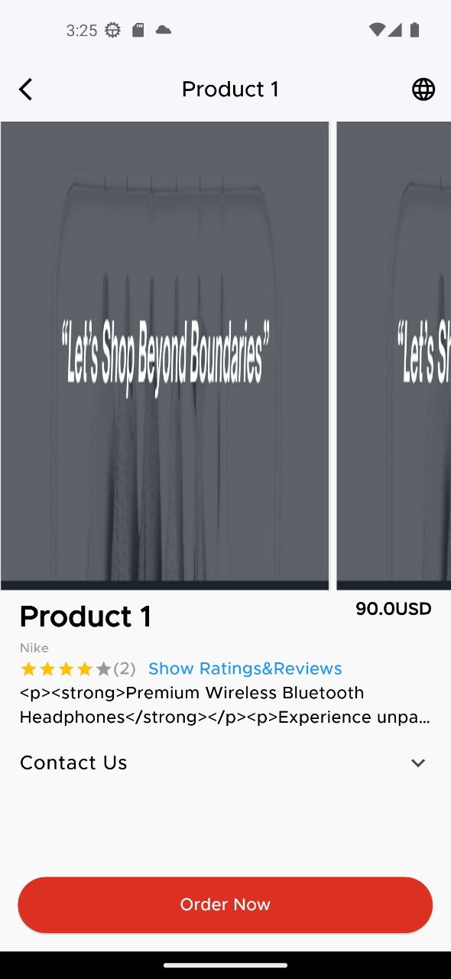
Product details Page

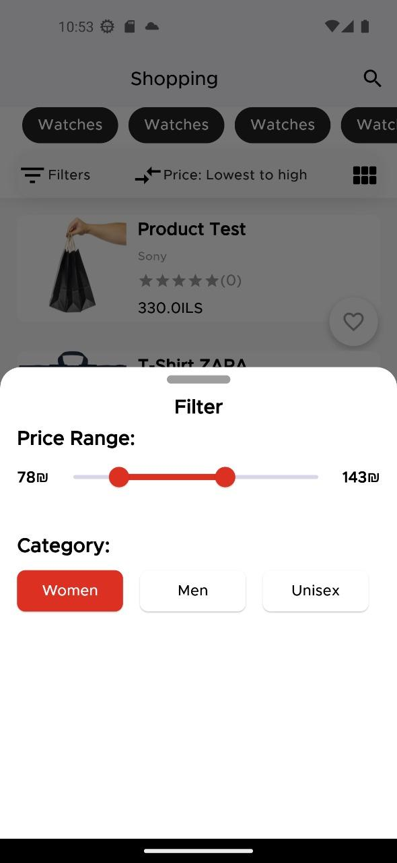
Filter Page “Price Range”


Rating & Reviews Page


Add Rate & Review Page

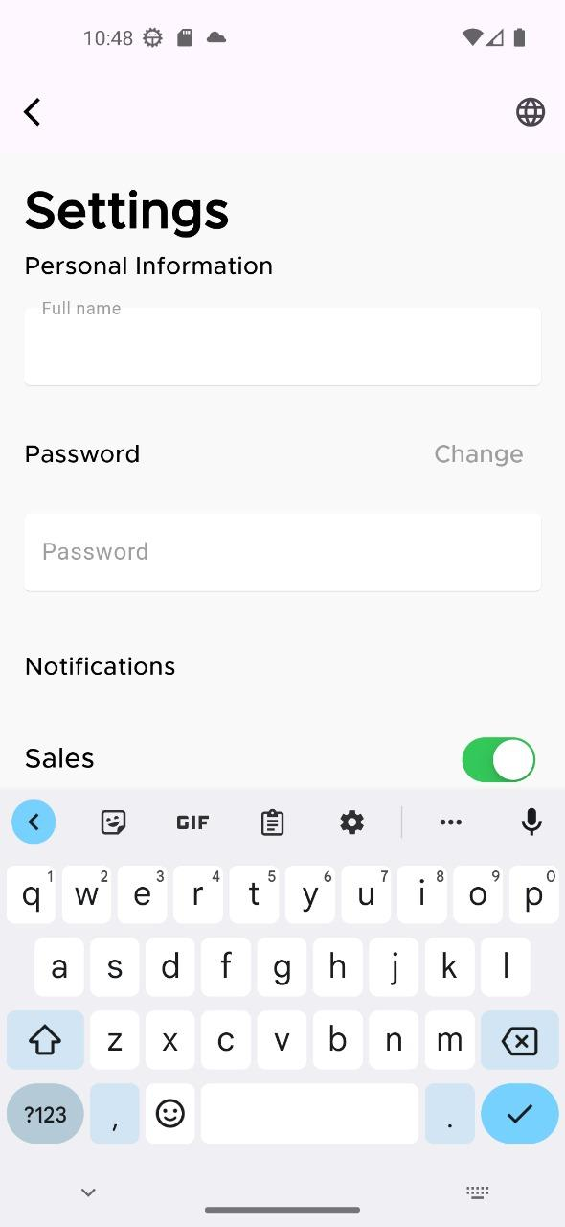
Settings Page

4.4 Technologies

4.4.1 Backend

The backend of Quick Mart is responsible for handling business logic, database interactions, and real-time communication. The following technologies were used:
- Spring Boot:
Spring Boot was chosen as the primary framework for developing the backend due to its simplicity, scalability, and robust ecosystem. It provides a streamlined way to create stand-alone, production-grade Spring-based applications with minimal configuration.
- MySQL:
MySQL was used as the relational database management system (RDBMS) to store and manage data for the e-commerce platform. It was selected for its reliability, performance, and ease of integration with Spring Boot.
- Spring Data JPA:
Spring Data JPA was utilized to simplify database interactions and reduce boilerplate code. It provides a powerful abstraction layer for CRUD operations and supports advanced querying capabilities, making it easier to manage data persistence.
- WebSocket:
For real-time notifications and messaging, WebSocket was implemented. This technology enables bidirectional communication between the client and server, ensuring that users receive instant updates on order status, promotions, and other important events.
- RESTful APIs:
The backend exposes RESTful APIs to facilitate communication between the frontend and the server. These APIs are designed to be stateless, scalable, and easy to consume.
- Maven:
Maven was used as the build automation tool to manage dependencies and streamline the build process for the Spring Boot application.

4.4.1 Frontend

The frontend of Quick Mart is designed to deliver a responsive, user-friendly interface for customers. The following technologies were used:
- Vue.js:
Vue.js was chosen as the frontend framework due to its simplicity, flexibility, and performance. It enables the creation of dynamic, single-page applications (SPAs) with a component-based architecture.
- Vuetify:
Vuetify, a Material Design component framework for Vue.js, was used to build the user interface. It provides a rich set of pre-built components, such as buttons, cards, and navigation drawers, ensuring a consistent and modern design across the application.
- Axios:
Axios was used to handle HTTP requests from the frontend to the backend. It simplifies the process of making API calls and handling responses, making it easier to integrate with the RESTful APIs.
- Vue Router:
Vue Router was implemented to manage navigation within the application. It enables the creation of a seamless, single-page experience by dynamically loading components based on the URL.
- WebSocket Client:
The frontend integrates a WebSocket client to establish a real-time connection with the backend. This allows users to receive instant notifications and updates without refreshing the page.
- HTML5 and CSS3:
Standard web technologies like HTML5 and CSS3 were used to structure and style the application. These technologies ensure compatibility across different browsers and devices.
- JavaScript (ES6+):
Modern JavaScript (ES6+) was used to implement dynamic functionality and enhance the user experience. Features such as arrow functions, promises, and async/await were leveraged to write clean and efficient code.

5. Results and Discussion:
Accepting and participation of employees: Acceleration Mart sees a significant increase in the selection and participation due to the complete customization and services. Buyers and customers have reported a high level of satisfaction with a uniform that is harmonious, which is especially regarded for precision and convenience.
Transaction performance: In the combined charging machine and the management of the order, the transaction has improved a lot. Merchants can easily order and communicate with customers while buying products easier and faster.
Control and inspection of system administrators: Online components of the system administrator provides effective control and inspection of equipment. The system administrator can check the customer, products, orders and sales smoothly, ensuring that the platform will work smoothly and efficiently.
Platforms across the platform: Mobile transmission allows Speed ​​Mart to win, allowing both Android and iOS customers to access and use from platforms - - -
Machine learning together: The integration of the learning of the machine into the algorithm helps the customer connection platform and the products they are looking for the keys, happiness and income growth. Personal
The results showed that as soon as Marty, the objective was to help present the safe and worthwhile environment for shopping and shopping. The recruitment process and participation of the relevant people show that the function of the platform is reasonable and effective in responding to the needs of both buyers and customers.
Improving transaction efficiency highlights the importance of embedded payment systems and real-time sequence management in facilitating easy transactions. The advantageous use of feedback from smart matching algorithms highlights the cost of using better technology, such as machine recognition to beautify consumers in…
Additionally, the effectiveness of the website administrator in monitoring and controlling the system demonstrates the importance of centralized control tools to maintain operational efficiency. The capabilities of the Go platform ensure that Quick Mart can support a large audience. Allows access to a larger market... .
Ultimately, Quick Mart's success is a result of its comprehensive feature set. Consumer-Centric Design and the combination of superior technology the platform's ability to provide a green and consistent marketing environment; This makes the platform the leading solution for today's business and procurement needs. Continuous awareness of innovation and constant awareness of one's experience can be the key to maintaining and improving one's success within one's destiny.

- Future work

Advanced data analysis: Use advanced data analysis tools to provide more deeply in -depth information about market user behavior and sales efficiency.
This will help merchants increase their inventory and their marketing strategies and help Quick Mart continuously improve their platforms.

Personal recommendations: Developing more complex personal engine, which uses the AI ​​and the learning of the machine to provide advice of products that have been adjusted to AI customers and the learning of machinery.
This will help increase user experience by displaying products that match the settings and previously purchased.

Multiple language support: introducing multiple language support to support wider viewers This will allow the platform to be able to access more for users in various sectors and may increase the user base and participation.

Combining social media: allowing users to share the purchase of reviews and items that they want to enable the integration with social media platform smoothly. This can increase the participation of users and push the amount of usage to the platform through social sharing.

Loyalty and prize program: Introducing loyalty and prize systems to promote repeated purchase and create customer loyalty.
Measurement of shopping experiences with signs and prizes can increase user participation.

Community construction: launching community qualifications that users can participate with each other, share experiences and give suggestions. The construction of a strong community will increase the treatment of users and create a market environment that is stronger and more supportive. By focusing on these areas quickly, Mart is able to create and grow continuously, maintain a leading platform for merchants and customers ..

Conclusions
Quick Mart is a disruptor in the online market scene that is creating an enduring experience for both the traders and customers through a myriad of features. This cross-platform mobile application, available on both Android and iOS, provides quick transactions with integrated chat and payment systems, all the while providing real-time order managing. An intelligent matching algorithm makes utilization of cutting-edge machine studying techniques, thus allowing the user to easily discover a wished-for product and augmenting their user experience. An admin site is there for efficient system monitoring and control to track provision, products, orders, and sales, making sure that the operation is thriving. The user-centric design combined with sophisticated technology makes Quick Mart an absolute answer to the need for contemporary commerce and shopping.

