An Najah National University



Information Technology Faculty
Department of Computer Science
Graduation Project Documentation
Recommendation System
Ahmad Atef Dwekat (11422203)
Asim Mazin Abd Albaqi(11526473)
Ersan Qaher Abu Esheh (11422183)

Supervisor : Dr. Hamid Abdelhaq

December 2018

Abstract:
Nowadays, the demands on recommendation system are getting increase quickly, like recommendation for movies, books, and restaurants. In our project the recommendation will be for jobs. The aim of our project is to get prediction for job by match it with its relative resumes vice versa. We work on data retrieval using TFIDF to get top key words from files and use them in elastic search to get related jobs or resumes ‘CVS’. This approach aims to reduce the amount of data that will enter the collaborative filtering to make the algorithm more scalable and accurate. By using this approach without content-based collaborative filtering we were able to get prediction and retrieve the most accurate data.

This documentation describes our graduation project in five chapters:
- In Chapter one you will find a brief introduction about the project.
- Chapter two contains methodologies
- In Chapter three you will find a detailed discretion of the provided services
- Chapter four taking about Conclusion and future work will be found at the end of the document.

Chapter 1: Introduction

Introduction:
Recommendation it is got more needed which it depends on the application and what user need, like amazon for ecommerce recommendation or net flex for movie recommendation. Our project it is a job recommendation system that recommend job for resumes depends on some properties. The main reason for creating the system is for helping people who do not know the world of business like new graduates. Moreover, the system helps companies to avoid classifications for big amount of received resumes which save time and efforts.

Our system is a web application which is provide several services that offer for companies employer accounts to rise a job post which the system predicts resumes for this job post and it offers for the applicant an account to get into the system which offer a predicted job post for applicant resume.

Chapter 2 : Methodology
This chapter presents architecture for the techniques that been used in the system that can be divide into main six parts:
- Elasticsearch
Elasticsearch DSL (Domain Specific Language) is a high-level library whose aim is to help with writing and running queries against Elasticsearch and be more flexible to store JSON in Elastic search server that mapping dynamically by the library after we :
- Create Index named recommendation
- Create document type divide in to four part :
  - Job post json
  - Cleaned Job post json
  - CV json
  - Cleaned CV json
- The query that use to search :
query_string to search in all field in JSON and return most match CV or Job post with ES score by match at least one word from top key word
{
"query":
{
"query_string" : {
"query" : "keyword OR keyword OR keyword ......OR keyword"
}
}
}
- Use a prepared method to insert and delete from ES

Job post map
{"recommendation":{"mappings":{"jopPost":{"properties":{"PhysicalRequirements":{"type":"text","fields":{"keyword":{"type":"keyword","ignore_above":256}}},"contract":{"type":"text","fields":{"keyword":{"type":"keyword","ignore_above":256}}},"country":{"type":"text","fields":{"keyword":{"type":"keyword","ignore_above":256}}},"email":{"type":"text","fields":{"keyword":{"type":"keyword","ignore_above":256}}},"job_duties":{"type":"text","fields":{"keyword":{"type":"keyword","ignore_above":256}}},"job_qualifications":{"properties":{"optional":{"type":"text","fields":{"keyword":{"type":"keyword","ignore_above":256}}},"required":{"type":"text","fields":{"keyword":{"type":"keyword","ignore_above":256}}}}},"job_title":{"type":"text","fields":{"keyword":{"type":"keyword","ignore_above":256}}},"mappings":{"properties":{"_doc":{"properties":{"email":{"properties":{"type":{"type":"text","fields":{"keyword":{"type":"keyword","ignore_above":256}}}}},"properties":{"properties":{"email":{"properties":{"type":{"type":"text","fields":{"keyword":{"type":"keyword","ignore_above":256}}}}}}}}},"email":{"properties":{"type":{"type":"text","fields":{"keyword":{"type":"keyword","ignore_above":256}}}}}}},"others":{"type":"text","fields":{"keyword":{"type":"keyword","ignore_above":256}}}}}}}}

Cleaned Job post map
{"recommendation":{"mappings":{"CleanedjopPost":{"properties":{"contract":{"type":"text","fields":{"keyword":{"type":"keyword","ignore_above":256}}},"job_duties":{"type":"text","fields":{"keyword":{"type":"keyword","ignore_above":256}}},"job_qualifications":{"properties":{"optional":{"type":"text","fields":{"keyword":{"type":"keyword","ignore_above":256}}},"required":{"type":"text","fields":{"keyword":{"type":"keyword","ignore_above":256}}}}},"job_title":{"type":"text","fields":{"keyword":{"type":"keyword","ignore_above":256}}},"others":{"type":"text","fields":{"keyword":{"type":"keyword","ignore_above":256}}}}}}}}

CV map
{"recommendation":{"mappings":{"CVS":{"properties":{"EmpolymentHistory":{"type":"text","fields":{"keyword":{"type":"keyword","ignore_above":256}}},"Qualification":{"type":"text","fields":{"keyword":{"type":"keyword","ignore_above":256}}},"education":{"type":"text","fields":{"keyword":{"type":"keyword","ignore_above":256}}},"personal_information":{"properties":{"address":{"type":"text","fields":{"keyword":{"type":"keyword","ignore_above":256}}},"calendar":{"type":"date"},"country":{"type":"text","fields":{"keyword":{"type":"keyword","ignore_above":256}}},"email":{"type":"text","fields":{"keyword":{"type":"keyword","ignore_above":256}}},"fn_title":{"type":"text","fields":{"keyword":{"type":"keyword","ignore_above":256}}},"phone":{"type":"text","fields":{"keyword":{"type":"keyword","ignore_above":256}}},"sex":{"type":"text","fields":{"keyword":{"type":"keyword","ignore_above":256}}},"telephone":{"type":"text","fields":{"keyword":{"type":"keyword","ignore_above":256}}}}},"skills":{"type":"text","fields":{"keyword":{"type":"keyword","ignore_above":256}}}}}}}}

Cleaned CVs map
{"recommendation":{"mappings":{"CleanedCVs":{"properties":{"EmpolymentHistory":{"type":"text","fields":{"keyword":{"type":"keyword","ignore_above":256}}},"Qualification":{"type":"text","fields":{"keyword":{"type":"keyword","ignore_above":256}}},"education":{"type":"text","fields":{"keyword":{"type":"keyword","ignore_above":256}}},"personal_information":{"properties":{"address":{"type":"text","fields":{"keyword":{"type":"keyword","ignore_above":256}}},"calendar":{"type":"date"},"country":{"type":"text","fields":{"keyword":{"type":"keyword","ignore_above":256}}},"email":{"type":"text","fields":{"keyword":{"type":"keyword","ignore_above":256}}},"fn_title":{"type":"text","fields":{"keyword":{"type":"keyword","ignore_above":256}}},"phone":{"type":"text","fields":{"keyword":{"type":"keyword","ignore_above":256}}},"sex":{"type":"text","fields":{"keyword":{"type":"keyword","ignore_above":256}}},"telephone":{"type":"text","fields":{"keyword":{"type":"keyword","ignore_above":256}}}}},"skills":{"type":"text","fields":{"keyword":{"type":"keyword","ignore_above":256}}}}}}}}

- NLTK ‘Natural language Toolkit ’

The Natural Language Toolkit (NLTK) is a platform used for building Python programs that work with human language data for applying in statistical natural language processing (NLP) which been used to clean the jobs and resumes from stop words and punctuation marks.

C-TFIDF ‘Term frequency inverse document frequency ’
TFIDF is an information retrieval technique that weighs a term’s frequency (TF) and its inverse document frequency (IDF). Each word or term has its respective TF and IDF score. The product of the TF and IDF scores of a term is called the TF*IDF weight of that term.
For a term t in a document d, the weight Wt,d of term t in document d is given by:
Wt,d = TFt,d * log (N/DFt)

Where:
- TFt,d is the number of occurrences of t in document d.
- DFt is the number of documents containing the term t.
- N is the total number of documents in the corpus.
The TF (term frequency) of a word is the frequency of a word (i.e. number of times it appears) in a document. When you know it, you’re able to see if you’re using a term too much or too little

TF = term frequency for a word in file /total number of words in the file
For example, when a 100 word document contains the term “cat” 12 times, the TF for the word ‘cat’ is
TFcat = 12/100 i.e. 0.12
The IDF (inverse document frequency) of a word is the measure of how significant that term is in the whole corpus.
For example, say the term “cat” appears x amount of times in a 10,000,000 million document-sized corpus (i.e. web). Let’s assume there are 0.3 million documents that contain the term “cat”, then the IDF (i.e. log {DF}) is given by the total number of documents (10,000,000) divided by the number of documents containing the term “cat” (300,000).
IDF (cat) = log (10,000,000/300,000) = 1.52
∴ Wcat = (TF*IDF) cat = 0.12 * 1.52 = 0.182

Chapter 3: Technologies
Environment:
Django framework:
Django is a high-level Python Web framework that encourages rapid development and clean, pragmatic design. Built by experienced developers, it takes care of much of the hassle of Web development, so you can focus on writing your app without needing to reinvent the wheel. It's free and open source
Languages used:
- Python 3
- JavaScript
Others:
- Json files
- Html
- Ajax
- SASS, bootstrap 4
- jQuery
- Git
- Grunt ,Gulp ‘ JS task runner’
Applications used:
- Atom
- XAMPP
- Elastic search server
- Source tree

Chapter 4: system overview

Section 1 Sign Up page


Figure 1:Sign Up page

Where the user will enter his personal information needed to run the application in the way that is designed for.

The required information:
- User name
- Email
- Password
- User type

The activity consists from four text Field ,where the user can enter his username, user type Email, Password.
The entered information values are stored in the data base . In a table called login. the table has the following fields
Table 1 User Info
ID | Email | Username | Password

Table 2 privilege table
ID | Fk_id | privilage
Section 2 Sign In page:



Figure 2: Sign In page
Where the user will enter his personal information needed to run the application in the way that is designed for.
- The required information:
- Email
- Password

The activity consists from Two text Field ,where the user can enter his Email, Password.
The entered information values are get from the data base. In a table called login. the table has the following fields
Table 3 User Info
ID | Email | Password

Section 3: Employer view

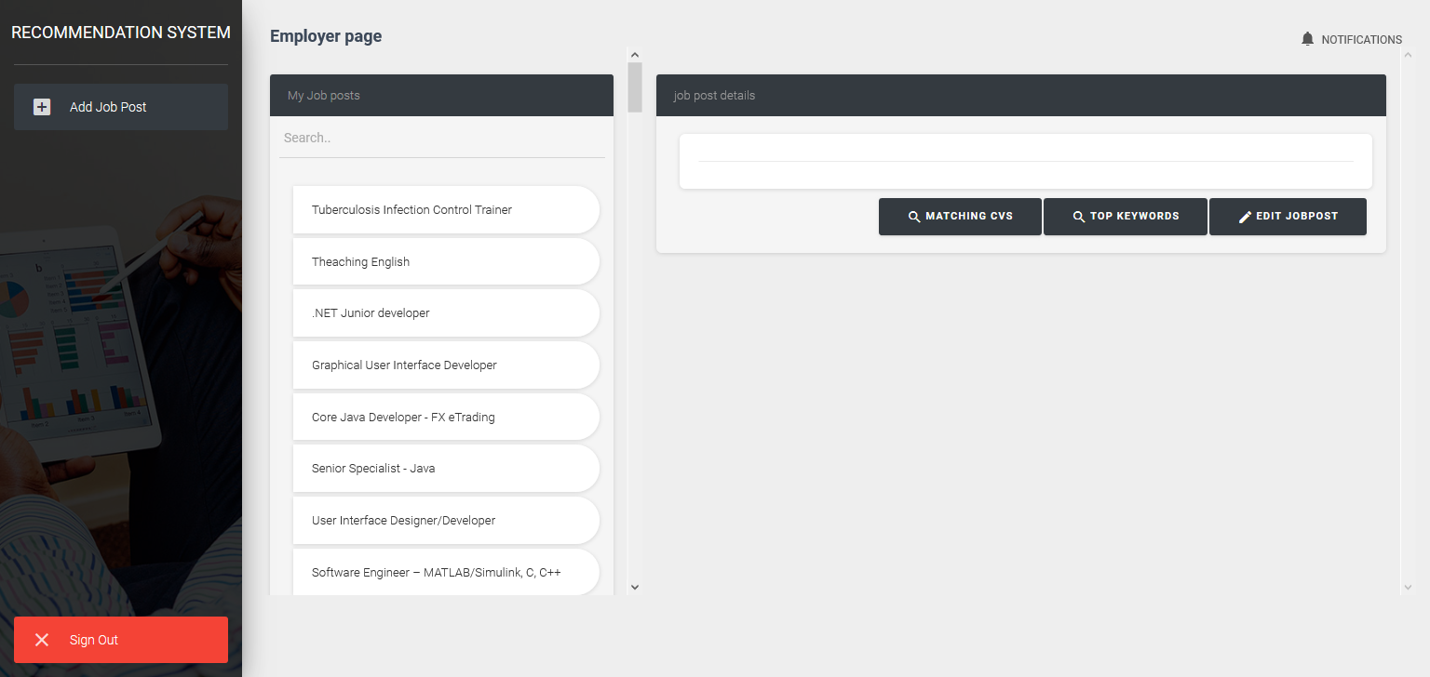
Figure 3 Employer view
Before the page loaded :
- Search in the json file from elastic search
- Display the related job post for the employer email address

When clicked on specific job post:
- We get the top related five key words that calculated previously from database
- Send the words to elastic search to return the relevant cv(s)
- Display the returned cv(s) as in the next figure4
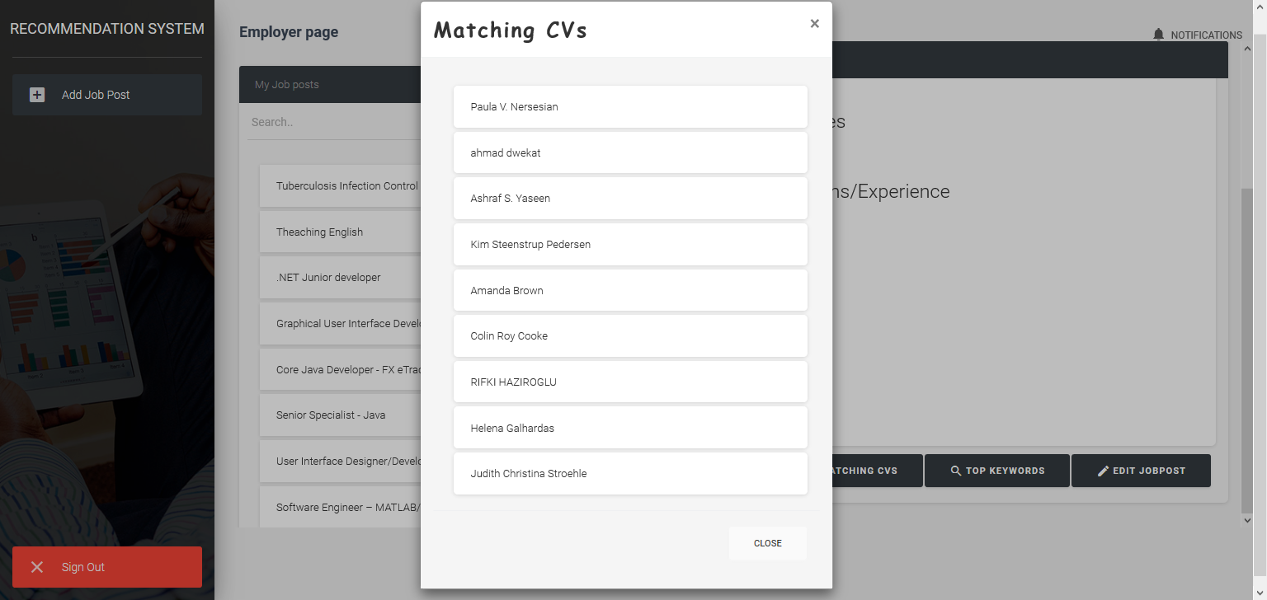
Figure 4 matching cv(s) view
When click on CV’S applicant name :
- Send the id of clicked CV to elastic search then get the data

Section 4: Job post Insertion :

Figure 6 Job Post insertion
The user will enter his Job post information needed to run the application in the way that is designed for.
The required information:
- Job title
- Job type
- Country
- Requirements/Qualifications/Experience
- Soft skills
- Duties and responsibilities
- Others

When the employer click on save :
- store the data as json file
- Index the json file in elastic search
- Do some text cleaning using NLTK as json file
- Index the cleaned json file in elastic search
- calculate the TF and store it to database
- Calculate the IDF for the whole job posts
- Redirect to figure 3

Section 5: CV Insertion
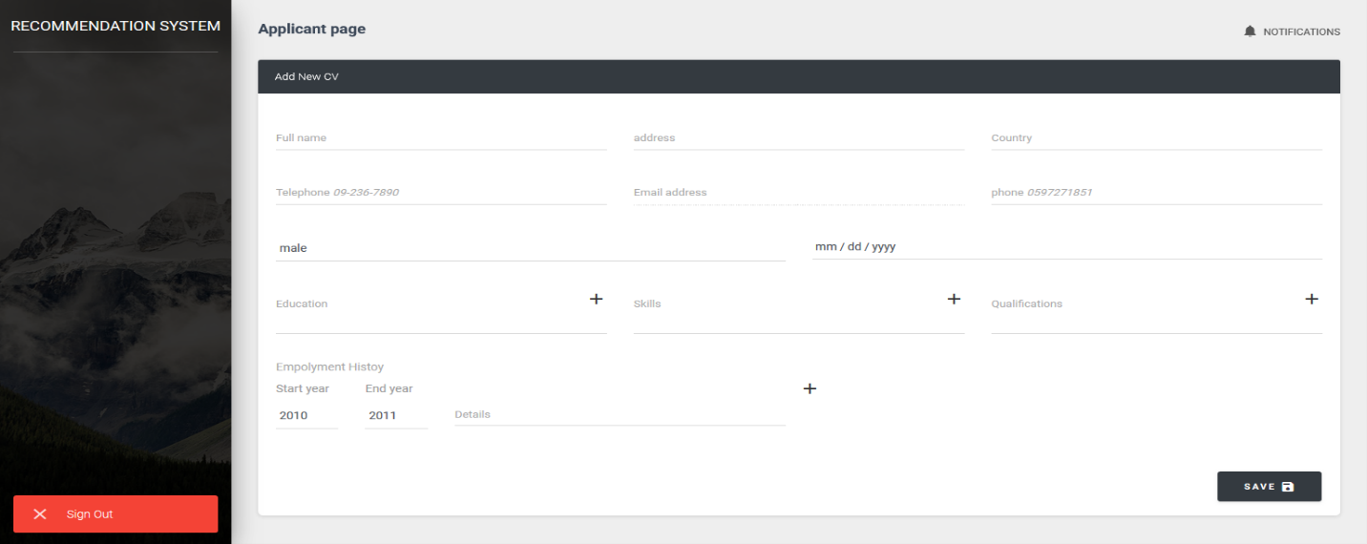
Figure 7: CV insertion

The applicant will enter his CV information that will entered once needed to run the application in the way that is designed for.
The required information:
- Full name
- Address
- Country
- Telephone
- Phone number
- Education
- Skills
- Qualifications
- Employment history

When the employer click on save :
- store the data as json file
- Index the json file in elastic search
- Do some text cleaning using NLTK as json file
- Index the cleaned json file in elastic search
- Calculate the TF and store it to database
- Calculate the IDF for the whole job posts
- Redirect to figure 8

Section 6 : Applicant view
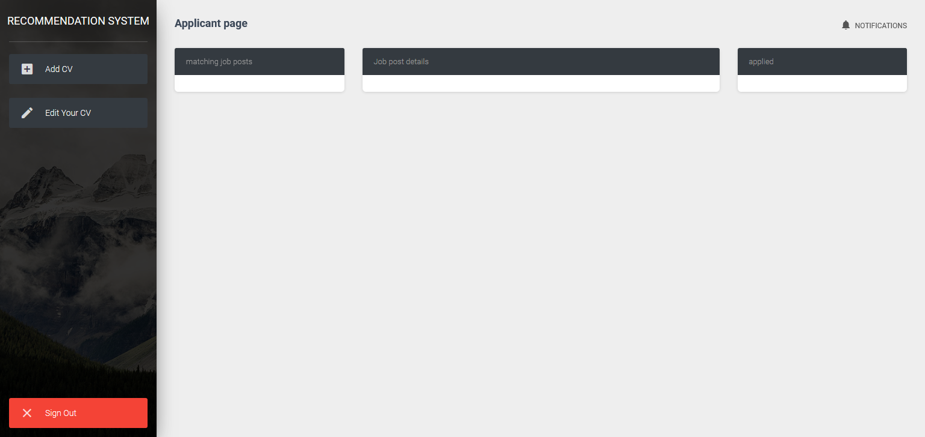
Figure 8 applicant view
Before the page loaded:
- Search in the cleaned json file from elastic search for related job posts
- Display the related job post for the applicant in matching job post area
- Get job posts that applied with the applicant CV from database and display it in applied area

When clicked on specific job post:
- Get description of clicked job post
- Display the job post description in job post details area

Chapter 5 : Diagrams
Entety relationship
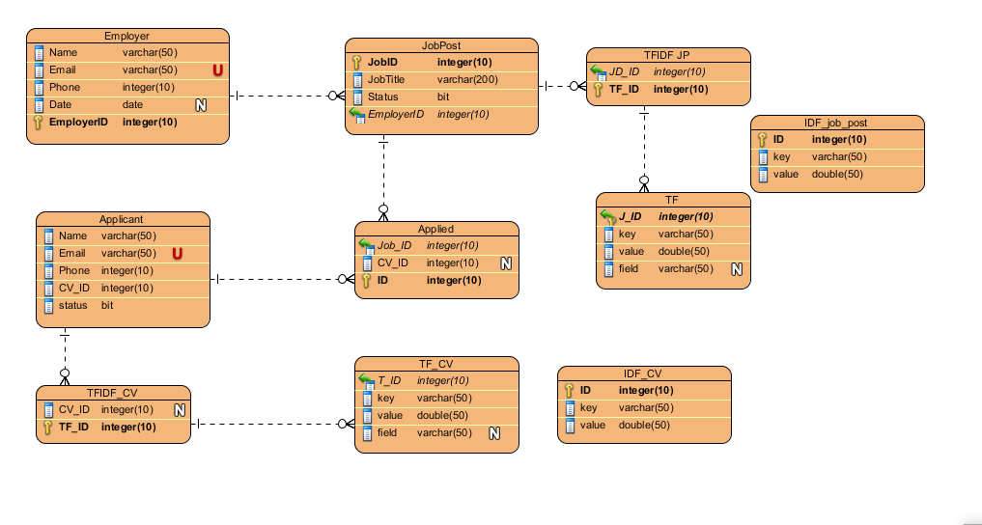

Database Description: system consists of employer table and applicant table the employer has one-to-many relation with job post table and job post table has one-to-many relation with TFIDF JP table and TFIDF JP it has one-to-many relation with TF table.
Applicant table has one-to-many relation with applied table which it has many-to-one relation with job post, the applicant has one-to-many relation with TFIDF_CV and TFIDF_CV has one-to-many relation with TF_CV.
There is two table are individual IDF job post and IDF_CV, which they are present the vocabulary of the inserted job post and CVs.

UML models:

Use case model

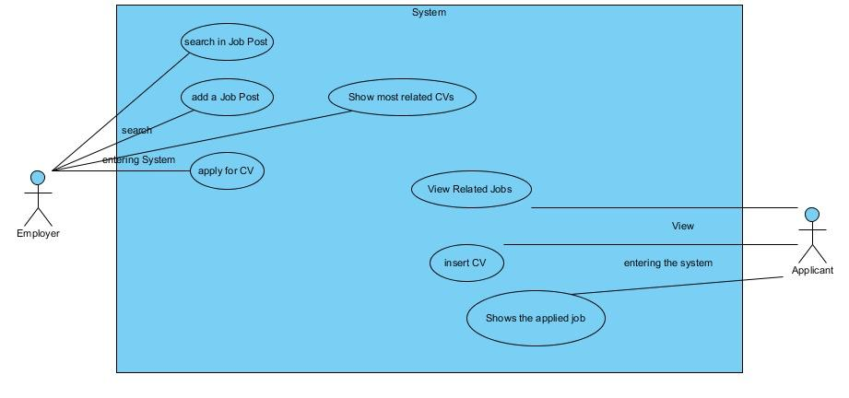
Employer can enter the system, assume registered, Employer can add many job posts and search in his job posts, and can apply for the recommendation that appear in the system.
Applicant can enter the system, assume registered, but firstly must insert its own CV in system form, the can show the applied jobs and view recommendations.

Sequence diagram

Employer
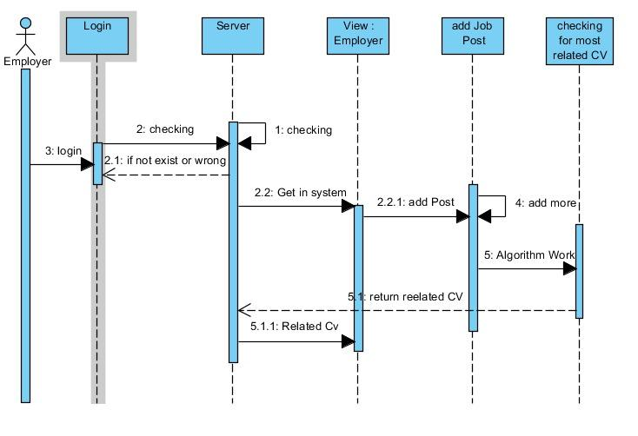

Applicant
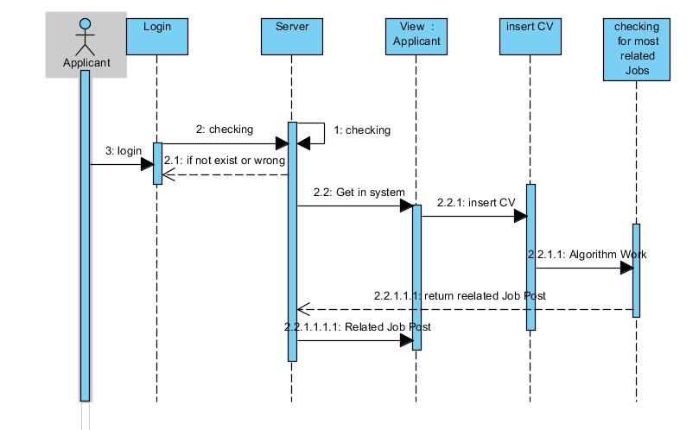

State model
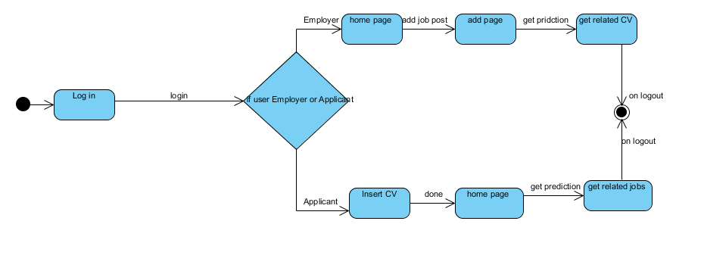

Activity diagram
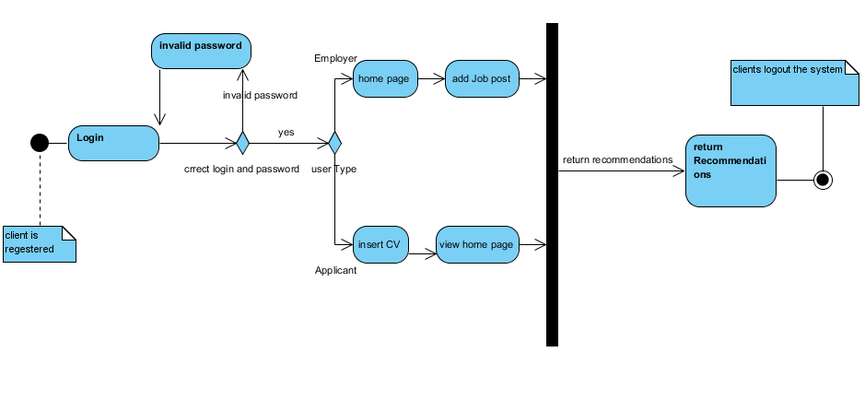

Class model
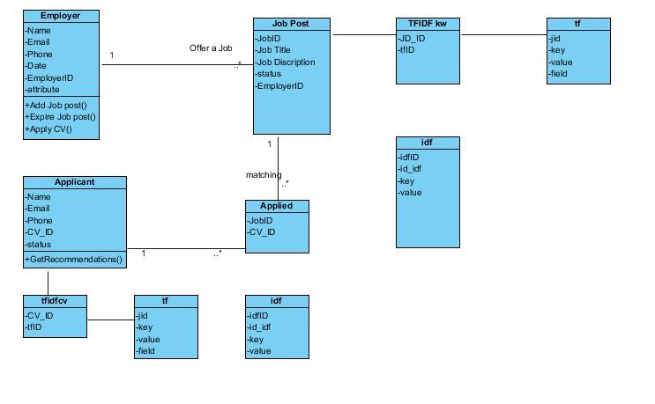

Chapter 6: Conclusion

Future work :

- Use content based celebrating filtering to get more accurate recommendation
- Support Arabic language
- Support uploading pdf resume and analyze it

