
Graduation Project
Data mining and analysis for decision making

2019 - 2020
An-Najah National University
Information Technology Faculty
Management Information Systems Department

Graduation Project
Data mining and analysis for decision making

Supervised By: Dr.Mohammed A. Dwikat

Yaqob Quzmar

Adham Nassar

Mohammed Aker

2019-2020
An-Najah National University
Information Technology Faculty
Management Information Systems Department

Table of Content

Table of Contents 3
Project Goals 4
Data Acquisition 5
01 Data Mining Process
1.1 Business Understanding
1.1.1 Business objectives 5
1.1.2 Action plan 6
1.1.3 Used tools 7
1.2 Data Understanding
1.2.1 Exploring data 8
1.2.2 Data quality 10
1.2.3 Metadata summerization 11
1.3 Data Preparation
1.3.1 Data Integration 12
1.3.2 Data reduction 14
1.3.3 Data transformation 16
1.3.4 Data cleaning 17
1.4 Model building & Testing
1.4.1 Association rule discovery 20
1.4.2 Decision tree classification 22
1.5 Deployment
1.5.1 ARD deployments 25
1.5.2 DTC deplyments 27
02 RFM Analysis
2.1 RFM model
2.1.1 Building the model 30
2.1.2 RFM results 32
2.2 Deployment
2.2.1 Segmentation 33
2.2.2 Recommendation system 35
03 Dashboard 37 Automation 38
Attachments 40

Introduction

In these days Data is considered as the most valuable source that companies have, and each company that recognize the value of data, will search for techniques to hiring these data in good ways to gain more profits or to reduce the costs, one of these techniques is data analysis, that enables decision makers of companies to analysis the data, describe it, and put hypothesis to check if it accepted or rejected.
Another technique that helps to gain advantages from data is the data mining process, this method enables data specialist to explore and analysis large quantities of data in order to discover meaningful patterns as “Association Rule Discovery”, but there are many challenges data specialist will face in data mining process as distributed data, privacy preservation, data quality, and heterogeneous data.
Finally data as we mentioned considered as strength point for any company, if it knows how to gain, clean, transform, and store it, also analysis and mining techniques are powerful methods that help to perform excellent reports and make accurate decisions.

Project Goals

- Data mining through CRISP-DM:

  - Build tree for classification.
  - Discovering hidden association rules.
  - Build dashboard & Summarizing results in clear reports.

- R.F.M Analysis:

  - Customer Segmentation.
  - Customer relationship management development.
  - Recommendation System based on customer features.

- Automating the process

Data Acquisition

At the first weeks we’ve decided to gain data from a local company, and because of the company’s policies of data privacy and security, we got the data after two weeks from the request date, unfortunately, the data we’ve got was not as expected, because there were a lot of missing and empty values in it, and has very low levels of integration, not to forget that the TPS employees in the company ignored many rules when they inserted transactional data, also we faced another problem, which is the data was in Arabic language which makes it more difficult for us to deal with it by software, codes, and others formulas.
As a result, we’ve decided to gain data from big online market in Canada called “Super Store” we acquired from them many excel data files contain transactions data for four years (2012, 2013, 2014, and 2015) and another file contains data about returned orders, also we gained a file which summarize the supervisor for each region, after that we combined these files, clean them, and start processing.

Business Objectives

We’ve analyzed the business model for Superstore and we listed some highlighted points that we need to achieve through our project goals:

- Rising Sales and profits.

- Increasing Customers Traffic.

- Building Customer Loyalty.

- Improve Promotion Content and targeting it.

- Developing advanced services for key customers.

- Building clear dashboard with accurate alerts.

Action Plan

We decided to use Cross-Industry Standard Process (CRISP-DM) to manage the Data Mining process, also we used Microsoft Project program to set an action plan and schedule our work time, in the next figure you can see Gant-chart that represent the scheduling of CRISP-DM work:
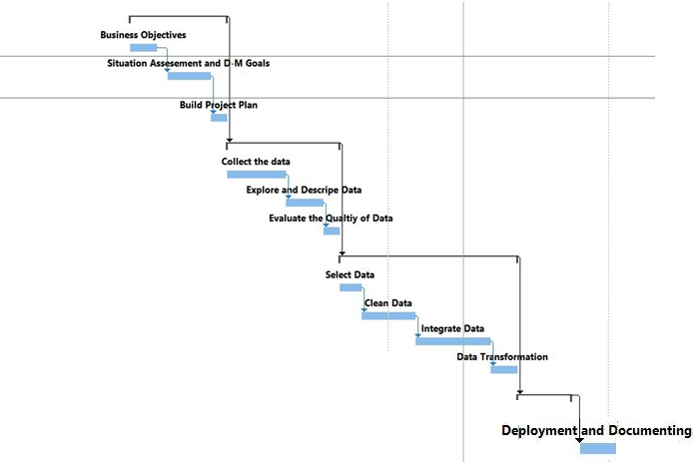
Figure 1: Gant-chart for CRISP-DM

During implementation and deployment the project, we faced some challenges that we can mention some of it as:

- Data acquisition.
- Low Quality of row data.
- Limitation of free trial tools.
- Capabilities of our personal computers.

Used Tools

- Microsoft Excel: we used Microsoft excel software in many techniques, dealing with MS-Excel to solve mathematical calculation, testing, viewing, editing, and integration.

- Rapid Miner: modeling and designing, market basket analysis, predictions, Goins, data cleaning, returned prediction.

- SPSS: free tool build by IBM for data analysis we used SPSS tool for checking normality, Metadata description, data analysis, hypotheses accepting or rejecting and RFM analysis.

- Tableau: was a great tool that help us in exploring and describing data we used it for data visualization, data analysis, and building dashboard.

Data understanding

After we have collected the data we started to explore and describe it to understand its metadata that will help us to know which data is good for analysis and which we will keep for selection.
We gained two data files of orders, one of them is orders for (2012, 2013, 2014) contain 33760 record which we will join it later with another file contains data for 2015 with 17350 record, they are different just in “order priority” an attribute that founded just in the data file of year 2015, also another file was attached with independent data for the returned orders between 2012 and 2014 years, here we explain each attribute to know its importance for the rest:

- Row_ ID: is a dummy incremental ID for each record, each record contains data about one item of each order so one order may has many Row_ID.

- Order_date: the date of delivering the order, uses format mm-dd-yyyy

- Ship date: the date of shipment, uses format mm-dd-yyyy

- Customer Name: two sections, first and last name for each customer.

- Order_ID (Order_No): each order has a specific identification code, that constructed from four sections are:

    - Two chars (XX): first two chars from central country, supervise others.
    - The year of order
    - Customer_ID: (Varchar)
    - Incremental: identification number for each day start from 40909.

- Ship_Mode: means the type of shipment, we realized its related with time, So we found a difference between Order_date and Ship_date the results:

  - Same day (0, 1 Days) 3. Second class (2, 3, 4, 5 Days)
  - First class (1, 2, 3 Days) 4. Standard class (4, 5, 6, 7 Days)

- Customer_ID (Cust_id): consisting from two sections

- Two characters ( XY ): each char represent the first character of customer first and last names e.g.(Ahmad Marwan AM)
- Random sequence number for each customer could be 5-9 digits

- Segment: describe the type of customer, the value of records we have are a choice from (Consumer, Corporate, Home Office).

- Postal_Code: No. for each city as (P.O.B), large number empty values.

- City: name of customer city, which we shipped to it.

- State: name of Customer State, which we shipped to it.

- Country: Customer country which belong for a central one.

- Region: Super store divided the world for 23 region then assign country for each region and states for each country to drill down data.

- Market: choice from (LATAM, Europe, USCA, Africa, Asia Pacific) there is problem in this column that is inserted just in the new file, so there is 9000 missing value.

- Category: choice from three selections to determine the general type of the purchased product (Furniture, Office Supplies, Technology).

- Sub-Category: branching for Category choice to determine more specific type for the purchased product.
- Product_Name: text description for the purchased product, size, color...

- Sales: value of sale for each purchased product

- Quantity: the quantity of purchased product for each order

- Discount: the amount of discount for each transaction

- Profit: amount of returns they gain from each transaction.

- Shipping_Cost: how much each transaction costs to shipping depending on the type.

- Order Priority (not founded in 2012-2014): attribute that classify importance’s of each order.

- Check: attribute has same value for all records “Yes”, we will delete it.

Data Quality

We’ve considered some measures to evaluate the quality of row data and we find some problems:
Factor | What it means? | Metric
Accuracy | Means how correct it is | Ratio of errors to data
Completeness | Not recorded, unavailable | Number of missing values
Consistency | Some modified but some not | Number of inconsistencies
Uniqueness | specific details appears only once | Number of duplicates
Orderliness | The data has the required format | Ratio of unsuitable format
Interpretability | How easily the data can be understood? | -

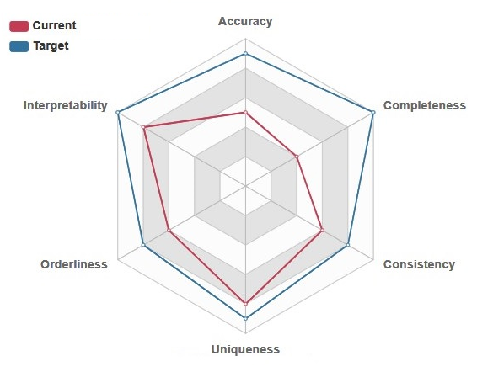
Figure 2: Show the current and target quality of data

Attribute | Type | Size | PK/FK | Comment
Row_ID | Numeric | 5 |  | Dummy (incremental)
Order_ID | Varchar | 35 | PK
Order_Date | Date | 10 |  | 1/1/2012 to 12/31/2015
Ship_Date | Date | 10
Ship_Mode | String | 14 |  | Radio Chick
Customer_ID | Varchar | 12 | FK
Customer_Name | String | 30
Segment | String | 12 |  | Radio Chick
Postal_Code | Numeric | 5
City | String | 22
State | String | 22
Country | String | 22
Region | String | 20 |  | Radio Chick
Market | String | 20 |  | Radio Chick
Category | String | 15 |  | Radio Chick
Sub_Category | String | 15 |  | Radio Chick
Product_Name | String | 40
Returned | Binomial | 5 |  | Radio Chick
Sales | Numeric | 5
Quantity | Numeric | 3
Discount | Numeric | 3
Profit | Numeric | 5 |  | Can be minus
Shipping_Cost | Numeric | 5
Figure 3: Metadata Summarization (2.3)

Data Integration

- Integrating columns: we joined the attached file Returns (2012-2014) with the file that contain data of (2012-2014) by using join process in Rapid Miner tool.

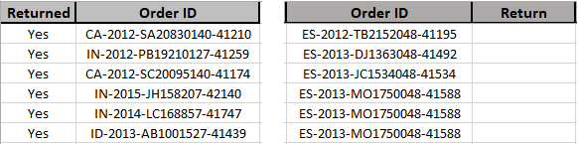
Return file Final data File
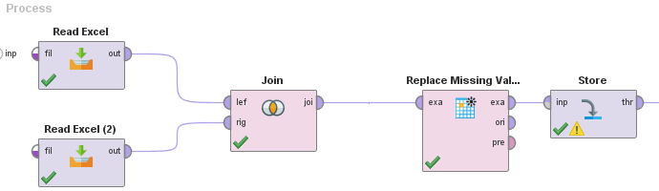
- The first operator read excel data file that contain transactions records from 2012 to 2014, to matching returns by Order_ID attribute.

- The second operator read Returns file that contain (Order_ID and Return).

- Join operator matching Order_ID between two files and build a Return attribute in data file (2012-2014), then compare values of return attribute in data file and return file, if it yes assign yes, else keep it missing.

- Finally next operator replacing missing values by No, storing final data on local repository.

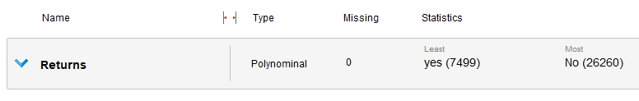

- Integrating records: we combined the data file of (2015) and data file of (2012-2014) in one file calling it (final data) but there was a vital problem faced us, its “Data inconsistency” that caused by the differences between attributes names and number in two files.

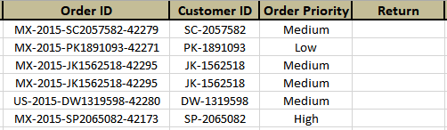
Data File of (2015)
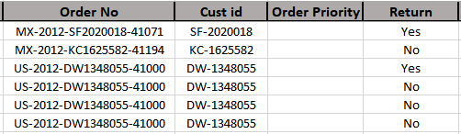
Data File of (2012-2014)
We solved data inconsistency problem by “Schema Integration”, so we renamed old attributes in the file (2012-2014) as same as its name in file (2015), also we added dummy attribute for (2012-2014) file named “Order_Priority” created just in the latest file, and we create a dummy attribute in data file of (2015) we call it “Return”, These two attribute values all will be missing, we create there just to enable appending.
Appending: first two operators read data from both files, Append operator add data records of data file (2015) on file (2012-2014), Last operator export data to new excel file.
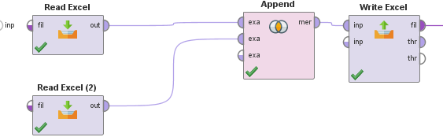

Data Reduction

- Dimensionality Reduction “delete columns”: remove unimportant attributes in the data file like Dummy incremental ID, Redundant attribute, Attribute with the same value, and attribute with many missing or many empty values.
Attribute | Problem | Explanation
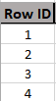 | Dummy incremental ID | This column can’t help us in analysis or mining because it doesn’t have any rule for classifying data for groups.
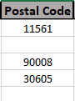 | Many Empty values  “USA and Canada” | Many countries didn’t have postal code so it has empty values that means it’s not founded in the real world and we can’t replace it by another one.
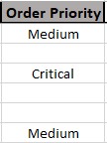 | Many Missing values  “New attribute” | This attribute has large number of missing values, and isn’t accurate to replace them because we don’t know the rule that was considered to classify these orders.
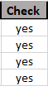 | Same value | This attribute can’t help us in any type of data mining types.

- Benefits of Dimensionality Reduction:
1. Allow easier visualization and reduce noise
2. Avoid the curse of dimensionality eliminate irrelevant features
3. Reduce time and space required in data mining
- Remove records that contains extreme values “delete rows”: extreme values which are samples that do not comply with the general behavior of the data model, so it affecting on the average of data and the other statistical measures, So we used SPSS tool to determine extreme values and then delete it.

- We used descriptive statistics in SPSS to find standardized values column

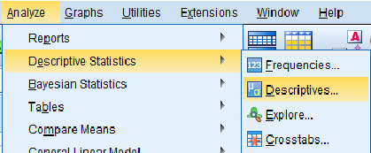

- Then we select profit attribute to remove from it extreme values

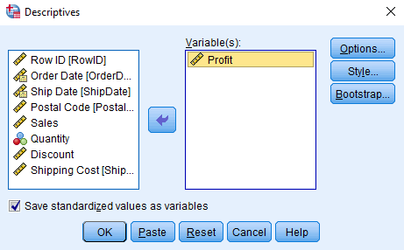

- Finally after sorting data, we delete ten extreme values from each side

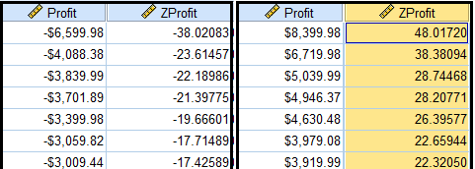
Sorting ascending Sorting descending

Data Transformation

Attribute construction: new attributes constructed from the given ones, So we constructed new attribute (Product_ID) to facilitate dealing with the large numbers of types of products and to facilitate joining them within groups, the Product_ID attribute rely on three attribute values (Category, Sub-Category, and Product_Name), Firstly we coded the data of category and sub-category attributes as showed in table:
Category | Code | Sub-Category | Code | P_Name
Furniture | Fur | Bookcases | Bo | A | 10
Furniture | Fur | Chairs | Ch | B | 20
Furniture | Fur | Furnishing | Fu | C | 30
Furniture | Fur | Tables | Ta | D | 40
Office Supplies | Off | Appliances | Ap | E | 50
Office Supplies | Off | Art | Ar | F | 60
Office Supplies | Off | Binders | Bi | G | 70
Office Supplies | Off | Envelops | En | H | 80
Office Supplies | Off | Fasteners | Fa | I | 90
Office Supplies | Off | Labels | La | … | …
Office Supplies | Off | Paper | Pa | … | …
Office Supplies | Off | Storage | St | … | …
Office Supplies | Off | Supplies | Su | … | …
Technology | Tec | Accessories | Ac | … | …
Technology | Tec | Copiers | Co | X | 880
Technology | Tec | Machines | Ma | Y | 890
Technology | Tec | Phones | Ph | Z | 900

Then we used if statement to assign each numeric value for each product category type and adding to it sub-category numeric value, finally we sorted data ascending depending on Product_Name attribute and we started from second record if Product_Name of it has as same as value of the previous one, it will take same Product_ID, else add to the Product_ID attribute ten degrees and so on.

Data Cleaning

- Handling noise data

  - Noise: random error or variance in a measured (Scale) variable.
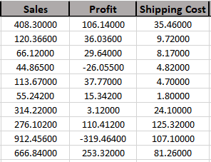
Noise data before rounding
  - Rounding: will remove interference between numeric values so values as (2.99, 3 and 3.01) are smoothed to (3, 3 and 3) and so on.

    - For scale variables we used round function in MS-Excel to smoothing numeric data, =ROUND ((Value), 2).

    - After using this function all decimal digits will be removed and just two decimal digits will stay.
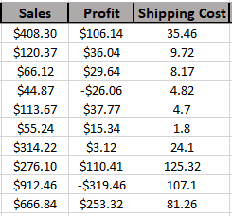
Arranged data after rounding

Data Cleaning

- Replacing missing values:

    - Missing values are: values for variable exists in the data world but has not been entered in the data file.

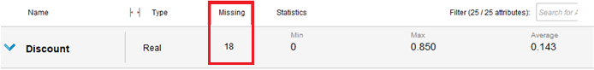
Statistics for Discount attribute

    - As we see in the previous figure discount attribute contains 18 missing values need to clean it, thus by replacing missing values automatically by the average:

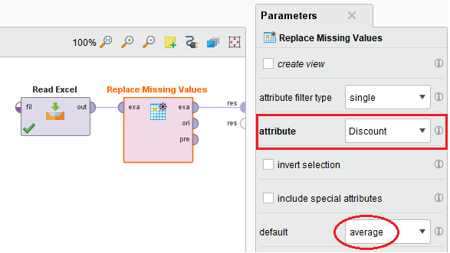
Replacing missing values by average using RapidMiner tool

Data Cleaning

- Replacing missing values temporarily:

    - We have attribute called “Return” which is a result from join process, this attribute contains 17531 missing value, these missing values of returned orders from 2015 which aren’t founded.

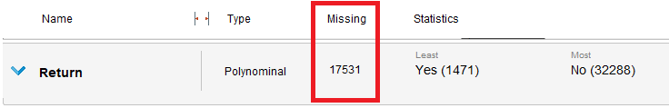
Return attribute statistics

    - We need to replace these values temporarily by global constant “unknown” because we will use a prediction technique to predict the class label of these records if it’s Yes or No.

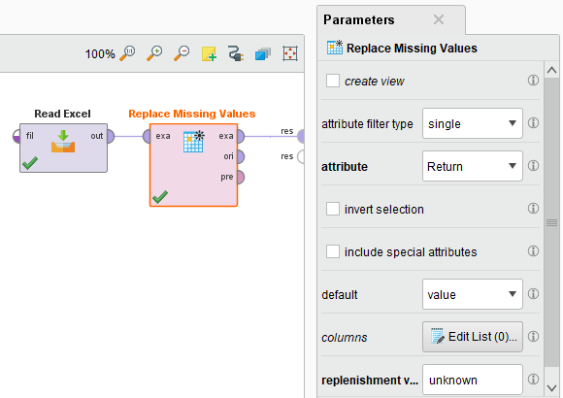

Association Rule Discovery

Association rule discovery technique enable us to analyze the market basket and notice “what are the products that customers bought together”, this will give us ideas to improve the promotions, product display in the market, and developing methods for product display in website.
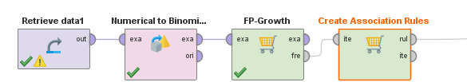
Design: Association Rule Discovery by Rapid miner
    - First operator reads data from final data, which was cleaned in previous stage.
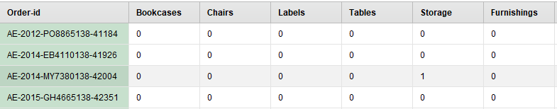
    - Second operator converts binary numbers to binomial values (True, False).
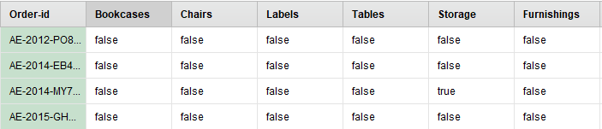
    - FP-Growth operator calculates all frequently-occurring item sets in the data set, using the FP-tree data structure, and find support for each case, the algorithm read each records on order and mapping it into path in the FP-tree.
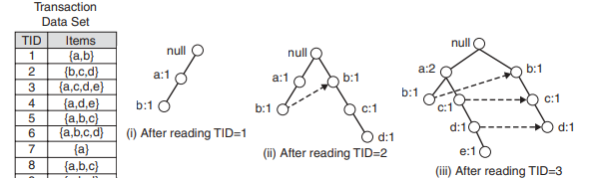

FP-Growth operator summarize the associated frequented items and the support value for each rule in a table as showed:

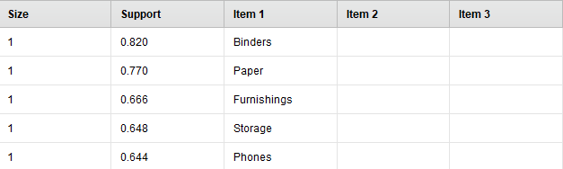

    - Last operator generates a set of association rules from the data set of frequent item sets, so it determine the premises product and the conclusion product, also this operator calculate the Support, Confidence, and Lift for each case .

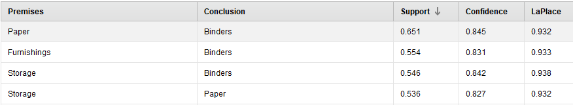

    - This step enables us to evaluate the results and to select the optimal, because it gives us the support and confidence values, so by the filter we increase the criterion value to show just the high confidence value rules.

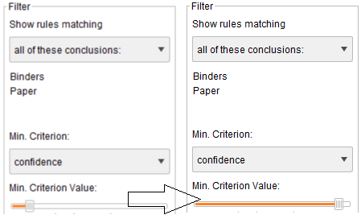

Prediction Tree

In Data Cleaning stage we replaced missing values for “Return” attribute by global constant “unknown” now we will use prediction technique to predict these unknown values if it’s returned or Not.

Step 1: choose the best attributes (columns) to build the optimal model using Correlation between the attributes.
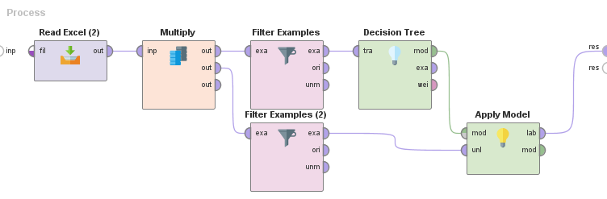

Step 2: This process divides the whole data set into two data sets, one for building the model (not missing) and the other (missing) then apply the not missing model on missing and the result is predicted returns column.
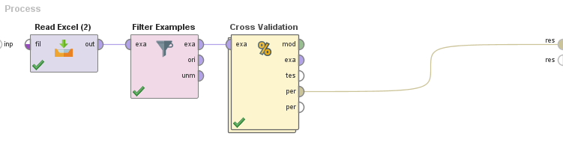
Step 3: This process splits data into training and testing set by k-fold algorithm (10 is default)
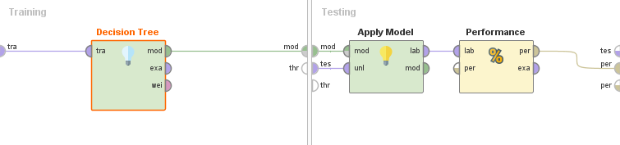

Step 3-cross validation: In left side training set (model) and in right side testing set apply model and measure accuracy of not-missing.
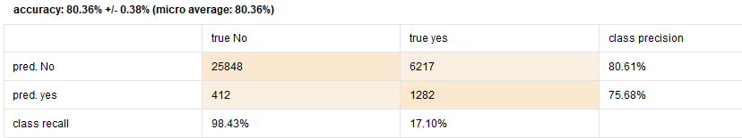
Result of Cross validation 0.001
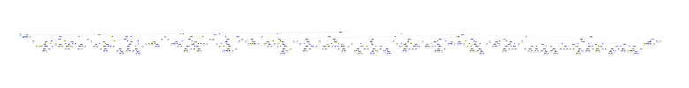
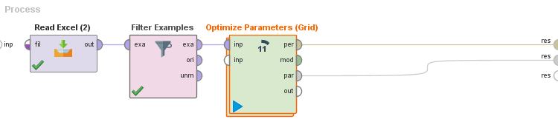
Step 4: This Operator finds the optimal values of the selected parameters for the operators in its sub process.
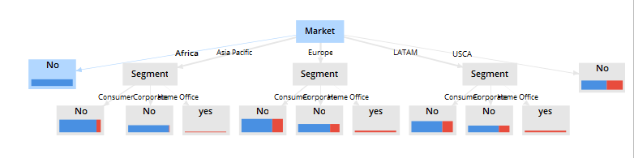

Output screen for Rapid Miner for Prediction process

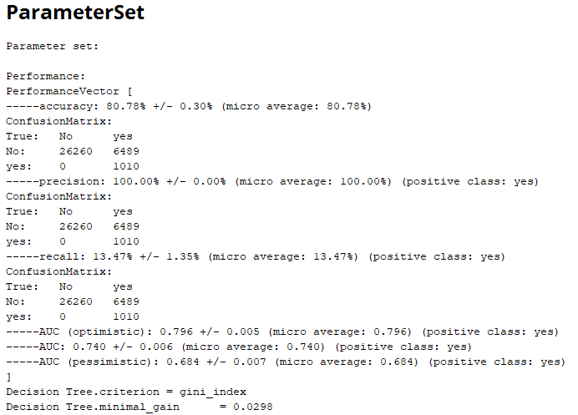

Deployment Association Rule Discovery

The results of market basket analysis give us three types of rules are:
- Trivial rules: Known to everyone as ({Table} {chairs}).
- Inexplicable rules: Seem strange as ({Ink} {Photo Frame}).
- Useful rules: that we need to work on it because it actionable.
We selected some valuable rules from these useful rules that resulted from the analysis to deploy it and give advices to achieve the business objectives, we based on two metrics are:
- Support: The proportion of Market Basket Analysis where the Rule is true.

- Confidence: Measures how often the right side of the rule holds, given the left side.

Rule |  |  | Metrics
No. | Premises | Conclusion | Support | Confidence
1 | { Copiers } | { Appliances } | 0.09 | 0.632
2 | { Bookcase } | { Appliances } | 0.02 | 0.402
4 | { Binders, Arts } | { Copiers } | 0.12 | 0.75
5 | { Phones } | { Accessories } | 0.07 | 0.53
Some of actionable rules from basket analysis

- Cross selling: as we see in the rule number one there is a high confidence in the relation between copiers and appliances so customer who buy a copier will immediately search for the place of appliances, thus the superstore has the option of placing them apart from each other so that the customer has to walk the aisles to search for appliances, and by doing so potentially seeing and buying other items.

- Up selling: in the second rule there is good a confidence value between Bookcases and Appliances but less than the confidence between copiers and Appliances, maybe the customer who buy a Bookcase forgotten to buy an Appliance machine, so we need to put the items next to each other to make it more convenient for the customers to pick them up together and not forget to buy one when buying the other.

- Web store: in the web store design, any product has relationship with another one they mustn’t placing them apart from each other, So when the user search for one product as Copier and return to navigate the webs tore we should show them the Appliances products to remind them to buy.

- Promotions & Discounts: we use tableau visualization tool to show the relationship between profits and the sub-category of products, we found that “Tables” category profits value is negative!!, so a decision should be decide, for example, to make a promotion between tables products and two products has high affinity value to increase the tables sales.

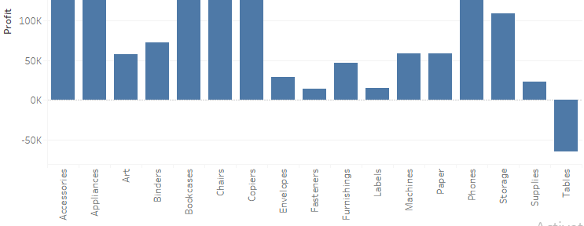
Bar chart show us the relation between sub-category and profits

As we see in transaction number two there is excellent relation between bookcases and appliances, as we seen tables and bookcases may be suitable if we promote them with each other, so the promotion we advise it for this company says:

    - Buy Table and has discount 15% on Bookcases now!!

    - Hoover Refrigerator, metal bookcase and wood table just 3500$ now.

    - After a customer buys a copier, remind them to buy office table.

Deployment results of Decision tree

After we finished classification model by decision tree, we reassigned the missing values in the return attribute for each order in 2015 by the results that we got from Rapid Miner, this enables us to visualize data more accurately by building the dashboard and building graphs that show us the relationships between returns attribute and others attributes to make decisions that improve the organizational performance.

- Returned product – Year:

As we can see in the figure, the returned product rate is raising rapidly, it increases by 5400 returned products from 2012 to 2015, Superstore must to put strategy for reducing the number of returned products because it cost them so much.

Series time chart

- Returned product – Subcategory:

We used pie chart to find what type of products mostly returned, as we see in the figure Binders, Art and Storage are the most sub-category returned products from 2012 to 2015. Superstore must to discovering the reasons for returning the products.

- Returned product – Supervisor (Region):

Who is the responsible, who is the defaulter?

    - By using horizontal bar chart we found whom from the supervisors that have most number of returned products!! Now we can accountable them for their failure.

    - Also Managers with few returns should be promoted and motivated, this increase from their effectiveness.

`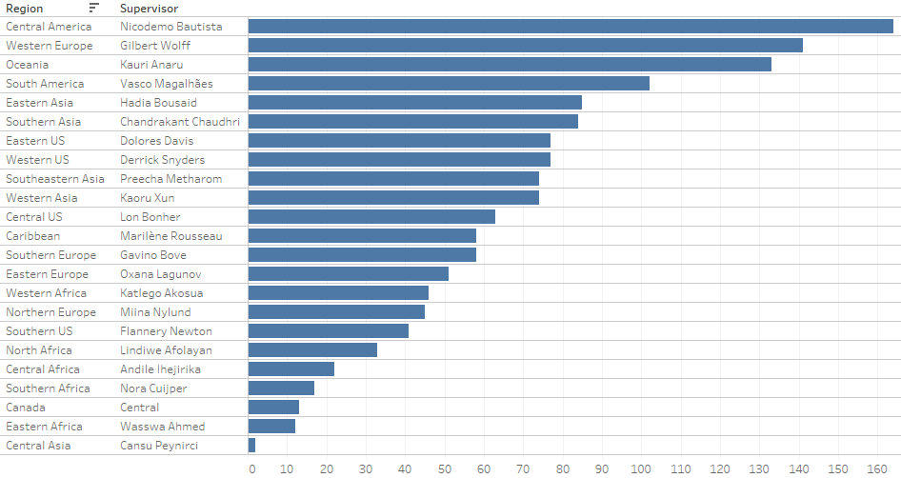

Central America, Western Europe and Oceania regions considered the worst in returning filed but Canada Eastern Africa and Central Asia are the best, as showed in the previous graph.

RFM Analysis

- What’s RFM?
RFM stands for (Recent, Frequency, Monitory), it’s a method used for analyzing customer value. Commonly used in database marketing and direct marketing and has received particular attention in retail and professional services industries.

- Why we did RFM?

  - Customer Segmentation
  - Improve customer retention
  - Developing a Recommendation System
  - Improve customer relationship management

- What was the data we used?
After completing the data mining process we cleaned and prepared data for 17415 customer’s transactions, we used some attributes to build and deploy the RFM model:
- Transaction Date (Order_date).
- Amount of transaction (Sales).
- Customer identifier (Customer_ID).

- Problems we faced:
When SPSS tool read the data excel file, it read transaction date as a string attribute, we modified this issue by reformatting the attribute, we changed the attribute type to Date, and its format to mm/dd/yyyy.

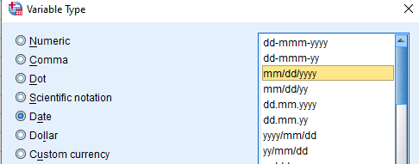

Building RFM Model

Open SPSS then import excel data file, we transform the Order_date from String to Date, then from top bar we selected Direct Marketing choose technique:
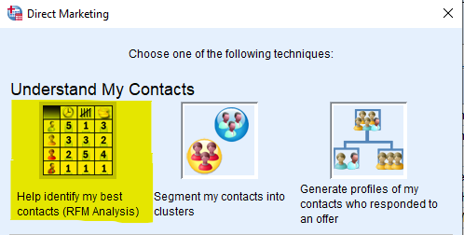
After we selected RFM analysis we selected the data format Transaction data
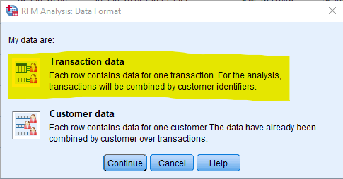
Next we fill the attributes for each required filed as showed in the figure:
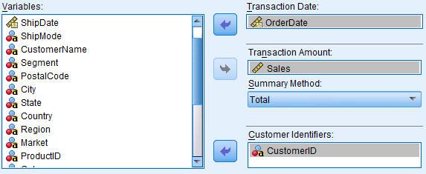

RFM Results

There are three results for RFM model for each Customer_ID, based on three attributes:
- Recency_Score Based on most recent Date for transactions.

- Frequency_Score Based on Counts of the transactions.

- Monetary_Score Base on Amount of total sales customer pay.

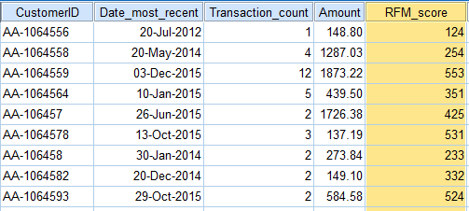
Sample of RFM results
For example Customer “AA-106458”:
Recency =2/5 Frequency =3/5 Monetary =3/5

- We decided to combine Frequency & Monetary in one value because they are related, by take the average of them.

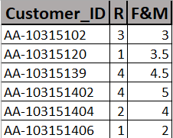

RFM Deployment

- Customers Segmentation: we divided the customers for eight segments depending on the value of (Recency) and (Frequency & Monetary) for each customer, the next table show how we categorized the eight segments:

No | Segment | Recency | Frequency & Monetary | Note
1 | Champion | 4 - 5 | 4 - 5 | $∈$ Loyal
2 | Loyal | 2 - 5 | 3 - 5 | Primary
3 | Potential Loyal | 2 - 5 | 0 - 3 | Primary
4 | Need Attention | 2 - 3 | 2 - 3 | $∈$ Potential Loyal
5 | Recent | 4 - 5 | 0 - 1 | $∈$ Potential Loyal
6 | At-risk | 0 - 2 | 2 - 5 | Primary
7 | Don’t Lose | 0 - 1 | 4 - 5 | $∈$ At-risk
8 | Lost | 0 - 2 | 0 - 2 | Primary
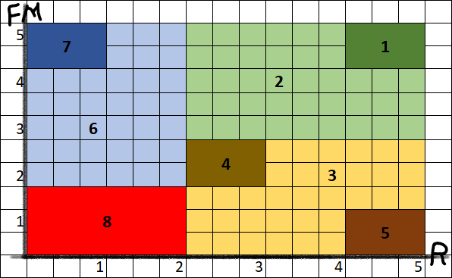

After we distributed customers on the eight segments we represent the results by pie chart:

No | Segment | Recency | Frequency & Monetary | Total
2 | Loyal | 2 - 5 | 3 - 5 | 6714
3 | Potential Loyal | 2 - 5 | 0 - 3 | 5485
6 | At-risk | 0 - 2 | 2 - 5 | 3014
8 | Lost | 0 - 2 | 0 - 2 | 2202
Total |  |  |  | 17415

- Recommendation System: by using MS-Excel and developer tool we built a simple recommendation system for casher in superstore enable them to know the customer type, description and some tips to deal with customers through inserting Customer_ID, using Visual Basic programing language.

After we segmented the customers for eight segments we give each type of segments behavior description and tips to dealing with them basing on the values of Recency, frequency and monetary.

- Champion

  - Behavior: Bought recently, buy often and spend the most!
  - Tips: Reward them. Can be early adopters for new products. Will promote your brand.

- Loyal:

  - Behavior: Spend good money with us often. Responsive to promotions.
  - Tips: Upsell higher value products. Ask for reviews. Engage them.

- Potential Loyal

  - Behavior: Recent customers, but spent a good amount and bought more than once.
  - Tips: Offer membership / loyalty program, recommend other products.

- Need Attention

  - Behavior: Above average Recency, Frequency and Monetary values. May not have bought very recently though.
  - Tips: Make limited time offers, Recommend based on past purchases. Reactivate them.

- Recent

  - Behavior: Bought most recently, but not often.
  - Tips: Provide on-boarding support, give them early success, start building relationship.

- At-Risk

  - Behavior: Spent big money and purchased often. But long time ago. Need to bring them back!
  - Tips: Send personalized emails to reconnect, offer renewals, provide helpful resources.

- Don’t Lose

  - Behavior: Made biggest purchases, and often. But haven’t returned for a long time.
  - Tips: Win them back via renewals or newer products, don’t lose them to competition, and talk to them.

- Lost

  - Behavior: Lowest Recency, Frequency and Monetary scores.
  - Tips: Revive interest with reach out campaign, ignore otherwise.

By MS-excel macros (Visual Basic) we built a recommendation system:
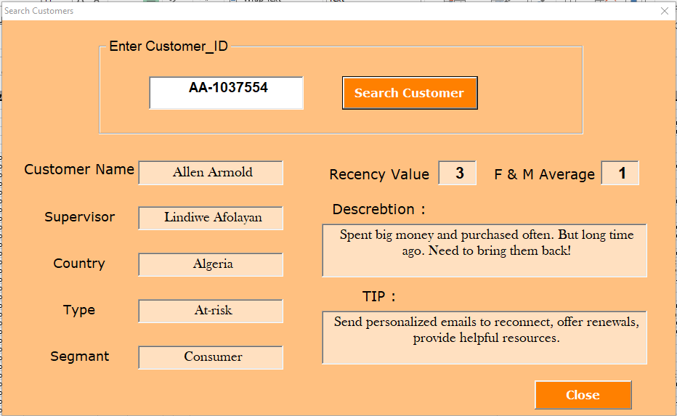

Depending on the cleaned data, RFM results and behavior and tip that we assigned it for each customer we build the dashboard by excel and visual basic programing language, this dashboard enables the employee to know how to deal with each customer by inserting their ID.

Dashboard

We set some Key performance indicators (KPIs) to show relations between attributes of data by charts on Tableau tool:
- Revenue Growth Rate.
- Returned Products Rate.
- Growth of Orders numbers per Period
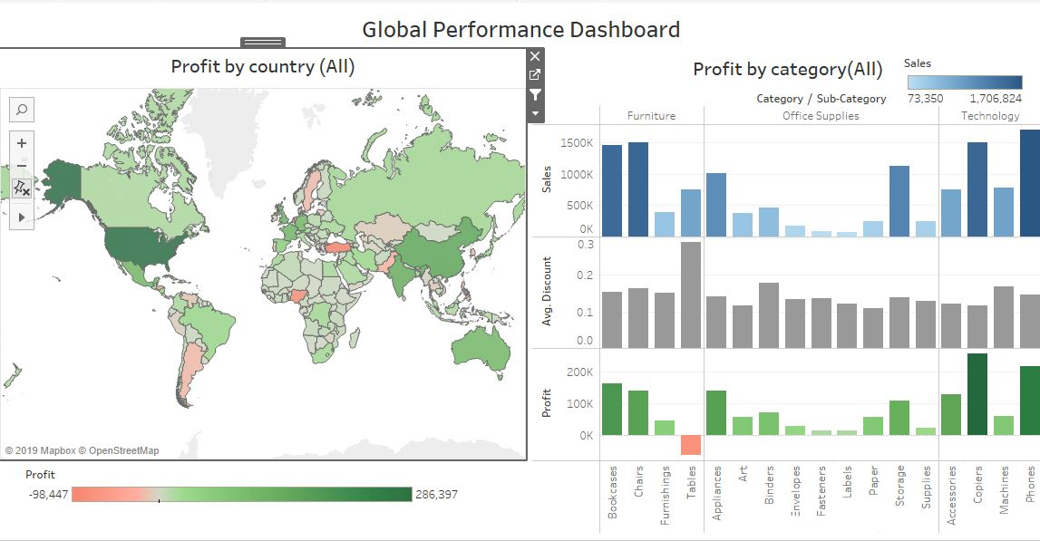
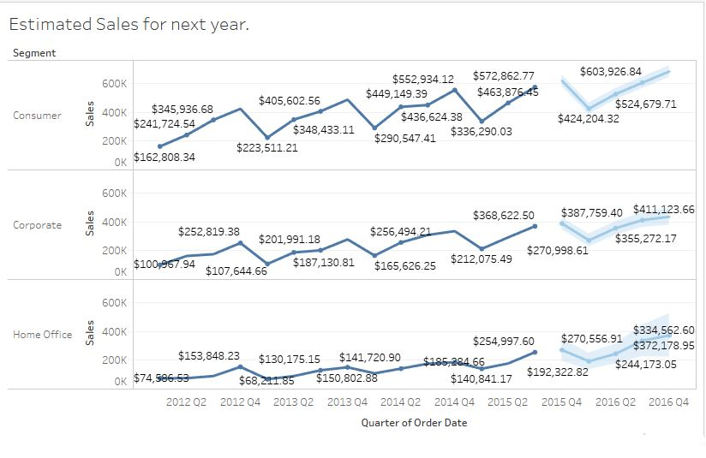

Automation the processes

Before we started the work in the project we’ve thought how the others will benefit from our work and develop it easily, by the written documentation, but then we found more appropriate solution, which is to code them, but how !?
The tools we have worked with deal with programing languages as (Visual Basic), (R language) and (Python).
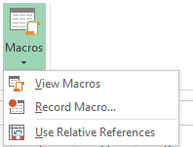
MS-Excel
We used Record Macros function in MS-excel that record every command we used during the data preparation so that we can apply it to future data modification of our work.
So we recorded our steps on excel and attached it in the end of this documentation.
Rapid Miner
After implementing different types of models for example (Association, Cleaning and Prediction) on the current available transactions data, we automated the final design of all sub-models by gathering them in one general model.
That was done, we will be able to use this General Model on any new or different Transactions Data expecting the same or a close output. You can see the figure for the final general model that we attached on this file.
SPSS
To copy code, before press ok to implement, press copy to take copy of code, then, if you want to run ,it go to File->New->Syntax and paste it, after that select the code that you want to run it and press run button.
You can save it by: save as (as a SPSS file).
You can also delete the first row and replace it with the initial code (when you open data), so when you open an empty file and run the code it will open and execute it.

MS-Excel Macros Attachments

Schema Integration for data file 2012-2014
Sub Macro1()
' Macro1 Macro
Range("AA1").Select
ActiveCell.FormulaR1C1 = "Order Priority"
Range("AB1").Select
ActiveCell.FormulaR1C1 = "Return"
Range("Z1").Select
Selection.Copy
Range("AA1:AB1").Select
Selection.PasteSpecial Paste:=xlPasteFormats, Operation:=xlNone, _
SkipBlanks:=False, Transpose:=False
Application.CutCopyMode = False
Columns("AA:AA").EntireColumn.AutoFit
Columns("AB:AB").EntireColumn.AutoFit
Range("AB3").Select
Range("B1").Select
ActiveCell.FormulaR1C1 = "Order_ID"
Range("F1").Select
ActiveCell.FormulaR1C1 = "Customer_ID"
Range("F2").Select
End Sub

Schema Integration for data file 2015
Sub Macro2()
' Macro2 Macro
ActiveWindow.SmallScroll ToRight:=1
Range("AB1").Select
ActiveCell.FormulaR1C1 = "Return"
Range("AA1").Select
Selection.Copy
Range("AB1").Select
Selection.PasteSpecial Paste:=xlPasteFormats, Operation:=xlNone, _
SkipBlanks:=False, Transpose:=False
Application.CutCopyMode = False
End Sub
Dimensionality reduction for final data file
Sub Macro3()
' Macro3 Macro
Columns("I:I").Select
Selection.Delete Shift:=xlToLeft
Columns("Z:Z").Select
Selection.Delete Shift:=xlToLeft
Columns("A:A").Select
Selection.Delete Shift:=xlToLeft
End Sub

RFM automation by excel

' RFM_Auto ظ…ط§ظƒط±ظˆ
'
'
Sheets("ظˆط±ظ‚ط©1").Select
Selection.Copy
Sheets("ظˆط±ظ‚ط©2").Select
Range("M2").Select
Selection.End(xlToLeft).Select
Selection.End(xlToLeft).Select
ActiveSheet.Paste
Range("H2").Select
Application.CutCopyMode = False
ActiveCell.FormulaR1C1 = "=(RC[-2]+RC[-1])/2"
Range("H2").Select
Selection.AutoFill Destination:=Range("H2:H17416")
Range("H2:H17416").Select
Range("H2").Select
Range(Selection, Selection.End(xlDown)).Select
Selection.Copy
ActiveWindow.LargeScroll Down:=1
Range("H17416").Select
ActiveWindow.LargeScroll Down:=-1
Range("H17392").Select
ActiveWindow.LargeScroll Down:=-1
Range("H17368").Select
Selection.End(xlUp).Select
Selection.End(xlUp).Select
Range("I2").Select
Selection.PasteSpecial Paste:=xlPasteValues, Operation:=xlNone, SkipBlanks _
:=False, Transpose:=False
Columns("F:G").Select
Application.CutCopyMode = False
Selection.Delete Shift:=xlToLeft
Range("G2").Select
Range(Selection, Selection.End(xlDown)).Select
Selection.Copy
Application.CutCopyMode = False
Selection.Cut
Application.CutCopyMode = False
Selection.Cut
Range("F2").Select
ActiveSheet.Paste
Range("G2").Select
ActiveCell.FormulaR1C1 = ""
Range("N12").Select
ActiveCell.FormulaR1C1 = _
"IF(AND(E2>=4,F2>=4),""Champions"",IF(AND(E2>=2,F2>=3),""Loyal Customer"",IF(AND(E2>=3,F2>1,F2<3),""Potential Loyalist"",IF(AND(E2>=4,F2<=1),""Recent Customer"",IF(AND(E2>=3,E2<4,F2>=0,F2<=1),""Promising"",IF(AND(E2>=2,E2<3,F2>=2,F2<3),""Customer Need Attention"",IF(AND(E2>=0,E2<=1,F2>=4),""Cant Lose Them"",""Lost"")))))))"
Range("G2").Select
ActiveCell.FormulaR1C1 = _
"=IF(AND(RC[-2]>=4,RC[-1]>=4),""Champions"",IF(AND(RC[-2]>=2,RC[-1]>=3),""Loyal Customer"",IF(AND(RC[-2]>=3,RC[-1]>1,RC[-1]<3),""Potential Loyalist"",IF(AND(RC[-2]>=4,RC[-1]<=1),""Recent Customer"",IF(AND(RC[-2]>=3,RC[-2]<4,RC[-1]>=0,RC[-1]<=1),""Promising"",IF(AND(RC[-2]>=2,RC[-2]<3,RC[-1]>=2,RC[-1]<3),""Customer Need Attention"",IF(AND(RC[-2]>=0,RC[-2]<=1,RC[-1]>=4" & _
"),""Cant Lose Them"",""Lost"")))))))"
Range("G2").Select
Selection.AutoFill Destination:=Range("G2:G17416")
Range("G2:G17416").Select
Range("H2").Select
ActiveCell.FormulaR1C1 = "=VLOOKUP(RC[-1],R13C11:R23C13,2,FALSE)"
Range("H2").Select
Selection.AutoFill Destination:=Range("H2:H17416")
Range("H2:H17416").Select
Range("I2").Select
ActiveCell.FormulaR1C1 = "=VLOOKUP(RC[-2],R13C11:R23C13,3,FALSE)"
Range("I2").Select
Selection.AutoFill Destination:=Range("I2:I17416")
Range("I2:I17416").Select
ActiveWindow.ScrollColumn = 8
ActiveWindow.ScrollColumn = 7
ActiveWindow.ScrollColumn = 6
ActiveWindow.ScrollColumn = 5
ActiveWindow.ScrollColumn = 3
ActiveWindow.ScrollColumn = 2
ActiveWindow.ScrollColumn = 1
Range("G2").Select
Range(Selection, Selection.End(xlDown)).Select
With Selection.Interior
.Pattern = xlSolid
.PatternColorIndex = xlAutomatic
.ThemeColor = xlThemeColorDark1
.TintAndShade = -0.149998474074526
.PatternTintAndShade = 0
End With
Range("A1:I17416").Select
Range("G7").Activate
Selection.Borders(xlDiagonalDown).LineStyle = xlNone
Selection.Borders(xlDiagonalUp).LineStyle = xlNone
With Selection.Borders(xlEdgeLeft)
.LineStyle = xlContinuous
.ColorIndex = 0
.TintAndShade = 0
.Weight = xlThin
End With
With Selection.Borders(xlEdgeTop)
.LineStyle = xlContinuous
.ColorIndex = 0
.TintAndShade = 0
.Weight = xlThin
End With
With Selection.Borders(xlEdgeBottom)
.LineStyle = xlContinuous
.ColorIndex = 0
.TintAndShade = 0
.Weight = xlThin
End With
With Selection.Borders(xlEdgeRight)
.LineStyle = xlContinuous
.ColorIndex = 0
.TintAndShade = 0
.Weight = xlThin
End With
With Selection.Borders(xlInsideVertical)
.LineStyle = xlContinuous
.ColorIndex = 0
.TintAndShade = 0
.Weight = xlThin
End With
With Selection.Borders(xlInsideHorizontal)
.LineStyle = xlContinuous
.ColorIndex = 0
.TintAndShade = 0
.Weight = xlThin
End With
Range("K1").Select
End Sub

General Model by Rapid Miner

