
MEDICAL TRAINING MATCHING PROGRAM
(MTMP)

Students:
MOHAMMAD DONBOK 11420240
MOHAMMAD AL-ASAB 11524992
AHMAD SUFIAN 11718172

Supervisor:
Dr. Baker Abdulhaq

This document done and submitted for Graduation Project in
Computer Information Systems department.
An-Najah National University
2018 / 2019

© Copyright

Chapter one 5
Introduction 5
Project Scope 6
Problem Specification 7
Goals and Objectives 7
Motivation 8
Chapter Two 9
Introduction 9
System Analysis 10
Requirements Collection 10
Interviews: 10
Other Systems: 10
Brainstorming: 10
Requirements 11
Functional Requirements 11
Users 15
Admin 15
doctor 15
students 15
Non-Functional Requirements 16
Usability 16
Efficiency 16
Reliability 17
Maintainability 17
Security 17
Portability 17
Chapter Three 18
Introduction 18
Current system 19
The advantage and disadvantage for current system : 22
Advantage : 22
Disadvantage: 22
Proposed System: 23
The advantage and disadvantage for proposed system : 24
Advantage : 24
Disadvantage: 24
Methodology 25
Chapter Four 27
Programming Language and Tools 28
What do we used 28
Implementation 28
how the transfer operation managed? 29
Separation of Concerns which consists of four layers : 29
Chapter Five 32
Conclusion 33
Future work 33
References 34

Abstract
MTMP is a project that will solve a problem that face the employees who are responsible on the operation of distributing the trainee students of medicine faculty at An Najah National University on hospitals .
the traditional way in distributing the trainee done manually which costs time and effort and sometimes it face problems and errors, so the benefits of the MTMP system is to make the whole operation computerized that will give a fast results using matching algorithms , this algorithm received data that include information about students as an imported file from server like (zajel) then the employee by just press a button the system will distribute students on groups automatically depending on specific conditions that mentioned in system requirements then the system distribute this groups on another table that will show the hospital and the group will train in , the doctor who will supervise the groups , the program that every group will start with like (Internal Medicine ,surgery , Obs & Gyn and Psychiatry ) programs also the table will change dynamically every specific period of time .
The employee will have the abilities in control the operation , edit the table, add students , move student from group to other ,change the supervisor and a lot of ability the employee can control.

Chapter one

(Define The System)

Introduction
The faculty of medicine have a complicated operation in distributing the 4th year students on hospitals, a lot of students, few hospitals and specific doctors who will supervise the students in the training session. The main point is to reduce the traffic of students in hospitals and distribute them in a fair way so every students take all the programs, per contra reducing the traffic of trainees in the hospitals must Take into consideration.
This complicated operation took a lot of time from the employee who is responsible on it and may have some conflicts.

Project Scope
As a developers we suggests a computerized system which control this complicated operation to make it easy on employee to interact with the issue, so we suggest the MEDICAL TRAINING MATCHING PROGRAM (MTMP).

The MTMP is a desktop / mobile application which will serve three different users:

- The employee who is responsible on the distribute operation representing the admin who has a full control on the system.

- The students who can only view there training schedule.

- The doctors who can only view his/her program and which group he/she will supervise.

Problem Specification
The problem is about making a fair dynamic distribution for the students by put them in groups depending on some specific conditions which should be occurred to do the operation , The traditional way in distribute the groups manually is very hard to do because there is 3 sets every set consists of 10 subsets, every subset should contain maximum 7 students with mixed of male and female in a rate that is Proportional to the total number of males and females , also the GPA in every subset should be between range of (2.5 - 4) and in additions to more conflict requirements that must be checked to make the groups.

Goals and Objectives
- The main goal of MTMP system is to : achieve this conflict operation in a short time by just insert the needed info then by using a stable matching algorithm built on the system requirements the result will shown as a schedule containing the groups training information including the (start / end) date , the supervisor ,hospital name and in which application student will be in a specific period of time . this operation will be executed dynamically so the schedule changed with its elements every specific period.

- Employees who are responsible on the distribution can see a schedule combine all groups training session in order to interact with the MTMP system by editing and viewing the results like move student from group to another change the supervisor for a group if he/she is absent.

- Students can view there training session in a schedule containing the supervisor name, hospital and the application they are involved with.

- Doctors can view which group he will supervised.

- Save time: instead of losing time on making the distribution manually by the employee the MTMP will do it in a few times and the employee can find time to improve the training operation and tracking the training session.

Motivation
Our motivation is that currently there isn’t any system helps the training employees in the medicine faculty at AN-Najah University to make the distribute operation, we suggests the idea of our system which took a great interest from the employees.
MTMP will help these employees in control and improve the training session by let them interact easily with the system.

Chapter Two
(Requirements)

Introduction
after agreed the idea of MTMP project and discuss it.
we get the support from the medicine faculty training sector to apply the idea , they were very friendly and supportive.
In this chapter, we will talk about system analysis and system design model.

System Analysis
In this chapter, we will discuss how we collect the requirements and the methods we used to collect the requirements.

Requirements Collection

Interviews:

One of the default styles to collect information for most systems. Where we make interviews with employees who are responsible on the training operation . then ask them what they hope to be implemented as an application to make the operation more dynamic and easy.

Other Systems:

It is one of the sources that used to collect requirements. We made a search on the Internet sites such as carms (The Canadian Resident Matching Service (Carms) is a national, independent, for service organization that provides a fair, objective and transparent application and matching service for medical training throughout Canada).

Brainstorming:

we suggests a special edits on the system be discuss it with the employees and approve it to be added to the system .

Requirements

The following section presents functional and nonfunctional requirements identified for the MTMP.
Functional requirements are listed first, according to their relationship to the overall system and users.
The non-functional requirements that pertain to (Efficiency, usability, Reliability, Maintainability, Security, Portability)
The functional requirements have been specified using a natural language description.

Functional Requirements

The system should distribute the student into maximum 30 groups that every set of groups will have the same training schedule for a year of training :

- The groups are three sets A’s ,B’s and C’s.
- The sets consists of 10 subsets for each set .( A1….A10) , (B1….B10),(C1...C10).
- Every subset contain maximum 7 students .
- The subset must be mixed of male and female in a rate of [for example]
2 males : 5 females and vice versa.
- The rate must be calculated by the system before the matching depending on the number of all trainees , so the rate could be 4:3 depending on the result of the mathematical expression that it took the number of trainees and find the rate automatically.
- The GPAs in every subset should be in different levels for example A0 should have 7 student with ranging in GPAs between (2.5-4).

The Conditions that the student must done it to be accepted in the training program:

- The System must check three conditions to determine acceptation for a student :
- If the student get a degree of 500 or high in the toefl exam.
- If the student have a completed 130 credit hours successfully .
- If the student GPA is 2.5 or higher.

*Notes :

- Toefl score will be imported as Excel sheet
- The completed hours and the GPAs should inserted to the system from a database.

About the schedule training session :

- The system should create a schedule for student that he/she can only view it on his account.
- The system should create a schedule for Doctor that he/she can only view the group he will supervise .
- the employees who are responsible on the training program can view and edit the schedule as an admin.

- The schedule have columns , every column represent the week , first column contain the date of the first training day for the student , the next column contain the date of the second week which the system should count 7 days from the previous date and so tell the last week which is represented in the last column that should contain the date of the last week.

- The row titled with the group number for example (A1) , the intersection between the row and column must have the doctor symbol which is specified by the matching algorithm , in addition it contains the training subject and the hospital name the student will train in it.

- For A’s groups they start with Internal Medicine subject for 12 week but they must cover three section (heart , lungs ,Digestive) throw this period , then Surgery subject for 12 weeks that cover(Urologist , Blood vessels, Eye surgery)throw this 12 week , now groups A’s split up from A1-A5 they will take Obs & Gyn for 4 weeks in rafidia hospital then next 4 weeks they continue in Jenin hospital for same subject and last 4 weeks they start with Psychiatry subject. at the same time groups A’s form A6-A10 will start the Psychiatry subject for 4 weeks then continue with Obs & Gyn subject 8 weeks in rafidia hospital, this operation to ensure that no intersection will happen to reduce the students crowds

- For B’s groups they start with Surgery subject for 12 week but they must cover three section (Urologist , Blood vessels, Eye surgery) throw this period ,now groups B’s split up from B1-B5 they will take Obs & Gyn for 4 weeks in rafidia hospital then next 4 weeks they continue in Jenin hospital for same subject and last 4 weeks they start with Psychiatry subject. at the same time groups B’s form B6-B10 will start the Psychiatry subject for 4 weeks then continue with Obs & Gyn subject 8 weeks in rafidia hospital, this operation to ensure that no intersection will happen to reduce the students crowds
then Internal Medicine subject for 12 weeks that cover (heart , lungs ,Digestive) throw this 12 week .

- For C’s groups they split up from C1-C5 they will take Obs & Gyn for 4 weeks in rafidia hospital then next 4 weeks they continue in Jenin hospital for same subject and last 4 weeks they start with Psychiatry subject. at the same time groups C’s form C6-C10 will start the Psychiatry subject for 4 weeks then continue with Obs & Gyn subject 8 weeks in rafidia hospital, this operation to ensure that no intersection will happen to reduce the students crowds , then the groups continue together in Internal Medicine subject for 12 weeks that cover (heart , lungs ,Digestive) throw this 12 week then with Surgery subject for 12 week but they must cover three section (Urologist , Blood vessels, Eye surgery) throw this period.

Available hospitals for each subject :

- Internal medicine (مستشفى النجاح , طوباس الحكومي ,مستشفى الوطني ,مستشفى الزكاة طولكرم ,مستشفى نابلس التخصصي ,مستشفى جنين الحكومي ,مستشفى العربي التخصصي ) .

- Surgery ( مستشفى جنين الحكومي , طوباس الحكومي ,نابلس التخصصي, العربي التخصصي , طولكرم الحكومي , رفيديا الحكومي ,مستشفى النجاح ).

- Obs & Gyn ( مستشفى الاتحاد ,مستشفى طولكرم الحكومي , وكالة قلقيلية , مستشفى رفيديا اجباري 8 أسابيع لبعض المجموعات, مستشفى درويش نزال ,مستشفى نابلس , طوباس الحكومي , جنين الحكومي).

- Psychiatry ( صحة المخفية ,صحة طولكرم ,صحة جنين وطوباس , صحة قلقيلية) must choose one of them for all 4 weeks for each group .

Users

Admin

Use case | Description
view | can view the whole groups , the students details.
edit | can edit the hospitals supervisor and students schedule
delete | delete a student from program
add | add student to a group, program...

doctor

Use case | Description
view | can view the group he will supervise.

students

Use case | Description
view | can view his schedule and the hospital he will train at and his group mates

Non-Functional Requirements
This subsection presents the identified non-functional requirements The subcategories of non-functional requirements given are (Usability, Efficiency, Reliability, Maintainability, Security, and Portability).

Usability
- The system is easy to use.
- The navigation bar designed to be user friendly.
- Users can move between pages from the navigation menu easily.
- designed perfectly to understood and be comfort for user.
- users clearly understand what happens when they click on a button

Efficiency

- The system shall be fast to respond orders from the user.
- The system should handle the load without degradation of service.
- The system can handle with maximum number of Characters without performance degradation (Capacity).
- The system shall be able to perform without lagging.
- get responds fast from server without crashes so we used json file type.

Reliability

Maintainability

Security

Portability

Chapter Three
(Literature and Methodology)
This chapter will introduce a background for the current distributing system and also discuss the proposed system. The advantages and disadvantages of the proposed distributing system will be identified. Finally the feasibility study and the development methodology for the proposed distributing system will be shown.

Introduction
MTMP System ,which make the operation easy and comfort for the employees who are responsible on distribute the students on groups and hospitals , about 230 student must distribute on the groups depending on specific conditions make the operation complicated and hard for the employees , so the MTMP give the employee full control on the operation.
Comparison with the current system and the proposed system:

Current system
Sara Mughrabi who is responsible on distribute the students on groups face a difficulties in this operation .
description of this operation :
First, she received an excel sheet from zajel which include students information whom achieve the conditions we described previously in the system requirements.
student information included in first excel sheet : ( name , registration number ,GPA and number of hour ,gender).
Second, she received another excel sheet that’s include students toefl degrees from AMRA Information Technology .
how Sara interact with the current system:
- she combined the first excel sheet with the toefl excel sheet to get a new excel sheet include the information of student and his/her own toefl degree next to his name.
- she sort the students depending on the GPA from the highest grade to lowest (descending).

Example:
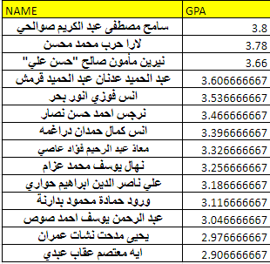
- then she make an excel sheet that contain tables which represent the groups of students(empty tables). by having about 210 students maximum and every group contain 7 student we get 30 groups(210/7 = 30).
- every table contain 10 groups (form A1-A10 , B1-B10 ,C1-C10).
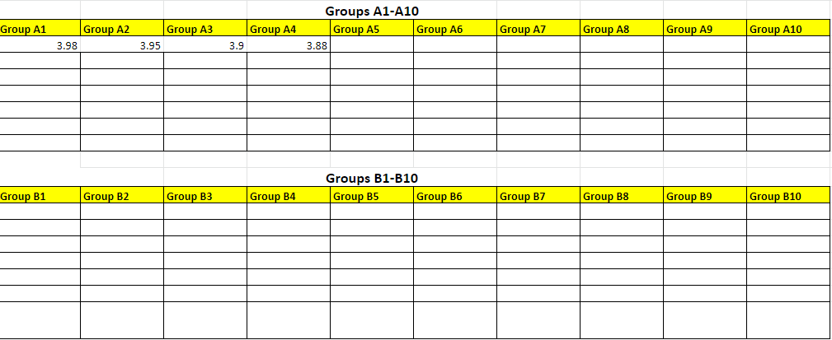
- then after point 4 she (Sara) will fill the tables with students info, as we know every tables contain 10 columns and every columns contain 7 rows . the columns represent the sub-group ex(A1,A2……..,A10).
- from point 2 she take the first 10th higher student GPA and fill it in first row and repeated in 2nd and 3rd row until the table end, it’s for every tables (A,B,C)

- the last result for the tables is every sub-groups will contain 7 students with GPA is Descending and every table contain 10 groups the total students for one table is (7*10=70) and the total for all tables is (70*3=210) and Take into consideration the ratio male : female 4:3 or 5:2.

- after that every group will distributed to the hospitals and doctors with different specialty depending on the requirement that we previously described .
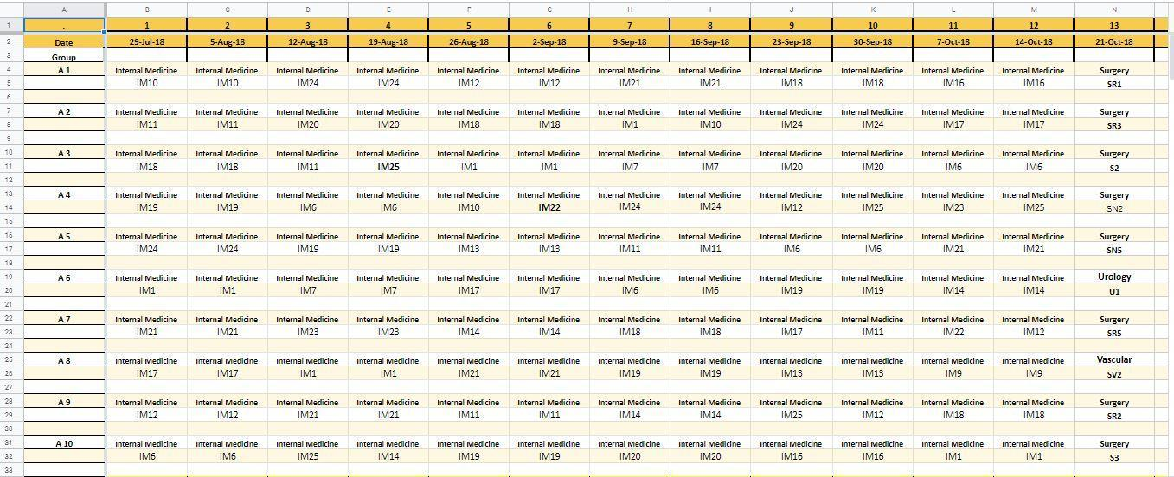
- the final result for the current system well be :

The advantage and disadvantage for current system :

Advantage :
- it’s better than a few system in paper and naive one
- not big to take memory
- more control of the model of the system because it’s not a program it’s about a excel sheet fill it with one employee .

Disadvantage:
- the current system it’s complicated , not organized and hard to deal with
- the system is not dynamic it’s sort of static system and that explains many thing
- low performance
- hard to edit
- the system is dealing with data offline that no API or another system connected with it
- no data dependency if the employee change data in some table attached with another table it will not be changed that will cause many problem
- it’s have a problem with user (student ) view the result
- the system will be hard to understand for new employee
- data loss

Proposed System:
After we describe the current system about how it’s work , how Sara (employee) interact with the system ,describing advantage disadvantage , now we will describe how our system (the proposed system ) works.
How our system work and how the user will interact with it ??
Our system completed in every way that serve the all requirement that we previously described in modern way, easy and flexible with high performance.
MTMP will computerize the steps that Sara do in the current system and give more enhancements on the operation.
- the system will offer an easy user interface with navigation bar to let th admin move between the abilities .
- the system import the students data automatically and distribute them on groups using an algorithm build on specific conditions described in the system requirements so Sara will get the results automatically.
- a completed schedule contains every group with it hospitals, supervisor , application(internal medicine ,surgery ..) and the start -end dates will shown in home page .
- editing page there will be every group with its specifications so Sara can edit , view details and delete students.
- the admin just control the operation without the need of apply all conditions manually.

The advantage and disadvantage for proposed system :

Advantage :
- no need to sort the degree of students the system will do it automatically.
- no need to combine the excel sheets, there is no excel sheets required , the data will imported from server and stored in database tables to be used in the algorithms to give the final results.
- easy to use and understood by any employee .
- high performance
- dynamic so the schedule changed every specific period automatically by an algorithm build on some conditions depending on time explained in the system requirement .
- the system solve the problem of data dependency in the traditional system so in MTMP if she edit some fields it will automatically change in all related fields.
- no data loss all the data stored in a secured database.

Disadvantage:
- our system need a source to import the students data like zajel which is a data that needs the university permission to get the data , so it is hard to give us data about students because of privacy issues .
- the university administration will study the system carefully in order to give us an API to let us import specific data ,they fear of making overload on their servers which make us to make a virtual server with virtual data.

Methodology
After studying this system deeply, the methodology that we follow in this system is The Agile scrum methodology.
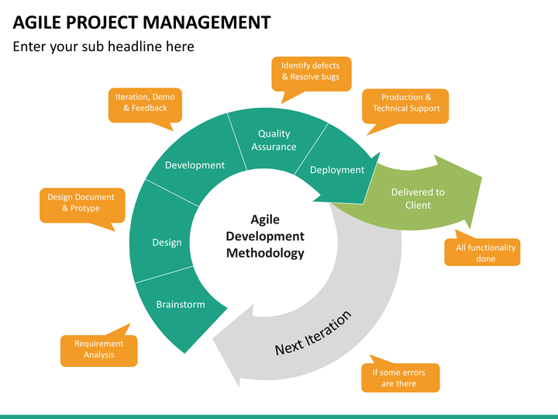

- Step one : After collect the requirements and analyze it we make a design suggestion and take a feedback from the stakeholder (Sara) then we take feedback from her , when we get the acceptation we start the development step.
- Step two : Development step start with making a simple prototype and take feedback from Sara then if she accept we make a test on the code after that we delivered it to client (Sara) if it is ok we start the next iteration.

Chapter Four
(System Implementation)

Programming Language and Tools

What do we used
1. Angular as a Front-End (Typescript ,html ,CSS).
2. Asp.Net as Back-end(API).
3. C#
4. RabbitMQ as a message passing between server and Elasticsearch.
5. Elasticsearch as cashed system between server and the API.
6. git for source control.
7. Design patterns( dependency Injection ,observer ,unit of work , MVVC in angular).
8. Entity framework core.

Implementation
the cycle of the system start with importing data from the server (Zajel) using RabbitMQ technics which is a message passing techniques that create a TCP connection and make channels inside the connection that let the system transfer data through the channels .

how the transfer operation managed?

the RabbitMQ techniques work among two sides consumer and producers
Consumer : consume a request for data the data come from the server with a binding key that used to determine the channel that the data will transfer throw.
Then the data stored in the Elasticsearch which is represent the cash system and change the data to Json file Type.
Using the Observer design pattern which track the (Post , Edit ,Delete)operation and Reflect on cashed system.

Separation of Concerns which consists of four layers :
- First layer : UI which represents the angular .
- Second layer : ASP.NET (API) which have a group of controllers received request from the UI which call an instance from the third layer.
- Third Layer : Business layer which include all the algorithms built on specific conditions depending on requirements.
- Fourth layer : project data access layer which reflects the changes on database.
- Database: we used SQL Server ,Code First approach ,entity framework in.net.

Applying the dependency inversion principle allows A to call methods on an abstraction that B implements, making it possible for A to call B at runtime, but for B to depend on an interface controlled by A at compile time (thus, inverting the typical compile-time dependency). At run time, the flow of program execution remains unchanged, but the introduction of interfaces means that different
implementations of these interfaces can easily be plugged in.

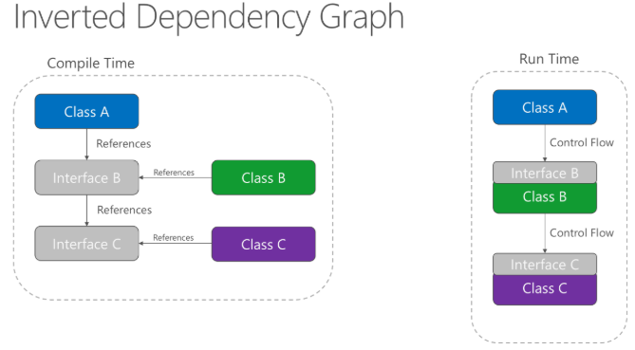

Chapter Five
(The Conclusion)

Conclusion

MTMP system is created to organize the training distributing operation for students at an Najah National University and make it done computerized under control from the employee who are responsible on the operation by make the system comfort for user and dynamic .

Future work

While there are a number of features, needs, wants, and/or capabilities known ,especially that the system is specified and targeted the 4th year students there are some of these that will not be planned for the final release of this project. However, below is a list of planned enhancements for MTMP:
- Extend the system to include students of 5th and 6th year because there training programs are different of the 4th year students.
- make the project Appropriate and dynamic to meet all universities requirements not only An Najah University.

References
Angular learn reference :
- https://angular.io/guide/quickstart
- Udemy -Angular 7.

ASP.Net references :
- https://dotnet.microsoft.com/apps/aspnet .

Elasticsearch :
- https://info.elastic.co.
- Udemy -Complete guide to Elasticsearch Tutorial.
RabbitMQ :
https://www.rabbitmq.com/tutorials/tutorial-one-java.html.

