

An-Najah National University Faculty of Engineering
Department of Computer Engineering

Graduation Project 2

iCashier

Students:
Dana Aqel

Aya Jabali

Supervisor: Dr. Luai Malhis

Presented in partial fulfillment of the requirements for bachelor's degree in computer engineering.

September 2023

Acknowledgment

I want to preface by thanking Allah, all praise to Him, as I would not have had a quarter of the strength, patience, knowledge or mind power that the completion of this project required me to have, without Him. Secondly, I would like to give thanks to my supervisor, Dr. Luai and head of department, Dr. Manar, for their support throughout the entire semester through all hardship. More thanks go to carpenter Alaa Zorba and engineer Abdullah Hinnawi for their true support and help when it came to almost everything to do with the project. Lastly, a big thank you goes out to my friends and family for always being there through thick and thin, no matter what.

Disclaimer

This report was written by Dana Aqel and Aya jabali at the Computer Engineering Department, Faculty of Engineering, An-Najah National University. It has not been altered or corrected, other than editorial corrections, because of assessment and it may contain language as well as content errors. The views expressed in it together with any outcomes and recommendations are solely those of Dana Aqel and Aya jabali . An-Najah National University accepts no responsibility or liability for the consequences of this report being used for a purpose other than the purpose for which it was commissioned.

Table of Contents

Abstract | ………. | 6
Introduction | ………. | 7
General Background | ………. | 7
Objectives | ………. | 7
Significance | ………. | 7
Organization | ………. | 8
Theoretical Background and Previous Work | ….…… | 9
Methodology | ………. | 10
Technical choices | ………. | 10
Microcontroller | ………. | 10
Power sources | ………. | 11
Libraries | ………. | 11
ICs | ………. | 12
Constraints | ………. | 18
Results, Analysis and Discussion | ………. | 19
Conclusion and Future Work | ………. | 21
References | ………. | 22

List of Figures

Arduino Uno & USB A to USB B cable | ….............. | 10
Computer power supply | ….............. | 11
12v power supply | ….............. | 11
Intercom wires | ….............. | 11
Jumper wires | ….............. | 11
DC gear motor | ….............. | 12
J-5718HB3401 stepper motor | ….............. | 13
IR sensors | ….............. | 14
SH-400 TTL 2D barcode and QR scanner | ….............. | 14
L298N dual H-bridge motor drive module board | ….............. | 15
LCD & I²C | ….............. | 15
YS-DIV268N-5A driver | ….............. | 16
ec c› | …………..................... | v6
Re/ y | …………..................... | v7
- c ca e a | …………..................... | v7
Process Flowchart | ….............. | 20

Abstract

A substitution for a human worker to check out items and compute their bill before sending them to be packaged and shipped out is proposed by this project at a warehouse/inventory of an online business. The need for human labor is aimed to be reduced, which, in turn, results in a reduction of time and effort spent before orders are shipped out. This is achieved by having items scanned and their bills computed by the system, after which they are sorted into either of two bins: “scanned and ready to be packaged,” or “unscanned and in need of rescanning or replacement,” depending on the reason for the initial lack of scanning. This way, when multiple systems are implemented, one for each replaced human worker, multiple orders can be prepared for packaging simultaneously without requiring human intervention. The system incorporates a barcode scanner for detecting item barcodes, which, in turn, are used for bill computation. Infrared sensors are employed to determine the presence and position of items on the system’s belt, as well as control the system’s auto shut-off in the absence of items on the main belt, and motors are responsible for propelling the main belt of the system as well as moving the bins to capture the designated items. An LCD is used to showcase the process and its updates, as well as the bill and current number of items in each bin. Following extensive testing, the system demonstrated accurate performance of scanning and sorting items up to 90% of the time; explanations for the margin of error will be later addressed in the constraints section of this report.

Chapter 1: Introduction

General background
Human workers in warehouses often work in harsh conditions and are severely underpaid and, on the flipside, those same warehouses are often
short-staffed and have business running slow. Due to the terrible work conditions and the human nature, human workers are likely to make mistakes while preparing orders for packaging, such as missing to scan an item, messing up bill computation, failing to identify faulty items, etc. This whole scenario is inefficient and costly and must be eliminated as much as possible.

Objectives
The project's objectives are multi-faceted. The system's primary goal is to replace human workers in the warehouse, decreasing effort spent in order preparation through automated scanning, precise billing, and improved fault detection. This route increases quality control and operational efficiency.
Simplicity remains at the core of the system's design, ensuring easy implementation and use.
Moreover, the system reduces time, expenses and labor, introducing a shift from manual processes to automation. This encapsulates the project's mission to optimize warehouse operations.

Significance
The importance of this project’s development lies in many aspects, including bettering warehouse work environments, enhancing order preparation, minimizing fault occurrence in online orders, cutting back on the need for human labor and intervention, reducing expenses for online businesses and shifting manual processes to automation. This project offers benefits for all parties included in an online business scenario; it offers better business and budget for said online business, better work environments for human workers and better experience for customers with fault-free orders, prepared and delivered within much less time.

Organization
This report is organized into chapters, starting with the introduction. This section is further divided into subsections covering the project's general background, objectives, significance and the report's structure. Then, the report continues with a chapter on previous work related to the project. The third chapter outlines the methodology employed in the project's development, further divided into subsections discussing technical choices and applied constraints. After that, the report presents the results and analysis deducted from the project's implementation, along with the discussion of the entire development process. A conclusion and future work recommendations chapter follows after that and finally, the report ends with references.

Chapter 2: Theoretical Background and Previous Work

In order to carry out the entire process of working on this project, I definitely relied on previous knowledge for the most part. Learning to code in Arduino IDE would not have been possible without the simple courses of C++ Programming and Data Structures and Algorithms I’ve previously taken. Learning to interface both DC and Stepper motors with the Arduino board also would not have been possible without initially taking both Microprocessors and Digital Circuits Design courses.

However, for the extra knowledge I needed to gain, I started with an Arduino crash course [1]. Then, I studied barcode reader interface [2][3]. Next, I researched IR sensor interface [4]. After that, I needed to build the system’s main belt. I started with researching how to build one [5], then operating one [6][7].
Furthermore, I by then needed to add an LCD to monitor the system’s current functionality. After implementing that post researching it [8], it was time to interface the stepper motor [9].

During the entire research phase, I never came across projects that addressed the same issue and aimed for the same goal as mine. However, I’ve come across many projects that at least implemented one aspect of mine. Putting all of my previous and newly acquired information, I was able to make iCashier possible.

Chapter 3: Methodology

The process of working on this project entailed doing a lot of research beforehand. I referred back to many of my colleagues, my supervisor and the workshop’s supervisor as well. I also referred back to many previous projects that had the same concept as mine, ones that implemented a conveyor belt, other ones that incorporated a barcode scanner and so on. Additionally, I took an Arduino crash course and thoroughly researched the interface of every IC I used before using it. Safety measures I had to pay mind to mostly did with the electrical details to do with the project; I intended to make sure I was using safely wrapped cables and wires, had to pay attention to not causing overhead by connecting many ICs and power consuming parts all at once and to the same power source and I definitely had to ensure I was connecting the right amount of power to each IC to avoid burning or causing any damage.

Technical choices
    - Microcontroller
I used the Arduino Uno R3. The Arduino UNO is a microcontroller board based on the ATmega328P. It has 14 digital input/output pins (of which 6 can be used as PWM outputs), 6 analog inputs, a 16 MHz ceramic resonator, a USB connection, a power jack, an ICSP header and a reset button [10].

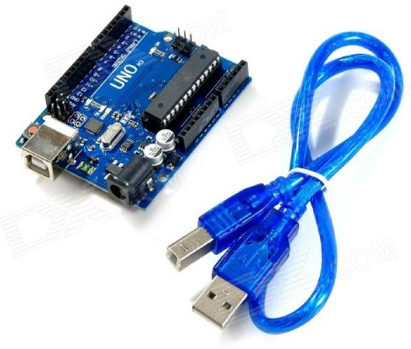
Figure 1: Arduino Uno R3 and USB A to USB B cable

Power sources and connection to them
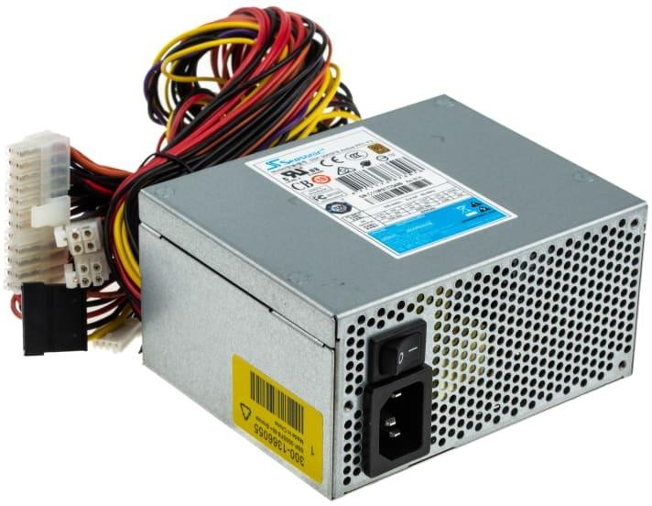
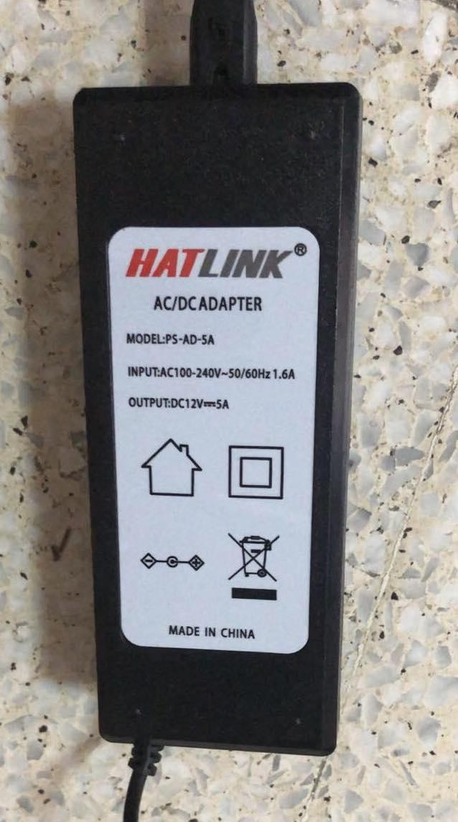
Figure 2: Computer power supply Figure 3: 12v power supply for main belt for bins belt

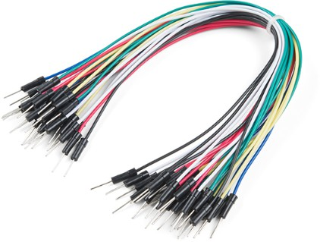
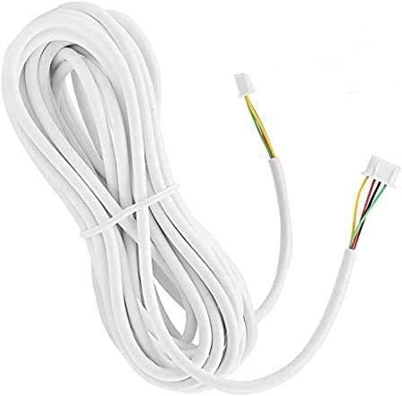
Figure 4: Jumper wires Figure 5: Intercom wires

Libraries

      - <SoftwareSerial.h> : to await scanned barcode from barcode reader
      - <LiquidCrystal_I2C.h> : to interface the LCD and I²C

ICs

- DC gear motor: this was used to run the system’s main belt. I opted for a DC motor instead of another option due to its suitable speed for the barcode scanner to scan the items just fine, as items need to pass by it at a certain low speed in order for their barcodes to be picked up correctly. I also was not interested in positioning the items in certain spots, so there was no need for a stepper motor, for example.
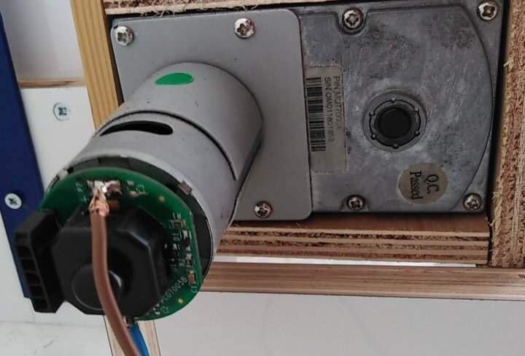

Figure 6: DC gear motor

- J-5718HB3401 stepper motor: this was used to move the system’s bin belt. In this case, I was intent on positioning the bins exactly at the main belt’s end to properly catch the items off of it. I also was in need for the belt to move very quickly and seamlessly to catch the items on time, therefore, I used this specific stepper motor.

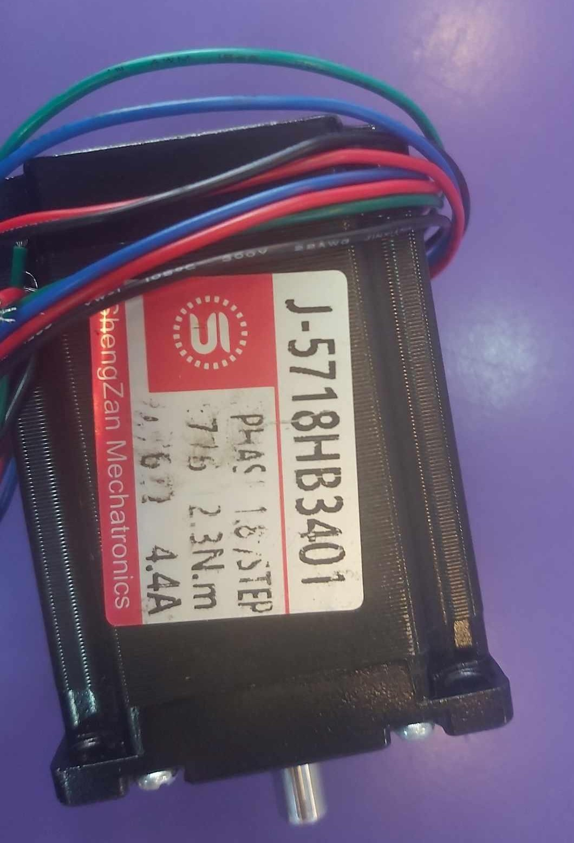

Figure 7: J-5718HB3401 stepper motor

- IR sensors: I used two IR sensors for multiple purposes. The first sensor is to identify the presence of an item on the belt, which in turn resets the timer for the system’s automatic shut off after 30 seconds of no item detection to minimize power consumption. The identification of an item’s presence also has the barcode scanner awaiting the item to be scanned and starts a 30 second timer for the item to be detected by the second sensor, and if not, for reasons like the item being picked up or it falling off the belt, the system would also automatically shut off in this case. The second IR awaits the item after getting scanned and, upon detection, resets the auto shut off timer, performs and showcases on the LCD the bill computation and current number of items in each bin and also controls the stepper motor/bin belt. If an item is detected at the second IR sensor after being scanned and within 30 seconds post its detection at the first sensor, the bin system will move to have the “scanned” bin be placed at the end of the main belt in order to catch the scanned item. In short, the IR sensors are used to detect and identify the presence and position of items on the belt, monitor the system’s auto shut off

feature, control the bin belt, compute the bill and showcase updates of the process on the LCD and prepare the barcode scanner for item scanning.
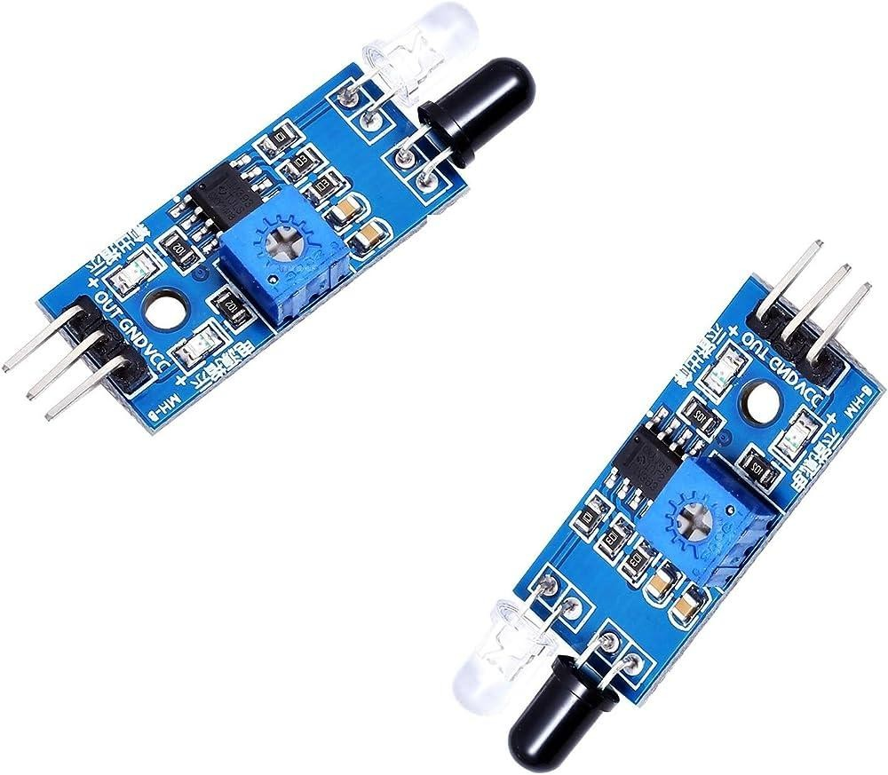

Figure 8: Infrared Reflectance Sensor IR Module Line Follower TCRT5000

- SH-400 TTL 2D barcode and QR scanner: This was used to scan the item barcodes and send them to the microcontroller via serial communication by connecting its TX and RX directly to the Arduino. I opted for this option instead of a handheld USB interfaced barcode scanner because this one was easier to interface without the need for a USB shield and had a simple software library to code with. It also was more suitable in shape and size.

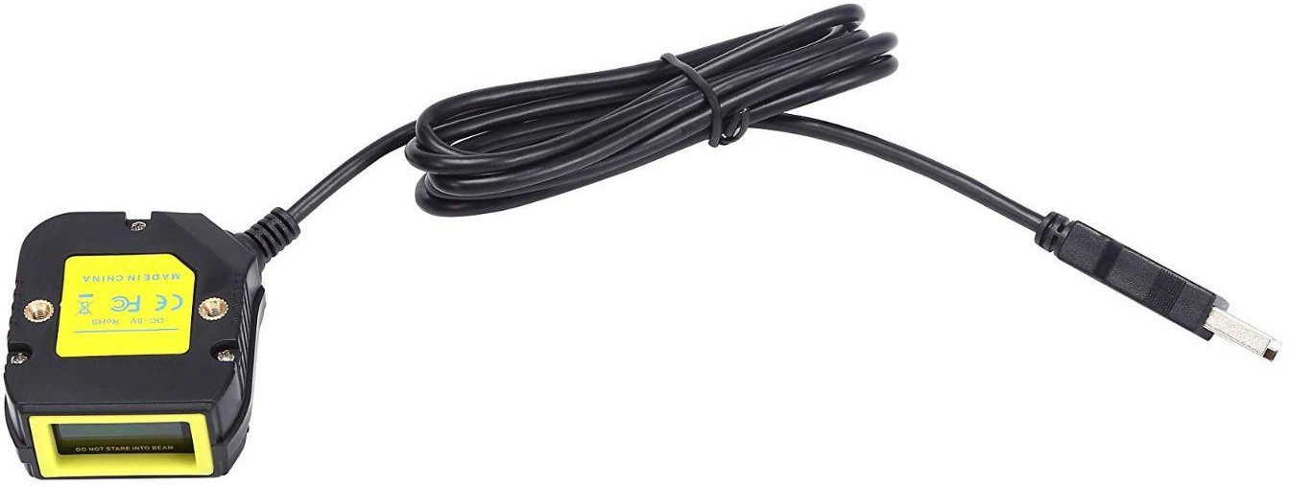

Figure 9: SH-400 TTL 2D Barcode And QR Scanner

- L298N dual H-bridge motor drive module board: This was used to interface the DC motor with the Arduino board, which in turn made it possible to control through code. It controls the motor’s direction and speed.

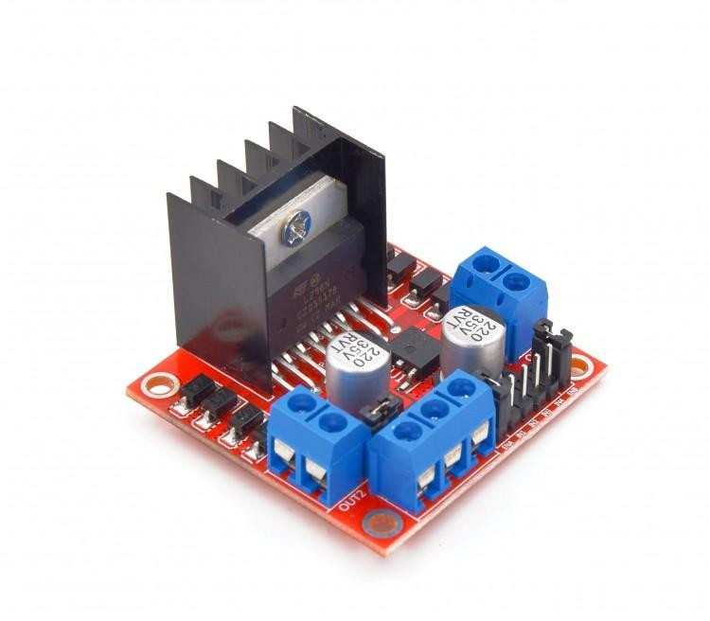

Figure 10: L298N Dual H-Bridge Motor Drive Module Board

- LCD and I²C: The LCD was used to showcase the updates of the system’s process. It’s updated when an item is detected and scanned -or not- and displays the item’s price, the bill’s total and the current total number of items
in each bin. The I²C was used to interface the LCD with the Arduino by minimizing the number of pins necessary, making the original 16 pins go down to just 4.
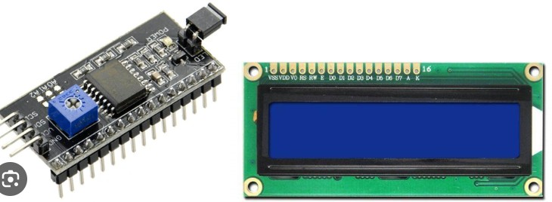

Figure 11: 16*2 LCD display and I²C

- YS-DIV268N-5A driver: This was used to enable the Arduino to control the stepper motor; it controls its direction and number of steps taken per

revolution. It also sets the amount of voltage consumed and the degree of each step taken. I set the voltage to 4.2 as the stepper motor needs 4v and the step angle to 1.8 degrees.
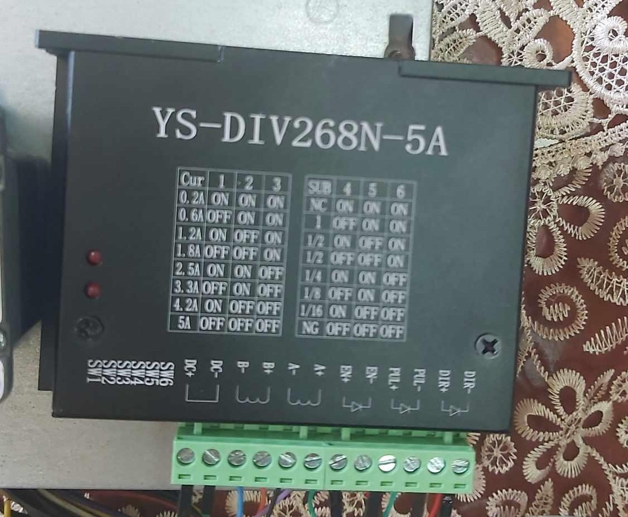
Figure 12: YS-DIV268N-5A driver

✓c c› : iS uceb So Su× ou/oﬀ SLe cy Se ×i my c a S oue aub So Sa e ca×e aSo t SLe ca e a SLa re cet So mo i o× SLe cy Se .
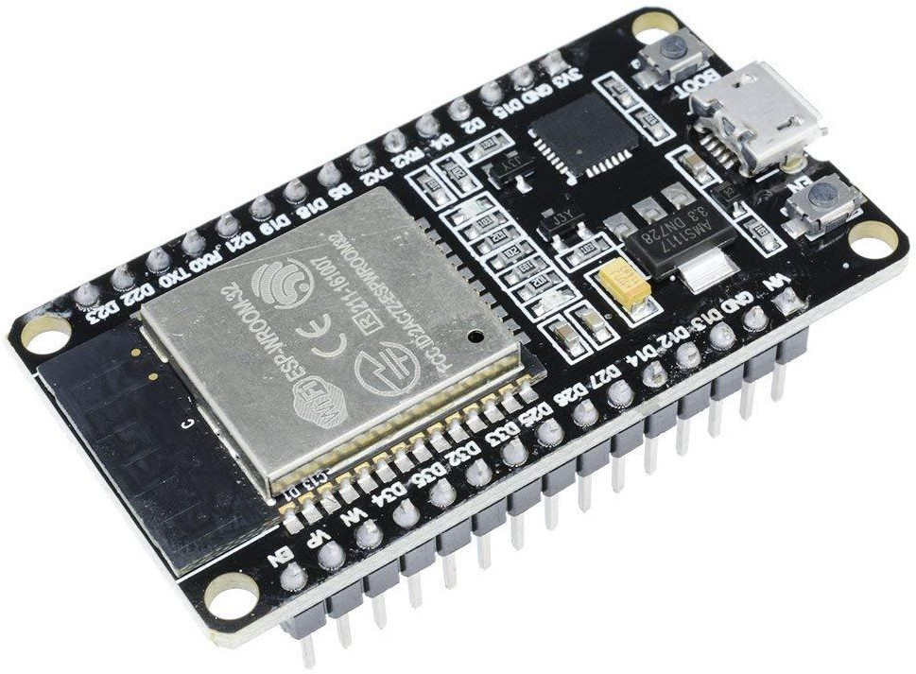

ﬁgu×e vc: ec c›

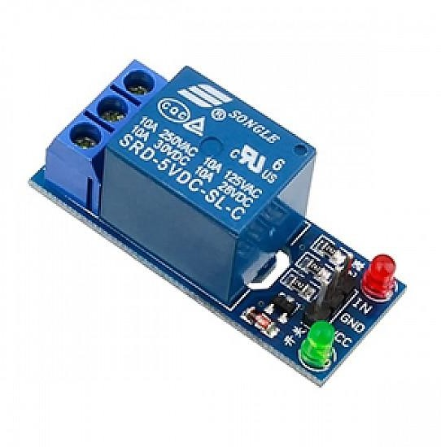
Re/ y : c i cLi g SLe c al/e× cu× eut ×aI e iu co ×oI of SLe mai moto .
Fig ×e vC: Re/ y

vt. ✓c Came×a : SLi ic au ideaI coI iou fo× o × ioS ap licatio So eu ble SLe di×ecS ,guicൻ aub /o -po e ratc^ of SLe cy Se .
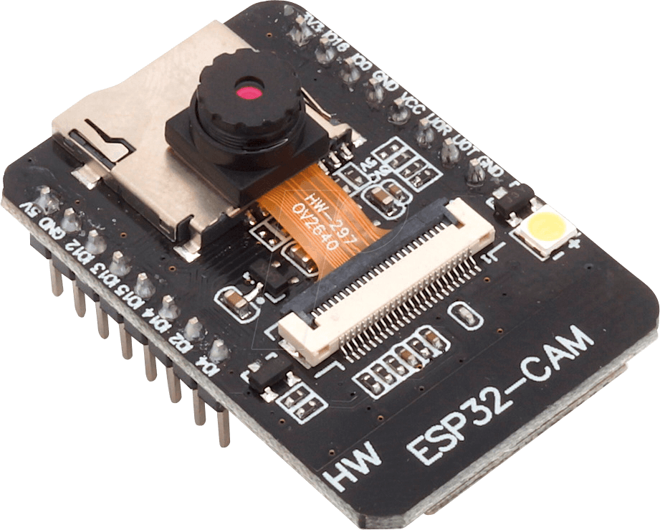

Fig ×e v3: ✓c Came×a

  - Constraints

- Economy: electronic parts tend to be pretty expensive, which limited expanding the number of ICs implemented in the entire project, in turn minimizing the scope of the project and its features.
- Environment: working at home was suitable at first until I needed assistance from either colleagues with experience or the workshop’s supervisor, so I moved the project to the workshop to work there. However, working there entailed having to share electricity with everyone else which impaired its performance compared to working at home and dealing with issues caused by accidental damage caused by others, naturally from there being too many of us in the same room at once.
- Barcode scanner: Although it’s set to continuous scanning mode and has a high sensitivity to and detection of the presence of a barcode, the scanner naturally constantly flickers, as in, it isn’t actively scanning the whole time. This caused a small margin of error where an item on the belt would happen to pass by the barcode scanner exactly at the time of its flicker, leading to a lack in scanning, even if the item was not faulty and had a barcode sticker on it.
- Main belt’s size: In order to carry out the scanning of multiple items consecutively, they’d have to be initially placed in designated spots, separated by enough distance. However, this would entail having the belt be much longer in order to accommodate dealing with multiple items at once, which in turn would be very expensive and hard to implement, as that would make the project’s size bigger than what could be handled and easily moved around. Due to the prior mentioned, the final belt size was able to handle only one item at a time.
- Sensitivity and vulnerability: moving around the project entailed there being a chance in disconnection of wires or parts accidentally breaking off. The project overall was very sensitive and susceptible to damage, especially when it was at school.
- IR sensors: although there are cardboard homes/coverings for each sensor, they still were a little susceptible to noise due to lighting, especially if it was natural lighting, leading to incorrect readings which affected the system as a whole as they are the core of its functionality.

Chapter 4: Results, Analysis, and Discussion

The main goal for this project was to develop a system capable of replacing human workers while offering additional features not typically provided by human labor. This system was designed to perform precise item scanning and sorting, calculate bills and keep a count of the current items in each sorting bin. Moreover, it had the capability to automatically shut down after a 30-second interval of inactivity. In its final version, the project successfully achieved its main goal and implemented all the predetermined features. However, it is important to note that the system's performance was affected by a 10% margin of error, mainly due to issues related to the barcode scanner and IR sensors, as discussed in the constraints section.

During the testing phase of the system, which performed at a 90% accuracy rate, several scenarios were examined:

- Idle State Scenario: The system was powered on without any items placed on the main belt. It successfully detected the absence of items and automatically shut down after a 30-second interval, achieving 100% success in this scenario.
- Inventory Item Scanning Scenario: A non-faulty, inventory-registered item was placed on the belt. The system detected the item using the first IR sensor, initiated the barcode reader’s scanning process and communicated the barcode it picked up with the microcontroller via serial communication to verify its existence in the inventory and retrieve related data. After that, the second IR sensor updated the LCD with the scanning status, bill information and the number of items in the “scanned” bin. The stepper motor was then activated to move the “scanned” bin to catch the item. However, this scenario introduced slight error margins due to occasional failures of the barcode scanner to read an item's barcode, even when the item was present and registered. Additionally, the IR sensors occasionally detected noise, leading to false item presence indications.

- Unregistered Item Scenario: This scenario involved placing an unregistered item on the belt, resulting in the item being sorted into the “unscanned” bin as it was excluded from the bill computation.
- Improper Item Placement Scenario: An item, whether registered or not, was placed on the belt with its barcode facing away from the barcode scanner. Consequently, the item was not scanned correctly and was sorted into the “unscanned” bin.
- Early Item Removal Scenario: An item was detected by the first IR sensor but was removed from the belt before reaching the second IR sensor. In this case, the system adhered to the 30-second timer and automatically shut down upon the second IR sensor's monitoring.

Achieving 100% accuracy in the system's performance would require addressing issues related to the barcode reader's constant scanning mode, ensuring suitable lighting and minimal noise for the IR sensors and potentially redesigning the main belt with a much larger size to accommodate multiple items at once.

Process flowchart:
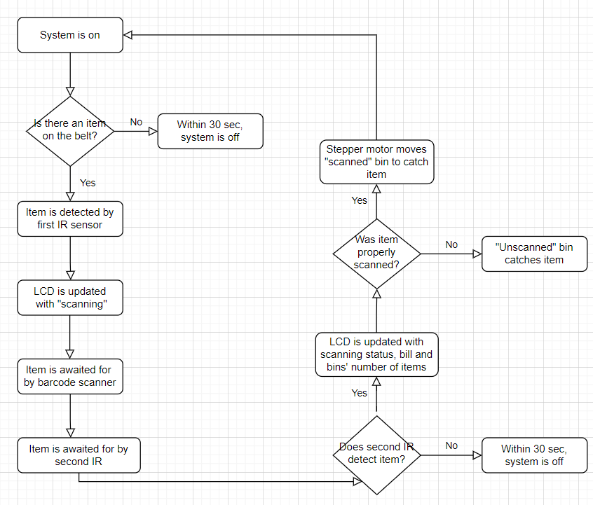

Chapter 5: Conclusion and Future Work

In summary, this project effectively replaced human workers in online business warehousing operations, guaranteeing improved efficiency and precision with only a 10% margin of error. Its primary aim was to automate item scanning and sorting, bill computation and bin tracking, addressing the need to eliminate harsh environments and reduce human-related errors in the workplace.

After substantial testing, the system revealed important implications, including its need for a noise-free environment and the potential for redesigning it to handle multiple items simultaneously.

Future work could focus on securing a noise-free operational environment, resizing the system for better item accommodation and developing an application to control and monitor the system and its orders. This project represents a significant step towards automating and optimizing online business warehousing processes, streamlining operations and reducing errors.

While this conclusion doesn't introduce new information not previously mentioned, it underscores the project's significance, accomplishments and potential avenues for future development. The journey from research and development to testing and error resolution has led to a fully functional system that holds promise in transforming the landscape of online business warehousing.

References

- PEA (2022). Arduino MASTERCLASS. Retrieved June 20, 2023 from https://www.youtube.com/watch?v=BLrHTHUjPuw.

- ENG.ANAS (2022). SH-400 TTL 2D Barcode And QR Scanner. Retrieved July 30, 2023 from
https://technolab.ps/product-details/1927?fbclid=IwAR1pvjFgfR7SW8d230vFRRky9LMMdv GckA1nqZHPS5XNbZiZENzQdjMK-gw

- CircuitSchools Staff (2022). QR Code/Barcode Scanner using Arduino & QR scanner module. Retrieved July 7, 2023 from
https://www.circuitschools.com/barcode-qr-code-scanner-using-arduino-qr-scanner-module/
?fbclid=IwAR18nHJavcH3Hf9JCWS_ZsfbEwP9Bc1K0up0G8YhEkbWPTBP60xX-JZuJMg

- Robocraze (2022). IR SENSOR INTERFACING WITH ARDUINO. Retrieved July 20, 2023 from
https://robocraze.com/blogs/post/ir-sensor-interfacing-with-arduino?fbclid=IwAR0CiXw8Q1t K7QfUVF23Q74jNaSymmM8DcHAIqhk_P7h9yJNvKfTqKmTgM0

- Easy HomeMade Projects (2020). How to Make a Conveyor Belt System at Home. Retrieved July 7, 2023 from https://www.youtube.com/watch?v=o7VVmtX7SKs

- Ashish Choudhary (2021). Automatic Bottle Filling System using Arduino.
Retrieved July 7, 2023 from
https://circuitdigest.com/microcontroller-projects/automatic-bottle-filling-system-using-arduin o?fbclid=IwAR2WmZ3qQdwfIldPvLenWOy7MjidNModKHMw0Vmtyo1x4oSnkjbJHs7QWeQ

- Team Psi (2017). How to connect your “L298N Dual H-Bridge Motor Controller” to “Arduino Uno”. Retrieved August 2, 2023 from
https://www.youtube.com/watch?fbclid=IwAR2kit2fJnp5Jr2EVcjat4nkZ4-Vjjhm06TeP u8S2kJvfjDbnL779Fv479c&v=OkHR1BZCcqA&feature=youtu.be

- Last Minute Engineers (unspecified). Interface an I2C LCD with Arduino.
Retrieved July 28, 2023 from
https://lastminuteengineers.com/i2c-lcd-arduino-tutorial/?fbclid=IwAR18nHJavcH3Hf 9JCWS_ZsfbEwP9Bc1K0up0G8YhEkbWPTBP60xX-JZuJMg

- Maker Tutor (2018). HY-DIV268N-5A Stepper Motor NEMA 23 with Arduino UNO.
Retrieved August 13, 2023 from https://www.youtube.com/watch?v=PZbc-IgfDa8&t=1s

- Arduino (unspecified). Arduino UNO R3. Retrieved August 30, 2023 from https://docs.arduino.cc/hardware/uno-rev3

