

An-Najah National University
Faculty of Engineering & Information Technology

Mechanical Engineering Department

Design of Automatic Hinge-Bending Machine
SUPERVISOR: Dr. Ahmad Ramahi STUDENTS:
Ma’moun Ata-Allah
Mohammed Abdel Karim
Mohammed hessian
Baha Khaldi

Submitted in partial fulfillment of the requirements for Bachelor degree in Mechanical Engineering.

2017
Contents
Table of Figures: 5
List of Tables: 6
Dedication: 7
Acknowledgment: 8
Abstract: 9
Chapter 1 10
Introduction 10
1.1 Problem 10
1.2 Objectives 10
1.3 Project output 10
1.4 Importance 11
1.5 Structure of the report: 11
Chapter 2 12
Constraints, Standards and Earlier course work 12
2.1 Constraints 12
2.2 Standards 12
2.3 Earlier course work 13
Chapter 3 15
Literature Review 15
3.1. Hinges History 15
3.1.1 Ancient Hinges 16
3.1.2 The Middle Ages 16
3.2.3 Victorian Era 17
3.1.4 Present Day 17
Figure 10. Flag hinges[24] 20
3.2 Main Blocks of the Project 20
3.2.1 Bars Auto Loader 21
3.2.2 Automatic Bar Feeding Machine 22
3.2.2.1 Conveyor system 22
3.2.3 Automatic Cutting 23
3.2.3.1 cold saw 23
3.2.4 Forming (Bending) machine: 24
3.2.4.1 Eccentric press 24
3.2.5 Assembly: 25
3.3 Control System: 25
3.4 Motors: 26
3.5 Pneumatic cylinder: 28
Chapter 4 29
Methodology 29
Chapter 5 30
Design of automatic hinge bending machine 30
5.1 Project’s work principle: 30
5.2 Description of the hinge bending machine 30
5.3 Autoloader design 31
5.3.1 stand design 31
5.3.2pneumatic system design 34
5.4 conveyor design 35
5.4.1 chain and sprocket design 35
5.4.2 roller and its component selection and design 39
5.4.3 Bearing design and selection 46
5.4.3 Bolt selection 48
5.5 Cold Saw Design 49
5.5.1 Blade Selection and Design 49
5.5.2 Force and stress analysis on the bolts connecting the motor with the rotational link 53
5.5.3 Forces at Point A 56
5.5.4 force and stress analysis at point B 56
5.5.5 force and stress analysis at point C 58
5.5.6 force and stress analysis at point D 61
5.5.7 Pneumatic Cylinder Design 64
5.5.8 Slider connecting the cold saw with the mechanical press design. 65
5.6 Design of eccentric press machine 68
5.6.1eccentric mechanism consists of: 68
5.6.2 Stroke calculation 68
5.6.3 Bending force: 70
5.6.4 Static force analysis 70
5.6.5 Dynamic force analysis: 71
5.6.6 Motor analysis 73
5.6.7 Pulley – flywheel system 74
5.6.8 Flywheel 76
5.6.9 Gear box 79
5.6.10 Bearing 84
5.6.12 Pin design 86
5.6.13 Fatigue on connecting rod 87
5.6.14 buckling 89
5.6.15 Dimension of punch and Die 90
5.6.16 scotch yoke mechanism 91
Chapter 6 92
Production line feasibility study 92
6.1 Cost Analysis 92
6.1.1 What Is a Cost Benefit Analysis? 92
6.1.2 Identifying Costs 92
6.1.3 Identifying Benefits 93
6.1.4 Evaluate Costs and Benefits 94
Chapter 7 98
Operation manual and trouble shooting 98
7.1 Operating: 98
7.2 Troubleshoot: 99
7.3 Warnings: 100
Chapter 8 101
Conclusions and Recommendations 101
6.1 Conclusions 101
6.2 Recommendations 101
Appendix (1): 102
129
Appendix (2): 145
Appendix (3): 268
References: 269

Table of Figures:
Figure 1. kitchen and refrigerator door hinges[1] 15
Figure 2. ancient hinges[12] 16
Figure 3. hinges in the Medieval period[13] 16
Figure 4. hinges in the Victorian Era[14] 17
Figure 5. Spring hinge[15] 17
Figure 6. Barrel hinge[16] 18
Figure 7. Butt/Mortise hinges[17] 18
Figure 8. Continuous hinges, or piano hinges[18] 19
Figure 9. Concealed hinges[19] 19
Figure 10. Flag hinges[20] 20
Figure 11:project's block diagram 20
Figure 12. production line autoloader[21] 21
Figure 13. conveyor system. 22
Figure 14. cold saw cutting machine[35] 23
Figure 15. eccentric press 24
Figure 16: PLC. [50] 25
Figure 17:induction motor[51] 26
Figure 18:Servo motor. 27
Figure 19:HP series air cylinder 28
Figure 20:free body diagram of autoloader 32
Figure 21: Double acting cylinder terminology. 34
Figure 22: Hp series air cylinder piston. 35
Figure 23: nomenclature of roller chains. 36
Figure 24: CHAIN SPROCKET ENGAGEMENT. 36
Figure 25: FREE BODY DIAGRAM FOR CONVEYOR. 38
Figure 26: shaft free body diagram and the shear moment diagram. 40
Figure 27: Kt for round shaft with shoulder fillet in bending. 43
Figure 28: Notch sensitivity(q). 43
Figure 29: Kts for round shaft with shoulder fillet in torsion. 44
Figure 30: Notch sensitivity(qs). 44
Figure 31: free body diagram of the key. 46
Figure 32: shaft with bearing free body diagram. 46
Figure 33: HZ tooth shape. 50
Figure 34: Cross section of material to be cut. 50
Figure 35: free body diagram for the force acting in the motors bolt. 54
Figure 36: Free body diagram at point A. 56
Figure 37: free body diagram of point B. 57
Figure 38: free body diagram at point C. 59
Figure 39: force diagram at point c between the link holder and the pin. 61
Figure 40: free body diagram at point D. 61
Figure 41: Dimensions at point D. 62
Figure 42: inner and outer roller chain standard dimension. 118
Figure 43: MNT065 SERVO MOTOR DIMENSIONS. 124
Figure 44: INDUCTIOM MOTOR DIMENSIONS. 127
Figure 45: INDUCTION MOTOR WIRING DIAGRAM AND SPECIFICATIONS. 128
Figure 46: hp series for pneumatic cylinder 129

List of Tables:
Table 1: Parts And Their Standards 12
Table 2: Fs vs w*sin(theta) 32
Table 3: ASTM Minimum Tensile And Yield Strength For Some Hot-Rolled And Cold Drawn Steel 103
Table 4: ASTM Minimum Tensile And Yield Strength For Some Hot-Rolled And Cold Drawn Steel 104
Table 5: Mechanical Properties Of Some Aluminum Alloys 105
Table 6: Diameters And Areas Of Coarse-Pitch And Fine-Pitch Metric Threads. 106
Table 7: Metric Mechanical Property Classes For Steel Bolts, Screws, And Studs. 107
Table 8: Dimensions Of Square And Hexagonal Bolts. 108
Table 9: Dimensions Of Square And Hexagonal Nuts. 109
Table 10: Dimensions Of Metric Plain WASHERS (All Dimensions In Millimeters). 110
Table 11: Polyurethane Pros, Cons, Properties. 111
Table 12: Polyurethane Type (70 A) Properties. 112
Table 13: Coefficient Of Friction(Cof) Between Steel And Polyurethane. 113
Table 14: Dimensions Of American Standard Roller Chains-Single Strand. 114
Table 15: Rated Capacity Of Single-Strand Single-Pitch Roller Chain For A 17-Tooth Sprocket. 115
Table 16: Single-Strand Sprocket Tooth Counts Available. 116
Table 17: Tooth Correction Factor. 117
Table 18: Multiple-Strand Factor K2. 117
Table 19: Millimeter Dimensions For Some Standard Square-Rectangular-Key Applications. 119
Table 20: Parameters For Marin Surface Modification Factor (Ka). 119
Table 21: Reliability Factor (Ke) Corresponding To 8 Percent Standard Deviation Of The Endurance Limit. 120
Table 22: Bearing Characteristics That May Influence The Selection Of Bearing Type. 121
Table 23: Reliability Life-Adjustment Factor (Kr) For Bearing Reliabilities Different From R=90%. 122
Table 24: Estimated Impact Factors For Various Applications. 122
Table 25: Approximate Radial Load Factors For Selected Bearing Types. 122
Table 26: Dimensions And Load Ratings For Selected Single-Row Radial Deep-Groove (Conrad Type) Ball Bearings: Series 60, 62, And 63. 123
Table 27: Mnt065 Servo Motor Length. 124
Table 28: Mnt Series Servo Motor Type (Mnt 065) Properties. 125
Table 29: Induction Motor Features, Description, And Specifications. 126
Table 30: Pitch, Feed Speed And Rpm For Blede. 130
Table 31: Width And The Number Of Teeth For The Blade. 131
Table 32: Feed Per Tooth (Sz). 131
Table 33: Cutting Angle And Relief Angle. 132
Table 34: Tooth Dimensions And Specifications. 132
Table 35: Blade Weight. 133

Dedication:
We dedicate our work to our beloved families and many friends. A special feeling of gratitude to our lovely mothers, whose words of encouragement still ringing in our ears. Our fathers who left fingerprints of grace on our lives.
We also dedicate this dissertation to our friends and colleges family who have supported us throughout the process. We will always appreciate all they have done.

Acknowledgment:
Apart from the effort we put in this project, we would like to express our gratitude to the people who guided us through this project.
- First, we thank Allah for giving us the courage and the determination, as well as guidance in conducting this project, despite all difficulties.
- Second, we also extend our heartfelt gratitude to our supervisor Dr. Ahmad Al-Ramahi We felt motivated in every single minute we spent with him. Without his encouragement and guidance this project would not have materialized. Also, he made us believe that we had capability, strength and courage to preserve even when we felt lost. You were the spark that ignites our ambitions. We aspire to emulate you.

Abstract:
Industrial safety is a priority in all engineering practices. Unfortunately, this significant term is not considered curiously in the local market. One of the industrial applications is the manufacturing of hinges. Hinges are currently fabricated in the local market using primitive ways that are dangerous on their manufacturers. For the purpose of overcoming these unsafe conditions, a fully-automated machine that produces hinges will be designed; which is the main objective of this project.

The machine is expected to perform the following three main functions:
i) Feeding, ii) Forming (Bending), and iii) Assembly.

The estimated fabrication cost of the proposed machine will also be considered. This project is considered as a good practical exercise in mechanical engineering field; as it enhances the project’s team abilities to understand the concepts of design of an automatic electromechanical system; also, it promotes their self-confidence by being able to provide solutions to real needs for local industry.

Chapter 1

Introduction

1.1 Problem
This chapter introduces the problem statement, objectives, the project output and importance of work and finally the structure of report.

Hinge is a mechanical component that connects two solid objects, typically allowing only a limited angle of rotation between them. Two objects connected by an ideal hinge rotate relative to each other around a fixed axis of rotation. Hinges may be made of flexible material or of moving components. In biology, many joints function as hinges like the elbow joint.

A large variety of hinges are available from most hardware stores. The type bought depends on how it is to be used and what it is to be fitted to. For example, when selecting a hinge for a jewelry box, a small brass butt hinge is likely to be used rather than a concealed hinge. Furthermore, brass hinges are more expensive than steel ones and they give a quality look to the completed product.

In the local market of Palestine, hinges are produced using traditional unsafe ways. For this reason, we decided to make an innovative machine that can be used to manufacture hinges at high performance, depending on an automated process instead of the traditional one specifically used in Palestine.

1.2 Objectives
The objective of this project is to introduce a novel design of hinge manufacturing machine; the proposed design provides most of the user’s requirements like simplicity, safety, easiness of use and low cost. Furthermore, it is an automated machine, thus it will reduce the need of human efforts.

1.3 Project output
A report that documents a detailed design of an Automatic Hinge- Bending machine; including all necessary calculations, plans, charts, detailed and assembly drawings.

1.4 Importance
Enhancing the term of safety, is considered the most important challenge in our new design. This can be obtained through replacing human resources with automated machines.

In addition, companies that utilize our design will be able to manufacture hinges easily, quickly and efficiently.

1.5 Structure of the report:
- Chapter 1 is the introduction: which describe the problem statement, objective, project output and the importance of the project.
- Chapter 2 is the constraints, standards and earlier course work: which describe the constraints facing the implementation of this project will be discussed. Design standards, and theoretical practices, that can help in the project, are also presented.
- Chapter 3 is the literature review: reviews literature related to hinge history and the main component of an automatic hinge bending machine.
- Chapter 4 is the methodology: which shows the implemented steps that needed to finish the project properly.
- Chapter 5 is the design of hinge bending machine: contains all the necessary calculation, kinematic and kinetic analysis, load and stress analysis, in addition to selection of parts.
- Chapter 6 is the Operation manual and Troubleshooting.
- Chapter 7 is the cost analysis: which describe the approximate price for the parts used in the project in addition to the expected time needed to retain the initial value for the machine.
- Chapter 8 is the conclusions and recommendations

Chapter 2

Constraints, Standards and Earlier course work

This chapter shows the limitations, the followed standards and the benefits extracted from earlier courses.

2.1 Constraints
Money is the major constraint in this project. Time problem arises with the lack of sponsorship. In order to bypass this, only a design using solid work software to simulate the process as in reality will be adopted.

Another challenge for this project is the unavailability of shaping machines, some of which are linked the Israeli allowance for their importing. Finding the most effective and reliable design is the last constraint.

2.2 Standards
In general, AGMA, CEMA, AISI and ISO standards were followed through the development process of this project. Table (1) shows main parts with its standard:
Table 1: parts and their standards
Part | Standard
Stands structure material | AISI 1006
Hinge material | AISI 1010
Air cylinder | HP. Z. 32. 25. G. 1. T3 (HP-series)
Roller chain | ANSI chain No. 25
Conveyor roller shaft material | Aluminum No.2017 (wrought)
Bearing | Ball bearing series 60, No. 6000
Bolts | M5 * 0.8 and M10 * 1.5 (class 4.6)
Blade material | AISI M2 No.1.3343
Saw blade sizes | Wolferal premium quality cutting-off saw blades
Servo motor for conveyor | G BSM80 - MNT065 - 100  (MNT series)
Induction motor for cold saw | Model No. ACI-PMCB040-4R4FAT

2.3 Earlier course work
- static
The basic principles of vectors, the balance of forces on different objects, the application of the principles of statics to different structures, axial forces, shear forces, force, friction, centers of gravity and inertia.
- Dynamic
Kinematics of particles, two and introduction to three dimensional dynamics of rigid bodies. Force and acceleration, work and energy, impulse and momentum. Introduction to vibrations.

- Machinery
Kinematics of particles, two and introduction to three dimensional dynamics of rigid bodies. Force and acceleration, work and energy, impulse and momentum. Introduction to vibrations.

- Machine design 1
Introduction to design process. Design considerations. Tolerances, fits and surface finish. Stress analysis and deflection of mechanical elements. Energy methods. Statistical considerations in machine design. Design of screws, fasteners. Failure and fatigue of machine elements. Students in individual or groups should perform short projects to practice the main principles of the courses.

- Machine design 2
Design of welded joints, mechanical springs, spur gears, shafts, belts, chains and rolling bearings. Lubrication and journal bearings. Design of helical, bevel, and worm gears. Brakes and clutches. Students in individual or groups should perform short projects to practice the main principles of the course.

- Solid work
Current trends and developments in the field of Applied Mechanics

- Manufacturing process and production 1
Production of ferrous materials. Production of non-ferrous materials. Sand casting, powder metallurgy, rolling, forging, extrusion and drawing. Metal cutting.

- Materials
Atomic structure and bonding, structure of crystalline solids, and diffusion. Imperfections in solids. Dislocations and strengthening mechanisms, fracture of materials. Phase diagrams and alloy formation. Ferrous and nonferrous metals and alloys.

Chapter 3

Literature Review
This chapter summarizes prior studies related to hinges manufacturing and, the components to be used in building the required hinge-bending machine.

3.1. Hinges History
The advent of hinges has caused a revolution in the way we build our houses, secure our possessions, and travel around. Hinge, regardless how small it is, can make you eight times stronger than you would be without it.[14] In fact, you probably reap the benefits of at least five hinges before you get to work in the morning, without even realizing them.
Butt hinges on your doors help get you out of your bedroom and keep the steam at bay while you shower. Kitchen cabinet hinges come in handy when you’re reaching for cereal or coffee beans. Don’t forget the refrigerator door hinge that keeps your milk cold. Figure1 illustrates several uses of hinges.
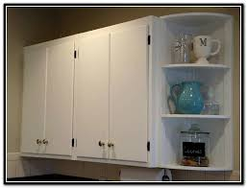
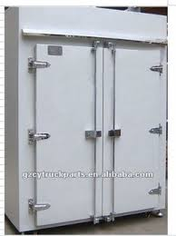

Figure 1. kitchen and refrigerator door hinges[14]
A hinge is a mechanical bearing that connects two solid objects, typically, allowing only a limited angle of rotation between them.
No one knows exactly when the hinge was invented, but we can imagine what life would be like without it. For example, during the ancient settlement in Turkey 6500 BC, houses had no front doors. Instead, people propped up ladders against their mud-brick houses and entered them from a hole in the roof. [14] In other societies, people had to rely on heavy rocks and giant slabs of wood or stone to keep them safe from weather and intruders.

3.1.1 Ancient Hinges
The very first hinges were introduced by societies of Africa, Asia, Europe and elsewhere. Because of the high cost of metal during that period, most of very early hinges were bronze ones. Figure2 shows a set of ancient hinges. [15]
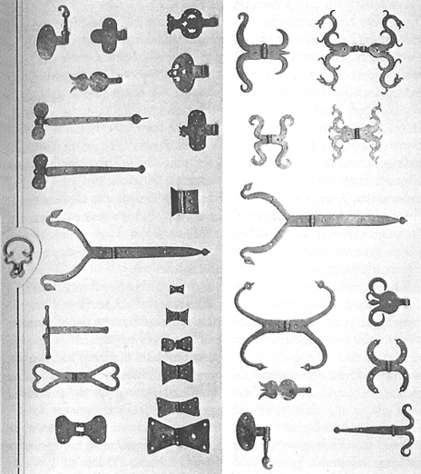
Figure 2. ancient hinges[16]

3.1.2 The Middle Ages
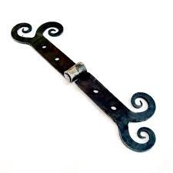
Metalwork was improved during the medieval period, and hinges became more familiar during that age. Figure 3 confirms how hinges industry has been improved during the middle ages. [15]

Figure 3. hinges in the Medieval period[17]

3.2.3 Victorian Era
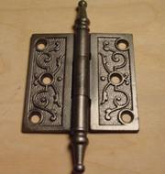
When steam power and industrialization began in earnest, the hinge industry found itself in the middle of a manufacturing explosion. With so many mechanical advances over a relatively short period of time, there were all sorts of machines requiring hinge parts. Complex hinges were able to be manufactured faster and at a fraction of the cost of their predecessors. The 19th century witnessed a huge number of hinge innovations, including hinges with ball bearings for smoother opening, and hinges with neat finishes. So many products with hinges entered daily life, that to list them all would be ludicrous, and yet the expansion was far from over. Figure 4 shows an example of hinges in the Victorian era. [15]

Figure 4. hinges in the Victorian Era[18]

3.1.4 Present Day
Since the 20th century to this day, further improvements in hinge industry have been achieved. A set of examples can be found from hinges that allow doors move in both directions, to other hinges that keep phones and such snapping shut and popping open. Moreover, new decorative and corrosion-resistant measures are in place to protect metal hinges from salty air or wear and tear while retaining visual luster. And because so much new technologies developed in the 20th century, hinges found places everywhere in aerospace, military, computing, travel, and more fields. In fact, the desk on which the average reader’s computer sits probably has more hinges than one might expect. [15]
Some types of hinges in present day:
- Spring hinge: a spring-loaded hinge is made to provide assistance in the closing or the opening of the hinge leaves. A spring is the main component of a hinge, applying force to secure a hinge closure or keep a hinge open. Figure 5 shows an example of spring hinges.
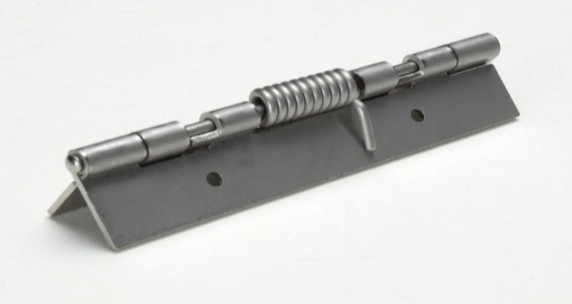

Figure 5. Spring hinge[19]
- Barrel hinge: a sectional barrel is secured by a pivot. A barrel is a component of a hinge, having a hollow cylinder shaped section, where the rotational bearing force is applied to the pivot, and may also have a screw shaped section for fastening and/or driving the pivot. Figure 6 shows an example of barrel hinges.
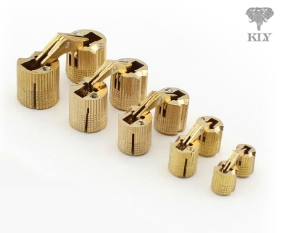

Figure 6. Barrel hinge[20]
- Butt/Mortise hinges: a two-leave hinge, which is usually used as a set of threes or fours, which are inset (mortised) into the door and frame. Most residential hinges found in the U.S. are made of steel, although mortise hinges for exterior doors are often made of brass or stainless steel to prevent corrosion. Figure 7 shows an example of butt hinges.
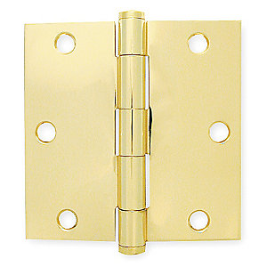

Figure 7. Butt/Mortise hinges[21]
- Continuous hinges: This type of hinge is also known as a piano hinge. It runs along the entire length of the door, panel, or box. Continuous hinges are manufactured with or without holes. These hinges also come in various thicknesses, pin diameters, and knuckle lengths. Figure 8 shows an example of continuous hinges.
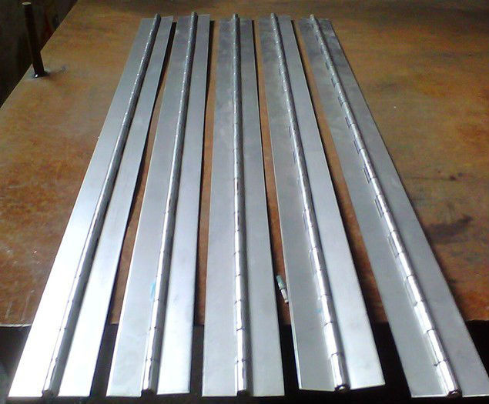

Figure 8. Continuous hinges, or piano hinges[22]
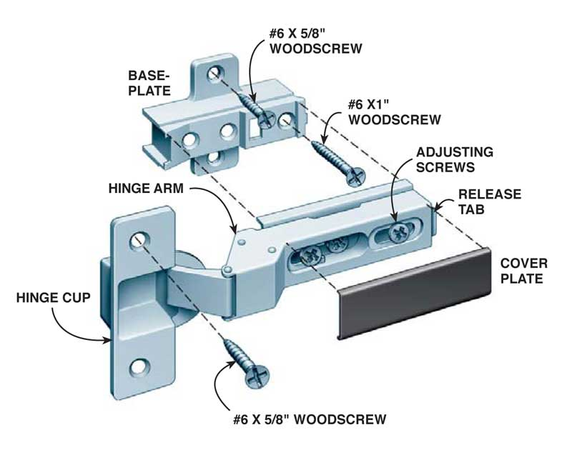
- Concealed hinges: made of two parts: one part is the hinge cup and the arm, the other part is the mounting plate. They are used for furniture doors (with or without self-closing feature, and with or without damping systems). Figure 9 shows an example of concealed hinges.

Figure 9. Concealed hinges[23]
- Flag hinges: a flag hinge can be taken apart with a fixed pin on one leaf. Flag hinges can also swivel a full 360 degrees around the pin. They are manufactured as a right-hand and a left-hand configuration. Figure 10 shows an example of flag hinges.

The project will mainly focus on innovating an automated processing design for this type of hinges.
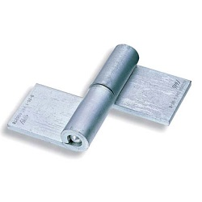

Figure 10. Flag hinges[24]

3.2 Main Blocks of the Project
This figure shows the block of the project. Also, the configuration of parts to each other.
Flat bar auto loader

Feeding
Cutting

Feeding
Forming (bending)

Feeding
Assembly

Figure 11:project's block diagram

3.2.1 Bars Auto Loader
A machine is used to automatically transfer and insert parts with an accurate direction and orientation to the work region. These machines come with different shapes and structures. Based on the application, some of them are suitable for different shapes while others can handle only a specific shape. Figure 12 shows autoloader for the production line.
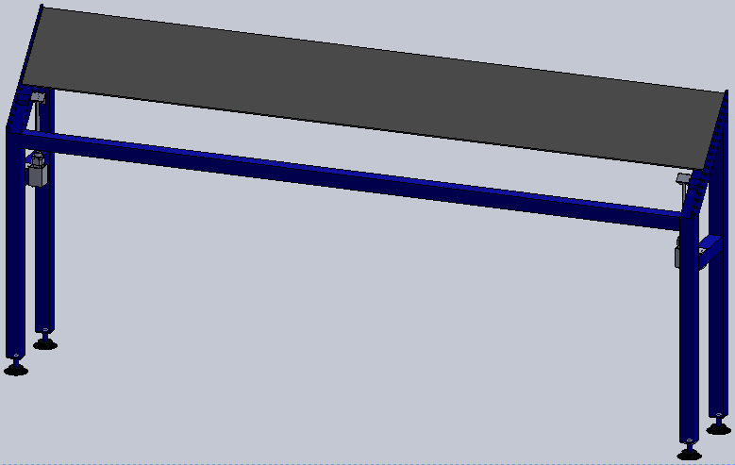
Figure 12. production line autoloader

3.2.2 Automatic Bar Feeding Machine
A machine is used to feed parts that are loaded manually or by an automatic loader machine with the right direction and orientation to the working process.
A conveyor system is used for feeding the bars.

3.2.2.1 Conveyor system
A chain sprocket conveyor is used for feeding the bars to the cutting process. Figure 13 shows the conveyor system for the production line.
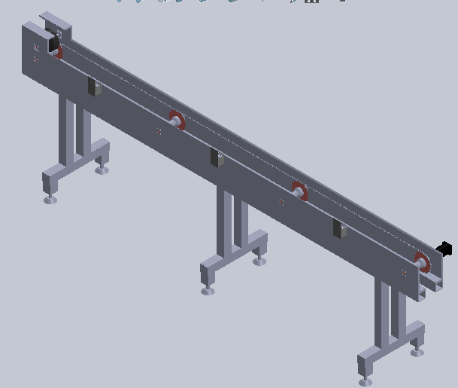
Figure 13. conveyor system.

3.2.3 Automatic Cutting
A machine used to remove material from the workpiece by means of shear deformation.
A cold saw is used for the production line which moves automatically by using a pneumatic system

3.2.3.1 cold saw
A cold saw is a power-saw using a toothed or abrasive disc or blade to cut different materials using a rotary motion spinning around an arbor. Figure 14 shows the cold saw system for the production line.

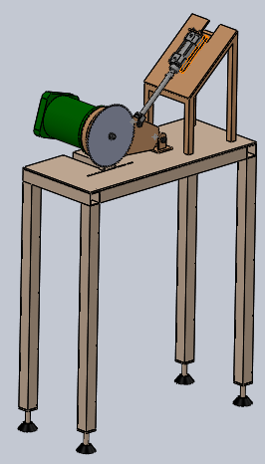
Figure 14. cold saw cutting machine

3.2.4 Forming (Bending) machine:
For forming parts, presses are one of the tools used for this purpose.
An eccentric press which is one of the types of mechanical presses is used for forming the parts in its desired shape.

3.2.4.1 Eccentric press
The eccentric press uses a motor to drive an eccentric shaft, rotating in a connecting rod. The connecting rod moves a ram in a slider joint one dimensionally. The eccentric shaft itself is round; therefore, it may completely rotate within the connecting rod. The center of the drive is not the center of the overall shaft. As the motor rotates, the center of the drive remains stable but the overall center of the shaft changes. This causes the shaft to change position, providing motion. The actual principle of an eccentric press is very similar to a crank press but the eccentric press allows for a stroke of a short distance. Figure 15 shows the mechanism of Eccentric Press.
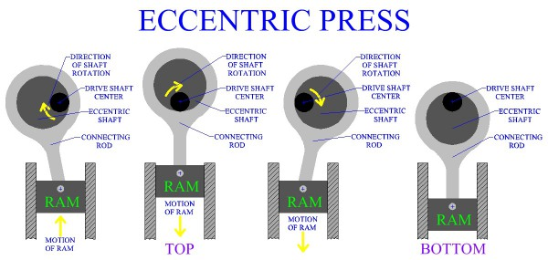
Figure 15. eccentric press

3.2.5 Assembly:
The project team will select the most suitable assembly mechanism to assemble the produced hinges.

3.3 Control System:
2- A Programmable Logic Controller, PLC or programmable controller is a digital computer, used for automation of typically industrial electromechanical processes, such as control of machinery on factory assembly lines, amusement rides, or light fixtures. PLCs are used in many industries and machines. They are designed for multiple analogue and digital inputs and output arrangements, extended temperature ranges, immunity to electrical noise, and resistance to vibration and impact. Programs to control machine operation are typically stored in battery backed-up or non-volatile memory. A PLC is an example of a “hard” real-time system; since output results must be produced in response to input conditions within a limited time, otherwise unintended operation will result. Figure (16) shows a PLC.
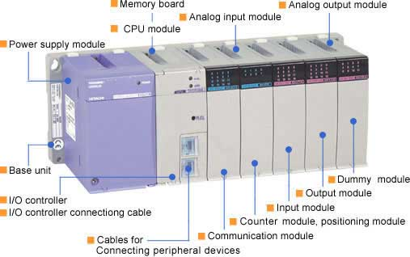
Figure 16: PLC. [25]

3.4 Motors:
Electric motor is an electrical machine that converts electrical energy into mechanical energy. Electric motors are used to produce linear or rotary force (torque).
Electric motors can be powered by Direct Current (DC) sources, such as batteries, motor vehicles or rectifiers, or by Alternating Current (AC) sources, such as inverters and generators.
Electric motors may be classified by electric power source type, internal construction, application, type of motion output, and so on.
-types of motors used to drive the production line:
1- Induction motor: An induction motor is an asynchronous AC motor where power is transferred to the rotor by electromagnetic induction, much like transformer action, in the project we used an induction motor to drive the cold saw for more specification about the chosen motor see table (30) in appendix (1).
Figure 17 shows an example of Induction motor.
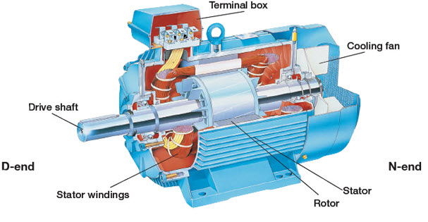
Figure 17:induction motor

2- A servomotor: is a rotary actuator or linear actuator that allows for precise control of angular or linear position, velocity and acceleration. It consists of a suitable motor coupled to a sensor for position feedback. It also requires a relatively sophisticated controller, often a dedicated module designed specifically for use with servomotors, in the project we used servo motor to drive the conveyor for more specification about the chosen motor see table (29) in appendix (1).
Figure 18 shows the servo motor used to drive the conveyor.
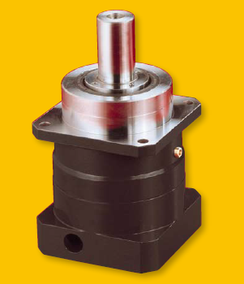
Figure 18:Servo motor.

3.5 Pneumatic cylinder:
Pneumatic cylinder(s) (sometimes known as air cylinders) are mechanical devices which use the power of compressed air to produce a force in a reciprocating linear motion. [26]
-double acting cylinder used in two stations:
the first one used to lift the bars in the autoloader, and the second one used for lifting and lowering the arm of the cold saw.
Figure (47) in appendix (1) shows the specifications and the standard for the chosen pneumatic cylinder.
Figure 19 shows the Air cylinder used to in the production line.

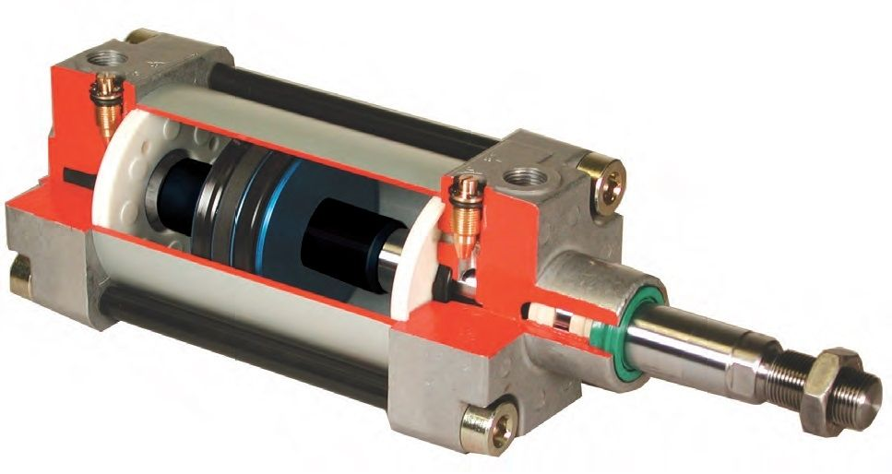
Figure 19:HP series air cylinder

Chapter 4

Methodology

The following steps summarize the methodology adopted in implementing the project:
- Conduct sufficient relevant literature review: in this chapter, the following steps were covered:
- A background of hinges history, uses, types and recent innovations;
- The main parts of the project (production line), the options that each part have, and the advantages and disadvantages of each option;
- The system and actuating devices that can be used to control and power the whole structure.
- A preliminary design will be prepared for the production line considering the following
- The project’s block diagram that describes the configuration of parts that create the production line;
- The principle of work of the production line;
- Deciding on the main parts for the production line;
- A schematic drawing showing the main blocks of the production line.
- A Study was made for the existing market and the methods used in producing hinges;
- The system was designed, the necessary kinematic, load and stress analysis was calculated and all necessary work drawing and plans was prepared by using suitable CAD software.
- An assembly was made for the whole structure;
- Prepare all of the mechanical and electrical charts needed;
- Electronic design which includes sensors, electric actuators and other electronic components was made for the system;
- Adjust the system functionality by. First, using an appropriate controller (PLC) to control the system. Second, programming the controller to make the system work effectively;
- Proper operating manual and safety instructions was prepared;
- A feasibility study of the machine was prepared.
- Project report that documents the complete experience was made.

Chapter 5

Design of automatic hinge bending machine
This chapter presents a detailed design of the automated hinge bending machine, the design includes material selection of machine elements, force and stress analysis, kinematic analysis and other tasks such as mechanisms analysis, assembly drawing and modeling.
Hinge bending machine consist of six main blocks, autoloader system, conveyor system, cold saw station, bending station, assembly station and control system.
Kinematic, force and stress analysis were conducted for critical machine elements of the hinge bending machine. Material and components selection was performed for certain elements of the hinge bending machine.

5.1 Project’s work principle:
- Flat bars will be added manually to a flat bar autoloader machine, which will automatically rearrange each bar in the right direction and orientation to be ready for the feeding process;
- In the feeding process, a conveyor will pass bars received from the loader to the cutting machine. The cutting process is done in steps where each step equals the length of the small flat plate which will later be curved to form one side of the hinge;
- An automatic saw cutting machine will cut the bar into small flat parts;
- After the cutting process, a sliding feeder that has a specific shape and direction will lead the cut parts to a bending machine;
- A punch-die press will form by bending each part to its desired shape;
- A crank slider mechanism will push the formed shape to the assembly station;
- In the assembly station, the two halves of the hinge will be directed in a specific orientation using a specific mechanism, allowing them to be assembled with the pin to form the hinge.

5.2 Description of the hinge bending machine
After defining the work principle of the hinge bending machine design comes as a next step. Actually, design is an integrated and continuous process of using all the existing sources of knowledge, human source and money so satisfy all the wanted functions, flexibility, comfort and safety factor.
Design includes choosing standard component that will be used in the hinge bending machine (e.g. autoloader system, conveyer system, cold saw system, press system and control system). In this project; combination of searching, investigating and comparison was done to select the most proper, available and economical parts.
Detailed mechanical drawings were prepared for all parts of the hinge bending machine using solidworks software with actual dimensions. The following Figure () shows the complete hinge bending machine.

5.3 Autoloader design
The following section includes the design of the stand and the pneumatic system for the autoloader in which the bar will transfer automatically and properly to the next station.

5.3.1 stand design
This section describes the force analysis, angles and the material of the stand. Also, it includes the time for the bar to reach the conveyor.
- Material: AISI No.1010, cold drawn(CD)for the bar and AISI No.1006, cold drawn(CD)for the stand table(4) and table (5) in App (1) shows material’s properties.
- Coefficient of friction between (Mild steel – Mild steel) (μ_{s}) =0.74.
- Mild steel density(ρ)=7.85(g/cm³) =7850(Kg/m³).
- Bar dimensions: Length(L)=3m, Width(W)=4cm, Thickness(T)=0.5cm.
- Bar volume(V)=L*W*T=6*10⁻⁴(m³).
- Mass of each bar(M)=ρ* V=4.71(Kg).
- Weight of each bar=M*g=46.2051(N). where: g is the gravity acceleration and equal 9.81(m/s²).
- Stand free body diagram and the required calculations. figure (20) shows the free body diagram:
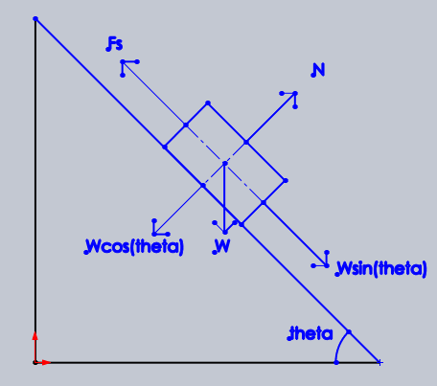
Figure 20:free body diagram of autoloader
-where:
- N: Normal force which equals W*cos(θ).
- W: Weight.
- F_{s}: Friction force which equals μ_{s} * N
-calculations:
For bar sliding, the force produced from the weight in the inclined direction which equals to (W*sin(θ)) must be equal or larger than the value of the friction force (F_{s}). table (2), shows the values of (F_{s) and} (W*sin(θ)) at different angles (θ). The selected value of (θ) for the stand is highlighted in the same table.
Table 2: Fs vs w*sin(theta)
Fs | W*sin(theta) | theta
27.66 | 27.1586 | 36
27.3 | 27.8 | 37
26.94 | 28.446 | 38
26.57 | 29.0778 | 39
26.19 | 29.7 | 40
24.177 | 32.67 | 45

Note: the angles with red color font in table 2 are allowable angles for the stand.

-When Fs Equal W*sin(θ) then (θ) will equal.
Fs = W*sin(θ).
μ_{s} *W*cos(θ)= W*sin(θ).
μ_{s} = tan(θ).
θ = 36.50144112®.

- the time needed for the bar to reach the conveyor.
ΔX = V₀*t + 0.5*a*t²…………………. (1).
Where:
ΔX: displacement between the bar initial position on the stand and the conveyor.
V_{0:} initial velocity of the bar.
a: bar acceleration.
t: time for the bar to reach the conveyor.
ΔX = 30.2(cm) = 0.302(m).
V₀ = 0(m/s).
a =?
t =?
To find the time needed, the acceleration of the bar while descending should be calculated by measuring the descending force (F_{D}) which equals to the difference between the friction force (F_{S}) and the weight force(F_{W}) on the inclined plane.
F_{D} = F_{W} - F_{S}…………… (2).
Where:
F_{D}: descending force.
F_{W}: weight force.
F_{S}: friction force.
F_{W} = W*sin (45) = 4.71 * sin (45) = 32.67(N).
F_{S} = μ_{s} * N = 0.74 * W*cos (45) = 24.177(N).
-substitute in equation (2).
F_{D} = 32.67 - 24.177 = 8,5(N).
F_{D} = m * a………………. (3).
Where:
F_{D}: descending force.
m: bar weight.
a: bar acceleration.
F_{D} = 8,5(N).
m = 4.71(kg).
a =?
-substitute in equation (3).
a = $\frac{FD}{m}$ = $\frac{8,5}{4.71}$ = 1.8(m/s²).
-now substitute the value of a in equation (1) to find the time t.
ΔX = V₀*t + 0.5*a*t²
0.302 = 0 + 0.5*1.8*t²
t = 0.6(s).

5.3.2pneumatic system design
In this section the required pressure or force needed for lifting the bar was calculated and according to it a suitable pneumatic air cylinder was chosen. Figure (47) in App (1) shows properties and specifications for the chosen pneumatic system.
The force exerted by double acting pneumatic cylinder on outstroke can be expressed as. The force exerted on instroke can be expressed as, figure (21) shows the terminology of a double acting cylinder.
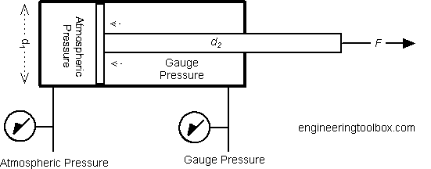
Figure 21: Double acting cylinder terminology.
F = p π (d12 - d22) / 4
where:
p: Pressure.
d1 = Full bore piston diameter (m).
d2 = Piston rod diameter (m).
- Lifting/loading piston
The load the piston will lift comes from the bars weight. Since there will be two pistons on each side of the stand the load will be divided by two, the bar weight=4.71(Kg), W/2=2.355(Kg).
An air cylinder piston with the following specification have been chosen:
- A compressor of pressure = 3 Bar = =3 Kg/cm² will be used.
- D piston = 3.2 cm, A piston = (3.2)2 *π/4 = 8.04 cm².
- D rod = 1 cm, A rod = (1)2 * π/4 = 0.785 cm²
- Net Area = 8.04 – 0.785 = 7.255 cm2.
The maximum load on piston from 2.355(Kg) = 23.10255(N).
From catalog Fig (47) in App (1) the smallest air cylinder piston has a 32mm diameter which can press a maximum load of:
F = p π (d1² - d2²) / 4
F= (3 bar * (8.04-0.785)) = 21.765 (Kg) = 213.5 (N).
Note: that piston load can be controlled by modifying machine pressure.
-Figure (22) shows the catalogue for the chosen air cylinder piston.
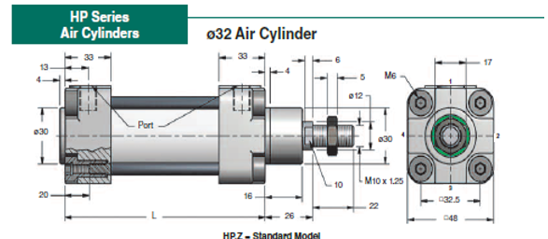
Figure 22: Hp series air cylinder piston.

5.4 conveyor design
This section explains the detail design of the conveyor from the material chosen to the part selection with its standard and also the necessary stress analysis calculation for the parts.

5.4.1 chain and sprocket design
-In this section the selection and the required calculations were accomplished.
- Material used for the conveyor stand made out of mild steel AISI 1006 for more details see table (4) in App (1).
- Chain type is AISI with chain No. 25 with single strand. Table (15) in App (1) shows characteristic of chain No. 25.
- Number of sprocket teeth(N) selected to be equal 65. Table (17) in App (1) shows the available number of teeth for different chain number.
- Tabulated horse power, lubricant type and sprocket speed are chosen from table (16) in App (1) with the following: the sprocket speed is 50(rev/min) with 0.05(hp) tabulated horse power and lubricant type is (A).
- Material used for chain and sprocket:
- Chain: stainless steel.
- Sprocket: carbon steel.
-Figure (23) shows the nomenclature of roller chain.
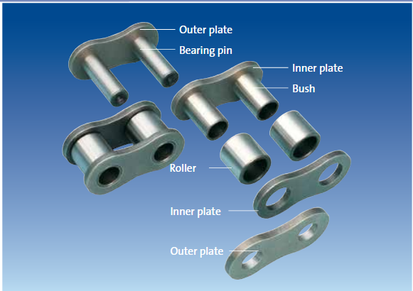

Figure 23: nomenclature of roller chains.
-Figure (24) shows a sprocket driving a chain and rotating in a counterclockwise direction. Denoting the chain pitch by ρ,the pitch angle by γ,and the pitch diameter of the sprocket by D.
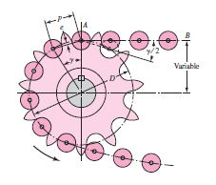

Figure 24: CHAIN SPROCKET ENGAGEMENT.

-calculations for chain and sprocket:
- Pitch angle (γ)=$\frac{360}{N}=\frac{360}{65}=5.538462$®.

- Angle of articulation (γ/2) =2.76923®.

- Pitch diameter(D)=$\frac{}{\sin\left(\frac{}{2}\right)}=\frac{0.25}{sin2.76923}=5.17455\left(in\right)=131.4336075\left(mm\right).$

- D/2=2.5873(in)=65.71680376$\left(mm\right).$

- Center to center distance© chosen to be equal 3(m).

- Length of the chain in pitches(L/ρ)=$\frac{2*C}{}+\frac{N1+N2}{2}+\frac{(N1-N2)^2}{4*π*C/}$. Where: N1=N2=65 teeth
(L/ρ)=1009.88 approximately =1010, L=6.41275(m).

- Chain velocity(V)=$\frac{N**n}{12}$
Where: N: Number of teeth.
: Chain pitch in (in).
n: Sprocket speed (rev/min).
V=$\frac{65*0.25*50}{12}=67.7083\left(\frac{feet}{min}\right)=0.343958(\frac{m}{s})$.

- Max exit velocity(V_{max})=$\frac{π*D*n}{12}$
Where: D: Pitch diameter.
n: Sprocket rev/min.
V_{max}=$\frac{π*5.175*50}{12}=67.74059\left(\frac{feet}{min}\right)=0.344119(\frac{m}{s})$.

- Min exit velocity(V_{min})=$\frac{π*d*n}{12}$
Where: d=D*cos($\frac{γ}{2}$)=5.168956(in).
V_{min}=67.66148$\left(\frac{feet}{min}\right)$=$0.34372(\frac{m}{s})$.

- The allowable power(H_{a})=k1*k2*H_{tab}
Where: k1 and k2 are correction factors table (18) and table (19) in App (1) shows the values of k1 and k2 respectively.
-K1=($\frac{N1}{17}$)^{1.08}=$(\frac{65}{17}$)^{1.08}=4.26
-k2 = 1.
-H_{a} = 4.26*1*0.05=0.21283(hp).
- Free body diagram for the conveyor:
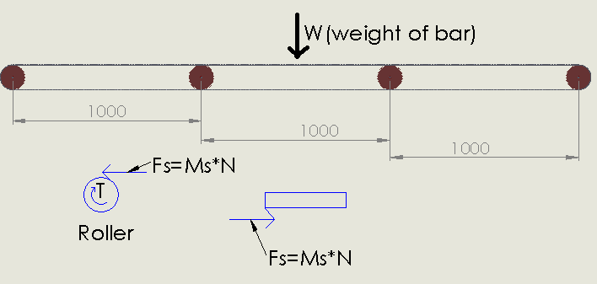
Figure 25: FREE BODY DIAGRAM FOR CONVEYOR.
-The only load exerted on the rollers comes from the bar’s weight and since at once the bar reaches the conveyor there are three rollers supported the bar, the weight will be divided on each roller that’s mean each roller will support a one-third of the bar’s weight.
W=46.158(N), W/3=15.386(N).

5.4.2 roller and its component selection and design
-In this section the selection and the required calculations were accomplished.
- Material used for the rollers and bar:
Roller: Polyurethane type 70 A. Table (12) and table (13) in App (1) shows material properties.
Bar: Mild steel (AISI 1010). Table (5) in App (1) shows material properties.

- Coefficient of friction between(COF) between: Polyurethane type 70 A and Mild steel equal 0.71. Table (14) in App (1) shows COF between steel and other types of Polyurethane.

- Force needed to move the bar
F_{s}=μ_{s}*$\frac{N}{3}$=0.71*$\frac{46.158}{3}$=10.92(N), (from each roller).

- Total torque to move the bar= F_{s}*r_{rooler}(at the area of contact with the bar)*3
T=10.92*0.02*3=0.6552(N.m).

- The velocity(V) of the bar designed to be equal 0.86 (cm/s), that’s mean that the bar moves 6 cm each 7 second.

- Power needed to move the system(P)= F_{s}*3*V=10.92*3*0.0086 = 0.283(w)=0.000283(kw)=0.0004(hp).
Where :1 (hp)=745.7(kw)
-for more safety since there are losses comes from roller chain, sprocket and other elements in the system a safety factor of 2 will be taken so the new power (P_{new})will equal =2*P=8*10⁻⁴(hp) even though the value still small.

- Motor selection
Motor type: a servo motor with 80 (w) is selected which can move the system at the same time its value still less than the value of the allowable horse power so the selection is acceptable.
Table (28), table (29) and figure (44) in App (1) shows the chosen motor standard with its specifications.

5.4.2.1 Roller shaft design
-In this section the selection and the required stress analysis calculations were accomplished.
- Shaft material: Aluminum table (6) in App (1) shows the properties of the chosen material.
- For aluminum, the value given for fatigue strength correspond to 50*10⁷ cycled of completely reversed stress. From this NO. of year for the shaft without failure can be calculated by the following:
Velocity of roller =velocity of shaft =0.06m/s.
W=$\frac{V}{r(shaft)}$=$\frac{0.06}{5*10^-3}$=12rad/s.
n=w*$\frac{60}{2π}$=114.6(rev/min), approximately (n) =115(rev/min).
No. rev /year=115*60*24*365=60444000(rev/year).
No. of year=$\frac{Total NO. cycle }{No. rev/year}=\frac{50*10^7}{60444000}$=8.3 years.
- Loads on shaft come from the bar weight, for more safety add one kg of other elements located on the shaft by this the total weight on each shaft will equal to W_{tot}=W_{BAR}/3 + 1(kg)*9.81=46.158/3 + 9.81=25.2(N).
- Shaft free body diagram and its shear moment diagram. Figure (26) shows the free body diagram and the shear moment diagram of the shaft:
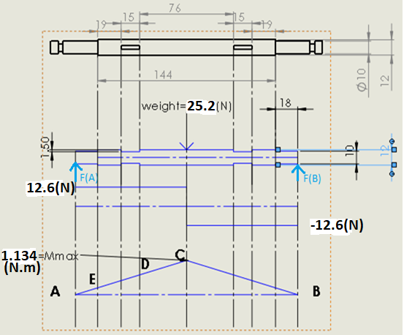

Figure 26: shaft free body diagram and the shear moment diagram.
- Force analysis:
$\sum{M}$_{A}=0.
W_{tot}*distance_{(C-A)} = F_{B*} distance_{(B-A).}
25.2*9*10⁻²=F_{B}*18*10⁻².
F_{B}=12.6(N).
$\sum{F}$_{Y}=0.
F_{A=} F_{B=}12.6(N).
M_{MAX}=10.675*9*10⁻²=1.134(N.m).
- Stress analysis:
- At maximum moment (point c).
(Moment)M=1.134(N.m), Torque(T)=0.655(N.m), diameter(d)=12(mm), Kf=K_{fs}=1, Safety factor(n)??
-By using Good Man Criteria:
M_{a}=1.134, Tm=0.655, M_{m}= T_{a}=0.
Endurance limit(S_{e})=K_{a}* K_{b}* K_{c}* K_{d}* K_{e}* K_{f}*S_{e}’
- K_{a}=a(S_{ut})^{b} , a=4.51,b=-0.265 where a,b chosen from table(20) in App (1) for machined surface finish.
- K_{a}=4.51 (179) ^{-0.265}=1.141.
- K_{b}=1.24(d)^{-0.107}=1.24(0.012)^{-0.107}=0.95.
- K_{c}= K_{d}= K_{f}=1.
- K_{e}=0.814 from table (21) in App (1) with reliability 99%.
- S_{e}’=0.5(S_{ut})=0.5*179=89.5.
- S_{e}=78.969(Mpa).
$$\frac{1}{n}=\frac{16}{π(0.012)^3}\{\frac{{\left(4{\left(1.134\right)}^{2}\right)}^{\frac{1}{2}}}{78.969*{10}^{6}}+\frac{{\left(3{\left(0.655\right)}^{2}\right)}^{\frac{1}{2}}}{179*{10}^{6}}\}$$

$\frac{1}{n}=2$947313.761{2.9*10⁻⁸+6.34*10⁻⁹}
n=9.6(safe).
-check for yielding(static):
A von Mises maximum stress is calculated for this purpose:
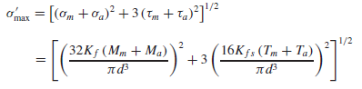
σ'_{max}=$\{\left(\frac{32*1.134}{π*{\left(0.012\right)}^{3}}\right)^2+3*\left(\frac{16*0.655}{π*{\left(0.012\right)}^{3}}\right)^2\}$^{1/2}
= [4.5*10¹³ +1.12*10¹³]^{1/2}=7.5(Mpa).
To check for yielding, this von Mises maximum stress is compared to the yield strength, as usual.
n_{y=}$\frac{Sy}{σ'max}=\frac{70}{7.5}=9.33$ (safe).
- At stress concentration (point D).
M_{D} =12.6*((15+19+18)*10⁻³)=0.655(N.m), Torque(T)=0.655(N.m).
-By using Good Man Criteria:
- M_{a}=0.655, Tm=0.656, M_{m}= T_{a}=0, take K_{f}=2.5 and K_{fs}=2.2
$$\frac{1}{n}=\frac{16}{π(0.012)^3}\{\frac{{\left(4{\left(2.5*0.655\right)}^{2}\right)}^{\frac{1}{2}}}{78.969*{10}^{6}}+\frac{{\left(3{\left(2.2*0.655\right)}^{2}\right)}^{\frac{1}{2}}}{179*{10}^{6}}\}$$

$\frac{1}{n}=2$947313.761{4.15*10⁻⁸+1.4*10⁻⁸}.

n=6.1(safe).
-check for yielding(static):
A von Mises maximum stress is calculated for this purpose:
σ'_{max}=$\{\left(\frac{32*2.5*0.655}{π*{\left(0.012\right)}^{3}}\right)^2+3*\left(\frac{16*2.2*0.655}{π*{\left(0.012\right)}^{3}}\right)^2\}$^{1/2}
= [9.32*10¹³+5.41*10¹³]^{1/2}=12.14(Mpa).
n_{y=}$\frac{Sy}{σ'max}=\frac{70}{11.008}=5.8$ (safe).

- At stress concentration (point E).
-M_{E} =12.6*(18*10⁻³)=0.2268(N.m), Torque(T)=0.655(N.m).
-By using Good Man Criteria:
- M_{a}=0.2268, Tm=0.655, M_{m}= T_{a}=0, S_{e}= K_{a}* K_{b}* K_{c}* K_{d}* K_{e}* K_{f}*S_{e}’
- S_{e}=80.632(Mpa) with K_{b}=1.24(d)^{-0.107}=1.24(10)^{-0.107}=0.97, while the other factors have the same value as before the different here is the diameter of the shaft so K_{b} will change.
- K_{f}=1+q(K_{t}+1).
- From figure (27) at r=0.5(mm):
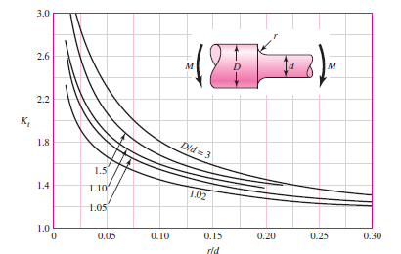
Figure 27: Kt for round shaft with shoulder fillet in bending. [1]
- r/d=$\frac{0.5}{10}$=0.05
- D/d=$\frac{12}{10}$=1.2
- from the figure K_{t} = 2.1
- from figure (28) at 0.5 notch radius q=0.8
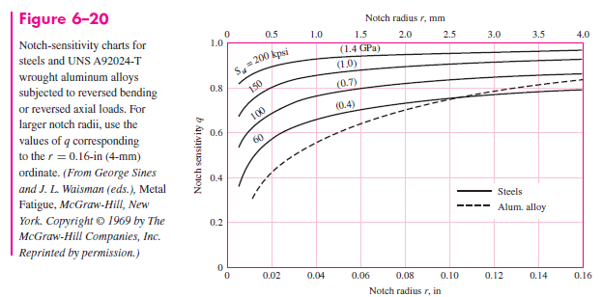
Figure 28: Notch sensitivity(q). [1]
- K_{f} = 1.88
- K_{fs}=1+q_{s}(K_{ts}+1).
- From figure (29) at r=0.5(mm):
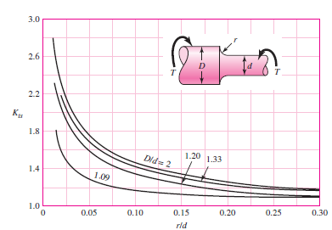
Figure 29: Kts for round shaft with shoulder fillet in torsion. [1]
- r/d=$\frac{0.5}{10}$=0.05
- D/d=$\frac{12}{10}$=1.2
- from the figure K_{ts} = 1.49
- from figure (30) at 0.5 notch radius q=0.81
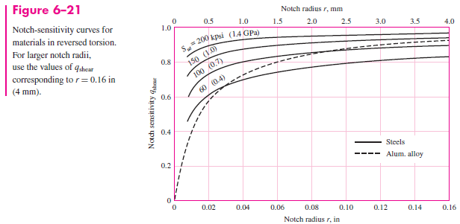
Figure 30: Notch sensitivity(qs). [1]
- K_{fs}=1.4
$$\frac{1}{n}=\frac{16}{π(0.01)^3}\{\frac{{\left(4{\left(1.88*0.2268\right)}^{2}\right)}^{\frac{1}{2}}}{80.63*{10}^{6}}+\frac{{\left(3{\left(1.4*0.655\right)}^{2}\right)}^{\frac{1}{2}}}{179*{10}^{6}}\}$$

$\frac{1}{n}=5092958.179${1.06*10⁻⁸+8.87*10⁻⁹}.

N=10.1(safe).

-check for yielding(static):
A von Mises maximum stress is calculated for this purpose:

σ’_{max}=$\{\left(\frac{32*1.88*0.2268}{π*{\left(0.01\right)}^{3}}\right)^2+3*\left(\frac{16*1.4*0.655}{π*{\left(0.012\right)}^{3}}\right)^2\}$^{1/2}
= [1.89*10¹³+5.42*10¹³]^{1/2}=8.55(Mpa).

N_{y=}$\frac{Sy}{σ'max}=\frac{70}{8.898}=8.2$ (safe).

Note: it was obvious that the values of safety factor are a little bit high and to solve this the diameter size of the shaft must be reduced but we will keep it as is for easy handling, fitting and manufacturing. Also, to make it consistent with the dimensions of the parts in general.

5.4.2.2 Square key design
-In this section the selection and the required calculations were accomplished.
- A 3 (mm) square key is selected UNS G10060 hot rolled steel was used. The design will be based on a yield strength of 170 (Mpa). A factor of safety of 2 will be taken. The length of the key is unknown. Table (20) in App (1) shows the square key standard chosen dimensions.
- The force F at the surface of the shaft is:
F=$\frac{T(to move the bar)}{\begin{aligned}r(of the shaft where \\ the key located)\end{aligned}}$=$\frac{0.655}{6*10^-3}$=109.2(N).
- Free body diagram of the key:
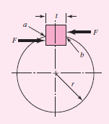
Figure 31: free body diagram of the key.
- Shear stress(S_{sy})=0.577*S_{y}=0.577*170=98.09(Mpa).
- Length of the key(L)
$$\frac{Ssy}{n}=\frac{F}{t*L}$$

Where:
S_{SY}:Shear Stress(Mpa).
F: Force(N).
t: thickness of the key (mm).
n: safety factor.
L: Length of the key.

$$\frac{98.09*10^6}{2}=\frac{160.167}{0.003*L}$$

L=1.08857(mm).

- it’s obvious how small the length is, so for easy manufacturing, fitting and to hold both the sprocket, and the roller with the shaft; a length of 15mm will be used (less than 1.5 times the diameter of the shaft). This size will also be suitable with other elements dimensions.

5.4.3 Bearing design and selection
This section describes the criteria of selection for the chosen bearing. Also, it shows the required analysis and calculations.
- Free body diagram of the shaft containing the bearings
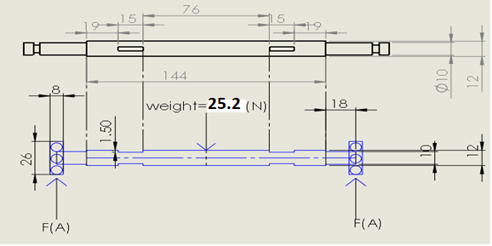
Figure 32: shaft with bearing free body diagram.

- Force analysis:
$\sum{M}$_{A}=0
W_{tot}*distance_{(C-A)} = F_{B*} distance_{(B-A).}
25.2*9*10⁻²=F_{B}*18*10⁻².
F_{B}=12.6(N).
$\sum{F}$_{Y}=0.
F_{A=} F_{B=}12.6(N).

- Impact factor(IF)
-for uniform load IF=1.1. Table (25) in App (1) shows the values of IF for different application.
- Reliability life adjustment factor(K_{R}) = 1. Table (24) in App (1) shows the values of K_{R} at different reliability percent.
- Velocity of roller =velocity of shaft =0.06m/s.
W=$\frac{V}{r(shaft)}$=$\frac{0.06}{5*10^-3}$=12rad/s
n=w*$\frac{60}{2π}$=114.6(rev/min), approximately (n) =115(rev/min).
- Design life :2 year,6 day/week,8 hr/day.
Design life (L_{d}) in revolution =2 year*52 $\frac{week}{year}$*6 $\frac{day}{week}$*8 $\frac{hr}{day}$*60 $\frac{min}{hr}$*115 $\frac{rev}{min}$=34444800 rev.
- Bearing type is single row deep groove ball bearing. Table (23) in App (1) shows bearing properties.
- Load factor for selected bearing type. Table (26) in App (1) shows the Approximate radial load factors for selected bearing types.
- Dynamic equivalent radial load P_{e}
P_{e} =X_{d}*F_{r} + Y_{d}*F_{a}
Where:
X_{d}:dynamic radial load factor, based on bearing geometry (see table (26) in App (1)).
Y_{d}:dynamic axial(thrust) load factor, based on bearing geometry (see table (26) in App (1)).
P_{e1} =(X_{d1}*F_{r} )+ (Y_{d1}*F_{a} )=(1*12.6)+ 0=12.6(N).
P_{e2} =(X_{d2}*F_{r} )+ (Y_{d2}*F_{a} )=(0.55*12.6)+ 0=6.93(N)
P_{e1}> P_{e2} choose P_{e1}=P_{e.}
- Basic dynamic load rating requirement corresponding to the reliability level selected:
[C_{d}®]_{req}=$\left(\frac{Ld}{KR*({10}^{6})}\right)^\frac{1}{a}$*(IF)*P_{e}
Where:
[C_{d}®]_{req}: required radial dynamic load rating to give a bearing reliability of R percent.
L_{d}: design life, revolutions.
K_{R}: reliability adjustment factor from table (24) in App (1).
IF: application impact factor from table (25) in App (1).
P_{e}: equivalent radial load.
A: exponent equal to 3 for ball bearing or 10/3 for roller bearing, in our case a=3.
[C_{d}®] _{req}=$\left(\frac{34444800}{1*({10}^{6})}\right)^\frac{1}{3}$*(1.1) *12.6=45.1(N).
- Static equivalent radial load P_{es}
P_{es} =X_{s}*F_{sr} + Y_{s}*F_{sa}
Where:
X_{s}: static radial load factor, based on bearing geometry (see table (26) in App (1)).
Y_{s}: static axial(thrust) load factor, based on bearing geometry (see table (26) in App (1)).
P_{es1} = (X_{s1}*F_{r)} + (Y_{s1}*F_{a}) = (1*12.6) + 0=12.6(N).
P_{es2} = (X_{s2}*F_{r)} + (Y_{s2}*F_{a}) = (0.6*10.7) + 0=7.56(N).
P_{es1}> P_{es2} choose P_{es1}=P_{es.}
- Bearing selection:
Bearing No. 6000, with bore =10mm, outside diameter=26mm, width=8mm, Cd=4.62KN, C_{S}=1. 96KN, limiting speed (30/36). Since Cd> [C_{d}®] _{req}, C_{S} > P_{es}
Table (27) in App (1) shows all the properties of the chosen bearing.

5.4.3 Bolt selection
An M5*0.8 bolt was selected to hold the parts together in each location where the bolt existed. Since the loads which the bolts will support are very small, then such a bolt will be acceptable since it a has very good properties, table (7) shows the selected bolt diameter and areas, table (8) shows the selected bolt properties, table (9) shows the selected bolt dimensions, table (10) shows the selected nut dimensions and table (11) shows the selected washer dimensions. Note: all the tables mentioned before located in App (1).

5.5 Cold Saw Design
This section gives a detailed analysis for the components of the cold saw from the selection of the blade to the force acting on or from the blade to the motor calculation and selection and finally the stress analysis to the main component holding the system such as the link holder, pins, base and the pneumatic cylinder.

5.5.1 Blade Selection and Design
This sub section describes the selection criteria for a suitable blade which can cut the desired material. Also, all the exerted forces to or from the blade on the work piece were accomplished.
- Saw Material properties. Table (37) in App (1) shows the chosen material standard for the blade.
High speed TUNGSTEN MOLYBDENUM STEEL.
High performance saw blades. Hardened and tempered to 64 +/-1® HRC.
Used on all types of machines to cut tubes, pipes and solid sections made out of ferrous and non-ferrous with tensile strengths up to 900 N/mm² up to 160mm cross section.

- Blade surface coating
TiN Titanium Nitride:
Technical characteristics:
PVD coating.
Surface hardness: 2200-2400 HV.
Oxidization temperature: 520 C®.
Coefficient of friction: 0.55.
Applications:
Medium hard steel
Hard steels
Furniture tube and sections in general.
Mixed, steel-plastic components.

- Material to be cut:
Mild steel AISI 1010, table (5) in App (1) shows mild steel properties.

- Blade tooth form:
C or HZ toothing, alternate “V and flat”. The chip is split into three parts, each 1/3rd of the blade width. This improved swarf removal permits the use of higher cutting speeds and feeds on bigger sections and solids. Supplied as standard on saw blades with 5mm and coarser tooth pitches, figure (33) shows HZ tooth shape.


Figure 33: HZ tooth shape. [5]

- Cross section of material to be cut:
Solid section with 40 mm in width and 5mm in thickness, figure (34) shows the cross section of the material to be cut.
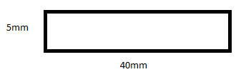
Figure 34: Cross section of material to be cut.

- Pitch:
From table (31) in App (1), pitch = 10 mm.

- Blade weight:
From table (36) in App (1), weight = 0.48(kg).

- Blade diameter:
From table (31) in App (1) the diameter chosen to be equal D = 200 mm.

- Blade width and number of teeth:
From table (32) in App (1):
Width=2mm, No. teeth = 64HZ.

- Blade RPM.
The RPM value was chosen to be equal 80 (RPM), table (31) in App (1) shows the acceptable RPM range for the blade at specific diameter value.

- Feed per tooth S_{z}:
From table (33) in App (1) S_{z} chosen to be equal 0.06 mm/tooth.

- Cutting speed: v [m/min]
V=$\frac{D . π .N}{1000}$
Where:
D: Saw diameter (mm).
Π: constant 3.14
N: RPM [1/min].
V=$\frac{200 . π .80}{1000}=50.3(\frac{m}{\min{}})$ = 0.84(m/s).

- Feed: S [mm/min]
S = S_{Z} * Z * N.
Where:
S_{Z}: feed per tooth (mm/tooth).
Z: Number of teeth.
N: RPM [1/min].
S = 0.06 * 64 * 80 = 307.2(mm/min).
From table (31) and table (33) in App (1) the value of cutting speed and feed located within the acceptable range.

- Cutting ratio(r)
Cutting ratio chosen to be equal 0.5

- Cutting angle and relief angle
Cutting angle ($γ$) = 18®
Relief angle (α) = 12®
Table (34) in App (1) shows the Cutting angle and relief angle for cutting the desired material.

- Tooth specification and dimensions.
Table (35) in App (1) shows the dimensions for the blade

- Shear angle (Ø)
tanØ = $\frac{r.cos⁡(γ)}{1-r.sin⁡(γ)}$

tanØ = $\frac{0.5*cos⁡(18)}{1-0.5*sin⁡(18)} β$

Ø=29.4®

- Friction angle ($β)$
$β=2[45+\frac{γ}{2}-∅$]
$$β=2[45+\frac{18}{2}-29.4]$$
$β=$49.2®

- Shear force (F_{S})
F_{S} =( S_{SY}) * (A_{S}) = (0.5*S_{Y}) * ($\frac{w*t0}{sin∅}$)= (0.5*300*10⁶) * ($\frac{(2*{10}^{-3})*(0.06*{10}^{-3})}{sin29.4}$)=36.67(N).

- Cutting force (F_{C})
F_{C} = $\frac{Fs*cos⁡(β-γ)}{cos⁡(∅+β-γ)}$.

F_{C} = $\frac{36.67*cos⁡(49.2-18)}{cos⁡(29.4+49.2-18)}$=63.9(N).
-for four teeth engagement during cutting the total cutting force will equal:
F_{CT} = 4* F_{C} = 4 * 63.9 = 255.6(N).

- Thrust force (F_{t})
F_{t} = $\frac{Fs*sin⁡(β-γ)}{cos⁡(∅+β-γ)}$
F_{t} = $\frac{36.67*sin⁡(49.2-18)}{cos⁡(29.4+49.2-18)}$=38.7(N).
-for four teeth engagement during cutting the total thrust force will equal:
F_{tT} = 4* F_{t} = 4 * 38.7 = 154.8(N).

- Power needed to move the blade(P)
P = V_{C} * F_{CT} = 0.84 * 255.6 = 214.704 (w) = 0.215 (Kw) = 0.28832 (hp).

- Motor Selection
An AC induction motor with the following features has been selected
- Brushless Design and Plastic Cooling Fan for Long Life and Quiet Operation.
- Compact Size, High Efficiency.
- 220VAC or 380VAC Input.
- Shaft Oil Seal is Dust and Waterproof.
- TEFC Design.
- IP55 Rated.
- Class F Insulation.
- Excellent Cross for Some Leeson and Baldor AC Industrial Motors.
- High Starting Torque for High Inertia Loads.
- Long Life and Highly Reliable.
- CE Certified and RoHS Compliant.
Table (30) in App (1) shows all the properties of the chosen motor.
Figure (45) and figure (46) in App (1) shows the dimensions and the wiring diagram for the motor.

- Arc length for cutting
Feed(S) = 307.2(mm/min) = 5.12(mm/s).
The cutting time chosen to be equal 4 second for either back or forth.
Feed is considered a speed so:
Feed(S_{x}) =$\frac{s}{t}$
where:
S is the distance of the arc which equal S = r * φ, r = 250(mm).
t: time.
5.12 = $\frac{s}{4}$
S = 20.48 (mm).
S = r * φ.
20.48 = 250 * φ
Φ = 0.08192 rad = 4.7®.

- Start and end angle of the saw
Start angle = 17® from the surface.
End angle = 12.3® from the surface.

- Angular velocity for the rotating link
S = w * r
Where:
S: feed (mm/s).
w: angular velocity(rad/s).
r: radius (mm).
substitute in the equation.
5.12 = w * 250.
W=0.02048(rad/s) = 0.195(rev/min).

5.5.2 Force and stress analysis on the bolts connecting the motor with the rotational link
- Rotational link material is AISI 1006, table (4) in App (1) shows the characteristics of the material.

- Blot type

An M10 * 1.5 class (4.6) metric bolt is chosen for more specifications see table (7) and table (8) in App (1).

- Number of bolts
4 bolts with M10*1.5

- Motor weight = 8(kg).

- Free body diagram.

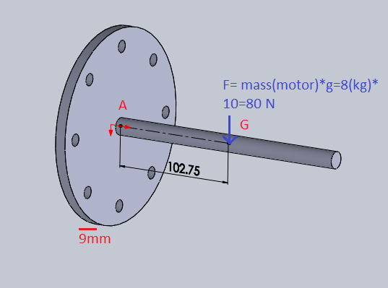
Figure 35: free body diagram for the force acting in the motors bolt.

- $\sum{F}$_{y} = 0
F_{y} = 80 (N).

- $\sum{MA}$_{x} = 0
M_{X} = 80*102.75* 10⁻³ = 8.22(N.m).

- Stresses
- Bearing in bolt
σ = $\frac{F}{Aproj}$ = $\frac{F}{d*t}$

where:
d: bolt diameter.
t: member thickness.
σ = $\frac{F/4}{d*t}$ = $\frac{80/4}{10*9*10^-6}$ = 222222.2 (pa).

n = $\frac{Sp}{σ}$ = $\frac{225*10^6}{222222.2}$ = 1012.5 (safe).

- Bearing in member
σ = $\frac{F}{Aproj}$ = $\frac{F}{d*t}$

σ = $\frac{F/4}{d*t}$ = $\frac{80/4}{10*9*10^-6}$ = 222222.2 (pa).

n = $\frac{Sy}{σ}$ = $\frac{280*10^6}{222222.2}$ = 1260 (safe).

- Bolt shear
τ = $\frac{F}{At}$ = $\frac{F/4}{At}$ = $\frac{80/4}{58*10^-6}$ = 344827.6(pa) for (thread extended).

n = $\frac{0.577*Sp}{τ}$ = $\frac{0.577*225*10^6}{344827.6}$ = 376.5 (safe).

τ = $\frac{F}{Ar}$ = $\frac{F/4}{At}$ = $\frac{80/4}{\frac{}{4}*(10*{10}^{-3})^2}$ = 254647.9(pa) for (thread extended).

n = $\frac{0.577*Sp}{τ}$ = $\frac{0.577*225*10^6}{254647.9}$ = 509.82 (safe).

- Bending stress
σ = $\frac{M*C}{I}$

Where:
M: moment in (N.m).
C: distance away from the neutral axis.
I: Moment of Inertia.

I = $\frac{}{64}$ * (d1⁴-d2⁴) – 4*($\frac{}{64}$ * d3⁴ + A d²), A: AREA, d: distance between the center of circle d3 and the neutral axis.
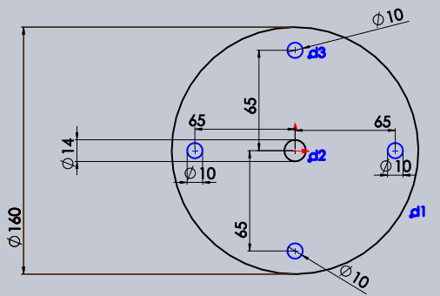
I =( $\frac{}{64}$ * (160⁴-14⁴) – 4*($\frac{}{64}$ * 10⁴ + (Π * 5²) * 65²)) * 10⁻¹² = 3.2 * 10⁻⁵

σ = $\frac{8.22*80*10^-3}{3.2*10^-5}$ = 20485.4(pa).

n = $\frac{Sy}{σ}$ = $\frac{280*10^6}{20485.4}$ = 13668.3(safe).

5.5.3 Forces at Point A
- Free body diagram at point A
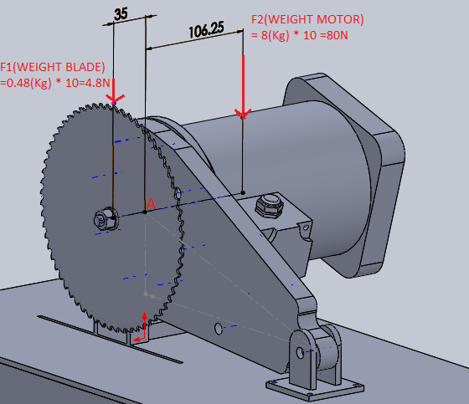
Figure 36: Free body diagram at point A.

- $\sum{M}$_{A} = F_{motor}*d_{motor} – F_{blade} *d_{blade}
= (80*0.10625) – (4.8*0.035) =8.332(N.m).

- $\sum{F}$_{A} = 80+4.8 = 84.8(N).

5.5.4 force and stress analysis at point B
- Material of the rotating link and the link base.
AISI 1006 for both. Table (4) in App (1) shows the properties of the chosen material.

- Type of bolt/pin at point B
M10 * 1.5 with class 4.6 was chosen. Table (7) and table (8) in App (1) shows chosen bolt properties and dimensions.

- Free body diagram at point B.
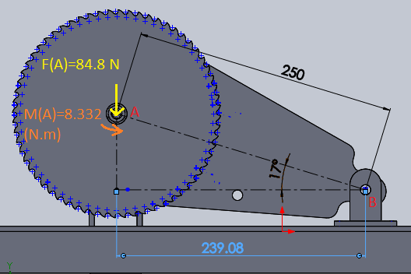
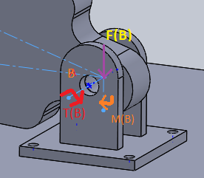
Figure 37: free body diagram of point B.

- $\sum{M}$_{B}= 84.8 * 0.23908 = 20.3(N.m) (T(B))

- $\sum{F}$_{B}=0

F_{B} = F_{A} = 84.8(N).
M(B) = 8.332(N.m).

- Check for safety at point B.
- Bearing stress at point B.
σ_{pin} = $\frac{F}{Aproj}$ = $\frac{F}{d*t}$

Where:
d: bolt diameter.
t: member thickness.

σ = $\frac{84.8}{10*20*10^-6}$=424000(pa).

n_{pin}= $\frac{Sy}{σ}$=$\frac{240*10^6}{424000}$ = 566(safe).

σ_{plate}=424000(pa).

n_{plate}= $\frac{280*10^6}{424000}$ = 660.3(safe).

- Shear stress from force.
τ _{force} = $\frac{F}{A}$ = $\frac{84.8}{\frac{}{4}*d^2}$ = $\frac{84.8}{\frac{}{4}*{10}^{2}*10^-6}$ = 1079707.134(pa).

n= $\frac{0.577*Sy(pin)}{σ}$ = $\frac{0.577*240*10^6}{1079707.134}$ = 128.3(safe).

- σ _{moment} = $\frac{M*C}{I}$

σ _{moment} = $\frac{8.332*15*10^-3}{\left(\frac{1}{12}*{30}^{3}*20-\frac{1}{12}*{10}^{3}*20\right)*10^-12}$ = 2884153.8(pa).

n= $\frac{Sy(plate)}{σ}$ = $\frac{280*10^6}{2884153.8}$ = 97.1(safe).

5.5.5 force and stress analysis at point C
- Density of AISI 1006 mild steel which is the material of the rotating link =7850 kg/m³.
- Area of the rotating link = 37560.68 mm².
- Thickness of the rotating link = 20 mm.
- Volume of the rotating link(V)= area(A) * thickness(t)= 37560.68 * 20 *10⁻⁹ =7.5 * 10⁻⁴ (m³).
- Mass of the rotating link(m)= Density* Volume =6(kg).
- Free body diagram at point C.
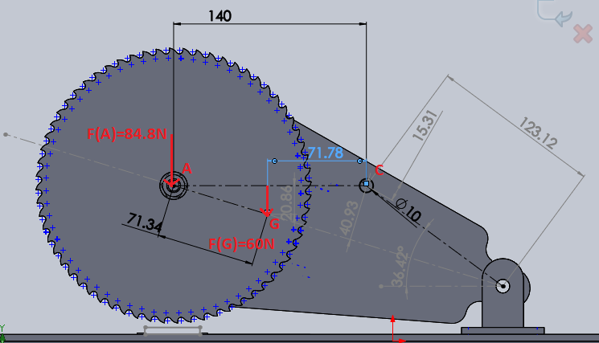
Figure 38: free body diagram at point C.

- $\sum{M}$_{C} = 0
M_{C} = (weight_{motor+blade} *distance_{A-C}) + (weight_{rotating link}*distance) + M_{A}
M_{C} = (F_{A} *distance_{A-C}) + (F_{G}*distance_{G-C}) + M_{A}
M_{C} = (84.8 *140*10⁻³) + (60*71.78*10⁻³) + 8.332 = 24.54(N.m).

- $\sum{F}$_{C} = 0
F_{C} = weight_{motor} + weight_{blade} + weight_{rotating link}
F_{C} = (8kg * 10) + (0.48kg * 10) + (6kg * 10) =144.8(N).

- The pin or bolt used at point c is an M10 * 1.5 with property from table (7) and table (8) in App (1), while the material for either the link holder or rotating link the same as before which is AISI 1006 table (4) in App (1) shows its properties.

- Stresses on bolt

- Bearing stress in bolt

σ_{pin} = $\frac{F}{Aproj}$ = $\frac{F}{d*t}$=$\frac{F/2}{d*t}$=$\frac{144.8/2}{10*3-10^-6}$=2413333.3(pa).

n = $\frac{Sp}{σ}$ = $\frac{225*10^6}{2413333.3}$ = 93.23 (safe).

- Bearing in member

σ = $\frac{F}{Aproj}$ = $\frac{F}{d*t}=\frac{F/2}{d*t}$ =2413333.3(pa).

n = $\frac{Sy(material0}{σ}$ = $\frac{280*10^6}{2413333.3}$ = 116.02 (safe).

- Bolt shear

τ = $\frac{F}{At}$ = $\frac{F/2}{At}$ = $\frac{144.8/2}{58*10^-6}$ = 1248275.9(pa) for (thread extended).

n = $\frac{0.577*Sp}{τ}$ = $\frac{0.577*225*10^6}{1248275.9}$ = 104 (safe).

τ = $\frac{F}{Ar}$ = $\frac{F/2}{At}$ = $\frac{144.8/2}{\frac{}{4}*(10*{10}^{-3})^2}$ = 921825.4(pa) for (thread extended).

n = $\frac{0.577*Sp}{τ}$ = $\frac{0.577*225*10^6}{921825.4}$ = 140.8 (safe).

- Tensile stress on member

σ = $\frac{F}{\left(w-d\right)*(t)}$ = $\frac{F/2}{\left(30-10\right)*\left(3\right)*10^-6}$ = $\frac{144.8/2}{\left(30-10\right)*\left(3\right)*10^-6}$ = 1206666.7(pa).

n = $\frac{Sy(material)}{σ}$ = $\frac{280*10^6}{1206666.7}$ = 232(safe).

- Tearing stress

τ = $\frac{F}{a*t}$ = $\frac{F/2}{\left(1.5d\right)*(t)}$ = $\frac{144.8/2}{\left(1.5*10\right)*\left(3\right)*10^-6}$ = 1608888.9(pa).

n = $\frac{0.577*Sy(material)}{τ}$ = $\frac{0.577*280*10^6}{1608888.9}$ = 100.4(safe).

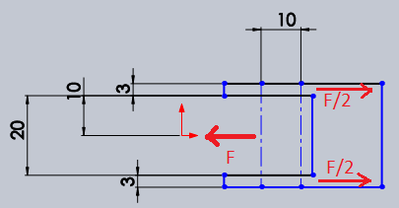
Figure 39: force diagram at point c between the link holder and the pin.

5.5.6 force and stress analysis at point D
- Type of bolt at point D
M5 * 0.8 class 4.6 Bolt Used at point D to connect the link holder with the pneumatic cylinder. table (7) and table (8) in App (1) shows bolt properties.
- Link holder and pneumatic cylinder rod material.
Material for both link holder and pneumatic rod is AISI 1006, table (4) in App (1) shows material properties.

- Free body diagram at point C
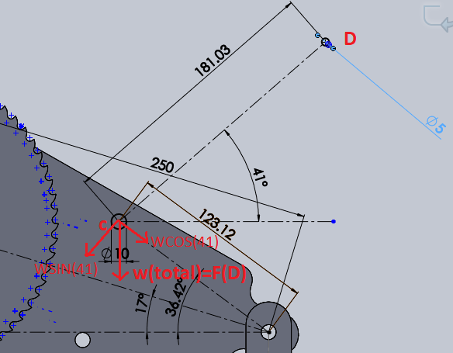
Figure 40: free body diagram at point D.

- Dimensions at point D
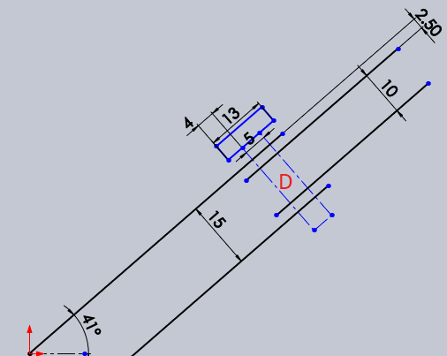
Figure 41: Dimensions at point D.
- $\sum{M}$_{D} = 0
M_{D} = F_{D} *cos(φ)*d=144.8*cos (41) *181.03*10⁻³=19.8(N.m).

- $\sum{F}$_{D} = 0
F_{D}= weight_{motor} + weight_{blade} + weight_{rotating link}
F_{D} = (8kg * 10) + (0.48kg * 10) + (6kg * 10) =144.8(N).
F_{D}*cos (41) = 144.8 * cos (41) = 109.3(N).
F_{D}*sin (41) = 144.8 * sin (41) = 94.9(N).

- Stresses at point D:
- From force (F_{D} *sin (41))
-shear on bolt

τ = $\frac{F}{A}$ = $\frac{F/2}{A}$ = $\frac{94.9/2}{\frac{}{4}*5^{2}*10^-6}$ = 2416608.6(PA).

n = $\frac{0.577*Sp}{τ}$ = = $\frac{0.577*225*10^6}{2416608.6}$ = 53.7(safe).

- normal stress between the two links

σ = $\frac{F}{A}$ = $\frac{94.9}{\frac{}{4}*{\left(15-10\right)}^{2}*10^-6}$ = 4833217.312(pa).

- From force (F_{D} *cos (41))
-shear on member

τ = $\frac{F}{A}$ = $\frac{109.3}{\frac{}{4}*{15}^{2}*10^-6}$ = 618511.5(pa).

n = $\frac{0.577*Sy(matarial)}{τ}$ = $\frac{0.577*280*10^6}{618511.5}$ = 261.2(safe).

- From moment
-bending stress on member

σ _{moment} = $\frac{M*C}{I}$ = $\frac{19.8*{10}^{-3}*\frac{15}{2}}{\frac{}{64}*{15}^{4}*{10}^{-12}}$ = 59757375.9(pa).

σ _{total} =sqrt (σ _{moment}² + σ²)

σ _{total} =sqrt (59757375.9² + 4833217.312²) =59952514.24(pa).

n = $\frac{Sy(matarial)}{σtotal}$ = $\frac{280*{10}^{6}}{59952514.24}$ = 4.67(safe).

Note: it was obvious that the values of safety factor are very high causing an over-safe condition.
One way to control the safety factor value is to reduce the thickness of the parts or to select bolts with smaller diameters. Another way is to change the material of either the bolts, the parts or both of them. Both solutions can be considered, but none of them will be adopted since standard dimensions were used for most of the parts.
Another reason for not changing the current model is to ensure the easy handling, fitting, manufacturing of the parts.
Any change in either the dimensions or the material is not going to have a significant impact on the total price of the system.

5.5.7 Pneumatic Cylinder Design
This section shows the selection and the calculations for the pneumatic cylinder.
The purpose of using the pneumatic system is to lift and descend the cold saw rotating link.
While lifting the load on piston comes from the blade weight, motor weight and rotating link weight the total will equal 144.8(N).

While descending the piston has to apply a force equal the difference between the total thrust force and the total weight, this equal F_{t(total)} – weight(total) = 154.8-144.8 = 10 (N).

From catalogue fig (47) in App (1) an air cylinder piston with the following specification have been chosen:
- A compressor of pressure = 3 Bar = =3 Kg/cm2 will be used.
- D piston = 3.2 cm, A piston = (3.2)2 *π/4 = 8.04 cm².
- D rod = 1 cm, A rod = (1)2 * π/4 = 0.785 cm².
- Net Area = 8.04 – 0.785 = 7.255 cm².
The maximum load on piston = 144.8(N).
F = p π (d1 - d2) / 4
where:
p: Pressure.
d1 = Full bore piston diameter (m).
d2 = Piston rod diameter (m).
From catalog Fig (47) in App (1) the smallest air cylinder piston is 32mm Diameter which can press a maximum load of:
F = p π (d1 - d2)/4.
F= (3 bar * (8.04-0.785)) = 21.765 (Kg) = 213.5 (N).
Note: that piston load can be controlled by modifying machine pressure.
-Figure (47) in App (1) shows the chosen air cylinder piston.

5.5.8 Slider connecting the cold saw with the mechanical press design.
This section describes the angle and the length of the slider. Also, it shows the free body diagram of the work piece sliding on the slider and the time needed for the work piece to reach the press.
- Material: AISI No.1010, cold drawn(CD)for the bar and AISI No.1006, cold drawn(CD)for the stand table (4) and table (5) in App (1) shows material’s properties.
- Coefficient of friction between (Mild steel – Mild steel) (μ_{s}) =0.74.
- Mild steel density(ρ)=7.85(g/cm³) =7850(Kg/m³).
- Bar dimensions: Length(L)=6cm, Width(W)=4cm, Thickness(T)=0.5cm.
- Bar volume(V)=L*W*T=12*10⁻⁶(m³).
- Mass of work peice(M)=ρ* V=0.0942(Kg).
- Weight of each bar=M*g=0. 942(N). where: g is the gravity acceleration and equal 10(m/s²).
- Slider free body diagram and the required calculations. figure (42) shows the free body diagram:
Figure 42: slider free body diagram
-where:
- N: Normal force which equals W*cos(theta).
- W: Weight.
- F_{s}: Friction force which equals μ_{s} * N
-calculations:
For bar sliding the force produced from the weight in the inclined direction which equal (W*sin(theta)) must be equal or larger than the value of the friction force (F_{s}) table (3) shows the values of (F_{s) and} (W*sin(θ)) at different angles (θ). Also, the selected value of (θ) for the stand.

Table 3: Fs vs w*sin(theta)
Fs | Wsin(theta) | Wcos(thata) | thata | FD=Wsin(theta)-Fs
0.56395 | 0.55369371 | 0.762094008 | 36 | -0.010255859
0.556713 | 0.56690975 | 0.75231465 | 37 | 0.01019691
0.549307 | 0.57995311 | 0.742306129 | 38 | 0.030646574
0.541733 | 0.59281981 | 0.732071495 | 39 | 0.051086902
0.533994 | 0.60550593 | 0.721613865 | 40 | 0.071511668

Note: the angles with the red color font are allowable angles for the slider and the highlighted one is the one chosen for the stand which is 39®.

-When Fs Equal W*sin(θ) then (θ) will equal.
Fs = W*sin(θ).
μ_{s} *W*cos(θ)= W*sin(θ).
μ_{s} = tan(θ).
Theta = 36.50144112®.

- The time needed for the work piece to reach the press.
ΔX = V₀*t + 0.5*a*t²…………………. (1).
Where:
ΔX: displacement between the bar initial position on the stand and the conveyor.
V_{0:} initial velocity of the work piece.
a: bar acceleration.
t: time for the work piece to reach the press.
ΔX = 27 (cm) = 0.27 (m).
V₀ = 0(m/s).
a =?
t =?
To find the time we need, first find the acceleration of the work piece while descending by calculating the descending force (F_{D}) which equal the difference between the friction force (F_{S}) and the weight force(F_{W}) on the inclined plane.
F_{D} = F_{W} - F_{S}…………… (2).
Where:
F_{D}: descending force.
F_{W}: weight force.
F_{S}: friction force.
F_{W} = W*sin (39) = 0.942 * sin (39) = 0.59281981 (N).
F_{S} = μ_{s} * N = 0.74 * W*cos (39) = 0.541733 (N).
-substitute in equation (2).
F_{D} = 0.59281981 - 0.541733 ₌ 0.051086902 (N).
F_{D} = m * a………………. (3).
Where:
F_{D}: descending force.
m: work piece weight.
a: work piece acceleration.
F_{D} = 0.051086902 (N).
m = 0.0942(kg).
a =?
-substitute in equation (3).
a = $\frac{FD}{m}$ = $\frac{0.051086902 }{0.0942}$ = 0.54(m/s²).

-now substitute the value of a in equation (1) to find the time t.
ΔX = V₀*t + 0.5*a*t²
0.27 = 0 + 0.5*0.54*t²
t = 1(s).

5.6 Design of eccentric press machine

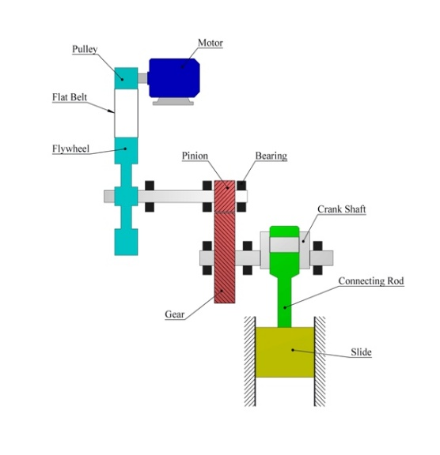
Part of eccentric press that will be designed

5.6.1eccentric mechanism consists of:
Eccentric shaft, connecting rod, punch, pin, die
Flywheel, gear ratio, shafts, bearings, pulley,
Flat belt, Motor.
____________________________________________
At the beginning, the part that has been designed, has dimensions which width, length, thickness are (4cm, 6cm, 0.5cm) respectively.

5.6.2 Stroke calculation
Mean bend radius is
${ r}_{m}$=0.75 cm
Stroke =2π $r_{m}$ = 2*3.14*0.75 =4.71 cm
Length of crank:
${ L}_{C}$ =$\frac{S}{2}$ = $\frac{4.71}{2}$ =2.355 cm
Length of connecting rod:
${ L}_{con}$ = $6* L_{C}$ =6*2.355 = 14.13 cm
n=$\frac{lcon}{lc}$ = 6
Relationship between θ and β
$\frac{L_{con}}{sinθ}=\frac{L_{crank}}{\sin{β}}$
$\sin{β =}\frac{L_{crank}*\sin{θ}}{L_{Con}}$
$β=\sin^{-1}{\frac{L_{crank}*sinθ }{L_{con}}}$
Note: we have an excel sheet which has all values of $β$ at Table (1) in App (1)

- crank properties $$Production rate = 5 part per minute$$
$$Speed (n) = 5 rev/minute$$
Angular velocity (W) =$\frac{2*π*5}{60}$
$${ W}_{ceank} =0.52 rad/s$$
Because it is constant ${α }_{crank}=0$

2- Connecting rod properties
${w }_{con}$ =$\frac{\cos{θ}*W_{crank}}{\sqrt{(n^{2}-(sin{θ) ^2)}}}$ = 0.08531 rad/s at angle 10 degree
${α }_{con}$=$-W^{2}\sin{θ \left[(n^{2}-1)/(n^{2}-\sin{θ^{2}) }\right]}$= -0.00761 rad /s*s at angle 10 degree

3 - Piston
V=$-r W^{ }{\left.\left(\sin{θ} + \frac{\sin{2θ}}{2n}\right.\right)}^{ }$ = -0.24535 (cm/s) at angle 10 degree
. a =$-rW^{2}{\left.\left(\cos{θ} + \frac{\cos{2θ}}{n}\right.\right)}^{ }$= -0.72069 (cm /s*s) at angle 10 degree
Note: we have excel sheets which have all values of (${w }_{con}$ ,${α }_{con}$, v , a )
At various angles. In Table (1) in App (1).

5.6.3 Bending force:
Material (1010 CD) from table (A-20) in App (1)
$Ϭ_{u}$=$370*10^{6}$ pa
$$K : factor =1.8$$
$$w :width =4*10^{-2} m$$
$$t : thickness =0.5*10^{-2} m$$
$$W:die opening =2.25*10^{-2} m$$
$F=\frac{K Ϭ_{u} w t^{2}}{W}$=29.6 KN

5.6.4 Static force analysis
We analysis static force on piston
Maximum velocity for piston at$θ=90$ , $β=9.4$
$$\sum{f_{x} =0}$$
${ F}_{b}-{F }_{43}\cos{β }=0$
${F }_{43}$ =$\frac{F_{b}}{\cos{β }}=\frac{29.7}{\cos{9.4}}$KN =30.1 KN
We analysis static force on connecting rod
Because connecting rod is two force member
$F_{32}$ =$F_{43}$ =30.1 KN

We analysis static force on Crank:
Vertical distance (H) between two couple force on crank
$${ H= r}_{crank} *\sin\left(θ+β\right)$$
$$M=F_{23} r \sin{(θ+β)}$$
$$=(30.1 kN)(2.355*10^{-2}) (\sin{(90+9.4)} = 700 Jole =0.7 kJole$$

5.6.5 Dynamic force analysis:
$$\sum{F_{x} =max}$$
$$\sum{F_{y}=may }$$
$\sum{M=I_{σ}}$ $*α$
$Anylsis on$Piston
At$θ=90$
$$\sum{Fx=m*ax}$$
$$W+F_{b} –F_{34} \cos{β}=\left(22Kg\right)\left(0.1047\right)$$
$$F_{34}=\frac{\left(Fb –\left(0.3\right)\left(0.1047\right)\right)+w}{\cos{9.4 }}$$
$$=\frac{\left(29.7\right)+\left(0.3*10\right)-\left(0.3\right)\left(0.1047\right)}{\cos{9.4}}$$
=29.9 KN

Analysis on Connecting rod
$F_{34}$=$F_{23}$ =29.9 KN

Analysis on turning moment:
M =$F_{23}$ r $\sin{(θ+β)}$ =$F_{23}$ H
$$F_{23} =\frac{F_{b} +w-m\ddot{x}}{\cos{β}}$$
M= ($(F_{b}+w)-m\ddot{x})/\cos{β})$ (r) ($\sin{θ}+\frac{\sin{2θ}{ }}{2n})*\cos{β}$
$$=((F_{b}+w)-mx ̈)(r)(sin⁡θ+\frac{\sin{2θ}}{2n})$$
Note: we have an excel sheet which has all values of Mat Table (1) in App (1)

5.6.6 Motor analysis
We have found maximum force on excel sheet from table (37) in App (1)
And maximum velocity on excel sheet from table (37) in App (1)
Mechanical efficiency is 0.8
$p=\frac{F*V}{ζm}$ = (35.648KN * 0.01225 m/s)/0.8 = 468.75 (w)
We selected motor 3/4 HP 1750 RPM 90V FR 56C CDP3440 s
To reduce its speed into 5 rev/min we must make gear ratio and pulley – flywheel system

5.6.7 Pulley – flywheel system
Flat belt: Polyamide (F-0) has several properties which thickness is 0.03 (in), minimum pulley
Diameter is 0.6(in), allowable tension is 10, specific weight is 0.035 coefficient friction is 0.5
From Table (17-2) in App (1).
Design factor =1.05
Velocity ratio is 3.5:1
Angular speed of the small driving pulley is 1750 (rev/min)
The nominal power transmission is to be 0.75 $hp$
Under very light shock ($K_{s}=1.15$)
$$velocity ratio=\frac{D}{d} =3.5 =\left(\frac{N_{1}}{N_{2}}\right) =\frac{1750}{N_{2}}$$
$$N_{2}=500(rev/min)$$
d =10 in $→$ D=3.5(10) =35 in
$C_{P}=0.87$ From Table (17-4) in App (1) Page (890).
$C_{V}=1$ Because it is polyamide
$F_{1a}=b(10)(1)(1)$
= 10(b) (pound) where (b) is width of flat belt.
$$H_{d}=H_{nom} K_{S} n_{d }=0.75*1.15*1.05$$
= 0.905HP
$$T=\frac{63025*H_{d}}{n} =\frac{63025\left(0.905\right)}{1750} =32.16 Ibf.in$$
$$θ=θ_{d}=π-2\sin^{-1}\left(\frac{D-d}{2c}\right)$$
C: central distance (22.5 in)
$$=3.14-2\sin^{-1}\left(\frac{35-10}{2*22.5}\right)=1.96$$
$$\exp\left(fθ\right)=\exp\left(0.5*1.96\right) =2.66$$
Centrifugal tension (Fc)

W = (12) (0.035) (b) (0.03)
=0.0126 (b) ($ib$/ft.)
$$V=\frac{πdn}{12}=\left(\frac{3.14*10*1750}{12}\right) =4579.16 (ft/min)$$
$$F_{C}=\frac{w}{g}{\left(\frac{V}{60}\right)}^{2} =\frac{0.0126b}{32.17}{\left(\frac{4579.16}{60}\right)}^{2} =2.28b$$
$${(F}_{1a})-F_{2}=\frac{2*T}{d} =\frac{2*32.16}{10} =6.52 Ib$$
$$F_{2}=10b-6.52$$
$$F_{i}=\frac{\left(F_{1a}\right)+F_{2}}{2}-F_{c}$$
$$= \frac{10b+10b-6.52}{2}-2.28b$$
$$=3.64b-3.26$$
$$b=\frac{3.26}{3.64} \frac{exp⁡(fθ)}{exp⁡(fθ-1)}$$
$$= \frac{3.26}{3.64} \frac{2.66}{(2.66-1)} =1.35 in$$
1.35 In = 34.29 mm
Now we would select (35mm) from Table (A-17) in App (1)

5.6.8 Flywheel
The maximum fluctuation of energy
e = $∆kE=E at W_{max}-E at { W}_{min}$
$worke done per cycle = area under graph$
$(w.d)/cycle$=1397.224 + 1397.1
$= 2794.328 jole$
$(w.d)/cycle$ =$Tm * crank angle$
$$2794.328 = T_{m}* 2π$$
$$T_{m}=445 N.m$$
$$Power of engine =\frac{T_{m} *w}{ζm}$$
$$P=\frac{445*0.52}{ζm}$$
$$ζm=\frac{work absorbed}{work supplied }$$
$$Work absorbed =(30Kn)*(4.71)*{10}^{-2}$$
$$ζm=\frac{1413}{2794.328} =0.5$$
$$P=\frac{445*0.52}{0.5} =462.8 (w)$$
$$e =1075.96 jole$$
= $I W^{2}C_{s}$
Where $C_{s}$ = $\frac{W_{max} –W_{max} }{W_{mean}}$
For punching Cs =0.1 At Table (38) in App (1)
e = $I W^{2}C_{s}$
1076 =$I {\left(52.33\right)}^{2}\left(0.1\right)$
$$I=????$$

$W_{2}$ =$\frac{\left(2π n_{2}\right)}{60}=\frac{6.28*500}{60} =52.33(rad/s)$
e = $I ({W_{2})}^{2}{C }_{s2}$
1076=$I\left(10.46\right)\left(0.1\right)$
$$I=3.92 Kg m^{2}$$
=$mk^{2}$ where k= (0.45m)
m =$\frac{I}{K^{2}}$ = $\frac{19.4}{0.45*0.45}$ =19.4 Kg
$$V=\frac{πDn}{60} =\frac{3.14*1.2*100}{60} = 23.25 \left(\frac{m}{s}\right)$$

Stresses:
$$Ϭ=V^{2}ρ+\frac{4.935R}{n^{2}t}$$
$$Ϭ(Hoop)=V^{2}ρ={\left(23.25\right)}^{2}*\left(7200\right)=3.9 Mpa.$$
$$n : 6 arms$$
$m=πDA ρ$ , $ρ:dencity of chromium$
$$=3.14*0.9*A*7200$$
$$A=b*t$$
$$Assume b=3t$$
$$A=3*t^{2}$$
$$m =πDA ρ$$
$$19.4=3.14*1.2*A*7200$$
$$A=\frac{19.4}{3.14*1.2*7200}$$
$$=0.01 m^{2}$$
$=3*t^{2} =0.000935$
$$t^{2}=0.00318m^{2}$$
t=0.0178 m
$$b=3*0.0178$$
=0.053 m
Total stress:
$$Ϭ_{t} =\frac{3}{4} ϭ_{HOOP} +\frac{4.935R}{n^{2}t}$$
$=\frac{3}{4} *3.9Mpa +(4.935*0.45)/{(6}^{2}*0.0178)$
$$=(2.91 +3.46 )Mpa$$
$=6.37 MPa .$

5.6.9 Gear box
We use three gear box each one has gear ratio (25: 5, 25: 5, 20: 5)
type | pinion | gear | gear
d (cm) | 5 | 25 | 20
N (teeth) | 16 | 80 | 64
m (mm/t) | 3.125 | 0.625 | 0.78125
θ (deg) | 20 | 20 | 20
F

11-Shaft design:
Machined shaft, heat treatment steel shaft, has an ultimate strength of$S_{ut}=105 kpsi$ and a yield strength of$S_{y}=82 kpsi$, these properties on each shaft.
The reliability ($K_{R}$=0.99) from Table (6-4) in App (1)
$K_{a}=2.7*{105}^{-0.265}=0.787$ From Table (6-2) in App (1)
$K_{b}=0.87$
$$K_{c}=K_{d}=K_{f}=1$$
$K_{e}=0.814$ From Table (6-5) in App (1)
$$\grave{S_{e}}=0.5*105=52.5 kpsi$$
$$S_{e}=0.787*0.87*0.814*52.5$$
$$=29.3 kpsi$$

Goodman criteria:
n | K_{f} | K_{fs} | M_{m} | T_{m} | M_{a} | T_{a} | d | Se | S_{ut} | S_{y}
5 | 1.5 | 1.5 | 0 | 113.28 | 964.73 | 0 | 0.750158 | 33839.03 | 105000 | 82000

$$d={\left(\frac{16n}{π}{\left[\frac{1}{S_{e}}{\left[4{\left(K_{F }M_{a}\right)}^{2}+3{\left(K_{FS}T_{a}\right)}^{2}\right]}^{\frac{1}{2}}+\frac{1}{S_{ut}}{\left[4{\left(KM_{m}\right)}^{2}+3{\left(K_{fs }T_{m}\right)}^{2}\right]}^{\frac{1}{2}}\right]}^{ }\right)}^{\frac{1}{3}}$$
At section A is maximum moment:
$M_{a}=964.73 b in$ ,$M_{m}=0$
Steady torsion $T_{m}=113.28 bin$ , $T_{a}=0$
$A_{y}=186.39 N$ , $A_{z}=\left(603.23\right) N$
$F_{21}^{t}=512 N$ , $F_{21}^{r}=186.39 N$
$$K_{P}=0.879 d^{-0.107}=0.87$$
By substituting these on previous equation we got d =0.78 in at safety factor (n) =5
We found at $d=0.78 → K_{b}=0.917$
Then substituted $K_{b}=0.917$ on previous equation, we got d = 0.75
$d=0.75 →$ $K_{b}=0.92$
Then d = 0.75 in is correct

Static safety:
$$\grave{σ_{a}}={\left[{\left(\frac{32 K_{F }M_{a}}{π d^{3}}\right)}^{2}+3{\left(\frac{16K_{fs}T_{a}}{π d^{3}}\right)}^{2}\right]}^{\frac{1}{2}}$$
$$\grave{σ_{m}}={\left[{\left(\frac{32 K_{F }M_{m}}{π d^{3}}\right)}^{2}+3{\left(\frac{16K_{fs}T_{m}}{π d^{3}}\right)}^{2}\right]}^{\frac{1}{2}}$$
$\grave{σ_{a}}=34934 .87 kpsi$ .
$\grave{σ_{m}}=3486.787 kpsi$ .
$$n=\frac{S_{y}}{\grave{\grave{σ_{a}}+\grave{σ_{m}}}} = \frac{82000}{37207.78} =2.2$$
We chose the diameter of the shaft is 2.5 cm as standard on table (A-17) in App (1)
Other types of shaft are:
Shaft A | 2.5(cm)
Shaft B | 3(cm)
Shaft C | 3(cm)
Shaft D | 3(cm)

Analysis on shat two:
n | K_{f} | K_{fs} | M_{m} | T_{m} | M_{a} | T_{a} | d | Se | S_{ut} | S_{y}
2 | 1.5 | 1.5 | 0 | 566.44 | 3616.85 | 0 | 1.187741 | 32329.34 | 105000 | 82000

$$d={\left(\frac{16n}{π}{\left[\frac{1}{S_{e}}{\left[4{\left(K_{F }M_{a}\right)}^{2}+3{\left(K_{FS}T_{a}\right)}^{2}\right]}^{\frac{1}{2}}+\frac{1}{S_{ut}}{\left[4{\left(KM_{m}\right)}^{2}+3{\left(K_{fs }T_{m}\right)}^{2}\right]}^{\frac{1}{2}}\right]}^{ }\right)}^{\frac{1}{3}}$$

At section B is maximum moment:
$M_{a}=3615.85 b in$ ,$M_{m}=0$
Steady torsion $T_{m}=566.44 bin$ , $T_{a}=0$
Forces on B:
$B_{z}=3072.23 N$ , $B_{y}=745.4 N$
Forces on gear which has diameter 25 cm
$F_{12}^{t}=512 N$ , $F_{12}^{r}=186.53 N$
Forces on gear which has diameter 5 cm on its shaft $$\frac{T_{1}}{r_{1}}=\frac{T_{2}}{r_{2}}$$ $T_{2}=\frac{r_{2}}{r_{1}} T_{1}$
$T_{2}=\frac{25}{5}\left(12.8\right) =64 N.m$
$$T_{2}=F_{43}^{t} r$$
$$F_{43}^{t}=\frac{T_{2}}{r} =\frac{64}{0.025} =2560 N$$
$$F_{43}^{r}=F_{43}^{t} \tan{20} =2560*\tan{20} =931.764 N$$
By substituting these on previous equation we got d =0.78 in at safety factor (n) =2
Then d = 1.18 in.

Static safety:
$$\grave{σ_{a}}={\left[{\left(\frac{32 K_{F }M_{a}}{π d^{3}}\right)}^{2}+3{\left(\frac{16K_{fs}T_{a}}{π d^{3}}\right)}^{2}\right]}^{\frac{1}{2}}$$
$$\grave{σ_{m}}={\left[{\left(\frac{32 K_{F }M_{m}}{π d^{3}}\right)}^{2}+3{\left(\frac{16K_{fs}T_{m}}{π d^{3}}\right)}^{2}\right]}^{\frac{1}{2}}$$
$\grave{σ_{a}}=32997.2 kpsi$ .
$\grave{σ_{m}}=4392.577 kpsi$ .
$$n=\frac{S_{y}}{\grave{\grave{σ_{a}}+\grave{σ_{m}}}} = \frac{82000}{37389.77} =2.19$$

We chose the diameter of the shaft is 3 cm as standard on table (A-17) in App (1)

5.6.10 Bearing
Type bearing A has properties:
Single row ball bearing
N =500 rev/min
$$L_{d}=1800 hours$$
Moderate shock loading (IF=1.75) from table (11.3) in App (1)
Shaft diameter is 2.5 cm
$$L_{d}=500*60*1800=54*{10}^{6} rev$$
$$p_{e}=X_{d}F_{r}+Y_{d}F_{a}$$
$$=1*F_{r}+0*0$$
=631.369 N
$$C_{d}={\left[\frac{L_{d}}{KR\left({10}^{6}\right)}\right]}^{\frac{1}{a}}\left(IF\right)\left(Pe\right)$$
$$K_{R} from table \left(11.2\right) in App (1)$$
$$C_{d}={\left[\frac{54*{10}^{6}}{1*{10}^{6}}\right]}^{\frac{1}{3}}\left(1.75\right)\left(2659.48\right) =22.097 KN$$
We selected (6305) from table (11.5) in App (1)
Other types of bearing are:
A | 6305
B | 6306
C | 6306
D | 6306

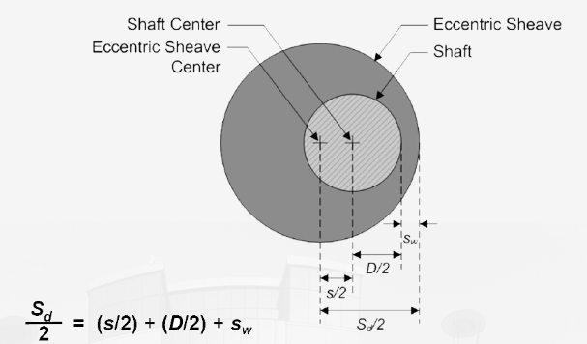
5.6.11 Eccentric shaft

$\left(\frac{S_{d}}{2}\right) =\left(\frac{S}{2}\right)+\left(\frac{D}{2}\right)+\left(S_{W}\right)$
D=3 cm
$$\frac{S_{d} }{2}=\frac{4.71}{2} +\frac{3}{2} +S_{w }, where S_{w}=2 mm$$
= $4.035 cm$

Bearing between Eccentric shaft and connecting rod is single row
We designed it by using previous equation on section bearing
$$C_{d}=12.33 KN →bearing type is 6008$$

5.6.12 Pin design
Location of the pin between punch and connecting rod.
Material (1006) has $Sy$ ₌ 170 *10^6 $Mpa$ from Table (A-20) in App (1)
$$for n=1$$
1- Shear stress on pin
$$n=\frac{0.5S_{y}}{τ}$$
$$τ=\frac{F}{A} =\frac{35256}{\frac{π}{4}d^{2}}$$
$$d=\sqrt{\frac{n*4*F}{0.5 S_{y}π}}$$
d =22.9 mm
2- Bearing stress:
$$n=\frac{S_{y}}{σ_{b}}$$
$$σ_{b}=\frac{F}{A} = \frac{30*{10}^{3}}{d t}$$
$$d=\frac{35256}{S_{y} t} =20.0 mm$$
Because d at shear is bigger than d at bearing, we must design at shear stress
We chose the diameter of the shaft is 2 cm as standard on table (A-17) in App (1)

5.6.13 Fatigue on connecting rod
It is exposed to fluctuation force (35.2569 ….. 25.189) KN
Connecting rod has a Material (1006) where $Sy$ ₌ 170 *10^6 $Mpa$
$Sut$ = 300 * 10^6 $Mpa$
From Table (A-20) in App (1)
The reliability ($K_{R}$=0.99) from Table (6-4) in App (1)
$K_{a}=4.51*{300}^{-0.265}=0.9948$From Table (6-2) in App (1)
$$K_{b}=1 because it is axial load$$
$$K_{c}=0.85 because it is axial load$$
$$K_{d}=K_{f}=1$$
$K_{e}=0.814$ From Table (6-5) in App (1)
$$\grave{S_{e}}=0.5*300=150000000 Mpa$$
$$S_{e}=0.9948*0.85*0.814*150000000$$
$$=103.24*{10}^{6} Mpa$$

$$Fm=\frac{F1+F2}{2} =30.21 KN$$
$$Fa=\frac{F1-F2}{2} =5.03 KN$$
$$σm=Kf*\frac{Fm}{A} =1.5*\frac{30.21*{10}^{3}}{4*t^{2}} =\frac{11332.5}{t^{2}}$$
$$σa=Kf*\frac{Fa}{A} =1.5*\frac{5.03*{10}^{3}}{4*t^{2}} =\frac{1888.85}{t^{2}}$$
$$w=4*t$$
$$A=w*t$$
$$A=4*t^{2}$$
By substituting these factor on front equation at safety n = 0.8
$$n=\frac{1}{\frac{σ_{a}}{Se}+\frac{σ_{m}}{S_{ut}}}$$
We got the thickness of connecting rod is 0.0072 m
We chose the thickness of the shaft is 1 cm as standard on table (A-17) in App (1)
Then the width is 4 cm

5.6.14 buckling
Material (1006) From Table (A-20) in App (1)
$E=200 GPa ,S_y=170Mpa , c=1$ In plan
$L=14.71 cm , F_{app}=35.2569 KN$ , W = 4 cm, t = 1 cm
$$P_{cr} =n*F_{app}$$
$${\left(\frac{L}{K}\right)}_{1 }={\left(\frac{2π^{2}CE}{S_{y}}\right)}^{\frac{1}{2}}$$
${\left(\frac{L}{K}\right)}_{1 }=156$.07
$$K=\frac{W}{\sqrt{12}} , A=t*W$$
$$\frac{L}{K}=\frac{0.1471}{0.0115}=12.2369$$
Because $\frac{L}{K}< {\left(\frac{L}{K}\right)}_{1 }$
Then use Johnson equation
$$\frac{p_{c}}{A}=S_{y}-{\left(\frac{S_{y}}{2*3.14} \left(\frac{l}{K}\right)\right)}^{2}*\left(\frac{1}{c*E}\right)$$
$$P_{cr}=67790.99 N$$
$$n=\frac{P_{c}}{F_{a}}=\frac{67790.99}{35256.9}=1.92$$

5.6.15 Dimension of punch and Die
D2 steel is an air hardening, high-carbon, high-chromium tool steel. It has high wear and abrasion resistant properties. It is heat treatable and will offer a hardness in the range 55-62 HRC, and is machinable in the annealed condition. D2 steel shows little distortion on correct hardening. D2 steel’s high chromium content gives it mild corrosion resisting properties in the hardened condition
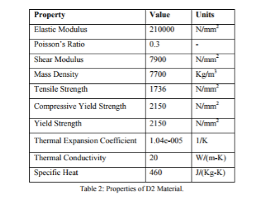
type | Mass(Kg) | length(cm) | Width(cm) | thickness(cm)
punch | 0.3848 | 5 | 5 | 2

Die dimension

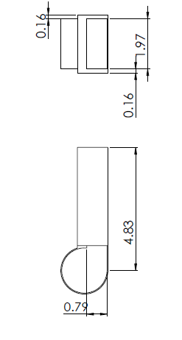
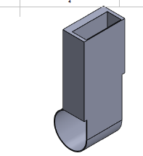

5.6.16 scotch yoke mechanism
The scotch yoke is a mechanism for converting the linear motion of a slider into rotational motion or vice-versa to push the part from die.

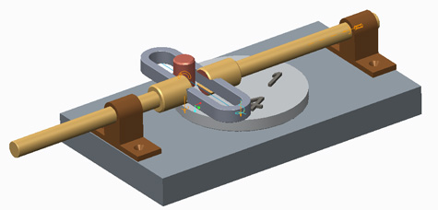

Chapter 6

Production line feasibility study

6.1 Cost Analysis

6.1.1 What Is a Cost Benefit Analysis?
A cost benefit analysis is used to evaluate the total anticipated cost of a project compared to the total expected benefits in order to determine whether the proposed implementation is worthwhile for a company or project team.

If the results of this comparative evaluation method suggest that the overall benefits associated with a proposed action outweigh the incurred costs, then a business or project manager will most likely choose to follow through with the implementation.
Generally speaking, a cost-benefit analysis has three parts. First, all potential costs that will be incurred by implementing a proposed action must be identified. Second, one must record all anticipated benefits associated with the potential action. And finally, subtract all identified costs from the expected benefits to determine whether the positive benefits outweigh the negative costs.

6.1.2 Identifying Costs
The first step is to identify and quantify all costs associated with a proposed action. In order to successfully identify all potential costs of a project, one must follow the subsequent steps.

Make a list of all monetary costs that will be incurred upon implementation and throughout the life of the project. These include start-up fees, licenses, production materials, payroll expenses, user acceptance processes, training, and travel expenses, among others.
Make a list of all non-monetary costs that are likely to be absorbed. These include time, lost production on other tasks, imperfect processes, potential risks, market saturation or penetration uncertainties, and influences on one’s reputation.
Assign monetary values to the costs identified in steps one and two. To ensure equality across time, monetary values are stated in present value terms. If realistic cost values cannot be readily evaluated, consult with market trends and industry surveys for comparable implementation costs in similar businesses.
Add all anticipated costs together to get a total costs value.

6.1.3 Identifying Benefits
The next step is to identify and quantify all benefits anticipated as a result of successful implementation of the proposed action. To do so, complete the following steps.

Make a list of all monetary benefits that will be experienced upon implementation and thereafter. These benefits include direct profits from products and/or services, increased contributions from investors, decreased production costs due to improved and standardized processes, and increased production capabilities, among others.
Make a list of all non-monetary benefits that one is likely to experience. These include decreased production times, increased reliability and durability, greater customer base, greater market saturation, greater customer satisfaction, and improved company or project reputation, among others.
Assign monetary values to the benefits identified in steps one and two. Be sure to state these monetary values in present value terms as well.
Add all anticipated benefits together to get a total benefits value.

6.1.4 Evaluate Costs and Benefits
The final step when creating a cost benefit analysis is to weigh the costs and benefits to determine if the proposed action is worthwhile. To properly do so, follow the subsequent steps.
Compare the total costs and total benefits values. If the total costs are much greater than the total benefits, one can conclude that the project is not a worthwhile investment of company time and resources.
If total costs and total benefits are roughly equal to one another, it is best to reevaluate the costs and benefits identified and revise the cost benefit analysis. Often times, items are missed or incorrectly quantified, which are common errors in a cost benefit analysis.
If the total benefits are much greater than the total costs, one can conclude that the proposed action is potentially a worthwhile investment and should be further evaluated as a realistic opportunity

We have collected all the costs related to our project and have included them in the table 1:
Element |  | Number/ Mass | Price $
1 | Bolts | # 68 | 10
2 | Bearing | # 8 | 20
3 | Lager | # 8 | 45
4 | Mild steel mass | m=272 kg | 136
5 | Sprocket | # 25 | 287.5
6 | Chain | # 1010 | 200
7 | Pneumatic system | # 3 | 340
8 | Roller shaft from aluminum | # 5 | 25
9 | Roller from polyurethane | # 2 | 20
10 | Motors | # 3 | 718
11 | Mild steel cross section | 33meter | 1000
12 | Blade of saw | # 1 | 52
13 | Eccentric press | # 1 | 875
14 | Professional | #1 | 11271.5
 | Total |  | 15000

Table 1

Based on the results of table 1 total initial cost = $ 3599.5

Cost results are summed as follows
operating costs | costs $
Workers | 10000
plate mild steel | 64183
electric appliance | 250
Pins | 26743
Repairs | 500
rent the shop | 2400
Total | 104076

Benefit is calculated as follows:
Benefit = number of parts/hour * price of parts * number of hour / day
= 300*0.485*8 = 1028.57 $/ day = 181852 $/year
These calculation on table 3 below shows the comparing between cost and benefits
costs $ | year 0 | year 1 | year 2 | year 3 | year 4 | year 5
increase salary | 0 | 100 | 100 | 100 | 100 | 100
initial cost | 15000 | 0 | 0 | 0 | 0 | 0
depreciation | 0 | 1500 | 1500 | 1500 | 1500 | 1500
operating cost | 0 | 132819 | 132819 | 132819 | 132819 | 132819
Total | 15000 | 134419 | 134419 | 134419 | 134419 | 134419
benefits | 0 | 181852 | 181852 | 181852 | 181852 | 181852

costs $ | year 5 | year 5 | year 6 | year 7 | year 8 | year 9 | year 10 | year 11
increase salary | 100 | 100 | 100 | 100 | 100 | 100 | 100 | 100
initial cost | 0 | 0 | 0 | 0 | 0 | 0 | 0 | 0
depreciation | 1500 | 1500 | 1500 | 1500 | 1500 | 1500 | 1500 | 1500
operating cost | 132819 | 132819 | 132819 | 132819 | 132819 | 132819 | 132819 | 132819
Total | 134419 | 134419 | 134419 | 134419 | 134419 | 134419 | 134419 | 134419
benefits | 181852 | 181852 | 181852 | 181852 | 181852 | 181852 | 181852 | 181852

Since benefits are larger than costs; the project is considered feasible
Profit after a one-year operation = benefits – costs = 181852-134419 = 47433 $
So that as a result, the initial cost of the project can be recovered from the first year and this equation below shown that:
Initial cost = A*(P/A,$i,$ $np$)
15000 =47433*(P/A, 10%,$np$)
$np$ = 1 year
Where:
A=net cash flow
$np$= payback period
$i$= percentage profit

Chapter 7

Operation manual and trouble shooting

7.1 Operating:
Start the process of manufacturing hinges by inserting bar from steel 1010 where it is manually inserted and be dimensioned length 3m
to move to the cutting stage where it is cut by saw and cut 5 pieces per minute, where each piece takes 12 seconds, as the saw takes 4(s) During the descent and take 4(s) During the rise
The pieces are moved by a blat based on 3 roller and a speed of 0.015 m/s, where it is transferred to the stage of bending. Where the bending of the piece metal by mechanical pressure, as it takes a period of bending 12(S) where it 6(S) to go down ram and 6(S) for the height of ram and the process is continuously non-stop
After the bending process, the flexed piece is removed by scotch yoke mechanism to move to the assembly stage

7.2 Troubleshoot:
Problem | Causes | Solution
Rapid belt failure | Tensile members damaged from improper installation | Replace with new, matched set, properly installed
Belt sidewalls dry and hard | High-temperature environment | Remove source of heat
Rough Cut | This can be caused from using a dull or damaged blade, incorrect blade for the material being cut, or from worn or loose guides | If the blade is dull, you can sharpen it. If the blade is damaged, it will need to be replaced.
Incorrect driver/driven ratio in | Design error | Change sheaves
Blade Breakage | This can be caused by many different things such as incorrect blade tension, incorrect blade, excess feed | You need to always ensure you have proper tension on your blade before you begin your project
Belt sidewalls soft and sticky. Low adhesion between cover, plies. Cross section swollen | Oil or grease contamination of belt | Remove source of oil or grease. Clean belts and sheave grooves cloth moistened with nonflammable, non-toxic degreasing agent or commercial detergent and water
Inaccurate Cut | This can be caused from using a dull or damaged blade, incorrect blade for the material being cut, or from worn or loose guides | If the blade is dull, you can sharpen it. If the blade is damaged, it will need to be replaced.

7.3 Warnings:

To reduce the risk of burns, fire, electric shock, or injury of persons, following warnings should be considered
- Always unplug the machine from the electrical outlet
  - Immediately after using, when cleaning ,when making any user servicing adjustments mentioned in this manual, or if you are leaving the machine unattended.

- Always unplug the machine from the electrical outlet when removing covers, lubricating, or when making any adjustments mentioned in the instruction manual.

  - To unplug the machine, switch the machine to the symbol “O” position to turn it off, then grasp.
  - The plug and pull it out of the electrical outlet. Do not pull on the cord.
  - Plug the machine directly into the electrical outlet. Do not use an extension cord.
  - Always unplug your machine if the power is cut.

- For a longer service life:
  - Use only neutral soaps or detergents to clean the case. Benzene, thinner, and scouring powders
  - Can damage the case and machine, and should never be used.

- For repair or adjustment:
  - In the event a malfunction occurs or adjustment is required, first follow the troubleshooting table
  - In the back of the operation manual to inspect and adjust the machine yourself.

Chapter 8

Conclusions and Recommendations
This chapter presents the conclusions and recommendations to achieve the maximum benefits of the Automatic Hinge-Bending Machine.

6.1 Conclusions
The conventional approach for manufacturing hinges in our local market is time consuming, inefficient and unsafe. In order to enhance the manufacturing process and provide a safer working environment, modern technologies in designing and producing hinges will be introduced. at the beginning, an inventory study was conducted to evaluate the local market and understand the process used in producing hinges. Based on that, a preliminary design of an automatic hinge -manufacturing machine was proposed. Then a detailed design for each station of the production line was made.
Solid work software was utilized to implement our design. The software provides a rich module for the project. It also supports many features like animations and microcontrollers, that can be used in simulating the process of producing hinges and controlling the system respectively.
The design of an Automatic Hinge-Bending Machine showed the importance of automation in increasing the production rate, improving product quality, decreasing number of workers, increase safety and reducing operation costs.

6.2 Recommendations
- To be committed to the proposed methodology.
- To be aware of the detailed design for each part.
- To replace the chain and sprocket with belt and bullies.
- To find an appropriate way to assemble the hinge parts together.
- To make the press in the bending station more flexible by make it able to bend different thicknesses of metal.
- To find a way to hold each half of the hinge stationary while bending to prevent any failure in the hinge shape.

Appendix (1):

Important Related Documents

Table 4: astm minimum tensile and yield strength for some hot-rolled and cold drawn STEEL. [1]
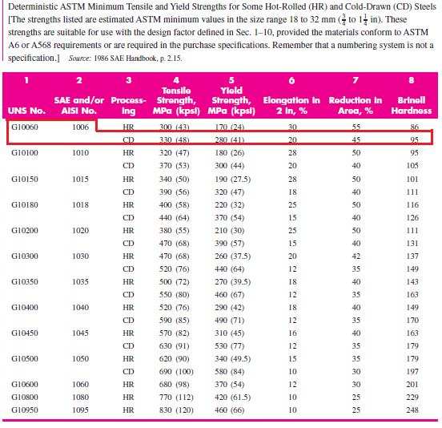

Table 5: ASTM MINIMUM TENSILE AND YIELD STRENGTH FOR SOME HOT-ROLLED AND COLD DRAWN STEEL. [1]
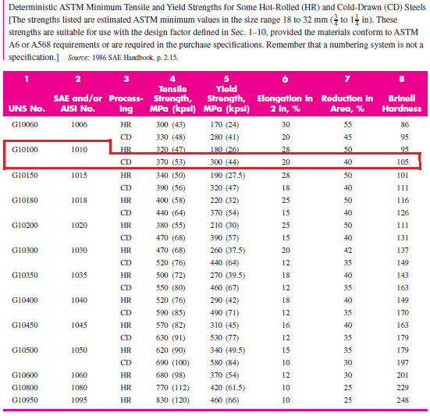

Table 6: mechanical properties of some aluminum alloys. [1]
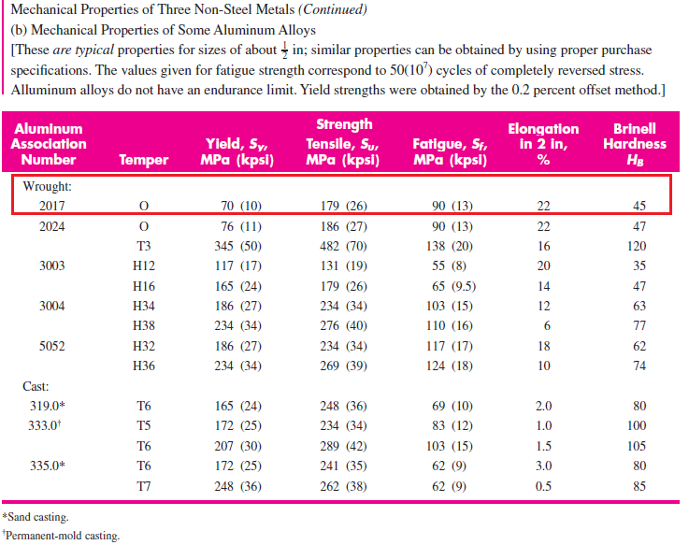

Table 7: diameters and areas of coarse-pitch and fine-pitch metric threads. [1]
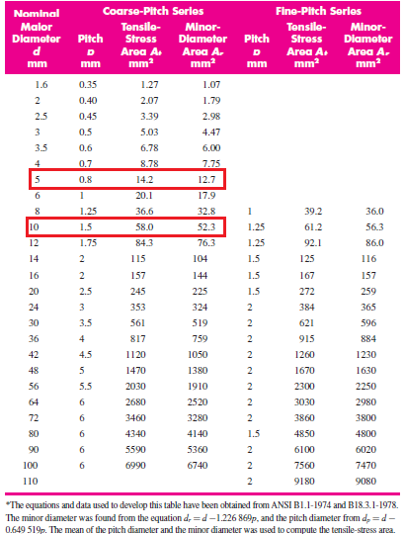
Table 8: metric mechanical property classes for steel bolts, screws, and studs. [1]
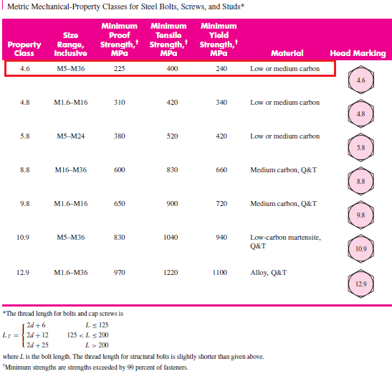

Table 9: dimensions of square and hexagonal bolts. [1]
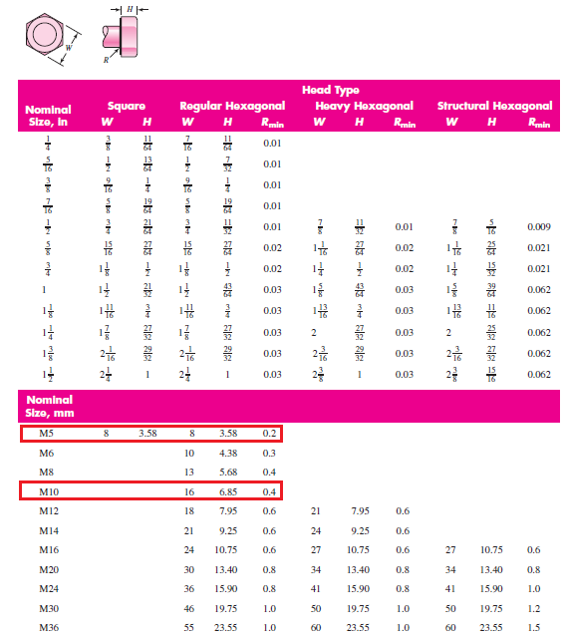

Table 10: DIMENSIONS OF SQUARE AND HEXAGONAL nuts. [1]
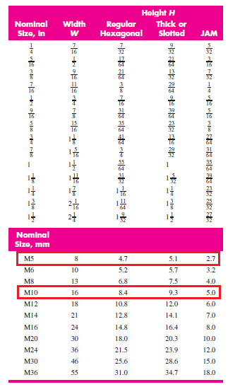

Table 11: dimensions of metric plain WASHERS (all dimensions in millimeters). [1]
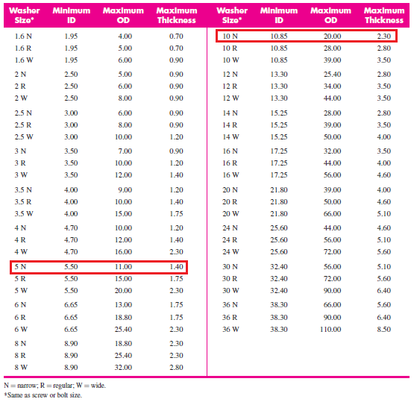

Table 12: polyurethane pros, cons, properties. [10]
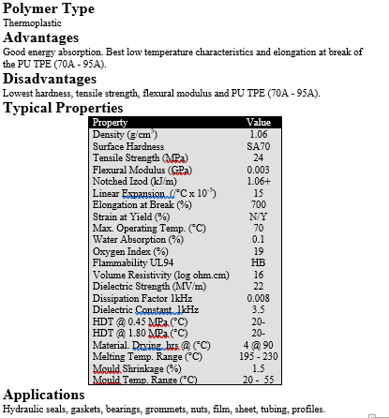

Table 13: polyurethane type (70 a) properties. [9]
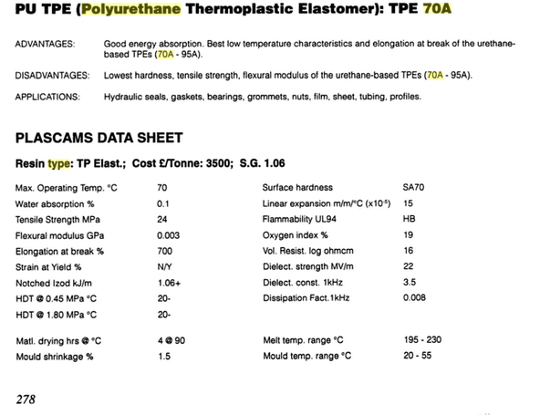

Table 14: coefficient of friction(cof) between steel and polyurethane. [8]
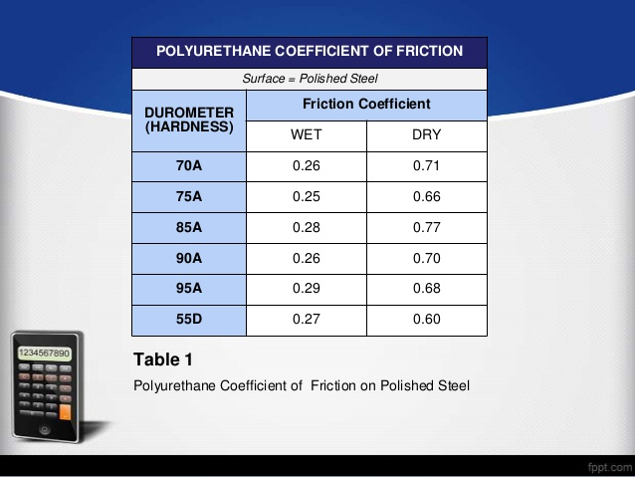

Table 15: dimensions of American standard roller chains-single strand. [1]
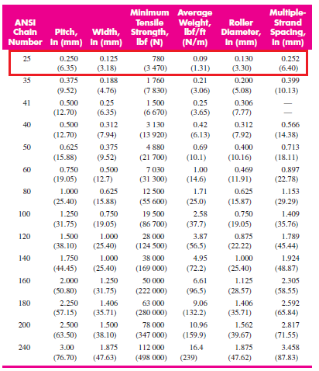

Table 16: rated capacity of single-strand single-pitch roller chain for a 17-tooth sprocket. [1]
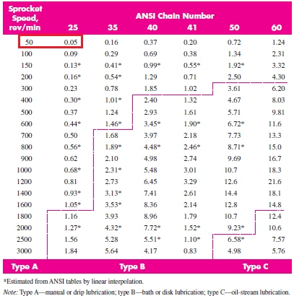

Table 17: single-strand sprocket tooth counts available. [1]
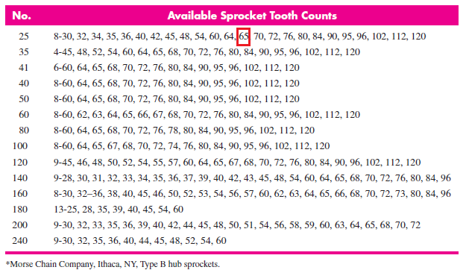

Table 18: tooth correction factor. [1]
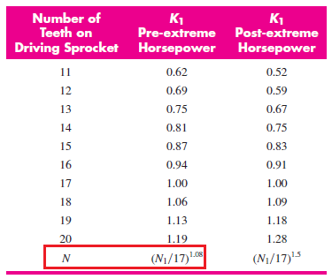

Table 19: multiple-strand factor k2. [1]
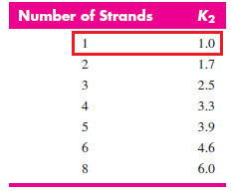

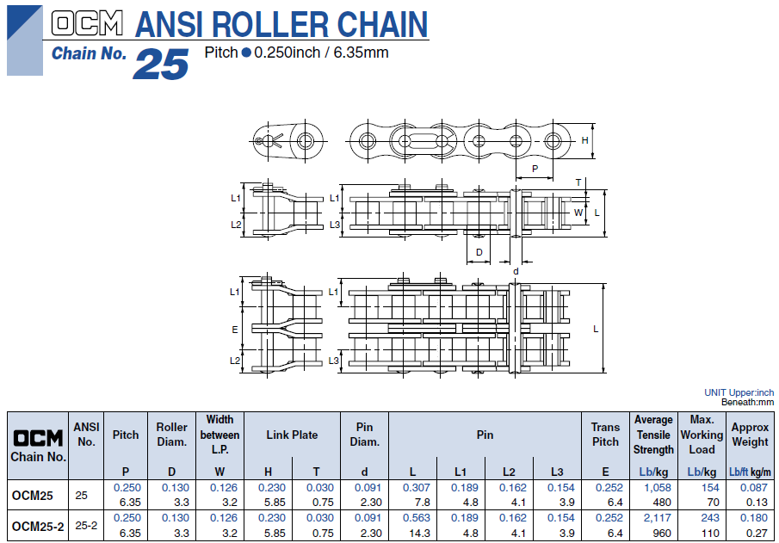
Figure 43: inner and outer roller chain standard dimension.

Table 20: millimeter dimensions for some standard square-rectangular-key applications. [1]
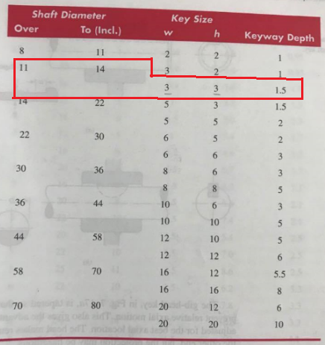\
Table 21: parameters for marin surface modification factor (kA). [1]
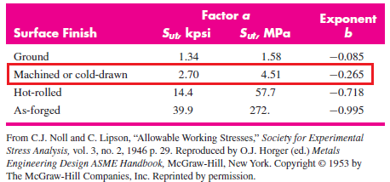

Table 22: RELIABILITY FACTOR (KE) CORRESPONDING TO 8 PERCENT STANDARD DEVIATION OF THE ENDURANCE LIMIT. [1]
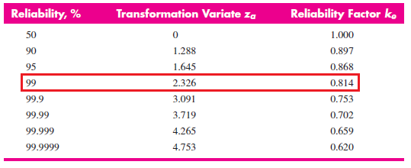

Table 23: BEARING CHARACTERISTICS THAT MAY INFLUENCE THE SELECTION OF BEARING TYPE. [2]
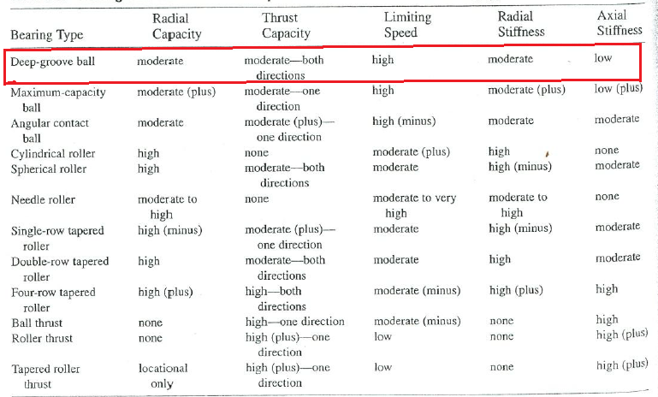

Table 24: RELIABILITY LIFE-ADJUSTMENT FACTOR (KR) FOR BEARING RELIABILITIES DIFFERENT FROM R=90%. [2]
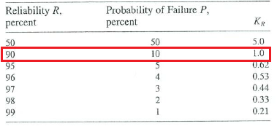
Table 25: ESTIMATED IMPACT FACTORS FOR VARIOUS APPLICATIONS. [2]
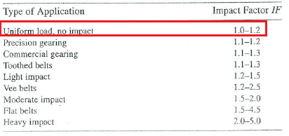
Table 26: APPROXIMATE RADIAL LOAD FACTORS FOR SELECTED BEARING TYPES. [2]
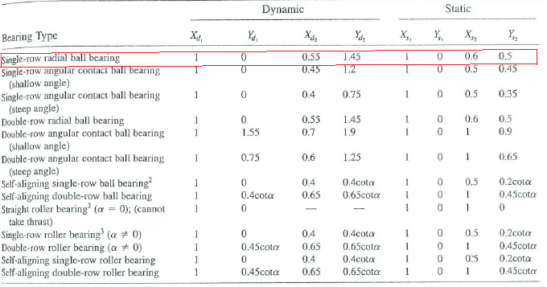
Table 27: DIMENSIONS AND LOAD RATINGS FOR SELECTED SINGLE-ROW RADIAL DEEP-GROOVE (CONRAD TYPE) BALL BEARINGS: SERIES 60, 62, AND 63. [3]
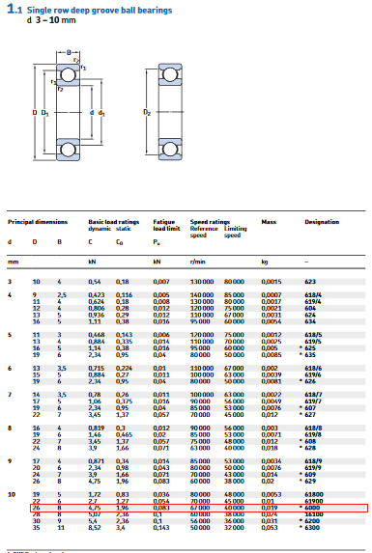
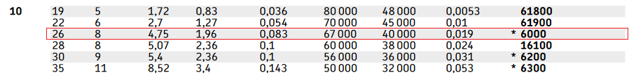
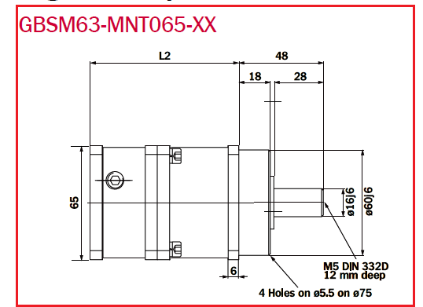
Figure 44: MNT065 SERVO MOTOR DIMENSIONS. [6]

Table 28: MNT065 SERVO MOTOR LENGTH. [6]
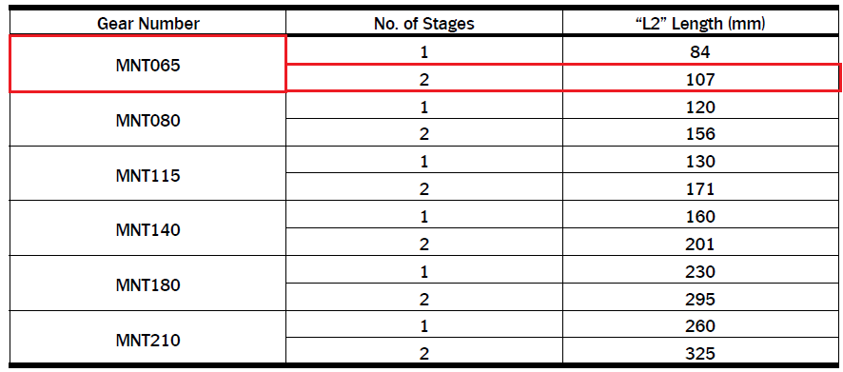
Table 29: MNT SERIES SERVO MOTOR TYPE (MNT 065) PROPERTIES. [6]
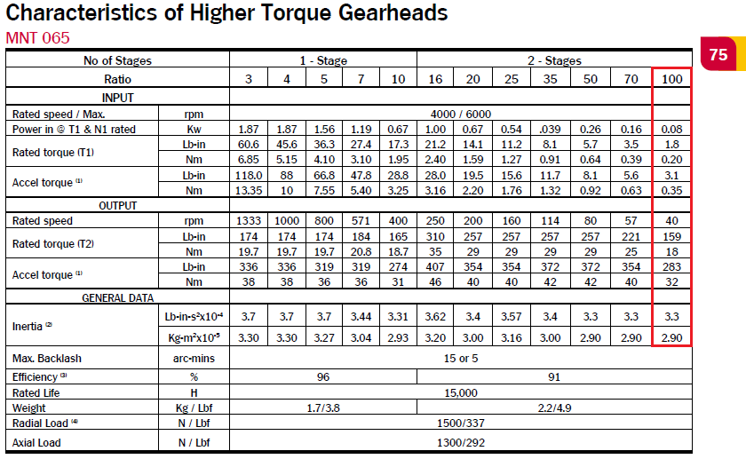

Table 30: INDUCTION MOTOR FEATURES, DESCRIPTION, AND SPECIFICATIONS. [7]
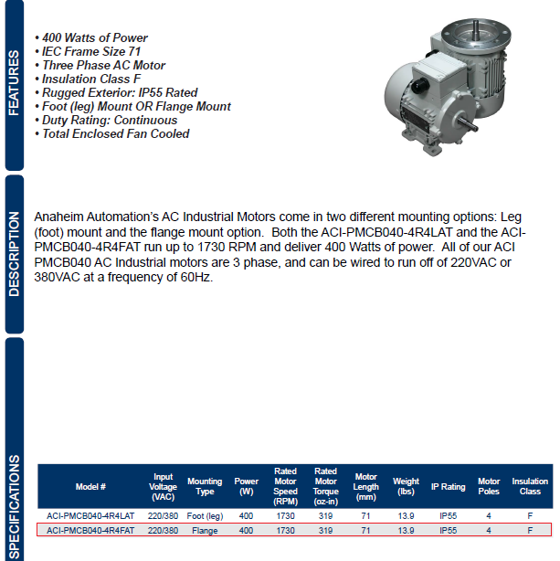
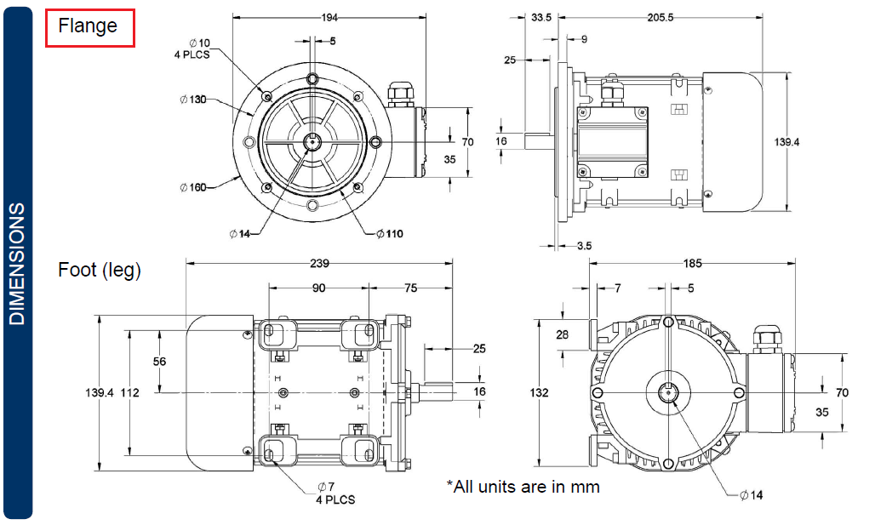
Figure 45: INDUCTIOM MOTOR DIMENSIONS. [7]

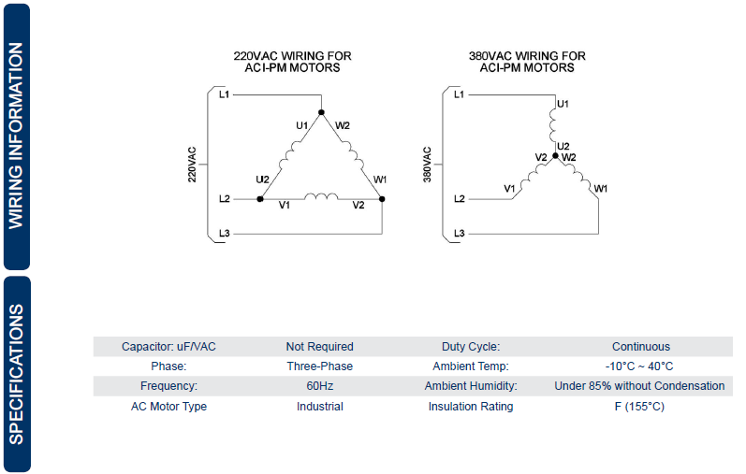
Figure 46: INDUCTION MOTOR WIRING DIAGRAM AND SPECIFICATIONS. [7]

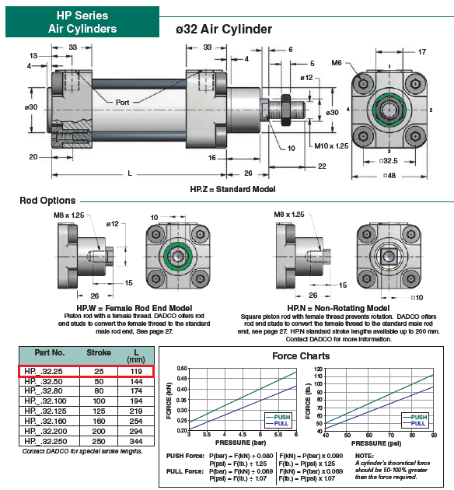
Figure 47: hp series for pneumatic cylinder. [4]

Table 31: PITCH, FEED SPEED AND RPM FOR BLEDE. [5]
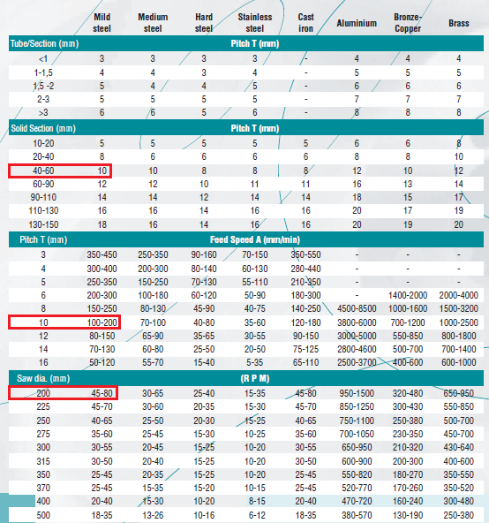

Table 32: width and the number of teeth for the blade. [5]
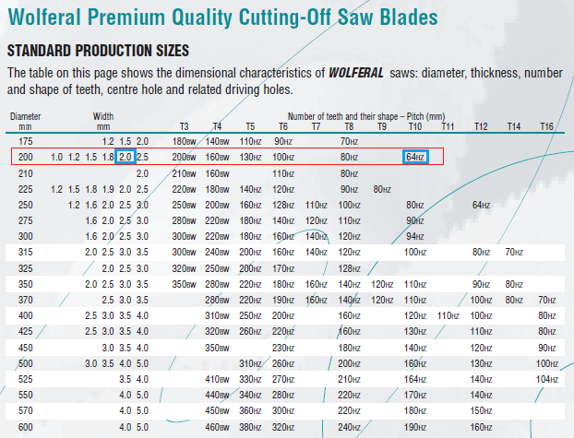

Table 33: FEED PER TOOTH (Sz). [5]
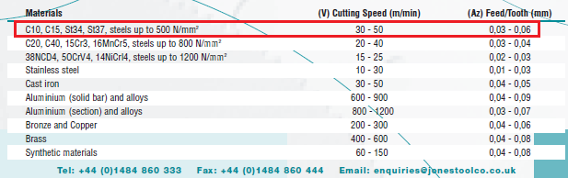

Table 34: cutting angle and relief angle. [5]
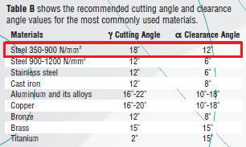

Table 35: tooth dimensions and specifications. [5]
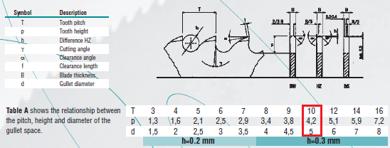
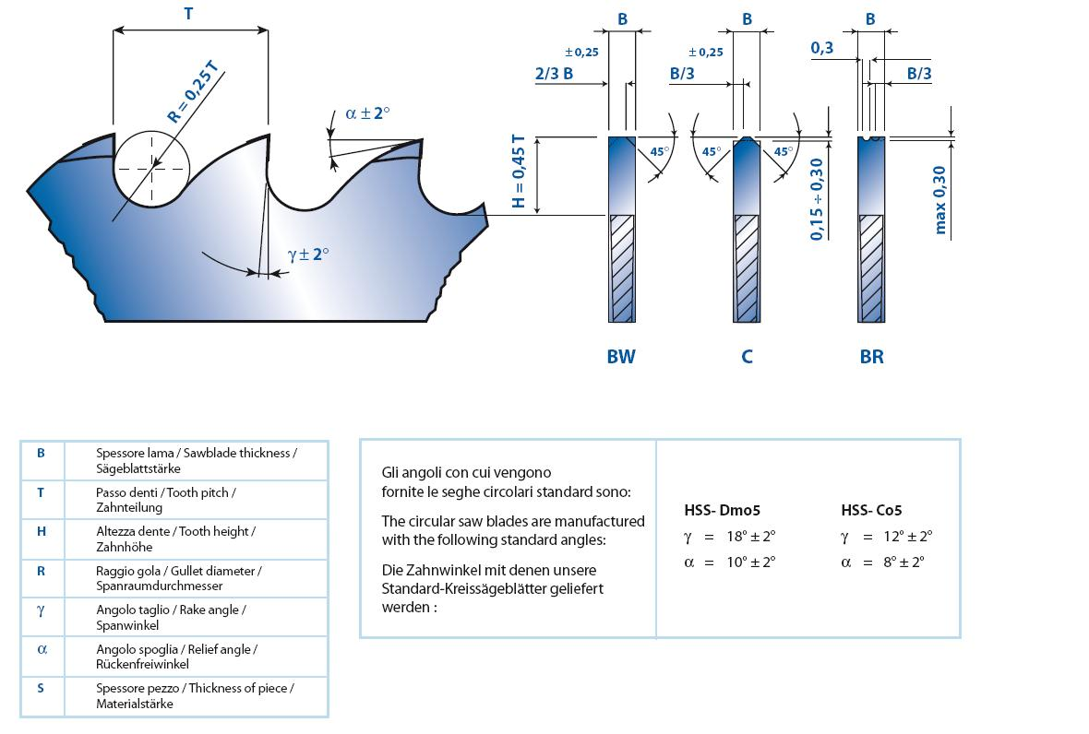

Table 36: BLADE WEIGHT. [5]
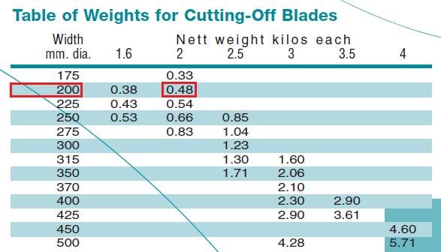

Table 37: blade saw material[5]
Material | Standard No. | AISI SPEC
HSS-DM05 | 1.3343 | M2

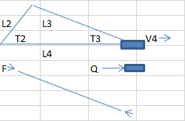
Table (38): values for parameters on first row at various angle
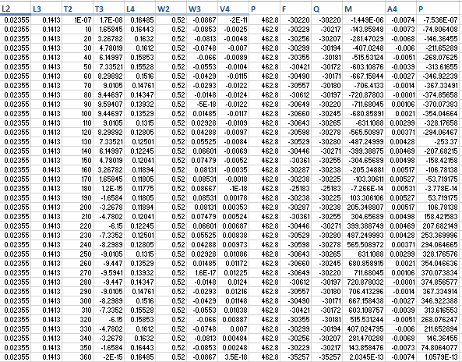

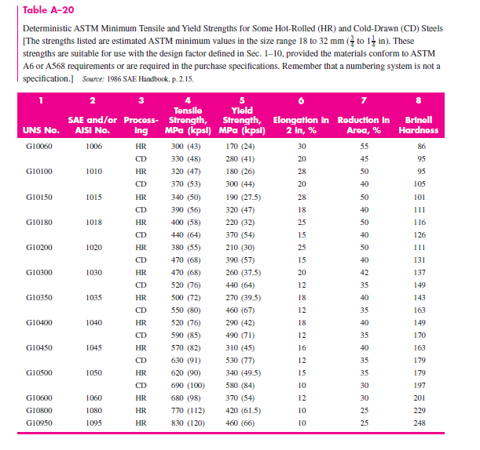

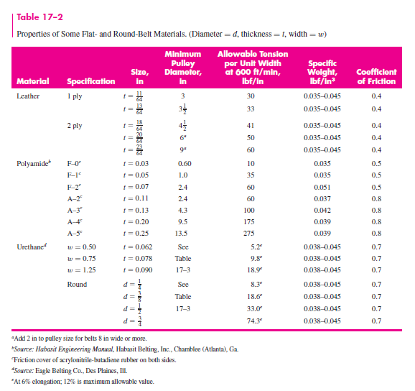

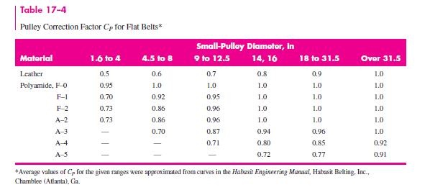

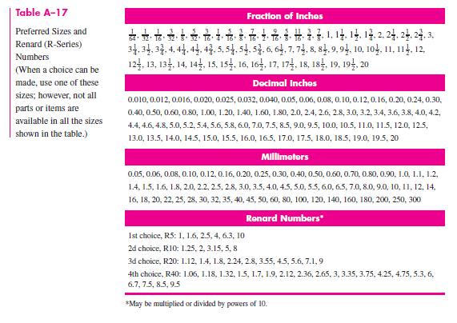

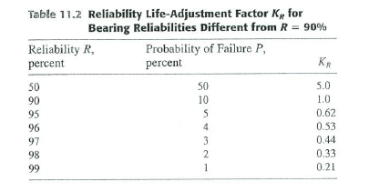

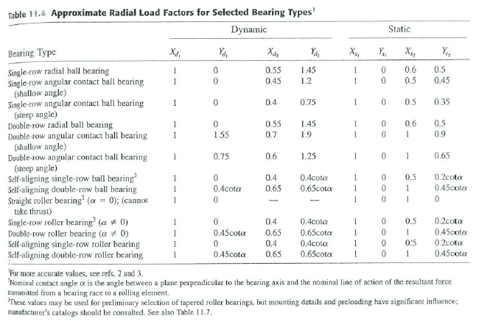

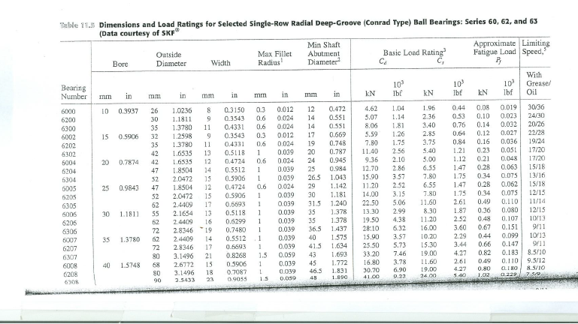

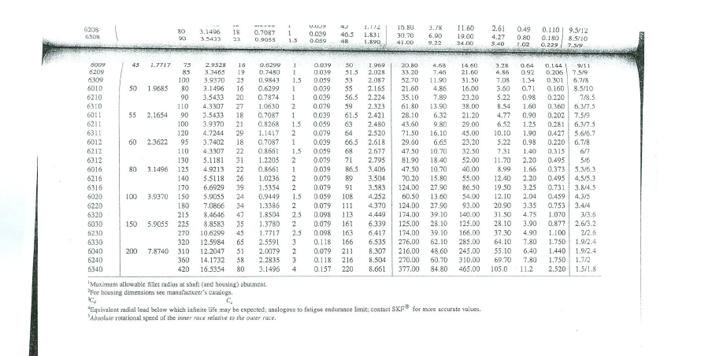

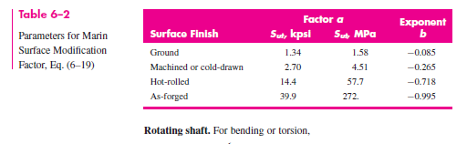

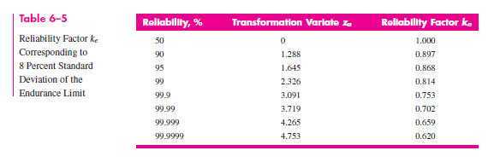

Table (38): permissible values for C_{S}

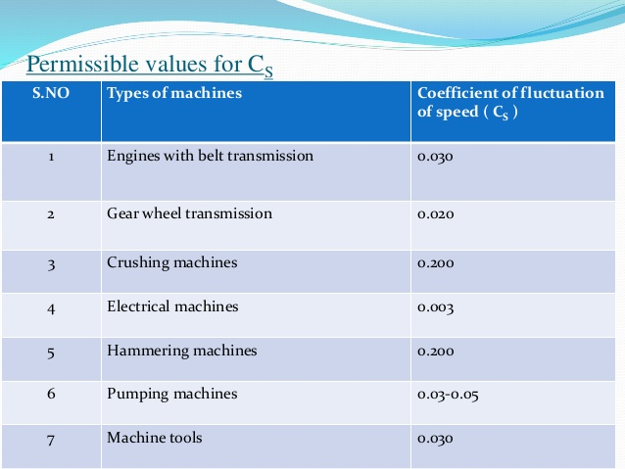

Appendix (2):

Detailed Drawing for The Production Line

Note: all dimensions
In mm

Total assembly
Shape
For the production
Line
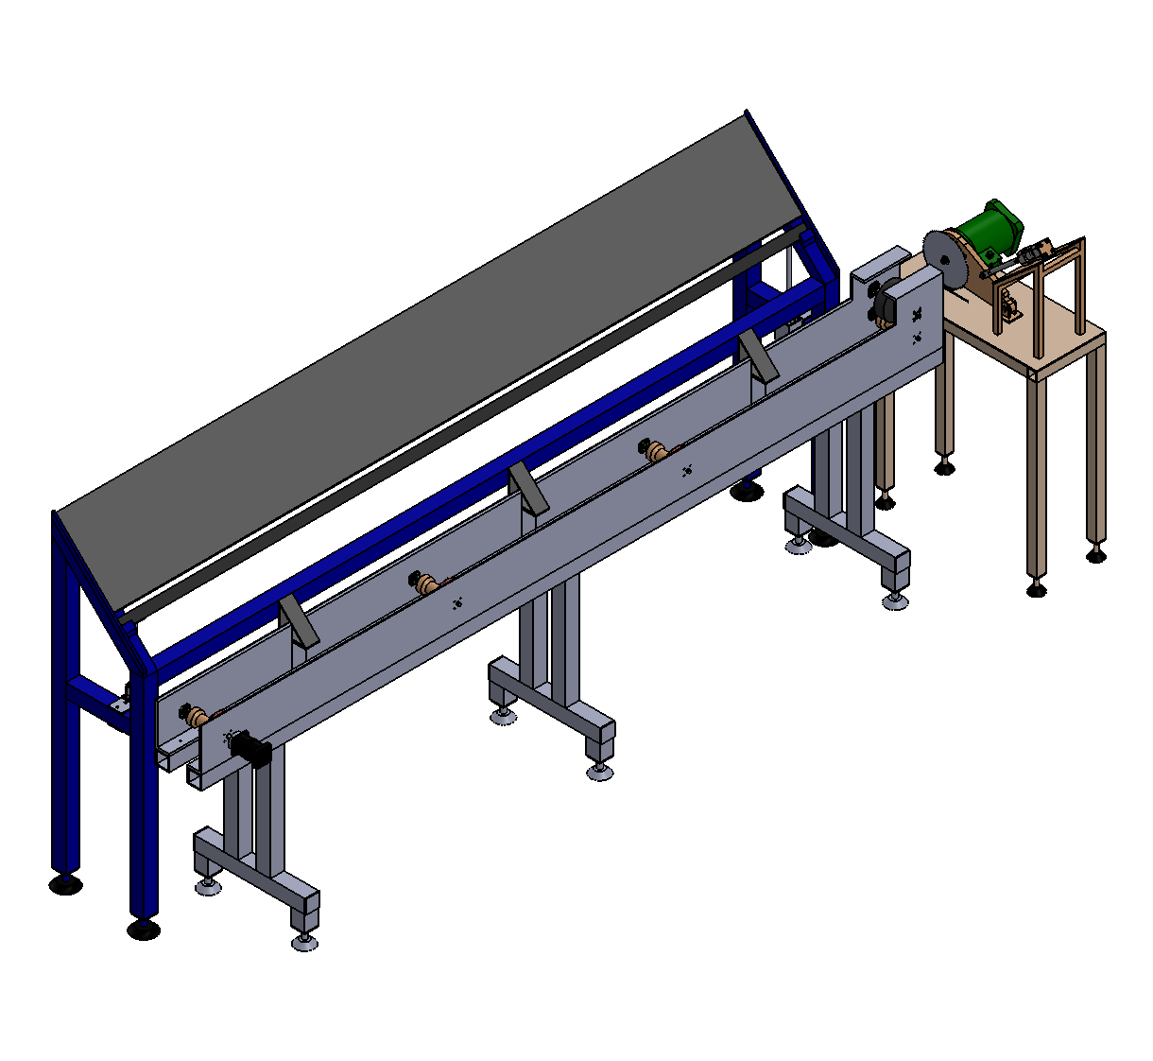
A
A
B
B
C
C
D
D
6
6
5
5
4
4
3
3
2
2
1
1
part name
1
assembly for
the autoloader
with the convoyer
and the cold
saw
part No.
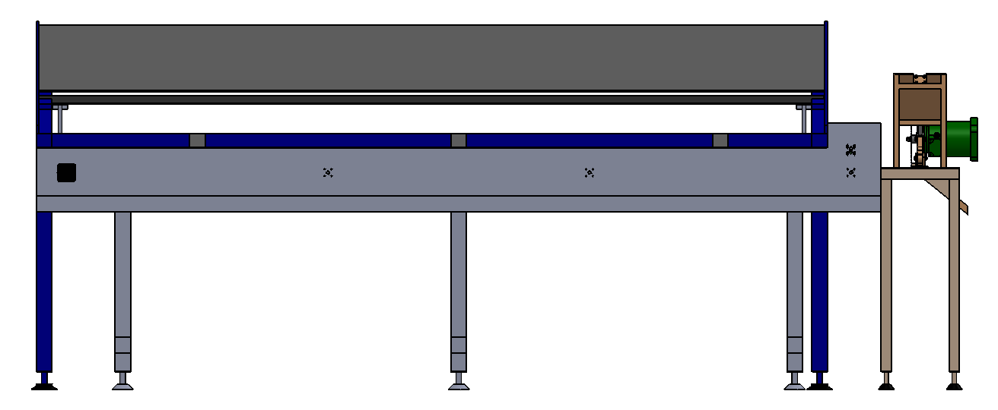
A
A
B
B
C
C
D
D
6
6
5
5
4
4
3
3
2
2
1
1
rt No.
pa
2
ew
side vi
me
part na
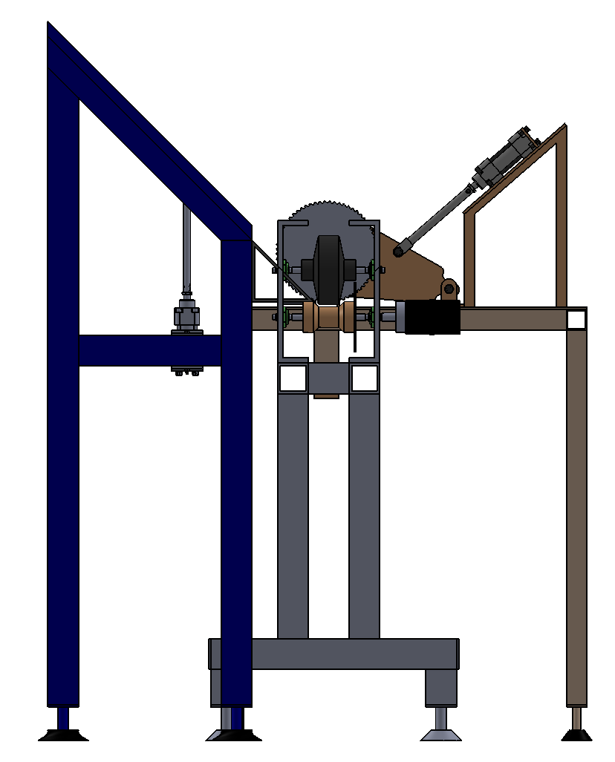
A
A
B
B
C
C
D
D
6
6
5
5
4
4
3
3
2
2
1
1
part No.
3
ront view
f
part name

Production line
Station No. (1)
Autoloader

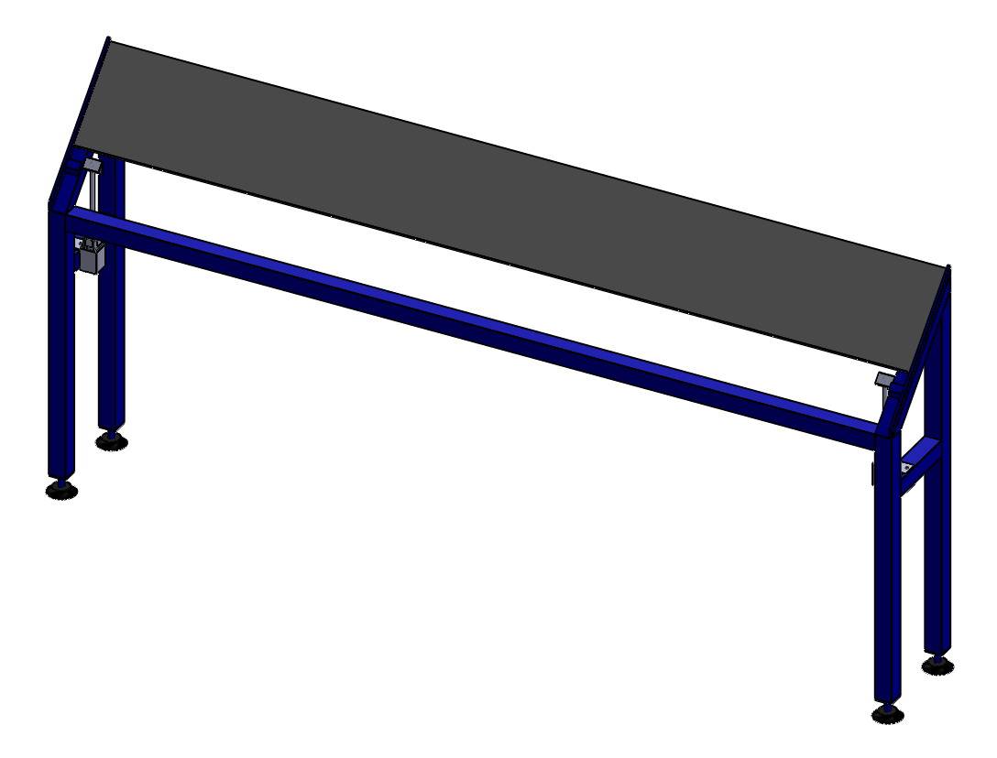
A
A
B
B
C
C
D
D
6
6
5
5
4
4
3
3
2
2
1
1
part No.
23
autoloader
assembly
shape
part name
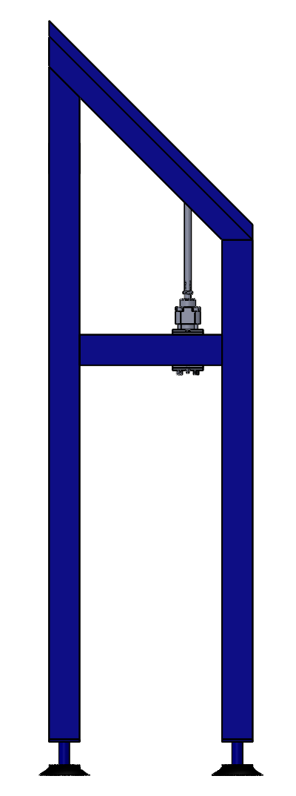
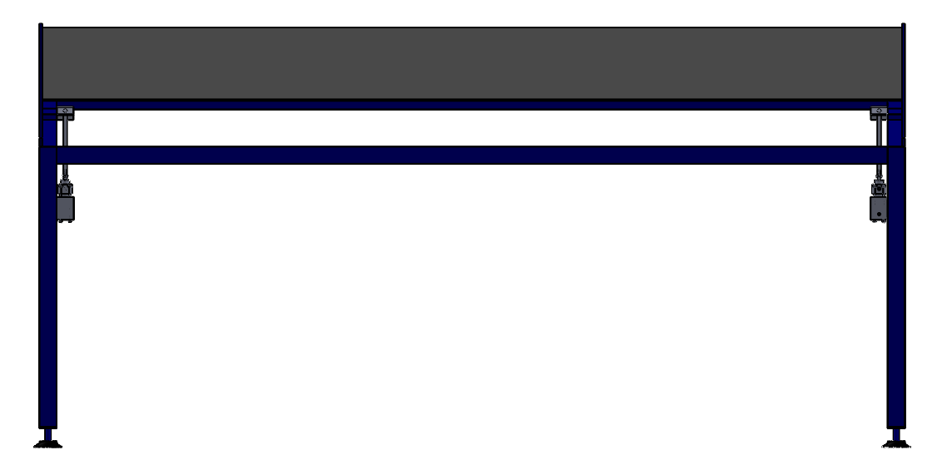
A
A
B
B
C
C
D
D
6
6
5
5
4
4
3
3
2
2
1
1
part No.
24
de and front
si
ew of the
vi
and assembly
st
p
art name
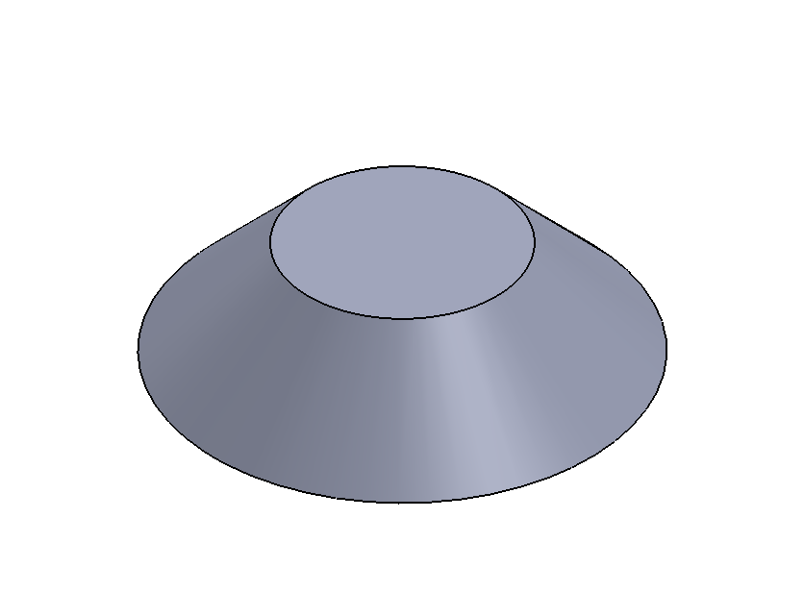

80

40

40
28.28

80
45°
A
A
B
B
C
C
D
D
6
6
5
5
4
4
3
3
2
2
1
1
part No.
1
stand base
part name
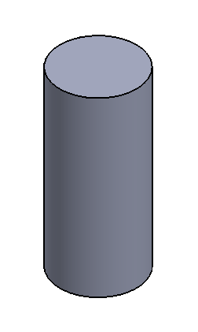
20
20
45
45
20
A
A
B
B
C
C
D
D
6
6
5
5
4
4
3
3
2
2
1
1
part No.
2
base cylinder
part name
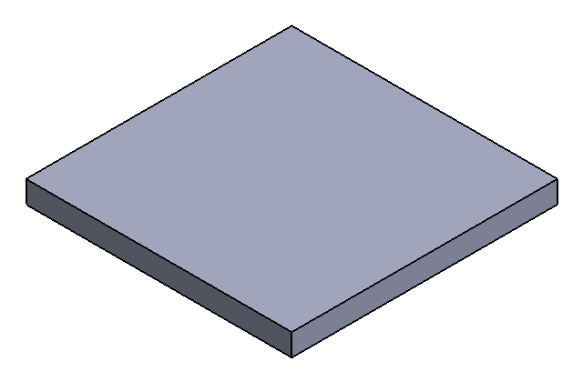
60
60
60
5
60
5
A
A
B
B
C
C
D
D
6
6
5
5
4
4
3
3
2
2
1
1
part No.
3
end cap
part name
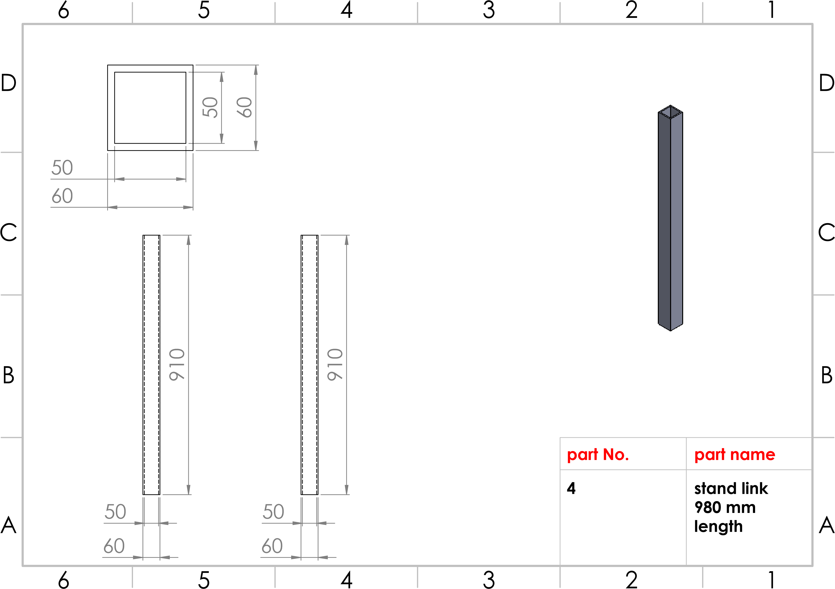
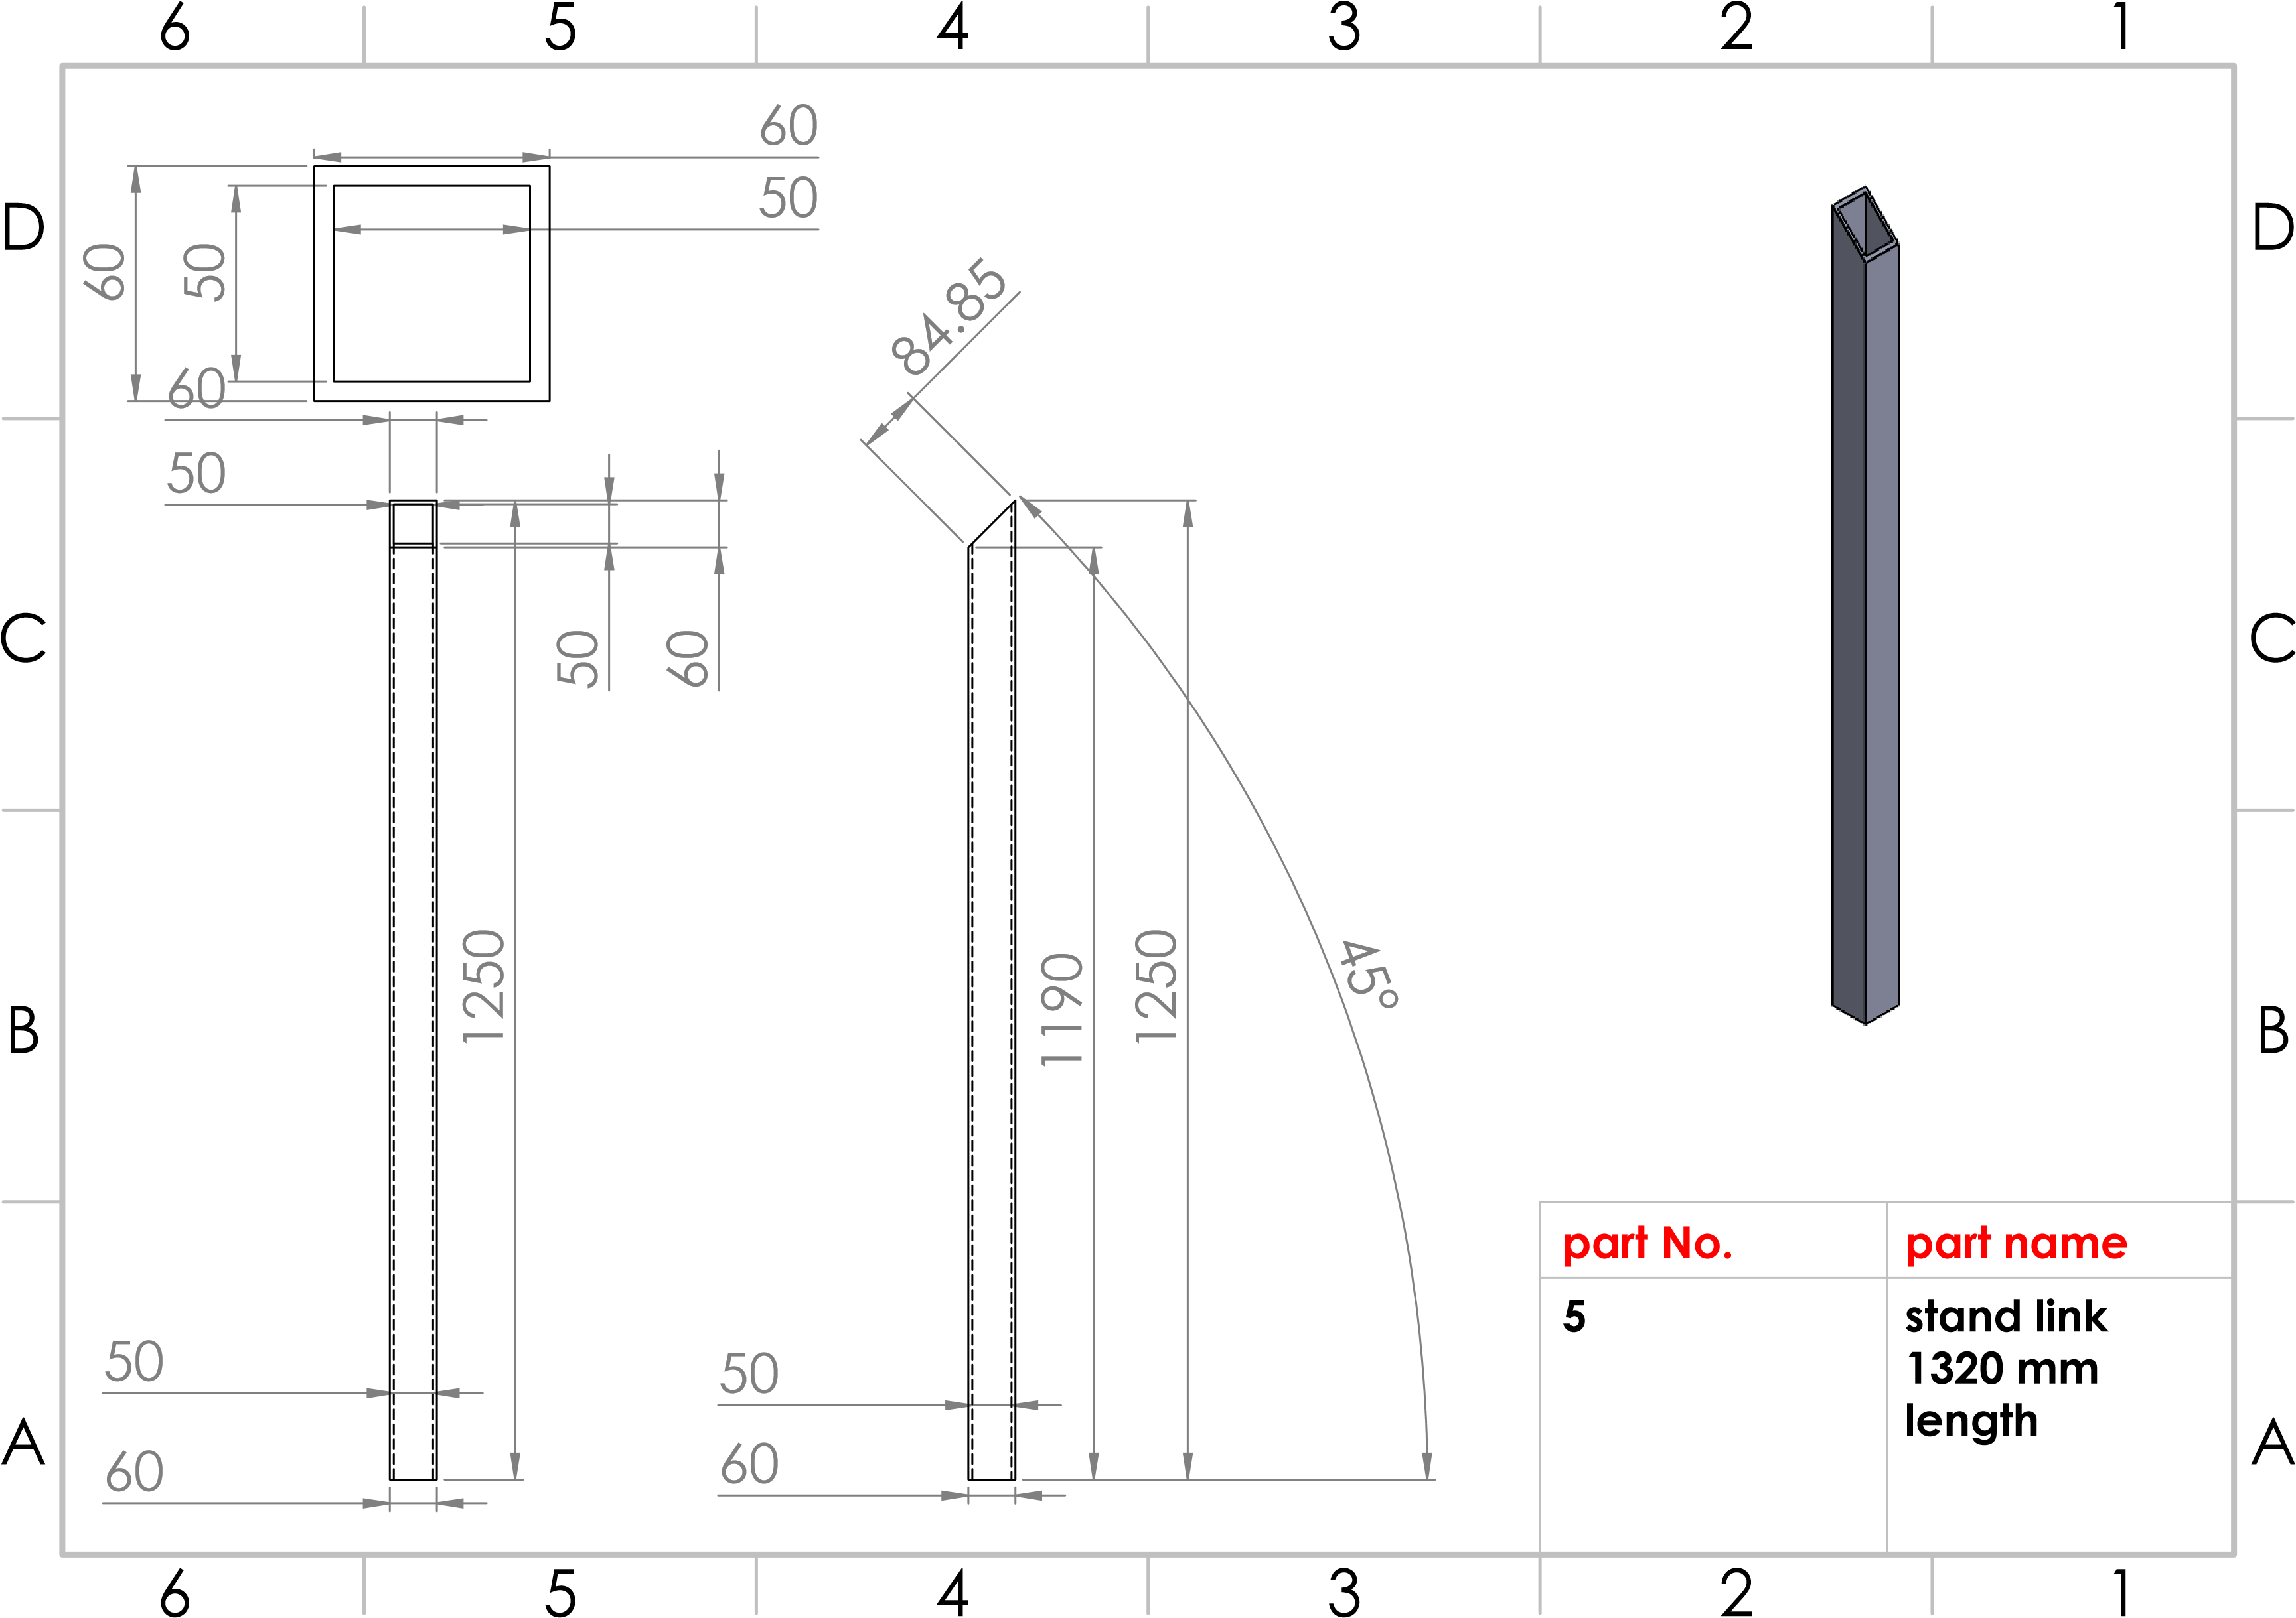
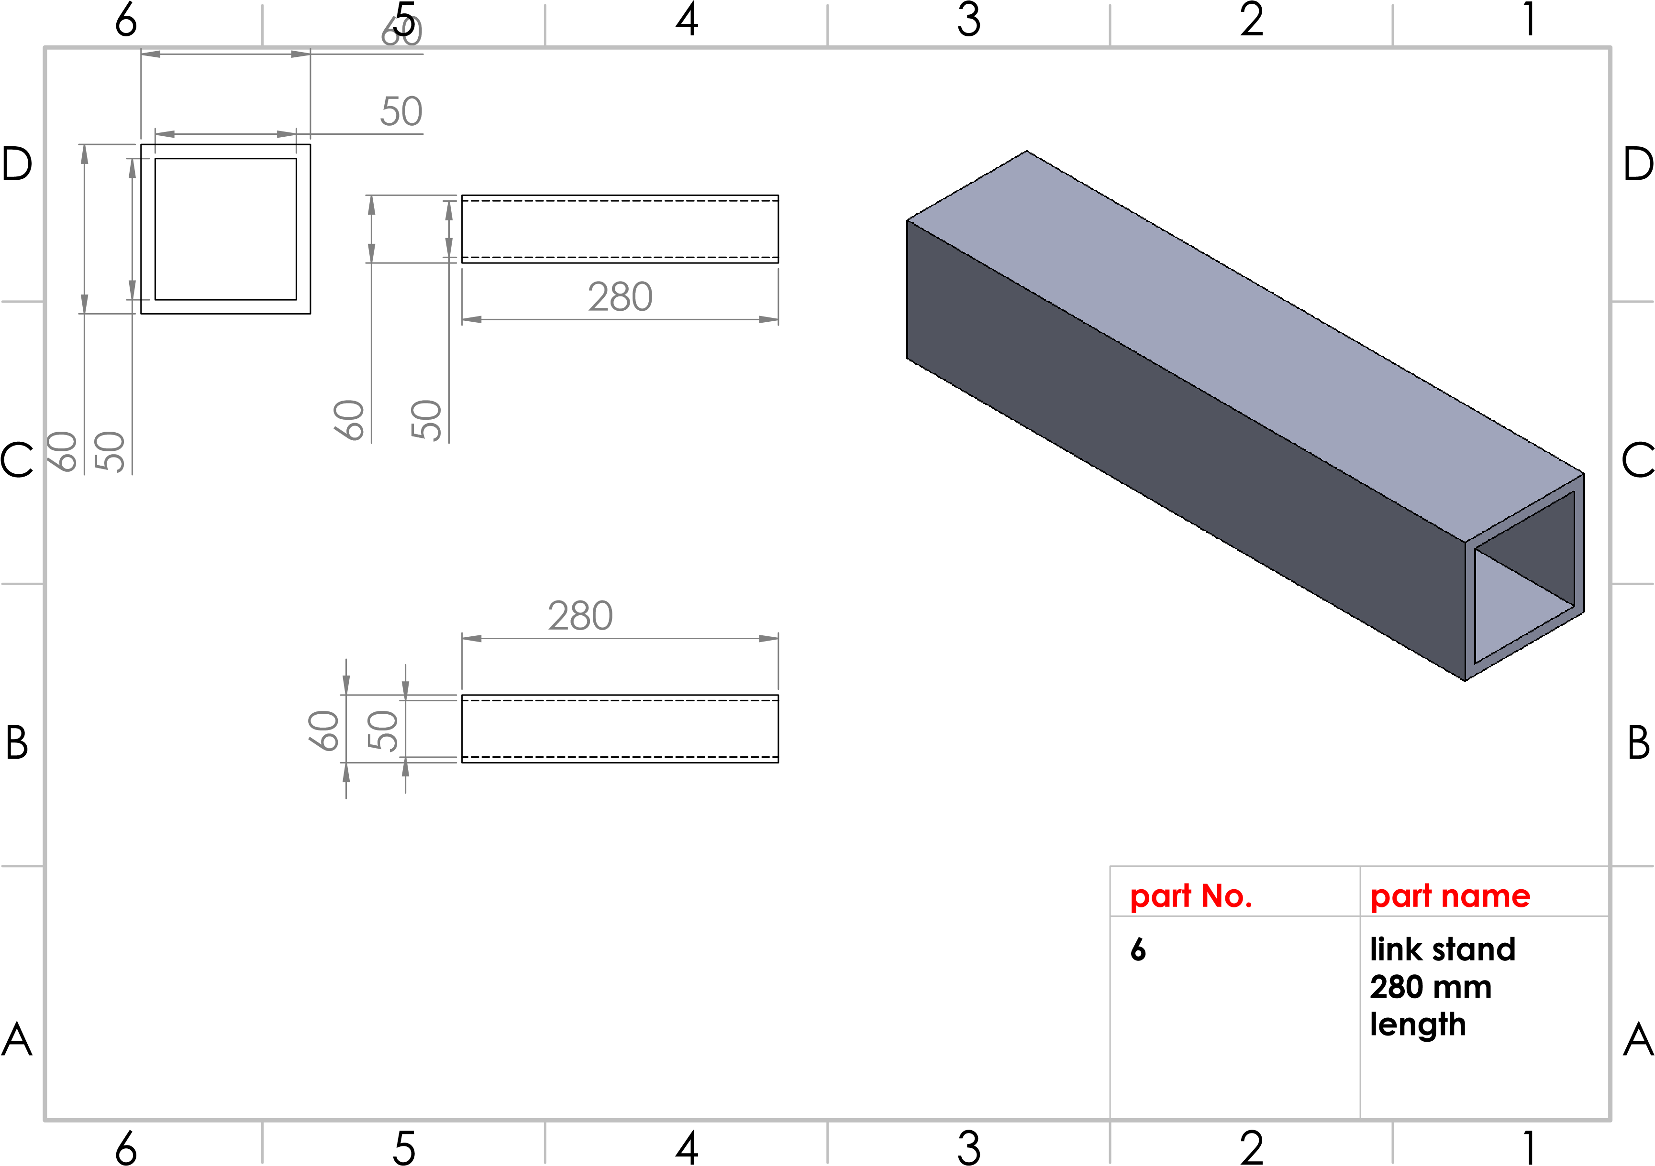
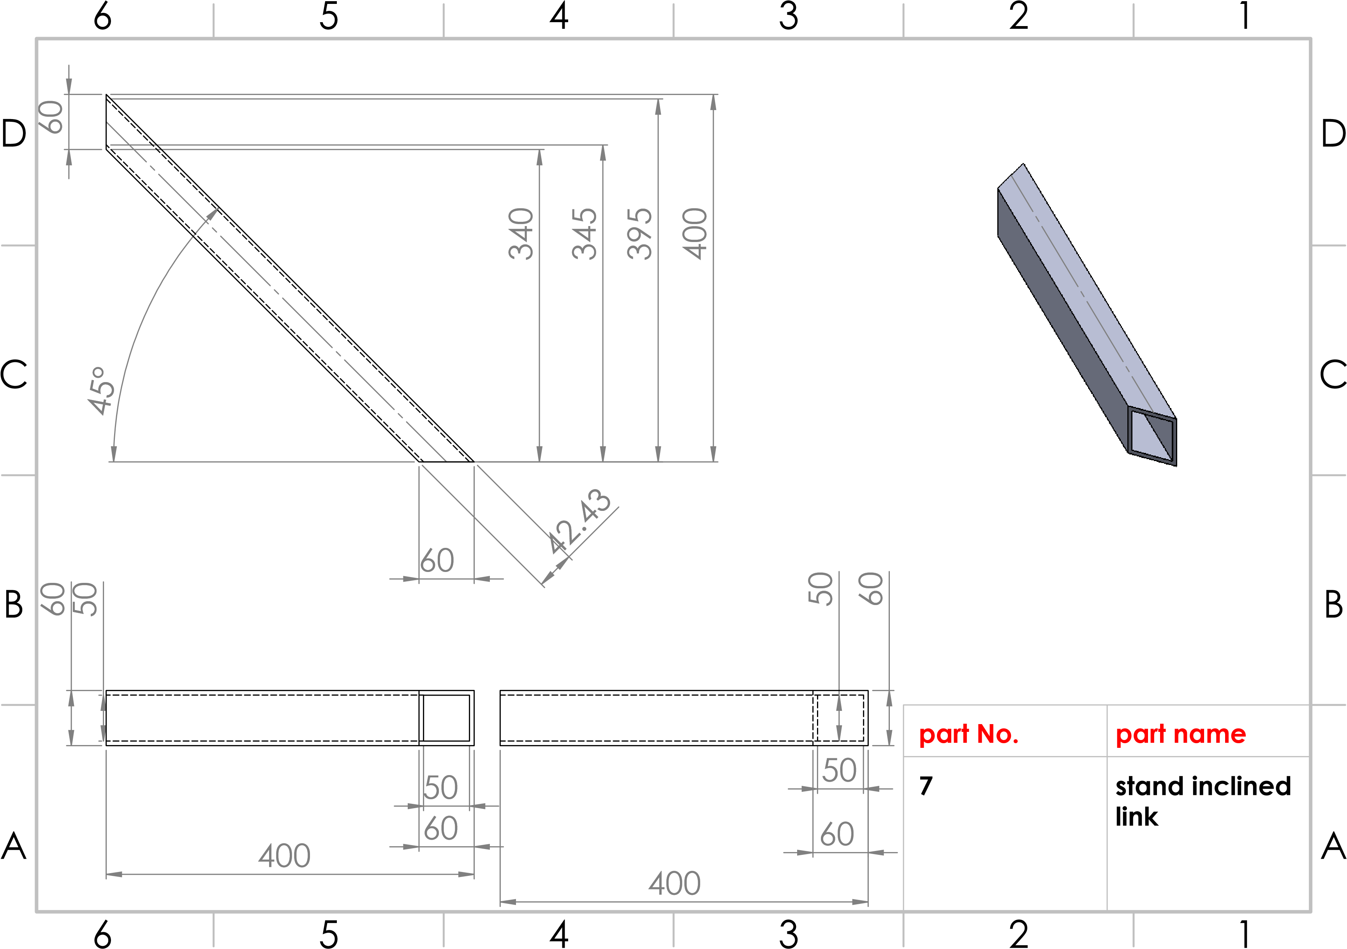
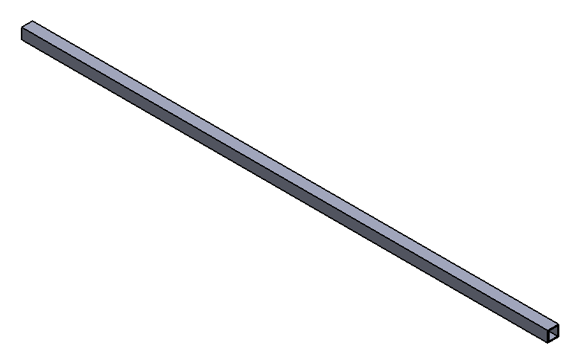
60
50
60
50
2905
60
50
A
A
B
B
C
C
D
D
6
6
5
5
4
4
3
3
2
2
1
1
part No.
8
2905
mm
stand link
part name
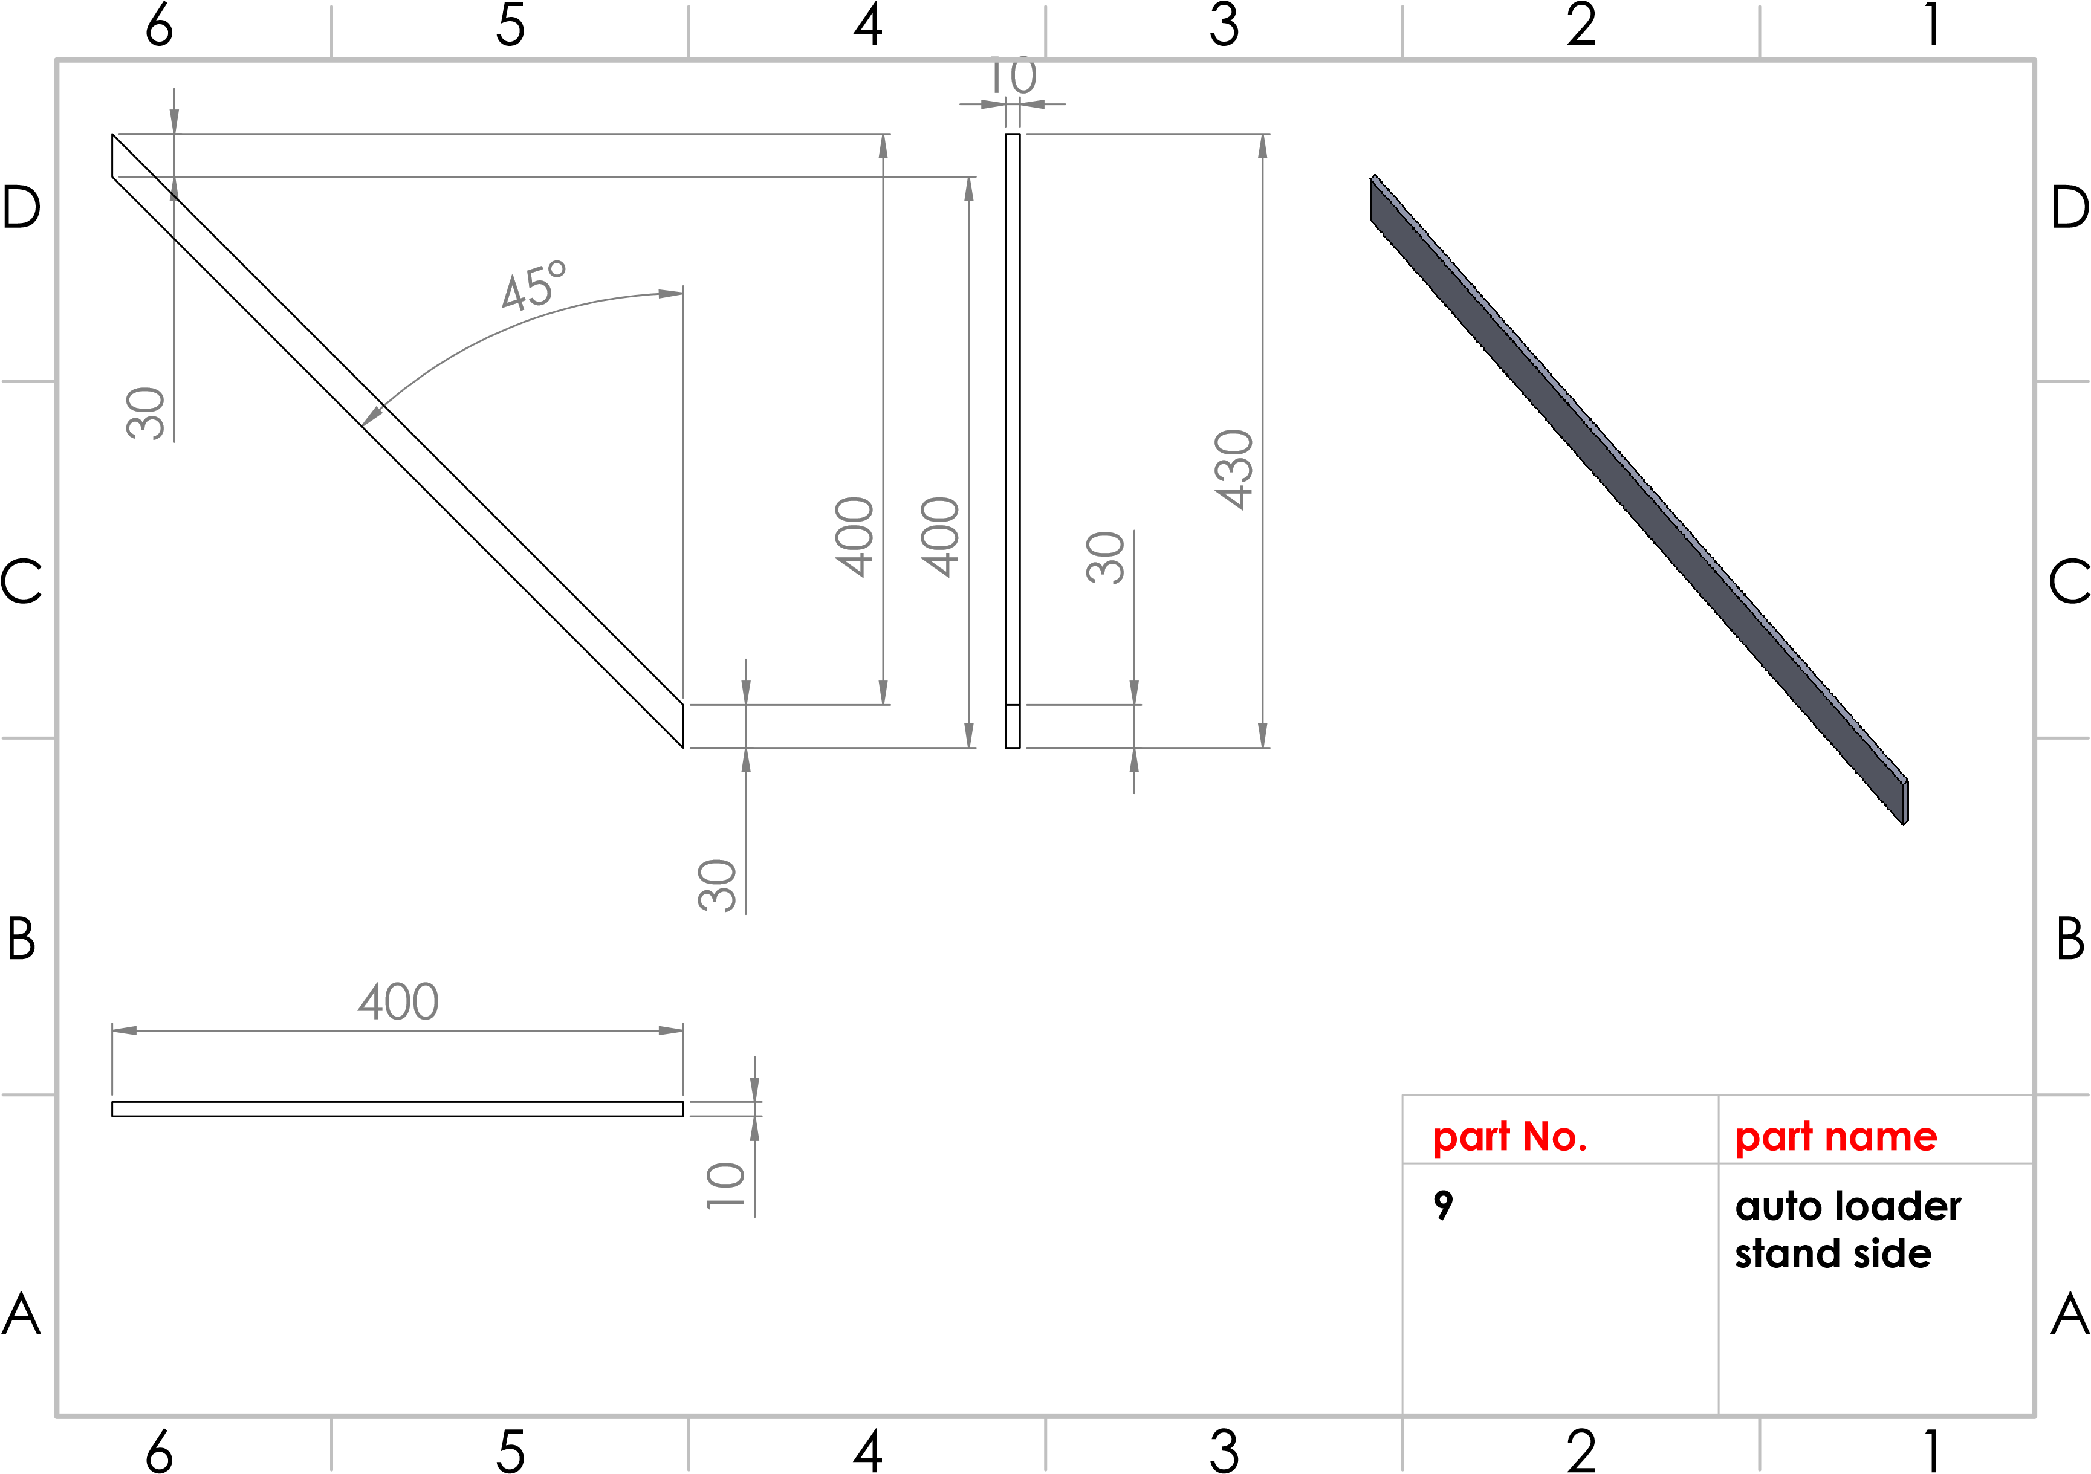
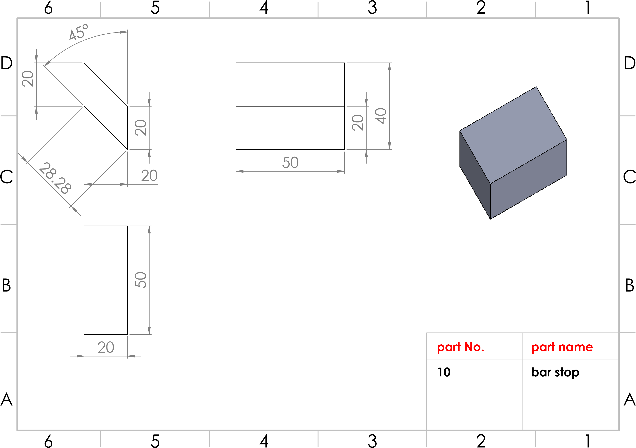
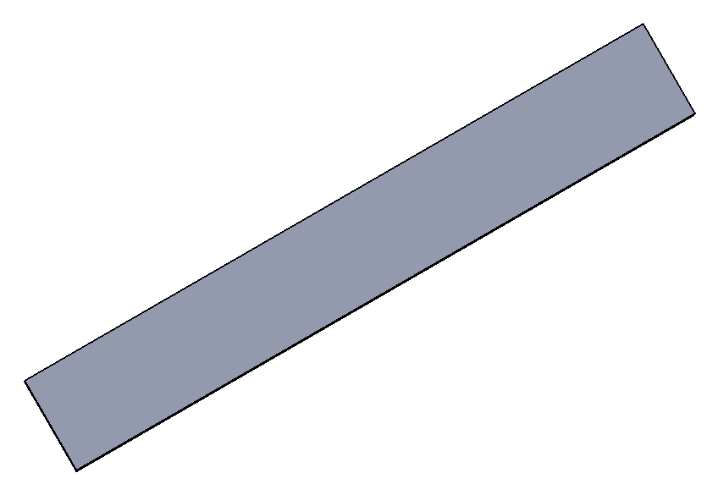
5
45
°
.69
355
251.51
251.51
251.51
3005
251.51
3005
A
A
B
B
C
C
D
D
6
6
5
5
4
4
3
3
2
2
1
1
part No.
11
bar's cover
part name
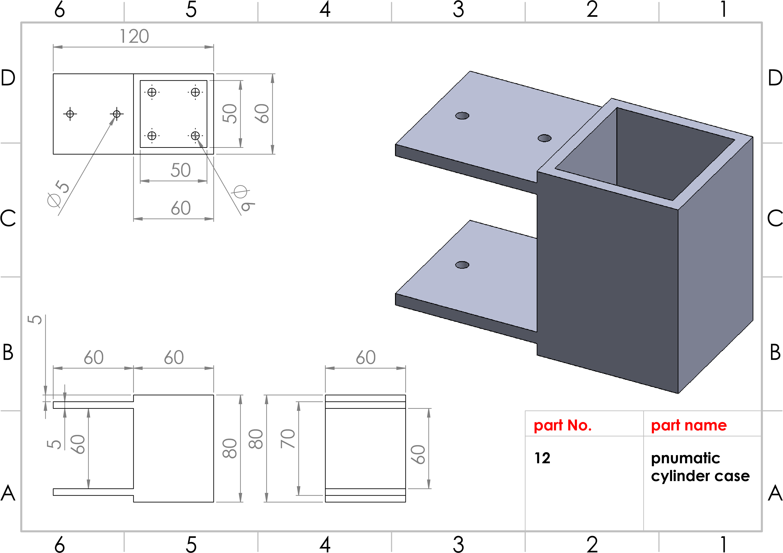
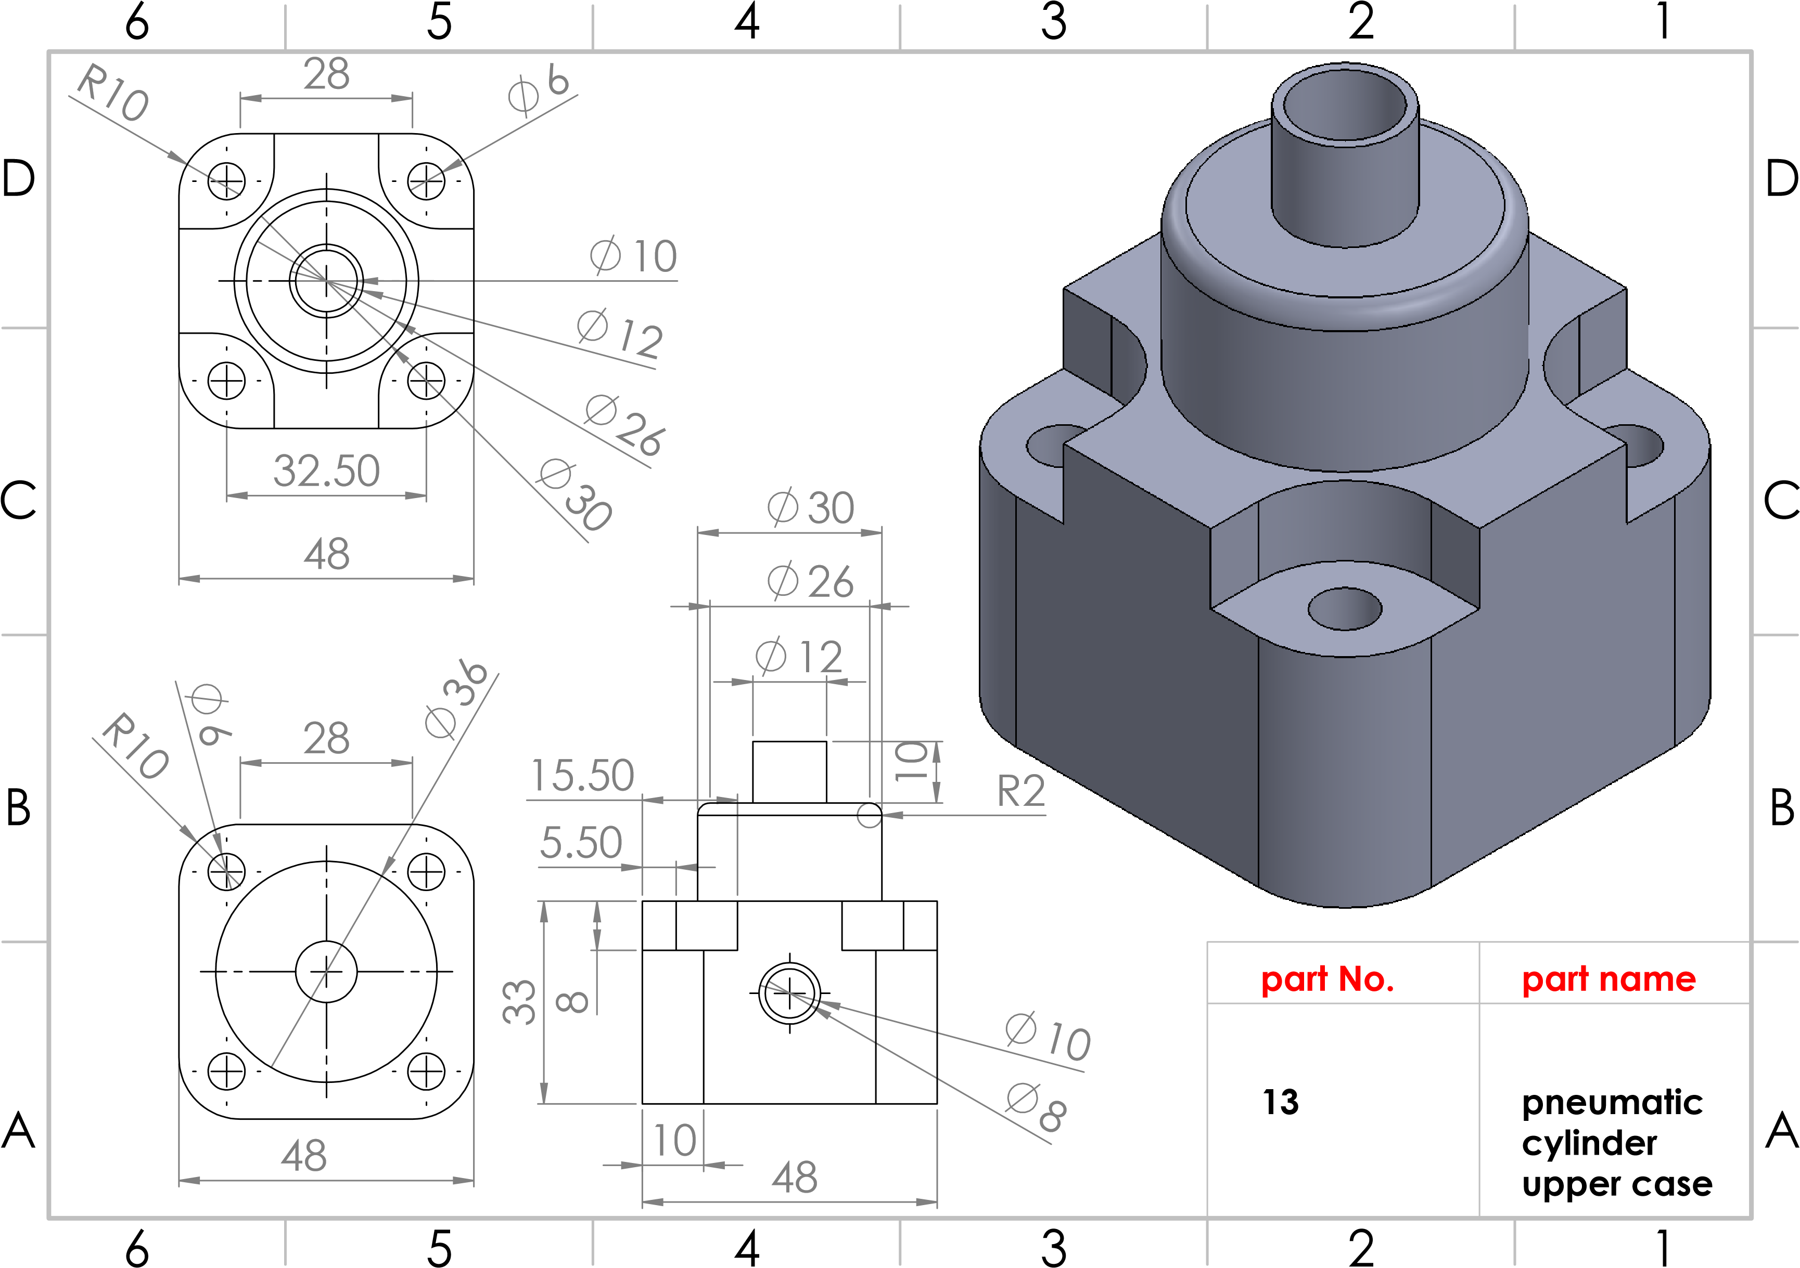
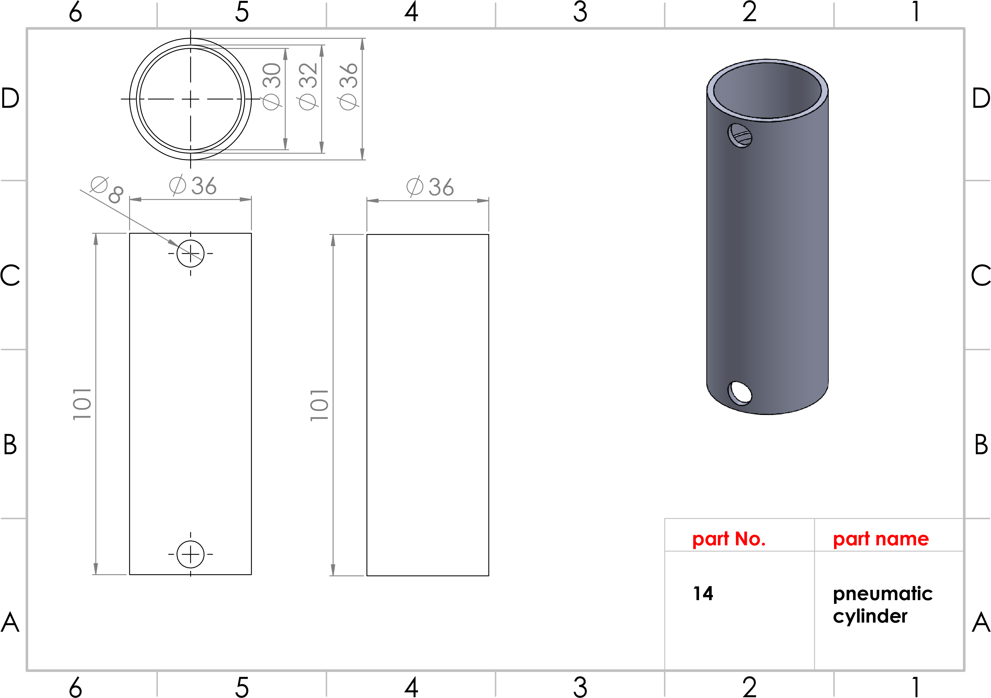
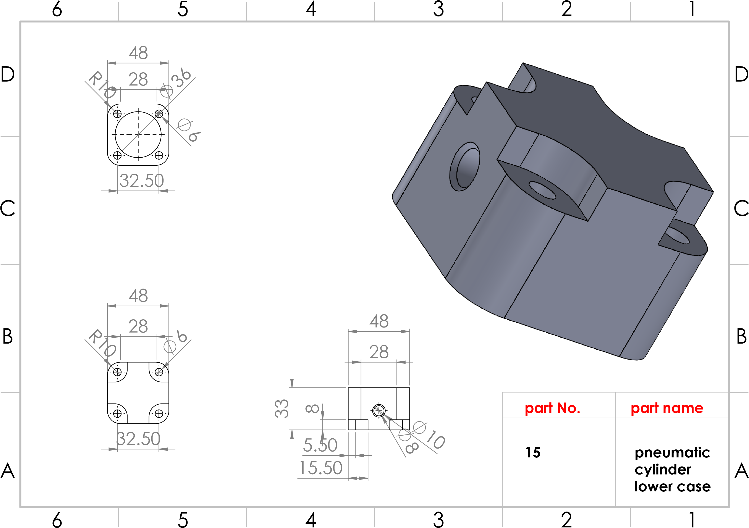
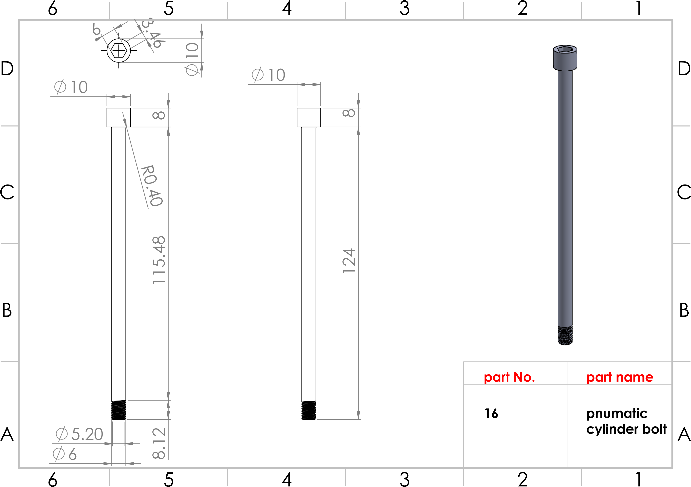
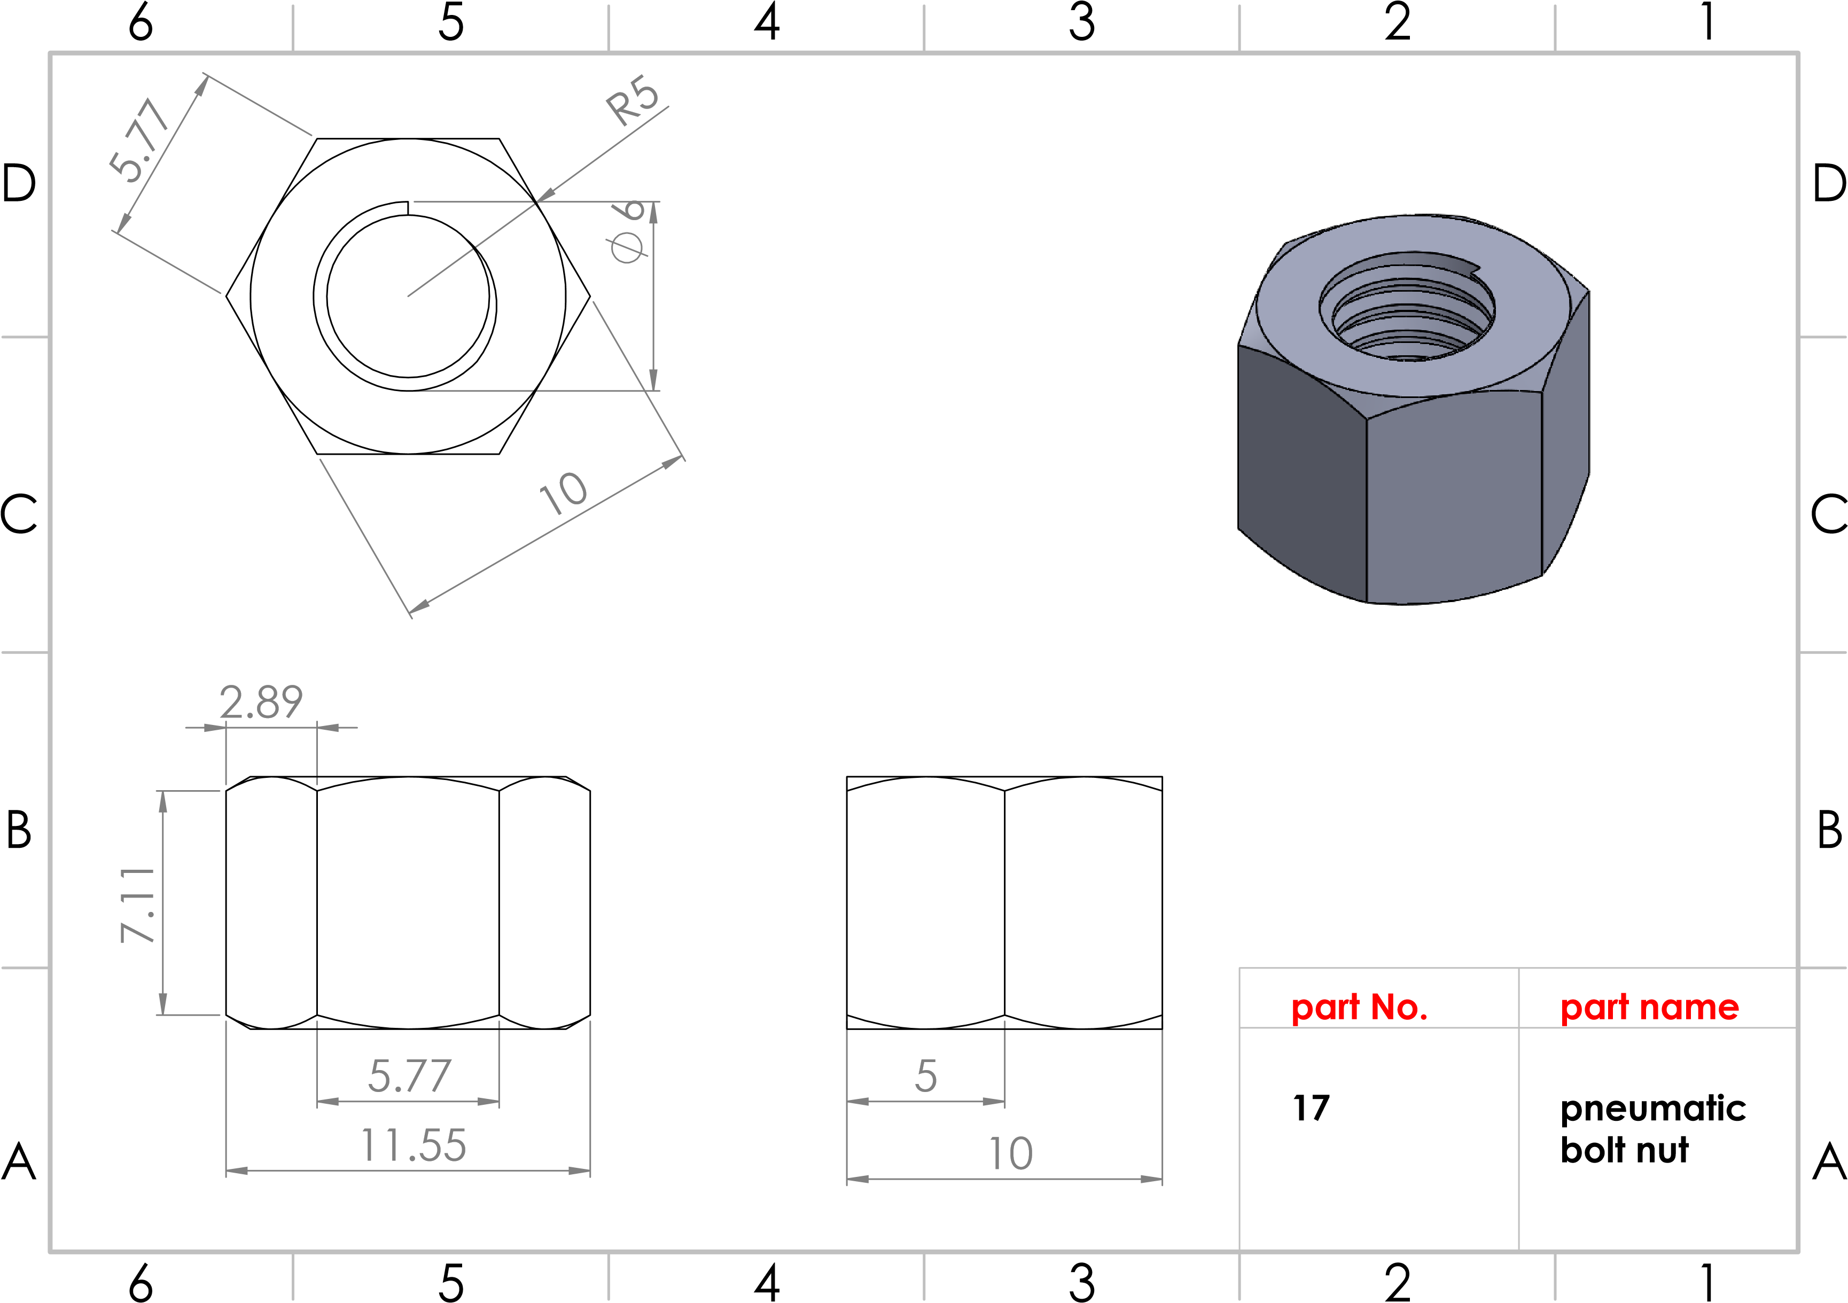
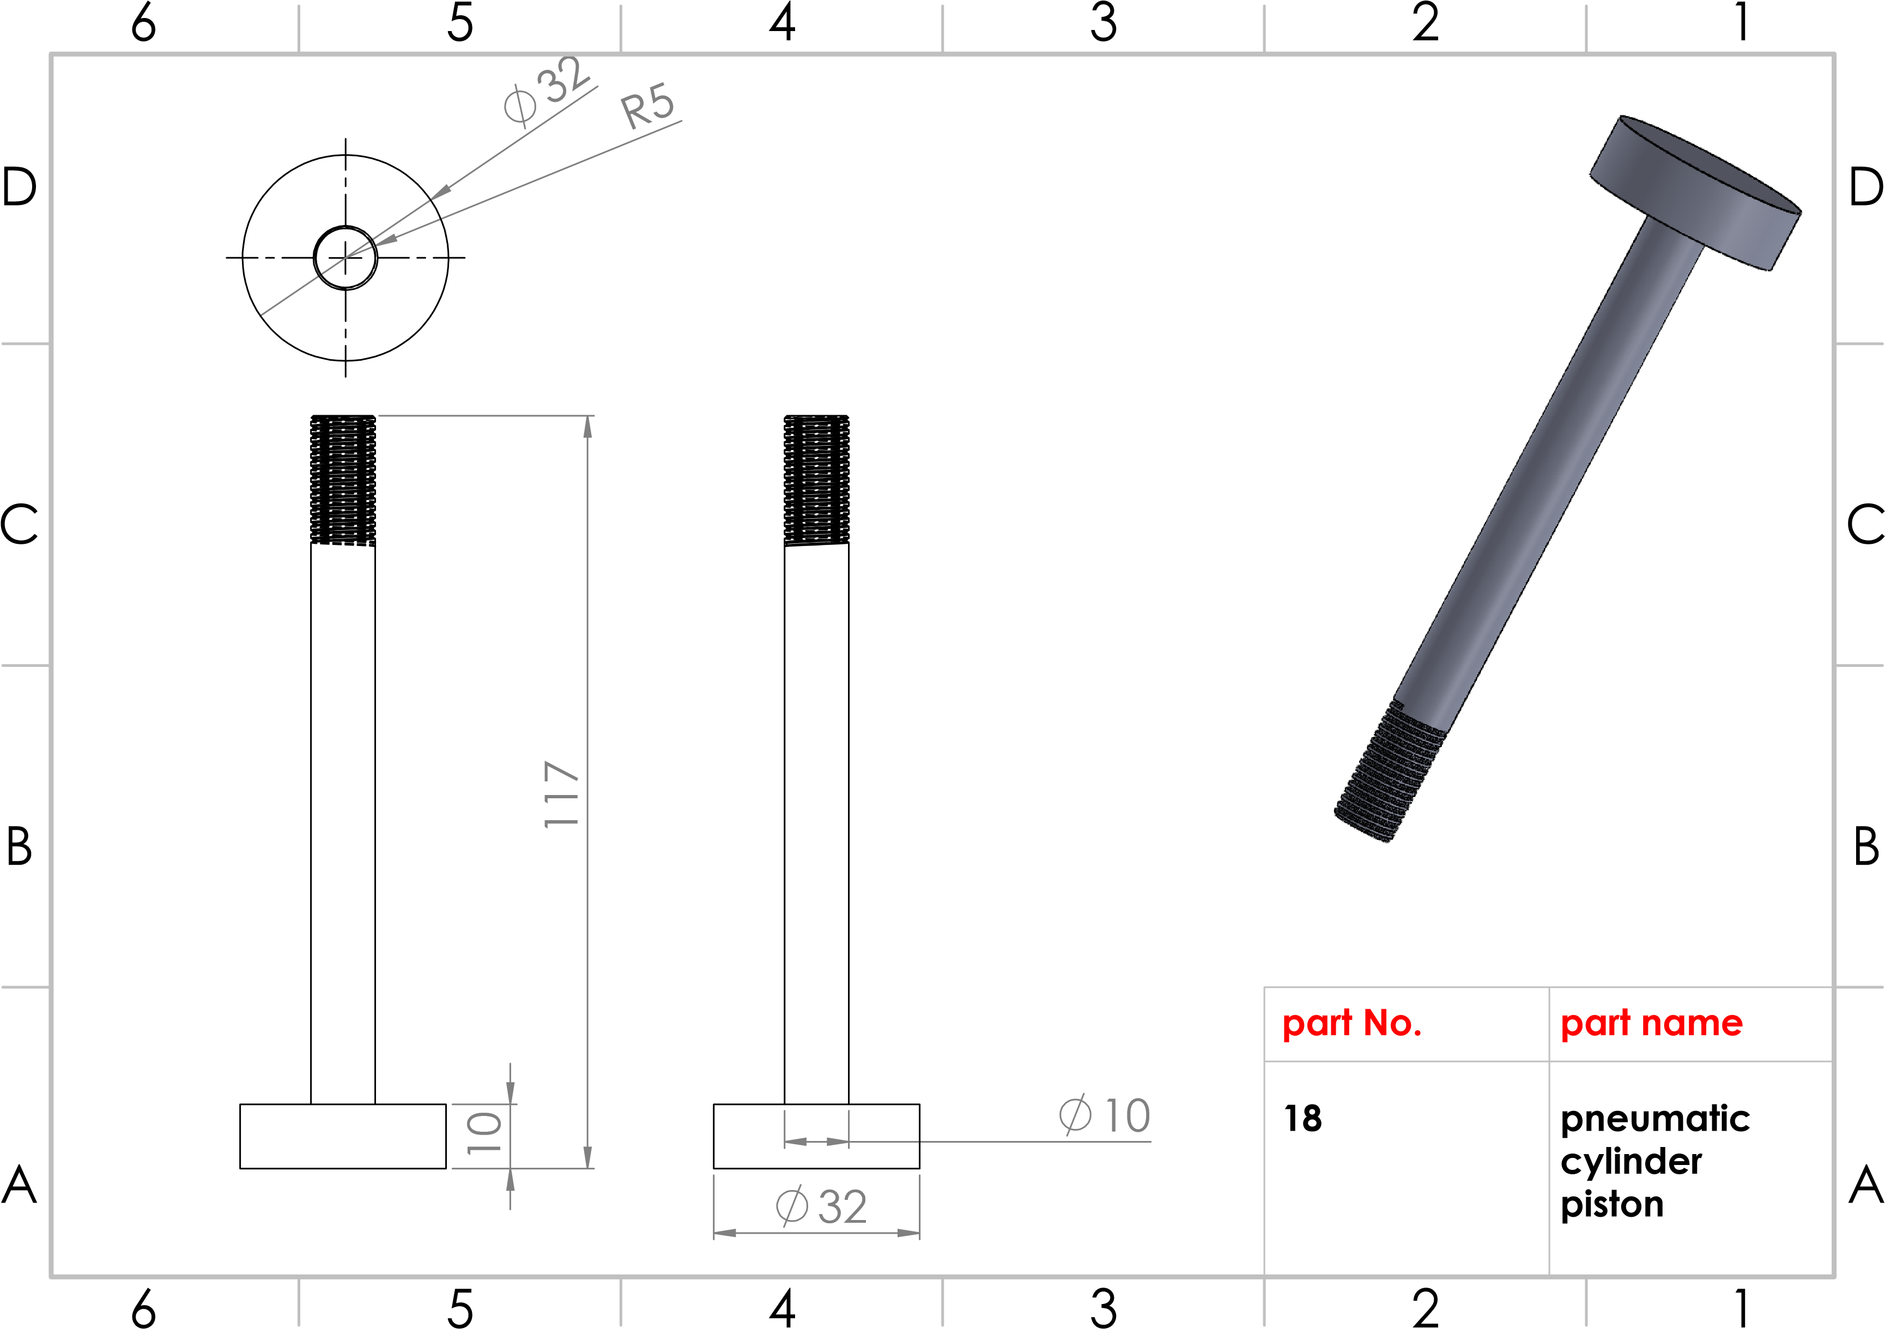
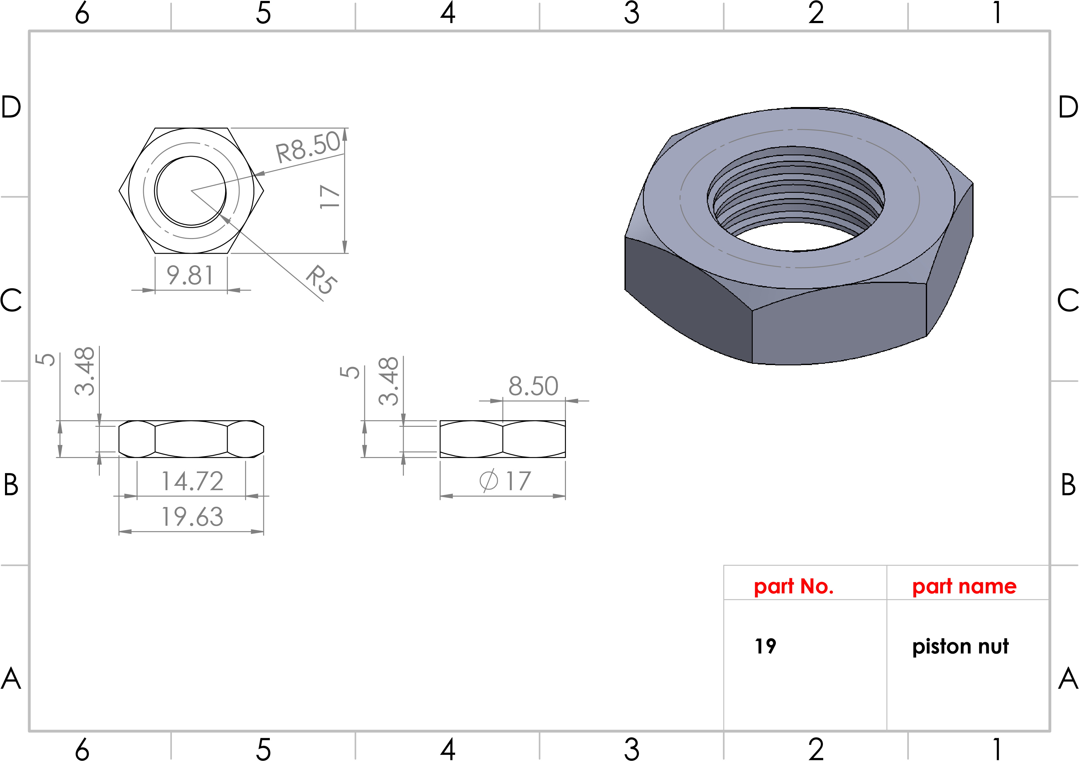
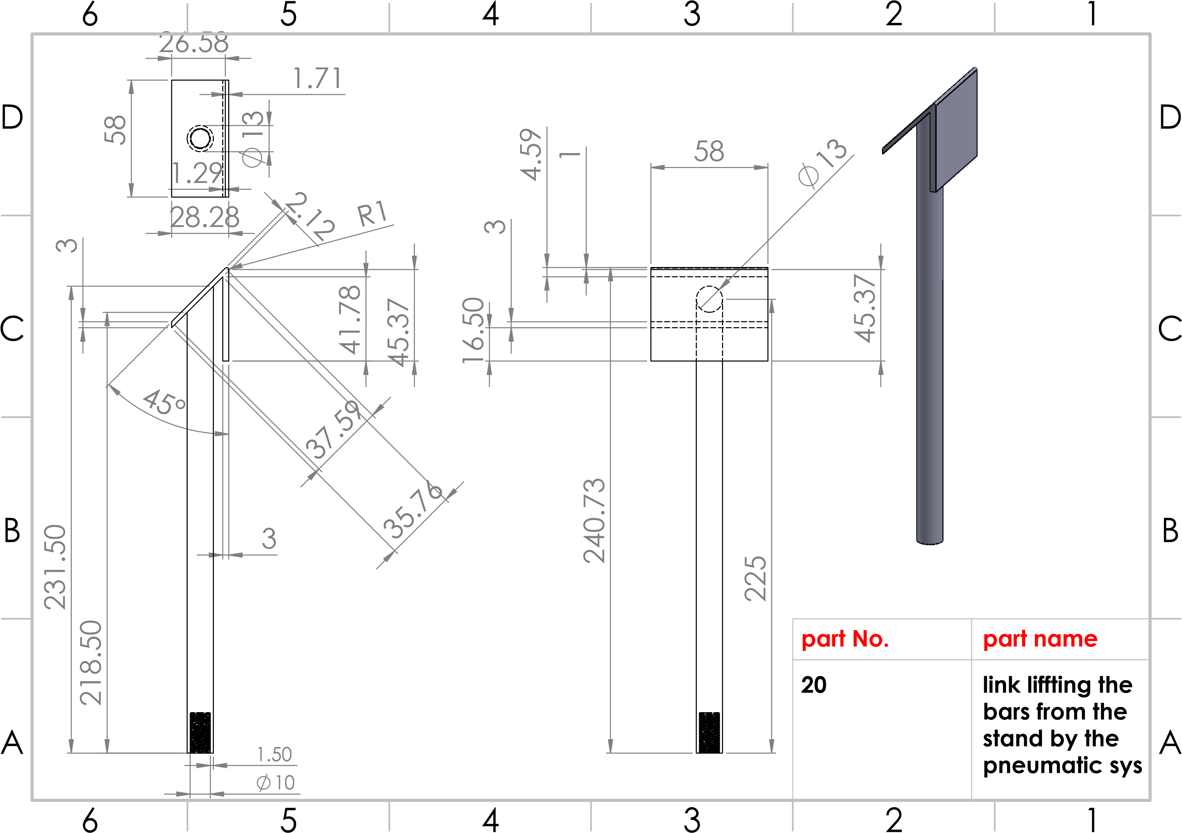
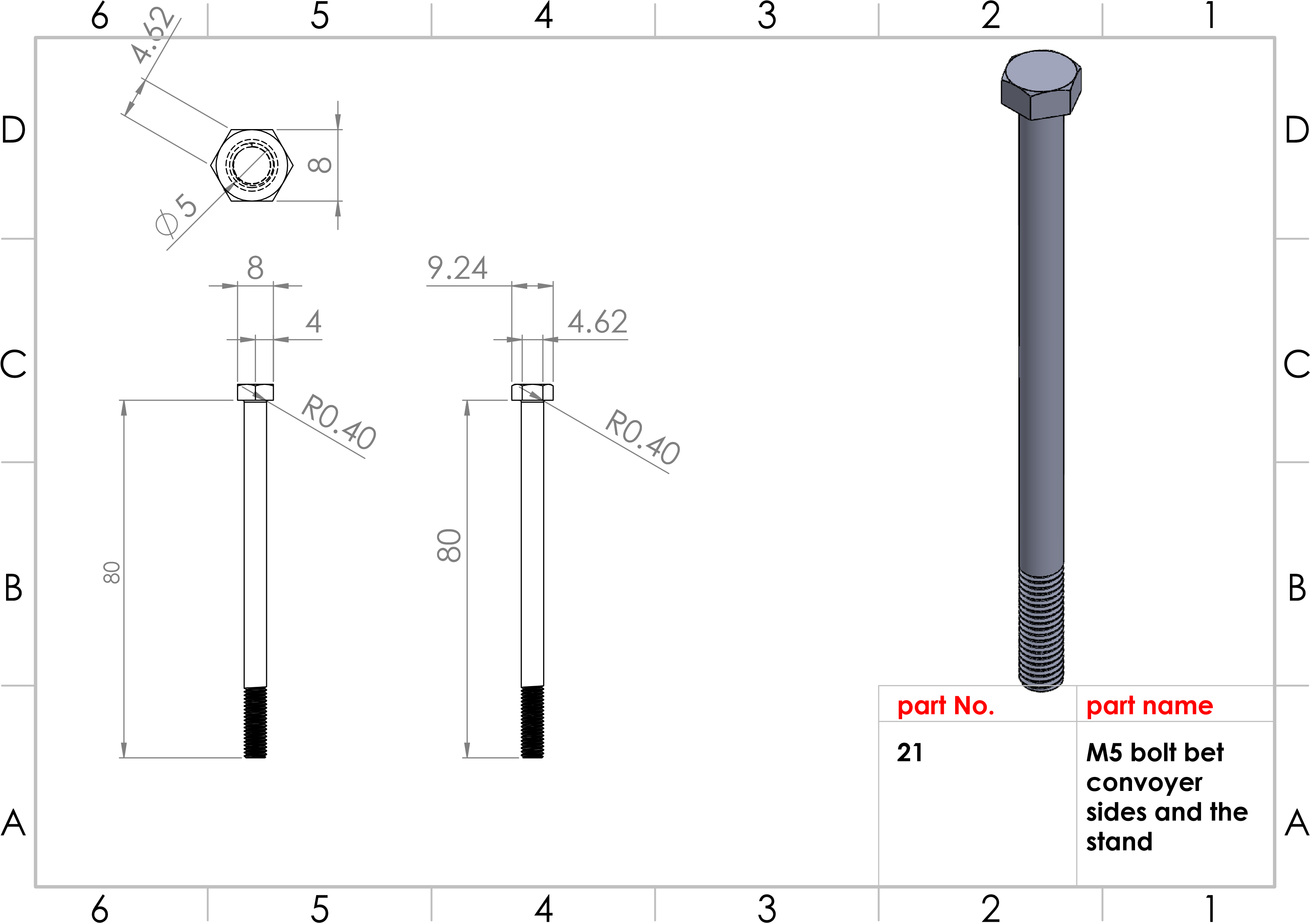
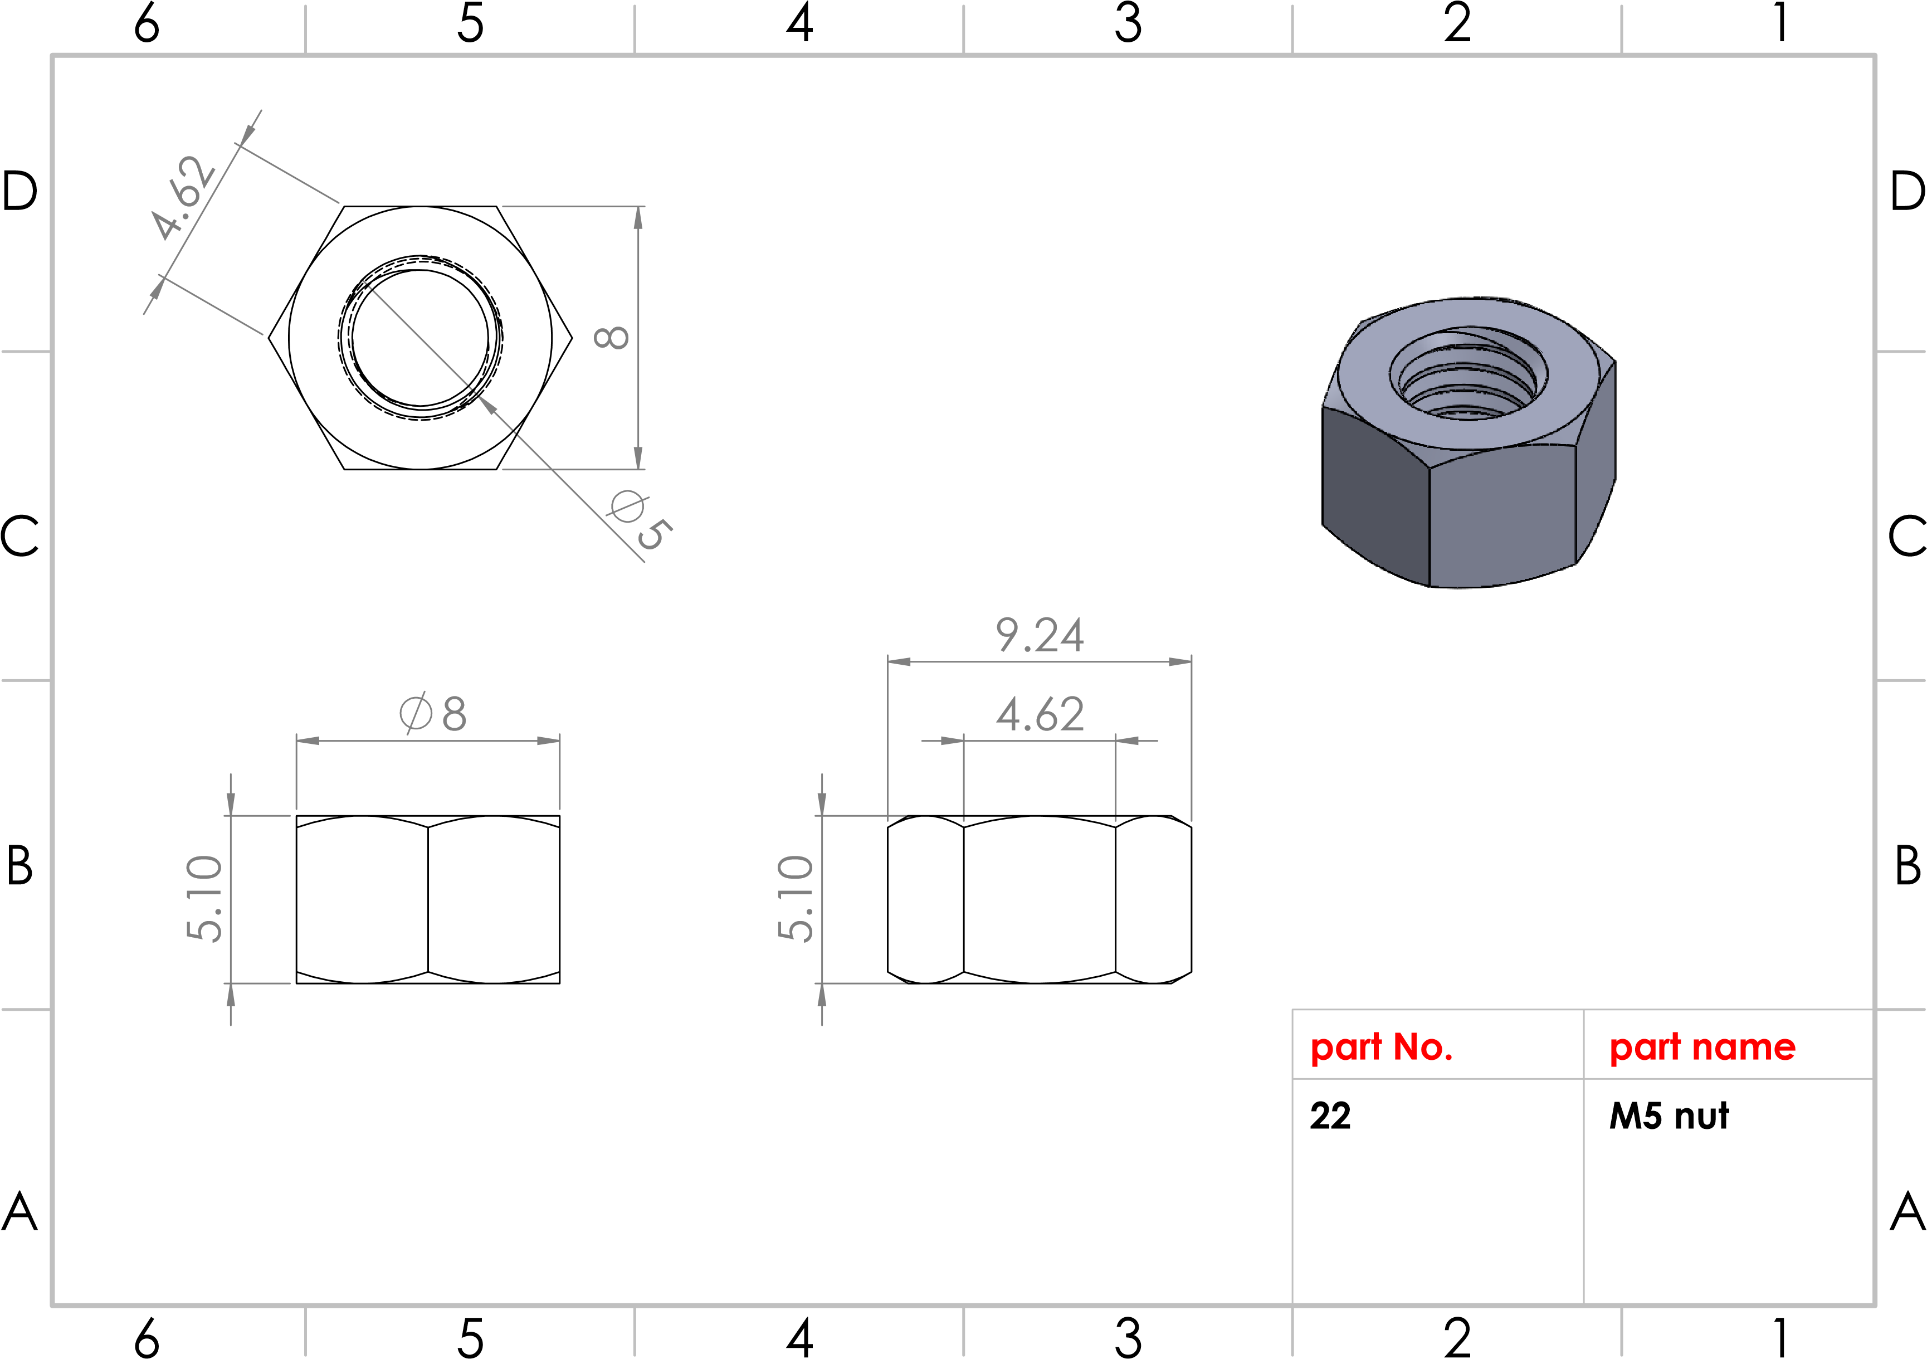

Production line
Station No. (2)
Conveyor

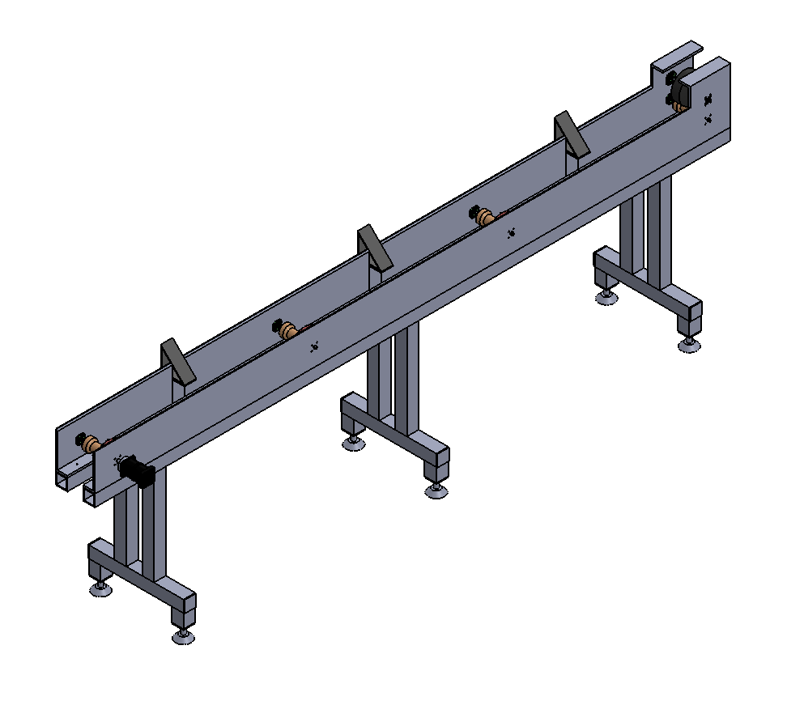
A
A
B
B
C
C
D
D
6
6
5
5
4
4
3
3
2
2
1
1
part No.
27
convoyer
assembly
part name
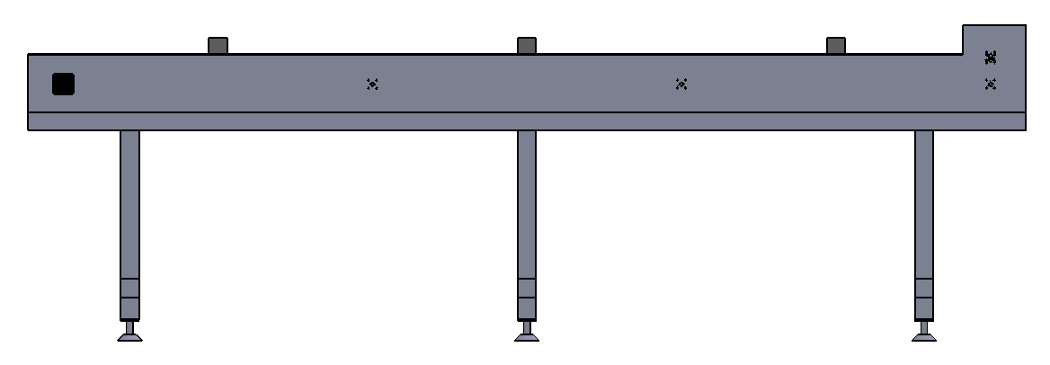
A
A
B
B
C
C
D
D
6
6
5
5
4
4
3
3
2
2
1
1
part No.
convoyer side
view
part name
28
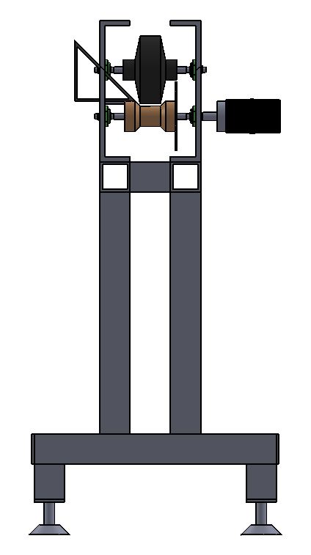
A
A
B
B
C
C
D
D
6
6
5
5
4
4
3
3
2
2
1
1
part No.
29
convoyer front
view

part name

80

40

40
28.28

80
45°
A
A
B
B
C
C
D
D
6
6
5
5
4
4
3
3
2
2
1
1
part No.
1
stand base
part name
20
20
45
45
20
A
A
B
B
C
C
D
D
6
6
5
5
4
4
3
3
2
2
1
1
part No.
2
base cylinder
part name
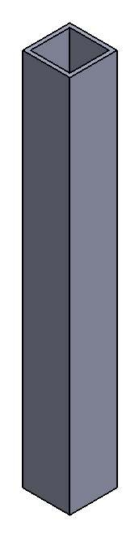
60
50
5
60
480
60
480
A
A
B
B
C
C
D
D
6
6
5
5
4
4
3
3
2
2
1
1
part No.
5
stand link
mm
480
length
part name
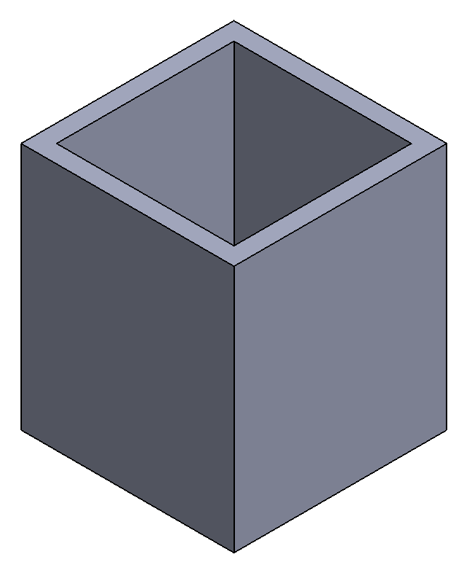
60
50
5
70
60
60
70
A
A
B
B
C
C
D
D
6
6
5
5
4
4
3
3
2
2
1
1
part No.
4
part name
stand link
70
mm
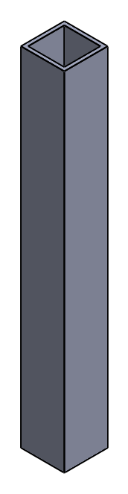
60
50
5
60
500
60
500
A
A
B
B
C
C
D
D
6
6
5
5
4
4
3
3
2
2
1
1
part No.
5
stand link
mm
500
length
part name
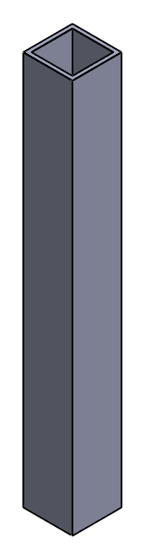
50
60
5
60
480
60
480
A
A
B
B
C
C
D
D
6
6
5
5
4
4
3
3
2
2
1
1
part No.
6
stand link
mm
480
length
part name
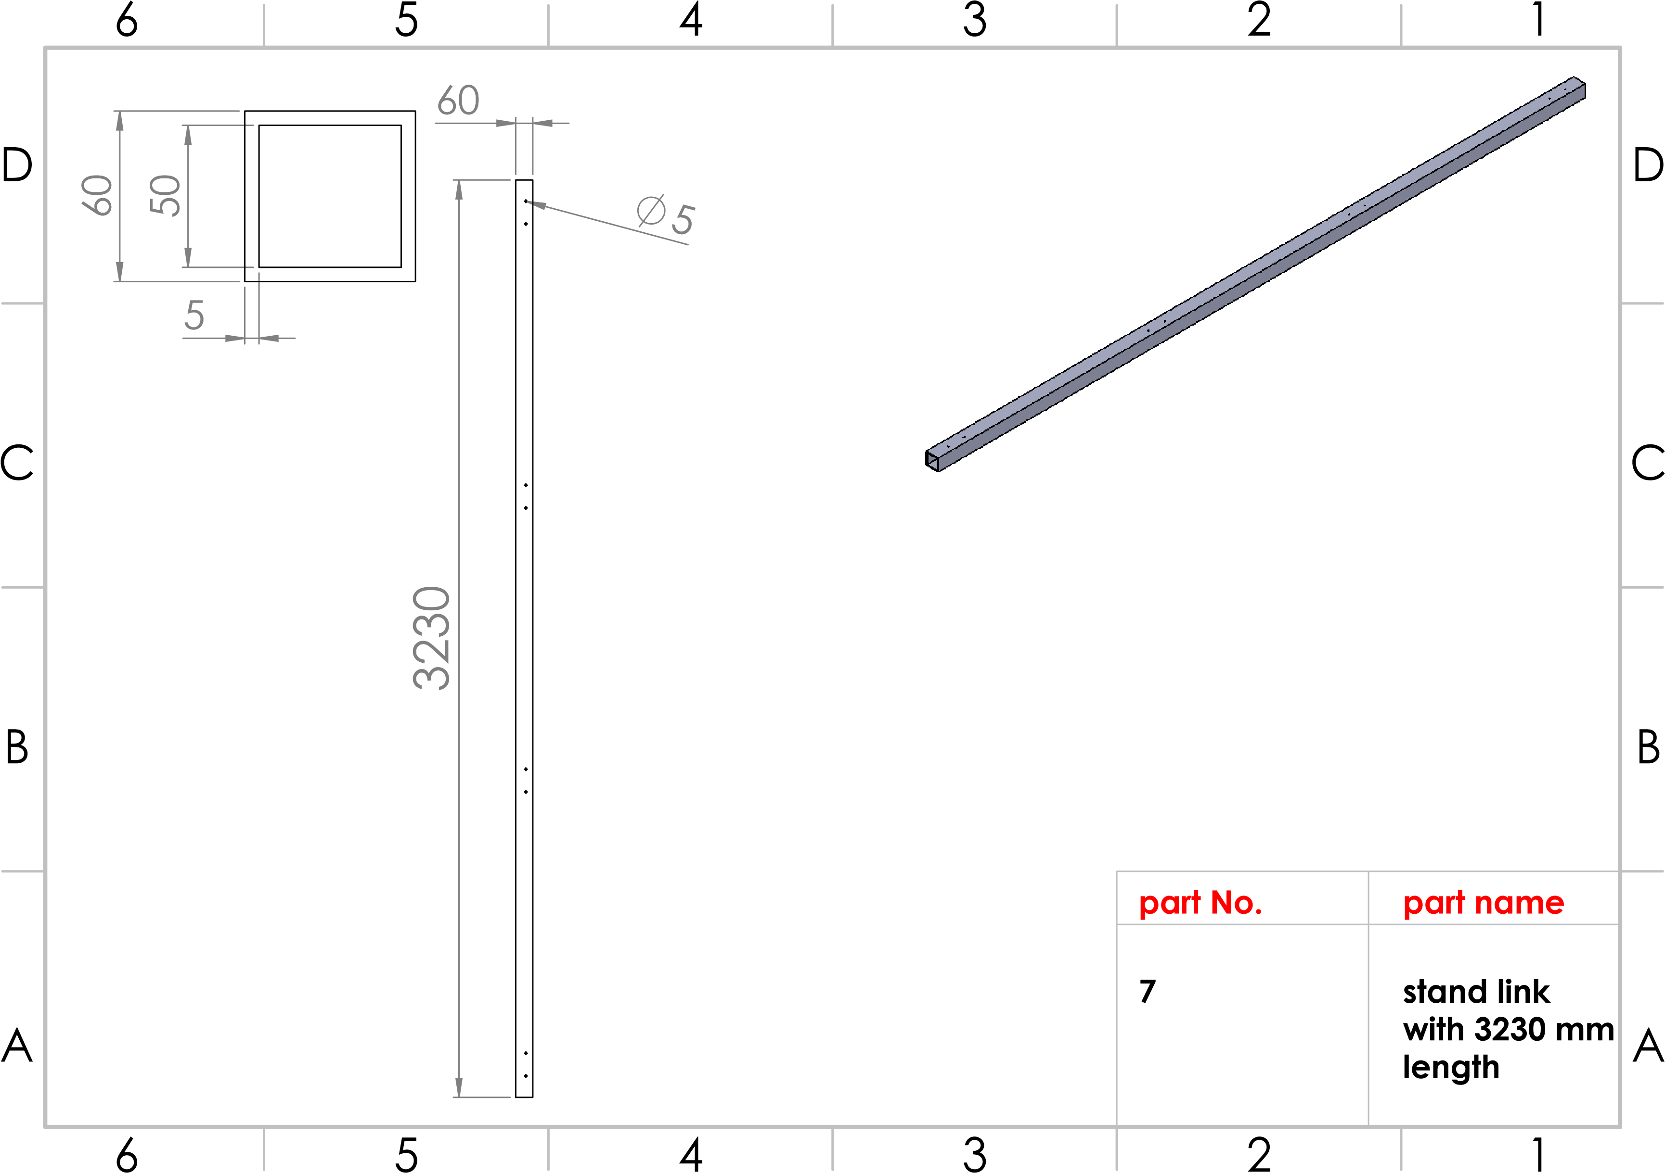
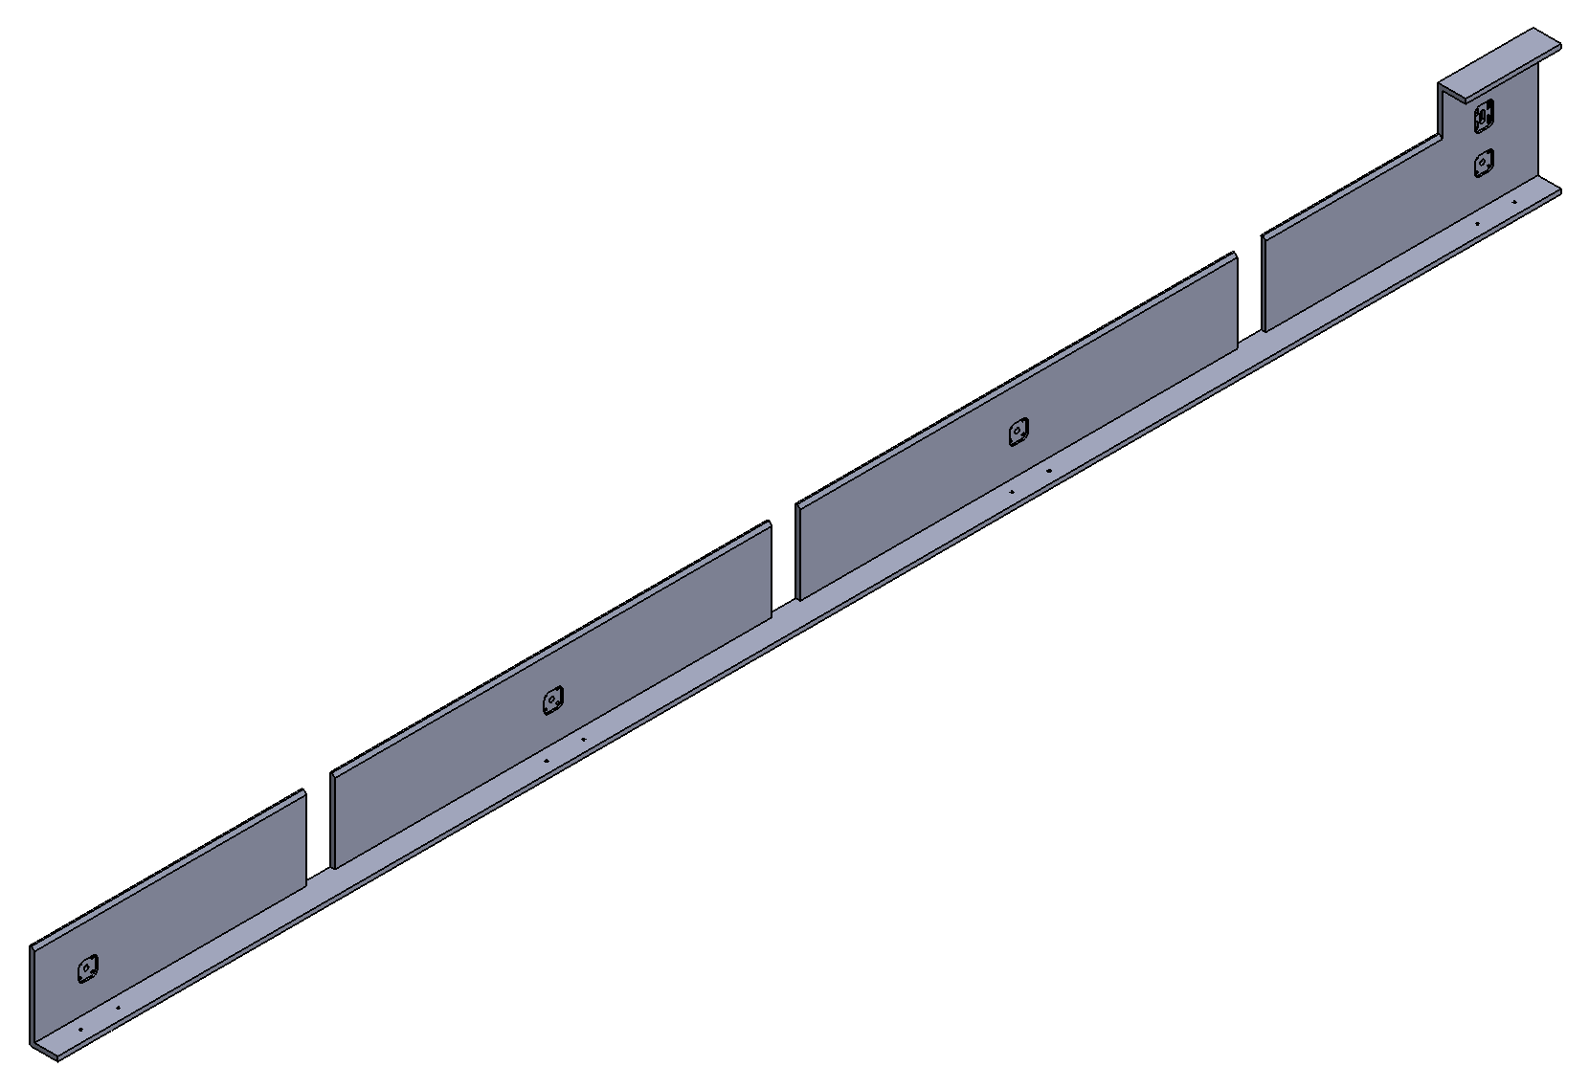
A
A
B
B
C
C
D
D
6
6
5
5
4
4
3
3
2
2
1
1
part No.
8
ide 2 shape
s
only
part name

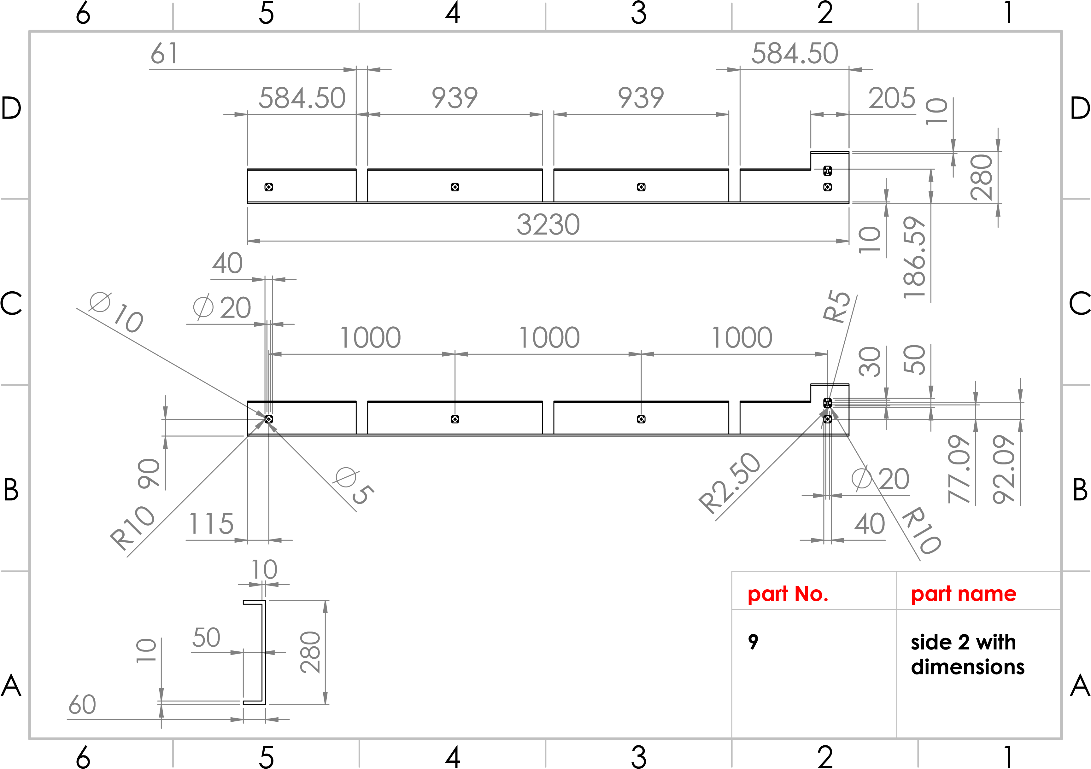

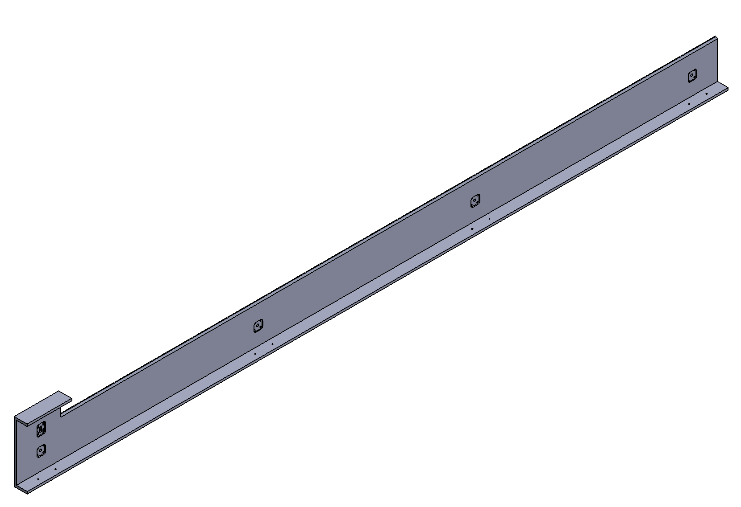
A
A
B
B
C
C
D
D
6
6
5
5
4
4
3
3
2
2
1
1
part No.
10
tand side
s
shape only
1
part name
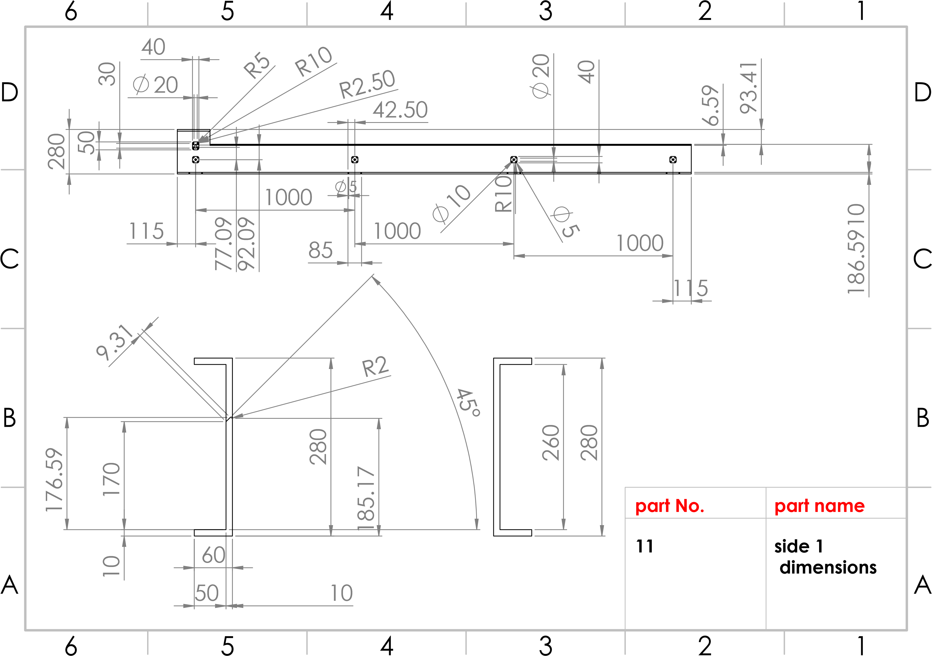
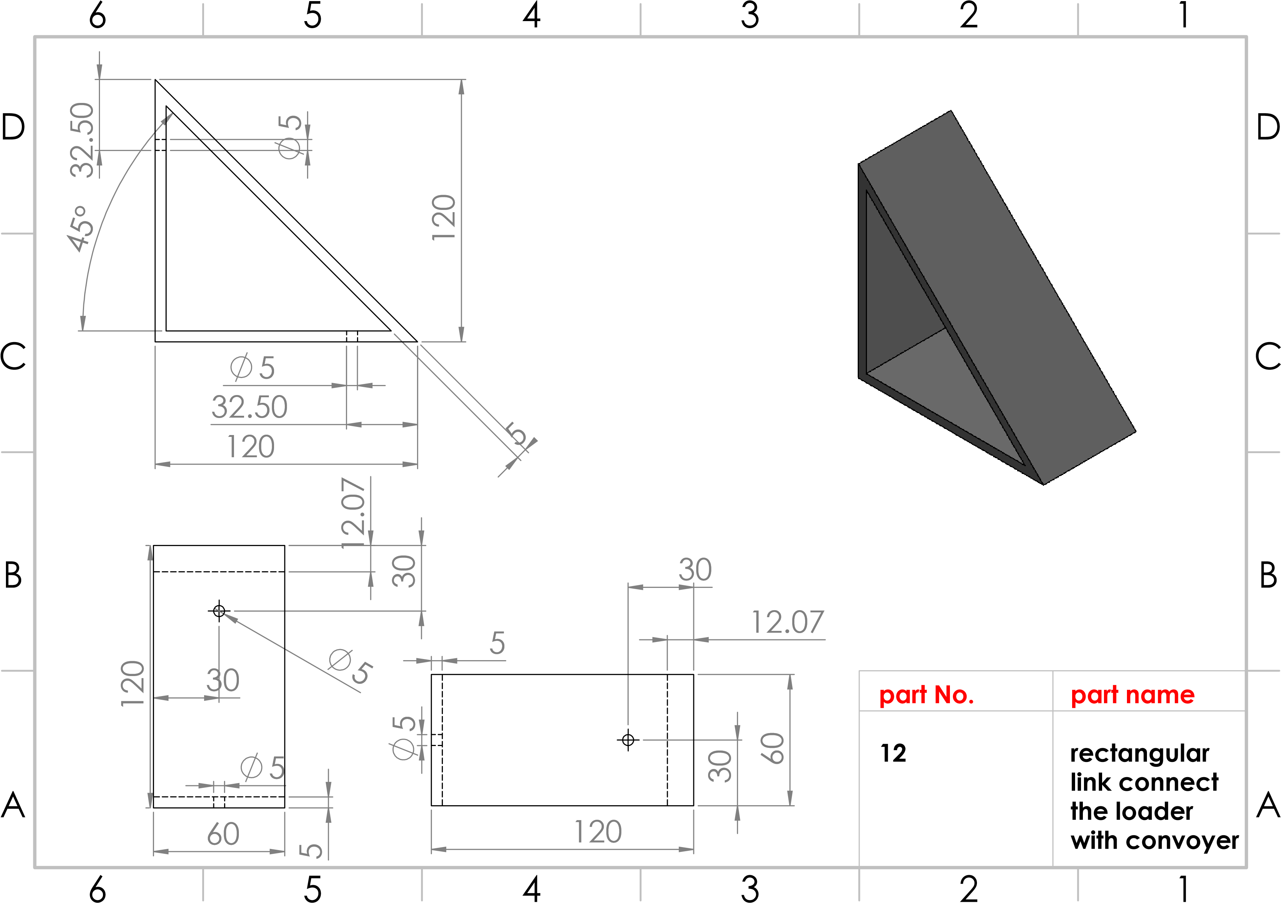
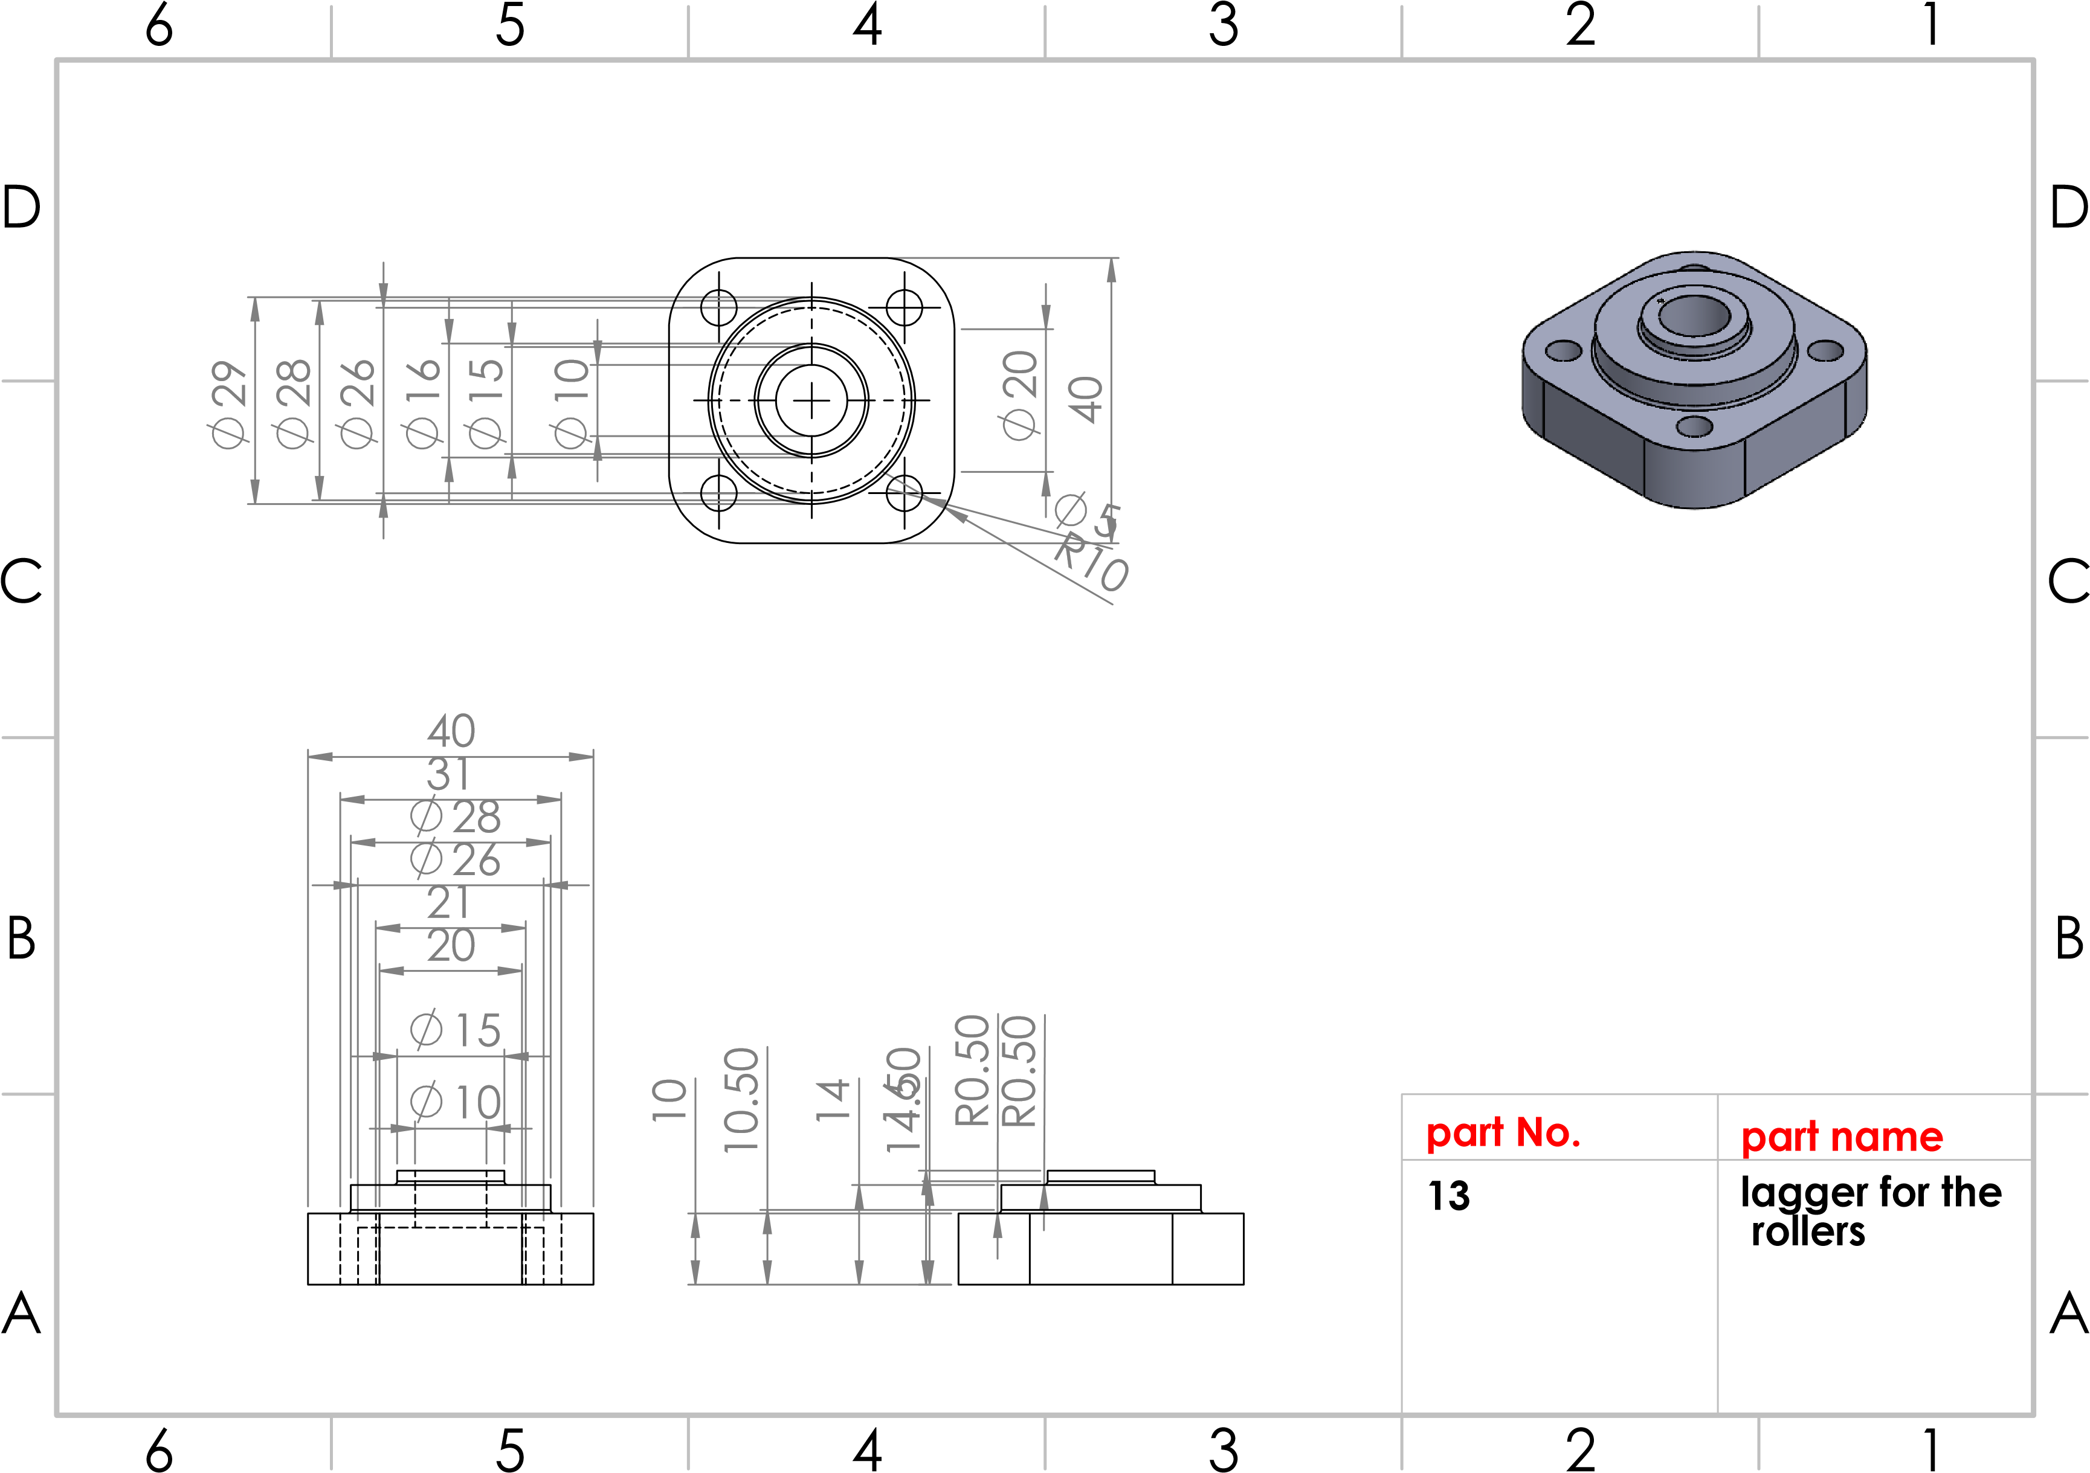
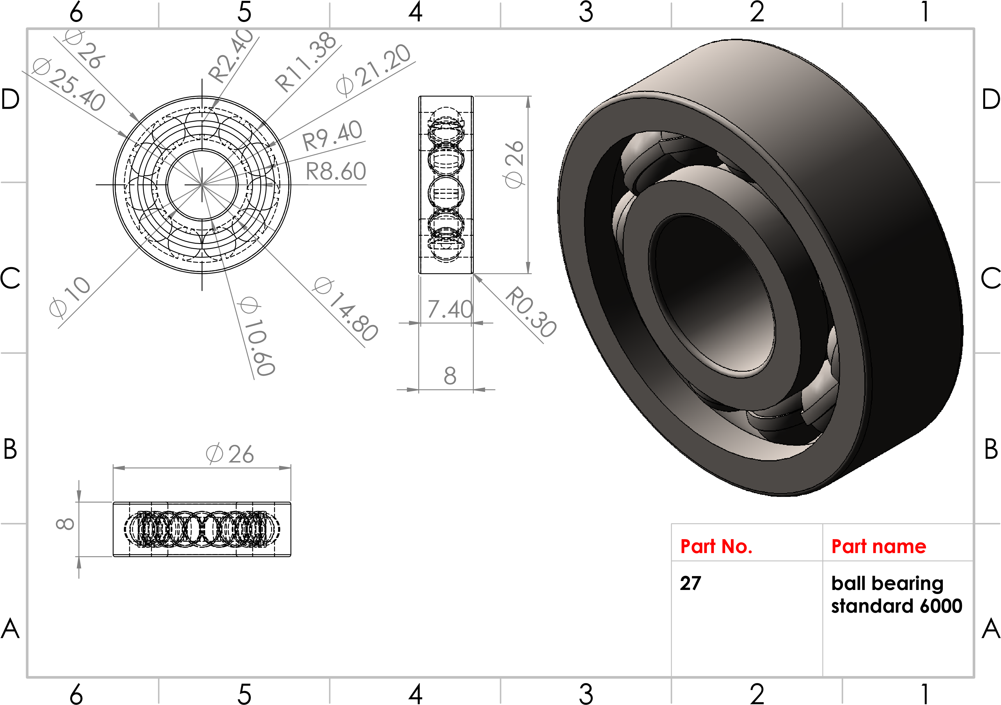
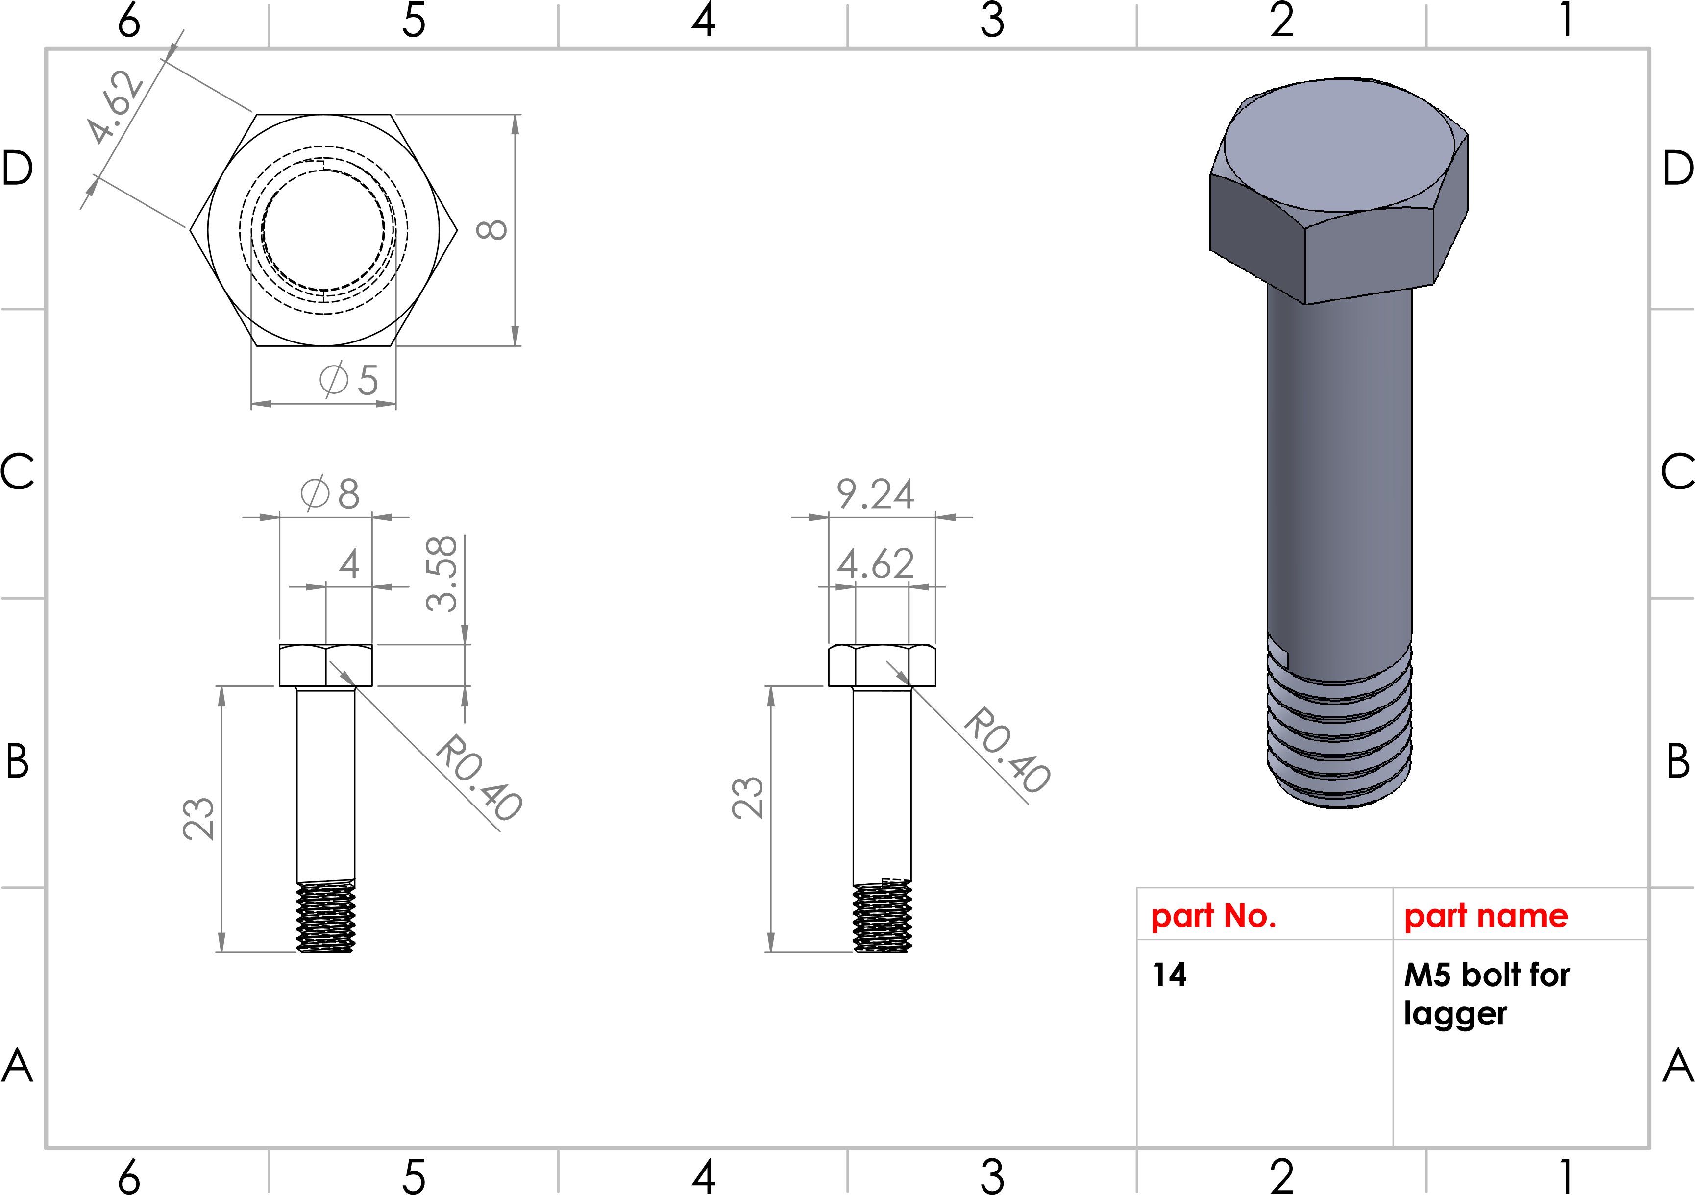
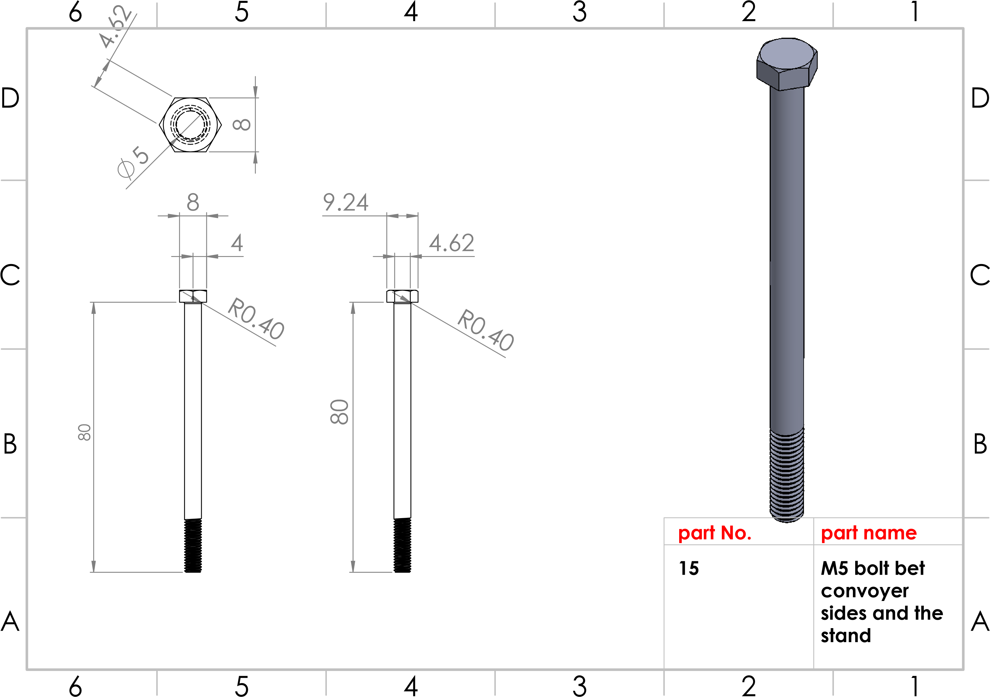
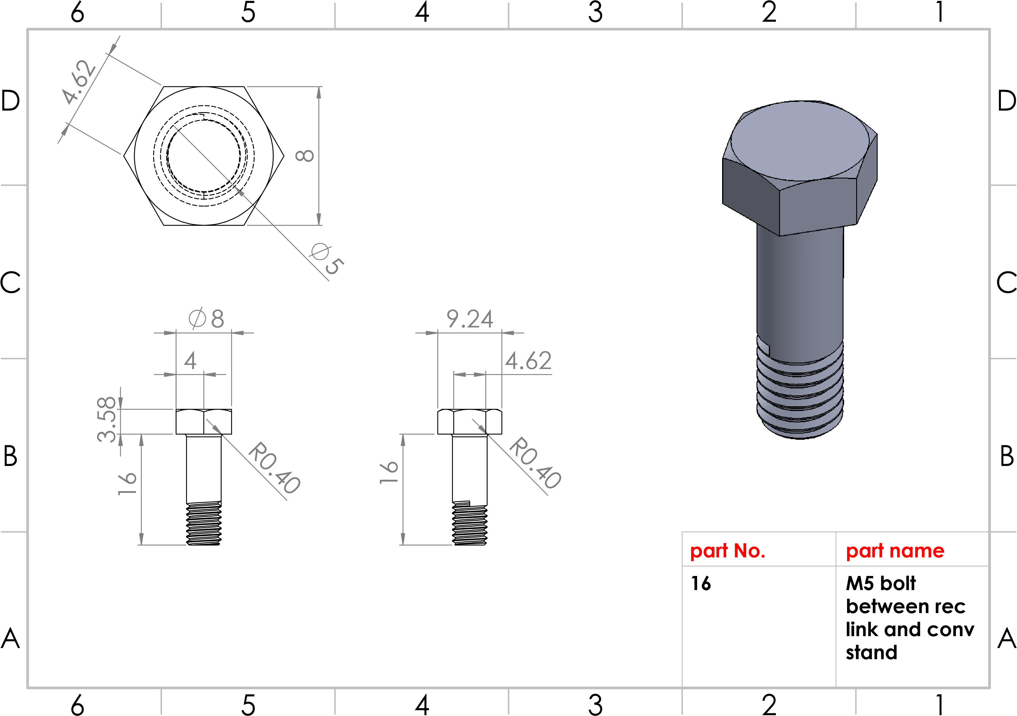

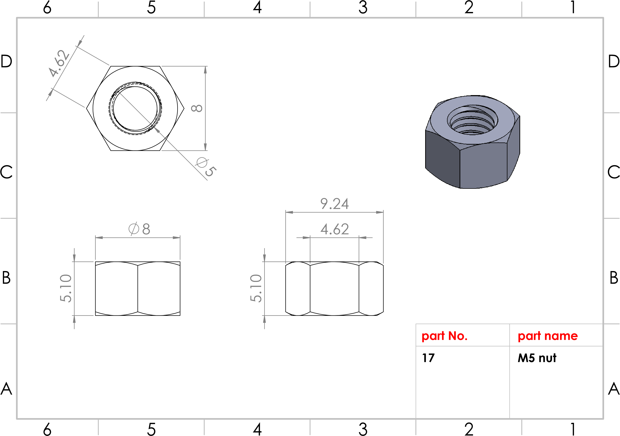

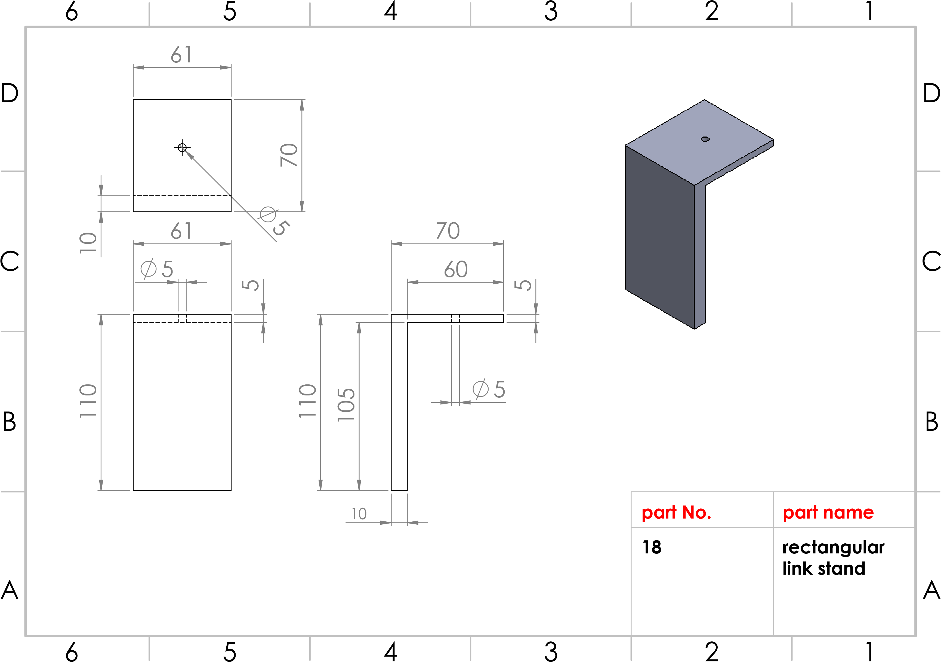
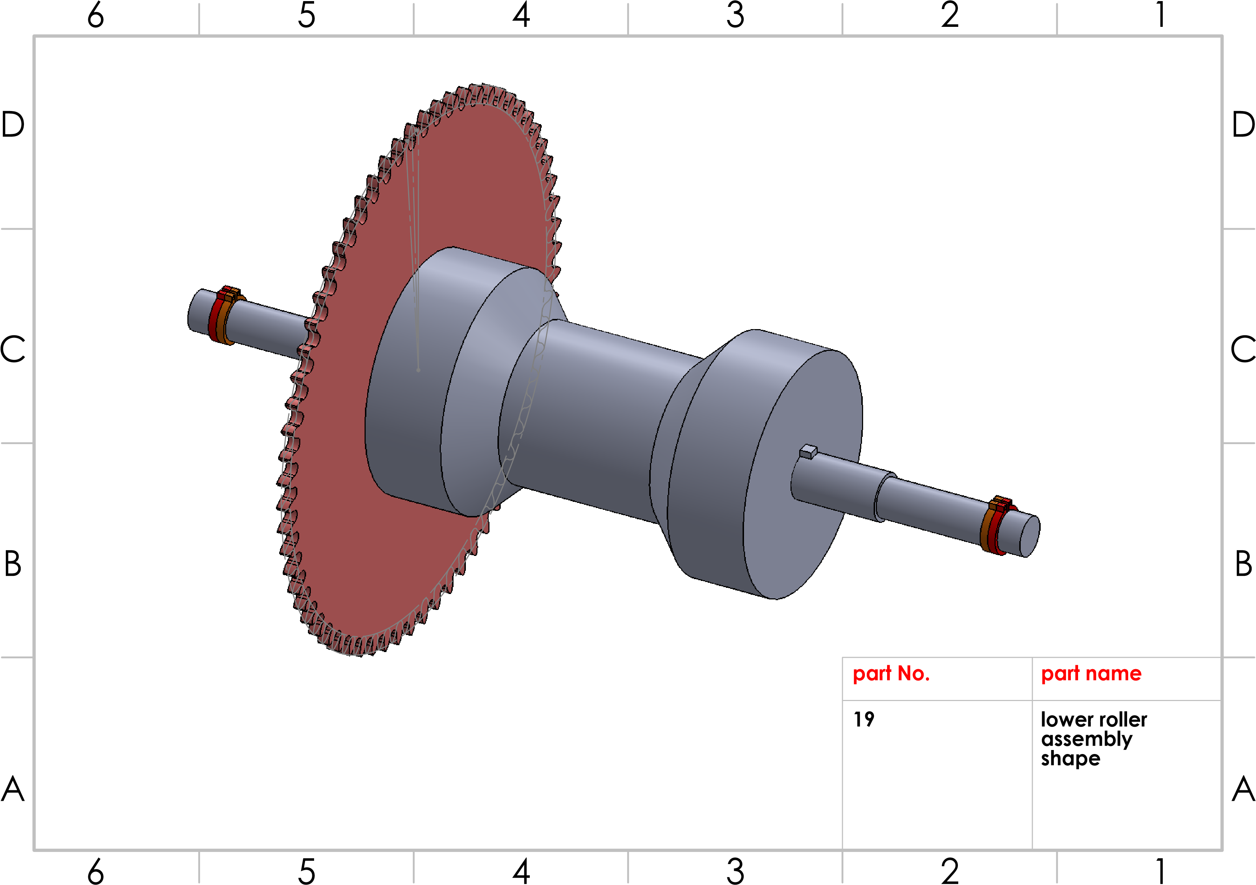

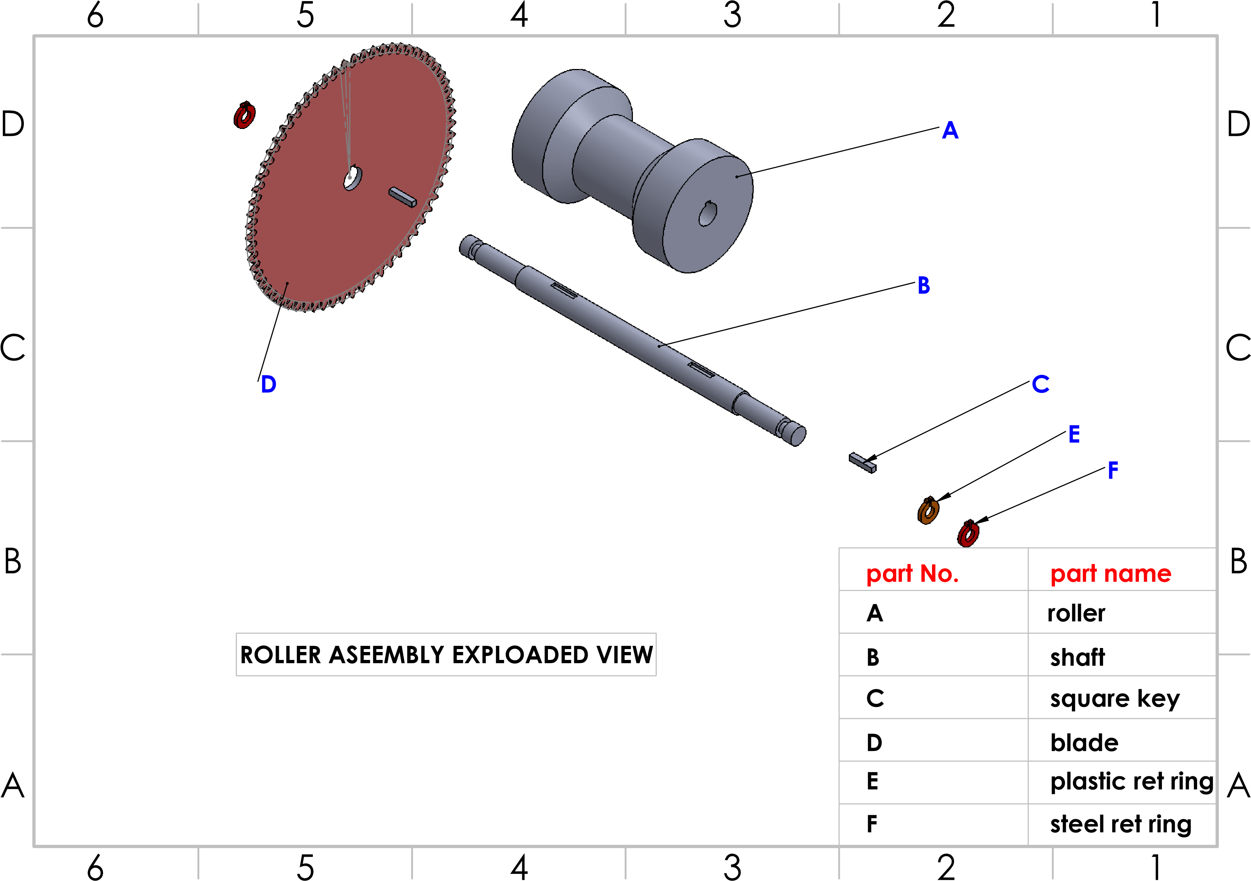

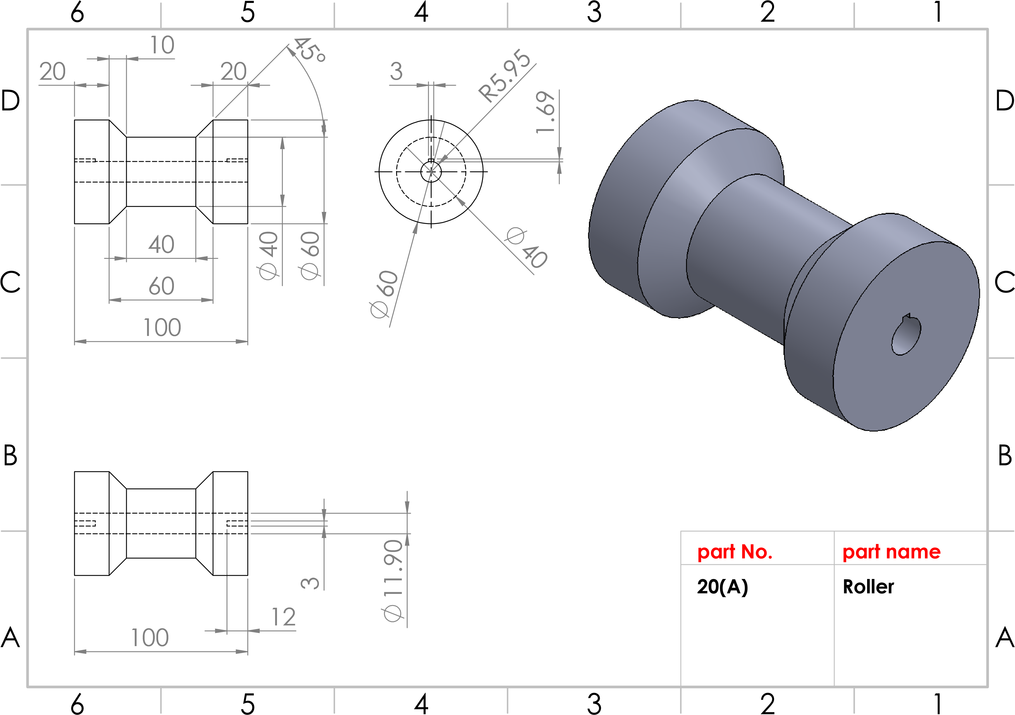
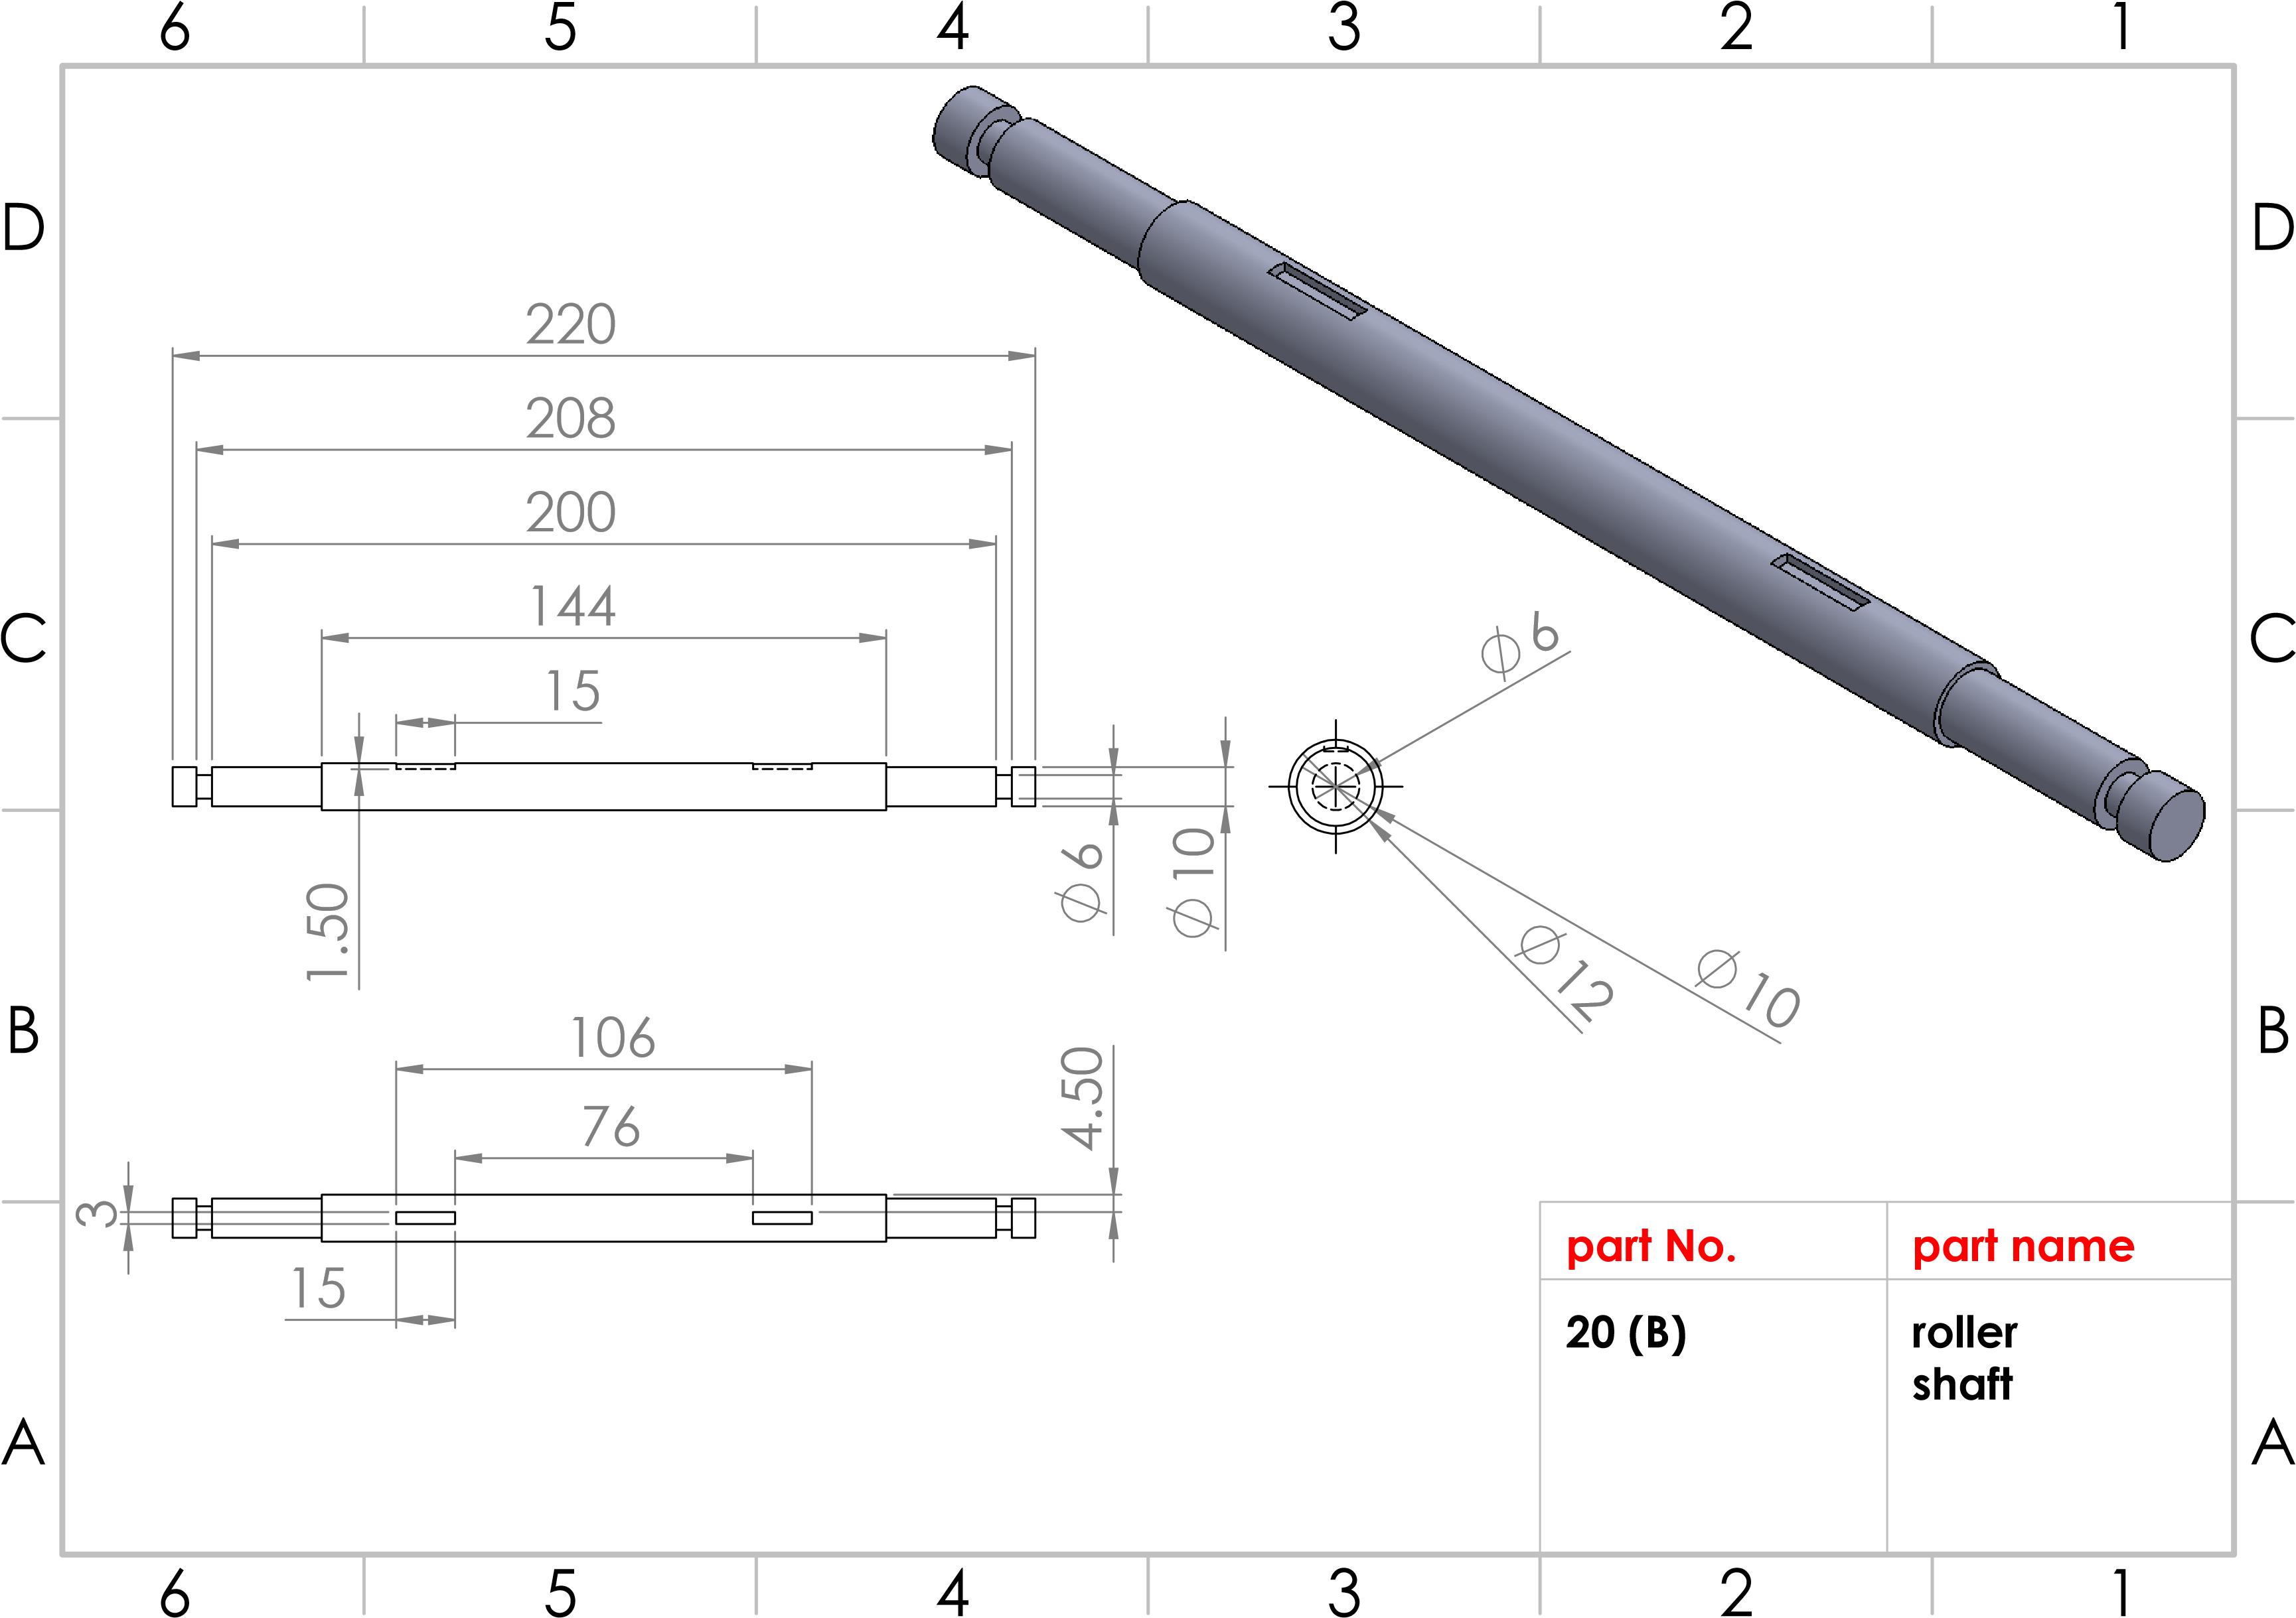
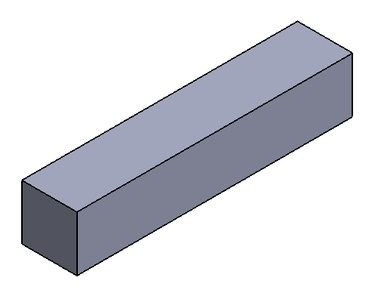
3
3
15
3
15
3
A
A
B
B
C
C
D
D
6
6
5
5
4
4
3
3
2
2
1
1
Part No.
)
20
(C
art name
P
quare key
s
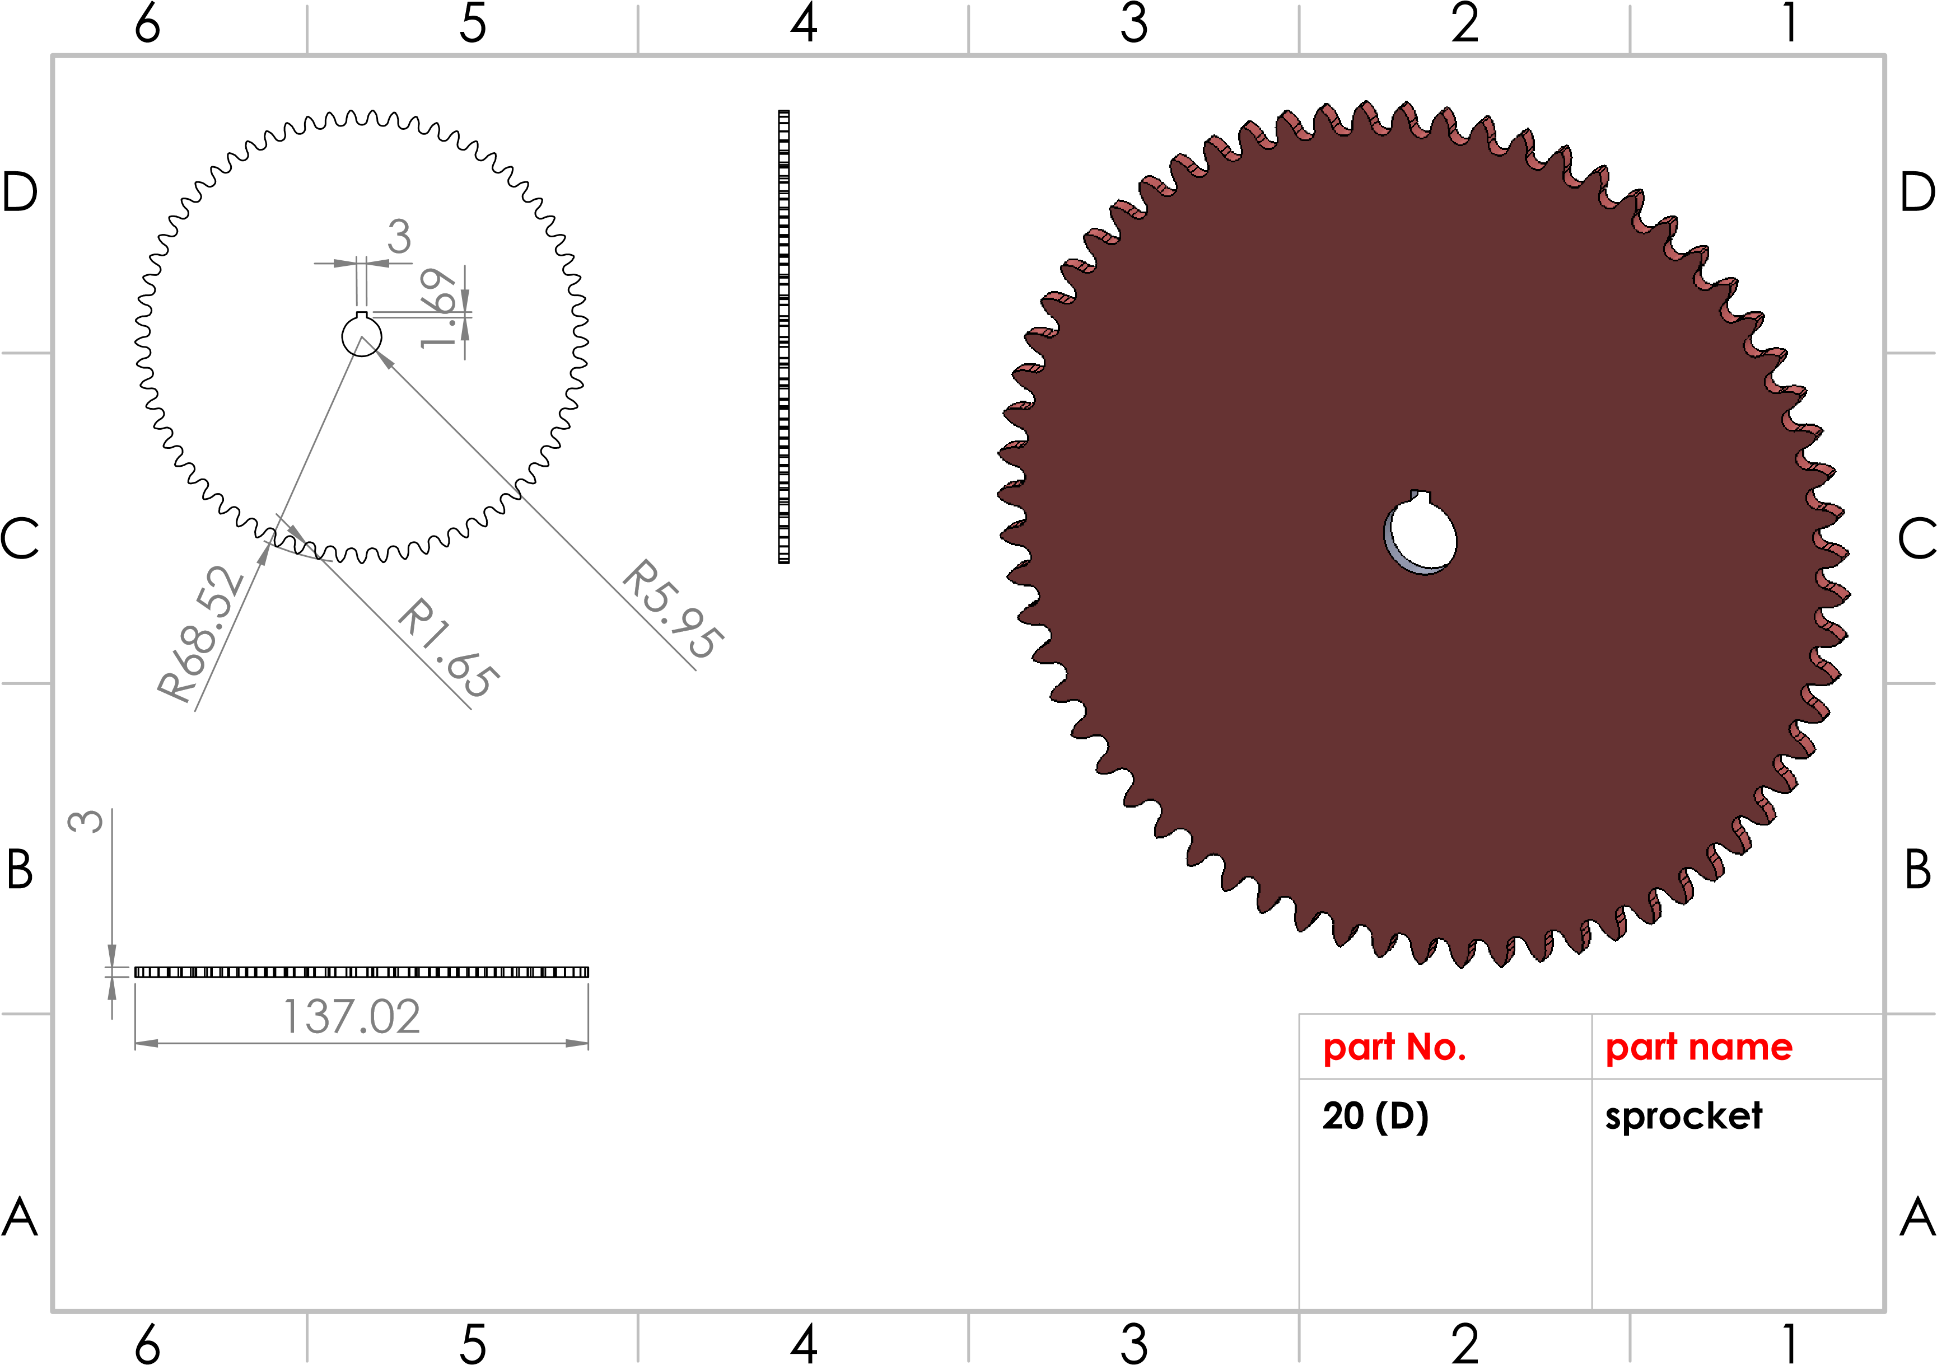
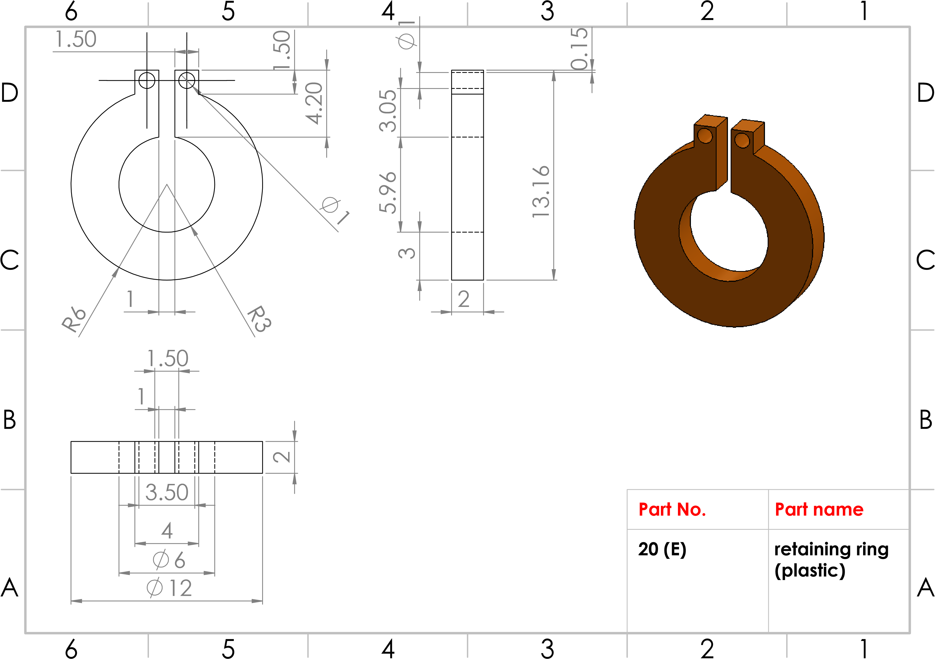
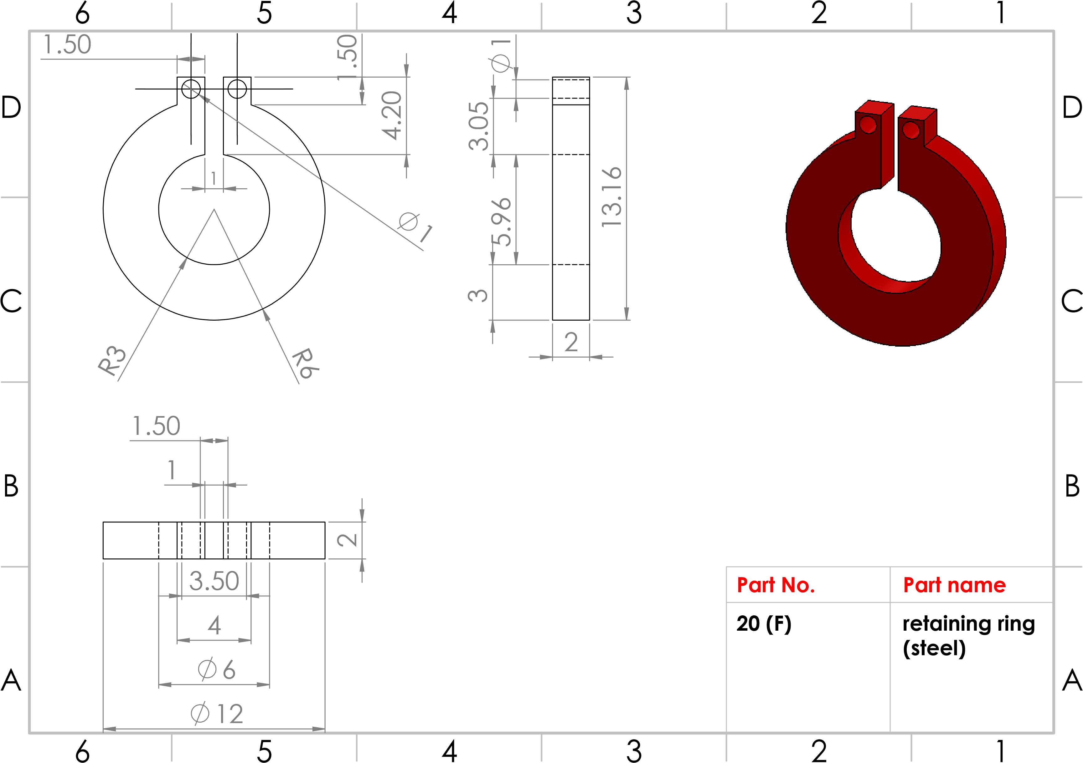
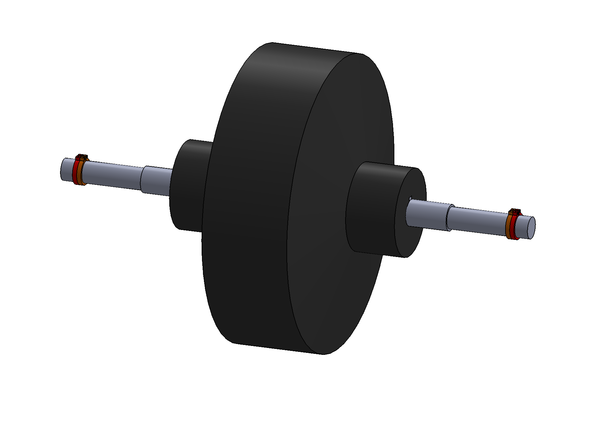
A
A
B
B
C
C
D
D
6
6
5
5
4
4
3
3
2
2
1
1
Part No.
21
Part name
upper
oller assembly
r
shape
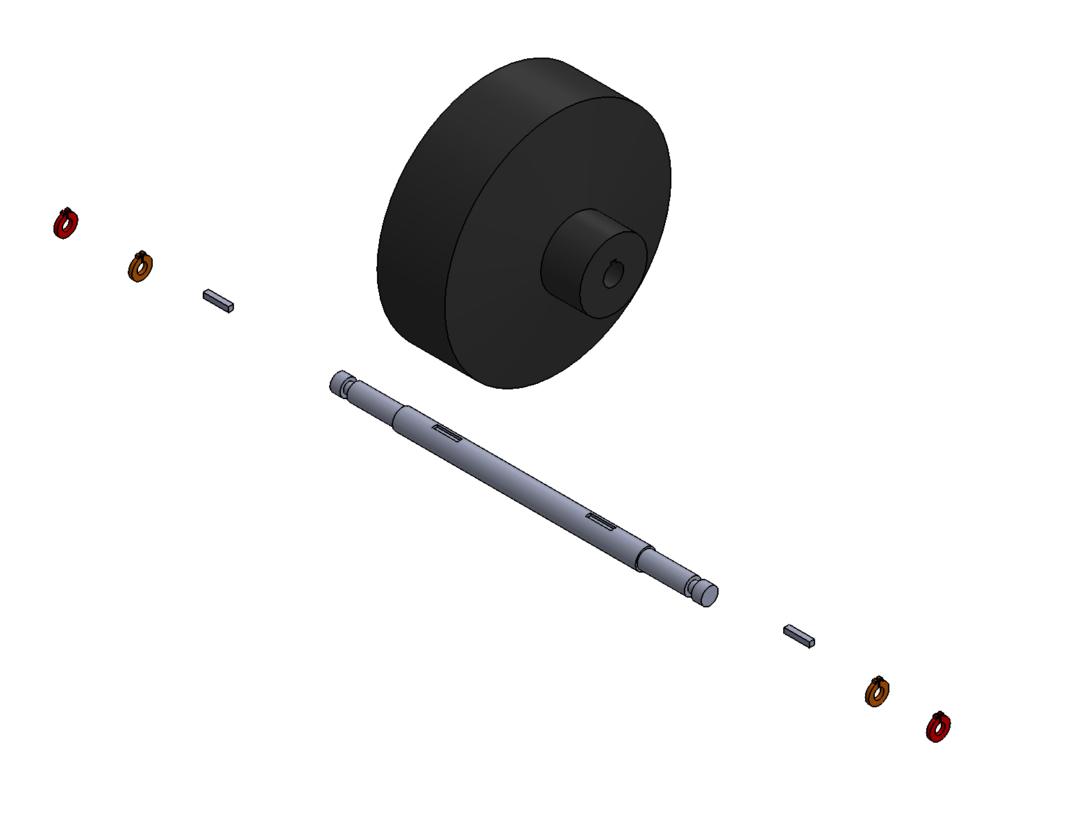
A
B
C
D
E
A
A
B
B
C
C
D
D
6
6
5
5
4
4
3
3
2
2
1
1
part No.
A
B
C
D
E
part name
oller
R
s
haft
s
quare key
et ring plastic
r
r
et ring steel
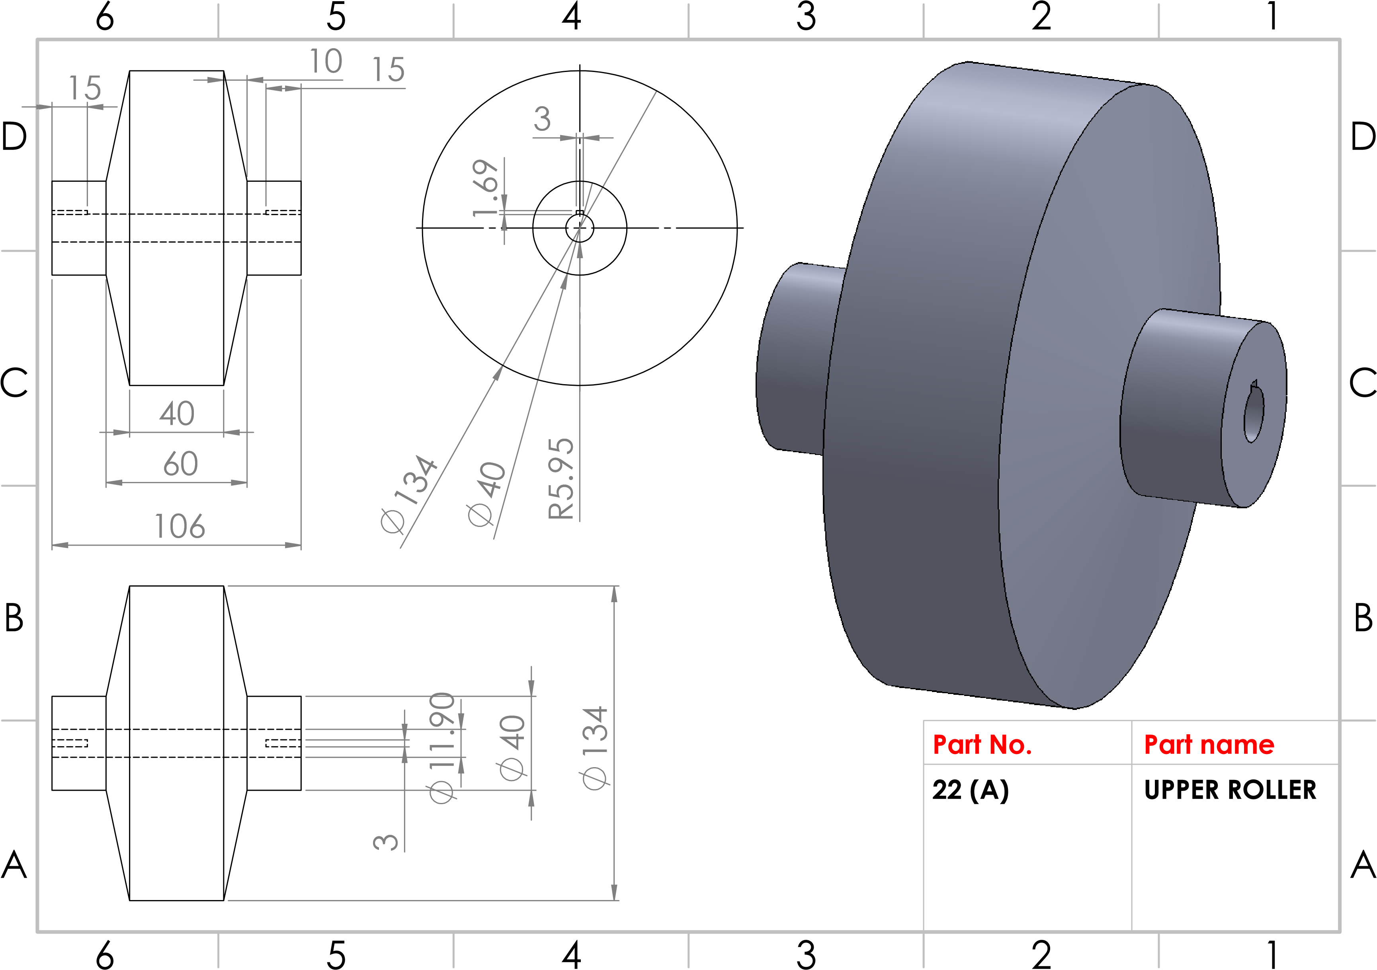

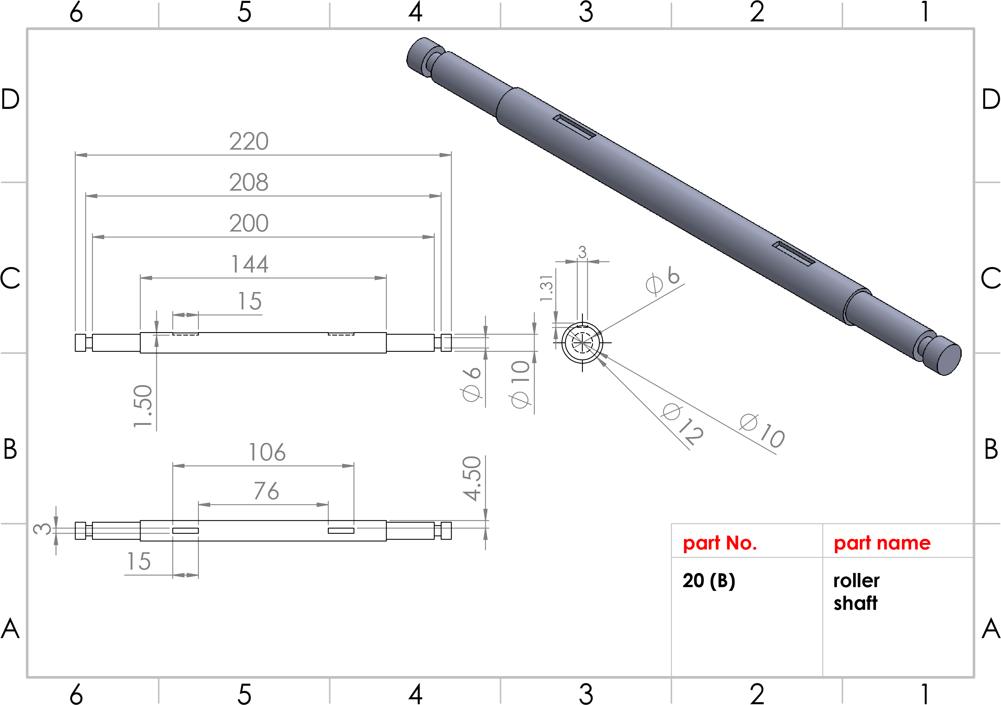

3
3
15
3
15
3
A
A
B
B
C
C
D
D
6
6
5
5
4
4
3
3
2
2
1
1
Part No.
)
20
(C
art name
P
quare key
s
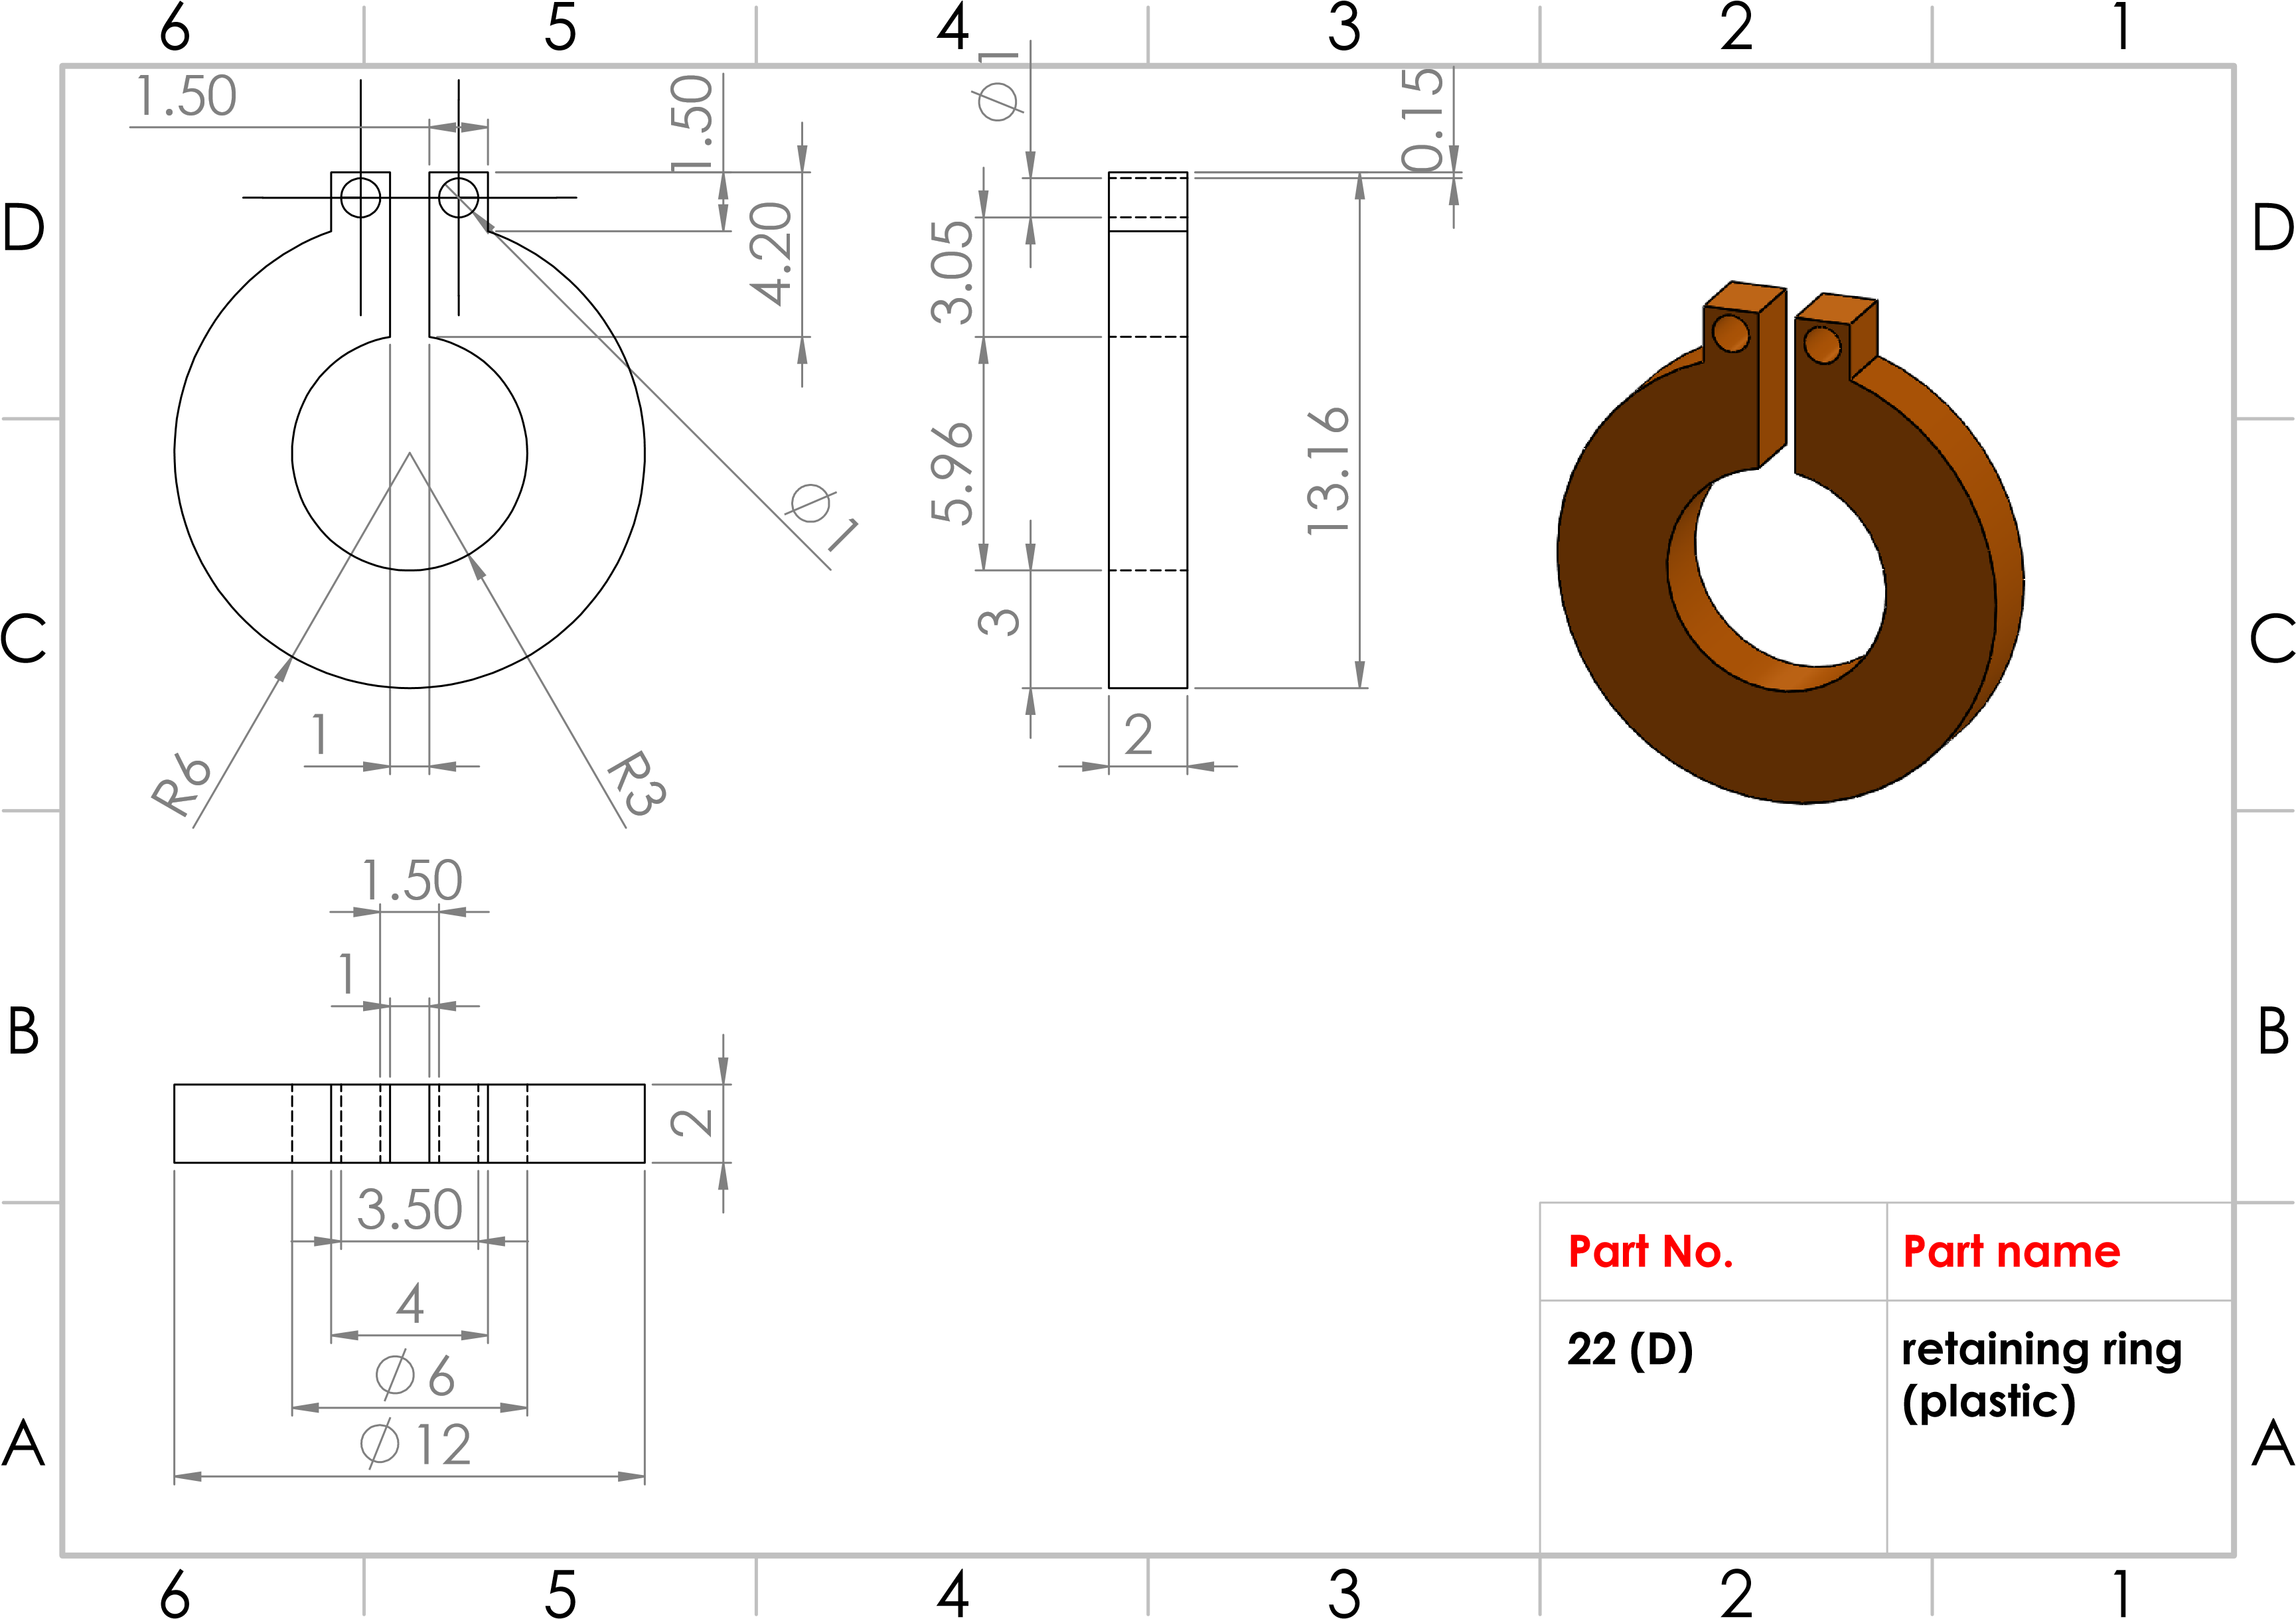
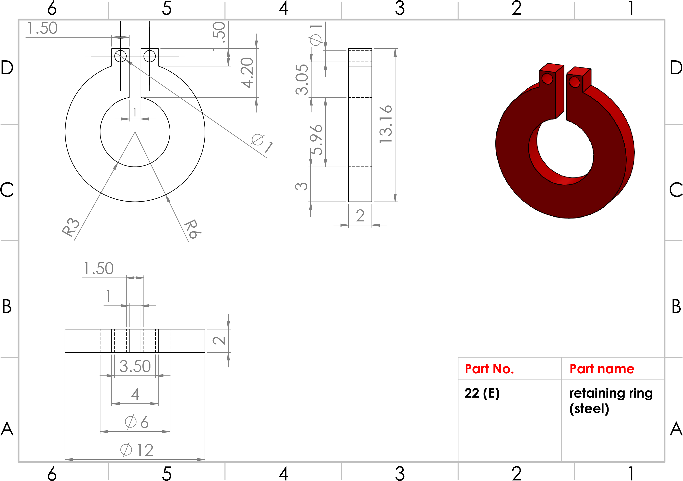
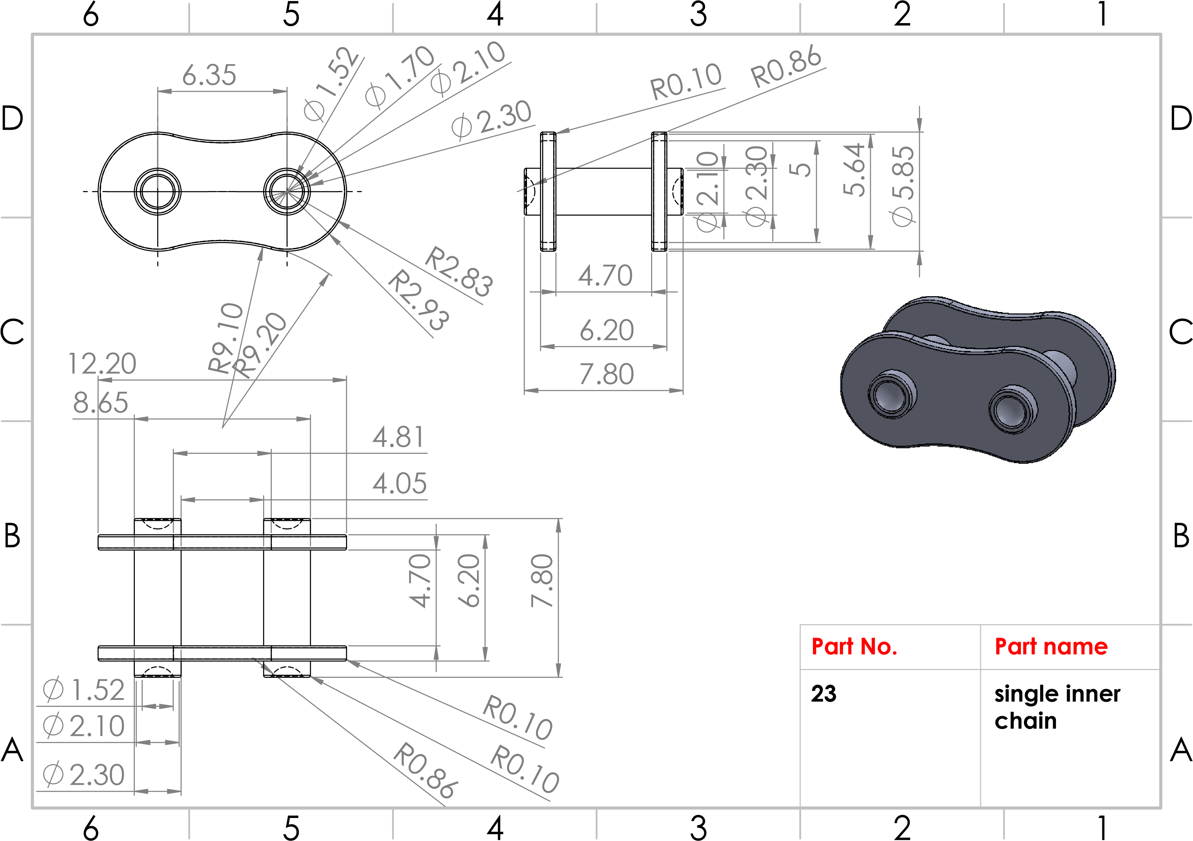
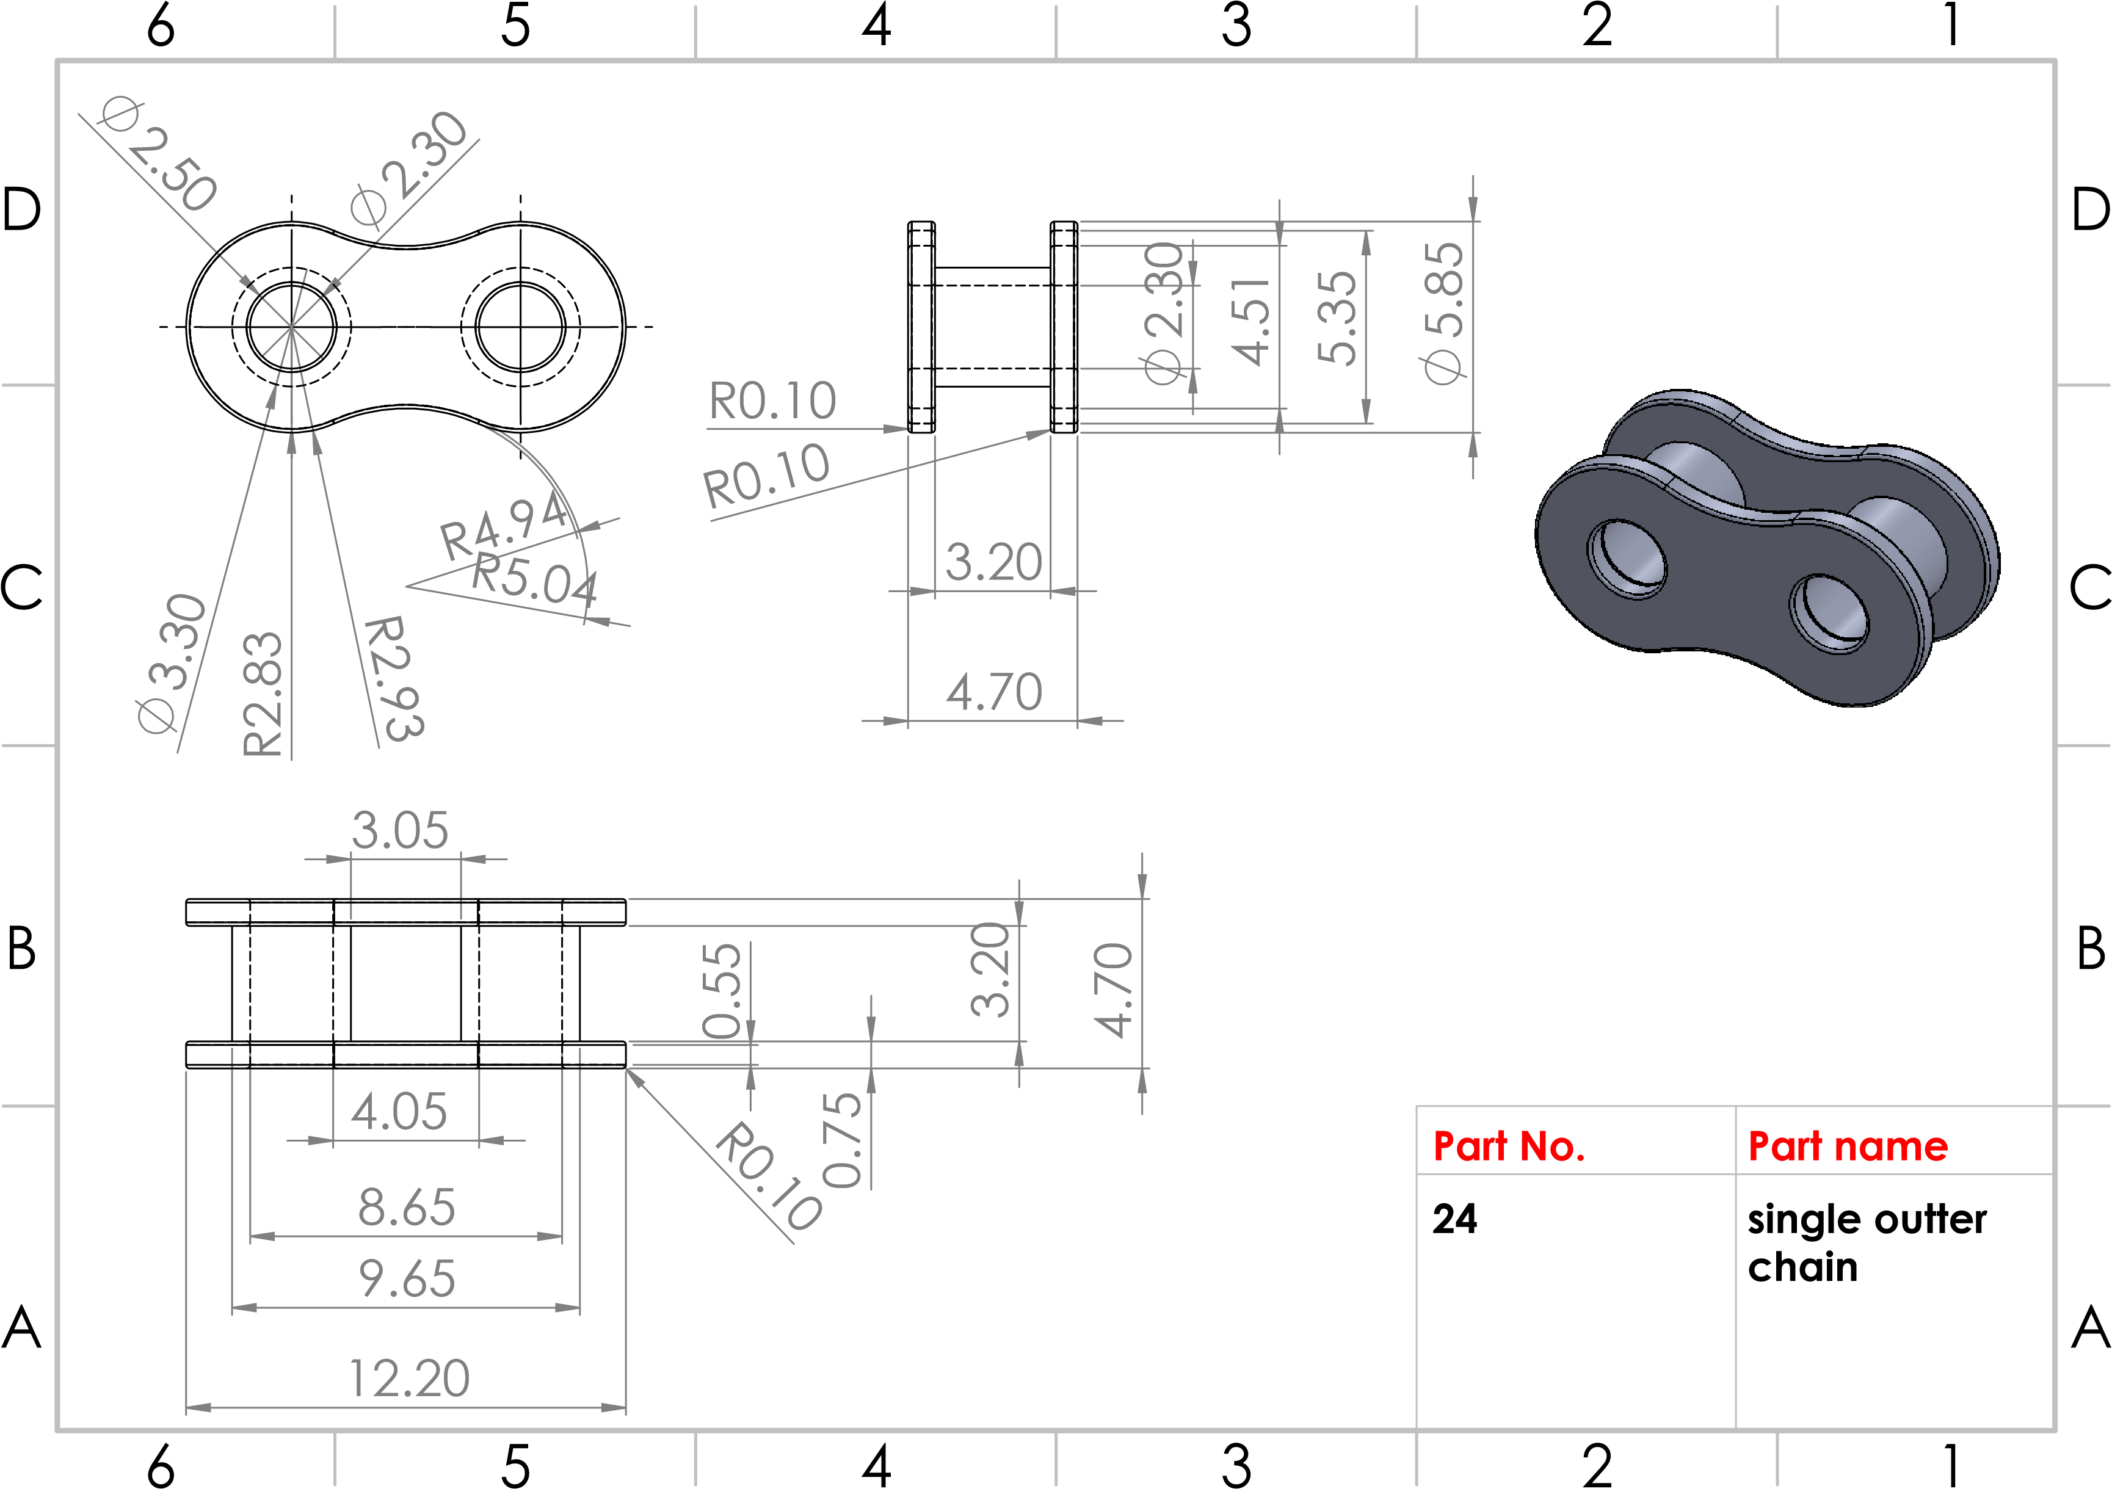
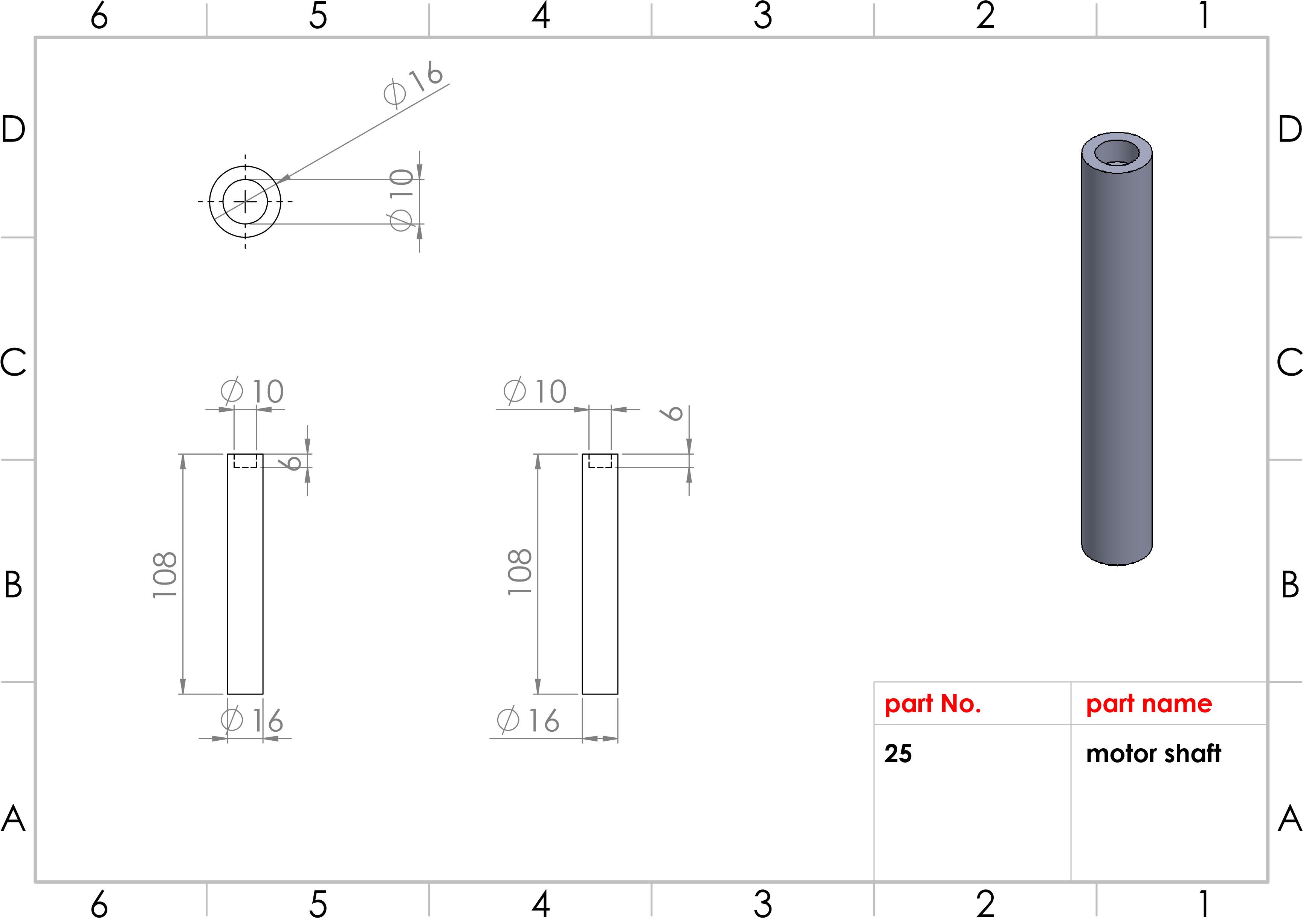
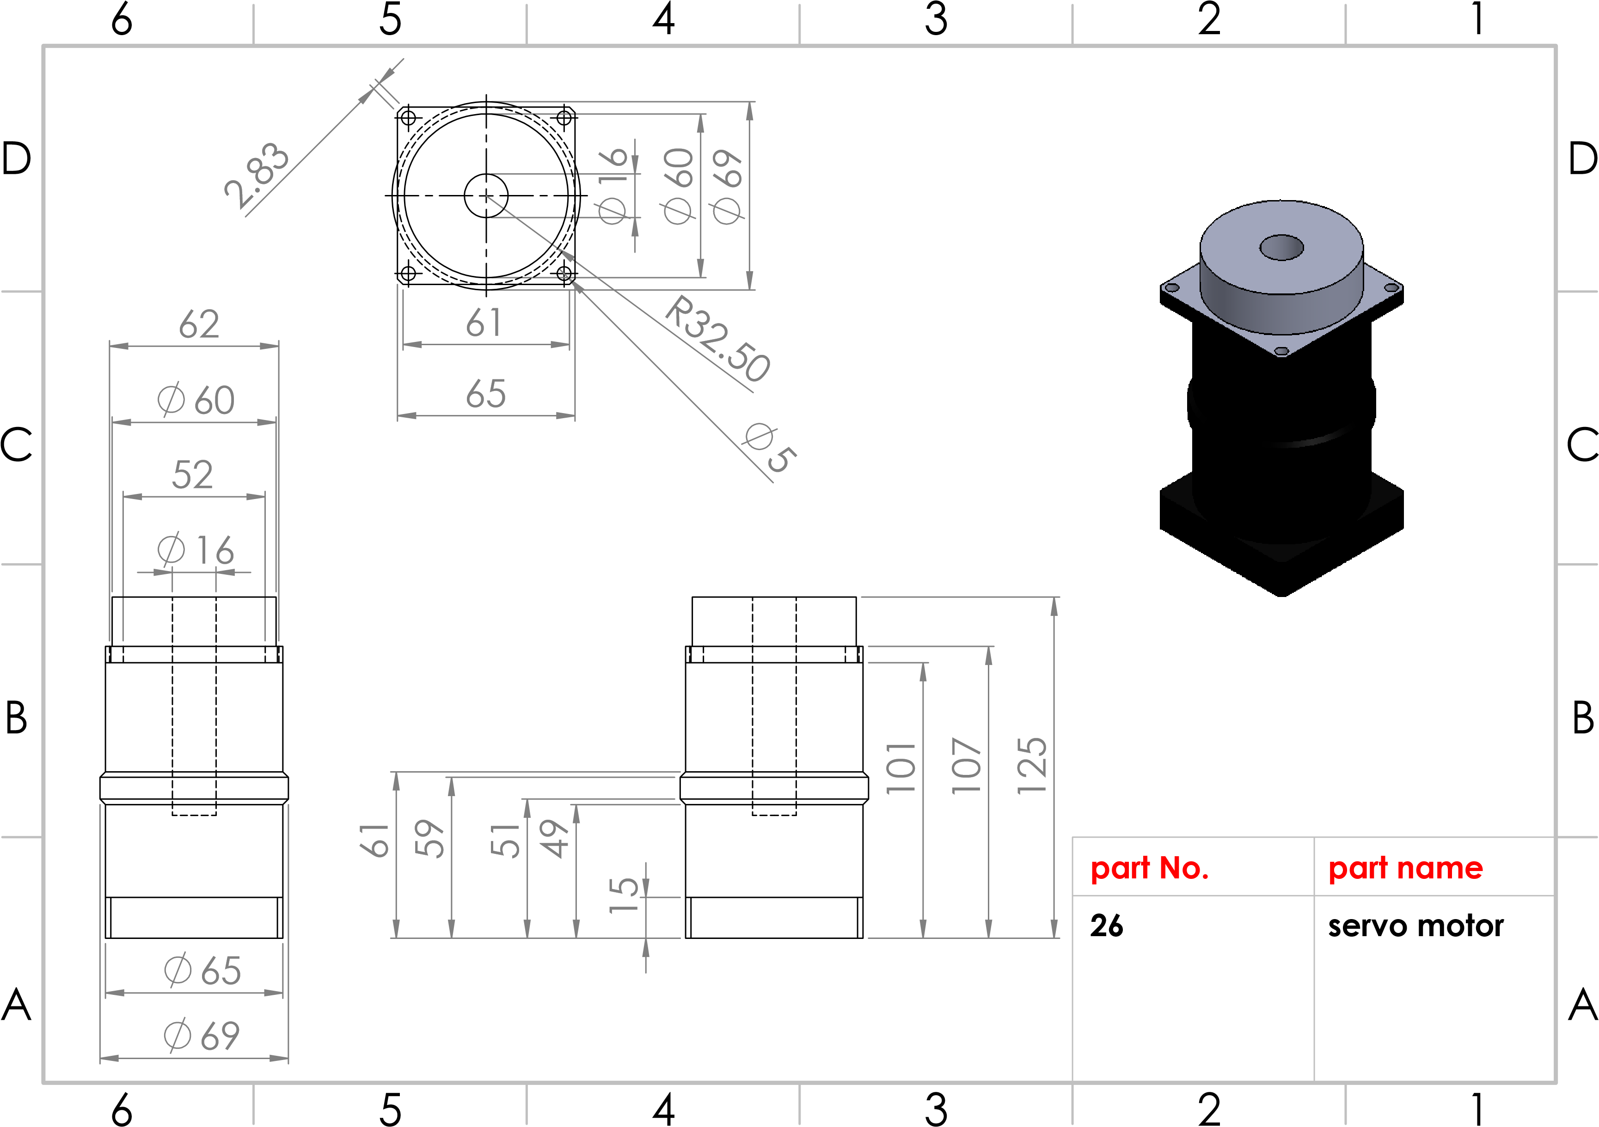

Production line
Station No. (3)
Cold saw

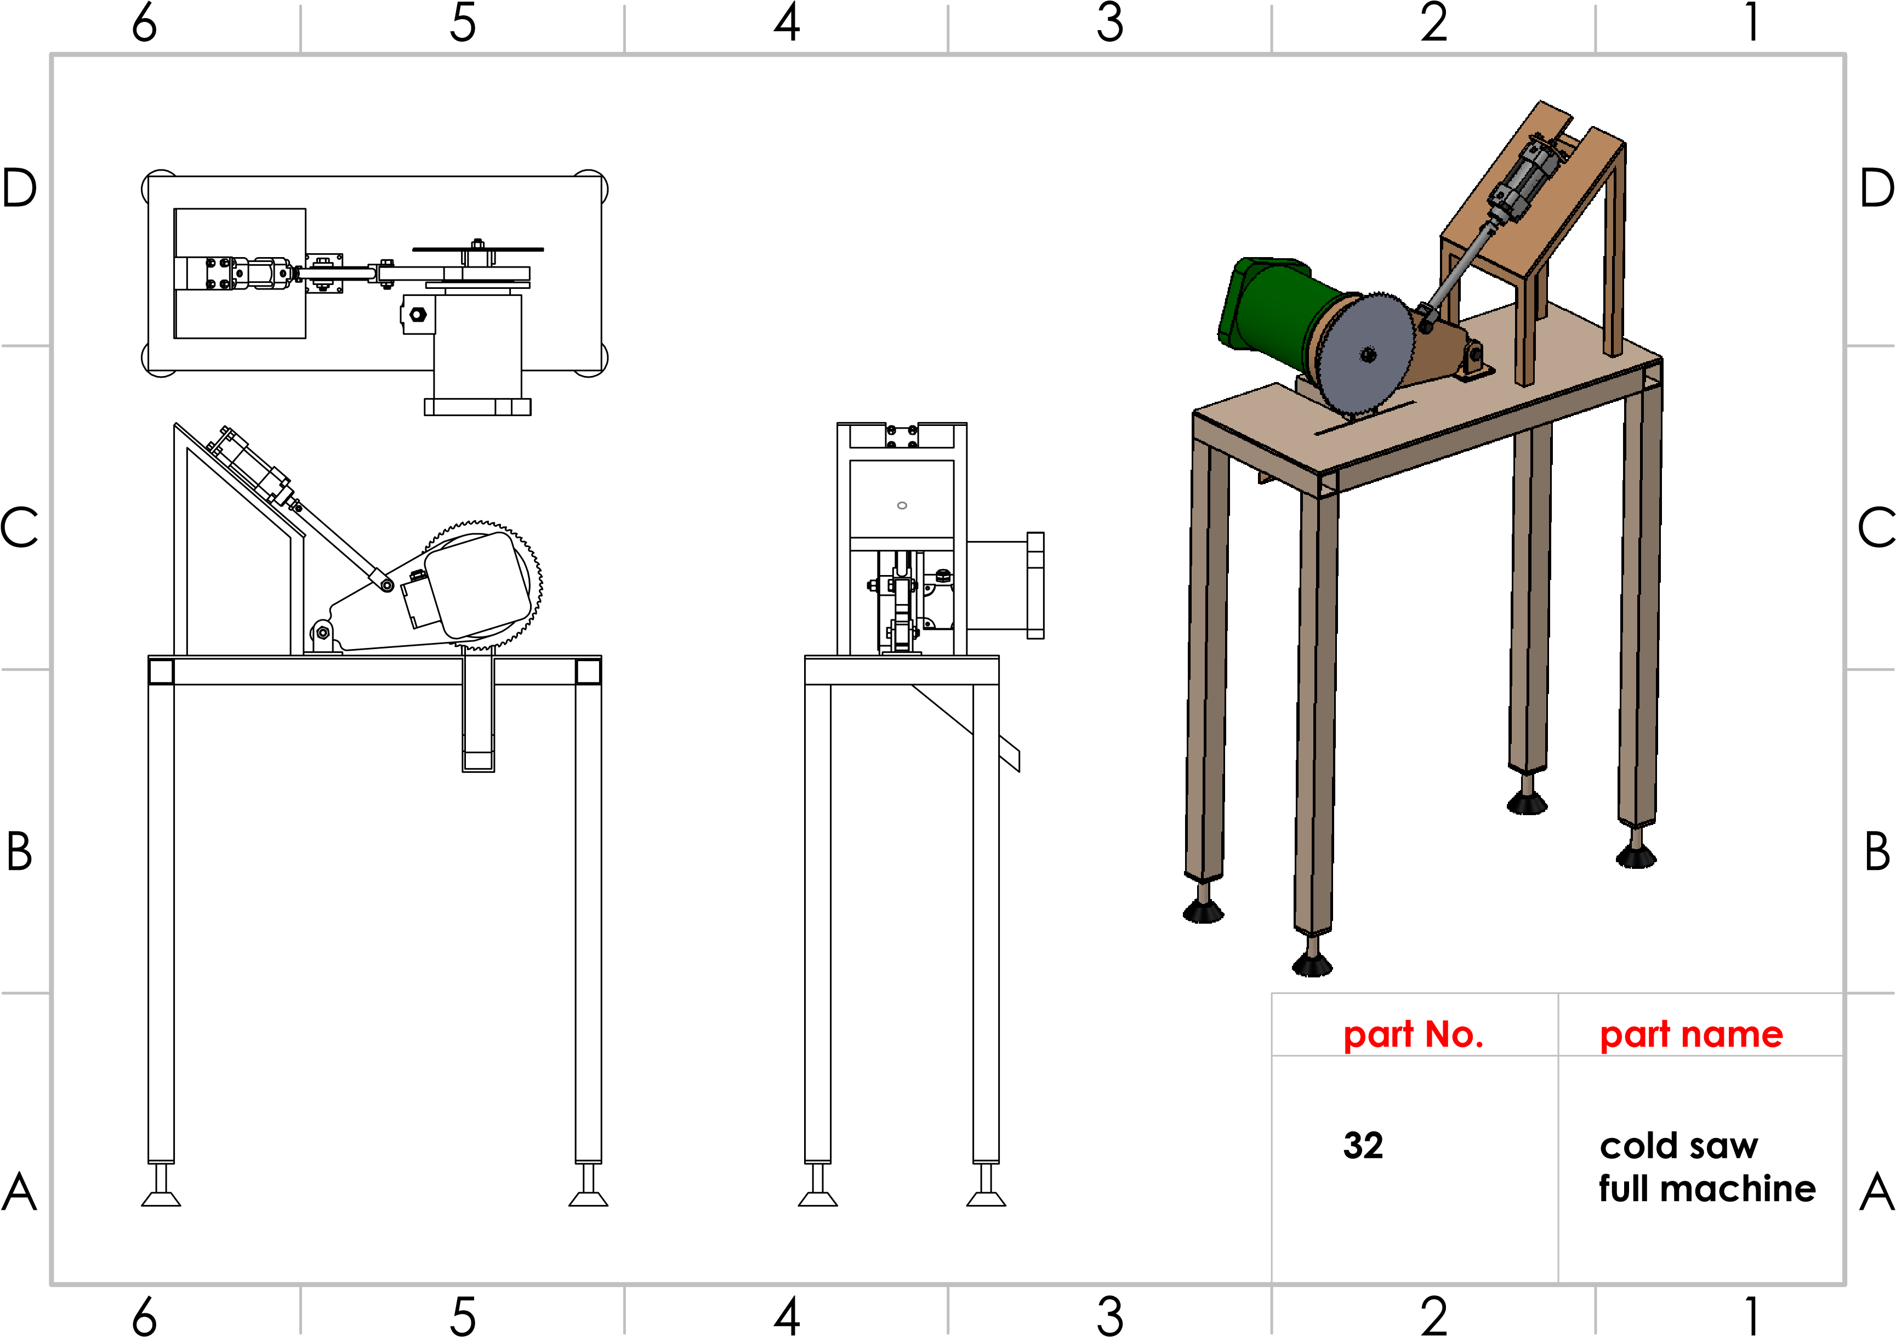

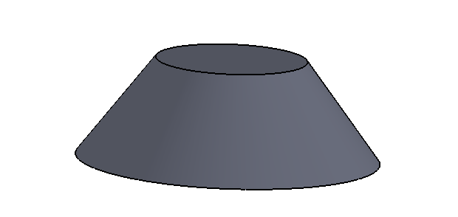
60
30
60
60
25
30
°
53.13
20
A
A
B
B
C
C
D
D
6
6
5
5
4
4
3
3
2
2
1
1
part NO.
part name
1
leg
base
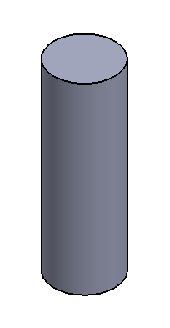
15
45
15
45
15
A
A
B
B
C
C
D
D
6
6
5
5
4
4
3
3
2
2
1
1
part No.
2
part name
Cylinder base
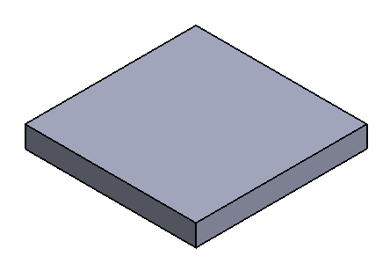
40
40
40
5
4
0
5
A
A
B
B
C
C
D
D
6
6
5
5
4
4
3
3
2
2
1
1
part No.
3
end cap
part name
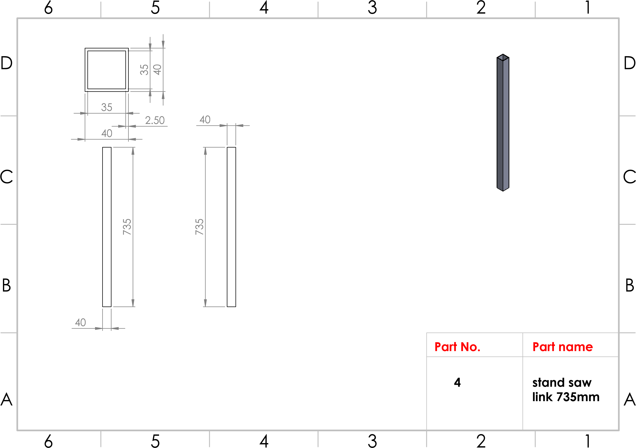
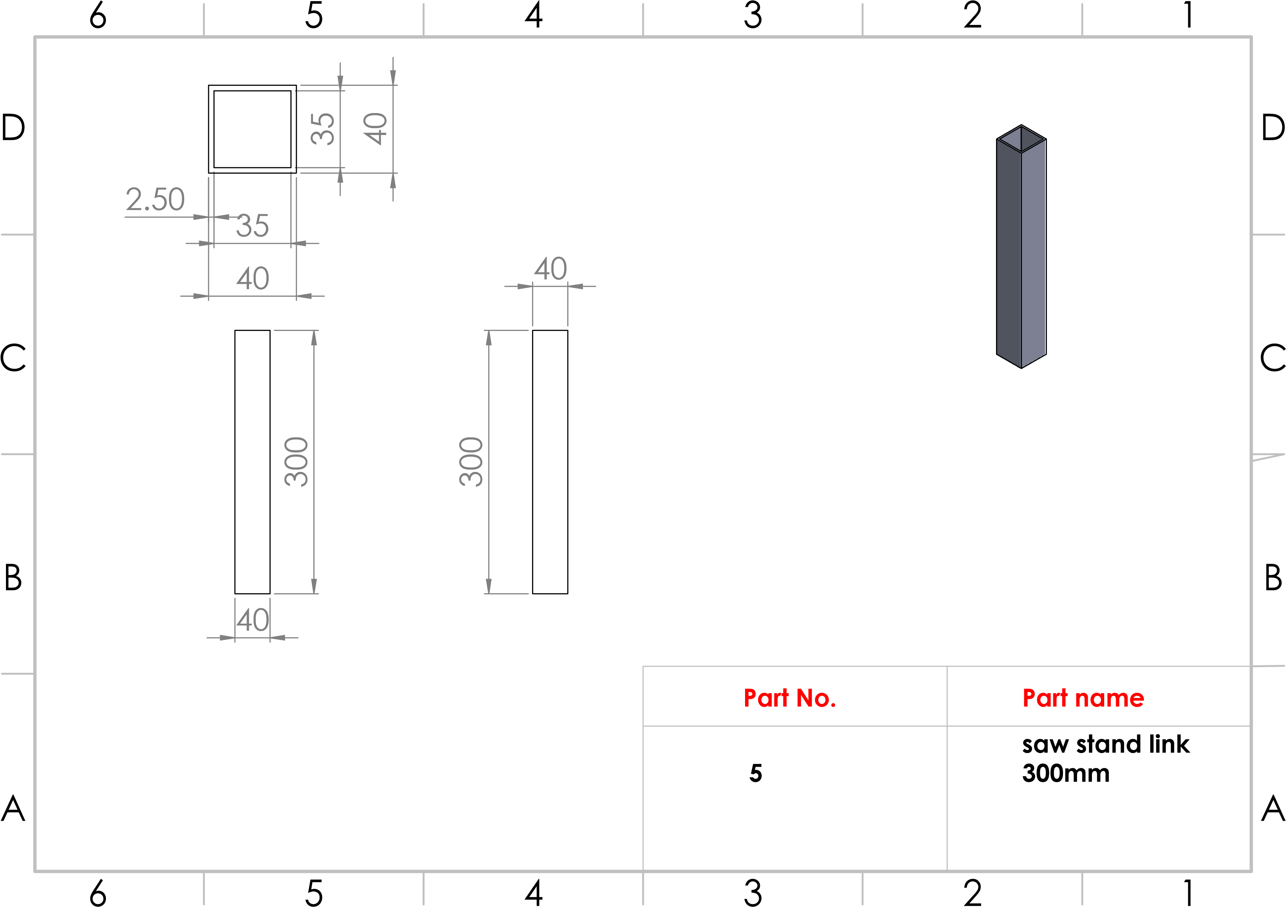
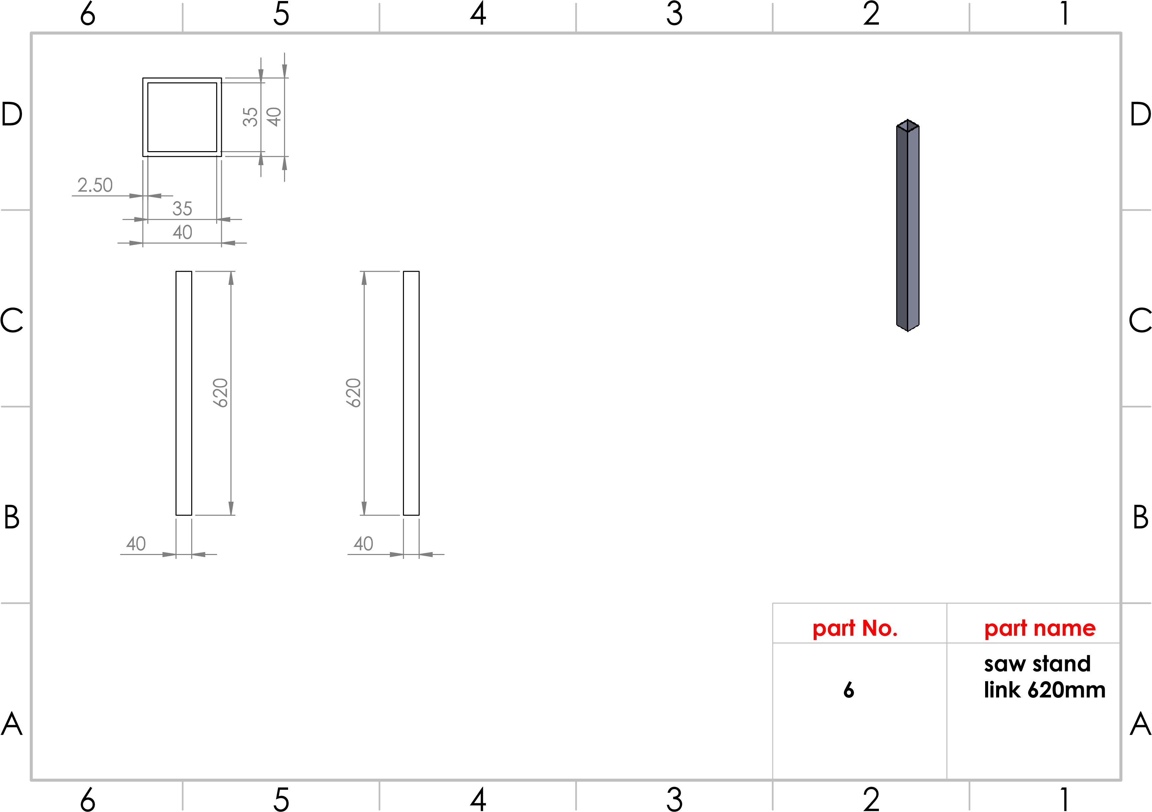
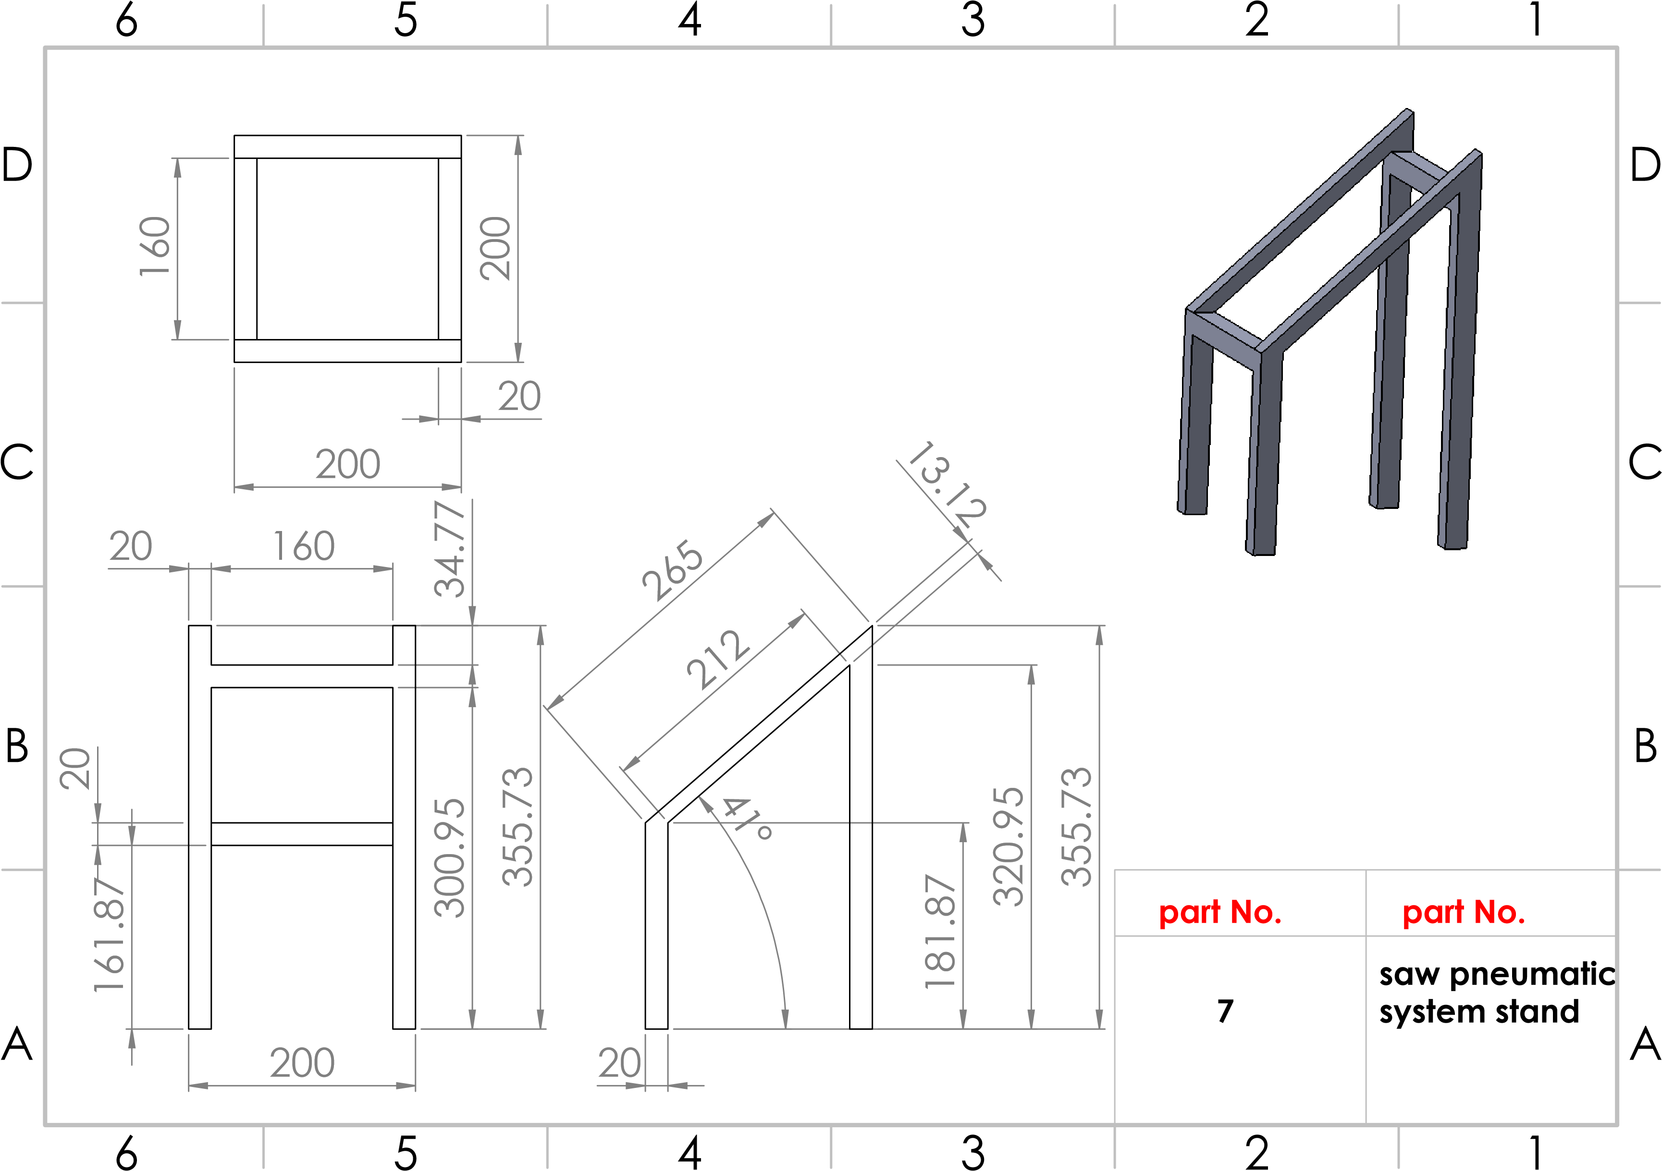
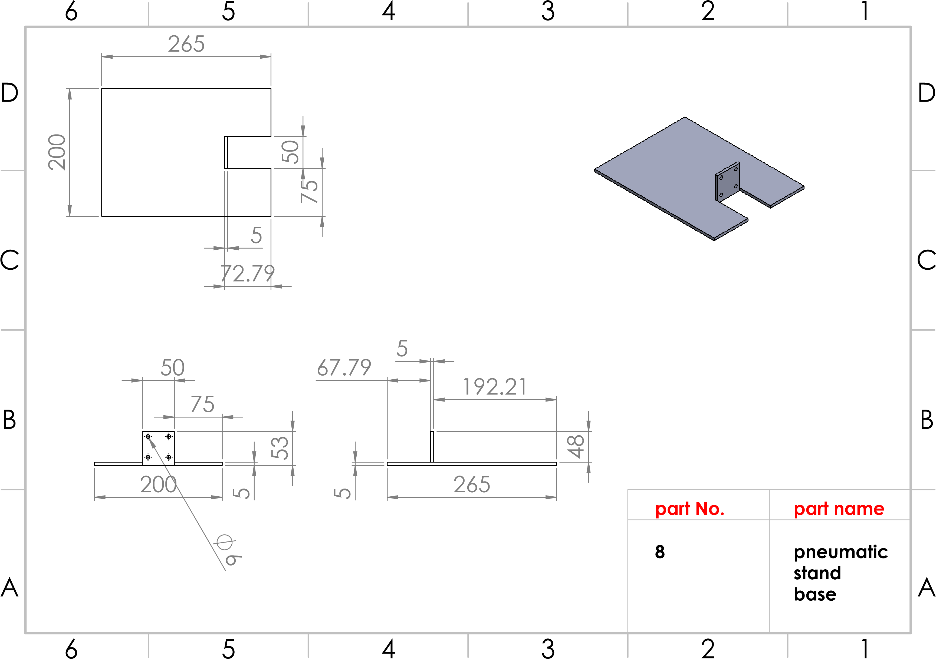
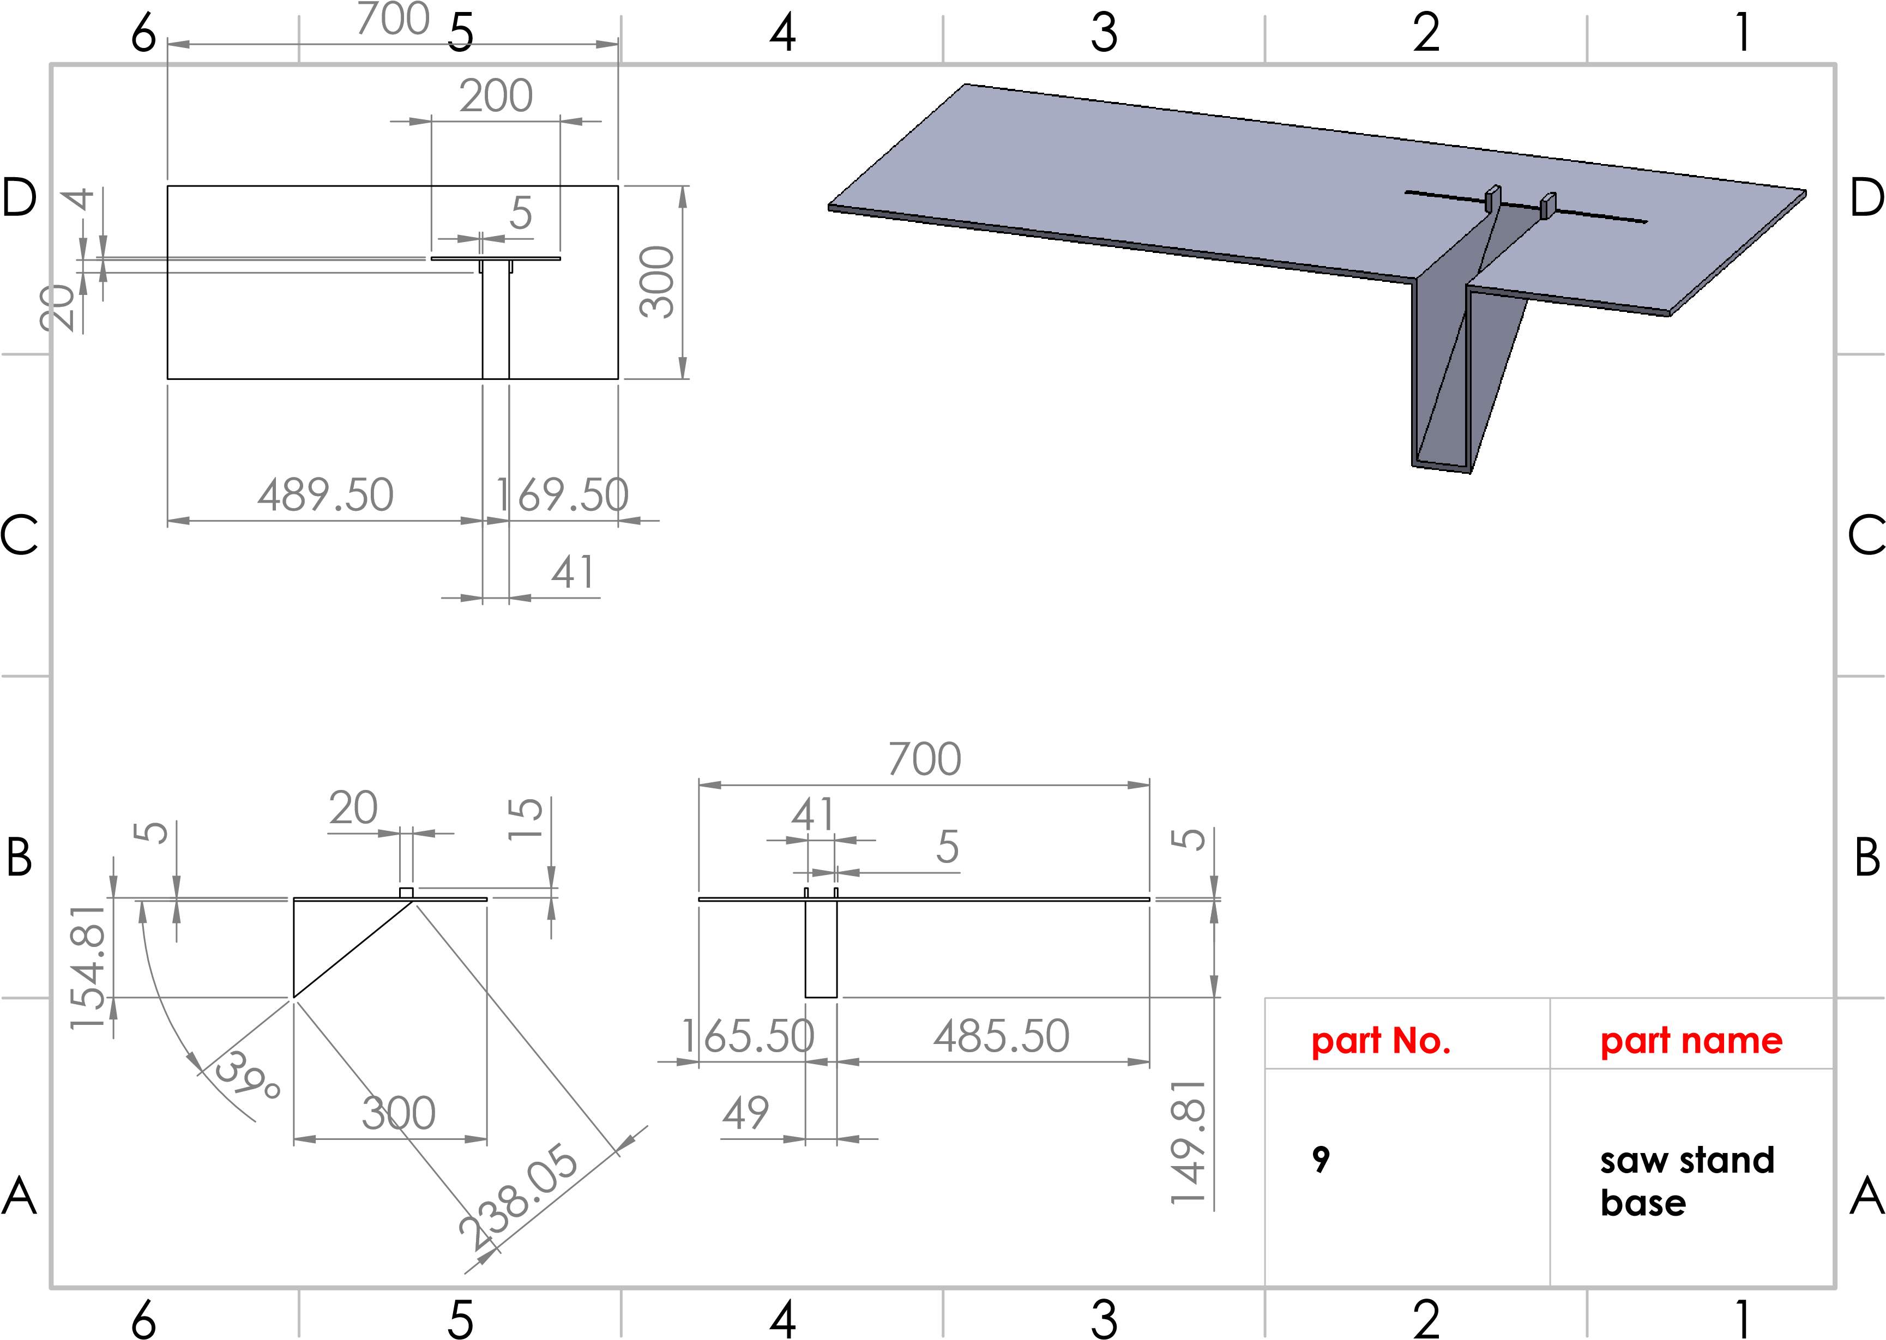
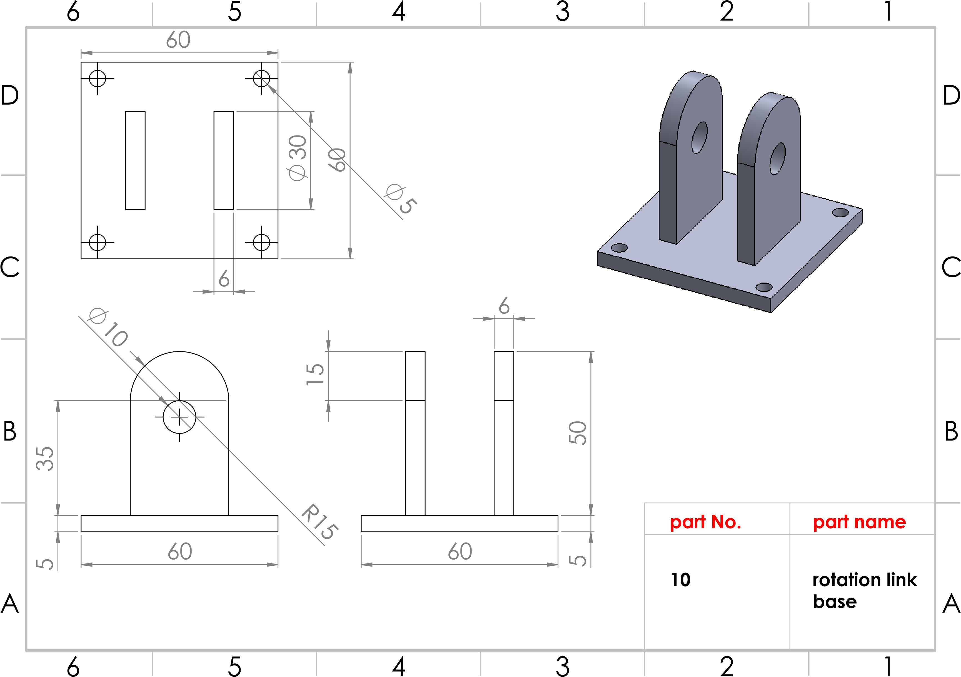
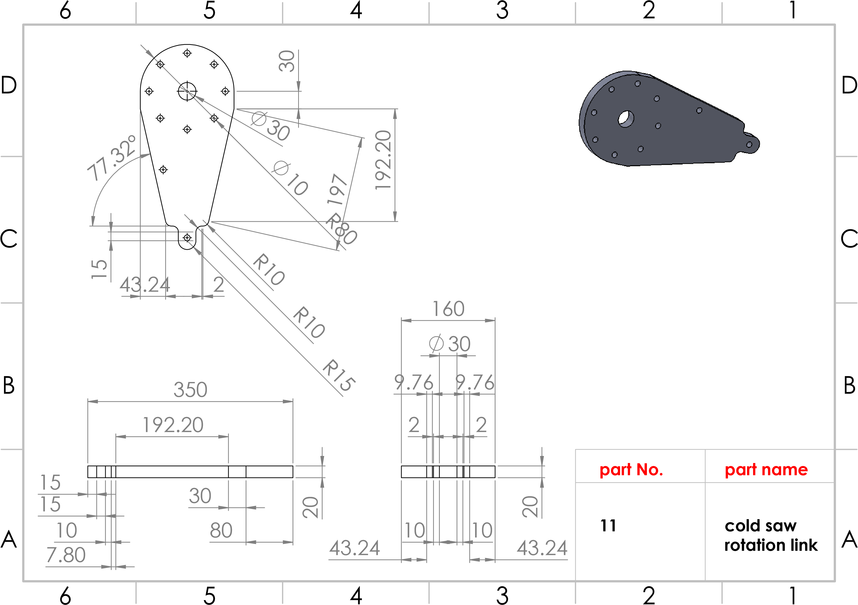
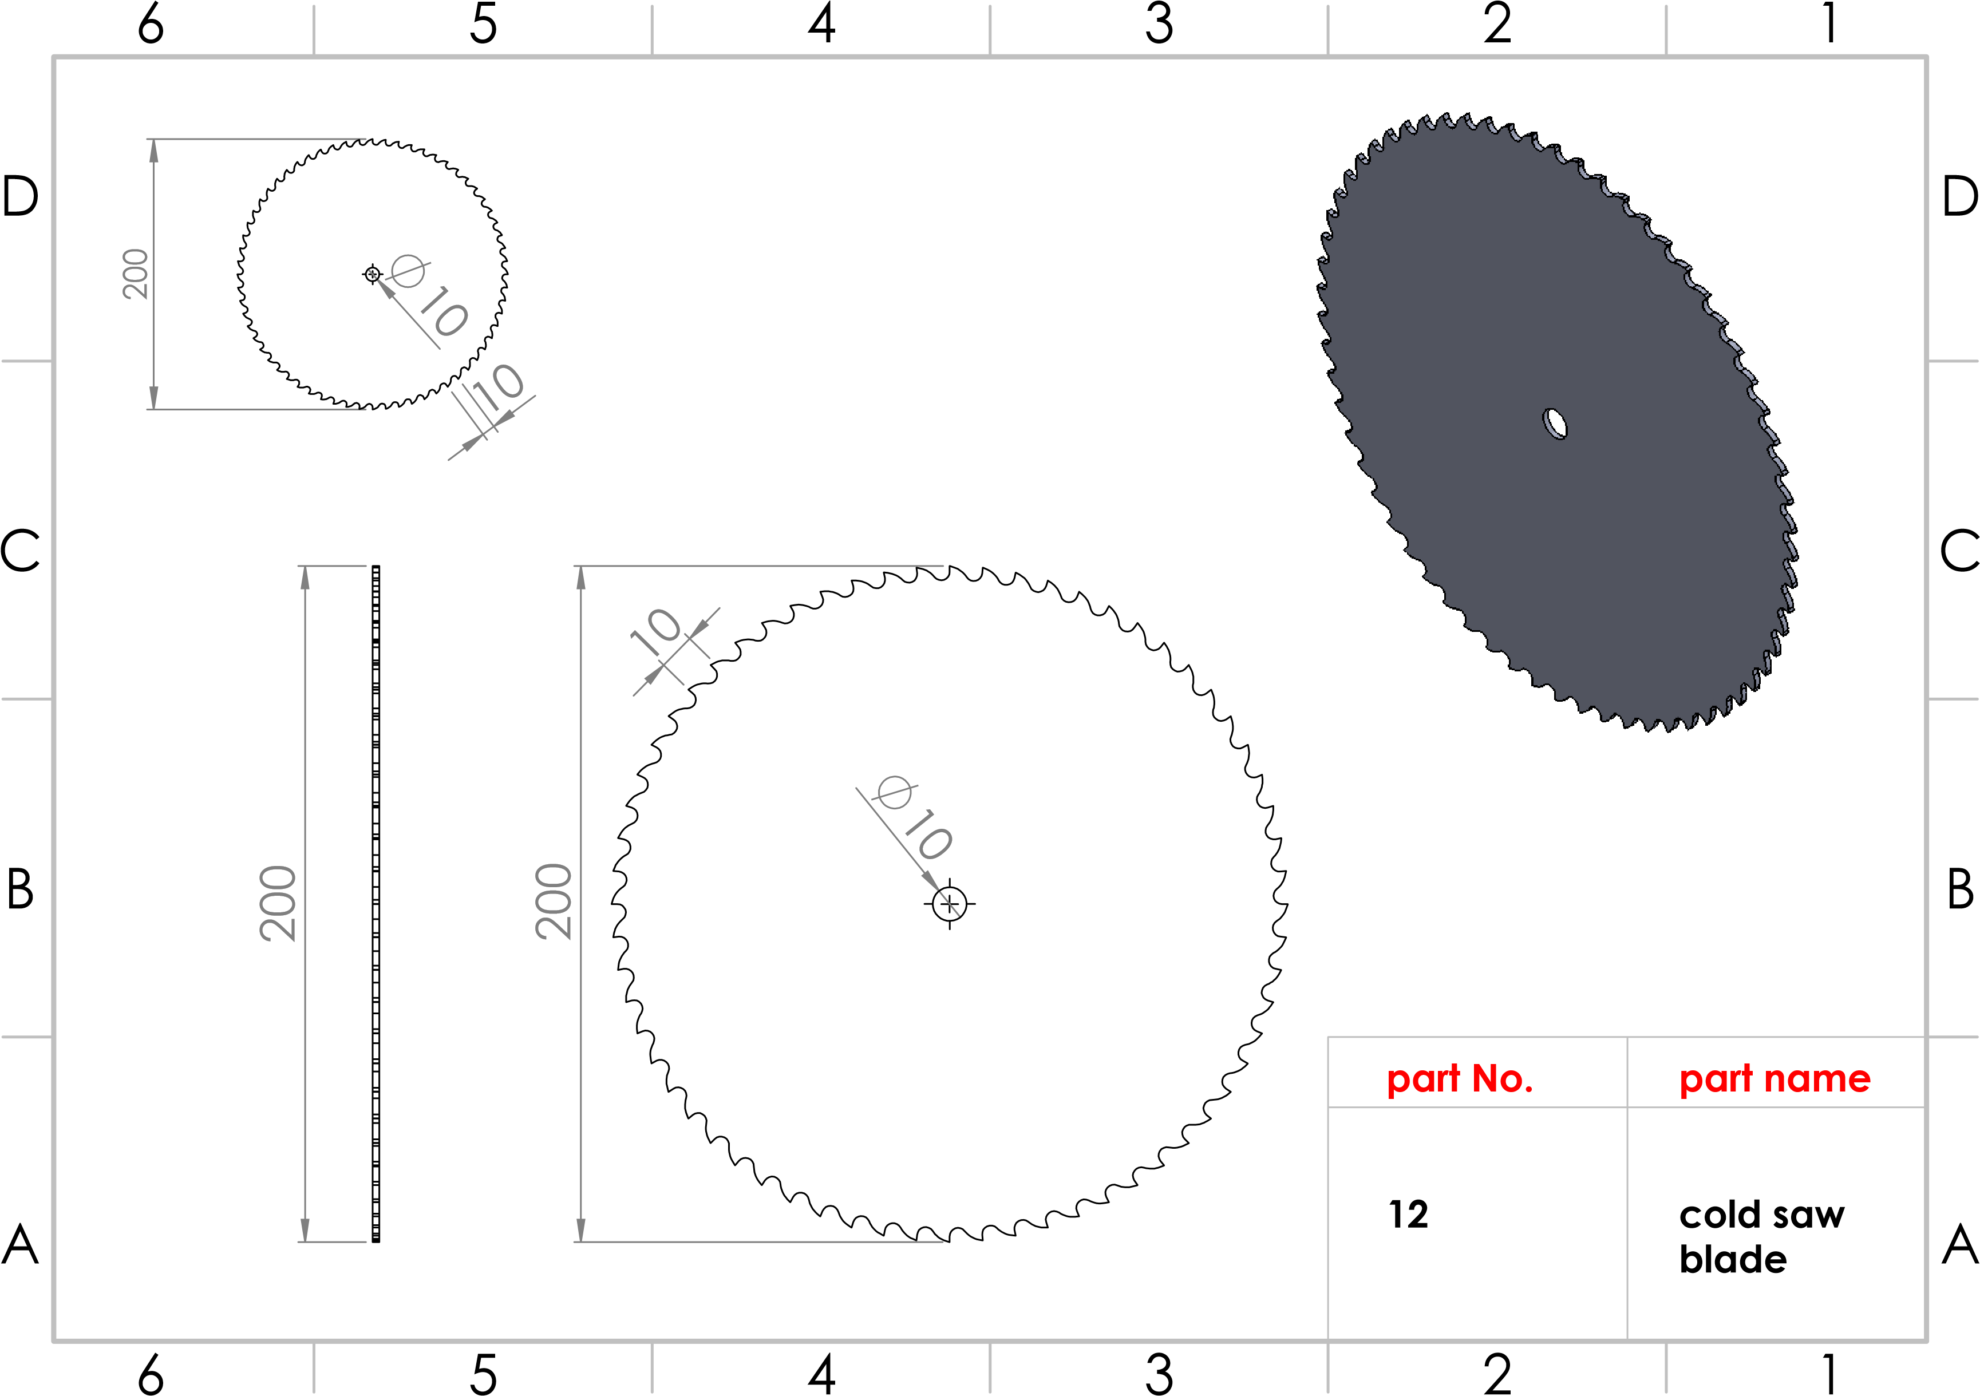
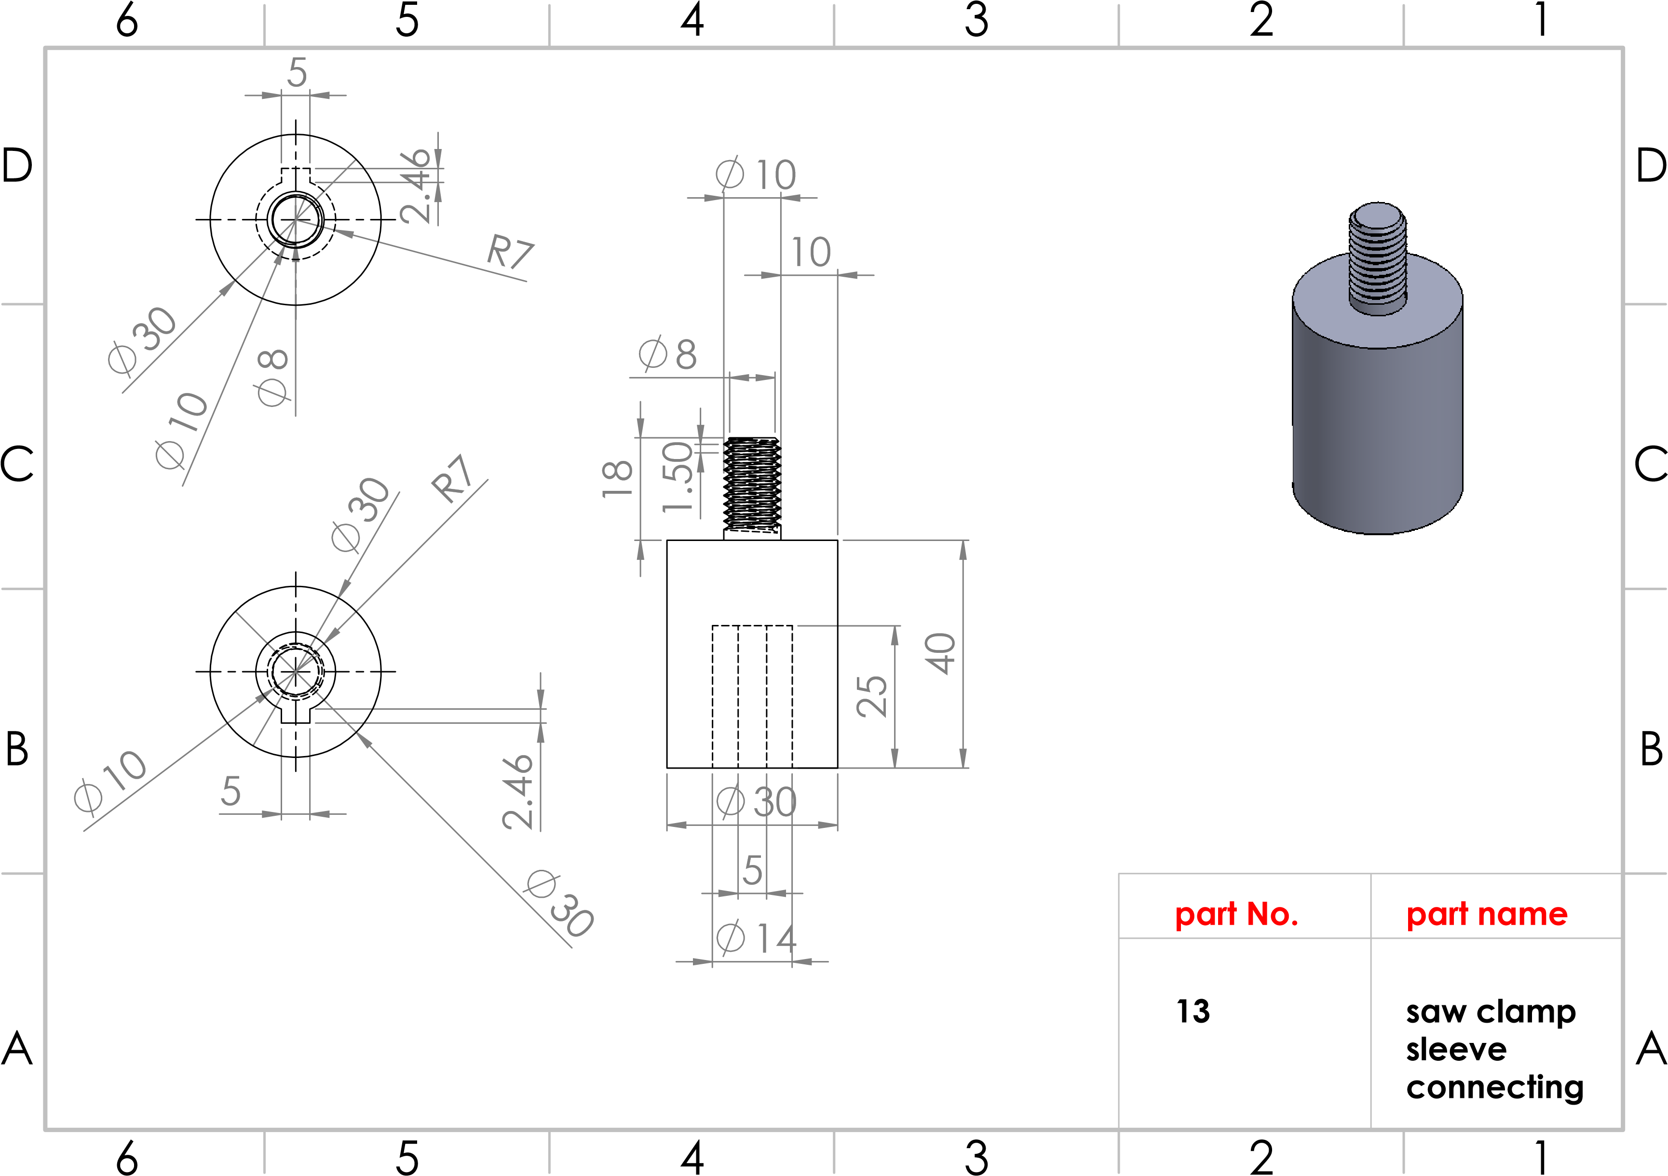
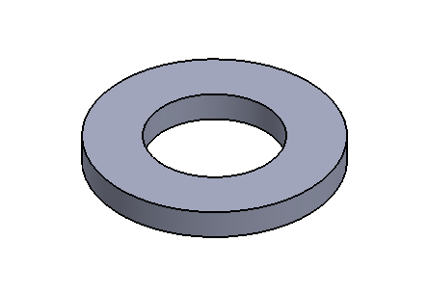
20
10.85
20
2.30
20
2.30
A
A
B
B
C
C
D
D
6
6
5
5
4
4
3
3
2
2
1
1
part No.
14
saw clamp
washer
part name
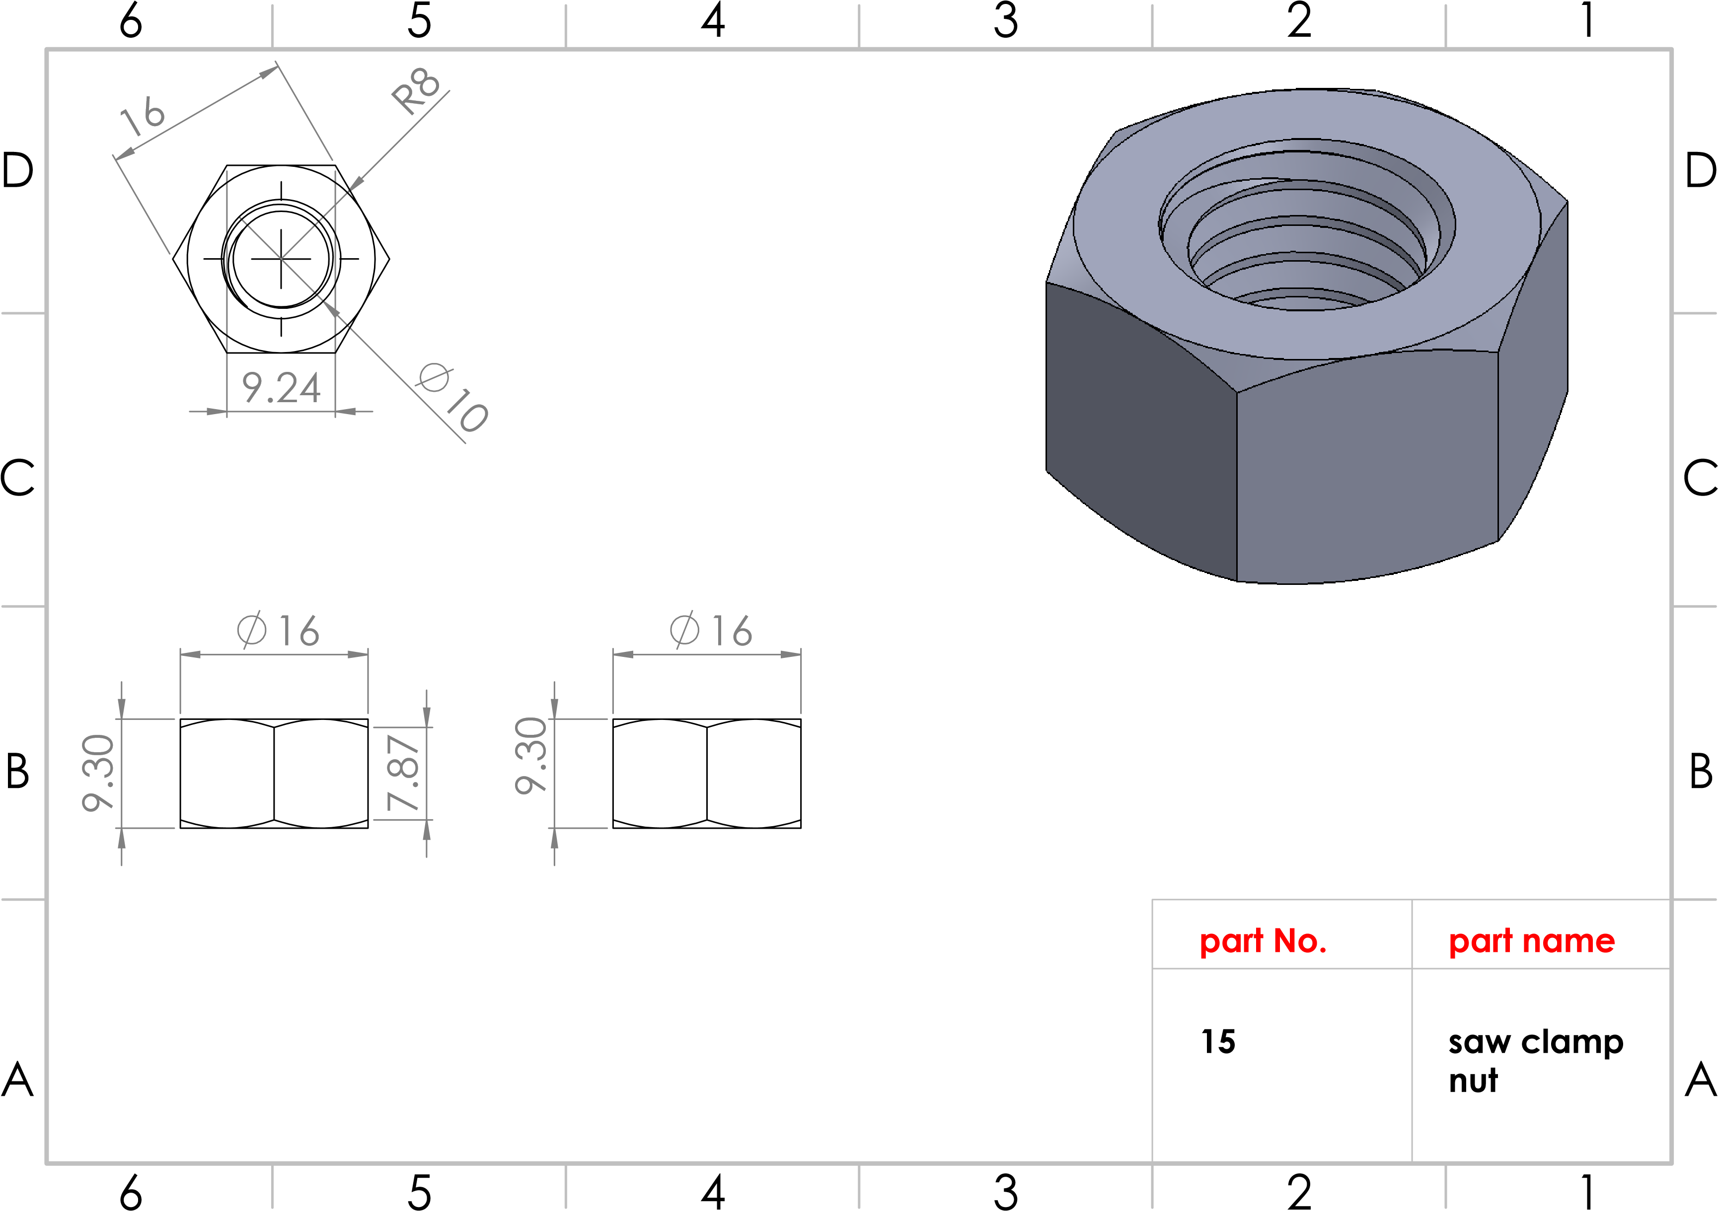
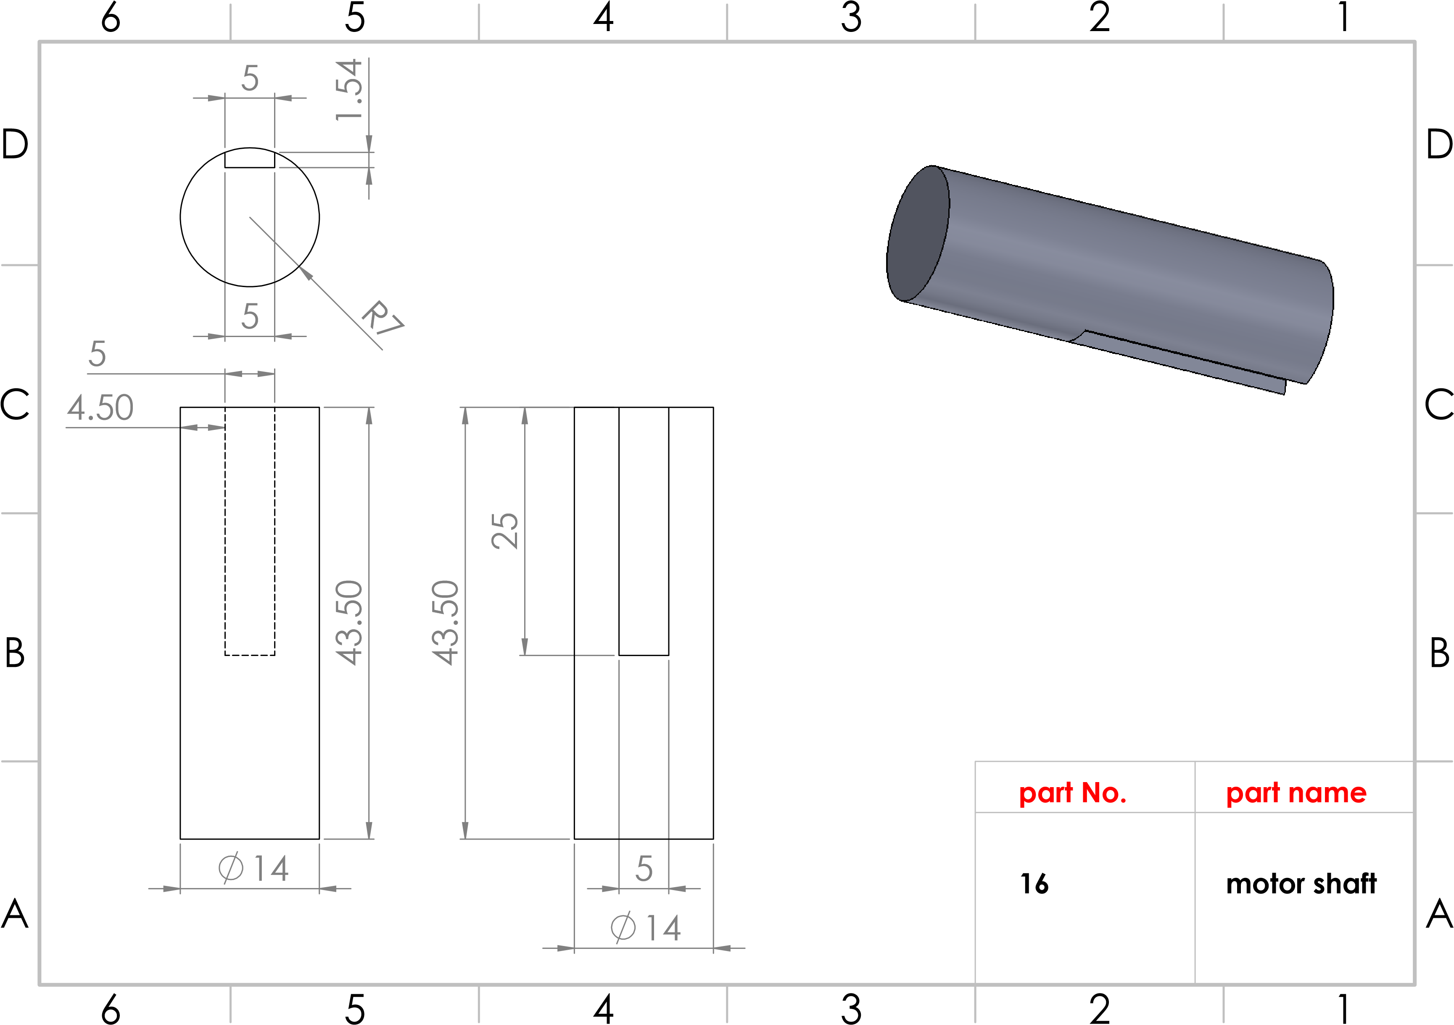
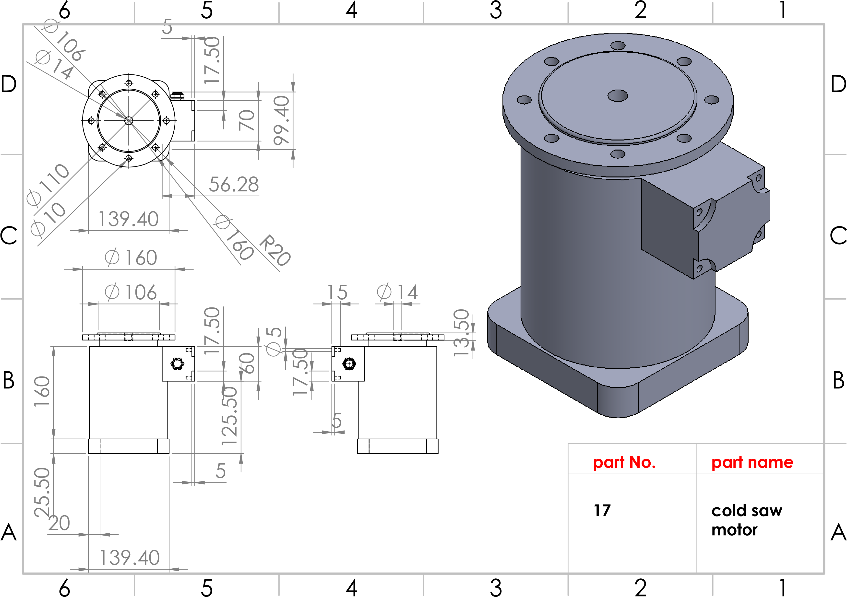
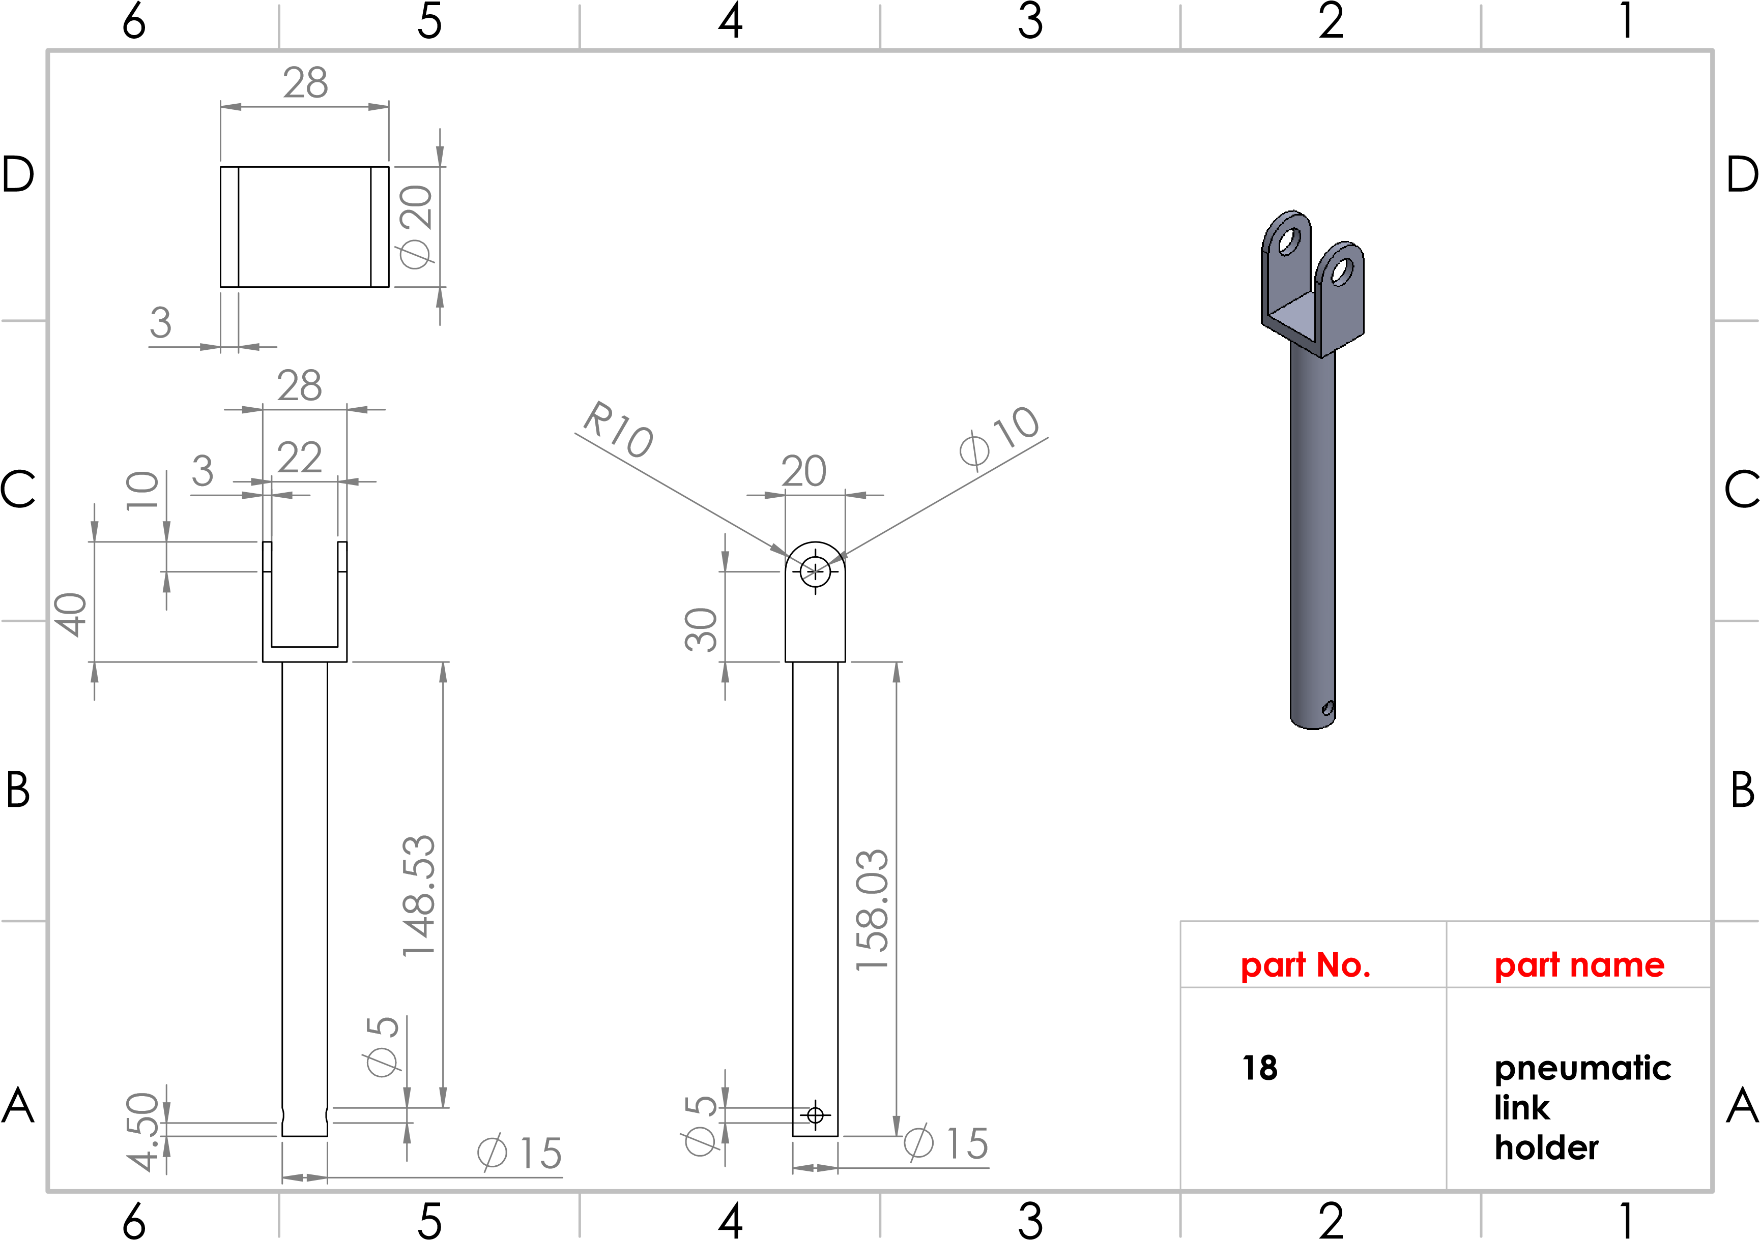
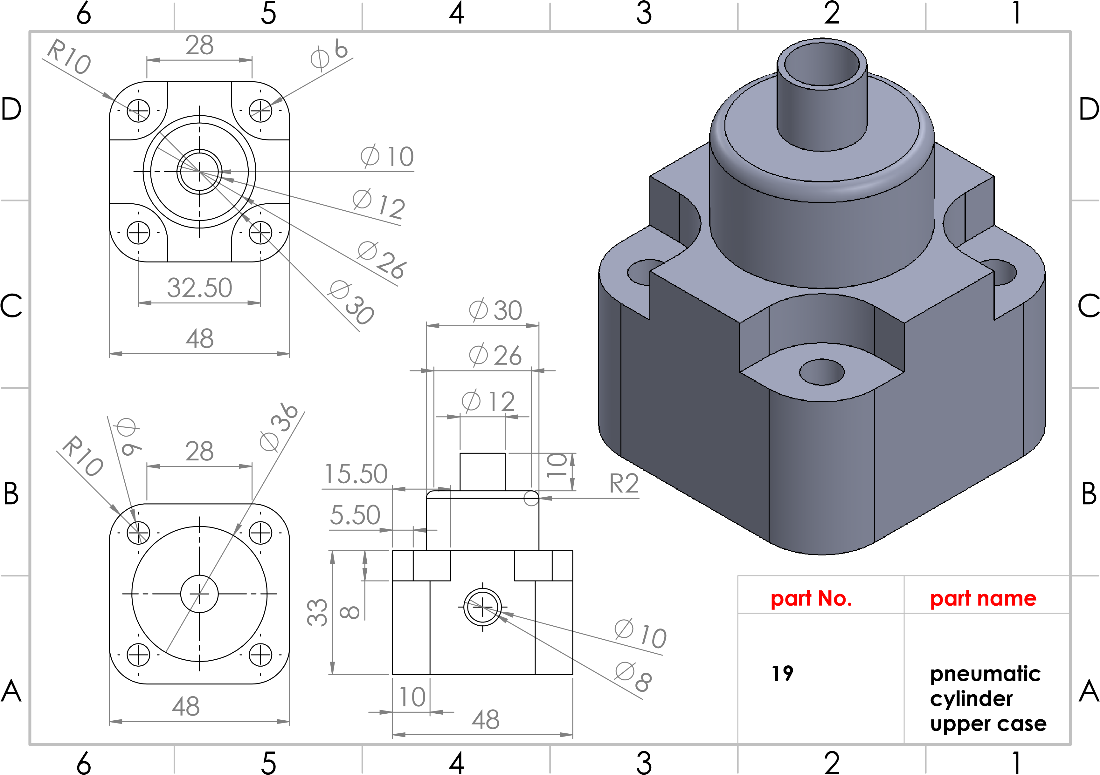
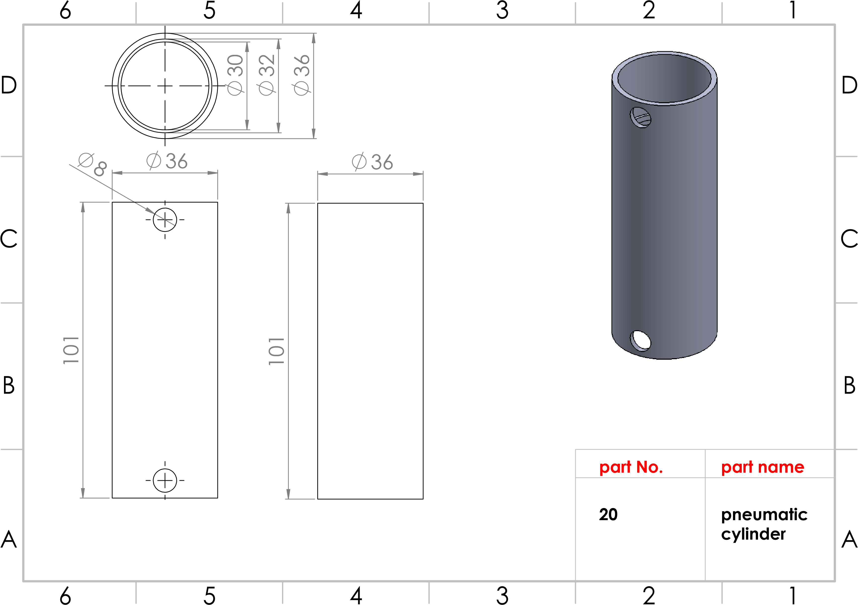
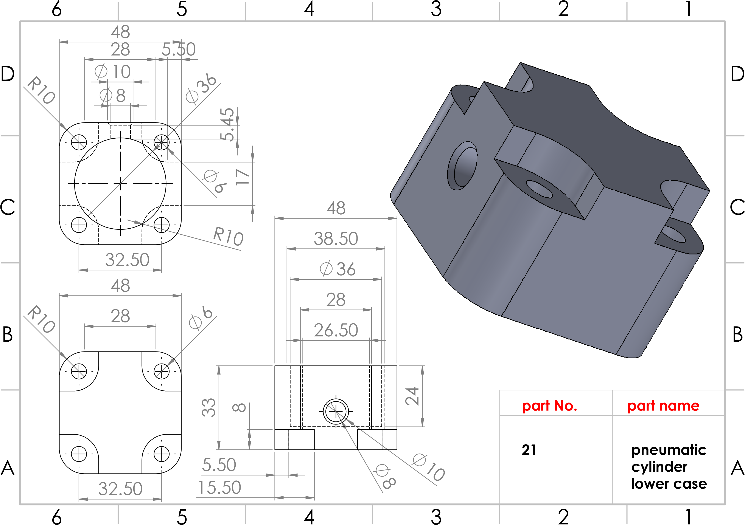
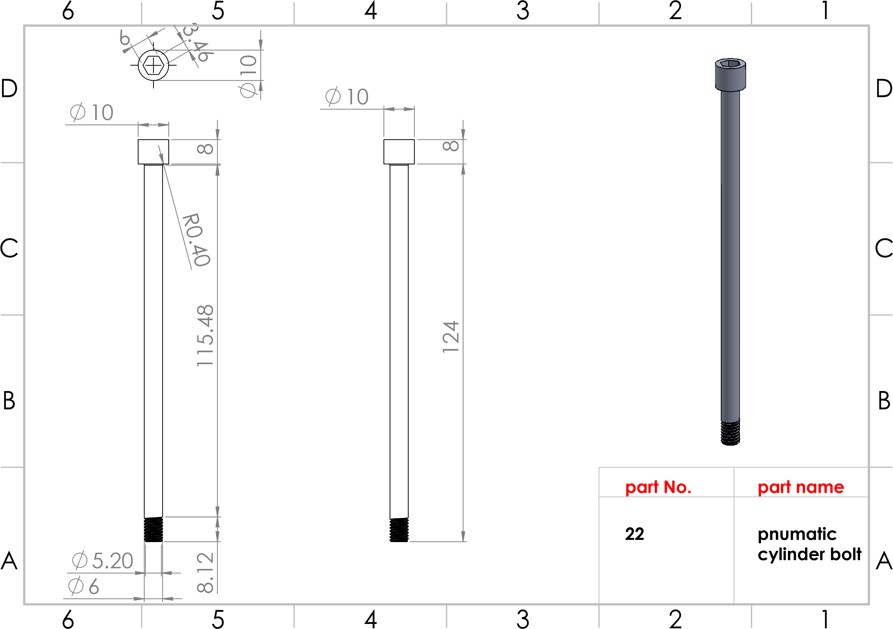
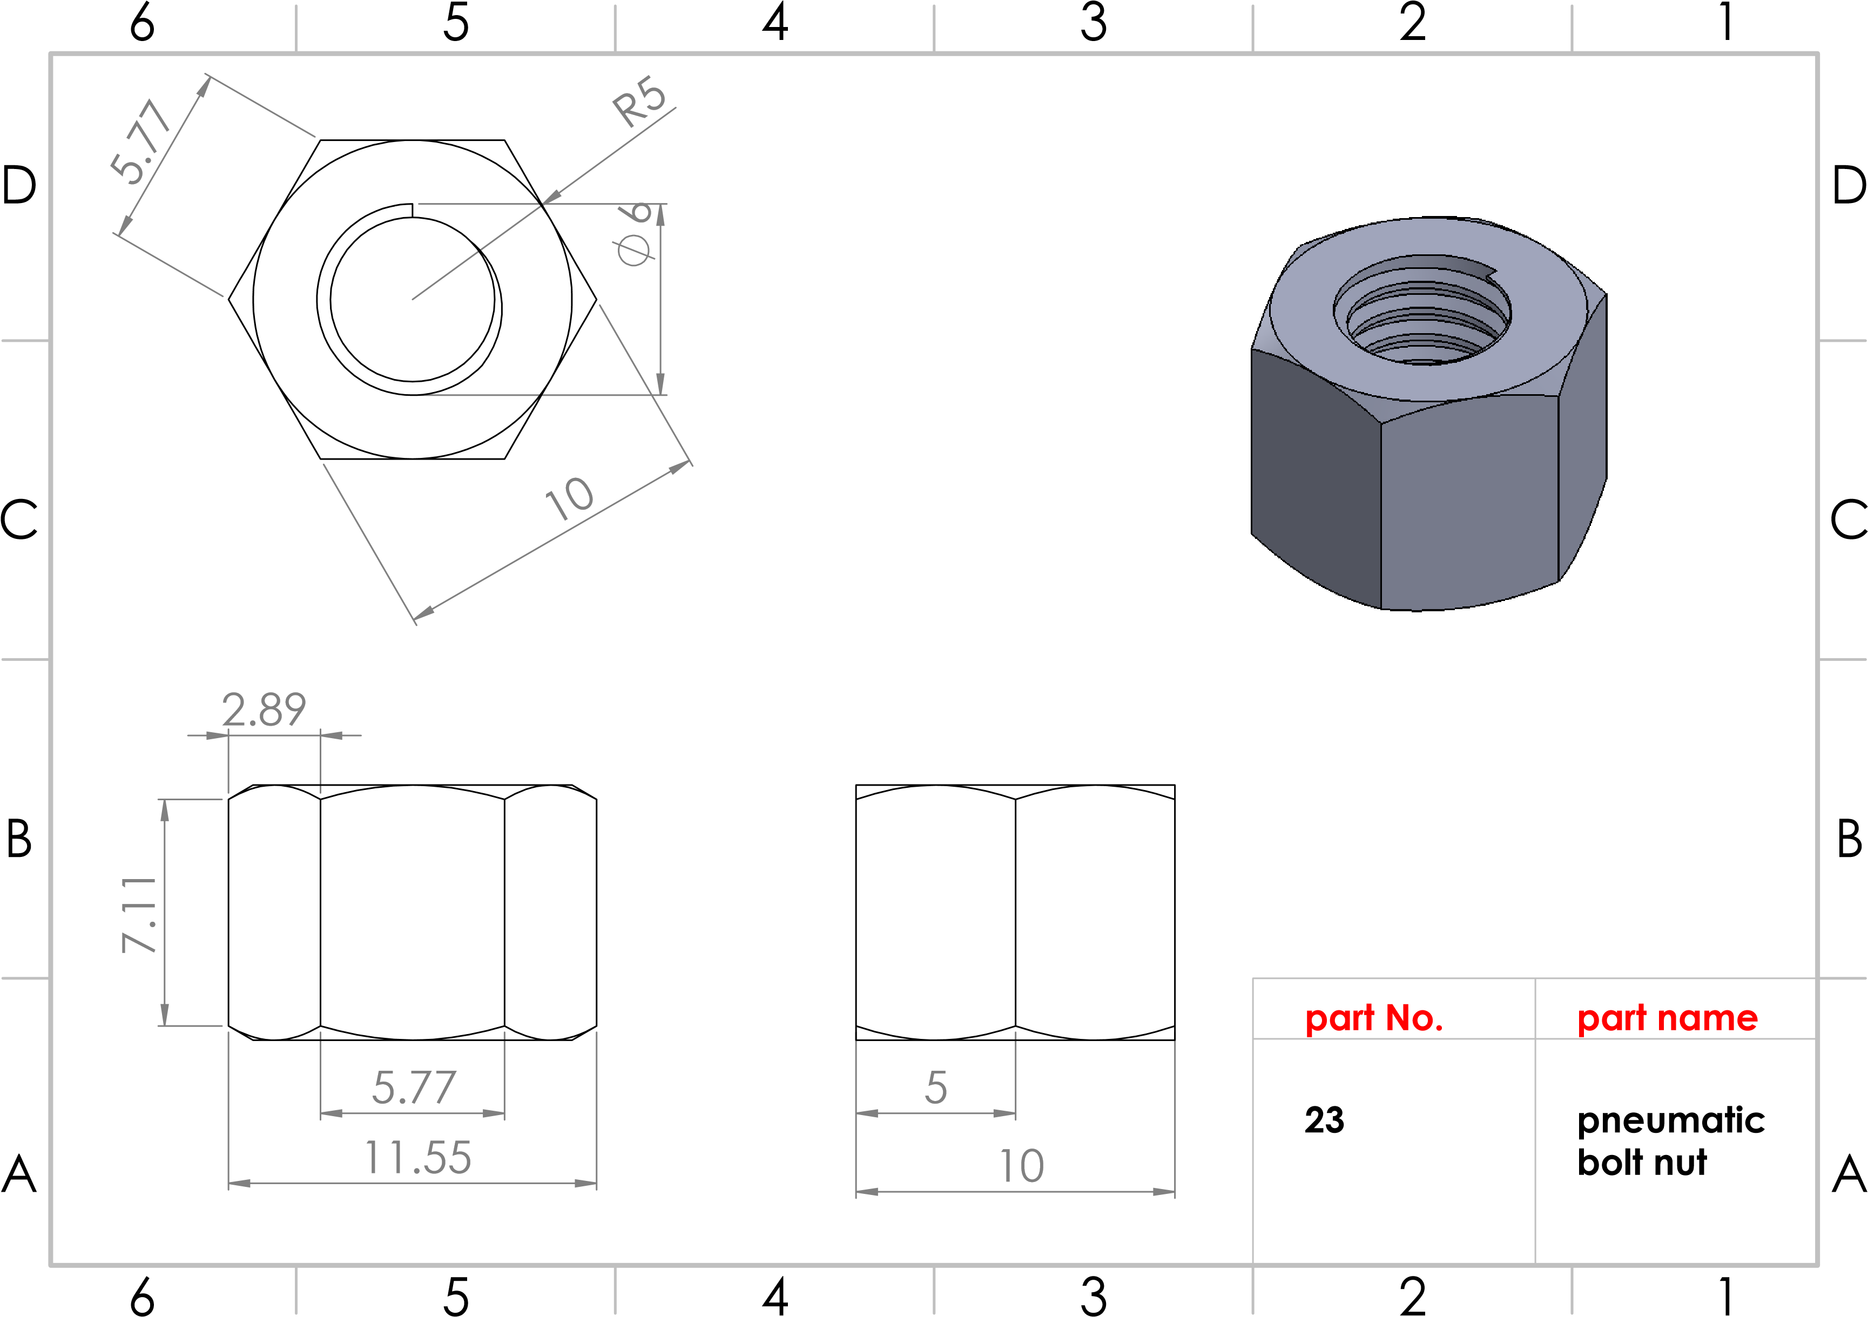
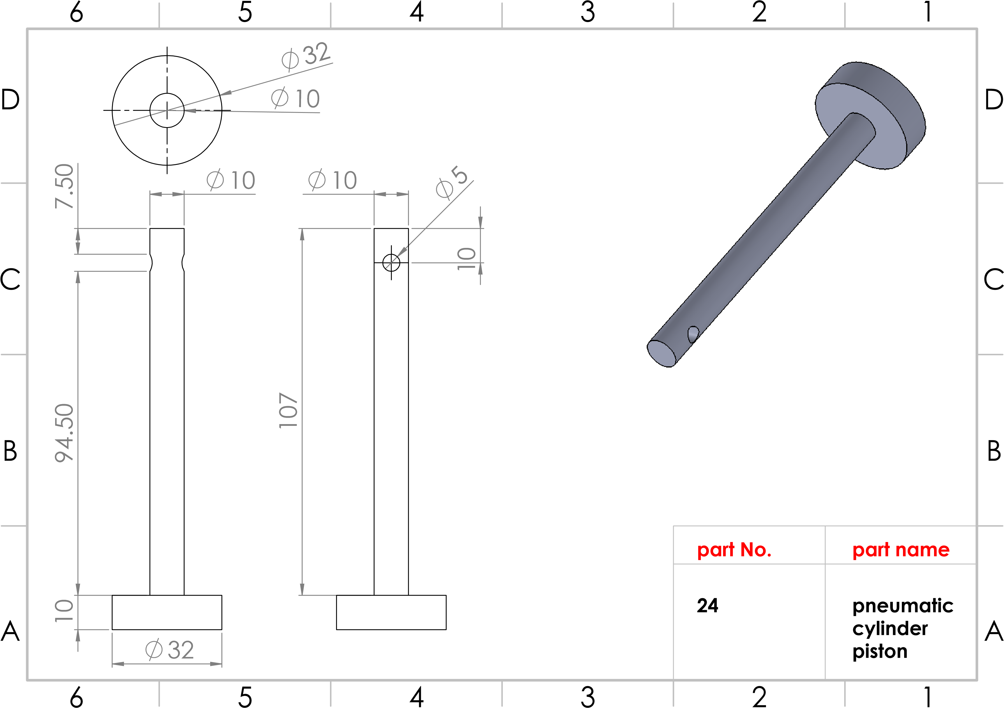
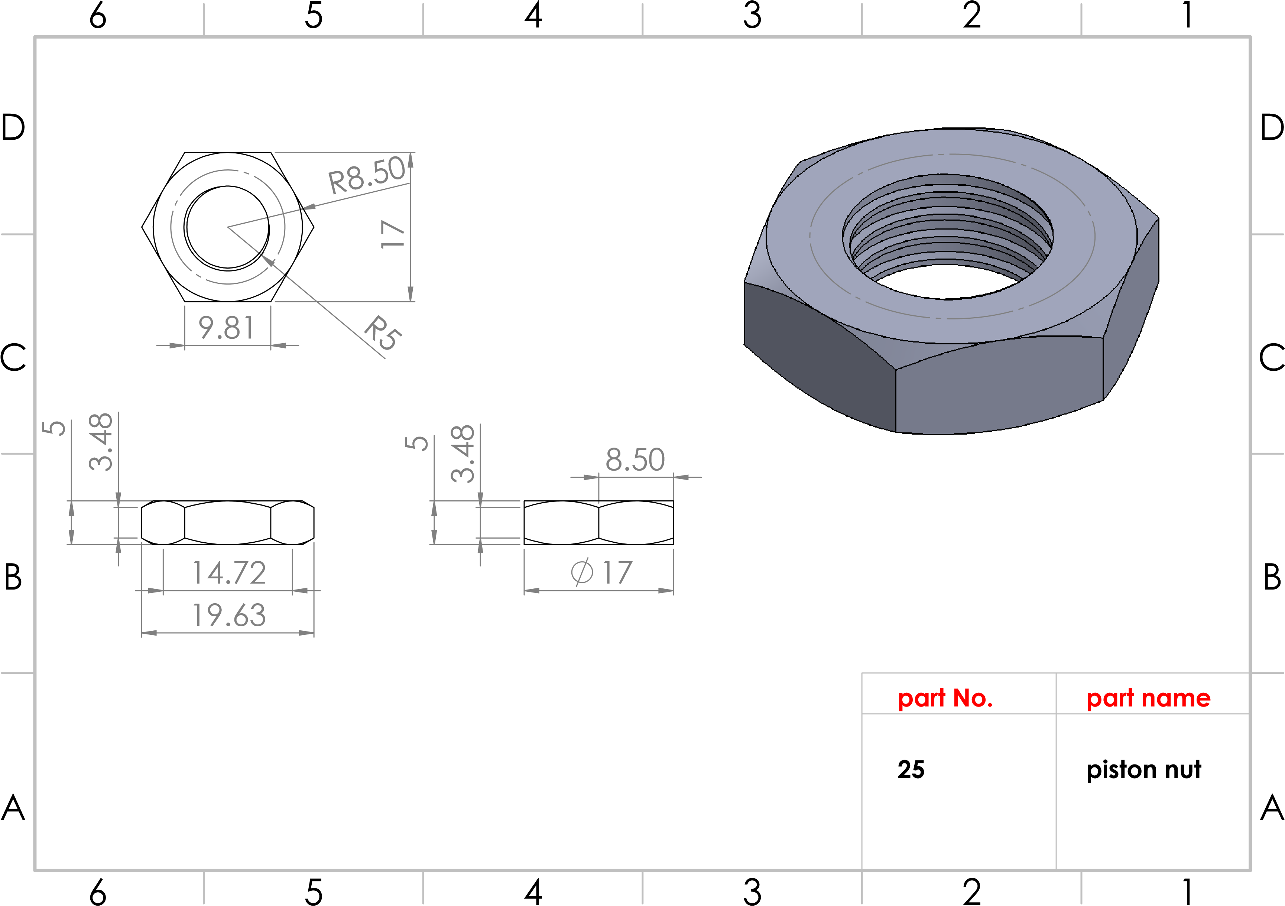
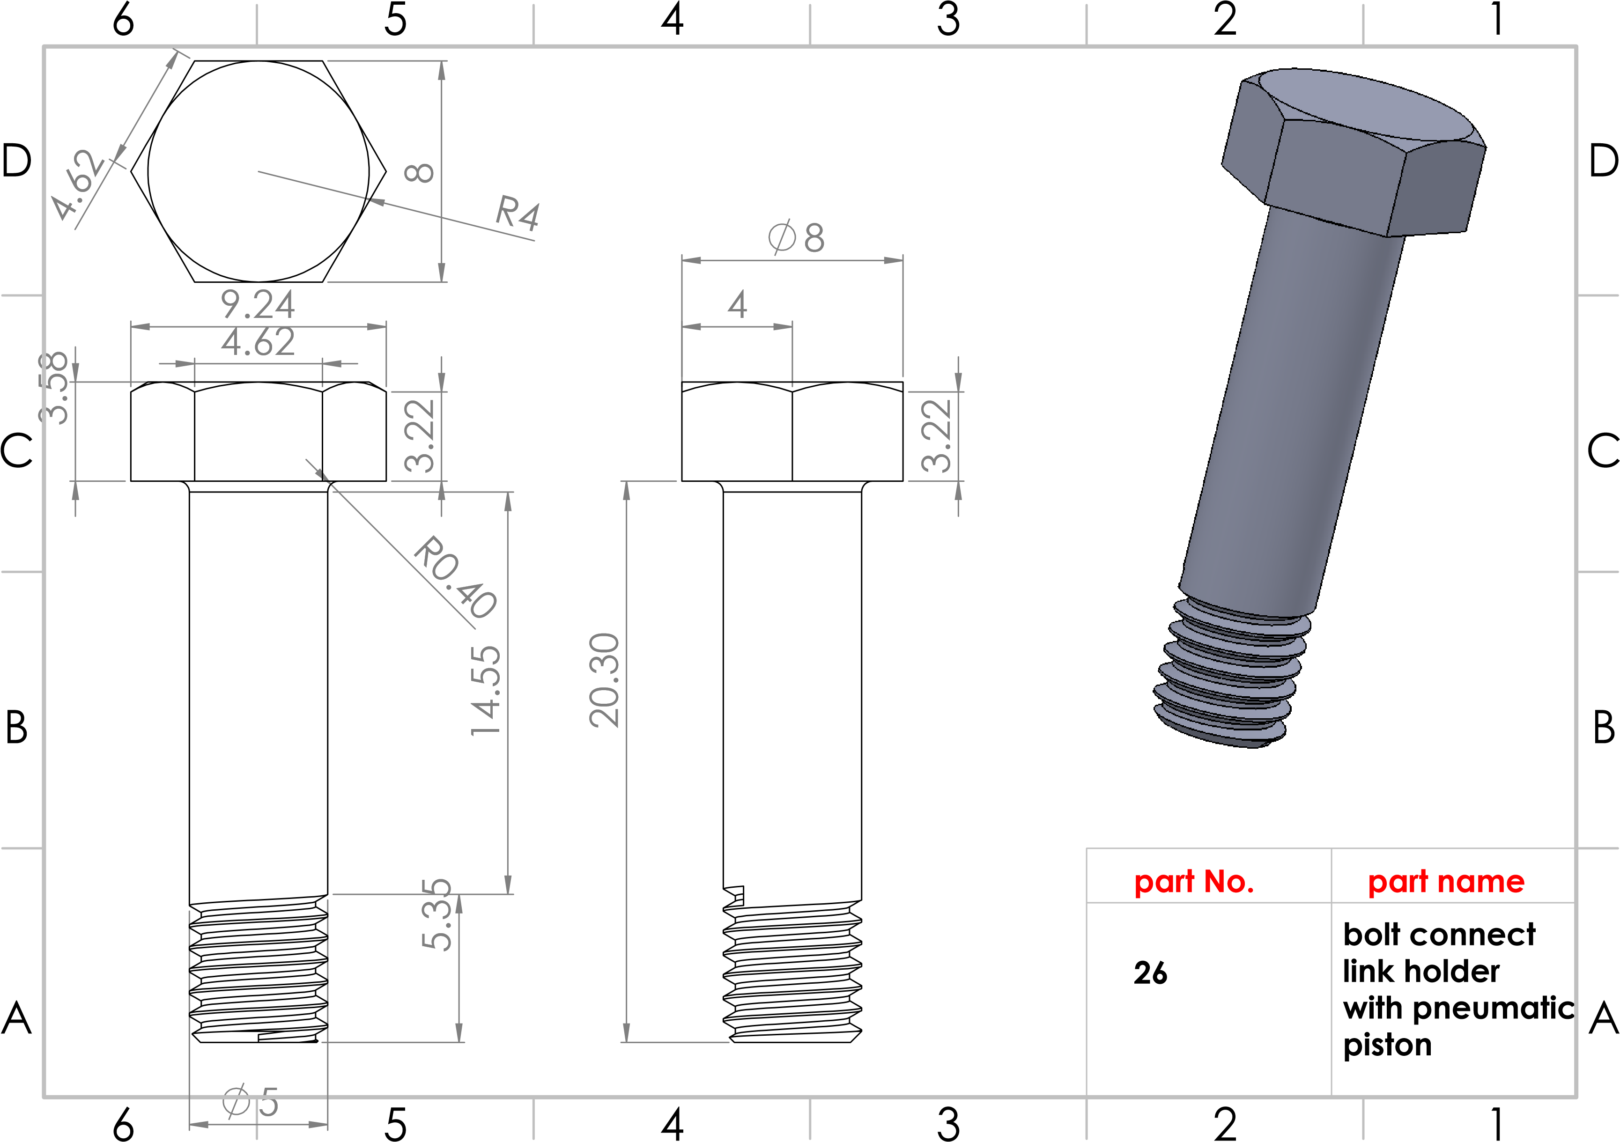
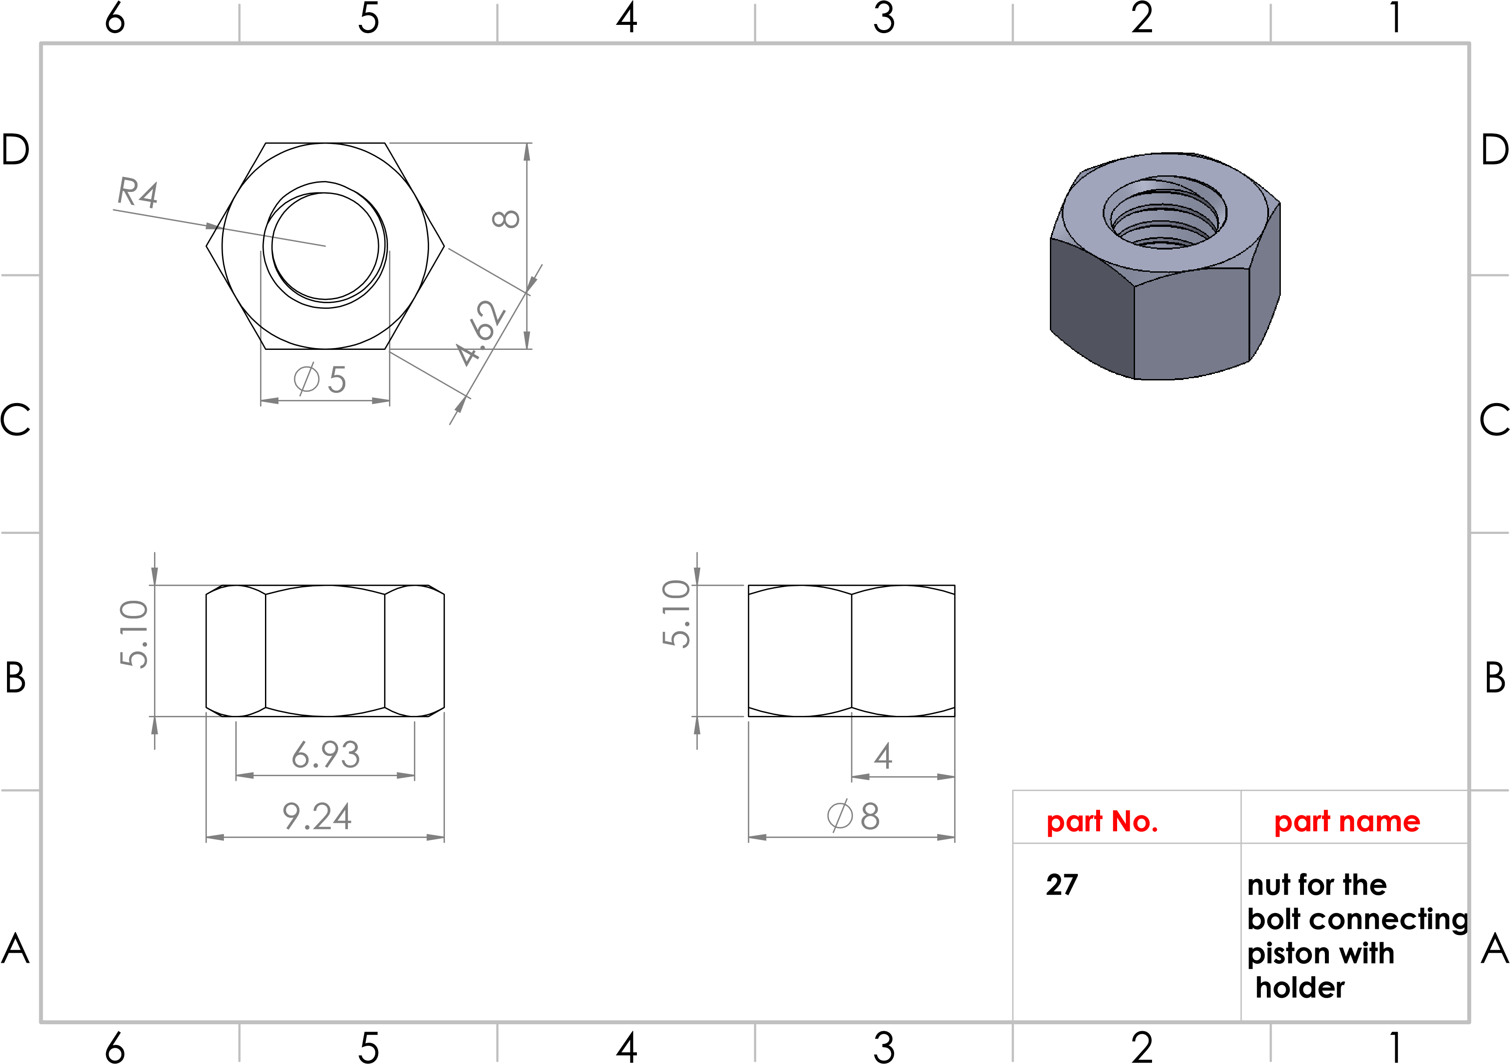
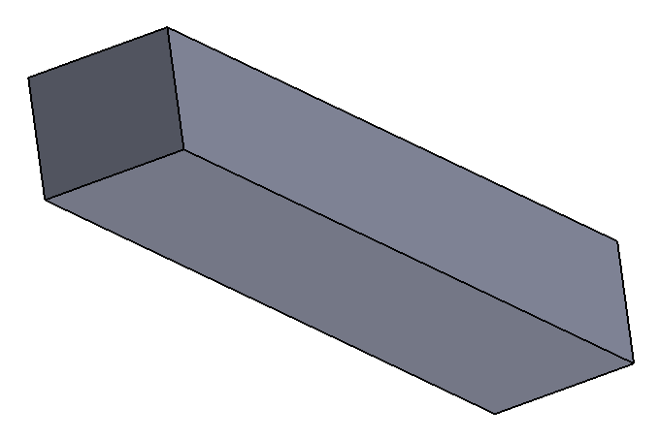
4
5
5
25
4
25
A
A
B
B
C
C
D
D
6
6
5
5
4
4
3
3
2
2
1
1
part No.
28
rectangular
key
part name
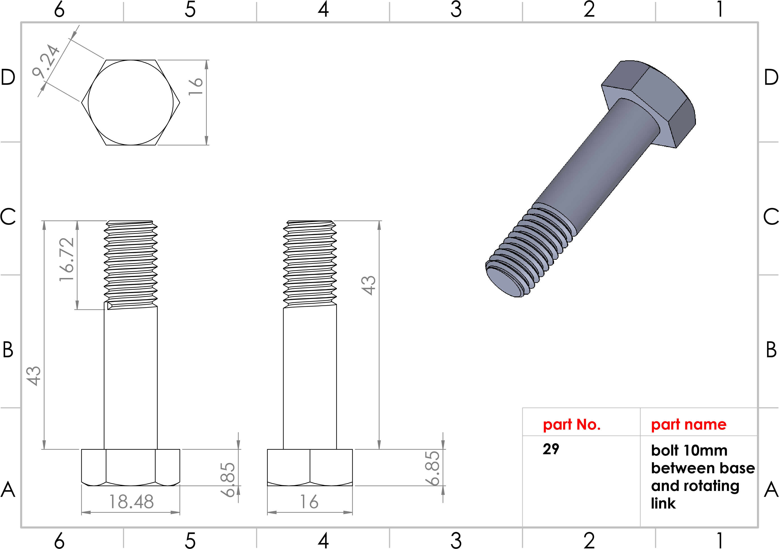
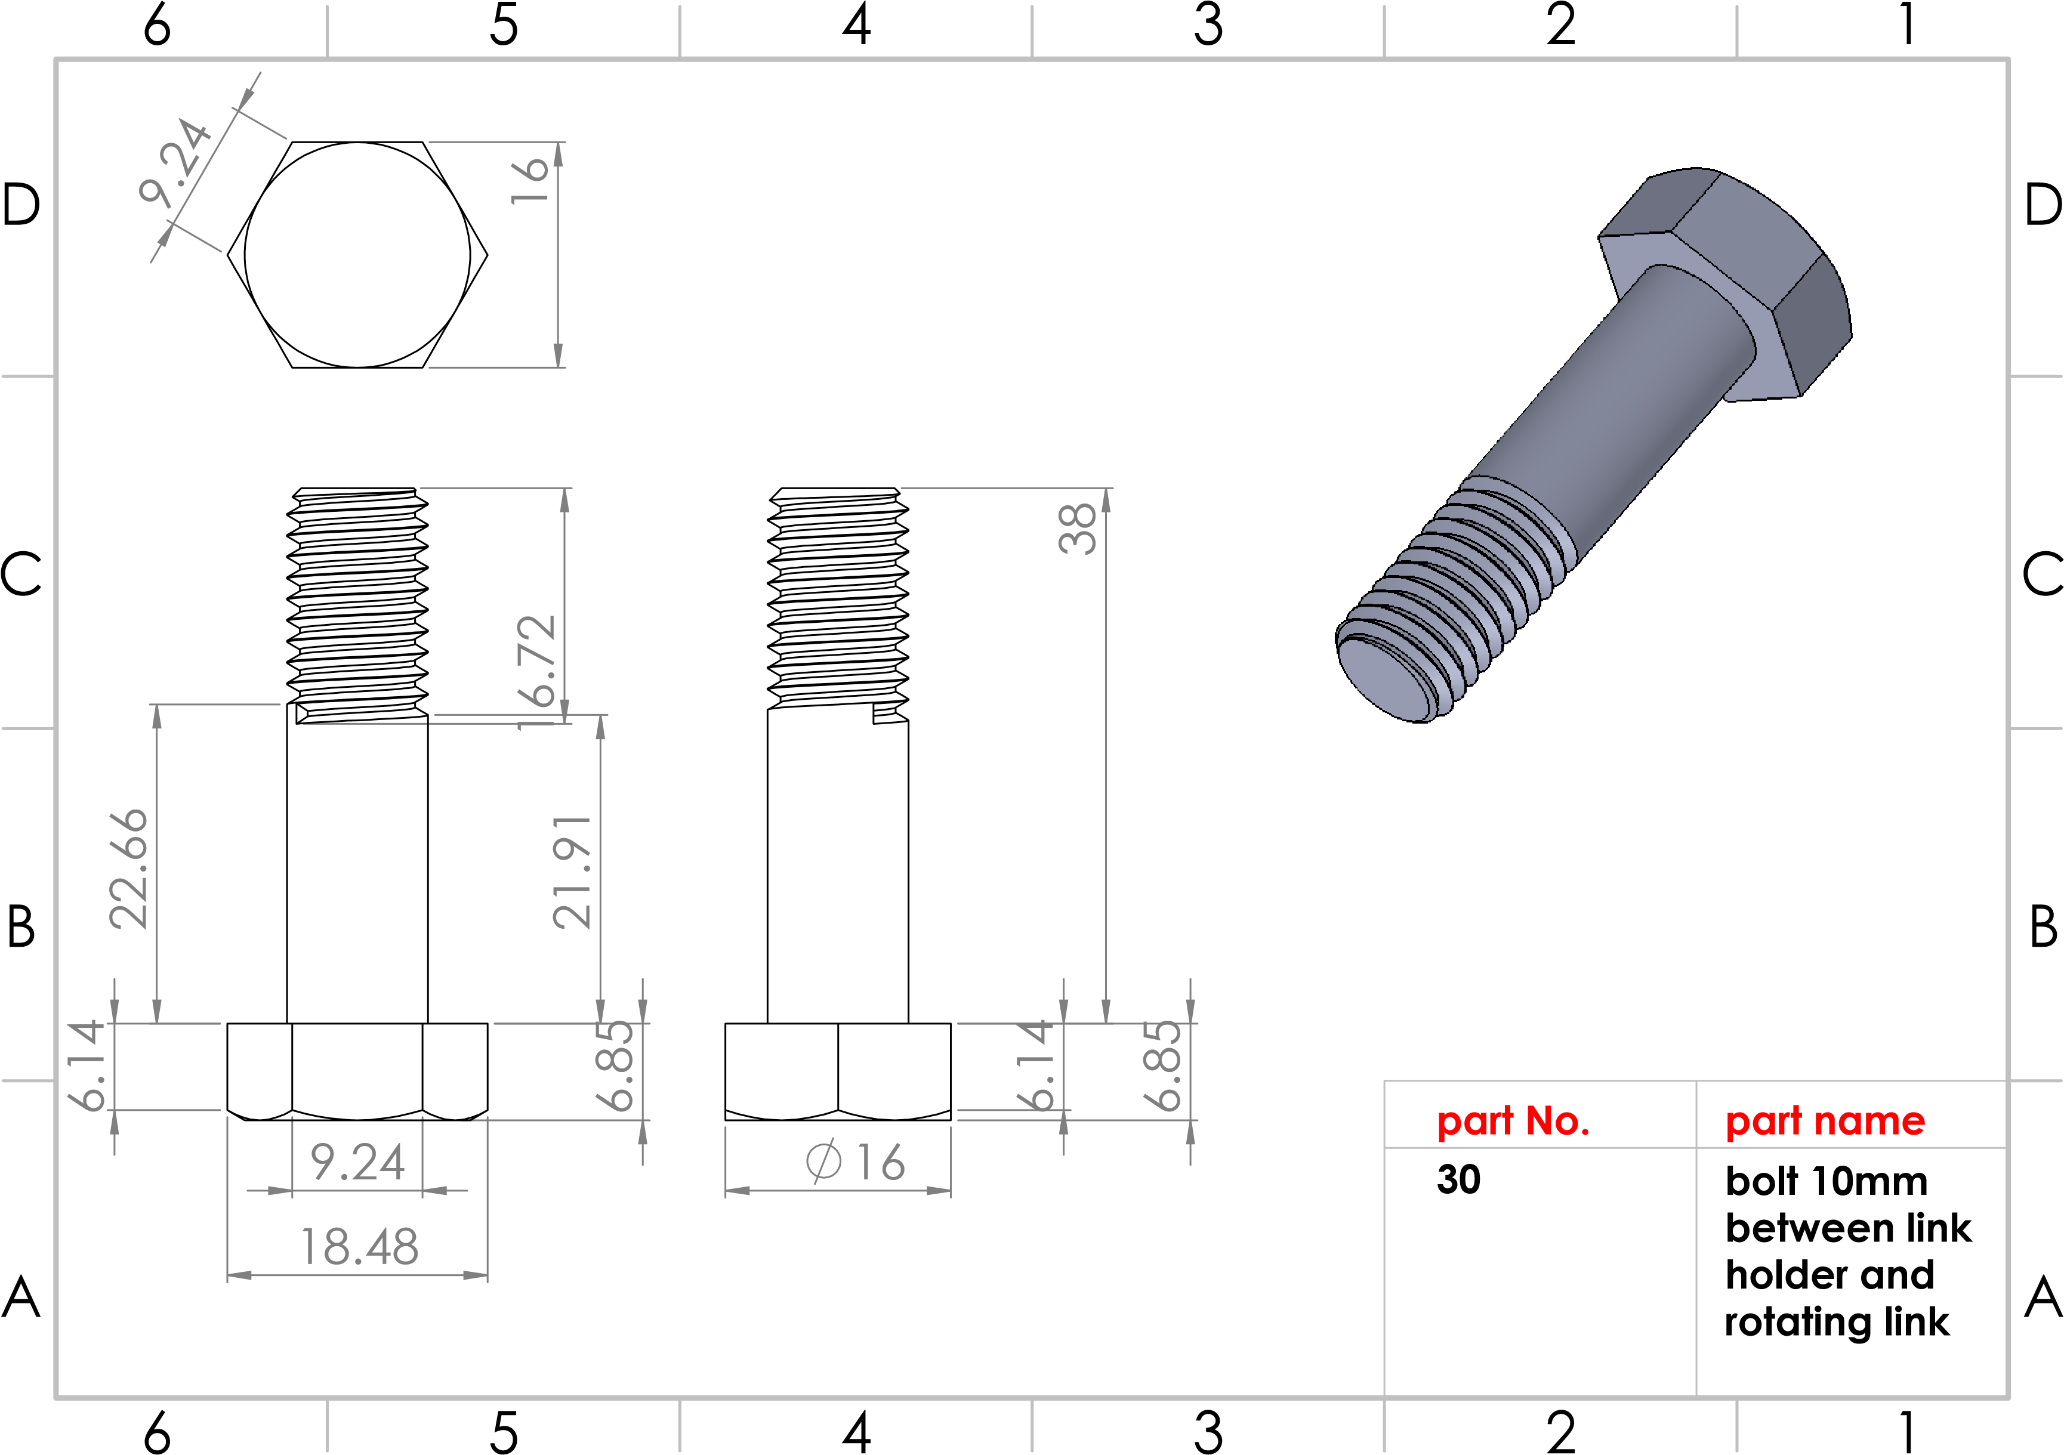
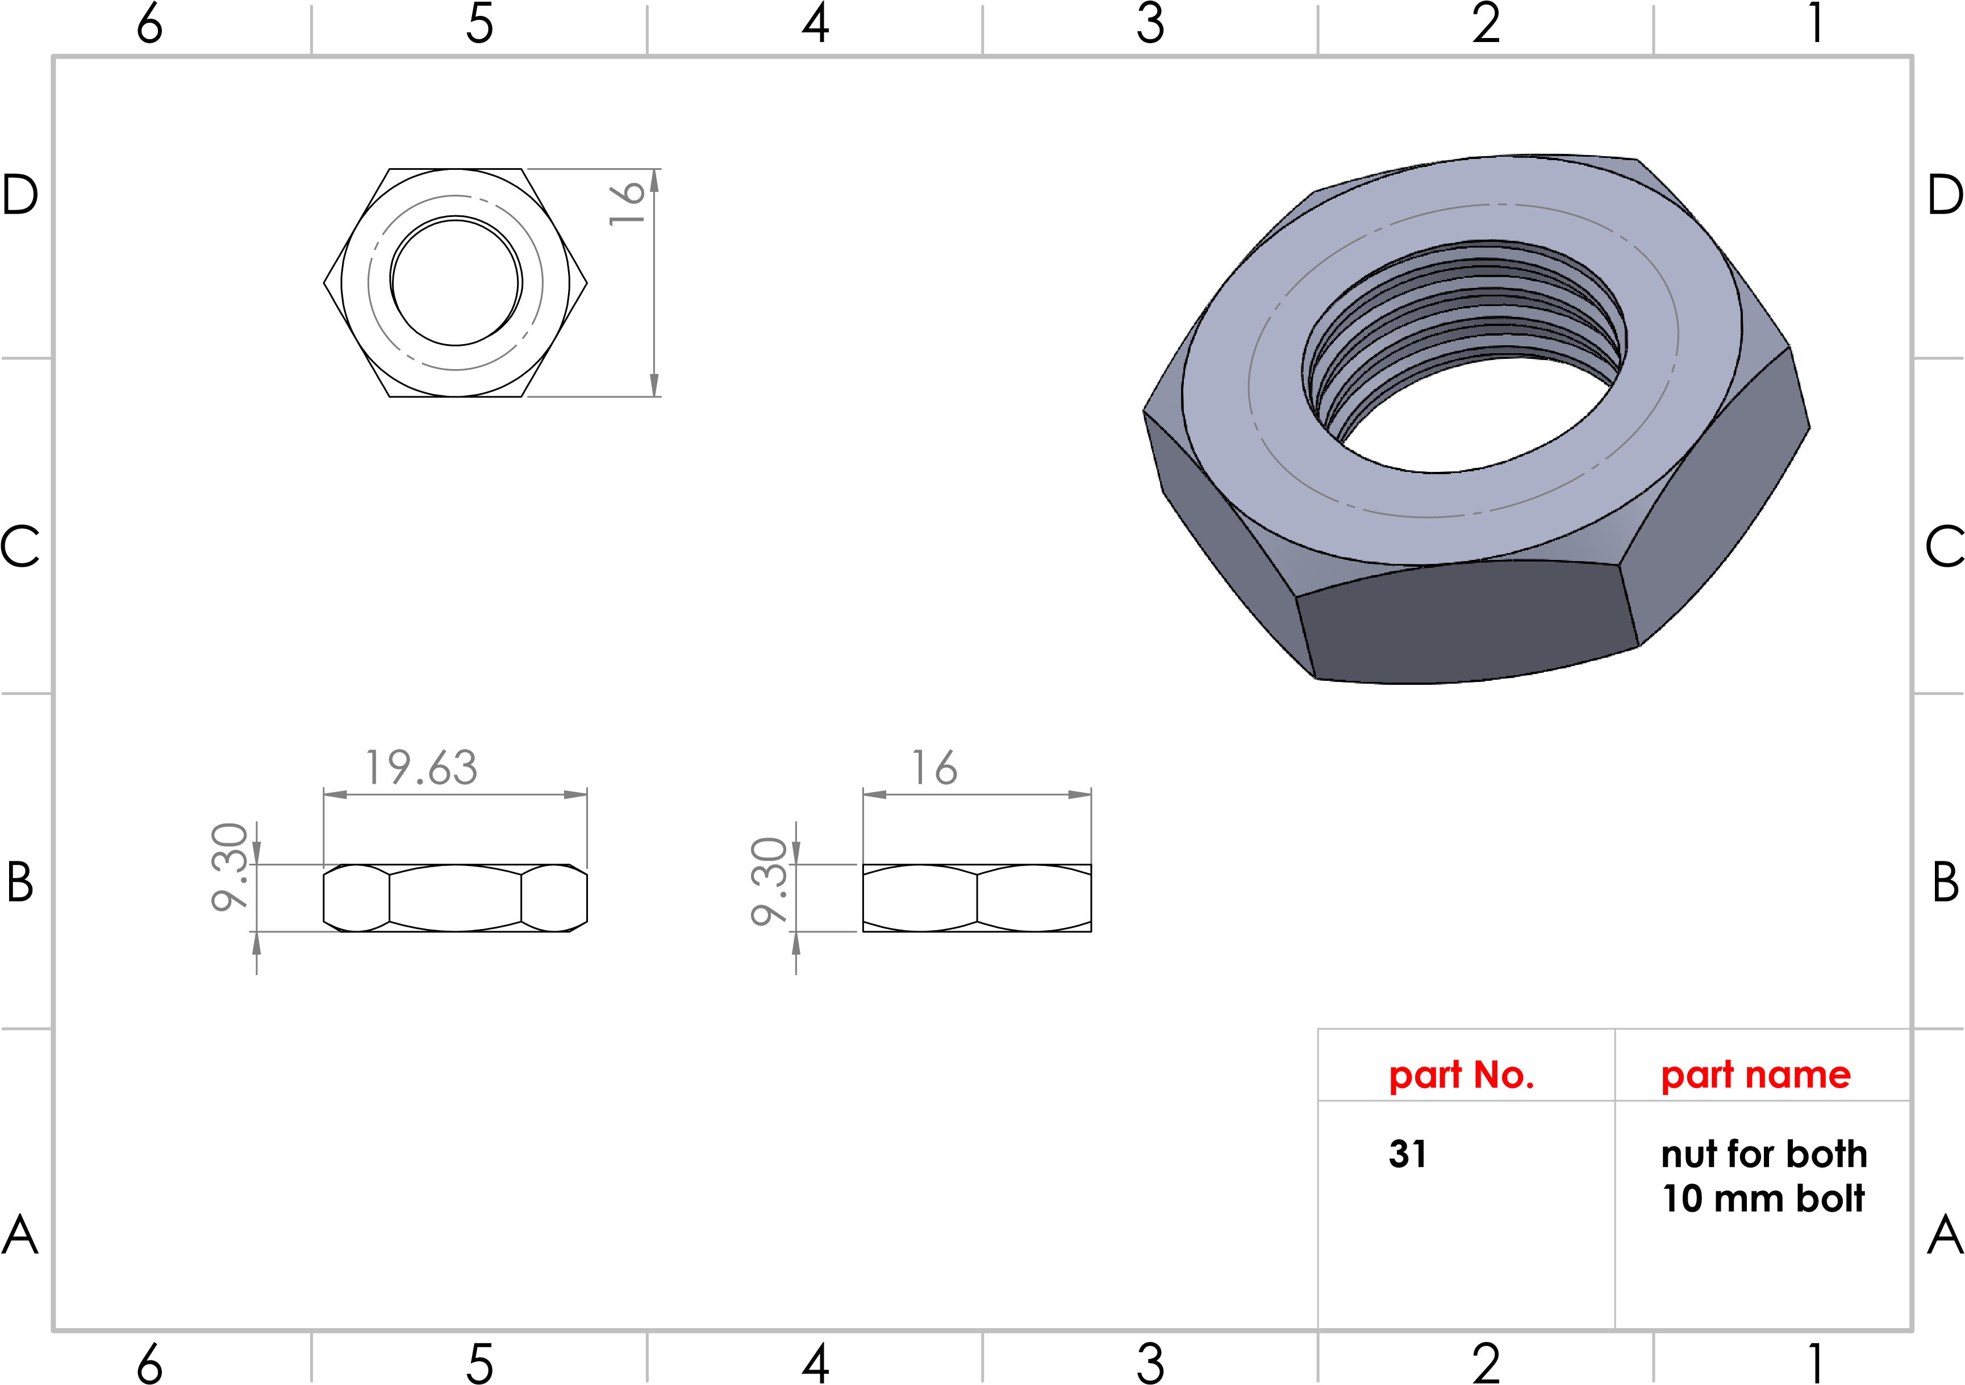
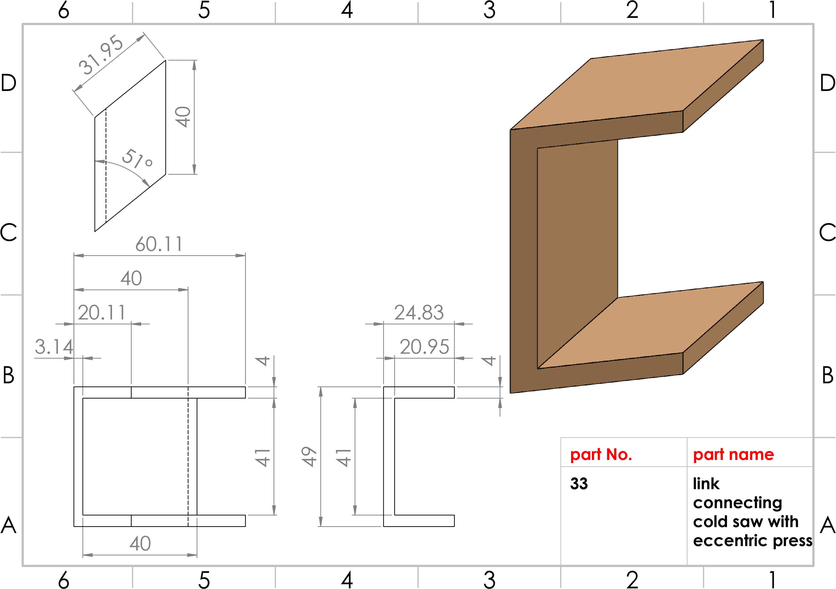
Production line
Station No. (4)
Eccentric press

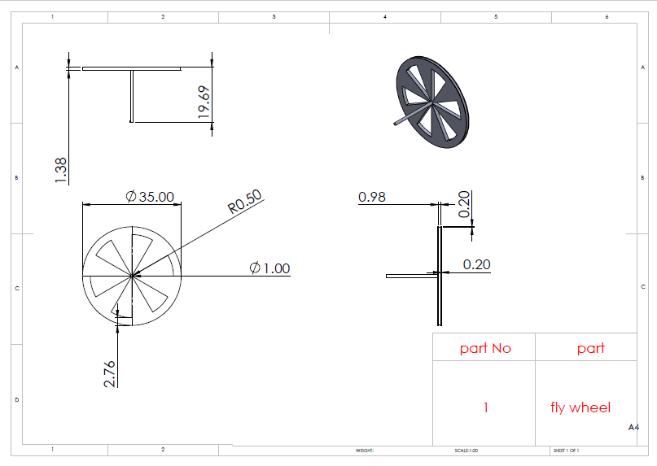

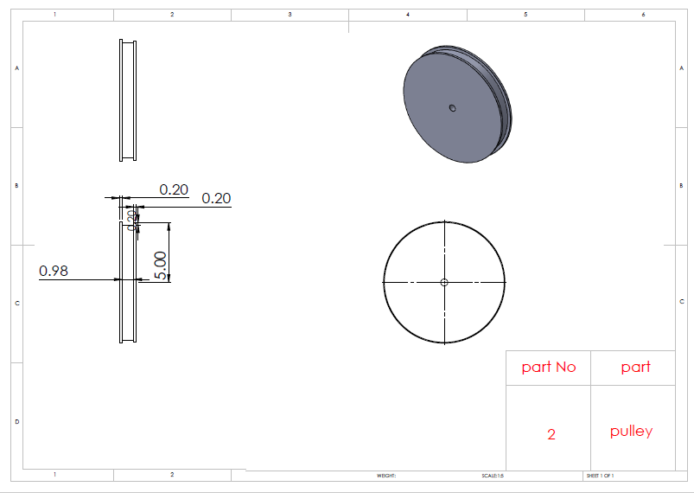

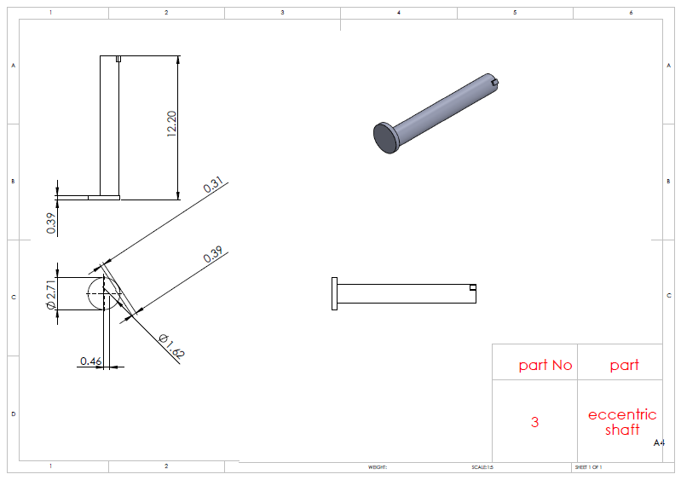

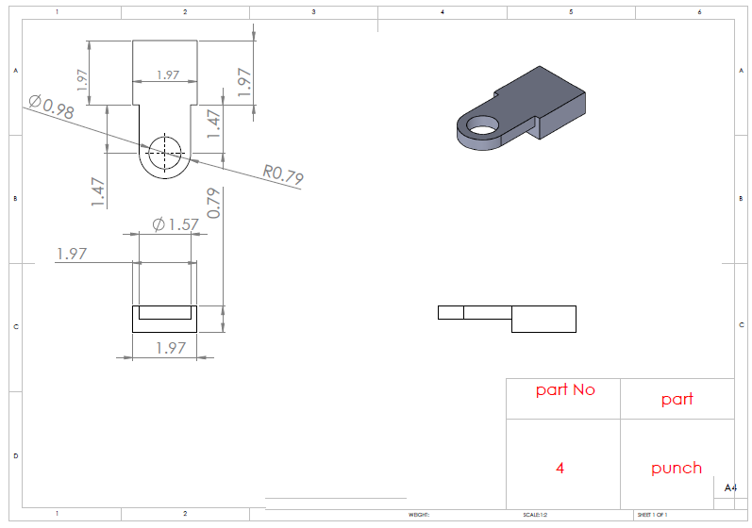

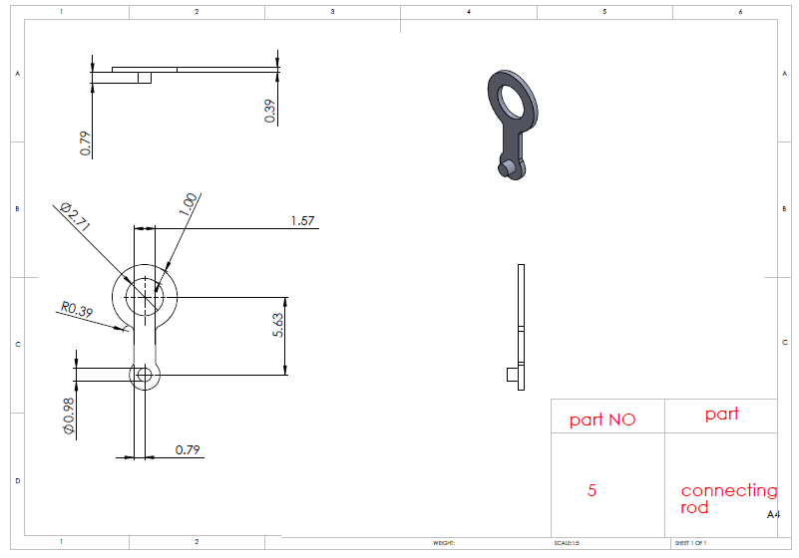

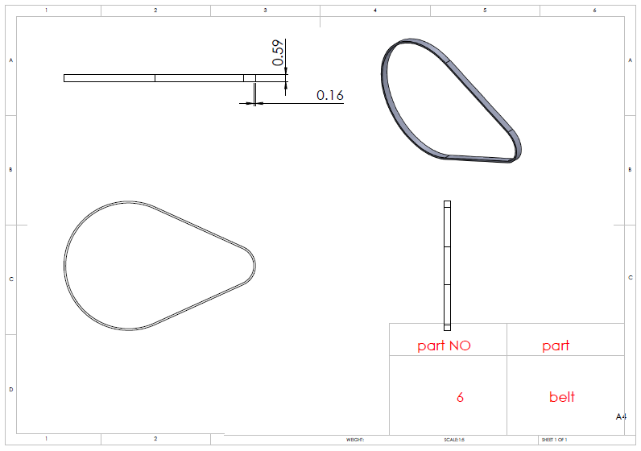

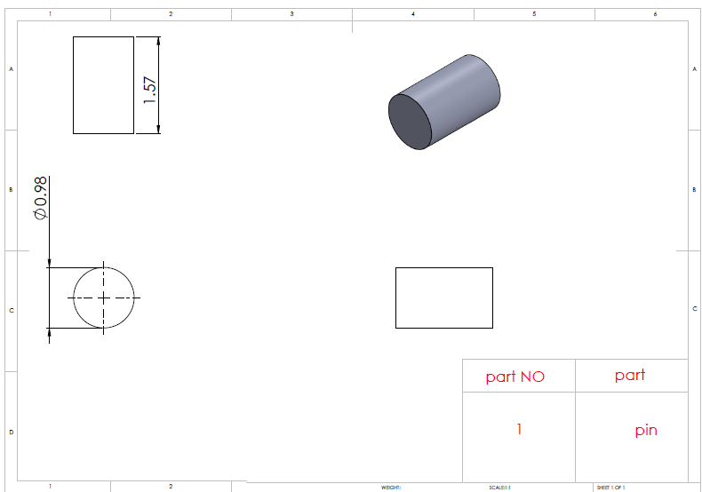

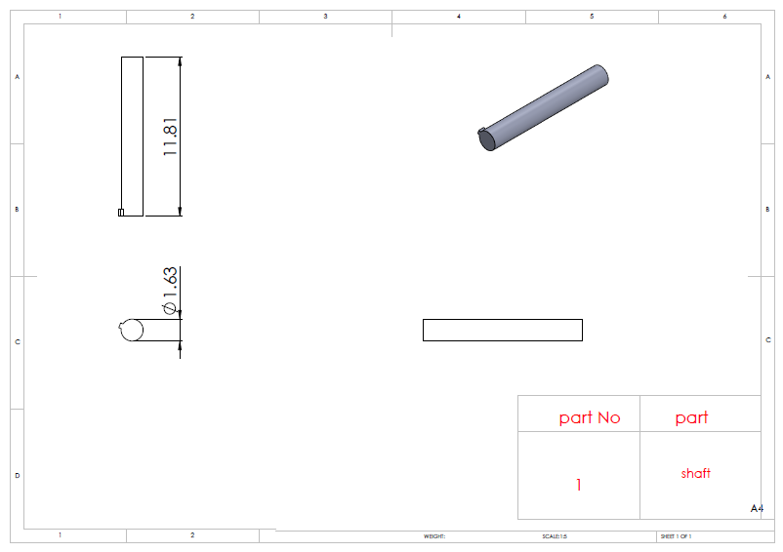

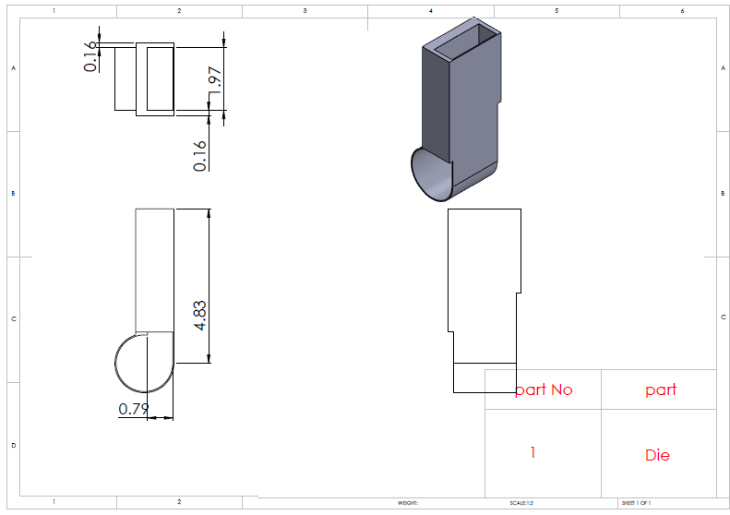

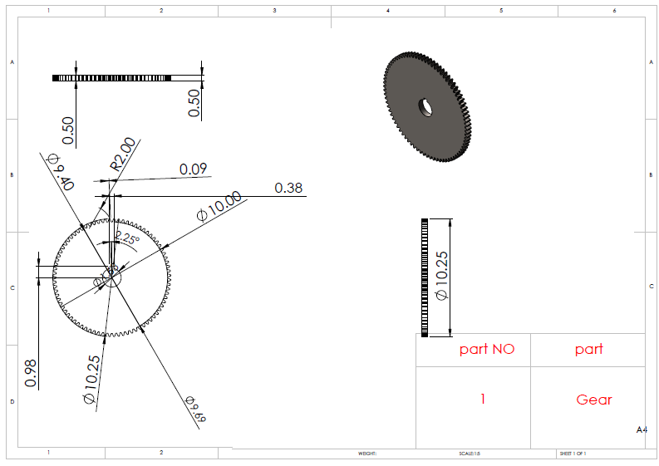

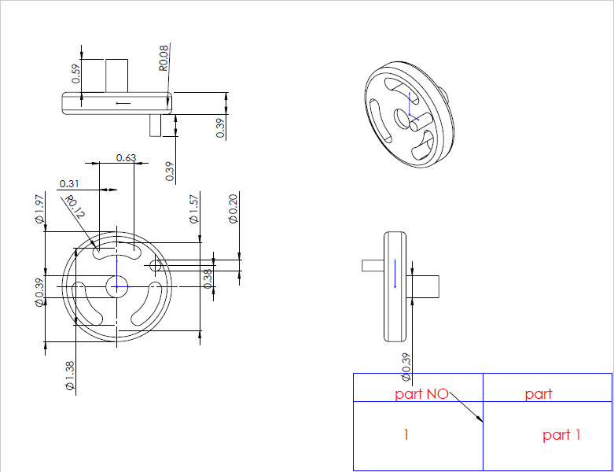

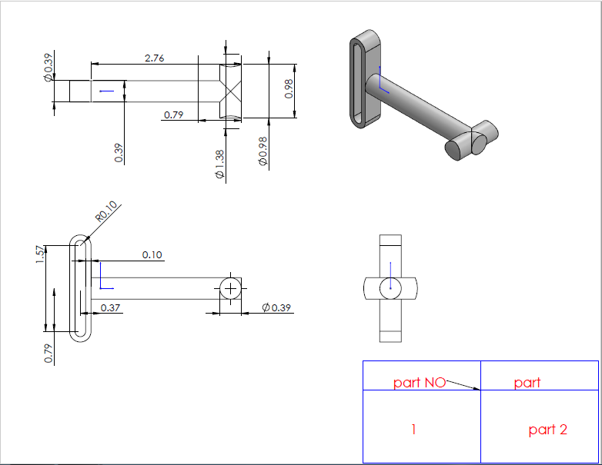

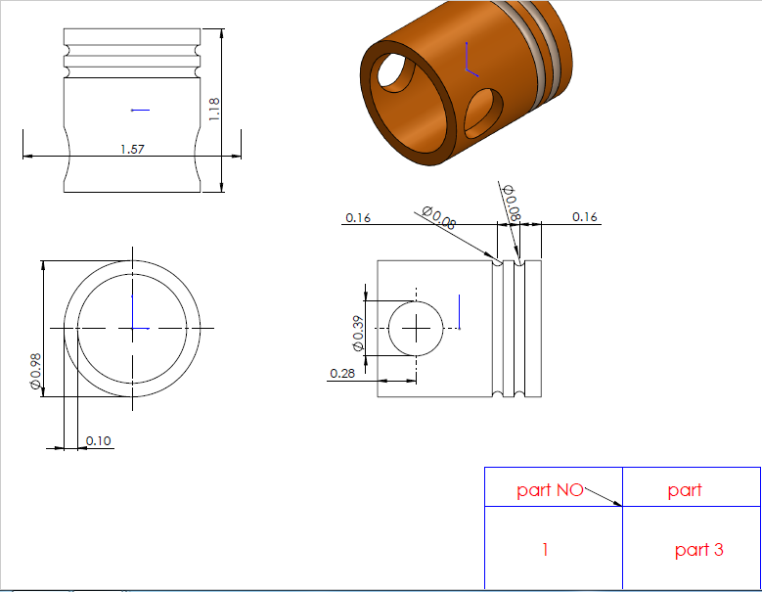

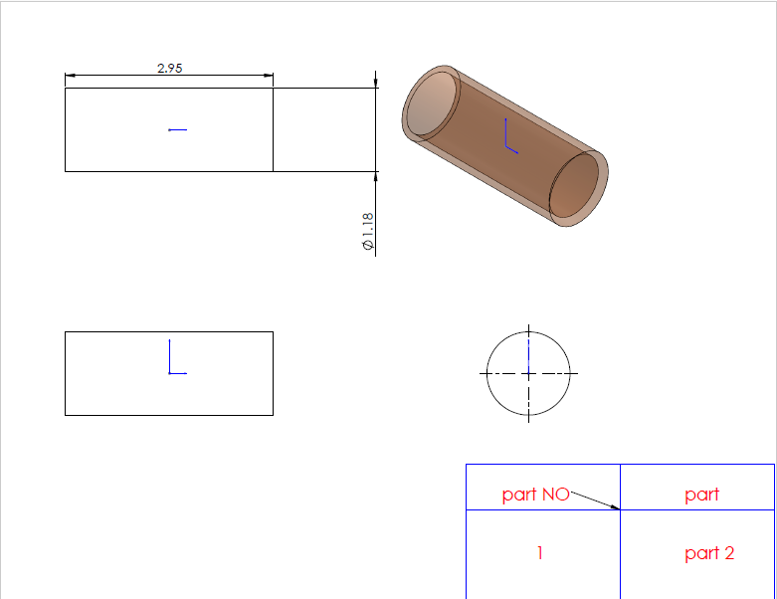

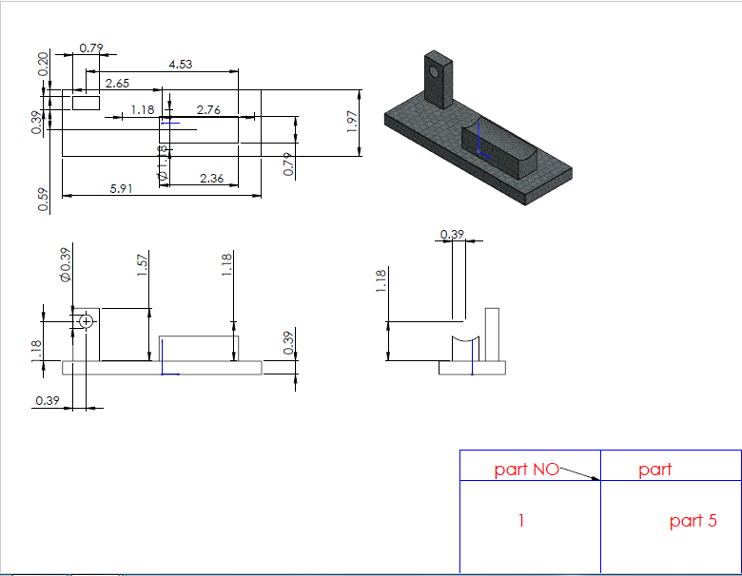

Appendix (3):

PLC & Control Panel Diagram

References:
[1]: Budynas, R., & Nisbett, J. (2011). Shrigley’s mechanical engineering design (9th ed.). New York: McGraw-Hill.
[2]: Collins, A. J., Busby, H., & Staab, G. (2010). Mechanical design of machine elements and machines (2nd ed.). Boston: Wiley & Sons.
[3]: SKF USA Inc, roller bearing, 2016.
[4]: DADCO company, Air cylinder (HP series), catalog No. C13103A, USA, 2017.
[5]: The Jones Tool CO Ltd, Wolferal saw and tool selection manual, UK, 2007.
[6]: BALDOR company, AC servo motor and servo rated gearheads for the automation industry, South San Francisco.
[7]: Anaheim Automation Inc, AC Induction motor, ACI-PMCB040-4R4FAT, California, 2017.
[8]: Sunray-Inc., understanding polyurethane coefficient of friction, 2013.
[9]: Hough. & Dolbey. R. (1995). The plastics compendium (volume 1). UK: Rapra Technology Limited.
[10]: https://www.azom.com/article.aspx?ArticleID=852
[11]: https://coldsawbladestore.com/cold-saw-blade-guide/#
[12]: http://www.supercutbandsaw.com/how_to_choose.html
[13]: http://bandsawblog.com/the-three-tooth-rule-2/
[14]: http://www.hardwaresource.com/hinge-resource-center/hinge-information/hinge-history/historical-development-and-advances-of-the-hinge/#_ftnref2.
[15]: http://www.thomasnet.com/articles/hardware/hinge-evolution.
[16]: http://www.mutualscrew.com/blog/assets/content/colonial_hinges.jpg.
[17]: https://s-media-cache-ak0.pinimg.com/236x/39/bc/69/39bc696d90f7f66e64573005831c9cf9.jpg.
[18]: http://cfnewsads.thomasnet.com/images/cmsimage/image/hinge-victorian-resized.jpg.
[19]: https://www.customhinges.com/wp-content/uploads/2015/11/Custom-Hinge-06.jpg.
[20]: https://ae01.alicdn.com/kf/HTB1oqDNHVXXXXbYXpXXq6xXFXXXQ/8mm-Diameter-Barrel-Hinge-Solid-Brass-hinges-6-pack.jpg.
[21]: https://static.grainger.com/rp/s/is/image/Grainger/1WAA8_AS01?$mdmain$.
[22]: https://sc01.alicdn.com/kf/HTB1AxWPGFXXXXX9XXXXq6xXFXXXc/200217369/HTB1AxWPGFXXXXX9XXXXq6xXFXXXc.jpg.
[23]: http://www.popularwoodworking.com/wp-content/uploads/Euro_2D00_Hinges_5F00_fig_2D00_a1.jpg.
[24]: http://www.misumi-europe.com/en/catalog/material/mech/TAK1/PHOTO/221004900907.jpg.
[25]: http://www.rocatek.com/images/forum/plc_desc.jpg.
[26]: https://en.wikipedia.org/wiki/Pneumatic_cylinder.

High-speed steel (HSS or HS) is a subset of tool steels, commonly used as cutting tool material.
It is often used in power-saw blades and drill bits. It is superior to the older high-carbon steel tools used extensively through the 1940s in that it can withstand higher temperatures without losing its temper (hardness). This property allows HSS to cut faster than high carbon steel, hence the name high-speed steel. At room temperature, in their generally recommended heat treatment, HSS grades generally display high hardness (above Rockwell hardness 60) and abrasion resistance (generally linked to tungsten and vanadiumcontent often used in HSS) compared with common carbon and tool steels.

