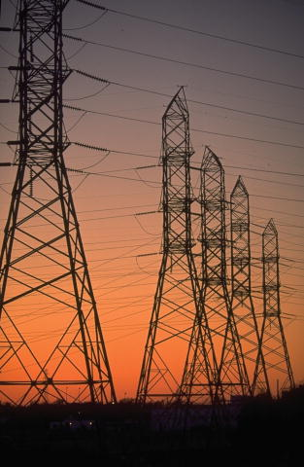


An-Najah National University
Faculty of Engineering
Electrical Engineering Department
Graduation Project Report
Electrical And Economical Study For Unified Salfeet Network

Supervisor:
Dr. Imad Breik
Prepared By:
Ahmad Hurani
Riyad Ya’aqbeh
Mohammad Khoffash
2012-2013
Index
Table of table …………………………………………………………………………………………………………………3
Table of figure ………………………………………………………………………………………………………………..4
Abstract ……………………………………………………………………………………………………………………….. 5
Introduction.…………………………………………………………………………………………………………………. 6
Chapter 1 ……………………………………………………………………………………………………………………… 7
  - Description of salfeet network ……………………………………………………………………………… 7
  - Transmission line....................................................................................................... 10
  - Energy consumption sectors...................................................................................... 11
  - Unified electrical network ......................................................................................... 12
Chapter 2 ………………………………………………………………………….…………………….…………………… 15
2.1Theory……………………………………………………………………….…………………..………………………… 15
2.1.1 Replacing the taps ratio of some transformers………………………….………………………….. 15
2.1.2 power factor correction ……………………………………………………………………………………….. 16
2.1.3 Power losses ………………………………………………………………………...………………………………. 18
2.1.4 Improved the voltage level ……………………………………………………………………………………. 20
2.1.5 Method of Improvement ……………………..………………………….……………………………………. 20
2.2 Result of Salfeet Network ……………………….………………………….……………………………………. 23
2.2.1 Original case…………………………………………..……………………….………………………………………. 23
2.2.2 after increasing the tap changer of transformer ..……….…………………………………………. 27
2.2.3 after adding and distribute the capacitors …………..…….……………………………………………. 31
2.3 Economical study ………………………………………………………….……………………………………………. 35
Chapter 3 …………………………………………………………………………………………………………………………. 39
3.1 main components of over head lines …………………………………………………..……………………… 40
3.2 conductors materials …………………………………………………………………………….……………………. 40
3.3 Supports …………………………………………………………………………………………………………………….. 44
3.4 Insulators …………………………………………………………………………………………………………………... 46
3.5 Important points ……………………………………………………………………………………………………….. 52
3.6 sag in overheaded lines ………………………………………………………………………………………………. 56
3.7Calculation of sag ………………………………………………………………………………………………………. 58
3.8 effect of wind andice loading ……………………………………………………………………………………. 61
3.9 Distribution of steel tower and truss between the villages by using google earth ….. 62
Chapter 4 ………………………………………………………………………………………………………………………. 66
4.1 street lighting improvement and high efficient TR. ………………………………………………….. 66
4.1.1 street lighting improvement …………………………………………………………………………………. 66
4.1.2Replacing the mercury lamps by HPS type ……………………………………………………………. 67
4.1.3 street lighting control …………………………………………………………………………………………… 68
4.2 high efficiency copper wound TR. Save energy and dollars ……………………………………… 69
4.2.1losses in TR. …………………………………………………………………………………………………………… 69
4.2.2 life cycle costing …………………………………………………………………………………………………… 69
4.2.3 efficiency VS. Temp . Rise …………………………………………………………………………………….. 70
4.2.4 the econonics of efficiency ………………………………………………………………………………….. 70
4.2.5 Test of acceptable if we change the standard TR. To high
efficient TR. In salfeet distric ………………………………………………………………………………………… 73
Chapter 5 ……………………………………………………………………………………………………………………... 76
Matlab software to find the SPBP in rising the PF ………………………………………………………… 76
References …………………………………………………………………………………………………………………… 87

Table of Table :
Table 1.1. TR. Details in the network. ……………………………………………………………………………………………….7
Table 1.2. Transformers OfSalfeet City………………………………………………………………………………………………8
Table 1.3.Transformers of Salfeet villages…………………………………………………………………………………………8
Table 1.4.transmission resistance.........................................................................................................10
Table 1.5 transmission reactance...........................................................................................................10
Table 1.6. Energy consumption sector………………………………………………………………………………………………11
Table 1.7.network villages as a loads......................................................................................................13
Table 2.1.orginal case- max…………………………………………………………………………………………………………………23
Table 2.2.result – orginal max..................................................................................................................24
Table 2.3.orginal case- min…………………………………………………………………………………………………………………….25
Table 2.4.result – orginal min....................................................................................................................26
Table 2.5.change tap changer case- max…………………………………………………………………………………………………27
Table 2.6.result – after tap changr max…………………………………………………………………………………………………..28
Table 2.7.change tap changer case- min…………………………………………………………………………………………………29
Table 2.8.result – after tap changr min…………………………………………………………………………………………………..30
Table 2.9.adding capacitor case- max……………………………………………………………………………………………………..31
Table 2.10.result – after add capacitor max……………………………………………………………………………………..32
Table 2.11.adding capacitor case- min………………………………………………………………………………………………33
Table 2.12.result – after add capacitor min………………………………………………………………………………………34
Table 2.13.result – distribution of capacitor……………………………………………………………………………………………35
Table 3.1 number of tower and truss in between each two village………………………………………………………….55
Table 3.2.total number of tower and truss we are need to unified salfeet network...................................56
Table 3.3.total number we are need in each type of insulator………………………………………………………………....56
Table 4.1.comparison between HPS and mercury lamps…………………………………………………………………………..65
Table 4.2.street lamps in the network……………………………………………………………………………………………………….66
Table 4.3.comparison between standard and H.E. TR……………………………………………………………………………….70
Table 4.4 characteristic of high eff. Tr ………………………………………………………………………………………………………71
Table 4.5.the deferent in energy losses between H.E and standard TR……………………………………………..........72
Table of figure:
Figure 1.1: sector of energy consumption ………………………………………………………………………………………………………….11
Figure 1.2.suitable configuration for salfeet unified electrical network. ……………………………………………………………..13
Figure 1.3.one line diagram for salfeet city and its villages………………………………………………………………………………...14
Figure 2.1 Changing taps ratio…………………………………………………………………………………………………………………………….15
Figure 2.2 transformer………………………………………………………………………………………………………………………………………..16
Figure 2.3 power factor……………………………………………………………………………………………………………………………………….17
Figure 2.4: 5% tap changer. ………………………………………………………………………………………………………………………………..21
Figure 2.5: ring connection……………………………………………………………………………………………………………………………………22
Figure 2.6: capacitor at the bus…………………………………………………………………………………………………………………………….22
Figure 3.1.steel cord aluminum conductor. ………………………………………………………………………………………………………….43
Figure.3.2. pin type insulators. …………………………………………………………………………………………………………………………….48
Figure.3.3.suspension insulators. …………………………………………………………………………………………………………………………50
Figure.3.4.strain insulator. ……………………………………………………………………………………………………………………………………51
Figure.3.5.sackle insulator. ……………………………………………………………………………………………………………………………………52
Figure.3.6.truss with arm in front . ………………………………………………………………………………………………………………………..54
Figure.3.7.tower. ……………………………………………………………………………………………………………………………………………………54
Figure.3.8.sag in overhead lines. ……………………………………………………………………………………………………………………………..57
Figure.3.9. sag when supports are at equal levels. …………………………………………………………………………………………………..59
Figure.3.10.sag when supports are at unequal levels. ……………………………………………………………………………………………….60
Figure.3.11. Effect of wind and ice loading. ………………………………………………………………………………………………………………61
Figure.3.12.distribution towers and trusses between Haris village and Qafill Haris viallge………………………………………63
Figure.3.13.distribution towers and trusses between Daristia village and Qafill Haris viallge…………………………………….64
Figure.3.14.distribution towers and trusses between Daristia village and Qafill Haris viallge……………………………………65
Figure.4.1 transformer………………………………………………………………………………………………………………………………………………72
Figure.5.1 capacitor delivered Q ……………………………………………………………………………………………………………………………….78
Figure.5.2 window of our program before run and test numbers ………………………………………………………………………………79
Figure.5.3 window of our program after run and test numbers……………………………………………………………….…………………80
Abstract :

Salfeet network consist of 19 villages in addition to salfeet town. This project is important because it will improve all the network system by improving the voltage level and reducing the losses by collect the required data for salfeet network and then subject it to load flow study using new version of ETAP program
The objectives of this project are:
- Collect all data about salfeetnetwork including all parameters
(transformers, transmission lines , load , swing buses ).
- To design Unified Electrical Network for salfeet district.
- Improve the voltage level and decrease the losses in the network.
- To get economical benefit when improving the performance of salfeet network.
- Analyze the network under minimum and maximum conditions using load flow analyses.
- Giving recommendations for the best system to be used in salfeet .

Introduction

In power engineering, the power flow study, also known as load-flow study, is an important tool involving numerical analysis applied to a power system. A power flow study usually uses simplified notation such as a one-line diagram and per-unit system, and focuses on various forms of AC power (i.e.: voltages, voltage angles, real power and reactive power). It analyzes the power systems in normal steady-state operation. A number of software implementations of power flow studies exist.
In addition to a power flow study, sometimes called the base case, many software implementations perform other types of analysis, such as short-circuit fault analysis, stability studies (transient & steady-state), unit commitment and economic load dispatch analysis. In particular, some programs use linear programming to find the optimal power flow, the conditions which give the lowest cost per kilo watt hour delivered.
Power flow or load-flow studies are important for planning future expansion of power systems as well as in determining the best operation of existing systems. The principal information obtained from the power flow study is the magnitude and phase angle of the voltage at each bus, and the real and reactive power flowing in each line.
Commercial power systems are usually too large to allow for hand solution of the power flow. Special purpose network analyzers were built between 1929 and the early 1960s to provide laboratory models of power systems; large-scale digital computers replaced the analog methods.

1.1.Description of Salfeet network :

Salfeet city is fed by Israel Electrical Company ,there is One Connection point at araeel, this connection point capacity is 3 MW (rated ) and the voltage is 33KV.Salfeet city contains16 distribution transformers with different rating power depending on the region and the consumption energy in each one.
When talking about the Salfeet district , there are 19 villages surrounding the city of Salfeet, and contains 65 electrical transformers. But suffers from several problems , including losses in power, drop voltage, and the absence of unified network, where each village alone are associated with the network Israeli feeder
The transformers details in this network:
Table 1.1. TR. Details in the network.
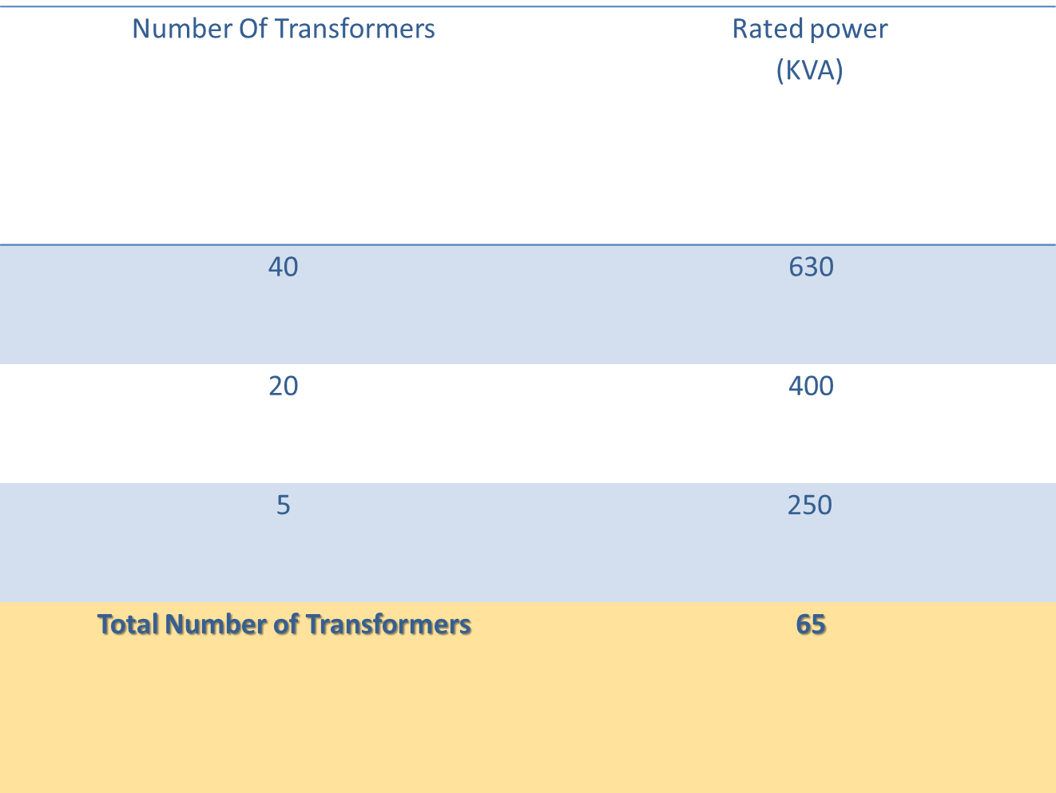

Table 1.2. Transformers OfSalfeet City.
Power factor | Actual power | Rated power | Transformer number
0.85 | 250 | 400 | Tr1
0.84 | 200 | 400 | Tr2
0.85 | 200 | 400 | Tr3
0.89 | 380 | 630 | Tr4
0.87 | 230 | 400 | Tr5
0.89 | 280 | 400 | Tr6
0.86 | 220 | 400 | Tr7
0.84 | 120 | 250 | Tr8
0.88 | 350 | 630 | Tr9
0.84 | 235 | 400 | Tr10
0.87 | 215 | 400 | Tr11
0.87 | 210 | 400 | Tr12
0.85 | 420 | 630 | Tr13
0.91 | 300 | 400 | Tr14
0.90 | 400 | 630 | Tr15
0.86 | 150 | 250 | Tr16

Table 1.3.Transformers of Salfeet villages.
PF | Load(%) | Load(KVA) | KVA  rated | number of transformers | Village
0.85 | 75 | 300 | 400 | Tr18 | Farkha
0.83 | 80 | 200 | 250 | Tr19 | Khirbaqais
0.86 | 65 | 162.5 | 250 | Tr20 | Amoria 1
0.88 | 60 | 240 | 400 | Tr21 | Amoria 2
0.85 | 70 | 175 | 250 | Tr22 | Skaka 1
0.87 | 70 | 280 | 400 | Tr23 | Skaka 2
0.83 | 50 | 300 | 600 | Tr24 | Yasoof
0.86 | 75 | 450 | 600 | Tr25 | Marda
0.84 | 50 | 200 | 400 | Tr26 | Qaer
0.86 | 70 | 420 | 600 | Tr27 | Qefel hares
0.84 | 70 | 420 | 600 | Tr28 | Hares
0.9 | 60 | 360 | 600 | Tr29 | Dearistia 1
0.88 | 50 | 200 | 400 | Tr30 | Dearistia 2
0.85 | 50 | 200 | 400 | Tr31 | Dearistia 3
0.87 | 50 | 200 | 400 | Tr32 | Dearistia 4
0.91 | 55 | 220 | 400 | Tr33 | Qarawa bane hasan 1
0.85 | 50 | 300 | 600 | Tr34 | Qarawa bane hasan 2
0.83 | 50 | 300 | 600 | Tr35 | Qarawa bane hasan 3
0.86 | 60 | 360 | 600 | Tr36 | Qarawa bane hasan 4
0.85 | 50 | 300 | 600 | Tr37 | Qarawa bane hasan 5
0.9 | 55 | 330 | 600 | Tr38 | Bidia 1
0.88 | 60 | 360 | 600 | Tr39 | Bidia 2
0.85 | 50 | 300 | 600 | Tr40 | Bidia 3
0.85 | 50 | 300 | 600 | Tr41 | Bidia 4
0.87 | 65 | 390 | 600 | Tr42 | Bidia 5
0.84 | 60 | 360 | 600 | Tr43 | Bidia 6
0.86 | 50 | 300 | 600 | Tr44 | Bidia 7
0.85 | 70 | 280 | 400 | Tr45 | Bidia 8
0.83 | 50 | 200 | 400 | Tr46 | Bidia 9
0.87 | 65 | 260 | 400 | Tr47 | Bidia 10
0.85 | 75 | 450 | 600 | Tr48 | Masha
0.89 | 50 | 300 | 600 | Tr49 | Azzawia 1
0.9 | 55 | 330 | 600 | Tr50 | Azzawia 2
0.86 | 50 | 200 | 400 | Tr51 | Azzawia 3
0.91 | 65 | 260 | 400 | Tr52 | Azzawia 4
0.92 | 70 | 280 | 400 | Tr53 | Azzawia 5
0.83 | 50 | 200 | 400 | Tr54 | Rafat 1
0.87 | 60 | 360 | 600 | Tr55 | Rafat 2
0.85 | 55 | 330 | 600 | Tr56 | Daer ballot 1
0.88 | 50 | 300 | 600 | Tr57 | Dear ballot 2
0.92 | 70 | 420 | 600 | Tr58 | Sarta
0.9 | 50 | 300 | 600 | Tr59 | Broken 1
0.87 | 50 | 300 | 600 | Tr60 | Broken 2
0.83 | 50 | 300 | 600 | Tr61 | Broken 3
0.88 | 60 | 360 | 600 | Tr62 | Kofraldaek 1
0.85 | 50 | 300 | 600 | Tr63 | Kofraldaek 2
0.84 | 55 | 330 | 600 | Tr64 | Kofraldaek 3
0.87 | 50 | 300 | 600 | Tr65 | Kofraldaek 4
0.9 | 65 | 260 | 400 | Tr66 | Kofraldaek 5

1.2 Transmission Lines.
The cross sectional area: 3*95 ( AL)
Resistance
We had the resistance at T =20 C so to find it at the T =75 C we use the following equation:
R2/R1= (T+t2)/ (T+t1)
Where T= 228 C for AL
T= 241 C for CU
Table 1.4.transmission resistance.
TYPE | CROSS SECITONAL AREA | T =20 C | T =75 C
ACSR | 3*95 | 0.33 Ω\KM | 0. 403 Ω\KM

Table 1.5 transmission reactance.
TYPE | CROSS SECITONAL AREA | X(Ω\KM)
ACSR | 3*95 | 0.263

Later when we started, we needed some values such as X/R, Z% for transformers that we should to use it in ETAP program.
And we use Google earth program to find the length of transmission line , and to make anew suitable configuration in this study . also the length of the transmission line inside the salfeet municipality , because they are have a poor data about it

1.3 Energy consumption sectors :
Distribution of energy consumption as follows:
Table 1.6. Energy consumption sector.
Load Type | Consumption %
Residential | 80%
Commercial | 10%
Industry | 4%
Pumps | 6%

Figure 1.1: sector of energy consumption

1.4 Unified electrical network
Salfeet district electrical network is not unified and the villages are not not connected electricaly , so we will make the best configuration to unify all the district and have one connection , and this configration depend on many factor :
1-natural Relief of the district .
2-We changed some of the tracks due to the presence of Israeli settlements.
3-the shortest length between the villages .

Advantages of unified electrical system :
1-Increase the availability and reliability of the system and lower probability or expected loss of feeding.
2-Mutual assistance in emergency situations when a failure occurs.
3-Increased dynamic stability, the fact that the all system more capable than single systems to restore its stability after disturbances or serious accidents, and to reduces the fault current , because its propoational inversly with the size of electrical system
4- Opportunities for the possibility of a maintenance programs better.
5-increasing the diversity factor , so that give us economical benefit from reducing the installed capacity.
6- increasing the efficiency of the source , , so that give us environmental benefit from reducing the emissions from the station, because it will be more efficiently when the load increasing.

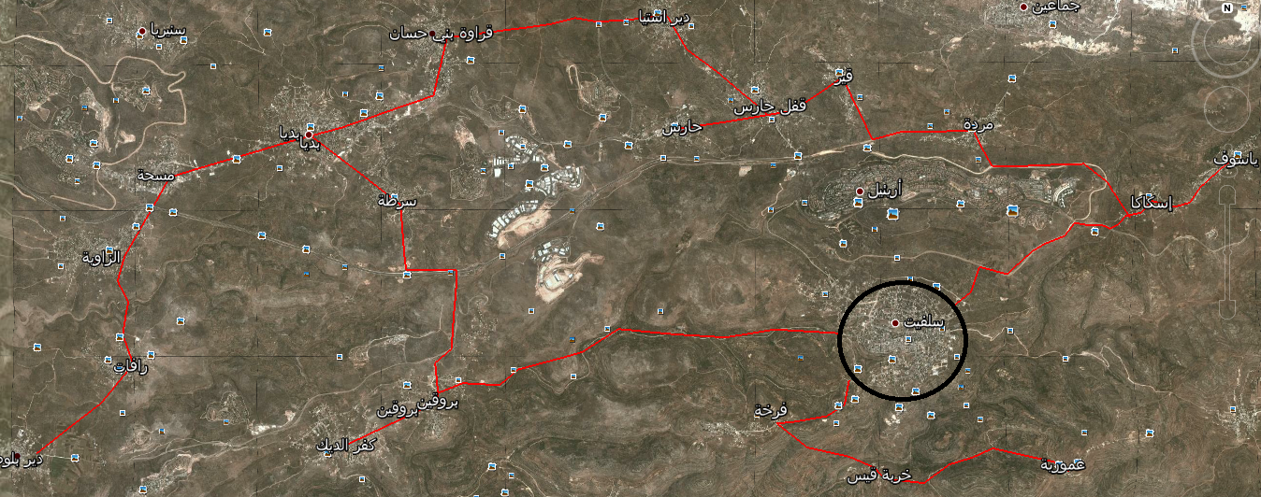
Figure 1.2.suitable configuration for salfeet unified electrical network.
Table 1.7.network villages as a loads.
Q (KVAR) | P (KW) | Name
2037 | 3622 | Salfeet city
158 | 255 | Farkha
122 | 166 | Khirbaqais
198 | 350 | Amoria
230 | 393 | Skaka
167 | 249 | Yasof
230 | 387 | Marda
109 | 168 | Qair
214 | 361 | Kifl hares
228 | 353 | Hares
456 | 844 | Dairistia
758 | 1269 | Qarawabnehassan
769 | 1314 | Kofraddeek
446 | 780 | Broqen
165 | 386 | Sarta
1558 | 2653 | Bidia
237 | 383 | Masha
838 | 1231 | Azzawia
289 | 479 | Rafat
316 | 545 | Dair ballot

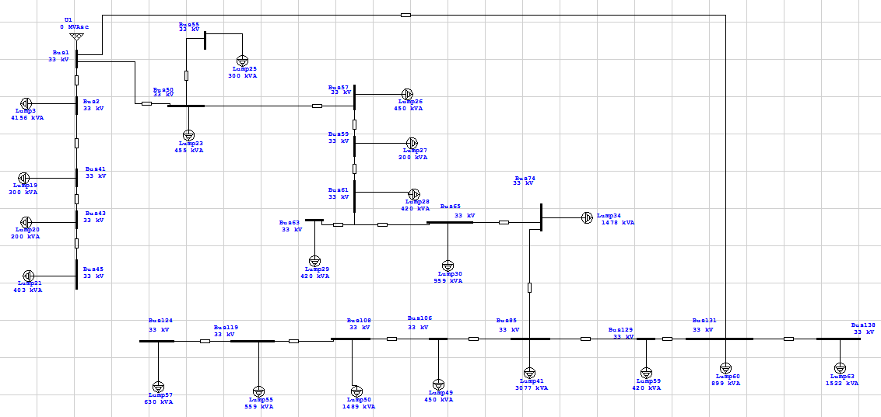Figure 1.3.one line diagram for salfeet city and its villages

:Electrical Network Improvement H.2C
As we see in the previous chapter we have a lot of problems in this network and in this chapter we want to show how we will work in the next first semester
- Replacing the taps ratio of some transformers.
- Improving the reliability of the network by adding ring connection.
- Adding capacitors "fixed and variable".
- Make all salfeet district as a unified system .
2.1 : Theory :

2.1.1Replacing the taps ratio of some transformers:

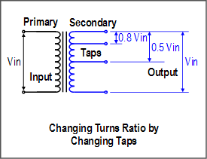
Figure 2.1 Changing taps ratio

A transformer tap is a connection point along a transformer winding that allows a certain number of turns to be selected. This means, a transformer with a variable turns ratio is produced, enabling voltage regulation of the output. The tap selection is made via a tap changer mechanism
Tap changing can be effected when
a) The transformers is on no- load and
b) The load is still remains connected to the transformer.

These are called off load tap changing and on load tap changing. The Off load taps changing relatively costs less. The tap positions are changed when the transformer is taken out of the circuit and reconnected.
The on-load tap changer on the other hand tries to change the taps without the interruption of the load current.
In view of this requirement it normally costs more.

And because the voltage on some buses is lower than the range to accept it so we may change the tapes ratio of some transformers depending on the following equations:

$$\frac{V^{H,Tap}}{V^{L,Nom}}=\frac{V^{H,Calclated}}{V^{L,Desiered}}$$
N: is approximated to the near integer number within the range of taps, may be positive or negative value.

$$\frac{V^{H,Tap}-V^{H,Nom}}{Range of each Tap}$$

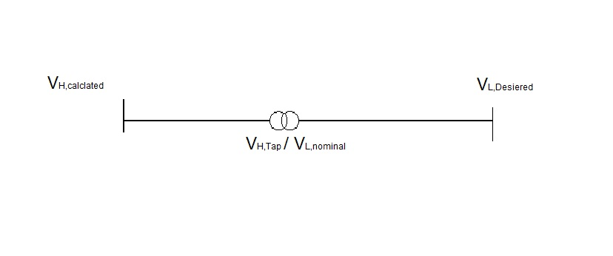
Figure 2.2 transformer

2.1.2Power factor correction
Depending upon the rate structure of your electric utility, you may be able to save a substantial amount of money on your electric bill. Pay-back period for an equipment purchase including installation cost may be less than six months to a year. Utility rate structures that account for reactive power consumption, by either a KVA or var demand usage, or a power factor penalty are the ones that can provide this pay-back. Other ancillary benefits to be gained by correcting power factor are lower energy losses, better voltage regulation and released system capacity. Here we explain the fundamentals of power factor and how shunt capacitor banks can benefit you.
All electric equipment requires "vars" - a term used by electric power engineers to describe the reactive power required by the inductive characteristics of electrical equipment. These inductive characteristics are more pronounced in motors and transformers, and therefore, can be quite significant in industrial facilities. The flow of vars, or reactive power, through a watt-hour meter will not affect the meter reading, but the flow of vars through the power system will result in energy losses on both the utility and the industrial facility. Some utilities charge for these vars in the form of a penalty, or KVA demand charge, to justify the cost for lost energy and the additional conductor and transformer capacity required to carry the vars. In addition to energy losses, var flow can also cause excessive voltage drop, which may have to be corrected by either the application of shunt capacitors, or other more expensive equipment, such as load-tap changing transformers, synchronous motors, and synchronous condensers.
The power factor is the cosine of the angle between the voltage and current in the circuit or the ratio of the resistance to the impedance of the circuit and also the ratio of the real to the apparent power. To give more detail regarding power factor see Fig1.1 the links below for additional information on power factor.

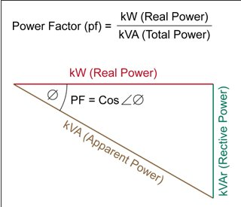

Figure 2.3 power factor

TYPES OF POWER FACTORS
1- Unity power factor - real equal apparent power.
2- Leading power factor - when the current leads voltage by an angle and the true power will less than the apparent power.
3- Lagging power factor - when the current lags voltage by an angle and the true power is less than the apparent power.
4- Zero power factor - when there is phase difference of 90 degree between the current and the voltage. If the circuit has zero power factor you have no useful work to be done.

Why we need to improve power factor:
1-To avoid poor voltage regulation.
2- To decrease the reactive power (to reduce the overall current for a given power requirement and hence reduce the penalty costs on the electricity bill).
3-Saving money
4-Increasing efficiency.
HOW TO CORRECT THE POWER FACTOR:
1-using synchronous motor can improve the power factor.
2- Using static capacitors can also improve the power factor.
3- For indicative circuit they can improve the power factor by connecting in series of capacitor.

2.1.3Power losses

Power in an electric circuit is the rate of flow of energy past a given point of the circuit. In alternating current circuits, energy storage elements such as inductance and capacitance may result in periodic reversals of the direction of energy flow. The portion of power that averaged over a complete cycle of the AC waveform, results in net transfer of energy in one direction is known as real power. The portion of power due to stored energy, which returns to the source in each cycle, is known as reactive power.
Engineers use the following terms to describe energy flow in a system (and assign each of them a different unit to differentiate between them):
Real power (P) or active power watt [W]. ►
►Reactive power (Q): volt-ampere reactive [var].
►Complex power (S): volt-ampere [VA].
►Apparent Power (|S|), that is, the absolute value of complex power S:
volt-ampere [VA]
Phase of Voltage Relative to Current (φ), the angle of difference (in degrees) between voltage and current ; Current lagging Voltage (Quadrant I Vector), Current leading voltage (Quadrant IV Vector)
A perfect resistor stores no energy, so current and voltages are in phase. Therefore there is no reactive power and the real power equal the apparent power perfect resistor
$$P=I^{2}R=\frac{V^{2}}{R}$$

For a perfect capacitor or inductor there is no net power transfer, so all power is reactive. Therefore for a perfect capacitor or inductor:
$$Q=I^{2}\left|X\right|=\frac{V^{2}}{\left|X\right|}$$
Where X is the reactance of the capacitor or inductor.
►Apparent Power:
S= p + jQ
P =$\sqrt{3} V I*\cos{θ}$
Q=$\sqrt{3} V I*\sin{θ}$
►Power Factor = $\cos{θ}$
Where:
$θ$ = $θv-θi$

2.1.4 :Improved the voltage level
We have to improve the voltage level of each bus to arrive to the consumer in acceptable range that can work in it.
To arrived to this (improved the voltage level) we have use some methods(Changing Under load Transformer (TCUL) and by using capacitors ) and we have to reduce the losses in the network.
Why Voltage Control?
1- Mainly are Technical benefits & Economical benefits [∑ PG ↓= ∑PL + ∑ ∆P↓ ]
2- To minimize real power losses in the system (Objective Ploss)
3- To minimize voltage deviations from desired voltage values (Objective Vdesired).
4- To avoid the damage on the network when a critical condition (Max. load, min. load, Faults) is applied on it.
►Both the objectives achieve their desired minimum by optimal control of the reactive power control variables. The controls recommended while achieving this objective may in certain cases actually deteriorate the system voltage stability condition under stressed conditions.
Methods of voltage control and rescheduling of active/reactive power generations are proposed in order to reduce the risk of voltage instability and increase the reactive reserve of generators, they are namely:
1- Control by Generators (increase the amount of real power generated).
2- Install sources of reactive power
a) Synchronous condenser
b) Capacitors banks (Because it minimizes movement of reactive power in the network
Tap Changing Under load Transformer (TCUL) [Substation transformers]►
Voltage must not exceed the rated voltage (not above 10% of Vnom & ∆P must not increase too much.
2.1.5 Methods Of Improvement:
- Changing the tapes ratio of transformers.
- Adding new connections( ring connections )
- Adding capacitors.
- Changing the tapes ratio of transformers.
We changed all tapes ratio of transformers, by +5%
Figure 2.4: 5% tap changer.

- Adding new connections( ring connections )
We want to add a new ring connections in order to reduce the currents that flowing in the cables, then losses and the drop in voltage will decrease see the following :
∆P=3|I|^(2 ) * R
SO
∆P↓=3|I|^2↓R
And to increase reliability of the network which means if any cable has been broken then the currents will have another path to flow so the load will always have continuity of currents.
→ Ring between bus ( 1) to bus (131)
We add two rings as we can see in the picture:

Figure 2.5: ring connection
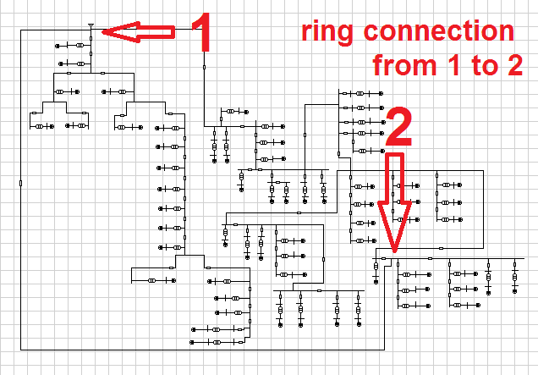
3. Adding capacitors.
We add the capacitors to the grid for many reasons summarize in the following point:
- Reducing the current so it reduce the losses in the grid.
- Improving the voltage .
- Organizing the movement of the reactive power.
- Improving the power factor .
They work as follows:
I↓ & then ∆V ↓ & then (VL= V1-∆V)↓ )
Without a capacitor:
I=√((〖PL〗^2+〖QL〗^2))/(√3 VL)
With a capacitor:
I↓=√((〖PL〗^2+(〖QL-QC)〗^2 )/(√3 VL)
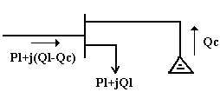 Figure 2.6: capacitor at the bus
2.2Results of Salfit Network :
2.2.1 orginal case:
(MAX CASE ) Table 2.1.orginal case- max.
V(Rated) | V(terminal
0.4 | 0.385 | Lump3
0.4 | 0.388 | Lump4
0.4 | 0.387 | Lump5
0.4 | 0.386 | Lump6
0.4 | 0.385 | Lump7
0.4 | 0.383 | Lump8
0.4 | 0.390 | Lump9
0.4 | 0.387 | Lump10
0.4 | 0.379 | Lump11
0.4 | 0.384 | Lump12
0.4 | 0.385 | Lump13
0.4 | 0.385 | Lump14
0.4 | 0.383 | Lump15
0.4 | 0.384 | Lump16
0.4 | 0.387 | Lump17
0.4 | 0.386 | Lump18
0.4 | 0.380 | Lump19
0.4 | 0.378 | Lump20
0.4 | 0.382 | Lump21
0.4 | 0.383 | Lump22
0.4 | 0.381 | Lump23
0.4 | 0.381 | Lump24
0.4 | 0.386 | Lump25
0.4 | 0.379 | Lump26
0.4 | 0.382 | Lump27
0.4 | 0.378 | Lump28
0.4 | 0.378 | Lump29
0.4 | 0.38 | Lump30
0.4 | 0.381 | Lump31
0.4 | 0.381 | Lump32
0.4 | 0.381 | Lump33
0.4 | 0.38 | Lump34
0.4 | 0.380 | Lump35
0.4 | 0.38 | Lump36
0.4 | 0.378 | Lump37
0.4 | 0.38 | Lump38
0.4 | 0.38 | Lump39
0.4 | 0.379 | Lump40
0.4 | 0.38 | Lump41
0.4 | 0.38 | Lump42
0.4 | 0.377 | Lump43
0.4 | 0.378 | Lump44
0.4 | 0.38 | Lump45
0.4 | 0.375 | Lump46
0.4 | 0.379 | Lump47
0.4 | 0.377 | Lump48
0.4 | 0.374 | Lump49
0.4 | 0.379 | Lump50
0.4 | 0.379 | Lump51
0.4 | 0.378 | Lump52
0.4 | 0.376 | Lump53
0.4 | 0.376 | Lump54
0.4 | 0.377 | Lump55
0.4 | 0.377 | Lump56
0.4 | 0.377 | Lump57
0.4 | 0.379 | Lump58
0.4 | 0.379 | Lump59
0.4 | 0.384 | Lump60
0.4 | 0.384 | Lump61
0.4 | 0.383 | Lump62
0.4 | 0.381 | Lump63
0.4 | 0.383 | Lump64
0.4 | 0.382 | Lump65
0.4 | 0.383 | Lump66
0.4 | 0.38 | Lump67

- From the table above we see Table 2.2.result – orginal max.
 | MW | Mvar | MVA | %PF
Source (Swing Buses) | 15.464 | 9.553 | 18.177 | 85.08lagging
Source (Non-Swing Buses) | 0000 | 0000 | 0000 | 0000
Total Demand | 15.464 | 9.553 | 18.177 | lagging85.08
Total Motor Load | 3.436 | 1.961 | 3.956 | 86.85 lagging
Total Static Load | 11.581 | 6.629 | 13.344 | 86.79 Lagging
Apparent Losses | 0.627 | 0.963
I(swing) | 477 A
(MIN CASE) Table 2.3.orginal case- min.:
V(Rated) | V(terminal
0.4 | 0.393 | Lump3
0.4 | 0.394 | Lump4
0.4 | 0.394 | Lump5
0.4 | 0.393 | Lump6
0.4 | 0.393 | Lump7
0.4 | 0.392 | Lump8
0.4 | 0.395 | Lump9
0.4 | 0.393 | Lump10
0.4 | 0.389 | Lump11
0.4 | 0.392 | Lump12
0.4 | 0.393 | Lump13
0.4 | 0.393 | Lump14
0.4 | 0.391 | Lump15
0.4 | 0.392 | Lump16
0.4 | 0.393 | Lump17
0.4 | 0.393 | Lump18
0.4 | 0.39 | Lump19
0.4 | 0.389 | Lump20
0.4 | 0.391 | Lump21
0.4 | 0.392 | Lump22
0.4 | 0.39 | Lump23
0.4 | 0.391 | Lump24
0.4 | 0.393 | Lump25
0.4 | 0.39 | Lump26
0.4 | 0.391 | Lump27
0.4 | 0.389 | Lump28
0.4 | 0.389 | Lump29
0.4 | 0.39 | Lump30
0.4 | 0.391 | Lump31
0.4 | 0.39 | Lump32
0.4 | 0.39 | Lump33
0.4 | 0.39 | Lump34
0.4 | 0.39 | Lump35
0.4 | 0.39 | Lump36
0.4 | 0.389 | Lump37
0.4 | 0.39 | Lump38
0.4 | 0.39 | Lump39
0.4 | 0.389 | Lump40
0.4 | 0.39 | Lump41
0.4 | 0.39 | Lump42
0.4 | 0.389 | Lump43
0.4 | 0.389 | Lump44
0.4 | 0.39 | Lump45
0.4 | 0.387 | Lump46
0.4 | 0.389 | Lump47
0.4 | 0.388 | Lump48
0.4 | 0.387 | Lump49
0.4 | 0.39 | Lump50
0.4 | 0.389 | Lump51
0.4 | 0.389 | Lump52
0.4 | 0.388 | Lump53
0.4 | 0.388 | Lump54
0.4 | 0.389 | Lump55
0.4 | 0.388 | Lump56
0.4 | 0.388 | Lump57
0.4 | 0.389 | Lump58
0.4 | 0.389 | Lump59
0.4 | 0.392 | Lump60
0.4 | 0.392 | Lump61
0.4 | 0.391 | Lump62
0.4 | 0.391 | Lump63
0.4 | 0.391 | Lump64
0.4 | 0.391 | Lump65
0.4 | 0.392 | Lump66
0.4 | 0.39 | Lump67

- From the table above we see Table 2.4.result – orginal min.
 | MW | Mvar | MVA | %PF
Source (Swing Buses) | 7.918 | 4.711 | 9.213 | 85.94lagging
Source (Non-Swing Buses) | 0000 | 0000 | 0000 | 0000
Total Demand | 7.918 | 4.711 | 9.213 | lagging85.94
Total Motor Load | 1.718 | 0.980 | 1.978 | 86.85 lagging
Total Static Load | 6.085 | 3.483 | 7.011 | 86.79 Lagging
Apparent Losses | 0.115 | 0.248
I(swing) | 241.78 A

2.2.2 After increasing the Tap Changer of transformer:
(MAX CASE ) Table 2.5.change tap changer case- max.
V(Rated) | V(terminal
0.4 | 0.404 | Lump3
0.4 | 0.406 | Lump4
0.4 | 0.406 | Lump5
0.4 | 0.404 | Lump6
0.4 | 0.403 | Lump7
0.4 | 0.401 | Lump8
0.4 | 0.409 | Lump9
0.4 | 0.405 | Lump10
0.4 | 0.396 | Lump11
0.4 | 0.402 | Lump12
0.4 | 0.404 | Lump13
0.4 | 0.404 | Lump14
0.4 | 0.401 | Lump15
0.4 | 0.402 | Lump16
0.4 | 0.405 | Lump17
0.4 | 0.404 | Lump18
0.4 | 0.397 | Lump19
0.4 | 0.395 | Lump20
0.4 | 0.4 | Lump21
0.4 | 0.401 | Lump22
0.4 | 0.398 | Lump23
0.4 | 0.399 | Lump24
0.4 | 0.404 | Lump25
0.4 | 0.397 | Lump26
0.4 | 0.4 | Lump27
0.4 | 0.396 | Lump28
0.4 | 0.395 | Lump29
0.4 | 0.398 | Lump30
0.4 | 0.399 | Lump31
0.4 | 0.398 | Lump32
0.4 | 0.399 | Lump33
0.4 | 0.397 | Lump34
0.4 | 0.398 | Lump35
0.4 | 0.397 | Lump36
0.4 | 0.396 | Lump37
0.4 | 0.398 | Lump38
0.4 | 0.397 | Lump39
0.4 | 0.396 | Lump40
0.4 | 0.397 | Lump41
0.4 | 0.397 | Lump42
0.4 | 0.394 | Lump43
0.4 | 0.395 | Lump44
0.4 | 0.397 | Lump45
0.4 | 0.392 | Lump46
0.4 | 0.396 | Lump47
0.4 | 0.393 | Lump48
0.4 | 0.391 | Lump49
0.4 | 0.397 | Lump50
0.4 | 0.396 | Lump51
0.4 | 0.395 | Lump52
0.4 | 0.393 | Lump53
0.4 | 0.392 | Lump54
0.4 | 0.394 | Lump55
0.4 | 0.394 | Lump56
0.4 | 0.394 | Lump57
0.4 | 0.396 | Lump58
0.4 | 0.396 | Lump59
0.4 | 0.402 | Lump60
0.4 | 0.401 | Lump61
0.4 | 0.401 | Lump62
0.4 | 0.399 | Lump63
0.4 | 0.401 | Lump64
0.4 | 0.399 | Lump65
0.4 | 0.401 | Lump66
0.4 | 0.398 | Lump67

- From the table above we see Table 2.6.result – after tap changr max
 | MW | Mvar | MVA | %PF
Source (Swing Buses) | 16.622 | 10.328 | 19.570 | 84.94lagging
Source (Non-Swing Buses) | 0000 | 0000 | 0000 | 0000
Total Demand | 16.622 | 10.328 | 19.570 | lagging84.94
Total Motor Load | 3.436 | 1.961 | 3.956 | 86.85 lagging
Total Static Load | 12.668 | 7.252 | 14.597 | 86.79 Lagging
Apparent Losses | 0.518 | 1.116
I(swing) | 513.6 A

(MIN CASE) : Table 2.7.change tap changer case- min
V(Rated) | V(terminal
0.4 | 0.412 | Lump3
0.4 | 0.413 | Lump4
0.4 | 0.413 | Lump5
0.4 | 0.412 | Lump6
0.4 | 0.412 | Lump7
0.4 | 0.41 | Lump8
0.4 | 0.414 | Lump9
0.4 | 0.412 | Lump10
0.4 | 0.408 | Lump11
0.4 | 0.411 | Lump12
0.4 | 0.412 | Lump13
0.4 | 0.412 | Lump14
0.4 | 0.41 | Lump15
0.4 | 0.411 | Lump16
0.4 | 0.412 | Lump17
0.4 | 0.412 | Lump18
0.4 | 0.409 | Lump19
0.4 | 0.408 | Lump20
0.4 | 0.41 | Lump21
0.4 | 0.411 | Lump22
0.4 | 0.409 | Lump23
0.4 | 0.409 | Lump24
0.4 | 0.412 | Lump25
0.4 | 0.408 | Lump26
0.4 | 0.41 | Lump27
0.4 | 0.408 | Lump28
0.4 | 0.407 | Lump29
0.4 | 0.409 | Lump30
0.4 | 0.409 | Lump31
0.4 | 0.409 | Lump32
0.4 | 0.409 | Lump33
0.4 | 0.409 | Lump34
0.4 | 0.409 | Lump35
0.4 | 0.408 | Lump36
0.4 | 0.408 | Lump37
0.4 | 0.409 | Lump38
0.4 | 0.409 | Lump39
0.4 | 0.408 | Lump40
0.4 | 0.408 | Lump41
0.4 | 0.408 | Lump42
0.4 | 0.407 | Lump43
0.4 | 0.407 | Lump44
0.4 | 0.409 | Lump45
0.4 | 0.406 | Lump46
0.4 | 0.408 | Lump47
0.4 | 0.407 | Lump48
0.4 | 0.405 | Lump49
0.4 | 0.408 | Lump50
0.4 | 0.408 | Lump51
0.4 | 0.407 | Lump52
0.4 | 0.406 | Lump53
0.4 | 0.406 | Lump54
0.4 | 0.407 | Lump55
0.4 | 0.407 | Lump56
0.4 | 0.407 | Lump57
0.4 | 0.408 | Lump58
0.4 | 0.408 | Lump59
0.4 | 0.411 | Lump60
0.4 | 0.411 | Lump61
0.4 | 0.41 | Lump62
0.4 | 0.409 | Lump63
0.4 | 0.41 | Lump64
0.4 | 0.409 | Lump65
0.4 | 0.41 | Lump66
0.4 | 0.409 | Lump67

- From the table above we see Table 2.8.result – after tap changr min
 | MW | Mvar | MVA | %PF
Source (Swing Buses) | 8.534 | 8.093 | 9.938 | 85.87lagging
Source (Non-Swing Buses) | 0000 | 0000 | 0000 | 0000
Total Demand | 8.534 | 5.093 | 9.938 | lagging85.87
Total Motor Load | 1.718 | 0.980 | 1.978 | 86.85 lagging
Total Static Load | 6.682 | 3.825 | 7.699 | 86.79 Lagging
Apparent Losses | 0.134 | 0.288
I(swing) | 260.8 A

2.2.3 After adding and distribute capacitors :
(MAX CASE ) Table 2.9.adding capacitor case- max
V(Rated) | V(terminal
0.4 | 0.409 | Lump3
0.4 | 0.408 | Lump4
0.4 | 0.41 | Lump5
0.4 | 0.405 | Lump6
0.4 | 0.409 | Lump7
0.4 | 0.403 | Lump8
0.4 | 0.411 | Lump9
0.4 | 0.409 | Lump10
0.4 | 0.399 | Lump11
0.4 | 0.407 | Lump12
0.4 | 0.406 | Lump13
0.4 | 0.406 | Lump14
0.4 | 0.407 | Lump15
0.4 | 0.402 | Lump16
0.4 | 0.407 | Lump17
0.4 | 0.406 | Lump18
0.4 | 0.404 | Lump19
0.4 | 0.402 | Lump20
0.4 | 0.405 | Lump21
0.4 | 0.407 | Lump22
0.4 | 0.404 | Lump23
0.4 | 0.405 | Lump24
0.4 | 0.408 | Lump25
0.4 | 0.403 | Lump26
0.4 | 0.405 | Lump27
0.4 | 0.402 | Lump28
0.4 | 0.4 | Lump29
0.4 | 0.4 | Lump30
0.4 | 0.401 | Lump31
0.4 | 0.403 | Lump32
0.4 | 0.402 | Lump33
0.4 | 0.4 | Lump34
0.4 | 0.403 | Lump35
0.4 | 0.402 | Lump36
0.4 | 0.402 | Lump37
0.4 | 0.403 | Lump38
0.4 | 0.4 | Lump39
0.4 | 0.399 | Lump40
0.4 | 0.403 | Lump41
0.4 | 0.403 | Lump42
0.4 | 0.398 | Lump43
0.4 | 0.401 | Lump44
0.4 | 0.401 | Lump45
0.4 | 0.396 | Lump46
0.4 | 0.401 | Lump47
0.4 | 0.397 | Lump48
0.4 | 0.395 | Lump49
0.4 | 0.399 | Lump50
0.4 | 0.399 | Lump51
0.4 | 0.398 | Lump52
0.4 | 0.396 | Lump53
0.4 | 0.395 | Lump54
0.4 | 0.4 | Lump55
0.4 | 0.397 | Lump56
0.4 | 0.398 | Lump57
0.4 | 0.399 | Lump58
0.4 | 0.399 | Lump59
0.4 | 0.404 | Lump60
0.4 | 0.404 | Lump61
0.4 | 0.405 | Lump62
0.4 | 0.402 | Lump63
0.4 | 0.403 | Lump64
0.4 | 0.402 | Lump65
0.4 | 0.404 | Lump66
0.4 | 0.4 | Lump67

- From the table above we see Table 2.10.result – after add capacitor max
 | MW | Mvar | MVA | %PF
Source (Swing Buses) | 16.555 | 7.038 | 18.003 | 92.24lagging
Source (Non-Swing Buses) | 0000 | 0000 | 0000 | 0000
Total Demand | 16.806 | 7.038 | 18.220 | Lagging92.24
Total Motor Load | 3.436 | 1.961 | 3.956 | 86.85 lagging
Total Static Load | 12.919 | 4.106 | 13.555 | 95.3 Lagging
Apparent Losses | 0.451 | 0.972
I(swing) | 478.15 A

(MIN CASE)Table 2.11.adding capacitor case- min
V(Rated) | V(terminal
0.4 | 0.414 | Lump3
0.4 | 0.415 | Lump4
0.4 | 0.415 | Lump5
0.4 | 0.414 | Lump6
0.4 | 0.414 | Lump7
0.4 | 0.412 | Lump8
0.4 | 0.416 | Lump9
0.4 | 0.414 | Lump10
0.4 | 0.411 | Lump11
0.4 | 0.414 | Lump12
0.4 | 0.414 | Lump13
0.4 | 0.414 | Lump14
0.4 | 0.414 | Lump15
0.4 | 0.411 | Lump16
0.4 | 0.414 | Lump17
0.4 | 0.414 | Lump18
0.4 | 0.412 | Lump19
0.4 | 0.411 | Lump20
0.4 | 0.412 | Lump21
0.4 | 0.412 | Lump22
0.4 | 0.411 | Lump23
0.4 | 0.412 | Lump24
0.4 | 0.414 | Lump25
0.4 | 0.412 | Lump26
0.4 | 0.413 | Lump27
0.4 | 0.411 | Lump28
0.4 | 0.411 | Lump29
0.4 | 0.411 | Lump30
0.4 | 0.412 | Lump31
0.4 | 0.412 | Lump32
0.4 | 0.412 | Lump33
0.4 | 0.411 | Lump34
0.4 | 0.412 | Lump35
0.4 | 0.412 | Lump36
0.4 | 0.411 | Lump37
0.4 | 0.412 | Lump38
0.4 | 0.411 | Lump39
0.4 | 0.411 | Lump40
0.4 | 0.411 | Lump41
0.4 | 0.411 | Lump42
0.4 | 0.41 | Lump43
0.4 | 0.411 | Lump44
0.4 | 0.412 | Lump45
0.4 | 0.41 | Lump46
0.4 | 0.411 | Lump47
0.4 | 0.41 | Lump48
0.4 | 0.409 | Lump49
0.4 | 0.411 | Lump50
0.4 | 0.41 | Lump51
0.4 | 0.41 | Lump52
0.4 | 0.409 | Lump53
0.4 | 0.409 | Lump54
0.4 | 0.41 | Lump55
0.4 | 0.41 | Lump56
0.4 | 0.41 | Lump57
0.4 | 0.41 | Lump58
0.4 | 0.41 | Lump59
0.4 | 0.413 | Lump60
0.4 | 0.413 | Lump61
0.4 | 0.413 | Lump62
0.4 | 0.412 | Lump63
0.4 | 0.413 | Lump64
0.4 | 0.413 | Lump65
0.4 | 0.413 | Lump66
0.4 | 0.411 | Lump67

- From the table above we see Table 2.12.result – after add capacitor min
 | MW | Mvar | MVA | %PF
Source (Swing Buses) | 8.601 | 2.807 | 9.048 | 95.07lagging
Source (Non-Swing Buses) | 0000 | 0000 | 0000 | 0000
Total Demand | 8.601 | 2.807 | 9.048 | Lagging95.07
Total Motor Load | 1.718 | 0.980 | 1.978 | 86.85 lagging
Total Static Load | 6.772 | 1.587 | 6.956 | 97.36 Lagging
Apparent Losses | 0.111 | 0.239
I(swing) | 237.45 A

2.3 Economical study
In the economic study do it to know how our design of improving the network is economic feasible and to know how long the payback period of our design.
The payback period method compares the losses power and any extra losses before improvement with the cost of the capacitors we used to improve the condition.
The following calculation illustrates an economical study in condition after improvement.
The capacitors added in the original maximum as follows

Capacitors that added to the Original maximum :
Table 2.13.result – distribution of capacitor
Variable capacitor-max case | Fixed capacitor-min case | # of Bus
35 | 35 | 3
0 | 30 | 5
30 | 25 | 8
40 | 25 | 13
0 | 30 | 17
20 | 15 | 19
0 | 35 | 21
30 | 35 | 23
0 | 25 | 25
55 | 60 | 30
0 | 20 | 37
0 | 25 | 40
45 | 40 | 42
25 | 30 | 44
20 | 20 | 48
60 | 10 | 49
35 | 10 | 53
50 | 30 | 54
35 | 45 | 56
60 | 55 | 58
25 | 30 | 60
60 | 55 | 62
25 | 60 | 64
0 | 20 | 69
30 | 25 | 71
0 | 25 | 73
45 | 40 | 78
35 | 45 | 80
55 | 45 | 82
45 | 40 | 84
0 | 40 | 89
45 | 40 | 91
45 | 40 | 93
0 | 45 | 95
50 | 50 | 97
0 | 40 | 99
0 | 40 | 101
25 | 30 | 103
0 | 30 | 105
0 | 60 | 107
0 | 25 | 114
25 | 30 | 121
0 | 40 | 123
0 | 45 | 126
0 | 30 | 128
0 | 35 | 135
35 | 45 | 137
0 | 40 | 140
0 | 40 | 142
0 | 50 | 144
0 | 35 | 146
0 | 35 | 11
0 | 25 | 15
0 | 30 | 110
0 | 30 | 35
0 | 30 | 67
0 | 30 | 87
0 | 30 | 112
0 | 25 | 133
0 | 25 | 148
0 | 20 | 76
0 | 20 | 116
0 | 20 | 118
0 | 25 | 130
1085 | 2160 | ∑

Saving in penalties:

- Pmax=16.622MW.
- Pmin=8.534MW.
- Losses before improvement=0.518MW.
- Losses after improvement=0.451MW.
- P.F before improvement=0.8494
- P.F after improvement=0.9224
- Pav=( Pmin+ Pmax)/2=12.578MW.
- L.F= Pavg/ Pmax=0.756.
- Total energy per year=Pav*8760=110183.28MWH.
- Total cost per year=Total energy*cost(NIS/KWH)
= 110183280*0.6 = 66109968 NIS/year.
- Saving in penalties of P.F= 1*(0.9224-0.8494)*Total cost of energy
= 4826027 NIS/year.

Saving in losses:

- Average losses before improvement =0.756*518 =391.6 KW.
- Energy of the losses before improvement=391.6*8760=3430416 KWH.
- Cost of losses before improvement= 3430416*0.6=2058249 NIS/year.
- Average losses after improvement =0.756*451 =341 KW.
- Energy of the losses after improvement=341*8760=2987160 KWH.
- Cost of losses after improvement=2987160*0.6=1792296 NIS/year.
- Saving in losses= cost of losses before –cost of losses after
= 2058249-1792296=265953 NIS/year.

Simple Pay Back Period :

- Total fixed capacitor banks using in maximum case=2160 KVAR.
- Cost per KVAR = 25NIS.
- Total regulated capacitor banks using in maximum case=1085 KVAR.
- Cost per KVAR = 125NIS.
- Total cost of capacitor banks= (125*1085)+(2160*25)=189625 NIS.
- Total saving=saving in losses +saving in penalties
=265953+4826027 = 5091980NIS.
- S.P.B.P=Investment /Saving
=189625/5091980= 0.0372 years.

Chapter 3

Mechanical Design:
Electrical Power can be transmitted or distributed either by means of underground cables or by overhead lines. The underground cables are rarely used for power transmission due to main reasons. Firstly, power is generally transmitted over long distances to load centers. Obviously, the installation costs for underground transmission will be very heavy. Secondly, electric power has to be transmitted at high or medium voltages for economic reasons .It is very difficult to provide proper insulation to the cables to withstand such higher pressures. Therefore, as a rule, power transmission over long distances is carried out by using over headlines. With growth in power demand and consequent rise in voltage levels, power transmission by overhead lines has assumed considerable importance.
An overhead line is subjected to uncertain whether conditions and other external interferences. This calls for the use of proper mechanical factor safety in order to ensure the continuity of operation in the line. In general, the strength of the line should be such so as to provide against the worst probable weather conditions .In this chapter; we shall focus our attention on the various aspects of mechanical design of over head lines.

3.1. Main Components of overhead lines:
In general, the main components of overhead lines are:
- Conductors:
Which carry electric power from the sending end station to receiving end station.
- Supports:
Which may be poles or towers and keep the conductors at suitable level above the ground.
- Insulators:
Which are attached to supports and insulate the conductors from the ground.
- Cross Arms:
Which provide support to the insulators.
- Miscellaneous Items:
Such as phase plates, danger plates, lightning arrestors, anti climbing wires .
3.2.Conductors Materials:
The conductor is one of the important items as most of the capital outlay is invested for it. Therefore, proper choice of material and size of the conductor is of considerable importance. The conductor material used for transmission and distribution of electric power should be have the following properties:

- High electrical conductivity
- High tensile strength in order to withstand mechanical stresses.
- Low cost so that it can be used for long distances.
- Low specific gravity so that weight per unit volume is small.

The most commonly used conductor materials for overhead lines are copper, aluminum, steel-cored aluminum, galvanized steel and cadmium copper.
The choice of a particular material will depend upon the cost, the required electrical and mechanical
Properties and the local conditions.

- Copper:
Copper is an ideal material for overhead lines owing to its high electrical conductivity and greater tensile strength. It is always used in the hard drawn form as stranded conductor.
Although hard drawing decreases the electrical conductivity slightly yet it increases the tensile strength considerably.
Copper has high current density i.e. the current carrying capacity of copper per unit of X-sectional area is quite large. This leads to two advantages. Firstly, smaller X-sectional area of conductor
is required and secondly, the area offered by the conductor to wind loads is reduced. Moreover, this metal is quite homogeneous, durable and has high scrap value. There is hardly any doubt that copper is an ideal material for transmission and distribution of
electric power. However, due to its higher cost and non availability, it is rarely used for these purposes.

- Aluminum:

Aluminum is cheap and light as compared to copper but it has much smaller Conductivity and tensile strength. The relative comparison of the two materials is briefed below :

1) The conductivity of aluminum is 60% that of copper. The smaller conductivity of aluminum
means that for any particular transmission efficiency, the X-sectional area of conductor must be larger in aluminum than in copper. For the same resistance, the diameter of aluminum conductor is about 1·26 times the diameter of copper conductor.
The increased X-section of aluminum exposes a greater surface to wind pressure and, therefore, supporting towers must be designed for greater transverse strength. This often requires the use of
higher towers with consequence of greater sag.

2) The specific gravity of aluminum (2·71 gm/cc) is lower than that of copper (8·9 gm/cc).
Therefore, an aluminum conductor has almost one-half the weight of equivalent copper conductor.
For this reason, the supporting structures for aluminum need not be made so strong as that of copper conductor.

3) Aluminum conductor being light, is liable to greater swings and hence larger cross-arms are
required.

4) Due to lower tensile strength and higher co-efficient of linear expansion of aluminum, the sag is greater in aluminum conductors.
Considering the combined properties of cost, conductivity, tensile strength, weight etc., aluminum has an edge over copper. Therefore, it is being widely used as a conductor material. It is particularly profitable to use aluminum for heavy-current transmission where the conductor size is
large and its cost forms a major proportion of the total cost of complete installation.

- Steel cord aluminum:

Due to low tensile strength, aluminum conductors produce greater sag. This prohibits their use for larger spans and makes them unsuitable for long distance transmission.
In order to increase the tensile strength, the aluminum conductor is reinforced with a core of galvanized steel wires. The composite conductor thus obtained is known as steel cored aluminum and is abbreviated as A.C.S.R. (aluminum conductor steel reinforced).
Steel-cored aluminum conductor consists of central core of galvanized steel wires surrounded by a number of aluminum strands.
The result of this composite conductor is that steel core takes greater percentage of mechanical strength while aluminum strands carry the bulk of current. The steel cord aluminum conductors have the following advantages :

1) The reinforcement with steel increases the tensile strength but at the same time keeps the composite conductor light. Therefore, steel cored aluminum conductors will produce smaller sag and hence longer spans can be used.
2) Due to smaller sag with steel cored aluminum conductors, towers of smaller heights can be used.

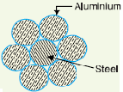
Fig 3.1.steel cord aluminum conductor.

- Galvanized steel:

Steel has very high tensile strength. Therefore, galvanized steel conductors can be used for extremely long spans or for short line sections exposed to abnormally high stresses due to climatic conditions. They have been found very suitable in rural areas where cheapness is the main consideration. Due to poor conductivity and high resistance of steel, such conductors are not suitable for transmitting large power over a long distance. However, they can be used to advantage for transmitting a small power over a small distance where the size of the copper conductor desirable from economic considerations would be too small and thus unsuitable for use because of poor mechanical strength.

- Cadmium copper:

The conductor material now being employed in certain cases is copper alloyed with cadmium. An addition of 1% or 2% cadmium to copper increases the tensile strength by about 50% and the conductivity is only reduced by 15% below that of pure copper. Therefore, cadmium copper conductor can be useful for exceptionally long spans. However, due to high cost of cadmium, such conductors will be economical only for lines of small X-section i.e., where the cost of conductor material is comparatively small compared with the cost of supports.

3.3. Supports:

The supporting structures for overhead line conductors are various types of poles and towers called line supports. In general, the line supports should have the following properties:

1) High mechanical strength to withstand the weight of conductors and wind loads.
2) Light in weight without the loss of mechanical strength.
3) Cheap in cost and economical to maintain.
4) Longer life.
5) Easy accessibility of conductors for maintenance.

The line supports used for transmission and distribution of electric power are of various types including wooden poles, steel poles, R.C.C. poles and lattice steel towers. The choice of supporting structure for a particular case depends upon the line span, X-sectional area, line voltage, cost and local conditions.

- Wooden poles:

These are made of seasoned wood and are suitable for lines of moderate X-sectional area and of relatively shorter spans, say up to 50 meters. Such supports are cheap, easily available, provide insulating properties and, therefore, are widely used for distribution purposes in rural areas as an economical proposition. The wooden poles generally tend to rot below
the ground level, causing foundation failure. In order to prevent this, the portion of the pole below the ground level is impregnated with preservative compounds like creosote oil. Double pole structures of the ‘A’ or ‘H’ type are often used to obtain a higher transverse strength than could be economically provided by means of single poles.
The main objections to wooden supports are: (i) tendency to rot below the ground level (ii) comparatively smaller life (20-25 years) (iii) cannot be used for voltages higher than 20 kV (iv) less mechanical strength and (v) require periodical inspection.

- Steel poles:
The steel poles are often used as a substitute for wooden poles. They possess greater mechanical strength, longer life and permit longer spans to be used. Such poles are generally used for distribution purposes in the cities. This type of supports need to be galvanized or painted in
order to prolong its life. The steel poles are of three types. (i) Rail poles (ii) tubular poles and
(iii) Rolled steel joints.

- RCC poles:
The reinforced concrete poles have become very popular as line supports in recent years. They have greater mechanical strength, longer life and permit longer spans than steel poles. Moreover, they give good outlook, require little maintenance and have good insulating properties. The holes in the poles facilitate the climbing of poles and at the same time reduce the weight of line supports.
The main difficulty with the use of these poles is the high cost of transport owing to their heavy weight. Therefore, such poles are often manufactured at the site in order to avoid heavy cost of transportation.
- Steel towers:
In practice, wooden, steel and reinforced concrete poles are used for distribution purposes at low voltages, say up to 11 kV. However, for long distance transmission at higher voltage, steel towers are invariably employed. Steel towers have greater mechanical strength, longer life, can withstand most severe climatic conditions and permit the use of longer spans. The risk of interrupted service due to broken or punctured insulation is considerably reduced owing to longer spans. Tower footings are usually grounded by driving rods into the earth. This minimizes the lightning troubles as each tower acts as a lightning conductor.

3.4. Insulators:
The overhead lines conductors should be supported on the poles or towers in such a way that currents from conductors do not flow to earth through supports. Line conductors must be properly insulated from supports. This is achieved by securing line conductors to supports with the help of insulators.
The insulators provide necessary insulation between line conductors and supports and thus prevent any leakage current from conductors to earth. In general, the insulators should have the following desirable properties :

1) High mechanical strength in order to withstand conductor load, wind load etc.
2) High electrical resistance of insulator material in order to avoid leakage currents to earth.
3) High relative permittivity of insulator material in order that dielectric strength is high.

- Types Of Insulators:

The successful operation of an overhead line depends to a considerable extent upon the proper selection of insulators. There are several types of insulators but the most commonly used are pin type, suspension type, strain insulator and shackle insulator.

- Pin type insulators:

The part section of a pin type insulator is shown below as the name suggests, the pin type insulator is secured to the cross-arm on the pole. There is a groove on the upper end of the insulator for housing the conductor. The conductor passes through this groove and is bound by the annealed wire of the same material as the conductor .Pin type insulators are used for transmission and distribution of electric power at voltages up to 33 kV. Beyond operating voltage of 33 kV, the pin type insulators become too bulky and hence uneconomical. Causes of insulator failure. Insulators are required to withstand both mechanical and electrical stresses. The latter type is primarily due to line voltage and may cause the breakdown of the insulator. The electrical breakdown of the insulator can occur either by flash-over or puncture. In flashover, an arc occurs between the line conductor and insulator pin (i.e. earth) and the discharge jumps across the air gaps, following shortest distance. In case of flash-over, the insulator will continue to act in its proper capacity unless extreme heat produced by the arc destroys the insulator. In case of puncture, the discharge occurs from conductor to pin through the body of the insulator. When such breakdown is involved, the insulator is permanently destroyed due to excessive heat. In practice, sufficient thickness of porcelain is provided in the insulator to avoid puncture by the line voltage. The ratio of puncture strength to flashover voltage is known as safety factor.

$$safety factor of isnulator=\frac{puncture strengh}{flash-over voltage}$$

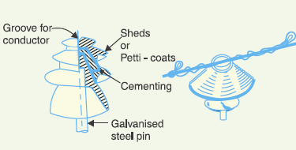
Fig.3.2. pin type insulators.

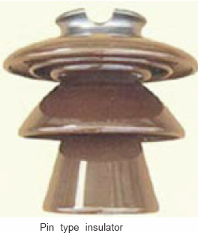

It is desirable that the value of safety factor is high so that flash-over takes place before the insulator gets punctured. For pin type insulators, the value of safety factor is about 10.

- Suspension type insulators.
The cost of pin type insulator increases rapidly as the working voltage is increased. Therefore, this type of insulator is not economical beyond 33 kV. For high voltages (>33 kV).

They consist of a number of porcelain discs connected in series by metal links in the form of a string. The conductor is suspended at the bottom end of this string while the other end of the string is secured to the cross-arm of the tower. Each unit or disc is designed for low voltage, say 11 kV. The number of discs in series would obviously depend upon the working voltage. For instance, if the working voltage is 66 kV, then six discs in series will be provided on the string.

Advantages:

1) Suspension type insulators are cheaper than pin type insulators for voltages beyond 33 kV.
2) Each unit or disc of suspension type insulator is designed for low voltage, usually 11 kV.
Depending upon the working voltage, the desired number of discs can be connected in series.
3) If any one disc is damaged, the whole string does not become useless because the damaged disc can be replaced by the sound one.
4) The suspension arrangement provides greater flexibility to the line. The connection at the cross arm is such that insulator string is free to swing in any direction and can take up the position where mechanical stresses are minimum.
5) In case of increased demand on the transmission line, it is found more satisfactory to supply the greater demand by raising the line voltage than to provide another set of conductors.
The additional insulation required for the raised voltage can be easily obtained in the suspension arrangement by adding the desired number of discs.
6) The suspension type insulators are generally used with steel towers. As the conductors run below the earthed cross-arm of the tower, therefore, this arrangement provides partial protection from lightning.

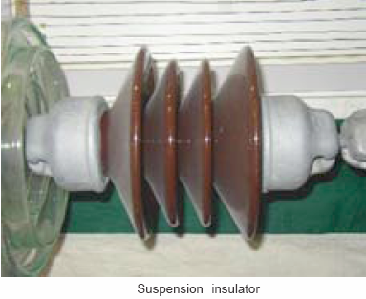
Fig.3.3.suspension insulators.
- Strain insulators:

When there is a dead end of the line or there is corner or sharp curve, the line is subjected to greater tension. In order to relieve the line of excessive tension, strain insulators are used. For low voltage lines (< 11 kV), shackle insulators are used as strain insulators. However, for high voltage transmission lines, strain insulator consists of an assembly of suspension insulators. The discs of strain insulators are used in the vertical plane. When the tension in lines is exceedingly high, as at long river spans, two or more strings are used in parallel.

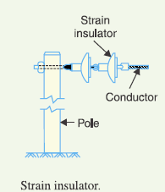
Fig.3.4.strain insulator.

- Shackle insulators:

In early days, the shackle insulators were used as strain insulators. But now a days, they are frequently used for low voltage distribution lines. Such insulators can be used either in a horizontal position or in a vertical position. They can be directly fixed to the pole with a bolt or to the cross arm. Shackle insulator fixed to the pole. The conductor in the groove is fixed with a soft binding wire.

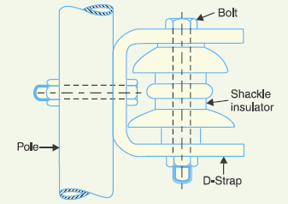
Fig.3.5.sackle insulator.

3.5. Important Points:

There is some of criteria we must take it into account when we do the mechanical design process for the electrical distribution network on 33 (KV) voltage level as we will explain below:

- Distances between the towers :
The distance between each tow towers in the range (90 – 100) meter.

- The high of tower is (12) meter in 33 (KV) voltage level.

- Thickness of the steel material (80 – 90) mm, 90 mm from the base of tower and 80 mm toward the top of tower .

- Base of tower (2-2-2.5) m, (0.5) m above the ground and each base need about (8) cup of concrete reinforced by iron.

- The distances between the insulators in the range (0.5-1) m.

- Number of steel truss which we can put it in series in straight line without need to put the steel towers from 1 to 4 trusses until about 400 m distance.

- We used in this project two types of supports, one of them called steel truss ( with arm in the center of top truss or arm in front of truss with angle of 90 degree )and other type called steel towers as we see in the figure below :

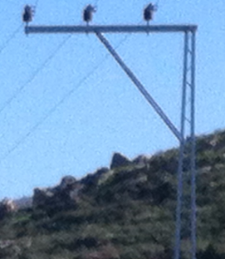
Fig.3.6.truss with arm in front .

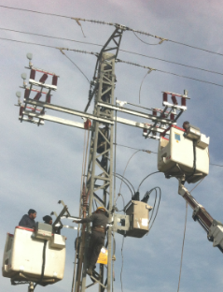
Fig.3.7.tower.

Number of steel towers and steel ladders we are need it to connect each tow villages with each other to unified the electrical network:
Table 3.1 number of tower and truss in between each two village
First | End | Steel Towers | Steel Ladders
First | End | Steel Towers | With arm in the center | Arm in 90 degree
Salfeet | Farkha | 12 | 20 | 8
Farkha | Khirbat qais | 6 | 16 | 4
Khirbat qais | Amoria | 6 | 22 | 3
Salfeet | Skaka | 10 | 30 | 8
Skaka | Yasoof | 6 | 8 | 4
Skaka | Marda | 6 | 20 | 4
Marda | Qaera | 6 | 18 | 2
Qaera | Qefel Hares | 4 | 9 | 3
Qefel Hares | Hares | 8 | 10 | 5
Qefel Hares | Dearistia | 6 | 14 | 4
Dearistia | Qarawa Hasn | 8 | 26 | 6
Qarawa Hasn | Bidia | 6 | 20 | 2
Bidia | Sartta | 7 | 10 | 2
sartta | Broqeen | 10 | 22 | 5
Broqeen | Kofor Al Deek | 7 | 9 | 1
Bidia | Masha | 6 | 16 | 4
Masha | Al Zawia | 6 | 10 | 2
Al Zawia | Rafat | 6 | 10 | 4
Rafat | Deer Ballot | 8 | 12 | 5
Broqeen | Swing Bus | 12 | 30 | 6

Total number of steel towers and steel ladders we are need it to connect villages with each other to unified the whole electrical network:
Table 3.2.total number of tower and truss we are need to unified salfeet network.
Steel Towers | Steel Ladders
Steel Towers | With arm in the center | With Arm in 90 degree
146 | 332 | 82

- Type of insulator we are used it in this project is PIN type insulators , Suspension type insulators and Strain insulators .Table below shows the total number of insulators we are need it :
Table 3.3.total number we are need in each type of insulator.
Type of insulators | PIN | Suspension | Strain
Number | 788 | 600 | 876

3.6. Sag in Overhead Lines:

While erecting an overhead line, it is very important that conductors are under safe tension. If the conductors are too much stretched between supports in a bid to save conductor material, the stress in the conductor may reach unsafe value and in certain cases the conductor may break due to excessive tension. In order to permit safe tension in the conductors, they are not fully stretched but are allowed to have a dip or sag. The difference in level between points of supports and the lowest point on the conductor is called sag.

Figure below shows a conductor suspended between two supports A and B. The conductor is not fully stretched but is allowed to have a dip. The lowest point on the conductor is O and the sag is S.

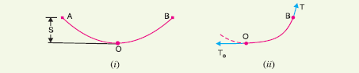
Fig.3.8.sag in overhead lines.

The following points may be noted:

1) When the conductor is suspended between two supports at the same level, it takes the shape of catenaries. However, if the sag is very small compared with the span, then sag-span curve is like a parabola.
2) The tension at any point on the conductor acts tangentially. Thus tension TO at the lowest point O acts horizontally.
3) The horizontal component of tension is constant throughout the length of the wire.
4) The tension at supports is approximately equal to the horizontal tension acting at any point on the wire. Thus if T is the tension at the support B, then T = TO. Conductor sag and tension. This is an important consideration in the mechanical design of overhead lines. The conductor sag should be kept to a minimum in order to reduce the conductor material required and to avoid extra pole height for sufficient clearance above ground level. It is also desirable that tension in the conductor should be low to avoid the mechanical failure of conductor and to permit the use of less strong supports. However, low conductor tension and minimum sag are not
possible. It is because low sag means a tight wire and high tension, whereas a low tension means a loose wire and increased sag. Therefore, in actual practice, a compromise in made between the two.

3.7. Calculation of Sag:

In an overhead line, the sag should be so adjusted that tension in the conductors is within safe limits. The tension is governed by conductor weight, effects of wind, ice loading and temperature variations.
It is a standard practice to keep conductor tension less than 50% of its ultimate tensile strength i.e.. We shall now calculate sag and tension of a conductor when 1) supports are at equal levels and 2) supports are at unequal levels.

- When supports are at equal levels:

Consider a conductor between two equivalent supports A and B with O as the lowest point as shown in Fig. It can be proved that lowest point will be at the mid-span.

Let
l = Length of span
w = Weight per unit length of conductor
T = Tension in the conductor.

Consider a point P on the conductor. Taking the lowest point O as the origin let the co-ordinates of point P be x and y. Assuming that the curvature is so small that curved length is equal to its horizontal projection (i.e. OP = x), the two forces acting on the portion OP of the conductor are:
(a) The weight wx of conductor acting at a distance x/2 from O.
(b) The tension T acting at O.

Equating the moments of above two forces about point O, we get,

$$S=\frac{W L^2}{8T}$$

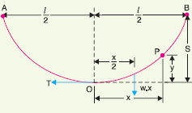
Fig.3.9. sag when supports are at equal levels.

- When supports are at unequal levels:

In hilly areas, we generally come across conductors suspended between supports at unequal levels. Fig. below shows a conductor suspended between two supports A and B which are at different levels. The lowest point on the conductor is O.

Let
l = Span length
h = Difference in levels between two supports
x1 = Distance of support at lower level (i.e., A) from O
x2 = Distance of support at higher level (i.e. B) from O
T = Tension in the conductor

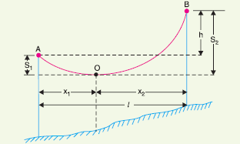
Fig.3.10.sag when supports are at unequal levels.

If w is the weight per unit length of the conductor, then,

$$S1=\frac{W X1^2}{2T}$$
And
$$S2=\frac{W X2^2}{2T}$$
Also
x1 + x2 = l

Where

$x1=\frac{l}{2}- \frac{T h}{W l}$

$x2=\frac{l}{2}+ \frac{T h}{W l}$

Having found x1 and x2, values of S1 and S2 can be easily calculated.

3.8. Effect of wind and ice loading:

The above formulae for sag are true only in still air and at normal temperature when the conductor is acted by its weight only. However, in actual practice, a conductor may have ice coating and simultaneously subjected to wind pressure. The weight of ice acts vertically downwards i.e., in the same direction as the weight of conductor. The force due to the wind is assumed to act horizontally i.e., at right angle to the projected surface of the conductor. Hence, the total force on the conductor is the vector sum of horizontal and vertical forces as shown in Fig.

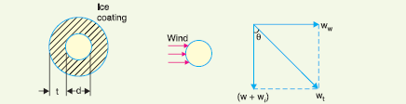
Fig.3.11. Effect of wind and ice loading.
Total weight of conductor per unit length is

$$Wt=\sqrt{({W+Wi)}^{2}+{Ww}^{2}}$$

Where
W = weight of conductor per unit length.
Wi = weight of ice per unit length.
Ww = wind force per unit length.

3.9. Distribution of steel towers and truss between the villages by using Google Earth Software Program:

The Fig. below shows examples on distribution of steel tower and truss between the villages by using Google Earth software program.

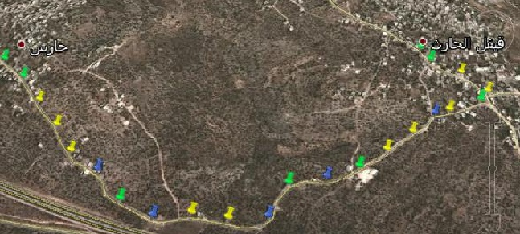
Fig.3.12.distribution towers and trusses between Haris village and Qafill Haris viallge.

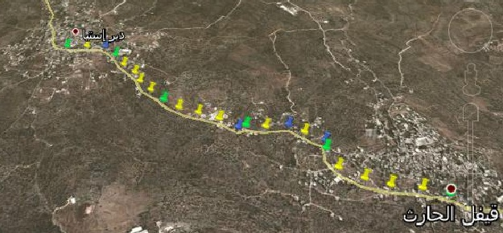
Fig.3.13.distribution towers and trusses between Daristia village and Qafill Haris viallge.

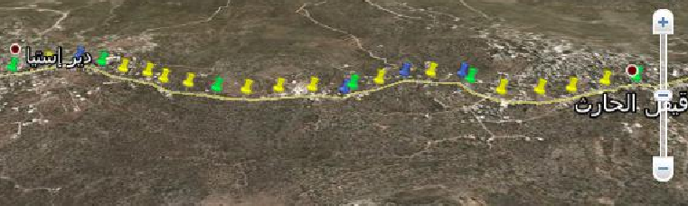
Fig.3.14.distribution towers and trusses between Daristia village and Qafill Haris viallge.

- Note That:

Green Pin: Steel Tower.
Yellow Pin: Steel truss (with arm in the center top of truss).
Blue Pin: Steel truss (with arm in front of truss with angle of 90 degree)

Chapter 4

4.1 Street Lighting Improvement and High Efficient Transformers:
4.1. 1 Street Lighting Improvement:
There are several light sources which have been used in electric street lights. The most commonly used in street lighting High Pressure Sodium (H.P.S) and Mercury Vapor, there is many different in properties between them as shown in the table below:
Table 4.1.comparison between HPS and mercury lamps.
Properties | H.P.S | Mercury vapor
Flux (lm) | 5510 | 4340
Power consumption(w) | 70 | 125
System efficacy (lm/w) | 61 | 31
Average lux | 19 | 14
Utilization | 0.0034 | 0.0032
Lifetime (hours) | 20,000_ 30,000 | 6000_10,000

From the previous table we note the H.P.S is better than the mercury vapor in many features.
So, we are going to replace the mercury lamps with H.P.S to get better economical and illumination benefits. High pressure sodium lamps are quite efficient. They have been widely used for outdoor area lighting such as streetlights.

The number of H.P.S and Mercury lamps in each village of SALFEET district as shown in table below :
Table 4.2.street lamps in the network.
Village | H.P.S | Mercury | Total #
BEDIA | 455 | 200 | 650
AL ZAWIA | 205 | 115 | 320
QARAWA HASAN | 230 | 150 | 320
QAFRE AL DEEK | 198 | 175 | 355
BROQEEN | 124 | 96 | 220
DARE BALLOT | 100 | 50 | 150
RAFAT | 120 | 80 | 200
SKAKA | 130 | 65 | 186
AMMORIA | 115 | 55 | 170
DEARISTIA | 180 | 70 | 250
SARTTA | 70 | 32 | 102
MASHA | 80 | 40 | 120
HARIS | 70 | 20 | 90
QAFEL HARIS | 74 | 26 | 100
FARKHA | 90 | 15 | 105
KHARBET QAIS | 55 | 25 | 80
YASOOF | 75 | 45 | 120
MARDA | 80 | 32 | 120
QEARA | 72 | 25 | 97
SALFEET | 300 | 700 | 1000
Total | 3823 | 1989

4.1.2 Replacing the mercury lamps by H.P.S type:
The number of lamps=1989.
The oldest type power "mercury vapor"=125 W.
The new type power "high pressure sodium"=70 W.
Price of KWH=0.6 NIS
Average hour every day =11 hour.

The saving in energy=
1989*{0.125-0.070}(KW)*25000(h)*0.6(NIS/KWH)=1640925 NIS
1989lamp*(0.125-0.070) KW*(11*365) h/year*0.6NIS=263532 NIS/year
Cost of lamps = 1989*200=397800 NIS
S.P.B.P=397800/263532 =1.509 year =18.1 month

Moreover, the illumination is increasing from 4340 to 5510, and the lux is increasing from 14 to 19, and the average working hour increase from (6000-10000) to (20000-30000) hour

4.1.3 Street Lighting Control :
There are two types of control either you can turn on/off the lamps depending on the sun shine or you can control the illumination using voltage controller.
- Timer and photo cells:
Timer and photo cell sensor connected in series to turn on/off the lamps .
- Voltage control :
Uses for control the illumination of the lamps to reduce the energy consumption depending on the day hour.

4.2. High-Efficiency Copper-Wound Transformers Save Energy and Dollars.
Dry-type transformers, for a variety of reasons, have largely replaced oil-filled units within industrial, commercial and institutional buildings in the some countries. However, unlike oil-filled units in the utility grid, little attention is often paid to the energy efficiency of dry-type units. Unlike motors, they have no moving parts to wear out, and so are expected to last 20 years or more.
Efficiency is seldom specified when buying dry-type transformers. Values of 95% or higher are typical, and differences between high- and low-efficiency units are only 1% to 2%, with a significant first-cost premium for the more efficient units.
But first cost is not the last cost of any transformer. Complete life-cycle costs must be carefully examined along with the economics of high efficiency dry-type transformers.

4.2.1 Losses in transformers :
There are three deferent types of losses:

1. No-load loss (also called iron loss or core loss): Caused by the hysteresis and eddy currents in the core. It is present whenever the transformer is connected, and independent of the load. It represents a constant.

2. Load loss (or copper loss or short circuit loss): Caused by the resistive losses in the windings , and by eddy currents in the structural steelwork and the windings. It varies with the square of the load current.

3. Cooling loss (only in transformers with fan cooling): Caused by the energy consumption of a fan. The bigger the other losses, the more cooling is needed and the higher the cooling loss. These losses can be avoided if operational temperature is kept low.

4.2.2 Life-Cycle Costing
When a lower cost, 98% efficient unit and a higher cost unit at 99% are compared, that means that the losses are actually cut in half.
Conductor losses, also known as coil losses or load losses, should not be overlooked – for one reason because such losses vary by the square of the load. That means a fully loaded transformer has four times the load losses compared with one running at 50% of its design load. In many applications, transformers are heavily loaded. But even at lower load factors, if the units are not efficient , losses mount rapidly.
Thus, the continuing costs of transformer losses should be balanced with the savings to be gained from efficient units – savings which go on year after year – quickly paying back the extra first cost.
Other benefits pile up as well. Efficient transformers run cooler, and thus more reliably, because of decreased stress on insulation materials. As a result, they will have a higher overload capacity, an important issue in dry-type transformers. The ultimate result can be units with a smaller kVA rating actually doing the same job, with attendant first-cost savings.

4.2.3Efficiency vs. Temperature Rise.

Efficiency and temperature rise are related, but separate issues. Inefficiency is purely and simply the generation of waste heat- I2R losses in the transformer windings. To the extent heat is generated, the unit is inefficient. The temperature rise, on the other hand, results not only from how much heat is generated, but also from how much is removed.
An in efficient dry-type transformer can, in fact, run cool by incorporating into its design larger air passages or fan-cooling. High-efficiency transformers eliminate the need for these extra cooling costs.

4.2.4The Economics of Efficiency.
The examples below are of high-efficiency, copper-wound transformers designed to achieve an 80°C temperature rise and high efficiency. These are compared to standard, run-of-the-mill units using aluminum, the low-cost winding material, and designed to a 150°C rise.
The 1,500 kVA unit represents a typical, large dry-type transformer used for industrial and some larger commercial applications. In these applications, duty cycles can be quite high. Both 65% and 85% are used in the examples. Paybacks in high-electricity-cost areas can be as fast as one year for the design shown.
For light commercial applications, such as lighting circuits in office buildings, smaller units, such as the 75 kVA example shown, are used. Here, duty cycles would typically be lower. The sample calculations are for 50% and 75% dutycycles. In these applications, however, the customer is likely to pay a higher electricity rate than is the case in industrial applications. But here, again, paybacks can be short – as little as 1.1 years.
Once the unit's first cost premium is paid back, those energy savings continue to accumulate for the decades the transformer will be in service.

Table 4.3.comparison between standard and H.E. TR.
DRY-TYPE TRANSFORMERS
Energy Efficiency Means Annual Savings, Rapid Payback
A simple analysis to help understand the dramatic effect of energy efficiency on transformer operating costs and payback.
 | Manufacturer A - 1,500 kVA*
> | Standard (Aluminum) | High Efficiency (Copper) | Standard (Aluminum) | High Efficiency (Copper)
Load Factor** | 65% |  | 85%
Efficiency | 96% | 98% | 96% | 98%
Temp. Rise  (100% load) | 150° C | 80° C | 150° C | 80° C
Core Loss | 4.3 kW | 5.5 kW | 4.3 kW | 5.5 kW
Conductor Loss | 9.1 kW | 4.1 kW | 15.5 kW | 7.1 kW
Total Loss | 13.4 kW | 9.6 kW | 19.8 kW | 12.6 kW
Power Saving | – | 3.8 kW | – | 7.2 kW
First Cost | $16,750 | $22,650 | $16,750 | $22,650
Cost Premium | – | $5,900 | – | $5,900
Benefits of Using High-Efficiency Copper-Wound Dry-Type Transformers
Electrical  Energy Cost | Annual Savings | Payback Period | Annual Savings | Payback Period
$0.05/kWh | $1,660 | 3.5 y | $3,150 | 1.9 y
$0.07/kWh | $2,330 | 2.5 y | $4,420 | 1.3 y
$0.09/kWh | $3,000 | 2.0 y | $5,680 | 1.0 y
 | Manufacturer B - 75 kVA*
 | Standard (Aluminum) | High Efficiency (Copper) | Standard (Aluminum) | High Efficiency (Copper)
Load Factor | 50% |  | 75%
Efficiency | 96% | 98% | 96% | 98%
Temp. Rise  (100% load) | 150° C | 80° C | 150° C | 80° C
Core Loss | 0.34 kW | 0.21 kW | 0.34 kW | 0.21 kW
Cond. Loss | 0.73 kW | 0.32 kW | 1.64 kW | 0.72 kW
Total Loss | 1.07 kW | 0.53 kW | 1.98 kW | 0.93 kW
Power Saving | – | 0.54 kW | – | 1.05 kW
First Cost | $890 | $1,790 | $890 | $1,790
Cost Premium | – | $900 | – | $900
Benefits of Using High-Efficiency Copper-Wound Dry-Type Transformers
Electrical Energy Cost | Annual Savings | Payback Period | Annual Savings | Payback Period
$0.05/kWh | $240 | 3.8 y | $460 | 2.0 y
$0.07/kWh | $330 | 2.7 y | $640 | 1.4 y
$0.09/kWh | $420 | 2.1 y | $830 | 1.1 y
* Actual examples of 1,500 kVA, 15 kV - 277/480 V, and 75 kVA, 480 V - 120/208 V, transformers.
** A combination of duty cycle and percent of full loading.

Example for characteristic of high efficient transformer from SongjinGeneral Electric company :
Table 4.4 characteristic of high eff. Tr .
Fig.4.1 transformer
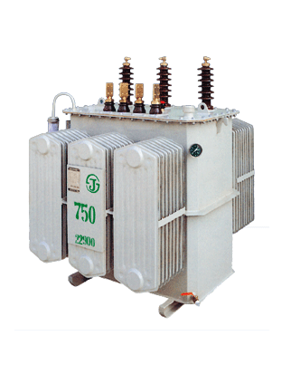

4.2.5 Test the acceptable if we change the standard transformer to high efficient transformer in salfeet district :

Salfeet network have 65 transformer , so we compare between the high efficient transformer and the standard transformer , to give us how we can save the losses in energy , the data we considered in the table below :
Table 4.5.the deferent in energy losses between H.E and standard TR.
Saving | Pin(KW) (eff=98%)  High efficient transformer | Pin(Kw) (eff= 96%)  standard transformer | NO. of transformer
4.517431973 | 216.8367347 | 221.3541667 | 1
5.803571429 | 278.5714286 | 284.375 | 14
7.653061224 | 367.3469388 | 375 | 15
2.742346939 | 131.6326531 | 134.375 | 16
3.613945578 | 173.4693878 | 177.0833333 | 3
4.253826531 | 204.1836735 | 208.4375 | 5
5.297619048 | 254.2857143 | 259.5833333 | 6
3.571428571 | 171.4285714 | 175 | 2
7.589285714 | 364.2857143 | 371.875 | 13
3.883928571 | 186.4285714 | 190.3125 | 12
2.142857143 | 102.8571429 | 105 | 8
6.547619048 | 314.2857143 | 320.8333333 | 9
4.196428571 | 201.4285714 | 205.625 | 10
3.976403061 | 190.8673469 | 194.84375 | 11
4.022108844 | 193.0612245 | 197.0833333 | 7
7.18962585 | 345.1020408 | 352.2916667 | 4
5.420918367 | 260.2040816 | 265.625 | 18
3.528911565 | 169.3877551 | 172.9166667 | 19
2.97087585 | 142.6020408 | 145.5729167 | 20
4.489795918 | 215.5102041 | 220 | 21
3.162202381 | 151.7857143 | 154.9479167 | 22
5.178571429 | 248.5714286 | 253.75 | 23
5.293367347 | 254.0816327 | 259.375 | 24
8.227040816 | 394.8979592 | 403.125 | 25
3.571428571 | 171.4285714 | 175 | 26
7.678571429 | 368.5714286 | 376.25 | 27
7.5 | 360 | 367.5 | 28
6.887755102 | 330.6122449 | 337.5 | 29
3.741496599 | 179.5918367 | 183.3333333 | 30
3.613945578 | 173.4693878 | 177.0833333 | 31
3.698979592 | 177.5510204 | 181.25 | 32
4.255952381 | 204.2857143 | 208.5416667 | 33
5.420918367 | 260.2040816 | 265.625 | 34
5.293367347 | 254.0816327 | 259.375 | 35
6.581632653 | 315.9183673 | 322.5 | 36
5.420918367 | 260.2040816 | 265.625 | 37
6.31377551 | 303.0612245 | 309.375 | 38
6.734693878 | 323.2653061 | 330 | 39
5.420918367 | 260.2040816 | 265.625 | 40
5.420918367 | 260.2040816 | 265.625 | 41
7.213010204 | 346.2244898 | 353.4375 | 42
6.428571429 | 308.5714286 | 315 | 43
5.484693878 | 263.2653061 | 268.75 | 44
5.05952381 | 242.8571429 | 247.9166667 | 45
3.528911565 | 169.3877551 | 172.9166667 | 46
4.808673469 | 230.8163265 | 235.625 | 47
8.131377551 | 390.3061224 | 398.4375 | 48
5.676020408 | 272.4489796 | 278.125 | 49
6.31377551 | 303.0612245 | 309.375 | 50
3.656462585 | 175.5102041 | 179.1666667 | 51
5.029761905 | 241.4285714 | 246.4583333 | 52
5.476190476 | 262.8571429 | 268.3333333 | 53
3.528911565 | 169.3877551 | 172.9166667 | 54
6.658163265 | 319.5918367 | 326.25 | 55
5.963010204 | 286.2244898 | 292.1875 | 56
5.612244898 | 269.3877551 | 275 | 57
8.214285714 | 394.2857143 | 402.5 | 58
5.739795918 | 275.5102041 | 281.25 | 59
5.548469388 | 266.3265306 | 271.875 | 60
5.293367347 | 254.0816327 | 259.375 | 61
6.734693878 | 323.2653061 | 330 | 62
5.420918367 | 260.2040816 | 265.625 | 63
5.892857143 | 282.8571429 | 288.75 | 64
5.548469388 | 266.3265306 | 271.875 | 65
4.974489796 | 238.7755102 | 243.75 | 66
344.7650935 | 16548.72449 | 16893.48958 | sum

Saving in losses:

- Average losses =344.765 KW.
- Energy of the losses =344.765*8760=3020141.4 KWH.
- Cost of losses = 3020141.4*0.6=1812084.84 NIS/year.
- Saving = 1812084.84 NIS/year

Simple Pay Back Period :
- Total fixed number transformer in 250KVA type= 5 transformer.
- Cost of 250 KVA transformer = 39600NIS.
- Cost of this type =5*39600=198000 NIS.
- Total fixed number transformer in 400KVA type= 20 transformer.
- Cost of 400 KVA transformer = 50600NIS.
- Cost of this type =20*50600=1012000 NIS
- Total fixed number transformer in 630KVA type= 40 transformer.
- Cost of 630 KVA transformer = 60500NIS.
- Cost of this type =40*60500=2420000 NIS
- Total cost of transformer= (198000)+(1012000)+(2420000)=3630000 NIS.
- S.P.B.P=Investment /Saving
=3630000/1812084.84= 2.0032 years.
So this period is acceptable , but it need high investment .

Chapter5:Matlab software to find the SPBP in raising the PF
Power factor correction:
The power factor of an AC electrical power system is defined as the ratio of the real power flowing to the load, to the apparent power in the circuit,and is a dimensionless number between -1 and 1. Real power is the capacity of the circuit for performing work in a particular time. Apparent power is the product of the current and voltage of the circuit. Due to energy stored in the load and returned to the source, or due to a non-linear load that distorts the wave shape of the current drawn from the source, the apparent power will be greater than the real power. A negative power factor occurs when the device which is normally the load generates power which then flows back towards the device which is normally considered the generator.
In an electric power system, a load with a low power factor draws more current than a load with a high power factor for the same amount of useful power transferred. The higher currents increase the energy lost in the distribution system, and require larger wires and other equipment. Because of the costs of larger equipment and wasted energy, electrical utilities will usually charge a higher cost to industrial or commercial customers where there is a low power factor.
Linear loads with low power factor (such as induction motors) can be corrected with a passive network of capacitors or inductors. Non-linear loads, such as rectifiers, distort the current drawn from the system. In such cases, active or passive power factor correction may be used to counteract the distortion and raise the power factor. The devices for correction of the power factor may be at a central substation, spread out over a distribution system, or built into power-consuming equipment.

Why we need to improve power factor:
1-To avoid poor voltage regulation.
2- To decrease the reactive power (to reduce the overall current for a given power requirement and hence reduce the penalty costs on the electricity bill).
3-Saving money
4-Increasing efficiency.
HOW TO CORRECT THE POWER FACTOR:
1-using synchronous motor can improve the power factor.
2- Using static capacitors can also improve the power factor.
3- For indicative circuit they can improve the power factor by connecting in series of capacitor.

Adding capacitors:
We add the capacitor in the grid for many reason summarized in the following point:
- Reduce the current so it reduce the losses in the grid
- Improving the voltage
- Organized the movement of the reactive power
- Improving the power factor

We add the capacitor in the network instead of some steps as follows:
- The bus which has the minimum voltage in the grid
- If the previous step does not work we add the capacitor on the next minimum voltage bus.
- The bus which has the maximum number of braches
The value of the capacitor that we added Depend on some slandered values and how much we want the value of the bus and instead the power factor lagging (not leading)
The slandered value of the capacitor which we used as follows:
If VNOM≥0.38 kV (c=0.1MVAr).
If VNOM≥3 kV (c=3 or 6MVAr).
The problem happens when we added tow much capacitor because it will not affect the voltage and will increase the cost which is not benefit economically
They work as follows:
I↓& then ∆V ↓& then (VL= V1-∆V)↓ )

Without a capacitor:
$$I=\frac{\sqrt{({PL}^{2}+{QL}^{2})}}{\sqrt{3}VL}$$

With a capacitor:

$$I↓=\frac{\sqrt{({PL}^{2}+({QL-QC)}^{2}}}{\sqrt{3}VL}$$
The capacitor can be fixed or regulated as follows:

In this report we will work in two different state using (ETAP program) as follows:
- Maximum load state
- Minimum load state

Fig.5.1 capacitor delivered Q

Because of the importance of improving the power factor as shown before . we designed MATLAB program to improve the power factor and calculate the needed QVAR of capacitors to increase the power factor to existing value .
In our matlab project , we calculate the simple pay back period by find the investment and by find the saving in panelties just .
This is the window of the our program:
Fig.5.2 window of our program before run and test numbers
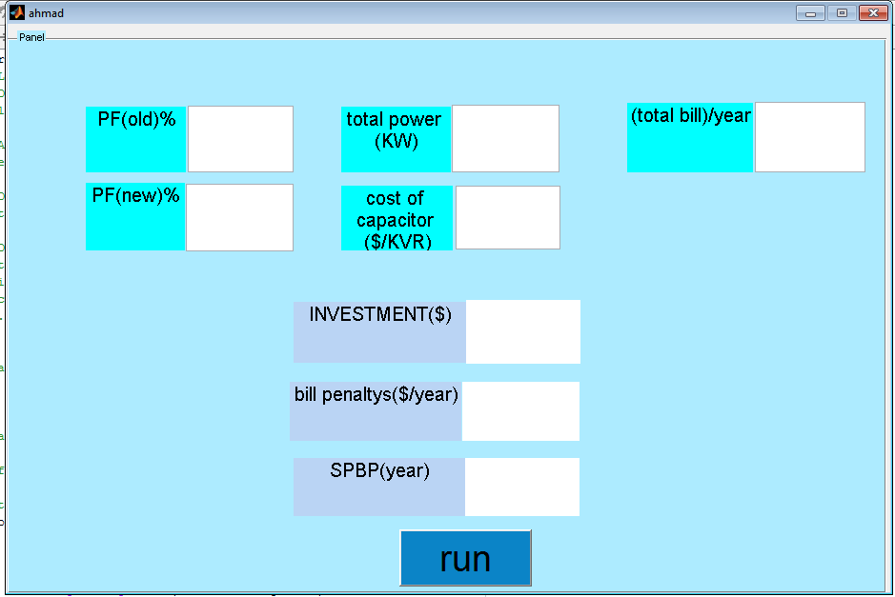

This is the window of our program with number to test the program after pressing on "RUN " botton:
Fig.5.3 window of our program after run and test numbers
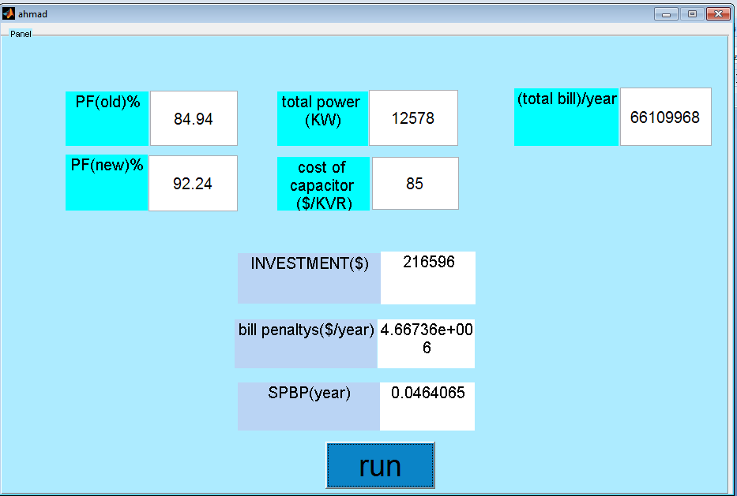
Now our code in m.file we can inserted below :

function varargout = ahmad(varargin)
% AHMAD MATLAB code for ahmad.fig
% AHMAD, by itself, creates a new AHMAD or raises the existing
% singleton*.
%
% H = AHMAD returns the handle to a new AHMAD or the handle to
% the existing singleton*.
%
% AHMAD('CALLBACK',hObject,eventData,handles,...) calls the local
% function named CALLBACK in AHMAD.M with the given input arguments.
%
% AHMAD('Property','Value',...) creates a new AHMAD or raises the
% existing singleton*. Starting from the left, property value pairs are
% applied to the GUI before ahmad_OpeningFcn gets called. An
% unrecognized property name or invalid value makes property application
% stop. All inputs are passed to ahmad_OpeningFcn via varargin.
%

% *See GUI Options on GUIDE's Tools menu. Choose "GUI allows only one
% instance to run (singleton)".
%
% See also: GUIDE, GUIDATA, GUIHANDLES

% Edit the above text to modify the response to help ahmad

% Last Modified by GUIDE v2.5 29-Apr-2013 10:04:15

% Begin initialization code - DO NOT EDIT
gui_Singleton = 1;
gui_State = struct('gui_Name', mfilename, ...
'gui_Singleton', gui_Singleton, ...
'gui_OpeningFcn', @ahmad_OpeningFcn, ...
'gui_OutputFcn', @ahmad_OutputFcn, ...
'gui_LayoutFcn', [] , ...
'gui_Callback', []);
if nargin && ischar(varargin{1})
gui_State.gui_Callback = str2func(varargin{1});
end

if nargout
[varargout{1:nargout}] = gui_mainfcn(gui_State, varargin{:});
else
gui_mainfcn(gui_State, varargin{:});
end
% End initialization code - DO NOT EDIT

% --- Executes just before ahmad is made visible.
function ahmad_OpeningFcn(hObject, eventdata, handles, varargin)
% This function has no output args, see OutputFcn.
% hObject handle to figure
% eventdata reserved - to be defined in a future version of MATLAB
% handles structure with handles and user data (see GUIDATA)
% varargin command line arguments to ahmad (see VARARGIN)

% Choose default command line output for ahmad
handles.output = hObject;

% Update handles structure
guidata(hObject, handles);

% UIWAIT makes ahmad wait for user response (see UIRESUME)
% uiwait(handles.figure1);

% --- Outputs from this function are returned to the command line.
function varargout = ahmad_OutputFcn(hObject, eventdata, handles)
% varargout cell array for returning output args (see VARARGOUT);
% hObject handle to figure
% eventdata reserved - to be defined in a future version of MATLAB
% handles structure with handles and user data (see GUIDATA)

% Get default command line output from handles structure
varargout{1} = handles.output;

% --- Executes on button press in pushbutton1.
function pushbutton1_Callback(hObject, eventdata, handles)
% hObject handle to pushbutton1 (see GCBO)
% eventdata reserved - to be defined in a future version of MATLAB
% handles structure with handles and user data (see GUIDATA)
pf1 = str2num(get(handles.edit1,'string'));
pf2 = str2num(get(handles.edit2,'string'));
p = str2num(get(handles.edit3,'string'));
cost = str2num(get(handles.edit4,'string'));
bill = str2num(get(handles.edit5,'string'));

pf11 = (pf1/100);
pf22 = (pf2/100);
a = acosd(pf11);
s = acosd(pf22);
qc = p * (tand(a) - tand(s));
invest = qc * cost ;
set(handles.text1,'string',invest);
if(pf11>=.92)
pan = 0;
sp = 0;
set(handles.text12,'string',sp);
set(handles.text9,'string',pan);
end
if(.92>pf11>=.8)s=(.92 - pf11);
c = (s * 1);
pan = (c * bill);
sp = (invest/pan);
set(handles.text9,'string',pan);
set(handles.text12,'string',sp);
elseif(.8>pf11>=.7)s=(.92 - pf11);
c = (s * 1.25);
pan = (c * bill);
sp = (invest/pan);
set(handles.text9,'string',pan);
set(handles.text12,'string',sp);
elseif(pf11<.7)s=(.92 - pf11);
c = (s * 1.5);
pan = (c * bill);
sp = (invest/pan);
set(handles.text9,'string',pan);
set(handles.text12,'string',sp);

end

% --- Executes during object creation, after setting all properties.
function pushbutton1_CreateFcn(hObject, eventdata, handles)

% hObject handle to pushbutton1 (see GCBO)
% eventdata reserved - to be defined in a future version of MATLAB
% handles empty - handles not created until after all CreateFcns called

function edit1_Callback(hObject, eventdata, handles)
% hObject handle to edit1 (see GCBO)
% eventdata reserved - to be defined in a future version of MATLAB
% handles structure with handles and user data (see GUIDATA)

% Hints: get(hObject,'String') returns contents of edit1 as text
% str2double(get(hObject,'String')) returns contents of edit1 as a double

% --- Executes during object creation, after setting all properties.
function edit1_CreateFcn(hObject, eventdata, handles)
% hObject handle to edit1 (see GCBO)
% eventdata reserved - to be defined in a future version of MATLAB
% handles empty - handles not created until after all CreateFcns called

% Hint: edit controls usually have a white background on Windows.
% See ISPC and COMPUTER.
if ispc && isequal(get(hObject,'BackgroundColor'), get(0,'defaultUicontrolBackgroundColor'))
set(hObject,'BackgroundColor','white');
end

function edit2_Callback(hObject, eventdata, handles)
% hObject handle to edit2 (see GCBO)
% eventdata reserved - to be defined in a future version of MATLAB
% handles structure with handles and user data (see GUIDATA)

% Hints: get(hObject,'String') returns contents of edit2 as text
% str2double(get(hObject,'String')) returns contents of edit2 as a double

% --- Executes during object creation, after setting all properties.
function edit2_CreateFcn(hObject, eventdata, handles)
% hObject handle to edit2 (see GCBO)
% eventdata reserved - to be defined in a future version of MATLAB
% handles empty - handles not created until after all CreateFcns called

% Hint: edit controls usually have a white background on Windows.
% See ISPC and COMPUTER.
if ispc && isequal(get(hObject,'BackgroundColor'), get(0,'defaultUicontrolBackgroundColor'))

set(hObject,'BackgroundColor','white');
end

function edit3_Callback(hObject, eventdata, handles)
% hObject handle to edit3 (see GCBO)
% eventdata reserved - to be defined in a future version of MATLAB
% handles structure with handles and user data (see GUIDATA)

% Hints: get(hObject,'String') returns contents of edit3 as text
% str2double(get(hObject,'String')) returns contents of edit3 as a double

% --- Executes during object creation, after setting all properties.
function edit3_CreateFcn(hObject, eventdata, handles)
% hObject handle to edit3 (see GCBO)
% eventdata reserved - to be defined in a future version of MATLAB
% handles empty - handles not created until after all CreateFcns called

% Hint: edit controls usually have a white background on Windows.
% See ISPC and COMPUTER.
if ispc && isequal(get(hObject,'BackgroundColor'), get(0,'defaultUicontrolBackgroundColor'))
set(hObject,'BackgroundColor','white');
end

function edit4_Callback(hObject, eventdata, handles)
% hObject handle to edit4 (see GCBO)
% eventdata reserved - to be defined in a future version of MATLAB
% handles structure with handles and user data (see GUIDATA)

% Hints: get(hObject,'String') returns contents of edit4 as text
% str2double(get(hObject,'String')) returns contents of edit4 as a double

% --- Executes during object creation, after setting all properties.
function edit4_CreateFcn(hObject, eventdata, handles)
% hObject handle to edit4 (see GCBO)
% eventdata reserved - to be defined in a future version of MATLAB
% handles empty - handles not created until after all CreateFcns called

% Hint: edit controls usually have a white background on Windows.
% See ISPC and COMPUTER.
if ispc && isequal(get(hObject,'BackgroundColor'), get(0,'defaultUicontrolBackgroundColor'))
set(hObject,'BackgroundColor','white');

end

function edit5_Callback(hObject, eventdata, handles)
% hObject handle to edit5 (see GCBO)
% eventdata reserved - to be defined in a future version of MATLAB
% handles structure with handles and user data (see GUIDATA)

% Hints: get(hObject,'String') returns contents of edit5 as text
% str2double(get(hObject,'String')) returns contents of edit5 as a double

% --- Executes during object creation, after setting all properties.
function edit5_CreateFcn(hObject, eventdata, handles)
% hObject handle to edit5 (see GCBO)
% eventdata reserved - to be defined in a future version of MATLAB
% handles empty - handles not created until after all CreateFcns called

% Hint: edit controls usually have a white background on Windows.
% See ISPC and COMPUTER.
if ispc && isequal(get(hObject,'BackgroundColor'), get(0,'defaultUicontrolBackgroundColor'))
set(hObject,'BackgroundColor','white');
end

% --- Executes on button press in pushbutton2.
function pushbutton2_Callback(hObject, eventdata, handles)
% hObject handle to pushbutton2 (see GCBO)
% eventdata reserved - to be defined in a future version of MATLAB
% handles structure with handles and user data (see GUIDATA)

% --- Executes during object creation, after setting all properties.
function pushbutton2_CreateFcn(hObject, eventdata, handles)
% hObject handle to pushbutton2 (see GCBO)
% eventdata reserved - to be defined in a future version of MATLAB
% handles empty - handles not created until after all CreateFcns called

% --- If Enable == 'on', executes on mouse press in 5 pixel border.
% --- Otherwise, executes on mouse press in 5 pixel border or over pushbutton1.
function pushbutton1_ButtonDownFcn(hObject, eventdata, handles)
% hObject handle to pushbutton1 (see GCBO)
% eventdata reserved - to be defined in a future version of MATLAB
% handles structure with handles and user data (see GUIDATA)

function edit6_Callback(hObject, eventdata, handles)
% hObject handle to edit6 (see GCBO)
% eventdata reserved - to be defined in a future version of MATLAB
% handles structure with handles and user data (see GUIDATA)

% Hints: get(hObject,'String') returns contents of edit6 as text
% str2double(get(hObject,'String')) returns contents of edit6 as a double

% --- Executes during object creation, after setting all properties.
function edit6_CreateFcn(hObject, eventdata, handles)
% hObject handle to edit6 (see GCBO)
% eventdata reserved - to be defined in a future version of MATLAB
% handles empty - handles not created until after all CreateFcns called

% Hint: edit controls usually have a white background on Windows.
% See ISPC and COMPUTER.
if ispc && isequal(get(hObject,'BackgroundColor'), get(0,'defaultUicontrolBackgroundColor'))
set(hObject,'BackgroundColor','white');
end

References
- Salfeet Municipality
- http://www.sjtr.co.kr/product/product02.asp?idx=9&langCode=2
- http://en.wikipedia.org/wiki/Power_factor
- google earth

