


AN-NAJAH NATIONAL UNIVERSITY


Faculty of Engineering & Information Technology Computer Engineering Department

Graduation Project II (Hardware)

Cookies Crafter

Prepared by:
Besan Husam Jadallah (12029713) Lana Jaara

Supervisor: Dr. Saed Tarapiah

Presented in partial fulfillment of the requirements for Bachelor degree in Computer Engineering.

An-Najah National University Jan , 2025

We are deeply grateful to our supervisor, Dr. Saad Tarbieh, for his invaluable guidance and support throughout this semester. His cooperation and expertise have been instrumental in the success of our project.
We also extend our sincere thanks to all the professors of the Computer Engineering Department, who were always available to help and answered every question we had with patience and clarity. Their encouragement and insights greatly enriched our experience and contributed to the development of our work.
Additionally, we would like to express our heartfelt gratitude to Engineer Abdullah Hennawi for his continuous support and valuable advice. His guidance and feedback throughout the project were immensely helpful and played a significant role in its development.
Finally, we would like to express our heartfelt gratitude to our friends and family for their unwavering support and belief in us. They have been a constant source of motivation, and we are truly thankful for their encouragement throughout this journey.

Yours sincerely, Besan and Lana

This report was written by the students at the Computer Engineering Department, Faculty of Engineering, An-Najah National University. It has not been altered or corrected, other than editorial corrections, as a result of assessment and may contain language as well as content errors. The views expressed in it together with any outcomes and recommendations are solely those of the students. An-Najah National University. accepts no responsibility or liability for the consequences of this report being used for a purpose other than the purpose for which it was commissioned.

The cookie-making machine is an innovative and fully automated system designed to revolutionize the cookie preparation process. It combines mechanical, electronic, and programming technologies to deliver an efficient and user-friendly solution tailored to diverse needs.

The system automates every step, starting with dispensing and mixing dough to achieve a homogeneous consistency. The dough is then cut into individual pieces and placed on a rotating tray, which pauses to allow the addition of chocolate based on user preferences. The tray continues to the baking section, where cookies are baked at an optimal temperature monitored by advanced sensors.

To enhance functionality, the machine features an ultrasonic sensor that monitors ingredient levels and provides real-time alerts on an LCD screen for timely refills. Additionally, it features a mobile application via an ESP module, enabling remote operation, a keypad for inputting the desired number of cookies and chocolate preferences, and an RFID-based payment system for convenience.

This project seamlessly integrates mechanical, electronic, and programming technologies to deliver a practical, efficient, and user-friendly solution, addressing the challenges of traditional cookie- making while paving the way for future advancements in automated food preparation. This project exemplifies how automation can redefine traditional processes, setting a benchmark for future innovations in food technology.

List of figures VII
- Introduction
  - Statement of the Problem VIII
  - Objectives VIII
  - Scope of the Work VIII
  - Significance of the Work VIII
  - Organization of the report VIII
- Literature Review X
- Constraints, Standards/Codes, and Earlier Coursework XI
  - Constraints XI
  - Standards/Codes XI
  - Earlier Coursework XI
- Methodology XII
  - Choosing the idea XII
  - System Structure XII
  - Hardware Components XVI
  - Mobile Application XXVI
  - Flow Chart of the system XXVIII
- Result and Analysis XXIX
  - Dough Kneading System XXIX
  - Baking System XXIX
  - Chocolate Placement XXIX
  - Production Efficiency XXIX
  - Error Handling XXIX
  - System Performance XXX
  - Accuracy and Quality XXX
  - Challenges XXX
- Discussion XXXI
  - System Strength XXXI
  - Areas for Improvement XXXI
- Conclusions and Future Work XXXII
  - Conclusions XXXII
  - Future Work XXXII
- References XXXIII

  - Outer design of the Cookies Crafter Machine XII

  - The two containers XIII

  - Dough Mixer XIII

  - Dough Cutting Stage XIV

  - Adding Chocolate and Baking Stage XIV

  - Adding Chocolate XV

  - The final product XV

  - Arduino Mega 2560 XVI

  - 1-Relay module XVII

  - IBT_2 H-Bridge . . . . . . . . . . . . . . XVII

  - DC Motor XVIII

  - DC Gear Motor 12v XVIII

  - Stepper motor Nema17 XIX

  - Stepper motor Driver 3.5a XIX

  - Peristaltic Pump 6-30V. . . . . . . . . . . . . . . . . . . . . . . . . . . . . . . . . . . . . . . . . . . . . . . . . . . . . . .XX

  - Themorcouple tempreture sensor with max 6675 XX

  - LDR Sensor XXI

  - Laser XXI

  - Altrasonic Sensor XXII

  - RFID XXII

  - ESP 32 XXIII

  - Wires used in the project. XXIII
  - LCD with 12C XXIV
  - Keypad XXIV
  - Power Supply XXV
  - Home Page XXVI
  - Order Page XXVI
  - Payment & Confirmation Page XVII
  - Flow Chart of the system XXVIII
  - The final product XXXI

Statement of the Problem

The cookie-making process, while simple in concept, often requires significant time and effort when performed manually. Ensuring consistency in size, shape, and quality, particularly for small-scale production, poses challenges that need innovative solutions.

Objectives

The primary objective of this project is to design and implement a fully automated cookie-making machine that simplifies the process of preparing cookies. Specific goals include:
Automating dough mixing, shaping, and baking.
Providing users with options to customize cookie size, shape, and additional toppings such as chocolate.
Integrating modern technologies for remote operation and enhanced usability.

Scope of the Work

The project focuses on the mechanical and electronic design of the cookie-making machine. It includes the development of hardware components such as mixers, cutters, dispensers, and sensors, along with the integration of a control system for automation. Marketing and large-scale production aspects are outside the scope of this work.

Significance of the Work

This machine addresses the demand for efficient, consistent, and customizable cookie production, particularly for small-scale bakers and households. By reducing manual effort and improving production quality, the system provides a cost-effective and user-friendly solution that bridges the gap between traditional baking and modern automation.

Organization of the report

This report clearly explains the design and implementation of the cookie project. It begins with the problem statement and background, followed by a detailed methodology covering hardware components and software implementation. The results section highlights testing outcomes, while the discussion analyzes challenges and improvements. Finally, the conclusion summarizes key findings and suggests future enhancements.

Cookies, especially chocolate chip cookies, are among the most popular baked goods worldwide, cherished by people of all ages. Their origin dates back to the late 1930s when Ruth Wakefield created the iconic chocolate chip cookie recipe in the United States. Over the years, cookies have evolved into a global phenomenon, becoming a staple treat in many cultures and cuisines [1].

The process of making cookies involves several stages, each contributing significantly to the final product’s quality. Key steps include mixing the dough, shaping it into desired forms, baking at controlled temperatures, and optionally adding toppings such as chocolate chips, nuts, or sprinkles. Among these steps, dough preparation and baking are critical, as they directly affect the texture, flavor, and overall appeal of the cookies [2].

In recent years, advancements in baking technology have played a significant role in improving cookie production. Automation in baking has enabled manufacturers and home bakers to achieve consistent results, enhance efficiency, and cater to growing consumer demand. For example, automated cookie-making machines streamline the process by handling dough mixing, shaping, and baking, reducing manual effort while ensuring uniformity [3].

The growing popularity of cookies has also led to innovations in customization. Modern cookie- making systems allow users to personalize their cookies by adjusting ingredients, selecting toppings, and even choosing the desired level of doneness. This level of customization has transformed cookie preparation into an interactive experience, aligning with the modern consumer’s preference for personalized products [4].

Given the widespread appeal of cookies, our project aims to design an innovative automated cookie-making machine. This machine simplifies the process by allowing users to select the desired number of cookies and add chocolate toppings based on their preferences. The system automates dough preparation, shaping, and baking while offering real-time monitoring of ingredient levels and operational status through an integrated LCD display. Additionally, it incorporates advanced technologies such as wireless connectivity via an ESP module for remote operation and an RFID- based payment system for convenience [5].

By integrating mechanical, electronic, and programming technologies, this project seeks to address the challenges of traditional cookie-making methods and provide an efficient, user-friendly solution. This machine exemplifies how automation and innovation can enhance the cookie production process, meeting the demands of modern consumers while maintaining the timeless appeal of this beloved treat [6].

Constraints:
During the execution of this project, several constraints were encountered:
Transportation Challenges: Due to road conditions, checkpoints, and detours, significant time was spent commuting, which limited the time available for practical work.
Cost of Components: The high cost of electronic components posed financial challenges, requiring careful budget management and sourcing alternatives when possible.

Standards/Codes
The following standards and codes were considered in the project:
Safety Standards: Ensured compliance with electrical safety standards for the design and integration of components.

Communication Protocols: Utilized standard protocols such as I2C and SPI for communication between sensors and microcontrollers.

Wireless Standards: Applied IEEE 802.11 for the ESP module to enable Wi-Fi connectivity.

Earlier Coursework
This project benefited significantly from knowledge gained in previous coursework:
The Microcontroller using PIC Controllers course provided us with valuable knowledge on programming microcontrollers, controlling connected components, setting up serial communication, and utilizing tools like I2C and PWM. These fundamental skills enabled us to develop our project successfully.

The Circuits and Electronics courses equipped us with a solid understanding of basic circuits and electronic components, which was essential during the development of our project.

Critical Thinking and Research Skills course taught us how to write scientific research papers and structured reports. It enhanced our critical thinking abilities and improved our research skills by guiding us to rely on credible sources.

Networks course helped us understand the fundamentals of networking and communication. This knowledge allowed us to build a network system, enabling users to control the system remotely via an application.

This chapter presents the methodology adopted in developing the automated cookie-making machine. It covers the system's structure, hardware components, overall design, and the integration of the mobile application.

Choosing the idea

The initial and most critical step in the project was selecting the idea. Several concepts were explored, but many did not align with our objectives. The idea for the automated cookie-making system originated from observing the challenges in preparing cookies manually, such as time consumption and inconsistency in quality. This inspired us to design an automated system that simplifies cookie preparation while ensuring efficiency, and ease of use.

System Structure

First, the user enters the desired number of cookies and specifies whether they want chocolate or not via the keypad. The system will then display on the LCD whether the RFID has authorized the user or not. It will also display the current temperature and check if the materials are running low by using the ultrasonic sensor.

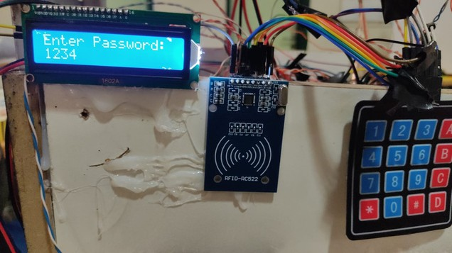
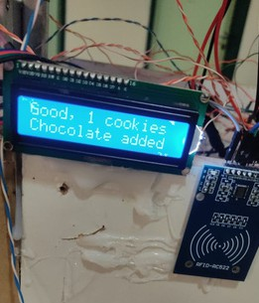

Figure 4.1: Outer design of the Cookies Crafter Machine

there will be two containers: one containing milk and butter, and the other containing flour, sugar, and baking soda. These ingredients will be dropped into the kneading machine according to specific steps.
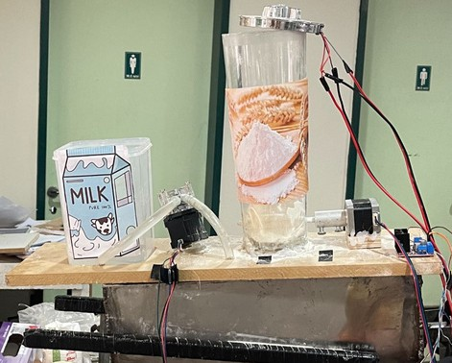

Figure 4.2: The two containers.

The ingredients will be kneaded, and then pushed forward to be cut into portions.
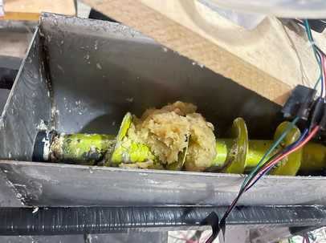
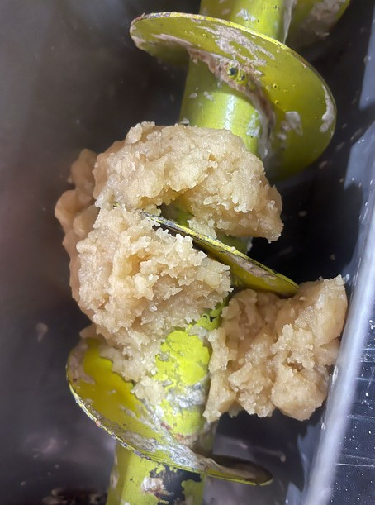
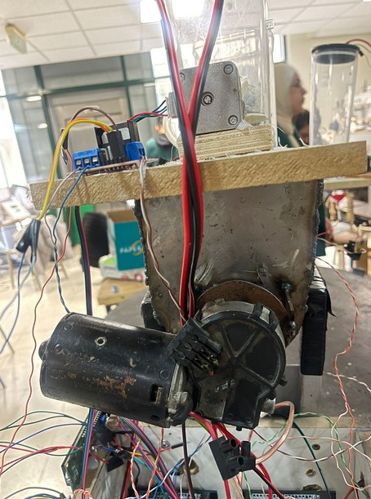

Figure 4.3: Dough Mixer.

This is the dough cutting stage, where the dough will be divided into portions.

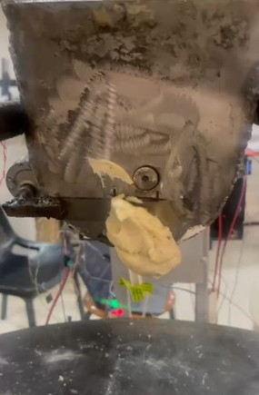
Figure 4.4: Dough Cutting Stage.

At this stage, heat will be distributed onto the baking tray, and the cookies will be transferred to ensure even distribution of the chocolate.

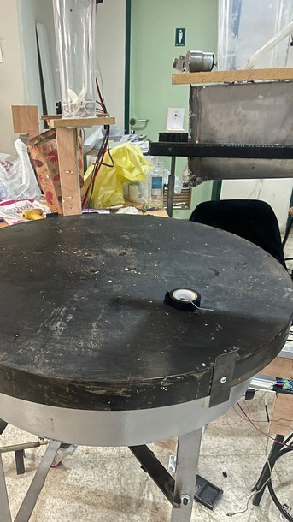 | 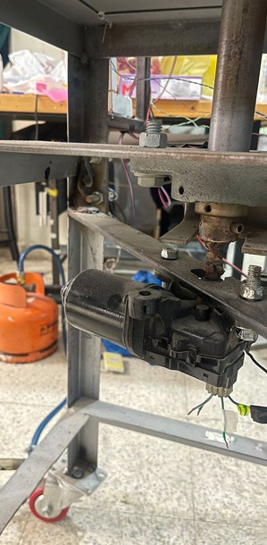 | 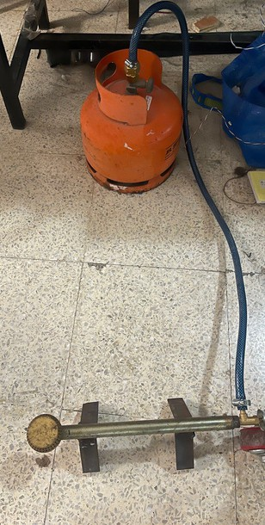

Figure 4.5: Adding Chocolate and Baking Stage.

At this stage, the chocolate will be poured onto the cookies.

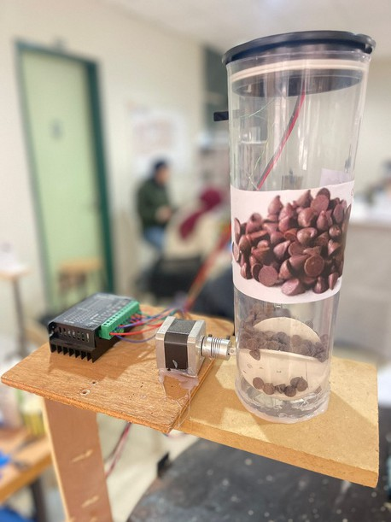
Figure 4.6: Adding Chocolate .

And this is the final product of our cookies machine .


Figure 4.7: Final Product.

Hardware Components

Arduino Mega 2560

The Arduino Mega 2560 acts as the central control unit in the cookie-making machine, coordinating all components and ensuring smooth system operation. It controls the DC motors using H-Bridge and Relay modules to enable precise movement of the baking tray and the dough- cutting blade. The Stepper Motors, managed through 3.5A drivers, perform specific tasks such as placing chocolate on the cookies, dispensing dry ingredients, or operating the pump. Additionally, the Arduino reads data from several sensors, including the MAX6675 Thermocouple to monitor the oven temperature, the LDR sensor with laser to detect the positions of cookies on the conveyor belt, and Ultrasonic sensors to measure distances, helping to monitor when ingredients required for dough preparation run out.

It also interfaces with the RFID module to verify user identity and the Keypad to allow users to input preferences, while the LCD screen displays system status and instructions. Furthermore, the Arduino communicates with the ESP32 module, enabling integration with a mobile app for remote control and system monitoring. With its extensive input/output capabilities, the Arduino Mega 2560 efficiently integrates all electrical and mechanical components, ensuring the system operates reliably and efficiently.

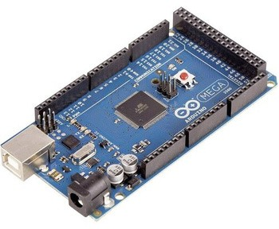
Figure 4.8: Arduino Mega 2560.

1-Relay module:

The Relay One Channel connected to the DC motor controls the operation of the mixing mechanism in the cookie-making machine. This relay acts as a switch to turn the motor on or off, enabling precise control over the mixing process. The DC motor drives the mixer to combine the ingredients thoroughly and, once the mixing is complete, moves the dough forward for the next step in the process. The use of the relay ensures safe and efficient operation by isolating the control circuit from the high-power motor circuit, preventing potential electrical hazards and allowing the Arduino Mega 2560 to manage the mixing and dough-moving process effectively

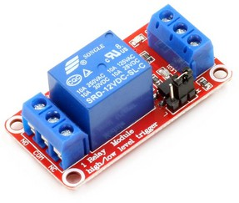
Figure 4.9: 1-Relay module.

IBT_2 H-Bridge:

The IBT-2 motor driver is used to control the DC motor responsible for moving and rotating the baking tray in the cookie-making machine. The IBT-2 allows for precise control of the motor's speed and direction, ensuring accurate positioning of the tray during operation. The motor stops when the LDR sensor detects the presence of a cookie at the desired location on the tray. This integration between the IBT-2 driver and the sensor ensures smooth and reliable movement of the tray, enabling the system to align the cookies correctly for the next step in the process. The IBT-2's high-current capacity and efficient control make it an essential component for managing the tray's movement seamlessly

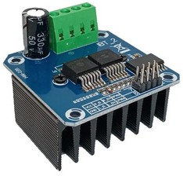
Figure 4.10: IBT_2 H-Bridge.

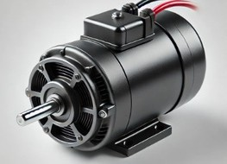
DC Motor

The DC motor is a key component in the cookie-making machine, with two motors assigned to specific tasks. The first DC motor rotates the baking tray to move the cookies into position for placing chocolate on them and to ensure even heat distribution across the tray during baking. The second motor powers the mixer, which kneads the dough thoroughly and pushes it forward to the next stage in the production process. These motors are critical for the smooth and efficient operation of the machine, providing precise control and reliable performance to maintain system productivity.

Figure 4.11: DC Motor.

DC Gear Motor 12v

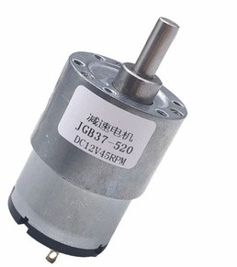
The DC motor with a gearbox is utilized in the cookie-making machine to drive a cutting blade welded to its shaft. This motor provides the torque and precision necessary to operate the blade efficiently, enabling it to cut the dough into pieces as it is pushed forward by the previous DC motor. The gearbox enhances the motor's performance by reducing speed and increasing torque, ensuring smooth and reliable operation of the cutting process. This system is essential for enabling accurate and continuous dough cutting as part of the production process.

Figure 4.12: DC Gear Motor 12v.

Stepper motor Nema17

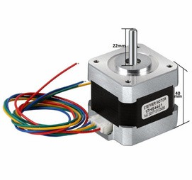
In the cookie-making machine project, two NEMA 17 stepper motors were used to dispense dry ingredients and chocolate. The first motor is dedicated to dispensing dry ingredients such as flour or sugar, where it moves the components in a specific direction with precision as needed. The second motor is responsible for dispensing the chocolate, working similarly to control the exact amount added to the cookies during the manufacturing process. Both motors are controlled by a precise control system to determine the correct quantity of ingredients being distributed, ensuring the continuity of the process and the quality of the final product.

Figure 4.13: Stepper motor Nema17.

Stepper motor Driver 3.5a

In the cookie-making machine project, three NEMA 17 stepper motors are used, and they are controlled by three 3.5A Stepper Motor Drivers. The role of these drivers is to supply the appropriate power and control the movement of the motors with high precision. Each driver controls its corresponding NEMA 17 motor, ensuring a steady and balanced current while adjusting the required speed and movement accuracy. With the capability to supply up to 3.5 amps of current, these drivers enable the system to operate the motors efficiently, even under heavy loads, ensuring stable and precise performance of the moving components in the cookie-making machine.
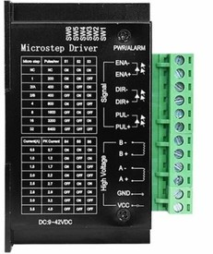
Figure 4.14: Stepper motor Driver 3.5a

Peristaltic Pump 6-30V Large Flow Stepper Motor Peristaltic Pump Tube Vacuum

In the cookie-making machine project, a Peristaltic Pump 6-30V with a large flow rate and stepper motor was used to dispense milk and other liquid ingredients. This pump works by using a stepper motor to rotate rollers, which compress the peristaltic tubing and move the liquid through it in a precise, controlled manner. This system ensures that the liquid ingredients are dispensed smoothly and accurately, providing the necessary consistency for the cookie-making process. The vacuum feature in the pump helps maintain the required flow rate and reduces the possibility of air bubbles or contamination in the liquid, ensuring a high level of hygiene and efficiency during operation.
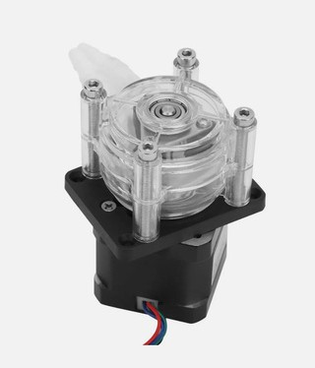
Figure 4.15: Peristaltic Pump 6-30V Large Flow Stepper Motor Peristaltic Pump Tube Vacuum.

Themorcouple tempreture sensor with max 6675

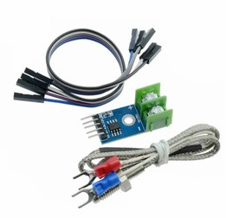
The Thermocouple Temperature Sensor with MAX6675 is used in the cookie-making machine project to monitor and control the temperature during the baking process. This sensor measures the temperature of the oven or any other relevant component, providing real-time temperature data. The MAX6675 is a thermocouple-to-digital converter that converts the analog signal from the thermocouple into a digital signal, which can be easily processed by the microcontroller. This enables precise temperature control, ensuring that the baking environment stays within the desired range, which is crucial for producing high- quality cookies.

Figure 4.16: Themorcouple tempreture sensor with max 6675

2LDR Sensor

In the cookie-making machine project, two LDR (Light Dependent Resistor) sensors are used to detect the position of the cookies on the conveyor belt. The LDR sensors work by measuring the intensity of light reflected from the surface of the cookies. When a cookie passes in front of the sensor, the amount of light reflected changes, which is detected by the sensor. This data is then used to determine the position of the cookie on the belt, allowing the machine to perform actions such as placing chocolate or other ingredients at the correct location.

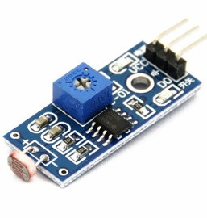
Figure 4.17: 2LDR Sensor.

2Laser

In the cookie-making machine project, two lasers are used in conjunction with the LDR sensors to stop the conveyor belt when an object (such as a cookie) interrupts the laser beam. The lasers continuously emit a beam of light, and if a cookie or any object passes through the beam, it breaks the laser's path. This disruption triggers a signal to stop the conveyor belt's movement, allowing the machine to perform specific tasks, such as dispensing chocolate or dough at the precise location where the cookie is positioned. This ensures that the ingredients are added exactly where needed, improving the accuracy and efficiency of the process.
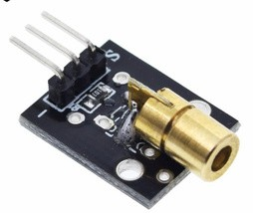

Figure 4.18: 2Laser.

2Altrasonic Sensor

In the cookie-making machine project, the Ultrasonic Sensor is used to monitor the level of materials in the containers. The sensor emits ultrasonic waves and measures the time it takes for the waves to reflect back from the surface of the materials. Based on the time delay, it calculates the distance between the sensor and the material's surface. When the materials in the container reach a low level, the sensor triggers an alert on the LCD display, notifying the user that the materials are running low and need to be replenished. This helps maintain the efficiency of the machine and ensures that production continues smoothly without interruptions.
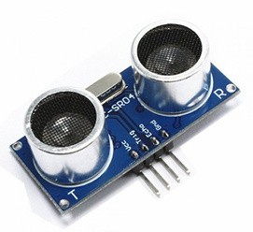

Figure 4.19: 2Altrasonic Sensor.

RFID

In the cookie-making machine project, the RFID technology is used to identify the user when they place their RFID tag near the reader. Once the system scans the tag and recognizes the user, it activates the machine, allowing the user to start interacting with it. This automatic user identification ensures that only authorized users can operate the machine and also enables personalized settings or actions based on the user’s profile.

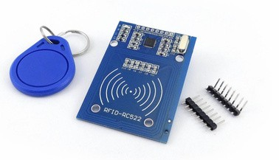
Figure 4.20: RFID.

ESP 32

In the cookie-making machine project, the ESP32 is used to establish a wireless connection between the mobile app and the Arduino. The ESP32 is a powerful microcontroller with built-in Wi-Fi and Bluetooth capabilities. It acts as a communication bridge, allowing the mobile app to send commands and receive data from the Arduino wirelessly. This enables remote control of the machine, such as adjusting settings, monitoring the process, and receiving notifications or updates. The ESP32 enhances the flexibility and convenience of the system, making it easy to interact with the machine from anywhere within the network range.
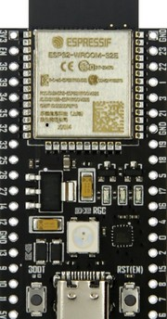

Wires used in the project
Figure 4.21: ESP 32.

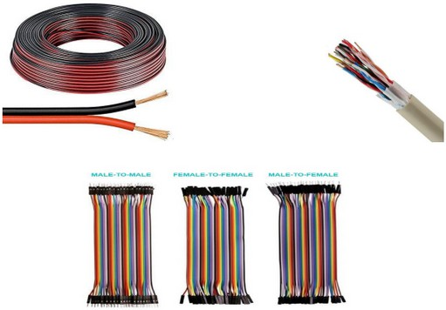
Figure 4.22: Wires used in the project.

LCD with I2C

the LCD screen is used to display data entered by the user through the keypad, such as the password, the number of cookies, and whether they want to add chocolate or not. After entering this information, the screen displays it for user confirmation. Additionally, the screen receives data from the temperature sensor and shows a message indicating that the oven has reached the required temperature, helping to monitor the process easily and accurately. The I2C protocol is used to connect the LCD to the Arduino Mega 2560, reducing the number of required pins and simplifying the wiring process.
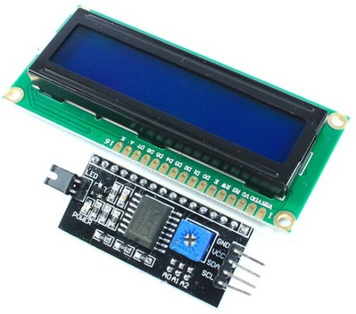
Figure 4.23: LCD with 12C.

Keypad

The keypad in the cookie-making machine project is used for user input. It allows the user to enter a password, specify the number of cookies, choose whether to add chocolate or not, and set the desired temperature for the baking process. This input is then processed by the system to control the machine’s operations accordingly, ensuring a customizable and efficient baking experience.
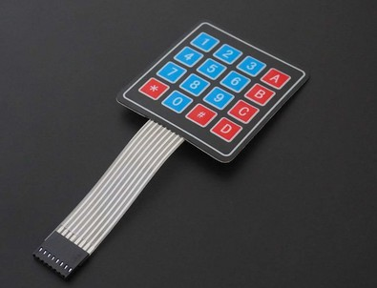
Figure 4.24:Keypad.

Power Supply

ISO-450 ATX Computer Power Supply 350W, 5V 32A, 12V 16A, we used it to supply some of our components that needed a voltage, it provided us with 12v, 5v, 3.3v, and Ground, we used 12v for motors and 3.3v,5v for lasers. Figure 4.14: Power Supply

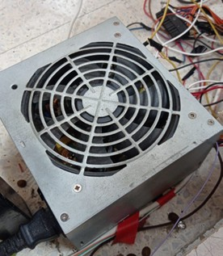
Figure 4.25: Power Supply.

Mobile Application

The mobile app, developed using MIT App Inventor, serves as a user-friendly interface for controlling the cookie-making machine. The app consists of three main pages:

Home Page
The starting screen that provides access to the main features of the app.

Figure 4.26: Home Page.

Order Page
This page allows the user to input the number of cookies, baking duration, and whether they want to add chocolate to their order. Once the order is confirmed, a notification is sent to the user. If any required input is missing, the app prompts the user with an alert to ensure all necessary details are provided.
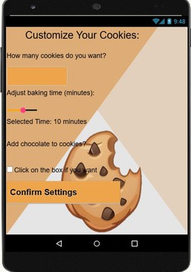

Figure 4.27: Order Page.

Payment & Confirmation Page

This final page is designed for order confirmation and payment, integrating RFID authentication to complete the process securely.
The app enhances the automation of the cookie-making process by providing a seamless and interactive user experience


Figure 4.28: Payment & Confirmation Page.

The system works as follow
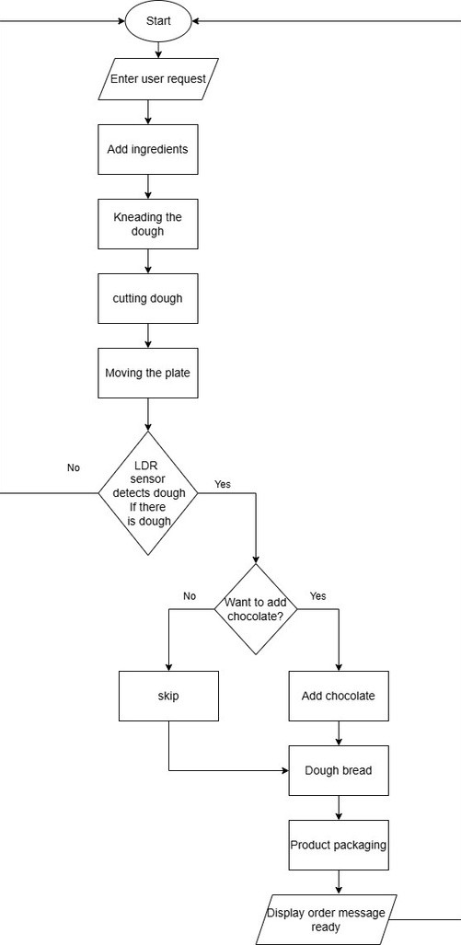

Figure 4.29: Flow Chart of the system.

Chapter 5: Results and Analysis
The automated cookie-making machine successfully achieved its primary objectives, including kneading the dough, baking cookies, adding chocolate decorations, and efficiently delivering the final product. Below are the key results:

Dough Kneading System:
The machine's dough kneading component mixed the ingredients evenly, achieving a consistent texture suitable for cookie preparation.
The kneading process took approximately 10 minutes per batch, ensuring the dough was ready for baking without manual intervention.

Baking System:
The oven maintained a consistent temperature of 180°C, ensuring even baking for all cookies.
Each batch required approximately 10 minutes for baking, resulting in uniform texture and quality.

Chocolate Placement:
Sensors accurately detected the position of cookies on the conveyor, achieving a detection success rate of 95%.
The time between detection and chocolate placement was around one second, ensuring proper synchronization with the conveyor's movement.

Production Efficiency:
The machine produced an average of 4 cookies per 15 minutes, meeting the expected production targets.
Minimal downtime was observed, demonstrating the system's reliability.

Error Handling:
Minor issues were observed in the dough mixing process, where the dough occasionally moved forward, leading to incomplete mixing of the ingredients. Additionally, there were occasional delays in the sensor response, particularly with the LDR , which was affected by fluctuations in lighting conditions.

5.2 Analysis Chapter 5: Results and Analysis

System Performance
The integration of sensors, motors, and conveyor belt ensured efficient task coordination. The dough kneading system was effective, but slight inconsistencies in dough texture under certain conditions suggest room for optimization in ingredient mixing ratios.

Accuracy and Quality
Dough texture, baking quality, and chocolate placement accuracy validated the machine's performance. However, further refinement in dough kneading speed and sensor calibration could improve overall consistency.

Challenges

Challenges with Sensor Accuracy:
Sometimes, environmental factors such as temperature or lighting conditions can affect the performance of the sensors, leading to errors in detecting cookie positions or delays in task execution.

Variations in Dough Properties:
Dough properties (such as moisture and viscosity) may change due to environmental variations or differences in ingredients, requiring continuous adjustments to ensure consistent quality.

Challenges in Temperature Control:
Maintaining a constant temperature in the oven during baking is critical. Any changes in temperature can affect the cookies' doneness and quality.

Challenges in Scaling Up Production:
As demand or production volume increases, the system may struggle to maintain the same level of performance and efficiency. The system may need upgrades to handle higher loads and increase production capacity.

Chapter 6: Discussion

System Strengths

Automating cookie production, from kneading the dough to delivering the final product, significantly reduced time and increased efficiency compared to manual methods.
Features like customizable dough consistency, baking time, and chocolate placement added flexibility to the system.

Areas for Improvement

Dough Consistency: Optimizing ingredient ratios and kneading parameters could ensure uniform dough quality under varying conditions.
Sensor Sensitivity: Enhancing sensor precision would improve detection accuracy and reduce errors
Scalability: Adding features like multiple decoration options or the ability to produce cookies in various shapes and sizes would increase versatility.
Energy Backup: Implementing a UPS or battery system would ensure uninterrupted production during power outages.

The final product of our Cookies Crafter Machine is shown in figure 5.1


Figure 4.30: The final product.

Conclusions

In this project, an automated cookie production system was successfully designed and implemented, automating the entire process from dough kneading to final decoration. The system demonstrated high efficiency in reducing time and increasing productivity compared to traditional manual methods. Features like customizable dough consistency, baking time, and chocolate placement added significant flexibility to the system, making it more adaptable to varying user needs.

While several objectives were successfully met, such as ensuring consistent cookie quality, some minor challenges were observed, including delays in sensor detection and slight inconsistencies in dough texture under certain conditions. These challenges highlight areas for potential improvement.

Future Work

Based on the results and challenges identified during the system's implementation, several areas for improvement and expansion have been identified for future development:

    - Introducing Additional Decoration Options: The system could be expanded to include additional decoration options such as icing or multi-layered designs, offering greater diversity and allowing for more customization of the cookies.
    - Exploring Machine Learning Applications: Machine learning techniques can be explored for predictive maintenance and optimization, helping to improve system performance and minimize unexpected downtime.
    - Enhancing the Dough Kneading Mechanism: The dough kneading mechanism should be further improved to handle different types of ingredients or larger production volumes, thus enhancing system performance under varying operational conditions.
    - Cookie Packaging: A packaging stage could be added after baking to further automate the process, saving time and ensuring the preservation of the final product's quality.
    - Ensuring Consistent Cookie Weights: Improving the system to produce cookies with more consistent weights is essential. Additionally, the option to produce cookies in different sizes could be added to meet varying market demands.

- J. Smith, The History of Cookies: From Ancient Times to Modern Delights, Food Culture Press, 2015.

- L. Brown, "Baking Science and Techniques: The Key to Perfect Cookies," Culinary Journal, vol. 34, no. 2, pp. 56-72, 2020.

- R. Williams and K. Thompson, "Automated Baking Systems: Revolutionizing the Industry," International Journal of Food Technology, vol. 45, no. 4, pp. 112-130, 2019.

- M. Davis, "Personalization in Baking: How Technology is Changing Consumer Preferences," Food & Innovation Review, vol. 29, no. 3, pp. 89-105, 2021.

- Y. Chen and S. Patel, "Smart Kitchen Appliances: Enhancing Home Baking with IoT and Automation," Journal of Engineering and Food Technology, vol. 12, no. 1, pp. 33-50, 2022.

- E. Roberts, The Future of Baking: A Look into Robotics and AI in Food Production, Tech & Food Journal, vol. 17, no. 5, pp. 145-160, 2018.

- J. Smith, "Automation of Production Systems: An Overview of Modern Methods," Automation Journal, vol. 15, no. 3, pp. 200-210, 2020.

- L. Brown and M. Taylor, Introduction to Sensor Technologies in Automation, Automation Publishing, 2018.

- A. Johnson, "The Future of Automation in Food Production," Tech Trends, 2021. [Online]. Available: https://www.techtrends.com/automation-food.

- World Economic Forum, "The Impact of Automation on Global Industries," 2020. [Online]. Available: https://www.weforum.org/reports/impact-of-automation.

