
Al-Najah National University

Faculty of Engineering and Information Technology \Computer Engineering

Graduation Project 2
MedHero

Done by:
Alaa Hamayde
Hadi Nassar

Supervisor: Dr.Sufyan Samara

2/9/2023

Acknowledgment:

After months of work on our project (the medicine reminder machine), we would like to thank God for his guidance and support as well as our supervisor, Dr. Sofian Samara, for his guidance and assistance as well as for supplying us with crucial project information. We want to express our gratitude to our family for their continuous support while we were attending college. for supporting us despite all of our challenges.

Table of Contents Acknowledgment………………………………………………………………………………………...1 Abstract…………………………………………………………………………………………………..5 1. Introduction…………………………………………………………………………………………………….6 1.1 Problem Statement………………………………………………………………………………...6 1.2 Objectives………………………………………………………………………………………….6 1.3 Significance of the work…………………………………………………………………………..7 1.4 Organization of the report………………………………………………………………………....7 2. Constraints and Earlier CourseWork…………………………………………………………………………...8 2.1 Constraints………………………………………………………………………………………..8 2.2 Earlier CourseWork………………………………………………………………………………………..8 3.Literature Review……………………………………………………………………………………..10 4. Methodology………………………………………………………………………………………….11 4.1 Data collection…………………………………………………………………………………...11 4.2 Data analysis………………………………………………………………………………….....11 4.3 Alarm Part (Nexion touch screen ).................................................................................................12 4.3.1 Smart Touch Screen Implementation……………………………………………………13-14 4.4 Mechanical Part…………………………………………………………………………………...15 4.4.1 Mechanical Design…………………………………………………………………………...15 4.4.2 Assembling…………………………………………………………………………………...16 4.4.3 Parts……………………………………………………………………………………….17-19 4.5 Controller Parts…………………………………………………………………………………….20 4.5.1 ESP 23………………………………………………………………………………………....20 4.5.2 Nexion Display………………………………………………………………………………...20 4.5.3 other parts…………………………………………………………………………………..21-26 4.5.4 Implementation for mechanical part………………………………………………………..27-29 5. Discussion………………………………………………………………………………………...….30-32 6. Conclusions and Future work………………………………………………………………………..….33 7.References…………………………………………………………………………………………….…34 4

Table of Figures Figure:

Nexion Touch Screen (Instruction,reminder,details etc) ……………………………………...13 Figure 2: Display Current Time & Date………………………………………………...……………….13 Figure 3: Set Reminder…………………………………………………………………………………..14 Figure 4: GUI(Nexion)..............................................................................................................................14 Figure 5: Mechanical Design…………………………………………………………………………….15 Figure 6: Mechanical body………………………………………………………………………………16 Figure 7: ESP32………………………………………………………………………………………….20 Figure 8: Nextion Display with SD-Card………………………………………………………………..21 Figure 9:Servo Motor……………………………………………………………………………………21 Figure 10: IR-Sensor…………………………………………………………………………………….22 Figure 11: Ultrasonic Sensor…………………………………………………………………………….22 Figure 12:Water Solenoid Valve……………………………………………………………………….. .23 Figure 13: Water Level Contactless……………………………………………………………………...23 Figure 14:Power Supply…………………………………………………………………………………24 Figure 15: Relay…………………………………………………………………………………………24 Figure 16: I2C…………………………………………………………………………………………...24 Figure 17: Buck Converter………………………………………………………………………………25 Figure 18: male-male wires……………………………………………………………………………...26 Figure 19:male-female wires……………………………………………………………………………………26 Figure 20: female-female wires………………………………………………………………………….26 Figure 21: Implementation(Servo).............................................................................................................27 Figure 22: Implementation(Valve+Ultrasonic)..........................................................................................27 Figure 23: Implementation(IR-sensor for hand)................................................................................................28 Figure 24: Implementation(water sensor+medicine sensor (IR))....................................................................28 Figure 25: Implementation(connection to WIFI)...............................................................................................29 Figure 26: Results....................................................................................................................................................30

Abstract :

Most elderly people need to take their medications at precise times throughout the day, so if sons are gone all day it may be challenging for them to remember to give their parents' medication. Additionally, some elderly individuals may have Alzheimer's disease, making it much more challenging for sons to remember.
Additionally, during an epidemic, the patient can find it challenging to speak with others directly for fear of infecting them, and he might get so exhausted that he forgets his prescription appointments. These factors led us to create our invention as a medicine reminder device.

Workflow for the project: A blynk app that sets precise dates and times for administering medications according on the type of fixed medications required throughout the day.

The machine that sets certain days for administering medications at specified times in accordance with the type of medication required throughout the day is the project's operating concept.
medication is based on the patient's medication kinds(Acamol, Cetamol, exforge, asprin, Concor ,trofin), and the administrator also establishes the
medication dosages. Each type of medication has a distinct area for disposal, so that
When the time for the medication arrives, the dose is administered at the designated location, then a notification received on blynk app that alert thers is a medications dispensed, at the same time there is an buzzer alarm at each date.

Additionally, this device has a water supply to take the medicine dose, it also has a sensor for the cup's existence(laser sensor), and there is also a sensor to alert the administrator When the amount of medicine or water in the tank is approaching.

- Introduction
  - Problem Statement:
The "Medicine Dispenser Machine" initiative seeks to address a variety of issues for certain social groups, the most notable of which are:

- Elderly individuals whose sons are gone all day, making it difficult for them to administer their medications on time.

- Those who have Alzheimer's disease require a reminder for their medication.
- Infectious illness patients could have a hard time finding individuals to give them treatment.
2.2. Objectives:
By reminding patients to take their drugs on schedule, the initiative seeks to protect the health of a particular set of patients. This would improve the patients' chances of recovering and make it simpler for their relatives to manage their everyday lives while caring for their patients.
Our project is a simulation of a medication reminder device, with two main interconnected components. The first component is an LCD screen that shows the current time and the counts of medications , A glass of water is successively filled to go with taking the medication dose at certain intervals throughout the day, fans that save the temperature inside the box to save the medicine and the other component is in charge of dropping the medication when the alarm goes off at those intervals.

1.3. Significance of the work:
Our project is mainly for patients who are unable to remember the dates of their medications and take them on time, and there is no one to follow them during the day. It can also be used in hospitals to relieve nurses during their working hours, or in cases of contagious epidemics due to the inability to communicate directly between people.

1.4. Organization of the report:
In this report, we explain the idea in details. Going through the report you can first see the problems and limitations we faced during our work including equipment, tools we used and time. Then, you can read about similar systems to get a background about the topic being discussed and what special features we have done upon other systems. After that, the methodology of our work is extensively explained. Next chapter states our results and a discussion to interpret and compare the results. Ending it up with the conclusion of the whole work and what is our vision for the future to improve our work.

2. Constraints and Earlier Coursework:
2.1. Constrains :
1-In the beginning, most of the equipment and parts are not very efficient, for example, the servo motors We used many servos, but we faced difficulty in operating them collectively because of the power needed to operate them. The solution is need a voltage regulators for each servo or a buck converter for whole system , in addition to medications size. It was difficult to deal with all the medications the same that make us have difficulties to dispense just one pill ,we solve it by bring an same size of tupes put those medications in those tupes , in addition to the inaccuracy in the performance and reading of the IR sensors, we sole it by debounce the sensor to delay in reading pills refilling .
2- Lack of funds :Some solutions needed more money to make, which would make the project too expensive and unaffordable, especiallymedications at a small scale.
3-Lack Of Time : Time is the most important factor in any project. Researching, communicating, testing, developing, understanding the requirements, planning, and the wasted time due to inexperience, all of these things require time which, no matter how tiny, quickly adds up.
4-Lack Of Tooling: Some special tools were needed to cut, prepare and assemble all the parts which are not available or too expensive for home use, so a specialist was required to help with it.

2.2. Earlier Coursework :
Working on our project requires knowledge from some of the courses we took in the computer engineering program, including:
Microcontroller: The microcontroller provides basic information about understanding the PIC Microcontroller and how to program hardware components, also the lab of this course provides how-to download code on the PIC Microcontroller equipment and how to understand every pin and feature there. so, it is one of the most important materials that helped us understand how to deal with the ESP32 controller in the project, through our knowledge of how to deal with the microcontroller, as the laboratory of this material contributed mainly to help us start working on the project.
Networks and Communication: This course taught us how to use Wi-Fi to communicate between two devices, as we used Wi-Fi to connect both microcontrollers (LCD display& ESP32), and we also used it to communicate with the "Signal" application to send notifications to the admin.

Electronic circuits: This course has mainly contributed to helping us deal with electrical circuits and related connections. as a result of this course that provides basic information about how to deal with many different circuits and how to wire their circuits.
Critical Thinking and Research Skills : The research and the writing of this report were all taught in this course, and it’s one of the few non-technical courses which also is life long.

3. Literature Review :
When creating this project, our focus was to build a machine that can be used without the need for people to give medicines to the person in need. We found, according to the latest statistics, that the percentage of the elderly in the world is 10% and it is estimated that 60% to 70% of them have Alzheimer's disease, and therefore we need this machine for these people.
The medication dispenser machine is designed for patients who need follow-up without possible personal intervention due to mental illnesses or infectious diseases. It is also designed for patients suffering from Alzheimer’s disease and does not require any effort. When the specified medication falls at the specified time, it makes an alarm through a sound and sends a notification to the phone, and then the patient has to put The cup is in the right place to drink water with the medicine, and there are mirrors that maintain the temperature of the medicine room to prevent damage.

4. Methodology :

This section provides detailed information about the methods and techniques we used to develop Machine, from designing and assembling the exoskeleton to the end Through Blynk app and other tools in the reminder machine and how they are linked together to reach the final product.
4.1. Data collection:
After we decided to make the idea, we started searching for similar ideas to discuss how the system works, what are the parts required in the manufacture, what are the work of the tools used, the inputs, and the expected results of the system.
4.2. Data analysis:
After collecting all data required to build that machine we decided what tools should we use to catch expected results.
Alarm : the alarm is determined by blynk app where the required time is(hours , seconds, minutes) is entered as well as the required day then by the ntp global server we send our application data to esp via wifi initialization to process those data so we set the time by the app then send it as seconds then compare the time with the current time if equal then turn on the buzzer and turn on the servo to release the pill detected time(servo will turn 60 degrees with 800 delay )to sure that the pill released and notification will send to app that there is pills in the container, including the sensor that sense the water cup ,and we used in our case laser sensor as we put the cup in specific location the water pump turned on but if no exist cup the water pump doesn’t work.

4.3. Alarm Part:
The main part in our project is the alarm of dispensed pills when the current time for Palestine time same as time set by the user on blynk app the system will trigger signal to servos till it to turn on specific degree to sure that the pill released this followed by buzzer sound and notifications on blynk app and count down the pills number for specific tupe of 6 tupes then check if the number of pills lower than 4 pills the system will notify with lower quantity message on blynk app , we can set the date of pills as max as 3 times a day , you can go to schedule and set the first time and second and third , but if there is no more than twice for example its normal to set 2 times or one time.
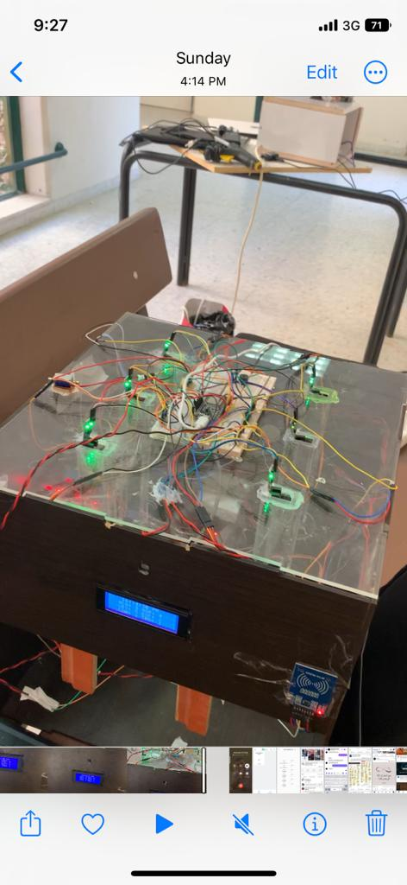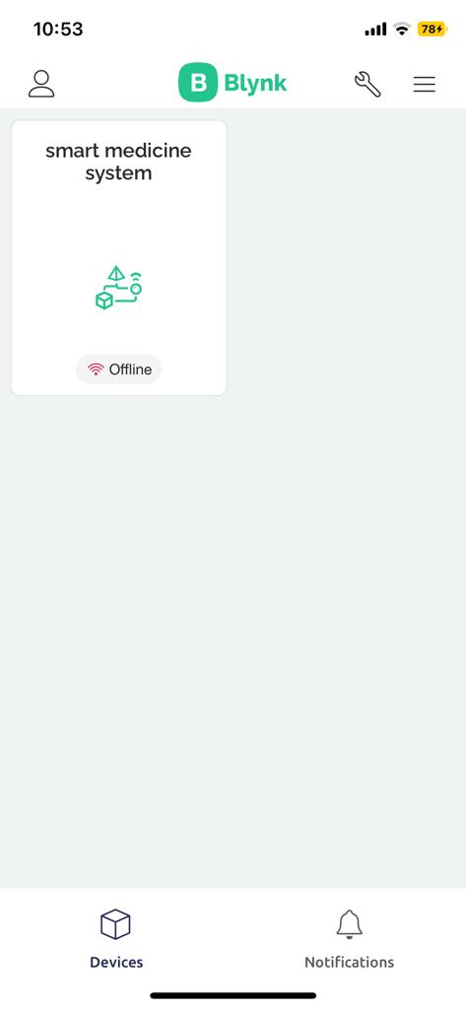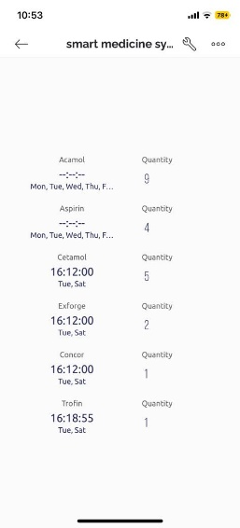
Water bump :
if there is detected cup that must put it in specific location the water bump will work.
for 10s or when the cup removed.
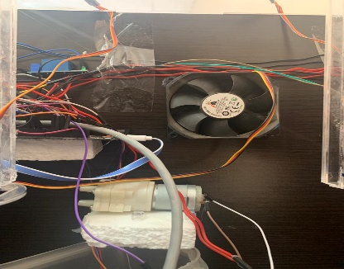

Temperature control part:
if the temperature of box less than 25 the aurduino mega send signal to 2 relays to turn on the 2 fans until the temperature come 25.
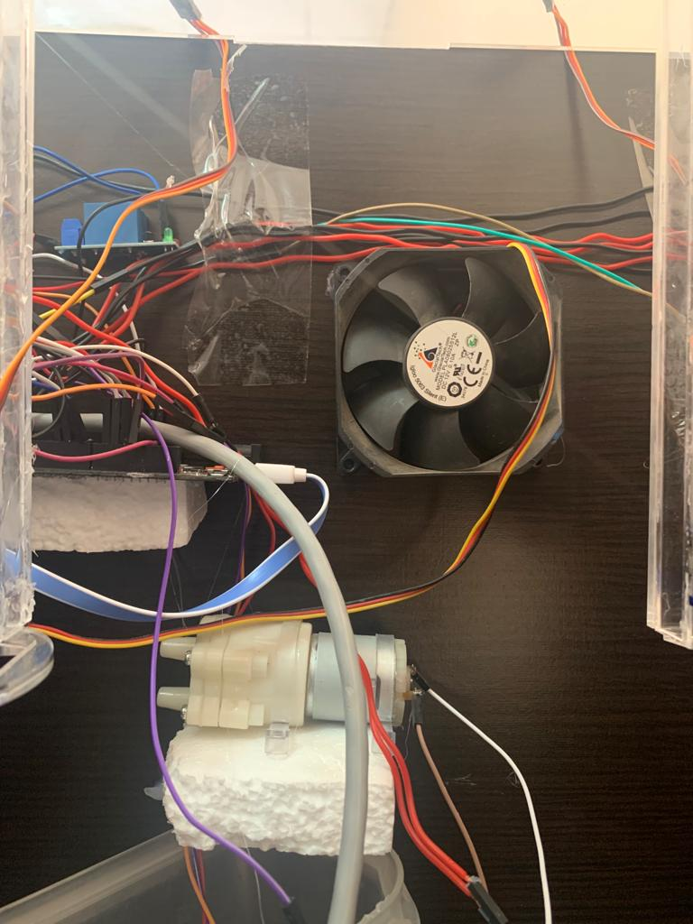

Solonoid lock part :
This part if the rfid module detect its specific card the solenoid will open the door let the user refill the pills.
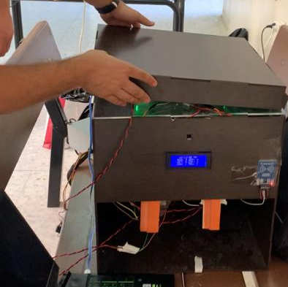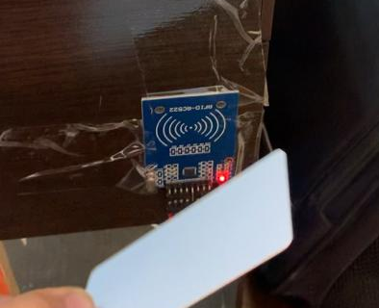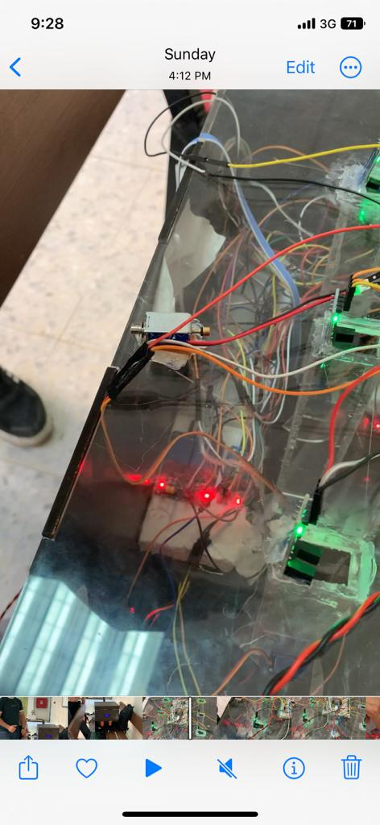

4.4. Mechanical Part:
The mechanical part of the project is the part responsible for moving the servo motors It requires the presence of a number of servo Motors to generate movement to direct it. To do this, it requires performing the following steps:
4.4.1 Mechanical Design : the servo move for specific degrees until the hole of 2nd piece match the hole for tupe to let the pills released , the delay and the design of this piece will guarantee that one pill will released .
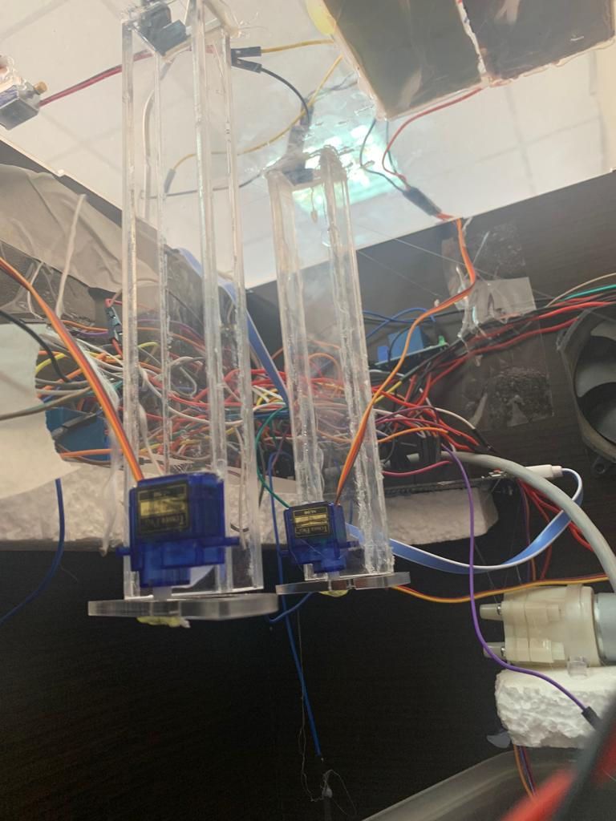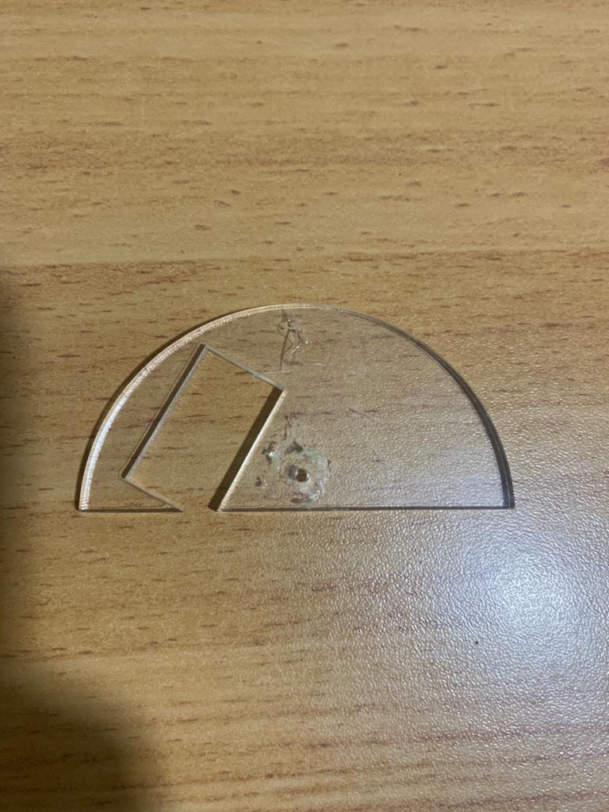

Some parts require special tools for cutting and handling, so a professional was necessary.
4.4.2 Parts:
Item name | Item image | quantity
Esp32 | 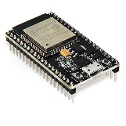 | 1
RFID module | 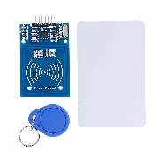 | 1
Arduino mega2650 | 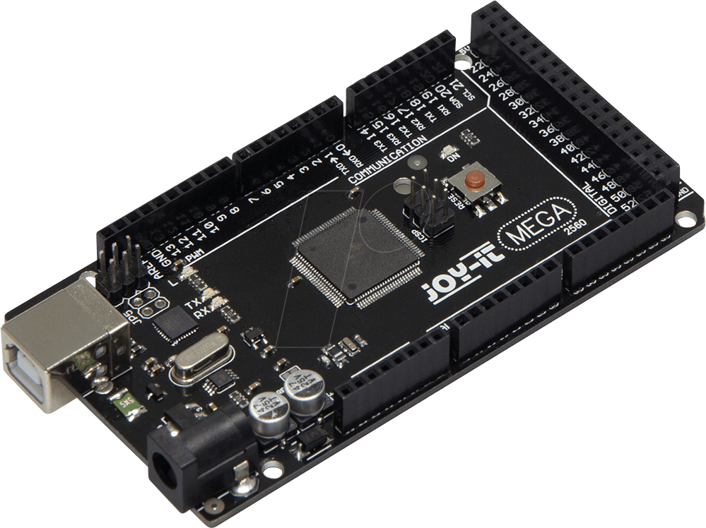 | 1
Temperature  sensor | 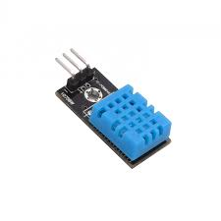 | 1
Lcd2004  display  module | 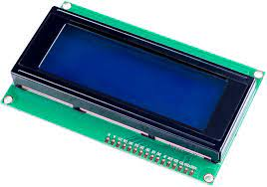 | 1
Laser sensor | 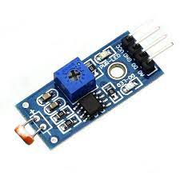 | 1
solonoid | 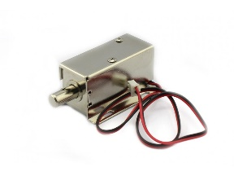 | 1
Servo motor | 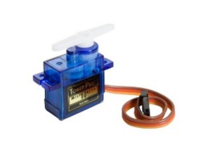 | 6
IR sensor | 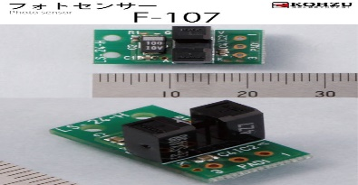 | 6
wires | 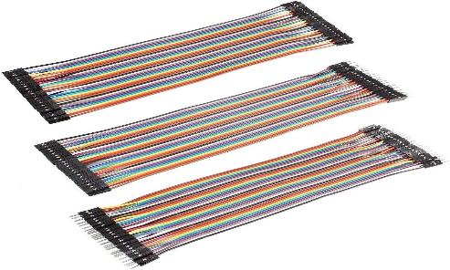
Water  pump | 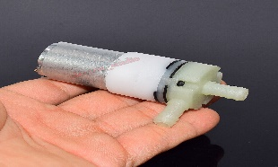 | 1

4.5.3.

4.5.4 Implementation for mechanical Part :
This code below will check the flags for medications if the current time will equal to the schedule time the flag will set by 1 but before anything we must move the servos for default positions to guarantee that will move the correct direction.
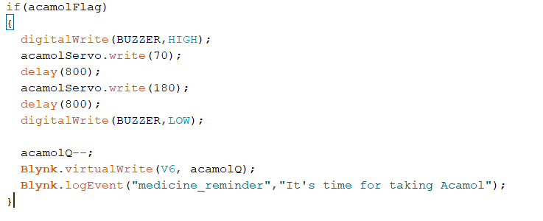
Figure 1: turn on the buzzer and move the servo then back it to default position and send notification to blynk app that tits time to take the medicine
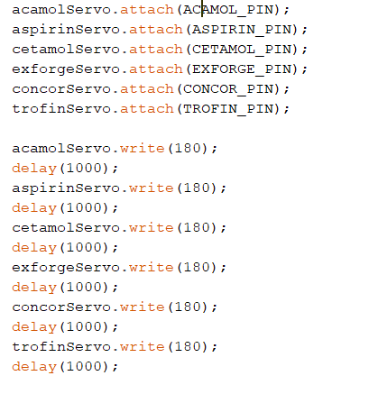
Figure 2: move the servos to defualt positions in setup mode.
Implementation for fans work :
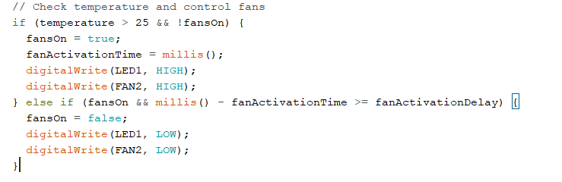
Figure 3: check the temp if < 25 turn on the fans and led for fan work guide.

Implementation for laser sensor work:
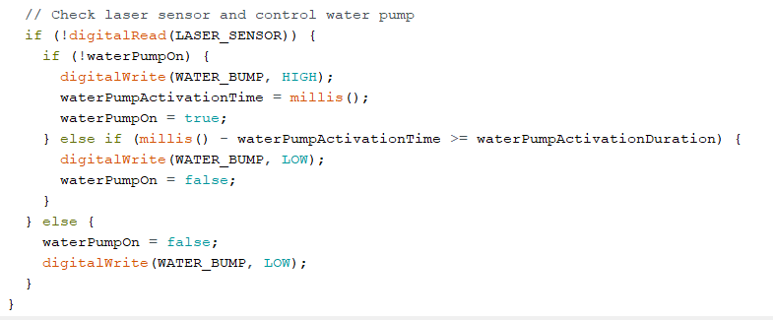
Figure 4: if the cup cut the laser the bump will work for 10s or the laser detected.

Implementation for RFID module work:
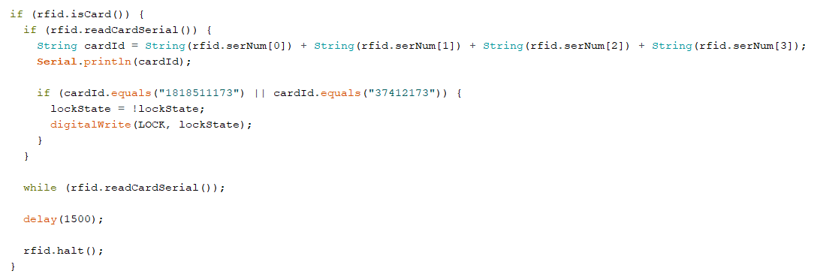
Figure 5:if the rfid card that have this number is detected the solonoid will open and when it read the card another time it lock the solonoid .

Controller parts :
Esp32:
It is responsible for connecting the data to the system and also connecting the data to the mobile application, as we connected the six servo motors and the six IR sensors to it.

Arduino mega 2650:
It was used until we attached the additional features to it the RFID and the water pump and the temperature sensor and the tow fans.

Other Parts :
temperature sensor:
It was used to keep the system cool, so if the temperature was higher than 25, the fans would turn on.

RFID:
It was connected with an electric lock, where the system cover is opened using an ID card on the RFID to fill the tubes with medicine, and then the system cover is closed using the same ID card.

Lcd2004 display module:
It was used to display the time as well as the names of the medicines and also the quantity contained in each tube.

Servo motor:
Six servo motors were connected to the six tubes, so that when the medication time arrived, the specified servo motors would be activated and the medication would be dropped.

IR Sensors:
We used six sensors on each tube. The sensor calculates the amount of medicine that is added to each tube and displays it on the phone application and the Size screen.

Water pump:
We used it with a laser sensor. When the laser penetrates, the water pump works for ten seconds and then stops.

Solonoid Lock :
This part responsible to lock or open the door via rfid module to able refill pills.

5. Result and Discussion :

In the final stage, the project fulfilled the requirements related to it, such as setting the dates, dropping the medication, and filling the patient’s water cup, by communicating between both microcontrollers through a series of specific commands that are sent to the serial from the blynk app and then read to start the implementation of the mechanical part. The alarm sound is heard by buzzer.

6. Conclusions and Future work :
In conclusion, the medicine dispenser machine is a prototype that helps everyone who needs to take medicine for a long time without having someone to remind them of medicines and monitor them throughout the day and ensure that they get their medicine regularly and continuously without interruption, thus improving their health quickly. Thankfully, we have achieved all the goals that were written in the first proposal. While we were working we learned many new things about hardware components and how to connect them together while keeping in mind the calculations required to avoid damaging any component. We learned how to use and program ESP32, as well as how to work with the blynk app. However, we had the problem of being restricted to summer term time. But for future work, we aspire to be a medicine reminder mechanism that can be used for more than one patient simultaneously, and it may be developed to accommodate more medicines.

7. References.

Smith, A. (2020). Smart Medicine Dispensers: A Comprehensive Review. Journal of Healthcare Technology, 12(3), 45-58.

Johnson, P. E., & Williams, L. S. (2019). IoT in Healthcare: A Review of Applications and Challenges. International Journal of Internet of Things, 7(2), 89-104.

Blynk Inc. (2022). Blynk: Build Mobile and Web Apps for IoT. Retrieved from https://blynk.io/.

Nest Labs. (2021). Nest: Thermostats, Cameras, Doorbells, and More. Retrieved from https://store.google.com/us/category/connected-home.

Ring. (2022). Ring: Video Doorbells and Security Cameras for Your Home. Retrieved from https://ring.com/.

MedMinder. (2020). MedMinder: Smart Medication Dispensers. Retrieved from https://www.medminder.com/.

Hero Health. (2021). Hero Health: Medication Dispenser with a Mission. Retrieved from https://herohealth.com/.

Pillsy. (2018). Pillsy: The Smart Pill Bottle and App. Retrieved from https://www.pillsy.com/.

