

An-Najah National University
Faculty of Engineering & Information Technology
Department of Computer Engineering

Medilink
Integrated Healthcare Platform
Prepared by:
Raghad Ayman Yameen
Yumna Eyad Abu Hanish
Supervised by:
Dr. Samer Arandi
Dr. Abdallah Rashad
June 14, 2026
Presented in partial fulfilment of the requirements for the Bachelor degree in Computer Engineering.

Acknowledgments
First and foremost, we would like to express our deepest gratitude to Allah Almighty for granting us the strength, patience, and guidance to complete this graduation project successfully.
We would like to extend our sincere appreciation and profound thanks to our esteemed supervisor, Dr. Samer Arandi & Dr. Abdallah Rashed, for his invaluable guidance.
We are also grateful to our university and the faculty members for providing the academic foundation and environment that enabled us to reach this milestone.
A special word of thanks goes to our families, who have been our constant source of inspiration and support. Their sacrifices and belief in our abilities have been the driving force behind our academic journey.

Disclaimer
Raghad Yameen and Yumna Abu Hanish have written this report as requirements for a Bachelor’s degree in Computer Engineering Department. No one modifies or corrects it because it will be evaluated by professors at An Najah National University. It is worth mentioning that An-Najah National University does not have any responsibility for any word in this report.

Abstract
This graduation project presents the development of MediLink, an integrated healthcare platform designed to connect patients, doctors, and administrators through a modern mobile application supported by artificial intelligence capabilities.
The system consists of three main components: a Flutter-based mobile application that provides a user-friendly interface supporting multiple platforms (Android, iOS, and Web), a backend server built with Node.js and Express to manage business logic and data processing, and an AI microservice that utilizes Google Gemini API to provide intelligent features such as symptom checking and medical report analysis.
The platform supports three user roles: patients who can book appointments, manage medications, upload medical reports, and consult doctors via paid chat; doctors who can manage their schedules, write prescriptions, view patient medical histories, and set consultation fees; and administrators who oversee user management, approve doctor registrations, manage medical specialties, and monitor system analytics.
Key features include JWT-based authentication, real-time push notifications via Firebase Cloud Messaging, automated reminders for appointments and medications, secure file storage, and responsive design that adapts to different screen sizes. The backend utilizes PostgreSQL with JSONB data type for flexible reminder tracking, and the frontend employs Riverpod for state management and GoRouter for navigation.
The project was developed as a graduation requirement for the Bachelor's degree in Computer Engineering at An-Najah National University. While MediLink demonstrates the potential of integrating modern technologies in healthcare, it remains an academic prototype and is not intended for real medical use. The AI features are experimental and should not replace professional medical advice.

Table of Contents
Acknowledgments 2
Disclaimer 3
Abstract 4
Chapter 1: Introduction 9
1.1 General Background 9
1.2 Objectives 9
1.3 Significance 10
1.4 Organization of the Report 10
Chapter 2: Theoretical Background and Previous Work 11
2.1 Theoretical Background of the Project 11
2.2 Previous Similar Works 11
Chapter 3: Methodology 12
3.1 Constraints and Earlier Coursework 12
3.2 Used Technologies 17
3.3 System Architecture 29
3.4 Database Design 29
3.5 MediLink as a Mobile Application 31
3.6 MediLink as a Website 36
Chapter 4: Results and Analysis 74
Chapter 5: Discussion 75
Chapter 6: Conclusion & Future Work 76
6.1 Conclusion 76
6.2 Future Improvements 76

List of Figures
Figure 1: Login – Mobile Application 32
Figure 2: Role Selection – Mobile Application 33
Figure 3: Patient Registration – Mobile Application 34
Figure 4: Doctor Registration – Mobile Application 35
Figure 5: Welcome Page – Web 36
Figure 6: Login Page – Web 37
Figure 7: Role Selection Page – Web 38
Figure 8: Register as a Patient – Web 39
Figure 9: Register as a Doctor – Web 40
Figure 10: Forgot Password – Web 40
Figure 11: Doctor Dashboard – Web 41
Figure 12: Doctor Fees – Web 42
Figure 13: Doctor Chat – Web 43
Figure 14: Chat List – Web 44
Figure 15: Manage Schedule – Web 44
Figure 16: Day Schedule – Web 45
Figure 17: Patients List – Web 45
Figure 18: Doctor’s View of a Patient File – Web 46
Figure 19: Medical Reports & Documents – Web 47
Figure 20: Prescriptions (Doctor View) – Web 48
Figure 21: Patient Appointments (Doctor View) – Web 48
Figure 22: Doctor Reports a Patient – Web 49
Figure 23: AI Patient Summary – Web 51
Figure 24: Doctor Writes a Prescription – Web 52
Figure 25: Doctor Appointments Management – Web 52
Figure 26: Patient Chat – Web 53
Figure 27: Patient Medical File – Web 54
Figure 28: Patient Medical Documents – Web 55
Figure 29: AI Analysis of a Medical Document – Web 56
Figure 30: Find a Doctor (Sort by Price, Specialty and Rating) – Web 57
Figure 31: Patient Reports a Doctor – Web 57
Figure 32: Secure Payment for a Consultation – Web 58
Figure 33: Patient Books a Visit – Web 59
Figure 34: Patient Appointments – Web 59
Figure 35: Patient Rates a Completed Appointment – Web 60
Figure 36: Electronic Prescription – Web 61
Figure 37: PDF Export of a Prescription – Web 61
Figure 38: Medication Schedule – Web 62
Figure 39: Health Library – Web 63
Figure 40: FAQ Center – Web 63
Figure 41: AI Symptom Checker – Web 64
Figure 42: Notifications Inbox – Web 65
Figure 43: Admin Dashboard – Web 66
Figure 44: AI Platform Insights – Web 66
Figure 45: Patient Management – Web 67
Figure 46: Doctor Management – Pending Approvals – Web 68
Figure 47: Doctor Management – All Doctors – Web 68
Figure 48: Patient Reports Moderation – Web 69
Figure 49: Doctor Reports Moderation – Web 69
Figure 50: Manage Specialties – Web 70
Figure 51: Manage Content – Articles – Web 71
Figure 52: Published Article Preview – Web 71
Figure 53: Manage Content – FAQs – Web 72
Figure 54: FAQ Entry Preview – Web 72
Figure 55: Doctor Ratings Overview – Web 73
Figure 56: Reports & Statistics – Web 73

Chapter 1: Introduction

1.1 General Background
The healthcare sector is undergoing a rapid digital transformation driven by advancements in mobile technologies, cloud computing, and artificial intelligence. In recent years, the demand for accessible, efficient, and patient-centered healthcare services has increased significantly. Traditional healthcare systems often face challenges such as long waiting times for appointments, difficulty in managing medications, lack of communication between patients and doctors, and limited access to medical records. According to the World Health Organization (WHO), digital health technologies can help bridge the gap between healthcare providers and patients, especially in regions where access to medical services is limited. Mobile health (mHealth) applications have emerged as powerful tools to empower patients, streamline clinical workflows, and improve health outcomes. MediLink is proposed as an integrated healthcare platform that leverages modern technologies including Flutter for cross-platform mobile development, Node.js for backend services, and Google Gemini AI for intelligent medical assistance. The platform aims to connect patients, doctors, and administrators in a unified digital ecosystem, providing features such as appointment booking, medication reminders, medical report management, AI-powered symptom checking, and secure chat consultations.

1.2 Objectives
The primary objectives of this graduation project are to develop a cross-platform mobile application using Flutter that runs on Android, iOS, and Web platforms, providing a seamless experience for patients, doctors, and administrators. The project also aims to create a robust backend server using Node.js and Express to handle authentication, business logic, data persistence, and API services. Another key objective is to integrate artificial intelligence capabilities using Google Gemini API to provide intelligent features such as symptom checking and medical report analysis, enhancing the platform's diagnostic support. The project further aims to implement role-based access control supporting three distinct user roles including Patient, Doctor, and Admin, each with customized dashboards and permissions. Additionally, the project seeks to enable real-time notifications utilizing Firebase Cloud Messaging (FCM) to send automated reminders for upcoming appointments and medication schedules, improving patient adherence. The project also aims to provide secure data management ensuring encrypted storage of medical records, prescriptions, and personal information using JWT-based authentication. A responsive user interface that adapts to different screen sizes including mobile, tablet, and desktop is another important objective. Finally, the project aims to document the system comprehensively including system architecture, API endpoints, database schema, user manuals, and testing procedures for future reference and maintenance.

1.3 Significance
The significance of the MediLink project lies in its potential to address critical gaps in the healthcare delivery process. From a market perspective, the global mobile health (mHealth) market was valued at approximately $75 billion in 2024 and is projected to reach $230 billion by 2030, with a compound annual growth rate of 18.5%. With over 6.8 billion smartphone users worldwide and 76% of patients expressing preference for digital health tools according to McKinsey & Company, there is substantial demand for integrated healthcare platforms like MediLink. The project addresses several key problems in current healthcare systems. Long appointment waiting times are solved through an online booking system with real-time availability checking. Medication non-adherence is addressed through automated reminders and dose tracking. Limited access to medical records is resolved through centralized digital storage accessible anytime. Poor doctor-patient communication is improved through a secure chat consultation feature. Lack of preliminary medical guidance is mitigated through an AI-powered symptom checker for initial assessment. Administrative burden on clinics is reduced through automated scheduling, reminders, and reporting. The primary beneficiaries of MediLink include patients who gain easy access to healthcare, medication reminders, lower costs, time savings, and convenience. Doctors benefit from digital scheduling, patient history viewing, reduced no-shows, and additional revenue opportunities. Administrators benefit from centralized management, analytics and reporting, user oversight, content control, and system monitoring. From an academic perspective, this project contributes by demonstrating the integration of multiple modern technologies including Flutter, Node.js, PostgreSQL, and Google Gemini into a cohesive system, providing a reference architecture for similar healthcare platforms, exploring the effectiveness of AI in preliminary medical symptom assessment, and documenting best practices for secure healthcare data management.

1.4 Organization of the Report
This report is organised into six chapters. Chapter 1 introduces the project, presenting the general background, the objectives, the scope and the significance of MediLink. Chapter 2 reviews the theoretical background of the work and surveys previous, similar healthcare platforms in order to position MediLink against existing solutions. Chapter 3 describes the methodology, covering the engineering constraints, the technologies adopted, the overall system architecture, the database design, and a detailed walkthrough of the application as both a mobile app and a website. Chapter 4 presents the results, demonstrating the implemented features across the patient, doctor and administrator roles. Chapter 5 discusses these results, the challenges faced and how they were addressed. Finally, Chapter 6 concludes the report and outlines directions for future work.

Chapter 2: Theoretical Background and Previous Work
LETERATURE REVIEW

2.1 Theoretical Background of the Project
MediLink is a web and mobile healthcare platform intended to aid patients, doctors, and administrators during their medical journey. It is a graduation project whose purpose is to make healthcare more accessible and efficient through modern technology. With the system, patients can book appointments, manage their medications, upload and view medical reports, and communicate with doctors through paid chat consultations. Doctors can manage their schedules, write prescriptions, view patient medical histories, and set their consultation fees. Administrators can oversee user management, approve doctor registrations, manage medical specialties, and monitor system analytics. The platform also enhances the healthcare experience through AI-powered symptom checking and medical report analysis, as well as a secure repository of medical records and prescriptions.

2.2 Previous Similar Works
While the idea of healthcare platforms is not new, MediLink differentiates itself from others because it is particularly designed to serve patients, doctors, and administrators together in one integrated system. As opposed to general-purpose telemedicine applications such as Teladoc or medication reminder apps like Medisafe, MediLink combines appointment booking, medication management, medical report storage, AI-powered symptom checking, and doctor communication in a single package. It also incorporates role-based access for patients, doctors, and administrators, and encourages seamless interaction between all parties through chat consultations and prescription management. Whereas other healthcare applications exist, none reproduce this system's full range of medical, administrative, and AI-powered support in the same integrated, multi-user environment.

Chapter 3: Methodology

3.1 Constraints and Earlier Coursework
1-Economy
Budget Limits:
Since this project is non-profit and student-driven, it was important to produce it on a shoestring budget. We worked with open-source software and free versions of applications like Firebase Cloud Messaging, Google Gemini API (free tier), and PostgreSQL in an effort to stay within a tight budget. All development tools including Flutter SDK, Node.js, Visual Studio Code, and Postman were used for free. No commercial licenses or paid subscriptions were required throughout the development process.
Maintenance Charges:
Maintenance activities such as bug fixing, security patches, and server upkeep are expected to be performed by student developers or institutional support. Since MediLink is an academic graduation project and not a commercial product, ongoing maintenance costs are minimal. The system is designed to be easily maintainable with well-documented code and modular architecture.

2. Environment
Power Consumption:
The MediLink system is designed to be performance-focused with low energy consumption for client. The Flutter mobile application is optimized to reduce battery drain by using efficient state management with Riverpod and using push notifications instead of frequent polling.
3. Society
Information Security:
Authentication through secure JWT tokens and optional Firebase Auth safely stores information. JWT tokens and role-based access control also protect user information, ensuring that patients can only access their own medical records, doctors can only access their assigned patients, and administrators have appropriate access levels. All passwords are hashed using bcrypt before storage.

Privacy:
Standard privacy policies are adhered to by the system. Users' medical records, prescriptions, chat messages, and personal information are private to their own account unless explicitly shared with authorized healthcare providers. Doctors can only view medical
information of patients they are treating, and administrators only have access necessary for platform management.

4. Politics
Inclusivity and Accessibility:
The MediLink platform is designed to be accessible and inclusive for all patients, doctors, and administrators regardless of background, gender, or medical condition. The Flutter framework includes built-in accessibility features such as screen reader support, large text options, and high contrast modes to accommodate users with disabilities.

5. Ethics
Safe Usage:
The MediLink platform does not contain objectionable content and encourages healthy medical interaction. Features like appointment reminders, medication notifications, and smart calendars reduce stress and help patients avoid missed deadlines for taking medications or attending doctor visits. The AI symptom checker includes clear disclaimers that it does not provide medical diagnosis.

Fair Use:
The platform encourages ethical sharing of medical information. Doctors who view patient medical records must do so only for legitimate treatment purposes. Patients are encouraged to use the AI symptom checker as a preliminary tool only and to consult real doctors for actual medical concerns. The system promotes honest and truthful communication between all parties.

6. Health and Safety
Digital Wellbeing:
With scheduling of appointments and smart medication notifications, the system aims to reduce digital overload and provide clean communication without spamming. Patients receive only relevant notifications for their upcoming appointments and medication doses, with configurable reminder settings to avoid notification fatigue.

Doctors receive notifications only for appointment requests and patient messages, not for marketing or unrelated content.
Emergency Handling:
The AI symptom checker is designed to recognize emergency symptoms such as chest pain, difficulty breathing, and severe bleeding, and immediately advises users to call emergency services rather than relying on the application. Clear disclaimers inform users that MediLink is an academic prototype and not a real medical product.
7. Sustainability
Scalability and Upgradeability:
The MediLink system has been designed with the philosophy of modularity as the design approach, hence it is easy to add new features like video consultation, advanced health analytics, integration with wearable devices, or AI-powered medical image analysis in future versions. The frontend and backend communicate through a well-defined API, allowing either side to be modified independently. The database uses JSONB fields for flexible data storage, enabling new features to be added without complex schema migrations.
Reliability and Durability:
The PostgreSQL database ensures data persistence and durability. Regular backup procedures protect against data loss. The system handles network disconnections gracefully and recovers from server

restarts without data corruption, ensuring long-term reliability for users.

3.2 Used Technologies
Flutter
Flutter is an open-source UI software development kit created by Google for building cross-platform applications from a single codebase. It is used for developing the frontend mobile and web application for MediLink.

Why Flutter?
- Cross-Platform Support: Enables one codebase to run on Android, iOS, and Web platforms simultaneously, reducing development time and maintenance effort.
- Hot Reload: Allows developers to see code changes instantly during development, speeding up debugging and testing.
- Rich Widget Library: Provides a large collection of pre-designed widgets following Material Design guidelines for a modern and consistent user interface.
- Performance: Compiles to native ARM code for mobile platforms and JavaScript for web, ensuring fast performance.

Dart
Dart is the programming language used with Flutter, developed by Google and optimized for UI development. It is used to write all frontend code for MediLink including screens, widgets, providers, and API services.
Why Dart?
- AOT and JIT Compilation: Ahead-of-time (AOT) compilation for fast startup times and just-in-time (JIT) compilation with hot reload for development productivity.
- Familiar Syntax: Syntax similar to Java and JavaScript, making it easy to learn for developers with backgrounds in those languages.
- Asynchronous Support: Built-in support for async/await, making it easy to handle API calls and database operations.

Riverpod
Riverpod is a state management library for Flutter. It is used in MediLink to manage authentication state, user data, appointments, medications, and other application data.
Why Riverpod?
- Compile-Time Safety: Errors are caught during development rather than at runtime.

- Testability: Providers can be easily mocked and tested in isolation.
- Scalability: Can handle small to very large applications without performance degradation.
- No BuildContext Dependency: Unlike Provider, Riverpod does not require BuildContext to access state.

GoRouter
GoRouter is a declarative routing package for Flutter. It is used in MediLink to handle navigation between screens and implement role-based access control.
Why GoRouter?
- Declarative Routing: All routes are defined in a central location, making navigation easy to understand and maintain.
- Deep Linking: Supports direct navigation to specific screens from URLs.
- Route Guarding: Restricts access to certain screens based on authentication status and user role (patient, doctor, admin).
- Parameter Passing: Easily passes data between screens through route parameters.

Node.js
Node.js is an open-source JavaScript runtime environment built on Chrome's V8 engine. It is used to build the backend server for MediLink.
Why Node.js?
- Event-Driven Architecture: Non-blocking I/O model efficiently handles thousands of concurrent connections with minimal overhead, important for healthcare applications with multiple simultaneous users.
- JavaScript Everywhere: Uses the same language (JavaScript) for both frontend and backend, reducing context switching.
- Large Ecosystem: Vast collection of libraries available through npm (Node Package Manager).
- High Performance: Built on Chrome's V8 engine, providing fast execution of JavaScript code.

Express.js
Express.js is a minimal and flexible web application framework for Node.js. It is used to build RESTful APIs for MediLink.
Why Express.js?
- Minimal and Flexible: Provides just enough features to build web applications without unnecessary complexity.
- Middleware Support: Easily adds middleware for authentication, logging, error handling, and request parsing.

- Routing: Simple and intuitive API for defining routes and handling HTTP methods (GET, POST, PUT, DELETE).
- Large Community: Extensive documentation and community support.

PostgreSQL
PostgreSQL is a powerful, open-source object-relational database system. It is used as the primary database for MediLink to store users, appointments, medications, prescriptions, and medical reports.
Why PostgreSQL?
- JSONB Support: Allows storing semi-structured data like the reminders_sent array in appointments, enabling flexible tracking of reminder history without complex table structures.
- ACID Compliance: Ensures data integrity even in the event of system failures.
- Reliability: Proven reliability with over 30 years of active development.
- Performance: Excellent performance for both read and write operations.

Sequelize
Sequelize is a Node.js ORM (Object-Relational Mapping) library for SQL databases. It is used in MediLink to simplify database interactions.
Why Sequelize?
- Object Mapping: Maps database tables to JavaScript objects, reducing the amount of raw SQL code needed.
- Query Building: Programmatically builds SQL queries, reducing syntax errors.
- Migrations: Supports version control of database schema changes.
- Connection Pooling: Manages database connections efficiently to improve performance.

Firebase Cloud Messaging
Firebase Cloud Messaging (FCM) is a cross-platform messaging solution from Google. It is used in MediLink to send push notifications for appointment reminders and medication schedules.
Why Firebase Cloud Messaging?
- Free to Use: No cost for sending notifications, suitable for academic projects.

- Cross-Platform: Works across Android, iOS, and Web platforms from a single integration.
- Reliable Delivery: Maintains persistent connections to devices and delivers messages even when the application is in the background or closed.
- Simple Integration: Easy to integrate with Flutter frontend and Node.js backend.

JSON Web Tokens (JWT)
JSON Web Tokens (JWT) is an open standard for securely transmitting information between parties as a JSON object. It is used in MediLink for user authentication and authorization.
Why JWT?
- Stateless Authentication: Server does not need to store session information, improving scalability and reducing database load.
- Secure: Digitally signed tokens prevent tampering and ensure authenticity.
- Compact: Can be easily sent in HTTP headers for API calls.
- Self-Contained: Contains user information (claims) within the token itself.

bcrypt
bcrypt is an adaptive cryptographic hash function designed for hashing passwords. It is used in MediLink to securely hash user passwords before storing them in the database.
Why bcrypt?
- Slow by Design: Computationally expensive to hash passwords, making brute-force attacks impractical.
- Automatic Salting: Includes a random salt with each hash, ensuring identical passwords produce different hashes.
- Work Factor: Configurable cost factor that can be increased as hardware becomes more powerful.
- Widely Used: Proven security with extensive use in production applications.

Dio
Dio is a powerful HTTP client for Dart and Flutter. It is used in MediLink to handle API requests from the Flutter application to the backend server.
Why Dio?
- Interceptors: Supports interceptors for adding authentication tokens to requests automatically.
- Request Cancellation: Can cancel in-progress requests when needed.

- Form Data: Handles multipart form data uploads for medical report files.
- Response Caching: Supports caching responses to improve offline experience.

flutter_secure_storage
flutter_secure_storage is a Flutter plugin that provides secure storage on mobile devices. It is used in MediLink to store sensitive data such as JWT tokens and user credentials.
Why flutter_secure_storage?
- Platform Security: Uses Android Keystore on Android and iOS Keychain on iOS for secure storage.
- Encryption: Data is encrypted at rest, preventing unauthorized access.
- Simple API: Easy to use with read and write methods.
- No Root Access: Protects data even if the device is compromised.

Multer
Multer is a Node.js middleware for handling multipart/form-data, primarily used for file uploads. It is used in MediLink to handle uploads of medical reports and prescription documents.
Why Multer?

- Easy File Handling: Processes incoming files and makes them available in request objects.
- File Filtering: Can filter files by type (e.g., only images and PDFs).
- Storage Options: Supports both disk storage and memory storage.
- Size Limits: Configurable limits for file sizes to prevent abuse.

node-cron
node-cron is a task scheduling library for Node.js. It is used in MediLink to run scheduled jobs such as checking for upcoming appointments and sending reminder notifications.
Why node-cron?
- Cron Syntax: Uses standard cron syntax, making it flexible and easy to configure.
- Lightweight: Small package with no external dependencies.
- Timezone Support: Supports scheduling in different timezones.
- Simple API: Easy to set up and manage scheduled tasks.

Visual Studio Code
Visual Studio Code (VS Code) is a free, lightweight source-code editor developed by Microsoft, with debugging support, IntelliSense, and

Git version control. It is used for frontend (Flutter) and backend (Node.js) development.
Why Visual Studio Code?
- Cross-Platform Support: Runs on Windows, macOS, and Linux, matching the project's multi-environment demands.
- Extensions: Supports extensions for Flutter, Dart, and Node.js plugins, enhancing development speed.
- Debugging: Powerful debugging capabilities for debugging code.
- Git Integration: Simplifies version control and collaboration.

Postman
Postman is an API development and testing tool that provides an easy way to construct, test, and document APIs. It is used to test the backend APIs for MediLink such as login, appointments, medications, and notification endpoints.

Why Postman?
- API Testing: Allows quick testing of endpoints like /api/auth/login, /api/patients/appointments, and /api/patients/medications.

- Collaboration: Enables simple sharing of API specifications with the team.
- Automation: Facilitates automated testing of API responses.
- Ease of Use: Provides a user-friendly interface for debugging API calls.

3.3 System Architecture
MediLink follows a layered client–server architecture composed of three main tiers that communicate over secure HTTP using JSON. The presentation tier is a single Flutter codebase compiled to Android, iOS and Web; it uses Riverpod for state management and GoRouter for declarative, role-aware navigation, and it talks to the backend through the Dio HTTP client. The application tier is a Node.js/Express REST API organised into routes, controllers, services and Sequelize models; it enforces JWT authentication and role-based authorization, implements the business logic (appointment booking, prescriptions, paid-chat access), and runs scheduled jobs with node-cron. The data tier is a PostgreSQL database accessed through the Sequelize ORM.
In addition to these tiers, the platform integrates three external services. Firebase Cloud Messaging delivers push notifications to all of a user’s registered devices, backed by an in-app notification store so that no alert is ever lost. Firebase/Firestore provides the real-time transport for the chat feature. The Google Gemini API powers the artificial-intelligence features, namely the symptom checker, medical-report analysis, the doctor’s patient summary, the prescription safety check and the administrator’s platform insights. A typical request flows from a Flutter screen, through Dio, to an Express route guarded by the authentication middleware, into a controller that applies the business rules and calls the relevant service or Sequelize model, and finally to PostgreSQL; the JSON response then updates the Riverpod state and re-renders the user interface.

3.4 Database Design
The persistent state of MediLink is stored in a relational PostgreSQL schema managed through Sequelize models. At its centre is the users table, which holds the credentials and the role discriminator and is specialised by either a patient_profiles or a doctor_profiles record. Doctors are linked to a specialties catalogue and publish weekly doctor_availability slots, which the booking engine consults when creating appointments. Clinical data is captured in prescriptions and prescription_items, which in turn generate patient_medications and their medication_schedules used by the reminder jobs. Supporting tables store medical_reports, ratings, chat_conversations and messages, notifications and fcm_tokens, health_articles and faqs, and the symptom_checker_logs that record every AI interaction. A notable design choice is the use of PostgreSQL’s JSONB type – most prominently the reminders_sent column on appointments – to flexibly track which reminder intervals have already been delivered without introducing additional tables. Table 1 summarises the principal entities of the schema.
Entity / Table | Description
users | Core account for every user, storing the email, bcrypt password hash, role (patient/doctor/admin) and basic profile fields.
patient_profiles | Patient-specific health data: blood type, height, weight, chronic diseases, surgeries, allergies and current medications.
doctor_profiles | Doctor-specific data: specialty, qualification, experience, license, verification status, consultation and chat fees, and average rating.
specialties | Catalogue of medical specialties used in doctor registration and patient search.
doctor_availability | Weekly recurring time slots that define when a doctor accepts appointments.
appointments | Booked visits between a patient and a doctor, including date, time, status and the JSONB reminders_sent tracker.
medical_reports | Uploaded medical documents (PDF/image) belonging to a patient, with file metadata and privacy flag.
prescriptions / prescription_items | Electronic prescriptions and their individual medication lines (dosage, frequency, duration, instructions).
patient_medications / medication_schedules | Active medications derived from prescriptions and their per-dose schedule used by the reminder service.
chat_conversations / messages | Paid chat threads between a patient and a doctor and the individual messages exchanged.
ratings | Five-point ratings and comments left by patients for completed appointments.
notifications / fcm_tokens | In-app notification records and the Firebase device tokens used to deliver push notifications.
health_articles / faqs | Educational content authored by administrators and published to patients.
symptom_checker_logs | History of AI symptom-checker queries and the JSONB AI response returned to the patient.
Table 1: Principal entities of the MediLink database schema

3.5 MediLink as a Mobile Application
This section presents the MediLink client running as a native mobile application on the Android emulator. The mobile build is produced from the same Flutter codebase as the web client, so it shares the same business logic, state management and API layer while adapting the layout to a small touch screen.
Login:
On mobile, the login screen offers the same email-and-password authentication as the web client. The Flutter application stores the returned JWT in secure storage and routes the user to the dashboard that matches their role.
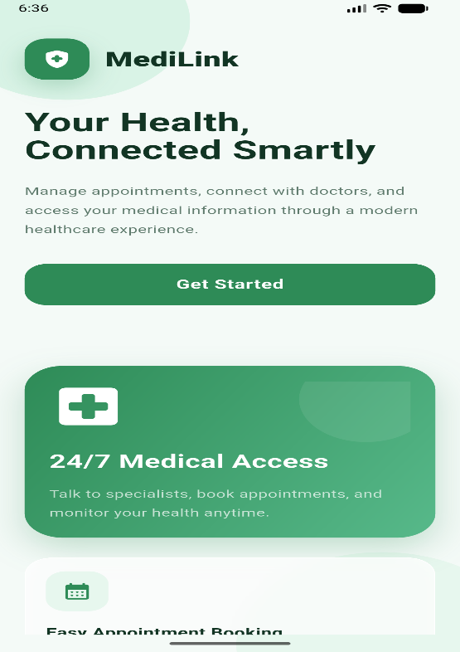
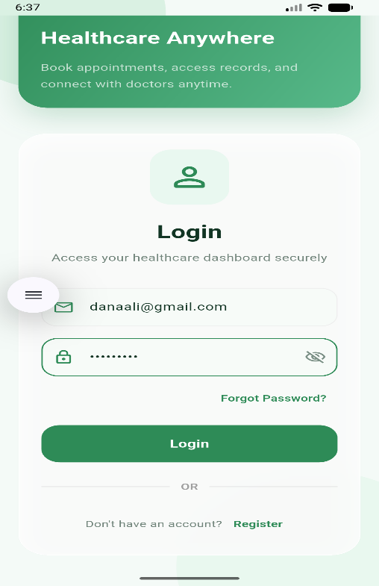
Figure 1: Login – Mobile Application

Register:
The registration flow guides the user through selecting a role and completing the corresponding form. Patients provide their personal and account details, while doctors additionally supply their professional credentials and a verification document that an administrator must approve before the account becomes active.
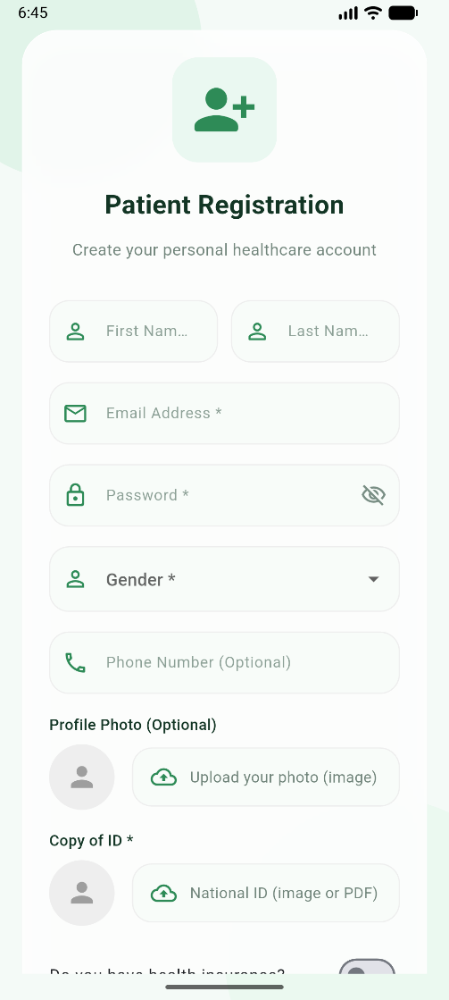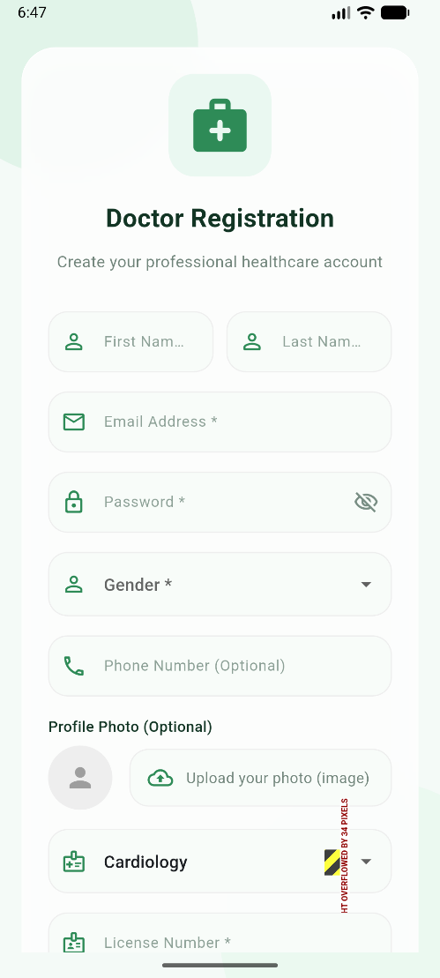
Figure 2: Role Selection – Mobile Application

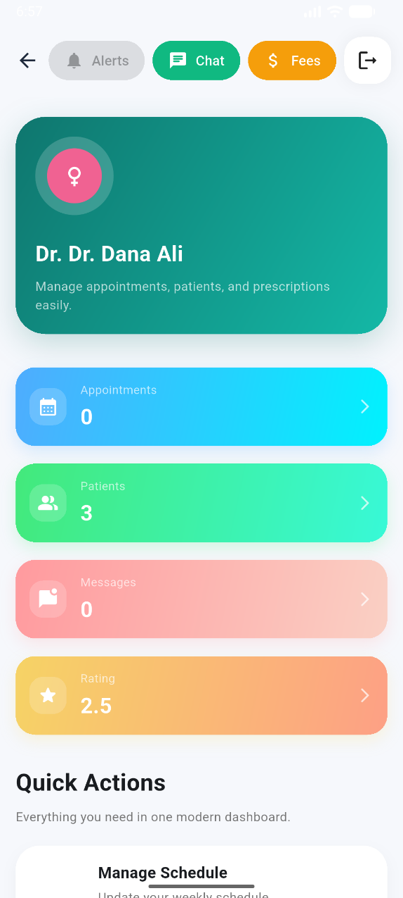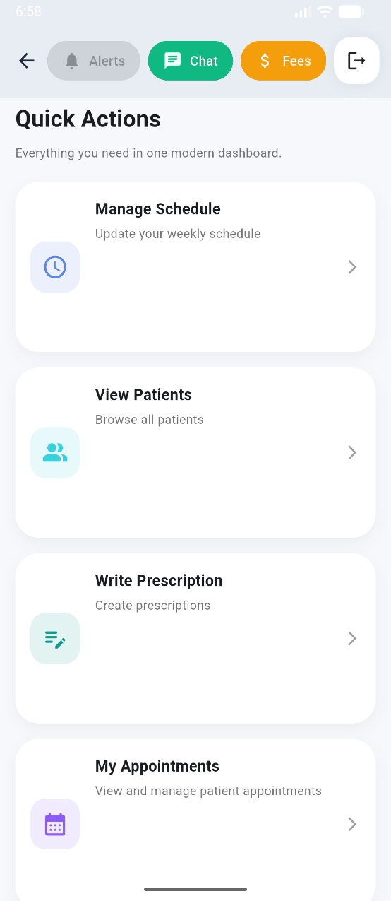
Figure 3: Patient Registration – Mobile Application

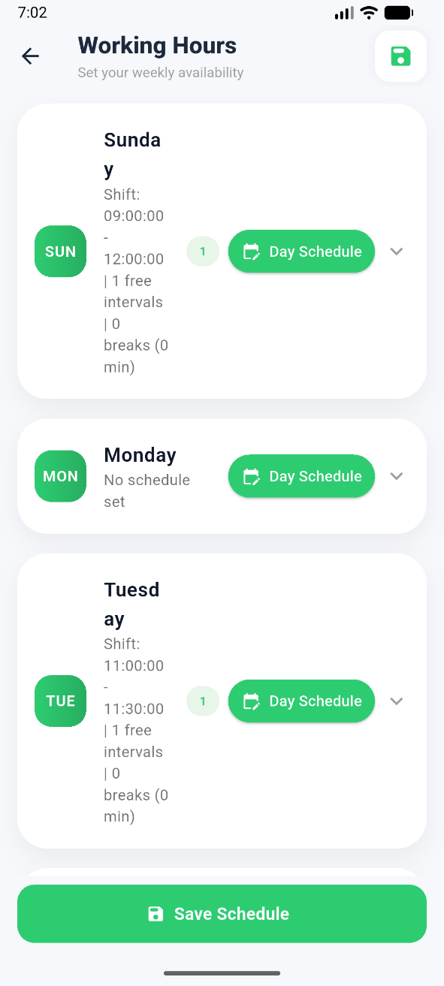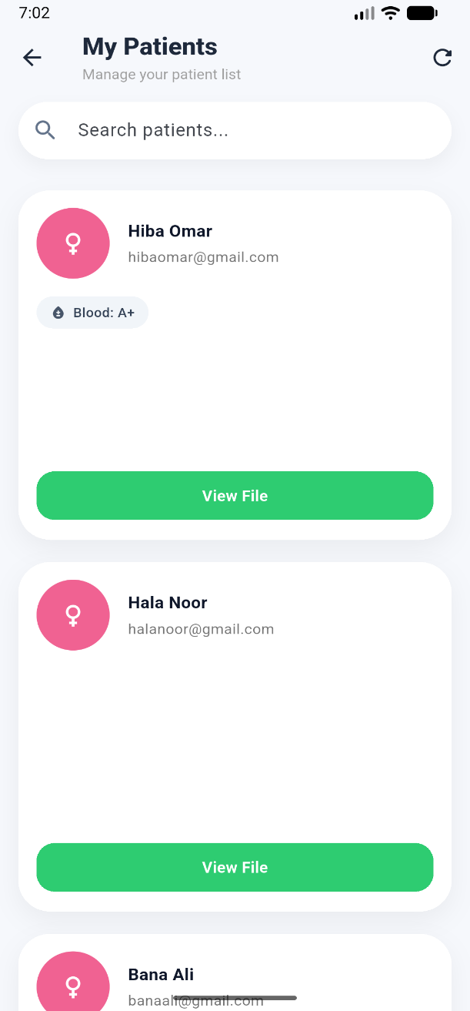
Figure 4: Doctor Registration – Mobile Application

3.6 MediLink as a Website
This section presents the MediLink client running as a responsive web application. The following figures walk through the platform screen by screen for each of the three user roles – patient, doctor and administrator – and explain the purpose and behaviour of every screen.
The welcome screen is the entry point of the MediLink web application. It introduces the platform with a short value proposition and provides the primary calls to action that direct visitors either to sign in to an existing account or to begin the registration process.
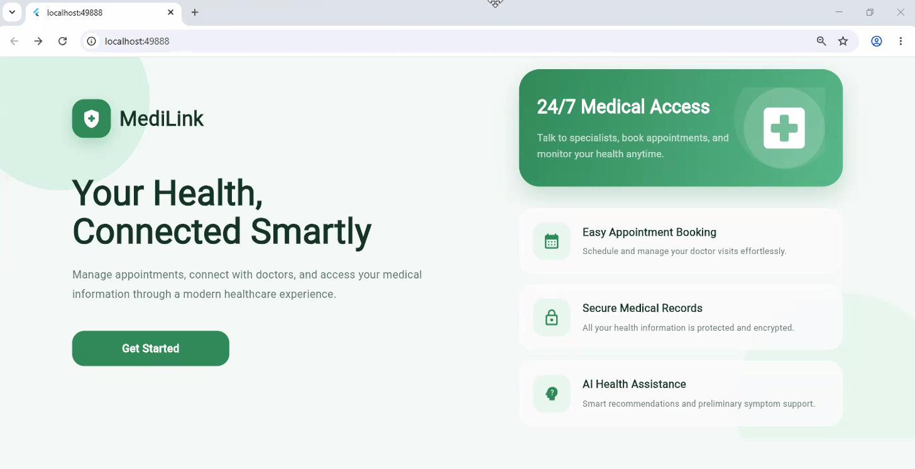
Figure 5: Welcome Page – Web
The login page authenticates users with their registered email address and password. The credentials are submitted to the /api/auth/login endpoint, which validates the user and returns a signed JSON Web Token (JWT). The token is stored securely on the client and attached to every subsequent request. After a successful login the user is redirected automatically to the dashboard that matches their role (patient, doctor or administrator).
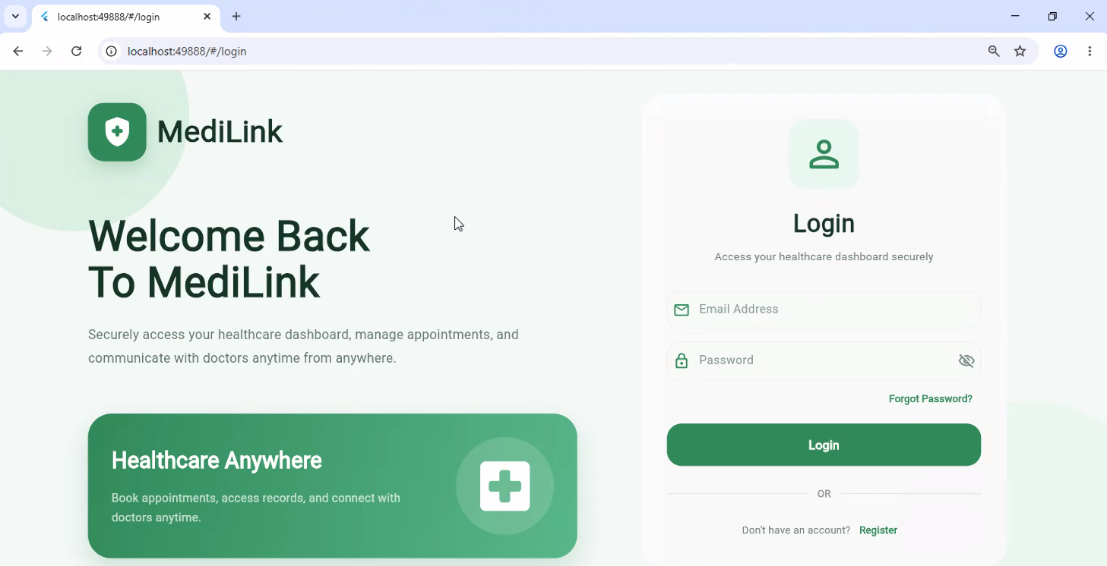
Figure 6: Login Page – Web

Before creating an account, the user chooses whether to register as a patient or as a doctor. This selection determines which registration form is displayed next and which fields and verification documents are required.
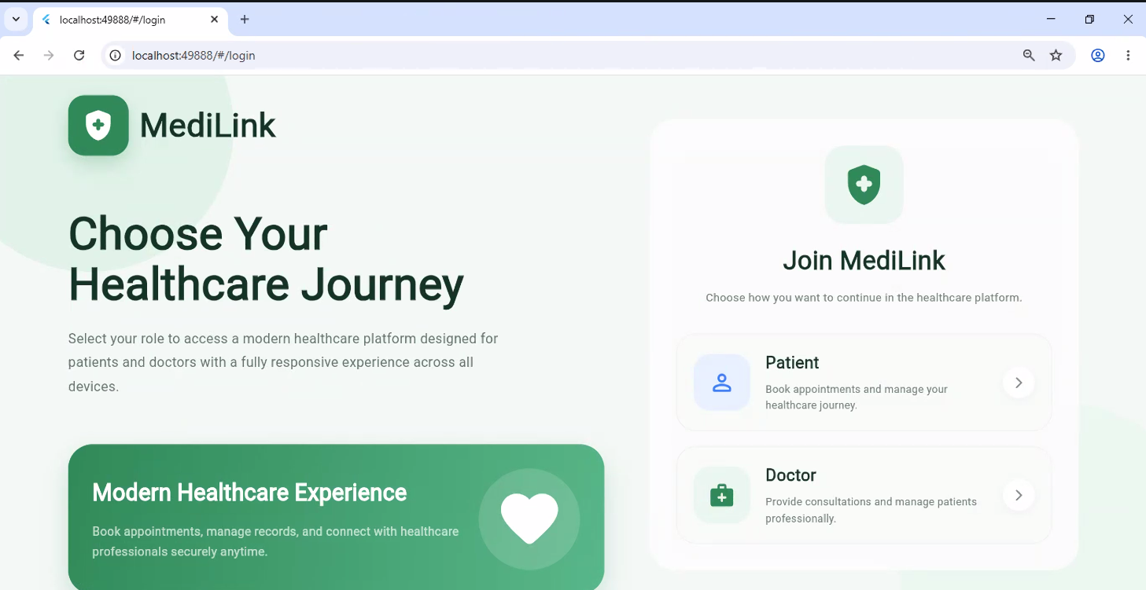
Figure 7: Role Selection Page – Web
The patient registration form collects the user’s personal details (name, email, phone number, date of birth and gender) together with a password. On submission the data is sent to /api/auth/register, the password is hashed with bcrypt before storage, and a linked patient profile record is created.
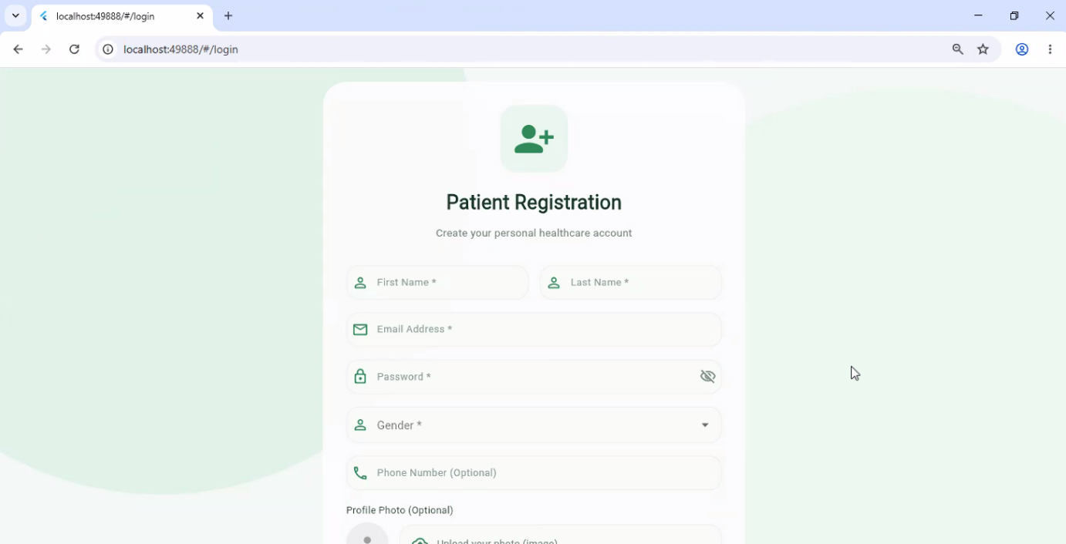

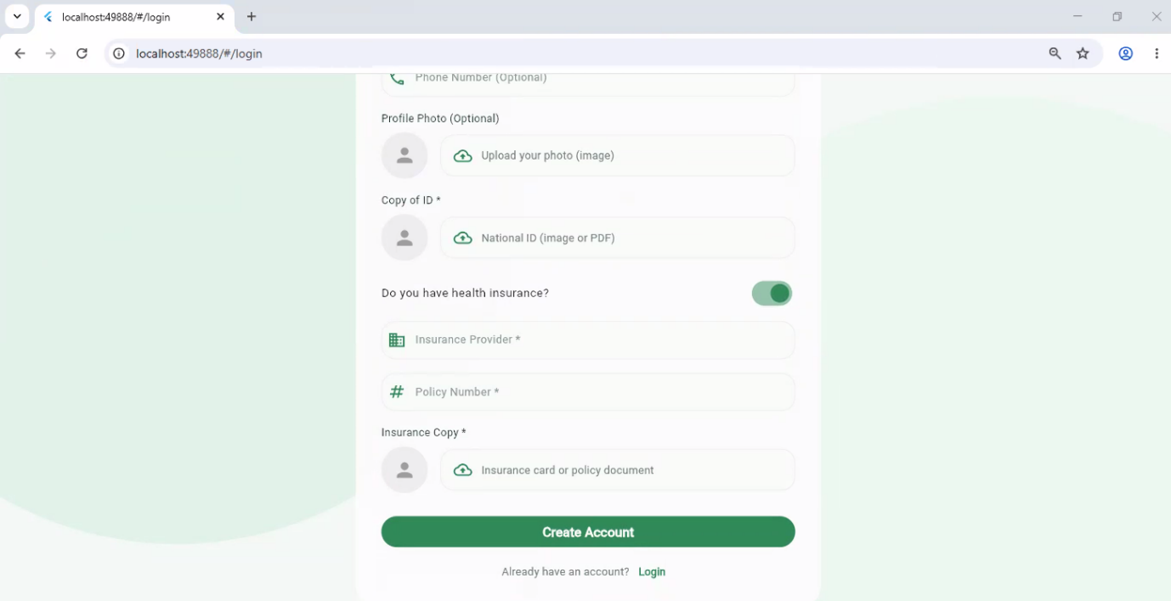
Figure 8: Register as a Patient – Web
The doctor registration form extends the standard fields with professional information such as the medical specialty, qualification, years of experience and license number, and it requires the upload of a verification document. Newly registered doctors remain in a pending state and cannot operate on the platform until an administrator reviews and approves their credentials.
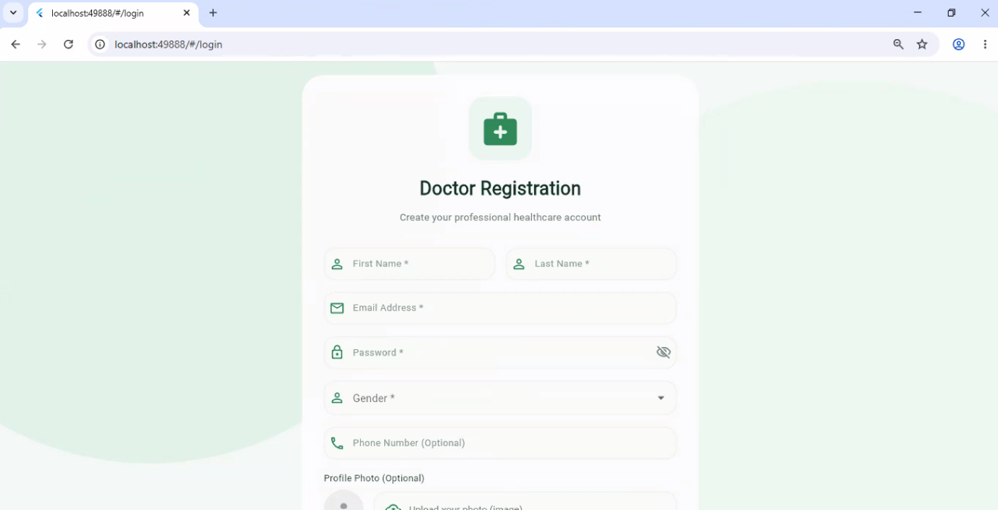

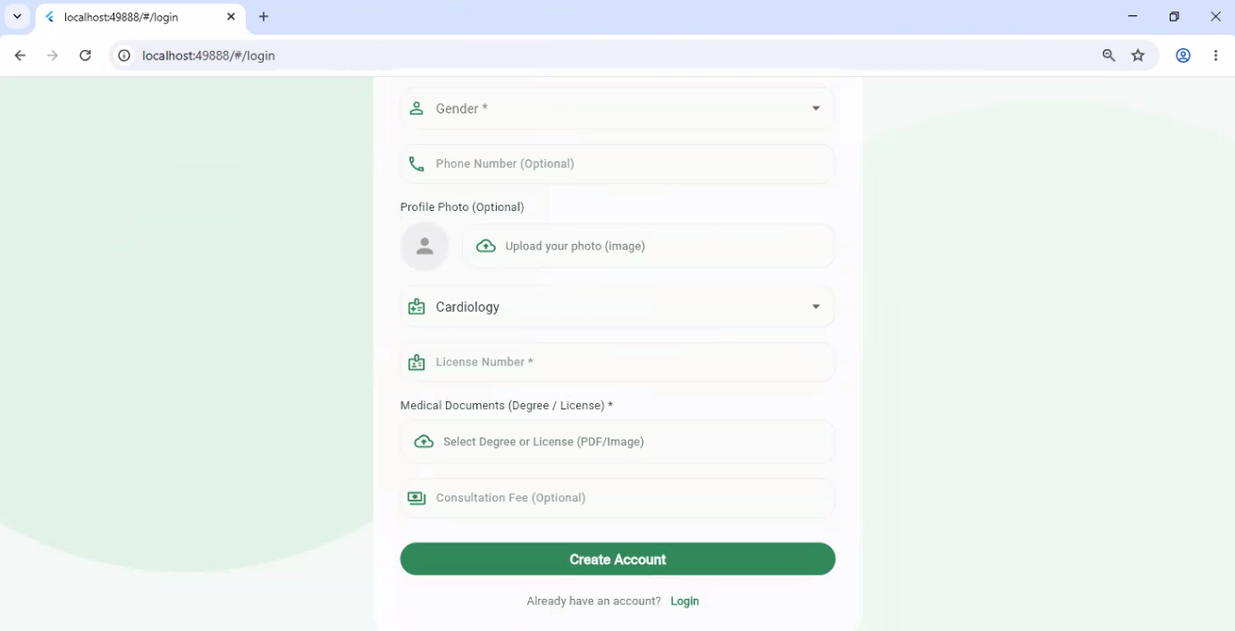
Figure 9: Register as a Doctor – Web

The forgot-password screen allows a user who cannot remember their credentials to request a reset. The reset is delivered through the integrated Firebase Authentication service so the user can securely set a new password.
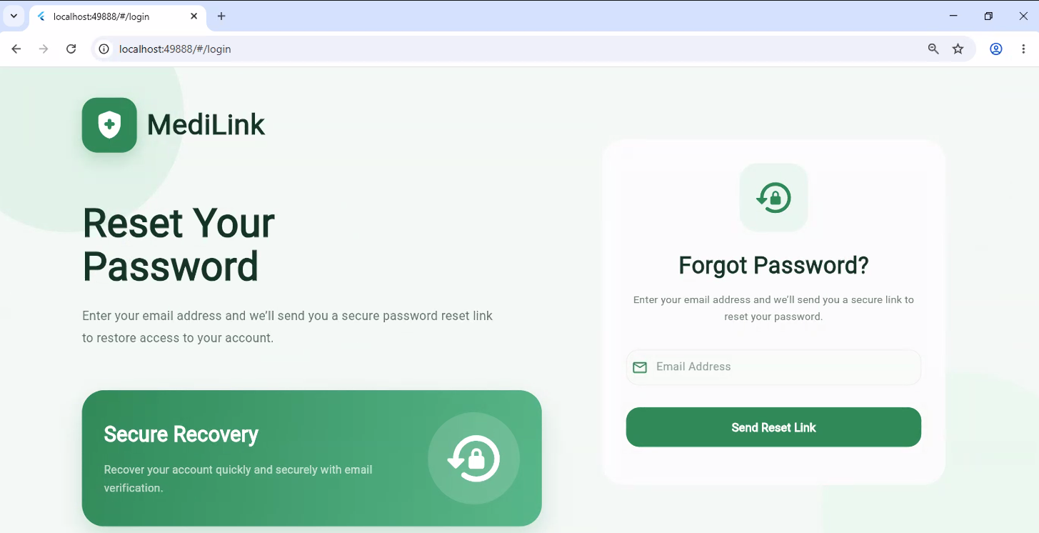
Figure 10: Forgot Password – Web

The doctor dashboard is the landing page for verified doctors. It summarises the most important information – upcoming appointments, unread chat conversations and recent appointment-change alerts – and offers quick navigation to the schedule, patients, prescriptions and fee-management screens.
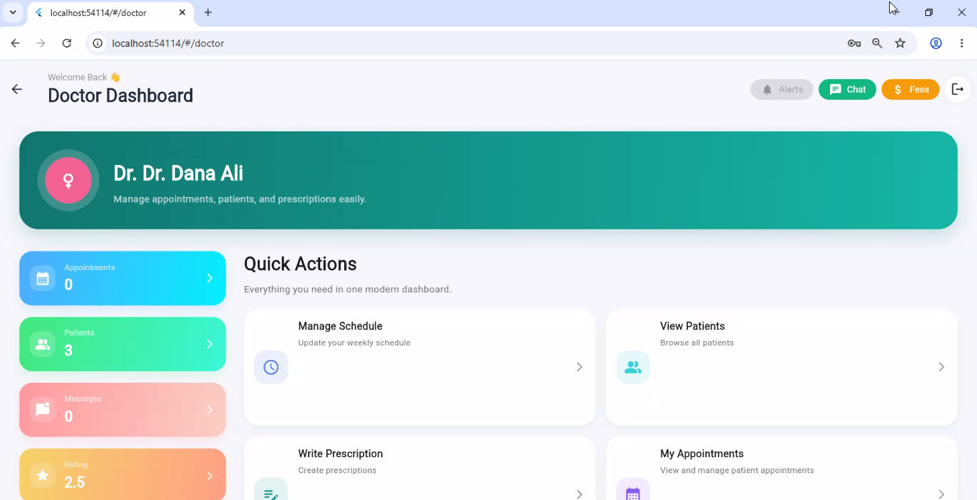
Figure 11: Doctor Dashboard – Web
On the fees screen the doctor configures the consultation fee charged for a visit, the separate fee charged for paid chat consultations and the validity period of a chat payment. These values are stored on the doctor profile and are shown to patients before they book an appointment or start a chat.
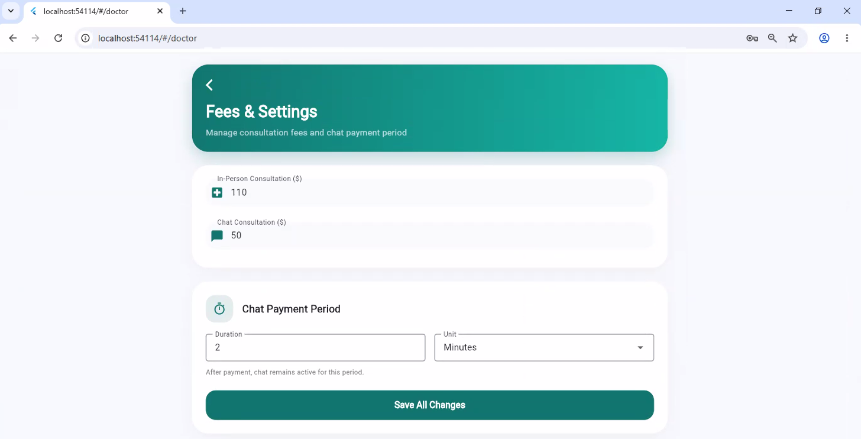

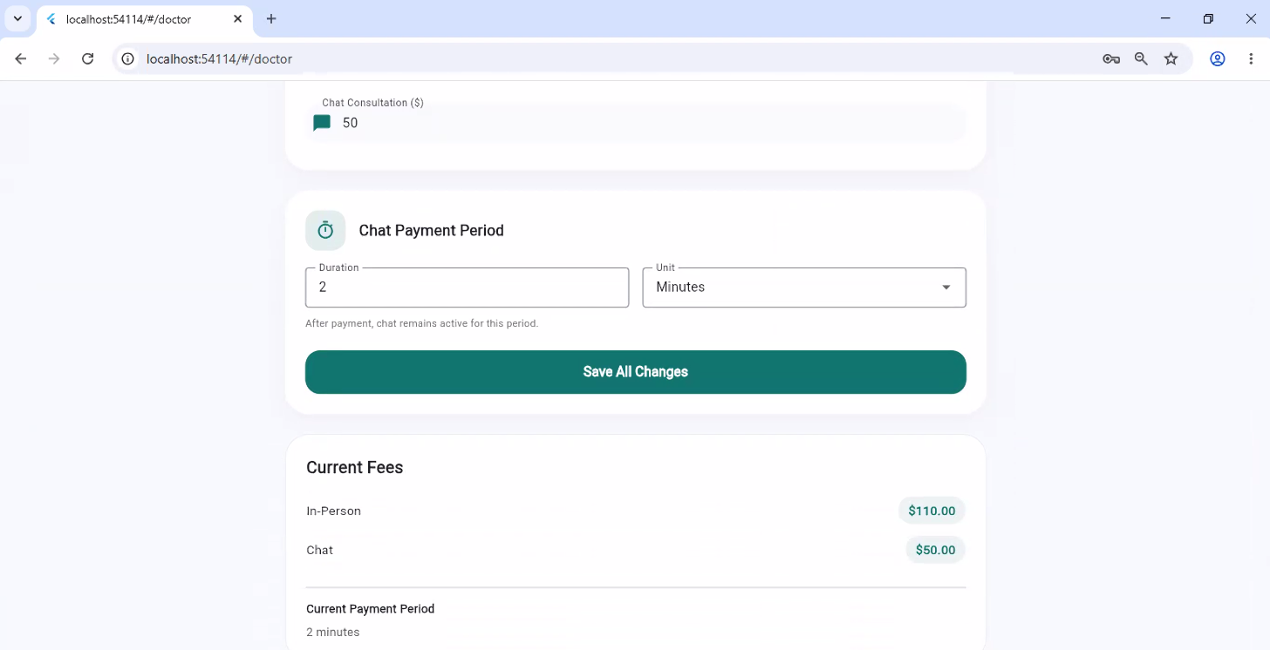
Figure 12: Doctor Fees – Web
The chat screen lets the doctor communicate with patients who have paid for a consultation. Messages are exchanged in real time through Firebase, and the conversation supports text as well as image and document attachments.
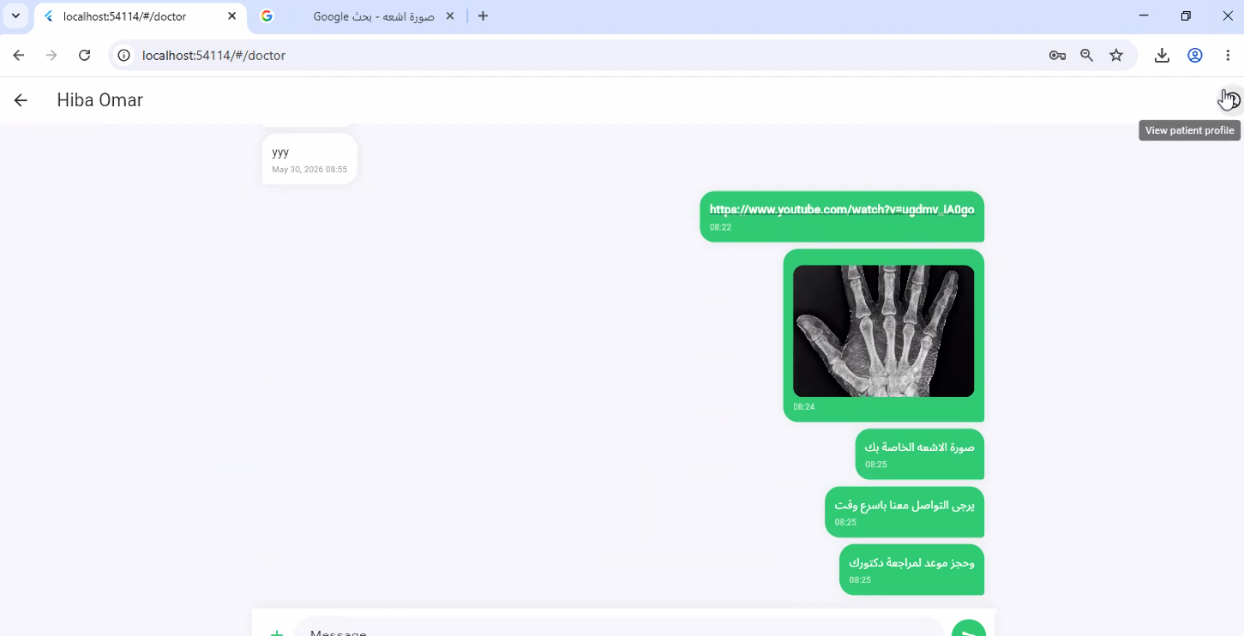
Figure 13: Doctor Chat – Web

The chat-list screen displays all of the doctor’s active conversations, showing each patient’s name, the most recent message and the read or unread status of the thread.
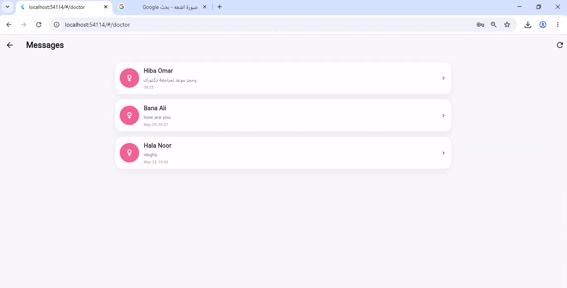
Figure 14: Chat List – Web
Through the schedule screen the doctor defines a weekly availability pattern by selecting the days and the time ranges during which appointments are accepted. These availability slots are later consumed by the booking engine to compute the free slots offered to patients.
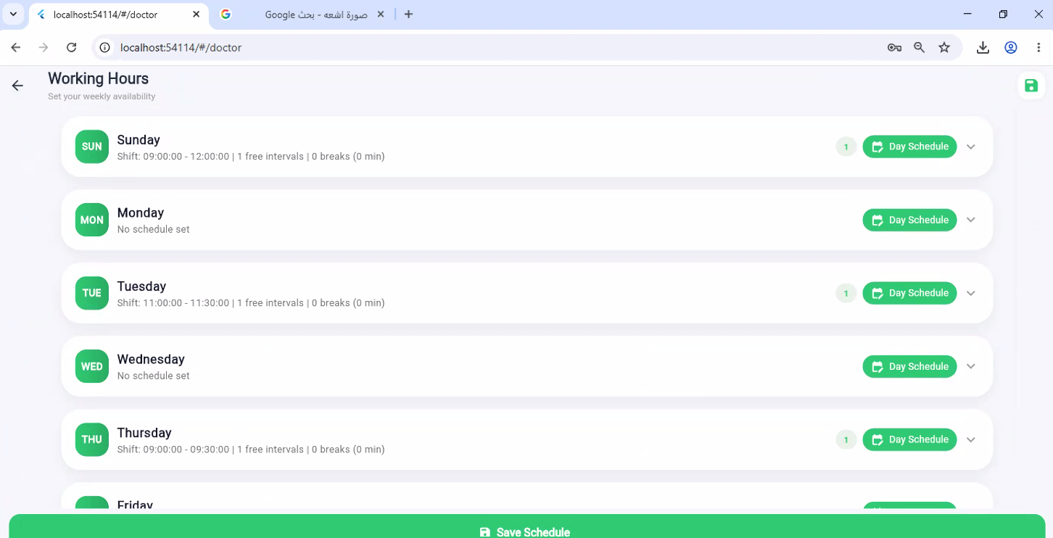
Figure 15: Manage Schedule – Web

The day view presents the availability and the booked appointments for a single selected day, giving the doctor a focused overview of the daily workload.
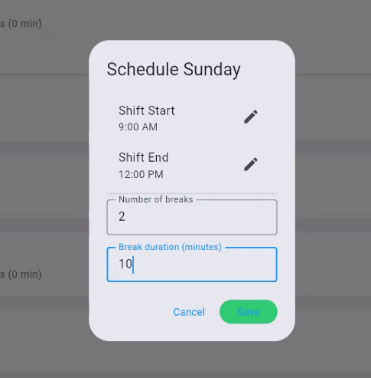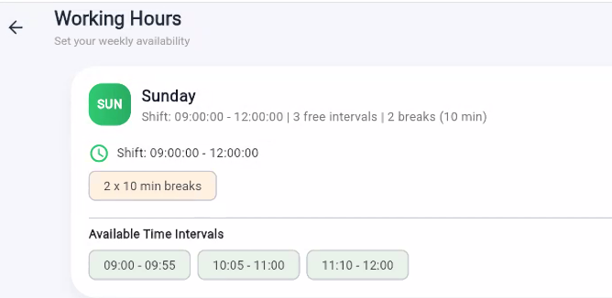
Figure 16: Day Schedule – Web
The patients screen lists every patient who has interacted with the doctor, for example through an appointment. From here the doctor can open an individual patient’s medical file.
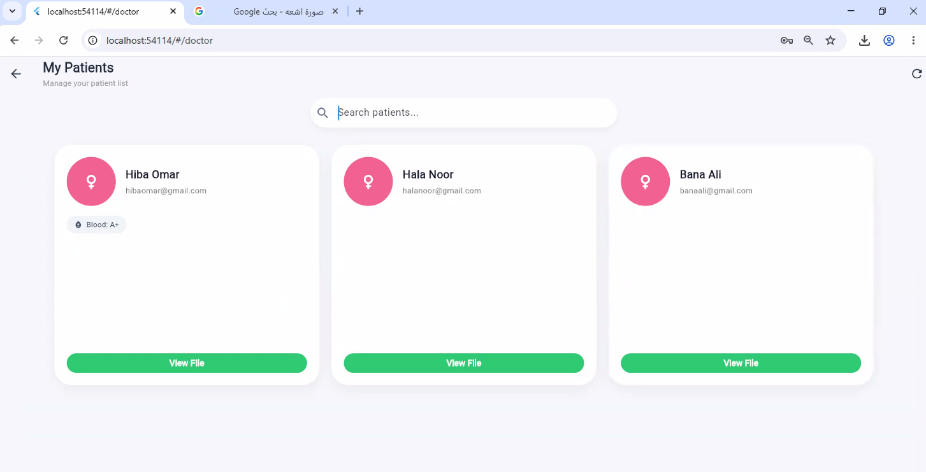
Figure 17: Patients List – Web

The patient-file screen gives the doctor a consolidated view of a single patient’s medical history, including the health profile, previously uploaded reports, past appointments and prescriptions, supporting an informed clinical decision.
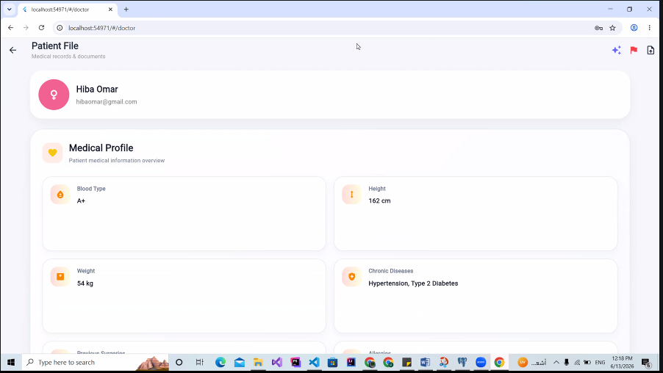
Figure 18: Doctor’s View of a Patient File – Web
This section of the patient file lists the medical reports and documents associated with the patient. Each report can be previewed or downloaded, and the doctor may also upload new reports on the patient’s behalf.
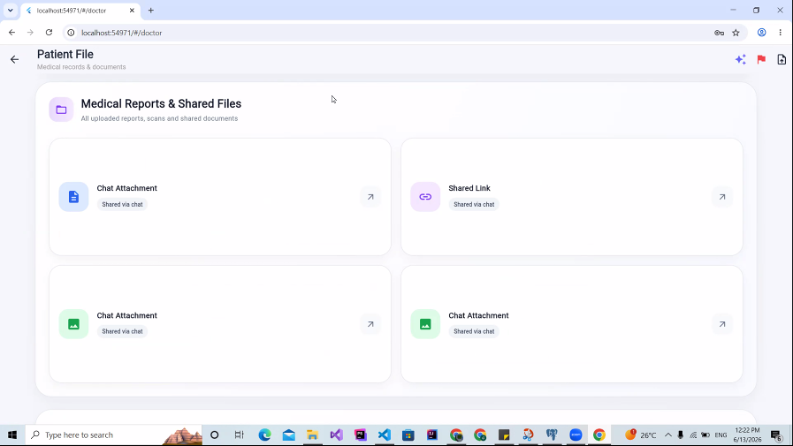
Figure 19: Medical Reports & Documents – Web

The prescriptions view shows the electronic prescriptions issued to the patient. Each prescription records the diagnosis, the list of prescribed medications with their dosage and frequency, and any additional notes.
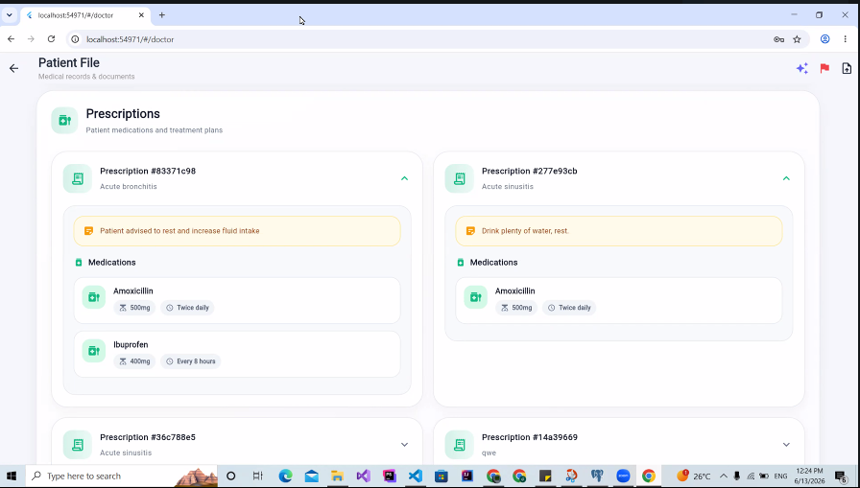
Figure 20: Prescriptions (Doctor View) – Web
This view lists the appointments recorded between the doctor and the selected patient, including the date, time, consultation type and status of each one.
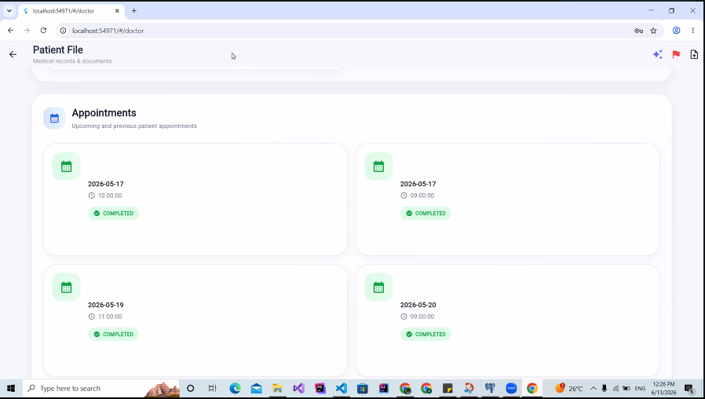
Figure 21: Patient Appointments (Doctor View) – Web

When necessary the doctor can submit a report about a patient – for example for inappropriate behaviour or repeated no-shows – to the administration. The report stores a reason and a comment and is queued for admin review.
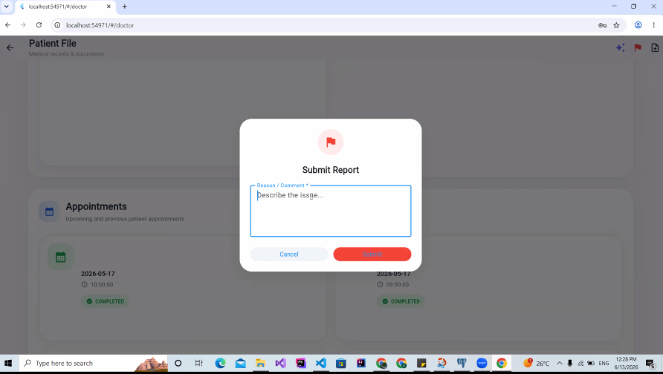
Figure 22: Doctor Reports a Patient – Web
Using the integrated Google Gemini service, the doctor can request an AI-generated clinical summary of the patient. The model analyses the patient’s profile and history and returns a concise snapshot to assist the doctor. The feature is clearly presented as decision support rather than a diagnosis.
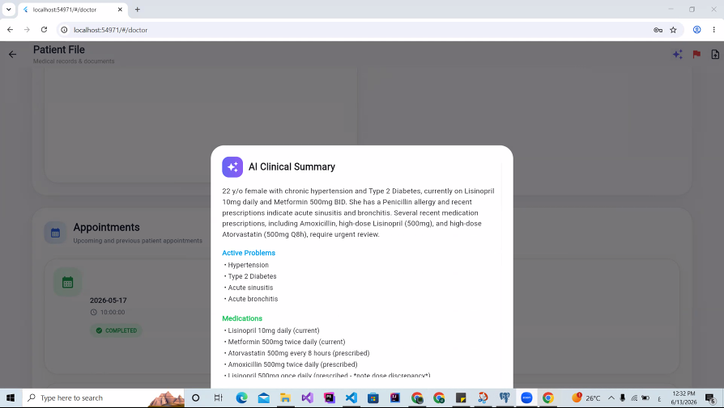

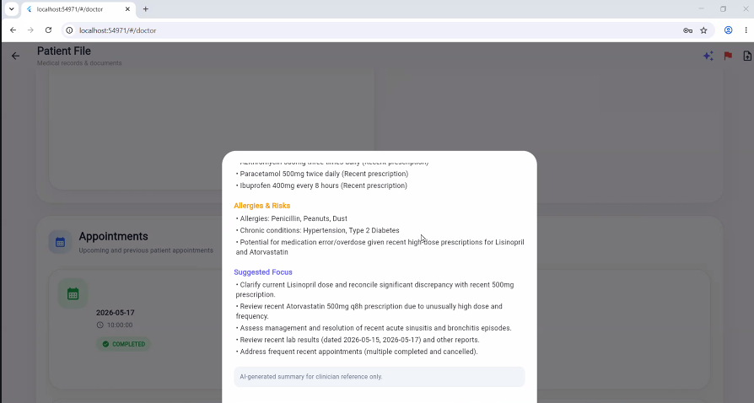
Figure 23: AI Patient Summary – Web
On the write-prescription screen the doctor records a diagnosis and adds one or more medication items (name, dosage, frequency, duration and instructions). Before the prescription is saved, an AI safety check and an allergy check are run against the patient’s recorded allergies. Saving the prescription automatically creates the corresponding patient-medication entries and their reminder schedules.
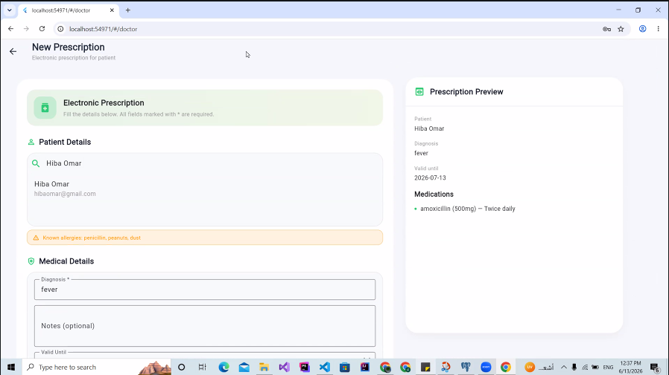

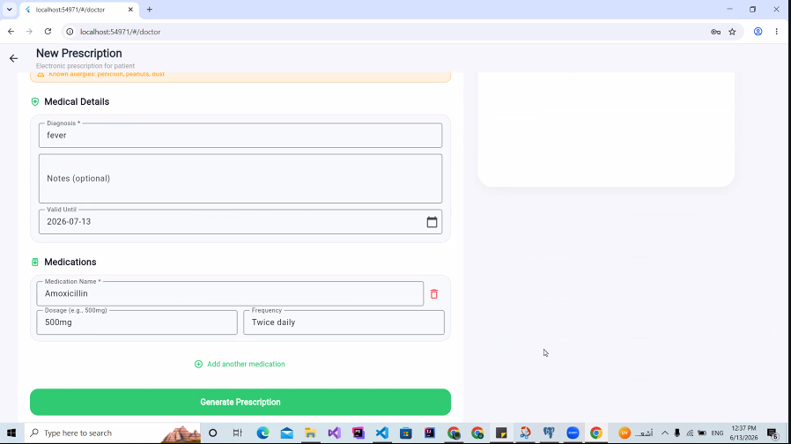
Figure 24: Doctor Writes a Prescription – Web
The appointments screen lets the doctor manage all incoming appointments by confirming, completing, cancelling or rescheduling them. Every status change notifies the patient through a push notification.
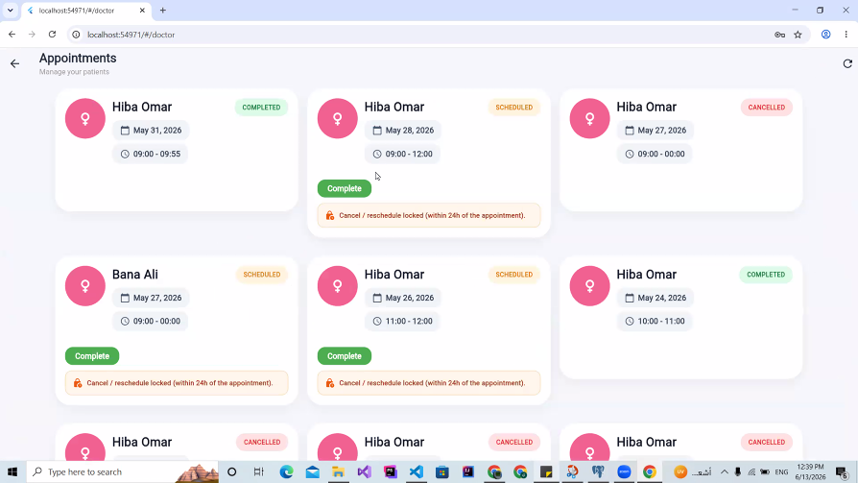
Figure 25: Doctor Appointments Management – Web

From the patient side the chat screen is used to message a doctor after the consultation fee has been paid. The same real-time messaging and attachment capabilities are available, and the screen indicates when the paid chat window is about to expire.
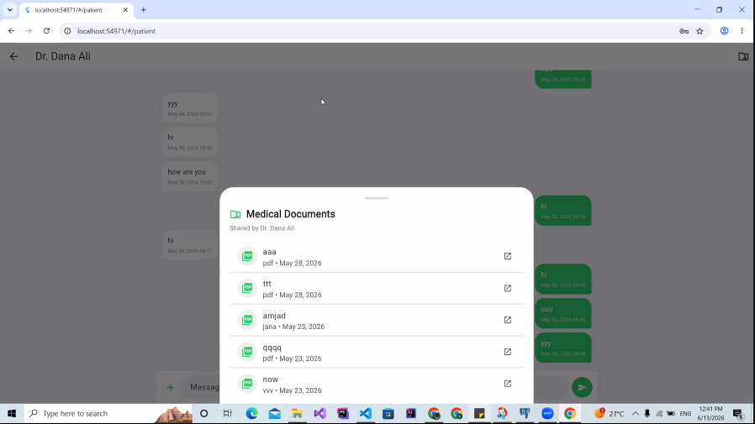
Figure 26: Patient Chat – Web
The medical-file screen allows the patient to view and edit their personal health profile, including blood type, height and weight, chronic diseases, previous surgeries, allergies and current medications.
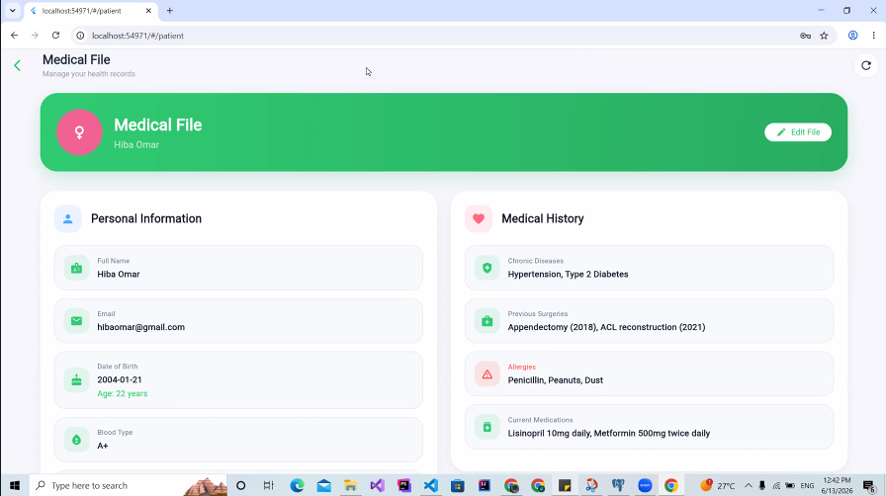

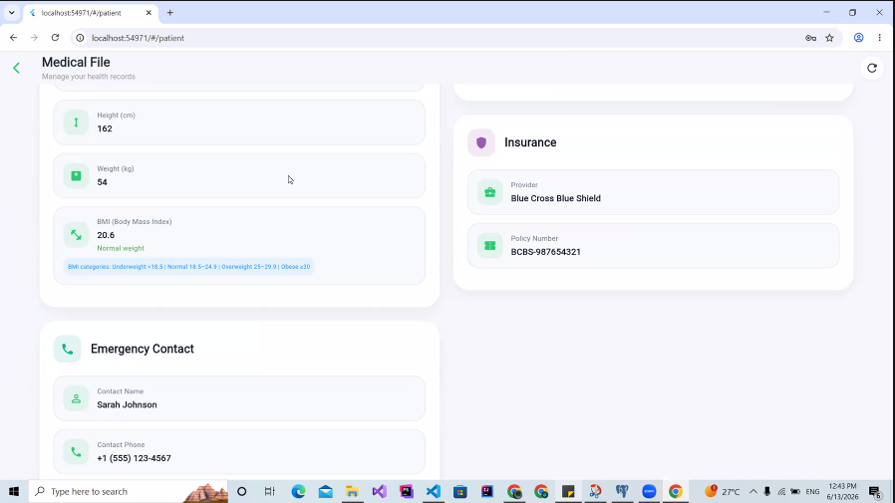
Figure 27: Patient Medical File – Web
This view lists the medical reports the patient has uploaded or received. Each document can be opened, downloaded and, where supported, submitted for AI analysis.
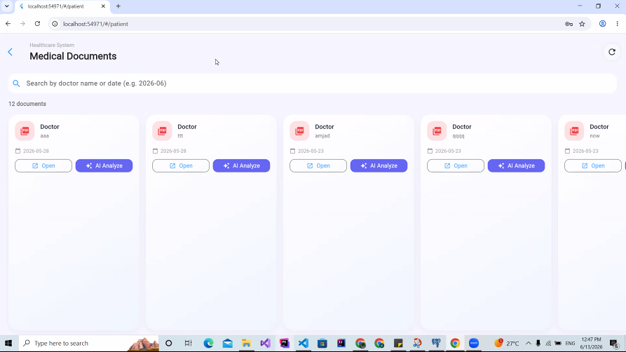
Figure 28: Patient Medical Documents – Web

The patient can submit a report file (PDF or image) for analysis by the Gemini-powered service, which returns a plain-language explanation of the document’s contents together with a disclaimer reminding the user to consult a professional.
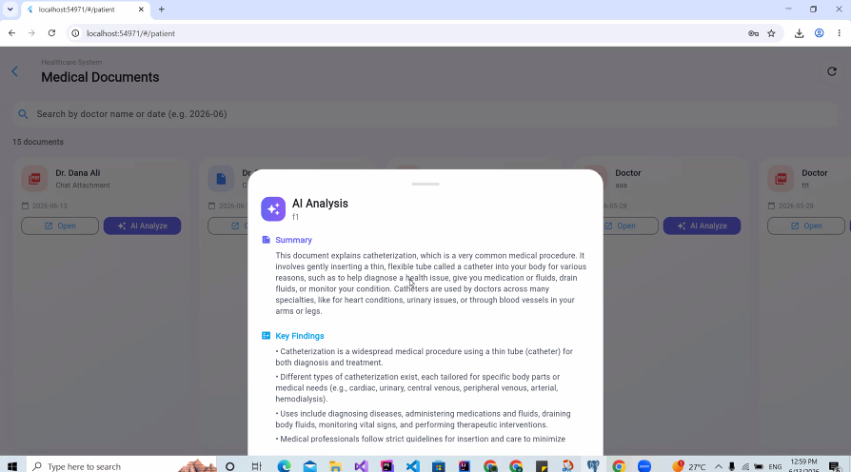
Figure 29: AI Analysis of a Medical Document – Web
The doctor-search screen lets patients discover doctors and sort or filter the results by consultation price, specialty and average rating, helping them choose the most suitable provider.
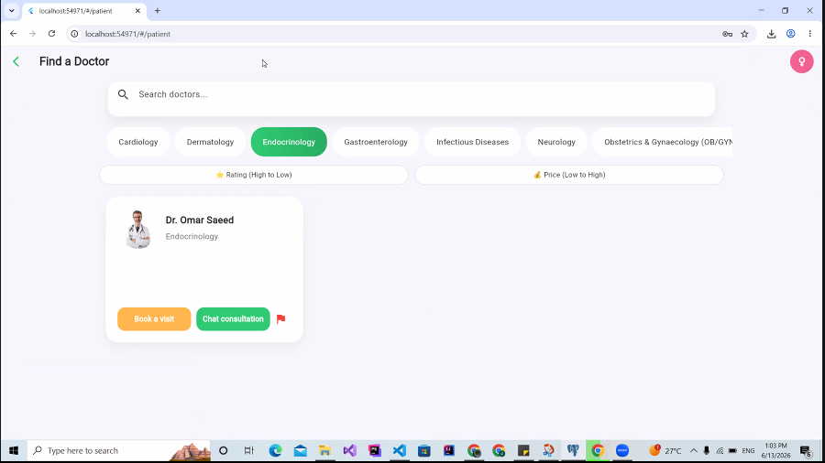

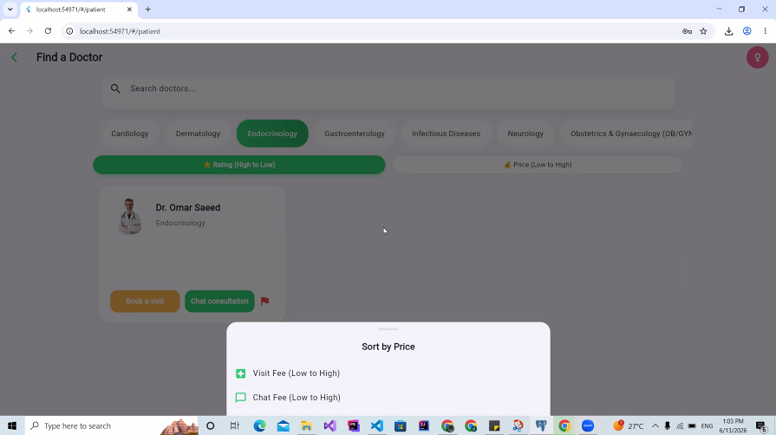
Figure 30: Find a Doctor (Sort by Price, Specialty and Rating) – Web
Patients can submit a report about a doctor to the administration, recording a reason and an optional comment that is then reviewed by a moderator.
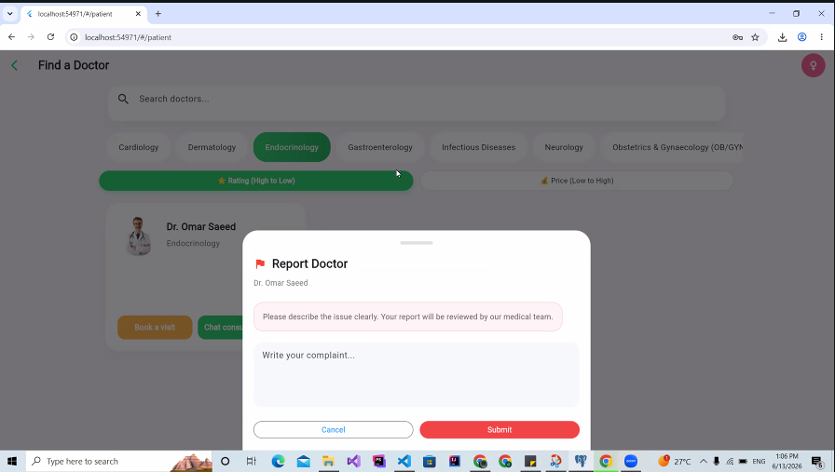
Figure 31: Patient Reports a Doctor – Web

Before a paid action such as a chat consultation, the patient is shown a payment step that confirms the applicable fee. Once the payment is confirmed, the conversation is unlocked for the configured validity period.
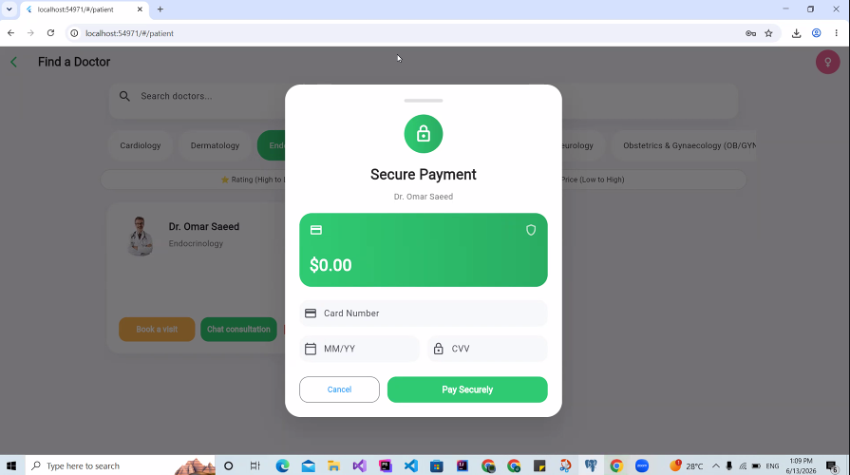
Figure 32: Secure Payment for a Consultation – Web
From a doctor’s profile the patient selects an available date and time slot and submits a booking request. The backend re-validates the slot to prevent double booking before the appointment is created.
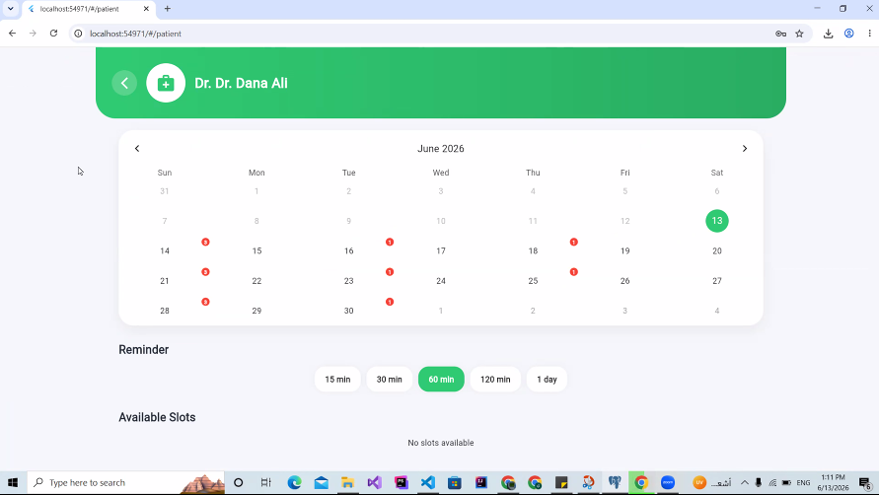
Figure 33: Patient Books a Visit – Web

The appointments screen lists the patient’s upcoming and past appointments and allows them to cancel or reschedule a visit, as well as to rate a completed one.
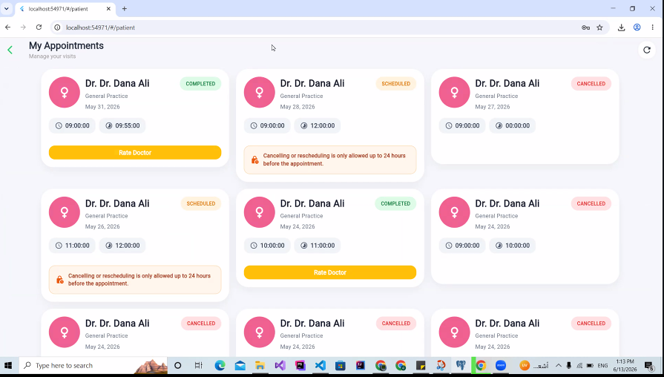
Figure 34: Patient Appointments – Web
After an appointment is completed the patient can rate the doctor on a five-point scale and leave a comment. Submitting a rating updates the doctor’s average rating and review count through a database trigger.
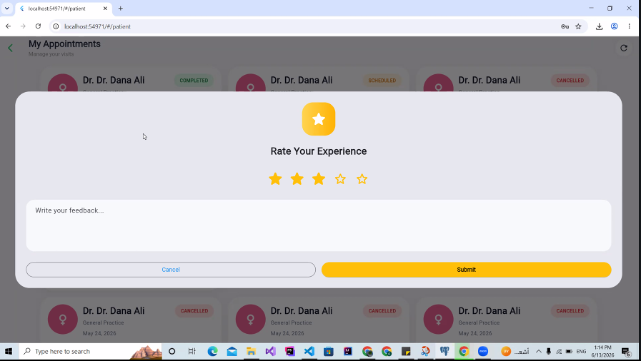
Figure 35: Patient Rates a Completed Appointment – Web

The e-prescription detail screen displays a single prescription in a clear, formatted layout, listing the diagnosis, every medication with its dosage and instructions, and the prescribing doctor.
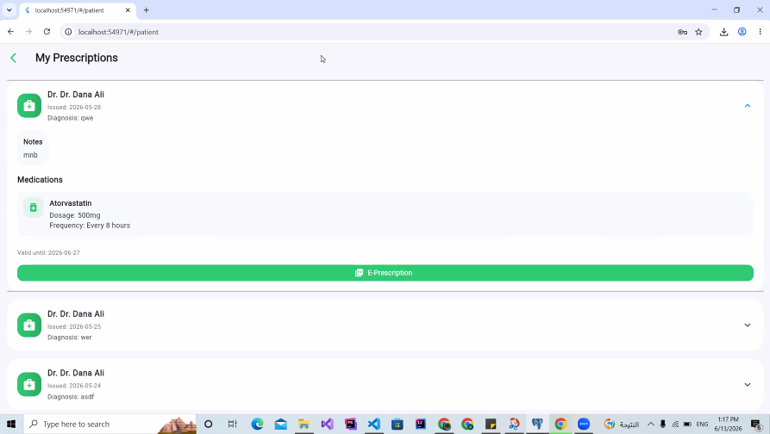
Figure 36: Electronic Prescription – Web
The patient can export any prescription as a professionally formatted PDF, generated on the client with the pdf and printing packages, which can then be saved, printed or shared.
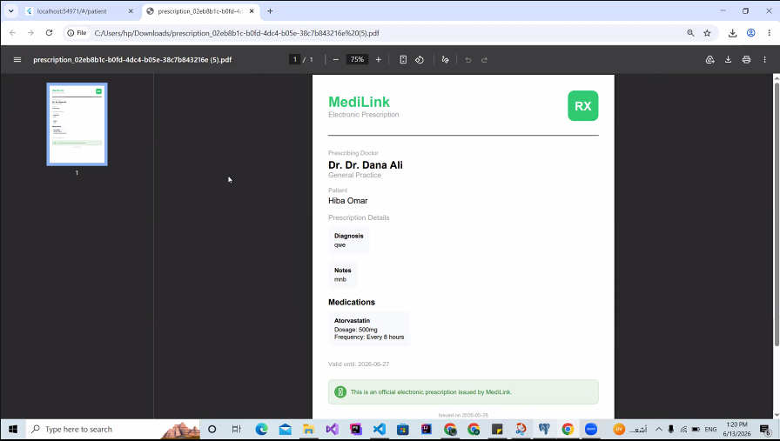
Figure 37: PDF Export of a Prescription – Web

The medication screen tracks the patient’s active medications, their daily dose schedule and the remaining stock. Patients can mark doses as taken and receive automated reminders at each scheduled time.
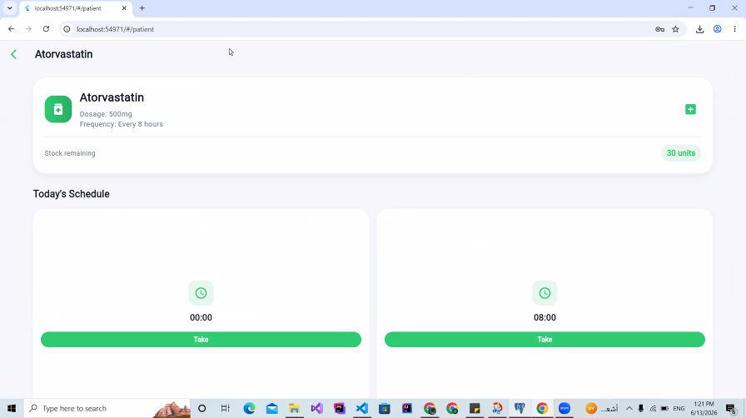
Figure 38: Medication Schedule – Web
The health library presents educational articles published by the administration. Patients can browse and search articles by category and open any article to read its full content.
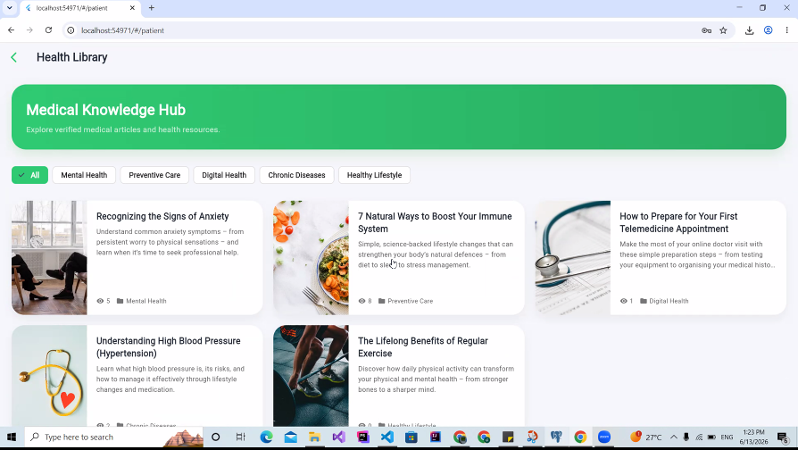
Figure 39: Health Library – Web

The FAQ center answers common questions about using the platform. Entries are grouped by category and can be searched.
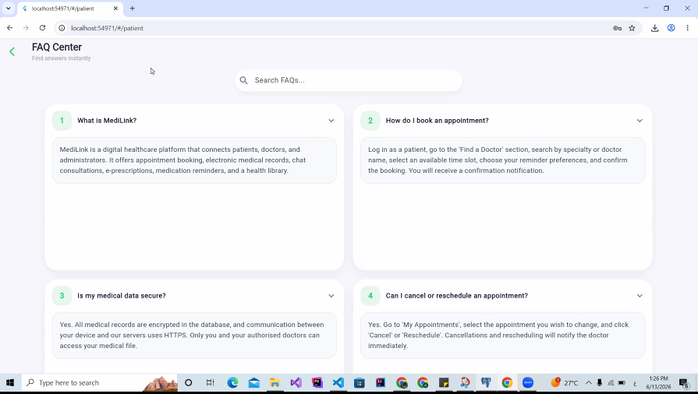
Figure 40: FAQ Center – Web
The symptom checker lets the patient describe their symptoms in natural language. The text is sent to the Gemini-powered service, which suggests a relevant specialty and a severity indication and escalates clearly to emergency advice for critical symptoms. Every result includes a medical disclaimer and is logged for reference.
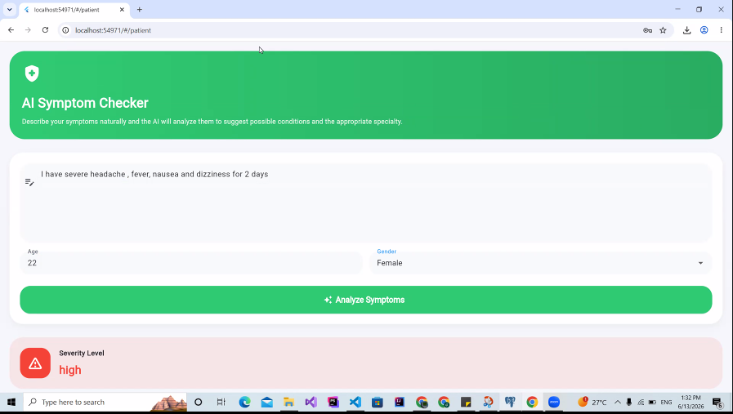

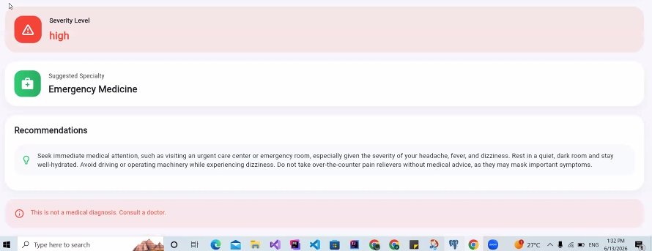
Figure 41: AI Symptom Checker – Web
The notifications inbox aggregates all in-app alerts the user has received – appointment reminders, medication reminders, chat messages and status changes – and lets them mark items as read.
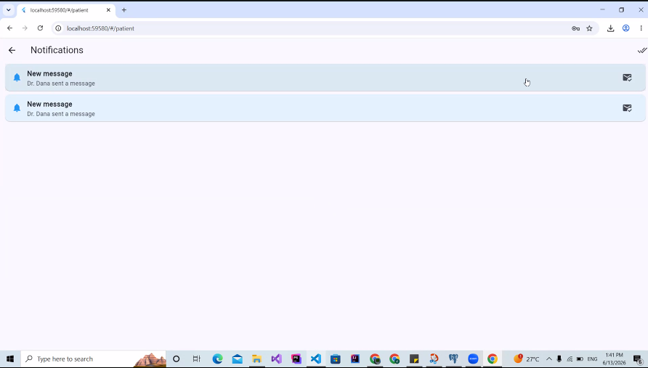
Figure 42: Notifications Inbox – Web

The admin dashboard provides a high-level overview of the platform through key metrics such as the total number of users, doctors, patients, appointments and prescriptions, with quick access to the management screens.
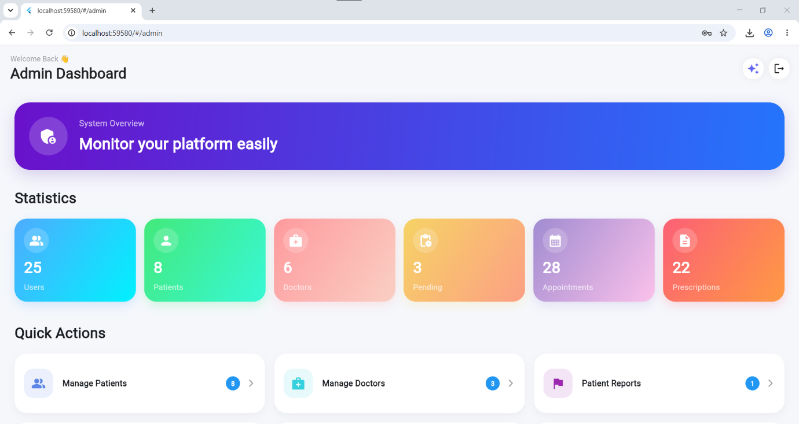
Figure 43: Admin Dashboard – Web
The administrator can request AI-generated insights that interpret the platform’s aggregated statistics and highlight trends, offering a narrative summary that supports decision-making.
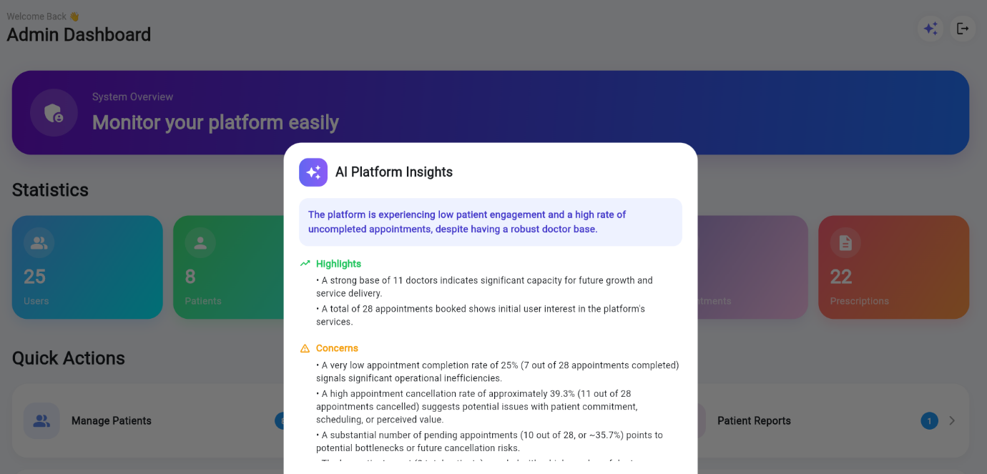
Figure 44: AI Platform Insights – Web

The patient-management screen lets the administrator search the patient base and enable or disable individual accounts.
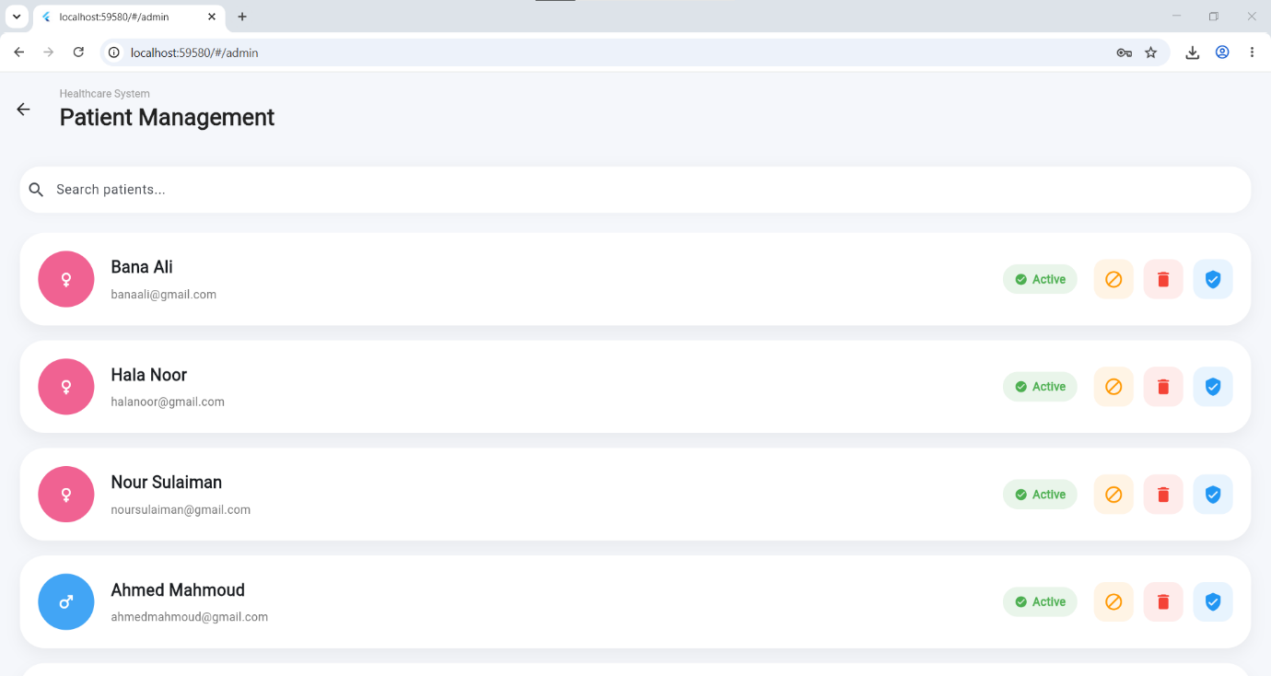
Figure 45: Patient Management – Web

Pending doctor registrations are listed here for review. The administrator inspects the submitted qualifications and verification documents and either approves or rejects each application; only approved doctors become visible to patients.
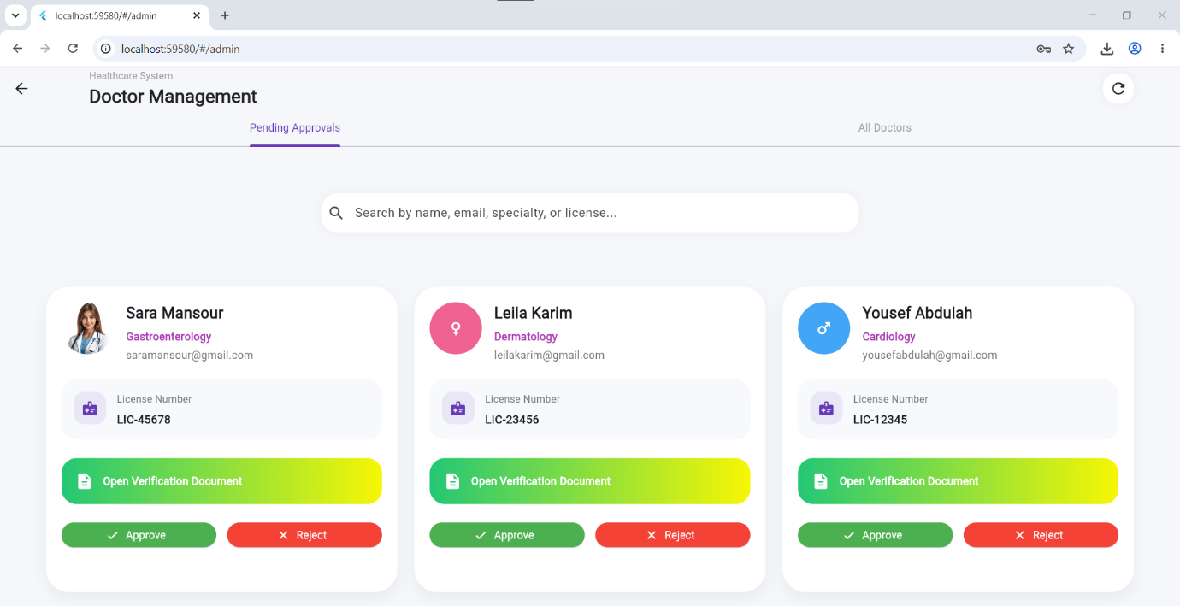
Figure 46: Doctor Management – Pending Approvals – Web

This screen lists every doctor on the platform, allowing the administrator to review, manage or remove accounts.
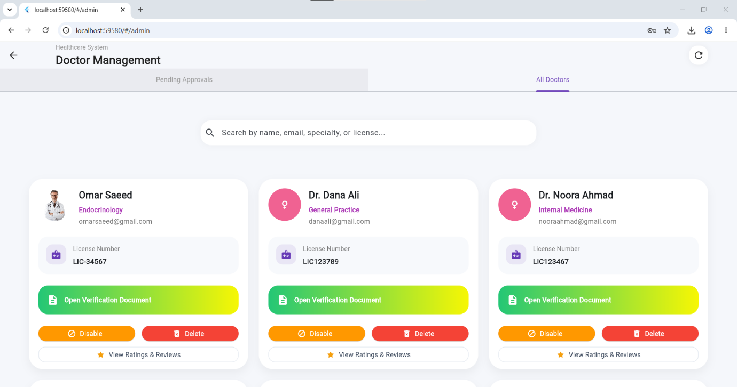
Figure 47: Doctor Management – All Doctors – Web

Reports submitted by doctors about patients are listed here for the administrator to review and act upon, updating the status of each report.
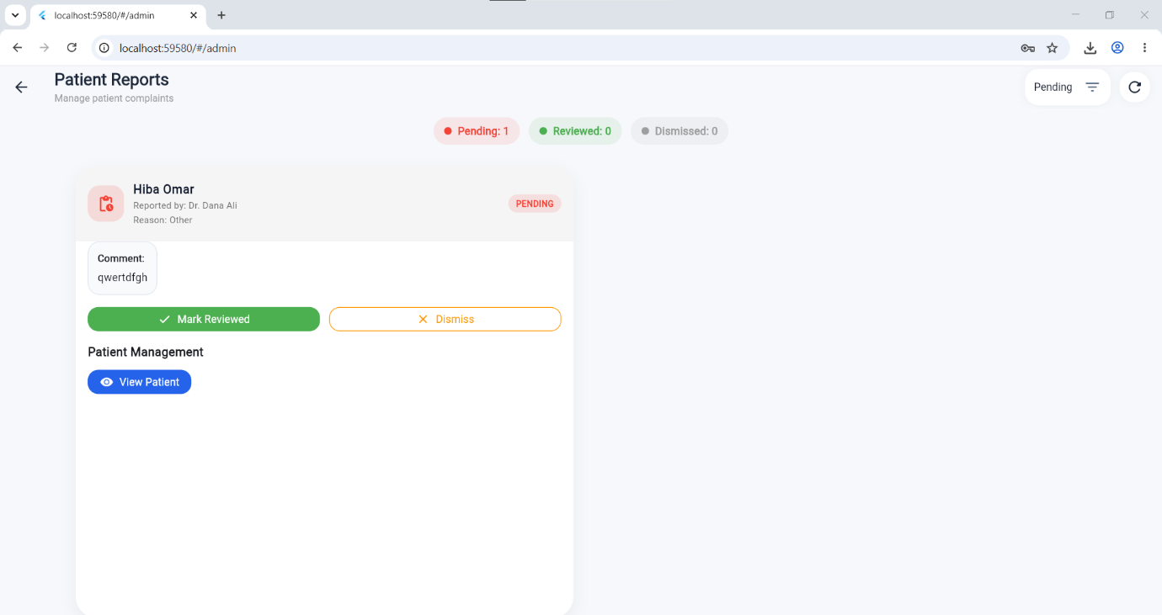
Figure 48: Patient Reports Moderation – Web

Reports submitted by patients about doctors are listed here for moderation; the administrator can review the details and resolve each case.
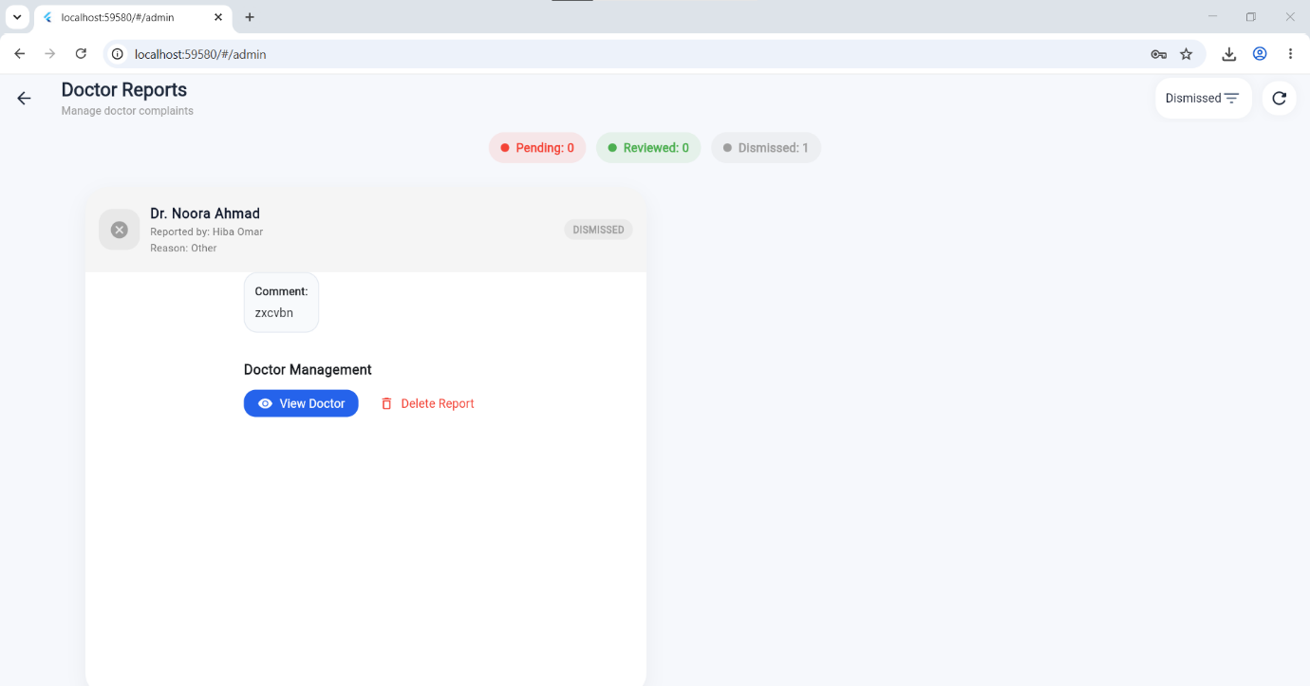
Figure 49: Doctor Reports Moderation – Web

The administrator maintains the catalogue of medical specialties used during doctor registration and patient search, adding, editing, activating or removing entries.
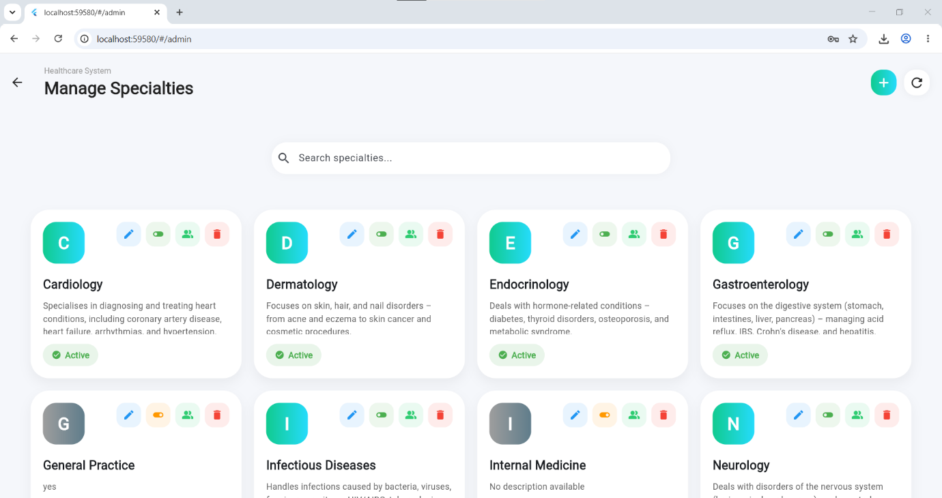
Figure 50: Manage Specialties – Web

From the content-management screen the administrator creates and edits health articles using a rich-text editor, sets the category and publication state, and uploads an accompanying image.
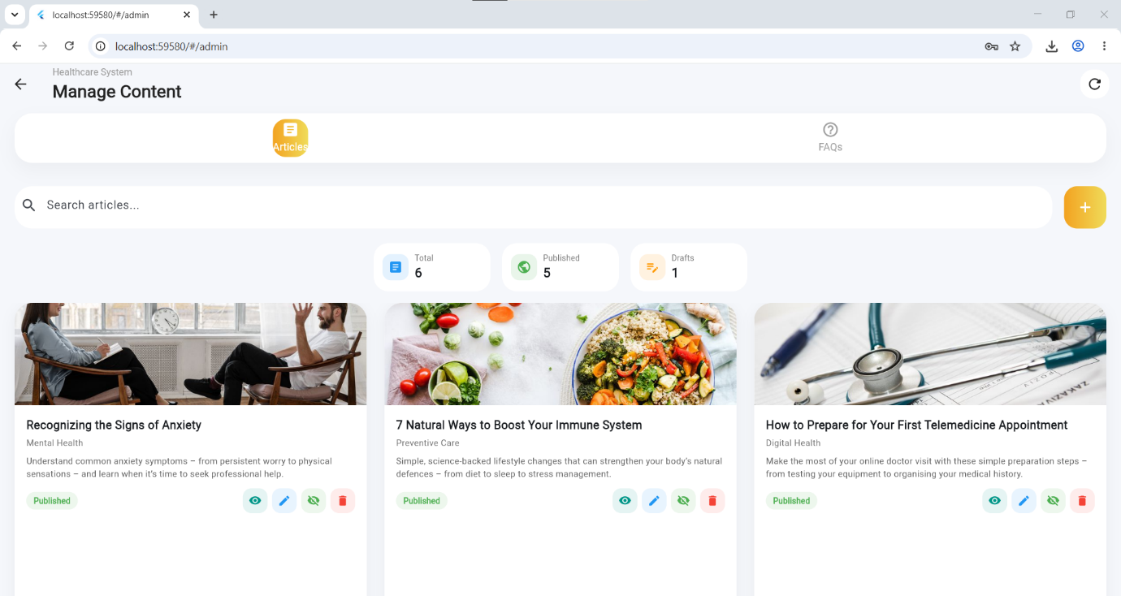
Figure 51: Manage Content – Articles – Web
This view shows a single article as it is composed in the editor, including its formatted body and image.
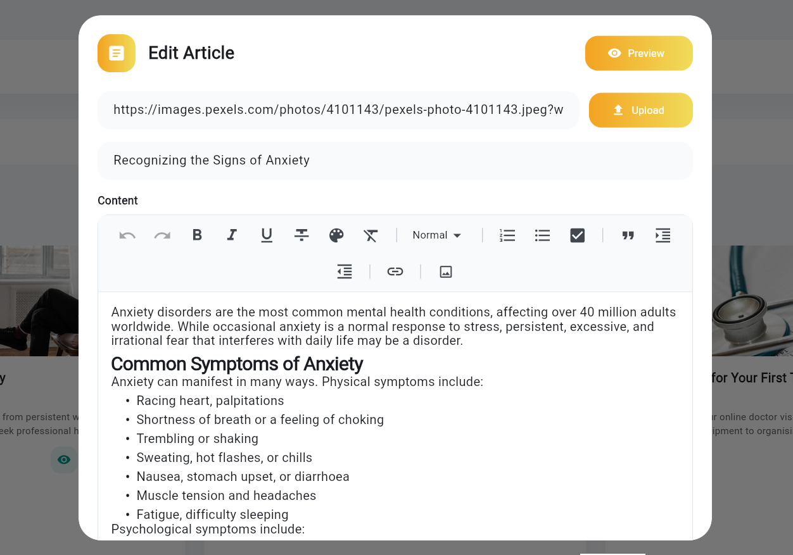
Figure 52: Published Article Preview – Web

The administrator manages the list of FAQ entries, creating questions and answers, grouping them by category and controlling their order and visibility.
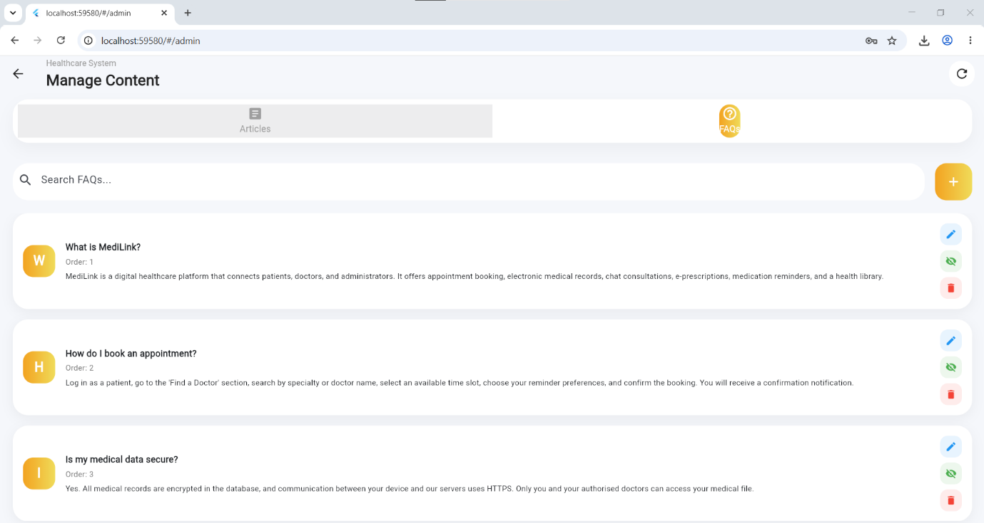
Figure 53: Manage Content – FAQs – Web
This view shows an individual FAQ entry as it will appear to the end user.
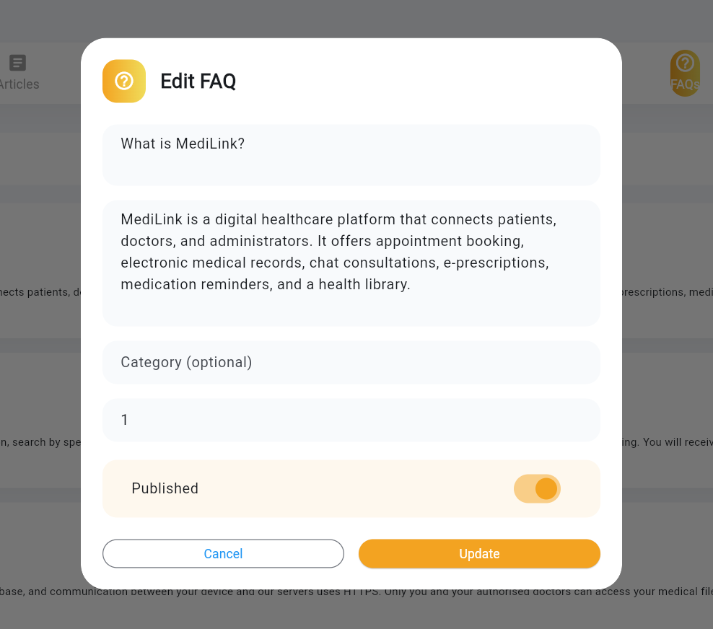
Figure 54: FAQ Entry Preview – Web

The administrator can review the ratings and comments that patients have left for any doctor, providing oversight of the quality of service on the platform.
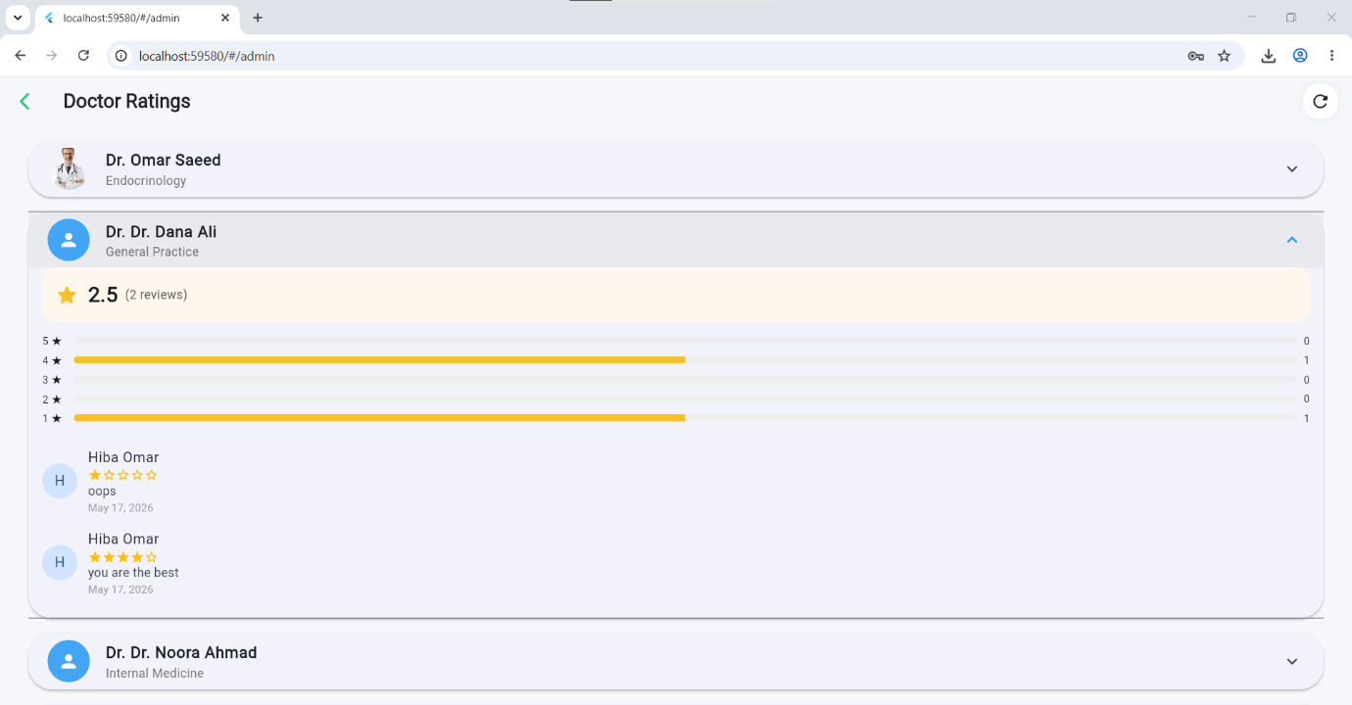
Figure 55: Doctor Ratings Overview – Web
The reports-and-statistics screen presents aggregated analytics about platform activity, supporting monitoring and reporting.
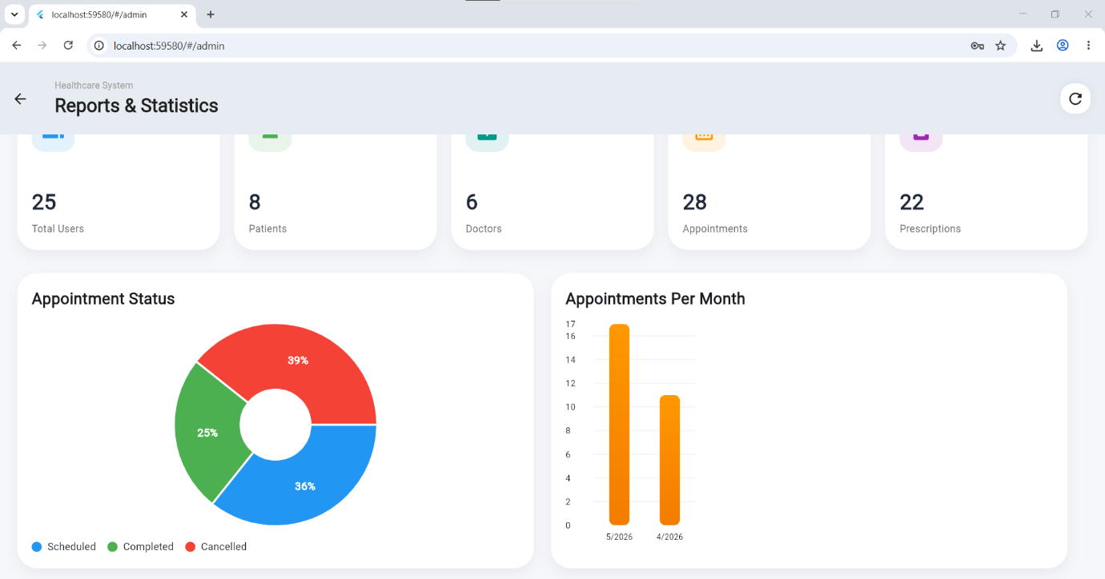
Figure 56: Reports & Statistics – Web

Chapter 4: Results and Analysis
The MediLink platform was successfully implemented as a fully functional web and mobile healthcare application. The patient module enables users to book appointments by searching for doctors and selecting from available time slots, manage their medications with automated reminders and dose tracking, upload and view medical reports in PDF or image format, check symptoms using the AI-powered symptom checker, and communicate with doctors through paid chat consultations. The doctor module provides tools for configuring weekly availability schedules, managing appointments with confirmation and cancellation options, writing electronic prescriptions with medication details and instructions, viewing complete patient medical histories including past appointments and reports, and setting consultation fees for chat services. The administrator module offers centralized control through a dashboard displaying key metrics such as total users, appointments, and prescriptions, user management with activation and deactivation capabilities, doctor approval functionality requiring verification of qualifications and licenses before granting access, specialty management for adding and editing medical specialties, and content management for health articles and FAQs. The AI symptom checker was tested with various symptom descriptions, successfully identifying common conditions while correctly recognizing emergency symptoms like chest pain and difficulty breathing and advising users to call emergency services immediately, supporting both English and Arabic languages. The push notification system successfully delivered appointment reminders before scheduled appointments as well as medication reminders at specified times across Android, iOS, and Web platforms. Overall, all functional requirements were achieved, the system operates reliably across three user roles, and MediLink is ready for demonstration as a graduation project.

Chapter 5: Discussion
The development of MediLink demonstrated that integrating Flutter, Node.js, and AI capabilities into a single healthcare platform is feasible and effective. Flutter successfully enabled cross-platform development for Android, iOS, and Web from one codebase. Riverpod managed state reliably, while GoRouter handled role-based navigation correctly. PostgreSQL with JSONB was valuable for tracking reminder history. The main challenge was ensuring reliable push notification delivery across all platforms, which was resolved with proper FCM token handling. Overall, the system meets all defined requirements and demonstrates the potential of AI-assisted healthcare platforms.

Chapter 6: Conclusion & Future Work

6.1 Conclusion
The MediLink project successfully delivered an integrated healthcare platform connecting patients, doctors, and administrators through a mobile and web application. All functional requirements were achieved including appointment booking, medication reminders, medical report uploads, AI symptom checking, and push notifications. The system performs reliably across Android, iOS, and Web platforms, making healthcare more accessible and efficient.

6.2 Future Improvements
Several enhancements could be added to MediLink in future versions:
- Offline Mode: Allow users to access cached data and queue actions without internet.
- Wearable Integration: Sync health data automatically from smartwatches and fitness trackers.
- Multilingual Support: Add more languages beyond Arabic and English.
- Payment Gateway: Integrate PayPal or Stripe for real financial transactions.
- Emergency Contact: Notify a designated family member automatically in critical situations.
- Voice Input: Enable voice input for the symptom checker feature.
- Cloud Deployment: Deploy with auto-scaling to handle larger numbers of users.

