AnNajahNational University



Faculty of Engineering & Information Technology Computer Engineering Department
Graduation Project 2 Report

Robotic arm

Students:

Misk Sawallha, Ansam Darweesh

Supervisor: Dr. Aladdin Masri

Submitted with the aim of completing the graduation Requirements of Computer Engineering Bachelor's degree
May.2022

Acknowledgment
We begin by offering our utmost gratitude and appreciation to God, the Almighty, for bestowing His blessings upon us during the journey of our graduation project, leading us to its successful completion. Our hearts are filled with deep gratitude as we extend our sincere thanks to our project supervisor, Dr. Aladdin Masri, whose invaluable guidance played a pivotal role in our project's development. It has been an honor and privilege to study and work under his esteemed mentorship.
We are indebted to our families for their unwavering love, prayers, and unwavering support throughout this endeavor. Their encouragement has been a constant source of strength and motivation. Additionally, we would like to express our heartfelt thanks to the entire teaching staff of the Computer Engineering Department, whose knowledge and expertise have shaped our academic journey.
Lastly, but certainly not least, we extend our sincere thanks to our friends and colleagues for their assistance and unwavering support throughout the project. Their contributions have been invaluable, and we are grateful for their presence on this remarkable journey.

Disclaimer

This report was written by Misk Sawallha and Ansam Darweesh in the Department of Computer Engineering at the Faculty of Engineering at An-Najah National University. It has not undergone any modifications or corrections by an auditing professional. Therefore, there may be errors in both the language and content of the report. All information and opinions presented in this report are solely those of the students. An-Najah National University assumes no responsibility for the outcomes or consequences resulting from the use of this report for any purpose other than its intended use.

Table of Content
Acknowledgment 2
Disclaimer 3
List of Figures 5
Abstract 6
Chapter 1: Introduction 7
  - :statement of problem 7
  - :Project objectives 7
  - :Scope of the work 7
  - : Importance of project: 8
  - :Organization 8
Chapter 2: Constraints, Standards 9
  - : Constraints 9
  - : Standards 9

Chapter 3: Methodology 10
Chapter 4: Results and Discussion 23
Chapter 5: Conclusion, Recommendations & Future work 24
5.1 : Conclusion & Recommendation 24
5.2: Future Work 25
References 26

LIST OF FIGURES

Figure 1:arduino Nano 10
Figure 2:NRF24L01+transciver 10
Figure 3: NRF24L01+ adapter 11
Figure 4:4.5 inch flex sensors 12
Figure 5:10K Resistors 12
Figure 6:6V Battery 13
Figure 7:Connector and wires 13
Figure 8: mini breadboard 14
Figure 9:Glove 14
Figure 10:Triple axis accelerometer & gyro breakout 14
Figure 11: Robotic arm 15
Figure12: MG996r Servo 16

Figure 13: 6-volts batteries 17
Figure 14:Glove Design 18
Figure 15: Interfacing flex with Arduino 20
Figure 16: interfacing Accelerometer with Arduino 20
Figure 17:Robotic Arm 22
Figure 18: interfacing servo to Arduino 22
Figure 19: interfacing NRF24L01+ with Arduino 23

Abstract

Since the creation of humans, people have been seeking ways to make their tasks easier and faster. From the invention of the wheel to the Webb Space Telescope, technological advancements have played a significant role in this pursuit. The rise of the robot industry has been particularly influential in this regard.

Robots have become a major industry and are used in various aspects of life. However, most robots are programmed to perform a specific task and are unable to respond to real-time human inputs. To solve this problem, our project proposes a robotic arm controlled by a person through a glove equipped with sensors. The robotic arm, powered by motors, mimics the movements of a human arm. All of this is managed by a software system that communicates with the sensors on the glove.

This project would replace the need for a human to perform dangerous tasks, such as chemical experiments, laser science, or x-ray centers, providing protection from hazardous environments.

Chapter 1: Introduction

Statement of the problem
Human interactions are essential in any workplace, but workplace safety is non-negotiable. Adhering to general safety guidelines can aid in creating a safer work environment, but accidents may still occur due to sudden circumstances or actions caused by humans or the work environment, particularly in hazardous workplaces where extreme caution and precision are necessary for each step. Furthermore, there are instances where human interaction is necessary in tasks that involve dangerous materials, toxic chemicals, and exposure to radiation such as lasers or thermal heating. It is a fact that relying solely on programmed robotic actions will not replace the human factor. However, prioritizing human safety above everything else prompts the need to develop a tool that can replicate human actions accurately with minimal errors, resulting in a higher level of workplace safety.

Project objectives:
The Glove-Controlled Robotic Arm is a device that allows the user to have complete control over a robotic arm. The device features an Arduino Nano-based glove that tracks the user's hand movements and wirelessly transmits them to another Arduino Nano-based device connected to the robotic arm. The robotic arm is equipped with the necessary motors to replicate the user's hand movements, enabling it to perform tasks in hazardous work environments without endangering the user.

1.3 Scope of the work:
As previously stated, this project involves a robotic arm that replicates human hand movements using a glove worn by the user. This device allows the user to remotely control the robotic arm, eliminating the need to be physically present in hazardous environments. The project has been tested and proven to perform a wide range of hand movements, particularly in laboratory settings for scientific experiments.

1.4 Importance of project:
The Glove-Controlled Robotic Arm is a versatile device that can operate in a variety of dynamic environments based on the glove worn by the user. This technology allows for remote control of the robotic arm in hazardous environments where human presence may be dangerous.

1.5 Organization:

This report has organized as follows:

- Chapter one: Overview about objectives and importance of this project.
- Chapter two: the description for constraints, standards

- Chapter three: Followed methodology for the implementation of the project.

- Chapter four: Result and Discussion.

- Chapter five: summarizations, project report and future work recommendations

Chapter 2: Constraints, Standards and Earlier Work

Constraints

At the start of this semester, we collaborated with our supervisor to develop our idea, which focused on creating a glove-based system, with particular emphasis on the fingers. We initially utilized flex sensors for this purpose; however, due to their high cost, we sought an alternative method using paper, lead, and copper. After successfully creating a sensor and measuring its resistance, we integrated it into our circuit, transmitting the value wirelessly to a receiver circuit, which in turn controlled the servo motor. Despite the successful integration, the motor's efficiency did not meet our expectations. As a result, we purchased two flex sensors, which proved to be more effective, albeit at a higher cost in terms of both time and money.

Standards

We have chosen to utilize the Arduino Nano 2560 microcontroller for our project due to its various advantages. Firstly, it offers a simple and accessible user experience, making it suitable for both beginners and advanced users. The Arduino software is easy to use and provides flexibility for more experienced individuals. Additionally, the Arduino Nano is an affordable option, making it cost-effective for our purposes. Furthermore, it is a cross-platform tool, allowing compatibility across different operating systems.

The programming environment provided by Arduino is straightforward and user-friendly, enabling clear code development. Moreover, both the software and hardware components of Arduino are open source and extensible, providing opportunities for customization and expansion.

We specifically opted for the Arduino Nano because it meets our project requirements. It offers a sufficient number of pins, including 14 digital input/output pins, six of which can be utilized as PWM outputs, and eight analog inputs.

Throughout the project, we adhered to established software and electrical engineering standards. Our code was written in Arduino C language, following proper conventions to ensure maintainability and reusability. We designed each functionality separately to facilitate both reusability and integration, aiming to accomplish our project goals efficiently.

Chapter 3: Methodology

3.1 Tools and equipment
Tools were used in “Glove-Controlled Robotic arm” are as follows:

Glove part:

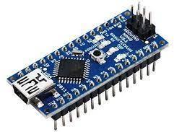
    - Arduino Nano
Figure 1: Arduino Nano

    - nRF24L01+ ľíansceiveí

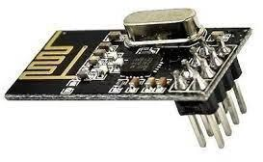
Figure 2: nRF24L01+ ľíansceiveí

    - nRF24L01+ adapter.
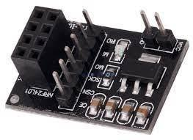
Figure 3: nRF24L01+ adapter

    - 4.5 inch flex sensors

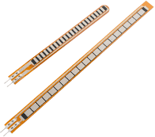

Figure 4: 4.5 Flex Sensoís

5)5x 10k Resistoís
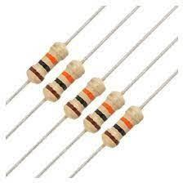
Figure 5: 5x 10k Resistoís..

6)9V Batteíy.


Figure 6: 9V Batteíy

7)9V Batteíy Connectoí. And wires
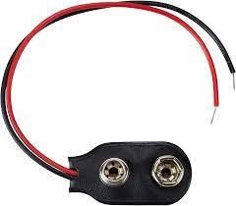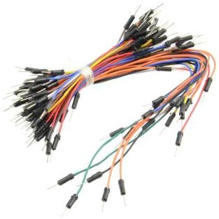

Figure 7: Connectors and wires

8)Mini Bíeadboaíd

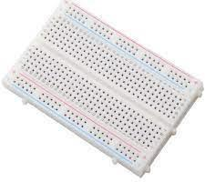

Figure 8: Mini Bíeadboaíd

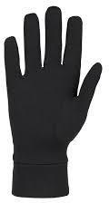
9)Glove
Figure 9: Glove
10)Triple Axis Accelerometer & Gyro Breakout - MPU-6050A

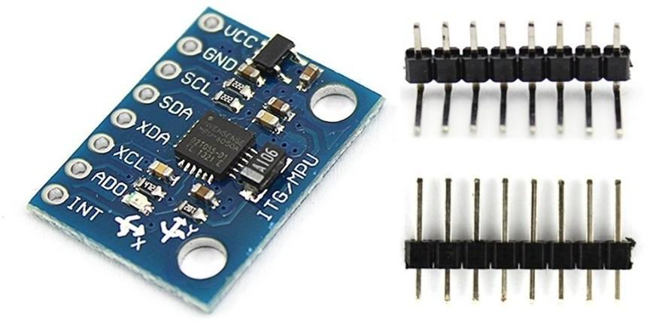

Figure 10: Triple Axis Accelerometer & Gyro Breakout - MPU-6050A

Robotic arm part:

11)Robotic Arm

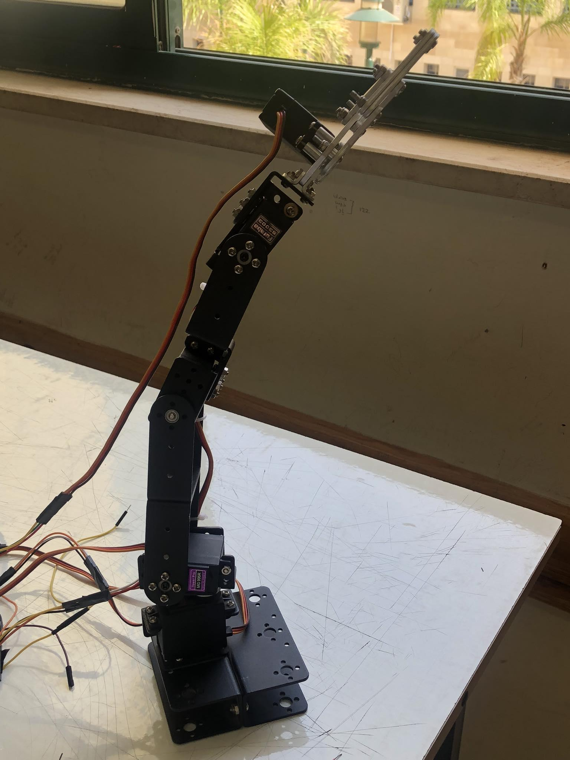
Figure 11: Robotic arm
12)6x MG996R Seívo.

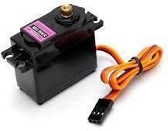

Figure 12: MG996R Seívo.

13)6-volts batteries
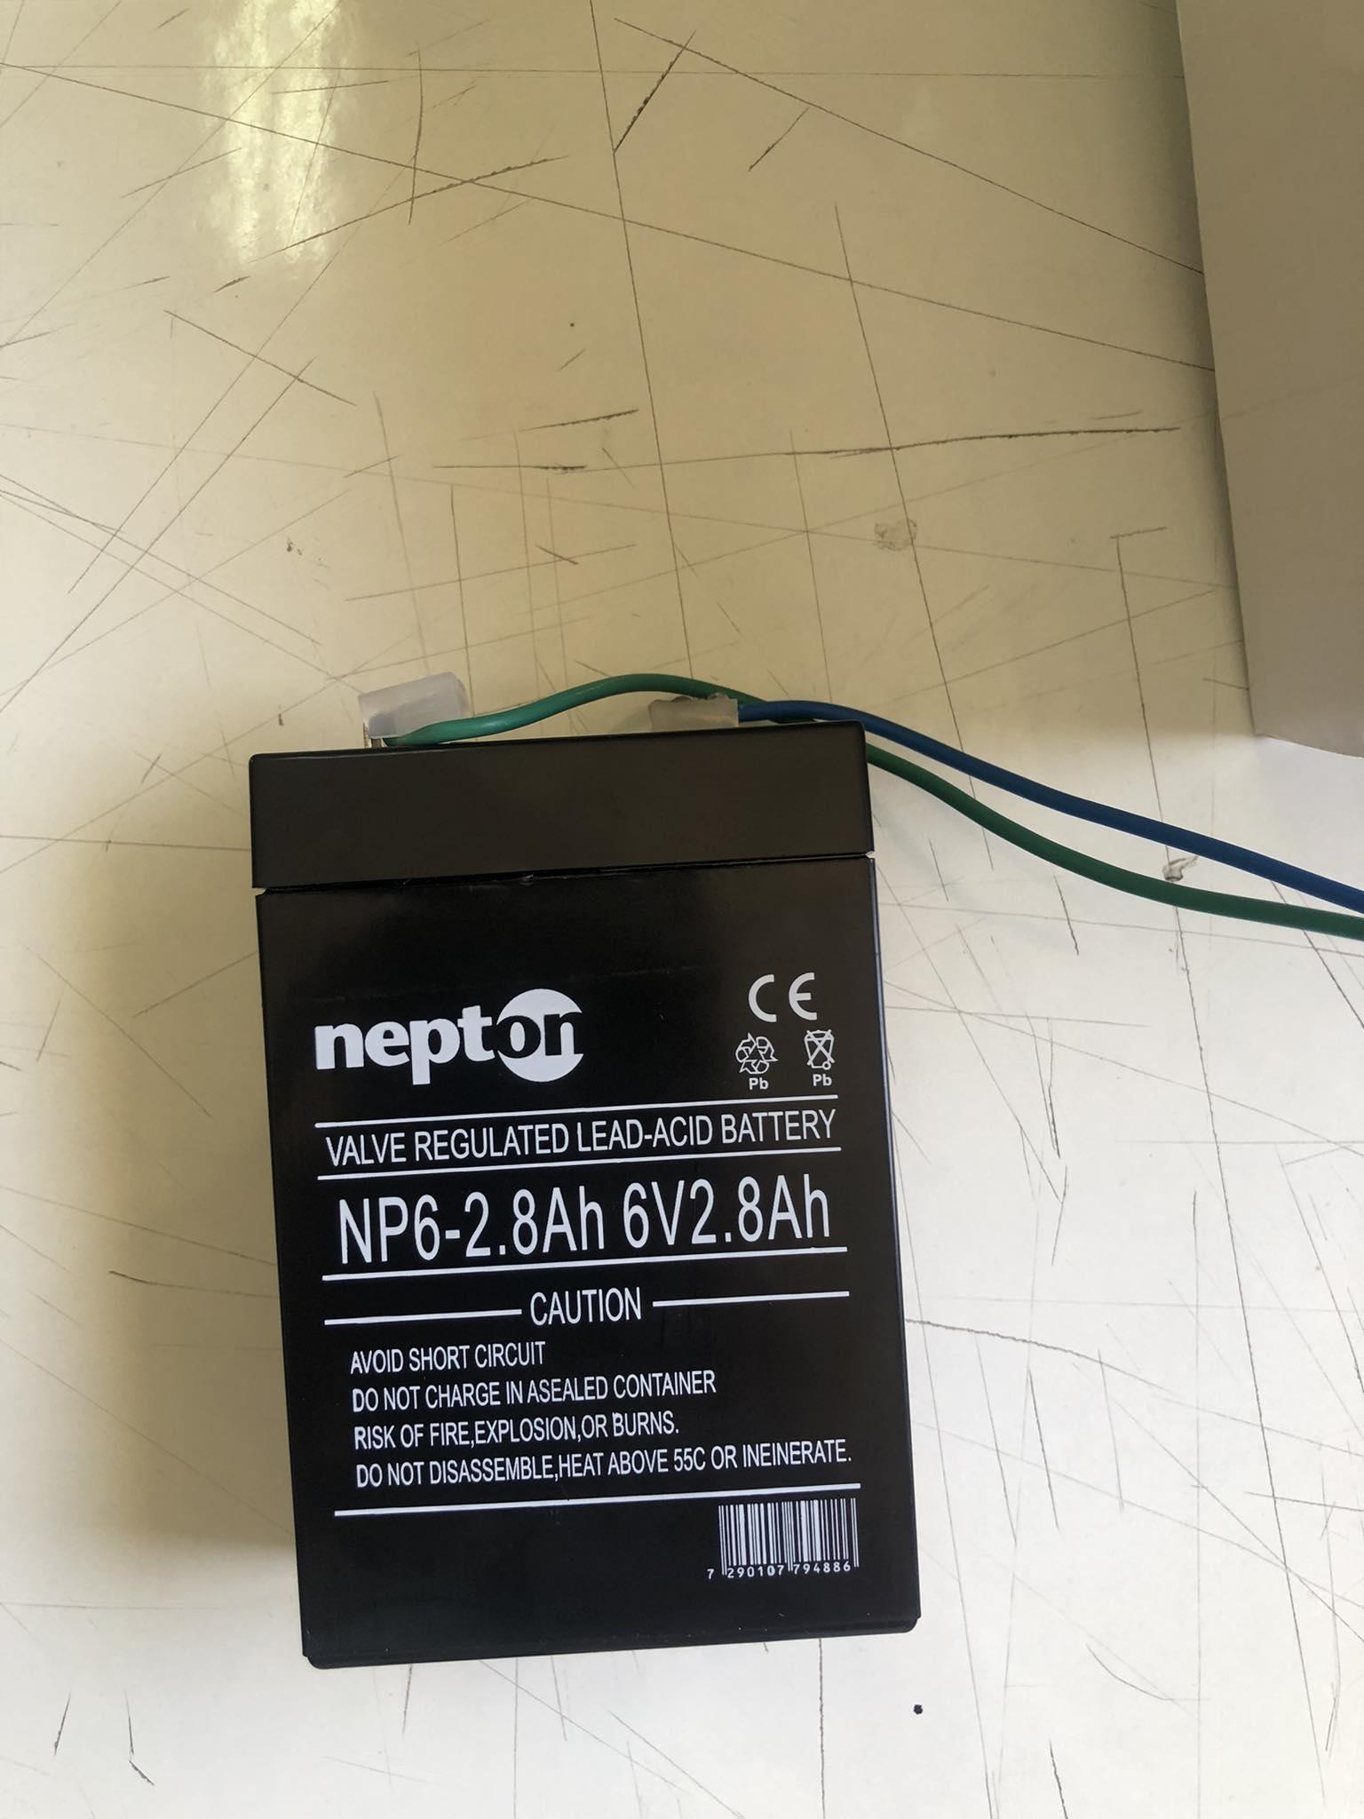
Figure 14: Battery

3.2 Project Design
3.2.1Glove Design
Firstly, we design the glove that will be detecting the arm movements by providing it with the right sensor that we fixed on it.
Here is the glove design

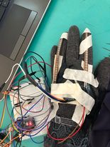
Figure14: Glove desgin

For the fingers we used flex sensor, which is a sensor that measures the amount of deflection or bending. Usually, the sensor is stuck to the surface, and resistance of sensor element is varied by bending the surface [6], which works perfectly to detect the fingers movements.
For the wrist and elbow since there movements occurs in certain axis so the right sensor to detect it is Triple Axis Accelerometer & Gyro Breakout - MPU-6050A, which are X-axis for elbow and Z-axis for the wrist.

As we mentioned before, our microcontroller is Arduino Nano it has 8 analog pins which was enough for connecting the two flex sensors and the MPU 6050 and here is how we connected each element to the circuit.

The connection of the flex sensors
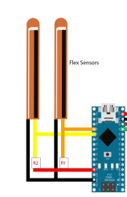
Figure15: Interfacing flex with Arduino And here is the connection of the accelerometer
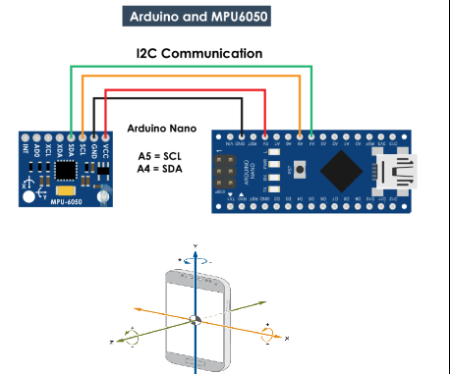
Figure16:interfacing Accelerometer with Arduino

3.3.1 Robotic Arm design
After we decided the directions of movement for each part (fingers, wrist, elbow), we started looking for a suitable design for the arm.

We found a design that suited our project from the InMove Robot design for hand and arm. We then designed an attachment for the elbow.

We started the assembly process for the arm step by step, connecting each of the fingers, wrist, and elbow. We attached the servos to each part.

The process of gathering the fingers included attaching the servos to the strings and the fingers so that the pulling process would work correctly.

Each servo connects to two strings: one for clockwise movement and one for counterclockwise movement. When the servo moves, it pulls the string, which pulls the finger attached to it. When the servo moves the other way, it releases the string and the finger
returns to its original position.

And here is the final product.
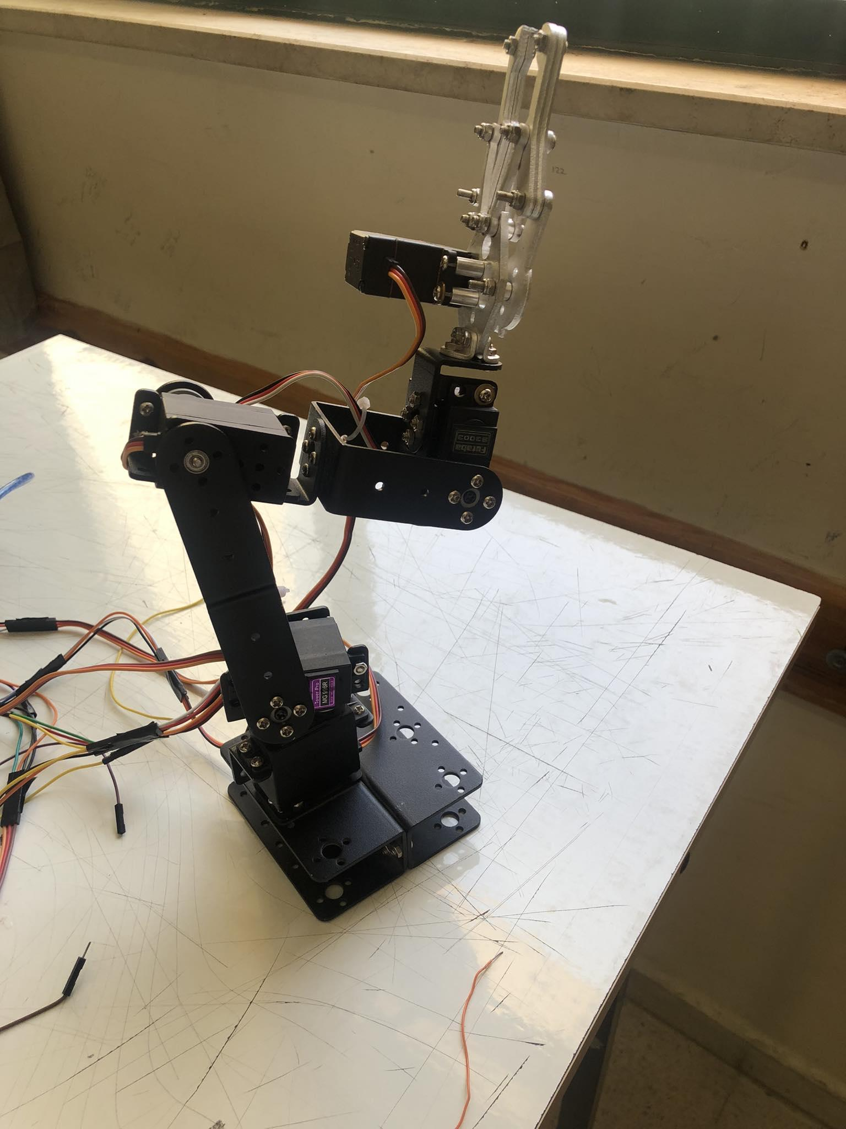
Figure17: Robotic Arm

The connection for the servo motors for each part connected to the nano microcontroller is as shown below
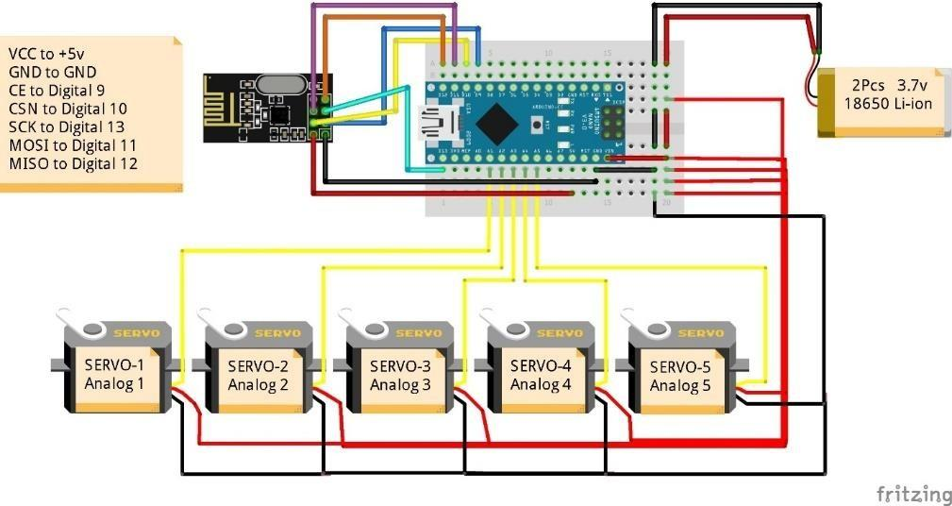
Figure18: interfacing servo to Arduino

3.3.1 Wireless connection:

After completing the design of the two parts, we began working on the communication process. Since the main goal of our project is to have the glove and the robotic arm in separate areas to avoid hazards, we decided to use wireless communication instead of wired communication. Wired communication would have been an obstacle in the area where the arm is located.
So here is our wireless connection that we used in in the main circuit for both parts.
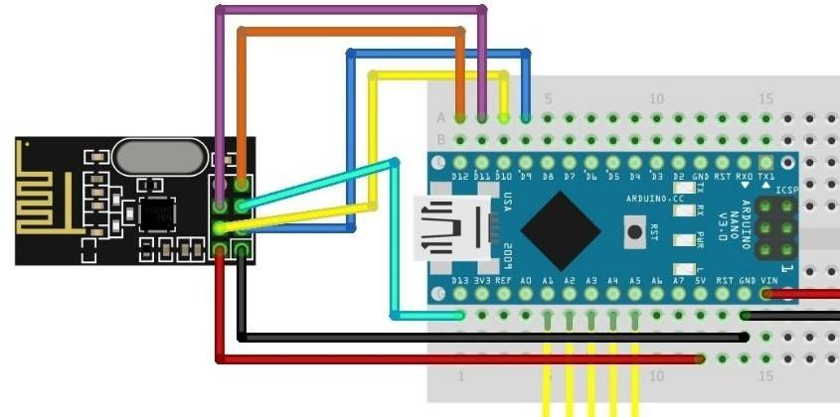
Figure19: interfacing NRF24L01+ with Arduino

We utilized the nRF24L01+ Transceiver and its adapter for our connection. These wireless transceiver RF modules enable data transmission and reception. Operating on the 2.4 GHz ISM band, this technology is approved for engineering applications worldwide. With an efficient range of 100 meters (200 feet), it is ideal for wireless remote-control projects. [7]

3.2 Servo motors

We used three types of servo motors for the arm. This choice is appropriate because servo motors allow precise position control and provide a range of movement from 0 to 180 degrees, which aligns well with hand movements. When selecting servo motors, three factors were considered: continuous torque, peak torque, and speed.

Initially, SG90 servo motors were used for the fingers. However, they were unable to handle the required torque and lacked sufficient speed. Consequently, more powerful servo motors, specifically the MG996R Servos, were employed. These motors were capable of pulling the strings connected to the fingers and operated efficiently.

For the wrist, we initially used the same servo motors that worked successfully with the fingers. Although they functioned, they did not deliver the desired efficiency in wrist rotation. As a result, they were replaced with servo motors that provided suitable efficiency in wrist rotation.

Chapter 4: Results and Discussion
At the end, Glove controlled robotic arm succeeded to achieve the purpose of this project, by receiving the angles from the glove and moving according to them sonorously and wirelessly.

If we look at the robotic arm that was designed in figure 19, we can see that the designed capable of performing human controlled tasks dynamically with the robot's power.

Chapter 5: Conclusion, Recommendations & Future work

5.1 Conclusion & Recommendations

In this chapter, we successfully implemented the dynamic robot industry in various aspects of life despite obstacles in our country. The project yielded positive results. Additionally, despite the challenging process, the development of the robot provided us with an opportunity to enhance our capabilities and deepen our understanding of hardware.

We gained valuable experience in working with servo motors, flex sensors, Arduino, NRF transmitters, and their interconnections. Prior knowledge of hardware proved to be time-saving

Future Work

There is a list of features that could be added to “Glove controlled robotic arm”

    - Muscle control with EMG sensor: This would allow the user to control the robotic arm with their own muscles, not just their hand movements. The EMG sensor would measure the electrical activity in the user's muscles and use this information to control the robotic arm. This would make the robotic arm more natural and intuitive to use.

    - Enhanced joints: The robotic arm could be enhanced with more sophisticated joints that allow it to move in a wider range of motion. This would make the robotic arm more versatile and capable of performing a wider range of tasks.

    - AI system: An AI system could be used to monitor the environment around the robotic arm and make decisions about how to interact with it. For example, the AI system could be used to detect obstacles and avoid them, or to identify objects that the robotic arm should interact with. The AI system could also be used to learn from the user's interactions with the robotic arm and improve its performance over time.

References:
- [3](Cooper, 2016) From IBM Business Operations Blog link: https://www.ibm.com/blogs/internet-of-things/introduction-to- robotics/?fbclid=IwAR0M3HYb4ZQ5oUDp7RIDOjLQRxsWB7- 918FbZDRWPF4NMQTYEU9QcktRNsg
- [1](Scassellati, 2002) from Trends Link: https://scazlab.yale.edu/sites/default/files/files/TICS-02- Imitation.pdf?fbclid=IwAR2w5zMxEDDAxwYFMWi1oo33sF6iuu3JCbJ6h9Pt9fYBKpGkC n74qbOFmy8
- [2] (Reporters) From Robots Reporters Link:
https://robotreporters.com/alter-3-robot-conducts-android-opera-in-japan-exploring- the-future-of-human-communication/?fbclid=IwAR2xTEuKlowuQSVnmGs2hsbr- wQTxmqlzvJAlCqnKkYlE_-vHSO3Qhytt7M

- [Inmove](LANGEVIN) form Inmove link: https://inmoov.fr/
- [Robata](Scassellati, 2002) from Trends Robata Link: https://scazlab.yale.edu/sites/default/files/files/TICS-02- Imitation.pdf?fbclid=IwAR2w5zMxEDDAxwYFMWi1oo33sF6iuu3JCbJ6h9Pt9fYBKpGkC n74qbOFmy8
- [5] Figure 15 from: Irimia R, Gottschling M (2016) Taxonomic revision of Rochefortia Sw. (Ehretiaceae, Boraginales). Biodiversity Data Journal 4: E7720. https://doi.org/10.3897/BDJ.https://www.ti.com/lit/ds/symlink/lm2596.pdf?ts=1608894899188&r ef_url=https%253A%252F%252Fwww.ti.com%252Fproduct%252FLM2596%253Futm_source% 253Dgoogle%2526utm_medium%253Dcpc%2526utm_campaign%253Dapp-null-null-GPN_EN- cpc-pf-google- wwe%2526utm_content%253DLM2596%2526ds_k%253DLM2596%2526DCM%253Dyes%252
6gclid%253DCj0KCQiAuJb_BRDJARIsAKkycUmn2b5w43sRJ1HfmUAvDT7sJu_HW6B24Gh 2mlOKHCDNuPOUk1Mj3mcaAtLHEALw_wcB%2526gclsrc%253Daw.ds
- [6] Retrieved from Wikipedia, the free encyclopedia Link: https://en.wikipedia.org/wiki/Flex_sensor
- [4] Robots in industry from this link: https://www.sciencedirect.com/science/article/abs/pii/S0003687084901212?fbclid=IwAR 10GwTKOrd9UG4QC0d2YLuSVPSqvaGxmo1zLA5Moe2NsTyNh3GGcfVs8U0
- Alter3 From this link:https://robotreporters.com/alter-3-robot-conducts-android-opera-in- japan-exploring-the- future-of-human- communication/?fbclid=IwAR2xTEuKlowuQSVnmGs2hsbr-wQTxmqlzvJAlCqnKkYlE_- vHSO3Qhytt7M

- [7] About NRF24L01+ from this link: https://howtomechatronics.com/tutorials/arduino/arduino-wireless-communication- nrf24l01-tutorial/?fbclid=IwAR1TmVfJgooVIOTLOvpQxDdYkeCMCh1350TZ4FJ3zFJf- kSjydwCuFfDs1A

Appendix

#include <SPI.h>
#include <nRF24L01.h>
#include <RF24.h>
#include "FlexLibrary.h"
#include <Wire.h>
#include <MPU6050.h>
MPU6050 mpu;
RF24 radio(7,8); // CE, CSN
const byte address[6] = "00001";
int maxIndex = 470;
int minIndex =460;
int maxRing = 550;
int minRing = 500;
int wristLess=35;
int wrist=110;
int wristMore=50;
int clipper = 0;
// Flex index(A1, minIndex, maxIndex, 10, RUN_AVG, 0);
// Flex ring(A2, minRing, maxRing, 10, RUN_AVG, 0);
const int flexPinRing = A1; // Analog pin for index finger flex sensor
const int flexPinIndex = A2; // Analog pin for ring finger flex sensor

void setup() {
// wrist=110;
// wristMore=90;

Serial.begin(9600);
radio.begin();
radio.openWritingPipe(address);
radio.setPALevel(RF24_PA_MIN);
radio.stopListening();
while(!mpu.begin(MPU6050_SCALE_2000DPS,MPU6050_RANGE_2G))
{
Serial.println("Could not find a valid MPU6050 sensor,check wiring!");
delay(500);
}
checkSettings();
}
void checkSettings()
{
Serial.println();

Serial.print(" * Sleep Mode: ");
Serial.println(mpu.getSleepEnabled() ? "Enabled" :
"Disabled");

Serial.print(" * Clock Source: ");
switch(mpu.getClockSource())
{
case MPU6050_CLOCK_KEEP_RESET:
Serial.println("Stops the clock and keeps the timinggenerator in reset");
break;
case MPU6050_CLOCK_EXTERNAL_19MHZ:
Serial.println("PLL with external 19.2MHz reference"); break;
case MPU6050_CLOCK_EXTERNAL_32KHZ:
Serial.println("PLL with external 32.768kHz reference");
break;
case MPU6050_CLOCK_PLL_ZGYRO:
Serial.println("PLL with Z axis gyroscope reference");
break;
case MPU6050_CLOCK_PLL_YGYRO:
Serial.println("PLL with Y axis gyroscope reference");
break;
case MPU6050_CLOCK_PLL_XGYRO:
Serial.println("PLL with X axis gyroscope reference");
break;
case MPU6050_CLOCK_INTERNAL_8MHZ:
Serial.println("Internal 8MHz oscillator"); break;
}

Serial.print(" * Accelerometer: ");
switch(mpu.getRange())
{
case MPU6050_RANGE_16G: Serial.println("+/-16 g"); break;
case MPU6050_RANGE_8G: Serial.println("+/-8 g"); break;
case MPU6050_RANGE_4G: Serial.println("+/-4 g"); break;
case MPU6050_RANGE_2G: Serial.println("+/-2 g"); break;
}
Serial.print(" * Accelerometer offsets: ");
Serial.print(mpu.getAccelOffsetX());
Serial.print(" / ");
Serial.print(mpu.getAccelOffsetY());
Serial.print(" / ");
Serial.println(mpu.getAccelOffsetZ());

Serial.println();
}
void loop() {

// index.updateVal();
// ring.updateVal();
// int ringPos = map(ring.getSensorValue(), minRing,
// maxRing, 180, 80);
// ringPos = constrain(ringPos, 80, 180);

// int indexPos = map(index.getSensorValue(), minIndex,
// maxIndex, 90, 0);

// indexPos = constrain(indexPos, 0, 90);
int flexValueIndex = analogRead(flexPinIndex);
int flexValueRing = analogRead(flexPinRing);
int mappedValueIndex = map(flexValueIndex, 0, 1023, 0, 100);
int mappedValueRing = map(flexValueRing, 0, 1023, 0, 100);
Serial.print("Index: ");

Serial.print(mappedValueIndex);
Serial.print("\tRing: ");

Serial.println(mappedValueRing);

delay(100);
Vector rawAccel = mpu.readRawAccel();
Vector normAccel = mpu.readNormalizeAccel();
Serial.print(" Xnorm = ");
Serial.print(normAccel.XAxis);
Serial.print(" Znorm = ");
Serial.print(normAccel.ZAxis);
Serial.print(" Ynorm = ");
Serial.println(normAccel.YAxis);

if(mappedValueIndex>=40){
clipper = mappedValueIndex;
}
else if(mappedValueIndex < 40 && mappedValueIndex >=30){
clipper = mappedValueIndex;
}
else if( mappedValueIndex <= 25){
clipper =0 ;
}
if (normAccel.XAxis <= 2 and normAccel.XAxis >= -2)
{
wristMore=50;
wristLess = 35;
}
else if (normAccel.XAxis <= 5 and normAccel.XAxis >= 2)
{
wristLess=90;
}
else if (normAccel.XAxis < -2 and normAccel.XAxis >= -5)

{
wristLess=10;
}

if (normAccel.XAxis <= 2 and normAccel.XAxis >= -2)
{
wristMore=50;
wristLess = 35;
}
else if (normAccel.XAxis <= 10 and normAccel.XAxis >= 5.5)
{
wristMore=20;
}
else if (normAccel.XAxis <= -5.5 and normAccel.XAxis >= -10)

{
wristMore=150;
}

if (normAccel.ZAxis < 5 and normAccel.YAxis > 0)
{
wrist=180;
}
else if (normAccel.ZAxis > 5 and normAccel.YAxis < 0 and normAccel.YAxis > -5)
{
wrist=110;
}
else if (normAccel.ZAxis < 0 and normAccel.YAxis < 0 and normAccel.YAxis < -5)

{
wrist=20;
}
int elbow=115;
if(normAccel.XAxis>-3)
{
elbow=115;
}
else if (normAccel.XAxis<-3)
{
elbow=40;
}
delay(500);
String debug = ((String) "\twristLess: " +
wristLess+"\twristMore: " + wristMore+"\twrist:"+wrist+"\telbow"+elbow );
Serial.println(debug);

int msg[5];
msg[0]=wristLess;
msg[1]=wristMore;
msg[2]=wrist;
msg[3]=elbow;
msg[4]= clipper;//clipper
;
radio.write(&msg, sizeof(msg));
}

