Graduation Project report



Al-Najah University
Faculty of Engineering & Information Technology
Computer Science

CrowdManagementSystem
Abdullah Farraj
Supervised By:
Mohammed Sharaf

Outline

Chapter 1: Introduction
…………………………………………………………….. 4
1.1 Introduction

Chapter 2: Design
………………..…..……………..... 5
2.1 Problem to be solved (what is new)
……………………………………………………………..... 6
2.2 Tools used
………………………………………………………………... 9
2.3 Diagrams
……………………………………………………………..... 12
2.5 Challenges

Chapter 3: Future work
……..……………………………………………………..... 13
3.1 Future work

Chapter 4: Conclusion
……..……………………………………………………..... 13
4.1 Conclusion

Chapter 1

  - Introduction
Crowd management system are an integral part of rooms and areas. Planning for crowds, monitoring crowds and managing crowds, are fundamental tasks in security management. As a consequence, crowd management is a sprawling R&D area that includes theoretical models, simulation tools, as well as various support systems. There has also been significant interest in using computer vision techniques to monitor crowds. However, overall, the topic of crowd management has been given only little attention within the rooms and areas domain. In this app I report on a program for rooms and areas crowd management based on a participatory mobile phone sensing platform.
I describe an application for smart, rooms and areas crowd management based on participatory mobile phone sensing and location/situation specific information delivery. The application supports quick and flexible deployments of management for specific events or spaces that include four key functionalities: (1) Mobile phone based delivery of event/space specific information to the users, (2) participatory sensor data collection (from users activity) and flexible analysis, (3) location and notification specific message for administration.

Chapter 2

  - Problem to be solved

Every app in the world has its features that makes it a strong one in the programming, all the phones scientist’s aims to bring a new things or a new features to there app's, so they think different and out of the box to do that .
The new features is the most important factor to make a good, famous app and bring the best security to the person.
According to the previous paragraphs, I think different not as the other developers thinks, I bring a new features to our app ,this features make me sure that the app well be Strong , famous ,and have a good security for us , So let’s see what’s new in our app ?

- Sensor shake detector
The shake sensor is the same as the motion sensor and acceleration. In this application use it logically and make of its output data in detecting the fall of the phone so that specific values ​​are set. These values ​​are analyzed and calculated. If reach the maximum value, then it should send an notification to administration.
- Easy-To-Use
This application is designed to suit all ages through which they can easily handle user activity and choose whether they want to go to the rooms or areas and can see if there is crowd by seeing how many people in the room or areas, if he wants to go it can see its location from a button click.
- Count-People-Sensor
There is a sensor to count people and this sensor is characterized by its low cost and unique advantage is counting people who in and out and accuracy of the full.
- ESP8826
Is a piece used to send data using Wi-Fi programmed using Arduino. This widget takes data from the sensor and sends it to the database.
IIV. Geofence
Is a location-based service in which an app or other software usesGPS, RFID, Wi-Fi or cellular data to trigger a pre-programmed action when a mobile device or RFID tag enters or exits a virtual boundary set up around a geographical location, known as a geofence. is a location-based service in which an app or other software usesGPS, RFID, Wi-Fi or cellular data to trigger a pre-programmed action when a mobile device or RFID tag enters or exits a virtual boundary set up around a geographical location, known as a geofence.

So this is our features that I depends on to have a good and competitive app all over the world and sure it will be.

Chapter 2

  - Tools used

In this section, we want to talk about the tool that has been used in our app in order to reach the best quality and the best player experience so let’s start.

- Android Studio
Android Studio is the official integrated development environment (IDE) for Android application development. It is based on the IntelliJ IDEA, a Java integrated development environment for software, and incorporates its code editing and developer tools.
To support application development within the Android operating system, Android Studio uses a Gradle-based build system, emulator, code templates, and GitHub integration. Every project in Android Studio has one or more modalities with source code and resource files. These modalities include Android app modules, Library modules, and Google App Engine modules.
Android Studio uses an Instant Push feature to push code and resource changes to a running application. A code editor assists the developer with writing code and offering code completion, refraction, and analysis. Applications built in Android Studio are then compiled into the APK format for submission to the Google Play Store.
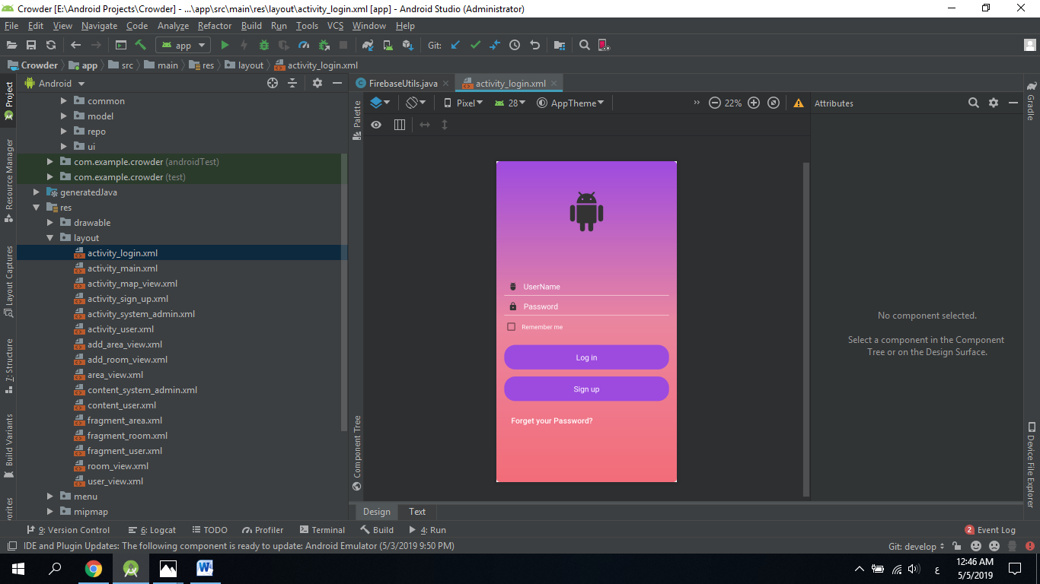
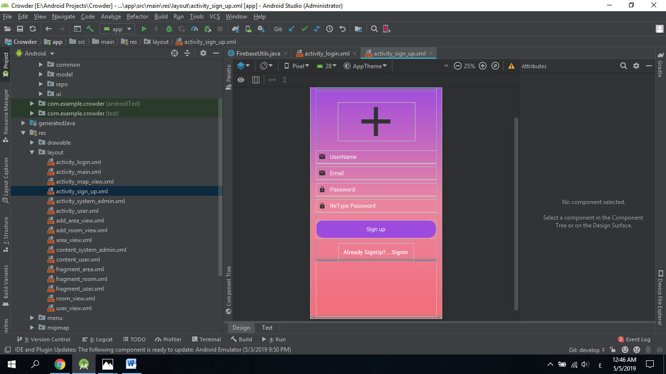

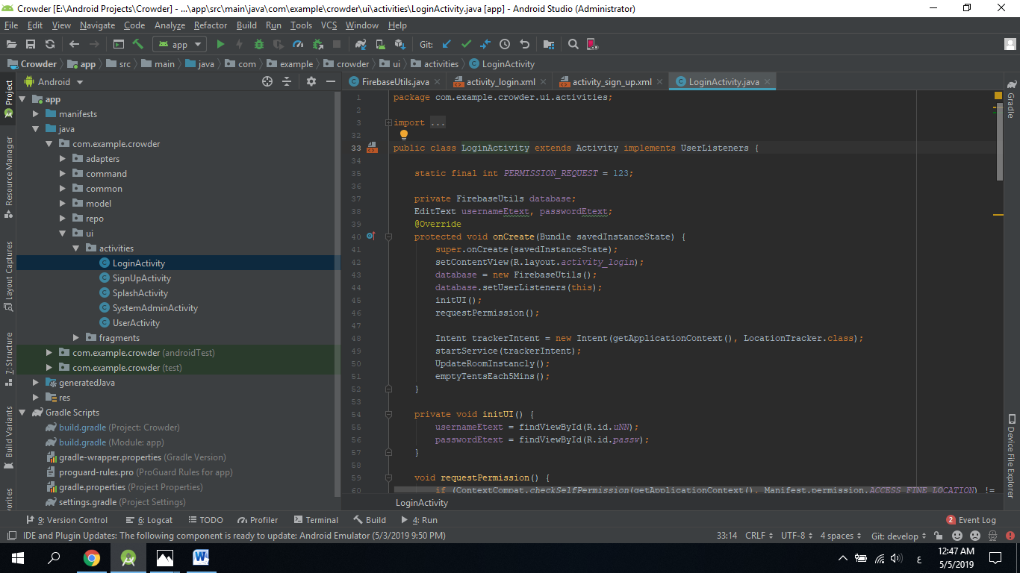

- Firebase
Firebase is a mobile platform from Google offering a number of different features that you can pick ‘n mix from. Specifically, these features revolve around cloud services, allowing users to save and retrieve data to be accessed from any device or browser. This can be useful for such things as cloud messaging, hosting, crash reporting, notifications, analytics and even earning money through AdMob.
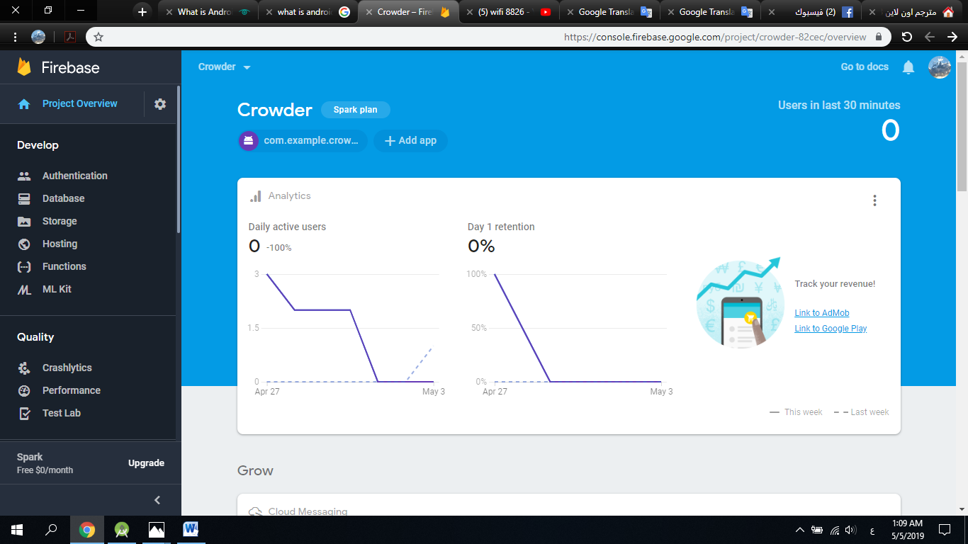

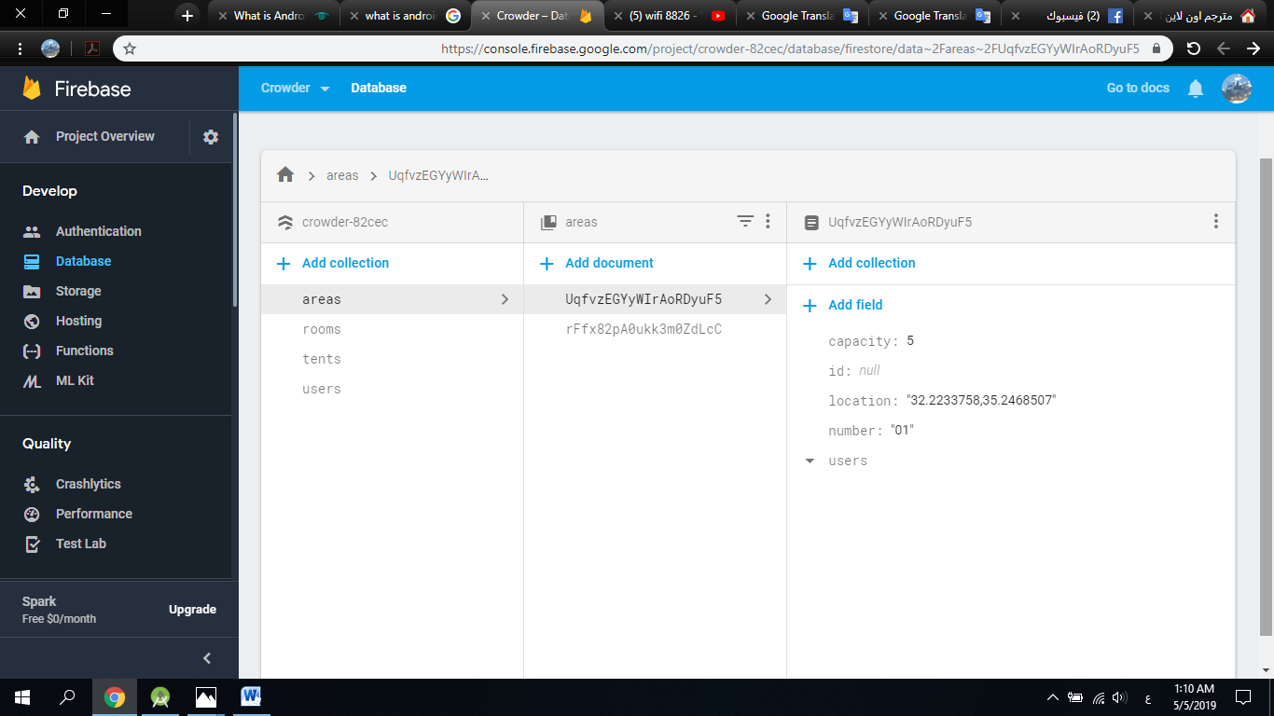

Chapter 2

  - Diagrams

Use Case:
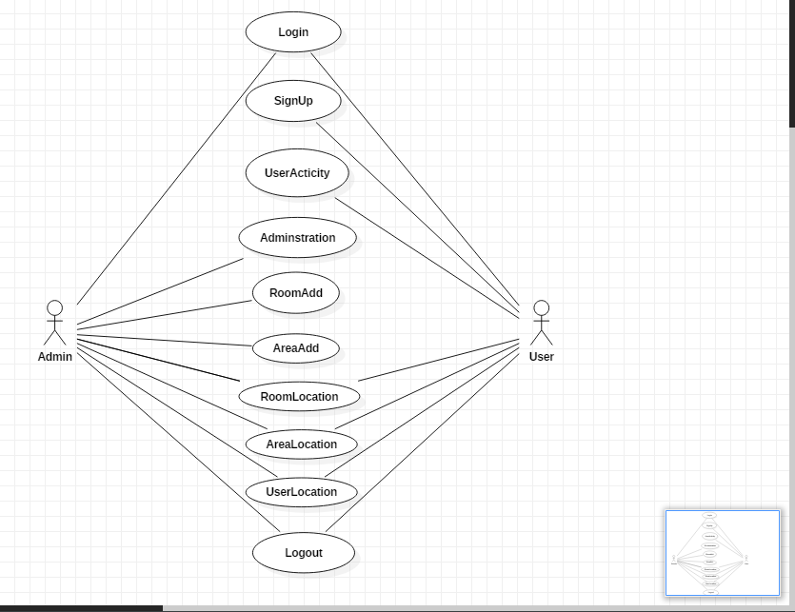

UserSequence:
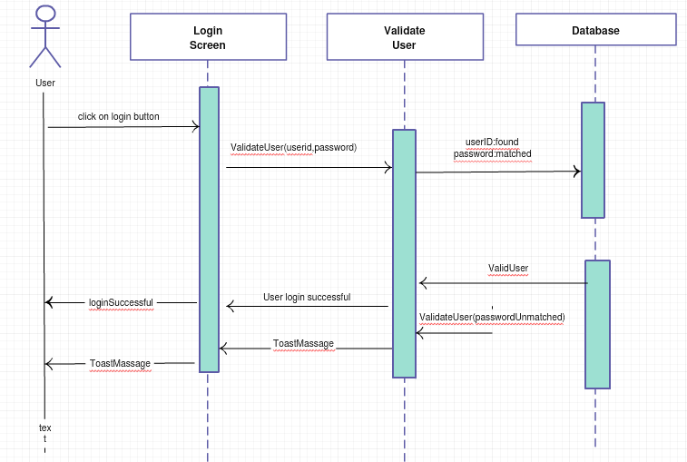

AdminSequence:
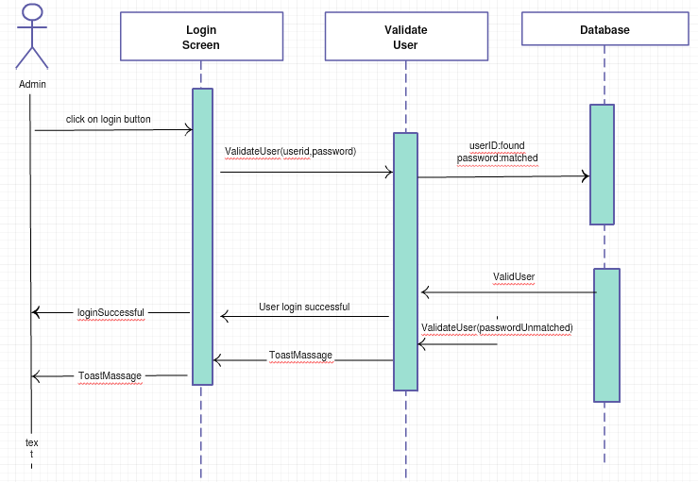
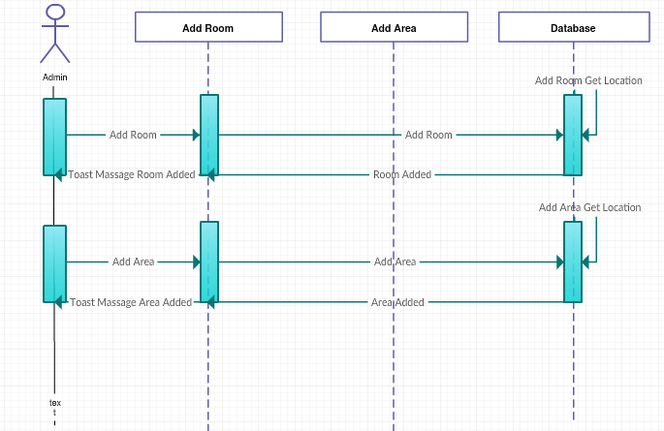

  - Challenges

There is a lot of challenges that faced from the beginning of the project, here I want to explain the most important challenges that we faced:

- How many people dropped his phone
When we take sensor values from the phone and check them, we encountered how to compare them with the rest of the users in the same location and at the same time using the database and converting the point in the map to red in the event of a particular event and the challenge was to compare all the sites of some users and send the message to the management.

- Check users a rounding some Point
It was difficult to get and compare the locations, especially when compared to the point taken to the room or areas. We had to take the point value of the room or area and compare it to all users’ locations in addition to fetching them from the database.

Chapter 3

3.1 Future work
Sure I don’t want to stop here, I want to make updates and improvements for our app to stay at the top all the time so there is a future work that I want to do in the near future.
- Give to university to keep more security with student’s crowd.
- Add activity name is event display every events on city-wide.
- Support more information about user.
- Make it on watch gear.

Chapter 4

4.1 Conclusion
After you know what is CrowdManagementSystem ,you will find that our app to keep security of any person in crowd is powerful and effective in crowd time and it's easy to know how many persons are there, any person exposure to something.

