## 

**Multi-criteria decision making model for the selection of subcontractors in Palestine**

## Introduction:

The construction industry at Palestine is very complex, due to widely varying and several factors influence on projects outcome. As construction projects become larger and more complex, then managing these projects and their challenges become more complicated and core element for success. During the past few years, many of the construction projects at Palestine were completed beyond planned time and budget.

There is no doubt that the construction industry sector represents the locomotive of development at Palestine and it is one of the key economic sectors and one of the main forces that motivate the Palestinian national economy. It activates many other industries and sectors such as the construction materials trading. Also it can accommodate a huge functional and labor staff, as it constitutes an important element in attracting investments. In addition to that this sector is considered to be one of the most productive sectors,where the Palestinian Central Bureau of Statics (PCBS) shows that the construction sector contribution to the Palestinian Gross Domestic Product (GDP) is increasing since the Palestinian National Authority (PNA) establishment to reach 11.1% in 2010. This is a large proportion covered by this sector, thus positively it is affecting various economic, social, educational and vocational sectors, and other Palestinian aspects.

## Statement of problem:

The process used in Palestine construction industry in selecting the best subcontractors among bidders is not based upon scientific concepts. The method is based upon subjective factors and criteria which differ from investment group to another. This will lead to different decisions even if it used by the same evaluator or different evaluator. However, we at Palestine are badly in need for a model that based on scientific ground and which takes in to account all the criteria’s needed in the evaluation process. This model must be simple, easy to use accurate and quick and give the same results if it is used by different evaluators

## 

## SIGNIFICANCE OF STUDY

The significance of this research are represented through the following:

* To introduce new methods to the Palestinian market to help in reducing the decision making time for selecting subcontractors for large construction projects.
* Ensuring that the selected subcontractor will deliver the best quality to the project and help in achieving project's goals in minimum time.
* To make sure that the selected subcontractor is highly valid to the specifications which the project owner had ordered.
* Minimize the time waste and the drifting from project's plan that could occur if a nonqualified subcontractor was chosen.

## Analytical Hierarchy Process (AHP)

One of these methods is the analytical hierarchy process (AHP), this process is the way to make decisions implemented by its powerful and user-friendly computer software. AHP can implement many types of decision problems such as portfolio management, transportation planning, artificial intelligence and manufacturing system design. The problems which were solved by using AHP in the past are Project procurement system selection model (Al-Hazmi and Caffer 2000), Advanced automation and or conventional construction process (Hastak 1998), and application of AHP in project management Prequalification of contractors (Al-Harbi 2001).

## Required data:

In this research the data required are:

1- The criteria for the subcontractors selection: there are many criteria can be used in the selection of subcontractors and should be determined in order to analyze it and use it in the AHP model.

2- Bidding system used in Palestine which is discussed in chapter 2 .

3- AHP model: the model has been build after the determination of the main goal and the criteria, as we will see in the model development.

## Data collection:

The data used in this research are collected through many ways, which are :

1. **Literature review from the internet and journals publications:** the literature review helped us in the formation of the general picture about our subject, gathering information and ideas and refines these ideas in the best shape.

**Questionnaire: one of the effective and representative tools in data collection**

## Model development

Our model will consist of three levels:

1. Level one: the goal or objective, which is selection of the best subcontractor among other subcontractors.
2. Level two: the criteria: in our model the criteria are :

Bid price, firm background, financial capability , technical capability , management capability , construction capability , past experience , reputation , health and safety policy , use of information technology .

1. Level three: the alternatives, which are C1, C2,C3.

### The Analysis of the questionnaire

The likert scale equation (relative important index (RTI)) =∑weights /5N, where N is the sample size.

After applying the likert scale equation on the proposed criteria, the obtained weight for each criterion was:

In order to create proposed model for selection of the best subcontractor, the most ten important criteria will be used which are:

* 1. Quality and durability of work from recent project history.
  2. Technical capability.
  3. Construction capability.
  4. Reputation.
  5. Financial capability.
  6. Bid price.
  7. Past experience.
  8. Contractor classification.
  9. Staff availability.
  10. Experience of working with the owner.

## Pairwise Comparison

In order to determine priorities and make overall judgments, pairwise comparison of the factors is necessarily. A 9-point scale will be used to determine the relative weights of the factors.

Table:- Pairwise Comparison Scale.

|  |  |
| --- | --- |
| Points scale | Description |
| 1 | Equally importance |
| 3 | Moderately importance |
| 5 | Strongly importance |
| 7 | Very strongly importance |
| 9 | Extremely importance |

The expert choice software automatically applies a comparison matrix, the matrix contains number of cells which entered with a weight according of a 9-point scale.

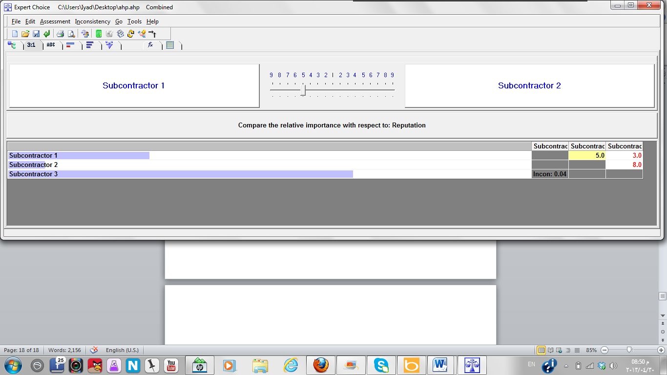

Figure.:- Pairwise Comparison Between Subcontractor1 & Subcontractor2 Related to Reputation criteria.

After recording all preferences and relative importance of all the factors affecting the selection of best subcontractor with respect the next step is synthesis of overall result for selection of best subcontractor. Expert Choice runs synthesis of overall goal automatically and generates the results as shown in Figure below:

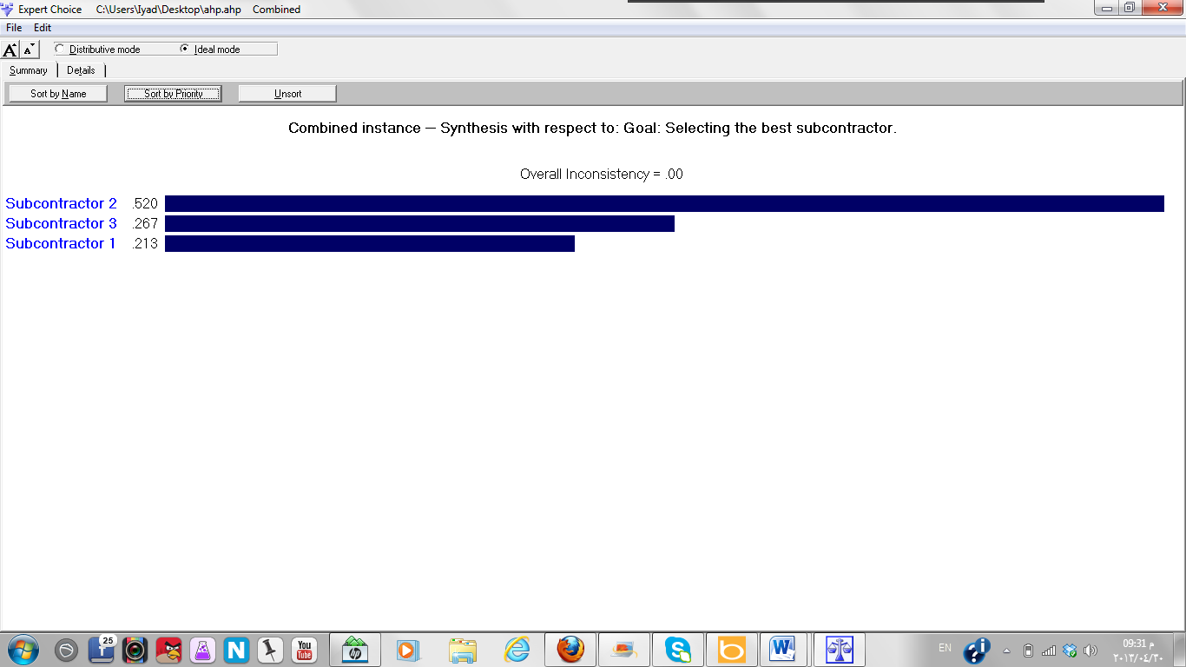

## summary

The main objectives of this research is to select the best subcontractor considering many important criteria and develop an AHP model using expert choice software as tool for the selection of the best subcontractor.

In this research a list of criteria collected from the literature review ,then a questionnaire was developed to choose the most 10 effective criteria on the selection of the best subcontractor .a Second questionnaire was developed to do a pairwise comparison between the criteria and insert it to the software to obtain the weight for each criteria.

Finally a hierarchical model was developed as a tool for the user as a tool for the selection of the best subcontractor. the user just has to insert the values to the software and then the result will be displayed .

## Conclusion

The respondents who participated in this survey were highly experienced , because the results includes that 57% of the respondents has experience more than 10 years in the construction sector. Moreover the sample was approximately equally distributed between the public and private sectors , The 60% of questionnaires was distributed to the private sector and 40% to the public sector.

## Recommendations

1. Database should be developed for appropriate selection of the subcontractors method based on past record.
2. This method should be used for the selection of subcontractors because its simplicity and transparency.
3. This model can be used for the selection of main contractors.