An-Najah National University
Faculty of Engineering and IT
Computer Information Systems
جامعة النجاح الوطنية
كلية الهندسة وتكنولوجيا المعلومات
قسم أنظمة المعلومات الحاسوبية

3tayer

Student :
Baraa Freihat

Supervisor:
Dr. Emmad Saadeh

A Graduation project report submitted in partial fulfillment of the requirements for B.Sc. degree in Computer Information Systems.
An-Najah National University
2017 / 2018
Table of Contents

Table of Contents ------------------------------------------------------------------------------------------------ 2
Acknowledgement ----------------------------------------------------------------------------------------------- 4
Abstract ----------------------------------------------------------------------------------------------------------- 5

CHAPTER ONE
INTRODUCTION -------------------------------------------------------------------------------------------------- 6
1.1 Introduction -------------------------------------------------------------------------------------------------- 6
1.2 Project Scope ------------------------------------------------------------------------------------------------ 6
1.3 Problem Specification -------------------------------------------------------------------------------------- 7
1.4 Goals and Objectives --------------------------------------------------------------------------------------- 7
1.5Motivation ---------------------------------------------------------------------------------------------------- 8
1.6 System Requirement ---------------------------------------------------------------------------------------- 8
1.7 Project Plan and Schedule --------------------------------------------------------------------------------- 9
1.8Outline of the Project ---------------------------------------------------------------------------------------- 9

CHAPTER TWO
LITERATURE AND METHODOLOGY ------------------------------------------------------------------------- 10
2.1Introduction --------------------------------------------------------------------------------------------------10
2.2 Current Systems --------------------------------------------------------------------------------------------10
2.3 Proposed System ------------------------------------------------------------------------------------------- 12
2.4 Feasibility Study ------------------------------------------------------------------------------------------- 13
2.5Methodology ------------------------------------------------------------------------------------------------ 13

CHAPTER THREE
SYSTEM ANALYSIS AND DESIGN ---------------------------------------------------------------------------- 14
3.1 Requirements discovery ---------------------------------------------------------------------------------- 14
3.2 Requirements classification ------------------------------------------------------------------------------ 15
3.2.1 System actors -------------------------------------------------------------------------------------------- 15
3.2.2 Functional requirements -------------------------------------------------------------------------------- 16
3.2.3 Nonfunctional requirements --------------------------------------------------------------------------- 19
3.3 Requirements validation ---------------------------------------------------------------------------------- 20
3.4 Requirements management ------------------------------------------------------------------------------- 20

CHAPTER FOUR
UML ------------------------------------------------------------------------------------------------------------ 21
4.1 Full use Case Diagram ------------------------------------------------------------------------------------ 21
4.1.1 Owner of system package ------------------------------------------------------------------------------ 22
4.2 Class Diagram ---------------------------------------------------------------------------------------------- 23
4.3 Sequence diagrams ---------------------------------------------------------------------------------------- 24
4.3.1 Place Order ----------------------------------------------------------------------------------------------- 24
4.3.2 Ship order ------------------------------------------------------------------------------------------------- 25
4.3.3 Add Store ------------------------------------------------------------------------------------------------- 26
4.3.4 Search product ------------------------------------------------------------------------------------------- 27
4.3.5 Add product ---------------------------------------------------------------------------------------------- 28
4.3.6 Edit product ---------------------------------------------------------------------------------------------- 29
4.3.7 Send & receive messages ------------------------------------------------------------------------------- 30
4.4 Activity diagrams ------------------------------------------------------------------------------------------ 31
4.4.1 Add product ---------------------------------------------------------------------------------------------- 31
4.4.2 Send & receive messages ------------------------------------------------------------------------------- 32
4.4.3 Edit product ---------------------------------------------------------------------------------------------- 33
4.4.4 Searching product --------------------------------------------------------------------------------------- 34
4.4.5 Add Stores ------------------------------------------------------------------------------------------------ 35
4.4.6 Ship orders ----------------------------------------------------------------------------------------------- 36
4.4.7 Order product -------------------------------------------------------------------------------------------- 37
4.5 State Diagram ---------------------------------------------------------------------------------------------- 38
4.5.1 Payment state Diagram --------------------------------------------------------------------------------- 38
4.5.2 Shipment Diagram -------------------------------------------------------------------------------------- 39
4.5.3 Order State Diagram ------------------------------------------------------------------------------------ 40

Acknowledgement

I would like to thank Dr. EmmadSaadah for his expert advice and encouragement throughout this project.

3taeyr

Abstract

3taeer:

Deals Store an online store, web based application, which allows customers order product online , also they can find a product of interest by searching for the name of product , it's price or it's category .
On hand the trader can offer his products in the store , then after offer the product he can modify the offer or delete it and on the other hand the trader can buy products from another trader.
In the system there is the administrator who can manage the whole website (he has all privileges) this administrator is the owner of the company .

CHAPTER 1
INTRODUCTION

1.1 Introduction

"3taeer" is a business-to-business website designed to help traders to offer their goods for their traders and other customers without the need to go to their places.
It helps customers to be up to date with the latest goods by the traders who dealing with.
In addition ; customers can also ask to deliver goods to them . The website saves time , money and effort which traders and their customers used to consume .
As well , the website is easy to use , protected and available for all traders and customers to register in it.

1.2 Project Scope

"3taeer" Is used to provide an interface between a traders with each other, between a traders and a customer on the Internet.
"3taeer" allows trader to offer his goods to his customers and other traders without the need to reach them.
"3taeer" provides to traders an easy way to see the available goods , and latest goods by his trader , as well as he can reserve whatever from offered goods , And then receive them.
The system can handle many services to take care of all traders and customers in a quick manner . The system is secured, user appropriate and easy to use

1.3 Problem Specification

Traders need organized website to display their product and communications with customers:
- Super deals can be with small quantities of huge of products
- customers need one place to find all of super deals at once
- Traders who want to selling outlet products
- Traders who need to selling products after bankruptcy
- Traders who don't own enough warehouse for extra products

1.4 Goals and Objectives

E-marketing is an integrated system to work together to achieve the objectives that have been carefully studied and were planned to be implemented meticulously in specific numbers ; monitoring their performance constantly , improving it and Submitting a report about them in parallel .

Some of these goals are :
- The quick arrival of goods and services to customers
- Accessing the traders any time and everywhere using the system
- Taking advantage of the marketing budget is much better and more effective
- Discovering the desires and needs of consumers for goods and services in order to provide and satisfy these needs as much as possible

1.5 Motivation
traders still using regular trading methods to sell and buy goods which cost them a lot of effort, money and time
trader usually travels to market his goods or employs large number of salesman who own a car or gives him a car in addition to the salary; to market his goods, which cost him a lot of money
The proposed system provides a new way of trading which saves effort ,money and time, and makes trading easier between importers and traders by giving information about products and online ordering which reduces lost and increases Revenues.

1.6 System Requirement

- Web server
- SQL server
- DNS & Hosting
- Net Frameworks :
- PHP
- HTML5
- CSS3
- Ajax
- Bootstrap
- JavaScript
- JQuery

1.7 Project Plan and Schedule

 | Task | Start date | Finish date | Status

1.8 Project outline
"3taeer" system Serves almost all kinds of businesses that involve trading
"3taeer" is just easy as the name is, since traders can easily track and keep their sales and inventory up to date on the website. furthermore with the intelligence part of the system, traders will enjoy an growth in their businesses income.

CHAPTER TWO
LITERATURE AND METHODOLOGY

2.1 Introduction
Every system has its own functionalities; 3taeyr was found to give new functionalities over regular trading methods. After reading this section the customer will be able to distinguish the differences between the old system and the proposed system in many aspects, he will also know the properties and the advantages of the proposed system; hence customer can easily define the best system with full understanding.

2.2 Current System
After many visits for the trading companies and giving out questionnaires concerning the traditional method of marketing already used there, we could come up with some advantages and disadvantages summarized down here:

Advantages:
1. Customers can see pictures for products and make sure the product is the same with the picture.
2. Low cost for buying or selling operations.
3. No need for physical company to get up the business.
4. Easy to manage the business.
5. Easy to communicate with customers directly.
6. No taxes are required.

Disadvantages:
1. It costs a lot of time to get the product.
2. Low revenues because the business model depends on only the ads so the number of visitors decides the revenues.
3. No auditing for offers by admin or owner of business.
4. The operation of buying and selling depends on the time that the customer’s and trader’s phones are available.
5. No difference between the users as customers or traders.
6. After buying a product the offer in a lot of sites stay available.
7. Don’t use log in system so that can increase the number of fake customers and traders.

2.3 Proposed System
3taeyr came to exceed many important shortages that old systems suffered from, let us illustrate how 3taeyr did that and how it came with its own shortages.

Advantages:
1. Buying and selling 24/7.
2. Traders don’t worry about the space or inventory.
3. Traders only who can offer their products.
4. Any offer should be approved by the admin.
5. The system support categories and interests to buy and sell products.
6. The company which responsible for delivery products not users.
7. Easy communicate with the owner of company.
8. The offer will be deleted when some customer buy the product.
9. Admin make sure in the inventory is the same with the product in the picture.
10. Good business that uses ads and commissions.
11. Log in system reduce the number of fake users.

Disadvantages:
1. Users who don’t have knowledge about how using the internet.
2. Some customers prefer to meet the traders face to face and make the deal.
3. Costs a lot of effort and time for admin.

2.4 Feasibility Study

Technical:

The system needs web programming language; it also needs servers, developers and designers. All of these needs are available in the company, a good experienced team well be responsible for developing the system functionalities and its design to make it available for customers.
Operational:

These days people want to do their works as fast as they can; so a computerized system is required instead of the current system .A lot of importers and traders still using the old methods which means a lot to target with our system, some of its advantages are reducing the number of employees, time, effort and money.

2.5 Methodology (SDLC)

After studying this system deeply, We decided to use Agile methodology for many reasons , First The nature of our project require to keep in contact with the user for knowing his requirements , needs and priorities in the system and supplying him with the prototypes repeatedly for taking his feedback while working on the system ,Secondly agile methodology is more flexible, that if we need to do any adjustment on the system for some reason it doesn't cost us much, and by agile Methodology the system easier to test and debug during a smaller iteration.
Moreover, agile methodology builds a collaborative team environment since they work together to find better ways of solutions.

CHAPTER THREE
SYSTEM ANALYSIS AND DESIGN

3.1 REQUIREMENT DISCOVERY

In this phase, we used many techniques to identify and extract the requirements from the user community. These techniques are:

Interviews :
we made interviews with many traders and sales mans such as (Anas jaradat "Imported Housewares and trader from jenin ", Omar alfathi "importer from jenin" and Mohammed al-qarout "Sales Representative")we asked them about their needs and suggestions from new system and the shortcomings exists in the old system. The interviews included general questions, directed questions to take additional information from them , and indirect questions to gain better understanding about their requirements .

Other systems:
we have studied existing internet systems such as (amazon.com , ebay.com , alibaba.com ,shobiddak.com); we analyzed the available services and operation requirements that match our system to understand more details about the services we need to offer .

Questionnaires :
We have distributed questionnaires to some importers such as in our area about the old system disadvantages and about the acceptance of the new system .

Using Brainstorming:
I have tried to analyze the system in depth, integrate many technologies with each other, and trying to produce numerous and creative requirements which achieve the users needs so it keeps them satisfied.

3.2 REQUIREMENT CLASSIFICATION

After defining the system requirements through the ways mentioned above, we specified it into many modules, and it's actors.
Actors :

Actors | Actor Type | Actor Description
Owner of system | primary | Who is responsible for Management ,functionality and keeping the system running well and be more usability
Trader | primary | Use the system to offer their  deals , communicate with customers
Customers | primary | Retail buyers ,use the system to order and browse products
“Credit” Payment Service | Secondary | verify Payment Process
“PayPal” Payment Service | Secondary | verify Payment Process
Shipment <<Service>> | Secondary | Ship the orders to the customers according to their address
Visitor | Primary | Who is enter the website to view the products

Use cases & packages
First identify the use cases for each Actor functionality in the system :
** Owner of system (Admin ):
- Manage the system which consists
- Stores.
- Employees.
- Ads.
- Users.
- Get report of System performance and activities
- Block Users
- agree Requests
- search on users
- slider ( update / Delete )
- Footer (Edit / Delete)
- Edit products
- Delete product
- Sold Products
- Categories
- SMS
** Traders
- Send / Receives messages from customers
- Consider the Products
- Consider the Rejected Products
- Consider Sold Products
- Add products
- Edit products
- Delete product
- Categories ( Add /Delete )
- Contact with admin
- Search the users
- Buy products
- Pay for order

** Customers :
Using system for:
- Searching for products
- Buy products
- Send /receives messages to Traders and Customers
- Buy products
- Pay for order

** Credit Payment Service :
This operation can be done by more than one way :
- Payment Process for orders via visa Card

** PayPal Payment Service :
This operation can be done by more than one way :
- Payment Process for orders via PayPal

** Shipment :
Delivery orders via packages or mail shipment

** Visitors :
Users who enter in the site to
- Browsers the products
- Search for products

Now we're going to specify non-functional requirements in our system :

- scalability : "3taeer" is developed in such way to be scalable without losing it's core consistency, meaning that developers can expand and add new features without affecting the other functionalities within the system.

- availability : the system developed and tested, in order to minimize it's single point of failure opportunities .

- security : developers of the system were very careful in validating all user inputs, keeping the system with last patches and hosting the website on a highly-reputation hosting service provider.

- Recoverability : we care about our client and made sure to keep their personal
information and data safe as much as possible, we developed a risk management plan and also the system load all data to the backup in real time .

- Reliability : all functions of the system are complete , hence clients can get their jobs done without suffering from any shortages with respect to system services.

3.3 requirements validation
In this part of the document, it’s important to verify and validate all the of the requirement , to make sure that we are building the system right and it matches the customer’s needs, and also to make sure it’s stable to view the performance of the system on both functional and non-functional requirements.
To concur this step, first we built a functionality to test and verify every requirement in the system, secondly, the system is reviewed by the targeted customers to insure that the system matches what is expected, and the requirements are running according to the discovery process. Thirdly, for the validation process, the system is fully tested after every release and iteration, also, the customer had always been in touch with development process to make sure that we are building the right system.
The feed back from the customer was the most valuable factor in validating the system features and functionality, and this helped the developers to tune the system performance, reduce the margin error, and also to launch the system without any problems.

3.5 Requirements management
A good system engineering needs a good Requirements Management ,which in return ensure that the system meets all desired capabilities. In order to achieve that we made sure to analyze ,trace and keep documenting the 3taeyr system requirements continuously, to keep up with the clients needs . Clients are what we focus on , we support them to plan their requirements , and help them to organize them to achieve the best they can .

CHAPTER Four
UML

4.1 Full use Case Diagram

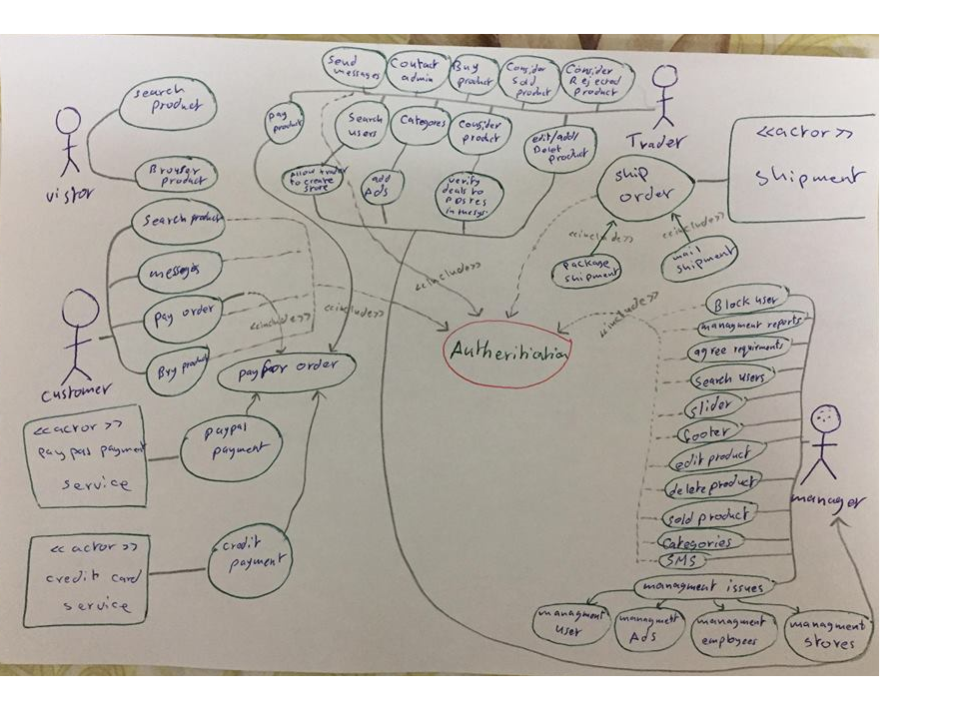

Owner of system package4.1.1 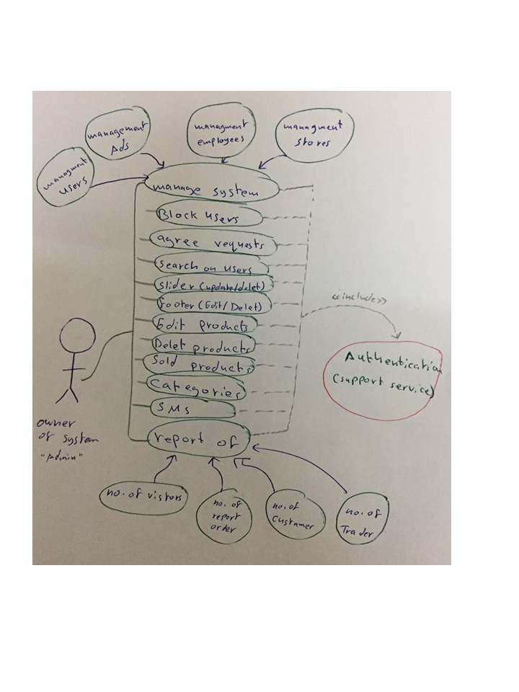

4.2 Class Diagram

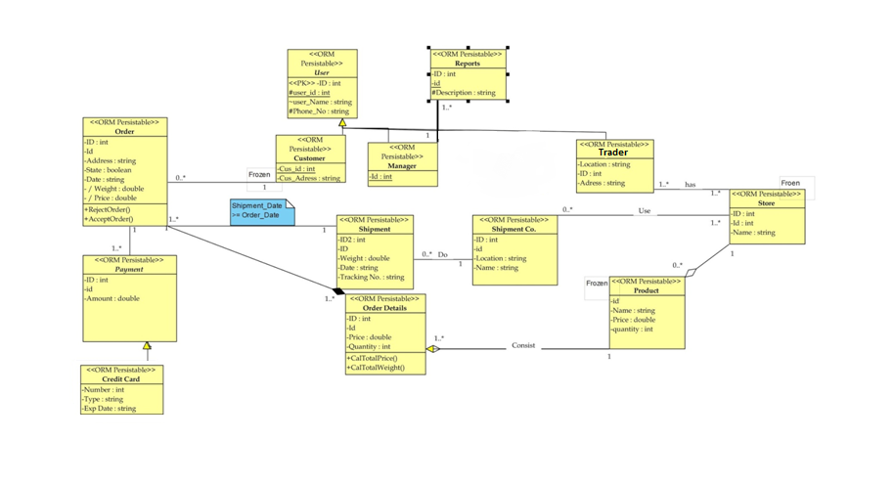

4.3 Sequence diagrams

4.3.1 Place Order

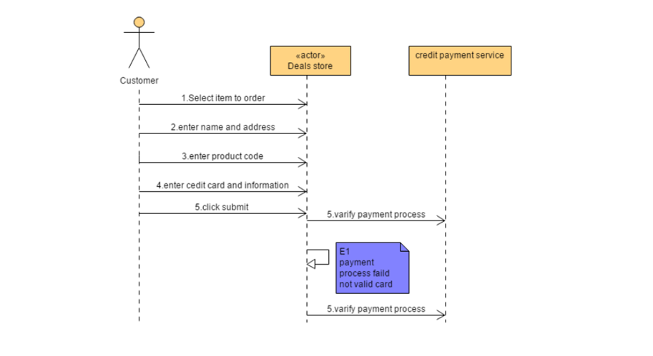

4.3.2 Ship order

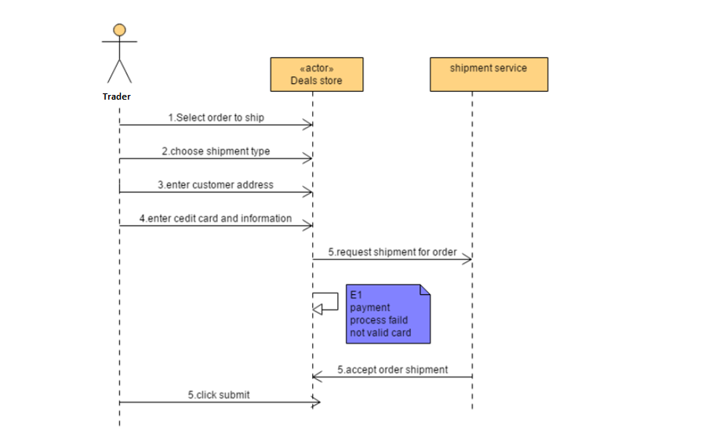

4.3.3 Add Store

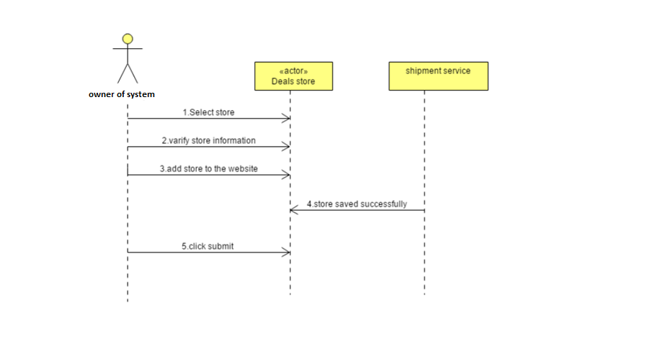

4.3.4 Search product

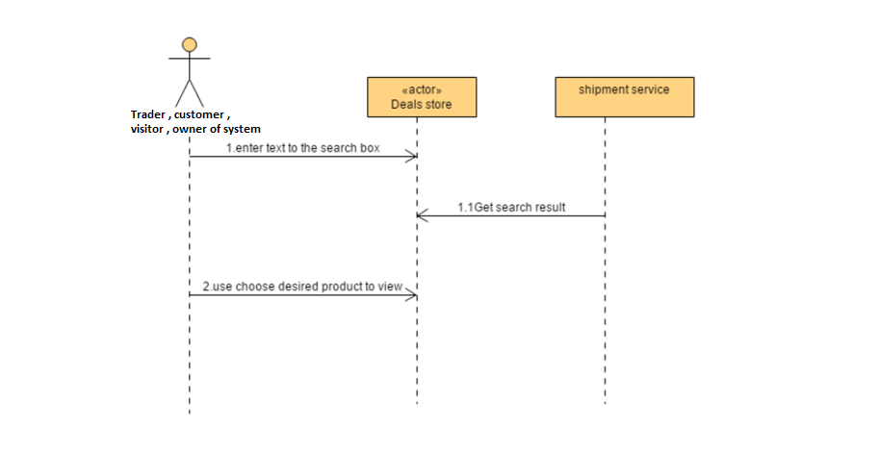

4.3.5 Add product

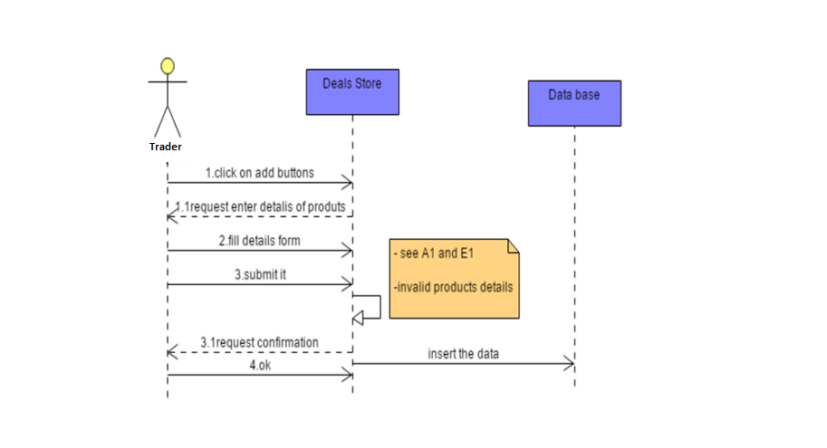

4.3.6 Edit product

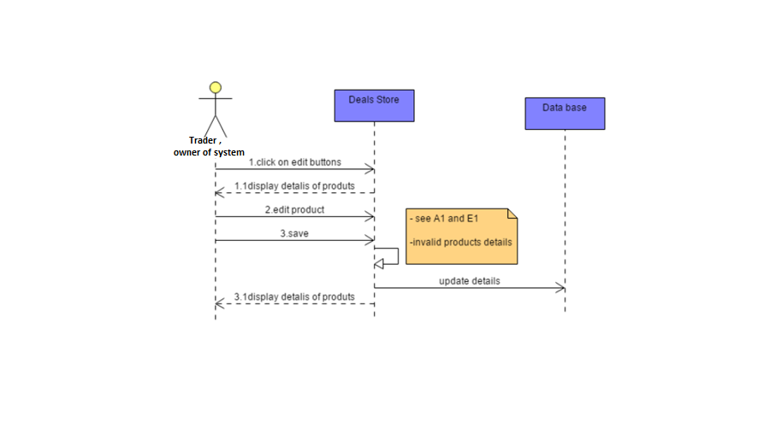

4.3.7 Send & receive messages

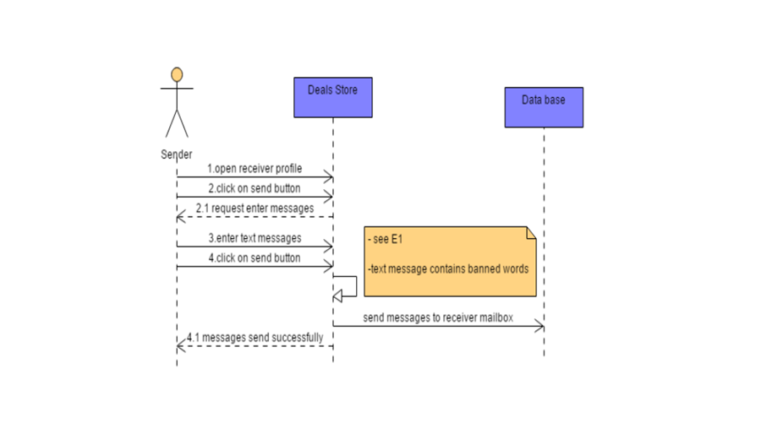

4.4 Activity diagrams

4.4.1 Add product

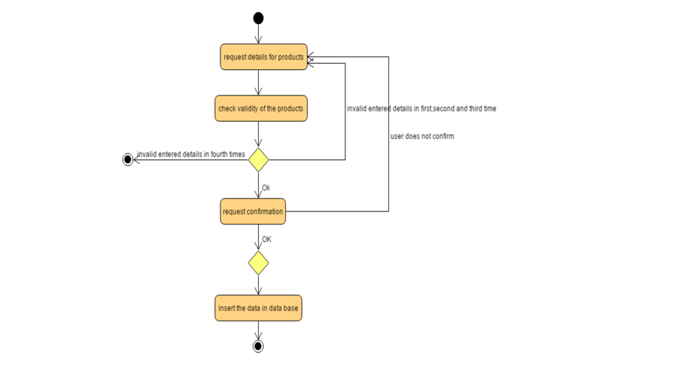

4.4.2 Send & receive messages

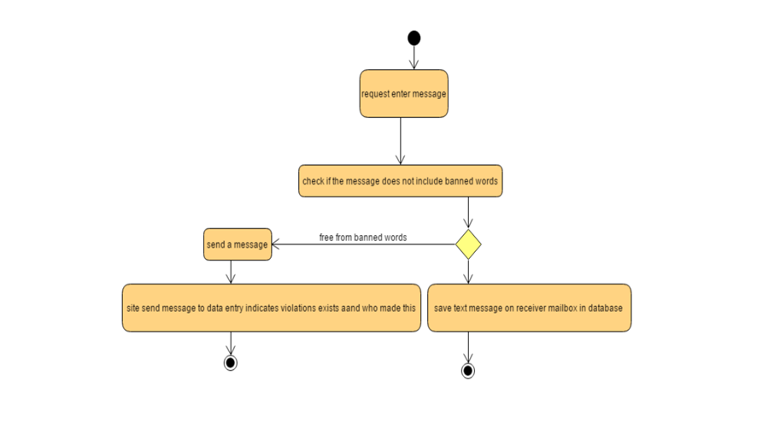

4.4.3 Edit product

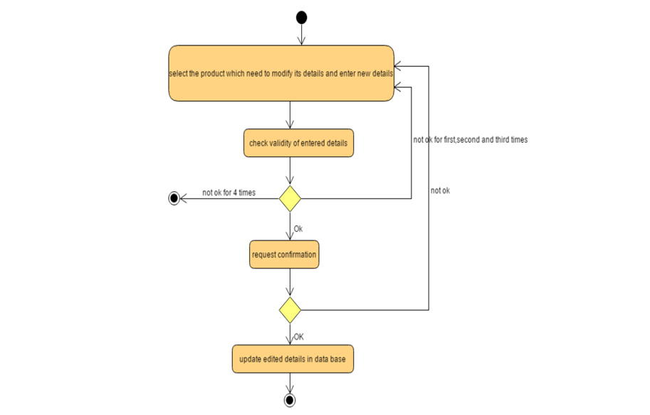

4.4.4 Searching product

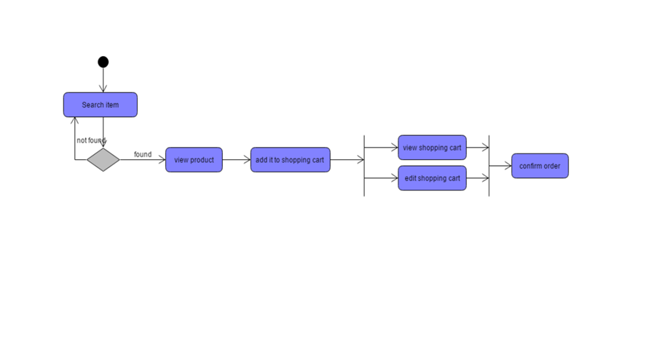

4.4.5 Add Stores

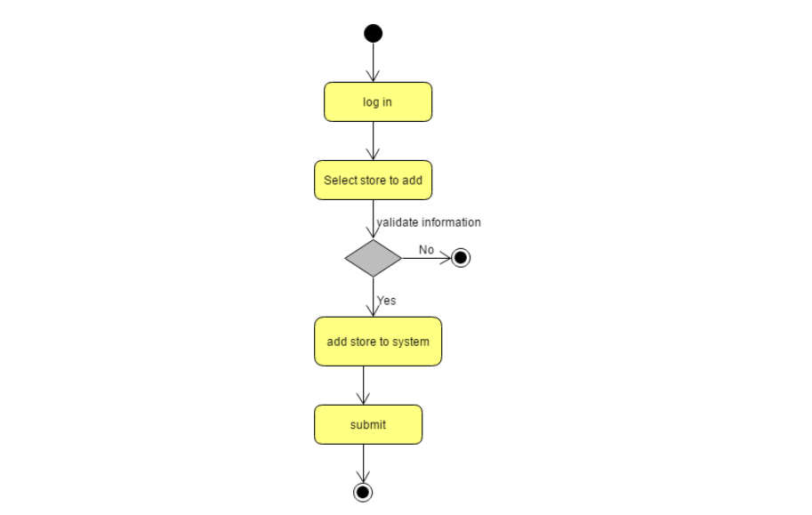

4.4.6 Ship orders

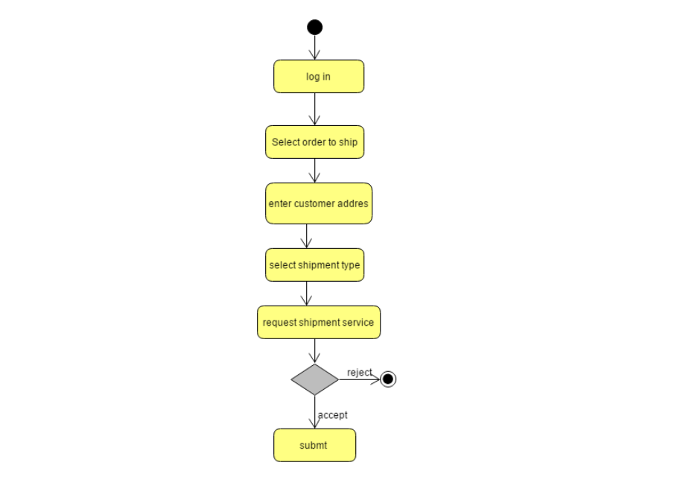

4.4.7 Order product

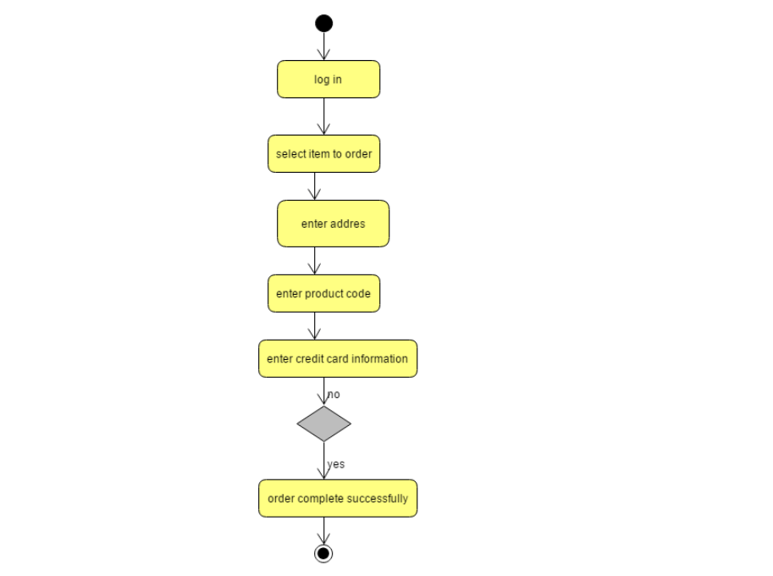

4.5 State Diagram

4.5.1 Payment state Diagram

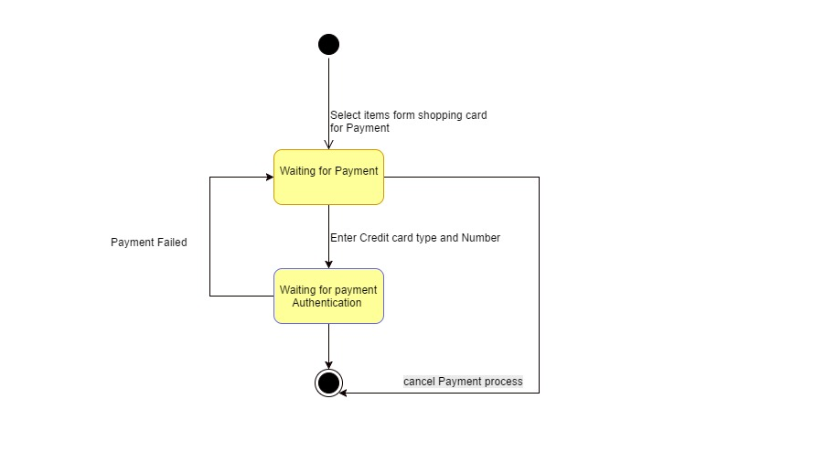

4.5.2 Shipment Diagram

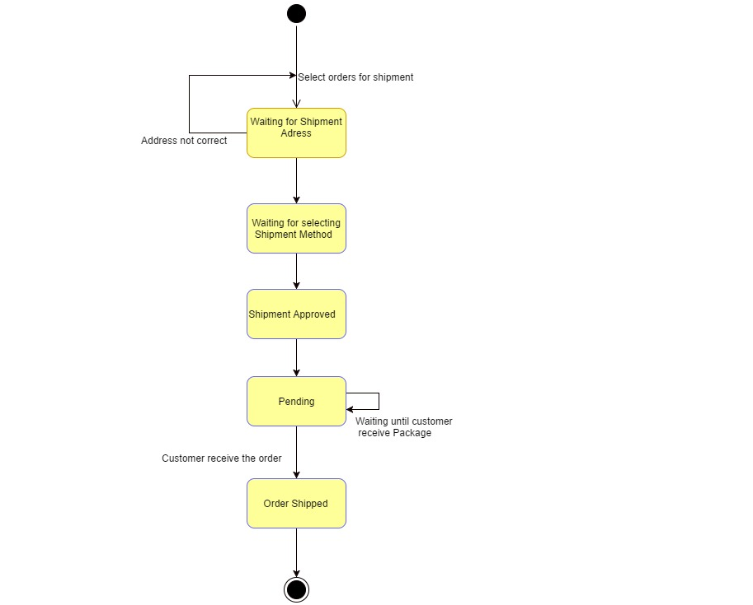

4.5.3 Order State Diagram

