
Faculty of Engineering and Information Technology
Materials and Science Engineering Department

Graduation Project 1

Green concrete production via waste iron powder carbonation
Prepared by:
Diala Saabneh
Mohammad Shadid

Supervised by: Prof. Hamdallah Bearat

Presented in partial fulfillment of requirements for Bachelor degree in Material and Science Engineering
Fall 2018
Table of Contents
Abstract ……………………………………………………
Introduction ………………………………………………1
Literature Review ………………………………………..2
Methodology …………………………...............................4
- Raw Materials………………………………….4
- Sample Preparation…………………………….5
- Experimental Procedures………………………9
- Reaction Setup ……………………………….12
- Carbonation Reaction Process ………………..12

Results & Discussion ………………………........................13
Conclusion ………………………………………………….18
Future Work ………………………………………………...19
References…………………………………………………..20

List of Figures
Figure 1 : Sample of Clay used before grinding ………………………….. 4
Figure 2: Electrical Grinder…………………………………………………5
Figure 3 : Steel Balls used in the Electrical Grinder………………………..6
Figure 4 : The set of Sieves………………………………………………….6
Figure 5 : Clay quantity after Sieving……………………………………….7
Figure 6 : : The Electrical Shaker…………………………………………...7
Figure 7 : The Electrical Mixer……………………………………………...8
Figure 8: One Sample after Molding………………………………………..9
Figure 9 : Mixture of Clay with several particle size ……………………...10
Figure 10 : Particle size of Glass used …………………………………….10
Figure 11 :Iron Fillings used in both samples …………………………..…11
Figure 12:Prticle size of sand used ………………………………………..11
Figure 13 : Carbonation Reaction at Static Conditions Setup ………….…13
Figure 14 : The Final Pressure of Co2 gas when reached 950 psi ………..14
Figure 15 : The pressure Drop ……………………………………………14
Figure 16 : The First Sample After Carbonation Reaction …………….....15
Figure 17 : The Flow-through based Carbonation reaction Setup ………..16
Figure 18: Flow Rate at Flow-through carbonation reaction ……………..17
Figure 19 : The Second Sample after Carbonation reaction …………..…17

Abstract

This project is prepared as a graduation project in material science and engineering. The project focused on producing a new environmentally friendly concrete. The new product formed by carbonation of iron waste (in form of powder or filings) with addition of sand, clay, glass and slaked lime and presence of water. Iron powder and filings are abundant industrial waste. The main benefit of the product presented in disposing iron filings and glass wastes and the use of CO₂ gas as a carbonation reaction medium which aims to reduce its emissions in the atmosphere. The production of ordinary Portland cement is responsible to over 5% of all CO₂ emissions. In this case, the project would avoid the amount of CO₂ produced in the conventional cement and further absorbing extra amount of CO₂ and subsequently reducing the CO₂ emissions. The reaction is done in a high pressure reactor system. It allows for high pressure or flow through conditions. Optimization of different parameters (P_{CO2}, temperature, time, particle size, flow rate, pH, and mortar chemistry and mineralogy) controlling the carbonation process shall be pursued. These parameters will affect the rate and extent of carbonation as well as the properties of the product. Mechanical and chemical testing of products should be done. In the first chapter of this project, two samples were prepared and tested. The first sample was placed under static pressure condition. The sample crumbled after the experiment. The second was placed under flow through condition. It shows that a reaction occurred; this was manifest by an increase in sample volume. Further characterization shall be done with both XRD and SEM/EDX to determine if iron had carbonated and what form of mineral phases appeared in the sample.

- Introduction
This project studies the ability of producing iron-based green cement using iron filings waste feedstock by carbonation process. Iron filings found in large amount in the area of several iron and steel processing industries. It forms an environmental issue and economic loss that should be solved. The selection of iron filing as a main feedstock in this study to reduce it as a non-disposable solid waste(Dobleand Kumar 2005)."Non disposable solid waste is one of the most active research areas nowadays as one of the pollutants that has large impact on environment and ecosystem". Specifically, this project focuses on studying the reaction mechanism between the feedstock, especially iron filling waste, and CO₂ gas in the carbonation process to form iron carbonate(FeCO₃) that will act as the cement in the new green concrete. The selection of the carbonation approach as the main reaction process is to exploit CO₂ gas in good way(Brown 2017)."CO₂ is considered as the main greenhouse gas and contributor to global warming, which leads to increase the atmospheric and oceanic temperature, rising sea level and intensifying number of weather events due to heat and IR radiation capturing.". Due to the huge industrial sector and energy consumption the concentration of CO₂ increases by 2 ppm every year". Meanwhile, cement is all around us.(Uwasu andYabar 2014)" The world produced over 3.6 billion tons of cement in the last few years and the amount could increase to 4.6 billion tones by 2050. Cement is inexpensive, pourable but it’s dirty because production process of ordinary Portland cement contributes over 5% of the total CO₂ emission." The key ingredient of cement is limestone which releases CO₂ to atmosphere when heated. Therefore, cements dirtiness looms as one of the major downside of globalization. Depending on this, the ultimate goal of this project is to produce a green cement by using two environmental burdens as input materials. Thus, use “two bad products” to produce “one good one”. Furthermore, this project will focus on the reaction process and the parameters that will affect it such as CO₂ pressure , time, temperature, particle size, and type of aggregate. In this case the product must be tested. This will include mechanical strength (compressive, tensile, water absorption, thermal conductivity). Chemical and phase analyses will be done using SEM/EDX and XRD.

Literature Review

Dri et al. (2014)They studied the effect of solid to liquid ratio on the efficiency and characterization of carbonated metal waste, they used XRF, XRD and SEM–EDS analytical techniques to define the phases present in carbonated waste uses. For the materials investigated (blast furnace slag (GGBS), phosphorus slag (PS) and steel slag (SS)), the carbonation efficiency increased when the S/L ratio decreased (from 50 g/L to 25 g/L and then 15 g/L) because of the dilution effect.

Das et al .(2014), The study explored the possibility of carbonating waste iron powder to use it as a binder for concrete . Under controlled conditions the iron powder would react with the CO2 forming iron carbonates which have binding capabilities ,Mechanical properties as compressive and flexural strength of the iron-based binder system increased with carbonation . The method of mineral route of carbonation where the mined mineral rocks are the feed stock through which CO2 passed on is one of the promising routes to reduce the amount of CO2 and making a carbonated mineral which may be used with a suitable binder in construction . In order to get benefits through (i) consumption and trapping of CO2 , (ii) reducing the overall ordinary Portland cement production which is a significant emitter of greenhouse gases . The study also provides the influence of curing regime for the mechanical properties of this binder system .Characterization of the reaction products were carried out with the thermogravemetric analysis . Experimentally , the starting materials were obtained with defined composition and particle size. The distribution of particle size of the starting materials including iron powder, fly ash, metakaolin, limestone powder and OPC obtained from laser diffraction-based particle size analyzer followed by mixing procedure and sample preparation with determination of desirable mixture proportions and curing procedure including compressive and flexural strength tests . TGA assessed the influence of CO2 penetration on the degree of reaction . The components of the whole binder system provided acceptable properties for several applications.
Neithalath et al. (2014) they studied the effect of source materials and curing conditions on mechanical properties of a unique binder system that utilizes the carbonation of metallic iron powder for cementation properties .They found that waste iron powder in conjunction with commonly used concrete components, can be carbonated to produce a binding material with good properties for a wide range of construction material.

( Jeong , Young &Takafumi , 2015 From a review of available literature , it was found that the most problem the steel reinforced concrete faces is corrosion of steel bars embedded in concrete . Although there are many protection ways to prevent corrosion ,however , each has a weakness point that makes it at some point ineffective specially under environmental chemical factors . A study of pore blocker mechanism determined that the use of micro-sized iron powder as a pore blocker has a potential effect on the prevention of ingress of harmful ionic species into cementitious materials . Experimentally materials used were Portland cement , river sand and iron powder , they chose the amount of iron powder relating to the critical threshold value of the maximum porosity required for preventing corrosion . This content of iron powder selected was sufficient in reducing the volume of pores in the concrete samples of that study .Samples preparation started with embedding steel reinforcing bars in a mortar sealed and cured , relocated in chambers for carbonation and corrosion testing . The porosity of morter , depth of carbonation , corrosion area , weight loss of the rebar all were measured and EMPA used for scanning images . This study found that partial replacement with iron powder of DR type that is the most helpful with carbonation significantly prevented the corrosion of rebars as it reduced the porosity and so the penetration of harmful ionic species.

SitiNorhanaSelamatet.al( 2017)
In malaysia the steel industry is estimated at750 tons every day, so there is around 7.5 ton of slag produced every day. So they studied the mineral CO2 sequestration of the steel slag due to its impact on environment. For this purpose they use the mechanical milling process as a form of mechanical activation rout. In this process the solid slag become powder, they chose specimen with low content of oxygen. They extracted Fe, Ni, Pb, Sn and Cu from the slag as powder. Then they took Fe powder and find that the CO2 absorption was upgraded by 25 time higher than the specimen that without grinding process.

Methodology
Raw material :
- Iron filings waste.
  - The role of iron filings waste was to act as the cementious material that will be carbonated giving the iron carbonate FeCO3 .

- Sand.
  - The aggregate that provides strength for the product .

- Glass waste.
  - The aggregate that provides strength for the product.
- Clay.
  - The role of clay is to act as a binder and giving the plasticity .

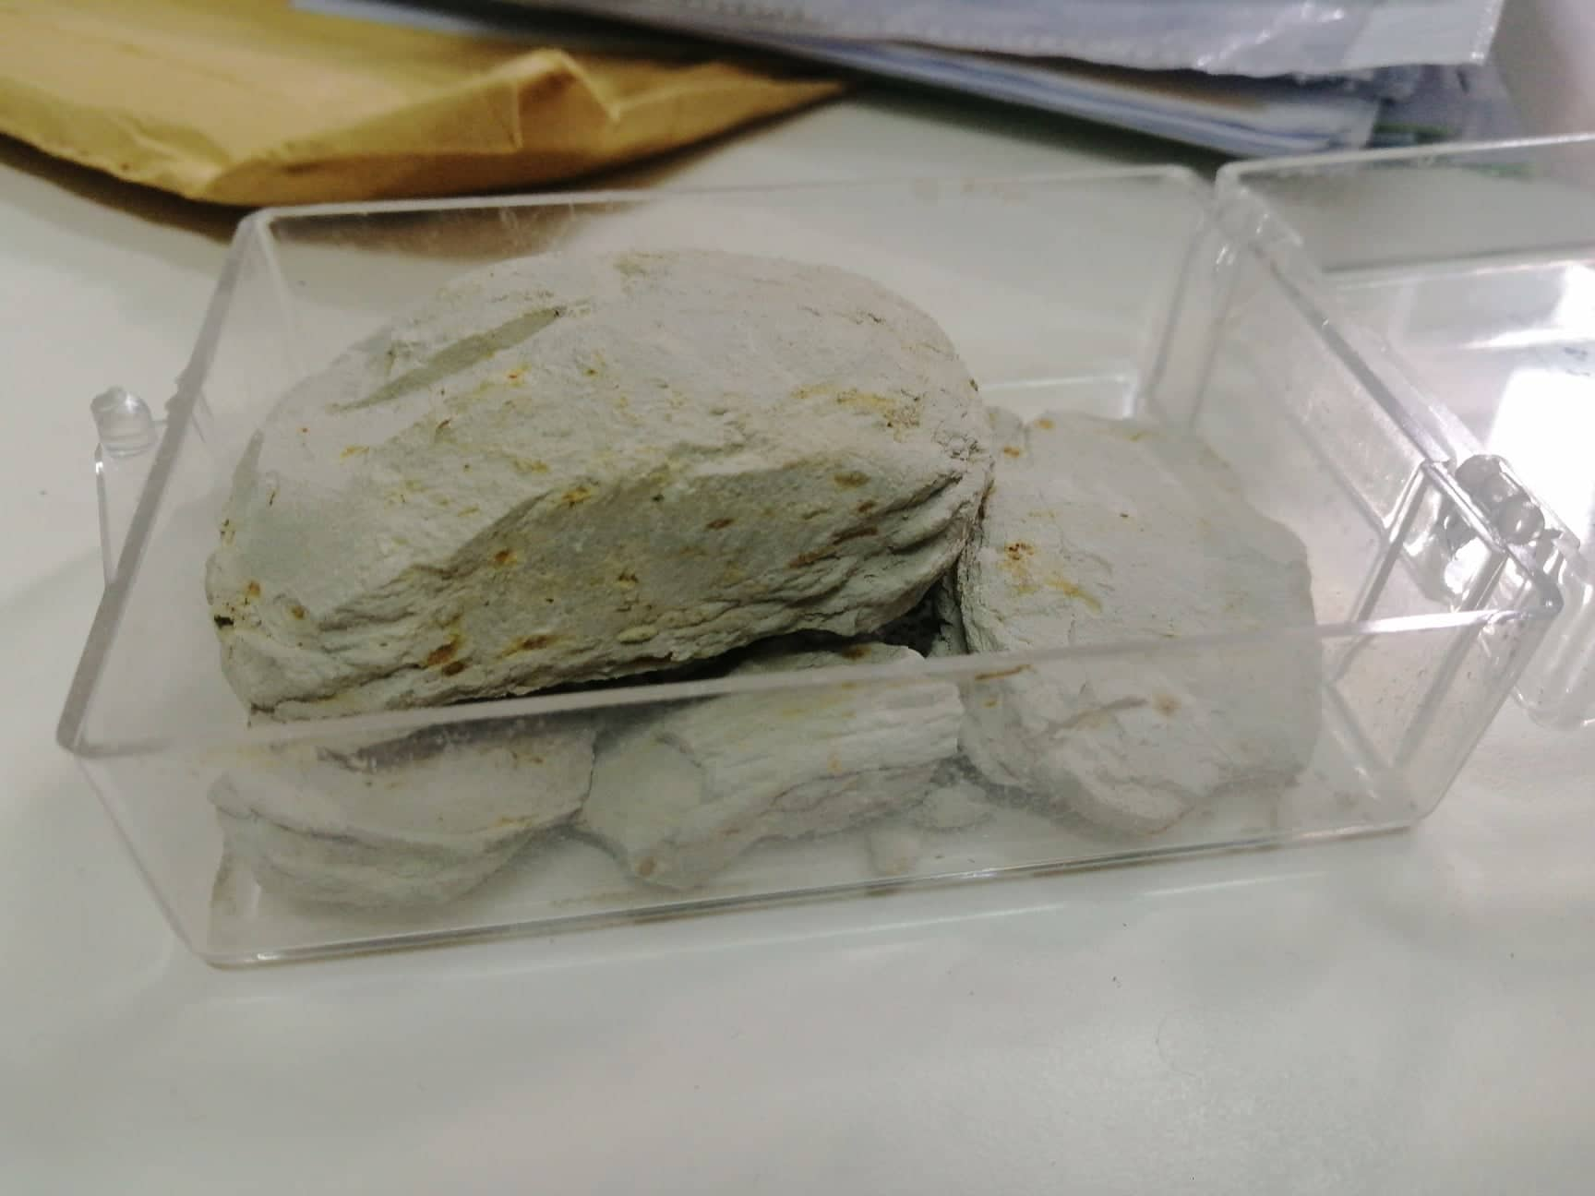Figure 1. Sample of clay used before grinding .

- Slaked lime (Ca(OH)2).
  - Used to prevent oxidation of iron .
- Carbon dioxide (CO2).
  - The main carbonation reaction medium .
- Water.
  - Water is to combine the ingredients .

Sample preparation
Sample preparation includes many steps, sieving, grinding(crushing), corrosion protection, mixing and molding.

Grinding (use milling): is a method used to reduce the particle size of several material, it’s done by putting the material in a ball mill , and then it rotates electrically for several time periods depending on the material nature, quantity and number of balls. That results in reduction of the particle size. In this project a crusher was used in the Civil Engineering Department (Figure1) to reduce the particle size of glass and clay. For glass 10 balls used for 41 minutes as a rotation time, and for clay also 10 balls used but for 35 minutes. Fig (2)

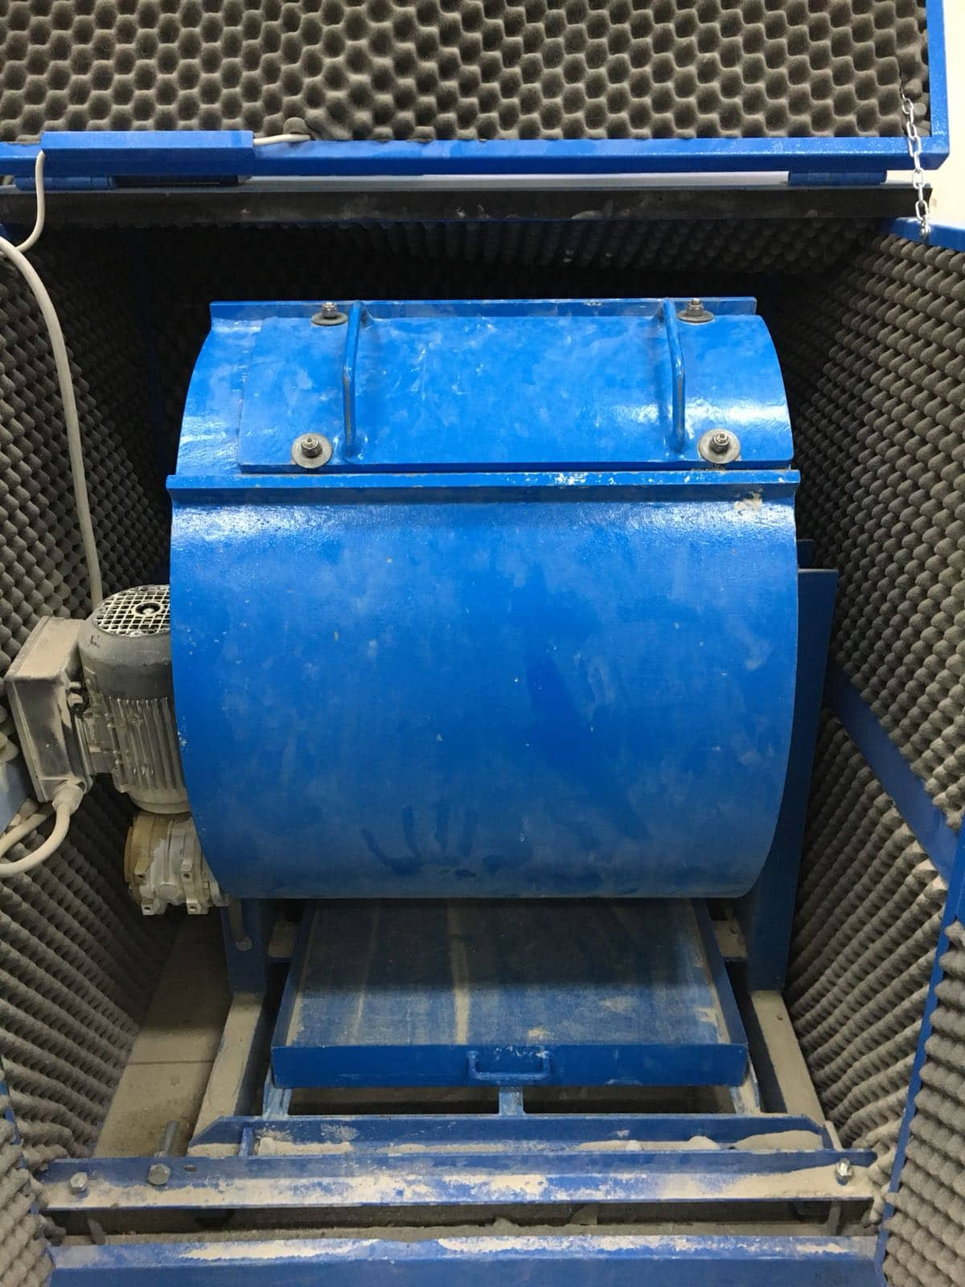
Figure2. Electrical Grinder .

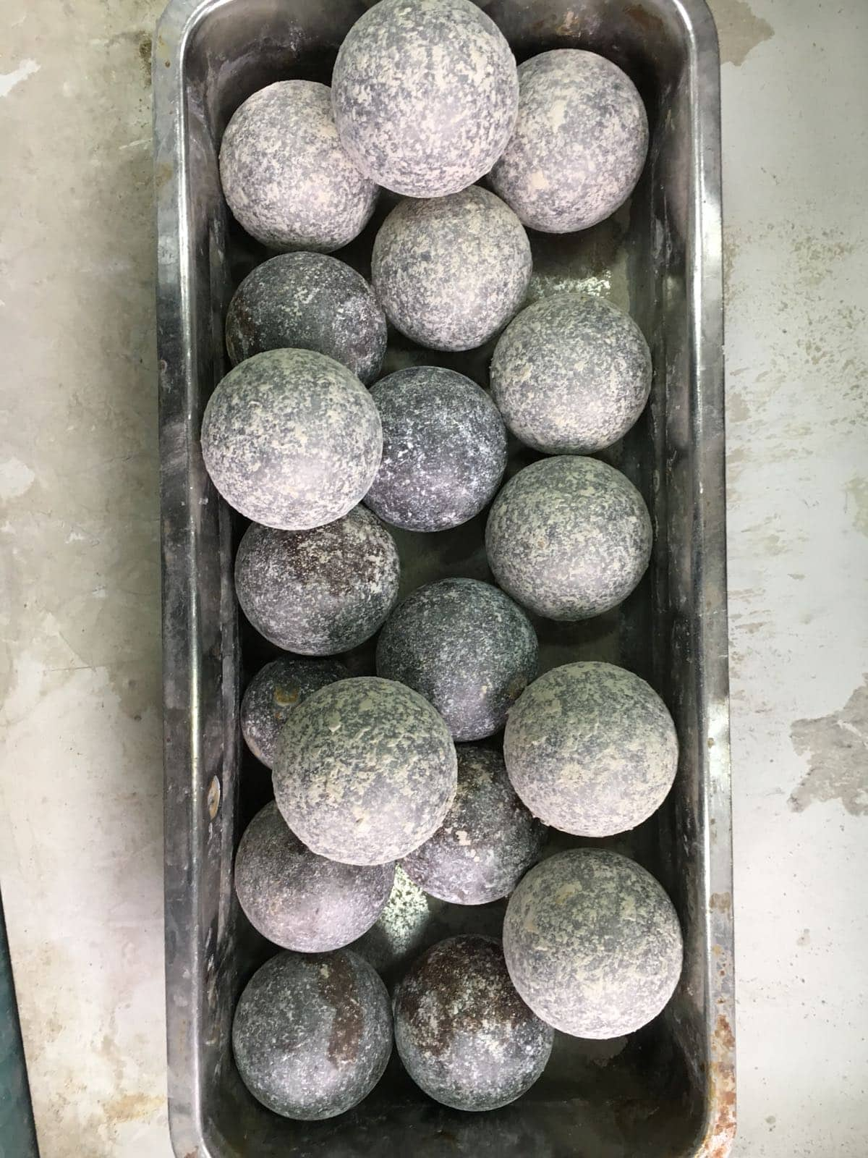
Figure 3. Steel Balls used in the electrical grinder .

Sieving: is the process where the materials is separated into different size levels by using set of sieves Fig (4). In this project sieving was used to separate sand, clay and glass particle size. The size levels resulted ranges between 4.75 mm and 75 micron.

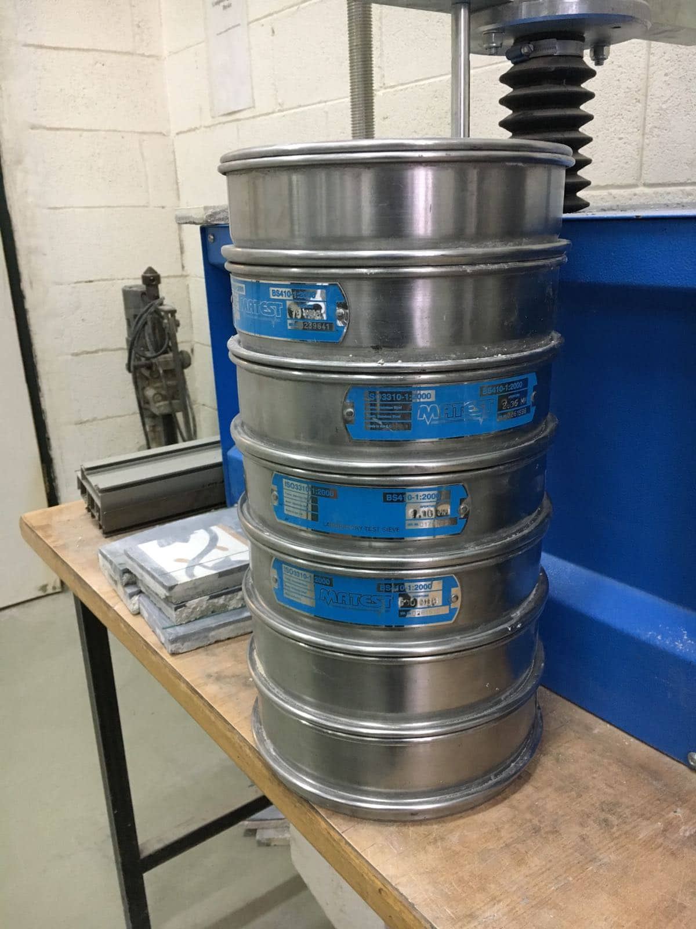
Figure 4. The set of sieves used with mesh size ranges between 4.75mm and 75 micron.
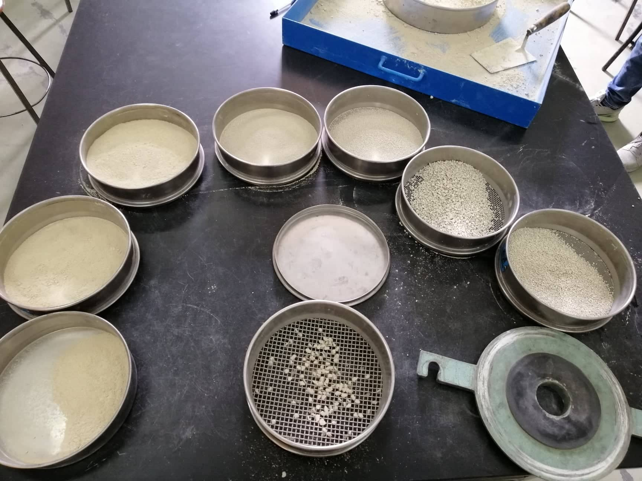
Figure 5. Clay quantity after sieving .

The electrical shaker used to enhance sieving process . The set of sieves are placed on the shaker by order containing the material , They are electrically shacked separating the material to several particle sizes . This process saved time and provided the potential of more accurate sieving Fig (6).
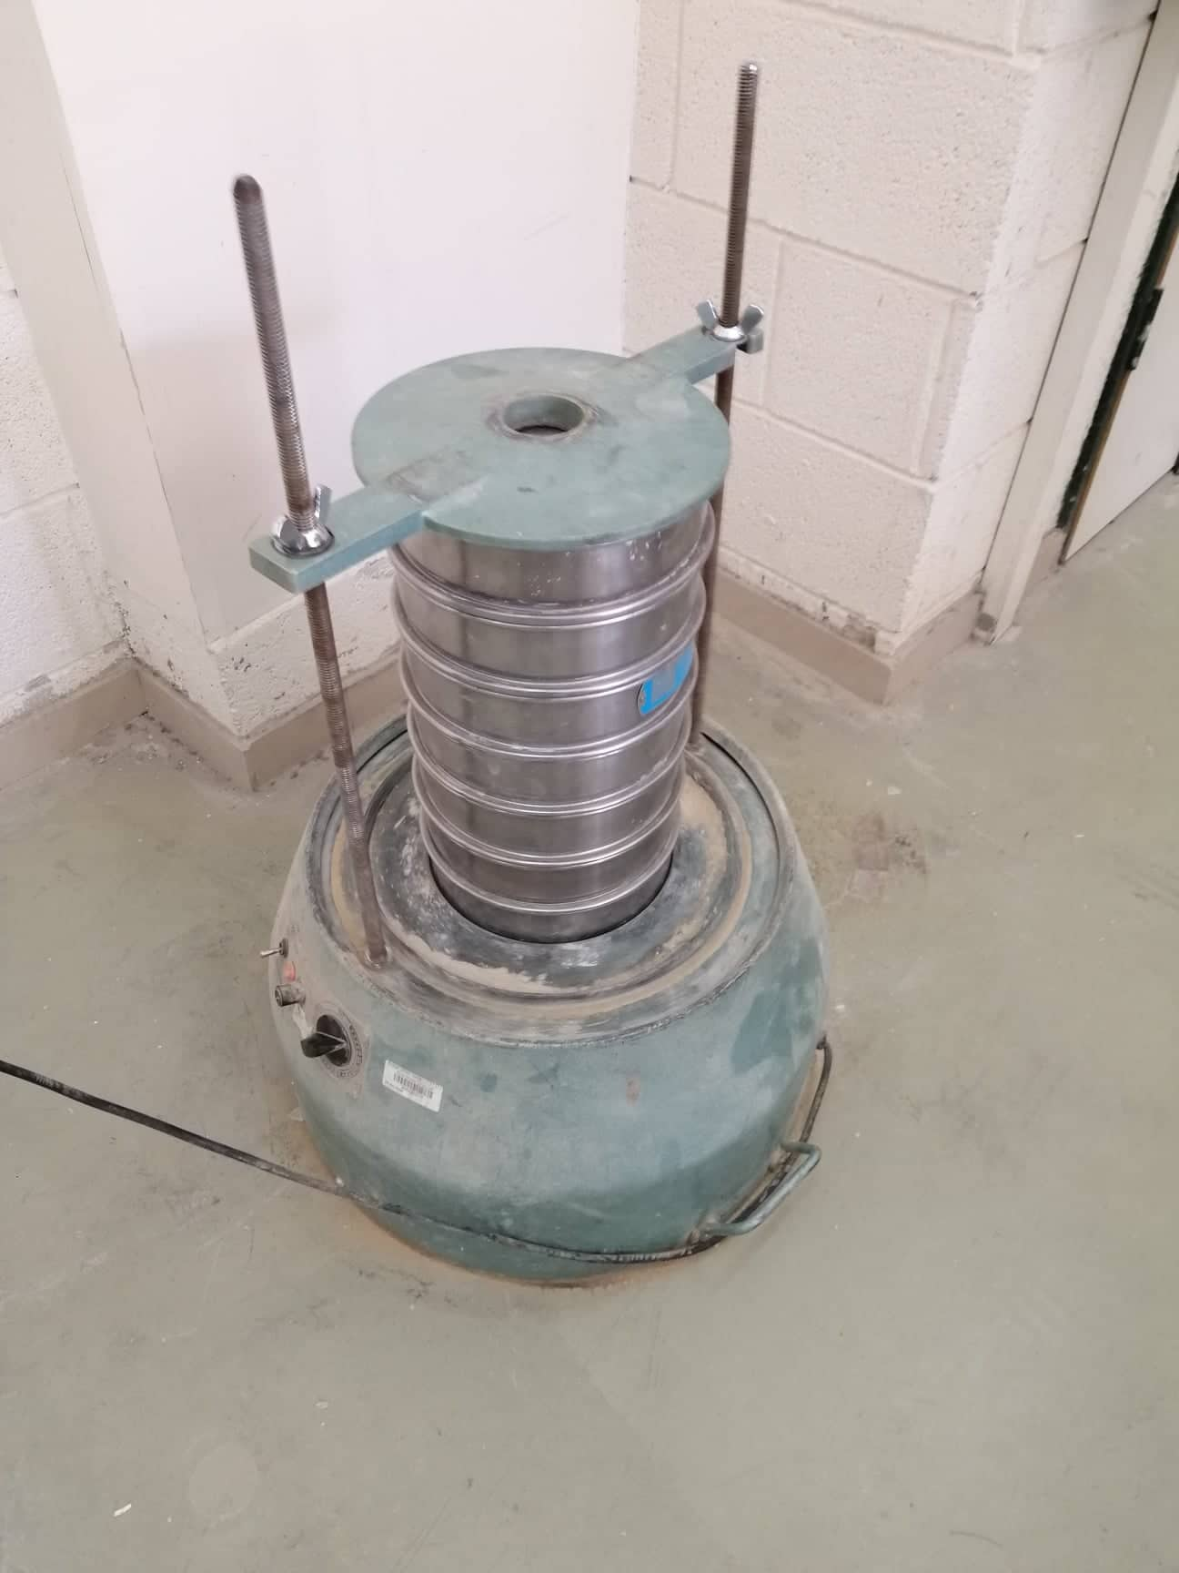
Figure 6. The electrical shaker .

Corrosion protection: is mainly used to protect the iron filings from corrosion just before it mixed with the other ingredients. In this case iron filing was placed into acetone(CH₃COCH₃) just after taking it from its source.

Mixing: is the process where ingredients of such product are mixed at uniform speed by using electrical mixer to produce a homogenous mix. In this project the iron filing, sand, glass and clay was mixed with presence of water, then the sample was ready to be molded to its desired final shape Fig (7).

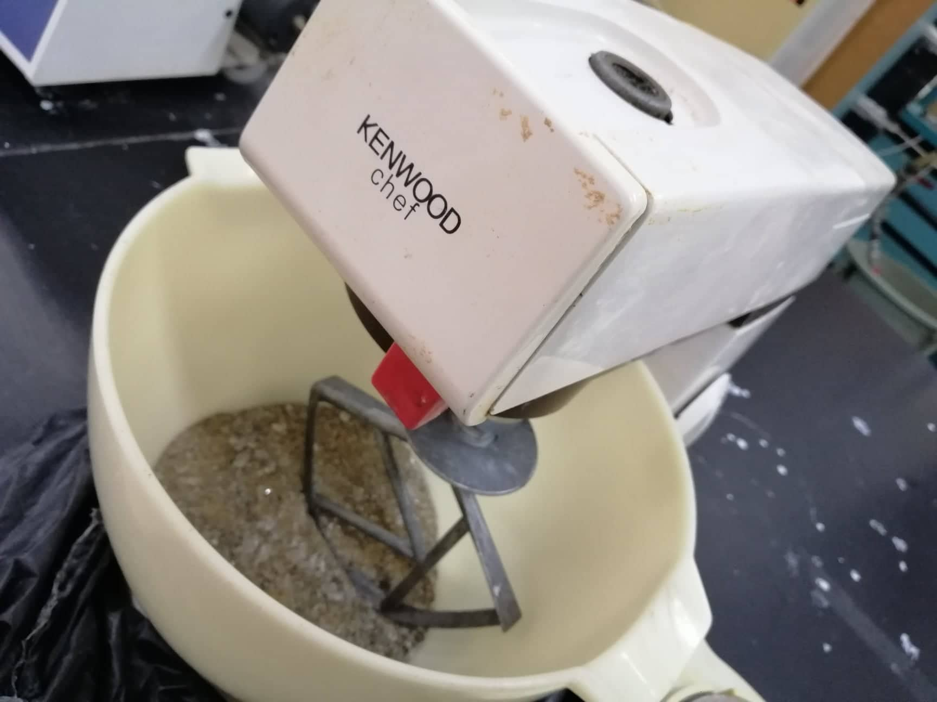
Figure 7.The electrical mixer .

Molding: is the process where the sample is prepared to the desired shape using a mold. In our project a double open-ended cylindrical mold was used Fig (8).

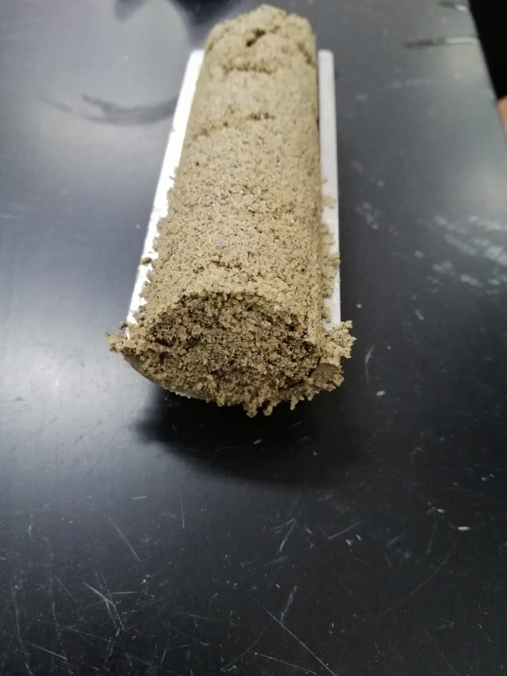
Figure 8. One sample after molding.
After these steps are done the sample was ready to be studied at different reaction conditions.

Experimental procedures
Raw materials of the first sample were iron filings, sand, glass, clay, water and carbon dioxide each with specific particle size and weight. The total weight of the sample was 1000g. Iron fillings were in random particle size and .4wt% . Sand particle size was separated to two portions, one is less than 300 microns and the other was less than 600 microns and .3wt% in total. Particle size of glass was on three portions, one was less than 1.18 mm, the others were less than 2.36mm and less than 4.75mm with total wt% of .25. Particle size of clay ranges between less than 600microns and less than 75microns with .05 wt% in total. Water used was 200 ml in volume.
The second sample prepared consisted of the same raw material of the first sample with addition of slurry solution of slaked lime Ca(OH)2 ( 50g slaked lime and 300 ml water with 1:6 solid to liquid ratio). Iron fillings was also with random particle size and .4wt%. Particle size of the sand was on two portions, one was less than 300microns and the other was less than 600microns with .3wt% in total. Particle size of glass was less than 600microns with .2wt% . Particle size of clay ranges between less than 600microns and less than 75microns with .1wt% . The total weight of the second sample also was 1000g.

The following figures materials used in both samples showing the particle size for each :
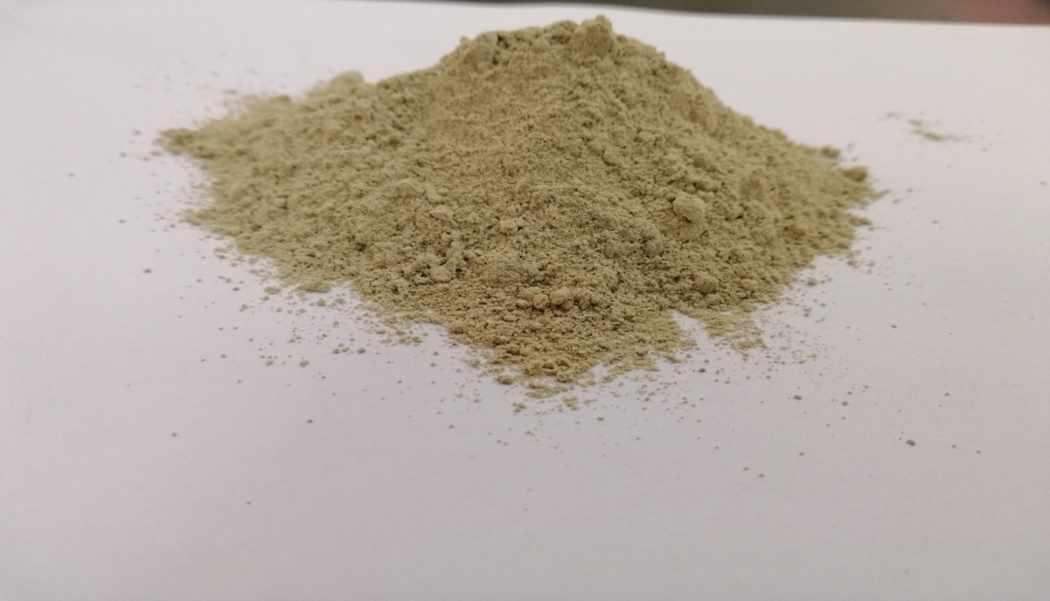Figure9.Mixture of clay with several particle size .
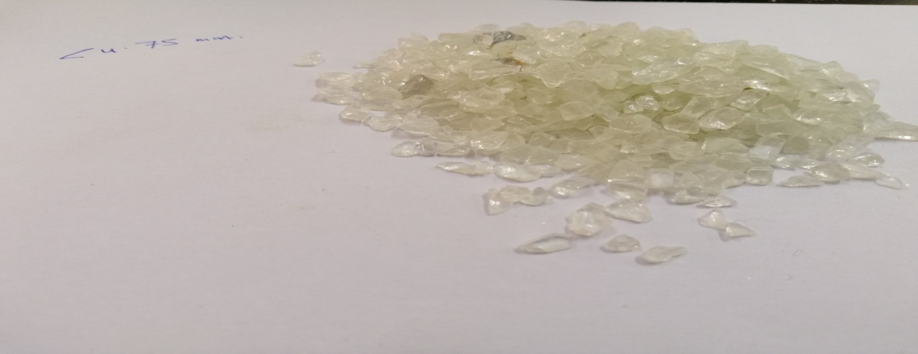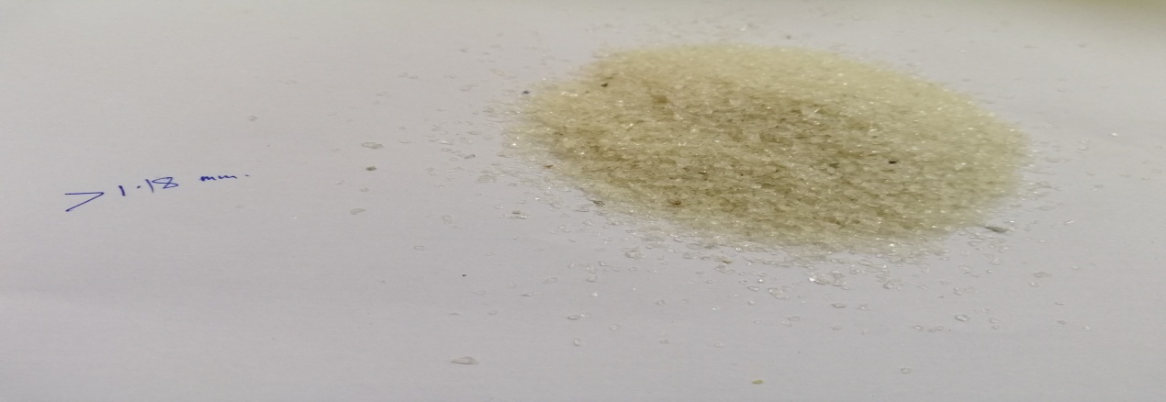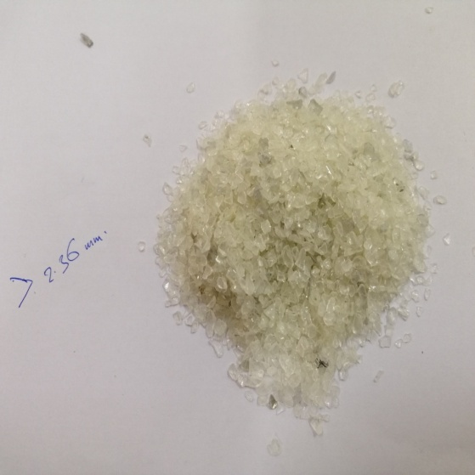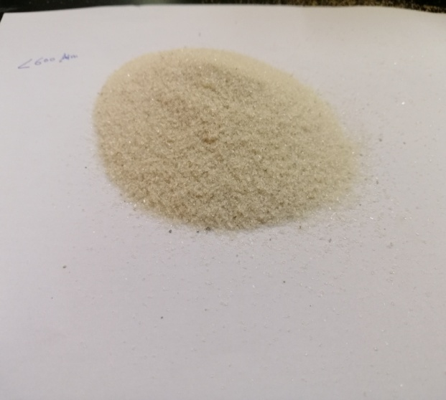Figure 10: Particle Size of galss used .
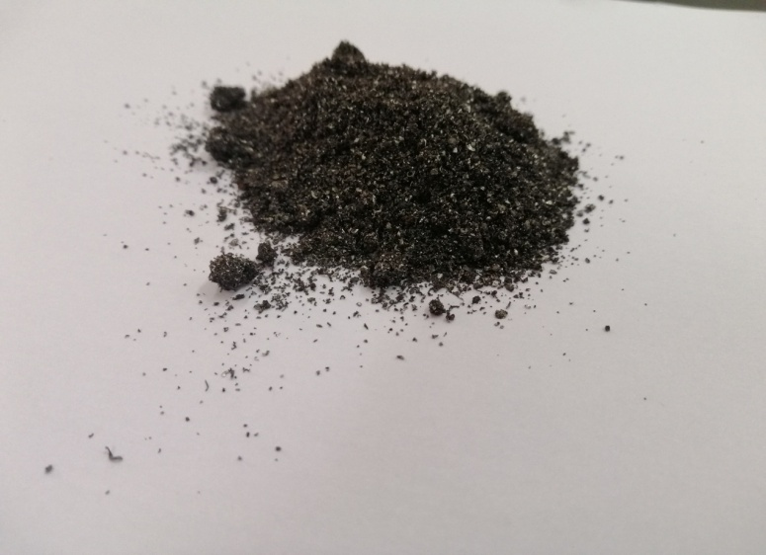
Figure11 : Iron Filings used in both sampels .
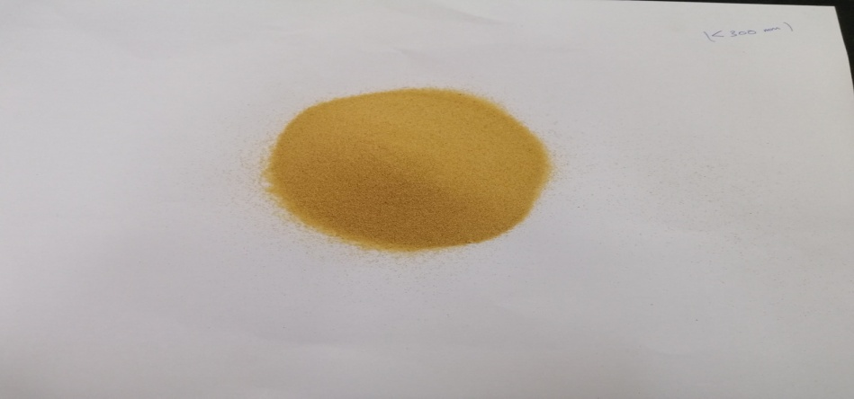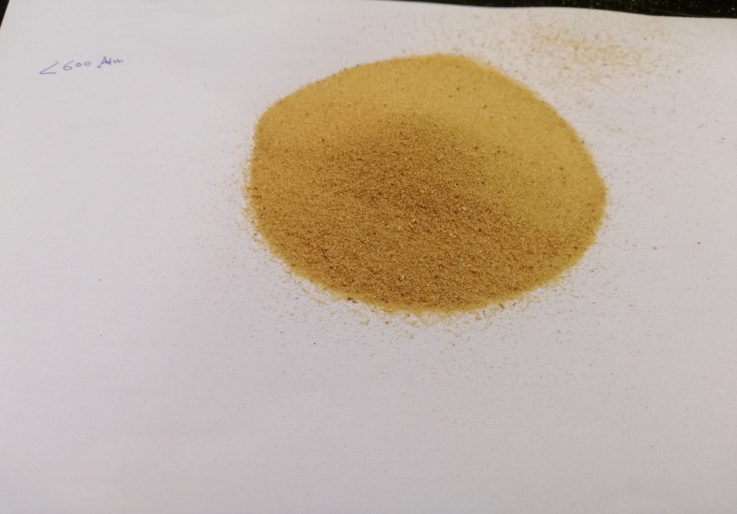
Figure12 : Particle Size of sand used.

Reaction Setup
The carbonation process happened in high pressure/high temperature reactor. This rector is the equipment where the desired conditions of the carbonation reaction are adjusted. It is a double-ended reactor made of 316L stainless steel with specific dimensions (diameter is 31.75 mm, length is 177.8 mm, minimum wall thickness is 6.1mm and internal volume of 150 cm³ ) with pressure rating of 5000bar . this reactor is designed to proceed under either static or flow-through conditions.

Carbonation Reaction Process
After sample preparation steps ( grinding , sieving , mixing and molding ) , the following step was the carbonation reaction . the reactor connected to Co2 gas cylinder , pressure gauge , inlet and outlet valves . The first sample left in the mold and placed in the reactor under static pressure conditions of 950 psi for one hour. Before that , The outlet valve remain locked to allow filling the reactor by Co2 gas , the pressure stopped increasing after it reached 950 psi (65 bar) then the inlet valve was locked . The second sample also left in the mold and placed in the reactor under flow-through conditions where the flow rate was 20 L/min for one hour . That was after the reactor connected to the Co2 gas cylinder , flow gauge , outlet and inlet valves that remained opened . The connections are shown in figures below in the results .

Results and Discussion
Two samples were prepared and inserted in the carbonation reaction setup. The first sample is placed under static pressure condition where, the CO2 pressure inside the reactor was 950 psi for one hour , after one hour the pressure dropped to 300 psi . It was supposed that sample will be carbonated and become stronger with brown color due to the presence of iron carbonate. In fact, the sample after one hour became crumbled and inconsistent. It was assumed that the decay on sample strength due to the large particle size of glass used and the formation of iron oxide which made a barrier that prevented the formation of iron carbonate. Also , it was found that the drop in pressure value from 950 psi to 300 psi was due to a leak happened in the reactor . As a result , the conditions have changed and the sample carbonation reaction didn’t happened well . That explain why the sample became crumbled and its strength decreased . This sample isn’t considered successful or suitable to be studied .The following figures shows the first carbonation setup and the sample after the reaction respectively :

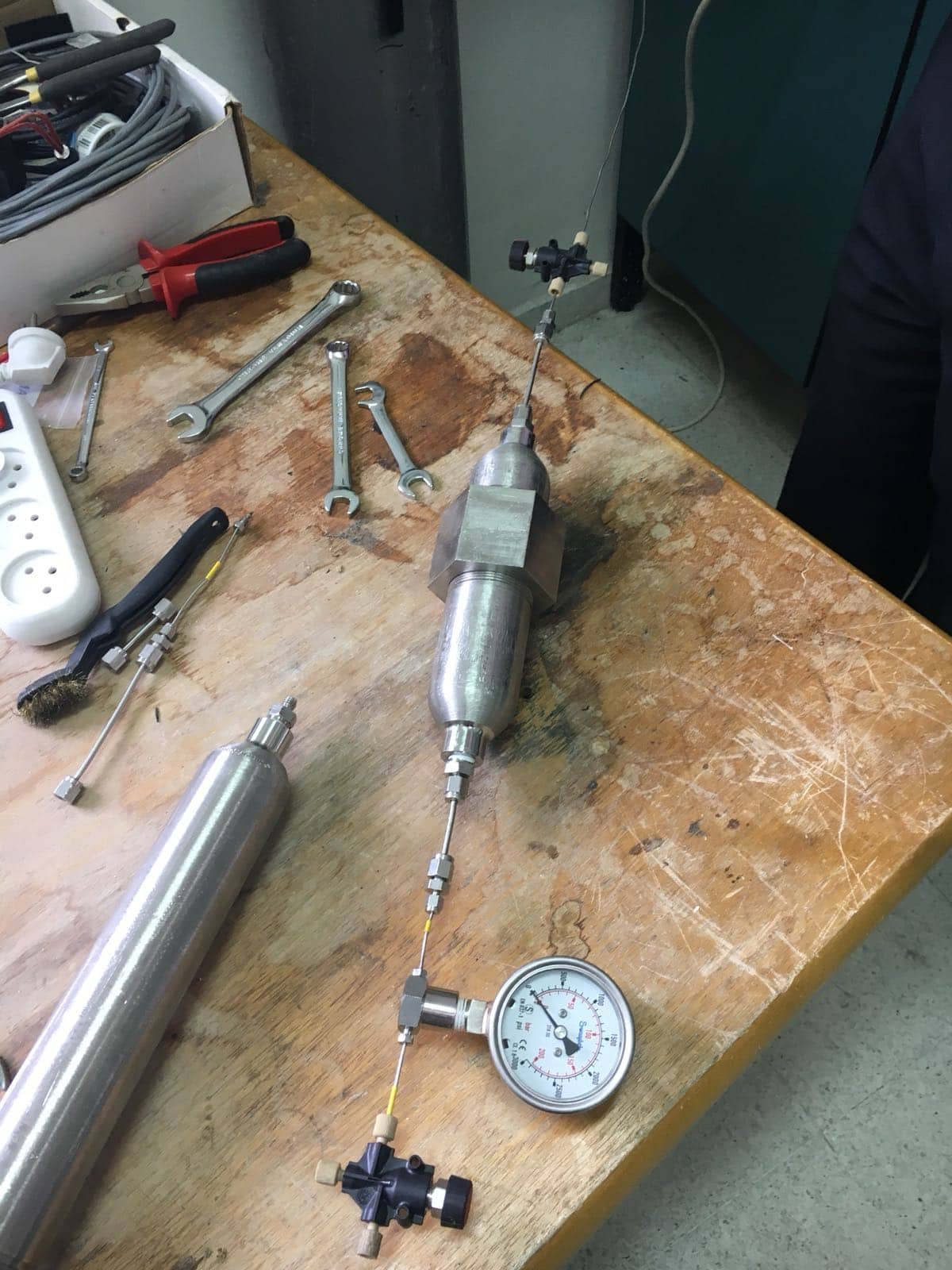
Figure 13. Carbonation Reaction at static conditions setup .

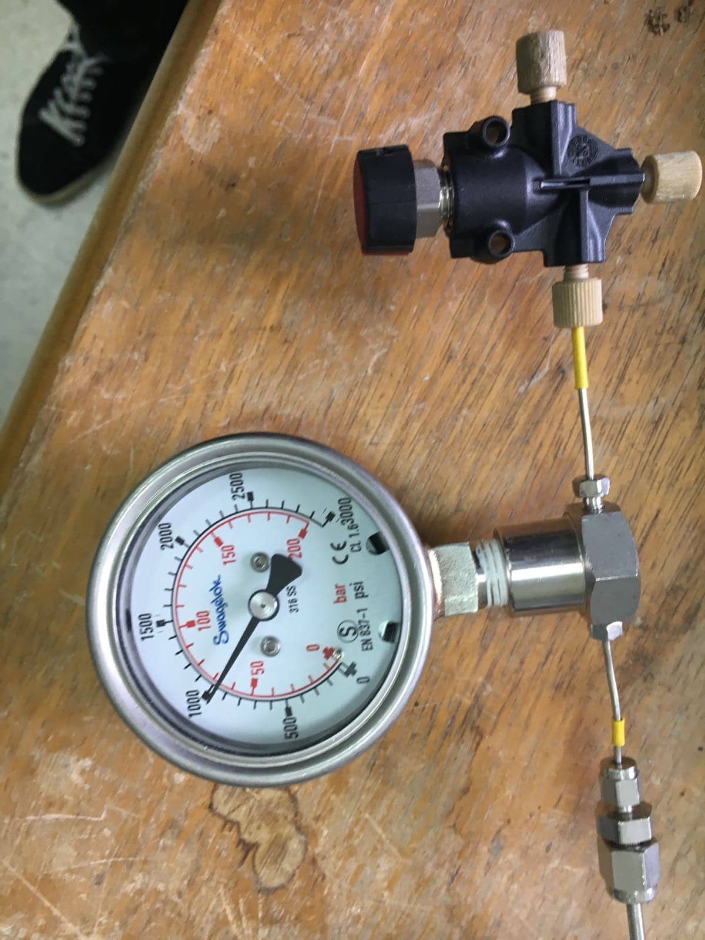
Figure 14. The final pressure of CO2 gas when reached 950 psi .

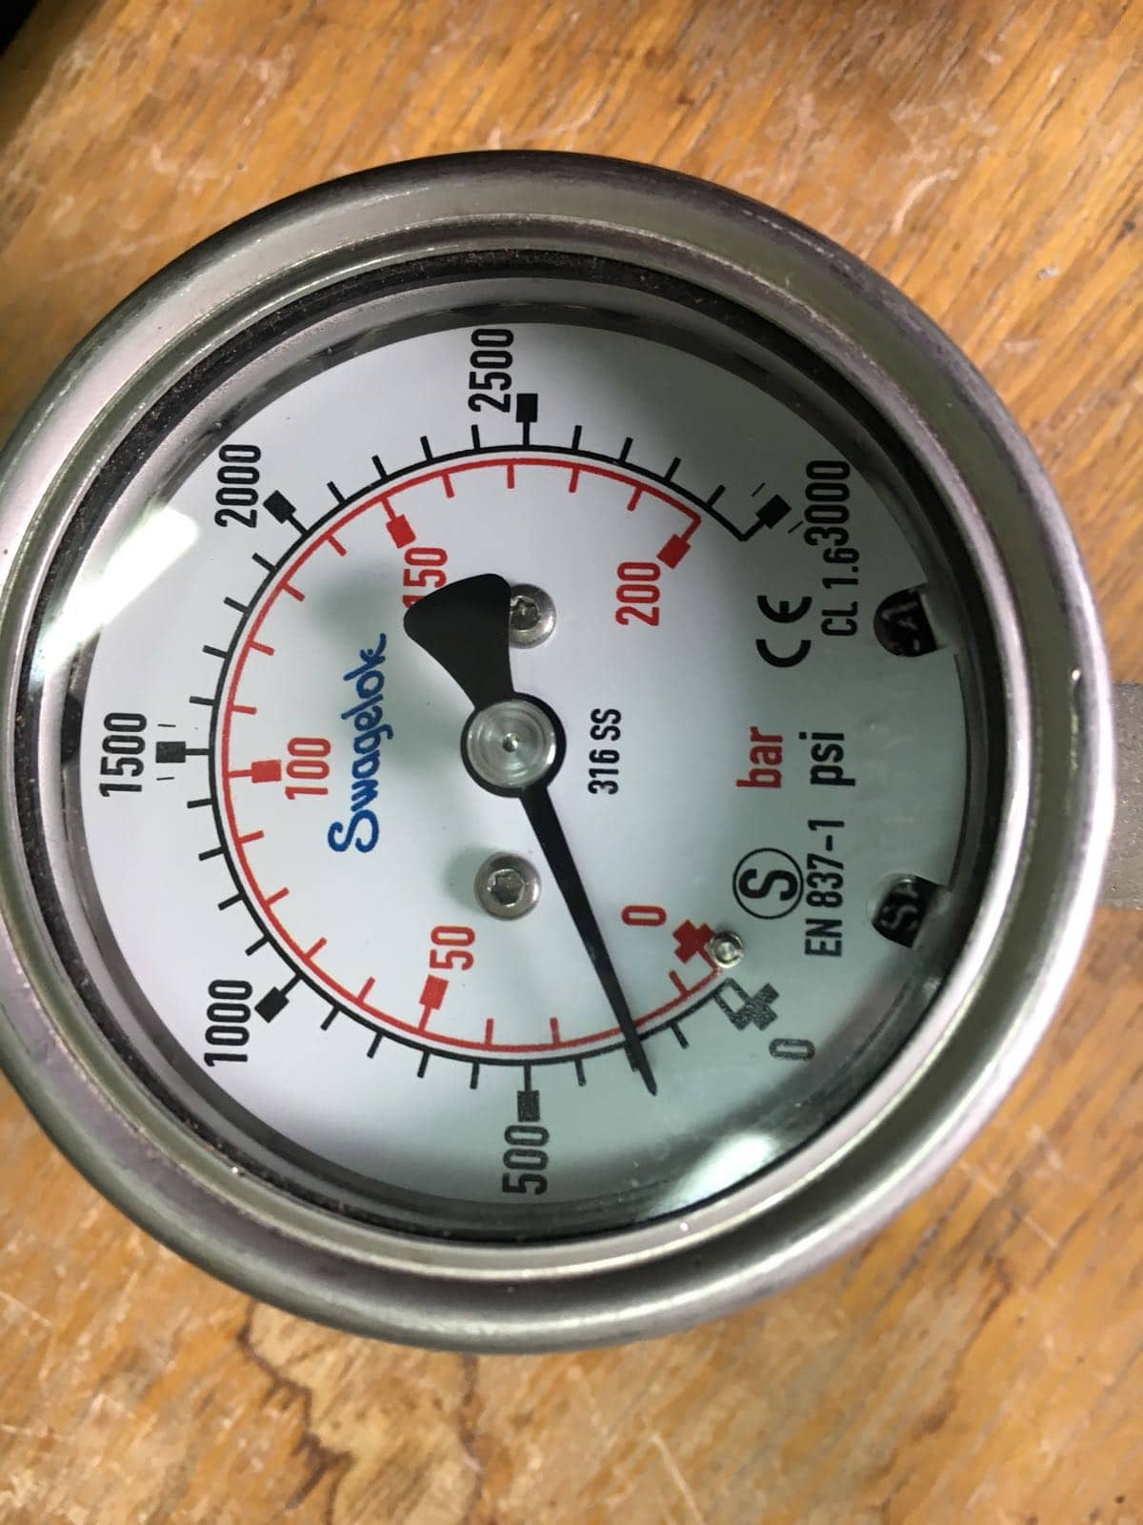Figure 15.The pressure dropped to 300 psi .
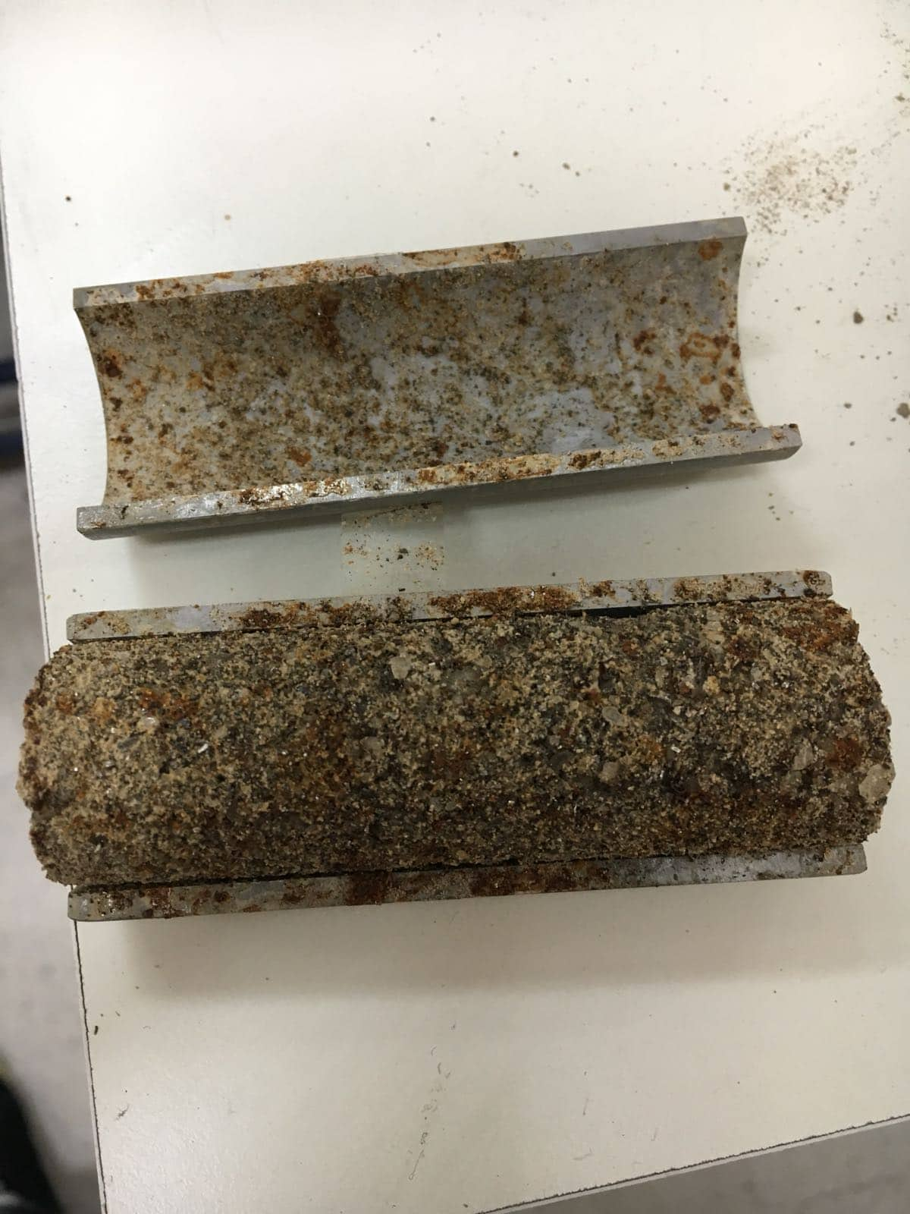
Figure 16.The first sample after carbonation reaction for one hour .

The second sample is placed under flow through condition, the CO2 flow rate was 20 l\min for one hour. In this sample a slurry solution of slaked lime was used to protect the iron filling from oxidation as the first sample. After one hour of reaction the sample volume increased in the side that where in direct contact with CO2 gas flow, the strength of this side was higher than the strength of the original sample this indicates that a carbonation reaction occurred. But the opposite side of sample was crumpled. It was assumed that the crumpling of the other side was due to the short reaction time and the use of single open-ended mold, which prevented CO2 gas flow to reach enough to that side. The following figures show the reaction setup of flow-through carbonation reaction and sample after reaction:

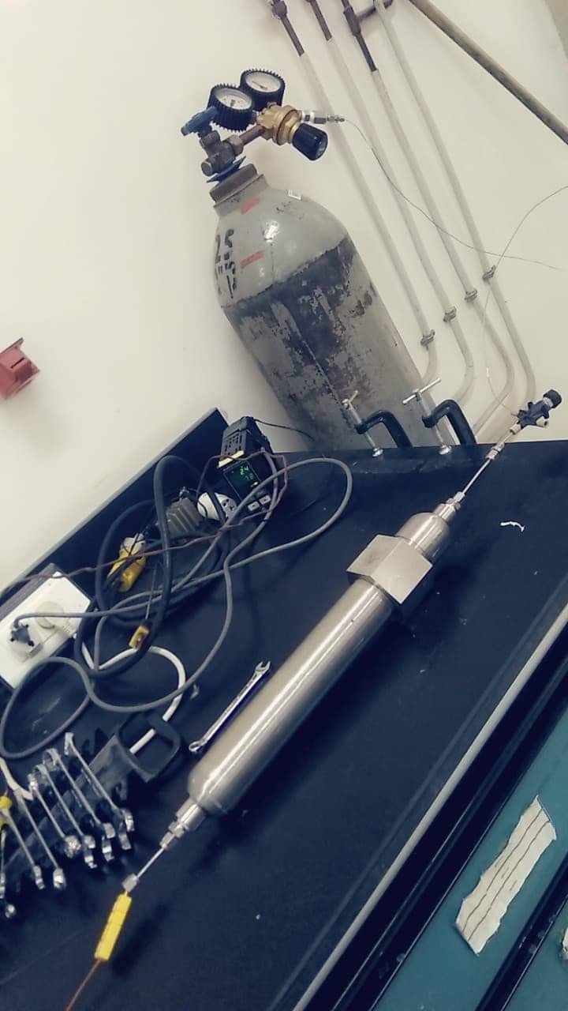
Figure 17. The flow-through based Carbonation reaction setup .

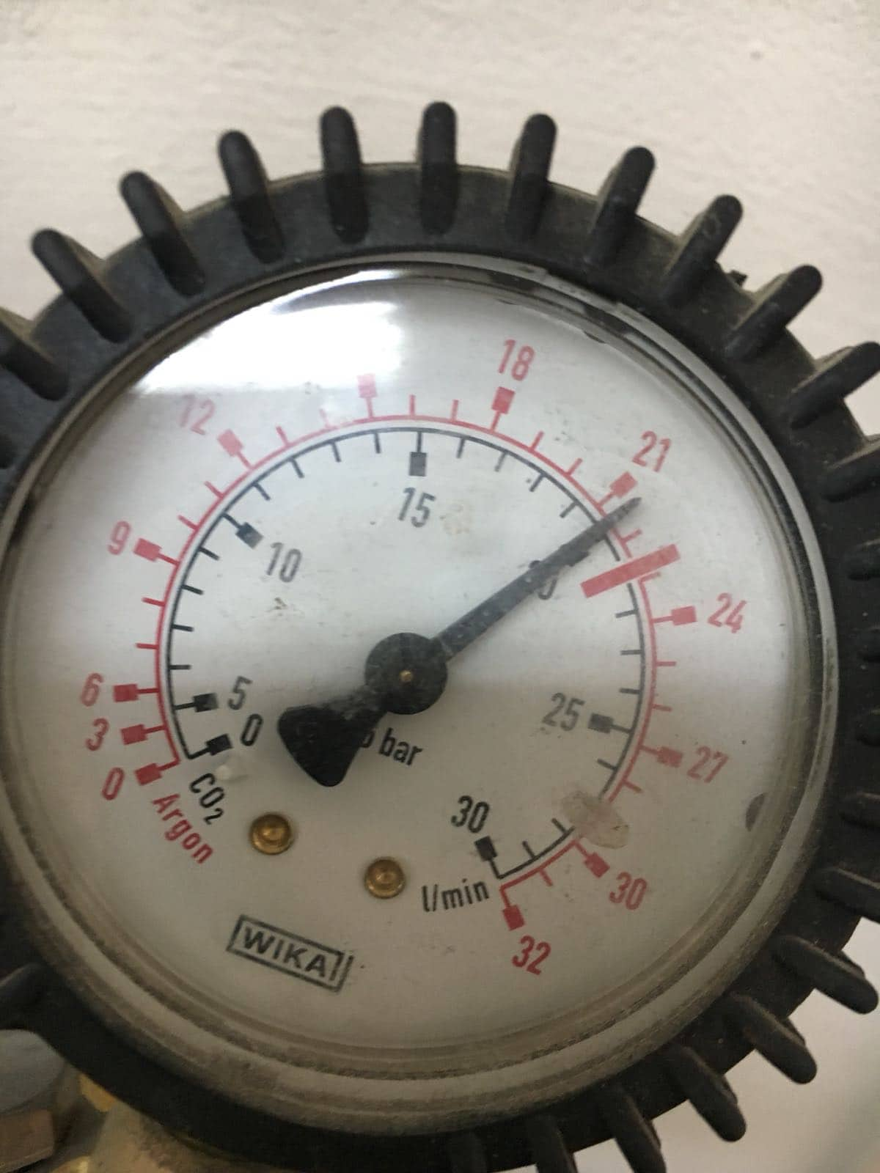
Figure 18. Flow rate were 20 L/min .
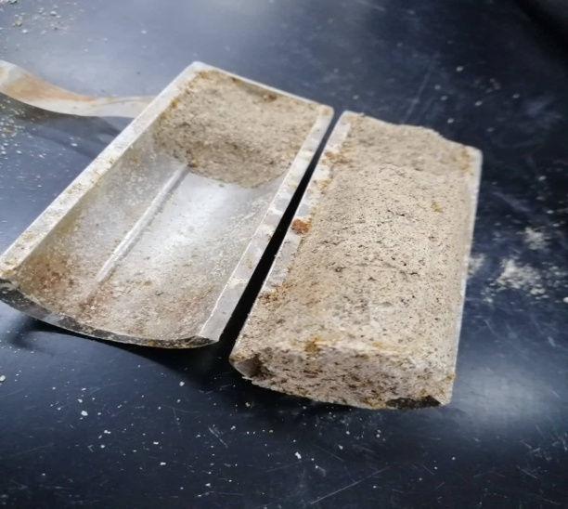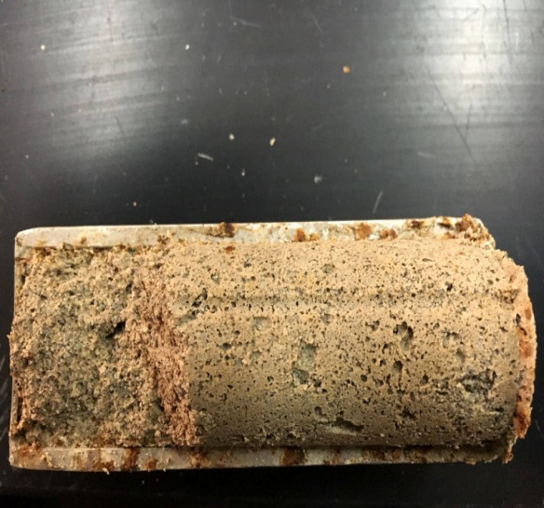
Figure 19. The second sample after flow-through based carbonation reaction for 1 hr .

Conclusion
The project studies if it possible to make a green concrete where the cement is iron carbonate. Tow samples were prepared each with different composition but same raw materials. One of the two samples that prepared was faulty. It crumbled after 1 hour of carbonation at static pressure. The second sample was semi reacted and have larger volume after 1 hour of carbonation reaction at flow through condition. Therefore, that increase in volume indicated that a carbonation reaction occurred. In general, environment affected by different pollutants such as non disposable solid waste and CO2 emissions. These pollutants are the main raw materials of the new concrete, this would mitigate the environmental issues of these pollutants.
Future Work
The future work shall focus on studying the effect of different reaction parameters on the product properties. Especially mechanical strength, chemical properties, water absorption and radiation absorption. In this case, large number of samples will prepared with different composition of the feedstock, and study the effect of the addition of aluminum filings in the sample. Furthermore, large carbonation chamber will be designed and made to cure samples under controlled conditions. It has to withstand moderate static pressures and flow through conditions, acceptable for the samples that have the desired dimensions for the conventional concrete testing methods and it will allows temperature measurement inside the chamber.

References
Brown, O.R., 2017. Oxygen, the Breath of Life: Boon and Bane in Human Health, Disease, and Therapy. Bentham Science Publishers.

Das S, Souliman B, Stone D, Neithalath N. Synthesis and properties of a novel structural binder utilizing the chemistry of iron carbonation. ACS applied materials & interfaces. 2014 May 29;6(11):8295-304.

Doble M., Kumar A.,2005, Biotreatment of Industrial Effluent,Elsevier, ISBN:978-0-7506-7838-4,336 p .

Dri, M., Sanna, A. and Maroto-Valer, M.M., 2014. Mineral carbonation from metal wastes: effect of solid to liquid ratio on the efficiency and characterization of carbonated products. Applied Energy, 113, pp.515-523.

Kim, J.J., Heo, Y.S. and Noguchi, T., 2015.Effect of Iron Powder on Inhibition of Carbonation Process in Cementitious Materials. ISIJ International, 55(7), pp.1522-1530.

Uwasu M., Yabar H., 2014, World cement production and environmental implications , Environmental Development , Vol 10 , pp 36-47 .

Selamat, s., 2017, Review of CO2 Reduction Technologies Using Mineral Carbonation of Iron and Steel Making Slag in Malaysia , Journal of Physics, Vol.888,pp 508-512 .

www.sciencedirect.com/science/article/pii/S2211464514000256 , 2:25pm,December 9,2018.

