

An-Najah National University
Faculty of Engineering
Electrical Engineering Department

Graduation Project
Propagation Measurements and Path Loss Model Tuning at GSM 900 Channels in Nablus City

Mahmoud S. Al-Najjar  eng_mnajjar@hotmail.com | Bashar A. Al-Sayeh  bashar.alsayeh@gmail.com

Supervisor
Dr. Allam Mousa

May - 2010
شـــكـــــــر و تـقــديــــــر
لابد لنا ونحن نخطو خطواتنا الأخيرة في الحياة الجامعية من وقفة نعود إلى أعوام قضيناها في رحاب الجامعة مع أساتذتنا الكرام الذين قدموا لنا الكثير باذلين بذلك جهودا كبيرة في بناء جيل الغد لتبعث الأمة من جديد.........................
وقبل أن نمضي نقدم أسمى آيات الشكر والامتنان والتقدير والمحبة إلى الذين حملوا أقدس رسالة في الحياة.....................
إلى الذين مهدوا لنا طريق العلم والمعرفة...............
إلى جميع أساتذتنا الأفاضل.............

"كن عالما .. فإن لم تستطع فكن متعلما ، فإن لم تستطع فأحب العلماء ،فإن لم تستطع فلا تبغضهم"

ونخص بالتقدير والشكر
د.علام سعيد موسى

على مابذله من جهد ورعاية لإخراج بحثنا هذا على أكمل وجه.....فله كل الشكر والتقدير، وكذلك نشكر كل من ساعد على إتمام هذا البحث ومد لنا يد العون المساعدة وزودنا بالمعلومات اللازمة لإتمام هذا البحث ونخص بالذكر

شركة الإتصالات الخلوية الفلسطينية – جـوال
المهندس : عـنـتـــر سـلـيـــم
المهندس : أكــرم بـــركـــة

كما نتقدم بالشكر الموصول إلى جامعتنا الحبيبة متمثلة بإدارتها وهيئتها التدريسية

إهـــــــداء

إلى حكمتي .....وعلمي
إلى طريقي .... المستقيم
إلى طريق........ الهداية
إلى ينبوع الصبر والتفاؤل والأمل..........
إلى شمعة متقدة تنير ظلمة حياتي........
إلى من بوجودها أكتسب قوة ومحبة لا حدود لها...........
إلى من عرفت معها معنى الحياة..........
إلى كل من في الوجود بعد الله ورسوله أمي الغالية

إلى مَن علّمني كَيف الصعود و حَمل لي شُعلةً
تلذذ بحروقاتِها في يَديهِ لينيرَ لي دَربي..........
إلى ذاك الرَجل الذي عَلَمني العِزّة و كحّل عينيّ بالكِبرياء........
إلى من علمني العطاء بدون انتظار......
إلى من أحمل اسمه بكل افتخار ...
أرجو من الله أن يمد في عمرك لترى ثماراً قد حان قطافها بعد طول انتظار وستبقى كلماتك نجوم أهتدي بها اليوم وفي الغد وإلى الأبد......... والدي العزيز

وإلى إخوتي وأسرتي جميعاً

ثم إلى كل من علمني حرفاً أصبح سنا برقه يضيء الطريق أمامي

مـحـمـود سـمـيـر الـنـجـار

إهداء إلى روح أبي الراحل ....... الذي علمني كيف أمسك بالقلم و كيف أخط الكلمات بلا ندم ........
إهداء إلى معلمي و أستاذي و إلى حضن احتواني في كل محني و أزماتي

أنحني أمامك عرفانا بالجميل يا من سقيتني سر الإنسان الأصيل
كنت شمسي التي أستمد منها دفئي و معرفتي
وكنت قمري الذي أستمد منه أملي و شوقي

إهداء إلى روح أبي الراحل..........
تقديرًا لمن جعل لي قيمة
أبدأ و أختم باسمك
يا من أذقتني طعم الدنيا الجميل
و بعدك .... تذوقت جرعاتها المريرة ............
وأتمنى من الكل ان يبر والديه ويسعدهما قبل فوات الأوان ....
رحمك الله يا أبي وأسكنك الفردوس الأعلى.....

عن النبي صلى الله عليه وسلم قال: " رغم أنف ثم رغم أنف ثم رغم أنف قيل من يا رسول الله قال من أدرك أبويه عند الكبر أحدهما أو كليهما فلم يدخل الجنة" صحيح مسلم

يا أمي .. يا حبي .. يا قلبي الدافئ يا أمي
شكرًا كلمة لن توفيك حقك مهما صار
عهدا عليا ان أريك الدرجات العليا
وان أواصل مسيرة تعليمي
وتريني في المناصب العليا
فلك الفضل بعد الله
ولك الشكر يا أمآآه

بـشـار عـبـد الـباسـط الـسـائـح
Abstract
Imprecise propagation models lead to networks with high co-channel interference and a waste of power. In this study, we aim to adapt a propagation model for Nablus as we examine the applicability of propagation model in Nablus for GSM frequency band. The study helped to design better GSM network for the city area , In spite of the limitations of geographical terrains and frequency channels. The modification is accomplished by investigating the variation in path loss between the measured and predicted values, according to the propagation model for a specific cell BS 1. Then, more modification is performed on the model according to the results obtained through more investigation. We will then verify our modified model by applying it for other cells and conclude the results. Theoretical simulation by the model and the obtained experimental data is compared and analyzed further. Bertoni-Walfisch model -without tuning- give us the best results in mean error (1.426 dB), which is much less than mean error in Standard Macrocell model -used by JAWWAL-Palestinian mobile communication company- (10.91 dB) for BS 1 . These two models had been tuned using Linear Least Square algorithm to fit measured data for GSM-900 in Nablus city, which is a vital step in the planning and rollout of wireless networks. Finally, to make sure that Bertoni-Walfisch is better than any other path loss model, we made a comparison between them in RMSE, Standard Deviation and Mean Error.

Introduction
In spite of the development of numerous empirical path loss prediction models so far, the generalization of these models to any environment is still questionable. They are suitable for either particular areas (urban, suburbs rural, etc.), or specific cell radius (macrocell, microcell, picocell) depending on the diversity of environment where mobile communications occur. So in general, there is a relationship between these models and types of environments for which they are suitable. To overcome this drawback, the empirical models’ parameters can be adjusted or tuned according to a targeted environment. The propagation model tuning must optimize the model parameters in order to achieve minimal error between predicted and measured signal strength. This will make the model more accurate for received wireless signal predictions.

List of Figures

Figure 1 | Poor frequency reuse range limited by downtilt only | 14
Figure 2 | Better frequency reuse range limited by downtilt and buildings | 14
Figure 3 | Example of hill-top cell site | 14
Figure 4 | Definitions of Factors Neglected in Okumura-Hata Model | 19
Figure 5 | Geometry of Cost 231 Walfisch- Ikegami | 20
Figure 6 | Definition of Street Orientation angle ϕ | 21
Figure 7 | The building geometry and parameters in Bertoni-Walfisch Model | 23
Figure 8 | Street Geometry for Haret Model | 25
Figure 9 | BS1 location | 38
Figure 10 | Received power distribution for BS1 | 38
Figure 11 | Prediction map of BS1 for ASSET software and drive test in coloured samples | 39
Figure 12 | Log-distance model at n=3.86 and measured data | 43
Figure 13 | Comparison of Standard macrocell model and measured data | 45
Figure 14 | Path loss comparison of Standard macrocell model before and after tuning | 47
Figure 15 | Received power comparison of Standard macrocell model before and after tuning | 47
Figure 16 | Comparison of Standard macrocell model and measured data for BS 1 | 49
Figure 17 | Path loss comparison of Bertoni-Walfisch (BW) model before and after tuning for BS 1 | 50
Figure 18 | Received power comparison of Bertoni-Walfisch (BW) model before and after tuning for BS 1 | 51
Figure 19 | Path loss comparison between measured data for BS 1 and propagation models | 53
Figure 20 | Received power comparison between measured data for BS 1 and propagation models | 53
Figure 21 | Path loss comparison between measured data for BS 9 and propagation models | 55
Figure 22 | Received power comparison between measured data for BS 9 and propagation models | 55
Figure 23 | Prediction map of BS9 for ASSET software and drive test in coloured samples | 57

List of Tables

Table 1 | Path Loss Exponents for Different Environments | 18
Table 2 | Restrictions of the Cost 231 W-I Model | 20
Table 3 | Parameters and range of validity | 26
Table 4 | BS1 information | 37
Table 5 | Statistics for received power | 38
Table 6 | BS2 information | 40
Table 7 | BS3 information | 40
Table 8 | BS4 information | 40
Table 9 | BS5 information | 40
Table 10 | BS6 information | 41
Table 11 | BS7 information | 41
Table 12 | BS8 information | 41
Table 13 | Path loss exponent for different base stations | 44
Table 14 | Statistical values for Log-distance propagation model applied for a certain base stations | 44
Table 15 | Model parameters before and after tuning | 46
Table 16 | Statistical values for Standard Macrocell model applied on BSs | 48
Table 17 | Base stations parameters | 50
Table 18 | Mean Error comparison between tuned Bertoni-Walfisch model with known models | 51
Table 19 | Standard Deviation comparison between tuned Bertoni-Walfisch model with known models | 52
Table 20 | RMSE comparison between tuned Bertoni-Walfisch model with known models | 52
Table 21 | BS9 information | 54
Table 22 | Path loss exponent for BS9 | 54
Table 23 | Statistical values for Log-distance propagation model applied for BS9 | 56
Table 24 | Statistical values for BS9 | 56

Contents

Chapter 1: Fundamentals of GSM | 10
1.1 Modes of Propagation | 11
1.2 Effects of Buildings and Trees | 11
1.2.1 Reflections from Buildings and Trees | 11
1.3 Types of Cells | 12
1.3.1 Macro Cells | 12
1.3.2 Micro Cells | 12
1.3.3 Pico Cells | 12
1.3.4 Umbrella Cells | 13
1.3.5 Selective Cells | 13
1.4 Site Locations and Antenna Heights | 13
1.5 Containment of Coverage Through Reflection from Buildings | 13
1.6 Hill-Top Cell Sites | 14
1.7 Off-grid” Site Locations | 15
Chapter 2: Propagation Models | 16
2.1 Radio Propagation Models | 17
2.1.1 Free-Space Model | 17
2.1.2 Log-distance propagation model | 17
2.1.3 Okumura-Hata Model | 18
2.1.4 Cost 231( Walfisch - Ikegami ) | 20
2.1.5 The Bertoni-Walfisch propagation model | 22
2.2 Summary of model features | 24
2.2.1 Input Parameters Treated | 24
2.2.2 Propagation Factors Included | 24
2.2.3 Output Parameters | 24
2.3 Haret Path Loss Model | 25
2.3.1 Non-Los Path Loss Formula For Low-Rise Environments | 25
2.3.2 Non-Los Path Loss Formula For High-Rise Environments | 26
2.3.3 LOS Path Loss Formula For Both Environments | 26
2.4 Standard Macrocell Model based on Hata model | 27
Chapter 3: Regression Analysis | 29
3.1 Minimum mean square error | 30
3.2 Root Mean Squared Error | 30
3.3 Standard Deviation | 31
3.4 Linear least square method | 31
Chapter 4: Measurements and Tuning Procedures | 33
4.1 Coordinate Systems | 34
4.2 The Global Positioning Systems | 35
4.3 Model Tuning Approaches | 35
4.4 Statistical Tuning Approach | 35
4.5 Concept of Continuous Wave | 36
4.6 Frequency reuse problem in drive test | 36
4.7 Measurements Mechanisms | 36
4.7.1 Drive Test Tools | 36
4.7.2 First Experiment | 37
4.7.3 Second Experiment | 37
Chapter 5: Data Analysis, Results and Conclusion | 42
5.1 Propagation Models Implementation | 43
5.1.1 Log-distance model implementation | 43
5.1.2 Standard Macrocell model implementation | 44
5.1.3 Bertoni-Walfisch model implementation | 48
5.2 Special Case Study | 54
5.3 Results and Conclusions | 58
5.4 Acknowledgment | 58
APPENDIX I: Useful formulas | 59
APPENDIX II: References and Datasheets | 67

CH.1
Fundamentals of GSM

1.1 Modes of Propagation

Propagation in the 800/900 MHz band, for the most part, takes place via space waves. At this frequency groundwaves are attenuated very rapidly with distance, and skywaves pass readily through the ionosphere with little energy being reflected back to earth. Space waves are subject to absorption, reflection, refraction, and scattering by the troposphere and by the surface of the earth and obstacles in their paths. For the relatively short service ranges of land mobile systems using this band, propagation is usually by direct or reflected wave with some diffraction over obstacles. Interference, however, may occur at distances beyond the normal horizon via diffraction over the earth or by refraction or scattering by the troposphere. Because of the multiplicity of factors involved, most coverage and interference predictions depend on a statistical approach. However, deterministic analyses are still required to account for isolated and gross terrain features.[2][18]

1.2 Effects of Buildings and Trees

In urban areas propagation is generally dominated by shadow loss and reflections caused by buildings and trees. In the case of land mobile systems these are usually in the environment surrounding the mobile. Signals arrive from all directions with random amplitude and phase, and with a spread in arrival times of several microseconds. It is impossible to describe the received signal using deterministic models.

1.2.1 Reflections from Buildings and Trees

In a given situation a reflection from an individual building may be dominant. This may happen because of the building's height, size, orientation, or specific path configurations. Reflections may make a high signal available in areas deeply shadowed by buildings or terrain. The gain produced by a large reflecting surface can even result in signal levels in excess of free space values. The strength of the reflected signal is determined by the height and width of the portion of a building visible to both terminals and is affected by obstacles within the first Fresnel zone of the incident or reflected ray and by the nature of the reflecting surface-type of material, size, shape, and orientation of sheathing elements. The vertical and horizontal width of the reflecting surface will determine the effective beamwidth of the reflected signal in the vertical and horizontal directions, respectively. In the case of hills, the factors that influence the amplitude and beamwidth of the reflected fields include the size, shape, and orientation of the reflecting surface and its coefficient of reflection which may be affected by trees or other vegetation. Composite signals reflected from wind-disturbed foliage or moving automobiles may exhibit a short-term variability of several decibels when measured between fixed terminals or a base station and a stationary vehicle.

1.3 Types of Cells

Due to the uneven changes in the population density of different countries and regions in the world, there are different types of cells used according to the best results in uninterruptible communication. These are listed as:
- Macro Cells
- Micro Cells
- Pico Cells
- Umbrella Cells
- Selective Cells

1.3.1 Macro Cells
Macro cells can be regarded as cells where the base station antenna is installed on a mast or larger building structures that are taller than an average roof-top level.
A macro cell is a cell in a mobile phone network that provides radio coverage served by a power cellular base station (tower). Generally, macro cells provide Global System for Mobile Communication (GSM) coverage larger than micro cell such as rural areas or along highways. The antennas for macro cells are mounted on ground-based masts, rooftops and the other existing structures, at a height that provides a clear view over the surrounding buildings and terrain. Macro cell base stations have power outputs of typically tens of watts.

1.3.2 Micro Cells
A micro cell is a cell in a mobile phone network served by a low power cellular base station (tower), covering a limited area such as a mall, a hotel, or a transportation hub. A micro cell is usually larger than a Pico cell, though the distinction is not always clear. Typically the range of a micro cell is less than a mile wide. In micro cell propagation, propagation generally is based on diffraction from edge of buildings for Non-los cases. Range:200500 m
The antennas for micro cells are mounted at street level. Micro cell antennas are smaller than macro cell antennas and when mounted on existing structures can often be disguised as building features. Micro cells provide radio coverage over distances up to, typically, between 300m and 1000m. Micro cell base stations have lower output powers than macro cells, typically a few watts.

1.3.3 Pico Cells
Pico cells are small cells whose diameter is only few dozen meters; they are used mainly in indoor applications. It can cover e.g. a floor of a building or an entire building, or for example in shopping centers or airports. Pico cells provide more localized coverage than micro cells, inside buildings where coverage is poor or there are high numbers of users.

1.3.4 Umbrella Cells
A layer with micro cells is covered by at least one macro cell, and a micro cell can in turn cover several pico cells, the covering cell is called an umbrella cell. Global System for Mobile Communication (GSM) If there are very small cells and a user is crossing the cells very quickly, a large number of handovers will occur among the different neighboring cells. The power level inside an umbrella cell is increased compared to the micro cells with which it is formed. This makes the mobile to stay in the same cell (umbrella cell) causing the number of handovers to be decreased as well as the work to be done by the network.

1.3.5 Selective Cells
The full coverage of the cells may not be required in all sorts of applications, but cells with limited coverage are used with a particular shape. These are named selective due to the selection of their shape with respect to the coverage areas. For example, the cells used at the entrance of the tunnels are selective cells because coverage of 120 degrees is used in them.

1.4 Site Locations and Antenna Heights

If it all possible, it is necessary to choose locations for cell sites and antennas carefully and consider issues such as proper containment of coverage, alignment of sites into a specific hexagonal pattern, etc. Again, choices for sites may be limited due to availability of space for equipment and antennas, accessibility for maintenance, and availability of links to the base stations (either radio or physical) from the switch. Nevertheless, it is important to address certain considerations when selecting a cell site. At least, by simply mounting antennas at a lower level(<40 m), one can essentially reduce a cells coverage area and increase the effectiveness of frequency reuse.[3]

1.5 Containment of Coverage Through Reflection from Buildings

In urban/suburban areas, where: 1) several cell sites may be required, 2) frequency reuse is unavoidable, and 3) in-building penetration is a must, selected sites should offer contained coverage. While downtilt and variations in ERP may help to reduce the effective radius of each cell site, they nonetheless may not be sufficient enough. However, one can also rely on the presence of buildings in the area to serve as radio-path shields thus limiting coverage area. Furthermore, reflection from these buildings will also provide coverage to areas that normally would not be reachable through line-of-sight paths. These additional paths would consequently increase in-building penetration within the contained area. In order to achieve these results, it is important that antenna/base sites are chosen accordingly. First of all, the highest point in the area will probably do more harm than good as a cell site location if the area can be considered as suburban or urban. The reason why is that it will cause more interference to surrounding sites due to the fact that signals will propagate out over the other, lower buildings into other coverage areas. Furthermore, street coverage and in-building penetration immediately surrounding the site will probably be more limited due to the lack of reflections off surrounding buildings. Examples of these situations are shown below

Figure 1 : Poor frequency reuse range limited by downtilt only |  | Figure 2 : Better frequency reuse range limited by downtilt and buildings

The choice of the highest point in an area for a cell site would most likely only work in low-density suburban or rural areas where the overall number of sites needed to meet subscriber demands is small. Frequency reuse would not be necessary and these sites could be considered as “broadcast” sites.

1.6 Hill-Top Cell Sites

As another example, consider the placement of a cell site at the top of a hill overlooking a town or city. While coverage will be adequate in the area immediately surrounding the cell site down to the side of the town facing the site, coverage within the city may be limited due to signal path obstructions due to buildings on the edge of the town. In other words, reflections off buildings on the edge of the city will provide coverage to areas between the buildings and the cell site, but probably not on the opposite side of the obstructions. An example is shown below:

Figure 3: Example of hill-top cell site

1.7 Off-grid” Site Locations

As was stated before, following a hexagonal pattern when assigning cell sites is a good starting point in reducing co channel interference as much as possible. However, due to possible limitations of adequate cell space for sites, locations may need to be assigned that are “off grid.”
In any case, the hexagonal grid reflects an ideal situation. Terrain effects will obviously skew the pattern out of any type of symmetry. As a result, some interference may appear in some areas regardless of how close you assign sites to the grid. It is at this point where the engineer will consider ways to control this interference.

CH.2
Propagation Models

2.1 Radio Propagation Models

As the radio waves travel from the transmit antenna to the receive antenna, they suffer attenuation due to propagation loss [4]. This loss can be modeled using a variety of methods, some of which are discussed below.

2.1.1 Free-Space Model

The power received Pr by an antenna of gain Gr due to a source of Pt watts and antenna gain Gt at wavelength and free space distance d is given by the Friis transmission formula [5]:

P_{r} = P_{t}G_{t}G_{r}[λ/4πd]² | (2-1)

Since wavelength equals the speed of propagation divided by frequency, the propagation loss (or path loss) is conveniently expressed as a positive quantity and equation (1-1) can be rewritten as [6]:

L_{FdB} = 10 log(P_{t} / Pr)  = -10 log G_{t} – 10 log G_{r} + 20 log(f_{MHz}) + 20 log(d_{km}) +k | (2-2)

Where k = 20 log(4π / 3x10⁸) is often useful to compare path loss with the basic path loss between isotropic antennas [6];
LdB = 20 log(f_{MHz}) + 20 log(d_{km}) + 32.4 | (2-3)

The relations in equation (1-3) do not apply to small path lengths. For applicability, the transmitting antenna must be located in the far field of the receiving antenna. A commonly applied criterion is d≥( 2 d_{a}² / λ ) , where d_{a} is the major antenna dimension. This criterion is based on limiting the phase difference at distance d over a plane to one sixteenth of the wavelength [5][7].

2.1.2 Log-distance propagation model

Log – distance propagation model was used to estimate the path loss exponent in the first stage of model calibration [3][12], which give us the first impression of the relationship between path loss and distance between transmitter and receiver. Taking the collection of measurements, the observed propagation loss presents a dependence on the distance (d) between the transmitter and the mobile receiver that can be expressed as,

PL(dB) =L₀ + 10 n log (d / d₀) | (2-4)

Where, L₀ =32.4+20 log10(f)+20 log10(d₀₎ is the reference path loss, n is the path loss exponent (usually empirically determined by filed measurement), d₀ is the reference distance in (km), d is the distance between transmitter and receiver in (km).

It is important to select a free space reference distance that is appropriate for the propagation environment. In large coverage cellular systems, 1 km reference distances are commonly used, whereas in microcellular systems, much smaller distances (such as 100 m or 1 m) are used. The reference distance should always be in the far field of the antenna so that near-field effects do not alter the reference path loss[3][16]. Table 1 gives some typical values of n, larger values of n correspond to more obstructions and hence faster decreases in average received power as distance becomes larger [3].

Table 1 Path Loss Exponents for Different Environments
Environment | Path Loss Exponent , n
In building line-of-sight | 1.6 to 1.8
Free Space | 2
Obstructed in factories | 2 to 3
Urban area cellular radio | 2.7 to 3.5
Shadowed urban cellular radio | 3 to 5
Obstructed in building | 4 to 6

2.1.3 Okumura-Hata Model [19]

The Okumura-Hata model [8] or a variation of it is used by most of the propagation tools. The model is based on an empirical relation derived from Okumura’s report on signal strength and variability measurements [9][18]. The model is parameterized for various environments, namely urban, suburban and open areas. It is applicable to:

- Frequency f (150...1500 MHz)
- Distance between transmitter and receiver d (1...20 km)
- Antenna height of the transmitter h t (30...200 m)
- Antenna height of the receiver h r (1...10 m)

Since the model only requires four parameters for the computation of path loss, the computation time is very short. This is the primary advantage of the model. However, the model neglects the terrain profile between transmitter and receiver, i.e. hills or other obstacles between the transmitter and the receiver are not considered. However, Hata and Okumura made the assumption that the transmitter would normally be located on hills and could ignore basic terrain losses. Also, phenomena such as reflection and shadowing are not included in the model [10]. Since the height of the transmitter and the receiver is measured relative to the ground, an effective antenna height heff is additionally used and added to the antenna height of the transmitter to improve the accuracy of the prediction. The parameters marked green in the figure below are the parameters considered by the Okumura- Hata model.

Figure 4: Definitions of Factors Neglected in Okumura-Hata Model.

In this example, the prediction would be too optimistic since the model assumes line-of-sight transmission and does not consider that the actual path is obstructed by two hills [10]. The basic prediction of the median field strength is obtained for the quasi-smooth terrain in an urban area. The correction factor for either an open area or a suburban area has to be taken into account. The additional correction factors, such as for a rolling hilly terrain, the isolated mountain, mixed land-sea paths, street direction, general slope of the terrain etc., make the final prediction closer to the actual field strength values. Hata Model for Urban Areas is formulated as [19]

Lpu = 69.55 + 26.16 log f – 13.82 log hb – Ch + [44.9 – 6.55 log hb] log d | (2-5)

For small or medium sized city
Ch = 0.8 + (1.1 log f – 0.7) hm – 1.56 log f | (2-6)

And large cities
Ch= | 9.29 (log (1.54 hm))² – 1.1  3.2 (log (11.75 hm))² – 4.97 | ,if 150 ≤ f ≤ 200  ,if 200 < f ≤ 1500 | (2-7)

Lpu Hata path loss for urban areas (dB).
f: The carrier frequency (150 MHz ~ 1500 MHz).
hb: Base station antenna height (20 – 200 m)
hm: Mobile station antenna height (1m ~ 10 m)
Ch: Antenna height correction factor.
d: Distance between the base and mobile stations (1m ~ 20 Km).
2.1.4 Cost 231( Walfisch - Ikegami ) [20]

The parameters, excess path loss from Walfisch-Bertoni model and final building path loss from Ikegami Model are combined in this model with a few empirical correction parameters. This model is statistical and not deterministic because you can only insert a characteristic value, with no considerations of topographical database of buildings. The model is restricted to flat urban terrain.
- The parameters used in Cost 231 Walfisch- Ikegami are denote figure
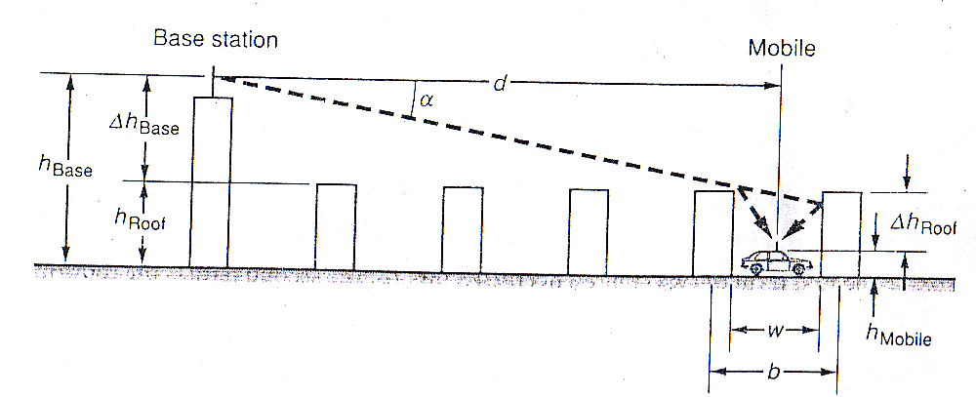
Figure 5: Geometry of Cost 231 Walfisch- Ikegami

- The formulation of the model is given as follow

If a free LOS exists in a street canyon then, path loss defined as :
L_{los}=42.6+26logd+20logf d ≥20m | (2-8)

Walfisch Ikegami (NLOS)

Restrictions of the model are given as follow:

Table 2 Restrictions of the Cost 231 W-I Model
Frequency (MHz) | 800-2000 MHz
Base Station Height (h_{base}) | 4-50 m
Mobile Height (h_{mobile}) | 1-3 m
Distance d,km | 0.02-5 km

If a non-LOS exists, path loss defined as follow:

L_{b} = | L_{FS} + L_{rts} + L_{msd}  L_{FS} |  | (2-9)
L_{b} = | L_{FS} + L_{rts} + L_{msd}  L_{FS} | If L_{rts} + L_{msd} < 0 | (2-9)

L_{FS} represents free space loss, L_{rts} is rooftop to street diffraction and scatter loss, L_{rts} is the multi-screen loss.

The rooftop to street diffraction and scatter loss L_{rts} represents the coupling of wave propagating along the multi-screen path into the street mobile located.

where L_{ori} defined as,

L_{rts} = | -16.9 – 10log w + 10 log f+ 20 log ∆h_{mobile} + L_{ori}  0 | h_{roof}>h_{mobile} | (2-10)
L_{rts} = | -16.9 – 10log w + 10 log f+ 20 log ∆h_{mobile} + L_{ori}  0 | L_{rts}<0 | (2-10)

L_{ori} = |  | -10 + 0.354 (φ/deg) | 0 ≤ φ < 35 | (2-11)
L_{ori} = |  | 2.5 + 0.075 [(φ/deg) - 35] | 35 ≤ φ < 55 | (2-11)
L_{ori} = |  | 4 -.114[(φ/deg) - 55] | 55 ≤ φ ≤ 90 | (2-11)

Where ϕ is the angle between incidences coming from base station and road , in degrees shown in following figure.

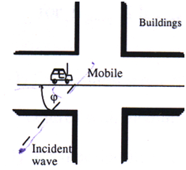
Figure 6 : Definition of Street Orientation angle ϕ.

Δh_{mobile}=h_{roof} -h_{mobile}
Δh_{Base}= h_{base} -h_{roof}

The multiscreen diffraction loss L_{msd} is an integral for which Walfisch-Bertoni model approximate a solution to this for the cases base station antenna height is greater than the average rooftop. COST 231 extended this solution to the cases base station antenna height is lower than the average rooftop by including empirical functions.

Lmsd = L_{bsh} + k_{a} + k_{d} log (d/km) + k_{f} log (f/MHz) – 9 log (b/m) | (2-12)

L_{bsh} = |  | =-18 log (1+ ∆h_{base}) | for h_{base} > h_{roof} | (2-13)
L_{bsh} = |  | 0 | for h_{base} ≤ h_{roof} | (2-13)

kf = -4 + |  | 0.7 [(f/925)-1] | Medium sized cities and suburban centers with moderate tree density | ()
kf = -4 + |  | 1.5 [(f/925)-1] | Metropolitan centers | ()

k_{a} |  | 54 | for h_{base} > h_{roof} | (2-14)
k_{a} |  | 54 – 0.8∆h_{base} | for d ≥ 0.5 km and h_{base} ≤ h_{roof} | (2-14)
k_{a} |  | 54 – 0.8∆h_{base} R/0.5 | for d < 0.5 km and h_{base} ≤ h_{roof} | (2-14)

k_{d} = |  | 18 | for h_{base} > h_{roof} | (2-15)
k_{d} = |  | 18 – 15 ∆h_{base} / h_{roof} | for h_{base} ≤ h_{roof} | (2-15)

The term k_{a} denotes the increase of the path loss for base station antennas below the rooftops of adjacent buildings. The terms k_{d} and k_{f} control the dependence of the multi screen diffraction loss versus distance and radio frequency.
In case of that data on the structure of buildings and roads are not available, following values could be taken as default.
b= 20 ~ 50m
w= b/2
h_{roof}= 3m x (number of floors)+roof
roof=3 m for pitched 0 m for flat
ϕ=90⁰

2.1.5 The Bertoni-Walfisch propagation model

Bertoni-Walfisch proposed a semi empirical model that is applicable to propagation though buildings in urban environments. In our study we apply this model, because of its simplicity and validity which has been verified with measurements [6]. The model assumes building heights to be uniformly distributed and the separation between buildings are equal. Propagation is then equated to the process of multiple-diffraction past these rows of buildings. The building geometry and parameters in Bertoni-Walfisch model are illustrated, in Figure 7.

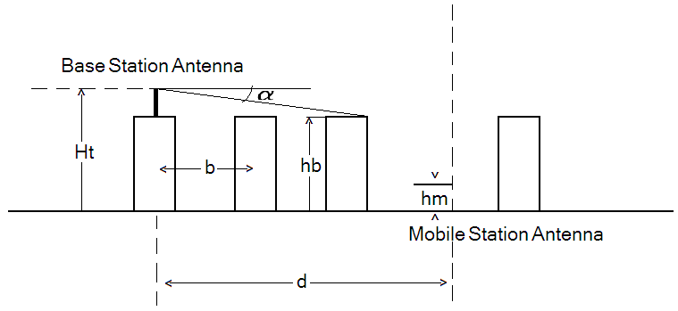

Figure 7: The building geometry and parameters in Bertoni-Walfisch Model

The path loss formula for Bertoni-Walfisch propagation Model is given as [3],[6];

PL(dB) = 89.5 + A + 38log (d) -18log (Ht-hb) + 21log (f) | (2-16)

Where,
A = 5log [ (b/2)²+(hb-hm)² ] - 9log (b) + 20log {tan⁻¹[ 2 (hb-hm)/b) ] }
d : Distance between base station and the mobile in km.
f : Frequency in MHz.
Ht : Antenna Height in meters.
hb : Building height in meters.
hm : Mobile height in meters.
b: center-to-center spacing of the rows of the buildings in meters.

2.2 Summary of model features
Rating Scale: N = Not treated; L = Limited treatment; E = Extensive treatment

2.2.1 Input Parameters Treated[2]
Model | Antenna Height |  |  |  | Terrain data | Building data | Foliage data | Hill shape | Distance
Model | Above average terrain | Above street level | Effective height | Mobile (1-3 m)
Okumura | N | E | E | E | L | N | L | L | E
Bertoni-Walfisch | N | E | L | E | L | E | N | N | E

2.2.2 Propagation Factors Included
Model | Free space | Diffraction by smooth earth | Reflection from earth surface | Reflection from hills | Diffraction by hills | Atmospheric refractivity | Building penetration
Okumura | E | E | N | N | L | N | N
Bertoni-Walfisch | E | N | N | N | N | N | N

2.2.3 Output Parameters
Model | Loss deviation | Location variability | Time fading | Median transmission loss
Okumura | L | E | N | E
Bertoni-Walfisch | N | N | N | E

2.3 Haret Path Loss Model
This model is a measurement based prediction model and valid for base station antennas near to or below the heights of the surrounding buildings in low building environments and at street lamp height in high-rise environment.
In this model, street is represented in different routes as lateral, transverse and stair case shown in figure below. For each route, path loss formula is proposed for LOS and NON-LOS cases.

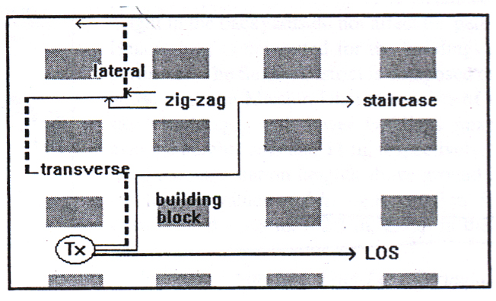
Figure 8 : Street Geometry for Haret Model

In low - rise environments, since propagation is dominated diffraction over rooftops, a single Non-LOS formula including mobile antenna height correction and mobile do last building distance is derived for all routes.
In high – rise environments, since diffraction over rooftops is not dominant, path loss for each route defined separately.

2.3.1 Non-Los Path Loss Formula For Low-Rise Environments
In calculation of non-los path loss in low-rise environments, parameter Δh_{base} is used to represent the reference height of the base station with respect to average height of the surrounding buildings:

Δh_{base}= h_{b}-h_{o} | (2-17)

where,
h_{b}: base station antenna height with respect to ground, meters
h_{o}: Average height of the buildings , meters

In low - rise environments, since propagation is dominated diffraction over rooftops, a single Non-LOS formula including mobile antenna height correction and mobile do last building distance is derived for all routes.
In high – rise environments, since diffraction over rooftops is not dominant, path loss for each route defined separately.

The proposed formula for all non –los routes:
L(R) = [139.01 + 42.59 log f] – [14.97 + 4.99 log f] sgn (∆h_{base}) log (1+ |∆h_{base} |)  + [40.67 – 4.57 sgn(∆h_{base}) log(1+|∆h_{base} |) log d + 20log(∆h_{m} / 7.8) + 10 log (20/r_{h})] | (2-18)

Table 3 Parameters and range of validity
Parameters | Range of validity
f (Frequency), GHz | 0.9<f<2 GHz
d (Distance from mobile to base station), km | 0.05<d <3
r_{b} (distance to mobile the last rooftop, m
Δh_{m} (reference height of the last building to mobile height) | -8<Δh_{m}<6

2.3.2 Non-Los Path Loss Formula For High-Rise Environments
As mentioned before, there is no single non-los formula for high-rise environments due to that main propagation is not diffraction over rooftops. The proposed formulas for each route can be written as follow

Lateral Route
L = 135.41+12.49 log f – 4.99 log h_{b} + (46.84 – 2.34 log h_{b} ) log R | (2-19)

Combined ST ( Stair and Transverse) Route
L = 143.21 + 29.74 log f – 0.99 log h_{b} + (47.23 + 3.72 log h_{b}) log R | (2-20)

f is in GHz, and R in km. h_{b} base station antenna height.
In all calculations, mobile antenna height is fixed to 1.6m and there is no correction for it.

2.3.3 LOS Path Loss Formula For Both Environments
In LOS measurements, there is a break point, which is a function of carrier frequency and antenna heights, divides LOS propagation path into near-in and far-out segments. Path loss formula for cases distance lower than break point and higher than break point is derived by using slope-intercept models to fit to the measurements as follow:

L = 81.14 + 37.4 log f – 0.09 log h_{b} + (15.8 – 5.73 log h_{b}) log R | R<R_{bk} | (2-21)
L = [48.38 – 23.1 log R_{bk}] + 45.7 log f + (25.34 – 13.9 log R_{bk}) log h_{b} + (32.1 + 13.9 log h_{b}) log R + 20 log (1.6 / h_{m}) | R>R_{bk} | (2-22)

where, | R_{bk} = (4h_{b} h_{m}) / (1000 λ)
(3.1.5)
λ: wavelength , in meters and R_{bk} is in km.

2.4 Standard Macrocell Model based on Hata model [11]

The Standard Macrocell model incorporates an optimal dual slope loss model with respect to distance from the base station. It also incorporates algorithms for effective base station heights, diffraction loss, and the effects of clutter. The general pathloss formula for the Macrocell models is as follows:

Path Loss (dB) = k1 + k2 log(d) + k3 (Hms) + k4 log(Hms) + k5 log(Heff) + k6 log(Heff) log(d) + k7 (diffn) + C_Loss | (2-23)

Where:
d | Distance from the base station to the mobile station (km).
Hms | Height of the mobile station above ground (m). This figure may be specified either globally or for individual clutter categories.
Heff | Effective base station antenna height (m).
diffn | Diffraction loss calculated using either the Epstein-Peterson, Bullington, Deygout or Japanese Atlas knife edge techniques.
k1 and k2 | Intercept and Slope. These factors correspond to a constant offset (in dB) and a multiplying factor for the log of the distance between the base station and mobile.
k3 | Mobile Antenna Height Factor. Correction factor used to take into account the effective mobile antenna height.
k4 | Multiplying factor for Hms.
k5 | Effective Antenna Height Gain. This is the multiplying factor for the log of the effective antenna height.
k6 | Multiplying factor for log(Heff)log(d).
k7 | Multiplying factor for diffraction loss calculation.
C_loss | Clutter specifications taken into account in the calculation process.

The propagation model can be tuned by modifying the k-factors. For improved near and far performance, dual slope attenuation can be introduced by specifying both near and far values for k1 and k2 and the crossover point.

CH.3
Regression Analysis

3.1 Minimum mean square error [21]

In statistics and signal processing, a minimum mean square error (MMSE) estimator describes the approach which minimizes the mean square error (MSE), which is a common measure of estimator quality.
The term MMSE specifically refers to estimation in a Bayesian setting, since in the alternative frequentist setting there does not exist a single estimator having minimal MSE. A somewhat similar concept can be obtained within the frequentist point of view if one requires unbiasedness, since an estimator may exist that minimizes the variance (and hence the MSE) among unbiased estimators. Such an estimator is then called the minimum-variance unbiased estimator (MVUE).
Let X be an unknown random variable, and let Y be a known random variable (the measurement). An estimator is any function of the measurement Y, and its MSE is given by
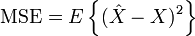 | (3-1)

3.2 Root Mean Squared Error [22] [23]

The RMSE is a quadratic scoring rule which measures the average magnitude of the error. The equation for the RMSE is given in both of the references. Expressing the formula in words, the difference between forecast and corresponding observed values are each squared and then averaged over the sample. Finally, the square root of the average is taken. Since the errors are squared before they are averaged, the RMSE gives a relatively high weight to large errors. This means the RMSE is most useful when large errors are particularly undesirable.

The root mean squared error E_{i} of an individual program i is evaluated by the equation:

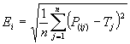 | (3-2)

where P_{(ij)} is the value predicted by the individual program i for sample case j (out of n sample cases); and T_{j} is the target value for sample case j.
For a perfect fit, P_{(ij)} = T_{j} and E_{i} = 0. So, the E_{i} index ranges from 0 to infinity, with 0 corresponding to the ideal.
These equations below show the relationship between MSE and RMSE [24]
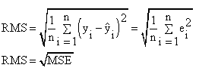 | (3-3)

3.3 Standard Deviation[25]
In probability theory and statistics, the standard deviation of a statistical population, a data set, or a probability distribution is the square root of its variance. Standard deviation is a widely used measure of the variability or dispersion, being algebraically more tractable though practically less robust than the expected deviation or average absolute deviation.
It shows how much variation there is from the "average" (mean). A low standard deviation indicates that the data points tend to be very close to the mean, whereas high standard deviation indicates that the data are spread out over a large range of values.
The most common estimator for σ used is an adjusted version, the sample standard deviation, denoted by "σ" and defined as follows:
σ = | 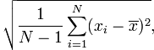 | (3-4)

where {x₁,x₂,…..,x_{N}} are the observed values of the sample items and is the mean value of these observations.

3.4 Linear least square method

Linear least square regression is by far the most widely used fitting method. It is what most people mean when they say they have used "regression", "linear regression" or "least squares" to fit a model to their data. Not only is linear least squares regression the most widely used fitting method, but it has been adapted to a broad range of situations that are outside its direct scope [17] [26].

The Difference between path loss drive test and pathloss model is

∆L₁=L_{measured} - L_{model} | (3-5)

Where, L_{measured} is the measured values for path loss , L_{model} is the modeled values for path loss.
Assuming equation (6) where C₁ and C₂ are offset values will be added to the model after finding them;
∆L₂=C₁ + C₂ log(d) | (3-6)

And the error function is
E(C₁, C₂) = $\sum_{i=1}^{N}{ }$(∆L_{i2} - ∆L_{i1})² | (3-7)

To make sure the error function is minimum (least)

∂E(C₁, C₂) / ∂C₁ = 0 | (3-8)
∂E(C₁, C₂) / ∂C₂ = 0 | (3-9)

By means of calculating equation group, the solution of parameters C₁ and C₂ are calculated as:

C₁ = { [ $\sum_{i=1}^{N}{ }$(log d_{i})² ] . [$\sum_{i=1}^{N}{ }$∆L₁ ] - [ $\sum_{i=1}^{N}{ }$(log d_{i}) ] . [$\sum_{i=1}^{N}{ }$(log d_{i}) ∆L₁ ] } / { N . [ $\sum_{i=1}^{N}{ }$(log d_{i})² ] –[ $\sum_{i=1}^{N}{ }$(log d_{i}) ]² } | (3-10)
C₂ = { N . [ $\sum_{i=1}^{N}{ }$(log d_{i}) ∆L₁ ] - [$\sum_{i=1}^{N}{ }$(log d_{i}) ] [ $\sum_{i=1}^{N}{ }$∆L₁ ] } / { N . [ $\sum_{i=1}^{N}{ }$(log d_{i})² ] - [ $\sum_{i=1}^{N}{ }$(log d_{i}) ]² } | (3-11)

The final tuned model formula becomes,
 | L_{tuned model} = L_{model} + ∆L₂ |  | (3-12)

While the method of least squares often gives optimal estimates of the unknown parameters, it is very sensitive to the presence of unusual data points in the data used to fit a model.

CH.4
Measurements and Tuning Procedures

4.1 Coordinate Systems [27]

Coordinate systems to specify locations on the surface of the Earth have been used for centuries. In western geodesy the equator, the tropics of Cancer and Capricorn, and then lines of latitude and longitude, were used to locate positions on the Earth. Eastern cartographers used other rectangular grid systems as early as A.D. 270, and various units of length and angular distance have been used over history. The meter is related. to both linear and angular distance, having been defined in the late 18th century as one-ten-millionth of the distance from the pole to the equator.

The most commonly used coordinate system today is the latitude, longitude, and altitude system. The prime meridian and the equator are the reference planes used to define latitude and longitude. The geodetic latitude (there are many other defined latitudes) of a point is the angle from the equatorial plane to the vertical direction of a line normal to the reference ellipsoid. In other words, latitude measures how far north or south of the equator a place is located. The equator is situated at 0º, the north pole at 90º north (or simply 90º, since a positive latitude number implies north), and the south pole at 90º south (or -90º). Latitude measurements range from 0º to (±) 90º.

The geodetic longitude of a point is the angle between a reference plane and a plane passing through the point, both planes being perpendicular to the equatorial plane. Longitude measures how far east or west of the prime meridian a place is located. The prime meridian runs through Greenwich, England. Longitude is measured in terms of east, implied by a positive number, or west, implied by a negative number. Longitude measurements range from 0º to (±) 180º.

The geographical coordinates (latitude and longitude) are typically expressed in the expressed form (i.e., degrees, minutes, and seconds). Sometimes the coordinates can be shown in universal transverse mercator (UTM) format or in values expressing north or east, for example. When the positioning coordinates are obtained from topographical charts, they are normally expressed in UTM format.

The geodetic height at a point is the distance from the reference ellipsoid to the point in a direction normal to the ellipsoid. Altitude is measured with reference to mean sea level (MSL), and height is measured with reference to the soil or ground level. In this application, altitudes are known as above mean sea level (AMSL) and heights as above ground level (AGL). It is essential to show the vertical or altimetric reference datum (or VRD) with the altitude, because altitudes change when the vertical datum changes.

4.2 The Global Positioning Systems [27]

The global positioning system (GPS) is based on information users receive from satellites. The purpose of GPS is to provide users with the ability to compute their location in three-dimensional space. To accomplish that, the receiver must be able to lock onto signals from at least four different satellites. Moreover, the receiver must maintain a lock on each satellite's signal long enough to receive the information encoded in the transmission. Achieving and maintaining a lock on four or more satellite signals can be impeded, because the signal is transmitted at 1.575 GHz, a frequency that is too high to bend around or pass through solid objects in the signal's path. This why GPS receivers cannot be used indoors. Outdoors, tall buildings, dense foliage, and terrain that stand between a GPS receiver and GPS satellite will block that satellite's signal.

4.3 Model Tuning Approaches

Model tuning is a process in which a theoretical propagation model is tuned with the help of measured values obtained from test drive data. The models have several parameters that can be changed as need arises. The aim is to get the predicted field strength as close as possible to the measured field strength [13]. A number of approaches for model tuning may be defined. The following sections describe the basic model tuning approaches.

4.4 Statistical Tuning Approach

This method uses “predictor’s” or "specifiers” in general statistical modeling theory. These are parameters that have been found through statistical analysis to bear relationship to the quantity that is to be predicted [14]. In this approach, the first step is the selection of an appropriate statistical model. Subsequently, the model is used to predict the field strength of a given network. Drive tests are then carried out to collect measurement data of the network. The data is then analyzed to identify trends and errors before converting it into a suitable format to calibrate the predictor’s coefficients. The iterations are repeated several times to minimize the error between the predicted and the measured field strengths [13]. In the statistical tuning approach, all environmental influences are implicitly taken into account regardless of whether they can be separately recognized. Thus, the accuracy of this approach depends not only on the accuracy of the measurements, but also on the similarities between the environment to be analyzed and the environment where the moments are carried out. Their computational efficiency is found to be effective [15]. However, the inability to explicitly account for particular features of the propagation environment is perhaps the greatest limitation of statistical tuning measurement-based approach. The accuracy and usefulness of such an approach also depends on the environment where the original data was taken and how universally applicable the environment is. In spite of its limitations, the statistical tuning approach is widely used because it is simple and allows rapid computer calculation. It also has a certain "comfort" factor in that planners using the method over time have come to know what to expect and to make their own ad-hoc "corrections" to the prediction values provided by this approach. When the propagation environment is fairly homogeneous and similar to the environment where the measurements were taken, a statistical tuning approach can achieve reasonably good prediction results. With the recent advent of automated field strength measurement systems with GPS position logging, it is now relatively easy to acquire vast amounts of measurement data.[14]

4.5 Concept of Continuous Wave

The narrow band CW (Continuous Wave) transmitter, which can be tuned to a specific test frequency, was tuned together with a directed antenna. This ensures good frequency isolation and constant signal to avoid interference, the frequency chosen out of traffic or BCCH channels, since neither GSM operators nor anyone else uses it.

4.6 Frequency reuse problem in drive test

Frequency reuse is a technique of reusing frequencies and channels within a communications system to improve capacity and spectral efficiency. Frequency reuse in mobile cellular systems means that each cell has a frequency that is far enough away from the frequency in the bordering cell that it does not provide interference problems [28]. In addition, JAWWAL needs frequency reuse for many sites; for example in Nablus city JAWWAL has around 70 sites each site has 2-3 cells while JAWWAL has 24 channels from GSM-900 band; first 12 channels are BCCH(Broadcast Control CHannel), and the last 12 are traffic channels, because of agreements with the Israeli occupation authority. So, frequency reuse in an urgent need in Palestinian cellular networks.

4.7 Measurements Mechanisms
4.7.1 Drive Test Tools

The drive test mechanism has been used to obtain the desired measurements . Hence, a Laptop, with drive test software (TEMS Investigation), has been used together with a mobile phone connected to it as a GPS (Global Positioning System) receiver and a vehicle (car).

4.7.2 First Experiment

According to the requirement of radio network planning we choose a macrocell base station (called BS1) located in down town , then the drive test has been performed walking through each lane to cover the entire area from the northern mountain through the city center to the southern one. Unfortunately, this drive test had been failed. Because the frequency of the selected cell had many frequency reuse. So, we received a signal just around 200 meters as a maximum distance due to interference with another neighbor cells with the same frequency, which is not enough to make a useful analysis. As a result, we cannot conclude a clear relationship between distance and path loss slope per decade. Also, we cannot depend on this drive test to get a suitable path loss model for the entire area of Nablus.

4.7.3 Second Experiment

Due to a last fail test, we need to repeat this test with the same cell. But at this time, we turned off the neighboring 6 cells which have the same frequency at midnight. Where we cannot turning off the cells during day, because cells are busy so the most of capacity of cells are full enough. So, the number of samples become larger and the range of distance is wider.
Here is cell information Table 4 located at down town in Nablus.

Table 4 BS1 information
Antenna Name | XPol A-Panel 806–960
Type No. | 739 620
P_{TX} | 45 dBm
G_{TX} | 2 x 12.5 dBi
EIRP | 48.9 dBm
Azimuth | 120º
Height | 12 m
Total down tilt (Mech. + Elec.) | 10º
Effective Testing Data Number | 50748
Feeder length | 15 m

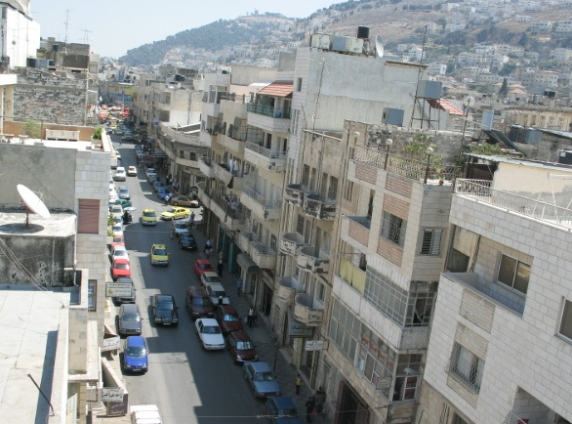 | 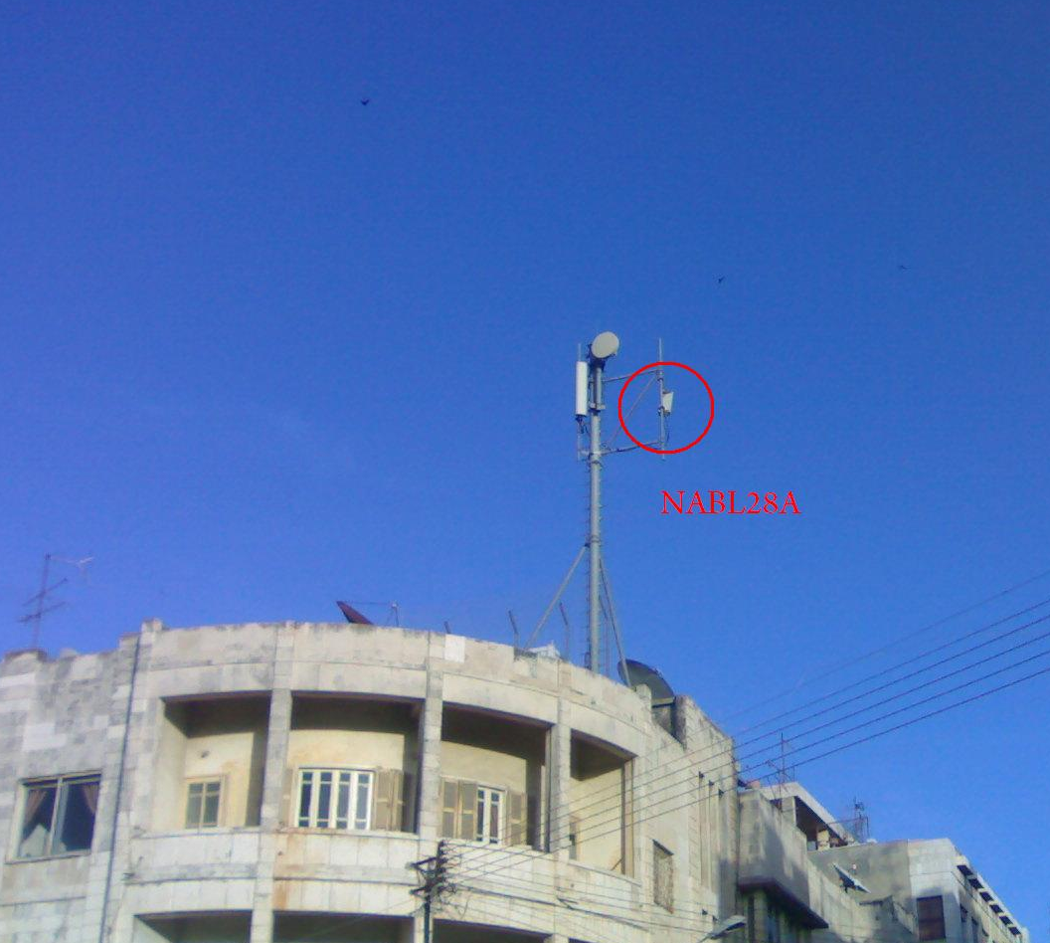
(a) This picture taken from cell BS1 with azimuth 120º | (b) BS1 site
Figure 9: BS1 location

Figure 9 shows desired macrocell BS1 (b)location ,(a) direction of main loop with azimuth 120º. Where, drive test of this cell will implemented with path loss models to tune the most suitable one. Figure 11 shows coverage prediction map of Standard macrocell model based in Hata model using ASSET software, with received power (dBm) sampling. Notice that, samples varies from -35 to -120 dBm. To clarify these samples, Table 5 and figure 10 shows the received power distribution.

Table 5 Statistics for received power
Min RX(dBm) | Max RX(dBm) | Average Rx( dBm)
-120 | -35 | -65.12

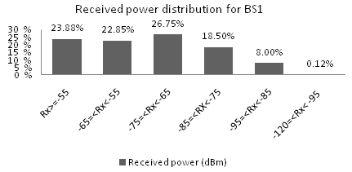
Figure 10 : Received power distribution for BS1

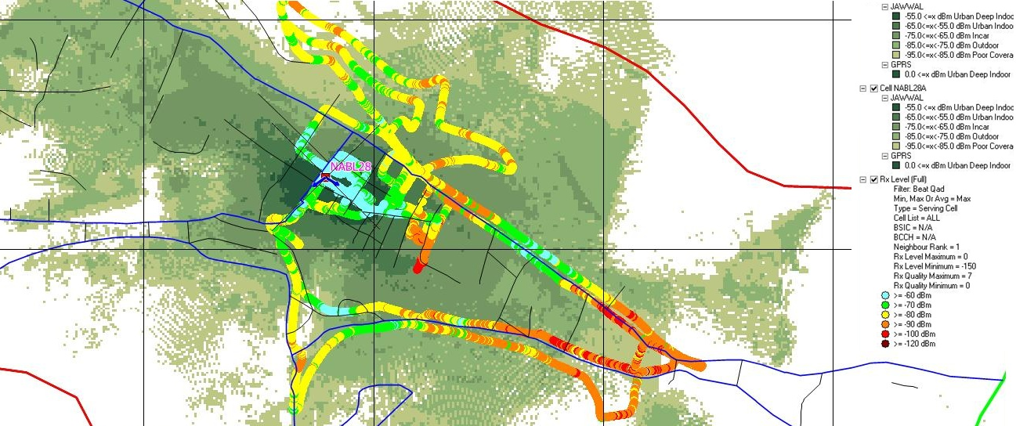 | Figure 11 : Prediction map of BS1 for ASSET software and drive test in coloured samples

Our modeling process requires more than one test to give path loss model more accuracy which describe Nablus environment. We got another 7 drive tests, their cell information show in Table 6,7,8,9,10,11and 12 respectively.

  Table 6 BS2 information
  Antenna Name | XPol A-Panel 900 65°
  Type No. | 739 635
  P_{TX} | 40 dBm
  G_{TX} | 2 x 17 dBi
  EIRP | 62 dBm
  Azimuth | 130º
  Height | 28 m
  Total down tilt (Mech. + Elec.) | 11º
  Effective Testing Data Number | 4163
  Table 7 BS3 information
  Antenna Name | XPol A-Panel 900 65°
  Type No. | 739 622
  P_{TX} | 41 dBm
  G_{TX} | 2 x 15.5 dBi
  EIRP | 62.5 dBm
  Azimuth | 155º
  Height | 17 m
  Total down tilt (Mech. + Elec.) | 0º
  Effective Testing Data Number | 9627

  Table 8 BS4 information
  Antenna Name | XPol A-Panel 900 65°
  Type No. | 739 632
  P_{TX} | 37 dBm
  G_{TX} | 2 x 17 dBi
  EIRP | 65 dBm
  Azimuth | 130º
  Height | 14 m
  Total down tilt (Mech. + Elec.) | 12º
  Effective Testing Data Number | 8336
  Table 9 BS5 information
  Antenna Name | XPol A-Panel 900 65°
  Type No. | 739 635
  P_{TX} | 42 dBm
  G_{TX} | 2 x 17 dBi
  EIRP | 62 dBm
  Azimuth | 220º
  Height | 28 m
  Total down tilt (Mech. + Elec.) | 2º
  Effective Testing Data Number | 21390

  Table 10 BS6 information
  Antenna Name | XPol A-Panel 900 65°
  Type No. | 739 684
  P_{TX} | 43 dBm
  G_{TX} | 2 x 15.5 dBi
  EIRP | 62 dBm
  Azimuth | 220º
  Height | 17 m
  Total down tilt (Mech. + Elec.) | 8º
  Effective Testing Data Number | 3968
  Table 11 BS7 information
  Antenna Name | XPol A-Panel 900 65°
  Type No. | 739 622
  P_{TX} | 35 dBm
  G_{TX} | 2 x 17 dBi
  EIRP | 65.5 dBm
  Azimuth | 195º
  Height | 14 m
  Total down tilt (Mech. + Elec.) | 4º
  Effective Testing Data Number | 3937

Table 12 BS8 information
Antenna Name | XPol A-Panel 900 65°
Type No. | 739 632
P_{TX} | 39 dBm
G_{TX} | 2 x 17 dBi
EIRP | 65 dBm
Azimuth | 260º
Height | 14 m
Total down tilt (Mech. + Elec.) | 6º
Effective Testing Data Number | 2652

CH.5
Data Analysis, Results and Conclusion

5.1 Propagation Models Implementation
5.1.1 Log-distance model implementation

Choosing d₀ = 1m as a reference we apply this model to measurements and calculate the path loss exponent n (as shown in Equation (1-4) ,this value was found to be 3.86 which means that the BS1 is located in Shadowed urban area as shown in Table 1 . Hence, the Log-distance propagation model may be re-written as ,

PL(dB) =L₀ + 38.6 log(d / d₀) | (5-1)

The Simulation results of this propagation model and the measured values are illustrated in Figure 12.

Moreover ,applying this model for another cells to find path loss exponent n Table 13, where the main statistical indications (Mean Error µ ,Standard Deviation σ ,Root Mean Square Error RMSE) for Log-distance propagation model values compared to the measured ones are illustrated in Table 14.

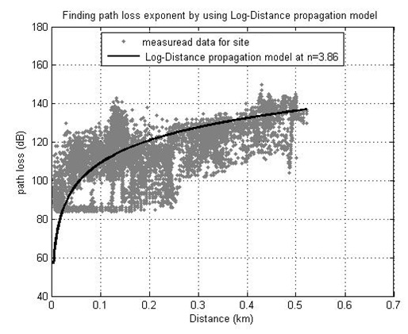
Figure 12 : Log-distance model at n=3.86 and measured data

Table 13 Path loss exponent for different base stations
Cell No. | Path loss exponent n
BS1 | 3.86
BS2 | 3.9
BS3 | 3.6
BS4 | 3.82
BS5 | 4.163
BS6 | 3.645
BS7 | 3.915
BS8 | 4.41

Table 14 Statistical values for Log-distance propagation model applied for a certain base stations
Base station No. | Mean error | Standard deviation | RMSE
BS1 | 2.11 | 13.14 | 13.31
BS2 | 2.22 | 13.864 | 14.04
BS3 | 0.22 | 8.8 | 8.8116
BS4 | 0.72 | 11.396 | 11.4186
BS5 | 1.473 | 11.628 | 11.721
BS6 | 0.1547 | 5.9 | 5.92
BS7 | 0.444 | 9.414 | 9.423
BS8 | 0.335 | 9.06 | 9.065

Table 13 indicates that n values refers to all base stations located in shadowed urban area which is true as in Table 1. In Table 14, Standard deviation values for base stations are around 10 dB. Also, RMSE are accepted values.

5.1.2 Standard Macrocell model implementation

This model used by ASSET software where many companies use it. So, we need to study and compare it with other models. Default parameters are shown below which used by mobile cellular company JAWWAL.

Heff | 12
Hms | 1.5
diffn | 6.2
C_Loss | 8 urban area
k1 | 135
k2 | 38
k3 | -2.55
k4 | 0
k5 | -13.82
k6 | -6.55
k7 | 0.7

Formula before tuning,

Path Loss (dB) = k1 + k2 log(d) + k3 (Hms) + k4 log(Hms) + k5 log(Heff) + k6 log(Heff) log(d) + k7 (diffn) + C_Loss | (5-2)

Figure 13 shows measured data and the macrocell model before tuning. Notice that, the model approximately pass through measured data with a mean error 10.91dB. So, this error is not small enough to rely on it, which indicates that the model needs to be tuned. The tuned model of BS1 will be applied on other base stations BS2,BS3,BS4,BS4, BS5,BS6,BS7,BS8 and BS9 to test its efficiency in Nablus environment.

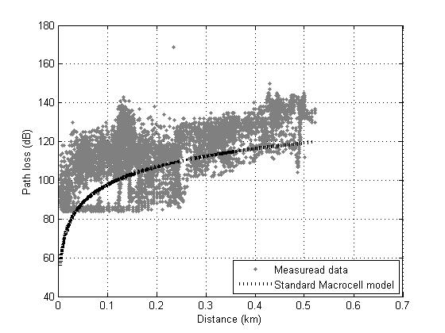
Figure 13 : Comparison of Standard macrocell model and measured data

Now, we proposed a simple linear-iterative tuning method using a least square theory based on existing model tuning method, and this method is used to tune macrocell model of GSM system in urban area. So, this process used to minimize the error, the formula is.

Path Loss (dB) = (k1+C1) + (k2+C2) log(d) + k3 (Hms) + k4 log(Hms) + k5 log(Heff) + k6 log(Heff) log(d) + k7 (diffn) + C_Loss | (5-3)

Concluding all the above calculating process, it can be found that this model tuning methods simplifies multi-parameters non-linear iterative in literature[29][17] into two parameters linear iterative, the complexity of calculating process is reduced obviously.

After applying LMSE the offset values C₁ and C₂ are found to be 4.412 , -7.88 respectively. Hence , Tuned model may be given as ;

Path Loss (dB) = 139.41 + 30 log(d) + -2.55 (Hms) + 0 log(Hms) + -13.82 log(Heff) + -6.55 log(Heff) log(d) + 0.7 (diffn) + C_Loss | (5-4)

Table 15 shows k factors of the model before and after tuning. Figure 14 shows path loss of measured data and macrocell model before tuning versus tuned model. In another point view, some engineers prefer to see the path loss curves as a received power curves which give clearer indication of received signal strength, Figure 15 shows received power of measured data and macrocell model before and after tuning. See Appendix I for path loss and received power conversion
Table 16 shows statistical values (Mean Error µ, Standard Deviation σ and Root Mean Square Error RMSE).

Table 15 Model parameters before and after tuning
Parameters | Before tuning | After tuning
C1 |  | 4.412
C2 |  | -7.88
k1 | 135 | 139.41
k2 | 38 | 30
k3 | -2.55
k4 | 0
k5 | -13.82
k6 | -6.55
k7 | 0.7

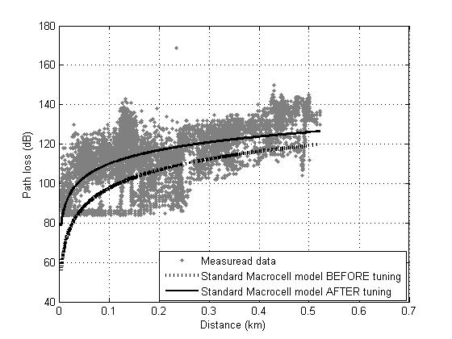
Figure 14 : Path loss comparison of Standard macrocell model before and after tuning

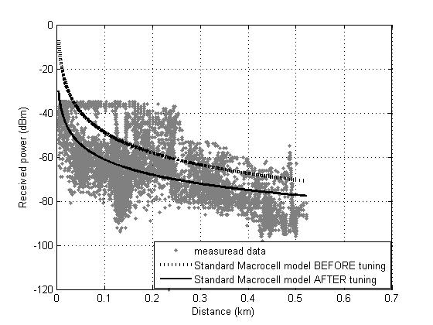
Figure 15 : Received power comparison of Standard macrocell model before and after tuning

Table 16 Statistical values for Standard Macrocell model applied on BSs
 | Mean Error  µ (dB) |  | Standard Deviation  σ |  | Root Mean Square Error  RMSE
BTS | Before  tuning | After tuning | Before tuning | After tuning | Before  tuning | After tuning
BS1  main cell used to get tuned model | 10.91 | 0 | 11.792 | 11.29 | 6.066 | 11.29
BS2 | 18.536 | 10.368 | 10.807 | 9.11 | 21.457 | 13.801
BS3 | 12.067 | 5.746 | 8.396 | 7.898 | 14.701 | 9.768
BS4 | 14.510 | 6.309 | 10.157 | 9.164 | 17.712 | 11.125
BS5 | 21.774 | 11.257 | 9.621 | 8.936 | 23.80 | 14.373
BS6 | 13.565 | 7.753 | 5.496 | 5.085 | 14.636 | 9.271
BS7 | 16.797 | 8.24 | 8.556 | 8.019 | 18.85 | 11.497
BS8 | 25.971 | 15.569 | 7.987 | 7.54 | 27.171 | 17.298
Average | 16.77 | 8.16 | 9.10 | 8.38 | 19.30 | 12.30

In Table 16, the mean error of BS1 has been reduced to zero, standard deviation were decreased by 4.25%, but in general, for average values, mean error, standard deviation and RMSE are decreased by 51.34% , 7.91% and 36.27% respectively. On the other hand, average standard deviation is 8.38 which acceptable value [1].

5.1.3 Bertoni-Walfisch model implementation

Now we want to use a LMSE on Bertoni-Walfisch model and monitor the improvement of the model before and after tuning and compare the result (mean error, standard deviation and root mean square error) with Okumura-Hata, Walfisch-Ikegami, Haret and Standard Macrocell models. The general formula of Bertoni-Walfisch model is

PL(dB) = 89.5 + A + 38log (d) -18log (Ht-hb) + 21log (f) | (5-5)

Where,
A = 5log [ (b/2)²+(hb-hm)² ] - 9log (b) + 20log {tan⁻¹[ 2 (hb-hm)/b) ] }

This model applied on BS1. Where this cell is the most suitable one which is located in down town, that means this cell represent Nablus city atmosphere, so parameter models about base stations environment which substituted in equation (5-5) are:

Ht = 12 m
Hb = 9 m
Hm = 1.5 m
f = 957 MHz
b = 10 m
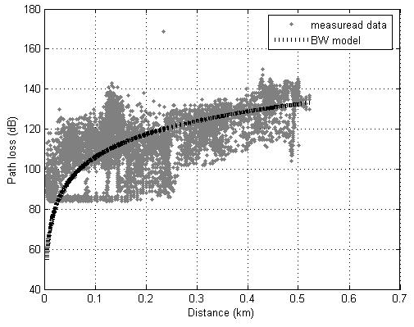
Figure 16 : Comparison of Standard macrocell model and measured data for BS 1

Figure 16 shows measured data and the Bertoni-Walfisch model before tuning. Notice that, the model approximately pass through measured data with a mean error 1.426 dB, see Table 18. It is smaller than error in Standard Macrocell model 10.91 dB (used in JAWWAL-Palestinian mobile communication company) which indicates that this model is more accurate than Standard model, notice that both error values for models before tuning. To make Bertoni-Walfisch more and more accurate we will tune it using LMSE. The tuned model of BS1 will be applied on other base stations BS2,BS3,BS4,BS4, BS5,BS6,BS7 and BS8 to test its efficiency in Nablus environment.
After applying LMSE the offset values C₁ and C₂ are found to be -10.9 , -15 respectively. Hence , Tuned model may be given as ;

PL(dB) = (89.5 + C₁ ) + A + (38 + C₂ )log (d) -18log (Ht-hb) + 21log (f) | (5-6)

PL(dB) = 78.6 + A + 23 log (d) -18log (Ht-hb) + 21log (f) | (5-7)

As a result, equation (5-7) is a path loss formula for Nablus city. Figure 17 shows path loss of measured data and macrocell model before tuning versus tuned model. In another point view, Figure 18 shows received power of measured data and macrocell model before and after tuning.

Table 17 contains height of transmitter Ht , average building height Hb and separation between buildings b for each base station.
Table 17 Base stations parameters
BSs | Ht (m) | Hb (m) | b (m)
BS1 | 12 | 9 | 10
BS2 | 28 | 18 | 10
BS3 | 17 | 10 | 10
BS4 | 14 | 10 | 10
BS5 | 28 | 18 | 10
BS6 | 17 | 10 | 10
BS7 | 14 | 10 | 10
BS8 | 14 | 10 | 10

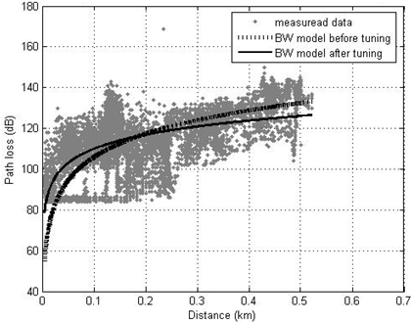
Figure 17 : Path loss comparison of Bertoni-Walfisch (BW) model before and after tuning for BS 1

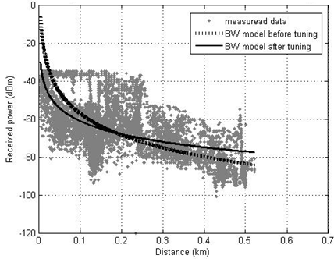
Figure 18 : Received power comparison of Bertoni-Walfisch (BW) model before and after tuning for BS 1

Table 18 Mean Error comparison between tuned Bertoni-Walfisch model with known models
BSs | Effective Testing Data Number | Bertoni-Walfisch | Tuned Bertoni-Walfisch | Hata | Walfisch-Ikegami | Haret | Standard Macrocell model
BS1 | 50748 | 1.426 | 0 | 12.598 | 10.58 | 10.348 | 10.91
BS2 | 4163 | 6.978 | 10.728 | 17.82 | 16.5 | 10.329 | 18.536
BS3 | 9627 | 2.367 | 9.633 | 9.737 | 10.106 | 8.636 | 12.067
BS4 | 8336 | 3.254 | 6.941 | 14.726 | 11.697 | 10.966 | 14.510
BS5 | 21390 | 13.041 | 12.32 | 23.117 | 18.936 | 15.769 | 21.774
BS6 | 3968 | 3.342 | 11.576 | 10.789 | 11.083 | 9.707 | 13.565
BS7 | 3937 | 5.88 | 8.891 | 16.424 | 14.322 | 13.567 | 16.797
BS8 | 2652 | 16.813 | 16.311 | 27.214 | 25.255 | 24.377 | 25.971
Average Mean Error | --- | 6.64 | 9.55 | 16.55 | 14.80 | 12.96 | 16.76

Table 19 Standard Deviation comparison between tuned Bertoni-Walfisch model with known models
BSs | Effective Testing Data Number | Bertoni-Walfisch | Tuned Bertoni-Walfisch | Hata | Walfisch-Ikegami | Haret | Standard Macrocell model
BS1 | 50748 | 13 | 11.294 | 12.96 | 12.99 | 12.98 | 11.792
BS2 | 4163 | 13.52 | 9.544 | 12.732 | 13.52 | 12.879 | 10.807
BS3 | 9627 | 8.941 | 7.956 | 8.861 | 8.94 | 12.358 | 8.396
BS4 | 8336 | 11.362 | 9.2 | 11.163 | 11.362 | 11.362 | 10.157
BS5 | 21390 | 10.987 | 9.09 | 10.567 | 10.987 | 10.644 | 9.621
BS6 | 3968 | 6.027 | 5.127 | 5.944 | 6.026 | 5.924 | 5.496
BS7 | 3937 | 9.286 | 8.039 | 9.220 | 9.286 | 9.229 | 8.556
BS8 | 2652 | 8.538 | 7.559 | 8.489 | 8.538 | 8.496 | 7.987
Average Standard Deviation | --- | 10.20 | 8.47 | 9.99 | 10.20 | 10.48 | 9.10

Table 20 RMSE comparison between tuned Bertoni-Walfisch model with known models
BSs | Effective Testing Data Number | Bertoni-Walfisch | Tuned Bertoni-Walfisch | Hata | Walfisch-Ikegami | Haret | Standard Macrocell model
BS1 | 50748 | 13.07 | 11.294 | 18.075 | 16.76 | 16.6 | 16.066
BS2 | 4163 | 15.215 | 14.35 | 21.9 | 21.333 | 16.51 | 21.457
BS3 | 9627 | 9.249 | 12.493 | 13.165 | 13.493 | 12.358 | 14.701
BS4 | 8336 | 11.82 | 11.528 | 18.478 | 16.3 | 15.726 | 17.712
BS5 | 21390 | 17.052 | 15.311 | 25.418 | 21.893 | 19.025 | 23.80
BS6 | 3968 | 6.891 | 12.661 | 10.789 | 12.615 | 11.371 | 14.636
BS7 | 3937 | 10.99 | 11.986 | 18.834 | 17.069 | 16.408 | 18.85
BS8 | 2652 | 18.856 | 17.977 | 28.507 | 26.659 | 25.815 | 27.171
Average RMSE | --- | 12.89 | 13.45 | 19.40 | 18.265 | 16.72 | 12.89

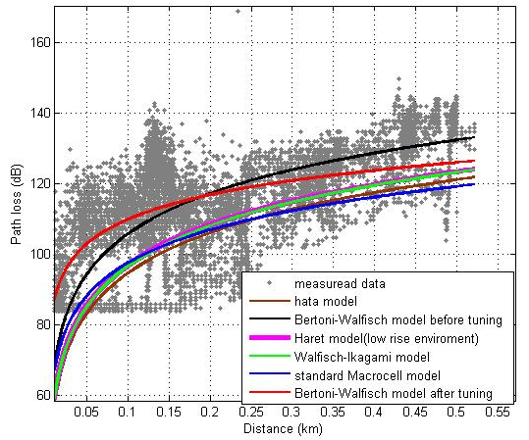
Figure 19 : Path loss comparison between measured data for BS 1 and propagation models

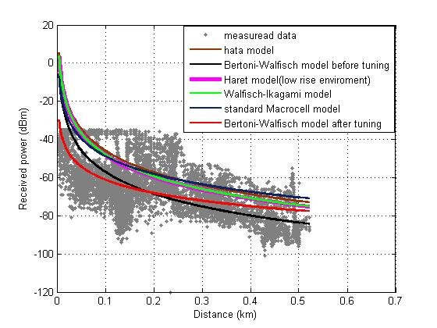
Figure 20 : Received power comparison between measured data for BS 1 and propagation models

Figures 19 and 20 shows path loss and received power of measured data plotted with propagation models (Hata, Haret, Walfisch-Ikegami, Standard Macrocell, and Bertoni-Walfisch before and after tuning) respectively.

5.2 Special Case Study

Consider this special case -cell BS9- in order to verify that the modified Bertoni-Walfisch equation (5-7) is applicable for rural area in Nablus district -called Al-Bathan Valley- , another data generated ASSET tool for another cell in Al-Bathan. Based on that practical data, the propagation path loss and the distance have been re-verified for another cell. BS9 information shown in Table 21.

For path loss exponent of BS 9, it is a little bit higher than previous cells. It is 4.79 which emphasize that area is hilly[18][33], see Table 22. At first glance, when we implement Log-distance model, standard deviation is acceptable, see Table 23 .But unfortunately, Bertoni-Walfisch model is never suitable for BS 9; Because Bertoni-Walfisch model used only for urban areas. So, statistical values for this base station becomes higher for tuned Bertoni-Walfisch model, see Table 24.

Table 21 BS9 information
Antenna Name | XPol A-Panel 900 65°
Type No. | 739 623
G_{TX} | 2 x 17 dBi
EIRP | 58.4 dBm
Azimuth | 0º
Height | 16.5 m
Total down tilt (Mech. + Elec.) | 0º
Effective Testing Data Number | 33187

Table 22 Path loss exponent for BS9
Cell No. | Path loss exponent n
BS9 | 4.79

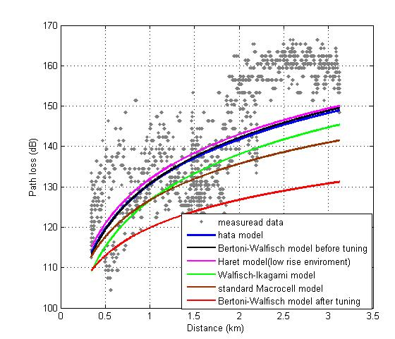
Figure 21 : Path loss comparison between measured data for BS 9 and propagation models

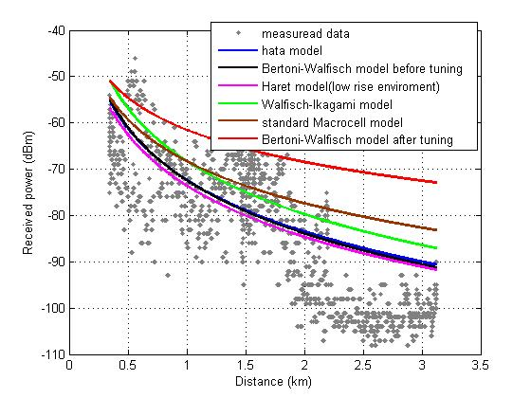
Figure 22 : Received power comparison between measured data for BS 9 and propagation models

Table 23 Statistical values for Log-distance propagation model applied for BS9
Base station No. | Mean error | Standard deviation | RMSE
BS9 | 0.134 | 9.703 | 9.7

Table 24 Statistical values for BS 9
 | Bertoni-Walfisch | Tuned Bertoni-Walfisch | Hata | Walfisch-Ikegami | Haret | Standard Macrocell model
Mean error | 3.231 | 16.236 | 3.463 | 7.386 | 2.249 | 8.45
Standard deviation | 9.552 | 10.683 | 9.583 | 9.55 | 9.592 | 9.975
RMSE | 10.083 | 19.436 | 10.19 | 12.074 | 9.852 | 13.074

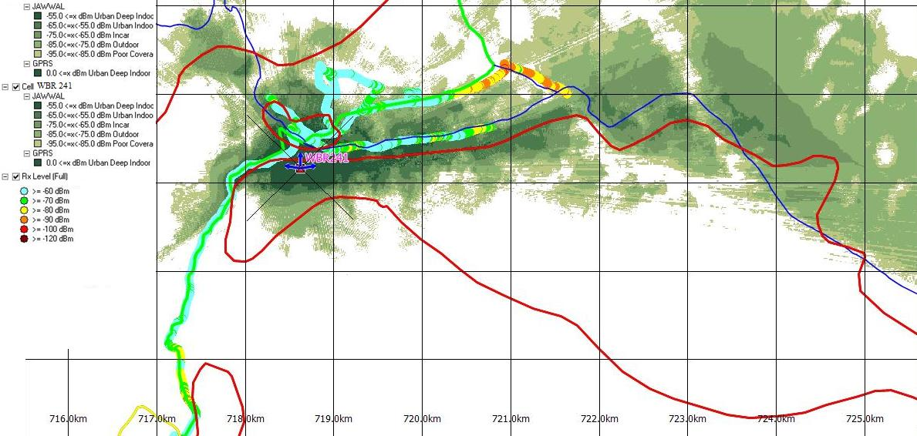 | Figure 23 : Prediction map of BS9 for ASSET software and drive test in coloured samples

5.3 Results and Conclusions

In this study, different path loss models for macro cells were used. The calculated path loss is compared with existing model like Bertoni-Walfisch, COST231-Walfisch-Ikegami, Haret, Standard Macrocell and Okumura-Hata. Fine tuning of the Bertoni-Walfisch model is carried out using Linear Least Square method on large number of measurement records. The mean Error value for BS 1 has been reduced to zero. For all base stations, average standard deviation was reduced to 8.47 dB. Hence, this tuned Bertoni-Walfisch propagation model is proposed to improve the performance and so it may be used for propagation prediction in the city.

The presence of terrain profile had not considered, Where this factor may increase the accuracy of Bertoni-Walfisch model. In addition to get a perfect tuned Bertoni-Walfisch model, we recommend to bring a building map for Nablus city , which gives a pretty quite image of building heights and separations.

5.4 Acknowledgment

The authors wish to sincere thanks, appreciation and gratitude to Eng. Antar Salim and Eng.Akram Barakeh (Senior Radio Planning Engineers in JAWWAL Company) for the support and corporation they have given while preparing this work.

APPENDIX I
Useful formulas

Calculation of EiRP
EiRP = PAPower - cellEquipmentLoss - feederLoss + antennaG + antennaCorrectionFactor + cellCorrection

Where,
FeederLoss = (feederLength * feederLossPerMeter) + feederConnectionLoss
AntennaG = antennaGain (+ 2.14 if the gain is in dBd)

P_{RX}= EiRP – path loss - cellEquipmentLoss - feederLoss + antennaG + antennaCorrectionFactor + cellCorrection
Frequency calculation
According to the GSM 900 recommendations the channels are numbered as follows:

fl(n) = 890.2 + 0.2*(n–1) in MHz

Where n (Absolute Radio Frequency Channel Number, ARFCN) goes from 1 to 124 and fl is a frequency in the lower band, BTS receiver (Uplink).

Example: N=111, Fl = 890.2+ 0.2(111-0) = 912.2 MHz uplink

fu(n) = fl(n) + 45 in MHz

Where n goes from 1 to 124 and fu is a frequency in the upper band, BTS transmitter. (Down Link)

Example: N=111, Fu (111) = Fl(111) + 45 = 957.2MHz downlink.

Formula for the distance calculation between two coordinates on earth [34]
e = cos⁻¹[ sin(LAT1)*sin(LAT2) + cos(LAT1)*cos(LAT2)*cos(LONG2-LONG1) ]
r = 6378.137 km
Distance = e * r
Where,
LAT1: Latitude for first point
LONG1: Longitude for first point
LAT2: Latitude for second point
LONG2: Longitude for second point
r: Earth equator

The decibel [35]

The decibel, abbreviated dB, is one-tenth of the international transmission unit known as the bel. The origin of the bel is the logarithm to the base 10 of the power ratio. The logarithm to the base 10 is the common logarithm. It is that power to which the number 10 must be raised in order to equal the given number. The number 10 is raised to the second power, or squared, in order to get 100. Therefore the log of 100 is 2.
The decibel is expressed mathematically by the equation

dB = 10 log $\frac{P2(larger power)}{P1(smaller power)}$

The complicated negative characteristics of the logarithm of the ratio can be avoided by always placing the larger power value in the numerator of the equation. In each problem it is known whether there is a gain or loss.

The decibel is not a unit of power. The unit of power in our exponential or logarithmic system of numbers is represented by dBm, where the m is the unit, meaning above or below one milliwatt. Since 1 row is neither above nor below I mw, I mw = 0 dBm. It should be noted that
dB ± dB | = | dB
dBm ± dB | = | dBm
dBm ± dBm | = | dB

What is dBm? [30]

dBm (sometimes dBmW) is an abbreviation for the power ratio in decibels (dB) of the measured power referenced to one milliwatt (mW). It is used in radio, microwave and fiber optic networks as a convenient measure of absolute power because of its capability to express both very large and very small values in a short form. Compare dBW, which is referenced to one watt (1000 mW). And this relationship below shows how to convert Watt to dBm.

And

Where P is the power in W and x is the power ratio in dBm.

GSM Bands [31]

Network type | Frequency band uplink / downlink MHz
GSM 800 | 824-849 / 869-894
GSM 900 | 890-915 / 935-960
GSM 1800 | 1710-1785 / 1805-1880
GSM 1900 | 1850-1910 / 1930-1990

Range of received Signal Strength (SS) in dBm [31]

SS > -77 | Good
-86 < SS < -77 | Fair
-110 < SS <-87 | Bad

Units Conversion [32]
Decibel Conversion: Power
dB = 10 log [P2/P1]
Decibels relative to Power

Decibel Conversion: Voltage
dB = 20 log [V1/V2]
Decibels relative to Voltage across same resistance

Decibel Conversion: Current
dB = 20 log [I1/I2]
Decibels relative to Current through same resistance

Decibel Conversion: Milliwatts
dBm = 10 log [Signal (mW)/1mW]
Decibels relative to one milliwatt

Decibel Conversion: Microvolts
dBmv = 20 log [Signal (mV)/1mV]
Decibels relative to one microvolt across same resistance

Decibel Conversion: Microamps
dBmA = 20 log [Signal (mA)/1mA]
Decibels relative to one microamp through same resistance

Power Conversion: dBw to dBm
dBm = dBw + 30
Conversion from dBw to dBm.

Voltage Conversion: dBv to dBmv
dBmv = dBv + 120
Conversion from dBv to dBmv.

Voltage to Power Conversion: dBmv to dBm
dBm = dBmv - 107
Where the constant 107 is as follows:
* RF systems are matched to 50W
P = V² / R
10Log₁₀[P] = 20Log₁₀[V] - 10Log₁₀[50^{W}]
V = (PR)^{0.5} = 0.223 V = 223000 mV
For a resistance of 50W and a power of 1 mW:
20Log₁₀[223000mV] = 107 dB

Power Density
dBw/M² = 10Log₁₀[V/M - A/M]
Decibel-Watts per square meter.
dBm/M² = dBw/M² + 30
Where the constant 30 is the decibel equivalent of the factor 1000 used to convert between W and mW:
10Log₁₀[1000] = 30

Electric Field to Power Density
dBm/M² = dBmV/M - 115.8
Where the constant 115.8 is as follows:
P=|E|²/Z_{o}
Where Z_{o} is the free space characteristic impedance (W), equal to 120p.
Change this equation to decibels, converting dBW/M² to dBmW/M² for power density and dBV/M to dBmV/M for the electric field.
This yields 115.8

Electric Field Voltage
V/M = 10^{{[(dBmV/M) -120]/20}}
Electric Field Voltage in volts per meter

Electric Field Current
dBmA/M = dBmv/M - 51.5
Where the constant 51.5 is a conversion of the characteristic impedance of free space (120p) into decibels: 20Log₁₀[120p] = 51.5
A/M = 10^{{[(dBmA/M) -120]/20}}
Electric Field Current in amps per meter

Antenna Factor
AF_{dB} = E_{dB} - Vr_{dB}
where:
AF = Antenna Factor in dB/M
E = Field strength at the antenna in dBµv/M
Vr = Output voltage from receiving antenna in dBµv
AF (for 50 W) = 20 log f (MHz) - G(dBi) - 29.78 dB.
where f is the measured frequency (MHz), G is the antenna gain (dBi) over isotropic.
(E) dBmv/M = (Vo) dBmv + (AF) dB/M
AF is the antenna factor of the measuring antenna (as per calibration or per antenna manufacturer).
E is the unknown or measured electric field strength.
Vo is the adjusted (calibrated for cable & connector losses) spectrum analyzer output.
Magnetic Flux Density
dBpT = dBmA/M + 2.0
Where the constant 2.0 is as follows:
The magnetic flux density B is in Teslas (T)
The permeability of the medium is in Henrys per meter (H/M)
The permeability in free space is: m_{o} = 4p x 10⁻⁷ H/M
Convert from T to pT and from A/M to mA/M, and take the Log:
240 - 120 + 20Log₁₀[4p x 10 ⁻⁷] = 2.0

Conversion between field strength and received power

P_{R}=((c/4$π$ *f_{c})^2)*(E^2/30 ) W
P_{R}: Received power, E: Electric field, f_{c}: Carrier frequency

APPENDIX II
References and Datasheets

7.1 References

[1] Z. Nadir, Member, IAENG , N. Elfadhil, F. Touati. Pathloss Determination Using Okumura-Hata Model And Spline Interpolation For Missing Data For Oman.

[2] McConoughey, S. R., et. al., 1988, "Coverage Prediction for Mobile Radio System Operating in the 800/900 MHz Frequency Range", IEEE Transactions on Vehicular Technology, Vol.37, No. 1, pp. 3-72.

[3] James Demetriou and Rebecca MacKenzie. “Propagation Basics”. September 30, 1998, pp.39-42. Available online on http://www.scribd.com/doc/7218261/Propagation-Basics
[Accessed in April 2010].

[4] Communication Research Centre, 2005, Satellite Communication and Radio Propagation.

[5] Hess, G. C. 1998. Handbook of land-mobile system coverage. London: artech house, inc.

[6] Parsons, J. D. 2000. The Mobile Radio Propagation Channel. New York: John Wiley and sons, Inc.

[7] Mishra, R.A. 2004. Fundamentals of Cellular Network Planning and Optimization 2G/2.5G/3G…Evolution to 4G. New York: John Willy and Sons, Inc.

[8] Hata, M. 1980. Empirical Formula for Propagation Loss in Land Mobile Radio Services. IEEE Transactions on Vehicular Technology. 29.

[9] Okumura, Y., Ohmori, E., Kawano, T. & Fukuda, K. 1968. Field Strength and its Variability in UHF and VHF Land Mobile Radio Service. Review Electronic Communication Lab. 16(9-10).

[10] AWE Communications. S.a. Wave Propagation and Radio Network Planning.

[11] ASSET, User Reference Guide, Software Version 6.1, Reference Guide Edition 1. V 6.0 is available online on http://www.scribd.com/doc/19033329/ASSET-User-Reference-Guide
[Accessed in April 2010].

[12] B.Yesim Hanci and I.Hakki Cavdar. “Mobile Radio Propagation Measurements and Tuning the Path Loss Model in Urban Areas at GSM-900 Band in Istanbul – Turkey”. Fall 60th Vehicular Technology Conference IEEE Vehicular Technology Conference No60, Los Angeles CA , ETATS-UNIS 2004, pp. 139-143

[13] Lempiäinen, J. & Manninen, M. 2001. Radio interface system planning for GSM /GPRS / UMTS. Boston: Kluwer Academic Publishers.

[14] Anderson, H.R. 1997. Coverage Prediction for Digital Mobile Systems Part .

[15] Neskovic A., Neskovic N. & Paunovic G. 2002. Modern Approaches in Modeling of Mobile Radio Systems Propagation Environment.

[16] M. A. Alim, M. M. Rahman, M. M. Hossain, A. Al-Nahid. “Analysis of Large-Scale Propagation Models for Mobile Communications in Urban Area”. International Journal of Computer Science and Information Security,Vol. 7, No. 1, 2010,pp.135-139

[17] Mingjing Yang and Wenxiao Shi. “A Linear Least Square Method of Propagation Model Tuning for 3G Radio Network Planning”. Vehicular Technology Conference, 2008. VTC 2008-Fall. IEEE 68th, Calgary, pp.150-154.

[18] Mukubwa Wanyama Emmanuel. “A statistical per cell model tuning approach for cellular networks”.
http://libserv5.tut.ac.za:7780/pls/eres/wpg_docload.download_file?p_filename=F587524610/MukubwaWE.pdf [Accessed on March 2010].

[19] http://en.wikipedia.org/wiki/Hata_Model_for_Urban_Areas [Accessed on November 2009].

[20] Propagation Models in Urban Area for Wireless Communication Systems in UHF and VHF Band, Yakup Bayram

[21] http://en.wikipedia.org/wiki/Minimum_mean_square_error [Accessed on December 2009].

[22] http://www.gepsoft.com/Gepsoft/APS3KB/Chapter09/Section3/SS04.htm [Accessed on December 2009].

[23]http://www.eumetcal.org/intralibrary/open_virtual_file_path/i2055n15861t/english/msg/ver_cont_var/uos3/uos3_ko1.htm [Accessed on December 2009].

[24] http://www.xycoon.com/lsrms.htm [Accessed on March 2010].

[25] http://en.wikipedia.org/wiki/Standard_deviation [Accessed on April 2010].

[26] http://www.itl.nist.gov/div898/handbook/pmd/section1/pmd141.htm [Accessed in March 2010].

[27] Harvey Lehpamer. “Microwave transmission networks: planning, design, and deployment” .California, USA . Mcgraw-hill Professional Publishing (Apr 2004).

[28] http://www.javvin.com/wireless/FrequencyReuse.html [Accessed on March 2010].

[29] Chen Bo, Shi Wenxiao and Yang Mingjing, “Study on Propagation Model Tuning Based on WCDMA System”, Journal of Jilin University (Information Science Edition), Jilin University Press, Changchun, China, 2008, pp.38-43.

[30] http://en.wikipedia.org/wiki/DBm [Accessed on November 2009].

[31] Allam Abdul-Fattah and Reyad Zarifah , Supervisor: Dr.Allam Mousa. “Solutions for Limited Number of Frequencies Allowed for JAWWAL network (study case : Nablus city)”. An-Najah National University, Electrical Engineering Department.

[32] http://www.radioing.com/eengineer/convert.html [Accessed on November 2009].

[33] Eng. Indrani Hissalle. “Estimating Signal Strengths Prior to Field Trials in Wireless Local Loop Networks”. http://www.christiealwis.com/Knowledge%20Sharing/EstimatingSignalstrength.pdf [Accessed on March 2010].

[34] http://www.koordinaten.com/informations/formula.shtml [Accessed on May 2010].

[35] Algie L.Lance . “Introduction to Microwave Theory and Measurements”. Published 1964 by McGraw-Hill in New York

7.2 Datasheets

