

Department Of Energy and Enviromental Engineering
Faculty Of Engineering and Information Technology
An–Najah National University
Graduation Project- Ι
Optimization of the Tilt Angle of PV System for Malaysia

Supervisor Name:
Prof : Tamer Khatib

Students Names:
Sundus Nael Akram Al-Abaad
Shorouq Sameer hassen massallha

A report submitted in partial Fulfillment of the requirement for Bachelor degree in Energy and Environmental Engineering

Acknowledgement

We would firstly like to acknowledge our supervisor, Prof : Tamer Khatib, we are grateful to him for his guidance and kind advice. He helped us by giving various ideas and taught us many basics about optimizing the tilt angle of photovoltaic module, he guided us in this project such as improving our searching capabilities and improve our skills in matlap software program and how to write the report. Without his help we would not have been possible for us to present this project.

Also, we would like to express our gratitude for everyone who helped us during the graduation project. Thanks are extended to faculty of Engineering and Information Technology in general and specially for Energy and Environmental Engineering department members.

Finally, we would like to thank our respective families for their constant support and encouragement .

Table of Contents
Abstract 5
Ch1: Introduction 6
1.1 Background: 6
1.2 Problem statement: 7
1.3 Objectives: 8
1.4 Methodology : 9
1.5 Time line: 10
Ch2: Literature view 11
2.1 Case study for Madinah,(2011): 11
2.2 Case study for Rajasthan,(2012): 12
2.3 Case study for Oman,(2013): 13
2.4 Case study for China,( 2016): 14
2.5 Case study of Turkey,(2016) : 14
Ch3: Theory 15
Ch4: Results and Analysis 17
CH:5 Reference 24
Appendix: A 25

List of figure

Figure 1: the component for horizontal surface 7
Figure 2 :the component for tilt surface 7
Figure 3: Flow chart of the work packages for project 10
Figure 4: Monthly average daily total solar irradiation 12
Figure 5: The seasonally adjusted tilt angles 12
Figure 6: power vs tilt for may 13
Figure 7: power vs tilt for June 13
Figure 8: tilt angle vs global solar radiation for January month 18
Figure 9: tilt angle vs global solar radiation for February month 18
Figure 10: tilt angle vs global solar radiation for March month 19
Figure 11: tilt angle vs global solar radiation forAprile month 19
Figure 12: tilt angle vs global solar radiation for May month 20
Figure 13: tilt angle vs global solar radiation for Junmonth 20
Figure 14: tilt angle vs global solar radiation forJuly month 21
Figure 15: tilt angle vs global solar radiation for Augast month 22
Figure 16: tilt angle vs global solar radiation for Sebtember month 22
Figure 17: tilt angle vs global solar radiation forOctober month 22
Figure 18: tilt angle vs global solar radiation for November month 23
Figure 19tilt: tilt angle vs global solar radiation for December month 24

List of table

Table 1:The schedule time for the project 10
Table 2 : Monthly tilt angle optimization results 13

Abstract

Solar energy is one of the best efficient in the production of electricity, Malaysia has also use solar panel for the generation of electricity, our study was in specific region so we chosen the Kuala lampor city in Malaysia with Latitude:3.11, Longitude:101.97 , below the equator.
Our graduation Project talk about how to optimum the tilt angle for pv system by using a specific calculation and apply it in mat lap program, we take the data that we need in our calculation then we test the result at fixed tilt angle then we make this value as a range then we optimizing the tilt angle that give the maximum solar energy comparing with the solar energy come from horizontal surface that done by considering the Liu and Jordan model for solar energy incident on a tilt surface.
The result we have for a 12 month for Kuala lampor by matlap software program figure is not complete result ,so in our graduation Project-2 we will complete this result and find the optimum tilt angle that has a maximum solar energy and fined the seasonally result by the Kuala lampor Location.

Ch1: Introduction

1.1 Background:
The importance of renewable form of energy increases with the increase in population as well as the style of living. Among the renewable sources of energy, solar photovoltaic has proved to be promising because of its easy and efficient way of energy production. Sun is a huge source of solar energy and it is time that we utilize it to the maximum level,though this form of energy is very easy to generate but at the same time its efficiency is very less due to many reasons, one of the confusions or dilemmas that engineers face is the amount of global solar radiation, this radiation is different depend on the surface type ,if the surface was a horizontal as show in figure1.1.1,the amount of global solar radiation constant from direct radiation that form 70% in clear sky and diffuse that formed by conflicts the radiation by impediments such as dust and clouds, on the tilt surface as show in figure1.1.2,we have another component of radiation that is tie reflected part from radiation that form because of conflicts with the surfaces ,another factor that effect on the amount collected by solar panel is tilt angle of the panels, whether to keep it fixed or to vary it according to the month or season or year [1]. The advantage with the latter is that if the panel follows the sun, it can collect all the energy and hence give high energy output. But at the same time the equipment’s used to track the sun are so expensive that even after the increase in efficiency, they are not feasible to be installed in huge solar photovoltaic plants. A lot of research has been done at attempts to make this system feasible and can apply at any region whatever their ability.
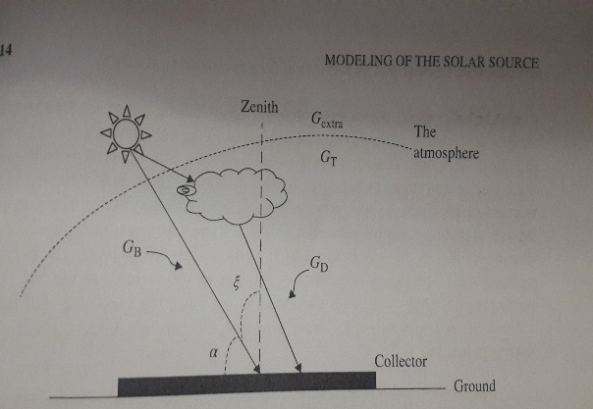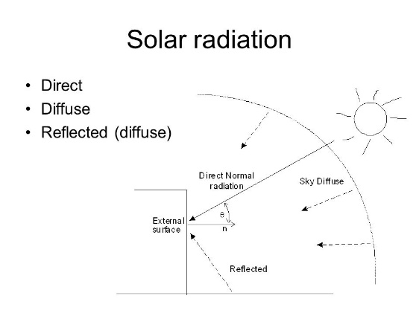
Figure 1.1.1:the component for horizontal surface Figure 1.1.2:the component for horizontal surface
1.2 Problem statement:

Recently, research and development in fid the best angle that has a maximum solar energy is sun tracker , Active sun trackers are electromechanical or pure mechanical devices that keep changing the tilt and the orientation of a solar panel/solar array periodically during the day. However, the capital cost of such a system is high and it consumes energy during tracking[2] .
So we face a problem that we have to optimum the tilt angle from a horizontal surface, so we have a maximum of solar energy without spend all of this money on the equipment, so we can apply this solution in any region with out force it to pay the high costs.

1.3 Objectives:

The foremost way to increase the solar energy that come from the sun and collect by solar panel is optimum the tilt angle because it has a significant effect on the amount of solar energy ,the goals that we aim to reach them by graduation Project are :
- Collecting the maximum solar energy that the solar panel can get from global solar radiation.
- Finding the optimum tilt angle witch achieve the previous point.
- Feasible method so we can apply it in any region whatever its possibilities.

1.4 Methodology :
In our project we will optimization the tilt angle that utilized to have a maximum solar energy collected by solar panel in Kuala lampor ,so we work step by step from the beginning to the last point that to write a report, in this chapter we will show and discus our work briefly see the figure 1.4.1.
Wp1
Collect the data that we need to start the project in excel sheet

Wp2
Transfer the data to the system from excel sheet

Wp3
Define the location data for the Kuala lampor on mat lap

Wp4
Define the specific equations that used to calculate the variables

Wp5
Set one value for tilt angle and take the result for one year with global solar radiation

Wp6
Set a range for tilt angle from 0 to 90 and take the result for one month with global solar radiation

Wp7
Set a range for tilt angle from 0 to 90 and take the result for one year with global solar radiation and take the angle that give a maximum global solar radiation

Wp8
Write the report
d

Figure1.4.1: Flow chart of the work packages for project

1.5 Time line:

From the binging step in our project to the end ,we organize and regulate our time to finish at the specified time without any losses from our time and reduce the negative effect as we can in table 1.5.1

Table 1.5.1:The schedule time for the project
work package 1 | 1st and 2nd week
work package 2 | 3rd and 4th week
work package 3 | 5th and 6th week
work package 4 | 7th and 8th week
work package 5 | 9th and 10th week
work package 6 | 11th and 12th week
work package 7 | 13th and 14th week
work package 8 | 15th and 16th week

Ch2: Literature view
Under this title there are a lot of studies and research that have been applied to find the optimum tilt angle that give the maximum solar energy that collected from solar panel ,and a lot of them can reach their purpose, here we would to refer to these studies and research and the most important result and details they achieved.

2.1 Case study for Madinah,(2011):
The study is based upon the measured values of daily global and diffuse solar radiation on a horizontal surface ,it is shown that the optimal angle of tilt for each month, allows us to collected the maximum solar energy for Madinah site.
The historical data used in this study are available from 1998 to 2002, includes global
irradiance, diffuse irradiance, direct normal irradiance, air temperature and relative humidity, all these data have been collected each 5 min , in the figure 2.1.1 shown the relation between the tilt angle from 0 to 90 and the global solar radiation per month[3]
Figure 2.1.1: Monthly average daily total solar irradiation on a south facing surface in Madinah over the year for different tilt varying from 0 to 90

The result The results show that the tilt angle will be optimum when it change per season as the figure 2.1.2 shown .
37 17 12 28
Dec-Jan-Feb Mar-Apr-May Jun-Jul-Aug Sep-Oct-Nov

Figure 2.1.2: The seasonally adjusted tilt angles.

2.2 Case study for Rajasthan,(2012):
In this study we show the optimum tilt angle of a solar photovoltaic panel , for May and June, they use voltmeter device and but it in deferent position to collect the data and the result as shown in figure 2.2.1 and figure 2.2.2 .
Figure 2.2.1 power vs tilt for may Figure 2.2.2 power vs tilt for June

In the month of May the power obtained up to 16th may is maximum at tilt of 10 and after that maximum power obtained at a tilt of 5.Similarly on the month of June maximum power obtained at an tilt angle of 5, Since declination of sun is mostly perpendicular to earth surface on 20th June to 23rd June, hence maximum power between these days is at a tilt of 0. so, we concluded that graph between power and tilt shows that for the month of May the tilt angle is 5-10 and the tilt angle for June month it is 5-2.As the value of tilt angle increase the power decrease accordingly[4].

2.3 Case study for Oman,(2013):
Numerical method for optimization of the PV module tilt angle, is implemented using MATLAB and hourly meteorological data and load demand. The results show that for Sohar zone the tilt angle of a PV array must be adjusted twice a year where the PV array must be slanted at 49 degrees in the period of 21/09-21/03 (n=255-81), while it must be horizontal (tilt angle is zero) in the period of 21/03-21/09 (n=81-255). This adjustment practice gains the energy collected by a PV array by 24.6%.This paper contains important information for those who are interested in photovoltaic system investment in Oman, the data collected per month is shown in the table 2.3.1 below.

Table 2.3.1: Monthly tilt angle optimization results
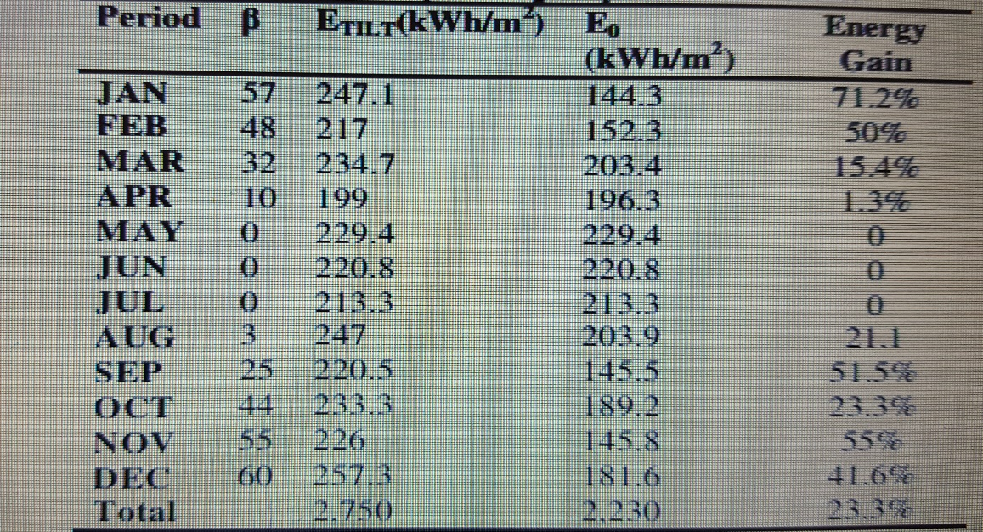

2.4 Case study for China,( 2016):
In this study suggests a simple and universal method to obtain the optimum tilt angles by estimating the monthly mean daily global solar radiation on tilted surfaces facing directly towards the equator, which is based on monthly average daily global solar radiation data produced from Typical Meteorological Year (TMY) data. The monthly, seasonal, and yearly optimum tilt angles for photovoltaic panels are calculated at six stations of different climatic types.
The results indicate that changing the monthly, seasonal, and yearly optimum tilt angles causes a significant yearly gain in the solar radiation for the region. In addition, general correlations are generated to estimate the optimum tilt angle of solar collectors at six typical climatic stations of China.[5]

2.5 Case study of Turkey,(2016) :
The optimization of tilt angles was performed using solar radiation data measured for eight big provinces in Turkey, The optimum angle for tilted surfaces varying from 0° to 90° in steps of 1° was calculated by searching for the values of which the daily total solar radiation was at a maximum for a specific period. It was found that the optimum tilt angle changed between 0° and 65° throughout the year in Turkey. It was seen that the optimum tilt angle reached a minimum of 0° in June and July and, the monthly average daily total radiation at this angle was generally at a maximum. In addition, the optimum tilt angle increased during the winter months and reached a maximum in December in all provinces.[6]

Based on this cases study and their future view ,we applied our project and estimate the optimum tilt angle that give the maximum global solar radiation for Malaysia,Kuala lampor.

Ch3: Theory

In our project we depending on liu and Jordan model [7],to optimize the best tilt angle that give us the maximum solar radiation by solar panel .
Estimation Techniques[8]:
- At first we define the location for Kuala lampor (Latitude:3.11,Longitude:101.97)

- Define the ρ : ground Aledo =.3

- We take the data for global(G) and diffuse (D) radiations, for Kuala lampor

- We estimate the direct(B) radiation by using this equation :

B=G-D (3.1)

- We estimate the declination angle by using this equation :

DEC=23.45*(sin(360*(N-81)/365)) (3.2)

- We estimate the sunshine hour angle by using this equation :

Wss=acos (-1*tan(L).*tan(DEC)) (3.3)

- We estimate R_{R}: amount of reflected solar energy on a tilt surface, by using this equation :

R_{R}=(1-cosd (TLT))/2 (3.4)

- We estimate R_{B :} ratio between global solar energy on a horizontal surface and global solar energy on a tilt surface, by using this equation :

R_{B}=(cosL_TLT)*cos(DEC)*sin(Wss))+(Wss*sin(L+TLT)*sin(DEC)))/((cos(L)*cos(DE C)*sin(Wss))+(Wss*sin (L)*sin (DEC)) (3.5)

- We estimate R_{D}: ratio between diffuse solar energy on a horizontal surface and diffuse solar energy on a tilt surface, by using this equation :

R_{D}=(1+cosd (TLT))/2 (3.6)

- We estimate the G_{-TLT} :the global solar radiation on tilt surface, by using this equation :

G_TLT=B_TLT+D_TLT+R_TLT (3.7)

That solve by using this equation:

G_TLT=(G-D)* R_{B} +D*R_{D}+G*ρ*R_{R} (3.8)

- Set the tilt range between (0 – 90).

- Drown the figure for each month a long one year for tilt angle with the global solar radiation by matlap soft ware program.

- Choose the maximum tilt that give a maximum solar radiation.

- Then define the optimum tilt angle for each month .

Ch4: Results and Analysis

After we done our calculation and our methodology ,it is time to have a result by matlap software program, the result to each month has shown below in figures 4.1 _ 4.12 that describe the relation between the optimum tilt angle that give the maximum global solar radiation.
Figure 4.1: tilt angle vs global solar radiation for January month
Figure 4.2: tilt angle vs global solar radiation for February month
Figure 4.3: tilt angle vs global solar radiation for March month
Figure 4.4: tilt angle vs global solar radiation for April month

Figure 4.5: tilt angle vs global solar radiation for May month
Figure 4.6: tilt angle vs global solar radiation for Jun month

Figure 4.7: tilt angle vs global solar radiation for July month

Figure 4.8: tilt angle vs global solar radiation for August month
Figure 4.9: tilt angle vs global solar radiation for September month
Figure 4.10: tilt angle vs global solar radiation for October month

Figure 4.11: tilt angle vs global solar radiation for November month
Figure 4.12: tilt angle vs global solar radiation for December month

This result is not complete ,and we will complete the code of matlap software program in Graduation Project- IΙ, and you can see in the appendix A

CH:5 Reference

[1] M. Jamil Ahmad* and G.N. Tiwari.2009. Optimization of Tilt Angle for Solar Collector to Receive Maximum, Radiation, The Open Renewable Energy Journal, 2, 19-24 19.
[2] Khatib, T. 2010. A review of designing, installing and evaluating standalone photovoltaic power systems. J. Appl. Sci.10:1212–1228.
[3] M. Benghanem.2011. Optimization of tilt angle for solar panel: Case study for Madinah, Saudi Arabia, Applied Energy, 1427–1433.
[4] Saurav Kumar1, Dr. P.B.L Chaurasia2, Hari Kumar Singh3.2012. Experimental Study of Optimum Tilt Angle for Solar PV Panel in Jaipur (Rajasthan), International Journal of Science and Research (IJSR), ISSN (Online): 2319-7064.
[5] Haixiang Zang *, Mian Guo, Zhinong Wei and Guoqiang Sun.2016. Determination of the Optimal Tilt Angle of Solar Collectors for Different Climates of China, College of Energy and Electrical Engineering, Hohai University, Nanjing 211100,
[6] N Arslanoglu,2016, Optimization of Tilt Angle for Solar Collectors: A Case Study for Bursa, Turkey, Excellence in Research and Innovation for Humanity.
[7] Liu, B., and Jordan, R. 1962. Daily insolation on surfaces tilted towards the equator. Trans. ASHRAE 67:526–541.
[8] T. Khatib,1 A. Mohamed,1 M. Mahmoud,2 and K. Sopian3.2015. Optimization of the Tilt Angle of Solar Panels for Malaysia, Energy Sources, Part A: Recovery, Utilization, and Environmental Effects, 37:606–613.

Appendix: A

clc
clear
close all
filename='Malaysian Daily Solar Data';
sheetname='Kuala Lumpur';
G=xlsread('Malaysian Daily Solar Data','Kuala Lumpur','E2:E33');
D=xlsread('Malaysian Daily Solar Data','Kuala Lumpur','F2:F33');
B=G-D;
TLT=1;
L=3.11;
Ro=.3;
float a=zeros(90,365);float b=zeros(90,365);float c=zeros(90,365);float d=zeros(90,365);float e=zeros(90,365);float f=zeros(90,365);float g=zeros(90,365);float h=zeros(90,365);float i=zeros(90,365);
while TLT<=90
N=1;
while N<=31

DEC=23.45*(sind (360*(N-81)/365));
Wss=acosd (-1*tand(L).*tand(DEC));
RB=((cosd(L-TLT)*cosd (DEC)*sind (Wss))+(Wss*sind(L-TLT)*sind(DEC)))/((cosd (L)*cosd (DEC)*sind (Wss))+(Wss*sind (L)*sind (DEC)));
RR=(1-cosd (TLT))/2;
RD_1=(1+cosd (TLT))/2;
%RD_2=(3 + cosd (2*TLT))/4;
%RD_3=1-(TLT/180);
B_TLT=B(N).*RB;
R_TLT=G(N).*Ro*RR;
D_TLT=D(N).*RD_1;
G_TLT=B_TLT+D_TLT+R_TLT;
a(TLT,N)= B_TLT;
b(TLT,N)= R_TLT;
c(TLT,N)= D_TLT;
d(TLT,N)= G_TLT;
e(TLT,N)= DEC;
f(TLT,N)= Wss;
g(TLT,N)= RB;
h(TLT,N)= RR;
i(TLT,N)= RD_1;
disp(a(TLT,N))
disp(b(TLT,N))
disp(c(TLT,N))
disp(d(TLT,N))
disp(e(TLT,N))
disp(f(TLT,N))
disp(g(TLT,N))
disp(h(TLT,N))
disp(i(TLT,N))
N=N+1;

end
TLT=TLT+1;
end

x=(TLT-2)/30;
y=1:x:(TLT-1);
s=1:1:31;
clc
d1=[];
d2=[];
d3=[];
d4=[];
d5=[];
d6=[];
d7=[];
d8=[];
d9=[];
d10=[];
d11=[];
d12=[];
d13=[];
d14=[];
d15=[];
d16=[];
d17=[];
d18=[];
d19=[];
d20=[];
d21=[];
d22=[];
d23=[];
d24=[];
d25=[];
d26=[];
d27=[];
d28=[];
d29=[];
d30=[];
d31=[];
d32=[];
d33=[];
d34=[];
d35=[];
d36=[];
d37=[];
d38=[];
d39=[];
d40=[];
d41=[];
d42=[];
d43=[];
d44=[];
d45=[];
d46=[];
d47=[];
d48=[];
d49=[];
d50=[];
d51=[];
d52=[];
d53=[];
d54=[];
d55=[];
d56=[];
d57=[];
d58=[];
d59=[];
d60=[];
d61=[];
d62=[];
d63=[];
d64=[];
d65=[];
d66=[];
d67=[];
d68=[];
d69=[];
d70=[];
d71=[];
d72=[];
d73=[];
d74=[];
d75=[];
d76=[];
d77=[];
d78=[];
d79=[];
d80=[];
d81=[];
d82=[];
d83=[];
d84=[];
d85=[];
d86=[];
d87=[];
d88=[];
d89=[];
d90=[];
for sh=1:1:31
d1=[d(1,sh);d1]
d2=[d(2,sh);d2]
d3=[d(3,sh);d3]
d4=[d(4,sh);d4]
d5=[d(5,sh);d5]
d6=[d(6,sh);d6]
d7=[d(7,sh);d7]
d8=[d(8,sh);d8]
d9=[d(9,sh);d9]
d10=[d(10,sh);d10]
d11=[d(11,sh);d11]
d12=[d(12,sh);d12]
d13=[d(13,sh);d13]
d14=[d(14,sh);d14]
d15=[d(15,sh);d15]
d16=[d(16,sh);d16]
d17=[d(17,sh);d17]
d18=[d(18,sh);d18]
d19=[d(19,sh);d19]
d20=[d(20,sh);d20]
d21=[d(21,sh);d21]
d22=[d(22,sh);d22]
d23=[d(23,sh);d23]
d24=[d(24,sh);d24]
d25=[d(25,sh);d25]
d26=[d(26,sh);d26]
d27=[d(27,sh);d27]
d28=[d(28,sh);d28]
d29=[d(29,sh);d29]
d30=[d(30,sh);d30]
d31=[d(31,sh);d31]
d32=[d(32,sh);d32]
d33=[d(33,sh);d33]
d34=[d(34,sh);d34]
d35=[d(35,sh);d35]
d36=[d(36,sh);d36]
d37=[d(37,sh);d37]
d38=[d(38,sh);d38]
d39=[d(39,sh);d39]
d40=[d(40,sh);d40]
d41=[d(41,sh);d41]
d42=[d(42,sh);d42]
d43=[d(43,sh);d43]
d44=[d(44,sh);d44]
d45=[d(45,sh);d45]
d46=[d(46,sh);d46]
d47=[d(47,sh);d47]
d48=[d(48,sh);d48]
d49=[d(49,sh);d49]
d50=[d(50,sh);d50]
d51=[d(51,sh);d51]
d52=[d(52,sh);d52]
d53=[d(53,sh);d53]
d54=[d(54,sh);d54]
d55=[d(55,sh);d55]
d56=[d(56,sh);d56]
d57=[d(57,sh);d57]
d58=[d(58,sh);d58]
d59=[d(59,sh);d59]
d60=[d(60,sh);d60]
d61=[d(61,sh);d61]
d62=[d(62,sh);d62]
d63=[d(63,sh);d63]
d64=[d(64,sh);d64]
d65=[d(65,sh);d65]
d66=[d(66,sh);d66]
d67=[d(67,sh);d67]
d68=[d(68,sh);d68]
d69=[d(69,sh);d69]
d70=[d(70,sh);d70]
d71=[d(71,sh);d71]
d72=[d(72,sh);d72]
d73=[d(73,sh);d73]
d74=[d(74,sh);d74]
d75=[d(75,sh);d75]
d76=[d(76,sh);d76]
d77=[d(77,sh);d77]
d78=[d(78,sh);d78]
d79=[d(79,sh);d79]
d80=[d(80,sh);d80]
d81=[d(81,sh);d81]
d82=[d(82,sh);d82]
d83=[d(83,sh);d83]
d84=[d(84,sh);d84]
d85=[d(85,sh);d85]
d86=[d(86,sh);d86]
d87=[d(87,sh);d87]
d88=[d(88,sh);d88]
d89=[d(89,sh);d89]
d90=[d(90,sh);d90]
end
shrouq=sum(d1)
shrouq_1=sum(d2)
shrouq_2=sum(d3)
shrouq_3=sum(d4)
shrouq_4=sum(d5)
shrouq_5=sum(d6)
shrouq_6=sum(d7)
shrouq_7=sum(d8)
shrouq_8=sum(d9)
shrouq_9=sum(d10)
shrouq_10=sum(d11)
shrouq_11=sum(d12)
shrouq_12=sum(d13)
shrouq_13=sum(d14)
shrouq_14=sum(d15)
shrouq_15=sum(d16)
shrouq_16=sum(d17)
shrouq_17=sum(d18)
shrouq_18=sum(d19)
shrouq_19=sum(d20)
shrouq_20=sum(d21)
shrouq_21=sum(d22)
shrouq_22=sum(d23)
shrouq_23=sum(d24)
shrouq_24=sum(d25)
shrouq_25=sum(d26)
shrouq_26=sum(d27)
shrouq_27=sum(d28)
shrouq_28=sum(d29)
shrouq_29=sum(d30)
shrouq_30=sum(d31)
shrouq_31=sum(d32)
shrouq_32=sum(d33)
shrouq_33=sum(d34)
shrouq_34=sum(d35)
shrouq_35=sum(d36)
shrouq_36=sum(d37)
shrouq_37=sum(d38)
shrouq_38=sum(d39)
shrouq_39=sum(d40)
shrouq_40=sum(d41)
shrouq_41=sum(d42)
shrouq_42=sum(d43)
shrouq_43=sum(d44)
shrouq_44=sum(d45)
shrouq_45=sum(d46)
shrouq_46=sum(d47)
shrouq_47=sum(d48)
shrouq_48=sum(d49)
shrouq_49=sum(d50)
shrouq__50=sum(d51)
shrouq_51=sum(d52)
shrouq_52=sum(d53)
shrouq_53=sum(d54)
shrouq_54=sum(d55)
shrouq_55=sum(d56)
shrouq_56=sum(d57)
shrouq_57=sum(d58)
shrouq_58=sum(d59)
shrouq_59=sum(d60)
shrouq_60=sum(d61)
shrouq_61=sum(d62)
shrouq_62=sum(d63)
shrouq_63=sum(d64)
shrouq_64=sum(d65)
shrouq_65=sum(d66)
shrouq_66=sum(d67)
shrouq_67=sum(d68)
shrouq_68=sum(d69)
shrouq_69=sum(d70)
shrouq_70=sum(d71)
shrouq_71=sum(d72)
shrouq_72=sum(d73);
shrouq_73=sum(d74)
shrouq_74=sum(d75)
shrouq_75=sum(d76)
shrouq_76=sum(d77);
shrouq_77=sum(d78);
shrouq_78=sum(d79)
shrouq_79=sum(d80)
shrouq_80=sum(d81)
shrouq_81=sum(d82);
shrouq_82=sum(d83)
shrouq_83=sum(d84);
shrouq_84=sum(d85)
shrouq_85=sum(d86)
shrouq_86=sum(d87)
shrouq_87=sum(d88)
shrouq_88=sum(d89)
shrouq_89=sum(d90)
f=[sum(d1),sum(d2),sum(d3),sum(d4),sum(d5),sum(d6),sum(d7),sum(d8),sum(d9),sum(d10),sum(d11),sum(d12),sum(d13),sum(d14),sum(d15),sum(d16),sum(d17),sum(d18),sum(d19),sum(d20),sum(d21),sum(d22),sum(d23),sum(d24),sum(d25),sum(d26),sum(d27),sum(d28),sum(d29),sum(d30),sum(d31),sum(d32),sum(d33),sum(d34),sum(d35),sum(d36),sum(d37),sum(d38),sum(d39),sum(d40),sum(d41),sum(d42),sum(d43),sum(d44),sum(d45),sum(d46),sum(d47),sum(d48),sum(d49),sum(d50),sum(d51),sum(d52),sum(d53),sum(d54),sum(d55),sum(d56),sum(d57),sum(d58),sum(d59),sum(d60),sum(d61),sum(d62),sum(d63),sum(d64),sum(d65),sum(d66),sum(d67),sum(d68),sum(d69),sum(d70),sum(d71),sum(d72),sum(d73),sum(d74),sum(d75),sum(d76),sum(d77),sum(d78),sum(d79),sum(d80),sum(d81),sum(d82),sum(d83),sum(d84),sum(d85),sum(d86),sum(d87),sum(d88),sum(d89),sum(d90)]
r=1:1:90;
%figure(1)
%plot (s,d)
%hold on
%figure(2)
plot(r,f)

