3d- Scanner
A 3D scanner is a device that analyzes a real-world object or environment to collect data on its shape. The collected data can then be used to construct digital, three dimensional models useful for a wide variety of applications. These objects can be extensively used by the entertainment industry in the production of movies and video games. Other common applications of this technology include industrial design, orthotics and prosthetics
Main Idea :
The main idea behind this project is to obtain the outer surface of the object . so the straight forward way that we considered is to slice the object to thin slices using a laser pointer formed into a line and aimed into the object, this laser line will take the outer shape of the thin part of object at this moment a camera positioned at a known angle captures an image of the object. And send it somehow to the PC “to be tilled later” , then rotate the object so that laser line covers another part of the object, repeat these steps until the whole object is scanned .
At PC side prepare the pictures remove everything except the lighted part of the object , then group all pictures together each in its correct position as its distance from the laser rod . The result is a digital image similar to the word object shape .
Tools needed :
- PIC microcontroller. - Digital camera.
- Laser diode. - Stepper motors.
- Lenses “to convert laser beam from a point into straight line”.
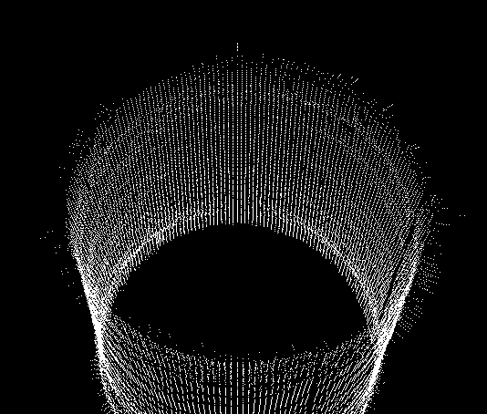
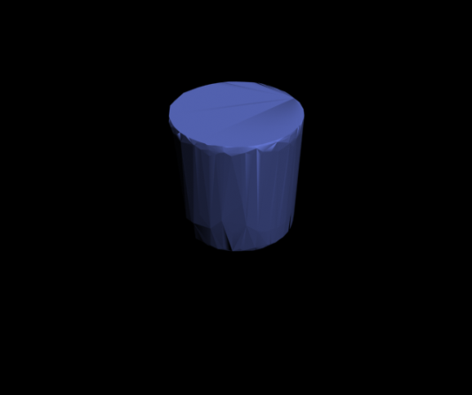
Output sample :

Students :
-Bashar Nadir Mu’ala.
- Ahmad Haza’ Khader.

