Contents: page
Abstract............................................................................................... 5
Introduction......................................................................................... 7
Chapter one:
Marketing analysis .............................................................................. 9
Chapter two:
Planning process ................................................................................. 13
Chapter three:

Planning the network ............................................................................46

Chapter four:

Automatic frequency plane …………………………………….……77

Chapter five :

Site survey…………………………………………………………93

References .......................................................................................... 101

Abstract:

1. The objectives of this project:
- Cover all subscribers in Nablus city with minimum number of sites.
- Achieve the indoor and outdoor conditions.
- Obtain high quality and minimum percentage of dropped call.

2. Project Methodology:
a . Definition of the Requirements :
- We measured the acceptable signal strength in (indoor, outdoor, deep indoor).
- We calculate the traffic per subscriber …
- Determined the RBS which we use it (2202.2206)..
- Determined the phase which we operate under it ..
- Determined the Grade Of Service (GOS) ..

b. RADIO PROPAGATION MODEL TUNING ACTIVITY:
- Determined the area which covered from every site.
- Prediction of signal strength.
- The shape of radiation pattern.
- The type of cell for every location.

c. NOMINAL CELL PLANNING:
- We calculate the number of RBS.
- Choose the best site for cell.
- The direction of antenna (tilting angle, azimuth).

d. SITE SEARCH AND SURVEY:
After achieve the requirement prediction tools we search and survey for sites to find the most appropriate site to achieve the radio coverage …….
e. DRIVING TEST :
Practical measurement for signal strength this test gives us accurate report for the coverage of specific area ….
3. Summary :
After we finished the marketing analysis we obtained the desired information such as ( average number of call per hour and the duration of the call ) and classifying the city into different area depend on the density of habitants we can find the nominal number of sites to achieve the coverage and capacity specifications .

Introduction:
As a result of developments in telecommunications all of people have a mobile so the GSM network must planned to serve the huge amount of traffic , and the planner must take in his mind the exceeding of the number of subscribers in every year so we can't say this network is optimum because the location of the network will exchange due to building or terrains , and the number of subscriber will increase at every second . finally the planner must take all of this parameter in his mind to have the best performance and good quality to satisfy all of subscribers .
This project will describes the network planning . It's includes the following information:

- Cell types
- Radio Frequency (RF) propagation prediction and rules
- Approximate range
- Cell coverage
- Capacity
- Timing advance

The objective of cell planning is to build a cellular system that provides sufficient coverage and quality, meeting the traffic demands and allowing for future system growth. All these factors must be accomplished using a limited number of network elements and radio frequencies. The cell planning procedure involves the following factors:

- Predictions of radio coverage (indoor and outdoor).
- Traffic dimensioning.
- Site selection.
- Frequency planning.

The feedback from the system can be used to redesign and improve the cell plan. Efficient tools ,are available for predicting the radio path and for detailed planning of frequencies. Such tools are necessary for dealing with irregular site location and unevenly distributed traffic.

Chapter one
marketing analysis
any project analysis will start from marketing study to know demands of the customer and to know if the market have a capacity for new project , we perform this study by publish questionnaire in the area where the project will execute before this step we classify the area in different categories to simplify the development in the future the following table shows this categories :
Location | Dense urban | Urban | Suburban | Rural
OLD TOWN | *
NORTH MOUNTAIN |  | *
SOUTH MOUNTAIN |  |  | *
RAFEDIA |  | *
ALMAKHFIA |  | *
BIET AZAN |  |  |  | *
AN-NAJAH UN |  | *
BIET EIBA |  |  |  | *
ALDAHYA |  |  |  | *
Table (1): the Districts categories in Nablus city ..
After this we publish the following questionnaire just for calculate the amount of traffic per subscriber in Nablus City and use it in our project to find number of RBS needed to serve the city with coverage and capacity with acceptable percentage.

An Najah national university
Electrical engineering department
Questionnaire for traffic calculations :
Location | - Old town.  - Rafedia.  - Al –makhfia.  - Biet wazan.  - South Mountain.  - North mountain.  - Other location .
Operator (SIM) | - Jawwal .  - Wataniya mobile.
Number of call per hour | - One call .  - Two call.  - Three call.  - Four call.  - More than four call.
Duration of the call | - Less than 30 second.  - One minute.  - Two minute.  - Three minute.  - Four minute .  - More than four minute.
Quality of call | - Very good.  - Good.  - Acceptable.  - Poor.  - Very poor.

From this questionnaire we find the following important spacification for planning network :
- Duration of each call

- Number of calls per hour

- Duration of each call :
We find from questionnaire that most of people spent 90 second in their call in average the following graph show this value

Fig (1): relation between numbers of people which submit to questionnaire and duration of call .

2)Number of call per hour :
Also we find that number of call per hour is 1.185 this value is 1 call approximately and the following graph show this value:

Fig (2) : relation between numbers of people which submit to questionnaire and numbers of call

Chapter two
Network Design
2.1 Radio Network Design
2.1.1 Radio Planning Process
In the following steps , the workflow of the macro cell planning process is illustrated .

- DEFINITION OF THE REQUIREMENTS: at the beginning, it is necessary to define the performance requirements of the GSM network to be implemented.

- RADIO PROPAGATION MODEL TUNING ACTIVITY: in order to obtain more reliable radio propagation predictions, it is suitable to tune the models implemented in GSM planner for the most important and critical areas to be covered.

- NOMINAL CELL PLANNING: the requirements, defined in the first phase, are the input to dimensioning of the network in terms of nominal number of sites, using dimensioning and/or design tools.

- SITE SEARCH AND SURVEY: the cell planner, with the support of the site hunters, finds the most appropriate sites to achieve the radio coverage, according to the general criteria. The construction aspects and the possibility

- to obtain the site installation permission license are also taken into account by the site hunters. For the most critical sites in terms of coverage/capacity requirements, the cell planner decides to perform a survey and, if necessary, RF measurements.

- RADIO NETWORK DESIGN: different network design aspects are analyzed, in particular
- Downlink common channel power allocation
- Frequency planning in the case of cells with more than one carrier for capacity requirement
- Code planning
- Parameters involved in the handover algorithms.

- INITIAL TUNING: the default setting of the cell data parameters and the sit configuration are optimized using measurements in the field.

2.1.2 Radio Network Design Requirements

The radio network design requirements are related to coverage, capacity and services and they are specified for each area type: dense urban, urban, suburban and rural (see Table(2) ).

DENSE  URBAN | Areas within the urban perimeter. This includes densely developed areas where built up features do not appear distinct from each other. The typical street pattern is not parallel.  The average building height is below 40 m. The average building density is > 35%.
URBAN | Built up areas with building blocks, where features do appear more distinct from each other in comparison to Dense Urban. The street pattern could be parallel or not.  The average building height is below 40 m. The average building density is from 8 % to 35%.
SUBURBAN | Suburban density typically involves laid out street patterns in which streets are visible. Building blocks may be as small as 30 by 30 m, but are typically larger and include vegetation cover. Individual houses are frequently visible.  The average building height is below 20 m. The average building density is from 3 % to 8 %.
RURAL | Small and scattered built up areas in the outskirts of larger built-up  environments.  The average building height is below 20 m. The average building density is < 3 %.
Table(2): Area Type Classification
In addition to these main area types, roads, which are classified as a type of vector, have to be considered due to their significant traffic volume. The roads can be surrounded by vegetation and buildings or not and located in flat or hilly areas.

2.1.3 Coverage Requirements

- For each area, the extension in km² of coverage area is defined. The value of required coverage area may increase through several phases in the evolution of the network.

- The coverage priority should be identified according to land usage, population distribution and/or vehicular distribution. The high traffic areas (the highest priority coverage) where a continuous coverage has to be guaranteed are, for example, public congregations, highways or roads with high amounts of vehicular traffic, business areas and the like.

- The areas with restrictions on site placement and configuration and on RF power emission should be identified.

2.1.4 Capacity Requirements
- For each area, the number of subscribers and their “profile” (business, conventional, data or/and speech user) is defined. This value can be obtained considering census data. An
annual subscriber forecast is required in order to plan the network growth.

- The traffic volume per subscriber and service type is determined on average during the busy hour. Typically, this amount is given in Erlang for speech service and in Kbyte/h
for data services.

- A non-uniform subscriber distribution should be distinguished and densities quantified in order to plan “hot spot” coverage.
2.1.5 Service Requirements

- The types of service offered must be given. For each area, the estimated usage of each service should also be given. The services are characterized by the QoS (Quality of Service) parameter related to different radio access bearer attributes. The main attributes to define a service are bit rate, transfer delay, Bit Error Rate (BER) and Block Error Rate (BLER).
- The areas with different coverage reliability should be distinguished to determine which service could be guaranteed.

2.1.6 Model Tuning
In the cell planning process, the GSM planner tool is used to predict the radio coverage by means propagation models, for a particular site configuration. Different propagation models are considered according to the different environments and site configurations. The “Algorithm 9999” model, implemented by Ericsson and based on the Okumura-Hata model, is recommended for macrocell configuration, in urban, suburban and rural environments. The model tuning (model calibration) is performed in order to obtain more reliable radio propagation predictions. Measured and predicted signal strength samples are compared, and the mean error between them minimized.
2.1.7 Nominal Cell Planning

The scope of a nominal cell planning activity depends usually on requirements according to the particular phase of the network planning process e.g. license application or radio network design. In the case of a license application activity, the site count needed to achieve the required coverage/capacity is required. It can also be necessary to define, in addition to the number of needed sites, the radio and service coverage for each site. In order to obtain radio predictions, the GSM planning tool GSM planner, based on tunable radio propagation models, is used. Radio network design is an activity based on predictions by the design tool and knowledge of the actual local environment. The result of this activity is a complete radio network plan with a realistic number of sites and RBS configurations.

2.1.8 Site Search

In a typical macrocell configuration the base station antenna height is greater than the average rooftop level. The cell coverage radius obtained with this configuration is potentially the largest with respect to other site configurations at the same power emission conditions. Its maximum value is different according to the environment types and installation details. For a new radio network when the number of subscribers is not so critical, a macro cell site configuration type is generally considered as the first solution. The network growth requires capacity expansion by means of different strategies, for example:
- Using a higher number of cells per area with a smaller radio coverage radius (cell splitting).
- Introducing small/microcells to increase coverage.
- Hot spot coverage to increase capacity.
- Implementing advanced radio network capacity control features.
- Adopting specific solution for indoor coverage.
- Migration towards 3-sectors site if 3x1 Omni configuration has been adopted in the first deployment of the network.

The different area types (described in Table ) can be also characterized by different channel models. In the case of the use of macrocell configurations to provide also indoor coverage, the building penetration margin, typically 15 to 20 dB, has to be taken into account in the link budget calculations. When planning for wireless data services, the same bit rate can either be provided uniformly over the cell area or it can vary and be smaller at the cell border than close to the base station, thereby allowing larger cell range. The choice between these two strategies depends on which service the network is dimensioned for, i.e. whether there is a need to guarantee a fixed grade of service for high bit rate services. For macrocell deployment, different approaches and solutions are considered according to the particular environment: building layout, site placement, traffic type and density and radio propagation effects; as a consequence, the three different environments, Dense Urban/Urban, Suburban/Rural and Road may have to be planned separately throughout the entire service area.

2.1.9 Traffic Volume
GSM network planning is mainly based on radio coverage aspects according to the different environments, and on the traffic distribution. The different area types are defined considering the radio propagation aspects. Each area type can be also characterized taking into account a general traffic volume and traffic type.

- Dense urban: In the case of dense urban, the traffic volume demand is the highest and of both conventional and business type.

- Urban: The urban area is characterized by high traffic volume non-uniformly distributed due to the presence of hot spot areas with high traffic density as commercial and business zones.

- Suburban: The suburban areas are characterized by a medium uniform traffic density. Nevertheless, within this area type it is also possible to find the presence of “hot spot” zones with a higher traffic volume, e.g. industrial areas. This traffic type is mainly business with a variable density during the day and the days of a week.

- Rural: The rural areas are characterized by a low traffic density; geographically non-uniform distribution due to the presence of scattered population centers.

- Road: In the road environment the traffic density can change considerably during the day and in the different days of the week. Moreover, the traffic is often high-speed vehicular type.

2.2 Radio Planning Principle

This Section describes the cell planning guidelines. The section includes the following information:

- Cell types
- Radio Frequency (RF) propagation prediction and rules
- Approximate range
- Cell coverage
- Capacity
- Timing advance
The objective of cell planning is to build a cellular system that provides sufficient coverage and quality, meeting the traffic demands and allowing for future system growth. All these factors must be accomplished using a limited number of network elements and radio frequencies. The cell planning procedure involves the following factors:
- Predictions of radio coverage (indoor and outdoor)
- Traffic dimensioning
- Site selection
- Frequency planning
The feedback from the system can be used to redesign and improve the cell plan. Efficient tools, such as the Ericsson Engineering Tool (EET), are available for predicting the radio path and for detailed planning of frequencies. Such tools are necessary for dealing with irregular site location and unevenly distributed traffic.

2.2.1 Cell Type
The following table illustrate the main type of cells :

Cell Type | Typical cell  radius | Typical position of base station antenna
Macro-cell  (large cell) | 1 km to 30 km | Outdoor; mounted above medium rooftop  level, heights of all surrounding buildings  are below base station antenna height.
Small macro-cell | 0.5 km to 3 km | Outdoor; mounted above medium rooftop  level, heights of all surrounding buildings  are above base station antenna height.
Micro cell | Up to 1 km | Outdoor; mounted below medium roof-top  level.
Pico-cell/indoor | Up to 500 m | Indoor or outdoor (mounted below medium roof-top level)
Table (3): Cell type classification .

2.2.1.1 MacroCell

A macrocell (traditional cell) normally operates at a high output power with the Base Transceiver Station (BTS) antenna located on a roof or other high position. These cells are designed to provide coverage to both indoor and outdoor areas.

2.2.1.2 Umbrella Cell

An umbrella cell is a macrocell that has a useful coverage that extends over several smaller macrocells. The smaller cells handle most of the traffic in the area covered by the umbrella cell. Therefore, an umbrella cell is only used when no other cell is suitable. The location of an umbrella cell is typically “high,” so frequencies must be selected with care to avoid Carrier-to-Interference (C/I) problems.

2.2.1.3 MicroCell

A microcell is a small cell in an outdoor urban environment with a low BTS antenna height relative to the surrounding buildings (typically, 5 to 10 meters above ground level). The microcells normally have a low Effective Radiated Power (ERP) and a coverage area following the shape of the streets. Microcells can be used in existing networks to handle outdoor coverage
holes caused by shadowing due to buildings. This application is particularly relevant in urban areas and downtowns which have tall buildings. Microcells can also be used to handle outdoor hot spots (areas of high traffic) that occur in downtown streets. Microcells can also be used in conjunction with picocells, umbrella cells, and macrocells to create a high capacity Hierarchical Cell Structures (HCS) network. Streets tend to have a guiding affect while buildings tend to obstruct the radio waves. Since buildings are not perfect reflectors, some indoor coverage may result from the microcell. When the coverage area of a microcell is considered, the propagation over rooftops can be neglected; however, lower objects, such as trees, vehicles, and advertising signs will have a greater impact on the microcell as a result of a lower antenna height and ERP.

The location of the antenna also affects the shape of the coverage area. For instance, an omni directional antenna located at an intersection of two streets will produce a cross-shaped coverage area, while one located between buildings along a street will produce a cigar-shaped coverage area. The antennas utilized in microcells may differ from those used in depending on the application. Microcell antennas are mounted on walls or other reduced spaces such as street lights or traffic lights, since the antennas need to be small, inconspicuous, and easy-to-install. Another consideration is the need for feeder cables run to the antennas.

2.2.1.4 Pico Cell

A picocell is a microcell in an indoor environment. A picocell has a low radiated power and a coverage area following the shape of a building or part of a building.

Picocells can be used in existing networks to handle indoor coverage holes caused by the lack of macrocell coverage. These coverage holes occur when either the macrocell plan does not include indoor coverage margins or when the exterior walls of a building attenuated the signal more than
expected. Typical indoor locations that lack macrocell coverage include office buildings, hospitals, shopping malls, airports, indoor stadiums, and parking garages. Picocells can also handle hot spots. Indoor propagation is very different when compared to outdoor propagation. Walls, floors, corridors, people, and furniture cause reflections, and thus multipath effects and attenuation. Typically, a building is the coverage area, but indoor lifts can be excluded while some nearby outdoor location is included. A multistory building requires more than one picocell for complete coverage of the building. For indoor coverage, a coax or fiber cable can be used. Coax cable costs less but also has a higher transmission loss than fiber. A distributed antenna system using multiple antennas provides the following advantages:

- Better control of the coverage area

- Better coverage levels

- Reduced antenna output power

- Lower dynamic range requirements
A single antenna system costs less and is easy to plan and install. While the gain associated with multiple antennas is available for both uplink and downlink, the cost of such systems is more than a space diversity antenna system. Distributed antenna systems can also be implemented using leaky feeder cables. The antennas utilized in picocells may differ from those used in macrocells depending on the application. Typically, bidirectional or directional antennas with different beam widths are suitable for picocell applications. The picocell antennas should be mounted on walls or ceilings using small, inconspicuous, and easy-to-install antennas. The transmitter-subscriber distance in picocells is significantly smaller than in macrocells, thus the
security of the antenna equipment may be an issue that needs to be considered when planning the cell location. Most of the subscribers in a picocell are stationary or moving at relatively low speeds; however, faster moving subscribers will be in parking garages or in streets immediately outside of a building that houses a picocell. The traffic distribution for a picocell is not always uniform and will change during the day. High-traffic hours depend on planned indoor activities. For instance, a hotel would not have much traffic during the day, but probably more traffic in the morning and evening. Similarly, in a sports stadium, the traffic will only be high during an event.

2.2.1.5 MacroCell & Microcell Interaction
To meet the demand for capacity and extensive coverage, different types of cells are needed. For instance, the microcells complement an existing macrocell plan to enhance the capacity, or a large macrocell might be used to provide coverage for coverage gaps between small cells. The coexistence of different types of cells requires a more sophisticated frequency planning method. Handover is also a critical issue when different types of cells coexist. The HCS feature handles the handover issue.

2.2.2 RF Propagation & Prediction

RF propagation prediction is a complex part of cell planning. Many propagating prediction models are available to choose from. The RF propagation model for 1900 MHz is based on the COST 231-HATA propagation model. This model is valid for frequencies between 1500 and 2000 MHz.

Equation 1 is the COST 231-HATA formula:
Lp = 46.6 + 33.9log (f) – 13.82log (Hb) + (44.9 -6.55log (Hb)) .log (R) + Ca
where:

Lp is the path loss in decibels

f is the frequency in megahertz

Hb is the antenna height at the BTS in meters

R is the distance to the transmitter in kilometers

Ca is the correction factor in decibels

Area Type | Ca (Db)
Dense Urban | -2.9
Urban | -2.9
Sub-Urban | -10.5
Rural | -21.4
Flat Open | -32.4
Table (4): correction factor table .

2.2.2.1 Approximate Range

One of the factors that defines a cell is the area that it covers. The range that is covered from a cell depends on several factors such as type and placement of antennas, ERP of Mobile Station (MS) and BTS, and terrain. The desired range is also dependent upon the traffic density (Erlang/km2). If the range is likely to be interference-limited rather then noise-limited, use of the full sensitivity of the BTS and MS is impossible. Think of the cochannel interference power as a noise power. The resulting range R can be approximately calculated by the COST 231-HATA formula as in Equation 2.

Note: The allowed path loss may be restricted either by the uplink path loss or by the downlink path loss, The maximum allowed path loss, Lp, is calculated in Equation 3.

Equation 3:

Lp = min (uplink path loss; downlink path loss)

Given the range R (km), some other coverage parameters can be calculated, as shown in Equation 4 on through Equation 8.

Equation 4:
Equation 5

Equation 6:
Equation 7:
Equation 8:
In practice, range is also dependent upon terrain features. Software tools are available for improved accuracy.

2.2.3 Cell Coverage
when planning a system it is not sufficient to use this sensitivity level for Ms and BTS as a planning criterion. Various margins have to be added in order to obtain the desired coverage. In this chapter these margins are discussed and the planning criteria to use in different types of environments are presented. Furthermore the principles of how to perform coverage acceptance tests are described.

2.2.3.1 Required signal strength
To the sensitivity level of an MS, margins have to be added to compensate for Rayleigh fading, interference and body loss. The obtained signal strength is what is required to perform a phone call in a real-life situation and will be referred to as SS^{req}.SS^{req} is independent of the environment.
Equation 1
where
MS_{sens} | = MS sensitivity.
RF_{marg} | = Rayleigh fading margin.
IF_{marg} | = Interference margin.
BL | = Body loss.
Design level
Extra margins have to be added to SS_{req} to handle the log-normal fading as well as different types of penetration losses. These margins depend on the environment and on the desired area coverage. The obtained signal strength is what should be used when planning the system and it will be referred to as the design level, SS_{design}. This signal strength is the value that should be obtained. The design level can be calculated from:
Equation 2 MS Outdoor
Equation 3 MS in-Car
Equation 4 MS Indoor
where
LNF_{marg(o)} | = Outdoor log-normal fading margin.
LNF_{marg(o+i)} | = Outdoor + indoor log-normal fading margin.
CPL | = Car penetration loss.
BPL_{mean} | = Mean building penetration loss.

2.2.3.2 Margins

2.2.3.2.1 Rayleigh Fading
Rayleigh fading is due to multipath interference and occurs especially in urban environments where there is high probability of blocked sight between transmitter and receiver. The distance between two adjacent fading dips is approximately /2.
However, the GSM specification allows worse quality for slow MSs (3 km/h) than for fast moving MSs. The sensitivity performance at fading conditions corresponding to an MS speed of 50 km/h in an urban environment (called TU50)
Note:
TU50 = Typical Urban 50 km/h, TU3 = Typical Urban 3 km/h

, is in accordance with good speech quality, while the sensitivity performance for slow MSs at TU3² does not correspond to acceptable speech quality.
In order to obtain good speech quality even for slow mobiles, an extra margin, RF_{marg}, is recommended when planning. From experience, 3 dB margin seems adequate. In a frequency hopping system the Rayleigh fading dips are levelled out and there should be no need for a Rayleigh fading margin. But since a Broadcast Control Channel (BCCH) has a static frequency allocation (no frequency hopping allowed), the Rayleigh fading margin is recommended in cell coverage estimations, regardless of using frequency hopping or not.
Rayleigh fading margin (RF_{marg}) = 3 dB
Rayleigh fading dips on the BCCH can be levelled out by using antenna hopping, thereby improving sensitivity performance. This increases the rate of SNR variations creating channel conditions that are more comparable to faster moving MSs. The practical experience of the BCCH antenna hopping is that the Rayleigh fading margin can be reduced to 1 dB in cell coverage estimations due to the improved sensitivity performance.
Rayleigh fading margin (RF_{marg}) = 1dB

with BCCH Antenna Hopping

2.2.3.2.2 Log-Normal Fading
The signal strength value computed by wave propagation algorithms can be considered as a mean value of the signal strength in a small area with a size determined by the resolution and accuracy of the model. Assumed that the fast fading is removed, the local mean value of the signal strength fluctuates in a way not considered in the prediction algorithm. This deviation of the local mean in dB compared to the predicted mean has nearly a normal distribution. Therefore this variation is called log-normal fading.

2.2.3.2.3 Interference
The plain receiver sensitivity depends on the required carrier to noise ratio (C/N). When frequencies are reused, the received carrier power must be large enough to combat both noise and interference, that means C/(N+I) must exceed the receiver threshold. In order to get an accurate coverage prediction in a busy system, an interference margin (IF_{marg}) is defined.
The interference margin depends on the frequency reuse, the traffic load, the desired percentage of area coverage and whether the uplink or the downlink is considered. Frequency hopping, dynamic power control and DTX reduce the interference level. In a normal system an interference margin of 2 dB is recommended.
Interference margin (IF_{marg}) = 2 dB

2.2.3.2.4 Body Loss
The human body has several effects on the MS performance compared to a freestanding mobile phone.
- The head absorbs energy.
- The antenna efficiency of some MSs can be reduced.
- Other effects may be a change of the lobe direction and the polarization. These effects can be neglected in the link budget since 1) no mobile antenna gain is used and 2) X-polarized antennas are standard equipment today.
The body loss recommended, is 3 dB. For 850 MHz, a need for a somewhat higher margin has been indicated. 5 dB is the Ericsson recommendation.

Body loss (BL) = 5 dB

2.2.3.2.5 Car Penetration Loss
When the MS is situated in a car without external antenna, an extra margin has to be added in order to cope with the penetration loss of the car. This extra margin is approximately 6 dB.

Car penetration loss (CPL) = 6 dB

2.2.3.2.6 Design Levels
In this section the design levels, SS_{design}, are calculated for outdoor, in-car and indoor coverage. this signal strength is calculated as the sum of the required signal strength, SS_{req} and various margins, the value of SS_{req} has been taken to be:
Note that if Antenna hopping is used on BCCH, RF_{marg} =1 dB should be used which gives that SS_{req} will be 2 dB lower than the above, that is -96dBm.

2.2.3.2.7 Outdoor and in-Car Coverage
The design levels for outdoor and in-car coverage are calculated according to:
SS_{design} = SS_{req} + LNF_{marg(o)} | MS outdoor
SS_{design} = SS_{req} + LNF_{marg(o)} + CPL | MS in-car
where LNF_{marg(o)} is the log-normal fading margin that is needed to handle the outdoor log-normal fading. This fading will be represented by its standard deviation _{LNF(o)} and depends on the area type. Typical values of _{LNF(o)} are presented in the following Table.
Area type | _{LNF(o)} [dB]
Dense urban | 10
Urban | 8
Suburban | 6
Rural | 6
Table(5):Typical Values of the Standard Deviation of the Outdoor Log-Normal Fading for Different Area Types.
In Table 6 the design levels SS_{design}, for different area types and coverage requirements are calculated. The value of LNF_{marg(o)} is calculated according to the simulations which includes the multi-servergain,

Area type | Coverage [%] | SS_{req}  _{[dBm]} | LNF_{marg(o)}  _{[dB]} | SS_{design outdoor}  _{[dBm]} | SS_{design in-car}  _{[dBm]}
Dense urban  _{LNF(o)} = 10 dB | 75 | -94 | -3.1 | -97.1 | -91.1
 | 85 | -94 | 0.7 | -93.3 | -87.3
 | 90 | -94 | 3.2 | -90.8 | -84.8
 | 95 | -94 | 6.8 | -87.2 | -81.2
 | 98 | -94 | 10.7 | -83.3 | -77.3
Urban  _{LNF(o)} = 8 dB | 75 | -94 | -3.4 | -97.4 | -91.4
 | 85 | -94 | -0.2 | -94.2 | -88.2
 | 90 | -94 | 1.8 | -92.2 | -86.2
 | 95 | -94 | 4.9 | -89.1 | -83.1
 | 98 | -94 | 8.1 | -85.9 | -79.9
Suburban + rural  _{LNF(o)} = 6 dB | 75 | -94 | -3.7 | -97.7 | -91.7
 | 85 | -94 | -1.2 | -95.2 | -89.2
 | 90 | -94 | 0.5 | -93.5 | -87.5
 | 95 | -94 | 3.0 | -91 | -85
 | 98 | -94 | 5.5 | -88.5 | -82.5
Table (6): Design Levels for Various Area Types and Coverage Requirements. A Car Penetration Loss (CPL) of 6 dB Has Been Used.
SS_{req} should be set to -96 dBm if Antenna hopping is used on BCCH.

2.2.3.2.8 Indoor Coverage
Definitions
Indoor coverage
By indoor coverage is understood the percentage of the ground floors of all the buildings in the area where the signal strength is above the required signal level of the mobiles, SS_{req}.

Building penetration loss
Building penetration loss is defined as the difference between the average signal strength immediately outside the building and the average signal strength over the ground floor of the building, The building penetration loss for different buildings is log-normally distributed with a standard deviation of _{BPL}.
Variations of the loss over the ground floor could be described by a stochastic variable, which is log-normally distributed with a zero mean value and a standard deviation of _{floor}.
In this document _{BPL} and _{floor} is lumped together by adding the two as were they standard deviations in two independent log-normally distributed processes. The resulting standard deviation, _{indoor} or _{LNF(i)}, could be calculated as the square root of the sum of the squares.

General
Indoor coverage in this document is about calculation of a required margin to achieve a certain indoor coverage in a fairly large area; large compared to the average macrocell size. It is assumed that it is the macrocells in the area that provides the major part of the indoor coverage. Hotspot microcells in the area will of course improve on the indoor coverage but that effect is not covered in this document.
The guidelines in this document regarding indoor coverage are not applicable to the case where the area of interest basically is covered by contiguous microcells and where macrocells only are used as umbrella cells.
It is common knowledge that the building penetration loss to floors higher up in the building in general decreases. This effect is known as height gain. This is actually an effect of the building penetration loss definition and not of the building structure.

Indoor design level
The indoor design level is calculated
SS_{design} = SS_{req} + LNF_{marg(o+i)} + BPL_{mean} | MS indoor
where the sum of BPL_{mean} and LNF_{marg(o+i)} can be seen as the indoor margin. BPL_{mean} is the mean value of the building penetration loss and LNF_{marg(o+i)} is the margin that is required to handle the total log-normal fading which are composed of both the outdoor log-normal fading (_{LNF(o)}) and the indoor log-normal fading _{LNF(i)}. The total standard deviation of the log-normal fading is given by:
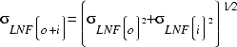
In the following table some values of BPL_{mean} ,_{LNF(o)} and _{LNF(i)} are presented. These figures are based on experience. Note that the characteristics of different urban, suburban etc. environments can differ quite a lot over the world. Thus the values in the following table must be treated with restraint. They should be considered as a reasonable approximation when no other information is obtainable. Rural areas are not considered in the following table, since they are usually not designed for indoor coverage.
 | BPL_{mean} [dB] | _{LNF(o)} [dB] | _{LNF(i)} [dB] | _{LNF(o+I)} [dB]
Dense urban | 18 | 10 | 9 | 14
Urban | 18 | 8 | 9 | 12
Suburban | 12 | 6 | 8 | 10
Table (7) : the design levels required to obtain 75%, 85%, 90%, 95% and 98% indoor coverage are given.
The parameters for the building penetration and the log-normal fading are taken to be those presented in Table 8.

Area type | Coverage [%] | SS_{req}  _{[dBm]} | LNF_{marg(o+i)}  _{[dB]} | BPL_{mean}  _{[dB]} | SS_{design indoor}  _{[dBm]}
Dense urban  _{LNF(o+i)} = 14 dB | 75 | -94 | -3.2 | 18 | -79.2
 | 85 | -94 | 1.8 | 18 | -74.2
 | 90 | -94 | 5.1 | 18 | -70.9
 | 95 | -94 | 9.9 | 18 | -66.1
 | 98 | -94 | 15.3 | 18 | -60.7
Urban  _{LNF(o+i)} = 12 dB | 75 | -94 | -3.1 | 18 | -79.1
 | 85 | -94 | 1.3 | 18 | -74.7
 | 90 | -94 | 4.2 | 18 | -71.8
 | 95 | -94 | 8.4 | 18 | -67.6
 | 98 | -94 | 13.1 | 18 | -62.9
Suburban  _{LNF(o+i)} = 10 dB | 75 | -94 | -3.1 | 12 | -85.1
 | 85 | -94 | 0.7 | 12 | -81.3
 | 90 | -94 | 3.2 | 12 | -78.8
 | 95 | -94 | 6.8 | 12 | -75.2
 | 98 | -94 | 10.7 | 12 | -71.3
Table (8): Indoor Design Level for Various Area Types and Coverage Requirements.
SS_{req} should be set to -96 dBm if Antenna hopping is used on BCCH.

2.2.3.3 Coverage Acceptance Test

2.2.3.3.1 General
The verification of a cell plan is done by performing measurements in the system. The aim is to measure the signal strengths and to estimate if the received level corresponds to the required signal strength SS_{req}. The recommended equipment to use in acceptance tests is a TEMS mobile phone with rooftop antenna. This equipment shall be used in all acceptance cases below.
In order to be connected to the best server as much as possible during the acceptance test a pure signal strength ranking, K-ranking, shall be used in the locating algorithm. In addition a small handover hysteresis, for example 3 dB shall be used. Power Control downlink shall also be switched off.
Compensation should be made for different objects affecting the measured values, e.g. feeder loss and antenna gain in the external antenna.

Outdoor

The acceptance level to verify is the required signal strength SS_{req} for outdoor coverage. This level should be measured at least in A % of the samples, where A represents the required area coverage.
Criteria for downlink signal strength | Rural, 95% outdoor coverage
Acceptance level, (SS_{req}) dBm or better in 95 % of the samples | -94

Table (9): Example 1:95% Outdoor Coverage

2.2.3.3.3 In-Car
The acceptance level to verify is the required signal strength SS_{req} for in-car coverage. This level should be measured at least in A % of the samples, where A represents the required area coverage.
Criteria for downlink signal strength | Rural, 95% in-car coverage
Acceptance level, (SS_{req}) dBm or better in 95 % of the samples | -88

Table (10): Example 2: 95% in-Car Coverage

2.2.3.3.4 Indoor
To verify indoor coverage, subtract the outdoor log-normal fading margin LNF_{marg(o)} corresponding to the desired coverage (A%) from the SS_{design} value. This level should be measured at least in A % of the samples.

Criteria for downlink signal strength | Urban, 95% indoor coverage
SS_{design} [dBm] | -68
Acceptance level, (SS_{design}- LNF_{marg(o)} dBm) or better in 95 % of the samples | -73

Table (11): Example 3: indoor Coverage

2.2.4 Radio Network Capacity

When a cellular network is designed, the capacity, or number of subscribers, is a significant area of concern. While the cell plan is designed to provide coverage for all areas of the network, the capacity will ultimately determine the number of cell sites that are necessary in a given area. For instance, if a geographical area is covered by one cell and the calculated traffic within that area exceeds the traffic channels available, then congestion problems most likely occur. In that case, the solution may be to add cell sites or add more Transceiver Units (TRUs) to an existing site to provide more traffic channels. To determine the number of channels necessary in a network, the traffic needs to be calculated and the Grade of Service (GOS) must be defined

2.2.5 Traffic :
The amount of traffic that a cell can handle is determined by the traffic carried by each subscriber. Traffic is measured in Erlang and is defined in equation 9.

Where:

n : the number of calls per hour and subscriber
T : the average conversation time
A : the offered traffic from one or several users in the system Since the traffic varies by the hour; the network should be dimensioned to meet the needs of the busiest hour. A typical customer profile can be as follows:

- Number of calls per hour and subscriber: 1
- Average time of call: 90 seconds
- Number of subscribers: 100

Equation 10:

A = N * T /3600
A = 25 mErlang
Multiplying the traffic required for each subscriber by the total number of subscribers yields a traffic of 2.5 Erlang. This number is necessary to calculate the total number of channels that are required in a network.

2.2.6 Grade of Service
The GOS must be determined to calculate the number of channels needed. The GOS actually indicates the probability of the system being congested. Typical values used for GOS are 2% to 5% in this project we assume GOS is 2%.
Note: A higher GOS indicates a higher probability of the network being congested; a lower GOS indicates lower probability often work congestion, which is preferred. To determine the number of channels required in a cell, an Erlang table is necessary. An Erlang table lists the number of channels required to serve an amount of traffic for a specific GOS.
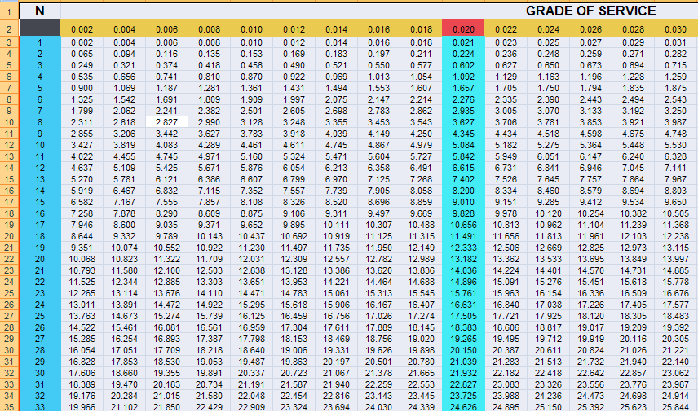

Table (12): Erlang table

Note: To determine the number of channels, calculate the total traffic in Erlang and find the number of channels (in the Erlang table) that correspond to the desired GOS.

Chapter three:

Planning the network

3.1 specifications of the equipments used in the project:
The equipments of the network depend on the area will be covered, number of user in this area, terrains and obstacles and the position of the site. So planner must be more than accurate when choose the equipments such as (RBS, FEEDER, # OF TRUS for each cell, Tower…………etc).

- RBS 2206 with 12 TRU.
- FEEDER 1/2 inch and 2/3 inch.
- Tower depends on the area.

3.2 phases
First we can divide the number of subscribers in Nablus for two phases, to ensure best coverage and quality, this phases is obtained from the marketing analysis in first chapter and it's equal :
- First phase: 20,000 subscribers.
- Second phase :50,000 subscribers.

3.2.1 Phase one

3.2.1.1 Coverage specification in first phase
We wish to cover Nablus city in the first phase with percentages equal to:
* 70%of the area in Nablus is covered by indoor coverage.
* 30% of the area is covered by outdoor coverage.
This percentage will satisfy from the tool (Aircom), and we will redistribute the BTS to ensure these values.

3.2.1.2 Traffic calculations:
Resorting to the questionnaire that we published in different areas in Nablus city we find the parameters which is associated to traffic calculations
From this questionnaire we determine:
* average number of calls per hour is 1 call.
* Average duration of call is 90 second.
From the following equation we find the traffic per subscriber
A = N * T / 3600 .
A: traffic per subscriber .
N: number of call per hour .
T: duration of the call.

Note: Every subscriber has 25 mErlang and we will use this value in BTS calculation.

3.2.1.3 Calculation of the number of BTS for first phase:
* We assume every BTS have 3 cells.
* So every cell has 4 TRU.
* Every TRU have 8 slots.
* # of traffic channel per cell = (8*3) – 2 = 30 traffic channels.

*From Earlang table we find that every 30 TCH can provide 21.932 Earlang.
*so for the BTS is 21.932*3= 65.796 Earlang.
*the amount of traffic for 20,000 subscriber is 20,000 *0.025= 500 Earlang .
*#of BTS for first phase 500/65.8 =8 BTS.

This 8BTS will produce the coverage and capacity for all subscribers in first phase.

3.2.1.4 Simulation for first phase:
By using the Aircom software we distribute the sites in specified area to ensure the coverage and the following picture show these sites.
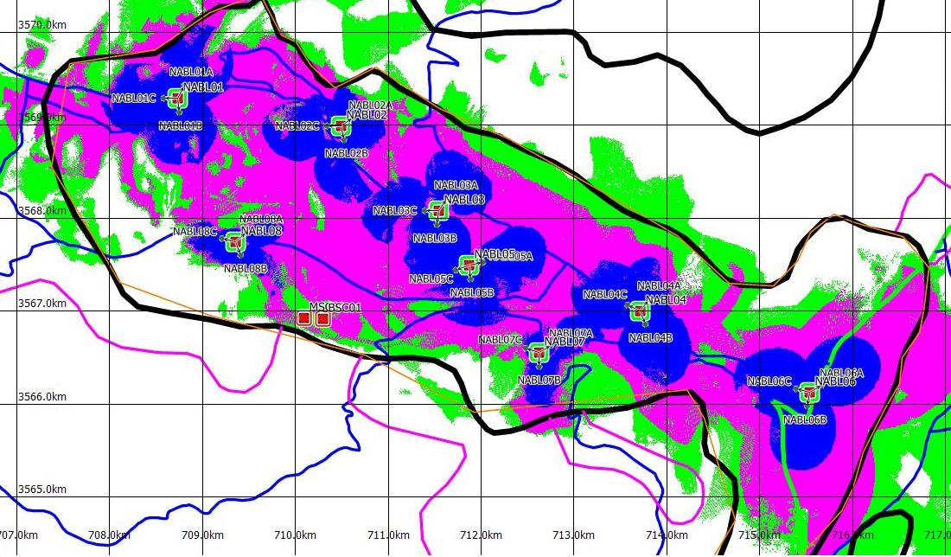

Fig (3): the map of Nablus city in the first phase with 10 sites which taken from AIRCOM tool

This picture include 8 sites with RBS 2206, but there is a large areas covered with outdoor coverage, this mean that there is huge amount of dropped calls due to bad coverage.
Now we will display the name of the sites and the name of the cells in every site and we show the locations of these sites , this locations was define by longitudes and latitudes .

The location of these sites:
Number of site | Name of the cell | longitude | Latitude
NABL01 | NABL01A | 35.23398152 | 32.23789780
NABL01 | NABL01B | 35.23398152 | 32.23789780
NABL01 | NABL01C | 35.23398152 | 32.23789780
NABL02 | NABL02A | 35.24501118 | 32.22946838
NABL02 | NABL02B | 35.24501118 | 32.22946838
NABL02 | NABL02C | 35.24501118 | 32.22946838
NABL03 | NABL03A | 35.26774096 | 32.21934956
NABL03 | NABL03B | 35.26774096 | 32.21934956
NABL03 | NABL03C | 35.26774096 | 32.21934956
NABL04 | NABL04A | 35.24829722 | 32.22413611
NABL04 | NABL04B | 35.24829722 | 32.22413611
NABL04 | NABL04C | 35.24829722 | 32.22413611
NABL05 | NABL05A | 35.28686265 | 32.21106873
NABL05 | NABL05B | 35.28686265 | 32.21106873
NABL05 | NABL05C | 35.28686265 | 32.21106873
NABL06 | NABL06A | 35.27803840 | 32.19495888
NABL06 | NABL06B | 35.27803840 | 32.19495888
NABL06 | NABL06C | 35.27803840 | 32.19495888
NABL07 | NABL07A | 35.22165845 | 32.22685100
NABL07 | NABL07B | 35.22165845 | 32.22685100
NABL07 | NABL07C | 35.22165845 | 32.22685100
NABL08 | NABL08A | 35.23398152 | 32.23789780
NABL08 | NABL08B | 35.23398152 | 32.23789780
NABL08 | NABL08C | 35.23398152 | 32.23789780
Table (13): the location of each sites in Nablus city in first phase .

3.2.1.4 .1 Sites configuration:
Each sites in the first phase has specific configuration depends on the area which be covered by this site so we handle every one and study it with relative to the equipments and location of it, the antenna
Which we use it in our project in this phase:
1)742264 antenna.
2) 741324 antenna
And the antenna specification used in this phase is:

*For antenna 742264: fig(4) 742264 antenna 741324 antenna
Frequency range | 824–960 MHz |  | 1710–2170 MHz
Frequency range | 824–894 MHz | 870–960 MHz | 1710–1880 MHz | 1850–1990 MHz | 1920–2170 MHz
Gain | 2 x 14 dBi | 2 x 14 dBi | 2 x 16.5 dBi | 2 x 16.8 dBi | 2 x 17 dBi
Half-power beam width Copolar +45°/ –45° | Horizontal: 68°  Vertical: 16° | Horizontal: 65°  Vertical: 14.5° | Horizontal: 65°  Vertical: 7.8° | Horizontal: 65°  Vertical: 7.3° | Horizontal: 63°  Vertical: 6.8°
Impedance | 50 ohm | 50 ohm | 50 ohm | 50 ohm | 50 ohm
Table (14 ): the specification table for 742264 antenna.

*And For antenna 741324:
Frequency range | 870–960MHz | 1710–1880MHz
Gain | 2 x 18 dBi | 2 x 19 dBi
Half-power beam width Copolar +45°/ –45° | Horizontal: 65°  Vertical: 7° | Horizontal: 60°  Vertical: 4°
Impedance | 50 ohm | 50 ohm
Table (15) : the specification table for 741324 antenna.

Site NABL01
- Equipments of the site :
RBS 2206 with 12 TRU.
Feeder 1/2 inch with length 6 m.
Ant type depend on the area 742264 or 741324.

- Location and alignment of the cell in site NABL01
Cell name | Ant type | Azimuth angel | Tilt angel | Ant high | Longitude | Latitude
NABL01A | 742264 | 27 | 0.0 | 25 | 35.21543146 | 32.24087598
NABL01B | 741324 | 174 | 0.0 | 25 | 35.21543146 | 32.24087598
NABL01C | 742264 | 270 | 0.0 | 25 | 35.21543146 | 32.24087598
Table(16) : Location and alignment of the cell in site NABL01

Site NABL02
1) Equipments of the site:
RBS 2206 with 12 TRU.
Feeder 1/2 inch with length 6 m .
Ant type depend on the area 742264 .
2) Location and alignment of the cell in site NABL02
Cell name | Ant type | Azimuth angel | Tilt angel | Ant high | Longitude | Latitude
NABL02A | 742264 | 55 | 4.0 | 25 | 35.23398152 | 32.23789780
NABL02B | 742264 | 169 | 0.0 | 25 | 35.23398152 | 32.23789780
NABL02C | 742264 | 270 | 0.0 | 25 | 35.23398152 | 32.23789780
Table(17) : Location and alignment of the cell in site NABL02

Site NABL03
- Equipments of the site :
RBS 2206 with 12 TRU.
Feeder 1/2 inch with length 6 m.
Ant type depend on the area 742264 or 741324.
- Location and alignment of the cell in site NABL03
Cell name | Ant type | Azimuth angel | Tilt angel | Ant high | Longitude | Latitude
NABL03A | 741324 | 34 | 0.0 | 25 | 35.24501118 | 32.22946838
NABL03B | 742264 | 188 | 0.0 | 25 | 35.24501118 | 32.22946838
NABL03C | 742264 | 270 | 0.0 | 25 | 35.24501118 | 32.22946838
Table(18) : Location and alignment of the cell in site NABL03

Site NABL04
- Equipments of the site :
RBS 2206 with 12 TRU.
Feeder 1/2 inch with length 6 m .
Ant type depend on the area 742264 or 741324.
- Location and alignment of the cell in site NABL04
Cell name | Ant type | Azimuth angel | Tilt angel | Ant high | Longitude | Latitude
NABL04A | 742264 | 37 | 4.0 | 25 | 35.26774096 | 32.21934956
NABL04B | 741324 | 159 | 0.0 | 25 | 35.26774096 | 32.21934956
NABL04C | 742264 | 295 | 0.0 | 25 | 35.26774096 | 32.21934956
Table (19) : Location and alignment of the cell in site NABL04

Site NABL05
- Equipments of the site :
RBS 2206 with 12 TRU.
Feeder 1/2 inch with length 6 m .
Ant type depend on the area 742264 or 741324.
- Location and alignment of the cell in site NABL05
Cell name | Ant type | Azimuth angel | Tilt angel | Ant high | Longitude | Latitude
NABL05A | 741324 | 78 | -4.0 | 25 | 35.24829722 | 32.22413611
NABL05B | 742264 | 174 | 0.0 | 25 | 35.24829722 | 32.22413611
NABL05C | 742264 | 250 | 0.0 | 25 | 35.24829722 | 32.22413611
Table (20) : Location and alignment of the cell in site NABL05

Site NABL06
- Equipments of the site :
RBS 2206 with 12 TRU.
Feeder 1/2 inch with length 6 m .
Ant type depend on the area 741324.
- Location and alignment of the cell in site NABL06
Cell name | Ant type | Azimuth angel | Tilt angel | Ant high | Longitude | Latitude
NABL06A | 741324 | 59 | 0.0 | 25 | 35.28686265 | 32.21106873
NABL06B | 741324 | 190 | 0.0 | 25 | 35.28686265 | 32.21106873
NABL06C | 741324 | 285 | 0.0 | 25 | 35.28686265 | 32.21106873
Table(21) : Location and alignment of the cell in site NABL06

Site NABL07
- Equipments of the site :
RBS 2206 with 12 TRU.
Feeder 1/2 inch with length 6 m .
Ant type depend on the area 742264.
- Location and alignment of the cell in site NABL07
Cell name | Ant type | Azimuth angel | Tilt angel | Ant high | Longitude | Latitude
NABL07A | 742264 | 59 | 0.0 | 25 | 35.25731388 | 32.22181944
NABL07B | 742264 | 180 | 0.0 | 25 | 35.25731388 | 32.22181944
NABL07C | 742264 | 288 | 0.0 | 25 | 35.25731388 | 32.22181944
Table(22) : Location and alignment of the cell in site NABL07

Site NABL08
- Equipments of the site :
RBS 2206 with 12 TRU.
Feeder 1/2 inch with length 6 m.
Ant type depend on the area 742264.
- Location and alignment of the cell in site NABL08
Cell name | Ant type | Azimuth angel | Tilt angel | Ant high | Longitude | Latitude
NABL08A | 742264 | 48 | 0.0 | 25 | 35.27740263 | 32.22486667
NABL08B | 742264 | 160 | 0.0 | 25 | 35.27740263 | 32.22486667
NABL08C | 742264 | 284 | -4.0 | 25 | 35.27740263 | 32.22486667
Table(23) : Location and alignment of the cell in site NABL08

3.2.1.4 .2 Calculation of the percentages coverage:
First we must find the total area of Nablus city; this number will help us to calculate the percentage of each categories of the coverage that covered the city.
What each color in fig 3.1 mean?
There are four colors and we assume that each of this color means arrange of signal strength and the following table show that:
The color
 | Deep indoor | 0ــــــ -55 dbm
 | Indoor | - 56ــــــ -65 dbm
 | Outdoor | - 66 ــــــ -85 dbm
 | Poor | - -85dbm
Table(24) : each color means arrange of signal strength.
*Percentage of the deep indoor:
Total displayed area(km²): | 25.397
Covered area(km²): | 5.760
Covered area (%): | 22.69%
Table(25) : the percentage for the covered area of the deep indoor in first phase.
*Percentage of the indoor:
Total displayed area(km²): | 25.397
Covered area(km²): | 9.980
Covered area (%): | 39.30%
Table (26): the percentage for the covered area of the indoor in first phase.

*Percentage of the outdoor:
Total displayed area(km²): | 25.397
Covered area(km²): | 6.367
Covered area (%): | 25.07%
Table (27): the percentage for the covered area of the outdoor in first phase.
*Percentage of the poor coverage:
Total displayed area(km²): | 25.397
Covered area(km²): | 3.286
Covered area (%): | 12.94%
Table (28): the percentage for the covered area of the poor coverage in first phase.

And the following chart shows these percentages:

Fig(5) : the percentage for the covered area in first phase.
From the previous chart we find that 8 sites does guarantee the capacity specification but doesn't satisfy the coverage specification because the summation of deep indoor and indoor is 62% and this value is less than our specification which is 70%.

3.2.1.4 .3 the solution for the coverage problem in first phase
We add another two sites (NABL09, NABL10) in the network to ensure the specification of the coverage in the first phase because the 8 sites didn’t ensure that, and modify the location of site number NABL07 and site number NABL08.
The following fig shows the new modification:
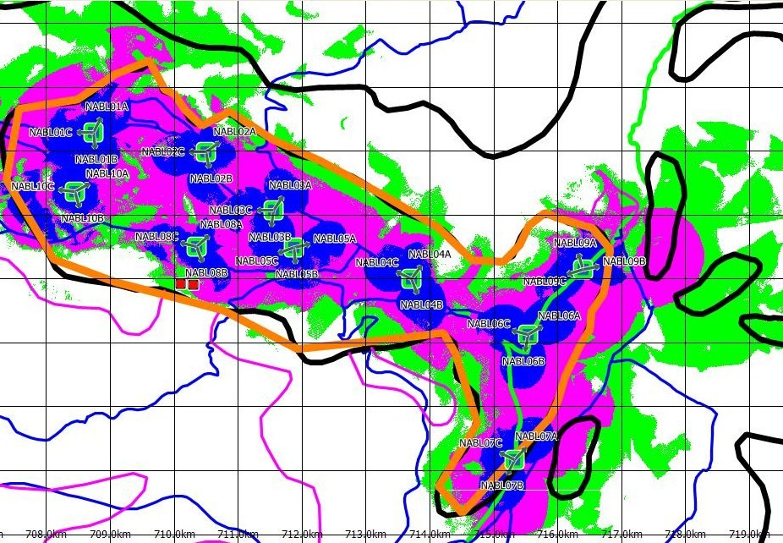
Fig(6) : The map of Nablus city in the first phase with 10 sites which taken from AIRCOM tool.

3.2.1.4 .3 .1 the configuration of the new sites and the modified sites:

The new sites

Site NABL09
- Equipments of the site :
RBS 2206 with 12 TRU
Feeder 1/2 inch with length 6 m
Ant type depend on the area 742264
- Location and alignment of the cell in site NABL09
Cell name | Ant type | Azimuth angel | Tilt angel | Ant high | Longitude | Latitude
NABL09A | 742264 | 343 | 4.0 | 25 | 35.29112658 | 32.22162415
NABL09B | 742264 | 79 | 0.0 | 25 | 35.29112658 | 32.22162415
NABL09C | 742264 | 253 | 0.0 | 25 | 35.29112658 | 32.22162415
Table (29) : Location and alignment of the cell in site NABL09 .

Site NABL10
- Equipments of the site :
RBS 2206 with 12 TRU.
Feeder 1/2 inch with length 6 m .
Ant type depend on the area 742264 or 741324.
- Location and alignment of the cell in site NABL10
Cell name | Ant type | Azimuth angel | Tilt angel | Ant high | Longitude | Latitude
NABL10A | 742264 | 343 | 4.0 | 25 | 35.29112658 | 32.22162415
NABL10B | 741324 | 79 | 0.0 | 25 | 35.29112658 | 32.22162415
NABL10C | 741324 | 253 | 0.0 | 25 | 35.29112658 | 32.22162415
Table (30) : Location and alignment of the cell in site NABL10.

The modified site:

Site NABL07
- Equipments of the site :
RBS 2206 with 12 TRU.
Feeder 1/2 inch with length 6 m .
Ant type depend on the area 742264.
- Location and alignment of the cell in site NABL07
Cell name | Ant type | Azimuth angel | Tilt angel | Ant high | Longitude | Latitude
NABL07A | 742264 | 59 | 0.0 | 25 | 35.28422500 | 32.19352778
NABL07B | 742264 | 180 | 0.0 | 25 | 35.28422500 | 32.19352778
NABL07C | 742264 | 288 | 0.0 | 25 | 35.28422500 | 32.19352778
Table (31) : Location and alignment of the cell in site NABL07 modified .

Site NABL08
- Equipments of the site :
RBS 2206 with 12 TRU.
Feeder 1/2 inch with length 6 m .
Ant type depend on the area 742264.
- Location and alignment of the cell in site NABL08
Cell name | Ant type | Azimuth angel | Tilt angel | Ant high | Longitude | Latitude
NABL08A | 742264 | 48 | 0.0 | 25 | 35.23211111 | 32.22451944
NABL08B | 742264 | 160 | 0.0 | 25 | 35.23211111 | 32.22451944
NABL08C | 742264 | 284 | -4.0 | 25 | 35.23211111 | 32.22451944
Table (32) : Location and alignment of the cell in site NABL08 modified.

The percentage of the coverage in first phase with 10 sites:
*Percentage of the deep indoor:
Total displayed area(km²): | 25.397
Covered area(km²): | 8.363
Covered area (%): | 32.93%
Table( 33): the percentage for the covered area of the deep indoor coverage in first phase with 10 sites.

*Percentage of the indoor:
Total displayed area(km²): | 25.397
Covered area(km²): | 11.487
Covered area (%): | 45.23%
Table( 34): the percentage for the covered area of the indoor coverage in first phase with 10 sites.

*Percentage of the outdoor:
Total displayed area(km²): | 25.397
Covered area(km²): | 3.390
Covered area (%): | 13.35%
Table( 35): the percentage for the covered area of the outdoor coverage in first phase with 10 sites.

*Percentage of the poor coverage:
Total displayed area(km²): | 25.397
Covered area(km²): | 2.156
Covered area (%): | 8.49%
Table( 36): the percentage for the covered area of the poor coverage in first phase with 10 sites.

And the following chart shows these percentages:

Fig(7) : the percentage for the covered area in first phase with 10 sites.

Due to this modification, the percentage of indoor and deep indoor is 78% and this value is greater than the specifications (<70%), and the following chart compare between the 8 sites and 10 sites.
Now we compare the percentage of covered area in the first phase in two cases (8 sites and 10 sites) …

*the following chart shows these percentages between 8 sites and 10 sites:

Fig(8) : the percentage for the covered area in first phase in two case 8 sites and 10 sites .

3.2.2 second phase :
As a result of increasing number of subscribers in our operator , we need to improve our network in both sides ; capacity and coverage, to be able to serve all needs of subscribers with high quality at all times.

To satisfy this we assume two specifications in coverage and capacity:

Capacity
In this phase we want to serve 50,000 subscribers in normal conditions so in this phase can serve 30,000 subscribers above the first phase .

Coverage
We rise the percentage of indoor coverage which give us a good signal strength in major parts of Nablus city and the percentage as following:
- 80%of the area in Nablus is covered by indoor coverage.
- 20% of the area is covered by outdoor coverage.

3.2.2.1 Calculation of the number of BTS for first phase:
* We assume every BTS have 3 cells.
* So every cell has 4 TRU.
* Every TRU have 8 slots.
* # of traffic channel per cell = (8*3) – 2 = 30 traffic channels.

*From Earlang table we find that every 30 TCH can provide 21.932 Earlang.
*so for the BTS is 21.932*3= 65.796 Earlang.
*the amount of traffic for 50,000 subscriber is 50,000 *0.025= 1250 Earlang .
*#of BTS for first phase 1250/65.8 = 19 BTS.

This 19 BTS will produce the coverage and capacity for all subscribers in second phase but we have 10 sites from first phase so we must add another 9 sites in congested areas the following table show the districts name which we add the sites in .

Name of the site | District name
NABL 11 | شارع عمان
NABL 12 | الدوار
NABL 13 | مفرق رفيديا الجامعه القديمه
NABL 14 | مخيم العين
NABL 15 | البلده القديمه
NABL 16 | رفيديا القديمه
NABL 17 | المخفيه
NABL 18 | شارع القدس/ بلاطه
NABL 19 | المساكن الشعبيه
Table (37) : the position of the new sites in the second phase .

3.2.2.2 Simulation for first phase:
By using the Aircom software we add 9 sites in specific location to ensure the coverage and the following picture show these sites.
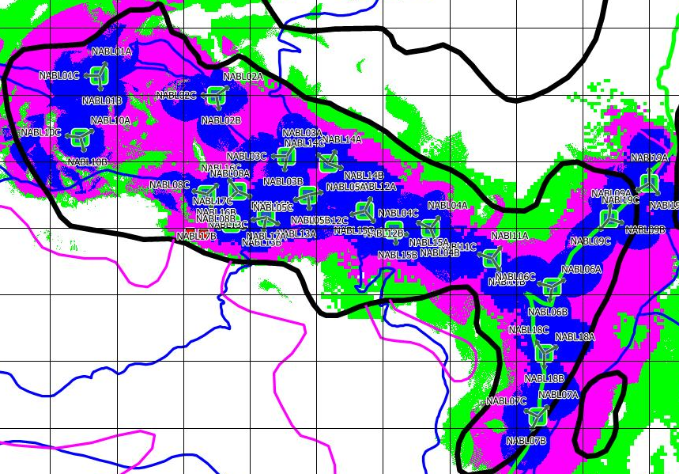
Fig (9) : The map of Nablus city in the second phase with 19 sites which taken from AIRCOM tool.

This picture include 19 sites with RBS 2206, we note that the percentage of indoor and deep indoor is increased and the congested area is covered with more than one sites and from many directions .
Now we will display the name of the additional sites with respect to first phase and the name of the cells in every site and we show the locations of these sites , this locations was define by longitudes and latitudes .

The location of these sites:
Number of site | Name of the cell | longitude | Latitude
NABL11 | NABL11A | 35.27740357 | 32.21501827
NABL11 | NABL11B | 35.27740357 | 32.21501827
NABL11 | NABL11C | 35.27740357 | 32.21501827
NABL12 | NABL12A | 35.25731389 | 32.22181944
NABL12 | NABL12B | 35.25731389 | 32.22181944
NABL12 | NABL12C | 35.25731389 | 32.22181944
NABL13 | NABL13A | 35.24159444 | 32.22121944
NABL13 | NABL13B | 35.24159444 | 32.22121944
NABL13 | NABL13C | 35.24159444 | 32.22121944
NABL14 | NABL14A | 35.25165833 | 32.22840278
NABL14 | NABL14B | 35.25165833 | 32.22840278
NABL14 | NABL14C | 35.25165833 | 32.22840278
NABL15 | NABL15A | 35.26193056 | 32.21918611
NABL15 | NABL15B | 35.26193056 | 32.21918611
NABL15 | NABL15C | 35.26193056 | 32.21918611
NABL16 | NABL16A | 35.23714722 | 32.22486667
NABL16 | NABL16B | 35.23714722 | 32.22486667
NABL16 | NABL16C | 35.23714722 | 32.22486667
NABL17 | NABL17A | 35.23600000 | 32.22056667
NABL17 | NABL17B | 35.23600000 | 32.22056667
NABL17 | NABL17C | 35.23600000 | 32.22056667
NABL18 | NABL18A | 35.28536667 | 32.20206389
NABL18 | NABL18B | 35.28536667 | 32.20206389
NABL18 | NABL18C | 35.28536667 | 32.20206389
NABL19 | NABL19A | 35.30269444 | 32.22475000
NABL19 | NABL19B | 35.30269444 | 32.22475000
NABL19 | NABL19C | 35.30269444 | 32.22475000
Table (38): The location of new sites in the second phase .

3.2.2.2 .1 Sites configuration:
Recording to section 3.2.1.4 .1 Each sites in the second phase has specific configuration depends on the area which be covered by this site so we handle every one and study it with relative to the equipments and location of it, the antenna Which we use it in our project in this phase:
1)742264 antenna.
2) 741324 antenna

Site NABL11
1)Equipments of the site :
RBS 2206 with 12 TRU.
Feeder 1/2 inch with length 6 m.
Ant type depend on the area 742264 or 741324.

2)Location and alignment of the cell in site NABL11
Cell name | Ant type | Azimuth angel | Tilt angel | Ant high | Longitude | Latitude
NABL11A | 742264 | 38 | 0.0 | 25 | 35.27740357 | 32.21501827
NABL11B | 741324 | 148 | 0.0 | 25 | 35.27740357 | 32.21501827
NABL11C | 741324 | 288 | 0.0 | 25 | 35.27740357 | 32.21501827
Table (39) : Location and alignment of the cell in site NABL11

Site NABL12
1)Equipments of the site :
RBS 2206 with 12 TRU.
Feeder 1/2 inch with length 6 m.
Ant type depend on the area 742264 or 741324.
2)Location and alignment of the cell in site NABL12
Cell name | Ant type | Azimuth angel | Tilt angel | Ant high | Longitude | Latitude
NABL12A | 741324 | 25 | 0.0 | 25 | 35.25731389 | 32.22181944
NABL12B | 741324 | 140 | 0.0 | 25 | 35.25731389 | 32.22181944
NABL12C | 741324 | 255 | 0.0 | 25 | 35.25731389 | 32.22181944
Table (40) : Location and alignment of the cell in site NABL12

Site NABL13
1)Equipments of the site :
RBS 2206 with 12 TRU.
Feeder 1/2 inch with length 6 m.
Ant type depend on the area 742264 or 741324.
2)Location and alignment of the cell in site NABL13
Cell name | Ant type | Azimuth angel | Tilt angel | Ant high | Longitude | Latitude
NABL13A | 741324 | 119 | 0.0 | 25 | 35.24159444 | 32.22121944
NABL13B | 741324 | 190 | 0.0 | 25 | 35.24159444 | 32.22121944
NABL13C | 741324 | 259 | 0.0 | 25 | 35.24159444 | 32.22121944
Table (41) : Location and alignment of the cell in site NABL13

Site NABL14
1)Equipments of the site :
RBS 2206 with 12 TRU.
Feeder 1/2 inch with length 6 m.
Ant type depend on the area 742264 or 741324.

2)Location and alignment of the cell in site NABL14
Cell name | Ant type | Azimuth angel | Tilt angel | Ant high | Longitude | Latitude
NABL14A | 742264 | 29 | 0.0 | 25 | 35.25165833 | 32.22840278
NABL14B | 741324 | 109 | 0.0 | 25 | 35.25165833 | 32.22840278
NABL14C | 741324 | 310 | 0.0 | 25 | 35.25165833 | 32.22840278
Table (42) : Location and alignment of the cell in site NABL14

Site NABL15
1)Equipments of the site :
RBS 2206 with 12 TRU.
Feeder 1/2 inch with length 6 m.
Ant type depend on the area 742264 or 741324.

2)Location and alignment of the cell in site NABL15
Cell name | Ant type | Azimuth angel | Tilt angel | Ant high | Longitude | Latitude
NABL15A | 742264 | 110 | 0.0 | 25 | 35.26193056 | 32.21918611
NABL15B | 742264 | 172 | 0.0 | 25 | 35.26193056 | 32.21918611
NABL15C | 742264 | 269 | 0.0 | 25 | 35.26193056 | 32.21918611
Table (43) : Location and alignment of the cell in site NABL15

Site NABL16
1)Equipments of the site :
RBS 2206 with 12 TRU.
Feeder 1/2 inch with length 6 m.
Ant type depend on the area 742264 or 741324.

2)Location and alignment of the cell in site NABL16
Cell name | Ant type | Azimuth angel | Tilt angel | Ant high | Longitude | Latitude
NABL16A | 741324 | 113 | 0.0 | 25 | 35.23714722 | 32.22486667
NABL16B | 742264 | 225 | 0.0 | 25 | 35.23714722 | 32.22486667
NABL16C | 742264 | 324 | 0.0 | 25 | 35.23714722 | 32.22486667
Table (44) : Location and alignment of the cell in site NABL16

Site NABL17
1)Equipments of the site :
RBS 2206 with 12 TRU.
Feeder 1/2 inch with length 6 m.
Ant type depend on the area 742264 or 741324.

2)Location and alignment of the cell in site NABL17
Cell name | Ant type | Azimuth angel | Tilt angel | Ant high | Longitude | Latitude
NABL17A | 741324 | 110 | 0.0 | 25 | 35.23600000 | 32.22056667
NABL17B | 741324 | 250 | 0.0 | 25 | 35.23600000 | 32.22056667
NABL17C | 741324 | 320 | 0.0 | 25 | 35.23600000 | 32.22056667
Table (45) : Location and alignment of the cell in site NABL17

Site NABL18
1)Equipments of the site :
RBS 2206 with 12 TRU.
Feeder 1/2 inch with length 6 m.
Ant type depend on the area 742264 or 741324.

2)Location and alignment of the cell in site NABL18
Cell name | Ant type | Azimuth angel | Tilt angel | Ant high | Longitude | Latitude
NABL18A | 741324 | 62 | 0.0 | 25 | 35.28536667 | 32.20206389
NABL18B | 741324 | 180 | 0.0 | 25 | 35.28536667 | 32.20206389
NABL18C | 741324 | 326 | 0.0 | 25 | 35.28536667 | 32.20206389
Table (46) : Location and alignment of the cell in site NABL18

Site NABL19
1)Equipments of the site :
RBS 2206 with 12 TRU.
Feeder 1/2 inch with length 6 m.
Ant type depend on the area 742264 or 741324.

2)Location and alignment of the cell in site NABL19
Cell name | Ant type | Azimuth angel | Tilt angel | Ant high | Longitude | Latitude
NABL19A | 741324 | 0 | 0.0 | 25 | 35.30269444 | 32.22475000
NABL19B | 741324 | 140 | 0.0 | 25 | 35.30269444 | 32.22475000
NABL19C | 741324 | 240 | 0.0 | 25 | 35.30269444 | 32.22475000
Table (47) : Location and alignment of the cell in site NABL19

3.2.2.2 .1 Calculation of the percentages coverage:
Recording to section 3.2.1.4 .2 we can find the percentage of coverage in deep indoor , indoor and outdoor .
*Percentage of the deep indoor:
Total displayed area(km²): | 25.397
Covered area(km²): | 12.007
Covered area (%): | 47.28%
Table( 48): the percentage for the covered area of the deep indoor coverage in second phase.
*Percentage of the indoor:
Total displayed area(km²): | 25.397
Covered area(km²): | 8.347
Covered area (%): | 32.86%
Table( 49): the percentage for the covered area of the indoor coverage in second phase.
*Percentage of the outdoor:
Total displayed area(km²): | 25.397
Covered area(km²): | 3.4608
Covered area (%): | 13.62%
Table( 50): the percentage for the covered area of the outdoor coverage in second phase.
*Percentage of the poor coverage:
Total displayed area(km²): | 25.397
Covered area(km²): | 1.5822
Covered area (%): | 6.23%
Table(51): the percentage for the covered area of the poor coverage in second phase.

And the following chart shows these percentages:

Fig (10) : the percentage for the covered area in second phase .
Now we compare the percentage of covered area in the first phase in two cases (8 sites and 10 sites) and the second phase (19 sites) …
*the following table shows these percentages between 8 sites and 10 sites and 19 sites :
Number of phase | First phase |  | Second phase
Number of sites | 8 sites | 10 sites | 19 sites
Percentage coverage deep indoor | 22.69% | 32.93% | 47.28%
Percentage coverage indoor | 39.30% | 45.23% | 32.86%
Percentage coverage outdoor | 25.07% | 13.35% | 13.62%
Percentage coverage poor coverage | 12.94% | 8.49% | 6.23%
Table (52): the percentage for the covered area in the first phase and the second phase .
And the following chart shows these percentages between 8 sites and 10 sites and 19 sites :

Fig (11) : the percentage for the covered area in the first pase and second phase

Chapter four :

Automatic frequency plane

4.1 Introduction
In a cellular radio system, a land area to be supplied with radio service is divided into regular shaped cells, which can be hexagonal, square, circular or some other irregular shapes, although hexagonal cells are conventional. Each of these cells is assigned multiple frequencies (f₁ - f₆) which have corresponding radio base stations. The group of frequencies can be reused in other cells, provided that the same frequencies are not reused in adjacent neighboring cells as that would cause co-channel interference.
The increased capacity in a cellular network, compared with a network with a single transmitter, comes from the fact that the same radio frequency can be reused in a different area for a completely different transmission. If there is a single plain transmitter, only one transmission can be used on any given frequency. Unfortunately, there is inevitably some level of interference from the signal from the other cells which use the same frequency. This means that, in a standard FDMA system, there must be at least a one cell gap between cells which reuse the same frequency.

4.2 Engineering guideline :
The key characteristic of a cellular network is the ability to re-use frequencies to increase both coverage and capacity. As described above, adjacent cells must utilise different frequencies, however there is no problem with two cells sufficiently far apart operating on the same frequency. The elements that determine frequency reuse are the reuse distance and the reuse factor.

The reuse distance, D is calculated as
where R is the cell radius and N is the number of cells per cluster. Cells may vary in radius in the ranges (1 km to 30 km). The boundaries of the cells can also overlap between adjacent cells and large cells can be divided into smaller cells
The frequency reuse factor is the rate at which the same frequency can be used in the network. It is 1/K (or K according to some books) where K is the number of cells which cannot use the same frequencies for transmission. Common values for the frequency reuse factor are 1/3, 1/4, 1/7, 1/9 and 1/12 (or 3, 4, 7, 9 and 12 depending on notation).
In case of N sector antennas on the same base station site, each with different direction, the base station site can serve N different sectors. N is typically 3. A reuse pattern of N/K denotes a further division in frequency among N sector antennas per site. Some current and historical reuse patterns are 3/7 (North American AMPS), 6/4 (Motorola NAMPS), and 3/4 (GSM).
If the total available bandwidth is B, each cell can only utilize a number of frequency channels corresponding to a bandwidth of B/K, and each sector can use a bandwidth of B/NK.
Code division multiple access-based systems use a wider frequency band to achieve the same rate of transmission as FDMA, but this is compensated for by the ability to use a frequency reuse factor of 1, for example using a reuse pattern of 1/1. In other words, adjacent base station sites use the same frequencies, and the different base stations and users are separated by codes rather than frequencies. While N is shown as 1 in this example, that does not mean the CDMA cell has only one sector, but rather that the entire cell bandwidth is also available to each sector individually.
Depending on the size of the city, a taxi system may not have any frequency-reuse in its own city, but certainly in other nearby cities, the same frequency can be used. In a big city, on the other hand, frequency-reuse could certainly be in use.

4.3 Technical Description of frequency reuse in our network :
Before we made an automatic frequency plan for the network in Nablus city, we must define many parameters to help us in defining the frequencies in each cell , this parameter will support a good handover and best quality (low interference between cells) as follow .

- Neighbor cells.
- Height resolution in Nablus city .
- Traffic map for each cell.

4.3.1 Neighbor cells
Neighboring means that there is relation between the serving cell and another surrounded cells for it, this depends on the radiation pattern of the cell (type of antenna ) ,EIRP, the distance between cells and if there line of site between them .
In our project we decide that by :
- From the previous BTS map fig ( 9 )
- Height resolution from Google map
- By survey for the sites and guarantee if there is line of site between it .

The following table show the neighbor cells for each cell :
Cell Name | Neighbor cells
NABL01A | NABL01B | NABL01C | NABL02C
NABL01B | NABL01A | NABL01C | NABL10A | NABL02C
NABL01C | NABL01A | NABL01B | NABL10C
NABL02A | NABL02B | NABL02C | NABL03A
NABL02B | NABL02A | NABL02C | NABL08A | NABL16A | NABL03C
NABL02C | NABL02A | NABL02B | NABL01A | NABL01B | NABL10A
NABL03A | NABL03B | NABL03C | NABL14A | NABL14C
NABL03B | NABL03A | NABL03C | NABL05C | NABL16A | NABL13A
NABL03C | NABL03A | NABL03B | NABL02B | NABL08A | NABL16C
NABL04A | NABL04B | NABL04C | NABl11A | NABL12B | NABL14B
NABL04B | NABL04A | NABL04C | NABl11C | NABL15A | NABL15B
NABL04C | NABL04A | NABL04B | NABL12A | NABL12B | NABL15A | NABL14B
NABL05A | NABL05B | NABL05C | NABL12A | NABL12C | NABL14B
NABL05B | NABL05A | NABL05C | NABL12C | NABL13A | NABL15C | NABL16A
NABL05C | NABL05A | NABL05B | NABL03B | NABL13A | NABL16A
NABL06A | NABL06B | NABL06C | NABL09C
NABL06B | NABL06A | NABL06C | NABl11B | NABL18A | NABL18C
NABL06C | NABL06A | NABL06B | NABl11A | NABl11B | NABL18C | NABL09C
NABL07A | NABL07B | NABL07C | NABL18A | NABL18B
NABL07B | NABL07A | NABL07C
NABL07C | NABL07A | NABL07B | NABL18B
NABL08A | NABL08B | NABL08C | NABL02B | NABL03C | NABL16C | NABL17C
NABL08B | NABL08A | NABL08C | NABL13C | NABL16B | NABL17B | NABL17C
NABL08C | NABL08A | NABL08B | NABL10B | NABL17C
NABL09A | NABL09B | NABL09C | NABl19C
NABL09B | NABL09A | NABL09C | NABl19B | NABl19C
NABL09C | NABL09A | NABL09B | NABL06A | NABL06C
NABL10A | NABL10B | NABL10C | NABL01B | NABL02C
NABL10B | NABL10A | NABL10C | NABL02C | NABL08C
NABL10C | NABL10A | NABL10B | NABL01C
NABl11A | NABl11B | NABl11C | NABL06C
NABl11B | NABl11A | NABl11C | NABL06B | NABL06C | NABL18C
NABl11C | NABl11A | NABl11B | NABL04B | NABL15A
NABL12A | NABL12B | NABL12C | NABL04A | NABL04C | NABL14B
NABL12B | NABL12A | NABL12C | NABL04C | NABL15A | NABL15B | NABL15C
NABL12C | NABL12A | NABL12B | NABL05A | NABL05B | NABL15C
NABL13A | NABL13B | NABL13C | NABL03B | NABL15B | NABL15C | NABL17A
NABL13B | NABL13A | NABL13C | NABL17A
NABL13C | NABL13A | NABL13B | NABL16A | NABL16B | NABL17A
NABL14A | NABL14B | NABL14C | NABL03A
NABL14B | NABL14A | NABL14C | NABL04C | NABL05A | NABL12A
NABL14C | NABL14A | NABL14B | NABL03A
NABL15A | NABL15B | NABL15C | NABL04B | NABL04C | NABL12B
NABL15B | NABL15A | NABL15C | NABL12B
NABL15C | NABL15A | NABL15B | NABL05B | NABL12B
NABL16A | NABL16B | NABL16C | NABL03B | NABL05C | NABL17A
NABL16B | NABL16A | NABL16C | NABL08B | NABL17B | NABL17C
NABL16C | NABL16A | NABL16B | NABL02B | NABL03C | NABL08A | NABL17C
NABL17A | NABL17B | NABL17C | NABL13A | NABL13B | NABL13C | NABL16A
NABL17B | NABL17A | NABL17C | NABL08B | NABL16B
NABL17C | NABL17A | NABL17B | NABL08A | NABL08B | NABL16B | NABL16C
NABL18A | NABL18B | NABL18C | NABL06B | NABL07A
NABL18B | NABL18A | NABL18C | NABL07A | NABL07C
NABL18C | NABL18A | NABL18B | NABL06B | NABL06C | NABl11B
NABl19A | NABl19B | NABl19C
NABl19B | NABl19A | NABl19C | NABL09B
NABl19C | NABl19A | NABl19B | NABL09A | NABL09B
Table (53) : the neighbor cells for each cell.
This data Excel sheet will import to the tool (mentum planet for GSM) that we use to guarantee if it's true or not, and if true we must take it in our consideration when we apply the automatic frequency reuse .

4.3.2 Height resolution :
This parameter depend on the terrains of the city such as mountains ,hills, roads, valleys ……etc .
From digital map for Nablus city and Google maps we defined it , the following picture show the geographical nature of the city .
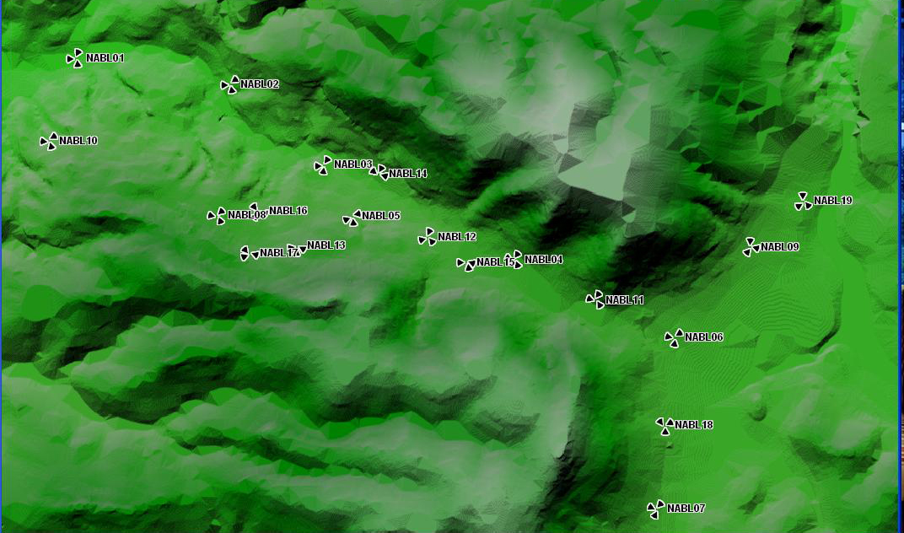 fig (12) : the geographical nature of the Nablus city.

4.3.3 Traffic map for each cell
For each area, the number of subscribers and their “profile” (business, conventional, data or/and speech user) is defined. This value can be obtained considering census data. An annual subscriber forecast is required in order to plan the network growth.
The traffic volume per subscriber and service type is determined on average during the busy hour. Typically, this amount is given in Erlang for speech service and in Kbyte/h .
There three type of traffic:

- Estimated traffic: it's the amount of traffic which we expect it after the network launch.

- Carried traffic: it’s the real amount of traffic that the network will loaded after launch.

- Offered traffic: amount of traffic that the network planed to carry it and for our network for second phase its equal to 1250 Erlang.

In our project we deal with estimated traffic depends on the density of subscribers, type of area (dense urban, urban, suburban and rural), clutters , open area and the distance between the sites .

The following table shows the traffic for each cell:

Site ID | Sector ID | Carried Traffic (Erlang) | Site ID | Sector ID | Carried Traffic (Erlang)
NABL01 | 1 | 9.55 | NABL10 | 2 | 77.7
NABL01 | 2 | 11.75 | NABL10 | 3 | 172.65
NABL01 | 3 | 11.2 | NABl11 | 1 | 37.79
NABL02 | 1 | 5.86 | NABl11 | 2 | 12.75
NABL02 | 2 | 5.44 | NABl11 | 3 | 10.91
NABL02 | 3 | 8.53 | NABL12 | 1 | 8.82
NABL03 | 1 | 3.24 | NABL12 | 2 | 12.58
NABL03 | 2 | 2.84 | NABL12 | 3 | 3.29
NABL03 | 3 | 4.81 | NABL13 | 1 | 16.15
NABL04 | 1 | 5.72 | NABL13 | 2 | 21.96
NABL04 | 2 | 16.75 | NABL13 | 3 | 12.42
NABL04 | 3 | 5.25 | NABL14 | 1 | 11.03
NABL05 | 1 | 8.57 | NABL14 | 2 | 12.51
NABL05 | 2 | 4.94 | NABL14 | 3 | 7.12
NABL05 | 3 | 11.42 | NABL15 | 1 | 36.87
NABL06 | 1 | 45.3 | NABL15 | 2 | 23.7
NABL06 | 2 | 15.84 | NABL15 | 3 | 18.04
NABL06 | 3 | 17.64 | NABL16 | 1 | 8.07
NABL07 | 1 | 24.71 | NABL16 | 2 | 11.5
NABL07 | 2 | 6.92 | NABL16 | 3 | 9.79
NABL07 | 3 | 10.29 | NABL17 | 1 | 4.52
NABL08 | 1 | 6.14 | NABL17 | 2 | 5.51
NABL08 | 2 | 2.41 | NABL17 | 3 | 6.56
NABL08 | 3 | 44.34 | NABL18 | 1 | 25.9
NABL09 | 1 | 32.8 | NABL18 | 2 | 19.06
NABL09 | 2 | 24.55 | NABL18 | 3 | 18.19
NABL09 | 3 | 43.52 | NABl19 | 1 | 27.59
NABL10 | 1 | 134.65 | NABl19 | 2 | 81.32
 |  |  | NABl19 | 3 | 14.72
Table (54) : the amount of traffic for each cell.
After we use mantum planet we export the following traffic distribution of traffic and the following maps show this data .
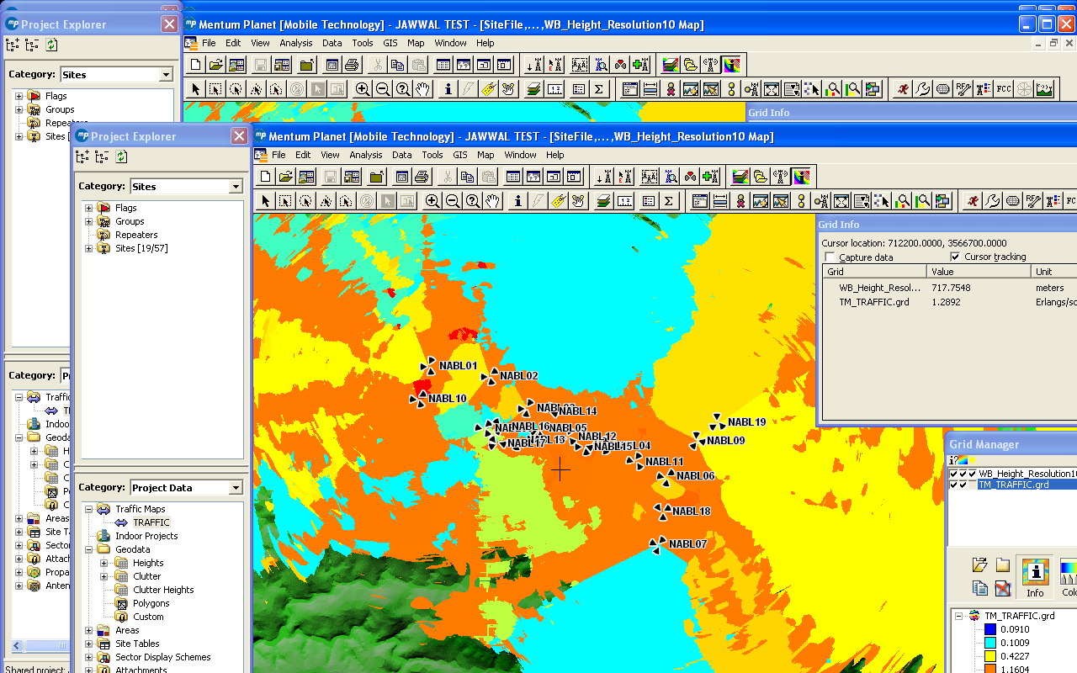
Fig (13): Every color represent a range of traffic Earlang/sqr Km.

4.4 Best server :
After we define traffic and neighbor maps we must find the best covered area for each cell and the signal strength to determine where the mobile must hand the call when the signal decrease to level low than threshold , so there is two type of best server as follow :
- Best server for each cell .
- Best server for the signal strength within the city .
    - Best server for each cell :
This mean that if the mobile within specific area for the cell ,it must be connect to this cell ,the following map show that :
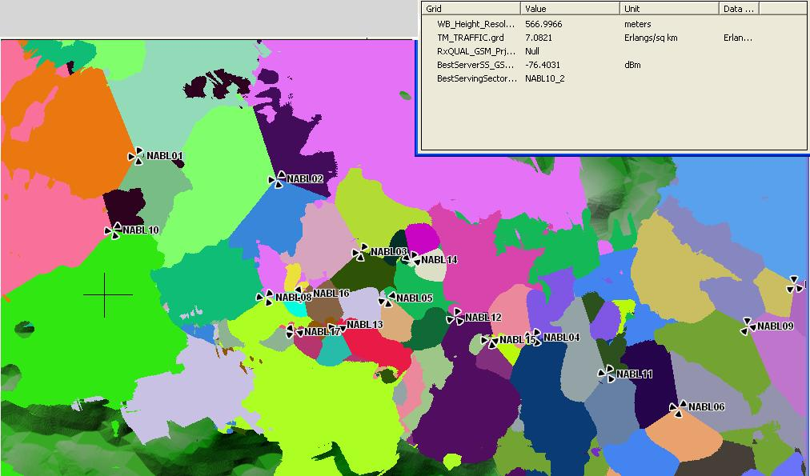
Fig (14) : Best server for each cell.
From the previous map we find that there is problem in NABL 10 because its cover the entrance of Nablus city and the new campus of An Najah university so we must add a new site beside it to share this traffic .
4.4.2 Best server for the signal strength within the city :
from planet tool we find the distribution of signal strength in Nablus city depends on the previous parameter , so we can find the signal strength in every point and carrier to interference ratio within the city ,the following map show that and show example for signal strength :
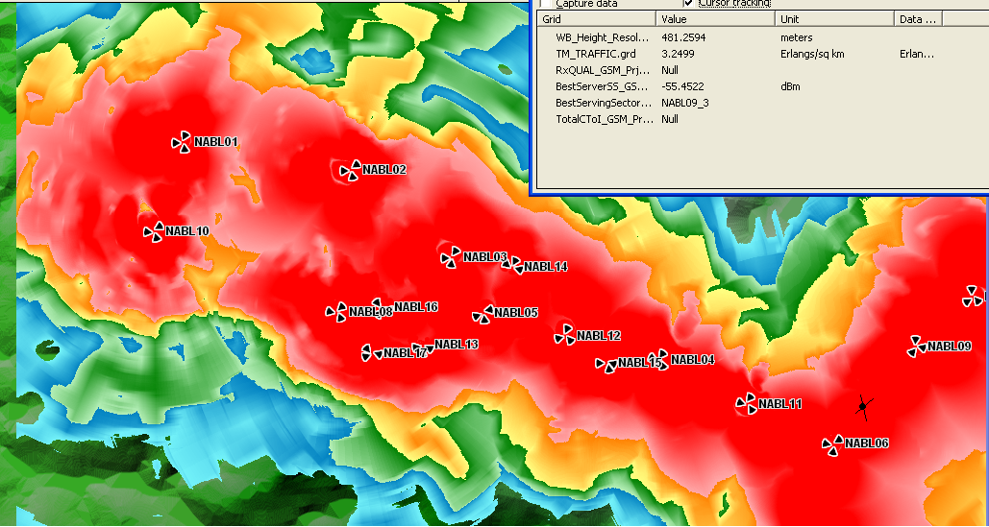
Fig (15) : Best server for the signal strength within the city .
4.5 Frequency of each site :
Finally and from all of the previous data we can determine the best frequency of each cell, but before that we must determine the range of frequency for the network but this range can change upon if this range is reserved or not.
But this frequency must assigned to BCCH and separated from TCH
We assume that the range of frequencies is ( 1-24)
The range of BCCH is from 11-24
The following table show these frequency :
Which 1 represent the cell A.
2 represent the cell B.
3 represent the cell C.

Site ID | Sector ID | Carried Traffic (Erlang) | Site ID | Sector ID | Carried Traffic (Erlang)
NABL01 | 1 | 12 | NABL10 | 2 | 18
NABL01 | 2 | 23 | NABL10 | 3 | 24
NABL01 | 3 | 20 | NABl11 | 1 | 18
NABL02 | 1 | 24 | NABl11 | 2 | 11
NABL02 | 2 | 12 | NABl11 | 3 | 22
NABL02 | 3 | 21 | NABL12 | 1 | 17
NABL03 | 1 | 16 | NABL12 | 2 | 15
NABL03 | 2 | 21 | NABL12 | 3 | 19
NABL03 | 3 | 19 | NABL13 | 1 | 11
NABL04 | 1 | 13 | NABL13 | 2 | 23
NABL04 | 2 | 19 | NABL13 | 3 | 17
NABL04 | 3 | 23 | NABL14 | 1 | 20
NABL05 | 1 | 12 | NABL14 | 2 | 14
NABL05 | 2 | 16 | NABL14 | 3 | 18
NABL05 | 3 | 14 | NABL15 | 1 | 21
NABL06 | 1 | 24 | NABL15 | 2 | 17
NABL06 | 2 | 21 | NABL15 | 3 | 13
NABL06 | 3 | 16 | NABL16 | 1 | 24
NABL07 | 1 | 14 | NABL16 | 2 | 13
NABL07 | 2 | 23 | NABL16 | 3 | 15
NABL07 | 3 | 11 | NABL17 | 1 | 15
NABL08 | 1 | 22 | NABL17 | 2 | 24
NABL08 | 2 | 20 | NABL17 | 3 | 11
NABL08 | 3 | 16 | NABL18 | 1 | 19
NABL09 | 1 | 20 | NABL18 | 2 | 17
NABL09 | 2 | 22 | NABL18 | 3 | 23
NABL09 | 3 | 13 | NABl19 | 1 | 12
NABL10 | 1 | 14 | NABl19 | 2 | 16
 |  |  | NABl19 | 3 | 18
Table (55) : the BCCH frequency for each cell .
The following picture show the frequency on the site after the AFP

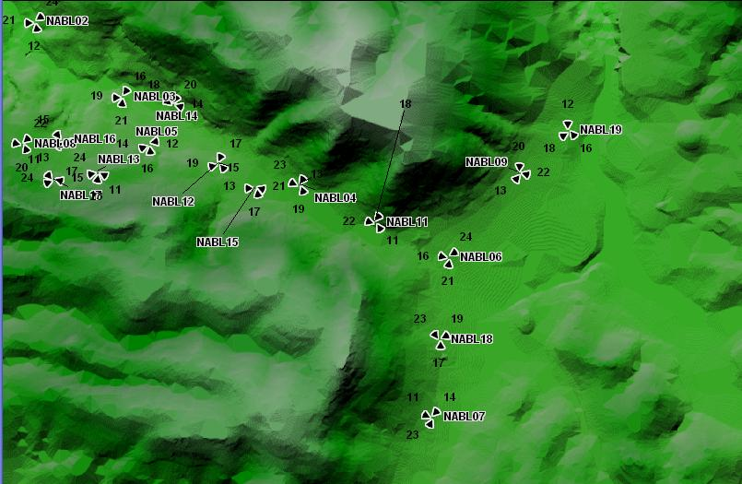
Fig (16): the BCCH frequency for each cell.

Chapter five
Site survey :
5.1 ABSTRACT
The purpose of the chapter is to indicate the comparison results of the system performance of two cellular operators in the city and our network which are JAWWAL (GSM900), WATANYIA (GSM900 and 1800), by means of the drive-test measurements and site survey .
Equipment used :
- Hp laptop 67302
- GPS with navigation system
- Samba 75 for GSM
- Camera canon with 8 megapixel
Method of the survey
This survey divide in two way :
- To ensure the location of each site
- To compare with the existing operators and our network.

5.2 Ensure the location of each site

After we have the location of each sites from the tools ,we visit this sites and verify if its suitable or not , so we visit two sites NABL08 and NABL13 .

5.2.1 NABL 08
We change the location of this site because it lies in low place and suffers from shadowing from neighbor buildings , the new location is above NASER center building in Rafidia street , the longitude and latitude as follow :
NABL 08 | longitude | latitude
Before the change | 35° .23'39.815 | 32°.23'78.978
After the change | 35°.14'01.065 | 32°.13'30.153
Table (56) : the longitude and latitude for site NABL08 before and after change .

The direction of each cell is show in the following picture
- NABL08 cell A with azimuth 48°
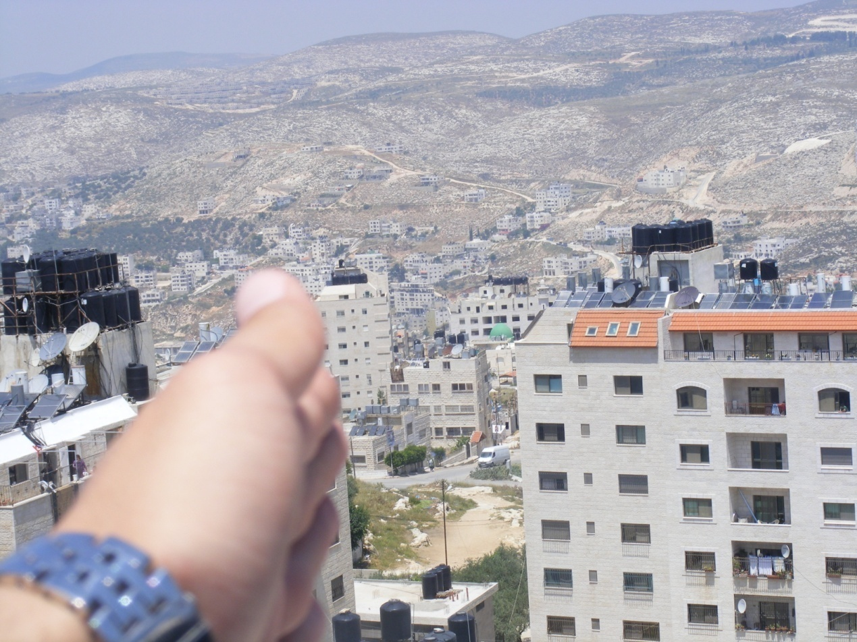
Fig (16): the direction of NABL08 cell A.
- NABL 08 cell B with azimuth 160°

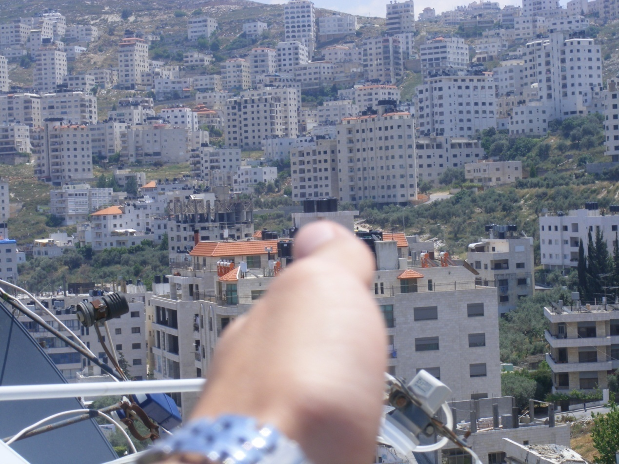
Fig (17): the direction of NABL08 cell B.

- NABL 13 Cell C with azimuth 284°

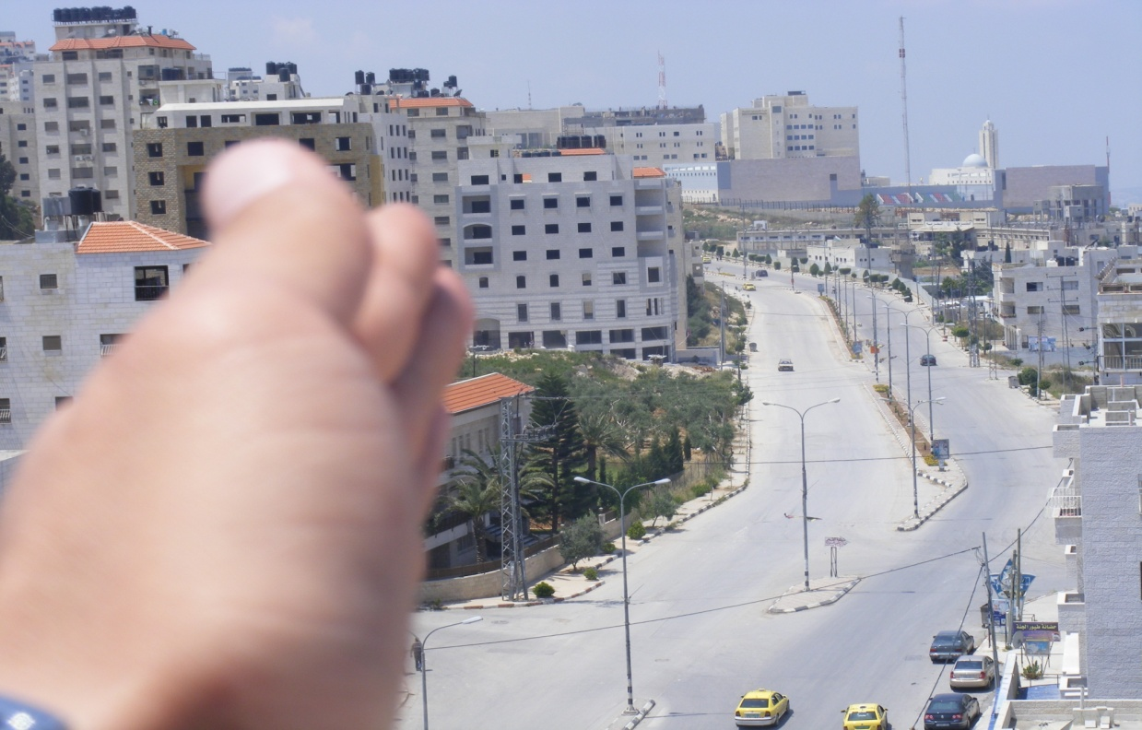
Fig (18): the direction of NABL08 cell C.

    - NABL 13

After we visit the location of this site we find that is suitable and lies above
Dream 7 building near to old campus of An najah university but we redirect the direction of the cells antenna as shown in the following picture :

1. NABL 13 cell A with azimuth 106

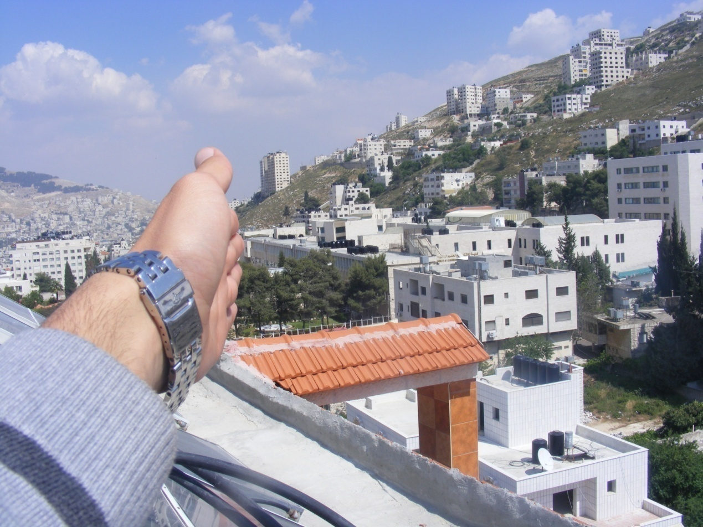

Fig (19) : the direction of NABL13 cell A.
- NABL 13 cell B with azimuth 182

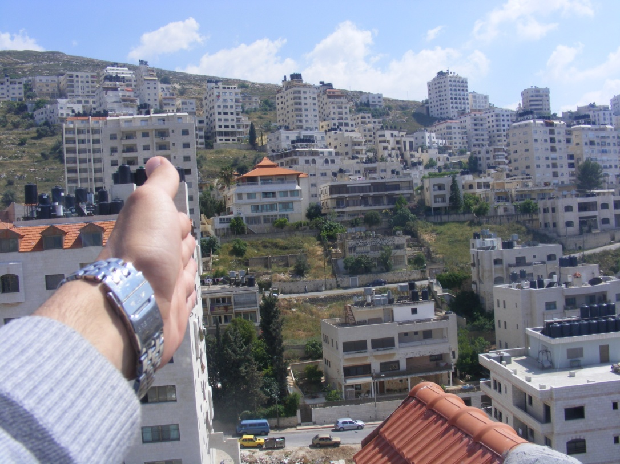

Fig (20) : the direction of NABL13 cell B.

- NABL 13 cell c with azimuth 275

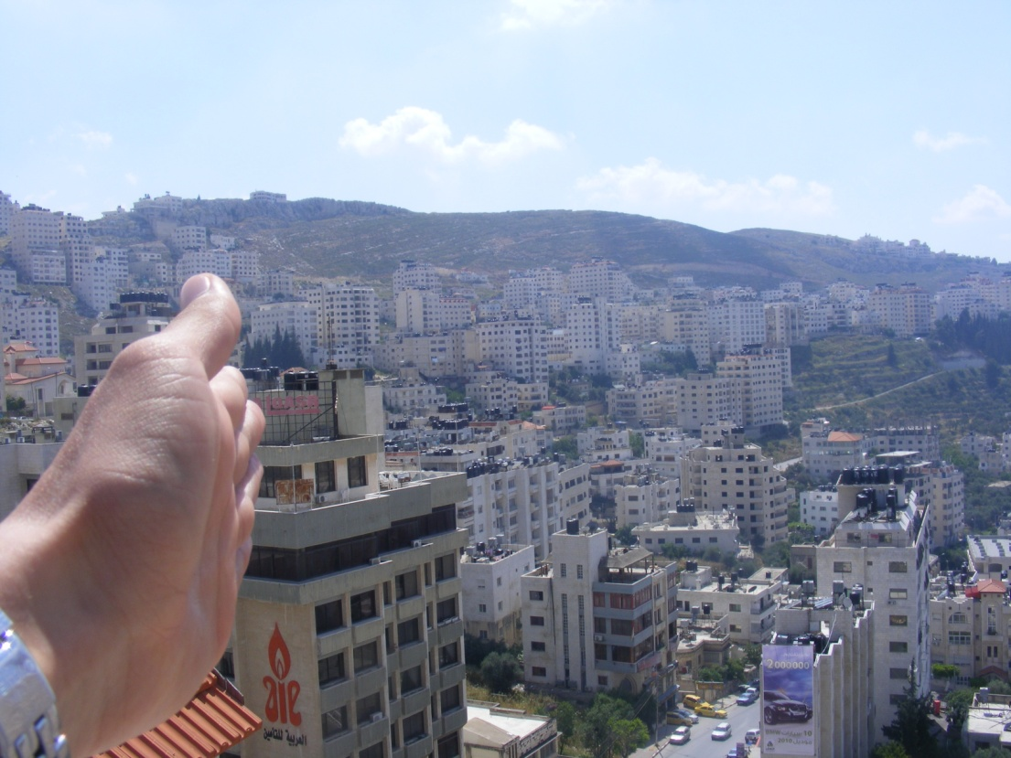

Fig (21) : the direction of NABL13 cell C.

5.3 compare with the existing operators and our network
From the survey we have a comparison between the operators depend on the signal strength and the following data show that :
According to the summary of the RxLev results in dedicated mode below :
Operator | JAWWAL | Wataniya | Our network
Number of samples | 520 | 480 | 500
Min (Rx Level dBm) | -72 | -74 | -86
Max (Rx Level dBm) | -53 | -50 | -53
Table (57) : RxLev form three operator .

We obtain our signal strength from mantum planet tool and we add to each reading 5 dBm (penetration losses) because the mantum planet tool don't care to the penetration losses .
for example the signal strength in the mantum planet tool equal (-56) but when we need to compare it with other reading from jawwl network we consider the reading -61dBm ((-56)+(-5)) = -61dBm

The following table show the average signal strength in different area in Nablus city .

Location | Our network | JAWWAL | Watanyia
بيت وزن | -73 | -68 | -77
الاكاديميه | -61 | -55 | -58
شارع رفيديا الجنيد | -55 | -58 | -50
مستشفى رفيديا | -58 | -63 | -69
اول شارع عبدالرحيم محمود | -53 | -53 | -56
نابلس مول | -62 | -61 | -73
الجامعه القديمه | -62 | -65 | -54
بيت ايبا | -73 | -64 | -61
قبر النبي يوسف | -57 | -64 | -68
مخيم بلاطه | -63 | -72 | -61
الغاوي(اعلى المساكن) | -85 | -67 | -71
زواتا | -86 | -78 | -72
اخر كفر قليل | -79 | -62 | -59
عسكر | -60 | -58 | -64
المخفيه | -64 | -60 | -62
الدوار | -60 | -55 | -57
البلده القديمه | -69 | -62 | -59
الجبل الشمالي بالقرب من مستشفى الاتحاد | -68 | -58 | -62
شارع تل | -71 | -66 | -62
راس العين | -68 | -59 | -55
Table (58) : the average signal strength in different area in Nablus city for three operators.

References :
[1] Ericsson Training Manuals.

[2] JAWWAL company .

[3] William Lee, “Mobile Cellular Telecommunications”, McGraw Hill, 2001.

[4]J. Schiller, Addison, “Mobile Communication”, Wesley, 2000.

[5] Theedere S. Rappaport: Wireless communications.

[6] KATHREIN-Werke KG, 790 – 2500 MHz Base Station Antennas for Mobile Communications.

