Chapter One
Introduction
In every construction process that digs into the soil and rocks, there are two types of excavations: open and braced excavation. In open excavation, no need for bracing, but braced excavation needs support called bracing.
Bracing is in steel structures such as Signal diagonals, Cross bracing, v bracing, k bracing, Chevron bracing, and Eccentric bracing. Or in the soil as Sheet piles, Wooden piles, Soldier beams, Slurry walls, Cofferdam, Soil grouting, Soil freezing, and Soil nailing.
We will talk about Soil nailing in chapter three, so soil nailing is a technique to treat or stop landslides on slopes, natural soil sliding, or man-made (fill), it is a remedial construction measure to make the over-steepening of new or existing soil slopes safe. Its advantages: It can be used on a new building that helps trap slopes, no elections at all, no restrictions on the height of the walls, construction time is reduced, etc, but there are some limitations that make it not suitable as the high water table, types of soil, low-strength soils, nails are only used for permanent long-term applications in delicate and expanding soil, corrosion with metal nails, larger liquid limit, reduced undrained shear strength, long-term deformations, prior to nail placement, overexposed, specialist is needed to design and install the nails.
Drilled and grouted, driven, self-drilling, launched, jet-grouted, and its types (single fluid, double fluid, and triple fluid), all of these are soil nailing methods. And the machines used are rotary machines with a downhole hammer, drilling rigs, grout pumps, jet grout, and drilling and grout mixing equipment.
It is used to reinforce retaining walls and soil slopes, etc, widen roads, in bridge abutments', support high-rise buildings, tunnel entrances, etc.
Its installation for soil surface, construction from top to bottom sequence, drilling of nail holes, excavation for soil cut, providing final facing, soil nail, and grout.
Its steps: Install cut-off drainage and excavate unsupported cut, 1 to 2 m high, drill hole for nail, install and grout nail, repeat the process to the final grade, and place final facing.
Some of the explanations on design methods are talked about, and the difference between soil nailing and anchors, soil nailing is as mentioned before, but anchor has different types as ground anchors and its types (sub-horizontal ground anchors, soil (rock) anchor), and vertical ground anchors, and means a system capable of transmitting a tensile load into a competent stratum, drawing support from the structure to be anchored.
Chapter Two talks about excavation types, bracing types in soil, and ways of supporting locally.
A review of soil nailing, in general, is presented in Chapter Three. Also, this chapter talks about soil nailing advantages, limitations, types of equipments used, and the process of soil nailing .
Chapter four An example of designing soil nails in an area where work is underway in the Rafidia area in the city of Nablus, where the height of the wall that will be designed for is 12 meters, and it is a retaining wall that was constructed as Sheet Piles.

Chapter Two
Review of Excavation Support Systems

2.1 Introduction
This chapter reviews the main aspects of excavations and excavation supports systems. It talks about drilling and supporting systems, tools used, the types of excavations in soil open and braced excavation, supporting systems in steel structures (signal diagonals, cross bracing, v bracing, k bracing, chevron bracing, and eccentric bracing), and in soil excavation (Sheet piles, Wooden piles, Soldier beams, Slurry walls, Cofferdam, Soil grouting, Soil freezing, and Soil nailing). It contains some previous studies in the field of soil nailing.
2.2 Excavation
Drilling is used in various applications in geology, agriculture, hydrology, civil engineering, petroleum, and industries based on natural gas. Establishing any structure such as roads, buildings, etc, needs excavation to lay the foundations, and then bracing is installed as a form of protection, as a way to strengthen the soil after loosening from excavation, to ensure that the soil does not collapse, and the safety of human life, facilities, and buildings.
Some of excavating purposes: obtaining samples of the rock, access to rocks from which raw materials can be extracted, access to the rocks that can then be measured, and providing access to rocks to provide engineering support.
Where the type of soil used and its characteristics when digging, the height required for excavation, and the place to be excavated, must be considered, including consideration of the ease or difficulty of accessing equipment to it, and the location of the groundwater.
Some of the equipment used in excavation such as crawler bulldozer, wheel dozer, crawler loader, wheel loader, grader, hydraulic crawler excavator, hydraulic wheel excavator (easy to move), front hydraulic excavator, backhoe loader (two pieces of equipment in one body), scraper (large excavation and backfilling). Figure 2.1-2.2 shows different types of excavation equipments.

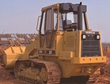 | 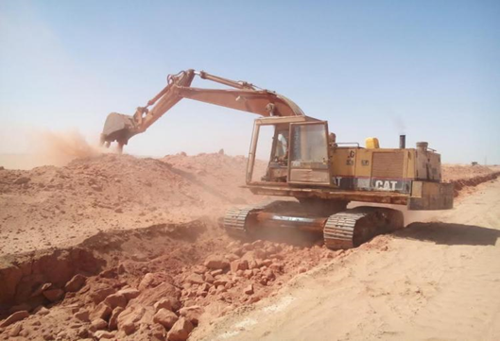
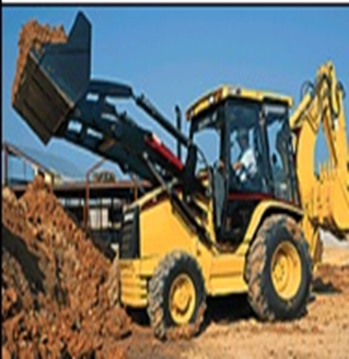 | 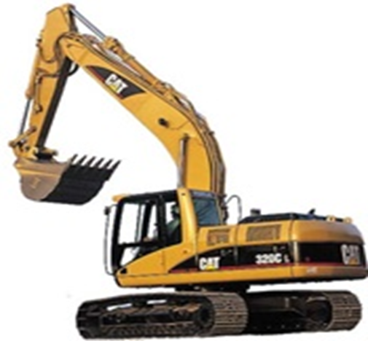
Figure 2.1 Excavation Equipments

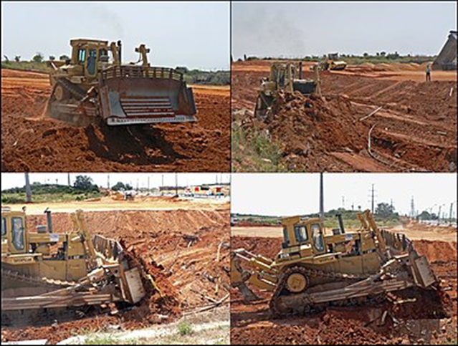
Figure 2.2 Excavation Equipments

The crawler bulldozer is one of the most famous equipments used in many earthmoving applications and is characterized by high productivity and thrust, to work in many difficult sites such as slopes, its uses are many such as brushing materials and preparing sites for projects, road construction, etc. Figure 2.3 shows Crawler Bulldozer.
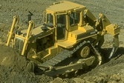
Figure 2.3 Crawler Bulldozer

Two main types of excavation: open excavation, and braced excavation.
Figure 2.4 shows Open Excavation.
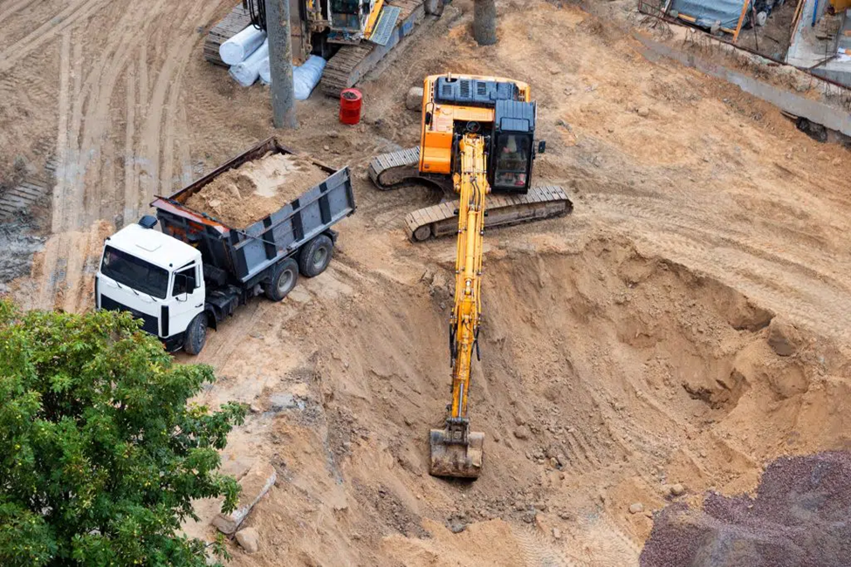
Figure 2.4 Open Excavation

The open cut is more cost-effective than other methods, especially in strong solid soil such as rock, the principle of this excavation method is to be on a certain slope, so that the soil does not collapse, does not disintegrate, without needing support. The open-cut method stands in contrast to the top-down construction method. This method is good for buildings with one or two floors at most so that the soil does not collapse on the house.
Open cut advantages: relatively economical, easy to hide your work, and potentially versatile, on the other hand, it has disadvantages: slower than top-down construction, will not work on all topography, and can cause issues with groundwater.
The second type of excavation is braced excavation, which is a method where deep excavations with straight vertical faces are laterally supported by a sheeting and bracing system until the structure is built. In other words, many types of excavation support systems are used to keep the sides of deep excavations stable, and to ensure that movements will not cause damage to neighboring structures or utilities in the surrounding ground.

2.3 Bracing Types
Bracing is a method used to make the structure stable, and also increases its ability to withstand lateral loads due to wind and earthquakes and not collapse, this method is very necessary, especially in buildings that resist earthquakes.
Bracings are placed vertically or horizontally and used for soil or structures, steel structures bracing types as shapes: signal diagonals, cross bracing, v bracing, k bracing, chevron bracing, and eccentric bracing. Figure 2.5-2.6 show different types of bracings.

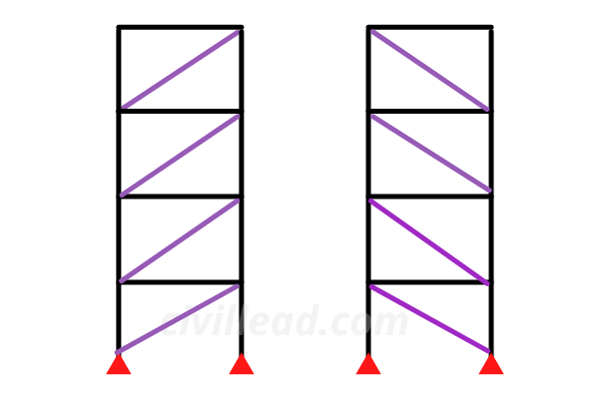 | 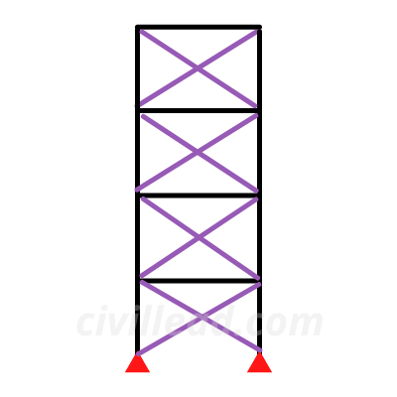 | 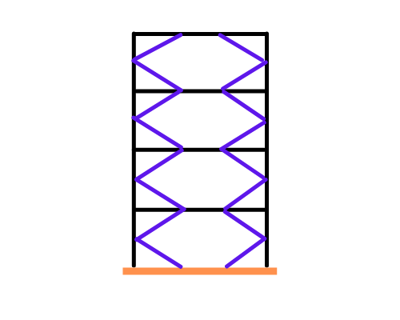
signal diagonals | cross bracing | k bracing
Figure 2.5 Different Types of Bracings.

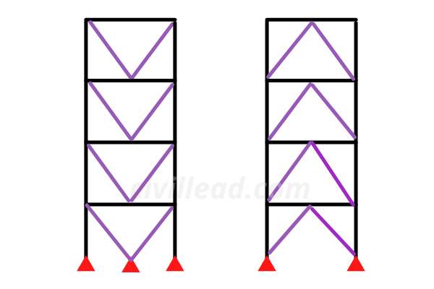 | 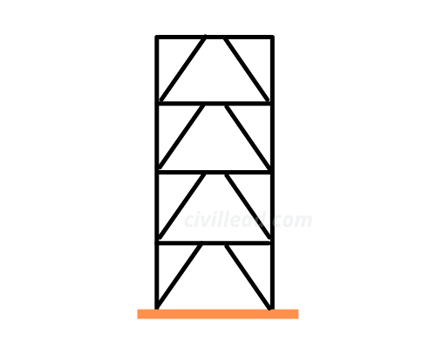
V bracing | Eccentric bracing
Figure 2.6 Types of Bracings.

There are bracings in soil, especially after cutting it, and excavation for several reasons, which is called braced cut.
Braced Cut as mentioned before, supports the soil laterally after excavation, so as not to collapse, by using sheeting and bracing systems. The lateral thrust on the sheeting is resisted by the horizontal members in compression (struts) is known as a bracing system, bracing cut’s main components are struts, wales, sheet piles, or wooden board. Figure 2.7 shows brace cut components.

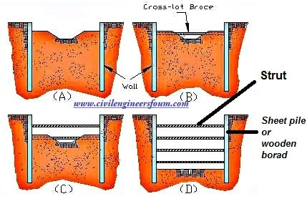
Figure 2.7 Brace Cut Components.

Bracing after the cut is used to resist lateral pressure, provide safety to the construction work, and enable deep excavation.
There are many types of braced cuts: Sheet piles, Wooden piles, Soldier beams, Slurry walls, Cofferdam, Soil grouting, Soil freezing, and Soil nailing.
Sheet and Wooden piles are the main types of braced cuts that are generally used under normal circumstances.

Sheet and Wooden Piles
Sheet Piles
Are made of steel, timber, or reinforced concrete, are sections of sheet materials with interlocking edges, driven into the ground to provide earth retention and excavation support, used for retaining walls, land reclamation, underground structures such as car parks and basements, marine locations for riverbank protection, seawalls, cofferdams, and so on.

Advantages of Sheet Piles
Recyclable and reusable, available in a wide range of lengths, sizes, and steel options, used for temporary and permanent structures, installed using silent and vibration-free methods, quicker installation than contiguous or secant walls, cofferdams can be constructed in almost any desired shape, provide a close-fitting joint to form an effective water seal, light in weight, making lifting and handling easy, length and design of the pile are easily adjustable, joints are designed to withstand the high pressure necessary for them to be placed in place, a little maintenance is needed above and underwater. Figure 2.8 shows Sheet Piles.
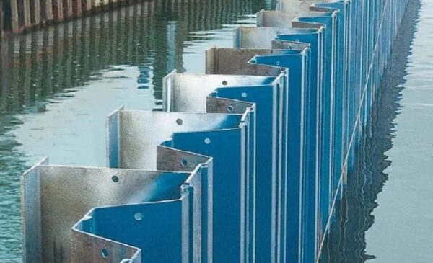 | 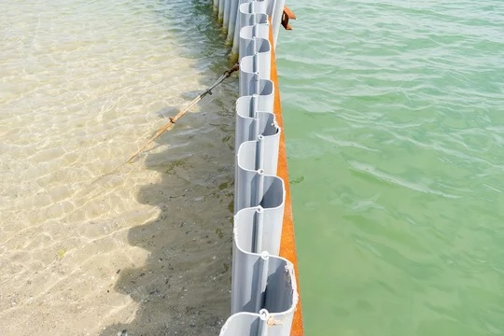
Figure 2.8 Sheet Piles.

Wooden Piles
For temporary structures and braced sheeting in excavation works, cannot be used under the water table, preservative treatment shall be given, the life of timber sheet pile is short, and not suitable in the strata consisting of gravel and boulders. Figure 2.9 shows Wooden Piles.

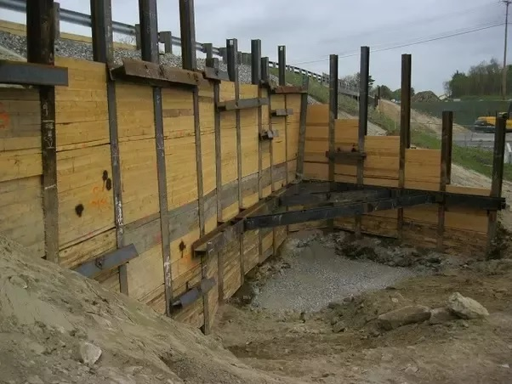
Figure 2.9 Wooden Piles.

Comparison between the sheet and wooden piles:
Sheet | Wooden
More strength | Less strength
Safe for deep excavation | Not safe for deep excavation
Can be reused | Cannot be reused
Its initial cost is high | Its initial cost is low
Overall economic | Overall uneconomic than sheet

Concrete Sheet Piles
Used in permanent river embankments, canals, and other marine structures, usually connected by tongue and groove joints, relatively heavy and bulky, displacing large volumes of soil during driving which increases resistance, and should not damage the piles and provides suitable reinforcement is very necessary. Figure 2.10 shows concrete piles.
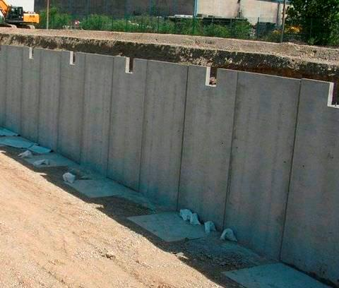
Figure 2.10 Concrete Piles

Solider Beam
Lagging walls and soldier piles are frequently used when creating foundations, as one of the first varieties of earth retention devices for deep excavations, soldier piles have a well-established track record. Soldier Piles have been used for several purposes, such as remediation, earth retention, and slope stabilization, these methods are not only functional but also economical, according to builders.
The soldier pile system is intended to keep the soil's horizontal movement and any potential utility and structural movement within safe, practical bounds. In the case of cantilever walls, horizontal movement is prevented by passive soil resistance acting on the soldier piles' front face, cantilever systems can be created for soldier heaps up to a cut height of around 12 feet, tiebacks can be grouted and drilled into the retained material, if more stability is needed or if a deeper excavation is needed, steel struts may also be used as lateral reinforcement elements, and may be positioned between the soldier piles. Figure 2.11 shows soldier beams.

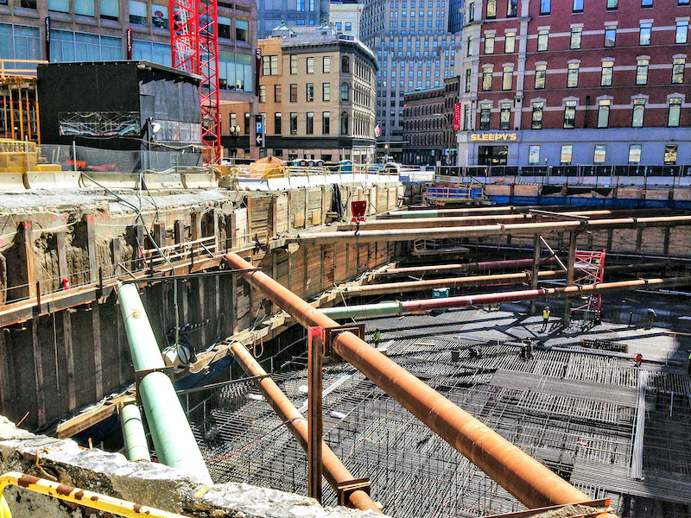
Figure 2.11 Soldier Beams

Slurry Wall
In locations of soft earth near open water or with a high groundwater table, reinforced concrete barriers are constructed using the slurry wall technique, this method is frequently used to lay foundations and construct diaphragm (water-blocking) walls around tunnels and open cuts. Figure 2.12 shows the slurry wall.
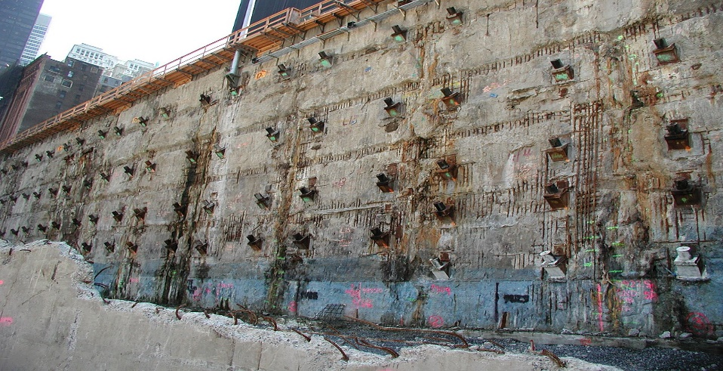
Figure 2.12 Slurry Wall

Figure 2.13 shows a Clamshell-type Slurry Wall Excavator.
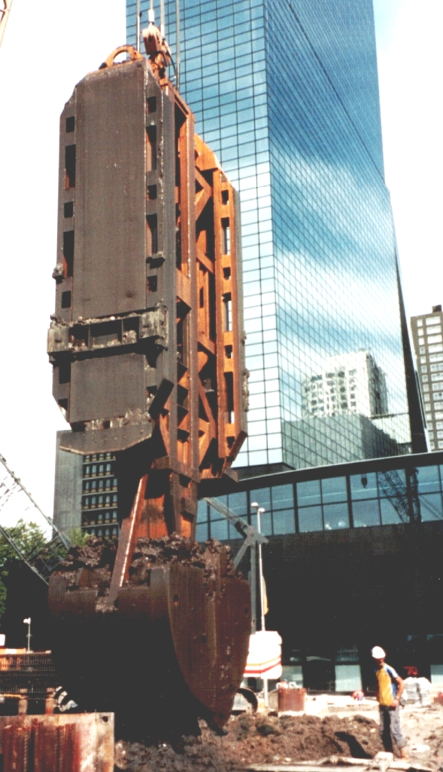
Figure 2.13 Slurry Wall Excavator

Cofferdam
A cofferdam is a structure placed within a body of water that enables the pumps out of the contained region, by pumping a dry working environment is created, enabling the work to be done safely, permanent dams, oil platforms, bridge piers, and other structures built on the water are frequently constructed or repaired using cofferdams. Usually made of welded steel, these cofferdams have sheet piles, wales, and cross braces. Figure 2.14 shows Cofferdam.
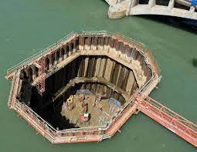 | 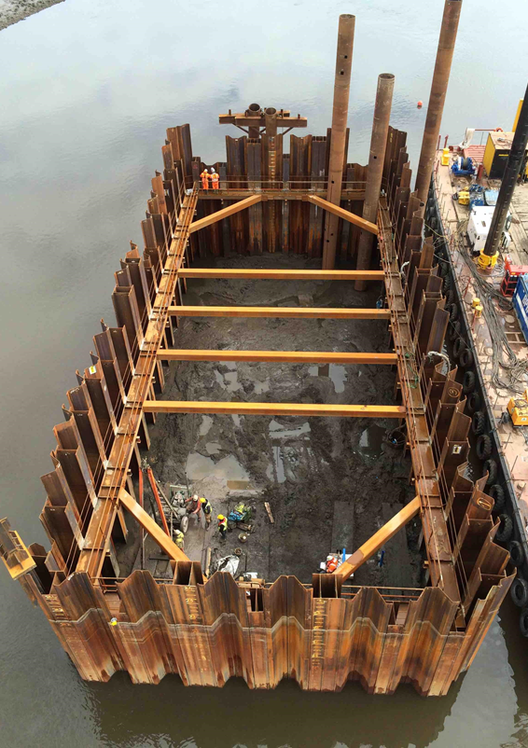
Figure 2.14 Cofferdam.

Soil Grouting
In order to form a cemented mass, permeation grouting, also known as cement grouting or pressure grouting, permeates coarse, granular soils with flowable particle grouts. Grouting can either strengthen a formation, lessen water flow through it, or fix flaws in masonry and concrete construction, despite the fact that permeation grouting is a component of all types of grouting, there are four separate methods: permeation, compaction, fractural, and jet grouting. Figure 2.15 shows the steps of soil grouting.
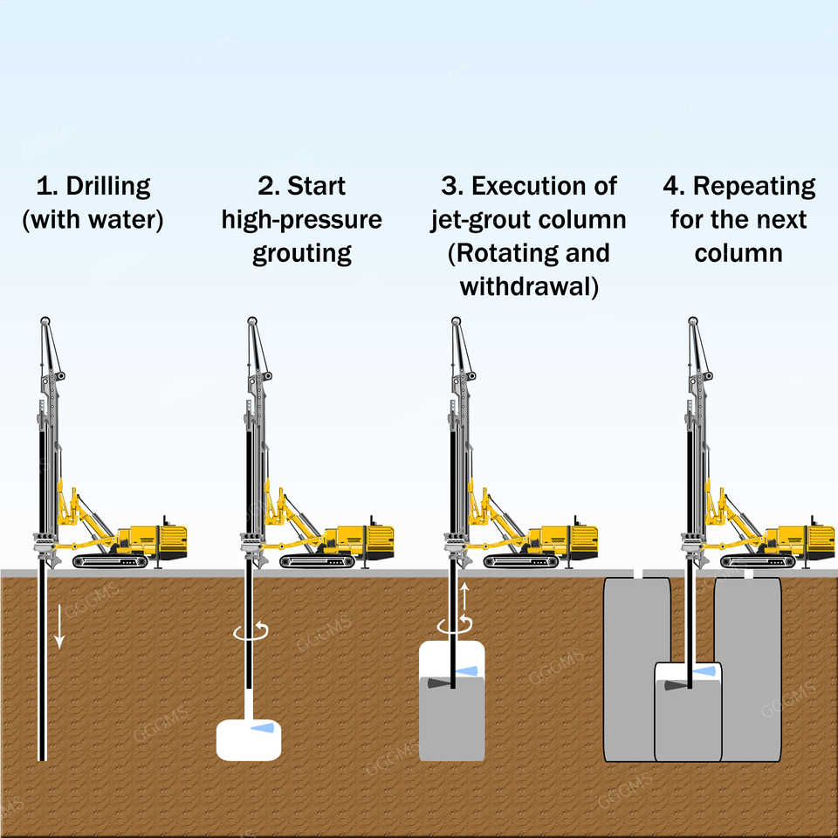
Figure 2.15 Soil Grouting Steps

Soil Freezing
By forming an ice-soil structure in the earth, the technique of soil freezing provides temporary soil fortification. The idea is to make ice out of pure water, by moving brine or liquid nitrogen through underground, closed pipes, or by combining the two approaches, freezing can be achieved. Figure 2.16 shows soil freezing.
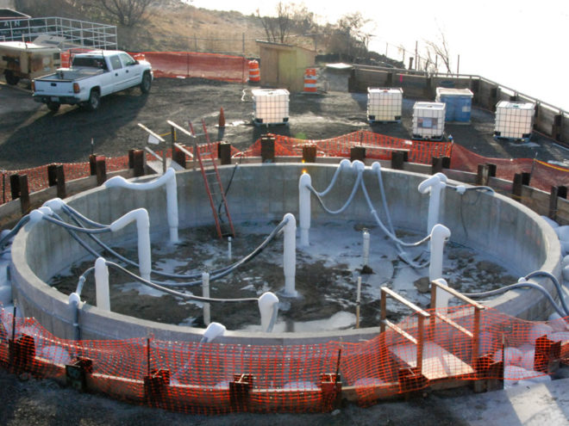
Figure 2.16 Soil Freezing

Soil Nailing
We will take about it in chapter three. Figure 2.17 shows soil nailing.
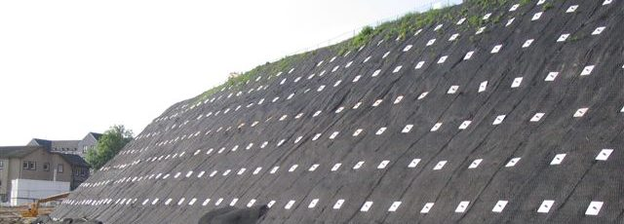
Figure 2.17 Soil Nailing

2.4 Review of Local Excavation Systems
In general, excavation of soil is necessary in the ground to build a structure either above ground or underground. As the excavation may be shallow or deep depending on our requirements. But when deep cuts are made in the soil, the soil may collapse from the sides of the excavated area due to its low stability.
To prevent this and to make the cut vertical exactly, we need some temporary earth-retaining structures called pit abutments. Soil cutting failure arises when the excavation limit exceeds its safe height limit and is dependent on the soil's unconfined compressive strength and cohesion. The following table also provides the safe height limit for different soil types based on unconfined compressive strength and cohesion limits.

Safe height  (Foot) | Unconfined compressive strength  (pounds per square foot) | Coherence  (pounds per square foot pressure) | Soil type
<5 | less than 500 | <250 | very soft
5-10 | 500-1000 | 250-500 | Soft
10-20 | 1000-2000 | 500-1000 | Average
20-40 | 2000-4000 | 1000-2000 | harsh
40-80 | 4000-8000 | 2000-4000 | Too harsh
>80 | >8000 | >4000 | Solid

Types of Drilling Supports
Excavation supports or earth retaining structures are needed where the excavation is deep and the required slope cannot be provided. The types of excavation props will be discussed. In general, there are two commonly adopted methods of providing drilling props.

1. Single Isolated Piles
The single insular pilasters are nothing but (I) sections consisting of a network between two flanges. Where these sections (I) are dug into the ground around the perimeter of the excavation. The piles are driven to the point below the required excavation depth. While weak concrete is used to fill single isolated piles.
The spacing between each adjacent bale is limited to 10 feet. After that, the bulge is made and the surrounding soil is well supported by the edges of the single isolated piles. And between single insulated bales, wood lags are used. Where the lag consists of long planks or planks placed behind the leading edges of the piles to support the soil between the bales.
The timbers are 2 to 4 inches thick so some hand digging is required behind the leading edge. Whereas, to provide a strong bond between the horizontal planks and the front flange, welded studs, clips, etc. are used. For narrow cuts of limited width and greater depth, drilling supports are provided in the form of supports.
The struts connect the member that connects the wall cut on one side to another cut wall horizontally. A horizontal member called (waller) is arranged in front of the rafter lag to stabilize the supports. While if the excavation is very wide, inclined supports called buckets will be used. Figure 2.18 shows Single Isolated Piles

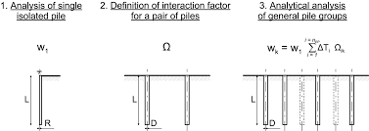
Figure 2.18 Single Isolated Piles

2. Hydraulic Support
Wooden boards are placed and fixed by iron or steel columns and beams. It is preferable to use this type of support for medium-depth excavations. Figure 2.19 shows Wood Reinforcement.
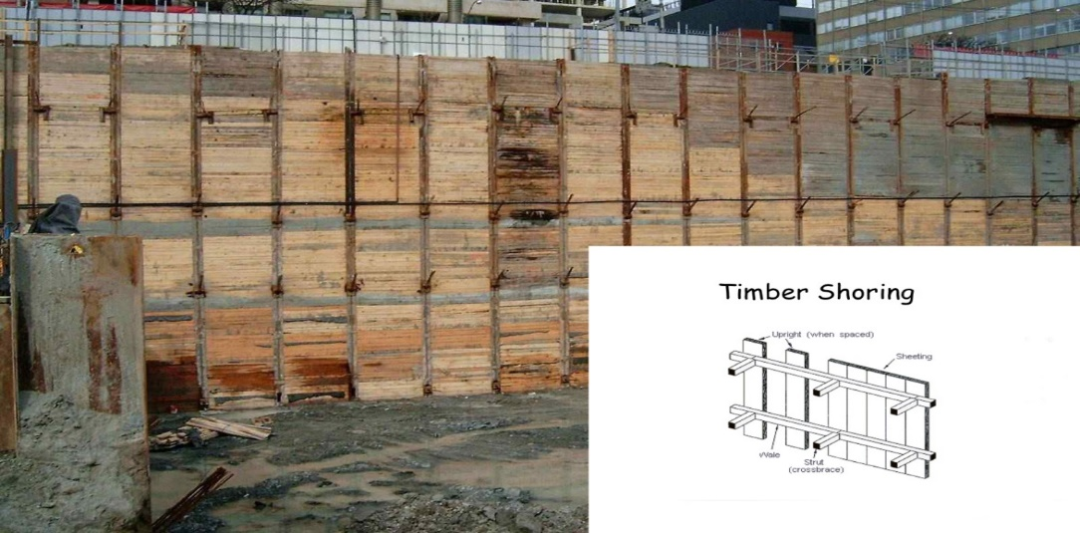
Figure 2.19 Wood Reinforcement

Painting each of the reinforcement with wood and reinforcement with piles or intersecting piles. Using soil nails or the retaining wall (Soil Nailing) is a technique (method) according to which the walls of the excavations are fixed by steel supports. Figure 2.20 shows Soil Nailing support.
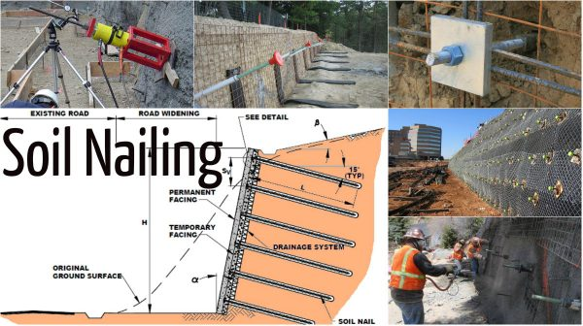
Figure 2.20 Soil Nailing Support

Chapter Three
Soil Nailing
3.1 Introduction to Soil Nailing
Soil nailing is a method to safe stability in slopes, and vertical cuts, it has many advantages and limits, advantages like: It can be used on a new structure that aids in trapping slopes; there are no elections at all; there are no restrictions on the height of the walls; the construction process is sped up; etc. However, there are some restrictions that make it unsuitable, such as high water table, soil types, low-strength soils, the use of nails, which are only used for permanent long-term applications in delicate and expanding soil, corrosion with metal nails, a higher liquid limit, reduced undrained.
Soil nailing techniques include driven, self-drilling, launched, jet-grouted, and its varieties (single fluid, double fluid, and triple fluid). And the tools employed include drilling rigs, grout pumps, jet grout, drilling and grout mixing equipment, as well as rotary machines with downhole hammers.
It is utilized to support high-rise buildings, widen roadways, bridge abutments, strengthen retaining walls and soil slopes, etc.
Its installation for the soil's surface, the building's top-to-bottom progression, the drilling of nail holes, the excavation for the soil cut, the provision of the final facing, the soil nail, and the grout.
Its steps: Install cut-off drainage and excavate unsupported cut, 1 to 2 m high, drill hole for nail, install and grout nail, repeat the process to the final grade, and place final facing.
Some of the explanations on design methods are talked about, and the difference between soil nailing and anchors, soil nailing is as mentioned before, but anchor has different types as ground anchors and its types (sub-horizontal ground anchors, soil (rock) anchor), and vertical ground anchors, and means a system capable of transmitting a tensile load into a competent stratum, drawing support from the structure to be anchored.

3.2 Soil Nailing
Soil nailing is a method of ground stabilization that may be applied on both natural and excavated slopes. It entails drilling holes in a slope face to insert steel bars, which are subsequently grouted in place. To keep the slope face in place, a mesh is fastened to the bar ends.
They are widely employed as a corrective remedy to stabilize embankments, levees, and other structures. Other uses for soil nailing include: shoring for temporary excavation, tunnel portals, roadway severance, abutments of a bridge, and existing retaining structures that must be repaired and rebuilt.
The major factors to consider when selecting whether to use soil nailing are the ground conditions, the applicability of other methods such as ground anchors, geosynthetic materials, and so on, and the cost.
Soils with a high groundwater table, cohesion-less soils, soft fine-grained soils, extremely corrosive soils, loess, loose granular soils, and terrain subjected to recurrent freeze-thaw activity are all unsuitable for soil nailing. Figure 3.1 shows Soil Nailing for retaining wall.
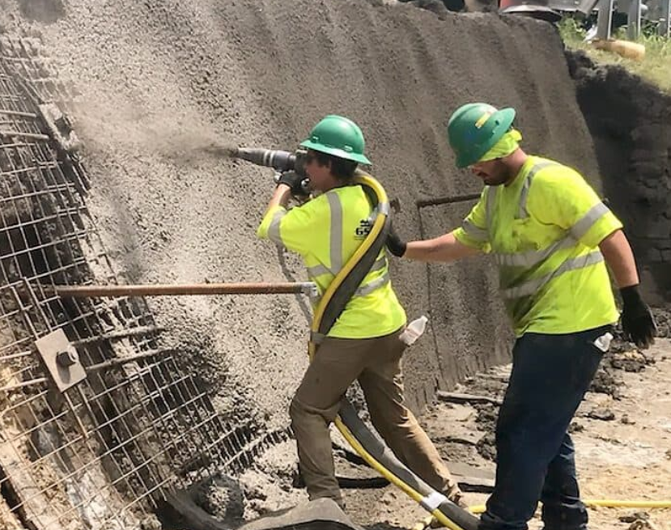
Figure 3.1 Soil Nailing for Retaining Wall

Advantages of Soil Nailing:
Soil nailing has so many advantages which help in ways other techniques can’t help which gives popularity to it and here are some of the advantages:
It may be utilized in a new building, temporary constructions, renovation, and other applications, and to restore the current wall system quite easily.
Soil nailing aids in the confinement of slopes. As a result, more room is available.
The nailing procedure requires only a minimal amount of slope preparation.
There are no height restrictions on the walls.
Construction time is reduced as compared to conventional slopes.
Because the nails are spaced at regular intervals, there is no need for shoring throughout. Figure 3.2 shows Shoring Excavation.
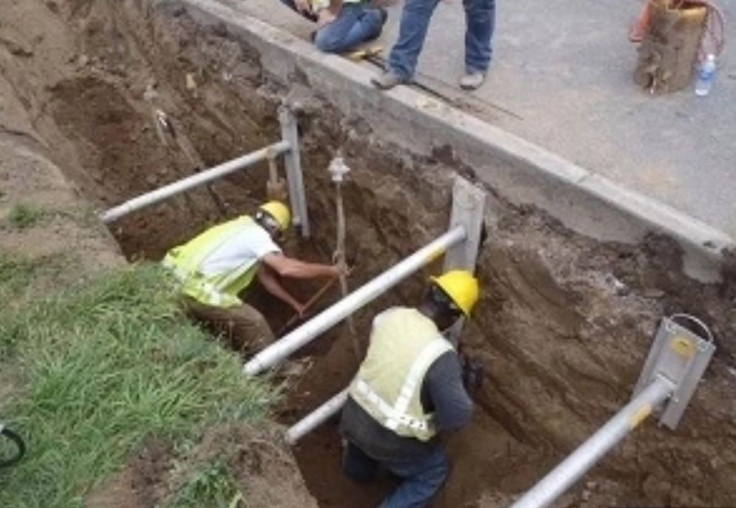
Figure 3.2 Shoring Excavation
The cost is typically less than that of erecting a retaining wall.
When used in conjunction with mesh and shotcrete, it has the potential to reduce slope erosion. Figure 3.3 shows Mesh and Shotcrete.
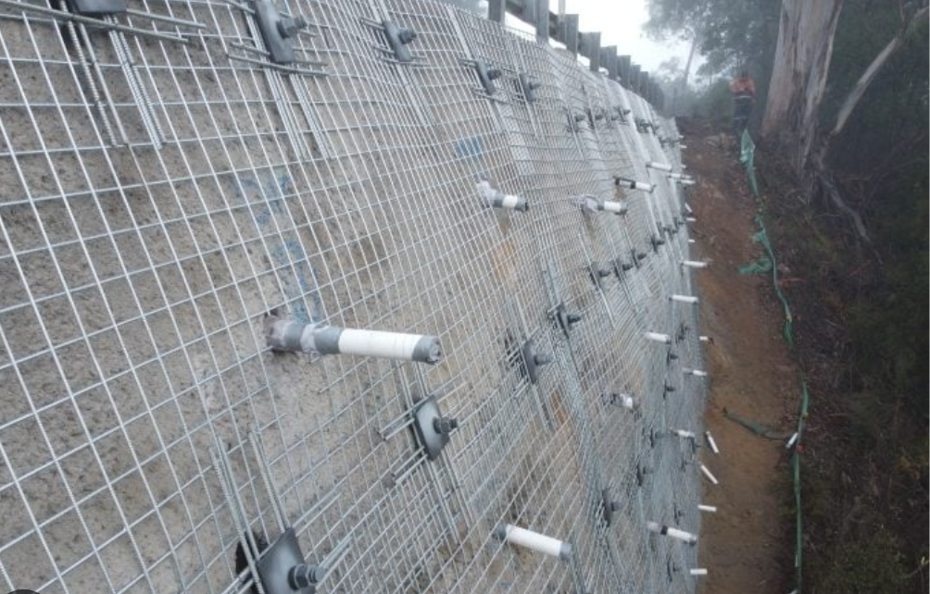
Figure 3.3 Mesh and Shotcrete

Less noise, fewer traffic jams, and less influence on the surrounding environment. Thus, it is eco-friendly.
This method is adaptable, fast, and simple to implement.
Saving time and money by requiring less work.
Limitations
Every method has some limitations that can occur, so here are the limitations of soil nailing: A high-water table is not an ideal situation for soil nailing, non-cohesive soils, fine-grained soils, very caustic soils, and loose granular soils are not suitable for soil nailing.
The density of soil nails rises as the shear strength of the soil decreases. This means that low-strength soils require more nails to stabilize, nails are only used for permanent long-term applications in delicate and expanding soil, and corrosion will occur with metal nails.
Soils with a high plasticity have a larger liquid limit, as a result, reduced undrained shear strength, which can cause long-term deformations, prior to nail placement, the soil may have been overexposed, sand and gravel may not work well with soil methods, the nails may need to be designed and installed by a specialist.

3.3 Soil Nailing Types
There are several ways to go about the soil nailing procedure, this decision is entirely based on the price, the site's accessibility, the available workspace, the groundwater level, and the surrounding circumstances. The common methods are:
Drilled and Grouted Soil Nailing Method.
With this technique, holes are first bored on an incline, and then the mortar is used to insert nails with a diameter of 100 to 200 mm that are spaced 1.5 meters apart in the middle of the holes. After being filled with filler material, the dowels are put into the pre-drilled holes. This style involves drilling holes into the slope face or wall, then inserting dowels into the holes that have already been created (As shown in the figure), Concrete and shotcrete are used as fillers to cover these holes.
A down-the-hole hammer, a rotary percussion drill, or a rotary are used to drill the holes. The method is chosen based on the soil and the state of the ground.
To generate a composite mass resembling a gravity wall, steel tendons are drilled and grouted into the soil as part of a reinforcement procedure. Although numerous architectural solutions are available for permanent wall facings, such as precast panels or "green" vegetation cells, a shotcrete facing is commonly applied. Figure 3.4 shows drilling holes and inserting nails.
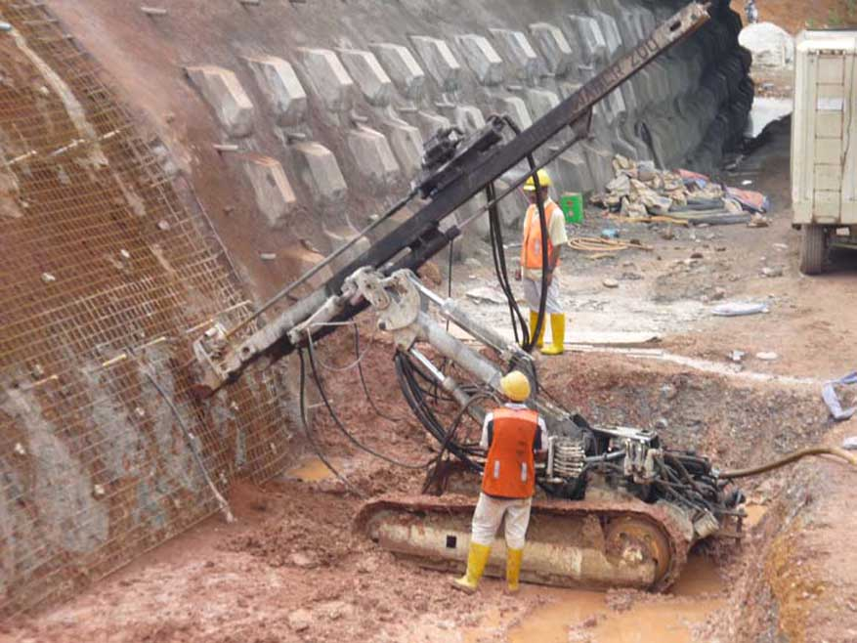
Figure 3.4 Drilling Holes and Inserting Nails.

Advantages:
Underground obstacles are surmountable, gaining knowledge about the environment, this technique allows the use of long soil nails, and before introducing the reinforcement, the drill holes can be examined.
Disadvantages:
Sometimes, drilling holes might cause collapse, casing is necessary before drilling holes at critical site regions.

Driven Soil Nailing Method:
The soil-nail reinforcement is inserted into the ground in this instance utilizing a ballistic technique and a compressed air launcher. Both vibratory methods and hammering tools can be used to accomplish this. The earth surrounding the reinforcement will be moved and compacted throughout this process when the nail is driven. As a result, the approach disturbs the soil less.
Driven soil nailing is a method for temporarily stabilizing soil slopes that is incredibly quick. However, it does not prevent the reinforcement steel or nails from corrosion. In the driven soil nailing method, the relatively small (19–25 mm) nails are pushed into the slope face during excavation, the nail spacing is 1 to 1.2 meters. Figure 3.5 shows the Driven Soil Nail method.
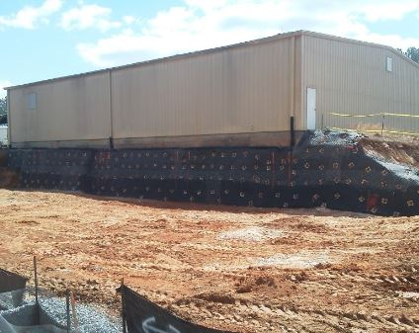
Figure 3.5 Driven Soil Nail Method

Advantages and Disadvantages
Advantages are rapid, and less soil disturbance, on the other hand, disadvantages are: this technique can only penetrate short distances due to the low power required, and penetration causes the nail reinforcement to buckle excessively, making it unsuitable for sites with rigid cores and susceptible to corrosion.

Self-drilling Soil Nailing Method:
This technique makes use of hollow bars, during the drilling procedure, hollow bars are drilled into the slope's surface and grout is injected concurrently, compared to grout nailing, this form of soil nailing is quicker when compared to driven nails, and this technique gives nails more corrosion resistance, as shown in Figure 3.6
A hollow rock bolt, a coupler, a nut, a drill bit, a plate, and a centralizer make up the self-drilling soil nail system. When working in challenging situations, it is the ideal substitute for traditional soil nails. This process is quick because grouting and drilling are done simultaneously. Instead of using air or water as the flushing medium, cement grout is employed here, which helps to keep the hole's stability. Figure 3.6 shows self-drilling soil nail.
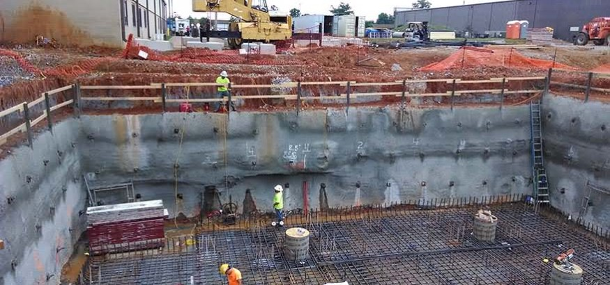
Figure 3.6 Self-drilling Soil Nail.

Advantages:
1. Self-drilling soil nails perform all of the drilling, grouting, and anchoring. The construction is finished one stage at a time. Self-drilling soil nail systems can speed up construction and are especially useful for challenging or time-sensitive projects.
2. The nearby soft and fragmented rocks make it challenging to create holes using the conventional construction procedure. Although constructed, the hole is susceptible to collapse, making it challenging to insert a rock bolt or cable bolt. While self-drilling soil nails only make up for the shortcomings of older technologies.
3. To fulfill the needs of various projects, self-drilling soil nails with complete thread can be joined to any length with ease.
4. T-thread self-drilling soil nails with couplers and grouting have a bonding stress that is more than one time greater than that of standard rock bolts.
5. Self-drilling soil nails use strong slagging techniques during drilling that increase drilling speed by using high-pressure water and air.
6. To prevent collapse, shorten drilling time, and reduce building trouble, a soil nail will be left in the hole after drilling.
Disadvantages:
Rock penetration is challenging, there are concerns about corrosion and durability, and the required grout cover might not be achieved in the absence of centralizers.
Jet-Grouted Soil Nailing Method
In the jet-grouted soil nailing method, dirt is eroded using jets to make holes in the slope's surface. Following that, concrete grout is used to place steel bars in this hole. Finally, jet-grouted soil nailing offers steel bars considerable corrosion protection (nails). Existing slopes and excavations are stabilized using soil nailing, comparing the top-to-bottom structure to the other retaining wall systems, it is superior.
Shotcrete or concrete is applied to the excavation face as construction moves from top to bottom to provide continuity. In essence, soil nails function in tension to strengthen the soil's resistance to shearing. Figure 3.7 shows Jet Grouting.
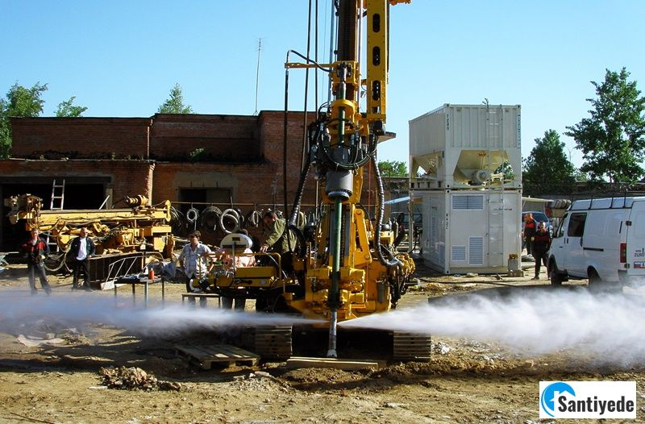
Figure 3.7 Jet Grouting

Jet Grout Soil Nailing Types
There are three varieties of jet grouting and soil nailing:
1-Single fluid jet grouting.
2-Double fluid jet grouting.
3-Triple fluid jet grouting.
Advantages and Disadvantages:
The ability to adapt to different site conditions, there are no limitations concerning the base of the wall's embedment due to surface adding can be used to control movement, supplementary nails greater compressibility of soil Strengths along the excavation's face include using the jet grout, resulting in a general soil enhancement. Disadvantages are: stress of the necessity of a knowledgeable contractor, underground easements for nails are needed, in fine-grained soils, long-term creep of soil nails is possible. Since this is a temporary wall and there weren't many fine-grained soils in the vicinity, creep shouldn't be a big problem. The size of the jet grout columns and the necessary soil nail length will be difficult to forecast due to the various soils indicated on site, thus verification and proof testing of the nails are crucial.

Launched Soil Nail Method
Long steel rods are inserted into an unstable or possibly unstable existing soil mass as part of the soil nailing reinforcement process. By imparting the tensile and shear resistance of the nail to the soil, soil nails have been inserted into the groundwork to strengthen the soil mass.
This technique uses a pressurized air device to drive steel bars quickly into the ground. Soil nails can be quickly installed, and the length of the bar piercing the ground is also difficult to manage. Figure 3.8 shows Launched Soil Nail method.
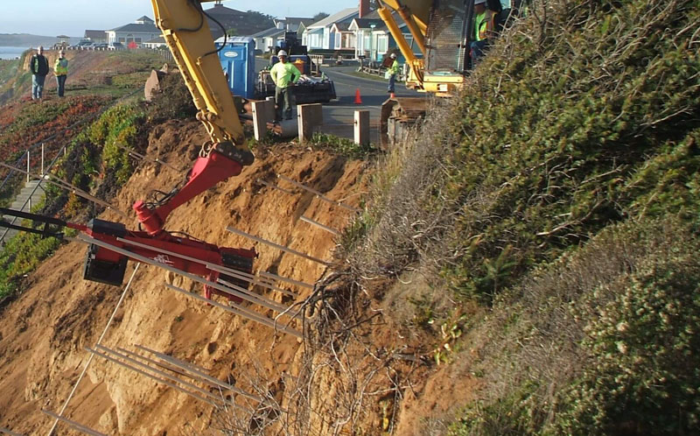
Figure 3.8 Launched Soil Nail Method

Advantages and Disadvantages:
Instant stabilization, rapid output, low-impact access, and affordable prices, tests show that the nail/soil bond is usually stronger than when nails are put in using conventional drilling techniques, in the majority of soil situations, both galvanized and non-galvanized bars will endure for a very long time. Disadvantages are sand and gravel might not be compatible with soil technique, the metal nail will corrode, it is not suited for use in locations with high water tables, and it requires specialized and experienced contractors. In soils with poor shear strength, very high soil density may be needed.

3.4 Machinery Used for Soil Nailing
Rotary Machine with A Downhole Hammer
Rotary down-the-hole hammer drills in addition to drilling anchor holes and geological pressure gauge holes, hydraulic down-the-hole drilling rigs, and crawler down-the-hole hammer drills are frequently employed in open-pit mining, water conservation, and other engineering rock drilling operations. Figure 3.9 shows the Rotary machine with a downhole hammer.
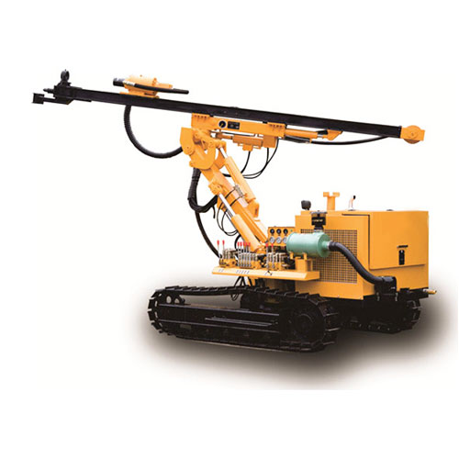
Figure 3.9 Rotary machine with a downhole hammer

Drilling Equipment
To install the nails, a few popular types of drilling equipment are employed, including tri-cone bits, down-the-hole hammers, and rotary air- and water-flushed bits. It's crucial to get drilling tools with enough power and sturdy drill rods. Figure 3.10 shows Soil Nail Drilling.
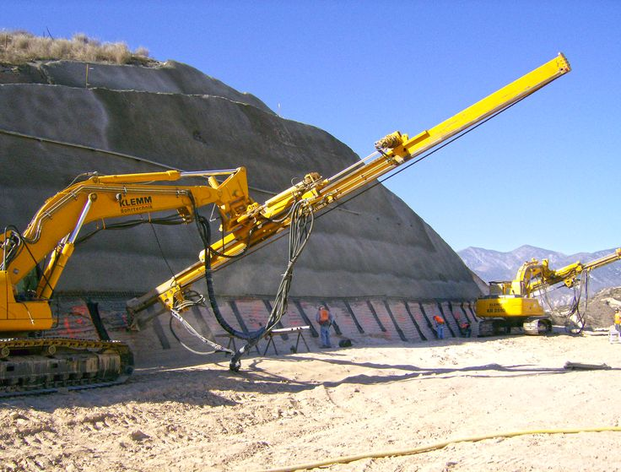
Figure 3.10 Soil Nail Drilling

Grout Mixing Equipment
Consider using a high-speed shear colloidal mixer to create a homogenous grout mix, a strong grout pump is necessary for continuous grout mix delivery, a specific grout pump must be utilized if the fine aggregate is used as filler for economic reasons. Figure 3.11 shows Grout Mixing Equipment.

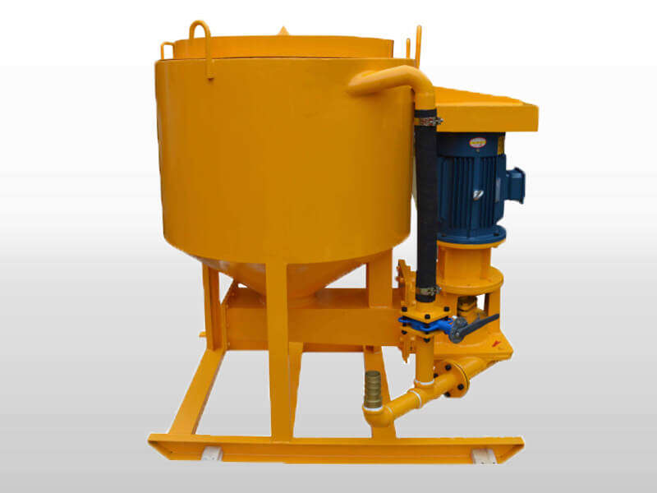
Figure 3.11 Grout Mixing Equipment

Drilling Rigs
Hollow bars with self-drilling anchors are often drilled with hydraulic rotary percussion drills (the top hammer). Drilling using a rotating percussive tool is commonly used to install the self-drilling hollow bars, it is simultaneous to drill and grout. Figure 3.12 shows Drilling Rigs.
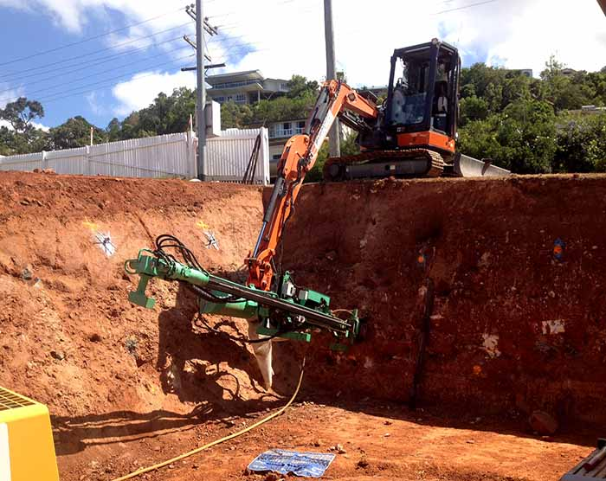
Figure 3.12 Drilling Rigs

Grout Pump
For the grouting procedure in civil and underground applications, a high-pressure grouting pump is ideal. Leadcrete Equipment is a reputable high-pressure grouting pump manufacturer and supplier, our engineers have the knowledge and skills necessary to create the high-pressure grouting pump that best suits your needs. Figure 3.13 shows Grout Pump.
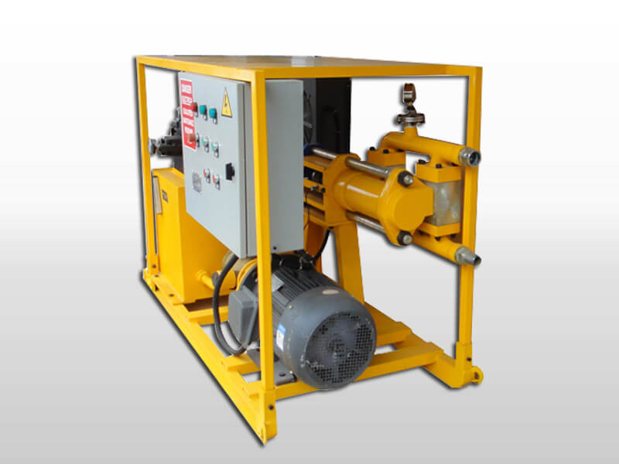
Figure 3.13 Grout Pump

Jet Grout Soil Nailing
The soil is eroded using the Jet Grout Soil Nailing Technique, which results in holes on the surface of the slope. In this hole, steel bars are inserted and grouted with concrete.
The steel bars are well protected against corrosion by it, by inserting steel reinforcing bars, a process known as "soil nailing" can strengthen soil slopes, excavations, or retaining walls. Figure 3.14 shows Jet Grout Soil Nailing.
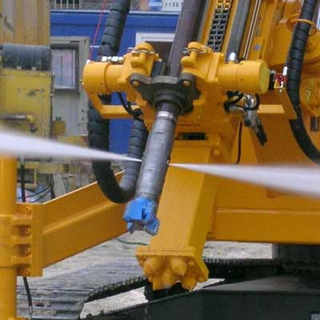
Figure 3.14 Jet Grout Soil Nailing

3.5 Soil Nailing Applications
One of the most affordable and practical techniques for building retaining walls from top to bottom is using soil nails. They are an efficient, dependable, and technically possible slope protection solution. A perfect and affordable solution for making temporary retaining walls for large excavations is provided by soil nails.
Its uses:
1. It is used to stabilize and reinforce retaining walls and soil slopes.
2. For example, soil nailing is used to widen roads, build railway embankments, highway cuts, guard against landslides and floods along riverbanks, and more.
3. Shored Mechanically Stabilized Earth (SMSE) walls may be built using it.
4. It is employed in the bridge abutments' construction and retrofitting.
5. Excavation retaining structures for high-rise buildings in urban areas.
6. Tunnel entrances in stratified slopes that are steep and unstable.
7. Building and modifying bridge abutments with intricate borders that require wall support beneath piled foundations.
8. Securing steep cuts to increase available development space.
9. Stabilizing already existing, excessively steep embankments.
10. Soil nailing through already-built masonry or concrete structures, like collapsing retaining walls.
11. Road construction.
12. To transfer external forces (tensile) to the ground by using guy wires.
13. To anchor support structures for excavations which include reinforcing trench boxes or sheet piling.
14. The stabilization of eccentrically stressed foundations.
Figure 3.15 shows some applications of soil nailing.

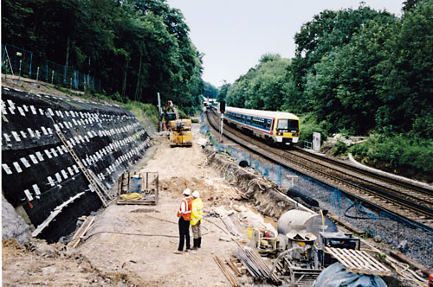 | 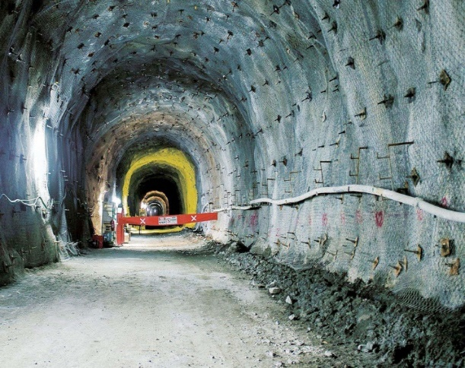
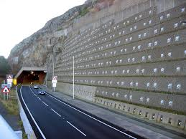 | 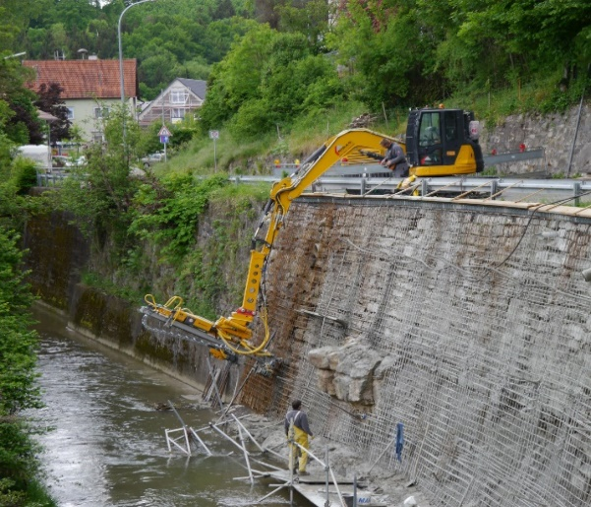
Figure 3.15 Applications of Soil Nailing

3.6 Installation Considerations
The procedure begins with drilling the dirt and identifying the target points for the steel bar and nails. After drilling is finished, the holes need to have nails put into them. The grout is then injected into the ground to create a structural member. The soil is then protected by placing reinforcement on a soil surface. Figure 3.16 shows some installation considerations.
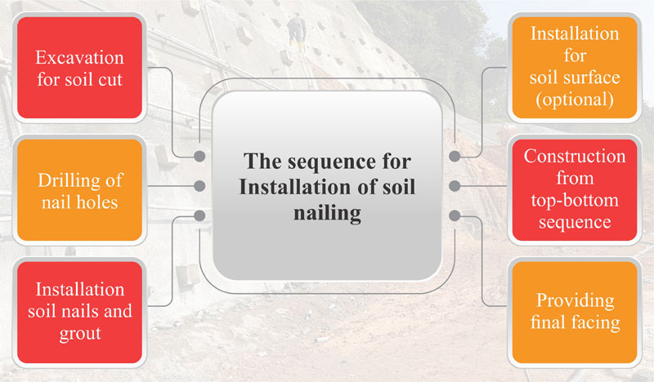
Figure 3.16 Installation Considerations

The non-resistant zone is normally 4 to 5 meters away from the slip plane, therefore soil nails must drill a hole there. The strength of the soil must be taken into consideration while determining the horizontal or vertical spacing of soil nails, at the margin of any surface where it is being balanced, additional earth nails are inserted. Finally, soil tying should begin right after excavation, the slope of the soil collapses with any delay.
The length and configuration of soil nails are constrained by the presence of service, subsurface constructions, or other concealed barriers. The area is occupied by the soil nails that are being cleaned, and the location places limitations on any future development.

3.7 Process and Methods
Soil nailing is the insertion of solid or hollow steel or glass fibre bars into the face of an excavation or an existing slope to reinforce it, transferring part of the load from the potentially unstable mass to more competent strata, typically where the potentially unstable mass has a maximum thickness of 6 to 8 m. The face of the slope is protected by shotcrete and welded wire mesh, geogrid/geotextile sheets, and cast-in-place concrete or prefabricated panels.
The technique has been developed in France, Germany, and United States over the past 25 years or so (Guilloux and Schlosser, 1985; Nicholson, 1986; Bruce and Jewell 1986a; 1986b; Munfach et al.; 1987; Juran and Elias, 1987; Gnilsen, 1988, Recommendations Clouterre, 1991; Byrne et al., 1998; Mitchell and Jardine, 2002; Phear et al., 2005), as a development of the “root piles” technique originally developed in the 1950’s described by Lizzi (1977); Bruce (1992a, b). Its application has extended to a wide variety of ground types, from soils to weathered and un-weathered rocks; while the term “ground nail” might be a more suitable generic term, “soil nail” has become established as the commonly accepted generic terminology and is used here for nails installed in all types of ground which can be conveniently described as continuous. Case histories are listed for example in Bruce and Jewell (1987a; 1987b) and Bruce (1989).
A typical construction sequence for drilled and grouted nails is described below and shown in Figure 3.16 alternative methods of installations include percussive methods or Vibro-drilling (Myles and Bridle, 1991), combinations of vibration driving with injections and driving nails by compressed air or pyrotechnic launchers. Figure 3.17 shows a typical application.

1. Installation of ditches to intercept and divert surface water; excavation/trimming in stages of limited height (typically 1 or 2 m), minimizing ground disturbance, and removing loosened areas, leaving a working bench of (5÷7)m width. For installation in existing slopes, special provisions must be made for access (long-reach booms, sledges, or similar).
2. Dilling of nail holes at predetermined locations to a specified length and inclination using drilling methods appropriate for the ground, supporting the drill hole with casing, if required, although this will often have a serious adverse impact on the cost-effectiveness of soil nailing. Bentonite or other mud suspensions should not be used, as “smear” on the drill hole walls can significantly reduce the grout-to-ground bond. Typical drill hole size: 100 to 300 mm, spacing: 1 to 2 m, both vertically and horizontally; inclination: 15° below horizontal to facilitate grouting; length: 6 to 15 m (up to 28 m using large hydraulic-powered track-mounted rigs with continuous flight augers).
3. Installation and grouting of nails. Plastic or steel centralizers are commonly used to center the nail in the drill hole; stiffer grout mix may be alternatively used to maintain the position of the nail and prevent it from sinking to the bottom of the hole. The steel nails are commonly 25 to 50 mm in diameter; solid or hollow; the yield strength is 420 to 500 N/mm2. Steel nail diameter smaller than 25 mm are not recommended due to difficulties associated with placement of such flexible tendons in drilled holes. Grouting takes place under gravity or low pressure from the bottom of the hole upwards. Grouted steel nails protected only by the grout annulus are not generally considered adequate for permanent application in some countries; in these cases, additional protection against corrosion may be given by sacrificial thickness, by heavy epoxy coating, and by encapsulating it in a grout-filled corrugated plastic sheathing. “Self-drilling nails” (Figure 3.18) can be used where open-hole drilling is not possible or practical. However, they require special corrosion considerations and testing procedures to be considered for permanent applications. In general, the self-drilling nails should not be used in aggressive ground (as defined in Byrne et al., 1998) and coatings should not be considered acceptable corrosion protection, which can be assured only by providing sacrificial steel.

STEP 1  Install cut-off drainage and excavate unsupported cut, 1 to 2 m high | 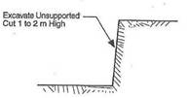 | 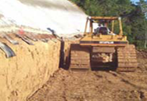
STEP 2  Drill hole for Nail | 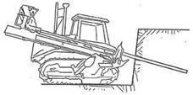 | 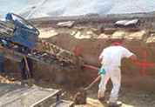
STEP 3  Install and grout Nail | 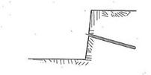 | 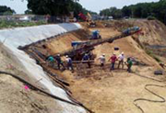
STEP 4  Repeat the process to the Final Grade | 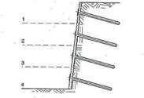 | 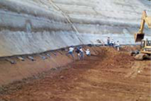
STEP 5  Place Final Facing  (on permanent walls) | 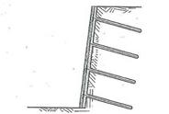 | 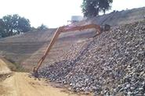
Figure 3.16 Construction Sequence for Drilled and Grouted Nails

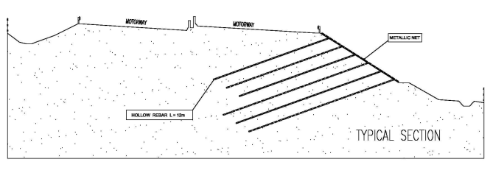
Figure 3.17 Typical Application.

In case of permanent reinforcement and use of drilling and grouting methods, the steel bar is encapsulated in a cement grouted body to provide corrosion protection and improved load-transfer to the soil; the steel bar is also typically protected with a heavy epoxy coating or by encapsulation in a grout-filled corrugated plastic sheathing. For other installation methods protection against corrosion can be provided by sacrificial thicknesses; BS 8006:1995 gives guidance on sacrificial thicknesses for galvanized and non-galvanized nails. When shotcrete facing is not adopted, corrosion protection at the nail head may be provided by precast or cast-in-place concrete head details.
Nails are characterized by “continuous” reinforcement with transfer of shear stress along the full length of the inclusion. The effect is to reduce nail forces at the face, allowing the use of only a thin cover, primarily to resist erosion or slump of the face.
The nails are installed horizontally or subordinately, approximately parallel to the direction of major tensile straining in the soil. The nails work predominantly in tension, but are considered to work also in bending/shear, especially where the orientation is perpendicular to the anticipated shear surface; in these cases, nails may more properly be called dowels.
The nails contribute to the support of the soil partially by directly resisting the destabilizing forces and partially by increasing the normal loads (and hence the shear strength) on potential sliding surfaces (see Figure 3.18 of fact sheet 6.0 on the general aspects of hazard mitigation by transfer of load to more competent strata). The reinforcements are passive and develop their action through nail-soil interaction as the soil deforms; the face protection need to be installed in order to keep the soil from caving in between the bars. Figure 3.18 shows nail details.
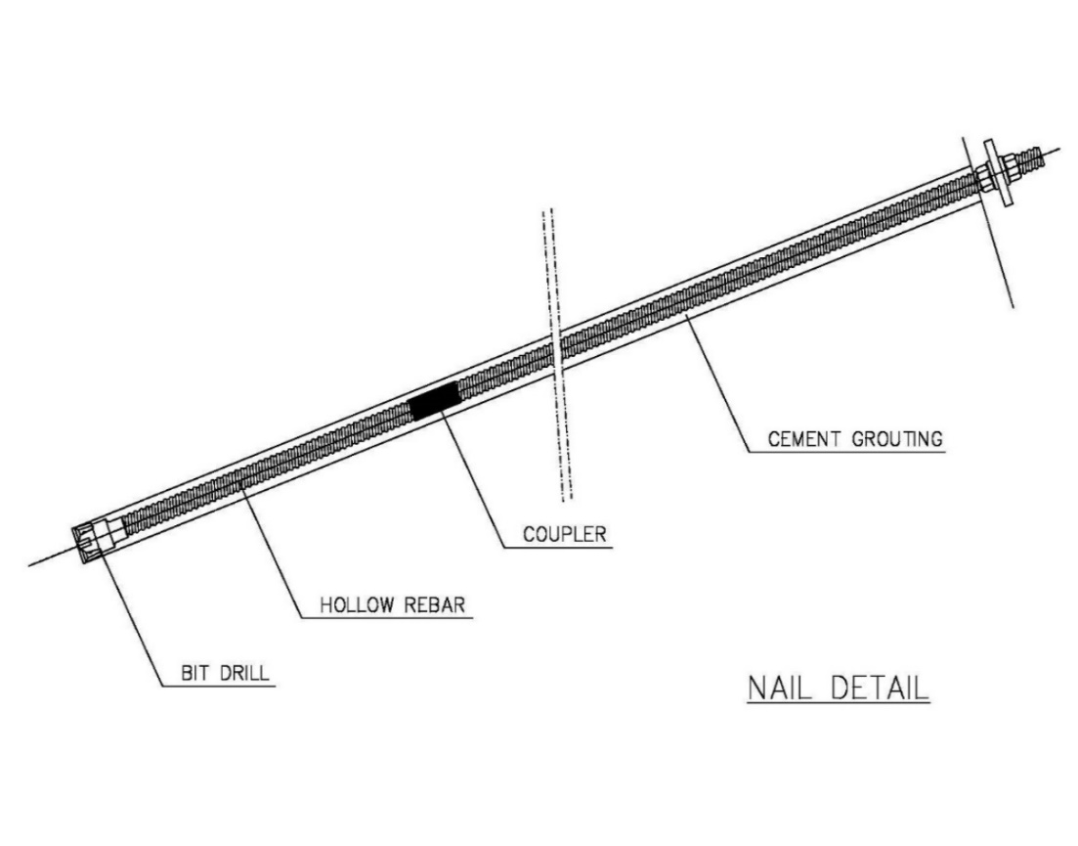
Figure 3.18 Nail Details

3.8 Techniques Advantages
1. Construction flexibility in heterogeneous soils with cobbles, boulders, and other hard inclusions, as the obstructions offer no problems for the relatively small diameter nail drill holes.
2. Well suited to sites with difficult or remote access because of the relatively small size and mobility of the equipment's.
3. High system redundancy as the soil nails are installed at high density and the consequence of a unit failure are therefore correspondingly less severe.
4. The system is relatively robust and flexible and can accommodate significant total and differential displacements.
5. Soil nailing has been documented to perform well under seismic loading conditions (See for example Felio et al., 1990).
6. Additional nails can easily be installed during construction, if slope movements occur or are greater than expected.
7. The method is well suited for the rehabilitation of distressed retaining structures.

The disadvantages of the technique are mainly linked to its constructability, in relation to nature of ground to be reinforced and/or the presence of groundwater percolating through the face; in general, the economical use of soil nailing requires that the ground be able to stand during construction. In addition, when the drill and grout methods are adopted, it is highly desirable that the open drill hole can maintain its stability for at least several hours. Therefore, difficulties can be experienced in:
1. Loose clean sands and gravels or coarse-grained soils of uniform size unless in a very dense condition; these soils will not generally exhibit adequate stand-up time and are also sensitive to vibration induced by construction equipment's.
2. Soils with excessive water content or below the groundwater; significant groundwater seepage at the exposed face can cause serious problems (e.g. local slump; drill hole instability, impossibility to obtain a satisfactory ground-grout bond).
3. Organic soils or clayey soils with Liquidity Index greater than 0.2 and undrained shear strength less than 50 kPa; remolding caused by nail installation may reduce skin friction to unacceptable values.
4. Highly fractured rocks with open joints or voids and open-graded coarse materials (e.g. cobbles), geotextile nail socks, or low slump grout may be necessary in such materials to mitigate the difficulty of satisfactorily grouting the nails.
5. Rock or decomposed rock with weak structural discontinuities inclined steeply toward and daylighting into the cut face.
6. Expansive (e.g. swelling) soils; these soils may result in significant increases in the nail loading near the face. Water must be prevented from reaching expansive soils that are soil nailed.
It should also be noted that the long-term performance of shotcrete facings has not been fully demonstrated, particularly in areas subjected to freeze-thaw cycles. In these circumstances, it is recommended that the design prevents frost from penetrating the soil by the provision of an appropriate protective structure (e.g. granular or synthetic insulating layer).
Special attention must be paid in both the design and the construction stages to the issue of corrosion and durability of the structural elements.

3.9 Design Methods
As highlighted by Mitchell and Jardine (2002), there is still much discussion about the assessment of the behavior and stability of nailed structures. A discussion on the differences between the design approaches widely used in Europe and the United States, as reported in Schlosser (1983) and Juran and Beech (1984), can be found in Juran and Elias (1987), Gnilsen (1988), Jewell (1990), Jewell and Padley (1990a; 1990b; 1990c; 1991), Bridle and Barr (1990) and Schlosser (1991).
Solutions to the problem require:
1. Carrying out appropriate soil structure interaction analyses to investigate the internal stability of the composite system made up of nails, facing, and soil, both in the “active zone” close to the facing, where the shear stresses exerted by the soil on the reinforcement are directed outward and tend to pull the reinforcement out of the ground, and in the “resistant zone”, where the shear stresses are directed inward and tend to restrain the reinforcement from pulling out.
2. Evaluation of the overall stability of the nailed structure, considered as a massive retaining structure (external stability).
For internal stability to be achieved, the nail tensile strength must be adequate to provide the support force to stabilize the active block. The nails must also be embedded a sufficient length into the resistant zone to prevent a pullout failure.

In addition, the combined effect of the nail head strength (as determined by the strength of the facing or connection system) and the pullout resistance of the length of the nail between the face and the slip surface must be adequate to provide the required nail tension at the slip surface (interface between active and resistant zones).

All potential failure modes, which involve: a) face failure (active zone slides off the front of nails); b) pullout of nails from the resistant zone; c) structural failure of nails (in tension, bending, or shear), must be analyzed separately (simplified procedures) or simultaneously (advanced approaches).

Major difficulties in finding rigorous and reliable solutions for the internal stability of the nailed structure derive from the fact that both the forces acting in the nails and the forces acting on the facing are governed by the deformation behavior of the entire system, which, in turn, depends on the geometric and mechanical characteristics of the various elements (including the soil), together with the sequence, rate, and method of construction. For example, the latter may influence the load transfer characteristics between soil and nail. The building of soil nailed structure involves a critical phase with respect to internal or external stability, which can be lower during the building phase than when the reinforcement is finally built, therefore, the internal and external stability of the nailed structure shall be checked for all the construction phases (Figure 3.19).
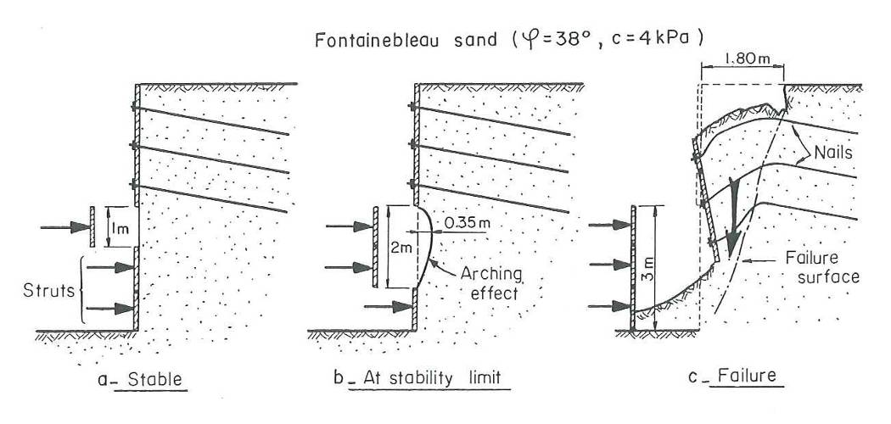
Figure 3.19 Internal and External Stability

The simplest and most widely adopted method to investigate both internal and external stability of soil-nailed structures is based on the slip surface limit equilibrium method by incorporating the reinforcing effect of the nails, including consideration of the strength of the nail head connection to the facing, the strength of the nail tendon itself and the pullout resistance of the nail-ground interface. Typically, the analyses are carried out concerning Ultimate Limit States, with the magnitude of deformations (Serviceability Limit States) controlled indirectly by the application of appropriate values of partial factors in ULS calculations. Where deformations are critical, it becomes necessary to resort to numerical analysis.
The contribution of any nail to the stability of a particular sliding surface will be the least of a) the tensile strength (shear/bending contributions neglected) or the “ideal” strength (shear/bending contributions considered) of the nail; b) the pullout resistance of the length of nail beyond the slip surface; c) the nail head strength plus the pullout resistance of the length of the nail between the slip surface and the face of the exposed surface. All potential surfaces must be examined to ensure that the design is complete.
In the case of the drilling and grouting method of nail installation, the pullout resistance of the nail will be the least of the ground-grout bond and grout-tendon bond. Ground-grout bond is strongly dependent on the method of construction; for this reason both pullout tests and short-term creep tests are a standard part of nail preliminary testing for check and calibration of the design before starting with the construction activities; in short-term creep tests, the rate of creep of the nail will increase as the applied load increases; a creep rate exceeding 6 mm/60 minutes is generally considered unacceptable.
In the simplified procedure, both internal and external stability analyses are usually carried out in 2D (plane strain) conditions.
In order to check both stability and deformation behavior of the soil nailed structure the analyses carried out with the simplified procedure can be supplemented by true soil-nail-facing interation analyses with the use of finite element (FE) methods; the best approach is to use 3D models, where the nail is modelled explicitly as is; often the 3D geometry is such that it can be simplified considering symmetry in the model.
In static conditions, the reliability of the design method depends on the correct selection of the operational strength parameters of the soil and on the correct modelling of the ground-grout load transfer curves; uncertainties can be minimized by preliminary pull-out tests.
The internal and external stability under seismic conditions can be investigated by means of pseudo-static methods and/or finite element methods; the external stability can be also investigated by means of Newmark type of analysis, the reliability of pseudo-static analyses depends on the same factors affecting static analyses, with the addition of uncertainties on the appropriate values of pseudo-static seismic coefficient kh to be used; Newmark type analyses must be carried out for a large number of strong motion records and the results must be treated by statistical techniques to minimize error.
FEM analyses retain all the limitations of the simpler methods, except that they can incorporate a more detailed constitutive modeling of soil behavior, overcoming the need to preselect operational values of strength, as well as geometric simplifications.
Systematic monitoring and reporting of performance is necessary, both to verify that the structure performs as anticipated and to enhance confidence and expertise in the use of this technique in the future, especially in light of the continuing debate on the best methods of design. In particular, monitoring of any lateral outward movement of the face is highly desirable. Designers should detail monitoring requirements (type, location, frequency, and data treatment) as an integral part of the design.
Performance monitoring instrumentation should include slope inclinometers, survey points, and nail loads at the head and along the nail length to measure movements and stresses during and after construction.
Sufficient environmental monitoring should also be carried out to provide the necessary framework for interpretation of performance monitoring. Environmental monitoring should include, as a minimum, temperature variations, and groundwater levels.
Monitoring should continue for a period of at least 2 years after construction, in order to gather information as a function of time and environmental changes such as freeze-thaw cycles and/or variations in groundwater levels.

3.10 Functional Suitability Criteria

Table 3.1

Type of movement
Descriptor | Rating | Notes
Fall | 7 | Applicable to slides and in special circumstances to falls and topples in cemented or stiff/hard cohesive soils.
Topple | 6
Slide | 8
Spread | 0
Flow | 0

Material type
Descriptor | Rating | Notes
Earth | 9 | Applicable to earth and debris. In very coarse debris drilling can be problematical and launching is precluded.
Debris | 5
Rock | 0

Depth of movement
Descriptor | Rating | Notes
Surficial (< 0.5 m) | 8 | Practical soil nail lengths and the need to achieve sufficient anchorage in the underlying stable soil limit the application of this technique to situations where the residual thickness of the actual or potential landslide to be stabilized is significant.
Shallow (0.5 to 3 m) | 9
Medium (3 to 8 m) | 7
Deep (8 to 15 m) | 0
Very deep (> 15 m) | 1

Rate of movement
Descriptor | Rating |  | Notes
Moderate to fast | 0 |  | Workers’ safety and end result require construction to take place when movement is extremely slow or very slow (maximum 1.5 m/year, corresponding to approximately 5 mm/day).  Under special conditions and taking due precautions it may be carried out when movement is “slow” (up to 1.5 m/month, corresponding to 5 cm/day).
Slow | 2
Very slow | 9
Extremely slow | 10
Groundwater Conditions
Descriptor |  | Rating |  | Notes
Artesian |  | 0 |  | Drillhole stability where groundwater may be encountered should be reviewed carefully, since the use of temporary casing, if required, would normally make this technique excessively expensive. Groundwater seepage at the surface must be avoided, incorporating suitable drainage works, with the risk of local slumping before the drainage works are effective.
High |  | 2
Low |  | 4
Absent |  | 10

Surface Water
Descriptor | Rating | Notes
Rain | 8 | Where sliding is due to channelized water, construction difficulties may be expected and there may be special requirements for the facing.
Snowmelt | 7
Localized | 5
Stream | 3
Torrent | 0
River | 1

Reliability and feasibility criteria
Criteria | Rating | Notes
Reliability | 6 | Successful application depends on correct schematization and characterization of the landslide, design and construction detail, and correct application.
Feasibility and Manageability | 6 | There are over 25 years of experience with the technique, but it is still susceptible to technological and design improvements.

3.11 Soil nailing and Anchors
A Bit of History
The Soil nailing and ground stabilization technique began to evolve in the early 70’s inspired by the New Austrian Tunneling method. A system was developed for underground rock excavation.
Over the years, the technique has been successfully deployed all over the world to tackle the challenge of slipping rocks, and unstable embankments, and to provide stability for slopes generally.
So, before moving on to list out the difference between both systems, let’s first see Soil Nailing.
Soil nailing is a fashion used to support and strengthen a dam (Figure 3.20), it can also be used to support excavations to allow steeper cuts and/ or deeper excavations. The abecedarian conception is that soil can be effectively corroborated by installing nearly spaced grouted sword bars, or “nails”, into a pitch or excavation as construction proceeds from the original ground to the bottom of the excavation or from the top down, unlike ground anchors, the soil nail bars aren't slackened when they 'reinstalled and are grouted along the entire length of the nail.
They're forced into pressures the ground deforms indirectly in response to the loss of support caused by the excavation. The grouted nails increase the shear strength of the overall soil mass and limit relegation during and after excavation. Soil nails are clicked along their full length and aren't constructed with endless unbonded lengths, as are base anchors. Figure 3.21 shows a typical soil nail.
Soil nailing is a cost-effective volition to conventional retaining wall structures for most soils. Still, they explain what soil nailing stabilization and anchoring mean.
Soil nail wall construction is sensitive to ground conditions, construction methods, equipment, and excavation sequencing. For soil nail walls to be most economical, they should be constructed in the ground that can stand unsupported on a vertical or steep slope cut of 3 to 6 feet for at least one to two days and can maintain an open drilled hole for at least several hours.

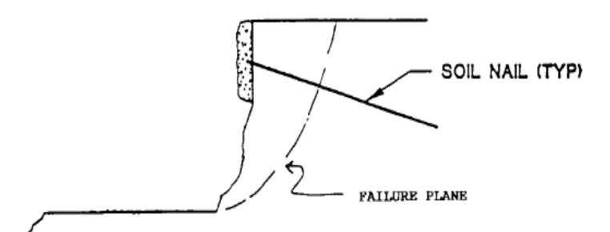
Figure 3.20 Soil Nailing in Dams

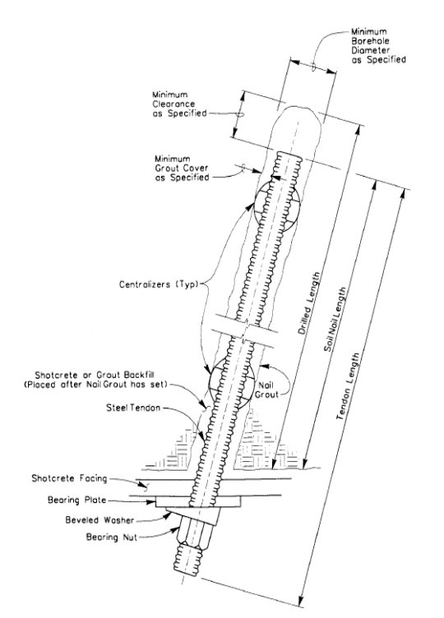
Figure 3.21 Typical Soil Nail

3.12 Ground Anchors
Sub Horizontal Ground Anchors
Sub-vertical ground anchors are used for temporary and endless structures. The use of sub-vertical ground anchors with distance pile or dogface ray shoring permits high walls and deeper excavations than are possible with stake-type construction – up to 35 bases or so depending on soil parcels versus 15 bases for stake construction. Walls can be erected more advanced than 35 bases by using high-strength distance pile or dogface beams with multiple rows, or categories, of sub-vertical ground anchors.
Soil (rock) Anchor
Unlike soil nailing which is pre-tensioned tendons, rock anchors are post-tensioned tendons that transfer tension from the unstable exterior to the underlying interior rock mass; hence, providing substantial reinforcement.
Rock anchors are made from bolts between the sizes of 15 to 32 diameter bars, drilled into 30 to 60 mm boreholes, and their length ranges from 3 to 6 meters long.
Factors Sub-vertical ground anchors are constructed by drilling holes at a slight angle (generally 15 degrees) of the vertical axis, latterly a special prestressing system is installed and the tip portion, known as the clicked length, is grouted. The clicked length acts as a Harborage by distributing the prestressing force to the girding soil. The unbonded end is secured with an anchor head. Relating to Figure 3.22 for a sub-vertical ground anchor schematic. According to Bridge Standard Detail distance (XS) 12- 040 for sub-vertical ground anchor details.

Table 3.4 Sub-Horizontal Ground Anchor Components
DESCRIPTION | COMPONENT
This transfers load from the wall reaction to the anchor zone and is generally a prestress rod or strand. | Prestressing Steel – Support Member
The portion of prestressing steel fixed in the primary grout bulb through which load is transferred to the surrounding soil or rock. Also known as the anchor zone. | Bond Length
The portion of the prestressing steel that is free to elongate elastically and transmit the resisting force from the bond length to the wall face. | Unbonded Length
This consists of a plate and anchor head or threaded nut and permits stressing and lock-off of the prestressing steel. | Anchorage
This provides corrosion protection as well as the medium to transfer load from the prestressing steel to the soil or rock. | Grout

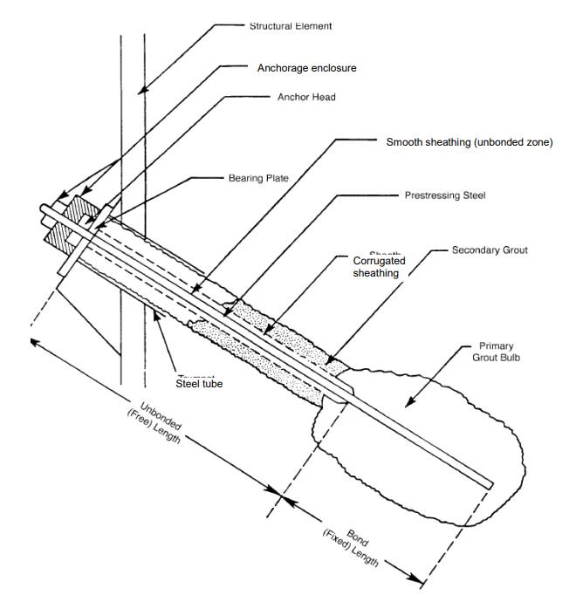
Figure 3.22 Sub-vertical Ground Anchor Schematic.

Sequence of Construction
Table 3.5. Sub Horizontal Ground Anchor Construction Sequence.
DESCRIPTION | SEQUENCE
Drill the holes to the required length and diameter. | 1
Install the prestressing steel unit. (Strands or Bar) | 2
Place primary grout. | 3
Complete performance and proof tests (refer to the section on testing later in this chapter). | 4
Lock-off and stress. | 5
Place secondary grout. | 6

3.13 Vertical Ground Anchors
Vertical ground anchors are analogous to sub-vertical ground anchors although they act in the perpendicular airplane. They can be used where point conditions don't allow traditional piles to achieve the necessary tensile capacity. For illustration, where gemstone exists close to the ground Face (or comb elevation), piles driven to turndown may be too short to develop sufficient skin disunion to repel uplift or tensile loads needed by the design.
Vertical, ground anchors are especially effective when combined with spread footings sitting directly on a gemstone, or as part of a seismic build strategy to add uplift capacity to a footing.
A schematic of a prestressing bar perpendicular ground anchor for a build operation is shown in Figure 3.23, relating to Bridge Standard Detail wastes (XS): 12-030-1 and 12-0302 for perpendicular ground anchor details.
The Contractor is responsible for furnishing the perpendicular ground anchor system that conforms to the design conditions shown on the contract plans and the testing conditions specified in the contract. After opting for a perpendicular ground anchor system, the contractor sends the shop delineations and computations to structure design, documents unit, for distribution, review, and authorization analogous to the process outlined above for sub-vertical ground anchors.
The recording of readings from the performance and evidence tests must be proved by the contractor and handed to the mastermind. Structure Construction field labor force substantiation all performance and evidence testing of the perpendicular ground anchors.

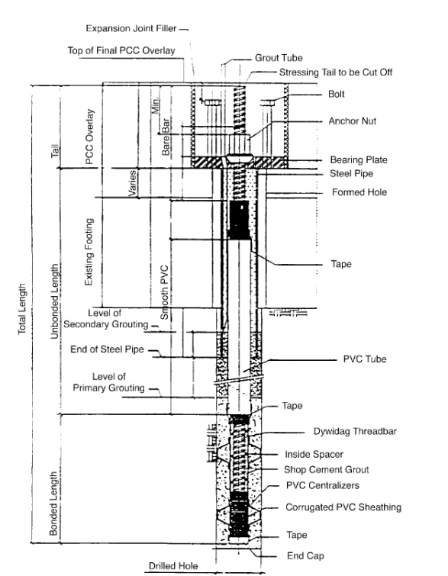
Figure 3.23 Ground Anchor

Table 3.6 Vertical Ground Anchor Construction Sequence.
DESCRIPTION | SEQUENCE
Drill the hole the required depth and diameter. | 1
Install the prestressing strands or bar. | 2
Place primary grout. | 3
Complete performance and proof tests (refer to section on testing later in this chapter). | 4
Lock-off and stress. | 5
Place secondary grout. | 6

3.13.1 Testing of Ground Anchors
Ground anchors require testing of the in-place anchors. Performance tests are done on a predetermined number of anchors, and proof tests are required on all of the remaining anchors. If the test results indicate that the anchors are not achieving capacity, additional monitoring and testing is required. If they do not pass at that point, a revision to the original design will be required. The redesign should be discussed with the Designer.

3.13.2 Rock Anchor Applications
Rock anchors are typically implemented in the following situations:
• To anchor retaining embankment walls.
• Used in the stabilization of eccentrically loaded tensioned foundations
• Used to reinforce and stabilize slopes, rock walls, and or cuts.
• Used to secure unconsolidated rocks in underground excavation projects.
• To provide support for marine structures like dock walls.

3.13.3 Drilling Techniques
For rock anchors, different techniques can be used to drill them in place. The type of method employed depends mostly on the prevailing condition such as the type of drill rig used and the working environment conditions.
Bar anchors are placed into the hole and grouted in place; then the multi-strand anchors are deployed, grouted into place, and post-tensioned to the specified load.

3.14 Reviews of Soil Nailing Studies
First Review
Wikipedia by using references: Goldstein, Natalie (Sep–Oct 2001), "Construction d'un mur de soutènement entre Versailles-Chantiers et Versailles-Matelots", S. Rabejac and P. Toudic, Manual for Design and Construction Monitoring of Soil Nail Walls (Report). Washington, D.C.: U.S. Federal Highway Administration (FHWA). October 1998. FHWA-SA-96-069, Geotechnical Engineering Circular No. 7: Soil Nail Walls (PDF) (Report). FHWA. 2003. FHWA-IF-03-017.
Treating the soil to withstand the conditions and what happens around it is done in many ways, but in this research, soil nailing will be discussed, as its analysis, how to decide if soil nailing is effective or not, and the way to do it.
Soil nailing is a modern method from the New Austrian tunneling method, to treat unstable soil and stop landslides or to make them safe, by entering iron rods into soil, which must be able to stand, have good cohesion, common limit states used in soil nail wall design is strength limit and service limit states. Design considerations include wall layout, soil nail spacing, a pattern on the wall face, inclination, length and distribution, material, and relevant ground properties, then evaluation nail length, and maximum force, final design should be tested, to construct this technique starting with excavation, then bracing, holes are drilled, then install and grout the nails into place, a layer of shotcrete is applied.
To stabilize retaining walls or pre-existing fill slopes (embankments and levees), soil nail components may be utilized, so it is the most effective method with cost and time.

The Second Review
Samrity Jalota1, Amanpreet Tangri2, Mohammad Farhad Ayazi3
1,3M.E. Research Scholar, Chandigarh University, Mohali 140413, Punjab, India
2Assistant Professor, Department of Civil Engineering, Chandigarh University, Mohali 140413, Punjab, India
Soil Nailing has been an alternative technique to the other conventional soil supporting systems, as it offers flexibility, rapid construction cost, and competitive cost. Its main purpose is to increase the tensile strength, and shear strength of soil and restrain its displacement, nails support the soil and transfer loads to the soil mass behind the wall. Soil nails are the closely spaced reinforcing passive elements drilled and grouted sub-horizontally in the ground to support excavation in soil and soft, weathered rocks and enhance the stability and geotechnical properties of engineering structures.
Soil nailing is comparatively flexible and thus accommodates larger total and differential settlements. Also, they have performed better during past seismic events, thus proving the system's better flexibility. Soil nailing is a top-to-the-bottom construction method, it involves the reinforcing of soil by elongated elements called soil nails, nails are inserted at a certain angle to the horizontal into the pre-drilled holes and then grouted.
Soil nail wall has more redundancy than anchored walls as the large number of nails is used and thus ensures greater structural stability and involves no compromise in the level of safety.

Third One
Application and Practice part 1(Zoheb Daimi)
Soil nailing is viable and showed beyond doubt method used in stabilizing slopes. Metal inclusions implanted in soil are widely used, and it is critical to distinguish between them, piling and in-situ reinforcing are the two main categories as shown: piling is a term used to describe additions inserted in the soil, to sustain external loads that are delivered directly to them, in-situ reinforcement refers to inclusions put in the soil, to preserve soil balance under self-weight and surcharge loading.
In soil nailing, the reinforcement is installed horizontally or sub-horizontally so that it improves the shearing resistance of the soil by acting in tension. On well-defined shear surfaces, soil dowelling is used to restrict or stop downward slope movement, dowelling slopes are often substantially flatter than soil nailing or reticulated micro-pile applications, when excavating a steep slope in homogenous granular soil, it is most effective to install reinforcement through the face in a direction near to horizontal, and when drilling machinery cannot be positioned on the slope, reticulated micro-piling is the best option.
The stability of a nailed structure, like that of a gravity retaining wall, must be evaluated against both external and internal forces, internal stability requires that the reinforcing components be put in a dense enough pattern to guarantee efficient contact with the soil in the reinforced zone, reinforcing pieces must also be long and strong enough to create a solid reinforced zone.

Forth Review
Soil Nailing -A Review, Mohammad Farhad Ayazi, Samrity Jalota, Amanpreet Tangri, (2020)
Soil nailing technique use to stabilize the slopes, and the process of installation is carried out by using facing our structure, soil nailing technique is usually used for new construction although can use for old structures. Facing control erosion of nails and reduce undermining forces, is typically divided into, hard facing, flexible facing, and soft facing.
The existing slope is reinforced and strengthened by embedding steel bars called soil nails into the slope. In this technique, the construction proceeds from top to bottom which is useful where the ground is excavated in lifts of limited height.
An investigation by researchers shows soil nailing is an economical procedure to stabilize soil slopes. Its advantages are little damage to the environment and friendly, requires little construction materials, is more economical, more stable against seismic load, is easily adjusted, and small space needed. Its disadvantages: restricted area, experienced labor needed, gravel and sand not good for this technique, a nail is rotten after a long term. Its components: tendons, grout, centralizers, facing, drainage, and connection components.
Slopes with soil nails are more stable and have less deformation than slopes without nailing, inclination of nails, in this technique can affect directly the stability of slopes, and 10 inclination can sustain more loads, soil nailing method is more economical than other classical methods for improvement and repairing of old slopes, and can reduce cost up to 30%, finite element method shows soil nailing is more effective in greater slopes, and slopes with 60 inclination has more load carrying capacity than 45, inclusions can increase shear strength in soil nailing slopes, and reduce horizontal deformation, vertical inclusion should be extended to a depth zone in sufficient numbers.
Project II will be talking about designing methods and design for a real soil nailing.

Chapter Four
Design of Soil Nailed Walls
4.1 Introduction
This chapter talks about using computer programs, and manual design then comparing between the two ways to design soil nailing, and explains step-by-step designing and constructing this bracing way, especially on the Liddawi-Building construction project.

4.2 Nails
Soil nails typically consist of steel (mostly Grade 60-420 MPa), or polymeric material, consisting of reinforcing the ground using closely spaced reinforcing elements designed to act in tension, requiring at least two rows of nails (and preferably more). Figures 4.2.1-4.2.2 shows Nail Components.
When constructing a soil nailed wall, the excavation usually proceeds in lifts of 1.2m involving excavation, the drilling of the soil nail hole, installation and grouting in of the soil nail, and then placing of reinforcement mesh and shotcrete on the excavated face. On completion of a row of soil nails and facing, the excavation proceeds to the next row of soil nails.

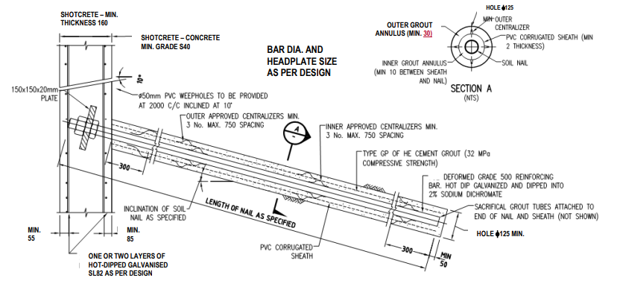
Figure 4.2.1 Soil Nail Components

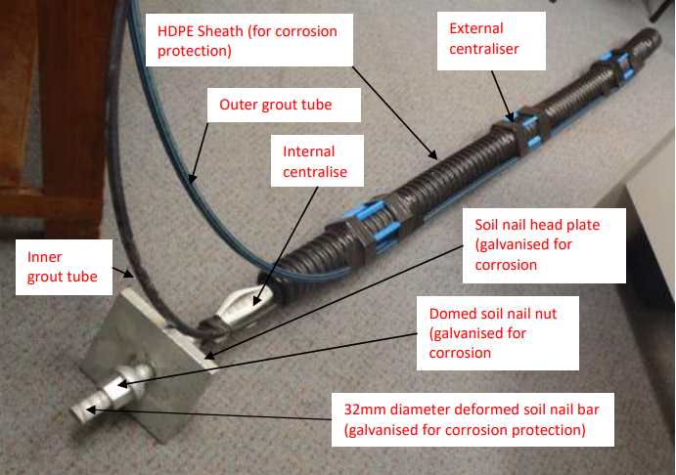
Figure 4.2.2 Soil Nail Components

Soil Nail Components:
1. Tendons
Are the ground reinforcing elements behind a soil nail wall and equivalent to (steel) bars.
Tensile stress in each tendon mobilizes in response to lateral movement and deformation of the retained soil, soil movement can occur during excavation, after excavation in the absence of external loads (as a result of time-dependent deformations), or after excavation when external loads such as surcharge or traffic loads are applied. They can be solid or hollow bars, solid bars are placed in stable drill holes and grouted in place, hollow bars are fitted with a sacrificial drill bit and are used to drill the hole to then remain in place as the permanent soil nail reinforcement, both solid and hollow bars are typically fully threaded.
2. Grout:
used for soil nails usually consists of Portland cement and water, its functions: transferring shear stresses between the deforming ground and the tendons, tensile stresses from the tendons to the surrounding stable soil, and providing some level of corrosion protection to the tendons. Grout is placed in the drill holes under gravity using the tremie method.
3. Corrosion Protection
Soil nails require chemical and physical protection against corrosion. A greater level of protection is required for soils with higher corrosion potential and for projects with lower risk tolerance.
The lowest level of corrosion protection in U.S. practice is provided by the grout alone, encapsulation of the bar provides the highest level of corrosion protection, achieved by adding a protective sheath and grouting the bars in a phased process. Corrosion protection of the soil nail tendon can also be provided by application of a fusion-bonded, epoxy coating, galvanization, or sacrificial steel.
4. Shotcrete
Facing consists of an initial and a final component soon after excavation, the initial facing is applied on the exposed soil, before or after nail installation to provide temporary stability and protection, the initial facing also receives the bearing plate of the soil nail, most commonly consisting of reinforced shotcrete which includes the following items:
1. Welded-wire mesh (WWM) installed over the entire excavation lift, and effectively over the entire wall using appropriate lap splices.
2. Horizontal bars (referred to as 10 waler bars) placed around nail heads to add bending resistance in the horizontal direction.
3. Vertical bearing bars placed at nail heads to add bending resistance in the vertical direction.
The final facing is constructed over the initial facing and provides structural continuity throughout the design life, generally consists of CIP-reinforced concrete, reinforced shotcrete, or precast concrete panels, The final facing may also include an aesthetic finish.
5. Connection Components
The soil nail is connected to the facing through a number of components including: nuts, washers, bearing plates, and headed-studs. The headed studs are attached to the bearing plate and become embedded within the final facing.
6. Drainage System
Installed behind soil nail walls to:
(1) Collect perched groundwater or infiltrated surface water that is present behind the facing.
(2) direct the collected groundwater away from the wall.
The drainage system does not provide full coverage of the wall area, but rather covers commonly 10-20%, or more, of the excavation face, depending on the selected strip drain spacing and commercial widths that are available.
Figure 4.2.3 shows Typical cross-section of a soil nail wall.
Figure 4.2.4 shows Roadway cut supported with soil nails.
Figure 4.2.5 shows an example of road widening under an existing bridge.
Figure 4.2.6 shows Drilling Nail Holes.
Figure 4.2.7 shows Solid nail tendon installation.
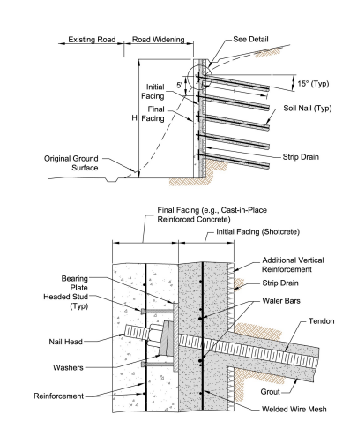
Figure 4.2.3 shows Typical cross-section of a soil nail wall
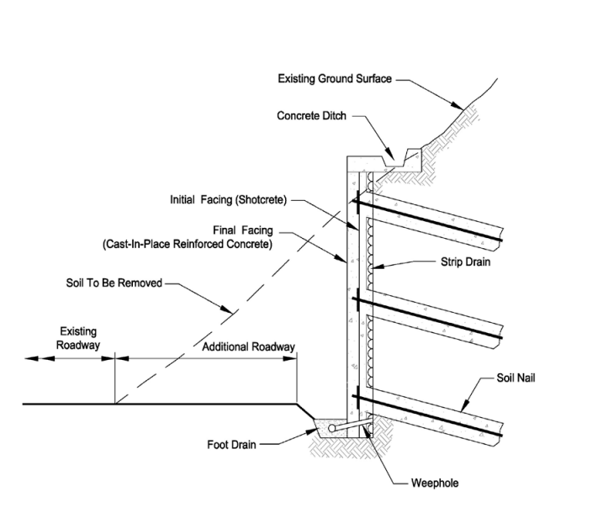
Figure 4.2.4 shows Roadway cut supported with soil nails

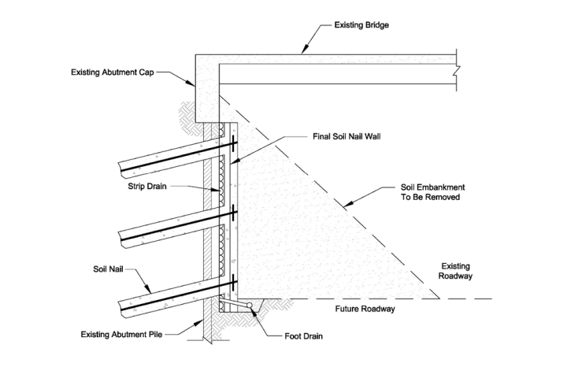
Figure 4.2.5 shows an example of road widening under an existing bridge.
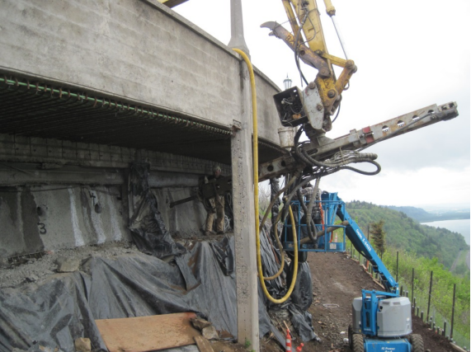
Figure 4.2.6 shows Drilling Nail Holes

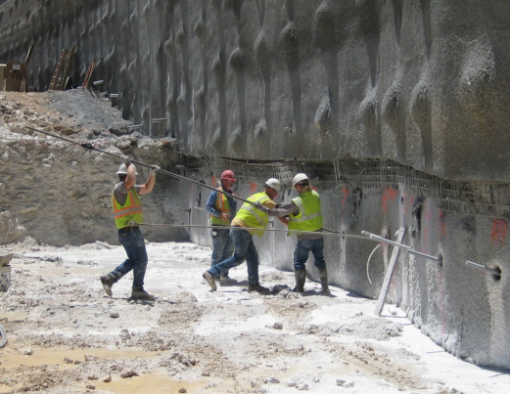
Figure 4.2.7 shows Solid nail tendon installation

Nails Properties and Spacing
To establish the layout of the soil nail wall, must include the height, length, and inclination of the wall (must be in the range from 0 to 10).
The development of the wall longitudinal profile, the placement of wall appurtenances (such as traffic barriers, utilities, and drainage systems), and the determination of ROW restrictions are all included in the evaluation of the wall layout.
Nail spacing ranges from 1.25 to 2 m (1.5 preferred), for conventional drilled and grouted soil nails, and lower for driven nails (0.5m), due to the fact that driven nails develop bonds with weaker bonds than drilled and grouted nails. Spacing may be affected by the presence of existing underground structures. And forces from global stability analysis and facing design affected by the spacing (larger get larger),
Multiplying horizontal and vertical spacing must be equal or less than 4 m² (HV*SV<=4 m²), minimum spacing must be about 1m, and the maximum spacing is 2m (easy to construct, support the lateral earth pressures and imposed surcharge loads), and the inclination for nails ranges from 10 to 20 degrees (typically 15 degrees), less than 10 should not be used to avoid the potential for creating voids in the grout, lengths may be uniform or variable.
Soil Nail Pattern is one of these: Square (Rectangular), triangular, and irregular (limited locations).
4.3 Manual Design
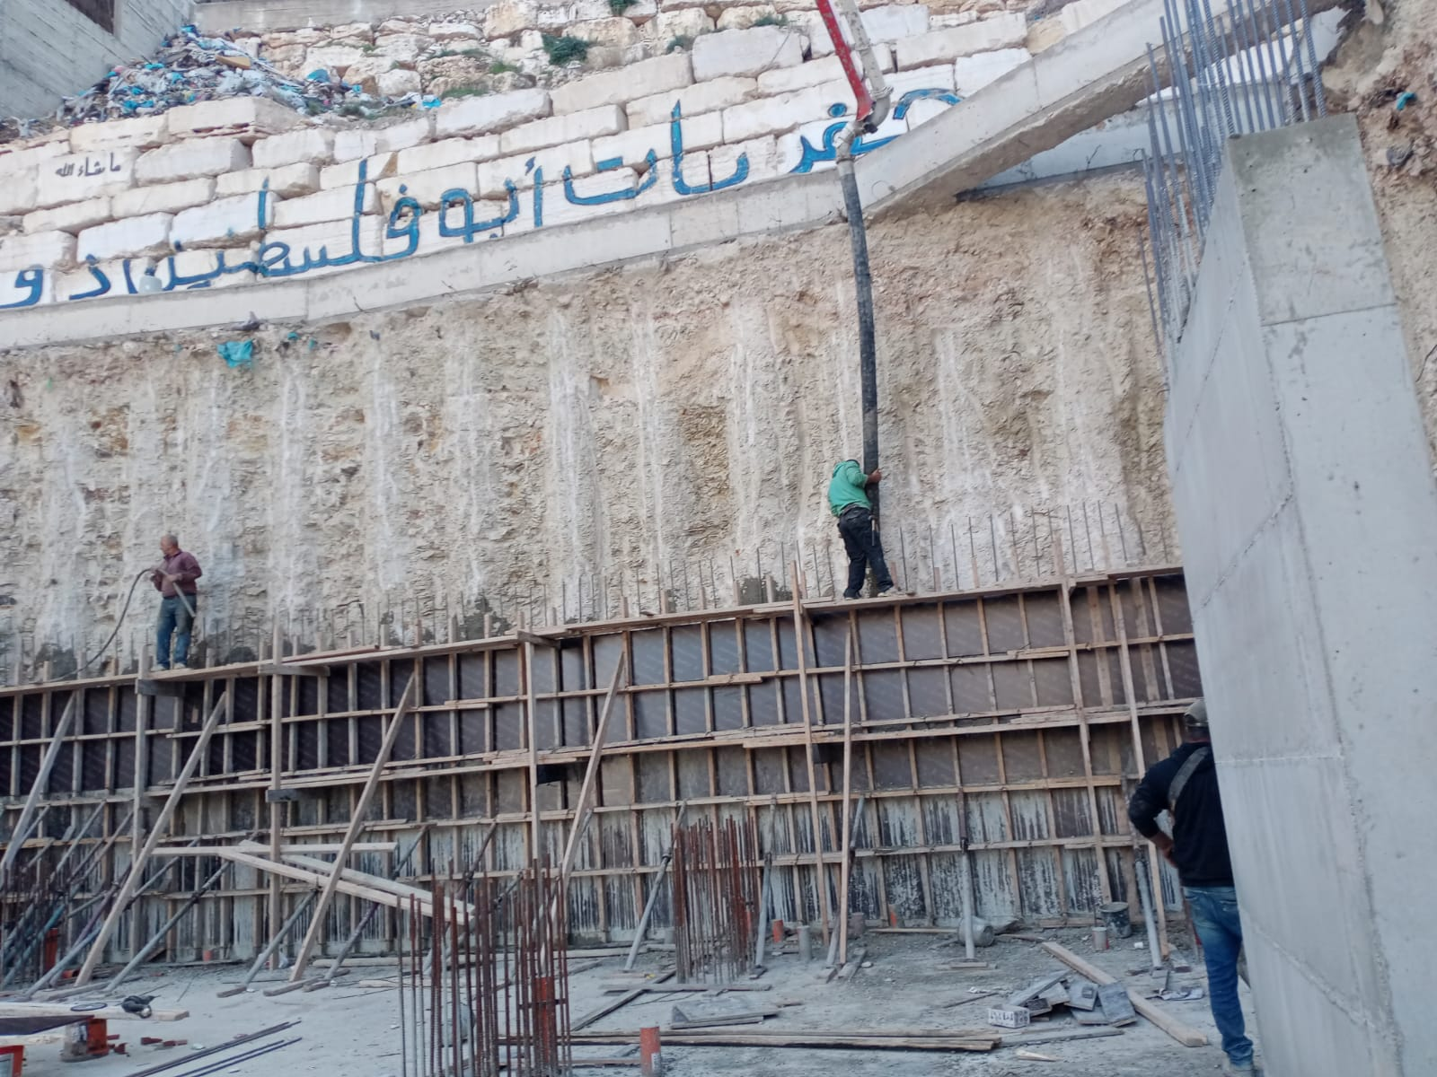
Figure 4.3.1 shows The wall for which it was designed in this project
The picture shows the site in Rafidia, where support for excavating piles was made, while the project was designed as soil nails.

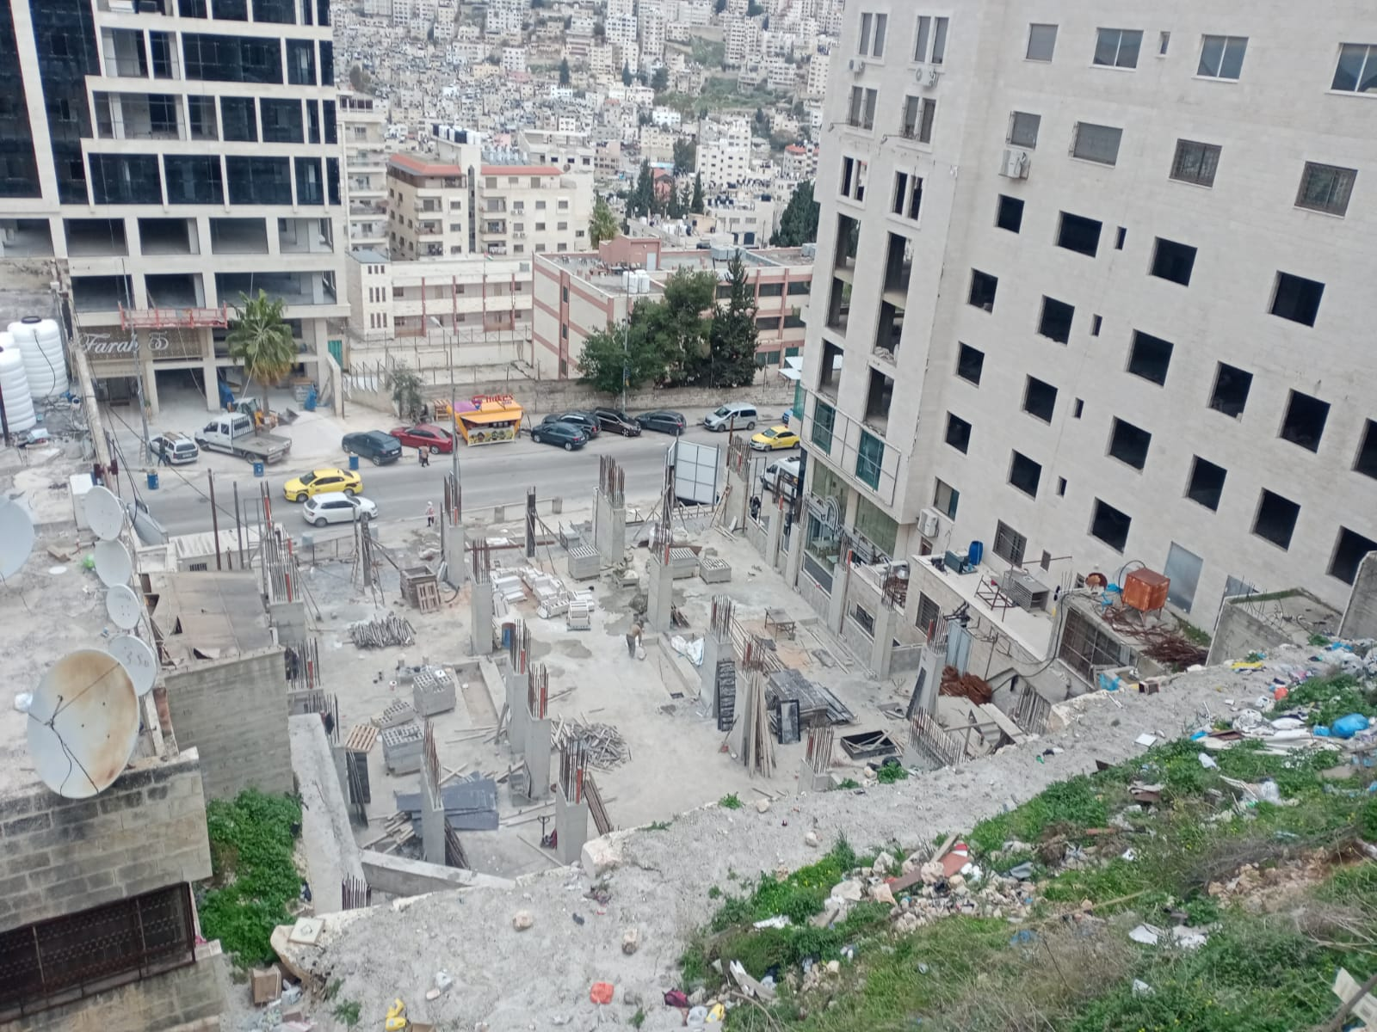
Figure 4.3.2 Shows the building being worked on
It shows the building that was worked on to design the wall, where the height of the wall is 12 meters, the width of the building is 30 meters, and the soil is silt clay ,
And the bearing capacity 250Kn/m^2,c=40,thita =25.

Design charts were developed using the computer program SNAIL to help estimate
lengths and maximum tensile forces of soil nails for typical conditions in design. The charts were developed for ranges of the angle of backslope (β) and the effective friction angle (φs) of the retained soils. The bond strength and other parameters need to be selected before using the charts. The charts are expected to provide reasonable estimates for the conditions and assumptions indicated. However, the charts should not replace the use of soil nail design computer programs for more complex conditions and for other drastically different conditions.
Following assumptions were made:
*face batter, α = 0.
*nail inclination, i = 15.
*normalized cohesion, c* = c′/γs H = 0.02.
*factor of safety for overall stability, FSOS = 1.35.
*drill hole diameter, DDH = 4 in.
1. Select the following parameters (Figure B.1) using consistent units before using the charts:
*wall height (H)
*angle of backslope (β)
*vertical and horizontal spacing of soil nails (SV and SH)
Figure 4.3.1 shows Conditions for calculations with charts

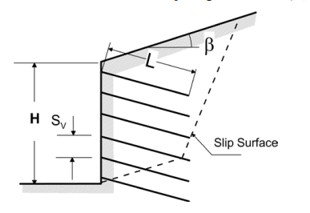
Figure 4.3.3 shows Conditions for calculations with charts

2. Select the following properties and parameters for the retained soil using consistent units:
*unit weight (γs)
*effective friction angle (φs)
*cohesion (c)
*bond strength (qU),
*Factor of safety for pullout (FSPO, usually 2.0)
3. Select the appropriate chart corresponding to β = 0, 10, or 30 degrees (Figures B.2 through B.4).
4. Calculate the normalized bond resistance (µ) as defined below and enter µ in the horizontal axis of the chart for both parts (a) and (b).
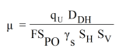
Equation B.1: Normalized bond resistance.
5. Select the appropriate curve for φs. Interpolate between φs = 27, 31, 35 or 39 degrees as needed.
6. Obtain the normalized soil nail length (L/H) required to achieve FSOS = 1.35 from part (a), and the normalized maximum tensile force (tmax) from part (b). Interpolate between Figures B.2 through B.4 if needed. Note that only sufficiently high values of φs will achieve the selected FSOS for relatively large values of β.
7. Calculate the soil nail length (L) by multiplying the normalized soil nail length (L/H) read from the chart by H (in feet).
8. Calculate the soil nail maximum force (Tmax) by multiplying the tmax read from the chart by γs, H, SV and SH.
9. If necessary, correct L/H for values of FSOS, c*, and DDH (in inches) other than those assumed.
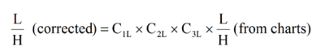
Equation B.2: Corrected normalized length. Where:
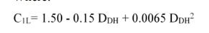
Equation B.3: Length correction factor for drill hole diameter.
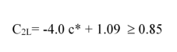
Equation B.4: Length correction correction factor for cohesion.
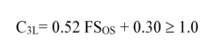
Equation B.5: Length correction factor for factor of safety.

10. If necessary, correct tmax for values of FSOS, c*, and DDH (in inches) other than those assumed.
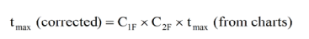
Equation B.6: Corrected normalized maximum force.

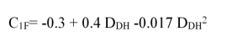
Equation B.7: Load correction for drill hole diameter.
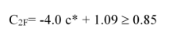
Equation B.8: Load correction for cohesion.
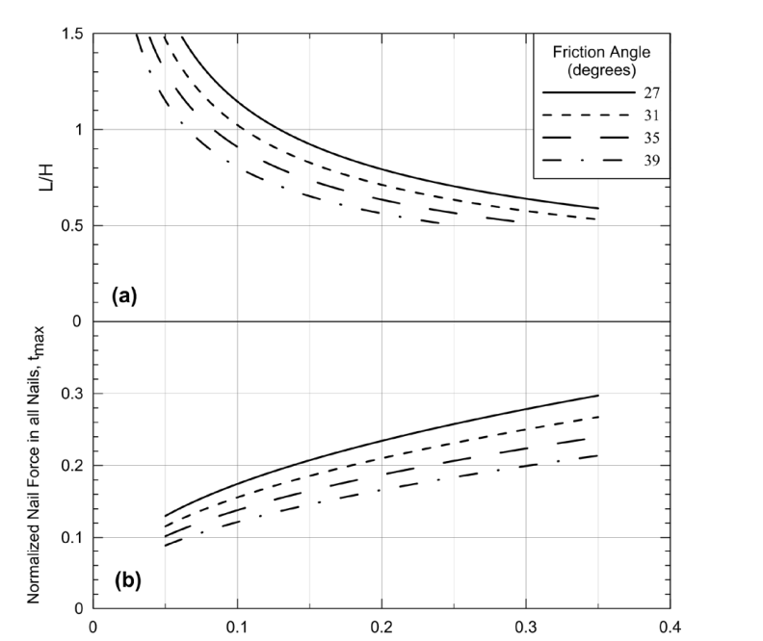
Figure 4.3.4 shows Bond resistance m

Figure 4.3.2: Chart. Batter = 0 deg, -Backslope =0 deg.
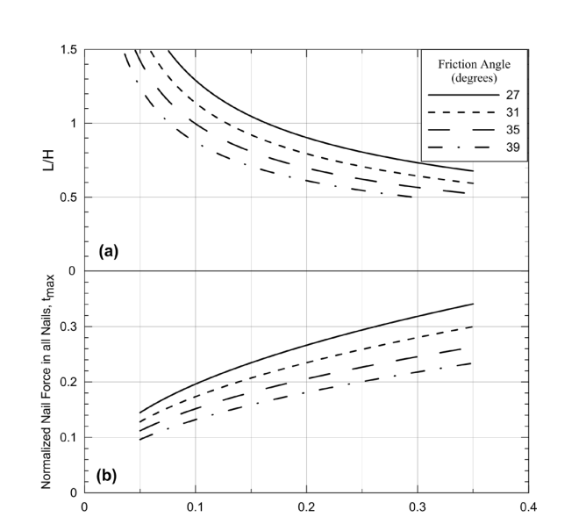
Figure 4.3.5shows BOND STRENGTH

Figure 4.3.3: Chart. Batter = 0 deg. - Backslope =10 deg.

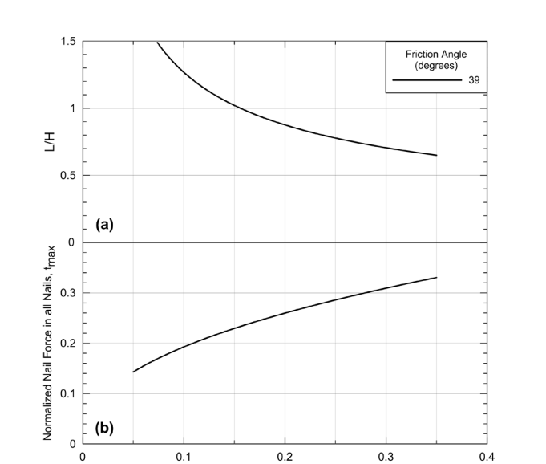
Figure 4.3.6 shows BOND STRENGTH

Figure 4.3.4: Chart. Batter = 0 deg. - Backslope =30 deg.

In our project
Manual Method:
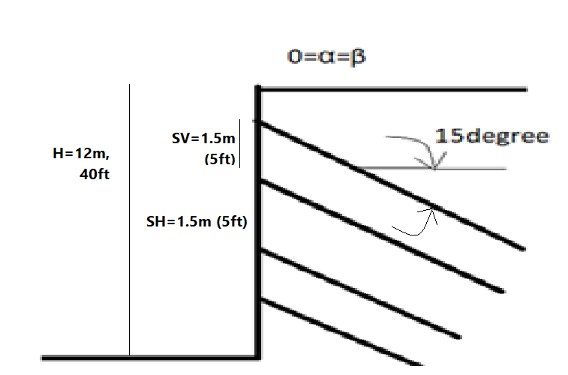
Dense Silly Sand
γ=18KN/m3 nearly 120 PCF
ϕ=25 degrees
C=40 KN/m2
Step 1: Initial Considerations and Parameters
1. Wall Length >> H: Face batter α=0, β=0.
2. Soil Nail spacing SH=SV=1.5m (5ft).
3. Soil Nail pattern on wall face: uniform.
4. Soil Nail inclination=15 degrees.
5. Soil Nail length distribution: uniform.
6. Soil Nail Material (Nail Bar): Grade 420, Fy=420 Mpa (60 Ksi).
From site investigation: Soil properties:
Φ=25 degrees
γ=18 KN/m3
C= 5KPa, (100psf)
q= 125 KPa (18 psi), select DDH=150mm (6 in)
Select, Fsp=2
Calculate normalized bond strength
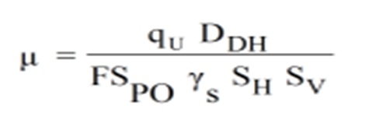
= ((18*(144in²/ft²)*6*(1ft/12 in)) / 2*120pcf* 5ft*5ft= 0.23
**In other design consideration
1. Drilling method: conventional rotary drilling is possible for existing ground conditions.
2. Drill hole diameter: select minimum diameter compatible with condition
DDH= 150 mm(6in).
3. Minimum Factor of Safety: for the Following conditions:
Temporary structure, static loads only, non-critical structure use.
Failure Mode | Resisting Component | Symbol | Minimum Recommended factors of safety
External  Stability | Global Stability | FS_{G} | 1.35
External  Stability | Global Stability | FS_{G} | 1.2-1.3
External  Stability | Sliding | FS_{SL} | 1.3
External  Stability | Bearing Capacity | FS_{H} | 2.5
Internal  stability | Pullout Resistance | FS_{P} | 2.0
Internal  stability | Nail Bar Tensile Strength | FS_{T} | 1.5
Facing  Strength | Facing Flexure | FS_{FF} | 1.35
Facing  Strength | Facing Punching Shear | FS_{FP} | 1.35
Facing  Strength | Headed-Stud Tensile (A307 Bolt) | FS_{HT} | 1.8

About Loading conditions: The Dead Load is just self-weight, and the live is minimal during construction, and neglected after construction, and there is no Wind, Impact, Seismic Loads.
Step 2: PRELIMINARY DESIGN
For α=0, β=0.
Nail Length From Figure:
Φ=25, μ =0.23,
L/H=0.9, t _{MAX-S}=0.28
**The correction for drillhole diameter, C_{1L}=0.91
Design Nail Tensile Load
(for drillhole diameter, C_{1F}=2.1)
T _{max-s}= t_{max-s} γ S_{H}S_{V}HC_{1F}= 0.28*120*5*5*40*2.1/1000=70.56 Kip
**Required cross-section area of steel:
At= (Tmax-s * FST)/fy= (70.56*1.5)/60=1.764 in²
Select a No 25 (No.8) threaded bar with cross-sectional area A=510 mm2 (0.79 in²)
Diameter =25 mm (1.12 in).
Cover is at least (6-1.12)/2=2.44 in (62mm>minimum cover(25mm))
Step 3: FINAL DESIGN
*External Failure Modes and Internal Failure Modes: only the preliminary design developed in Step 2 is considered.

*No Seismic Considerations are necessary.
*Facing Design:
1. Maximum design tensile force at the face:
To= Tmax-s(0.6+0.057( Smax(ft)-3))=70.56* (0.6+0.057(5-3))= 50.3 kip
2. Facing Features:
a. Wall facing type:
Temporary: Shotcrete + WWM.
Permanent: Cast-in-Place Reinforced Concrete.

Facing geometry
Temporary facing thickness (h) =100mm (4 in)
Permanent facing thickness (h) =200mm (8 in)
Steel reinforcement
(fy)=420Mpa (60ksi)
*temporary facing reinforcement select
(WWM)=4*4- W2.9*W2.9
*Select rebar: horizontal and vertical water bars = 2*No3. Grade 60
As=2* 0.11=0.22 in² (in both directions)
*permanent facing reinforcement: No.5 @12 in each way
Concrete strength, fc’= 21 Mpa (3000psi)
1-Facing reinforcement
Temporary facing
a) Reinforcement in the vertical and horizontal direction in mid-span area par unit length (WWM for temporary facing)
a_{vm} = a_{hm} = 0.087 in²/t for WWM4*4 – w2.9*w2.9
b) Reinforcement in the vertical and horizontal direction around the soil nail head
a_{vm} = a_{hm} + a_{vm}/Sv =0.087+(0.23/5)=0.14 in²/ft
c) C_{F}=2.0
d) $ρ$n =AVN /0.5h=(0.14 in²/ft/12)/(0.5*4 in)*100=0.58%
e)$ρ$m = AVN/0.5h=(0.087 in²/ft/12)/(0.5*4 in)*100=0.36%
f)$ρ min (\%)=\frac{0.24*\sqrt{fc'(psi)}}{fy(ksi)}$ $=\frac{0.24*\sqrt{3000}}{60}$ =22%
g) $ρmax \left(\%\right)=\frac{0.05*{fc}^{'}\left(psi\right)}{fy\left(ksi\right)}*\frac{90}{90+fy(ksi)}$ $=\frac{0.05*3000}{60}*\frac{90}{90+60}$ =1.5%
* $ρ$m = 0.36%> $ρ$ min=22% Ok
$ρ$m = 0.36%< $ρ$ max =1.5% Ok
* $ρ$n = 0.58%> $ρ$ min=22% Ok
$ρ$n = 0.58% < $ρ$ max =1.5% Ok :$ρ$n/$ρ$m
=1.5<2.5 Ok
$ρ$total = $ρ$n+ $ρ$m=0.58%+0.36%=0.94%
Permanent facing
- Area per unit length for No.5 @12in, each way
a_{vn} = a_{vm} = 0.31 in²/ft
b) Total reinforcement in the vertical direction (no water bars)
a_{vn} = a_{vm} = 0.31
c) C_{F} =1.0 (from the table)
d) $ρ min \left(\%\right)>=\frac{0.24*\sqrt{fc'(psi)}}{fy(ksi)}=\frac{0.24*\sqrt{3000}}{60}$ =0.22%
e) $ρ max \left(\%\right)=\frac{0.05*{fc}^{'}\left(psi\right)}{fy\left(ksi\right)}*\frac{90}{90+fy(ksi)}$ $=\frac{0.05*3000}{60}*\frac{90}{90+60}$ =1.5%
* $ρ$n =$ρ$m =0.31/12(0.5*8)*100=0.65%
*$ρ$total =1.29%
*facing tensile flexural resistance (R_{FF})-Temporary and permanent facing
a) facing flexural resistance (R_{FF})
Temporary A. 5 a, R_{FF} = 140KN (32kip)
Permanent A. 5 a, R_{FF} = 412.8KN (93kip)
b) Verify FS_{FF}< R_{FF}
Temporary=1.37*14.9=20.41 kip <32kib
Permanent=1.5*14.9=22.35 kip <93kip
*facing flexural resistance (R_{FP})
Temporary from table A.56< R_{FP}= 150KN (35kp)
Permanent he= 4.8 in (120mm)
Verify fs= p to <RFP
Temporary 1.37*14.9=20.41kip<35kip
Permanent 1.5*14.9=22kip<32kip
*Soil nail length
L =0.7*H 0.7*40=28 ft
0.7*12=8.4 m Use L= 9m
9m length for one nail Ok (between 0.6* H, 1.2* H)
*Check for S_{V}, S_{H}
Sv =3 ft <5 ft Ok
*Check S_{H}*S_{V}=25 ft² < (35 -42) ft²
*Sv_{o}: the spacing between the first row and top of wall (S_{Vo})
Sv_{o}= 3ft < 3.5 ft Ok.

4.4 DESIGN BY PROGRAM
PROGRAM: S NAIL PLUS2013 FROM DEEP EXCAVATION
1-MODEL WIZARD
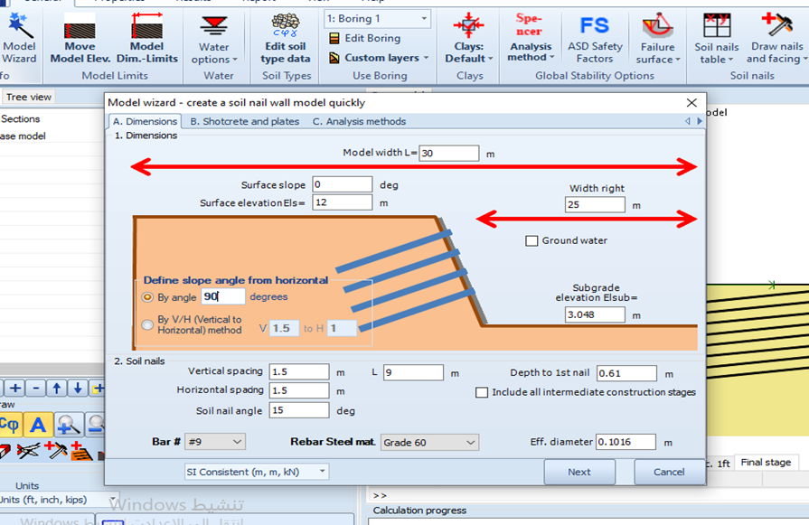
2-Shotcrete and plates
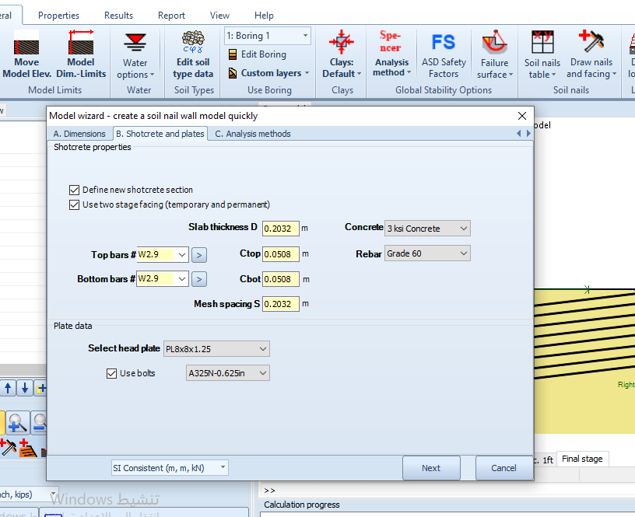
3-Soil properties
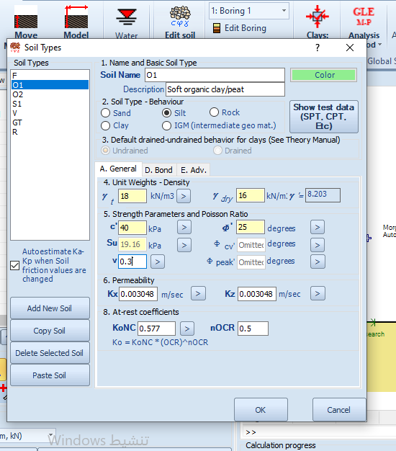
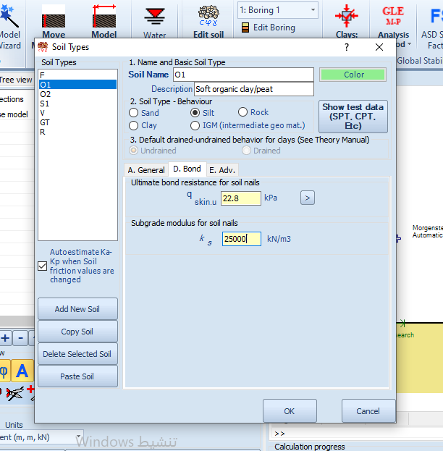

Results and details of the design
1.
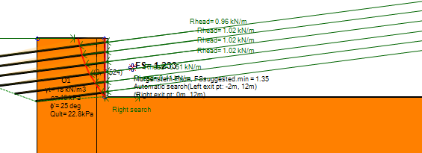

2.
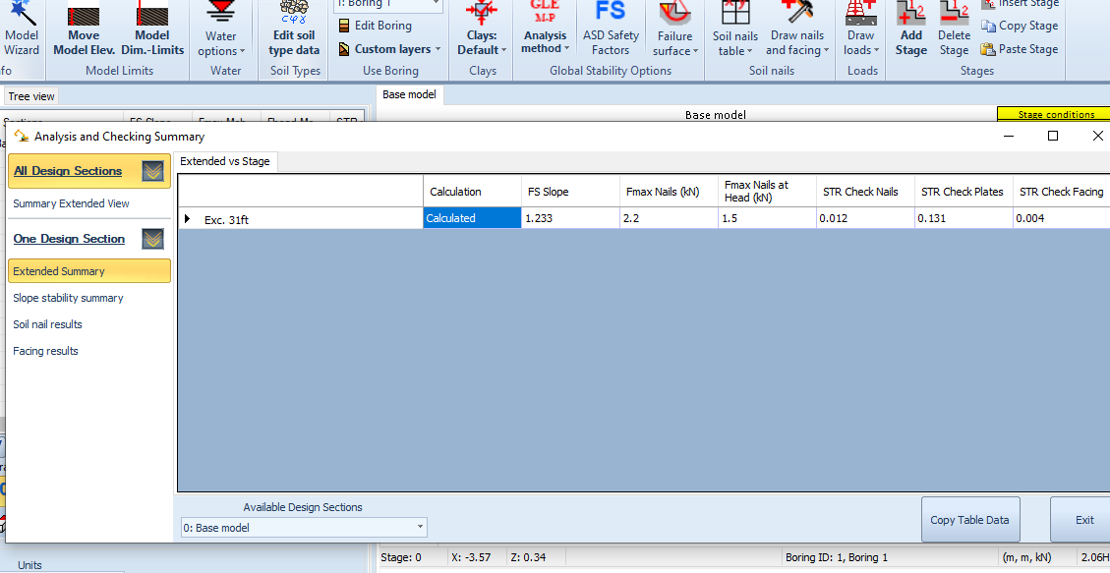
3.
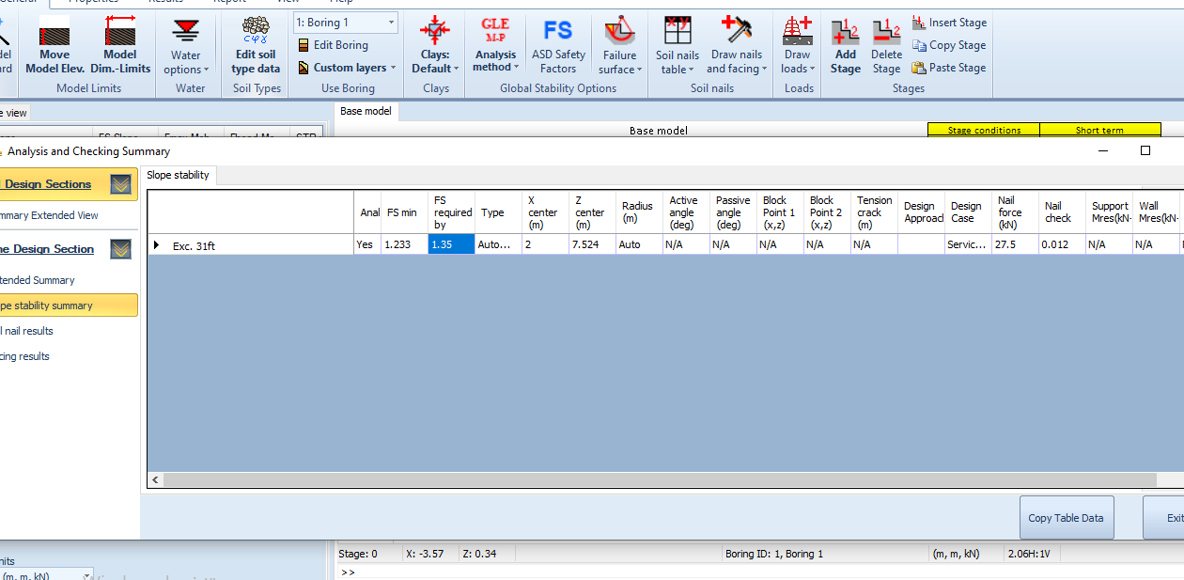
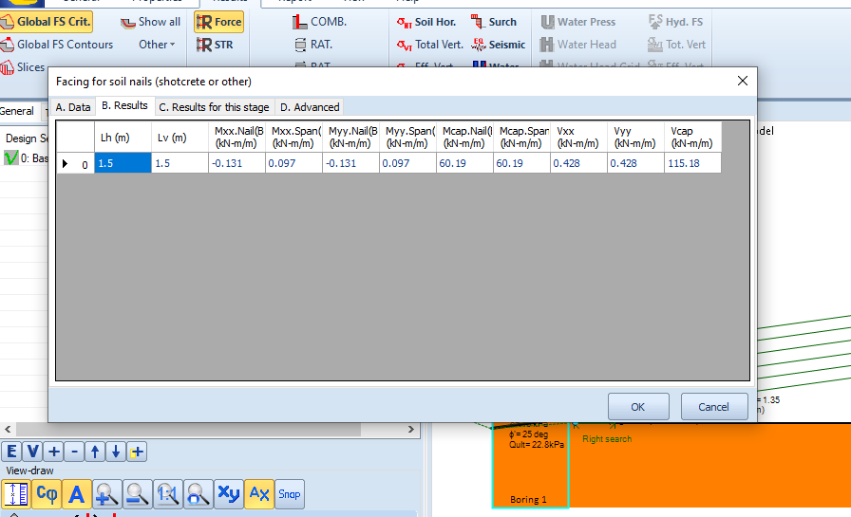
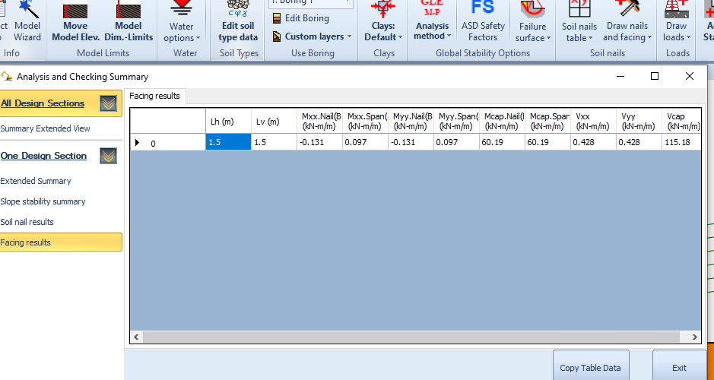
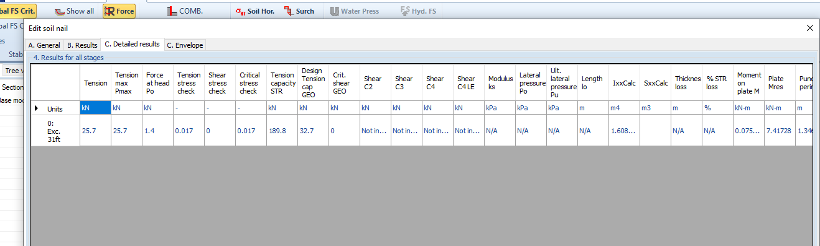

Results for all nails
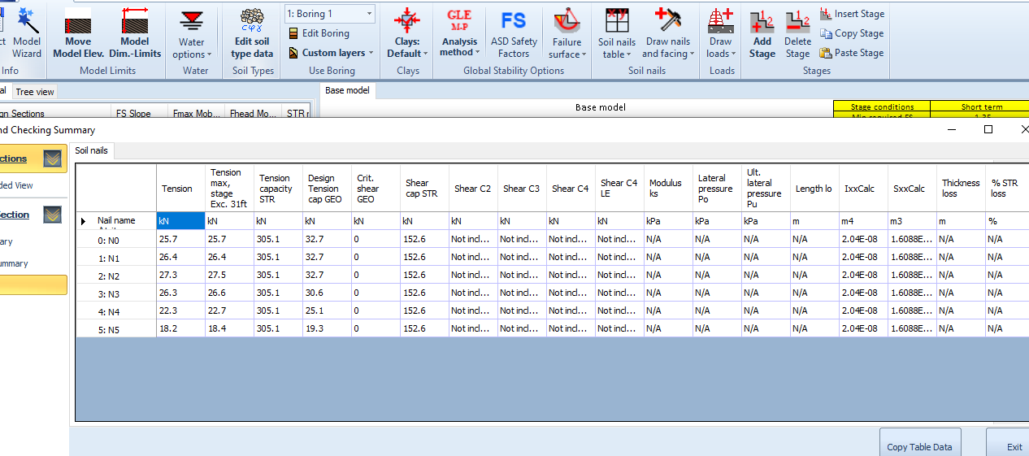
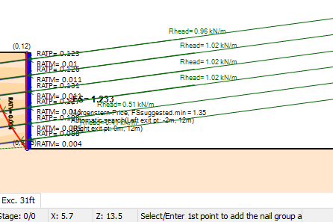
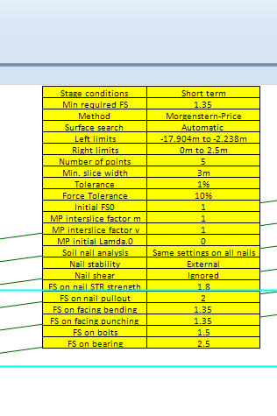

Facing
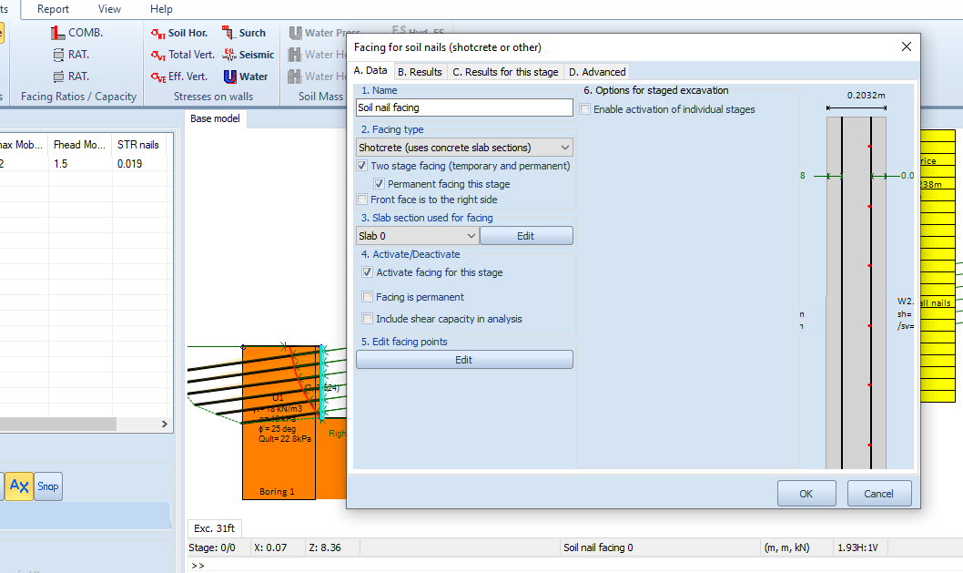
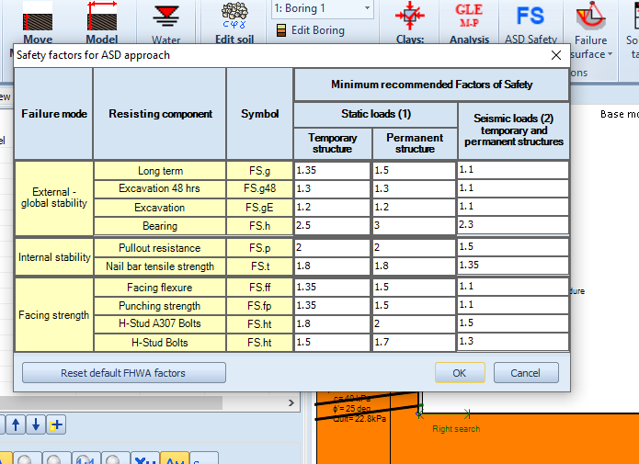
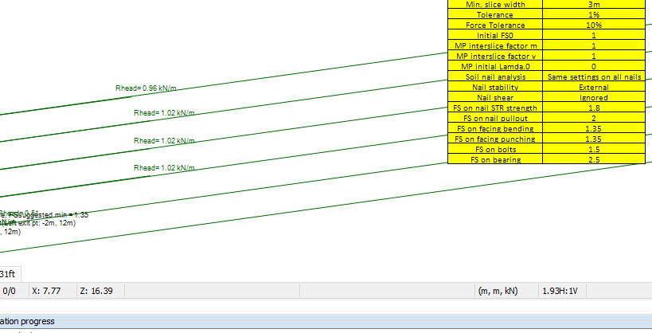

Details and results for each component of the nails
Nail 1
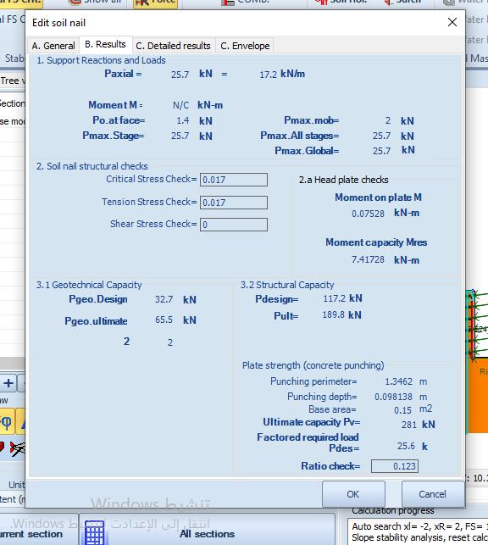
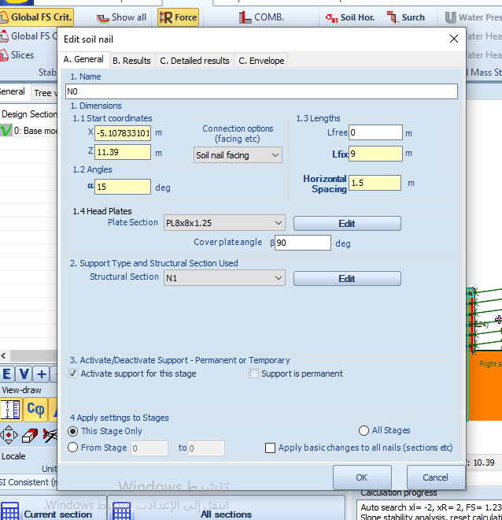
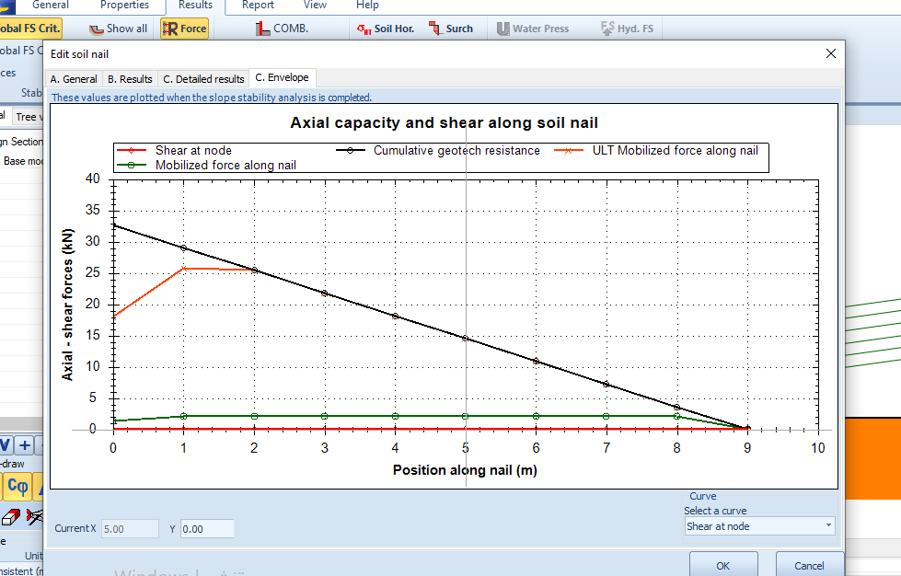

2.
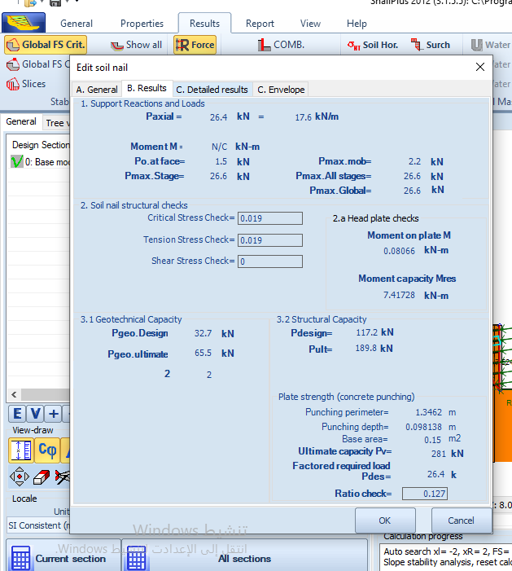
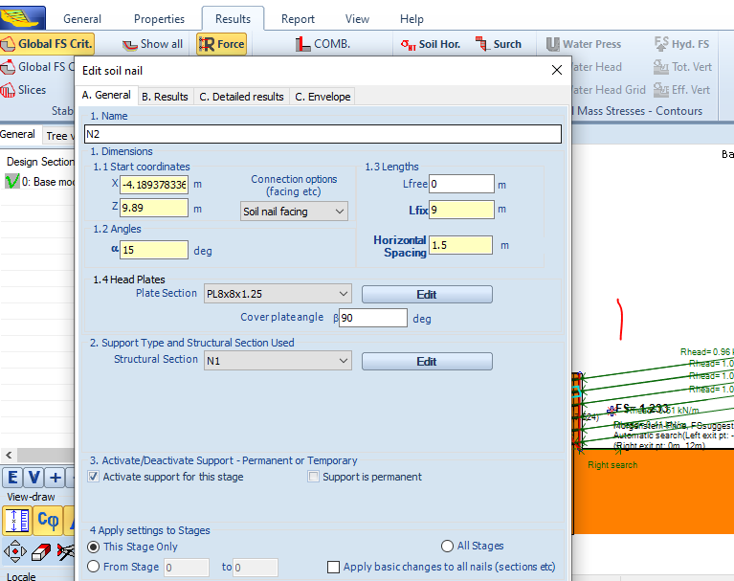
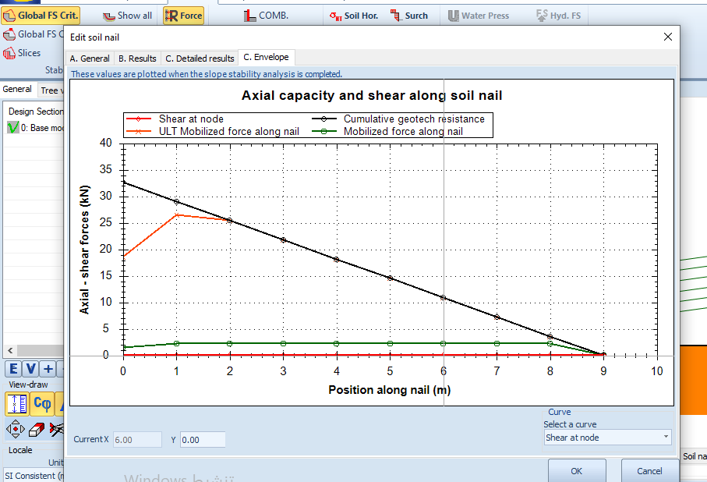

3.
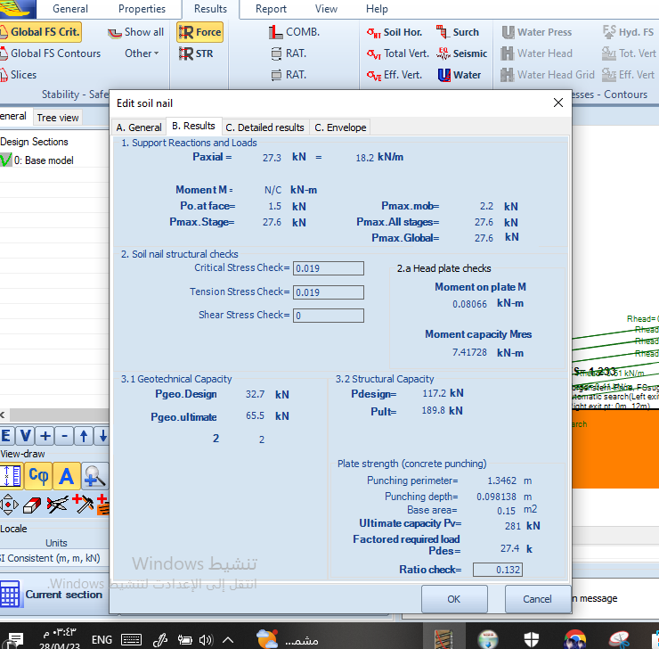
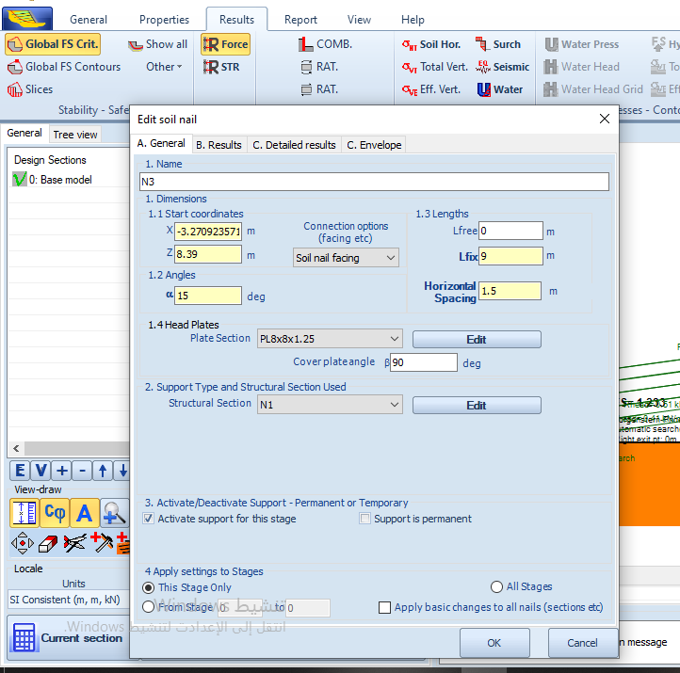
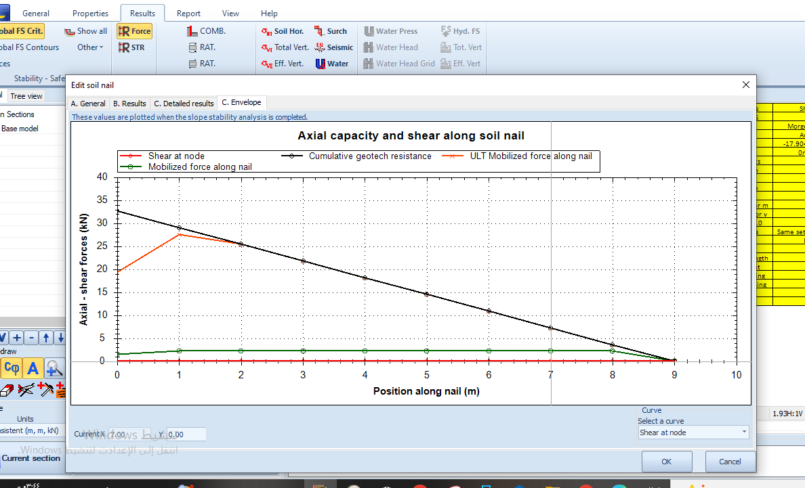
4.
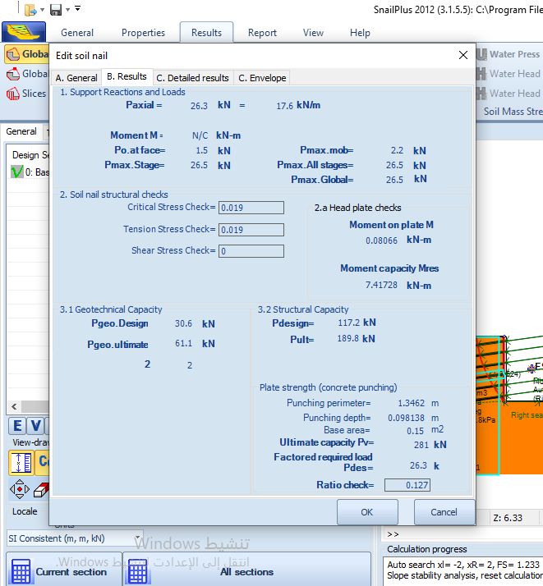
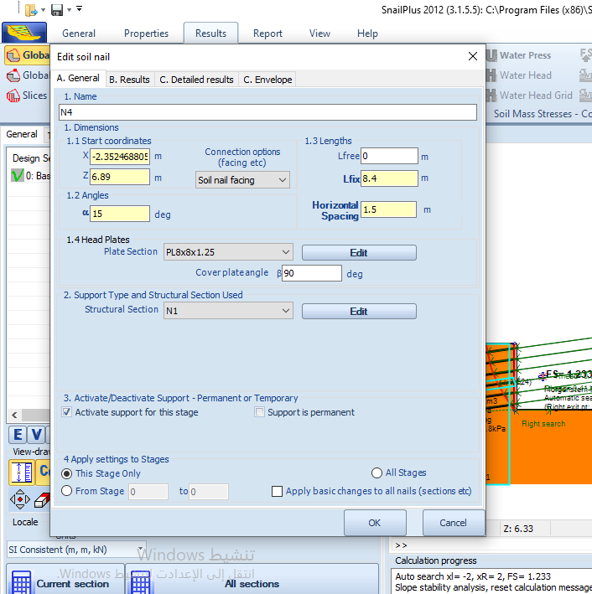

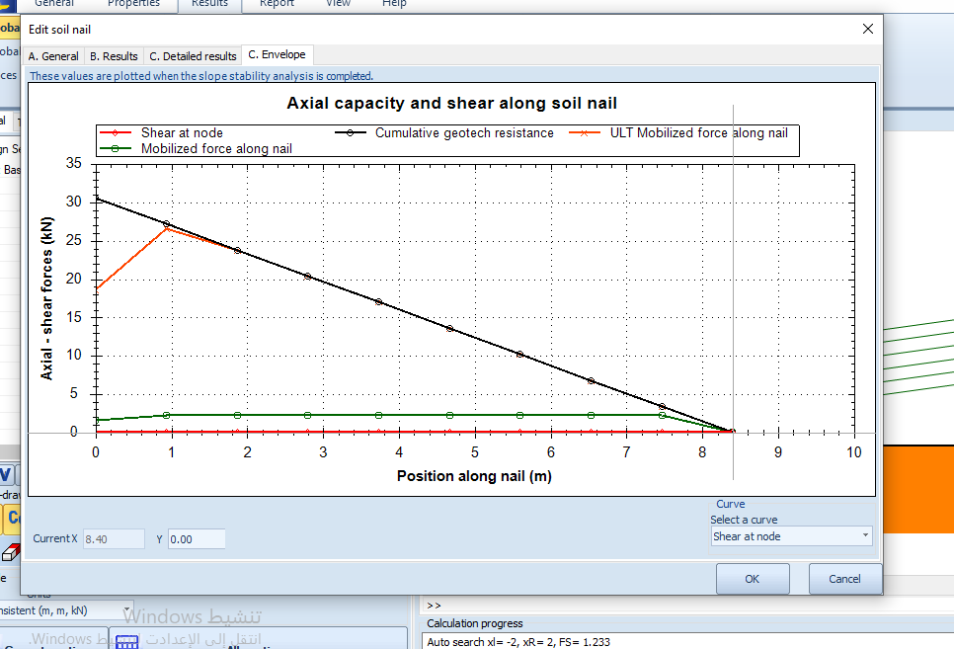
5.
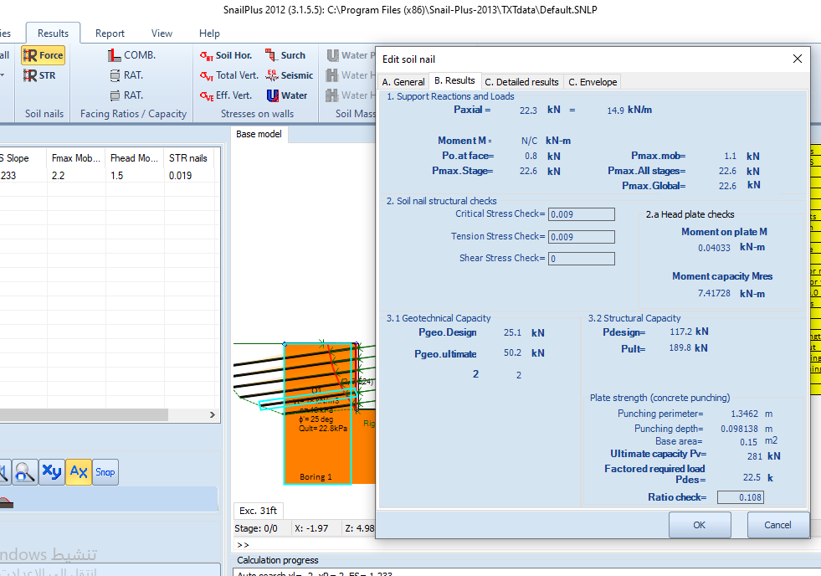
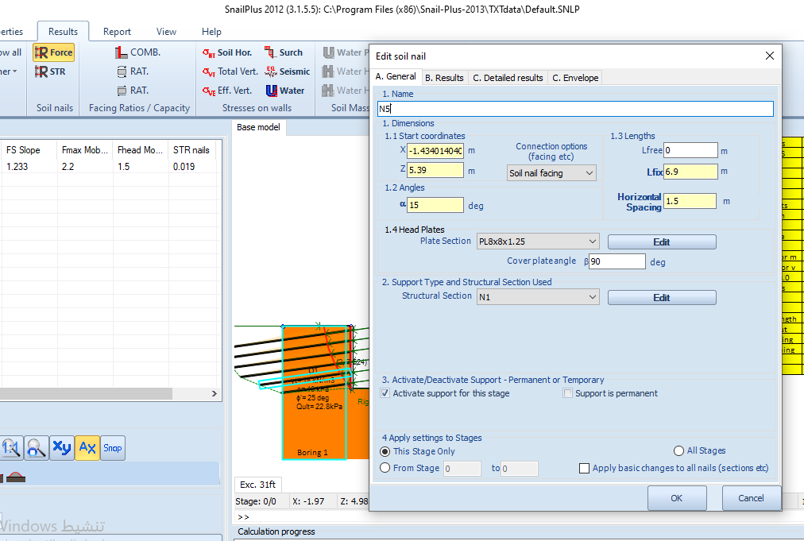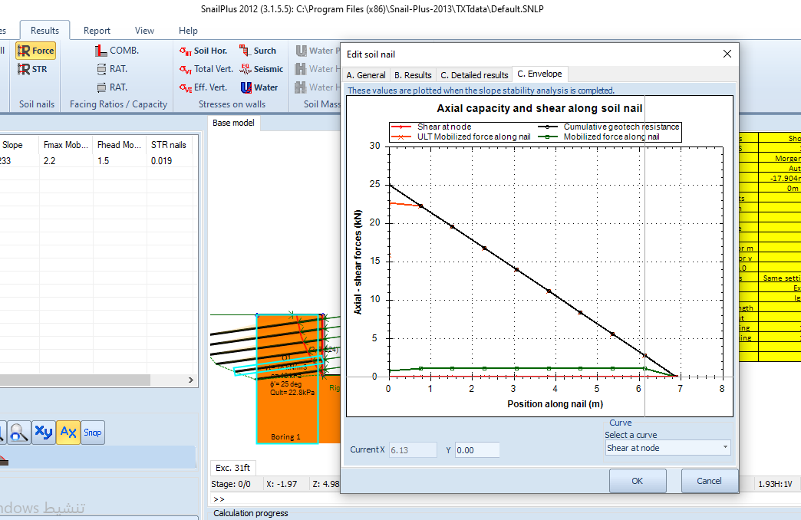

6.
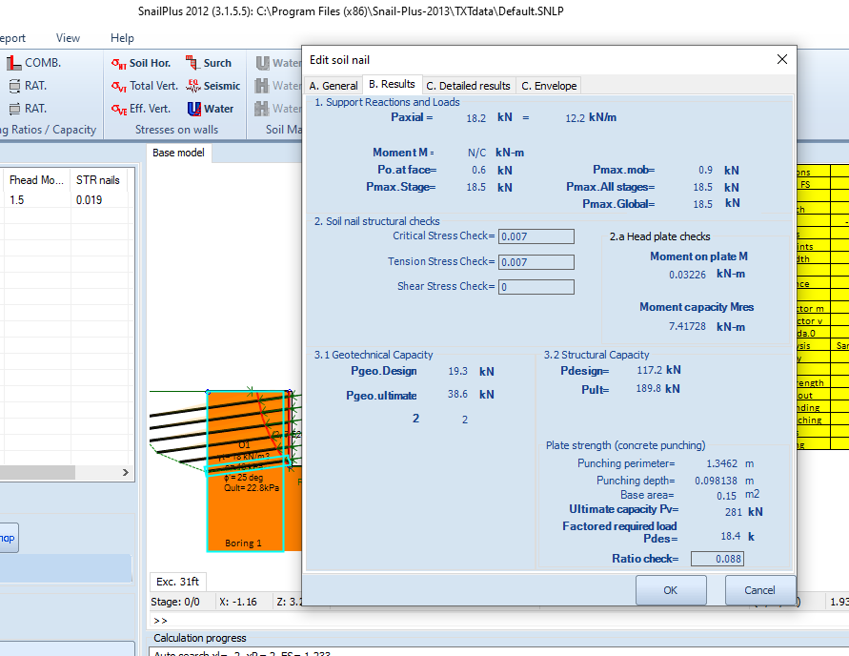
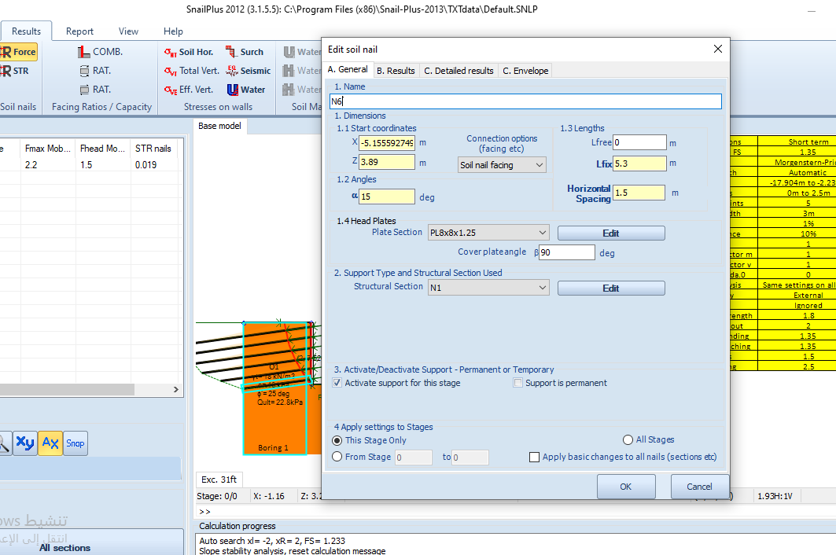
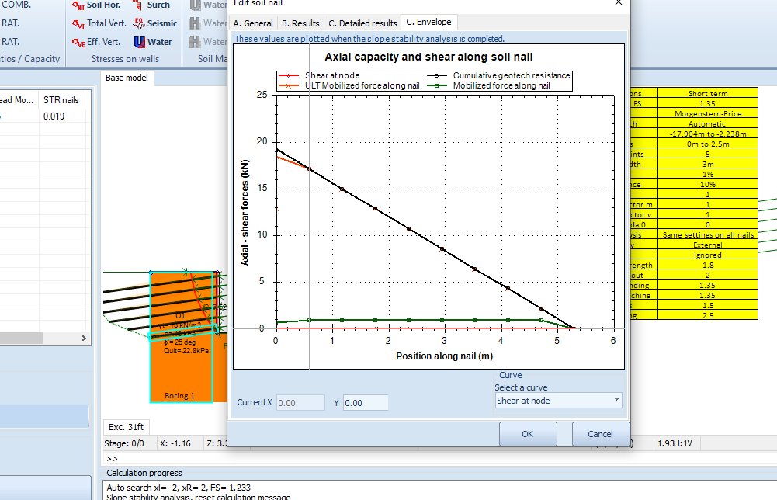

4.5 Conclusion

In conclusion, soil nailing is a corrective construction technique that allows for the safe over-steepening of new or existing soil slopes. It is used to remediate unstable natural soil slopes or unstable man-made (fill) slopes. The procedure entails the insertion of relatively thin reinforcing elements into the slope, (general purpose reinforcing bars), these bars are usually from steel and with a spacing range (of 1.25-2) preferred 1.5m minimum spacing is 1m and the maximum is 2m and the inclination for nails ranges from 10 to 20 degrees, and pattern can be either square or triangular, or irregular, and lengths can be uniform or variable. However, there are also specialty solid or hollow-system bars available. Hollow bars may be drilled and grouted concurrently by using a sacrificial drill bit and by pushing grout down the hollow bar as drilling continues. Solid bars are often inserted into pre-drilled holes and then grouted into place using a separate grout line. There have also been created kinetic techniques for shooting relatively short bars into soil slopes.
Bars inserted into the slope face using drilling techniques are typically fully grouted, installed at a little downward slope, and spaced at regular intervals. At the surface, a hard facing (typically shotcrete, concrete applied pneumatically) or separate soil nail head plates may be utilized. As an alternative, the soil face beneath the head plates could be secured with a flexible reinforcing mesh. Where necessary, flexible mesh facing may be combined with rabbit-proof wire mesh and materials that prevent environmental deterioration.

Additionally, to stabilize retaining walls or pre-existing fill slopes (embankments and levees), soil nail components may be utilized; this is typically done as a corrective remedy. Its first application using modern techniques in Versailles in 1972.
Most soil nail wall construction follows a specific procedure, starting with excavating a cut, then putting a temporary bracing if necessary. Using conventional earth-moving equipment and hydraulic drills. After that, drilling holes for the soil nails and the equipments needed depends on how stable the material is that the soil nail wall is supporting, with stable ground, air flush or dry auger rotary or rotary percussive procedures can be employed.
Single tube, duplex, air-and-water flush, and hollow stem auger rotary methods are employed for unstable terrain. The nails must be installed and grouted into place after the holes have been drilled. A drainage system is set up once all the nails have been installed. The nail heads, which are extended to the base of the wall where they are typically attached to a footing drain, are positioned vertically between the synthetic drainage mat. Before putting the last facing in place to finish the soil nail wall, a layer of shotcrete is applied and bearing plates are put in. In order to account for additional preparation work or supplemental activities for particular project conditions, modifications to the aforementioned processes may be required.
Soil nail walls are clearly superior than other options in terms of construction. In addition to having less of an impact on the environment, soil nail walls call for a smaller right-of-way than ground anchor walls. Soil nail walls can be built very quickly, and they normally use fewer construction equipment and resources than ground anchor walls.
One great advantage is that soil nail walls are much more economical than concrete gravity walls and similarly or more economical than ground anchor walls.

References
•Braced cut by Ash.
•JPGuger 2009.
•Pile Buck1984.
•Bridle R.J., Barr B.I.G. (1990). ” Discussion on Jewell & Pedley (1990b)” Ground Engineering, vol.23, n° 6, 30-31.
•Bruce D.A. (1989). American developments in the use of small diameter inserts as piles and in situ reinforcements”. Proc. of Int. Conf. on Piling and Deep Foundations, Deep Foundations Institute, vol. 1, 11-22.
•Bruce D.A., Jewell R.A. (1986). ”Soil nailing: application and practices, Part 1”. Ground Engineering, vol. 19, n° 8, 10-15
•Bruce D.A., Jewell R.A. (1987a). ”Soil nailing: application and practices, Part 2”. Ground Engineering, vol. 20, n° 1, 21-38
•Bruce D.A., Jewell R.A. (1987b). ”Soil nailing: the second decade”. Proc. Int. Conf. on Foundations and Tunnels, vol. 2, 68-83.
•Bruce D.A. (1992a). ”Recent progress in American pinpile technology”. Proceeedings of a Conference on grouting, soil improvement, and geosynthetics, New Orleans, R.H. Borden, R.D. Holtz, I. Juran editors, Geotechnical special Publication 30, ASCE, 2, 765-777.
•Bruce D.A. (1992b). ”Two new specialty geotechnical processes for slope stabilization”. Proceedings of a specialty Conference on stability and performance of slopes and embankments, Berkley, CA, R.B. Seed and R.W. Boulanger editors, Geotechnical Special Publication 31, ASCE, 1505-1519.
•BS 8006: 1995” Code of practice for strengthened-reinforced soils and other fills”. British Standard Institute.
•Bustamente M., Doix B. (1985). ”Une méthode pour le calcul des tirants et des micropieux injectés”. Bull. Liaison labo P. Et Ch., 140, ref. 3047, 75-92.
•Byrne R.J., Cotton D., Porterfield J., Wolschlag C., Ueblacker G. (1998). ”Manual for Design & Construction Monitoring of Soil Nail Walls”. U.S. Department of Transportation, Federal Highway Aministration, Publication n° FHWA-SA-96-069R, Revised October 1998.
•Gässler, G. (1990). “In situ techniques of reinforced soil. State of the art report”. Proc. BGS Conference on Performance of Reinforced Soil Structures, Glasgow, Thomas Telford, London, 185-196.
•Gnilsen R. (1988). ” Soil nailing debate”. Civil Engineering, ASCE, vol. 58, n° 8, 61-64.
•Guilloux A., Schlosser F. (1985). ”Soil nailing: practical applications”. Proc. of Int. Symposium on Recent Developments in Ground Improvement Techniques, Bangkok, Balkema, 289-297.
•Felio G.Y., Vucetic M., Hudson M., Barar P., Chapman R. (1990). ”Performance of soil nailed walls during the October 17, 1989 Loma Prieta earthquake”. Proc. of 43th Canadian Geotechnical Conference, Quebec, Canada.
•DoT (1994). ”Advice Note HA 69/94. Design methods for the reinforcment of highway slopes by reinforced soil and soil nailing techniques.”. design manual of Roads and Bridges, vol. 4, sect. 1, part 4, The Highway Agency, HMSO, UK
•Jewell R.A. (1990). ”Review of theoretical models for soil nailing” Proc. of Int. Conf. on Performance of reinforced soil structures, A. Mc Gown, K.C. Yeo, K.Z. Andrewes editors, Thomas Telford, 265-275.
•Juran I., Beech J. (1984). ”Theoretical analysis of the behaviour of nailed soil retaining structures” Proc. of Int. Con. on In-Situ Soil and Rock Reinforcement, Paris, 301-307.
•Juran I., Elias V. (1987). ”Soil nailed retaining structure. Analysis of case histories”. Proc. Spec. Conf. on Soil Improvement – a ten year update, J.P. Welsh editor, ASCE, Special Publication 12, 232-244.
•Jewell R.A., Pedley M.J. (1990a). ”Soil nailing design – the role of bending stiffness”. Report n° OUL 1813/90, Department of Engineering Science, University of Oxford.
•Jewell R.A., Pedley M.J. (1990b). ”Soil nailing design – the role of bending stiffness”. Ground Engineering, vol.23, n° 2, 30-36.
•Jewell R.A., Pedley M.J. (1990c). ”Replay to discussion by Bridle & Barr (1990)”. Ground Engineering, vol.23, n° 6, 32-33.
•Jewell R.A., Pedley M.J. (1991). ”Closure to discussion by Schlosser (1991)”. Ground Engineering; vol. 24 n° 9, 34-39.
•Juran I., Baudrand G., Farrag K., Elias V. (1990). ”Kinematical limit analysis for design of soil nailed structures”. Journal of Geotechnical Engineering, ASCE, 116, 1, 54-72
•Lazarte C.A., Elias V., Espinoza D., Sabatini I.J. (2003). ”Geotechnical Circular n. 7, Soil Nail Walls”. US Department of Transportation, FHWA, FHWA-A0-IF-03-017, Washington D.C. (http://isddc.dot.gov/OLPFiles/FHWA/016917.pdf )
•Linzi F. (1977). ”Practical engineering in structurally complex formations (the In Sity Reinforced Earth)”. Proceedings International Symposium on the Geotechnics of Structurally Complex Formations, Capri, Italy, AGI.
•Mitchell J.M., Jardine F.M. (2002). ”A guide to ground treatment”. CIRIA C573, London.
•Munfakh G.A., Abramson L.W., Barksdale R.D., Juran I. (1987). ”In-situ ground reinforcement”. Proc. Spec. Conf. on Soil Improvement – a ten year update, J.P. Welsh editor, ASCE, Special Publication 12.
•Myles B., Bridle R.J. (1991). ”Fixed soil nails – the machine”. Ground Engineering, vol. 24, n° 6, 38-39.
•Nicholson P.J. (1986). ”In situ ground reinforcement techniques”. Proc. Int. Conf. Deep Foundations, Deep Foundations Institute and CIGIS, Beijing, China.
•Phear A., Dew C., Ozsoy B., Wharmby N.J., Judge J., Barley A.D. (2005). ”Soil nailing – best practice guidance”. CIRIA C637.
•Soil nailing technique, its types, applications, and installation considerations. The Constructor. (2018, August 11).
•Soil Nailing Technique, Its Types, applications, and installation considerations - The Constructor.
•Soil Nailing -A Review, Mohammad Farhad Ayazi, Samrity Jalota, Amanpreet Tangri, (2020).
•The Engineering Community. “Soil Nailing Technique and Types.” The Engineering Community, 19 July 2019,
SOIL NAILING TECHNIQUE AND TYPES (theengineeringcommunity.org)
•Applications of Soil Nail Walls.” CivilEngineeringBible.com, https://civilengineeringbible.com/article.php?i=108.
•Applications of Soil Nail Walls.” CivilEngineeringBible.com,
https://www.slideshare.net/asertsem.
• Design of Soil Nail Walls - Information – Deep Excavation.
•https://www.designingbuildings.co.uk/wiki/Soil_nailing?fbclid=IwAR2-3cqD8Yi_m3f7Ta6hWF7iLvHlpXQprS2CdmvVRLwcSkIWecNNCfLWeo0.
•https://dailycivil.com/soil-nailing-advantages-and-disadvantages-of-soil-nailing/?fbclid=IwAR1rqlon2iwjr9UtZv0we7sDNNdGSyzXV5pTzZtVSG5cnEr-y_ZjBZeMpdQ

